Chapter 1

TUA-HA TEXTILE at A Glance
TUA-HA COMPOSITE TEXTILE LTD

Tua-Ha Textile Ltd. is a state-of-the-art Knitting, Dyeing – Finishing & Garment Manufacturing
factory. The project has been a setting up of a 100% export oriented composite knit garment unit. The project has been designed to fulfill the present world market demand for producing most value added fabrics. The project is equipped with open width finishing line. This helps saving all types of fabrics consumption. Also the quality of fabrics is improved tremendously. The machinery of the project is Brand new and has been imported from abroad.

Objectives:
 To meet the appropriate expectations of clients
 To gain confidence of the Buyers
 To be the "Tag carrier of made in Bangladesh"
 To create employment opportunities
 Speedy Communication through Internet & Telecom services.

Location:

Corporate Office Address | Factory Address
Mahatab Plaza ( 7th Floor)  Bijaynagar, Puran Polton,  Dhaka.  Tel:+88029337505/9354880  www.info@tua-ha.com | Kabirpur, Savar,Dhaka  EPZ-Kaliakoir Road  (2-Km south of NandanPark)  Tel: 880-02-7702744-7  Fax: 880-2-7702743  www.info@tua-ha.com

Person to be Contacted
S.M Kaniz Fatima  Deputy General Manager  Admin,operation & Compliance,  Tua-Ha Textile Ltd.  Cell: 01711353411(Direct) | Md. Sanuar Hossain  Dyeing Manager  Dyeing Section  Tua-Ha Textile Ltd  Cell: 01615602483(Direct)

Map of location from Dhaka
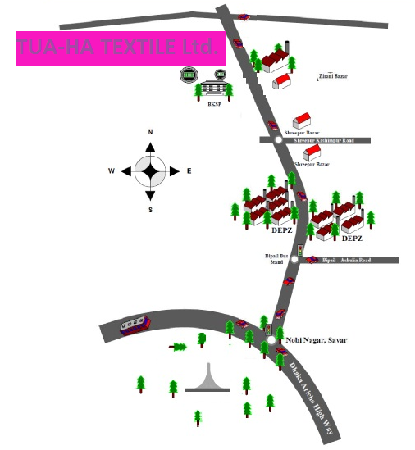

Compliance:

Tua-Ha TextileLtd. complies with specific regulation and requirement state by the land of
law or by the customer against work environment, sound, noise, safety & health, working
hour, wages, mandatory benefits, cleaning & hygienic, work regulations etc.

Other Compliance Matters:

 No child labor/involuntary labor.
 Timely payment, incentive, Bonus and leaves following minimum wages.
 Transportation in companies account for distance labors/staffs.
 Free routine medical checkup and medical facilities.
 Training of operators and technical staffs.
 Regular evacuation drill and trained staffs.
 Alternative in building staircase.
 Emergency exit.
 Forklift and wheel loader to warehouse go-down.
 Security Observation through CC TV.

Remarks:
It’s a wonderful project. This project makes profit more than ever for its strong management.
Tua-Ha Textile Ltd. (NFL) is leading house of industries and commerce in Bangladesh
having Knitting, Dyeing and Garments industries. The main accomplishment of their project
is the highly gas burn power plant and own chemical waste water treatment plant. This is effectively running to remove effluents from drained water. It is such a type of industry which
has the ability to maintain finest quality products. To fulfill the buyer requirements the factory
has established a strong management and equipped with modern machineries.

ORGANOGRAM of TUA-HA TEXTILE Ltd.
Chairman
Managing Director

General Manager
Admin.
Manager

m
Knitting
Manager

Production
Manager
Sample
Manager

Complains..
Manager

Finishing
Manager
Manager
Quality
Manager

w. Study
Manager

AGM

Admin.
Officer

Manager

m
supervisor

m
Asst. Prod. Manager

m
Sample
Officer

m
Complains Officer

m
Finishing
Officer

m
Quality
Officer
W. Study
Officer Quality
Manager
cer
m

Time
Keeper

m
Feeder
Man

m
Line
Cheap

m
Operator
Helper

Operator
Supervisor
Helper

Helper
Operator
Store Officer

m
Helper
Asst. Store Officer

m

Cutting
Officer

m
Helper
Operator
Loader
Man

Shift Change:

The industry maintains three shifts for Knitting and Dyeing & Finishing Section. For Garments
section maintains one general shift. Shift duration are given below-

Dyeing & Finishing

Shift | Duration
A | 8.00 AM to 8.00 PM
B | 8.00 PM to 8.00 AM
Garments
General Shift | 8.00 AM to 5.00 PM

Job Description / Responsibility of Production Officer:

 To prepare programs as per order sheet.
 To follow up production time to time & quality of products according to the order
sheet.
 To prepare fabric swatch & trim card for buyer`s approval before bulk production
 To solve any problem of Dyeing
 To give the solution for dia, GSM, shrinkage, spirality, crease mark, line mark and
hand feel problem of the finished fabrics.
 To meet the planning schedule according to the requirement of Garments Div.
 To submit Daily production reports to the Concern Authority
 To maintain registers of dye yarns and samples
 To develop new samples and keep it for future requirement.
 Any other assignment given by higher authority.

Communication System:

 Intercom Telephone
 Fax
 E-mail
 Written letters

Chapter 3

Raw Material

RAW MATERIAL
Raw material is a unique substance in any production orieneted textile industry. It plays a vital role in continuous production and for high quality fabric.

Types of raw material:
- Yarn
- Fabric
- Dye stuff
- Chemical and auxiliaries
- Accessories

Name and sources:
Yarn:
The raw material ( cotton yarn ) used in knitting are the product of Viyellatex Spinning Ltd. They produce carded and also combed yarn according to their buyer requirement. The yarn count range vary for carded yarn from (34/1) to (7/1) Ne. The yarn count range vary for combed yarn from (40/1) to (20/1) Ne.

Mélange:
Mélange is produced by blending different amount of top dyed fibre with gray fiber. Different types of mélange used in knitting are:

Mélange

White /Ecru mélange gray mélange Anthra mélange
(dyed fiber 0.2-2%) (dyed fiber 2-15%) (dyed fiber 15-30%)

Sources of mélange:
- Patartoli
- Prime
- Shohag pur
- Therma

Sources of polyester:
- Kader Synthetic
- Chaina
Count: 75 den, 100 den, 150 den.

Sources of Lycra:
Brand : Roica
Country : Taiwan

Brand : Texlon
Country: Korea

Brand : Acelen
Country : China

Brand : Creora
Country : Japan

Brand : Lioli ( In used mostly )
Country : China

Count : 20 den, 40 den, 70 den.

Price list of different types of yarn:
Yarn count | Combed yarn | Carded yarn
40/1 | 3.65 $/kg | 2.65-2.7 $/kg
34/1 | 3.00 $/kg | 2.5-2.6 $kg
32/1 | 2.90 $/kg | 2.30 $/kg
30/1 | 2.70 $/kg | 2.30 $/kg
28/1 | 2.70 $/kg | 2.25 $/kg
26/1 | 2.65 $/kg | 2.25 $/kg
24/1 | 2.60 $/kg | 2.25 $/kg
22/1 | 2.55 $/kg | 2.20 $/kg
20/1 | 2.50 $/kg | 2.15 $/kg

Polyester yarn:
Kader synthetic – 2.40 $/kg
China – 1.60 $/kg

Lycra yarn:
20 den- 12.70 $/kg
40 den – 8.40 $/kg
70 den – 7.50 $/kg

Chapter 4

Knitting Section

Knitting:

Knitting is the method of creating fabric by transforming continuous strands of yarn into a
series of interlocking loops, each row of such loops hanging from the one immediately preceding
it. The basic element of a knit fabric structure is the loops intermeshed with the loops
adjacent to it on both sides and above and below it.

The weft knitted structure is very different from the warp knitted one. The difference is apparent
from both warp and weft knitted structures is shown in simplest forms in below. It is
seen from this figure that in a knitted structure a horizontal row of loops can be made using
one thread and the thread runs in horizontal direction.

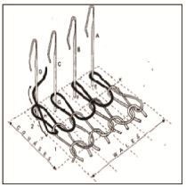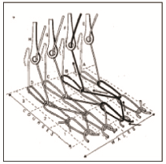
Weft knitting
Warp knitting

In a warp knitted structure, each loop in the horizontal direction is made from a different
thread and the number of threads used to produce such a fabric is at least equal to the number
of loops in a horizontal row. One can say that in a warp knitted fabric the threads run roughly
in a vertical direction.

Types of Fabric:

Single jersey & Double Jersey derivatives that is familiar in Northern Fashion Ltd. is given
below-

Single jersey Derivatives

1. Single jersey with lycra and without lycra
2. Single lacoste with half feeder lycra ( in lacoste never used full feeder lycra)
3. Pique & double lacoste
4. Two thread terry
5. Denim single jersey
6. Three thread fleece

Double jersey derivatives

1. (1x1) Rib
2. (1x1) half feeder lycra Rib
3. (1x1)Full feeder lycra Rib
4. (2x1) Rib
5. (2x1) half feeder
6. (2x1) full feeder lycra
7. (2x1) Rib
8. Offal Fabrics
9. I-lack fabric
10. Flat Back Rib

Production Calculation:
It has been expound in the sections above that the output of a circular knitting machine depends
on a series of different influencing variables. A wealth of machine data and data on the
fabric to be produced is required for calculating production capacity.

In this respect the cylinder diameter d in inch, the gauge E, the system count S, the machine
rpm n, and the efficiency level ɳ of the circular knitting machine must be known. The following
data on the fabric produced must also be available:

 The construction (e.g. single jersey , rib, purl etc.)
 The course density or course /cm and the weight per unit area in gm/m2.

Production is calculated in accordance with the following equation-

Machine rpm * No. of feeder * Efficiency * 60
Running Length (L) = m/ hr
No. of feeders per course * courses per cm * 100

Cylinder Diameter in inch * Machine Gauge
Fabric width (WB) = Meter
Wales per cm * 100

Running length in meter per hour * WB * Weight in GSM
Production in Kg, P = Kg / hr
1000
Machine list of knitting section in Tua-Ha Textile:
Machine name | Dia | Gauge | Brand | Origin | Machine quantity
Circular Knitting (single jersey) m/c | 21 | 24 | ORIGIO | ITALT | 1
Knitting (single jersey) m/c | 22 | 24 | ORIGIO | ITALT | 1
Knitting (single jersey) m/c | 23 | 24 | ORIGIO | ITALT | 1
Knitting (single jersey) m/c | 24 | 24 | ORIGIO | ITALT | 1
Knitting (single jersey) m/c | 26 | 24 | ORIGIO | ITALT | 2
Knitting (single jersey) m/c | 34 | 24 | ORIGIO | ITALT | 1
Knitting (single jersey) m/c | 36 | 24 | SANTEC | TAIWAN | 1
Knitting (single jersey) m/c | 34 | 24 | SANTEC | TAIWAN | 2
Knitting (single jersey) m/c | 30 | 24 | SANTEC | TAIWAN | 1
Knitting (single jersey) m/c | 30 | 20 | SANTEC | TAIWAN | 1
Knitting (single jersey) m/c | 34 | 20 | SANTEC | TAIWAN | 1
Knitting fleece m/c | 34 | 20 | SANTEC | TAIWAN | 1
Knitting fleece m/c | 30 | 20 | SANTEC | TAIWAN | 2
Inter lock m/c | 32 | 24 | ORIGIO | ITALT | 1
Inter lock m/c | 34 | 24 | ORIGIO | ITALT | 1
Inter lock m/c | 36 | 24 | ORIGIO | ITALT | 1
Inter lock m/c | 38 | 24 | SANTEC | TAIWAN | 2
Inter lock m/c | 40 | 24 | SANTEC | TAIWAN | 1
Inter lock m/c | 42 | 24 | SANTEC | TAIWAN | 2
Circular Knitting (Rib) m/c | 32 | 18 | ORIGIO | ITALT | 1
Circular Knitting (Rib) m/c | 34 | 18 | ORIGIO | ITALT | 1
Circular Knitting (Rib) m/c | 36 | 18 | ORIGIO | ITALT | 1
Circular Knitting (Rib) m/c | 38 | 18 | SANTEC | TAIWAN | 2
Circular Knitting (Rib) m/c | 40 | 18 | SANTEC | TAIWAN | 1
Circular Knitting (Rib) m/c | 42 | 18 | SANTEC | TAIWAN | 1
Auto striper | 30 | 24 | SANTEC | TAIWAN | 2
V-Bed knitting m/c | 64*18g | - | JY-LEH | TAIWAN | 2
Gray fabric inspection m/c | - | - | HSING CHENG | THAILAND | 1

Knitting Procedure for Elastane Single Jersey Fabric:
Procedure-1 for Lycra S/J

Design Setting on Machine (Cam, Needle Arrangement Setting)

Yarn Cones Place on Creel
Yarn from Cone to Yarn Pipe
Yarn to Positive Feeder
Ceramic Eye Pot

Knot Catcher

Magnate Pressure

Ceramic Eye Pot

Yarn Wheel (A yarn Storage Device)

Yarn Guide

Sensor

Yarn Guide
Yarn to Feeder

Yarn to Ceramic Eye pot

Yarn & Elastane Feed to Needle

Fabric Rolled on Take-Up Roller

Elastane Bobbin Place on Bobbin Stand

Elastane from Elastane Bobbing

Elastane to Sensor

Elastane to Guide

Elastane to Guide

Knitting Procedure for Single Jersey Fabric (Without Elastane):
Procedure for S/J (No Lycra)

Design Setting on Machine
(Cam, Needle Arrangement Setting)
Yarn Cones Place on Creel
Yarn from Cone to Yarn Pipe
Yarn to Positive Feeder
Ceramic Eye Pot
Knot Catcher

Magnate Pressure
Ceramic Eye Pot
Yarn Wheel (A yarn Storage Device)
Yarn Guide
Sensor
Yarn Guide
Yarn to Feeder

Yarn to Ceramic Eye pot

Yarn & Elastane Feed to Needle
Fabric Rolled on Take-Up Roller

Faults, causes and there remedies in knitting:
Fault-1: Hole Mark

Caues:

- Holes are the results of yarn breakage or yarn cracks.
- During loop formation the yarn breaks in the rejoin of the needle hook.
- If the yarn count is not correct on regarding structure, gauge, course and density.
- Badly knot or splicing.
- Yarn feeder badly set.
Remedies:

- Yarn strength must be sufficient to withstand the stretch as well as uniform.
- Use proper count of yarn.
- Correctly set of yarn feeder.
- Knot should be given properly.

Fault-2: Needle Mark

Caues:

- When a needle breaks down then needle mark comes along the fabrics.
- If a needle or needle hook is slightly bends then needle mark comes on the fabrics.

Remedies:

- Needle should be straight as well as from broken latch.

Fault-3: Sinker Mark

Caues:

- When sinker corrode due to abrasion then some times can not hold a new loop as a result sinker mark comes.
- If sinker head bend then sinker mark comes.

Remedies:

- Sinker should be changed.

Fault-4: Star

Caues:

- Yarn tension variation during production.
- Buckling of the needle latch.
- Low G.S.M fabric production.
Remedies:

- Maintain same yarn tension during production.
- Use good conditioned needles.

Fault-5: Drop Stitches

Caues:

- Defective needle.
- If yarn is not properly fed during loop formation i.e. not properly laid on to the needle hook.
- Take-down mechanism too loose.
- Insufficient yarn tension.
- Badly set yarn feeder.

Remedies:

- Needle should be straight and well.
- Proper feeding of yarn during loop formation.
- Correct take up of the fabric and correct fabric tension.
- Yarn tension should be properly.

Fault-6: Oil Stain

Caues:

- When oil lick through the needle trick then it pass on the fabrics and make a line.

Remedies:

- Ensure that oil does not pass on the fabrics.
- Well maintenance as well as proper oiling.

Fault-7: Rust Stain

Caues:

- If any rust on the machine parts.

Remedies:

- If any rust on the machine parts then clean it.
- Proper maintenance as well as proper oiling.

Fault-8: Pin Hole

Caues:

- Due to break down or bend of the latch, pin hole may comes in the fabric.

Remedies:

- Changes the needle.

Fault-9: Grease Stain

Caues:

- Improper greasing.
- Excess greasing.
Remedies:

- Proper greasing as well as peoper maintenance.
Fault-10: Cloth fall-out:

Caues:

- Cloth fall-out can occur after a drop stitch especially when an empty needle with an empty needle with closed latch runs into the feeder and remove the yarn out of the hook of the following needles.
Remedies:

- Make sure all the latches of needle are closed with feeding yarn after a drop stitch.

Fault-11: Barre

A fault in weft knitted fabric appearing as light or dark course wise (width wise) stripe
Caues:

- This fault comes from yarn fault.
- If different micro near value of fiber content in yarn.
- Different lusture, dye affinity of fiber content in yarn.
- During spinning different similar classes of fiber is mixed specially in carded yarn and these fibers have similar characteristics.
- In draw fame different similar classes sliver is mixed and make one sliver.

- We can use this fabric in white color.
Remedies:

Fault-12: Fly dust

Caues:

- In knitting section too much lint is flying to and from that are created from yarn due to low twist as well as yarn friction. This lint may adhere or attaches to the fabric surface tightly during knit fabric production.

Remedies:

- Blowing air for cleaning and different parts after a certain period of time.
- By cleaning the floor continuously.
- By using ducting system for cleaning too much lint in the floor.
- Over all ensure that lint dies not attach to the fabric.

Fault-13: Yarn Contamination

Caues:

- If yarn contains foreign fiber then it remains in the fabric even after finishing.
- If lot count mixing occurs.

Remedies:

- By avoding lot, count mixing.
- Fault less spinning.

Fault-14: Yarn Faults

- Neps
- Slubs
- Yarn count variation
- Thick / thin place in yarn
- Hairiness

Remarks :

From the Knitting Section of Tua-ha Textile ltd. We have gathered a huge knowledge about knitting. Now we know about the knitting procedure, knitting machines, their specifications, types of machine, count, GSM, control of GSM etc. we also learn how to run a knitting machine and what should be done in case of any breakage or machine stoppage.

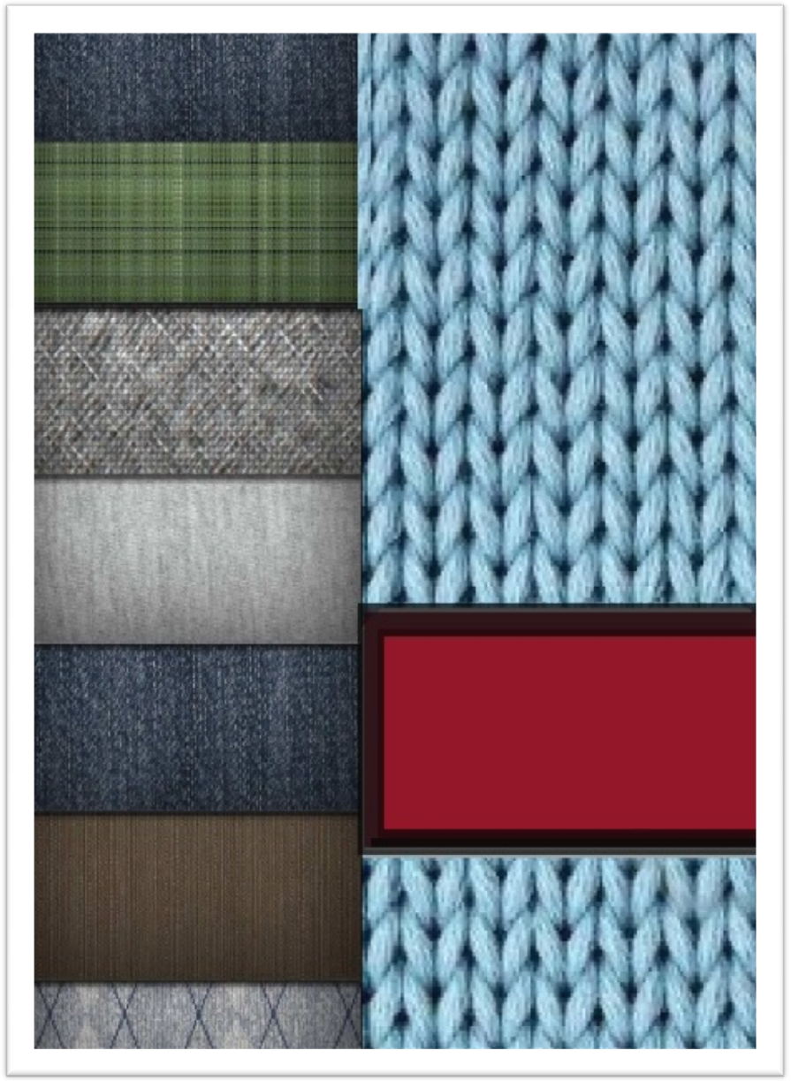
Chapter 5

Laboratory

Flow chart fof lab dip development:

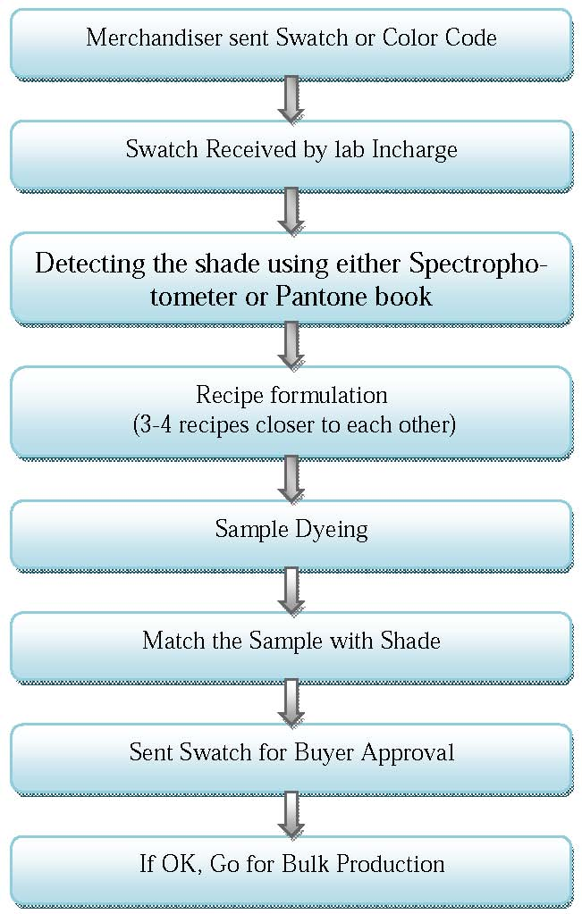

Water Ratio of Sample :-

PROCESS | RATIO
Scouring | 1:6
Aquachron | 1:5
P.T. hot | 1:8
Only wash | 1:5
Acid+ Enzyme | 1:5
Enzyme hot | 1:5
Colour | 1:6
N.S.R. Hot | 1:8
Normal hot | 1:6
Acid | 1:5
Fixing | 1:5
Softener | 1:5

CMC (Colour Measurement Combination):
DL(-) = DARKER;
DL(+) = LIGHTER;
Da(+) = REDDER;
Da(-) = GREENISH;
Db(-)= BLUEISH.

LABORATORIES PERCENTANCE OF SOLT & SODA

TOTAL SHADE | SALT | SODA
0.01-0.5% | 20 g/l | 06 g/l
0.5-1% | 30 g/l | 08 g/l
1-2% | 40 g/l | 10 g/l
2-3% | 50 g/l | 15 g/l
3-4% | 60 g/l | 18 g/l
4-6% | 70 g/l | 20 g/l
6-8% | 80 g/l | 20 g/l
ABOVE 8% | 100 g/l | 20 g/l

LIGHT BOX / LIGHT SOURCE:
- D65
- TL84
- ULTRA VIOLET
- FLOROCIENT

OTHERS LIGHT SOURCE:
- TL83.10DEG
- U300010DEG
- A-10DEG
- FO2-10DEG

Quality Management System
The Quality Assurance Department is assigned to maintain consistently uniform quality of the material in process and various stages of its manufacturing.
Object of quality control:
- Research.
- Selection of raw materials.
- Process control.
- Process development.
- Product testing.
- Specification test.

Quality management system in Tua-ha Textile:
QA
On-Line
Off-Line

Online Quality Control:
There are two types of online quality control. These are as follows:-
- Raw material control
Raw material control means control the quality of raw materials. (e.g.- Quality of Grey fabric, Dyes, Chemicals and Auxiliaries )
- Process control
Process control means the selection of right process and controlling of some parameters. Such as pH, Water hardness, water volume, Temperature, Reel speed, Pump pressure etc.
Online Tests:
- Dyed fabric.
- Shade check.
- Wash fastness.
- Water Fastness.
- Crocking fastness.

Laboratory:
Laboratory is the heart of dyeing Industry. An efficient laboratory can increase the efficiency of dyeing.
So, laboratory in-charge is sometime called pilot. Before bulk production, a sample is sent to buyer for approval. Laboratory supplies the recipe to the floor.
Purpose of Laboratory:
- Get color approval from buyer.
- Recipe supply to the floor.
- Shade correction.
- Minimize the deviation between bulk and laboratory.
Laboratory line :
- Standard Sample:
At first recipe % of standard sample is measured by CCM (Computer Color Matching) system.
- Laboratory Trial :
Then by taking those recipe laboratory officers produce laboratory trial and match with standard according to buyer requirement.
- Approved Sample :
Then the sample swatch, which is matched with the standard, is sent to buyer for approval.

Off-Line Tests :
Off-line tests for finished fabrics are divided into two groups. These are as follows :
- Physical Tests.
- Chemical Tests.

Physical Tests :
- GSM of fabric.
- Abrasion resistance / Pilling.
- Dimensional stability test.
- Spirality test.
- Color fastness to rubbing test (Dry / Wet).
- Bursting strength test (For knitted fabric).
- Tensile strength test (For Woven fabric).

Chemical Tests :
- Color Fastness to washing.
- Color Fastness to light.
- Color Fastness to heat
- Color Fastness to actual laundering.
- Color Fastness to Chlorinated water.
- Color Fastness to water spotting.
- Color Fastness to perspiration.
- Color Fastness to Seawater.
- Flammability test.
- Fiber analysis.
- pH test.
- Spray test (water repellency).
- Phenolic yellowing.
Quality Standard :
Here in the factory, they are following ISO standard for their testing purpose. But testing standard depends on buyer requirements.

SOME TEST PROCEDURE:
A) Color fastness to rubbing (wet & dry) :
1) Procedure :
At first take a sample of size ( 14 x 5 ) cm at Wales & Course wise. Put the crocking cloth the 8 holes by permanent marker & also at the edges of the template.
Then sewn the fabric & it is given to the washing m/c for run at 60º C for 60 minutes with water.
After that dry the sample & then measure the fabric.
Spin speed --- 500 rpm
Drum speed --- 500 rpm

2) Calculation:
- Shrinkage Test :
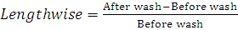 x 100
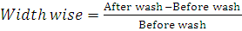 x 100
- Spirality Test :
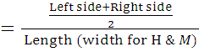 x 100%

Color fastness to water ( ISO 105 EO1 & EO2 ) :
- Sample size : Cut the specimen & multi-fiber at 10 x 2 cm & sewn together.
- Solution : Wet in distilled water at room temperature & it will suck water.
- Place it in acrylic resin plates & put the weight on to the plates.
- Keep it in oven & keep the temperature at 37 ± 2º C for 4 hours.
- Open the specimen & dry it in the air hot exceeding 60º C.
- Assess the staining & shade change with gray scale.

Color fastness to perspiration Alkaline & Acid solution ( Method : ISO 105 E04 ) :

- Procedure :
Cut the specimen & multi-fiber at 10 x 2 cm & sewn together.

- Prepare solution :

Alkaline solution :
- 0.5 g/l of 1-histadine mono hydrochloride monohydrate
- 5 g/l of sodium chloride
This solution is brought to pH = 8 with 0.1 mole/l caustic solution.

Acid solution :

- 0.5 g/l of 1-histadine mono hydrochloride monohydrate
- 5 g/l of sodium chloride
- 2.2 g/l of sodium dihydrogen orthophosphate dehydrate

- M : L = 1 : 10
- Wet the specimen in flat dish containing acid & alkaline solution & keep for 30 min. Then take the specimen & squeeze the excess solution by two glass rods.
- Put the specimen into the acrylic resin plates & put wt. on the plates.
- Keep it in the oven at 37º C ± 2º C for 4 hrs.
- Open the specimen 6 multi-fiber & dry separately in the air temperature not exceeding 60º C.
- Access the staining & shade change with gray scale.

pH TEST :
pH Measurement :-
Enzyme pH – 5
Color dosing – (6-7)
Color hot – (6.5-7.5)
Fixing – 5.5
Softener – 5.5
Polyester – 4.5
Cotton – (6-7)

Procedure :
Take 2 gm sample fabric and cut into small pieces. Then put it conical flax with 100 cc water (M : L = 1 : 10). Then shake it 15 min, then place it in a shaker m/c for 1 hour. Then check pH by pH meter.

GSM TEST :
Procedure:
GSM is the most important factor. There is a GSM cutter. The sample cut by the GSM cutter is weighted in the electronic balance. The reading (in gm) from the balance is multiplied by 100 to get the value of GSM.

SCOPE OF QUALITY CONTROL, QUALITY ASSURANCE AND TESTING :
The scope of quality control, quality assurance and testing are good. It has the following options –
- Testing Laboratory.
- Machine auditing system.
- A good training system.
- Excellent analytical backup.
- Technical experts.

RESPONSIBILITY OF OFF-LINE QUALITY CONTROL :
To check the following things :-
- Inspection of fabric in the inspection m/c under 4-point system.
- Yarn count and lot number.
- Buyer.
- Design.
- Stitch length of grey fabric.
- Shade of grey fabric within one order.

RESPONSIBILITY OF ON-LINE QUALITY CONTROL :
To check the following things:-
- M/C Dia & Gauge.
- Buyer.
- Design.
- Grey fabric GSM & stitch length.
- Yarn count & lot number.
- Yarn whether approved or not by Q.C. Department.
- Finished Dia & grey Dia.
- Fabric quality checking under 4-point system.

RESPONSIBILITY OF IN CHARGE OF QUALITY CONTROL :
- Making report.
- Supervise the grey Q.C.
- Check machine is running according to program or not.
- Check program can meet the requirement which is mentioned in the order sheet or not.
- Check yarn is approved by Q.C. or not.

RESPONSIBILITY OF THE FINISHING Q.C. :
Finishing Q.C. (shade) :
- After unloading from dyeing, cut small piece, check shade with standard/ approved lab dip/production sample & previous production batch (if any).
- Then instruction to finishing for finish by mentioning specific temperature in dryer.
- After finish again cut sample & check same way like before at dry state.
- Keep the record of every lot after dry & after finished state.
- If any batch is not OK at any stage then make the re-process card for dyeing.
- If any batch is closer to standard but not exactly pass with standard, then make trial for that batch in finishing to make it OK.
- Maintain the resister of all batches.
- Check the shade of Body to Rib, Body to Collar & Cuff.

In Charge :
- Supervise the trainee Q.C. & Q.A.
- Make report every day.
- Cross check whatever shade already checked by Q.C.

Q.C.(Finishing):
- Make the R₂R continuity of each dye lot by cutting small piece from each roll of dye lot.
- Inspect 30-40% of each dye lot under 4-point inspection system & report accordingly.
- If found any problem then re-inspect 100% of that dye lot and make report & re-process card (if re-process able) for dyeing. If it is knitting faults then immediately inform to officer asking decision.
- Check the evenness of a dye lot by checking R₂R continuity.
- Check the shade of body to rib, body to collar & cuff.

In Charge :
- Monitor the all Q.C.’S (finishing) work including shade Q.C.
- Take decision when asking advise from his subordinate.
- Make daily problematic batch report .
- Make daily production report .
- Maintain resister khata.
- Make daily batch reprocess job card .

RESPONSIBILITY OF QUALITY ASSURANCE MANAGER :-
- Responsible for all quality matter of fabric.
- Yarn selection.
- Monitoring product development.
- Organize Laboratory.
- Control grey and finished fabric inspection under 4-point system.
- Documentation after shade check of every lot.

Remarks :
They have a well-equipped testing laboratory called Textile Testing Services limited for all kinds of Textile Testing. The laboratory of Tua- ha is approved by world renowned buyer Marks & Spenser and also Puma. Now they are just testing their internal tests but they are trying to develop their laboratory. So that external author can send their textile material for testing by suitable testing fees.

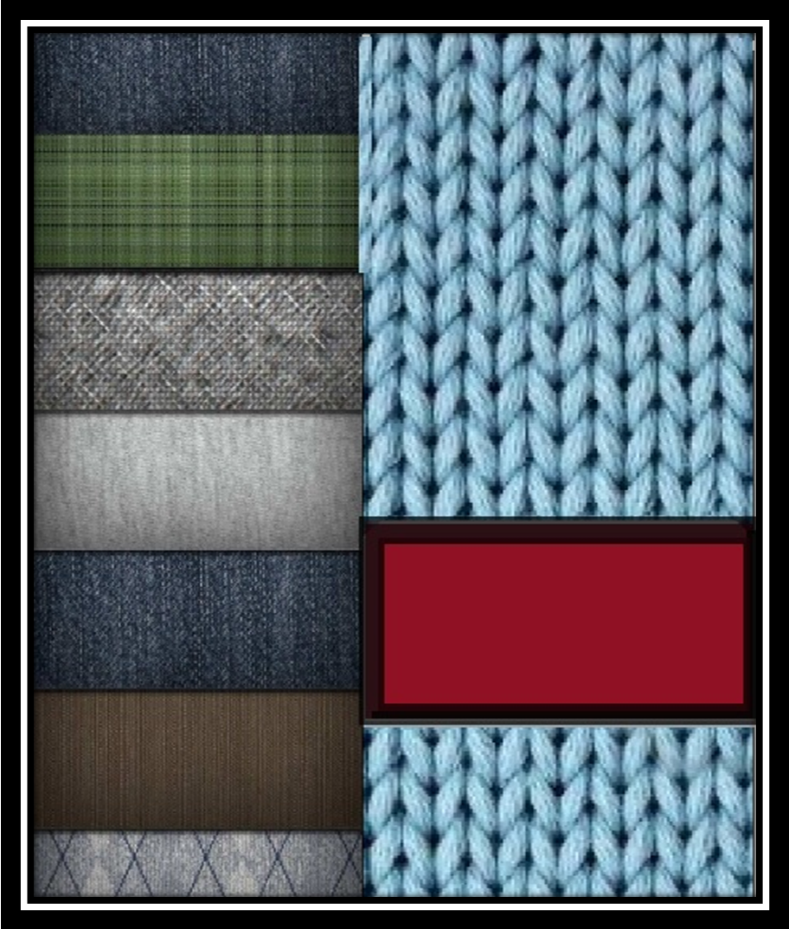
Chapter 6

Dyeing & Finishing Section

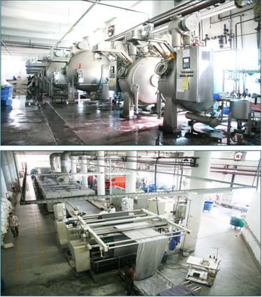

Tua-HaTextile Ltd. has a state-of-the-art Dyeing & Finishing Section. The capacity of the Dyeing section has been rated annually about 15,00,000 kgs of dyed and finished fabric.

RESPONSIBILITY OF PRODUCTION OFFICER :
• Overall supervision of dyeing & finishing.
• Dyeing & chemicals requisition issue & check.
• Program making, sample checking & color measurement.
• Control the supervisor’s operators & helpers of machines.
• To give dye-line or the program slip according to daily production plan, batch preparation & pH check.
• To rectify the finished fabric which rejected from quality control department.
• To check daily production report.
• To study dyes & chemicals nature delivery by the manufacture & applied them correctly to the production to get best product.
Job Description :
Title : Production officer.
Dept: Dyeing.
Report to : Senior production officer.
Job summary : To plan execute & follow up the production activities & control the quality production with related activities.
Title : Senior Production officer.
Dept: Dyeing.
Report to : Dyeing manager.
Job summary : To plan execute & follow up the production activities & control the quality production with related activities.

Dyeing Machine Specification :

Machine no. : A-1
- Company / Brand Acme
- Model AM-SF
- Origin Taiwan
- Comprasher Normal
- Temperature 95º C
- Capacity 50 KG

Machine no. : A-2
- Company / Brand Acme
- Model AM-SF
- Origin Taiwan
- Comprasher Normal
- Temperature 95º C
- Capacity 100 KG

Machine no. : A-3
- Company / Brand Acme
- Model AM-SF
- Origin Taiwan
- Comprasher Normal
- Temperature 95º C
- Capacity 250 KG

Machine no. : A-4
- Company / Brand Acme
- Model AM-SF
- Origin Taiwan
- Comprasher Normal
- Temperature 95º C
- Capacity 600 KG

Machine no. : A-5
- Company / Brand Acme
- Model AM-SF
- Origin Taiwan
- Comprasher Normal
- Temperature 95º C
- Capacity 600 KG

Machine no. : A-6
- Company / Brand Acme
- Model AM-SF
- Origin Taiwan
- Comprasher Normal
- Temperature 95º C
- Capacity 600 KG

Machine no. : H-7
- Company / Brand Acme
- Model AM-OHD
- Origin Taiwan
- Comprasher High comprasher
- Temperature 180º C
- Capacity 100 KG

Machine no. : H-8
- Company / Brand Acme
- Model AM-OHD
- Origin Taiwan
- Comprasher High comprasher
- Temperature 180º C
- Capacity 150 KG

Machine no. : H-9
- Company / Brand Acme
- Model AM-OHD
- Origin Taiwan
- Comprasher High comprasher
- Temperature 180º C
- Capacity 300 KG

Machine no. : H-10
- Company / Brand Acme
- Model AM-OHD
- Origin Taiwan
- Comprasher High comprasher
- Temperature 180º C
- Capacity 300 KG

Machine no. : H-11
- Company / Brand Acme
- Model AM-OHD
- Origin Taiwan
- Comprasher High comprasher
- Temperature 180º C
- Capacity 600 KG

Machine no. : H-12
- Company / Brand Acme
- Model AM-OHD
- Origin Taiwan
- Comprasher High comprasher
- Temperature 180º C
- Capacity 900 KG

Machine no. : H-7
- Company / Brand TONG GENG
- Model TGRU-NUV-3 (600)
- Origin Taiwan
- Comprasher Normal
- Temperature 98º C
- Capacity 600 KG

Machine no. : A-13
- Company / Brand TONG GENG
- Model TGRU-NUV-3 (600)
- Origin Taiwan
- Comprasher Normal
- Temperature 98º C
- Capacity 600 KG

Machine no. : A-14
- Company / Brand TONG GENG
- Model TGRU-NUV-3 (400)
- Origin Taiwan
- Comprasher Normal
- Temperature 98º C
- Capacity 400 KG

Machine no. : A-1
- Company / Brand Acme
- Model AM-SF
- Origin Taiwan
- Comprasher Normal
- Temperature 95º C
- Capacity 50 KG

Raw materials for Dyeing :
Raw materials used in dyeing section are-
- Grey fabrics.
- Dyes.
- Chemicals.

Grey fabrics :
Following types of grey fabrics are dyed :
- Single jersey.
- Single jersey with lycra.
- Polo pique.
- Single lacoste.
- Double lacoste.
- Fleece/ Tery.
- Wapel.
- Interlock.
- Slub jersey.
- 1x1 Rib.
- 2x2 Rib.
- 4x2 Rib.
- Rib with lycra.
- Different types of collar & cuff etc.

Different Types of Dyes Used in Tua-ha Textile With Their Brand Name :

BRAND NAME | COUNTRY NAME | NAME OF DYE STUFF
Dystar | Germany | Remazol Red RR  Remazol Yellow RR  Remazol Blue RR  Remazol Ultra Red RGB  Remazol Ultra Yellow RGB  Remazol Blue RSPL  Remazol Turquoise Blue G  Remazol Navy RGB  Remazol Golden Yellow RGB  Remazol Deep Black RGB  Remazol Brilliant Blue R Spec  Dianix Navy CC  Dianix Turquoise S-BG
IMPOCOLOR | GERMANY | Imcozin Blue E-NR  Imcozin Blue V-CR 150%  Imcozin Brilliant Red V-F3B  Imcozin Brilliant Yellow V-4GL  Imcozin Yellow E-3R 150%
HUNTSMAN | SWITZERLAND | Terasil Red W-4BS  Terasil Navy W-RS  Novacron Red FN-R-01  Novacron Yellow F-4G
COLORTEX | INDIA | Corafix Red GDB  Corafix Dark Blue GDR  Corafix Black GDNN  Coralene Black MD  Corazol Yellow RD GRAN

Different Types of Chemicals Used in Tua-ha Textile :
Wetting Agent | Feloson NOF
Levelling Agent | A-41,  GSS
Anti-creasing Agent | Ciba-C,  Kapavon CL
Salt | Glauber’s salt
Acid | Acetic Acid
Detergent | Sodium Carbonate  Rukozen- WBL
Soda | Soda ash
H₂O₂ | H₂O₂
Enzyme | Bio- ACE,  Biopolish-B41
Soaping Agent | Rukozen- NZA  Dekol ISN
H₂O₂ Killer | Kapatex-PKS
Sequestering Agent | CS  Polyclean-SP  Securon-540
Softener | RSK  Nerosoft-JS (an-ionic)  Nerosoft-NI (non-ionic)
Hypo | Sodium thiosalphate
Fixing Agent | Sandofix-EC  Protan FCE-375
Caustic | Caustic

RECIPE AT DIFFERENT STAGE IN DYEING :

Recipe for machine’s heavy wash :
Detergent = 0.5 gm/l.
Caustic = 1 gm/l.
Hydrous = 2 gm/l.
60 min at 90º C.
For machine neutralization :
Acetic acid = ( As required ) gm/l.

Recipe for scouring and Bleaching ( for cotton ) :
Wetting agent = 0.7 gm/l.
Stabilizer = 0.5 gm/l.
Anti-creasing agent = 1 gm/l.
Caustic = 2%
Hydrogen per oxide ( H₂O₂) = 2.5%
Sequestering agent = 0.5%
Hydrogen per oxide killer = 2.5%
60 min at 105º C.

Recipe for hot (cotton black):
Wetting agent = 0.5 gm/l.
Sequestering agent = 0.75 gm/l
Caustic = 1 gm/l
10 min at 80º C.

Recipe for enzyme treatment (for cotton):
Wetting agent = 0.1 gm/l
Acid = 1 gm/l
Enzyme = 0.75 gm/l
50 min at 55º C.

Recipe for leveling (for cotton):
Anti-creasing agent = 1 gm/l
Leveling agent = 0.5 gm/l
10 min at 60º C.

Recipe for softening :
Sapamine CWS (Anionic) = 1.5% (for color)
Nerosoft-NI (Non-ionic) = 1.5% (for white)
10 min at 45º C.

Recipe for Reduction (Polyester):
Caustic = 2 gm/l
Hydrous = 2.5 gm/l
20 min at 90º C.

Dyeing Parameter & Calculation
The things which influence the effective coloration of textile materials with reactive dye are called as parameters of dyeing. These include –Temperature, Time, Liquor ratio, pH of the bath etc. A brief description about them is given below-
Effects of Temperature:
Temperature of the dye bath plays vital role for dyeing. Rise in temperature has a large effect on an increase in the diffusion rate of dyes into fabrics. Increasing of temperature increases the rate of dyeing & of the dye migration. Higher dyeing temperature ensures the good leve-ling & better penetration of dye in to the fibers. But the temperature depends on the types of dyes adapted in the dye bath. For Example-in case of hot brand dyestuff the dosing tempera-ture of dye is 80ºC and for cold brand dye temperature is kept 60ºC.
Effects of pH:
In the case of most popular fiber reactive dyes, a high PH actually activates the cellulose (cot-ton) fiber, forming a cellulosate anion, which can then attack the dye molecule, leading to a reaction that produces a strong, permanent covalent bond. Without a high pH, the dye will not fix permanently to the cellulose fiber. For this reason Sodium Carbonate (Na2CO3) [Some time mixed alkali such as (NaOH + Na2CO3)] is used for no other reason than to increase the PH of the dye reaction, so that the fiber will react with the dye. Basically during the color ad-dition, the PH of the bath remains at near about 6, but after adding alkali it goes rise to pH
11.4 & this is the critical stage in which the dye molecules fix up with the fiber.
Effects of Material: Liquor Ratio (M : L):
Dye bath exhaustion increases with the decreasing of liquor ratio. Dyeing at low liquor ratio decreases the amount of waste dyes & chemicals in the effluent. Because higher the liquor ratio greater the amount of g/l of chemicals which increases the volume of effluent. To get rid from this problem Then Air flow Dyeing machine is getting popular in our country which can dyeing at 1:3 Materials: Liquor ratio. But in case of Thies Jet Dyeing machine it can possible up to 1: 5 Materials: liquor ratio.

Effects of Time:
The time for dyeing also the vital one. A specific Time adjusted with the temperature, very much needed for better dyeing. For this reason color dosing takes place in 20 minutes (may vary process to process) & Specific run time is set for dyeing.

Shrinkage:
A dimensional change resulting in a decrease in the length or width of a specimen subjected to specified condition is known shrinkage.
Spirality:
If the wales of the knitted fabric are not perpendicular to the course and skew to the right or left spirality occurs in the fabric. This creates serious problem, especially in the apparel in-dustry.

Dyeing Calculation:
g/ l ×Total liquor
Required chemical =
Stock Solution % ×1000
Required Dye = Material weight ×Shade %
Conversion of % to gm/l :
X ×10
X%= { } gm/ l
Liquor ratio (only L value)
Conversion of gm/l to %:

X × Liquor ratio (only L value)
X gm / l = { }%
Liquor ratio (only L value)

Finishing:

The term dyeing finishing in a board sense cover all the process through which fabric under goes after leaving the knitting m/c to the stage at which it enter the market.
It is term used for series of process to which all bleached printed &certain. In fact finishing include the final treatment. Finishing process apply on fabric of every kind of fabric to market the fabric neat, soft, attractive, & presentable.

Machine list of Finishing section:

Machine name | Machine Quantity
Slitting m/c | 02
Dewatering m/c | 02
Raising m/c | 02
Sueding m/c | 01
Washing m/c | 04
Thread shaker | 04
Metal detector | 01
Dryer | 02
Electric Boiler | 05
Electric Iron | 47

Rope Opening, Slitting & Dewatering Machine:
Slitting is a process that is applied for cutting the tubular fabric through the intended brake Wales lime on length wise direction prior to stenter processing.

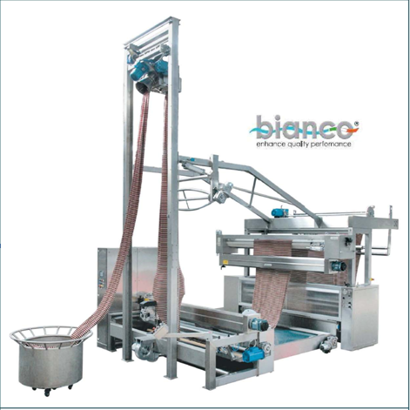

Bianco Rope Opening, Slitting & Dewatering Machine

Schematic diagram of Rope Opening, Slitting & Dewatering Machine

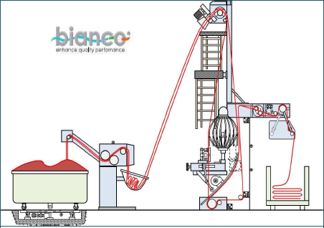

Figure: Schematic diagram of Rope Opening, Slitting & Dewatering Machine

Machine Function:

- Open the fabric from the rope form.
- Reduce the water content
- To slit the fabric from tube form
- Apply overfeed to give some compaction.
- Width-wise stretch the fabric.
- Plait the fabric

Function of main parts
- J-Box: Squeeze the fabric to reduce the water contains. Water reducing percentage depends on J-Box pressure.
- Detwister: By the detwister rope formed fabric become untwists form. (due to action of sensor)
- Hand Wheel: It is manual and used for guiding the rotary blade.
- Turn Wheel: It controls the fabric rotation
- Rotary Blade: To cut the fabric through break wales line.
- Ring: To help cutting.
- Guide Roller: To guide the fabric to plaiting
- Plaiter: To plait the fabric.
- Sensor: Sense for cutting through break wales line.

Basic Operation Principle:
The bianco tensionless tubular fabric slitting and opening lines are used after the wash process or the dyeing station.
- The fabric, placed in a basket in rope form.

- It is made to pass through the squeezing unit where most of the impregnation liquid is
extracted.

- Then it enters the detwister, which eliminates the tension of the rope and is prepared for
the slitting and spreading processes.

- The container is placed on a platform whose rotation, synchronized with the action of the
detwister, untwists the rope preceding the entrance to the detwister.

- The latter is placed at the top of the structure, for optimal distance from the automatic
slitter, so as to enhance the effectiveness of rope detwisting and spreading.

- Then the untwist form fabric is transferred to the basket by means of motorized belts and
then it moves on towards the slitter without stresses that would can be widened upto a
diameter of 80 cm.

- The cutting line can be controlled by means of basket rotation.

- From conveyor belt fabric is passed through dogal centering roller (It constitutes a
compacata fabric centering system, with faster centering action and enhanced efficacy
compared to traditional centering devices.)

- The open with fabric is passed through squeezing system to extract the greatest possi-ble
quantity of impregnation liquid from the fabric, by squeezing it between two rub-ber
coated rollers. (It structure is highly compact and sturdy, and it can be made either of iron
or of stainless steel).

- After squeezing the fabric it go to the plaiter to plait on a trolley.

Checking Parameter:
Cutting Line Check: Operator checks fabric cutting line. Rotary blade cut fabric throughwales line or not.
Bow and Slant Check: Operator checks bow and slant at delivery side.
Faults Check: As mentioned earlier.

Dewatering machine:
Dewatering machine specification:
Machine no :01
Machine name :Heliot
Brand name : Dewatering
Country :France
Padder pressure :1-1.5bar
Pressure Capacity :4 bar

Machine no :02
Machine name :Dewatering
Brand name : Heliot
Country : France
Padder pressure :1-1.5bar
Pressure Capacity :4 bar

Function:
-Reduce water content
-Apply chemical
-Apply over feed to give some compaction.
-Open the fabric From the rope from.
-Width wise stretch the fabric.
-Plait fabric.

Working principle of Dewatering:
After completing the dyeing procsse from the dyeing machine then the fabrics read for dewatering. In de-twisting m/c tubular fabric are mainly processed. there is a magnetic sensor which sense the twist of the fabric & direction turn the fabric in opposite direction to remove wiste automatically. Here dewatering is performed-watering is the process remove the water from the fabric completely by squeezing and is done by the padder. a suitable expender is used before the fabric is passed through the in of he padder.
which expender is used before the fabric is passed the nip of the padder.a suitable expender is used before he fabric passed through the nip of the padder, which expand the fabric is passed through the nipe of the expended are fabric flat wise and adjust than width. the expender with is adjusted as s/j-20%, PK-25%,int30%, lacoste40%wider than the required width. there is appairenc of rubber coated padder, where is removed han the required width the expender width is adjustet as s/j-20%, pk-255,INT-25% ,wider than the required width. there is pair of rubber coated padder, where water is removed from the fabric when passed through the nip of it.

Normal squezzer contain single or double padder where,One for removing water andOther for applying finishing chemical such as softener.But this finishing is done only for the tubular fabric. Open width knitted fabrics are applied finishing treatment later in stenter.

Dryer:
Machine specification:
Dryer no. 01
Brand name: Heliot
Origin: France
Chaber::3
Year of conostruction:2006
Ratiomatic Burner:
Brad name: ECLIPSE
Year:03/2002
Capacity:300kw
Voltage: 230/400v
Frequency:50Hz
Fule: Natural gas
Pressure(105-500)m/bar

Dreyer no:02
Brand name: Savtex AG
Origin: Switzerland
Type: SANTASHINK
Chaber::5
Year of conostruction:2008

Fuel combustion chamber:
Brad name: ECLIPSE
Year:12 /2007
Capacity:300 kw
Voltage: 240/400v
Frequency:50 Hz
Fule:Natural gas
Pressure(105-500)m/bar
Working principle of dryer:
After dewatering then the fabric through the dryer. the main function of the dryer is given below:
-T dry he fabric
-TO control the overfeed system.
-T o control vibration which increase the GSM.

The m/c contain two chambers. two mesh endless conveyors are placed lengthwise to the chamber named conveyor net and filter net . each chamber contain aburner, which supply hot air. This hot is guided through he ducting lin by suctionfan. there are a nozzel placed in bt^{n} filter and conveyor net. when fabric pass through on the conveyor net, hot air is supplied to the wet to dry it. there are exhaust fan which such he wet air and deliver to tea to through the ducting line.
The speed of dryer depends on the temp. of he m/c &GM of the fabric. If the m/c temp. is high& m/c speed also high and the m/ c temp. is low then mc speed also low. The vibration speed of the m/c for heavy fabric is 730m/min and normal fabric is 480m/min.

RAISING MACHINE:
Machine specification of raising m/c:
No. of m/c : 02

Raising m/c: 01(single drum)

Brand name : Lafer
Country: Italy
Cylinder: 01
Drum speed: 110
Drum dia : 68 inch
Machine speed: 40m/min
Pile roller: 12
Manufacturing Year: 2002

RAISING MACHINE:
8.19 Machine specification of raising m/c:
No. of m/c :02
Raising m/c: 01(single drum)
Brand name: Lafer
Country: Italy
Cylinder: 01
Drum speed: 110
Drum dia: 68 inch
Machine speed: 40m/min
Pile roller: 12
Manufacturing Year: 2002

RAISING MACHINE:
Machine specification of raising m/c:
No. of m/c :02
Raising m/c: 01(single drum)
Brand name :Lafer
Country: Italy
Cylinder: 01
Drum speed: 110
Drum dia: 68 inch
Machine speed: 40m/min
Pile roller: 12
Manufacturing Year:2002

Raising m/c: 02(double drum)
Brand name : Lafer
Country: Italy
Cylinder: 02
Drum speed: 110
Drum dia: 68 inch
Machine speed: 40m/min
Pile roller: 24
Counter pile roller:24
Manufacturing Year: 2002

FUNCTION OF RAISING MACHINE:
- To produce brush effect.
- TO produce the fleece fabric.
- To raise the fibre on the fabric surface.

Machine specification of Sueding m/c:
No. of sueding m/c : 01

Brand name : Lafer
Country: Italy
Cylinder: 01
Company name :SPA machine tessili
Model: GSI 106
Drum speed: 110
Drum dia: 72 inch
Machine speed: 40m/min
Counter pile roller:24
Manufacturing Year: 2002

Process of final inspection (Q.A.D)
- After completing the finishing process here firstly check the shade as per buyer standard with.
- Dimensional stability from lab
- Secondly check dia/width fabric wt. or GSM
- Thirdly check fabric surface or appearance as per buyer standard
- The even roll with every meter check as per four (04) point system
- Make a report
- If OK then ready for delivery
- If not ok then identify the fault
If it is the knitting fault then inform the knitting dept. by job card and mail,& requested the fabric for replacement
If it is dyeing fault & If make sure that it is reprocess able ten give job card to dyeing department correction. And if is not reprocess able then reject the fabric & inform the dyeing dept to replace the rejected quantity.

Stenter machine:

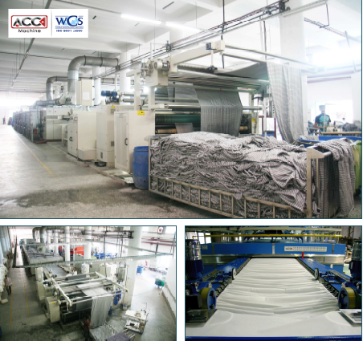
Figure: Stenter machine

Basic Working Principal of Stenter:
The stenter line has units: 2 padders, 1 weft straightener, 1 tenter and drying chambers. There are also steaming, selvedge degumming and curing arrangement. At least padder is simply wash with water. The squeeze pressure normally 5 bars. In two padder the fabric is treated with softener. The fabric is passed through tenter. There are two steams along fabric width that apply steam from below fabric. There are gumming unit before drying chamber. In sten-ter, fabric enters in drying chambers by gripping with chain pin and with over feed/ under feed that is with more controlled conditions. The drying chamber has 7 units. Generally tem-perature kept about 150 – 200 ºC. The fabric comes out form chamber by tenter chains grip-ping with pins. Before delivery the fabric is removed from the tenter chains by unpinning rollers and then the cutting units cut the additional fabric from the gummed sides. Now at de-livery side there is an antistatic arrangement to remove static electricity from heated fabric.

Function of Stenter:
- Apply chemical and softener
- To dart set the T/C fabric
- Drying of fabric
- To control width
- Curing of fabric
- Apply pigment dyeing
- To control GSM
- To control shrinkage
- To decrease spirality
- To decrease bowing effect
- Surface coating for teflon finish
- Apply soil release chemical finish
- Heat set for cotton/lycra fabric

Main parts of stentre
1. Feed Zone:
-Centering device
2. Chemical Padding Zone:
-Squeezing roller-Chemical tray
3. Bowing Control Zone:
-Bowing roller (Rubber rollers, number of roller 2)-Sensor (no of sensor 6)-Uncurling roller
4. Chin Entry Zone:
-Uncurling device (both side of the chain entry)-Sensor (both side of the chain entry)-Brush roller (for attaching the fabric with the pin of the chain, no of brush
roller 4) -Selvedge gumming device with gum box under chain entry.
- Drying Zone (gas burner 10) Cooling Zone.
- Cooling Zone
- Delivery Zone

Material Safety Data Sheet (MSDS) for Stenter Machine:
Work should be done before running machine.
- Clean the machine (inner & outer side.)
- Switch ON the main switch.
- ON the Gas & Air line bulb.
- Have any bad sound in machine? Check it.
- Check conveyor belt, it is ok or not.
- Run the machine.
- After raising temperature at a specific state start running the fabric
- Close the all bulb after ending the operation.
- Switch OFF Emergency switch.
- OFF the main power
- Don’t touch, machine & machine switch on wet hand or foot.

Compacting machine:

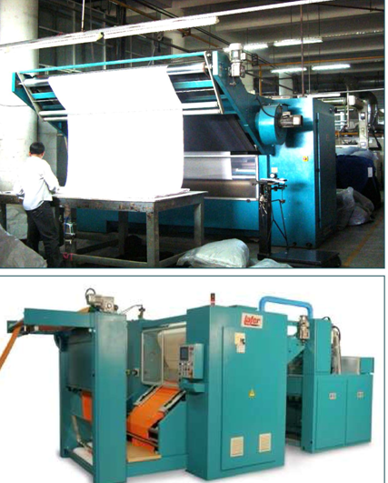

Figure: Compacting machine

Function:
To control shrinkage
To control width
To control GSM
To smooth fabric
Heat setting of fabric for lycra

Checking Parameter:
1 Shade Check: In delivery side operator checks the shade of fabric with customer ap-proved swatch.
2 With Check: Operator measures fabric width by using measuring tape and compared with required width.
3 Wight Check: Operator checks the weight by using GSM cutter and electronic bal-ance & compares with the required finished width.
4 Fault Check: As mentioned before
5 Design & Slanting: Operator checks design and slanting at delivery side.
6 Edge line checking: check two edges of fabric at delivery side.

Technical description of the basic compacting machine:
The machine include the following units
- Support Structure:
It consists of sturdy body sides made of painted steel, supporting the cylinders, the mechanical part and the plant system; they are connected by means of longitudinal and transversal cross-section. The body sides are provided with special safety locks.

- Inlet Tightener:
The inlet tightner is designed to drag the fabric to the machine with an adequate ten-sion. Its effect can be varied by turning the hand wheel provided.

- Fabric Draw Roller:
The draw rollers receive their movement from a variable speed motor. They deter-mine the speed of fabric.
-The rollers are normally covered with rubber and it is most important that the surface of the covering is always in good condition so ass to avoid slipping of the fabric. Should this not be so then it is necessary to replace the covering.
-The processing of fabrics treated with chemical against might involve a rapid de-terioration of the drag rolls coating.

- Idle Cylinders:
The idle cylinders are designed to change the route of the fabric to convey it in the right position for subsequent working.

- Dancing Roller Synchronizer:
The dancing roller is constituted by a cylinder mounted on oscillating arm, connected to a rheostat for the synchronization of the various group.

- Inlet fabric Guide:
It consists of shoulders supporting a couple of adjustable spreader rollers operated by an independent motor, and a pneumatically operated fabric centering unit with move-able staves, controlled by border guard photocells.

- Steaming Tank :
It consist of no. 1 steam delivery chamber on the fabric, made of inox steel and com-plete with metering valve and on-off solenoid valve.

- Compacting units:
They are the real compacting units. Each unit consists of:
-A steam heated cylinder, diameter 500 mm., made of chromium plated and ground steel; it is complete with a rotary joint for steam feeding, a thermocouple feeler to feel the temperature, and an effective system for the condensate drainage. The cy-linder temperature can be adjusted with the utmost (+/-2˚C) directly from the keyboard placed on the control board, and is shown on the display.
-A thick Nomex – Polyester compacting felt. The double action felt centering de-vice ensures perfect felt alignment during running. The computer controlled felt control mechanisms automatically releases felt tension after a machine stop.
-An adjustable position counter-roller for the fabric shrinkage control during inlet in the compacting group.
-An inlet element in a special non-adherent fibre (shoe) equipped with a device for adjusting both angle of incidence and insertion length.

I) Spreader Roller
It is a spreader roller, for the selvedge unwinding and the inlet of the fabric perfectly spread in the machine.

J) Scroll Roll Unit
The adjustable spreading scrolls at entry are used for open width knits and for all fa-brics that have lengthwise creases. Consists of two adjustable spiral scroll roll driven by an independent motor.
K) Device for Fabric Tension Check
It consists of a cylinder combined with a special load cell sensor. It allows synchro-nizing the speed between the upper and lower compacting unit, and adjusting the fa-bric tension between them with the utmost precision. The adjustment is performed di-rectly from the keyboard placed on the control board and is shown on the display.
L) Cooling Unit
It consists of a steel structure including a conveyer belt, the drag and tension cylinders Of the latter, a suction chamber with a net plane for a perfect distribution of the cool-ing air. The chamber is connected to a high-efficiency centrifugal electric fan.
M) Checking Table:

The inspection table is composed by a steel structure that supports a table that accom-panies the fabric falling from the cooling band. In this phase the operator placed in the rolling up unit zone can carry out a check on the quality of the worked fabric and no-tice possible defects.

O) Fabric Storage Chute for the System Non-Stop:

It consists of a j-plate for the fabric storage during the phase of roll change. It allows removing the finished roll, and starting a new roll without stopping the system.

P) Rolling Unit

It consists of a bearing structure and a moveable trolley which supports the rolling cy-linders. The trolley sides on two rails in order to allow the perfect alignment of a sel-vedge on the roll of fabric. The movement is automatically controlled and is operated by an electromechanical actuator. The reading of the selvedge border is performed by two photocells, whose position can be adjusted by means of a hand wheel. The rolling cylinders are covered with vulcanized rubber for a perfect adhesion. The roll compac-tedness can be adjusted by a pneumatically operated device. The rolling unit is com-plete with a spreader roller, operated by an independent motor, placed immediately before the rolling cylinders.

Q) Steam System

It is installed in the machine. It includes a filter, an on-off valve, a pressure gauge for displaying the line pressure and a condensate separator. It is provided with a series of servo-operated solenoid valves to feed the different elements of the machine and wit automatic steam traps complete with by-pass for manual drainage.

R) Controls

The main controls are located on the left side at the machine entry; they include a “Touch Screen” interface and a set of buttons. The auxiliary controls are placed on the panel at the machine exit. The emergency stop buttons are located on the sides of the machine.

S) Electric Board:

The electric board is installed in the machine. It includes the electromechanical instal-lation, electronic cards, a set of inverters and the PLC controlling the machine.
It is also equipped with protection devices, and cooling devices. All operation func-tion is shown in the “Touch Screen” on the main control board.
The machine is equipped with a direct grounding of all the electric components and of the metal frame.
The preventive measures to ensure immunity in the presence of electromagnetic dis-turbances have been adopted, and have been taken the necessary precautions to atte-nuate the disturbances of an electromagnetic nature produced by the electric/ electron-ic system of the machine

T) Pneumatic System
It includes an on-off valve, a filter-lubrication unit, a pressure regulator and a series of solenoid valves for the operation of the pneumatic actuators.

Common dyeing faults with their remedies

- Uneven dyeing :

Causes:
- Uneven pretreatment
- Improper color dosing
- Using dye with high fixation property
- Uneven heat setting in case of synthetic fibres
- Lack of control on dyeing m/c

Remedies:
- By ensuring even pretreatment
- By proper color dosing
- By ensuring even heat setting in case of synthetic fibres
- By controlling on dyeing m/c

- Batch to batch shade variation :

Causes:
- Fluctuation of temp
- Improper dosing time of dyes and chemicals
- Dyes lot variation
- Improper reel speed,pump speed, liquor ratio
- Improper pretreatment

Remedies:
- Use standards dyes and chemicals
- Maintain the same liquor ratio
- Maintain the same dyeing cycle
- Identical dyeing procedure should be followed for the same depth of the shade

3. Patchy dyeing effect:

Causes:
- Entanglement of fibre
- Faulty injection of alkali
- Improper addition of color
- Due to hardness of water
- Improper salt dosing
- Dye migration during intermediate dyeing
- Uneven heat in the m/c

Remedies:
- By ensuring proper pretreatment
- Proper dosing of dyes and chemicals
- Heat should be same throughout the dye and chemicals
- Proper salt dosing

- Roll to roll variation or meter to meter variation:

Causes:
- Poor migration of dyes
- Improper dyes solubility
- Hardness of water
- Faulty m/c speed

Remedies:
- Use standard dyes and chemicals
- Proper m/c speed
- Use of soft water

- Crease mark:

Causes:
- Poor opening of the fabric rope
- Shock cooling of synthetic material
- Due to high speed of m/c running

Remedies:
- Maintaining the proper reel speed and pump speed
- Reducing the m/c load
- Higher liquor ratio

6. Dye spot:

Causes:
- Improper dissolving of dyes in dye bath
- Improper dissolving of caustic soda in dye bath

Remedies:
- By proper dissolving of dyes and chemicals
- By passing the dissolved dyestuff through affine stainless steel mesh strainer, so that the large un-dissolved particles are removed

7. Softener Mark:
Causes:
- Improper mixing of the softener
- Improper running time of the fabric during application of softener
- Entanglement of the fabric during application of softener

Remedies:
- Maintaining proper reel speed & pump speed
- Proper mixing of the softener before addition
- Prevent the entanglement of the fabric during application of softener

Flow chart for Dyeing :

Grey fabric receive from knitting section

Batching

Select machine number

Fabric loading

Select production program

Pre treatment

Select recipe for dyeing
Recipe confirm by D.G.M.

Dyeing

Post treatment
Unload

Scouring, Bleaching & Enzyme Treatment :
Level in

Nof + Stabilizer (60º C by injection)
Fabric load

Caustic dosing (60º C X 10 min)
H₂O₂ dosing (70º C X 10 min)

Temperature raise at 105º C
Run time 30 min

Drain
H₂O₂ killer hot wash (80º C X 10 min)

Drain
Acetic Acid dosing (60º C X 10 min)

MIR Rinse (10 min)

Acetic Acid (55º C by injection )
Check pH 4.5
Enzyme dosing (55º C X 5 min)

Run time 30 min
Drain
CS hot wash (90º C X 10 min)

MIR Rinse ( 20 min)

Flow Chart for OBA Treatment :
Level in (Water from PT)
H₂O₂ dosing (70º C X 10 min)
OBA dosing (78º C X 15 min)
Temperature raise to 105º C
NOF + H53 new

Fabric Load

Caustic dosing (65º C X 10 min)
Run time 3 min

Run time 60 min
Drain ( B.D.)

Level in (Water from PT)

Normal Hot (70º C X 5 min)

Drain ( B.D.)

Acid dosing (50º C X 10 min)

Level In

CS Hot (90º C X 5 min)
Drain

Rinse for 10 min

Acid

Drain
Rinse for 3 min

Unload

Flow Chart for CVC (blended fleece fabric) Dyeing :
Water load

Detergent (Lun + CS)
(To remove hardness of water)

Fabric load

Scouring & Bleaching chemicals dosing
Scouring 75 min X 45º C & Bleaching 60 min X 105º C

Absorbency check
Acid ( pH = 4.0-4.5 )

Leveling ( 10 min X 60º C )

Dyes dosing ( 45 min X 135º C )

Bath Drop

Reduction Clearing
Cotton Part

Acid at cold

Leveling ( 40º C)
Salt dosing (40º C)

Color dosing (40º C)
Soda dosing

Temperature raising at 60º C
Run 30-60 min

Bath Drop

Acid (Natural)
Hot (20 min X 80ºC – 95ºC)

Rinse wash

Fixing agent add
Softener Treatment(30 min X 40ºC)
(According to buyer requirement)

Check Ph = 4.5-5.0

Polyester part dyeing
Water load
Detergent (Lun + CS)
(To remove hardness of water)

Fabric load

Acid (pH = 4.0-4.5)

Leveling (10 min run X 60ºC)
Dyes (30ºC)

Temperature raise to 130º-135ºC
Codling at 80ºC

Reduction cleaning (80º-85ºC)
(Acid & softener at cold)

Bath drop

Reduction Cleaning:
Raising temp at 130ºC
Caustic Dosing (60ºC X 6 min)

Hydrose injection

Drain

Normal wash

Drain

Cotton part dyeing:

Water load

Detergent (Lun+CS)
(To remove hardness of water)

Fabric load

Scouring & bleaching chemical dosing
(Scouring 75 min x45º C & bleaching 60 x 105º C)

Absorbency check

Peroxide clean
(10 min x 80º C)

Neutralization
(20 min x60º C)

Enzyme
(50 min x 55º C)

Check pH
(pH =4.5-5.0)

Leveling (40⁰ C)

Salt dosing (40º C)

Color dosing (40º C)

Soda dosing

Temperature rising at 60º C

Run 30-60 min

Bath drop

Acid (neutral)

Hot(20 min x80ºC-90ºC)

Rinse wash

Softener treatment(30 min x40ºC)
(According to buyer requirement)

Check pH (pH=4.5-5.0)

Dyeing Sequence for Levafix Shade:

Level In

Leveling agent injection (40ºC)

Color dosing linear (35 min x 40ºC)

Salt dosing (15 min x 40ºC)

Half soda dosing linear (30 min x40º C)

Half soda dosing (70% progressive)
(50 min x 60º C)

Check ph & check sample

MIR rising 10 min

Bath drop

Dyeing sequence for Turquoise color

Level In (water form p.t 80º C) pH check

Leveling agent injection

Color dosing linear (40 min x 80ºC)

Salt dosing (15 min x 80ºC)

Soda dosing (70% progressive)
(50 min x 80º C)

Check sample

MIR rising 10 min

Bath drop

Dyeing sequence for Black shade

Level In

Leveling agent injection

Salt dosing (10 min x 60ºC)
Color dosing linear (30 min x 60ºC)

Soda dosing (70% progressive)
(50 min x 80º C)

Check sample

MIR rising 10 min

Bath drop

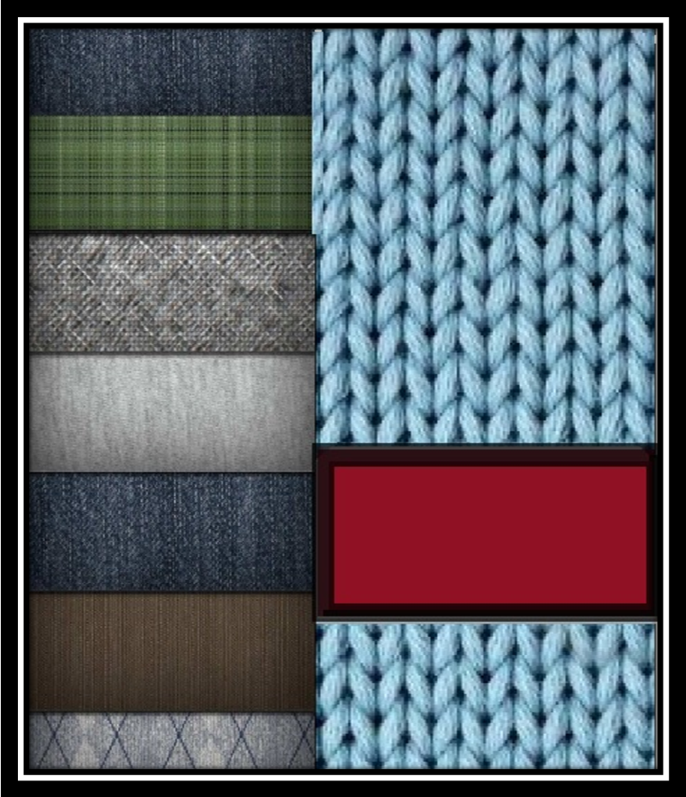
Chapter 7
Garments section

GARMENTS CUTTING SECTION:
Cutting:
Cutting means to cut out the garments pieces from lays of the fabric with the help of cutting templets. To make accomplete garments, cutting is necessary. The use of term cutting is necessary. The use of the term cutting can present a difficulty. It is used in the sense of cutting room an area which normally includes the activities of market planning, spreading, lay and preparation of sewing.

Pattern Making:
When the various parts of a garments is drawn on the hard paper according to the size and shaoe and cut those them the every specific cut paper is called pattern.

Marker making:
Marker making means drawing by pattern on the graph or newspaper for cutting according to the style. Marker is made for cutting fabric.

Marker planning:
Marker is a thin paper which contain all necessary pattern pieces for all sizes and for a particular style of garments. The marker is placed on the fabric for cutting.

The main objective of marker making:
1. To minimize the fabric wastage.
2.To improve the quality of a garments.

Spreading:
Spreading means the smooth laying out of the fabric in superimposed layer specified length.
The cutting marker is layed on the top most layer.

The spread can be of two basic types-
1. Flat spread
2. steaped spread.

Lay:
Spreading means the smooth laying out of the fabric in superimposed layer specified length. And after spreading the shape of fabric plice is called fabric lay. During spreading no of lay should be not more than 300.

According to construction fabric lay are two types:
1. Straight lay
2. Stepped lay

Cutting section is a place where he number of fabric are cut to make the garments .At first take pattern from the sample section which is made by pattern master. Then place this pattern on the on the fabric lay and mark different part like body, sleeve, cuff etc. Then it cut on the marketing point by the cutting m/c. Worker use metal hand glove when they use cutting individual part of the garments to identify back & front part. Then all the part are send to the quality controller table for the final check.

There are two type of cutting technique:
1.Manually operated technique
2.Computerized technique
Different types of m/c are used for cutting. Here mainly used straight knife cutting m/c.
Here use Km cloth cutting m/c. this m/c can up down 3000-3600 time per minute. There are 5 cutting m/c are used.

Different type of garments:
1.Round neck
2. V neck
3.High neck
4.Mog neck
5.Polo shirt
6.Short pant
7.Trouser
8.Tank top9.Baby set
10. Turtle neck T-shirt

9.1 Garment cutting section:
M/C Specification:
DISCRPOTION | BRAND | ORIZNE | No. OF M/C
Cut table-fonio  727MT.18 | RIMOLDI | ITALY | 1
Cut table-fonio  727MT.14 | RIMOLDI | ITALY | 1
Band sew-steela  840/1 | RIMOLDI | ITALY | 1
Band sew-fonio  330/1 | RIMOLDI | ITALY | 1
PL -922 rib cutting machine | LU | TAIWAN | 3
KS-AU-V-10 straight knife cloth cutting m/c | KM | JAPAN | 2
KS-AU-V-08 straight knife cloth cutting m/c | KM | JAPAN | 10
AS 100Eautomatic spreading m/c | TESAN | TURKY | 1
TS 100E automatic tubular spreading/c | TESAN | TURKY | 1
20MT MDF LAM AIR floating tables | TESAN | TURKY | 1
Band knife cutter SBK-700/900 | KM | JAPAN | 1

Sewing:
Sewing section is an important division of the garments factory, without which a garments factory can not be conceived. TUA-HA Textile Ltd. Is a knit composite factory and it has a sewing section. Three floor are used in TUA-HA textile Ltd.for the purpose of sewing garments. Here, ever floor has nine lines. As a result totally twenty seven lines in three floor. In this factory, different designs of knit garments are produced such as T-shirt, Polo shirt, trouser, jersey etc. In this factory three category arments are produce
- Ladies
- Gents
- Kids

According t design-way suited system, m/c, and man power are serially arranged in the line to work I production which facilitates rapidly and easy production for a certain design garments.
When T-shirt are produced TUA-HA textile ltd. Following process and the system of arrange m/c and man power in the line, are maintain:

List of m/c in swing unit:
WORKING PROCESS | MACHINE NAME | MEN POWER(OPERATER) | MEN POWER(HELPER)
Shoulder join | Over lock n/c | 1 | 2
Care level joint | Flat lock m/c | 1 | 1
Shoulder to sewing | Flat lock m/c | 1 | 1
Rib joint | Over lock n/c | 1 | 1
Rib side joint | Plain m/c | 1 | 1
End point of the rib, join | Over lock n/c | 1 | 1
Back rib pipne | Flat lock n/c | 1 | 1
Back rib pipne tuck | Plain m/c | 1 | 1
Label top sam | Plain m/c | 1 | 1
Sleeve hem | Flat lock n/c | 1 | 1
Body &sleeve sticker no. matching | Over lock n/c | 1 | 1
Sleeve joint | Over lock n/c | 1 | 1
Side seam | Plain m/c | 1 | 1
Sleeve tuck(for pressure stitch) | Plain m/c | 1 | 1
Bottom hem | Flat lock n/c(3needle) | 1 | 1

When polo shirt are produced TUA-HA textile ltd. Following process and the system of arrange m/c and man power in the line, are maintain:
WORKING PROCESS | MACHINE NAME | MEN POWER(OPERATER) | MEN POWER(HELPER)
Shoulder joint | Over lock m/c | 1 | 2
Care level stitch | Plain m/c | 1
Main label stitch | Plain m/c | 1
Care label joint | Plain m/c | 1
Sleeve joint | Over lock m/c | 1 | 1
Collar joint | Over lock m/c | 1
Neck pipne | Over lock m/c | 1
Pipne tuck | Plain m/c | 1
Neck top sewing | Flat lock m/c | 1
Pipne top sewing | Plain m/c | 1 | 1
Main label joint | Plain m/c | 1
Placket top swing(side) | Plain m/c | 1 | 1
Placket roller | Plain m/c | 1 | 1
Placket joint | Plain m/c | 1
Placket top sewing(inside) | Plain m/c | 1
Placket nose tuck | Plain m/c | 1
Placket top sewing(out side) | Plain m/c | 1 | 1
Ribbons mouth tuck | Over lock m/c | 1 | 1
Side seam | Plain m/c | 1 | 1
Sleeve tuck | Plain m/c | 1
Sleeve tuck(for reure stitch) | Flat lock m/c(2needle) | 1 | 1
Sleeve hem | Flat lock m/c(2needle) | 1 | 1

When all sewing of dress are completed then the dress is deposited in a certain box. Thus dresses are deposited in the box. There after those are transferred to inspection table for verification and inspection. Here swig fault, measurement properly taken or not, whether different parts o dress correctly joined or not are properly examined ad checked. If fault are to be not possible repair then those are piled in reject box. Which garments are free from fault or correctly produce and right made as per buyer requirements, are piled up in separate box, the theose are sent to the finishing section.
Garments production capacity:
60,000Pcs per day
Machine name of sewing section and there details:-
Machine name | Model | Brand | Type | Origin
Single needle lock stitch | 1010-3 | Brother | Normal | Japan
Single needle lock stitch | 1010-3 | Brother | Normal | China
Single needle lock stitch | FY-5550 | Yamata | Normal | China
Single needle lock stitch | FY-5550 | Brother | Normal | China
Single needle lock stitch | GC-6150M | Typical | Normal | China
Single needle lock stitch | GC-6720MD3N |  | Auto | China
Single needle lock stitch | Feiyue |  | Normal | China
Over lock M/C | MX3244-03 | Pegasus | 6thread | China
Over lock M/C | MX5214-03 | Pegasus | 4thread | China
Over lock M/C | MX5214-M53 |  | 4thread | China
Over lock M/C | MX5214-MD3 |  | 4thread | China
Over lock M/C |  |  | 4thread | China
Over lock M/C | FY2100-4 | Yamata | 4thread | China
Over lock M/C | F-514M2-24 | Siruba | 4thread | Japan
Flat lock M/C | WT664-35BC | Pegasus | Compressor | Japan
Flat lock M/C | W2664-35C |  |  | Japan
Flat lock M/C | WT-264-01GB |  | Small cylinder bed | Japan
Flat lock M/C | W-664-01GB |  | Small cylinder | Japan
Flat lock M/C | C-007J | Siruba |  | Japan
Flat lock M/C | W562-01GB | Pegasus | Flat bed | Japan
Flat lock M/C | W662-02GB |  | Flat bed folder type | Japan
Flat lock M/C | FY3106-0CB | Yamata | Flat bed | Japan
Flat lock M/C | GK32500-1356 | Typical |  | Japan
Flat lock M/C | GK32500-1356 |  | Cylinder bed | Japan
Button hole M/C | HE-800A-3 | Brother | Auto | Japan
Button stitch M/C | BE-438D | Brother | Auto | Japan

Bartack M/C | KE-430D-D(2) | Brother | Auto | Japan
Plaket M/C | UZU-pl-11 | UZU |  | Thailand
P.M.B M/c | 1404MD | Kanasai | 6thread | Japan
D.F.B M/C | 1412PL | Kanasai | 24thread | Japan
Back tape M/c | W522-D4B | Pegasus | Folder type | Japan
Feet of the arm M/c | DA-9270-11 | Brother | Normal | Japan
Feet of the arm M/c | GK360 | Typical | Normal | China
2nd lock M/C | 1-B420A-005 | Brother | Normal | Japan
2nd lock M/C | GC-6845H | Typical | Normal | China
2^{nd zigzag M/C} | FY20U43 | Feiyue | Normal | China
2^{nd zigzag M/C} | FY20U43 | Yamata | Normal | China
Picoting M/C | PX302-4W | Kanasai | Normal | Japan
Snap button setting M/C | UZU-333E | UZU | Normal | Thailand
Fusing M/C | 450C | HASHIMA | Auto | Japan

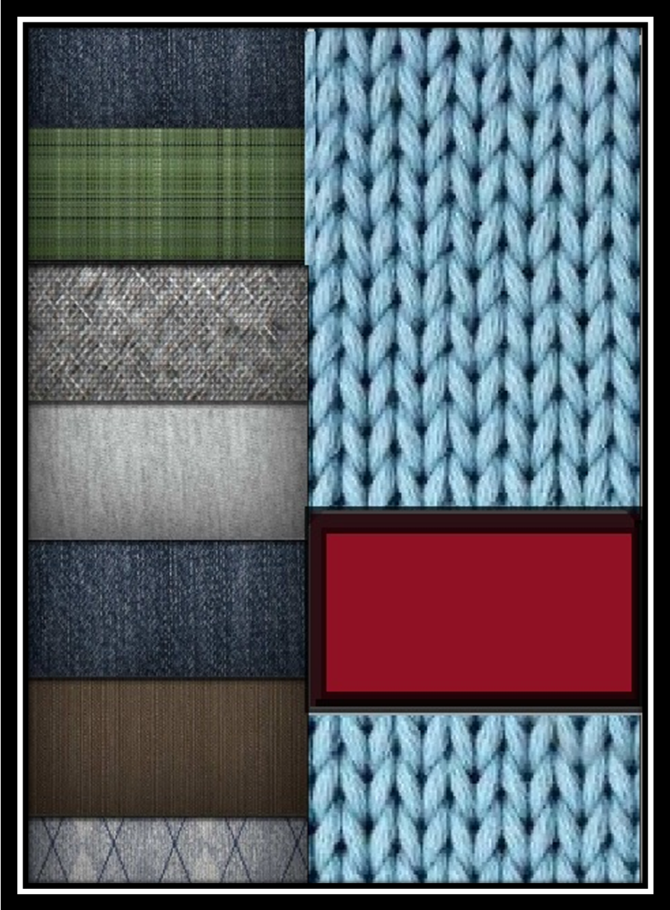
Chapter 8
Maintenance

Maintenance
Maintenance is a procedure by which we can maintain active functioning in operation according to the behavior and utility of a particular element. In engineering, we use this terminology for maintaining smooth and uninterrupted performance of machinces, tools and metallurgical characteristics in practical uses.

Objectives of maintenance:
→To keep the factory plants, equipments, machine tools in an optimum working condition.
→To ensure specified accuracy to and time schedule of delivery to customer.
→To keep the downtime of machines to the thuds to have control over the production program.
→To keep the production cycle within the range.
→To modify the tools to meet the need for production.

Three types of maintenance are performed in thu-ha textile ltd.
1.Preventive Maintenance.
2. Routine/Schedule Maintenance.
3.Breakdown Maintenance.

- Preventive Maintenance: Actions perform periodically(or continuously)prior to functional failure to achieve the desired level of safety and reliability for an item. These actions are performed to reduce consequences of failures.

- Schedule Maintenance: It is time based maintenance and pre-planned to performed on machine and equipments. This plan usually made on monthly basis.

- Breakdown Maintenance: In this type of maintenances when the machine remains stop that the maintenance is done.

Maintenance Tools Equipments& their function:

Name of tools | Function
Slide wrench | To give shape
Spanner | Tightening and opening bolt
Pliers | Tightening and opening bolt
Hacksaw | Cutting, Holding, Joining, Wire ,Gripping
Pipe wrench | Cutting
Chisel | Tightening ,opening, Gripping, Pipe
File | Shaping, cutting
Clamp | Shaping
Vice | Gripping

Name of the Equipments | Function
Grinding m/c | Grinding
Cutting m/c | Cutting
Drill m/c | Drilling
Shaping m/c | Shaping
Lathe m/c | To make smooth
Bending m/c | Bending

Maintenance Procedure:
Preventive Maintenance: They always follow preventive maintenance.
Breakdown Maintenance: When a problem occurred the operator informed the supervisor, then the supervisor informed the production officer, then the production officer called the maintenance officer. The maintenance officer visits the problem and takes necessary steps to solve the problem.

Flow chart of maintenance:

Problem occurred
↓
Operator
↓
Supervisor
↓
Production officer
↓
Maintenance officer
↓
Solution

Remarks:
Their maintenance procedure is very good & effective as a result they have good efficiencies.

Chapter 9
Utility

Utility facilities available

The following utility facilities available in Thu-ha textile.
1.ETP( Effluent Treatment Plant)
2.Electricity and Generator.
3.Steam or Boiler
4.Hot water
5.Water
6.Compressed Air

Generator house

The list of machine:
- Generator 3
- Panel 2
- Distribution Board 1
- Generator Control panel 1

- Generator:
To generate the power(volts&amps) for every in the factory.

- Panel:
To store the power (volts&amps) from the generator for every in the factory.

There are two types of panel:
1.PFI(power factor Improvement) panel
2.LT panel

PFI panel:
To store the power (volts& amps) from the generator for the boiler house, finishing section& dyeing section in the factory. Supply AC current 4Amps &400 volts.

LT panel:
To store the power (volts & amps) from the generator for the boiler house, finishing section& dyeing section in the factory. According there need .Supply AC current 4Amps &400 volts.

- Distribution:
To supply the (volts &amps) for the light, AC, fan etc in the different section. Supply AC current.4Amps & 400 volts.

- Generator Control panel:
To con troll the generator for the generate power.

Effluent Treatment Plant
Process description
The effluent from different sources will be collected in an Equalization tank through a Bar Screen. Bar Screen will remove large floating materials. The equalized effluent is then pumped to a Flocculation tank. Coagulation agents, like Lime, Alum and Polyelectrolyte will be dosed in the Flocculation Tank to agglomerate the suspended particles. The effluent from this tank will pass through the Primary Tube Settler where flocks are removed. After primary tube settler, the effluent flows to the Aeration Tank, where BOD & COD are removed. The pH of the effluent will be corrected to bring to the level of 8 to 8.5. After Aeration Tank, the effluent will pass through a Secondary Clarifier where suspended biological solids are re-moved. From Secondary Clarifier, the effluent will be discharge to drain.
Sludge generation from primary clarifier will be taken to sludge pit or sludge drying bed. From sludge pit sludge will be fed to centrifuge followed by filter press unit. Sludge cakes generation from filter press will be dried and can be disposed suitably. Sludge from second-ary clarifier will be re-circulated back to aeration tank and periodically to sludge pit.

Technical Details of the plant
1. Plant capacity
The Effluent treatment plant has been designed for 40 m³ per hour capacity.

2. Design Effluent analysis
The plant has been designed on the basis of following analysis report:
SL | Parameter | Unit | Value
1 | Biological Oxygen Demand (BOD) | mg/l | 500
2 | Chemical oxygen Demand (COD) | mg/l | 800
3 | pH |  | 6-8

3. Treated Effluent Quality
SL | Parameter | Unit | Value
1 | Biological Oxygen Demand (BOD) | mg/l | 50
2 | Chemical oxygen Demand (COD) | mg/l | <200
3 | pH |  | 7.5-8.5

At the outlet of the treatment system treated water quality will be as follows:
Design Consideration:
- Variation of Water quality and quality will not be more than 10%
- The plant is not design to reduce total dissolved solids.
- Type of Dye used is reactive dyeing trial run.

4. Chemical Consumption
Item | Dosage
Alum | 10% solution at 100mg/ltr
Lime | 10% solution at 100mg/ltr
Polyelectrolyte | 1% solution at 2-4 ppm
Acid | As per requirement
Urea | 5 kg per day( as shock does during long shutdown of the plant)
Phosphate | 3 kg per day( as shock does during long shutdown of the plant

Above given figures of chemical consumption will get reduced if the sewage dis-charge is added.
In case it is not possible to provide sewage discharge to the plant, then some di-ammonium phosphate & urea will be required at time of commissioning.

Water treatment plant:
Water for a textile plant may come from various sources .These includes surface water from rivers and lakes, and subterranean water from wells.
The various salts present in water depend on the geological formations through which the water has flowed. These salts are mainly the carbonates (CO3²⁻), hydrogen carbonates or bicarbonates ( HCO3⁻), Sulphates ( SO4²⁻) and chlorides ( Cl⁻) of calcium ( Ca²⁺), magnesium (Mg²⁺) . Although calcium and magnesium carbonates in limestone are relatively insoluble in water. So in this reasons, water hardness can be divided into two ways
1) Temporary hardness : Ca(HCO3)2 , Mg(HCO3)2 , Fe(HCO3)2
2) Permanent hardness : CaCl2 , CaSO4 , Ca (NO3)2 , MgCl2 , MgSO4 , Mg(NO3)2
This water hardness causes some serious consequences in a textile dyeing and finishing
industries and these are
- Precipitation of soaps .
  - 2. Redeposit ion of dirt and insoluble soaps on the fabric being washed ,
  - a. this can cause yellowing and lead to uneven dyeing and poor handle.
- Precipitation of some dyes as calcium and magnesium salts.
- Scale formation on equipment and in boilers and pipelines.
- Reduction of the activity of the enzymes used in washing.
- Incompatibility with chemicals in finishing recipes and so on.

Hardness expressed by parts per million (ppm) of CaCO3 which is standard hardness scale
and it is also called American hardness.
Capacity: 60m³ per hour

Chapter 10
Boiler

Boiler:
The equipment used for producing steam from water is called steam generator or boiler. The boiler used for producing steam in GKL is Cochran boiler which is a fire tube type boiler. This produced seam line in different section. Simple vertical boiler of fire tube type is mainly used in small plant requiring small quantity of steam and where floor area is limited.

Classification of boilers:
1) Fire-tube boiler (gas): Low pressure, low running cost, less change of busting but greater risk of damage.
2) Water-tube boiler: High pressure, high running cost, high change of busting & don’t damage the whole boiler.

As this factory used fire tube boilers and its description is given below.
In boiler house, steam is produced at high temp &pressure. This produced steam is supplied by the steam line in different section.

Uses: Steam use for-
- Power generation (steam engine /turbine).
- Processing in industries(dyeing 7 finishing mill, paper mill etc).
- Heating purposes (house, office, hospital etc in cold countries).
- Hot water supply.

Essentials of a good boiler:
- Required pressure and quality at minimum fuel.
- Initial installation and maintenance cost low.
- Parts approachable for rep
- Quick starting capacity.
- Conform to the safely regulations of boiler act.

Working principle:
The gas is feed through the side to the furnace where fire created by electric spark. The boiler move the fire into the flue pipe by compress air and then the flue gases enter through the combustion chamber which is lined with fire bricks on the outer wall of boiler. The gases passing through the horizontal smoke tubes give their heat to the water and convert water into steam. This steam gets accumulated to the upper portion of the shell from where it can be supplied to the users. Finally, the gases are discharge to the atmosphere through the smoke box and chimney.

Feed water tank

Gas
Burner
Boiler
Blower
3
Steam

Factory house

Fig: Steam produces procedure mechanism

The list of machineries:
1. Three Boilers
2. Boiler water softener plant
3. De-alkalize
4. One hot water tank
5. One water feed tank.

Boiler Specification:
Boiler no. :01
Machine Name (fictional) :Steam Generate
Boiler Type :Fire tube Boiler
Brand Name :SCHNEIDER KESSEL BERUN
Model name :20424
Max. Steam Out :6 t/h
Test Press :20.5 bar
Volume :12540L Year of Manufacture :2008
Country Name :Germany

Boiler no: :02
Machine Name (fictional) :Steam Generate
Brand Name :SCHNEIDER KESSEL BERUN
Model name :HDD-P5000-10
Max. Working pressure :10 bar
Mini. Steam Temp :20 C
Max. Steam Temp :185 C
Test Pressure :13.5 bar
Volume :5200 L Year of Manufacture :2006
Manufacturers Name :Germany Thai Boiler
Manufacturing Ltd.

Boiler no: :03
Machine Name (fictional) :Steam Generate
Boiler Type :Fire tube Boiler
Brand Name :SCHNEIDER KESSEL BERUN
Model name :20424
Max. Steam Output :6 t/h
Test Pressure :20.5 bar
Volume :12540L Year of Manufacture :2008
Country Name :Germany

Where,
A= Hard water storage tank
B= Stone filter
C= Carbon filter

Chapter 10
Marketing

Marketing Strategy:
Marketing strategy is a very important factors to sale the products to the buyer. Tua-ha Textile Ltd mainly senior marketing officers, merchandiser and higher deal with buyer. There are some fixed buyers of the industry. The buyers give their orders continuously all over the year. The marketing officers and by both side understanding the rate and the order quantity are fixed.
Duties & responsibilities of marketing officer:
The main duties and responsibilities of a marketing officer are given bellow:
- To prepare cost sheet by dealing with the buyer.
- To take different steps by discussing with the high officials and merchandiser.
- To maintain a regular & good relationship between commercial officer & merchan-diser.
- To maintain a regular communication with the buyers & buying houses.
- Communicate with the new buyer.

Master LC and Commercial Activities:
Merchandiser have to have the about basic terms and conditions of L/C and about the procedure of commercial departments activities. After having an Export L/C. merchandiser should check the main points/clause of the L/c very carefully.
Documentary Credit:
buyers bank is committed (on behalf of buyer) to make payment to the seller (beneficiency0 under some terms and conditions. Such terms and conditions usually furnished by the buyer clearly in the L/C accordingly to the ICC publication NO-600. These terms and conditions will be backed by documents.
Parties Involved to Latter of Credit:
There is several numbers of parties involved in a L/C and the rights& obligation of the involved parties also differ each others .Involved parties are as follows.
01. Buyer/ Importer/applicant
02. L/C Opening/Issuing Ban
03. Negotiating Bank
04. Paying/Reimbursing Bank.

Different Types of L/C:
• Revocable L/C
• Irrevocable L/C
• Transferable L/C
• Confirmed L/C
• Divisible L/C
• Restricted L/C
• Revolving L/C
• Anticipatory L/C

Payment mode:
• Credit available by sight payment
• Credit available by Deferred payment
• Credit available by negotiation
• Credit available by Acceptable

Clauses of L/C:
All the merchandiser must read following clauses very carefully of a L/C and they must know meaning of these clauses. If they do not understood these clauses they should consult with Commercial manager about these clauses.
- Applicant Name& Address
-Beneficiary Name& Address
-Consignee Name& Address
-Opening Bank’s Name& Address
-Advising Bank’s Name& Address
-Confirming bank’s Name& Address
-L/C number
-L/C Issue Date
-L/C expire Date & Place
-Payment available By
-Description of Merchandiser
-Total quality of Merchandiser
-Unit price of Merchandiser
-Total value of Merchandiser
-Shipment Date of Merchandiser
- INCOTERM
-+/- Allowed
-Partial Shipment
-Trans-Shipment
-Port of Loading
-Port of Discharge
-Document presentation Period
-Required Document

Incoterms:
Incoterms sduch as FOB, CIF, and DDU have became part of the language international trade and are in constant use the world .Incoterms define the responsibilities of buyer and seller for delivery of goods under sales contrast /LC.Incoterms 2000 is the authority text for determining how costs and risk are allocated to the parties. Thes turms are regularly incorporated into sales contracts worldwide. Incoterms 2000 contains the official ICC text of the thirteen trading terms.

Product Category & Group:
There are mainly four product group such as
- Men’s
- Lady’s
- Children’s
- Baby’s

Pricing ( Consumptions & Costing) :
To do costing of garments merchandiser have to keep the following variables in mind. A good merchandiser has vast knowledge about the following –

Variable function:
01.Year cost For Sweater Costing
02.fabrices Cost For Woven & Knit garments
03. Accessories Cost
04.Print/embroidery/Speacial Works/Washing Charges
05.Yearn Consumption Fir Sweater
06.fabrices Consumption For Knit & Woven Garments
07.Cutting 7 Making Cost (CM)
08 Freight (In Case of CFR)
09.Cpmmertial Cost (L/C Related, BTB Related, Interest Related)
10.Compan y Establishment Cost
11.Profit
12.Costing

01.Year cost For Sweater Costing:
Merchandisers may collect yearn price from different overseas suppliers as well as from different local yearn manufacture.
02.fabrices Cost For Woven & Knit garments:
- Merchandisers may collect the WOVEN FEBRI CS prices from different overseas fabrics suppliers as well as from different local WOVWN fabrics manufacturer.
- find different fabrics cost idea in separate sheet.
- KNIT FABRICS has been developed tremendously in our country rather than WOVEN FABRICS and SWEATER YEARN. Merchandiser may collect the knit Fabrics price from different Local /overseas fabrics as well as from different local Knit fabrics manufacturer.

03. Knit Fabrics Cost :
Merchandiser may calculate the cost of knit fabrics himself. But they have to have enough idea of the flowing –
A. Respective Yearn price Per Kg find required respective data for different knit fabrics.
B. Knitting Price per Kg
C. Dyeing 7 Finishing price Per Kg
D. Special; finish price Per Kg (like Brush, Peach, UV Finish , Teflon Finish , Easy care Finish, Anti Bacteria Finish, Merchandiser)
E. Dyeing Process Loss per Kg.
F. Commercial Cost(Packing, Transportation& BBL etc)
G. Profit per Kg.

A.)White Fabrics Price with Enzyme & Silicon Finish-
30/1 yearn = USD 3.50
Knitting = USD 0.15
Dyeing = USD 0.60
Total = USD 4.25
Process Loss 15% = USD 0.64
Fabrics Price = USD 4.89/kg

B.)White Fabrics Price without Enzyme & Silicon Finish-
30/1 yearn = USD 3.50
Knitting = USD 0.15
Dyeing = USD 0.45
Total = USD 4.10
Process Loss 10% = USD 0.41
Fabrics Price = USD 4.51/kg

C)Reactive Black &Royal Blue Fabrics Price with Enzyme & Silicon Finish-
30/1 yearn = USD 3.50
Knitting = USD 0.15
Dyeing = USD 1.82
Total = USD 5.47
Process Loss 15% = USD 0.82
Fabrics Price = USD 6.29/kg

D) Reactive Black &Royal Blue Fabrics Price without Enzyme & Silicon Finish-
30/1 yearn = USD 3.50
Knitting = USD 0.15
Dyeing = USD 1.67
Total = USD 5.32
Process Loss 10% = USD 0.53
Fabrics Price = USD 5.85/kg

E.)Average Color Fabrics Price with Enzyme & Silicon Finish-
30/1 yearn = USD 3.50
Knitting = USD 0.15
Dyeing = USD 1.22
Total = USD 4.87
Process Loss 15% = USD 0.73
Fabrics Price = USD 5.60/kg

F.) Average Color Fabrics Price without Enzyme & Silicon Finish-
30/1 yearn = USD 3.50
Knitting = USD 0.15
Dyeing = USD 1.60
Total = USD 4.71
Process Loss 10% = USD 0.47
Fabrics Price = USD 5.18/kg

Knitting Charges of some commonly used knit fabrics:
Single Jersey For Solid Dye- TK 8.00= USD 0.13/kg
Single Jersey Yearn Dyed Feeder Stripe - TK 20.00= USD 0.13/kg
Single Jersey Yearn Dyed Multi Feeder Stripe - TK 50.00= USD 0.76/kg
Single Jersey Yearn Dyed Auto Stripe - TK 120.00= USD 1.82/kg
Single Jersey With 5% Elasthane For Solid Dye- TK28.00= USD 0.43/kg
Single Jersey With 5% Elasthane Yearn Dyed Feeder Stripe - TK 35.00= USD 0.53/kg
Pique For Solid dye- TK 8.00= USD 0.13/kg
Pique Yearn Dyed Feeder Stripe - TK 25.00= USD 0.38/kg
Pique Yearn Dyed Multi Feeder Stripe - TK 70.00= USD 1.06/kg
Pique Yearn Dyed Auto Stripe - TK 140.00= USD 2.12/kg
Pique With 5% Elasthane For solid Dye - TK 30.00= USD 0.46/kg
Pique With 5% Elasthane Yearn Dyed Feeder Stripe - TK 35.00= USD 0.53/kg
1X1 Rib For Solid Dye - TK 35.00= USD 0.53/kg
1X1 Rib Yearn Dyed Feeder Stripe - TK 25.00= USD 0.38/kg
1X1 Rib With 5% Elasthane For Solid Dye - TK 25.00= USD 0.38/kg
1X1 Rib With 5% Elasthane Yearn Dyed Feeder Stripe - TK 35.00= USD 0.53/kg
1X1 Pointal Rib For Solid Dye - TK 80.00= USD 1.22/kg
1X1 Flat Black Rib For Solid Dye - TK 40.00= USD 0.61/kg
2X2 Rib For Solid Dye - TK 20..00= USD 0.31/kg
2X2 Rib Yearn Dyed Feeder Stripe - TK 35.00= USD 0.53/kg
2X2 Rib With 5% Elasthane For Solid Dye - TK 30.00= USD 0.46kg
1X1 Rib With 5% Elasthane Yearn Dyed Feeder Stripe - TK 35.00= USD 0.53/kg
Variable/Varigated/Placement Rib For Solid Dye - TK 35.00= USD 0.53/kg
Plain Interlock For Solid Dye - TK 20..00= USD 0.31/kg
Plain Interlock Yearn Dyed Feeder Stripe - TK 35.00= USD 0.53/kg
Drop Needle Interlock For Solid Dye - TK 30..00= USD 0.46/kg
Drop Needle Interlock Yearn Dyed Feeder Stripe - TK 40..00= USD 0.61/kg
2T Terry - TK 16.00= USD 0.25/kg
2T Terry With Elasthane - TK 35.00= USD 0.31/kg
3T Terry/Fleece - TK 20.00= USD 0.31/kg
3T Terry/Fleece With Elasthane - TK 40.00= USD 0.61/kg
Mini Waffle or waffle - TK 40.00= USD 0.61/kg

Soiled Dyeing Of some commonly used knit fabrics:
Yearn Dyed wash- TK 20.00= USD 0.31/kg
Mélange wash- TK 30.00= USD 0.46/kg
Pigment Dye For All cotton - TK 3.00= USD 4.50/kg
White- all Types of cotton Fabrics without enzyme - TK 35.00= USD 0.50/kg
White- all Types of cotton Fabrics with enzyme - TK 40.00= USD 0.61/kg
White- 95/5 cotton/Elasthane/S/J without Enzyme - TK 70.00= USD 1.06/kg
White- 95/5 cotton/Elasthane/S/J without Enzyme - TK 75.00= USD 1.14/kg
Average color- All types of cotton fabrics without Enzyme –TK 70.00=USD 1.06/Kg
Average color- All types of cotton fabrics with Enzyme –TK 80.00=USD 1.22/Kg
Average color- 95/5 Cotton/Elasthane S/jersey without Enzyme –TK 105.00=USD 1.59/Kg
Average color- 95/5 Cotton/Elasthane S/jersey without Enzyme –TK 115.00=USD 1.75/K
Reactive Black-All types of cotton fabrics without Enzyme –TK 110.00=USD 1.67/Kg
Reactive Black-All types of cotton fabrics with Enzyme –TK 120.00=USD 1.82/Kg
Reactive Black-95/5 Cotton/ Elasthane S/jersey without Enzyme –TK 145.00=USD2.20/ Kg
Reactive Black-95/5 Cotton/ Elasthane S/jersey with Enzyme –TK 155.00=USD2.35/ Kg
Reactive Black& Royal Blue Dyeing Charges are same.

Yearn Dyeing Charges of some Commonly Used Knit Fabrics:
White- All types of cotton Yearn-USD 0.90-1.10/Kg
Light color-All types of cotton Yearn-USD 1.50-1.70/Kg
Medium Color- All types of cotton Yearn-USD 1.80-2.20/Kg
Dark Color- All types of cotton Yearn-USD 2.00-2.25/Kg
Reactive Black& Royal Blue- All types of cotton Yearn-USD 2.50-2.75/Kg

Special finishing Charges of some Commonly Used Knit Fabrics:
Brushing-TK 10.00 = USD 0.15/Kg
Peach finished- TK 20.00 = USD 0.31/Kg
Silicon Softener- TK 10.00 = USD 0.15/Kg

Freight:
Although most orders for garments are placed by buyers on FOB , with buyers to pay for freight at the shipping destination, it is still necessary for the shipper or the agent to know how to calculate sea freight and air freight as buyers always need to know how much freight the merchandise cost per dz. If you are required to sell on CIF (with the shipper to prepay for freight at the shipping port0 you will need to calculate the freight accurately for your own costing.

Sea freight:
Sea freight is usually charged on volume –how much CBM (cubic meter) –very rarely by weight as” density cargo”. In fact ANERA (Asia North America eastbound rate agreement) has designed the freight tariff more based on the usual value of the type of goods , than the usual weight of them , taking into consideration that for the importers that for low value merchandise they should give a low freight rate in order to make it possible for the importers to buy goods overseas. However , for high value merchandise , they should charge a high freight rate, as it is believed that buyer can afford to pay more on freight. They have designed the freight tariff in such a way that everybody can do business and there is sufficient profit for the shipping.
Consider  Size | Calculated  Capacity | Practical  Capacity | Container  FCL rate | FCL rate for  CBM | LCL rate per  CBM
20” Capacity | 29.5 CBM | 27 CBM | 3500 | 130 | 160
40”Normal | 61.32CBM | 54 CBM | 5000 | 92 | 160
40”Hi Cube | 69.15 CBM | 62 CBM | 6500 | 92 | 160

Note: FCL= Full Container Loading
LCL=Loose Container Loading
If you ship heavy goods as loose cargo because the size of the shipment is very small, the shipping lines will charge you by weight or by volume whichever is higher.
1 CBM(100 CM x100 CM X100 CM)=1000 Kg

Air freight:
Unlike sea freight, the airlines have decide to for the heavy merchandiser (high destiny goods) by weight and lightweight merchandise (low density goods)by volume. however, as airplanes can take less weight then ocean liners the way they Set the standard, in the garments industry, when you ship by air, you have a 70% chance to be Charged by weight about 30% chance by volume.
The followings are the relationship between weight and volume as set by LATA ( international air transport association )
- From most shipping location in the far east to the US destination and Canada 7000 cubic cm= 1 kilo
- From certain location in the far east to the U. S. destination and Canada 6000 cubic cm=1 kilo
There for when you have low density goods to ship by air , in order to determined if you should try to make the cartons as small possible to save fright. First you check with the local air .forwarding agent by asking him in the country where you are how many cubic cm is considered 1 kilo in weight .They will tell you either 7000 or 6000. This is the answer you need.

Than you physically cheek the weight and measurement of the good s packed of the air shipment . Now we have the 3 answers as follow ,for example
- The country in Bangladesh and the formula is 6000 cubic cm = 1 kilo
- The measurements of the cartons are 50 cm X 60 cm X 40 cm
- The gross weight of the cartons are 16 kilo per carton.

Now let us find out of we should try to make the cartons smaller to save air freight by doing the following calculation
Multiply 5 by 60 by 40=120000 cubic cm.
120000 cubic cm divided by 6000=20 kilo

Now you know , by volume , the one carton is of 2 kilo , but by actual weight the carton is of only 16 kilo . You also know the airline will charge whichever is higher, in this case , they will charge you for 20 kilo , by volume . If the air freight rate is 2.80 per kilo this carton will cast you $56.00
Now in order to save some money, let us try to make the carton smaller ,usually by cutting the height of the carton. lets say have succeeded in cutting down the height by 58 cm , and see how much money awe can save.
Original size of the carton : 50X 60X 35 CM(20 kilo)
Now cut down to 50 X 60 X 35 CM = 105000 CUBIC CM .
105000/6000=17.5 kilo
Now by using the new carton, we have saved 2.5 kilo and this carton will cost only $ 49.00 (17.5 kilo X 2.80 )
Prepare Raw Materials And Accessories Requirement List
Merchandises have to prepare a requirement list of all yarn/ fabric and all accessories and other materials needed to complete a particular odder immediately after having and odder sheet.
Sourcing of materials

Merchandiser should fine out the sources of yarn, fabric, and accessories from local or from overseas market. He/ she must have and idea of unit price of He/ his requirement material and have to know the procedure of negotiation.
Merchandisers have to follow each stage order from test cutting to shipment.

Solving shortage problem:
The merchandiser should know the death of any commodity such has yarn, Fabric and accessories,etc from the beginning of an order execution. Action should be taken immediately to arrange required materials, after discovering the shortage. It is excepted that the merchandiser should verify and quality of required should goods prior to execution of the order. If the materials is found invariable, the superior should be informed about the concern.
Communication with associates-production people and Buyer
It is essential to communication with buyer regarding each order. It is excepted to give some time to the buyer to read the send message Merchandiser should to go thought the message receive from the buyer reply on time. In many case , merchandiser have to provided order status to the buyers.
Also merchandiser has to communicate with the people that are in house ,venders, contraction and job workers. Only thought the right communication can one meet deadline for the concerned orders.
Quality control , ETP, COC, and Work study:
Merchandiser have to have the basic idea on Quality Control, ETP, COC, and WS.
Marketing policy:
Merchandiser have to develop new buyer and keep eyes on current market situation.

Remarks:
A part from the above mention procedures, merchandiser has tom assign subordinates to help him in the order execution and direct the procedures. He has to revise his knowledge from time-to-time to know current market trends. To record preferences for all the planned activities, use daily or time log systems.
The merchandiser should find out exact reasons for time consumption. It is necessary to keep record of time value and keeping it is going to be shared with concerned parties/buyers. It is certain that merchandising jobs need huge time planning.

Conclusion:

We have completed our Industrial Training successfully by the grace of Allah. Industrial Attachment sends us to the expected destiny of practical life. THU-TEXTILE LTD. Is well known factory in the field of Bangladesh. The completion of the three months Industrial Attachment at THU-TEXTILE LTD. gave us the inspiration that factory is one of the appropriate destiny to implement the theoretical knowledge. From this Industrial attachment we got the idea about the factory environment , production process, total management, store& inventory process, maintenance, utility etc.

THU-TEXTILE LTD. Are well known equipment and the working environment is excellent .The relationship between top management to bottom level is so nice. We are lucky to get the opportunity of having training in this mill. The factory runs by a number of efficient Textile Engineering, Skilled technical & Non- technical persons.

All the Textile Engineering, Skilled technical & Non- technical persons. Are very sincere, co-operative and helpful. We wish good luck of them and also for this factory. It was really a productive learning besides our four year academics, so we wish we will be able to implement our learning methodology knowledge successfully in the textile industry and the betterment of the economy of our country.

