Textiles have such an important bearing on our daily lives that everyone needs to know something about them. From earliest times, people have used textiles of various types for covering, warmth, personal adornment, and even to display personal wealth. Today, textiles are still used for these purposes and everyone is an ultimate consumer.
A textile or cloth is a flexible material consisting of a network of natural or artificial fibres often referred to as thread or yarn. Yarn is produced by spinning raw fibres of wool, flax, cotton, or other material to produce long strands. Textiles are formed by weaving, knitting, crocheting, knotting, or pressing fibres together (felt).
The words fabric and cloth are used in textile assembly trades (such as tailoring and dressmaking) as synonyms for textile. However, there are subtle differences in these terms in specialized usage. Textile refers to any material made of interlacing fibres. Fabric refers to any material made through weaving, knitting, spreading, crocheting, or bonding that may be used in production of further goods (garments, etc.). Cloth may be used synonymously with fabric but often refers to a finished piece of fabric used for a specific purpose (e.g., table cloth).
Textiles have an assortment of uses, the most common of which are for clothing and containers such as bags and baskets. In the household, they are used in carpeting, upholstered furnishings, window shades, towels, covering for tables, beds, and other flat surfaces, and in art. In the workplace, they are used in industrial and scientific processes such as filtering. Miscellaneous uses include flags, backpacks, tents, nets, cleaning devices such as handkerchiefs and rags, transportation devices such as balloons, kites, sails, and parachutes, in addition to strengthening in composite materials such as fiberglass and industrial geotextiles. Children can learn using textiles to make collages, sew, quilt, and toys. Textiles used for industrial purposes, and chosen for characteristics other than their appearance, are commonly referred to as technical textiles. Technical textiles include textile structures for automotive applications, medical textiles (e.g. implants), geotextiles (reinforcement of embankments), agrotextiles (textiles for crop protection), protective clothing (e.g. against heat and radiation for fire fighter clothing, against molten metals for welders, stab protection, and bullet proof vests). In all these applications stringent performance requirements must be met. Woven of threads coated with zinc oxide nanowires, laboratory fabric has been shown capable of "self-powering nanosystems" using vibrations created by everyday actions like wind or body movements.
From fiber to fabric Impress-Newtex Composite Textiles Ltd is truly integrated undertaking has the capability to offer a complete product range for the export textile markets. The goal of Impress-Newtex Composite Textiles Ltd. is to become the preferred partner for sourcing high quality fabrics and clothing from Bangladesh with highly advanced technology and an emphasis on developing local human resources. Impress-Newtex Composite Textiles Ltd. has the potential to make an important contribution to the nation's growing readymade garments export sector. The rational behind the existing structure and future expansion of Impress-Newtex Composite Textiles Ltd. is to capture value-added at each stage of the textile manufacturing process. Despite Bangladesh's lack of indigenous cotton production capability, Impress-Newtex Composite Textiles Ltd. has leveraged Bangladesh's labor cost advantage and export competitiveness to the maximum

Chapter: 02
Project Description

Company Name: Impress-Newtex Composite Textiles Ltd.
Type: 100 Export Oriented Knitting and Dyeing Factory.
Established: 1996
Location: Gorai I/A, Mirzapur, Tangail.
Total Area: 10 acors (approximately)
Investors: Md. Riaz Ahmed Khan (Chairman), Md. Akram Khan (M.D), Md. Sharfuddin Rumi (Executive Director), Md. Nurul Islam (Executive Director).
Project Cost: 150 cror Taka (approximately)
Annual Turnover: 200 crore Taka (approximately)
Certification & Awards:
ISO 9001: 2000 Certified (100% Export oriented Industry)
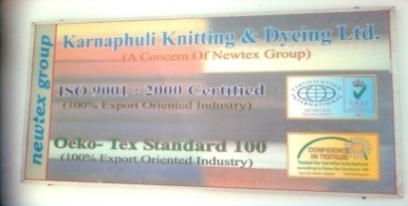
Oeko-tex Standard 100 (100% Export Oriented Industry)
Production capacity:
Knitting: 17 tons/day (average), Dyeing: 15 tons/day (average), Finishing: 13-15 tons/day (average).
Main Production:
Knitted Fabrics (Single Jersey, Single Lacoste, Fleece, Rib, Interlock, Terry, Collar & Cuff etc), Dyed fabrics & finished fabrics.
Factory Contact: 09229-87024
Head Office:
Chandrashila Suvastu Tower (10th & 11th Floor)
69/1, Green Road (Panthapath), Dhaka-1205
Tel: 9663237, 9675097, 8614910, 8629259
Mobile: 01713569299
Fax: 88-02-8615928
E-mail: Newtex@bdcom.net
Web-site: www.newtexbd.com
Bank Address:
Islami Bank Bangladesh Ltd
Local Office, 75 Motijheel C/A
Dhaka, Bangladesh
Phone: 9552902-3, 9552897-8
Telex : 642525 IBANK BJ, 642403 IBANK BJ.
Swift: IBBLBDDH102

Knitting & Dyeing Department
It is a state of the art composite knit fabric production mill, which serves the growing needs of high-quality knit garments exporters in Bangladesh.
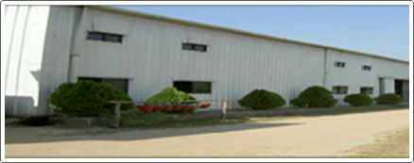
Impress-Newtex Composite Textiles Ltd.

Location of the Project
Mirzapur Cadet College
Savar Bi-pole
DEPZ
DEPZ
Dhaka Mymensingh Road
Konbari
Chandra
Kaliaquyor
Abdullah pur
Tangail HW
E
N
W
S
Impress-Newtex Composite Textiles Ltd

Basic Layout of the Company

Dyeing & Finishing
&
Management Office
Generator & Boiler
ETP
Batch & Fabric Store
Water
Source
Mosque

Garments

Knitting
Section
Yarn Storage
Security Office

Composite Textiles Impress-Newtex Ltd.
Gorai Industrial Area, Mirzapur, Tangail
Layout Plan of Flat-Bed Knitting Section
19 ft
Machine-02

8ft
Machine-07

8ft
Machine-03

8ft
Machine-09

8ft
Machine-01

8ft
Machine-08

8ft
Machine-04
10ft
Machine-05
10ft
Machine-06
10ft
Table
58ft
N
E
W
S

Layout Plan of Circular Knitting Section
N
E
W
S

Entry
Exist
Exist
01

02
04
06
05
11
12
16
17
03

07
08
13
14
15
10
09
21
20
19
18
Fabric Inspection
Table

Rack

Knitting Floor Layout Plan
N
E
W
S
04
03
02
01
07
08
09
10
11
12
06
05
104 ft
30 ft
N
E
W
S

Chapter: 03
Factory Organogram:

Top Management:
AGM
Accounce Officer
Maintenance
Officer
Executive Director
Admin Officer
Chairman
Managing Director
General Manager (GM)
Executive Director
Deputy General Manager (DGM)

Quality Controller
Asst. Quality Controller
Lab Assistant
Lab Technician
Asst. Supervisor
Supervisor
Sample Q.C.
Sample Supervisor
Lab Q.C. Assistant
Asst.Lab In-Charge Iccccarge
Q.C. In-charge
Shift In-charge
Sample In-charge
Lab In-charge
Lab Q.C. Supervisor
Asst. Manager R & D
Planning Asst. Manager
Asst. Manager Q.A.
Asst. Manager Finishing
APM Dyeing
General Manager
Sr. Planning Officer
Supervisor R&D
Sr. Officer R&D ddD

Production Officer (P.O)
APM Dyeing
Assistant Operator
Operator
Dyeing supervisor
Dyeing shift in-charge
Assistant Manager Finishing
Delivery Supervisor
Delivery Coordinator
Store keeper
Finishing Supervisor
Finishing Shift In-charge
Assistant Operator
Finishing Operator
Delivery Loader

Production Officer
Knitting Master
Quality Inspector
Supervisor
Assistant operator
Operator
Store Officer
Assistant Manager
AGM
Store Keeper
Store Supervisor
Store Assistant
Helper

Assistant Engr.
Generator operator
S.A. Engineer.

Assistant Electrician
Jr. Electrician
Electrician
Generator In-charge
Generator Assistant
DGM
Asst. Manager Maintenance
Maintenance Officer
Engineering Store In-charge
Assistant store In-charge
Sr. Engineering Officer

Maintenance Officer
Helper
Painter and Carpenter
Assistant Engineer Civil
Boiler Assistant
Assistant Boiler Operator
Boiler operator
Helper
Jr. Fitter
Fitter
Sr. Fitter
Assistant Foreman
Foreman
Assistant Engineer mechanical

Gardener
Security In-charge
Sweeper
Driver
Time Keeper
Admin Officer
Senior security
Security
Cleaner

Chapter: 04

Machine Description

4.1 Machine Description of Knitting Section:

Serial  no | Name | Origin | Needles |  | Type | M/C dia | Gauge | Feeder
1. | JUINN LONG | Taiwan | 1440T |  | S/J | 19’’ | 24G | 57F
2. | JUINN LONG | Taiwan | 1584T |  | S/J | 21’’ | 24 | 63F
3. | JUINN LONG | Taiwan | 1740T |  | S/J | 28” | 24 | 69F
4. | JUINN LONG | Taiwan | 1740T |  | S/J | 23” | 24 | 69F
5. | JUINN LONG | Taiwan | 2400T |  | S/J | 32” | 24 | 96F
6. | JUINN LONG | Taiwan | 2712T |  | Ly S/J | 36” | 24 | 108F
7. | SAMJUNG | Korea | 1658T |  | Rib | 22” | 24 | 66F
8. | SUNG CHANG | Korea | 1996T |  | Rib | 23” | 24 | 69F
9. | SUNG CHANG | Korea | 1996T |  | Rib | 21” | 24 | 63F
10. | FALMAC | Singapore | 1696T |  | Rib | 30” | 18 | 48F
11. | FALMAC | Singapore |  | 1696T | Rib | 30” | 18 | 48F

Knitting Machines | Dia | Nos Set | Gauge | Company | Origin
Single jersey | 22 | 1 | 24 | ORIZIO | Italy
Single jersey | 24 | 1 | 24 | ORIZIO | Italy
Single jersey | 25 | 1 | 24\20 | ORIZIO | Italy
Single jersey | 26 | 1 | 28\24\20 | ORIZIO | Italy
Single jersey | 30 | 2 | 24 | ORIZIO | Italy
Single jersey | 18 | 1 | 24 | FUKUHARA | Japan
Single jersey | 20 | 1 | 24 | FUKUHARA | Japan
Single jersey | 21 | 1 | 24 | SUNG CHANGS | Korea
Single jersey | 22 | 1 | 24 | SUNG CHANGS | Korea
Single jersey | 23 | 1 | 24 | SUNG CHANGS | Korea
Single jersey | 24 | 2 | 24 | SUNG CHANGS | Korea
Single jersey | 25 | 1 | 24 | SUNG CHANGS | Korea
Single jersey | 26 | 1 | 24 | SUNG CHANGS | Korea
Fleece | 32 | 1 | 28\24\20 | PAI LUNG | Taiwan
Fleece | 32 | 1 | 28\24\20 | JIUNN LONG | Taiwan
Rib | 30 | 1 | 16 | FUKUHARA | Japan
Rib Interlock | 30 | 1 | 18 | FUKUHARA | Japan
Rib Interlock | 33 | 1 | 18 | FUKUHARA | Japan
Rib | 20 | 1 | 18 | SUNG CHANGS | Korea
Interlock | 30 | 2 | 20 | SUNG CHANGS | Korea
Eight Lock | 36 | 1 | 18 | FUKUHARA | Japan
S Jersey | 36 | 1 | 24/28 | JIUNN LONG | Taiwan
Rib | 30 | 2 | 18 | FALMAC | Singapore
Flat knit |  | 3 | 14 | STOLL | Germany
Raising |  | 1 | - | Lafer | Italy

Types of the Machinery:
In Impress-Newtex Composite Textiles Ltd, there are several brand machines used in knitting section. Name of these machines are given below:
Name of the Machine ( Circular Knitting machine)
PAI LUNG  (Taiwan) | 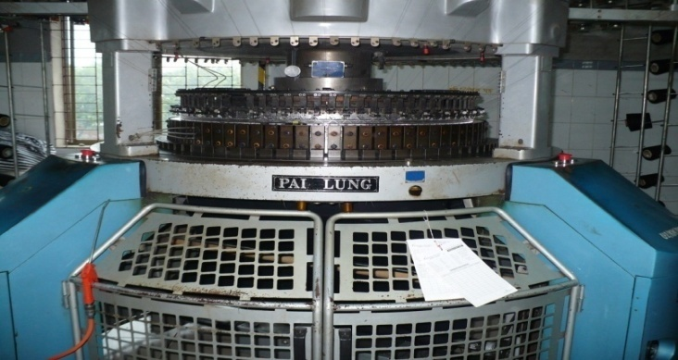
ORIZIO  (Italy) | 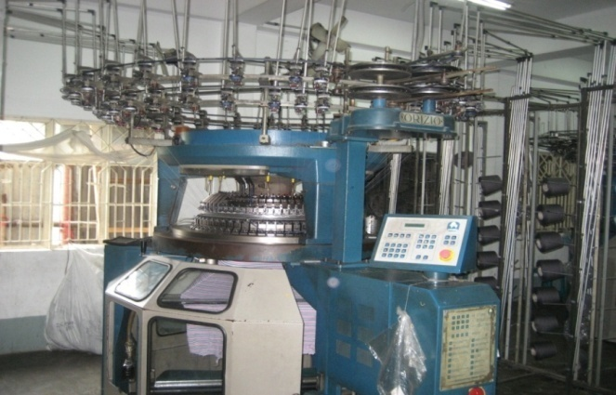

Fukuhara  (Japan) | 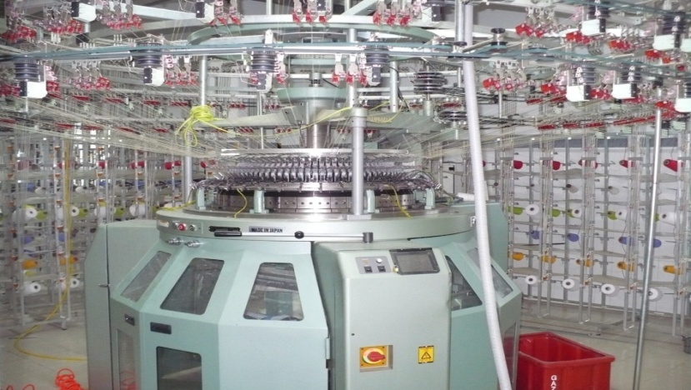
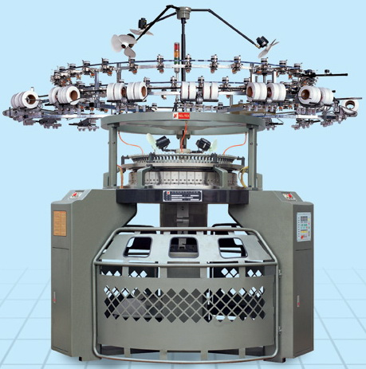

Jiunnlong
(Taiwan)

Flat Bed Knitting Machine

STEIGER
(Italy)
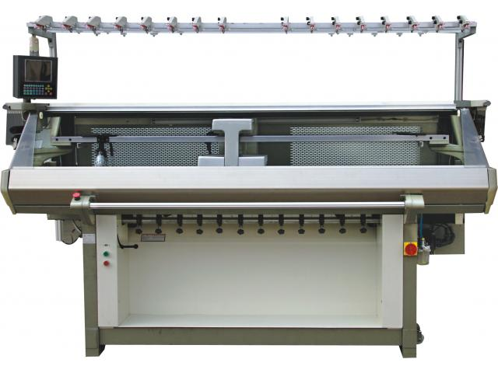

Flat Bed Knitting Machine

MATSUYA
(Japan)

Flat Bed Knitting Machine

Shima Seiki
(Japan)
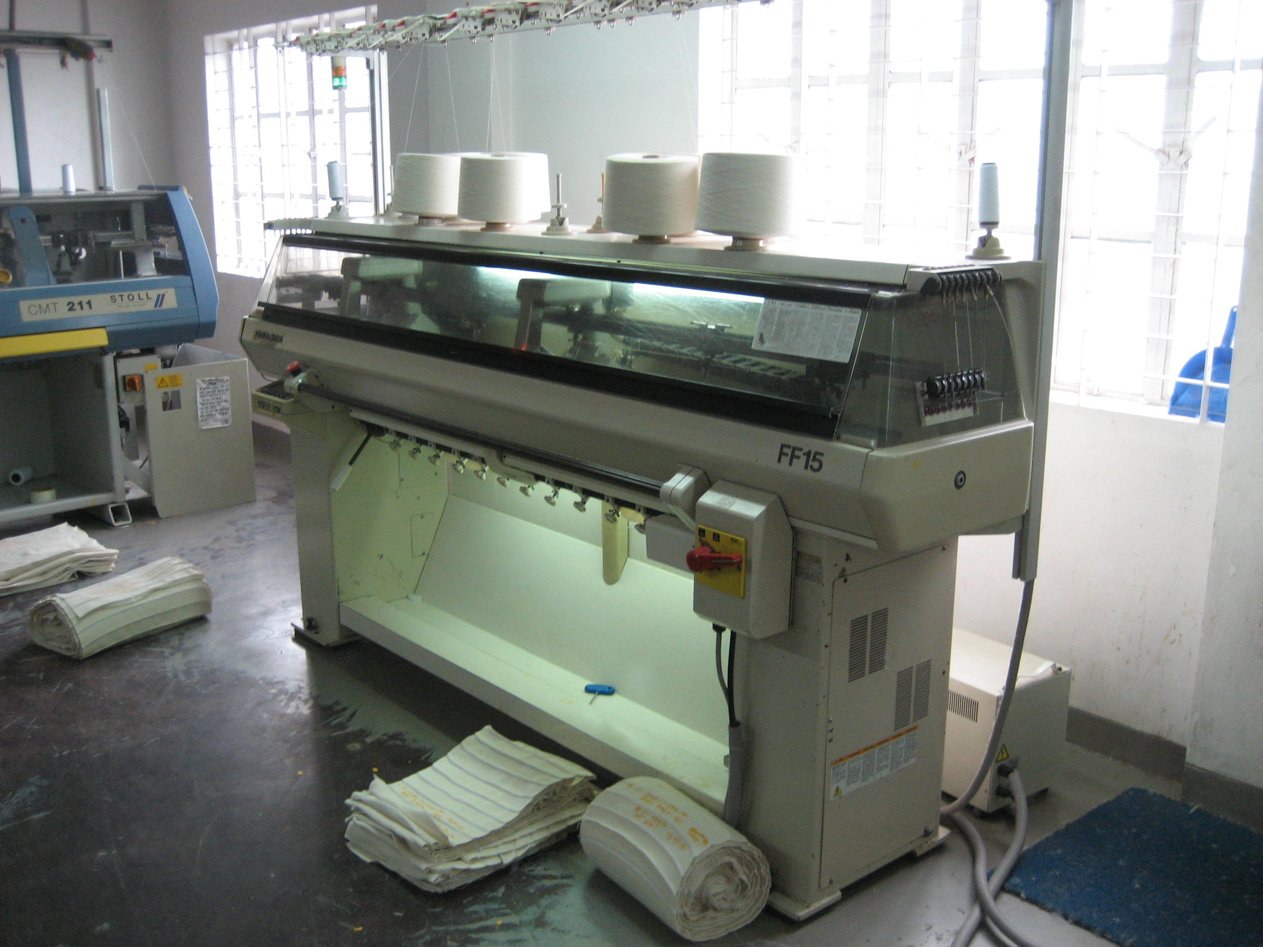

Machine Operating Rules (by machine company):
Description of knitting parts:

Name of parts | Figure | Working principle
Creel | 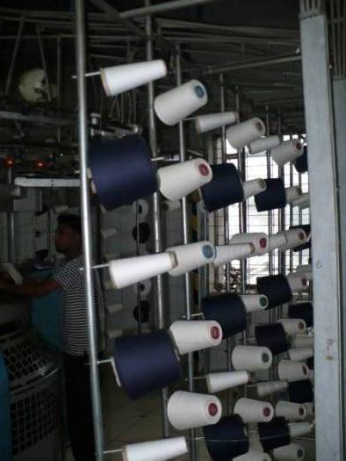 | Creel is a part of knitting machine. Here yarn packages are stored for yarn feeding in the machine.
MPF Wheel | 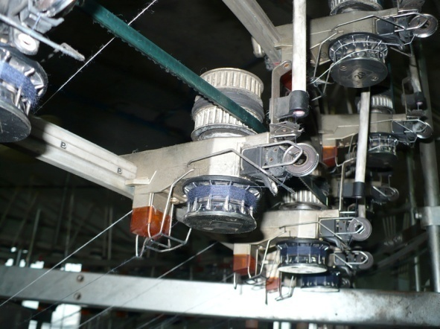 | Its control the speed of the MPF. Pulley belt gives motion to the wheel.
MPF | 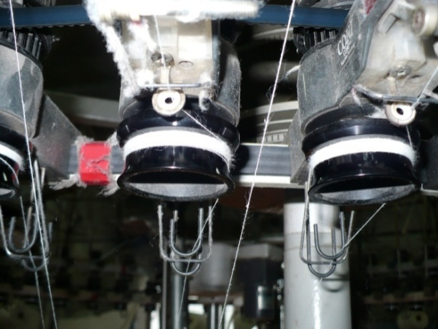 | It’s mean Mamminger positive feed. It gives equal length yarn distribution in the knitting cycle.

VDQ Pulley | 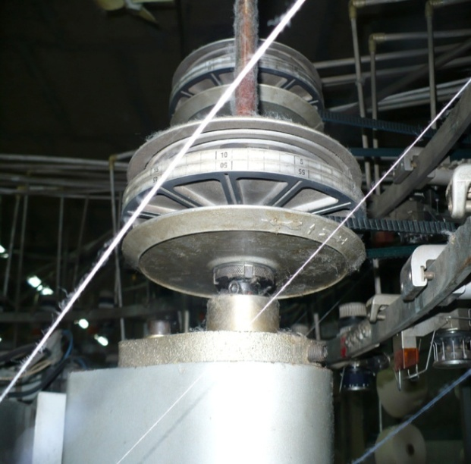 |  | It is a very important part of the machine. It controls the quality of the product. Altering the position of the tension pulley changes the G.S.M of the fabric. If pulley moves towards the positive directive then G.S.M decreases and reverse direction G.S.M will increase
Pulley belt |  |  | It controls the rotation of the MPF wheel.
  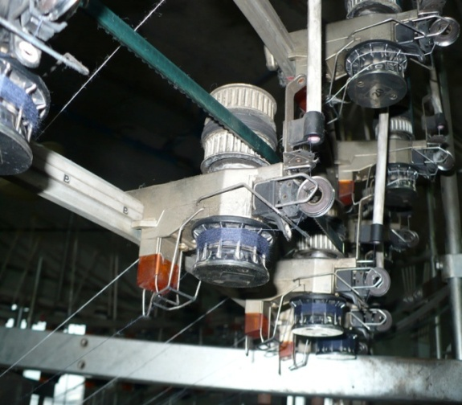
Yarn guide pipe | 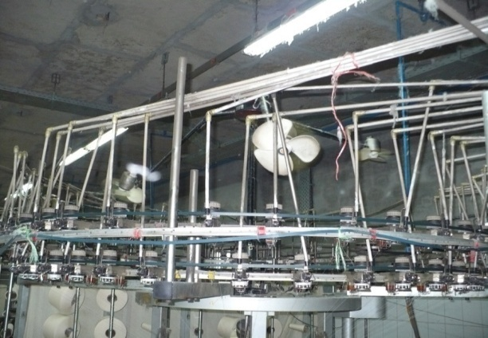 |  | It helps the yarn to feed in the feeder & also reduce ply.
Inlet & outlet stop motion |  | 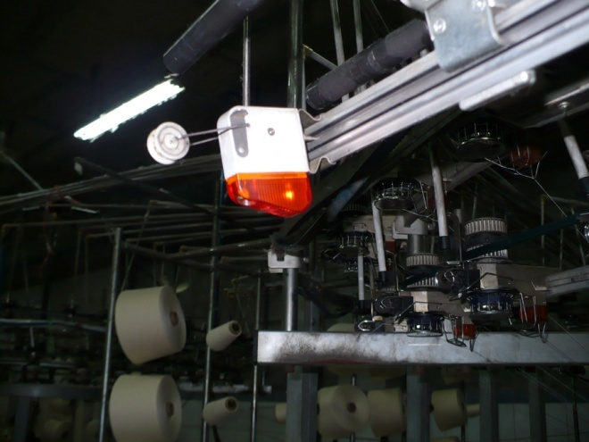 |  | It is an important part of the machine. It stops the machine instantly when a yarn breaks.
Feeder ring |  | 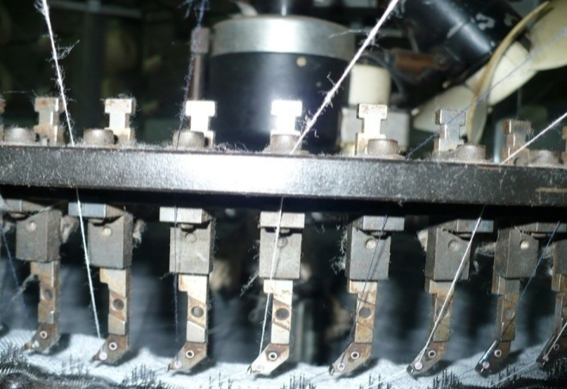 |  | It is a ring where all feeders are place together.
Feeder |  | 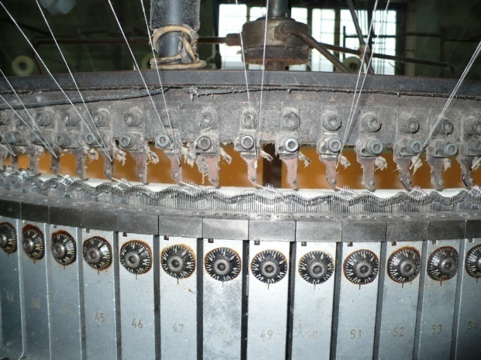 |  | Feeder is a device where yarn passes through the knitting section.

Brush | 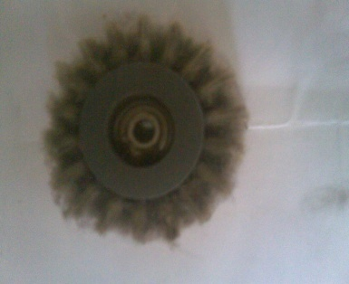 | It cleans the pulley belt.
Sinker | 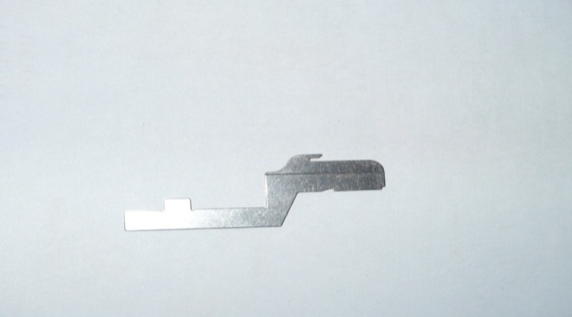 | It is most important element of the machine. It helps to loop formation, hold down the loop, knocking over the loop.
Sinker ring | 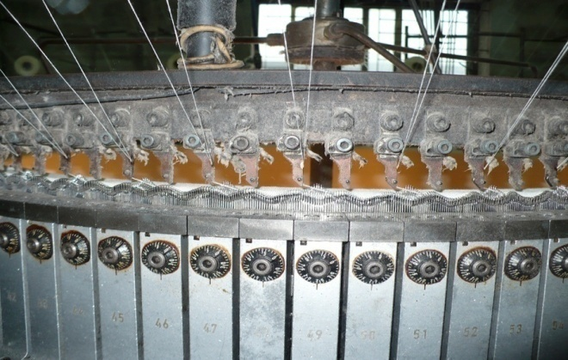 | It is a ring where all sinkers are placed together.

Cam | 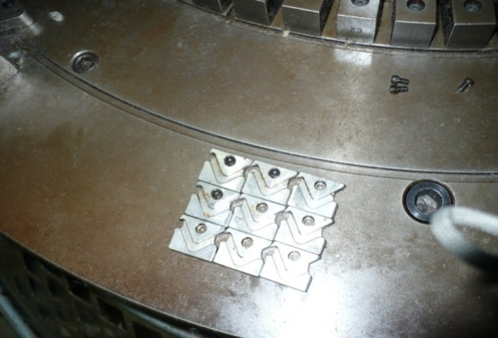 | Cam is a device which converts rotary machine drive into a suitable reciprocating action for the needles and other elements. The cams are carefully profiled to produce precisely-time movement and dwell periods and are two types, engineering and knitting cams.
Cam box | 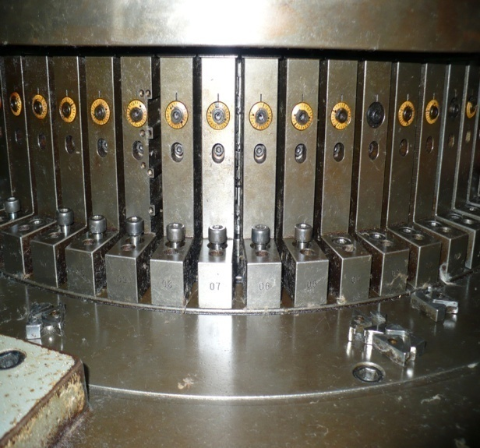 | Where cam are placed horizontally in the box.
Needle | 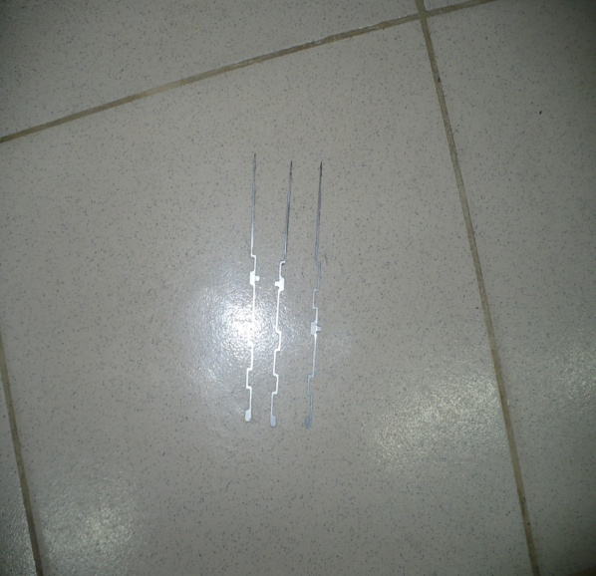 | Needle is a primary knitting elements. It gives movement according to the cam arrangement.

Cylinder | 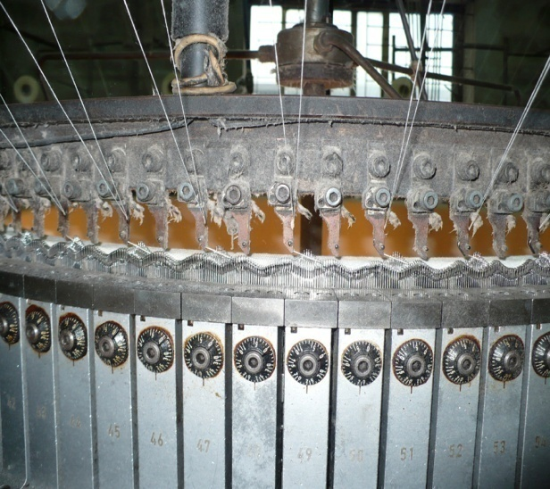 | Needle track are situated here.
Needle trick | 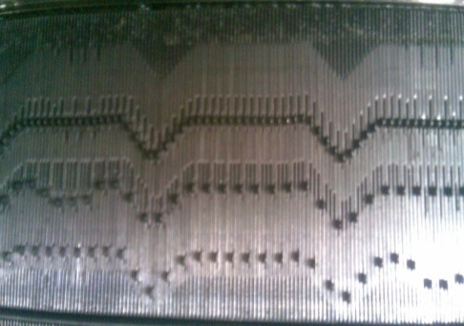 | Where all needles are placed in a decent design.
Lycra attachment | 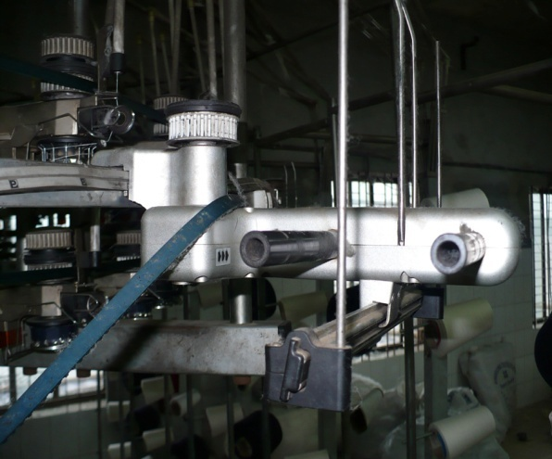 | Lycra is placed here and feeding to the machine.
Lycra stop motion | 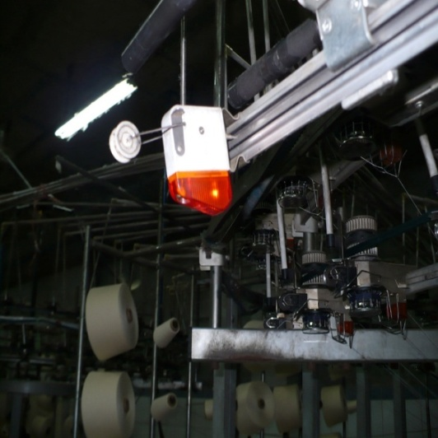 | When lycra is broken it stops the machine.
Screen | 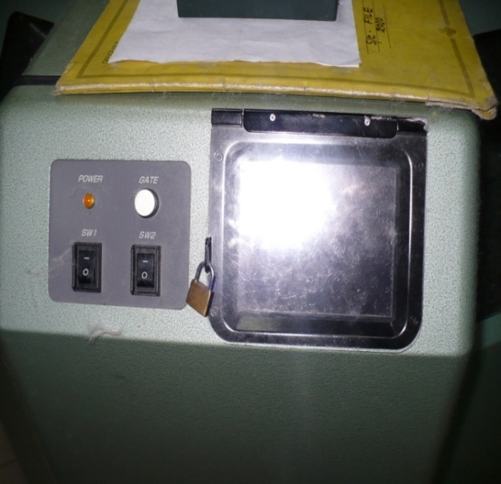 | It is a digital screen. Which show the all machine information and we can get command to the machine.
Automatic oiler | 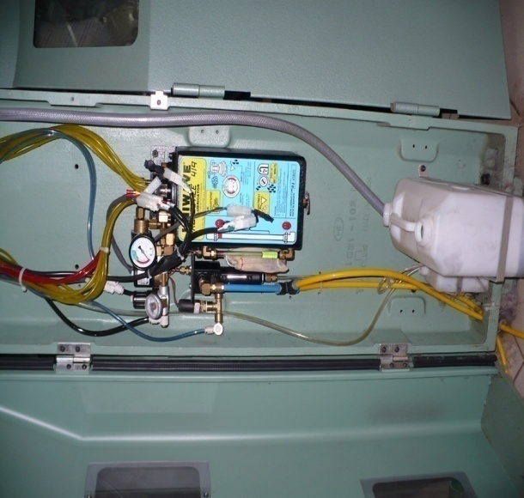 | It gives the machine oil all the time properly and automatically.

4.2 Machine Description of Dyeing Lab:

Name: Spectrophotometer  Model: Data Color 650  Brand: Data Color  Origin: U.S.A  Function:  Shade measurement, Collect recipe,  Pass/fail operation, Color difference, Metamerism, Reflectance curve, Fastness rating, Cost comparison |  |  | 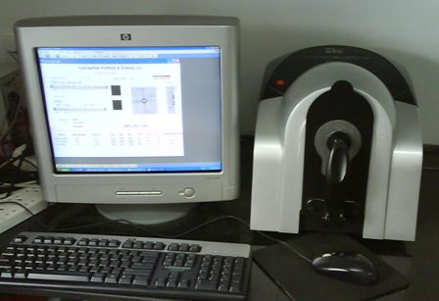
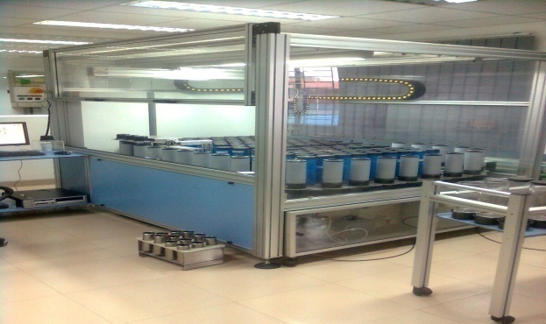
Robolab XPN
Model: 0966
Brand: talos ROBOTICS
Origin: Greece
Function: Auto pipetting, Auto solution.
Name: TEXLINK
TYPE: Sample dyeing machine
Brand: HSD-12
Brand: TEXLINK
Origin: China
Function: To dye the sample
Glycerin is used for holding heat.
No of machine: 2
Name: FONG’S  Type: Sample dyeing machine  model: V415  brand: FONG’S  Origin: Hong Kong  Normal water is used.  No of machine: 2  Function: To dye the sample | 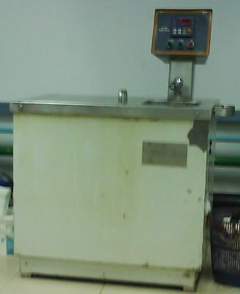
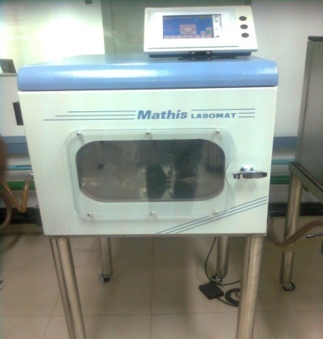
Mathis LABOMAT
Type: Sample dyeing machine
Model: CH8156
Origin: Switzerland
Function: To dye the sample.
ROTAWASH
Type: washing machine
Model: M 228A
Brand: SDA ATLAS
Origin: England
Function: To measure the
color fastness to wash.
Washcator FOM 71 CLS
Type: washing machine
Model: FOM71 CLS
Origin: Sweden
Function: To wash the fabric
Quickwash plus
Model: M222
Brand: SDL ATLAS
Origin: England
Function: Quick wash with shrinkage measure.
Washing machine  Model: WD-80264 NP  Brand: LG  Origin: China  Function: To wash the sample |  | 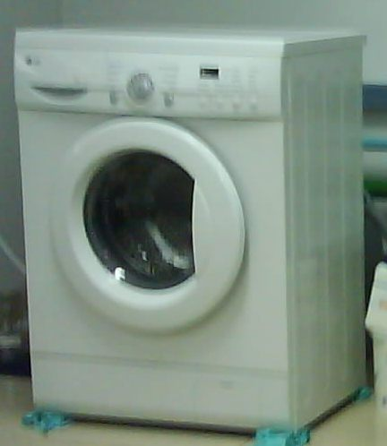
CHANNEL
Type: Dryer
Model: DV 452
Brand: CHANNEL
Origin: China
Function: To dry the sample
INDESIT
TYPE: Dryer machine
Model: I 30640
Origin: England
Function: To dry the sample

4.3 Machine Description of Dry Lab:

ICI PILLING & SNAGGING TESTER  Origin: England  Model:M227  Brand: SDL ATLAS  Function: To measure the pilling test and hairiness test. | 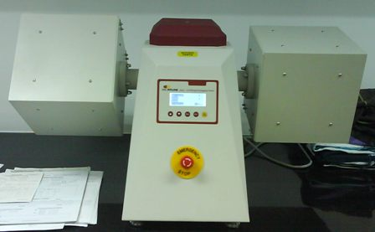
XENON STRAHLER  Type: Light fastness tester machine  Model/brand: XENONEST 150S+  Origin: Germany  Function: To measure light fastness | 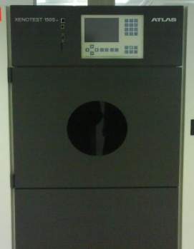
Microprocessor pH meter  Function: To measure pH & temperature | 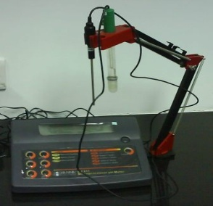
Tumble Dryer
Brand: White-Westing house
Crock master  Brand/Model: JAMES H. HEAL  Origin: England  Function: To measure color fastness to rubbing. | 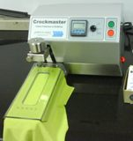
Perspiration Tester
Model: G209A
Brand: SDL ATLAS
Origin: England
Function: To measure perspiration
Light Box  Brand: VeriVide  Common Light Source: D65, UV, TL83, TL84, F11 etc.  Function: Shade matching on the recommended light source, detect Metamerism. | 
Electrical Heater
Iron machine
Origin: Singapore

4.4 Machine Description of Dyeing Section
Machine No: 01  Name/Brand: FONG’S  Origin: Hong Kong  Year of Manufacture: 2002  No. of nozzle: 1  Machine Capacity: 10 kg  Maximum loading capacity (practical): 9.5 kg  Machine type: H.T | 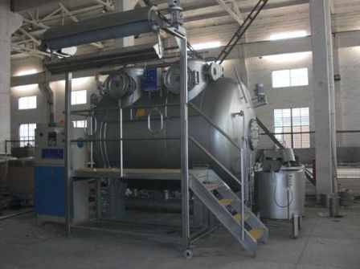
Machine No: 02-05
Name/Brand: FONG’S
Origin: Hong Kong
Year of Manufacture: 1997
No. of nozzle: 2
Machine Capacity: 500 kg
Maximum loading capacity (practical): 450 kg
Machine type: HT
Machine No: 06  Name/Brand: DILMENLER  Origin: Turkiye  Year of Manufacture: 2001  No. of nozzle: 1  Machine Capacity: 100 kg  Maximum loading capacity (practically): 80-90 kg  Machine type: HT |  | 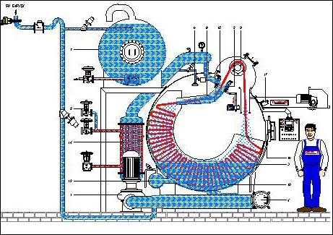
Machine No: 07-08
Name/Brand: TONG GENE
Origin: Taiwan
Year of Manufacture: 2007
No. of nozzle: 1
Machine Capacity: 200 kg
Maximum loading capacity (practical): 180 kg
Machine type: Atmospheric
Machine No: 09-10
Name/Brand: TONG GENE (Sample machine)
Origin: Hong Kong
Year of Manufacture: 2007
No. of nozzle: 1
Machine Capacity: 50 kg
Maximum loading capacity (practical): 40 kg
Machine type: HT
Machine No: 11-14
Name/Brand: FONG’S
Origin: Hong Kong
Year of Manufacture: 2007
No. of nozzle: 1
Machine Capacity: 15 kg
Maximum loading capacity (practical): 12kg
Machine type: HT
Machine No: 15  Name/Brand: DILMENLER  Origin: Turkiye  Year of Manufacture: 2003  No. of nozzle: 1  Machine Capacity: 200 kg  Maximum loading capacity (practical): 180 kg  Machine type: HT | 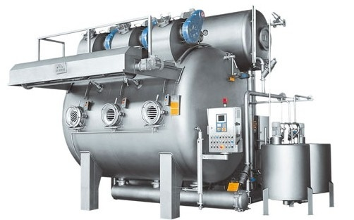
Machine No: 16-17
Name/Brand: TONG GENE
Origin: Taiwan
Year of Manufacture: 2005
No. of nozzle: 3
Machine Capacity: 600 kg
Maximum loading capacity (practical): 500 kg
Machine type: Atmospheric
Machine No: 19
Name/Brand: Bangla Machine
Large portion Capacity: 20 kg
Small portion capacity: 10 kg
Machine type: Atmospheric
Machine No: 20
Name/Brand: SCLAVOS
Origin: Greece
Year of Manufacture: 2008
No. of nozzle: 6
Machine Capacity: 1600 kg
Maximum loading capacity (practical): 1500 kg
Reel speed: maximum = 320, using = 250-280
Pump speed: maximum =100, use = 92 rpm
Machine type: HT

4.5 Machine Description of Finishing Section
Finishing section is divided into two lines:
- Tube line
- Open line
- The machine that are used for Tube line are given bellow:
- Dewatering machine (Hydro, CORINO, FM CALATOR)
- Dryer (FONG’S, DILMENLER)
- Compactor machine (Tube tex, FERRARO)
- The machines that are used for tube line are given bellow :
- Slitting and Dewatering machine (Bianco)
- Stenter machine, Lafer

Machines for tube fabric
De-watering machine (Hydro)
Capacity: 200 kg
Function: To remove water.
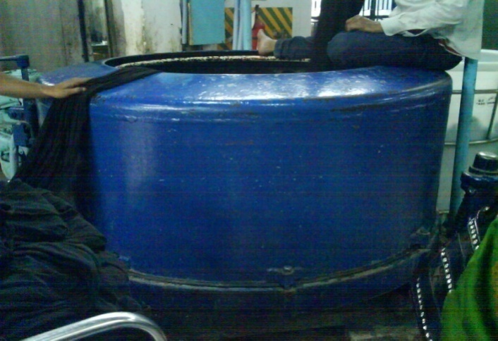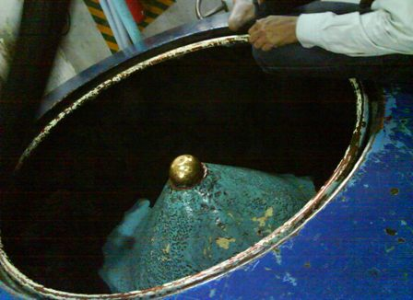
De-watering & Squeezer machine (CORINO)  Capacity: 2.5-3 ton/shift  Sometimes chemicals (softener) are used if required.  Function: To remove water, To slit tube roll of fabric, To remove extra dust of fabric. | 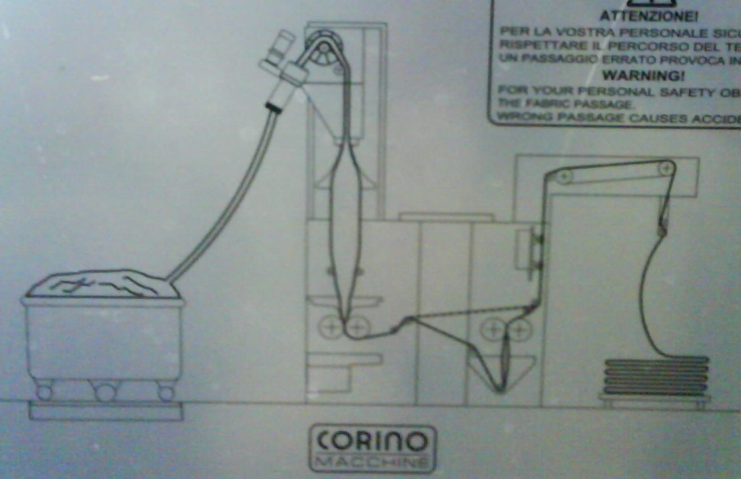
De-watering & Squeezer machine (FM CALATOR)  Origin: Sweden  Capacity: 3-4 ton/shift  Roller pressure = 5 bar  Function: To remove water. |  | 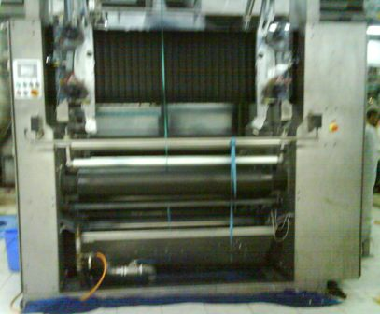
Dryer (FONG’S)
Capacity: 200-250 kg/hour
Temperature range: 150-170°C (Single jersey: 140; Single Lacoste=150Lycra Interlock, Rib, Fleece=160), depend on fabric GSM.
For 200GSM or more, fabric is dried 2 times.
Steam is used to provide heat.
Dryer (DILMENLER)
Origin: Turkiya
Machine Type: DMS 05
2 chamber 2 pass Relax Dryer machine
Capacity: 2400-3000 kg/shift
Temperature= 150-170
Function: To dry the fabric.
Compacting machine (Tube tex)
Origin: USA
Capacity: 4 ton/shift
Controlling point: Feed roller, Take roller, Blade, Steam, Roller pressure, Shape.
Roller pressure: Single Jersey=12-16 bar, Single Lacoste = 25-28 bar, Interlock = 15-20 bar, Rib = 12-15 bar.
Functions: To compact the fabric, crease remove, shrinkage control, dia control, GSM control.
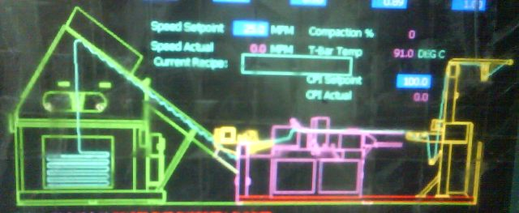

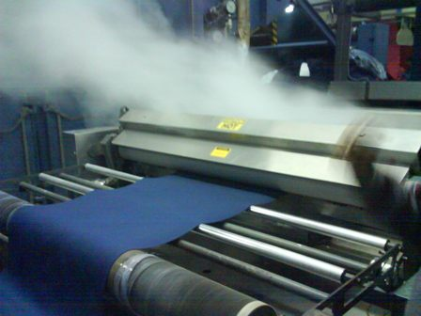
Calendar & Compactor (FERRARO)
ORIGIN: Italy
Capacity: 2 tons/shift
Function: To compact the fabric, crease remove, dia control, increase lusture.

Machines for Open fabric
Slitting & De-watering machine (Bianco)
Origin: Italy
Capacity: 4-5 tons/shift
Speed: 90m/min
Fabric slit/open with auto-controlling device.
Function: Opening, water removing.
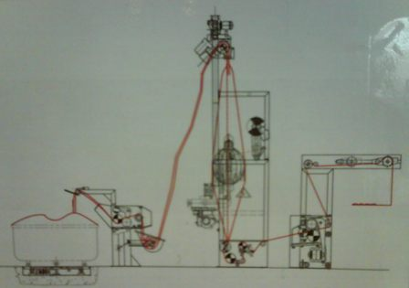

Stenter machine
Chamber: 8
Fuel: Natural gas
Pressure: 2-4, 6 bar
Temperature range: up to 220°C
Major parts of a Stenter machine:
- Centering device
- Bow & Bias control device
- Curling control device
- Width/dia adjust device
- Padding device
- Over-feed device
- Heat Chamber (Burner/Blower)
- Cooling Units
Feed system: Knitted fabric in open width form & woven fabric are treated.
Used for:
- Drying
- Heat setting
- Width control
- Curing (printing)
- For woven fabric- loop control, weft straightening.
- Pigment dye application
- Finish chemical application
- Selvedge gumming & trimming
- Selvedge trimming etc.

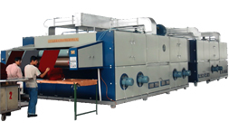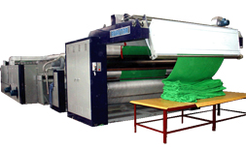
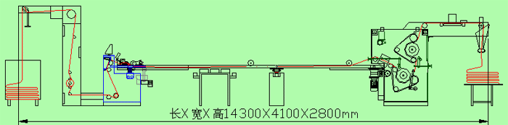
Bianco (Device of Stenter)
Origin: Italy
Maximum speed: 50 m/min
Function: Bowing & bias control.
PLATINUM (STENTERING MACHINE)
Origin: South Korea
Machine speed: 8-100 m/min
Working width: 2400mm/94.48 inch
Main Function: Dry the fabric, dia control.
Auto Test Rolling machine (Device of Stenter)
Origin: South Korea
Machine speed: 8-10 m/min
Working width: 2400mm/94.48 inch
Function: fabric rolling
Lafer SPA (Open Compacting machine)  Model: KSA 500 RUNNER  Origin: Italy  Capacity: 10 tons/day  Speed: 50 rpm  Function: Shrinkage control, GSM control, Dia control, compacting the fabric. | 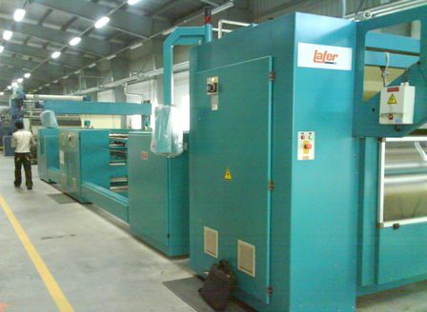

Chapter: 05
Raw Material
5.1 Raw materials for knitting

Type of yarn | Count (depend on GSM)
Cotton | 20^{S}, 22^{S}, 24 ^{S}, 26 ^{S}, 28 ^{S}, 30 ^{S}, 32 ^{S}, 34^{S}, 40^{S}
Polyester | 72 D,75 D, 100 D
Lycra yarn | 20D, 40D
Grey Mélange (C-90% V-10%, C-95% V-5%) | 24^{S}, 26^{S}
PC (65%Polyester & 35% cotton) | 24^{S}, 26^{S}, 28^{S}, 30^{S}
CVC | 24^{S}, 26^{S}, 28^{S}, 30^{S}

5.2 Raw materials for dyeing
Knitted grey fabrics (Single Jersey, Single Lacoste, Lycra Single Jersey, Lycra Single Lacoste, Interlock, Rib, Fleece, Twill tape).
Chemicals used in Impress-Newtex:

Chemicals name | Supplier | origin
Jinterge SCF-105 | Jintex Corporation | Taiwan
Jintex 2UD | Jintex Corporation | Taiwan
Jinsoap CBA | Jintex Corporation | Taiwan
Caustic soda | Samuda chemical Complex | Bangladesh
Kappazon K 75 | Kapp-Chemie Gmbh & Co | Germany
Hydrozen peroxide | Samuda chemical Complex | Bangladesh
Jintex CPS/Green Acid | Jintex Corporation | Taiwan
Jintexzyme OEM | Jintex Corporation | Taiwan
Ecozyme LXN | Ecochem (Pvt.) Ltd. | Sri Lanka
Kappaquest A-41 | Kapp-Chemie Gmbh & Co | Germany
Glauber salt | Huaian Youbang Trade Co Ltd | Chaina
Soda ash | Huaian Youbang Trade Co Ltd/  Chaina Chem(QINGADAO) Co Ltd. | Chaina
Jinsoap AW-501 | Jintex Corporation | Taiwan
KAPPASOFT BD | Kapp-Chemie Gmbh & Co | Germany
Kappawet BOS | Kapp-Chemie Gmbh & Co | Germany

List of dyes which are used in INCTL :

Cotton dyes name | uppliers | Origin
Remazol Blue BB | Dystar | Germany
Remazol-Turquise Blue G | Dystar | Germany
Levafix Brill Yellow CA | Dystar | Germany
Remazol Blue RR | Dystar | Germany
Levafix Amber CA | Dystar | Germany
Levafix Blue CA | Dystar | Germany
Levafix Red CA | Dystar | Germany
Reactobond Yellow RR | Meghmani dyes & intermediates Ltd. | India
Reactobond Red 3RR | Meghmani dyes & intermediates Ltd. | India
Reactobond Red 3BX | Meghmani dyes & intermediates Ltd. | India
Reactobond Yellow 3RX | Meghmani dyes & intermediates Ltd. | India
Reactobond Yellow 4GL | Meghmani dyes & intermediates Ltd. | India
Remazol Orange RR | Meghmani dyes & intermediates Ltd. | India
Kirazol Red RGB | Kirri Dyes Co. | India
Kireactive Blue RRX | Kirri Dyes Co. | India
Kireactive Yellow-HB | Chemitech Co. | India
Kireactive Blue-RGB | Chemitech Co. | India
Kirractive Blue BRX | Chemitech Co. | India
Kirractive Blue RRX | Chemitech Co. | India
Solazol Blue R (spl) | Solarfine Chemical Co. ltd. | Taiwan
Solazol Black B | Solarfine Chemical Co. ltd. | Taiwan
Terasil Blue WBLS | Hantsman | China
Terasil Red W-4BS | Hantsman | China
Terasil Yellow W4G | Hantsman | China
Disperse Blue BGE | Xiangtan Zenith Fine Chemical Co. | China
Disperse Navy XF | Xiangtan Zenith Fine Chemical Co. | China
Drimarin Blue CLBR | Klariant | China
Synozol BR Blue KPL | Kyung-In Synthetic Corporation | Korea

Chapter: 06
Production Planning Sequences and Operation

6.1 Production Planning Sequence & Operation at INCTL:
Final Quality Inspection
Finishing of dyed fabric
Delivery
Collect yarn from spinning mill
Go for bulk production of dyeing
Batch preparation
Match the swatch according to buyer’s requirement
Knitting

6.2 Process flow chart of knitting:

Yarn in cone form

Feeding the yarn cone in the creel

Feeding the yarn in the feeder via trip-tape positive feeding arrangement and tension device

Knitting

Withdraw the rolled fabric and weighting

Inspection

Numbering

6.3 Basic technological concept :

The fundamental structure unit of a knitted fabric is the loop. Any circular knitted fabric is composed of row after row of intermeshed loops. Different types of fabric are made of different method of intermeshing the loop. The gross dimension of knitted fabric is simply a relation of average shape and size of individual loop. There are several key variables in the production which affect the average shape and size of the loop. After knitting the grease fabric is dyed to required shade and finished to required weight and width.

6.3.1 Classification of knitting:
Knitting
Weft knitting
Warp knitting
Flat knitting
Circular knitting
Double jersey
Single jersey

6.3.2 Warp knitting :
A method of making a fabric by normal knitting means is which the loop made from each warp thread is formed substantially along the length of the fabric. Characterized by the fact that each warp thread is feed more or less in the line with the direction in which the fabric is produced.

6.3.3 Weft knitting
A method of making a fabric by normal knitting means is which the loop made from each weft thread formed substantially along the length of the fabric. Characterized by the fact that each warp thread is feed more or less in the line with the direction in which the fabric is produced.

6.4 Single jersey
A fabric in which all the loops of the Wales are intermeshed in one direction is called single jersey. Only cylinder is used to make single jersey fabric. End Products of Single Jersey Circular Knitting Machine:
1. Single Jersey Plain
2. Single Lacoste
3. Double Lacoste
4. Single pique
5. Double pique
6. Terry
7. Heavy Jersey

6.5 Double jersey
A fabric in which all the loops of the alternate wale/Wales are intermeshed in one direction and all the loops of the other wales knitted t the same course are intermeshed in the other direction is called the double jersey. Dial and cylinder are used to make this type of fabric.

End products of Rib Interlock Circular Knitting Machine:

Interlock M/C:  a) Interlock pique  b) Mash fabric  d) Honeycomb fabric | Rib M/C:  a) 1×1 Rib fabric  b) 2×2 Rib fabric

6.6 Cam Arrangement

Single Jersey | 11Rib
  K | K | K | K
  K | K | K | K
  K | K | K | K
  K | K | K | K
  K | M | K | M | K
  M | K | M | K | M
Single Lacoste | 11Interlock
  K | K | K | T | K | K
  K | T | K | K | K | T
  K | M | K | M
  M | K | M | K
Double Lacoste | Two thread fleece
  K | K | K | K | T | T
  K | T | T | K | K | K
  K | T | K | M
  K | M | K | M
  K | M | K | T
Double pique/Polo pique

K | T | K | T
T | K | T | K

6.7 Methods of increasing production
By the following methods the production of knitted fabric can be increased –
A. By increasing m/c speed:
Higher the m/c speed faster the movement of needle and ultimately production will be increased but it has to make sure that excess tension is not imposed on yarn because of this high speed.
B. By increasing the number of feeder:
If the number of feeder is increased in the circumference of cylinder, then the number of courses will be increased in one revolution at a time.
C. By using machine of higher gauge:
The more the machine gauge, the more the production is. So by using machine of higher gauge production can be increased.
E. By imposing other developments:
a) Using creel-feeding system.
b) Applying yarn supply through plastic tube that eliminates the possibilities of yarn damage.
c) Using yarn feed control device.
d) Using auto lint removal.

6.8 Production calculation
A. Production/shift in kg at 100% efficiency:
$=\frac{\text{RPM} × \text{No}\text{.} \text{of} \text{Feeder} × \text{No}\text{.} \text{of} \text{Needle} × \text{SL}(\text{mm})}{\text{3527}\text{.}\text{80}× \text{Yarn} \text{count}}$
B. Production/shift in meter:
$\begin{aligned}=\frac{\text{Course}\text{/min}\text{.}}{{\text{Course}}/{\text{cm}}} \\ =\frac{\text{RPM}×\text{No}\text{.} \text{of} \text{Feeder}×\text{60}×\text{12}×\text{Efficiency}}{{\text{Course}}/{\text{cm}}×\text{100}}\end{aligned}$

C. Fabric width in meter:
$\begin{aligned}=\frac{\text{Total} \text{no}\text{.} \text{of} \text{wales}}{{\text{Wales}}/{\text{cm}}×\text{100}} \\ =\frac{\text{Total} \text{no}\text{.} \text{of} \text{Needles}\text{used}\text{in} \text{knitting}}{{\text{Wales}}/{\text{cm}}×\text{100}}\end{aligned}$
6.9 Knitting variables
- Yarn count  - Yarn twist  - Spinning system  - No. of ply of the yarn  - Stitch length  - Yarn tension  - Required time (M/C running time); | - Take down tension  - Yarn quality  - Machine gauge  - Machine Diameter;  - Machine rpm  - No. of feeds or feeders in use;  - Machine running efficiency.

6.10 Relationship between knitting parameter
1. Stitch length increase with decrease of GSM.
2. If stitch length increase then fabric width increase and Wales per inch decrease.
3. If machine gauge increase then fabric width decrease.
4. If yarn count increase (courser) then fabric width increase.

5. If shrinkage increases then fabric width decrease but GSM and Wales/inch increase.
6. for finer gauge, finer count yarn should use
7. Grey GSM should be less than finish GSM

6.11 Considerable points to produce knitted fabrics
When a buyer orders for fabric then they mention some points related to production and quality. Before production of knitted fabric, these factors are needed to consider. Those are as follows-

- Type of Fabric or design of Fabric.
- Finished G.S.M.
- Yarn count
- Types of yarn (combed or carded)
- Diameter of the fabric.
- Stitch length
- Color depth.

6.12 Effect of stitch length on color depth
If the depth of color of the fabric is high loop length should be higher because in case of fabric with higher loop length is less compact. In dark shade dye take up% is high so GSM is adjusted then. Similarly in case of light shade loop length should be relatively smaller

6.13 Factors that should be change in case of fabric design on quality change
- Cam setting
- Set of needle
- Size of Stitch Length

6.14 Key accessories used in Circular knitting
- Yarn feeder guide
- Needle
- Sinker
- Cam
- Cylinder
- VDQ pulley
- Pattern wheel
- Sinker cam cap
- Sinker trick ring
- Dial
- Needle retaining spring
- Cam box
- cam plate
- Inventor
- Belt

6.15 Quality control equipment
- Yarn tension meter
- Stitch length meter
- Magnifying glass
- GSM cutter etc

6.16 Difference between S/J and double jersey m/c:
Single jersey m/c | Double jersey m/c
1.One set needle is used. | 1. Two set needle are used.
2.Has sinker. | 2. Has no sinker.
3. Inside of m/c is vacuum. | 3. Inside is not vacuum.
4. Has sinker box. | 4. Has no sinker box.
5. Has sinker ring. | 5. Has no sinker ring.
6.Ex:- S/J | 6.Ex:-Rib,Interlock etc.

6.17 Main parts of a Single jersey m/c
- Needle
- Cam (Needle cam, Sinker cam)
- Sinker
- Sinker cam
- Feeder
- Feeder ring
- Cam box
- Wheel
Relation between m/c dia & Number of feeder of this m/c:
Number of feeder =m/c dia 3

Positive feed system:
If needle gets required thread without stretch for loop formation, it is called positive feed system.
Negative feed system:
If needle drawls the thread for loop formation called negative feed system.

Negative feed system is best. Because
- Easy mechanism.
- No slippage.
- Maximum 4 course length variation.
- To adjust loop length variation.
- No possibility of thread breakage.
- Wide range yarn feeding.
V.D.Q:
V.D.Q means Variable dia for quality.
Function: To control fabric G.S.M.

6.18 Faults & their causes in Knitting

1. Hole Mark

Causes:
- Holes are the results of yarn breakage or yarn cracks.
- During loop formation the yarn breaks in the rejoin of the needle hook.
- If the yarn count is not correct on regarding structure, gauge, course and density.
- Badly knot or splicing.
- Yarn feeder badly set.

Remedies:
- Yarn strength must be sufficient to withstand the stretch as well as uniform.
- Use proper count of yarn.
- Correctly set of yarn feeder.
- Knot should be given properly.

2. Needle Mark
Causes:
- When a needle breaks down then needle mark comes along the fabrics.
- If a needle or needle hook is slightly bends then needle mark comes on the fabrics.
Remedies:
- Needle should be straight as well as from broken latch.

3. Sinker Mark
Causes:
- When sinker corrode due to abrasion then some times can not hold a new loop as a result sinker mark comes.
- If sinker head bend then sinker mark comes.
Remedies:
- Sinker should be changed.

4. Star Mark

Causes:
- Yarn tension variation during production.
- Buckling of the needle latch.
- Low G.S.M fabric production.
Remedies:
- Maintain same Yarn tension during production.
- Use good conditioned needles.

5. Drop Stitches

Causes:
- Defective needle.
- If yarn is not properly fed during loop formation i.e. not properly laid on to the needle hook.
- Take-down mechanism too loose.
- Insufficient yarn tension.
- Badly set yarn feeder.

Remedies:
- Needle should be straight & well.
- Proper feeding of yarn during loop formation.
- Correct take up of the fabric & correct fabric tension.
- Yarn tension should be properly.

6. Oil stain
Causes:
- When oil lick through the needle trick then it pass on the fabrics and make a line.
Remedies:
- Ensure that oil does not pass on the fabrics.
- Well maintenance as well as proper oiling.
7. Rust stain
Causes:
- If any rust on the machine parts.
Remedies:
- If any rust on the machine parts then clean it.
- Proper maintenance as well as proper oiling.

8. Pin hole

Causes:
- Due to break down or bend of the latch, pin hole may come in the fabric.
Remedies:
- Change the needle.

9. Grease stain
Causes:
- Improper greasing
- Excess greasing
Remedies:
- Proper greasing as well as proper maintenance
10. Cloth fall- out
Causes:
- Cloth fall- out can occur after a drop stitch especially when an empty needle with an empty needle with closed latch runs into the yarn feeder and remove the yarn out of the hook of the following needles.
Remedies:
- Make sure all the latches of needle are closed with feeding yarn after a drop stitch.

11 . Barre: A fault in weft knitted fabric appearing as light or dark course wise (width wise)
stripe(s).
Causes:
- This fault comes from yarn fault.
- If different micro near value of fiber content in yarn.
- Different lusture, dye affinity of fiber content in yarn.
- During spinning different similar classes of fiber is mixed specially in carded yarn & these fibers have similar characteristics.
- In draw fame different similar classes sliver is mixed and make one sliver.
Remedies:
- We can use this fabric in white color.
12. Fly:
Causes:
- In knitting section too much lint is flying to and fro that are created from yarn due to low twist as well as yarn friction. This lint may adhere or attaches to the fabric surface tightly during knit fabric production.

Remedies:
- Blowing air for cleaning and different parts after a certain period of time.
- By cleaning the floor continuously.
- By using ducting system for cleaning too much lint in the floor.
- Over all ensure that lint does not attach to the fabric.
13.Yarn contamination
Causes:
- If yarn contains foreign fiber then it remains in the fabric even after finishing,
- If lot, count mixing occurs.
Remedies:
- By avoiding lot, count mixing.
- Fault less spinning.
14. Yarn Faults:
- Neps. Slubs. Yarn count, Thick/Thin place in yarn, Hairiness.

Comparison between machine dia and grey dia.
Formula:
Grey dia =(1.2-1.4)machine dia

Introduction: Generally grey dia is (1.2-1.4)times higher than machine dia.
Machine Parameter:
Machine no: 08
Machine dia: 32″
Fabric type:Fleece
Fabric dia: ?
- Procedure: Measure the dia of grey fabric by measuring tape.
And we get 40.5″

- Grey dia = 1.265 Machine dia
Result: Grey dia is 1.26 times of machine dia.

Determination of the lycra percentage of weft knitted fabric.
- Introduction: Lycra percentage means how much lycra is used with 100gm fabric.

- Procedure:
1. At first we will have to take one cotton yarn package and its related lycra package.
2. Then we will have to weigh both package by electronic balance and note down it.
3. Then this both package is set on respective place and then run the machine again.
4. Run the machine for certain times(hours) before the total yarn gets finished.(approximately 8hrs or 1 shift).
5. Then again take those selected packages and weigh once again.
6. Calculate the consumption of both lycra and cotton yarn package.
7. Then add both both consumption weight of lycra and cotton yarn package.
8. Divide the consumption of lycra by total consumption weight of lycra and cotton.Then multiply the result by 100.
9. Now we get lycra percentage in the produced fabric.

Calculation:
Machine no:17
Produced fabric: Full feeder lycra single jersey:
Yarn count: 34^{s}
Weight of cotton yarn package at start = 780gm
Weight of cotton yarn package at end = 180gm
Weight of lycra yarn package at start =140gm
Weight of lycra yarn package at end =120gm
So, amount of cotton yarn used = (780-180)gm
=600gm
Amount of lycra yarn used = (140-120)gm
=20gm

Amount of total yarn used =(600+200)gm
=620gm

Lycra percentage
=3.23%
Result: Lycra percentage on produced fabric is 4.54%

Again,

Calculation:
Machine no:09
Produced fabric: Full feeder lycra single jersey:
Yarn count: 40^{s}
Weight of cotton yarn package at start = 460gm
Weight of cotton yarn package at end = 60gm
Weight of lycra yarn package at start =260gm
Weight of lycra yarn package at end =240gm
So, amount of cotton yarn used = (460-60)gm
=420gm
Amount of lycra yarn used = (260-240)gm
=20gm

Amount of total yarn used =(420+20)gm
=440gm

Lycra percentage
=4.54%
Result: Lycra percentage on produced fabric is 4.54%
So from above two experiments in is transparent that lycra percentage increase with the increase
Of count of cotton yarn.
Determination of the extensibility of lycra.
- Procedure:
- Measure the length of lycra from package to needle butt.
- Then measure the length of lycra at relaxed state.
- Subtract the length of lycra at extensible position from the length of lycra at relaxed state.
- Then divide the length of extension by the extensible length of lycra and then multiply by 100 to get lycra extensibility.

Calculation of extensibility:
Length of lycra from package to needle butt=61.5
And length at relaxed state =9.5
Length of extension =52
Lycra extensibility =(52/61.5 )
=84.55%
Remarks: Lycra extensibility is 84.55%.

Conversion of interlock to rib and rib to interlock:
By the following ways we can convert rib to interlock and interlock to rib:-

→ By changing time gaiting of needle through moving or rotating dial or cylinder for a length of about distance between two needle.

→ For rib structure needle is set side by side of cylinder and dial. And for interlock structure the needle remain face to face.
→ The cylinder is adjusted by moving screw up and down.
→ Cam box of both dial and cylinder will have to be changed.

check and conform actual count of yarn:
By following way we can check and confirm actual count of yarn:
Machine name: Wrap Reel electronic.
Company Name: SDL ATLAS(Brand)
SL:751H0003
And Electronic Balance
Function: To measure the actual count of yarn

Formula:

Here , L = Length of the yarn in yards
W= Weight of yarn in lb.
W= weight unit 1lb.
l= length unit (840yds).
Procedure:
→ At first we will have to take 100m of yarn from the package whose count will have to be checked. It is done by wrap reel machine.
→ Then its weight is measured by electronic balance.
→ By putting this value in the formula we can calculate the count.

Example:
We took a cotton yarn package whose count is 34^{s}.
For getting sure we took 100m of yarn by wrap reel machine and then measure its weight on electronic balance. And we got 178gm.
_{So, its actual count is}
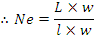
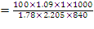
= 33.06^{s}
Remarks: So the actual count is 33.06^{s}.
0

VDQ pulley and its function:

VDQ pulley means variable diameter quality pulley. It is very important part of knitting machine.
Function:
- Control yarn supply
- Control yarn tension
- Control stitch length
- Finally control G.S.M

Changing of stitch length by VDQ pulley:
There is a nut or screw under or over the pulley. After losing the nut we can change the diameter controlling parts. If we rotate ‘+’ direction diameter will increase and stitch length will increase. If we rotate ‘-‘ direction diameter will decrease and stitch length will decrease.

Relationship between grey dia, grey stitch & grey G.S.M:
Grey dia is proportional to grey stitch
Or, grey dia ∞grey stitch
And grey G.S.M is inversely proportional to stitch length
Or grey G.S.M∞

Tightness factor:
It is a measure of how much of the fabric is covered by yarn and indicates how open and closed a fabric is called tightness factor.
It is the ratio of the area covered by the yarn in one loop to the area occupied by that loop.
Tightness factor where l is loop length in cm
Tightness factor range from 11(for slack fabric) to 19 (for tight fabric) and an average of 15 is preferable which is optimum in general.
If loop length in mm then k-value is always between 1to 2 and the average 1.5

What types of precaution will take when we will produce grey Milange and white fabric:
- At first yarn count must be checked
- Two machines are separated by net so that grey Milan dust or fibres can not contaminate the white fabric or can not be introduced into the white fabric as fly.
Calculation of machine efficiency or production efficiency:
Date: 20-06-12

Introduction:
The machine which is used to produce single jersey fabric is called single jersey machine.
Machine Parameters:
Jiunn long machine co. ltd.(made in Taiwan)
Model no.:JLS-02
Machine No.:081105(13)
Needles: 2544T
Diameter: 34″
Feeder: 96
Gauge: 24
Yarn count:30^{s}
GSM: 150
Stitch length: 2.70mm
R.P.M: 18.5
Operator Name: Md. Sumon and Humayun Ahmad.
Production .0000946×
12.33Kg/hour
73.98Kg/6hours
Production has obtained:
Weight of 1st roll=20,62Kg
Weight of 2nd roll=21.12Kg
Weight or 3rd roll=25.70Kg
Total weight=67.44Kg
Efficiency:
Efficiency=
=91%
Describe the oiling system of circular knitting machine:
Oiling:
Oiling is the process of supply oil in different parts of machine. Oiling is very important for smooth running of machine . It is compared with blood circulation of human body.

Types of oiling:
In general oiling is done in two ways:
- Pulsonic oiling system
- Uniwave oiling system
Pulsonic oiling system:
It is electrically driven oiling system . In this system of oiling , motor is used. It is modern type of oiling system and in modern system. Maintenance of personic oiling system is difficult and skilled personnel is required to maintain personic oiling system.

Uniwave oiling system:
It is conventional oiling system
- Motor is not required in this system.
- Oil is supply through compressed air.
- Easy to maintain.
- Less skilled personnel can maintain this type of oiling system

6. Working Procedure of dyeing lab:
Re-matching
Not approval
Buyer’s approval
Bulk production
Quality Inspection
Buyer’s order/ Swatch
Prepare recipe for sample dyeing to match the swatch
After dyeing sample is submitted to the buyer

Rope Length: Total length of fabric is called rope length.

, For Open Fabric, Finish dia = tube dia 2

Rope length =

Batch ratio =

Process sequence of Batch preparation

Receive batch card from Grey In-charge

Make the priority as per dyeing plan

Take one specific Batch card.

Read the Batch Card for own understanding

Check the availability of fabric

Take required quantity of body fabric from ware-house.

Make required no. of Rope maintaining equal length.

Take collar/cuff as per size, keep the total weight.

Distribute the collar/cuff or Rib in each rope equally unsure equal length

Stitch the fabric

Write down the weight against roll no. in the back side of the Batch Card.

Write the total weight in Batch card

Put signature & date.

Fill up the production report form.

Dyeing section at Impress-Newtex Composite Textiles Ltd.(INCTL)
At INCTL the following dyeing process were run during our internship:
- Whitening
- Normal dyeing
- Turkish color dyeing
- PC/CVC dyeing
- Topping
- Strippin
Whitening
Machine filling with required amount of water

At 60 , Add Detergent, Sequestering agent & Anti-creasing agent (Ink-jet dosing)

Add Caustic Soda, 10 min dosing

At 70 add by 10 min dosing

At 80 run 10 min & then add whitener by 20 min dosing, run 10 min

At 90 run 60 min& shade check, then cooling at 80

Rinse 10 min

Normal Hot at 90

Rinse 10 min

At 50 add acid & check pH (4-4.5)
Shade check

Add Enzyme at 55 & run 60 min

At 70 run 10 min

Rinse 10 min

Add Softener at normal temp & run 30 min

Unload
Flow chart of Pre-treatment (Scouring/Bleaching) process of cotton at INCTL

Load the fabric in machine & filled with required amount of water

Add Detergent, Sequestering (Sirrix SB), Anti-creasing agentat 50 (ink-jet dosing)

Caustic Soda dosing at 60 for 5 minutes & run 5 minutes

dossing at 70 for 5 minutes & run 5 minutes

Run 30 minutes at 98 & then shade check (time may vary)

Cooling at 80 & Drain

Normal Hot 80

Acetic Acid & killer is added at 55

Rinse 10 minutes

After 10 min check pH (4-4.5) & add Enzyme & run 60 minutes

Rise temperature up to 80 & run 10 minutes & shade check

Drain & Rinse 10 minutes

Dyeing Process Flow Chart:

Normal Process | Turquoise Color Process
Add Leveling, Sequestering & Anti-creasing agent at normal temperature (40), 5 minutes  Dye 30 minutes dosing at 40 & run 20 minutes  Salt dosing 10 minutes & run 20 minutes  Soda dosing 3 times (15+15+15)minutes, 1%, 2%, rest% is dosed  Run 10-20 minutes  Color Hot at 60 for 10-20 minutes (Time may vary depending on required shade) & shade check  BD  Rinse 10 minutes  Drain | Add Leveling, Sequestering & Anti-creasing agent at 40, 5 minutes  Dye 30 minutes dosing at 60 & run 20 minutes  Salt dosing 10 minutes & run 20 minutes  Soda dosing 3 times (15+15+15)minutes, 1%, 2%, rest% is dosed  Run 10-20 minutes  Color Hot at 80 for 10-20 minutes (Time may vary depending on required shade) & shade check  BD  Rinse 10-20 minutes  Drain

After-treatment (Acid, Soaping, Softener) process flow chart:

Add Acid at 40 & run 20 minutes

Rinse 5-10 minutes

Soaping at 90 & run 10 minutes, then shade check

Rinse (30-50 minutes), time may vary

Check p H (4-4.5)

Add softener at 40 & run 30 minutes & shade check

Unload

Process Flow Chart of P-C Blends at INCTL:
Polyester part dyeing:

Leveling, Acid, Anti-creasing agent at 50, 5 minutes ink-jet dosing & check pH= 4-4.5

Disperse dye is dosing 10 minutes

Rise temperature up to 130 & run 30 minutes, then shade check (time may vary)

BD

Pre-treatment:
Add Detergent, Caustic soda, Sequestering (Sirrix SB, a multi-functional group) at 90, 5 minutes dosing (Here, temperature & time may vary)

dosing for 5 minutes

Rise temperature up to 98 & run 20-30 minutes & shade check

Cooling & then drain

Cotton part dyeing:

Add Levelling, Sequestering, Anti-creasing agent at 40 for 10 minutes ink-jet dosing

Dye is dosing for 20 minutes & run 15 minutes

Salt dosing for 10 minutes & run 20 minutes

Soda dosing 3 times (15+15+15) minutes of 1%, 2%, rest% respectively & run 5 minutes

Run 30-60 minutes at 60 & shade check (depend on shade requirement)

BD

Rinse 10 minutes

After-treatment:

Add acid at 40 for 20 minutes & check pH(4-4.5)

Rinse 10 minutes

Soaping at 90 for 20 minutes & check shade

Rinse 10 minutes

Check pH, add softener at 40 for 20 minutes & shade check

Unload

Finishing Operation Sequences:

Cotton (Tube) | Cotton (open)
Hydro-extractor  Dryer  Tubular Compactor  Packing  Delivery  Inspection | Hydro-extractor/ De-watering  Stenter  Slitting/Opening  Open compactor  Inspection  Delivery

Chapter: 7

Quality Assurance System
Quality Control:
Mainly this factory follows ISO Standard. But testing Standard depends on buyer requirements.
Quality Assurance
On Line
Off line

On Line Test:
1. GSM of the Fabric
2. Exact Diameter and Width
3. Grey Fabric Inspection (4 point)
4. Shade Check
5. Bias and Bowing
6. Visual appearance (Enzyme performance)
7. Stripe
Off Line Test:
All the Off Line tests for finished fabrics can be grouped as follows-
- Physical Tests, and
- Chemical Tests.
Physical Tests | Chemical Tests
- GSM of Fabric  - Rubbing Fastness or Crocking  - Pilling test  - Diameter and Width  - Tensile strength  - Tearing test  - Bursting test  - Light Fastness test | - Shrinkage and Spirality or Twisting  - Fastness to Washing  - Fastness to Perspiration  - Fastness to Chlorine  - P^{H} Test

Quality Control Flow Chart

Yarn receiving

Sample Knitting

Batching

Dyeing (Check shade & Faults of dyeing)

Dewatering & Untwisting

Drying (Check diameter, Pretreatment, Shrinkage Spirality and GSM)

Compacting

Final inspection

If sample OK go for bulk production

List of Equipments:
- Computer
- Light box
- Electric Heater
- Sample Dyeing M/C
- Electrical Balance
- pH meter
- G S M Cutter
- Washing M/ C
- Shrinkage & Spirality measurement instrument

Finished Fabric dia:
In Knit, dyeing finishing, finished diameter is Very important factor. It should be kept as the buyer requirements. Simply a measuring tape measures it. Finished diameter is controlled at compacting m/c.

GSM Test:
G S M is the most important factor. There is a G S M Cutter. The Sample cut by this weighted in the electronic balance. The reading (in gm) from the balance multiplied by 100 to get Value of GSM.

Rubbing Fastness test:
Purpose:
The fastness test to rubbing is used on a variety of fabrics to evaluate the transfer of surface from the test fabric when it applied surface friction or rubbed against a rough surface.
Rubbing fastness test is determined by Crock meter. The test fabric is clamped in the plate of the crock meter. A standard fabric is used for rubbing the test sample. `0 cycles are given manually by a handle. Then the standard fabric is assessed with the help of the grey scale. The scale is graded from 1 to 5, being the Poorest and 5 being and 5 being the best.

Pilling Test:
Generally, pilling test is applicable for fabric with synthetic fabric. This test is carried out in pilling box. A Sample of 10cm 10cm is sewn round a rubber tube. Then the tube in the Pilling box and the door of it is closed. Then the meter is set for 14400 cycles. After the cycle is completed, the fabric is assessed by a special grey scale. The grey scale is provided Pilling box.

Light fastness test:
Purpose:
Light fastness is the test design to evaluate the laundering fastness test of dyeing, Pigment which re to be made in comparison of result obtained on many test pieces treated under light.
Method: ISO-105 C06

Apparatus:
- Light fastness tester & blue scale
- Scale
- Scissor
- Hard paper
Procedure:
At first, we took the blue woolen cloth & test sample. The blue woolen clothes were dyed with acid blue, 104,109 etc. Then we cut the woolen cloth & sample according to template. The blue woolen cloth is cut to make standard & sample is cut to test light fastness. Then we put the holder of woolen cloth and sample in the set of machine and set the time, which was 24 hrs. After completing the process we get the slandered test result. Then we compared with the standard rating.

Standard | Rating
8 | Fast
7 | Fast
6 | Average
5 | Average
4 | Average
3 | Average
2 | Not fast
1 | Not fast
Result:
The test result of light fastness test is equivalent to the class of standard 6.So we can say that the color fastness of dyed fabric is average.

Chemical Test:
- Shrinkage and Spirality or Twisting
- Fastness to wash
- Fastness to Perspiration
Wash fastness Test:
Purpose:
The resistant of color of my dyed or printed material to washing is known as Wash fastness.
The test fabric is sewn with multifibre such that two multifibre strip remain at the both side of the test fabric.
Then they are washed with the recipe:
5 gm fabric + 100 cc water + 0.5% detergent + 0.10 % sodium perborate + 25 Steel balls.
Washes with: 60º c x 30 min
Then the multifibre is detached from the test fabric. It is dried and wash fastness is assessed by grey scale.

Color Fastness to Perspiration:
Purpose:
To assess the degree of change of shade or cross staining due to Perspiration.
Method: ISO ISO-105C06
Reagent: Alkaline Solution:
- L Histadine monohydrochloride monohydrate 0.5 g/l
- NaCl
- Di – Sodium Orthophosphate dehydrate 0.5 g/l
- ( Dilute the Solutions in one liter distill water)
- 8 ± 0.05 with 0.1 mol/ltr. (0/1N) NaOH.

Procedure: (Alkaline Perspiration)
- Keep the specimen in contact with S.D.C multifibre stripe
- Allow the Specimen to soak for 30 min
- Place the specimen glass slide and lightly scrap of with a glass rod.
- Place the specimen indicator for hrs at 37º C. Then remove from incubator open out keep sometime in open air.
- Repeat the same process with another specimen using the acid solution.

Assessment: Assess the change in color of each specimen and the staining of the multifibre strip using the grey scale.
Report: Record the change in color of each specimen and & the staining of the individual components of the multifibre adjacent fabric separately for both the acid alkaline test.

Check:
Purpose: To fulfill the buyer requirements to keep the pH of the fabric as Per standard.
Method: ISO-105C06
Procedure:
- Take 3 Pieces of 2 gm sample
- Take 100ml of distilled water (pH – 5.5 to 7.5) in three Conical Flack.
- Shake them for 1 hrs in normal temperature.
- Finally measures the pH by average them.
- Standard pH range for colored fabric 6 to 8

Shrinkage and Spirality Test:
Shrinkage and Spirality both are very important for control the quality of fabric. Buyer considers + 5% allowance for both Shrinkage and spirality.The scale is 50 cm long.
Instrument:
- Washing m/c
- Measurement tape
- Scissors etc.
Calculation:
Before wash - after wash
Shrinkage % = x 100
Body Width

Left twisting Right twisting
Spirality % = x 100
Body Length (F) Body Length (B)

Quality Control:
Mainly this factory follows ISO-105C06 Standard. But testing Standard depends on buyer requirements.

Remarks:
Quality Control is the most important department in every Textile industry. It is strongly recommended that the Quality should be maintained as exactly the buyer’s requirements.

Chapter: 08
R & D (Research & Development)
R & D fabrication:
- Sampling order receiving from Merchandiser.
- Selection of yarn.
- Knitting parameters setting.
- Finishing parameters setting (Samples + Production).
- Samples inspection according to four point system.
- Testing of samples.
- Checking parameters at every stage (Knitting, Dyeing & Finishing).

Process flow of R& D:
Quality & testing
Dispatching
Sample Order
Decision of Parameter
Dyeing
Yarn demand generation
Yarn procurement
Finishing

Knitting

Chapter: 09

Maintenance
9.1 The term maintenance has the following meanings:
- Any activity – such as tests, measurements, replacements, adjustments and repairs — intended to retain or restore a functional unit in or to a specified state in which the unit can perform its required functions.
- For material — all action taken to retain material in a serviceable condition or to restore it to serviceability. It includes inspection, testing, servicing, classification as to serviceability, repair, rebuilding, and reclamation.
- For material — all supply and repair action taken to keep a force in condition to carry out its mission.
- For material — the routine recurring work required to keep a facility (plant, building, structure, ground facility, utility system, or other real property) in such condition that it may be continuously used, at its original or designed capacity and efficiency for its intended purpose.
9.2 Objects of maintenance
- To keep the factory plants, equipments, machine tool etc in an optimum working condition.
- To ensure specified accuracy of products and time schedule to delivery to customers.
- To keep the down time of machines to the minimum.
- To keep the production cycle within the stipulated range.
- To modify the machine tools to meet the need for production.
- To improve productivity of existing machines and to avoid sinking of additional capital.
- To reduce the maintenance costs as far as possible thereby leading to reduction in factory overheads.
- To prolong the useful life of the factory plant and machinery by retaining their acceptable level of accuracy of performance.

9.3 Function of maintenance
1.Inspection or check ups
2.Lubrications
3.Planning & Scheduling
5.Training of maintenance personnel
6.Storage of spare parts
7.Records & analysis

9.4 Types of maintenance at INCT
Maintenance
Preventive maintenance
Break-down maintenance
Mechanical
Electrical
Mechanical
Periodic Maintenance
Mechanical
Electrical

Electrical

9.4.1 Preventive maintenance
Preventive maintenance refers to only a part of good maintenance program. It consists of routine actions taken in a planned manner to prevent breakdown & to ensure operational accuracy is economically & practically possible to do so.
Preventive maintenance, where equipment is maintained before break down occurs. This type of maintenance has many different variations and is subject of various researches to determine best and most efficient way to maintain equipment. Recent studies have shown that Preventive maintenance is effective in preventing age related failures of the equipment. For random failure patterns which amount to 80% of the failure patterns, condition monitoring proves to be effective.
9.4.2 Breakdown maintenance
Breakdown maintenance practice allows a machine to run without much routine attention fill it actually breakdown.
9.4.3 Periodic Maintenance
Maintenance of different machines is prepared by expert engineer of maintenance department for a period of time. Normally in case of dyeing machine maintenance after 30 days complete checking of different important parts are done.

9.5 Flowchart of maintenance
Problem

Inform to maintenance department

Detect problem

Problem can be repairing or replacing

Repair can be solved immediately, replacing requires time (parts needed to buy & then solved the problem)

9.6 Advantages of maintenance
- Reduction in production down time.
- Lesser overtime pay for maintenance personnel.
- Lesser number of stands by equipments is needed.
- Less expenditure on repair.
- Due to planned spare parts replacement, lesser spare parts are needed to keep reserve in store.
- Greater safety to the employees because of reduced breakdown.
- To get optimum production & optimum quality.

9.7 Requirements for good maintenance
- Good supervision & administration of maintenance department.
- Proper control of maintenance work.
- Correct clear & detailed instruction should be given to the maintenance crew & to the operators.
- A good lubrication program should be followed.
- Proper maintenance record should be maintained.
- Adequate stock of spares should always be kept.
- Surrounding should be dust free & clean with proper ventilation & illumination.
- Manufacturers of machine tools should be consulted when required.
- Maintenance department should remain in contact with planning & purchasing department for deciding the type of machine tools to be purchased.
9.8 Planning of maintenance work
Following steps are involves planning of maintenance work:
- Anticipation of maintenance work.
- Determination of the best method to perform the work.
- Scheduling of maintenance work to conform to production plans.
- Arranging the required material.
- Allocation of work to the individuals.
- Instruction the individuals about schedules & methods.
- Follow up & checking of work.
- Evaluation of the work & performance.

9.9 Scheduling of work to specific time periods
Types of schedule | Activities | Source of information
Long term | Lubrication | Manufacturers recommendation
Long term | inspection | Technical experience
Long term | Overhauling | History of machine
Long term | Cleaning | Analysis of life span
Long term | Replacement of m/c | Techno economic evaluation
Short term | Repairs | Inspection
Short term | Replacements | Complains of breakdown, analysis of machine history, techno economic evaluation.

9.10 Evaluation of maintenance performance
1. Ratio of cost of maintenance (to be measured from year to year) to capital investment.
i.e. maintenance performance =
2. Ratio of down time to the available hours
i.e maintenance performance = 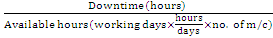
Frequency of breakdown:
The ratio between no. of break down to available machine hour.
i .e Frequency of break down =
Effectiveness of planning:
Effectiveness of planning =

9.11 Maintenance Tools & Equipments
1. Combination Tools/Spanner
Function: Tightening & loosening of nuts & bolts.
2. Socket Ratchet Set:
Function: Tightening & loosening of nuts & bolts.
3. Slide Range:
Function: Tightening & loosening of nuts & bolts.
4. Pipe Threat Cutting Tools:
Function: To cut the threat in pipe.
5. Bearing Puller:
Function: To assist the opening of bearing from shaft.
6. Pipe Range
Function: Tightening & loosening of pipe joint.
7. Pipe Cutting Tools
Function: For Pipe cutting.
8. Hole Punch
Function: Punching the hole.
9. Divider
Function: For circle marking on metal &wood.
10. Easy Opener
Function: To open the broken head bolts.
11. External Threat Die
Function: For external Threat cutting.
12. Heavy Scissor
Function: Cutting of gasket & steel sheet.
13. Oil Can
Function: Oiling of moving parts.
14. Srill M/C
Function: For drilling.
15. Grease Gum
Function: Greasing of moving parts.
16. Grinding M/C
Function: For grinding& cutting of mild steel.
17. Welding M/C
Function: For welding.
18. Spirit Leveler
Function: For perfect leveling.
19. File
Function: For smooth the metal surface.
20. Hammer
Function: For scaling & right angling.
21. Hacksaw Blade
Function: For metal cutting.
9.12 Yearly Maintenance Schedule for DILMINLER DYEING M/C
Application Point | Type of Maintenance | Type of Lubricant | Schedule Time
Control Pannel & Elec. Conn. | Clean, calibrate & Tightened if need | --- | Scheduled day
Float Level Indicator | Cleaning & Calibrate If need | --- | Scheduled day
Strainer for Steam and Water Line | Cleaning | --- | Scheduled day
Main Winch inner reel bearing | Greasing | Staburages NBU 12 | 1, st Scheduled day of January then after every 02 month
Main Winch unloading reel bearing | Greasing | Staburages NBU 12 | 1, st Scheduled day of January  then after every 02 month
Mixer motor bearing | Greasing | Staburages NBU 12 | 1, st Scheduled day of January then after every 02 month
Circulation pump motor bearing | Greasing | Shell Alvinia G 3 | 1, st Scheduled day of January then after every 02 month
Dosing pump motor bearing | Greasing | Shell Alvinia G 3 | 1, st Scheduled day of January then after every 02 month
Fan motor bearing | Greasing | Shell Alvinia G 3 | 1, st Scheduled day of January then after every 02 month
Filter & Radiator of Panel AC | Cleaning | ---- | Scheduled day
Gear Reductors | Checking & toping if need | Mobil SHC 632 | Scheduled day
Gear Reductors | Replace oil | Mobil SHC 632 | 1, st Scheduled day of January every year
Belt tension of reel motor | Checking & tightening if need | --- | Scheduled day
Nut & bolt and gasket | Check for tightness, replace if need | --- | Scheduled day
Pneumatic Line and oiler | Check for air leak & toping oil if need | --- | Scheduled day

9.13 Yearly Maintenance Schedule for STENTER M/C
Maint. Point | Type of Maint. | Type of Lubricant | Schedule Time
Lint filter of chamber | Cleaning | ----------- | Every Day (if need)
Cooling Air Filter | Cleaning | ----------- | Every Day (if need)
Selvedge suction filter | Cleaning | ----------- | Every Day (if need)
Chain rail (entry box) | Cleaning | ----------- | Scheduled day
Heating chamber | Cleaning | ----------- | Scheduled day
Pin plate and seat | Cleaning | ----------- | Scheduled day
Oil trough of exhaust air duct | Cleaning | ----------- | Scheduled day
Hot air nozzle | Cleaning |  | 1st Scheduled day of January and july
Control Pannel & Elec. Connection | Cleaning & Tightened if need | ----------- | Scheduled day
Disassembling Exhast blower | Cleaning | ----------- | 1,st Scheduled  day of January
Exhast blower bearing | Greasing | Staburages N12 MF | 1, st Scheduled  day of month
Chain Rail | Cleaning | ----------- | 1,st Scheduled  day of January
Width adjustment screw | Cleaning | ----------- | Scheduled day
& bolt (hot area) | Greasing | Kluber Moly UMF T4 | Scheduled day
Bearing of Screw End | Greasing | Staburages N12 MF | 1, st Scheduled  day of month
Pin plate and seat | Cleaning | ----------- | Scheduled day
 | Oiling | Optimal Lub oil | Every Day (if need)
Pin chain driven gear box | Check & Toping (if need) | Mobilube CE 90 | Scheduled day
Gear reducer | Check & Toping (if need) | Mobilube CE 90 | Scheduled day
Bearing (high temp. zone) | Greasing | Staburages N12 MF | 1, st Scheduled  day of month
Bearing (normal temp. zone) | Greasing | Mobilux EP3 | 1, st Scheduled  day of month
Circulating Blower motor | Greasing | Staburages N12 MF | 1, st Scheduled  day of month
Chain rail steering base surfase | Cleaning & Greasing | Mobilux EP3 | Scheduled day
Semi closed gear reducer (high | Check | ----------- | Scheduled day
temp. zone) | Greasing | Staburages N12 MF | 1, st Scheduled  day of month
Semi closed gear reducer | Check | ----------- | Scheduled day
 | Greasing | Mobilux EP3 | 1, st Scheduled  day of month
Screw bolt & nut (entry , exit box) | Greasing | Mobilux EP3 | 1, st Scheduled  day of month
Motor (Normal temp.) | Greasing | Mobilux EP3 | 1,st Scheduled  day of January and july
Blower Motor (High temp.) | Greasing | Staburages N12 MF | 1,st Scheduled day of  January, April, july & October
Transimition Chain, sprockate & gears | Greasing | Mobilux EP3 | 1,st Scheduled day of  January and july

9.14 Maintenance of Generator (CATERPILLAR)
Oil change: After 2000 hr
Oil filter: after 2000 hr
Tefit adjust: 1000 hr
Air filter: 1000 hr

9.15 Maintenance of water pump:
Bearing, seal, capling, pump bearing, shaft etc portion.

9.16 Maintenance of Compressor (GARNDER DENVER)
Oil change: after 2500 hr
Air filter change: after 2500 hr
Oil separator change: after 6500 hr

Remarks:
Maintenance of machine is very essential to prolong the machine life and good maintenance is important for economical consideration.
In this industry maintenance program is done by expert maintenance team. So very few times production are stopped due to machine problem.

Chapter: 10
Utility Service
10.1 Utility Available and Source at INCTL

Electricity : Generator
Gas : TITAS
Water : Pumps
Compressed air : compressor
Steam : Boiler

10.2 Electricity

The main utility electricity is supplied from Generator. The total power is then distributed as per requirements of different section like knitting, Dyeing, Finishing, WPT, EPT and Garments.

Generator House:
No of generator: 03

Generator No: 01
CATERPILLAR
Year Built: 2005
Engine Model: 3412
450 KVA 360 KW 0.8 Cos 50 Hz
3 phase 12 wire
X WYE Delta
X Series Parallel
Generator 400 volts 650 AMPS
Excitation 57 volts 8.7 AMPS
592 Frame 1500 Rev/min
Maximum temperature rise 105 by resistance
40 Ambient 1000 meters Altitude
Class H Insulation
Enclosure type
Generator No: 02
CATERPILLAR
Year Built: 2008
Engine Model: G3808
637 KVA 510 KW 0.8 Cos 80 Hz
Without fan rating
3 phase 6 wire
X WYE Delta
X Series Parallel
Generator 400 volts 919 AMPS
Excitation 57 volts 8.7 AMPS
592 Frame 1500 Rev/min
Maximum temperature rise 80 by resistance
40 Ambient 1000 meters Altitude
Class H Insulation
Enclosure type
10.3 GAS

Mainly gas is delivered from TITAS. It is mainly used for steam production. Generally 0.35 m³ gas is required to produce 1kw electricity. The price of 1m3 gas is 5.25 tk.

10.4 Water

Pump section

Motor
Sumber savle
Iron removing plant
Softener
Soft water reserve tank
Supply to dyeing
Raw water reserve tank

10.5 COMPRESSOR

Compressor is mainly used to deliver compressed air to different section as required. In KKDL Ltd 2 compressors are used to produce and deliver compressed air to different section.

10.5.1 Process Flow Chart
Air Flow System
Air from environment by cooling Fan
Filtering the Air
Intake Valve
Air end (oil supplied by injector)
Combing Fan (air)
Dryer (remove moisture)
Air Receiver
Header (to supply different zone)
Separate Tank (Oil Air)
Dry Air

10.5.2 Compressor house

GARDNER DENVER  Year Built: 2005  Capacity: 3.12 m³/min  Maximum pressure: 10 bar  Speed of rotate: 2781 rpm  Weight: 628 kg  Motor power: 22KW  EI supply: 400/50 V/Hz  Fuel: Compressor oil & electricity  Air filter is used.  Function: Air production | GARDNER DENVER  Year Built: 2004  Capacity: 2.2 m³/min  Maximum pressure: 10 bar  Speed of rotate: 3976 rpm  Weight: 420 kg  Motor power: 15KW  EI supply: 400/50 V/Hz  Fuel: Compressor Oil & electricity  Drive by motor  Screw type compressor  Maximum air supply: 7 bar  Function: Air production

10.6 BOILER
Boiler is mainly used to produce and deliver steam to different section as required. In KKDL, there are 2 boilers to produce and deliver steam to different section.

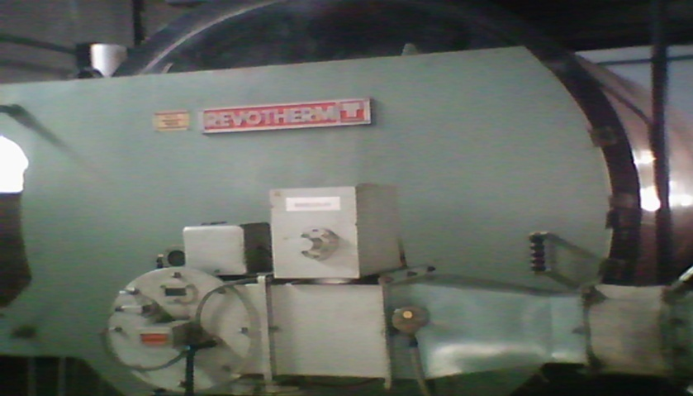

10.6.1 Boiler Section at INCTL:
MERCHMAR (Fire tube boiler)  Fuel type: Natural gas  Electricity supply: 415 V 50 Hz 3 PH  Manufacture: 30-07-01  Origin: England  Capacity: 11200 PPH  Year Manufacture: 2001  Working pressure: 1034/150 N/mm²/PSI  Design pressure: 1069/155 N/mm²/PSI  Test pressure: 1604/233 N/mm²/PSI | HURST (Fire tube boiler)  Year of manufacturing: 2006  Origin: China  Capacity: 10350 PSI  Fuel: Natural Gas  Steam LBs/hr = 10350  Maximum W.P. P.S.I. = 150

Chapter: 11
Store & Inventory Control

Inventory control:
Inventory control is a planned approach of determining what to order, when to order and how much to order to stock so that costs associated with buying and storing are optimal without interrupting production and sales.
Inventory Control reduces costly inventory errors, improves customer service, and will increase the value of our business. Wasp’s inventory software and inventory tracking systems are easy to use and implement without the cost or complexity of larger inventory tracking systems.
Inventory control is concerned with minimizing the total cost of inventory. In the U.K. the term often used is stock control. The three main factors in inventory control decision making process are:
- The cost of holding the stock (e.g., based on the interest rate).
- The cost of placing an order (e.g., for row material stocks) or the set-up cost of production.
- The cost of shortage, i.e., what is lost if the stock is insufficient to meet all demand.
The third element is the most difficult to measure and is often handled by establishing a "service level" policy, e. g, certain percentage of demand will be met from stock without delay.
An inventory control system is a process for managing and locating objects or materials. In common usage, the term may also refer to just the software components.
Objectives or importance of inventory control:
- Financial objectives:
Hence the goal to keep inventory cost within the limits of funds available.
- Property protection objectives:
These are twofold objectives in terms of end results to be achieved namely-
- To safe an important asset again theft, preventable waste, ensures able damage or unauthorized use.
- To make certain that the value of this asset is correct in the company’s book.
- Operating objectives:
- To obtain the best overall balance between product & inventory carrying costs on one hand &customer service to the other.
- To minimize losses from price declines.
Functions of inventory control:
- To develop policies, plans & standards to achieve inventory control objectives.
- To build up a logical & workable plan for doing the job satisfactory.
- To develop methods that will bring defined result economically.
- To provide necessary physical facilities.
- To maintain overall control by checking result & adopting corrective action.
Types of inventory:-
- Production inventories:
Items which are converted to final product by processing e.g. –raw materials.
- In process inventories:
Semi-finished products at various stages of production.
- Finished goods inventories:
Complete products ready for dispatch.
- Miscellaneous inventories:
Scarp, Surplus & obsolete items.
Advantages of inventory control:
A well planned and properly administered system of inventory control will give the following benefits:
- Improvement of customer frictions.
- Improvement of labor and community relations.
- Increase in the effectiveness of key personnel’s.
- Reduction in manufacturing cost.

Procedure for inventory control:

Control of incoming material:

When the goods from the supplies arrive at the factory gate. This form is filled up by the man at the gate. This form is known as stores Receipt Voucher (S.R.V). Here mentions the goods received date. Suppliers name, together with information regarding rejected or returnable goods.
Then the incoming materials go through the inspection the inspector will sign the S.R Voucher or the authorizes the store keeper to accept the goods. From the stores the S.R. Voucher will move to the accounts section which will in due course of time match it with the suppliers invoice before making any money payment.

Control of stores issue:

The material is issued from the stores against a particular numbers. On the basis of materials requisition note duly signed by the authorized person, usually it is raised in triplicate. One copy is retained in the authorized person’s office, one in the store & in the third copy moves from the stores to the central stock control department.
Where concerned persons will make necessary adjustment in their stock ledger & then to the costing department. Sometimes surplus material from the production departments are returned to stores under a note.

Perpetual inventory control:

To control the physical location & movement of the inventory. We usually use the perpetual inventory record. It usually shows the maximum & minimum limit of inventory receipts , issues & balance on any given date & quality etc. One of the simplest types of perpetual inventory control card is a bin card. It very easily facilitates the physical checking of the stores.

The type of inventory carried in INCTL as follows-
- Gray fabric : Own knitted or imported
- Dyes and chemicals: Local or Imported
- Spare parts : Local or Imported
- Packing materials : Local or Imported
- Finished fabrics : Good or Rejected

Material Safety Data Sheet (MSDS):
MSDS indicate above materials properties, chemical reaction, using method
Which are dangerous or not etc. It also indicates how the materials should be kept.

- Sulfuric acid (H₂SO₄)
- Hydrochloride acid (HCl)
- Caustic Soda (NaOH)
- Acetic acid (CH₃COOH)
- Hydrogen peroxide ()
- Sodium Hypochlorite (NaOCl)
- Oxalic acid (COOH-COOH)
- Soda ash (Na₂CO₃) etc.

Stock position:
The materials which are stock in store room. From store room materials (dyes & chemicals) are taken when necessary.
Update:
Dyes must be stock, otherwise dyeing process will be hampered due to lack of dyes & chemicals.
For more production stock should be more & for less production stock should be less. Normally, May, June & July, these 3 months order is not available.

Store of dangerous chemicals:

Dangerous chemical: Caustic soda, Acetic acid, Hydrogen peroxide, Hydrose etc.
Keep:
- Cold places
- Used hand gloves
- Use eye protected glass
- Use gum boot
Store of Enzyme:
It should always keep in A.C. room.
Arrange dyes:
Arranging each color separately in a order (Red, Yellow, Black, Orange etc.)

Separate Spoon & pot:
Separate spoon & pot must be used for separate dyes & chemical. It has the following importance:
- Avoid unwanted mixture between two different dyes & chemicals.
- To avoid uneven shade.
- To ensure uniformly dyeing.
Safety measure to be taken during weighing & handling dyes:
- Hand gloves
- Eye glass
- Gum boot etc.
Rack:
There are some racks where dyes & chemicals are kept.

Life-time:
Life time means expire date. It is very important for dyes. If dyes life time is over then the dyes will give uneven shade.

Chapter-12
Cost Analysis

Introduction:
Costing is a process by which the setting price of a product is calculated. It is a very important task for a factory which runs for business purposes.And it is also strictly followed in the Impress-Newtex Composite Textiles Ltd. Costing of the products considering the raw materials expenditure, salary and wages of officers and workers, distributions and advertisement expenses etc. all direct and indirect expenses is done in this factory. It is determined by a troop of accountants with advice and consultancy of executive director.
Costing Of the Product:
The following points are considered for costing any dyed product in Impress-Newtex Composite Textiles Ltd. -

- Total dyes & chemical cost
- Total utility cost
- Salary
- Payment
- Transport cost
- Entertainment cost
- Miscellaneous cost
- Government cash incentive
Price of the Product:
Generally price of product is determined by the required profit adding to the total expenses.
So,
Price of products= (Direct expenses + Indirect expenses + Factory Overhead) + Required profit

Knitting Charge of Different Fabrics:

Fabric name | Charge per kg(Tk)
- Single Jersey | 09
- Single Jersey with Lycra | 30
- Single locust PK | 16
- Double lacost PK | 16
- Single PK | 16
- Double PK | 16
- Rib | 17
- Rib with Lycra | 30
- Interlock | 25
- Fleece fabric | 22-25

Dyeing Charge of Different Fabrics:
Name of fabric process | Charge per kg(Tk)
- White with Enzyme | 35
- White without Enzyme | 30
- Avg. color with Enzyme | 85
- Avg.color without Enzyme (Light& med.) | 75
- Deep shed with Enzyme (Black) | 110
- Deep shed without Enzyme (Black) | 95
- Only wash (Tubular) | 25
- Only wash (Open) | 45
- Double dyeing (Face & Back) | 115
Costing of the Product:

Let price of yarn is $ 3.00/ kg.
Process loss of yarn for knitting (10%) = $0.30
Knitting fabric cost = $3.30
Cost of dyes & chemicals = $2.50
Process loss for dyeing (12%) = $0.30
Dyed fabric cost = $ 6.10
Packing cost = $0.05
Production cost of fabric=$6.15
Fabric price (with 25% margin) =$7.79

Fabric consumption/ doz. =
(Body length + Sleeve length) x Chest length x 2 x GSM x12 /10000000
Garments specification:
Body length=78 cm
Sleeve length=33 cm
Chest length=62 cm
GSM=210
Fabric consumption/ doz. = {(78+33) x62x2x210x12}/ 10000000
= 3.469 kg
Fabric consumption/doze (with 10% wastage) = 3.816 kg
Body fabric cost / doz. =$(7.79x 3.816)
= $29.73
Cost of collar& cuff/doz = $ 4.00
Cost of Trims=$ 2.25
Cost of Trims (with 5% Process loss) = $2.36
Production Cost of Garments/ doz=$36.09
Garments Price/doz (with 25% Profit) =$45.12

Remarks:
Costing is very important for a productive factory. Without proper costing all production curriculums will go to vain. Because a factory cannot reach to its goal without achieving good profit and good profit is not possible without skillful costing. In Impress-Newtex Composite Textiles Ltd.There are some skillful personnel to do this job.

Chapter-13
Marketing Activities

MARKETING ACTIVITIES:
Consumers of Product:
Impress-Newtex Composite Textiles Ltd. is a 100% export oriented industry. All the goods produced in this industry are exported into various foreign countries.
Product Label:
Product label differs from buyer to buyer. The product labels are prepared according to the fabric criteria & the buyer requirements.
Package Size & Label Market:
Package size & label differs from buyer to buyer. The Package size & label are prepared according to the buyer requirements.
Importing Countries:
There are some countries which are importing goods from Impress-Newtex Composite Textiles Ltd. Which are given below?
• Belgium
• Netharland
• Germany
• Sweden
• Japan
Manpower of Marketing:
Marketing plays a vital role in the field of displaying / showing the goods criteria of the products to the buyer & to communicate with the buyer. There are about 15 people in the marketing section of the industry.
Marketing Strategy:
Marketing strategy is a very important factors to sale the products to the buyer. If the marketing strategy is not so developed, it will be very hard to reach the goal. In case of garments marketing the dealings with the buyer is a very important factor.
Impress-Newtex Composite Textiles Ltd. mainly senior marketing officers, merchandiser & higher officials deal with the buyer. There are some fixed buyers of the industry. The buyers give their orders continuously all over the year. The marketing officers & the merchandisers communicate with the buying houses to collect the orders.
By both side understanding the rate & the order quantity are fixed. A well defined marketing strategy has the following characteristics:
- Good quality
- Low price or competitive price
- Prompt service
- Good commitment r Good business communication
Duties & Responsibilities of Marketing Officer:
Job summery:
i) Market search
ii) Market development
iii) Customer’s motivation
iv) Production follow up
v) Technical assistance of customer
Dealing with the buyer & convince the buyer is the main duty of marketing officer. A marketing officer also has some other duties. The main duties & responsibilities of a marketing officer are given bellow
To prepare cost sheet by dealing with the buyer.
- To take different steps by discussing with the high officials & merchandisers To maintain a regular & good relationship between commercial officer & merchandisers
- To maintain a communication with the buyers and buying houses
- Communicate with better criteria of the products
Garment merchandising is an intricate and detail oriented job. If it can be done properly .can be very rewarding. On the country, if it is done with lack of knowledge. Insufficient skill and thoroughness, it can be destructive.
In the Impress-Newtex Composite Textiles Ltd, very skilled and experienced personnel run the merchandising section. After receiving an order, the merchandiser with the help of pattern master calculates the total consumption of fabric. Then according to the cost detail sheet and the price mentioned by the buyer costing is done. After the price is negotiated with the buyer order is placed to the suppliers of raw material and accessories.
The manufacturing factory as per the requirement suppliers the fabric and a ledger is maintained regularly to assess the production status. The accessories such as label, button, zipper, sewing thread, packing materials are collected from outside [sometime mentioned by the buyer] through back-to-back L/Cs. The merchandising department also looks for the sources for procuring yarns to produce fabric. Merchandising section monitors the production status regularly and ensures time delivery of the shipment.
Remarks:
MASCO INDUSTRIES Ltd has a well learned marketing & merchandising team. They always communicate with the buyers. Impress-Newtex Composite Textiles Ltd. has some fixed buyers. The marketing section also looks the quality & quantity buyers.

MARKETING ACTIVITIES
Introduction:
INCT is 100% export oriented industry. All the goods produced in this industry are exported into various foreign countries.
Product label differs from buyer to buyer. The product labels are prepared according to the fabric criteria & the buyer requirements.
Recent Buyer of INCTL:
  - H & M
  - ZXY
  - TAG & HAPPA FASHION
  - IMPRESS PRENATAL
  - TEEN AGE
  - ARTSANA
  - GDS
  - AWG
  - MERCHANTEX
  - BILLA AG
  - IMPRESS CONFORMA
  - CENTERLINE
  - IMPRESS OLIMPIAS
  - IMPRESS GARTICO
  - BROVA
  - DESIGN TEX
  - PROM TEX
  - DIKIES and so on.

Marketing Strategy
Marketing Strategy is a very important factors to sale the products to the buyer. If the marketing strategy is not so developed, it will be very hard to reach the goal. In case of garments marketing the dealings with the buyer is very important factor.
INCT mainly senior marketing officers, merchandiser & higher officials deal with the buyer. There are some fixed buyers of the industry.yhe buyers give their orders continuously all over the year. The marketing officers & the merchandisers communicate with the buying house to collect the orders.
By both side understanding the rate & the order Quantity are fixes.
A well define marketing strategy has the following characteristics:
- Good quality
- Low price or competitive price
- Prompt service
- Good commitment
- Good business communication

Remarks:
INCT has a well learned marketing & merchandising team. They always communicate with the buyers. INCT has some fixed buyers. The marketing section also looks the quality & quantity buyers.

Chapter: 14
Water Treatment and Disposal system

14.1 Water Treatment Plant (WPT)
Water for a textile plant may come from various sources. But this water can not be used directly in textile processing because it contains various salts. These salts are mainly the carbonates (CO₃²⁻), Hydrogen carbonates or bi-carbonates (HCO₃⁻), Sulphates (SO₄²⁻) and Chlorides (Cl⁻) of Calcium (Ca²⁺), and Magnesium (Mg²⁺). These are called hardness in the water. These must be removed though water treatment plant.
14.2 Effluent Treatment Plant (ETP)
The effluent generated from different sections of a textile industry must be treated before they are discharged to the environment. Various chemicals and physical means are introduced for this purpose.
Capacity : 40m³/ hr
Cost : Tk. 2.5 / m³

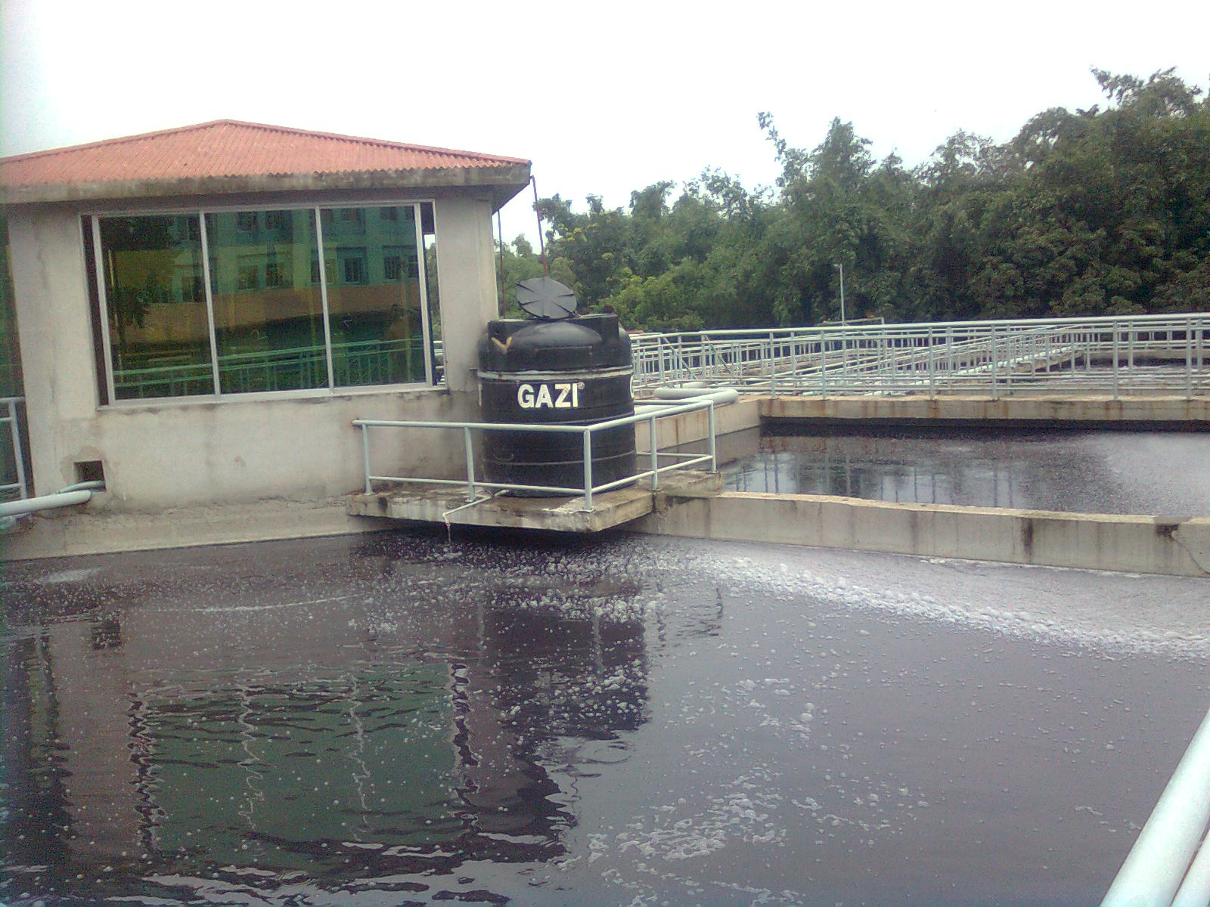
Picture: ETP of Impress-Newtex Composite Textiles Ltd.

14.3 Process Flow chart of Biological Effluent Treatment Plant
Sludge Return Tank
Sludge Thickener
Filter Press
Dry Sludge

Dispose to Land Filling
Polyelectrolyte Dosing
Fabric Dyeing
Homogenizing Tank
Distribution Tank
Sedimentation Tank
Pumping and Screening
Antifoaming
Dosing
Biological Oxidation Tank
Acid Dosing
De-colorant
Dosing

14.4 Function of different Unit of Biological Effluent Treatment Plant (ETP)

Screening unit
It works like a filter. By filtering waste water, it removes threads, pieces of fabrics, small metal pieces etc. In this unit a rotating brush is used for clean the pores if screen. The brush rotates periodically.

Storage and Homogenization tank
Different waste water from varies process is stored and makes a homogeneous mixture by mixing different concentration of waste water.

Neutralization tank:
Neutralization of waste water is performed by dosing 98% H₂SO₄ as required to control the PH of waste water PH range 6.5 to 7.5.

Distribution tank:
It distributes the water to the biological oxidation tank. Continuous aeration is supplied here. Antifoam is dosed here to control the foaming in the oxidation tank.

Biological oxidation tank:
It is the heat of E T P. The entire harmful chemicals are damaged here by breaking their bonds. This is done by bacteria. To ensure the proper function work and growth of bacteria, few conditions must be maintained.
- Temperature : 35º to 37º C
- (Maximum) : 6.5
- Dissolved oxygen : 4 PPM

Sedimentation Tank / Biological feeding tank:
Treated water is overflowed here from oxidation tank. Decolourent is used here to destroy the color of waste water.

Settling tank / Sedimentation Basin:
A tank or basin in which waste water is held for a period of time, during which the heavier solids settle to the bottom and the lighter material will floats to the water surface. In this tank sludge is immersed and the harmless water is discharge to ponds, Land, river etc.

Sludge Thickener:
Sludge taken here from clarifier. Polyelectrolyte is dosed coagulate the sludge. After one hour of polyelectrolyte dosing aeration is stopped and fresh water discharge to drain when sludge is taken. The thickened sludge is transferred to the sludge thickener bed.

Sludge Thickener bed:
Here sludge is dried which is used as good fertilizer as well as fuel of brick field. Sludge is dried under the sunlight.

14.5 Required Chemical for Biological ETP:
H₂SO₄:
Function: Neutralize the waste water controlling the P^{H}. It is auto dispensed in the neutralization tank.
Polyelectrolyte:
Function: Used for sedimentation / sludge coagulation and also killing bacteria.
Antifoaming Agent:
Function: Used for reduction / controlling foam. It is used auto / manually in the distribution tank.
De-colorant:
Function: Used for removing color. It is used auto / manually in the sedimentation feeding tank.
Sodium Hypochlorite:
Function: It is used to kill the harmful bacteria. It is used in the biological oxidation tank.

14.6 Product Quality Checked:
- Biological Oxygen Demand (BOD)
- Chemical Oxygen Demand (COD)
- Total suspended solids
- Total dissolved solids
- Color
- etc.

14.7 Remarks
Waste water from processing industries e g. Dyeing , Printing , Finishing and washing causes great harmful effect on our environmental, As a result agricultural land loses its fertility, natural water becomes polluted aquatic life is destructive and crops are damages.
So, it is important to control ETP plan.

Chapter: 15
CONCLUSION

There is large difference between the theoretical knowledge and practical experiences. This is truer in case of the study of Textile Technology. Industrial attachment or Industrial training is an essential part for textile education because it minimizes the gap between theoretical and practical knowledge. This industrial training increases our thought a lot about textile technology. It also helps us to know a lot about industrial production process, machineries, and industrial management and made us suitable for industrial life. Besides it gives us the first opportunity to work in industry. So we can say industrial attachment prepare us for the expected destiny of practical life.

We have completed our industrial attachment from Impress-Newtex Composite Textiles Ltd. During our eight weeks long industrial training at Impress-Newtex Composite Textiles Ltd we got the impression that this factory is one of the modern export oriented composite knit garments industry of our country. This factory does not compromise in case of quality. So, they have established on-line and off-line quality control of each product. Besides, they also use the good quality yarn, dyes and chemicals in their production process. Due to this, it has earned a “very good reputation” in foreign market for its quality product over many other export oriented textile mills. It has very well educated and technically experienced manpower to get rid of any defect in production process. It has also a good organizational hierarchy.

There are some suggestions from us within our limited knowledge

SOME SUGGESTIONS:

- Knitting production needs to increase as well as technical persons need to be employed there.
- More skilled labor should be used in a project and the overall efficiency will increase.
- Dyeing floor should keep always neat and clean. It kept wet after unloading the fabric from the dyeing machine. Water must be swept time to time.
- During the transport of the fabric and during the loading of the machine, fabrics get soiled due to their drawing over the floor. This makes the fabric/part of the fabric dirty. It may require more scouring/bleaching agent or may create stain.
- Due to the pressure of higher production sometimes machine operators do not maintain accurate time according to the actual process so that less quality product is produced and may reject. So our suggestion is to increase machine and reduce the pressure on the operator.
- Should increase understanding between the top level personal and floor level personal.
- Finishing section need to be enlarged well as more technical persons need to be employed there.
- The machine stoppage time should be analyzed and minimized. The maintenance should be carried out when the machine is out of action (Wherever possible) and routine maintenance should be carried out regularly.
- In knitting and finishing section, every worker should use mask to make protect them from fly. Otherwise the exhaust air system should be more effective.
- Workers are not interested to wear their gown & hand gloves.
- Some workers do not want to maintain the proper time and temperature of dosing of dyes and chemicals; proper rinsing, soaping or proper dyeing procedure.
- Proper follow-up required at knitting, dyeing & finishing section by the key personnel.
- In the Laboratory, there is no technical person; a textile engineer (B.Sc) may be employed here.
- There is shortage of proper light in the dyeing and finishing floor, specially, when smoke is produced from dryer and Stenter. Proper lighting should be provided in the floor.
- Knitting and finishing floor is jammed with fabrics, so it should have to be neat and clean.
- The person at the top level of a department must take good care of the trainees & he should provide all kinds of support to them.

Limitations of the report:

- Because of secrecy act, the data on costing and marketing activities have not been supplied.
- We had a very limited time. In spite of our willing to study more it was not possible to do so
- Some points in different chapters are not included as these were not available.
- It is not possible to hold the whole thing of a textile industry in such a small frame as this report. So, try our hard to summarize all the information that we are provided.

