Submitted by

WWW.ASSIGNMENTPOINT.COM

Esquire Knit Composite Ltd. is a apparel buying house where is worked with knit garments having own modern knit composite garments equipped with the latest and most economical machinery from china Japan and Singapore .Bangladesh’s share of global market is steadily in the wake of success of the ready-made garments sector .Esquire Knit Composite Ltd. is completely responsive for the requirements of the international market. The professional terms continuously follow the fashion method and trends all over the world, and have the ability to anticipate and identify the products that clients want. The Esquire Knit Composite Ltd. have learned to perform and compete with the world competitors, providing a dependable source of buyer from USA,KOREA , CHAINA This new unit has recruited the most qualified and technicians from the sample pool of trained personnel now available locally in this sector . the main purpose of the study “A study on Esquire Knit Composite Ltd.” were determine the existing international marketing system and to analyze the overall merchandising procedure of the company .the present study is based on the primary and secondary data .the study mainly covered the marketing system . A brief historical background, mission, vision, strategy and different types of products of Esquire Knit Composite Ltd.have also been introduced in the study. Through SWOT analysis some major strength and weakness of Esquire Knit Composite Ltd. have been analyzed in this report. After analyzing the marketing system of Esquire Knit Composite Ltd. accordingly to resolve them. To collect relevant data and information, questionnaire is prepared in the basis of silken sewing limited. Practical experiences are applied and interview of different employees, official and stuffs been taken to complete this report. Some finding and recommendations have been developed in the last chapter the basis of observation and experience during my internship program. Due to the limitations of time and my personal limitations, and in depth study could not be done. However, I expect this concept of self review will persuade further for practical test. Now here add some findings and recommendation of this report.

Chapter-01
Introduction of the study
- Background report | 11
- Limitation of the study | 12
Chapter-02
Research methodology
- Methodology |  |  |  |  |  | 14
Chapter -03
Back ground of the Bangladesh garments
- History of Bangladesh garments |  |  |  |  |  |  | 16
- Contribution to the country and society |  |  |  |  |  |  | 17
- Development of Bangladesh garments industry |  |  |  |  |  |  | 18
- Product of Bangladesh garments industry |  |  |  |  |  |  | 19
- Markets of Bangladesh garments industry |  |  |  |  |  |  | 19
Chapter-04
Overview of Esquire Knit Composite Ltd.
- At a glance- Esquire Knit Composite Ltd. |  |  |  |  |  |  |  |  | 21
- Vision |  |  |  |  |  |  |  |  | 22
- Mission |  |  |  |  |  |  |  | 22
- Objective |  |  |  |  |  |  |  | 23
- Company profile |  |  |  |  |  |  |  | 24
- Business process |  |  |  |  |  |  |  | 25
- Terms and conditions |  |  |  |  |  |  |  | 25
- Buyer/ Customer Base |  |  |  |  |  |  |  | 26
- Creative source of raw materials |  |  |  |  |  |  |  | 26
- General Ethics |  |  |  |  |  |  |  | 26-27
- products |  |  |  |  |  |  |  | 28
- products list |  |  |  |  |  |  |  | 29-31
- Relationship between merchandising and marketing |  |  |  |  |  |  |  | 32
Chapter: 05
Findings
- Findings |  |  |  |  |  |  |  | 34-43
Chapter- 06
SWOT Analysis
- Strength |  |  |  |  |  |  |  |  |  |  | 45
- Weakness |  |  |  |  |  |  |  |  |  |  | 46
- opportunity |  |  |  |  |  |  |  |  |  |  | 46
- Threats |  |  |  |  |  |  |  |  |  |  | 46
Chapter- 07
Recommendation & Conclusion
- Conclusion |  |  |  |  |  |  |  |  |  | 47
- Recommendation |  |  |  |  |  |  |  |  |  | 48

- Reference | 50
- Appendix | 51

- BACKGROUND OF THE REPORT

- OBJECTIVES OF THE REPORT

- LIMITATION OF THE STUDY

In BBA program of Dhaka International university requires a internship attachment with a view to achieve practical knowledge with different associate with different field of Business. Internship has to be completed through private business organization, manufacturing organization, Govt. offices public sector Corporation or other non financial institution. So this internship has great opportunity for e to see the real business world, acquire knowledge and to the smarter world business professional.

Esquire Knit Composite Ltd. as per as the advice and recommendation of the honorable supervisors Assistant Prof. Md. Ruhul Amin the main concentration of industry his report is textile industry Bangladesh particular reference to “buying house”. This report focuses on the practices of commercial work area procedure, and techniques in the preparation in order to shipment in Esquire Knit Composite Ltd.

1.2 Limitation of the study

During the study I had faced the following limitation:

- Shortage of time: In during such a study within a short period. I could not perform all the activities regarding study property.

- Shortage of secondary data sources: publication of this field not available and there were no organization or department for maintaining proper information about the company.

- Respondent unwillingness: some respondents were unwilling to respond due to maintaining secrecy about the company.

- Lack of accurate data: respondents were unwilling to disclose their income and sales. So, this types of data used in this report is not too proper.

The study requires a systematic procedure from selection of the topic to preparation of the final report. To perform the study, the data source were to be classified, analyzed, and intercepted in a systematic manner and key point to be found to. The overall process of methodology has been given as follows:

- Selection of the topic: the topic of the study was assigned by respected supervisor. While assigned by the respected supervisor while assigning the topic necessary suggestion and recommendation were given by the super visor to make this internship report a well organized and perfect one.

- Type of report: Descriptive

- Identify data sources: Essential data sources, both primary and secondary, were identified that would be needed to carry on the study and complete this report.

- The primary data sources :
- On the job work to find relevant data
- Informal survey.

- Secondary data sources:
- Different official circular issued by the BGMEA.
- Other documents of Esquire Knit Composite limited.
- Company profile of Esquire Knit Composite limited.

- Classification, analysis, interpretation of data: some pictorial tools are used in this report for analyzing the collect data to classifying those interprets them in a clear understandable manner.
- Tools use for analyzing those data: Dichotomous.
- Questionnaire structure: unstructured questionnaire.

  - History of the Bangladesh garments

  - Contribution of the country and society

  - Development of Bangladesh garments Industry

  - Products of Bangladesh garments industry

  - Markets of Bangladesh garments industry

3.1 History of Bangladesh garments:

The domestic market for readymade garments, except children wear and men’s knit wears were virtually nonexistent in Bangladesh until the sixties. Large scale production of readymade garments (RMG) in organized factories is a relatively new phenomenon in Bangladesh. Until early sixties, individual tailors made garments as per specifications provided by individual customers who supplied the fabrics.
Since the late 1970s , the readymade garments (RMG) industry started developing in Bangladesh primarily as an export oriented industry although ,the domestic market for RMG has been increasing fast due to increase in personal disposable income in change in life style . The sector rapidly attained high importance in terms of importance, foreign exchange earnings and its contribution on GDP. In 1999, the industries employed directly more than 1.4 million workers, about 80% of whom were female .with the growth of RMG industry, linkage industries shipping fabrics yarns, accessories, packaging materials etc. have also expanded. in addition ,demand for services like transportations , banking shipping and insurance has increased .all this have created additional employment .the total indirect employed created by the RMG industry in Bangladesh offers best invest opportunities in South Asia .garments sector in the largest employer in Bangladesh . This given women the chance to be finally. Even through trade unionization is banned inside the expert processing zones (EPZ), the working environment is better than that of the majority of the garments factories that operate outside the EPZs. But pressure from buyer to abide by labor codes that enables factories to maintain satisfactory working conditions.

In recent times, garments workers have protested against their low wages. The fast protested broke out in 2006, in since then, there have been periodic protests by the workers. This has forces the government to increases minimum the wage of workers. The RMG sectors are expected to grow despite the global financial crisis of 2009. As chins in finding it challenging to make despite the global and foot wear items at cheap price due to rising labor cost .however in recent years, the ready-made garments (RMG) sector has biggest emerged as the biggest earner of foreign currency.

3.2 Contribution to the country and society:
In addition to its economic contribution, the explanation of RMG industry as noticeable social changes by bringing more than 1.12 million women has changed their status in the family.
The attractive opportunities of employment change the traditional practical hegemony of the father , brother and husband .most working women can now choose when to start family life .most importantly the growth of RMG produced a group of entrepreneurs who have created a strong private sector .many women hold top executive position in RMG industry.
In the 1980s, there are only 50 factories employing on a few thousand people. Currently, there are 4490 manufacturing units. The RMG sectors contribute around 75% to the total earnings. In 2007 it earned $9.35 billion. this sector also contributes around 13% to the GDP, which was only around 3% in 1991 USA is the largest importer of Bangladesh RMG products ,followed by Germany , UK , France and other E.U countries.
From one of the record Bangladesh bank it has been found that 2010-2011the earning of foreign currency through export was mostly came from RMG sector.

Item | Export receipt (USD million)
Woven Garments | 3638.07
Knitwear products | 2508.02
Terry towels | 72.31
Others textile | 140.49
Sweater garments | 1556.81
Table: 3.1 source Bangladesh 2012.

3.3 development of the Bangladesh garments industry
The garments industry of Bangladesh has been the key export of main source of foreign exchange for the last 25 years. At present, the country generates about $5 billion worth of products each year by exporting garments. The industry provides employment to about 3 million women. Two non-market elements have performed a vital function is confirming the garment industry’s continual success; these elements are:
- Quotes under multi-fiber agreement (MFA) in the North American market, and
- Special market entry to European market.
The whole procedure is strongly related with the trend of relocation of production. Till the end of 1982, there were only 74 garment manufacturing units. The break through occurred in 1984-85, when the number of garment factories increased to 587 the number of RMG factories short up around 2900 in 1999. Bangladesh is no one of largest apparel exporters of the world. The industry has grown during the 1990s roughly at the rate of 22% by late 1980s RMG export become the one in the number one in the terms of exports.
Since developing nations provide areas that do not impose costs like environmental degeneration, this practice protects the developed counties against the issues of environment and law. Bangladesh garments sector becomes global chain that causes due to the transfer to the salary structure in the garment industry, all over the world. Apparel labor charges per hour in USA are 10.12but it is only .30 in Bangladesh. These differences accelerated the world apparel exports from $3 billion in 1965, with developing nations contributing 59 percent. In 1991 the number of worker in readymade garment industry of Bangladesh was 582000 and it grew up to 1404000 in 1998. In USA, however 1991-figure showed 1106thousand of workers in the apparel sector and in 1998 it turned down to 765.8 thousand. One external factors of the application was the GATT approved multi-fiber agreement (MFA) which accelerated international relocation of the garment quota production. Under MFA, large importers of RMG like USA and Canada imposed quota restriction, which limited export of apparel from countries like Hong Kong, South Korea, Singapore, Taiwan, Thailand, Malaysia, Indonesia, Sri- Lanka, and India to USA and Canada. The government provided various kinds of incentives such as duty free import fabrics under back – to back L/C, bonded ware house facilities, etc .the govt. also took a number of pragmatic steps to streamline export processing zone facilities, and etc. the govt. also took a number of pragmatic steps to streamline export-import formalities.

3.4 Products of Bangladesh Garments Industry:

Bangladesh exports very limited category of products. the factories in Bangladesh products shirts , jackets, sweaters, knitwear’s ,baby wears and others garments ,with high concentration in the export of shirts of low price . Bangladesh competes with India, Sri Lanka, and Mexico and other Central American countries and other Central American countries in the lower price segment, in this market. Exporters from Bangladesh produce mostly those items on which quotas are available. However, there are a few exceptions. Many firms now export some non-quota items as well. The share of such items in the total quantity however is very small. Recently, exports of knit-wears have been increased. These indicate that Bangladesh is actively engaged in the process of product diversification.

4.4 Markets of Bangladesh:

Readymade garments (RMG) industry occupies a dominant position in the export manufacturing sector of Bangladesh .the advent of the RMG sector happened during the early 1980s in Bangladesh. Since then during the supportive policies of the government of Bangladesh, this industry has experienced a significant growth. In 1988, the export oriented RMG sectors overtook the traditionally dominant jute sectors in terms of gross exports accruals. And since then this sector has continued to consolidate it predominant position in this export basket of Bangladesh. According to data of 2003-04 financial years, the export earnings of the RMG sector was 5686.09 million US dollars, which constituted 74.79present of total exports earnings. The industry, which started with only a few factory units during 1980s, now boasts 4094 factory units employing around 1.5 million workers. Although Bangladesh export garments to some countries, in exports are highly concentrated in two major markets, the USA and EU. The USA as the largest importer country imported 42.24% of total garments exported from Bangladesh in 1998-99 and 50.38%in EU in the same years. The major reason of the growth this almost duty free and quota free access of this market. Other exports markets are small in comparison to Bangladesh.
Yet, Bangladesh has not been able to have market access to ASEAN, or Indian marketers although it imports a huge quantity of fabrics and yarn from these countries. The main reason for these are the tariff and non-tariff barriers Bangladesh face in this markets.

- At a glance- a Esquire Knit Composite Ltd.
- Vision
- Mission
- Objective
- Company profile
- Business process
- Terms and conditions
- Buyer/Customer base
- Creative source of raw materials
- Products
- Product list

4.1: At a glance- Esquire Knit Composite Limited

Esquire Knit Composite Ltd.100% Export oriented knit garment manufacturing unit located in Esquire Knit Composite Ltd. and the biggest buying house located at Uttara, Dhaka. Sector # 05.road no # 3. House no # 33. Dhaka 1230, Bangladesh. It’s a private limited company owned by 4 directors –

- Mr. M. Enamul Haque (Managing Director)
- Mr. Saiful Islam (Director)
- Mr. AFM Touhidul Alam (Executive Director)
- Mr. Modasser Pasa (Director-Finance)

The company was establishing in 2008-06-28. Today it has work force of over of 750 in a factory & 40 in a buying house division here , 70% are female and 30% male workers in a factory % 80% male & 20% female .the company is using an area of 70000 square feet.

Esquire Knit Composite Ltd. is proud of its contribution in being amongst the key players in Bangladesh garments division. Esquire Knit Composite Ltd. is not only producing on-time quality apparels but also producing under fill socially and legally complaint. It is also hard to start a new business for any person. New business takes time to reach of the pick point. But for Esquire Knit Composite Ltd. took short time. Now it is working with its full production capacity and increasing its client to expand their market share more production capacity.

4.2: Vision
Earning foreign currency through exporting and serving the clients successfully with expertise and experiences of production capacity, and participating in the economic growth of the country.

4.3: Mission
Readymade garments 100% export oriented that try to keep track most popular trends in fancy fashion especially in ladies and girls casual wear. We provide an extensive range of manufacturing capability in all categories, including knitwear, women wear, and out wear to customer at reasonable prices, right delivery, good quality and services.

We are committed,

- To our customers: total satisfaction through providing on-time delivery of quality products and services.

- To our employees: good work environment & compliance with national and international rules.

- To our society: Creation of a better tomorrow.

4.4: Objectives

Esquire Knit Composite Ltd. has decided to achieve some objective in the further progress in the garments industrial fields. The objectives are as follows:

- Expand business activities.
- Produced more standardize quality products.
- Ensure higher productivity of the production and more responsible to customers’ needs and satisfaction.
- Participating in economic growth through earning foreign currency by exporting its products.
- Generating higher employment taking newer internship.
- Establishing strong brand image through aggressive marketing and promotional campaign.

4.5 Company profile:
Company profile of Esquire Knit Composite Ltd
Product or service we provide | Garments
Main manufacturing item | T-shirt, Tank Top, Polo shirt, Sweat shirt, Rugby shirt, Fleece jacket, Sear fine, Fashionable knit, Girls and children dress with printing and embroidery.
Production capacity | T-shirt : 200000 pcs per month  Polo-shirt : 175000 pcs per month  Sweat shirt : 150000 pcs per month
Children – wear | Product item: All kinds of knit item
Primary Business type | US $ million – US $2.5 million (unlimited for buying sector)
Year started | 2008-2013
Number of Employees | Above 1000 & 40 for Buying sector
Focus market | World wide
Factory size (square size) | 70000
No. of R&D staff | 25
Export percentage | 100%
Exporting countries | China, Germany, France, Italy, USA, Canada, Poland, AUS, UK.
Machinery | Factory is set up with brand new imported Machinery from Japan, UK, Singapore, China, and Germany. At present, total 200 sets of machine & equipment are installed and operational. the machines like conveyor type lock metal detector, thread removing etc.
Corresponding bank
Factory name and location | Esquire Knit Composite limited.  Kachpur  Sonargaon  Narayangonj
Buyer name | Tesco, British home store, LPP, Argos, Arsenal, The fielding group, Shops direct Group, TVM, Group Zanier, and Li &Fung.
Table 3.1 Company Profile of Esquire Knit Composite Limited

4.6: Business Process:
Business Process
Client sent the sample
We make quotations to the client
Client except the price , then make counter samples and send to clients for the feed back
Client confirm the samples , place the order and open L/C or T/T
Make the correct sample with print, embroidery etc. for approval.
Production(quality maintenance)
Production (quality maintenance)
Shipment
Figure -4.1: Business process of Esquire Knit Composite Limited.

4.7: terms and conditions
- MCQ: in terms of value, they required a minimum shipment value of USD 15000 per shipment.

- Delivery lead time : after order confirmation , company require 20 days for approval sampling , which involve making up samples in correct sizes, color and yarn, for approval. Upon confirmation of the samples, about 45/60days are required for production, depending on the product, order quality and time of year.

- Sample delivery charge: A full sampling service is available to meet all design need. Delivery costs of all sending samples in the all step of order processing up to shipment are to buyer account.

- Payment terms: make payment by T/T for all orders below US $ 10000 & 100%in advance. For larger amount payment must made by irrevocable and transferable L/C in our favor Silken Sewing Limited.

4.8: Buyer/ Customer Base:
Esquire Knit Composite Ltd. has established solid business relationships and customers in Europe and north America. AUS, and is proud to be highly regarded in the market for their integrity and commitment to deliver what they have promised. They are providing services to a wide range of customers of customer including retail specialty stores, catalog houses and importers.

4.9: Creative Source of Raw Materials:
- Materials composition: Esquire Knit Composite Ltd. manufactures knit garments mainly bottom and tops with materials from Cotton, PVC, and PC etc. even other materials / composition as required.

- For sweater: Acrylic, cotton .spaniel, cashmere like, lamb’s wool, mohiyarn, and blended yarn.

- Knitting: Jersey, fib cable, button, lace, etc needed. So they can provide a complete garment to the customer.

- Techniques: company has expertise in all embroidery, print, acid, washed, decorated, with brands /sequins/ lather /laces / buttons and other techniques to manufacture every distinctive masterpiece in the world for its customers.

4.10: General Ethics:

- Code and conduct: The Company operates in full compliances with the applicable laws, rules and regulations, including those relating to labor, worker health, and safety and environment.

- Child labor: Factory always employed those workers who have reached the minimum legal age in effort for admission employment, or at least the age of eighteen. The company with all rules governing the employment of children. Whenever they employ people aged 18 years or over, factory are encouraged to develop workplace to such schemes.

- Work environment: The Company encourages developing lawful work place apprenticeship programs for the educational benefit of the workers.

- Discrimination: Factory never discrimination in hiring and recruiting employees, including matters of safety, benefit advancement, disciplinary measures, social and ethnic origin, political opinion or disability. The company employs workers on the basis of their abilities to do the job, not on the basis for their personal characteristics or beliefs.

- Hygiene, health safety: It provides a safe and healthy working environment for their workers, and takes every necessary step to prevent occupational accident and illness and censure that employees are not unsanitary or dangerous working condition.

- Wages and hours: The Company set working hours, wages and overtime pays in compliances with all applicable laws. Here the main working hour is 8 am -7 pm. And after 8 pm the overtime period is counted.
- Freedom of association: There is the right of employees to form and join trade union and to bargain collectively. Workers representatives shall not be the subject of discrimination and shall have access to all workplace necessary to enable them to carry out their representation functions.

- Hours of work: hours of work followed by the law and industry standards, workers shall require to in excess of 48 hours a week on regular basis, in addition they must be allowed at least one day per 7 days period only, the company may requires employee to work overtime, and in any event shall not exceed 12 hours a week. Overtime hours must always be compensated at a premium rate.

4.11 : Products

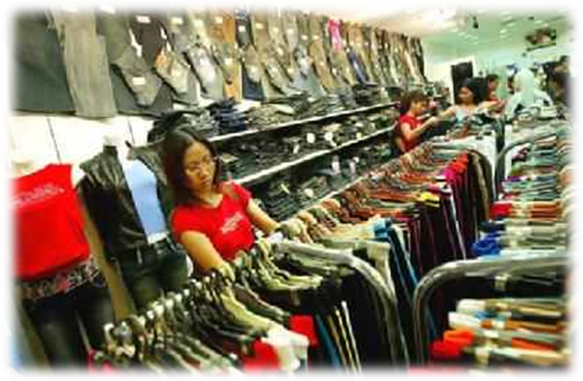

Men’s Collection Women’s collection kid’s Collection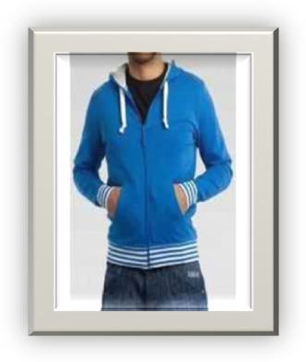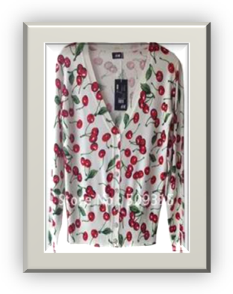 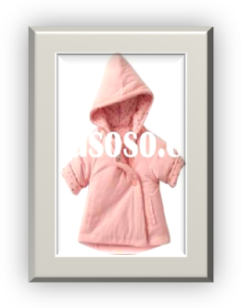

4.12 Product List:
Men’s Products
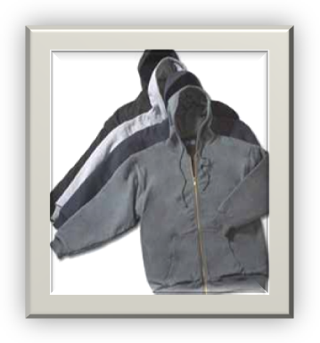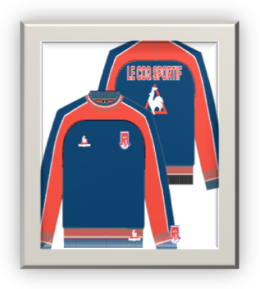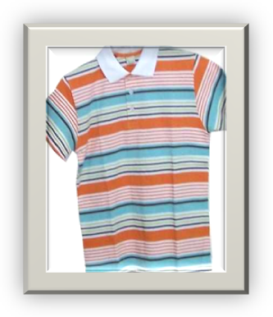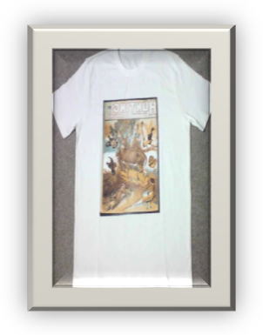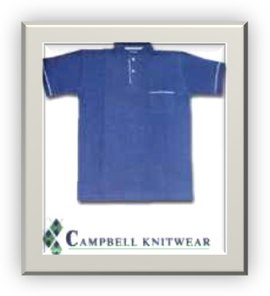

Women’s product
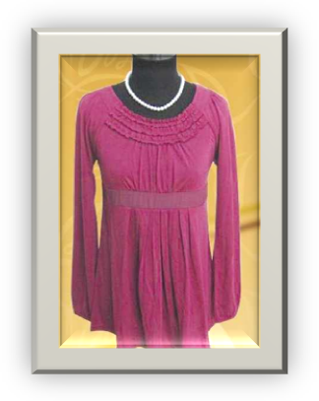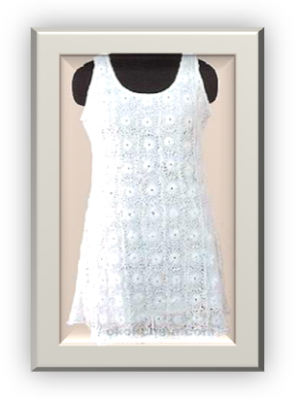

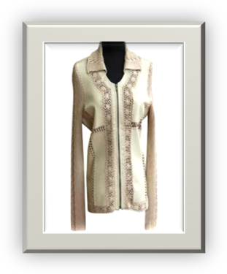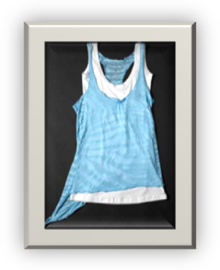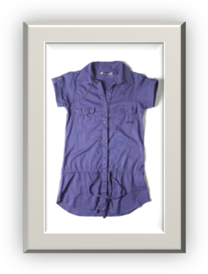

Kid’s Product

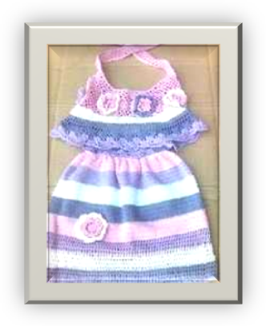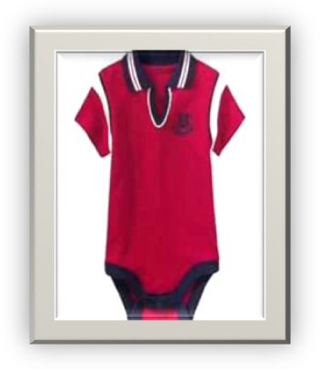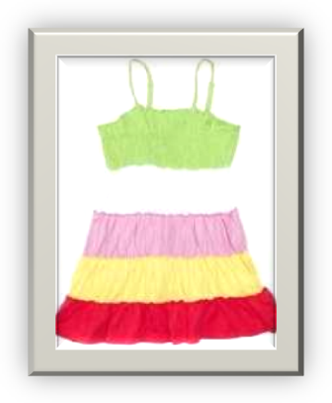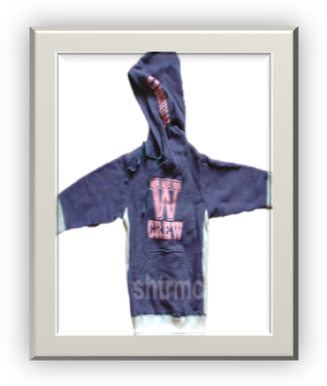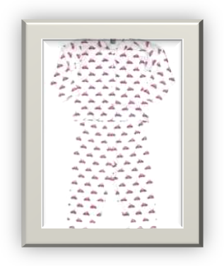

4.13 Relation between merchandising and marketing
Merchandising
Merchandising is the direct sales pitch to the consumer conducted in an immediate, often face to face manner. In-house consulting and sample issuance are just a few example of merchandising techniques. The goal of merchandising is to compel the consumer to buy the product. Merchandising sizes on the typically brief opportunity to sell directly to the consumer; the parties responsible to the successful merchandising include the sales person and the layout of the store itself. The sales person engages directly with the customer by providing a sales pitch or demos of the product. The layout is a store of highly influential method of merchandising: having a product directly at eye level. For example, can make the difference between the sales or the customer not seeing it and therefore walking away.
Marketing
Merchandising is a subset of marketing. Marketing has several other arenas that do not overlap with merchandising. For instance, marketing also entails how to distribute the product and how best to package the item. Gathering data is another marketing field, from issuing surveys to holding consumer focus groups. Others issues includes in-house marketing. This pertains to devising strategy, assessing which price is best for the product and out lining the objectives of campaigns, promotions and other marketing endeavors.

Relationship
Without other disciplines within marketing merchandising would not be effective. For example, if a company has not assessed which audience will be most desiring of the item, the business cannot effectively pitch its wares with in the retail store. Likewise, without proper analysis of how display cases boost sales or the mannerisms adopted by customer service representatives to capitalize on sales, many unrelated fields of marketing ceases to the effective. Indeed, merchandising is at the tail end of the marketing chain. While the first links include product design, packaging considerations, distribution and ad campaigns merchandising is the most time sensitive links. Business has a fleeting moment by which to persuade the consumer to take the item to the cash register.
Considerations
Merchandising applies to a retail setting, where as marketing applies to most every business, including financial services. Tourism and hospitality. In order to merchandise. Companies must have a tangibles product to offer the consumer. Therefore, service based industries do not engage in merchandising due to the lack of merchandise ,unless the industry sales apparel or product related to its industry, such as sports jerseys for athletic teams.

  - What type of order do you prefer?

T-shirt | 48%
Trouser | 19%
Jacket | 19%
Sweater | 14%

Analysis: In survey data from above table it is found that some of respondent are 48% T-shirts are double to other orders, trouser 19% and jacket 19% are semi size order of the whole orders. And sweater 14% it is quarter size order of the whole orders.

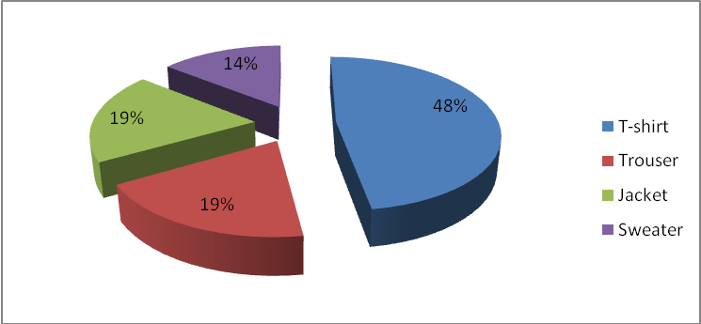
Figure: 5.1 what type of order do you prefer?

  - What is the order completion time controllable need/want?

3 month | 60%
3 month | 25%
1 month | 15%

Analysis: In survey data from above table it is found that some of respondents are 3 months, 3 months, 1 month.

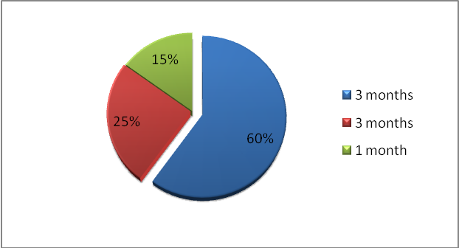

Figure: 502: What are the order completion time controllable need/ want?

  - What is the general order size?

60000 units | 30%
30000 units | 60%
20000 units | 10%

Analysis: In survey data from above table it is found that some of respondents are 60000 units are 30%order quantity size, 30000 units are 60% order quantity size, 20000 units are 10% order quantity size-

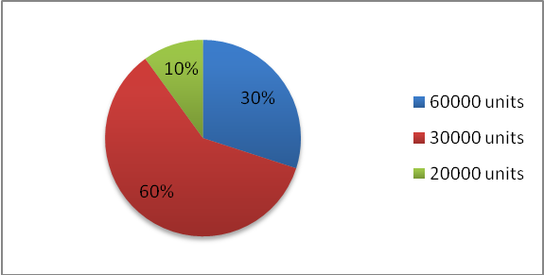

Figure 5.3: What is the general order size?

  - What is your raw materials collection source?

Local source | 80%
From Abroad | 20%

Analysis: In survey data from above table it is found that some of respondents are collect our raw materials from local source 80%, from Abroad 20%.

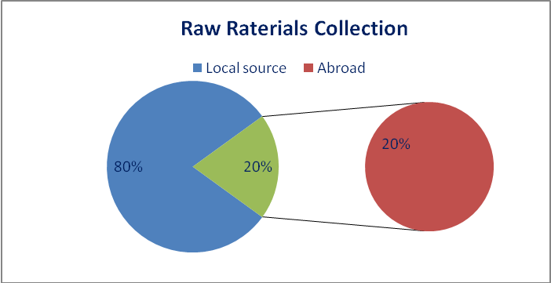

Figure5.4: what are your raw materials collection sources?

  - What type of products is most rising now days?

T-shirt | 50%
Polo-shirt | 20%
Trouser | 15%
Jacket | 10%
Sweater | 5%

Analysis: In survey data from above table it is found that some of respondents are 50% T-shirts is most rising product now a day, and other products polo-shirt 20%, Trouser 15%, Jacket 10%, and Sweater 5% based on order quantity.

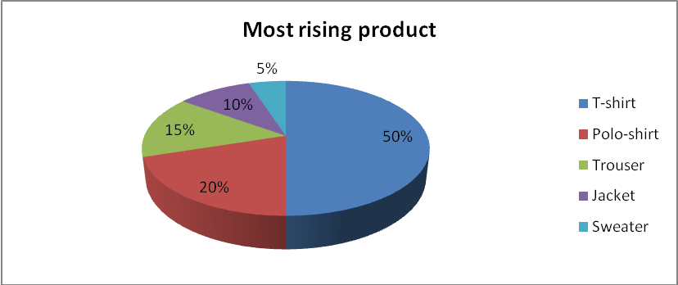

Figure: 5.5 -What type of products is most rising now days?

6. What’s your payment procedure?

Cash | 10%
Check | 70%
Credit | 20%

Analysis: In survey data from above table it is found that some of respondents are 10% cash, 70% check, and 20% credit. The local buyer is paying on cash and check. And the foreign buyers pay to credit card.

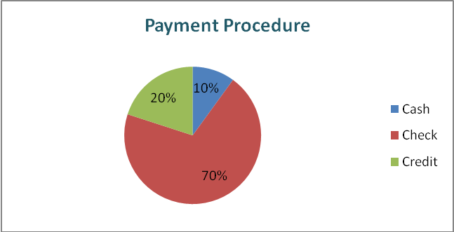

Figure: 5.6- What’s your payment procedure?

7. Do you produce any item by your company itself?

Answer: Yes. We produce 100%of our products by our company for sweater & woven we use other producer…

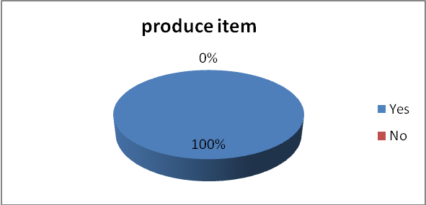

Figure: 5.7 Do you produce any item by your company itself?

8. What are the problem your usually face in your operation?
Bureaucratic problem | 30%
Political problem | 40%
Lack of government support | 30%

Analysis: In survey data from above it is found that some of respondents are 30% bureaucratic problem, 40% political problem, 30% lack of govt. problem support. And the threats are new comers.

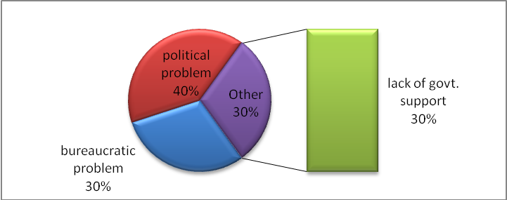

Figure: 5.8 what are the problem your usually face in your operation?

9. Mention the countries that you program business with them generally?

USA | 50%
Australia | 30%
EU | 20%

Analysis: In survey data from above it is found that some of respondents are 50%USA, 30%Australia, 20%EU. They both countries are continuing program business generally.

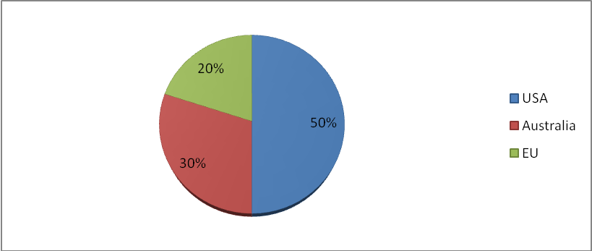

Figure: 5.9 mention the countries that you program business with them generally?

10. Do you follow any marketing technique?

Answer: Yes. We follow 100% marketing technique.

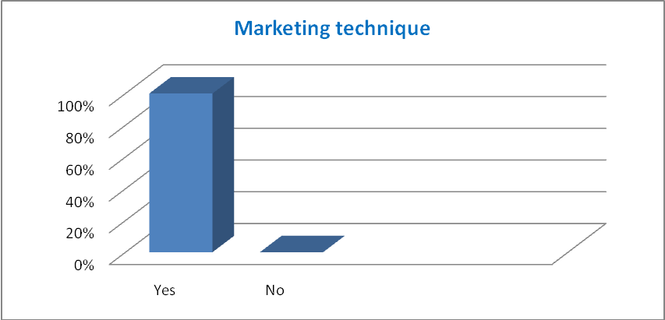+

Figure: 5.10 Do you follow any marketing technique?

- Strength
- Weakness
- Opportunities
- Threats

SWOT Analysis of Esquire Knit Composite Limited.
SWOT stands for strengths, weakness, opportunity and threats. A company must have strengths and weakness in different section. Also it has some potentiality and faces some different kinds of markets threats and opportunity. This analysis provides a through picture about the company’s overall conditions.

5.1 Strength:

- Esquire Knit Composite Ltd. has large amount of asset.
- Their top management is very strong. They have taken all decision timely and manage all things in a systematic way.
- The labor forces of the company are very cheap and readily available. They are skilled and effective workers.
- The important policy of the company has been flexible and friendly for import of raw materials of garments accessories.
- The company has a strong base of buyer to sustain in the competitive market.
- Esquire Knit Composite Ltd. have independent sample production unit, having highly dedicated professional merchandising and quality control team to ensure buyer satisfaction.
- Esquire Knit Composite Ltd. serious about their shipment of their orders.
- Esquire Knit Composite Ltd. has expert and skilled workers.
- Esquire Knit Composite Ltd. has highly improved machinery and information technology to ensure the best quality.
- This company has workers training and development facilities.
- Management stuff has adequate transport facilities.
- Their employee turnover rate is low.
- Their medical facilities are highly available.
- They paid salary at a right time

5.2 Weakness:
- Research and development (R&D) practices are not available. It has become a barrier in effective and efficient market research, new product development, corporate strategic planning etc.
- Esquire Knit Composite Ltd. depend on 90% imported raw materials and technology.
- Esquire Knit Composite Ltd. administrative cost is comparatively higher than any other company.
- Because of the world wide bad economic condition, textile industry is earning limited profit.
- Window-dressing of Esquire Knit Composite Ltd. is not good.

5.3 Opportunity:
- Very higher quality product which have a good demand in international market.
- Fashion institutes are growing day by day worldwide which increases the opportunity to textile industry by increasing large number of buyer’s orders.
- Efficient and skill workers are increasing day by day which insures the best quality of manufacturing the garments.
- There is a good opportunity for marketing in knit wear garments in future.

5.4 Threats:
- Very competitive in international market, especially in China for their lower labor cost.
- Many new competitors are coming in front with new product style and technology.
- Dependency in foreign countries so far raw materials price in increasing day by day.
- Esquire Knit Composite Ltd. is affected by the Govt. regulations of exports and import policy. And customs facilities are not well mannered which hang the company’s business operation smoothly.

These are the terms that help us to understand the condition of the Esquire Knit Composite Limited.

Conclusions:

Bangladesh is not prepared enough to face the new rules of the trade regime. Most of them are lacking in skills in technology and the mentality that is need to be supported with the changes in the world markets. And the procedure of Bangladesh will have to realize that they must become more efficient to sustain in the competition of garment sector.

Thought, there are some problems the Esquire Knit Composite Ltd. is facing, in continuing their business, but it is the time for the company to take necessary actions to solve the problems. Esquire Knit Composite Ltd. has to build strong relationship with the customers, as well as with the buyers, for their survival.

The authority needs to be more careful about their export procedure. They need to develop their merchandising sector more so that the employees can get motivated and remain loyal to the company. The management should take initiatives to make their operations more cost effective. They also need to create good alliance with the supplier, buyers and as well as their buying house.

Esquire Knit Composite Ltd. will have to be dynamic enough to focus on specialized with the nice markets; they need to go for more market research, surveys and also should develop their R&D sector, rather than remain fixed with existing market in the first world.

Recommendations:

- The employee should be trained properly. And in case of hiring new employees the authority must focus on their ability and working capability.

- Problem con be minimized if the decision making process will not get lengthy and also the employees can take participation.

- The company needs to develop their survey procedures so that they can have frequent updates regarding the markets.

- Production unit should be increased. So that the lead time can be reduced.

- The company needs to cope up with the modern style and trends. And this can possible only if they can develop their marketing management sector.

- The company needs to increase their investment rates.

- The use of modern technology should be increased. If they use more equipment and maintain them properly they can reduce the time consumption and cost also.

- The government should focus on the development of the port. The authority must maintain the rules and regulation so that the shipment procedures can be run smoothly.

- Govt. plays a vital role in the export import sectors. So Govt. should aid the garment industries so that they can earn more foreign currency, can contribute to the economic growth and as can participate in the international markets.

- What type of order do you prefer?
- What is the order completion time controllable need/want?
- What is the general order size?
- What’s your raw materials collection source?
- What types of products are most rising now a day?
- What is your payment procedure?
- Do you produce any item by your company itself?
- What are the problems you usually face in your operation?
- Mention the countries that you perform business with them generally?
- Do you follow any marketing technique?

