Submitted by
WWW.ASSIGNMENTPOINT.COM

Bangladesh is a developing country. Today necessity of Bank as a financial institution is undeniable. Banking industry is the most growing sector in the economy of Bangladesh. Both Islamic Bank and interest based conventional banks invest their money to earn profit. But they differ in the manner of operation. The operation of Islamic bank is regulated by Islamic principles, while the activities of conventional banks are controlled by general banking rules and regulation.

Bangladesh is one of the largest Muslim countries in the world. The people of this country are deeply committed to Islamic way of life as enshrined in the Holy Qur'an and the Sunnah. Naturally, it remains a deep cry in their hearts to fashion and design their economic lives in accordance with the precepts of Islam. We have been experienced with banking from very ancient period. To say bank we simple mean an institution, an intermediary whose duty is to take deposit and giving loan who is in need and demand. And through this process earn interest.

Banking is the backbone of national economy. All sorts of economic and financial activities revolve around the bank. As the industry produces goods & commodities, bank creates & controls money market and promotes formation of capital. Banking is a powerful medium to bring socio-economic changes in a developing country like Bangladesh. Three important sectors like Agriculture, Commerce and Industry provide the bulk of the country’s wealth. So the nourishment of these sectors is only possible through satisfactory banking facility. The banking service facilitates the integration of these three. For rapid economic growth, a fully developed banking system can provide the necessary boost. Banks provide both short and long term credits. The customers come from all walks of life, from a small business to a multi-national corporation having its business activities all around the world. The banks have to satisfy the requirements of different customers belonging to various social groups. The banking business has, therefore, become complex and requires specialized skills. It functions as catalytic agent for bringing about economic, industrial growth and prosperity of the country. As a result different types of banks have come into existence to suit specific requirements.

Today banking has become the most essential parts of our life and the central driving force of every economy. It turns as the heart of the economy of each country. Most of the financial transactions are now being made through the bank. Worldwide banks have become the center points of the economy and Bangladesh is not an exception. So, Banks are playing vital role in our economy.

1.1 Origin of the Report

All over the world the dimension of banking has been changing rapidly due to deregulation, technological innovation and globalization. Now banks must compete the market place both with local institution as well as foreign ones. To survive in this competitive banking world banks require developing appropriate financial structure, developing professionalism in the sense of developing appropriate manpower structure and expertise and experience.

During the BBA program after completion of all the courses every student has to go through a practical orientation in reputed business organization to gather the practical knowledge. To prepare a report based on the customers’ perception of service quality of Shahjalal Islami Bank Limited (Dhanmondi Branch) is an important curriculum in Bank Management. My Internship supervisor Mr.Md. Kaium Hossain (Lecturer of Eastern University) and Mr. Akther Hossain (Branch Manager of Shahjalal Islami Bank Ltd-Dhanmondi Branch) help me to select the topic for the report.

As my supervisor Mr. Md. Kaium Hossain directed me to present the report in different way based on my personal observations in customer service in general banking of Shahjalal Bank Ltd, Dhanmondi Branch. I have tried my best to show my personal observation and knowledge in this report. I am preparing this Report from few practical experiences and with the help of different books, Annual report, Journal, Web Site and direct supervision of my honorable supervisor.
1.2 Background of the Report
Shahajalal Islami Bank Limited is a private commercial bank, which is 6th Islamic Shariah based bank in Bangladesh. The Bank started its operation on 10th May 2001; during this period it could improve its image in the society as an Islamic Bank. Now it has 26 branches in Bangladesh. All branches are situated in the highly demanded areas.
As a new bank, Shahjalal Islami Bank Ltd. has been competing with other private banks where all the banks are adopting different incentive programs to attract the customers. Accordingly, Shahjalal Islami Bank Ltd. is offering different type of deposit scheme bearing highest rate of return. Mudarabah Deposit Scheme, Monthly income scheme and Millionaire scheme are the most popular offers that are completely new innovation in the banking sector and widely accepted by the clients.

All banks are competing to give effective real time service to their customers. The internship report is a basic requirement for the BBA program. The proposed topic is “Customers’ Perception of Service Quality of Shahjalal Islami Bank Limited”. The topic has been Suggest by Md. Akther Hossain (Branch manager of Shahjalal Islami Bank Limited Dhanmondi Branch) and supervised by internship supervisor Mr. Md. Kaium Hossain. I have completed my Internship on Shahjalal Islami Bank Limited, Dhanmondi Branch at Momtaz Plaza, Dhaka.

1.3 Rationale of the Report
Internship report is a part of B.B.A program. The internship program has been set for 90 days’ period. I believe this study will be beside me in future, especially if I get myself involved in banking and activities related to other financial institutions. The program has helped me a lot to understand the organizational atmosphere and behavior.

1.4 Objectives of the Report

➔ Broad Objective
- The broad objective of the report is to have an overview on Customers’ Perception of Services Quality of Shahjalal Islami Bank Limited Dhanmondi Branch.

➔ Specific Objectives
- To analyze the customers’ perception of Shahjalal Islami Bank
- To have an idea about the overall service of Shahjalal Islami Bank Ltd

1.5 Sources and Methods of collecting Data
1.5.1 Sources of collecting Data
In order to make the Report more meaningful and presentable; two types of data & information have been used widely. These are as-

Data Sources

Primary sources Secondary sources

Information used in this report has been collected from both primary and secondary sources.

➔ Primary Sources

The primary Sources are as follows-
- Majority of the information were collected from the primary sources, mainly the questionnaire survey
- Writer’s observation of the survey
- Informal interviews of executives, officers and employees, clients of Shahjalal Islami Bank Limited.

➔ Secondary Sources

The secondary Sources of data are as follows-

- Annual report of Shahjalal Islami Bank Limited (SJIBL)
- Brochures of Shahjalal Islami Bank Limited (SJIBL)
- Internet, web site of SJIBL
- Different publications regarding banking function
- Other necessary books & materials.
1.6 Methodology
My research is descriptive in nature. I have collected data for my report both from primary and secondary sources. For preparing questionnaire I followed Servqual Scale for measuring customers’ perception. Actually I seek to find the answer of the Servqual scale’s questions including five dimensions. These five dimensions were Assurance, Responsiveness, Reliability, Empathy, and Tangibles.

I have collected the data both from secondary source and primary source. But my main concentration was on primary source. I followed all the formal procedure to collect primary data more appropriately. I made a detailed questionnaire for our survey. I have taken informal interviews of executives, officers, empoyees, clients of Shahjalal Islami Bank Limited. For colleting the secondary data I used annual report of Shahjalal Islami Bank, brochures of Shahjalal Bank, books, publications, reading materials, Internet, Web site of Shahjalal Islami Bank Limited.

In my report I have used the normal formula of calculating percentage. I have collected data from my survey. Then I have input the data into SPSS. I used SPSS for getting desired output. I input all data from my survey.
1.6.1 Sampling
The total population was 500.From that I had chosen 50.So my sample size is 50.Here; I used the non-probability convenience sample. My sampling frame constituted the available clients of Shahjalal Islami Bank, Dhanmondi Branch. I worked with a sample size of 50 respondents that was determined considering the availability of the clients.
1.7 Scope of the Report
In order to complete the entire report it will be needed to observe the whole process step by step. Successfully accumulation of the report needs a fully observation of the process and fully observation requires a certain time period. This report covers the perception of shahjalal islami bank’s client about their service quality. In addition I have tried my best to give my own observation & job experiences during the internship period in the customer service of Shahjalal Islami Bank Limited (SJIBL). Different classes of clients were respondents. I tried to know their opinion about the service quality of Shahjalal Islami Bank Limited. By using Servqual method I have made evaluation about customer perception of service quality of Shahjalal Islami Bank Limited (SJIBL).

1.8 Limitations of the Study
There were certain limitations regarding the study that is summarized below:
- Unable to collect information from all the clients
- Some respondents were unhelpful
- Inadequate data sources
- Field practice varies with the standard practice that also created problem
- Short period of time

2.0 COMPANY OVERVIEW

2.1 Historical Background of Shahjal Islami Bank Limited
In August 1974, Bangladesh signed the charter of Islami Development Bank and committed itself to reorganize its economic and financial system as per Islamic Shariah. In January 1981, the then Present of Peoples Republic of Bangladesh while addressing the 3rd Islamic Summit Conference held at Makkah and Taif suggested, “The Islamic countries should develop a separate banking system of their own in order to facilitate their trade and commerce.” This statement of the president indicated favorable attitude of the government of the people’s republic of Bangladesh towards establishing Islamic Banking in our country. Earlier in November 1980, Bangladesh Bank sent a representative to study the working of several Islamic banks abroad. In November 1982, a delegation of IDB visited Bangladesh and showed keen interest to participate in establishing a joint venture Islami bank in the private sector. They found a lot of work had already been done and Islamic banking was in a ready form for immediate introduction.
Two professional bodies of Islamic Economics Research Bureau and Bangladesh Islamic Banker’s Association made significant contributions towards introduction of Islamic banking in the country. They came forward to provide training on Islamic banking to top bankers and economists to fill- up the vacuum of leadership for the future Islamic banks in Bangladesh. Their professional activities were reinforced by a number of Muslim entrepreneurs working under the aegis of the then Muslim Businessmen Society. The body concentrated mainly in mobilization of equity capital for the emerging Islamic bank.
At last, the long drawn struggle of The Shahjalal Bank Limited was incorporated as interest free Shariah Based Commercial Bank in Bangladesh as a Public Limited Company with limited as on 1st day of April, 2001 under Companies Act 1994 and commenced commercial operation on the 10th day of May 2001. Shahjalal Islami Bank Limited is based on Islamic Shariah. SJIBL is named after the name of a saint Hajrat Shahjalal (R) who dedicated his life for the cause of peace in this world and hereafter and served the humanity. Its corporate head quarter is situated at 10, Dilkusha, C/A, Jiban Bima Bhaban, Dhaka -1000, and Bangladesh. Now it has 26 branches 17 Branches are in Dhaka, 4 branches are in Chittagong, 4 branches are in Sylhet and 1 branch are in khulna. The sponsors of SJIBL are leading business personalities and renowned industrialists of the country. . During last eight years SJIBL has diversified its service coverage by opening new branches at different strategically important locations across the country offering various service products both investment & deposit. Islamic Banking, in essence, is not only Interest-Free banking business, it carries deal wise business product thereby generating real income and thus boosting GDP of the economy. Board of Directors enjoys high credential in the business arena of the country, Management Team is strong and supportive equipped with excellent professional knowledge under leadership of a veteran Banker Mr. Muhammad Ali.

2.2 Elements of Islamic Bank
2.2.1 Prohibition of Interest
The traditional capitalist banking system depends on interest. It receives interest for providing loans and pays interest for taking loans. The spread between these two interests is the source of its profit. But according to Islamic Shariah all types of interest is banned. Islamic Bank does not carry on business of interest and it completely avoids the transaction of interest.
2.2.2 Investing in Halal Business
Islamic Shariah has banned the business of haram goods. For example Islam not only forbids the drinking of alcohol but also banned the business of alcohol/ therefore Islamic Bank does not get any harem business and only do halal business.

2.2.3 Investment Based on Profit
After departing from interest, the alternative ways of income for Islamic Bank are investment and profit. Thus Islamic Bank gives up of any transaction of interest and makes investments based on profit. Bank distributes its profit to its depositors and shareholders.
2.2.4 Halal paths and procedures
Islamic Shariah also rejects any haram path or process in case of a halal business. Therefore Islamic Banking system only allows the halal path and procedures of halal business.

2.2. 5 Features of Islamic Banking system
- Prohibition of interest.
- Investment based on profit.
- Investing in halal business.
- Halal paths and procedures.
- Islamic Bank and customer relationship.
- Islamic Bank follows cash based account system.
- It is a multi purpose bank.
- Islamic Bank does not create any credit.

2.2.6 Company Profile
The above company profile is disclosed as follows:
Name of the Company : Shahjalal Islami Bank Limited
Legal Form : A public limited company incorporated in
Bangladesh on 1st April 2001 under the companies Act 1994 and listed in Dhaka Stock Exchange Limited and Chittagong Stock Exchange Limited.
Commencement of Business : 10th May 2001.
Registered office : Uday Sanz, Plot No. SE (A)
2/B Gulshan South Avenue,
Gulshan – 1, Dhaka-1212.
Telephone No. : 88-02-9570812, 7160591
Fax No. : 88-02-9570809
Website : www.shahjalalbank.com.bd
SWIFT : SJBL BD DH
E-mail : sblho@shahjalalbank.com.bd
Chairman Alhaj Engr. Md. Towhidur Rahman
Managing Director : Muhammad Ali
Auditors : M/S. Syful Shamsul Alam & Co.
Chartered Accountants
Paramount Heights
65/2/1 Box Culvert Road (level-6)
Purana Paltan, Dhaka-1000
Phone: 88-02-9555915, 9560332
Tax Advisor : M/S K.M Hasan & Co.
Chartered Accountants
87, New Eskaton Road
Dhaka.
Phone: 88-02-9351457, 9351564
Legal Advisor : Hasan & Associates
Chamber of Commerce Building
(6th floor), 65-66 Motijheel C/A, Dhaka
No. Of Branches : 51
No. Of ATM Booth : 05
No. Of SME Centers : 05
Off-Shore banking Unit : 01
No. Of Employees : 1109
Authorized Capital : Tk. 4,000 million
Paid up Capital : Tk. 2,245.98 million
Face Value per Share : Tk. 100

2. 3 Board and Management of the Bank
2.3.1 Board of Directors

Chairman

Alhaj Engr. Md. Towhidur Rahman

Vice Chairman
Alhaj Mohiuddin Ahmed

Directors
Alhaj Sajjatuz Jumma,
Alhaj Anwer Hossain Khan,
Alhaj Mohammed Faruque,
Alhaj Tofazzal Hossain
Alhaj Md. Harun Miah,
Alhaj Mohammed Farooq
Alhaj Mohammed Hasan,
Alhaj Md. Abdul Barek
Alhaj Md. Solaiman,
Alhaj Syed Nurul Arefeen
Alhaj Abdul Halim,
Alhaj Akkas Uddin Mollah
Alhaj Khandoker Sakib Ahmed
Alhaj A.K. Azad
Alhaj Mohammed Younus

Independent Director

Alhaj Nazmul Islam Nuru

Sponsors

Alhaj Md. Abdul Mannan
Managing Director
Muhammad Ali

Company Secretary

Md. Emran Hossain Sr. Vice President

Audit Committee
Alhaj Sajjatuz Jumma,
Alhaj Nazmul Islam Nuru

2.3.2 Staff List of Dhanmondi Branch
SL | NAME | DESIGNATION | DEPARTMENT
01 | Md.Akhter Hossain | SVP & Manager
02 | Md.Naquibal Islam | SAVP Dy Manager
03 | Monir Ahammad | AVP | FOREIGN TRADE INCHARGE
04 | ASM Hasanul Islam | FAVP | FOREIGN TRADE (EX)
05 | Shahnaz Parvin | JAVP | FOREIGN TRADE (EX)
06 | Aminul Islam | EO | FOREIGN TRADE (IM)
07 | Md. Tohiduzzaman | EO
08 | Md. Belal Hossain | EO | FOREIGN TRADE (IM)
09 | Md.Monzur Hossain | FEO | FOREIGN TRADE (EX)
10 | Md. Mjharul Hoque | FEO | CREDIT INCHARGE
11 | Md. Rasheduzzaman | MTO | CREDIT
12 | Md.Ahmed Abu | JEO | CREDIT
13 | Noor-E-Rabbi | AEO | CREDIT
14 | Abul Kalam Azad | AEO | CREDIT
15 | Kamrul Islam | SO | GB INCHARGE
16 | Md.Iqbal Hafiz | SO | GB (CUSTOMER SERVICE)
17 | Ambia Begum | SO | GB (CUSTOMER SERVICE)
18 | Md.Rakibul Hasan | TSO | GB (CUSTOMER  SERVICE)
19 | Md.Manzur Rashid | TSO | GB (CLEARING)
20 | Mahabub Hossain | TSO | GB (RECEIPTION)
21 | Tofazzal Hossain | OFFICER | GB
22 | Neaz Morshed | OFFICER | GB
23 | SM Iftakher Anawar | OFFICER | GB

2.4 Organizational Structure

There are five different wings to consist the organizational structure of SJIBL. They are
- Board of Directors
- Board Committees
- Executive Committee
- Policy Committee
- Management Team

2.4.1 Board of Directors

The Board of Directors of 13 members. The Board of Directors is the apex body of the bank

Chairman

Vice Chairman

Directors

Managing Director

Secretary

2.4.2 Board of Committee
The Board of Directors also decided the composition of each committee and determines the responsibilities of each committee.

2.4.3 Executive Committee
All routine matters beyond delegated powers of management are decide upon by or routed through Executive Committee, subject to ratification by the Board of Directors.
Chairman

Deputy Chairman

Director

Managing Director

Secretary

Legal Advisor

Auditors

2.4.4 Policy Committee

All matters relating to the principles, rules and regulations, ethics etc. operation and management of the Bank are recommended by the Committee of the Board of Directors.

2.4.5 Management Team

Managing Director

Executive Vice President

Vice President

Sr. Asst. Vice President

Assistant Vice President

2.5 Organization Profile

2.5.1 Vision
To be the unique modern Islami Bank in Bangladesh and to make significant contribution to the national economy and enhance customers' trust & wealth, quality investment, employees' value and rapid growth in shareholders' equity.

2.5.2 Mission
- To provide quality service to customer
- To set high standard of integrity
- To make quality investment
- To ensure sustainable growth in business
- To ensure maximization of shareholders wealth
- To extend customers innovative services acquiring state of the art technology blended with Islamic principles.
- To ensure human resources development to meet the challenges of time

2.5.3 Strategies
- To strive for customers best satisfaction & earn their confidence.
- To manage & operate the Bank in the most effective manner.
- To identify customers needs & monitor their perception towards meeting those requirements.
- To review & updates policies, procedures & practices to enhance the ability to extend better services to the customers.
- To train & develop all employees & provide them adequate resources so that the customers needs are reasonably addressed.
- To promote organizational efficiency by communicating company plans, polices & procedures openly to the employees in a timely fashion.
- To cultivate a congenial working environment.
- To diversify portfolio both the retail & wholesale markets.

2.5.4 Motto

Committed to Cordial Service



2.5.5 SWOT Analysis
Shahjalal Islami Bank has some strength, weakness, opportunity and threat. Such as
➔ Strengths of SJIBL
- Develop Management system: SJIBL has better management system, which is always responsible for better service.
- More found for investment: For adequate financial ability they can provide loan to the more investment clients.
- Straightforward and reliable employee: all of the employees of SJIBL are sincere reliable. They are always devoted themselves to the works for better customer service.
- Shahjalal Islami Bank Limited has already achieved a goodwill among the clients that’s helps it to retain valuable clients.

➔ Weakness of the SJIBL
- SJIBL has lack of ATM booth.
- Credit proposal evaluation process lengthy.
- No substantive use of annual confidential report to reward or to punish employee. Hence employee becomes in efficient.

➔ Opportunities of the SJIBL
Regulatory environment favoring private sector development
- Wide banking network
- Credit card business
- The bank provides the better customer service.
- They can offer micro credit business for small business.
- Many branches can be opened to reach the bank’s services in remote location.

➔ Threats of SJIBL:
- The common attitude of Bangladeshi clients to default.
- Increased competition in the market for public deposit.
- Market pressure for lowering the interest rate.
- Bangladesh bank sometimes requires private commercial banks to be abide by such rules and regulation, which is not suitable, every commercial bank.

2.6 Departmental Activities

2.6.1 General Banking (GB)

Generally all sources of activities of a Bank are done in the General Banking. For the better work activities and for better service this General Banking is divided in several activities.

2.6.1.1 Customer Service

From the Open an account to close the account, generally activities are done in the customer service. How to open an account, How to maintain an account and all source of information for the customers are the activities of the customer service. These desks are treated as some areas like Customer Service, Clearing, Accounts and Reception.

2.6.1.1.1 How to Open an Account

a) For an Individual Customer
- Copy the passport, if available or Employer’s Certificate or Commissioner’s Certificate or Letter of Introduction by a person accepted to the Bank.
- TIN Certificate, if applicable.
- Two recent passport size photographs duly attested by the Introducer.

b) For Sole Proprietorship
- Copy of Trade License.
- Two recent passport size photographs of the proprietor/Signatory duly attested by the Introducer.
- Copy of the passport the proprietor/Signatory, if available Commissioner’s/Chairman’s Certificate or Letter of Introduction by a person accepted to the Bank.
- TIN certificate.

c) For Partnership
- Copy of Partnership Deed of the Firm.
- List of Partners with their address and phone number.
- Copy of Trade License.
- Extract of Resolution of the Partners of the Firm for opening the account and authorization for its operation duly certified by the managing Partner of the Firm.
- For Registered Partnership, Certificate of Registration of the Firm along with duly certified copy of the Partnership Deed.
- Two recent passport size photographs of each Partner/Signatory duly attested by the Introducer.
- Copy of Passport of each Partner/Signatory, if available or Commissioner’s/Chairman’s Certificate or Letter of Introduction by a person acceptable to the Bank.
- TIN Certificate.
d) Private & Public Limited Company
- Certified true copy of the Memorandum and Article Association of the Company.
- Certified true copy of Certificate of Incorporation of the Company.
- Certificate true copy of Certificate of Commencement of Business of the Company in case of Public Limited Company.
- Latest list of Directors with address and phone number along with Form XII.
- Extracts of duly adopted Resolution of the Board of Directors of the Company for opening the Account and authorization for its operation duly certified by the Chairman/Managing Director of the Company.
- Copy of Trade License.
- Two recent size photographs of each signatory duly attested by the introducer.
- Copy of the passport of each signatory, if available or Commissioner’s/Chairman’s
- Certificate or Letter of Introduction by a person acceptable to the Bank.
- TIN Certificate.

2.6.1.1.2 Other activities of Customer service
- The main activity of the customer service is first to open an account.
  - Collect all relevant information from the Customer.
  - Issue Checkbook for Savings and Current account.
  - Customers Collect Check book For Savings 10 leaf and for the Current 25/50 leaf by the requisition.
  - Customers also collect VISA card in the way of some formalities.
  - Pay Order is issued from the customer service.
  - All kinds of Document, which are Demanded by the Customer, is given from the customer service.
  - The Document Should is relevant to his/her account. The documents are may be Solvency certificate, Bank Statement, or other supportive Document relevant to his/her account.
  - All kinds of information are served for the customer from the customer service

2.6.1.2 Clearing
On behalf of the customer bank receives their proceeds of instruments such as Drafts, Cheques, Pay Order and sends for collection through these methods:
Outward Bills for Collection (OBC) and Inward Bills for (IBC) within the cleaning houses area.
Clearing
Clearing Department works are classified in two ways:
- Outward Clearing
- Inward Clearing

2.6.1.2.1 Outward Clearing:
This instruments drawn on other banks, within the clearinghouse area, are deposited through our clients are sent for collection is called outward clearing.
➔ Procedure for Outward Clearing:
- Instrument received
- Check these items in the instrument: a) date, b) branch, c) amount in words and figure d) signature
- Special crossing seal, clearing seal, endorsement seal as “Payees A/C credited”
- Entry in the Outward Clearing Register.
- Preparation for Clearing House: a) Schedule making, b) send to principal office.
The amount in party A/C in the clearing part is not in the available balance part of the computer program. If the instrument is honored then the amount merges are available balance. This is done by customized software prepared by SJIBL OT Department.

2.6.1.2.2 Inward Clearing:
When we receive cheque drawn on our branches within the clearinghouse area presented by other banks is known as inward clearing:

➔ Procedure for Inward Clearing:
- Instrument (DD/Cheque/PO) comes from principal office
- Entry in “Inward Register”
- Cheque – in computer
- DD payable
- Pay Order respective register
- Sign in the register by authorized officer
- Cancellation of instrument
- Send IBCA to Local Office for honored instrument
Send Return memo, showing cause, to Local Office for dishonored instrument

➔ Transfer Delivery:
Transfer delivery is of two types:
- Outward
- Inward
➔ Outward Transfer Delivery:
Instrument send for collection to other branches is outward transfer delivery. Its procedure is like this:
- Receive instrument
- Special crossing seal, transfer delivery seal, endorsement as “payees A/C will credit”
- Entry in “Outward transfer delivery” register
- Schedule enclosed
- Receive IBCA and credit the party A/C
➔ Inward Transfer Delivery:
When instrument come to our branch for collection then it is called inward transfer delivery. Its procedure is as follows:
- Receive instruments
- Verification of following items is taken.
- Branch
- Date
- Amount in words and figure
- Signature
- Serial number
- Entry in “Inward transfer delivery” register
- Voucher
- IBCA issue

2.6.1.3 Reception
There are some tuff jobs activities in the reception are like
- All phone calls are received and transfer by the receptionist.
- All kinds of inward / outward Documents are registered by the receptionist in the different Register book, Inward, Outward, Local, and Foreign Register.
- The incoming Documents received in reception then the document is going for the marking to the Manager or to the Sub Manager.

2.6.2 Cash Department
Cash department is the most vital department of a bank and it is call blood of a bank. It is a platform to communicate with customers. Cash department receives & pays cash directly.
In the cash department there are following register:
- Vault register
- Cash receive register
- Cash payment register
- Cash balance register
- Rough cash balance book
- Cash remittance register
- Key register
- Cash position memo
There is a procedure of cash in and cash-out from the vault. Also a systematic procedure is maintained for receiving cash through different vouchers and payment against different cheques and vouchers.

2.6.2.1 Cash Receive:
Cash is the life of a bank. Different types of from are use for cash deposits for different types of accounts. Cash may be received by the following ways:
- Current of Savings account pay-in-slip
- Credit voucher
- Different types of instrument remittance (TT, DO, PO etc.) are received by respective forms.
- Bills like National Life Insurance Co. Ltd.
- Share collection
- Different types of scheme

2.6.2.2 Cash payment:
Cash is paid in payment counter against the following instrument:
- Cheques
- Cash debit voucher
- Pay-in-slip
- Pay Order, DD etc.
- Bank’s expense also paid to outsider through cash debit voucher.

2.6.2.3 Procedure:
Receive of the cheques with a signature behind it.
- Scrutinize it by an authorized officer.
- Submit to computer-to-computer section for checking the available balance.
- Cancelled & seal up “Pay in Cash” and cancellation through sign up.
- Again submitted to computer section for debiting the party A/C and seal up “Posted”.
2.6.2.4 Cash Balance
- Sum of total received
- Sum up total payment
- Total receiving + Opening balance – Total payment = Closing balance for that day & opening balance for the next day.
- Check it with computer sheet.
- Counting cash.
- Entry the cash balance register.
- Write cash position memo with denomination.

2.6.2.5 Sorting and Stitching:

2.6.2.5.1 Sorting:
At the end of the day, the amount of cash has to be sorted out in order to identify the different types of notes, say-500, 100, 50, 20,10,5 and so on. Hundred pieces of any type note create a packet and ten packets make a bundle. In this way, the cash is actually sorted out.

2.6.2.5.2 Stitching:
After sorting out the cash, packets are stitched along with a slip bearing the name of the bank, total number of notes and the signature of the cash-in-charge. Two round seals are given at both sides of the packet.

2.6.3 Vault Opening:
The vault opened with two different keys of two respective authorized officers. The officers are:
- Manager of the Branch
- Cash – in – charge Officer

Strong room has two keyholes opened by two officers respectively by two keys of cash. Generally sub-manager of the Branch bears authority absence of manager. Grill door one keyhole opened by – two keys of two officers and bring out following thing: Cash, Vault register, Receive register, Payment register, Balance Book, security station. Enter the amount of cash withdrawal from the vault register.

2.6.3.1 Vault limit:
Vault is the very secret place to keep money in the bank. Usually vault is made of very hard material like iron or steel, generally it is fireproof, damp-proof. The vault has a fixed limit too. The limitation depends on the regular transaction of the branch. If the amount exceeds its limit, the extra money should be sent to the Bangladesh Bank. The vault limit of the Foreign Trade Branch is Tk.1.5 (one and half) crore.
2.6.3.2 Vault Closing:
Before vault closing concern officer will –
- Cheque receives, Payment, Cash balance, Vault register signature.
- Signature of the computer sheet.
- Count physical cash.
- Keep cash in safe.
- Bundle in safe.

2.6.4 Remittance department
Shahjalal bank has the remittance department. Shahjalal bank is increasing the profit day by day. This bank earns profit from remittance department. There have two types of remittance 1. Local remittance 2. Foreign remittance.

2.6.4.1 Local Remittance
Local Remittance means sending money from one place to another for the customers and it is very important service system in our country. For this service, our country business sectors are get facility by transfer funds from one place to another. Some of the instrument that Shahjalal Islami Bank Limited, Foreign Trade Branch provides are immense beneficial to the clients. These are:
➔ Demand Draft (DD)
➔ Pay Order (PO)

2.6.4.1.1 Demand Draft (DD):
Demand Draft is an order of issuing bank in another branch of the same bank to pay specified sum of money to the payee on demand. It is generally issued when customer wants to remit money in any place which is out of the clearinghouse area of issuing branch payee can be purchaser himself or another. Bearing money may be risky.
2.6.4.1.2 Pay Order (PO):
This is very important instrument of the Bank. Pay Order gives the payee the right to claim payment from the issuing bank. It can be en-cashed from issuing bank only. Unlike Cheque, there is no possibility of dishonoring pay order because before issuing pay order banks takes out the money of the pay order in advance.

Pay Order Amount (Taka) | Commission And Vat (Taka)
Up to 1.00 Lac | 50+8=58
Up to 5.00 Lac | 100+15=115
Above 5.00 Lac | 150+23=173

2.6.4.2 Foreign remittance
Foreign remittance is a transfer of money by a foreign worker to his home country. Money sent home by migrants constitutes the second largest financial inflow to many developing countries, exceeding international aid. Remittances are playing an increasingly large role in the economies of many countries, contributing to economic growth and to the livelihoods of needy people (though generally not the poorest of the poor). As remittance receivers often have a higher propensity to own a bank account, remittances promote access to financial services for the sender and recipient, an essential aspect of leveraging remittances to promote economic development.
2.7 PRODUCTS & SERVICES
2.7.1 Deposit Scheme
Bank account is a contractual relationship between a bank and the customers. It is the best way for a customer to build relationship with the bank. Like interest-based conventional banks, the main function of Shahjalal Islami Bank Limited (SJIBL) is to mobilize saving and provide financial support to the entrepreneurs. Depositors receive interest in a predetermined rate for their deposits make with an interest based banks, where SJIBL neither pay not receive interest and mobilizes saving of the common people in line with Islamic Shariah.
Deposit account can take in a various forms such as:

- Al – Wadiah Current Deposit (AC)
- Mudarabah Savings Deposit (MSD)
- Short – Notice Deposit (SND)

2.7.1.1 Al – Wadiah Current Deposit (ACD)
Shahjalal Islami Bank Limited receives deposits in its Al – Wadia Current Account. It has some similarity with the current account of conventional bank. The term Al – Wadiah Current Deposit means deposit of money allowing somebody to sue it. Banks being trustee preserves and keeps or in safe custody of what is deposited.

2.7.1.2 Mudaraba saving Deposit (MSD)

It is open by the lower and middle people who wish to save a part of their incomes to meet their future need intend to earn an income from their savings. It aims at encouraging savings of non-trading persons(s), institution(s), society, etc. by depositing small amount of money in the bank.



➔ Restriction on withdrawals and deposit:
- The number of withdrawals over a period of time is limited. Two withdrawals per week are permitted. But more than that no interest will be paid on rest amount for that month.
- The total amount of one or more withdrawal on any date should not exceed 25% of the in the accounts unless 7 (seven) days advance notice is given.
- The customer may deposit any amount in the savings bank account subject to a minimum of Tk.2000/- in the account.

Shahjalal Islami Bank Limited also receives term deposit from the clients. The SND account is different from the interest-based banks. It is also a Time Deposit account. The formalities for opening of this account are similar to those required for Al-Wadiah Current Account. The only difference is that seven (7) days notice is required for withdrawal of any sum and profit is paid. The rate of profit for this account is 5%. If the withdrawal on demand is desired, it may be paid subject to the for-feature for the period of notice or the expired of notice.

2.7.1.3 Mudaraba Short Notice Deposit (MSND)

The Shahjalal Islami Bank Limited (SJIBL) is containing some Deposit Scheme, which are the really profitable for bank and customer. The Bank maintains Shariah –based transaction with their customer by different Scheme those are

- Monthly Deposit Scheme (MDS)
- Mudarah Term Deposit Receipt (MTDR)
- Monthly Income Scheme (MIS)
- Double Profit Deposit Scheme (DPDS)
- Millionaire Scheme (MS)
- Hajj Palon Scheme (HS)

2.7.1.4. Monthly Deposit Scheme (MDS/DPS)
This account open very easy and there are no fixed day to open. Account holders do not need any savings account if he/she directly pays their monthly installment. Account holders carefully complete the MDS form and attests two copies passport size photograph one nominee and other own with form.

2.7.1.5MudarabaTermDeposit Receipt (MTDR)

It is like a fixed deposit in the conventional banking system but it does not receive or accept interest father, this account give profit and collect deposits. After the matured if client don’t withdraw his/her money than it will be auto renewed with imposed profit for the next days.

2.7.1.6. Monthly Income Scheme (MIS)
This scheme is very popular in our country, job retreat people opens this scheme. And which people are not able to do business than they are wanting to safe from risk and they open it. It is the scheme for profit earning. In this account depositor can deposit minimum of Tk. 50,000/- and above. it is the fixed deposit for 3 (three) years.


2.7.1.7 Double Profit Deposit Scheme (DPDS)
The Shahjalal Islami Bank gives the facility to the client by the Islamic Shariah Mudaraba rules and regulations. In this scheme depositors can deposit more than Tk.10, 000 for 6 years and after the maturity date accountholder will receive double than his/her deposited amount. Depositor will get 80% investment facility by deposit the deposit receipt.

2.7.1.8 Millionaire Scheme:
It maturity is long than other scheme. Generally this account is designed for children. Here, applicants are the selected people for operating the account on behalf of the accountholder. The depositor should to deposit the account within first 15 days of the month; neither will he/she be designated as debtor to the bank.



2.7.1.9 Hajj scheme
Hajj is compulsory for all who are the ability to hajj at that cause Hajj is important for all. Hajj is the important way for the Islam but many people have the interest but there have no ability. Many people create the ability but at that time they are physically weak. At that cause Shahjalal Islami Bank open this scheme.
Requirements for this scheme
- Must be age above 18.
- Account holder must be citizen of the Bangladesh.
- Account holder must be need the attested photo with introducer.
- Gradient can maintain their account for the child.
Duration of the scheme:
- This account is duration time is 1 year to 25 year.
- 12 monthly schemes within one year.

Other deposit schemes:
- Mudaraba Lakhpoti Deposit Scheme
- Mudaraba Education Deposit Scheme
- Mudaraba Marriage deposit Scheme
- Mudaraba Mohor Deposit Scheme
- Special MTDR Scheme

2.8 Investment products
Small Business Investment Scheme

➔ Target groups
- Small Businessmen like Wholesaler, Retailer, Small Manufacturer/Producer and Trader etc
- Self-Employed Person like Doctors/Engineers/Professionals etc.
- Small & Cottage Industries.
- Other existing & new small business, micro & small industries and commerce.

➔ Rate of Profit/Rent

Rate of profit/rent is 15.00% p.a.



Car Purchase Investment Scheme
Maintaining a car now a day is no more a luxury, but an essential part of daily working life to add speed to its performance and taking this as view Shahjalal Islami Bank has introduced Car Purchase Investment Scheme.
➔ Purchasable Car
Brand New or Reconditioned
- Private Car
- Microbus
- Jeep
➔ Eligibility
- Age between 20 to 55 years
- Permanent employees of Govt., Semi Govt. and Autonomous Bodies
- Banks and financial institutions
- Executives/Officers of Multinational Companies and renowned NGOs

➔ Ceiling
- Maximum Tk. 40.00 lac for brand new
- Maximum Tk. 30.00 lac for reconditioned
➔ Period
- Maximum 5 years for brand new
- Maximum 4 years for reconditioned
➔ Profit Rate
Most competitive in the market

Investment Scheme for Marriage


➔ Eligibility
Any Bangladeshi salaried or a self employed person having 2 (Two) years professional experience
Investment Amount: Maximum Tk.3, 00,000/-
Period: Maximum 48 months
Age: 25 years to 60 years

Investment Scheme for Education



➔ Eligibility
Any Bangladeshi credit worthy salaried or a self-employed person can avail this facility for their Children.
➔ Investment Amount
In Bangladesh: Maximum Tk. 7,00,000/-
In Abroad: Maximum Tk. 15,00,000/-
Period: Maximum 60 months.

Investment Scheme for Doctors



➔ Eligibility
Bangladeshi salaried or a self employed Doctor having at least 2(two) years professional experience.
Period: Maximum 60 months.
Age: 25 to 60 years
Profit Rate: Most competitive within your reach.

2.9 Other Services of Shahjalal Islami Bank:
- SMS Service
- Internet Banking
- ATM Service
- Gp bill collection
- VISA Card
- Kushiara
- Western Union
- SWIFT services

SMS Service:



Shahjalal Islami Bank again fulfills the demand of time in the era of modern banking technology by introducing the Mobile banking i.e. SMS / Push Pull Service. Get real-time banking information on your handset. This automated SMS / Push Pull can be reached 24 hours a day, 7 days a week. This service performs Balance query, Mini statement, Cheque Book Request, Cheque Leaf Status, FC Rate Information, Cheque Stop Payment Instruction, Statement Request by Courier/Post, Statement request by E-mail, Help inquiry.
- Way to access SMS Push/Pull Service:
You may download the application form above or collect it from any branch of the bank.
Please submit this form to your respective branch to obtain the PIN Code.
"
Gp bill Collection
Grameen Phone subscribers availing the service to pay their bills, advances, security deposit and other related charges through all branches of Shahjalal Islami Bank Limited

ATM Service
➔ SJIBL ATM Location
Shahjalal Islami Bank Limited is providing ATM services to its valuable cardholders 24/7 for 365 days. At present the Bank has 5 ATM’s of its own and also providing ATM services to its customer’s through shared ATM with Q-Cash member Banks, DBBL, Brac Bank and other VISA ATMs
➔ Shahjalal Islami Bank Limited ATM Location is given below:
- Dhaka Main ATM Booth
58 Dilkusha C/A, Dhaka-1000.
- Motijheel ATM Booth
Karim Chamber, 99, Motijheel C/A, Dhaka – 1000
- Dhanmondi ATM Booth
Momtaz Plaza, House – 07, Road – 04, Dhanmondi R/A, Dhaka – 1205
- Dhanmondi (Anwer Khan Modern Hospital)
House# 17, Road# 08, Dhanmondi R/A, Dhaka-1205.
- Gulshan ATM Booth
40/5, North Avenue, Gulshan-2, Dhaka-1212
- Sylhet ATM Booth
Sylhet Station Club Building, Shahjalal Road, Bandar, Sylhet
- Khulna ATM Booth
Moon Mansion, Moylapota More, 10 KDA Avenue, Khulna
- Sylhet (Branch ATM)
Al-Falah Tower(1st floor), Dhupadighir puropar, Kotowali, Sylhet,
- Sylhet (Branch ATM)
397, Amberkhna, Dargah Gate, Airport Road,Kotowali, Sylhet
- Jessore (Branch ATM)
Sadhinata Bhaban (1st Floor) Holding no: 91, M.K. Road. Kotawaly, Jessore

Q-Cash Member Banks are:
All the Q-Cash member banks can make ATM transactions within their network at very nominal fees.

AB Bank Eastern Bank IFIC Bank
Jamuna Bank Janata Bank Mercantile Bank
Mutual Trust BankNational Bank Pubali Bank
Basic Bank NCC Bank Trust Bank
Uttara Bank Sonali Bank City Bank

ATM Transaction Charges:
ATM Outlet | Charges per transaction
SJIBL ATM | Free
Q-Cash Network | Tk.10.00
Dutch Bangla Bank Ltd. | Tk.20.00
OMNIBUS (Brac bank Ltd.) | Tk.20.00
Other VISA ATM | Tk.125.00

Kushiara



Kushiara Money Transfer’s a definition of safety and reliability and a popular Money Transfer Company in United Kingdom (U.K.). Kushiara offers “Instant Cash” next day collection from Bank counter at most cities in Bangladesh and “Quick Credit” to beneficiary’s account in all over the Bangladesh.
Payment may be made by bank deposit (Kushiaras account at Barclys Bank) or cheque or bank draft. We shall process the remittance request and post the customer copy of the remittance form to customers given address after the fund are cleared.

Western Union



Shahjalal Islami Bank Limited has set up a Representation Agreement with Western Union Financial Services Inc. U.S.A. Millions of people have confidence on Western Union for sending money to their friends and family. Through Western Union Money Transfer Service, Bangladeshi Wage Earners can send money quickly from over 280,000 Western Union Agent Locations in over 200 countries and territories world wide.

➔ 3 easy steps to receive your money:
- Your loved ones deposit the money at any Western Union Agent location and get a receipt with MTCN.
- He/she then informs you about the amount sent (sender name, amount, sending country, receiver name and MTCN
- You go to the nearest Shahjalal Islami Bank Branch with a valid identity card. You fill a simple form and receive the money.

SWIFT services



Shahjalal Islami Bank Limited is a member of the society for Worldwide Inter Bank Financial Telecommunication (in abbreviation S.W.I.F.T). SWIFT is the industry-owned co-operative supplying secure, standardized messaging services and interface software to nearly 8,100 financial institutions in 207 countries and territories. SWIFT members include banks, broker-dealers and investment managers.

SJIBL VISA Card:



➔ SJIBL VISA Prepaid Card (Local):
SJIBL VISA Prepaid Local Cards are open to the customers even having no account with Shahjalal Islami Bank Limited. Cardholders can have the card against prepayment and have access from anywhere in Bangladesh. SJIBL VISA Prepaid Local Cards are accepted locally at all VISA labeled merchant outlets, ATMs, etc.

➔ SJIBL VISA Prepaid Card (International):
SJIBL VISA Prepaid International Cards are also open to the customers even having no account with Shahjalal Islami Bank Limited. Cardholders can have the card endorsing US Dollar paying against Travel Quota, Exporters Retention Quota or marking Lien of his/her FC Account. SJIBL VISA Prepaid International Cards are accepted world wide at all the VISA labeled merchant outlets, ATMs, etc.

➔ SJIBL VISA Prepaid Card (Dual):
The Dual Card is a hassle free product, no need to carry two separate plastic cards for local and international use. Now, with one plastic card, the Cardholders can enjoy all the benefits and make transactions locally & globally from their Prepaid card account at all the VISA labeled merchant outlets, ATMs, etc.

➔ SJIBL VISA Souvenir Card (Gift Card – Local):
SJIBL Souvenir Card is a very attractive and stylish product. Like a Gift Card, SJIBL Souvenir Card can be used by anyone wishes to. The intending customer may have the card instantly or may customize the card as required. The SJIBL Souvenir Cards are accepted locally at the entire VISA labeled merchant outlets, ATMs, etc.

➔ Features
- Sense of satisfaction of having an International brand
- Anywhere anytime banking
- 24 hours and 7 days a week banking
- Directly linked to Cardholders Account at SJIBL (AWCD/MSD/MSND)
- Convenient Cash Withdrawal at ATMs
- Accepted at all VISA terminals locally & globally
- Local & International transactions with the same card (for Dual Cards)
- PIN Change
- Balance inquiry
- Avoid pressure at counters of bank

➔ Usage Limit

Description | Transaction Limit
Cash withdrawal limit (total) | 4 times per day
Cash withdrawal limit (amount) | Tk. 30,000 per day  (up to Tk. 50,000 per day on request)
Balance checking | 4 times per day
PIN change | 2 times per day
Invalid PIN retry count | 3 times per day
Card usage limit in ATMs (total) | 10 times per day

➔ SJIBL VISA Card usage
- SJIBL VISA Card can be used at Q-Cash, DBBL, Brac Bank and all VISA labeled ATMs in Bangladesh.
- Shopping at a large number of shops, restaurants, departmental stores, supermarkets, boutiques and other merchants through any VISA accepted POS terminals in Bangladesh
- SJIBL VISA Prepaid Local/International/Dual Card can be used locally & globally in entire VISA labeled merchant outlets & ATMs.

3.0 FINDINGS & ANALYSIS
My main objective is to identify the customers’ perception of service quality of Shahjalal Islami Bank Limited (Dhanmondi Branch). In below I analyze my findings in a descriptive way. I used SPSS software to complete my report so the data are given is reliable and perfectly analyzes. I went to different groups of client to collect information for my research. I used Descriptive Analysis & Frequency Distribution.

3.1 Descriptive Analysis and Frequency Distribution:
To analyze my respondents’ answer I did descriptive analysis and frequency distribution.
➔ Descriptive Analysis: It refers the transformation of raw data into a form that will make them easy to understand and interpret; rearranging, ordering, manipulating data to provide descriptive information.
➔ Frequency Distribution: It refers a set of data organized by summarizing the number of times a particular value of a variable occurs.
I targeted my sample size as 50. By using descriptive analysis and frequency distribution, I can assume about the total population. I did the analysis for all the questions. Those are given descriptively and graphically as follows:

Q-1 GENDER

Gender

 |  | Frequency | Percent | Valid Percent | Cumulative Percent
Valid | male | 24 | 48.0 | 48.0 | 48.0
Valid | female | 26 | 52.0 | 52.0 | 100.0
Valid | Total | 50 | 100.0 | 100.0

My sample size was 50. Among them I found that there is 24 male and 26 female. I can also see that 48%male and 52% female was my respondent. The ratio is given bellow in the chart:

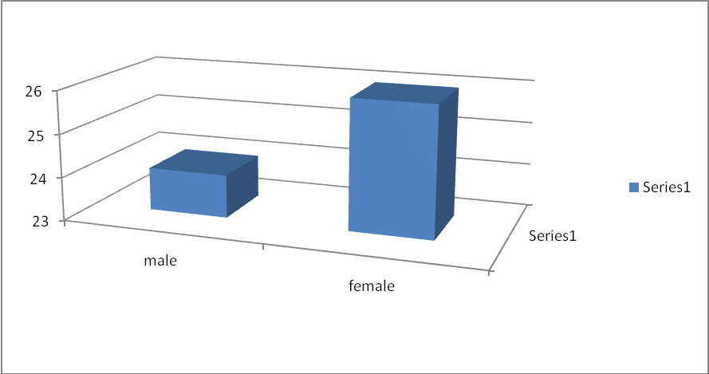

Q-2 AGE

Age

 |  | Frequency | Percent | Valid Percent | Cumulative Percent
Valid | 15-30 yrs | 13 | 26.0 | 26.0 | 26.0
Valid | 31-45 yrs | 16 | 32.0 | 32.0 | 58.0
Valid | 46-60 yrs | 15 | 30.0 | 30.0 | 88.0
Valid | more than 60 yrs | 6 | 12.0 | 12.0 | 100.0
Valid | Total | 50 | 100.0 | 100.0

I divided my respondent’s age group into four classes. Among them 15-30 years old were 13 people. 31-45 years old were 16 persons. 46-60 years old were 15 persons. More than 60 years old were 6 persons. So the available clients are between 31-45 years old. The ratio of the different age group people is given bellow:

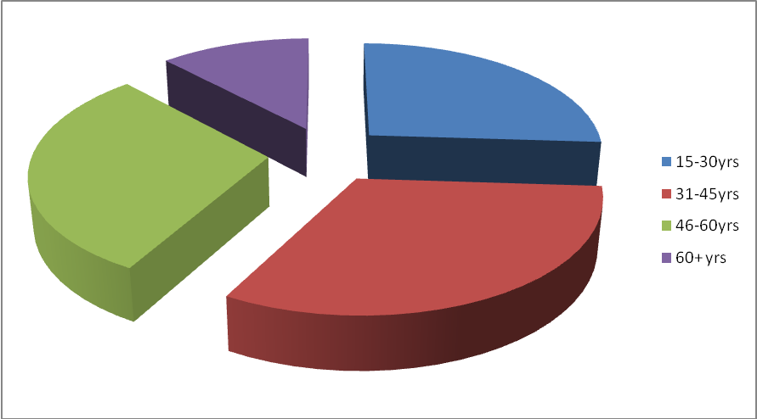

Q-3 OCCUPATION

Occupation

 |  | Frequency | Percent | Valid Percent | Cumulative Percent
Valid | Service Holder | 12 | 24.0 | 24.0 | 24.0
Valid | Business person | 18 | 36.0 | 36.0 | 60.0
Valid | Others | 20 | 40.0 | 40.0 | 100.0
Valid | Total | 50 | 100.0 | 100.0

My sample size was 50. Among them I found that there is 12 Service holder and 18 Business persons & 20 others occupation holder. I can also see that 24% Service holder and 36% Business persons & 40% others Others occupation holder includes Student,Housewife,Retried person etc. The ratio is given bellow in chart:

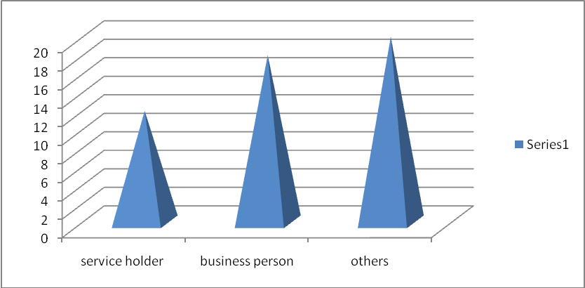

Q-4 Among different schemes of Shahajalal Islami Bank which one you prefer most

 |  | Frequency | Percent | Valid Percent | Cumulative Percent
Valid | Mudaraba savings/Alwadiah current | 9 | 18.0 | 18.0 | 18.0
Valid | Mudaraba term deposite(MTD) | 13 | 26.0 | 26.0 | 44.0
Valid | Mudaraba Lakhopoti Deposite scheme | 13 | 26.0 | 26.0 | 70.0
Valid | Visa debit card/visa prepaid card(local/international) | 9 | 18.0 | 18.0 | 88.0
Valid | pay order | 6 | 12.0 | 12.0 | 100.0
Valid | Total | 50 | 100.0 | 100.0

I have selected five popular schemes in the general banking of Shahjalal Islami Bank. Among them Mudaraba Term Deposit (MTD) & Mudaraba Lakhopoti Deposit are more popular. The ratio of different schemes is given bellow in the chart:

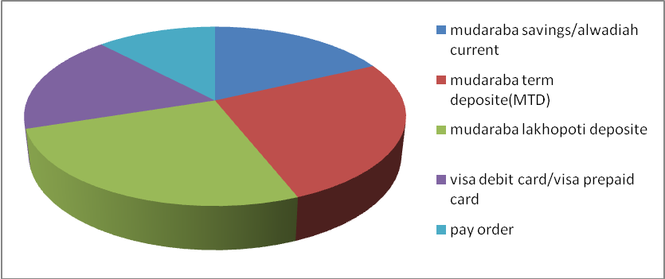

I made my questionnaire according to five dimensions. These are Assurance dimension, responsiveness dimenssion, reliability dimensions, empathy dimension &tangible dimension. There are some effective questions under the dimensions. Under the dimension there are some questions. The analysis of those questions is given bellow:

3.2 ASSURANCE DIMENSIONS

Q-1 Employee in Shahjalal Islami Bank has the knowledge to answer your question

 |  | Frequency | Percent | Valid Percent | Cumulative Percent
Valid | strongly disagree | 10 | 20.0 | 20.0 | 20.0
Valid | disagree | 2 | 4.0 | 4.0 | 24.0
Valid | agree | 25 | 50.0 | 50.0 | 74.0
Valid | strongly agree | 13 | 26.0 | 26.0 | 100.0
Valid | Total | 50 | 100.0 | 100.0

I have chosen 50-sample size for my survey. I also add that I got various types of answer from my respondents. My first question was employee in shahjalal bank have the knowledge to answer your question. Most of the respondent was agree with this comment. 25 respondents were agreed with this statement. Here strongly agree was 13 and disagree was 2 & strongly disagree was 10. The ratio between them is given bellow:

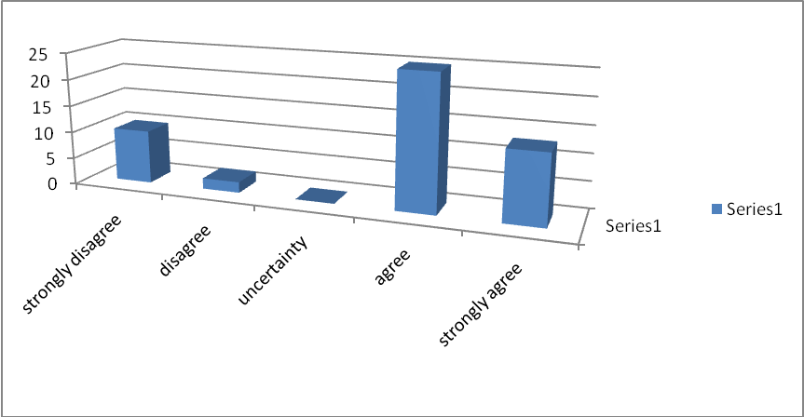

Q-2 you feel safe in your transaction with Shahjalal Islami Bank

 |  | Frequency | Percent | Valid Percent | Cumulative Percent
Valid | disagree | 12 | 24.0 | 24.0 | 24.0
Valid | uncertainty | 4 | 8.0 | 8.0 | 32.0
Valid | agree | 21 | 42.0 | 42.0 | 74.0
Valid | strongly agree | 13 | 26.0 | 26.0 | 100.0
Valid | Total | 50 | 100.0 | 100.0

21 respondents were agreed with the comment and 13 were strongly agreed. 4 respondents were uncertain and 12 respondents were disagreed. But there were no strongly agreed respondents. The ratio is given bellow in the chart:

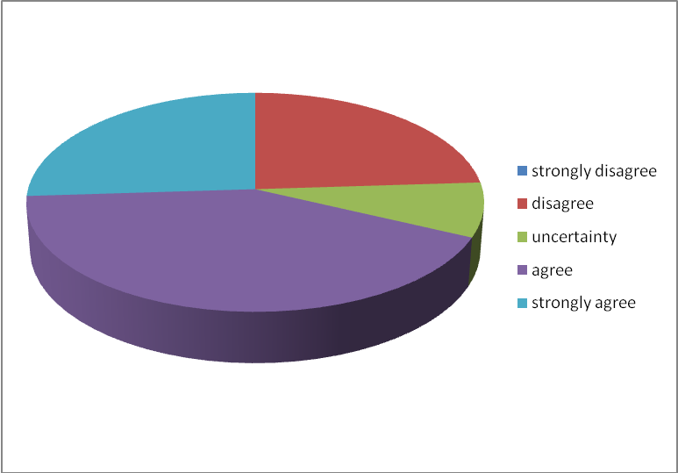

Q-3 Employees in Shahjalal Islami Bank is consistently courteous with you

 |  | Frequency | Percent | Valid Percent | Cumulative Percent
Valid | strongly disagree | 8 | 16.0 | 16.0 | 16.0
Valid | disagree | 12 | 24.0 | 24.0 | 40.0
Valid | uncertainty | 8 | 16.0 | 16.0 | 56.0
Valid | agree | 16 | 32.0 | 32.0 | 88.0
Valid | strongly agree | 6 | 12.0 | 12.0 | 100.0
Valid | Total | 50 | 100.0 | 100.0

Employees in Shahjalal bank is consistently courteous with you. 16 respondents were agreed with the comment and 12 respondents were disagreed with the comment. 8 respondents were uncertain and 6 respondents were strongly agreed. The ratio is given bellow in the chart:

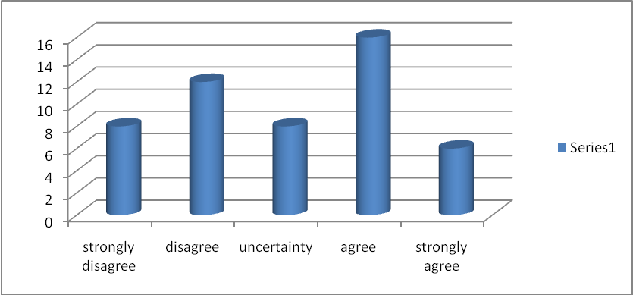

Q-4 The behavior of employees in Shahjalal Islami Bank instills confidence in you.

 |  | Frequency | Percent | Valid Percent | Cumulative Percent
Valid | strongly disagree | 6 | 12.0 | 12.0 | 12.0
 | disagree | 6 | 12.0 | 12.0 | 24.0
 | uncertainty | 2 | 4.0 | 4.0 | 28.0
 | agree | 23 | 46.0 | 46.0 | 74.0
 | strongly agree | 13 | 26.0 | 26.0 | 100.0
 | Total | 50 | 100.0 | 100.0

The behavior of employees in shahjalal Islami Bank instills confidence in you.23 respondents were agreed & 13 respondents were strongly agreed.6 respondents were strongly disagreed.6 respondents were disagreed. The rest of respondents were uncertain. The ratio is given bellow in the chart:

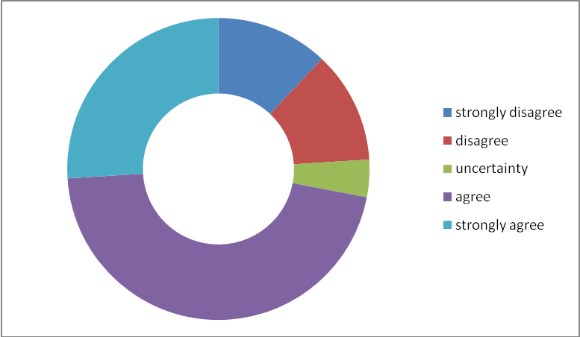

3.3 RESPONSIVENESS DIMENSIONS

Q-1 Employees of Shahjalal Islami Bank shows sincere interest in problem solving

 |  | Frequency | Percent | Valid Percent | Cumulative Percent
Valid | strongly disagree | 14 | 28.0 | 28.0 | 28.0
Valid | disagree | 4 | 8.0 | 8.0 | 36.0
Valid | uncertainty | 2 | 4.0 | 4.0 | 40.0
Valid | agree | 19 | 38.0 | 38.0 | 78.0
Valid | strongly agree | 11 | 22.0 | 22.0 | 100.0
Valid | Total | 50 | 100.0 | 100.0

Employees of Shahjalal Islami bank shows sincere interest in problem solving.19 respondents were agreed & 14 respondents were strongly disagreed.11 respondents were strongly agreed with this comment.4 respondents were disagreed. The rest of respondents were uncertain with this comment. The ratio is given bellow in the chart:



Q-2 Employees in Shahjalal Islami Bank give you prompt service

 |  | Frequency | Percent | Valid Percent | Cumulative Percent
Valid | strongly disagree | 4 | 8.0 | 8.0 | 8.0
Valid | disagree | 20 | 40.0 | 40.0 | 48.0
Valid | uncertainty | 5 | 10.0 | 10.0 | 58.0
Valid | agree | 14 | 28.0 | 28.0 | 86.0
Valid | strongly agree | 7 | 14.0 | 14.0 | 100.0
Valid | Total | 50 | 100.0 | 100.0

Employees in Shahjalal Islami Bank give you prompt service. Disagreed respondents were 20 and agreed respondents were 14. 7 respondents were strongly agreed and 4 were strongly disagreed
5respondents were uncertain with this comment. The ratio is given bellow in the chart:

: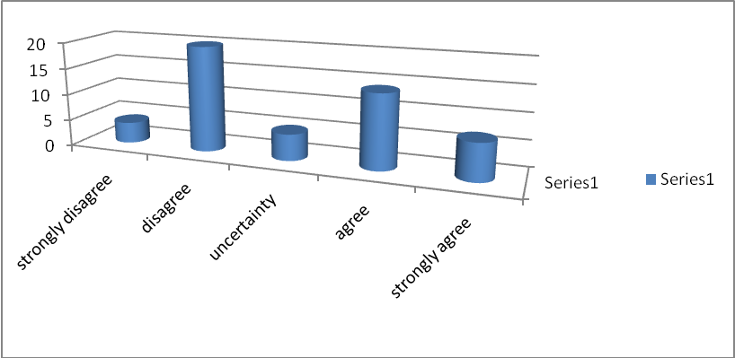

Q-3 Employees in Shahjalal Islami Bank are willing to help you

 |  | Frequency | Percent | Valid Percent | Cumulative Percent
Valid | strongly disagree | 4 | 8.0 | 8.0 | 8.0
Valid | disagree | 6 | 12.0 | 12.0 | 20.0
Valid | uncertainty | 10 | 20.0 | 20.0 | 40.0
Valid | agree | 22 | 44.0 | 44.0 | 84.0
Valid | strongly agree | 8 | 16.0 | 16.0 | 100.0
Valid | Total | 50 | 100.0 | 100.0

Employees in Shahjalal Islami Bank are willing to help you. My sample size was 50.Among them agreed respondents were 22 and uncertain respondents were10. 8 respondents were strongly agreed and 4 were strongly disagreed. The ratio is given bellow in the chart:

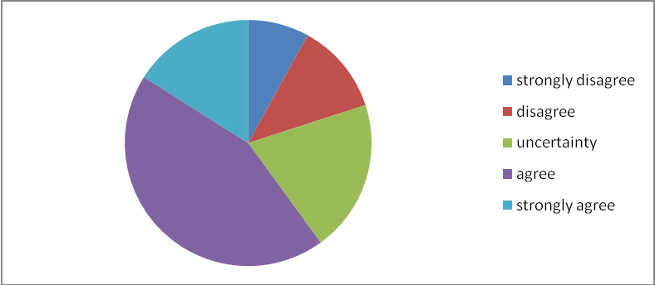

Q-4 Shahjalal Islami Bank keeps customers informed, when services will be performed

 |  | Frequency | Percent | Valid Percent | Cumulative Percent
Valid | strongly disagree | 4 | 8.0 | 8.0 | 8.0
Valid | disagree | 6 | 12.0 | 12.0 | 20.0
Valid | uncertainty | 3 | 6.0 | 6.0 | 26.0
Valid | agree | 13 | 26.0 | 26.0 | 52.0
Valid | strongly agree | 24 | 48.0 | 48.0 | 100.0
Valid | Total | 50 | 100.0 | 100.0

Shahjalal Islami Bank keeps customers informed, when services will be performed. Among all respondents 24 were strongly agreed and. 13 respondents were agreed. 6 respondents were disagreed and 4 were strongly disagreed. The ratio is given bellow in the chart:

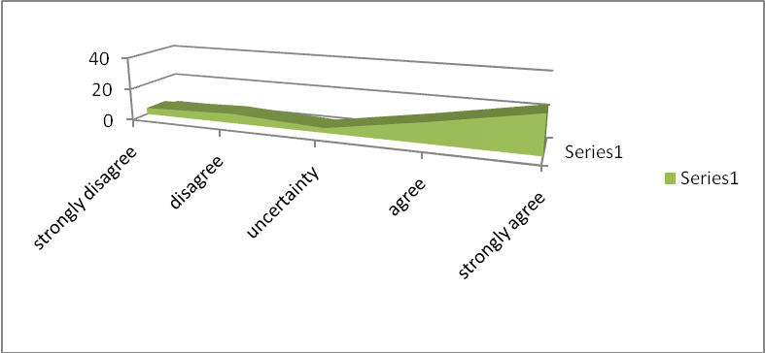

3.4 RELIABILITY DIMENSIONS

Q-1 When Shahjalal Islami Bank promises to do something by a certain time, it does so.

 |  | Frequency | Percent | Valid Percent | Cumulative Percent
Valid | strongly disagree | 8 | 16.0 | 16.0 | 16.0
Valid | uncertainty | 1 | 2.0 | 2.0 | 18.0
Valid | agree | 25 | 50.0 | 50.0 | 68.0
Valid | strongly agree | 16 | 32.0 | 32.0 | 100.0
Valid | Total | 50 | 100.0 | 100.0

When Shahjalal Islami Bank promises to do something by a certain time, it does so. Agreed respondents were 25 and strongly agreed respondents were 16.8 respondents were strongly disagreed. The number or uncertain respondent were 1. The ratio is given bellow in the chart:



Q-2 Shahjalal Islami Bank delivers their services on time

 |  | Frequency | Percent | Valid Percent | Cumulative Percent
Valid | strongly disagree | 8 | 16.0 | 16.0 | 16.0
Valid | disagree | 8 | 16.0 | 16.0 | 32.0
Valid | agree | 22 | 44.0 | 44.0 | 76.0
Valid | strongly agree | 12 | 24.0 | 24.0 | 100.0
Valid | Total | 50 | 100.0 | 100.0

Shahjalal Islami Bank delivers their services on time. Agreed respondents were 22 & strongly agreed respondents were 12.The number of both strongly disagreed & disagreed respondents were 8. The ratio is given bellow in the chart:

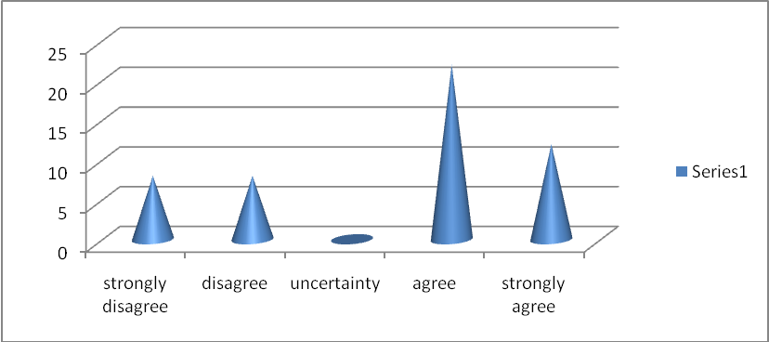

Q-3 Shahjalal Islami Bank provides its services at the time it promises to do so

 |  | Frequency | Percent | Valid Percent | Cumulative Percent
Valid | strongly disagree | 4 | 8.0 | 8.0 | 8.0
Valid | disagree | 8 | 16.0 | 16.0 | 24.0
Valid | uncertainty | 8 | 16.0 | 16.0 | 40.0
Valid | agree | 22 | 44.0 | 44.0 | 84.0
Valid | strongly agree | 8 | 16.0 | 16.0 | 100.0
Valid | Total | 50 | 100.0 | 100.0

Shahjalal Islami Bank provides its services at the time it promises to do so. . Agreed respondents were 22 & strongly agreed respondents were 12.The number of both strongly disagreed & disagreed respondents were 8.The ratio is given bellow in the chart:

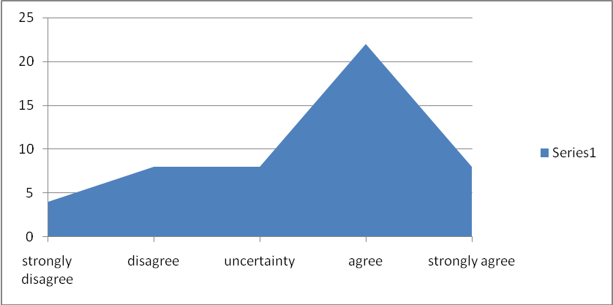

Q-4 Shahjalal Islami Bank insists on error free records

 |  | Frequency | Percent | Valid Percent | Cumulative Percent
Valid | strongly disagree | 10 | 20.0 | 20.0 | 20.0
Valid | disagree | 4 | 8.0 | 8.0 | 28.0
Valid | uncertainty | 3 | 6.0 | 6.0 | 34.0
Valid | agree | 15 | 30.0 | 30.0 | 64.0
Valid | strongly agree | 18 | 36.0 | 36.0 | 100.0
Valid | Total | 50 | 100.0 | 100.0

Shahjalal Islami Bank insists on error free records.18 respondents were strongly agreed & 15 were agreed.10 respondents were strongly disagreed & 4 were disagreed .The number of uncertain respondents were 3.The ratio is given bellow in the chart:

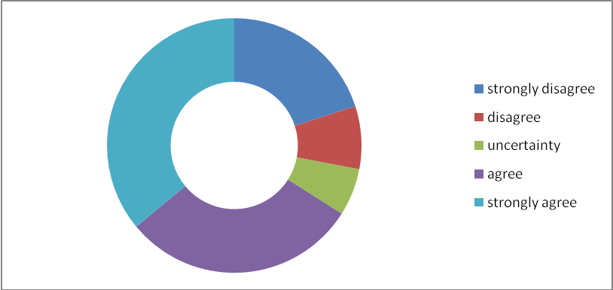

3.5 EMPATHY DIMENSIONS

Q-1 Employees of Shahjalal Islami Bank understand your specific needs

 |  | Frequency | Percent | Valid Percent | Cumulative Percent
Valid | strongly disagree | 8 | 16.0 | 16.0 | 16.0
Valid | disagree | 8 | 16.0 | 16.0 | 32.0
Valid | agree | 10 | 20.0 | 20.0 | 52.0
Valid | strongly agree | 24 | 48.0 | 48.0 | 100.0
Valid | Total | 50 | 100.0 | 100.0

Employees of Shahjalal Islami Bank understand your specific needs. Strongly agreed respondents were 24 and agreed respondents were 10. The numbers of both strongly disagreed & disagreed respondents were 8. There was no uncertain customer.

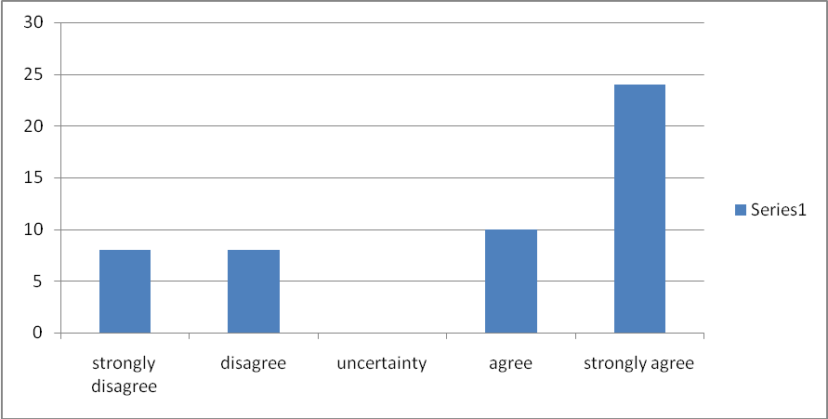

Q-2 Shahjalal Islami Bank has employees who give you personal attention

 |  | Frequency | Percent | Valid Percent | Cumulative Percent
Valid | strongly disagree | 6 | 12.0 | 12.0 | 12.0
Valid | disagree | 10 | 20.0 | 20.0 | 32.0
Valid | uncertainty | 5 | 10.0 | 10.0 | 42.0
Valid | agree | 19 | 38.0 | 38.0 | 80.0
Valid | strongly agree | 10 | 20.0 | 20.0 | 100.0
Valid | Total | 50 | 100.0 | 100.0

Shahjalal Islami Bank has employees who give you personal attention. Agreed respondents were 19 and Disagreed respondents were 10. 6 were strongly disagreed & disagreed respondents were 8. There were no uncertain respondent with this comment. The ratio is given bellow in the chart:

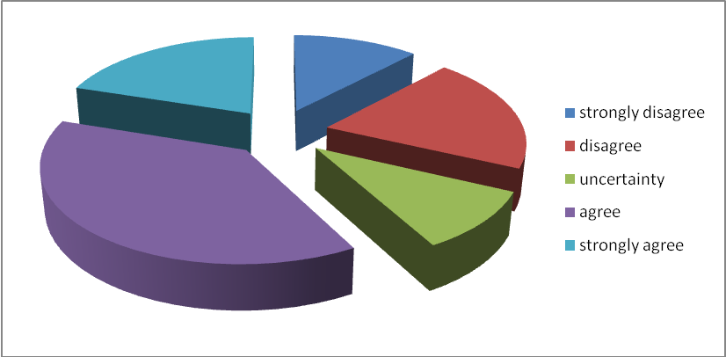

Q-3 Shahjalal Islami Bank has your best interest at heart

 |  | Frequency | Percent | Valid Percent | Cumulative Percent
Valid | disagree | 8 | 16.0 | 16.0 | 16.0
Valid | uncertainty | 8 | 16.0 | 16.0 | 32.0
Valid | agree | 21 | 42.0 | 42.0 | 74.0
Valid | strongly agree | 13 | 26.0 | 26.0 | 100.0
Valid | Total | 50 | 100.0 | 100.0

Shahjalal Islami Bank has your best interest at heart. Agreed respondents were 21 and Disagreed respondents were 8. 13 were strongly agreed & uncertain respondents were 8. The ratio is given bellow in the chart:

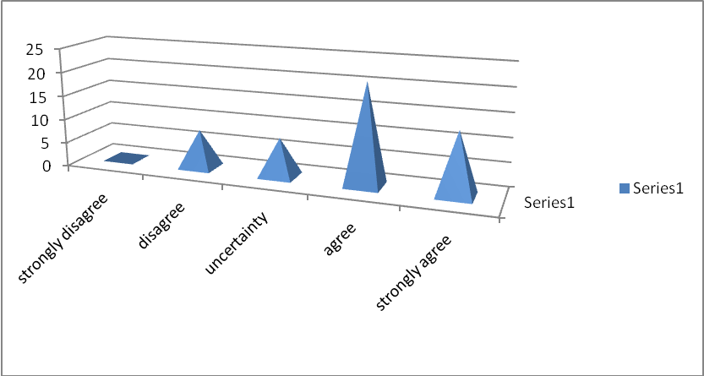

Q-4 Employees of Shahjalal Islami Bank has friendly manner to serve you

 |  | Frequency | Percent | Valid Percent | Cumulative Percent
Valid | strongly disagree | 4 | 8.0 | 8.0 | 8.0
Valid | disagree | 12 | 24.0 | 24.0 | 32.0
Valid | agree | 25 | 50.0 | 50.0 | 82.0
Valid | strongly agree | 9 | 18.0 | 18.0 | 100.0
Valid | Total | 50 | 100.0 | 100.0

Employees of Shahjalal Islami Bank has friendly manner to serve you. Agreed respondents were 25 and Disagreed respondents were 12. 9 were strongly agreed & 4 were strongly disagreed. There were no uncertain respondent with this comment. The ratio is given bellow in the chart:

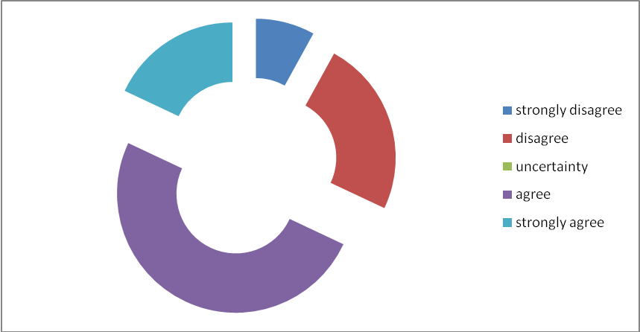

Q-5 Employees of Shahjalal Islami Bank has operating hours that are convenient to all customer

 |  | Frequency | Percent | Valid Percent | Cumulative Percent
Valid | strongly disagree | 5 | 10.0 | 10.0 | 10.0
Valid | disagree | 2 | 4.0 | 4.0 | 14.0
Valid | uncertainty | 3 | 6.0 | 6.0 | 20.0
Valid | agree | 14 | 28.0 | 28.0 | 48.0
Valid | strongly agree | 26 | 52.0 | 52.0 | 100.0
Valid | Total | 50 | 100.0 | 100.0

Employees of Shahjalal Islami Bank have operating hours that are convenient to all customers. Strongly agreed respondents were 26 and Disagreed respondents were 2. 5 were strongly disagreed & agreed respondents were 14. The numbers of uncertain respondents were 3. The ratio is given bellow in the chart:

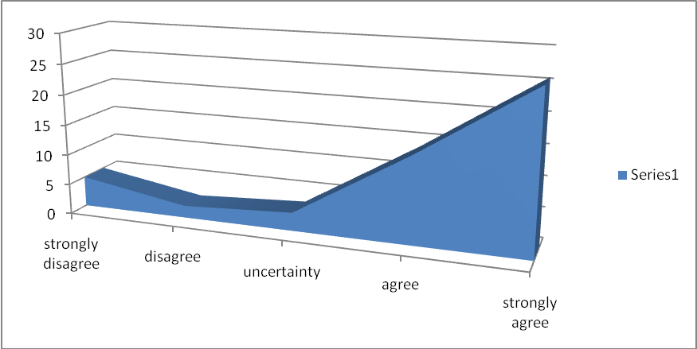

3.6 TANGIBLES DIMENSIONS

Q-1 Physical facilities of Shahjalal Islami Bank are visually appealing

 |  | Frequency | Percent | Valid Percent | Cumulative Percent
Valid | strongly disagree | 8 | 16.0 | 16.0 | 16.0
Valid | disagree | 4 | 8.0 | 8.0 | 24.0
Valid | uncertainty | 1 | 2.0 | 2.0 | 26.0
Valid | agree | 24 | 48.0 | 48.0 | 74.0
Valid | strongly agree | 13 | 26.0 | 26.0 | 100.0
Valid | Total | 50 | 100.0 | 100.0

Physical facilities of Shahjalal Islami Bank are visually appealing. Agreed respondents were 24 and Disagreed respondents were 4. 13 were strongly agreed & 8 were strongly disagreed. The number of uncertain respondent was 1 with this comment. The ratio is given bellow in the chart:

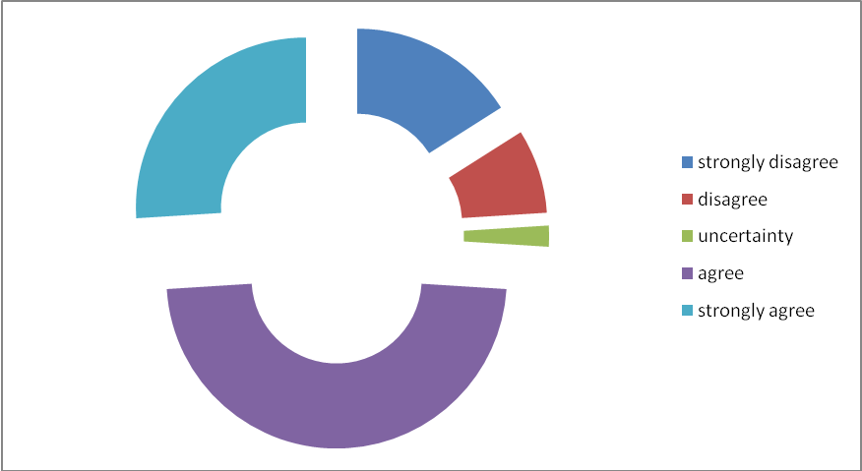

Q-2 Information, documents are available here which you need

 |  | Frequency | Percent | Valid Percent | Cumulative Percent
Valid | strongly disagree | 2 | 4.0 | 4.0 | 4.0
Valid | disagree | 6 | 12.0 | 12.0 | 16.0
Valid | uncertainty | 4 | 8.0 | 8.0 | 24.0
Valid | agree | 19 | 38.0 | 38.0 | 62.0
Valid | strongly agree | 19 | 38.0 | 38.0 | 100.0
Valid | Total | 50 | 100.0 | 100.0

Information, documents are available here which you need. . Agreed respondents were 19 and strongly agreed respondents were 19. 6 were disagreed & 2 were strongly disagreed. The numbers of uncertain respondents were 4 with this comment. The ratio is given bellow in the chart

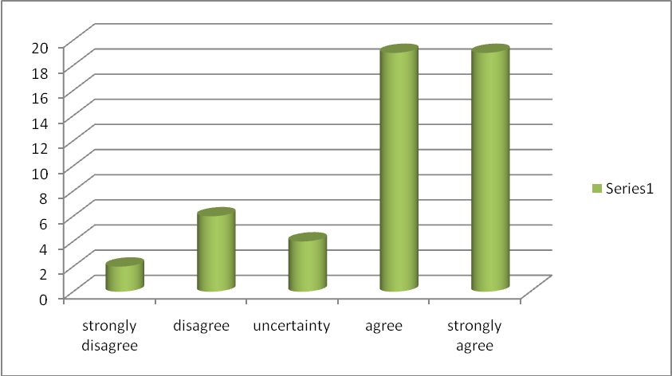

Q-3 Environment of Shahjalal Islami Bank is neat and clean

 |  | Frequency | Percent | Valid Percent | Cumulative Percent
Valid | disagree | 8 | 16.0 | 16.0 | 16.0
Valid | uncertainty | 4 | 8.0 | 8.0 | 24.0
Valid | agree | 27 | 54.0 | 54.0 | 78.0
Valid | strongly agree | 11 | 22.0 | 22.0 | 100.0
Valid | Total | 50 | 100.0 | 100.0

Environment of Shahjalal Islami Bank is neat and clean. With this comment agreed respondents were 27 and strongly agreed respondents were 11. 6 were disagreed. The numbers of uncertain respondents were 4 with this comment. The ratio is given bellow in the chart:

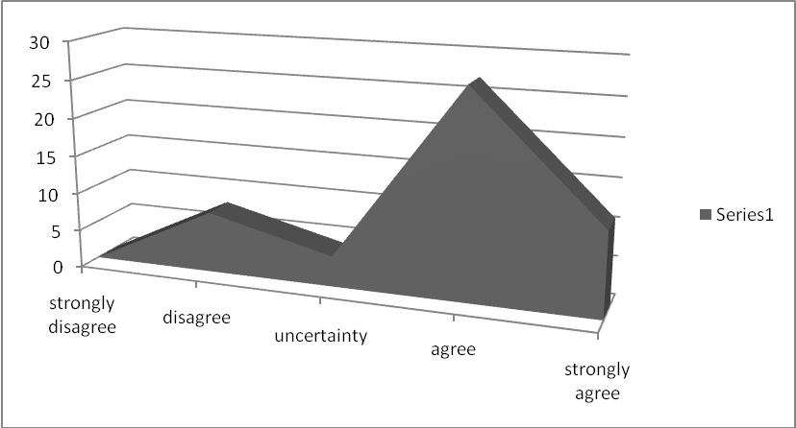

Q-4 Shahjalal Islami Bank use modern equipment

 |  | Frequency | Percent | Valid Percent | Cumulative Percent
Valid | strongly disagree | 4 | 8.0 | 8.0 | 8.0
Valid | disagree | 6 | 12.0 | 12.0 | 20.0
Valid | uncertainty | 2 | 4.0 | 4.0 | 24.0
Valid | agree | 24 | 48.0 | 48.0 | 72.0
Valid | strongly agree | 14 | 28.0 | 28.0 | 100.0
Valid | Total | 50 | 100.0 | 100.0

Shahjalal Islami Bank use modern equipment. With this comment agreed respondents were 24 and strongly agreed respondents were 14. 6 were disagreed. The numbers of uncertain respondents were 2 with this comment. The ratio is given bellow in the chart:

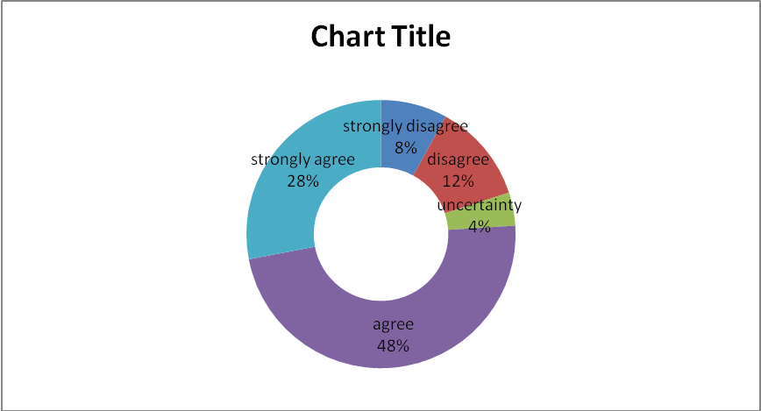

3.7 Special Findings
- My Sample size was 50.I divided my respondents’ age group into four classes. persons. The available clients are between 31-45 years old.
- Among the respondents’24% Service holder and 36% Businesspersons & 40% others occupation holder includes Student, Housewife, Retried person etc.
- I have selected five popular schemes in the general banking of Shahjalal Islami Bank. Among them Mudaraba Term Deposit (MTD) & Mudaraba Lakhopoti Deposit are more popular.
- Respondents prefer Mudaraba Term Deposit (MTD) & Mudaraba Lakhopoti Deposit because these schemes is auto renewable & easy to encashment for a client.
- From my survey I also found that most of the businesspersons prefer pay order scheme. On the other hand service holder prefer Savings Scheme
- Some respondents said employers of Shahjalal Islami bank should show more sincere interest in case of problem solving.
- From respondents’ response it is easy to say that employers of shahjalal bank does not provide prompt service to all customer.
- The operating hours of Shahjalal Islami Bank is convenient to all customers. But few Govt, officer said it is not suitable operating hours for them.

4.0 Recommendation & Conclusion
4.1 Recommendations
Based on my three months observation in the bank, I achieved lot of practical knowledge. Besides From my survey I identified some problems regarding service quality &try to give some recommendation to improve service quality.

- Sometime service quality shows the company overview or product quality so they need to think about it.
- Shahjalal Bank should give prompt service to all customer
- Shahjalal Bank should give some exclusive offering that retains their clients.
- The operating hours of Shahjalal bank doesn’t match with govt.officer .So they should look into this matter.
- They should increase number of ATM booth.
- Bank should introduce consumer credit scheme.

4.2 Conclusion
The performance of a Banks today competitive business is important. Just few years ago the number of bank was very small. So the competition was not a strong as its today. Things have changed with the emergence of many new banks now the Customers have option to take the one that the best so the current banking business scenario is simply highly competitive.
After doing this exploratory research I learn many things about banking activities and its affects on client perception. From my research and analysis I got lot of result about the Customers’ Perception of Service Quality of Shahjalal Islami Bank Limited Dhanmondi Branch. I identified that many of the respondents from my sample aware about the service quality of Banking activities. But in case of client retaining it has no significant affect on clients. On the other hand in some case it affects clients to choose different schemes of banking services.

4.3 JOB Experience

The internship report is a basic requirement for the BBA program. I have completed my Internship at Shahjalal Islami Bank Limited, Dhanmondi Branch. From the Opening an account to closing the account, generally activities are done in the customer service. How to open an account, How to maintain an account and all source of information for the customers are the activities of the customer service. Besides I have taken complaint from the client & give it to Customer in charge officer. I also helped customers to open an account. Cash department is the most vital department of a bank and it is call blood of a bank. It is a platform to communicate with customers. Cash department receives & pays cash directly. In clearing department I receive cheques from customers. Here I engaged myself with data entry. The internship program has been set for 90 days’ period. I believe this study will be beside me in future, especially if I get myself involved in banking and activities related to other financial institutions. The program has helped me a lot to understand the organizational atmosphere and behavior.

Questionnaire
“The Customers’ Perception of Service Quality: A Case Study on Shahjalal Islami Bank Limited Dhanmondi Branch”

I am a student of BBA, Eastern University conducting an Internship report survey about “Customer perception about service quality: A case study on Shahjalal Islami Bank Limited Dhanmondi Branch” and would like to know your views and opinions. Would you mind spending a few minutes to help me by completing this questionnaire? All of the information you give will be treated as completing confidence and it will not possible for anyone to identify the information you give me when I write up the report.

Please put the tick (√) marks in the appropriate box.

1. ⁮ Male ⁮ Female

2. Age

⁮ 15-30 yrs ⁮ 31-45 yrs ⁮ 46-60 yrs ⁮ more than 60

3. Occupation:

⁮ Service holder ⁮ Business person ⁮ others…………….

4. Among Different schemes of Shahjalal Islami bank Dhanmondi Branch Which one you prefer most?

⁮ Account opening:Mudaraba Savings / Alwadiah Current
⁮ Mudaraba Term Deposit (MTD)
⁮ Mudaraba Lakhopoti Deposit Scheme
⁮ Visa Debit Card/ Visa Prepaid Card (Local/ International)
⁮ Pay Order

5. Why the scheme is chosen by you?
. . . . . . . . . . . . . . . . . . . . . . . . . . . . . . . . (Please Specify)

Now I would like to give you some questions from several dimensions. The answers mark will be marked as follows:
Strongly Disagree= 1
Disagree= 2
Uncertainty= 3
Agree= 4
Strongly agree= 5

Perception statements in the assurance dimensions

1. Employees in Shahjalal bank have the knowledge to answer your questions. 1 2 3 4 5
2. You feel safe in your transaction with Shahjalal Bank. 1 2 3 4 5
3. Employees in Shahjalal Bank are consistently courtious with you. 1 2 3 4 5
4. The behavior of employees in Shahjalal Bank instills confidence in you. 1 2 3 4 5

Perception statements in the responsiveness dimensions

1. Employeees of Shahjalal bank show sincere interest in problem solving 1 2 3 4 5
2. Employees in Shahjalal Bank give you prompt service. 1 2 3 4 5
3. Employees in Shahjalal Bank are willing to help you. 1 2 3 4 5
4. Shahjalal Bank keeps customers informed, when services will be performed 1 2 3 4 5

Perception statements in the reliability dimensions

1. When Shahjalal Bank promises to do something by a certain time, it does so. 1 2 3 4 5
2. Shahjalal Bank delivers their service on time. 1 2 3 4 5
3. Shahjalal Bank provides its services at the time it promises to do so. 1 2 3 4 5
4. Shahjalal Bank insists on error-free records. 1 2 3 4 5

Perception statements in the empathy dimensions

1. Employees of Shahjalal Bank understand your specific needs. 1 2 3 4 5
2. Shahjalal Bank has employees who give you personal attention. 1 2 3 4 5
3. Shahjalal Bank has your best interests at heart. 1 2 3 4 5
4. Employees of Shahjalal Bank has friendly manner to serve you 1 2 3 4 5
5. Employees of Shahjalal Bank has operating hours that are convenient to all 1 2 3 4 5
customer.
Perception statements in the tangibles dimensions

1. Physical facilities of Shahjalal Bank are visually appealing. 1 2 3 4 5
2. Information, documents are available here which you need 1 2 3 4 5
3. Environment of Shahjalal Bank is neat and clean 1 2 3 4 5
4.Shajalal Bank use modern equipment 1 2 3 4 5

Statistics

 |  | Gender | Age | Occupation | Among different schemes of Shahajalal Islami Bank which one you prefer most
N | Valid | 50 | 50 | 50 | 50
N | Missing | 0 | 0 | 0 | 0
Mean |  | 1.5200 | 2.2800 | 2.1600 | 2.8000
Median |  | 2.0000 | 2.0000 | 2.0000 | 3.0000
Mode |  | 2.00 | 2.00 | 3.00 | 2.00(a)
Std. Deviation |  | .5047 | .9906 | .7918 | 1.2778
Variance |  | .2547 | .9812 | .6269 | 1.6327
Range |  | 1.00 | 3.00 | 2.00 | 4.00
Minimum |  | 1.00 | 1.00 | 1.00 | 1.00
Maximum |  | 2.00 | 4.00 | 3.00 | 5.00
Percentiles | 50 | 2.0000 | 2.0000 | 2.0000 | 3.0000

ASSURANCE DIMENSIONS
Statistics

 |  | Employee in Shahjalal Islami Bank have the knowledge to answer your question | You feel safe in your transaction with Shahjalal Islami Bank | Employees in Shahjalal Islami Bank are consistently courtious with you | The behavior of employees in Shahjalal Islami Bank instills confidence in you
N | Valid | 50 | 50 | 50 | 50
N | Missing | 0 | 0 | 0 | 0
Mean |  | 3.5800 | 3.7000 | 3.0000 | 3.6200
Median |  | 4.0000 | 4.0000 | 3.0000 | 4.0000
Mode |  | 4.00 | 4.00 | 4.00 | 4.00
Std. Deviation |  | 1.4441 | 1.1112 | 1.3093 | 1.3231
Variance |  | 2.0853 | 1.2347 | 1.7143 | 1.7506
Range |  | 4.00 | 3.00 | 4.00 | 4.00
Minimum |  | 1.00 | 2.00 | 1.00 | 1.00
Maximum |  | 5.00 | 5.00 | 5.00 | 5.00
Percentiles | 50 | 4.0000 | 4.0000 | 3.0000 | 4.0000

RESPONSIVENESS DIMENSIONS

Statistics

 |  | Employees of Shahjalal Islami Bank shows sincere interest in problem solving | Employees in Shahjalal Islami Bank give you prompt service | Employees in Shahjalal Islami Bank are willing to help you | Shahjalal Islami Bank keeps customers informed, when services will be performed
N | Valid | 50 | 50 | 50 | 50
N | Missing | 0 | 0 | 0 | 0
Mean |  | 3.1800 | 3.0000 | 3.4800 | 3.9400
Median |  | 4.0000 | 3.0000 | 4.0000 | 4.0000
Mode |  | 4.00 | 2.00 | 4.00 | 5.00
Std. Deviation |  | 1.5739 | 1.2617 | 1.1471 | 1.3311
Variance |  | 2.4771 | 1.5918 | 1.3159 | 1.7718
Range |  | 4.00 | 4.00 | 4.00 | 4.00
Minimum |  | 1.00 | 1.00 | 1.00 | 1.00
Maximum |  | 5.00 | 5.00 | 5.00 | 5.00
Percentiles | 50 | 4.0000 | 3.0000 | 4.0000 | 4.0000

RELIABILITY DIMENSIONS

Statistics

 |  | When Shahjalal Islami Bank promises to do something by a certain time, it does so | Shahjalal Islami Bank delivers their services on time | Shahjalal Islami Bank provides its services at the time it promises to do so | Shahjalal Islami Bank insists on error free records
N | Valid | 50 | 50 | 50 | 50
N | Missing | 0 | 0 | 0 | 0
Mean |  | 3.8200 | 3.4400 | 3.4400 | 3.5400
Median |  | 4.0000 | 4.0000 | 4.0000 | 4.0000
Mode |  | 4.00 | 4.00 | 4.00 | 5.00
Std. Deviation |  | 1.3354 | 1.4309 | 1.1808 | 1.5414
Variance |  | 1.7833 | 2.0473 | 1.3943 | 2.3759
Range |  | 4.00 | 4.00 | 4.00 | 4.00
Minimum |  | 1.00 | 1.00 | 1.00 | 1.00
Maximum |  | 5.00 | 5.00 | 5.00 | 5.00
Percentiles | 50 | 4.0000 | 4.0000 | 4.0000 | 4.0000

EMPATHY DIMENSIONS

Statistics

 |  | Employees of Shahjalal Islami Bank understand your specific needs | Shahjalal Islami Bank has employees who give you personal attention | Shahjalal Islami Bank has your best interest at heart | Employees of Shahjalal Islami Bank has friendly manner to serve you | Employees of Shahjalal Islami Bank has operating hours that are convenient to all customer
N | Valid | 50 | 50 | 50 | 50 | 50
N | Missing | 0 | 0 | 0 | 0 | 0
Mean |  | 3.6800 | 3.3400 | 3.7800 | 3.4600 | 4.0800
Median |  | 4.0000 | 4.0000 | 4.0000 | 4.0000 | 5.0000
Mode |  | 5.00 | 4.00 | 4.00 | 4.00 | 5.00
Std. Deviation |  | 1.5836 | 1.3342 | 1.0160 | 1.2651 | 1.2911
Variance |  | 2.5078 | 1.7800 | 1.0322 | 1.6004 | 1.6669
Range |  | 4.00 | 4.00 | 3.00 | 4.00 | 4.00
Minimum |  | 1.00 | 1.00 | 2.00 | 1.00 | 1.00
Maximum |  | 5.00 | 5.00 | 5.00 | 5.00 | 5.00
Percentiles | 50 | 4.0000 | 4.0000 | 4.0000 | 4.0000 | 5.0000

TANGIBLES DIMENSIONS

Statistics

 |  | Physical facilities of Shahjalal Islami Bank are visually appealing | Information, documents are available here which you need | Environment of Shahjalal Islami Bank is neat and clean | Shahjalal Islami Bank use modern equipment
N | Valid | 50 | 50 | 50 | 50
N | Missing | 0 | 0 | 0 | 0
Mean |  | 3.6000 | 3.9400 | 3.8200 | 3.7600
Median |  | 4.0000 | 4.0000 | 4.0000 | 4.0000
Mode |  | 4.00 | 4.00(a) | 4.00 | 4.00
Std. Deviation |  | 1.3851 | 1.1502 | .9624 | 1.2216
Variance |  | 1.9184 | 1.3229 | .9261 | 1.4922
Range |  | 4.00 | 4.00 | 3.00 | 4.00
Minimum |  | 1.00 | 1.00 | 2.00 | 1.00
Maximum |  | 5.00 | 5.00 | 5.00 | 5.00
Percentiles | 50 | 4.0000 | 4.0000 | 4.0000 | 4.0000

