Submitted by
WWW.ASSIGNMENTPOINT.COM

Economic history shows that development has started everywhere with the banking system and its contribution towards financial development of a country is the highest in the initial stage. Schumpeter (1933) regarded the banking system as one of the two main agents (other being entrepreneurship) in the whole process of development. Keynes also emphasized the role of banking services in the process of economic development of a country, while she was addressing the House of Lords regarding International and Monetary System (quoted in Sharma 1985). Moreover Alexander Gerashchenko (1962) in his popularly known “Gerschenkron’s Hypothesis” explained the banking system as the key role player at certain stage of the industrialization process.

The word ‘Bank’ comes from the word ‘Bancus’.Generally by the word "Bank" we can easily understand that the financial institution dealing with money. But there are different types of banks like Central Banks, Commercial Banks, Savings Banks, Investment Banks, Industrial Banks, and Co-operative Banks etc. But when we use the term "Bank" without any prefix, or restriction, it refers to the Commercial banks. Commercial banks are the primary contributors to the economy of a country. So we can say Commercial banks are a profit-making institution that collects the deposits from the surplus unit of the society and then lend the deposits collected to the deficit unit of the society. So the people of the society and the government are very much dependent on the commercial banks as the financial intermediary. As banks are profit-earning concern they collect deposit at the lowest possible cost and provide loans and advances at higher. The differences between two are the profit for them.

Modern banking system plays a vital role for a nation’s economic development. Over the last few years the banking world has been undergoing a lot of changes due to deregulation, technological innovations, globalization etc. These changes in the banking system also brought revolutionary changes in a country’s economy. Present world is changing rapidly to face the challenge of competitive free market economy. It is well recognized that there is an urgent need for better, qualified management and better-trained staff in the dynamic global financial market. Bangladesh is no exceptions of this trend. Banking Sector in Bangladesh is facing challenges from different angles though its prospect is bright in the future.
.

Internship program is essential for every Business Administration student. In other words it is mandatory for the student of any professional degree. It helps them to get acquainted with the real life situation. To acquire some practical knowledge it’s a best way. This internship report is based on the author’s internship experience in Dutch Bangla Bank Ltd , Malibagh Branch and Dhaka-1217.

1.1 Origin of the Report:

Bachelor of Business Administration is a specialized course. Southeast University arranges a four years specialized course to provide some efficient graduates in this business sector of the country. The whole course design is not limited within the theoretical boundary but it also extends to the practical exposure through the internship program. After completion of 4 years in the BBA program of the faculty of business studies, department of Finance, Southeast University, three months organizational attachment is must. So the preparation and submission of this report is partial requirement for the completion of the Bachelor of Business Administration (BBA).This report is outcome of the two months long internship in out of three months program conducted in Dutch Bangla Bank Ltd , one of the reputed private commercial banks of the country .While working operating procedures carried out by the bank were observed and supportive effort with the trainers, bankers & under the guidance of my faculty respective supervisor Md. Shamsul Arefin.
This internship program has been prepared on the basis of my practical experience in the general banking along with the foreign exchange division activities. I really worked hard about the foreign exchange division. This report will also provide the essential information’s how the private commercial banks contribute for the economic development of the country.
I have tried my best to utilize the opportunity to enrich my knowledge on banking system and incorporate it with the theoretical course.

1.2 Background of the study:

The internship program which is necessary to complete the BBA program exercise a significant importance as it enables a student to familiar with the practical business activities. The student work closing with the people of an organization and learn about the function of that organization. This program enables a student to develop his analytical skill and scholastic attitude.

1.3 Importance of Internship:

Classroom learning is all about theoretical and internship learning is all about practical. Characteristics of internship learning can be thought of as ‘touchable’ and ‘viewable’ whereas classroom learning is conceptual in nature. Here lies the importance of internship. It helps students to compare between classroom learning, knowledge and practical reality at the Community level. Just prior to joining the job it acts as a tool to accelerate the new graduates in their professional life.

1.4 Coverage of the study:

- To obtain practical experience about foreign exchange activities by involving Internship program.
- To build professional carrier in the banking sector as well as any financial institution.
- To know about the foreign exchange activities in Bangladesh.

  - RATIONALE OF THE STUDY:

Bangladesh is one of the underdeveloped countries in the world. The company of the country has a lot left to be desired and there are lots of scopes for massive improvement. In an economy like this, banking sector can play a vital role of an intermediary can mobilize the excess fund of surplus sector to provide necessary finance, to those sectors, which are needed to promote for the sound development of the economy.

Like in many other emerging market economies, commercial banks in the Bangladesh economy are to face an increasing competition for their business in the coming days. Their business will no longer remain easy as they had earlier the real change in the banking business has started to come with govt.’s decision to allow the business in the private sector in the middle of the eighties. This report is an effort to reflect a clear idea about the strategies, activities and performance of Dutch Bangla Bank Ltd Bangladesh Ltd. Regarding Foreign exchange banking practices in Bangladesh- A case study of Dutch Bangla Bank Ltd (Malibagh branch), Dhaka-1217.

1.6 Objectives of the study:

The objective of the study is to gather practical knowledge on banking system and operation. This internship gives us a chance to co-ordinate with the theoretical knowledge and the practical experience and to evaluate the Foreign exchange banking practices in Bangladesh- A case study of Dutch Bangla Bank Ltd . And also the performance of general banking this Bank. The following are of objectives for internship in bank:

1.6.1 General Objective

The general objective is to prepare & submit a report on the topic of “Foreign exchange banking practices in Bangladesh- A case study of Dutch Bangla Bank Ltd ." The primary purpose of this report is to get an idea about the relationship between customers & Dutch Bangla Bank Ltd , a second-generation bank of the country and make a analysis of foreign exchange practices on the banking sector of Bangladesh.

1.6.2 Specific Objective
- To apply theoretical knowledge in the practical field.
- To be familiar with the banking management system.
- To have exposure to the functions of general banking section.
- To analyze the service procedure of Dutch Bangla Bank Ltd .
- To evaluate the performance of foreign exchange division.
- To come up with a SWOT analysis of Dutch Bangla Bank Ltd .
- To know the return on export, import & remittance.
- To familiarize the working hours, values and environment of the bank.
- To analyze the financing system of the Bank and find out whether the bank needs any improvement.
- To familiarize different rules and regulations of export and import formalities.
- To find out the contribution of private commercial banks for the economic development of the country.

1.7 Scope of the study:

During these three months internship program in Dutch Bangla Bank Ltd , Malibagh Branch almost all the desks have been observed. For that purpose I needed to get information from Dutch Bangla Bank Ltd s Head Office. But I was appointed into Dutch Bangla Bank Ltd , Malibagh Branch, Dhaka-1217. There I had to work in foreign exchange & general banking department desks as a routine work. It was difficult to collect the information relevant my report, because the people of this Bank was so busy with their duty that they cannot be able to give me much time. Here I try to cover the activities and rules and regulation related to my report.

1.8 Limitations of the study:

Although I have obtained wholehearted cooperation from employee of Dutch Bangla Bank Ltd , Malibagh branch but they were extremely busy. So they were not able to give me much time, as they and I would like. Besides, total duration of internship is not sufficient to give me more than a superficial idea of the functioning of the various departments. I was rotated through on the way of my study. I have faced the following problems, which may be termed as the limitation/short coming of the study. These are as follows:

- It was very different to collect the information form various personnel for the job constrain.
- Bank policy was not disclosing some data and information for obvious reasons.
- Due to time limitation many of the aspects could not be discussed in the present report.
- Since the bank personnel where very busy, they could provide me little time.
- Another significant problem faced during the preparation of this report was the contradictory explanation of a single subject by different employee.
- Because of the limitation of information some assumption was made. So there may be some personal mistakes in the report.
- The time 2 months out of 3 months only, which is in sufficient to know all activities of the branch are prepare the report.
- The insufficiency of information was not adequately available. Moreover, the sources were hazardous and in-discipline. Therefore the providence of insufficient information came out as a constraint.
- Almost all the personnel were apparently too busy to assist us with their valuable support.
- Long internship was not able to provide us with adequate time to impose more databases sophistic to the formulation of this report.
- During the internship, in many part of our enquiry, our performance was hindered by some sort of inexperience of some of the personnel of the bank due to lack of orientation to the procedure of such internees.
- There was no remuneration for our internship that demoralizes our motivation to keep consistency in our extensive study.
- Sometimes we had to face unexpected conduct on the part of some of the personnel that was supposed to be a little bit more cordial.

- The study was limited only to the Dutch Bangla Bank Ltd .
- Another Problem was time constraints. The duration of my work was only three months. But this time is not enough for a complete and fruitful study.
- Getting financial information is very hard job.
- The Bank was a busy one having heavy rush of people, whom officers need to deal with. So allocation of time for an internee is very much tough for the officers of the bank.
- Although there are a lot of limitations, I have tried to put my best effort as far as possible to prepare the report.

1.9 Methodology of the study:
The planned methodology of the research is given below:

1.9.1 (A) Sources of data.
Data regarding the completion of this research will be collected from both primary and secondary sources.
The core information and data source is expected to be primary, because it will involve interviewing officials of Dutch Bangla Bank Ltd , Malibagh branch to get detailed information about the innovative products they offer. The officials who will be interviewed are:

- Branch Sales & Service Manager
- Sales Team Manager
- Cash Manager
- Personal Financial Consultant

(1) Primary sources.
- Practical desk work
- Face to face conversation with the officer
- Direct observations
- Face to face conversation with the client
(2)Secondary sources.
- Annual reports of Dutch Bangla Bank Ltd .
- Files & Folders
- Memos & Circulars
- Daily diary (containing my activities of practical orientation) maintained by me,
- Various publications on Bank,
- Websites,
- Different circulars sent by Head Office and Bangladesh Bank.

1.9.2 (B) Questionnaire design, data collection and answer.

As the internship program involves constantly interacting with officers, I am able to manage some answers of the questions. The questionnaire is made by me of some general questions. This will try to measure the quality of services in comparison to other multinational banks of Bangladesh. Most of the information will be collected by interviewing of the bank officials.
For several years annual report of various schemes this section of Dutch Bangla Bank Ltd , Malibagh Branch, and Head Office is a big source. While conducting the study both primary and secondary information were explored. But hardly any primary information could be found. In the absence of primary information the majority of the study has been based on secondary information.

Chapter Two

Profile of the Organization

2.1 Historical Background of the Bank:

Dutch Bangla Bank Ltd is a public listed scheduled bank categorized in private sector and established under the ambit of Bank Companies Act, 1991 and incorporated as a public limited company under the Companies Act, 1994 on June 02. The Bank started commercial banking operations effective from August 03, 1999. The Bank converted its Banking Operations into Islamic Banking based on Islamic Shariah from traditional banking operation in July 01, 2004 after obtaining approval from Bangladesh Bank.

During the span of time the Bank has been widely acclaimed by the business community, from small entrepreneurs to large traders and industrial conglomerates, including the top rated corporate borrowers for forward- looking business outlook and innovative financing solutions. With a few of the Company’s activities and program on the basis of Islamic Shariah, within this period of time it has been able to create an image of responsibility for itself and has earned significant reputation in the country’s banking sector. Within an operative period as eight years, the bank has arrived at a strong financial and business position by expanding its market share compared to its contemporaries and to some extent to the 2nd even 1st generation banks of private sector. In edition, the Bank has also made a significant contribution to the national economy under the prudent leadership and untiring support of the member of the Board of Directors, who are leading business personalities and reputed industrialists of the country.

As a matter of policy, the Bank conducts its business on the principles of Mudaraba, Murabaha, Bai-Muazzal and hire purchase transaction approved by Bangladesh Bank. The Bank is one of the interest-free Shariah-based Banks in the country and its modus-operandi is substantially different from those of other commercial banks.

The gradual improvement in the overall policy environment has enabled Bangladesh to improve its economic performance in recent years. Successive governments in Bangladesh have been confronted with the problem of stimulating the economic growth rate in a country where a substantial segment of the population lives below the subsistence level. Economic policies are still guided by five year plans. The prospect of economic growth in Bangladesh in the near future will depend on the pace of economic reforms and the quality of macroeconomic management. Accelerating the rate of economic growth will require higher levels of investment. This will primarily come from private flows of foreign direct investment. This can be established by reforming the financial system and continuing the process of financial deepening.
The banking industry in Bangladesh is one characterized by strict regulations and monitoring from the central governing body, The Bangladesh Bank. As the government is often the owner and regulator as well as the supervisor and customer of a bank, there has been ample opportunity for mismanagement over the years. The banking sector is plagued with a lack of credit discipline, archaic loan recovery law, corruption, inefficiency, overstaffing, etc. Several reform measures of the financial sector have been taken to improve the situation. Relative stability achieved by the support extended by both the central bank and the Government of Bangladesh in the past has restored public confidence in the country's banking sector. Moreover, Nationalized Commercial Banks (NCBs) and old generation Private Commercial Banks (PCBs) would have to lower the rate of NPAs in their portfolios. Failure to do so would mean re-capitalization, at least for the NCBs. This may in turn lead to a further drain on the limited resources of the Government of Bangladesh at this time or in the immediate future this recapitalization would not be feasible. With these conditions in place, the World Bank anticipates the likelihood of a situation where the ever-increasing burden of non-performing loans and growing rate of debt servicing would place the economy under enormous strain and result in a crisis in the banking sector in the long term.
The main concern is that currently there are far too many banks for the bank to sustain.
As a result the market will accommodate only those banks that can transpire as the most competitive and profitable ones in the future.

Dutch Bangla Bank Ltd that was named before as Bengal Export Import Bank Ltd. being newly formed commercial bank of the country with a distinctive identity was opened in 3rd August 1999,with the permission if Bangladesh Bank under Banking Companies Act-1991. The bank received the certificate of incorporation #C-37884(2164)/99 under the company act of 1994.
Dutch Bangla Bank Ltd was established in 1999 under the leadership of Late Mr.Shahjahan Kabir, founder chairman who had a long dream of floating a commercial bank which would contribute to the socio-economic development of our country. Mr.Nazrul Islam Mazumder became the honorable chairman after the demise of the honorable founder chairman respectively.
The bank has migrated all of its conventional banking operation into Shariah based Islamic banking since July/2004.

Currently the major financial institutions under the banking system include

- Bangladesh Bank
- Commercial Banks
- Islamic Banks
- Leasing Companies
- Finance Companies

Figure 1: Percentage different banking Sectors in Bangladesh
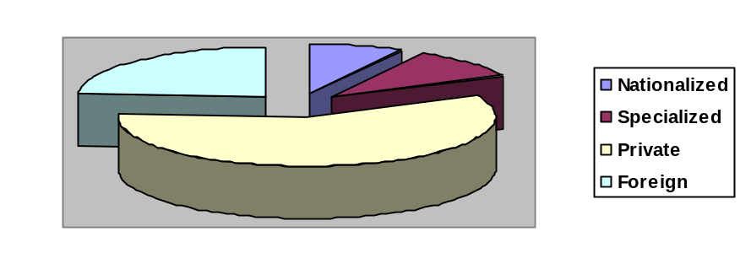
The number of banks in all now stands at 49 in Bangladesh. Out of the 49 banks, four are Nationalized Commercial Banks (NCBs), 28 local private commercial banks, 12 foreign banks and the rest five are Development Financial Institutions (DFIs).
Generally, the commercial banks and the finance companies provide
Myriad of banking products/services to cater to the needs of their customers. However, the Bangladeshi Banking industry is characterized by the tight Banking rules and regulations set by the Bangladesh Bank. All banks and financial institutions are highly governed and controlled under the Banking Companies Act 1993. The range of banking products and services is also limited in scope. With the liberalization of markets competitions among the banking products seems to be growing more instances each day. In addition, the banking products offered in Bangladesh are fairly homogeneous in nature due to the tight regulations imposed by the central bank. Competing through differentiation is increasingly difficult and other banks quickly duplicate any innovative banking service.
These private banks are popularly known to public as First Generation Banks (9 banks opened during 1982-88), Second Generation banks (13 banks opened during 1992-96) and Third Generation banks (13 banks opened during 1999-2001).

The name of all the banks operating in Bangladesh and their date of incorporation are given below:

Name of bank | Date of incorporation | Name of bank | Date of incorporation
Nationalized commercial banks |  | Specialized banks
Sonali bank Ltd | 1972 | BKB | 1972
Janata Bank Ltd | 1972 | BSB | 1972
Agrani Bank Ltd | 1972 | BSRS | 1972
Rupali bank Ltd | 1972 | RAKUB | 1987
 |  | BASIC | 1988
Private Commercial Banks

1st generation private banks |  | 2nd generation private banks
AB bank Ltd. | 1982 | Eastern bank Ltd | 1992
Utara bank Ltd | 1983 | National credit and commerce bank Ltd | 1993
National bank Ltd | 1983 | Prime bank Ltd | 1995
Islami bank Ltd | 1983 | Dhaka bank Ltd | 1995
IFIC bank Ltd | 1983 | Southeast bank Ltd | 1995
United Commercial bank Ltd | 1983 | Al-Arafa Islami Bank Ltd | 1995
The City bank Ltd | 1983 | Social Investment bank Ltd | 1995
Pubali bank Ltd | 1984 | Dutch-Bangla bank Ltd | 1996
Al-Baraka bank Ltd | 1987
3rd generation private banks |  | Foreign commercial banks
Bangladesh Commerce Bank Ltd | 1998 | Standard Chartered bank | 1948
Mercantile Bank Ltd | 1999
Standard bank Ltd | 1999 | American Express Bank Ltd | 1996
One Bank Ltd | 1999 | State Bank of India | 1975
Dutch Bangla Bank Ltd | 1999 | Habib Bank Ltd | 1976
Premier Bank Ltd | 1999 | Muslim Commercial bank | 1994
Mutual Trust Bank Ltd | 1999 | National Bank of Pakistan | 1994
First security Bank Ltd | 1999 | CITI Bank N.A. | 1995
Bank Asia Ltd | 1999 | HSBC | 1996
The Trust bank Ltd | 1999 | Shamil Islami Bank | 1997
Jamuna Bank | 2001 | Credit Agricol Indosuez | 1997
Shahjalal Islami Bank | 2001 | Hanvit Bank | 1999
BRAC Bank | 2001 | Mashreq | 2001
Bank of Ceylon | 2007
Source: Bangladesh Bank.

2.2 Key Function of Dutch Bangla Bank Ltd :

Like other commercial banks like Dutch Bangla Bank Ltd performs all traditional banking business including introduction of a wide range of caving and credit products, retail banking and ancillary service with the support of modern technology and professional management, but the Dutch Bangla Bank Ltd Bangladesh Limited emphasizes its function in export and import trade handing and financing of export oriented industries will enhance wealth, quotes more employment opportunities helps formation of capital and reduces in balance in the balance of payment in the country

2.3 Social Commitment:

The purpose of the banking business is, obviously, to earn profit, but the promoters and the equity holders of Dutch Bangla Bank Ltd are aware of their commitment to the society to which they belong. A chunk of the profit is kept aside and/or spent for socio-economic development through trustee and in patronization of art; culture and sports of the country and the bank want to make a substantive contribution to the society where we operate, to the extent of our separable resources.

2.4 Corporation Culture:

This bank is one of the most disciplined Bank with a distinctive corporate culture. Here we believe in shared meaning, shared understanding and shared sense making. Our people can see and understand events, activities, objects and situation in a distinctive way. They mould their manners and etiquette, character individually to suit the purpose of the Bank and the needs of the customers who are of paramount importance to us. The people in the Bank see themselves as a tight knit team/family that believes in working together for growth. The corporate culture they belong has not been imposed; it has rather been achieved through their corporate conduct. The Bank achievement has been possible because of the able leadership; dedicated and committed services provided by all levels of management and staff which all possible because of a good and quality full corporate culture.

2.5 Communications Strategy of Dutch Bangla Bank Ltd :

Dutch Bangla Bank Ltd is a third generation bank. It has converted into Islami Banking in July 01, 2004 with the approval of Bangladesh Bank. Dutch Bangla Bank Ltd mainly emphasis on public relation out of four communications strategy. Dutch Bangla Bank Ltd does following activities for their market promotion and advertising.

- When they open new branch, send letter to the elite persons, offices and industries in that area for opening account in their bank.
- Every year they arrange get together for their loyal customer in Dhaka and Chittagong. For that reason Dutch Bangla Bank Ltd build good relationship with their clients. Dutch Bangla Bank Ltd also solves the clients problems and they show the procedure the overcoming the problem.
- They arrange the ceremony of award to the honorable person in every year.
- They send gift item at the beginning of the year to the senior citizen of the society. These items include pen, dairy, calendar, pen stand, wall clock etc.
- They also give special gift to the elite person in different occasions.
- In every month the higher authority of Dutch Bangla Bank Ltd give information about the market condition and suggestion to the branch manager.
- The managers of every branch tell present condition of his branch to the head office in every month.
- Head Office updates deposit and investment guideline to the branch manager.
- Dutch Bangla Bank Ltd sponsors different types of National games.

Dutch Bangla Bank Ltd will soon setup a Research and Development Division and separate marketing divisions, which are, help them to implement better marketing strategy.

2.6 Place Strategy of Dutch Bangla Bank Ltd :

One of the simplest methods of segmenting markets is by their geographic location. People who are living in one region of the country have consuming and purchasing habits that differ from those who live other regions. For example, the usage of woolen sweaters and jackets is higher in north India, due to the extreme cold during cold during the winter months, compared to consumers in south India. Even in local markets, geographic segmentation is important. A bank branch in the western part of the city may attract account holders from that part of town to the bank. However, the bank branch manager may find it difficult to attract customers from the eastern part of the city due to the location inconvenience. When marketers analyze geographic data, they study sales by region, by state, city size, specific locations and the kind of retail outlets where sales are made.

Its may be seen and unseen it is not necessary that bank perform its activities by branch network. Bank may be deal contacts with a client or corporation in different location out of Bank branch. Dutch Bangla Bank Ltd has 54 branches in urban and rural area. But most of them are in urban commercial area.

2.7 DUTCH BANGLA BANK LTD.'s Objectives:

Based on their mission and vision, Dutch Bangla Bank Ltd has come up with few objectives, which they believe will help them reach their desired destination. They are:

2.7.1 Gaining a larger market share: Dutch Bangla Bank Ltd currently has a quite low market share of less than 6%. They want to increase their market share in the coming years.

2.7.2 Strengthening brand image: Dutch Bangla Bank Ltd. wants to establish them as a bank providing excellent service in the minds of the customers. This will help them strengthen their brand image.

2.7.3 Provide technologically advanced services: Dutch Bangla Bank Ltd. wants to provide technologically advanced services for the convenience of their customers. They were the first bank in the country to introduce Money link ATM cards. Now they have introduced Phone-banking, Internet banking and sms/ online banking.

2.7.4 Making banking comfortable and convenient for customers: Dutch Bangla Bank Ltd. wants to retain their customers by making customers feel comfortable while they are at the banking premises. For this reason they have arranged for adequate seating facilities. Now customers do not have to wait for long hours in queues, they can sit with their token until their token number appears on the screen and they are called to the counter.

2.7.5 Encourage and motivate customers so as to increase sales and profits: Dutch Bangla Bank Ltd. wants to retain their previous customers by keeping them motivated by providing them with gifts for extensive use of ATM cards and Credit Cards and by providing higher interest rates to customers who open their accounts with a higher initial balance. This will also help them to attract new customers.

2.7.6 Ensuring customer satisfaction: Standard Chartered Bank has made use of different means of getting feedback from customers so as to understand their level of satisfaction, based on which they can take the necessary actions to ensure customer satisfaction.

2.8 DUTCH BANGLA BANK LTD.’s Strategies:

Dutch Bangla Bank Ltd has formulated some strategies to achieve their desired Objective. These are:

Promotional activities: Dutch Bangla Bank Ltd is trying to achieve their objective of increasing their market share by engaging in promotional activities. Example: They are offering free shopping worth Tk 2,000 from Agora to customers who will be able to refer at least 5 new customers to DUTCH BANGLA BANK LTD..
Assigning targets to salespeople: The salespeople of Dutch Bangla Bank Ltd are assigned targets based on their desired increase in market share. Salespeople are paid based on the number of sales they can make. If they are unable to achieve their target, they are not paid. This acts as a negative motivational factor, which is a driving force for the salespeople.

Offering a very wide range of innovative products: Dutch Bangla Bank Ltd wants to establish themselves as a strong brand name in the minds of customers. In order to achieve this objective they are continuously coming up with innovative products such as night banking, 24 hours ATM banking, 24 hours Phone banking, Internet banking, Sms banking, platinum credit cards having a maximum credit limit of BDT 1,000,000 and many more.

Introducing more convenient and comfortable means of banking: The innovative products offered by Dutch Bangla Bank Ltd. have already made banking more convenient for customers. They have introduced token systems for customers who want to engage in cash and cheque transactions or want to make remittances. Customers no longer have to wait for long hours in the queue; they can sit making themselves comfortable and wait for their token number to appear on the screen before they go to the counter.

2.9 Vision of Dutch Bangla Bank Ltd :

The gist of their vision is “Together towards Tomorrow”. Dutch Bangla Bank Ltd , as the name implies, is not a type of Bank in some countries on the globe, but is the first of its kind in Bangladesh. It believes in togetherness with its customers, in its march on the road to growth and progress with services.
- Provides the greatest return to the stakeholders by the stakeholders by achieving sound profitable growth.
- Be perceived by the customers and employees as the best whenever it operates.
Customer Services and Automation:
“To err human and forgiveness divines” a proverb, the bank believes but the customers will not accept. Because for a service they pay for they want it 100% defect free. So improvement of the customer service should always be their motto altered expectations of the customer have shifted the focus from resource base productivity.
To operate in the globalize environment, the banks future plan is to equip all the units of the bank with the modern technology, such as online computer network telex, fax, e-mail etc. for the service of the customer round the clock, it has a plan to install ATMs suitable places in Dhaka and other cities of the country.

2.10 Missions of Dutch Bangla Bank Ltd :

The bank has chalked out the following corporate objectives in order to ensure smooth achievement of its goals-

- To be the most caring and customer friendly and service oriented bank.
- To create a technology based most efficient banking environment for our customer.
- To ensure ethics and transparency in all levels.
- To ensure sustainable growth and establish full value of the honorable shareholders.
- To add effective contribution to the national economy.
- Provide high quality financial services in export and import trade.
- Providing efficient customer service.
- Maintaining corporate & business ethics.
- Become trusted repository of customers’ money and their financial advisor.
- Making its products superior & rewarding to the customers.
- Display team spirit and professionalism.
- Create sound capital base.
- Enhance shareholders wealth.
- Fulfilling its social commitments by expanding its charitable & humanitarian activities.

8 Organizational (General) Hierarchy of DBBL
Managing Director (MD)

Additional Managing Director (AMD)
Deputy Managing Director (DMD)

Senior Executive Vice President (SEVP)

Executive Vice President (EVP)

Senior Vice President (SVP)
Vice President (VP)

Senior Assistant Vice President (SAVP)

Assistant Vice President (AVP)

Senior Principal Officer (SPO)

Principal Officer (PO)

Senior Officer (SO)

Officer

Assistant Officer (AO)
Trainee Officer (TO)

Flow chart-2.8 Organizational (General) Hierarchy

3.9 Services and Products:  Products and Services offered by DBBL:  - Retail Banking  - Remittanceand collection  - Importandexport handlingand financing  - Corporate Banking  - Project Finance  - Investment Banking  - Consumer credit  - Agriculture Loan  - Real time any branch banking  - 24 Hours Banking through ATM  - DBBL-NEXUS Debit card  - DBBL-Maestro/Cirrus Debit card  - DBBL Credit card  - Internet Banking  - SMS Banking  - On line Banking through all Branches | 3.10 Banking Products  Various Deposits:  - Savings Deposit Account  - Current Deposit Account  - Short Term Deposit Account  - Resident Foreign Currency Deposit  - Foreign Currency Deposit  - Convertible Taka Account  - Non-Convertible Taka Account  - Exporter's FC Deposit(FBPAR)  - Current Deposit Account-Bank  - Short Term Deposit Account-Bank  Loan & Advances:  - Lease Finance  - Other Term Loan  - FMO Local currency Loan for SME  - FMO Foreign currency Loan  - Cash Credit (Hypothecation)  - Small Shop Financing Scheme

2.12 Organizational Structure of Dutch Bangla Bank Ltd :

The development of on organization depends on the management style of their organizations the same the development if the bank is being occurred only for the good management team. Management of the Dutch Bangla Bank Ltd controlling of all the resources of the organization. To achieve the ultimate objective of making Dutch Bangla Bank Ltd the finest banking of the country, the workforce will be futuristic in outlook, professional in attitude and honest in reputation.
The board of directors wants to repose in the management all executive powers to run this service industry administration and credit portfolio independently without any undue influence from outside. The board formulates policy and gives policy directives to the management. Transparency and accountability are strictly ensured at all leaves of the bank. Bank operate with integrity, competence and farsightedness abiding by all the principals and provisions laid down in the bank company act 1991, 1994 and the guidelines of Bangladesh Bank. The bank is committed to pursue a straight forward, upright legitimate banking business, never be tempted by the abnormal prospect of large returns to do any thing. It will only do what may be done under the national policy.

2.13 Organizational Development of the Dutch Bangla Bank Ltd :

In the 1450s and 1960s a new integrated type of training originated knows was organizational development. Organizational development is an intervention strategy that uses group processes to focus on the whole culture of an organization in order to bring about planned change, it seeks to change belief attitudes, values structure and practices so that organization can better adapt to technology and live with the fast pace of change.

The general objective of organization development is to change all parts of the organization in order to make humanly responsive, more effective, and more capable of self-renewal.

The organizational development process does not preclude the use of conventional training method, which is useful for some purpose. The management of Dutch Bangla Bank Ltd is also concern about the training for its development. They believe that if the employees will be trained enough they would contribute more for the development of the banking business that is why; they send some employee in every batch. So a number of employees took training from different training institutions such as Bangladesh Bank, National Bank training Institute, Bangladesh Institute of Bank Management.

2.14 Shariah Auditing:

This is the civil supervisory aspect that shapes the Bank’s main feature. Its existence is part of the Shariah Supervision procedures. One of its main tasks is to check the Shariah complacency in the Bank’s transactional procedures in accordance to the Fatwa’s issued in that regard, under the guidance of the Shariah Supervisor.

The Shariah auditor is assigned the task of revising the bank’s transactional procedures throughout the year to check the extent to which the staff members and the different departments have abided by the regulations, advices, and Fatwa’s issued by the Fatwa & Shariah Supervisor Board, forums & banking conferences. As well as, the Shariah Supervision Board certifies assuring that all the contracts that state a right for the Bank or an obligation on the Bank.

Moreover, the Shariah Auditing submits periodic reports to the Shariah Supervisor in order to be proposed to the Shariah Supervisor Board to state what it finds appropriate in that regard.

2.15 SHARIAH BOARD:
The Board of Directors has formed a Shariah Supervisory Board of the bank. Their duty is to monitor the entire Bank’s transactional procedures, & assuring its Shariah complacency. This Board consists of the following members headed by its chairman.
The tasks of the Shariah Supervisory in summary is replying to inquires of the Bank’s administration, staff members, depositors, customers, follow up with the Shariah auditors and private them with the guidance, submitting reports & remarks to the Fatwa & Shariah Supervision Board and the administration, participating in the Bank’s training programs, participating in the supervision & handling the duty being the General Secretary of the Board.

2.18 Branch Network:
I worked in Malibagh branch, Dhaka-1217. It is 23rd number branch of Dutch Bangla Bank Ltd Bangladesh Ltd. Malibagh Branch is established on16th June 2003. The address of Dutch Bangla Bank Ltd is 484, D.I.T Road, Malibagh,
Dhaka-1217.

The Bank operates through its Head Office at Gulshan, Dhaka and 54 branches in the whole Bangladesh. In Dhaka city there are 16 branches with a head office. They are:-
1) Motijheel Branch 2) Rajuk branch, 3) Malibagh Branch,4) New Eskaton Branch,
5) Elephant Road Br, 6) Islami Banking Branch (Uttara, Dhaka), 7) Gulshan Branch, 8) Panthapath Branch, 9) Nawabpur Branch, 10) Imamgonj Branch, 11) Dhanmondi Branch, 12) Mirpur Br. 13) Bashundhara Branch (Badda), 14) Paltan branch, 15) Kawran bazaar branch, 16). Shatmasjid Road Branch (Dhaka). The branches of Dutch Bangla Bank Ltd outer from Dhaka are:-

1) Mawna Chowrashta Branch, 2) Agrabad Branch (Chittagong), 3) Khatungonj Branch (Chittagong), 4) Gazipur Chowrashta Branch (Gazipur), (Dhaka), 5) Sonaimuri Branch (Noakhali), 6) Sylhet Branch (Sylhet), 7) Jessore Branch, 8) Asulia Branch,
9) Narayangonj Branch (Narayangonj), 10) Shimrail Branch (Dhaka) , 11)Laksham Branch (Comilla), 12) Jubilee Road Br. (Chittagong), 13) Rangpur Branch(Rongpur), 14)MoulvibazarBranch,(Moulovibazar),15) Fenchugonj,Branch(Fenchugonj,Sylhet), 16)Savar Bazar Branch (Savar,Dhaka), 17) Comilla Branch(Monoharpur Comilla), 18)Bogra Branch(Barogola, Bogra),19) Ashuganj Branch, 20) CDA Avenue Branch (Chittagong), 21) Chowmuhani Branch (Noakhali), 22) Mudaforganj Branch ( Laksam Comilla), 23) Kustia Branch, 24) Rajshahi Branch, 25) Golapgonj Branch (Sylhet), 26)Chagalnaiya Branch (Feni), 27)Naria Branch (Shariatpur), 28) Khulna Branch, 29)Pahartoli Branch (Chittagong), 30)Beani Bazar Branch (Sylhet), 31)Nabiganj Branch (Sylhet), 32)Barishal Branch, 33)Bianibazar(sylhet), 34) Nobigong (sylhet). And there are also proposed four branches in the country. They are 1) Dinajpur, 2) Feni
3) Narayangonj, 4) Panchoghoti. The Bank also carries out international business through a Global Network of Foreign Correspondent Banks.
Slogan of the Dutch Bangla Bank Ltd “Local Bank Global Network”.

DUTCH BANGLA BANK LTD. branch also open an offshore banking outer the country. It is called “Dutch Bangla Bank Ltd. exchange”. It works as like “Western Union”, “American Express”, “Money gram” etc.

2.19 Products & Services:

Dutch Bangla Bank Ltd launched several financial products and services since its inception. Among them are Monthly Income scheme, Monthly Savings Scheme, Super Savings Scheme, Education Savings Scheme, Multiplus Savings Scheme, Hajj Deposit Smart Saver Scheme. All of these have received wide acceptance among the people.

2.19.1 Monthly Savings Scheme

The prime objective of this Scheme is to encourage people to build up a habit of saving. In this Scheme one can save a fixed amount of money every month and receive substantial lump sum of money after five, eight, ten or twelve years.

2.19.2 Monthly Income Scheme

Under this Scheme, customer has to deposit a fixed amount of money for five years and in return he will receive benefits on monthly basis. Benefits start right from the first month of opening an account under the Scheme and will continue up to five years when the depositor will get refund of his deposit. This scheme is a sure investment for a steady return.

2.19.3 Super Savings Scheme

Super Saving Scheme offers a small depositor to invest his fund (minimum 10,000/-) and the fund will be double in 6 (six) years period. This scheme will secure the future of the investment with ease.

2.19.4 Smart Saver Scheme

Smart Saver is a high return investment plan which helps a customer builds up sizeable amount in a period of 5 years. This scheme offers a customer to buy Smart Saver Term Deposit 5 times the invested amount. Smart Saver is a 5 years term deposit scheme.

2.19.5 Education Savings Scheme

The most gratifying experience for parents is proper education of their children. Educational expense is rapidly increasing and therefore appropriate planning needs to be done by all parents. Dutch Bangla Bank Ltd offers "Education Savings Scheme" to assist in financial planning well ahead in time for the children's higher education. Deposit of Tk 25,000/- and multiples thereof at a time will be accepted under the scheme. The instrument shall be issued for 7 years, 10 years or 20 years terms.

2.19.6 Multiplus Savings

Savings helps to build up capital and capital is the prime source of business investment in a country. Investment takes the country towards industrialization which eventually creates wealth. That is why savings is treated as the very foundation of development. To create more awareness and motivate people to save Dutch Bangla Bank Ltd offers multiplus savings scheme any individual, company, educational institution, government organization, NGO, trust, society etc may invest their savings under this scheme. The deposit can be made in multiplus.

2.19.7 Mudaraba Hajj Scheme

In order to smooth arrangement of fund for performing Hajj, the bank has introduced this scheme for 5, 8, 10, 15 & 20 year’s period

2.19.8 Swift Service

The SWIFT services helped in sending and receiving the messages and instructions related to NOSTRO Account operations and L/C related matters. The bank has brought 06 of branches under SWIFT network.

Dutch Bangla Bank Ltd is foreign commercial bank in the arena of banking business, To all intents and purposes; it’s on time delivered service to the customers as demand is considerably better than others. By means of day to day customer service, the customers are being well-informed concerned with its contemporary and up - to -the- minute invented products easily. It also thinks that Customer Care brings perfection to a bank and believes that effective Customer Care strengthens the product knowledge in to customer's mind more positively and precisely.

The following financial products are available for the customers. The products are customers friendly and easy to use. The product mix is maintained in accordance with the need basis for the customers and profit generating for the banks as well.

2.19.9 Finance/Investment
- Corporate finance
- Industrial finance
- Commercial finance
- Lease finance
- Syndicate finance
- Hire purchase finance
- Real state finance
2.19.10 Modes of investment

- Murabaha
- Bai Muazzal
- Izarah Bil Baia
- Wazirat Bil Wakala
- Quard -e- Hassan
- Local Documentary Bill Purchased
2.19.11 Foreign exchange

- Non Resident Foreign Currency Deposit Account.
- Foreign Currency Deposit Account.

2.19.12 Deposit
- Al- Wadiah Current Deposit.

2.19.13 Mudaraba Saving Deposit:
- Mudaraba Monthly Saving Scheme (Money Grower)
- Mudaraba Monthly Income Scheme (steady Money)
- Mudaraba Super saving Scheme (Double in6 Years)
- Mudaraba Multiple Saving Scheme (More than triple in10 years)
- Mudaraba Education Saving Scheme.
2.19.14 Mudaraba Short term Deposit.

Mudaraba term Deposits.
    - One month
    - Three months
    - Six months
    - Twelve months
    - Twenty Four months
    - Thirty Six months
2.20 Market:

Dutch Bangla Bank Ltd of Bangladesh limited, one of the leading private commercial banks, I promoted by a group of renowned Bangladeshi entrepreneurs, and commenced its banking operation on 3rdAugust 1999. Within an operative period as short as six years, the bank has arrived at a strong financial and business position by expanding its market share compared to contemporaries and to some extent to the 2nd even 1st generation banks sector. In addition, the bank has also made a significant contribution to the national economy sector under the prudent leadership and steady support of the member of the Board of the Directors, who are leading business personalities and reputed industrialists of the country.

The progression of marketing operation of any organization depends on the efficacy of custom service. To achieve superior customer responsiveness often requires that the company achieve superior efficiency, quality and innovation. To achieve superior customer Responsiveness Company needs to give customers what they want when they want it. It must ensure a strong customer focus, which can be attained through leadership; training employees to think the customers; bringing the customers into the company through superior market research; customize the product to the unique needs of individual customers or customer groups and respond quickly to customers’ demands. Customers’ service is the set of activities and organization use win and retains customers’ satisfaction. It can be provided before, during or after the sale of product or exist on its own. The progress of Dutch Bangla Bank Ltd is very rapid with the concern of profit making and growth of its operation within the country towards the country’s economy.

2.21 Overall Performance of Dutch Bangla Bank Ltd :

Figure in Crore
Sl. | Particulars | 2004 | 2005 | 2006 | 2007 | 2008
1 | Authorized Capital | 100.00 | 100.00 | 350.00 | 350.00 | 350.00
2 | Paid-up Capital | 62.78 | 87.90 | 171.38 | 214.22 | 267.78
3 | Reserve Fund | 35.73 | 57.00 | 81.09 | 113.46 | 153.26
4 | Deposits | 1907.82 | 2831.90 | 3503.20 | 4154.66 | 5758.70
5 | Investment (General) | 1933.20 | 2604.60 | 3264.13 | 4019.52 | 5363.77
6 | Investment ( Shares on Bonds) | 154.30 | 163.30 | 223.33 | 245.77 | 289.40
7 | Foreign Exchange Business | 4931.24 | 7294.00 | 9617.51 | 11790.01 | 15643.46
 | a) Import Business | 2678.10 | 4143.20 | 4959.67 | 6139.94 | 7854.05
 | b) Export Business | 2241.84 | 3128.50 | 4623.46 | 5579.04 | 7646.56
 | c) Remittance | 11.31 | 22.30 | 34.38 | 71.03 | 142.85
8 | Operating Profit | 83.58 | 117.58 | 137.87 | 190.82 | 251.84
9 | Loan as a % of total Deposit | 101.33% | 91.97% | 93.18% | 96.75% | 93.14%
10 | No. of Foreign Correspondent | 200 | 222 | 246 | 246 | 278
11 | Number of Employees | 768 | 934 | 1020 | 1104 | 1312
12 | Number of Branches | 28 | 28 | 30 | 35 | 42
13 | Return on Assets | 1.57% | 1.65% | 1.73% | 2.00% | 1.83%

In the annual report of the year 2008, capital structure did not contain any value for the component of proposed cash dividend, but in the annual report of the year 2007, it was mentioned hat proposed cash dividend was 31.5 million taka for the year 2007. Annual reports 2004, 2005, 2006, 2007 and 2008.

From the table in the last page, paid up capital was the largest component of the bank’s capital structure for each year though contribution of this component in the capital structure was declining gradually. Two components of the capital structure; proposed issue of bonus share and share premium had no contribution in the capital structure in the year 2006. It is observed that in the year 2007, there is neither proposed issue of bonus share nor proposed cash dividend. Instead of these two things the amount of retained earnings became too large.

Figure: Capital structure
Capital structure for the base year
2008
76%
5%
8%
11%
0%
Paid up capital
Statutory reserve
Other reserves
proposed cash
Dividend
Retained earnings
Capital structure for the year 2007
52%
22%
11%
15%
Paid up capital
statutory reserve
Share premium
Retained earnings

The authorized and paid up capital of the bank was Tk. 3500 million and Tk. 2142.20 million while it started its banking operation in 2007. The capital and reserve of is bank as on 31st December 2007 stood at Tk. 14000.00 million. The bank also made a 1% general provision on unclassified investments of the bank, which amounted to Tk. 188.22 million.

Chapter Three

Theoretical Discussion
About Foreign Exchange.

3.0 Foreign Exchange:

One of the largest businesses carried out by the commercial bank is foreign trading. The trade among various countries falls for close link between the parties dealing in trade. The situation calls for expertise in the field of foreign operations. The bank, which provides such operation, is referred to as rending international banking operation. Mainly transactions with overseas countries are respects of import; export and foreign remittance come under the preview of foreign exchange transactions. International trade demands a flow of goods from seller to buyer and of payment from buyer to seller. In this case the bank plays a vital role to bridge between the buyer and seller. Foreign exchange department of Dutch Bangla Bank Ltd is one of the most important departments of all departments. This department handles various types of activities by three separate sections.

Foreign exchange means the exchange which is happen with the foreign market or the foreign countries. From one country to another country which criteria is occurred that is foreign exchange. There are three types of foreign exchange. They are:–
1) Import business 2) Export business 3) Remittance

1) Import business : The business which is from the importer that is import business.
Suppose- I am a businessman. I want to buy something from the foreign country then I will be the importer. To do import business at first I have to open a LC (letter of credit) by the support of a bank in my country. And there are also some bank formalities which should I fulfill.

2) Export business : The business which is from the exporter that is export business.
Suppose- I am a businessman. I want to sell something to the foreign country then I will be the exporter. To do export business I have to get an order from the importer for export something. Here are also some bank formalities which should I fulfill by my country bank.

3.1 Foreign Exchange Market:

The meaning of foreign exchange market is, in which international currency trade take place is called the foreign exchange market. There are two types of foreign exchange market. They are: - 1) Wholesale or Interbank 2) Retail or client market.

3.2 Foreign Exchange Market Participants:

Foreign exchange market Participants can be categorized into five groups. They are:-

1) International banks
2) Bank customers (Include MNC’s, many managers & private speculators)
3) Non bank dealers (They are large number of financial institutions/ investment banks.)
4) For: Ex: brokers (Match dealer orders to buy & sell currencies for a fee but don’t take
Position themselves).
5) Central bank

3.3 Foreign Exchange Rate Market:

There are two types of foreign Exchange rate market. By which rate the customer & the dealer will exchange their money. They are:-

1) Spot exchange rate: It means the rate which is applicable for the spot time or the current exchange rate is used for the foreign exchange that is called spot exchange rate.
Suppose- I am a businessman. I want to business something by the foreign exchange then I should have to follow the exchange rate system. If the exchange rate is fixed today but whatever when will I do my business after one month or three months later this exchange rate should applicable for that day business or exchange, it is called the spot exchange rate. Actually the spot market involves almost the immediate purchase or sale of foreign exchange. It contains some types. They are-

  - Spot rate quotations =

- Direct quotation or American term: The U.S. dollar equivalent. As the price of the foreign currency in terms of dollar. For example, $0.009198=1yen; and 1 taka= $0.01428571.

- Indirect quotation or European term: The price of a U.S dollar in the foreign currency. Foreign currency units per dollar or as the price of dollars in terms of the foreign currency. For example, 108 yen= per dollar; and1$/70 taka.
  - Note that the direct quote is the reciprocal of the indirect quote.

b) The Bid- Ask spread =

- The bid price is the price a dealer is willing to pay you for something.
- The ask price is the amount the dealer wants you to pay for the thing.
- The bid-ask spread is the difference between the bid and ask prices.

c) Spot FX. Trading = For most currencies quotations are carried out of four decimal places in both American and the European terms. However some currencies (Japanese yen, Slovakian Korna, South Korean Won) quotations may be carried out only two or three decimal places, but in American terms the quotations may be carried out to as many as eight decimal places.

d) Cross rates =A cross exchange is an exchange rate between a currency pair where neither currency is the U.S dollar. The cross exchange rate can be calculated from the U.S dollar exchange rate for the two currencies using either European or American quotation terms. Suppose that S ($/DM) = .50
i.e. $1= 2 DM
and that S(Y/DM) = 50
i.e. DM1=Y 50
e) Triangular Arbitrage = Triangular arbitrage is the process of trading out of the US dollar into a second currency, then trading it for a third currency, which is in turn traded for US dollars. The purpose is to earn an arbitrage profit via trading from the second to the third currency. Suppose: The cross rate trader at Deutsdche bank notice that, Credit Lyonnais is buying dollar at S (e/$)= 1.0240(also the same as Deutsdche bank).The next find that credit agricole is making direct market between the Euro and the Pound with a current ask price of S(E/Eh)= 1.5580.

2) Forward exchange rate: It means the rate which is applicable for the forward time or the future exchange rate will use for the foreign exchange that is called forward exchange rate. Suppose- I am a businessman. I want to business something by the foreign exchange then I should have to follow the exchange rate system. If the exchange rate will fixed that day when will I do my business after one month or three later this is called the forward exchange rate. When I will do my business & which exchange rate will happen in that time it is called forward exchange rate. Some time it should be beneficial or loser for the importer or the exporter. Actually the forward market involves contracting today for the future purchase or sale of foreign exchange. A forward contract is an agreement to buy or sell an asset in the future at prices agreed upon today.

- Forward rate quotations =

1) Direct quotation or American term: The U.S dollar equivalent. As the price of the foreign currency in terms of dollar. As example , lets consider the American term Swiss franc forward quotations in relationship to the spot rate quotation for Monday, August 24, 2007.We see that:
S ($/SF) = 0.6653
F1 ($/SF) = 0.6660
F3 ($/SF) = 0.6670
F6 ($/SF) = 0.6684.

- Indirect quotation or European term: European term forward quotations are the reciprocal of the American term quotos. In European terms, the corresponding Swiss franc forward quotes to those stated above are:
S (SF/S$) = 1.5030
F1 (SF/$) = 1.5016
F3 (SF/$) = 1.4993
F6 (SF/$) = 1.4961

The price of a U.S. dollar in the foreign currency. Foreign currency units per dollar or as the price of dollars in terms of the foreign currency.

- Bank quotes for 1, 2, 3, 6, 9 & 12month maturities are readily available for forward contracts.

- Long and short forward positions = One can buy (take a long position) or (take a short position) foreign exchange forward. Bank customers can contract with their international bank to buy or sell a specific sum of FX for delivery on a certain date. Inter bank traders can establish a long or short positions by dealing with a trader from a competing bank.

- SWAP transactions = A SWAP transaction is the simultaneous sale (or purchase) of spot foreign exchange against a forward purchase (or sale) of approximately an equal amount of the foreign currency. Suppose, a multinational company has just received $1 million from sales and knows it will have to pay those dollars to a California supplier in three months. The company’s asset – management department would meanwhile like to invest the $ 1 million in Swiss francs. A three- month’s swap of dollars into Swiss francs may result in lower broker fees than the two separate transactions of selling dollars for spot Swiss francs and selling the Swiss francs for dollar on the forward market. Swaps make up a significant proportion of all foreign exchange trading.

- Forward Premium/discount = When forward rates greater than the current spot rate it say forward premium, and when forward rates lower than the current spot rate it say forward discount.

3.4 Rate of Exchange:

It means the price of one currency expressed in terms of another currency. Rate of exchange is the rate by which the relation among different foreign currencies is established in terms of local currency of that country. Value at which one countries currency can be converted into another’s country. In exercise of the power conferred by section three of exchange regulation ACT 1947, Bangladesh has issued license to certain bank to deal in foreign exchange is called authorized dealer.
- Spot rate: it is quoted for transaction where the foreign currency bought or sold is to be received or delivered immediately. The current rate of exchange quoted in the foreign exchange market.
- Forward rate: when a rate is applied to a future date it is called forward rate at which foreign exchange can be sold or bought for delivery at a future time.
- Cross rate: the rate of exchange quoted expressing the quotation for any two currencies in term of a third.
- SWAO: sport rate against forward purchased or a spot purchase against forward rate.
- Pence rate/direct quotation: rates are quoted in term’s foreign currency per one unit of foreign currency.
- Currency rate/indirect quotation: rates are quoted in terms of foreign currency per one unit of home currency.
- Buying rate: authorized dealer applies this at the time of purchasing/negotiation of export document and payment against TT.MT, check and drafts required from abroad.
- Selling rate: authorized dealer applies this at the time of lodgment of import documents, realization of LC margin from importer and other foreign exchanges transaction on overseas bank.
- Telquel rate: This is the rate when rate of foreign currency is quoted according to the since of the bill.
- Forward rate at a discount: when forward rate is higher than that of spot rate.
- Forward rate at a premium: when for ward rate is lower than that of spot rate.

3.5 Balance of payment:

The balance of payment is the statistical record of a country’s international transactions over a certain period of time presented in the form of double entry bookkeeping. In one country’s transactions are divided into debit & credit. Balance of payment includes-
- Export- Import
- Rendering or receiving service
- Gifts, aid, gratuities
- Investment made or received
- Income on investment
- Increase or decrease in serve

3.6 Accounts/Components of Balance of payment:

- Current account ( export- import)
- Capital account (FDI investment)
- Statistical discrepancy (errors or missing adjustment)
- Official reserve account (central banks)

3.7 Disequilibrium in Balance of payment:
Inequality between demand for and supply of foreign exchange. If Balance of payment is positive then it is surplus. And if BOP is negative then it is deficit.
Types:
- Cyclical disequilibrium
- Secular disequilibrium
- Structural disequilibrium

3.8 Disequillibrating devices to correct BOP Disequilibrium:
- Restrict import
- Artificial stimulation of export
- Depreciation of income and prices
- Attraction of foreign investment

3.9 International Commercial terms: (INCOTERMS)
International Commercial terms first established IN Paris-1953 then gradually it is renewed in 1967, 1976, 1980, 1990, 2000.
- Scope of International Commercial terms –
  - Limited to parties involved.
  - Applies to tangible goods.
  - Discounts relate to other contracts.
  - Deals only with specific terms (Packing, transportation, ownership).
- Types of incoterms- There are 13 incoterms. All are maintained by the agreement. First 4 types completed 95% of works and another 9 completed 65%. But in FOB 65% works are completed. They are-

3.9.1 FAS (Free Along Ship): Where the goods will load that destination is the responsibility. Actually seller will produce, packing and reached the product to the dock. But the rent, costs will bear the buyer. But checking cost, loading cost will bear the seller. The seller rent the ship on behalf the buyer and mail the cost of the rent to the buyer.
3.9. 2 FOB (Free On Board): The main activity over here is to send the goods to the trolly of the ship. Here should be another charge. Try to do the work is advance here. But here should be written for the port i,e. FOB CTG or FOB MONGLA.
Documents are required:
- Freight collect bill of lading
- Invoice.
- Other documents required by the buyer.

3.9. 3 Cost & Freight (CFR):
The insurance cost & risk will bear by the buyer. But the ship rent will bear the seller then it will send to the buyer. Two things are required:
- ERC= Export Registration License
- IRC= Import Registration License

Cost insurance & freight (CIF):
Here the seller will pay the freight cost and also the ship rent. But the risk taker will be the buyer. The insurance cost will pay the seller but if there is any problem then it will taken by the buyer.
3.9.5 UCPDC (Uniform Customs & Practices for Documentary Credit-600):
The insurance will made for 110%.The CIF, CIF&C, CIFC & Interest. All of the things should be mentioned. Documents are required:
- Documents bill of lading.
- Invoice.
- Insurance policy.
- Other documents required by the buyer.

3.9.6 Delivered Ex Ship (DES):
Ex. Ship means it ends to the destination. Here the seller will bear the risk & costs. If the seller will pay the commission & interest then it should be mentioned. This contract is very strong.

3.9.7 Delivered Ex. Quang (DEQ):
The products will placed to the port by unload from the ship. After this buyer will pay all of the costs.

3.9.8 EX. Works (EXW):
It is the sellers’ responsibility. The seller will packing the product & then places it outside of the factory. Then buyers’ expense will start. After production its value will increase. Example: Oil, Sugar etc. But the price should be lower. Documents are required:
1. Invoice.
2. Other documents required by the buyer

3.9.9 Free Carrier (FOB):
The seller do the job for get in the products on the truck and the buyer pick down the products from the truck.

3.9.10 Carriage paid To (CFR):
If there is more transshipment then the seller will pay the 1st one. And the rest of the transshipment will pay the buyer. All of the things should be mentioned in the contract, if the transshipment is allowed or not allowed.

3.9.11 Carriage & Insurance Paid To (CIP):
All the things are for sellers. Other than C. It means with out carriage.

3.9.12 Delivered At Frontier (DAF):
It means the border area. The two countries border. DAF= Benapole, DAF= Petra pole.
Here it should be written that which frontier.

3.9.13 Delivery Duty Paid (DDP):
Here the dealer completes the customs formality and the customs duty. It’s done by the seller. Another time the seller does the job by the preference of buyer.

3.9.14 Delivery Duty Unpaid (DDU):
The seller doesn’t pay the customs duty. Seller manages to send it to the customs.

3.10 Documents used in Foreign Trade:
Some documents are used in the foreign trade. They are –
- TT= Telegraphic Transfer of funds from abroad value.
- MT= Mail Transfer.
- DT= Demand Transfer.
- TC= Traveler Cheque.
- LC= Letter of Credit.

3.11 Documentary Trade Bill:
There are six document copies and a bank forwarded copy is required. The documentary trade bills are:-
- Bill of Lading: It means which ship carries the goods that’s copy.
- Commercial Invoice: Whatever the agreement. Really which is exported that should be mentioned. Which product will export that should be written clearly.
- Consular Invoice: In the commercial invoice what things are mentioned all of the things should mentioned in the consular invoice. Customs will give the clarity. For sensitive product it is required.
- Legalized Invoice: All of the things should be attested in their business pad.
- Proforma Invoice: It is a document which is submitted before the letter of credit. Here should be a expiry date.
- Certificate of Origin: From where which item is should take all of the things will mentioned in here. The exporters’ countries Chamber of Commerce will certify that yes this goods comes from there. Ex. Cotton must be of Uzbek origin.
- Packing list: It is important. Which product, how much, where packed all things should be written.
- Weight Certificate: The weight should be clarified.
- Quality or Inspection Certificate: The will certify that I got the right goods. ‘COTECNA’ they will give the clearance certificate.
- Health Certificate: If any animal will import then all of the things are clear it is written in here.
- Blacklist Certificate: The valuable countries sometime don’t receive the goods from the small countries. The small countries are listed in a blacklist.
- Generalized System of Preference Certificate: GSP means that I am exporting from Bangladesh in a lower tax rate.
- Phyto sanitary Certificate: The goods should come without insects it should follow.
- Insurance: If the goods are insured or not that is certified over here.

Three things should be attested under the bill of lading. They are :-
  - Evidence of carriage
  - Evidence of receipt
  - Title of goods.

3.12 Types of Bill of Lading:
- Mates receipt: - It is temporary deed of Bill of lading.
- Clean Bill of lading: - Here are no problems about the goods.
- Claused Bill of lading: - Here are no problems about the goods. But dram lickings, packages torn are checked then it’s written in here.

3.13 Discussion about the Bill of Lading:
  - On board bill of lading= It is a complete bill of lading. Received for shipment B/L, Shipped on deck B/L, Freight paid B/L, Freight to be collect B/L are include here. In here if any objections then its realize that the rent is not paid. Importer will pay.
  - Ocean bill of lading= It should be issued by any ship company. If the goods come from by the troller then the goods will not acceptable. Accept only from the reputed or big company but not from the small company.
  - Straight bill of lading= The importers name is written so, the importer will get extra benefit. If they show the duplicate copy then it will accept. But bank don’t accept the duplicate copy. Only he will take whose name the cheque is transferred.
  - Order bill of lading= In here only one man can release goods.
  - Stale bill of lading= Exporter export the goods and send the B/L duly. Then his B/L will be stale. Which date is written in the LC within that time the goods should be send. Otherwise it will stale.
  - Charter party bill of lading= The ship company they issue the B/L. But the whole ships will booked by any broker or company, they distribute it. Which B/L issued by them it is called Charter party bill of lading. It is not acceptable by the bank. If it is mentioned in the LC then it is used. If there will any damage that’s why bank don’t accept it. But if it is LC then it will be acceptable.
  - House bill of lading= It is issued by the trade forwarder. The company who are in the ship they will issue it. They will issue it specifically in a small part.
  - Liner bill of lading= It is fixed rates ship. Whose ship runs in fixed and who are in the ship they issue it. But theirs rent is less than others. In this case they get extra benefit.
  - Short form bill of lading= What steps will do for damage that are mentioned in here. But in a short form it is written in shortly. Unavoidable B/L cannot found easily. It’s happen rarely.
  - Third party bill of lading= Any body can contract it on behalf of exporter. If there is no obstacle in LC then bank will accept it. It’s required to make the documents clear.

  - Bill of Lading related:
- Trans shipment- The ship will change to go of its destination. The rent should be less. Part of discharge at port of destination. It should be allowed or not allowed. The importer try to earn the goods by not allowed.
- Partial shipment- If it is written in LC then part by part work will do. Actually part by part shipment will happen. Not allowed means its not be part by part. B/L is one time. Which date is mentioned in that day the goods will pick on the ship. After the date if they pick up the goods then it will not applicable.

  - Air way bill:
It is only related with airway. The goods will come by the airway. The exporter will come by made by own with the B/L. But there is much risk. Lot of documents are there. Three copies will made. One copy with goods, one copy to exporter and one copy to importer. In airway bill if the goods will go to the destination I can call back it before it is load. But it is not happen in ship. If it is pick on the ship one time then it will never happen to get return.
House airway bill it is as like as previous. It is more seen in here.
IATA- INTERNATIONAL AIR TRANSPORT ASSOCIATION: For this good business will happen. If the knowledge is good then they do better business.
Above those some secured service we can get by a) Courier, 2) Postal.
3.16 Letter of Credit. (LC):
Letter of Credit is an instrument used by the bank on behalf of the importer at his request in favor of foreign supplier. LC application forms, bill of exchange are the deed for the exporter. It is the main payment method. Mainly there are 5 major components in LC. They are-
- Issuing bank
- Advising bank
- Beneficiary / Exporter / Seller
- Applicant / Importer / At the request.
- Negotiation bank

There are two types of Letter Of Credit.
  - Revocable: Revocable means the LC can be change anytime. Any party can cancel this type of LC. It is risky. Bank always don’t prefer it.
  - Irrevocable: It is totally opposite of the revocable. Irrevocable means it can’t be easily cancel. If the applicant and the beneficiary want to cancel the LC then they will cancel it.

Importers document: It means the documents are given by the exporter to the importer by the courier service. These documents are required:-
    - Bill of exchange
    - Delivery Chalan
    - Packaging list
    - Bill of lading / Bill of air / Trick receipt.
    - Certificate of origin.

3.17 Here are some documents about LC:
- LDBC: It means Local Document Bill for Collection. For bill collection it is required to record on the register book of bank.
- TENOR: It means how many days it should take for transaction.
- LC Block: It means the page / form where the LC is written with the banks seal.
- SWIFT: The full abbreviation of it, Society for Worldwide Interbank Financial Transaction. It is use for the foreign exchange.
- IRC: Import Registration Certificate is the full abbreviation of IRC. If any new industrial organization wants to import some heavy machinery / parts then IRC is not required for import.
- LC adjustment: Here, the pay order will come from the issuing bank. Beneficiary bank will send the PO for collection to the issuing bank. Then the PO will pass. Then it will adjust to the loan account of the beneficiary’s bank. Which amount will loan by the beneficiaries bank there should be some charges and commissions. Then the rest amount will be adjusted to the parties account. The interest should be adjusted by the loan amount. It should be 13% or 16%. The bank take the fees for import renew:-
  - 1 lac = 1700 tk.
  - 5 lac = 2300 tk.
  - 15lac = 3500 tk.
  - 50 lac = 13500 tk.

3.18 Operation of Documentary Credit:
- Open account transaction- Here the money is directly transferred. It is not so much use.
- Advance payment- Here the money is paid advance.
- Bills for collection- It is happened by the bank. Some time without bank it is happened.
- Consignment sell- It is not so much use in the business. It is actually a lot or products or goods. The goods send to the importer but the price don’t fixed in advance.
3.19 Summary Stages in the Operation of LC:

- Contract: The contract is happen before the LC. But after the LC It is not valued.
- Apply: The applicant at first applies for it.
- LC Open: Then the applicant will open the LC by the bank.
- LC Send: It means that it should send to the exporter bank.
- Shipment: After all of the criteria then the shipment is happen.
- Exporter draws bill of exchange: The real document or the deed.
- Importer Verifies: The importer will verify that is it all clear or not.
- Payment importer: When they satisfy then they will pay.

  - Types of LC:
  - Negotiation Credit- Any bank can negotiate it. The document is send by the exporters’ bank. It is used more. To collect money they show the papers to the bank of exporter. Then he will do what is his wish. Here also two things-
    - Restricted, here only that people will negotiate it whose name are listed.
    - Open, here any bank will do the job.
  - Acceptance Credit- Here main thing is to show the document and the things. By showing the doc. Then collect / take the things.
  - Defferd Payment- To import heavy machinery then it is worked. The payee will give the payment after 180 days. Then it will be a beneficiary by to paying in defferd.
  - Revocable & Irrevocable- Revocable means the LC can be change anytime. Any party can cancel this type of LC. It is risky. Bank always don’t prefer it. And irrevocable is totally opposite of the revocable. Irrevocable means it can’t be easily cancel. If the applicant and the beneficiary want to cancel the LC then they will cancel it.
  - Confirmed & Unconfirmed LC- In my LC if there is any connection of the 3rd party then it is confirmed LC. Who are working with the small bank and if there is any link of the big / strong bank with that small bank then it is confirmed LC. And the unconfirmed is also the opposite of the confirmed LC. But in foreign exchange irrevocable & confirmed LC is better. The banks don’t see the all things of unconfirmed, comfortably give.
  - Amendments’ of Credit- It will do for many reasons. Supp: To change the quality, to ready the product again, shipment date, price etc. are the reasons / factors effecting to the LC. The importer and who pen the packet he will correct it. If he takes the amendment 1, then he will receive the whole. Nothing should be deducted. Or if he wants to take the 2nd one then he will take the 2nd one. It can’t be doing after or before the export of the goods. If the exporter doesn’t receive the goods then it will not have any value. He will take its responsibility who does the corrections of it.
  - With course & without clause- Here to give the money and get back the money returns. It will not to be the unselfishness. In without recourse the exporter will not get the money but in with course the exporter will get the money.
  - Transferable Credit- The exporter will export the goods. But if he doesn’t do for his busyness then any other person will do the exporters job for to do the export. To do the transferable credit one thing should follow strictly that if they have the transferable ability, who does and to whom it will do.

  - Back to Back Credit- It is very popular. Actually the exporters do the back to back LC. Suppose if any exporter wants to export any goods to other but somehow he doesn’t have some good and cheap accessories. Then the exporter will import some accessories from others. Here the exporter will open the back to back LC. This type of LC actually based on the 1st LC. But there is no relation of the original LC with it. It is totally individual.
In Dutch Bangla Bank Ltd , papers/documents required for submission for opening of back to back L/C

- Master letter of credit
- Valid import registration certificate (IRC) & export registration
- Letter of credit application & LCA from duty filled in signed
- Perform invoice or indent
- Insurance cover note with money receipt
- IMP form duty signed.

Payments of back to back letter of credit

In case back to back as 60 days, 90 days, 120 days and 180 days of maturity period different payment is made. Payment is given after realizing export proceeds from the LC issuing bank.

Test key arrangement
Test key arrangement is a secret code maintained by the banks for the authentication for their telex messages. It is a systematic procedure by which a test number is given and the person to whom this number is given can easily authenticate the same test number by maintaining that same procedure. Dutch Bangla Bank Ltd has test key arrangement with so many banks for the authentication of LC message and for making payment.

10) Red Clause Credit- It is beneficial. The importer will take loan from the exporter.
11) Green Clause Credit- The payment will be in advance. And there should some monitoring to the goods.
12) Salient feature of LC- Here the telecommunication system is happened. But the advising bank will not be the beneficial.
13) Expiry date- When will the product will issue and when will be the expiry date all of the things should be mentioned. If the expiry date will over then the goods have no value.

14) Last shipment date- In the LC where the expiry logo there should be the expiry date and the last shipment date. 1st the expiry date and then the last shipment date will mentioned. If the shipment will delay then nobody can claim. If they fail to shipment here then they will shipment it by air. Here will not get any profit but the principle will get. If the LC increases the expiry date then the shipment date will not be increase. If it is cleared perfectly then no problem. The expiry date will in a holiday then they will get a concession but it is not given in the shipment. Here the issuing date will written. If (Until, till, from, include) are written then fix the date. The last negotiation will mentioned within 21 days. He will get the time to export in the bill of lading. Some time it is written in the LC (1st half= 1-10, middle=11-20, 2nd half=21-30). Then nothing is changed.
15) Fixed & revolving- Here fixed means for the specific amount all the things should be fixed. But in revolving LC it will happening in the whole year.
Above all the LC’s are mostly used and popular.

Following papers to be obtained from the new export while they desire to make export through Dutch Bangla Bank Ltd

  - ERC
  - Trade license
  - Membership certificate from chamber /EPB
  - Account to be maintained with bank
  - Export LC contract
  - EXP form to be certified
  - TIN
  - VAT
  - Memorandum and article of association of the company
  - Confident credit report to be obtained of the importer
  - Registered partnership deed (In case of partnership concern).

The following are the documents normally involved at stage of shipment

    - EXP form
    - Photocopy of the registration certificate
    - Photocopy of the contract
    - Photocopy of the LC
    - Customs copy of ERF form for shipment of jute goods and EPC form of raw jute.
    - Freight certificate from the bank incase payment of the fraught at the port of lading is involved
    - Railway receipts, barge receipt or truck receipt
    - Shipping instruction
    - Insurance policy

3.21 Remittance Section:

The word “Remittance” means sending of money from one place to another place through post and telegraph. Commercial Banks expose this facility to its customers by means of receiving money from one branch of the bank and making an easier arrangement for payment to another branch within the country. Dutch Bangla Bank Ltd sells and purchases PO, DD and TT to its customers only. It does not offer remittance service frequently to those other then its customer.
Considering this quick transaction, the modes of bank remittance are categorized as under:

Remittance

Pay Order (PO) - Demand Draft Order (DD) -Telegraphic Transfer (TT) - ELDORADO

3.21.1 Pay Order (PO):
Pay Order an instrument, which is used to remit money with in a city thorough banking channel the instruments are generally safe as most of them are crossed. A customer can purchase different modes of payment Order such as pay by cash and pay order by check.
Dutch Bangla Bank Ltd charges different amount of commission on the basis of payment order amount
Total Amount of PO | Commission
Up To 10000 | TK. 29 (25tk + VAT 15%)
10001-100000 | TK. 69 (60+9)
100001- and above | TK. 138 (120+18)

3.21.2 Demand Draft (DD):

Demand Draft is many popular instruments for remitting money from one corner of country another. The instrument is basically used for transfer and payment. Difference between pay order and demand draft is in terms of place only. PO is used for remittance money with in the city where as DD is used for within the country DD too, constitutes current liability on the part of a bank. At DUTCH BANGLA BANK LTD. DD is not sold to people other than its customer.
Its may be paid in cash to the payee on proper identification or the amount may be credited to his account. Dutch Bangla Bank Ltd charges commission for DD is 0.15% of the principal.

How DD works:

- The Application must be an A/C holder in Dutch Bangla Bank Ltd .
- Applicant files up the relevant form with a credit voucher for the bank.
- DD is handed over to the customer where paying bank is mentioned
- And payment will be made from another branch.
- An IBCA along with photocopy of DD is sent to the paying bank.
- If DD comes to the bank on which it drawn, the bank honors it.

3.21.3 Telegraphic Transfer (TT):

Telegraph transfer in one of the fastest means of transferring money from one branch to another or from one to another. The TT issuing bank instructs its counterpart by tested telex message regarding remittance of money. No instrument is given for TT both parties should have account, as money is transferred.

3.21.4 ELDORADO:
ELDORADO is a secure web based and on-line Remittance Payment System. Presently ELDORADO has 8 (eight) member banks having 501 branches all over the country.

Facilities of ELDORADO system:
- On-line transactions on real time basis
- Fund transfer (inter bank and inter branch)
- Direct electronic payment substitutes
  - Demand draft
  - Telegraphic transfer
  - Mail transfer
  - Pay order
- Fully compliant with all relevant Bangladesh Bank regulations.
Types of transactions:
- Payment of foreign remittance in taka
- Transfer of inland remittance in taka.

Mode of remittance in taka:

- Payment of foreign remittance
  - Exchange house to bank A/C Pay
  - Exchange houses to pay cash for non-account holders
  - Exchange houses to “advice and pay”
- Transfer of inland remittance:
- Customer A/C to Customer A/C transfer
- Customer A/C to pay cash for non-account holders.
- Customer A/C to advice and pay
- Cash deposit by non-account holders to Customer A/C
- Cash deposit for cash payment ( both are non-account holder)
Process of Remit fund through ELDORADO:
Step 1: Client will deposits money to exchange housed or any of the 501 branches of member banks within Bangladesh.
Step 2: Beneficiaries get notification by sms/e-mail from ELDORADO system
Step 3: Beneficiary draws the money from his account or receive cash from the branches within Bangladesh.

Member of banks of ELDORADO as on 31st December 2009:
- BANK ASIA
- DUTCH BANGLA BANK LTD L.T.D.
- DHAKA BANK
- BRAC BANK
- MUTUAL TRUST BANK
- AL-ARAFAH ISLAMI BANK L.T.D.
- FIRST SECURITY ISLAMI BANK
- SOCIAL ISLAMI BANK L.T.D.

3.21.5 Flow chart of remittance process

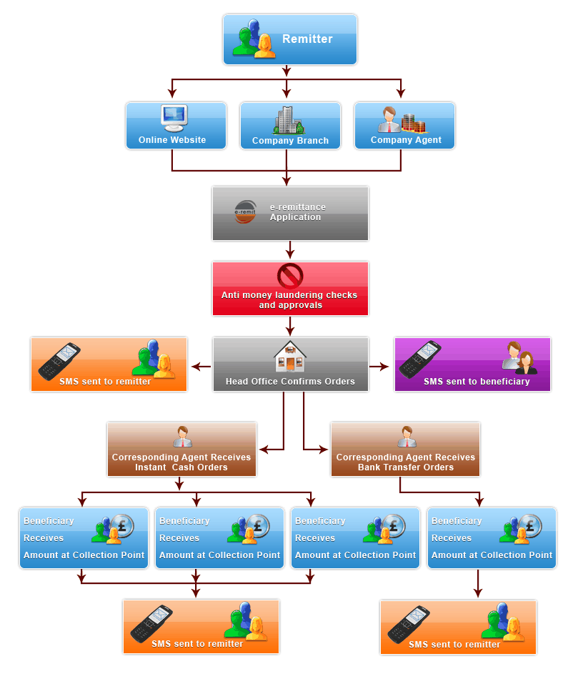

3.22 Import Procedure:

One of the important functions of the Dutch Bangla Bank Ltd is to undertake import of merchandise into the country and payment of foreign exchange forwards the cost of the merchandise to foreign suppliers.

In almost all the countries of the world there is import trade control in one form or the other which supervises the import into the country and controls certain items of exports depending upon national exigencies. The main object of the import trade control is to conserve the scarce foreign exchange resources of the country with a view to meeting the needs of development of its expanding economy. In Bangladesh, the import of goods is regulated by the Ministry of Commerce in terms of the Import and Export (Control) Act, 1950, with Import Policy Orders issued biannually, and Public Notices issued from time to time by the Chief Controller of Import and Export (C C. I. & E) which payments for these imports are regulated by Central Bank, i.e. Bangladesh Bank, through its Exchange Control Department. So, Import Trade Control and Exchange Control are complementary and supplementary to each other.

According to the Imports and Exports Act, 1950 as adopted in Bangladesh any one willing to carry import business needs registration with the licensing authority, i.e. Chief Controller of Imports and Exports and its offices at the important trade centers of the country.

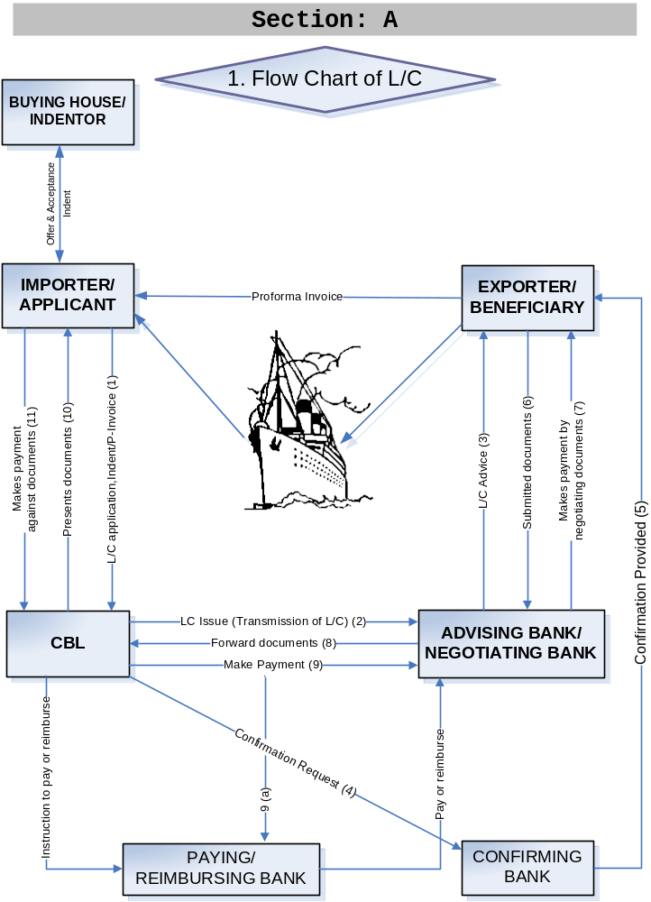
Flowchart: Import Procedure of Dutch Bangla Bank Ltd

3.23 Export Process Guidelines:

All exports from Bangladesh are subject to export trade control exercised by the Ministry of Commerce through Chief Controller of Imports and Exports (CCI&E) under the provisions of “Import & Exports (Control) Act 1950” read with provisions of Importers, Exporters and Indenters (Registrations) Order, 1981.

The ensuing Export Process Guidelines have been presented in six (6) sections covering under mentioned areas:
- Receiving export LC & advising to beneficiary
- Procurement of raw material by opening BTB LCs or Export-Reprocessing LC.
- Pre-shipment finance
- Export document scrutiny, processing and negotiation
- Post shipment finance
- Proceed realization

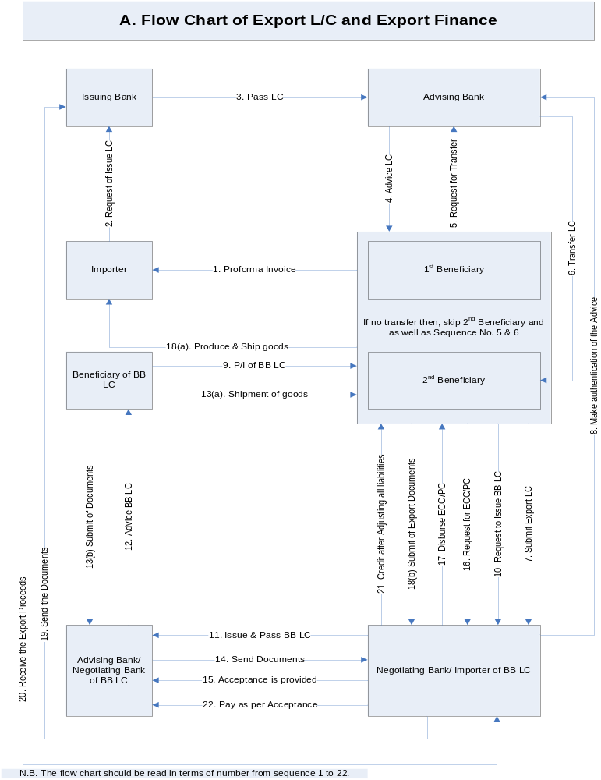

Flowchart: Export Financing Process of Dutch Bangla Bank Ltd

3.24 Name of the bank: Dutch Bangla Bank Ltd.
How many charges to foreign exchange transaction:
Incase of import:
Types of service | period | Rate of charges
l/c opening commission under cash (100% cash margin) | 1st quarter | .25%
l/c opening commission under cash (100% cash margin) | for each subsequent quarter | .25%
l/c opening commission under cash (100% cash margin) | minimum | 1000
l/c opening commission under cash(below 100% cash margin) | 1st quarter | .40%
l/c opening commission under cash(below 100% cash margin) | for each subsequent quarter | .40%
l/c opening commission under cash(below 100% cash margin) | minimum | 1000
l/c opening commission under cash (loan/credit/barter) | 1st quarter | .40%
l/c opening commission under cash (loan/credit/barter) | for each subsequent quarter | .30%
l/c opening commission under cash (loan/credit/barter) | minimum | 1000
l/c opening commission ( back to back, l/c on account of export oriented garments, textile) | 1st quarter | .40%
 | for each subsequent quarter | .40%
 | minimum | 1000
l/c opening commission for deferred payment | 1st quarter | .50%
l/c opening commission for deferred payment | for each subsequent quarter | .50%
l/c opening commission for deferred payment | minimum | 1000
If l/c is transmitted by mail/ courier | India | At actual cost
If l/c is transmitted by mail/ courier | Other SAARC country | At actual cost
If l/c is transmitted by mail/ courier | All other country | At actual cost
If l/c is transmitted by swift |  | 750

Incase of export:
Types of service | Rate of charges
Negotiating commission on export bill in foreign currency | .15%
Negotiating commission on export bill in local currency | .15%
Advising foreign bank l/c to local beneficiaries | 750 t.k.
Amendment to above | 750 t.k.
Transfer of export l/c | 750 t.k.
Pre advising of export l/c | 750 t.k.
Adding of confirmation | .20% per quarter
Issuance of P.R.C. | 500 taka/certificate
Document under collection of foreign currency (where buying and selling allowed) | .15%
Document under collection of foreign currency (where buying and selling are not allowed) | .15%
Collection from foreign of foreign currency | At actual cost plus 300 t.k. to be deducted from collected proceeds

Incase of inland:
Types of service | period | Rate of charges
Opening commission | 1st quarter | .40%
Opening commission | part | @.40% minimum t.k. 1000
Advising of I L C |  | 750 taka
Inland document under collection in F.C. (Where buying and selling is not allowed) |  | @.15%
Inland document under collection in F.C./T.K. (Where buying and selling is not allowed) |  | @.15%

3.25 Foreign exchange risk management:
Since Foreign Exchange involves purchase and sale of any national currency against
other national currency, thus Foreign Exchange risk is the risk or chance of loss due to
unexpected movement of market price of the currencies of different countries or the
price of the assets denominated by foreign currencies.

All the foreign exchange transactions are carried out on behalf of the customers against
underlying foreign exchange transactions. Hence the foreign exchange risk of the Bank
lies at a minimum level.
For effective and efficient management of Foreign Exchange Risk, the Bank has a well
developed and well structured Foreign Exchange Risk Manual and an international
standard Dealing Room Manual. We also follow all kinds of guidelines which Central
Bank advises us from time to time in order to mitigate risk.
The Treasury of the Bank is mainly divided into three departments namely Front Office,
Mid Office and Back Office. With the help of these three departments, the Treasury
carries out the whole procedure of Foreign Exchange. The Front Office independently
conducts the transactions and the Back Office is responsible for verification of the deals
and passing of their entries in the books of account. The Mid Office plays a vital role in
the process by checking the Foreign Exchange procedure performed by Front and Back
Office and by reporting it directly to the Managing Director of the Bank.
Shadow ledgers are being maintained for all of its Foreign Currency Accounts. All
foreign exchange transactions are revalued at Mark-to-Market rate as determined by
Bangladesh Bank. All Nostro accounts are reconciled on monthly basis and outstanding
entries beyond 30 days are reviewed by the management for their settlement.

3.26 Prevention of money laundering
Money laundering risk can be defined as the loss of reputation and expenses incurred as
penalty for being negligent in prevention of money laundering. Money Laundering is the
process of filtering money obtained through illegal activities such as drug trafficking,
through the financial system. The purpose is to conceal illegal sources of income and
allow criminals to spend their funds without revealing the crimes that produced them.
Dutch Bangla Bank Ltd identified the money laundering as one of its core risk areas and has been making all out efforts to prevent money laundering.
Banks are the forefront of money laundering risk. For mitigating the risk, the bank has a
designated Chief Anti-Money Laundering Compliance Officer (CAMLCO) at Head
Office, Central Compliance Unit who has sufficient authority to implement and enforce
corporate wide AML policies, procedure & measure and who is reporting directly to the
senior management and the board of directors and Compliance Officer at the branches,
who independently review the transaction of accounts, with verification of Know Your
Customer (KYC) and Suspicious Transaction Report (STR). They are also reporting
Cash Transaction Report (CTR) to the Central Compliance Unit, Head Office on regular
basis. The Central Compliance Unit has also arranged Training/Workshop for
developing awareness and skill regarding AML activities of Executives and Officer of the
bank and conducting inspection regarding AML activities of our branch. Bank has
established a Manual for Prevention of Money Laundering and issues circulars time to
time giving specific guidelines in accordance with anti-money laundering laws,
regulations, Anti-money Laundering Ordinance, 2008 & Anti Terrorism Ordinance.

Chapter Four

Financial Analysis of Dutch Bangla Bank Ltd L.T.D.

Sources and uses of Fund:

The composition of sources of bank fund is paid up capital, reserve and deposit from the customer and different banks. The bank uses the major portion of its fund for investment in loan and advances. The bank also invested in securities and shares. The surplus fund is applied in call money market to earn satisfactory returns.
Source: annual report

4.1 Capital:

The bank started with an authorized capital of TK 1000 million and while its initial paid up capital was TK 225.00 million by the sponsors in the year 1999. the Capital and reserve of the Bank as on 31stjune 2009 stood at 5,498,111,312 t.k. including paid up capital of TK. 2,677,746,000

The Bank also made provision on investments (shares and bond) which is amounted to TK. 2,976,105,858 up to 31st june 2009

Capital structure of Dutch Bangla Bank Ltd has changed from year to year. The components of the capital are paid up capital share premium, statutory reserve, proposed share dividend, retained earnings and other reserve.

Authorized and paid up capital of Dutch Bangla Bank Ltd :

Year | Authorized Capital Tk in million | Paid up Capital (Tk.) in million
2009  up to 31st june | 3500.00 | 2677.74
2008 | 3500.00 | 2677.74
2007 | 3500.00 | 2 142.19
2006 | 2500.00 | 1713.75
2005 | 1000 | 313.88
2004 | 1000 | 253.13
2003 | 1000 | 225.00
2002 | 1000 | 225.00
2001 | 1000 | 225.00
Capital Position of Dutch Bangla Bank Ltd

Capital and Reserve Fund:

The bank started its business with an authorized capital of Tk 1000 million while it’s initial Paid up capital was Tk. 225.00 million subscribed by the sponsors in the year 1999. The Capital Reserve of the bank as on 31st June 2009 stood at Tk. 184,530,136 including paid up capital of Tk. 2,677,746,000.

4.2 Deposit:
Deposit is one of the principle sources of fund for investment of commercial bank and investment of deposit is the main stream of revenue in banking business. The total deposit of the bank stood at t.k. 65,211,919,360 million as on june2009 against Tk. 57,586,991,798 million of the previous year (December 31st 2008).

Investment (general): Total amount of Investment of the Bank Tk. 50838. 70million as on December 31, 2008 as against Tk. 38214.42 million as on December 31 2007 showing an increase of Tk. 12624.28 million. Investment is the core asset of a Bank. It gives emphasis to acquire quality assets and does appropriate lending risk analysis while approving commercial and trade investment to clients
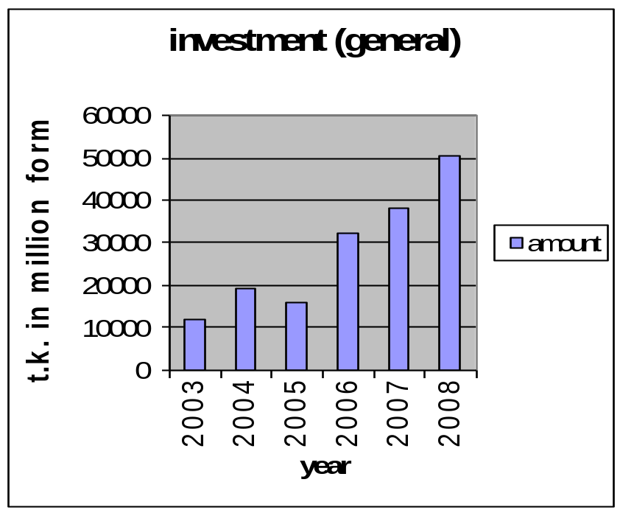

4.2.1 Investment (Share & Bonds): The size of the investment portfolio in 2009, up to 31st December is Tk. 2894.02 million while it was Tk 2457.71 million in December 2007. The portfolio companies Islamic Investment Bond, Shares and Prize Bonds.
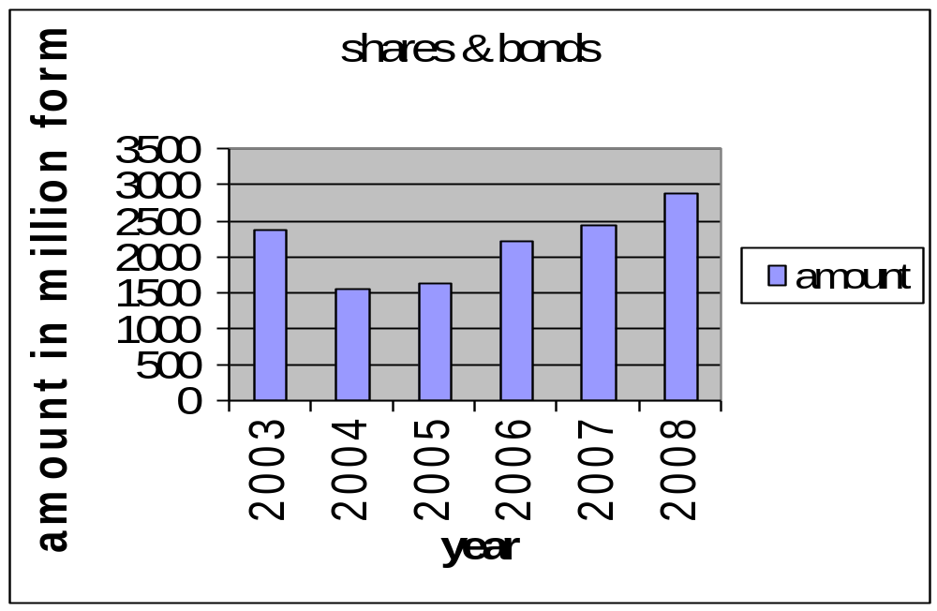

From the graph we can see that the investment in share and Bonds has been decreased in 2005 and 2006 compared to 2008. The reason is that, the rate of return in other investment is much higher than investment in share and Bond. Moreover, Dutch Bangla Bank Ltd was able to invest in other sectors. If we compare the general investment and investment in bond and share, we can see that general investment is much higher.

4.2.2 Remittance: It stood at Tk. 215. 97 as of 2008 against 131. 71of 31st December 2007.
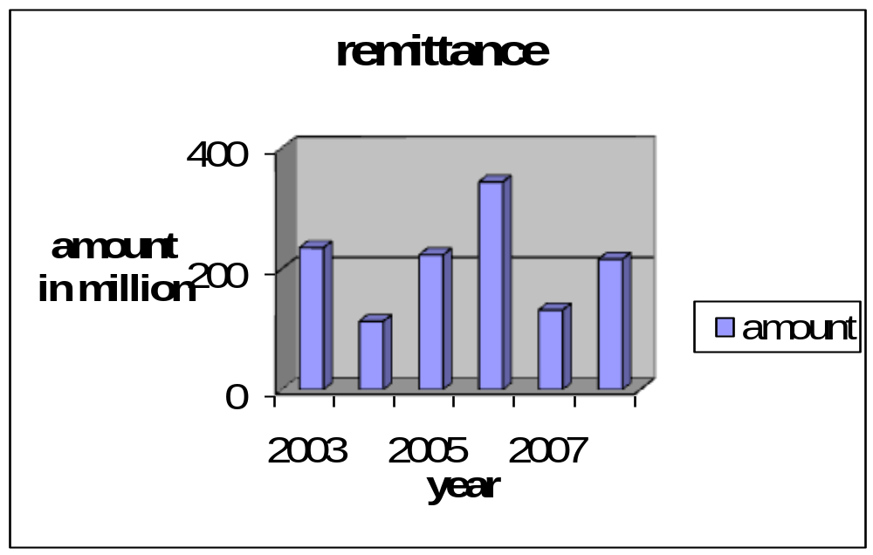

From the graph we can see that the import has decreased in 2007 compared to 2008, but the year 2006 has got the highest rate of remittance.

4.2.3 Import: It stood at Tk. 82591. 07 (in a million) as of 2008 against 92602.31of 2007.
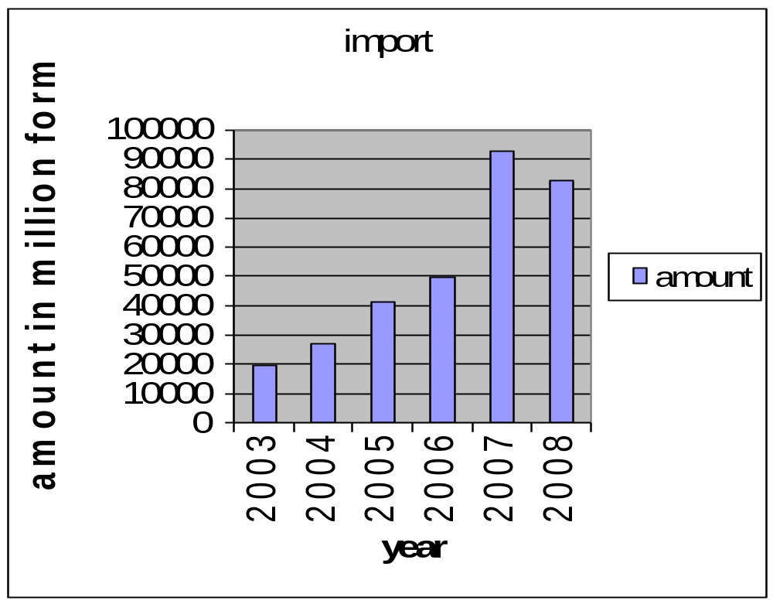

From the graph we can see that the import has decreased in 2008 compared to 2007.

4.2.4 Ratio on classified investments and total investments in 2008 is 1.88%, and in 2007 is 1.58%
4.2.5 Return on investments (shares and bonds) in 2008 is 2.03% and in 2007 is 8.77%

4.2.6 Return on assets (after tax) in 2008 is 1.83% and in 2007 is 2.00%
4.2.7 Price earning ratio (times) in 2008 is 7.85 and in 2007 is 11.28
4.2.8 Earnings per share in 2008 is 4 0.95 and in 2007 is 34.76

4.3 Comparative Analysis between Dutch Bangla Bank Ltd. and others bank:

In my survey I found that, most of the bank had started their remittance service as early as possible. Alls the bank has engaged in remittance service in order to earn profit from this service.

Every bank needed a declaration when from Bangladesh bank and the recipient, when the amount exceeds $2000 and all the tractions are kept in a record book.

Every bank had told, that T.M.(Table and miscellaneous) form has needed to fill, when customer want to send currency to abroad. Form “C” has needed to fill when currency come from abroad.

Most of the bank try to provide the fund to the recipient account with in 1 (one) day. Recipient can easily withdraw money from his account, if remittance comes. Funds are made available to the recipient account in form of taka.
If the recipient does not know whether the remittance has availability or not, in that case the bank will call the recipient.

Every bank ensures that, there are no chances of fraudulent. If there any mistake happens, then, at 1st branch inform the head office and then head office informs the abroad bank about the mistake, or if there is a dispute between remitters, recipient and the bank; then all related document would be verified. But I don’t think so, because a recently news has published, which show, that there is a chance of fraudulent in banking sector.

Remitters or recipients can not know the exchange rate the exchange rate before engaging in the transactions. As a result the banks are always gainer. They protect themselves from fluctuation by this way, Example: If currency rate is 69.5/dollar, then the bank provides 69/dollar to the recipient account.

Most of the banks, does not charges any fees to the remitter and the recipient, before engaging in the transactions. But, in case of export and import every bank charges a little amount. Example: Dutch Bangla Bank Ltd charges 3.5% on the actual amount.

Dutch Bangla Bank Ltd has total value of remittance process is 19 lack 11 thousand averages per month in dollar. This is very good to see, cause in my survey I have found, that the other competitor banks doesn’t achieve this amount in the remittance process.

The exchange house has a vital role in remittance processes. Those who has more exchange house, they will be benefited more. But I’m sorry to say, that Dutch Bangla Bank Ltd doesn’t have so many exchange house.

4.4 SWOT Analysis:
The Bank’s strength and competitive capabilities can be shown by the SWOT analysis. The SWOT analysis is grounded in the basic principle that strategy-making efforts must aim at producing a good fit between a company’s resource capability and its external situation. The SWOT analysis of Dutch Bangla Bank Ltd is as follows:

The acronym SWOT stands for:

The SWOT analysis comprises of the organizations internal strength and weakness and external opportunities and threats. SWOT analysis gives an organization an in sight of what they can do in future and how they can complete with their existing competitors. This tool is very important to identify the current position of the organization relative to others and is grounded in the basic principle that strategy-making efforts must aim at producing a good fit between a company’s resource capability and its external situation, which are playing in the same field and also used in the strategic analysis of the organization.

Figure 4 in the next page summarizes the strengths, weakness, opportunities and threats of standard chartered bank.

a) Strengths

Reputation of the Bank: Since the inauguration the bank has managed their activity with their own images to serve their customers. They have provided services successfully and have achieved goodwill among the .s. The Bank is opening with its efficiency and integrity.

Sponsor: Dutch Bangla Bank Ltd has sponsors from various sectors of Bangladesh. The most successful entrepreneurs from various sectors started this company. As a result there was a combination of different thoughts and skills in the management of the bank, which is very much essential for success in today’s competitive market.

Top Management: Dutch Bangla Bank Ltd has a very competent and experienced top Management. The current Managing Director Mr. Mohammed Lakiotullah has banking experience for a long time period. He had the experience of marketing and customer relationship management in his long career. This has helped the bank to achieve its goal.

.ing: Dutch Bangla Bank Ltd is operating based on Islamic Shariah. As Bangladesh is a Muslim country, the Shariah banking has been able to attract customers and achieved a great success in the private banking sector.

Branches: Dutch Bangla Bank Ltd is operating their business all over the country with 30 branches and still planning to expand their business by opening new branches in the country. It has strengthened the distribution of the bank’s services.

b) Weakness:

Promotion: The bank does not any formal promotional activity. They do not give any sort of advertisement or do not have any marketing activity. They do not even too many bill boards. This is why they are far behind the competitive in the private banking. Even some people do not know that Dutch Bangla Bank Ltd is operated according to Shariah. Some people think Dutch Bangla Bank Ltd is responsible for Import and Export only.

Remuneration: The remuneration of the officers of Dutch Bangla Bank Ltd is lower compared to other private banks. Even the internship students are paid nothing. This is why high skilled human resources are discouraged to join here.

Internee: DUTCH BANGLA BANK LTD. do not control the Internees. As intern want to adjust the official rules & regulations, but Dutch Bangla Bank Ltd have not control on the INTERN. When an Intern comes in the bank, outside the bank, are they learning from the bank?

Online Banking: Though Dutch Bangla Bank Ltd has introduced Automation in banking service, but the network is not strong. Even most of the general clients do not know about the online banking. Here online service charge 100/- monthly and after one year will 1200/-, if as a client use or not use. And as client if you registered in online services from then they will take service charge from the client.

Centralization Decision Making: The decision making of the bank is too many centralized. No decision is made without the authorization of the head office. Sometime some quick decision is needed to be taken, but from the branch, no one can make decision. It is one of the major draw back of the bank.

c) Opportunity:

Consumer Banking: Dutch Bangla Bank Ltd is operating corporate banking. In our country there is a huge opportunity of consumer banking. So Dutch Bangla Bank Ltd can reposition their branding and introduce consumer banking with corporate banking.

ATM: The banking sector of the country is becoming modernized in the country. People like to draw money any time from anywhere. So ATM card is getting popularized in the country. Dutch Bangla Bank Ltd can introduce ATM system in their bank. More Over, .s are not providing ATM cards. So those who want ATM card but do not like interest, they can be attracted by ATM card issued by a ..

More Branches: The economy of the country is expanding. The business outside Dhaka is also expanding. As a result, the demand for banking service is increasing day by day. So Dutch Bangla Bank Ltd can open more banks in the country and can expand their business.

.ing: In our country people are religious. Most of the people are Muslim. They are becoming educated and know the bad impact of interest. So they are moving towards .ing. Dutch Bangla Bank Ltd takes this opportunity.
New Products: The intention of the people has been changing. They now want to save more. They also want some benefit on their saving. So Dutch Bangla Bank Ltd can introduce more products and schemes.

d) Threat:

Competitions: In Bangladesh, after economic reform, more private bank has started their operation in the country. They are coming with different types of attracting products. This has increased the completion among the private banks.

Devaluation of local Currency: The value of local currency is decreasing. So investment in local banking is decreasing. More over the inflation is increasing in the country. So people want to save money but in many cases they cannot. As a result, the banks are getting less deposit.

Bank Default: There is a tendency of the people of the country to become bankrupt. Few days ago Oriental bank has a great suffering. In our country, the receivable from top 20 bankrupt companies stood 88.36 billion. This is discouraging banks to make new investment.

Chapter Five

Findings & Analysis

5.1 Findings

According to some clients opinion introducer is one of the problems to open an account. If a person who is new as a client wants to open account, it is a problem for him/her to arrange an introducer of SB or CD Account holder.

In Foreign Exchange Division it is required to communicate with foreign banks frequently and quick. For opening a L/C it’s required to contact with the Main branch.

5.2 Ratio analysis of Dutch Bangla Bank Ltd :

Current Ratio
In 2008 the current ratio of Dutch Bangla Bank Ltd is 1.6 and in 2007 the ratio was 1.20.That means Dutch Bangla Bank Ltd liquidity condition was not good in 2007 compare to 2008. It is increased by 40%.

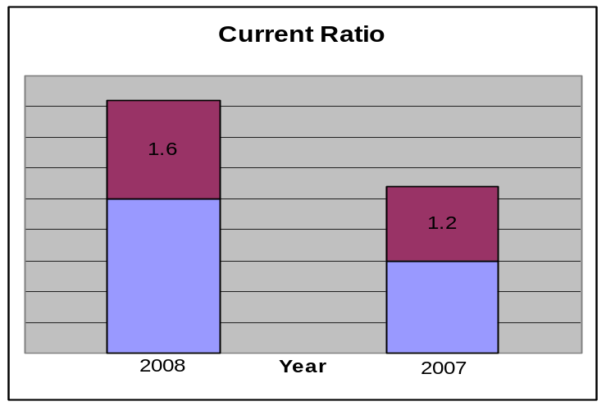

Debt to Equity
In 2008 debt to equity of Dutch Bangla Bank Ltd is Tk.18.43 and in 2007 it was Tk. 12.63.

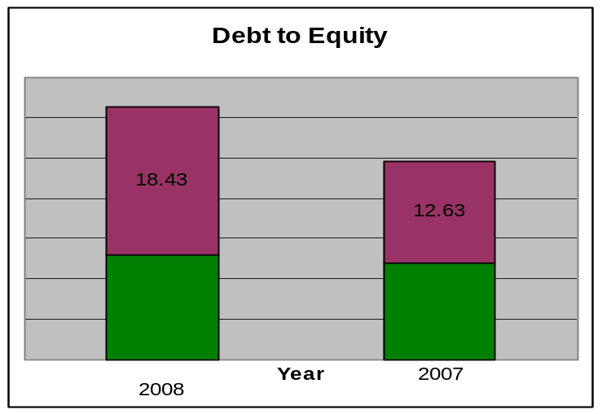

Debt to equity is increased by 45.92% in 2008.

Debt to Total Asset
In 2008 debt to total asset of Dutch Bangla Bank Ltd is 0.93 and in 2007 it was 0.94.

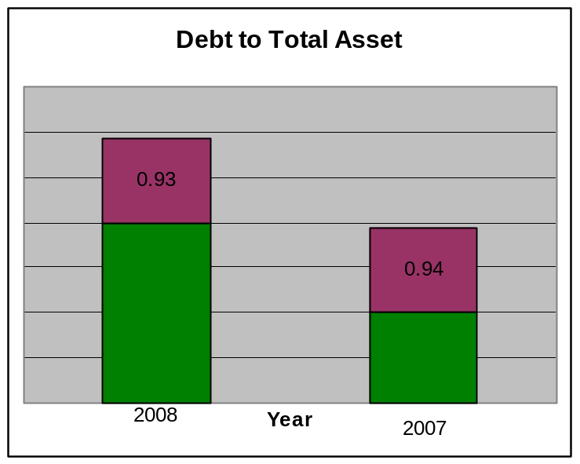

Debt to equity is increased by 1.06% in 2008.

Current Capital
In 2008 the current capital of Dutch Bangla Bank Ltd is Tk. 5763.88 million and in 2007 it was Tk. 4569.56 million.
Compare with last year this year their current capital position is very good. It is changed by 26.13%.

Return on Assets
In 2008 the return on assets of Dutch Bangla Bank Ltd is 1.83% and in 2007 it was 2%.

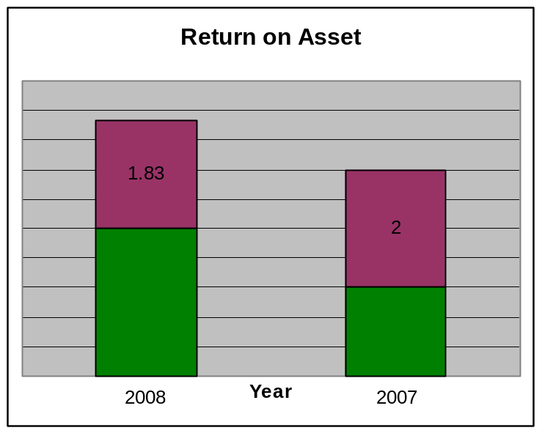

In 2007 return on assets is good compare to 2008. It is increased by 8.5%.

Return on Equity
In 2008 the return on equity of Dutch Bangla Bank Ltd is 25.88% and in 2007 it was 33.53%.

Return on Equity
33.53
25.88
0
5
10
15
20
25
30
35
40
Year 2007
Year 2008
Year
In percentage
In 2008 return on equity is not good compare to 2007. It decreased by 22.81%.

Net Income per Share

In 2008 the net income per share of Dutch Bangla Bank Ltd is Tk. 40.95 and in 2007 it was Tk. 34.76.

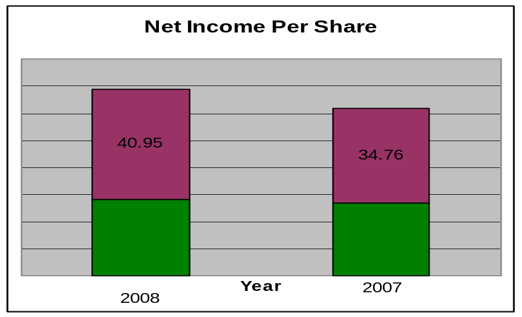
In 2008 net income per share is good compare to 2007. It increased by 17.80%.

Earning per Share
In 2008 the earning per share of Dutch Bangla Bank Ltd is Tk. 40.95 and in 2007 it was Tk. 34.76.

In 2008 earning per share is good compare to 2007. It increased by 17.80%.

Price earning ratio

In 2008 the price earning ratio of Dutch Bangla Bank Ltd is 7.85 times and in 2007 it was 11.28 times.

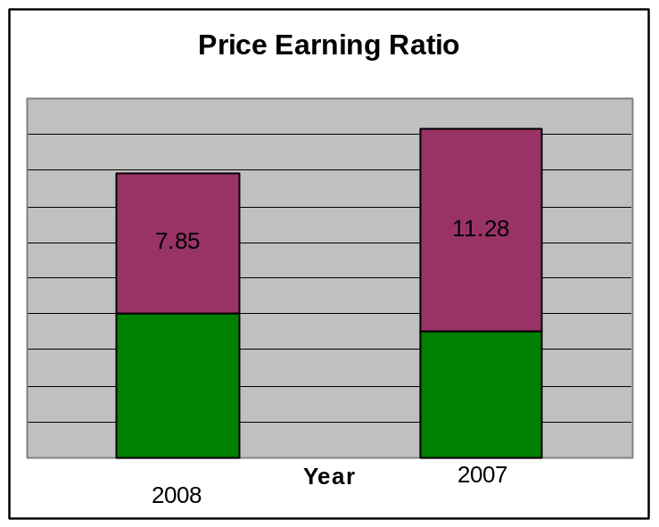
In 2008 price earning ratio is bad compare to 2007. It is decreased by 30.40%.

In 2008 the overall performance of Dutch Bangla Bank Ltd is in satisfactory level. Because, in 2008 Banks performance is better compare to 2007’s performance, in almost every aspect. Their Return on Equity and price earning ratio decreased during the year. On the other hand their capital & reserve fund, deposit, assets, investments, Return on Assets etc increased during the year.

5.3 Highlights on the overall activities of Dutch Bangla Bank Ltd :
 |  | Amount in million (Taka)
SL No. | Particulars | 2008 | 2007
1 | Paid up capital | 2677.74 | 2142.19
2 | Total capital | 5763.88 | 4569.56
3 | Surplus of capital | 420.98 | 498.91
4 | Total asset | 68446.46 | 51503.02
5 | Total deposit | 57586.99 | 40195.23
6 | Total investment | 53637.67 | 26046.34
7 | Total contingent liabilities and commitments | 26070.56 | 22632.65
8 | Ratio on investment and deposits | 93.14% | 96.75%
9 | Ratio on classified and total investment | 1.88% | 1.58%
10 | Profit after tax and provision | 1096.62 | 930.84
11 | Classified investment for the year | 1007.84 | 635.10
12 | Provision held against classified investments | 369.89 | 270.76
13 | Surplus/(Shortage) of provision | - | -
14 | Cost of Fund | 9.52% | 9.07%
15 | Profit earning assets | 56192.52 | 42357.64
16 | Non-profit bearing assets | 12253.93 | 9145.38
17 | Return on investment | 2.03% | 8.77%
18 | Return on assets | 1.83% | 2.00%
19 | Income on investment | 54.24 | 205.59
20 | Earning per share (Taka) | 40.95 | 34.76
21 | Net income per share (Taka) | 40.95 | 34.76
22 | Price earning ratio (Times) | 7.85 | 11.28

5.4 Findings of the Study:
This study is focused on the various schemes of Dutch Bangla Bank Ltd , some of which are not now in force and others are carrying on well. We will now discuss in brief, what we have found after this research under the strength, weakness and success status of various schemes.

- Dutch Bangla Bank Ltd is the largest of the state-owned commercial banks that come into being in the year of 1999 through the merger of branches of some banks Dutch Bangla Bank Ltd has total of 15 branches as of 31st December 2002.
- The operation of Dutch Bangla Bank Ltd is decentralized and the authority for loan sanctioning is delegated in order to make its operations more flexible and responsive to the growing needs of the economy.
- Dutch Bangla Bank Ltd ’s management information system and financial information system have been restructured over the recent years to keep pace with the process of development.
- Dutch Bangla Bank Ltd is now carrying on their 6 of their schemes successfully.
- Continuous group training facilities are there for the area managers to delve into the different scheme.
- The applicants for loans must be prospective and prone his or her eligibility according to the requirements of the bank and the process of facilities test.
- The rate of interest and the terms and conditions are pointed out clearly in the agreement between the creditor and the debtor.
- The projects must be productive so as to maintain the streams of the yield that would ascertain the effectiveness and the velocity of the credit.
- Before the sanction of the loans, eligible borrowers are to undergo an intensive training regarding the roles, philosophies, procedures and regulations of Dutch Bangla Bank Ltd , which takes them to a test of recognition. During this test, the borrower must satisfy the authority of the bank about their integrity, sincerity an understanding to the principles of the bank.
- The repayment record of the area, represented by the borrower, will be considered to be basis for the disbursement of loans.
- The transparency of all transactions are to be ensured by the respective DGM and MD of various departments or schemes in the meeting of board of directors in brief manner of accounts.

5.5 Foreign Exchange Department

- In foreign exchange department it is required to communicate with foreign banks frequently and quickly. To make the process easily modern communication media for example e-mail, fax and win fax, Internet etc. should be used. But the bank has not much practice of using these media.
- Modern technical equipment such as computer is not sufficient in foreign exchange department. As a result the exchange processes make delay and it is also complicated.
In order to improve the service quality customers expressed different opinion in their point of view. I can summarize their opinion, which is the gist of their suggestions. They have to take some more steps to improve the service quality. Each department of the bank should be computerized. The cash transaction process would be easier and very prompt that it would take a very short time. More branches should be opened in Dhaka city and other the other cities of the country. They will have to start consumer credit scheme and other scheme that will help the consumer. It is badly needed to provide modern banking services such as credit card, ATM card, visa care etc. Dutch Bangla Bank Ltd is providing better service comparing to other private banks. But there are almost fifty two banks in our country. In the near future some new banks are going to be opened. So in order to complete in the market Dutch Bangla Bank Ltd should be very careful about their service. They will have to improve their service quality and provided more facility.

Chapter Six

Conclusion

&
Recommendation

6.1 Recommendations:

- The interest rate and other charges may be competitive in orders to compete with competitions and attract customers as well as keeps the old ones.
- Once a person becomes an expert in each department he/she should not be switch to another department as standardization is extremely important to increase workers efficiency.
- Sitting arrangement should be adequate.
- To provide quality service to the customers it is necessary to have a trained teem of an organization or an institution. For this reason the bank should recruit more fresh, bright and energetic persons as MBA, BBA, and BBM, etc.
- Bank should offer more facilities to the customers as credit card, visa card, ATM machine etc.
- Branch expansion in Dhaka city as well as other cities i.e. Khulna is also a key factor to serve more people better service and earn more profit.
- The bank should attempt to enter the share market by issuing shares to capitalize more money and invest thereafter by expanding the number of branches around the city.
- One of the business strategies is promotion. So to improve the business status bank should introduce more promotional programs.
- IN general banking department it is necessary to implement modern banking process instead of traditional system. It should be more computerized.
- The loan sanction process should be easier that the client can feel convenient to take loan from the bank.
- Foreign exchange department should be fully computerized that the exchange would be convenient for both bankers and the clients.

- Salary structures may be revised in comparison with other commercial bank which will motivate employee to show more performance for bank which is essential for the bank’s prosperity.
- Business power to be delegated gradually to the Branch Manager for business development.
- Online services should be added to get more satisfaction and popularity from customer.
- The management should organize more training for the employees so that they can develop their knowledge and skill.
- The bank has a provision for internship program but it is not will organized. Although the officials are very careful and cooperative with the interns, the authority should be more structured. If they can properly make them trained it will be very fruitful to recruit them because they learn overall banking in the internship period, so in the beginning of the job they can work as experienced persons. It is also very important that they should give honoree to the intern.

6.2 Conclusion:

From the practical implementation of customer dealing procedures during the whole period of my practical orientation in Dutch Bangla Bank Ltd Bangladesh Limited I have reached a firm and concrete conclusion in a confident way. I believe that my realization will be in harmony with most of the banking thinkers.

Dutch Bangla Bank Ltd is one of the newest banks in Bangladesh. For that point of view, this bank is not highly experienced about the banking industry in this country. The more aggressive the bank will become the more intense the competition will be. In coming days they are to face various key challenges such as:

- To satisfy the existing customers.
- To continue increasing penetration in the target market
- To face the more aggressively net bank
- To turn satisfied customer into fully satisfied customer.

It is quite a evident to build up an effective and efficient banking system to the highest desired level computerized transaction is a must. So this issue should be considered as soon as possible. Besides every bank has to survive a midst of a large number of banks including local and foreign banks. That’s why to keep pace with expected profit margin of the time being and for the future every bank should try heart and soul to please the customers in a smart and trusty way.

But quite regretful to mention that most our bank face decreasing profit trend due to switch over of their presents customers to those foreign with higher customer service facilities. So timely decision for introducing sophisticated banking instruments should be taken as early as possible.

After taking effective and defeating measures regarding efficient employees and instruments will help the local office of Dutch Bangla Bank Ltd to reach the pinnacle of success with high profit and productivity.

Dutch Bangla Bank Ltd is a new generation Bank. It is committed to provide high quality financial services/products to contribute to the growth of G.D.P. of the country through stimulating trade & commerce, accelerating the pace of industrialization, boosting up export, creating employment opportunity for the educated youth, poverty alleviation, raising standard of living of limited income group and over all sustainable socio-economic development of the country.

In achieving the aforesaid objectives of the Bank, Investment Operation of the Bank is of paramount importance as the greatest share of total revenue of the Bank is generated from it, maximum risk is centered in it and even the very existence of Bank depends on prudent management of its investment portfolio. The failure of a Commercial Bank is usually associated with the problem in investment portfolio and is less often the result of shrinkage in the value of other assets. As such investment portfolio not only features in the assets structure of the Bank, it is critically important to the success of the Bank also.

The main philosophy of Dutch Bangla Bank Ltd is to diminish interest and charge or pay fixed interest on loans or deposits and at the same time establish an egalitarian society based on the principle of social justice and equity Instead of predator mined interest on deposits, Dutch Bangla Bank Ltd offers the proof it to the depositions as an agreed ratio. Where as, interest based conventional banks pay a fixed interest a savings and deposits and grant loans with interest for any purpose.

