The economic development of the country depends largely on the activities of commercial Banks. Especially in a country like Bangladesh, our agricultural, industrial and economic developments are very much depending on smooth operation of Banks. So we must ensure efficient and effective performance of Banks. In this respect I have tried to find out the satisfaction level of customer of Shahjalal Islami Bank Limited (SJIBL). How efficiently they serve the customer with their services and whether the customers are really satisfy or nor by conducting a scientific research I tried to find out as my best level.
I found that there are some lacking in the services done by the various part of Shahjalal Islami Bank Limited (SJIBL) as well as there are also some strengths in different sectors. I find that the overall performances of branch services, cashier services, and customer care services are better than SMS Banking Services. SMS Banking Services need better improvement as it is the most important in the branch service.
Finally it can be said that the customer services level of Shahjalal Islami Bank Limited (SJIBL), should be increased to cope up the present arising problem. Otherwise it may lose its customers due to its strong competitors. However, I have identified some loopholes of the program which needs special attention. I hope that if the existing problems are addressed properly the bank will be able to expand the program as per their target and it will continue to provide more revenues in maximizing the wealth of the bank in the years to come.

Table of contents
Chapter – 1
Introduction |  |  | pg 9
Background of the report |  |  | pg 10
Objective of the report |  |  | pg 11
Scope of the study |  |  | pg 11
Methodology of data collection |  |  | pg 12
Limitations of the study |  |  | pg12
Chapter – 2
Organizational Part
Introduction |  |  | pg 14
Historical background |  |  | pg 14
At a Glance of SJIBL |  |  | pg 15
Objectives of SJIBL |  |  | pg 15
Vision |  |  | pg 16
Mission |  |  | pg 18
Core values |  |  | pg 19
The organizational structure |  |  | pg 19
Hierarchy of AIBL |  |  | pg 20
Management Hierarchy of AIBL |  |  | pg 21
Network of the Branches |  |  | pg 22
Chapter - 3
Findings and Analysis |  |  | pg 27
Chapter- 4
Schedule of Profit Rate |  | pg 33
ATM location |  | pg 34
Risk Management |  | pg 36
Chapter - 6
Investment Schemes of SJIBL |  | pg 39
Types of Investment |  | pg 41
Chapter - 7
Conclusion | pg 43
Acronyms | pg 44
Appendix | pg 45
References | pg 46

Chapter -1
Introduction
Background of the report
Objective of the report
Scope of the study
Methodology of data collection
Limitations of the study

  - Introduction:
The word “Bank” refers to the financial institution deals with money. Commercial banks are the primary contributors to the economy of the country. On the other hand they are borrowing money from the locals and lending the same to the business as loans and advances. So the people and the government are very much dependent on these banks as the financial intermediary. Moreover, banks are profit - earning concern, as they collect deposit at the lowest possible cost and provide loans and advances at higher cost. The differences between two are the profit for the bank.
A student takes the internship program when he or she is at the last leg of the BBA degree; internship program brings a student closer to the real life situation and thereby helps to launch a career with some experience.

1.2 Back ground of the study:
As the student of Bachelor of Business Administration (BBA) every student has to conduct a practical orientation (Internship) on any organization for fulfilling the requirements of the B.B.A program. In order to fulfill this requirement of the Internship program I choose Shahjalal Islami Bank Limited (SJIBL). The main purpose of the program is to know the real world situation. The topic of my report is “Training Program of Shahjalal Islami Bank Ltd’’. In this regard I have opportunity to make my internship in Shahjalal Islami Bank Limited from September 28 to December 28, 2011.
With the objective of achieving success here & hereafter by pursuing the way directed by Allah and the path shown by His Rasul (SM), Shahjalal Islami Bank Ltd was established (registered) as a private limited company on 10 May 2001, under Bank Company Act, 1991 and incorporated as a public limited company under companies act, 1994.
During this short span of time, the bank has been successful to position itself as a progressive and dynamic financial institution in the country.
Involvement of the banking sector in different financial events is increasing day by day. At the same time the banking process is becoming faster, easier and the banking area is becoming wider. As the demand for better service increases, the banking organizations are coming with innovative ideas. In order to survive in the competitive field of the banking sector, all banking organizations are looking for better service opportunities to provide to their clients.
Within short time SJIBL expands its branches all over the country. But as their experience in terms of success rate in each branch which includes profit, client size, etc. The performance of Ashkona branch is also very good as like other branch. As a part of my topic I will try to identify the all important part of the training program.

1.3 Origin of the report

Present world is changing rapidly to face the challenge of competitive free market economy. To keep pace with the trend banks need executive with modern knowledge and provide fresh graduate with modern theoretical and practical knowledge in banking and financial institution management. As the practical origination is an integral part of the BBA degree requirement, I was sent to Shahjalal Islami Bank Limited (SJIBL) (Ashkona Branch) to take the real life exposure of the activities of banking financial institution for three months only starting from 28th September, 2011. This research is a partial requirement of BBA Internship Program in the Southeast University and report is being prepared from three months extensive knowledge and research.

1.4 Objective of the report

The primary objective of this report is to comply with the requirement of my course. But the objective behind this study is something broader. The principal intent of this report is to analyze the trends of modern banking training systems. Objectives of the study are summarized in the following manner:
  - To identify the present state of the training program of Shahjalal Islami Bank Limited (SJIBL)
  - To observe the effectiveness of the training program of SJIBL.
  - To observe the employee reaction towards the training program.
  - To know about the modest of investment in Islamic Banks.
  - To provide the recommendation for improvement of training systems of (SJIBL)
  - Finally, to sketch out the overview of (AIBL)

1.5 Scope of the study

Shahjalal Islami Bank Limited (SJIBL) is one of the new generation banks in Bangladesh. The scope of the study is limited to the Ashkona Branch. The report will cover the functions of different departments of Shahjalal Islami Bank Limited (SJIBL), Ashkona Branch like Products and services of the bank.
I will include on my report first of the introduction of Shahjalal Islami Bank. Then the overall banking activities, products and services. Finally, I shall provide an analytical view on a real project that Shahjalal Islami Bank arranges training program for its employees and this is the special focus of my report.

1.6 Methodology of the Study:
Data Collection:
Secondary Source:
- HR manual of the Shahjalal Islami Bank Limited.
- Archiving Instruction Manual of the Shahjalal Islami Bank Limited.
- Prior research Report.
- Web site of Shahjalal Islami Bank.
- Internet browsing ( to know about the detail of archiving management system)
Primary Source:
- The “Primary Sources” are as follows-
- Face-to-face conversation with the respective officers and staffs of the Branch.
  - Informal conversation with the clients.
  - Practical work exposures form the different desks of the four departments of the Branch covered.
- Relevant file study as provided by the officers concerned.

1.7 Limitation of the study:
In all high opinion some limitation and weakness remain within which failed to escape by any means. These are follows:
- Limitation of time: It was one of the main constraints that hindered to cover all aspects of the study.
- Lack of Secondary data: The HR manual was the main secondary Information source of information that was not enough to complete the report and private the reader a clear idea about the bank.
- Confidentiality of data: Confidentiality of data was another important barrier that was faced during the conduct of this study. Every organization has their own privacy that is not open to others.
- Lack of understanding of the respondents: Lack of understanding of the respondents was the major problem that created much uncertainty about proof of theoretical question.

Chapter -2
Profile of the bank
History of the SJIBL
Objectives of SJIBL
Functions of the SJIBL
Role of the SJIBL in the economic development
Organ gram of the SJIBL
Branch Information

  - Profile of the bank:
Name of the Company | Shahjalal Islami Bank Limited
Legal Form | A public limited company incorporated in Bangladesh on 1st April 2001 under the companies Act 1994 and listed in Dhaka Stock Exchange Limited and Chittagong Stock Exchange Limited.
Commencement of Business | 10th May 2001
Head Office | Uday Sanz, Plot No. SE (A)  2/B Gulshan South Avenue,  Gulshan - 1, Dhaka-1212.
SWIFT | SJBL BD DH
Chairman | Alhaj Anwer Hossain Khan
Managing Director | Md. Abdur Rahman Sarker
No. of Branches | 73
No. of ATM Booth | 15
No. of SME Centers | 06
Off-Shore banking Unit | 01
No. of Employees | 1617
Authorized Capital | Tk. 6,000 million
Paid up Capital | Tk. 3425.12 million
Face Value per Share | Tk. 10

  - History of the SJIBL:
Shahjalal Islami Bank Limited (SJIBL) commenced its commercial operation in accordance with principle of Islamic Shariah on the 10th May 2001 under the Bank Companies Act, 1991. During last ten years SJIBL has diversified its service coverage by opening new branches at different strategically important locations across the country offering various service products both investment & deposit. Islamic Banking, in essence, is not only INTEREST-FREE banking business, it carries deal wise business product thereby generating real income and thus boosting GDP of the economy. Board of Directors enjoys high credential in the business arena of the country, Management Team is strong and supportive equipped with excellent professional knowledge under leadership of a veteran Banker Mr. Md. Abdur Rahman Sarker.

2.3 Objectives of SJIBL :
The objectives of Shahjalal Islami bank is to be the unique modern Islami Bank in Bangladesh and to make significant contribution to the national economy and enhance customers' trust & wealth, quality investment, employees' value and rapid growth in shareholders' equity. Moreover it has so many objectives to achieve its yearly targets , customers’ trust , Life time banking and so on. those are given below in short :
  - To provide quality services to customers.
  - To set high standards of integrity.
  - To make quality investment.
  - To ensure sustainable growth in business.
  - To ensure maximization of Shareholders' wealth.
  - To extend our customers innovative services acquiring state-of-the-art technology blended with Islamic principles.
  - To ensure human resource development to meet the challenges of the time.
  - To review & updates policies, procedures & practices to enhance the ability to extend better services to the customers.
  - To train & develop all employees & provide them adequate resources so that the customer’s needs are reasonably addressed.
  - To promote organizational efficiency by communicating company plans, polices & procedures openly to the employees in a timely fashion.

  - Functions of the SJIBL:

  - To strive for customers best satisfaction & earn their confidence.
  - To manage & operate the Bank in the most effective manner.
  - To identify customers needs & monitor their perception towards meeting those requirements.
  - To review & updates policies, procedures & practices to enhance the ability to extend better services to the customers.
  - To train & develop all employees & provide them adequate resources so that the customer’s needs are reasonably addressed.
  - To promote organizational efficiency by communicating company plans, polices & procedures openly to the employees in a timely fashion.
  - To cultivate a congenial working environment.
  - To diversify portfolio both the retail & wholesale markets.

  - Role of the Shahjalal Islami Bank Limited in the economic development:
This has been divided 2 major parts:
1. Islamic and economic development.
2. Use of Islamic banking and finance for economic development of nation.
Economists today argue that “development is about outcomes, that is, development occurs with the reduction and elimination of poverty, inequality, and unemployment within a growing economy” (Dudley Seers), seeing three objectives of development:
- Producing more ‘life sustaining’ necessities such as food, shelter, and health care and broadening their distribution
- Raising standards of living and individual self esteem
- Expanding economic and social choice and reducing fear.
Attention around Islamic fundamentalism, as well as the number of supporters, received a great boost after the Arab nations’ defeat against Israel in the Six-Day War of 1967. Many Muslims felt that this humiliating defeat was caused by the Arabs turning away from God and embracing foreign ideologies such as communism or capitalism ideologies which are viewed as inherently opposed to Islam and therefore unable to solve the problems of the Muslim world. The fundamentalists call for a return to Islamic law, the Sharia, which is believed to offer solutions to economic and social problems of all times and all places. This message naturally has great appeal in many Muslim countries, due to widespread poverty, inequality and unemployment. Islamic scholars point to the military and economic success of early Islamic society to prove that adherence to Islam may bring about great material achievements. Islam is not the only religion with a fundamentalist economic agenda. Indeed, there are striking similarities between the economic analysis
Development theory demonstrating that interest-free loans and other forms of gift exchange are common institutions in traditional, rural societies in poor parts of the world today. Economic development, however, challenges these informal institutions, for a variety of reasons. Similarly, the viability and success of the Islamic scheme of interest-free banking can be expected to be far greater in a traditional, rural setting, relative to a modern, urbanized environment. Islamic banks be implemented as rural development banks.
As Shahjalal Islami Bank is an Islamic financial organization, first of all its strictly bans on the interests. The ban on interest is the only issue where there is some degree of consensus amongst Islamic economists. as a result , the interest ban is without comparison the Islamic economic issue that has attracted the most attention from both supporters and observers of Islamic economics.
The general Islamic norms of altruism and honesty are common to most ethical systems, religious and non-religious. This is not to say that such norms are unimportant for the market economy. My point is simply that these general norms cannot be expected to influence economic development in a Muslim country in other ways than they affect economic development in a non-Muslim country.
Economic development and growing international trade brought with it an increase in market transactions, such as interest-based banking. A first response to this challenge was for the medieval religious scholars, Christian as well as Muslim, to insist on the principle of the interest prohibition, but to allow interest in practice through a number of legal tricks.
Being an Islamic bank , Shahjalal Islamic bank follows all the rules of Allah in the financial transactions, in this sense obviously Shahjalal Islamic Bank contributes a lots to the welfare of the society and as well as economic development of the Bangladesh.

  - Organ gram of the Shahjalal Islami Bank Limited:
Board of Directors:
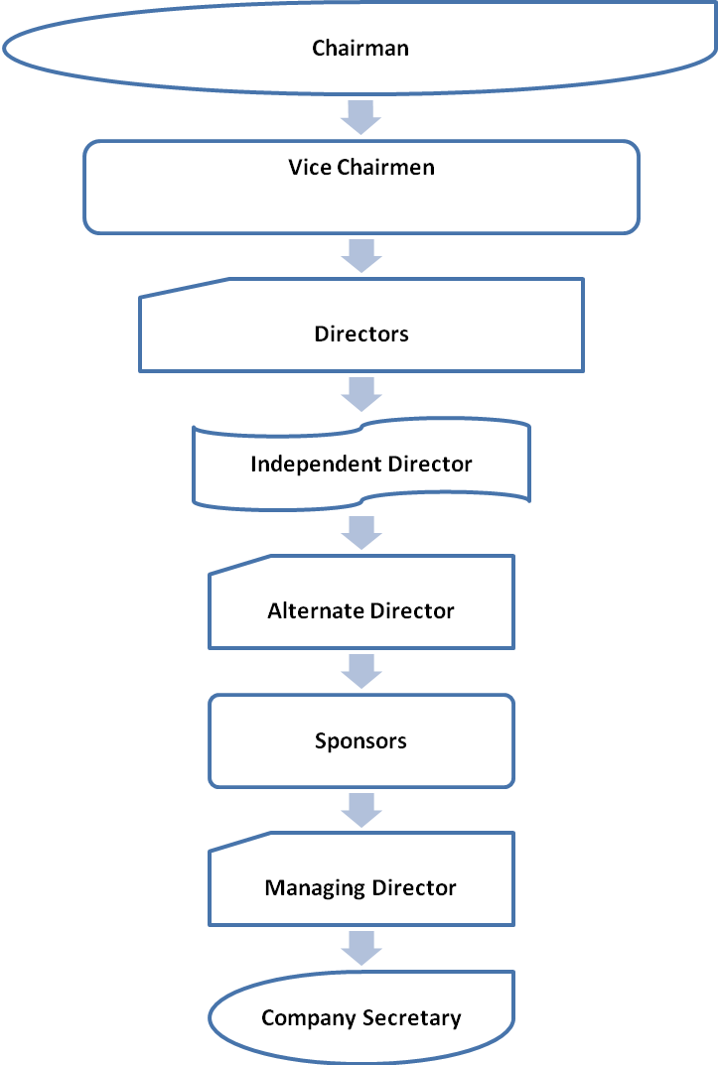

Executive committee:


Audit Committee:
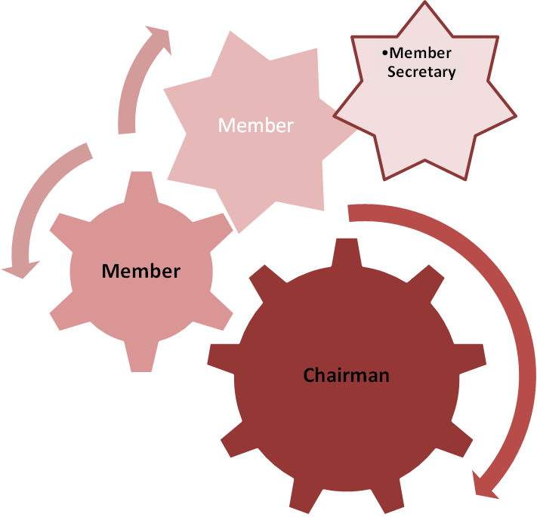

Shariah Council:
Shariah Council of the Bank is playing a vital role in guiding and supervising the implementation and compliance of Islamic Shariah principles in all activities of the Bank since its very inception. The Council, which enjoys a high status in the structure of the Bank, consists of prominent ulema, reputed banker, renowned lawyer and eminent economist.
Members of the Shariah Council meet frequently and deliberate on different issues confronting the Bank on Shariah matters. They also conduct Shariah inspection of branches regularly so as to ensure that the Shariah principles are implemented and complied with meticulously by the branches of the Bank.

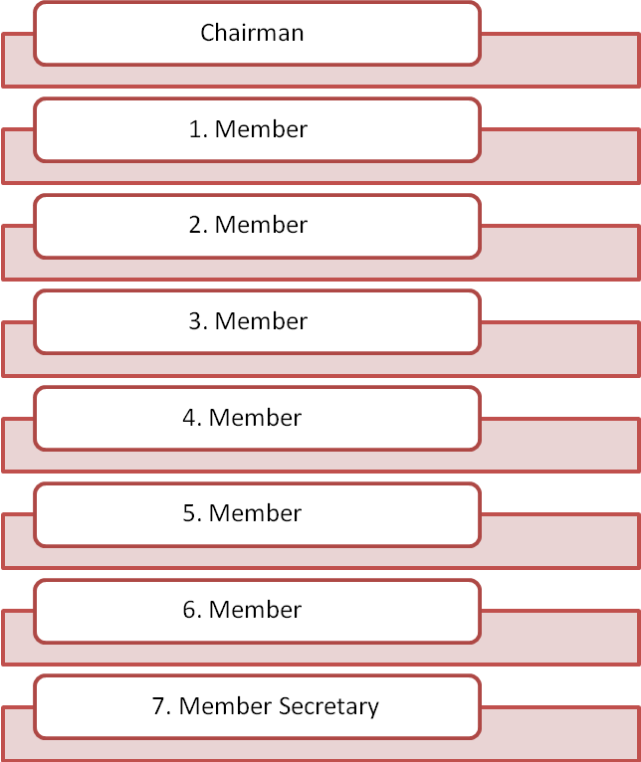

Chapter- 3
Financial Statement
Findings and Analysis

Findings & analysis:
a) Ratio Analysis:
From the annual report (2006-2010) of the Shahjalal Islami bank i have tried to find out the financial position of the bank.
Current Ration = Current assets / Current Liabilities
2006 =  = 1.08 times
2007= 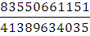 = 2.02 times
2008=  = 1.92 times
2009 = 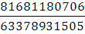= 1.28 times
2010 = = .85 times
Comment : We can see that current ratio of the Shahjalal Islami bank is not in the good position.
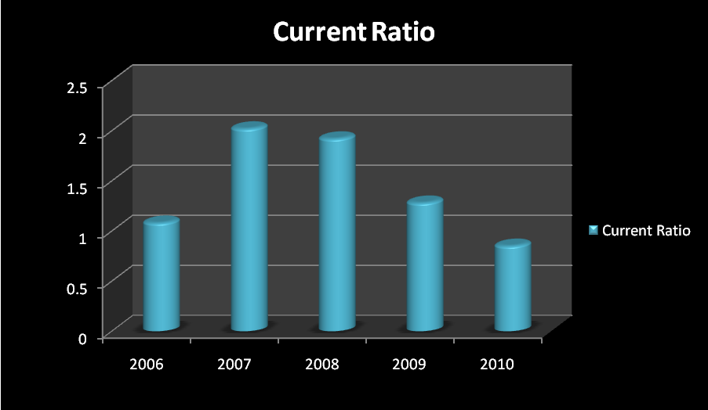
Graph: Current ratio is in the good position.

- Cash ratio= 
2006= 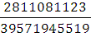 = 0.07 times
2007= 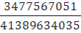= 0.08 times
2008= 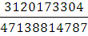= 0.06 times
2009= 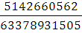= 0.08 times
2010=  = 0.08 times

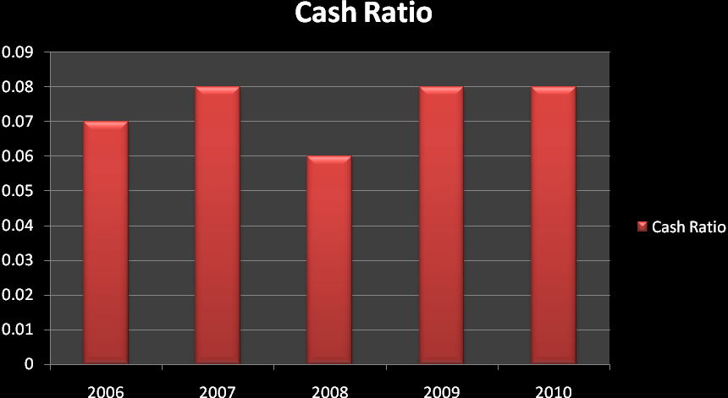
- Graph: we can see cash ration is same in almost every years of the bank.

Total Debt Ratio:
Total Debt Ratio = 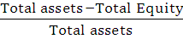
2006= =0.947 times
2007= = 0.941 times
2008== 0.926 times
2009==0.923 times
2010==0.873 times
Comments: Total Debt ratio of the bank is in the good position
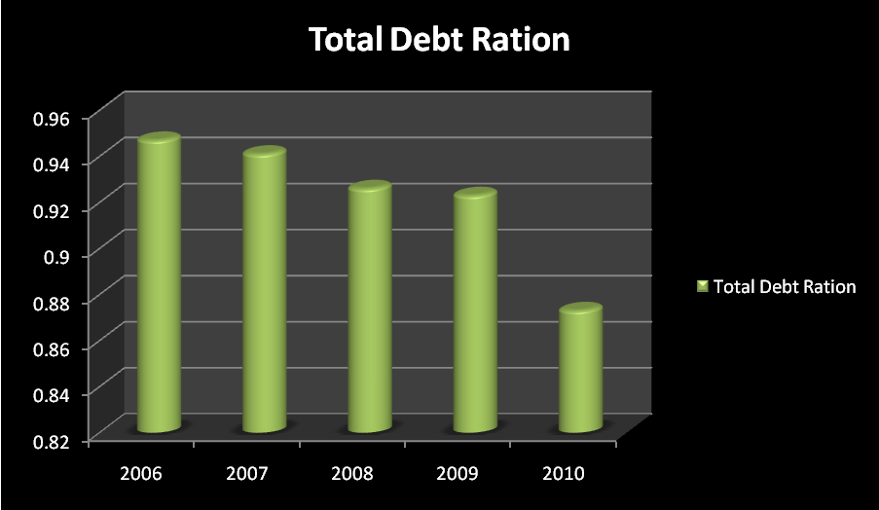
Graph: We can see from the graph that in 2010 the Total Debt Ratio of the Shahjalal Islami bank has decreased.
Return on Assets
Return on Assets = 
2006= 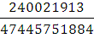=0.005=0.5%
2007==0.007=0.7%
2008==0.006=0.6%
2009==0.01=1%
2010==0.02%=2%
Comments: Year by year return on assets is increasing
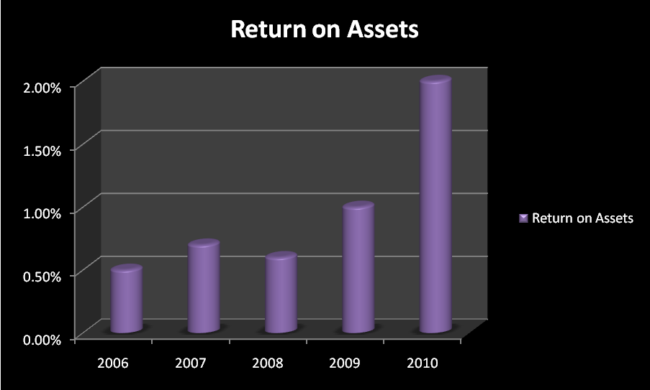
Graph: Return on assets of city bank has increased in 2010 from the consecutive years.
Return on Equity:
Return on Equity= 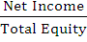
2006=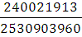=0.09=9%
2007==0.11=11%
2008==0.09=9%
2009== 0.14=14%
2010=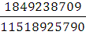=0.16=16%
Comments: We can see that, the return on equity of Shahjalal Islami bank has been increased consecutively from 2008 to 2010.
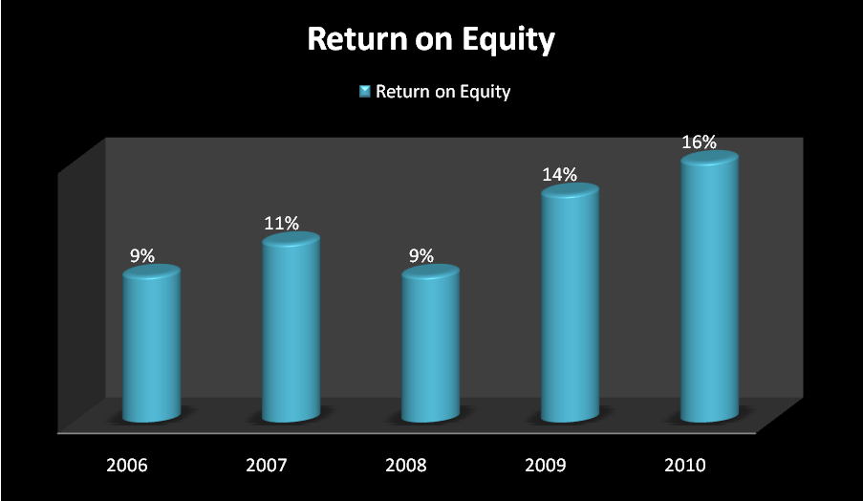
Graph : From the graph we can see that, in 2010, the Return on Equity has been increased mostly that 16%.

Chapter -4
Schedule of Profit Rate
ATM location
Risk Management

Schedule of Profit Rate
Sl. | Deposit Product | Provisional Rate
01. | Mudaraba Savings Deposit | 4.00%
02. | Mudaraba Special Notice Deposit
02. | Average balance less than 1 crore | 5.00%
02. | Average balance 1 crore to less than 25 crore | 7.00%
02. | Average balance 25 crore to less than 50 crore | 8.00%
02. | Average balance 50 crore to less than 100 crore | 8.50%
02. | Average balance 100 crore and above | 9.00%
03. | Mudaraba Term Deposit
03. | i) 1 Month | 12.00%
03. | ii) 2 Month | 12.00%
03. | iii) 3 Months | 12.00%
03. | iv) 6 Months | 12.00%
03. | v) 1 Year | 12.00%
04. | Mudaraba Scheme Deposits
04. | a) Monthly Income Scheme:
04. | 1 year-3 Years | 12.00%  (Tk.1,000/-per month per lac)
04. | b) Multiple Benefit Scheme:
04. | i) Double Benefit  Yearly Rate: 12.25% | 11.61%  (Will be doubled in 6 years)
04. | ii) Triple Benefit  Yearly Rate: 12.25% | 11.62%  (Will be tripled in 9.5 years)
04. | c) Millionaire Scheme:
04. | i) 5 Years  (Tk 12,470/ Per Month) | 11.00%
04. | ii) 10 Years  (Tk. 4,500/ Per Month) | 11.25%
04. | iii) 12 Years  (Tk.3,280/ Per Month) | 11.25%
04. | iv) 15 Years  (Tk.2,120/ Per Month) | 11.30%
04. | v) 20 Years  (Tk.1,080/ Per Month) | 11.45%
04. | vi) 25 Years  (Tk.575/ Per Month) | 11.51%
04. | d) Monthly Deposit Scheme:*
04. | i) 5 Years Yearly:11.54% | 11.00%
04. | ii) 8 Years Yearly:11.66% | 11.10%
04. | iii) 10 Years Yearly:11.83% | 11.25%
04. | e) Hajj Scheme:**
04. | Up to 10 Years | 11.25%

*Mudaraba Hajj Scheme Deposit: Monthly installment and provisional amount payable at maturity (amount in Taka)
Year | Monthly Installment | Expected Amount payable at Maturity to meet-up Hajj Expenses | Yearly Rate
1 | 25,000 | 3,19,000 | 11.65%
2 | 12,000 | 3,24,250 | 11.75%
3 | 7,700 | 3,31,000 | 11.75%
4 | 5,500 | 3,34,500 | 11.80%
5 | 4,200 | 3,39,300 | 11.80%
6 | 3,350 | 3,45,500 | 11.82%
7 | 2,725 | 3,49,000 | 11.82%
8 | 2,275 | 3,55,000 | 11.83%
9 | 2,000 | 3,74,500 | 11.83%
10 | 1,700 | 3,77,800 | 11.83%

SJIBL ATM Location

Shahjalal Islami Bank Limited is providing ATM services to its valuable cardholders 24/7 for 365 days. At present the Bank has 13 ATM's of its own and also providing ATM services to its customers through shared ATM with Q-Cash member Banks, DBBL, Brac Bank and other VISA ATMs.

Shahjalal Islami Bank Limited ATM Location is given below:
- Head Office ATM Booth
UDAY SANZ, 2/B Gulshan South Avenue, Gulshan-1, Dhaka-1212
- Dhaka Main ATM Booth
58 Dilkusha C/A, Dhaka - 1000.
- Motijheel ATM Booth
Karim Chamber, 99, Motijheel C/A, Dhaka-1000
- Dhanmondi ATM Booth
Momtaz Plaza, House-07, Road-04, Dhanmondi R/A, Dhaka-1205
- Dhanmondi (Anwer Khan Modern Hospital)
House# 17, Road# 08, Dhanmondi R/A, Dhaka-1205.
- Gulshan ATM Booth
40/5, North Avenue, Gulshan-2, Dhaka-1212
- Chawkbazar (Branch ATM)
2 Chawkbazar, Kapashgola Road, Chittagong
- Agrabad (Branch ATM)
104 Agrabad C/A, Chittagong
- Sylhet ATM Booth
Sylhet Station Club Building, Shahjalal Road, Bandar, Sylhet
- Sylhet (Branch ATM)
Al-Falah Tower(1st floor), Dhupadighir puropar, Kotowali, Sylhet,
- Sylhet (Branch ATM)
397, Amberkhna, Dargah Gate, Airport Road,Kotowali, Sylhet.
- Khulna ATM Booth
Moon Mansion, Moylapota More, 10 KDA Avenue, Khulna
- Jessore (Branch ATM)
Sadhinata Bhaban (1st Floor) Holding no: 91, M.K. Road. Kotawaly, Jessore
- Bogra (Branch ATM)
Nurul Hoque Tower, 357/395 Boro Gola Mor, Bogra
- Tangail (Branch ATM)
Nirala Complex, Par Dihgulia, Tangail

Q-Cash Member Banks are:
All the Q-Cash member banks can make ATM transactions within their network at very nominal fees.
Sl. | Bank Name
01. | Basic Bank Limited
02. | Bank Asia Limited
03. | Bangladesh Commercial Bank Limited
04. | Eastern Bank Limited
05. | IFIC Bank Limited
06. | ICB Islamic Bank Limited
07. | Janata Bank Limited
08. | Jamuna Bank Limited
09. | Mercantile Bank Limited
10. | Mutual Trust Bank Limited
11. | National Bank Limited
12. | NCC Bank Limited
13. | Pubali Bank Limited
14. | Shahjalal Bank Limited
15. | Sonali Bank Limited
16. | Social Islami Bank Limited
17. | Standard Bank Limited
18. | State Bank Of India
19. | The City Bank Limited
20. | Trust Bank Limited
21. | Uttara Bank Limited
Additional Banks by Acquiring BEPS:
Sl. | Bank Name
01. | Dhaka Bank Limited
02. | EXIM Bank Limited
03. | Southeast Bank Limited
04. | United Commercial Bank Limited
ATM Transaction Charges:
ATM Outlet | Charges per transaction
SJIBL ATM | Free
Q-Cash Network | Tk.10.00
Dutch Bangla Bank Ltd. | Tk.25.00
OMNIBUS (Brac bank Ltd.) | Tk.20.00
Other VISA ATM | Tk.25.00

Risk Management

Shahjalal Islami Bank Ltd. introduces Risk Management Unit (RMU) to analyze and measure business risk with taking effective steps to reduce the risks involved in the business of Banking.
SJIBL has set up a separate Risk Management Unit in line with the regulatory requirement to address and supervise the existing and potential business and capital risks. This specialized unit cautions the bank against any financial and operational risk at macro level impacting the micro functionalities. It intimate the management of various kinds of core risk as prescribed by the Bangladesh Bank in different functional areas: credit, foreign exchange, asset and liability management, internal control and compliance, money-laundering and information communication technology risks, apart from capital adequacy risk.
Reporting line of Risk Management Unit direct to the Deputy Managing Director of the Bank with reporting to the Audit Committee of the Board of Directors of the Bank as and when required. The Risk Management Unit is headed by a Deputy Managing Director who is the Chief Risk Officer (CRO) of the Bank. The Organ ogram of the RMU is given below which emphasis on management of different risk profiles of the Bank:
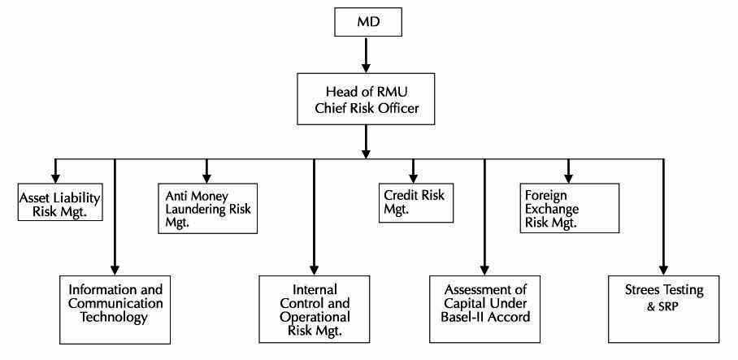

The RMU reviews quarterly the risk status of the bank and based on qualitative and quantitative Key Risk Indicators (KRI) on different risk areas, place a monthly Risk Management Paper (RMP) entailing Credit Risk, Market Risk, Operation Risk, Liquidity Risk, Sustainability Risk, Capital Adequacy Risk and Earning risk components of the risk domain to the Managing Director. Risk Management Paper is also submitted to the Bangladesh Bank as compliance report on quarterly basis.

Importance of the RMU:

In early 2003 and 2004 Bangladesh Bank issued guidelines on the followings six (6) core risks to comply the Risk Management in the Banking sector:
- Investment Risk Management (IRM)
- Asset Liability Risk Management (ALCO)
- Foreign Exchange Risk Management
- Internal Control and Compliance Risk Management
- Anti Money Laundering Risk Management
- Information Technology Risk Management
When world recession had started in 2008 & 2009 and heavily affected world economy as well as Bangladesh economy also at that time. Due to simplicity of financial system in Bangladesh, our Banking sector was not severely affected. Bangladesh Bank introduced Risk Management Unit (RMU) to supervise all core risk in banking which will assist to create business environment with analysis of risk and to reduce the risk associated in banking.

Risk Management Process (Term of References):
- Collect all relevant data from different models and information systems for analyzing risk.
- Assess the quality, completeness, and correctness of all relevant data/information needed to analyze risks.
- Highlight risky portfolios and deficiencies of the bank on timely manner with recommendations and suggestions.
- Analyze data/information through preparation of paper named Risk Management paper.
- Identify, evaluate/measure, control and monitor major risks in line with the standard set in the policy guideline to avoid unnecessary loss and ensure the banks in pricing all risk correctly.
- Oversee the capital management function of the bank in consistency with the Risk Based Capital Adequacy Measurement Accord (Basel-II).
- Identify, Assess and quantify key transaction risks inherent in a given transaction to ensure that the quality of the assumption are tested against due diligence carried out by different operational business units.
- Review market conditions and take precautionary measures towards facing abnormal market situation and vulnerability of investments of the Bank.
- Analyze the bank's own resilience capacity towards facing financial difficulties of the bank.
- Ensure through independent oversight that different risks are identified, evaluated, monitored, and reported within the established risk management framework.
- Take necessary steps to bring the position within limit and also assess and measure volatility of market and vulnerability of investment from time to time.
- Conduct periodic stress tests so that any errors/mistakes/lapses are eliminated gradually during daily operations of the Bank.

Chapter - 6
Investment Scheme of SJIBL

Islamic Mode of Investment Bai Mechanism:
Bai means purchase and sale of goods in cash or on credit or in advance at an agreed upon profit, which may or may not be disclosed to the client. Majority of investments of Islamic banks are extended through this mechanism. A good number of investment products have been designed to facilitate mainly working capital financing which goes as follows:
Bai-Murabaha
Murabaha LC(Sight/Deferred):
Through this mode of indirect facility, the bank facilitates import of goods of the client at fixed rate of service charge (LC commission) on invoice value. LC may be opened at 100% cash or at a different ratio.
Murabaha Post Import TR :
This is a post import finance under the principle of “Bai”, extended to retire Shipping Documents under LC opened. We buy the imported goods and sell the same to the importer at a cost plus an agreed upon profit repayable today or on some date in the future in lumpsum or by installments. Usually payment is made by lumpsum from the sale proceeds of the consignment. Possession of goods remains with the client. Collateral security is usually obtained to secure the finance.
Murabaha Post Import Pledge :
As like as Murabaha Post Import TR with an exception to security. Goods remain under the control of the Bank. Collateral security may or may not be obtained.
Bai-Muajjal
Bai-Muajjal Commercial TR:
It is an agreement between bank and client whereby bank delivers goods to the client upon deferred payment, i.e. the client shall pay the price at some future date at a time, by lumpsum or by installment. Under this mode of investment, bank is not supposed to disclose cost price and profit separately. Goods are delivered on trust and Trust Receipt is obtained for legal implication.
Bai-Muajjal (Real Estate):
Mode of operation and principle of this product are alike Bai-Mujjal Commercial TR. Difference is with the purpose, i.e. the facility is only extended against construction or purchase of building, apartment etc.
Bai-Muajjal (WES Bill):
Investment facility under this Mode is extended to liquidate ABP liability at maturity, when the client can not liquidate the liability as a result of non-repatriation of the related export proceeds.
Bai-Muajjal (Term):
Under this mode of investment, term facility is given to meet client’s requirement, which is repaid by a specific repayment schedule. Purpose is a bit different, such as to meet BG claim, etc.
Bai-Salam
Bai-Salam (PC):
This is export finance. Bai-Salam is a term used to define a sale in which the buyer makes advance payment, but the delivery is delayed until some time in the future. Usually the seller is an individual or business and the buyer is the bank.
The Bai-Salam sales serve the interest of both parties:
- The seller- receives advance payment in exchange for the obligation to deliver the commodity at some later date. He benefits from the salam sale buy locking in a price for his commodity, thereby allowing him to cover his financial needs whether they are personal expenses, family expenses or business expenses.
- The purchaser benefits because he receives delivery of the commodity when it is needed to fulfill some other agreement, without incurring storage costs. Second, a Bai-Salam sale is usually less expensive than a cash sale. Finally a Bai-Salam agreement allows the purchase to lock in a price, thus protecting him price fluctuation.

Types of Investment:
There are several types of investment that SJIBL has provides to the customer, those are:
- Small and Medium Enterprise (SME) Investment Operation
- Small Business Investment Scheme
- Car Purchase Investment Scheme
- Household Durable Investment Scheme
- CNG Conversion Investment
- Overseas Employment Investment Scheme
- Investment Scheme for Doctors
- Investment Scheme for Executives
- Investment Scheme for Education

Chapter- 7
Conclusion
Acronyms
Appendix
References

Conclusion
This paper has outlined the framework for the study of the role of SJIBL in Islamic banking within the overall relationship between culture and information systems. Despite the richness of the study area, this topic has been largely neglected to date. The notion of ‘role’, a rich description of expected behavior and responsibilities, seems to be an appropriate approach to study the influence of Islamic culture, strongly supported by Actor Network Theory to identify relevant actors (human and non-human), networks and relationships. Islam is a fast growing religion whose fundamentals are appealing to an ever-growing Muslim community. This community is itself growing in economic and political importance globally. Islamic banking is an essential component of everyday Muslim business life. It is thus felt that the research will make a useful contribution to IS theory and practice.

Acronyms

A/C Account
ATM Automated Teller Machine
BB Bangladesh Bank
BIBM Bangladesh Institute of Bank Management
CBL City Bank Limited
CEO Chief Executive Officer
DMD Deputy Managing Director
FDR Fixed Deposit
L/C Letter Of Credit
PO Pay Order
SME Small and Medium Enterprise
STD Short Term Deposit
T/C Travelers Cheque
AVP Assistant Vice President
DMD Deputy Managing Director.
EO Executive Officer
SAVP Senior Assistant Vice President
SEO Senior Executive Officer
SO Senior Officer

Appendix:
SHAHJALAL ISLAMI BANK LIMITED
BALANCE SHEET
AS AT 30 JUNE 2010
June'2010 December'2009
Note Taka Taka
PROPERTY AND ASSETS
Cash
Cash in hand (Including Foreign Currencies) 3 5 57,904,171 5 62,922,561
Balance with Bangladesh Bank & Sonali Bank
(Including Foreign Currencies) 4 5,169,398,340 3,515,663,193
5,727,302,511 4,078,585,754
Balance with other Banks and Financial Institutions
Inside Bangladesh 1,301,243,881 1,729,470,208
Outside Bangladesh 285,105,510 4 04,441,115
5 1,586,349,391 2,133,911,323
Placement with other Banks & Financial Institutions 6
3,897,081,214 4,287,781,041
Investments in Shares & Securities
Government 1,100,000,000 1,100,000,000
Others 1,047,228,646 2,383,146,682
7 2,147,228,646 3,483,146,682
Investments
General Investment etc. 48,020,056,711 40,369,639,045
Bills Purchased and Discounted 4,371,235,663 3,588,621,666
8 52,391,292,374 4 3,958,260,711
Fixed Assets Including Premises 9 1,264,800,227 620,466,461
Other Assets 10 529,705,004 358,743,429
Non Banking Assets - -
Total Assets 67,543,759,367 58,920,895,401
LIABILITIES AND CAPITAL
Liabilities
Placement from other Banks & Financial Institutions 11
4,900,000,000 4,500,000,000
Deposits and Other Accounts
Mudaraba Savings Deposits 3,525,201,500 3,072,788,942
Mudaraba Term Deposits 31,608,945,549 27,578,741,808
Other Mudaraba Deposits 13,240,146,600 12,489,742,364
Al-Wadeeah Current & Other Deposit Accounts 4,771,172,580 3,966,538,988
Bills Payable 1,301,501,726 3 51,419,391
12 54,446,967,955 47,459,231,493
Other Liabilities 13 2,319,199,079 1,995,596,548
Deffered Tax Liabilities 14 56,746,714 39,434,092
Total Liabilities 6 1,722,913,748 53,994,262,133
Capital/Shareholders' Equity
Paid-up Capital 15 3,425,119,500 2,740,095,600
Statutory Reserve 16 1,474,592,400 1,182,585,039
Retained Earnings 17 6 70,509,419 7 53,328,328
Asset Revaluation Reserve 18 2 50,624,301 2 50,624,301
Total Shareholders' Equity 5,820,845,619 4,926,633,268
Total Liabilities & Shareholders' Equity 67,543,759,367 58,920,895,401

