Mercantile bank was established in June 2, 1999 as a private commercial bank and started its operation. The total amount of loan been provided was 47669.29 till 2005 its main investing projects are business, garments, micro credit, construction and others. Activates of this project are quit satisfactory. Import-from the beginning of the bank it has been evolve in foreign exchange to help the countries international trade. Its capital was 58325.20 million till 2005 till December. The activities of the General Banking Department of MBL are mainly divided into the following categories: Account Opening Section, Local Remittance Section, Deposit Schemes Section, Accounts Section, Clearing Section, Collection Section, and Cash Section. Foreign Exchange Department is an international department of the bank. It deals with globally and facilities international trade through its various modes of services. It bridges between importers and exporters.

Bangladesh Bank issues license to scheduled banks to deal with foreign exchange. These banks are known as Authorized Dealers. If the branch is authorized dealer in foreign exchange market, it can remit foreign exchange from local country to foreign country. This department mainly deals with foreign currency. This is why this department is called foreign exchange department. MBL Foreign exchange department started foreign exchange operation three years ago it deals in – Operates import, Operates export, foreign remittance. One of the primary functions of commercial banks is the sanctioning of credit to borrowers. Bank credit is a catalyst for bringing about economic development. Without adequate finance there can be no growth or maintenance of a stable output. Bank lending is important to the economy, for it makes possible the financing of agriculture, commercial, and industrial activities of a nation. At the same time, a bank will, therefore, distribute its funds among various assets in a manner as to derive sufficient income. Various Credit Schemes of MBL are Consumers Credit Scheme (CCS), Car Loan Scheme, Doctors Credit Scheme, Rural Development Scheme, Lease Financing, Personal Loan, Small Loan.

1.2 Objective of the study

In order to conduct a worthwhile report preparation of BCBL, it is necessary to go through the profiles of the banks under study. This study aims at analyzing the whole banking in view of commercial bank. Consequently, the study will mainly describe the procedure, system, methods and briefly define the current condition – truly to my sense of perception. It will also contain inputs of my personal findings and/or acuity.

The objectives of the study are as follows:

Wider Objective
- To get an idea about the overall activities of BCBL and make an industry analysis on the banking sector of Bangladesh.
- To identify the job satisfaction of the employee of BCBL.

Specific Objective
- To see the level of job satisfaction of the employee of BCBL
- To examine the motivational programmers undertaken by the employer.
- To be acquainted with the background of the bank.
- To fulfill the partial requirement of the BBA program.
- To measure the performance and productivity of the bank through CAMELS rating, risk analysis.
- To identify the credit approval, their securities and monitoring process of Mercantile Bank Limited
- To identify the amount of outstanding credits and disbursement.

- To identify the different sectors that have or had been provided the different credit facilities and also to identify sectors getting highest or lowest credit facility and. reasons behind for this.

- To identify the classified loans of different sectors in the last several years and analyzing the changes that had been occurred to them
- To identify the default problem and its reason of the BCBL.
- To relevant rules, regulations, theories and practices for banking;
- To identify the strength, weakness, and critical risk factors of BCBL.

1.3 Scope of the study

The report covers the functions of different departments of BCBL, like General Banking, credit analysis, Investment and Foreign Exchange, Account, Human Resources. It’s also present a brief scenario of Mercantile Bank Limited. In total Furthermore, overall banking activities, products and services have focused.

1.4 Methodology

A checklist has been prepared and using the checklist data was collected. According to the checklist interviews were conducted and made a discussion session from the executive officer of several departments of BCBL

Sampling:

A total number of 10 employees will be randomly selected for collecting data.

Sources of information:

Primary Data: Primary data was collected for preparing this report through personal observation and interviewing the office executives.

Secondary Data: Secondary data was collected from the annual report, journals, different books related to the banking sector and the web site of MBL.

Data Collection Instruments:

In conducting evaluative study, interviewing method will be used for data collection, while a checklist would enable to record direct observation. A combination of structures and unstructured interview schedules would help generate information for this study. Along with interviewing techniques Focus secondary data source will also be used to approach the various issues to assess and to generalize the information within a very short period of time.

Study Plan:

The proposed study can be organized under three phases such as

Phase I: Inception Phase
Phase II: Survey/Data Collection Phase

Phase III: Reporting Phase

Phases | Activities
Phase I  Inception Phase | Collection and review of relevant documents/literature. Development of Data Collection Instruments (DCIs) and Techniques, Developing Guidelines for Focus Group Discussions (FGD).
Phase II  Survey/Data Collection Phase/Field Work | Deployment of Data gatherers, monitoring and supervision of the data collected though the field work, Development of Tabulation and Data Analysis, Plan and techniques, Field Data Collection.
Phase III  Reporting Phase | Editing data, Data Computation, Analysis of Data and Preparation of Tables and prepare graphical presentation.

Sl.  No. | Activities | Days | Weeks
Sl.  No. | Activities | Days | 1 | 2 | 3 | 4
1 | Planning the Study | 5
2 | Preparation of Tools | 10
3 | Pre-testing Tools and Production | 4
4 | Data Collection | 45
5 | Data Analysis | 15
6 | Draft Report Submission | 12
7 | Final Report Submission | 7
 | Total | 98

1.5 Limitation of the study

To make a report various aspects and experience are needed. But I have faced some barriers for making a complete and perfect report. These barriers or limitations which I have faced are mentioned below:

- Difficulty in accessing data of its internal operations.
- Non-availability of some preceding and latest data.
- Some information was withheld to retain the confidentiality of the bank.
- I was placed to this Bank for only 12 weeks of time & working like a
regular employee hindered the opportunity to put the effort for the study.
- Entrance to every nock and corner of the bank was not possible for us.
- Lack of experience.
- Time constraint

  - Brief History of Banking System

Evaluation of the word “Bank”

The word Bank originated from the Italian word “Banco”. Banco means long tool. In ancient time Italian Jews merchants used to do business of lending money by sitting on the tools. And it is assumed that the word “Bank” derived from the word “Banco” (tools. To meet the expense of war of 1171 one type credit certificate was lunched in Italy at an interest rate of 5%. It was called as “Minte” in Italian language and “Banke” in German Language. Then German Language was widely used in Italy. As a result, the word “Banke” gradually changed to the word “Banco”from which the word “Bank” originated.

Evolution of Bank

The modern banking system is an evolutionary growth right from the Middle Ages. The genesis of modern bank lay in the functions performed by the Merchant with wide reputation commanding confidence far and near could easily finance domestic and foreign trade. The famous merchant houses established branches to trade centers at home and abroad began to use credit devises to accommodate their customers Jagath Seth, for example, had his branch office in London in the 18th century. Even earlier the indigenous hounds, which finance domestic trade in India was the innovations of the local merchants. In this credit operations in these credit operations in the ancient merchant houses lay the germs for the development of the important credit instrument lately known as bill of exchange and these merchants were virtually foreunncersof the modern exchange banks. The second ancestor of banks was the moneylender. The traditional shellac notorious for usury an edit necessity.

He was the man who could supply money through he charged heavily he did lending. The lending business earned him bad name no doubt but he was dependable and trustworthy. People with surplus quite unaccustomed with money lending business and trade secrets could safely keep their surplus with the moneylender for investment by the letter on firms of a share of profit. The moneylender thus was an embryonic banker performing duel functions lending money and mobilization of savings. Exactly the modern bank does this as a lineal descendant of the ancient moneylender. The third in the chain of ancestors stood the goldsmith have safe vaults for the safe upkeep or their gold stocks. They were the embodiments of safety and security. Naturally, people with valuables and jewelers approached goldsmiths for safe custard. Initially the goldsmiths charged commission for safe upkeep. The practice later on changed as the goldsmith utilized the deposits for earning profits. The receipts provided to the depositors certifying the amount the value of the thing deposited became honorable

Documents as soon as the reputation and integrity of goldsmith became well known. The deposit receipts embryonic bank notes. The letter of instruction transferring the ownership of deposits became the cheques. Experience neither showed that all deposits were nor withdrawn simultaneously. The goldsmith was always left with a surplus above the normal withdraws. This enabled him to issue more credit instruments even in access of actual deposits. He could thus create deposits. A modern Bank then comes in itself the functions of all the there ancestors like the merchant it makes a specialty of financings foreign trade like the money lender collects savings and end like the goldsmith provides a convenient mechanism by which people can make payments to each other.

Banking structure in Bangladesh

Banking system of Bangladesh comprises of different types of bank and financial institutions. The name of our central bank is “Bangladesh Bank” it is the director and regulator of banking system of Bangladesh. Banking structure in Bangladesh is briefly described below.

- Bangladesh Bank is the central bank of Bangladesh. It is director of money market in Bangladesh. It regulates the activities of other banks of Bangladesh through credit control, exchange control etc.

- Commercial bank both the pMBLic and private sectors of commercial bank are active in Bangladesh. There are 4 nationalized commercial bank– Sonali Bank, Rupali Bank, Agrani Bank.

- In 1983 priority gives on private sector of banking business. As a result two nationalize bank was handed over to private sector, which are Pubali and Uttara bank.

- Now in our country a large number of private banks are doing banking business.

Hierarchy Analysis

Banking sector has a vital role to play in the economic activities and development of any country. This sector is much more important in a developing country like Bangladesh. The whole scenario of the economy of a country can be ascertained by examining the condition of the banking sector. In Bangladesh, the banking sector dominates the financial sector and macroeconomic management largely depends on the performance of the banking sector. Banking grew primarily in the public sector with main emphasis on restructuring of the financial system and development needs of the war-torn economy with gradual liberalization in subsequent years. It was increasingly felt that banks should be allowed in the private sector for giving a fillip to development process on the basis of private initiative. In the 80’s for the first time a number of banks in the private sector were allowed. Subsequently in the mid 90’s some more banks in private sector also commenced operations. Finally, in 1999, 3rd generation of private sector banks was given permission to operate. As a result while up to 80’s public sector banks dominated financial sector, banks in the private sector were given increased responsibility with the passage of time.

At present there are 51 scheduled banks operating all over the country. Out of these, 9 are state-owned (including five specialized banks), 29 are private commercial banks and the rest 13 are foreign commercial banks.

Private commercial banks are divided into three groups according to their commencement of business. They are familiar in the name of 1st generation, 2nd generation and 3rd generation banks.

1st Generation Banks (Established 1982-1988):
National Bank Limited, The City Bank Limited, United Commercial bank Limited, AB Bank Limited, IFIC Bank Limited, MercantileBank Bangladesh Limited and Al-Baraka Bank Bangladesh Limited.

2nd Generation Banks (Established 1992-1996):
Eastern Bank Limited, National Credit & Commerce Bank Limited, Southeast Bank Limited, Dhaka Bank Limited, Al Arafah Islami Bank Limited, Social Investment Bank Limited and Dutch-Bangla Bank Limited.

3rd Generation Banks (Established 1999 to present):
Mercantile Bank Limited, Standard Bank Limited, One Bank Limited, EXIM Bank Limited, Premier Bank Limited, Mutual Trust Bank Limited, First Security Bank Limited, Bank Asia Limited, the Trust Bank Limited, Jamuna Bank, and BRAC Bank, and Mercantile Bank Limited.

  - About Mercantile Bank Ltd.

One of the largest businesses carried out by the commercial bank is foreign trading. The trade among various countries falls for close link between the parties dealing in trade. The situation calls for expertise in the field of foreign operations. The bank, which provides such operation, is referred to as rending international banking operation. Mainly transactions with overseas countries are respects of import; export and foreign remittance come under the preview of foreign exchange transactions. International trade demands a flow of goods from seller to buyer and of payment from buyer to seller. In this case the bank plays a vital role to bridge between the buyer and seller.

Background of the organization Mercantile bank limited:-
Mercantile bank was established in June 2, 1999 as a private commercial bank and started its operation. The renowned 30 industries established this bank with everybody’s consent Mr. Abdul Jalil elected as the chairman. Mercantile bank is a private commercial bank with head office at 61 Dilkusha C/A, Bangladesh started operation on 2nd June ,1999 ,the bank has 28 branches spread all over the country and introducing some branches with assets of taka 13078.93 million and more than 300 employees. The bank has diversified activities in retail banking, corporate banking and international trade.

Credit-mercantile bank is playing an important role while giving loan for the small and the medium enterprise. In the terms of credit mercantile bank has introduced new schemes mostly for the business people in Bangladesh. Different categories of loan been provided to the businessman. The total amount of loan been provided was 47669.29 till 2005 its main investing projects are business, garments, micro credit, construction and others.

Consumer credit scheme mercantile bank has been providing loan to medium and low income people. This policy has gained a great popularity among consumers. The total amount was 314.57 million, which is 0.68% of total credit till 31 December, 2005.Micro credit after starting its operation it has gains a huge support by the consumers mainly supported by consumers who are small; entrepreneurs. Activates of this project are quit satisfactory. Import-from the beginning of the bank it has been evolve in foreign exchange to help the countries international trade. Its capital was 58325.20 million till 2005 till December the import items are,

- machinery
- electronic items
- rice
- paddy
- whet seeds
- garments items
- chemical
- button
- cloths
- yarn
- accessories
- cotton

  - Roles in Economic Development.

☞ Business roles of Mercantile Bank Limited:

- Achieve business vision through quality and customer acceptance by providing financial services.
- Maintain highest ethical standards in every aspect.
- Customer focus – a perspective of quality throughout:
- The entire organization or each department and bank.
- All processes, systems and services.
- Compliance – with regulatory requirements.
- Added value – through continuous improvements to benefit customers and the bank.

☞ Roles to the customers

Although, Mercantile Bank Limited is new in the Banking industry, it tries its best to satisfy its customer through developing the efficiency of its function and to reach its ultimate goal of: Winning client Satisfaction. Customer can enjoy withdrawal, transfer and pay utility bills from anywhere in Bangladesh from any of the thirteen branches. More over the bank has started PC banking facility to reduce the time to deliver the service to its customer. Moreover, it charges competitive rate of service to its customers.

☞ Roles to the community

Mercantile Bank Limited performs its roles for the community through:

- Contributing to higher education (Education Credit scheme).
- Promoting local industry.
- Overall development activities through different kind of scheme.

☞ Controlling

Mercantile Bank Limited does not believe in the traditional banking, it still believes Islamic System Base banking. It tries to increase and maintain its market share in the private banking sector through two types of control techniques:
- Feed Forward Control.
- Feedback Control.

Feedback control technique monitor output of a process and feed into the system to obtain desired outputs. On the other hand feed forward control technique monitor inputs into a process to ascertain weather these are as planned; if they are not, the inputs are changed in order to get the desired result.

☞ Roles towards ethics and society

Mercantile Bank Limited strongly believes in banking ethics and social responsibilities. It is fully devoted to fulfilling the satisfaction of the customer as well as it employees. It performs its social responsibilities through involving in different type of social development activities to develop the socio-economy of the country.

  - Divisions of MBL.

The Head Office of Mercantile Bank has nine major divisions and each comprising of various departments. The major divisions in the Head Office are as follows:

1. Investment Division

This division has the authority to determine the party or the client who will get the credit facility from the bank. The credit clients are selected according to the criteria of credit policy. This division has the fu]l authority to take any decision against or favor the client and these divisional works is supported by the Credit Services Division.

2. Financial Administration Division

This division can handle the credit proposal, disbursement, monitoring and credit recovery position that is given by all branches. Each branch has their own credit division and all branch-wise activities are reported to the head office credit services division.

3. Audit & Inspection Division, H.O

This division can control all the financial position, activities of overall organization. They provide the total budgetary limitation to every department for the respective year. They also carry out the financing activities with the access and operational activities.

4. Marketing & Public Relation Division

This division mainly works for

- To improve the marketing network through out the country
- To implement the marketing strategies and the concept of Trade Marketing
- To improve the procedure which is ultimately provide date regarding to competition and relative market.
- To arrange several workshop and seminar which can improve the quality of existing officers.

5. Common Services Division

This division can handle all the general activities except the credit and financial sector. All the administration activities are designed and implemented by this division.

6. Human Resource Division (HRD)

This division deals with the employees as the core resources of the organization. They mainly emphasize on the recruitment of employees and the employee benefits & services. And, the main philosophy is to motivate the employee to work with efficiently and effectively.

7. Computer It Division (IT)

This division can handle the IT activities. Each branch has their own IT division and all branch-wise activities are reported to the head office IT division

  - Branches.

Head Office
61, Dilkusha Commercial Area
Dhaka-1000, Bangladesh
Tel: 880-2-9559333,0171-535960
Fax:880-2-9561213
Telex: 642509 MBLID BJ
E-mail: mbl@bol-online.com
Website: www.mblbd.com
Mercantile Bank Limited has a predominately network of its forty two branches

At first I have been placed in the General Banking Department. General Banking department performs the majority functions of a bank. It is the core department.

In fact, bank operates with the people’s money. And this process starts with the General Banking department. The activities of the General Banking Department of MBL are mainly divided into the following categories:

    - Account Opening Section,
    - Local Remittance Section,
    - Deposit Schemes Section,
    - Accounts Section,
    - Clearing Section,
    - Collection Section,
    - Cash Section,

3.1 Account Opening System

The relationship between Banker and customer begins with the opening of an account by the customer. Opening of a account binds the Banker and customer into contractual relationship. But selection of customer for opening an account is very crucial for a Bank. In fact, fraud and forgery of all kinds start by opening account. So, the Bank should take extreme caution in its selection.

Types of Account:

Saving Account
Current Account
Fixed Deposit Account
Short Term Deposit (STD) Account
DPS Account

  - Documents Necessary To Opening An Account

- Account opening form dully filled up.
- Two copies of passport sdize photographs.
- Mandate or authority form filled up for opening an individual, proprietorship is to be obtained if a customer want to authorize another person to operate an account on behalf of him.
- Citizenship Certificate.

3.3 Documents Needed For Each Account

Current / Savings Deposit account:

Introduction of the applicant by a current account holder of this branch.

Proprietorship Firm

- Name of authorized persons, designation, specimen signature card.
- Trade licence.
- Passport (if there is no introducer)
- Citizenship Certificate

Partnership Firm

- Account must be opened in the name of the firm.
- Thre form should describe the names and addresses of all partners.
- Partnership deed is required.
- Trade licence from city corporation is needed.
- Letter of authority is achieved.

Limited Company:

- Certificate of incorporation
- Certificate of Commencement of Business (In case of Public Limited Company only.)
- Form XII. (List of all Directors, Designation, Address, Specimen Signature)
- Memorandum of Association
- Article of Association
- Power of attorney.
- Resolution of the Board of Directors authorizing opening of an account.

Societies/Clubs/Associations:

Other than above mentioned common documents resolution of who will operate the account must be noted.

Account Opening Procedure :

1. Applicant fills up the relevant application form in the prescribed manner.

2. He/She is required to fill up the specimen signature card.

3. For individual introduction is needed by an account holder

4. The authorized officer scrutinizes the introduction and examines the documents submitted.

5. Issuance of deposit slip and the deposit must be made in cash. No cheque or draft is acceptable to the Bank.

6. After depositing the cash a cheque book is issued.

7. Account is opened

3.4 Current Account

It is purely a demand deposit account. There is no restriction on withdrawing money from this account. As many withdrawals are allowed the customers. It is suitable when funds are to be collected and money is to be paid away at frequent interval. Current Account is most suitable for private individuals, traders, merchants, importers and exporters, mill and factory owners, limited company’s etc. For opening of a Current Account minimum deposit of TK.1000/- is required along with introductory reference. No interest is given the Current Account deposited money.

The following points are important,

- A current account is a running and active account, which may be operated upon any number of times during a working day. There is no restriction on the number and the amount o0f withdrawals from a current account.
- The Banker is under an obligation to repay these deposits on demand, so they are called demand liabilities of a Banker.
- The primary objective of current account is to save big customers as businessmen, join stock companies, public authorities, etc. from risk of handling a lot of cash themselves.
- The cost of providing current account facilities is considerable to the Bank since they undertake to make payments and collect the bills, drafts, cheques, for any number of times daily. The Bank is, therefore, do not pay interest on current deposits while on the other hand, some Banks charge for incidental charges on such accounts.
- The Bank provides overdraft facilities also in certain cases

3.5 Savings Account

This deposit is primarily for small-scale savers. The main object of this account is promotion of thrift. Hence there is restriction on withdrawals in a month. Heavy withdrawals are permitted only against prior notice.

Features:

- Any Bangladeshi National residing home or abroad may open savings account with BCBL
- This account may be opened in single/joint name.
- Minimum amount of TK.500.00 is required as initial deposit.
- Frequent withdrawal is not encouraged
- Normally withdrawal not allowed more than ¼ th of the balance with maximum of TK.1000/- in a week.
- 7 days notice is required for withdrawal of large amount.
- The rate of interest is 7.75% against S.B Account.

Requirement for opening of the A/c.
- Account opening form as per format below. The account opening form and signature card to be filled in and duly signed.
- Two copies passport size photographs of the account holder.
- Photograph of nominee (if any) duly attested by the account holder.
- Photocopy of the 1st 7 pages of the passport for non-resident Bangladeshi national.
- Signature in the account opening form/card must be same with the signature of the passport.

3.6 Fixed Deposit Account

It is popularly known as “Time Deposit”. Because these deposits are not repayable on demand but they are withdraw able subject to a period of notice. The prospective fixed deposit holder is expected to fill up an application form prescribed for the purpose, stating the amount and the period of deposit. The application itself contains the rules and regulations of the deposit including the space for specimen signature.

Features:

- Payment made on expiry of agreed period.
- Payment demanded before expiry of agreed date then Penalty is charged.
- Introducer is not needed.
- Copies of Party and 2 copies of Nominees photograph are needed.
- Loan is sanctioned against FDR.

Interest Rate: Rate of Interest is varies on the period of maturity date.

Duration | Rate of Interest
3 months | 8.75%
6 months | 9.00%
12 months | 9.25%
24 months | 9.50%
36 months | 10.00%

3.7 STD & DPS Account

- STD Account

Short Term Deposit or STD Account opening procedure is similar to that of the Saving Account. The rate of interest on this type of account is 6% per annum.

- Deposit Pension Scheme Account (DPS)

DPS is a pension scheme, which was recommended by the Government in the eighties. Now day’s banks are reluctant to open such an account because the Government is not showing its interest any more. The Branch is only maintaining those accounts opened previously... The interest rate on this account is 15% per annum. A Depositor can open any Deposit Pension Account for deposit of TK.100/-, TK.200/-, TK.300/-, TK.400/-, and TK.500/- in each month. And for this the depositor will have to deposit the specified amount of money by the 8th day of each month either in cash or in cheque. The depositor of this account can select more than one nominee for claiming the deposited money after his death. A depositor can withdraw the total amount of deposit (Principal + Interest) at a time after a specific period of 10 or 20 years.

3.8 Documents given to the account holders

After all the account opening formalities have been completed, Bank opens an account in the name if the applicant. Bank then provides customers with –
- Deposit Slip.
- A cheque Book.

3.9 Issuing Cheque Book To The Customer

- Issuing cheque book (For new account)

- When a new account is opened and the customer deposits the minimum required money in the account the account opening form is sent for issuance of a cheque book
- Respected Officer first draw a cheque book kept under his own disposal. He / she then sealed it with branch name.
- He / she enters the number of the cheque book in cheque Issue Register. He / she also writes down the name of the customer and the account number in the same Register.
- Account number is then writing down on the face of the cheque book and on every leaf of the cheque book including Requisition Slip.
- The name of the customer is also written down on the face of the Cheque book and on the Requisition slip.
- The word “Issued on” along with the date of issuance is written down on the requisition slip.
- Number of cheque book and date of issuance is also written on the application form.
- Next, the customer is asked to sign in the cheque book issue register.
- Then the respected officer signs on the face of the requisition slip put his initial in the register and hand over the cheque to the customer.

- Issuance of Cheque Book (Old Account)

All the procedure for issuing a new cheque book for old account is same as the procedure of new account. Only difference is that customer have to submit the requisition slip of the old cheque book with date, signature and his/her address. Computer posting is then given to the requisition slip to know the position of account and to know how many leaf/leaves still not used. The number of new cheque book is entered on the back of the old requisition slip and is signed by the officer.

- If the cheque is handed over to any other person then the account holder an acknowledgement slip is issued by the bank addressing the account holder with details of the cheque book. This acknowledgement slip must be signed by the account holder and returned to the bank. Otherwise the bank will not honor any cheque from this cheque book.

- At the end of the day all the requisition slips and application forms are sent to the computer section to give entry to these new cheques.

3.10 Transfer of an Account

When an account is transferred from one office to another, the account opening form etc. signed at the time of opening account and any forms or documents signed subsequently which are necessary for its proper conduct at the time of transfer, must be forwarded under cover of form, to the office to which the account is transferred together with the relative mail transfer, specimen signature card(s) and standing instruction if any, no exchange should be charged on such transfer. Attention is also invited in this connection.

As far as possible, the fullest, information regarding the character, means and standing of the constituents and the way to the account has been conducted must be given to the receiving office.

A banker can close the account of his customer or justifies the stoppage of the operation of the Account under following considerable circumstances: ---

- Notice given by the customer himself.
- Death of customer.
- Customer’s insanity and insolvency.
- Order of the court.
- An application to close the account from customer is received.
- Signature is verified
- Draw amount from the A/C keeping TK 200 for Savings and TK 500 fo Current A/C as closng charge.
- Cheque book is destroyed.

3.11 Remittance Department

A lot of cash handling from one place to another risky. So, Bank remits funds on behalf of the customers to save them from any awkward happening through the network of their branches. There are three modes of remitting money from one place to another. These are –

    - Pay Order (PO)
    - Demand Draft (DD)
    - Telegraphic Transfer (TT)
    - Mail Transfer (MT)

3.11.1 Pay order

A pay order (P.O) is an instrument from one branch to another of the same Bank to pay a certain sum of money to the person thereon or to his order. Unlike cheque, there is no possibility of dishonoring pay order because before issuing P.O Bank takes out money of the pay order in advance.

Reasons for issuing P.O
- Remittance purpose
- Advices pay
- Payment against bill submitted to the Bank

MBL charges commission on the following rate—
# For Tk. 1 to 100000, the commission is Tk.25.
# For Tk. 100000 to 500000, the commission s Tk. 60.
# For Tk 500000 to above, the commission is Tk. 75.

Following procedure is maintained for the issuance of PO:

- Customer is supplied with PO form.
- After filling the form the customer pays the money in cash or by cheque.
- The concerned officer then issues PO on its specific block.
- This block has three parts, one for bank and other two for the customer. ‘A/C Payee’ crossing is sealed on all Pay Orders issued by the bank.
- The officer then writes down the number of the PO block on the PO form.
- Two authorized officers sign the block.
- At the end customer is provided with the two parts of the block after signing on the back of the bank’s part.

Payment of Pay order:

As the P.O issued by the bank is crossed one it is not paid over the counter. On the contrary the amount is transferred to the payees’ account. To transfer the amount the payee must duly stamp the PO.

The Payee deposits it to his Collecting Banker.
Payment is given and is registered in incoming payment of P.O. Book.

Collecting Bank sends the P.O. to the issuing Bank through clearing house arrangement

The Pay Order is passed and cancelled in the deposit section

3.11.2 Demand draft

Demand Draft (DD) is issued in favor of a customer who maintains an A/c with this branch. It can be issued against Cash, Cheque etc. If DD amount is more than Tk 20,000, a text code is given on IBCA.

Issuing of Demand Draft (D.D)

- Customer is supplied with DD/MT form.
- Customer fill up the form which includes the name of the Drawer, name of the Payee, amount of money to be sent, exchange, name of the branch, signature and address of the drawer.
- The customer may pay in cash or by transferring the amount from his/her account (if any).
- After the money is paid and the form is sealed and signed accordingly it is given to the DD issuing desk.
- Upon receiving the form concerned officer issue a DD on a particular block.
- DD block has two parts, one for bank and another for customer.
- Bank’s part contains issuing date, drawer’s name, payee’s name, sum of the money and name of the drawee branch. Customer’s part contains issuing date, name of the payee, sum of the money and name of the drawee branch.

After furnishing all the required information entry of the DD is given in the DD/MT issue register and at same time bank issue a DD confirmation slip addressing the drawee branch. This confirmation slip is entered into the DD advice issue register and a number is put on the confirmation slip from the same register. Later on the bank mails this slip to the drawee branch.

- At least two Grade-I officer sign the DD block and if the amount of the DD is Tk.20,000/= or more than the amount is sealed on the DD with a special red seal to protect it from material alteration.
- The number of DD is put on the DD form.
- Next the customer signs on the back of the DD and is supplied with his/her part of DD

How DD works?
The applicant should have A/C with MBL
Applicant fills up the relevant form with a credit voucher (income A/C) for the Bank

DD is handed to the customer where paying Bank is mentioned and payment will be made from another Bank

An IBCA along with photocopy of DD is sent to the paying Bank (An advice to paying Banker)

If DD comes to the Bank on which it is drawn, the Bank honors it.

Duplicate DD

In some cases, it may happen that the DD is lost and reported to the concerned Branches. In this case, issuing Branch will communicate with the paying Branch and will obtain confirmation regarding non-payment of the DD & Paying Branch will exercise cautions against payment of DD including caution

marking on the respective DD Advice with the words “Care Reported Lost” issuing Branch

will then issue a duplicate DD on obtaining of indemnity bond from the Applicant signed by two persons known to the Bank as Sureties. In such case, duplicate DD be marked with the words
“DUPLICATE IN LIEU OF ORIGINAL NO……………..”

Demand Draft Payment

- When a DD is brought for payment, the branch check out the following matters:
Whether the DD is drawn on them,
Whether it is crossed or not,
Whether it is properly signed by authorized officers of the issuing
branch.
- The branch then checks out whether the confirmation slip has arrived or not.
- If the confirmation has not arrived, the DD is given entry in the Ex-Advice register.
- Afterwards, when the confirmation slip arrives it is given entry in the DD/MT advice register and the word ‘Ex’ is written down beside the amount. The date of receiving the confirmation slip is written down in the contra date column of the Ex-Advice register.

- Concerned officer write down the date on which the DD was paid, on the confirmation slip, sign it and write “E.P. on <date of receiving the confirmation slip>” between two parallel lines.
- When the confirmation slip arrives before the DD, it is entered into the DD/MT advice register and kept in a file. Later when the DD arrives the date is put on the confirmation slip and the above-mentioned procedure is applied.
- When the situation of payment arises concerned officer check out whether it is crossed or not.
- If it is crossed he should just transfer the amount to the account mentioned in DD by crediting the account and debiting the issuing branch.
- If it is to be paid over the counter, the officer must check whether the person carrying the DD is the payee or not.
- If all the particulars are all right and the payee is genuine bank made the payment.

Issuing of Demand Draft:
- Customer is supplied with DD/MT form.
- Customer fills up the form, which includes the name of the Drawer, name of the Payee, amount of money to be sent, exchange, name of the Drawee branch, signature and address of the drawer.
- The customer may pay in cash or by transferring the amount from his/her account (if any).
- After the money is paid and the form is sealed and signed accordingly it is given to the DD issuing desk.
- Upon receiving the form concerned officer issue a DD on a particular block.
- DD block has two parts, one for bank and another for customer.
- Bank’s part contains issuing date, drawer’s name, payee’s name, sum of the money and name of the drawee branch. Customer’s part contains issuing date, name of the payee, sum of the money and name of the drawee branch.

After furnishing all the required information entry of the DD is given in the DD/MT issue register and at same time bank issue a DD confirmation slip addressing the drawee branch. This confirmation slip is entered into the DD advice issue register and a number is put on the confirmation slip from the same register. Later on the bank mails this slip to the drawee branch.

- At least two Grade-I officer sign the DD block and if the amount of the DD is Tk.20, 000/= or more than the amount is sealed on the DD with a special red seal to protect it from material alteration.
- The number of DD is put on the DD form.
- Next the customer signs on the back of the DD and is supplied with his/her part of DD.

Stop payment of Demand Draft

The issuing can issue instructions to the drawee bank to stop the payment of the DD issued by them only on written request of the drawer and should inform the drawee bank immediately. Once the drawee branch made the payment, no action can be taken against it.

3.11.3 Telegraphic Transfer (TT)

Telegraphic Transfer is effected by telegram, telephone, telex or Fax as desired by the remitter. Transfer of funds by telegraph is the most rapid and convenient but expensive method. The drawer and the payee should have accounts with MBL. TT is issued against cash, cheque, and letter of instruction.

Commission
Tk 25 or 0.15% of the principle, which is higher.

Issuing of Telegraphic Transfer (T.T)

- Customer fills up the TT form and pays the amount along with commission in cash or by cheque.
- The respected officer issues a cost memo after receiving the TT form with payment seal, then signs it and at last give it to the customer.
- Next a TT confirmation slip is issued and its entry is given in the TT issue register.
- A test number is also put on the face of the slip. Two authorized officer signs this slip.
- Telex operator then transfers the message to the drawee branch mentioning the amount, name of the payee, and name of the issuing branch, date and test number.
- The confirmation slip is send by post.

Payment of Telegraphic Transfer (T.T)

- When a TT arrives through telex it is sent to the respected officer for the verification of the test number. If the test number is OK, the officers write down “Test Agreed” on it and sign it. Otherwise a message is sent back to the issuing branch for the correction of the test number.

- After agreeing the test the branch issues a debit voucher and accredit voucher – debiting the issuing branch and crediting the payees’ account. Branch also issues a credit advice slip addressing the payee informing him/her about the arrival of the money.
- Later, when the confirmation slip arrives the contra date, on which the payment was made, is put on it and the officer sign it.

3.11.4 Mail Transfer (M.T)

It is a non-negotiable instrument and generally is not handed over to the customer rather sent through post office to the concerned Branch for credit to the perspective amount. When the transfer of fund from one branch to another takes place by mail but most of the time over telephone, it is called MT. The process of TT and MT is almost identical, only difference is the media. Procedures of issuing and payment of an MT is discussed below:

Issuing of Mail Transfer (M.T)

- Customer is provided with the MT form.
- Customer fills up the form, deposits the amount to be sent along with exchange and mail or telephone charge.
- A cash memo is then issued in favor of the customer mentioning the amount paid by the customer, name of the drawee branch, name and account number of the payee and the date. The officer then signs it and gives it to the customer.
- An MT is then issued on a prescribed block, known as the MT block. Two authorized officers sign it and a test number is put on it.

- The number of MT is entered into the MT issue register along with other details, such as name of the drawee branch, name of the payee, date of issuance, amount, and exchange, name of the drawer and test number.
- If it is to be sent by mail then the branch mail it by normal post or by courier, depending on drawers’ request.
- If it is to be sent over telephone, the message is sent over telephone with test number as soon as possible and the following sentence is written on the MT block –“Message is conveyed over telephone”.
- This block is then sent by the mail.

Payment of Mail Transfer (M.T)

- When the branch receives an MT over phone or telex the test number is checked.
- If the test is OK the MT is given entry in the DD/MT advice register.
- A credit voucher is issued on the same time – debiting the issuing branch and crediting the payees’ account.
- Later on when the branch receives the MT block it checks in the MT advice register to see whether the payment is made or not. If it is paid on then contra date is put on the block and it is vouched.
- If it is not paid on before, then it is entered in the MT advice register and payment is made to the respective payee.

3.12 Clearing & Bills section

Satmosjid Branch of MBL receives different types of instruments, such as cheque, PO, DD etc from its customers for collection. It also pays on behalf of its customers for those instruments that come to it through clearinghouse. When instruments of MBL are sent for collection or received for payment through clearing house it is called Inter Bank Clearance or IBC. These are treated in a little different manner than instruments of other banks.

Outward clearing bills

It refers the instruments drawn on the other Banks received by the MBL. They are of three kinds.

Cheques drawn on another branch of MBL. The settlement process –

Cheques are directly sent to the respective branch
OBC received along the instrument by the respective branch
Entry passed in OBC register of that branch

IBCA is sent from that branch to this branch.

When IBCA comes customer’s account is credited.

Cheques drawn on another Bank, which is situated within clearing house area.
Cheques are collected from branches.

BCBL along with bills are sent to principal branch.

These bills are sent to clearing house from Principal Branch.

Depositor’s account is credited with branches.

If drawer’s bank honors the bill then.

Short Collection (SC)

BCBL has many branches, which are not member of clearinghouse. When instruments of these branches come to the branch for collection, a different procedure is followed known as Short Collection. When an instrument arrives for short collection following procedure is applied:

- The instrument is crossed with crossing seal.
- Sealed with SC seal on its face.
- Endorsed by the officer and “The account will be credited on realization “ is written on the back of it by the off
- The instrument is then sent to the drawee branch.
- Upon receiving the instrument the drawee branch debits the account and sends a debit TRV with LSC (Local Short Collection) number.
- After receiving the LSC branch enters it in the LSC register and credits the party’s account issuing a credit voucher.

3.13 Cash Section

Cash section is a very sensitive organ of the branch and handle with extra care. I was not authorized to deal in this section because of its sensitivity. But I was fortunate enough to know the procedures of this section. Operation of this section begins at the start of the banking hour. Cash officer begins his/her transaction with taking money from the vault, known as the opening cash balance. Vault is kept in a much secured room. Keys to the room are kept under control of cash officer and branch in charge. The amount of opening cash balance is entered into a register. After whole days’ transaction, the surplus money remain in the cash counter is put back in the vault and known as the closing balance. Money is received and paid in this section.

Cash Receipt:

- At first the depositor fills up the Deposit in Slip. There are two types of deposit in slip in this branch. One for saving account and another for current account.
- After filling the required deposit in slip, depositor deposits the money.
- Officers at the cash counter receives the money, count it, enter the amount of money in the scroll register kept at the counter, seal the deposit in slip and sign on it with date.
- Then this slip is passed to another officer who enters the scroll number given by the cash counter in his/her register along with the amount of the money, sign the slip and keep the banks’ part of the slip. Other part is given to the depositor.
- All deposits of saving account are maintained by one officer and other accounts by another officer.
- At the end of the day entries of both of these registers are cross checked with the register kept at the cash counter to see whether the transactions are correct or not.

Cash Payment:

- When a person comes to the bank to cash a cheque, (s) he first gives it to the computer desk to know the position of the check and posting of the cheque. If the account has sufficient fund the computer in charge will post it into the computer, will sign it and seal it.
- This cheque is then sent to the concerned officer. There are two officers who verify the cheques – one for savings and similar types of account and another for current and similar types of account.

- After receiving the cheque respected officer first checks it very carefully for any kind of fraudulent activity. He also checks the date of the cheque, amount in word, amount in figure and signature of the drawer.
- If the instrument is free of all kind of error the respected officer will ask the bearer to sign on the back of it.
- He will then put his/her initial beside the bearers’ signature.He will also sign it on its face, will write down the amount by red pen and will put on a scroll number from his/her scroll register.
- Then the cheque will be sent to the cash counter. At the cash counter bearer will be asked again to sign on the back of the instrument. The cash officer will then enter the scroll number in his/her register and will pay the money to the bearer.
- At the end of the day these scroll numbers of the registers will be compared to ensure the correctness of the entries.

4.1 Concept of Human Resource Management

Human Resource Management (HRM) is the term increasingly used to refer the philosophy, policies, procedures and practices related to the management of people within an organization. The terms personnel and industrial relations, personnel and labor relation and employee relations are also frequently synonymous with personnel management or human resource management.
In other words, HRM is the process of evaluating human resource needs, finding people to fill those needs and getting the best work from each employee by providing the right incentives and job environment, all with the goal of meeting the objectives of the organization. Human resource professional deal with such as area as employee recruitment and selection, training, performance evaluation, compensation and benefits, professional development, safety and health, forecasting and labor relations.
Some of the challenges today in human resources management are maintaining a diverse workforce, dealing with major technological changes, keeping up with government regulations, and handling corporate restructuring and downsizing. Human resources management begins with planning.
According to the process-systems view, human resource management is the systematic planning, development, and control of a network of interrelated process affecting and involving all members of an organization. These processes include: Human resource planning, Job and work design Staffing, Training and development, Performance appraisal and review, Compensation and reward Employee protection and representation, Organization improvement

  - Responsibilities and Objectives of HRD of MBL

HRM is pro-active rather than reactive it always looks forward to what needs to be done, i.e. it asks managers to anticipate and prevent issues from arising rather than following a problem to develop and then simply reacting to it. A close look at HRD of MBL approach major responsibilities, which are given below:

Attraction: Identifying job requirements. Estimating the people and skills-mix requirements.

Selection: Choosing the most suitable integrity personnel under Islamic framework.

Retention : Creating the conditions necessary for rewarding performance and providing a Healthy conductive work environment.

Development: Preserving and improving employee’s knowledge, skills, and abilities and other Characteristics.

Assessment: Evaluation of Integrity, behavior, attitudes and performance.

Adjustment: Activities intended to maintain compliance with culture policies.

4.3 HR Programmes in MBL

HR programmes which taken up comprehensively lead to the complete and satisfactory implementation of the HR system. MBL may broadly identify five clear programmes:

- HR planning involving:

  - Forecasting manpower needs
  - Forecasting manpower supply both within and without the organization.
  - Arriving at a net plus or minus position.
  - Initiating required politics and steps.

- HR information system involving:

  - Creation of a wide database for up-to-date information on all aspects.

- HR development involving:

  - Training.
  - Guidance.
  - Career management.
  - Skill up gradation.

- HR relationship involving:

  - Dealing with individual and collective problems.
  - Negotiation with trade unions and staff associations
  - Attempts to increase cooperation and trust and increase employee
involvement.

- HR utilization involving:

  - Attempting to increase relationship with customers.
  - Method study
  - Work study
  - Job analysis
  - Job enrichment etc.

4.4 Components of HRM in MBL

Components of HRM: The major components of HRM in Mercantile Bank Limited are:

- Human Resources Planning
- Recruitment, Screening and Selection
- Training and Development
- Performance Appraisal and Promotion
- Job Analysis and Design
- Organizational Culture

HRM Functional Components:

ACQUISITION

HR Planning
Job Analysis:
Job Description
Job Specification
Recruitment & Selection
Job Changes
Employee Socialization
& induction

MAINTENANCE

Safety & Health
Employee Relations
Formulate & Review
HR Policy
Employee Services
Record Maintenance
HR Research

DEVELOPMENT

Training
Management
Development
Career Planning &
Development

MOTIVATION

Job Design
Performance Appraisal
Job Evaluation
Compensation & Benefits
Discipline

INTERNAL & EXTERNAL INFLUENCE

4.5 Organogram of HRD

Vice President (HRD)

Administration
And personnel
Vice President (HRD)

Recruitment and Selection
Vice President (HRD)

Staff Welfare and Training
Vice President (HRD)

Disciplinary and Appeal

Executive Vice President
Human Resource Division
Human Resource Planning

Resignations

Terminations

Research, analysis, and evaluations.

Human resource audits.

Monitoring Discipline and Norms

Probe to Fraudulence

Grievance

Legal action against violation

Appeal

Counseling
Remuneration

Benefits

Recognition and rewards

Employee Training

Training Evaluation

Seminar Workshop

Job Analysis

Screening

Test

Interview

Final selection

Physical Test.

Placement

4.6 Human Resource Planning of MBL

HR planning is in effect, a systematic approach to ensure that the right people will be in the right place at the right time. It may be looked upon as a strategy for the acquisition, utilization, improvement and preservation of an enterprise’s human resources. HRD of MBL always concern about the HR planning. The HR division emphasis the most valuable planning for acquiring the most efficient and honest personnel who will contribute to the bank. Like other organization MBL created a good Human Resource Planning. The HR Planning Model are presented below:

I. Collect information
A. From the external environment B. From Inside the organization
1. economy- general and specific industry 1. Strategy
2. Competition 2. Business plan
3. Benchmarking and best practice information 3. Current human resources
4. Technology 4. Rates of turnover and mobility
5. Labor markets
6. Demographic and social trends
7. Government regulations

II. Forecast demand for human resources
A. Internal Supply B. Aggregate and individual positions
III. Forecast supply of human resources
A. Internal Supply B. External Supply
IV. Plan and conduct needed Programs

A. Increase or reduce work force size. C. Develop managerial succession
Plan.
B. Change skill mix D. Develop career plans

4.7 Objectives of the HR planning of MBL

- Planning and control

- Realization of organizational goals

- Existing deployment, Creating and maintaining inventory

- Adjust with the external environment.

- Help organization to meet the goal through mission, vision, structure and
objectives.

- Ensure the right people in right place.

- Reduce the labor costs, Utilize employee capabilities effectively

- Establish employment equity goals.

- To develop recruitment tools and strategies that attracts and promotes faculty and staff from diverse groups who enhance the reputation and distinctiveness.

4.8 Recruitment and Placement Process of MBL

Prelude

Mercantile Bank Limited (MBL) is committed to have best possible stuff and to retain them through continuous development. The organization believes in integrity and merit for its employees who have the potential to enhance and utilizes their skills and knowledge. MBL fully supports the philosophy of non-discrimination in employment.

Job Analysis

Jobs are the building blocks of the structure of any organization. Jobs can be sources of psychological stress and even mental stress and physical impairment.

The process of determining the tasks that make up a job and the skills, abilities, and responsibilities needed to perform the job. Knowledge about jobs and their requirements are collected through a process of job analysis. Simply stated, job analysis is a procedure for obtaining pertinent job information.

Job analysis consists of three distinct components, which are:

- Job description
- Job specification and
- Job performance standards

So, Job Description + Job specification + Job Performance Standards = Job Analysis.

The new job description and job specification as well as job performance standard will increase management’s understanding and involvement in determining the level of responsibility attached to each job. MBL always follow the HR procedures and that’s why the organization analysis the job carefully and this job analysis involves in the following steps:

- Determine the use of job analysis information

- Collect background information

- Select the positions to be analyzed

- Collect job analysis data

- Review information with participants

- Develop a job description and job specification

Mercantile Limited ( MBL)
Human Resource Division
Job Analysis
A process for obtaining all pertinent job facts
Job Description

A written statement that states:

Job Title

Location

Job summary

Duties

Tasks

Responsibilities

Working conditions

Job specification

A written statement that lists the human qualifications required for the job contains:

Education

Islamic Knowledge

Experience

Training, judgment

Initiative, physical
Efforts and skills.

Communication
skills.

Emotional
C characteristic.
Job performance standards

Makes explicit the quantity and or quality of in basic tasks. Purposes are:

Motivation

Performance evaluation

Control, commitment.

4.9 Sources of Recruitment

After job analysis the HRD recruit employees from two sources and within this sources the best individuals are selected for employee testing and selection process.

External Sources
- Personal applications
- Fresh graduate from famous educational institution
- Internee Employees (In case of Outstanding Performance)
- Newspaper ads
- Internet

Internal Sources
- Transfers
- Promotions
- Employee
- Recommendation
- Retrained employee

4.10 Performance Appraisal Process.

Performance appraisal process is important for any organization to its human resource department. MBL’s human resource department evaluates the employee performance in a effective way so that the HRD examine the employee’s skills, performance, abilities and professional competencies. The HRD department always monitors employee’s previous and current performance records.

Procedure of Performance Appraisal:

Employee performance appraisal of MBL is different from other banking organization. The performance appraisal of MBL comprises two parts which are included the following content:

- Part I: Personal Data, Educational Qualification, Job History, Training and Workshop, Promotion and Reward Record.

- Part II: Personal Traits, Subject Rating (Personal aspect, Business aspect, Business Performance etc).

Evaluation system

Probationary officer and Officer are evaluated the following grading system:

Grade A: 85% or above marks obtained is recognized as an outstanding performance. Grade “A” is conferred for scoring that marks.

Grade B: 75% - 84% marks obtained is recognized as a very good competent employee and consequently Grade “B” is bestowed for obtaining that marks.

Grade C : The employees whose obtain 74% -65% marks they got grade “C” which is accepted as competent employee.

Grade D : Grade “D” is given who obtained 55%-64% marks and they are recognized as incompetent employee.

4.11 Employee Welfare and Benefit.

MBL offer ample benefit and welfare to its employee. Because HRD of MBL believes that human resource is the heart of an organization. So if the employee gets proper financial support and other facilities they will be motivated as well as the workforce will be faster. Employee of MBL gets the following benefits:

- Transport Investment Scheme: The top-level officer gets these facilities. The bank provides the car under transport investment scheme.

- Housing Investment Scheme: In housing investment scheme, the employee can make arrangement for comfortable accommodation. MBL provide financial support to its employee through investment scheme.

- Provident Fund: The bank will cause to be established and maintained in the bank the fund by contributors to be made partly by the members and partly by the bank in accordance with the provisions of the rule.

- Recreational Pay and Tour: The employee of MBL gets recreational facilities and a handsome amount is paid to the employees for this recreation and also the employee get 15 days leave. The annual picnic is arranged every year at branch wise where employees of MBL participate.

- Leave Facilities: The employees of MBL get casual leave, recreational leave, festival leaves etc.

- Rewarding: HRD arrange reward ceremony for the talent and best employee among all the branches. The rewarding ceremony is organized once in a year. Handsome cash with certificate is endowed and these rewarding programs is arranged by HR department of MBL.

- Reimbursement Benefit: If any employee occurs severe injured or death then HRD gives one time big amount of money to that employee’s family.

  - Job Satisfaction.
General Job satisfaction means better quality of life, better health (both mental and physical) mirror job stability and probable greater co-operativeness. The fast steps toward improving job satisfaction are determining its causes and correlates. Compared job satisfaction with the river system stated that “the picture we present resembles the path of a major river system in which rain falls on the terrain through out the river basin and dissolves particles of soil and rock, a process that corresponds to the actual events the person experience.

AT the area of operational research are greatly over looked in the country’s hospital of systems, low salaries, limited promotions, few paths, restricted research choice and insufficient training, lack of access to information, inadequate support staff and weak infrastructure.

4.12.1 Background information of Job Satisfaction:

The idea of job satisfaction is not new it is the result of an interaction between the person and his environment. In 1939, Roetheisberger and Dickson wrote that workers attitude towards objective in the work environment can be referred the relation between and organism and its physical environment likert (1961) observed “The subordinated reaction to the supervisory act as perceived by the subordinates” Rosen and Rosedin (1955) view job satisfaction as on consequence of discrepancy between percepts and value standards.

4.12.2 Specific aspects of the Job:

Job contents, working conditions co-workers, job status, wage, salary, supervisory, promotion job security, communication, organization structure and limit, management and work schedule, rewards and recognition.

There are three important dimensions to job satisfaction.

First, job satisfaction is an emotional response to a job situation. As, such, it cannot be seen; it can only bi inferred

Second, job satisfaction is often determined by how well out comes meet or exceed expectations

Third, job satisfaction represents several related attitudes Smith Kendall, and Hulling have suggested that there are five job dimensions that represent the most important characteristics of a job about which people have affective responses.

- Pay
- The work itself
- Promotion opportunities
- Supervision
- co-worker.

4.12.3 Outcomes of Job Satisfaction:

Job satisfaction in and of it is a desirable out come. However, from a pragmatic management and organizational effectiveness perspective, it is important to know how, if at, satisfaction relates to outcome variables. For instance, if job satisfaction is high, ill the employ perform better and the organization be more effective? it job satisfaction is low, with there be performance problems and ineffectiveness? This question has been ascended by both I hear. There are many simple answers. In examining the out comes of job satisfaction, it is important to brisk down the analysis into a series of specific subtopics. Among some analyst regarding job satisfaction Fred Luthans is mostly famous. For our purposes, job satisfaction will be defined as the amount of overall positive affects that individuals have toward their jobs. When we say that an individual has high job satisfaction, we mean that individual generally and feel positively toward it.

4.12.4 Factors affecting Job Satisfaction:

(A) Pay: Is such an important determinant of job satisfaction because if is instruments in fulfilling so many of the needs. Money facilities the obtaining of food, shelter, and clothing and provides the mean to enjoy valued leisure interests outside of work. More over, pay can serve as a symbol of achievement and a source of recognition.

(B) The Work itself: Along with pays the content of the work itself plays a very role in determining how satisfied Bank employees are with their jobs. By and large, employees want jobs that are challenging they do not want to be

doing mindless jobs day after day. The two most important aspects of the work itself that influence job satisfaction are---

- Variety and control over work methods
- Work pace

A job with too little variety causes workers to feel bored and fatigue. Job with too much variety and stimulation causes workers to fell psychologically stressed and “burned out”

(C )Promotion: Promotion opportunities have a moderate impact on job satisfaction. A promotion to a higher level in an organization typically involves positive changes in supervision, jog content, and pay, promotions take acuter of different forms and have a variety of accompanying rewards. Promotions take number of different forms and have a variety of accompanying rewards.

(D) Supervision: Two dimension of supervision style, in particular, seem to have some impact on employee job satisfaction. The first dimension is employee centeredness or cogitation. Supervisors who establish a supportive personal relationship with subordinates and take a personal interest in them contribute to their employee’s satisfaction. Second dimension of supervisory style that seems to contribute to employee’s satisfaction is influence, or participation, in decision-making.
Senior officer who participate in decisions that affect their jobs display a much higher level of satisfaction with their supervisors and with their over able work situation.

(E) Work group: The work group serves as a social support system for employees. People often use their co-workers as a sounding board for their problems or as sources of comfort. In study called what you really want from

your job researchers found that while employees said they were very satisfied with the friendliness of their co- workers, they rated the work group only fourteenth in importance out of eighteen factors.

(F) Working condition: working condition to contribute in a modest way to job satisfaction, features such as temperature, humidity ventilation, lighting and noise, work schedules, cleanliness of the work place and adequate tools and equipment can all effect job satisfactory. Ventilation, lighting and noise, work schedules, cleanliness of the work please and adequate tools and equipment can al l effect job satisfactory.

4.12.5 Way of improving Job Satisfaction:

The team diagnostics offered by OD - ONLINE are used to enhance the overall dynamics of the team. How well members interact with each other, how equipped members feel to conduct their respective tasks, and the amount of personal trust among team members are all measured by OD - ONLINE diagnostics

(I) Team Member Interaction:

How well do the members of your team interact with one another? Scales in this category measure how cohesive members are with one another, the level of conflict within the group, the openness of communication within the group, and the overall satisfaction of individuals as team members.

(II) Team Performance:

These measures assess how much support the team feels the organization provides, whether resources are available when the team needs them, the level of feedback the team receives, and how degree to which roles and expectations are defined.

(III) Interpersonal Trust:

Do members of your team trust one another? It's one thing to get along with each other, but quite another to actually have faith in the abilities of your teammates. Measures in this category include faith in fellow teammates, confidence in the abilities of teammates, and the degree of shared values among team members.

4.13 Job satisfaction of the employee and HR
Practices in MBL.

Findings from the study

Table no: 1
Title: Inter-personal relationships among the employees are good.

Response | Scale | No. of Employees | Percentage (%)
Fully Disagreed | 1 | 0 | 0 %
Somewhat Agreed | 2 | 0 | 0 %
Moderately Agreed | 3 | 0 | 0 %
Agreed | 4 | 2 | 20 %
Fully Agreed | 5 | 8 | 80 %
Total |  | 10 | 100 %

Graph:

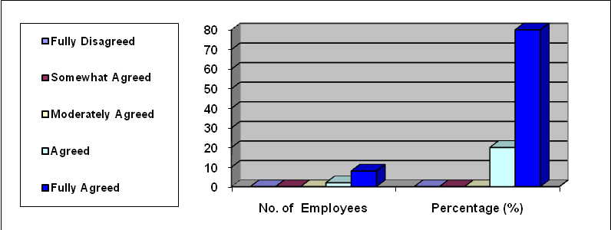

Interpersonal relationship is one of the important factors to keep the working environment smooth for better productivity. In the above table, it is found that majority (80%) of the employees fully agreed that inter-personal relationships among the employees are good. None of them disagreed in this regard.

Table no: 2

Title: Top to bottom communication are satisfied.

Response | Scale | No. of Employee | Percentage (%)
Fully Disagreed | 1 | 0 | 0 %
Somewhat Agreed | 2 | 0 | 0 %
Moderately Agreed | 3 | 0 | 0 %
Agreed | 4 | 3 | 30 %
Fully Agreed | 5 | 7 | 70 %
Total |  | 10 | 100 %

Graph:

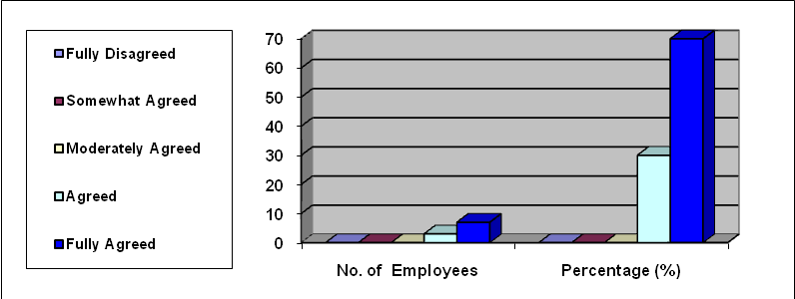

Proper downward communication ensures flow of information among the employees to be aware about the policies, direction and to some extent motivate employees to drive for the desired action. Majority (70%) of the employees under survey mentioned that they receive information in time and there is no information gap regarding policies and other related matters. No employee made any adverse comments.

Table no: 3

Title: The quantity of work expected / allotted, is satisfied for you.

Response | Scale | No. of Employee | Percentage (%)
Fully Disagreed | 1 | 0 | 0 %
Somewhat Agreed | 2 | 0 | 0 %
Moderately Agreed | 3 | 2 | 20 %
Agreed | 4 | 6 | 60 %
Fully Agreed | 5 | 2 | 20 %
Total |  | 10 | 100 %

Graph:

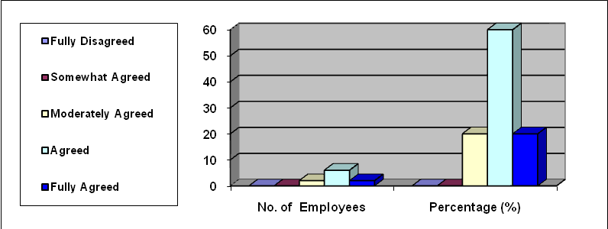

In the above table it is found that majority (60%) of the employees are agreed their quantity of work expected / allotted, is satisfied for them. No employee made any adverse comments.

Table no: 4

Title: Quality of work expected /allotted is satisfied for you.

Response | Scale | No. of Employee | Percentage (%)
Fully Disagreed | 1 | 0 | 0 %
Somewhat Agreed | 2 | 0 | 0 %
Moderately Agreed | 3 | 2 | 20 %
Agreed | 4 | 6 | 60 %
Fully Agreed | 5 | 2 | 20 %
Total |  | 10 | 100 %

Graph:

This is very important for an organization to maintain quality of the work for better productivity. Majority (60%) of the employees under survey mentioned that their quality of work expected / allotted is satisfied for the. None of them disagreed in this regard.

Table no: 5

Title: Your satisfaction with the organization structure is positive.

Response | Scale | No. of Employee | Percentage (%)
Fully Disagreed | 1 | 0 | 0 %
Somewhat Agreed | 2 | 0 | 0 %
Moderately Agreed | 3 | 0 | 0 %
Agreed | 4 | 6 | 60 %
Fully Agreed | 5 | 4 | 40 %
Total |  | 10 | 100 %

Graph:

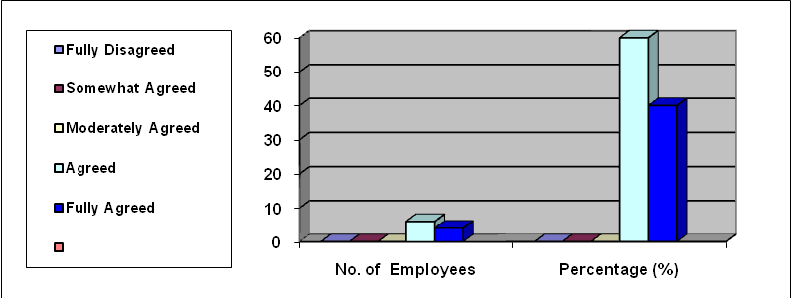

Organization structure is one of the important factors to keep employee in the organization. In the above table it is shown that majority (60%) of the employees agreed they are satisfied with the organization structure and 40% of the employee are fully agreed in this topic. No employee made any adverse comments.

Table no: 6

Title: MBL follows skill-based pay.

Response | Scale | No. of Employee | Percentage (%)
Fully Disagreed | 1 | 0 | 0 %
Somewhat Agreed | 2 | 2 | 20 %
Moderately Agreed | 3 | 2 | 20 %
Agreed | 4 | 6 | 60 %
Fully Agreed | 5 | 0 | 0 %
Total |  | 10 | 100 %

Graph:

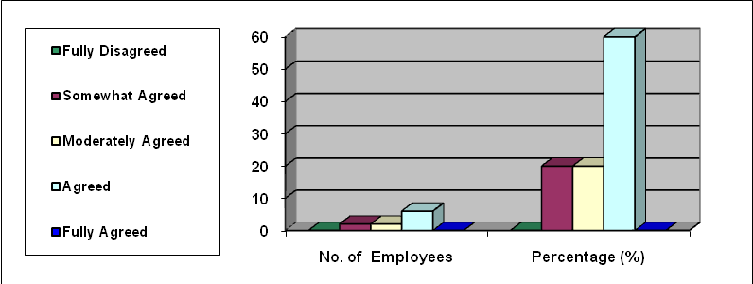

Majority (60%) of the employees under survey mentioned that they are agreed that Mercantile Bank Ltd. Provide skill-based pay. None of them disagreed in this regard.

Table no: 7

Title: MBL provide level of salary, with respect to your experience.

Response | Scale | No. of Employee | Percentage (%)
Fully Disagreed | 1 | 0 | 0 %
Somewhat Agreed | 2 | 0 | 0 %
Moderately Agreed | 3 | 5 | 50 %
Agreed | 4 | 3 | 30 %
Fully Agreed | 5 | 2 | 20 %
Total |  | 10 | 100 %

Graph:

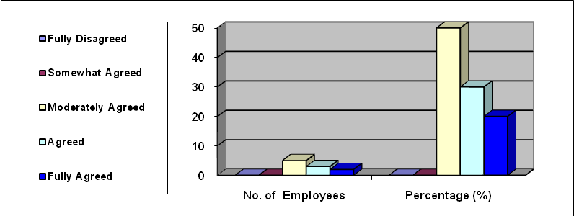

In table, it is found that among all the employees of Mercantile Bank, Satmosjid Road, Dhanmondi Branch, 50% are Moderately agreed, 30% are agreed and 20% are fully agreed in different range with their satisfaction with MBL provide level of salary, with respect to their experience.

Table no: 8

Title: Satisfied on allowance paid structure.

Response | Scale | No. of Employee | Percentage (%)
Fully Disagreed | 1 | 0 | 0 %
Somewhat Agreed | 2 | 1 | 10 %
Moderately Agreed | 3 | 4 | 40 %
Agreed | 4 | 3 | 30 %
Fully Agreed | 5 | 2 | 20 %
Total |  | 10 | 100 %

Graph:

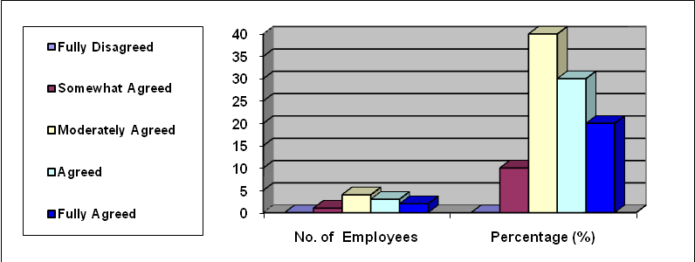

Majority (40%) of the employees under survey mentioned that they are moderately agreed and 30% are agreed with allowance pain structure. No employee made any adverse comments.

Table no: 9

Title: MBL has proper reward policies.

Response | Scale | No. of Employee | Percentage (%)
Fully Disagreed | 1 | 0 | 0 %
Somewhat Agreed | 2 | 2 | 20 %
Moderately Agreed | 3 | 3 | 30 %
Agreed | 4 | 3 | 30 %
Fully Agreed | 5 | 2 | 20 %
Total |  | 10 | 100 %

Graph:

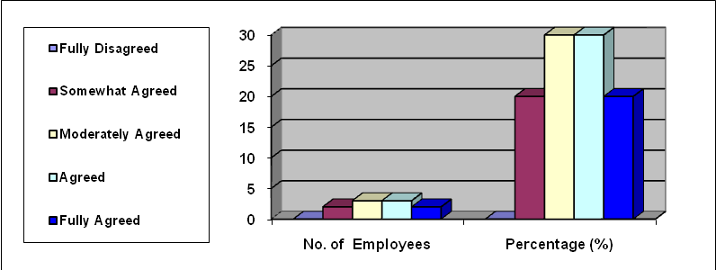

If an organization provides reward system then their employees are encouraged to do well. From the above table both 30% of the employee mentioned they are moderately agreed and agreed that MBL has a proper reward policies.
None of them disagreed in this regard.

Table no: 10

Title: MBL provide better policies for Leaves & Holidays.

Response | Scale | No. of Employee | Percentage (%)
Fully Disagreed | 1 | 0 | 0 %
Somewhat Agreed | 2 | 0 | 0 %
Moderately Agreed | 3 | 2 | 20 %
Agreed | 4 | 7 | 70 %
Fully Agreed | 5 | 1 | 10 %
Total |  | 10 | 100 %

Graph:

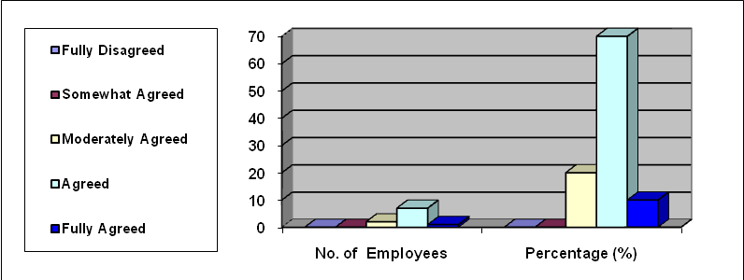

Majority (70%) of the employees under survey mentioned that Mercantile Bank Ltd. Provide better policies for leaves & holidays. No employee made any adverse comments.

Table no: 11

Title: Job’s are clearly defined.

Response | Scale | No. of Employee | Percentage (%)
Fully Disagreed | 1 | 0 | 0 %
Somewhat Agreed | 2 | 1 | 10 %
Moderately Agreed | 3 | 0 | 0 %
Agreed | 4 | 4 | 40 %
Fully Agreed | 5 | 5 | 50 %
Total |  | 10 | 100 %

Graph:

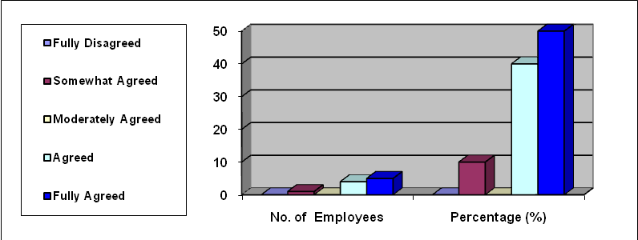

From the above table we found that 10% of the total employees are somewhat agreed, 40% are agreed and 50% are fully agreed in different range with job’s are clearly defined.

Table no: 12

Title: MBL has proper job description for employees.

Response | Scale | No. of Employee | Percentage (%)
Fully Disagreed | 1 | 0 | 0 %
Somewhat Agreed | 2 | 0 | 0 %
Moderately Agreed | 3 | 1 | 10 %
Agreed | 4 | 5 | 50 %
Fully Agreed | 5 | 4 | 40 %
Total |  | 10 | 100 %

Graph:

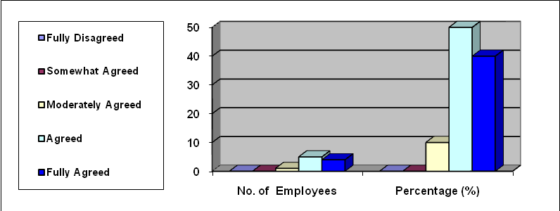

Majority (50%) of the employees under survey mentioned that they are agreed with the organizations job description & 40% employees are also fully agreed with this topic. No employee made any adverse comments.

Table no: 13

Title: MBL has an effective promotion policy.

Response | Scale | No. of Employee | Percentage (%)
Fully Disagreed | 1 | 0 | 0 %
Somewhat Agreed | 2 | 0 | 0 %
Moderately Agreed | 3 | 0 | 0 %
Agreed | 4 | 5 | 50 %
Fully Agreed | 5 | 5 | 50 %
Total |  | 10 | 100 %

Graph:

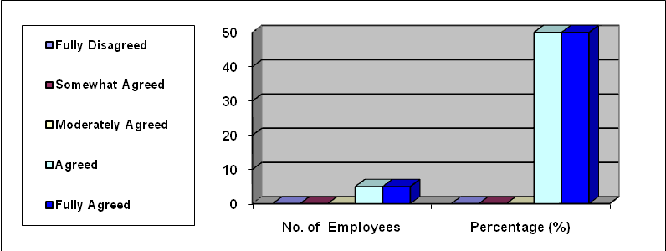

An effective promotion policy is very much important for an organization. From the above table both 50% of the employee mentioned they are moderately agreed and agreed that MBL has an effective promotion policy. None of them disagreed in this regard.

Table no: 14

Title: Training for higher responsibilities is effective.

Response | Scale | No. of Employee | Percentage (%)
Fully Disagreed | 1 | 0 | 0 %
Somewhat Agreed | 2 | 0 | 0 %
Moderately Agreed | 3 | 0 | 0 %
Agreed | 4 | 9 | 90 %
Fully Agreed | 5 | 1 | 10 %
Total |  | 10 | 100 %

Graph:

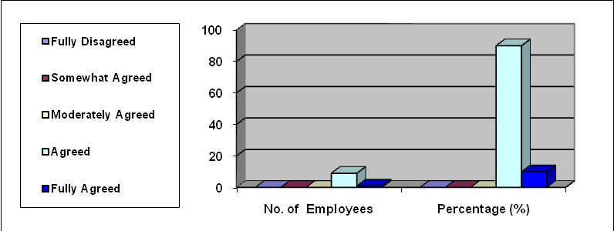

Majority (90%) of the employees under survey mentioned that training is very much effective for an employee to improve in his/her career. No employee made any adverse comments.

Table no: 15

Title: Employee feels their jobs are secured.

Response | Scale | No. of Employee | Percentage (%)
Fully Disagreed | 1 | 0 | 0 %
Somewhat Agreed | 2 | 0 | 0 %
Moderately Agreed | 3 | 0 | 0 %
Agreed | 4 | 2 | 20 %
Fully Agreed | 5 | 8 | 80 %
Total |  | 10 | 100 %

Graph:

In the above table, it is found that majority (80%) of the employees fully agreed that they feels their jobs are secured. None of them disagreed in this regard.

Table no: 16

Title: MBL has proper termination policies.

Response | Scale | No. of Employee | Percentage (%)
Fully Disagreed | 1 | 1 | 10 %
Somewhat Agreed | 2 | 1 | 10 %
Moderately Agreed | 3 | 1 | 10 %
Agreed | 4 | 4 | 40 %
Fully Agreed | 5 | 3 | 30 %
Total |  | 10 | 100 %

Graph:

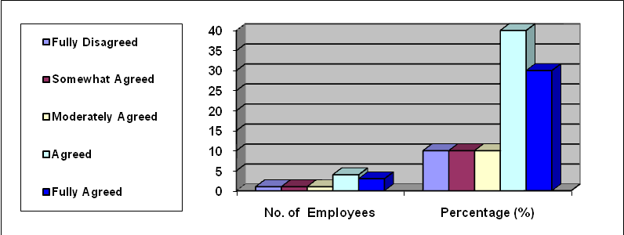

The above table mentioned that 10% employees are fully disagreed, 10% employees are somewhat agreed, 10% employees are moderately agreed, 40% employees are agreed and 30% employees are fully agreed in different range with MBL has a proper termination policies.

Table no: 17

Title: The methods of conflict resolution in your organization are satisfied.

Response | Scale | No. of Employee | Percentage (%)
Fully Disagreed | 1 | 0 | 0 %
Somewhat Agreed | 2 | 0 | 0 %
Moderately Agreed | 3 | 2 | 20 %
Agreed | 4 | 7 | 70 %
Fully Agreed | 5 | 1 | 10 %
Total |  | 10 | 100 %

Graph:

From the above table, it is found that among from the employees of Mercantile Bank, Satmosjid Road Branch, 20% are moderately agreed, 70% are agreed and 10% are fully agreed in different range with they are satisfied with the method of conflict resolution in MBL.

Table no: 18

Title: Ways and procedure are followed for transfer of employees are satisfied.
Response | Scale | No. of Employee | Percentage (%)
Fully Disagreed | 1 | 0 | 0 %
Somewhat Agreed | 2 | 0 | 0 %
Moderately Agreed | 3 | 1 | 10 %
Agreed | 4 | 4 | 40 %
Fully Agreed | 5 | 5 | 50 %
Total |  | 10 | 100 %

Graph:

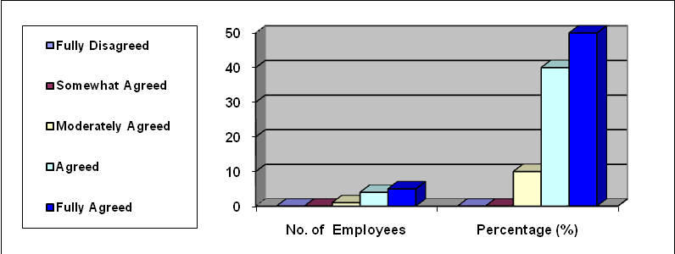

Majority (50%) of the employees under survey mentioned they are fully agreed that they are satisfied with the ways and procedure followed for transfer of employees & 40% employees are also fully agreed with the same topic. No employee made any adverse comments.

Table no: 19

Title: MBL use the perfect method for recruiting the right people.

Response | Scale | No. of Employee | Percentage (%)
Fully Disagreed | 1 | 0 | 0 %
Somewhat Agreed | 2 | 0 | 0 %
Moderately Agreed | 3 | 3 | 30 %
Agreed | 4 | 2 | 20 %
Fully Agreed | 5 | 5 | 50 %
Total |  | 10 | 100 %

Graph:

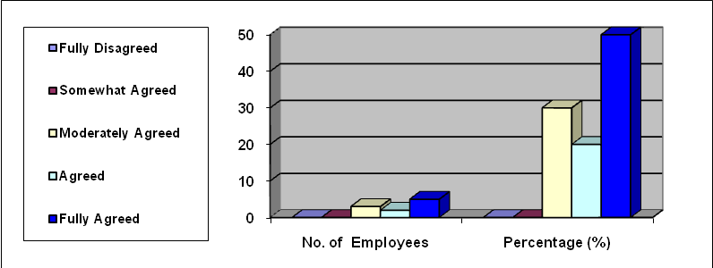

Recruiting is the most important thing for HRD of ant organization. The HRD always concern about recruiting the right person for the right job. From the above table we found that majority (50%) of the employees think that MBL.

Table no: 20

Title: MBL’s provided training is sufficient.

Response | Scale | No. of Employee | Percentage (%)
Fully Disagreed | 1 | 0 | 0 %
Somewhat Agreed | 2 | 0 | 0 %
Moderately Agreed | 3 | 0 | 0 %
Agreed | 4 | 2 | 20 %
Fully Agreed | 5 | 8 | 80 %
Total |  | 10 | 100 %

Graph:

Majority (80%) of the employees under survey mentioned, they are fully agreed that their provided training is sufficient for them. No employee made any adverse comments.

Table no: 21

Title: MBL has some Disguised Employment.

Response | Scale | No. of Employee | Percentage (%)
Fully Disagreed | 1 | 1 | 10 %
Somewhat Agreed | 2 | 2 | 20 %
Moderately Agreed | 3 | 5 | 50 %
Agreed | 4 | 0 | 0 %
Fully Agreed | 5 | 2 | 20 %
Total |  | 10 | 100 %

Graph:

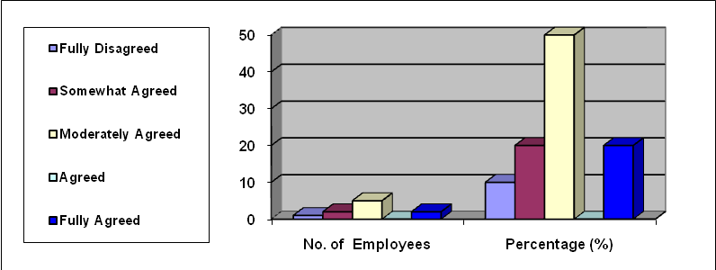

In the above table, it is found that majority (50%) employee of the organization think that there are some disguised employee in their branch, those are really burden for the organization.

Table no: 22

Title: MBL maintain the performance appraisal process in a systematic way.
Response | Scale | No. of Employee | Percentage (%)
Fully Disagreed | 1 | 0 | 0 %
Somewhat Agreed | 2 | 0 | 0 %
Moderately Agreed | 3 | 0 | 0 %
Agreed | 4 | 7 | 70 %
Fully Agreed | 5 | 3 | 30 %
Total |  | 10 | 100 %

Graph:

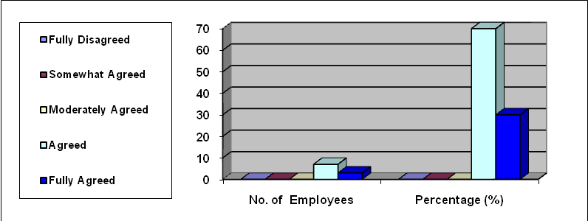

Performance appraisal process is important for any organization to its human resource department. An organizations human resource department evaluate the employee performance and such a effective way the HRD examine the employee’s skills, performance, abilities and professional competencies. From the above table we found that 70% of employee of MBL feels that MBL maintain the performance appraisal process in a systematic way.

Table no: 23

Title: You feel that you work in a positive working environment.

Response | Scale | No. of Employee | Percentage (%)
Fully Disagreed | 1 | 0 | 0 %
Somewhat Agreed | 2 | 0 | 0 %
Moderately Agreed | 3 | 0 | 0 %
Agreed | 4 | 2 | 20 %
Fully Agreed | 5 | 8 | 80 %
Total |  | 10 | 100 %

Graph:

Majority (80%) of the employees under survey mentioned, they are fully agreed that they work in a positive work environment. No employee made any adverse comments.

Table no: 24

Title: MBL select the best practices of Human Resource and initiate the same in MBL.

Response | Scale | No. of Employee | Percentage (%)
Fully Disagreed | 1 | 0 | 0 %
Somewhat Agreed | 2 | 0 | 0 %
Moderately Agreed | 3 | 0 | 0 %
Agreed | 4 | 3 | 30 %
Fully Agreed | 5 | 7 | 70 %
Total |  | 10 | 100 %

Graph:

Human Resource is the term increasingly used to refer to the philosophy, policies, procedures and practices related to the management of people within an organization. Majority (70%) of the employees feels that MBL select the best practices of Human Resource and initiate the same in MBL. No employee made any adverse comments.

Table no: 25

Title: Management includes Employees’ views and opinions while formulating and implementing new rules and regulations.

Response | Scale | No. of Employee | Percentage (%)
Fully Disagreed | 1 | 0 | 0 %
Somewhat Agreed | 2 | 0 | 0 %
Moderately Agreed | 3 | 3 | 30 %
Agreed | 4 | 3 | 30 %
Fully Agreed | 5 | 4 | 40 %
Total |  | 10 | 100 %

Graph:

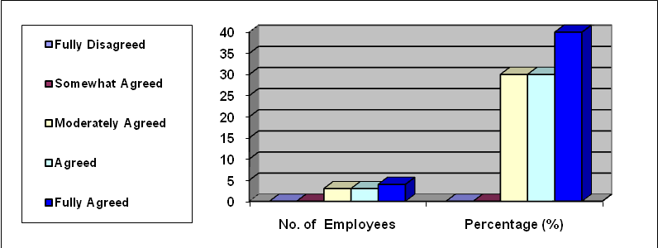

From the above table, it is found that from all the employees, 30% are moderately agreed, 30% are agreed and 40% are fully agreed in different range with management includes Employees’ views and opinions while formulating and implementing new rules and regulations.

4.1Findings

During the internship in Bangladesh Commerce Bank Limited (BCBL) and using the pre-designed structured questionnaire, the following observations are notable and these are:

- Employees are over burdened by work.
- Number of employee is not sufficient for the branch.
- Compensation is not equitable for the skilled people.
- The salary structure is not lucrative for all categories of employees.
- Salary does not comply the employee’s experience.
- Modern HR practice is yet to apply.
- The employees of BCBL are satisfied with the performance appraisal systems.
- The working condition is not apposite in every branch except head office. So the employee can’t work smoothly in rush hour.
- The employee of BCBL has less opportunity to participate in policy formulation.
- The service of customer care department is not satisfactory.
- Loan sanction is not examined in proper way.
- Foreign exchange is not running smoothly.
- The General Banking System is not so much smooth like other private banks.
- Sometimes probationary officers behave is not that much good with internee.

4.2 Recommendation

The overall activities of Bangladesh Commerce Bank Limited (BCBL) and as well as Human Resource Practice of BCBL are running smoothly. The overall activities along with managing human resource may be improved by the following steps:

- Job analysis may be done in a regular basis and accordingly employees should be informed about the changes.
- Employees may be given opportunity to contribute in policy formulation.
- The working environment should be established at outstanding way so that the employee can fulfill their job in most effective manner and smoothly.
- The percentage of women employee should be increased.
- Employment planning should be done scientifically so that everybody comfortably does his or her duties.
- Incentive policies may be changed to attract people to ensure retention of skill manpower.
- Management should ensure the job security.
- Recruitment should be done systematically to ensure the right person in the right job.
- Inter-personal communication may be improved to have better supervisory understanding.
- In order improve the behavior, especially who are involved with dealing customer, may be send to the training course on “Human Relations” or any other relevant training courses.

  - Conclusion

This report has attempted to explain the BCBL banking practices. Also I have attempted to harmonize the practical exposure during my tenure of internship and link the theoretical knowledge gained in the previous terms of BBA Program. During the three months Practical orientation program at BCBL, almost all the desks have been observed more or less.

Competent and capable human resources are urgently required in the financial sector to meet up the challenges of the 21st century. BBA Program was introduced to do the same. No doubt, this practical orientation program has enabled me to have a clear idea about the functioning of different areas of banking operations.

This report has attempted to explain the job satisfaction as well as Human Resource Management that are followed by the Satmosjid Road branch of Mercantile Bank Limited. Also I have attempted to harmonize the practical exposure during my tenure of internship and link the theoretical knowledge gained in the previous terms of BBA Program. During the three months Practical orientation program at Satmosjid Road Branch, almost all the desks have been observed more or less and a total of 10 employees have been interviewed to have the knowledge regarding HR practice of MBL.

Competent and capable human resources are urgently required in the financial sector to meet up the challenges of the 21st century. BBA Program was introduced to do the same. No doubt, this practical orientation program has enabled me to have a clear idea about the functioning of different areas of banking operations and practice of Human Resource policies.

If Mercantile Bank Limited adopts some new policy regarding compensating employees, recruitment and selection on the basis of salary survey and job analysis, we hope MBL can be a market dominant and have skill employee for higher productivity to meet millennium goal.

Performance Appraisal Form For Executives/Officers ( For full one year)

Official's Identity No.

MERCANTILEBANK BANGLADESH LIMITED
HUMAN RESOURCES DIVISION
HEAD OFFICE, DHAKA

Name of the Branch: Head Office Complex Corporate Branch

Performance Appraisal Form for Executives/Officers (for full one year) From 01.10.2005 To 30.09.2006

PART-I
PERSONAL DATA

(To be filled in by the Official under reporting)

1. Name (in block letters)
2. Father's Name
3. Mother's Name
4. Spouse's Name
5. Date of Birth
6. Designation
7. Present Place of Posting
8. Date of Joining in MBL & Designation
9. Date of Promotion/Joining
in the present post
10. Scale of Pay
11. Present Salary
12. Educational Qualification

Examination | Year of Passing | School/College/Board/University | Class/Division/CGPA | Group/Discipline  /Main Subjects

13. Professional Qualification (Banking & Others):
Diploma/Degree | Year of Passing | Institute | Main Subjects | Distinction,  if any
a. |  | N/A
b.
c.
d.

14. Training & Workshop attended:
Course Title | Duration | Institute | Country | Sponsor | Remarks
a
b
c.

15. Posting History (MBL)
Rank/Position | Place of Posting | Duration | Assignments

16. Promotion History (MBL)

Effective Date | Promotion |  | Remarks
Effective Date | From | To
 | NIL

17. Rewards:
Date | Particulars of Rewards | Grounds | Remarks
 | NIL

18. Period of service under the Reporting Officer (From 14.02.2006 to till date)

Date: Signature of the Official

PART-II

Personal Traits of the Executives/Officers under reporting
(To be filled in by the Reporting Officer)

Full Marks-50

Marks Secured: ................

Sl No | Subject For Rating | Marks Rated

PERSONAL ASPECTS Marks: 6 x 3 = 18

Honesty & Integrity
Discipline & Punctuality
Intelligence & power of Judgment
Initiative/drive/Diligence
Demeanor & Personality
Consciousness about security

BUSINESS ASPECTS
Marks: 8 x 2.5 = 20

Professional Knowledge & Skill
Quality/Accuracy and Quantity/speed of work
Ability to make decision & implement decision
Promptness to carry out superiors' instructions
Leadership Quality & Ability to supervise
Power of expression (oral & writing)
Sense of Co-operation, Responsibility and Reliability
Willingness and ability to train up subordinates

- Business Performance:

(Applicable for Managers, 2nd Officers, Investment & foreign exchange Incharges)

Particulars | As on 31st December… | Target for..… | As on 31st December……… |  | % of Achievement
a. Deposit
b. Investment
c. Operating Profit
d. Export
e. Import
g. Income (Net)
h. Overdue
i. Overdue Recovered in last year |  |  |  | Tk.
ii. Overdue Recovered in current year |  |  |  | Tk.
iii. Overdue Reduced by Rescheduling |  |  |  | Tk.
iv. Overdue reduced by Waiver of compensation |  |  |  | Tk.
v. Overdue reduced by Write-off (Principal & other charges) |  |  |  | Tk.

- Administrative/Disciplinary action (taken/pending, if any) : (To be filled in by HRD)

Nature of irregularities/  Lapses committed | Where occurred | Nature of punishment awarded | Authority | Remarks
a.
b.
c.
d.

21. Performance Summary:

Please highlight the outstanding performance of the official over the last year after taking into account the ratings on the above aspects. Indicate both strengths and weaknesses.

(Signature of the Reporting Officer)

Recommendations of the Reporting Officer

 | Eligible for Promotion | :
 | Recommended for promotion | :
 | Not fit for further promotion | :
 | Recently promoted and time for  next promotion not yet matured | :
 | Recommended for Advance Increment/Awards | :
 | Needs training for shouldering further responsibilities | :
 | Needs training for shouldering the present assignments. | :
 | Fit for the Present Post. | :
 | Recommendation for training specifying the subjects. | :

Seal & Signature | :
Name | :
Designation | :
Date | :

Comments of the Countersigning Officer

a. | Very good/reasonably good/lenient/strict/prejudicial | :
b. | I agree/do not agree with the Reporting Officer | :
c. | Additional comments | :

Seal & Signature | :
Name | :
Designation | :
Date | :

Comments of the EP/DEP

(In respect of all Divisional/Zonal Heads/Managers)

a. | I agree/do not agree with the Reporting Officer/ Countersigning Officer, if disagreed, the reasons for such disagreement. | :
b. | Additional comments | :

Seal & Signature | :
Member Secretary | :
Shariah Council | :
Date | :

A Questionnaire
On
Human Resources Practices
In
Marcentile Bank Ltd.
(MBL)

When data is provided to us, I’ll use it solely for the purposes education. Confidential information will not be disclosed, I recognize that information is valuable and I’ll take all reasonable measures to protect it whilst in my care.

(Please circle the number from 1-5 depending upon your feelings for each question)

1= Fully Dissatisfied, 2= Dissatisfied, 3= To Some Extent Satisfied,
4= Satisfied, 5= Fully Satisfied

1 | Inter-personal relationships among the employees. | 1 | 2 | 3 | 4 | 5
2 | Top to bottom communication. | 1 | 2 | 3 | 4 | 5
3 | The quantity of work expected / allotted to you. | 1 | 2 | 3 | 4 | 5
4 | Quality of work expected /allotted to you. | 1 | 2 | 3 | 4 | 5
5 | Your satisfaction with the organization structure. | 1 | 2 | 3 | 4 | 5
6 | MBL follows skill-based pay. | 1 | 2 | 3 | 4 | 5
7 | Your level of salary with respect to your experience | 1 | 2 | 3 | 4 | 5
8 | Allowance paid to you except salary | 1 | 2 | 3 | 4 | 5
9 | MBL’s proper reward policies. | 1 | 2 | 3 | 4 | 5
10 | Policies for leaves & holidays. | 1 | 2 | 3 | 4 | 5
11 | Job’s are clearly defined. | 1 | 2 | 3 | 4 | 5
12 | Proper job description for employees. | 1 | 2 | 3 | 4 | 5
13 | Promotion policy of MBL. | 1 | 2 | 3 | 4 | 5
14 | Training for higher responsibilities. | 1 | 2 | 3 | 4 | 5
15 | The level of job security. | 1 | 2 | 3 | 4 | 5
16 | MBL’s termination policies. | 1 | 2 | 3 | 4 | 5
17 | The methods of conflict resolution in MBL. | 1 | 2 | 3 | 4 | 5
18 | Ways and procedure are followed for transfer of employees. | 1 | 2 | 3 | 4 | 5
19 | MBL use the perfect method for recruiting the right people. | 1 | 2 | 3 | 4 | 5
20 | MBL’s provided training. | 1 | 2 | 3 | 4 | 5
21 | The organizational climate of MBL. | 1 | 2 | 3 | 4 | 5
22 | MBL’s performance appraisal process. | 1 | 2 | 3 | 4 | 5
23 | Working environment of MBL. | 1 | 2 | 3 | 4 | 5
24 | Practices of Human Resource and initiate the same in MBL. | 1 | 2 | 3 | 4 | 5
25 | Management includes Employees’ views and opinions while formulating and implementing new rules and regulations. | 1 | 2 | 3 | 4 | 5

1= Fully Dissatisfied, 2= Dissatisfied, 3= To Some Extent Satisfied,
4= Satisfied, 5= Fully Satisfied

(Thank you, for your co-operation.)

