Submitted by

WWW.ASSIGNMENTPOINT.COM

BRAC Bank Limited is a scheduled commercial bank in Bangladesh. It established in Bangladesh under the Banking Companies Act, 1991 and incorporated as private limited company on May 20, 1999 under the Companies Act, 1994. Its operation started on July 4, 2001 with a vision to be the market leader through to providing all sorts’ support to people in term of promoting corporate and small entrepreneurs and individuals all over the Bangladesh.
BRAC Bank will be a unique organization in Bangladesh. The Bank consists of major divisions named 1) Corporate banking, 2) Retail banking, 3) Treasury, 4) Small & Medium Enterprise (SME). At present the Bank operating its business by 56 Branches. BRAC Bank is the first local commercial banks that proving online banking service to its customers from the very beginning of its starts.
BRAC Bank, for the first time among local commercial banks, starts providing loan facilities to small and medium trading, manufacturing and service oriented enterprises all over the country.
1.1 Background of the study:

Through this report an individual can expect to have a good knowledge and understanding on the various methods of operation performed by BRAC Bank Limited particularly in the area of Financial Institutional Services. From the last three months of the bank’s disbursement, everything is tried to include in precise form. I have tried my level best to put more emphasis on the Retail loan Process and its recovery since it was the topic of my internship program. This report is to be used only for the academic purpose. I have collected all the necessary and relevant data from various primary, secondary and tertiary sources. After three months long hard labor, it has become possible for me to make the report comprehensive and factual. The data is truly and strictly confidential and no one can use its components in full or partial. I would like to give thanks to everyone who has helped and encouraged me in the process of preparing this report.

1.2 Significance
This report is the result of three-month internship in BRAC BANK LIMITED. I enter as an internee in BRAC BANK LIMITED beginning Feb 25th. 2010 to 25th May. 2010. And I have completed this internship period successfully. This internship report contains all the information that I gather at the time of my internee in BRAC BANK LIMITED. My topic is Analysis of Repayment behavior of the Retail loan borrowers Of BRAC Bank Ltd. All these information will help the management to identify various scopes and limitations of the Institution and Project department and to take decisions regarding the improvement or reengineering of this Department. This is the basic rationale behind the study. Besides, it would be a great opportunity for me to get familiar with this system. So this study is very significant for both the company and me. They satisfy my work and give an opportune job. Now this time I am an employee of BRAC Bank Limited. Retail Banking Operations (RBO).
1.3. Scope of the report:
Scope of the study is quite clear. Since Asset Operations Department is dealing with all types of loan activities in the bank, studying these core themes, Opportunities are there to learn other aspects of matters.

- Concept of Retail and its impact in overall economy of Bangladesh
- Entrepreneurship development situation through Retail banking
- Importance of Retail banking in context of Bangladesh
- Pioneer’s strategy regarding Retail banking
- Small entrepreneurs of rural –urban spectrum are enjoying the BRAC Bank loan facility without the presence of bank at rural area.
- Virtual banking concept through Retail banking
- Core concept of retail banking operation.

1.4. Objective of the Report:

1.4.1 Broad Objectives

- To analyze the repayment behavior of Retail loan borrowers

- To know Retail loan and its process of recovery

- And Process of retail banking.

1.4.2 Specific Objectives

- To find out basic appraisal of Retail loan
- To know the enterprise selection criteria to provide Retail loan
- To know the terms and conditions of Retail loans
- To know the disbursement and recovery procedures of Retail loans
- To make some policy implications and conclusion to further the development of Retail loan products of BBL.
- To know the work process and monitoring system of Retail Banking Department
- To access the key performance indicator of the department
- To know how the Retail loan borrowers would behave in repaying their loan.
- To know whether Retail loan borrowers are dully paying their installments..
1.5. Methodology:
In fact, my aim was to collect as much information as it can be possible for me to make an overview of the bank, its mission and vision, its departments and its functions. Of course I had to collect enough information so that I can make an analysis of Retail loan and the specific behavior of its borrowers. I have collected around forty customers’ information so that I could know something about their age, education, experience, loan repayment behavior and so on. The data collected allowed me to make an analysis regarding Retail loan, its process starting from sanction of loan to closing of loan and especially regarding Retail loan borrowers behaviors that is whether they are paying dully or lately or they have any default tendency.

1.5.1 Types of Research:

It is descriptive research.
Collection primary Data:
For collecting primary data is depth interview technique has been used through set of small rayed but very original and standard informal way will be used in the information. Primary data also collected using questioner survey to the customer and employee.
Collection secondary Data:
In order to collect secondary Data defiance related materials like BRAC Bank limited address difference daily newspaper, Operational manual Official Website Banking journals has been used, moreover various library sources used as secondary of sources an collections early mentioned data and information
1.5.2. Sources of data:

For collecting the required data, I have used different sources or methods like the following:

1. Primary data sources:

- Interviews of Customer relationship officers (CRO)
- Focus group meetings
- Direct observation
- And also I am an employee retail banking operation.
2. Secondary data sources:
- Operational manual
- Official Website
- Banking journals
- BBL newsletters
- Research papers
1.5.3.Data collection procedure:
Data processing and Analysis:
After collecting all the data they will be coded and data will be processed analyzed and graphically using MS word, Excel and MS word.
Techniques of analysis:

Quantitative and qualitative data were collected and analyzed according to acceptable standards of practice. Different tables and graphs were used to make the data meaningful and comparable. Qualitative data were analyzed rationally and in comparison with current market condition. Necessary percentages and averages were calculated and the analyzed results were described step by step.
1.5.4. Questionnaire:

I collected the 37 customers before BRAC bank loan purpose and after the loan taken purpose am used in the Questionnaire. The average Questionnaire administered time 25 min. for official and 20 min. for the customer.

1.5.5. Sampling planning;

1.5.5.1 Population: The entire customer works in the local area of BRAC Bank Ltd.
1.5.5.2 Sampling unit: All the sampling unit of the every is on customer of BRAC Bank Ltd.
1.5.5.3 Sample frame: NO well-structured sample frame is found.

1.5.5.4. Sampling procedure: non-probability convenience sampling produce is used in the survey.

1.5.5.5. Sampling size: The sampling size is 37 for customer

1.5.5.6. Data analysis and reporting:
Data collection: data use here was drawn mainly from secondary sources. Necessary dealing room operation executives were interviewed with in formal questions, branch management of generate boundary wad also interviewed with informal questions. This report handling of over all banking activity and customer relationship management are highlighted other secondary sources used are annual report of the bank.
1.6 Limitations:

The study has suffered from a number of barriers

- Data from BRAC Bank is highly confidential for the outside people and I had no authority to use the core banking software.
- BBL changes its core banking software, MBS to Finical that’s why all the employees are very busy with their work, sometimes I had to wait more than one week for a piece of information.
- Time is also a big constraint for my research. I have to submit a broader deal in a shorter form of outcome.
- It was difficult to communicate with the customers, as many of them were unable to give me much time for interview.
- As I have taken a sample of 37 observations, there may be sampling error.
- I had to go under my day-to-day job responsibility that I was supposed to do so. So I could get few more time to spend in collecting data for preparing my internship report.



Organization Profile

2.0. Background of the Organization:
BRAC Bank Limited is a scheduled commercial bank in Bangladesh. It established in Bangladesh under the Banking Companies Act, 1991 and incorporated as private limited company on 20 May 1999 under the Companies Act, 1994. BRAC Bank will be a unique organization in Bangladesh. The primary objective of the Bank is to provide all kinds of banking business. At the very beginning the Bank faced some legal obligation because the High Court of Bangladesh suspended activity of the Bank and it could fail to start its operations till 03 June 2001. Eventually, the judgment of the High Court was set aside and dismissed by the Appellate Division of the Supreme Court on 04 June 2001 and the Bank has started its operations from July 04, 2001.
The importance of financial intermediaries in the development of the overall economy of country cannot be described in short. From the inception of the civilization the banking sector dominate the economic development of a country by mobilizing the saving from the general people and channeling those saving for investment and thus economic development and growth. In ancient time, the importance of commercial banks after the ravage of the liberation war to develop a better economy was severally needed and it is needed now and will be required in future also. In time-to-time Government of Bangladesh agreed to permit the private commercial banking in the country. BRAC bank will be knowledge-based organization where the BRAC Bank professionals will learn continuously from their customers and colleague’s world wide to add value. It will work as a team, stretch, they will innovate and break barriers to serve customers and create customers loyalty through a value chain of responsive and professional delivery. The bank promotes broad-based participation in the Bangladesh economy through the provision of high quality banking services. BRAC Bank will do this by increasing access to economic opportunities for all individuals and business in Bangladesh with a special focus on currently under-served enterprises and households across the rural – urban spectrum. BRAC Bank believes that the pursuit of profit and developmental goals is mutually reinforcing.
Increasing the ability of under – served individuals and enterprises to build their asset base and access market opportunities will increase the economic well being for all Bangladeshis at the same time, this will contribute significantly to the profitability of the Bank. BRAC Bank intends to set standards as the Market leader in Bangladesh. It will produce earnings and pay out dividends that can support the activities of BRAC, the Bank’s major shareholder. Development and poverty alleviation on a countrywide basis needs mass production, mass consumption and mass financing. BRAC Bank goal is to provide mass financing to enable mass production and mass consumption, and thereby contribute to the development of Bangladesh. BRAC Bank intends to set standard as the market leader in Bangladesh by providing efficient, friendly and modern fully automated online service on a profitable basis aiming at offering commercial banking service to the customers’ door around the country, BRAC Bank limited established 26 branches up-to this year.
This organization achieved customers’ confidence immediately after its establishment. Within this short time the bank has been successful in positioning itself as progressive and dynamic financial institution in the country. It is now widely acclaimed by the business community, from small entrepreneur to big merchant and conglomerates, including top rated corporate and foreign investors, for modern and innovative ideas and financial solution. Thus within this short time it has been able to create an unique image for itself and earned significant solution in the banking sector of the country as a bank with a difference. The emergence of BRAC Bank Limited is an important event in the country’s financial sector at the inception of financial sector reform. The authorized capital of BBL is Tk. 1000 million and paid up capital of the same bank is Tk. 500 million.
Shareholders | Percent
BRAC | 31.74%
IFC | 9.50%
Shore Cap International | 8.76%
General Public through IPO | 40%
Non-Residents Bangladeshi’s | 5%

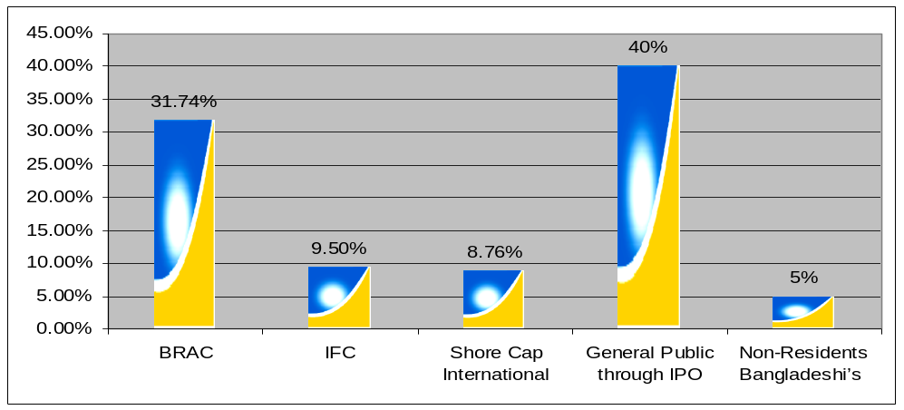
Fig-1 Shareholders of BRAC Bank Limited

The Chairman of the Bank is Mr. Fazle Hasan Abed. Now the Managing Director of the bank is Mr. Imran Rahman. The bank has made a reasonable progress due to its visionary management people and its appropriate policy and implementation.
Logo of BRAC Bank:


2.1 Corporate Vision:
BRAC Bank will be a unique organization in Bangladesh. It will be a knowledge-based organization where the BRAC Bank professionals will learn continuously from their customers and colleagues worldwide to add value. They will work as a team, stretch themselves, innovate and break barriers to serve customers and create customer loyalty through a value chain of responsive and professional service delivery.
Continuous improvement, problem solution, excellence in service, business prudence, efficiency and adding value will be the operative words of the organization. BRAC Bank will serve its customers with respect and will work very hard to instill a strong customer service culture throughout the bank. It will treat its employees with dignity and will build a company of highly qualified professionals who have integrity and believe in the Bank’s vision and who are committed to its success. BRAC Bank will be a socially responsible institution that will not lend to businesses that have a detrimental impact on the environment and people. So Brac Bank operates following a specific vision like:
“Building a profitable and socially responsible financial institution focused on Markets and Business with growth potential, thereby assisting BRAC and stakeholders build a "just, enlightened, healthy, democratic and poverty free Bangladesh".
2.2. Corporate Mission:
- Sustained growth in Retail banking operation sector.
- Continuous low cost deposit growth with controlled growth in Retained Assets
- Corporate Assets to be funded through self-liability mobilization. Growth in Assets through Syndications and Investment in faster growing sectors
- Continuous endeavor to increase fee based income
- Keep our Debt Charges at 2% to maintain a steady profitable growth
- Achieve efficient synergies between the bank's Branches, Manage various lines of business in a fully controlled environment with no compromise on service quality
- Keep a diverse, far flung team fully motivated and driven towards materializing the bank's vision into reality
2.3. Goals:

BRAC Bank will be the absolute market leader in the number of loans given to small and medium sized enterprises through out Bangladesh. It will be a world-class organization in terms of service quality and establishing relationships that help its customers to develop and grow successfully. It will be the Bank of choice both for its employees and its customers, the model bank in this part of the world.
2.4. Organogram:
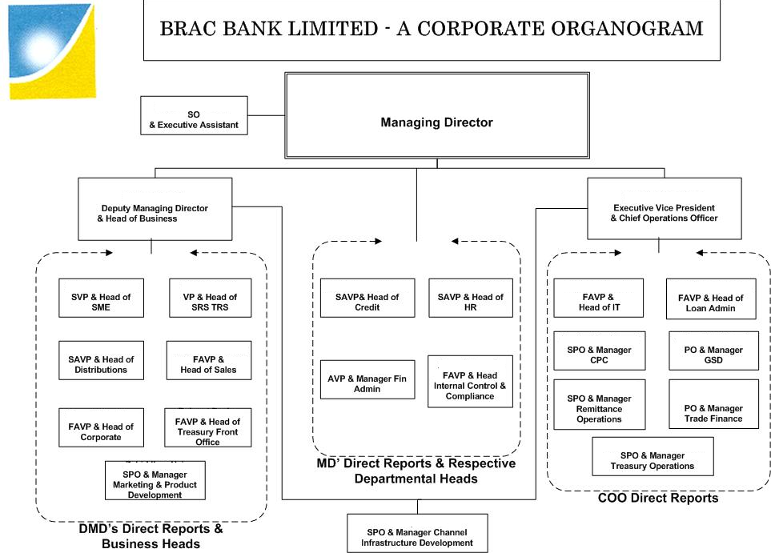
Fig: 2.A corporate Organogram of Brac Bank Limited.

2.5. Marketing Mix
The set of controllable tactical marketing tools- product, price, place and promotion that the organization blends to produce it wants in the target market. The many possibilities can be controlled into four groups of variables known as the 7 P’s: Product, Price, Promotion and Place.
2.5.1. Product
Means the goods and services combination the company offers to the target market. In view of retail loan, it has 12-product loan provide of BBL, they have short term and medium term loans. whether CRO provide quick and quality services to clients. Customer service is another element of product strategy. Companies design its products and support services to profitability meet the needs of target customers. Short terms products means per month target loan the sales persons, they are find out the borrower.
Short Term Products:
Easy repay- these categories of products are easy repaid for the clients. When the pick season comes like Christmas of EID then these short-term products could be required for the clients. If the clients have that loan at the pick season then cliets business carries out hot cakes and easily can repay the loan to BRAC bank.
Shirt fund requirement- without pick season, many clients could have required short funds to hold the tender or dealership. BRAC bank would be a good hand for the clients to have that dealership.
Mid Term Products
Proper Utilization- on average, clients get these categories of loan for 6 to 180 months. (Include Home loan). So clients can easily utilize the money regarding the prospect of the business.
Easy repay- though it is a long time repayment schedule, so clients make the profits to get the required amount of loan and repay the loan in a monthly basis.
2.5.2. Price-
The amounts of money customers have to pay to obtain the products. In terms of Retail banking operation of BRAC bank, clients have to pay a certain amount of processing fees and stamp costs to get the loan. One of the factors that affect the companies own pricing moves. For example- many banks have processing fees with 1.5% charge and other miscellaneous costs. But BRAC bank has withdraws other costs and charges to carry out in the competitive market.
- Costly- BRAC bank retail loan interest rate is vary to product ways minimum 3% to 19.5 %, So it is little bit of costly by the competitive edge but the client gets this loan within very short period of time. In this situation client cannot think about the interest rate because at the right time they get the loan, which they can exercise in their business, can yields profits.
- Easy sanction- If the CIB (Credit Information Bureau) is being cleared from Bangladesh Bank and all information is being transparent from client then the loan is become sanctioned in favor of client.
- All time consultancy- without taking any money, the officer of this bank give moral advices to clients to develop the business.
2.5.3. Place (Distribution)
Includes company’s activities that make the product available to target consumers. Retail loan already spread out its unit offices around the country. Retail tries to reach each and every small business enterprise to meet client’s demands. Marketing channel decisions are among the most important decision that management faces. Management must make channel decision carefully, incorporating today’s needs with tomorrow like selling environment. Retail banking operation of BRAC bank already has 56 braches and ROC office, which is spread throughout the country and lots of staffs working under Brac bank. These officers have respective selected supervisors who directly report to the Retail main head office. So Retail division has everywhere in Bangladesh to serve all respective clients.

2.5.4. Promotion-
Promotion Means activities that communicate the merits of the product and persuade target customers to buy it. Brac bank to provide some condition of Every sales person for the collection of borrowers, For example- if a sales person up to 15 lacs taken Retail product sale the bank provide per lac 500 tk. Paid, in this case they collection maximum product sale then the bank paid 600 Tk.
Door to door service- it is a door-to-door customer services to clients. The sales persons knock the door of the business enterprise whether the client have required any loan or not.
Market to non-Bank people: there are some clients who do not maintain any account in the bank. They are dealing by cash. By providing BRAC bank loans, these sorts of clients can be attached with the banks. Also they can understand more about banking and can have a good relationship with them.
Neglected People- there are some people who are very afraid of dealing with the bank. They were very simple dresses too afraid to the bank. But they are carrying out good business and potential clients. They could be target for the BRAC Bank Limited
e. People. Banking service usually depends on direct information between customer and a firm is employee BBL maintains a good relationship with its customer service quality it’s often arrested bared on customer interrelations with front line. Staff and BBL devotes signifience effect to necessity. I traing I and motivating they employees.
2.5.5. Physical environment:
The appearance of bbl vehicles in terror furnishing, requirement staff member, sings, printed materials and\d visible cues all provided tangible evidence of the bank services unity. Bbl managers its Physical environment very carefully as it can have a profound impact n customer impression
They have:
- Setting arrangement for customer.
- Necessary furniture and elective equipment.
- Prayer time space
- Well decorated office space
- Skilled tech place.
2.5.6. Process: Brac Bank Limited creats and delivery process requires the design and implement by effective process. A process is the method and sequence of action in the bbl designs its process in such a way that leads that fast dynamic and very well effective service delivery and result in satisfaction customers. In the process of ht bank high productivity and decrease likelihood of service failure in the bank most of the direction comes from head office abut there difference culture in different brunch based on location but every whir a specifics highly maintained.

1. Product
- Quality
- Features
- Sizes
- Services
- Returns

2. Price
- Discounts
- Payments
- Services fees

Target customers

Intended Positioning

4. Promotion
- Advertising
- Sales promotion
- Public relation
3. Pace (Distribution)
- Locations
- Assortments
- Logistics

5. People.
6. Physical environment
7. Process.
Fig.3. The 7 P’s of the marketing mix in terms of Retail loan BRAC bank Ltd.

2.6. Company SWOT Analysis:
SWOT analysis is an important tool for evaluating the company’s Strengths, Weaknesses, Opportunities and Threats. It helps the organization to identify how to evaluate its performance and scan the macro environment, which in turn would help organization to navigate in the turbulent ocean of competition.
2.6.1. Strengths:
Company reputation:
BRAC bank has already established a favorable reputation in the banking industry of the country particularly among the new comers. Within a period of 5 years, BBL has already established a firm footing in the banking sector having tremendous growth in the profits and deposits. All these have leaded them to earn a reputation in the banking field
Sponsors:
BBL has been founded by a group of eminent entrepreneurs of the country having adequate financial strength. The sponsor directors belong to prominent resources persons of the country. The Board of Directors headed by its Chairman Mr. F H Abed. Therefore, BBL has a strong financial strength and it built upon a strong foundation.
Top Management:
The top management of the bank is also major strength for the BBL has contributed heavily towards the growth and development of the bank. The top management officials have all worked in reputed banks and their years of banking experience, skills, expertise will continue to contribute towards further expansion of the bank. At BBL, the top management is the driving force and the think tank of the organization where policies are crafted and often cascaded down.
Facilities and equipment:
BBL has adequate physical facilities and equipments to provide better services to the customers. The bank has computerized and online banking operations under the software called MBS banking operations. Counting machines in the teller counters have been installed for speedy service ant the cash counters. Computerized statements for the customers as well as for the internal use of the banks are also available.
Impressive branches:
This creates a positive image in the minds of the potential customers and many people get attracted to the bank. This is also an indirect marketing campaign for the bank for attracting customers. 13 branches of the bank are impressive and are compatible to foreign banks.
Interactive corporate culture:
BBL has an interactive corporate culture. Unlike other local organization, BBL’s work environment is very friendly, interactive and informal. There are no hidden barriers or boundaries while interacting among the superior or the subordinate. The environment is also lively and since the nature of the banking job itself is monotonous and routine, BBL’s likely work environment boosts up the spirit and motivation of the employees.
Team work at mid level and lower level:
At BBL’s mid level and lower level management, there are often team works. Many jobs are performed in groups of two or three in order to reduce the burden of the workload and enhance the process of completion of the job. People are eager to help each other and people in general are devoted to work.

2.6.2. Weaknesses:
Advertising and promotion of SME loan:
This is a major set back for BBL and one of its weakest areas. BBL’s adverting and promotional activities are satisfactory but it SME loan is not advertised well. It does not expose its SME product to general public and are not in lime light. BBL does not have neon sign or any advertisement for SME loan in the city. As a result people are not aware of the existence of this bank.
NGO name (BRAC):
BRAC is one of the largest NGO of the world and it is operating its activities in Bangladesh. BRAC bank is not a NGO bank but many people of them country consider it as a NGO bank like Grameen bank which is not correct.
Low remuneration package:
The remuneration package for the entry and the mid level management is considerably low. The compensation package for BBL entry level positions is even lower than the contemporary banks. Under the existing low payment structure, it will be very difficult to attract and retain higher educated employees in BBL. Specially CRO’s are not satisfied with compensation package provided to them.
2.6.3. Opportunities:
Diversification:
BBL can pursue a diversification strategy in expanding its current line of business. The management can consider options of starting merchant banking or diversify in to leasing and insurance. By expanding their business portfolio, BBL can reduce their business risk.
Product line proliferation:
In this competitive environment BBL must expand its product line to enhance its sustainable competitive advantage. As a part of its product line proliferation, BBL can introduce the following products.
ATM: This is the fastest growing modern banking concept. BBL should grab this opportunity and take preparation for launching ATM. Since BBL is a local bank, they can form an alliance with other contemporary banks in launching the ATM.
2.6.4. Threats:
Multinational banks:
The emergence of multinational banks and their rapid expansion poses a potential threat to the new growing private banks. Due to the booming energy sector, more foreign banks are expected to arrive in Bangladesh. Moreover, the already existing foreign banks such as Standard Chartered is now pursuing an aggressive branch expansion strategy. This bank is establishing more branches countrywide and already launched is SME operation. Since the foreign banks have tremendous financial strength, it will pose a threat to local banks.
Upcoming banks:
The upcoming private local banks can also pose a threat to the existing private commercial banks like BBL. It is expected that in the next few years more local private banks may emerge. If that happens the intensity of competition will rise further and banks will have to develop strategies to compete against an on slaughter of foreign banks.
Contemporary banks:
The contemporary banks of BBL such as Dhaka bank, prime bank and Dutch Bangle are its major rivals. Prime bank and other banks are carrying out aggressive campaign to attract lucrative clients as well as big time depositors.
Default culture:
This is a major problem in Bangladesh. As BBL is a new organization the problem of non-performing loans or default loans is very minimum or insignificant. However, as the bank becomes older this problem arises and the whole community suffers from this chronic diseases. BBL has to remain vigilant about this problem so that proactive strategies are taken to minimize this problem if not elimination.
2.7. Objectives of the Bank:
The objective of BRAC Bank Limited is specific and targeted to its vision and to position itself in the mindset of the people as a bank with difference. The objective of BRAC Bank Limited is as follows:
- Building a strong customer focus and relationship based on integrity, superior service.
- To creating an honest, open and enabling environment
- To value and respect people and make decisions based on merit
- To strive for profit & sound growth
- To value the fact that they are the members of the BRAC family – committed to the creation of employment opportunities across Bangladesh.
- To work as a team to serve the best interest of our owners
- To relentless in pursuit of business innovation and improvement
- To base recognition and reward on performance
- To responsible, trustworthy and law-abiding in all that we do
- To mobilize the savings and channeling it out as loan or advance as the company approve.
- To establish, maintain, carry on, transact and undertake all kinds of investment and financial business including underwriting, managing and distributing the issue of stocks, debentures, and other securities.
- To finance the international trade both in import and export.
- To develop the standard of living of the limited income group by providing Consumer Credit.
- To finance the industry, trade and commerce in both the conventional way and by offering customer friendly credit service.
- To encourage the new entrepreneurs for investment and thus to develop the country’s industry sector and contribute to the economic development.
2.8. Bank’s Culture:
Bank has adopted trust as a corporate value which is acronym for team work, respect for all people, unquestionable integrity, excellence in everything BRAC Bank of SME do, Sense of urgency in getting things done and total commitment.
All employees are expected to conduct themselves in accordance with the rules and regulations of the bank.
2.9. Management of BRAC Bank Limited:
Boards of directors are the sole authority to take decision about the affairs of the business. Now there are 5 directors in the management of the bank. All the directors have good academic background and have huge experience in business. Mr. Mohammed Ali Rumee is the chairperson of the bank. The board of directors holds meetings on a regular basis.
2.10. Departments of BRAC Bank Limited:
If the jobs are not organized considering their interrelationship and are not allocated in a particular department it would be very difficult to control the system effectively. If the departmentalization is not fitted for the particular works there would be haphazard situation and the performance of a particular department would not be measured. BRAC Bank Limited has does this work very well. Departments are as follows:
- Human Resources Department
- Financial Administration Department
- Asset Operations Department
- Credit Division
- SME Division
- Internal Control & Compliance Department
- Marketing & Product Development
- Impaired Asset Management
- Remittance Operation Department
- Treasury Front
- Treasury Back
- General Infrastructure Service
- Information Technology Department
- Customer Service Delivery
- Cards Division
- Call Center
- Cash Management
- Secured Remittance department
- Women Entrepreneur Cell
- Payment Service

2.11. Business Units:

There are five different business units generating business BRAC Bank Limited:
- Small & Medium Enterprise (SME)
- Corporate Banking
- Retail Banking
- Treasury
- Remittance Services

All the units are being operated in a centralized manner to minimize costs and risks.

2.11.1. Products and Services:
Small & Medium Enterprise (SME):

For SME loan operation,
BRAC Bank Ltd has in total 900 unit offices, 80 zonal office, 12 territory and 1800 Customer Relationship Officers. These CROs work for the Bank to converge clients for getting the SME loan. Once CROs get the loan application and if it is less than 500,000 TK then zonal officer has the authority to approve the loan. But if it is above 500,000 then the CROs send it to Head Office for all necessary approval. After approving the loan then Asset Operation Department starts its work. As the scopes of businesses are growing, the amount of files and disbursement is getting bigger. In May 2007, AOD has processed 3249 files amounting Tk. 1,235,200,000. So SME Division’s success greatly relies on the performance. Up to April 2007, BBL provides loans for 70000 clients and in total 2265 crore TK. But the most important thing is only 17 crore TK is bad loan; this is a great achievement for SME unit of BBL. Currently they have 44147 outstanding clients and in total 1070 crore TK SME loan.
2.11.2. SME Products-
1. Prothoma Rin.
2. Supplier Finance.
3. Anonno Rin.
4. Digoon Rin.
5. AroggoRin.
6. Pathshala Rin.
7. Opurbo Rin.
2.12. SME Loan process flow is shown below.
When a customer comes to the unit office for a loan request, first he/she meets with the customer relationship officer to discuss about the loan, which loan product is suitable for him/her. After then the following process takes place:
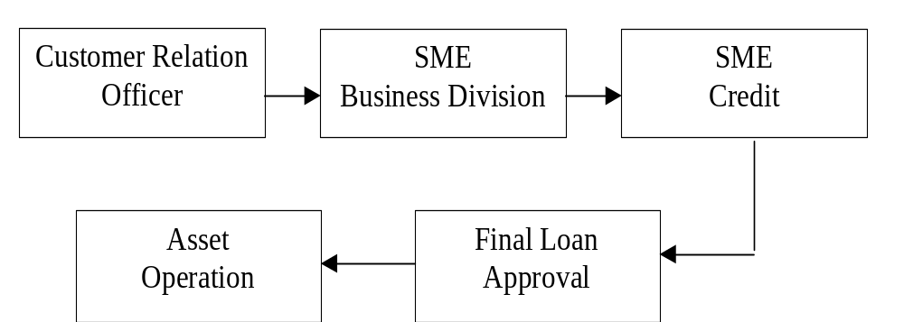

2.13.1. Corporate Banking:
Categories- the facilities our corporate Division offers to our customers are mainly of two-
Funded Facilities Non-Funded Facilities
Funded Facilities-
Funded tells us that this type of facilities allows the customer to have money ‘on his hand’ for use i.e. he will get money as to meet his business demand. Examples are-
Working Capital Loan.
Over Draft Facility.
Term Loan.
Lease Finance.
Demand Loan.

Non-Funded Facilities-
Non-Funded facilities are those type of facilities where customers don’t get fund on their hand rather get Bank’s Guarantee service to do international trading-import and export. Letters of Credit, Bank guarantees etc. are the examples of the non-funded facilities.
Working Process of corporate wing-
An example will be handy to understand when the corporate wing starts its work. Say you are one of our clients. You need Tk. 5 core to be used in your business. The first you may contact is the RM (Relationship Manager) who is our delegate to make all kinds of negotiation with you. He then Would take the proposal to the corporate Head takes it for further analysis such as whether it would be profitable venture for the Bank, or whether the Bank can disburse more in the industry etc. Then if the Corporate Head thinks it fit to go ahead, he then would take the file to the credit division – works to find out the worthiness of the borrower and other relevant facts important to assess the possibility of recovery. Then it goes to the credit committee and then finally the file goes to the Managing Director. A diagram is given for better understanding-

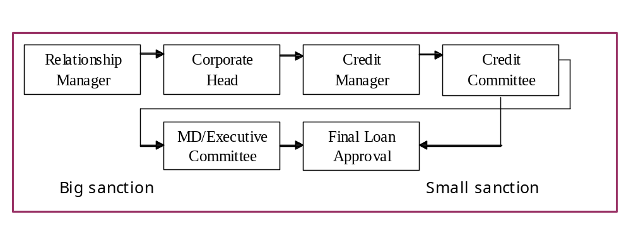

2.13. Retail Banking:

Retail Loans are consumers’ loan. Based on the customer demand these loans are given. BRAC Bank has a wide range of retail loan-

1. Car Loan. 2. Doctor’s Loan.
3. Secured Loan/OD. 4. High Flyer Loan.
5. Top Up Loan. 6. Credit Card Loan.
7. Study Loan. 8. Teacher’s Loan.
9. Now Loan. 10. Salary Loan.

2.14.1 Process Flow of Retail Loan

Branch/
Sales Officer
Retail
Business Division
Credit Manager

Asset
Operation
Final Loan
Approval

BRAC Bank’s Retail Division is being operated centrally. Under the Retail Banking Division all the branches, which acts as sales & service center, are reportable to Head of Retail Banking. Different products of Retail Banking are as follows:
- Deposit Products
- Lending Products
- Locker Services
- Remittance Services etc.
The product and services that are currently available are given below-
2.13.2. Depository Products
BRAC Bank Limited is now offering 6 depository products for mobilizing the savings of the general people:
- Savings A/C
- Current A/C
- STD A/C
- Fixed Deposit A/C
- DPS A/C
2.13.3. Loan Products
BRAC Bank is offering the following loan and advance product to the client for financing different purpose that fulfill the requirements of the bank and have good return to the investment as well as satisfy the client. The loan and advance products are:
Loan Product

Secured Facility
(Which is backed by 100% Cash Covered/ other security)
Secured Loan
Secured Overdraft
Partly Secured Facility
(This is partly secured by cash)
Life Style Loan
Professional Loan

Unsecured Facility
Insta Cash
Credit Card Loan
Teachers’ Loan
High Flyer Loan
Now Loan
Salary Loan

2.13.4. New Product and services
The bank has its concentration for new product and services development for satisfying its customer and increasing its customer base. The bank firmly believes that technology based product and services will play significant role in the performance of the bank as people are getting more conscious about their service quality. They prefer now faster service with least cost. For delivering faster service the bank has introduced online banking service from the very beginning. There are some new products and services that BBL has lately introduced. These are:
- Now Loan
- Salary Loan
- Credit card Services (Proposed)
- Islamic Banking Services (Proposed)
- ATM services
BRAC Bank Limited is always emphasizing the improvement of banking service and betterment of living standard of the general people of Bangladesh. The product and services are targeted to the lower level to the upper level income group in deposit collection. For lending, the services are made if certain requirements are fulfilled.
2.13.5. Treasury
Money Market Desk
BRAC Bank has a strong presence in the Treasury Market in Bangladesh. The Money Market Desk of the Treasury Division mainly deals in Bangladeshi Taka transactions. The basic activities undertaken by the Money Market Desk are:
- Management of Statutory Reserves viz. Cash Reserve Ratio (CRR) & Statutory Liquidity Ratio (SLR)
- Daily Funds & Liquidity Management
- Investment Management

Treasury Services
  - Call/Overnight Lending & Borrowing
  - Term Money Borrowing & Lending
  - Repurchase Agreement
  - Treasury Bills (T-Bills)
2.13.6. Secured Remittance Services (SRS)

BRAC Bank has introduced an innovative remittance services for Bangladeshis living abroad with some unique features compared to any of the existing remittance program. Bangladeshi expatriates can now send their money to their relatives any where in Bangladesh even to the remotest part within 24 hours at a reasonable cost and competitive exchange rate.
2.13.7. Information Technology (IT)

BRAC Bank Ltd. is currently running countrywide true online banking system. The system allows their customers to do transactions all around the country. The bank cheques are all marked with Barcodes that makes each cheque unique and disallows it to be duplicated. All the signature and customer information with their pictures can be verified from any console at any branch on the bank. We also ensure Offsite backup and Disaster Recovery. Their Goal is to provide a true online baking system, which will not only fulfill the demand of time but also set new benchmarks in twenty-first centuries banking world.
Special Features

- All Branches are computerized
- 99% of the bank’s work is automated using latest technology
- BRAC Bank is a member of SWIFT community
- Intercity Branches are connected via optical fiber backbone network

2.14. Branches & SMESCs:
BRAC Bank Limited is fast growing commercial banks in our country. Bank has established a good operating network throughout the country. It has 36 branches throughout the country till June 2008.
2.15. Performance of BRAC Bank Limited:
BRAC Bank Limited will be the most successful private sector commercial bank in our country, though it started its operation few years back. It has achieved the trust of the general people and made reasonable contribution to the economy of the country by helping the people investing allowing credit facility.
2.16. Capital Fund:
The authorized and paid up capital of BBL is TK.1000 million and TK.500 million respectively. The paid up capital is one of the strongest in the banking industry. The bank is going to raise its paid up capital in the month September, 2006 by TK.500 million with issuing public share of 5, 00,000 of TK.100 each.

Internal and External source of cash
Date | 31/12/06 | 31/12/07 | 31/12/08 | 31/12/09
Ordinary share | 405,020,000 | 500,000,000 | 500,000,000 | 500,000,000
Preference share |  |  |  | 150,000,000
Statutory reserve |  | 19,860,550 | 58,396,570 | 135,564,816
Surplus in profit | (9,095,940) | 70,346,259 | 224,490,340 | 226,006,069
Total | 395,924,060 | 590,206,809 | 782,886,910 | 1,011,507,885
(Amount in Taka)

2.17. Strategic Marketing Theories relate to SME BRAC Bank Limited
In terms of business, marketing management as the analysis, planning, implementation and control of programs designed to create builds and maintains beneficial exchange with
Target clients for the purpose of achieving organizational objectives.
Demand management
As a small and medium enterprise of BRAC bank, it basically provide small micro credit loans and also its product is different terms of small and medium terms of loans. Though it is pioneer division and makes demarcate plans to increase demand in the market in terms of small and medium enterprise. So SME provides the loan that affects the level, timing and nature of demand in a way that helps customer to enhance their business in spite of economic development. SME already have Zonal offices, 265unit offices around the country and 583 CRO to serve door to door customer services and also it exists close to 14482 clients.
Sample of MIS report has given below:
Month | Total No. of loans requested by the clients | Total No of loan disbursed | Total amount of loan disbursed (Crore)
January 2008 | 389 | 319 | 7.26
February 2008 | 487 | 433 | 9.85
March 2008 | 516 | 473 | 11.97
April 2008 | 549 | 519 | 13.11
May 2008 | 607 | 576 | 13.95
June 2008 | 649 | 611 | 15.68
July 2008 | 687 | 625 | 17.59
August 2008 | 782 | 726 | 18.62
September2008 | 821 | 785 | 19.65
October 2008 | 873 | 813 | 23.85
November 2008 | 914 | 852 | 26.34
December 2008 | 958 | 917 | 30.05
Fig: 6. Sample of MIS report .
Building Customer Relationship:
The main security of SME is building relationship between clients and banks. Demands basically comes from two groups: new customers and repeat customers. SME do not want to lose good customers because banks are facing new marketing realities like changing demographics, slow growth economy, more sophisticated competitors etc. For the repeat borrowers BRAC bank SME provides lots of extra benefits to clients to obtain satisfaction. The key to customer retention is superior value and satisfaction. With this in mind many banks are going to extreme to keep their customer satisfied.
SME relates with the modern marketing concept
First it provides customer satisfaction.
Second customer satisfaction through integrated effort.
Finally, for integrated effort to come about organization belief that goals should and can be achieved.
In terms of SME the goal is to economic development of our country through meet and exceed customer needs better than competition. In terms of customer orientation, SME provides the best facilities to customers regarding their needs. SME provides unsecured loans up to 5 lacs which none of other banks provide. In spite of integrated effort, SME is a team based organization. CRO go to the door to door business and by depend on their behalf SME gives the loan to clients. Though it is team base management bank, the behalf that corporate goals can be achieved and customers are satisfied by gaining trust of management.
Marketing concept
The achievement of corporate goals through meeting and exceeding customer needs better than competition
Integrated effort
All staff accepts the responsibility for creating customer satisfaction
Goal achievement
The belief that corporate goals can be achieved through customer satisfaction
Customer orientation
Corporate activities are focused upon providing customer satisfaction
Strategic Planning in a Nutshell of Small and Medium Enterprise
In terms of our country most financial institution start out with extensive business and marketing plans to attract potential customers. But organization has some internal steps to carry out organization in the long run which it related to Small and Medium Enterprise of BRAC Bank Limited are as follows:
- Identify the major elements of the business environment in which the organization has operated over the previous few years. In terms of SME of BRAC Bank Limited, it provides loans to small and medium enterprise. CRO or marketing officers deals with the clients directly and CRO’s are all in all to provide the loans in terms of their beliefs. SME is very friendly to provide various facilities by the existing clients.
- Describe the mission of the organization in terms of its nature and function for the next two years. By thinking of clients benefits and satisfaction, SME will withdraw up to 10 lacs without collateral security for providing loans. Disbursement system will carry out by means of courier services. CRO will send necessary documents to head office to disburse the loan which is nonparallel decision by comparing other banks.
- Explain the internal and external forces that will impact the mission of the organization. In terms of SME, it has various unit offices surround the country and has vast number of employees to handle different clients. Though it is a worlds number NGO’s bank, which has strong feedback and reputation in terms of social and environmental sights. By considering external forces, IFC or World Bank is financially collaborating with BRAC Bank. So it is big driving force for the SME of BRAC Bank Limited.
- Identifying the basic driving force that will direct the organization in the future. In terms of SME of BRAC Bank, it believes integrity, honesty and conciseness bilaterally of clients and us. Though it is credit division, so marketing officers can relate with bravery. Management is very strict in terms of that issue. It is a strong reputed organization so client will faith on us and carry out long term relation with SME.
- Develop a set of long term objectives that will identify what the organization will become in the future. In terms of SME it has a long term vision to run into the organization. Already It applying MBS (Millennium Banking System) software by means of online facilitates in terms of keeping all record and to way the process easier in the long run. SME thinks key business process with IT Management together in which IT can be enable can give best possible outcomes.

Key Marketing Processes Relate to SME
Basically strategic plans defines the organizations overall mission and objective. Within each business unit, marketing plays a role in helping to accomplish the overall strategic objectives.
2.18. Market Segmentation
The market consist of many types of customers, products and needs and the marketer has to determine which segments offer the best opportunity for achieving company objectives. SME segments the market into three categories: Trading, Manufacturing and Service. In trading business, there are different kinds like retailer, wholesaler, food business, general stores etc. in manufacturing, there are mills, bakery, press business, etc and also except purchasing manufacturer organization also take loans to meet the working capital requirements. In service business, there are pathology, hospitals and satellite business. Though in our country there is not much manufacturing organization, so most of the demands go for trading business. Though it is a small and medium enterprise therefore it focus on small loan clients that is small types of business like trading , manufacturing and service. Basically manufacturing clients take medium or low amount of loan during short period of time.

Small and Medium Enterprises
Manufacturing
Mills
Bakery
Press
Retail
Factory

Service
Pathology
Satellite
Hospital
Fast food

Trading
Whole sell
Retail
Garments
Departmental stores

2.18.1. Bases for Segmenting Consumer Market
There is no single way to segment a market. A market has to try different segmentation variables, alone and in combination, to find the best way to view the market structure.
Geographic segmentation:
Dividing a market in to different geographic units such as nations, states, region, countries, cities, or neighborhood. In terms of SME, it targets every region around the country in terms of small business. Now the SME has almost 265 unit offices to provide credit facilities to the clients around the country. Each of the SME unit offices mainly setup the district levels around the city but not in the rural or undeveloped areas. Though where the potential enterprises/businesses are more, SME try to develop unit office at that particular region/ areas to capture the entire market.
Demographic Segmentation:
Dividing the market in to groups based on demographic variables such as age, sex, family, income, education, religion and nationality. In terms of SME, in some cases it is very strict. If some one who has Hindu religion and live close to the border, SME would have very careful to provide loans to those clients. SME provide loans 20-60 aged peoples. SME is restricted to provide loans more than age of 65.
Behavioral Segmentation:
Behavioral segmentation divides buyers in to groups based on their knowledge, attitude, uses or responses to a product. Many marketers believe that behavior variables are the best starting point for building market segments. In terms of SME, few clients would be found those who had done MS and most of clients are secondary or higher secondary pass. But basically SME segments clients at least whether the clients can understand his/her own business. SME gives very importance on attitude. At the first sight if any client behave rough then CRO never go to that particular client.

2.19. Target Consumer
To succeed in today’s competitive marketplace, organization must be customer centered and keeping them by delivering greater value. But before it can satisfy customers, organization must first understand their needs and wants. There are two many different kinds of consumers with too many different kinds of needs and some organization in a better position to serve certain segments of the market. In terms of SME of BRAC bank, their target customers basically small and medium enterprises. BRAC bank SME target ed customers those who have minimum income of 40-70 thousand taka per month. Mostly entrepreneurs inour country is illiterate. Some of them are higher secondary and BSC graduate. So SME mainly targeted those clients who actually understand his own business. There are three sectors of target customers which SME follows: Trading, Service and Manufacturing. Basically according to the clients demand, SME support them financially to enhance their business
Marketing Analysis

Marketing
control
Marketing
planning

Marketing Implementation

Product

Price Place

Promotion

Target Consumer

2.20. Market Targeting
The process of evaluating each marketing segment’s attractiveness and selecting one or more segments to enter. In terms of SME, the scope is specified which the target market is small and medium enterprise. But SEM is restricted on leather, jewelry and alcohol business.
2.20. Differentiated marketing:
using a differentiating marketing strategy, an organization decides to target several markets or niches and designs separate offers for each. Basically it provides the loan within 25 days and gives the highest months to repay the loan than other banks. In terms of trading business, if the business is not too big then SME is not allow to give more than 20 months to repay the loan. On the other hand, in case of manufacturing business, if the business is too big then SME gives the client gross period and more than 30 months to repay the loan. SME also categorizes the dealings with the customers in A, B & C groups.
A-Categories officers are dealing with the high educated clients, like MBA or PhD holder or highly social client.
B-Categories officers are dealing with the undergraduate or normal standard clients.
C- Categories officers are dealing with the non educated or illiterate normal clients.
2.21. Market Positioning
Arranging for a product to occupy a clear, distinctive and desirable place relative to accomplish products in the minds of target consumers. Formulating competitive positioning for a product and detailed marketing mix. To meet the customer demands, SME already establish different offices across the country. Before taking the loan CRO clearly defines to the clients regarding SME policies and repayment schedules. To positioning in the market, SME not only provide loan but also they give some valuable ideas to enhance the clients business and for economic development.
Once a company has decide which segments of the market it will enter, it must decide what positions it wants to occupy in those segments. A products positioning in the way the product is defined consumers mind relative to competing product. Main head office of SME is in Dhaka city and rest of its unit offices are spread out surrounding the country. Each unit office consist of 2 or 3 CRO who provides door to door services, they even work at night. Many banks have field officers but could not carry out the unit office facilities. So BRAC bank can reach to the potential clients at anywhere in the country. The CRO of SME never say to the customer at the first impression that interest rate is 24%. They try to make understand to the clients mind that 2% per month or equal monthly payment as well as many benefits.
2.22. Unique Selling Propositions:
Facilities- the main facility of SME is to provide quick service to the clients, which might take 15 to 20 days. Hypothecation loans are collateral security free which other banks take securities. If any clients got serious problem in business after taking SME loans then it gives reschedule to repay the clients loan. While taking repeat loan SME provide various facilities to the clients.
2.22.1. Different features-
IFC and Shore banks are going to carry out equity participation with BRAC bank. It will deposit more funds to provide more loans to the clients, which cover around the whole country
2.22.2. Different services-
to get the loan, client do not have to go in bank directly. All sort of work are done by the CRO for clients to have the loan quickly. In terms of necessities CRO go to clients home and bring repayments of the loan. In favor of clients, CRO also work in holidays.

2.23. Marketing Strategies for Competitive Advantages
To be successful the company must do a better job than its competitors for satisfying target consumers. Thus marketing strategies must be geared to the needs of consumers and also to the strategies of competitors. The core competency of SME is that it already set up the business around the country and marketing officers go to the door to door to the clients. On the other hand, it provides the highest amount for unsecured loans than other banks. Also it provide extremely quick services to clients by getting the loan.

Theoretical Aspects

3.0. Marketing Theory:

Marketing is one of the major sectors for an organization which help the organization to reach to the goal effectively and efficiently. It is the process by companies creates value for customers and builds strong customer relationships in order to capture value from customers in return.
In achieving the business goal organization have to identify their target customers groups to which they provide the products. For this, organization screen out their potential customers group through
- Market Segmentation – The process of dividing a market into distinct groups of buyers with different needs, characteristics or behavior.
- Target Marketing - The process of evaluating each market segment’s attractiveness and selecting one or more segments to enter.
- Market Positioning - Occupying a clear, distinctive and desirable place relative to competing products in the minds of target customers.
In achieving the target effectively marketing tools are used to provide the products to the customers. Marketing tools is known as marketing mix or 4ps.
The marketing mix is probably the most famous phrase in marketing. Marketing decisions generally fall into the following four controllable categories:
- Product
- Price
- Place (distribution)
- Promotion
"Marketing mix" is a framework which acts as a guideline for marketers to implement a marketing concept. It consists of a set of major decision areas that a company needs to manage in order to at least satisfy consumer needs.
According to Kotler Armstrong, the marketing mix is a set of "controllable tactical marketing tools [product, price, place, promotion] that the firm blends to produce the response it wants in the target market". The marketing mix consists of everything the firm can do to influence the demand for its product.
3.1. Origin of Marketing Mix
The term "marketing mix" became popularized after Neil H. Borden published his 1964 article, The Concept of the Marketing Mix. Borden began using the term in his teaching in the late 1940's after James Culliton had described the marketing manager as a "mixer of ingredients". The ingredients in Borden's marketing mix included product planning, pricing, branding, distribution channels, personal selling, advertising, promotions, packaging, display, servicing, physical handling, and fact finding and analysis. E. Jerome McCarthy later grouped these ingredients into the four categories that today are known as the 4 P's of marketing, depicted below: These four P's are the parameters that the marketing manager can control, subject to the internal and external constraints of the marketing environment. The goal is to make decisions that center the four P's on the customers in the target market in order to create perceived value and generate a positive response.
The traditional marketing mix contains of four major elements, the "4-Ps of marketing". As defined by Kotler (1999):
Product: "Anything that can be offered to a market for attention, acquisition, use or consumption that might satisfy a want or need. In includes physical ob-jects, services, persons, places, organizations and ideas."
Price: "The amount of money charged for a product or service, or the sum of the values that consumers exchange for the benefits of having or using the product or service."
Place: "All the company activities that make the product or service available to target customers."
Promotion: "Activities that communicate the product or service and its merits to target customers and persuade them to buy."
.2. 7p’s in Details:
Place
Channels
Coverage
Assortments
Location
Inventory
Transportation
Logistics
Promotion

Advertising
Personal Selling
Sales Promotion
Public relation

Product
Variety
Quality
Design
Features
Brand Name
Packaging
Services
Price

List Price
Discount
Allowance
Payment Period Returns
Credit Terms

Marketing Mix

Fig: 7. 7p’s in Details

3.2 1. Product:
The product is the most important aspect of the marketing mix. Products have both tangible and intangible benefits. Tangible benefits include benefits which can be measured such as the top speed of a car. Intangible benefits are benefits that cannot be measured such as the enjoyment of the customer will get from the product.
Exactly what product or service are you going to sell to this market? Define it in terms of what it does for your customer. How does it help your customer to achieve, avoid or preserve something? You must be clear about the benefit you offer and how the customer's life or work will be improved if he or she buys what you sell.
Here are some examples of the product decisions to be made:
- Brand name
- Functionality
- Styling
- Quality
- Safety
- Packaging
- Repairs and Support
- Warranty
- Accessories and services
3.2 2. Price:
The amount of money customers have to pay to obtain the product. Many things influence prices, including the number of suppliers, the number of customers, and the availability of the product.
Effective pricing for a product is very much important to keep current customers and potential customers. If the price is too high consumers will avoid the product as they will believe it to be too expensive yet if the product is priced too low they may believe that there is something wrong with the product for it to be so cheap. But in luxuries or fashionable products or in case of reputed brand product value pricing is important. So in here extra price should be charged for their values which differentiate it from others related products. In this case this statement the higher the price, the more you sell will be effective. So pricing of products should be taken very carefully so that customers can measure price with their expected quality.
Exactly how much are you going to charge for your product or service, and on what basis? How are you going to price it to sell at retail? How are you going to sell it at wholesale? How are you going to charge for volume discounts? Is your price correct based on your costs and the prices of your competitors?
Some examples of pricing decisions to be made include:
- Pricing strategy (skim, penetration, etc.)
- Suggested retail price
- Volume discounts and wholesale pricing
- Cash and early payment discounts
- Seasonal pricing
- Bundling
- Price flexibility
- Price discrimination

3.2 3.Place
Company activities that make the product available to target consumers. Getting the product to the customer as quickly and conveniently as possible is an essential aspect of marketing mix. The place is not where is located your business but where our customers are. Distribution is about getting the products to the customer. Some examples of distribution decisions include:
- Distribution channels
- Market coverage (inclusive, selective, or exclusive distribution)
- Specific channel members
- Inventory management
- Warehousing
- Distribution centers
- Order processing
- Transportation
- Reverse logistics
In consumer marketing channels we have to consider three main distribution channels.
- Selling to the customers
- Selling to the retailers
- Selling to the wholesalers.
3.2 4. Promotion:
Promotion includes all the activities designed to bring a company’s goods or services to the favorable attention of customers. That means the steps or activities that communicate the merits of the products and persuade target customers to buy it.
It represents the various aspects of marketing communication, that is, the communication of information about the product with the goal of generating a positive customer response. Marketing communication decisions include:
- Promotional strategy (push, pull, etc.)
- Advertising
- Personal selling & sales force
- Sales promotions
- Public relations & publicity
- Marketing communications budget
3.2 5. Physical Evidence: The environments in which the reference and information service are delivered that performance and communication of the service.

3.2 6.Process: The procedure mechanisms and flow of the activity by which the reference and information service are acquired.

3.2.7. People: All human action who plays a part in reference and information services delivery namely the librating personnel.

Overview on Retail Loan

4. 0. About Retail Loan

Types of Retail Loan Product:

- Salary.
- Quick. Unsecured Loan.
- Staff personal
- Staff Salary.

- Auto.
- Home
- Secured Loan (SL). Secured Loan.
- SOD.
- Staff Auto.
- Staff Home.

Discuss About All of the Retail Loan.

- Normal Salary & Staff Salary.

Documentation of Salary Loan:

- Salary Certificate.
- Last 6 Months Bank Statement with salary certificate.
- Last 3 months pay slip (in case of salary very).
- National ID card (NID).
- Clear CIB Report.(NILL OR STD)
- Data verification certificate.
- Visiting Card.
- Age Minimum 23.
- Maximum Age 65.(Add loan)

Charge Documentation of Salary Loan:

  - Demand Promissory Note (DP Note)
  - Letter of Continuation.
  - Letter of lien
  - Letter of Authority
  - PG

Types of Salary Person:

For Type –A
Service length 1 Year (current origination 6 months.)

If Salary: 12000-24999 (10 Time Total Home)
25000-34999 (12 Times Total Home)
35000-Above. (15 Times Total Home)

Example: salary 12000/= X 10= 1, 20,000/=

Note: If the company 5 years Business they must be 20 employees then they taken salary Loan.

For Type –B:

Service length 2 Year (current origination 1 year.)

If Salary: 20000-29999 (8th Time Total Home)
30000-39999 (10th Time Total Home)
40000-Above. (12th Time Total Home)

Example: salary 20000/= X 8 = 1, 60,000/=

Security of Salary Loan:

Per 6 months 1 BBL PDC +1 BBL UDC Full Amount.
- Minimum 1 PG :
If Married then PG = Wife.
If Unmarried then PG= Father /Mother/ First Blood Relation.

Process of Salary Loan:
- CIF Creation
- Loan Account creates. (Interest Rate is 19%)
- Verify CIF & Loan Account.
- Certificate Issue.
- Disbursement :
Charge: Processing Fees-----------------1.5%
VAT (on Processing Fees) ------15%
Documentation Fees------------ -100TK
VAT (On Documentation Fees)--15%
Stamp Charge for 1 PG---------500
2PG----------660
3PG----------820
Data Verification Charge (DVF)—250.

Hints: PDC= Post Dated Cheques.
UDC= UN Dated Cheques.
VAT= Value Added Tax.
PG= Personal Guarantor.

*Note: Processing Charge Minimum 3000 Tk.

2. Quick Loan

Documentation of Quick Loan:

- 3 Years Trade Licenses (same Business).
- Tax Identity Number (TIN Certificate).
- National ID card (NID).
- Visiting Card.
- Clear CIB Report.
- Data verification certificate.
- Last 1 Year Bank Statement.
- Sanction Letter of all Loans.

Security of Quick Loan:

Per 3 months 1 BBL PDC +1 BBL UDC Full Amount.

- If the Customer other bank transaction in sector he/she given 3 months 1 that bank PDC +1 BBL UDC Full Amount. (Decided to the credit department).

- Minimum 2 PG :
If Married then PG = Wife.
If Unmarried then PG= Father /Mother/Brother/Business friend/ First Blood Relation.

Charge Documentation of Salary Loan:

1. Demand Promissory Note (DP Note)
2. Letter of Continuation.
3. Letter of lien
- Letter of Authority.
- Banking Agreement Letter (BA Letter).

Process of Quick Loan:
- CIF Creation
- Loan Account creates. (Interest Rate is 19.5%)
- Verify CIF & Loan Account.
- Certificate Issue.
- Disbursement:
Charge: Processing Fees-----------------1.5%
VAT (on Processing Fees) ------15%
Documentation Fees------------ -100TK
VAT (On Documentation Fees)--15%
Stamp Charge for 2PG----------660(Minimum 2PG)
3PG----------820
Data Verification Charge (DVF)—250.
*Note: Processing Charge Minimum 3000 Tk.

3. Staff personal Loan:

Documentation of Staff Loan:

- Salary Certificate.
- Staff PIN Number
- National ID card (NID).
- Visiting Card.
- Department Head Approval.
- Fulfill the loan file.

Charge Documentation of Staff Loan:

1. Demand Promissory Note (DP Note)
2. Letter of Continuation.
3. Letter of lien
4. Letter of Authority

Process of Staff Loan:
- CIF Creation
- Loan Account creates. (Interest Rate is 8%)
- Verify CIF & Loan Account.
- Certificate Issue.
- Disbursement:
Stamp Charge -----180
1PG-----------------340

4. AutoLoan.

Documentation of Auto Loan:

- 3 Years Trade Licenses (same Business).
- Tax Identity Number (TIN Certificate).
- National ID card (NID).
- Visiting Card.
- Clear CIB Report.
- Data verification certificate.
- Last 1 Year Bank Statement.
- Sanction Letter of all Loans.
- Quotation (Due accepted by client).
- Purchase Order.
- Bill & delivery challan
- Money Receipt.
- Joint Registration (BRTA).
- Insurance of vehicle.

Charge Documentation of Auto Loan:

1. Demand Promissory Note (DP Note)
2. Letter of Continuation.
3. Letter of lien
4. Letter of Hypothecation
5. Letter of Authority.
6. Banking Agreement Letter (BA Letter).

Process of AUTO Loan:
- CIF Creation
- Loan Account creates. (Interest Rate is 15.5% To 18%)
- Verify CIF & Loan Account.
- Certificate Issue.
- Disbursement:

Charge: Processing Fees-----------------1%
VAT (on Processing Fees) ------15%
Documentation Fees------------ -100TK
VAT (On Documentation Fees)--15%
Stamp Charge for 1PG----------660
2PG----------820
Data Verification Charge (DVF)—250.

- If the client changes quotation then we collected Quotation charge: Per Quotation charge-----------575 (500 Quot. +15%VAT).
- Issued Pay Order to the origination Dept. Request.
- DDPALL & DDIC then Print the Pay order.
- If the origination Dept. mention the pay order is issued respective branch then we selected the branch and issued pay order.

5. Home Loan. Home Loan

(TPA to be executed)

Name: …………………………… Reference No. …………….

Common:

1. Application Booklet OK. Yes / No
2. PDC (……..) Yes / No
3. Legal Vetting with good right Yes / No
4. Valuation with Rajuk Plan Yes / No
5. CIB Yes / No
6. Wanting as per vetting
1. ………………………………
2. ………………………………
3. ………………………………
4. ………………………………
7. BA Letter Yes / No
8. Insurance Yes / No
9. Latest TIN Clearance Yes / No
10. Sanction Advice Yes / No

Special instruction (if any):

1. Phase disbursement Yes / No
2. …………………………………
3. …………………………………
4. …………………………………
Extra Documents:
1. TPA / Four Party Agreement, duly signed Yes / No
2. Original Allotment Agreement Yes / No
3. Original Money Receipt Yes / No
4. Builder’s Letter Yes / No
5. Undertaking form Developer (if any) Yes / No
Deferral:
Matter Time
1. …………………………………… ………..
2. …………………………………… ………..
3. …………………………………… ………..
4. …………………………………… ………..

Checked by
…………………………….
Home Loan
(Leasehold, Mortgage to be executed)

Name: …………………………… Reference No. …………….

Common:

1. Application Booklet OK. Yes / No
2. PDC (……..) Yes / No
3. Legal Vetting with good right Yes / No
4. Valuation with Rajuk Plan Yes / No
5. CIB Yes / No
6. Wanting as per vetting
1. ………………………………
2. ………………………………
3. ………………………………
4. ………………………………
7. BA Letter Yes / No
8. Insurance Yes / No
9. Latest TIN Clearance Yes / No
10. Sanction Advice Yes / No

Special instruction (if any):

1. Phase disbursement Yes / No
2. …………………………………
3. …………………………………
4. …………………………………

Extra Documents:
1. Registered Title Deed/ Original Delivery Receipt Yes / No
2. Mortgage Permission Yes / No
3. Mortgage & IGPOA with Delivery Receipt Yes / No
4. Builder’s Letter Yes / No
5. Undertaking form Developer for legal document (if any) Yes / No

Deferral:
Matter Time
1. …………………………………… ………..
2. …………………………………… ………..
3. …………………………………… ………..
4. …………………………………… ………..

Checked by
…………………………….
Home Loan
(Freehold, Mortgage to be executed)

Name: …………………………… Reference No. …………….

Common:

1. Application Booklet OK. Yes / No
2. PDC (……..) Yes / No
3. Legal Vetting with good right Yes / No
4. Valuation with Rajuk Plan Yes / No
5. CIB Yes / No
6. Wanting as per vetting
1. ………………………………
2. ………………………………
3. ………………………………
4. ………………………………
7. BA Letter Yes / No
8. Insurance Yes / No
9. Latest TIN Clearance Yes / No
10. Sanction Advice Yes / No

Special instruction (if any):

1. Phase disbursement Yes / No
2. …………………………………
3. …………………………………
4. …………………………………

Extra Documents:
1. Registered Title Deed/ Original Delivery Receipt Yes / No
2. Mortgage & IGPOA with Delivery Receipt Yes / No
3. Builder’s Letter Yes / No
4. Undertaking form Developer for legal document (if any) Yes / No
5. Original NEC
Deferral:
Matter Time
1. …………………………………… ………..
2. …………………………………… ………..
3. …………………………………… ………..
4. …………………………………… ………..

Checked by
…………………………….

Home Loan
(Individual Seller, Leasehold, Mortgage to be executed)

Name: …………………………… Reference No. …………….

Common:

1. Application Booklet OK. Yes / No
2. PDC (……..) Yes / No
3. Legal Vetting with good right Yes / No
4. Valuation with Rajuk Plan Yes / No
5. CIB Yes / No
6. Wanting as per vetting
1. ………………………………
2. ………………………………
3. ………………………………
4. ………………………………
7. BA Letter Yes / No
8. Insurance Yes / No
9. Latest TIN Clearance Yes / No
10. Sanction Advice Yes / No

Special instruction (if any):

1. Phase disbursement Yes / No
2. …………………………………
3. …………………………………
4. …………………………………

Extra Documents:
1. Registered Title Deed/ Original Delivery Receipt Yes / No
2. Indemnity Bond to execute Mortgage & IGPOA Yes / No
3. Undertaking form Seller for Mutation & LDTR Yes / No
4. Mortgage Permission Letter Yes / No

Deferral:
Matter Time
1. …………………………………… ………..
2. …………………………………… ………..
3. …………………………………… ………..
4. …………………………………… ………..

Checked by
…………………………….

Home Loan
(Individual Seller, Freehold, Mortgage to be executed)

Name: …………………………… Reference No. …………….

Common:

1. Application Booklet OK. Yes / No
2. PDC (……..) Yes / No
3. Legal Vetting with good right Yes / No
4. Valuation with Rajuk Plan Yes / No
5. CIB Yes / No
6. Wanting as per vetting
1. ………………………………
2. ………………………………
3. ………………………………
4. ………………………………
7. BA Letter Yes / No
8. Insurance Yes / No
9. Latest TIN Clearance Yes / No
10. Sanction Advice Yes / No

Special instruction (if any):

1. Phase disbursement Yes / No
2. …………………………………
3. …………………………………
4. …………………………………

Extra Documents:
1. Registered Title Deed/ Original Delivery Receipt Yes / No
2. Mortgage & IGPOA with Delivery Receipt Yes / No
3. Undertaking form Seller for Mutation & LDTR Yes / No
4. Undertaking form Seller for legal document (if any) Yes / No

Deferral:
Matter Time
1. …………………………………… ………..
2. …………………………………… ………..
3. …………………………………… ………..
4. …………………………………… ………..

Checked by
…………………………….

Home Credit
(Leasehold)

Name: …………………………… Reference No. …………….

Common:

1. Application Booklet OK. Yes / No
2. PDC (……..) Yes / No
3. Legal Vetting with good right Yes / No
4. Valuation with Rajuk Plan Yes / No
5. CIB Yes / No
6. Wanting as per vetting
1. ………………………………
2. ………………………………
3. ………………………………
4. ………………………………
7. BA Letter Yes / No
8. Insurance Yes / No
9. Latest TIN Clearance Yes / No
10. Sanction Advice Yes / No

Special instruction (if any):

1. Phase disbursement Yes / No
2. …………………………………
3. …………………………………
4. …………………………………

Extra Documents:
1. Registered Title Deed/ Original Delivery Receipt Yes / No
2. Mortgage permission letter Yes / No
3. Indemnity Bond to execute Mortgage & IGPOA Yes / No
4. Quotation Yes / No

Deferral:
Matter Time
1. …………………………………… ………..
2. …………………………………… ………..
3. …………………………………… ………..
4. …………………………………… ………..

Checked by
…………………………….

Home Credit
(Freehold)

Name: …………………………… Reference No. …………….

Common:

1. Application Booklet OK. Yes / No
2. PDC (……..) Yes / No
3. Legal Vetting with good right Yes / No
4. Valuation with Rajuk Plan Yes / No
5. CIB Yes / No
6. Wanting as per vetting
1. ………………………………
2. ………………………………
3. ………………………………
4. ………………………………
7. BA Letter Yes / No
8. Insurance Yes / No
9. Latest TIN Clearance Yes / No
10. Sanction Advice Yes / No

Special instruction (if any):

1. Phase disbursement Yes / No
2. …………………………………
3. …………………………………
4. …………………………………

Extra Documents:
1. Registered Title Deed/ Original Delivery Receipt Yes / No
2. Mortgage & IGPOA with Delivery Receipt Yes / No
3. Quotation Yes / No

Deferral:
Matter Time
1. …………………………………… ………..
2. …………………………………… ………..
3. …………………………………… ………..
4. …………………………………… ………..

Checked by
…………………………….

Home Credit & Takeover

Name: …………………………… Reference No. …………….

Common:

1. Application Booklet OK. Yes / No
2. PDC (……..) Yes / No
3. Legal Vetting with good right Yes / No
4. Valuation with Rajuk Plan Yes / No
5. CIB Yes / No
6. Wanting as per vetting
1. ………………………………
2. ………………………………
3. ………………………………
4. ………………………………
7. BA Letter Yes / No
8. Insurance Yes / No
9. Latest TIN Clearance Yes / No
10. Sanction Advice Yes / No

Special instruction (if any):

1. Phase disbursement Yes / No
2. …………………………………
3. …………………………………
4. …………………………………

Extra Documents:
1. Current Liability Letter from existing Bank Yes / No
2. Indemnity Bond to execute Mortgage & IGPOA Yes / No
3. Letter of Deposit of Title Deed Yes / No
4. Quotation Yes / No
5. Redemption, Revocation from Existing Bank Yes / No
6. NEC from existing Bank Yes / No
7. Mortgage & Power in favour of BBL Yes / No

Deferral:
Matter Time
1. …………………………………… ………..
2. …………………………………… ………..
3. …………………………………… ………..
4. …………………………………… ………..

Checked by
……………………………

Overview on SME loan

The most valuable natural resource of Bangladesh is its people. As a nation we struggled for our independence and now the attainment of economic uplift is the main goal. Micro lenders are working here in the financial field, providing very small amount and on the other hand regular commercial banks have been providing bigger amount of loans to larger industries and trading organizations. But the small and medium entrepreneurs were overlooked. This missing middle group is the small but striving entrepreneurs, who because of lack of fund cannot pursue their financial uplift, as they have no property to provide as equity to the commercial banks. With this end in view-BRAC Bank was opened to serve these small but hard working entrepreneurs with double bottom line vision. As a socially responsible bank, BRAC Bank wants to see the emancipation of grass-roots level to their economic height and also to make profit by serving the interest of missing middle groups. 50% of its total portfolio usually collected from urban areas, are channeled to support these entrepreneurs who in future will become the potential strength of our economy. Brac Bank is the market leader in giving loans to Small and Medium Entrepreneurs. They have been doing it for the last five years.
4.1. Why SME Loan?
The main focus of BRAC Bank is to develop human and economic position of a country. Its function is not limited only to providing and recovering of loan but also try to develop the economy of a country. So reasons for this program from the viewpoint of BBL:
4.2. Support Small Enterprise:
The small enterprise, which requires 2 to 30, lacks Tk. loan, but they have no easy access to the banks/financial institutions. For example: In case of Anonno loan, an amount of 3 to 8 lacs is provided without any kind of mortgage.
4.2.1. Economic Development
Economic development of a country largely depends on the small and medium seal enterprises. Such as, if we analyze the development history of Japan, the development of small & medium scale enterprises expedite the development of that country.
4.2.2. Employment Generation
The bank gearing employment opportunities by two ways: Firstly, by providing loan to the small enterprises expanding, these businesses require more workers. Secondly, Small & Medium Enterprise (SME) program requires educated and energetic people to provide support to entrepreneurs.

4.2.3. Profit Marking
SME program is a new dimensional banking system in the banking world. Most of the CROs are providing door-to-door services to the entrepreneurs. Entrepreneurs are satisfied by the service of the bank and make profit.
4.2.4. Encourage Manufacturing
The focus of BRAC Bank is to encourage manufacturing by the entrepreneurs who produce by purchasing various types of materials. CRO try to educate them to produce material if possible because if they can produce in line of purchase profits will be high.
4.2.5. Pread the experience
Another reason of BRAC Bank is to spread the knowledge on the importance of SME banking regarding various businesses. The customer services officer share their knowledge from various businesses and tries to help the entrepreneurs who have shortage of the gathered knowledge. CRO’s who are the driving force of SME division of BRAC Bank also gather knowledge about various businesses and make stronger knowledge base.

4.3. Retail Banking Network Coverage
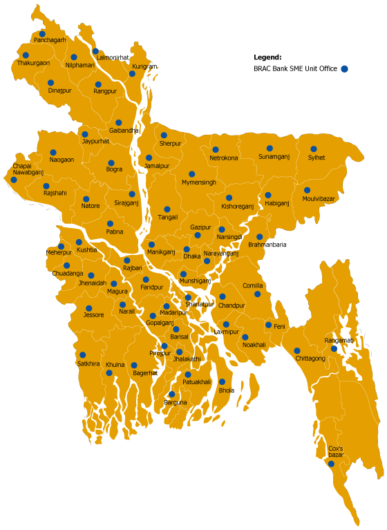

4.4. Security Documentation against Loan:

A document is a written statement of facts and a proof or evidence of particular transaction between parties involved. While allowing any disbursements against credit facilities to borrowers, it should be ensured that prior to any disbursements; security documentation is fully and properly completed.
4.4. 1 Purpose of Decorate Documentation and its Importance:
Documentation is necessary for the acknowledgement of a debt and its terms and conditions by the borrower and the creation of charge on the securities in favor of the bank by the borrower. Correct and proper documentation allows a bank to take legal measures against the default borrowers.
If filing a suit with the courts against a default borrower becomes necessary, the court will first review all documents. If any of the documents is found to be defect or incomplete, the purpose of security documentation will be defeated and a court ruling in favor the bank cannot be expected. Proper care should, therefore, be taken while completing security documentation.
4.4.2. Type of Securities:
The following listed securities may be obtained from borrower against loan to enterprises, either individually or in a combination.
It is really up to the bank what they would like to accept as security from the borrower as not all the securities stated below are suitable:

- Mortgage of loan and other immovable property with power of attorney to sell
- Lien of Fixed Deposits receipts with banks and other non-banking financial institutions, lined, these have to confirm by the issuer.
- Lien of Pratirakshay sanchay patra, Bangladesh sanchay patra, ICB unit certificates and wage earner development bond, all considered Quasi or Near cash items
- Lien of shares quoted in the stock exchange (This is rarely accepted)
- Pledge of goods (Banks are akin to stay away from such securities now a days)
- Hypothecation of Goods, Book Debt & Receivables, Plant & Machineries
- Charge on fixed assets of a manufacturing enterprise
- Lien of cheque, Drafts and order
- Lien of work orders, payment to be routed through the bank and confirmed by the issuer.
- Shipping documents of imported goods

4.4.3. Land Related Securities Documentation Process:
Each SME unit offices are lilies with at least two local lawyers who will work on behalf of the bank. These always will be employed whenever a borrower and where the security will be landed and immovable property accept a loan sanction. Any one of the lawyers will be provided with photocopies of all the relevant land related documents and while handing over show the original documents to them, the lawyers will carry out checks of the originals and if satisfied returned to the borrower. The documents generally provided are:
- Title Deeds or Deed of conveyance otherwise known as ‘Jomeer Dalil’ which signifies ownership of a particular land.
- Baya Dalil or Chain of Documents, which signifies that the conveyance of titles has been proper and legal.
- Mutation Certificate if Khatian which signifies that the title if the land has been duly registered in the Government/Sub-registrar’s records.
- Duplicate Carbon Receipt or DCR
- Latest Khajna or land rent receipt
- Purchase such as CS Khatian, SA Khatian and BS Khatian
- Mouja Map
- Municipal rent receipts if the land falls within a municipal area

The lawyer will then carry out a search at the Sub-registrar of land’s office to check if the proffered land is actually registered in the name of the proposed mortgagor and whether the said land is free from any encumbrances. The Sub-register’s office, which means that the land or immovable property can be mortgaged to the bank, then the lawyer will provide his own opinion on the acceptability of the property, whether it is legally held and explain the chain of ownership. If all is acceptable, the lawyer will draw up the Mortgage Deed that will be registered, the irrevocable power if attorney to sell the land and the Memorandum of Deposit of Title Deed. The lawyer will have the borrower or the Mortgagor, if different or 3rd party, sign the documents in front of the Sub-registrar of land to register the mortgage, The CRO must ensure that the receipt for the original Mortgage deed must be signed off (Discharged) at the back of the receipt so that the bank may obtain the originals in the future. The borrower will bear all the charges and will pay directly at the Sub-Registrar’s office including the cost of the stamp paper required. The cost of the lawyer will also be realized from the borrower be an account payee cheque in favor of the lawyer and handed over to the lawyer straight away.
The charges related to the creation of mortgages and other associated costs are incorporated in a separated sheet and are attached herewith. The CRO will have all other security documents, as sent by SME HO, signed by the borrower and hand carry all the security documents including all the original land documents and deliver those to the credit administration officer who will check the list of documents and receive those through a check list in writing. The credit administration officer once satisfied will prepare the disbursement memo to disburse the loan.

4.4.4. Mortgage:

I) Equitable Mortgage or Memorandum of Deposit of Title Deeds

It is created by a simple deposit of title deeds supported by a Memorandum of Deposit of Title Deeds along with all the relevant land documents. All the searches and verification of documents as stated above must be carried out to validate the correct ownership of the property. This deed also provides the bank power to register the property in favor of the bank for further security, if needed.
ii) Registered Mortgage
It is created by an execution of a Mortgage Deed registered irrevocably in favor of the bank at the Sub-Registrar of land’s office. This virtually gives the bank the right to posses and self if accompanied with a registered irrevocable power of attorney to sell the property executed by the owner of the property, in case of default.

4.5 Basic Charge Documents:
4.5.1. Sanction Letter
Once a loan is approved, the borrower is advised by a ‘Sanction or offer letter’ which states the terms and condition s under which all credit facilities are offered and which forms an integral part of there security documentation. If the borrower accepts, then a contract between the bank and the borrower is formed and which both party are obligated to perform. Accordingly, all other charge documents and securities are drawn up and obtained. A standard sanction letter is attached herewith. All documents shall be stamped correctly and adequately before or at the time of execution. An un-stamped or insufficiently stamped document will not form basis of suit. Stamps are of 4 (Four) kinds. These are Judicial, Non-judicial, Adhesive and embossed impressed. Documents to be executed (Signed) by the borrowers concerned must be competent to do so in official capacity.
Following precautions should be taken at the time of execution of the security documents:
- The signature on the documents should be made in the presence of the CRO. The CRO should sign as witness on all charge documents.
- The document are to be filled in with permanent ink or typed
- If the document consist more than I page, the borrower should sign on each page
- If the signature of any third party is required to be obtained whose specimen signature is not available, then the main applicant should verity the specimen signature of the third party
- No document or column in any document should remain blank
- As far as possible there should be no erasure, cancellation or alternation in the document. If, however, there is any correction, overwriting or alteration, then that must be authenticated by a full signature of the signatory.
After stamping and execution of documents, the question of registration comes up. However, not all documents are required to be registered.
For the extension of any type of credit/loan facility, the following loan documents, which are considered basic, should be obtained from all borrowers:
- Demand Promissory Note
- Letter of Continuity (This is not always taken if there is only loan disbursement)
- Letter of Arrangement
- General Loan Agreement
- Letter of Disbursement
- General Loan Agreement
- Letter of Disbursement; Basically a letter requesting disbursement of the loan
- Letter of Installment, in case the facility is to be repaid in installment

4.6 .Other Basic Charge Documents:

4.6.1. Demand Promissory Note (DP Note)

It is a written promise by a borrower to pay the whole amount of existing or future loans/credit facilities on demand. It also gives the banks power to ask the borrower to repay the loan amount with interest without any prior notice. Section 4 of the Negotiable Instrument Act 1881 defines a promissory note as an instrument in writing, signed by the maker, to pay a certain sum of money only to, or the order of, a certain person, or to the bearer of the instrument, following precautions are to be taken while preparing a promissory note. Type the amount of the credit facility/loan in words and in figures. Type the rate of interest for the loan, which the borrower will subject to verify the signature of the borrower.
4.6.2. Letter of Continuity
This instrument is used in conjunction with the demand promissory note. This is to secure rights of recovery for existing and future credit facility, which are advanced in parts or on a recovery basis. Loan accounts may from time to time be reduced or even the balance in the said loan account may be in credit so this instrument, validates the said D.P Note, for making further drawings under the facility continuously possible.

4.6.3. Letter of Arrangement
This is a right given by the borrower to the bank to cancel the facility at any time without having to assign any reason. This is also an acknowledgement by the borrower that the credit facility has been approved in his favor and the borrower has to execute all necessary documents to avail credit facility.

4.6.4. General Loan Agreement
A loan agreement is an agreement of contract stating the general terms for the extension of a loan or credit facilities. The General loan agreement sets out the general standard terms and conditions governing the existing or future extension of loan or erudite facilities to the borrower.

4.6.5. Letter of Disbursement
This is simple a letter requesting disbursement of the loan/credit facilities at the agreed rate of interest.

4.7. Other Security Documents:
4.7.1. Letter of Undertaking
This is a Deed of agreement executed by the borrower agreeing to commit to carry out any or a particular obligation to avail of loan/credit facility.

4.7.2. Letter of Hypothecation of Goods & Stocks and Book Debt and Receivable:
These letters Hypothecation are actually two different sets of documents but because of their similarity, these are being explained together. These documents create an equitable or floating charge in favor of the bank over the goods and services and/ or book debts and receivables that are being financed where neither the ownership nor the possession is passed to the bank. Under this agreement, the borrower undertakes to keep the percent stock of goods and that, which may increase from time to time in good condition in future, in good condition. This hypothecation gives the bank the power to possesses and sell the mentioned goods and stocks or claims the book debts directly from the debtors in order to settle the borrower’s dues to the bank.

4.7.3. Letter of Hypothecation of Plant & Machinery
Under this agreement, the Borrower undertakes to keep the present plant and machinery at the present location in good condition and which gives the bank the power to posses and sell the mentioned plant and machinery to meet the borrower’s dues to the bank. In case of limited company, both private and public, these Letters of Hypothecation with schedules are usually registered with the Registrar of Joint Stock of Companies (RJSC) that provides more security to the banks.
4.7.4. Letter of Lien
A lien the right of one person to retain property in his hands belonging to another until certain legal demands against the owner of the property by the person in possession are satisfied. Thus a bank or a creditor who has in its possession a lien over the goods in respect of the money due by the borrower, as a general rule has the right to exercise certain powers to hold on to the security. In addition, if the bank has right to set off the value of the said goods or instrument in its possession, then the bank can sell the goods or encase the instrument to liquidate the dues by the borrower.
4.7.5. Right to Set Off
This deed of agreement gives the bank the right to offset the value of the goods or financial instrument in its possession and which has been discharged by the owner of that asset, against dues owned by the borrower.
4.7.6. Letter of Disbursement
This agreement gives the bank the right to possess goods and other assets in rented or leased premises of the borrower despite the fact that owner or the premises may be unable to realize dues from the borrower himself.
4.7.7. Personal Guarantees
This is a guarantee of a person or third who is not the direct beneficiary of the loan/credit facility but is equally liable for the loan. The involvement of a 3rd party creates additional pressure on the borrower to minimize the risk. The guarantor is the person who has to pay the entire outstanding loan and interest if the borrower fails to pay for any reason.

4.8. Selection of Potential Enterprise for SME:
4.8.1. Enterprise Selection Criteria:
The success of SME will largely depend on the selection of a business and man behind it. In terms of the business (Enterprise), the following attributes should be sought:
- The business must be in operation for at least one year
- The business should be environment friendly, no narcotics or tobacco business
- The business should be legally registered, i.e., valid trade license, income tax or VAT registration, wherever applicable.
- The business should be in legal trade, i.e.; smuggling will not be allowed or socially unacceptable business will not be entertained.
- The business must have a defined market with a clear potential growth
- The business must be located ideally close to the market and the source of its raw materials/suppliers. It should have access to all the utilities, skilled manpower’s that are required.
- Any risk assessed by the management in turn will become a credit risk for the bank. So effort should make to understand the risk faced by the business.
4.8.2. Entrepreneur Selection Criteria:
In order to understand the capability of the management behind the business, the following should be assessed:
- The entrepreneur should be physically able and in good health, preferably between the age of 25-50. If he/she is an elderly person closer to 50, it should be seen what the succession process will be and whether it is clearly defined or not.
- The entrepreneur must have the necessary technical skill to run the business, i.e. academic background or vocational training, relevant work experience in another institution or years of experience in this line of business.
- The entrepreneur must have and acceptable social standing in the community (People should speak highly of him), he should possess a high level of integrity (Does not cheat anyone, generally helps people), and morally sound (Participates in community building)
- The entrepreneur must possess a high level of enthusiasm and should demonstrate that he is in control of his business (Confidently replies to all queries) and has the ability to take up new and fresh challenges to take the business forward.
- Suppliers or creditors should corroborate that he pays on time and is general in nature
- Clear-cut indication of source of income and reasonable ability to save.
4.8.3. Guarantor Selection Criteria:
Equally important is the selection of a guarantor. The same attribute applicable for an entrepreneur is applicable to a guarantor. In addition he should posses the followings:

- The guarantor must have the ability to repay the entire loan and is economically solvent (Check his net worth)
- The guarantor should be aware about all the aspect of SEDF loan and his responsibility
- Govt. and semi-govt. officials can be selected as a Guarantor such as schoolteacher, college teacher, doctor etc.
- Police, BDR and Army persons, political leaders and workers, and Imam of mosque cannot be selected as a guarantor.
- The guarantor should know the entrepreneur reasonable well and should preferably live in the same community

- Loan can be repaid in two ways:
- In equal monthly loan installment with monthly interest payment, or
- By one single payment at maturity, with interest repayable a quarter end residual on maturity
- Loan may have various validates, such as, 3 months, 4 months, 6 months, 9 months, 12 months, 15 months, 18 months, 24 months, 30 months and 36 months.
- The borrower must open a bank account with the same bank and branch where the SME has its account
- Loan that approved will be disbursed to the client through that account by account payee cheque in the following manner: Borrower name, Account name, Banks name and Branch’s name
- The loan will be realized by 1st every months, starting from the very next months whatever the date of disbursement, through account payee cheque in favor of BRAC Bank Limited A/C. With Bank’s named and branches name
- The borrower has to issue an account payable blank cheque in favor of BRAC Bank Limited before any loan disbursement along with all other security.
- The borrower will install a signboard in a visible place of business of manufacturing unit mentioned that financed by “BRAC Bank Limited”.
- The borrower has to give necessary and adequate collateral and other securities as per bank’s requirement and procedures.
- SME, BRAC Bank may provide 100% of the Net Required Working Capital but not exceeding 75% of the aggregate value of the Inventory and Account Receivables. Such loan may be given for periods not exceeding 18 months. Loan could also be considered for shorter periods including one time principal repayment facility, as stated in loan product sheet.
- In case of fixed asset Financing 50% of the acquisition cost of the fixed asset may be considered. While evaluating loans against fixed asset, adequate grace period may be considered depending on the cash generation after the installation of the fixed assets. Maximum period to be considered including grace period may be for 36 months.

4.9. Monitoring:
Monitoring is a system by which a bank can keep track of its clients and their operations. So monitoring is an essential task for a CRO to know the borrowers activities after the loan disbursement. This also facilitates the build up of an information base for future reference.
4.9. 1.Importance of Monitoring:
Through monitoring a CRO can see whether the enterprise invested the sanctioned amount in the pre-specified area of his business, how well the business is running, the attitude of the entrepreneur, cash credit sales and purchase, inventory position, work in process and finished goods etc, This information will help the CRO/BRAC Bank to recover the loan accruing to the schedule and to take the necessary decisions for repeat loans. Moreover, monitoring will also help to reduce delinquency. Constant visit over the client /borrower ensures fidelity between the bank and the borrower and tends to foster a report between them.
4.9. 2.Area of Monitoring:
The purpose is to know the entire business condition and all aspects of the borrowers so that mishap can be avoided.
4.9. 2(a).Business Condition
The most important task of the CRO to monitor the business frequently, it will help him to understand whether the business is running well or not, and accordingly advice the borrower, whenever necessary. The frequency of monitoring should be at least once month if all things are in order.

4.9. 2(b).Production
The CRO will monitor the production activities of the business and if there is any problem in the production process, the CRO will try to help the entrepreneur to solve the problem. On the other hand the CRO can also stop the misuse of the loan other than for the purpose for which the loan was disbursed.
4.9. 2(c).Sales
Monitoring sales proceed is another important task of the CRO it will help him to forecast the monthly sales revenue, credit sales etc. which will ensure the recovery of the monthly loan repayments from the enterprise as well as to take necessary steps for future loans.
4.9. 2(d).Investment
It is very important to ensure that the entire loan has been invested in the manner invented. If the money is utilized in other areas, then it may not be possible to recover the loan.
4.9. 2(e).Management of raw materials
In case of a manufacturing enterprise, management of raw materials is another important area for monitoring. If more money is blocked in raw materials then necessary, then the enterprise may face a fund crisis. On the other hand the production will suffer if there is not enough raw materials.
4.10. Monitoring System:
4.10.1. The CRO can consider the following things for monitoring
The CRO will monitor each business at least once a month. He/she will make a monitoring plan/ schedule at beginning of the month
During monitoring the CRO must use the prescribed monitoring from and preserve in the client file and forward a copy of the report to SME head office immediately.
4.10.2.An SME branch will maintain the following files
The file will contain-
Purchase Receipt,
Delivery Memo’s,
Quotations
In addition, all other papers related to furniture and fixture procurement
4.10.3. Other fixed assets and refurbishment
All fixed assets and refurbishment related papers such as purchase receipt, Delivery memo’s, Quotation, Guarantee and Warrantee papers, Servicing related papers and any other paper related to fixed assets are refurbishment will be in this file.
4.10.4. Lease agreement file
This file will contain all papers related to lease agreement between the SESDS office and owners of the leased premises.
4.10.5. Individual client file
Individual files are to be maintained for each borrower and will hold loan application, Loan Proposal, Copies of Loan Sanction Letter, Disbursement Memo, Monitoring Report, CIB application and Report, Credit report from other bank and all other correspondents including bank receipt.
4.10.6. Statement files
All types of statement sent to SME head office will be kept in this file chronologically
4.10.7. Office instruction file
All kind of office instruction regarding administration should be kept in this file.
4.10.8. Operating instruction and guideline files.
All kind office instruction and guidelines related to operating should be kept in this file
4.10.9. New forms introduction file
All minutes of meeting, whenever held, should be kept in this file.
4.10.10. Security documents and legal aspect file
One set of security documents and lawyer’s opinions and suggestions regarding issue will be kept in this file. The original should be send to SME head office on a weekly basis
4.10.11. Survey form file
After conducting survey, all survey will be kept in this file chronological.
4.11. SME Banking System:
- Every SME unit office will have a current account with a designate bank in the area of a unit office. This bank account will be opened and operated by SME head office.
- To meet petty expense such as stationary, entertainment and other incidental expense, all unit office will be allowed patty cash of Tk. 2000/=
- The cheque of this patty cash will be issued from SME head office in the beginning of the month. All vouchers relating to such expenses should be send to the accounts from SME head office
- All the clients must open their account with the same bank account on the same day after receiving those from the borrowers, who should given a received as prescribed.
- Cheques should be deposited to the SME unit office bank account on the same day after receiving those from the borrowers, who should given a receipt as prescribed.
- Any loan installment credit should be transferred to the SME head office account in Gulshan, Dhaka on the same day as per agreement with bank.
- Every CRO should have an individual account in the same bank branch for their personal use and to receive their salaries and other benefits.
- Payment of lease rentals, utility bills and cheque drawn on the SME unit office bank account and issued by SME head office should pay other expenses (Large amount). If these bills are small amount, they should be paid from the patty cash and replenished later.
- All the financial accounting entries will be passed at the SME head office and will maintain separately on the basis of the unit office.
4.12. Economic Mapping Survey:
After starting a SME, unit office in a new area the CRO will conduct a survey of the business. The objective of the survey is to collect relevant information about the business, which will help to select potential business for SME loans.

4.12.1. Mapping and Survey Method:
To conduct the economic mapping and survey properly, the following process should be followed:
- The CRO will prepare a physical map of his working area showing main roads, businesses, markets, and industrial locations. In this map, the CRO will show different kinds of business in different colors. This map will show the approximate location of all kinds of business within the area and it will be kept on the display board at the SME unit office.
- The CRO will drive his total working area into several clusters, if possible, after that he will conduct the survey cluster wise. After completing one cluster, the CRO will start surveying another cluster.
- At the beginning of the survey, the CRO will screen out business that does not need loans over 2 lacs.
- After the survey, CRO will preserve the survey form cluster wise in a separate file. Based on the survey, the CRO will identify the potential businesses to pursue those for SME loans.
- Therefore, CRO will approach the potential borrowers immediately to process loan application
- For initial assistance, CRO may approach
- BRAC office
- Trade Associations and Chambers
- Local govt. office like UNO and Municipal office.
Once potential borrower is formally approached, then all details should be incorporated in the client register as per the prescribed format.

Analysis of Loan Repayment Behavior

5.0. Analysis of loan repayment behavior

SME loan in fact, a small loan ranging from 2 lacks to 30 lacks given to small or medium enterprises not for initiating the business but for the purpose of working capital management or for purchasing any long term asset. Any sound organization after one year of their starting of business can apply for this loan. It almost a rare case for Brac Bank that an SME borrower will default to repay the loan he/she has taken even the loan is given without taking any collateral. There are several reasons for which the SME loan borrowers hardly default. These reasons may like:
- The loan amount is not as large as it would be difficult to repay it.
- Mediocre entrepreneurs hardly default to repay loans. They are very conscious about their reputation in the market.
- As the loan is taken for meeting up of working capital, it can be easy to repay after the sales revenue is collected from respective customers.

However, from the observation of 37 SME loan borrowers’ personal and repayment information we find the following results:
- Average age of SME borrowers is 37
- Average age of most of the SME borrowers is 31 to 40 ages.
- Average education of most of the SME borrowers is Class VI to X.
- Average Experience is 1 to 5 years (along with some extreme values).
- Average the customer taken loan is 300000 TK.
- Average the customer recovery rate with term of the loan 24 month.
- Monthly income and expenditure of the Entrepreneur is around TK. 10001 to 20000 TK.
- Average the customer personal asset to keep the bank 500001-1000000 TK.
- Almost all of the borrowers are 43.24% retailer and 56.76% whole seller .
We have gathered 8 variables to analyze the relationship of each variable with recovery rate. These variables are:
- Age of the borrowers
- Education of the borrowers
- Experience of the borrowers related to their business.
- Amount of loan taken by the borrowers
- Term of loan
- Income of the borrowers
- Personal Asset of the borrowers
- Nature of business
We can analyze the relationship sequentially:
6.1 Relationship of recovery rate with age of the borrowers:
The relationship of recovery rate with the age of the customers can be described from the following charts:
Age group | Frequency | Recovery rate(%)
21-25 | 1 | 3%
26-30 | 4 | 11%
31-35 | 9 | 25%
36-40 | 8 | 22%
41-45 | 7 | 19%
46-50 | 4 | 11%
51+ | 3 | 9%
Total |  | 100%
Sources: Questionnaire survey
Fig: 8. Relationship of recovery rate with age of the borrowers
Recovery Rate Based On Age Group
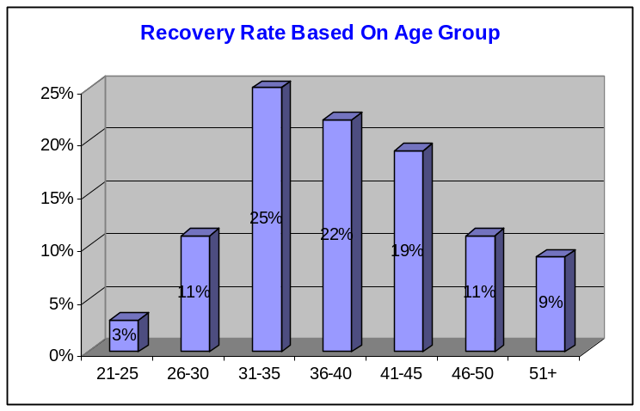

Sources: Questionnaire survey
Fig: 9. Recovery Rate Based On Age Group

From the above chart we can see that recovery rate increases as the age of the borrowers increases. Here the recovery rate is lowest at the age group of 21-25 for the lacking of experience and knowledge in the related business. They can’t make the proper use of funds. And that’s why their business fails. At the age of 31-35 recovery rate is 100%. At that age group people like to behave professionally and control everything with strict discipline. They are highly concerned about their career which brings success to their business. So at that time recovery rate is the highest. Again at the age of 50 and above recovery rate is also 100% because of their huge experience and success in business.
6.2. Relationship of recovery rate with education of the borrowers:

Education | Frequency | Recovery rate(%)
Alphabetic-5 | 8 | 21.62%
6 to 10 | 20 | 54.06%
11 to 15 | 9 | 24.32%
Total |  | 100%

Sources: Questionnaire survey
Fig: 10. Relationship of recovery rate with education of the borrowers
Recovery Rate Based On Education
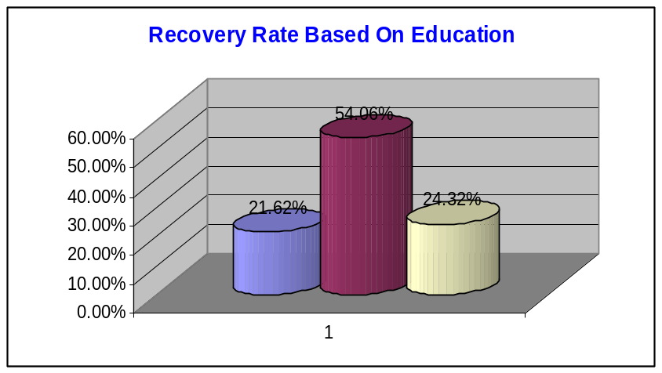
Sources: Questionnaire survey
Fig: 11. Recovery Rate Based On Education

From the above chart we can see that Small and medium businesses are not highly affected with the educational background of the borrowers. That’s why recovery rate also is not much affected with the education of the borrower. There should be some other variables affecting it as well.
6.3. Relationship of recovery rate with experience of the borrower:

Experience(year) | Frequency | Recovery rate(%)
1 to 5 | 13 | 35.14%
6 to 10 | 9 | 24.33%
11 to 15 | 5 | 13.51%
16-20 | 6 | 16.22%
20 above | 4 | 10.80%
Total |  | 100%
Sources: Questionnaire survey
Fig: 12. Relationship of recovery rate with experience of the borrower

Recovery Rate Based On Experience
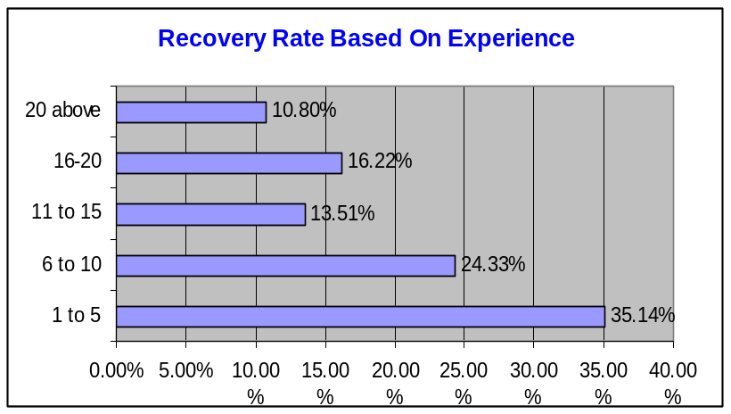
Sources: Questionnaire survey
Fig: 13. Recovery Rate Based On Experience

From the above graph we see that recovery rate is highly affected with the experience of the borrowers in the business he is engaged with. In fact, it is all out true that a business and its success is greatly affected by the experience the entrepreneur have on the same line of business. At the initial periods of the business lack of experience can cause the business to fail which ultimately results in the default of loan repayments. So Brac Bank is always concerned about the related experience of the entrepreneur. They don’t give SME loan to anybody having no experience or for initiating any business. And here also we see that recovery rate is lowest at the experience of 1 to 5 years.
6.4. Relationship of recovery rate with amount of loan taken:

Amount of Loan | Frequency | Recovery rate(%) | Recovery rate(%)
200,000 | 4 | 95% | 10.81%
250,000 | 1 | 100% | 2.70%
300,000 | 12 | 97% | 32.44%
350,000 | 2 | 100% | 5.41%
400,000 | 6 | 100% | 16.22%
450,000 | 1 | 94% | 2.70%
500,000 | 10 | 97% | 27.02%
850,000 | 1 | 100% | 2.7%
Total |  |  | 100%

Sources: Questionnaire survey
Fig: 14. Relationship of recovery rate
Recovery Rate Based On Experience
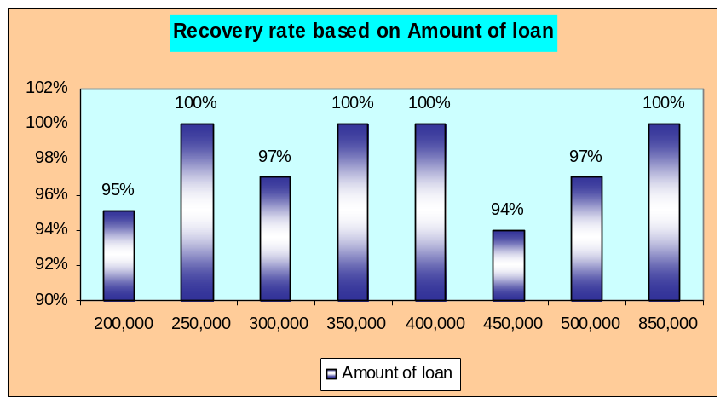
. Sources: Questionnaire survey
Fig: 15. Recovery Rate Based On Experience

From the above chart we see that its tough to make a relationship with both the recovery rate amount of loan taken by the borrowers. But still it can be said that loan amount ranging from 250000 to 400000 have a good recovery rate on an average. That’s why maximum amount or size of SME loan the authority like to disburse is 300000.

6.5. Relationship of recovery rate with term of loan:

Term Of Loan(Month) | Frequency | Recovery rate(%) | Recovery rate(%)
15 | 3 | 98% | 8.11%
18 | 3 | 100% | 8.11%
21 | 10 | 100% | 27.03%
24 | 11 | 98% | 29.73%
27 | 1 | 94% | 2.7%
36 | 5 | 94% | 13.51%
48 | 4 | 91% | 10.81%
Total |  |  | 100%
Sources: Questionnaire survey
Fig: 16. Relationship of recovery rate with term of loan

Recovery Rate Based On Term of Loan

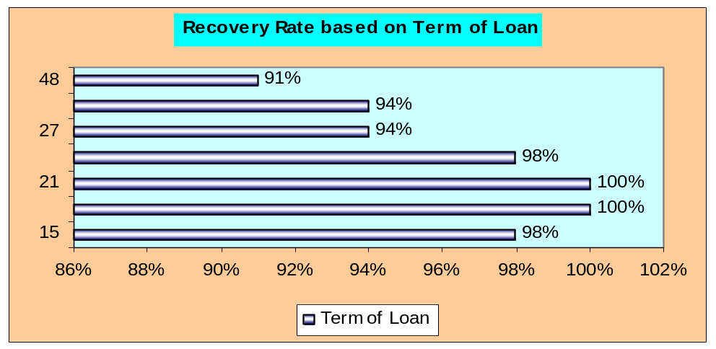
Sources: Questionnaire survey
Fig: 17. Recovery Rate Based On Term of Loan

The above graph shows that, as the loan duration increases the rate of recovery decreases. This may be the inherent reason of why the authority of BRAC Bank likes to disburse loan at a shorter term of 18 to 24 months.

6.6. Relationship of recovery rate with income of the borrower:

Income group | Frequency | Recovery rate(%)
1000-10000 | 5 | 13.51%
10001-20000 | 15 | 40.54%
20001-30000 | 8 | 21.62%
30001-40000 | 1 | 2.7%
40001-50000 | 3 | 8.11%
50000 above | 5 | 13.52%
Total |  | 100%
Sources: Questionnaire survey
Fig: 18. Relationship of recovery rate with income of the borrower

Recovery Rate Based On Income group
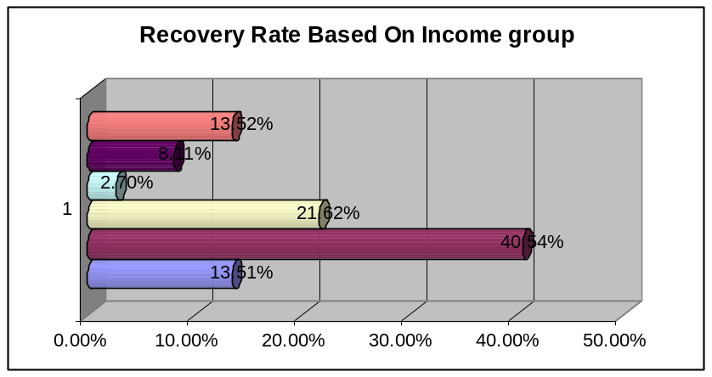
Sources: Questionnaire survey
Fig: 19. Recovery Rate Based On Income group

In fact, income of a borrower can be a vital factor to repay his loan. And the above graph is a replica of this truth. Here we see that people with higher income group like 30000 to 50000 or above have the highest recovery rate. Entrepreneurs having a good skill, knowledge and experience in business can make success in their business which ultimately increases their income as well. So their recovery rate is good than those group of people who have lower income.

6.7. Relationship of recovery rate with the personal asset of the borrower:

Personal asset | Frequency | Recovery rate(%)
100000-500000 | 9 | 24.33%
500001-1000000 | 13 | 35.13%
1000001-1500000 | 5 | 13.51%
1500001-2000000 | 3 | 8.11%
2000000 above | 7 | 18.92%
Total |  | 100%

Sources: Questionnaire survey
Fig: 20. Relationship of recovery rate with the personal asset of the borrower

Recovery Rate Based On Personal Assets
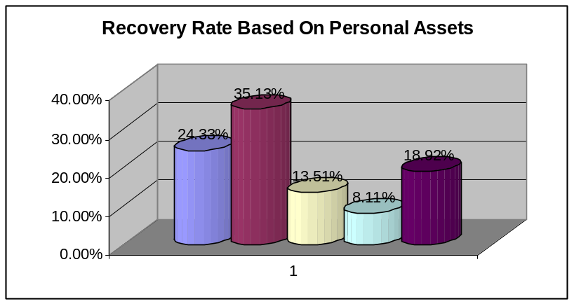
Sources: Questionnaire survey
Fig: 21. Recovery Rate Based On Personal Assets

Entrepreneurs who have sufficient personal assets and mortgage them for taking the loan have the record of higher recovery rate. They don’t have the tendency to make a default in paying the installments. Brac Bank likes to pay SME loans after collecting title deeds of those personal or family assets. People who don’t have much personal asset must show that they have sufficient family asset. Here from the above chart we see that entrepreneurs having lowest personal asset have the lowest recovery rate of 94%.

6.8. Relationship of recovery rate with the Nature of business:

Nature of business | Frequency | Recovery rate(%)
Whole sale | 16 | 43.24%
Retail | 21 | 56.76%
Total |  | 100%

Sources: Questionnaire survey
Fig: 22. Relationship of recovery rate with the Nature of business

Recovery Rate Based On Personal Assets
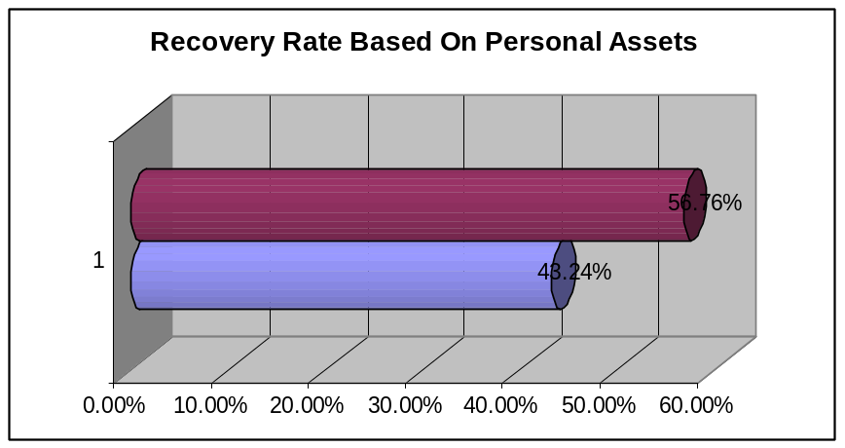
Sources: Questionnaire survey
Fig: 23. Recovery Rate Based On Personal Assets.

From the above chart we see that entrepreneurs having retail business have a less recovery rate than the entrepreneurs having whole sale business. This may happen because whole sale business transactions happen at a large scale. So they can convert their stocks as well as accounts receivables into cash very quickly before the occurrence of any misfortune. On the other hand, retail business transactions happen at a small lot. So they cannot make swift conversion of their current asset in to cash.

Major Findings

7. Findings

BRAC bank, as we know, is one of the fastest growing banks in Bangladesh. SME banking which has made the performance of this bank so enlightened is its core product to offer to the small and mediocre business entrepreneurs. In fact no businessman could think ever before that they could take loan so easily, without any collateral and without going to bank. But Brac Bank has made this improbable process so successfully through SME banking.
How ever from the analysis of SME loan repayment behavior I can make the following findings:
Age have a significant impact on the recovery of SME loan. Young entrepreneurs have a lower rate of recovery. On the other hand as middle aged and experienced entrepreneurs are very loyal with their loan repayment they can make proper and timely repayment of their loans. And that’s why most of the SME loan borrowers age rages from 30 to 40.
Education does not have any direct relationship with the recovery rate. In fact, Most of the entrepreneurs of retail and whole business (small or medium in size) are not highly educated. Most of them studied up to class 9 or 10. Sometimes there are some entrepreneurs who have only alphabetic knowledge or who can give their signature only. But still they are running their business so well for many years. In this case experience makes them successful in their business. So, education does have much impact on these small and medium enterprises and also on the recovery rate of SME loans.
Experience is the most significant variable which has a great impact on any kind of business and recovery rate as well. Experienced entrepreneurs run their business so tactfully, identify the exact time what is their pick time of sales and when they need fund. They take the loan in the pick season when they have excess demand but short of capital. Then they ensures the best use of the loan and finally they reach to success and make the dully installments. So their recovery rate is good and that’s why Brac bank looks always for experienced entrepreneurs.
Number of installments (term of loan) and amount of loan taken do affect recovery rate slightly. But trends show that BRAC bank prefers to disburse loan of an amount of 300000 and at a term of 18 to 24 months.
Another variable affecting recovery rate very much is the income of the borrowers. The higher the existing income of the borrowers, the lower the rate of default. Higher income groups make the best use of the loan they have taken and get success. On the other hand lower income group may misuse the loan and ultimately may default in paying installments.

Personal or family asset might have some impact while sanctioning the loan as well as when recovering the loan installments. Suppose if a borrower fails to pay one of his installments, bank can find his personal assets as back up for the recovery of the installments.
Retail business and whole sale business both types of businesses get loans from Brac Bank but whole sellers have a higher recovery rate as their business transactions occur at lot size and their collection is much quick.
Finally we can say that SME loan is a loan given especially to entrepreneurs who are experienced small or medium businessmen, more or less middle aged, at least moderate income generated and who have reasonable personal or family asset. That’s why their recovery rate is so high that is 97%. And their default rate is so small compared to other loan categories. Sometimes borrowers go for early settlements of their loans.

Recommendation

8.0. Recommendation
Considering all the findings and analyzing all the data the following recommendations are made, which will benefit both BBL and its customers.
- As we have seen that 11pm to 5pm is the main rush hour, so necessary CSA’s should be allocated in that time. From the customers’ suggestions we also found that it is very needed to increase the proper allocation of manpower to improve the service quality.
- The number of telephone/mobile should increase so that customers can call at daytime. Telephone/mobile busy related troubles should be decreased.
- The authority should minimize the problem solving duration and call waiting duration so that the overall customers’ satisfaction increases.
- Another very important thing from my personal observation is that one person calls for several times for the same problem, which increases the call frequency. Proper assurance and solution over phone can a better alternative to reduce extra calls and it also reduce the call waiting duration.
- It was found that the DSAs (Direct Sales Agents) are mostly the source of providing miss information to the cardholders about their cards. So, necessary steps should be taken so that they avoid this practice and give proper product information.
Only understanding the customer problem will not highly satisfy them unless individual attention and caring highly satisfy them. So proper individual attention and caring should be more to highly satisfy customer.
- The service providers should give their best keeping in mind that all kind of customers can get the service. Because most customers think that all the customers can avail this benefit.
- From the CSAs some body should make supervisors and they should give the responsibilities in different areas (currier, lost card, statement etc). It is very good news that for every evening shift there is one supervisor. But the concept of supervisor should change from shift wise to task wise.
Proper monitoring the activities of the call center could be better solution for handling queries.
- The CSAs should provide more information to the cardholders so that their learning level become high resulting the high customers satisfaction.
Considering the age of “24 – hour customer service” we can compare it with a new born baby. Therefore, like that baby the authority of the “24 – hour customer service” should develop strategic planning taking lessons from the past. They have to remember that the now customers have more choice and many alternatives.
At the very end of the ‘internship program’ working three months, it can be expected that these above recommendations will help to rearranging some infrastructures, which will support the large customers based service of credit card division of BRAC Bank Limited.

Conclusion

9.0. Conclusion

In fact, BRAC Bank promotes broad-based participation in the Bangladesh economy through the provision of high quality and modern banking services. SME loan is one of such quality product through which they offer the small and mediocre entrepreneurs a quality banking services and earn the maximum profit as well. The recovery rate of this loan is 97% which is extremely good in comparison to any other bank’s recovery rate. Brac Bank has made it possible as the loan is given to experienced, small and mediocre entrepreneurs most of whom are middle aged, slightly educated and having moderate income and this class of people is very loyal. But they can serve this class of customers with more commitment and loyalty and they can turn the recovery rate to 100%. For this they can make the following policy implications. Redefine mission/vision towards achievement of “Double Bottom-line”. Commit resources specifically for growth of SME business. Implement strict and continuous monitoring system of the whole recovery process. Train the Customer Relationship officers more comprehensively and realistically so that customers may not face any trouble while getting and repaying the loan. Analyze customers’ behavior that what type of customer makes default and stop giving them SME loan Risk Management department’s audit report should be more strict and reliable so that possible defaulter may not get the loan. Whether the borrowers are utilizing the loan on the right purpose should be ensured.

Bibliography

10.0. Bibliography
- Books, Publications and Journals of BRAC Bank Limited
- Valuable discussion of supervisors during the period of internship.
- Prospectus Of BRAC Bank Limited published in July 2007.
- Bangladesh Bank related websites
- Marketing Management, Philip Kotler, The millennium Edition
- Rose, Peter S. Commercial Bank Management, International Edition 1999, Irwin McGraw-Hill
- Practical knowledge from BRAC Bank Limited.

Annexure

Appendix – A
Questionnaire
On

“Customer Satisfaction: Before and After Launching 24 – hour Card Customer Services” and sme loan recovery purpose.
Dear respondent, I am doing my internship in BRAC Bank’s AOD department. For my internship report I need the following information. I am ensuring you that I will use this information only for the purpose of writing my internship report. Please fill in this questionnaire.

- In which occupation are you involved?

Business man | 18
Service holder | 9
Work in a bank | 5
Others | 5

- Could you please tell me in which group age recovery the sme loan?

Age group | Frequency
21-25 | 1
26-30 | 4
31-35 | 9
36 -40 | 9
41-45 | 7
46 –50 | 4
51 to above | 1

- What is your educational?

Education | Frequency
Alphabetic-5 | 8
6 to 10 | 20
11-15 | 9

- Do you have any idea/ knowledge about the BRAC bank recovery period?

Experience(year) | frequency
1to5 | 13
6to 10 | 9
11to 15 | 5
16 to 20 | 6
20 above | 4

5. What is your credit limit for the SME loan?

Amount | frequency
200000 | 4
250000 | 1
300000 | 12
350000 | 2
400000 | 6
4500000 | 1
500000 | 10
850000 | 1

6. Do you know about the installment of the SME loan ?

Term of month | frequency
15 | 3
18 | 3
21 | 10
24 | 11
27 | 1
36 | 5
48 | 4

7. What is your monthly income?

Income group | frequency
1000 -10001 | 5
10001-20000 | 15
20001-30000 | 8
30001-40000 | 1
40001-5000 | 3
50000 above | 5

8. If you take loan what kind of mortgage keep to the bank?

Personal asset | frequency
100000-500000 | 9
500001-1000000 | 14
1000001 | -
1500000 | 5
1500001 | -
2000000 | 3
2000000 above | 7

9. Which business recovery rate high?

Nature of Business | Frequency
Whole sale | 16
retail | 21

10. What type of query do you usually do in this bank regarding credit card service?

Queries
Address changes | 5
Balance enquiry | 7
Application status | 3
Authorization | 5
Card activation | 9
Card related | 5
other | 3

11. After launching 24 hrs customer service queries it has become easier for the customers to get information or solving problems than the past –the statement is:

Strongly true | True | Neutral | False | Strongly false
15 | 4 | 3 | 8 | 7

12. Do you think we can satisfy you more than before the 24-hr customer service was launched?

Extremely satisfied | Somewhat satisfied | Neutral | Somewhat dissatisfied | Extremely dissatisfied
21 | 6 | 4 | 5 | 1

13. When do you call here most?

- 7 AM – 11 AM
- 11 AM – 3 PM
- 3 PM – 7 PM
- 7 PM – 11 PM
- 11 PM – 3 AM
- 3 AM – 7 AM

14. If I ask you to rank the over all satisfaction regarding the quality of the service, please tell me your desired rank.

Before 24hrs customer service | 17
After 24 hrs customer service | 20

15. Why did you say that?

Before:…………………………………………………………………………………………………………………………………………………………………………………………………………………….…………………………………………

After:………………………………………………………………………………………………………………………………………………………………………………………………………………………………………………………………….

- Have you ever faced any trouble in inquiring over telephone?

Yes | 1
No | 2
Yes, what .....................................................................…...................................................................
……………………………………………………………………….
- Please tell me your opinion of getting services in different areas before 24-hrs customer service
Services | Before 24 hrs customer services
Adequate time provided to know problems | 3
Right info. provided | 4
Their behavioral attitude | 2
Problem solving duration | 4
Call waiting duration | 4
Your learning level (Are you learning or informed more?) | 8
Knowledge and professionalism of the staff | 12

- Please tell me your opinion of getting services in different areas after 24-hrs customer service?
Services | After 24 hrs customer services
Adequate time provided to know information | 2
Right info. provided | 4
Their behavioral attitude | 6
Problem solving duration | 5
Call waiting duration | 4
Your learning level (Are you learning or informed more?) | 6
Knowledge and professionalism of the staff | 10

19. Do you think 24 – hour service is essential for cardholders?

Extremely unessential | 2
Somewhat unessential | 5
Neither essential nor unessential | 5
Somewhat essential | 10
Very much essential | 15

20. Which credit card are you holding?

Silver | 17
Gold | 20

21. Do you think the number of phone should be increased?

Extremely not needed | 3.
Somewhat not needed | 5
Neither needed nor unneeded | 6
Somewhat needed | 7
Very much needed | 16

- For how long have you been with this bank?
……………… Months. …………………Years
23. What kind of customers do you think will be the mostly benefited by this 24hrs-customer service?
………………………………………………………………………………………………………………………………………………………………………………………………..………………..……………………………………………………
24. We want to improve this 24 hrs customer service. How do you think it should be improved?
………………………………………………………………………………………………………………………………………………………………………………………………..………………..……………………………………………………
Row table
Appendix: B

- Relationship of recovery rate with age of the borrowers:

Age group | Frequency | Recovery rate(%)
21-25 | 1 | 3%
26-30 | 4 | 11%
31-35 | 9 | 25%
36-40 | 8 | 22%
41-45 | 7 | 19%
46-50 | 4 | 11%
51+ | 3 | 9%
Total |  | 100%

2. Relationship of recovery rate with education of the borrowers:
Education | Frequency | Recovery rate(%)
Alphabetic-5 | 8 | 21.62%
6 to 10 | 20 | 54.06%
11 to 15 | 9 | 24.32&
Total |  | 100%

3. Relationship of recovery rate with experience of the borrower:

Experience(year) | Frequency | Recovery rate(%)
1 to 5 | 13 | 35.14%
6 to 10 | 9 | 24.33%
11 to 15 | 5 | 13.51%
16-20 | 6 | 16.22%
20 above | 4 | 10.80%
Total |  | 100%

4. Relationship of recovery rate with amount of loan taken:
Amount of Loan | Frequency | Recovery rate(%)
200,000 | 4 | 10.81%
250,000 | 1 | 2.70%
300,000 | 12 | 32.44%
350,000 | 2 | 5.41%
400,000 | 6 | 16.22%
450,000 | 1 | 2.70%
500,000 | 10 | 27.02%
850,000 | 1 | 2.7%
Total |  | 100%
5..Relationship of recovery rate with term of loan:
Term Of Loan(Month) | Frequency | Recovery rate(%)
15 | 3 | 8.11%
18 | 3 | 8.11%
21 | 10 | 27.03%
24 | 11 | 29.73%
27 | 1 | 2.7%
36 | 5 | 13.51%
48 | 4 | 10.81%
Total |  | 100%

6.Relationship of recovery rate with income of the borrower:

Income group | Frequency | Recovery rate(%)
1000-10000 | 5 | 13.51%
10001-20000 | 15 | 40.54%
20001-30000 | 8 | 21.62%
30001-40000 | 1 | 2.7%
40001-50000 | 3 | 8.11%
50000 above | 5 | 13.52%
Total |  | 100%

7. Relationship of recovery rate with the personal asset of the borrower:

Personal asset | Frequency | Recovery rate(%)
100000-500000 | 9 | 24.33%
500001-1000000 | 13 | 35.13%
1000001-1500000 | 5 | 13.51%
1500001-2000000 | 3 | 8.11%
2000000 above | 7 | 18.92%
Total |  | 100%

8. Relationship of recovery rate with the Nature of business:

Nature of business | Frequency | Recovery rate(%)
Whole sale | 16 | 43.24%
Retail | 21 | 56.76%
Total |  | 100%

