Submitted by

WWW.ASSIGNMENTPOINT.COM

Consumer banking, in other words banking for man-in-the street has been in prevalence in the western world since long which may be traced back in the sixties of the last century. In the Southeast Asia it has emerged as one of the popular vehicles for credit providing activities by the bankers in the seventies. With the passage of time consumer banking has become popular in those areas of the world and its scope of operation has been widened to a considerable extent.

Prime Bank Limited is one of the leading banks in Bangladesh. Since its inception in the year 1995, the Prime Bank Limited has earned tremendous popularity and credibility among the people for its service.

Banks are providing various schemes for clients. Consumers Credit Scheme(CCS) is one of them. Consumers Credit Scheme(CCS) of Prime Bank Limited is gaining more and more popularity which is functioning from the very inception of the bank.

Prime Bank Limited is one of the principal banks who are offering Consumers Credit Scheme(CCS) for the people. It is very helpful to people specially for middle class people and lower middle class people. Under this scheme people can take loan to buy household goods. By installment basis they can repay the loan. As total loan amount is repaid on installment basis it puts less pressure on consumer.

Under Consumers Credit Scheme(CCS) people can take loan from banks and can buy their necessary goods. For limited income group Consumers Credit Scheme(CCS) is very helpful. Prime Bank Limited wants sustainable growth and continue to meet social obligations. Day by day the number of consumers in Prime Bank limited increases which indicates potentiality of the scheme.

I have taken Prime Bank Limited, and four other private sector bank to make a comparison between Consumers Credit Scheme(CCS) of these.

Origin of the Report
This report entitled "Consumer Credit Scheme of Prime Bank Limited:A Comparative Study" originated from the partial fulfillment of the internship program. I have completed my internship at Prime Bank Limited, Banani branch, Dhaka. This report has been prepared under the supervision of Mr.Waquar Ahmad, Associate Professor of Finance Department, University of Dhaka.

Rationale of the study
In Bangladesh consumer banking concept in a different flavor started sometime in late eighties which has now become a very popular area of the country’s banks’ credit operation. Here scope of operation of consumer banking is very limited to the fixed income bracket people in acquisition of consumer durables by them through bank financing. That is why, it is better called consumer credit scheme. From the name it means credit operation of a type being carried out by bankers extended to people having limited and fixed but regular income for acquisition of household articles and other assets for personal use.
.
Realizing the importance of providing quality credit services in the competitive Banking sector, I have selected my report title as - "Consumer Credit Scheme of Prime Bank Limited: A Comparative Study".

Objective Of the Study

- To o give an overview on Prime Bank Ltd. and its services.
- To detail the Consumer Credit Scheme (CCS) Of PBL and its Consumer Credit Operation System.
- To perform a comparative analysis on CCS of PBL and those other private banks.
- Finding out the shortcomings of the Bank in its CCS operations and providing some Recommendation.

Methodology of the study

This research of which major objective is to describe the comparative study of customer service quality and how well the customers are accepting the services, is a single cross sectional design where preliminary information is gathered only from the existing clients (account holder) of Prime Bank Limited, The Premier Bank Limited, Dutch Bangla Bank Limited, National Bank Limited and BRAC Bank Limited to whom the quality of services is provided.
Primary Sources of Data Collections are:
- Face to face conversation with the bank officers.
- Some Questionnaire survey with the customers is made at Prime Bank Limited, The Premier Bank Limited, Dutch Bangla Bank Limited, National Bank Limited and BRAC Bank Limited.
- Observing various organizational procedures.

Secondary Sources of Data Collections are:
  - Annual Report and website of Prime Bank Limited.
  - Different publications regarding banking functions.
  - Internet.
It has been preferred simple random sampling technique in this research. The sample size of this research is 100. Each responding is given a questionnaire to fill in. the survey method used in this study is primary data collection tool. Certain objectives are examined using secondary data.

Scope of the Study

My assigned work was limited by the report topic to observe and collect information on Consumer’s Credit Scheme of different private sector banks. For this I have collected data and information on Consumer’s Credit Schemes of four private sector banks, along with Prime Bank Ltd. These are as follows:

- Dhaka Bank
- BRAC Bank
- First Security Bank Limited
- Standard Chartered Bank.

I have selected these banks not on the basis of their size, but on the basis of the market acceptability of their Consumer’s Credit Scheme.

Limitations of the Study

In preparing this report, I faced some unavoidable problems. Due to these problems, in spite of my maximum effort there may be some lacking or misleading data. These problems are:
- Observing and analyzing broad performance of PBL and one of its branches is not an easy job by this short duration of time (only three months).
- As I am a not an employee of PBL, some data could not be collected due to internal security of the bank.
- Collecting information on Consumer Credit Scheme from other banks was very tough.
- Because of shortage of employees in Banani Branch of PBL I had to work as a full time officer from 9a.m. to 7p.m. on every working day. so I didn’t get chance to give enough effort in preparing this report.
- Since there is no marketing department in this branch, I could not enrich my report with information on marketing procedures and promotional stategies of Prime Bank Ltd.

Chapter – 2
Organization Overview

Historical Background of PBL

In the backdrop of economic liberalization and financial sector reforms, a group of highly successful local entrepreneurs conceived an idea of floating a commercial bank with different outlook. For them, it was competence, excellence and consistent delivery of reliable service with superior value products. Accordingly, Prime Bank Ltd. was created and commencement of business started on 17th April 1995. The sponsors are reputed personalities in the field of trade and commerce and their stake ranges from shipping to textile and finance to energy etc.

As a fully licensed commercial bank, a highly professional and dedicated team is managing Prime Bank Ltd. with long experience in banking. They constantly focus on understanding and anticipating customer needs. As the banking scenario undergoes changes so is the bank and it repositions itself in the changed market condition.

Prime Bank Ltd. has already made significant progress within a very short period of its existence. The bank has been graded as a top Class bank in the country through internationally accepted CAMEL rating. The bank has already occupied an enviable position among its competitors after achieving success in all areas of business operation.

Prime Bank Ltd. offers all kinds of Commercial Corporate and Personal Banking services covering all segments of society within the framework of Banking Company Act and rules and regulations laid down by our central bank. Diversification of products and services include Corporate Banking, Retail Banking and Consumer Banking right from industry to agriculture, and real state to software.
The bank has consistently turned over good returns on Assets and Capital. During the year 2005, the bank has posted an operating profit of Tk.1520.34 million and its equity funds stood at Tk. 2808 million. Out of this, Tk. 1400 million consists of paid up capital and Tk. 1055.98 million represents reserve fund. The bank's current capital adequacy ratio is 9.96%. In spite of complex business environment and default culture, quantum of classified loan in the bank is very insignificant and stood at less than 0.96%.
Prime Bank Ltd., since it's beginning has attached more importance in technology integration. In order to retain competitive edge, investment in technology is always a top agenda and under constant focus. The past performance gives an indication of strength.

Whatever the transaction and customers need, PBL has tried to build long-term relationship. It is through these relationships that PBL has come to understand its customers and build value for them. Special counters are usually opened to meet the service demand of customers during heavy customers flow. Prime Bank limited believes that it gives its customers a world-class banking service through an IT based network of 47 branches.

Objective of the Bank

Prime Bank limited is designed to provide commercial investment bank services to all type of customers ranging from small entrepreneurs to big business firms. In this regard, it gives emphasize on the priority sector of the economy like industry, housing and self- employment. Besides, the bank aims to provide different customer friendly deposit and loan products to fulfill the banking needs of the individual customers.

The Vision of the Bank
To be the best Private Commercial Bank in Bangladesh in terms of efficiency, capital adequacy, asset quality, sound management and profitability having strong liquidity.

Mission of the Bank
- To build Prime Bank Limited into an efficient, market driven, customer focused institution with good corporate governance structure.
- Continuous improvement in business policies and procedures through integration of technology at all levels.

The Strategic Priorities of the Bank
To have sustained growth, broaden and improve range of products and services in all areas of banking activities with the aim to add increased value to shareholders investment and offer highest possible benefits to the customers.
Core Values of the Bank
For the customers:
To become most caring Bank – by providing the most courteous and efficient service in all area of business.

For the Employees:
By promoting the well – being of the members of the staff.

For the Shareholders:
By ensuring fair return on their investment through generating stable profit.

For the Community:
By assuming the Bank’s role as a socially responsible corporate entity in a tangible manner through close adherence to national policies and objectives.

Deposit Mix, Sources of Capital & Expenditure

Deposit mix of PBL at the end of the year 2006 is:
Current & other Deposits (15.10%)
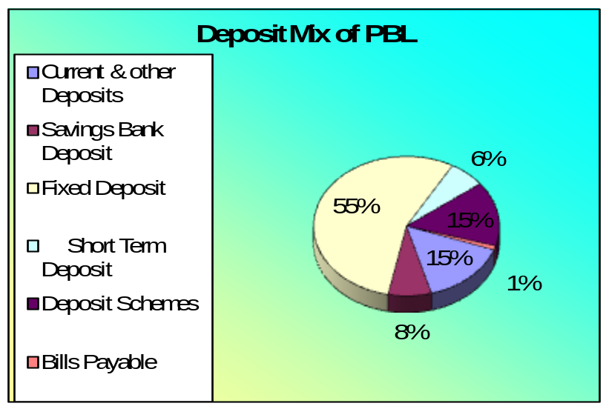 Savings Bank Deposit (7.53%)
Fixed Deposit (55.07%)
Short Term Deposit (6.34%)
Deposit Schemes (14.99%)
Bills Payable (0.97%)

The major sources of fund of PBL at the end of the year 2006 are:
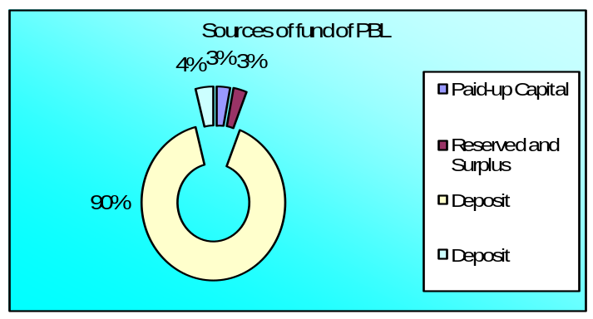a. Paid-up Capital
b. Reserved and Surplus
c. Deposit
d. Other Liabilities

The Bank uses its funds in following sectors up to the end of the year 2006:

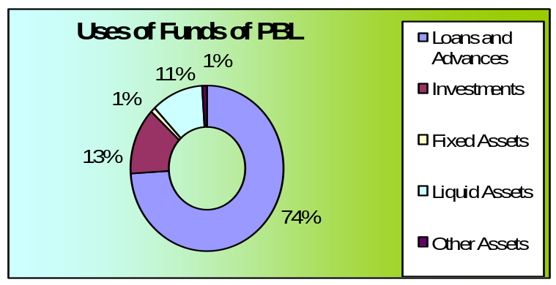 a. Loans and Advances
b. Investments
c. Fixed Assets
d. Other Assets
e. Liquid Assets

Credit Portfolio of PBL at the end of the year 2006 is:
- Small & Medium Enterprise
- 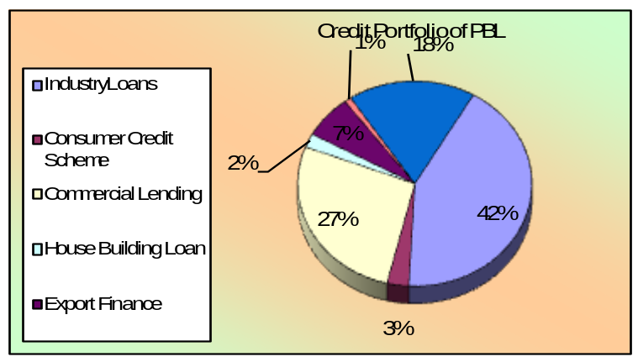Consumer Credit Scheme
- Commercial Lending
- Industry Loan
- House Building Loan
- Export Finance
- Others

Chapter – 3
Topic Analysis & Description

History of CCS of Prime Bank Limited

Consumer credit is the credit which is provided to people having fixed but regular income for acquiring consumer durables and other assets for personal use to service from their monthly income. Consumer Credit is a collateral free credit and backed by the monthly income of the loanees and guarantors acceptable to the bank.

Consumers Credit Scheme(CCS) is very helpful to limited income group. Prime Bank Limited want sustainable growth and continue to meet social obligations. For this they introduce Consumers Credit Scheme(CCS).Prime Bank Limited started Consumers Credit Scheme(CCS) since its inception in the year 1995.

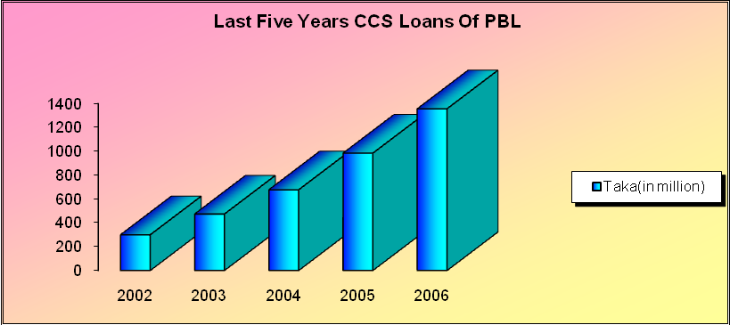

The above graph shows last five years allocation in Consumer Credit Scheme of Prime Bank Limited. It evident that day by day the number of consumers loan in Prime Bank limited is increasing. It is a clear indication of popularity and potentiality of this scheme. It becomes very popular to people especially to limited income group. It has been possible to reach this height of the market image and reputation of the bank because of this CCS. This covers wide range of people belonging to fixed income group.

Objectives of the Scheme

- To broaden the base of credit portfolios.
- To ensure access to credit by mass people as far as possible.
- To introduce and carry on collateral free credit operation.
- To diversify the credit portfolio so as to minimize the extent of delinquency.
- To improve the standard of living of the fixed income bracket people.
- To take part in the socio-economic development of the country.
- To enhance the purchasing power of the people by providing credit.
- To arrest delinquency rate which is one of the major problems in the banking sector of the country.
- To establish a participatory economic system in the country
- To enhance the base of beneficiaries of banking services.

Salient Features of CCS

- This is the loan which is provided to people to acquisition of goods for personal use
- This is collateral free loan
- This is loan which is based on personal guarantee against collateral security in case of general loan.
- This loan is provided to fixed income group of people.
- Security against this loan is personal guarantee and post dated cheques.
- This is a term loan repayable in installments convenient to customers.

Target customers:

The following are customers who are targeted to be marketed for CCS

- The officers of different public bodies.
- The executives and officers of nationalized commercial banks.
- The officers and executives of private commercial banks.
- The officers and executives of non-banking financial institutions and insurance companies.
- The officers and executives of multinational companies.
- The officers and executives of public limited companies, conglomerates of good repute acceptable to bankers.
- The self-employed persons acceptable to bankers.
- The professionals namely doctors, engineers, accountants, lawyers etc. However, Accountants and lawyers should be discouraged as far as possible.

Eligibility of Consumers

The above people who have fixed and regular monthly income with sufficient take home salary to repay the loan.
Following employees can get loan under CCS if he/she is within the age limit :
- Self employed persons who have regular and monthly fixed income with repayment capacity .
- Non-officers are also considerable on case to case basis to get CCS loan.

Consumer or personal credit is comprised of advances made to individuals to enable them to meet expenses or to purchase, on a deferred- payment basis, goods or services for personal consumption.

Such credit may be used not only to obtain consumer goods or services but to refinance debts which originated when such purchases were made. Consumer credit includes all credit granted for these purposes, whether it is extended by various financial, institutions, retail merchants, manufacturers, or by other service organizations.

This definition does not include mortgage credit on real estate or other types of investment credit which may be retired by regular investment payments.

Age Limit for being a consumer of CCS

- Minimum Age : 25 years
- Maximum Age : 60 years

Discouraged list of loanees:

The following are the people who should be discouraged in extending credit facilities under this scheme:

- The employees whose jobs are frequently transferable.
- The employees of enterprises which are not of good repute.
- Employees having take home pay less than Tk.10, 000 per month.
- Lawyers should be avoided.

Scope of consumer credit operation:

Consumer credit scheme is limited to the Section of people which has a fixed but regular monthly income to service the loan there from in easier installments. As a matter of fact, the people who are in the employment in public and private organizations having salary and allowances sufficient to service the loans in monthly installments are provided consumer credit. However, self-employed people are also provided this credit facility as per judgment of the bankers.

Eligible Items

Prime Bank Limited gives loan under Consumer Credit Scheme (CCS) to buy following items:

- Car Loan
- Doctors Loan
- Household Durable Loans
- Marriage Loan
- Any Purpose Loan
- Education Loan
- Hospitalization Loan
- Advance Against Salary
- Travel Loan
- CNG Conversion Loan

Credit Limit

Loan amount is different for different people. Loan is given for 80% of the given quotation. Amount of credit shall be allowed keeping in view the repayment capability of the customer. The amount of credit shall be determined in such a manner that monthly installment does not exceed 50% of the disposable income (take home salary/ income) of the customer. The monthly installment size will not exceed one third of the take home salary for non- officers only so as to enable the customer to repay the loan easily. Installment size also depends on the loan amount of concerned consumer.

Loan limit, down payment and period of loan of different items are presented in the following table:

Name of Item | Loan Limit | Head office Credit Committee | Period Of Loan  (Maximum)
Car (new) | Tk.20,00,000.00 | Up to 15.00 lac | 4 Years
Car (reconditioned) | TK.20,00,000.00 | Up to 15.00 lac | 4 Years
Household durables (Other items) | TK. 5,00,000.00 | 5.00 lac | 2 Years
Doctors Loan (Specialist) | TK.1,00,000.00 | 10.00 lac | 2 Years
Doctors Loan (General) | TK.5,00,000.00 | 5.00 lac | 2 Years
Salary | Tk.3,00,000.00 | 3.00 lac | 2 Year
Any Purpose | Tk.1,50,000.00 | -- | 2 Year
Education | Tk.3,00,000.00 | 3.00 lac | 2 Year
Travel | Tk.2,00,000.00 | 2.00 lac | 2 Year
Marriage | Tk.3,00,000.00 | 3.00 lac | 2 Year
Hospitalization | Tk.3,00,000.00 | 3.00 lac | 2 Year
CNG | Tk.60,000.00 | -- | 2 Year

Further Loan

After repayment of 75% of the credit allowed to a customer, he/she will be eligible for fresh credit under the scheme but the total amount of credit shall not exceed the ceiling under any circumstances.

Rate of interest & charges:

Simple interest rate is 16% and service charge is 1%. Apart from these, there is risk fund on total amount of loan at the time of disbursement of loan. Though simple interest rate is 16% effective interest rate is lower than this. As installment is paid interest rate reduces because interest is charged on the residual amount. So, higher interest rate is charged at initial stage and lower interest rate at later stage.

In following table rates of interest, service charge, risk fund and cost of stamp are present

Particulars | Rate | Mode of Recovery
Service Charge | 1% of Loan amount | 16% P.A.
Risk Fund | 1% on loan amount | Cash deposit at the time of disbursement
Cost of Stamps | Tk.600/- | Cash deposit at the time of disbursement

Service charge, risk fund and stamp charges have to be paid at the time of disbursement of loan. Monthly installment has to be paid within 7th day of each month. All branches transfer their entire outstanding balance in risk fund on regular basis to Financial Administration Division, Head Office at the end of every month through IBCA along with a statement as per existing practice.

If there is any license fee, registration fee, insurance charge etc. then customer will bear those. Customer will bear the expenses for necessary repair and maintenance of the articles during the period of loan. The articles shall remain in sole control and custody of the customer who will not let out, lend, resell or transfer the possession or rights of the same to a third party under any circumstances.

Mode of Repayment

Repayment will start from the following month of the disbursement of loan. Repayment of loans including accrued interest will be made by equal monthly installments. Before disbursement of loan, the customer will deposit crossed cheque covering the total number of monthly installments in favor of the bank which will have to be presented for collection on the due dates. Installments will be paid within 7th day of each month. Default in payment of 3(Three) consecutive installments shall render the client liable to handover the articles to the bank. Pre-payment is allowed. The client may repay the entire outstanding amount in lump sum before expiry of validity period of the loan.

Rebate

If customer repays the loan installments regularly as per schedule of payments of loan then he is allowed to get 5% rebate on the interest charged. Branch may refund the calculated rebate amount at the time of adjustment of the loan.

Rules for Application

Interested clients will have to apply for the credit in bank’s printed application form, which will be available in respective branch or any other authorized agent on payment of fifty taka only. Clients will submit the application form duly filled-in with one photograph and signed along with quotation(s) for purchase of desired articles.
The customer’s name/other name(s) including nickname, if any, should be mentioned in every loan application.

Processing of Application

First Phase:

Branch examines the credibility of the customer. On proper scrutiny of the application, branch will take the initial decision. Customers have to give a quotation of the product from the supplier. This initial decision is to be informed to the applicant within 3(Three) working days from the date of receiving application by branch CCS cell. After this second phase comes.

Second Phase :
In second phase branch will provide additional papers to the applicants whose applications are accepted for processing as following:

- Particulars of Guarantor form ;
- Letter of Guarantee ;
- Personal Net-Worth Statement for Businessman/Professionals.

Applicants will submit the above forms duly filled-in with the following additional papers

- Salary Certificate for service holder ;
- Trade license and TIN Certificate(if any) for Businessman ;
- TIN Certificate of applicants for vehicle loan ;
- Attested photocopies of current Tax Receipt, Electric bill etc. & lease agreement (if any) when the source of income o house rent as a landlord.

For proper scrutiny, branch will inspect the given information. This is needed to find out eligibility, feasibility and security. After completion of all necessary formalities, branch shall disburse the loan or decline the proposal within 7(Seven) working days from receiving the additional papers.

Customers have to give a quotation of the product to the branch. 20% have to be borne by the customer and 80% is given as loan under CCS. Price of the items (Down payment + Loan amount) should be given to the respective supplier through payment order after completion of necessary documentation.

Security Measures

Before disbursement of loan, the customer will deposit crossed cheque covering the total number of monthly installments in favor of the bank which will have to be presented for collection on the due dates. For security purpose customers have to give some personal guarantee/Bank guarantee/ Insurance guarantee.

The customer will provide following personal guarantee/Bank guarantee/ Insurance guarantee according to the Bank’s prescribe forms/financial instruments:

Nature of Security | Number/  Quantity | Particulars
Personal Guarantee | 01 | For Employees of Govt. Semi-Govt. & Corporate Organization.
Personal Guarantee | 02 | For Businessman and Employees of Non Corporate Private Organization.
Financial Instruments | 50% | Personal Guarantee will be waived.
Bank Guarantee | 100% | Personal Guarantee will be waived.
Insurance Guarantee | 100% | Personal Guarantee will be waived.
Ownership for Vehicles |  | In the name of the Bank.
Insurance for Vehicles |  | Comprehensive coverage from insurance companies (acceptable to Bank)
Corporate Guarantee |  | For Corporate arrangement with Head Office approval.

After that the bank/insurance guarantee should be authenticated to the satisfaction of the Branch Manager and financial instruments (FDR, PSP etc.) shall be duly discharged by the holder in favor of the bank. The articles procured under the scheme shall remain hypothecated to the bank as security.

To avoid embarrassment where the guarantor is the Head of the institution/office, his particulars shall be verified solely by an officer of the bank. The fact & circumstances should be recorded in the file.

Guarantor’s photograph will be obtained from each guarantor. If the guarantor is a senior government official/company executive, the condition for collection of photographs from such official/executive be relaxed and reasons therefore should be noted in file.

Documents to be Obtained

At the time of disbursement of loan, customer will have to execute some documents.
The documents are:
- Demand Promissory Note ;
- Letter of Authority ;
- Letter of Guarantee ;
- Loan Agreement under Consumer Credit Scheme ;
- Letter of Hypothecation ;
- Letter of Disbursement ;
- Agreement/Arrangement ;
- Undertaking ;
- Declaration;
- Insurance Policy (Applicable for Car)

Central CCS Unit

Consumers Credit Scheme (CCS) becomes very popular to people especially to limited income group. It is comparatively more remunerative to the bank. There is ample scope to expand the credit under the scheme. CCS becomes very much beneficial to certain people, for which it is not possible to buy goods at a time. If they can get loan they can buy the product on installment basis and can increase their standard of living. For this reason the number of consumers increases day by day. In order to boost up the Credit portfolio under “Consumers Credit Scheme(CCS)” , it has been necessitated to re-organize the “CCS” activities and reconstitute a “ Central CCS Unit ” at Head Office with a view to ensure the following :
- Prompt decision/approval of loan under CCS ;
- To reduce the burden of the branches for marketing and sanctioning CCS loan ;
- To make special efforts for recovery of stuck up loans and
- To strengthen the monitoring drive as well as supervision for recovery of Bank’s dues and thereby strengthen the Credit Portfolio.

Formation of Central CCS Unit

A central CCS unit will be established at Head Office. The unit will have a separate office. A Vice President or Senior Assistant Vice President will be the head of this unit. A team consisting with senior officers, principal officers will support to the unit head.

Responsibilities of the Central CCS Unit

- It will act as a separate profit earning unit of Head Office ;
- It will be an operating organ of Credit Division, Head Office ;
- The Head of CCS unit shall be under administrative control of the Senior Executive Vice President, Credit Division.
- Initially the Central CCS Unit will operate CCS loans of the following 14(Fourteen) Branches :

- Motijheel Branch ;
- IBB Branch ;
- Mohakhali Branch ;
- Gulshan Branch ;
- Elephant Road Branch ;
- Mouchak Branch ;
- Kawran Bazar Branch ;
- New Eskaton Banch ;
- Dhanmondi Branch ;
- Uttara Branch ;
- Moulavi Bazar Branch ;
- Bangshal Branch ;
- Foreign Exchange Branch;
- Banani Branch;

- All other Branches of the Bank shall report to the central CCS unit for their business result and submit CCS related returns regularly for MIS.

Job Description of the proposed unit

Central CCS unit will perform many duties. To identify the potential customers, and to focus the features of the scheme to create demand for purchasing household durable availing loan under the scheme. After receiving loan applications the central CCS unit shall make preliminarily scrutiny.

The following responsibilities will be vested with the unit :
- Marketing
- Loan Sanctioning
- Recovery of CCS loans of Dhaka City branches
- Follow up, monitoring and supervision

There will be 3(Three) teams consisting of 2(Two) officers in each team who will perform the above mentioned activities on rotational basis. They will keep record of their daily activities/performance in a separate register.

Job description of the Central CCS Unit

According to responsibilities the job description of the Central CCS Unit, Head Office shall be as under:

- Marketing :
Officers have to identify the potential customer for consumer credit. For this and to focus the features of the scheme, to create demand for purchasing household durable availing loan under the scheme. The respective officers of the unit will go to different Offices, Schools, Colleges, Universities(Government & Private), Insurance Companies, Private companies, Private Clinics professionals, well established businessman and pursue the officials/employees of the above institutions/offices/companies, businessman and professionals for availing CCS loan from Prime Bank Limited. They will also work for a possible arrangement with the institutions/ offices/companies to accommodate CCS loans to their employees under the Corporate Guarantee of the concerned institutions/offices/companies. The marketing officers will pursue their solicited customers to submit their loan applications either direct to the central CCS unit or to any other nearest branch of Prime Bank Limited. The branches shall forward the applications so received to the central CCS unit immediately. In the loan application the borrower shall mention the name of the branch of the Prime Bank Limited through whom they want to took the loan. Loan will be given from that branch and officers of that branch will process the loan.

- Loan Sanctioning:

After receiving loan applications the central CCS unit shall make preliminarily scrutiny. If found feasible and bankable, the customer shall be advised for submission of further necessary papers/ information, if any.

If found not feasible, they shall decline the proposal at that stage and politely advise the applicant accordingly .The customer should be advised at one time for required papers/information instead of piecemeal advice creating dissatisfaction of the customer. They shall arrange for necessary inception, spot verification of the applicants/Guarantors addresses/offices immediately.

A Committee shall be formed in the CCS unit consisting of Head of the Unit(Chairman) and other six officers(Members). The respective loans will be disbursed through the branch mentioned by the customer. The central CCS unit complete documentation and obtain post dated cheques before issuing sanction advice to the branches. They shall maintain a sanctioning and declining register in the computer. They shall keep the document and post dated cheques in the safe under joint custody making entry in the safe-in and safe-out register.

The delegation of business power for sanction/approval of CCS loan by the Credit Committee and the CCS Committee is fixed. The limit is different for different things.

To decide whether approved or declined a meeting is held. There will be a regular meeting in every working day presided by the head of CCS unit. After detailed discussion based on the papers and inspection report the committee will sanction or decline CCS loan as per delegated authority and refer to Head Office Credit Committee for approval /decision beyond the delegated authority of the CCS Committee. The head of CCS unit will attend the Credit Committee Meetings along with the proposals and specific recommendations for approval of loan cases beyond the delegated authority of the unit. The Credit Committee will approve or decline the proposals based on the merit. After deciding whether accepted or declined it is informed to the applicant with in very short time. If approved then documentation is prepared.

Follow up, Monitoring and Supervision

The credit under the scheme is fully supervised and the success of the scheme will depend on proper and persistent supervision, follow up, persuasion and monitoring of the credits by the branches. CCS unit shall monitor and supervise the CCS loan portfolio of all the branches.

Branches shall maintain proper records of the applicants received, loans sanctioned, disbursed and recovery made thereon. Branches shall send the statements of CCS loan and the overdue list to the CCS Unit within the first week of every month. The CCS unit shall properly utilize the MIS(Management Information System) available in the existing computer program for Consumer Credit Scheme of the bank to closely monitor and supervise the scheme.

Steps Taken in case of Default Installment

Before disbursement of loan, the customer will deposit crossed cheque covering the total number of monthly installments in favor of the bank which will have to be presented for collection on the due dates. Installments will be paid within 7th day of each month. If one installment is not paid then it has become overdue. Actions are taken on the basis of default installment.

Steps taken are described below :

- If one month installment is due then concerned officer will call a phone to the client ;
- In case of installment due for two months letter is given to the client and phone is also called ;
- In case of three months phone and letter to client as well as visit is done ;
- If installment is not given within four months then letter is given to the guarantor ;
- If installment is not given within five months then legal notice is send to the client
- In spite of all these steps if installment is not given then case is sued against the client.

In case of installment due for six months the loan is treated as classified loan.

Prime Bank Limited is one of the leading banks who are offering Consumers Credit Scheme(CCS) for the people. It started Consumers Credit Scheme(CCS) since its inception in the year 1995. Under Consumers Credit Scheme(CCS) people can take loan from banks and can buy their necessary goods. For limited income group Consumers Credit Scheme(CCS) is very helpful. Under this scheme people can take loan to buy household goods. By installment basis they can repay the loan. As total loan amount is repaid on installment basis it puts less pressure on consumer.

Consumers Credit Schemes(CCS) of PBL

Prime Bank Ltd is the pioneer of CCS in Bangladesh. Considering the demand, popularity of the customer Finance products and to diversify the risk portfolio of the management of PBL reviewed and amended some of the then existing terms and conditions of Consumer Loan Products at 8th February 2005. The re-engineering consumer financing guidelines with its features, terms and conditions are discussed below:

- Personal Loan (Secured)
- Personal Loan (Unsecured)

- Personal Loan (Secured):

- Eligibility: Any person having a Current Deposit (CD), Short Term Deposit (STD), or Savings (SB) account.
- Margin: Best effort basis. Accrued interest to be serviced quarterly.
- Limit: As per delegation of power circulated by the Bank from time to time.
- Security: Lien on FDR and any other saving instruments duly discharged with letter of authority to encase of default.
- Rate of Interest: In case of FDR 2-3% above FDR interest rate. In case of other deposit 15% p.a. with quarterly interest rate.
- Period: Maximum 12 (Twelve) months.

- Personal Loan (Unsecured):

The Consumer Credit Schemes that PBL provides are of following categories:

- Household durable loan.
- Car loan.
- Doctors loan.
- Advance against salary.
- Any purpose loan.
- Travel loan.
- Education loan.
- Marriage loan.
- CNG loan.
- Hospitalization loan.

1. Household Durable Loan:

Interest Rate: 16%
Service charge: 1%
Risk Fund: 1%
Down Payment: 25%
Income: Minimum 10,000 for salaried individuals and 40,000 for businessman.
Stamp: TK. 600.
Features: Under this head, loans are sanctioned against guarantee of third parties acceptable to the bank or pledge of FDR, Savings instrument of banks and assignment of salary where applicable.
Disburse Mode: One time disbursement, but through issuing Pay order toward the seller of the household products to the customer who is getting loan from the bank.
Repayment Method: The repayment method is installment basis. The customer has to pay equal monthly installment within the loan period.

2. Car Loan:

Interest Rate: 16%
Service charge: 1%
Risk Fund: Nill
Down Payment: 25%
Income: Minimum 10,000 for salaried individuals and 40,000 for businessman.
Stamp: TK. 600.
Features: Under this head, loans are sanctioned against Registration of the vehicle in the name of the Bank. Instead of down payment, the customer have option to avail loan against their FDR or any other savings instrument up to 90% of the loan amount.
Disburse Mode: One time disbursement, but through issuing Pay order toward the seller of the automobile retailer..
Repayment Method: The repayment method is installment basis. The customer has to pay equal monthly installment within the loan period.

3. Doctors loan:

Interest Rate: 16%
Service charge: 1%
Risk Fund: 1%
Down Payment: 25%
Income: Minimum 10,000 for salaried individuals and 25,000 for self employed.
Stamp: TK. 600.
Features: Under this head, loans are sanctioned against Registration of the vehicle in the name of the Bank. Instead of down payment, the customer have option to avail loan against their FDR or any other savings instrument up to 90% of the loan amount.
Disburse Mode: One time disbursement, but through issuing Pay order toward the seller of the Medical equipment..
Repayment Method: The repayment method is installment basis. The customer has to pay equal monthly installment within the loan period.
4. Advance Against Salary:

Interest Rate: 16%
Service charge: 1%
Risk Fund: 1%
Down Payment: Nill.
Income: Minimum 10,000 for salaried individuals and 25,000 for businessman.
Stamp: TK. 600.
Features: Under this head, if loans to be sanctioned, a letter of introduction including name, father’s name, designation, date of birth, date of joining, place of posting, date of last promotion, date of retirement, basic salary, total emolument, total in PF, take home salary etc. will be required.
Disburse Mode: One time disbursement.
Repayment Method: The repayment method is installment basis. The customer has to pay equal monthly installment within the loan period.

5. Any Purpose Loan:

Interest Rate: 16%
Service charge: 1%
Risk Fund: 1%
Down Payment: Nill.
Income: Minimum 10,000 for salaried individuals and 25,000 for businessman.
Stamp: TK. 600.
Features: This scheme is to meet the emergency need for fund by fixed income group of salaried person in Bangladesh. Under this head, if loans to be sanctioned, a letter of introduction including name, father’s name, designation, date of birth, date of joining, place of posting, date of last promotion, date of retirement, basic salary, total emolument, total in PF, take home salary etc. will be required.
Disburse Mode: One time disbursement of money.
Repayment Method: The repayment method is installment basis. The customer has to pay equal monthly installment within the loan period.
6. Education Loan:

Interest Rate: 16%
Service charge: 1%
Risk Fund: 1%
Down Payment: 10%.
Income: Minimum 12,000 for salaried individuals and 25,000 for businessman.
Stamp: TK. 600.
Now –a-days, to build a career for us, we need the best education or to get higher degree either at home or abroad. and this requires a substantial amount of finance. To relieve the customers this burden, PBL offers “Education Loan” that uninterrupted study flow of cash.
Disburse Mode: The sanctioned loan amount is deposited to the client’s account with the bank from where the client can withdraw money according to his requirement.
Repayment Method: The repayment method is installment basis. The customer has to pay equal monthly installment within the loan period.

7. Travel Loan:

Interest Rate: 16%
Service charge: 1%
Risk Fund: 1%
Down Payment: 10%.
Income: Minimum 12,000 for salaried individuals and 25,000 for businessman.
Stamp: TK. 600.
When planning an overseas vacation or making trip to a chosen exotic location, financing may be the key issue. PBL has taken over that worry of their customers by offering “ Travel Loan “.
Disburse Mode: The sanctioned loan amount is deposited to the client’s account with the bank from where the client can withdraw money according to his requirement.
Repayment Method: The repayment method is installment basis. The customer has to pay equal monthly installment within the loan period.

8. Marriage Loan:

Interest Rate: 16%
Service charge: 1%
Risk Fund: 1%
Down Payment: 10%.
Income: Minimum 10,000 for salaried individuals and 25,000 for businessman.
Stamp: TK. 600.
Tying the marital knot is an event of a life time, and its celebration and memories should last forever. With this view PBL has tailored Marriage loan that enable its customers to organize and celebrate the marriage in style. This loan is only for the Bangladeshi citizens.
Disburse Mode: The sanctioned loan amount is deposited to the client’s account with the bank from where the client can withdraw money according to his requirement.
Repayment Method: The repayment method is installment basis. The customer has to pay equal monthly installment within the loan period.

9. CNG Conversion Loan:

Interest Rate: 16%
Service charge: 1%
Risk Fund: Nill
Down Payment: 10%.
Income: Minimum 12,000 for salaried individuals and 25,000 for businessman.
Stamp: TK. 600.
Through CNG Conversion Loan, PBL provides its environment conscious customers an easy financing to convert their vehicles into CNG driven vehicles.
Disburse Mode: One time disbursement, but through issuing Pay Order toward the CNG Conversion Station.
Repayment Method: The repayment method is installment basis. The customer has to pay equal monthly installment within the loan period.

10. Hospitalization Loan:

Interest Rate: 16%
Service charge: 1%
Risk Fund: 1%l
Down Payment:
Income: Minimum 12,000 for salaried individuals and 25,000 for businessman.
Stamp: TK. 600.
Disburse Mode: One time disbursement, but through issuing Pay Order toward the Hospital authority.

Repayment Method: The repayment method is installment basis. The customer has to pay equal monthly installment within the loan period.

Recovery of CCS loans

After disbursement of loans, CCS unit shall diarise the date of payment of monthly installment. Before 10 days of due date of installment, they shall give reminder to the customers. If any customer fails to deposit on due date 2nd reminder shall be given. After 7 days 3rd reminder shall be given. If installment is not deposited , CCS unit shall arrange for visit the customer personally. The unit shall sanction loan very judiciously and shall maintain very effective & strong follow-up and persuasion to ensure that no new loan sanctioned by them is defaulted. The unit shall also take necessary step to recover the stuck-up old loans of different branches. The chronic defaulter loans classified Bad and Loss shall be referred to Recovery Agent for recovery. They shall ensure 100% recovery of new loans. Old classified loans should also be recovered so that the portfolio under old loan is fully liquidated within 2007.

CCS of Other private Sector Bank

The other private sector banks are:
- Dhaka Bank
- BRAC Bank
- First Security Bank
- Standard Chartered Bank

  - Consumer Credit Products of Dhaka Bank

We dream a lot of dreams those we can’t fulfill easily. Dhaka Bank Ltd (DBL) provides its customers Consumer Credit under the scheme of Any Purpose Loan to make its customers dreams come true. DBL maintain single Consumer Credit Scheme.

Eligibility of Customers to Apply:
Any Bangladeshi citizen can apply for their loan if he or she fulfills criteria:

- At least 21 years old.
- Family income exceeds the minimum amount fixed by Dhaka Bank.
- Permanent employee of an established company with confirmed 1 year service ahead.
- Self-employed person with at least 3 years professional association.
- Business person with experience of 3 years business administration and adequate cash flow.

Loan Limit:
The loan limit under Any Purpose scheme is from Tk. 25,0000 to 5,00,000.

Loan fee:
The customer has to pay 1% processing fee of the total loan amount at the time of taking the loan. Except this, when applying for the loan, the customer has to pay Tk. 500 as application fee, which is non refundable.

Disbursement Mode:
Payment is made directly by the Bank to the vendor or to the customer, as determined by the Bank, depending upon the purpose of the loan.

Repayment Method:
The repayment method is installment basis. The customer has to pay equal monthly installment within the loan period. The customer can also choose his repayment duration (12, 24, 36 or 48 month’s installment) at his convenience.

Amount of Monthly Installment:
The number of installments and the amount that the customer has to pay at each installment against the loan amount is given in the following table:

Loan Amount (Taka) | Number of installment (Maximum)
Loan Amount (Taka) | 12 Months | 24 Months | 36 Months | 48 Months
25,000 | 2,300 | 1,225 | -- | --
50,000 | 4,550 | 2,500 | -- | --
75,000 | 6,850 | 3,670 | -- | --
1,00,000 | 9,100 | 4,900 | 3,540 | --
1,50,000 | 13,700 | 7,375 | 5,285 | --
2,00,000 | 18,200 | 9,800 | 7,040 | --
3,00,000 | 27,500 | 14,690 | 10,557 | 8,550
4,00,000 | 36,300 | 19,600 | 14,025 | 11,360
5,00,000 | 45,400 | 24,500 | 17,590 | 14,200

Documents to be obtained:
a. Common documents required from Application:
- Application fees receipt
- Passport size photo (3 copies)
- Photocopy of passport
- Income Tax receipt or TIN Certificate
- One personal guarantee from spouse and another from other spouse with photograph
- Accepted quotation from a reputed dealer in favor of Dhaka Bank
b. Additional Documents Required from Salaried Person:
- Salary Certificate
- Latest Bank Statement for last six months
c. Additional Documents Required from Professional- Self Employed:
- Professional Certificate
- Latest Bank Statement
- Proof of Professional Association Membership
d. Additional Documents Required from Business Person:
- Personal & Company Bank Statement- last 12 months
- Copy of Median and latest trade license
- MOA latest form X11.
- Certificate of Incorporation & personal latest bank statement- 12 months
- Partnership Deed (For Partnership Concern)
e. Additional Documents Required for Additional Income:
- For Spouse income – Spouse’s salary Certificate
- For Spouse income – Latest Bank Statement of Spouse
- For Property income – Copy of Lease deed or Rent Payment copy
- For Interest income – Copy of Bond and FDR Certificate
f. Additional Documents required for Car Loan:
- Accepted Quotation from a required car dealer in favor of Dhaka Bank

Security:
- Personal Guarantee by third party
- Undated Cheque
- Post- dated Cheque

  - Consumers Credit Products of BRAC BANK LTD.

BRAC Bank Ltd.(BBL) provides 7 (seven) types of unsecured personal loans under CCS.

Types Of CCS:
- Salary Loan
- Credit Card Loan
- Teachers Loan
- Top Up Loan
- Travel Loan
- Study Loan
- Aroggo Loan
Other Loans:
- Car Loan
- Any Purpose Loan

Eligibility of Customers to Apply:
Any Bangladeshi citizen can apply for their loan if he or she fulfill criteria:
- At least 21 years old.
- Any person who has the monthly income 10,000 to 40,000 Taka.
- Family income exceeds the minimum amount fixed by Dhaka Bank.
- Self-employed person with at least 3 years professional association.
- Business person with experience of 2 years business administration and adequate cash flow.

Loan Limit:
The loan limit under Any Purpose scheme is from Tk. 20,0000 to 10,00,000.

Loan fee:
The customer has to pay 1% processing fee or minimum Taka 2000, of the total loan amount at the time of taking the loan
Disbursement Mode:
Payment is made directly by the Bank to the vendor or to the customer, as determined by the Bank, depending upon the purpose of the loan.

Repayment Method:
The repayment method is installment basis. The customer has to pay equal monthly installment within the loan period. The customer can also choose his repayment duration (12, 24, 36 or 48, 60 months installment) at his convenience.

Documents to be Obtained:
a. Common documents required from Application:
- Application fees receipt
- Passport size photo (3 copies)
- Photocopy of passport
- Income Tax receipt or TIN Certificate
- One personal guarantee from spouse and another from other spouse with photograph
- Accepted quotation from a reputed dealer in favor of Dhaka Bank
b. Additional Documents Required from Salaried Person:
- Salary Certificate
- Latest Bank Statement for last six months
c. Additional Documents Required from Professional- Self Employed:
- Professional Certificate
- Latest Bank Statement
- Proof of Professional Association Membership
d. Additional Documents Required from Business Person:
- Personal & Company Bank Statement- last 6 months
- Copy of Median and latest trade license
- MOA
- Certificate of Incorporation & personal latest bank statement- 6 months
- Partnership Deed (For Partnership Concern)
e. Additional Documents Required for Additional Income:
- For Spouse income – Spouse’s salary Certificate
- For Spouse income – Latest Bank Statement of Spouse
- For Property income – Copy of Lease deed or Rent Payment copy
- For Interest income – Copy of Bond and FDR Certificate
f. Additional Documents required for Car Loan:
- Accepted Quotation from a required car dealer in favor of Dhaka Bank

Security (When applicable):
- Personal Guarantee by third party
- Undated Cheque
- Post- dated Cheque

- Consumers Credit Products of First Security Bank (FSBL)

First Security Bank Ltd. grants only short term advances under its Consumer Credit Scheme. The bases of types of CCS of this bank are the various Nature of Financing rather than the purpose of providing the loan.
Therefore, the types of Consumer Credit provided by FSBL are:
- Secured Overdraft (SOD)- FDR
- Hire Purchase
- Consumer Finance Scheme

1. Secured Overdraft (SOD) – FDR:
a. Eligibility of Customer:
Any person having a Fixed Deposit with FSBL is eligible to take the loan.

b. Loan Limit:
Loan limit is 10% to 25% on the FDR value.

c. Rate of Interest:
3% above than the FDR rate.

d. Loan Period:
Loan is sanctioned for maximum 1 (One) year.

e. Repayment Method:
Lump Sum cash deposit within the validity.

f. Security:
- Lien on FDR
- Charge Document
- D.P. Note
- Letter of Agreement
- Letter of Lien
- Letter of Authority
- Letter of Continuity
- Letter of Guarantee

2. Hire Purchase:
under this scheme of FSBL the customer has to make down payment and the rest of the purchase price are spread over the loan period. The article is regarded as the property until the final payment has been made.

a. Eligibility of Customer:
Any person having a fixed source of income or desires to pay the loan amount in lump sum is eligible to take this loan.

b. Rate of Interest:
16% on the loan amount d. Loan Period:

c. Loan Period:
Loan is sanctioned for 6 (Six) months to 2 (Two) years.

d. Repayment Method:
Lump Sum cash deposit within the validity.
e. Security:
- Charge Document
- D.P. Note
- Letter of Agreement
- Letter of Authority
- Letter of Continuity
- Letter of Guarantee

3. Consumer Finance Scheme:
FSBL provides this credit to finance purchase of consumer durable to the fixed income group to raise their standard of living.

a. Eligibility of Customers to Apply:
Any Bangladeshi citizen can apply for their loan if he or she fulfill criteria:
- Government, Semi- Government, & Autonomous bodies.
- Banks, Insurance, & other Financial Institutions.
- Permanent employee of an established company with confirmed 1 year service ahead.
- Self-employed person with at least 2 years professional association.
- Firms and Corporate bodies.

b. Loan Limit:
The amount of credit is determined in such a way that the monthly installment does not exceed 50% of the disposable income of the customer, with an maximum limit of Tk. 10 lac.
c. Repayment Method:
The customer can repay the loan amount by equal monthly installments over the loan period.

d.Rate of Interest & Other Charges:
- Application Fee : Tk. 500
- Interest Rate : 16%
- Security Charge : 1%
- Risk Fund : 1%
- Down Payment : 30%
Security:
- Charge Document
- D.P. Note
- Letter of Agreement
- Letter of Authority
- Letter of Continuity
- Letter of Guarantee
- Undated Cheque

Terms And Conditions:
- For hire purchase the durable is covered by first party comprehensive insurance policy throughout loan period and the premium for the policy of each year is to born by the client.
- Retailed facility report containing marketing, financial, technical, socio-economic aspects showing detailed break-up of project cost and other usual financial analysis duly supported by its assumption.

- Consumers Credit Products of Standard Chartered Bank (SCB)

Although SCB is a foreign bank, operating in our country as a local bank. For its local operation the bank is competing with the private sector banks of our country. SCB provides CCS to its customer under the head of “ Personal Loan” and with the sologan of “ We Believe in Living Our Dreams”.

Types of CCS:
SCB provides 5 (Five) types of Consumer Credit. These are:
- Marriage Loan
- Medical Loan
- Education Loan
- Travel Loan
- All Purpose Loan
Eligibility of Customers to Apply:
Any Bangladeshi citizen can apply for their loan if he or she fulfill criteria:
- Government, Semi- Government, & Autonomous bodies.
- Banks, Insurance, & other Financial Institutions.
- Person who is working in any Multinational Companies.
- Self-employed person with at least 2 years professional association.
- Firms and Corporate bodies.
- Education Institute.

Loan Limit:
Based on the purpose of the loan and the client’s requirement loan limit varies from Tk. 25,000 to 5 lac.

Repayment Method:
The customer can repay the loan amount by equal monthly installments over the loan period.

Disbursement Mode:
For any purpose loan payment is made directly by the bank to the vendor, as determined by the bank, depending upon the purpose of the loan. For rest of the schemes the loan amount is deposited to the customer’s account with the bank. The client withdraw the amount according to his need.

Rate of Interest & Other Charges:
- Applicable Fee : Tk. 1,000
- Interest Rate : 18%
- Service Charge : 1%
- Down Payment : 10%

Penalty Charge:
Prepayment penalty of 3% is charged on outstanding amount. For delayed payment a penal interest @ 24% is charged.

Documents to be Obtained:
- Charge Document
- D.P. Note
- Letter of Agreement
- Letter of Authority
- Letter of Continuity
- Letter of Guarantee
- Original Certificate of Professional Degree
- Employer Certificate for employer
- Tin Certificate
- Tax Return of last period

Security:
- Personal Guarantee by third party
- Undated cheque
- Post dated cheque

Terms And Conditions:
- For hire purchase the durable is covered by first party comprehensive insurance policy throughout loan period and the premium for the policy of each year is to born by the client.
- Retailed facility report containing marketing, financial, technical, socio-economic aspects showing detailed break-up of project cost and other usual financial analysis duly supported by its assumption.
- The bank reverses the right to withdraw the facility and demand repayment if there has been any default in repayment of the loan.
- Interest rate is floating and can be revised at the bank’s sole discretion.
- The loan must be utilize for the specific purpose for which it has been sanctioned.

Chapter – 4
Comparative Analysis

PRODUCT TYPE COMPARISON

According to different types of Consumer Credit Schemes the comparison among the observed Banks are given below:

Loan Type | PBL | DBL | BRAC Bank | FSBL | SCB
1. Household durable loan | YES | NO | NO | YES | NO
2. Car loan | YES | YES | YES | YES | NO
3. Doctors’ loan | YES | NO | YES | NO | YES
4. Advance against salary | YES | NO | YES | NO | NO
5. Any purpose loan | YES | YES | NO | YES | YES
6. Education loan | YES | NO | YES | NO | YES
7. Travel loan | YES | NO | YES | NO | YES
8. Marriage | YES | NO | NO | NO | YES
9. CNG conversion loan | YES | NO | NO | NO | NO
10. Medical loan | YES | NO | NO | NO | YES
11. Teachers loan | NO | NO | YES | NO | NO
12. Credit Card loan | NO | NO | YES | NO | NO
13. Top Up loan | NO | NO | YES | NO | NO

Different banks have different types of schemes and most of the schemes are not common in all banks. Among these five banks PBL offers the maximum ten variety of Consumer Credit Schemes while DBL offers the minimum two types of Consumer Credit Schemes. On the other hand BRAC Bank provides eight types of Consumer Credit Schemes, SCB offers six types of Consumer Credit Schemes and FSBL provides three types of Consumer Credit Schemes. Offerings of PBL appears to be encouraging to the customers because of its variety in Consumer Credit Schemes. As a result, Compared to other Banks, PBL is definitely showing much better performance in this sector.

INTEREST RATE COMPARISON

Different banks have different types of schemes and most of the schemes are not common in all banks. So pricing comparison is performed based on the average interest rate of CCS of the banks.

Banks | Interest Rate
PBL | 16%
SCB | 16.5%
BRAC Bank | 17%
DBL | 18%
FSBL | 18%

Interest rate of CCS of each observed bank is given in the above table, which is also presented through the following charts:

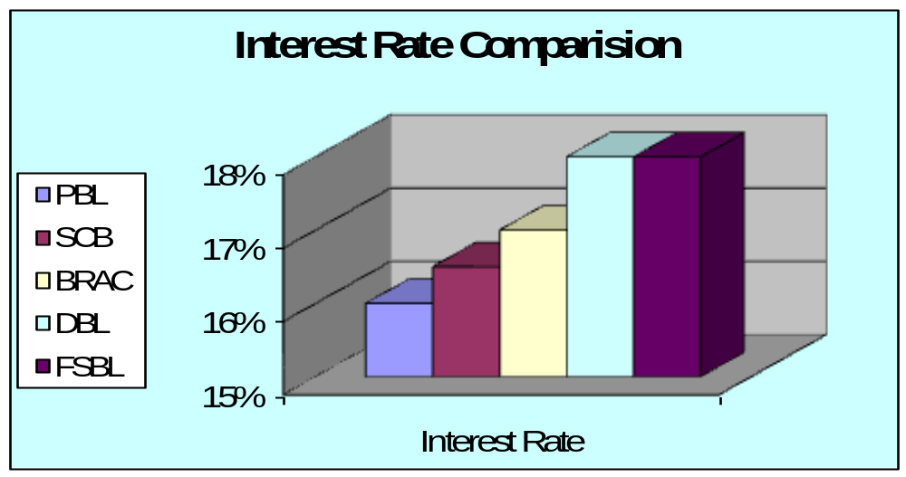

Considering interest rate of all the Consumer Credit operations of the five banks, PBL offers the least interest rate. It is surely encouraging to the customers.

LOAN LIMIT COMPARISON

Banks | Loan Limit (Max) | Loan Limit (Min)
PBL | TK. 10,00,000 | TK. 20,000
SCB | TK. 5,00,000 | TK. 25,000
BRAC Bank | TK. 10,00,000 | TK. 40,000
DBL | TK. 5,00,000 | TK. 25,000
FSBL | TK. 10,00,000 | TK. 20,000
Note: This Table does not contain car loan limit of PBL (TK. 40 lac) and Aroggo loan of
BRAC Bank (TK. 30 lac)

Loan limit of CCS differs bank to bank and also scheme to scheme. Even so, an average maximum and minimum loan limit of CCS of each observed bank is given in the above table, which is also presented through the following chart:

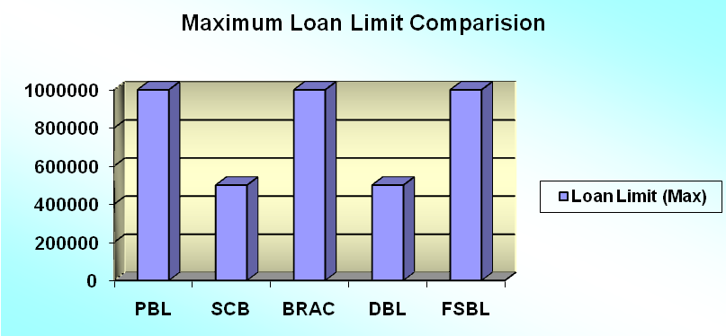

From the above graph it is Clear that Like FSBL and BRAC Bank, PBL is also offering the maximum loan limit of ten lac taka. On the other hand SCB and DBL are offering maximum limit of Five lac taka. So it is evident that PBL is one of the maximum loan limit offering banks among these five banks.

Minimum loan limit of CCS of each observed bank is presented through the following chart:

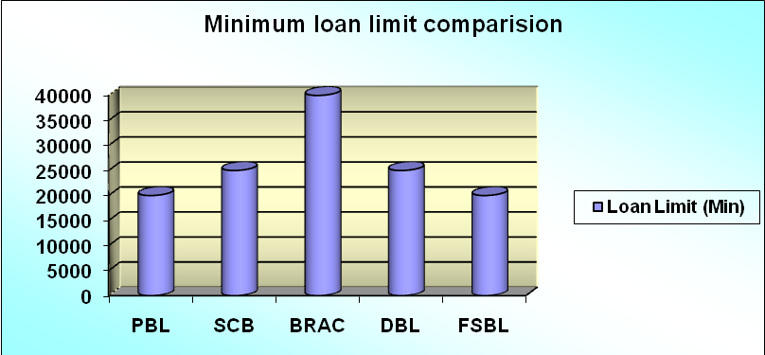

From the above graph it is Clear that Like FSBL , PBL is also offering the minimum loan limit of twenty thousand taka. On the other hand SCB and DBL are offering minimum limit of twenty Five Thousand taka Which is greater offering than PBL and FSBL. Among these five banks BRAC Bank’s offered minimum loan limit is the heist. So it is evident that PBL is one of the minimum loan limit offering banks among these five banks.

Comparison Based On Loan Period

Banks | Loan Period (Max) | Loan Period(Min)
PBL | 4 Years | 2 Years
SCB | 5 Years | 1 Years
BRAC Bank | 5 Years | 1 Years
DBL | 4 Years | 1 Years
FSBL | 4 Years | 1 Years

Loan period of CCS differs bank to bank and also scheme to scheme. Even so, an average maximum and minimum loan period of CCS of each observed bank is given in the above table, which is also presented through the following chart:

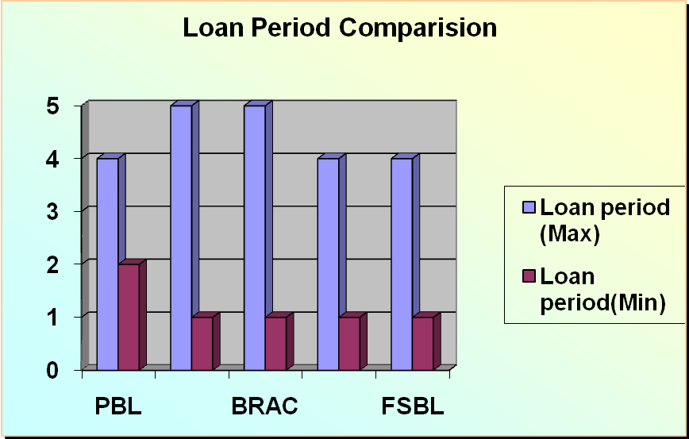

From the above graph, we see that SCB and BRAC Bank offering the same loan period while DBL and FSBL offering the same loan period. But PBL offers the unique Loan period which is more convenient to customers.

COMMON FEATURES OF CCS

Because of the severe competition and substantial number of rival’s different private banks diversify their Consumer Credit Schemes by types, different aspects, and different terms. Even so, there are several features of CCS where all the observed banks are found more or less similar. These are as follows:

- The eligibility of the customers is common for similar schemes of different banks.
- Disbursement mode of the loan amount is through issuance of Payment Order to the vendor (when the loan is sanctioned to purchase consumer goods) or through depositing the loan amount to the client’s account with the bank (when the loan is to be used for some other purpose or to purchase service).
- Repayment method is either lump sum cash deposit or installment basis. The customer can repay the loan amount by Lump sum cash deposit within the validity or by equal monthly installments over the loan period.
- Some of the documents, that are to be obtained by the banks to sanction the loan, are common for all of them. Some other documents are not required for all schemes but are common for similar schemes of almost all the observed banks.
- Though some of the schemes of BRAC Bank don’t require any security but rest of its schemes and all the CCSs of other banks require same types of securities from the clients.

Chapter – 5
Findings

Findings from Comparative Analysis:

From my comparative analysis I have found the problems associated with the Consumer Credit Schemes and their operations of prime Bank Ltd. in two categories. These are

- Major Problems
- Minor Problems
These two types of problems are discussed in brief as under:

- Major Problems Associated With Prime Bank Ltd.:

Weakness in Marketing:
Though there is marketing department in PBL, but the activities of that particular department can’t be able to take any significant role in the bank’s operation of CCS. The bank is concentrating on serving the clients for CCS rather than undertaking any promotional activity to create new clients.

High Interest Rate:
As a lot of private banks are operating in Bangladesh and most of them are providing CCS to people, the power of supplier is moderate to high. Clients want a low interest rate on their loan amount. PBL has more long term deposit than short term deposit, and due to competitive market PBL has to incur higher cost on their deposits. As consumer credit is sanctioned against short term deposits, the bank has to charge comparatively high interest rate than some of its rivals.

Limited Number Of Branches:
Prime Bank Ltd. has only 51 branches. It is a fewer in number considering those of many other private banks. There are some very important places in Bangladesh where PBL doesn’t have their branch. Few branch means limited geographic coverage, which ultimately means limited number of clients taking CCS of the bank. The more branches PBL has the more customers it can serve through CCS, the more income it can generate.

Insufficient Number Of Employees:

The number of employees at PBL is significantly low. At Banani Branch of PBL only 30 employees are providing the whole banking service where only 3 persons serve the CCS. There is only one Assistant Vice president at Credit Division who is providing and managing the entire CCS. He is over loaded with his responsibilities and so not being able to provide service to the customer in efficient manner.

- Minor Problems Associated With Prime Bank Ltd.:

Absence of Effective Training Policy:

PBL don’t have any effective training policy. Though it has a training institute but they are not using this institution properly. Consumer Credit Policy and rules are critical enough to understand. Even so, the officers of the bank are not being properly trained in this sector of Banking.

Lack of Flexibility of CCS:

The loan limit both upper and lower under CCS of PBL not enough standard and flexible to the client’s. Upper limit is only 5 lac (except car loan), where FSBL provides 10 lac as loan under CCS. The minimum loan amount also doesn’t provide any competitive advance to the bank.

Excess Requirement of Documents:

The client’s are bound to submit a lot of documents to the bank to avail Consumer Credit under any of the 11 CCS of PBL. The Bank is overloading the clients by charging so much documents and papers which seems to the clients being harassed by the relevant officer.

Chapter – 6
Recommendations

Recommendation

Prime Bank Limited (PBL) should consider the following recommendations:

- PBL can pursue to Government high officials and can make a better relationship with them to get government fund in order to keep cost of fund low. Moreover, the Bank should attract more short-term deposits from the depositors against which it can provide CCS to the clients at a lower interest rate.

- PBL can open some more branches in strategically important place and by doing that they can achieve more geographical coverage and enhance their business volume under CCS.

- PBL has 5 (five) Islamic Banking Branch (IBB). All of these 5 branches are doing very good business and have public acceptability. Consumer Credit Schemes involve Interest that the clients are to pay to the Bank. As Bangladesh is an Islamic country and Islamic Banking is a popular concept PBL can go for more Islamic Banking Branches through which it can operate its CCS activities with less doubt in the mind of people.

- The Bank should diversify its loan portfolio and client portfolio. PBL should launch new schemes under CCS that will be affordable for lower income group of the society. Moreover the Bank should launch special schemes under CCS for teachers and for Health & Treatment Facility of people.

- PBL should take some marketing officer and an Executive in marketing Division who has some experience regarding marketing of Consumer Credit Products. PBL also should go for some promotional activities through its Public Relation Department and use advertising and field level personal selling for its CCS products.

- PBL should concentrate on bringing extra features considering other Banks similar schemes. These are:

- Interest under CCS should be half yearly compound.
- Upper loan limit of CCS should be fixed at Tk. 10 lac.
- Lower loan limit of CCS should be fixed at Tk. 10,000.

- Choice of repayment should be made flexible up to 60 months under each scheme of CCS.

- The higher authority of the Bank should promote eligible and expert employees at higher rank. This will reduce the employee turnover rate.

Chapter – 7
Conclusion

CONCLUSION

Consumer Credit is a type of loan provided by banks to its customers. Where Credit is an important input in the production process of a country as well as in the income generation activities of an individual, Consumer Credit improves the standard of living of individuals. The demand for Consumer Credit in a developing country like Bangladesh is much higher than its supply.

The word ‘Credit’ comes from the Latin word “CREDO” meaning ‘I believe’. Consumer Credit is lender’s (i.e. the Bank’s) trust in a person’s ability to repay the loan amount, which the client takes to purchase consumer goods / services, at some specified time in the future.

Credit is power. For a Bank, Consumer Credit is a significant source of profit and on the other hand, wrong use of Consumer Credit would bring a disaster not only for the Bank but also for the economy as a whole. Wright or wrong judgment while extending Consumer Credit under any Scheme means success or failure of a Bank.

All the Private Banks those I’ve observed provide CCS to their clients within the policy guidelines of the respective Banks and the Bangladesh Bank.

Prime Bank Ltd. is the pioneer of and a leading Bank in Consumer Credit Scheme in Bangladesh. The CCS of the Bank aims to help the fixed income group in raising standard of living and has been widely appreciated. The rate of recovery under the Scheme is 96%.

The main purpose of this report is to study the CCS of PBL and some other Private Sector Banks and to make a comparison between CCS of PBL and those of other Banks. Considering all the Consumer Credit operations of the five banks, performance of PBL appears to be encouraging. Compared to other Banks, PBL will definitely show much better performance in the near future. But it requires amendment of some terms of CCS of the Bank such as documentation, client portfolio, interest rate, quality of service etc.

