Submitted by

WWW.ASSIGNMENTPOINT.COM

A bank is a financial institution which deals with deposits and advances and other related services. It receives money from those who want to save in the form of deposits and it lends money to those who need it. The term bank is derived from the French word Banco which means a Bench or Money exchange table. In olden days, European money leaders or money changers used to display coins of different countries in big heaps (quantity) on benches or table for the purpose of lending or exchanging. Now a day’s banking sector is modernizing and expanding its hand in different financial event every day.

The main objective of MBA program is to create skillful professionals for the business sector in Bangladesh specially in banking sector. To become skilled in any field a person should know the pros & cons of that particular area. However, it cannot be achieved only through the reading the book. There is a gap between thing mention in the book and real life situation. Keeping this fact in mind, MBA program is design to reduce this gap between this two and to reinforce the theoretical knowledge acquired so far from MBA program. Therefore every student of MBA program is sent to different organization for practical orientation at the end of the program and they require to submitting a report after completion of the practical orientation. I am very glad for getting the opportunity to accomplish my practical orientation at the Dutch-Bangla Bank Limited.

1.1 Objectives of the study/research

A. Broad Objectives:

The broad objective of this report is to gather knowledge about credit policy of Dutch-Bangla Bank Limited.

B. Specific objectives: To accomplish the main objective, it may cover the following:
- To know about different kinds of credit facilities the bank offers.
- To know about General Banking policy, the credit sanctioning policy and Foreign Exchange activities of DBBL.
- To give some recommendations against the major findings.

1.2 Methodology of the Report:
1.2.1 Types of research:
- This is descriptive research in nature.
1.2.2 Source of data collection:
Both primary and secondary sources of information have been used in the research.

1.2.2.1 Primary Sources:
∆ In depth interview with high officials of the branch.
∆ Questionnaire survey on customer.

1.2.2.2 Secondary Sources:
∆ Different books and periodicals related to the banking sector.
∆ Banks annual report.
∆ Newspaper.
∆ Bangladesh Bank report.
∆ Internet.
1.3 Data collection procedure:
Population: The population has been all Credit related banking department customer the customers of Dutch-Bangla Bank (Motijeel Branch)

Sample size:

Sample unit | Sample size:
Regular Customer or clients of the bank | 30

Sample Frame: No well structured sample frame was formed.
Sample procedure: Non probability convenience sampling.

1.4 Rationale of the Study
Theoretical knowledge is not enough for a business student. Because there is a far gap between theoretical knowledge and practical field, our internship program has been launched mainly to bridge this gap. Bangladesh is one of the developing countries with a large unemployed population. As the opportunity to expand agricultural sector is limited, so we have to incline to expand industrial sector to overcome our existing problems like unemployment, low economic growth and low living standard. Here industrial sector is very weak. To consider the real situation government has established Bangladesh Shilpa Bank to stimulate industrialization. This bank provides term loan to different industries and entrepreneurs. The purpose of Bangladesh Shilpa Bank is not only to grant credit but also to develop the country through industrialization by selecting correct project and provides assistance in different ways to implement the selected project successfully

1.5 Scope and Limitation
The scope of the report was to find the financial aspect of the operation of the bank. In addition, the report was done to find the effectiveness of the different Department’s services. Further more, the report also focused on the feasibility study and practical market issues about new ventures and operational procedures of Financial Institutions. An infrastructure of organization has been detailed, accompanied by company corporate perceptive and look into the future. The scope of this report is limited to the overall descriptions of the bank, its services, and its position in the industry, and its competitive advantage. The scope of the study is limited to organizational setup, functions, and performances.
Limitation, which I have faced while doing my internship report are discussed below:

* As, I had more dependence on the primary sources, so there might be some level of inaccuracy with those collected information. Though, adequate verification and cross- checking was used, to minimize the error level.

* Confidential information regarding past profit or product cost, financial information was not accurately obtained. Alike all other banking institutions, DBBL is also very conservative and strict in providing those information. In those cases, I have relied upon some assumptions, which in result have created certain level of inaccuracy. Still, I had tried my best in obtaining that sensitive information, as much as possible.
- Next, many of the analysis on the obtained data are based upon my sole interpretation. This in result might bring some biases, as lack of knowledge and depth of understanding might hinder me to produce an absolute authentic and meaningful report

Chapter: 2
Organization Part


Organization Part
Dutch-Bangla Bank Limited

2.1 About the company
Dutch-Bangla Bank Limited (DBBL) is a Bangladeshi-European private joint venture scheduled commercial bank, incorporated in Bangladesh in the year 1995. This public limited bank commenced its formal operation from June 3, 1996. The Netherlands Development Finance Company (FMO) of the Netherlands is the international co-sponsor of this bank with 30% equity holding. Out of the rest 70%, 60% equity has been provided by prominent local entrepreneurs and industrialists and the rest 10% shares is the public issue. During the initial operating year (1996-1997), the bank received skill augmentation technical assistance from the Amro Bank of the Netherlands (ABN). Starting with one branch in Dhaka, DBBL now has expanded to twenty four branches including thirteen branches outside of the capital. To provide client services all over Bangladesh, it has established a wide correspondent banking relationship with a number of local banks, and in order to facilitate international trade transactions, it has arranged correspondent relationship with large number of international banks which are active across the globe. Moreover, DBBL has introduced ATM cards and Internet banking to ensure the customer’s freedom to choose his/her own banking hours.
Dutch-Bangla Bank started operation is Bangladesh's first joint venture bank. The bank was an effort by local shareholders spearheaded by M Sahabuddin Ahmed (founder chairman) and the Dutch company FMO.
From the onset, the focus of the bank has been financing high-growth manufacturing industries in Bangladesh. The rationale being that the manufacturing sector exports Bangladeshi products worldwide. Thereby financing and concentrating on this sector allows Bangladesh to achieve the desired growth. DBBL's other focus is Corporate Social Responsibility (CSR). Even though CSR is now a cliche, DBBL is the pioneer in this sector and termed the contribution simply as 'social responsibility'. Due to its investment in this sector, DBBL has become one of the largest donors and the largest bank donor in Bangladesh. The bank has won numerous international awards because of its unique approach as a socially conscious bank.
DBBL was the first bank in Bangladesh to be fully automated. The Electronic-Banking Division was established in 2002 to undertake rapid automation and bring modern banking services into this field. Full automation was completed in 2003 and hereby introduced plastic money to the Bangladeshi masses. DBBL also operates the nation's largest ATM fleet and in the process drastically cut consumer costs and fees by 80%. Moreover, DBBL choosing the low profitability route for this sector has surprised many critics. DBBL had pursued the mass automation in Banking as a CSR activity and never intended profitability from this sector. As a result it now provides unrivaled banking technology offerings to all its customers.

2.2 Background
Dutch-Bangla Bank Limited (DBBL) is Bangladesh's most innovative and technologically advanced bank. DBBL stands to give the most innovative and affordable banking products to Bangladesh. An Amonst bank, DBBL is the largest donor in to social causes in Bangladesh. It stands as one of the largest private donor’s involed in imporving the country. DBBL is proud to be associated with helping Bangladesh as well as being a leader in the country's banking sector.
2.3 Vision

Dutch-Bangla bank dreams of better Bangladesh, where arts and letters, sports and athletics, music and entertainment, science and education, health and hygiene, clean and pollution free environment and above all a society based on morality and ethics make all our lives worth living. DBBL’s essence and ethos rest on a cosmos of creativity and the marvel – magic of a charmed life that abounds with spirit of life and adventures that contributes towards human development.

2.4 Mission
Dutch-Bangla Bank engineers enterprise and creativity in business and industry with a commitment to social responsibility. Profits alone do not hold a central focus in the bank’s operation, because man does not live by bread and butter alone.

2.5 Core Objectives
Dutch-Bangla Bank believes in its uncompromising commitment to fulfill its customer needs and satisfaction and to become their first choice in banking. Taking cue form its pool esteemed clientele, Dutch-Bangla Bank intends to pave the way for a new era in banking that upholds and epitomizes its vaunted marques “Your Trusted Partne
2.6 The Board and its Committees

The Board

Chairman
Mr. Abedur Rashid Khan

Directors
Mr. Zaheed Hossain Khan
Mr. Bernhard Frey : Nominee of Ecotrim Hong Kong Limited
Mr. Sayem Ahmed
Mr. Md. Fakhrul Islam : Elected from General Shareholders’ Group
Dr. Irshad Kamal Khan : Independent Director
Dr. Syed Fakhrul Ameen : Director from the Depositors
Mr. Chowdhury M. Ashraf Hossain : Director from the Depositors
Mr. Md. Yeasin Ali : Ex-officio Director

The Committees of the Board

1. Executive Committee of the Board of Directors
Mr. Sayem Ahmed : Chairman
Mr. Abedur Rashid Khan : Member
Mr. Zaheed Hossain Khan : Member
Mr. Md. Yeasin Ali : Member

2. Audit Committee of the Board of Directors
Mr. Zaheed Hossain Khan : Chairman
Mr. Abedur Rashid Khan : Member
Mr. Sayem Ahmed : Member
Dr. Irshad Kamal Khan : Member

2.7 DBBL Management

Name | Designation | Division
Mr. Md. Yeasin Ali | Managing Director
Mr. K. Shamshi Tabrez | Deputy Managing Director- 1
Mr. Abul Kashem Md. Shirin | Deputy Managing Director - 2
Mr. Md. Sayedul Hasan | Deputy Managing Director - 3
Mr. Khan Tariqul Islam | Chief Financial Officer
Mr. Khan Tariqul Islam | Chief Financial Officer | Human Resources Division
Mr. Md. Mosaddiqur Rahman | Divisional Head | General Service Division
Mr. Md. Mosaddiqur Rahman | Divisional Head | Marketing & Development Division
Mr. Md. Mosaddiqur Rahman | Divisional Head | Dutch-Bangla Bank Foundation
Mr. Moyen Uddin Ahmed | Executive Vice President | Card Division
Mr. A.K.M. Shah Alam | Executive Vice President | International Division (Treasury Back Office)
Mr. Iqbal Amin | Senior Vice President | Credit Administration Division
Mr. Mohammad Harun Azad | Senior Vice President | Vigilance Cell
Mr. Md. Shamsuddin Yousuf Khaled | Senior Vice President | Internal Control & Compliance Division
Mr. Md. Abul Kashem Khan | Senior Vice President | Information Technology Division
Mr. Mohd. Rafat Ullah Khan | Senior Vice President | Credit Division
Mr. Jalal Uddin Ahmed | First Vice President | Treasury Division (Front Office)
Mr. Md. Mohi Uddin | Vice President | Alternative Delivery Channel Division
Mr. Mahbub Jan Chowdhury | Vice President | Corporate Banking Division
Mr. Muhammad Muhibullahil Baqi | Vice President | Credit Monitoring & Recovery Division
Mr. Mir Mominul Huq | Senior Asst. Vice President | Retail Banking Division
Mr. Md. Monirul Alam | First Asst. Vice President | Board Secretariat
Mr. Mohammad Abu Kausar | First Asst. Vice President | SME Division

Other Department/ Section/ Wing
Name | Designation | Dept./Sectioin/Wing
Mr. Khan Tariqul Islam | Chief Financial Officer | Chief Anti Money Laundering Compliance Unit
Mr. Khan Tariqul Islam | Chief Financial Officer | Training Wing
Mr. Md. Shahazada Basunia | First Asst. Vice President | Public Relations

2.8 Corporate Governance
Corporate Governance is the system of internal controls and procedures used to define and protect the rights and responsibilities of various stakeholders. The Bank has adequately complied with all the orporate Governance Guidelines of Bangladesh Bank and SEC. It is ensured by the Board that all activities and transactions of the Bank are conducted in compliance with international best practices to protect the highest interest of all the stakeholders. The Bank has a policy for delegation of authority. Accordingly, authorities are delegated to CEO, other senior management and cross functional management committees comprising head of functional divisions and senior management to review achievements of key objectives. The Board has also clearly delegated authorities to Board Committees with specific terms of reference which sets out their objectives and responsibilities.

The Board

The Board is comprised of directors having diverse skills, experience and expertise to add value towards
better corporate governance of the Bank and maximizing value for all stakeholders. The Board discharges its responsibilities itself or through various committees. The Board meets on a regular basis to discharge its responsibilities. The Board is made up of 9 directors including a nonexecutive chairman and 4 non-executive directors representing shareholders, one independent director, two directors from depositors and one executive managing director as follows:

- Mr. Abedur Rashid Khan : Chairman
- Mr. Zaheed Hossain Khan
- Mr. Bernhard Frey : Nominee of Ecotrim Hong Kong Limited
- Mr. Sayem Ahmed
- Mr. Md. Fakhrul Islam : Elected from General Shareholders’ group
- Dr. Irshad Kamal Khan : Independent Director
- Dr. Syed Fakhrul Ameen : Director from the Depositors
- Mr. Chowdhury M. Ashraf Hossain : Director from the Depositors
- Mr. Md. Yeasin Ali : Ex-officio Director

Independent Director
In compliance with corporate governance guidelines of SEC, Dr. Irshad Kamal Khan was appointed as an independent director in the Board of the Bank. Dr. Khan is a Professor & Chairman of Department of Economics, Chittagong University.

Depositor Director
In compliance with corporate governance guidelines of Bangladesh Bank, Dr. Syed Fakhrul Ameen and Mr. Chowdhury M. Ashraf Hossain were appointed as Directors representing depositors of the Bank. Mr. Ameen is a Professor of Department of Civil Engineering in Bangladesh University of Engineering and Technology and Mr. Hossian is a businessman having a Masters Degree in Journalism.

Key objectives of the directors
The Board is responsible for ensuring governance and performance of the company by directing and Overseeing activities of the executive management by making them transparent, accountable and responsible. The directors are expected to protect the long term interest of the shareholders and all stakeholders by setting key objectives for the management and by monitoring and ensuring that those objectives are achieved by the management in a sustainable way while maintaining transparency and accountability at every stage of operations. The Board must be satisfied that sufficient risk management systems are in place to mitigate core risks of the Bank and that there are adequate checks and balances in the internal control system to protect the value and quality of assets of the Bank. The Board of Directors is entitled to timely, accurate and adequate information & data to ensure effective control over operational, financial, strategic, compliance, governance and risk management issues of the Bank.

The Board is responsible for ensuring the following
● Setting key targets of the Bank and monitoring progress towards achievement of such targets.
●Approval of major policy decisions and long term strategic plans to achieve key objective sin an efficient and effective way.
● Disclosure of accurate, timely and reliable information to shareholders.

They are expected to
● Demonstrate the highest professional and ethical standard.
● Be fully independent from management.
● Be knowledgeable about the business and challenges that DBBL is facing.
● Apply prudence and judgment in decision making.
● Display commitments to the Bank and its all stakeholders through participation in the
affairs of the Bank. Number of Board Meetings held in 2009 and the attendance of each Director are shown in Annexure – A of Corporate Governance Guidelines of SEC.

The Committees of the Board of Directors
As per Bangladesh Bank guidelines, the Board has two committees namely the Executive Committee and
the Audit Committee. Each Committee operates under specific Terms of Reference (TOR) that sets out its responsibilities and composition. The TORs are designed and reviewed to ensure that the objectives of each committee are achieved in an effective way and that regulatory obligations and obligation to shareholders are fulfilled. The Committee regularly evaluates progress towards key objectives. Accordingly, time and efforts are dedicated to focus on responsibilities those are central to achieve the core objectives of respective committees.

Executive Committee
Responsibility of Executive Committee
The responsibility of Executive Committee of the Board is clearly delegated by the Board. Accordingly,
the EC exercises all the powers and functions on behalf of the Board in regard to:
● approving credit proposals, monitoring risk status and quality of loan portfolio,
● Administrative affairs and
● Financial affairs
However, all policy matters and strategic issues are dealt with by the Board of Directors of the Bank.

The Executive Committee is comprised of the following members
Mr. Sayem Ahmed : Chairman
Mr. Abedur Rashid Khan : Member
Mr. Zaheed Hossain Khan : Member
Mr. Md. Yeasin Ali : Member

Audit Committee
Resposibilty of the Audit Committee along with the Report of the Audit Committee as per Bangladesh Bank guidelines is given on pages 43 to 44 of this Annual Report.

The Audit Committee is comprised of the following members
Mr. Zaheed Hossain Khan : Chairman
Mr. Abedur Rashid Khan : Member
Mr. Sayem Ahmed : Member
Dr. Irshad Kamal Khan : Member

Preparation of Financial Statements
Financial statements of DBBL give a true and fair view of the state of affairs of the Bank and the results of its operations and cash flows. All the applicable Bangladesh Accounting Standards and Bangladesh Financial Reporting Standards adopted by ICAB are complied with for preparation of financial statements. The financial statements are prepared by the management and approved by the Board of Directors and audited by auditors appointed in the Annual General Meeting.

External audit
Hoda Vasi Chowdhury & Co, Chartered Accountants (Independent Correspondent Firm to Deloitte Touche Tohmatsu) is the statutory auditors of the Bank. They don’t provide any other accounting, taxation or advisory services to the Bank except certification of cash incentives payable to exporters.

Compliance with Bangladesh Bank regulations
As a commercial bank, DBBL is regulated and supervised by Bangladesh Bank under Bank Company Act 1991 and rules and regulations made there under. DBBL attaches highest priority to strict compliance with all regulatory requirements of angladesh Bank in terms of core risk management, capital adequacy ratio, foreign exchange regulations, liquidity management, KYC and anti-money laundering compliance etc.

Audit and Inspection by Bangladesh Bank
Bangladesh Bank also undertakes audit & inspection of DBBL at regular intervals. Compliance with observations and recommendations made by Bangladesh Bank help the Bank to improve internal control, risk management, corporate governance and regulatory compliance maximizing benefit for all stakeholders.

Compliance with Corporate Governance Guidelines of Bangladesh Bank
DBBL has also adequately complied with Corporate Governance Guideline of Bangladesh Bank (BRPD Circular No 16 dated July 24, 2003) in terms of overall business activities of the Bank including credit and risk management, internal control, human resource management as well as income and expenses. Segregation of financial, operational and administrative authorities and responsibilities between Board and Management have been also ensured.

Compliance with SEC regulations
As a listed company, DBBL is regulated by Securities and Exchange Commission (SEC). As detailed in statement of corporate governance, we have adequately complied with corporate governance guidelines issued by the Securities and Exchange Commission.

Credit Rating of the Bank
In line with Bangladesh Bank's BRPD Circular No. 06 dated July 05, 2006 and in order to improve the risk management and corporate governance system of the Bank and to safeguard the interest of investors, depositors, creditors, shareholders and the Bank Management as a whole, credit rating of the Bank for the year 2008 was done by Credit Rating Agency of Bangladesh (CRAB). The date of rating by CRAB was 29 June 2009. CRAB assigned ‘A1’ (pronounced as single A one) rating in the Long Term and ST-2 rating in the Short Term. Credit rating will be done regularly on a yearly basis and credit rating of 2009 will be completed before June 30, 2010.

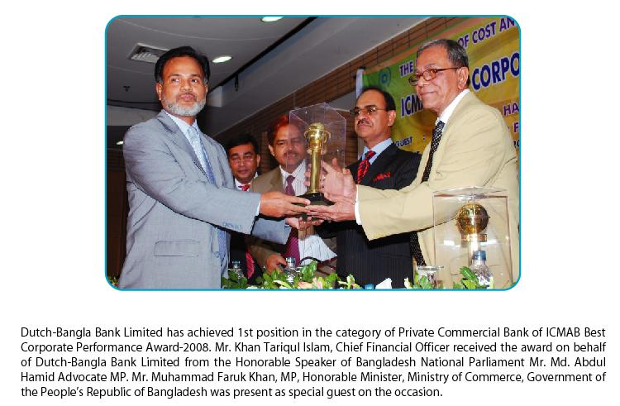
Awards:

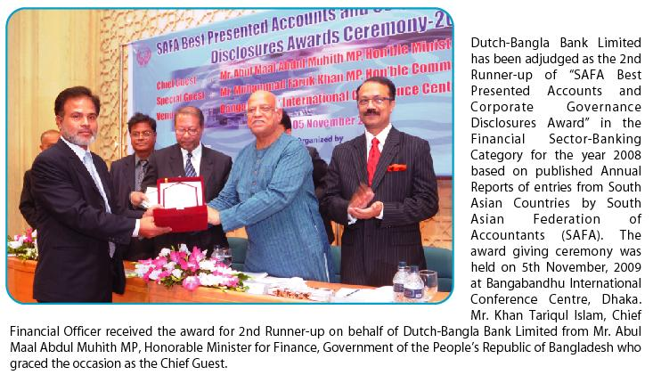

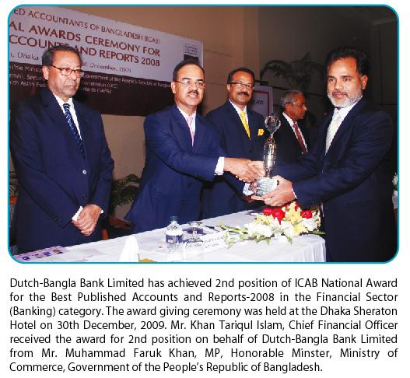
Highlights on the overall activities of the Bank for the years 2011 and 2010.

Serial  No. | Particulars | Year
Serial  No. | Particulars | 2011  Taka | 2010  Taka
1  2  3  4  5  6  7  8  9  10  11  12  13  14  15  16  17  18  19  20  21  22 | Paid up share capital  Total capital  Capital surplus  Total assets  Total deposits  Total loans and advances  Total contingent liabilities and commitments  Credit deposit ratio  Percentage of classified loans against total loans, advances  Net profit after taxation and provision  Amount of classified loans and advances at the end of the year  Provisions kept against classified loan  Provisions surplus against classified loan  Cost of fund  Interest earning assets  Non-interest earning assets  Return on investment (ROI)  Return on asset (ROA)  Income from investment  Earnings per share (Taka)  Net income per share (Taka)  Price earning ratio (Times) | 1,500,000,000  5,899,788,431  808,440,268  81,480,529,482  67,788,533,035  48,410,989,619  26,262,780,062  71.41%  2.46%  1,137,698,057  1,193,317,209  742,710,945  -  6.53%  69,963,330,113  11,517,199,369  14.64%  1.60%  1,334,166,052  75.85  75.85  25.81 | 1,000,000,000  4,587,482,361  376,096,230  60,618,968,787  51,575,667,260  41,698,321,269  23,253,619,532  80.85%  3.27%  821,665,049  1,363,174,636  464,010,979  -  7.66%  52,264,250,474  8,354,718,313  9.69%  1.49%  621,728,877  54.78  54.78  78.70

Chapter: 3
Credit Policy

3.1 Credit Policy of Dutch-Bangla Bank Limited

A credit policy includes all rules relating to loans and advances made by the bank to the borrowers. It includes types of credit extended by banks, method of judging the credit value of borrowers, the collateral or securities that are accepted by the banks and so on. This policy guidelines refer to all credit facilities extended to customers including placement of funds on the inter bank market or other transactions with financial institutions. DBBL Credit policy contains the views of total macro-economic development of the country as a whole by way of providing financial support to the Trade, Commerce and Industry. Throughout its credit operation DBBL goes to every possible corner of the society but the bank gives more emphases on corporate sector than consumer loan. They are financing large and medium scale business house and industry. At the same time, they also takes care entrepreneur through its operation of Lease Finance and some Small Loan Scheme etc. As a part of its Credit Policy DBBL through its credit operation maintains commitment for social welfare.

- Creating healthy loan assets to ensure good interest earnings for the bank.
- Ensuring safety of invested fund through judicious selection of borrowers
- Improving discipline and skill on use of resources.

3.2 Principles of lending
The principles of lending can be considered under the following heads:

Profitability
All credit facilities granted to the Bank’s customers must produce profit, either directly or indirectly. Spreads are normally associated with the element of risk undertaken and the period and nature of the facilities. When judging a credit proposal, concerned officer should take a comprehensive view of other allied business that will be received by the branches.
Generally, the Head office will advise the rates of interest to be charged on various types of credit facilities. The branch managers would ascertain market conditions and keep the Head Office informed. Cases for charging interest lower than the stipulated rate should be supported by sound business considerations.

Source of repayment
After satisfying that the transaction will be profitable, next attention to be given to the cash flow situation of the borrower. The Bank’s advances can be classified into three main categories, as follows:
- a very short-term advance which will be liquidated by funds received in the very near future: examples are advances against foreign or local bills or bridge financing where evidence of credit sanction from another financial institution is available;
Provision for current assets: this type of facility is needed for trading and /or manufacturing activities: the capacity and the potential for adjustment of the facility will depend on the nature of the borrower’s trade and the market in which he operates;
Term advance/ lending over 1 (one) year: examples of such facilities are investment in plant and machinery, building, a farm or a shop: generally, a long-term loan is repaid out of future earnings generated by the business.

Before granting a facility, it should be ensured that a reliable source of repayment exists and that the advance will be paid within the agreed period. When considering the period of repayments, required margin should be provided for unforeseen circumstances such as downward market trend, or the general economic condition of the country. Besides payment of interest and installments and other charges, the funds generated by the business should preferably leave adequate margin for meeting needs for future expansion or other business contingencies. Where the facilities are secured by fixed assets, the sale proceeds of such security should not be considered as a prime source of adjustment of the facility.
In order to ascertain the capacity of the business to meet the obligations, the cash flow projections should be examined. If such examination calls for a revision of the repayment schedule, the credit facilities should be re-examined and their viability should be determined.

Character and ability of the borrower
The branch manager should know his customer well and should be able to judge his intentions and ability to use the credit facilities to his advantage. Advance should be granted only to those borrowers in whom the branch manager has full confidence. Integrity of the borrower and his ability to conduct business are of paramount importance and take precedence over the value of the securities offered. The directors or partners of limited companies or partnerships should be men of integrity, experience and drive. Assessment of the company’s operations and information about the directors can be gained by studying the past year’s financial statements of the company, its general reputation in business circles, and by reference to the company’s bankers.
When recommending a review or extension of a limit, branch managers should verify the past performance from the branch records. The levels of maximum and minimum balances, turnover, the average debit balance, and timely receipt of the installments provide an adequate basis on which to judge the health of the account.
The borrower should possess good trade experience, business acumen, initiative and drive. He must have ability to control the finances of his business. Lack of financial control may ruin an otherwise successful business, particularly when the business faces adverse economic conditions. It is imperative that the branch manager should be able to form a favorable impression about the integrity and business ability of his prospective borrower before initiating the loan application.

Purpose of the facility
The purpose of advance should be studied with a view to understanding whether it is within the policy of the Bank. (If it is outside the Bank’s policy, the proposal should not be given further consideration).
Each proposal should be considered on its merits. Consideration should of course be given to the nature of business and certainty with which the business or the project will yield results. Branch managers should exercise their judgment and should avoid granting advances for speculative projects. The general test, which should be applied by the branch manager, is whether the Bank is called upon to finance a reasonable business project or whether the borrower will utilize the finance for speculative purposes.
In the case of corporate borrowers, the purpose of borrowing must be consistent with the objectives of the company. The objectives laid down in the Memorandum and Article of Association or by-laws of the company must be carefully examined before considering any credit facility for limited companies.

Terms of the facility
Credit facilities are broadly divided under the following categories:
- facilities needed for very short term requirements;
- facilities needed for current assets requirements;
- Facilities needed for long-term/investment requirements.

Facilities covered under category (a) above are generally required for a short period of up to three to six months. Such facilities include packing credits, advances against salaries, advances against purchase/discount of bills and bridging finance facilities. Facilities covered under category (b) are generally for a slightly longer period, say up to one year. When considering a facility of this nature, a feasibility study of the project should be made and a repayment schedule should be agreed.
Having agreed the period of repayment, the branch manager must ensure that repayment is received within stipulated period. It is prudent to take corrective action when the first default is made. Caution at an early stage prevents accumulating heavy debit balances and possible bad debts.

Safety
To safeguard Bank’s interest over the entire period of the advance a comprehensive view of the capital, capacity and integrity of the borrower adequacy and nature of security compliance with all legal formalities, completion of all documentation and finally a constant watch on the account are called for all advances will be against adequate security., Where advances are granted against the guarantee of a third party, that party must be subject to the same credit assessment as made for the principal borrower.
The basis of security valuations will be expert third party assessments at two levels; current market price and forced sale value. In the case of property, valuations should be done by enlisted surveyor of the Bank. Inventory valuations may be taken at the balance sheet values shown in unqualified audited accounts after the branch manager has carried out his own investigation into the composition of the inventory. Specialist values may be requested by the branch to provide other assets valuation (if required) such as machinery and equipment. The value of the debtor may be taken from the balance sheet. The cost of the valuation (if any) will be born by the borrower.
Information requirements
To satisfy the majority, if not all, of the principles of lending detailed above, the branch should collect information on the following questions, before considering whether credit facilities should be granted to the borrower:
Who is the borrower? Whether any special characteristics of the borrower need particular attention. For example, if the borrower is a trust, this calls for examination of the trust deed.
Is the branch satisfied about the character, ability, integrity and experience of the borrower? Is the branch confident about the borrower?
Is the purpose of borrowing consistent with the objectives of the company?
Is the purpose legal? Does it contravene any law? Advances should not be considered for illegal purposes.
What is the amount required? Is it sufficient for the purpose mentioned?
Is the security offered acceptable and adequate? Has sufficient margin been maintained? Can a valid charge be obtained on the security?
What is the period of advance? What are the sources of repayment? Is there reasonable certainty that the stipulated installment will be recovered?
What is the rate of interest charged? Will it be profitable to the Bank? In assessing the profitability of the account, allowance must be made for any ancillary business like foreign exchange, business of group accounts, contingent business etc. which may be available to the Bank from the borrower. Branches should also consider whether there is any onerous or difficult work involved in maintaining the account.

3.3 Types / Nature of Advances & Loan

The credit facilities granted by the bank are classified under different account heads as under :
- Loan (like short/ mid/ long term in nature)
- Overdrafts (allowing frequent debit/credit transactions within an agreed limit)
- Trade related credit facilities (like bills port folio)
- Short Term Advances (like continuing facilities)
- Contingent facilities (like Letters of Credit, Letters of Guarantee etc.)
- Others, if any.
Generally all facilities, except term loans are repayable on demand. Trade related credit facilities are self-liquidating in nature.
Cash Credit /Overdrafts are reviewed annually or at regular intervals in case a closer monitoring of the accounts is necessary.
Contingent liabilities are also self-liquidating in a broader sense. The credit worthiness of the client on whose behalf the liability is assured is very important.

The different account heads appearing in the Statement of Affairs of the branch, DBBL are categorized as under:

Continuing Advances:
Usually the forms of continuing advances are as under:
- Secured Overdraft (including Collateralized overdraft one)
- Cash Credit
- Loan Against Trust Receipts (LTR)
- Loan Against Imported Merchandise (LIM)
- Export Cash Credit (ECC)
Loans:
Loan General (usually short term in nature)
Transport Loan
House Building Loan
Term Loan (Industrial/project financing)
Others
Bridge Loan / Underwriting advance
Demand Loan:
Advance against Accepted Documentary Bill (local/ foreign)
Local / Foreign Documentary Bills Discounted / Purchased
Payments against Documents (PAD)
Inland / Foreign Bill Purchased (Clean)

Contingent facilities:
Letters of Credit (sight/ usance/ Back to Back)
Letters of Guarantee (Bid Bond, Performance Guarantee, Advance Payment Guarantee, Security Guarantee, Shipping Guarantee
3.4 Brief particulars of Loans & Advances:

Facility | Description | Security Support
Secured /Collateralized Overdraft (SOD/OD) | Facility is allowed against easily marketable /Govt. approved instruments (like FDRs, BSPs/PSPs, Unit certificates etc.) or against security of land /property acceptable to the bank. | a)Pledge of instruments duly discharged  b) Equitable/ registered mortgage of land/ property.
Cash Credit  CC (H) | Facility is allowed for financing inventory may be either hypothecated or pledged to the bank as primary security. | Letter of hypothecation/ pledge of Goods.
Loan against Trust  Receipt | Facility is allowed to facilitate delivery of goods against retirement of documents of Title to Goods. The client is under delegation to pay the outstanding out of the sale proceeds of the goods. | A standard form called “Trust Receipt”.
Loan against Imported  Merchandise (LIM) | Facility is allowed against documents received against L/C released to an approved clearing agent at the request of the client. Goods must be stored in a secured area of the go down under effective control if they are kept on the borrower’s premises. | Letter of pledge of Goods.
Export Cash  Credit (ECC) | Facility is allowed to exporters to facilitate purchase of raw materials for the purpose of manufacturing and exporting finished goods. | Letter of pledge of Goods. (under bonded facility)
Loan(secured, mortgages, bonds and shares, other marketable securities) | Facility is allowed for various purposes for acquisition of fixed assets and granted for short, mid or long term purposes. | Equitable /registered mortgage of tangible fixed assets.
Demand Loan |  | - Documents of Title to Goods.  - Accepted documentary bills.
Letter of Credit  (sight/ usance) | Letters of Credit for importation of capital machinery or commodity are called sight L/C as the draft to be drawn at sight. Drafts drawn under usance are for a tenure specified in the L/C and payable by the client in due dates. | Cash margin.
Letter of Credit  (Back to Back) | This type of Letters of Credit is backed by master export L/C for export of garments to overseas market. | Lien over master L/C of 1st class of banks acceptable to DBBL.
Letters of Guarantee  (Bid, PG, APG) | Usually guarantees can be classified under two heads. (a) Financial Guarantees towards fulfillment of financial commitment on behalf of the client, (b) Performance Guarantee when the bank guarantees the performance of the client as specified in the guarantee. | Margin in the form of cash and /or FDR.
Letters of Guarantee  (Shipping) | Bank issues guarantees in favor of the shipping company to enable the importer to obtain delivery of the goods without producing the Bill of Lading. | 100% built-in margin.

3.5 Processing of Credit Proposals

The client shall submit loan application form with necessary papers/documents as per Bank’s checklist.
On receipt of the loan application form, branch shall scrutinize the papers to ensure the following:
All the columns of the application form have been filled in with appropriate information and the application is signed.
All the papers/documents containing requisite information as per checklist have been submitted.
There is no apparent discrepancy in the application papers/documents submitted by the client.
On scrutiny of the papers, client should be interviewed to know details about the business and find out any inconsistency in the papers.
Credit proposals must be prepared for all credit facilities. Facilities will be renewed at the discretion of DBBL every year.
The processing of a credit proposal falls into mainly two stages as under:
- Obtaining due approval of the competent authority of DBBL
- Steps for allowing the client to avail the credit facility.
Management approval levels splits into following authority:
- Head Office Credit Committee
- Delegated authority to the Managing Director
- Executive Committee of the Board
The Credit Committee is responsible to review, and approve or reject any credit proposals on the basis of lending policy, lending criteria, sect oral exposure and/ or on other genuine grounds. Credit Committee usually sits on every week or more frequently as the need may arise. The proposals after thorough discussion/ deliberation if found suitable is recommended for approval to the Executive Committee of the Board through the Managing Director.
Under delegated lending authority to the Managing Director, credit proposals, one time or specific gets approval after scrutiny is done by Head Office Credit Division. From time to time the Managing Director may delegate the branch managers discretionary powers with due approval from the competent authority.
Head Office deals with analyzing, reviewing of proposals emanating from branches and have the following responsibilities:
- Reviewing and analyzing the proposal on the basis of merits and complying with usual norms and procedures and within the policy guidelines of DBBL.
- Processing of credit limit proposals for review by Credit Committee for approval and renewal
- Processing of full-dressed memo for sanction/ renewal/ re-structure of limits for approval of the Executive Committee of the Board.
- Monitoring of loan port-folio of branches including non-performing and classified accounts.
- Periodic review of various advances related statements.
- Identification and pursuing potential irregular advances.
- Monitoring and implementation of DBBL’s credit policy.
Credit proposal originates in the branch. Proposal after due checking, and analysis is sent with recommendation signed by the manager and the credit officer in-charge.
After the credit proposal has been finally approved by the competent authority as the case may be, the resolution /decision thereof are sent to the branch for further action as follows:
- Conveying offers to the borrower and obtain acceptance there against.
- Branch credit /loan administration perfect the security and charge documents considering the nature and the terms of the facility.
- Setting –off client file account record.

Credit Report:
The branch manager should ensure preparation of credit report on the client to determine its past record, business performances, market reputation etc. The credit report should contain the following:
- The nature of client’s business.
- The names of owners and details of their associated business concerns.
- Net worth of the individual person owing the firm /company (obtain through declaration at the time of submission of loan application).
- The financial health of the business concern.
- Assessment of managerial capability through analyzing the up to date financial statements and market report, previous bank’s transaction record.
CIB Report:
In the recent past, to stream line credit discipline in banking sector and for meticulous adherence to the treatment of delinquent borrower by the commercial banks and DFIs as per stipulation of Bank Companies Act 1991, Bangladesh Bank has introduced a credit port folio data base naming Credit Information Bureau (CIB). For processing credit proposals (both funded & non-funded) banks and DFIs need to obtain mandatory satisfactory CIB report from Bangladesh Bank. Present criteria for obtaining mandatory CIB report may be changed from time to time at the discretion of Bangladesh Bank. Any change in this regard shall be notified to the banks vide Bangladesh Bank CIB Circulars. Branch manager must obtain satisfactory CIB report prior to processing of credit proposals and mention the status of the client and its allied concerns /persons of the borrower in the credit line proposal as it is revealed in the latest CIB report.

Visiting Client:
A visit to the client’s business premises, factory can be a very useful avenue to gather information for preparation of credit proposal. This visit and meeting the client at their door-step may help to confirm the business decision reach by the manager with regard to the clients’ financial status, management efficiency and technical details about the good sense and services in which the client deals.

During the visit particularly to the factory go down, the manager can get an idea about the client’s investment, condition of the machinery and client’s stock movement. This will also help to judge its quality and acceptability as a reliable security. A set of question, which may be asked, should be prepared beforehand.

There are different sections covered in the credit proposal format which are:

01. Client introduction: Giving the exact name and style of the client as per registration in case of limited company. Also indicate the nature of the proposal “New” or “Renewal/ Revision”. Use figures in denomination of Taka in million. State exact nature of business/description of the project. Provide business capital /equity capital of the owner based on financial statements.

02. Particulars of owners: State whether proprietor, partners or directors Show the percentage of the shareholdings of the directors as per record. Provide declared assets / net worth as the case may be by individually.

03. Allied concerns: Provide name of allied business concern of the owners/ client, their nature of business and their investment / interest in the business.

04. Credit facility from other banks: Obtain declared statement from the client. Also refer to CIB report of Bangladesh Bank.

05. Account maintained with DBBL: State all accounts including Fixed Deposit, if any, showing average deposit/current deposit.

06. Existing credit lines(s): Give details and nature of facility. The amount of respective limit and the out standings on the date of the proposal. State validity/ maturity. State primary and collateral security in brief. In footnote, please provide overdue status of PAD/TR/Loan and whether Term Loan repayment is regular.

07. Proposed credit line(s): In case of renewal /revision, this section should be completed only after careful review of the conduct of the account. Client’s financial requirement. Managing of business affairs in terms of available facility (ies).
In case of fresh proposal, and after having a preliminary discussion with the client to have a clear view of client’s account, his future plans and financing requirements, the size of limit, period and proposed security to be structured.

09. Analysis of credit proposal: In this section, provide general background of the client, business profile, project details and management aspects of the business house/industry. Give views on qualification, experience and past history of the owners.

10. Third party information: Provide status of up to date CIB report.
Credit checking with other sources. Previous banks account transaction.

11. Financial information: This section reflects the financial soundness of the business concern and information to be collected / prepared from spreadsheet analysis on the basis of client’s management certified financial statements or audited financial reports. Furnish comments on the liquidity, profitability and leverage position of the client. This exercise / assessment should be done carefully pinpointing the strong and weak areas.

12. Prospects: Here business prospects market outlook of the product to be given.
Salient features of the products, pricing, market strategy to be provided in case of manufacturing products.

13. Assessment of financing requirement: Client’s financing requirement to be assessed on the basis of business cash flow /working capital assessment / future plans. Exact requirement to be assessed and recommended after preliminary discussion with the client.

15. Inadequacy in the documentation: Mention non-fulfillment of any documentation / mortgage perfection etc. Also indicate audit objection on client’s account.

16. Collateral security: Give details of security in the form of land, building, machinery, it’s written down value or surveyed value. Also show nature of marketable securities, its face value and average market value.

17. Risks Analysis: Furnish comments on LRA exercise, if done, and indicate the LRA rating. Indicate possible risks in the business and its mitigation.

18. Accounts/ business performance: Give details of client’s deposit/ loan accounts performance during last 12 months. Show debit/ credit summation, minimum/ maximum balances, L/Cs opened, export documents negotiated during last 12 months.

19. Bank’s earning: Give break-up of earnings from the relationship.

20. Recommendation: Give meaningful comments, consideration of the business line with clear recommendation.

21. Proposed facility (ies): Give facility wise proposed/renewed/restructured loan/ credit limits, purpose of the facility, source of repayment, pricing of the facility, security support and validity of the facility.

Other conditions/ special conditions including requirement of Bangladesh Bank approval to be highlighted.

3.6 Supporting Documents for processing credit proposal:

The branch manager while processing a credit proposal for Head Office approval must see that the proposal recommended is based on following supporting documentation:

- Credit report on the client
- Financial statements
- Spreadsheet analysis
- Net worth analysis
- Acceptable security details

Credit report on client is a prime requisite for assessing his /their creditability, managerial ability and past historical records. This report should be updated when renewal of credit facilities are considered. Third party credit report / CIB report alongwith credit report on the client should be kept in the file at the branch.

6.7 Posts sanction process:
After the credit Line Proposal has been finally approved by the appropriate sanctioning authority in the Bank’s credit organization structure it enters the post sanction processing stage. At this stage the signed credit line proposals is returned to the branch/ credit officers, following four further steps are to be taken by the branch manager before the borrower can use the credit lines that have been sanctioned to him. These steps are as follows:
- convey offer /sanction letter to the borrower
- Branch credit officers perfect the security and charge documents considering the nature and the terms of facility and the securities and in accordance with the laws of the land. Head Office will provide guidance to branches from time to time in this regard. Where considered necessary advice of DBBL’s panel lawyers should be obtained.
- An account number is allocated to the new credit facility.
- The account record is set up and borrower’s file is prepared.
When these four steps have been complied with, the post sanctioning process is completed and the borrower can draw on his account.

6.8 Disbursement
Disbursement of advance can take in the following different forms:
- Loans: Advance mace in a lump sum repayable either on fixed installment basis or in lump sum having no subsequent debit except by way of interest, incidental charges, etc. is called a loan.
- Overdrafts: Advance in the form of overdraft is always allowed on a current account operated upon cheques. Within the sanctioned limit, the borrower can overdue his account within a stipulated period.
- Cash Credit: Cash credit as form of advance is a separate account by itself and is maintained in a separate ledger. The borrower may operate the account within stipulated limit as and when required.
- Inland Bills purchased: Sometimes banks are to purchase bill of exchange to facilitate commercial transactions. In case of purchase and discounting of bills, the bankers credit the customer’s account with the amount of the bill after deducting his charges or discount.
- Payment against documents(PAD): PAD is associated with import and import financing. The bank opening letter of credit is bound to honor its commitment to pay for import bills when these are for presented for payment provided that it is drawn strictly.
- Loan against imported merchandise (LIM): When the importers fail to retire the documents or requests foe clearance of goods, the outstanding under PAD or B/E is transferred to LIM.
- Trusts Receipts: Advance against a trust receipt obtained from the customers are allowed when the documents covering an import shipment are given without payment.

- Long Term Loan: Long term loan is meant for setting up of a project/ industrial undertaking, i.e., financing for the development of the infra structural facilities including procurement of the facilities.

3.9 Monitor/ Control of Credit Operations

Advance allowed should be very closely watched to see whether the same are being conducted in accordance with the terms and conditions under which the limits were sanctioned or not. The results of the inspection should be an effective guide in sorting out the measures to be adopted in respect either of correcting the unsatisfactory operation of the advances or recovery of the same.

In order to ensure safety of advances, advances should be kept under supervision and thereby under control. This will include supervision at the time of disbursement to ensure proper utilization of bank credit, to supervise end use during the tenure of advance and to ensure that the repayment is regular.
The control of credit operations falls into two main parts, namely:

- Regular monitoring of all accounts and review of all EOLs;
- Monitoring of delinquent accounts.
Monitoring/controlling contains the following main sections:

- Control of overdrawn accounts;
- Control of loans; &
- Control of other credit activities
3.10 Renewal of limits

While sanctioning limits, the expiry date is fixed by the Sanctioning Authority. Therefore, branch required reviewing the limit for renewal at least 60 days before expiry of the period. If the Sanctioning Authority is satisfied with the recommendation made by the branch manager, the limit shall be renewed. Otherwise, it will be renewed for adjustment purposes only, farther drawings in the accounts of the customers should not be allowed.

3.11 Recovery of Advances
Advances granted in any form are repayable either on demand or on the expiry of the validity period, or through agreed installments. When repayment is not forth coming in accordance with the repayment terms, recovery efforts should be launched.
When the repayment pattern of the advance is such that continuance of the facility is not worthwhile or while the advance allowed on installment has been defaulted or the advance allowed confronts with the following circumstance advance should be recalled:

- Borrower or the grantor dies.
- Borrower or the grantor has become insolvent.
- Borrowing Company has been liquidated.
- Partnership has been dissolved.
- Borrower does not come forward to renew the documents much before the expiry of the expiry of the period of limitation.
- Value of the security has been deteriorated.
- Financial position of the borrower has deteriorated alarmingly which is beyond restoration.
- The party commits fraud of any sort.
- Policy of the bank has under gone change in relation to certain types of advances.
- Bangladesh Bank has imposed restriction on certain type of advance and desires its adjustment etc.

For the recovery of the advances, branch should take the under mentioned steps:
- Make formal demand for repayment in writing.
- Put pressure on the borrower by utilizing the most effective and meaningful media, which can exert adequate influence on the borrower.
- Intimate the borrower about bank’s ultimate resorting to file suit in the event of non-repayment.
- Advice the guarantor if any to adjust the advance or have it adjusted by the principal debtor.
- If the borrower and his guarantor (if any) comes forward and proposes repayment arrangement and the same is considered to be an acceptable proposal, the branch should seek controlling decision in this regard and act in accordance with the instruction.

Time Limitation

Limitation refers to a period within which existing rights can be enforced in the court of Law. In other words, limitation prescribes the time Limit within which the credit shall file suit against the defaulting debtor for the realization of advance made to the latter. Limitation period cannot be extended through any agreement made by the debtor and creditor. But the period can be extended by performance of some acts by the parties. If the borrower executes fresh promissory notes or a new bond etc. even after the expiry of the limitation period, the same is extended from the date of execution of fresh documents as per section 25/3 of the contract act 1872. The documents shall however be taken much before the limitation expires because the may not be available to execute the documents immediately after the limitation period expired.

Limitation period for filling suit for the recovery of advances are as under.

i. | For recovery of money lent under a D. P. note | 3 years form the date of execution of documentation.
ii. | When D. P. note is/ is not accompanied by security by way of pledge or hypothecation | 3 years in either case
iii | When a temporary over draft is created in the account of Customer and he does not adjust it. | 3 years from the date of overdraft.
iv | If the amount is recoverable on the basis of a bill of exchange or a promissory note payable at a fixed for payment. | 3 years form the date when the bill or promissory note falls due.
v | In the case of an advance on a bond where no date is fixed for payment. | 3 years from the date of execution of the bond.
vi | In case of bill of exchange payable at or after sight but not at a fixed time. | 3 years from the date when the bill is presented.
vii | On a promissory note or bond payable by installments. | 3 years from the date of default as to the part then payable and for the other parts, the dates of default of the respective parts of payment.
viii | In case In case of an advance under a D. P. Note either accompanied or unaccompanied by any security or an overdraft or Bond Payable at fixed time by installments on condition of the whole amount falling due at a time in the event of event of default in the payment of one or more installments. | 3 years commencing from the date of 1st default in payment of the installments.
ix | a. In case of an advance against mortgage of immovable property or otherwise secured by a charge upon immovable property & the money is payable by the mortgagor on demand and no installments provided. | : Twelve years from the date of the mortgage deed.
 | b. If the mortgage money is payable by installment and the mortgage deed provides that if default is made in payment of one or more installments, the whole amount shall fall due. | Twelve years from the date of the 1st default unless payee or the oblige waives the benefit of the provision.
 | C. In case of an advance against mortgage of property, but where the mortgage wants a personal decree against the mortgagor. | 3 years of the execution of the mortgage deed or the date of default (as the case may be)

The period of limitation for making various types of application to courts varies from 10 to 90 days except in a few specified cases, e.g., execution of money decree, where application can be filed within 12 years from the date when the decree becomes enforceable. An appeal against an order or decree of a lower court, which will be heard by a High Court, must be preferred within 90 days of order or decree. If any appeal has to be made to any other appellate authority, lower than the High Court, period of limitation is only 30 days. It is always advisable to consult the Bank's Legal Adviser on such matters.
3.12 Qualitative Judgment:

If the recovery of the credit becomes uncertain resulting from change of circumstances under which credit was extended or the borrower sustains loss of capital or the value of security decreases or any adverse situation arises then the credit will be classified on the basis of Qualitative Judgment. Besides, if the credit is extended without any logical basis or the credit is frequently rescheduled or the rules of rescheduling are violated or the trends of exceeding credit limit observed frequently or a suit is filed for recovery of the credit is extended without the approval of the competent authority, then the loan will be classified on the basis of Qualitative judgment. Under this judgment the loans will be classified as under:

Substandard: Due to reasons stated above or for any other reason if in spite of possible loss of any credit, there is any probability of changing the present situation through taking proper steps.

Doubtful: Even after taking proper steps, if the full recovery is not ensured.

Bad/Loss: If the probability of recovery becomes totally nil.

If any improvement achieved in the accounts classified it will again be declassified. However, the credit once classified by inspection team of Bangladesh Bank, that will be treated as final classification and before any subsequent inspection is conducted by Bangladesh Bank or without prior approval of Bangladesh Bank the credit will not attain any merit of declassification.

3.13 Accounting Procedure of Interest of Classified Loan

Sub-standard or Doubtful: Interest will be imposed on that credit account but such interest will not be transferred to the Income Account. Instead the interest will be kept in Interest Suspense.

Bad/Loss: Imposition of interest on Bad/Loss account will be suspended. If any suit is required to recover such credit, the suit will be filed on total amount of principal included interest calculated up to the period before the suit is filed. Such interest will be kept on interest suspense. In case of any special reason if interest is imposed on Bad/Loss account then such interest will be reserved on suspense account.

If any classified loan or part thereof is recovered i.e. actual deposit on account of recovery is
Made in the credit account, then recovery of non-imposed as well as imposed interest will be made first from such deposit. Then original loan will be adjusted.

Reservation of Provision

Provision for reserve will be kept at the following scale:
Sub-Standard : 20%
Doubtful : 50%
Bad/Loss : 100%

After adjustment of Interest Suspense and value of Eligible Securities from outstanding balance of classified credit-the reservation of provisions will be kept on the calculated balance. General provision will be kept at the rate of 1% on unclassified loans.

Eligible Securities as stated above will include the following securities:
Security in respect of lien against loan: 100%
Security in respect of gold or gold ornaments kept in the bank as per present market value: 100%
Security against value of Govt. Bond/Sanchaya patra under lien: 100%
Guarantee made by the Govt. or Bangladesh Bank: 100%
Market value of easily marketable goods preserved under the custody of Bank: 50%
Market value of the Mortgaged Land & Buildings: Maximum 50%

3.14 Definition of Foreign Exchange:
Foreign Exchange means foreign currency and it includes any instrument drawn, accepted, made or issued under clause (13), Article 16 of the Bangladesh Bank Order, 1972. All deposits, credits and balances payable in any foreign currency and draft, travelers cheque, letter of credit and bill of exchange expressed or drawn in Bangladeshi currency but payable in any foreign currencies. Foreign Exchange Act. 1947 defines foreign exchange as "foreign currency and includes deposits, credits, and balances payable in foreign currency as well as drafts, travelers cheques, letter of credit, bills of exchange drawn in local currency but, payable in foreign currency". According to Dr. Paul Einzig, "Foreign exchange is the system or process of converting one national currency into another and transferring money from the country to another." Foreign exchange deals with foreign trade and foreign currency.

3.15 Definition of Foreign Trade

No country is self-sufficient in all the goods. Some countries have special advantage to produce some items. Bangladesh can manufacture readymade garments easily due to lower cost of labor. So Bangladesh is exporting readymade garments to USA where as USA is exporting machinery to Bangladesh due to their favorable transaction to that item. These kinds of cross border transaction or exchange of goods are called foreign trade.

For conducting these foreign dealings the respective banks need authorization of the central bank. The respective Banks need "Authorized Dealer License" for conducting this foreign correspondence. The bank which holds this license is called authorized dealer. Bangladesh Bank issues this license by seeing the bank's performance and also the parties that deals with.

3.16 Authorized Dealers:
Authorized Dealer means a Bank, Authorized by Bangladesh Bank to deal in Foreign Exchange under the Foreign Exchange Regulation (FER) Act 1947. But there are some persons or firms, authorized by Bangladesh Bank to deal in Foreign Exchange with limited scope are called Authorized Money Changers. To get a license for authorization a bank will apply the General Manager, Foreign Exchange Policy Department, Bangladesh Bank, Head Office, Dhaka complying the subsequent conditions:
The Bank must have adequate manpower trained in Foreign Exchange.
Prospect to attract reasonable volume of Foreign Exchange business in the desired location.
The bank meticulously complies with the instruction of Bangladesh Bank.
The bank will commit to deal in Foreign Exchange within the limit & will submit periodical returns as instructed by Bangladesh Bank.

Functions of Authorized Dealer:
Authorized Dealer can handle all kinds of Foreign Exchange transaction as per Foreign Exchange Regulation (FER) Act 1947 under the instruction of Bangladesh Bank. Following are the main function of an Authorized Dealer:
- Exchange of Foreign Currencies.
- To make arrangement with Foreign Correspondent.
- Buying & Selling Foreign currencies.
- Handling of Inward & Outward Remittance
- Opening of L/C & Settlement of Payment.
- Investment in Foreign Trade.
- Opening & Maintenance of Accounts with Foreign Banks under intimation to Bangladesh Bank
- Export Documents handling.

Wings of Foreign Exchange:
A Bank's Foreign exchange department has three definite wings through which foreign exchange transactions are conducted.
Foreign Exchange
Import Section Export Section Remittance Section

The key products of Financial Institution Department are divided into two categories:

1 Risk Products
- L/C Confirmation
- Negotiations
- Inter and intra Bank Guarantee
- Local Bill Discounting

2 Non-Risk Products
- L/C Advising
- L/C Transfer
- L/C amendment advising
- Reimbursement Undertaking and Authorities
- Fund Transfers
- Export proceeds
- BDT Draft Drawing
- International Payments (T T’s)
- Account Services (Vostro Account Management)

3.17 Import Department

Introduction:
Import trade of Bangladesh is controlled under the import & Export control Act (IEC) 1950. Authorized Dealer Banks will import the goods into Bangladesh following import policy, public notice, F, E circular & other instructions from competent authorities from time to time.

3.18 Definition on Import:
Buying of goods & services form foreign countries for sales is considered as import. The person or organization who import the goods & services form foreign countries is known Importer and from which goods & services are imported is known as Exporter. In case of Import, the importers are asked by their Exporters to open a Letter of Credit (L/C). So that there payment against goods & services is ensured.

General Provision for Import:
Regulation of Import – Import of goods under this order shall be regulated as under:

Banned list:
Banned goods are not allowed to import through the foreign exchange transaction. Such as Live Swine, Eggs of shrimps and prawns etc.
Restricted list: Any item, which is restricted by the “Import Policy Order 1997-2002” in Annexure –1(b) shall be importable only on fulfillment of the conditions (b) specified therein against the item.

Free Importable Items:
The items which are not included either in the Banned list or restricted list shall be freely importable:
In addition to the conditions mentioned in the Restricted and Banned Lists the conditions restrictions and procedures for import of various items mentioned in the test portion of this Order, shall as usual apply in case of import of those items.

General conditions of Import Goods:
Import Trade Control Schedule Numbers- For import purpose use of new ITC Numbers with at least six digits corresponding to the classification of goods as given in the Import Trade Control Schedule 1998, based on the Harmonized Commodity Description and Coding System shall be mandatory.
NOC on the basis of ROR (Right of Refusal):
No objection Certificate on the basis of right of Refusal form any authority shall not be required for import of any freely importable item by any Public Sector Agency. However, in cases where a public sector agency is required to import banned or restricted items included in the control list prior permission of the Ministry of Commerce shall have to be obtained on the basis of ROR issued by the ministry of Industries or by the Sponsoring Ministry/Division or by both as the case may be.
Restriction regarding source of procurement of goods:
(a) Goods from Israel or goods originating form that country shall not be importable. Goods shall also not be importable in the flag vessels of that country.
(b) All kinds of import from and export to Serbia and Montenegro, fragments of former Socialist Republic of Yugoslavia shall be banned.
Pre- Shipment Inspection:
Unless otherwise specified pre-shipment inspection of imported goods shall not be obligatory in case of import be the private sector importers.
Shipment of Bangladesh Flag Vessels:
Subject to waiver specified below shipment of goods shall normally be made on Bangladesh flag vessels.

3.19 Types of Importer:
Goods are imported for personal use, commercial or industrial purpose. So there are three kinds of importer such as:

- Personal Importer.
- Commercial Importer.
- Industrial Importer.

3.20 Letter of Credit (L/C):

Letter of Credit (L/C) is a payment guarantee to the seller by the issuing bank on be half of the importer. In other words, it is a letter of the Issuing Bank to the beneficiary undertaking to effect payment under some agreed conditions. L/C is called documentary Letter of Credit, because the undertaking of the Issuing Bank is subject to presentation of some specified documents. Through the L/C Buyers & Sellers enter into a contract for buying and selling goods/ services and the buyer instructs his bank to issue L/C in favour of the seller. Here bank assumes fiduciary function between the buyer and seller.

3.21 Mechanism of L/C:
The subsequent diagram brings out clearly the operation of L/C:

Contract Sale
(1)
Exporter London
(Beneficiary)
Ships Goods To
(5)
Importer Dhaka
(Applicant)
Forward
L/C To
(4)
Presents Docs & Obtains Payment s
From (6)
Recovers
Amount from (8)
Applies for Opening of
L/C
(2)
Midland Bank, London Advising / Negotiating Bank.
DBBL
Dhaka
(Issuing Bank)
Opens L/C and Sends it to (3)

Obtaining Reimbursement from (7)

3.22 Classification of L/C:
There are many kinds of L/C. Few of them are briefly discussed below:

Irrevocable L/C:
Irrevocable L/C cannot be amended or cancelled without the consent of the beneficiary or any other interested parties.
Revocable L/C:
It can be amended or cancelled by the Issuing Bank, without the consent of the Beneficiary or any other interested parties. If it is not indicated in the L/C whether it is Revocable or Irrevocable then the L/C to be treated as Irrevocable.
Add-Confirmed L/C:
When a third Bank provide guarantee to the beneficiary to make payment, if Issuing Bank fail to make payment, the L/C a third Bank adds their confirmation to the beneficiary, to make payment, in addition to that of Issuing Bank. Confirmed L/C gives the beneficiary a double assurance of payment.
Clean Clause L/C:
It is a Normal Caused L/C without third Bank’s confirmation.
Revolving L\C:
It is an L\C, where the original amount restores after it has been utilized. How many times and how long, the amount will restore must be specified in L\C.
For example, an L\C opened for USD 10,000,000 and shipment effected for USD 5,000,000, now the L\C restored for full value i.e. there is scope to effect full value i.e. there is scope to effect further shipment of USD 10,000,000. Revolving L/C may be opened to avoid difficulties of opining new L/C. This L/C is not allowed in our present import policy.
Transferable L/C:
If the word “Transferable” incorporated in an L/C, then the L/C is transferable. Transferable L/C can be transferred by the 1st beneficiary to the 2nd beneficiary. But 2nd beneficiary cannot transfer it further to another beneficiary. Transfer may be done to more than one beneficiary partially, if not prohibited in the L/C

Clean Letter of Credit:
This is a commercial letter of credit wherein the Issuing Bank does not ask any documents as evidence of execution of the deal under the L/C. Under the said L/C only Bill of Exchange may be negotiated or may be paid without any supporting documents. Clean letter of Credit is not permissible in our import policy.

Documentary Letter of Credit:
All the commercial letter of credits, where export related documents such as invoice, B/L etc are required to present with the bill of exchange, is called Documentary Credit. Under this L/C, bill of exchange will not be honored without other required documents.

Other Classification of L/C:
On the basis of fund L/C may be classified as follows:

Back to Back L/C:
Back to Back L/C is backed by another Export L/C. Where Import of the goods to be made to execute the export L/C & payment of Back to Back bills to be made normally from related export proceeds, the import L/C is called Back to Back L/C.

Cash L/C:
Where payment of import bill under L/C is being made form (i) Foreign Currency reserve in Bangladesh Bank or (ii) F.C account with Authorized Dealer the L/C is called Cash L/C.

Barter L/C:
Where final settlement is being made through commodity Exchange between the nations, the L/C is called Barter L/C.
L\C under Commodity Aid, Loan, Credit or Grant: Where final settlement of import payment are made through Commodity Aid, Loan, Credit or Grant.

3.23 Different Parties to a Documentary Credit:

Normally the subsequent parties are related to a documentary credit. Such as

The Issuing Bank:
This is the bank who issues Documentary credit on account of its client.
The advising Bank:
This is a Bank acting as Agent of the Issuing Bank, to advise the L/C to the beneficiary.

The confirming Bank:
This Bank gives the beneficiary a double assurance of payment. This is a third Bank undertake to make payment, to the beneficiary, if the Issuing Bank fail to make Payment.

Negotiating Bank:
This Bank provides value to the beneficiary against presentation of documents complying credit terms. Usually this is exporter’s Bank who purchases the export documents.

Reimbursing Bank:
This is a Bank acting as Agent of the Issuing Bank Authorized to make payment or to honor reimbursing claim of the Negotiating Bank.

The Transferring Bank:
If the L/C is transferable then the 1st beneficiary through a bank nominated by the Issuing Bank this bank is called the Transferring Bank.
The Applicant: Importer or buyer is the applicant of a Letter of Credit. Applicant must be the client of the Issuing Bank.

The beneficiary:
Exporter or Seller of the goods is the Beneficiary of a Letter of Credit.

Notify Party:
The Party / Bank to whom the arrival of shipment has to be notified or to be informed is called notify party.

Import

L/C Beneficiary
L/C Opening Bank
L/C Advising Bank

Chapter: 4
Financial Highlights

Financial Highlights

Financial information is much more sophisticated and sensitive than any other information. Because from the financial information only, we can grasp the core theme of any topic, particularly the financial position of a particular institution. So, to know about many important issues like capital, reserve fund, deposits, advances, investment, foreign exchange, operating profit, profit before tax, profit after tax, total assets, total liabilities, net assets per value, Earning per share etc. we normally use to make focus on financial highlights. Here also I use this Financial Highlights of DBBL to know the above-mentioned important issues.

 |  |  |  | Taka in million
Balance Sheet (As at 31 December) | 2007 | 2008 | 2009 | 2010 | 2011
Authorized capital | 500.00 | 600.00 | 700.00 | 720.00 | 750.00
Paid-up share capital | 202.14 | 202.14 | 202.14 | 202.14 | 212.14
Share premium | 13.07 | 13.07 | 13.07 | 13.07 | 13.07
Total capital | 864.35 | 1009.00 | 1,536.29 | 1,874.50 | 2,309.26
Capital surplus/(deficit) | 97.90 | 128.27 | 196.23 | 304.74 | 417.90
Reserve fund | 217.47 | 276.67 | 353.09 | 452.89 | 590.46
Retained earnings | 270.64 | 336.51 | 425.78 | 507.24 | 679.24
Deposits | 13,457.76 | 18,975.45 | 22,133.81 | 25,067.56 | 30,241.11
Loans & advances | ' 10,044.43 | 13,391.64 | 15,431.32 | 19,976.06 | 25,134.74
Lease receivables | - | - | - | 1211.17 | 3,242.85
Import | 21,215.04 | 21,858.01 | 27,549.60 | 35,974.44 | 39,029.01
Export | 8,800.62 | 11,015.94 | 15,659.17 | 19,581.71 | 28,144.17
Total assets | 17,463.23 | 22,865.66 | 26,965.60 | 29,560.55 | 37,339.55
Total earning assets | 16,387.63 | 20,457.32 | 25,342.87 | 28,161.76 | 34,705.58
Total non-earning assets | 3,075.60 | 3,408.35 | 4,622.73 | 4,398.79 | 6,633.97
Total contingent liabilities | 4.640.22 | 5,583.34 | 7,786.52 | 12.588.25 | 19,890.15
Bicome Statement
/Total operating income | 2,299.27 | 3,897.40 | 4,115.49 | 5,366.92 | 7,434.73
Total operating expense | 902.01 | 1,473.84 | 1,661.70 | 1,734.51 | 2,495.15
Total income from investment | 58.17 | 102.33 | 224.32 | 126.62 | 183.57
Profit before provisions | 497.26 | 723.56 | 753.79 | 832.41 | 999.58
Total provision | 222.72 | 227.56 | 91.68 | 206.44 | 315.56
Profit before tax | 474.54 | 596.00 | 782.10 | 899.02 | 987.82
Provision for tax | 211.74 | 318.40 | 471.95 | 562.67 | 620.00
Net profit (after tax) | 262.80 | 377.60 | 410.16 | 536.35 | 667.82
Ratios & Statistic
Return on equity (ROE %) | 37.85 | 31.50 | 29.63 | 26.03 | 31.01
Capital adequacy ratio (%) | 8.20 | 10.09 | 10.23 | 10.45 | 10.16
Loan deposit ratio (%) | 70.00 | 59.00 | 66.72 | 71.09 | 73.91
Amount of classified Advances (Taka) | 41.19 | 56.41 | 41.58 | 23.24 | 357.35
Provision kept against classified Advances (Taka) 6.94 |  | 19.04 | 19.04 | 19.04 | 123.77
Provision surplus/(deficit) (Taka) | - | 1.75 | 10.38 | 13.70 | -
Classified loans to total loans (%) | 0.51 | 0.60 | 0.36 | 0.16 | 1.77
Return on assets (ROA %) | 1.59 | 1.13 | 1.11 | 1.06 | 1.29
Return of Investment (R01%) | 7.74 | 3.11 | 8.84 | 6.22 | 5.25
CostofFund (%) | 7.86 | 8.65 | 8.53 | 6.90 | 7.48
Earning Per Share (Taka) | 80.54 | 87.86 | 103.97 | 116.93 | 181.97
Dividend Per Share (Taka) | 17.50 | 20.00 | 20.00 | 22.50 | 25.00*
Price Earnings (P/E) Ratio (Times) | 7.30 | 6.64 | 9.15 | 18.84 | 22.02
Net Asset Value (NAV) per share (Taka) | 248.01 | 409.88 | 791.85 | 906.53 | 1167.18
Market price per share (Taka) | 627.00 | 607.00 | 631.50 | 2852.50 | 3,187.50
Number of shareholders | 688 | 571 | 451 | 503 | 783
Number of employees | 609 | 901 | 1136 | 1231 | 1548
Number of branches | 22 | 45 | 50 | 80 | 100
*Proposed

Chapter: 5
Graphical Presentation

Graphical Presentation

Loan & Advances: | 2011 | 2010
 | (Amount in TK.) | (Amount in TK.)
Loans, Cash credit, Overdrafts etc. | 17,989,510,326 | 13,387,699,162
Bills Purchased & Discounted | 2,145,228,197 | 1,588,357,457
Payable in Bangladesh | 2,118,883,002 | 1,544,636,624
Payable outside Bangladesh | 26,345,195 | 15,732,321
Total | 2,145,228,197 | 43,720,833

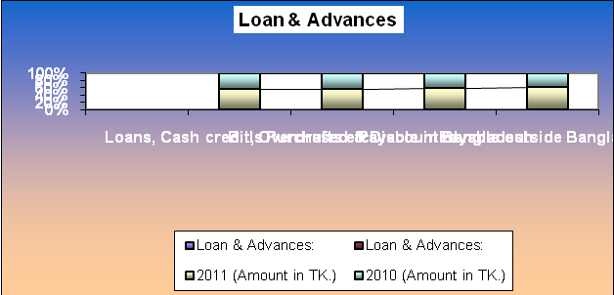
The table and the graph show that the growth of loan and advance from 2010 to 2011 is very healthy. And it means that the capacity of earning is satisfactory.

Maturity Grouping of Loans & advances: | 2011 | 2010
 | (Amount in TK.) | (Amount in TK.)
Payable on Demand | 1,533,400 | 820,900
Less than 3 months | 2,360,000,000 | 350,000,000
More than 3 months but less than 1 year | 150,000,000 | 1,050,000,000
More than 1 year but less than 5 year | 600,000,000 | 600,000,000
More than 5 years | 388,207,042 | 34,156,621
Total | 3,499,740,442 | 2,034,977,521

Sector wise Loans & Advances: | 2011 | 2010
 | (Amount in TK.) | (Amount in TK.)
Agricultural & Fisheries | 157,294,086 | 301,811,312
Industry | 11,786,241,757 | 9051909425
Construction | 673,061,010 | 562,410,629
Transport and comm. | 438,044,801 | 145,948,453
Business | 2,006,000,000 | 1,108,979,000
Miscellaneous | 2064370161 | 1,278,421,477
Total | 20,134,734,738,523 | 14,976,056,619

DBBL gives emphasis on industry and trading sector rather than agricultural and fisheries for giving loan & advance. So that the giving amount of loan of agricultural sector is decrease from 2010 to 2011 and increased the amount in industrial and trading sectors year to year.

 | 2011 | 2010 | In %
 | (Amount in TK.) | (Amount in TK.)
A) Urban:
Dhaka Region | 17,216,995,912 | 12,659,513,831 | 91.00%
Chittagong Region | 1,502,757,133 | 1,453,495,352 | 8.00%
Khulna Region | 9,078,610 | 0 | 0.48%
Sylhet Region | 51,904,889 | - | 0.27%
 | 18,780,736,544 | 14113009183 | 99.75%
B) Rural: | 2005 | 2004
Dhaka Region | 1,317,689,789 | 830813986 | 97.00%
Chittagong Region | 36,312,190 | 32233450 | 2.68%
Sylhet Region
Noagoan Region
Total | 1,354,001,979 | 863,047,436 | 99.68%
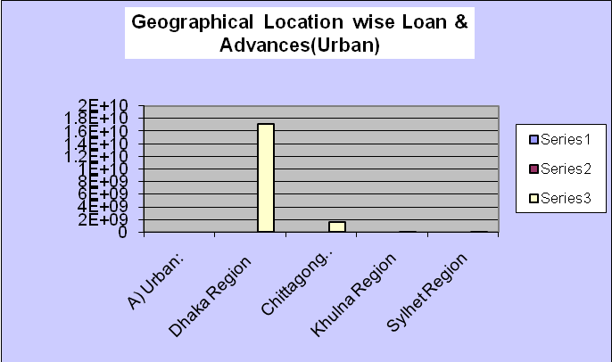

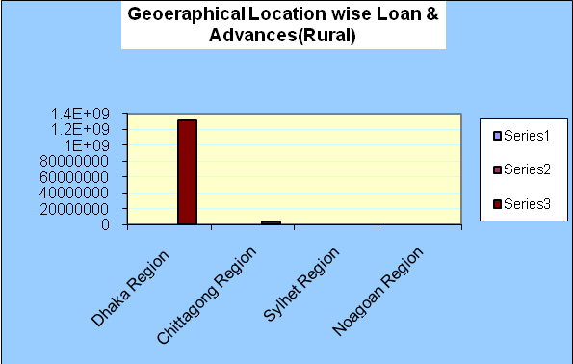
As a commercial bank DBBL always concern about their safety of loan and for city oriented branches the bank gives more loan to urban area than rural area.

Classification of Loans & Advances as per | 2011 |  | 2010 |  | In %
Bangladesh Bank Circular: | (Amount in TK.) |  | (Amount in TK.)
Unclassified | 19,773,372,771 |  | 14,952,819,751 |  | 98.21%
Special Mention Account | 4,016,715 |  | - |  | 0.20%
Substandard | 223,917,711 |  | - |  | 1.11%
Doubtful | 512,985 |  |  |  | 0.03%
Bad or loss | 132,918,341 |  | 23236868 |  | 6.60%
Total | 20,134,738,523 |  | 14,976,056,619 |  | 106.15%
Provision for Loans & Advances |  | 2011 |  | 2010
 |  | (Amount in TK.) |  | (Amount in TK.)
Provision for Classified loans & Advances |  | 123,767,686 |  | 19,043,356
Provision for Unclassified loans & Advances |  | 557,757,293 |  | 447,721,821
Total |  | 681,524,979 |  | 466,765,177

123,767,686
557,757,293
19,043,356
447,721,821
0
100,000,000
200,000,000
300,000,000
400,000,000
500,000,000
600,000,000
2011
2010
Provision for Classified
Loans & Advances
Provision for
Unclassified loans &
Advances

Year | 2008 | 2009 | 2010 | 2011
Profit after tax | 177.6 | 210.16 | 236.35 | 367.82
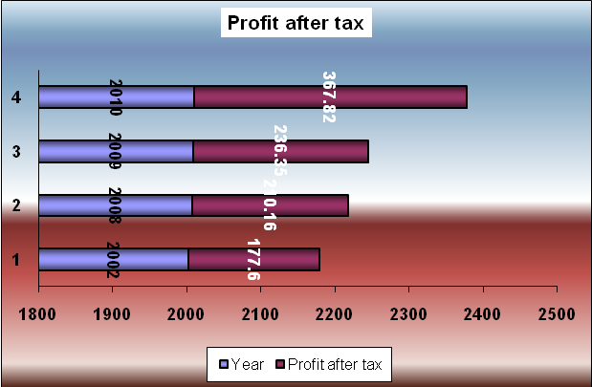

The rate of profit after tax is increasing and positively growing up situation. In Bangladesh the economic situation is always facing unstable situation in this circumstance the bank makes its profit more and more that means and shows the stability and strength of the Bank.

Year | 2008 | 2009 | 2010 | 2011
Total capital | 909 | 1136.29 | 1474.5 | 1909.26


The table and graph proves clearly that the position of the bank in case of capital is increasing from year to year at high rate. That also shows the stability of the bank in unexpected situation.

Year | 2002 | 2003 | 2004 | 2005
Deposit | 15975.45 | 17133.81 | 21067.56 | 27241.11

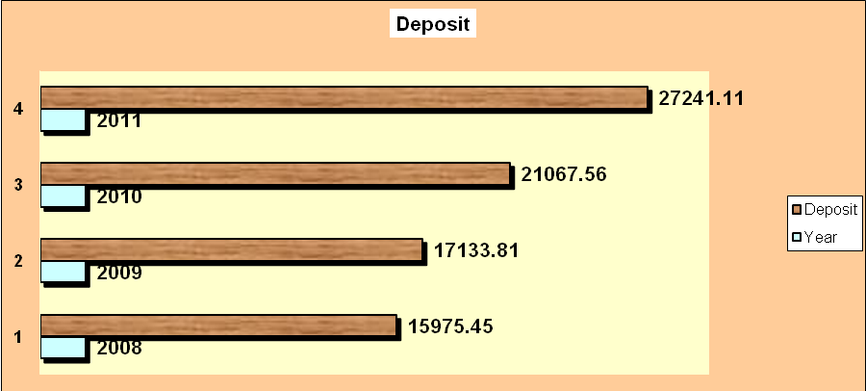

Deposit is the fund which a bank collects from the surplus units on condition of safety and given interest and gives to deficit units by charging a high interest for making profit. The given report shows the increasing scenario of the deposit.

Year | 2008 | 2009 | 2010 | 2011
Advances | 9391.64 | 11431.32 | 14976.6 | 20134.74
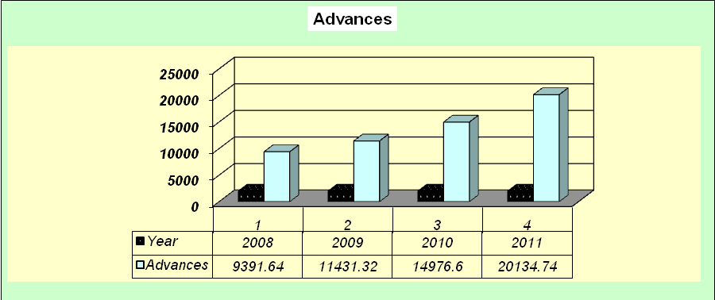
Loan and advance is the pure source of income of a bank. The bank which can use its fund properly it able to earn huge income. So that the growth of loan and advance of DBBL is increasing day by day.

Year | 2010 | 2011
Investment | 951.17 | 2242.85

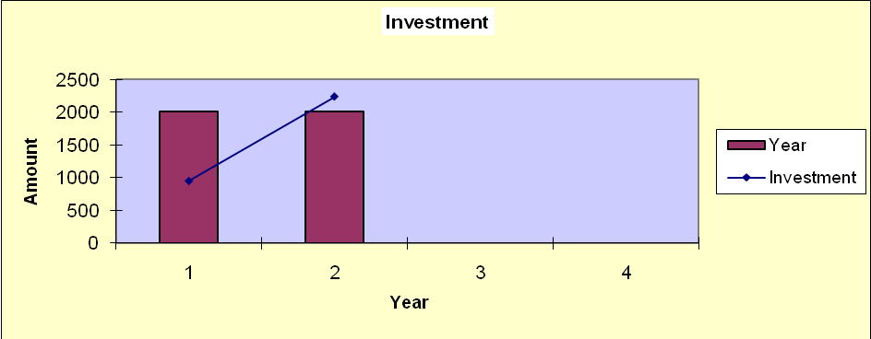
The bank uses it fund for investment in lease financing and other sectors. And the amount of investment amount is increasing from 2009 to 2010.
Year | 2008 | 2009 | 2010 | 2011
Import Business | 11858.1 | 17549.6 | 25974.44 | 26029.1

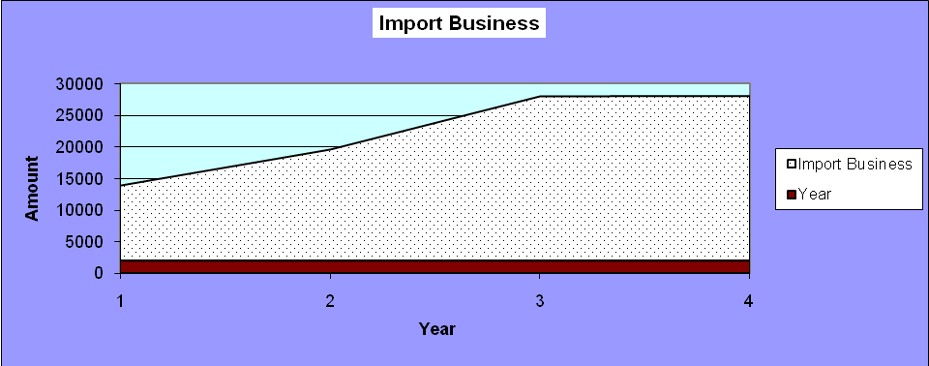

Year | 2008 | 2009 | 2010 | 2011
Export Business | 5015.94 | 7659.17 | 13581.17 | 22144.17

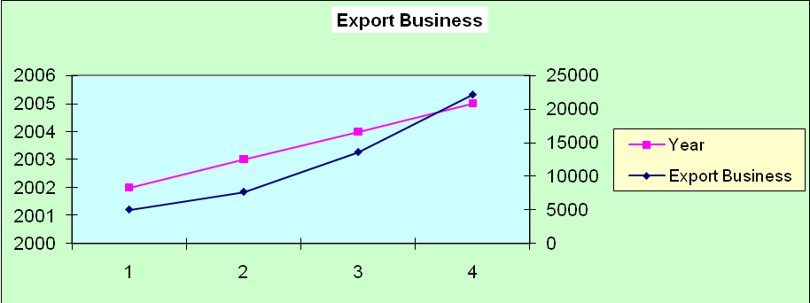
Financing in export import sector is very profitable for a bank because it is less risky an any other investment. For this reason DBBL prefers corporate banking. The tables of import and export business present the increasing growth in using fund.

Chapter: 6
Analysis

6.1. Respondent customer by types of account

Particulars | No. of Clients | Percentage
Savings account | 15 | 50
Current account | 12 | 40
Fixed account | 2 | 6.67
Other | 1 | 3.33
Total | 30 | 100

Source: Questionnaire Survey

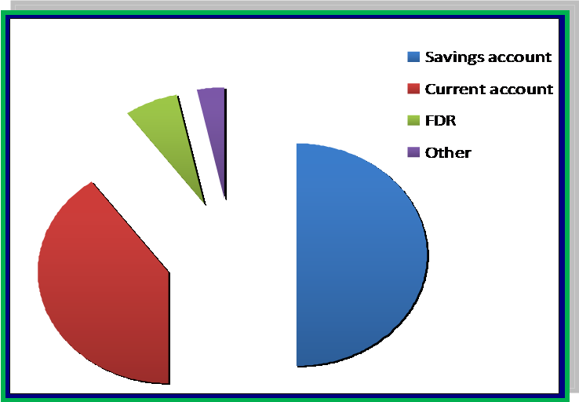

Graph: Reason for choosing DBBL

The above graphical presentation shows that out of 30 respondent 50% of customers have savings accounts, 40% have current account and also 6.67% have FDR accounts 3.33% have others accounts. So, majority of the respondent have savings account. Customers willingly want open savings account because customers try to deposit their money for future and they think that savings account is the best way (In-depth interview)

6.2. Customer perception on Interest rate provided for deposit A/C of DBBL

Particulars | No. of Clients | Percentage
Attractive | 6 | 20%
Competitive | 16 | 53.33%
Good | 6 | 20%
Fair | 2 | 6.67%
Total | 30 | 100%

Source: Questionnaire Survey

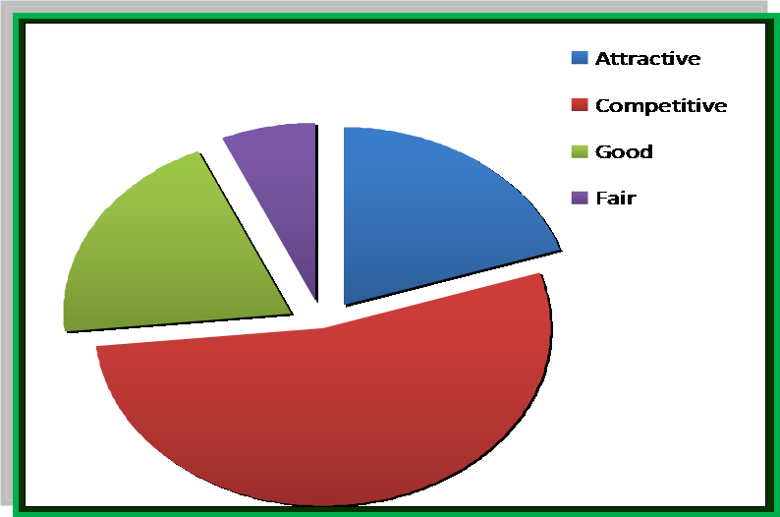

Graph: Customer perception on Interest rate provided for deposit A/C of DBBL

The above graphical presentation shows customer perception about different interest rate provided for deposit A/C of DBBL, 20% respondents said attractive, 53.33% competitive, 20% good and 6.67% fair. So majority respondent think that the interest rate for A/C is competitive.

6.3. DBBL’s principle of lending

Particulars | No. of Clients | Percentage
Strongly agree | 2 | 6.67%
Agree | 5 | 16.67%
Neutral | 8 | 26.67%
Disagree | 12 | 40%
Highly disagree | 3 | 10%
Total | 30 | 100%

Source: Questionnaire Survey

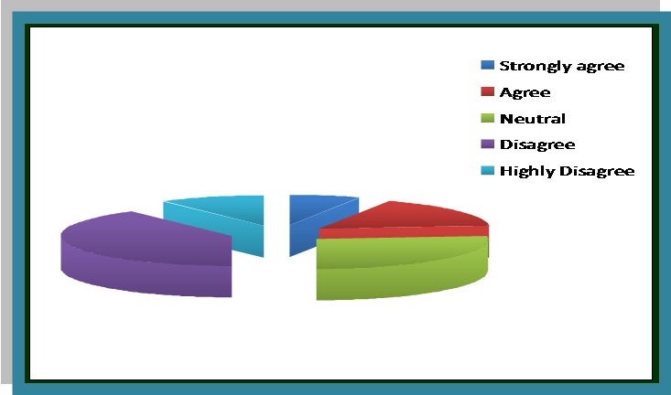

Graph: DBBL’s principle of lending

The above graphical presentation shows, 6.67% strongly agree, 16.67% agree, 26.67% neutral, 40% disagree and 10% are highly disagree about DBBL takes conservative decision to this policy. So, majority respondent disagree about DBBL.

6.4. The bank gives more emphasis on corporate sector than consumer loans.

Particulars | No. of Clients | Percentage
Strongly agree | 5 | 16.67%
Agree | 15 | 50%
Neutral | 10 | 33.33%
Disagree | 2 | 6.67%
Highly disagree | 0 | 0%
Total | 30 | 100%

Source: Questionnaire Survey

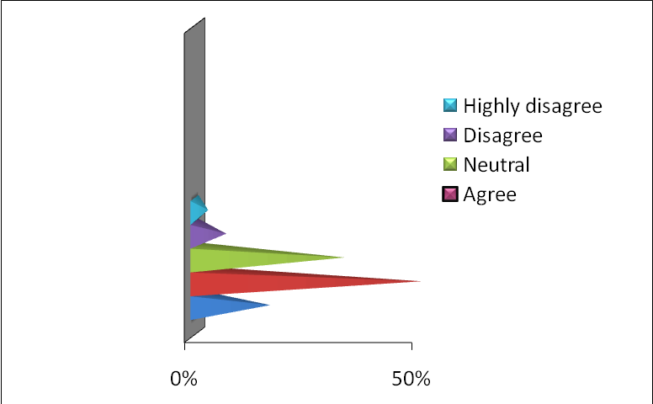

Graph: The bank gives more emphasis on corporate sector than consumer loans.

The above graphical presentation shows, 16.67% strongly agree, 50% agree, 33.33% neutral, 6.67% disagree and 0% are highly disagree. They are fully committed to provide corporate lone. So, about half percent of the respondent are agree.

6.5. Customer perception with the local remittance (PO/DD/TT) service

Particulars | No. of Clients | Percentage
Delight | 3 | 10%
Satisfied | 10 | 33.33%
Moderate | 13 | 43.33%
Dissatisfied | 2 | 6.67%
Highly dissatisfied | 2 | 6.67%
Total | 30 | 100%

Source: Questionnaire Survey

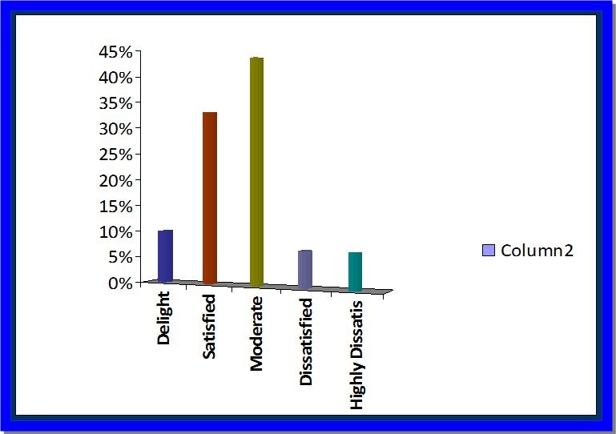

Graph: Customer perception with the local remittance (PO/DD/TT) service

The above graphical presentation shows customer perception with the local remittance (PO/DD/TT) services. 10% delight, 33.33% satisfied, 43.33% moderate, 6.67% dissatisfied, 6.67% highly dissatisfied. So, the majority respondent’s perception is moderate.

6.6. DBBL contingent facilities

Particulars | No. of Clients | Percentage
Delight | 3 | 10%
Satisfied | 10 | 33.33%
Moderate | 13 | 43.33%
Dissatisfied | 2 | 6.67%
Highly dissatisfied | 2 | 6.67%
Total | 30 | 100%

Source: Questionnaire Survey
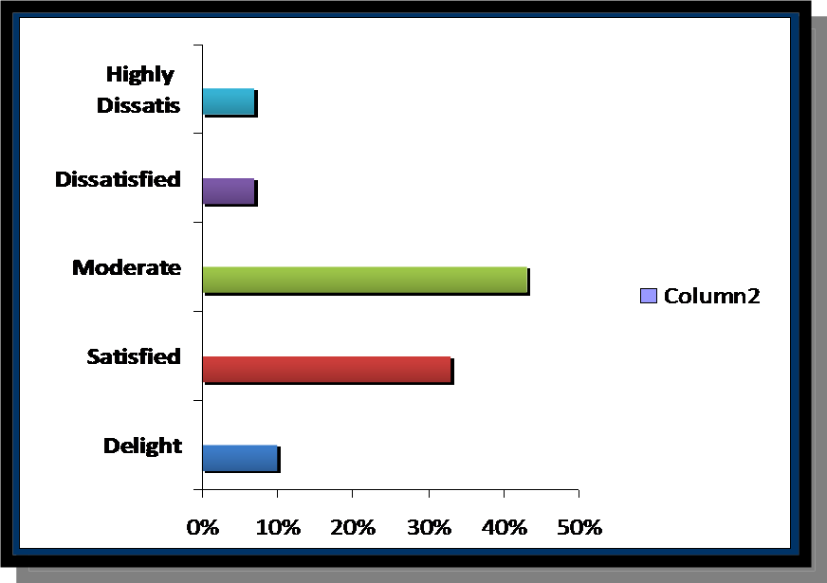

Graph: DBBL contingent facilities

The above graphical presentation shows customer perception with the DBBL contingent facilities. 10% delight, 33.33% satisfied, 43.33% moderate, 6.67% dissatisfied, 6.67% highly dissatisfied. So, the majority respondent’s perception is moderate.

6.7. DBBL’s loan against import merchandise is available

Particulars | No. of Clients | Percentage
Strongly believe | 2 | 6.66%
Believe | 7 | 23.33%
Neither believe nor disbelieve | 11 | 36.66%
Disbelieve | 7 | 23.33%
Strongly disbelieve | 3 | 10%
Total | 30 | 100%

Source: Questionnaire Survey
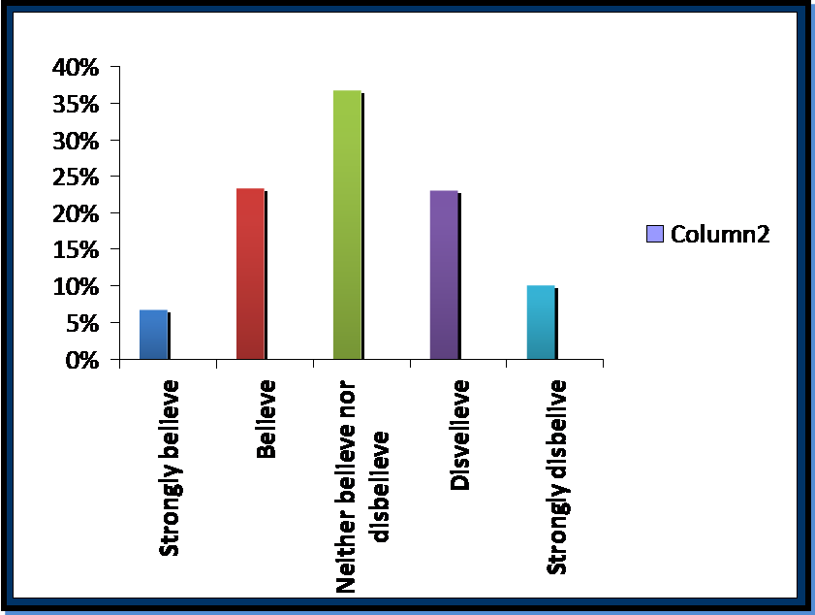

Graph: DBBL’s loan against import merchandise is available

The above graphical presentation shows that, 6.66% strongly believe, 23.33% believe, 36.66% neither believe nor disbelieve, 23% are disbelieve and 10% are strongly disbelieve. So, the majority respondent’s perception is neither believes nor disbelieve.

6.8. DBBL’s L/C facility is available

Particulars | No. of Clients | Percentage
Strongly agree | 5 | 16.67%
Agree | 15 | 50%
Neutral | 10 | 33.33%
Disagree | 2 | 6.67%
Highly disagree | 0 | 0%
Total | 30 | 100%

Source: Questionnaire Survey

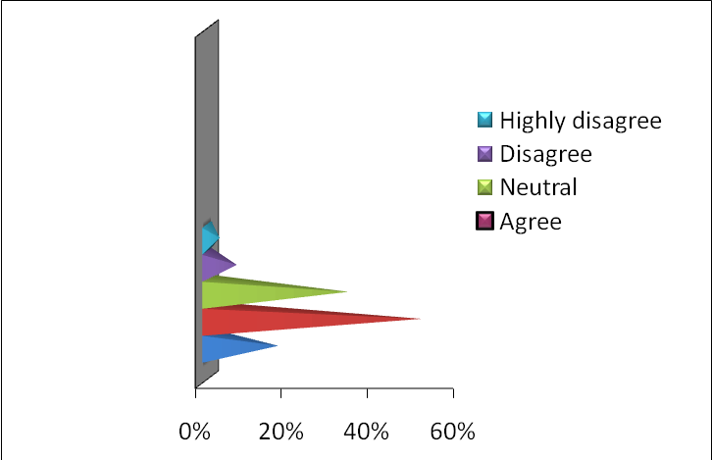

Graph: The bank gives more emphasis on L/C facility.

The above graphical presentation shows, 16.67% strongly agree, 50% agree, 33.33% neutral, 6.67% disagree and 0% are highly disagree. So, about half percent of the respondent are agree.

6.9. DBBL use modern technology

Particulars | No. of Clients | Percentage
Strongly agree | 2 | 6.66%
Agree | 12 | 40%
Neutral | 8 | 26.66%
Disagree | 5 | 16.67%
Highly disagree | 3 | 10%
Total | 30 | 100%

Source: Questionnaire Survey
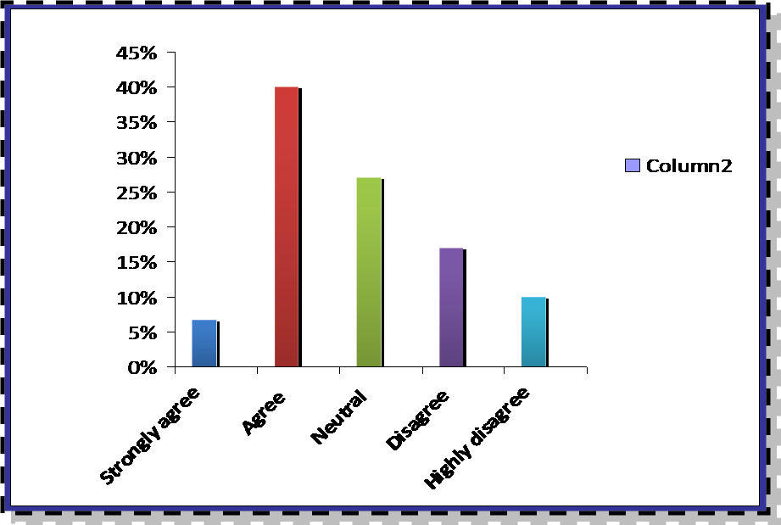

Graph: Customer perception about DBBL’s modern technology

The above graphical presentation shows, 6.67% respondent strongly agree, 40% agree, 26.66% neutral, 16.67% disagree and 10% are highly disagree. So, the majority respondent’s perception is agree that DBBL use modern technology.

6.10. Customer perception about money transfer of DBBL.

Particulars | No. of Clients | Percentage
Excellent | 1 | 3.33%
Competitive | 10 | 33.33%
Good | 18 | 60%
Fair | 1 | 3.33%
Poor | 1 | 3.33%
Total | 30 | 100%

Source: Questionnaire Survey
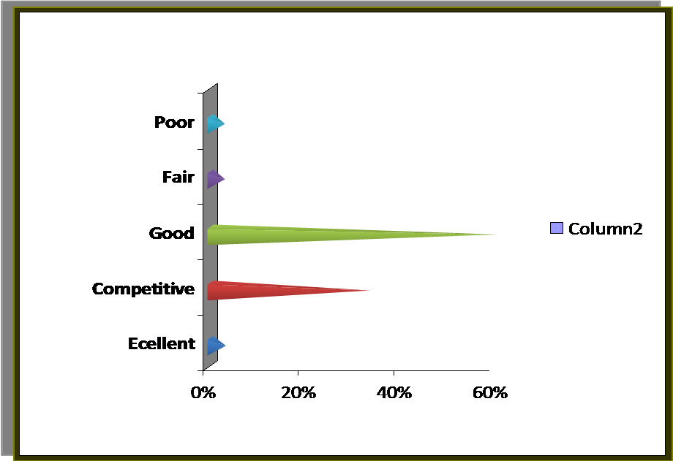

Graph: Customer perception about money transfer of DBBL.

The above graphical presentation shows customer perception about transfer of DBBL.3.33% customer said excellent, 33.33% competitive, 60% good, 3.33% fair and 3.33 % poor. So the majority respondent’s perception about money transfer is good.

Chapter: 7
Major Findings of DBBL

7.1 Major Findings:

- Most of the customer have savings account. Customer tries to deposit their money for future and they think that savings account is the best way.
- Most of the customers think that the interest rate for A/C is competitive.
- Customer perception is not positive enough on principles of lending.
- The bank gives more emphasis on corporate sector than consumer loans
- The service of DBBL is satisfactory.
- Most of the respondent said quality of money transfer facilities is satisfactory.
- L/C facilities have some problem.
- The perception of DBBL’s loan against import merchandise is neither believes nor disbelieve.
- The perception of DBBL’s contingent facilities is moderate.
- DBBL takes conservative decision to the principle of lending.

Chapter: 8
Conclusions & Recommendations

8.1 Conclusion:
Dutch-Bangla Bank is one of the leading private commercial banks in Bangladesh. The time period of this bank is very little although DBBL has already made a good position as a private bank and create an image in the clients mind. Dutch-Bangla Bank Ltd. Believes that building strong relationship with all particular customers, stakeholders, is crucial for growth and prosperity.
In retrospect of the marvelous growth of FI revenue over the previous years and contemplating the intensity of competition yet to come, it is crucial for DBBl to rethink its strategies and marketing plan to sustain the growth of FI revenue. Corporate banking service providers domiciled in Bangladesh are expected to be fighting for a bigger pie, as the growth prospect of the country’s corporate banking business is limited. One of the ways to achieve that objective is to maximize FI revenue generated from local clients and introduces more local products. Because, there is a huge potentials for inbound revenue.
However, export growth dropped while import soared in 2004/2005, putting pressure on trade deficit. Although special incentives were extended to the garment, jute, and leather sectors in the national budget, export income has been affected due to flood damage, which has disrupted transport and communications and lowered industrial output and distribution. Increase in import payments was due to drastic surge in imports of food grains and capital machinery. Foreign exchange reserve position will remain stable.

8.2 Recommendations:

- To sustain in a competitive market, every company needs to create some innovative products that can attract customers.

- DBBL requires to fulfill the need at least it should develop some consumer products like Residential Real Estate loans, Vehicle loans, Personal Loan, Festival loans, Pension Scheme, Marriage loan, Health care loan etc.

- As a FI DBBL's motto should be that we could meet up every financial needs of customer so that the customer can not leave us for any reason.

- I have already mentioned that DBBL does not offer competitive interest rates for fixed deposit so, if it fails to be competitive it fails to get huge deposit from FDR as well as it could loose some customers who could do any other transaction.

- DBBL can segment its target market for filing loans. Now a days different commercial banks offer SME (Small & Medium Enterprise) banking, DBBL can also provide special loan for specific customers. It can follow SME banking or it can introduce different types of short term loans like monthly loan, weekly loan etc.

- Charges on various services should be flexible.

- It should take creative activities to overcome any charging situation.

- DBBL should take customer oriented decision.

- The bank gives more emphasis on corporate sector than consumer loans. So it should also emphasis to consumer loans.

- Most of the customers think that the interest rate for A/C is competitive. It should be changed.

- DBBL should provide easy terms and condition for any kind of transaction.

Bibliography and Appendix

Appendix:

QUESTIONNAIRE:

Dear Respondent, as a student of Bangladesh University of Business & Technology (BUBT), doing M.B.A (Master of Business & Administration) internship program at Dutch-Bangla Bank Ltd. specializing in Marketing. My assigned topic is “Credit Control police of Dutch-Bangla Bank Ltd.” I would like to request you to kindly spare a few minutes from your busy schedule to fill up the questionnaire and make research a fruit full one. I am ensuring you that I will use this information only for the purpose of internship report. Your kind co-operation will be highly appreciated.
About respondent:
Personal information:
Q a: Gender
□ Male □ Female

Q b: Age
□ 18-30 □ 31-45 □ 46-50 □ 51-60 □ 60+

Q c: Education level
□ Undergraduate □ Graduate □ HSC or Below SSC □ Others……………….

Q d: Monthly Income (TK)
□ 10000-15000 □ 15000-25000 □ 35000-45000 □50,000+ □100,000+

Q e: Profession
□ Private Employee □ Govt. Employee □ Student □ Business
□ others……………….

Q f: Years of banking transaction
□ Less than 2 □ 2-5 □ 5-10 □10+

Q g: Do you have Debit/ Credit cards?
□ Yes □ No

Q h: Types of bank accounts
□Savings □ Current □ FDR or DPS □ others…………….

Q i: Primary bank accounts
□ NCBs □ PCBs □ FCBs

1) What types of account do you have in DBBL?
a. Savings account b. Current account
c. Fixed account d. Other

2) What is your perception on Interest rate provided for deposit A/C of DBBL?
a. Attractive b. Competitive
c. Fair d. Good

3) What is your perception on DBBL’s principle of lending?
a. Strongly agree b. Agree c. Neutral
d. Disagree e. Strongly disagree

4) Are you agree the bank gives more emphasis on corporate sector than consumer loans
a. Strongly agree b. Agree c. Neutral
d. Disagree e. Strongly disagree

5) Are you satisfied with the local remittance (PO/DD/TT) service?
a. Delight b. Satisfied c. Moderate
d. Dissatisfied e. highly dissatisfied

6) Are you satisfied with DBBL contingent facilities?
a. Delight b. Satisfied c. Moderate
d. Dissatisfied e. highly dissatisfied

7) Do you believe with DBBL’s loan against import merchandise is available?
a. Strongly believe b. believe c. Neither believes nor disbelieve
d. Disbelieve e. Strongly disbelieve

8) Do you agree with DBBL’s L/C facility is available?
a. Strongly agree b. Agree c. Neutral
d. Disagree e. Strongly disagree

9) Are you satisfying with the technology of ATM?
a. Delight b. Satisfied c. Moderate
d. Dissatisfied e. highly dissatisfied

10) The quality of money transfer of DBBL?
a. Excellent b. Competitive
c. Good d. Fair e. Poor

11. Please provide your valuable opinion for Credit Control police of Dutch-Bangla Bank Ltd.

…………………………………………………………………………………………………………………………………………………………………………………………………………………………………………………………………………………………………………………………………………………………………………………………………………

Thanks for your kind co-ordination

