In the backdrop of a mercurial, ever-changing fashion world,Fariha knit tex Ltd considers its prime mission to suit every new taste, whim and demand of
Customers from around the world and all strains of human culture.

FNL acts on the basic premise that “fashion is an exploration into the images people seek to convey – about themselves and the way they live.”

So, in dealing with its target consumers, FNL mainly aims to know their perception about themselves and translates those into garments. Doing that, over the years, FNL designers have acquired an almost telepathic understanding of the consumers’ needs.

FNL has started manufacture and export garments since late 1990. Its mission is to produce the latest design; quality knit fabrics and apparels for international markets.

FNL is one of the few elite private sector business groups, which contributed wealth as well as welfare to the struggling economy of Bangladesh.

As time is essential to space so is taste to its products. The secret is love – which, paired with meticulous efficacy and a keen sensitivity to style, makes FNL an emerging brand destined to light up the horizon of fashion.

FNL has team of skilled and dedicated technocrats backed by adequate number of modern USA and European machinery and equipments to match international standard of all kinds of knitwear products.
General Information About The Factory:

Name of the factory: FARIHA KNIT TEX LTD.Type : 100 % Export Oriented Composite knitwear Industry

Year of Establishment : 1997

Status ( Legal Structure ) : Private Limited Company

Annual Production capacity : 7000 ton of knit fabric ( Open & tubular form )

Total Manpower: Male- 3750 Female-1250

Address: Baroibogh,West Masdair , Fatullah,Narayanganj, Bangladesh.
LOCATION OF FNL

DND ROAD
FNL

FATULLAH BISIC

FARIHA KNIT TEX Limited is located at Baroibogh , in Narayanganj about 3 km from the BISIC

7Product mix:

- 100 % cotton
- CVC (Chief Value Cotton) (60/40)
- Grey melange
* 5 % Viscose & 95% Cotton
* 10 % Viscose & 90% Cotton
* 15 % Viscose & 85 % Cotton
- Ecro melange (2%)
- Camel melange (1%, 2%)
- PC (52/48)

Project Cost: 90 core Taka

Different Departments:

Production Oriented Department:
• Yarn store
• Raw fabric store & Raw fabric inspection section
• Knitting
• Planning & Control
• Batching
• Chemical store
• Dyeing Section
• Finishing Section

• Dyeing lab section
• Wet lab
• Quality Control
• Maintenance
• Utility
• Water treatment plant

Supporting department:
- Prochrement
- Merchandising
- Marketing
- IT
- HRD
- Finance & accounting
- Medical
- Personnel Administration
- Security

REMARK:

It's a wonderful project. Though it's a new project but profitable for it's strong management The main draw back was there is no Effluent treatment But within some days The Effluent treatment plant will be completed.

FARIHA KNIT TEX Ltd.(Dyeing Department) Manpower List :

No. | Section | Person
01 | GM/AGM | 01
02 | DM | 0l
03 | ADM | 01
04 | SPO | 01
05 | P.O | 04
06 | Planning | 01
07 | Q.C / Q.I | 86
08 | Maintenance | 71
09 | Batch | 75
10 | Dyeing | 149
11 | Finishing | 139
12 | Store | 26
13 | Delivery | 29
14 | Washing | 23
15 | Accounts | 03
16 | Marketing | Ol
17 | Store (Acc) | 02
18 | Ex.Of./'Time | 04
19 | Pion | 04
 | Total | 621

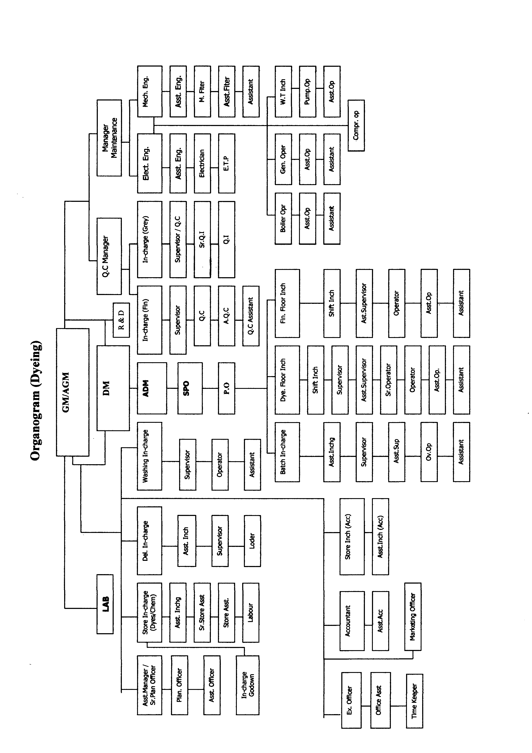

Shift Change:

Shift | From | To
A | 8 A.M. | 8 P.M.
B  _ | 8 P.M. | 8 A.M.

Responsibility of production officer :

- Overall supervision of dyeing & finishing.
- Dyes & chemicals requisition issue & check.
- Program making, sample checking color measurement.
- Control the supervisors operators & helpers of machines .
- To give dye-line or the program slip according to daily production plan. Batch preparation & pH check
- To rectify the finished fabric which rejected from quality control department .
- To check daily production report
- To study dye & chemicals nature delivery by the manufacture & applied them correctly to the production to get best product .

Job Description :

Title : Production Officer.
Dept.: Dyeing
Report to : Senior production officer
Job summery : To plan execute & follow up the production activities & control the quality production with related activities .

Title : Senior Production Officer
Dept.: Dyeing
Report to : Dyeing Manger
Job summery :To plan execute & follow up the production activities & control the quality production with related activities .

REMARK :

In this dyeing plan all the P.O ,S.P.O & D.M are technical person . Thus why efficiency of this section is very high .

List of Machines

Department | Machine type | No. of machine
Grey Fabric Store & inspection | Fabric inspection m/c | 3
Batching | Back sewing m/c | 01
Batching | Turning m/c | 02
Batching | Plaiting m/c | 02
Batching | Overlock m/c | 02
Dyeing floor | Winch dyeing m/c  (Environmental ) | 12
Dyeing floor | Winch dyeing m/c (High  Pressure) | 9
Dark Room | Light Box | 02
LAB | Ahiba Naunce-( Sample  Dyeing m/c) | 04
LAB | Fongs ( S-D.M ) | 02
LAB | Lab Extractor | 02
LAB | Dryer | 01
LAB | Yarn Twist  Tester | 01
LAB | Incubator ( Oven ) | 01

Lab | Verivide Light Cabinet  Cac 120 | 01
Lab | Hot Plate (Single Burner) | 01
Lab | Computer | 01
Lab | Philips Hot Iron | 01
Lab | Handy Data color | 02
Lab | . Dryer | 02
Lab | Rota Wash | 01
Lab | Commercial Washer | 02
Lab | Electronic Crock meter | 02
Lab | Manual crock meter | 01
Lab | Perspiration tester | 01
Lab | pH Meter | 03

Finishing |  | Dewatering & Detwisting m/c | 02
 |  | Efficient Shrinkage Dryer | 01
 |  | Compactor(Tubular) | 02
 |  | Santashrink Jumbo Dryer | 01
 |  | Open width Compactor | 02
 |  | Slitting & Dewatering m/c | 03
 |  | Brushing m/c | 01
 |  | Industrial Washer | 03
 |  | Stenter | 01
 |  | Calender | 01
 | Backsewing m/c |  | 01
 | Peach finish |  | 02

Lay out plan of FNL

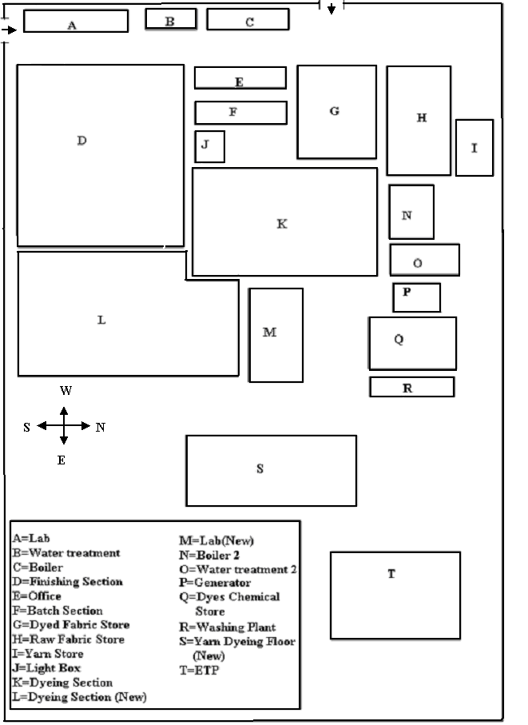

Machine Specifications

Grey Inspection Machines :

1. Brand Name :UZU
Model : U2- 90031
Country Of Origin : Thailand
Serial No : 0095172
Motor: 210 HP
Power: 220 V

2. Brand Name: HSING CHENG
Model: HC-TIM -1500 mm
Country Of Origin : Thailand
No of motor: 02
Motor: 210 HP
Power : 220 V
Year of Manufacture : 2005

Batch Section:

1. Back sewing machine
Manufacture: MTG MECCANICA SNC
Country Of Origin : Italy

2. Turning Machines
Brand Name: HSING CHENG
Model: HC-TFM -1500 mm
Country Of Origin : Thailand
No of motor: 02
Motor: 210 HP
Power: 220 V
Year of Manufacture : 2005

3. Over lock Machine
Brand Name: JUKI
Model No: 3614
Country Of Origin : Japan

Lay out plan of Dyeing-Finishing floor

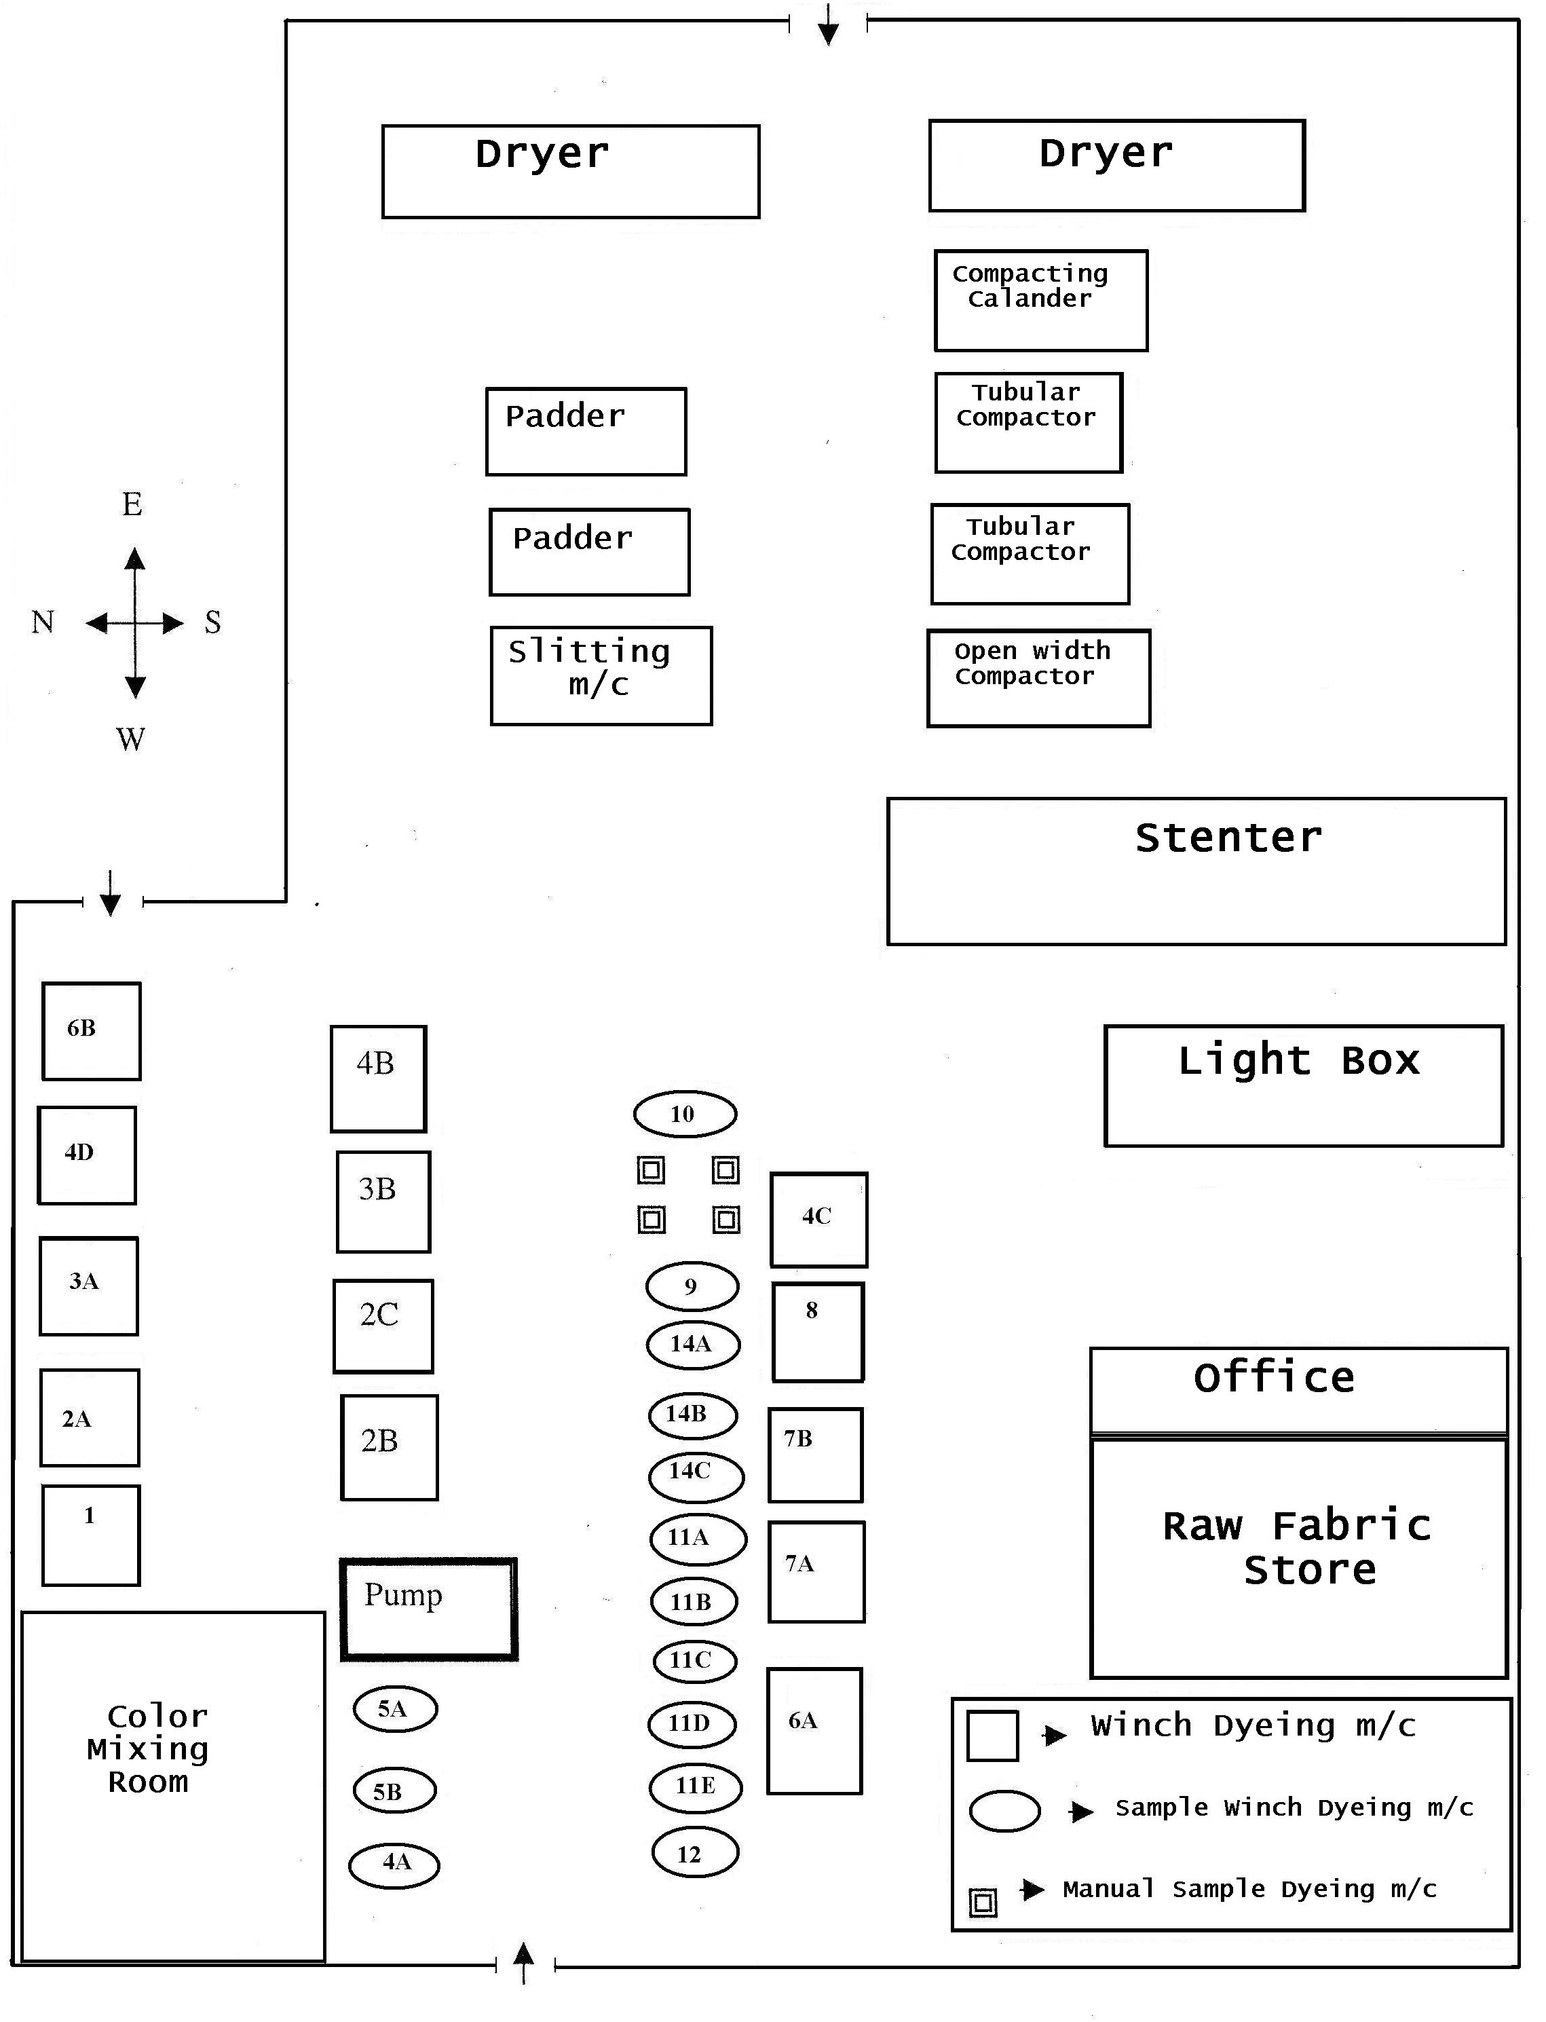

Dyeing Machines (Winch Dyeing Machine):

Machine No: 01
Brand Name: FONGS
Model: GN 6-SR -6T
Serial No :26012102
Country Of Origin : Honkong
Machine Type: ATM Machine
Capacity: 1000Kg
Cycle time: 03 min
No of cycle : 12
Main pump speed: 80-150 m/min
Winch speed: 250 m/min
No of Nozzle: O4
No of motor: 08
Power: 415 V 3 @ 50 Hz
Water supply pressure req. : 300 Kpa
Compressed Air pressure required: 700 Kpa
Steam pressure required : 700 Kpa
Year Built : 2002

Machine No: 2
Brand Name: FONGS
Model: GN 6-SR -4T
Serial No :26012101
Country Of Origin : Honkong
Machine Type:ATM Machine
Capacity: 750 Kg
Cycle time: 03 min
No of cycle : 12
Main pump speed: 80-150 m/min
Winch speed: 250 m/min
No of Nozzle: 04
No of motor: 08
Power: 415 V 3 @ 50 Hz
Water supply pressure req. : 300 Kpa
Year Built : 2002

Machine No: 03
Brand Name: FONGS
Model : GN-18 M-4 T
Serial No :2G011473
Country Of Origin : Honkong
Machine Type :Environmental
Machine Capacity :600 Kg
Cycle time : 03 min
No of cycle 12
Main pump speed :80-150 m/min
Winch speed :250 m/min
No of Nozzle: 04
No of motor: 08
Power: 415 V 3 @ 50 Hz
Water supply pressure req. : 300 Kpa
Compressed Air pressure required: 700 Kpa
Steam pressure required : 700 Kpa
Design temp. : 140 ° C
Year Built : 2001

Machine No: 04
Brand Name: FONGS
Model: GN-18 M-4 T
Serial No :24010297
Country Of Origin : Honkong
Machine Type :Environmental
Machine Capacity :500 Kg
Cycle time: 03 min
No of cycle : 12
Main pump speed :80-150 m/min
Winch speed :250 m/min
No of Nozzle: 04 No of motor: 08
Power: 415 V 3 @ 50 Hz
Water supply pressure req. : 300 Kpa
Compressed Air pressure required: 700 Kpa
Steam pressure required : 700 Kpa
Design temp. : 140 ° C
Year Built : 2000

Machine No: 05
Brand Name: FONGS
Model: GN-6 SR-3T
Serial No :26012100
Country Of Origin : Honkong
Machine Type: ATM Machine
Capacity: 750 Kg
Cycle time: 03 min
No of cycle : 12
Main pump speed: 80-150 m/min
Winch speed :250 m/min
No of Nozzle: 03
No of motor: 08
Power: 415 V 3 @ 50 Hz
Water supply pressure req. : 300 Kpa
Compressed Air pressure required : 700 Kpa
Steam pressure required: 700 Kpa
Design temp. : 140 ° C
Year Built : 2002

Machine No: 06
Brand Name: FONGS
Model: GN-18 M-3T
Serial No :24010325
Country Of Origin : Hong kong
Machine Type :Environmental
Machine Capacity :1000 Kg
Cycle time: 03 min
No of cycle : 12
Main pump speed :80-150 m/min
Winch speed :250 m/min
No of Nozzle : 06
No of motor: 08
Power: 415 V 3 @ 50 Hz
Water supply pressure req. : 300 Kpa
Compressed Air pressure required : 700 Kpa
Steam pressure required : 700 Kpa
Design temp. : 140 ° C
Year Built : 2000

Machine No: 07
Brand Name: FONGS
Model: GN-6-2T
Serial No :23009446
Country Of Origin : Honkong
Machine Type :HTHP
Machine Capacity :250 Kg
Cycle time: 03 min
No of cycle : 12
Main pump speed :80-150 m/min
Winch speed :250 m/min
No of Nozzle: 02
No of motor: 08
Power: 415 V 3 @ 50 Hz
Water supply pressure req. : 300 Kpa
Compressed Air pressure required: 700 Kpa
Steam pressure required : 700 Kpa
Design temp. : 140 ° C
Year Built : 1998

Machine No: 08
Brand Name: FONGS
Model: GN-18 M-2T
Serial No :23009199
Country Of Origin : Honkong
Machine Type :HTHP
Machine Capacity :500 Kg
Cycle time: 03 min
No of cycle : 12
Main pump speed :80-150 m/min
Winch speed :250 m/min
No of Nozzle : 01
No of motor: 08
Power: 415 V 3 @ 50 Hz
Water supply pressure req. : 300 Kpa
Compressed Air pressure required : 700 Kpa
Steam pressure required : 700 Kpa
Design temp. : 140 ° C
Year Built : 1998

Machine No: 09
Brand Name: FONGS
Model: GN-18-2T
Serial No :23009200
Country Of Origin : Honkong
Machine Type: HTHP Machine
Capacity: 1000Kg
Cycle time: 03 min
No of cycle : 12
Main pump speed: 80-150 m/min
Winch speed: 250 m/min
No of Nozzle: 06
No of motor: 08
Power: 415 V 3 @ 50 Hz
Water supply pressure req. : 300 Kpa
Compressed Air pressure required: 700 Kpa
Steam pressure required : 700 Kpa
Design temp. : 140 ° C
Year Built : 1998

Machine No: 10
Brand Name: FONGS
Model: ECO-6-2T
Serial No :28015334
Country Of Origin : Honkong
Machine Type: HP/HT
Machine Capacity: 750 Kg
Cycle time: 03 min
No of cycle : 12
Main pump speed: 80-150 m/min
Winch speed: 250 m/min
No of Nozzle: 02
No of motor: 08
Power: 415 V 3 @ 50 Hz
Water supply pressure req. : 300 Kpa
Compressed Air pressure required: 700 Kpa
Steam pressure required : 700 Kpa
Design temp. : 140 ° C
Year Built: 2003

Machine No: 11
Brand Name: AK
Model: GN-6-1T
Serial No :23009447
Country Of Origin : KOREAN
Machine Type :ATM
Machine Capacity :400 Kg
Cycle time: 03 min
No of cycle: 12
Main pump speed :80-150 m/min
Winch speed :250 m/min
No of Nozzle: 01
No of motor: 08
Power: 415 V 3 @ 50 Hz
Water supply pressure req. : 300 Kpa
Compressed Air pressure required: 700 Kpa
Steam pressure required: 700 Kpa
Design temp. : 140 ° C
Year Built: 1998

Machine No: 12
Brand Name: AK
Model: GN-18 M-4 T
Serial No :26011472
Country Of Origin : Honkong
Machine Type :ATM
Machine Capacity :400 Kg
Cycle time: 03 min
No of cycle : 12
Main pump speed :80-150 m/min
Winch speed :250 m/min
No of Nozzle: 0 1
No of motor: 08
Power: 415 V 3 @ 50 Hz
Water supply pressure req. : 300 Kpa
Compressed Air pressure required: 700 Kpa
Steam pressure required: 700 Kpa
Design temp.: 140 ° C
Year Built: 1998

Machine No: 13
Brand Name: FONGS
Model: ECO-38-6T
Serial No :28014582
Country Of Origin : Honkong
Machine Type: Environmental Machine
Capacity: 250Kg
Cycle time: 03 min
No of cycle: 12
Main pump speed :80-150 m/min
Winch speed: 250 m/min
No of Nozzle: 02
No of motor: 08
Power: 415 V 3 @ 50 Hz
Water supply pressure req. : 300 Kpa
Compressed Air pressure required: 700 Kpa
Steam pressure required : 700 Kpa
Design temp. : 140 ° C
Year Built: 2003

Machine No: 14
Brand Name: AK
Model: ECO-38-6T
Serial No :28014581
Country Of Origin : KOREAN
Machine Type: Environmental Machine
Capacity: 600 Kg
Cycle time: 03 min
No of cycle : 12
Main pump speed: 80-150 m/min
Winch speed: 250 m/min
No of Nozzle: 06
No of motor: 08
Power: 415 V 3 @ 50 Hz
Water supply pressure req. : 300 Kpa
Compressed Air pressure required : 700 Kpa
Steam pressure required : 700 Kpa
Design temp. : 140 ° C
Year Built : 2003

Machine No: 15
Brand Name: AK
Model: ECO-38-4T
Serial No :28015424
Country Of Origin : KOREAN
Machine Type: Environmental Machine
Capacity: 800Kg
Cycle time: 03 min
No of cycle: 12
Main pump speed: 80-150 m/min
Winch speed: 250 m/min
No of Nozzle: 02
No of motor: 08
Power: 415 V 3 @ 50 Hz
Water supply pressure req. : 300 Kpa
Compressed Air pressure required : 700 Kpa
Steam pressure required : 700 Kpa
Design temp. : 140 ° C
Year Built : 2003

Machine No: 16
Brand Name: FONGS
Model: ALLFIT -6O
Serial No : 26012103
Country Of Origin : Honkong
Machine Type :HP/HT Machine
Capacity: 100 Kg
Cycle time: 03 min
No of cycle : 12
Main pump speed: 80-150 m/min
Winch speed: 250 m/min
No of Nozzle: 02 N
o of motor: 08
Power: 415 V 3 @ 50 Hz
Water supply pressure req. : 300 Kpa
Compressed Air pressure required: 700 Kpa
Steam pressure required : 700 Kpa
Design temp. : 140 ° C
Year Built : 2001

Machine No: 11 B
Brand Name: FONGS
Model: ALLFIT -30
Serial No :29017180
Country Of Origin : Honkong
Machine Type :HP/HT
Machine Capacity :30 Kg
Cycle time: 03 min
No of cycle : 12
Main pump speed: 80-150 m/min
Winch speed: 250 m/min
No of Nozzle: 01
No of motor: 08
Power: 415 V 3 C 50 Hz
Water supply pressure req. : 300 Kpa
Compressed Air pressure required: 700 Kpa
Steam pressure required: 700 Kpa
Design temp. : 140 ° C
Year Built : 2004

Machine No: 11 C
Brand Name: FONGS
Model: ALLFIT -30
Serial No :29017183
Country Of Origin : Honkong
Machine Type :HP/HT
Machine Capacity :30 Kg Cycle time: 03 min
No of cycle : 12
Main pump speed: 80-150 m/min
Winch speed: 250 m/min
No of Nozzle: 01
No of motor: 08
Power: 415 V 3 @ 50 Hz
Water supply pressure req. : 300 Kpa
Compressed Air pressure required: 700 Kpa
Steam pressure required : 700 Kpa
Design temp. : 140 ° C
Year Built : 2004

Machine No: 11 D
Brand Name: FONGS
Model: ALLFIT -30
Serial No :29017182
Country Of Origin : Honkong
Machine Type :HP/HT
Machine Capacity :30 Kg
Cycle time: 03 min
No of cycle : 12
Main pump speed :80-150 m/min
Winch speed: 250 m/min
No of Nozzle: 0 1
No of motor: 08
Power: 415 V 3 @ 50 Hz
Water supply pressure req. : 300 Kpa
Compressed Air pressure required: 700 Kpa
Steam pressure required : 700 Kpa
Design temp. : 140 ° C
Year Built: 2004

Machine No: 11 E
Brand Name: FONGS
Model: ALLFIT -30
Serial No :29017181
Country Of Origin : Honkong
Machine Type :HP/HT
Machine Capacity :30 Kg
Cycle time: 03 min
No of cycle : 12
Main pump speed :80-150 m/min
Winch speed :250 m/min
No of Nozzle : 01
No of motor: 08
Power: 415 V 3 @ 50 Hz
Water supply pressure req. : 300 Kpa
Compressed Air pressure required: 700 Kpa
Steam pressure required : 700 Kpa
Design temp. : 140 ° C
Year Built : 2004

Machine No: 12
Brand Name: FONGS
Model: GN-18
Serial No :24010324
Country Of Origin: CHINA
Machine Type :Environmental
Machine Capacity: 100 Kg
Cycle time: 03 min
No of cycle : 12
Main pump speed :80-150 m/min
Winch speed :250 m/min
No of Nozzle: 0 1
No of motor: 08
Power: 415 V 3 @ 50 Hz
Water supply pressure req. : 300 Kpa
Compressed Air pressure required: 700 Kpa
Steam pressure required : 700 Kpa
Design temp. : 140 ° C
Year Built : 2000

Machine No: 13
Sample Dyeing m/c:
Brand: Ugoloni
Origin : Italy
Capacity: 20 Kg.

Machine No: 14 A
Brand Name: FONGS
Model: ECO-38-1T
Serial No: 2801420
Country Of Origin : Honkong
Machine Type :Environmental Machine
Capacity: 150 Kg
Cycle time: 03 min
No of cycle: 12
Main pump speed: 80-150 m/min
Winch speed :250 m/min
No of Nozzle: 01
No of motor: 08
Power: 415 V 3 @ 50 Hz
Water supply pressure req. : 300 Kpa
Compressed Air pressure required: 700 Kpa
Steam pressure required : 700 Kpa
Design temp. : 140 ° C
Year Built : 2003

Machine No: 14 B
Brand Name: FONGS
Model: ECO-38-1T
Serial No: 2801421
Country Of Origin : Honkong
Machine Type :Environmental
Machine Capacity: 150 Kg
Cycle time: 03 min
No of cycle : 12
Main pump speed: 80-150 m/min
Winch speed: 250 m/min
No of Nozzle: 01
No of motor: 08
Power: 415 V 3 @ 50 Hz
Water supply pressure req. : 300 Kpa
Compressed Air pressure required : 700 Kpa
Steam pressure required : 700 Kpa
Design temp. : 140 ° C
Year Built : 2003

Machine No: 14 C
Brand Name: FONGS
Model: ECO-38-1T
Serial No: 28015419
Country Of Origin : Honkong
Machine Type :Environmental Machine
Capacity: 150 Kg
Cycle time: 03 min
No of cycle : 12
Main pump speed : 80-150 m/min
Winch speed: 250 m/min
No of Nozzle: 01
No of motor: 08
Power: 415 V 3 @ 50 Hz
Water supply pressure req. : 300 Kpa
Compressed Air pressure required: 700 Kpa
Steam pressure required : 700 Kpa
Design temp. : 140 ° C
Year Built : 2003

Machine No: 14 D
Brand Name: FONGS
Model: ECO-38-1T
Serial No: 28015418
Country Of Origin : Honkong
Machine Type : Environmental
Machine Capacity: 150 Kg
Cycle time: 03 min
No of cycle : 12
Main pump speed: 80-150 m/min
Winch speed: 250 m/min
No of Nozzle: 01
No of motor: 08
Power: 415 V 3 @ 50 Hz
Water supply pressure req. : 300 Kpa
Compressed Air pressure required: 700 Kpa
Steam pressure required : 700 Kpa
Design temp. : 140 °C , Year Built : 2003
FINISHING MACHINES:

1. Slitting & Dewatering m/c
M/C quantity : 01
Brand-BIANCO
Origin-Italy
Pressure -4-4.5 bar
Output / Input Dancing R/1 pressure -0.5 bar
Power supply-400 volt
Utility Used : Electricity
Main Function :-To cut the tubular fabric for opening .
-To remove a slight amount of water in padding zone

2. Dewatering & Detwisting M/C
M/C quantity: 02
Brand -Santex
Origin-Switzerland
Extraction ( % )- 60 % ( approx }
Maxm Width capacity -140 cm
Workable Width -42 "
Year of manufacture: 1998
Other points :
Speed -66 yd/min ( Single jersey ) -50-55 yd/min (Rib/ Interlock )
Padder pressure -3.5 bar ( Single jersey ) -4-4.5 bar ( Rib / Interlock
There are shapes to control the dia of fabric.

4. SANTASHRINK JUMBO DRYER
M/C quantity : 01
Brand -SANTEX
Origin- Switzerland
Year of construction : 2003

5. Compactor (Tubular)
M/C quantity : 02
Brand -TUBETEX Origin-U.S.A
Year of construction :
Maxm line speed: 80 m/min
Useable line speed: 45 m/min
Maxm dia :55 "
Workable dia : 48 "
G.S.M Control : Maxm 20 % increase after compacting
M/c temp.- 95° C
Main Function : Dia Control, G.S.M Control, Shrinkage Control
Utility Used : Gas, Electricity, Steam
Sensor Position :
-Shoe pressure ( Two Shoe )
-Retard Roller ratio
-Pliater Ratio
-Edge drive ratio
-Near-far pressure
-Take-out roller ratio
-Conveyor Roller ratio

6. OPENWIDTH COMPACTOR:
M/C quantity : 02
Brand -TUBE-TEX
Origin-U.S.A
Maxm line speed: 60 m/min
Useable line speed: 30 m/min Maxm dia :95 "
Workable dia :90"
Steam box temp.-80° C
Feed R/L temp.-105° C
Over feed ( %)-upto 50 %
Shoe pressure : Maxm-18 Minm-5
Main Function :
-Width Control
-G.S.M Control
-To impart dimensional stability
Sensor Position :
-Shoe pressure ( One shoe )
-Retard Roller ratio
-Pliater Ratio
-Right-Left roller pressure
-Take-out roller ratio
-Conveyor Roller ratio

7. Compacting Calender :
M/C quantity : 01
Brand -SANTEX
Origin-Switzerland
Year of manufacture: 1998

8. STENTER :
M/C quantity : 02
Brand -TUBE-TEX
Origin-U.S.A
Maxm dia :111 "
Workable dia :100"
Temp.-120-140° C
Speed-20-50 m/min
Padder Pressure: 4-4.5 bar
Other points :
- Coarse & wales become align & even distribution by MAHLO in the feed side
- Bowing of fabric become straight
- 6 chamber ,12 burner ,12 blower.
- 12 nozzle at every chamber.
- 8 shape to control the width .
- Maxm width is not used because pin penetration is difficult & chains are
- Temperature control depends on shade condition . -In every chamber fabric width should be same .
Sensor points : Fabric speed, Fabric width, Temperature, Over feeding speed.
Utility Used: Gas, Electricity, Steam

9.Sweading M/C :
M/C quantity : 01
Brand -TUBETEX
Model: 10 GS X 1952
Origin-U.S.A
Year of manufacture-2005
Voltage - 400 V
Normal Current - 96 amp.
No of Pile :03
No of Counter-Pile :03
Setting Point :
Taker -in- Tension (14 K/g)
Drum Tension (47 K/g)
Fabric Return Tension (15 K/g)
Plaiter Tension (14 K/g)
R.p.m of drum (22)
Fabric Speed (10 m/min)
Pile/Counter Pile Speed ( 80-90 m/min )

10.Raising M/C :
M/C quantity : 01
Brand -GEMATEX
Model: KRM 6725
Origin-Germany
Year of manufacture-1999
Voltage - 400 V
Nominal Current -63 A
No of Pile :12
No of Counter-Pile :12
Dyeing Lab Section :
Sample Dyeing M/C :
Brand Name: AHIBA NUANCE
Capacity : 20 pots
Pot Capacity: 150 ml
Country: USA
Purpose :Sample dyeing
Heating System : Infrared
Sample Dyeing M/C :
Brand Name: FONGS
Capacity : 12 pots
Pot Capacity: 150 ml .
Country :HONKONG
Purpose: Sample dyeing
Heating System : Electricity
Auto Dispensing M/C :
Brand Name :DATA COLOR
Capacity : 42 pots
Pot Capacity: 950 ml
Dispensing Capacity : 12 pots
Country: TAIWAN
Purpose : Laboratory dispensing & pipe ting
Software: USA
Max. Capacity :220 gm
Min.Capacity : 0.02 gm
Country: TAIWAN
Purpose : Laboratory dispensing & pipeting
Software: USA
Color matching Light Box:
Brand: Verivide
Light Source : 4 types TL 83,D65,F,UV
Country: UK

THE TYPES OF RAW MATERIAL(YARN STOCK) USED IN THE FNL AND THEIR SOURCES INCLUDING PRICES ARE GIVEN IN THE CHART OF DAILY YARN STOCK(AS NO:03/09/08)

Raw material is a unique substances in any production oriented textile industry It plays a vital role in case of continuous production & for high quality fabric .

Types of raw material:
• Fabric
• Dyestuff
• Chemical & auxiliaries

Name & Sources of raw materials :

Grey Fabric :
• Single Jersey
• Single jersey with lycra
• Interlock
• Terry
• Single Lacoste
• Double Lacoste
• Rib
• Rib with Lycra
• 1 X 1 Rib
• 2X2 Rib
• 9X2 Rib

Fabric Sources :
• Knitexcel
• Apple Knit
• Energy group
• Dream Fashion
• Barnali Textile
• Alahi knitting
• Noor Textile
• Mother Knitting
• Microfibre
• Ibrahim Knitex

Basic Chemicals :
• Acetic Acid
• Soda Ash
• Caustic Soda
• Oxalic Acid
• Sodium hydrosulphate

Annual Requirment of Grey fabric : 4800 tons
Produced in KCL : 3000 tons
Brought in from other sources : 1800 tons

Dyes :

The following dyes are used:
1.Reactive
2.Disperse

Name of Dyes | Supplier | Store(kg) | Godown(kg) | Rate (Tk/Kg )
Cibacron Yellow - F4G | CIBA | 19.801 | 30 | 1690
Cibacron Yellow FN2R | " | 60.811 | 300 | 1361
Cibacron Orange – FNR | " | 12.444 | 0 | 2017
Cibacron Scarlet -F3G | " | 6.374 | 0 | 2216
Cibacron Red-FN3G | " | 67.485 | 270 | 2089
Cibacron Red-FNR | " | 49.82 | 425 | 1194
Cibacron Red-FN2BL | " | 16.666 | 380 | 1700
Cibacron Scarlet -FN6G | " | 24.99 | 25 | 2153
Cibacron Navy –WB | " | 80.956 | 300 | 435
Cibacron Red -WB 150 % | " | 84.961 | 50 | 745
Cibacron Red -HDN 200 % | " | 54.63 | 0 | 1400
Cibacron Turquish –HGN | " | 57.081 | 225 | 702.5
Bluton - BVB | " | 72.234 | 180 | 440
Bezactive Yellow S-MAX | CHT | 62.355 | 875 | 742
Bezactive Blue S-GLD | " | 8.423 | 0 | 1625
Bezactive Blue SFR | " | 24.682 | 0 | 2048
Bezactive Red S-3B | " | 26.714 | 75 | 705
Bezactive Red S-MAX | " | 69.314 | 0 | 758
Bezactive Yellow S-8G | " | 14.049 | 0 | 1203
Terasil Black SRL-O1 | CIBA | 4.862 | 0 | 1200
Terasil Black W-NS | " | 18.605 | 75 | 1789
Terasil Blue BGE-01 | " | 34.241 | 25 | 1882
Terasil Blue WBLS | " | 27.085 | 40 | 3000
Terasil Navy GRLC | " | 18.443 | 0 | 967.94
Terasil Red WRS | " | 36.855 | 100 | 2494
Terasil Violet BL-01 | " | 17.049 | 25 | 2711
Terasil Yellow W-4G | " | 23.571 | 15 | 930
Remazol Blue-RR | " | 32.586 | 200 | 1073
Remazol Yellow-RR | " | 22.713 | 100 | 962
Remazol Red –RR | " | 9.573 | 475 | 962
Remazol Brillient Yellow -3GL | " | 0.268 | 0 | 1800
Remazol Tarquise Blue-G | " | 27.067 | 0 | 550
Dychufix Yellow- EC | DYSIN | 134.14 | 200 | 452
Dychufix Red -EC  _ | " | 99.171 | 1660 | 494
Dychufix Blue BR-XF 150 % | " | 24.208 | 60 | 1425
Dychufix Red 2B-XF 150% | " | 45.414 | 140 | 475
Dychufix Turquoise Blue –G | " | 66.083 | 0 | 427.5
Dychufix Crimson MX-ED | " | 157.329 | 1360 | 591
Dychufix Navy Blue EC | " | 185 | 1628 | 585
Reactive Starfix Black –GR |  | 559.402 | 750 | 335
Everzol Brill. Blue –RSPL |  | 42.561 | 50 | 1100
Flabine -7GFE |  | 0.398 | 0 | 12000

Chemicals:

Chemicals Name | Supplier | Price (Tk/Kg ) | Mode of Action
Kappasol AF 200 | Kappachem | 371 | Antifoam
Kappwet BOS | Kappachem | 350 | Wetting (Detergent)
Kappquest FE | Kappachem | 147 | Sequestering
Kappazone H53 | Kappachem | 142 | Peroxide stabilizer
Kappasoft BD | Kappaachem | 283 | Cationic Softener
Kappasoft SM | Kappachem | 284 | Silicon Softener
Kappatex R98 | Kappachem | 345 | Reducing Agent
Invatex PC | CIBA | 139 | Peroxide Killer
Silvatol FLN | CIBA | 467 | Anti Oil
Cibecel DBC | CIBA | 176 | Leveling gent
Irgasol CO-NEW | CIBA | 346 | Sequestering,
Cibapon R | CIBA | 324 | Soaping Agent
Eriopon OS | CIBA | 573 | Reducing agent
Invatex AC | CIBA | 180 | Core neutralizing
Cibafix ECO | CIBA | 396 | Fixing
Tinofix FRD | CIBA | 316 | Fixing
Irgasol DAM | CIBA | 271 | Fixing Remover
Cibatex AB45 | CIBA | 188 | High Temp. pH Stabilizer
Univadine DIF | CIBA | 468 | DisperseLevelingAgent
Romapon 173 | Dystar | 88.53 | Anticrease
RogIyr BIO97600 | Dystar | 517.84 | Engyme
Acetic Acid | Taiwan | 89 | Acid
Soda Ash | China | 26 | Alkali
Glaubar Salt | China | 16.28 | Electrolyte
Caustic Soda | China | 52.34 | Alkali
Hydrogen peroxide 50% | India | 45.4 | Bleaching Agent
Oxalic Acid |  | 75 | Acid

Lay out plan of Lab Section
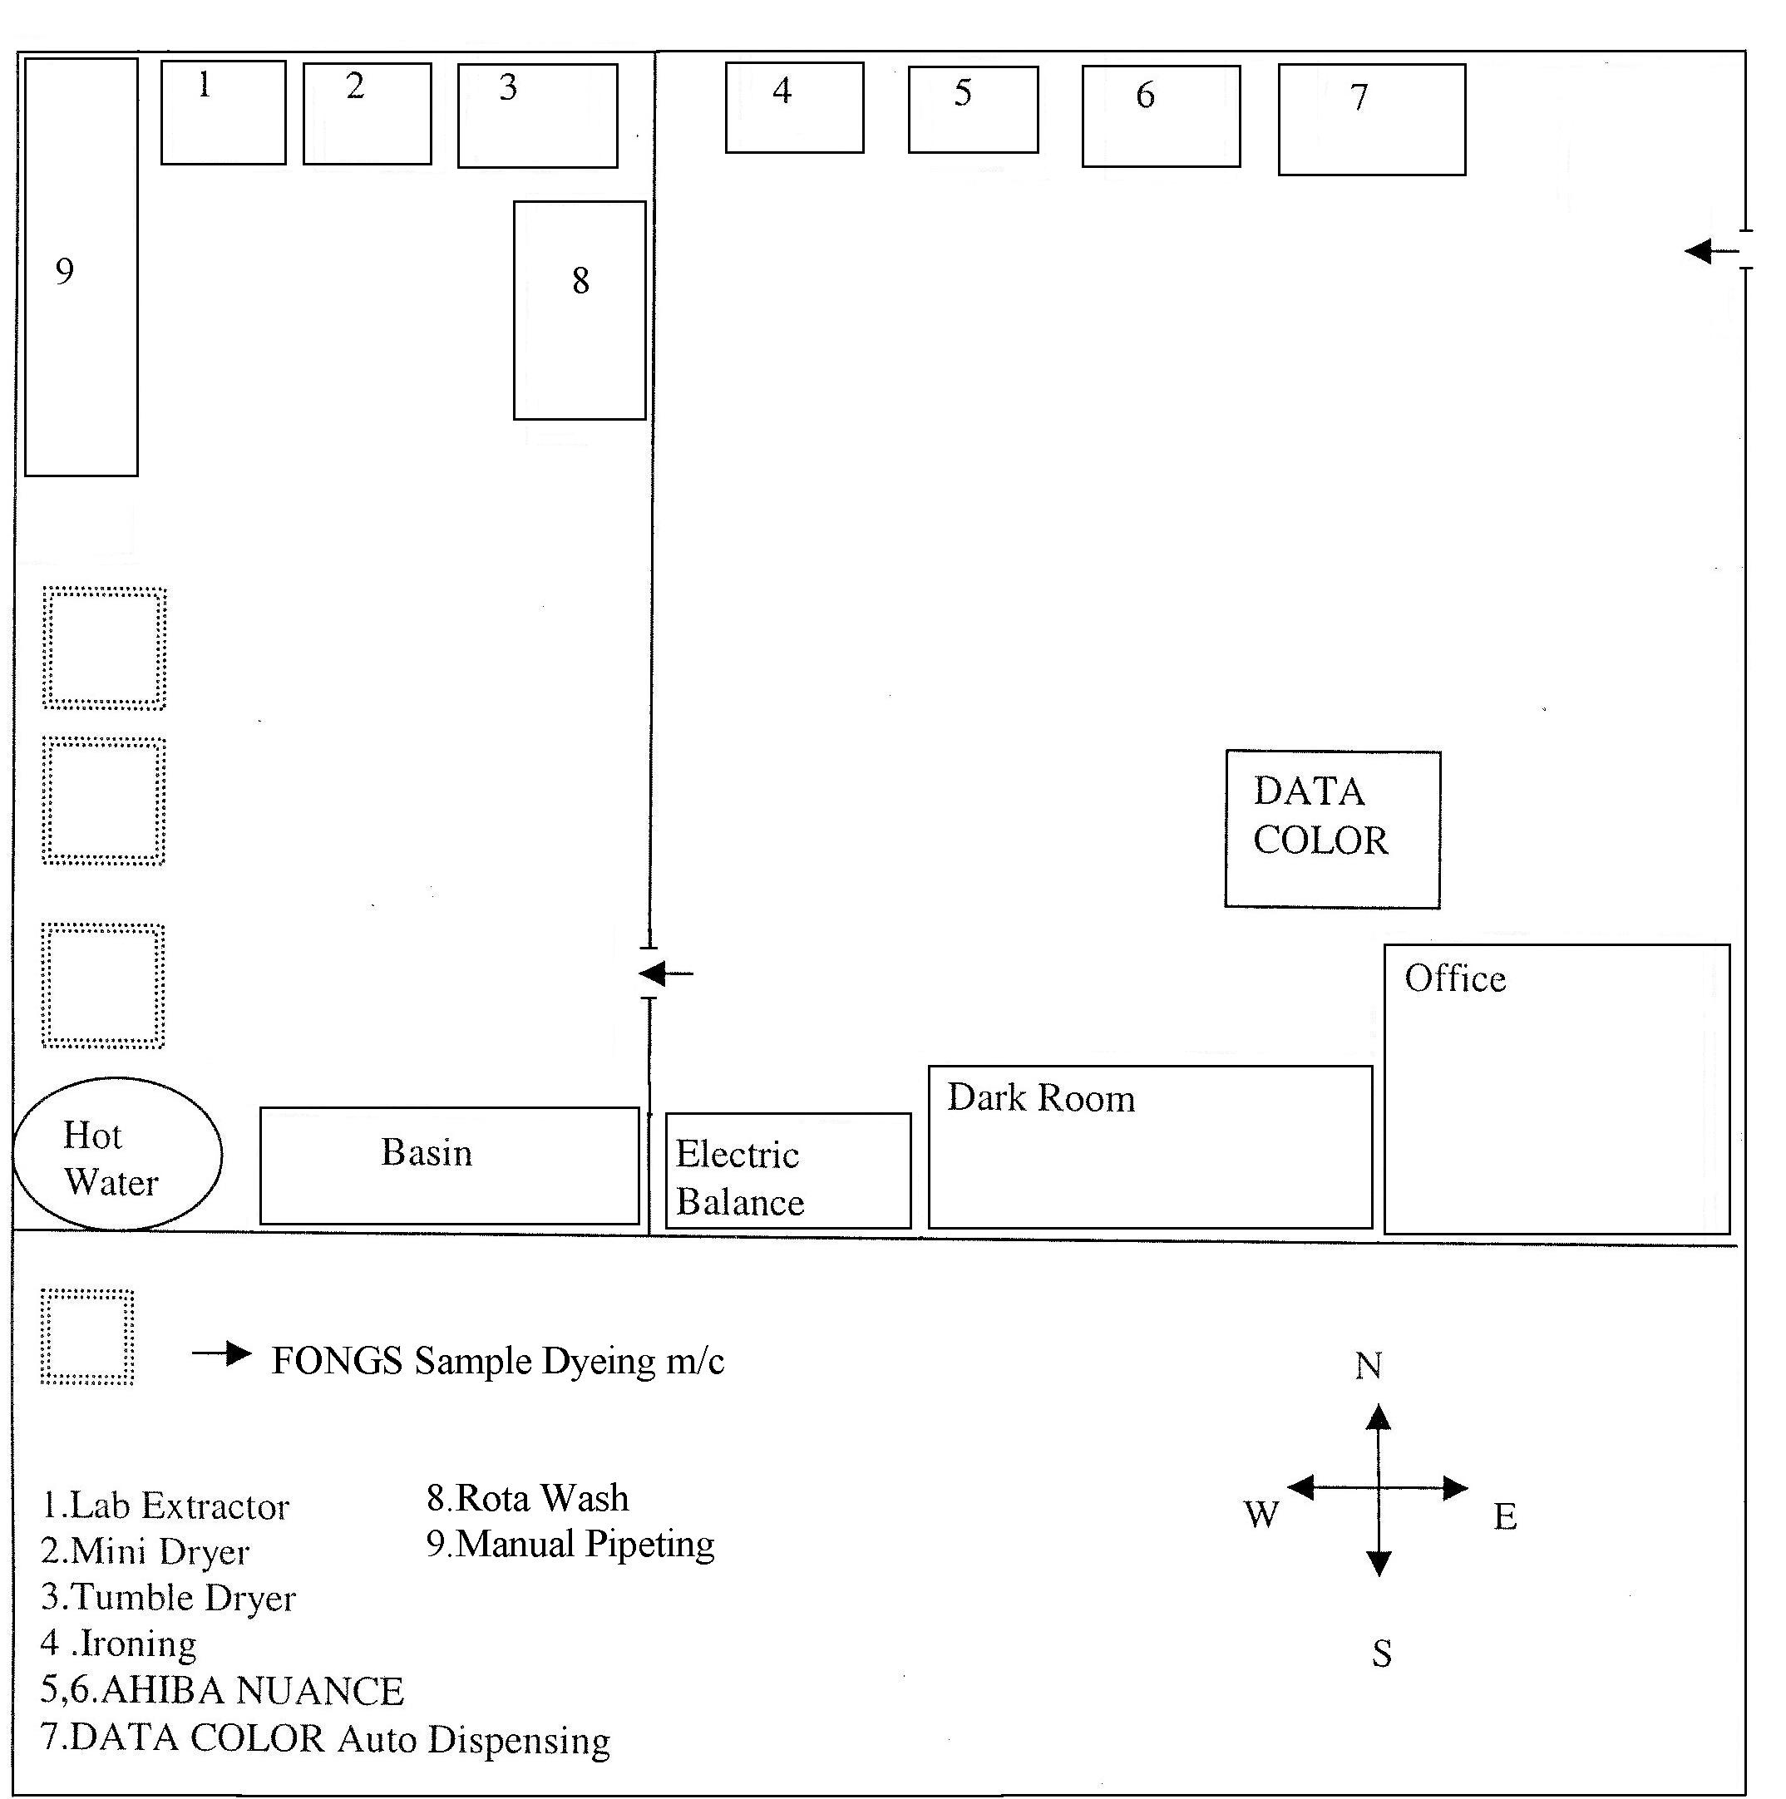

Tumble Dryer:
Model: G 511 V
Country: ITALY
Purpose : Drying

Mini Dryer:
Country: ITALY
Purpose : Drying
Temp.: Max 300°

Wash Fastness Tester :
Brand Name :Rota Wash
Capacity : 24 pots
Temp.: Max 100°
Country: UK

Lab Extractor M/C :
Country: UK
Purpose: Squeezing

Sequence of operation :

Lab dip approved
▼
Grey fabriC inspection
▼
Batching
▼
Scouring & Bleaching
▼
Enzyming ( If required )
▼
Dyeing
▼
Bath Drain
▼
Cold Wash
▼
Neutral With Acetic Acid
▼
Soaping
▼
Fixing (If required )
▼
Softening

Production Parameters :

Process | Temp(▫C) | pH | Time min | M : L ratio
Scouring -  Bleaching | 98 | 11.5-12 | 60' | 1:8
Enzyme Wash | 55 | 4.5-5 | 60' | 1:8
Enzyme Deactivation | 70 |  | 10'
Reactive Dyeing  (Light Shade) | 60 | 10.2-10.8 | 60' | 1:8
Reactive Dyeing  (Dark Shade) | 60 | 10.9-12 | 60' | 1:8
White Shade | 98 | 10.5-11.5 | 20' | 1:8
Turquish color dyeing | 80-90 | 10.9-12 | 90' | 1:8
Polyester dyeing | 130 | 4-4.5 | 45' | 1:8

Grey Fabric Inspection :
In grey fabric inspection the available faults are
-Hole
-Loop
-Set up
-Needle breaking
-Needle mark
-Star
-Sinker Mark
-Yarn problem
-Patta
-Wheel mark
-Oil mark
-Oil spot
-Thin & Thickness
-Patty
-Group mark

Batching :
Batching preparation is the process where inspected grey fabrics are divided into different batches with reasonable quantity according to machine capacity, nozzle number in order to make them suitable for the further operation In batching. It must be carefully observed that each Nozzle of a machine contains equal length of fabric.

Sequence of Batching :

Grey fabric divided into batches
▼
Batches divided nozzle wise according to lengh & Dia

Instrument used :
-Turning m/c
-Plaiting m/c
-Weighting m/c
-Back sewing m/c
-Overlock m/c

Information checked:
-Order No
-Color
-Yarn Count
-Yarn lot
-Yarn brand
-Knitting factory
-Machine No
-Roll No]

Pre-treatment:

-For scouring & bleaching at first the fabric is loaded on to the bath .
-Required amount of water is taken to the bath .
-Wetting Agent & Anti creasing Agent is added.
-Scouring Agents (Caustic/Soda) & Stabilizer are added by the aid of dosing when the temperature reaches at 50° C.
-H₂0₂ is added by the aid of dosing system for 5' .
-Temperature is raised to 98° C & the process is carried for 6O'
-The liquor are drained at 80° C.
-After that chemical wash & enzyme wash are done.

Curves for Pre-treatment:

Scouring & Bleaching:
Room Temperature
60▫C × 5'
98▫C × 60'
2▫C /min
80▫C
H₂O₂
1 2 3 4 5 6 7
1) Anticreasing
2) Wetting Agent
3) sequestering Agent
4) Antifoam
5) stabilizer
6) Soda
7) Caustic

Cold Wash
5'
5'
Cold Wash

Chemical Wash:

Room Temperature
60▫C × 5'
80▫C × 15'
1 2
1) Oxalic Acid
2) Peroxide Killer

Cold Wash
Cold Wash
5'
5'

Enzyme Wash:

P^{H}= 4.5-5
55▫C × 60'
70▫C × 10'
1 2
1) Acetic Acid
2) Bio-Polish

Cold Wash
Cold Wash
5'
5'

Dyeing Light /Medium Shade:

Dyeing Bath Preparation :
- Auxiliaries are added at 50° C
-Salt added by dosing system ( time : 10-20')
- pH maintained at 6.5-7
-Color dosing at 6O° C for 20'

Exhaustion & Fixation :
-After 30' soda ash added by dosing for 30-35'
-pH checked & maintained at 10.5
-Dye bath is kept at 60° C for 40-60'
-After every 10' the sample is checked fixation occurs during this time.
-Rinse for 10' & the bath is drained.

Neutralization :
-The material should be neutralized to remove alkaline condition at room temperature by acid wash for 15 min & rinsing will be carried on for 10 min.

Soaping :
-Then soaping agent is added & temperture raised to 90°-100°C for 10 min.
-The bath is cooled 7 rinsed for 10 min.
-Dye bath temperature then cooled to 60° C.

Softening:
Softener is applied to soften the fabric as well as it improves the hand feel. The material is treated at 60°C for 20 mins. Then rinsing again & material unload.

Procedure of Dark shade :

At first the bath is set at 50° C & take the right volume of water in the dye bath.
▼
Required amount of wetting agent is added.
▼
Caustic soda is added & second heat command 60°C & stabilizer is added also.
▼
H₂0₂ is dosed & 10' runs.
▼
Temperture raised to 100° C & run the material for 30'
▼
Cooling the bath at 75°C & bath is drained .
At 90° C the material is run for 15 mins
▼
Cooling the bath to 75°C to darin
▼
Add Acetic Acid to neutralize the whole bath of fabric & run time is 20'
▼

Rinse the fabric for 5' & bath is drained .
▼
New water from reserver is taken & pH should be 4.5-5 .
▼
Enzyme is injected to the bath . Run time is 60' at 55°C
▼
Temp. raised to 70° C & run time 10' & then drain
▼
Again new water is taken & dosing of glaubar salt for 20' & pH should be check
(pH =7)
▼
Color dosing for 30' at 50°C
▼
Soda is added by dosing for 40'at 50°C
▼
Then raise the temp. & run the fabric for 35-60'.At this time after every 10' the sample is checked.
▼
Rinse the material for 10' & bath is drained.
▼
At room temp. acid treatment is done for 20'& rinse the material for 5'
▼
Soaping is done at 90°C for 10 min & bath is drained.
▼
Fixing agent is added at 50° C & run time is 20' & bath is drained
▼
Softening is done at 60° C for 20'& balli is drained.
▼
Finally the fabric is unloaded.

White Shade:

At first Scouring bleaching chemicals are added to the bath & they are treated at 98°C for 60'
▼
Temp. is lowered at 80°C & OBA is added.Run time is 10'.
▼
Temp. is raised to 98° C & Run time is 20'.
▼
Then enzyme treatment is applied & then softening occurs

Dyeing Curve:

Room temperature
60▫C × 60'
1 2 3 4
1) Auxilaries
2) Salt
3) Color dosing(20-30')
4)Soda dosing(30-40')

Cold Wash
Cold Wash
5'
5'
Cold Wash
5'

Normal Hot:

60▫C × 10'
Acetic acid
20'

Chemical Hot:

60▫C
90▫C
80▫C
80▫C
Soaping chemical

Fixing & Softening (if dark shade):
50▫C × 20′
Fixing agent Softner
20′

Softening:
40▫C × 20′
Softener &
Acid

Stripping Recipe:

-First of all these two chemicals are taken & treated with fabric in cold temperature for 30 min.
Soda ash =0.5 g/L
Bleaching powder =0.5 g/L
Then Direct drain is done.
-After that some other chemicals named below are treated at 98°C for 45 min.
Anticreasing Agent =0.3 g/L
Levelling Agent =0.3 g/L
Wetting Agent =0.3 g/L
Caustic soda =1-2 g/L
-After that 3-5 g/L Reducing Agent is taken and treated at 80°C for 10'.
Then Direct Drain is done.
-After that half or full scouring takes place
-Lastly fabric is treated by acetic acid.

Stripping for white :
-First of all these two chemicals are taken & treated with fabric in cold temperature for 30 min.
Soda ash =0.5 g/L
Bleaching powder =0.5 g/L
Then Direct drain is done.
-After that these two chemicals are taken & treated with fabric at 98°C for 60 min.
Hydrose =1-2 g/L
Caustic Soda =1-2 g/L
-Lastly fabric is treated by acetic acid.

Machine Wash:
Add hydrose (6 g/L) & caustic Soda (6 g/L)
▼
Run 20' at 110° C
▼
Run 10' at 95° C
▼
Run 10' at 80° C
▼
Run 10' at 60° C
▼
Run 10' at 40° C
▼
Drain

FINISHING

Textile finishing, in a restricted sense, is the term used for a series of processes to which all bleached, dyed, printed & certain grey fabrics are subjected before they are put to market.

OBJECTIVE OF FINISHING:
-Improving the appearance,luster, whiteness etc.
-Improving the feel, which depends on the handle of the material & its softness, suppleness, fullness etc.
-Wearing qualities, non- soiling, anticrease, antishrink comfort etc .
-Special properties required for particular uses -water -proofing flame proofing etc .
-Covering of the faults in the original cloth .
-Increasing the weight of the cloth .

FINISHING EFFECTS:
-Easy care .
-Crease recovery.
-Dimensional stability
-Good abrasion resistance
-Improved tear strength
-Good sew ability
- Soft or stiff handle
-Shine or luster

SEQUENCE OF OPERATION:

For Open fabric:
Slitting
▼
Stenter( Softener used )
▼
Compactor

For tubular fabric:
Padder (Softener used)
▼
Drying
▼
Compactor

FINAL INSPECTION REPORT:

For final inspection , Inspection table & Inspection m/c is used .
The 4-point system is given below-

Size of Defect | Penalty point
Less than 3 inches | 1
3-6 inches | 2
More than 6- 9 inch | 3
More than 9 inch | 4

Size of holes & opennings-

1 inch or less | 2
More than 1 inch | 4

Some general rules of the inspection are-
- Not 1 metre of cloth is penalized more than 4 points.
- Cloth is inspected on face side only unless specified.
- If the total defect parts per 100 yards of fabric are 40 or more the fabric will be rejected.But it may be changed according to buyer’s requerments.

REMARK:

FNL strictly follow up the production parameters like Temp, M:L ratio pH check etc. As they do some difficult shade it takes more time for the production of the Batch.The production officer & Sr. production Officer try their best to reduce the production time.

SELF SHADE COLLECTION

Recipe | Sample
DY.B.B=2%
GLUBER SALT=32g/l
SODA=10g/l

DY.B.B=1%
GLUBER SALT=30g/l
SODA=10g/l

RE:NAVY RGB=1%
GLUBER SALT=32%
SALT=10%
RE:NAVY RGB=2%
GLUBER SALT=44%
SALT=14g/l

Recipe | Sample
DY.YRXF=2%
GLUBER SALT=44%
SODA=14g/l
DY.YRXF=1%
GLUBER SALT=32%
SODA=10g/l
DY:R3BXF=1%
GLUBER SALT=32%
SODA=10g/l
DY:R3BXF=1%
GLUBER SALT=44%
SODA=14g/l
SAMPLE COLLECTION

Recipe | Sample
DY.Y.3RXF=.62%
DY.R.3BXF=.24%
RE.B/GWF=6.6%
COMMON SALT=100g/l
SODA=30g/l
AS.Y-4GL=.96%
RE.TGB=.O3%
RE.N.RGB=.042%
GLUBER SALT=32g/l
SODA=10g/l
DY-YELLOW-4GL=1.32%
REMO-T.BLUEG=.83%
REMO-NAVY-RGB=,25%
GLUBER SALT=32g/l
SODA=10g/l
BMB=.06%
B.TEX=.18%

QUALITY ASSURANCE SYSTEM

The quality assurance department is assigned to maintain consistently uniform quality of the material in process & various stages of its manufacturing.

Objects of quality control
1.Research
2.Selection of raw material
3.process control
4.Process development
5.Product testing
6.Specification test

Scope of quality control, quality assurance & testing :

-Testing lab
-Machine auditing system
-A good training system
-Excellent analytical
-Technical Expe rtise

In KCL following flow diagram is followed-

Yarn Processing
▼
Yarn test
▼

Pass Fail
▼ ▼
Knitting Send to spinning mill
▼
Grey fabric inspection

Pass Fail
▼ ▼
Grey store Send to store as reject
▼
Batch making
▼
Dyeing
▼
Dewatwering
▼
Drying/Stenter
▼
Compacting
▼
Fabric checking
▼

Lab Inspection Shade
▼

Pass Fail
▼ ▼
Delivery
▼ Raecuable Reject
Send to concern ▼
Depertment Send to store as reject

I.aboratory :

Lab is the heart of the textile industry Higher precision lab can aid easily to achieve the goal of the organization Before bulk production a sample for the approval from industry is sent to the buyer As per the requirement of the buyer the shade is prepared in a lab considering the economical aspects .

LABORATORY STANDARD DYEING CURVE :

35▫C × 10'

50▫C × 60'
1 2 3 4 5
1) Auxilaries
2) Dyes
3) Gluber salt
4)Fabric
5)Soda ash
35▫C × 5'

Salt Alkali & acid requirement:

Dyestuff | % | <0.5 | 0.6 -1.0 | 1.10-2.0 | 2.10-3.0 | 3.10-5.0
Gluber  Salt | g /L | 20 | 30 | 40 | 50 | 60
Soda ash | g /L | 10 | 10 | 15 | 15 | 20
Acetic  Acid | ml | 0.5 | 0.5 | 0.5 | 0.5 | 0.5

Amount of Caustic :

Dye | Shade % | Amount(g/L)
Black | 6-7 | 1
Red | >5 | 0.5-1

For Disperse Dye :

Chemicals | Limit (g/L)
UNIVADINE DIF | 1
CIVATEX -AB- 45 | 1
Acetic Acid | 1
pH | 4-4.5
Time | 45 min
Temp. | 130▫C

For Reduction Cleaning

Chemicals | % | Medium Shade | Dark Shade
Detergent | g/L | 0.5 | 0.5
Caustic Soda | g/L | 1 | 2
Hydrose | g/L | 2 | 4
Acetic Acid | g/L | 0.5 | 0.5

Lab line:

1.Standard sample :
The buyer to the merchandising section of the industry gives the order by colored swatch or by using PANTONE BOOK CODE. This is called Standard sample. The sample is measured by the CCM to get the recipe. The most recipe is chosen by metamarism value under three light source, price & dyestuff availability. Naturally up to 0.5 is accepted Sometimes some buyer supply the reflectance curve & reflectance % of different wavelength from 400 -700 nm. Data are input to the computer, most recipe is chosen by same way .

2. Lab trial :
Getting the recipe the lab officer produce lab trial & match with standard according to buyer requirement Lab trial is made by the AHIBA dyeing machine.

PROGRAM NO | TEMPERATURE (▫C ) | TIME (min)
01 | 100 | 60
02 | 90 | 60
03 | 80 | 60
04 | 60 | 60
05 | 130 | 45
06 | 98 | 45
Physical test of fabric :
-Fabric weight
-Dimensional Changes in lengthwise
-Dimensional Changes in widthwise
-Seam Slippage
-Spirility test
-Pilling Resistance
-Softness test
-Hairiness test

Chemical test of fabric :

- Fastness to rubbing
- Fastness to washing
- Fastness to perspiration

Besides these, for the best qualified production these Chemical Test should be performed-
-Fastness to light
-Fastness to heat
-Fastness to sea water
-Fastness to chlorinated water
-Fastness to actual laundering

Finished fabric Inspection :

The final product should pass against the norms given by the buyer. The following tests are done-
-Shade check
-Gsm test
-Width or diameter test
-Shrinkage test
-Crocking test
-Pilling resistance test
-Color fastness to test
-Color fastness to perspiration
-Dimensional stability

Shade check :
The shade achieved is to be checked several times while in process & at finished state to ensure the customers demand under recommended light source .Generally the shade is checked at the following stage
-After dyeing
-After drying
-After trial for finishing
-After finishing

During dyeing period in QC there is a shade matching sequence:

Scoured sample
▼
Engyme sample
▼
Salt Sample
▼
Soda sample (after 10 min)
▼
BD sample ( 60▫C × 20 min)
▼
Normal hot sample
▼
Acetic acid sample
▼
Chemical hot sample
▼
ECO sample
▼
Softener sample

For this the following equipments are used :

1.Verivide light box
Manufacturer: Cundy building , frog island Origin : England
Light Source :
D-65 ( artificial day light )
TL-84 ( Shop light )
F ( florescent light )
UV ( Ultraviolet Blue light )

Procedure of GSM measurement by GSM cutter :

1. Cut the fabric with the G.S.M cutter.
2. Weight the fabric with the electric balance .
3. The cut sample is 100 sq.cm. The weight of the cut sample is multiplied by 100.
4. The result is the G.S.M of that particular fabric .

Suppose ,
The weight of the fabric is 2.51 gm. That means the G.S.M of the fabric is 251 gm.

Specification of GSM cutter :
Name: G.S.M CUTTER
Manufacturer: James H.Heal & Company limited.
Origin : England

Width or diameter test :
After finishing the fabric diameter or width is measured by a measuring tape. If the width is more or less compactor is used to set the required width If width is more ,then lengthwise tension is increased And if width is less it is increased by shape .

Shrinkage test :
The shrinkage properties is one of the most important properties to be checked for the knitted fabric .
For this the equipment used :
Name: Electrolux Washcator
Manufacturer: James H.Heal & Company limited.
Origin : England

There is a water label in m/c . Automatically water entered up to this label Then detergent
( 10 gm ) is added for per garment The useable program for Washcator are

Temperature (▫C ) | Time (min)
40 | 60
45 | 64
50 | 81

The washing methods:
Based on ISO 6330 ,3759 , 5077 .

Rubbing fastness test :
Rubbing fastness is tested by crock meter .

Name : Electronic Crock meter
Manufacturer: James H.Heal & Company limited. Origin : England
Test method : ISO 105 x 12. Dry & Wet rub is including in this method.

Pilling Resistance Test :
Name : ICI Pilling Test
Manufacturer: James H.Heal & Company Ltd.
Origin : England
Test method : EN ISO 12945-2

Description :
For wool / wool Blends / Elasthane Blends
-7200 revolutions
-1 revolution / sec

For other type of fabric
-14400 revolution
-1 revolution / sec

Color Fastness to Wash:

"Color Fastness " is the resistance of the color to fade or bleed by washing ,light ,water dry-cleaning chlorine perspiration & ironing .
Test method : ISO 6330,3759,5077.
Equipment Used:

1.Rota Wash
M:L = 1:50
Multifilament Size = 10*4 cm
Sample Size = 10*4 cm
Temp. = 50°C
Time = 30 min
Chemical Used : Detergent ECE (4 g/1 ),Na-per borate ( 1 g/1 )
Shade change is measured by color change scale & staining scale.

2.Washcator Washing m/c

Color Fastness to perspiration :

Test Method : ISO -105 E04
Temp = 37 +2°C
Time : 4 hr
Dry Temp = 60° C
M:L = 1: 50
Wet Time: 30 min
Multifilament Size = 10*4 cm
Sample Size = 10*4 cm
pH :8-5.5

Chemical Used: | Alkali (gll) | Acid ( g/1)
1-histadine mono hydrochloride | 0.5 | 0.5
Sodium Chloride | 5 | 5
Di-sodium Hydrogen Orthophosphate | 2.5 | 2.2
Ph | 8 | 5.8
Distilled water | 1000 ml | 1000 ml

Dimensional Stability:

This is checked by spirility test . Equipment Used :
Quick wash m/c
Template Size :
- 38 "x 38"
- 25" x 25"
Temp.= 50° C
Time = 12 ' (Wash & Dry)

REMARK :

In this modern world the buyer requirement is increasing day by day. And they are conscious about Quality of product more To fulfil this QC department has a lot to do Online. QC also check the following fault- Hole, Fly yarn, Dye stain, Chemical Stain, Uneven shade , Meter to meter Variation, compactor Crease, Patchy dyeing, Yam contamination, Sinker mark, dyeing Crease etc.
So QC department is very much important in dyeing section .

Maintenance :

Maintenance is a process by which equipment is look after in such a way that trouble free, Service & increased machine life can be ensured & specific product quality required by customers is sustained.
On time maintenance increase m/c lifetime & ensures trouble tree services.

MAINTENANCE OF MACHINERY

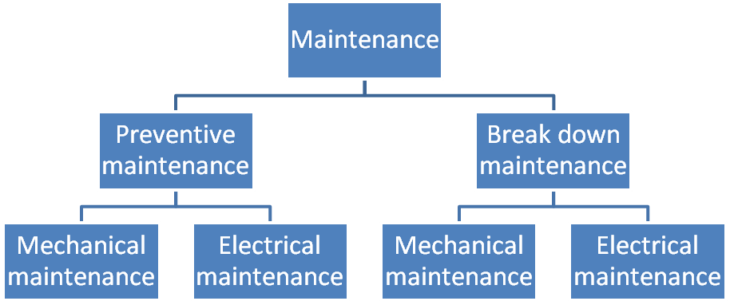

Preventive maintenance:

Preventive maintenance is a predetermined routine actively to ensure on time inspection/checking of facilities to uncover conditions that may lead to production break downs or harmful dcscription.

Break down maintenance:

In this case repairs are made after the equipment is out of order & it can not perform its normal functions.

Routine maintenance:

Maintenance of different machines are prepared by expert engineer of maintenance department. Normally in case of dyeing machine Maintenance after 30 days complete checking of different important parts are done.

MANPOWER SET UP FOR MAINTENANCE:

Position | No of person | Department.
B.SC Engr. | 2 | Elect. & Mechanical  Elect .& Mechanical
foreman | 2 | Elect. & Mechanical
Filter | 2 | Elect. & Mechanical
Assistant Filter | 2 | Elect. & Mechanical
Welder  _ | 2 | Elect. & Mechanical
Helper | 6 | Elect. & Mechanical

MAINTENANCE PROCEDURE:

Normally preventive maintenance is done here. For wlnch dyeing m/c it is kept for 15 days & for finishing floor it is kept for I5 days. During maintenance procedure following points should be checked.

CHECK LIST FOR DIFFERENT PARTS

Maintenance : Mechanical

SL NO. | Items needs to be checked & serviced
1 | Grease the m/c bearing
2 | Cleaning of drain valves, replace sesls if required
3 | Check air supply filters, regulators auto drain seals  g fd I I d
4 | Clean filters element & below out
5 | Greasing of unloading roller bearing
6 | Checking of oil levels & bolts of unloading roller gearbox
7 | Complete cleaning & machine
8 | Checking unloading roller coupling & Packing
9 | Checking & cleaning (if required) of main vessel level indicator
10 | Check the oil level pump bearing & refill if required
11 | Check the function or heart & cool modulating valves
12 | Check all belts & belt tension
13 | Check all door seals

Maintenance : Electrical

SL NO. | Items needs to be checked & serviced
1 | Check main panels
2 | Check panel cooling fan & clean its filter
3 | Clean main pump inverter & its cooling fan
4 | Check all circuit breaker ,magnetic ccnductors & relays
5 | Check current setting of all circuit breaker & motor over load
6 | Visual checking of all power & ccntrol cables
7 | Check aII motor’s terminals
8 | Check & clean fluff & dirt at all motor fan covers
9 | Check DC drive of neel motors
10 | Check all pressure switches
11 | Check calibration of main vessel & all addition tank
12 | Check all signal isolators
13 | Check setting & operation of lid safely switches
14 | Check setting of tangle sensors
15 | Check all pneumatic solenoids
16 | Check all indicating lamps
17 | Check calibration of heating/ cooling modulating valve
18 | Check all on/off switches

MAINTENANCE TOOLS & EQUIPMENTS:

The most important maintenance tools that are used frequently are tabulated.

Maintenance tools | Function
Tread trap | Joining of broken metallic parts
Cutting disc | For cutting pipes, rods
Globe valve | Fitting for steam line
Union | Fitting for water, steam line
Union Elbow | Fitting for water, steam line
Gear oil | Lubrication
Cutting oil | Lubrication
Hydraulic oil | Lubrication
Oil gun | Oil application
Spanner | Tightening of nut bolts
Master range | Tightening of nut bolts
Flat/Star screw driver | Screw tightening & loosening
Hacksaw blade | Cutting
Spray gun WP40 | Spraying a chemical named WP40
Drill m/c | Drilling to make hole
Grinding m/c | Grinding
Hacksaw Frame | Cutting
Grease | Lubrication

REMARKS:

Maintenance of M/C's are very essential to prolong the m/c life and good maintenance is important consideration. ln this industry maintenance program is done by expert maintenance team So very few times production are due to m/c problem. In FNL there is ON-LINE reporting for maintenance so rest result can be obtained in shortest time.

AVAILABLE FACILITY OF UTILITY

UTILITY | Source
Electricity | PDB & Generator
Gas | TITAS
Compressed air | Compressor
Steam | Boiler
Water | Natural Water by pump
Temp.Control | AC chiller
ETP | Drain out water

STEAM:
Equipment used : Boiler
No of boiler - 03
Type of boiler : Horizontal, Fire tube boiler
Brand :LOOSE INTERNATIONAL (Germany)
CLAVER BROOKS(U.S.A)
Capacity - 10 ton/hr (Loose International)
- 8 ton/hr( Claver brooks )
Fuel - natural gas,Diesel.
Steam Consumption : 2300 kg/hr for 1200-1500 products.
Steam pressure : 7-8 bar
Water pressure : 3-4 bar
Steam temp: 180°-190°C
Boiler Temp: 300°C
Chemical Used: NaCI Solution, NALCO 450 ( Scale Remover)

COMPRESSED AIR:

Source : Natural Air
M/C Name: Compressor
Brand: BOGGE (Germany)
CECATTO (ITALY)
No of m/c : 04
Capacity : 27,0001/hr, 1800 1/hr.
Unloading pressure :7.2 bar
Loading pressure : 5.6 bar
Chemical Used: Grease, Oil AMERILUBE

ELECTRICITY:
Source :PDB & Generator.
Equipment used: gas generator
Manufacturer: Wartsila-Frank
No of generator: 02
Gas engine used. 12 cyl. Per engine
Overall efficiency: 80%
Heat recovery : from 4 engines.
Cylinder capacity: 2.2 MW
Ignition pressure: 90 bar
Piston speed : 9 m/sec
Pressure of gas : 60-62 milibar
Air pressure: 7 bar
Electricity take up from PDB: 1.5 mw/sec
Mixture of gas air ; 1:18
Capacity: 1 MW

GAS :

Gas is mainly used for steam production. The gas is used from TITAS
Generally 2500 CFT gas is required to produce 1 ton steam/hr.

WATER:

Pump | No of pump | Capacity
Submersible | 05 | 100-125 m³ /hr
Booster | 14 | 100-125 m³ /hr
Centrifugal | 10 | 100-125 m³ /hr

Technical Details :

Water : Water Is supplied by pump.Pump supplies water on the basis of pressure .Pump pressure ranges from 0-10 bar. Water is stored in water treatment plant. The water is collected from the 120 ft below to the earth .In water softening plant this water is treated with resins mainly.
IN KCL there are three water treatment vessels. Capacity of these are :
1- 50,000 l/hr
2- 100,000l/hr
3- 250,000l/hr
Sequence of water treatment plant-
- Iron Remover
- MGF/ ACF ( TDS Remover)
- Softener

COMPRESSOR
Natural gas is drawn by pipe through the filter above the compressor & the air is compressed. In such a case the air becomes slightly hot. Hence cold water is drawn to reduce the temperature of compressed air. Thus the cold water becomes slightly hot & goes through outlet pipe to the overhead reservoir. Then the water falls slowly through a compressed air along with some vapors are transferred to the reservoir where the vapours are condensed & outlets drop by drop.
The moist compressed air is transferred to the dryer& a slight warm compressed air is delivered to require sections of KCL.

Steam:

Steam is an important utility for dyeing section. Steam produced by the boiler Supply water is simply treated in the boiler section by the two softener tank Then water reserves to the feed water tank & this feed water tank warms the water Then water passes to the boiler which produces steam & that steam supplies to the factory .

Main parts of the boiler :
-Gas Chamber
-Blower
-Gauge glass
-Safety valve
-Burner

Electricity :

It is impossible to continue the production without electricity. A frequent supply of electricity is necessary for soundless production. In KCL all machines in dyeing & finishing sections are provided electricity by the own generator of the industry .

UTILITY CONSUMPTION:
Water-80 l/kg of material
Gas required - 40 m³/hr
Electricity - 950 Kw/hr

COST OF DIFFERENT UTILITIES:
I unit electricity - 2.60 Tk
1 Kg Steam- 0.50 Tk
1 Ton Water - 7.30 Tk

Remarks :
For smooth running of a factory utilities are unavoidable. It has no direct use but help in the production So, utility should have the proper characteristics to met up the production parameter.

FREQUENCY OF INVENTORY UPDATE:

• Monthly inventory control
• Annual inventory control

SCOPE OF INVENTORY CONTROL:

- Raw materials
• Dyes store
• Other chemicals
• Grey fabrics
- Finished fabric
- Spare parts
- General store:
• Capital equipments
• Accessories
• Stationary
• Maintenance parts

INVENTORY SYSTEM FOR RAW MATERIALS:

• Raw materials partially received from production planning & directly from Head office.
• Material receiving & inspection report (MRIR) is prepared. Received quantity is mentioned & noted down.
• Submitted to QC dept. Some are OK & few are rejected.
• Entry of data of goods in DATATEX.
• Goods are arranged according to OK or rejected group. Department gives store requisitionto warehouse.
• As per requisition materials supplied & this record are noted down.

STAGES OF GREY FABRIC INVENTORY CONTROL:
• After knitting production
• Grey inspection
• Warehouse
• Batch preparation Dye house

STAGES OF FINISHED FABRIC INVENTORY CONTROL:

• Finishing section
• After final inspection
• Warehouse

STORE CAPACITY:

* Dyes & chemicals | : 100 tons
* Grey fabrics | : 50 tons
* Yarn store | : 100 tons
* Set range of dyes/chem. | : 4-5 t/day

REMARK:

- The inventory system of KCL covers both knitting & dyeing inventories.
- The space is noticed to be insufficient considerably.

Knitting Rate / Kg

S/j | 9 (TK/K g)
S/j Lycra | 35-40 "
1X1 Rib | 11-14 "
2X2 Rib | 22-25 "
9X2 Rib | 28-30 "
Lacoste | 16-18 "
Interlock | 18-20 "
Flat Knit  _ _ | 200 "
Engg. Stripe (a)S/j  (b)S/j Lycra | 100-120 "  150-160 "

Yarn Costing /Kg (L.C Value)

26 s | 2.55-2.60 Dolles
28 s | 2.60-2.65 "
30 s | 2.65-2.70 "
34 s | 2.85-2.87 "

Melange (Local)

26 s | 3.65-3.70 Dolles
28 s | 3.50-3.65 "

Chemical Costing /Kg

Light Color | 25 Tk
Deep Color | 35 "
Black | 40 "

Dyestuff Costing /Kg

Light Shade | 20 Tk
Deep Shade | 30 "
Black Shade | 40-45 "

Special Treatment

Enzyme Wash | 10 Tk/Kg
Silicon Wash | 10 "
Super Soft | 10 "

Finishing Section :

Padder | 5 Tk/Kg
Dryer | 10 "
Compacting (Tubular) | 10 "
Compacting (Open) | 25 "
Stenter | 25 "
Slitting | 5 "
Sweading | 30 "

REMARKS:

FNL does not provide us all the documents of costing, because it is confidential.So this Chapter is not so sufficient to analyze the costing of product.

FNL is 100 % export oriented industry. All the goods produced in this industry are exported into various foreign countries . Name of the main buyers of this mill are given below :
• H&M
• OKAIIDI
• CAMAIEU
• CARREFOUR
• JULES
• DECATHLON
• SPRIT
• QUICK SILVER
• BIZBEE
• KNIT LINE
• S.OLIVER
• AMS INTERNATIONAL
• RIPCURL
• BETTER BARCLAY

IMPORTING COUNTRIES :
Following countries mainly imports products from FNL through many internationally well recognized buyers .
• Europe Countries like UK France Germany etc
• U.S.A

MANPOWER:
Marketing plays a vital role in the field of displaying/showing the good criteria of the products to the buyer & to communicate with the buyer .there about 30 people in the marketing section of the industry .
Marketing Strategy :
Marketing strategy is a very important factors to sale the products to the buyers If the marketing strategy Is not so developed it will be very hard to reach the goal In case of garments marketing the dealings with the buyer is a very important factor.
In one composite mills Ltd. Mainly senior marketing officers ,merchandisers & higher officials deal with the buyer There are some fixed buyers of the industry. The buyers give their orders continuously all over the year. The
marketing officers & by both side understanding The rate & the order quantity are fixed.

Duties & Responsibilities Of Marketing Officer:
Dealing with the buyer & convince the buyer is the main duty of the marketing officer. A marketing officer has some also other duties The main duties & responsibilities of a marketing officer are given below :
• To prepare cost sheet by dealing with buyer .
• To take different steps by discussing with the high officials & merchandisers .
• To maintain a regular & good relationship between commercial officers & merchandisers .
• To maintain a regular communication with the buyers & buying houses .
• Communicate with the new buyers .
• Display the better criteria of the products .
• Actually the responsibilities & duties of marketing officer begins from getting order of buyer & ends after receiving goods by the buyer So he should be always smart energetic & sincere.

REMARKS:

FNL has a well learned marketing & merchandising team. They always communicate with
the buyers FNL has some fixed buyers The marketing section also looks for the quality & quantity of buyers .

We have completed our industrial attachment successfully by the grace of Almighty.
Industrial attachment sends us to the expected destiny of practical life The completion of the two months Industrial Attachment at FARIHA KNIT TEX LTD., we have got the impression that the factory is one of the most modern export oriented knit composite in Bangladesh Though it was established only a few year's ago ,it has earned " very good reputations "
For its best performance over many other export oriented textile mills .
Mill is settled with utility to give all convenient supports to the productions for twenty-four hours . FNLhas its own water pre-treatment plant & 26,300 cubic feet water reservoirs in its Godnail campus The Godnail premises has its own power generation plant where 1,900 kw power generators guarantee smooth & uninterrupted power supply to its every operation .
However there are some points to be mentioned :

• During the transport of the fabric in the dyeing floor & also during the loading of the machine, fabrics are soiled for the contact with floor. This makes the fabric/part of the fabric dirty. It may require more scouring/bleaching agent or may create stain making it faulty.
The- dyeing floor is watery most of the time. It should be cleaned all the time.
• Many time the dosing pipelines are clogged due to the careless dosing of the chemicals. The supervisors should supervise the floor more sincerely.
• The machine stoppage time should be analyzed & minimized. The maintenance should be carried out when the machine is out of action (wherever possible).

OUR APOLOGY :

• The management of FNL are very helpful Our respective seniors gave us time when ever they got .
• Due to secrecy act, all the data on costing & marketing activities has not been supplied & hence this report excludes these chapters.
• Some of the points in different chapter are not described as these were not available.
• The whole process is not possible to bind in such a small frame as this report, hence our effort spent on summarizing them.
• But it must be said that FNL is a best place to get the practical knowledge about the dyeing as they have lot of production of all quality .

We are enough fortunate that we have got an opportunity of having a training in this mill During the training period we are received co-operation & association from the authority full & found all man , machines & materials on appreciable working condition All stuffs & officers are very sincere & devoted there duties to achieve their goal.

