With the process of industrialization and modernization came social change, economic development, and technological innovation. But knowingly or unknowingly human beings introduced another entity to the civilization – pollution. Pollution is the introduction of contaminants into a natural environment that causes instability, disorder, harm or discomfort to the ecosystem i.e. physical systems or living organisms. The Bangladesh Environment Protection Act, 1995 defines pollution as:
“Contamination or alteration of the physical, chemical or biological properties of air, water, or soil, including the change in temperature, taste, turbidity, odour or any other characteristics of these or such discharge of any liquid, gaseous, solid and radioactive substance, the discharge, disposal and dumping of which may cause adverse/negative changes of the environment.”
Industrial pollution is pollution which can be directly linked with industry, in contrast to other pollution sources. This form of pollution is one of the leading causes of pollution worldwide. This form of pollution dates back to antiquity, but widespread industrial pollution accelerated rapidly in the 1800s, with the start of the Industrial Revolution. The Industrial Revolution mechanized means of production, allowing for a much greater volume of production, and generating a corresponding increase in pollution. The problem was compounded by the use of fuels like coal, which is notoriously unclean, and a poor understanding of the causes and consequences of pollution. Later this type of Pollution became a popular issue after World War II, due to radioactive fallout from atomic warfare and testing. Because of the nature of the global environment, industrial pollution is never limited to industrial nations. As the countries all over the world are going through industrialization, more is being added to the global burden of industrial pollution, triggering the importance of detecting the causes behind this catastrophe and planning the ways of preventing it along with implementation.
2. History:
While the Industrial Revolution meant that more goods could be produced for human consumption, it also meant that more pollution would be emitted into the sky and more natural resources would have to be exploited in the production process. Although pollution of major proportions has been a problem since the centuries preceding the middle ages, it is worth noting that after World War II, the type of pollution involved changed significantly with introduction of nuclear weapons. The following timeline reflects on the history of pollution:
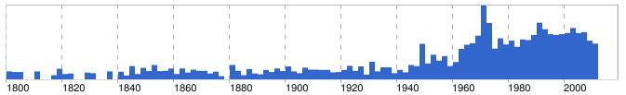 Graph 2.1 : History of industrial pollution
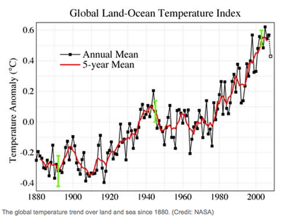
In February 1950, a discussion on problems of nuclear energy was held, where Einstein said that the idea of national security through nuclear weapons was "a dangerous illusion." He also said that "radioactive poisoning of the atmosphere and hence annihilation of any life on earth has been brought within the range of technical possibilities." The only way out of the situation, Einstein said, is "a supra-national judicial and executive body" and "a declaration of nations to collaborate loyally in the realization of such a restricted world government." In 1952, with the break out of ‘The Great Smog’, which had caused 6,000 deaths within a year due to respiratory diseases, the Clean Air Acts of 1956 and 1968 were formulated. The smog was formed due to burning of coal in production processes. The awareness regarding the situation went on increasing around the 1970’s, but the problem by then had taken a dangerous shape. Along with progress in production sectors and industry, the temperature of the earth has also been increasing. But faulty process designs and the greed for more production despite the environmental hazard are still going on. Some countries have formulated laws and regulations regarding the production process in order to ensure clean and safe environment, but when it comes to implementation most of the countries have failed in fulfilling their duties.
Graph 2.2: Change in temperature in Oceans
3. Pollutant:
A pollutant is a waste material that pollutes air, water or soil, and is the cause of pollution. Three factors determine the severity of a pollutant: its chemical nature, its concentration and its persistence. Some pollutants are biodegradable and therefore will not persist in the environment in the long term. However the degradation products of some pollutants are themselves polluting such as the products DDE and DDD produced from degradation of DDT.
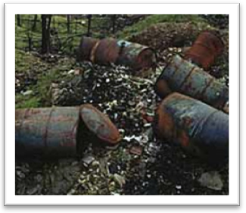
- 3.1Different Types of pollutants by absorptive capacity:

I. a-Stock pollutants:

Pollutants that the environment has little or no absorptive capacity are called stock pollutants (e.g. persistent synthetic chemicals, non-biodegradable plastics, and heavy metals). Stock pollutants accumulate in the environment over time.
Figure 3.1: Chemical wastes polluting soil.

The damage they cause increases as more pollutant is emitted, and persists as the pollutant accumulates. Stock pollutants can create a burden for future generations by passing on damage that persists well after the benefits received from incurring that damage have been forgotten.

II. b-Fund pollutants:

Fund pollutants are those for which the environment has some absorptive capacity. Fund pollutants do not cause damage to the environment unless the emission rate exceeds the receiving environment's absorptive capacity (e.g. carbon dioxide, which is absorbed by plants and oceans). Fund pollutants are not destroyed, but rather converted into less harmful substances, or diluted/dispersed to non-harmful concentrations.

- 3.2 Industrial Pollutants:

Industrial pollutants are pollution and waste by-product directly connected with industrial manufacturing. Industrial pollutants represent the leading worldwide cause of pollution in general and probably the most toxic to all life and nature.

3.3Today's Pollutant Sources:
Modern industrial pollutants don't use smokestacks nearly as often as in the past, but there is a far greater presence of liquid chemical pollutant produced. With the refining of manufacturing came new ways of melting, cleaning, acidifying and steaming products. That created another rainbow of pollutant by-product. Water pollution is now one of the biggest industrial pollutants, with wastewater pumped daily from factories that use it for washing and cooling among other uses.
- 3.4Notable Pollutants:
I. Heavy metal: Heavy metals occur naturally in the ecosystem with large variations in concentration. In modern times, anthropogenic sources of heavy metals, i.e. pollution, have been introduced to the ecosystem. Waste-derived fuels are especially prone to contain heavy metals, so heavy metals are a concern in consideration of waste as fuel. Within the European community the thirteen elements of highest concern are arsenic, cadmium, cobalt, chromium, copper, mercury, manganese, nickel, lead, tin, and thallium, the emissions of which are regulated in waste incinerators. Heavy metal pollution can arise from many sources but most commonly arises from the purification of metals. Unlike organic pollutants, heavy metals do not decay and thus pose a different kind of challenge for remediation. One of the largest problems associated with the persistence of heavy metals is the potential for bioaccumulation and biomagnifications causing heavier exposure for some organisms than is present in the environment alone.
II. Persistent organic pollutant: Persistent organic pollutants (POPs) are organic compounds that are resistant to environmental degradation through chemical, biological, and photolytic processes. Many POPs are currently or were in the past used as pesticides. Others are used in industrial processes and in the production of a range of goods such as solvents, polyvinyl chloride, and pharmaceuticals. Most of POPs are created by humans in industrial processes, either intentionally or as byproducts.
III. Polycyclic aromatic hydrocarbons: Polycyclic aromatic hydrocarbons (PAHs), also known as poly-aromatic hydrocarbons or polynuclear aromatic hydrocarbons, are potent atmospheric pollutants that consist of fused aromatic rings and do not contain heteroatoms or carry substituents. Naphthalene is the simplest example of a PAH. PAHs occur in oil, coal, and tar deposits, and are produced as byproducts of fuel burning.
IV. Volatile organic compound: Volatile organic compounds (VOCs) refer to organic chemical compounds which have significant vapor pressures and which can affect the environment and human health. A major source of man-made VOCs is solvents, especially paints and protective coatings. Chlorofluorocarbons, which are banned or highly regulated, were widely used cleaning products and refrigerants. Tetrachloroethene is used widely in dry cleaning and by industry. Industrial use of fossil fuels produces VOCs either directly as products (e.g. gasoline) or indirectly as byproducts (e.g. automobile exhaust).
4. Industrial Pollution: Types and Causes:
Industrial Pollution

Air Pollution
Water Pollution
Soil Pollution
Noise Pollution
Oil Pollution
Air pollution Water Pollution
Nuclear Pollution
Thermal Pollution

During this 21st Century industrial activities have become more prominent than ever all over the world. But this great boon has a great side effect that is Industrial pollution. Countries all over the world are facing this phenomenon consistently, which is deteriorating our clamatorial atmospheric balances causing serious disturbance.
4.1 Industrial Air Pollution:
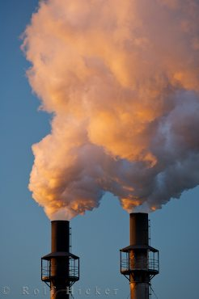
Air pollution is the introduction of chemicals particulate matter or biological materials that cause harm or discomfort to humans or other living organisms, or cause damage to the natural environment or built environment into the atmosphere. The atmosphere is a complex dynamic natural gaseous system that is essential to support life on planet Earth. Stratospheric ozone depletion due to air pollution has long been recognized as a threat to human health as well as to the Earth's ecosystems. Air pollution occurs when different toxic gases like Sulpher Di Oxide, Carbon Di Oxide, Nitrogen Di Oxide, chloro fluoro carbon etc get emitted from different industries and mix with atmosphere and cause environmental hazard.
Figure4.1 : Emission of pollutants
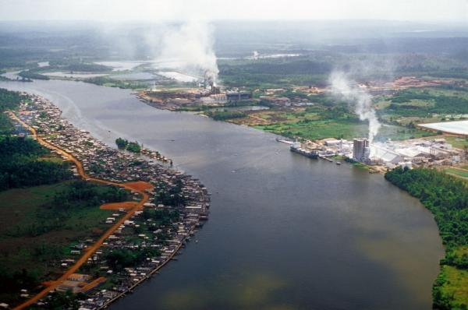
4.2 Industrial Water Pollution: Water pollution is caused by emission of domestic or urban sewage, agricultural waste, pollutants and industrial effluents into water bodies. Nowadays, one of the main sources of water pollution is the waste material discharged by industrial units, known as industrial water pollution. Waste materials like acids, alkalis, toxic metals, oil, grease, dyes, pesticides and even radioactive materials are poured into the water bodies by many industrial units. Some other important pollutants include polychlorinated biphenyl (PCB) compounds, lubricants and hot water discharged by power plants. The pollutants unloaded into the water bodies usually dissolve or remain suspended in water. Sometimes, they also accumulate on the bottom of the water bodies.
Fig 4.2: Water Pollution Caused by industrial activities.

4.3 Industrial Soil Pollution: Large quantity of solid wastes like unused and rejected chemicals (like calcium carbonate, magnesium sulphate, ferrous chloride, ferrous oxide, radioactive wastes, fly ashes, sludge, press mud, saw dust, bottles, plastic materials) unwanted industrial wastes generated during manufacturing processes (rejection, broken items of metal, plastic, wooden or chemical solids, powders) are dumped over on the surface of soil by almost all industries with difference in the degree. Larger the production base, larger is the generation of wastes. Traditionally, these materials have been dumped around the factory site or around the entire city. Rarely, they are put to recycling or safe conversion. All these solid materials dumped on surface of soils are bound to change the chemical and physical nature of soil besides contributing large quantity of pollutants to underground water - whenever rain water passes through them. In most situations, solid wastes has caused problems such as foul smell (sugar and paper industry), disturbed air composition (fly ash from thermal power plants and cement industries) changed the physical nature of soil (coal and steel industrial wastes), as well as radioactive dangers (atomic power plants).
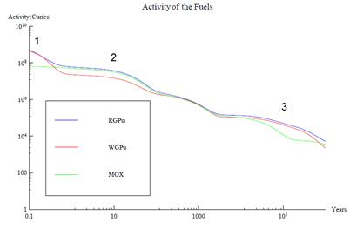
4.4 Nuclear Pollution: It is a new form of Industrial pollution which has been seen in the recent centuries. Nuclear pollution takes place in the form of radioactivity evolved from radioactive wastes from nuclear reactors.
Radioactive waste is a waste product containing radioactive material. It is usually the product of a nuclear process such as nuclear fission though industries not directly connected to the nuclear power industry may also produce radioactive waste. Radioactivity diminishes over time, so in principle the waste needs to be isolated for a period of time until it no longer poses a hazard. This can mean hours to years for some common medical or industrial radioactive wastes, or thousands of years for high-level wastes from nuclear power plants and nuclear weapons reprocessing. The majority of radioactive waste is low-level waste, meaning it has low levels of radioactivity per mass or volume. The main approaches to managing radioactive waste to date have been segregation and storage for short-lived wastes, near-surface disposal for low and some intermediate level wastes, and deep burial or transmutation for the long-lived, high-level wastes.
Graph 4.4 a: Activity of Fuels in Years

Radioactive waste comes from a number of sources. The majority of waste originates from the nuclear fuel cycle and nuclear weapons reprocessing. However, other sources include medical and industrial wastes, as well as naturally occurring radioactive materials (NORM) that can be concentrated as a result of the processing or consumption of coal, oil and gas, and some minerals

4.5 Thermal Pollution:
Thermal pollution is the degradation of water quality by any process that changes ambient water temperature. A common cause of thermal pollution is the use of water as coolant by power plants and industrial manufacturers. When water used as a coolant is returned to the natural environment at a higher temperature, the change in temperature decreases oxygen supply, and affects ecosystem composition. Urban runoff storm water discharged to surface waters from roads and parking lots–can also be a source of elevated water temperatures. When a power plant first opens or shuts down for repair or other causes, fish and other organisms adapted to particular temperature range can be killed by the abrupt rise in water temperature known as "thermal shock." Elevated temperature typically decreases the level of dissolved oxygen (DO) in water. The decrease in levels of DO can harm aquatic animals such as fish, amphibians and copepods Thermal pollution may also increase the metabolic rate of aquatic animals, as enzyme activity, resulting in these organisms consuming more food in a shorter time than if their environment were not changed.
4.6 Noise Pollution:
Industrial noise is usually considered mainly from the point of view of environmental health and safety, rather than nuisance, as sustained exposure can cause permanent hearing damage. Traditionally, workplace noise has been a hazard linked to heavy industries such as ship-building and associated only with noise induced hearing loss (NIHL). Modern thinking in occupational safety and health identifies noise as hazardous to worker safety and health in many places of employment and by a variety of means. Noise can not only cause hearing impairment (at long-term exposures of over 85 decibels (dB), known as an exposure action value, but it also acts as a causal factor for stress and raises systolic blood pressure. Additionally, it can be a causal factor in work accidents, both by masking hazards and warning signals, and by impeding concentration. Noise also acts synergistically with other hazards to increase the risk of harm to workers. A weighted measurements are commonly used to determine noise levels that can cause harm to the human ear, and special exposure meters are available that integrate noise over a period of time to give an LEQ value (equivalent sound pressure level), defined by standards.
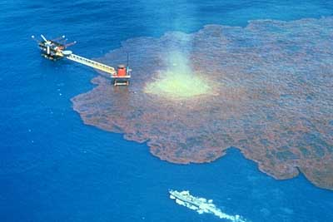
4.7 Oil Pollution: An oil spill is a release of a liquid petroleum hydrocarbon into the environment due to human activity, and is a form of pollution. The term often refers to marine oil spills, where oil is released into the ocean or coastal waters. Oil spills include releases of crude oil from tankers, offshore platforms, drilling rigs and wells, as well as spills
of refined petroleum products (such as gasoline, diesel) and their by-products, and heavier fuels used by large ships such as bunker fuel, or the spill of any oily white substance refuse or waste oil. Spills may take months or even years to clean up. Oil also enters the marine environment from natural oil seeps Public attention and regulation has tended to focus most sharply on seagoing oil tankers.
Figure 4.7: Oil pollution in sea water.
5. Statistics:
Air Pollution:
Figure 5 a: Pie Chart 1: Air Pollutants
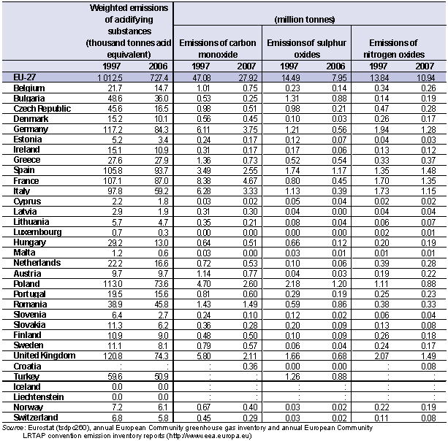
Figure: 5 Table 1: Emission of harmful gases from factories.

Water pollution in Different Countries
Countries | Emissions of Organic Water pollutants (kg/day) |  | Primary metals % 1993 | Paper and pulps % 1993 | Chemicals % 1993 | Food and Beverage % 1993 | Stone, ceramics and glass % 1993 | Textiles % 1993 | Wood % 1993
Countries | 1980 | 1993
Argentina | 244711 | 179432 | 7.7 | 11.8 | 7.7 | 57.8 | .3 | 8.6 | 1.5
Bangladesh | 66713 | 171087 | 2.9 | 7.2 | 4.1 | 36.9 | 0.1 | 47.1 | 0.7
Chili | 44731 | 82835 | 6.6 | 10.1 | 6.4 | 65 | 0.1 | 7.4 | 1.9
Brazil | 866790 | 855432 | 10.4 | 13.5 | 9.1 | 45.8 | 0.3 | 8.6 | 2.7
Italy | 442712 | 353906 | 17.0 | 16.1 | 10.5 | 25.8 | 0.3 | 16.1 | 2.1
Denmark | 65465 | 87244 | 2.3 | 28.0 | 7.3 | 47.7 | .1 | 3.7 | 2.7
France | 716285 | 609940 | 11.9 | 20.7 | 11.0 | 37.0 | 0.2 | 6.7 | 1.8
Germany | …. | 104617 | 15.6 | 15.3 | 15.1 | 27.9 | 0.2 | 6.4 | 2.0
India | 145747 | 144129 | 15.6 | 8.1 | 7.3 | 50.9 | 0.2 | 12.9 | 0.3
USA | 274299 | 247783 | 8.3 | 32.7 | 9.5 | 28.2 | 0.1 | 7.8 | 2.4
Sri Lanka | 30068 | 51328 | 1.4 | 8.0 | 6.4 | 52.00 | 0.2 | 29.9 | 0.7
Pakistan | 75125 | … | …. | … | … | … | … | …. | ..
China | 335823 | 533907 | 22.0 | 10.0 | 14.0 | 33.3 | 0.4 | 11.5 | 0.4
Malaysia | 77215 | 136055 | 6.8 | 14.3 | 15.2 | 31.8 | 0.2 | 11.1 | 7.6
Figure 5: Table 2: Water Pollutants and industrial effect on water pollution.
6. Industrial Pollution in Bangladesh:
Bangladesh had always been predominantly an agricultural based country and in early days pollution was never even felt in this region. Since early sixties, of necessity, industries of various kinds started to spring up slowly. It appears in a survey that ecological imbalance is being caused continuously due to discharge of various industrial wastes into air and water bodies. It has also been found that the intensity of pollution caused by the factories and industrial units depend on their type, location, raw materials, chemical effects, production process and discharge of gaseous, liquid and solid pollutants to the natural environment. There are wide spread fears that as the region develops in industrial infrastructure, industrial pollution will accelerate, compounding the problems posed by raw municipal wastes.
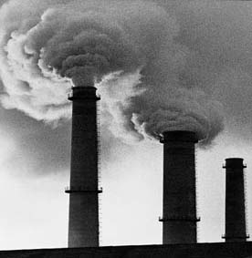
- Air Pollution: Air pollution costs Bangladesh dearly, both in dollars and lives. At the turn of the century the World Bank estimated that the cost associated with pollution in Dhaka is approximately 800 million USD every year and 15,000 human lives. In 2008, Norwegian Institute for Air Research (NILU) scientist Scott Randall along with local researchers measured the concentration of sulfur dioxide, nitrogen dioxide, ozone, as well as small and large dust particles in the air. The high concentration of dust particles surprised the researchers. There are numerous brick-making kilns working seasonally (in dry season) all over Bangladesh which is the other source of air pollution. Almost all of these kilns use coal and wood as their source of energy, resulting in the emission of oxides of sulfur, and volatile organic compounds. An emerging issue of great concern in the cities and towns is the high concentration of lead in the air from vehicular exhausts. An emerging issue of great concern in the cities and towns is the high concentration of lead in the air from vehicular exhausts. In response to public pressure and concern regarding air pollution by lead, in July 1999 the Government of Bangladesh executed the decision to provide only unleaded gasoline in the country. However, measurements on lead levels in ambient air after introduction of unleaded gasoline are still not available. The country does have a reasonably good number of laws and regulations to address air pollution. But when it comes to implementation the Government is not taking the proper initiative.
Figure 6 a: Air being polluted by industries
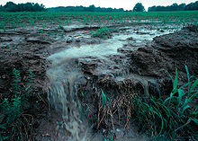
- Water pollution in Bangladesh: The Buriganga River was once the lifeline of the Bangladeshi capital. The water of the Buriganga is now so polluted that all fish have died, and increasing filth and human waste have turned it like a black gel. The plight of the Buriganga symbolizes the general state of many rivers in Bangladesh, a large flat land criss-crossed by hundreds of rivers which faces an uphill battle to keep them navigable and their waters safe for human and aquatic lives. A World Bank study said four major rivers near Dhaka -- the Buriganga, Shitalakhya, Turag and Balu -- receive 1.5 million cubic metres of waste water every day from 7,000 industrial units in surrounding areas and another 0.5 million cubic meters from other sources. Unabated encroachment that prevents the free flow of water, dumping of medicinal waste and waste of river passengers has compounded the problem, making the water unusable for humans and livestock. Among the top polluters are dozens of tanneries on the banks of the Buriganga. Chemicals such as cadmium and chromium, and other elements such as mercury carried by the industrial waste are also creeping into the ground water, posing a serious threat to public health. If the pollution is not controlled, we will face a serious health crisis in a year or two or at best three years Bangladesh enacted a law in 1995 making it compulsory for all industrial units to use effluent treatment plants in a bid to save river waters from pollution, but industry owners often flout the rule.
Figure 6 b: Pesticides are one of the major pollutants for both water and soil pollution
- Soil Pollution: The functional capabilities of the soil have deteriorated due to unbalanced use of agrochemicals, unplanned land use, encroachment on forest areas for agriculture and settlements, ineffective implementation of existing laws and guidelines, and improper disposal of hazardous industrial effluents. Degradation of soil quality in the floodplains is mainly attributed to improper use of fertilizers and pesticides to boost agricultural production. Around 83% of the cultivable land in Bangladesh has less than 3% of organic matter due to the extensive use of chemical fertilizers on land. Dispersed industrial growth, and uncontrolled discharge of untreated effluents in the nearby floodplain deteriorate the quality of land and soil.
- Sound Pollution: The main sources of sound pollution in Bangladesh are the loud sounds produced by the reactors, and by instruments related to various process operations. The presence of industries in urban areas further increases the problem. Recently the Government has decided to move all the mills and industries away from areas with high population density to reduce the effect.

7. Chemical waste management in Bangladesh:
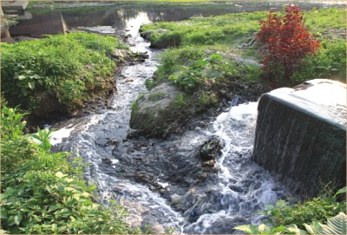
One of the main reasons behind Industrial pollution in Bangladesh is lack of knowledge required for chemical waste management. Despite the growing extent of this problem, the sector continues to remain one of the most disorganized areas of urban development in Bangladesh. An estimated 47000 tons of solid waste per day will be generated in urban areas by 2025, which is almost three and half times more than the current generation. In most of the city corporations and municipalities there is no separate department for solid waste management. Chemical wastes can be divided into many categories depending on their sources and types. Few are discussed below:
- Chemical waste from textile mills: In textile mills, they use different kinds of chemicals in different stages. There are different steps in dyeing of cotton, silk, PVC, synthetic. About 5000 garment industries exist in Bangladesh. Not only that there are many other garment related factories carrying out dying, printing, washing etc. Waste from BSCIC Industrial Area in Gazipur ends up in the Baimail Jheel and then flows into the Turag turning water of both into an obnoxious deep purple liquid. The garments industries and textile industries are creating a huge number of CFC gas. CFC in full Chloro-Fluoro-Carbon is claimed for breaking the ozone layer which covers our whole earth like protector.
Figure 7: Untreated excess dye of garment factories and chemical waste from pharmaceutical factories flow into the Turag River.
- Chemical waste from pharmaceutical: During the processes in pharmaceutical industries, various hazardous and non hazardous products are dumped which ultimately ends up in the rivers surrounding the industries causing intolerable stench and renders the water unusable for any domestic purpose.
- Solid Waste: Solid waste, as is known, are all sorts of solid refuses from offices, factories, markets, public institutions, construction debris and rubbish, and street sweeping. The estimates for solid waste production for Dhaka has varied from 3500 metric tons to 4500 tons per day on very rough per capita basis, which has been taken to be between 0.45 and 0.50 kg.
- Chemical wastes from tannery: There are also several hundred other industries of different sizes and categories of industries, including nearly 300 tanneries. One of the main by product in the tanneries is the Chromium which causes severe water pollution and is harmful for human body.
Besides many other hazardous wastes are being produced by the industries which pollute the environment surrounding us in many ways.
8. Impacts of Industrial pollution:
According to the Environmental Protection Agency (EPA), it has been estimated that industrial pollution is responsible for almost 50 percent of the pollution present in the World. There are various wide-ranging effects, as well as serious consequences, of industrial pollution on the ecological balance of the atmosphere along with biological impacts.

- 8.1 Ecological impacts:
- Global warming: Global warming is one of the most common and serious consequences of industrial pollution. The emission of various greenhouse gases such as Carbon di oxide (CO2), methane (CH4), among others from various industries, increases the overall temperature of the earth, resulting in global warming. It results in melting of glaciers and snow-capped mountains, causing an increase of the water levels in seas and rivers, thereby increasing the chances of flood. Apart from this, global warming also has numerous health risks on humans, such as increase of diseases such as malaria and dengue, cholera, Lyme disease and plague, among others.
- Environmental hazards: The emissions from various industries contain large amounts of gases such as carbon dioxide, sulphur and nitrogen, among others. These gases, when present in elevated levels in the atmosphere, often result in various environmental and health hazards such as acid rain, and various skin disorders in individuals.
- Disturbs the ecology of the water bodies: Dumping of various industrial waste products into water sources, and improper contamination of industrial wastes, often result in polluting the water. Such water pollution disturbs the balance of the ecosystem inside, resulting in the death of various animal and plant species present in the water.
- Loss of fertility of soil: Soil pollution, which occurs due to dumping of hazardous waste materials from industries in the soil, decreases the fertility of the soil. Industrial wastes contain large amounts of various chemicals which get accumulated on the top layer of the soil. Such loss of fertility ultimately results in changes in the ecological balances of the environment due to reduction in plant growth.
- Decreases the level of dissolved oxygen: The temperature of water increases when used in industrial processes. Elevated temperature typically decreases the level of dissolved oxygen (DO) in water. High temperature limits oxygen dispersion into deeper waters, contributing to anaerobic conditions. This can lead to increased bacteria levels when there is ample food supply. A large increase in temperature can lead to the denaturing of life-supporting enzymes by breaking down hydrogen- and disulphide bonds within the quaternary structure of the enzymes.
- Acid Rain: Acid rain is a rain or any other form of precipitation that is unusually acidic, i.e. elevated levels of hydrogen ions (low pH). It can have harmful effects on plants, aquatic animals, and infrastructure through the process of wet deposition. Acid rain is caused by emissions of sulfur dioxide and nitrogen oxides which react with the water molecules in the atmosphere to produce acids. The principal cause of acid rain is sulfur and nitrogen compounds from human sources, such as electricity generation and factories. Coal power plants are one of the most polluting. The gases can be carried hundreds of kilometers in the atmosphere before they are converted to acids and deposited.
- Smog: Smog is produced due to internal combustion engines and industrial fumes that react in the atmosphere with sunlight to form secondary pollutants that also combine with the primary emissions to form photochemical smog. Smog is also caused by large amounts of coal burning in an area caused by a mixture of smoke, sulfur dioxide and other components.

- 8.2 Biological Impacts:
- Skin Cancer on human beings: The people who work in the uranium mines suffer from skin burn and cancer. These occur due to the radiations from the radioactive material. The different organisms show different sensitivity to the radiations. There are certain conditions in which the oak trees can survive but the pine trees are not able to do so. The short range effects are known as the immediate effects and occur within the few days. It includes the loss of hair, nails, subcutaneous bleeding, and change in the number of cells and metabolism, change in the proportion of cells. The long range effects are known as the delayed effects and do not occur within the few days.
- Respiratory diseases: The World Health Organization states that 2.4 million people die each year from causes directly attributable to air pollution, with 1.5 million of these deaths attributable to respiratory diseases caused due to Industrial air pollution. The worst short term civilian pollution crisis in India was the 1984 Bhopal Disaster. Leaked industrial vapors from the Union Carbide factory, belonging to Union Carbide, Inc., U.S.A., killed more than 25,000 people outright and injured anywhere from 150,000 to 600,000. These respiratory diseases include Asthma, Emphysema, Bronchitis, Lung Cancer and many other similar diseases.
- Four Big Pollution Diseases of Japan: The four big pollution diseases of Japan were caused due to various kinds of heavy metal pollution and their effects are still prevalent in some regions in Japan. These diseases include the Minamata disease, Itai-itai disease and Yokkaichi asthma. The man reasons behind the diseases were mercury and cadmium poisoning released from the industries.
- Endangers the aquatic fauna: Releases of unnaturally cold water from reservoirs can dramatically change the fish and macro invertebrate fauna of rivers, and reduce river productivity. In Australia, where many rivers have warmer temperature regimes, native fish species have been eliminated, and macro invertebrate fauna have been drastically altered. Again the warm water released from the effluent streams from the industries harm aquatic animals such as fish, amphibians and copepods. Thermal pollution may also increase the metabolic rate of aquatic animals, as enzyme activity, resulting in these organisms consuming more food in a shorter time than if their environment were not changed.
- Cause water borne diseases: The water bodies are polluted to such extent that the water cannot be used for future needs without purification and thus it causes various water borne diseases in human body.
Besides, industrial pollution has more hazardous effects on health and environment which if not taken care of at the moment would cause great havoc in the future.

9. Prevention
Industrial Air pollution: Air pollution is the most common form of pollution evolved from industry works. Some preventive measures to control Industrial Air Pollution is as follows:
- Fan Intake and Discharge Silencers
- Sound Enclosures, Louvers, and Barriers
- Regenerative Thermal Oxidizers (RTO)
- Catalytic Thermal Oxidizers (CatOx)
- Recuperative Thermal Oxidizers (RecupTO)
- Industrial Tempering Ovens
- Concentrator Systems
- Heat and Energy Recovery
- Ionizing Wet Scrubbers
- Packed Tower Scrubbers
- Moisture Eliminators
- FRP Fans
- Architectural acoustical absorbing materials
- Acoustical barrier materials and enclosures
Industrial Water Pollution: The best approach is to practice waste reduction in different sectors of human activity and to prevent pollution at the source itself. The industries which have tried to reduce waste by recycling materials or redesigning production processes and products have found that such measures actually save money. Industrial and community sanitation along with control and treatment of human waste and industrial waste are necessary to reduce water pollution. More than 95% of urban sewage is released into the near water way or field due to inadequate or lack of treatment plants in developing countries. More sewage water treatment plants should be installed in cities and industrial belts’ the treated water can be reused. The national Environmental Engineering Research institutes should developed innovative methods to treat sewage and industrial effluents using filtration technique, chemical-based clariflocculators, lagoon system for aerobic cleansing etc.
An Example in Bangladesh: A project using this approach is under way in the Kaliakoir area of Central Bangladesh. The project is working to tackle both the causes and effects of pollution, by implementing changes to production processes with industrialists, through industry and community-based mitigation measures, and community and government monitoring. Kaliakoir is a well established industrial area, particularly known for textile firms, but suffering from chronic aquatic pollution. The local shallow lake (beel) ecosystem is heavily degraded to the point that the canal (khal) and beel, historically relied on by the community for bathing and fishing, are almost unusable. Initial analyses of these water bodies indicate that several water quality parameters exceed national/international standards - dissolved oxygen levels are zero in places, and pH levels are as low as 11. The project adopts a "cleaner production “approach to reduce the level of pollution generated by the factories. This approach includes:
- Discussions with factories to understand the operation process within each industrial unit.
- Construction of a material balance using inputs, processes and desired products to determine unwanted outputs (pollutants).
- Using results to identify pollution reduction measures, including identification of alternative raw materials or process, and recycling options for selected waste streams.
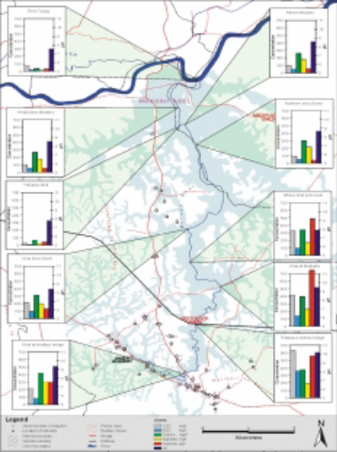
Observation and analysis in the factories suggests that introducing simple changes, like carefully monitoring the dyeing temperature time profile, can significantly improve efficiency, reduce pollution and save costs. Results suggest that 20 % improvement inefficiency could result in savings of up to $90,000, providing a serious incentive to introduce pollution reduction options. The project team is also working to improve effluent treatment facilities. The approach is multifaceted, providing technical support for private effluent treatment plants (ETPs), facilitating shared ETPs and developing novel methods for the treatment for residual pollutants on-site and in the wider environment.

Industrial Soil Pollution: There are several things that can reduce soil pollution caused by industrial activities:
- Improved Agricultural Techniques and reduction of Chemical Fertilizer and pesticides.
- Proper Solid waste management
- Reforestation.
- Recycling.
Thermal Pollution: In the USA about 75 to 80 percent of thermal pollution is generated by power plant remainder is Graph 4: Level of Various Water Quality Parameters. from industrial sources such as petroleum refineries, pulp and paper mills, chemical plants etc. Heated water from these sources may be controlled with:
- Cooling ponds: man-made bodies of water designed for cooling by evaporation, convection and radiation.
- Cooling Tower, which passes heat to atmosphere by means of evaporation or heat transfer.
- Cogeneration, a process where heat produced is recycled to use in the domestic and industrial purposes.

Industrial Pollution: A European Solution:
European nations are rapidly undergoing industrial development which is also taking toll on their environment and climate in the form of industrial pollution. A successful process of controlling industrial pollution is going on in those countries, which is called ‘LIFE’. LIFE ("L'Instrument Financier pour l'Environment"/the financing instrument for the Environment) is an EU program coordinated by the Environment Directorate-General (LIFE Unit).
LIFE provides industrial innovators with support that may be decisive, in particular within small and medium-sized industries, in demonstrating the feasibility of promising technologies and ensuring dissemination of positive results. Several LIFE projects in various sectors have already contributed to improving manufacturing processes and others are in progress. This brochure highlights examples of the role which LIFE plays in stimulating clean technologies. This role will be further strengthened through the LIFE-Environment projects selected in 2003. There are twice as many projects focusing on such technologies and on reducing the greenhouse effect as in 2002, representing more than 16% of the total. Action at source, and in particular at production sites, is an essential condition for the success of endeavors to reduce the environmental impact of economic activities. Priority should be given to choosing innovative techniques that are geared to prevention. It is also important not to consider problems separately but from an overall environmental point of view: air, water, soil, natural resources, etc. This two-pronged approach, both innovative and integrated, is characteristic of LIFE projects. Many of them contribute to the development of clean technologies in a wide range of industrial sectors.
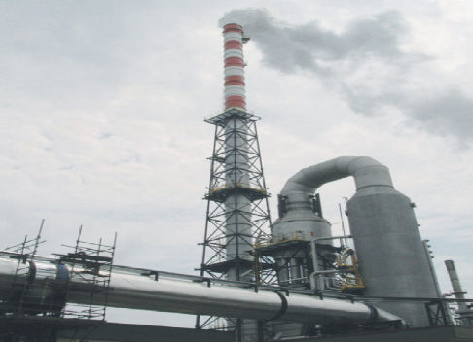
Fig 8: LIFE technologies improving
Factory environment through new
Ideas and improvisations.

Several Countries got benefited using LIFE to control pollution:

- In Belgium (p. 12), a research centre has been successful in preventing the use of sulphuric acid in the manufacture of semiconductors and reducing de ionized water consumption by 90%.
- In Spain (p. 13), a manufacturer of margarine has met the challenge of excluding from its production process all chemical treatment, waste disposal and pollutant emissions.
- In Italy (p. 14), a textile SME has reduced ink surpluses by 100% and waste water by 60% by developing digital fabric printing techniques at industrial level. In Austria (p. 15), one of the world’s leading diode manufacturers have drastically reduced the level of molybdenum in residual water discharged into the Danube and has transferred the process used to a Hungarian site.
- In Germany (p. 16), an SME has introduced, with major benefits to the environment and worker health, a dry sawing technique for metal tubes and profiles which is likely to be recognized as BAT.
- In France (p. 18), a plant of a major pharmaceutical concern has considerably improved its management of water resources by developing a set of new techniques applicable to many other sectors.
- In the Netherlands (p. 20), a major manufacturer of shock absorbers and a company specializing in industrial coatings have designed a varnish which contains hardly any volatile solvents, thereby putting an end to a conflict with the local population.
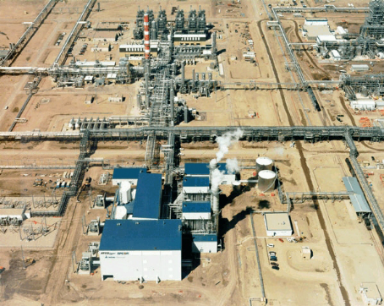
Cogeneration of heat and power
In the vast majority of cases, the largest single improvement in efficiency and reduction in
Air pollution that can be made at an industrial facility is through the adoption of Cogeneration- also known as combined heat and power, distributed generation, or recycled Energy. Cogeneration facilities can extract 80 to 85 percent of the energy in fuel, significantly reducing the air pollution compared to facilities where electricity and heat are produced separately. The engine used to generate electricity can vary from large diesels to giant turbines, but the approach is the same: make the electricity and use the heat that would otherwise
Fig 9: The Joffre Cogeneration facility in Canada. Western
station produces steam, heat and electricity for the NOVA Chemicals petrochemical facility. The surplus electricity of 290 megawatts is sold to the grid.

be wasted. The heat can also be used to provide air conditioning,
using absorption chillers in which heat is use to run a compressor instead of electricity, in which case it is called Tri generation.

Nuclear and Radioactive Pollution:
There are two ways of managing radioactive waste materials to reduce nuclear pollution:

- Initial Treatment of waste : 1. Verification
2. Ion Exchange
3. Synthetic Rock.
- Permanent Prevention : 1. Geologic Disposal
2. Space Disposal
3. Transmutation
4. Re-use of waste.

10. Conclusion:
Industrial technology uses a dizzying array of chemicals to keep modern life humming. These chemicals after fulfilling their roles in production end up accumulating in the atmosphere. One of the main problems is that public awareness is lagging behind the increasingly complex problem of pollution. The pollution menace and environmental disaster has been a long time in the making. Ecological concerns have been shunted aside in the rush towards industrialization and growth. Only now is the full extent of the ecological disaster emerging. The pollution menace does more than just degrade the quality of life; it dramatically cripples and shortens the life of human beings. Community health physicians calculate that illnesses traceable to environmental pollution account for more than 30% of the country's health budget. Officials estimate that one out of 20 people in the country now dies of environmentally-induced causes. The mass media and government should work on spreading awareness regarding the issue and it is high time the government takes a stern position in preventing the hazardous situation.
11
. Recommendation:
- More efficient production can both reduce industrialists' costs and reduce the costs to the nation, local community and environment in terms of pollution.
- It should be made mandatory by promulgating laws to use pollution control devices in Industries.
- The most satisfactory long-term solutions to air pollution may well be the elimination of fossil fuels and the ultimate replacement of the internal-combustion engine.
- Steps should be taken to treat the waste products from industries properly, i.e. chemical waste management should be taken seriously and it should be handled in a way that their hazardous quality might be reduced.
- Production modernization will also help in this regard. The production facilities should be checked from time to time to detect any discrepancies if present.
- Recycling should be done for products if possible.
- Law should be promulgated to stop the dumping of untreated hazardous wastes in the water bodies.
- Nuclear power is a safe and secure energy source that is a vital component in the fight against global warming. That's because, like renewable energy, nuclear power is a clean energy source.

