Submitted by

WWW.ASSIGNMENTPOINT.COM

The garment industry of Bangladesh has been the key export division and a main source of foreign exchange for the last 25 years. At present, the country generates about $5 billion worth of products each year by exporting garment. Two non-market elements have performed a vital function in confirming the garment industry's continual success; these elements are (a) quotas under Multi- Fibred Arrangement1 (MFA) in the North American market and (b) special market entry to European markets
Bangladesh’s industrial base, which has remained stagnant over the past two decades, is very narrow, contributing to about 11.5 percent of the GDP (BBS, 2001). Within this narrow industrial sector, however, the ready-made garments (RMG) industry has flourished as its most dynamic sector. Since its modest beginning in the early 1980s, the industry has contributed to the economy appreciably in terms of employment, output, and foreign exchange earnings. Moreover, employing as it does more than 1 million young women, the industry has brought about a noticeable change in society as well as in intra-household gender relations. Apparently the two most important factors behind the success of the RMG industry in Bangladesh are:
The availability of cheap labor; and
The GATT/WTO-controlled international textile and apparel trading system through the operation of the Multi Fiber Arrangement (MFA).
The phasing out of the MFA by the end of 2004, together with ever-increasing globalization, will exert intense competitive pressure on Bangladesh’s RMG industry. As the future of the manufacturing sector and the overall economy crucially depends on the performance of this industry, a matter of serious concern is how far, and in what manner, the RMG industry will face up to the challenge of the post-MFA trading scenario. In this connection, there is growing apprehension as to whether the industry, in order to remain competitive, will see both a reduction in the already very low wage levels and a further deterioration of the already very poor working conditions.

Table of contents
Acknowledgement | 03
Executive summary | 04
Chapter one
Introduction
Background of the study | 09
Objective of the study | 09
Scope of the study | 09
Limitation of the study | 10
Chapter two
Overview of the company
Factory Profile | 12
Board of Directors & Executive committee | 13
Our Concerns | 14
List of machineries | 15
Production capability | 19
Working environment | 20
Our product | 21
Our customer | 22
SWOT Analysis | 23
Chapter three
Literature review
Letter of credit | 26
Transaction of LC | 26
Terms of LC | 27
Chapter four
Methodology

Data instrument | 30
Data collection procedure | 30
Chapter five
Findings & Analysis
Readymade garments market | 32
Why buyer come here | 32
Merchandising in garments factory | 34
Chapter six
Recommendation &Conclusion
Recommendation | 42
Conclusion | 43
Reference | 44

acronyms

RMG- Ready Made garments
GSP- Gram per Square Meter
WTO- World Trade Organization
MFA- Multi-Fiber Agreement)
FOB- Free On Board
GSM- Gram per Square Meter
CIF- Cost Insurance & Freight
BBLC- Back to Back LC
QC-Quality Controller
I / C- Investigation Certificate
GDP- Gross Domestic Products
BBS- Bulleting Board System

Chapter One

Introduction

1.1Background of the study
The garment industry of Bangladesh has been the key export division and a main source of foreign exchange for the last 25 years. At present, the country generates about $5 billion worth of products each year by exporting garment. The industry provides employment to about 3 million workers of whom 90% are women. Two non-market elements have performed a vital function in confirming the garment industry's continual success; these elements are (a) quotas under Multi- Fibred Arrangement1 (MFA) in the North American market and (b) special market entry to European markets. The whole procedure is strongly related with the trend of relocation of production. It has been reveals that the tendency of low labor charges is the key reason for the transfer of garment manufacturing in Bangladesh. Bangladesh Garment Sector and Global Chain The cause of this transfer can be clarified by the salary structure in the garment industry, all over the world. Apparel labor charge per hour (wages and fringe benefits, US$) in USA is 10.12 but it is only 0.30 in Bangladesh. This difference accelerated the world apparel exports from $3 billion in 1965, with developing nations making up just 14 percent of the total, to $119 billion in 1991, with developing nations contributing 59 percent. In 1991 the number of workers in the ready-made garment industry of Bangladesh was 582,000 and it grew up to 1,404,000 in 1998. In USA, however, 1991-figure showed 1,106.0 thousand workers in the apparel sector and in 1998 it turned down to 765.8 thousand.

1.2 Objective of the case study:-
The objective of the case study is to develop the concept about the various aspects of the organizational structure, success & marketing process of the garments industry.
- This case study will help me to analyze the various concept of marketing
- Formal hierarchy
- Standardized export policies & rules
- Organizational network
- Various types of approaches to make profit
- Decision making in stable & unstable situation
- How to improve the quality of products &
- The production process which will enrich my experience for my future career.

1.3 Scope of the study:
During my project period I have got chances to visit many buying house, supervise many production process, & completed many sample program. Still now I am doing job in Viyellatex as asst. merchandiser & as an asst. merchandiser here I try to elaborate the merchandising profession and the production and marketing process of a garments factory.

Data instrument
As the raw data is being collected by personal interview with various employee & buyer of different company and buying house, it was analyzed by the spread sheet program EXCEL. The excel program was also used for the table a graphical presentation.
Beside those, the universal report writing software MS WORD was used to process all necessary research writing, charts graphs and tables.
To formulate the research problem I have constitute the following steps:
Data collection procedure
The source of data or information we divided into two parts that are primary and secondary source.
Primary data
In the primary source data are collected directly from viyellatex limited.
Secondary data
Secondary data are collected through different website journal and textbook and other data also collect by going various buying house.

1.4 Limitation of the study:
- Bangladesh garment industry still now is not that much developed. When I enter in Viyellatex they don’t even have their garments profile. I have created the profile.
- I found so many difficulties in searching information.
- Foreign buyers English is not that much clear.
- There are many code names in garments industry that is very important for production process, and I have memorized those codes.
- In garments factory most of the employee doesn’t have any educational background they do their job only with experiences.

Chapter Two

Company
Overview

FACTORY PROFILE

The Viyellatex believe whatever we have achieved; its credits should be directed toward our clients. Viyellatex LTD starts its journey in garment industry 1996 with interests in fabrics manufacturing and trading. Viyellatex is a 100% export oriented composite garments industry. The company is constantly providing customers across the world with garment sourcing solution, with manufacturing facilities. Bangladesh entered in readymade garments business in early 1980s. At that time there were very few local entrepreneurs who knew the trade. Mainly the foreign entrepreneurs directly operated their business for the cheap labor. But during late 1980s and early 1990s the scenario of Garment Sector of Bangladesh-started changing. Local expert and entrepreneurs started experiencing the knowledge of the trade.

In the above context Viyellatex is a privately owned company was established in 1996. The owners possess a vast experience in dyeing, finishing, knitting of Fabric.

  - BOARD OF DIRECTORS & EXECUTIVE COMMITEE

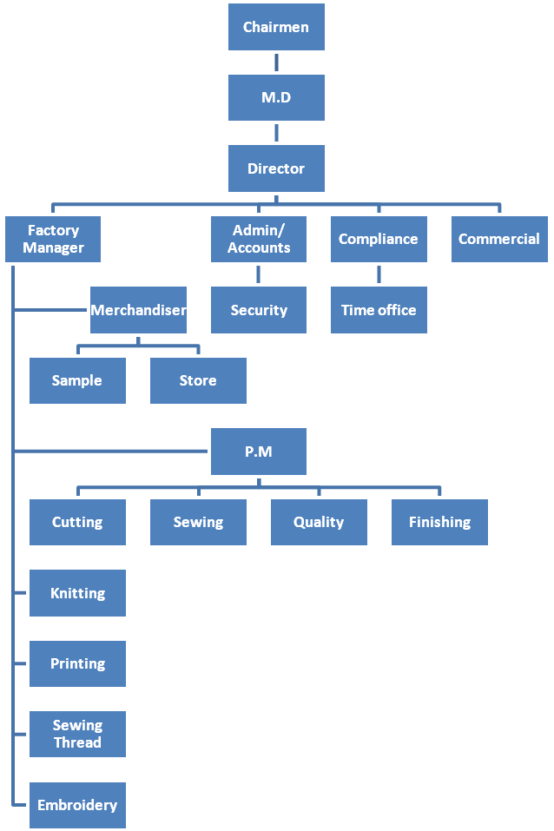
FACTORY ORGANOGRAM

  - Company Concerns:
- VIYELLATEX KNITTING LTD
- VIYELLATEX SEWING THREAD
- VIYELLATEX PRINTING
- VIYELLATEX EMBROIDERY
- VIYELLATEX ACCESSORIES.
- VIYELLATEX DYEING

The Company is organized into six divisions:
Company total numbers of employee are 1050 in 16 lines that work at two floors. (Per floor 7000 Square Meter.)
However, we are still looking towards further development and expansion in order to cover all branches of the industry, taking into consideration the availability of the raw material – cotton, competitive labor, and low power cost.
I have directed, hardworking, and efficient workforces, supervised and directed by a well-coordinated supportive management team. Not only we ensure the top quality of our products but also I treat safety, security, and hygiene as our priority area. We are equipped with fire fighting services and have a medical team of doctors and nurses to render services to our employees. I hope and believe that I can satisfy our buyers maintaining good-quality products in the most competitive market price.
2.3 List of machineries
LIST OF SEWING MACHINS
Company mission is to provide not only the highest possible product quality but also a total service.
SL. NO | DESCRIPTION | QUANTITY | BRAND
01 | Plain Machine | 240 | ZOJE
02 | Over Lock | 144 | ZOJE
03 | Flat Lock | 110 | ZOJE
07 | PMD | 04 | ZOJE
13 | Button Hole | 06 | ZOJE
14 | Button Attach | 06 | ZOJE
15 | Rib Cutter | 08 | ZOJE
8 | Kansai | 08 | ZOJE

Other logistic Machineries
1 | Cutting | 04
2 | Auto Boiler | 02
3 | P.P Belt Machine | 02
4 | Vacuum Table | 12
5 | Steam Iron | 12
6 | Embroidery Machine (20 head) | 02
7 | Sewing Thread Machine (72 cone) | 01
We have created world-class facilities to ensure better quality control and faster deliveries, the way the market is demanding today

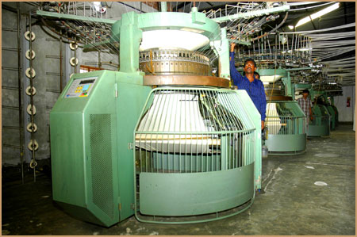

Rib & Interlock

Interlock
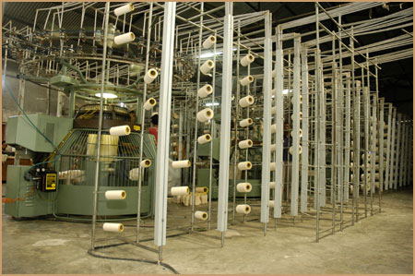

Rib & Interlock
List of Knitting Machines:
Company mission is to provide not only the highest possible product quality but also a total service to match.
Machine Specification:
SI | NAME OF MACHINE | DIA/GG & FEEDER. | NO OF MACHINES
1 | MACA BRAND HIGH SPEED SINGLE JERSY MACHINE | 20"X24GGX60 FEEDER | 01 Set
2 | MACA BRAND HIGH SPEED SINGLE JERSY MACHINE | 21"X24GGX63 FEEDER | 01 Set
3 | MACA BRAND HIGH SPEED SINGLE JERSY MACHINE | 22"X24GGX66 FEEDER | 01 Set
4 | MACA BRAND HIGH SPEED SINGLE JERSY MACHINE | 23"X24GGX69 FEEDER | 01 Set
5 | MACA BRAND HIGH SPEED SINGLE JERSY MACHINE | 24"X24GGX72 FEEDER | 01 Set
6 | MACA BRAND HIGH SPEED SINGLE JERSY MACHINE | 26"X24GGX78 FEEDER | 01 Set
7 | MACA BRAND HIGH SPEED SINGLE JERSY MACHINE | 25"X24GGX75 FEEDER | 01 Set
8 | MASA BRAND HIGH SPEED SINGLE RIB/INTER LOCK MACHINE | 30"X24 GGX60 FEEDER | 01 Set
9 | MASA BRAND HIGH SPEED SINGLE RIB/INTER LOCK MACHINE | 34"X24GGX63 FEEDER | 01 Set
10 | MASA BRAND HIGH SPEED SINGLE RIB/INTER LOCK MACHINE | 36"X24GGX66 FEEDER | 01 Set
11 | MASA BRAND HIGH SPEED SINGLE RIB/INTER LOCK MACHINE | 40"X24GGX69 FEEDER | 01 Set

Special Effect: - Enzyme finishes, silicon finish, antistatic system

LIST OF DYEING MACHINE

MACHINE NAME | BRAND | QUANTITY
Brand new tensionless relax dryer | ACME | 1 set
Ballooning squishier with compacting device | ACME | 1 set
Atmospheric normal temperature & normal pressure dyeing machine | ACME | 5 set
Fire tube boiler | DAELIM ROYAL | 1 set
Folding compactor machine | Tubetex
Over flow high temperature rapid dyeing machine & laboratory equipment. | ACME | 3+5 set
Specto photo meter | Data color | 1 set
Gas generator | JINAN | 1 set


VIYELLATEX
Embroidery machineries list:
In viyellatex there is an embroidery section the embroidery machines brand name in Sun Star viyellatex has two set embroidery machine

2.4 PRODUCTION CAPABILITY:
- Sewing Capacity: - 10000 PCS / Day
- Dyeing Capacity: - 08 Tons/day
- Printing Capacity: - 5000 PCS/ Day
- Embroidery capacity:- 4000 PCS/Day
- 24 hours Power Backup.

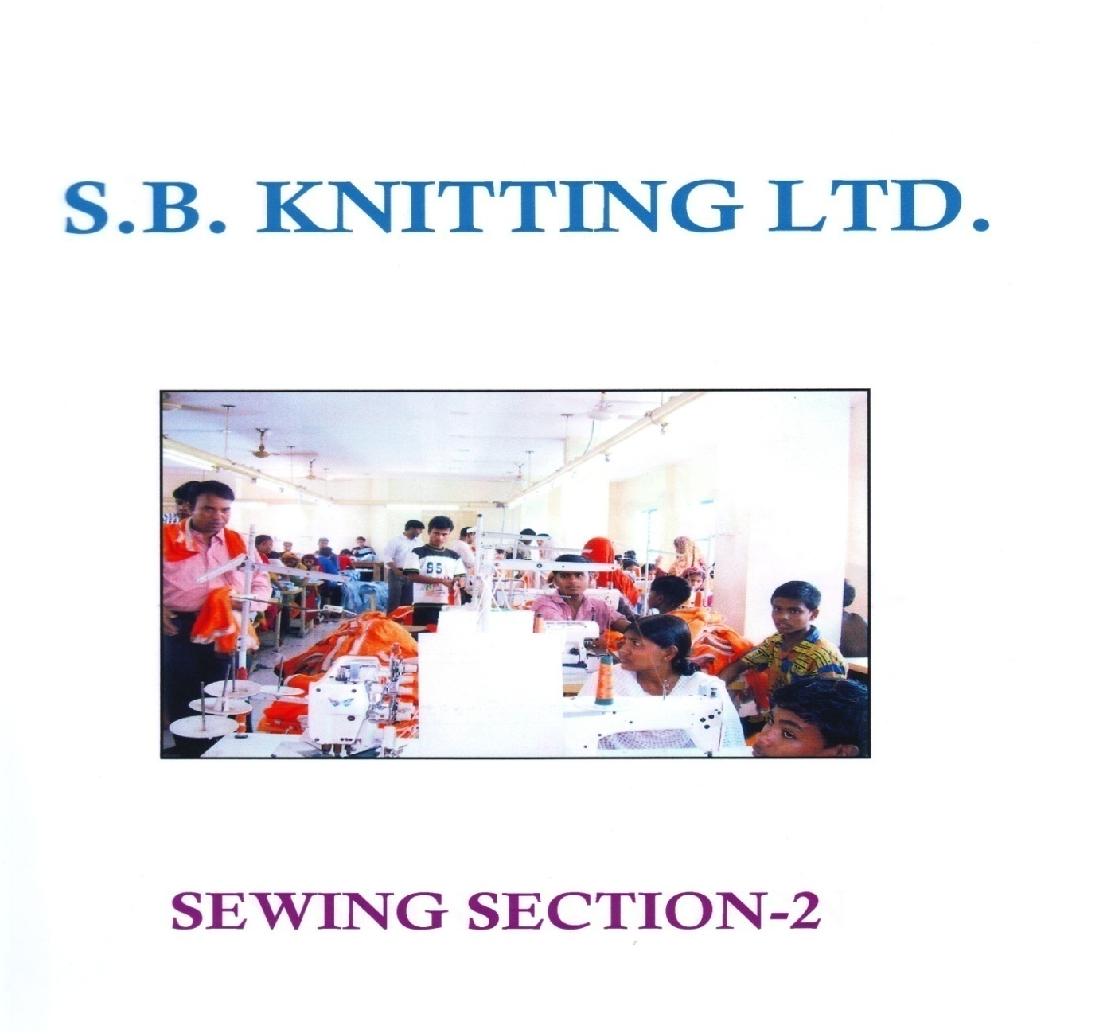
VIYELLATEX

2.5 WORKING ENVIRONMENT:
Next to its security measures, the factory is will equipped and furnished with enough fire-fighting equipment, fire alarms systems and trained personnel for facilitating emergency evacuation. All of which contribute to minimizing the fire- risks. The factory environment, with excellent lighting and ventilation, is one of the very best of its kind in Bangladesh.
2.6 Our product
- Knitting of fabrics in 100% cotton, blends and 100% polyester
- Dyeing and finishing fabric of 100% cotton, blends and 100% polyester.
- We are manufacturer and exporter of readymade garments like T-shirts, polo shirts, sportswear, underwear, and sweatshirts, casual wear, night wears, lingerie & polar fleece jacket etc.
- Different type of printing like Pigment, Rubber, Flock, Foil, Sugar, Dicsas , De active, Emboss, Plastic sole, Glitter, Hidensi , Transper, Gel, Stone print.
- All type of embroideries.
- Besides, we have very strong marketing division for all kinds’ of ready-made garments to expand market to Europe, U.S.A, Canada and all over the world.

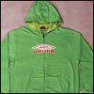 | 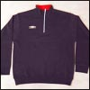 |  | 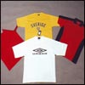
 | 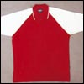 |  | 
 |  |  | 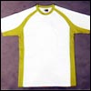
 | 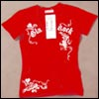 |  | 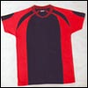
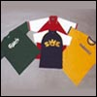 | 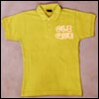 |  | 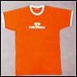

2.7 Our customer
Customer | Blues Clothing, Padma , Lankstone,I.C.S-UK
Customer | Gowitex, S.A Beechins & Texim, -Fabrimode,
Customer | Publi Shirt-Belgium ,Heusel GMBH-Trio GMBH,
Customer | H B PromotionGermany | Zara-Spain
Customer | Super Sports Sa-France, | DIGO (BELGIUM)
Customer | Setter House-Netherlands.

2.8 SWOT Analysis

Strength:
- Easily accessible infrastructure like sea road, railroad, river and air communication
- FDI is legally permitted
- Moderately open Economy, particularly in the Export Promotion Zones
- Improved GSP advantages under Regional Cumulative
- Looking forward to Duty Free Excess to US, talks are on, and appear to be on hopeful track
- Investment assured under Foreign Private Investment (Promotion and Protection) Act, 1980 which secures all foreign investments in Bangladesh
- OPIC's (Overseas Private Investment Corporation, USA) insurance and finance agendas operable
- Bangladesh is a member of Multilateral Investment Guarantee Agency (MIGA) under which protection and safety measures are available
- Excellent Tele-communications network of E-mail, Internet, Fax, ISD, NWD & Cellular services
- Weakness of currency against dollar and the condition will persist to help exporters
- Bank interest@ 7% for financing exports
- Convenience of duty free custom bonded w/house
- Readiness of new units to enhance systems and create infrastructure accordant with product growth and fast reactions to circumstances

Weakness .
- Lack of marketing tactics
- The country is deficient in creativity
- Absence of easily on-hand middle management
- A small number of manufacturing methods
- Low acquiescence: there is an international pressure group to compel the local producers and the government to implement social acquiescence. The US GSP may be cancelled and purchasing from US & EU may decrease significantly
- M/c advancement is necessary. The machinery required to assess add on a garment or increase competence are missing in most industries.
- Lack of training organizations for industrial workers, supervisors and managers.
- Autocratic approach of nearly all the investors
- Fewer process units for textiles and garments
- Sluggish backward or forward blending procedure
- Incompetent ports, entry/exit complicated and loading/unloading takes much time
- Speed money culture
- Time-consuming custom clearance
- Unreliable dependability regarding Delivery/QA/Product knowledge
- Communication gap created by incomplete knowledge of English
- Subject to natural calamities
Opportunity
- EU is willing to establish industry in a big way as an option to china particularly for knits.
- Bangladesh is included in the Least Developed Countries with which US is committed to enhance export trade
- knitwear are very economical even with china and is the prospect for Bangladesh
- If skilled technicians are available to instruct, prearranged garment is an option because labor and energy cost are inexpensive.
- Foundation garments for Ladies for the FDI promise is significant because both, the technicians and highly developed machinery are essential for better competence and output
Threat
- The exporters have to prepare themselves to harvest the advantages offered by the opportunities.
- Many new competitors are coming in front with new product style and technology.
- Dependency in foreign countries so far raw materials price is increasing day by day.

Chapter Three

LC Procedures

Letter of Credit (LC)

- Letter of credit (LC) is a financial instrument opened by importer.
- LC can be opened in favor of exporter. It gives assurance that the importer is solvent.
- Most of the LC is irrevocable. An irrevocable LC means that once the exporter has accepted the credit, the buyer cannot alter it without any permission of exporter.

Transaction of letter of credit (LC)

Authorization of payment

LC
Exporter Bank
Importer Bank

Document Request
Of To open LC Debited
LC

Exporter
Importer

- shipment
SHIPMENT
of good

- Buyer requests the bank for open a letter of credit.
- Issuing bank open an irrevocable LC and send it to exporter bank.
- Advising bank prepare letter of conformation of LC and send it to exporter
- Exporter review the LC. IF acceptable, exporter arranges with freight forwarder to deliver the goods.
- Exporter present delivery documents to advising bank for payment.
- Advising bank forward the entire document to issuing bank to authorize payment.
- At the same time, advising bank pays necessary payment to exporter.
- 8buyers account in the issuing bank is debited

Terms of LC
C.I.F (Cost, Insurance and freight):
- Charge by the exporter- the goods, transportation, insurance, miscellaneous etc.
- Must mention a delivery point up to where the exporter will bear the cost of freight.
C.F (Cost and Freight)
- The exporter quotes a price including the cost of goods and transportation.
- The insurance cost by importer.
- Importer knows such insurance company who offer lower insurance price.
F.O.B (Free on Board)
- F.O.B means exporter will take the responsibility up to the goods are loaded on the ship
- Importer has own transportation
- Ship company is well known to importer
Commercial invoice:
Commercial invoice is the final bill that allows the importer about how to pay to exporter. Commercial invoice is needed customs to impose tax.
Bill of lading:
A bill of lading is a documents issued by the ship-owner or by the master or captain of the ship or other agent in exchange of mate’s Receipt after the goods have been placed on the board the ship for being carried to a specific destination. It is used when the goods shipped from only a part of the cargo of a ‘general ship’
A bills of lading must be stamped and signed by the ship-owner or his agent, the master or captain of the ship
Backward Integration:
Customers are another potential source of competition. For reducing the production cost manufacturer make linkage or own the source of raw materials. Those linkages are called backward linkage or backward integration.
Labor-Capital relationship:
In countries where there is little capital available for investment and where the amount of investment per worker is low, manager might expect to find cheap labor rate and export competitiveness in product that require large amount of labor relative to capital.

Chapter Four

Finding

5.1 Readymade garments market:
Bangladesh now exports garments to about 25 countries around the world, the USA is the single largest importer of its RMG products, amounting to 43 percent of total garment exports. Bangladesh is the sixth-largest supplier of apparel in the US market. Considering the European Union as a single market, the USA then becomes the second largest. Over the past few years, Bangladesh’s RMG exports to the EU have expanded rapidly, with the EU currently importing about 52 percent of Bangladesh’s total garment products. The inter-temporal evidence of the narrow market base of Bangladesh RMG exports in the 1990s is provided by the concentration of exports to the US and EU market (almost 96 percent in 1998-99, see Table A2.8 in Annex). While the export share to the USA has witnessed an annual average rate of decline of 1.5 percentage points, however, the corresponding share to the EU has experienced an annual growth rate of 1.6 percentage points. Thus, the increment in the EU share has simply replaced the declining share in the USA market, which suggests that, instead of diversification, Bangladesh’s export market has remained concentrated over the past decade. The combined market share of the USA and the EU has thus increased from 95.5 percent to 95.6 percent between 1991-92 and 1998-99. Bangladesh so far has been unable to gain access to ASEAN or Indian markets, although it imports a huge quantity of fabrics and yarn from these countries. Similarly, although it imports about 95 percent of its total garment machinery from Japan, its market share of apparel export to Japan is a mere 0.1 percent.16 Bangladesh’s inability to gain access to these large markets in turn suggests that the country has yet to establish its claims, as advocated by the WTO, to the principles of reciprocity and market access. The North American quota system and GSP facilities afforded by the EU have contributed to the undiversified RMG export market in Bangladesh; in that entrepreneurs have focused on taking advantage of these special opportunities. Thus, the entire national clothing export business will be endangered by the year 2005, when the MFA is eliminated and GSP schemes may cease to operate. The country must thus make immediate and vigorous attempts to diversify its export markets.

5.2 Why buyer come here:
The principal static comparative advantage that Bangladesh enjoys over potential competitors is its cheap labor force. The wage level in the RMG industry is low both for males and females, compared with workers in a similar category in other sectors. For instance, a comparison on the basis of wage data provided by Bangladesh Bureau of Statistics8 shows that the average monthly wage of skilled RMG factory workers is 1.4 to 2 times lower than that of similar factory workers in the textile and other sectors.

Table 5.2.1: Labor costs in selected countries (in US $/hour)
Countries 1991 1993
Bangladesh NA 0.16
India 0.25 0.27
Pakistan 0.24 0.27
Sri Lanka 0.39 0.35
China 0.24 0.25
Indonesia 0.18 0.28
Thailand 0.59 0.71
Italy 13.5 NA
UK 7.99 NA
US 6.77 NA

Sources: Moore 1997, Table 2; Ramaswamy and Gereffi 1998, 123 as quoted in M. Vijayabaskar,
“Productivity, Competitiveness and Job Quality in Garment Industry in India,” a discussion
paper prepared for the Sub-regional Meeting on Productivity, Competitiveness and Job Quality
in Garment Industry in South Asia, Kathmandu 25-26 September 2001.

Table : Unit price realization of selected garment exports (in US $/piece)

SITC Product Bangladesh India Pakistan Sri Lanka China Thailand
description

Men’s woven wear
8414 Trousers 4.21 3.91 3.67 6.44 5.74 6.35
84151 Cotton shirts 4.82 5.59 3.74 6.15 4.02 7.51
84159 Shirts (other material) 4.17 6.16 2.89 5.72 5.28 4.85
Men’s knit wear
84324 Trousers 3.17 2.80 3.21 3.90 2.04 3.29
84371 Cotton shirts 2.97 4.53 4.06 7.44 5.49 7.48
84379 Shirts (other material) 3.45 4.62 3.81 6.08 8.14 3.34
Women’s woven wear
8425 Trousers, breeches 3.47 4.77 4.04 5.39 7.53 6.05
8426 Blouses, shirt-blouse 4.55 4.22 3.67 5.87 5.85 7.13
8427 Skirts 3.28 3.94 3.14 5.69 6.77 7.04
Women’s knit wear
8425 Skirts 0.00 2.92 5.68 4.85 3.13 4.41
8426 Trousers, breeches 2.59 3.74 2.90 4.82 6.78 4.54

Source: “Globalization and the Apparel Industry of Pakistan,” a discussion paper prepared by Asir Manjur for SMEDA
(Small and Medium enterprise Development Authority) for the Sub-regional Meeting on Productivity, Competitiveness .
Findings of Viyellatex ltd.

There are many problems in Viyellatex Limited. Problems can be internal. In order to think about future solutions I first want to find out these problems.
Employee’s problem: Most of the employees are unskilled. With improper background and under- educated. For that they are not efficient to do their tasks. It increases the cost of production as well as more time is needed to finish a particular task.
Problem in decision making: It’s a private limited company so employees personnel can not take any necessary decision without Managing Director’s concern. It takes more time to take any decision.
Insufficient Technology: They have limited computer facility in office for their daily activities. Sometimes many officers are to wait to use computer. Also, speed of the computer is the slower than required.
Small production unit: They can produce only 20,000 T-SHIRT per day because for their small production unit. For that they need 60 days lead time to complete an order. It is long time now days in the competitive RMG market.
Labor unrest: Some times labor unrest creates problems to export. Most of the employees are not happy with their wages, over time and other extra benefits. Also working environment is not friendly enough for their health.
Other problems
- The Viyellatex Ltd does not provide psychological security that their jobs will as continue long as they want.
- The benefit offered by Viyellatex Ltd is very little amount which is the main reason for employees high turnover.
The top level management is not concerned enough about the compensation package. So most of employees are suffering in pay dissatisfaction.
5.3 Merchandising in garments factory:
There is two type of merchandising in Garment Company:
- Commercial
- Official

Commercial:
They manage the export related document and ensure that the buyer LC is accurate. After production they also manage the document of shipment.
Official:
They manage the production process and see whether the product is produced regarding the requirement of the buyer and delivery the produced good within the shipment date.
Merchandiser face the following responsibility:
- From an inquiry, all information is gathered (measurement, GSM, Which fabric, colour, what type of print, quantity, packaging, FOB or CIF etc) to provide a good price per pcs (keeping in mind severe competition country wise);
- If price is o.k.; Then making & sending of sample to buyer for approval of style, print (if any), GSM, fabric, measurement & if there is any rectification to be made, we must do it accordingly; as buyer satisfaction is our goal!
- After approval + fixing a delivery date, order is placed to the nominated factory. Fabric conjunction information
- Forwarding master sample + accessories + PO to factory to open BBLC.
- With the help of QC, whole production status is being send to buyer through mail + phone. Daily production discussion with QC + keeping in touch with factory production in charge.
-Prepare weekly reports, monthly reports, master summary; incoming accessories inventory report to be sent to buyer for a better follow up of production in here + for a good understanding & correspondence system.
-Always being a source of information for a prompt reply for buyer queries through phone or by mail. During buyer visit in Bangladesh, all discussion, claims (if any) queries concerning production inspection or any production problem should be solved here itself.
- Maintain liaison with the shipping Lines & forwarder.
-For delivery, vessel is booked from the nominated shipping line.
-Preparing I / C based on inspected garments for shipment. Scrutinizing Export & Import documents. After delivery, buyer is provided the original documents through courier.
-During these procedure/ responsibilities, always proved to be a good mediator; taking into consideration both buyer + factory advantage/favor/benefit.

Knitting & Dyeing program:
After receiving the order of program merchandiser at first prepare the color and size ratio of the program and after that they prepare the knitting and ratio program. There some law for fabric consumption that is important to identify the required quantity of fabrics.
LAW:
BODY LENGTH+SLEEVE LENGTH X CHEST X 2PART X .GSM % 1000= FABRIC FOR 1 PCS+ 15% FABRIC
Here I present a copy of knitting and dyeing program

 | FABRIC TYPE : 100% COTTON FRANC TERRY 400 GSM WITH OUT BRUSH
 | & SINGLE JERSEY 240 GSM
S/L
1 | STYLE | FABRIC TYPE | Colour | GSM | DIA/CM |  | QTY/KG | 1X1LYCRA
2 | Iron Cap | 100%cotton terry fleece | White 11-0601tpx | 400 | 58 |  | 30 kg | With Flat knit
3 | Iron | 100% cotton S/Jersey | White 11-0601tpx | 240 | 58 |  | 15 kg | 02 kg
4 | Istycap 08 | 100% cotton terry fleece | Black 19-0303 tpx | 400 | 58 |  | 30 kg | with tipping
5 | Dry 08 | 100% coton S/Jersey | Black 19-0303 tpx | 240 | 58 |  | 15 kg | 02 kg
6 | Istituzionale 08 | 100% cotton S/Jersey | Black 19-0303 tpx | 240 | 58 |  | 15 kg | 03 kg
7 | Arvid | 100% cotton terry fleece | Black 19-0303 tpx | 400 | 58 |  | 25 kg | 04 kg
8 | Simplex 08 | 100% cotton S/Jersey | Black 19-0303 tpx | 240 | 58 |  | 15 kg | 04 kg
 |  |  |  |  | Merchandiser
 |  |  |  |  | Viyellatex ltd.
After knitting program we send 1x1m fabric to the buyer for the approval of color and shade of the fabric. If the fabric matched with the requirement than we use the fabric for production purpose.

Cutting:
After the fabric arrive in the factory then we send the fabric along with the measurement sheet to the cutting section. In cutting section cutting master cut the fabric according the measurement & sends it to printing section or embroidery section if necessary.

Printing:
In printing section print master at first develop the design of the print and make frame according the print. Before printing print master send a printing sample to the merchandiser. Merchandiser mach the print with the requirement and color Pantone if matched than he give permission to print the fabric. Here I present a copy of printing requirement.

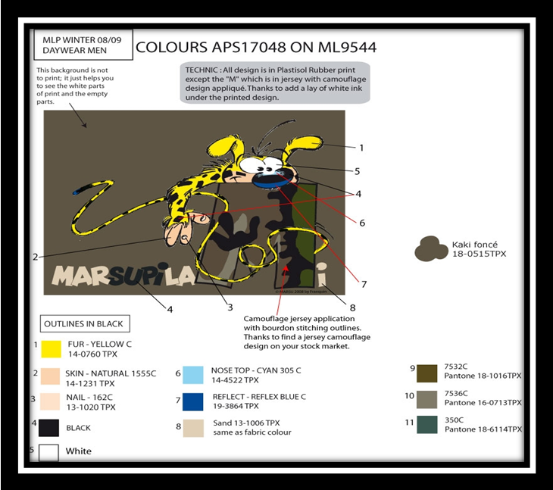
Embroidery:
When printing finished then print master send the fabric to the embroidery section if necessary. In embroidery section embroidery designer make the design of embroidery and set stitches for that design here I present some copy of embroidery design.



Embroidery patch
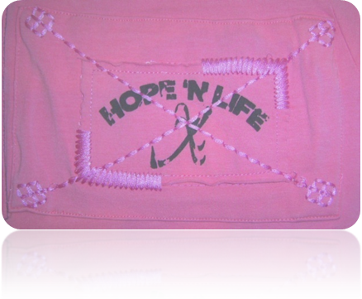
Embroidery design

Sewing Thread:
Thread may be contrast or in same color it must be matched with requirement. Store manages the sewing thread and the merchandiser approves the color and quality.
Sewing:
After embroidery of fabric in charge of the section send the Fabric to the sewing section in sewing section we send some of the accessories which need to be attached with the garment. Sewing section in charge and production manager observe the sewing process and keep them update with comments from the measurement. (Here by comments I mean the correction of order sheet and approval from buyers)
Finishing:
After sewing the RMG goes to finishing sector for attachment of other accessories, folding, packing, here we aid them with folding and packing approval from buyers. Here I present some list of accessories
PRODUCTION ACCESSORIES

- Hang tag: 6x10cm
Paper thickness 500gsm
Background white colour
Attached with orchid satin lace & a silver pin



FRONT SIDE



Background draw orchid 17-3628 TP


Outline + lettering in bright silver foil
After attachment of all accessories and packing the finishing section pack the garments in required carton in proper ratio and put the level of buyer address and the factory address on the carton. After Buying Quality Controller come in inspection to if the product meet their requirement. Then they send theses carton in our store house before shipment date

Cargo booking:
Cargo booking is another impotent responsibility of merchandiser there is a law of cargo booking.

Carton length x carton width x carton height x carton quantity= 1CBM

After booking of cargo we send RMG to port and there Buyer runs an inspection where the product is ok or not if product oks then the commercial merchandiser take the shipment document after customer clearance and submit the document to exporter bank and receive the LC money

Recommendation:
The employee should be trained properly. And in case of hiring new employees the authority must focus on their ability and working capability.

Problem con be minimized if the decision making process will not get lengthy and also the employees can take participation.

The company needs to develop their survey procedures so that they can have frequent updates regarding the markets.

Production unit should be increased. So that the lead time can be reduced.

The company needs to cope up with the modern style and trends. And this can possible only if they can develop their marketing management sector.

The company needs to increase their investment rates.

The use of modern technology should be increased. If they use more equipment and maintain them properly they can reduce the time consumption and cost also.

The government should focus on the development of the port. The authority must maintain the rules and regulation so that the shipment procedures can be run smoothly.

Govt. plays a vital role in the export import sectors. So Govt. should aid the garment industries so that they can earn more foreign currency, can contribute to the economic growth and as can participate in the international markets.

Conclusion:
Garment industry is controlled by the transfer of production. The globalization of garment production started earlier and has expanded more than that of any other factory. The global economy is now controlled by the transfer of production where firms of developed countries swing their attention to developing countries.

The garment industry of Bangladesh has been the key export division and a main source of foreign exchange for the last 25 years. Many people have earned their livelihood through this industry. There may be gender discrimination, low wage level exists in the garments industry, but still, they supply employment for all of these people who come here to live.
The Ready Made Garment industry in Bangladesh is made up of 3,486 manufacturers and accounts for 76% of total foreign exchange earnings. It employs about 180,000 managers and 1.5 Million workers, of whom 1.2 Million are women. In Bangladesh, the RMG industry has emerged as a major economic sector and has had its impact on the financial services sector, communications, transportation, and on other related industries.
The RMG industry has had a major social impact. It has empowered 1.2 million women with employment and economic independence, which in turn has earned for Bangladesh recognition as a modern and enlightened society.

