Submitted by
WWW.ASSIGNMENTPOINT.COM

Online banking is the practice of making bank transactions or paying bills via the Internet. Thanks to technology, and the Internet in particular, we no longer have to leave the house. We can shop online, communicate online, and now, we can even do our banking online. Online banking allows us to make deposits, withdrawals and pay bills all with the click of a mouse. It doesn't get much more convenient than that the benefits are many.

For the online banking customer, the convenience factor rates high. No longer does a person have to wait for the bank statement to arrive in the mail to check account balances. One can check the balance every day just by logging onto one's account. In addition to checking balances and transactions, one can catch discrepancies in the account right away and deal with them swiftly. The best part is that this can be done anywhere! As long as one has Internet access, one can practice online banking.

Since bills are paid online, the necessity of writing checks, affixing postage and posting the payment in the mail is eliminated. Once the amount is entered and the payee is checked off, the funds are automatically deducted from the payer's choice of account. Since the cost to the bank is minimal, the cost to the consumer, in many cases, is also minimal. While there is usually a fee for online banking, it can be extremely low. Those who partake in online banking all agree it's worth every penny. Not having to spend all Saturday morning standing in a crowded bank line is justification for most. It can even pay for itself since costs like postage and ATM fees are reduced.

Online banking also eliminates paper waste, which is a plus not only for those who have to handle all the paper work, but also for the environment. Security is always an issue with Internet transactions. Although information is encrypted, and the chances of your account being hacked are slim, it happens. Banks pay big bucks to install high tech firewalls. Chances are your money is in good hands.

You're also missing the personal service. No smiling teller or representative hands you receipt. Instead, except for what's printed into your account, all the paperwork is up to you. Always print copies of important transactions. If you have to deposit cash or checks, you'll still have to spend time at the ATM. unless payment to you is directly deposited; this is one thing you'll always have to handle manually. Still, the benefits far outweigh the risks. The convenience of online banking is a perk well worth the cost. What would you rather do, stand in a long line on a weekend morning or handle your transactions in the comfort of your own home.

Internet banking” refers to systems that enable bank customers to access accounts and general information on bank products and services through a personal computer (PC) or other intelligent device. Internet banking products and services can include wholesale products for corporate customers as well as retail and fiduciary products for consumers. Ultimately, the products and services obtained through Internet banking may mirror products and services offered through other bank delivery channels. Some example of wholesale products and services include:

- Cash management
- Wire transfer
- Automated clearinghouse (ACH) transactions
- Bill presentment and payment
- Balance inquiry
- Funds transfer
- Downloading transaction information
- Bill presentment and payment
- Loan applications
- Investment activity

There is a sea change in the media world. While most consumers see the news papers, the same magazines and listen to the same radio programs, behind this bland public exterior there is a seething world of innovation, acquisition, global partnership and divorces, births and deaths all of it most readily interpreted as the inevitable result of the technological revolution that is in the process of merging telephones, computers, televisions in to a single all singing, all dancing magic kit that will, very possible, change all of our lives more than we can imagine some day
There are 2 ways you can respond to this 1 is to panic, which may mean simply curling up in a corner and wishing that it would all go away. The other is to embrace the new religion with messianic fervor and go out to proclaim the millennium. I welcome you to the new emerging world of the Info-High-Way, destined to redefine the world of communications.

LIST OF ABBRIVIATION AND ACRONYMS
- DBL: Dhaka Bank Limited.
- CSD: Customer Service Department.
- I.P.O: Initial Public Offering
- MIS: Management Information System
- BOD: Board of Directors
- PABSOB: Private Association of Boarding Schools of Bangladesh
- CEO: Chief Executive Officer
- BIDC: Bangladesh Industrial Development Corporation
- HR: Human Resource
- FBCCI: Federation of Bangladesh Chamber of Commerce and Industries
- GM: General Manager
- FD: Fixed Deposit
- CA: Current Account
- CC: Call Account
- OD: Over draft
- PG: Prime Gold Saving Account
- PS: Prime Saving Account
- BOA: Bank of Asia
- SCT: Smart Card Technology
- ATM: Automated Teller Machine
- DGM: Deputy General Manager
- SWIFT: Society for Worldwide Interbank Financial Telecommunication

Chapter: One
1.0. Introduction

1.0 Introduction

The Internet has provided a new and inexpensive channel for banks to reach out to their customers. It allows customers to access banks’ facilities round the clock and 7 days a week. It also allows customers to access these facilities from remote sites/home etc. However, all these capabilities come with a price. The highly unregulated Internet provides a less than secure environment for the banks to interface. The diversity in computer, communication and software technologies used by the banks vastly increases the challenges facing the online bankers.

If you're like most people, you've heard a lot about online banking but probably haven't tried it yourself. You still pay your bills by mail and deposit checks at your bank branch, much the way your parents did. You might shop online for a loan, life insurance or a home mortgage, but when it comes time to commit, you feel more comfortable working with your banker or an agent you know and trust.

Online banking isn't out to change your money habits. Instead, it uses today's
computer technology to give you the option of bypassing the time-consuming, paper-based aspects of traditional banking in order to manage your finances more quickly and efficiently. The advent of the Internet and the popularity of personal computers presented both an opportunity and a challenge for the banking industry. For years, financial institutions have used powerful computer networks to automate millions of daily transactions; today, often the only paper record is the customer's receipt at the point of sale. Now that its customers are connected to the Internet via personal computers, banks envision similar economic advantages by adapting those same internal electronic processes to home use. Banks point of view online banking is as a powerful "value added" tool to attract and retain new customers while helping to eliminate costly paper handling and teller interactions in an increasingly competitive banking environment. Online banking or Internet banking allows customers to conduct financial transactions on a secure website operated by their retail or virtual bank, credit union or building society.

1.1 Origin of the report
We have prepared this report on basis of Online Banking System of DHAKA BANK. We have done this report for the course requirement of FIN- 320. We did the report with group work. Our course instructor Moniruzzaman Khan has assigned this report. Our group is including with 6 members. We choose The Dhaka Bank Limited for our survey. We collected information about Online Banking System of DHAKA BANK. We have collected the 10 employee’s opinion about Online Banking System. We have successfully done this report only for co-operating with other.

1.2 Background of the report
The BBA program is designed to focus on theoretical and professional development of people open to take up business as a profession as well as service as a career. Money and Banking course is designed with an excellent combination of theoretical and practical aspects. This course introduces us with new product development aspects in relation to marketing dynamic. It also helps us to learn about the concept such as description of money, bank like commercial banking, central bank, also its service of bank and one of the most important side of banking service is Online banking. The concept of banking will examined in the context of the global market within which business operates as well as the impact of technology in the modern business environment. We are assigned to prepare a report of online banking. We have tried our level best to present our experience of the organization and their questionnaires answer in this report.
1.3 Objectives of the study
The aim of our study was to know the Online Banking System of any organization as a partial requirement of the course Money and Banking. Therefore, to obtain this aim we set the following objectives of studies.
- BROAD OBJECTIVE:

To Know the Online Banking System of DHAKA BANK LIMITED.

- SPECIFIC OBJECTIVES:

.
- To find out the present scenario of online banking practice in Bangladesh.
- To find out the strength and weakness of online banking services.
- To find out how it’s performed through the internet.
- To find out what are the benefit of online banking.

1.4 Scope of the study
- A healthy banking system is essential for any economy striving to achieve good growth and yet remain stable in an increasingly global business environment. The Dhaka banking system, with one of the largest banking networks, has witnessed a series of reforms over the past few years like the deregulation of interest rates, dilution of the government stake in public sector banks (PSBs), and the increased participation of private sector banks. The growth of online banking services sector has been a key development on the market front. Bangladeshi banks (both public and private) have not only been keen to tap the domestic market but also to compete in the global market place.
- Studying the increasing business scope of the bank.
- Market segmentation to find the potential customers for the bank.
- Customers’ perception on the various products of the bank.
- The corporate sector has stepped up its demand for online services its expansion plans; there has also been a growth in online banking.

1.5 Methodology and SOURCES of Data
In this part, we describe the research methods followed in this study. We used Primary data with the help of secondary data for this research. We try to make study informative, analytical, useful and interesting.
- Primary data:
We collected our data from DHAKA BANK LIMITED (DBL) of Narayangonj branch. It is famous & well known in the country. We collected data from 10 employees of DHAKA BANK. We asked them some questions with a list of issues. Collecting data directly from the practical field is called primary source of data. The methods that were used to collect the primary data are as follows:
- Discussion with officials of the Dhaka bank in Narayangonj.

- Face to face conversation with the employees.

- Secondary data:
The secondary data has been collected from different publication of different banks. To clarify different conceptual matters, Internet and different articles published in the journals & magazines have been used. The Secondary Sources are:
- Book.
- Internet.
- Our course instructor.
- Different company annual report leaflet, article etc.
- Annual Reports of the individual banks.
- Newsletter of the regarding banks.
- Other published documents of concerned banks.

1.6 Limitations of the study
As it is the first organized research on this topic, we had to face a lot of problems since adequate
Information is not available, in many cases these were hard to gather. Some obstacles are faced in gathering some information for this report.

- The main limitation I faced in preparing this report was obstacles in finding information.
- Lack of sufficient information (both primary and secondary data), as this topic is considered as very much confidential topic for the organization.
- Time short.
- Little amount of data.
- Communication problem.
- Some of employees of the bank do not want to provide information.

Chapter: Two
2.0. Literature Review

Literature Review

Definition of the Bank: -Financial institution whose primary activity is to act as a payment agent for customers and to borrow and lend money. Banks are important players of the market and offer services as loans and funds.
    - Banking was originated in 18th century
    - First bank were General Bank of India and Bank of Hindustan, now defunct.
Bank of Bengal

State Bank of India
Bank of Bombay
Imperial Bank of India

Bank of Madras

Banking in a traditional sense is the business of accepting deposits of money from public for the purpose of lending and investment. These deposits can have a distinct feature being withdrawn able by cheques, which no other financial institution can offer. In addition, banks also offer financial services, which include:
- Issuing demand draft & traveler’s cheque.
- Credit cards
- Collection of cheques, bill of exchange.
- Safe deposit lockers
- Custodian services.
- Investment and Insurance Services.
The business of banking is highly regulated since banks deal with money offered to them by the public and ensuring the safety of this public money is one of the prime responsibilities of any bank. That is why banks are expected to be prudent in their leading and investment activities. Every bank has a compliance department, which is responsible to ensure that all the services offered by the bank, and the processes followed are in compliance with the local regulations and the Bank’s corporate policy.
The major regulations and act govern the banking business are:-
- Banking Regulation Act, 1949
- Foreign Exchange Management Act,1999
- Indian Contract Act
- Negotiable Instruments Act, 1881
Bank lend money either for productive purposes to individual, firms, Corporate etc. of for buying house property, cars and other consumer durables and for investment purposes to individuals and the others. However, banks do mot finance any speculative activity. Lending is risk taking. The depositor of banks is also assured of safety of their money by deploying some percentage of deposit in statutory reserves like SLR & CLR.
Banking System
Banking system is an integral sub-system of the financial system. It represent an important channel of collecting small saving from the households and ending it to the corporate sector.
The Indian Banking system has the Reserve Bank of India (RBI) as the apex body for all matters relating to the banking system. It is the comucopia of Banks of India and bankers to all others banks as well.

Classification of Banks
- Non-Schedule Banks
These are banks, which are mot included in the second schedule of the Banking Regulations Act, 1965. It means they do mot satisfy the conditions laid down by that schedule. They are further classified as back:
  - Central co-operative banks and primary credit societies
  - Commercial Banks
2. Schedule Banks
Schedule bank must have paid-up capital and reserve of mot less than Rs. 50, 00,000. The must satisfy the RBI than its affairs are mot conducted in a manner detrimental to the interests of its depositors. These are further classified as follow:
  - State co-operative Banks
  - Commercial Banks
Banks are further sub-divided as:-
  - Indian Banks:
These banks are companies registered in India under companies act, 1956, their place of origin is in India. These are further classified into.
- State Bank of India and its Subsidiaries
This group comprises of the State Bank of India (SBI) and its seven subsidiaries viz., State Bank of Patiala, State Bank of Hyderabad, State Bank of Travancore, State Bank of Bikaner & jaipur State Bank of Indore.
- Other Nationalized Banks:
This group consists of private sector bank that were national. The Government of India Nationalized 14 private banks in 1969 and another 6 in the year 1980.

- Regional Rural Banks:
The RBI established these in the year 1975 of Banking Commission. It was established to operate exclusively in rural areas to provide credit and other facilities to small and marginal armors, agricultural labor’s, artisans and small entrepreneurs.
- Old private Sector Banks:
This group consists of Banks that were established by the privy states, community organization or by a group of professionals for the cause of economic betterment in their area of operations. Initially their branches slowly speared throughout the national as they grew.
- New Private Sector Banks:
These banks were started as profit oriented companies after the RBI opened the banking sector to the private sector, these banks are monthly technology driven and betterment in their branches slowly speed throughout the nation as they grew.
3. Foreign Banks:
There are banks that were registered outside India and had originated in a foreign country.
On-line banking is a service provided by many banks, thrifts, and credit unions that allows customer to conduct banking transactions over the internet using a personal computer, mobile, telephone, or handheld computer (such as a “personal digital assistant”). Connected to a computer or connected to the internet. Denoting either a real time operation that is accomplished by a dialogue a humane operator and a computer system, or a system based on such operation. Base on internet service there are mainly two category bank in the world those are

- Off-line banking
- On-line banking

Off-line baking:
Not connected to an internet. Denoting computer equipment that is not useable, either because it is not connected to a computer or the system has been forbidden to use it. And we also said. Banking activities without any connectivity with online
On-line baking:
Online banking refers to an offer to an office or department that is directly linked with a computer or computer center. Practically every banking service has a computer link. Additionally, the expansion of home/office banking provides customer with online facilities to obtain up-to-date balances, transfer sums of money to and from different account and transfer to different persons.
Real time online banking/truly online banking:
In real time online banking, the following task can be solved
- Electronically fund transfer, from a/c to other a/c
- Banking transaction can be seen currently in bank account
- Transaction without going to bank branch

- Electronically fund transfer, from a/c to other a/c
"Funds Transfer" means the series of transactions beginning with the issue of originator's payment instruction to the sending bank and completed by acceptance of payment instruction by the beneficiary's bank for the purpose of making payment to the beneficiary of the instruction.
- Banking transaction can be seen currently in bank account
- Transaction without going to bank branch
No need of walking up to the bank branch, every time you need to do your banking. As you can do a lot of it online. From paying your bills to transferring funds, booking your rail/air tickets, shopping, sending a money order and doing lots more
On-line banking is a service provided by many banks, thrifts, and credit unions that allows customer to conduct banking transactions over the internet using a personal computer, mobile, telephone, or handheld computer, there are types of internet banking those are-
- Electronic Banking/E-Banking
- Internet Banking/Cyber banking/Virtual baking/I-banking

- Electronic Banking/E-Banking:
Electronic banking is the facility to operate a bank account a bank by remote instructions using a computer and telephone line. The facility is largely made use of by business firms, while individual customers usually make use of telephone for banking arrangements. The following way electronic banking is giving its services to the clients:
- Automated depositing and withdrawing
- Transfer money from one bank to another bank
- Electronically utility bills payment
- Solving intra bank and inter banking transaction

- Internet Banking/Cyber banking/Virtual baking/I-banking
Customer needs an internet access service. As an internet banking customer, he will be giving a specific user ID and a confident password. The customer can then view his account balance online. To ensure that customer’s personal data cannot be accessed by anyone but them, all reporting information has been secured using Version and Secure Sockets Layer (SSL)
Internet banking of Dhaka Bank bank:
Internet banking application addresses the needs of small, individual and corporate account holders of the bank. This application provides a comprehensive range of banking services that enable the customer to meet most of their banking requirement over the Net. One over the internet can do those things
- Account operation and inquiries
- Fund transfer and payment
- Utility bill payment
- Deposit
- Loans
- Inquiries and other services
- Session summary
Services provided by the bank:
Banks provide two types of services
- Fund Based
- Non-Fund Based
Banking Services

Fund Based Services

Non-Fund Based Services

FUND BASED AND NON-FUND BASED FUNCTIONS
The difference between fund-based and non-fund based credit assistance lies mainly in the cash outflow. While the former involves all immediate cash outflow, the latter may or may not involve cash outflow from a banker. In other words, a fund based credit facility to a borrower would result in depletion of actual liquidity of a banker immediately whereas grant of non-fund based credit facilities to a borrower may or may not affect the banker’s liquidity.
Fund Based Service:

Fund Based Services

Loans & Advances

Leasing & Hire Purchase

Investment

Commercial Loans
Personal Loans
Capital Market Investment
Debt Market Investment

FUND BASED FACILITY
Fund based functions of a bank are those in which banks make deployment of their funds either by granting advances or by making investments for meeting gaps in funds requirements of their customers/ borrowers. Fund-based functions of a bank may be classified into two parts:-
- Granting of Loans and Advances
- Making Investments in shares/ debentures/ bonds.
FUND BASED SREVICES
- LOANS AND ADVANCES

Commercial Loans Segment:
- Working Capital: - Working Capital is Current assets minus current liabilities. Working capital measures how much in liquid assets a company has available to build its business. The number can be positive or negative, depending on how much debt the company is carrying. In general, companies that have a lot of working capital will be more successful since they can expand and improve their operations. Companies with negative working capital may lack the funds necessary for growth, also called net current assets or current capital.
II. Cash Credit
This facility is given by the banker to the customer by way of a certain amount of credit facility. Its limit is fixed on the basis of security of the company`s current assets.
III. Overdraft
Banks allow selected customers to write cheques in excess of the balance in their current account, i.e., to overdraw. Overdrafts are arranged up to limits which depend on the customer's credit standing and the bank manager's humour. The arrangements allow flexibility in the amount spent and, equally, allow flexibility in repayments (although technically a bank can demand repayment of an overdraft within 24 hours). In that respect overdrafts are unlike personal loans, which are structured with regular repayments. Interest on overdrafts is charged on the fluctuating daily balance.
IV. Bills Discounting
This is the most important form in which a bank lends without any collateral security. The seller draws bills of exchange on the buyer of goods on credit. Such a bill may either be a clean bill or documentary bill which is accompanied by documents of title to goods,viz railway receipts. The bank purchase bills payable on demand and credit the customer`s account with the amount of bills less the discount. On maturity of the bills, the bank presents them to its acceptor for payment. In case the discounted bill is dishonored by the non-payment, the bank can recover the full amount from the customer along with the expense in that connection.
Tem Loan
A bank loan to a company, with a fixed maturity and often featuring amortization of principal. If this loan is in the form of a line of credit, the funds are drawn down shortly after the agreement is signed. Otherwise, the borrower usually uses the funds from the loan soon after they become available. Bank term loans are very a common kind of lending
I. Capital Expenditure
Money spent to acquire or upgrade physical assets such as buildings and machinery also called capital spending or capital expense.

II. Project Finance
Financing arrangements where the funds are made available for a specific purpose (the project), with the loan repayments geared to the projects cash flow. Project finance is used in connection with raising large amounts of money for big-ticket, energy-related facilities. The term has come to be loosely applied to various forms of financing. 'A financing of a particular economic unit in which a lender is satisfied to look initially to the cash flows and earnings of that economic unit as the source of funds from which a loan will be repaid and to the assets of the economic unit as collateral for the loan.'
Non-Fund based services:
It is generally perceived that the non-fund based business is very remunerative to bank and the borrowers. The banks, besides getting handsome commission or fee and some other service charges, also get the low cost deposits in the shape of margin and ancillary business. The funds of the borrower are not blocked in the advances to be given to the suppliers or beneficiaries and this keeps his liquidity position comfortable, production smooth and costs low.

Non-Fund Based Services

Letter of Credit/ Bank Guarantee
Merchant Banking Functions
Agency Functions
Funds remittance/Transfer Facilities

- FUNDS REMITTANCE/ TRANSFER FACILITIES
  - Issue of demand draft
  - Collection of bills and cheques
- ESTABLISHMENT OF LC/ BG
Letter of credit:- A Letter of Credit (L/C) is a written document issued by the Buyers' Banker (BBK), at a request of the Buyer (B), in favour of the Seller(S), whereby the Buyer's Banker (BBK) gives an undertaking to the Seller(S) that, in the event of the Seller tendering the Bill of Exchange to the Seller's Banker (SBK), along with all the required documents, in strict compliance of all the terms and conditions stipulated in the L/C, the entire amount of the bill will be paid to the Seller (S) by the Seller's Banker (SBK), on behalf of the Buyer's Banker (BBK) immediately, as has been, in turn, undertaken by the buyer to his own Banker(BBK).
Bank guarantee: - It is customary for the Bank, in normal course of business, to issue and execute guarantees in favor of third parties on behalf of the customers. The Bank guarantees are governed by various provisions as contained in the Indian Contract Act, 1872. The commercial transactions, bank’s customers are sometimes required to give a Bank Guarantee. This is mostly as an alternate to keep cash as a security deposit. The third party who seeks the guarantee, not being aware of the customer’s financial standing prefers a bank guarantee. In turn the Bank, which very well understands the financial standing of the customer, undertakes the guarantee of the customer’s financial commitments or performance of contracts by him. The bank charges commission for this service, which depends on the security available and the financial stability of the customer.
- AGENCY FUNCTIONS
  - Collecting of B/E, P-notes, cheques & securities
  - Selling of products of insurance co./ MF
  - Granting & issuing LC, traveler's cheque
  - Agent for any govt., local authority, etc
- MERCHANT BANKING
  - Syndication of loans
  - Venture capital finance
  - Public issue management
  - Corporate counseling
  - Mergers & acquisitions
  - Portfolio management services
  - Investment counseling
- E-BANKING
  - Electronic payment system
  - ATM
  - Tele-banking
  - Credit card and debit card
  - Online banking
- MOBILE BANKING
  - Account services
  - Credit card services
  - DEMAT account
  - Loan account services
  - Bill services
  - Other services
- DEPOSIT SCHEMES FOR NRI's
Foreign Currency Nonresident (FCNR-B) Deposits:
  - Tax Exemption
  - Choice of Currency
  - Remit in any Currency
  - Minimum & Maximum Amount
  - Joint account
  - Power of Attorney (P/A)
  - Nomination
- Resident Foreign Currency (RFC):- Deposits Returning Indians for permanent settlement, after staying abroad for not less than one year, can-
- Retain their savings in foreign currency in a RFC account.
- Get the proceeds of FCNR (B)/NRE Deposits credited to this account.
- Non Resident external (NRE):-Deposits can be placed in
- Savings Bank A/c
- Fixed Deposit A/c
- Non Resident Ordinary (NRO) Deposits:-
Where an Indian citizen having a resident account leaves India and becomes non-resident, his resident account should be designated as NRO account. Where non-resident Indian receives income in India, he can open a NRO a/c with such funds.

Chapter: three
3.0. An overview of Dhaka bank LIMITED

3.1 HISTORICAL BANKGROUND OF THE DHAKA BANK LIMITED

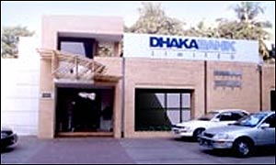
The Dhaka Bank Limited (DBL) is the first private sector bank in Bangladesh. The bank has been operating since 1995 with an authorized capital of Tk.1.75 billon. The noble intention behind starting this bank was to bring about qualitative changes in the sphere of Banking and Financial Management. Today the Dhaka Bank serves its customers at home and abroad with 41 branches spread over the country and about three hundred oversea correspondences covering the entire major cities and business center of the world. The services encompass wide diversified areas of trade, commerce and industry which tailored to the specific need of customers and are distinguished by an exceptional level of prompt and personal attention. Over the years the bank has expanded the spectrums of its services. The extensive and ever growing domestic network provides and carries various products and services to the doorsteps of millions.
The DBL was incorporated as a public limited company with limited liability on the 5th July, 1995 and its formal inauguration was on July 27, 1995 under company act, 1994 in Bangladesh with the primary objective to carry on all kinds of banking business. Functioning as a conventional Bank in the country since 1995, it has been able to consolidate its position in the banking sector. The bank has been able to establish a solid presence with the customers and general public through its improved Services, value addition in the economy and increasing shareholders value. The bank is listed with Dhaka Stock Exchange and Chittagong Stock Exchange.
Company Information:
- Company name : Dhaka Bank Ltd.
- Country/Territory : Bangladesh
- Products or Services : Deposit & Loan Scheme
- Business Type : Banking
- Business Form : Public Limited Co.
- Banking license received : 06/10/1999
- First Branch license received : 31/10/1999
- Inauguration of Bank : 27/11/1999
- Date of Publication of Prospectus : 29/06/2003
- Number of promoter : 22
- Number of Directors : 13
- Number of branch : 32
MISSION, VISSION AND OBJECTIVE OF DBL
3.2Mission of DBL

- To contribute to the socioeconomic development of the country.
- To attain highest level of customer satisfaction through extension of services by dedicated and motivated team of professionals.
- To maintain continuous growth of market share ensuring Quality.
- To maximize bank's profits by ensuring its steady growth.
- To maintain the high moral and ethical standards.
- To nurture an enabling environment where innovativeness and performance is rewarded.
3.3 Vision of DBL
"To be the leading bank in the country with best practices and highest social commitment"

3.4 Objective

Despite extreme competition among banks operating in Bangladesh, both local and international the Dhaka Bank Limited has made a remarkable progress practically in every sphere of its functions. The activities of the DBL are very implicit and vast comparing to that of other banks in the country today. The theme of the bank is “For Relationship Banking". The prime objectives of the DBL are to create a strong capital base, to earn good profit and pay satisfactory dividend to honorable shareholders with proper social commitments. To achieve the objectives the management is continuously working for the improvement of bank's assets quality by identifying potential depositors and good borrowers. Because it believes “The line of excellence never ends". The strategic plans and business will be its strength in this very competitive environment.


3.5 ORGANOGRAM OF DBL
DBL has moved from current geography to Business Matrix in the coming month. With this end in view the Board of Directors in it's meeting held on 29th July 2007 has approved an interim restructured organ gram and reporting lines for introduction in the bank. The restructured organ gram and the reporting lines are shown in the next page the management of the bank strongly believes to achieve desired goals through these changes. The changes would also result in much more value addition to the employees of the bank.
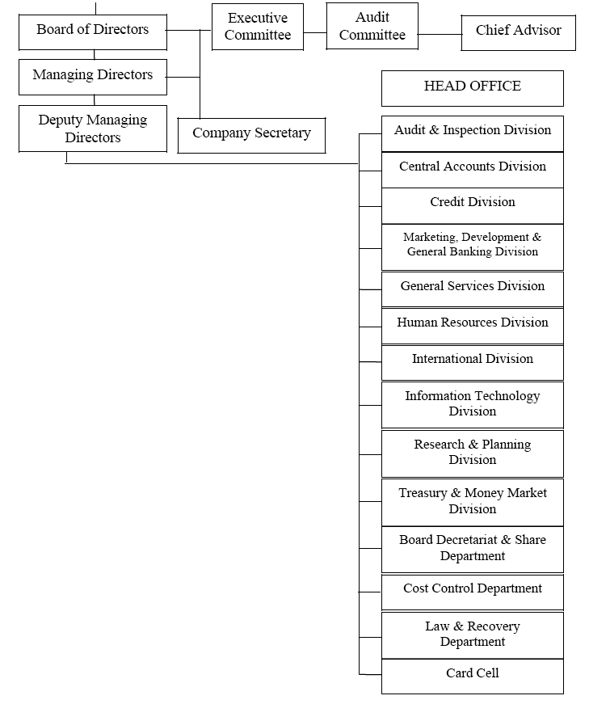

3.6 DESCRIPTION OF PRODUCT AND SERVICES OFFERED BY DBL

The services offered by DBL are discussed below

3.6.1 Services of DBL

The DBL concentrates the following categories of banking services-

• General banking,
• Retail banking
• Loans and Advances,
-SME (Small & Medium Enterprises)
-Corporate
• International Trade and Foreign Exchange,
-Export
-Import
-Remittance
• Online Banking Services,
• Debit Card and Duel Currency Credit Card Facilities.

3.6.2 Retail Banking

One of the most remarkable success stories of last 50 years' Banking Industry globally has been the conceptualization and innovative execution of banking with individual customers, their friends and families. The industry has termed it as Retail Banking or Personal Banking or Consumer Banking. The Dhaka Bank Ltd. recently has started its journey in Retail Banking. More than 800 staffs have been trained so far on the vital concepts of service excellence and sales. In the product side ATM fleet has been launched, Debit card has been issued, SMS Banking has been offered, 3 new deposit products have come, workers' foreign remittance business has been launched, new many billboards have come up and our communications in media has increased, manifold in the endeavor to build a Retail Banking brand namely "City Retail Happiness Counts".

3.6.3 SME Banking
Considering the potential growth and demand situation the Dhaka Bank Limited has extended credit facilities to small and medium enterprises through SME Banking in the year 2006 and 2007.A separate division has established in the Head Office with collaboration of all branches to process and handle loans under SME for attaining a organized several training program for development of adequate human resources.
3.6.4 Corporate and investment Banking
As part of its commitment to provide global quality service, the Dhaka Bank Ltd, one of the largest local Banks, has launched its Corporate & Investment Banking Division recently. This shift, from branch banking model to business driven matrix, is the first step of the bank's plan to revitalize its way of doing business in 2009. The C&I Division will comprise of a number of relationship teams centered in Dhaka and Chittagong to provide who will act as one stop contact point for the customers of the bank. This model has been successfully globally to provide better service and create increased customer satisfaction. The relationship teams have been staffed mainly through internal quality resources. The C&I relationship teams have already taken over the existing large accounts and servicing the customers to their satisfaction. The C&I have also booked blue-chip customers like Grameen Phone, Epylion group, Banglalink, Ericsson, Meghna Group, Esquire Group, Nandan etc. Recently Total new booking in last few months is more than BDT 3,000 million. The C&I Division will also have product team’s i.e. structured finance, Islamic finance, leasing, cash management who will meet the specialized product needs of the corporate customers. The time ahead is going to be very challenging for C&I. The major challenges shall be to increase the quality of the portfolio keeping in mind the business targets with timely formation and support from other departments i.e. centralized credit administration, operations.
3.6.5 Duel Currency Credit Card
Today's customer wants services and information to be provided at all times and places. This has become possible by ATMs and POS terminals and helped banks in achieving "Anytime, Anywhere Banking". Therefore there is a need for an automated system that will connect the branches through online to provide better services to the customers. The most modern technology based bank product for making hassle free financial transactions and drawing of cash money all over the world is given by Credit Card. The Dhaka Bank Ltd is the first among domestic banks to introduce a unique dual currency CITYCARD under the logo of VISA International in Bangladesh. After obtaining principal membership of VISA on 19 the February, 2003 the bank is pleasing its commitment to be a leader as card issuer in the arena. Tremendous responses are there from the market for this plastic money. Up to March, 2010 the number of CITYCARD is 20,215.
3.6.6 Computerization and Online Service

With computerization the bank had gone another step ahead towards providing pragmatic, safe and prompt banking services. All 83 branches including Islamic Banking Branch are brought under computerization net. Bank has implemented online real time banking through an agreement with Info sys Technologies Limited for supply of world reputed banking software "FINACLE". Within March, 2010 real time banking facilities have been introduced in 37 branches of the DBL. Under this system, Client will be able to do the following type of transactions:
- Easy to withdraw or deposit from any online branch
- Fund transfer with one click, no need TT/DD.
- Customer can easily tell which payments have cleared

3.6.7 Islamic Banking
The Dhaka Bank Limited started its Islamic Banking operation by opening its first Islamic Banking Branch at 9/H, Motijheel, Dhaka. The salient features of Islamic Banking are as follows:

- To conduct all its activities as per Islamic Shariah.

- To conduct its monetary matters free of interest.

- To establish banker-customer relationship on the basis of partnership.

- To follow Islamic principle in all its investment port-folio.

- To develop living standard of the poor incoming group.

- To render excellent services to the clients cordially.

- To conduct welfare related activities to the people.

3.6.8 SWIFT Banking (SINCE 2000)
The Dhaka Bank Limited is one of the first few Bangladeshi Banks who has become member of SWIFT (Society for Worldwide Inter-bank Financial Telecommunication) in 1983. SWIFT is members owned co-operative, which provides a fast and accurate communication network for financial transactions such as Letters of Credit, Fund transfer etc. By becoming a member of SWIFT, the bank has opened up possibilities for uninterrupted connectivity with over 5,700 user institutions in 150 countries around the world.
3.6.9 Corporate Governance
The bank recognizes the importance of Corporate Governance and is committed to maintain highest standard. A team of experienced professionals maintains the following committees to run the Bank efficiently:

- Management Committee

- Administrative and Disciplinary Action Committee

- Technical and Audit Committee

- Credit committee

- Procurement and purchase Committee

- Asset and liability Committee

3.6.10 FUNCTIONAL DIVISIONS OF DBL

The Bank accomplishes its functions through different functional divisions/ departments. The divisions/departments along with their major functions are listed below:
- Financial Division
Financial planning, budget preparation and monitoring
- Payment of salary

- Controlling inter-branch transaction

- Disbursement of bills

- Preparation of financial reports and annual reports

- Preparation/Review of returns and statements

- Maintenance of Provident Fund, Gratuity, Superannuation Fund

- Reconciliation

3.6.11 Credit and risk management
- Loan administration

- Loan disbursement

- Project evaluation

- Processing and approving credit proposals of the branches

- Documentation, CIB (Credit Information Bureau) report etc

- Arranging different credit facilities

- Providing related statements to the Bangladesh Bank and other departments

3.6.12 Branches Control & Inspection Division

- Controlling different functions of the branches and search for location for expansion

- Conducting internal audit and inspection both regularly and suddenly

- Ensuring compliance with Bangladesh Bank (BB), monitoring BB's inspection and
external audit reports

3.6.13 Retail Division
- ATM card, Credit and system operation and maintenance

- SWIFT operation

- Credit Card Operation (Proposed)

- Customer and vendor relationship

3.7 Deposit Products:
Dhaka bank has various types of Deposit & Advance Products.

Deposit Products are shown below:
- Savings Bank Account (Interest rate 7%)
- Current Account (Interest rate 0%)
- Short Term Deposit Account (Interest rate 6%)
- Fixed Deposit :

Tenor | Interest Rate
1 month | 10%
2 months | 11%
3 months | 13%
6 months | 13%
12 months | 13%
Above 12 month | 12.5%

- Sanchay Plus(SP):

Tenor | Interest Rate
6 month | 12%
12 months | 12.5%
18 months | 13%
24 months | 13.25%
30 months | 13.50%
36 months | 14%

- Monthly benefit Plus (MB+):

Deposit Amount in taka | Monthly Interest(for 5years) | Monthly Interest(for 3years)
1,00,000 | 1,000 | 975
2,00,000 | 2,000 | 1,950
3,00,000 | 3,000 | 2,925
4,00,000 & Onwards | 4,000 & Onwards | 3,900 & Onwards

- Double benefit Plus (DB+):

Tenure | Initial Deposit | Value at Maturity
6 year | TK.1,00,000/- | TK.2,00,000/-

- Triple benefit Plus (TB+):

Tenure | Initial Deposit | Value at Maturity
91/2 year | TK.1,00,000/- | TK.3,00,000/-

- Deposit Pension Scheme (DPS):

Deposit monthly installment ranging from Tk. 500/- to Tk.10, 000/- and on maturity the holder receives a handsome amount as per table below:
Amount Payable at Maturity:
Monthly Deposit |   Payment After 3 Years | Payment After 5 Years | Payment After 7 Years | Payment After10 Years | Payment After12 Years
500 | 21,500 | 41,000 | 65,500 | 115,000 | 160,000
1,000 | 43,000 | 82,000 | 131,000 | 230,000 | 320,000
2,000 | 86,000 | 164,000 | 262,000 | 460,000 | 640,000
3,000 | 129,000 | 246,000 | 393,000 | 690,000 | 960,000
4,000 | 172,000 | 328,000 | 524,000 | 920,000 | 1,280,000
5,000 | 215,000 | 410,000 | 655,000 | 1,150,000 | 1,600,000
8,000 | 344,000 | 656,000 | 1,048,000 | 1,840,000 | 2,560,000
10,000 | 430,000 | 820,000 | 1,310,000 | 2,300,000 | 3,200,000

3.8 Loan & Advances Products:
Corporate Loan (15.5%-17.5%)
- Loan on Trading (Import-Export based)
- Loan Against Trust Receipt (LTR)
- Loan Against Import Merchandize
- Loan Against Packing Credit
- Loan Against Cash Incentive
- Payment Against Document cash
- Payment Against Document Force
- Local Discounted Bill for Purchase(LDBP)
- Loan Against Foreign Bill (FDBP)

- Syndicate Loan (16%)
- Term Loan (16%)
- Secured Over Draft (SOD) (Spread 3%)
- Over Draft (OD) (15%-16%)
- Transport Loan (15%)


- Coverage (16%)
- Auto Loan
- House Finance
- Senior Citizen Support
- Marriage Loan
- Consumer Durable Loan
- Education Support
- Medical Support

- Personal Credit Scheme (17%)
- Purchase of miscellaneous household appliances.
- Purchase of Personal Computers.
- Purchase of refrigerators.
- Purchase of audio-video equipment.
- Purchase of Furniture.
- House renovation.
- Office renovation.
- Purchase of Office equipment/accessories.
- Marriages in the family.
- Advance rent payment.


- Staff Loan

- Staff House Building Loan (7%)
- Staff Car Loan (8%)
- Staff Loan against Provident Fund (7%)

Interest Rate on Lending
Type | Mid Rate | Maximum Rate
Agriculture (including Jute) | 9.00% | 9.00%
Term Loan (Large & Medium Scale Industries) | 15.50% | 17.00%
Working Capital | 15.50% | 17.00%
Export | 7.00% | 7.00%
Other Commercial Lending | 16.00% | 17.50%
SMALL & COTTAGE INDUSTRIES a) With Govt. Refinance | 12.00% | 12.00%
SMALL & COTTAGE INDUSTRIES b) Without Govt. Refinance | 13.00% | 13.00%
Urban Housing | 16.00% | 17.50%
Overdraft (OD) against FDR i) Issued by Bank Asia Ltd | 15.00% | 16.00%
Overdraft (OD) against FDR ii) Issued by Other Bank | 16.00% | 17.00%
Overdraft (OD) against FDR iii) MB+, DB+ ,DG+ of Bank Asia Ltd. | 16.00% | 17.00%
Micro Credit a. Micro Credit Scheme | 12.00% | 12.50%
Micro Credit b. Personal Credit Scheme | 16.00% | 17.00%
Micro Credit c. Car Own Scheme | 16.00% | 17.00%
Micro Credit d. Consumer Credit Schemes | 16.00% | 17.00%
Others | 16.00% | 17.00%
Overdraft (OD) against FDR iv) Similar Instruments issued by other banks | 16.00% | 17.00%


- Another Product:
- Debit/ ATM Card
- Credit Card (VISA & Master Card)


- Up Coming Products:
- Tele Banking
- Priority Banking


3.9 SWOT Analysis of The Dhaka Bank Limited
Every organization is composed of some internal strengths and weaknesses and also has some external opportunities and threats in its whole life cycle. This following will briefly introduce the customer to The Dhaka Bank Limited's internal strengths and weaknesses, and external opportunities and threats.

3.9 .1 Strengths

- Stable source of fund

- Strong Liquidity position

- Concentrated market

- Wide network of branches

- Experienced top management

- Diversified product line

3.9 .2 Weaknesses

- Deposit is lower than advance.

- Officer has limited experience and training

- Small market share in Banking-business

- Long-term credit is not sufficient

- Relatively high overhead expanse
- Problem in Delivery.

3.9.3 Opportunities
- Favorable regularity environment
- Private sector development
- Credit card business
- SME and Agro based industry loan
- Can increase the advertising of the Bank
3.9.4 Threats
- Deposit as well as quality assets
- Market pressure for lowering the interest rate
- Shrinkage in export, import and guarantee
- Poor business due to economic slump and war
- Frequency in Currency Devaluation
- Emergence of Competitors
- Govt. pressures to reduce interest rate

3.10 PERFORMANCE OF DBL FOR LAST TWO YEARS
The Dhaka Bank Ltd., since its incorporation, continued to maintain its stable position in the industry. The bank has been able to show a strong performance in business and financial accounts. With better customer service, fulfillment of commitments to corporate social responsibilities, ensuring sound corporate governance Bank consolidated a solid presence with the customers and general public and in the industry. During the last few years, significant improvement was evident in deposit mobilization, advance portfolio augmentation and recovery of non-performing loan. Foreign trade, in terms of import, export and inward foreign remittance have also shown noteworthy growth in the year 2008. Last few years performances are described below-
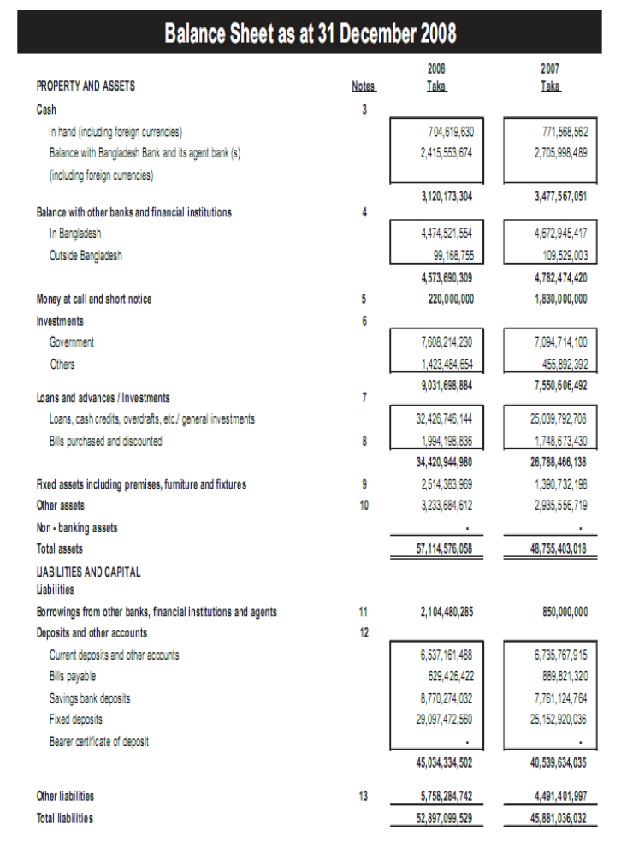

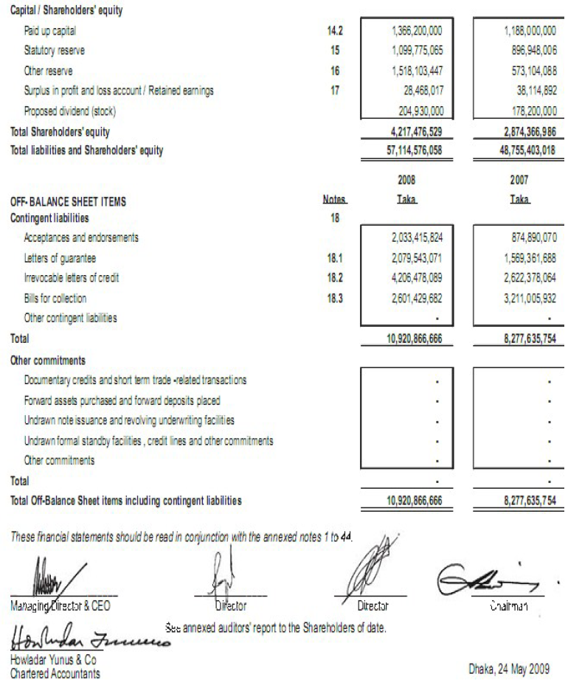

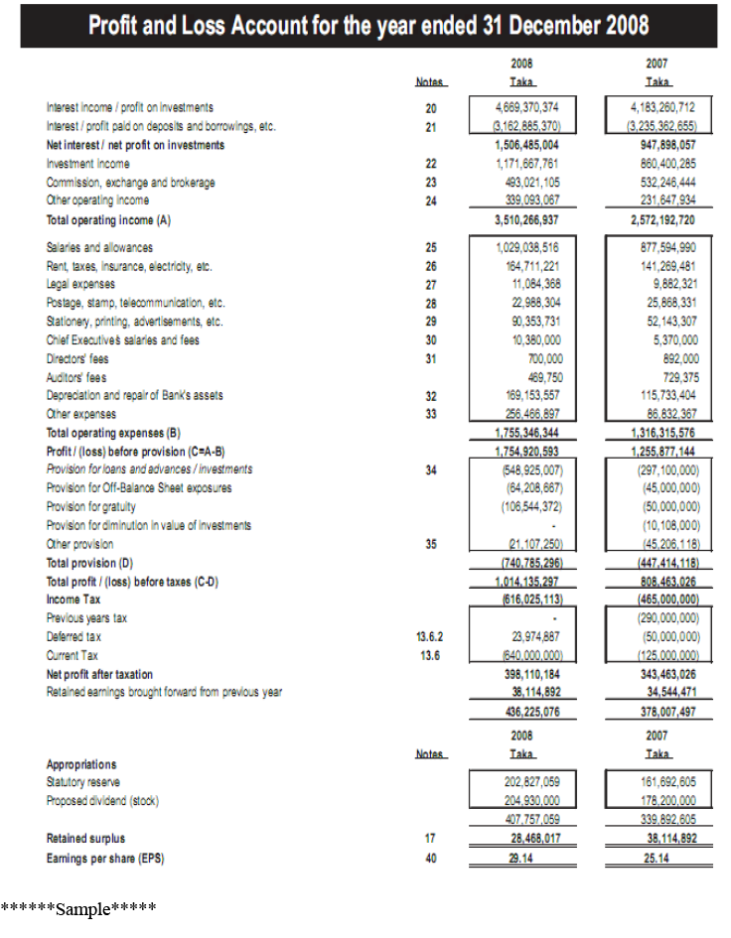

Chapter: four
4.0. Online banking system of Dhaka bank LIMITED

Online Banking System of DBL


4.1 Definition
Online banking (or Internet banking) allows customers to conduct financial transactions on a secure website operated their retail or virtual bank, credit union or building society.
Online banking is the practice of making bank transactions or paying bills via the Internet. Thanks to technology, and the Internet in particular, we no longer have to leave the house. We can shop online, communicate online, and now, we can even do our banking online. Online banking allows us to make deposits, withdrawals and pay bills all with the click of a mouse. It doesn't get much more convenient than that.
From the perspective of banking products and services being offered through Internet, Internet banking is nothing more than traditional banking services delivered through an electronic communication backbone, viz, Internet. But, in the process it has thrown open issues which have ramifications beyond what a new delivery channel would normally envisage and, hence, has compelled regulators world over to take note of this emerging channel. Some of the distinctive features of I-banking are:

1. It removes the traditional geographical barriers as it could reach out to customers of different countries / legal jurisdiction. This has raised the question of jurisdiction of law / supervisory system, to which such transactions should be subjected,
2. It has added a new dimension to different kinds of risks traditionally associated with banking, heightening some of them and throwing new risk control challenges,
3. Security of banking transactions, validity of electronic contract, customers’ privacy, etc., which have all along been concerns of both bankers and supervisors have assumed different dimensions given that Internet is a public domain, not subject to control by any single authority or group of users,
4. It poses a strategic risk of loss of business to those banks who do not respond in time, to this new technology, being the efficient and cost effective delivery
5. A new form of competition has emerged both from the existing players and new players of the market who are not strictly banks.
4.2 History 
The precursor for the modern home online banking services were the distance banking services over electronic media from the early '80s. The term online became popular in the late '80s and referred to the use of a terminal, keyboard and TV (or monitor) to access the banking system using a phone line. ‘Home banking’ can also refer to the use of a numeric keypad to send tones down a phone line with instructions to the bank. Online services started in New York in 1981 when four of the city’s major banks (Citibank, Chase Manhattan, Chemical and Manufacturers Hanover) offered home banking services using the videotex system. Because of the commercial failure of videotex these banking services never became popular except in France where the use of videotex (Minitel) was subsidized by the telecom provider and the UK, where the Prestel system was used. The UK’s first home online banking services was set up by the Nottingham Building Society (NBS) in 1983 ("History of the Nottingham". http://www.thenottingham.com/main.asp?p=1710 (Retrieved 2007-12-14). The system used was based on the UK's Prestel system and used a computer, such as the BBC Micro, or keyboard (Tandata Td1400) connected to the telephone system and television set. The system (known as 'Homelink') allowed on-line viewing of statements, bank transfers and bill payments. In order to make bank transfers and bill payments, a written instruction giving details of the intended recipient had to be sent to the NBS who set the details up on the Home link system. Typical recipients were gas, electricity and telephone companies and accounts with other banks. Details of payments to be made were input into the NBS system by the account holder via Prestel. A cheque was then sent by NBS to the payee and an advice giving details of the payment was sent to the account holder. BACS was later used to transfer the payment directly. Stanford Federal Credit Union was the first financial institution to offer online internet banking services to all of its members in Oct, 1994. Today, many banks are internet only banks. Unlike their predecessors, these internet only banks do not maintain brick and mortar bank branches. Instead, they typically differentiate themselves by offering better interest rates and online banking features.
4.3Advantages of online banking
- Convenience: Unlike your corner bank, online banking sites never close; they’re available 24 hours a day, seven days a week and they're only a mouse click away.
- Ubiquity: If you're out of state or even out of the country when a money problem arises, you can log on instantly to your online bank and take care of business, 24/7.
- Transaction speed: Online bank sites generally execute and confirm transactions at or quicker than ATM processing speeds.
- Efficiency: You can access and manage all of your bank accounts, including IRAs, CDs, even securities, from one secure site.
- Effectiveness: Many online banking sites now offer sophisticated tools, including account aggregation, stock quotes, rate alerts and portfolio managing programs to help you manage all of your assets more effectively. Most are also compatible with money managing programs such as Quicken and Microsoft Money.
4.4 Disadvantages of online banking
- Start-up may take time: In order to register for your bank's online program, you will probably have to provide ID and sign a form at a bank branch. If you and your spouse wish to view and manage your assets together online, one of you may have to sign adorable power of attorney before the bank will display all of your holdings together.
- Learning curve: Banking sites can be difficult to navigate at first. Plan to invest sometime and/or read the tutorials in order to become comfortable in your virtual lobby.
- Bank site changes: Even the largest banks periodically upgrade their online programs, adding new features in unfamiliar places. In some cases, you may have to re-enter account information.
4.5 Require equipment for Online Banking
In order to use online banking, you need a computer (in this Agreement, your computer and the related equipment are referred to together as your "Computer") with a web browser (either Netscape Navigator 4.0 or higher, Microsoft Internet Explorer 4.0 or higher), a member number, and an online banking PIN. The PIN is the confidential personal identification number you use to access your account(s) through online banking. You are responsible for the installation, maintenance, and operation of your Computer, browser and the software. Solidarity Community Federal Credit Union is not responsible for any errors or failures from any malfunction of your Computer, the browser or the software. Solidarity Community Federal Credit Union is also not responsible for any Computer virus or related problems that may be associated with the use of an online system.
4.6 Features of Online Banking
Online banking solutions have many features and capabilities in common, but traditionally also have some that are application specific. The common features fall broadly into several categories
- Transactional (e.g., performing a financial transaction such as an account to account transfer, paying a bill, wire transfer... and applications... apply for a loan, new account, etc.)
- Electronic bill presentment and payment - EBPP
- Funds transfer between a customer's own checking and savings accounts, or to another customer's account
- Investment purchase or sale
- Loan applications and transactions, such as repayments
- Non-transactional (e.g., online statements, check links, co browsing, chat)
- Bank statements
- Financial Institution Administration
- Support of multiple users having varying levels of authority
- Transaction approval process
- Wire transfer
Financial Institution Administration - features allowing the financial institution to manage the online experience of their end users ASP/Hosting Administration - features allowing the hosting company to administer the solution across financial institutions.
4.7 Different Types of Online Banking Services of Dhaka Bank Limited
- 4.7.1Phone Banking
Dhaka Bank is focused on delivering exceptional services to its customers that would strengthen the relationship and build Loyalty. To make banking experience quick, efficient, secure and easy, Dhaka Bank of Bangladesh now offer its customers 24/7 Phone Banking Services.
Dhaka phone banking provides its customer immense comport.
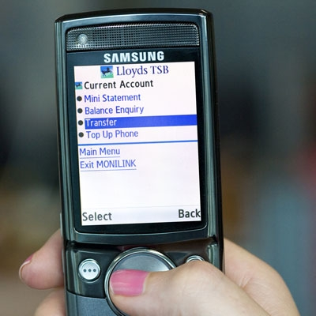
In addition, Dhaka Bank customers can also avail a host of services through automated Dhaka Phone Banking (IVR/Self Service Banking) that lets them use their telephone keypad to inquire about their financial balance/transactions.
- Dhaka Phone Banking Services
Dial - 0800-22522 to get absolute Banking freedom
- Branch Banking
- Inquiry
  - A/C balance
  - Statement details
  - Product information
- Transactions
  - Cheque book request
  - TPIN issuance & re-issuance
  - ATM PIN issuance & re-issuance
  - PO/DD & Bank certificate
  - Funds transfer
- 4.7.2Mobile Banking
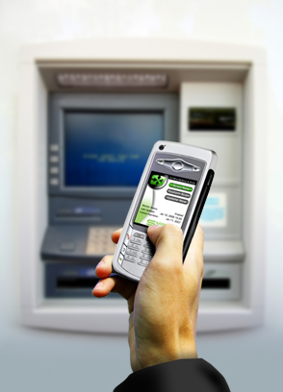
Mobile banking (also known as M-Banking, E-banking, SMS Banking etc.) is a term used for performing balance checks, account transactions, payments etc. via a mobile device such as a mobile phone. Mobile banking today (2007) is most often performed via SMS or the Mobile Internet but can also use special programs called clients downloaded to the mobile device.
- 4.7.3 SMS Banking

SMS banking is a technology-enabled service offering from Dhaka banks to its customers, permitting them to operate selected banking services over their mobile phones using SMS messaging.
- 4.7.4 Internet Banking
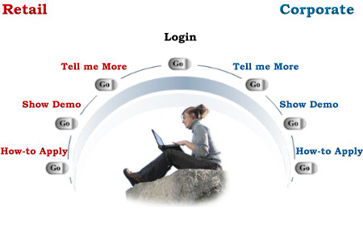
Dhaka bank financial services accessed via the Internet's World Wide Web. An Internet bank exists only on the Internet, the global network of computer networks without any "brick and mortar" branch offices. By eliminating the overhead expenses of conventional banks, Internet banks theoretically can pay consumers higher interest rates on savings than the national average. Banks use the Internet to deliver information about financial services, replace transactions done in branch offices, which eliminates the need to build new branches, and to service customers more efficiently. Internet banking sites offer the prospect of more convenient ways to manage personal finances, and such services as paying bills on-line, finding mortgage or auto loans, applying for credit cards, and locating the nearest ATM or branch office. Some Internet banks also offer 24-hour telephone support, so customers can discuss their needs with bank service representatives directly.

- 4.7.5Telephone Banking:
Telephone banking was a service provided by a financial institution which allows its customers to perform transactions over the telephone. Most telephone banking uses an automated phone answering system with phone keypad response or voice recognition capability. To guarantee security, the customer must first authenticate through a numeric or verbal password or through security questions asked by a live representative. With the obvious exception of cash withdrawals and deposits, it offers virtually all the features of an automated teller machine: account balance information and list of latest transactions, electronic bill payments, funds transfers between a customer's accounts, etc. Usually, customers can also speak to a live representative located in a call centre or a branch, although this feature is not guaranteed to be offered 24/7. In addition to the self- service transactions listed earlier, telephone banking representatives are usually trained to do what was traditionally available only at the branch: loan applications, investment purchases and redemptions, check book orders, debit card replacements, change of address, etc. Dhaka Banks which operate mostly or exclusively by telephone are known as phone banks.
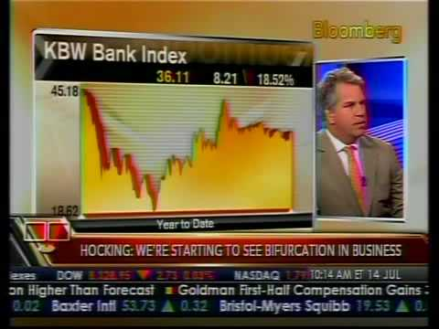
- 4.7.6 TV Banking
Dhaka Bank, they've introduced world to an all new way of banking. TV Banking. This pioneering initiative now enables you to get information regarding loans, accounts, deposits and a lot more while you're watching that exciting cricket match or your favorite sitcom. Quite certainly, TV Banking has revolutionized banking by bringing it right into your living room.

- 4.7.7 Retail Banking
The Retail banking application is an integration of several functional areas, and enables customers to:
- Issue Demand Drafts online
- Transfer funds to own and third party accounts
- Credit beneficiary accounts using the VISA Money Transfer, RTGS/NEFT feature
- Generate account statements
- Setup Standing Instructions
- Configure profile settings
- Use E-Tax for online tax payment
- Use E-Pay for automatic bill payments
- Interface with merchants for railway and airline reservations
- Avail DEMAT and IPO services
- 4.7.8 Corporate Banking

The Online DBI corporate banking application provides features to administer and manage corporate accounts online. The corporate module provides roles such as Regulator, Admin, Uploaded, Transaction Maker, Authorizer, and Auditor. These roles have access to the following functions:
- Manage users; define rights and transaction rules on corporate accounts.
- Access accounts in several branches with a single sign-on mechanism.
- Upload files to make bulk transactions to third parties, supplier, vendor and tax collection authorities.
- Use online transactional features such as fund transfer to own accounts, third party payments, and draft issues.
- Make bill payments over the Internet.
- Authorize, modify, reschedule and cancel transactions, based on rights assigned to the user.
- Generate account statement.

- Enquire on transaction details or current balance.
- 4.7.9 E-Ticking
You can book your railway, air and bus tickets online through Online DBI.
To book your train ticket, just log on to irctc.co.in and create an ID there at if you do not have one. Submit your travel plan and book the ticket(s)-either
- I-ticket (where the delivery of tickets will be made at your address) or
- E-tickets (wherein after successful payment transactions, an e-ticket is generated which can be printed any time. For an e-ticket, the details of photo identity card will required to be filled in)
And select Dhaka Bank of Bangladesh in the payment options. You will be redirected to Internet Banking site of DBI (www.onlinesbi.com). After submitting the respective ID and password, you can select your account. After a successful debit, Railways will generate the ticket. E-ticket can be printed by you whereas I-ticket will be dispatched by IRCTC at the given address. Service charges @ Rs.10/- per transaction shall be levied in addition to the cost of the ticket. Cancellation of E-ticket can be done by logging on to IRCTC's site; refund amount will be credited to your account directly within 2-3 days. You can also book your Air ticket through the e-ticketing feature. Logon to Indian Airlines website to make a payment for an e-ticket through Dhaka Bank of Bangladesh, you need to select DBI as the payment option. The payment request will be redirected to Internet Banking site. The request may be processed based on values sent from the airlines website. Once a transaction is processed, an appropriate response will be sent to airlines site to update the status of the transaction. You can print the E-ticket immediately.
To book bus tickets to destinations in Karnataka, log on to the KSRTC website. Provide details about the start and end points of your journey, date of journey and number of tickets. Verify availability of seats on the selected date and confirm the transaction. Select Online DBI to make the payment. Provide your credentials and select the SBI account that will be debited for the payment. You are provided a KSRTC reference number for your e-Ticket.

- 4.7.10 Bill Payment
A simple and convenient service for viewing and paying your bills online.
- No more late payments
- No more queues
- No more hassles of depositing cheques
Using the bill payment you can 'view and Pay various bills online, directly from your DBI account. You can pay telephone, electricity, insurance, credit cards and other bills from the comfort of your house or office, 24 hours a day, 365 days a year. Simply logon to http://www.onlinesbi.com/ with your credentials and register the biller to which you want to pay, with all the bill details. Once the bill is uploaded by the biller, you can make payment online.
You can also set up Auto Pay instructions with an upper limit to ensure that your bills are paid automatically whenever they are due. The upper limit ensures that only bills within the specified limit are paid automatically, thereby providing you complete control over these payments.
The e-PAY service is available in various cities across the country and you can now make payments to several billers in your region.

- 4.7.11 Fund Transfer
The Funds Transfer facility enables you to transfer funds within your accounts in the same branch or other branches. You can transfer aggregating Rs.1 lakh per day to own accounts in the same branch and other branches. To make a funds transfer, you should be an active Internet Banking user with transaction rights. Funds transfer to PPF account is restricted to the same branch.
Just log on to retail section of the Internet Banking site with your credentials and select the Funds Transfer link under Payments/Transfers tab. You can see all your online debit and credit accounts. Select the debit account from which you wish to transfer funds and the credit account into which the amount is to be credited. Enter the amount and remarks. The remarks will be displayed in your accounts statement for this transaction. You will be displayed the last five funds transfer operations on your accounts. On confirming the transaction, you will be displayed a confirmation page with the details of the transaction and the option to submit or cancel the funds transfer request. A reference number will be generated for your record.
- 4.7.12 Online Clearing
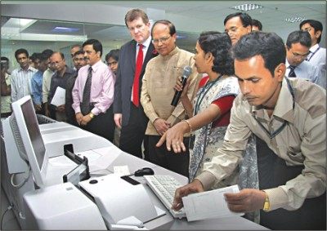
Online clearing takes place when a cheque is drawn by a Non-Dhaka Bank customer in favor of a Dhaka Bank customer but is deposited at Dhaka Bank. The person, who had drawn this cheque, however should have an account in the Islamabad/Rawalpindi area. The process for online clearing is as follows:
- The cheque is sent as an outward clearing via NIFT
- When the cheque is cleared, it is credited to the Dhaka Bank account via the online transfer software.
- 4.7.13 Demand Draft
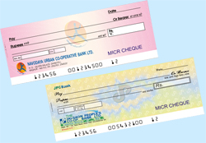
The Internet Banking application enables you to register demand drafts requests online. You can get a demand draft from any of your Accounts (Savings Bank, Current Account, Cash Credit or Overdraft). You can set limits for demand drafts issued from your accounts or use the bank specified limit for demand drafts.
You can opt to collect the draft in person at your branch, quoting a reference to the transaction. A printed advice can also be obtained from the site for your record.
Alternatively, you may request the branch to courier it to your registered address, and the courier charges will be recovered from you. If you have any queries, kindly approach your branch, quoting the reference number generated for the request.

4.8 Others Services provided by Online Banking (Dhaka Bank)
No need of walking up to the Dhaka bank branch, every time you need to do your banking. As you can do a lot of it online. From paying your bills to transferring funds, booking your rail/air tickets, shopping, sending a money order and doing lots more.
- Bill Payment: Skip the long queues; pay your utility bills anytime, anywhere.
- Ticket Booking: Book your rail tickets online or by SMS: in a quick and hassle-free way.
- Funds Transfer: Transfer funds instantly between your ICICI Bank accounts and non-ICICI Bank accounts.
- Special Promotions & Offers: Make most of the online offers created exclusively for ICICI Bank customers.
Most of the online banks have the equivalence in the services. Considering the services of banks given, we can show the view of services offered based on the following forms given below
4.8.1Security
- Providers of on-line financial services should provide sites that are secure.
Secure sites should include the most effective existing protections such as passwords and encryption, and should be routinely reviewed and updated to ensure that new security features are added as they are developed.

- Financial services providers should be vigilant to expose imposters using their names or similar names to induce consumers to reveal personal financial information.
- Federal and state regulators should carefully scrutinize the operating practices, security and solvency standards, and privacy policies of both on-line providers of financial services and of third-party providers, contractors and subcontractors.
- Financial services entities should take responsibility to make the consumer whole for losses from computer crime not caused by the consumer; for security breaches; for failures and losses caused by third parties selected by the financial services entity or by its subcontractors; and for losses contributed to by the financial institution's sharing of customer data internally, with an affiliate, or with a third party.
- Providers of on-line financial services should accept the responsibility to try to prevent, detect, and eradicate viruses and other security breaches. Viruses sometimes cannot be prevented, but some on-line banking contracts offered today attempt to eliminate all responsibility on the provider even to try to do so. Because a consumer's ability to access funds needed for daily living can be affected by viruses and other security breaches, on-line financial services providers should accept more responsibility than is commonly accepted by web site providers of lower- cost, less financially sensitive products.
4.8.2 Access
- Dhaka Bank should take affirmative steps to make on-line banking services available in
neighborhoods where access to on-line services is low. This may include providing access and training in community centers, housing projects, and urban high schools, as well as other creative approaches.
- On-line banking channels should not replace other channels that permit in-person activity unless and until there is clear evidence that all demographic groups (including age and income groups) are in fact being equally well served by on-line banking as by other bank channels, including brick and mortar branches.
- Dhaka Bank who provides special offers to Internet customers must also have an effective method to make those offers available to customers without access to the Internet.
- Dhaka Bank and insured financial services providers who accept deposits nationally should not restrict their Community Reinvestment Act areas to the physical location of their home offices.
4.8.3 Information and Disclosure
- Increases in fees and changes in material terms should be accompanied by at least 30 days advance notices. The notice should be sent by a means calculated to actually communicate the information to the customer. Posting information on the bank's web site about new fees or changes in material terms is not sufficient.
- Providers of on-line financial services should make their contracts available before the customer must give personal financial information and should make those agreements available in a form which the customer can download, print, and retain in a manner that shows what the agreement was when the consumer entered into it.
- On-line bill payment services, whether or not associated with on-line banking, should clearly disclose on the screen which is used to schedule the payment the date and time that the payment will be sent and whether the payment will be sent electronically or by ordinary mail.
- On-line financial services providers should use the power of the electronic environment to facilitate more effective consumer disclosure and education.
4.8.4 Consumer Rights
- On-line banking services should meet the consumer protection and other statutory requirements and restrictions of the consumer's home state.
- Disputes arising from on-line banking and bill payment should be resolved promptly, and should be at least as prompt as the voluntary timeframe of not more than five business days tore credit disputed funds which has been developed for debit cards.
- If an arbitration clause is used, it should permit the consumer to choose whether to agree to arbitration after the dispute arises, and should provide fair, cost-effective procedures for the consumer
- On-line bill payment services should not impose an earlier time for stop payments than the time the payment could be stopped if it were made by check.
- Financial services providers who use electronic mail to communicate with their customers should provide two-way convenience to the customer by treating emailed notices of disputes, stop notices, and similar documents required by law to be sent in writing in the same way as if those documents had been mailed.
- Customers wishing to close their accounts should be able to do so with an instantaneous electronic transfer of funds to another designated account.
- On-line banking contracts contain no provision presuming that a consumer is in receipt of information simply because the bank has sent or posted that information.
4.9 Changes brought in Information Technology by DBI
- In the next decade internet facility was provided for individuals.
- All DBI branches were connected and ATM’S were launched.
- 2001 - KMPG appointed consultant for preparing IT Plan for the Bank.
- Later on Core banking proposed by the IT consultancy company.
- 2002 – All branches computerized but on decentralized systems, there the initiative of core banking took place.
- 2008- more than 6500 branches (95% of business) on Core Banking Solution (CBS).
- Internet Banking facility for Corporate customers were also launched in early 2008.
- More Interfaces developed with e-Commerce & other sites through alternate channels like ATM & Online Banking.
- All Foreign Offices were brought on Centralized Solution.
- Large network is playing the role of backbone for connectivity across the country.
- Multiple Service Providers are providing the links – BSNL, MTNL, Reliance, Tata & reliance which are making the system errorless and provide high speed.
- Multiple Technologies to support the networking infrastructure – Leased lines, Dial-up, CDMA & VSAT.

CBS - Core Banking System Components

4.10 Dhaka Bank Limited Network Design (LAN & WAN)
The Dhaka Bank network is maintained and operated from the Network Operations Center (NOC) of the IT division as a Hub-Spoke network (Star network), where all traffic from spokes/nodes route through the central hub which is the core router Cisco 3845. For secured connectivity within the network, Dhaka Bank uses the Cisco 4507R as the core switch. Dhaka Bank uses the Cisco ASA 5520 firewall along with the implementation of an IP Access List, for better traffic security management. For monitoring and blocking of unexpected and harmful traffic flow, Cisco Security MARS is put in operation. As for
Web request monitoring, McAfee Web Gateway comes in action. To ensure efficient and smooth branch connectivity, the bank has obtained support from five connectivity vendors who provide links to all branches of the bank from the head office Data Centre through optical fiber, radio link and VSAT. In this way, Dhaka Bank Limited is successful in providing a high-level of security for better online operations using reliable Cisco devices. An illustrated form of this Dhaka Bank network system is as follows—
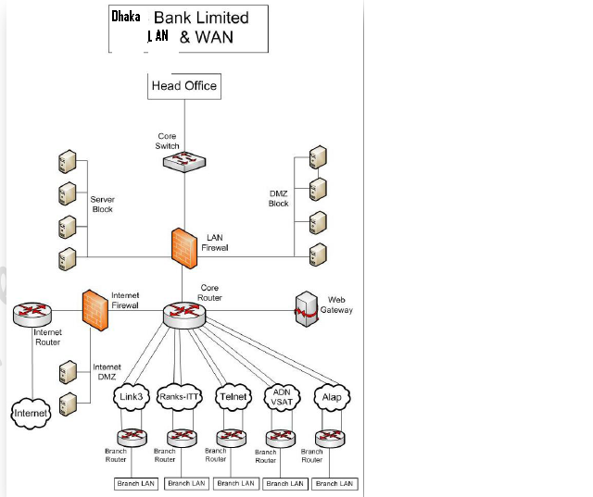
4.10.1Network implementation and configuration
Network implementation is the process of deploying a network by connecting necessary equipments following methodical processes like—
- Physical network design
This is the process of physically arranging the network in an organized manner to allow efficient performance. It is of two types— Local Area Network (LAN) and Wide Area Network (WAN) design

- Remote access provisions
Remote access refers to the method of providing services to a computer from a remote location. These services include—
- Remote administration
- Remote Boot/Shutdown
- Device access
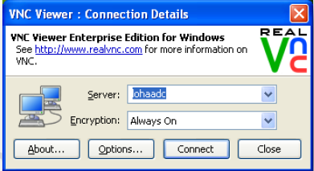
- System modification
- Remote viewing

- Configuration of network elements
Network configuration is the process of organizing and maintaining information about all the components of a computer network. When a network needs repair, modification, expansion or upgrading, the administrator performs necessary network configuration activities as a solution. Advantages of network configuration management include—

- Ensuring efficiency in maintenance, repair, expansion and up gradation of network
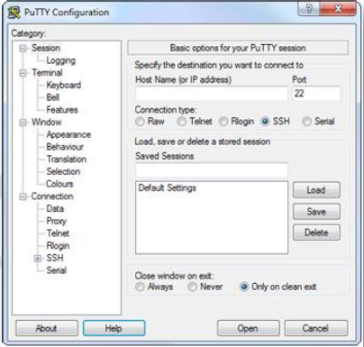
- Minimizing configuration errors.
- Minimizing downtime.
- Optimizing network security.
- Minimizing effects of configuration changes
- Restore previous configuration states in case of emergency
- Archiving the details of all network configuration changes

Chapter: five
5.0. FINDINGS

5.0Findings
The main vision of Dhaka Bank is to become a premier banking institution in Bangladesh. In achieving this mission, Dhaka Bank has been successful by increasing online banking service and its revenues, deposit facilities through online base and online branches connection in Bangladesh. Although there are no major problems on online banking at Dhaka Bank, some of the problems observed are as follows:
- Unavailability of ATM Booth: Our study recover that there is scarcity of ATM booth in all places. It creates high dissatisfaction in customer mind.
- Shortage of fund in ATM Booth: Most people complain that there is low money reserve in ATM Booth sometimes they find empty.
- High service charge: Online Banking charge is too high and it is still out of reach among the middle class and lower class family.
- Technological problem: There are some technological problem such as show empty of own account money, PIN code rejection, Database cannot be support in the system etc.
- Shortage of Branch: Branches are not available so especially business people face problems.
- Securities: Some people cannot rely on online banking. They feel less security on online Banking.
- User of online banking: User are low rather than other bank user on online banking
- Limited Areas: This bank provide online banking service in some specific areas.
- Training and Development: Employees are not well trained in online banking.

Chapter: six
6.0. Recommendation
6.1 Recommendation
We know that Dhaka Bank limited is one of the famous commercial bank in Bangladesh. We find out from our survey they have providing good online services which is give satisfaction and interest for its clients/customers. They gave their clients electronic fund transfer facilities, ATM, Debit card, credit card, pos, bill pay facilities in online etc. But they have also some lacking in online banking process. For removing lacking, they should take following steps in the online banking system-
- Increase ATM booth: Spread ATM booth all over the country in important place.
- Increase booth cash fund: All time update booth case fund.
- Rises Credit card acceptance in all places.
- Increase customer awareness about online banking of Dhaka bank.
- Resolve technological problem by using latest technology.
- Making online banking facilities more easy and suitable for all classes of people.
- Online banking area spread all over the Bangladesh.
- Making Service charge of online banking as low as possible.
- Provide proper training about online banking to the employees.
- Training and awareness among employees:-
It is recommended that Dhaka Bank of Bangladesh should conduct various training programmes for the employees, so that they will get aware with the terms of internet banking. After such programmes they can create awareness amongst the consumers.
- Exchange of information on threats and vulnerabilities at appropriate forums:-
There should be an open end discussion on the threats and vulnerabilities coming across the functioning of internet banking work by the employees in the various official forums and meets.
- Build an optimal operating model by understanding which activities to retain collaborate and outsource:-
There should be clear sight of operations which needs to outsource to other companies, this will lead to ease in work for employees. Outsourcing operations like, cyber security department, building IT structure on internet.
- Bank should Create and sustain customer, investor and regulator confidence by adopting international accounting standards :-
- Adopting international standards adds some more star to the glory of any company, DBL should impose such standards when it comes to internet banking or virtual banking, this will enhance the goodwill of DBL among regulator, customers and invertors.
- Bank should anticipate and get prepared for regulatory changes:-
Laws regarding IT or cyber laws get change as per the need. DBL should anticipate such kind of changes and get loaded with various plans and actions.

- Focus on identifying core competence:-
DBI possess some unique characteristics or positive points in it and with the help of them it can become a leader in market. Bank should identify such points and concentrate to flourish them more. This can be done with the help of internet banking, as internet banking of DBL is getting largely accepted by customers.
- Increasing usage of mobile phones is going to revolutionize the banking culture in near future:-

Mobile banking is also getting popular in the segment of internet banking thus this can add some more steps to progress for DBL. Bank is into the mobile banking but it is providing limited features.
- More stress should be given on security concern on internet:-
There are some people who are into unethical practices of hacking of accounts of customers. This is nothing but the breach in the security of the DBL on internet. There should be some measures in order to prevent such practices. IT structure should be unbreakable.

6.2 Conclusion
Studying the project we came to know that Internet banking is clearly the way forward for the State Bank of India. It provides comfort to customers at the same time it provides cost cutting to DBI by eliminating physical documentation. Internet banking saves time of bank as well as those of customers.
Study states that internet banking provides greater reach to customers. Feedback can be obtained easily as internet is virtual in nature. Customer loyalty can be gain. Personal attention can be given by bank to customer also quality service can be served.
Bank should know that No system is perfect, however a system of such a type will need to be very secure. This is a system which holds account details and customers wealth. If such a system was not trusted and not reliable, then DBL would face serious laws and would lose business.
After studying the SWOC analysis, we came to know various strengths of DBL such as quality customer service, greater reach, customer loyalty, easy access to information, 24 hours access, easy online applications etc. DBL should put efforts to multiply the number of strengths. In terms of weakness I come to know some of the major weaknesses they are lack of awareness of internet banking among the customers, obsolesce of technology related to security, complicated procedures of availing internet banking facilities, lack of knowledge among the employees of DBI. DBI should concentrate on the weaknesses and reduce them to zero.
In the third segment of SWOC analysis of internet banking we dealt with opportunities like 95 % market of internet market is untapped, DBL’s path to become first virtual bank. By encasing such opportunities bank can become the leader in banking sector of Bangladesh. In the last segment I come to know about various challenges which are in front of DBL, like sameness in IT infrastructure within various banks, need of various vendor supports for complex technology, maintaining secured IT infrastructure, alternative mechanism in case of failure of present security system.
The company can take the advantage of the reputation it has created in the market for itself and become more competitive
The recommendations and suggestions given, if adopted will improve the position of the company substantially and optimal profitability coupled with better service and satisfactions for investors may be achieved.

