The present study deals with marketing policies of the Krishibid Properties Ltd. The head Office of the firm is situated at Kazipara, Mirpur. The project of the firm is scattered throughout the Country. I have observed the matter very deeply that how they are conducting their marketing. The special features of theirs marketing policies are also observed. It will help my academic purpose. As a student of BBA (Major in Marketing) it is also my interest to observe the marketing policy of the selected firm KRISHIBID PROPERTIES LTD. It will also help the people who are interested to study in Marketing policy and its analysis.
1.2 Objectives of the Study
The present study normally deals with the marketing policies, problems, pattern, and patterns of Real Estate Industries in Bangladesh like KPL to know the present situation and to make the strategic planning to run the developing of the country smoothly. The specific objectives of the study are summarized below:
- To assess the role and contribution of apartment business to meet the housing.
- To identify the pricing situation of the sector in the light of soaring construction materials price.
- To identify the sources of funds of apartment business.
- To identify the factors motivating the buyers to buy flats and apartment.

In short, the objectives of the study is to find out the current condition, growth, market structure, financing condition and future prospects of the real estate sector in Bangladesh containing comparative scenario analysis with the global real estate market.

1.3 Data Used in the Study
In order to study the marketing strategies of the KPL some primary as well as Secondary data been has used in this report .
a) Primary Data
I discussed with the executives and officials of The Krishibid Properties Ltd and found the approximate data, which has been presented in the reported.
b) Secondary Data
- Annual Reports of 2005-2012 of KPL .
- REHAB Report 2012 .
1.4 Scope of the Study
The study effort to research and examine the present patterns and problems of the real estate business in Bangladesh and its future trend. Especially the objectives of the study were as follows:
- To know the housing status of Bangladesh.
- To know the overall condition of real estate business in Bangladesh.
- To determine the buying motive of the buyers.

1.5 Limitation of the Study
- Time Limitation
Survey is the main source of primary information collection. On the other hand office and related authority consultation is important for secondary information collection. Time duration for these activities was only few days and this time was not enough for detail primary and secondary information collection.

- Secrecy resorted by authority
Authority of the KPL and other involved institution simply oppose to provide Some needed information mainly the confidential data and service related information about the handed over or upcoming projects.

- Shortage of Experience and Manpower
The concept of marketing-mix manipulation is almost new in Bangladesh. So there is shortage of experience on it. Moreover as a single person I have to collect all the information about the company and also to understand and further have to collect other relevant information. Group members may be helpful in this respect. However, after all the report come to an end without any drawbacks within.

- 1.6 Time Schedule
 | Particular | Duration | Reamarks
01 | Data collection, analysis, & consultation with supervisor | 35 days & 15 days
02 | Data observation & separation | 15 days
03 | Data input to computer, setting processing & preparing the report | 15 days
04 | Making a output as book and shown the supervisor for correction then submitted him finally | 15 days
 | Total | 90 days

Chapter -2
Profile of the Organization
2.1 History of the Organization
The Kishibid Properties emerged as a sister concern of the Krishibid Group in 2008 to resolve the residential housing problems of agriculturists and other services holders in and outside the capital city Dhaka. Krishibid Properties limited caters for building modern apartments and commercial spaces using best quality materials. So far, KPL has completed and handed over 8 (Eight) such apartments projects and many are underway for completion. Krishibid Properties Limited is a member of REHAB (1136/2011).
All the buildings of KPL are designed by well qualified and experienced architects & engineers as per ACI and Bangladesh Building Code.
Board of Directors

Title Krishibid Properties Ltd.
Managing Director Prof.Dr. Md. Aminul Islam
No. of Director 09 (Nine)
Location Kazi Para, Mirpur , Dhaka
Year of Establishment 2008
REHAB Membership No 1136/2011
Total no of project 30 Residential Complex
Project Status Handed over projects : 08
Ongoing projects : 22
No .of Employees 150
Total worth of capital 7 crore 30 lakh (approx)

To materialize the project works properly there is very strong team of engineers consisting of 18 members who are experts in civil, Electrical, Architect and mechanical area.
Engineers
Engr. Samiruddin Ahmed, Principle Executive Officer. Civil Engineering
Engr. Mobasser Ahmed ,Asst. Officer, Civil Engineering
Engr. Md. Abdul Motin, Civil Engineering
Engr. Md. Farhad Kabir, Civil Engineering
Engr. Sabiul Karim, Civil Engineering
Engr. Jakaria Haider Bulbul, Civil Engineering
Engr. Belayat Hossasin, Civil Engineering
Engr.Kazi Golam Arifin, Executive Officer, IT
Engr. Sharif Ahmed, Asst. Officer. IT
Engr. Mehide Hasan, Asst. Officer.IT
Engr. Md. Kamrul Hossain , Civil Engineering
Engr. Abul Motin. Civil Engineering
Engr. Mithun Biswas, Architect Engineering
Engr. Arifur Rahman, Civil Engineering
Engr.Md. Rafiquazzaman, Civil Engineering
Engr.Md. Zillur Rahman, Electrical Engineering
Engr. Md. Rabiul Islam, Electrical Engineering
Engr. Md. Belal Hossain, Electrical Engineering
2.2 Objectives of the Organization
Although the Real Estate is a Business for housing still it has a socio economic perspective. It is playing a vital role to develop our country. This Real Estate sector is a people oriented business. Although it is a capital intensive business, still lots of people are involved in the construction works. In order to finish a project lots of labors, engineers are employed and they are getting a reasonable salaries . With the passage of the price of the construction materials have been increased at a greater speed . As a result the customers are facing the problems of higher cost for a flat. Again there are some problems involved with the quality of materials used by the owners. Considering all the points The KPL is trying to achieve the following objectives:
• To provide residential apartments and commercial spaces at affordable rates in locations having all civic amenities like closeness to road networks, bus stops, markets, schools, colleges, universities, hospitals, offices, etc. but free from sound & air pollution as well as water scarcity and flooding.

• To strengthen the personal relationship and cooperation among the members living in the apartment/commercial building

• To provide necessary assistance to the members towards the development of a transparent and efficient management system

2.3 Function of the Organization
Following the rules and regulation of REHAB all the real estate firms are conducting their activities . Thus the KPL is performing the following activities:
- Purchasing / hiring /leasing the land for construction of housing building.
- Preparing the structural plan for the approval RAJUK.
- Constructing the building according to the approved plan.
- Arranging water supply and sanitation facilities.
- Arranging electrical facilities.
- Marketing for selling the flats .
- Arrangement of care taking of the projects.
2.4 Role of the organization for The Economic Development of Bangladesh
Like other real estate company the KPL is also playing an important role for the economic development of Bangladesh. The various projects of the firm are scattered all over the country. With the progress of the project the life stile of the area is also changing . Again the construction work of the project, the income of the employees as well as the labors of the firm are also increasing . As the employees and the labors are spending there earnings in the localities of the projects, so, indirectly the income of the locality is also increasing .

2.5 Organogram of the Organization

KPL (Properties Ltd.)

Engineering Division

Design Wing

Quality Control Wing

Construction Wing

Electro-Mech Section

Architectural Section

Structural Section

Electro-Mechanical Section

Civil Construction Section

Marketing Division

Others Product

Branding & Product Wing

Sales & Service Wing

Flat & Plot Dept.

Branding & PDS

Sales & Service Dept.

Regional Manager

Sales & Marketing Sec.

Customer Care Sec.

R&D and Product

Branding & Promotion

2.6 Projects of the Organization
In hand projects
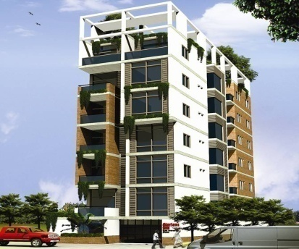
Glorious Sun
238, West Shewrapara, Mirpur, Dhaka- 1216
12 Flats in a 7 storied building on a 3.93 dec. plot

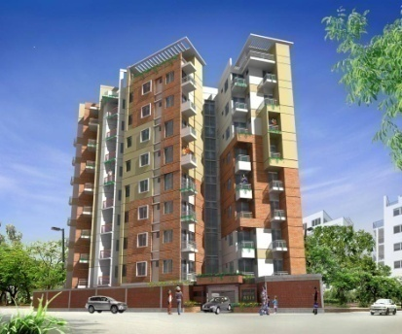
Glorious Star
102/1-A, WASA Road, West Shewrapara, Mirpur, Dhaka- 1216

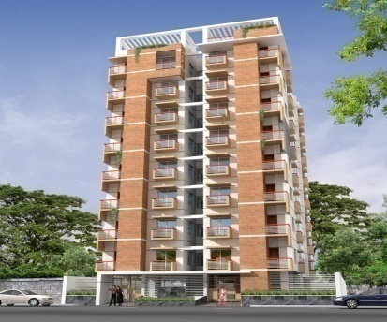
Glorious Monowara
157/4, Bishwa Road, Kuril Badda, Dhaka
27 Flats in a 9 storied building on a 10 Katha plot

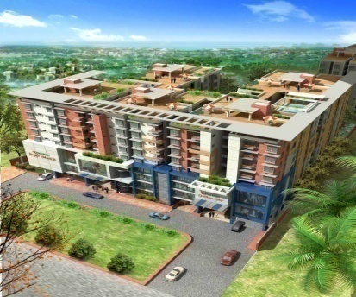
Krishibid Garden City (Gazipur)
Flat size : 850 - 1400 sft

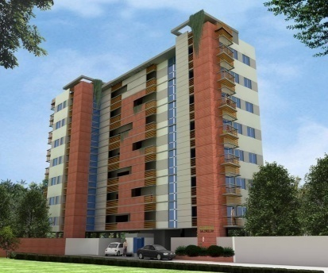
Glorious Salimullah
44/2 Barobagh, Mirpur-2, Dhaka- 1216

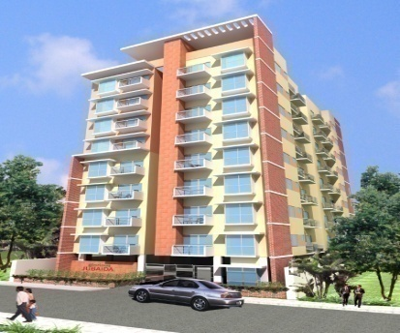

Glorious Jubaida
Dhaka 1208, Mirpur 10
24/7 shawrapara

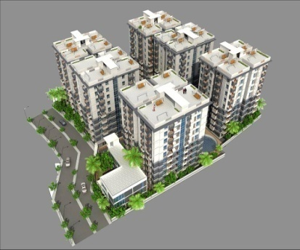
Krishibid Bhawal City

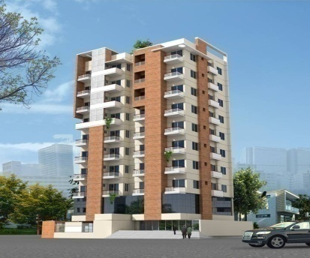
Glorious Mollah Tower
274, West Shewrapara, Mirpur, Dhaka- 1216
14 Flats in a 10 storied building on a 5.44 Katha plot

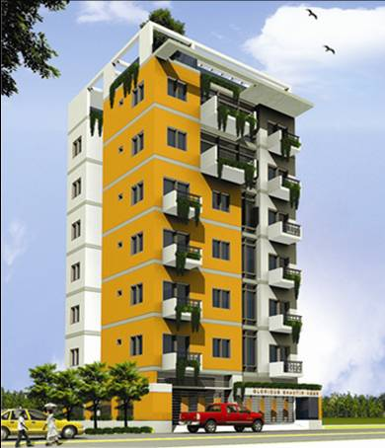
Glorious Shantir Neer
63, West Shewrapara, Mirpur, Dhaka- 1216
12 Flats in a 7 storied building on a 3.56 dec. plot

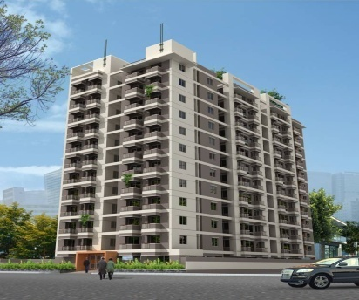
Krishibid Green Castle
25 Senpara Parbota, Mirpur, Dhaka-1216
66 Flats in a 12 storied building on a 20.5 katha plot

2.6 Hand over projects
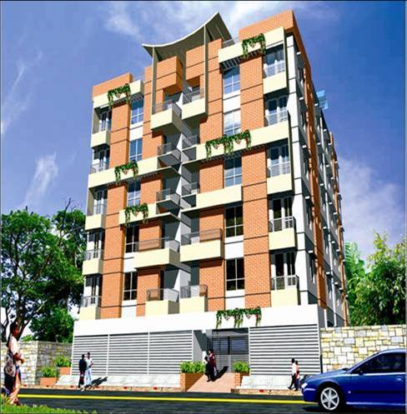
Glorious Moon
236/1 WASA Road, West Shewrapara, Mirpur, Dhaka - 1216
20 Flats in a 6 storied building on a 10 katha plot

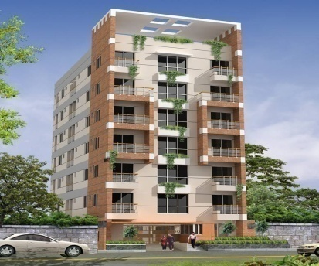
Krishibid Palace
House # 13, Road # 6, Block A, Sec.10, Mirpur, Dhaka
12 Flats in a 7 storied building on a 5.6 Katha plot

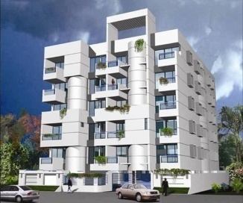
Glorious Dream
907, East Shewrapara, Mirpur, Dhaka -1216
20 Flats in a Six Storied Building on a 9.6 katha plot
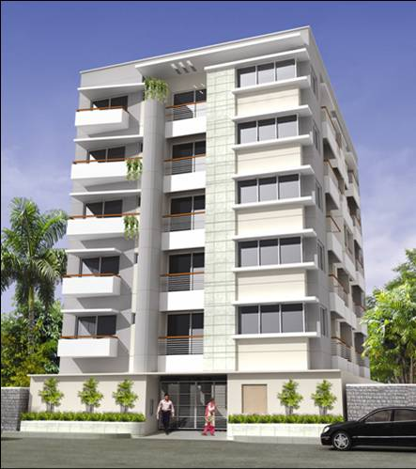
Glorious Amin Plot # 5, Road # 15, Sector # 12, Uttara M/T, Dhaka
10 Flats in a 6 storied building on a 5 katha plot

2.7 Upcoming projects
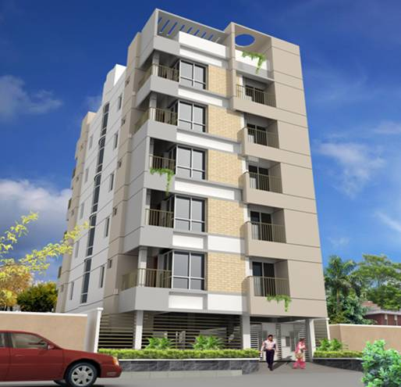
Glorious Mannan
Plot # 5, Road # 18, Sector # 10, Uttara M/T, Dhaka
10 Flats in a 6 storied building on a 3 katha plot

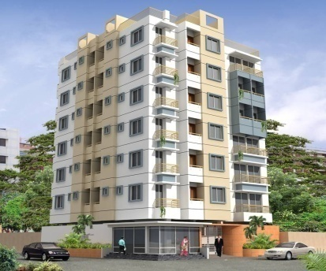
Glorious Hamza
170/9-A West Kafrul, Mirpur, Dhaka
18 Flats in a 7 storied building on a 5.4 katha plot

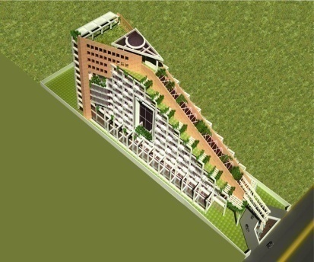
KRISHIBID SEA PALACE, KUAKATA

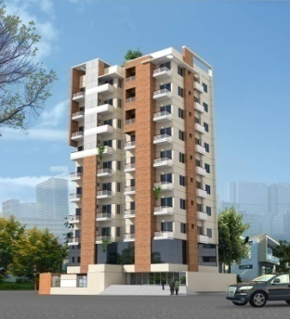
Glorious Mollah Tower
274, West Shewrapara, Mirpur, Dhaka- 1216
14 Flats in a 10 storied building on a 5.44 Katha plot

Chapter -Three
Literature Review
3.1 Introductory Thoughts
Real estate is used for a number of purpose like to provide shelter, comfort, convenience, and privacy ,a place of work, recreational facilities and related services. In an estimate real represent more than 40% of the national wealth. Therefore, the manner in which the resources of this magnitude are used has an important effects on the well being of our people, the success or failure of business firms and the general prosperity of the country.
The term real estate or apartment as commodity used has two meanings -
1) It is a name given to the commodity “realty” which include not only land but also all human improvements placed on the land.
2) It is to the name given to the business engaged in by those persons who conducts commercial transactions in real estate.
The basic component of reality as a commodity is land. It means not only the surface of the earth but also the property rights and interest that attach to ownership of reality , including subsurface minerals . Thus the real estate means acquirement of land and building which is called inherent right. The men who are the owner , user , maker, financier, or marketer of the property have some rights to the property.

3.2 History and Development of Apartment Companies in Bangladesh
In Bangladesh apartment business is a recent phenomena , although such activities were Initiated sometimes in 1964. Ispahani group was the pioneer in this sector . In 1970 there were only five registered firms in Bangladesh . From the early 1980s the business started to flourish and showed robust growth. By 1988, there were 42 developers in business. At present, more than 1500 companies are active in the real estate sector with 1081 of them registered with REHAB .
In the last four decades private developers have supplied more than 100000 units of apartments to the nation and will be supplying 25000 more units in the next three years . With 147.9 million people (Bangladesh Economic Review, 2011), Bangladesh is one of the most densely populated countries in the world. Land prices are high and permanent housing is rare—barely 2% in rural areas and 23% in urban centers. Estimates suggest a shortage of about 5 million houses in Bangladesh, with as many as 500,000 houses added annually in urban areas and 3.5 million added in rural regions (World Bank Document, 2010).
During the period from 1981 to 2000, the greater Dhaka population grew at an average rate of 5.5% from about 3.44 million to 10.0 million. During the same period the built up area increased from 104 sq. km (39% of the city area) to 150 sq. km. (55%). By the year 2015 the expected population of the city is forecasted to be as high as 15.7 million. It is expected that Dhaka will become one of the ten largest cities of the world by the year 2020 with a population as high as 20 million. To make provision for accommodation and comfortable living of this large population transformational development of Gazipur, Kaliakoir, Savar, Tongi, Narayanganj, Keraniganj and Purbachal will be required. Housing conditions of Dhaka City vary greatly between high and low-income groups as well as by area. The gap is obvious between luxurious high income apartments which exist in high-income areas such as Gulshan, Baridhara, Dhanmandi, Uttara areas and poorly constructed temporary housing (Jhupri) with extremely small floor space, very densely located on the lands prone to flood disasters. People from all socio-economic backgrounds in Dhaka face housing problem of one type or another. While the urban destitute need rehabilitation, the slum dwellers need slum upgrading. The low-income families are in need of low cost flats or plots and the middle and upper income families are complaining that the cost of a decent plot or a decent flat is going beyond their means.
3.3 Formation of REHAB and its contribution to our country

With the number of companies increasing gradually, various problems concerning the housing sector cropped up requiring early solution. At this stage it was necessary to form a trade association of the Real Estate developers to protect the overall interests of the sector. To strengthen the role of real estate sector Real Estate & Housing Association of Bangladesh (REHAB) was formed with only 11 members in 1991. The objective of REHAB was to promote formal private sector Real Estate Development inBangladesh.
REHAB is the only trade organization of Real Estate Developers with a current membership of 260 Developers. All major institutionalized Developers are members of this organization. REHAB is also the "A Class" member of the Federation of Bangladesh Chambers of Commerce and Industry (FBCCI). In the recent years REHAB has played a very significant role in nation building through Real Estate Development by its members. The members of REHAB contribute a large amount of revenue to the Government exchequer in terms of Registration Cost, Income Tax and Utility Service Charges.

The Present position of Real Estate sector at a glance :

Particulars | Units / Apartment
No of Apt. units Delivered by the Developer in last 20 years | 100,000
No. of Apt. units Delivered by REHAB Members per year | 9,000-10,000 Units
No. of Plot units Delivered by the Developer per year | 5,000-6,000 Units
Approx. turnover per year | BDT 28,000 m
Revenue to Govt | BDT 2,000 m

Source :REHAB Website – www.rehabhousing.com
Direct Employment :

Employment Type | Number
Architects | 500 nos
Graduate Engineer | 3,000 nos
Diploma Engineer | 10000 nos
Management Official | 20,000 nos
Direct Labour skilled & unskilled | 12 -15 %
Contribution to GDP | 2.5 m
3.4 The main reasons for the development of real estate business in Dhaka city are:

i) Rapid increase in the population of the city.
ii) Scarcity of unoccupied lands in important parts of the city.
iii) Very high prices of land.
iv) Hazards involving purchase of lands.
v) Profit motives of the land owners.
vi) Increase of remittance inflows in that finance many purchases.
vii) Re-structuring of households to single family units.
viii) Standard of security and other services in apartments

3.5 Apartment Development Process by the Commercial Developers
The process of the apartment development:
- Initial search for land , prior to purchase or co-sharing with the land owner.
- Acquisition, possession and registration for land.
- Signing agreement with the land owner in case of co-sharing arrangement.
- Obtaining relevant planning and building permissions.
- Initial planning and designing of the apartment.
- Overall financial management and programming.
- Obtaining a loan, if necessary, for part of expenditure.
- Ordering and purchasing of building materials.
- Filling of land above normal flood levels.
- Provision and connection of basic infrastructure service.
- Actual construction of dwelling with or without assistance.
- Transfer of title to buyers of flats/apartment.
3.6 TOTAL VOLUME OF THE REAL ESTATE SECTOR

At present, more than 1500 companies are active in the real estate sector with 1081 of them registered with REHAB. In the last four decades private developers have supplied more than 100000 units of apartments to the nation and will be supplying 25000 more units in the next three years (Sheltech, 2011). To measure the total volume of the real estate sector, data from the operating entities of this sector is a must. Once again, due to the lack of adequate primary data the total volume of this sector could not be calculated directly and accurately. But, in the following table we can see the volumes of this sector from 2001-2002 to 2009-2010. These volumes are calculated based on the overall GDP of the country in those yearsand the corresponding GDP contribution of the sector.

Year | Size of GDP (In Crore Tk) | Real Estate, renting and business services (% of GDP) | Real Estate, renting and business services (In Crore Tk)
2001-02 | 225,261 | 8.63 | 19,440
2002-03 | 237,101 | 8.48 | 20,106
2003-04 | 251,968 | 8.30 | 20,913
2004-05 | 266,974 | 8.12 | 21,678
2005-06 | 284,673 | 7.87 | 22,404
2006-07 | 302,971 | 7.64 | 23,147
2007-08 | 321,726 | 7.49 | 24,097
2008-09 | 340,197 | 7.34 | 24,970
2009-10 | 360,845 | 7.20 | 25,981

Growth and volume of the Real estate, renting and business services sector
If we extrapolate the trend we find the volume of the sector is BDT 26575.74 crore in 2010-2011. It must be mentioned here that this is a crude measure based on the secondary data.
Chapter –Four
Findings and Analysis

4.1 TREND OF REAL ESTATE BUSINESS IN THE CITY

The business of real estate had a very slow growth rate in the first decade. The industry grew in a moderate pace since 2006 but between 2008 and 2010 the growth rate was exponential. The following figure self-explains the trend of real estate business in the city.

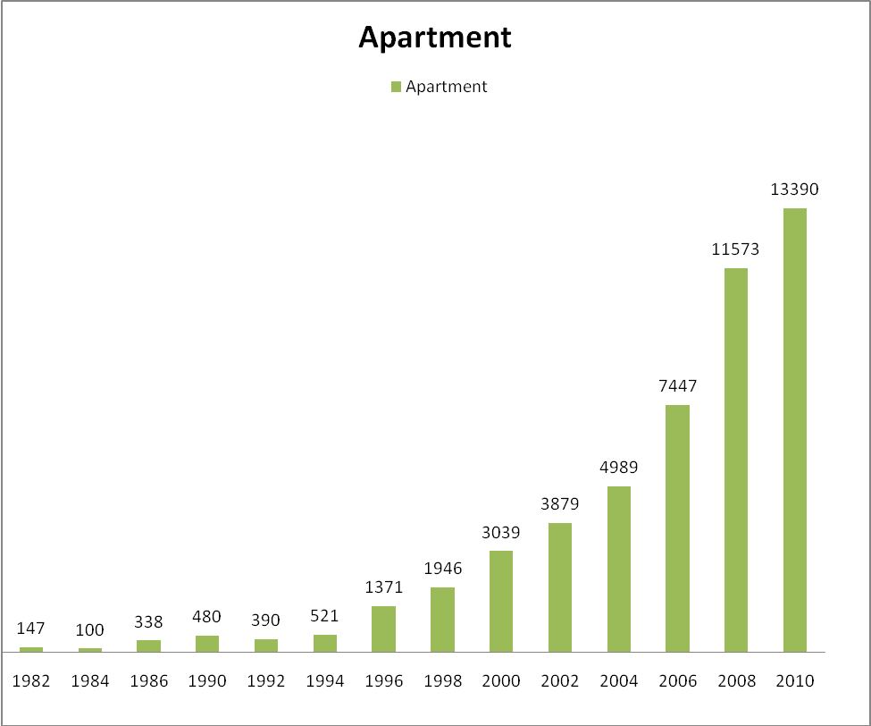
Sources: Sheltech 2011
No. of Apartments Developed Each Year from 1982 to 2010

Most popular Areas for Flats ( REHAB survey 2012 )

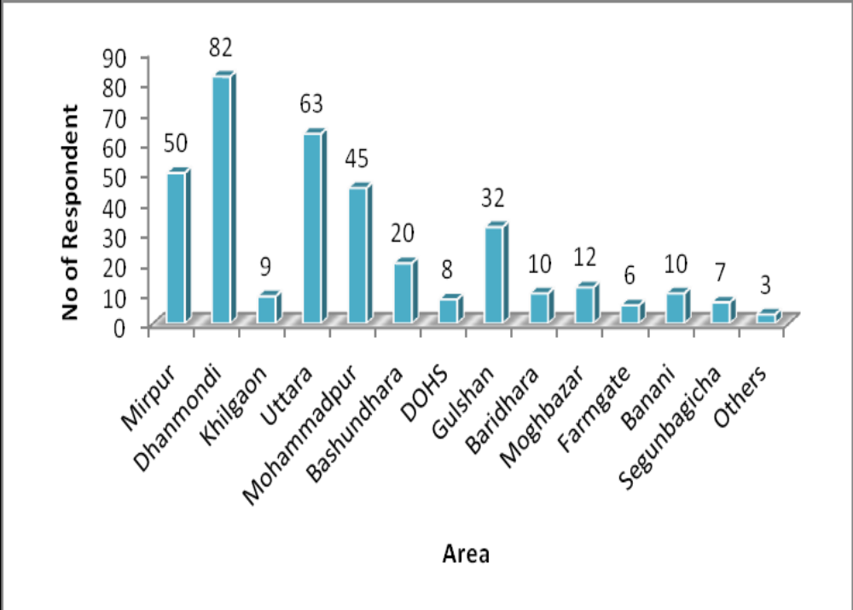

Major reasons for preferring particular area:

- More planned area (Uttara, Bashundhara, Dhanmondi, Gulshan)
- Ease of communication with office, school, college etc
- Personal choice
- Residing at that area for a long time and have relatives in that area
- Less expensive (Mirpur, Mohammadpur, Uttara )

The following table shows the price of per square feet apartments in the major areas of Dhaka city from 1990 to 2010

 | Average Price of Apartments (Taka/Sq. feet) |  |  |  |  | % Increase in price over the past two decades
Area | Year |  |  |  |  | Between 1990-2000 | Between 2000-2010
 | 1990 | 1995 | 2000 | 2005 | 2010
Dhanmondi | 2150 | 2200 | 2400 | 3300 | 14000 | 12% | 483%
Gulshan | 2115 | 2080 | 2450 | 4500 | 14000 | 16% | 471%
Banani | 1750 | 1950 | 2200 | 3100 | 12500 | 26% | 468%
Baridhara | 1850 | 1950 | 2150 | 4000 | 20000 | 16% | 830%
Lalmatia | 1800 | 1950 | 2400 | 3400 | 8500 | 33% | 254%
Mirpur | 1250 | 1300 | 1500 | 2500 | 5500 | 20% | 267%
Uttara | 1650 | 1750 | 2000 | 2700 | 5300 | 21% | 165%
Shantinagar | 1850 | 1900 | 2200 | 2700 | 5000 | 19% | 127%
Siddeswari | 1450 | 1800 | 2250 | 2750 | 5500 | 55% | 144%
Malibag | 1600 | 1850 | 2250 | 2500 | 7000 | 41% | 211%
Mohammadpur | 1450 | 1600 | 1800 | 3500 | 4500 | 24% | 150%
Shamoli | 1350 | 1500 | 1600 | 2100 | 7000 | 19% | 338%
Kolabagan | 1800 | 2000 | 2250 | 2100 | 5500 | 25% | 144%
Monipuripara | 1850 | 2000 | 2250 | 3300 | 5500 | 22% | 144%
Green Road | 1600 | 1700 | 2000 | 2500 | 5500 | 25% | 175%
Elephant Road | 1600 | 1800 | 2200 | 2500 | 5500 | 38% | 150%
Segun Bagicha | 1450 | 1550 | 1900 | 2500 | 6000 | 31% | 216%

Average Price of Apartments (Taka/ Sq. Feet) from 1990 to 2010

- In the first decade of 21st century, the percentage increase in per square feet price of apartments is very high, particularly in Baridhara, Dhanmondi, Gulshan, Banani, and Shamoli area.
- Compared to the price increase of the earlier decade, price rise is almost exponential in this decade.

The following figure shows the price hike trend of apartments in Dhaka city from 1990 to 2010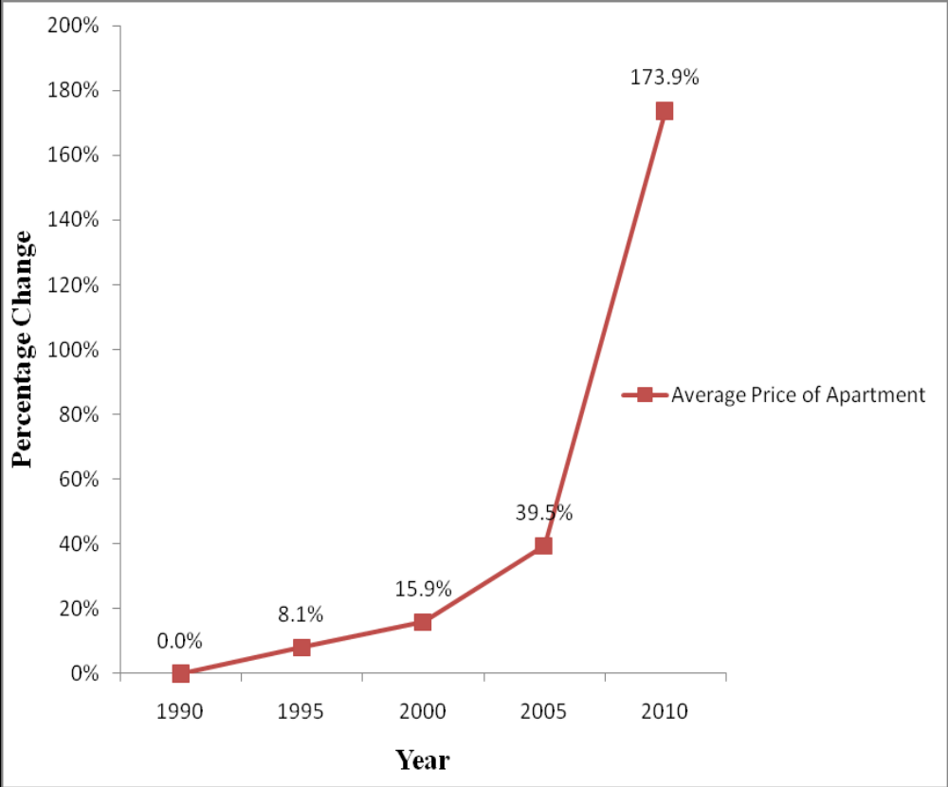
Source: Statistical Yearbook, Bangladesh Bureau of Statistics (BBS)

Price hike trend of apartments in Dhaka city from 1990 to 2010

LAND PRICE
The following table shows the price of per katha land in the major areas of Dhaka city from 1990 to 2010

 | Price of land Taka/Katha) |  |  |  |  | % Increase in price over the past two  decades
Area |  | Year |  |  |  | Between  1990-2000 | Between 2000-2010
 |  | 1975 | 1990 | 2000 | 2010
Baridhara | 25,000 |  | 600,000 | 5,000,000 | 40,000,000 | 733% | 700%
Gulshan | 25,000 |  | 600,000 | 2,200,000 | 25,000,000 | 267% | 1036%
Banani | 25,000 |  | 600,000 | 2,000,000 | 15,000,000 | 233% | 650%
Mahakhali | 25,000 |  | 600,000 | 1,800,000 | 12,000,000 | 200% | 567%
Dhanmondi | 25,000 |  | 600,000 | 2,200,000 | 20,000,000 | 267% | 809%
Lalmatia | 20,000 |  | 600,000 | 1,800,000 | 15,000,000 | 200% | 733%
Azimpur | 175,000 |  | 600,000 | 1,600,000 | 5,500,000 | 167% | 244%
Mohammadpur | 25,000 |  | 500,000 | 1,200,000 | 7,000,000 | 140% | 483%
Shantinagar | 20,000 |  | 500,000 | 1,500,000 | 10,000,000 | 200% | 567%
Shamoli | 17,500 |  | 300,000 | 1,000,000 | 4,500,000 | 233% | 350%
Uttara | 20,000 |  | 300,000 | 1,000,000 | 7,500,000 | 233% | 650%
Cantonment | 20,000 |  | 400,000 | 1,000,000 | 7,500,000 | 150% | 650%
Komlapur | 17,500 |  | 400,000 | 800,000 | 4,000,000 | 100% | 400%
Gendaria | 10,000 |  | 400,000 | 700,000 | 3,500,000 | 75% | 400%
Basabo | 2,000 |  | 300,000 | 800,000 | 3,500,000 | 167% | 338%
Kollanpur | 17,500 |  | 300,000 | 800,000 | 3,200,000 | 167% | 300%
Mirpur | 10,000 |  | 200,000 | 700,000 | 4,000,000 | 250% | 471%
Badda | 4,000 |  | 200,000 | 600,000 | 3,000,000 | 200% | 400%
Goran | 4,000 |  | 200,000 | 600,000 | 2,600,000 | 200% | 333%
Demra | 4,000 |  | 200,000 | 600,000 | 18,000,000 | 200% | 2900%
Motijheel | 50,000 |  | 1,200,000 | 3,500,000 | 20,000,000 | 192% | 471%
Kawran Bazar | 41,500 |  | 1,000,000 | 2,500,000 | 15,000,000 | 150% | 500%

The following figure shows the price hike trend of lands in Dhaka city from 1990 to 2010.

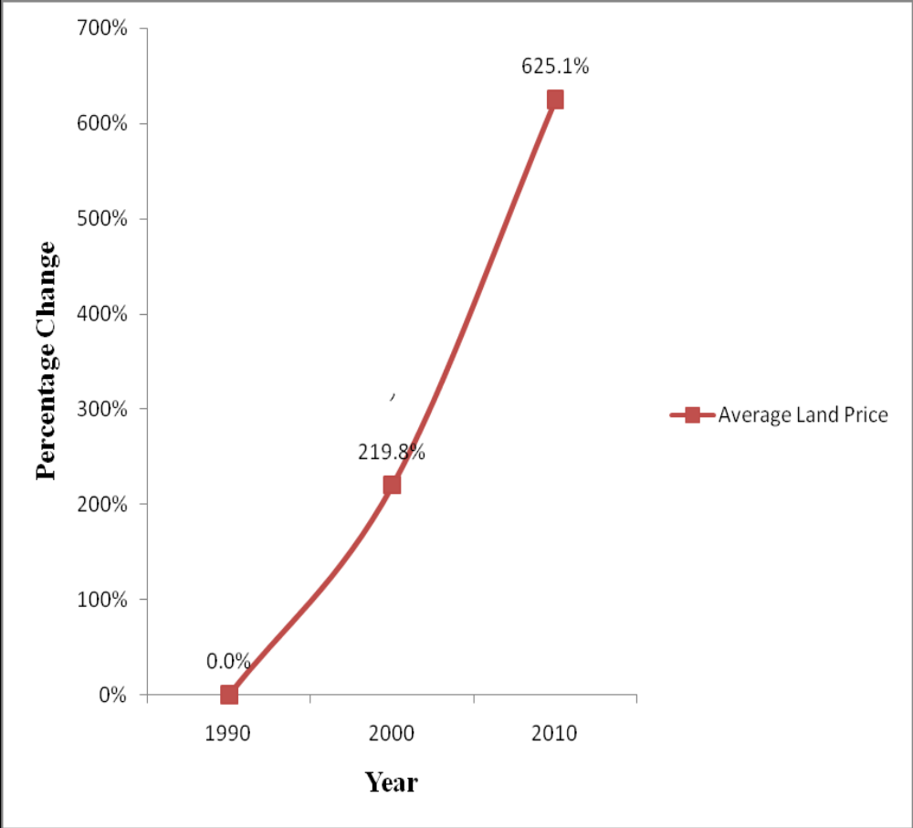
Source: Statistical Yearbook, Bangladesh Bureau of Statistics (BBS)
Land price hike trend from 1990 to 2010

GDP CONTRIBUTION TREND ANALYSIS
The sector wise share of Real Estate, Renting and Business Service sector to the national GDP of the country is as follows:

Year | GDP Contribution %
2001-02 | 8.63
2003-04 | 8.48
2003-04 | 8.3
2004-05 | 8.12
2005-06 | 7.87
2006-07 | 7.64
2007-08 | 7.49
2008-09 | 7.34
2009-10 | 7.02
Data Source: Statistical yearbook of Bangladesh, 2010
Share of Real Estate, renting and business services to the national GDP
The figure below shows the trend of GDP contributions of this sector.
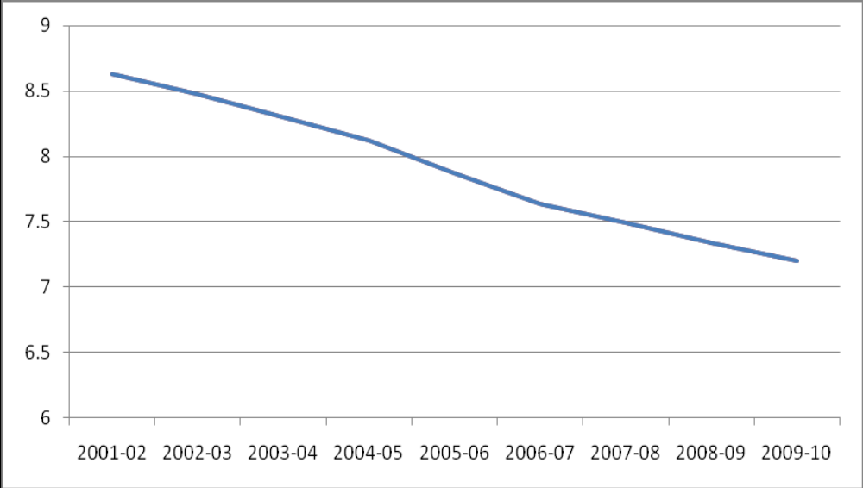 Trend of sector wise share of Real Estate, renting and business services

From the above figure, it is seen that sector wise share of Real Estate, Renting and Business service sector has a downward trend. But that does not show the real picture. To better understand the growth scenario, a comparison is made between overall GDP growth and GDP growth of the Real estate, renting and business service sector.
COMPARISON WITH OVERALL GDP GROWTH

The following table shows the comparison between overall GDP growth and growth of Real estate, renting and business services.
Year | Size of GDP (In Crore Tk) | Overall GDP Growth (%) | Real Estate, renting and business services (% of GDP) | Real Estate, renting and business services (In Crore Tk) | Real Estate, renting and business services Growth (%)
2001-02 | 225,261 | 4.42 | 8.63 | 19,440 | --
2002-03 | 237,101 | 5.26 | 8.48 | 20,106 | 3.43
2003-04 | 251,968 | 6.27 | 8.30 | 20,913 | 4.01
2004-05 | 266,974 | 5.96 | 8.12 | 21,678 | 3.66
2005-06 | 284,673 | 6.63 | 7.87 | 22,404 | 3.35
2006-07 | 302,971 | 6.43 | 7.64 | 23,147 | 3.32
2007-08 | 321,726 | 6.19 | 7.49 | 24,097 | 4.11
2008-09 | 340,197 | 5.74 | 7.34 | 24,970 | 3.62
2009-10 | 360,845 | 6.07 | 7.20 | 25,981 | 4.05
Comparison between overall GDP growth and growth of Real estate, renting and business services

- Basically, the total volume of Real Estate, Renting and Business service sector increased every year, as seen from the last column, a positive growth every year.

- But, compared to overall GDP growth, this sector expanded in a slower rate. That is why in overall GDP the contribution of this sector has a downward trend.

4.2 Competitor Analysis
In forming business strategy, managers must consider the strategies of the firm’s competitors. While in highly fragmented commodity industries the moves of any single competitors may be less important, in concentrated industries competitor analysis becomes a vital part of strategies planning. Competitor analysis has two primary activities.
- Obtaining information about important competitors
- And using the information to predict competitors behavior.

The goal of competitor analysis is to understand-
- How the industries complete with their competitors.
- To know the information of the competitors strategies and planned actions.
- To know the information how competitors might react to a firm’s actions
- To know the information how to influence competitor behavior to the firm’s own advantage.

Casual knowledge about competitors usually is insufficient in competitor’s analysis. Rather, competitors should be analyzed systematically; using organized competitor’s intelligence-gathering to compile a wide array of information so that well informed strategy decision can be made.
The Krishibid Properties Limited has no such systematic analysis of it’s competitors. It is one of the limitations as real estate business.

Market Segmentation
The purpose for segmenting a market is to allow your marketing/sales program to focus on the subset of prospects that are “most likely” to purchase your offering. If done properly this will help to insure the highest return for your marketing / sales expenditures. Depending On whether you are selling your offering to individual consumers or a business, there are definite differences in what you will consider when defining market segments. Then you should establish what the need is and who is most likely to experience that need. Your segmentation will be determined by a match between the benefits offered by your offering and the need of the prospect . Some “need” categories for segmentation include.
Reduction on Expenses
Prospects might be business that are downsizing, business that have products in the mature stage of their life cycle or individuals with credit rating problems. Improved cash flow prospects might be business that have traditionally low profit margins, business that have traditionally high inventory costs or individuals that live in expensive urban areas. Improved productivity prospects might be business that have traditionally low profit margins , business that have recently experienced depressed earnings or individuals with large families .
Improved manufacturing quality & Improved services delivery
Prospects might be business with complex , multi-discipline manufacturing process. Prospects might be service business in highly competitive markets, product business requiring considerable post-sale support or individuals in remote or rural areas.
Involvement with the social trends
Prospects might be business concerned with environmental protection, employees security etc or individuals who believe in say ‘no’ to drugs, anti-crime etc. Specific-relating to product/ service characteristics . Prospects might be business or individuals interested in safety, security, economy, comfort, speed, quality, durability etc.

Continuous learning about market
Market-driven firms stand out in their ability to continuously anticipate market opportunities and responded before their competitors. The market learning process in these firms are distinguished by : open minded inquiry based on the belief that all decisions are made from the market back, wide spread information distribution that ensures the relevant facts are available when needed, mutually informed mental models that guide interpretation and ensure that everyone pays attention to the essence and potential of the information and accessible memory of what has been learned . However , mystery of all the steps in the learning process is rare. Most firms suffer disabilities at one or more stages. Overcoming these learning disabilities and enhancing market learning competency is an important management challenges.

4.3 Designing of Marketing Strategy
Under the heading of Designing Marketing Strategy the following points are discussed
a) Customer targeting Strategy
Customer targeting strategy is a technical work which includes the following :
- ) Market Intelligence
It corresponds to the efforts conducted by the firm to decipher competitors standing and to try to anticipate their future moves . Important issues are product introductions, marketing approaches, changes in segmentation practices, price policies, product liabilities , new distribution channel , and improves services approaches.

- ) Defining and Analyzing Markets
These decision are concerned with generating marketing intelligence for the firm. It starts with an appropriate market segmentation, and a finer definition of product market segments so as to capture the different preferences and needs of customers . In each of those segments, analysis of the behavior of consumers and organizational buyers is conducted , as well as of the overall strategic competitive situation.

- ) Product Strategy
It refers to decision on how to position a business unit product offering including specific products , breadth of product lines, mix, and building – to serve it’s target markets , establishing strategic objectives for products-market share , profit contribution , and selecting a branding a strategy.

- ) Distribution Strategy
Decision involves selection of a distribution channel –whether direct or via retailers , wholesalers, agents, design and management of the physical distribution system- including customer service , demand forecasting , inventory control, materials handling , order processing , parts and services support , warehousing and storage, procurement, packing , returned goods handling , and traffic and transportation and push vs pull mode of operation of the distribution and sales system.
- ) Price Strategy
Te central factors that affects price strategy are product competitive positioning product mix , brand strategy, and product quality and features. The distribution strategy also influences how the price decision will be affected by the advertising and sales force strategy.
Krishibid Properties Ltd sale flat. After finish designing from a repotted architecture, they select price strategy . this price strategy based on some decision. Such as cost of land development, cost of raw materials, payment of land owner etc, after this they set up a price. This price strategy is two types. One is at a time and another is by installment. If client want to pay the money at a time , then they get some discount fr5om the fixed price. On the other way is installment process.

- ) Promotion and Advertising Strategies
An integrated promotion strategy has four components – advertising, presentation and promotion of goods , ideas, services by an identified sponsor. Personal selling – oral presentation to one or more prospective purchasers, sales promotion – includes trade shows , contests, samples, point-of-purchase displays, and coupons, and publicity- exhibition in mass media not paid for directly by sponsor.

- ) Sales Strategy
This encompasses all of the key decisions that should support a coherent sales strategy including account management , cross- selling and up-selling , territory management lead closure , opportunity management, sales force incentives, sales team composition , and customer engagement process.

- ) Service Strategy
The extend to which service activities become a highest priority to the firm is a critical elements of service strategy. Critical decisions are the scope of the service offering , the degree of the technical support provided , the amount of customization of service activities. The management of account inquiries, service dispatch, problem resolution and service tracking.

b) Positioning Strategy
After the organization has selected its target market, the next stage is to decide how it wants to position itself within that chosen segment . Positioning refers ‘how organizations want their consumers to see their product. What message about the product or service is the company trying to put across.

C) Developing and Positioning Strategy
Developing a positioning strategy depends much on how competitors position themselves. Do organization want to develop strategy and position themselves close to their competitors so consumers can make a direct comparison when they purchase? Or does the organization want to develop a strategy which positions themselves away from their competitors? Offering a benefit which is superior depends much on the marketing mix strategy the organization adopts. The pricing strategy must reflect the benefit offered and the promotion strategy must communicate this benefit. Ultimately positioning is about how you want consumers to perceive your products and services and what strategies you would adopt to reach this perceptual goal.

d) Marketing Relationship Strategy
A major international transport operation was facing increasing competition in all its markets. It was a market leader in every respect. It had a strong brand , a good reputation for customer serviced and charged a premium price. But its profitability was under threat from the increasingly price based competition.
Although it had managed its customers using a customer database for several years and had developed a relationship marketing approach. It had been sometime since it seriously evaluated this strategy . it decided to review the strategy.
The first step was to analyze its customer base from a new perspective. It created a data warehouse which pulled together for the first time data on purchases and service use, promotion responses and customer service. Analysis of this data showed the company had taken a wrong turning. There were two main shocks.
First, the average customer reminded an intense user for much shorter periods than the company had thought. This meant that the customer base was turning over fast, with just a few customers staying for a long times. The relationship marketing approach was falling down because it was too slow.
The company took too long to recognize the most valuable customers so they received higher quality and their best treatment just as they were thinking of leaving .At the critical period when new customers were forming their brands preferences they were treated poorly.
Secondly, the company correlated value, promotional response and complaints poorly. There were many low-use customers who often responded to promotions for incentives and complained frequently.
These findings shocked managers , particularly as several new competitors had successfully targeted new customers. This lead the company to redefine its relationship offer to new customers. Using data mining techniques, it developed a profile of future high value customers. It applied the profile to new customers , enabling it to single them out for improved management earlier in their relationship.

e) Planning for New Product
Product planning is a vitally important activity. The product planning process results in a strategic roadmap that directly translates the company’s strategy to the set of products, services, and technologies that drive your company’s vision and business result. As a product leader in your company :
Can you create a product strategy that almost guarantees you meet your business objectives?
Do you understand the factors that create opportunity for your organization?
Can you effectively define and communicate a vision for your product line and successfully defined it?
Product strategy and planning is not an individual activity, but individuals with these skills quickly become the leader of any product development focused organization. This 2-days rigorous , interactive workshop teaches the participants to apply tools and techniques to create successfully product strategies and plans. Topics covered include :
- The elements of high –growth product plans.
- Factors that determined new product success.
- How to create winning product roadmaps.
- Establishing goals to drive planning success.
- The drivers that create new product opportunities.
- Specific tools to identify high-potential products.
- Effective techniques for validating product concept.
- Building the business case for new products.
- Elements of effective product requirement.

4.4 Development of Marketing Program
Under the heading of Marketing program development the following points are discussed.
a) Brand Management Strategy
Brand marketers these days are telling the Tale of two economies. Each of them is real , but marketers are behaving differently depending on which economy they think their company exits in.
One world is the market place of Home Depot and Lowe’s , both of which are punching each other with abandon these days go to get a leg up in a continually growing home-improvement market . FedEx and UPS also have pulled out the stops on new branding campaigns, this year and last year and last year , respectively, as both try to increase their share of a delivery business that is changing rapidly.
b) Distribution Strategy
For product focused companies , establishing the most appropriate distribution strategies is a major key to success, defined as maximizing sales and profits .Unfortunately, many of these companies often fail to establish or maintain the most effective distribution strategies. Problems that we have identified :
- Unwillingness to establishing different distribution channels for different products.
- Fear of utilizing multiple channels, especially including direct or semi direct sales, due to concerns about erosion of distributor loyalty or inter-channel cannibalization.
- Failure to periodically re-visit and update distribution strategies.
- Lack of creativity and resistance to chance.

c) Pricing Strategy
One of the four major elements of the marketing mix is price. Pricing is an important strategies issue because it is related to product positioning. Furthermore , pricing g affects other marketing mix elements such as product features , channel decision , and promotion.

4.5 Marketing Strategy and the Marketing Mix
Before the product is developed , the marketing strategy is formulated , including target market selection and product positioning . There usually is a tradeoff between product quality and price, so price is an important variable in positioning . Because of inherent tradeoffs between marketing mix elements, pricing will depend on other product, distribution and other decisions.

- Calculate Costs
If the firm has decided to launch the product, there likely is at least a basic understanding of the costs involved, otherwise, there might be no profit to be made. The unit cost of the product sets the lower limit of what the firm might charge, and determines the profit margin at higher prices.
The total unit cost of a producing a product is composed of the variable cost of producing each additional unit and fixed coast that are incurred regardless of the quantity produced .The pricing policy should consider both types of costs .

- Environmental Factors
Pricing must take in to account the competitive and legal environment in which the company operates . From a competitive standpoint, the firm must consider the implications of its pricing on the pricing decisions of competitors. For example, setting the price too low may risk a price war that may not be in the best interest of either side. Setting the price too high may attract a large number of compititors who want to share in the profits.
From a legal standpoint, a firm is not free to price its products at any level it chooses. For example, there may be price controls that prohibit pricing a product too high. Pricing is too low may be considered predatory pricing or ”dumping” in the case of international trade. Offering a different price for different consumers may violate laws against price discrimination . Finally, collusion with competitors to fix prices at an agreed level is illegal in many countries.

- Promotional Strategy
Promotion is a form of corporate communication that uses various methods to reach a targeted audience with a certain message in order to achieve specific organizational objectives, must engage in some form of promotion. Such efforts may range from multinational firms spending large sums on securing high-profile celebrities to serve as corporate spokespersons to the owner of a one-person enterprise passing out business cards at a local business person’s meeting.
Like most marketing decision, an effective promotional strategy requires the marketer understand how promotion fits with other pieces of the marketing puzzle(e.g., product, distribution, pricing, target markets). Consequently, promotion decision should be made with an appreciation for how it affects other areas of the company. For instance, running a major advertising campaign for a new product without first assuring there will be enough inventory to meet potential demand generated by the advertising would certainly not go over well with the company’s production department .Thus, marketers should not work in a vacuum when making promotion decisions. Rather , the overall success of a promotional strategy requires input from others in impacted functional areas.
In addition to coordinating general promotion decisions with other business areas, individual promotions must also work together. Under the concept of integrated Marketing Communication marketers attempt to develop a unified promotional strategy involving the coordination of many different types of promotional techniques. The key idea for the marketer who employs several promotional options to reach objectives for the product is to employ a consistent message across all options. For instance, sales people will discuss the same benefits of a product as mentioned in television advertisement. In this way no matter how customers are exposed to a marketer’s promotional efforts they all receive the same information.

4.6 Implementing and Managing Marketing Strategy

Under the heading of implementing and managing marketing strategy the following points are discussed
a) Organizational Design
More specifically, Organization Design is a formal , guided process for integrating the people, information for technology of an organization. It is used to match the form of the organization as closely as possible to the purpose the organization seeks to achieve. Through the design process , organization act to improve the probability that the collective efforts of members will be successful.
Typically, design is approached as an internal change under the guidance of an external facilitator . Managers and members work together to define the needs of the organization then create systems to meet those needs most effectively. The facilitator assures that a systematic process is followed and encourages creative thinking.
Organization design begins with the creation of a strategy – a set of decision guidelines by which members will choose appropriate actions. The strategy is delivered from clear, concise statements of purpose, and vision, and from the organization’s basic philosophy. Strategy unifies the intent of the organization and focuses members toward actions designed to accomplish desired outcomes. The strategy encourages actions that support the purpose and discourages those that do not.
Creating a strategy is a planning , not organizing. To organize we must connect people with each other in meaningful and purposeful way. Further, we must connect people with the information and technology necessary for them to be successful. Organization structure defines the formal relationships among people and specifies both their roles and their responsibilities . Administrative systems govern the organizational through guidelines , procedures and policies. Information and technology define the process through which members achieve outcomes. Each element must support each of the others and together they must support the organization’s purpose.

b) Marketing strategy Implementation and Control
Organization structure is the formal and informal framework within which people work to achieve organizational objectives. Designing and implementing a suitable organization structure is necessary for the implementation of marketing strategy. Aspects like internal and external organizations, vertical structure, horizontal relationships, speed of responses, managing the operating environment etc, are the major consideration to be made in the design of a marketing organization. The options that are available for designing the marketing organization can be grouped into traditional structures and few forms. Traditional structures include functional, product, market, and matrix organization. A functionally organized structure is organized on the basis of various functions like marketing, production, research and development and finance. In product organization , structure is determined by the type and number of products that the organization has. Market organization is organized in to geographical units that report to a central corporate headquarters. A combination or matrix organization is a combination of the functional and products firms of organization.
The matrix structure helps in achieving the advantages of each of these organizational structures. Types of matrix structures include functional matrix, project matrix, anmd balanced matrix structure.
In selecting an organizational design, the factors that are to be the considered include the market and environmental situation , organizational characteristics, and the marketing strategy generally adopted by the organization. Implementation of the marketing strategies effected to a great extent by how the marketing activities are organized . There are basically four kinds of organizing concepts typically used in marketing –bureaucratic, transactional, corporate and rational. The environmental condition also influences the structure adopted by the organization. Organizations operating in global environments have to design the structure keeping in mind the market conditions in which they operate. Global organization restructuring involves steps like identifying the need for restructuring , integration of organizational functions , and identifying the most effective structure .Multinational organizations go in for various structures like domestic organization, volume expansion, resource acquisition, and international division.

4.7 Planning and Decision making process
Planning is the tool, which helps in operating the strategy of an organization. This, in turn, results in effective realization of the organizational goals. Goals define the roadmap towards realization of an organization’s vision and mission. Goal setting and planning complement each other. The decision making process is involved at different levels in the planning process. It ensures the smooth implementation of the plan. The paper discuss the function of decision making and the planning process in the organization. It examines the relevance of organizational goals.
The Krishibid Properties Limited has a decision making body and planning cell. All the new proposed activities of the project are approved in the decision making body.After the decision is approved matters are placed in the planning cell for execution purpose.
4.8 Organizing Technique, Motivating process, Stuffing Pattern and
Practiced by the world organizing technique, we can mean an arrangement of doing some thing in a planned way. Thus the organizing technique of the Krishibid Properties Limited. There are various sections of the firm the top level administrative tried their level best to maintain the harmony among the sections.
There are lots of different ways to organize a project. This is one of the system. It works very fine. If you want to start a project you must have to make a plan to start and to finish the project successfully. The work should be divided into various phases.
The Krishibid Properties Ltd, undertook the plans of various projects and there various phases of work of each projects. They are complementing these phases very efficiently accordingly to their plan they before starting the project.
The implantation of a project, need concerted efforts of people involved in the project. The project work is done in several phases. At each phases lots of people are involved to execute it. But at each stage all the peoples should perform their activities in an organized way.
Motivation Process
Motivation is to inspire people to work, individually or in groups in the ways such as to produce best results. It is the willingness to exert high levels of efforts towards organizational goals, conditioned by the efforts and ability to satisfy some individual need.
Motivating is getting somebody to do something because they want to do it. It was one assumed that motivation had to be injected from outside, but it is now understood that everyone is motivated by several different forces.
Motivation is a general term applied to the entire class of drives, desires, needs, wishes and similar forces. To say the managers motivated their subordinates is to say that they do those things which they hope will satisfy these drives and desires and induce the subordinates to act in a desired manner.
To motivate others is the most important of management tasks. It comprises the abilities to communicate , to set an example, to challenge, to encourage, to obtain feedback, to involve, to delegate, to develop and train, to inform, to brief, and to provide a just reward.
4.9 Controlling Methods
It’s hard to leave the office at a reasonable time of day when your work place culture centers on long hours. But the cost of not leaving work is high: a half built life and career burnout. Of course, if you never work long hours, you will never appear committed enough to get to the top ranks. So your job is to work enough hours to look committed but not so many hours that you risk your personal life and your ability to succeed over the long haul.
People cannot work full speed until they die. Pace yourself so you don’t burn out before you reach your potential. But don’t blame your long hours on your boss, your CEO, or your underlings. Someone who does not make a conscious, organized effort to take responsibility for the number of hours they work can be thrown off course by anyone. But the person who systematically follows the steps below will not be thrown off course, even by a workaholic boss in a workaholic industry.
Concentrate on quality of work over quality. The person who builds a career on doing the most work commits to living on a treadmill. The work will never be done, and you will become known among your co-workers as someone who never turns down an assignment. Read , dumping ground. Quality is what matters. People don’t lose a job for not working unpaid overtime, they lose a job for not performing well at the most important times, and a resume is not a list of hours worked. It is a list of big accomplishment.
Know the goals of your job. You need to know the equivalent of a home run in your job. Get a list of goals from your boss, and understand how they fit into the big picture. Judge if your work is high quality by what people need from you and how they measures success. Be sure to get goals that are quality oriented and not hours oriented.

Knowing your own boundaries, “wanting to work fewer works” is too vague a goal because you won’t know which hours to protect. Try getting home by 7 p.m., not working weekends, or leaving for few hours in the middle of the day to lift weights. There are concrete goals for cutting back hours.

Creating something important outside of work, if we don’t create a life of work that is joyful and engaging then you won’t feel a huge need to leave work. And if you don’t project a passion for life outside of work then no will think twice about asking you to live at work. So get some passion in your personal life. The only way to discover new aspects of you is to give them new opportunity to come out

Being brave, brave people can say no when someone is pushing hard, and brave people can go home when other people are working late, the bravery comes from trusting yourself to find the most important work and to do it better than anyone else. But sometimes , the bravest thing to do is leave. Some industries , for example coding video games ,or being a low level analyst at an investment bank, are so entrenched in the idea that workers have no lives that you will find yourself battling constantly to get respect for your personal life. In some cases, you are better of changing industries, or least changing companies.

Chapter Five
Recommendation and Conclusion

5.1 Recommendation
The findings of the study indicate that the marketing strategies adopted by The Krishibid Properties Ltd are not only as per the theoretical considerations. However on the basis of my practical observation some essential suggestions have furnished below for policy implications for the Krishibid Properties Ltd.

(1) The Kriishibid Properties Ltd efficiently analysis the strategic situation under the heading of (a) Market Analysis (b) Competitor Analysis (c) Market Segmentation and (d) Continuous Learning Method. The fourth heads seemed to weaker which should be strength as early as possible.

(2) The design of marketing strategies is carried out under following headings
(a) Customer Targeting Strategies.
(b) Positioning Strategies.
(c) Marketing Relationship Strategies.
(d) Planning for New Program.
(3) To make a strong customer relationship KPL should arrange their past and present customer information and make a strong customer database.
(4) Yearly evaluate the employers performance and should reward the successful or high performance employee.
(5) KPL should pay sales commission to the salesman, its an effective way to increase sales.
(6) HRD of KPL should be more strong, careful and conscious about its employee.
Among the above four strategies of Design of Marketing the position strategies seemed to be weaker. Therefore my suggestion is to improve this positioning strategy of Krishibid Properties Ltd immediately.
The development of marketing program of Krishibid Properties Ltd seemed to satisfactory still the promotional activities should increase at greater speed.
The implementation and managing marketing strategy was adopted through organizing and designing and marketing strategies implementing and control. But this implementation work seems to be weaker. So the authority of Krishibid Properties Ltd is suggested to improve these strategies very efficiently.

5.2 Conclusion
The Kishibid Properties emerged as a sister concern of the Krishibid Group in 2008 to resolve the residential housing problems of agriculturists and other services holders in and outside the capital city Dhaka. Krishibid Properties limited caters for building modern apartments and commercial spaces using best quality materials.
It is observed that Krishibid Properties Ltd has a wide range of market as it is sister concern of Krishibid Group of Companies. It has the familiarity throughout the country. Initially the group was mostly involved with the Renowned Agriculturists of our country .
The market profitability of Krishibid Properties Ltd mainly based on buyer power and supplier power. It has no such systematic analysis of its competitors. It is one of the limitations as real estate business.
Among the above four strategies of Design of Marketing the position strategies seemed to be weaker. Therefore suggestion may given to improve this positioning of Krishibid Properties Ltd as soon as possible.
The development of Marketing Program of KPL seemed to satisfactory still the promotional activities should increase at greater speed. The implementation and managing marketing strategies was adopted through organization and designing and marketing strategy implementing and control. But the implementation work seems to be weaker. So the authority of KPL may be suggested to improve these strategies.

