Submitted by
WWW.ASSIGNMENTPOINT.COM

The Sweater Factory which is a 100% export oriented factory is a concern of NDC Sweaters Ltd. The buying was established in 1997. It introduced itself as manufacturer and exporter of sweater/pullover/cardigan from Bangladesh. During my internship there I got the opportunity to closely observe the RMG industry of our country. I found that not only my organization but also other organizations of this particular industry is going through severe problems like, less number of orders, lower rates, labor riots etc. this particular study was taken to look insight of the situation and find out the underlying reasons behind such quandary in the RMG industry and how can this problem be overcome. I depended on both the primary and the secondary data sources to serve the purpose of my study. I took a survey of 105 samples that with the help of convenience sampling and few interviews of the industry experts including the director of The Sweater Factory Co Ltd. I prepared a questionnaire which consisted of 23 questions. A successful survey and some remarkable interviews produced a lot of data for preparation. I gathered some secondary data from internet articles and reports on the RMG industry for the analysis. For data preparation and interpretation I had used the statistical application software SPSS, which made my data interpretation a lot easier. After the analysis of various data presented on SPSS data table I interpreted them accordingly with the corresponding question of the survey. The findings of the study were very specific and precise. I found from the study that the fewer order is causing less production of the factory. The global economic recession and lack of efficient merchandising have been causing loss to the company. The important finding was that the management had a severe problem in decision making. They made a blunder by taking loan from the bank to expand their business. It was not a great decision to expand their business while they were struggling with the existing business setup. The management is guilty of being inflexible to the employees. Another finding was that failure to pay the salaries and other dues on time was the cause that resulted into labor riot in the factory. Few employees from the mid management have been guilty of influencing the labors and workers for labor riots. Management had failed to spot those criminals on right time. The cost of production has increased so much that they have been struggling with fewer quantities of orders to earn profit. On the basis of the findings I have come up with some suggestions that The Sweater Factory can follow to improve their current situation. These suggestions include, must focus on very good and professional merchandising, must increase employee productivity by motivating them, the top management must consult with others while making any important decision, management should promote labor union in the factory and few more. As far as the whole industry is concerned they must upgrade their machineries, must comply with the ‘’code of conduct’’ of foreign buyers, must have the government support for infrastructural developments. In addition to that the government must ensure that the industry does not suffer from bureaucratic complexities, corruption, and political instability. In conclusion of the study we can say that the global recession had a sequential impact on the overall RMG industry of Bangladesh. However, the other problems of The Sweater Factory can be solved by following the suggestions mentioned in this study.

CHAPTER ONE:

INTRODUCTION

Organization overview: THE SWEATER (FACTORY) CO. LTD.

The Sweater Factory Co. Ltd. Was incorporated in 1997. It introduced itself as manufacturer and exporter of sweater/pullover/cardigan from Bangladesh. Within a very reasonable time The Sweater Factory Co. Ltd had earned success. It started its journey as a very small manufacturer of sweaters only. However, currently it exports about 70,000 pcs every month during season.
Location of the Factory:
Initially the factory building was on a rent basis. It was situated at Gajipura in Gazipur. Now, it has its own four storied factory building at Manda,Sabujbag. The factory has a total area of 45000 sft. It has a well decorated head office situated at Uttara,Dhaka.
Historical Background of the Company:
In 1997, it started its business with only 100 knitting, 25 linking and few other machines. Mr. Jatindra Mohon Das is the founder Chairman of this factory. Since the beginning of the business The Sweater Factory Co. Ltd has been very successful in maintaining quality of their products. Their primary focus was to earn reliability of the buyers and create a long term relationship with them. Initially it was only depended on a few buying houses. As they gathered some experience in the industry, at the end of 2000 they became successful in marketing their products directly to the buyers. At that particular time, they had some new and good buyers from UK.
At the beginning of 2004 The Sweater Factory Co. Ltd. had expanded their capacity of production. With the Increased demand of the buyers and by producing quality products it had a significant growth in 2004. By the end of 2004 they had a total of 400 machines. In consideration with persisting demand of the international market it started international marketing department directly as manufacturer & exporter with its own management.

The Sweater Factory Co. Ltd. was running their business very profitably. The growth of the factory was remarkable. However, since 2008 the factory has been experiencing difficulties in business. They have been making loss and suffering from less production till now. Though they have become a bigger factory than before they have not been able to continue the growth of business.

Name of the TOP Management:

Jantindra Mohon Das
Founder Chairman & Managing Director
Graduated from IBA (DU)

Mr. Champak Das
Managing Director

Mr.Abdul Motin
Executive Director

Mohammad Abdullah
Merchandising Director

Mission Statement:

It is to build a mission statement because that communicates the company’s core values and goals. A corporate mission statement is an essential ingredient to the success of your company. It gives everyone, from top management, to the employees who work on the assembly line a clear sense of direction. They know where to focus their attention. And because they know where to fix their attention, they can help you create the desired outcome your corporate mission states.
The Mission Statement is a crucial element in the strategic planning of a business organization. Creating a mission is one of the first actions an organization should take. This can be a building block for an overall strategy and development of more specific functional strategies. By defining a mission an organization is making a statement of organizational purpose.
The mission of The Sweater Factory is as follows:

- To provide the quality and innovative sweater products at competitive price to meet the requirements of the customers.
- Contribute to the success and satisfaction of our customers and focusing on-in-time delivery.
- Co-operation, teamwork and partnerships.
- Continuous learning.
- Excel through the competence and dedication of the employees in an environment that supports the pursuit of Personal and professional growth.
- Honesty, fairness, integrity, and respect.

Vision:

Corporate vision is a short, succinct, and inspiring statement of what the organization intends to become and to achieve at some point in the future, often stated in competitive terms. Vision refers to the category of intentions that are broad, all-intrusive and forward-thinking. It is the image that a business must have of its goals before it sets out to reach them. It describes aspirations for the future, without specifying the means that will be used to achieve those desired ends.

Having well-defined visions and mission statements changes nothing if the exercise of crafting them is a complete waste of time and talent if visions and mission statements are used for nothing but being published in the annual report and displayed in a reception area.

The corporate success depends on the vision articulated by the chief executive or the top management. For a vision to have any impact of the employees of an organization it has to be conveyed in a dramatic and enduring way. The most effective visions are those that inspire, usually asking employees for the best, the most or the greatest. One has to make sure that one keeps stretch in one’s vision, communicate it constantly, and keep linking the events of today to one’s vision, underscoring the relationship between the two.

The vision of The Sweater Factory
“To become one of the most well-known sweaters factories in Bangladesh by providing the quality and innovative sweater products at competitive price to meet the requirements of the customers.”
Objective of the company
The core objective of the company is as follows:
- Maximize the return on investment of the investors.
- Maintain consistent growth of business.
Strategy of the Company:
Strategy is a very broad term which commonly describes any thinking that looks at the bigger picture. Successful companies are those that focus their efforts strategically. To meet and exceed customer satisfaction, the business team needs to follow an overall organizational strategy. A successful strategy adds value for the targeted customers over the long run by consistently meeting their needs better than the competition does.
Strategy is the way in which a company orients itself towards the market in which it operates and towards the other companies in the marketplace against which it competes. It is a plan an organization formulates to gain a sustainable advantage over the competition.
The Sweater Factory has followed the following strategies:
- The Sweater Factory has considered ‘Goodwill’ as the main marketing tool. They heavily rely on long term relationship with buyers for success.
- They emphasize on producing standardized products at a competitive price.
- They emphasize on establishing an efficient backward linkages.

List of the machineries:

Flat Knitting Machines

QTY
3GG | 102
5GG | 100
7GG | 110
10GG | 22
12GG | 400
Total | 734

Dial Linking Machines
14GG | 120
12GG | 30
8GG | 90
7GG | 60
TOTAL | 300
Over Lock Machine |  |  | 8 nos
Button Hole Machine |  |  | 3 nos
Button Stitch Machine |  |  | 3 nos
Plain Switch Machine |  |  | 20 nos

Washing and Ironing

Steam Boiler | 2 nos
Hydro Extractor | 2 nos
Dryer Er5415V | 2 nos
Washing Machine | 3 nos
Steam iron | 25 nos

Organization Structure:

Administrative Chart (Head Office)

Chairman & Managing Director

Director

Director (Admin. & Planning) Director (Marketing & Sourcing)

Commercial Account Purchase Merchandiser
Officer officer officer
Accessories
Developer Asst. Merchandising

Administrative Chart (Factory)

Chairman & Managing Director

Director

Director (Admin. & Planning) Director (Marketing & Sourcing)

Manager

PM YC S&D F.incharge QAM designer
Knt.Insp
Knt-sup winding-sup Wash Wash-sup
L&K insp
Link-sup Iron Iron-sup
Light chk
Ovl-sup PQC PQC

Treaming & mending Final chk Final chk & PCk

Time keeper Electric mechanic Security Store officer
Incharge

TOP LABEL MANAGEMENT:
Top Label Management places the order from abroad. Our main buyer is from USA like- Susan Lawrence, Pink Rose, Skiva, Max Import, Notations, Ellen Tracy etc.


Mr. Champak Das
Managing Director
Cotton Candy Int’l
( NDC Sweater’s LTD)

Major Functions of the Departments:

There are two three major departments in the organization. They are as follows:
- Administration & Finance department:
This department is responsible for carrying out commercial formalities. They usually handle the L/C,and other export documents. In addition to that they take care of daily office expenses, salaries and bank transactions.
- Marketing department:
Marketing department is a key one because merchandising is the most important part of this department. In addition to that they are responsible for accessories developing.
3. QA Department: QA department follow up the quality of the goods from the very beginning of the end.

4. Production department:
Production department basically works in two phases. One is production and the other is forwarding for shipment. The production process of sweater is described below:

Yarn preparation:
Initially, yarn is brought from local and international yarn manufacturer, and the accessories are collected from backyard-linkage industries of local and foreign origin. At the next step, raw package of yarns will be rolled up for giving those suitable revolving shape and will be sent those to Yarn Distribution (YD) section, where every spin of yarns will has been properly weighted, and specific amount of spindled yarn will has been allocated to the Knitting section.
Import Yarn

Winding

Yard
Distribution

Knitting Section:
Then every part of sweater will be knitted in the knitting section and passed them off First Inspection to get those checked whether each part will properly knitted or not, and to get confirmed if any yarn will be wasted. After First Inspection, each part of the sweaters will be linked up in the linking section and thoroughly checked in the Second Inspection and then to light checking with a view to ensuring if any hole is present in the sweater.

Knitting

Linking

2nd Inspection

Accurate measurement will tested in the Third Inspection; if it will be found up to the standard, the sweaters will be passed through the labeling section, where neck, care and size label are attached. Steam ironing will be performed after labeling and sent them in the quality control section, where each part of sweater will be checked carefully, thus if the sweaters will be found not up to the standard, they will be sent back to the Third Inspection section for mending the loopholes. Whole process of knitting will be being examined at final inspection section, and passed them for packing or folding. After packaging, whole lots are transferred into the warehouse and keep them standby for shipping.

Light
Checking

Quality
Control

Labeling

Ironing
Packing/
Folding

Final
Inspection

Exporting

Company’s competitive condition:

If we consider the current scenario of the RMG industry of our country we would find that the industry has already approached its maturity stage. A large number of sweater factories have been successfully operating their business for a long time. However, the recent global recession has caused fewer orders for most of the producers. As a result, they have been facing intense competition in the market. The sweater factory has not been able to perform well under this circumstance. So, company’s competitive position is not significant enough to mention here now.

Industrial Analysis:
PEST ANALYSIS:

Political Factor:
Uneven political conditions, deteriorating law and order situation and instability in gas and electricity prices are adversely affecting the sweater sector, while government has hardly taken any step to give some relief or incentives to the mill owners.
On the other hand, sweater and the other exporters also facing a lot of challenges due to increase in the production cost of the specific export goods, while such hurdles badly affected the Bangladeshi exporters to meet the challenges and compete in the local and international markets. Exporters are demanding that government should give them facilities to cope with the existing challenges and not get involved in favoritism.

Economical Factor:
Economical factors are also disturbing the all industries of Bangladesh as well as the sweater industry.
From 1999 to 2008 the inflation rate has been increased by significant percentages. The last and current Government has been failed to control the economy. As the prices have been increased, the suppliers try to get and save more profit from their investments. That’s why prices are decided and put with a high return in terms of profit.

The main problem with the sweater industry is shortage of electricity, gasoline and petroleum, due to which Sweater industry is bearing too much cost that why they have to increase their prices to earn profit or for break-even. There are some companies which have their own electricity plants but they have to spend a lot of money to run them. Other

problems which are facing by the sweater industry of Bangladesh are
- Not availability of skilled labors.
- Labors cost is increasing rapidly
- Loosing quality of its products in both markets domestically and internationally
- Poor monitory and Fiscal policies of the Govt. of Bangladesh
- Investors are pulling out their capital from the market quickly
- Foreign Investments are not coming towards Sweater industry

Sociological Factors:
- Sweater industry affecting the society and environment in number of ways, some of them are mentioned below.
- Polluting the air by pushing out ruins of chemicals. Different gases in air react with these ruins which become dangerous for human beings.
- No proper system to throw out the useless materials and chemicals.
- Most of the useless materials and acids are thrown into the fields which are react or disturb the agricultural products seriously.
- Since the cost of the production and labor cost are increasing day by day. That’s why the final product cost is also increasing that’s why people are buying low quality products and not spending too much to purchase.

- Sweater companies are firing the labors and employees as well because of high production cost and salaries that’s why the unemployment rate is increasing day by day which is not good for the industry as well as for the country.

Technological Factor:
The technology has been improved and updated in the sweater industry of Bangladesh and some of the companies in sweater industry are acquiring these technologies. By using new technology not only they improve their quality and efficiency but also improve their production as well as reducing the cost of production.

PORTER Analysis:

Bargaining power of Buyer:
The bargaining power of buyers is increasing day by day. The buyers are demanding more and improved quality in very cheaper prices, whether customers are from foreign or are from local markets. The competition at international level has been increased too much. If we look at a glance to USA exports of sweater industry from all over the world and especially from Asian countries then we can easily found that Bangladesh is offering comparatively less export prices to USA which is 2.51 US dollars per meter.
Bargaining power of Suppliers:
Bargaining power of suppliers is increasing of sweater industry day by day. The Govt. of Pakistan is playing very important role in this activity. As we all know that inflation rate is running upwards like a rocket and utility costs are also increasing day by day.
The costs of Yarns and chemicals which are used to dye the cloth and for sizing process have also been increased. Sweater companies are bearing too much manufacturing costs, if they come to increase their prices then there is a major threat that customers can move to other companies weather it is foreign marker or local market.

Rivalry:
The competition in the sweater industry is becoming very tough. The Sweater mills are competing with each other on the basis of their prices they offer, the quality which they produce. Competition at international level is very furious for Pakistan sweater industry. The major exporters of sweater products are,
In Local Market:
- Beximco Group
- Square Group
- Hamim Group.
- Pallmall Group.
- KDS Group.
In foreign Market:
- China
- India
- Pakistan
- Vietnam and many more.

Threats of new Entrants:

There is no threat of now entrance. If someone wants to enter in this industry, that company has to face number of competitors which are the big giants of that industry. On the other hand they have to purchase the latest technology, Fuel prices, high labor costs, opportunity cost etc. and major issue is that inflation is increasing day by day and instability of Pakistan Govt.

Threat of Substitutes:
There is no threat of substitute. Because Textile products and cloths are the basic necessity of the human life and customers cannot move to other products by leaving textile products.

SWOT ANALYSIS

Here is the SWOT analysis of The Sweater Factory co ltd.

Strengths:
- Having a good reputation in the market.
- Experienced management.
- Having own factory building.
- Advanced technologies are used in production.

Weakness:
- Longer lead time taken.
- Employee motivational level is very low.
- Crisis of working capital.
- Less effective merchandising.

Opportunities:
- The technology for sweater industry has been improved and it increases the efficiency of production.
- By motivating employees productivity can be increased considerably.
- The local market is another opportunity during slow season.
- Internet marketing has opened endless opportunity for the industry.

Threats:
- Rising in cost of energy and workforce.
- Rising in freight charges.
- Political unrest, corruption of the country.
- Labor riots.
- A very competitive market internationally.

Strategic problem of the company:

The management of the factory took a decision of expanding the business two years back. In order to do so they took a huge amount of loan from a bank. They could not reach the economies of scale with the existed capacity of production but went for further expansion. That was a mistake that caused them a lot of sufferings. The production cost went very high for them compared to a very competitive market. The strategy maker did not consult with the mid-management before taking such decision. Overall, it was a very bad strategy in forcing to grow your business without reaching the optimum growth with the existing possibilities.

Current state and future direction of the company:
Currently the organization is facing loss in business. A profitable company like The Sweater Factory has been passing the most difficult time so far. Probably some underlying causes and global recession are also responsible along with some wrong strategies for such crisis. If they do not take a look into the insight of their problems and take corrective actions immediately, I am afraid that they might have to close their business in a year or two from now Sweaters and director of The Sweater Factory. The experts had shared their invaluable thoughts with me regarding the current scenario of RMG industry of our country.
In order to collect secondary data, I depended on the Internet articles and documented literatures on the export oriented RMG sector of Bangladesh. I used the search engine of Google to find out the various internet editions of articles and literatures. I searched for some existing surveys and researches on the RMG sector of our country but unfortunately I could not find any of them. However, some of the articles and reports addressing the current problem of the industry were very useful for the understanding of the depth of the problem. I gathered few reports on the labor unrest of recent times that includes views of both the labor leaders and the owners on the situation from the internet. I found some existing interviews of few industry experts on the same matter too.
I had used the statistical application software SPSS for the analysis of collected data from survey. By using SPSS it was very convenient to find the mean, percentage, frequency, standard deviation, and skewness of resulted data. I took the help of bar chart for summarizing the result of each question. I compared two variable considering two questions taking one as independent and the other as dependent to find their relationship. Among numerous statistical applications I selected the important ones for the purpose of my study.

Methodology of the Study:

It has always been a big challenge for the researcher to collect appropriate and accurate data for analysis. In order to collect appropriate data for analysis I had to choose some useful data sources from many. In addition to that to collect accurate data I had to judge the authenticity of selected sources. I depended on both the primary and the secondary data sources to serve the purpose of my study. In order to collect primary data I took a survey and few interviews. I had selected survey because I found it the most effective way to discover the disguised and underlying reasons behind such poor condition of the organization. For the survey, I selected employees from every division of the organization as sample. The sample included the owner and the management as well. The number of people work for The Sweater Factory is about eight hundred. So it was not possible for me to select every person from there as sample for the survey in such a short period of time. To overcome this sampling problem I chose the Convenience sampling method. It was proved to be really inexpensive and less time consuming compared to other options that I had. In addition to that it was easy to access the samples. I surveyed 105 people as samples that represent every division of the organization. I prepared a questionnaire which consisted of 23 questions. The questionnaire was divided into two parts. The first part (ques.1-16) was applicable for every sample who participated in the survey and the second part of the questionnaire was applicable for the managements only. Initially I took a survey of 15 samples to check if any error existed in the questionnaire. I found a very few problems in there and edited the questionnaire accordingly. The survey was successfully done with cooperation of the respondents. I interviewed some industry experts face to face, such as, Mr. Nazibur Rahman, member of BGMEA, ex-director of FBCCI, Mr. Mahfuz Ahmed, Chairman of Eminence Sweaters and director of The Sweater Factory. The experts had shared their invaluable thoughts with me regarding the current scenario of RMG industry of our country.
In order to collect secondary data, I depended on the Internet articles and documented literatures on the export oriented RMG sector of Bangladesh. I used the search engine of Google to find out the various internet editions of articles and literatures. I searched for some existing surveys and researches on the RMG sector of our country but unfortunately I could not find any of them. However, some of the articles and reports addressing the current problem of the industry were very useful for the understanding of the depth of the problem. I gathered few reports on the labor unrest of recent times that includes views of both the labor leaders and the owners on the situation from the internet. I found some existing interviews of few industry experts on the same matter too.
I had used the statistical application software SPSS for the analysis of collected data from survey. By using SPSS it was very convenient to find the mean, percentage, frequency, standard deviation, and skewness of resulted data. I took the help of bar chart for summarizing the result of each question. I compared two variable considering two questions taking one as independent and the other as dependent to find their relationship. Among numerous statistical applications I selected the important ones for the purpose of my study. After analyzing the data collected I went for the interpretation of the obtained result. With the help of SPSS it was easier to interpret the results as well. The data resulted from the survey with management participants was difficult to interpret with statistics because the number of management participants was smaller compared to the total samples. So, to interpret the results I took the chart into consideration too. The chart made the interpretation easier.

Analysis and Interpretation of the Data:

In the beginning of the analysis I took the survey data into consideration. I had considered 19 specific questions from the questionnaire and the responses of the respondents of those questions for the analysis purpose. I decided to find the central tendency, distribution and the dispersion of collected data and the percentage on charts as well. The following results were obtained by the SPSS and they are presented with their corresponding question. I have presented below the analysis and the interpretation of data in a sequence that comply with my statement of the problems.

- What are the causes behind huge loss of The Sweater Factory?
I have selected eleven questions from the survey questionnaire with the responses and the interview of the director of The Sweater Factory to analyze for finding out the reasons which contributed to loss of the factory. The data that had been collected were arranged in a table for finding the mean, std. deviation and skewness by the help of SPSS. The following analysis and their interpretation should serve the purpose of finding appropriate answers to the question.

Q: You have been working in this organization for: According to the frequency table, maximum 60.8% of the respondents had been working for 1-3 years in this particular organization. 35.3% of the respondents had been working for last 4-6 years in there.
Frequency Table
Respondents’ working year
 |  | Frequency | Percent | Valid Percent | Cumulative Percent
Valid | less than 1 year | 4 | 3.9 | 3.9 | 3.9
Valid | 1 to 3 years | 62 | 60.8 | 60.8 | 64.7
Valid | 4 to 6 years | 36 | 35.3 | 35.3 | 100.0
Valid | Total | 102 | 100.0 | 100.0

So, most of the employees of the organization had been working for quite a bit of time. The management had been successful in keeping experienced workers.
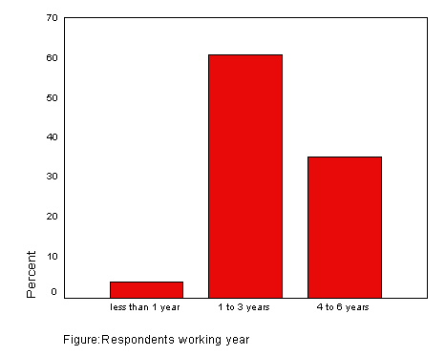

Q: Do you think less production is contributing to loss of the factory: The frequency table shows that above 80% of the respondents agreed that less production had contributed as a cause of loss to the factory.
Respondents thought on loss due to less production
 |  | Frequency | Percent | Valid Percent | Cumulative Percent
Valid | Yes | 82 | 80.4 | 80.4 | 80.4
Valid | No | 14 | 13.7 | 13.7 | 94.1
Valid | no idea | 6 | 5.9 | 5.9 | 100.0
Valid | Total | 102 | 100.0 | 100.0

Question | Respondents thought on loss due to less production
Mean | 1.25
Standard deviation | .56
Skewness | 2.119

From the above table, we got that the mean of the result is 1.25 and positively skewed which means the median and mode would be smaller than the mean. As the std. deviation is a marginal one we can accept the mean result.
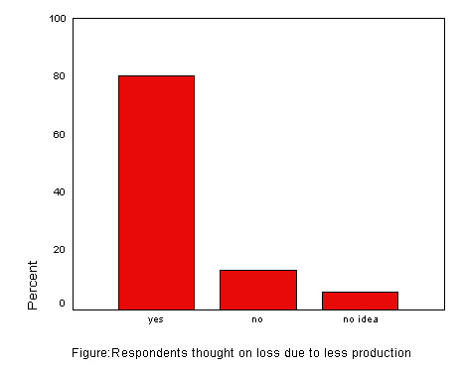

According to the respondents, number of production had decreased last season. As a result, the labors who earn their salary on production basis could not earn as much as they would want to. Similarly, the factory could not earn as much as they would have earned in other seasons. From above interpretation it is clear that less production had been one of the reasons for making loss last season.

Q: less number of orders is causing less production: The frequency table below shows that a total of 90.2% of the respondents thought that the less production is the result of less number of orders. Amongst them 52.9 % of people strongly agreed with the opinion.
Less number of orders is causing less production
 |  | Frequency | Percent | Valid Percent | Cumulative Percent
Valid | Disagree | 5 | 4.9 | 4.9 | 4.9
Valid | Neutral | 5 | 4.9 | 4.9 | 9.8
Valid | Agree | 35 | 34.3 | 34.3 | 44.1
Valid | Moderately Agree | 3 | 2.9 | 2.9 | 47.1
Valid | Strongly Agree | 54 | 52.9 | 52.9 | 100.0
Valid | Total | 102 | 100.0 | 100.0

Question | Less number of orders is causing less production
Mean | 5.94
Standard deviation | 1.23
Skewness | -.694

The mean of the results is 5.94 which imply a strong support for the opinion that less order is responsible for less production. It is negatively skewed which means the median and the mode would be even greater than the mean result. The following chart shows the percentage of agreement by the respondents.
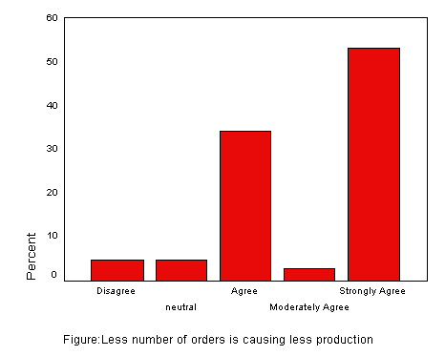

From the above analysis, it can be interpreted that the primary reason for less production and less profit was actually less number of orders. From the interview of Mr. Nazibur Rahman and Mahfuzur Rahman I got to know that the number of orders was not sufficient last season for making good profit. The reasons for fewer orders would be discussed in the later part of the analysis. So, the survey result for this particular question is justifiable that we should consider fewer orders as a cause of making loss of the factory.

Q: Less number of workers is causing less production: The frequency table shows that 44.1% of the respondents agreed that less number of workers is causing less production. However, 34.3% of the respondents disagreed with them. If we look at the frequencies on the following table we would find that the mean of the result is 4.25 with a std. deviation of 1.03. The positively skewed data suggest that the result is very close to support the fact that less number of workers is causing less production.
Less number of workers is causing less production
 |  | Frequency | Percent | Valid Percent | Cumulative Percent
Valid | Disagree | 35 | 34.3 | 34.3 | 34.3
Valid | Neutral | 15 | 14.7 | 14.7 | 49.0
Valid | Agree | 45 | 44.1 | 44.1 | 93.1
Valid | Moderately Agree | 6 | 5.9 | 5.9 | 99.0
Valid | Strongly Agree | 1 | 1.0 | 1.0 | 100.0
Valid | Total | 102 | 100.0 | 100.0

Question | Less number of workers is causing less production
Mean | 4.25
Standard deviation | 1.03
Skewness | .046

Through the interview with the director Mahfuzur Rahman I came to know that they were lacking required number of workers on a very few occasions. However, he did not want to consider this problem as the cause of incurring loss. According to him it was a temporary problem that happened several times before and it could not be taken as an excuse for loss. I would consider that the less worker problem was just a secondary cause of less production.
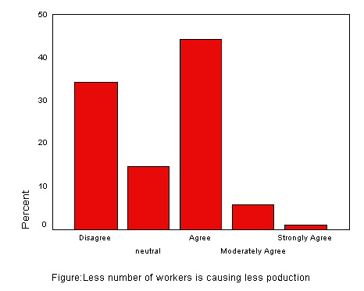

Q: Less effective merchandising is causing less production: The following data suggest that a total of almost 72% of the respondents thought that the merchandizing had not been the best for the factory.
less effective merchandising is causing less production
 |  | Frequency | Percent | Valid Percent | Cumulative Percent
Valid | Strongly Disagree | 4 | 3.9 | 3.9 | 3.9
Valid | Moderately Disagree | 2 | 2.0 | 2.0 | 5.9
Valid | Disagree | 15 | 14.7 | 14.7 | 20.6
Valid | Neutral | 8 | 7.8 | 7.8 | 28.4
Valid | Agree | 51 | 50.0 | 50.0 | 78.4
Valid | Moderately Agree | 18 | 17.6 | 17.6 | 96.1
Valid | Strongly Agree | 4 | 3.9 | 3.9 | 100.0
Valid | Total | 102 | 100.0 | 100.0

The following frequencies show that the mean result of the data is 4.67 which are negatively skewed with a higher median and mode value. Though the standard deviation is 1.31 the tendency of the distribution shows that the result support that less effectiveness of the merchandising was causing less order and thus less production.

Question | Less effective merchandising is causing less production
Mean | 4.67
Standard deviation | 1.31
Skewness | -.956

From the survey and the interview it was found that the management seemed to be not happy with the merchandisers’ effort. In fact, they were planning to employ a few new but experienced merchandisers for their factory. Though there were less number of orders last season the management thought that the merchandisers could have put a better effort to collect more orders. According to the management, many factories with the similar capacity had collected more orders than The Sweater Factory last season. So the efficiency and the effectiveness of the merchandisers of The Sweater Factory are questionable indeed.
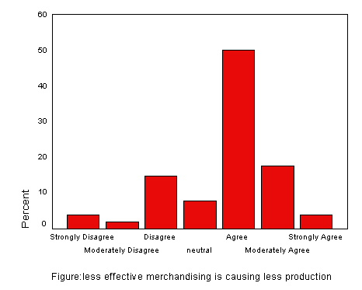

Q: Management is the worst thing of this factory: As per the following table only 38.2% of the respondents agreed that the management is the worst thing about the factory to consider. This was really a crucial and difficult question to answer for the respondents. Every possible option for the question had been chosen by the respondents. It became difficult for me to decide as well.

management is worst thing of this factory
 |  | Frequency | Percent | Valid Percent | Cumulative Percent
Valid | Strongly Disagree | 7 | 6.9 | 6.9 | 6.9
Valid | Moderately Disagree | 3 | 2.9 | 2.9 | 9.8
Valid | Disagree | 20 | 19.6 | 19.6 | 29.4
Valid | Neutral | 14 | 13.7 | 13.7 | 43.1
Valid | Agree | 39 | 38.2 | 38.2 | 81.4
Valid | Moderately Agree | 8 | 7.8 | 7.8 | 89.2
Valid | Strongly Agree | 11 | 10.8 | 10.8 | 100.0
Valid | Total | 102 | 100.0 | 100.0
Question | Management is the worst thing of the factory
Mean | 4.40
Standard deviation | 1.57
Skewness | -.365

The frequencies show that the mean of data is 4.40 with a significant std. deviation of 1.57 and negatively skewed. So the result suggests that the opinions of the respondents were slightly over the neutral to the agreeing side.

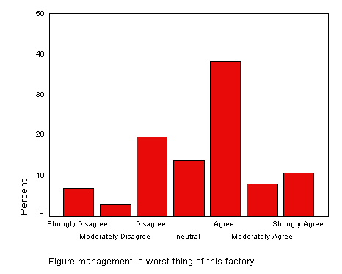

For a better understanding of the performance of the management I decided to take only the opinions of the employees who had been working for the organization for at least 1 year which is 98 people out of 102 samples. The number of difference is negligible. So, I compared the mean of the respondents’ working year (Q.1) as independent variable with the mean of the result of this particular question considered as dependent variable.

Report
management is worst thing of this factory
Respondents working year | Mean | N | Std. Deviation
less than 1 year | 3.00 | 4 | 1.83
1 to 3 years | 4.61 | 62 | 1.30
4 to 6 years | 4.19 | 36 | 1.88
Total | 4.40 | 102 | 1.57

The above report is the result of that comparison of means. According to the report respondents who had been working for 1-3 years had a higher mean of 4.61 suggest that they found the management worsens than other group of respondents with a comparatively lower std. deviation. On the other hand, employees working for 4-6 years had a mean of 4.19 who were somewhat closer to the earlier group of respondents in thinking but with a higher std. deviation. It can be said that the management is obviously not from the worst ones but they had not been successful enough with operation and few decisions may be. As a result, some of the respondents found them as worst thing of the factory to some extent.

Q: Merchandising is the worst thing of the factory: The following table presents an interesting result that 40.2% of the respondents thought that merchandising is the worst thing of the factory where as, 35.3% of the respondents thought the other way. Two percentages were very close indeed.

merchandising is the worst thing of this factory
 |  | Frequency | Percent | Valid Percent | Cumulative Percent
Valid | Strongly Disagree | 5 | 4.9 | 4.9 | 4.9
Valid | Moderately Disagree | 1 | 1.0 | 1.0 | 5.9
Valid | Disagree | 36 | 35.3 | 35.3 | 41.2
Valid | Neutral | 14 | 13.7 | 13.7 | 54.9
Valid | Agree | 41 | 40.2 | 40.2 | 95.1
Valid | Moderately Agree | 5 | 4.9 | 4.9 | 100.0
Valid | Total | 102 | 100.0 | 100.0

Question | Merchandising is the worst thing of the factory
Mean | 3.98
Standard deviation | 1.20
Skewness | -.520

From the above frequencies it was found that the resulted data had a mean of 3.98 with a higher std. deviation and of course negatively skewed. It suggests that the mean is lower than the median and mode values. From such analysis it will not be fair to say that merchandising is the worst thing of the factory. However, from our previous discussions about the effectiveness of merchandisers we can say that they might not be the worst but they were bad to some extent.

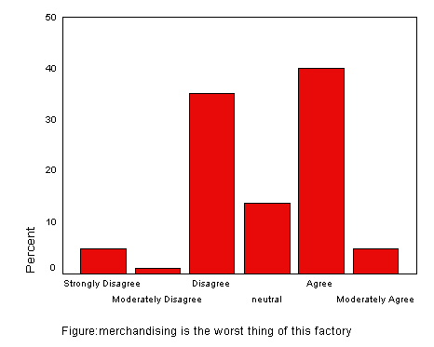

Q: Relationship between the worker and management is causing trouble in this factory: The following table shows that the highest 51% of the respondents strongly agreed with the opinion of the researcher. It is noticeable that a total of 89% of respondents thought the same whereas, 5.9% of the respondents only did not agree with the statement.
relation between the worker and management is causing trouble in this factory
 |  | Frequency | Percent | Valid Percent | Cumulative Percent
Valid | Disagree | 6 | 5.9 | 5.9 | 5.9
Valid | Neutral | 5 | 4.9 | 4.9 | 10.8
Valid | Agree | 33 | 32.4 | 32.4 | 43.1
Valid | Moderately Agree | 6 | 5.9 | 5.9 | 49.0
Valid | Strongly Agree | 52 | 51.0 | 51.0 | 100.0
Valid | Total | 102 | 100.0 | 100.0

Considering the frequencies of the following table, we find that the result carries a very healthy mean of 5.91 with a slightly higher std. deviation and negatively skewed. In suggests that the median and mode is on the higher side of mean and most of the respondents had agreed with the statement that the relationship between the worker and management had not been the best. As a result, the factory had not been able to continue its production efficiently.

Question | Relationship between the workers and the management is causing trouble in the factory
Mean | 5.91
Standard deviation | 1.25
Skewness | -.727

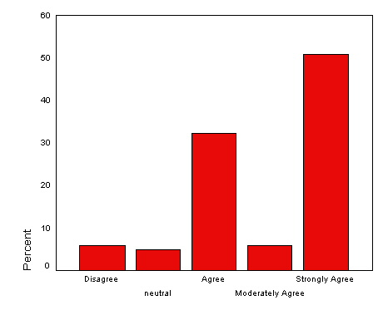
Figure: Relation between the worker and management is causing problems in factory

The relationship problem between the management and employees is a very common phenomenon found in almost every industry of our country. However, this kind of problem seemed to be a regular scenario of RMG industry of Bangladesh recently. The report of the Bangladesh Institute of Labor Studies reveals that the country’s RMG sector had experienced at least 150 incidents of labor unrest, over demand for payment of dues, in the past two years. Thousands of workers got injured and many factories were destroyed. The Sweater Factory was not an exception. It had also suffered a few times from labor unrest in recent times. From the interview of Mr. Mahfuz I came to know that the labors got impatient on few occasions for their payment of dues and some other reasons. Both the management and the employees had accepted the fact that there is lack of proper communication between them. Such a poor relation damaged the image of our sweater industry and affected the business of them. The Sweater Factory could not make one shipment on time due to three days strike of the labors. The problem continues on interval till now. So the trouble originated from the bad relation between worker and management had contributed to the loss of the factory for sure.
Q: The increased fixed cost of your factory are contributing to loss: The following data table shows that 80% of the management thought that the increased fixed cost had contributed to loss of the factory.
the increased fixed cost of your factory are contributing to loss
 |  | Frequency | Percent | Valid Percent | Cumulative Percent
Valid | Strongly Disagree | 1 | 1.0 | 20.0 | 20.0
Valid | Agree | 1 | 1.0 | 20.0 | 40.0
Valid | Moderately Agree | 1 | 1.0 | 20.0 | 60.0
Valid | Strongly Agree | 2 | 2.0 | 40.0 | 100.0
Valid | Total | 5 | 4.9 | 100.0
Question | Increased fixed cost is contributing to loss of the factory
Mean | 5.20
Standard deviation | 2.49
Skewness | -1.671

The above frequencies show that the mean of the resulted data is as high as 5.20 with a very high std. deviation and negatively skewed. Such statistical results produced some confusion for a question that was applicable for the management only because the number of respondents representing the management was very smaller compared to the total number of sample.
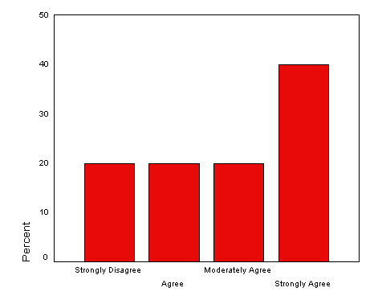
Figure: increased fixed cost is contributing to loss of the factory

However, by looking at the bar chart, it can easily be interpreted that majority of the managements agreed to the fact that fixed costs had increased and it was one of the reasons why the factory went for loss.

Q: The reason behind increased fixed cost: The resulted data from the table below shows that all the management respondents had identified that the fixed costs had increased significantly.

the reason behind increased fixed cost
 |  | Frequency | Percent | Valid Percent | Cumulative Percent
Valid | all of the above | 5 | 4.9 | 100.0 | 100.0
Missing | System | 97 | 95.1
Total |  | 102 | 100.0

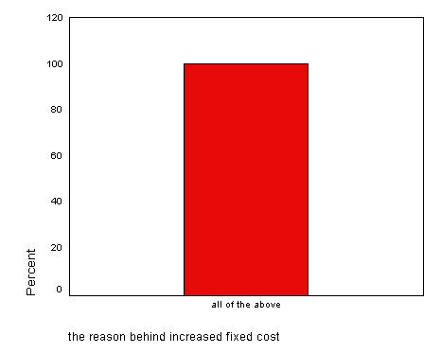

Many fixed costs of the factory, such as, cost of raw materials, salary of employees etc had raised in recent years. However, the rates for recent orders had gone down considerably. From the interview and internet sources I found that with the increased cost factories like, The Sweater Factory is struggling to maintain profitable business.

Q: Taking huge amount of loan is causing the company to incur loss: This was probably the most unusual question that you would find in a questionnaire. Amongst the management 80% of the respondents thought that taking bank loan caused the company to incur loss.
taking huge amount of loan is causing the company to incur loss
 |  | Frequency | Percent | Valid Percent | Cumulative Percent
Valid | yes | 4 | 3.9 | 80.0 | 80.0
Valid | no | 1 | 1.0 | 20.0 | 100.0
Valid | Total | 5 | 4.9 | 100.0
Missing | System | 97 | 95.1
Total |  | 102 | 100.0
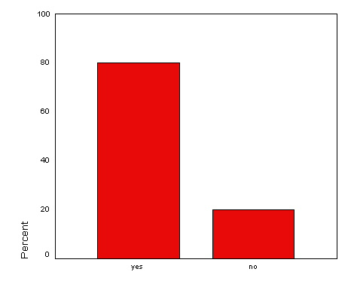
Figure: taking huge amount of loan is causing the company to incur loss

While interviewing the director Mr. Mahfuh Ahmed I came to know a crucial fact that The Sweater Factory had taken a huge amount of loan to extend their business. As a result, they had to pay a large amount of monthly installment to the bank. They were doing ok till the beginning of last year. Since the number of orders and profit margin had gone down they found it quite difficult to manage the bank installments. After paying the installment each month they had not been able to keep the sufficient working capital. Thus they became incurring loss in business. Though the Chairman of the factory did not agree with my statement I identified it as one of the main reasons for such poor condition of The Sweater Factory.

- Does the situation of The Sweater Factory resemble the actual scenario of RMG industry of Bangladesh?

In order to answer this particular question I had gone through many articles and reports on the RMG industry of Bangladesh of recent times. I asked few industry experts while interviewing them that what was the actual condition of the RMG industry then. I discovered that not only The Sweater Factory but also other factories have been going through a very difficult time as far as their business is concerned. On the month of September, 2009 the president of BGMEA had asked for about 300 million taka from the government to minimize the loss of the industry. Mr. Nazibur Rahman, member of BGMEA had pointed out various causes, such as, global recession, political unrest and various types of corruption, labor riots, over dependency on buyers etc. which have been responsible for such unfortunate situation. He also added that our fewer competencies had caused losing buyers to the competitors.

Let us consider 2 more questions and their responses of the respondents to summarize the result.
Q: Do you feel that some other factors like, politics, corruption, and government intervention are responsible for the poor condition of the industry?
This particular question was answered only by the management respondents. Being a part of the management they might actually face this kind of problems in their business operations. The articles, reports and interviews spotted out these problems of the industry. The following bar chart clearly shows that hundred percent of the respondents identified political unrest, corruption and government intervention as unnecessary obstacles for the improvement of the industry. Political unrest has been a serial killer for several industries of our country for a long time. In addition to that the corruption has caused remarkable damage to the industry. This kind of problems enhances the inefficiency of the industry. As a result, buyers become unsatisfied and switch to another country.
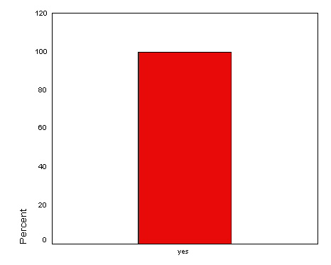
Figure: politics, corruption, and government intervention are responsible for poor situation

Q: Do you think that over dependency on foreign buyers and lack of proper communication with foreign bureaucrats encouraging buyers to take advantage over us?

In order to find the appropriate answer to the question at first we would consider the result of the survey data. The result is presented in a bar chart below:

Figure: over dependency on buyers and lack of communication with bureaucrats encouraging buyers to take advantage over us

According to the chart we see that hundred percent respondents agreed with the fact that over dependency on foreign buyers and lack of proper communication with foreign bureaucrats encouraging buyers to take advantage over us. In the interview Mr, Nazibur Rahman pointed this problem out that we have been losing our bargaining power since we tend to become over dependent on buyers. BGMEA and the Government have not been successful enough to maintain a prolific communication with foreign bureaucrats.

- Has any impact of global recession on RMG industry of our country? If it has then how it is affecting the business of The Sweater Factory?

The current global recession had severe impact on not only the western countries but also our country. The recession had affected our economy lately but greatly. Especially, the RMG industry which is an export based business has been suffering the most.
We need to consider 2 more questions and the responses by the respondents to find the opinion of the samples.
Q: The global recession is responsible for incurring loss in this season?
From the following chart we find that 60% of the respondents thought that recession had caused The Sweater Factory incur loss.
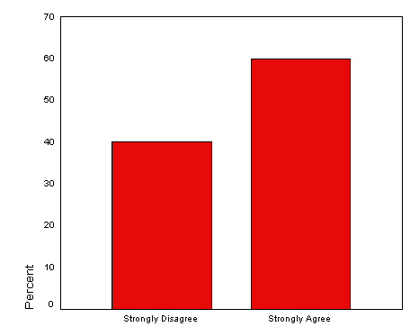
Figure: global recession is responsible for incurring loss in this season

Mr. Mahfuz Ahmed, director of TSF identified the global recession as one of the main reasons for making loss in last season in his interview. Surprisingly, 40% of the respondents did not agree with him. As an interviewer it seemed to me that few of them had no idea of recent economic recession. Mr. Nazibur Rahman also marked it as the cause of recent crisis of the industry. According to him, the recession has caused the purchasing power of the foreign buyers reduce. As a result, the sales of clothes or sweaters declined last season. Many of the imported cloths are still unsold in the retail stores. So, this year the buyers had a limited demand for readymade garments. Thus the number of orders and the rates has declined significantly. With a limited bargaining power and fewer competencies our producers have been losing markets to their competitors, India and China. This is how our RMG industry had got affected by global economic recession.

- How can they overcome this complexity to reinforce their business and thus showing the way to others in the industry?

In order to reinforce the business of The Sweater Factory they must improve on some weaknesses and eliminate the problems identified above. There were five questions in the questionnaire on the improvement of management-worker relationship and current income of the
Factory. The results of the survey are presented in frequency table and the percentage is presented on charts.

Q. By following proper wages policy and thus protecting labor rights can improve the relationship:

According to the following data table 89.2% of the total respondents felt that if the management follows the wages policy properly and protect other labor rights then the relationship between them would definitely improve.
proper wages policy and protecting labor rights can improve the relationship
 |  | Frequency | Percent | Valid Percent | Cumulative Percent
Valid | Disagree | 1 | 1.0 | 1.0 | 1.0
Valid | Agree | 3 | 2.9 | 2.9 | 3.9
Valid | Moderately Agree | 7 | 6.9 | 6.9 | 10.8
Valid | Strongly Agree | 91 | 89.2 | 89.2 | 100.0
Valid | Total | 102 | 100.0 | 100.0

The frequencies below suggest that a highest mean value of 6.83 with a very minimum std. deviation and negatively skewed. The median value is much greater than the mean. It can be interpreted as most of the respondents found the statement very useful and effective for maintaining healthy relationship.

Question | Proper wages and protecting labor rights can improve worker-management relationship.
Mean | 6.83
Standard deviation | .56
Skewness | -4.408

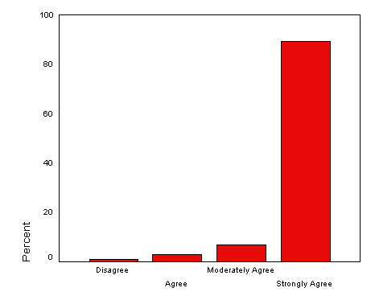
Figure: Proper wages policy and protecting labor rights can improve the relationship between worker and management.

The industry experts had the same perception as that of the respondents to improve the relationship between the worker and management.

Q. Emphasizing on motivational factors can improve the relationship:

The following data table shows that 89.20% of the respondents supported that emphasizing
 |  | Frequency | Percent | Valid Percent | Cumulative Percent
Valid | Neutral | 1 | 1.0 | 1.0 | 1.0
Valid | Agree | 5 | 4.9 | 4.9 | 5.9
Valid | Moderately Agree | 5 | 4.9 | 4.9 | 10.8
Valid | Strongly Agree | 91 | 89.2 | 89.2 | 100.0
Valid | Total | 102 | 100.0 | 100.0

on the motivational factors like, bonus, best employee awards etc. in the frequencies, we find

Question | Motivational factors can improve worker-management relationship.
Mean | 6.82
Standard deviation | .55
Skewness | -3.302

that a very higher value of mean which is 6.82 and a small std. deviation with negatively skewed data. The median and mode would be really higher than the value of mean.

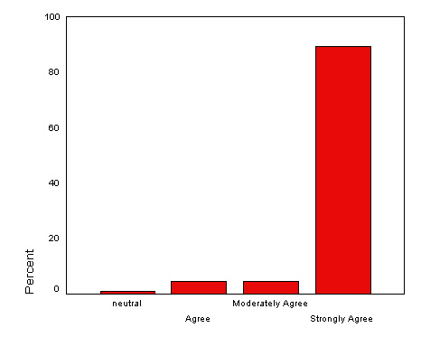

Figure: emphasizing on motivational factors can improve the relationship

According to many of the experts motivation is one of the keys to success. I found in an article that various factors like, bonus, awards, recognition make employees satisfied and can boost the performance of them at the same time. Nobody from the samples disagreed with this suggestion of the researcher. Thus by following these strategies The Sweater Factory might improve the worker-management relationship.

Q: Increased production can improve the current income: The results of this particular question are presented in the frequency table. The following table shows that 54.9% of the respondents were agreed to the statement. In addition to that 30.4% respondents strongly agreed with this.

increased production can improve the current income
 |  | Frequency | Percent | Valid Percent | Cumulative Percent
Valid | Neutral | 10 | 9.8 | 9.8 | 9.8
Valid | Agree | 56 | 54.9 | 54.9 | 64.7
Valid | Moderately Agree | 5 | 4.9 | 4.9 | 69.6
Valid | Strongly Agree | 31 | 30.4 | 30.4 | 100.0
Valid | Total | 102 | 100.0 | 100.0

Figure: increased production can improve the current income

Question | Increased production can improve the current income.
Mean | 5.56
Standard deviation | 1.03
Skewness | .421

The frequencies of the above table suggest that the mean value is as high as 5.56 with a Std. deviation of 1.03 and positively skewed. It implies that most of the respondents were on the agreeing side of the statement.
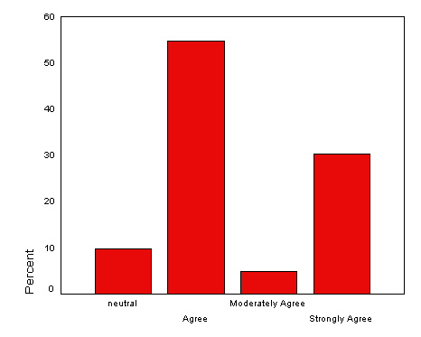
Figure: Increased production can improve the current income

It is quite obvious that if a factory meets its full potential or capacity of production it will make profit (holding other factors constant). A factory can achieve economies of scale by reaching its full capacity of production. Only increased number of orders can result in more production. Increased production will increase the sales as well. Thus the amount of profit should increase too. If The sweater Factory could increase their production the director believes that they would have been in a better position.

Q: Improved employee productivity can improve the current income: The frequency table below shows that a highest 35.3% of the respondents thought that they should enhance the employee productivity in order to increase the production and thus improve the current income of the factory. A total of 70.6% respondents were on the agreed side of the statement.

improved employee productivity can improve the current income
 |  | Frequency | Percent | Valid Percent | Cumulative Percent
Valid | Disagree | 21 | 20.6 | 20.6 | 20.6
Valid | Neutral | 9 | 8.8 | 8.8 | 29.4
Valid | Agree | 36 | 35.3 | 35.3 | 64.7
Valid | Moderately Agree | 15 | 14.7 | 14.7 | 79.4
Valid | Strongly Agree | 21 | 20.6 | 20.6 | 100.0
Valid | Total | 102 | 100.0 | 100.0

Figure: improved employee productivity can improve the current income

From the below frequencies, we find that a very healthy mean of 5.06 with a std. Deviation of 1.38 the results suggest that most of the respondents were on the agreeing side of the statement. The data were negatively skewed which suggest that the median and mode of the data would be higher than the mean value.

Question | Improved employee productivity can improve the current income.
Mean | 5.06
Standard deviation | 1.38
Skewness | -.108

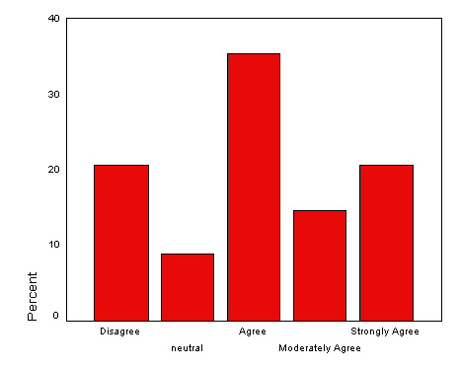
Figure: Improved employee productivity can improve the current income.

The level of production by a worker depends on some factors like age, sex, experience, and motivation etc. According to the director of The Sweater Factory it is necessary to monitor the workers and labors whether the factors are rightly present or not? Any of the factors that is not present in them rightly can cause less productivity. For instance, an over aged labor or a child labor won’t be able to produce as much as a young labor could. So, by making sure that the factors are rightly present in the workers The Sweater Factory might increase their employee productivity.

Q: Improved merchandising can improve the current income: the resulted data of this survey question is presented on the frequency table below. The table shows that a highest 63.7% of the respondents thought the same way that improvement in merchandising could improve the current income of the factory.

improved merchandising can improve the current income
 |  | Frequency | Percent | Valid Percent | Cumulative Percent
Valid | Disagree | 10 | 9.8 | 9.8 | 9.8
Valid | Neutral | 7 | 6.9 | 6.9 | 16.7
Valid | Agree | 65 | 63.7 | 63.7 | 80.4
Valid | Moderately Agree | 10 | 9.8 | 9.8 | 90.2
Valid | Strongly Agree | 10 | 9.8 | 9.8 | 100.0
Valid | Total | 102 | 100.0 | 100.0

The frequencies below on the table present that the mean of the result is as high as 5.03 with a std. deviation of .98 and the data are negatively but so marginally skewed that the chart seems to present almost a symmetric distribution of resulted data. The interpretation is very straight forward that majority of the respondents agreed with statement.

Question | Improved merchandising can improve the current income.
Mean | 5.03
Standard deviation | .98
Skewness | -.060
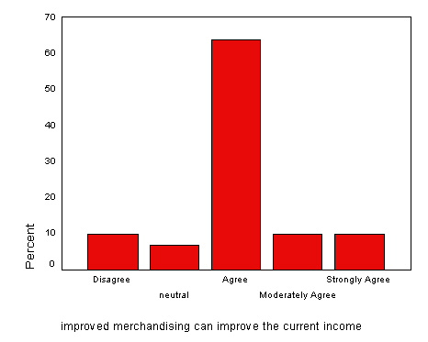

The chairman, director and many of the employees of the organization seemed to be not happy enough with the effort of the merchandisers. Though they did not find merchandising as the worst thing of the factory they expect slightly more successful marketing from them. The management had decided already to employ a few new merchandisers to improve the merchandising of the factory. By enhancing the marketing of the factory the number of orders could be increased and consequently current income of the factory could be improved.

Limitations of the Study

- In collecting information difficulty faced because of the nature of confidentiality maintained by officials.
- Available data could not be verified.
- Enough time could not be spent.

Report Writing

The Report is prepared under supervision of Mr.Anisuzzaman, Lecturer, School of Business Studies, Uttara University after completion of internship in Cotton Candy Int’l Limited. This Report is presented to Uttara University and Cotton Candy Int’l authority.

Conclusion:
Concluding the remarks, it can be said that The Sweater Factory incurred loss in past months due to less production which is a consequence of fewer orders. Actually the whole RMG industry has experienced the same crisis as The Sweater Factory in previous months. The Global Recession is being identified as the main reason for this crisis, according to the study. There was a sequential impact on the RMG sector of Bangladesh. The economic recession had affected the demand for new readymade garment products. The demand was significantly reduced in main importing countries like, US, UK, etc. As a result, our industry suffered a lot from lesser number of orders these days. However, according to many experts this crisis is a temporary phenomenon. So we have to be patient and wait for the progress of the global economy. Other than the problems created by the global recession can be solved by following the suggestions mentioned in this study. I firmly believe that this study report will help The Sweater Factory to reinforce their business into a profitable one.

Recommendation:

On the basis of the findings I have come up with some suggestions that The Sweater Factory can follow to improve their current situation. In addition to that I have few general suggestions too for the improvement of the overall RMG industry. The suggestions for The Sweater Factory are stated below:
- In order to overcome the problem of fewer orders and production The Sweater Factory must focus on very good and professional merchandising. For this improvement, they can arrange some training for their merchandisers or, they can employ a few vastly experienced merchandisers of the industry with a higher salary. They must improve their production level to avoid loss.
Another thing that they must consider is the employee productivity to increase production. They must motivate the workers to perform better than before.
- The top management has to be very smart and practical in making decisions. They have to foresee the results of their decision first. Moreover, they must consult with others while making any important decision. They have to be liberal to all employees.
- The management should promote labor union in the factory. Workers need a place to express their demands and it is also a necessity for the owners to take decisions after consulting with workers.
- In order to diminish the relationship problem between the workers and management the top management can arrange some programs within the factory premises or outside the factory to set a path of communication. For instance, they can arrange annual picnic for the employees and their family members.
- The Sweater Factory has liquidity crisis. As a result they often failed to pay the salaries on due time. In order to eliminate this problem they must have some back up amount of money in a separate account so that they can pay the salaries to the employees when they don’t get their dues from the buyers.
- The management can introduce some motivational factors like, Best employee award for every month. Such factors should increase the efficiency level of the employees.
- The management must recognize those people within the factory who has been creating problem between the management and workers for their personal interest and fire them as soon as possible.
- In order to cope with the increased production cost they must try to achieve the economies of scale by increasing the production. In addition to that they can utilize their assets present in the factory premises, such as, a pond located in front of the factory building. They may initiate some projects like fish farming there for earning some profit to meet increased cost of production.
- The Sweater Factory must comply with the law of labor rights and should follow proper wages policy to avoid labor riots.
- The Sweater factory must shorten their lead time. They have to help their existing suppliers to improve their efficiency or, they have to switch to some efficient and fast suppliers. They must improve their backward linkages.
The following suggestions are proposed for the overall industry of readymade garments:
- The industry must upgrade their machineries with the advancement of the technology. Otherwise, they will lack a huge competitive advantage over global competitors.
- Our industry must comply with the ‘’code of conduct’’ of foreign buyers to maintain a long-run relationship with them.
- Our industry must focus on product diversification and market diversification.
- The RMG industry must have the government support for infrastructural developments. In addition to that the government must ensure that the industry does not suffer from bureaucratic complexities, corruption, and political instability.
- The overall industry should focus on reducing the Lead time to remain competitive in the global industry.

The Process of Producing Sweaters
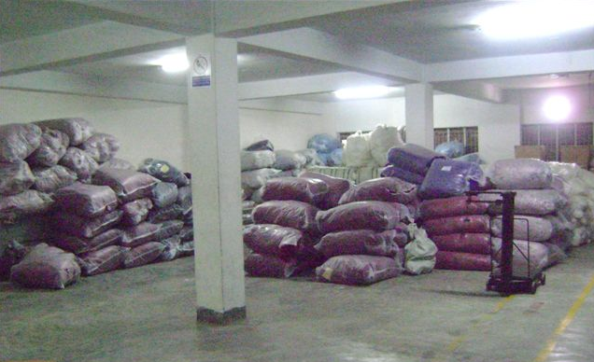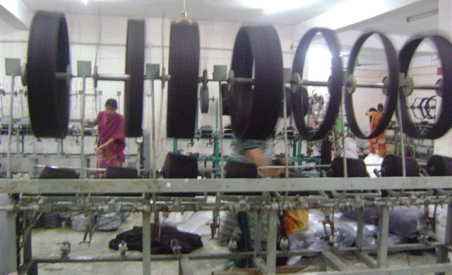
Dyed Yarn in Factory Store Winding Section
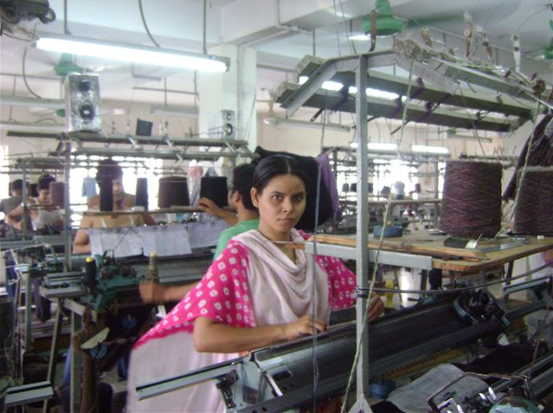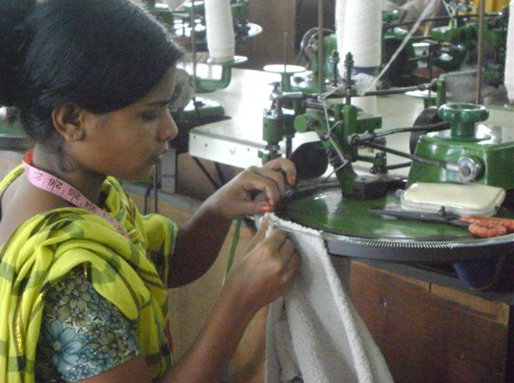
Knitting Section
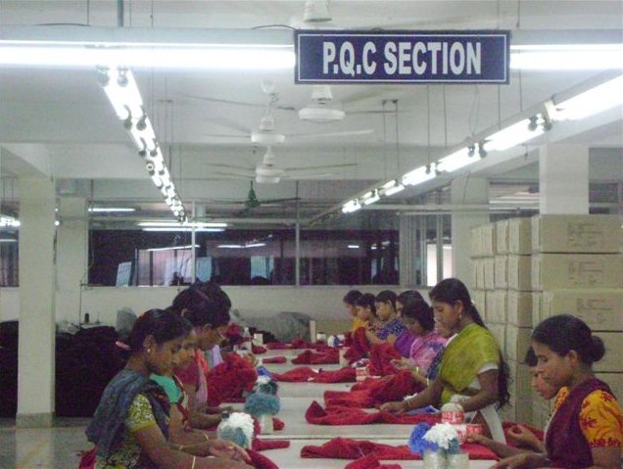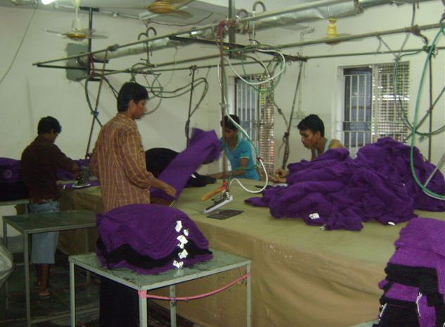
P.Q.C Section Iron Section

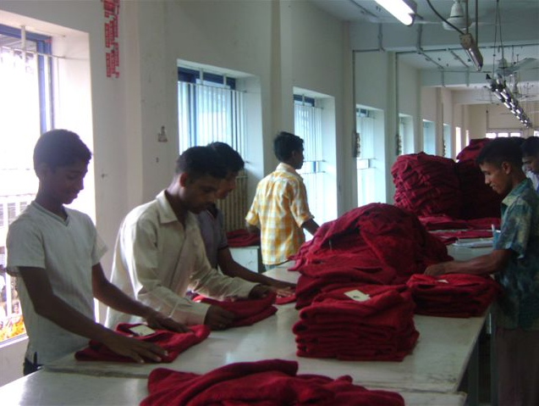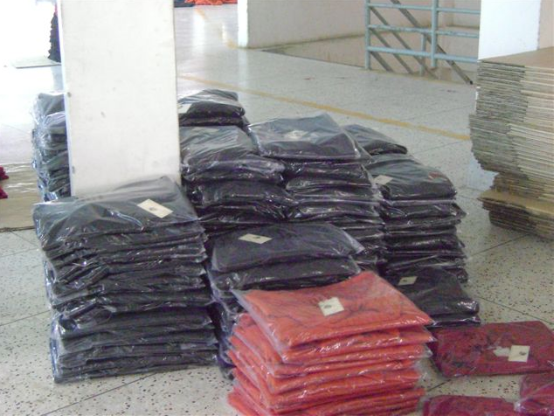
Packing Section Packed Garment

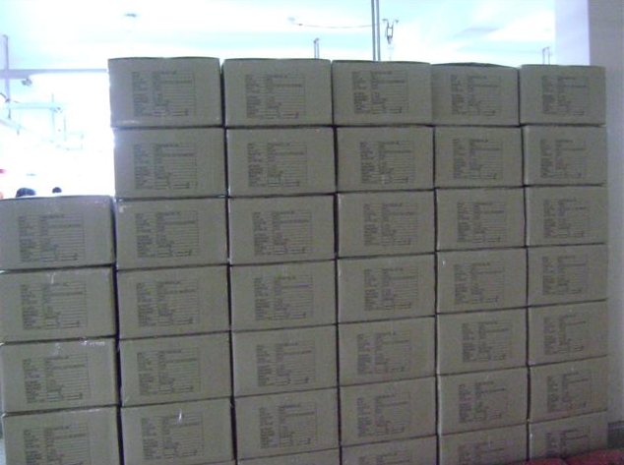
Carton Ready to Ship USA



