Submitted by

WWW.ASSIGNMENTPOINT.COM

Though soon after liberation in 1971, the insurance industry was nationalized and was controlled by two state owned institution namely Sadharan Bima Corporation for general insurance and Jiban Bima Corporation for life Insurance (with the exception of American life insurance Co, in the private sector), there are at present 43 general insurance and 17 life insurance companies operating in the private sector industrial growth, has not been as expected. It is however need to mention that despite tough competition, the company’s business show satisfactory performance. So far already 3 life insurance companies have gone public and their shares are all traded.

1.2 Objectives
In 1984, the government had allowed the flatiron of insurance companies in the private sector; such companies started functioning from the middle of 1985
The main objective of the study is to reveal the following overall insurance business in Bangladesh along with the specific objectives,

The major objectives of this report are given below –

- To examine theoretical knowledge with compare to the practical area of insurance business in Bangladesh.
- To get aware about the working environment that will help us an adjusting with the future work life.
- To focus the role of financial performance & application of IFRS4 in insurance companies for the development of investment in Bangladesh.
- To focus the overall performance of the financial performance of insurance Companies in Bangladesh
- To prepare necessary recommendation to develop the standard of service

1.3 Methodology
The theoretical part of the report is based solely on secondary information. And the major source of data for preparing the report is based on secondary information like annual reports.

Data processing and analysis:
The collect data from the secondary sources were analyzed to reveal the nature of financial statement analysis.
Ratio analysis technique is used in analysis.
Computer generated Word Processing programs, such as, MS Word was used to generated the report.
The main analysis of data was done with the following computer programs
- The powerful spreadsheet analyzer MS Excel
- Word processor MS Word.

Source of information
- Secondary Source
The main sources of the secondary data are the Intermediate Accounting.

Other sources
- Annual report of the insurance companies
- Annual report of the financial performance of the Ratio Analysis.
- Journals and Booklets published by insurance company in Bangladesh.
- Intermediate Accounting.

1.4 Scope
The study covers the following:-

- Property Insurance Policy
  - Fire Policy
  - Industrial All Risks Policy
  - Business Interruption Policy
  - House Hold All Risks Policy
  - Advanced Loss of Profit Policy

- Marine
  - All types of Marine Cargo Policy
  - All types of Marine Hull Policy

- Motor
- Automobile Compressive Policy
- Automobile Liability Policy

- Engineering
- Machinery Breakdown Policy
- Contractors All risks Policy Including Advance loss of profit
- Erection All risks Policy Including Advance loss of profit
- Electronic Equipment Policy
- Deterioration of Stock Policy

- Aviation
- Aviation Hull all risks including war risk policy
- Aviation primary legal liability policy
- Loss of license policy
- Airport liability polic
- Miscellaneous Accident
- Public Liability Policy
- Burglary& House Breaking Policy
- Cash in Transit policy
- Cash in safe policy
- Cash in counter policy
- Fidelity Guarantee policy
- Employer’s Liability/ Workmen’s compensation policy
- Personal Accident policy
- The peoples personal accident policy
- Personal Accident policy for Air Travel only policy
- Compressive Air Travel policy
- Professional indemnity policy
- Product liability policy
- Dread Disease policy
- Crop insurance policy Prawn culture insurance policy
- Livestock / Cattle insurance policy

1.5 LIMITATION
The report may suffer from limitation which is completely unintentional on my part, as the major part if my studies focus on the analysis of the performance of insurance companies of Bangladesh. The study has following limitations.

- As the time of constraint adequate primary data would not be generated to make an in depth study.
- The study is concentrated in general insurance in private insurance company and few executives of insurance company in Bangladesh.
- Lack of arability of detailed primary and secondary data on the subject has also been a limitation of the study.

Chapter-02

Theoretical Development

This section will focus on:

2.1 History of Insurance business in Bangladesh
2.2. Varies Types of Insurance Business in Bangladesh
2.3 The Traditional of Insurance Schemes
2.4 Non Traditional Insurance Schemes
2.5 Miscellamous Insurances

History of Insurance business in Bangladesh

Insurance a system of spreading the risk of one to the shoulders of many. It is a contract whereby the insurers, on receipt of a consideration known as premium, agree to indemnify the insured against losses arising out of certain specified unforeseen contingencies or perils insured against.

Insurance is not a new business in Bangladesh. Almost a century back, during British rule in India, some insurance companies started transacting business, both life and general, in Bengal. Insurance business gained momentum in East Pakistan during 1947-1971, when 49 insurance companies transacted both life and general insurance schemes. These companies were of various origins British, Australian, Indian, West Pakistani and local. Ten insurance companies had their head offices in East Pakistan, 27 in West Pakistan, and the rest elsewhere in the world. These were mostly limited liability companies. Some of these companies were specialized in dealing in a particular class of business, while others were composite companies that dealt in more than one class of business.
The government of Bangladesh nationalized insurance industry in 1972 by the Bangladesh Insurance (Nationalization) Order 1972. By virtue of this order, save and except postal life insurance and foreign life insurance companies, all 49 insurance companies and organizations transacting insurance business in the country were placed in the public sector under five corporations. These corporations were: the Jatiya Bima Corporation, Tista Bima Corporation, Karnafuli Bima Corporation, Rupsa Jiban Bima Corporation, and Surma Jiban Bima Corporation. The Jatiya Bima Corporation was an apex corporation only to supervise and control the activities of the other insurance corporations, which were responsible for underwriting. Tista and Karnafuli Bima Corporations were for general insurance and Rupsa and Surma for life insurance. The specialist life companies or the life portion of a composite company joined the Rupsa and Surma corporations while specialist general insurance companies or the general portion of a composite company joined the Tista and Karnafuli corporations.

The basic idea behind the formation of four underwriting corporations, two in each main branch of life and general, was to encourage competition even under a nationalized system. But the burden of administrative expenses incurred in maintaining two corporations in each front of life and general and an apex institution at the top outweighed the advantages of limited competition. Consequently, on 14 May 1973, a restructuring was made under the Insurance Corporations Act 1973. Following the Act, in place of five corporations the government formed two: the sadharan bima corporation for general business, and jiban bima corporation for life business.
The postal life insurance business and the life insurance business by foreign companies were still allowed to continue as before. In reality, however, only the american life insurance company. Continued to operate in the life sector for both new business and servicing, while three other foreign life insurance continued to operate only for servicing their old policies issued during Pakistan days. Postal life maintained its business as before.
After 1973, general insurance business became the sole responsibility of the Sadharan Bima Corporation. Life insurance business was carried out by the Jiban Bima Corporation, the American Life insurance Company, and the Postal Life Insurance Department until 1994, when a change was made in the structural arrangement to keep pace with the new economic trend of liberalization.
The Insurance Corporations Act 1973 was amended in 1984 to allow insurance companies in the private sector to operate side by side with Sadharan Bima Corporation and Jiban Bima Corporation. The Insurance Corporations Amendment Act 1984 allowed floating of insurance companies, both life and general, in the private sector subject to certain restrictions regarding business operations and reinsurance. Under the new act, all general insurance businesses emanating from the public sector were reserved for the state owned Sadharan Bima Corporation, which could also underwrite insurance business emanating from the private sector. The Act of 1984 made it a requirement for the private sector insurance companies to obtain 100% reinsurance protection from the Sadharan Bima Corporation. This virtually turned Sadharan Bima Corporation into a reinsurance organization, in addition to its usual activities as direct insurer. Sadharan Bima Corporation itself had the right to reinsure its surplus elsewhere outside the country but only after exhausting the retention capacity of the domestic market. Such restrictions aimed at preventing outflow of foreign exchange in the shape of reinsurance premium and developing a reinsurance market within Bangladesh.
The restriction regarding business placement affected the interests of the private insurance companies in many ways. The restrictions were considered not congenial to the development of private sector business in insurance. Two strong arguments were put forward to articulate feelings: (a) since the public sector accounted for about 80% of the total premium volume of the country, there was little premium left for the insurance companies in the private sector to survive. In this context, Sadharan Bima Corporation should not have been allowed to compete with the private sector insurance companies for the meager premium (20%) emanating from the private sector; (b) Being a competitor in the insurance market, Sadharan Bima Corporation was hardly acceptable as an agency to protect the interests of the private sector insurance companies and should not have retained the exclusive right to reinsure policies of these companies. The arrangement was in fact, against the principle of laissez faire.
Private sector insurance companies demanded withdrawal of the above restrictions so that they could (a) underwrite both public and private sector insurance business in competition with the Sadharan Bima Corporation, and (b) effect reinsurance to the choice of reinsures. The government modified the system through promulgation of the Insurance Corporations (Amendment) Act 1990. The changes allowed private sector insurance companies to underwrite 50% of the insurance business emanating from the public sector and to place up to 50% of their reinsurance with any reinsured of their choice, at home or abroad, keeping the remaining for placement with the Sadharan Bima Corporation.
According to the new rules the capital and deposit requirements for formation of an insurance company are as follows:
Capital requirements: for life insurance company - Tk 75 million, of which 40% shall be subscribed by the sponsors; for mutual life insurance company - Tk 10 million; for general insurance company - Tk 150 million, of which 40% shall be subscribed by th sponsors; and for cooperative insurance society - Tk 10 million for life and Tk 20 million for general.
Deposit requirements (in cash or in approved securities): For life insurance - Tk 4 million; for fire insurance - Tk 3 million; for marine insurance - Tk 3 million; for miscellaneous insurance - Tk 3 million; for mutual insurance company - Tk 1.4 million; and for cooperative insurance society, in case of life insurance - Tk 1.4 million, and in case of general insurance - Tk 1 million for each class.

The government guidelines for formation of an insurance company are:
(1) The intending sponsors must first submit an application in prescribed form to the Chief Controller of Insurance for prior permission. (2) After necessary scrutiny the Chief Controller shall forward the application with his recommendation to the Ministry of Commerce. (3) After further scrutiny, the Ministry of Commerce shall submit its views to the Cabinet Committee constituted for this purpose. (4) The decision of the Committee, if affirmative, should be sent back to the Ministry of Commerce which in turn should send it back to the Chief Controller of Insurance for communicating the same to the sponsors. (5) The sponsors would then be required to apply in a prescribed form to the Registrar of Joint Stock Companies to get registration as a public liability company under the Companies Act. Memorandum and Articles of Association duly approved by the Controller of Insurance would have to be submitted with the application. (6) Once the registration process was completed the sponsors would have to obtain permission of the securities and exchange commission to issue share capital. (7) Reinsurance arrangements would have to be made at this stage. (8) After all the above requirements were fulfilled the licence to commence business under the Insurance Act 1938 is to be obtained from the Chief Controller of Insurance. Application can only be made subject to government announcements in this regard.

The control over insurance companies, including their functions relating to investments, taxation, and reporting, are regulated mainly by the Insurance Act 1938 and the Finance Acts.
The privatization policy adopted in the 1980s paved the way for a number of insurers to emerge in the private sector. This resulted in a substantial growth of premium incomes, competition, improvement in services, and introduction of newer types of business in wider fields hitherto untapped. Prior to privatization, the yearly gross premium volume of the country was approximately Tk 900 million in general insurance businesses and approximately Tk 800 million in life insurance business. In 2000, premium incomes raised to Tk 4,000 million in general insurance business and Tk 5,000 million in life insurance business.

Up to 2000, the government has given permission to 19 general insurance companies and 10 life insurance companies in the private sector. Insurers of the country now conduct almost all types of general and life insurance, except crop insurance and export credit guarantee insurance, which are available only with the Sadharan Bima Corporation.
Numerous institutions, associations and professional groups work to promote the development of insurance business in Bangladesh. Prominent among them are the Bangladesh Insurance Association and Bangladesh insurance academy. Bangladesh Insurance Association was formed on 25 May 1988 under the Companies Act 1913. It is registered with the Registrar of Joint Stock Companies and has 30 members. It aims at promoting, supporting and protecting the interests and welfare of the member companies.
Surveyors and insurance agents occupy a prominent position in the insurance market of Bangladesh. The surveyors are mainly responsible for surveying and assessing general insurance losses and occasionally, for valuation of insurance properties, while the agents work to procure both life and general insurance business against commission. The system of professional brokers has not yet developed in Bangladesh. However, it is a common practice of the insurers to engage salaried development officers for promotion of their insurance business. [AH Choudhury]

2.2 Varies Types of Insurance Business in Bangladesh

Fareast Islamic Life Insurance
Fareast Islamic Life Insurance Co. Ltd. emerged as the 1st full-fledged Islami Life Insurance Company in the country in 2000 and has, by the grace of Almighty Allah, been able to bring confidence among the common people of the country.

Standard Insurance Ltd.
Standard Insurance Ltd. (SIL) is one of the leading General Insurance Company in Bangladesh.
Tax mates BD
Welcome. Regarding tax issue, you will get easy solution as per your demand. The program Tax calculator being developed as per requirements, if you need more, please sends a mail.
E-Zone HRM Ltd
13 Feb 2008 ... membership and insurance premium, while the deferred benefits are ... want to get rewards for their contribution to the companies business.
Homeland life insurance Company limited (HOLICO)
Homeland Life Insurance Company Limited is first time introduce Islami Life Insurance on basis of Quran & Sunnah in Bangladesh.
Rupali Insurance
A well know insurance company in Bangladesh
Dhaka mirror
choosing business insurance for your business can be a daunting task. Here you will find answers to demystify business insurance and help you insure
Bangladesh seeks
choosing business insurance for your business can be a daunting task. Here you will find answers to demystify business insurance and help you insure
Bangladesh business listing
Aided by its excellently skilled human resources, CRISL is poised to take any rating assignment pursuing international standards with its proven methodology and research on various economic fields of Bangladesh.
Centre for Policy Dialogue
In the process, CPD strives to bridge the gap between empirical research and policy advocacy through a sustained effort in public policy analysis. CPD Endeavour’s to create a national environment conducive
Pragati Life Insurance Limited
Pragati Life Insurance Limited is a public limited company registered with the Registrar of Joint Stock Company and licensed by the Controller of Insurance, Govt. of Bangladesh to transact life insurance business in Bangladesh.
Alico American Life Insurance Company (ALICO) is one of the largest international financial service companies globally. Incorporated in Delaware USA
Jibon Bima Corporation
The Jiban Bima Corporation (JBC) is the lone state-owned life Insurance company in Bangladesh, which started its maiden journey on May 14, 1973.

Eastland Insurance Company
Eastland general insurance company is involve with providing general insurance for all kind of occasions.
American Life Insurance Company (ALICO)
American Life Insurance Company (ALICO), a subsidiary of American International Group, Inc. (AIG), is one of the largest international life insurance companies in the

Reliance Insurance Bangladesh
Reliance general insurance, fire insurance, marine cargo insurance, engineering, motor and Miscellaneous insurance.
Progoti Insurance
Fire and other insurances. A group of young entrepreneurs of Bangladesh who had earlier launched a commercial Bank in the private sector sponsored the company with 30 million Taka capital in 1986.
Phoenix Insurance
Fire, marine, motor, flood & disaster insurance.
The City General Insurance Company Ltd. (CGIC)
Sponsored by few of the most eminent business personalities, industrialists and bankers of Bangladesh under the patronization and guidance of Al-Haj Anwar Hossain, Chairman of Anwar Group of Industries.
Meghna Life Insurance Company Ltd.
We are proud of our transparent and accountable services being rendered to our valued customers at their utmost satisfaction. Life insurance.
Paramount Insurance Company Limited.
Paramount Insurance Company Limited is one of the leading insurance companies of the country, since its establishment in November 1999; the company has successfully been in operation.
Pioneer Insurance Company Limited.
Pioneer Insurance Company Limited was founded in 1996 sponsored by a group of entrepreneurs of Bangladesh who had earlier established themselves as leading industrialists and business magnates of the country. Pioneer Insurance Company Limited is a public
Tactful Islamic Insurance Company Ltd.
Tactful Islamic Insurance Company Ltd is a leading General Insurance Company of Bangladesh.]
United Insurance
United Insurance Company Ltd. (UICL) is a Public Limited General Insurance Company (Non-Life) maintaining the traditional values of insurance business since commencement in 1985.
2.2 General Insurance in Private Sector:

    - Bangladesh General Insurance Co. Ltd.
    - Central Insurance Co. Ltd.
    - Eastern Insurance Co. Ltd.
    - Eastland Insurance Co. Ltd.
    - Federal Insurance Co. Ltd.
    - Janata Insurance Co. Ltd.
    - Karnaphuli Insurance Co. Ltd.
    - Phoenix Insurance Co. Ltd.
    - Purabi Insurance Co. Ltd.
    - Progati Insurance Co. Ltd.
    - Peoples Insurance Co. Ltd.
    - Reliance Insurance Co. Ltd.
    - United Insurance Co. Ltd.
    - Green Delta Insurance Co. Ltd.
    - Bangladesh Co-operative Insurance Co. Ltd.
    - Rupali Insurance Co. Ltd.
    - Crystal Insurance Co. Ltd.
    - Loyeds Insurance Co. Ltd.
    - Global Insurance Co. Ltd.
    - Desh General Insurance Co. Ltd.
    - Paramount Insurance Co. Ltd.
    - Continental Insurance Co. Ltd.
    - Nitol Insurance Co. Ltd.
    - Sonar Bangla Insurance Co. Ltd.
    - Republication Insurance Co. Ltd.
    - South Asia Insurance Co. Ltd.
    - City Generl Insurance Co. Ltd.
    - Northern Insurance Co. Ltd.
    - Meghana Insurance Co. Ltd.
    - Agrani Insurance Co. Ltd.
    - Pioneer Insurance Co. Ltd.
    - Private General Insurance Co. Ltd.
    - Express Insurance Co. Ltd.
    - Islami General Insurance Co. Ltd.
    - Prime Insurance Co. Ltd.
    - Popular Insurance Co. Ltd.
    - Oriental Insurance Co. Ltd.
    - Asia Pacific General Insurance Co. Ltd.
    - Asia Insurance Co. Ltd.
    - Standard Insurance Co. Ltd.
    - Bangladesh National Insurance Co. Ltd.
    - Union Insurance Co. Ltd.
    - Islami Insurance Bangladesh Ltd
    - Islami Commercial Insurance Co. Ltd
    - Tactful Islami Insurance Ltd.

2.2 Life Insurance in Private Sector:

- Delta Life Insurance Co. Ltd.
- National Life Insurance Co. Ltd.
- Meghana Life Insurance Co. Ltd.
- Sandhani Life Insurance Co. Ltd.
- Progressive Life Insurance Co. Ltd.
- Progati Life Insurance Co. Ltd.
- Prime Islami Life Insurance Co. Ltd.
- Golden Life Insurance Co. Ltd.
- Padma Islami Life Insurance Co. Ltd.
- Rupali Life Insurance Co. Ltd.
- Baria Life Insurance Co. Ltd.
- Popular Islami Life Insurance Co. Ltd.
- Far East Islami Life Insurance Co. Ltd.
- Sunflower Insurance Co. Ltd
- Sun life Insurance Co. Ltd.
- Homeland Life Insurance Co. Ltd.

Others:

- American Life Insurance Co. Ltd...
- Postal Life Insurance.

  - Insurance services marketed by our industry so far have been limited to conventional classes of insurance.

  - Little has been done to introduce or promote a need oriented insurance coverage and to apply innovative approach in responding to local needs and local hazards.

  - There is an acute shortage of well trained agents / employer of agents to give service to customers
  - There are no proper training facilities in the country.
  - There is an acute shortage of well trained and qualified loss adjusters in the country. There is a need for training of CILA (Chartered Institute of Loss Adjuster)

  - Absence of healthy competition is also another factor bringing about indiscipline and irregularity in the insurance industry. Healthy competition occurs where there is well informed market and in particular a well informed and well advised consumer group.

2.3 Traditional of Insurance Schemes:

Fire, Marine Hull, Marine Cargo, Motor , Aviation , Engineering, Miscellaneous Insurance so to say personal Accident , Burglary and House Breaking , Fidelity Guarantee Insurance , Cash-in Transit, Cash in Safe, Workmen’s compensation , public liability , Dreadly Disease Insurance and Overseas Medical aim Insurance.

2.4. Non Traditional Insurance Schemes:

ECG, Crop Insurance, Cattle Insurance, Shrimp Cultivation Project Scheme, Rubber Cultivation project insurance etc.

Fire Insurance:
Under fire insurance risk of indemnity is taken in case of losses occurred by the risk of fire, lighting, explosion (used in household work), Food, Cyclone, Earthquake, Riot etc.

Marine Cargo Insurance:
This policy is issued against existing risk in case of exporting commodities and shifting of commodities from one place to another .the risks which are covered in this case are fire, explosion, standing of ship or turn or loss due to displacement of goods at time of loading and unloading from the ship, earthquake, lightning or eruption, risk by clash, jettison, general average etc.

Marine Hull Insurance:
Marine Hull policy is issued for indemnity of ship. In this case, the risks which are taken by clash, fire, explosion, lightning, stranding, sinking, of ship by natural calamity, jettison general average etc.

Motor Insurance:
Motor policy id issued against risk on accident of miscellaneous cars, various motor cars, as private car , commercial vehicle, motor cycle, etc, In this case the risks which taken are fie, explosion, theft, riot, earth quake, flood, cyclone, any other loss by accident and the loss of lives & properties of third party.

Aviation Insurance:
This policy is issued against risk by loss of property and life of third party, aviation hull, engine, parts and passengers.

Engineering Insurance:
This policy is issued for probable loss at the time of engineering works. The risks taken in this regard are accident, natural calamities such as earthquake, flood, cyclone, and lives & properties of third party etc

2.5. Miscellaneous Insurances:

Personal Accident insurance
Insurance cover is made against accidental death and bodily injury. In this case, deaths, permanent loss of lymph and disability risks are covered.

Burglary & House Breaking Insurance.

Under this insurance risks are covered due to loss of properties and burglary.

Fidelity Guarantee Insurance.

This insurance is covered due to distrust of officers /employees transacting cash, money.

Cash in safe / cash in counter Insurance.
This insurance is covered against loss due to burglary & hijacking of cash money kept in policy holder’s own safe / counter. The risks taken are theft, hijacking, robbery etc.

Workmen’s Compensation Insurance.
This insurance is covered in order to indemnity any loss when regular salaried workers and other officials fell in accident or ill due to nature of works during working period. The risks taken are accident and professional diseases etc.

Public Liability Insurance
The liabilities are taken by the insurer through this insurance while any liability shoulders upon him due to loss of property or any person of third party for negligence of policy holder.

Peoples Personal Accident Insurance
This policy is issued against accidental loss of any professional between the age of 16 to 65.

Chapter-03

FINANCIAL STATEMENT ANALYSIS

This section will focus on:

4.1 Theoretical Aspect of Financial Statement Analysis

4.2 Calculation of financial Ratios of Insurance Company Ltd.
Analysis and Interpretation of Financial Ratios of Insurance
Co. Ltd Graphically presentation of the Ratios

4.1 FINANCIAL ANALYSIS

Introduction: Financial analysis is a very important aspect in the modern days of business. It consists of the application of analytical tools and techniques to financial statement and data in order to measure relationship that are significant and useful in decision making. It helps to do the selection of investment process it can also serve as a tool in the evaluation of management. At the same time it reduces and narrows the inevitable areas of uncertainty.

Financial analysis can be described in different ways, depending on the objectives to be attained. It can be used as preliminary screening tools in the selection of investment or merger candidates. Financial analysis can be used as forecasting tools of future financial condition and result. It can do the diagnosis of managerial operating of other problematic areas.

According to Leopold A. Bernstein “The process of financial statement analysis consist of the application of analytical tools and techniques to financial statements and data in order to derive from them measurement and relationship that are useful and significant for decision making”.

According to I .M. pandey “Financial analysis is a process of identifying the financial strengths and weaknesses or a firm by properly establishing relationship between the item of balance sheet and profit and loss account”.

4.1 Types of Ratio:
Every management is interested in evaluating probable aspect the firm’s performance. They need to protect the interest of all parties and see that the firm grows profitably. We can classify these ratios into few categories. They are as follows:

1. Liquidity Ratio:
Liquidity ratio measures the ability of a firm to meet the current obligation .A firm should ensure that it does not suffer from lack of liquidity and also does not have execs liquidity, will result in a poor creditworthiness, loss of creditors confidence.
The most common ratios which indicate the extent of liquidity or lack of it are as follows:

- Current Ratio:
Current ratio is calculated by dividing current assets into current liabilities.

So we can say that current ratio is: Current Assets
Current liabilities

- Quick / Acid Test Ratio:
An asset is liquid if it can be converted into cash immediately or reasonably soon without a loss of value. Cash is the most liquid asset. Other assets which are considered to be relatively liquid are book debts and marketable securities. The quick ratio found out by dividing cash, marketable securities & receivable by current liabilities.

So the quick ratio is: Cash, Marketable securities
Current Liabilities

C. Current Cash Debt Coverage ratio
Current cash debt coverage ratio is calculated by dividing Net cash provided by operating activities by Average current liabilities.

So we can ratio these: Net cash provided by operating activities
Average current liabilities

2. Activity Ratio
Activity ratios are employed to evaluate the efficiency with which the firm managers and utilizes its assets. This ratio indicates the speed with which assets are being converted or turned over into sales thus activity ratio involve a relationship between sales and assets.

- Assets Turnover Ratio:
Assets are used to generate sales. A firm can compute net asset turnover by dividing sales by average total assets. So assets turnover will be:

Assets Turnover = Net Sales
Average total assets

- Receivable turnover:
Receivable turnover ratio is calculated by dividing Net sales by Average trade receivable.

So we can ratio these: Net sales
Average trade receivable

3. Profitability ratio:
A company should earn and grow over a period of time profit is the difference between revenue and expenses over a period of time. It is the ultimate outcome of a company and the company will have no future if fails to make sufficient profit. The profitability ratios are calculated to measures the operating efficiency of a company.

a. Profit Margin on sales:
Profitability ratio in relation to sales is the profit margin or gross margin. It is calculate in the following way:

Profit margin on sales = Net Income
Net sales

- Rate of return on assets:
Rate of return on assets calculated by dividing net income by Average total assets. So these calculated of these:

Rate of return on assets = Net Income
Average total assets

a. Earning per share:
The earning per share is calculated by dividing the profit after taxes by the total number of common share outstanding. So ERS will be calculated as follows:

Profit after taxes

Number of common share outstanding

EPS calculation made over years to explain the firms earning power on per share basis

4. Coverage Ratio:
The ratio helps to cover the interest obligation. This ratio is used to get the firms debt servicing capacity. This ratio can be explained in the following:

- Debt to total assets
Debt to total assets calculated by dividing total debt by total assets. So we can calculated for this:

Total Debt

Total Assets

- Cash debt coverage ratio:
These ratios calculate by dividing net cash provided by operating activities by Average total liabilities.
So this calculated by = Net cash provided by operating activities
Total Liabilities

4.2 Calculation of financial Ratios of Insurance Company Ltd.

This chapter contains the calculation of main financial ratios for evaluating performance of Insurance Company Limited. Many hundreds of different ratios can be developed from a set of financial reports, but most of them are of little value or simply a different way of expressing the same concept. Although opinion among analysts vary widely as to which are the key ratios, most will agree that only a score or so are really significant.

The contains analysis and interpretation o the financial ratios of Insurance company ltd. And graphically presentation of the ratios on the basis of financial ratios calculated of the company.

Calculation of Some of the Important Financial Ratios for Measuring Performance.

City General Insurance Company Ltd.

1. Liquidity Ratio:

a. Current Ratio
Current Assets / Current Liabilities

Year | Calculation | Ratio
2009 | 51,853,929 /26,409,510 | 1.96 %
20010 | 49,427,930 /29,006,599 | 1.70 %
Table: 1.1

a. Current Ratios:

Year | Ratio
2009 | 1.96
2010 | 1.70
Table: 1.1
Current Ratio of the City general Insurance co. ltd 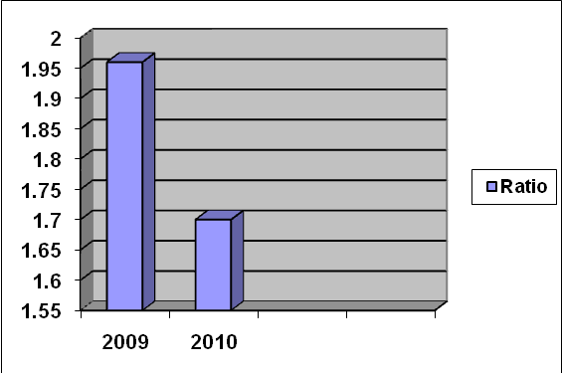

Figure: 1.1
The current ratio is 1:1 then it can be interpreted as insufficiently liquid. Because current ratio measures only total taka worth of current liabilities. The current assets may decline its value then the ability to pay liability will be threatening in case of 1:1 current ratio.

The current ratio of City General Insurance Co. Ltd Are 1.96 and 1.70 of the last two years of 2009, 2010 respectively. Which can be interpreted to be insufficiently liquid and not satisfactory.

b. Quick / Acid Ratio:

Cash, Marketable Securities & Receivable / Current Liabilities
Year | Calculation | Ratio
2009 | 20,165,827 / 26,409,510 | 0.76 %
2010 | 23,134,702 /29,006.599 | 0.80 %
Table: 1.2

b. Quick / Acid Ratio:
Year | Ratio
2009 | 0.76
2010 | 0.80
Table: 1.2

Quick Ratio of the City general Insurance co. ltd
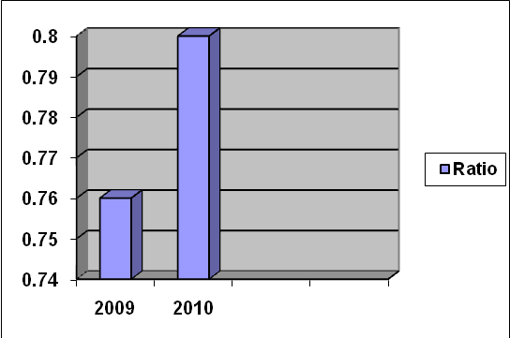

Figure: 1.2

The quick / acid test ratio of the City General Insurance Co. Ltd. Are 0.76, 0.80 of the last two years of 2009, 2010 respectively. Which can be interpreted to be insufficiently liquid and not satisfactory.

c. Current Cash Debt Coverage Ratio:

Net Cash provided by operating Activities /Average Current Liabilities
Year | Calculation | Ratio
2009 | 2,901,949 /18,905,005 | 0.15 %
2010 | 28,488,151 /27,708,055 | 1.03 %
Table: 1.3

c. Current Cash Debt Coverage Ratio:
Year | Ratio
2009 | 0.15
2010 | 1.03
Table: 1.3

Current cash debt coverage Ratio of the City general Insurance co. ltd

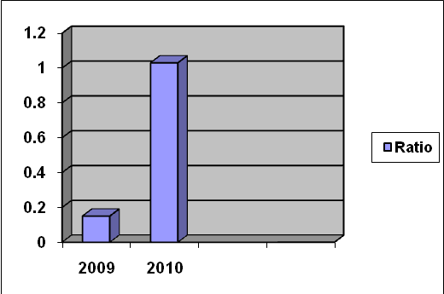

Figure: 1.3
Current cash debt coverage ratio of City General Insurance Co. Ltd. Are 0.15, 1.03 of the last two years of 2009, 2010 respectively. Which can be interpreted to be insufficiently liquid and not satisfactory.

Comment on Liquidity Ratios:
The liquidity position of the company is not satisfactory due to the fact that their receivable management and specially, inventory management is not satisfactory.
Though the current ratio, quick ratio, current cash debt coverage ratio are not satisfactory and the year of some satisfactory current ratio of 2009 and quick ratio, current cash debt coverage ratio of the year 2010.

2. Activity Ratio

d. Receivable turnover

Net sales /Average Trade Receivable
Year | Calculation | Ratio
2009 | 12,843,908/16,004,918 | 0.80 %
2010 | 16,3018,073/21,650,265 | 0.75 %
Table: 1.4

d. Receivable turnover

Year | Ratio
2009 | 0.80
2010 | 0.75
Table: 1.4

Receivable turnover Ratio of the City general Insurance co. ltd
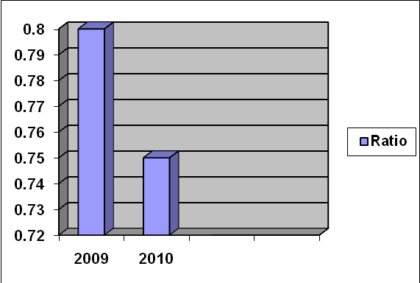

Figure: 1.4
Receivable turnover ratio of City General Insurance Co. Ltd. Are 0.80, 0.75 of the last two years of 2009, 2010 respectively. Which can be interpreted to be insufficiently liquid and not satisfactory.

e. Assets Turnover

Net Sales /Average Total Assets
Year | Calculation | Ratio
2009 | 12,843,908 / 205,513,833 | 0.06
2010 | 16,318,073 / 261,011,869 | 0.06
Table: 1.5
- Assets Turnover
Year | Ratio
2009 | 0.06
2010 | 0.06

Table: 1.5

Assets turnover Ratio of the City general Insurance co. ltd
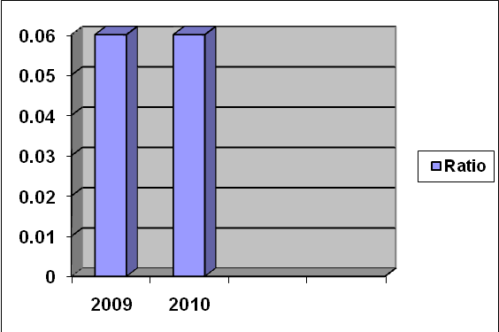

Figure: 1.5
Assets turnover ratio of City General Insurance Co. Ltd. Are 0.06, 0.06 of the last two years of 2009, 2010 respectively. Which can be interpreted to be insufficiently liquid and not satisfactory.

Comment on Activity Ratio:
The receivable turnover ratio is somewhat satisfactory in the year of 2009 is satisfactory. Asset turnover same of the not satisfactory of the year 2009, 2010
The current assets management is deplorable due to very bad inventory management liberal credit policy. So Assets Management position of the City General Insurance Co. Ltd. Is not efficient.

2. Profitability

f. Profit Margin on Sales

Net Income / Net Sales
Year | Calculation | Ratio
2009 | 15,988,902/12,843,908 | 1.24 %
2010 | 26,818,369/16,318,073 | 1.64 %
Table: 1.6

f. Profit Margin on Sales
Year | Ratio
2009 | 1.24
2010 | 1.64
Table: 1.6

Profit margin on sales Ratio of the City general Insurance co. ltd
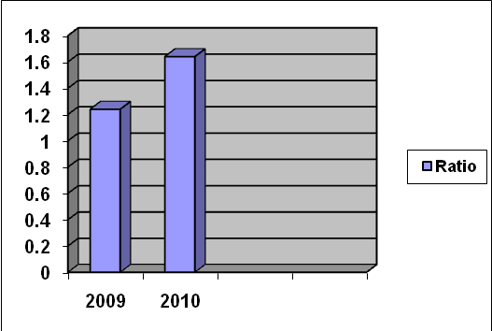

Figure: 1.6
The gross profit Margin Ratio of the City General Insurance Co. Ltd. Are 1.24, 1.64 of the last two years 2009, 2010 respectively.

The gross profit Margin Ratio of the City General Insurance Co. Ltd. Is somewhat satisfactory and in the year of 2010 ratio is higher. Some satisfactory of the year 2009
g. Rate of Return on Assets

Net Income / Average TotalAssets
Year | Calculation | Ratio
2009 | 15,988,902/205,513,833 | 0.08 %
2010 | 26,818,369/261011869 | 0.10 %
Table: 1.7

g. Rate of Return on Assets
Year | Ratio
2009 | 0.08
2010 | 0.10
Table: 1.7

Rate of return on assets Ratio of the City general Insurance co. ltd
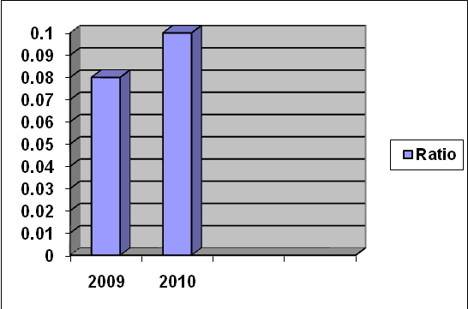

Figure: 1.7

The Rate of Return on Assets of the City General Insurance Co. Ltd. Are 1.24, 1.64 of the last two years 2009, 2010 respectively. Which can be interpreted to be insufficiently liquid and not satisfactory.

Comment on Profitability Ratio:
The profitability position of the City general Insurance Co. Ltd. Is somewhat satisfactory the profit margin on sales of the year 2010 and Rate of Return of Assets not satisfactory of the year 2009 &2010

3. Earning Per Share = 2009 ---7.33 TK
2010--- 13.08 TK

3. Earning Per Share

Year | Taka
2009 | 7.33
2010 | 13.08
Table: 1.8

Earning per share of the City general Insurance co. ltd
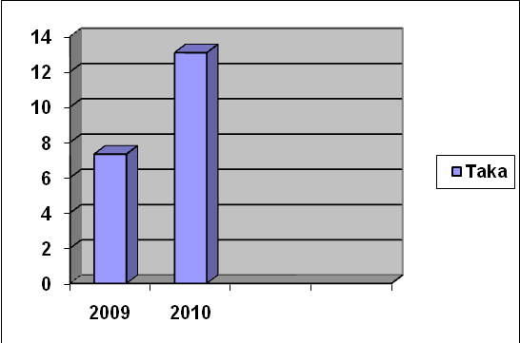

Figure: 1.8
The Earning per share of the City General Insurance Co. Ltd. Are 7.33, 13.08 of the last two years 2009, 2010 respectively.

In the year of 2010 the earning per share is higher i.e. 13.08 Taka than the other year and here is mentionable that the earning per share of the year 2009 is only Taka 7.33. Though
City General Insurance Co. Ltd. Is a riskier company but its Earning per share (EPS) is higher due to more use of debt capital.

4. Coverage Ratio:
h. Debt to Total Assets

Total Debt / Total Assets
Year | Calculation | Ratio
2009 | 67,084,429/249,939,353 | 0.27 %
2010 | 219,611,092/272,084,385 | 0.81 %
Table: 1.9

h. Debt to Total Assets
Year | Ratio
2009 | 0.27
2010 | 0.81
Table: 1.9

Debt to total assets Ratio of the City general Insurance co. ltd 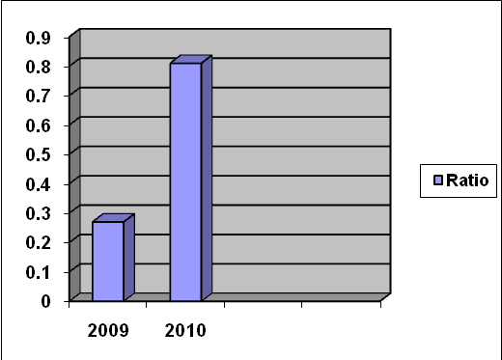

Figure: 1.9

Debt to Total Assets of the City General Insurance Co. Ltd. Are 0.27, 0.81 of the last two years 2009, 2010 respectively. Which can be interpreted to be insufficiently liquid and not satisfactory

I. Cash Debt Coverage Ratio

Net Cash Provided by Operating Activates / Average Total Liabilities
Year | Calculation | Ratio
2009 | 2,901,949/54,234,269 | 0.05%
2010 | 28,488,151/55,186,381 | 0.52 %
Table: 1.10

I. Cash Debt Coverage Ratio
Year | Ratio
2009 | 0.05
2010 | 0.52
Table: 1.10

Cash debt coverage Ratio of the City general Insurance co. ltd
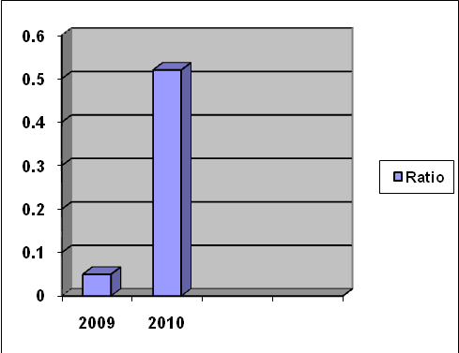

Figure: 1.10

Cash debt coverage ratio of the City General Insurance Co. Ltd. Are 0.05, 0.52 of the last two years 2009, 2010 respectively. Which can be interpreted to be insufficiently liquid and not satisfactory

Comment on Coverage Ratio:
The coverage ratio somewhat satisfactory debt to total assets and cash debt coverage ratio in the year of 2009 and not satisfactory in the year of 2010.

PIONEER INSURANCE COMPANY LTD.

1. Liquidity Ratio:

a. Current Ratio

Current Assets / Current Liabilities
Year | Calculation | Ratio
2009 | 500,542,223 /259,467,142 | 1.93%
2010 | 462,493,608 / 199,626,870 | 2.32%
Table: 2.1

a. Current Ratios:
Year | Ratio
2009 | 1.93
2010 | 2.32
Table: 2.1
Current Ratio of the Pioneer Insurance co. ltd
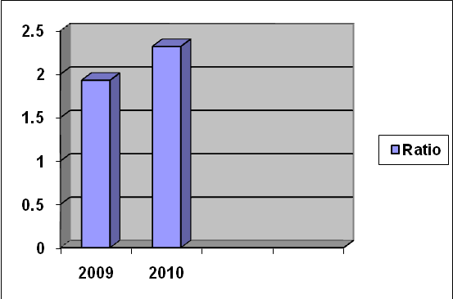

Figure: 2.1
The current ratio is 2:1 then it can be interpreted as insufficiently liquid. Because current ratio measures only total taka worth of current liabilities. The current assets may decline its value then the ability to pay liability will be threatening in case of 2.1 current ratio.

The current ratio of Pioneer Insurance Co. Ltd. Are 1.93 and 2.32 of the last two years of 2009, 2010 respectively. Which can be interpreted to be insufficiently liquid and not satisfactory. Some satisfactory of the year 2010 and this ratio of 2.32.

b. Quick / Acid Ratio:
Cash, Marketable Securities & Receivable / Current Liabilities
Year | Calculation | Ratio
2009 | 173,509,269 / 259,467,142 | 0.67%
2010 | 121,844,167 / 199,626,870 | 0.61%
Table: 2.2

b. Quick / Acid Ratio:
Year | Ratio
2009 | 0.67
2010 | 0.61
Table: 2.2
Quick / acid test Ratio of the Pioneer Insurance co. ltd
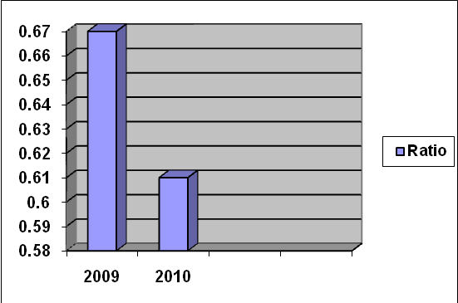

Figure: 2.2

The quick / acid test ratio of the Pioneer Insurance Co. Ltd. Are 0.67, 0.61 of the last two years of 2009, 2010 respectively. Which can be interpreted to be insufficiently liquid and not satisfactory

c. Current Cash Debt Coverage Ratio:

Net Cash provided by operating Activities /Average Current Liabilities
Year | Calculation | Ratio
2009 | 72,903,904 / 252,458,631 | 0.29%
2010 | 72,364,927 / 229,547,006 | 0.35%
Table: 2.3

c. Current Cash Debt Coverage Ratio:
Year | Ratio
2009 | 0.29
2010 | 0.35

Table 2.3
Current Cash Debt Coverage Ratio of the Pioneer Insurance co. ltd
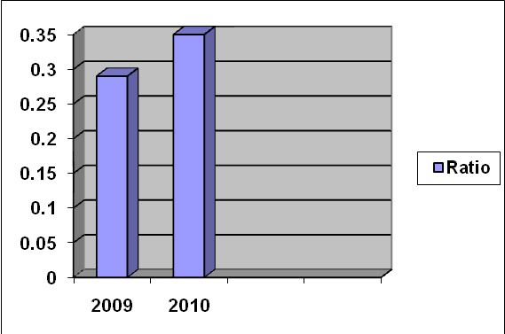

Figure: 2.3
Current cash debt coverage ratio of Pioneer Insurance Co. Ltd. Are 0.29, .35 of the last two years of 2009, 2010 respectively. Which can be interpreted to be insufficiently liquid and not satisfactory.

Comment on Liquidity Ratios:
The liquidity position of the company is not satisfactory due to the fact that their receivable management and specially, inventory management is not satisfactory.
Though the current ratio, quick ratio, current cash debt coverage ratio are not satisfactory and the year of some satisfactory current ratio of 2010 and quick ratio, current cash debt coverage ratio are not satisfactory.

2. Activity Ratio

d. Receivable turnover

Net sales /Average Trade Receivable
Year | Calculation | Ratio
2009 | 24,657,993 / 172,004,794 | 0.14%
2010 | 45,887,210 / 147,676,718 | 0.31%
Table: 2.4
d. Receivable turnover
Year | Ratio
2009 | 0.14
2010 | 0.31
Table: 2.4

Receivable Turnover Ratio of the Pioneer Insurance co. ltd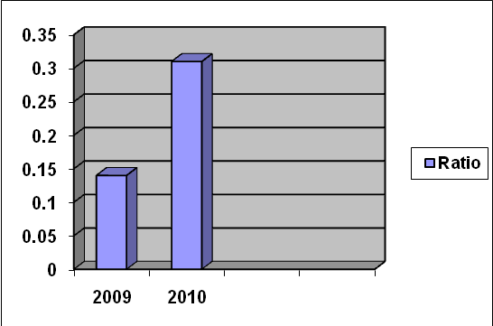

Figure: 2.4
Receivable turnover ratio of Pioneer Insurance Co. Ltd. Are 0.14 0.31 of the last two years of 2009, 2010 respectively. Which can be interpreted to be insufficiently liquid and not satisfactory.

e. Assets Turnover

Net Sales /Average Total Assets
Year | Calculation | Ratio
2009 | 24,657,993 / 626,400,549 | 0.04%
2010 | 45,887,210 / 683,854,050 | 0.07%
Table: 2.5

e. Assets Turnover
Year | Ratio
2009 | 0.04
2010 | 0.07
Table: 2.5

Assets Turnover Ratio of the Pioneer Insurance co. ltd
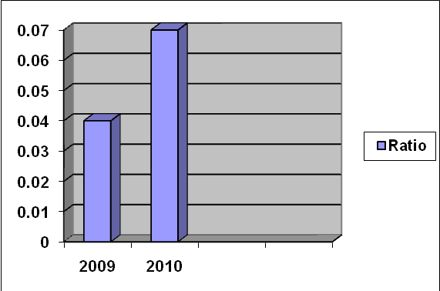

Figure: 2.5

Assets turnover ratio of Pioneer Insurance Co. Ltd. Are 0.04, 0.07 of the last two years of 2009, 2010 respectively. Which can be interpreted to be insufficiently liquid and not satisfactory.

Comment on Activity Ratio:
The receivable turnover ratio is somewhat satisfactory in the year of 2008 is satisfactory. Asset turnover same of the not satisfactory of the year 2009, 2010.
The current assets management is deplorable due to very bad inventory management liberal credit policy. So Assets Management position of the pioneer Insurance Co. Ltd. Is not efficient.

2. Profitability

f. Profit Margin on Sales

Net Income / Net Sales
Year | Calculation | Ratio
2009 | 70,496,925 / 24,657,993 | 2.86%
2010 | 88,985,208 / 45,887,210 | 1.94%
Table: 2.6

f. Profit Margin on Sales
Year | Ratio
2009 | 2.86
2010 | 1.94
Table: 2.6

Profit Margin on Sales of the Pioneer Insurance co. ltd
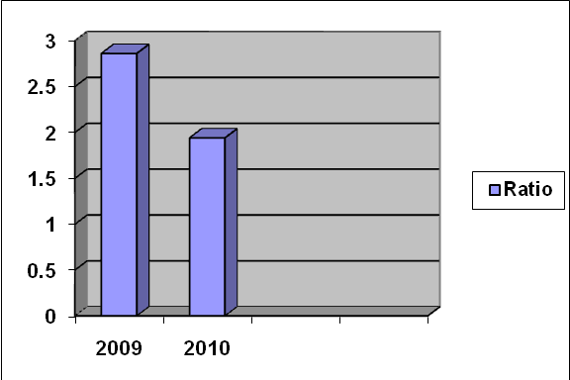

Figure: 2.6
The gross profit Margin Ratio of the Pioneer Insurance Co. Ltd. Are 2.86, 1.94 of the last two years 2009, 2010 respectively.The gross profit Margin Ratio of the Pioneer Insurance Co. Ltd. Is somewhat satisfactory and in the year of 2009 ratio is higher. Some satisfactory of the year 2009

g. Rate of Return on Assets

Net Income / Average Total Assets
Year | Calculation | Ratio
2009 | 70,496,925 / 626,400,549 | 0.11%
2010 | 88,985,208 / 683,854,050 | 0.13%
Table: 2.7

g. Rate of Return on Assets
Year | Ratio
2009 | 0.11
2010 | 0.13
Table: 2.7

Rate of Return on Assets Ratio of the Pioneer Insurance co. ltd
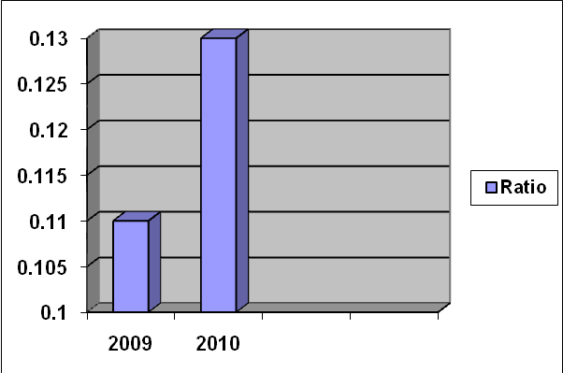

Figure: 2.7

The Rate of Return on Assets of the Pioneer Insurance Co. Ltd. Are 0.11, 0.13 of the last two years 2009, 2010 respectively. Which can be interpreted to be insufficiently liquid and not satisfactory.

Comment on Profitability Ratio:
The profitability position of the Pioneer Insurance Co. Ltd. Is somewhat satisfactory the profit margin on sales of the year 2007 and Rate of Return of Assets not satisfactory of the year 2009 & 2010.

3. Earning Per Share = 2009 --- 55.10 Tk
2010 ---- 62053 Tk

3. Earning Per Share
Year | Taka
2009 | 5.10
2010 | 62.53
Table: 2.8

Earning Per Share of the Pioneer Insurance co. ltd
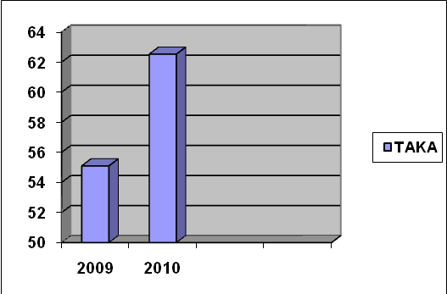

Figure: 2.8
The Earning per share of the Pioneer Insurance Co. Ltd. Are 5.10, 62.53 of the last two years 2009, 2010 respectively.
In the year of 2010 the earning per share is higher i.e. 62.53 Taka than the other year and here is mentionable that the earning per share of the year 2009 is only Taka 5.10. Though
Pioneer Insurance Co. Ltd. Is a riskier company but its Earning per share (EPS) is higher due to more use of debt capital.
4. Coverage Ratio:

h. Debt to Total Assets

Total Debt / Total Assets
Year | Calculation | Ratio
2009 | 414,102,002 / 677,030,867 | 0.61%
2010 | 394,763,159 / 690,677,232 | 0.57%
Table: 2.9

h. Debt to Total Assets
Year | Ratio
2009 | 0.61
2010 | 0.57
Table: 2.9

Coverage Ratio of the Pioneer Insurance co. ltd
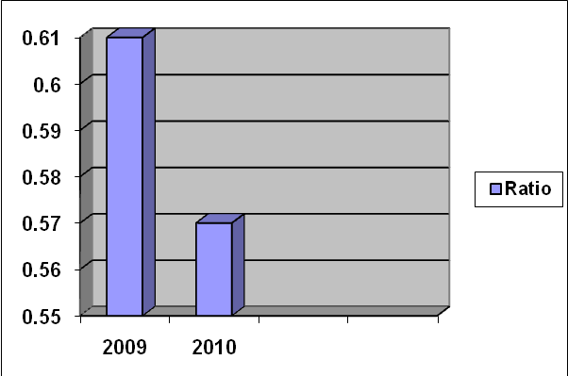

Figure: 2.9

Debt to Total Assets of the Pioneer Insurance Co. Ltd. Are 0.61, 0.57 of the last two years 2009, 2010 respectively. Which can be interpreted to be insufficiently liquid and not satisfactory. Some satisfactory of the year 2009.

I. Cash Debt Coverage Ratio

Net Cash Provided by Operating Activates / Average Total Liabilities
Year | Calculation | Ratio
2009 | 72,903,904 / 150,582,875 | 0.48%
2010 | 79,364,927 /174,885,574 | 0.45%
Table: 2.10

I. Cash Debt Coverage Ratio
Year | Ratio
2009 | 0.48
2010 | 0.45
Table: 2.10

Cash Debt Coverage Ratio of the Pioneer Insurance co. ltd
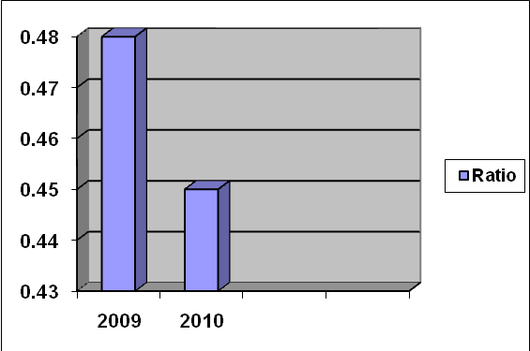

Figure: 2.10
Cash debt coverage ratio of the Pioneer Insurance Co. Ltd. Are 0.48, 0.45 of the last two years 2009, 2010 respectively. Which can be interpreted to be insufficiently liquid and not satisfactory

Comment on Coverage Ratio:
The coverage ratio somewhat satisfactory debt to total assets and cash debt coverage ratio in the year of 2009 and not satisfactory in the year of 2010.

UNITED INSURANCE COMPANY LTD.

1. Liquidity Ratio:

a. Current Ratio

Current Assets / Current Liabilities
Year | Calculation | Ratio
2009 | 257,639,813/32,067,254 | 8.03%
2010 | 553,835,022/91,399,665 | 6.06%
Table: 4.1
a. Current Ratio
Year | Ratio
2009 | 8.03
2010 | 6.06
Table: 4.1
Liquidity Ratio of the United Insurance co. ltd
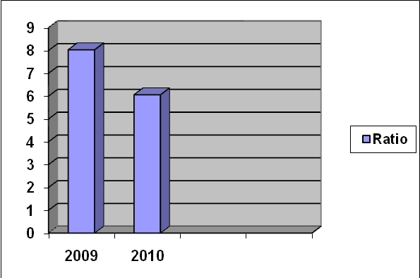

Figure: 4.1
The current ratio is 4:1 then it can be interpreted as insufficiently liquid. Because current ratio measures only total taka worth of current liabilities. The current assets may decline its value then the ability to pay liability will be threatening in case of 4.1 current ratio.

The current ratio of United Insurance Co. Ltd. Are 8.03 and 6.06 of the last two years of 2009, 2010 respectively. Which can be interpreted to be insufficiently liquid and not satisfactory. Some satisfactory of the year 2009, 2010

b. Quick / Acid Ratio:
Cash, Marketable Securities & Receivable / Current Liabilities
Year | Calculation | Ratio
2007 | 18,077,973/32,067,254 | 0.56%
2008 | 21,159,604/91,399,665 | 0.23%
Table: 4.2

b. Quick / Acid Ratio:
Year | Ratio
2009 | 0.56
2010 | 0.23
Table: 4.2

Quick / Acid Ratio of the United Insurance co. ltd
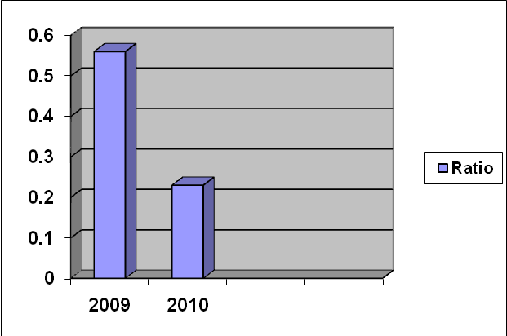

Figure: 4.2
The quick / acid test ratio of the United Insurance Co. Ltd. Are 0.56, 0.23 of the last two years of 2009, 2010 respectively. Which can be interpreted to be insufficiently liquid and not satisfactory

- Current Cash Debt Coverage Ratio:

Net Cash provided by operating Activities /Average Current Liabilities
Year | Calculation | Ratio
2009 | 61,073,137/30,317,261 | 2.01%
2010 | 10,761,860/61,733,459 | 0.17%
Table: 4.3

c. Current Cash Debt Coverage Ratio
Year | Ratio
2009 | 2.03
2010 | 0.17
Table: 4.3

Current Cash Debt Coverage Ratio of the United Insurance co. ltd
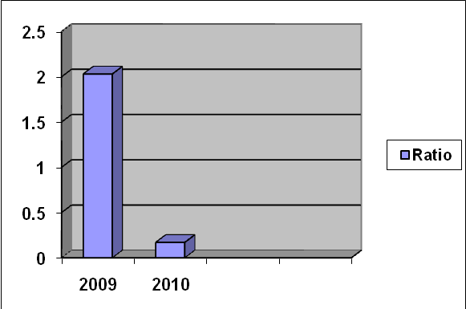

Figure: 4.3
Current cash debt coverage ratio of United Insurance Co. Ltd. Are 0.203, 0.17 of the last two years of 2009, 2010 respectively. Which can be interpreted to be insufficiently liquid and not satisfactory and some satisfactory of the year 2007 ratio of 2.03.

Comment on Liquidity Ratios:

The liquidity position of the company is not satisfactory due to the fact that their receivable management and specially, inventory management is not satisfactory.
Though the current ratio, quick ratio, current cash debt coverage ratio are not satisfactory and the year of some satisfactory current ratio of 2009, 2010 and current cash debt coverage ratio 2009 and quick ratio are not satisfactory.

2. Activity Ratio

- Receivable turnover

Net sales /Average Trade Receivable
Year | Calculation | Ratio
2009 | 90,966,570/16,572,469 | 5.49%
2010 | 334,057,290/19,618,789 | 17.03%
Table: 4.4

- Receivable turnover

Year | Ratio
2009 | 5.49
2010 | 17.03
Table: 4.4

Receivable turnover of the United Insurance co. ltd
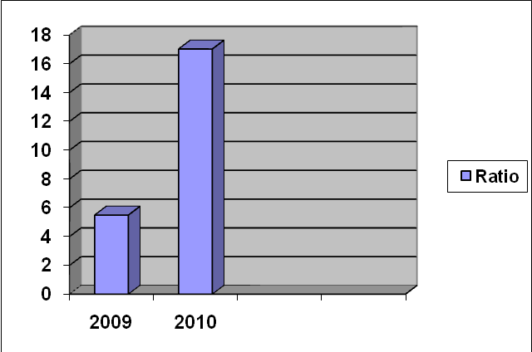

Figure: 4.4
Receivable turnover ratio of United Insurance Co. Ltd. Are 5.49, 17.03 of the last two years of 2009, 2010 respectively. Which can be interpreted to be insufficiently liquid and not satisfactory but satisfactory of the year 2008, this ratio 17.03

e. Assets Turnover

Net Sales /Average Total Assets
Year | Calculation | Ratio
2009 | 90,966,570/381,442,004 | 0.24%
2010 | 334,057,290/592,321,501 | 0.56%
Table: 4.5

e. Assets Turnover
Year | Ratio
2009 | 0.24
2010 | 0.56
Table: 4.5
Assets Turnover Ratio of the United Insurance co. ltd
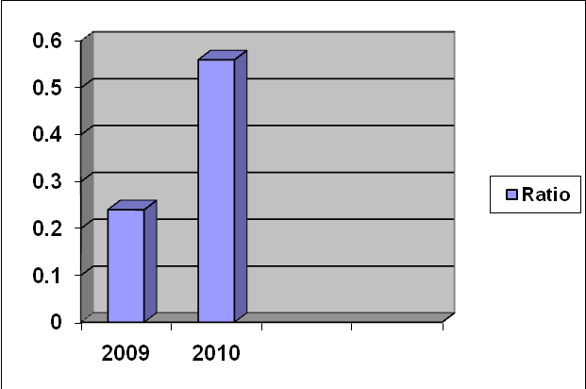

Figure: 4.5
Assets turnover ratio of United Insurance Co. Ltd. Are 0.24, 0.56 of the last two years of 2009, 2010 respectively. Which can be interpreted to be insufficiently liquid and not satisfactory.

Comment on Activity Ratio:
The receivable turnover and Asset turnover ratio is somewhat satisfactory in the year of 2008. Asset turnover and receivable turnover not satisfactory of the year 2007
The current assets management is deplorable due to very bad inventory management liberal credit policy. So Assets Management position of the United Insurance Co. Ltd Is not efficient

2. Profitability

f. Profit Margin on Sales

Net Income / Net Sales
Year | Calculation | Ratio
2009 | 32,026,351/90,966,570 | 0.35%
2010 | 373,180,223/334,057,290 | 1.12%
Table: 4.6

f. Profit Margin on Sales
Year | Ratio
2009 | 0.35
2010 | 1.12
Table: 4.6

Profit Margin on Sales Ratio of the United Insurance co. ltd
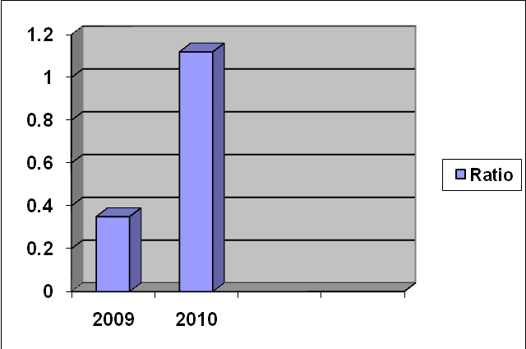

Figure: 4.6
The gross profit Margin Ratio of the United Insurance Co. Ltd. Are 0.35, 1.12 of the last two years 2009, 2010 respectively.
The gross profit Margin Ratio of the United Insurance Co. Ltd. Is somewhat satisfactory and in the year of 2010 ratio is higher. Some satisfactory of the year 2009

g. Rate of Return on Assets
Net Income / Average Total Assets
Year | Calculation | Ratio
2009 | 32,026,351/381,442,004 | 0.08%
2010 | 373,180,223/592,321,501 | 0.63%
Table: 4.7

g. Rate of Return on Assets
Year | Ratio
2009 | 0.08
2010 | 0.63
Table: 4.7

Rate of Return on Assets Ratio of the United Insurance co. ltd
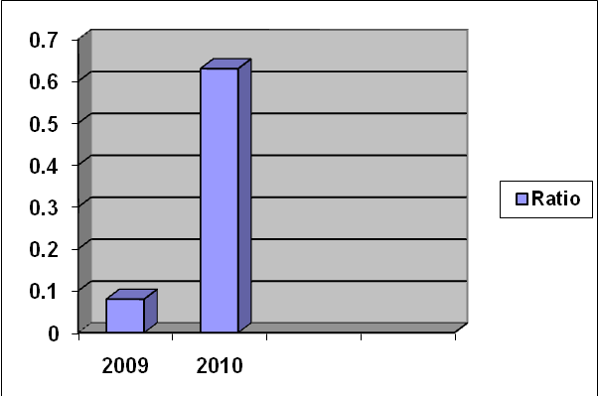

Figure: 4.7
The Rate of Return on Assets of the United Insurance Co. Ltd. Are 0.08, 0.63 of the last two years 2010 respectively and 2009 not respectively. Which can be interpreted to be insufficiently liquid and not satisfactory.

Comment on Profitability Ratio:
The profitability position of the United Insurance Co. Ltd. Is somewhat satisfactory the profit margin on sales & Rate of Return of Assets of the year 2010 and Rate of Return of Assets& profit margin on sales not satisfactory of the year 2009.
3. Earning Per Share = 2009 --- 25.53 Tk
2010 ----313.18 Tk
Table: 4.8

3. Earning Per Share

Year | TAKA
2009 | 25.53
2010 | 313.18

Table: 4.8

Earning Per Share of the United Insurance co. ltd
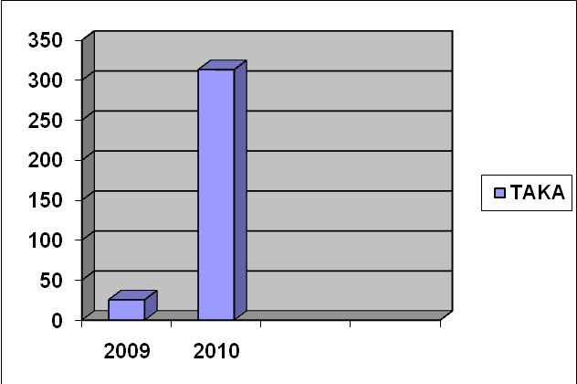s

Figure: 4.8

The Earning per share of the United Insurance Co. Ltd. Are 25.53, 313.18 of the last two years 2009, 2010 respectively.

In the year of 2010 the earning per share is higher i.e. 313.18 Taka than the other year and here is mentionable that the earning per share of the year 2009 is only Taka 25.53. Though United Insurance Co. Ltd. Is a riskier company but its Earning per share (EPS) is higher due to more use of debt capital.

4. Coverage Ratio:

h. Debt to Total Assets

Total Debt / Total Assets
Year | Calculation | Ratio
2009 | 173,025,952/55,881,081 | 3.09%
2010 | 215,196,254/770,414,520 | 0.28%
Table: 4.9
h. Debt to Total Assets
Year | Ratio
2009 | 3.09
2010 | 0.28
Table: 4.9

Debt to Total Assets Ratio of the United Insurance co. ltd
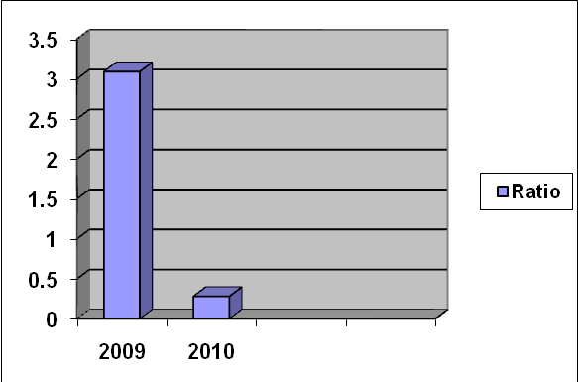

Figure: 4.9
Debt to Total Assets of the United Insurance Co. Ltd Are 3.09, 0.28 of the last two years 2009, 2010 respectively. Which can be interpreted to be insufficiently liquid and not satisfactory and some satisfactory of the year 2009

I. Cash Debt Coverage Ratio
Net Cash Provided by Operating Activates / Average Total Liabilities
Year | Calculation | Ratio
2009 | 61,073,137/153,783,307 | 0.40%
2010 | 10,761,860/194,106,481 | 0.06%
Table: 4.10 SOURCE: Annual Report 2009&2010

I. Cash Debt Coverage Ratio
Year | Ratio
2009 | 0.40
2010 | 0.06
Table: 4.10

Cash Debt Coverage Ratio of the United Insurance co. ltd
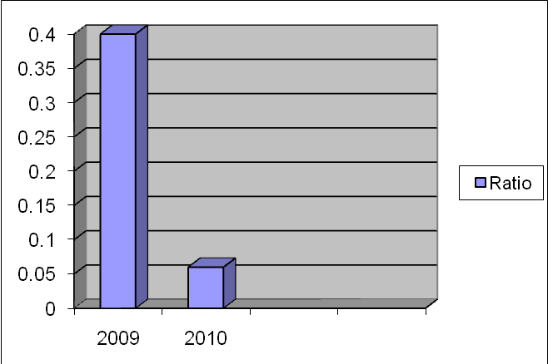

Figure: 4.10
Cash debt coverage ratio of the United Insurance Co. Ltd Are 0.40, 0.06 of the last two years 2009, 2010 respectively. Which can be interpreted to be insufficiently liquid and not satisfactory.

Comment on Coverage Ratio:

The coverage ratio somewhat satisfactory debt to total assets and cash debt coverage ratio not satisfactory in the year of 2009, 2010

Chapter-04

ALTMAN’S
FINANCIAL SOUNDNESS ANALYSIS

This section will focus on:

4.1 Theoretical Aspect of Z Score

4.2 Calculation of Z Score of Insurance Company Ltd.
Analysis and Interpretation of Financial Z Score model of . INSURANCE COMPANY

Altman’s Model

Z Score:

The z-score model is a linear analysis in that five measures are objectively weighted and summed up to arrive at an overalls core that than becomes the basic for classification of firms into one of the a priori grouping.

The final discriminate function is as followed:

The z-score model for public industrial companies is:Z=1.2X1+1.4X2+3.3X3+.6X4+1.0X5.
The z-score model for private industrial companies is:Z=6.56X1+3.26X2+6.72X3+1.05X4.
Where
X1=Working capital/total asset
X2=Retained earning/total asset
X3=EBIT/ total asset
X4=Market value of equity/total liability
X5=Sales/ total asset
A healthy public company has a Z>2.99,it is in the gray zone if 1.81<Z<2.99,it is unhealthy if it has a Z<1.81.
A healthy private company has a Z>2.60,it is in the gray zone if 1.1<Z<2.59,it is unhealthy if it has a Z<1.1.

Calculation Z Score for Measuring Performance.

City General Insurance Company Ltd
Discriminate Functions are bellow:

Title | 2009 | 2010
Working capital | 25444419 | 20421331
Retained earning | 2901949 | 28488151
EBIT | 15988902 | 26818369
Sales | 12843908 | 163018073
Total asset | 249939353 | 272084385

For 2009

As City General Insurance Company Ltd. is a private company so the value of
Z =6.56X1+3.26X2+6.72X3+1.05X4
=6.56*0.101+3.26 *.011+6.72*0.063+1-05*0.051
=1.17

Comment
A healthy private company has a Z>2.60,it is in the gray zone if 1.1<Z<2.59,it is unhealthy if it has a Z<1.1.As 1.1<1.17<2.59. So it is gray zone.

For 2010

As City General Insurance Company Ltd. is a private company so the value of Z=6.56X1+3.26X2+6.72X3+1.05X4
=6.56*0.075+3.26*.104+6.72*0.098+1.05*0.599
=2.11

Comment
A healthy private company has a Z>2.60,it is in the gray zone if 1.1<Z<2.59,it is unhealthy if it has a Z<1.1.As 1.1<2.11<2.59. So it is gray zone.

PIONEER INSURANCE COMPANY LTD.
Discriminate Functions are bellow:
Title | 2009 | 2010
Working capital | 241075081 | 262866798
Retained earning | 72903904 | 79364927
EBIT | 70496925 | 88985208
Sales | 24657993 | 45887210
Total asset | 677030867 | 690677232

For 2009

As Pioneer Insurance Company Ltd. is a private company so the value of Z=6.56X1+3.26X2+6.72X3+1.05X4
=6.56*.356+3.26*.107+6.72*.104+1.05*.036
=3.41

Comment
A healthy private company has a Z>2.60,it is in the gray zone if 1.1<Z<2.59,it is unhealthy if it has a Z<1.1.As 3.41>2.60, So it is Healthy.

For 2010

As Pioneer Insurance Company Ltd. is a private company so the value of Z=6.56X1+3.26X2+6.72X3+1.05X4
=6.56*.380+3.26*.018+6.72*.128+1.05*.066
=3.47

Comment
A healthy private company has a Z>2.60,it is in the gray zone if 1.1<Z<2.59,it is unhealthy if it has a Z<1.1.As 3.47>2.60, So it is Healthy.

UNITED INSURANCE COMPANY LTD.

Discriminate Functions are bellow:
Title | 2009 | 2010
Working capital | 225572559 | 462435357
Retained earning | 61073137 | 10761860
EBIT | 32026351 | 373180223
Sales | 90966570 | 334057290
Total asset | 55881081 | 770414520

For 2009

As United Insurance Company Ltd. is a private company so the value of Z=6.56X1+3.26X2+6.72X3+1.05X4
=6.56*4.03+.326*1.09+6.72*.573+1.05*1.62
=35.53

Comment
A healthy private company has a Z>2.60,it is in the gray zone if 1.1<Z<2.59,it is unhealthy if it has a Z<1.1.As 35.53>2.60, So it is Healthy.

For 2010

As Pioneer Insurance Company Ltd. is a private company so the value of Z=6.56X1+3.26X2+6.72X3+1.05X4
=6.56*.60+3.26*.013+6.72*.484+1.05*.043
=7.32

Comment
A healthy private company has a Z>2.60,it is in the gray zone if 1.1<Z<2.59,it is unhealthy if it has a Z<1.1.As 7.32>2.60, So it is Healthy.

Chapter-05

Problems, Recommendation,
& CONCLUSION

This section will focus on

5.1 Conclusion

Conclusion

Thus we can say there are lots of applications of financial analysis in the modern days of business. To assess any business condition financial analyses give a clear financial picture of any business organization. Which helps to evaluate the trend and condition of that organization.

From small to big business organization financial analysis helps a great deal in decision making process. As it helps to give idea about the financial condition, thus it helps in future financial projection and decision making process of any business house.

Eventually one can assess how important is financial analysis in the modern days of business. It gives the exact picture of the financial condition and helps future projection of any organization.

