IN PLANT TRAINING REPORT

BEXIMCO PHARMACEUTICALS LIMITED

Submitted by

WWW.ASSIGNMENTPOINT.COM

Beximco today is a symbol- a state of health, happiness and quality of life. But its journey to the growth and prosperity has been no bed of roses. BPL’s history is one of innovation and adventure, of risks taken and bold decisions made towards a noble purpose-building a healthier tomorrow where citizens like us can live longer, happier, and better.

Beximco Pharmaceuticals Ltd. or BPL, the leading pharmaceutical company of
Bangladesh and a member of the BEXIMCO Group was founded in 1976. Since then it has been producing produces pharmaceutical specialties of uncompromising quality in its several world-class pharmaceutical production units following current Good Manufacturing Practice (cGMP) as required by the World Health Organization (WHO).

Beximco Pharmaceuticals Ltd. has products of different therapeutic classes, each of which occupies a prominent position in the market and the heart of people. Life seems static without Napa and Neoceptin, the prime products of BPL. More than 10% of country’s total medicine need is supplied by Beximco Pharma where separate solid production unit and Liquid/Cream/Ointment Production unit manufactures comprehensive range of formulations, which come in tablet, capsule, powder, liquid, cream, suppository, nasal spray and others covering all the major therapeutic groups.

The factory at Auspara, Tongi, Gazipur comprises mainly of seven departments which are
- HRD (Human Resource Department)
- PPIC (Production Planning & Inventory Control)
- Warehouse
- Production
- Quality Assurance and Control Department
- Engineering Department
- Accounts, Finance and Informatics etc.
In each and every department of this plant all the personnel work very hard to produce products of the best quality and the least price. This is why Beximco has acquired a crown of success in such a short period.

Aims of In-Plant training:

To complete graduation we have to pursue several courses of Pharmacy for a period of four years in our university. We study a lot of subjects on various essential matters, but can not relate their implications in pharmaceutical industries. So our main objective behind taking this in-plant training is:-

- To actually see how a pharmaceutical company runs and understand all the processes, equipment, regulations and controls involved in the production of every kind of dosage form.
- To feel how different departments are interlinked and to understand the role, functions and responsibilities of each department in the factory.
- To update ourselves with modern and sophisticated machineries, dosage forms, and concepts.
- To practically see the application of GMP or cGMP in the plant.
- To learn about various trouble shooting in manufacturing being performed first hand
- To bring anew forgotten concepts

16.06.09 : Introduction to the plant

On the first day of our training we arrived at BPL factory, Tongi on 7:45 am and the security supervisor at the reception informed the HR department of our arrival. At 9:00 am we were taken inside to a conference room and there we met the head of HR.

Mr. Sharif introduced himself, saw our papers and then handed us a training schedule which contained the date and time on which training at a particular department will take place and to whom the students should report each day.

He mentioned the dress-code for office and gave a brief idea of Human Resource Department of Beximco Pharma. From him we understood that, BPL human resource is guided by the principle “Investing on human capital maximizes the potential of financial and commercial assets”. To achieve the full potential of its commercial and financial assets Beximco Pharma comprises of a number of young and highly motivated executives who reflect a diversity of background, experience and perspective. Their skills and intellect for capitalizing on emerging market opportunities and evolving customer needs, a bias for innovation and creativity, an appetite for prudent risk taking, and a strong sense of what needs to be done to grow and strengthen the business are key components in the successful implementation of Beximco Pharma’s sound business strategy.

Besides other important functions one of the major tasks of HR department of BPL is to prepare & arrange In-plant training program for students of different universities.

From time to time the HR head corresponds with the trainee students and takes notice of their progress. If any problem is faced during the length of training the HR head is informed and he handles it. He also notes down their daily attendance.

Major functions of HR department includes:-

- Recruitment of personnel, maintain & update personnel files
- Co-ordinate & monitor ‘Performance Appraisal’ of plant employees
- To assess the training needs of the personnel in light with the cGMP& other related HRD issues and arrange ‘induction training program’ for new employees.
- Ensure proper implementation of labor laws applicable to factory workers & employees.
- Implement Disciplinary actions, including suspensions, punishment & termination, when required.
- Maintain liaison with Government Regulatory bodies
- Ensure safety of all employee & company assets
- Monitor leaves of plant employees
- Handle external visitors & arrange all necessary uniforms & other accessories
- Supervise transport pool (distribution, repair, maintenance), canteen management & food arrangement

17.06.09: Production planning

On the very next day we came to know the basics of Production Planning. Every production or manufacturing company should follow a complete and precise production plan in order to ensure sound and uninterrupted production of medicine. The production planning department in BPL is concerned with the synchronization of the availability of the raw and packaging materials with man power, machine capacity, and time of delivery of the product depending on the market demand .

Functions of production planning department:-

Issue of BPR and BMR- Batch Packaging Record (BPR) and Batch Manufacturing Record (BMR) is issued every month by the planning department according to the production plan. If any change is required planning will consult with product development for its correction. The product standard is always maintained even in case of short batch but then batch size is reduced. So a single BPR/BMR is issued by production planning department that is for one time use only.

Maintain the monthly plan- A monthly plan is based on the demand of the market and according to it production planning department suggest production department to manufacture the product.

Ensure the availability of raw and packaging materials- : Production planning department also arranges for the delivery of all types of raw and packing materials by consulting with head office so that production runs smoothly.

Arrange physician’s sample:-Production department will separate physician’s samples from bulk production following the instructions of panning department. . In this case, samples are prepared at least one month prior to dispensing and are dispensed in catch corners. From manufacturing to packaging, PPD have to pay extra concern for this type of sample.

Arrange products for International market:- PPD will arrange and supply the products to the global market. After receiving information via email, they take necessary actions to meet that demand for export purpose.

Co-ordinate all sections: - Planning department co-ordinates all sections to give the highest production at minimum cost and time.

Compare man hour and achievements:- This is done to know the actual efficiency of man and machine.

Submission of monthly report:- PPD submits monthly production report to ED, Works for analysis at the end of each month.

Keep daily production reports & other important documents:- PPD preserves every paper deals of any products including acceptance/ rejection paper of raw and packaging materials, order paper, delivery report, invoices, BMR etc.

18.06.09: Warehouse

On the third day of our training we went to visit the BPL warehouse. We found that the chief difference between a normal warehouse and a pharmaceutical warehouse is that the latter stores raw material, packaging material and finished goods for human consumption and sorequire specified preservation techniques, place of storage, temperature, atmosphere, humidity etc. A BPL warehouse with about 1300 types of packaging materials and 500 types of raw materials has strictly maintained SOPs and is strongly guided by GMP.

The different areas we saw in the warehouse are:

Quarantine area: After receiving raw and packaging materials are kept here for QA approval
QC sampling area: This basically consists of sampling booths where the environment (temperature, humidity and pressure) is strictly controlled and the sampling is done by QC officer under laminar air flow and HEPA filter
Released area: QC approved raw and packaging materials are generally stored in the central place of warehouse with great safety and controlled temperature and controlled humidity.
Rejected area: QC rejected raw materials, packaging materials and finished goods are stored here with great care. The rejected area is located at one corner of the warehouse in a separate room, where entry is strictly regulated
In–process area: Materials dispensed for manufacturing are kept in this area.
Finished products area: Fully competed and ready-for- use products are stored here until delivery.
Special area: Area or room for storing heat and light sensitive materials like colors, vitamins, poisonous materials and flammable materials. There are 3 cold rooms (temperature below 25º).

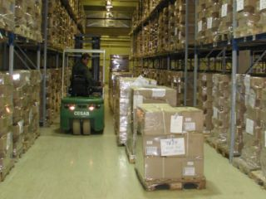
Fig 1: Portion of a warehouse
Two types of job is found in a typical warehouse
- Routine Jobs
- Periodic Jobs

Routine jobs of warehouse personnel involves:-

- Receiving and unloading the materials (raw & packaging) at receiving bay.
- Making the containers completely dust-free on arrival
- Matching the invoice with the containers received and checking them for any visible signs of damage
- Weighing the containers and verifying the invoice
- Officially receiving the materials and preparing the MRR (material receiving report)
- Informing the QC department and assisting the QC department personnel with sampling
- Appropriately labeling the containers with sample, quarantine, release or reject tags
- Placing the containers in the in-process area of warehouse so that it is ready for issue and can be sent to the production department
- Ensuring the containers are dispensed in an appropriate manner and on a FIFO (First-In-First-Out) basis
- Monitoring the inventory levels of each material stored in the warehouse
- Ensuring that the finished products are dispatched with the required documentation

Periodic jobs of warehouse personnel involves:-

- Export-The ware house is responsible for obtaining Export Permission (EP) order for products that are to be exported. It is also considered as the final check point where the containers are weighed and matched with the invoices before exporting so that any discrepancies can be discovered
- Pricing: Incase of a change in price the warehouse is responsible for obtaining approvals from customs. The appropriate documents are sent with samples of the product.
- To carry out efficient recall of a product when and if required and in the established procedure.
- Audits: To successfully face an audit, it is necessary for the warehouse to maintain the logbooks (for weighing, cleaning, temperature, sampling booth, daily calibrations, etc) as a proof that SOPs are followed within the warehouse premises.
- Inventory management: The BPL warehouse is responsible for continuously updating its inventory. The total inventory of materials is checked periodically and quantities of materials are either written on or off depending on whether it is excess or short respectively.
Labeling

We found the cascade labeling of materials in the warehouse most interesting. There are four kinds of labels.
Quarantine: Materials which has been received but are still not been sampled by the QC department are labelled with this sticker. It is usually yellow in color
Sample: Materials which are undergoing sampling by the QC dept. are labelled with this sticker over the Quarantine one
Released: Materials which proved satisfactory by the QC tests are then labelled with this sticker. The released sticker is stuck on such a way over the sampled one that the Sampling information is not visible. . It is usually green in color
Reject: If any material fails in the QC tests then it is labelled with a reject sticker. It is usually red in color.
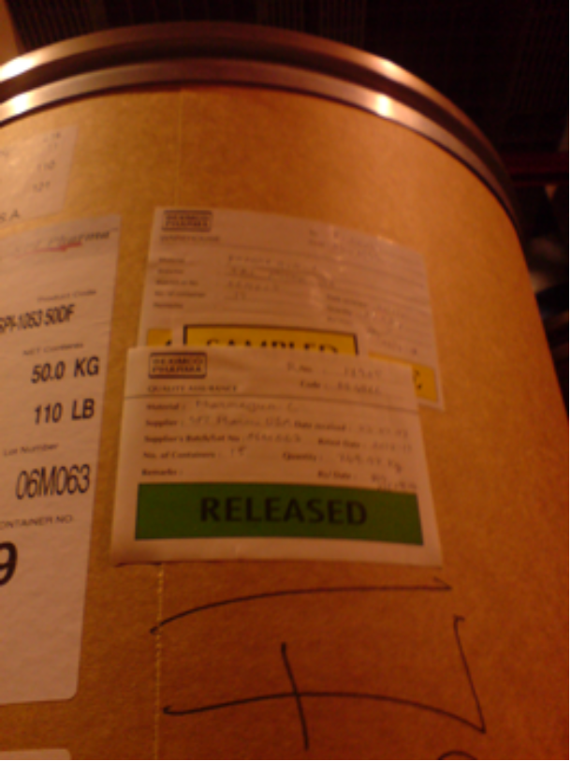
Fig 2: Cascade labeling

Terminology:

Sampling: The process of taking a small portion from a lot for test and analysis to show the quality of the whole lot. The purpose of sampling and subsequent testing is to provide an effective check on the quality of the product or substances being processed.
Sampling quantity: Sampling quantity should be the double of one complete test.
Lot: A batch or number of batches in a consignment.
Batch: A quantity of the product or material that is processed in one run following manufacturing USP.
Campaign: A campaign means no. of batches manufactured without any interruption or product change.
Handling: The term handling means checking according to invoice/ challan and other documents during receiving of the materials.
Preservation: It means the materials are stored in different conditions according to its nature of stability i.e. to maintain a specific temperature and relative humidity.
Dispensing: It means the materials are supplied to the production areas by weighing according to the proper document and release it from the RM store.
Quarantine: The term quarantine means the materials is not ready for use and it is under test after receiving. So a quarantine label is attached to the container.
FIFO: The term FIFO stands for First in First Out.
Re-Test: The term re-test means the samples are needed to be repeated analysis for identification according to previous documentation and it has to be done either 3/6/12 months.

Materials sampling plan:

The material sampling plan is done on the basis of FIFO system i.e. First in First Out. For active ingredients, every container and for excipient, (√n+1) containers are sampled (where n = total no. of the containers.)

Miscellaneous

- To keep warehouse free from rats and insect traps and pesticides bare used respectively
- To protect the materials from dust double-door system is used
- Raw and packaging materials are easily identified by index which has different code for different area
- Packaging material are stacked according to alphabetical order

Beximco Pharmaceutical Ltd has two other similar warehouses, one in Pharmatech and another in the infusion department.

21.06.09 and 22.06.09: Product Development

After the weekend we made a 2-days visit to the Product Development department of Beximco. There Suronjit Sir was kind enough to explain the role of PD.

The basic functions of Product Development department are:-
- Formulation of a new product
- Reformulation of exiting product
- Troubleshooting related to manufacturing
- Export related work
- Documentation

Product development flow sheet:

Selection of new product for product development

Preformulation study

Prototype/formulation feasibility trial batch

Analytical method development and preparation of STP

Pre-scale up batch and stability batch

Scale up batch

Stability study

Preparation of stability study report

Determination of product shelf life

Determination of product data sheet

Preparation of BMR and BPR

Pilot cum commercial batch production

Preformulation study:
Preformulation study of the active ingredient and excipient includes
- Chemical activity
- Solubility
- Particle size
- Compatibility
- Boiling point, melting point
- Moisture content
- Safety etc
Formulation feasibility:
After submitting of recipe to drugs administration that contains the following
a) Pharmacological part
- Strength
- Dosage form
- Contraindication
- Indication
- Description
- Precaution
- Side effect
- M.R.P
- Indication
b) Technical part
- Batch formula
- Manufacturing instructions
- Control data
Through trial-and-error method many formulations are checked and counter checked to find one that fits economically and technologically. This process to discover the most suitable formulation is Formulation feasibility.

Analytical method development and preparation of STP:

The active drug and the excipients and the final product must undergo a chain of analytical tests which would confirm their identity, purity, stability and other related parameters so according to USP,BP or for a completely new product methods of analysis are designed and developed and a standard test procedure is prepared and followed.

An analytical assay method validation report contains
- Product name
- Strength
- Protocol no.
- Method no.
- Issue date
- Date of next revision

Some confusing terms:

Pre-scale up batch: Batch size considering the minimum machine capacity of the production department preferably 10 times larger than the trial batch.
Scale up batch: If the pre-scale up batch is not enough to meet the demand then 10 times bigger batch is produced
Stability batch: The batch which undergoes stability testing at temperature and humidity mentioned in the protocol.
Pilot batch: The stability batch which is not discarded but marketed with a commercial batch.
Commercial batch: The batch which is manufactured according to market demand finally.

A stability test report contains
- Description
- Identification
- Weight
- Assay
- Microbiological test

Determination of product shelf-life:
There is two kind of stability testing
Real time with temperature 30⁰c+2 and relative humidity 65%+5
Accelerated stability with temperature 40⁰c+2 and relative humidity 75%+5
A product is kept for 1, 3, 6, 9,12, 24 months in the stability test chamber and if it is alright for 1 year in real time and 6 months in accelerated then 2 years expiry date can be given.

A stability study report has the following columns

Raw material | Specification | Batch no. | % | Quantity/  unit dose | Quantity  /batch | Weighed by | Checked  by

Product data sheet:
The following are found in a product data sheet
Product name: Label claim:
Pack size: Batch size:
DAR no.: Date:
Batch weight: Product code:
Revision no.

ID Code | Name of material to be used | Speci  fication | Unit of measure | Overage | Qty per tablet | Qty per batch
Raw material
Active
Excipient
 | Enteric coating material
Colour coating material
Polishing material
Packaging material
Primary
Secondary

BMR preparation:

- A BMR usually contains the following information
- Equipments
- Dispensing of raw materials/Manufacturing formula
- Receiving of dispensed raw material
- Manufacturing process
- Deviation record
- Production certification

Reformulation of exiting product:

To
a) Increase the quality of the product.
b) Prevent any type of problem existing in the product.
c) To save time and cost.
d) To increase patient acceptance.
Existing formulations are rearranged e.g changing a flavour or adding another vehicle or increasing/ decreasing the quantity of the active or additives.

Instrumentation of the PD Department:
Formulation Section
- Stirrer
- Electronic balance (with balance )
- Tap density tester (USP)
- High Speed Mixer Granulator
- Fluid Bed Dryer
- Multimill
- Moisture Analyzer
- Compression machine (16 stations)
- Film coating machine
- Watson pump
- Friability Tester
- Humidity control Oven
(For accelerated stability test : Temp.:40ºC, RH:65%)
- Humidity Control Oven
(For intermediate stability test: Temp.:30ºC,RH:65%)

Anaytical section:

- Erweka Double Station Disintegration
- Erweka Dissolution tester
- Shimadzu HPLC (Auto Injector UV-Vis Detector)
- Shimadzu HPLC (Auto Injector Diode Array Detector)
- Hanna Ph meter
- Membrane filter (0.45 micron)
7. Newtronic stability oven
8. Memmert oven
9. Sonicator

23.06.09 and 24.06.09: Solid Dosage Formulation

After completing the product development department we had a 2-days tour of the solid production unit. In Beximco it is the biggest unit from which comes 70% of the total turnover per year.
It is basically divided into
Solid Unit

Manufacturing area Packaging area

Granulation Compression Coating Encapsulation Blister Strip Powder Bottle
unit unit unit unit filling filling

Manufacturing Area:

The three common methods to make tablets are
- Wet granulation
- Dry granulation
- Direct compression

Granulation Unit | Miller | Granulator (Mixer) | Dryer | Capacity | Vaccum | Product observed
01 | GANSONS Multi-mill (India) | GANSONS Planetary Mixer  (India) | SAPPHIRE Fluidized bed Dryer | 60 kg | BELLE VILLE Vac-U-Max (U.S.A) | --------
02 | GANSONS Multi-mill (India) | GANSONS Planetary Mixer  (India) | SOLACE Fluidized bed Dryer | 120 kg | BELLE VILLE Vac-U-Max (U.S.A) | Tofen  tablet
03 |  | HSMG (High speed mixer Granulator) | SAPPHIRE Fluidized bed Dryer | 150 kg |  | Napa Extra
04 | GANSONS Multi-mill (India) | HSMG  Vietnam | SOLACE Fluidized bed Dryer | 250 kg | BELLE VILLE Vac-U-Max (U.S.A) | Napa Extra

Flow chart of wet granulation:

Raw materials weighing Blending Wet mass Drying Milling

Packing Coating Compression Blending Sieving

Wet granulation procedure for Napa extra:
Step 1: Granulating solution is prepared with povidone and water in a SS vessel
Step 2: Paracetamol and caffeine, pregelatinized starch, sodium starch glycolate, magnesium stearate, stearic acid is passed through 28 mesh and blended in high speed mixer and granulator.
Step 3: Granulating solution is added to dry blend for wet blending.
Step 4: The blend is semi dried in Fluid Bed Drier
Step 6: Semi dried granules is passed through multi-mill fitted with 9.35mm screen
Step 7: The dried granules are passed through multi-mill fitted with 2.4mm screen and transferred into Tote-bin
Step 8: LOD of crushed granules are checked.

Flow chart of dry granulation:

Raw materials weighing Dry mixing in V-blend Compaction by roller
compaction
Sieving Milling Slugging

Final mixing (lubrication) Compression

Flow chart of direct compression:

Raw materials weighing Drying Crushing Sieving

Packing Coating Compression Blending

Compression area:

1. Compression unit # 1:
Name of the machine: MANESTY
Model of the punch: D type
Name of the producer: MANESTY Machineries Ltd. Liverpool, England.
No of stations: 16
Capacity: 1500 tablets/hour
This is very old model tablet compression machine but it is the first machine by which Beximco started.

2. Compression unit # 2:
Name of the machine: MANESTY
Model of the punch: B type
Name of the producer: MANESTY Machineries Ltd. Liverpool, England.
No. of stations: 35
Capacity: 240000tablets /hour

3. Compression unit # 3:
Name of the machine: MANESTY
Model of the punch: B type
Name of the producer: MANESTY Machineries Ltd. Liverpool, England.
No. of stations: 35
Capacity: 240000 tablets /hour

4. Compression unit # 4:
Name of the machine: Fette-1200
Model of the punch: BB type
Name of the producer: Germany
No. of stations: 30
Capacity: 220000 tablets /hour

5. Compression unit # 5:
Name of the machine: Fette-3100
Model of the punch: BB type
Name of the producer: Germany
No. of stations: 55
Capacity: 594000 tablets / hour

6. Compression unit # 6:
Name of the machine: MANESTY
Model of the punch: B type
Name of the producer: MANESTY Machineries Ltd. Liverpool, England.
No. of stations: 35
Capacity: 70000 tablets / hour

7. Compression unit #7:
Name of the machine: SEJONG
Model of the punch: B type
Name of the producer: South Korea
No. of stations: 45
Capacity: 494000 tablets /hour

Coating area:
Coating is mainly done to improve product elegance; to mask unpleasant taste,odour; to control drug release from tablet; to provide physical and chemical protection.

Coatings usually done in solid section are:

Coating

Sugar coating Film coating Enteric coating

Aqueous coating Organic coating

Steps of Aqueous FILM coating:
Core Drying

Spray of Coating Solution at specific pan speed, temperature and pump speed

Polishing

Steps of Sugar coating:
Core drying

Seal coating (Opagloss NA 7150)

Sub coating
(Coating materials: Acacia, gelatin, talc, titanium oxide, sugar)

Colouring
(Colourting materials: Opulux As-22937[yellow],purified water , sugar)

Polishing
(e.g. Polishing materials: Opagloss-6000[white])
Machines used for coating:

Unit | Machine name | Origin | Capacity (Kg) | No.of guns
1 | Manesty Accela Cota 150 | England | 150 | 2
2 | Manesty Accela Cota 350 A | England | 350 | 2
3 | Manesty Accela Cota 350 B | England | 350 | 2
4 | Sejong Pharmatech  (Sugar coating) | Korea | 350 | 2

Capsule Filling Unit:
There is a highly sophisticated capsule-filling machine in the solid department of BPL. During capsule filling, room temperature and humidity (<40%) must be strictly controlled, because capsule shells are highly sensitive to moisture as well as some drugs (e.g. Ranitidine). Even though, after filling of capsules by mainly granules or pellets, finished capsules are transferred from the filling room to the packaging room by plastic drums that are covered by silica gel that acts as moisture absorbent.

Name of the machine | Source | Stations | Feature
Automatic Capsule Filling Machine  MG-2  (MG Futura) | Italy | 16 | Max. 50000  Capsules/hr

Capsule manufacturing procedure:

Sieving of raw material Mixing Compaction

Blister pack Polishing Blister pack

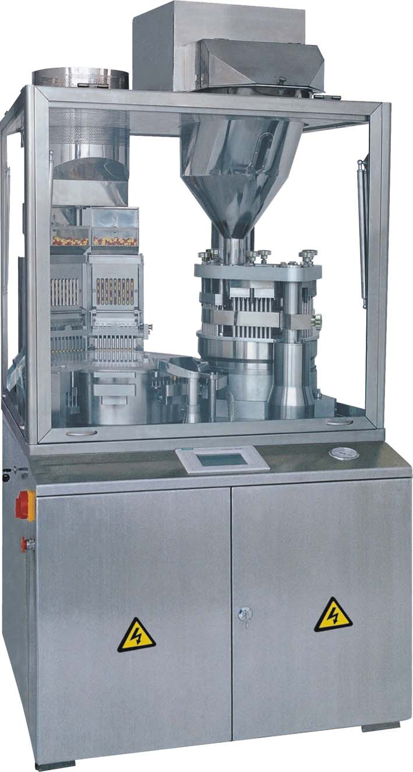
Fig 3: Capsule filing machine
Packaging Area:

Packaging can be defined as an economical means of providing presentation, protection, identification / information, containment, convenience, and compliance for a product during storage, carriage, display and use until the product is used or administered.

Types of Packaging:
1. Blister Packaging
2. Strip Packaging

Primary packaging materials:
    - ALU- ALU types
    - ALU- PVC type
    - ALU - PVDC type

Secondary Packaging Materials are:
- Inner carton
- Leaflet

Blister Packaging Area:

Packaging Unit | Machine | Supplier/Manufacturer
Blister 085 | Klockner Hansel | Germany
Blister 042 | Otto-Hansel | Germany
Blister 043 | Otto-Hansel | Germany
Blister 074 | Klockner -Hansel | Germany
Blister Elmac | Elmac | India
Blister Pampac | Pampac | India
Blister Hoong A | Hoong A | Korea

Strip Packaging Area:

Strip Packaging | Gansons Strip Packaging machine-1 | India
Strip Packaging | Hamson Strip Packaging machine-2 | India

Problems that may arise during packaging are :

- Empty pocket
- No pocket
- Damage of tablet/capsule
- Printing mistake
- Unclear printing
Blister packaging:
Foil soften by hot plate
Temp. 125-145°C

Heating plate
PVC sheet

Passed through desired dies plate which is kept
Cold & air pressure is applied to make pocket for small time & desired shape is resulted (air pressure 6-8 bar)

Alu-alu foil with properly labeled

Tablets or capsules are filled into the pockets
Pressed by two plates simultaneously (upper plate temp. 160-180°C for PVC & lower plate is cold

Passed through cutter
Desired blister pack

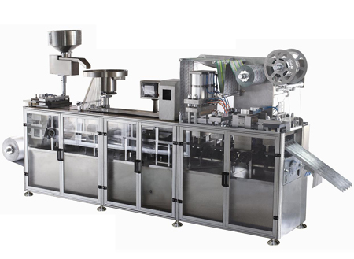

Fig 4: Blister packaging machine

Strip packaging:

Tablets or capsules in hopper
Tablets/capsules in vibrating disc
Enter through tode channel
Pressing
Hot roller having particular dies shape
Tablets or capsules enter between two alu roll strips

Strip packaging
Poly-coated alu rolls (coated with plastic materials) come from two sides

Printing Area:

To print:
- Batch No.
- Mfg. date
- Expiry date

Printing machine:

Machine Name | Origin
Semi-automatic Printing machines-  1,2,3 | China
KK & KK-2 Printing machine  (Automatic) | Taiwan

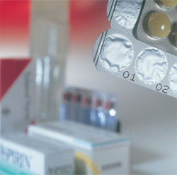
Fig 5: Primary and secondary packaging
25.06.09 and 28.06.09: Liquid dosage formulation

As we visited the LCO unit we found that Liquid manufacturing department of Beximco Pharmaceuticals Limited (BPL) is an important part of the production department. This liquid department mainly manufactures various types of syrups, suspensions, pediatric drops, nasal spray, cream, ointment, gels and suppositories etc. The numbers of liquid products that are manufactured in the LCO department of BPL are 85.
Areas:
- Line1- Non antacid syrup & suspension manufacturing area.
- Line 2- Antacid suspension manufacturing area.
- Line 3- Small volume preparation or nasal spray manufacturing area.
- Line 4- Cream, ointment & gel manufacturing area.
- OLSF- Oral Liquid Suppository Facility

Production of syrup :
Manufacturing

Filtration

Storage

Bottle filling

Sealing

Labelling

Packaging
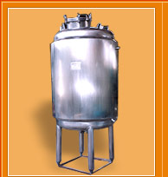
Fig 6: Mixing vessel
Production of Antacid suspension:

Manufacturing

Storage

Bottle filling Packaging

Sealing Labeling

Production of cream:
Gansons planetary mixer,
Oil phase
Seitz kettle,
Water phase

Stirring with inbuilt stirrer
Stirring with inbuilt stirrer

Oil phase is added to the water phase

Stirring with silverson stirrer

Cooling with water flow inside stainless steel jacket for 3 hr

Grinding with colloid mill
Filling

Packing

Production of ointment:
Base (which is liquefied by heat)

Addition of Active ingredient

Homogenization (75-80⁰c)

Congealing (below 40⁰c)

Milling

Storage Filling Packing

Production of suppository:
Manufacturing Vessel Melting Cooling (40⁰C)

Manufacturing vessel tank Sieving with 60 mesh screen Addition of active

Filling Congealing (20-21⁰C) Sealing and batch coding
15 minutes
Packing Cutting
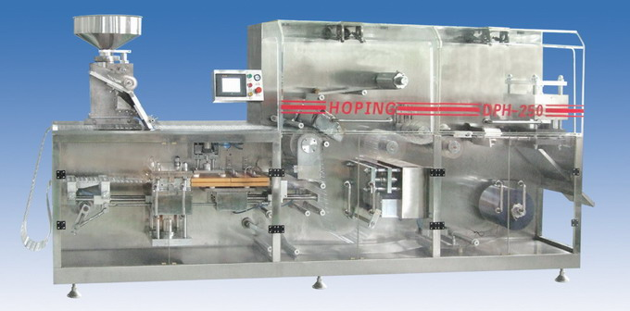
Fig 7: Suppository filling and sealing machine
Line1, Line 2, Line 3:

Name | Capacity
1.Manufacturing vessel | 3000L & 5000L
2.Storage vessel & agitator | 3000l & 5000L
3.Inline mixer & transfer pump | 400L , 440 psi
4.Millipore filtering machine | 5000L/hr
5. Vessel with fluid agitator | 1000L
6.Bottle filling machine  ( Automatic liquid filling & sealing machine) | 85-100 bottles/min
7.Labelling machine
Name | Capacity
8.Cap sealing machine | 28-32 bottles/min
9.Self adhesive labeling machine | 110bottles/min
10.Fluid Agitator | 250rpm
11.Liquid Transfer Pump | 1000L/hr
12. Liquid mixer | 450L
13.Liquid Filling Machine | 30-35 bottles/min
14.Laminar Air Flow Cabinet (used to control bacteria in the filling area)
15.Filtering machine | 1000L/hr

Line 04: Cream, Ointment & Gel production Area

Name | Capacity
1.Planetary mixer | 70L
2.Colloid mill | 250Kg/hr
3.General purpose mixing machine | 100L
4.Automatic tube filling & sealing machine | 25-55 tube/min

Line 05: Suppository Unit

Name | Capacity
1.Manufacturing Vessel | 100L
2.Filling & Sealing machine | 5000suppo./hr
3.Leak Test Apparatus | -
4.Weight balance machine | Max.1500gm Min. 0.01gm

Line 06: Oral Liquid Line
Only syrup of 50 ml, 60ml & 100 ml

Name | Capacity
1.Manufacturing Vessel | 5000L
2.Storage Vessel & Agitator | 5000L
3.Milipore Filter | 5000L/hr.
4.Auto filling , sealing machine (8 stations) | 6000 bottles/hr.
5.Bottle washing & labeling machine | 102 bottles/min.

Over Printing Area:

Name | Model | Origin | Capacity
1.Semi-automatic over printing machine | HAPA-L | Switzerland | 4000prints/hr
2.Automatic over printing machine | KK-610 | Taiwan | 4000prints/hr
3.Automatic over printing machine | KK -560 | Taiwan | 4000prints/hr
4.Automatic over printing machine | KK - 550 | Taiwan | 4000prints/hr
5.Semiautomatic printer | SAP-L | Bangladesh | 1500prints/hr
6.Semiautomatic printer | SAP-L | Bangladesh | 1500prints/hr
7.Automatic over printing machine | KK-570 | Taiwan | 4000prints/hr

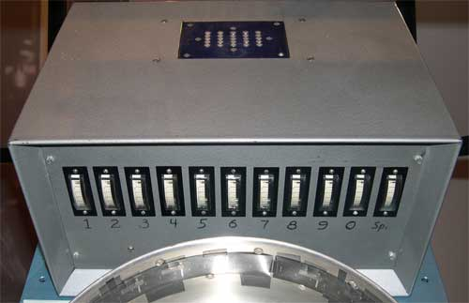
Fig 8: Over printing machine

29.06.09 and 30.06.09: Quality Control Department

At BPL, total quality control refers to the process of producing a perfect product by
a series of measures. BPL’s Q.C. lab is well equipped with most modern and sophisticated equipment and In every step, from the procurement of raw materials to the manufacturing of finished products, the latest World Health Organization (WHO) approved current Good Manufacturing Practices (cGMP) are being followed. There are written Standard Operating Procedures (SOPs) for every process and step involved which are being closely monitored to ensure that all concerned personnel are complying with these procedures.

Diagrammatic representation of present Q.C. activities:

Finished products

Calibration

Q.C
Analytical development & validation
Microbiological testing

Packaging
Documentation & routine analysis

Water & Effluent

Raw materials analysis:

The following parameters are tested for raw materials:
- Name of the Raw material, e.g. paracetamol B.P
- Appearance
- Melting point
- Infrared spectroscopy
- Thin layer chromatography
- Sulphated ash
- Heavy metal
- Assay

Bulk and Finished product analysis:

For the bulk and finished products the following features are tested:
- Appearance
- Identification
- Assay
- Average weight
- Weight uniformity
- Hardness
- Thickness
- Friability
- Disintegration
- Dissolution
- Related substances

Packaging materials Test parameters:

The following parameters are considered for packaging materials:
- Length
- Width
- Height
- Thickness
- GSM (gm/m²)
- Adhesion of ink
- Thickness of polyethylene/ thin film lacquer and aluminum layer
- Identification test of foil
- core (internal) and total diameters
- Appearance
- Text
- Design
- Identification test of PVC and PVDC
- Density of PVC and PVDC
- Mouth diameters (Both internal and external)
- Barcode
- Spike (Pierce) length
- Piercibility test etc.

Sampling of Raw materials:

First of all, there is a SOP for sampling raw materials. Also during sampling the environment is strictly controlled. The complete process of sampling is done under laminar air flow and HEPA filter and the class maintained is B. The temperature is always maintained below 25 ^{O}C while the humidity is never kept above 60%RH.

The following sampling plan is seen to be followed:

Type of RM | Physical  State | Instrument | No. of containers | Points of sample withdraw from a container
API | Solid | Sampling Thief | All | Top, Middle and Bottom
API | Liquid | Pipette | All | Top, Middle and Bottom
Excipients | Solid | Spoon | 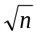+1 | Top, Middle and Bottom
Excipients | Liquid | Pipette |  | Top, Middle and Bottom

Sampling Procedure:
Sampling is done according to SOP. The main steps are as follows:
Material receive

Checking of physical condition of the container

Collection of sample as per sampling plan

Use some for test and some as retention sample

1. Instrument lab:
Instrument lab consists of the following machine: --

Ι. FTIR (Fourier Transform Infrared Spectroscopy):
This machine is used to identification and quantification. Here KBr disk method is used for sampling. This machine is controlled by computer with software; name ‘Prestige-21’ which is developed by SHIMADZU, Japan.

ΙΙ. GC (Gas Chromatography) machine:
This machine is used for the determination of quality and quantity of volatile product.

ΙΙΙ. HPLC (High Performance Liquid Chromatography):
Used for identification of compounds.

The list of machine are given bellow—

Instruments | Company/ Source | Number of Instrument
IR spectrophotometer | SHIMADZU, Japan | 1
Gas chromatography | SHIMADZU, Japan | 2
HPLC machine | Waters, USA | 1
 | SHIMADZU, Japan | 4

2. Chemical Lab:

Chemical lab consists of following equipment:—

Instruments | Company/ Source | Function
Inhaler aero sizer | USA | To determine the particle size of finished product
Karl fischer titration | Menler DL 18, Germany | To determine the amount of moisture in a sample
Dissolution test machine | ERWEKA DT6, Germany | To determine dissolution rate
Potentiometer | Stirrer 72, Switzerland | To determine potency
pH meter | Beckman32 | To determine pH
Melting point apparatus | BUCHI 530 England | To determine the melting point
Magnetic stirrer | B – 211, Germany | To stir
Shaker | Germany | To shake
Viscometer | USA | To determine viscosity
Automatic polarimeter | AP – 100, Japan | To determine optical activity
Microscope |  | To magnify
Disintegration determination machine | SHIMADZU, Japan | To determine disintegration time
Refractrometer |  | To determine refractive index
Degasser | SHIMADZU, Japan | To remove gas
Stamfvolumeter | Karl kobe, STAV 2003 Germany | To determine void space

3. Microbiological Lab:

Microbiology division of QC performs microbiological tests. A microbiological test determines the potency of products as well as the presence or absence of microbes in products of Beximco such as: Flatameal, Lactameal. In these products following microbes will not be allowed-
a) Escherichia coli
b) Pseudomonus aeroginosa
c) Staphylococcus aureus
d) Salmonella sp.

Machines used in microbiology lab:

Instruments | Company/ Source | Function
Incubator | Kotterman – 2736, Japan | For incubation
Autoclave | Mommert – 600, Germany | For sterilization
Laminer air flow | Air Tech, Japan | To create sterile working condition
The lab routinely checks the environment of the different production area. For the environmental inspection following tests are performed-
- Air particle count (D class)
- Microbial count (SWAP test)

Type of Microbes | Incubation temperature (°C) | Incubation Time (days)
Bacteria | 32-35 | 1-2
Fungi | 20-25 | 5-7

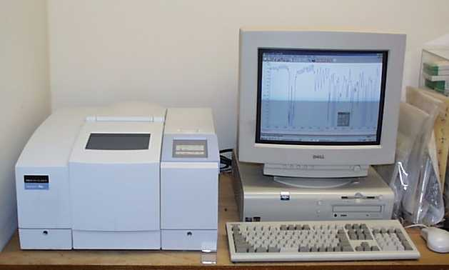

Fig 9: IR spectrophotometer

01.07.09 and 02.07.09: Quality Assurance Department

Quality assurance department is responsible for assuring that the quality policies adopted by a company are followed and in most organization it serves as the contact with regulatory agencies and are the final authority for product acceptance or rejection. BPL’s quality assurance establishes control or checkpoint to finally ensure the quality of the products during production and upon completion of the manufacturing. It starts with raw materials and component testing and includes in- process, packaging, labeling and finished product testing as well as batch auditing

Function of Q.A department:
- IPC: In process control is strictly maintained in different manufacturing departments through Q.A department.
- Validation: Validation of product is being conducted and organized and report prepared by Q.A.
- Documentation: All types of documents are controlled by Q.A.
- Calibration: Calibration of numerous equipments is made under Q.A.
- Standardization: Art works for packing materials is being standardized by Q.A
- Audit: Audit of different departments is conducted by Q.A on schedule basis.
- Vendor rating: To monitor the vendors, rating of vendor is done by Q.A with collaboration of purchase.
- Periodic product review: Product that has been manufactured is being reviewed by Q.A.
- Handling of market complaint: Find the cause and take the corrective measures of complaint product.
- Archives of sample and document: Sample and document are archived in Q.A area.
- Document for export requirements: All kinds of export documents are prepared and sampled by Q.A to IMT with collaboration of PD and Q.C.
- Preparation of COA: All types of COA are prepared by Q.A.
- New product approval: Whenever new product is considered to be launched, Q.A deals all the formalities regarding this purpose.

The function of Q.A. in different section of the industry is given below:
1. Dispensing Area:
# Receiving raw material & packaging material by thorough checking
# Attachment of Quarantine & sampled tag by proper sampling rule
# Released label checked with supplier label
# Checking all the parameters such as
- Name of the product
- Type of the product
- Mfg. date
- Exp. date
- Retest date
- Code no.
- Weight/content etc.

2. Production Area:
# In liquid & Aerosol: Manufacturing and packaging units are unified
- Cleanliness
- Maintenance of BPR and BMR in production
- Initial checking before final large scale production
- Microbiological test are made for antacid, specific creams, Vitamin syrups- all are tested for every batch, but in case of other syrups excluding vitamins, routine check is must.
- Fill weight also observed.
- After packaging-leak test or others
# In solid: Manufacturing and packaging units are separated.
- Cleanliness of the area instrument by physical inspection.
- In process Q.A checked:
- Hardness
- Thickness
- Weight variation
- Friability
- Disintegration time test
3. Packaging Area:
# During packaging QA checked:
- Humidity of the packaging area
- Over printing for labeling is checked and signed
- During blister packaging, pocket formation; sealing; labeling, inner cartoon, leaflet, code check, spoon in case of liquid preparation is made under Q.A
- Appearance of tablet, capsule etc.
- Labeling of stripper & inner & outer cartoon.

Flow chart for quality assurance activity:

Dispensing of raw & packaging materials

Checking of cleanliness,
approval of equipment
& area of manufacturing

In process checking of Sampling of in process
some parameters during product to Q.C.
compression, filling etc
.
#Identification
#Product problem
#Deviation
#Problem monitoring
#Solve the critical problem

IPC of packing operations

Transfer of finished product
for distribution after
collecting the retention sample

Investigation of product complaints, product recall returned products from market

05.07.09 and 06.07.09: Infusion (LVP Formulations)

We were amazed to see BPL’s infusion unit because it is a independent unit of its own and it had its own warehouse, QA and QC department. Infusion is a very sophisticated product where highest purity and quality must be maintained because this is introduced into the patient’s systemic circulation a micro-corruption may lead to death. In Beximco pharmaceuticals the quality and purity of infusion products are maintained strictly. They mainly produce dextrose saline.

The infusion preparation involves two main operations:-
- Preparation of WFI.
- Preparation of solution
Followed by bottle preparation, autoclave & packaging

Different sections of infusions unit:

- Production :
  - Solution Preparation:
  - Injection
  - Molding
  - Bottle Pack Preparation
  - Filling Autoclaving
  - Packaging

- Maintenance & Servicing Unit

- Quality Control Unit
  - Physical Control
  - Chemical Control
  - Microbiological Control

- Quality Assurance Unit
  - Sampling
  - In-process Control
  - Handling Non Conformance

- Utility
  - Water treatment
  - Boiler
  - Chiller
  - Air Compressor

- Warehouse

1. Preparation of WFI:

WFI means water for injection. From the name it is clear that this water is used in injection. So, it is not like normal water but it fulfills some criteria like;
- Totally free from various ions and minerals
- Must be free from pyrogen

Pyrogen is the waste product of microorganism. Pyrogen is destroyed at 450º C temperature. But maintenance of such a high temperature is very difficult. Pyrogen is removed by distillation

Two types of distillation are performed-
- Single column distillation
- Multi column distillation
In Beximco Pharmaceuticals multicolumn distillation process is applied.
The process is performed by the following step—

Step-1: Natural Water Collection:
At first the normal water is collected by deep tube well from the ground core. The pump is 120 feet deep. It is situated at the outside of building. Then the water is supplied to the reservoir by pipe line.

Step-2: Removal of Iron:
Then the water is supplied to the Erosion chamber. Here the water is oxidized from soluble ferrous chloride to insoluble ferric chloride. Then the ferric chloride becomes separable from the water and removed.

Oxidation
FeO Fe₂O₃

Step-3: Chlorination:
Then the water is supplied to the organism water tank. Chlorination is performed by using bleaching powder to destroy the micro-organism.

Step-4: Removal of Bad Odor and Pyrogen:
The water is passed through the activated carbon filter. As it remove dead body microorganism, it also remove the bad odor of the water. Here two types of filter are used;
- Pre-filter with the pore size 1.4μm
- Sterilized filter with the pore size 0.2μm.
The pre-filter is used to protect the main filter. These filters are usable for 15 hours standard active time.

Step-5: Removal of Minerals:
To remove minerals from the water, it is passed through three resin ion exchange columns. The three columns are:
- Anionic column
- Cationic column
- Mixed ion column
Here, cations (Na⁺, K⁺) are exchanged for H+ and anions (Cl⁻, Br⁻, I⁻) are exchanged for OH⁻. A conductometer is attached to the column terminal to determine the amount of ion in water by measuring the conductivity of the water. The more conductivity of water, the more ions present in water.
Now the water is free from minerals. It is called demineralized (DM) water. The DM water is preserved in a reservoir. DM water is used in oral preparation as it is not free from pyrogen.

Step-6: Removal of Pyrogen:
In Beximco Pharmaceuticals water is made free from pyrogen by distillation process. Here four distillation columns are available including DM water reservoir. The water is heated at 150º C Temperature and pure steam is prepared by fitting baffles in the path of vapors between the boiler and the condenser which prevent the entrainment of liquid droplets containing pyrogen. The distillation still or column is made up stainless steel fitted with the baffles. The condenser is also made up stainless steel. The reservoir is heat insulated. The pure steam (free from pyrogen) is converted to water in condenser and preserved in a reservoir at 50oC temperature.

Stap-7: Temperature Minimization:
Before using the WFI, is passed through a heat exchanger to minimize heat. The final temperature of water is 30±5ºC temperatures.

2. Preparation of solution:
The infusion belongs to the larger volume parenteral its manufacturing needs highly controlled, sterile environment.
The various rooms working stations of Beximco Infusion Ltd. have been divided as general area and clean area both of which has got three classes.
They are:

Area | Classification | Location
General | General class – 1/ G – 1 | Warehouse
 | General class – 2/ G – 2
 | General class – 3/ G – 3 | Packaging hall, autoclave area, duty officer rooms and visitor corridor

Class | BIL  Classification | Location | Specification
Class | BIL  Classification | Location | 0.5 µm | 5.0 µm
Clean class | Grade D  (Class 100000) | Personal air lock, material air lock, bottle pack area | 100000 | 700
 | Grade C  (Class 10000) | Injection, molding room, solution preparation room, clean corridor, weighing room | 10000 | 70
 | Grade A  (Class 100) | Under Laminar air flow | 100 | None

The steps of infusion production is given are

A. Dispensing:
The main responsibilities of dispensing are to supply accurate material at accurate quantity. This is approved / controlled by Q.A. department. The dispensing process of Beximco is as follows-
Ware house
↓
Raw material
↓
Supplied for Q.C by Q.A
↓
QC Test
↓
Back to Q.A
↓
If approved then for finally dispense
↓
Material air lock
↓
Weighting room.

B. Manufacturing:
A weekly program is prepared and according to it raw materials are gathered. The manufacturing process is as follows-
Solution preparation room
↓
Solution preparation unit
↓
Cleaning with citric acid weekly
↓
Flushing with DM and distilled water
↓
Sterilization at 120⁰ c, 1.2 bar, for 15 / 30 minutes
↓
Bubble point test to ensure the integrity of sterile filter
↓
Drain the WFI(300 L) taken for bubble test
↓
Collection of WFI for solution preparation, temperature must be 25 to 35⁰c
↓
Pouring the materials when WFI reach 1st propellen
↓
Mixing
↓
Pre-filter (2.5µ)
↓
Final filter (0.2µ)
↓
Re-circulation
↓
Transfer into reservoir tank
↓
Again re-circulation before transferring solution for filling
↓
Solution for filling.

C. Bottle filling:
Bottle is instantly prepared from low density polyethylene granules. Above the temperature 110⁰c the granules are melt and a positive air flow make bottle. Then the bottles are filling with the solution. Then the bottle is sealing and cooling below 20⁰c. The filling area is class-A (100). The sealing cap is a special cap which is air tight even after injection or remove of needle.

D. Autoclaving:
The bottled solution is then sterilized by autoclave. Five trolleys is loaded and placed in autoclave chamber. There they sterilized at 106⁰c with 1.1 bar pressure for 85 minutes. The heat of the entire place in the chamber is not equal. So this chamber is monitored digitally by a computer having specific software for this purpose. The area in the autoclave chamber where the temperature is lowest, samples are collected from there and send for QC test.

F. Packaging:
Before packaging some tests are performed. They are sequentially described below:
Sterilized bottle
Visual inspection
↓
Bottle under pressure belt (0.3-0.5 bar) for leakage test
↓
Extensive visual inspection by passing light through bottle
↓
Attachment of label
↓
Over-bag wrapping for safety
↓
Placed in carton and send to warehouse quarantine area
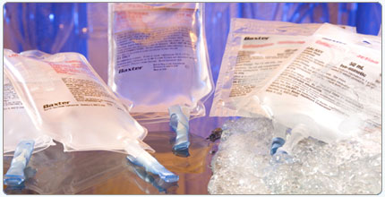
Fig 10: Infusion in bottle pack
Instrumentation of Production Section of Infusion Unit:

1. Injection molding machine
2. Vessel 1&2
Pharmaplan (Germany)
Capacity: 4500lit
3. Vessel 3&4
Getinge (Sweden)
Capacity: 4500lit
4. Bottle packing, filling & sealing machine
5. Autoclave
Getinge (Sweden)
6. Blue batch tester
Used for leakage testing of bottle
7. Pressure conveyor belt
Germany
Pressure: 0.3-0.5 Bar
8. Labeling machine
Avery (Germany)
9. Sealing machine
Impulse auto sealer (Taiwan)
10. Inkjet printer
Jaine 1000 (France)
11. UV –visible recording spectrophotometer
Shimadzu , Japan

Others:
- Polarimeter
- Flame Photometer
- Micro Osmometer
- Electronic Balance
- pH meter QC of infusion unit:

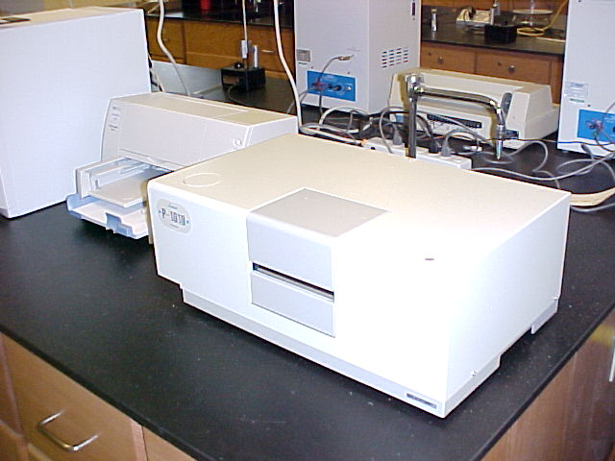
Fig 11: Polarimeter

QC department performs the following tests:

  - Physical test
  - Chemical test
  - Microbiological test

- Physical tests:
--Dimensions of cartons
--Weight of cartons, rubber disc
--Adaptability of cartons over bags

- Chemical tests:

1. For raw materials
a) Characteristics
b) Solubility
c) Identification
d) LOD
e) Optical rotation

2. For packaging materials
a) Tests performed for PVC granules & rubber disc
b) Appearance of solution
c) Density
d) Acidity/alkalinity test

3. For WFI
a) Characteristics
b) pH value
c) Oxidizable substances
d) Heavy metals

4. Finished products
a) Characteristics
b) Identification
c) Particulate materials

- Microbiological tests:

Tests carried out in QC lab. (Microbiology):
1. Microbial limit test of raw & packaging materials.
2. Monitoring of water.
3. Environmental control monitoring of surface for microbial contaminants in manufacturing area.
4. In process control test
5. Test for finished products

- Microbial limit test of raw & packaging material:
1. Total microbial count-
a) Total bacterial count
b) Total fungal count

2. Presence/absence of specific pathogens
a)Staphylococcus aureus
b)Pseudomonus aeruginisa
c) Escherichia coli
d) Clostridium Species
e) Salmonella Species
f)Entarobacteriacea

- Environmental monitoring:
1. Monitoring of surfaces-
a) Contact plate method
b) Swab method
2. Monitoring of air born microorganisms
a) Settle plate method
b) Active air sampling by air sampler
3. Monitoring of personnel

- Test for finished products
1. Sterility test
2. LAL test

- Monitoring of water
--Mainly sample is collected from 12 points daily
--Samples collected from 8 points weekly

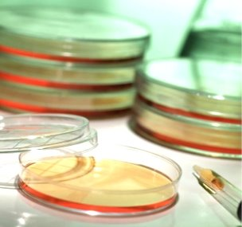
Fig 12: Media for micro-organism culture
07.07.09 : Engineering Services & Utilities

We had the opportunity to visit an important part of any industry i.e the Engineering Department. It is the driving force of the machineries and utilities and without the proper functioning of this department production would come to a stand-still. BEXIMCO Pharmaceuticals Limited has a strong engineering department, which rendering their services to act as a supportive hand for smooth production.

Machineries of this department are of 2 types :
- Production Machineries
- Utilities

Major functions :
  - Maintenance of production machineries
  - Operation & maintenance of utilities machineries
  - Maintenance of QC machineries

Maintenance ca also be of two types:

a) Scheduled/Preventive maintenance:
All the production machineries are checked periodically (weekly, monthly ets) for ensuring efficient operation and minimum breakdown.

b) Breakdown maintenance:
Breakdown maintenance is done when any machine is out of control due to mechanical, electronic or electrical problem.

Engineering department has the following units:

- Power house
- Compressed gas system
- Chiller system
- WFI plant
- DM Water plant
- Central heat, ventilation and air conditioning system (HVAC system)
- Steam generation(boiler) and supplied plant
- Nitrogen Plant

Power house:

BEXIMCO Pharmaceuticals Ltd has an own complete power supply plant, which is considered as the heart of the factory. They do not use PDB electricity. This power plant produces divided into two sectors Low Tension (LT) and High Tension (HT).About 4000kw power produced from LT sector and about 1950kw power produced from HT sector.

The power plant of BEXIMCO Pharmaceuticals consists of the generators below:-

Serial No. | Generator | Capacity
1. | Gas Generator | 0.92 MW
2. | Gas Generator | 0.90 MW
3. | Gas Generator | 0.90MW
4. | Gas Generator | 1.02 MW
5. | Diesel Generator (Stand by) | 0.37 MW

Compressed gas system:

Compressed gas used widely in various production such as blistering as well as cleansing purpose. Four compressors are present in this section to supply moisture
and oil free air.

Name of the compressor | Model | Air flow  (m3/min) | rpm | Operating pressure | Used for | Origin
Comp Air | L45 | 5.93-7.90 | 750-5000 | Max. 13 bar | Solid Track -I | USA
Comp Air | L30-9 | 4.49 | 3000 | 9 bar | Solid Track -I | USA
Comp Air | L 30-9 | 4.49 | 3000 | 9 bar | PTK & L.C.O. | USA
Mehrer | TZW 60 | 3.18 | - | 9 bar | Infusion Plant | USA

Chiller system:

This system is involved for the production of chilled water which is supplied through the pipe to produce air conditioning system BEXIMCO Pharmaceuticals has both compression and absorption type chiller of which one is in new solid and another one is in old solid area.

DM water plant:

BEXIMCO Pharmaceuticals has a well established DM water plant. At first the water is demineralized by reverse osmosis which reduces the mineral contents about 90% and then passed through the ion exchange resin. The advantages of reverse osmosis are-
To decrease regeneration time
To decrease chemical using
To decrease conductance above 90%

Flow chart of water demineralization:

Water

Bleaching dosing

Sand filter

Carbon filter

Water softener

Tank for reservation

Reverse osmosis

Anionic resin

Cationic resin

2.5µ filter

.2µ filter

DM water

Steam generation:

Though BEXIMCO Pharmaceuticals has a boiler unit, it has the capacity to produce 5.5 ton/hr. This capacity of the boiler is due to proper maintenance of the machine.

Name of the machine | Origin | Capacity | Model | Designed Pressure | Working Pressure
Cleaver Brooks Boiler-I | USA | 3136Kg/hr | CIW-700-200-150 | 150psi | 116psi
Cleaver Brooks Boiler-II | USA | 2 Ton/hr | CIW-700-125-150 | 150psi | 115psi

Flow chart of steam production:

Water is softened by removing the Ca2+ and Mg2+ ions

Pre Heated to 80-90 ºC

Supplied into the steam producing vessel

Heated at 100 ºC and at a pressure of 100bar

Saturated steam is produced with temperatures from 180-200 ºC

Supplied to respective area when required
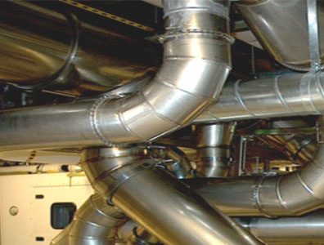
Fig 13: Steam pipes

Liquid Nitrogen Plant:

Liquid Nitrogen is employed in pharmaceutical primarily for packaging purposes as nitrogen by nature is inert and tends to be uncreative towards the APIs used.

Air is passed through compressor

Purifier Unit

Air is passed through cold box which contains
a. carbon unit
b. free expansion unit
c. condensing unit
d. column

Liquid Nitrogen

08.07.09 : Training Department

Finally we learned about the Training Department of BPL One of the agenda of the Human Resources Department is continuous development of the employees so that they can cope with the rapidly changing business environment. Innovation is a major priority that BPL wants to promote. Accordingly,training programs are regularly undertaken for the existing staff to seek opportunities for skills improvement. Beximco pharmaceuticals Ltd. arranges training also for new employees to introduce with job responsibilities and to comply with rules and regulation as well as to make them competent with their respective job in this company.

- Objective of training:
  - Error free operation
  - Fulfillment of regulatory requirements
  - Business purpose

- Purpose of Training:
  - To create skilled persons in BPL
  - To enhance efficacy of all walks of people of BPL

Beximco Provides Two Types Training Generally:
a) In-house Training
b) External Training

Training Procedure:

- Training Need Analysis
- Select “Resource Person”
- Preparing Training Calendar
- Conducting Training session
- Evaluation
- Documentation
- Retraining
Training Type:

- Classroom training
- Audio-visual training
- Interactive training
- On the job training
- Group exercise
Training Applies to:
- Manager
- Officer
- Workman
For new Employees:

- Basic GMP
- Safety Overview
- On the job
- SOP
For Existing Employees:

- GMP
- Safety
- Utility System
- On the job
- SOP
Covered Areas:
- Solid Manufacturing Plant
- Metered Dose Inhaler Plant
- Liquid, Cream, Ointment & Suppositories Plant and Pharmatek Plant
- Antibiotic Formulation Plant
- Infusion unit
- Quality Control Department
- Quality Assurance Department
- Product Development Department
- Production Planning Department
- Engineering Department
- Human Resources Department
Safety
The last but not the least is the safety parameter that we came to know about from the TRACK-II unit of Beximco. There we saw that the management of BPL are continuously thriving to protect the environment and ensure the safety and health of their employees and communities where they operate. It is always monitored that concerned people wear appropriate and designated dresses like gowns, aprons, masks, helmets etc. BPL is very careful in discharging the wastes that are generated from any of its operation. To ensure this, regular environmental monitoring of emissions is being carried out. BPL is continuously striving to minimize adverse impacts on environment and to ensure total environmental protection by minimizing waste generation and improving the monitoring system.

Activities of safety department are as follows:
- Induction of training for safety
- Collection of Material Safety Data Sheet (MSDS)
- Taking preventive action for fire

Fire can be classified as-

- Class A- Involve ordinary combustible material such as wood, paper etc.
- Class B- Involve flammable or combustible liquids & gases such as kerosene common organic solvents etc.
- Class C- Involve live electrical wires & equipments such as motors and appliances etc.
- Class D- Involve combustible metals such as Mg, Na etc.

Types of fire extinguishers are-

- Water is used for Class A fires.
- Dry chemical (multipurpose) extinguishers are used for Class B & C fires.
- Chemical foam extinguishers are used for Class A & Class B fires.
- Sand is used for Class D fires

In case of fire employees are instructed to

- Keep calm
- Use stair -not use lift
- Follow evacuation procedure
- If cloth catches fire roll yourself to the ground

Findings and Analysis:

During our training, the following observations were made

- Firstly in BPL, Standard Operating Procedures (SOPs) developed in accordance with the latest WHO approved current Good Manufacturing Practices (cGMP) are being strictly followed in every step.
- A highly dedicated academically sound and professionally competent team comprising of pharmacists, chemists, biochemists, microbiologists, engineers & others is making relentless efforts to offer the best in terms of product quality.
- World-class facilities are being employed in each and every department in case of mixing, filling, testing, labelling, batch printing and other procedures to ensure manufacturing of world class products.
- Central computerized software is used in several related departments like warehouse, product planning and dispensing area of solids to make inventory management easier
- A huge central warehouse with controlled temperature and humidity is a part of the plant
- Printed material like leaflet and label are kept under lock and key which is the first guide in cGMP
- Most of the instruments are calibrated and validated.
- Documentation of all kinds was found to be strictly maintained by the respective departments
- In certain areas like ION and Infusion units, FDA approved Zone-Grade concept was seen to be implemented
- Beximco Pharmaceuticals was found to be very concerned about the safety of its personnel
- Regular training sessions is found to be held for all the employees of the company
- Hazardous wasts are destroyed in collaboration with iccdrb.
- BPL Obtained ANVISA of Brazil this year besides TGA, GCCDR and MRHA, and have probably fulfilled a national aspiration of turning an import based country into an exporter of quality medicines.
- It is introducing SVP from its latest ION unit.

Recommendation:

From the very beginning, Beximco Pharma has always been a pioneer in adopting innovative technologies intended to take the organization to a standard which would match other reputed global Pharma companies. Personnel who are involved directly or indirectly in manufacturing have made GMP as a culture in their job responsibility.

Still a few things that caught our attention are:-

- Absence of Zone grade concept in the manufacturing area of solid and liquid which can help the company in further improving its quality of product
- A very noisy power plant which could be made sound-proof
- Absence of a common room/prayer room for female employees.
- A very congested PD department which could be expanded.
- Inaccessibility of TRACK-II and MDI plant to trainees.
- An out of order AAS and GC
- Absence of aerosizer of QC dept. which has been recently shifted to TRACK-II
- Sparse plantation
- No dust collector in dispensing of Solid Department.

Conclusion:

Beximco Pharmaceuticals Ltd. is the leading pharmaceutical company of
Bangladesh. It is the first pharmaceutical company in Bangladesh which received GMP clearance from TGA (Therapeutic Goods Administration), Australia. Its MDI plant is one of the best. Due to its playing a pioneering role in several pharmaceutical fields as well promotion of talents has made it an ideal place for learning standard practices in this field.

We enjoyed our in-plant training at BPL very much as we were warmly received by everyone in the factory and they quenched our curiosity at every level possible.

The chemical division of Beximco Pharma is excellent, very well-equipped and organized with diversified products thus making the factory completely different from BPL’s competitors.

We consider ourselves fortunate to have completed our training here at Beximco Pharmaceutical ltd. We hope that BPL flourishes in the coming years and such kind of co-operation is continued in future for any trainees.

