Report
on
LFE of Barahaat Para Jagannthpur Thakurgaon

Submitted by
WWW.ASSIGNMENTPOINT.COM

In all over the world village has some uniqueness we find this uniqueness in most of the subcontinent country. Bangladesh is one of them, where village and each person are primarily representing his/her village culture, history and origin. Our Bangladesh is consists of sixty eight thousand villages where more than 80 % peoples live here. The concept “ Gram ” that refer by Aryan, who entered in South Asia over 3000 years ago, social organizations of affinity groups of families. All the village that have primary structures like families, social groupings, etc. formed by traditionally conferred roles and position which are taken as given by the members of the society. Now a days village people are neglected year by year but the interesting thing is about 72% of our GDP comes from our agriculture which is commonly produced by our village farmers. Many of our farmers are peasants and most of the time they cultivates of others land. The real truth is that majority of them lives below the poverty level. Furthermore our natural beauty and our roots history reflect our sixty eight thousand villages.
1.2 Objective
The objective of a map is to show the major and minor resources and places of a selected area. From map we can get and overview of a place or a place. So by drawing a map of the village Jagannthpur we try to give an overall representation about its geographical location as well as its major and minor capital like peoples, types of house, types of trees and lands, types of occupation, level of education, gender deviation, level of earnings etc. By providing this information we also try to represent about Jagannthpur’s economic condition, living style, nature beauty of the village and lastly problems and probable solution of the problems.

1.3 Limitation
There was some limitation in our research. The limitation the found are given below:
- We measured the percentages of some measurement and criteria based on selected 25 families. Which will not give over all idea about the village
- Time constrain is one of the major issue to get actual data.
- To draw the village map, Para map and Transect map we had only one day. Moreover that was the first day to visit our assigned village. So it was difficult to communicate with the village people on the very first day.
- We try to focus the whole village based on only a small Para.
- In our research area there is no secondary data available, whish is a major loophole of our survey area.

2. 1 INTRODUCTION
Since we had to deal with people who are mostly illiterate, primary data were collected from filed work by building PRA’s and conducting Focus Group interviews. However, different sampling and other techniques according to different topics were adopted which are given in details below:

2.2 FOR VILLAGE MAP AND TRANSRCT
Transact of 200 steps of the BARAHAAT PARA was taken. With the help of local villagers, the entire map of JAGANNATHPUR was taken. We took an account of demography of the village through PRA.

2.3 FOR SOCIAL CHANGE PROCESS
For social change process, we used convenience sampling method-a type of non-probability sampling method for getting information about the social change.

2.4 FOR WEALTH RANKING AND RESOURCE MAPPING
We gathered PRA’s and arranged Focus group interviews at houses for sample design, we used Stratified sampling method, where we drew sub samples from samples within different strata of the society, classifying them based on some common characteristics. This is a probability method of sampling.
2.5 For seasonal cropping pattern and pricing
For getting data regarding to this topic, we made use of judgmental or purposive sampling method in which we have interviewed only the peasants and farmers those people who are related to agricultural occupation.

2.6 FOR HOUSEHOLD AND GENDER ROLE
For information regarding daily activities, we went for quota sampling where we grouped our population sampling on the basis of different age and gender group.

2.7 FOR MARKET ANALYSIS
For gathering information regarding rural market structure and their COD, we interviewed the wholesaler and the retailer of KHOCHABARI HAAT.

3.1 Introduction

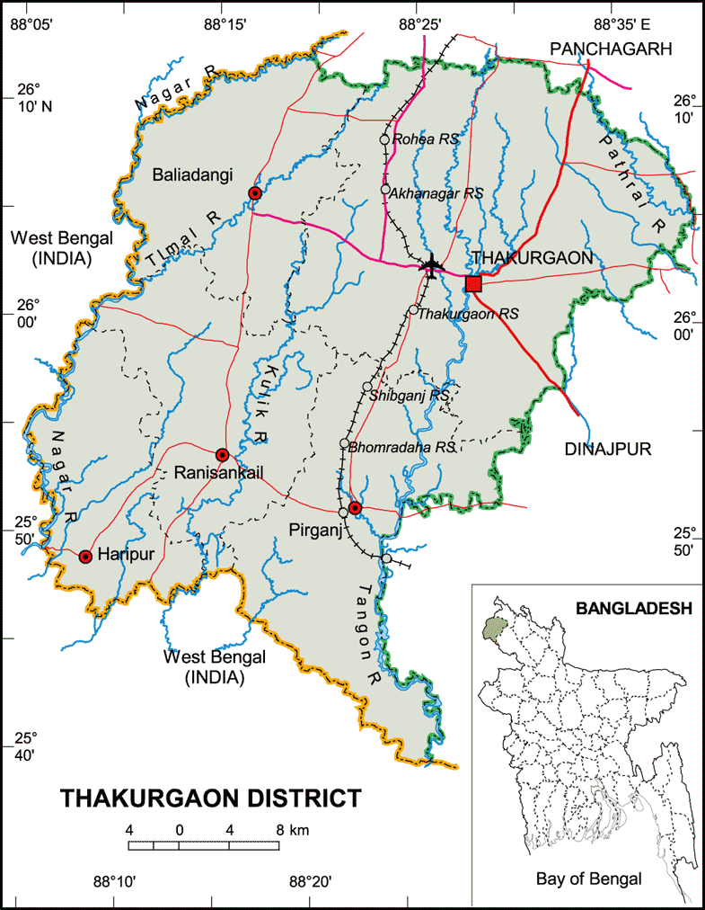

Map of Thakurgaon District

3.2 Para Map:
My assigned village (Jagannathpur) was so big which is not possible to come up a over view of the village. That is why I have concentrated on one Para as a sample of whole village. My selected a Para was Barahaat Para, where I can get overall idea like education, culture, no of male and female etc. Md. Mohon Ali to draw the map of Barahaat Para,and visit with to observe the whole Para at a glance. I had to survey twenty-five questionnaires to understand the age and sex distribution of Barahaat Para. Therefore, I have accumulated all the data into one table and converted into 100% from the questionnaire survey.

3.3 Barahaat Para:
The history of our study on assigned village is really interesting. Because of the village name, Barahaat para. By talking with the villager I have found out why the name is so. Villagers said 100 years before twelve people came to this place from another area and made twelve houses. In Bengali twelve means “ baro” so they decided to call this place as Barahaat para.

3.4 Population, Voter and Households:
The total of population in Jagannathpur is approximately 4300. Among them 3150 are voter (1150 male and 1050 female). In my assigned area there are around 200 people are live in Barahaat Para. where about 62 is male voter and about 55 is female inhabitant predominantly most of the inhabitants are Muslim at the same time site by site other religious people are also staying in this village. From the table I could come up one conclusion that this young age group people are staying in this Barahaat Para.

Table No 3.1 Age and Sex Distribution of Study Population
Age Group | Male |  | Female
Age Group | No. | % | No. | %
1 to 10 | 14 | 11.97 | 10 | 8.55
11 to 20 | 14 | 11.97 | 15 | 12.82
21 to 30 | 15 | 12.82 | 14 | 11.97
31 to 40 | 5 | 4.27 | 7 | 5.98
41 to 50 | 8 | 6.84 | 5 | 4.27
51 to 60 | 3 | 2.56 | 1 | 0.85
61 to 70 | 3 | 2.56 | 1 | 0.85
71 to 80 | - |  | 1 | 0.85
81 to 90 | - |  | 1 | 0.85
Total | 62 | 52.99 | 55 | 47.01
Source: LFE Field Survey, First Spring-2011

3.5 House Type:
People of Barahaat Para is used for living traditional houses, where house where build up by tin and bamboo combination. Recently they are using modern construction materials. Barahaat Para villagers day by day grabbing more cultivable land for house hold purpose and imaging of nuclear family.

3.6 Family Type
As like city and towns the villagers are moving joint families to nuclear families. In my survey I have found 21 families running nuclear family structure, which was 84% and only 4 families as 16% in joint family structure. And this change occurred vastly after liberation period. This change has a strong impact over the lifestyle of the villagers.
Table No. 3.3 Family Type
Family Type | No. | %
Nuclear | 21 | 84
Joint | 4 | 16
Total | 25 | 100
N = 125 Source: LFE Field Survey, First Spring-2011
3.7 School
Unfortunately in education rate of the village is so poor. From survey I have found that after primary school compilation drop out rate is too high, at the same time female condition is more worse. In the Jagannathpur there are Primary School, one Girls High School (Jagannathpur Girls School) and six NGO School in Jagannathpur. In our assigned Para there is only one BRAC School where most of students enrolled as student, rest of them go to Jagannathpur Primary school.
Table No 3.3 Educational Background of Currently Enrolled Students
Level of Education | Male |  | Female
Level of Education | No. | % | No. | %
Primary | 8 | 42.11 | 5 | 26.32
Secondary (Non SSC) | 3 | 15.79 | 2 | 10.53
SSC | 0 | 0.00 | 0 | 0.00
HSC | 0 | 0.00 | 1 | 5.26
Graduation | 0 | 0.00 | 0 | 0.00
Masters | 0 | 0.00 | 0 | 0.00
Total Population | 11 | 57.89 | 8 | 42.11
Source: LFE Field Survey, First Spring-2011

3.8 Marital Status
Male is more unmarried than female and married no is same in both male and female. According to our observation now a days male person are more career concern then their predecessors. There is a few numbers of widow and divorced women in our para. Most of the female got married in their early life stage.

3.9 Mosque and Temple:
In Jagannathpur village there are 11 mosques and three Hindu temples. In Matihak Para there are 3, in Khalifa Para there are 2, in Nebda Para there is 1, In Mijanur Para there are 2 and in Doba Para there are 3 mosque. Again among the three Hindu temples one of them is in Barahaat Para and rest of the temples are in Khalifa Para.

3.10 Shop:
There are little paltry tea shop and a grocery shop in our assigned village. In our assigned Para which is Barahaat Para we found three petty shops where village people buy their daily groceries like rice, dal, biscuit and other necessary goods are available.

3.11 Trees:
Once Jagannathpur was very rich with its trees especially fruit trees. There are number of fruit trees like mango, jack-fruit, litchi, banana, lemon, coconut, guava, palm etc but now it is tumbling day by day according the villager point of view. Still I have also found wooden trees like mahogany, eucalyptus and lots of bamboo as bushes. Unfortunately there is no social forest.

3.12 Transport and communication:
The village Jagannathpur is located on the north east part of MKP (Manab Kallan and the distance between Jagannathpur and MKP is around 2 km. the village people usually come to city area by rickshaw. They also used tempo.The communication system of Jagannathpur is not bad because most of the roads are pitch some are semi pitch here but some how the transportation facilities are gradually improving because flood and naturally calamite dose not effect.

Transect of Barahaat Para

To get the micro view of the whole Barahaat Para I do transect. Transect is on type of PRA technique which represents the structure of the whole village in terms of its components. It has overall impact on the relationships between the different important components of the village. It includes soil type, the land used pattern, the types of crops and trees, etc.

3.13 Objectives:
1. To get a clear idea of the distribution of the natural resources and other resources.
2. To get an idea how the households are distributed within the village.
3. To know the problems in each area

3.14 Findings :
- Barahaat Para land height is more or less plain, because people are using this land for agricultural purpose and house hold activates.
- Soil type is more or less sandy and mixed people are use it for farming purpose.
- in my transect map house hold are made of mud and clay some are also break made houses
- There are different types of tress has been found, among this Mango, Bamboo bush etc.

3.1.5 Conclusion :
The LFE program helped us to view a real picture of a village and gave an environment to interact with the villagers. And this creates a feelings in our mind that how simple, easy, honest and helpful the villagers are!

4.1 Introduction
Bangladesh is overpopulated country where most of the people live in the village and they are poor. They are mainly depending on agriculture, small business and farming due to modernization and influence of mass media lots of social and structural process has been changed in village life such as family, education, life style, participation of media. Etc. 4.2 Effectiveness of Female Right:
In village life women right has been established from the respondent point of view such as casting vote and participation in media these two elements are vital for improve change the society or rural life and also moving outside which is significant and prominent role in Jagannathpur village. Still women are not proactive in market place it means that in business sector they are annulled.
Table No 4.1 Rights of Female
Issues | Response
Issues | Yes |  | No
Issues | No | % | No | %
Casting Vote | 23 | 92 | 2 | 8
Shopping in the Market Place | 5 | 20 | 20 | 80
Visiting Relatives Outside the Village | 20 | 80 | 5 | 20
Watching TV at the Neighbors House | 13 | 52 | 12 | 48
Source: LFE Field Survey, First Spring-2011

4.3 Positive Social Change Occurring
In my comparison study, lots of positive change has been come in Jagannathpur village. Female education improving, communication ,agricultural facilities has been significant percentage change in village life. Nuclear families and health care facilities have been improved almost double. So I can come up a conclusion that these changes have improved in Jagannathpur village. This represent over all view of whole district.

Table No 4.2 Positive Social Change
 | Responses
Changes | No | 2004% | 2010%
Progress of Female Education | 21 | 62 | 84
Improvement of Communication | 18 | 35 | 72
Agricultural facilities has improved | 14 | 39 | 56
Improvement in toilet facilities | 12 | 40 | 48
No. of nutritious food has increased | 6 | 18 | 24
Health facilities have improved | 2 | 4 | 8
Nuclear families have increased | 4 | 6 | 16
Source: LFE Field Survey, First Spring-2011

4.4 Negative Social Change Occurring
According to the villager point of view after the liberation percentage of dowry, money inflation, and interest rate of micro credit and high price of everything is higher than the percentage of deterioration of law and order situation or crime going bad to worse, if I go through the table except the unemployment rate all the situation people are suffering, women are more operated by the social structured by observation of last five years
Table No 4.3 Negative social change
Changes | No | 2004% | 2010%
Dowry | 20 | 65 | 80
Money Inflation | 20 | 70 | 80
Interest rate has increased for micro credit | 12 | 39 | 48
Per Capita food land is decreasing | 9 | 29 | 36
Product Value has increased | 8 | 22 | 32
Unemployment rate has increased | 11 | 70 | 44
Crime | 7 | 10 | 28
Source: LFE Field Survey, First Spring-2011

Time or era | Types of house | Famil-y  type | Study | Occupation | Do-  wry | Tree | Entertainment
1971-  1980 | 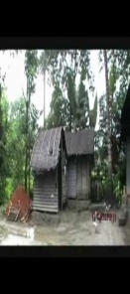 | 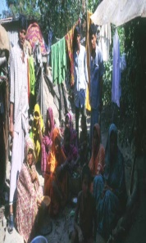 | 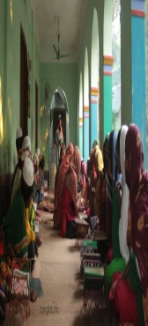 | 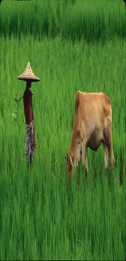 |  | 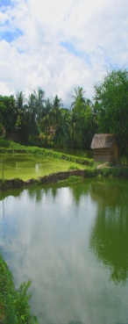 | 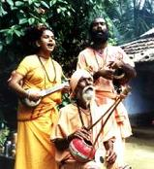
1981-  1990 | 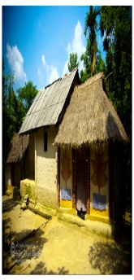 | 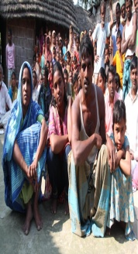 | 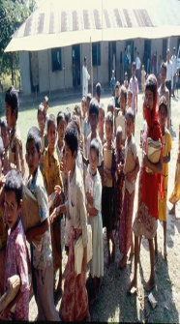 | 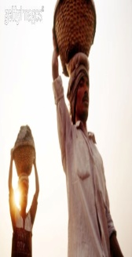 | 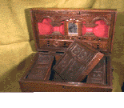 | 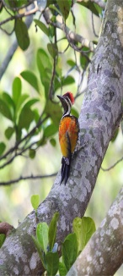 | 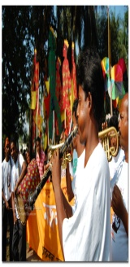
1991-  2000 | 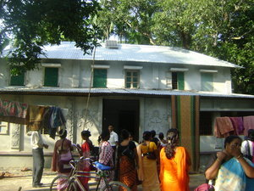 | 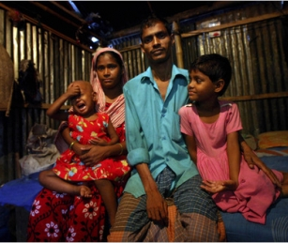 | 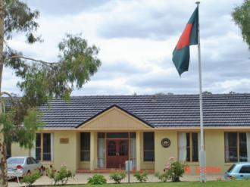 | 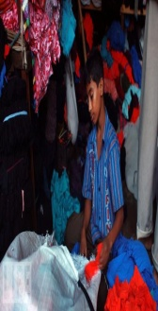 | 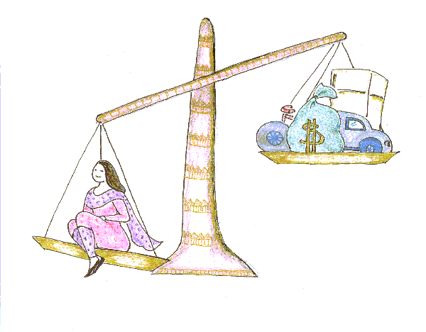 | 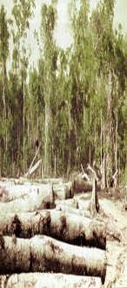 | 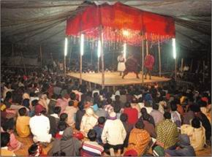
2001-  2011 | 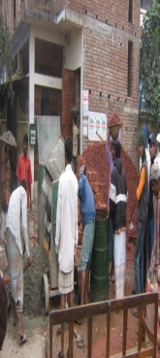 | 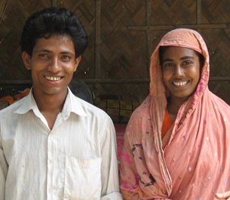 | 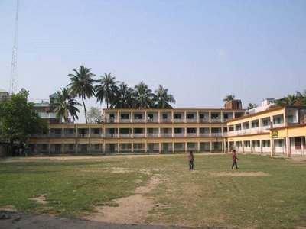 | 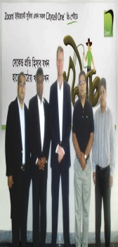 | 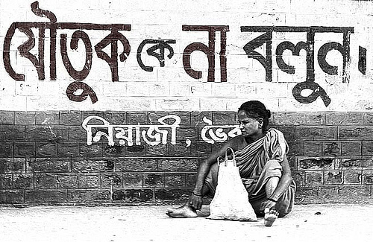 | 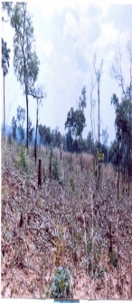 | 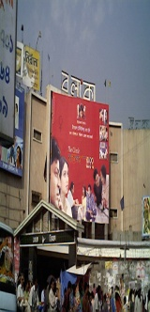
Social Change Process
4.5 Major changes of Jagannathpur village of Barahaat Para:
4.5.1 First decade from 1971 to 1980:
In the first decade of 1971 to 1980, villagers were use to stay clay house because of at that moment, people were not able to make concrete or ten set house. In that time people were staying with joint family where Grand father to Grand children were used to stay in same family and also shear same food. Their main occupation were agricultural based farming, where they were totally depend nature. Such as rain and flood base fertilization (Poli soil), cow dug etc. they also used primitive plowing system. Villager were not used to go school only religious based school were their. After the liberation in Jagannathpur villagers told it was a beginning dowry, Dowry was impose over the female, before that man were used to give dowry (Mohrana) to the female, according to Islamic low. Moreover, In that decade, there were so many types of trees like jackfruit, mango, gambrel, jam, bamboo tree in the village also lots of big Banyan trees, after the night fall lots of traditional folk (Jari, Morshadi and other traditional) song were sang by the villagers. In that time it was only entailment of the villagers.
.
4.5.2 Second decade from 1981 to 1990:
In the second decade of 1981 to 1990, previously villagers were use to stay clay house due to improvement of ecumenical condition people were able to make concrete or semi ten set house. Before people were used to staying with joint family where Great Grand father this is area of one Grand father concept. According to the villager opinion this was the area of immerging of nuclear family, joint family start splitting family become one man family. Villagers start diversification of their occupation, before they only agricultural was the main occupation in the mid Eighties villager move to business, also start migration to other cities and our side the countries such as Middle East. Before they were totally depend nature fertilization and rain water but now they were started using comical fertilization, irrigation and use advance plowing system to grow more crops in their fields. In the mid 80s Villager were used to go primary school only at the same time religious based school were their. Dowry in Jagannathpur villagers more imposing to the Bride fathers, new type of demand has been imposed to the Bride fathers, some time it become more harder to manage money, family member were taking long high interest rate. Moreover, in that decade trees were reducing because inhabitance were make more house in the forest type area, still jackfruit, mango, gambrel, jam, bamboo trees were remain in the village. After the night fall lots of traditional folk song place has been occupied by mass media that was radio, TV and VCR. The villagers who were staying out site they were also sending different type entailment equipment.

4.5.3 Third decade from 1991 to 2000:
In the third face of 1991 to 2000, villagers were used to stay in ten make house one only few clay house where found, ecumenical condition people were able to make concrete or well furnished house. In this area people were used to staying with nuclear family where Grand father were found very hardly. According to the villager opinion this was the area of growing of nuclear family concept, few joint family remain in the village due mass growing of nuclear family. More diversification comes in the village life spicily women were starting their own business. Pungently they take the lone form different NGOs and doing poultry Bird business. Villager were also massive mobilization of different part of the county and Middle East also Fareast Asia such as Malaysia and other ASIAN countries. Dependency on nature almost gone in this area they were totally depending on chemical fertilization and irrigation. In the case of rain water, they preferred irrigation and use advance plowing system to grow more crops in their fields. In the eve of 90s most of the young villagers were used to go primary school also so they are going for higher study in city or capital, only religious based school their also. Dowry in Jagannathpur villagers was remain same, Man family were become more demanding to Bride fathers. Moreover, in that decade trees were reducing because inhabitance were make more house in the forest type area, still jackfruit, mango, gambrel, jam, bamboo trees were remain in the village. After the night fall few traditional folk song take place. TV and Cable connection make them more home based entertainment.

4.5.4 Last decade from 2001 to 2011:
This is the last face of 2001 to 2011, what I have found in the village area. In this area villagers are starting to stay in ten make house and constriction homes. I have fond only few clay house where found, ecumenical condition people have been changed lots and also make home well furnished house. In this area most of the people used to staying with nuclear family which contain four to six members. In this area Grand father concept totally absent, I have fond few families where grand father is their. Also people are different types of Berth control step to make the family small. This is the area of nuclear family, few joint families remain but they are waiting to break and become nuclear families. Diversification of occupation become common phenomenon in village life spicily, women become more supportive starting their own business home based and market oriented. In this time villager are going for mobilization of different part of the county. Now they are moving acceding to their skill they are moving all over the world.. Dependency on nature almost gone in this area they were totally depending on chemical fertilization and irrigation. In the case of rain water, they preferred irrigation and use advance plowing system such as power tiller and other machine have been used for cultivation. In the area most of the young villagers are used to go primary school and high school. They also move for city or capital, in this area religious based school become unpopular, due to less job opportunities. According to the villager view that after 2005 dowry in Jagannathpur villagers was become more problem at the same time divorce rate has been increasingly, which become a problem for Bride family. Now NGOs and other social organization are more proactive step for these divorced women to make their right in the society, Such as small lone and different types of training programs etc. Farther more, in that decade trees and land place are reducing because inhabitance were make more house in the forest and cultivable land, few trees are remain in Jagannathpur villagers. Such as, jackfruit, mango, gambrel, jam, bamboo trees were remain in the village. Very few time traditional folk songs take place. Because people are more active in TV and Cable connection make them more home based entertainment, according to the villager view they are enjoying more Indian movies and Bangladeshi Drama.
4.6 CONCLUSION
Social change is a massive incident which cannot be clarified by this small study. But, after studying the rural life style of the villagers we found that the overall condition is now changing.

5.1 Introduction
In my assigned village Jagannathpur (Barahat para ) there are different groups of people who are amalgamated with based on occoupation. The groups are different in their professions, their lifestyles and even in their thinking also. I have tried to identify the groups and the groups are mentioned below.
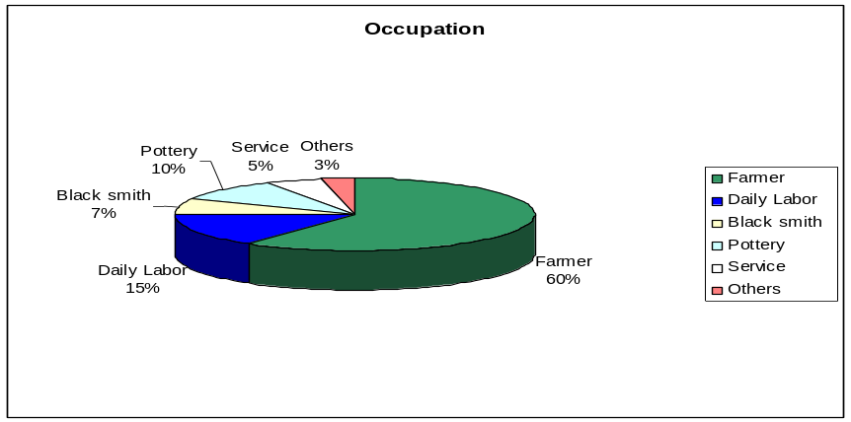
5.1.1 Occupation:
Barahaat Para village this is the same village which is found all over the Bangladesh where most of the people are farmer. What I have found 60%. In this part this big part of the population who are involved in daily labor and pottery industry, which contain 15 % and 10% of total population. Some are also Black smith and few people are service holder also some people are found how are involved in different activities. We have also found electrician, artist man in Barahaat Para.
The table shows that most of male and female of Barahaatpara
Table No.5.1 Primary Occupation (Dummy table 4)
Occupation | Male |  | Female
Occupation | No. | % | No. | %
Income Earner | 39 | 33.33 | 3 | 2.56
House Wife | 0 | 0.00 | 32 | 23.93
Student | 11 | 9.40 | 11 | 6.84
Unemployed | 0 | 0.00 | 0 | 0.00
Dependent(Children) | 11 | 8.55 | 10 | 8.55
Dependent(Adult) | 3 | 1.71 | 5 | 5.13
Total | 64 | 52.99 | 61 | 47.01
N = 125 Source: LFE Field Survey, First Spring-2011
5.1.2 Income based class system
Among the villager there are three basis economical class systems I have found in Barahaat Para.
Table No 3.5 Total Yearly Family Income
Income Range (Thousand in a Year) | No. | % | Income Class
0-20 | 2 | 8 | Lower
21-40 | 10 | 40 | Lower
41-60 | 5 | 20 | Lower
61-80 | 3 | 12 | Middle
81-100 | 2 | 8 | Middle
101-120 | - | - | Middle
121-140 | - | - | Upper
141-160 | 2 | 8 | Upper
161-180 | 1 | 4 | Upper
181-200 | - | - | Upper
Total | 25 | 100

Source: LFE Field Survey, First Spring-2011

In Barahaat Para 25 families the majority of the families are in the lower-income
group. They were occupying 68% and middle-income group is 20% which was much lesser than lower class. In the higher income group there was only 12% family. Form my observation, among the family who is educated or doing job out site the country he has broad lots of improvement in the family.

5.2 Economic Condition and wealth Distribution of Jagannathpur (Barahaat para):
To accomplish one’s daily crucial needs one should have an income and to have an income one should have an occupation. The Jagannathpur village is very advanced in Farmer and daily labor. As we profession like pottery transport worker, construction worker, and service holder are going out different villages and other districts.

5.2.1 Wealth Ranking
Based on inherited land and owned and income generation, I have divided the population of the survey in three classes. The classes are
- Upper Class (3 house hold).
- Middle Class (12 house hold).
- Lower Class ( 13 house hold)
In Barahaat Para 12% of the population falls in Upper Class. 52% of the population falls in the Middle class and the rest 36% of the population fall in the lower class. It can be said that majority of the population fall in the lower class.

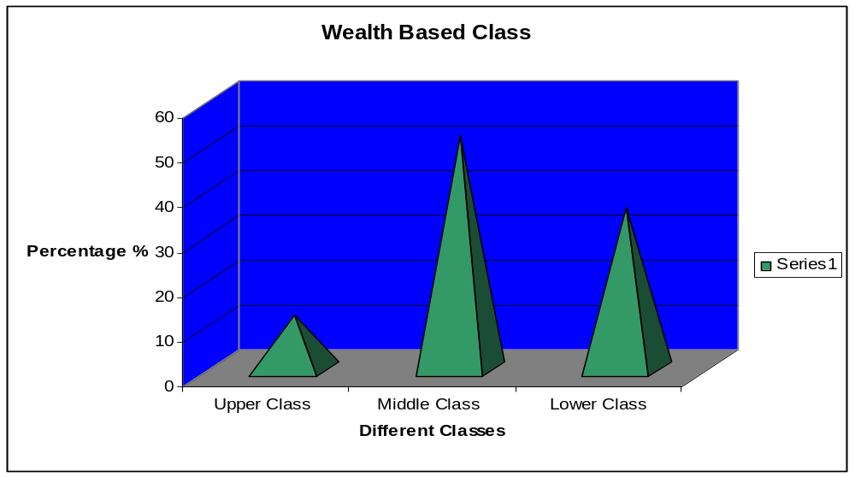
5.2.2 Preeminence Formation:
Authority refers to the degree to which individuals or groups can impose their will to others with or without the consent of others. There are two forms of power authority-being a form of power which has some legitimate basis and coercion- a form of power which is not regarded as legitimate by those subject to it.
Power can be measured on how decisions are made according to the three categories of leaders:
- Politicians;
- Social Importance and
- Economic Importance.

Diagram A: Societal stratification and percentage.
8 %
16%
16 % having Only “vita”

24 % land less

Rich
Upper Middle
Middle
Lower Middle,Poor
36 %

Diagram “A” is indicating different class and number of people (in percentage) fall under different strata.
Diagram B: Landowner ship and name of decent based on class.
Rich (Descent:Korimuddin Sarkar)
Upper Middle (Descent:Samad Ali )
Middle Class (Descent:Shobuj Miya)

Lower Middle: only “vita”
Poor class: landless (Descent: nil)
1 - 2 Pakhi

Only “vita”
2 - 4 Pakhi

30+ Pakhi

Diagram “B” is indicating the amount of land and different descent falls under distinct class. The arrow indicates total land possessed by each class decreases as it comes downward.
In a whole village around 8 % of the people are Rich and on an average having 30 to 45 Pakhi of land and more than that. Around 16 % of the villagers are belonging to the Upper Middle class, fairly having 2 to 4 Phaki of land. 36 % belong to the Middle class, having 1 to 2 Phaki of land of their own. Rest of them belongs to the Lower Middle and Poor class. Among the rest 16 % having only “vita” of their own and 24 % is land less.

5.2.3 Wealth Ranking:
Wealth ranking means categorizing the people of a particular area on the basis of the wealth they possess. As we have surveyed of 25 households so we have categorized the Jagannathpur villagers in to 3 classed. Land holding and annual income are the major determinants to judge the social class of Jagannathpur, Barahat Para. Apart from land holding and annual income occupation, economic group, possession of home appliances can also give the clear picture of wealth condition of the villagers. Thus, Wealth ranking tries to give us a complete view of social structure of the villagers.
5.2.3.1 Upper class:
People of this class can be very easily identified just by seeing whether they have own one or more cows and some cultivable land for agricultural purpose also they are using daily labor for cultivation. They are nuclear family also high education rate compare to other class of the villagers. Usually the upper class owns about 20-25 bighas of land. For the upper class people income sources are from every sector that we have mentioned earlier. They involved in agriculture, business and also different services. Furniture owned by this class of people is of luxurious quality if I think in context of a rural village.
5.2.3.2 Middle Class:
In the second step I have found middle class agriculture and small business are their main sources of income. Basically farmers and blacksmiths are of this group. They produce crop and vegetable in their own land. Now a days most of the middle class people use family planning process. Middle class people’s literacy rate is improving. The have also their own domestic animal their small business they look after by themselves. They have no servant for helping their household activities. All of them have the electricity. Every one of them live in the Tin shed house. Most of them have TV, Tape, and Cycle. Usually the middle class owns about 5-8 bighas of land.

Economical class system of Jagannathpur(Barahaat para):

Paramet  er inco  me  class | FAMILY  SIZE | INFRA  STRU  CTURE | CATTLE  &  POULTRY | INCOME  SOURCE | INCOME  PER  YEAR | LAND  SIZE
UPPER  CLASS | 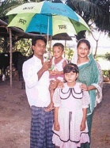  More nuclear family | Very few brick house but tin shade. |   They have cow, goat, hen and duck. | They earn from their own land, service as teaching, business. | 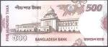  Approx  imately  tk  2,000, 00  to 3,00,000 per year | 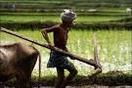  They have 20-25 bighas of land.
MIDDLE  CLASS | 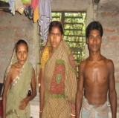  Nuclear family. | 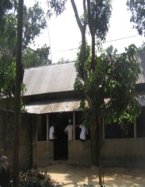  Maximum houses are made by tin & mud. | Basically they have 1 cow, 2-3 goat and hen. | 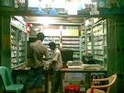  They earn money from crop of own land and shop. | They have a earning of tk 1, 00000 to 1, 50,000 per year. | 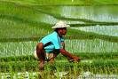  They have 10-12 bigghas of land.
LOWER  CLASS | 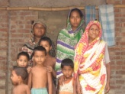  More joint family but they take foods separately. | 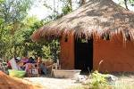  Maximum house type is hut. | They only have hen and duck. | 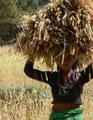  They are basicallydaily labor. | 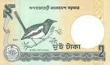They can hardly earn to continue their every day which will not be more than 40000 tk per year. | They do not have their own land; they work as a labor in others land. Very few have 20-25 decimal of land.

5.2.3.3. Lower Class:
In the bottom I have lower class people they are the most oppressed class in the society. They don’t have cultivable land. So they are totally dependent on other land load. They are call (Borga Farmer), they lease the land from the rich farmer and cultivate it. They have no certain occupation. They primarily work as agricultural laborers in farms owned by others. They also pull rickshaw vans or engage themselves in such other economic activities. they have very primitive household where I have not found any electricity. Unfortunately they do not have any idea about family planning they have more children and less participation in education. Some women in the poor family give financial support to their family through sewing handicraft and making biri earns extra money. Girls in the poor family get married earlier than the upper and middle class families. They are cursed by dowry as cash or jewelry or cycle etc.

5.2.4 Domestic Animals:
Considering the table all most half of the people have the cow. Because directly or indirectly they are influence their economical activates. comparing to any other domestic animals cow and ox. Now a day people are more founding interest in second option that is poultry birds. This is because; poultry birds are the main sources of eggs for villagers. Frequencies for goat are very low and as any of the 25 surveyed households does not have buffalo as their domestic animal so we haven’t considered this animal to be enlisted. I have found 6 percent of Ox and goat. This Ox is sold during festivals like Eid-ul Azah and they can earn a lot of profit. We have also found some family who has no domestic animals. The percentage of this group is 29 percentages.

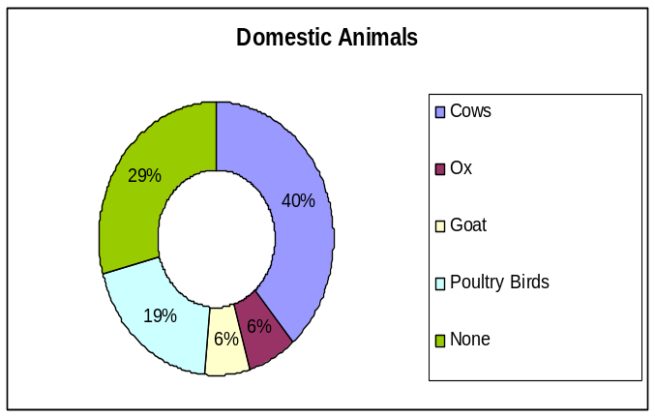
Domestic Animals | NO
Cows | 27
Ox | 4
Goat | 3
Poultry Birds | 29
None | 0
Total | 63

5.2.5 Storage Capacity:

In my assigned area most of the farmer got very poor amounts of money form their production of cultivation; it is very pity to say (68%) people who do not have any storage place. That is why they are selling their goods at a very poor price. Sometimes they could not even got the money back, what the lone they have taken form the NGO or Banks.Secondly,occasional agricultural laborers do not have that level of economic condition that they can have a storage place. And lastly, the agricultural laborers get so little amount of crops in their account that it is not a necessity for them to have a storage place.

AGRICULTURAL PRODUCTION CYCLE
Month  Crop | Jan |  | Feb |  |  |  | Mar |  |  |  |  |  |  | Apr |  |  | May |  | Jun |  | July |  |  |  | Aug |  |  |  |  | Sep |  |  |  |  | Oct |  |  | Nov |  |  |  | Dec
Month  Crop | Poush | Magh |  |  | Falgon |  |  |  | Choitro |  |  |  |  |  | Boish-  akh |  |  | Joish-  tho |  | Ashar |  |  | Sra-  bon |  |  |  | Bha-  dro |  |  |  |  | Ash-ar |  |  |  | Kar-  tik |  |  | Agr-  Roh-  yon |  |  |  |  | Po-  ush
Paddy (Amon)

Corn

Potato
Egg-
Plant

Legend | Land preparation | Seed  Bed | Transplan  -tation | Seed  Showing | Irrigation | Fertilizing | Pest control | Weeding | Growing  period | Harve  -sting
Colour

5.3 Crops of Jagannathpur, Barahaat Para:
Villagers of Jagannathpur, Barahaat Para mainly concentrate on growing paddy corn, potato and Eggplant.They cultivate some selective kinds of paddy. In the local selection they have hybrid types of paddy like BIRRI 11, BIRRI 28, BIRRI 29 and BIRRI 32, 33. they are planting it asher and srabon and harvesting in poush mag In this area people usually cultivate during the Irri, Amon and potato in this season. In this are I have found that farmers are also growing corn and eggplant. Crop they grow it very quickly with four or five months but in the case eggplant they grow it January to march this is the best time to cultivate it.

5.3.1 Irrigation:
Villagers accomplish this process through irrigation machine called Deep machine. Every farmer’s have not their own Deep machine. Rich farmers have their own facilities in the case of Poor farmers they take the support.

5.3.2 Insect Killing:
Farmers use different types of insecticide to kill the harmful insect and bug, unfortunately they are using too much insecticide which killed the useful insects of a land such as earthworm. Because there are many dangerous insect that is harmful for paddy. Farmers use pesticides to kill insect which name is “Fonadung”. They use 1 packet of Foradang for 1 Bigha of land.

5.3.3 Fertilizer Application:
At the time of transplantation farmers use Urea, Sulfur and Potassium fertilizers. Locally these Sulfur and Potassium fertilizers are known as “Lal Shar” and “Kalo Shar” respectively. At the mid of Falgun (Feb-Mar) they apply the Urea fertilizer and if necessary the other two also.

5.3.4 Harvest:
At the beginning of Boishakh (Apr-May) crops ripping process are on a full pace and at the end of this month the harvesting process starts. Just before the Joishtha (May-Jun) or at the very beginning of Joishtha, harvest is completed for the Irri season and the Amon season starts. So, lands are being prepared then for that season’s crops. The end of the Amon season, Potato season starts.
5.4 Cost of production and Cost Benefit Analysis:
This table shows the cost and profit analysis for 1 bigha of Irri. Here we can see that, 8-10 kg seeds are needed for 1 bigha of Irri. The price of seed is tk 50 per kg. Total amount 500 taka. Total cost for land preparation is 480 taka. For tractor tk 5 per decimal and 1 labor for 120 taka. Total irrigation cost Tk 576 (18 taka per decimal). Fertilizing cost 1700 taka, it included Potash (1500/packet) and uria (600/packet). Pesticide 100 taka per packet total cost 100 taka. Harvesting cost 1200 taka. Transportation cost 100 taka. So, total cost for 1 bogha of Irri is equal to Tk 4656. Farmers will get 25 kon of paddy for 1 bigha of land. Then they sold it total 15000 taka (tk 600 per mon). So, the profit is tk 10344.
ITEM | PRICE | AMOUNT
SEEDS | - KG  (Tk 50/KG) | TK 500
LAND PREPARATION | TRACTOR (TK 5/DECIMAL)  LABOR (120 TK PER LABOR) | TK 480
IRRIGATION | WATER ( TK 18 PER DECIMAL) | TK 576
FERTILIZER  (TSP,POTASH,URIA) | POTASH—1500/PACKET  URIA---- 600/PACKET  TSP---1500/PACKET | TK 1,700
PESTICIDE  (FORADANG) | 100 PER PACKERT | TK 100
HARVESRING | TK 120 PER LABOR | TK 1,200
TRANSPORTARION |  | TK 100
TOTAL |  | TK 4,656
SELL | TK 600 PER MON | TK 15,000
PROFIT |  | TK 10,344

5.4.1 Leasing System
In this system the owners of the land give the land a person for the agreed amount of the money. When the person gives the money to the owner, he has the authority to produce whatever he wants. This agreement will continue as long as the owner will not repay the money.

Leases out the land for the specified amount of money
Owner of the land
Lessee or who take the land

Return the land to the owners when the lessee gets the money
Figure: 5.7 Leasing System of Land Agreement

5.5 Labor Migration and wage
Barahaat Para inward and out migration are available in the village. During the harvesting and cultivating period, there is high demand for the labor. It is difficult to find the people to work. Also some people are coming form Mong place. In the cultivation and harvesting time labor wage higher amount of money has been distributed among the labor. It is informed that at the harvesting season, they have to pay maximum wage policy. The Wage rate for the different based on supply and demand of labor force are available in the market.
5.6 CONCLUSION

We have tried to represent the image of the economy, affluence, seasonalconsequence and cultivation condition of "Mokamergul" village here in this section of our report. We can consider villages as the spirit of our country and our countryside bordered by hundred of river, as a result we contain a healthier topsoil intended for agriculture. Subsequent to our assessment and according to our psychotherapy at the present we are able to articulate that rural community can expand our national economy.

6.1Concept of Market
Market is the set of actual and potential buyers and sellers of a product. Originally, a market stands for the place where buyers and sellers gather to exchange their goods. For example, in terms of village it could be haat, bazaar, village square, and cultivable land, crop field where transaction takes place.
Rural market consists of –
Rural Market

HAAT
BAZAR
PERMANENT SHOP

6.2 Concept of haat
“HAAT” is totally a village concept. A haat is a special type of village market. It sits generally once or twice a week one specific place, specialty about haat is that, mainly temporary shopkeepers come here to sell daily necessaries. On these haat days (days on which the hats are held) the market place takes the shape of big bazaar having areas allocated specifically for the transactions of specific few product in low price compeer to Bazer.

6.2.1 Inflow chart
Most of the consumer goods are coming in this village. Form different big districts of North Bangol. In this part Bogra, Rajshahi and Dhaka main source of product.
Jagannathpur villagers
BOGRA
PANCHAGOR
DINAJPUR
DHAKA
SHERPUR
SIRAJGONJ
NATORE
KUSTIA
RAJSHAHI
BAMUNIA
West Bangal
(prohibited Goods )

6.2.2 Outflow Chart
This area is now part of Rangpur Division most of the good are going in between Rangpur Divistion. Some rice and newly cultivated tea are moving Dhaka, except these two items are consumed by them self. N

W E
S
THAKURGAON
Jagannathpur villagers

Kurigram
Dinajpur
Panchagor

DHAKA
SHERPUR
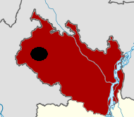
Immagring of new division Rangpur which make new marketing network mainly this areas Dinajpur, Gaibandha, Kurigram, Lalmonirhat, Nilphamari , Panchagarh · Rangpur, Thakurgaon

6.3 Value Chain Analysis : (Corn) Maize, Paddy and potato
In the value chain of analysis villages are all most follow the same type of value chain of their own production at the same time middle man and other land lord are still active in all the sectors of production.

Output

CORN
PADDY
POTATO
Distribution Channel
Farmer
Small Arotder
Big Arotder
Retailer
Consumer
Processing
Harvesting
Collecting Corn seeds from Maize
Work in Process
Fertilizer
Pesticide
Irrigation
Clean weeds
Cost of Labor
Male : 60 to 80 taka daily.
Female : 40 to 60 taka daily
Earning ( selling – Costing ) :
For 2 Bighas
(18000 – 10000 )
= 8000 taka (Corn)
For 1Bigha
(8750 – 3000)
= 5750 taka (Paddy)
For 1Bigha
(30000 – 20000)
= 10000 taka (Potato)

Raw Materials
Land
Seed
Tractor
Labor
From Villagers

From Traders

From fellow
farmers

Spending pattern

*Fooding
* Clothing
* Further Investment
* Saving

6.4 The differences between haat and bazaar
By visiting “KHOCHABARI HAAT”, I could identify the major differences that exist between a Bazaar and a Hut.
- Bazaar is a place where most of the permanent/regular sellers/shopkeepers sell their products and services. Hat consists of mainly temporary shopkeepers stock lot out sourcing.
- BAZAAR occurs 6 days a week. In village hut sits only some particular days (generally one or two days) in a week. It is worth mentioning there, “KHOCHABARI HAAT ” sits in “Wednesday”
- Bazaar sits in the morning and function till a few hours in the night. A Hat sits in late morning and breaks up by evening.
- BAZAAR is an “Urban” concept. Hat is “rural” concept.
- Mainly villagers from a particular village come to a village market. But people from different villages gather in a hat.
6.5 Different stages of rural market network:
This is the simple traditional rural market network found in most of the village in all over the Bangladesh, Jagannathpur is not different form other village.

Peasant
Haat
Town
Agricultural goods
Seller

Other Consumers

6.5.1 Distribution Channel of Paddy
More or less most the village people are following this type of channel of distribution network. Where Bepari’s are getting most benefited because they are buy it directly form the producer and selling to end user. They are the price maker and they maintain the flow of demand and supply of Paddy or rice market.
Farmers/ peasant
Bepari
Consumer
Chatal
Dhaka & other Places
Retailer

6.5.2 Distribution Channel of Potato
This is different type of channel of distribution network follow this is more perishable goods that is why all members are following it step by step. Also our country has less cold storage that is why few rich middle man (who have cold storage) getting the benefits. This is 2nd staple food in our county that is why now a days people are give high concentration on it. Especially they are concerning about storage or formation of the production.
Farmers/ peasant
Middle man syndicate
Consumer
Dhaka & other Places
Retailer
Store by Middle Man
6.6 Product and Services:
There are many products are coming form different village but Service is totally unavailable absent, haat always situated at the same place. I have found service sector also available near the Bazaar, such as Tea shop, Barber and some very primitive restaurant. Most of the village people know the price of the every service sector because customer is almost same, also price is very reasonable.

6.7 How villagers fix Price?
The villagers in hut told us that they consider market rate in fixing price. They also told us that since competition is high and most of them are small farmers, so they have very little control over price. The following factors force the farmers to follow the market price:
- High competition,
- Less product differentiation,
- No electricity – no storage facilities, which push the farmers to sell the product within a particular season.
- No co-operative organizations among small farmers – no power to influence price in market.
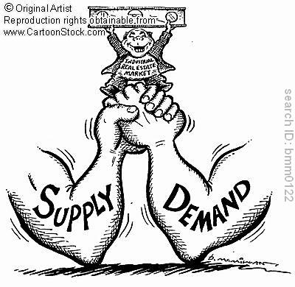
6.8 Place:

The name of the Haat is Khochabari Haat. It is situated about six Km. Away from the southern side of Rangpur highway. From the village Jannathpur, the distance of the Haat is about two Km. It is situated south-west of the village. As the Khochabari Haat is not that far away from the highway and the road is well constructed, so the transportation of the middlemen is very easy.

6.9 Promotion
Unfortunately promotional activities, advertising and sales promotion are not apparent in the village, at the same time villager have no idea about promotion. There are fish corners, vegetable corner, fruits corner and so on. The sellers are not interested in promotion. However, I have found one personal selling medicine for sexual and many others complex decease and there were noticeable gathering around him. He unintentionally doing promotion such as gives long speech and flyer. Farther more give some free medicine, “Take it test it, if you like it buys it next time.” Nice promotional strategy to market their product

6.10 How middlemen are affecting price?
In the rural market have asked different initial seller of rural market randomly. Such as If I consider Bangi from the chart, i see that when peasant sell it to the local consumers it cost 3-4Tk/pcs. On the other hand when peasants sell it to the whole sellers, it takes 1.50-2 Tk/pcs. Then when whole sellers sell it to the city buyers, it takes 10-15 Tk/pcs. And Lastly when city buyers sell it to end consumers , it takes 30-40Tk/pcs. Other vegetables and fruits are also selling like this.

Crope | Fermer |  | Whole Seller |  | City Buyer |  | Consumer
 | Local Consumer | Farner’s Selling price or Whole Seller’s Buying price |  | Whole Seller’s Selling price or City Buyer’s Buying price |  | City Buyer’s Selling price or Consumers Buying price
Bangi | 3-4Tk/pcs | 1.50-2/pcs |  | 10-15/pcs |  | 30-40/pcs
Chichinga | 8-10/kg | 6-8/kg |  | 10-12/kg |  | 16-18/kg
Jhinga | 8-10/kg | 6-8/kg |  | 10-12/kg |  | 18-20/kg
Taal | 3/pcs | 1.50-2/pcs |  | 3-4/pcs |  | 6/pcs
Corolla | 8-10/kg | 6-8/kg |  | 10-12/kg |  | 18-20/kg
Misti Kumra | 5-10/pcs | 4-6/pcs |  | 10-15/pcs |  | 20-25/pcs
Jali Kumra | 4-5/pcs | 2-3/pcs |  | 6-8/pcs |  | 12-15/pcs
Maize | --------- | 10-12/kg |  | -------------- |  | 15-17/kg (Poultry)
Sugar cane | ---------- | 40/maun |  | ------------ |  | 60/maun (Sugar mill)
Paddy | 12-14/kg | 12-13/kg |  | ---------------- |  | 14-15/kg (Whole seller to local consumer)
Milk | 12-15Tk/kg | 12-15Tk/Kg |  | 20-25Tk/kg to sweet shop or milk factory

this concept I can come up a conclusion that price of the product varies due to high transportation cost and middle man. One noticeable this is that cost of the fruits increase very rapidly but the cost of the vegetables increase very slowly. Because fruits rotten very quickly but in case of vegetables, it don’t happen very quickly.

6.11 CONCLUSION

A market plays a vital role in the economy and employment thus affecting the whole circulates flow of money within the economy. So we conclude saying that the Government and private sector entrepreneurs should take steps regarding the price stability, market competition, pricing of goods and services and as well as availability of proper products so that marketing of fake products are not encouraged.

7.1 INTRODUCTION
Jagannathpur villagers Health condition more or less soundness. Good health is the major wealth of human being. Because most of the villagers are farmer they need good health to do hear work. According to World Health Organization (WHO), “Health is a state of complete physical, mental and social well-being and not merely absence of disease or in infirmity.” In the rural life human and animal health are interrelated, so in this part water, air and land use and positive and negative impact of the Environment.

7.2 Key Factors of Environment
Environment issues are depending upon many factors. It’s not changed in one day. Its takes time to change. These things are as follows:

Increase in population and Houses

Extreme use of Chemical Fertilizer

Decrease in cultivable land area &
Trees

Increase in Air Pollution

Increase in Erath and Water.

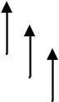
Increase in Environment
Pollution.

From the above diagram increase in population and house which shrink cultivable land and trees which pollute the air at the same time villager also use lots of chemical fertilizer which give worse impact on soil and water. Soil is losing the fertility, toxic chemical destroy the marine environment, in it continue inhabitance of villagers will face environmental pollution.
7.3 Sources of Water for Domestic Use:
Water is one of the most significant elements for the living creature. As we all know the human cannot live without air for few minutes, they also cannot live without water for few days. We can easily realize the importance of water for human and animals. In this part I have depict assigned Barahaat Para of village Jagannathpur.
Sources of water for Domestic use:
Water Sources responded use for different purpose | Drinking | Bathing | Washing Utensil clothes/utensils | Cooking
Piped Water | 0% | 0% | 0% | 0%
Tube well | 100% | 36% | 28% | 92%
Well water | 0% | 0% | 0% | 0%
Pond | 0% | 64% | 56% | 8%
Others(Tube well and Pond both) | 0% | 0% | 16% | 0%
(Source – Field survey, 2011)

In my Barahaat Para I have found that villagers are using 100% tube well water for drinking purpose. This is very good sign for any village. For bathing and swimming purpose 36% use tube well water and 64% use pond water, For washing 28% use tube well, 56% use pond water, 16% use both tube well and pond water. For cooking purpose 32% use tube well which is also a good sign and 8% use pond water. According to the villager point of view that pond water is not good at all lots of pesticide and toxic things make the water so polluted, which make lots of health hazard. Those who are extremely poor, they are unable to have tube well, so they use the pond water.

7.4 Sanitation & Toilet Facilities:
In Barahaat Para most of the villager used Ring Slab, which is 84% of total demography at the same time 12% have Septic Tank, in their houses and 4% use Pit Latrine. Alarmingly most of the toilet stands next to the pond which pollute the water after using this water it make lots of harmful for human. Good news is that now a day most of the people are using tube wheel water the credit of course goes to the education that has been given by government and non-government institution.

Table2: Toilet facilities
Type of toilet facilities theresponded have |  | Number  Family | Percentage
Septic Tank |  | 3 | 12%
Ring Slab |  | 21 | 84%
Hanging Latrine |  | 0 | 0%
Pit Latrine |  | 1 | 4%
Total |  | 25 | 100%
(Source – Field survey, 2011)

7.5 Waste Disposal:
I have found that villagers are intentionally or unintentionally polluting our environment, so what can expect from those who are poor and hardly any educated they pollute most of the time. 16% of them have no specific place to dispose the waste; they dispose different time in different places. Pie show that majority 32% has a specific place for dumping waste. 28% of the villagers use the nearby ditch, 24% use a hole beside the house and after filling the hole they cover that with earth.

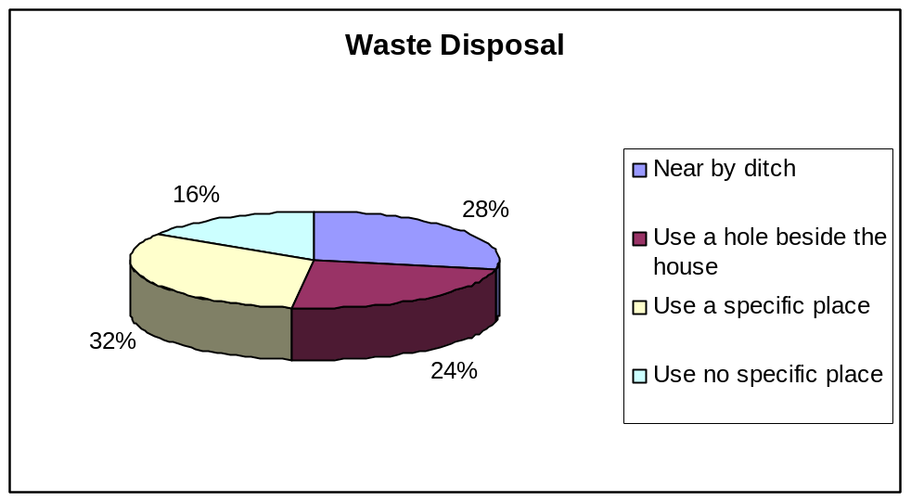
Source: Field Survey, 2011

7.6 Child Immunization:
In my assigned area Barahaat Para I have surveyed 25 house hold and tried to get an idea of knowledge of villagers on immunization and vaccination of child and also try to find out that most vaccination of child has been improved quite significantly. Major improvement came in Polio, Measles and Diphtheria, the reason behind this awareness is different activities on vaccination programs by the help of media and Government organization along with NGOs.
Table 3: Vaccination of Children
Name of diseases | No | 2004% | 2010%
Polio | 19 | 60 | 76
Whooping Cough | 9 | 30 | 36
Measles | 19 | 59 | 76
Tetanus | 15 | 52 | 60
B.C.G | 17 | 62 | 68
Hepatitis "B" | 9 | 30 | 36
Diphtheria | 14 | 48 | 56
OPV | 2 | 5 | 8
Source: Field Survey, 2011

7.7 Common Diseases:
In village 35% got fever among them most of them are young and middle age group. As rural people and young age group easily get infected with germs as they go around all day barefooted and lack other hygiene practices. Typhoid and malaria occurs 10% with in a year, pasra is 5% and pain is also 5%. Most of the old people are effected by pain due to heard work in young age.
Table 4: Common diseases

Diseases /Age Group | 0-15 | 16-30 | 31-45 | 45-65 | 66+ | %
Fever | 8 | 5 | 0 | 12 | 4 | 35
Typhoid | 7 | 0 | 0 | 3 | 2 | 10
Diarrhea | 5 | 6 | 1 | 3 | 2 | 25
Pasra | 2 | 2 | 1 | 0 | 0 | 5
Malaria | 5 | 2 | 0 | 1 | 1 | 10
Pain | 0 | 0 | 0 | 2 | 6 | 5
Source: Field Survey, 2011

7.8 Cooking place:
In our assigned Barahaat Para, most of the villagers (60%) use to cook in the kitchen. They prefer kitchen outside the house, e.g. in the backyard or front yard of the house. 20% of them cook outside, which means in open place. 12% of them cook inside their living room; this is very harmful for the environment of the living room. Only 8% have no specific place to cook.
7.9 Fuel Types Used for Cooking:
According to the villager now a day people are using more cow dung for cooking purpose which gives negative impact on agricultural sectors. 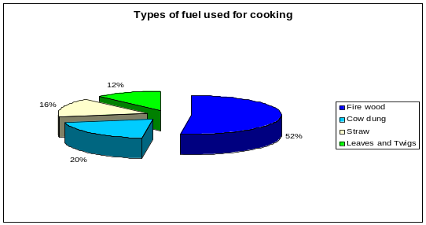 Source: Field Survey, 2011

7.10 Ponds:
The soil of these ponds is also sandy and loamy type. Lots of bamboo trees and unknown bushes were founded beside the ponds. According to the villagers some common fishes like Silver curp, Mirka, Grass curp, Ruhi, Katla, Pangus, Karp and Telapia are founded in the ponds.
7.11 NGO Contribution Jagannathpur Village
In my village area NGO has done lots of development in the Jagannathpur Village area form my comparison study in different areas. If I focus on Mother Health
Child Mortality rate has been improved lots 39% to 51%, which is quite significant
Nutrition has been also improved. In the case of family Planning it is quite considerable because due to growing of nuclear family at the same time concentrated on education and study.
 | Responses
Changes | No | 2004% | 2010%
Mother Health | 12 | 39 | 51
Child Mortality | 9 | 55 | 68
Nutrition | 13 | 35 | 45
Family Planning | 18 | 40 | 60
HIV Prevention | 2 | 18 | 24
Vaccination | 21 | 65 | 75
Source: Field Survey, 2011

7.12 CONCLUSION
Above all, we can say that Jagannathpur village is much developed from the side of health and environment except some abnormalities. The people of this village are living a healthy and happy life with the help of NGO and other welfare organizations.

8.1 INTRODUCTION

Micro credit and Economical effect on rural life and contribution of NGO

Microcredit is the extension of very small loans (microloans) to those in poverty designed to spur entrepreneurship. These individuals lack collateral, steady employment and a verifiable credit history and therefore cannot meet even the most minimal qualifications to gain access to traditional credit. Microcredit is a part of microfinance, which is the provision of a wider range of financial services to the very poor.
Microcredit is a financial innovation that is generally considered to have originated with the Grameen Bank in Bangladesh. In that country, it has successfully enabled extremely impoverished people to engage in self-employment projects that allow them to generate an income and, in many cases, begin to build wealth and exit poverty which has good positive impact in the rural life

8.2 NGO Activities at Jagannathpur Village
The inhabitants of villagers are poor. They are mainly depending on agriculture, small business and farming. That is why they don’t have availed cash for extend their business or growing their crops so in that case GO and NGO are doing prominent role improve the condition, micro-credit loan is one option
NGO Encourages Children's Education:

NGO/s | RESPONSE (OUT OF 24 FAMILIES)
NGO/s | Yes |  | No
NGO/s | Number | % | Number | %
MANAB KOLLAN | 7.00 | 16.67 | 0.00 | 29.16
GRAMEEN BANK | 2.00 | 20.83 | 3.00 | 12.50
BRAC BANK | 1.00 | 4.17 | 2.00 | 8.34
ASA | 1.00 | 4.17 | 1.00 | 4.16
TOTAL | 11.00 | 45.84 | 13.00 | 54.16
Source: Field Survey, 2011

According to the family respondents, MKP encourages highest percentage of children education. On the other hand ASA encourages the lowest percentage of child education. I have founded in Barahaat Para. Grameen Bank and BRAC also have significant support for child education of respondent’s point of view. This NGO’s like ASA and Brac bank encourages of one respondent for their children education.

8.3 NGO Encourages Sanitation:
I have founded in our Barahaat Para, MKP encourages the highest percentage (41.67%) for sanitation to the NGO’s respondents. The number of ten respondents supported from MKP for sanitation. And Grameen encourages 25%, Brac bank 8.33%, ASA 8.33% for sanitation to the NGO’s respondents. From this survey people are more satisfied with the MKP and Grameen Bank.

8.4 NGO Encourages Women’s Empowerment:
NGO/s | RESPONSE (OUT OF 24 FAMILIES)
NGO/s | Yes |  | No
NGO/s | Number | % | Number | %
MANAB KOLLAN | 8.00 | 33.34 | 3.00 | 12.50
GRAMEEN BANK | 4.00 | 16.67 | 4.00 | 16.67
BRAC BANK | 1.00 | 4.16 | 2.00 | 8.33
ASA | 2.00 | 8.33 | 0.00 | 0.00
TOTAL | 15.00 | 62.50 | 9.00 | 37.50
Source: Field Survey, 2011

According to the Micro Financing MKP encourages the highest percentage (33.34%) for women’s empowerment then Grameen Bank encourages 16.67%. ASA encourages 8.33% and BRAC encourages 4.16%. We founded the number of 15 respondents who told that their NGO’s are encourages women’s empowerment but they have complain that every this is good except the higher interest rate, if it reduced women will go for more entrepreneurship, such as, Handicraft and other hand make things.

8.5 NGO Encourages Economic Condition:

NGO/s | RESPONSE (OUT OF 24 FAMILIES)
NGO/s | Yes |  | No
NGO/s | Number | % | Number | %
MANAB KOLLAN | 11.00 | 45.83 | 0.00 | 0.00
GRAMEEN BANK | 8.00 | 33.34 | 0.00 | 0.00
BRAC BANK | 2.00 | 8.33 | 1.00 | 4.17
ASA | 2.00 | 8.33 | 0.00 | 0.00
TOTAL | 23.00 | 95.83 | 1.00 | 4.17
Source: Field Survey, 2011

I have surveyed in Barahaat Para where I have found 23 families have taken loan from the above listed NGO’s out of 24 families. MKP encourages highly for improving agricultural based economic condition around 45.83% among the total NGO respondents where BRAC and ASA encourages the lowest percentage for improving the economic condition.

8.6 NGO Improve Social Life:
NGO/s | RESPONSE (OUT OF 24 FAMILIES)
NGO/s | Yes |  | No
NGO/s | Number | % | Number | %
MANAB KOLLAN | 11.00 | 45.83 | 0.00 | 0.00
GRAMEEN BANK | 7.00 | 29.96 | 1.00 | 4.16
BRAC BANK | 1.00 | 4.16 | 2.00 | 8.34
ASA | 2.00 | 8.34 | 0.00 | 0.00
TOTAL | 21.00 | 87.50 | 3.00 | 12.50
Source: Field Survey, 2011

The respondents point of view some NGO’s encourages for social life. I have founded in our Barahaat Para that almost 21 families have taken micro credit loan out of 24 families for improving house and other social activates such as weeding and religious festivals. I surveyed Barahaat Para 11 respondents of them said that MKP supported their social life.

8.7 Source of loan and interest rate:
 | Last Amount Borrowed (In Thousand Taka)
Sources | Up to 5 | 5 to 10 | 10 to 20 | Over 20 | Total | % | Interest Rate %
Grameen Bank | 1 | 1 | 4 | 2 | 8 | 33.33 | 12.50 in 45 installment
Brac Bank | 1 | 2 | 0 | 0 | 3 | 12.50 | 15.00 in 46 installment
MKT | 3 | 3 | 5 | 0 | 11 | 45.83 | 12.50 in 45 installment
Asha | 1 | 0 | 1 | 0 | 2 | 8.33 | 12.50 in 45 installment
Source: Field Survey, 2011
I have found, more or less villagers have taken micro-credit loan from various NGO’s rather then local money lender. In the case of MKT they are offering the most lucrative package that is why 45.83% villagers go for it. At the same time Grameen Bank is also influence on micro credit loan. Among the villagers 5 to 10 years are very popular project. BRAC bank and Asha are also working but Brac has higher interest and Asha is new in this area that is why people don’t go for it.
8.8 Utilizations of Loan in Different sectors: 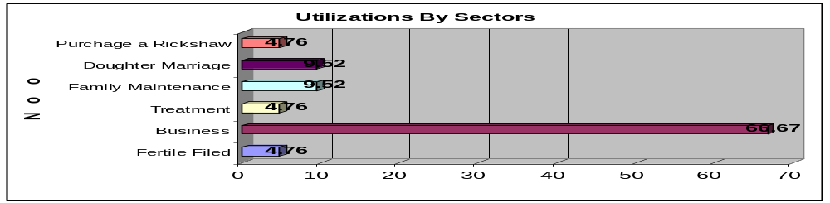 Source: Field Survey, 2011

Graph shows that more then half of the lone has been utilized in Business sectors. This is 67.67% of total fund. One the other hand fertile filed and purchase Rckshaw is most negate part of utilizations of funds only 4.6% funds used. In the case of Daughter mirage and maintenance villager are also using quite significant amount of money.
8.9 Conclusion
Most of the people of Jagannathpur village are below the poverty line, but they are trying to increase their current monetary stipulation by taking micro credit. There are also some upper and solvent people whose living standard is much higher than the needy people. The differences between the wealthy and needy people are in actual fact are very high.

10.1 Conclusion:
The village Jagannathpur is reflecting of all other village of Bangladesh. After surveying in Barahaat Para not only completed our academic requirements but we get a real picture of a village and village - people in our mind. From here we realized that how neglected the village peoples are. But the truth is that Bangladesh is agricultural country where more than 80% peoples are live in the village. When we visit Jagannathpur village and talked with village people we found that they are always neglected by the government as well as honorable citizens or even powerful politicians. If we compare to the city with the village we see that how far difference of the education, communication, health and other facilities between two locations though both locations are in Bangladesh. For example where there are 3 or more government as well as private health centre in an area of a city but don’t find any health centre in Jagannathpur. But the original scenario should to be opposite. Our government must take care of this neglected people because without farmer our economy will be a blank basket. So to make a developed and prosperous country we all need to take care of our village and its resourceful resources.

10.2 Major Findings of the Thakurgaon

 90% people are Muslims and 10% people are Hindu
 Main source of income of the villagers is agriculture.
 Tube-well is the most widely used source of water supply for all purposes.
 Almost 100% of the villagers use ring slab or slab latrine for sanitation.
 There is no bank and hospitals in the Para.
 There is only one pre primary school in our assigned Para.
 Low arable lands become flooded during rainy season.

