Submitted by

WWW.ASSIGNMENTPOINT.COM

In the modern business world, internship program help the students to demonstrate skills and competence from their supervised experience and in addition enables them to demonstrate maturity and acceptable professional, personal and interpersonal behavior.
Internship program is essential for all BBA students, because it helps him or her acquit with real life situation. The real estate sectors play a significant role in solving the housing crisis in Dhaka city, so I have selected Roots Developments Limited which is one of the leading companies in our country.
For completing my BBA degree Internship Report is one of the parts at the final semester of the Department of Business Administration, Northern University, Bangladesh. This is a study Marketing Activities of Roots Developments Limited h. It was a chance for me to learn about the management and how to use Marketing Policy In the modern business world, internship program help the students to demonstrate skills and competence from their supervised experience and in addition enables them to demonstrate maturity and acceptable professional, personal and interpersonal behavior. As the classroom discussion alone cannot make a student perfect in handling the real business situation, therefore it is an opportunity for the students to get accustomed with the real life situation through this program.

1.2 Background of the study

In the last four years BBA classes, we studied our courses on business studies from theoretical aspects. There was no scope to earn practical knowledge about business and its environment, theory and practice are inter-related and are equally important. Knowledge is not fruitful one unless it is a combination of both theory and practical. Under the department of Business Administration, BBA Program allows its student to study and analysis a selected organization in order to get a practical knowledge which also facilitates use of theoretical knowledge, students have already gathered. As a part of requirement of BBA Program, I was also assigned to prepare report titled on “Marketing Activities of Roots Developments Ltd ” A Study based on Corporate Office activities at Suvastu Arcade (9th floor) , 46-48 New Elephant Road , Dhanmondi Dhaka-1205.

1.3 Significance

This report is the result of three months internship in Roots Developments Ltd. I enter as an internee in Roots Developments Ltd. beginning from 1st October to 30 December, 2010 and I have completed this internship period successfully. This internship report contains all the knowledge that I gather at the time of my internee in Roots Developments Ltd. In this internee time I noticed that they work day to day. They work hard and soul. My topic is “Marketing Activities of Roots Developments Ltd.” It would be a great opportunity for me to get familiar with this system. So this study is very significant for both the company and me. They are strongly satisfied for my work.

.

1.4 Scope of the study
study

This report will give us a clear picture about the Marketing Activities in general & specially the activities of Marketing Activities of Roots Developments Ltd. The scope of the study is limited to organizational set up, functions, & performance.
The scope of this study is:
• Maintaining a good relation between employees & management.
• Improving an effective work station design.
• Effective marketing layout designing.
• Efficient handling of employees.
• Handling & setting the employees according to their work.
• Maintaining the link in effective manner.

1.5 Specific objectives

study

- To find out the Marketing activities of Roots Developments Ltd.
- To know the services offered by Roots Developments Ltd.
- To identify differences between theory and practice by working directly in a company.
- To know the terms and conditions of finance and accounts activities.
- To know the work process and monitoring system of marketing department.
- To discuss on function and operation of each level of the company.
- To find out existing problems of Roots Developments Ltd.
- To find out how efficiently its present strategies are working.
- To get an overall idea about the performance of Roots Developments Ltd.
- To find out the opportunity and threat of Roots Developments Ltd.
- To find out the strengths and weaknesses of the organization.

1.6 Methodology
The methodology describes the procedures to organize the scattered ideas & views to conduct a study. Proper working procedure helps to capture the right things during study periods & finally fulfills the objective of the study.
Generally a method involves a technique in which various stages of collecting data or information are interpreted. So, adoption of methodology is an important step in performing any study.
In this study a methodology is followed for the achievement & successful accomplishment of the dissertation work relevant data from reliable sources have used while preparing the report. Both primary & secondary data have used where necessary.

Data collection method:
Relevant data for this report has been collected primarily by direct investigation of different records, papers, documents, operational process and different personnel. No structured questionnaire has been used. Information regarding office activities of Roots Developments Ltd. has been collected through consulting and discussion with company personnel and employee.

Data sources:
Both primary and secondary source of data are used to complete this study. These two sources are explained below-
Primary sources:
- Face to face conversation with the company Department Head, Manager, Marketing Manager, Executive and other Employee.
- Notes taken from day to day working.

Secondary sources:
- Different manuals of Roots Developments Ltd.
- Files and documents of the Corporate Office.
- Monthly report of Roots Developments Ltd.
- Different paper of Roots Developments Ltd.
- Newspaper and Internet.
1.7 Data Analysis and Reporting

Only quantitative tools are used to analyze the gathered data and different types of computer software’s are used for reporting the gathered information from the analysis, such as Microsoft word and Adobe Photoshop 5.5.

1.8 Scope of the report

This is a large scope for doing the internship in any organization in Bangladesh. Internship provides practical knowledge to the students about their practical field. The BBA graduate students can share their managerial knowledge with the organization. The students have a large opportunity to acquire knowledge about the organization, organizational environment, participation with others and etc. The students can familiar with organizational culture. After studying this report you will be able to know about the Marketing activities of Roots Developments Ltd.

1.9 Rationale of the study

Internship program is essential for every student, especially for the student of Business Administration, which helps them to know the real life situation. For this reason a student takes the internship program at the last stage of the degree, to launch a career with some practical experience.

The internship program is very helpful to bridge the gap between the theoretical knowledge & real life experience as part of Bachelor of Business Administration (BBA) program. This internship report has been designed to have a practical experience though the theoretical understanding.

1.10 Limitations

The present study was not out of limitations. But it was a great opportunity for me to know activities of real estate business. Some constraints are appended bellow:

Preparation of this report helps me to know huge information about marketing department activities of a company. All situations or all people were in favor of mine. But in some cases I face some problem on account of some limitations. Those limitations are-

- As an internee I had only three (3) months time which is not enough to know as much information as this report required.
- Different officials express the same topics in different way. Sometimes I became confused.
- To collect information I had to difficulty because of the excessive nature of confidentiality by the officials.
- The company has no structured overview information so it was another problem for me.
- I had to go under my day to day job responsibility that I was supposed to do so. So I could get few more time to spend in collecting data for preparing my internship report.
- Some Different policies that are used in the organization are also confusing for me.
- Some important data that are necessary for the report are highly confidential to disclose.

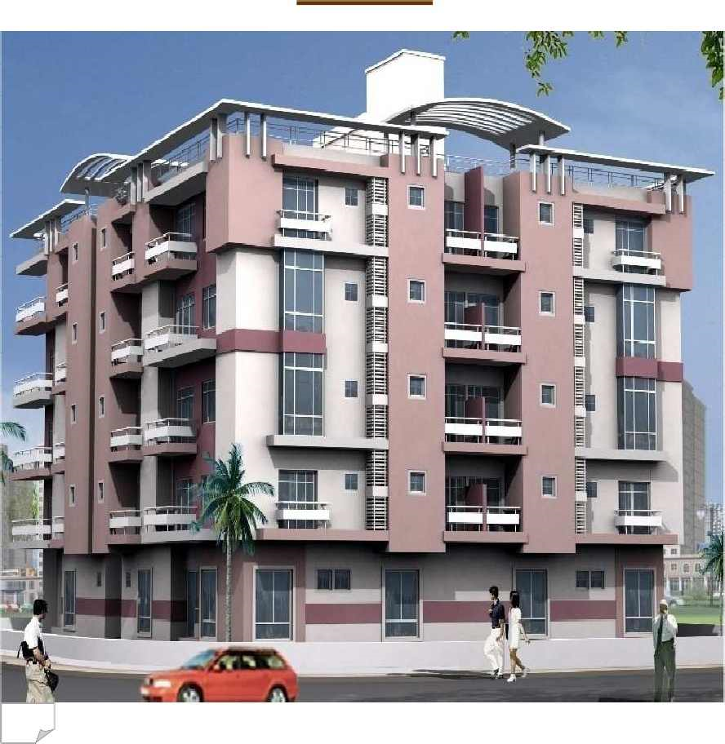

CHAPTER TWO
Profile of the Organization

2.1 History of Real State Business

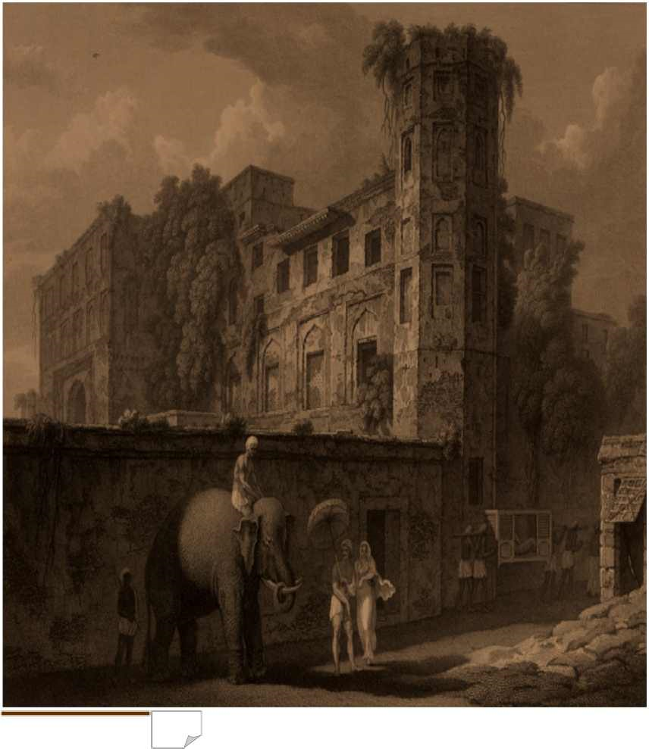
One of the fundamental rights of human being is housing. But regrettably a large number of populations in Bangladesh are still underprivileged of this requirement. One of the main reasons behind this situation the over population of the country. The rapid increasing of the growth is also alarming to deteriorate housing conditions. Even more to the reality is that every year a significant percentage of rural population arrived in Dhaka in order to search for job, study, for employment purpose, business purpose and others. On the other hand the land situation of the Dhaka city is gradually decreasing for many causes and becoming over population loaded.
Some pioneer group of companies started the housing and apartment business in the sense of real estate business in late 1970s in Bangladesh. Step by step during 1980s, very few were directly involved to develop this sector. Passing 1990s, this business has become a huge investing and massive contribution in national economy. It has become the most competitive business in Bangladesh and expanded through out the country.
The Dhaka city is expanding rapidly due to rapid urbanization; the shopping activities have increased in different urban areas of the country. The life style of urban people has also changed. Now a days they want to live in a modem but secured place like apartment building. The demand of modern commercial complex and residential apartment is very high in Dhaka City. Besides the sponsors are experienced in similar sectors. Their observation and experiences have inspired them to construct such two types of projects.

In order to meet the housing problem of Dhaka City in particular RDL emerged on 2008. Now near about 600 Real Estate Developer Companies are engaged in this business. As a result, real estate business in Bangladesh holds much popularity now-a-days. That's why prosper is very is good indeed.
The shortage of affordable dwelling/ commercial place around the world was an immense problem, As Bangladesh is a member of LDC (Least Developed Country) the metropolitan cities housing infrastructure are not preplanned and well established. For this the people have been facing various problem of business/living. After analyzing that the company envisaged to fix up a target market on which it can concentrate. The average earning groups who are mainly the employers of the government organization or NGOs, entrepreneur of small businesses etc are the fixed target clients of RDL. We believe of our strength to meet the expectation of the client.

2.2 Background of Roots Development Limited

Roots Development Limited is a fast growing quality construction and Developer Company in Dhaka to accomplish the ambition of typical breathing apartment and worthwhile endeavors. A house of eminent local, American and European sound immigrant entrepreneurs, full proficient experts of planner, designer and engineers have been contributing for different tasted residential houses particularly for Bangladeshi immigrants and archetypal buyers.
An inclusive address for sound living with no hazards is the vision of the company. The immigrants already finding their way to build up a bridge between their heritage and dreams of reality through and to the real roots.
We are passing through the golden era of internet & telecommunication where the whole is considered as a mere global village. The choosing tendency of people is changing day by day. So the standard style, quality, location, security and prestige are the uncompromising concern of the company will apart anyone buyer from the flow of traditional dwelling system.
Absolutely earth quake preventive standard construction materials with Bangladesh Standard Testing Institute (BSTI) approvals, Rajdhani Unnyan Kartripokhya (RAJUK) approved design, prescribed salient fitting & fixtures will assure our valued customer for ever relation with and distinguished projects of Roots Properties Limited.

Reasonable and competitive price, timely hand over and after sale services are the fundamental policies of the company for your utmost satisfaction. We, Roots Properties Limited committed to building up our real roots.
Roots Development Company [RDL] is working for the development both in urban and its adjacent areas. It has the reputation in the quality apartment and commercial complex construction in the Dhaka city particularly in remarkable areas.

RDL the promising shape of the capital city of Dhaka's present urban outlook and life style. RPL is the name of belief that has already marked its success as one of the exclusive Real Estate Company in the perspective of Real Estate production in Bangladesh. Accomplished and valued client's pleasure is its motto. It pledges the spirit of time of the day and most excellent quality within the reach of the urban dwelling system.
After incorporating RDL. The success of the company goes to its experienced and skilled personnel's. A team of hard-core professionals consisting of engineers, technocrats planners and architects along with a dedicated workforce help to achieve, which a few others could hope for total quality to the absolute delight of the customer. RDL has successfully started to construct different apartment projects located at Bosundhara,Banosree, aftab nagor, Uttara, Mohammadpur, Kalabagan, Kanthal Bagan, Elephant Road, west Dhanmondi and Mirpur areas in Dhaka city. The sell process of those projects is on function on first come first serve basis.
In RDL, construction materials and equipments are procured with great care so as to ensure highest promising standard of construction. RDL is enthusiastic to preserve a high standard in quality control and work of genius. Use of high quality materials and high-tech equipment is a daily routine for RDL family.
RDL assures its valued clients of entire service backed by years of collective efforts of the company and a widespread assortment to unbeaten mission. After sale service that turning point on our complete appreciative and hope of your expectations, aspiration and desires.
The whole strength of RDL is absolutely competent to build up a separate and tasted apartment class, commercial growth and urban development progress. Those who visited once the projects of RDL, remains a smooth and continuous communication. We assure the security of their invest first of all. RDL thinks of product first. The company always bears the courage of expenditure the actual need for any construction. Superiority for quality is an ethical matter in company’s motto. The in detail knowledge with growing tendency from accomplishing huge residential and commercial projects has no alternative. This effort has really made us a different than other traditional flow of rising companies.
2.3 Objectives of the Company

► To reach the goals of organization in individual aspects & the company as a whole.
► Efficiency of the work force by employing their skills & abilities.
► Providing employees with proper standards of job satisfaction.
► Providing the organization with well trained & well motivated employees.
► Communicate the policies to all employees of Human Resource Management issue.
► The objective is to have a clear knowledge of planning, organization and leading.
2.4 Mission of Roots Developments Limited

To provide best quality service for Roots clients at a price that is competitive yet affordable and delivers on time. RDL will constantly strive to improve our service delivery by new technology, innovation and creative ideas.
2.5 Policy of Roots Developments Limited
Roots policy is to work in partnership with our clients. We make sure we fully understand our clients' needs and concerns. RDL work together to work out the best strategy and tactics needed to deliver what RDL promise.
We are an ethical and eco-friendly company. We work in partnership with local authorities, local communities and other statutory bodies to ensure that we not only satisfy the authorities' legal requirements we also take into account the environmental effect our development may have for local communities. We are very conscious about the damage some developments may cause to local environment.

2.6 Roots consideration in site selection

Roots normally work in and around the Dhaka City, but for a major and exciting project we will take on any challenge anywhere in the country.
Roots Development Company selection of sites is determined by the availability of schools, colleges, banks & financial institutions, hospitals & clinics, markets & shopping centres and parks & recreational facilities within a reasonable distance from the development site. RDL prides itself in its ability to provide a safe and secured environment with a strong emphasis on enhancing the area's aesthetic appearance and beauty.
Finally Roots consider, Customer satisfaction' is our only measure of success. Our customers are our best assets. To serve and satisfy Roots customers is one of Roots primary goals.
2.7 Roots Business Areas
BUSINESS AREAS

BUSINESS AREAS

RDL is a provider of apartment, shop, office space, rental service and security service for specific client segments. RDL also provides architectural solution for building design and logistic solution for construction.
RDL selected client, sectors include top-level management personnel of national and multinational companies, small business enterprise, government employees, NGOs, distribution and others. RDL segmented the client groups on the basis of social structure. RDL provides its client exclusive apartments, rental service, and security service.
RDL corporate structure, based on its business areas, has been developed and the focus of the company's strategy has been directed to the management of logistic chains and technical information as well as the supply of construction related raw materials.

2.8 Roots Commitment and Specialty

Roots Development Company [RDL] has originated the following core commitment and policies to establish secured and foreign standard living atmosphere in Dhaka. The dependable and constructive steps of RDL absolutely made it different standard development company from the traditional flows. RDL clearly declares that:
- RDL never compromises with its quality for secured living and uses Bangladesh Standard Testing Institute [BSTI] approved construction materials as per proper rules and regulations of Rajdhani Unnyan Kartripokhya [RAJUK].
- RDL always makes the valued investors assured the hand over of their living project within the scheduled time frame.
- RDL has engaged a high profiled expert team of architect designer, planner and environment specialists for extra ordinary Archetypal Design.
- The mission of building up sound and complete apartment for only two types of buyers: only Bangladeshi immigrants in abroad and conscious buyers.
- RDL always chooses lands only in prime locations in Dhaka and land size is a great concern for avoiding huge gathering in a living apartment complex.
- RDL chooses lands at such a prime location in Dhaka with all type of communication facilities.
- RDL is the only committed developer company in Bangladesh that the valued buyers in land and in abroad always feel free for their secured investment.

- Competitive price, flexible and affordable payment mode, available loan facilities with minimum interest rate [if needed] are very favorable to our valued clients.
- After sale services for utmost satisfaction of the client for peaceful and comfortable living, RDL has adopted practices of ever relations with them.
- RDL builds your home to generate your roots.
Contact Information

er

Contact Information

er

Contact Information

er

Contact Information

er

Contact Information

er

Contact Information

er

Contact Information

er

Roots Development Ltd.
Membership No : 799/2010
Business Type: Real Estate Firms/Developers
Suvastu Arcade (9th Floor) 46-48 New Elephant Road, Dhanmondi
Dhaka,Bangladesh
E-mail:info@rootsdevelopment.com
Phone : 8621247, 9120695, 8618160
Fax : 88-02-9665430

2.9 Management of Roots development Limited

er

MANAGEMENT SYSTEM:

 | Managing Director | Engr. S. M. Palash

GENERAL ADMINISTRATION:

4 | General Manager | 01
5 | Senior Manager | 01
6 | Manager | 01
7 | Assistant Managers | 01
8 | Front desk operations | 02
9 | Office Assistants | 03
10 | Driver | 03
11 | Project Caretaker | 06

OTHER DEPARTMENTS

A | Department of Engineers

Chief Engineer [Civil] | 01
Diploma Engineer [Civil] | 02
Project Supervisor | 01
Asst. Supervisor-Project | 03

B | Department of Architects

Head of Architect | 01
Diploma Architect | 02
Cad Operator | 01

C | Department of Marketing

Marketing Consultan | 01
Sr. Manager –Sales & Marketing] | 01
Asst. Manager – Sales & Marketing | 02
Executive- Sales & Marketing | 04

D | Land Procurement

Manager – Land Procurement | 01
Asst. Manager – Land Procuremen | 01
Executive – Land Procurement | 02

E | Department of Accounts

Manager- Accounts | 01
Accounts officer] | 01

F | Department of Logistics

Manager- Logistic support | 01
Executive - Logistic support | 02

G | Department of Legal Affairs

Legal Advisor | 01

2.9.1 Organ gram of Roots Developments Ltd

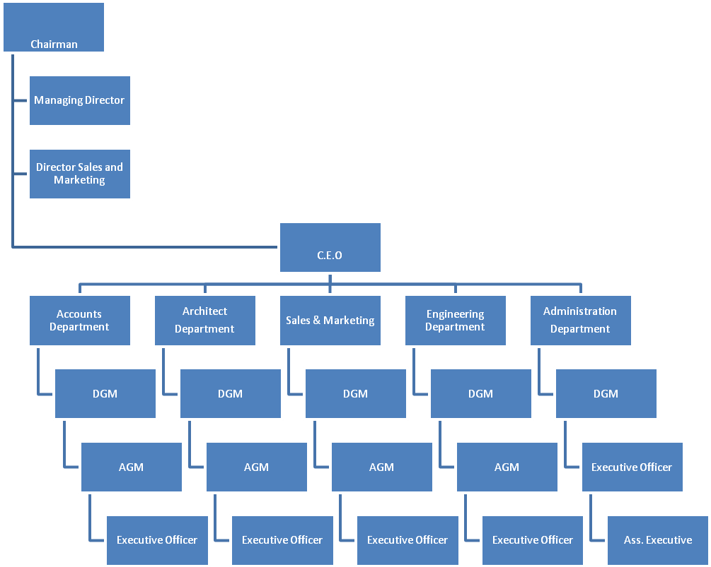

2.9.2 Departments of Company

Roots Developments Limited has six departments for operating the company. The departments and their activities are given bellow:
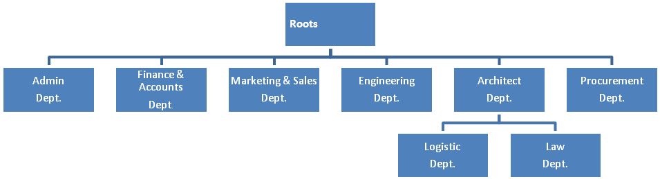

2.10 Project List of Roots Developments Limited

2.10.1 Complete Project:
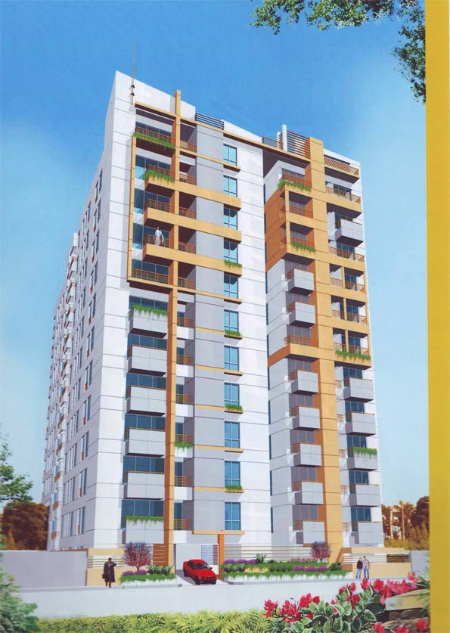
Project Name | Roots- Aridonous
Project Location | Hs # 62, Rd # 05, Sec # 13, Uttara, Dhaka-1230.
Size of Apartments | Type - A: 1850 sft
Project Hand Over | June 2009
Map Location :
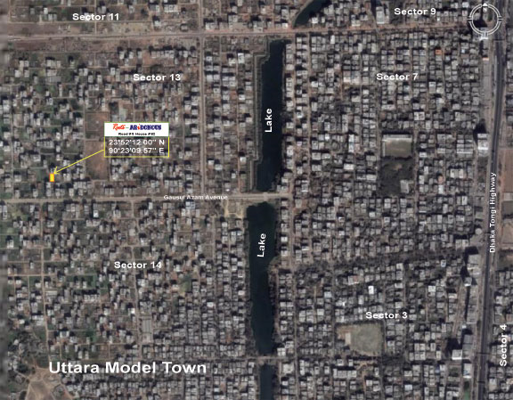

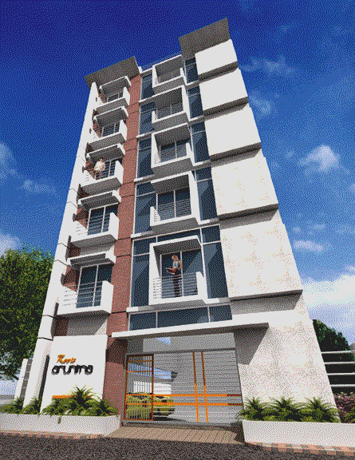

Project Name | Roots- ORUNIMA
Project Location | Hs # 30, Rd # 08, Sec # 12, Uttara, Dhaka-1230.
Size of Apartments | Type - A: 900 sft. Type - B: 1850 sft
Project Hand Over | December 2009
Map Location :
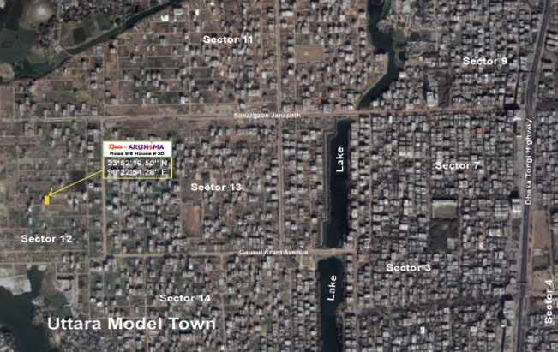

2.10.2 Ongoing Project:
1.Freedom Tower
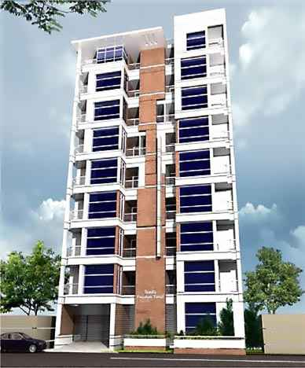
Freedom Tower
Project Name | Freedom Tower
Status | Ongoing
Project Location | Plot: D4, Block: D, Main Road, Aftab Nagor, Rampura, Dhaka
Facing | South
Total Floor | 9 (Nine), Basement and Ground floor will be Parking
Lift | Available
Generator | Available
Flat Size | 1100 sft. & 2200 sft.
Bedrooms | 3 bed for 1100 sft and 4 bed & servent bed for 2200 sft.
Bathrooms | 3 for 1100 sft. & 4 for 2200 sft.
Total flats | 8-16
Handover | June 2013
Description | Freedom Tower is one of the most high-status and lavish south facing residential project at 100 wide main road, Aftab Nagor, Rampura. Both (approx.) 1100 sft. and 2200 sft. sizes apartments are designed in this projects. One unit one floor or two unit facilities are available here consisting spacious room arrangement with all state-of-art modern fixtures and amenities. While designed both aesthetical and functional quality has been maintained very carefully. It gives magnificent & elegant outlook of building. Maximization of advantages especially in relation to the daylight and outside view. Cross ventilation to be ensured throughout the apartments as far as possible. Privacy will be emphasized in designing the layout so that the master and second bed rooms are located away from the guest bedroom and main entertainment areas.  Each 1100 sft. apartment will consist of Three Bedrooms, Three Toilets, One Kitchen, Living, Dining and Verandahs. And each 2200 sft. apartment will consist of four Bedrooms, four Toilets in addition to a Servants Toilet, One Kitchen, wide Living, Dining, Family living, study room and Verandahs.
2. Himadree
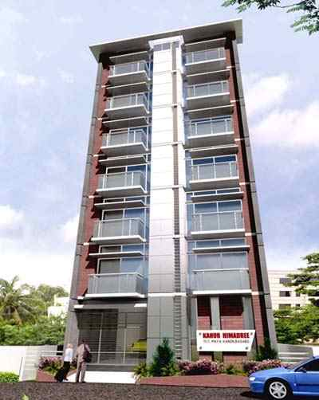
Himadree
Project Name | Himadree
Status | Ongoing
Project Location | Plot # 11/1, maya kanon, Basabo, sobujbag
Facing | South
Total Floor | 7 (Seven) Ground floor will be Parking
Lift | Available
Generator | Available
Flat Size | 800 sft. & 1600 sft.
Bedrooms | 2 bed for 800 sft and 3/4 bed for 1600 sft.
Bathrooms | 2 for 800 sft. & 3/4 for 1600 sft.
Total flats | 6-12
Handover | December 2011
Description | Himadree is an exclusively luxurious South Facing apartment project with 800 sft. & 1600 sft. apartment at Plot # 11/1, maya kanon, Basabo, sobujbag, the most posh living area near Motijheel C/A for peaceful living at present. Roots Developments Limited is going to create a mile stone building up this 7 storied residential project. One unit one floor or two unit facilities are available here consisting spacious room arrangement with all state-of-art modern fixtures and amenities. While designed both aesthetical and functional quality has been maintained very carefully. It gives magnificent & elegant outlook of building. Maximization of advantages especially in relation to the daylight and outside view. Cross ventilation to be ensured throughout the apartments as far as possible. Privacy will be emphasized in designing the layout so that the master and second bed rooms are located away from the guest bedroom and main entertainment areas. Each 800 sft. apartment will consist of Two Bedrooms, Two Toilets, One Kitchen, Living, Dining and Verandahs.  And each 1600 sft. apartment will consist of four Bedrooms, three Toilets in addition to a Servants Toilet, One Kitchen, wide Living, Dining, Family living and Verandahs.
3. Onirban
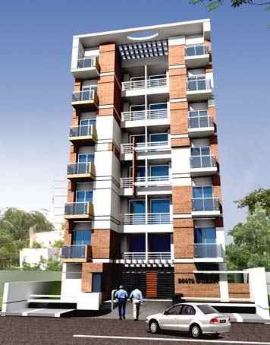
Onirban
Project Name | Onirban
Status | Ongoing
Project Location | Plot # 19, Road# 3, Bonsree, Rampura
Facing | South
Total Floor | 7 (Seven) Ground floor will be Parking
Lift | Available
Generator | Available
Flat Size | 900 sft. & 1800 sft.
Bedrooms | 2 bed for 900 sft and 4 bed for 1800 sft.
Bathrooms | 2 for 900 sft. & 3/4 for 1800 sft.
Total flats | 6-12
Handover | December 2011
Description | Onirban is one of the most prestigious south facing residential projects of the company for its special location, design and facilities accommodation. At Plot # 19, Road # 3, Bonsree, Rampura . Both (approx.) 900 sft. and 1800 sft. sizes apartments are designed in this projects. One unit one floor or two unit facilities are available here consisting spacious room arrangement with all state-of-art modern fixtures and amenities. While designed both aesthetical and functional quality has been maintained very carefully. It gives magnificent & elegant outlook of building. Maximization of advantages especially in relation to the daylight and outside view. Cross ventilation to be ensured throughout the apartments as far as possible. Privacy will be emphasized in designing the layout so that the master and second bed rooms are located away from the guest bedroom and main entertainment areas.  Each 900 sft. Apartment will consist of Two Bedrooms, Two Toilets, One Kitchen, Living, Dining and Verandahs. And each 1800 sft. Apartment will consist of four Bedrooms, three Toilets in addition to a Servants Toilet, One Kitchen, wide Living, Dining, Family living, study room and Verandahs.
4.
Project Name | Roots- Odommo
Project Location | Hs # 25 (South Facing), Rd # 04, Block # C, Banosree,Rampura, Dhaka-1217.
Size of Apartments | Type - A: 900 sft. Type - B: 1800 sft
Project Hand Over | December 2011

5.
Project Name | Roots- Oporajita
Project Location | Hs # 33, Rd # 24, Sec # 10, Uttara, Dhaka-1230.
Size of Apartments | Type - A: 925 sft. Type - B: 1850 sft
Project Hand Over | December 2011

6.
Project Name | Roots- Oronno
Project Location | Hs # 17(new), Rd # 01,Pallobi, Mirpur, Dhaka-1230.
Size of Apartments | Type - A: 1100 sft. Type - B: 2200 sft
Project Hand Over | June 2012
7.
Project Name | Roots- Orjita
Project Location | Hs # 33 (CP), Rd # 01,Pallobi, Mirpur Dhaka-1230.
Size of Apartments | Type - A: 1125 sft. Type - B: 2250 sft
Project Hand Over | December 2012

8.
Project Name | Roots- Oporajita
Project Location | Hs # 33, Rd # 24, Sec # 10, Uttara, Dhaka-1230.
Size of Apartments | Type - A: 925 sft. Type - B: 1850 sft
Project Hand Over | December 2011

2.10.3 Upcoming Project:

Project Name: Roots- Lausanne
Project Title | Lausanne
Project Name | Roots- Lausanne
Project Location | Mirpur
Description | Roots- Lausanne is also one of the most prestigious projects of the company for its special location, design and facilities accommodation. At mirpur BaraBag, plot # 1/5/A-B, west faces luxurious residential project. There remains 2400 sft. is with 4 wide bed rooms, 4 toilets, 4 verandahs, 2 wide living spaces, wide dining, drawing and separate servant bed & bath will assure your peaceful and secured living. 1200 sft. Apartments are designed with 3 bed, 3 bath, 2 verandahs, dining, drawing, kitchen, family living areas including all other facilities. 800 sft. Apartments are designed with 2 bed, 2 bath, 1/2 verandahs, dining, drawing, kitchen areas including all other facilities. 30 feet wide road passes away though the project. Both 2400 sft., 1200 sft and 800 sft. sizes apartments are designed in this projects. One unit one floor or two/three unit facilities are available here. Most up dated and modern fitting and fixtures made this marvelous residing place. Any one Bangladeshi immigrant in abroad or archetypal buyers easily chooses the project for extra ordinary and costly design and fittings. A brief on Roots- Sky de castllia Roots- Sky de castllia is one of the beautiful east facing residential apartment projects of the company for its location, design and facilities accommodation. At baitul aman road # 10, plot # 726/4/3 luxurious residential project. There remains 2400 sft. is with 4 wide bed rooms, 4 toilets, 4 verandahs, 2 wide living spaces, wide dining, drawing and separate servant bed & bath will assure your peaceful and secured living. 1200 sft. Apartments are designed with 3 bed, 3 bath, 2 verandahs, dining, drawing, kitchen, family living areas including all other facilities. 800 sft. Apartments are designed with 2 bed, 2 bath, 1/2 verandahs, dining, drawing, kitchen areas including all other facilities. 30 feet wide road passes away though the project. Both 2400 sft., 1200 sft and 800 sft. sizes apartments are designed in this projects. One unit one floor or two/three unit facilities are available here. Most up dated and modern fitting and fixtures made this marvelous residing place. Any one Bangladeshi immigrant in abroad or archetypal buyers easily chooses the project for extra ordinary and costly design and fittings.

Project Name: Roots- Ortencia
Project Title | Ortencia
Project Name | Roots- Ortencia
Project Location | Mohammadpur
Description | Roots- ORTENCIA is an exclusively luxurious South Facing apartment project. 60 feet wide Road [Mohammadpur Main Road (Nabodoy Housing)] passed away by the south front of this project. This is a 9 storied building including a car parking floor on ground floor. 3000 sft on each floor(Approx.). Any one valued buyer has the option to purchase 800 sft. flat with 2 beds, , 1000 sft. flat with 3 beds and 1200 sft. flat with 3 beds from any floor. Or even a total floor of 3000 sft. Or 2000 sft or 1800 sft with 4-6 beds is available for sale. Adjacent Mohammadia Housing Society at the just left site of the project has created extra values of high societal environment for choosy dwellers. One floor-one unit and one floor two/ three units apartment is completely designed along with parking spaces at ground floor. Most up dated and modern fitting and fixtures made this marvelous residing place. 4-6 wide bed rooms, 4 toilets, 4 verandahs, 2 wide living spaces, wide dining, drawing and separate servant bed & bath for full unit system will assure your peaceful and secured living. Conceptually this project is designed for the Bangladeshi immigrants in abroad or any archetypal buyers.

Project Name: Roots- Sky de castllia
Project Title | Sky de castllia
Project Name | Roots- Sky de castllia
Project Location | Mohammadpur
Description | Roots- Sky de castllia is one of the beautiful east facing residential apartment projects of the company for its location, design and facilities accommodation. At baitul aman road # 10, plot # 726/4/3 luxurious residential project. There remains 2400 sft. is with 4 wide bed rooms, 4 toilets, 4 verandahs, 2 wide living spaces, wide dining, drawing and separate servant bed & bath will assure your peaceful and secured living. 1200 sft. Apartments are designed with 3 bed, 3 bath, 2 verandahs, dining, drawing, kitchen, family living areas including all other facilities. 800 sft. Apartments are designed with 2 bed, 2 bath, 1/2 verandahs, dining, drawing, kitchen areas including all other facilities. 30 feet wide road passes away though the project. Both 2400 sft., 1200 sft and 800 sft. sizes apartments are designed in this projects. One unit one floor or two/three unit facilities are available here. Most up dated and modern fitting and fixtures made this marvelous residing place. Any one Bangladeshi immigrant in abroad or archetypal buyers easily chooses the project for extra ordinary and costly design and fittings.

Project Name: Roots Martiree Faruk Rizia
Project Title | Martiree Faruk Rizia
Project Name | Roots Martiree Faruk Rizia
Project Location | Mirpur
Description | Roots- Marteree Faruque Rizia is one of the most prestigious projects of the company for its special location, design and facilities accommodation. At mirpur main Pallobi, road #1, plot # 24, west faces luxurious residential project. There remains 2300 sft. is with 4 wide bed rooms, 4 toilets, 4 verandahs, 2 wide living spaces, wide dining, drawing and separate servant bed & bath will assure your peaceful and secured living. 1150 sft. apartments are designed with 3 bed, 3 bath, 2 verandahs, dining, drawing, kitchen, family living areas including all other facilities. 30 feet wide road passes away though the project. Both 2300 sft. and 1150 sft. sizes apartments are designed in this projects. one unit one floor or one unit two unit facilities are available here. Most up dated and modern fitting and fixtures made this marvelous residing place. Any one Bangladeshi immigrant in abroad or archetypal buyers easily choose the project for extra ordinary and costly design and fittings.

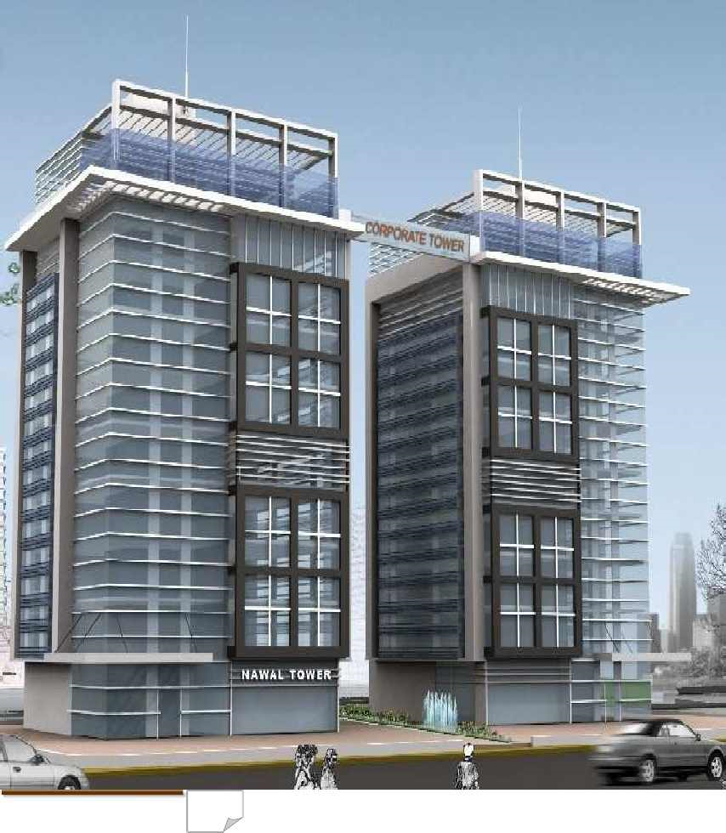

CHAPTER THREE

INTERNSHIP POSITION & DUTIES

3.1 Internship Period:

In the internship period it is very important for any one where practical experience gathered. I did my internship program at Roots Development Limited, from 01 September, 2010 to 30 December, 2010 the period of three month internship program.
I have learned many things about Marketing Activities. Working in Roots Development Limited. I feel as a part of their & every employee on their helped me so much to understand the works easily.
3.2 Job Description:

As an intern I engaged myself in different types of works which are given bellow:
►Potential client search: My main duty is client search, so at first I’m searching the
clients who are interested to buying the Flat.
► Making calls to customers & introducing them about our products:After searching the
client, I’m calling my customers & introducing them about our project & also invite to come our office.

►Ensure the visit of project’s location: I convince the customer to visit the project
location.
► Discuss with clients about the advantages & disadvantages of buying the land.
Then I discuss with my customers about the advantages & disadvantages of the land. I
discuss the main features of our project.
►Try to convince them to purchase the land: I’m trying to convince the customer to
purchase the land.
►Making the agreements & get the booking amount: If the customer are convinced,
then I’m making the agreement & get the booking amount.

► Payment collection system: Every customer payment system is not same. Some customer directly comes to company for payment & some customer pay their payment by cheque.
► Making calls to customers for giving the due amount: Every customer are not pay full amount of money. Most of the customer use installment. So I’m calling the customer for giving the due amount.
► Communicate with customer until the land have transferred: I’m communicating
with my customers until the land has transferred because of customer satisfaction.

3.4 Daily Routine:

My department of internship program is under marketing & sales department. So I was fully involved in marketing & sales department. Everyday I have to go office at 9.00 a.m. like all other employees & stay up to 6.00 p.m. Some days my work area is in office & some days work was out of office, in the field.
3.5 Learning Points:
During the internship period in RDL, I have learnt lots of things. These are listed bellow:
► Communicate with the clients: Communicate with the clients over phone &give
feedback them.
► Deal with customer: Here I have learnt how to deal with customer.
► Communicate with general people: To complete internship in RDL, I’m learnt
how to communicate with general people.
► Convincing the clients: Here I have learnt how to convincing the clients to
buy a Flat.
► High range of promotional activities required to make a good consumer
Relation: Here I have learnt how to make a good relation with customer.

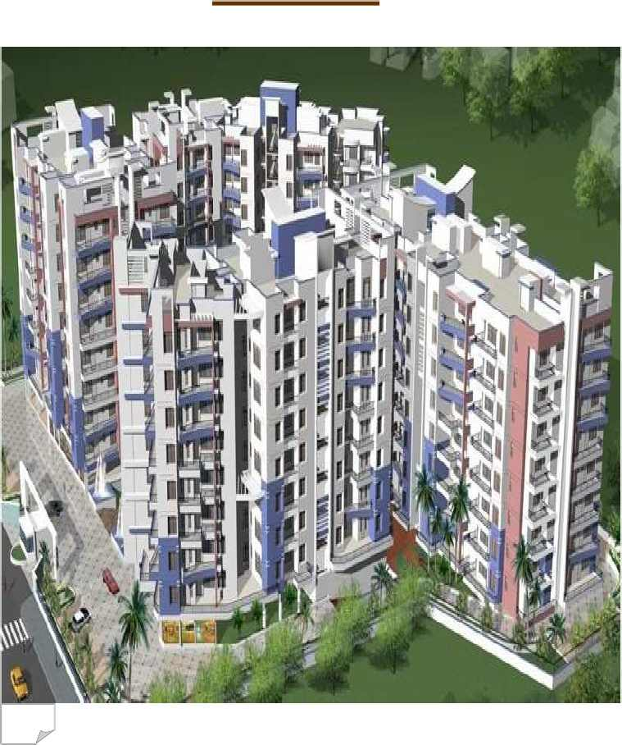

CHAPTER FOUR

Marketing Activities

4.1 Function of The RDL:

There are several department of Roots Developments .but the key function of main four department are discuss below:
- Marketing
- Accounts
- Engineering
- Land

The task of those function has been discussed in the following:

Marketing
These particular areas of the company deal with making marketing plans, implementing and executing the plan, carrying out promotional activities etc. the specific task are:
- Plan for Selling
- Expedite selling activities
- Searching new customer
- Advertising for project to attract the customer
- Advertising in TV. News paper and Magazine etc.
- Participating in different trade Fare home and abroad
- Provide necessary information to the customer
- Publishing yearly calendar, leaflets, telephone book
- Sending those publishing to the prospective customer
- Making sales deal with interested customer
- Taking the customer to the project for consideration
- Time to time inform the buyers about their land Development
- In the office briefing to the customer about the project
4.2 Marketing Strategy of RDL:

Generally marketing means a social and managerial process by which individuals and groups
obtain what they need and want through creating and exchanging products and values with
others. Many people think of marketing only as selling and advertising. However, selling and
advertising only the tip of the marketing iceberg. It the marketer does a good job of understanding consumer needs, develop products that provide superior value, and prices, distributes and promotes them effectively, these products will sell easily. Marketing of fixed assets are not such as other products or services. It is because buyers think a lot before making a buying decision of such product. They consider a number of things before making such decisions. So marketing strategy used in this business is like the other products marketing strategy. The marketing strategies used by the RDL are stated below: Like the other companies products marketing strategy, the marketing theory of RDL is made up of the 4 ps. Product, Price, Place, Promotion. Each 4 Ps contributes to its marketing.

4.3 Analysis 4 Ps of Roots Developments Limited:
:

1. Product Strategy

Normally we know, a product is anything that maximizes utility of the consumers. With respect
to product, marketing strategy consists of the following features of a product:

Roots Developments Ltd (RDL) is committed to provide to the living standards of the people. This commitments demands immense social responsibility of ensuring quality in terms quantity, purity, stability, safety, efficacy and presentation of the product. At every stage of the production, a stringent control mechanism involving raw material testing, in-process quality control, finished product testing as well as stability monitoring and documentation is maintained to ensure the highest quality product consistently.

In my study, products are land and buildings for residential and commercial use, for these products the main features are as follows:

- Product Varity of the RDL
- Durability of the Products
- Design of the Products
- Location
- Sizes and Without Impediments

Quality Maintenance and Control

In the case of land the quality is assured by developing firms and eliminating its problems such
as lowland ness, legal obligation, impediments etc. On the other hand, in the case of building
construction quality materials are used and all the necessary materials are used and maintained
accordingly, in some cases necessary experts opinions are also considered. All the quality
factors are controlled by the direct supervision of the MD of the company as well as with his
selected personnel specialized in the respective fields.

2. Pricing Strategy

Generally price is the amount of money charged for a product or service, or sum of the value
that consumers exchange for the benefits of having or using the product or service. Again
Pricing policy is the course of action or guiding philosophy that helps a business firm to pricing decisions smoothly and perfectly. It also guides the firm to achieve its goals. It is an important element of the entire marketing strategy of a firm. A firm can easily manipulate the demand of the target market by handling its price carefully.

At the present time, the market is highly segmented, primarily based on location, price of the
land and size of the apartments. As a result, the RDL is highly concerned to provide highest
quality residential real estate by considering its price as accepted by the target market.

The most common statement of the marketing executive of RDL is that we are dedicated to
providing customers of real estate with the highest quality services possible so the price of
Roots Developments Ltd is higher than other competitors.

Pricing Objectives:

The objectives of pricing strategy must be consistent with the company overall mission and
Purposes. A company can obtained six major objectives through its pricing survival. These are maximum current profit, maximum revenue, maximum sales growth, maximum market skimming, and product quality leadership. Roots Developments Ltd pursues three of the above objectives- Survival, maximum current profit, and maximum sales growth through its pricing.

Survival: Company pursues survival as its major objectives. Since RDL strong competitors and change in consumers wants for lands and housing, therefore survival is one of its pricing objective.

Maximum Current Profit: It estimates its demand and costs associated with alternative prices and choose the price that produces the maximum current profit, cash flow and rate of return on investment

Maximum sales Growth: RDL sets a reasonable price for its products (lands and
Apartments) considering the competitors prices. The company wants to maximize unit sales and
Thus profit.

.
Pricing methods

There are a number of price setting approaches, these are- markup pricing, and target return
pricing; buyer based pricing, going rate pricing, sealed bid pricing approach. At the present
time, RDL adopts going rate pricing method for its products. In going rate pricing the firm
bases its price largely on the competitor’s prices with less attention paid to its own costs and demands. The study shows the pricing of the real estate depends on certain factors such as
Location, square feet, quality of construction, construction cost, and amenities, markup policy,
Competitors price and demand for the product. In the case of pricing, RDL considers the
Following factors.

Determine the purchase price
Estimates the developments costs.
Predict the future costs of the land.
Fixed costs of the asset.
Variable costs of the assets.
Lastly competitors costs.

3. Place/Distribution Strategy

In the face of today’s competitive business environment, Roots Developments Ltd
Develops and retains high achieves and a motivated workforce and also provides an excellent working environment for them that reflect and promote a high level of loyalty and commitment, both to its employees and from its employees. At Roots Developments
Ltd, good work is always expected and rewarded. Over the years, the company has been
Successful in providing an environment and culture that nurtures individual growth and
Development, and allows people to attain personal fulfillment as well as achieve company objectives. The competent workforce of the company provides with every reason to be optimistic about the future.

4. Promotion Strategy
Promotion mix is composed of four tools of communications- advertising, personal selling, sales
promotion, and publicity. In the face of toady’s competitive business environment, RDL
develops and retains high achieves and a motivated workforce. We create an excellent working
environment for them that reflect and promote a high level of loyalty and commitment, both to
our employees and from our employees. At RDL, good work is always expected and rewarded.
Over the years, the company has been successful in providing an environment and culture that
nurtures individual growth and development, and allows people to attain personal fulfillment

Advertising

Here most of the importance is given to the advertisement and on creating customer faith and
also to the after sales services. Roots Developments Limited spends the biggest portion of its total promotion budget for advertising. When we look at the company, we can easily realize that the company could successfully anticipate the effectiveness of advertising. Here some of vehicles used as media for the advertisement of RDL products.

Newspaper
Advertisements are published frequently on the most of the national dailies citing feasibility, opportunities, advances etc along with attractive photograph of the projects.

Neon Sign Billboard
Lots of billboard and neon sign are established at the different places of the city. Generally these places are selected according to the commercial importance.

Television
Advertisement is also frequently shown on the national and private channel in order to attract
the potential customers and also to get the people to know about the projects

Personal Selling
Company maintains good relationship with the customers. Generally, the company follows two mode of personal selling for maintaining long term relationship with their target customers.
Field force employees
A number of employees are engaged in door to door marketing. They go to the customers houses, explain them about projects and request them to come to the office about the real condition of the projects. Generally this is the task of influencing the people to make a purchase decision.

In House Marketing Team

In hose marketing team is the part of the marketing department of the company. Usually they
work with the direct customers who come to the office directly for land and office purpose.
Different personnel of the in house marketing team co-ordinates with the customers. The
personnel explain explain different aspects of the projects to the customers and also give them
answer of questions. However their main motto is to sell their products by giving service.

Sales Promotion

Sales promotion is another essential ingredient in marketing campaign. Advertisement offers a
reason to buy, whereas sales promotion offers an incentive to buy. RDL offers the following
discounts, gifts, low cost services price off, cost free services etc.

Sales policy of RDL:

Moat of the company in this industry develop sales policy based on in house in house sales
personnel. The out side sales forces are generally used to create customers. In case of
purchasing a plot or a flat the first task a customer has to do is booking the plot or flat with a specified amount of money. After the booking rest of the are done by sales and credit
realization personnel. In case of selling RDL follows the following two sales policies.

1.Sales at a time with cash payment
In this case at first the customer pays the booking money and after one month of booking pays
the rest of amount.

2.Sales on installment
This is comparatively relaxed policy. There are several installment schemes. In this case the
purchaser can pays a specified amount either in 12 or 24 or 36 or 60 or 72 installments.
STRUCTURAL & GENERAL ENGINEERING FEATURES:

Swot Analysis of the company

- A reputed team of professionals supervises total foundation and structural Work.
- Experts specializing in earthquake design will design structure and foundation.
- Structural Design Parameters based on American Concrete Institute (ACI) code and American Standards of Testing (ASTM) codes.
- Heavy reinforced Cement Concrete Foundation.
- Systematic Structural combination of steel Reinforced Concrete frame and Shear wall core.
- Floor slabs all Reinforced Cement Concrete
- Sub-Soil Investigation and Soil Composition comprehensively analyzed.
- Comprehensive checking and Testing of all steel reinforcement by professional Design and Supervising Engineers.
- All Structural Materials including steel cement bricks, sylhet sand and other aggregates etc. of highest available standard and screened for quality.
- Direct supervision at every stage of construction by a team of experienced and qualified Civil Engineers to ensure highest quality of workmanship.
- Construction site equipment employed includes Vibro-hammers, Mechanical rollers, Steel cutting & Bending equipment, welding equipment, concrete mixers, concrete vibratos, water pumps, Material handing equipment, leveling instruments, theodolite etc.
- Systematic testing of concrete and other completed work samples at every stage from quality control Laboratories.
- Protection from Cyclone winds up to prevalent speeds incorporated in structure design.
- Structure is capable of consuming Earthquakes up to 7 on Richter scale and protection from Cyclonic storms (200km) per hour.

Building Entrance Features
 Secured Decorative MS Gate with Lamp posts as per the elevation & perspective of the Building.
 Logos on polished marble or granite.
 Comfortable internal driveway.
 Personal mailbox.
Reception Lobby
 Reception desk with Marble/Granite Top.
 Visitor’s waiting room & Separate toilet for visitors.
 Tiles floor in the reception area.
 Light Fittings.
 Community space for flat owners.
Lift
 International standard 08 Passengers capacity Lift (LG-Otis or Equivalent).
 Adequate lighting.
 Fast & reliable service to residents on all floors.
 Lift Lobbies & Staircases.
 Spacious lift lobby in each floor.
 Homogeneous floor tiles in all lift lobbies and staircase with proper lighting (RAK or Equivalent).
 Stair tiles in all staircases (RAK or Equivalent)
Apartment Layouts
 Will maximize advantages especially in relation to the daylight and outside view.
 Privacy will be emphasized in designing the layout so that the master and second bedrooms are located away from the guest bedroom and main entertainment areas.

Cable TV and Internet Provision
 Provision for connection of satellite dish antenna with multi channel capacity from the
 cable TV operation in Master Bed, Family living/Main living.
 Provision for telephone connection of Master Bed, Family living/Main living.
 Provision for internet cable connection in each flat.
Generator
 International Standard Generator (SDMO, France / FG. Wilson, Uk / Parkins or Equivalent)
 KVA capacity to cover Lift, Pumps, Common Lights and 3 (Three) Lights, 3 (Three) Fans per
Apartment.
Water Pumps
 Two Units (One standby)
 European Origin pedrollo or Saer or Equivalent.
Roof Top
 Protective parapet Wall
 Protected children’s area
 Cloth drying area
 Roof top garden
Intercom
 Good Quality and standard (Panasonic or Equivalent)
 To connect each Apartment to the concierge Desk

Interior Building Materials


Bath Rooms
 Essentially correct Uniform Floor Slope towards Water Outlet.
 Foreign made Sanitary Wares in all Bathroom except servant’s toilet (Cotto or RAK or equivalent).
 Full height wall Glazed tiles in all bathrooms (RAK / C B C or Equivalent) except servant’s toilet.
 Matching floor tiles in Bathrooms (RAK / C B C or Equivalent)
 All Mirrors in Bathrooms with overhead Lamps.
 Good Quality Chrome plated Fittings (Nazma/Gloria/ Equivalent).
 All Chrome plated Fittings carry Manufacture’s Warranty.
 Porcelain soap cases and Towel Rails.
 Cabinet Basin with marble top in Master Bath.
 One Bathtub in Master Bathroom (Ariston or Equivalent).
 Titles on Floor and Wall up to 7 feet in Maid’s bath with Long pan, shower and Lowdown.
 Provision for exhaust fan in all bathrooms.
 Concealed Hot and Cold water lines in Master Bath, 2nd Bath & 3rd bath.
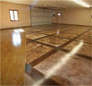
Floors & Verandah
 Mirror polish Homogeneous Tiles in Floors (RAK or C B C or Equivalent, Size 16”x16”).
 Tiles in Stair, Lobby & Verandah (C B C / RAK or Equivalent, size 16”x16”).

Walls
 Outside walls are plastered 00'-10''’ standard brickwork (1st class).
 All interior walls are also plastered 5' brickwork (1st class).
 Walls separating apartments are 00'-10'' brickwork (1st class)
 Smooth Finish Walls.
 Walls below ground are water proof RCC.
Painting & Polishing
 Plastic paint in all internal walls and ceilings in soft colors (Berger or Equivalent).
 French polished Doorframes & shutters.
 Exterior wall will be Weather coat paint (Berger or Equivalent).


Electrical
 MK (Singapore) or Equivalent electrical Switches, plug points and other Fittings.
 Fancy Light Fixtures in all Rooms.
 Three emergency lights and three Fans in each Apartment.
 Independent electric meter in each apartment.
 Electrical distribution box with main switch circuit breakers.
 Concealed electrical wring (BRB/PARADISE or Equivalent).
 All power outlets with ear-thing connection.
 Provision for air conditioner in master bed, 2nd bed and living area.

 Emergency power in lifts, lobby, inter COM service, common spaces like car parking, reception area, security room and main gate.
 concealed fan hook.

Doors Features

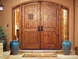
Main Door:
 Solid teak (Chittagong) decorative Main Entrance Door with lucrative chains, spy holes, calling bell switch, solid brass doorknocker, apartments no. In brass plate, doors handle with security Lock)
Door frame:
 Main door frames (00'-10'') are made of Chittagong Teak.
Internal Door:
 Internal doors are made of strong and durable Flush door with polish & good quality Mortis Lock
 All internal doorframes are of Chapalish/ Tick Shamble/ Shilkarai. (Covered
Bathroom Doors:
 Waterproof laminated door.

Windows
 Sliding Windows as per Architectural Design of the Building
 5 mm thickness glass with mohair lining
 Rain water barrier in 4” Aluminum sections
 Safety grills in all windows
 Fly proof net in all windows
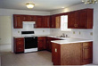
Kitchen
 Impressively designed platform with Marble / Granite top.
 Provision for double burner gas out let.
 Space provision for gas oven, washing machine & refrigerator.
 Partly tiles in the kitchen wall (Matching Glazed tiles)
 Suitably placed exhaust fan.
 One stainless steel sinks with mixture for washing purpose.
 Concealed water line for hot and cold water.
 Gas burners are surrounded by wall tiles up to 5 feet.
 Floor covered with homogeneous tiles (RAK/CBC or Equivalent).

MAJOR STRUCTURAL MATERIALS

Steel
 Deformed Bar
 Manufactured by:
i. Bangladesh Steel & Re-Rolling Mills Ltd. (BSRM)
ii. Rahim Steel mills Ltd.
iii. Bashudhara Steel Ltd.
iv. Other Equivalent High Standard Steel Mills Ltd.

Cement
 Manufactured by
i. M/S. Cemex (Bangladesh) Ltd. : Cemex Cement
ii. M/S. Meghna Cement Mills Ltd. : King Brand
iii. Other Equivalent High Standard Manufacturer

Aggregates
 Stone Chips for all columns, beams, foundations & other will be Bricks chips.
 High strength Bricks Chips from automatic Gas Fired picked Bricks from Gazipur.

Bricks
 First Class Bricks

Sand
 2.5 FM Coarse Sand
 1.5 FM Medium
General Amenities of Apartment

 Reserved Car parking in covered & protected Ground floor for residents with comfortable Driveways.
 Electricity supply approx. 220V/440V from DESA source with separate main cable and LT panel/distribution board.
 Water supply connection from WASA sufficient as per total calculated consumption.
 Underground water reservoir with one main lifting pump and standby pump.
 Sewerage system planned for long-term requirement.
 Gas pipeline connection from TITAS distribution system as per total calculated consumption, adequate safety measures incorporated.
 Termite protection treatment of ground.
 A fire extinguisher on each floor.

Loan Information:

Swot Analysis of the company

1.The client has to show his Income status, Savings and others resources/asset excluding apartment, and the age limit will be up to 50 years. The apartment loan may be sanctioned up to 70% of the total price. In case of Business man-Trade license, Income tax certificate, one-year Bank statement & balance sheet of the company are required.
2.The legal adviser of the investment company will examine the all documents relating to the land & clients. If the opinion is positive then the loan may be sanctioned in favor of the client. It will take 3 or 4 weeks to finalize the loan .The flat is to be mortgaged in favor of the investment company at the time of disbursement of loan. Investment period 1 year to 15 years.
Others information (BDH & IDLC):

Company | Delta Brac Housing Finance Corporation Ltd.  (DBH) | Industrial Development Leasing Company of Bangladesh Ltd.  (IDLC)
Contact | 1) Gulshan office, Land Mark, 9th floor, Gulshan North,Gulshan-2  Ph:8822374,9882112,01711-816671-2  Fax-880-02-9882110,  2) Dhanmondi office, Pantha plaza, 1st floor, 63/A,Lake Circus, Kalabagun Dhaka  Ph: 8130906, 9134211,0189-251216 | 1) Motijheel Office, Hadi Manson, 6th &7th floor, 2,Dilkusa,Motijheel, Dhaka, Ph: 9560111, Fax-880-02-9563620,  2) Dhanmondi office, SEL Center, 5th floor,29, West Panthapath Dhaka  Ph: 0189-220340,01711-837775
Email/Web site | dbh@deltabrac.com,  dhanmondi@deltabrac.com,  www.deltabrac.com | mailbox@idlc.com
Interest Rate | 15.75% | 16.25%
Processing fee | 0.75% | 0.75%
Sanction Amount | 70% of flat price | 70% of flat price

Others information (NHFI & IBBL):

Company | National Housing Finance & Investment Ltd.  (NHFI) | Islami Bank Bangladesh Ltd.  (IBBL)
Contact | National Plaza,7th floor, Free School street, Sonargoan Road, Dhaka  Ph: 9670612-4, 9669800, 9666281, 01711-682832, 01711-682833, fax-880-02-9671016, 251216 | Head office, 40,Dilkusha, Motijheel ,Dhaka  Ph:PABX-9563040, 9560099,956161-2  Fax-880-02-9564532
Email/Web site | housing@bdonline.com  housing@intechworld.net | Email-ibbl@agni.com
Interest Rate | 16.25% | 14.50%
Processing fee | 0.75% | Tk.2000.00
Sanction Amount | 70% of flat price | 50% of flat price

General Terms & Conditions for Buyer or Clients:

Swot Analysis of the company

- Application for allotment of apartments should be made on the prescribed application form duly signed by the applicant along with the Earnest money. The Company has the right to accept or reject any application without assigning any reason thereto.
- On acceptance of an application, the company will issue an allotment letter to the applicant on the receipt of which the applicant/allottee shall start making payment as per the schedule of payment in this Brochure Allotment of apartments are made on first come first served basis.
- Payment of earnest money, installments, car park costs, additional works and other charges shall be made by Bank Draft of Pay Order against which respective receipts will be issued. Bangladeshis residing abroad may remit payments in foreign exchange by TT of DD.
- Payment of installments and all other charges are to be made on due dates. The company may issue reminders to the allottee but, notwithstanding the issue of reminders, the allottee must adhere the schedule of payment to ensure timely completion of construction.
- Delay in payments beyond the due date will make the allottee liable to pay a delay charge of 3% per 30 days on the amount of payment delayed. If the payments is delayed beyond 60 days, the company shall have the right to cancel the allotment without notice to the allottee. In such an event the amount paid by the allottee will be refunded after deducting the Earnest Money.
- Connection fees/charges, security deposits and other incidental expanses relating to gas, water, sewerage and electric connections are not include in the price of apartments. These payments will be made by the company directly to the authorities concerned, on the allottee's accounts. The allottee will be billed proportionately on actual costs basis.
- Limited changes in the specifications, design and/or layout of the apartment and other facilities may be made by the company in larger overall interest of due to unavoidable reason.

- The possession of each apartment shall be duly handed over to the allottee on completion and on full payment of installments and other charges. Till then the possession will rest with the company.
- The allottee will pay stamps duties, registration fees, value added tax, documentation charges and other miscellaneous taxes and expenses to be incurred in connection with the deed of conveyance (Sales Deed). Only the actual sums shall be charged.
- Upon registrations, the flat owner irrespective of the floor becomes the proportionate owner of the land on which the building is to be constructed.
- Should the purchaser want to avail loan from any finical institutions the company will do all that is possible to help secure the loan. However the final decision regarding the grant of loan rests with the financial institution and with the compliance. All the necessary papers for grant the loan must be signed by the purchaser and he/she must attend the Registration office for the registration the mortgage deed. Irrespective of the loan being sanctioned or not, the client will be liable to pay as per schedule installments.
- After talking over of apartment or the project, the allottee(s) must consult the company prior to undertaking any structural or layout changes within the apartment complex. Failure to do so will be at the sole risk of the allottee.
- The completion period of the construction of the project can be affected by unavoidable circumstances beyond the control of the company, like force majeure, natural calamity , political disturbance strikes and changes the fiscal policy of the state etc.
- For the management of common facilities like the supply of electricity, water and sewerage and the maintenance of the building etc. and Owner's Association will be formed. All allottees after full payments of instilments and dues must became member of this Association for the common interest. Each allottee (for each allotment of apartments) must initially deposit Tk. 25,000 (Taka Twenty five thousand) only in the Reserve Fund for the management Expenses of the compel.

CHAPTER FIVE

Analysis & Findings

5.1 Industry Analysis:

Swot Analysis of the company

Dhaka is the most important city of Bangladesh where every year people are increasing. People are coming to Dhaka for various reasons. The population of Dhaka city is increasing terrifyingly. The current population growth of Bangladesh is 2.06% (2007 CIA EST.) and the population growth of Dhaka city is 4.2% . How fast the city is growing? In reality, Shelter problems are extremely familiar problems in Dhaka city. It was seen that In the middle of the 1970 and by 1985, apartment buildings were so popular that there was an acceptability of concept of living in a flat. At that time, there was an acute shortage of land and in a situation of rapid increase of land prices and the cost of constriction. However, Urbanization sense actually stared in the British period when they had a tendency to build their administrative centers on the banks of large rivers. A recent study of World Bank has estimated that about 40% of people of Bangladesh will be living in urban areas within 2025. Dhaka, the prime city of Bangladesh, its share of national urban population was 25% in 1981, 31% in 1991 and 34% in 2001 respectively . So, it is very clear if we want to solve housing problems beside the increasing population, we should have a proper plan of doing it. Real estate is playing an important role in the economy which is certainly important for a county like Bangladesh. As urbanization is taking place very fast, real estate business is also becoming more significant business in the last couple of years.
Average Investment in housing and construction US$ 1274 million per year Scope of Competitive Rivalry Still, most of the major competitors are concentrated in Dhaka, competing based on the location, price and size.

URBANIZATION AND POPULATION
The current population growth of Bangladesh is 2.06% (2007 CIA EST.)¬
And the population growth of Dhaka city is 4.2%¬
Population in millions 140.66 (2007)¬
Percent of population in urban areas 25.0 (2006)¬
GDP growth (% change per year): 5.3 6.3 6.0 6.6 6.5¬
A recent study of World Bank has estimated that about 40% of people of Bangladesh will be living in urban areas within 2025¬
¬ Dhaka, the prime city of Bangladesh, its share of national urban population was 25% in 1981, 31% in 1991 and 34% in 2001 respectively
Industry Growth Rate
4.8-6 percent annually (real estate and housing)
Stage in Lifecycle Growing

Number of Competitors
Total numbers of Rehab listed members are 454. The number of housing projects under construction is 2500.
Number of Apartments
Only 8000-9000 apartments are built per year where at least 1, 00,000 apartments are needed.
Management style
Most of real estate organizations are unstructured in nature. Generally, decisions are taken by top level management.
Market segmentation
Still, most of the market is concentrated in the posh areas like Gulshan, Baridhara, Banani, DOHS, Uttra e.t.c. Price variation among many flats is mainly depending upon the location of the project. The competition of the price is depending upon the flats offering by different development s in the same location.

Concentrated vs. Fragmented Industries
The industry is entirely concentrated. About 95 per cent of this business is still dominated by the top 10 companies. These ten companies have a large share of total private investment.
Ease of entry or exit
There are moderate entry or exit barriers in real business in Dhaka city.
Technology
Technology changes have been very slow in real estate business in Bangladesh.
Physical Characteristics
The buyers cannot understand the differences of the apartments as its physical attributes are alike.
Economy of Scale
Almost the cost is same both for luxuries apartments and high rise buildings.
Capital requirements
A big amount of money needs to be invested to start the business.
Profitability
The business is much profitable one. On an average, 30% profit margin come out of total investment.

THE MAIN BARRIERS OF HOUSING PROBLEM

- Increasing Land value
- Price Increase of Cement in Last 20 Years
- Increase Price of Construction Materials
- Increase Price per Brick
- Increase Price per Cubic Foot Sand
- Increase of Land Value in Different Location of Dhaka City

- 7. High Interest Rate Loan Compare to Other Neighboring Countries
Country name Interest rate
Bangladesh 14%-16%
India 8%-10%
Pakistan 9%-10%
China 4.14%-5.76%
Japan 2.37%-3.05%
Malaysia 6%-6.60%
USA 4.86%-6.00%
UK 5.25%-7.39%
Australia 7.34%-8.22%
France 3%-5%
New Zeeland 7.25%-9.25%
5.2Analysis of the RDL:

Core Value:
• Authenticity: That is the reason why customers come to them.
• Quality Commitment: Their finishing is best.
• Good Materials: Cement reinforcement, GI pipe, Ready mix cement, Hollow blocks.
• Reputation: More than 50 projects.
• Back up Support: Five concrete batching plants with a fleet of truck mixers, four concrete block plants.
• Experienced Professionals: Even their chairman is also an engineer.
• Design and Appearance: Even, they do design from KTGY (Singapore).

Communication Tools:
• Newspaper
• TV
• Billboard
• Fair
• Leaflet
• Brochure
• Dairy
• Calendar
• Moneybag
• Table cloth
• Tissue Box
• CD
• Web site
• Email list
• SMS
• Referral : People come to them through referee
Average Price: 3500-10000 sft (Roots Developments Limited)
Problems:
They don’t search land owners rather landowners want to give them land. Even, they don’t have agents for land search. The main reason of offering land to concord is its goodwill in the market. Landowners think that if they will provide land to concord, their value will be more. Even, they don’t give cash to landowners for their land. Concord just goes for win-win business

5.3 Brand Positioning:

Roots Brand Values:
1. Reliability: service is carried out dependably and accurately. Emotional benefit: customers feel they can rely on the service provider.
2. Assuredness: service staff demonstrates trust and confidence. Emotional response: customers trust the work being done and statements that are made.
3. Tangibility: service staff and premises are clean and look good. Emotional judgment: customers sense the organization takes pride in itself.
4. Empathy: Service staffs are caring and provide individualized attention, emotional reaction: customers feel recognized as individuals.
5. Responsiveness: Service staffs are willing to rapidly help customers. Emotional experience: customers fell they are important to the organization.
5.4 Important Consideration for Brand Positioning:

1. Root Strength: Try to find out the important aspects of original product, values or benefits that can make the brand grand. It is important to identify the appeal of consumer.
2. Competitive Environment: Competitive environment is an environment where there are many choices. The question is now whether customers can trace your brand from the available choices.
3. Target: can your brand is the best choice among the choices?
4. Insight: Can your brand understand the need of the consumer?
5. Benefits: The differentiating functional, emotional and sensory benefits that motivate purchase.
6. Values, Beliefs & Personality: Values describe why the brand stands for. Beliefs are the conviction the brand holds. Personality describes how the brand behaves, which includes its style of communication with its audience.
7. Reasons to Believe: Can your customers believe that your brand is the best one from the alternatives?
8. Discriminator: The single most compelling reason for the consumer to choose the product. What are competitive reasons for the buying?
9. Essence: The core idea or promise of the brand
5.5Findings of The origination:

Roots Developments Limited major findings of this are as follows :

- Actual market image of Roots Developments Ltd
- Company has opportunity to be market leader in this industry.
- It has moderate market share in the industry.
- Actual market size of the company
- The main competitors of the company
- The reason of highest market share is quality.
- Marketing strategy of the company.
- Customer satisfaction and their attitude toward the company
- Problem faced both customers and marketers in the same industry.
- Ensure that Brand is viewed as an asset of the company.

5.6Findings in the real estate business:

The task of marketing is not an easy, one mainly for such fixed asset, which cannot be replaced. Again now we are living in a very fast changing world. The demand of people also changing frequently and the result is a difficult position for every company to meet the changing customer demand. In the case of marketing and other function, the company department faces the following problems.

Lack of customer faith
The most difficult job for the most marketing executives is to create faith on customer mind. They always hesitate to make such purchase decision. They hardly believe the company and its projects for following reasons. There is no direct government supervision in this sector. So they feel insecure to make purchase decision from the company. There is no government policy to guide the business

.
Lack of customer knowledge regarding housing
This result in too much time is needs for the marketer to make a better understanding
regarding their perception about the company product.
Failure in commitment
Sometimes the company fails to hand over the flat within the specified period due to several factors like storage in raw materials, legal building, deadly in preparation of necessary papers etc.

Political Instability
It is another problem in marketing. Due to political unrest construction and development works delayed which delay the whole project. For this, hand over date is also extended. So, it reduces the good will of the company and customers faith.

Natural Climate
Natural climate like heavy rainfall, flood, storm, earth quake, usually delayed the
project work. So, unfavorable natural climate is one of the main problems in this
business.

Competitors
Competitors always change the policy frequently in this industry which is also considered as another major marketing problem.

Miscellaneous
Disturbance of illegal, collectors of subscription, corruption from the government and non- government bodies is also major problem in this sector

5.7 SWOT Analysis of RDL:

Swot Analysis of the company

The term SWOT is the abbreviated from of Strength, Weakness, Opportunity, & Threat. In SWOT analysis Strength & Weakness are determined by internal factor, while Opportunity & Threat are determined by the external factors.

S (strengths):

► Roots Development Limited management system are always committed to better service
► All of employees of RDL are sincere reliable.
► Roots Development Limited market potentiality is very high.
► Roots Development Group have effective sales team.
► Roots Development Limited always keep records in appropriate methods.
► Roots Development Limited use advanced information system.
► Roots Development Limited maintain Good relationship between top management & employees.
► Roots Development Limited have strong security system.
► Roots Development Limited has a well-decorated office.

W (weaknesses):
● Could not maintain the rules & regulation according to appropriate law.
● Installment facilities are not in customers favor.
● Decision can take only the top management.
● Improper government policy.

O (opportunities)
● Low area mark
● New real estate business is opening day by day.
● Improve the service quality then the others.
● Improve high customer satisfaction.
● Take the opportunity to get a huge amount of money.

T (threats):

● Increased the number of Real Estate company.
● Government interrupts in the way of development.
● Growing up of overall cost.
● Complexity of RAJUK rules & regulation.
● Project areas are hassle by the local village political.

Conclusion
&
Recommendation

Conclusion
In our country there is a not adequate land for people’s livings. Peoples are very interested to get a peace of land that meets their housing problem. Roots Developments Limited. Is one of the renowned housing companies in Bangladesh. The company provides complete housing solution to the people. Roots Developments Limited also contributes in our national economy. Main goal of Roots Developments Limited is to provide better services to the customers. Roots Developments Limited has been faced internal problem which is faced by almost every real estate company. At first, it is very difficult to find out a vast area of blank space in Dhaka city. Beside this Government & Non-government organizations always creates political forces. Local terrors often harassed company for donation. It is very though to occupy after buying the land. It is found in most cases that there is more partner or same land & have to face complexion of laws with them.
:
Today Real state is recognized the world over as the main engine that runs the economy,
creating work not only for masons and managers, accountants and architects, but also for
makers and sellers of building materials. It means work for maintenances, security cleaning and
other services; work for makers and sellers of appliances, furniture and vehicles; work for
bankers and bureaucrats, lenders and lawyer. Human being has always been in search of new
and better homes. Thus cities, towns and villages grew, flourished and wither away. In the
process, societies forever demand and produce all kinds of goods and services, through, never
satisfied, we ask for things more different. Real estate visibly shapes the way people live, work and innovates and therefore most strongly defines culture and civilization. In Bangladesh perspective, it is almost impossible for the government to ensure housing for all. As the public sector failed to provide this, people have taken their own initiative to ensure their
fundamental need for shelter. Government alone cannot provide housing to all and realizing
this, they decided to share the task of providing safe decent places to live with Real Estate
Developers, to make people productive resources. So, government should provide much
flexibility to the developers to provide better housing facilities not only to higher income
people but also middle and lower income people.

At the present time, the population of our country is increasing at very alarming rate but total
rent are remains constant. The demand of housing is very high, particularly in Dhaka city. So,
the prospect of real estate business is very high. Now if the real estate companies run their
business according to the demand of middle class, lower middle class, and higher middle class
people, the business must be profitable. From the study, which I have conducted at Roots Developments Limited (RDL) found that they are using all the possible policies to run the business. The report also has shown the overall picture of the Roots Developments Limited and opportunity in Bangladesh.

I was assigned in the real estate sector in Roots Developments Limited. Three months are short to understand every aspect of a company and overall market condition of this sector. Actually it
needs more time to determine the over all market size, conditions, opportunity, and business activities of the company.

Within the short time, I have tried to show the overall scenario of Roots Developments Limited and its Marketing activities and actual market image of different company through direct interviews from different customers based on marketing activities of Roots Developments Ltd.

And finally, At last, Roots Developments Limited doing its business successful in our country. It provides its services as per its commitment & improves the business continuously. So from my own experience I may suggest the following Recommendations for sound and success market operation of the company
.

Recommendations

As per earnest observation some suggestion for the improvement of the situation are given below:
- To attract more customers Roots Developments Limited has to create a new marketing
strategy which will be able to increase their business as it could improve revenue.
- The officers of Roots Developments Limited Corporate Branch think that long term
training is required for company officers for the betterment of the service.
Computer training is must today to improve the individual as well as company
performance.
- Maximum customers are expecting the responsible price, so carefully the price should be established in per flat. All modern facilities are equal distribution in all class of people.
- To provide financial assistance like Desa, Tista, Wasa, T&T to be strengthened
& for getting connection of utilities promptly the procedural bottleneck should be
removed.
- Improve office atmosphere to give customers friendly feeling.
- Provide intimate attention to customer needs.
- Customer convenience will receive priority.
- Customer database should be more organized.
- Have to more aware about customer’s right.

