Internship Report on
Marketing Practice followed by Molla Salt Limited

Submitted by
WWW.ASSIGNMENTPOINT.COM

The report is prepared to fulfill the partial requirement of the MBA program of northern university Bangladesh. My supervisor has authorized me to prepare a report about marketing activity of Molla Salt Ind. Ltd. Molla salt Ltd has assigned me to the sales department where I have worked as an internship from 16 may 2010 to 16 August 2010. I closely observed marketing activities. I also observe the promoted activities of Molla salt Ind. Ltd. Observing marketing activity give me an opportunity to understand how a market leader uses the promotional tools. Besides observing this is shows how the promotional tools used in the new business.

I have finished my project work mainly in two parts, in first part, I have study the theoretical aspects promoting and find out the tools of the promotional mix. In the second part, I analyzed the activities and observed the promotional program.

1.2 Objective of the report

The objective of the internship is to expose the student in the organization work situation and this report is result of such company involvement. The primary objective of the report is to explain the real life scenarios in the organizational working environment. However, the objectives of the study are:

- To know the marketing practice followed by Molla salt Ltd.
- To identify affecting consumer behavior of Molla salt Ind. Ltd.
- To identify Molla salt pricing strategy.

- To know what types of promotional tols Molla salt use to communicate with its target market.
- To develop an understanding how Molla salt is setting organizational structure to achieve its goals.
- TO focus on Molla’s communication policy.
- To know how Molla salt setup their marketing plan.
1.3 Methodology
The methodology of this report is the arrangement of conditions and analysis of the data in a manner that aims to combine relevance to the purpose of the procedure. The methodology of this study is the complete techniques that I have followed to write the report. By completing this report I have used the data analyzing method

- This study is based on both primary & secondary information.

- This job responsibility was conducted on 10th may,2010 through observation survey. The survey was conducted in central at head office. Information from the firm personnel was gathered through informal discussion. In addition, author used some secondary data; most off the primary information has collected through the tabulation work. To consume the survey the following step were followed:

1.4 Sources of idea

There are two types of data sources:

- Primary sources

- Secondary sources

1.4.1 Primary source:

I have collected data from the employees of Molla . It has been already written up. Actually, I have tried to think best in the view point of creative.

1.4.2 Secondary source:

For the report prepares our secondary sources are text book, subordinate books, magazines & company’s-

- Text books & subordinate books
- Magazine
- Relevant file study as provided by the concerned officers.

1.5 Rational of the study:

As I am MBA student, internship gives me a chance to learn the work practically that is the requirement of the MBA program. There are many things in theory but not applicable in practically. I wanted to gather knowledge from my internship program of the Business Administration Department in Northern University. After completion of our course in the different areas of studies are sent different reputed business organization to gather real situation. So I was pleased in Molla Salt Ltd.

1.6 Limitation:

- It is very difficult to collect the information from various personnel for their job constraint.

- Time limitation: By completing an ideal report is need for more than one year, but I have gotten only for making report three months.

- Data Sources: Our Company does not publish annual report. And it has not enough articles and publications. That’s why secondary data were not available about their activities.

Chapter-two

Profile of the organization

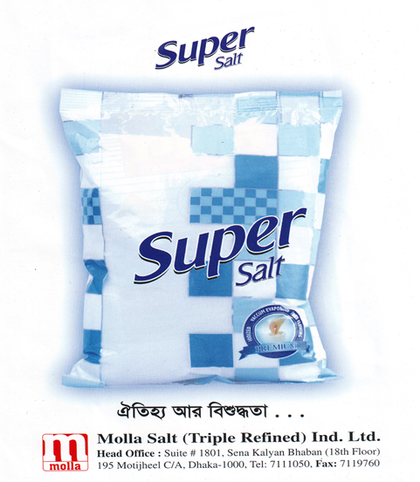

2.1 Introduction of the company:

Molla Salt Ind. Ltd. Is the pioneer of Iodized & packed Salt producer industries in Bangladesh. Still Molla Salt Ind. Ltd. Is the largest Salt Industry in Bangladesh. It is situated in Sena kalyan Bhaban (18th Floor), 195 Motijheel C/A, Dhaka.

Molla Salt (Triple Refined) Industries Ltd. is situated in Dapa, Fatullah, Narayanganj. Molla salt started there their business on 1996. Khobir Uddin Mlla is the main person who started this company. There are two brands in the market of Molla Salt, those are Molla salt and Molla Super salt. In 1995 Molla Salt was started their business with Molla Salt, and they marketed Iodized and packet salt, on that time they gained huge response from their customers and also market share. In 2000 Molla salt lose their market share, on that time Modhumoti salt covered Molla’s market share, that is why they gone slow on that time. In 2008 Molla salt had redesigned their strategy and develops another new brand, which is named Molla Super Salt. With the Molla Super Salt, Molla Super Salt has gained the market shares again.

Now in this year Molla Salt change their product name. They introduce a new name “Super Salt” instead of “ Molla Super Salt” and they redesign their packet also.

2.2 Mission:

- To ensure quality of the products.
- To maintain the delivery just in time.
- To satisfy customer’s needs & wants.
- To achieve more orders from super shop, retail outlets & corporate buyers.

2.3 Vision:

The vision of Molla Salt Ltd. Is to product availability in all the potential area & become a market leader with in the 1 or 2 years.

2.4 Management:

- Molla Mohammad Mojno –Chairman
- Khabir Uddn Molla - Managing Director
- Molla Mohammad Mijanur Rahman – Director
- Nozrul Islam – General Manager
- Monjur Morshad – Assistant General Manager (Accu & Finance)
- Probir Kumar Shaha – Production Manager
- Md. Hamid Khan – National Sales Manager

2.5 Management Style:

The management style of Molla Salt Ltd.is democratic because when any decision is taken from the top level it is informed to the hierarchy level for their comment to take. not only that I have also seen that for particular division like marketing division, here when brand managers want to take any decision for developing their branded product they can consult to the senior GM. So it is clear that Molla SaltLtd. follow democratic style.

2.6 Competitors:

Molla Salt Company produce two types of salt one is Molla normal iodized salt & another is Super Salt.

For the Molla normal salt huge competitors are involved in salt market. Their few competitors are:

- Modhubon Salt

- Pubali Salt

- Modumoti Salt

For the Super Salt the main competitors are:

- ACI Salt
- Confident Salt
- Ifad Salt
- Fresh salt

2.7 Business Philosophy:

Molla Salt Ltd run its business activities from its financials sources since this is privet ltd, organization. Making profit is a very big factor in the business because it is only way to generate money to keep the business running. For this reasons the organization completely depends on the selling of the salt. So their business policy is to serve the target customers with full satisfaction & keep running the business. Molla Salt Ltd is uncompromisingly working for the achievements of its goal.

Chapter-three

Internship position & duties

3.1 Internship position & duties:

I joined Molla salt Ind. as an internship on 16 may 2010. After joining I found what they do, how to maintain office discipline & how to maintain customer behaviour with employee. Day to day I adjusted with other and started my work. In Molla salt employees are mostly courteous, friend in nature & eager in spite of the tremendous workload. They helped me as tried their best. I was tried to maintain the office time. The internship period was three month. I worked in marketing sector.

3.2 Marketing activities:

I started my work as marketing division. I was tied to complete all the part of the marketing. They are following…

- Customer service: I have worked 2 week in the Customer service Department in in Molla salt Ind.
- Sales Activities: I was engaged about five week in sales department. So some time, I go for personal selling. Sometime I go to several outlets & observed sales progress. I also collect the cheque belongs to my company.
- New outlet: sometime I go to the new outlet & make sure my product availability.

3.3 Learning point:

Since, my major in marketing and having attracted with the marketing department, that’s why it is my privilege to learn lots of things. Especially I had learned about following things-

#Before doing my internee I had no experience about Consumer Marketing but in the time of my internee I have understood about the Consumer Marketing. I achieved huge knowledge how to Corporate Sales.

#I always tried to understand the company’s marketing manage, account officer, councillor and trainers, and by the internee I learnt these function from this company.
#How to communicate with the corporate buyer actually I got concept from this company.

#How to build relation with employee and client I also learnt from Molla salt Ind.

Chapter-Four
Findings & Analysis

I was working Molla Salt three month and find out those findings & analysis during my working period. Molla Salt’s owner and employee use very efficiently their task. I really learn this division & collect lot of information understand prospecting though advertising, reference, relationship, marketing, personal selling etc.

4.1 Function of the organization:

Every organization’s success depends on their various function performances. If function are not organized and don’t have interrelationship with their functions then it would be very difficult to control the system effectively as well as company’s success.

The key functions of the Molla Salt Company are in the following:

- Marketing
- Accounts
- Production
- transport

The task of those functions has been discussed in the following:

4.1.1 Marketing:

These particular areas of the company deal with marketing plan, implementing & executing the plan, carrying out the promotional activities etc.

The specific tasks are:

- Plan for selling product.
- Searching new customer & outlets.
- Provide necessary information to the customers.
- Increase sales volume.

4.1.2 Accounts:

Accounts division is very crucial & sensitive for the company, because of the nature of the business. We know that the business does require very frequent financial transactions. Most of the financial dealing is being done by the prior approval of the director of the Molla Salt.

The specific tasks are:

- Keeping, maintaining & restoring financial data.
- Making necessary payments to different parties.
- Maintaining banking activities.
- Maintaining financial inflows made by the buyers.
- Maintaining financial outflows.
- Make payment to the employee.

4.1.3 Production:

The factory of the Molla Salt is situated at narayanganj. The production department of the company is very skilled & efficient. Regular production of salt is going on without any interruption. Two kind of salt are produced one is consumer salt for mass consumption & another is Industrial salt for Industrial use.

The specific tasks are:

- Regularity of production is maintained.
- Regular supply of row material is ensured.
- Delivery of production is done on due time.
- Accounts of production are regularly maintained.
- Quality of production is ensured.

4.1.4 Transport:

Transport is an integral part for proper communication of men & material. This Company provides good transport facilities for carrying products to the outlets all over the country.

The specific tasks are:

- This company has required number of trucks, pickups & these are used to deliver salt to the dealers as per order.
- The company has provided some vehicles for use of the officials for proper contact with the dealers & corporate buyers.

- Two vehicles are specially allotted for carrying salt to the corporate sector in Dhaka metropolitan area.

I worked in corporate sector in Moola Salt Ind. So I give some sales report in Molla salt in corporate sector in 2010.

4.2 Pack size: Molla Salt packaging 2 types of size. 1 kg & 500 gram. The Carton size is 25 kg. that’s mean each carton contains 25 kg.

4.3 Price of the Salt:

Types of Salt | MRP Price per kg | Whole sale price per kg
Molla Normal Salt | 12.00 | 9.30 to 11.00 taka
Super Salt | 20.00 | 14.50 to 16.00 taka
Molla Vacuum Salt | ------ | 12.50 taka
Molla Mechanical Salt | ------- | 8.00 taka

4.4 The sales volume of Molla salt in 2010:

Month | Super Salt | Molla Normal salt | Total sales
August | 700 carton | 300 carton | 1000 carton
July | 750 carton | 250 carton | 1000 carton
Jun | 700 carton | 250 carton | 950 carton
May | 600 carton | 200 carton | 800 carton
April | 600 carton | 250 carton | 850 carton
March | 650 carton | 250 carton | 900 carton

4.5 Marketing Environment Analysis (Micro):

A company’s marketing environment consists of the actors and factors outside marketing that affect marketing management’s ability to build and maintain successful relationship with target customer.

Molla Salt Ltd. Micro Environment:

Molla Salt ltd. Micro environment consists of the company’s suppliers, customer markets, competitor & publics.

4.5.1 The Company (Molla Salt)
In designing marketing plans, marketing management to make the sales the product. Molla Salt Ltd. treat their to management, finance & accounting. All these interrelated.

4.5.2 Suppliers of Molla Salt

Molla Salt Company has no suppliers in Bangladesh. Raw materials of this company are imported from India throw letter of credit (L.C). The imported raw materials are then triple refined in company’s own factory in Bangladesh. The finished salt then becomes transparent, clear and super fine.

Molla Salt Company import raw materials through the Mercantile Bank.

4.5.3 Customer / Clients of Molla Salt:

Molla salt ltd. Study two types of customers market closely, one is consumer market & another is corporate market. Consumer markets consist of individuals & household that buy salt for daily use in their cook. On the other side corporate sector such as pharmaceutical company or other industry use this salt for their production. They use molla industrial salt. Each market type has special characteristics that call for careful study by the Molla Salt Ind.

Client’s information: I have worked with corporate clients. The all are professionally divided into two types- industrial client & super shop client.

Client’s responsibility: from our collected data-base, we called all types of clients and gave them the information of our products but all clients didn’t show their interest to our product. The clients who are interested to our product we provide them information about our product. It is not true that they all interested to take our product, but a large number of them want to take our products.

Give below some super shop list in Dhaka city:

S.L | Name of the shop | Location | Quantity per month | Type of salt
 | Agora | Dhanmondi | 35 Carton | Super Salt
 | Agora | Mogebazar | 30 Carton | Super Salt
 | Agora | Mirpur | 25 Carton | Super Salt
 | Agora | Gulshan | 32 Carton | Super Salt
 | Shop & Save | Uttora | 35 Carton | Super & Molla
 | Nandan mega shop | Gilshan | 25 Carton | Super Salt
 | Nandan mega shop | Dhanmondi | 43 Carton | Super Salt
 | Nandan mega shop | Mirpur | 20 Carton | Super Salt
 | PQS | Dhanmondi | 15 Carton | Super Salt
 | PQS | Kakrile | 25 Carton | Super Salt
 | Pick & Pay | Baridhara | 35 Carton | Super & Molla
 | Carrey family | Mirpur | 35 Carton | Super & Molla
 | G-mart | Mirpur | 40 Carton | Super & Molla
 | Amana super shop | Uttora | 20 Carton | Super & Molla
 | lavender | Gulshan | 25 Carton | Super Salt
 | CSD | Cantonment | 50 Carton | Super Salt
 | Mina Bazar | Dhanmondi | 65 Carton | Super Salt
 | Prince Bazar | Mirpur 1 | 40 Carton | Super Salt
 | Nandan mega shop | Kakrile | 35 Carton | Super Salt
 | Big Bazar | Jarra bari | 20 Carton | Super Salt

Give below some dealer list in Dhaka:

S.L | Name of Store | Dealer point location | Quantity per month
1 | Mojaffor store | Mogbazar | 4000 carton super salt  2000 carton molla salt
2 | Mayer Doua | Fokirapul | 3000 carton super salt,  2700 carton molla salt
3 | Good & well marketing | Khilgan | 2000 carton super salt,  3000 carton molla salt
4 | Hosan & well | Badda | 4000 carton super salt  2000 carton molla salt
5 | Nasima Traders | Katasure | 2500 carton super salt  2000 carton molla salt
6 | Kabir Traders | Mohakhali | 3200 carton super salt  2500 carton molla salt
7 | Faruk Store | Bonani | 4000 carton super salt  2500 carton molla salt
8 | Rohem & Sons | Kamrangi chor | 2000 carton super salt  3000 carton molla salt
9 | Abul Traders | Hatir pul | 3000 carton super salt  2000 carton molla salt
10 | Noor sons | Bashabo | 2500 carton super salt  2500 carton molla salt
11 | Rafiq Brothers | Uttora | 2500 carton super salt  2000 carton molla salt

Give below some restaurant list in Dhaka:

S.L | Name of Restaurant | Location | Quantity per month | Type of salt
1 | Roman Chinese | Ramna park | 15 Carton | Molla salt
2 | Kori-goast | Dhanmondi | 18 Carton | Molla salt
3 | Xiamin | Dhanmondi | 12 Carton | Molla & super salt
4 | Xiandian | Dhanmondi | 20 Carton | Molla salt
5 | Xianxin | Uttora | 15 Carton | Molla & super salt

Give below some industry list:

S.L | Name of Industry | Quantity per month | Types of salt
1 | Kya knit composite ind. | 1000 kg | Industrial salt
2 | KDS knit & packaging ltd. | 1500 kg | Industrial salt
3 | Baximco pharmaceuticals | 4500 kg | Industrial salt
4 | Pran agro. | 2800 kg | Industrial salt
5 | Health care pharma | 2500 kg | Industrial salt

4.5.4 Public of Molla Salt ltd.

There are some actual or potential interests or impacts on Molla salt ltd’s ability to achieve public objective. These are given below:

4.5.4.1 Media public:

- Newspaper & Magazine.
- Bangladeshi Television media.

4.5.4.2 Financial publics:

The company makes it financial dealing with the Mercantile Bank. At the time of establishing this factory, Mercantile Bank granted loan to this Company. Raw materiels from abroad are imported on letter of credit through this bank.

- Mercantile Bank.

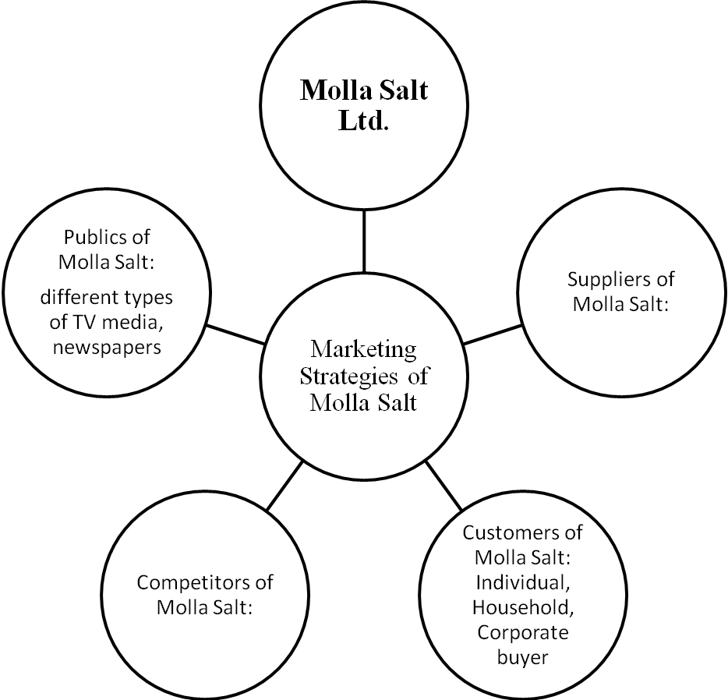

Molla Salt Micro environments

4.6 Marketing strategies of the Molla salt:
We know that one strategy is not for all companies. There are different strategy is required for the different types of products. Molla Salt Company’s main overall strategy is to deliver quality & wining long term customer’s loyalty.

4.7 Target market strategy:
Molla salt company is a prominent & large size company in to the salt industry. So thy target the customer who have upper- upper, upper- middle & also middle class people. The company target those types of people whose actually concuss about their health. Companies try to target segment perfectly & try to archive its marketing activities.

Positioning strategy:

Molla salt company’s competitive advantages are:

- Affordable price, higher quality, large sales of promotional activities, own transportation service.
- Provide grater margin for the wholesaler & retailer.
- The marketing mix that company sales its products competitive price, quality discount & transportation to promote the sales of the products.
- Company follows the marketing concept for, this reason the target potential buyers.
- Molla Super Salt provides 99.5% sodium chloride.

4.8 Customer Relationship Management:
Molla Salt Ltd. Also maintain customer Relationship Management (CRM), known as relationship marketing or customer management, is an information technology industry term methodology, strategy, software and other web-based capabilities use to help an enterprise organize and manage customer relationships.

Molla Salt Sales forces Department:
The professional sales force predicts and proposes the real-time analysis of information and distributes this information to the company & business partners. The goal of Molla Salt ‘s CRM is to aid organization in better understanding each customer’s & buyers value to the company, while improving the efficiency and effectiveness of communication. Molla Salt Company’s CRM capture analyzes & distributes all relevant data from customer and prospect interaction to every buyer in the organization. This distribution of information helps an organization sale forces to better meet customer, product & service needs.

Molla Salt’s Marketing Department:

Marketing concentrates on personalizing customer performances and offering them satisfying experiences. Molla Salt Company’s CRM has replaced traditional marketing techniques that focused on key marketing mix elements, such as product, price, promotion and place. By being too functionally-based, traditional marketing techniques neglected the customer in the after-sales process and failed to meet customer’s desire

4.9 Promotional Objectives:

Molla Salt ltd. usually set promotional which will help them to meet their broader marketing and organizational objectives and they have multiple objectives for doing these promotional activities.

- Informing:

The first objective is to provide information about the products of Molla Salt Ltd to its existing as well as potential customers. The specific information can be what products can be available, where they can be purchase and what prices of those products are.

- Increasing sales:

After providing information, encouraging prospective customers to purchase products is the most common promotional objective. Using advertisements and other promotional methods, Molla Salt Ltd attempt to persuade customers to buy iodine mix Super Salt or Molla Salt.

- Positioning the product:

Often Molla Salt Ltd uses promotional activities to create position a product as different or superior to competing products such as they offer low price, iodized, vacuum evaporated to the potential customer.

4.10 The promotional Mix:

To inform, influence & remain customers or general public Molla Salt Ltd use personal selling (person to person approach) and advertising, sales promotions, publicity (Non personal approach ). Molla Salt Ltd. is using all of this elements for attracting customers. Because Molla Salt Ltd. things that every single option will carry weight and being customized. So Molla Salt Ltd. uses all of those four tools which are treated as promotional mix.

Advertising:

Since all types, customers are very much familiar with advertising and if the particular advertising is very much attractive the potential customer are more influenced. And usually Bangladeshi customers are emotional so any emotional TV advertising will create a place in the mind of customers which can be treated as positional for Molla Salt Ltd. but advertising quite expensive , specially using national media with immense audiences . But Molla salt Ltd. has found advertising to be cost effective because it can be reach a vast number of people at low cost per person and it is also quite flexible.
Molla salt Ltd. uses different types of advertising. Molla Salt Ltd first use advertisement in 1996. That time that advertisement was get very popularity. The reason that Molla Salt Ltd. at first wants to create or increase demand for all its products. Not only has this Molla Salt Ltd also uses their advertisement in different media to selling the product more. Here Molla Salt Ltd introduces their product to the customers and tries to sell it more. Molla Salt Ltd also sdvertises used to build goodwill and create a favourable public image to the existing as well as potential customers.
Molla Salt Ltd is using different types of media for advertising which ultimately help share & care to inform as well as influence the potential customer to buy their products.

Those types of media are:

- Newspapers:

Molla Salt Ltd gives advertising to newspapers. This is a very important media because customers with different status can be able to evaluate those products and after that they may be influenced to buy those products. Also people are very much enthusiastic to read newspapers. So this is an important media for Molla Salt Ltd.

- Magazines:

Magazines are also media for Molla Salt Ltd. they are giving advertisement in different relevant magazines with colourful photo which make the customers interested to buy the products.

- Campaign:

In different fair, Molla Salt Ltd. always participates. Because, in the fair customers come and visit the stall and attendant can provide proper information regarding the products.

- Sales Promotion:

Molla Salt Ltd. declared sales incentive for kinds of seller and stimulates quick increase in sales by targeting promotional incentive on particular products. Molla Salt Ltd. gives short term incentives to encourage the purchase or sales of their products. Molla Salt Ltd. also promoting their products while selling. They offer different sales promotion for the customers which customers more influenced for buying their products. They offer different type of promotional offers depending on situation and budget.

- Public relation:

Molla Salt Ltd decided to make strong public relation. They use magazine, newspaper and different types of electronic media those are cheap way to reaching many customers. Molla Salt works for good relationship with its publics by obtaining favourable publicity, building up a good corporate image and handling off unfavourable rumours, stores and events. It is an important part of sales promotion which helps Molla Salt ltd. to create and maintains a favourable for a firm. Molla Salt Ltd expends lots of its publicity in one of the most important part of promoting of its products.

Chapter-Five

SWOT Analysis of the Organization

5.1 SOWT Analysis of the Organization:

SOWT means strength, weakness, opportunity & threats. Every organization has strength, weakness, opportunity & threats. Strength & weakness are influenced and calculated by company’s internal environment factor while Opportunities and Threats are influenced and calculated by external environment.

- Strength of the Company says how well the company will be able to perform in the market and make his positions in the market.

- Weakness of the Company says competitive uncap abilities in the key functional areas of the company.

- Opportunity which determine he company important avenues for profitable growth, potential utility/ scope to sustain in the competitive advantage.

- Threats which determine the barriers of company’s profitability and competitive well-being.

SOWT Analysis of the Molla Salt Ltd.:

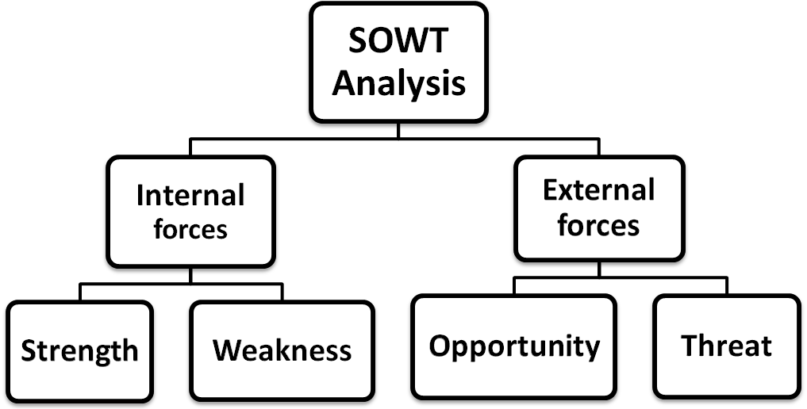

5.2 Strength:

- Their management is good. They make all the decision timely find the solution about the problem
- Very good and strong relationship marketing.
- Very good marketing inside & outside of the company.
- Qualified employees are available hare.
- Very quickly decision-making capability.
- Capable to quick action taken.
- Huge number of employees for marketing.

5.3 Weakness:

- This company no training department when the new employee or officer come to the work in their company they feel very much pressure about the work they cannot easily understand the work.
- The company has no transport facilities. The office time started from 9.00 am some officer come from any other place in Dhaka like as ftullah, Narayengonj.
- Molla Salt Company’s management stuff cannot take the decision independently. All the matter controlled by the owner of the organization.
- Molla salt Company has no separate human resource department. All the departments are together so it is tough to identify which one is which department.
- Lack of participation in publicly e.g. Bill Board.
- Poor coordination between departments.
- Lack of motivation program for the employees.
- Very poor evaluated procedures for the employees.

5.4Opportunity:

- Molla Company has planned marketing strategy to enter the new market by competitive price.
- Molla Company creates an image to the customers.
- Very good demand in super shop.
- Available potential target buyer in the corporate market.
- Molla Company can use modern technology.

5.5 Threats:

- Competitor & their destructive marketing.
- Prolonged decision-making.
- Many new companies are entering in the salt market.

Chapter-Six
Conclusion & recommendation

6.1 Conclusion:

I have done my internship in Molla Salt Company. This report is based on the experience I have gathered during my work in this company. The experience I have gathered here has certainly developed my knowledge & skill which will help me in my future career in marketing.

Molla Salt Company is an established salt company in Bangladesh. At present this company plays an important role in producing and marketing refined salt in the country. Molla Salt Company has become popular with the consumers by playing pioneering rolr in marketing iodine mixed super refined salt.

Marketing of salt has become very competitive despite that this company is facing the challenges very well.

During my internship in this company I have noticed some problems.

6.2 Recommendation:
I face some obstacle while working in Molla Salt Company. I would recommend some of the aspects in the management practices for the betterment of the company. This would be my own personal view. There are:

- Decentralization of power and responsibilities can be exercised to develop sense of dedication among.
- Molla Salt Company appointing more efficient employees in the marketing department of expending the present sales.
- More emphasize in promotional mix such as – advertisement, personal selling, sales promotion, public relation & direct marketing to transfer the prospective customer’s actual customer.
- Arranging employees training program regularly and to train the employees face the current market situation.
- Regular performance evaluation of the employees for increases their effectiveness.
- Molla Salt Company authority does not give more concentration of their employees face the current market situation.
- Molla Salt Company should provide transport facilities for their employees so that they come to the office.

Reference:

Book:

- Kotler. P. Keller. Marketing Management, 11th Edition, Prentice Hall Inc, New Jersey.
- Kotler. P & Armstrong, Principle of Marketing, 11th Edition, pearson Education, Inc Singpore.
- Naresh. K. Malhotra, Marketing research, 4th Edition.

Documents:

- Molla Salt Limited Brochures.
- Molla Salt Limited Administrative Papers.


An Internship Report
on
Marketing Activities of Molla Salt Company Ltd.

Prepared By:
Shahariar Ekram Shatil
ID# RMBA-080301784
Major in Marketing
Department of Business Administration
Northern University Bangladesh

Date of Submission: August 19, 2010



INTERNSHIP REPORT
On
Marketing Activities of Molla Salt Com. Ltd.
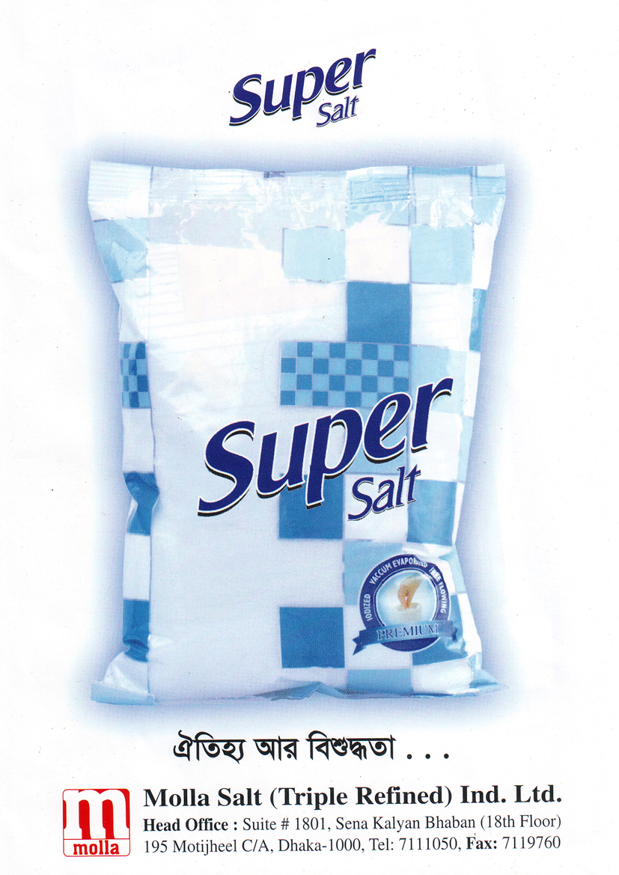

Date of Submission: 28 September, 2010

INTERNSHIP REPORT
On
Marketing Activities of Molla Salt Ltd.

Supervised by:
Abdullah Mohammad Ibrahim
Assistant professor in Marketing
Northern University Bangladesh

Prepared by:
Shahariar Ekram Shatil
ID# RMBA-080301784
Major in Marketing
Department of Business Administration

Date of Submission: 28 September, 2010

Letter of Transmittal

Date: June 12, 2009

To
Abdullah Mohammad Ibrahim
Assistant Professor
Department of Business Administration
Northern University Bangladesh.

Sub: Submission of Rnternship Report.

Dear Sir,

Due to respect I would like to submit my internship report entitled “marketing activities of Molla Salt Ltd.” As a part of academic curriculum. For preparing my internship paper, I tried my level best to make this report perfect.
My effort has always been to prepare a report as comprehensive, informative, and analytically sound as possible; however, my limited knowledge and lack of adequate analytical ability might result in some unintentional errors and mistakes. I hope that you will be kind enough to overlook them considering that I am still in the process of learning.
I would like to thank you, for all supportive suggestions, help and kind information.

Sincerely Yours,

__________________
SHAHARIAR EKRAM SHATIL
ID # MBA 080301784
(Major in Marketing)
Department of Business Administration (BBA)
Northern University Bangladesh.
Student declaration

I am Shahariar Ekram Shatil ID NO# 080301784 declare that the internship
Report on Marketing Activities of Molla Salt Ltd. is fully complete as Northern
University Bangladesh want this report is not for other course. Whole report is
prepared by me.

__________
Signature
Shahariar Ekram Shatil
ID No # 080301784
Major in Marketing
Masters of Business Administration
Northern University Bangladesh.

Letter of Acceptance

This report title Marketing Activities of Molla Salt Company Ltd. Submitted as partial requirement of MBA program.

This report has been prepared by shahariar ekram shatil, major in marketing, MBA program at Northern University Bangladesh under supervision and guidance.

This report is approved and accepted in quality form

Supervisor

_____________ ______________
Abdullah Mohammad Ibrahim Chairmen
Assistant Professor in Marketing
Department of Business Administration
Northern University Bangladesh
ACKNOWLEDGEMENT

I am heartily indebted to my supervisor Abdullah Mohammad Ibrahim, assistant professor in Marketing, Faculty of Business, Northern University Bangladesh, and Dhaka for his enthusiastic support and guide to complete the internship report.

I have my profound gratitude to the Management of Northern University for providing me active support and opportunities to study and learn my MBA program in respective manner.

I am thankful to the Molla Salt Management for their co-operation, valuable guidance, and generous support providing me with essential information.

I am also grateful to all of my teachers, Management, staff and fellow matters to give me real support and for their heartiest co-operation.

EXECUTIVE SUMMARY

Salt is an important element of our Bangladeshi food. We can not think of cooking or eating our food without salt.
Salt was naturally produced from Sea Water. Earlier it was produced manually. Preserving sea water in to the field and drying it up in the sun. Salt produced in this way was generally marketed in our company. That type of produced salt is very unhygienic and harmful for health.
Later on factories were established to refine salt in better quality; iodine mixed and also were packed for marketing. At present many developed companies have been established to produced iodize mix refined, packed salt. Iodine is mixed because it prevent to Goiter and many other diseases. Now a days this refined and iodine mixed salt has become popular with the consumers.
Molla Salt Company Ltd. is the pioneer salt company in the Bangladesh. Molla Salt Company is an established super salt company in Bangladesh. At present this Company plays an important role in producing and marketing refined super salt in the country. Molla Salt Company has become popular with the consumers and playing pioneering role in marketing iodine mixed super refined salt.
Company’s profile is very big factor in the business, because it is the only way to generate money to keep the business running. For this reason the organization completely depends on the selling the product. In the case of selling customers are the key to get the objective. This company uses all kinds of promotional tools to achieve marketing objective which creates better facility for the target market. So their business policy is to serve the target customer with full satisfaction and keep running the business in a legitimate way Molla Salt Company relentlessly working for the achievement if its goal.

