Internship Report

On

Modes & Schemes of Investment of IBBL

Submitted by
WWW.ASSIGNMENTPOINT.COM

To engage in an internship program in an organization is an integral part of BBA program. After completion of the program, a student must submit the report on the assigned topic to the supervisor and department. For fulfilling that requirement, I have worked on “Investment Operations of IBBL.” Here I am supposed to analyze investment banking as a whole scenario of Islami Bank Bangladesh Limited (IBBL) particularly in terms of its precise definition, problems, factors, contributions, and inventions. The primary goal of the internship program is to provide the intern with the job experience by orienting the intern with the organization and an opportunity for the intern to relate the theoretical conceptions in the real business environment. The program covers a period of two weeks in Islami Bank Training & Research Academy (IBTRA) and eight weeks in organizational attachment.

  - Objective of the Report:
1.2.1 General Objective:
The primary objective of this report is to observe the investment related activities for the Investment Department of Islami Bank Bangladesh Ltd.

1.2.2 Specific Objectives:
The other objectives include:

To acquire practical knowledge about the investment activities of IBBL

To evaluate the investment situation of IBBL.

To understand the different investment modes of IBBL.
- To familiarize with the various investment schemes.
- To get the practical exposure of the banking activities.
- To adapt with the corporate environment.
- To understand the investment policy of IBBL with other banks.
- To highlight the problems and necessary recommendations to overcome the problems in investment of IBBL.
1.3 Scope of the Report:
The scope of the study includes problems and prospects of investment of Islami Bank Bangladesh Limited. In this report I have focused on all the qualitative which include profiles of IBBL, investment modes like Bai mode, Profit & loss sharing, bearing mode, Rent sharing mode, different schemes of investment such as household durable schemes, housing investment scheme, transport investment scheme, car investment scheme, investment scheme for doctors small business investment scheme, rural development scheme, etc. and lastly financial performances have been depicted.

  - Limitation of the Report:
The main limitations of the report are as follows:
- Lack of adequate knowledge about Investment of any organization
- Sufficient records, publications, facts and figures are not available. These constraints narrowed the scope of the real analysis.
- For the reason of confidentiality, some useful information cannot be expressed in this report.
- Lack of available information about investment operations of IBBL.
- Unavailability of sufficient written documents as required making a comprehensive study.
- In many cases up to date information is not published.
- Because of the unwillingness of the busy key persons, necessary data collection became hard.
- Lack of experiences has acted as constraints in the way of meticulous exploration on the topic.

Chapter Two
Research Methodology

Methodology is an important part of a report. Methodology refers to the way by which data are collected for preparing any report or study. This is an explanatory type of report that has undertaken insights and understanding about overall investment operations of Islami Bank Bangladesh Limited. This report is prepared on the basis of primary and secondary data. The relevant data information was collected through direct interview of the personnel engaged in various departments of Islami Bank Bangladesh Limited. The secondary data source is annual report of the IBBL, which were collected from personal visit to the bank.

2.1 Sources of Data
2.1.1 Primary Sources of Data:
- Direct Interviews & Conversation
- Official records
- Observation of various organizational procedures
- Expert opinion

2.1.2 Secondary Sources of Data:

Most of the information used in this report has been collected from
- Annual Report 2007.
- IBTRA Library.
- Manuals of Investment of IBBL.
- Collection data from websites.
- Magazines /Journals/ Periodicals.

2.2 Methods of Collecting Data
Methods of collecting data means by which way data have been collected. Primary data
are collected through face to face conversation basis and secondary data are collected from different articles and annual report of the bank.

2.2.1 Primary sources of data are collected by:
    - Interviewing by Manager of Dhanmondi Branch and head of Investment Department.
    - Informal conversation with colleagues

2.2.2 Secondary sources of data are collected by:
    - Annual Report of Islami Bank Bangladeshi
    - Manuals and articles collecting from IBTRA
    - Relevant journals and articles available from Websites of IBBL

2.3 Variables covered
The efficiency of investment operations of IBBL is measured on the basis of following variables:
- Time
- Different modes of investment
- Different schemes of investment
- Objectives and accomplishment
- Knowledge of work
- Accuracy and reliability
- Judgment

Chapter Three
An Overview of Islami Bank Bangladesh Limited (IBBL)

3.1 Introduction:
Islam is the only way for the peace of humanity. Islam permits the rules which are beneficial for man. In Islam there is two terms as Halal and Haram. Halal is permitted by Allah and it brings welfare for the society. On the other hand Haram is totally restricted in Islam .In Islam, interest (riba) is totally forbidden by Allah. It means income from interest (riba) is Haram according to Quran and Sunnah. So every sort of financial transaction must be free from riba. But not only in Bangladesh but also over the world all the banks are working basing on interest. As it is haram in Islam the Muslim scholars thought a plan to establish a banking system that is free from interest and will work on the basis of profit-loss sharing. Then depending on this thought, it is decided to establish Islamic banks through the whole world to protect every one from this curse. So Islamic banks are working on the basis of Islamic Shariah that is free from interest.
An Islami Bank is a financial institution that operates with the objective to implement and materialize the economic and financial principles of Islam in the banking arena.

The Organization of Islamic Conference (OIC) defined an Islamic Bank as a financial institution whose statutes, rules and procedures expressly state its commitment to the principles of Islamic Shariah and to the banking of the receipt and payment of interest on any of its operation.

According to Islamic banking Act 1983 of Malaysia, and Islamic Bank is a company which carries on Islamic Banking Business Islamic Banding business means banking business whole aims and operations do not involve any element which is not approved by the religion Islam.
From those definitions, we can find some characteristics of Islami Banking as:
- It is a financial institution.
- It is a business institution.
- It operates its business activities free from interest.
- It is run according to rules and regulations formed and amended by Shariah Council.
- Islamic bank means not business product but running business through money.
- It is profit-loss sharing business organization.
The main objective of Islamic Banking is not only to earn profit, but also to do good and welfare to the people. Islam upholds the concept that money, income and property belong to Allah and this wealth is to be used for the good of the society.

3.2 Historical background of IBBL:

In August 1974, Bangladesh signed the Charter of Islamic Development Bank and committed itself to reorganize its economic and financial systems as per Islamic Shariah. In January 1981, the president of Bangladesh, the then, while addressing the 3rd Islamic Summit Conference held at Macca and Taif suggested, “ The Islamic countries should develop a separate banking system of their own to facilitate their trade and commerce. “This statement of the president indicated favorable attitude of the government of the People’s Republic of Bangladesh towards establishing Islamic banks and financial institutions in the country. Earlier in November 1982, Bangladesh Bank, the country’s central Bank, sent a representative to study the working of several Islamic Banks abroad.
In November 1982, a delegation of IDB visited Bangladesh and showed keen interest to participate in establishing a joint venture Islamic Bank in the private sector. They found a lot of work had already been done and Islamic banking was in a ready form for immediate introduction. Two professional bodies Islamic Economics Research Bureau (IERB) and Bangladesh Islamic Banker’s Association (BIBA) made significant contributions towards introduction of Islamic banking in the country.

They came forward to provide training on Islamic banking to top bankers and economists to fill up the vacuum of leadership for the future Islamic banks in Bangladesh. They also held seminars, symposia and workshops on Islamic economics and banking through out the country to mobilize public opinion in favor of Islamic banking.Their professional activities were reinforced by a number of Muslim entrepreneurs working under the aegis of the then Muslim Businessmen in society (now reorganized as industrialist & Businessmen Association). The body concentrated mainly in mobilizing equity capital for the emerging Islamic Banks.
At last, the long drawn struggle, to establish an Islamic bank in Bangladesh becomes a reality. Islami Bank Bangladesh Limited was established in March 1983. In which 19 Bangladeshi nationals, 4 Bangladeshi institutions and 11 banks, financial institutions and government bodies of the middle east and Europe including IDB and eminent personalities of the kingdom Saudi Arabia joined hands to make the dream a reality.

3.3 Basic Facts:

(As on 31st December 2007)
Date of Incorporation | 1st April 2001
Formal Inauguration | 10th May 2001
Capital Structure prior to IPO | Tk9, 35,82,5000
Local Shareholders | 42.64%
Foreign Shareholders | 57.36%
Mutual Fund | Tk93582500
Authorized Capital | Tk.5, 000 million
Number of Shares | 50,00,000
Paid-up Capital | Tk.3801.60million
Deposit | Tk.15048.37 million (As on 31-Dec-2007)
Total Assets | Tk.1, 91,362.35 million (as on Dec 31-2007
Investment | Tk1, 13,575 million (As on 31-Dec-2006)
Foreign Exchange Business: | Tk.168.37 million (As on 31-Dec-2007)
Manpower | 368 (As on 31 Dec-2007)

3.4 Visions and Mission of IBBL
The vision of Islami Bank Bangladesh Limited is to always strive to achieve superior financial performance, be considered a leading Islamic bank by reputation and performance.

- Their goal is to establish and maintain the modern banking techniques to ensure the soundness and development of the financial system based on Islamic principles and to become the strong and efficient organization with highly motivated professionals, working for the benefit of people, based upon accountability, transparency and integrity in order to ensure stability of financial systems.

- They will try to encourage savings in the form of direct investment

- They will also try to encourage investment particularly in projects which are more likely to lead higher employment

- The banks operate on Islamic principles of profit and loss sharing, strictly avoiding interest, which is the root of all exploitation and is responsible for large-scale inflation and unemployment.

The mission of IBBL is to establish Islami banking through the introduction of a welfare oriented banking system and also ensure equity and justice in the field of all economic activities, achieve balanced growth and equitable development through diversified investment operations particularly in the priority sectors and less developed areas of the country. To encourage socio-economic uplift and financial services to the low-income community particularly in the rural areas.

3.5 Major services
Islami bank Bangladesh limited offers all types of commercial banking services based on Islamic Shariah.the general banking services include taking deposit in the form of Mudaraba Savings Deposit, Mudaraba Cash Waqf Deposit, Mudaraba Special Notice Deposit, Mudaraba Term Deposit, Mudaraba Hajj Deposit, Mudaraba Savings Bond, Mudaraba Special Savings (pensions) Scheme, Mudaraba Monthly Profit Deposit, Mudaraba Muhor Savings, Mudaraba Foreign Currency deposit and Al-Wadeeah Current Account, Issuance of Telegraphic Transfer, Demand Draft, Locker Service, Banker to the Issue etc.

Investments include- providing investment facilities on Bai-Mudaraba, Bai- Muajjal, Hire-Purchase under Shirkatul Melk, Musharaka, Mudaraba, Bai- Salam etc. and various schemes that is Household Durable Scheme, Investment Scheme for Doctors, Small Business Investment Scheme. Housing Investment Scheme, Small Transport Scheme, Transport Investment Scheme, Car Investment, Agriculture Implements Investment Scheme, and Rural Development Scheme etc.

3.6 Management structure of IBBL

Islami bank Bangladesh limited is being managed by a board of directors comprising foreigners and local. An executive committee is formed by the board of directors for efficient and smooth operation of the Bank. Besides a management committee looks after the affairs of the bank.

Chairman

Executive President

Deputy Executive President

Executive Vice president

Senior Vice President

Vice President

Assistant Vice president

Chapter Four
An overview of Dhanmondi Branch
Of
IBBL

4.1 Introduction
Dhanmondi Branch started its operations as on 223rd branch of Islami Bank Bangladesh Limited in 26 December; 2001.Office floor is spacious & well decorates that can accommodate good number of customers comfortably.
Branch has efficient human resources that can meet up customer's needs. Order wise workload is distributed properly. Besides, interpersonal relationship is remarkable. Most noted strength is customer service. Prompt, cordial & enthusiastic service satisfies almost all customers. Flexible banking hour attracts more clients doing banking transactions with the branch. In some cases, customers, coming outside the banking hour can honour the cheque & others without delay.
This branch performs three departments as:

- General Banking Department
- Foreign Exchange Department
- Investment Operations Department

4.2 Special Services
Islami Bank Dhanmondi Branch in association with other branches of the bank offers two special services to its values customers. These are –
- E-Cash – ATM Cards Services
- SWIFT Service

    - E-Cash - ATM Card
Automated Teller Machine (ATM), interlaid, has unveiled the horizon of Electronic Banking of 21st Century. Through ATM, customers can avail non-stop online teller service without going to the specific branch of the member bank. They can withdraw or deposit cash or cheque as well as pay utility bills like DESA, BTTB, WASA, and TITAS etc. with the help of this modern computer controlled machine. The service is now offered by ETN and eight member banks including Islami Bank Bangladesh Limited.

4.2.2 Facilities
- ATM Card holders can withdraw cash from ATM at any time.
- Customers can make transactions from any of the machines with logo ‘E-cash’ installed at different places in the city.
- In course of time utility bills like WASA, TITAS, DESA etc can be paid through ATM.
- Now BTTB and Grameen Phone bill can be paid through ATM.
- Now IBBL E-cash cardholders can be paid their monthly installment of Mudaraba Hajj Savings, MSS (Pension), Mudaraba Muhor Savings and HDS schemes of IBBL through ATM.
- The machines are located in convenient places where customers usually deal with money matters. So they can easily avoid the risk of cash carrying by using ATM Card.
- Customers may know their present balance at any time from the machine.
- POS (Point of Sale)

4.2.3 SWIFT
Society for Worldwide Inter-Bank Financial Telecommunication (SWIFT) is a bank owned co-operative serving the financial community worldwide. The SWIFT Transport Network (STN) is a dedicated global network for secure communication between SWIFT Customers. SWIFT supports the financial data communication and processing needs of financial institutions, through a range of financial messaging services and value-added processing, as well as, access through the STN and interface and application software. In short SWIFT is a pioneer in the automation of the global financial industries.

Islami Bank Bangladesh Limited has introduced this SWIFT alliance entry system firstly in October 1999 and introduced SWIFT alliance access in October 2001. Islami Bank Bangladesh Dhanmondi Branch is connected to SWIFT in the following address:

Branch Name | SWIFT Address
Dhanmondi Branch, Dhaka | IBBLBDDH223

4.3 Investment performance of the Branch

Up to September 2007 comparing to overdue investment its outstanding investment is very high. In case of Bai-Murabaha as outstanding investment is 41.7% and overdue investment is 0.64% and incase of HPSM, it is 52.34% and 0.00%. In 2007, total investment is growing by 85%.

4.4 Business going up of the branch (Up to March 2007)

Deposit figure is 1097.21 million taka which was 1014.41 in 2006 and 999.27 in 2005,
Investment is 1734.62 million taka which was 1599.67 in 2006 and 905.56 in 2005 and Foreign Exchange is 792.58 million taka which was 2832.84 and 1463.65 in 2005. So here we find a clear picture about the branch.

Chapter Five

Investment Operations of Islami Bank Bangladesh Limited

5.1 Introduction:
Investment or investing is a term with several closely related meanings in business management, finance and economics, related to saving or deferring consumption. An asset is usually purchased, or equivalently a deposit is made in a bank, in hopes of getting a future return or interest from it. Investment is any use of resources intended to increase future production output or income. Investment is the process of using savings or resources to increase the economy's productive capacity; investment in capital goods occurs when savings are used to finance the production of new capital goods and/or new technology to increase productivity; investment in human capital or human resources occurs
From the above discussion, we can define investment as:
- The act of investing; laying out money or capital in an enterprise with the expectation of profit
- Money that is invested with an expectation of profit
- Outer layer or covering of an organ or part or organism
- The act of putting on robes or vestments
- The ceremonial act of clothing someone in the insignia of an office; the formal promotion of a person to an office or rank
5.2 Objectives of Investment
The objectives of investment operations of the Bank are:

- To invest fund strictly in accordance with the principles of Islamic Shariah.
- To diversify its investment portfolio by the size of investment, by sectors (public & private), by economic purpose, by securities and by geographical area including industrial, commercial, and agriculture.
- To ensure mutual benefit both for the bank and the investment-client by professional appraisal of investment proposals, judicious sanction of investment, close and constant supervision and monitoring thereof.

5.3 Necessity for preparation of credit report:
Preparation of credit report of the investment client is necessary and very much important for different purpose which is help to the investment officer to take decision for the invest of the propose project. By preparing the credit report is clearly mention the investment size, its rate of return and the fusibility of the project. The credit report help to identify the client past invest future of the client. Some important things as shown below,
- To select investment client carefully and judiciously.
- To ensure quality investment.
- To ascertain credit worthiness of the client.
- To ensure adequate securities both primary and collateral.
- To ensure clients business establishment and line of business.

5.4 Investment Modes of IBBL
When money is deposited in the IBBL, the bank, in turn, makes investments in different forms approved by the Islamic Shariah with the intention to earn a profit. Not only a bank, but also an individual or organization can use Islamic modes of investment to earn profits for wealth maximization. Some popular modes of IBBL’s Investment are discussed below.

5.4.1 BAI-MURABAHA (Contract Sale on Profit)

A. Meaning of Murabaha
“Bai-Murabaha" means sale for an agreed upon profit. Bai-Murabaha may be defined as a contract between a buyer and a seller under which the seller sells certain specific goods permissible under Islamic Shariah and the Law of the land to the buyer at a cost plus an agreed upon profit payable today or on some date in the future in lump-sum or by installments. The profit may be either a fixed sum or based on a percentage of the price of the goods.

B. Important Features of Murabaha
- A client can make an offer to purchase particular goods from the bank for a specified agreed upon price, including the cost of the goods plus a profit.
- A client can make the promise to purchase from the bank, that is, he is either to satisfy the promise or to indemnify any losses incurred from the breaking the promise without excuse.
- It is permissible to take cash/collateral security to guarantee the implementation of the promise or to indemnify any losses that may result.
C. Steps of Bai-Murabaha
First Step: The client submits a proposal regarding his requirements of the bank. The client sends a proposal with the specifications of the commodity to be acquired from the bank. The proposal also indicates details regarding the date, time and place of delivery as well as price and form of payment information. The bank responds by sending a counter proposal either accepting the buyer’s price or stipulating a different price.

Second Step: The client promises to buy the commodity from the bank on a Bai-Murabaha basis, for the stipulated price. The bank accepts the order and establishes the terms and conditions of the transaction.

Third Step: The bank informs the client (ultimate buyer) of its approval of the agreement to purchase. The bank may pay for the goods immediately or in accordance with the agreement.
The seller expresses its approval to the sale and sends the invoice(s).

Fourth Step: The two parties (the bank and the client) sign the Bai-Murabaha Sale contract according to the agreement to purchase.

Fifth Step: The Bank authorizes the client or its nominee to receive the commodity.

The seller sends the commodity to the place of delivery agreed upon. The client undertakes the receipt of the commodity in its capacity as legal representative and notifies the bank of the execution of the proxy.
D. Application of Bai-Murabaha
Murabaha is the most frequently used form of finance in IBBL throughout the world. It is suitable for financing the different investment activities of customers with regard to the manufacturing of finished goods, procurement of raw materials, machinery, and other required plant and equipment purchases. It is used widely about 53%.

5.4.2 BAI-MUAJJAL (Deferred Sale)

A. Meaning of Bai-Muajjal
The Bai-Muajjal may be defined as a contract between a buyer and a seller under which the seller sells certain specific goods, permissible under Shariah and law of the country, to the buyer at an agreed fixed price payable at a certain fixed future date in lump sum or in fixed installments.
B. Important Features of Bai-Muajjal
- It is permissible and in most cases, the client will approach the bank with an offer to purchase a specific good through a Bai-Muajjal agreement.
- It is permissible to make the promise binding upon the client to purchase the goods from the bank.
- It is permissible to take cash/collateral security to guarantee the implementation of the promise or to indemnify the bank for damages caused by non-payment.

5.4.3 HIRE-PURCHASE UNDER SHIRKATUL MELK
Hire-Purchase under Shirkatul Melk has been developed through practice. Actually, it is a synthesis of three contracts: (a) Shirkat; (b) Ijarah, and (c) Sale. These may be defined as follows:

Definition of Shirkatul Melk: ‘Shrkat’ means partnership. Shirkatul Melk means share in ownership. When two or more persons supply equity, purchase an asset and own the same jointly and share the benefit as per agreement and loss in proportion to their respective equity, the contact is called Shirkatul Melk. In the case of Hire Purchase under Shirkatul Melk, IBBL purchase assets to be leased out, jointly with client under equity participation, own the same and share benefit jointly till the full ownership is transferred to the client.

Definition of Ijara: The term ‘Ijara’ has been defined as a contract between two parties, the lessor and the lessee, where the lessee enjoys or reaps a specific service or benefit against a specified consideration or rent from the asset owned by the lessor. It is a lease agreement under which a certain asset is leased out by the lessor or to a lessee against specific rent or rental for a fixed period.

Definition of Sale contract: This is a contract between a buyer and a seller under which the onwnership of certain goods or asset is transferred by the seller to the buyer against agreed upon price paid by the buyer. In the case of Hire Purchase under Shirkatul Melk, the lessor bank sells or transfers its title to the asset under a sale contract on payment of sale price.

A. Stages of Hire Purchase under Shirkatul Melk
Hire Purchase under Shirkatul Melk Agreement has got three stages:
- Purchase of asset under joint ownership of the lessor and the lessee.
- Hire, and
- Sale and transfer of ownership by the lessor to the other partner - lessee.

B. Important Features
- In case of Hire Purchase under Shirkatul Melk transaction the asset/property involved is jointly purchased by the lessor (bank) and the lessee (client) with specified equity participation under a Shirkatul Melk contract in which the amount of equity and share in ownership of the asset of each partner (lessor bank and lessee client) are clearly mentioned. Under this agreement the lessor and the lessee become co-owners of the asset under transaction in proportion to their respective equity.
- In Hire Purchase under Shirkatul Melk Agreement the exact ownership of both the lessor (bank) and lessee (client) must be recognized. However, if the partners wish and agree the asset purchased may be registered in the name of any one of them or in the name of any third party clearly mentioning the same in the Hire Purchase Shirkatul Melk Agreement.

5.4.4 MUDARABA (Investment made by the entrepreneur)
A. Definition of Mudaraba
The term Mudaraba refers to a contract between two parties in which one party supplies capital to the other party for the purpose of engaging in a business activity with the understanding that any profits will be shared in a mutually agreed upon. Losses, on the other hand, are the sole responsibility of the provider of the capital. Mudaraba is also known a Qirad and Muqaradah
B. Steps of Mudaraba
The bank provides the capital as a capital owner. The Mudarib provides the effort and expertise for the investment of capital in exchange for a share in profit that is agreed upon by both parties.

- The Results of Mudaraba: The two parties calculate the earnings and divide the profits at the end of Mudaraba. This can be done periodically in accordance with the terms of the agreement, subject to the legal rules that apply.
- Payment of Mudaraba Capital: The bank recovers the Mudaraba capital it contributed before dividing the profits between the two parties because the profit is considered collateral for the capital.
- Distribution of wealth resulting from Mudaraba: In the event a loss occurs, the capital owner (the bank) is responsible for the entire loss. In the event of profits, they are divided between the two parties in accordance with the agreement between them, subject to the capital being recovered first.

C. Rules of Mudaraba
There are some legal rules that govern the business relationship Mudaraba which are as follows.
- It is a condition in Mudaraba that the capital be specific in nature. In other words, the amount of capital must be known at the inception of the contract. The purpose of this rule is to ensure that there is no uncertainty about the amount of capital and, thus, no uncertainty about the division of profits.
- It is a condition that capital must be in the form of currency in circulation. However, merchandise can be contributed, so long as both parties to the business arrangement agree upon its value.
- It is a condition that the capital cannot be subject to indebtedness.

5.4.5 MUSHARAKA (Partnership based investment)
A. Meaning of Musharaka
The word Musharaka is derived from the Arabic word Sharikah meaning partnership. At an IBBL, a typical Musharaka transaction may be conducted in the following manner.
One, two or more entrepreneurs approach an IBBL to request the financing required for a project. The bank, along with other partners, provides the necessary capital for the project. All partners, including the bank, have the right to participate in the project. They can also waive this right. The profits are to be distributed according to an agreed ratio, which need not be the same as the capital proportion. However, losses are shared in exactly the same proportion in which the different partners have provided the finance for the project.

5.4.6 BAI-SALAM (Advance payment)

A. Meaning of Bai-Salam
Bai-Salam is a term used to define a sale in which the buyer makes advance payment, but the delivery is delayed until sometime in the future. Usually the seller is an individual or business and the buyer is the bank.
The Bai-Salam sales serve the interests of both parties.
- The seller receives advance payment in exchange for the obligation to deliver the commodity at some later date. He benefits from the Salam sale by locking in a price for his commodity, thereby allowing him to cover his financial needs whether they are personal expenses, family expenses or business expenses.
- The purchaser benefits because he receives delivery of the commodity when it is needed to fulfill some other agreement, without incurring storage costs. Second, a Bai-Salam sale is usually less expensive than a cash sale. Finally a Bai-Salam agreement allows the purchase to lock in a price, thus protecting him from price fluctuation.
B. Steps of Bai-Salam
- Cash sale or Sale on Credit - The bank pays the agreed upon price at the time of the contracts inception. The seller agrees to the delivery of the commodity some specified date in the future.
- Delivery and Receipt of the Commodity on the Specific due Date: There are several options for delivery available to the bank
a) The bank may receive the commodity and resell it to another party for cash or credit.
b) The bank may authorize the seller to find another buyer for the commodity.
c) The bank may direct the seller to deliver the commodity directly to a third party with whom the bank has entered into another agreement.
- The Sale Contract: The bank agrees to sell the commodity for cash or a deferred price, which is higher than the Salam purchase price. The buyer agrees to purchase and to pay the price according to the agreement.

C. Application of Bai-Salam
Salam sales are frequently used to finance the agricultural industry. Banks advance cash to farmers today for delivery of the crop during the harvest season. Thus banks provide farmers with the capital necessary to finance the cost of producing a crop. Salam sale are also used to finance commercial and industrial activities. Once again the bank advances cash to businesses necessary to finance the cost of production, operations and expenses in exchange for future delivery of the end product. In the meantime, the bank is able to market the product to other customers at lucrative prices. In addition, the Salam sale is used by banks to finance craftsmen and small producers, by supplying them with the capital necessary to finance the inputs to production in exchange for the future delivery of products at some future date.

5.4.7. ISTISNA'A SALE

A. Definition of Istisna'a Sale
The Istisna'a sale is a contract in which the price is paid in advance at the time of the contract and the object of sale is manufactured and delivered later. It is a contract with a manufacturer to make something and it is a contract on a commodity on liability with the provision of work. IBBL can utilize Istisna'a in two ways.
- It is permissible for the bank to buy a commodity on Istisna'a contract then sell it after receipt for cash or deferred payment.
- It is also permissible for the bank to enter into a Istisna'a contract in the capacity of seller to those who demand a purchase of a particular commodity and then draw a parallel Istisna'a contract in the capacity of a buyer with another party to manufacture the commodity agreed upon in the first contract.

B. Steps of Istisna'a Sale
Istisna'a Sale Contract: The Buyer expresses his desire to buy a commodity and brings a request to purchase the commodity to the bank. The method of payment, whether cash or deferred is set forth in the agreement. The bank agrees to deliver the commodity to the buyer at some agreed upon time in the future.

Delivery and Receipt of the Commodity: The seller in the parallel Istisna’a agreement, delivers the commodity to the bank on the agreed upon date. The bank, in turn, delivers the product to the buyer of the original Istisna’a contract, in accordance with the original agreement. In this way, all parties fulfill their obligations to the contract.

C. Application of Istisna'a Sale
The Istisna'a contract allows IBBL to finance the public needs and the vital interests of the society to develop the Islamic economy in accordance with Islamic teachings. For example Istisna'a contracts are used to finance high technology industries such as the aviation, locomotive and ship building industries. In addition, this type of business transaction is also used in the production of large machinery and equipment manufactured in factories and workshops. Finally, the Istisna'a contract is also applied in the construction industry such as apartment buildings, hospitals, schools, and universities to whatever that makes the network for modern life. One final note, the Istisna’a contract is best used in those transactions in which the product being purchased can easily be measured in terms of the specified criteria of the contract.

5.4.8. IJARAH
A. Definition of Ijarah
According to Islamic Shariah, Ijarah is a contract between two parties – the lessor and the lessee, where the lessees (Hirer or Mustajir) have the right to enjoy/reap a specific benefit against a specified consideration/rent/wages from the lessor – the owner (Muajjir).

B. Elements of Ijarah
According the majority of Fuqaha, there are three general and six detailed elements of Ijarah:
- The wording: This includes offer and acceptance.
- Contracting parties: This includes a lessor, the owner of the property, and a lessee, the party that benefits from the use of the property.
- Subject matter of the contract: This includes the rent and the benefit.
5.5 Comparison of different investment modes of IBBL
5.5.1 Bai Murabaha vs Bai-Muajjal:
Bai-Murahaba must be sold on profit on the hand Bai-Muajjal can be sold on profit or loss. The purchase price of Bai-Murahaba is essential to publish. On the other hand the purchase price of Bai-Muajjal is not required to publish.

5.5.2 Murabaha vs Musaraka:
Mudaraba is a form of partnership of profit where one party provides funds while the other party provides expertise and management. On the other hand Musaraka is a contractor of partnership between two or more individuals in which all parties contribute capital, participate in the management, share the profit in portion to their capital as per pre-agreed ratio.

5.5.3 Hire Purchase under Sirkatul Melk (HPSM) vs Bai-Ishtisna:
HPSM is a combination of three contracts as Shirkat, Ijarah and sale. Shirkat means partnership. The Istisna'a sale is a contract in which the price is paid in advance at the time of the contract and the object of sale is manufactured and delivered later.

5.6 Investment Schemes of IBBL:
Keeping the same in view, side by side with Commercial and Industrial Investment operations, many special Investment Schemes have been introduced by the Bank over the years like:
- House-hold durables Scheme
- Housing Investment Scheme
- Real State Investment Program
- Transport Investment Program
- Car Investment Scheme
- Invest Scheme for doctors
- Small Business Investment Scheme
- Agricultural Implements Investment Scheme
- Mirpur Silk weavers’ Investment Scheme
- Rural Development Scheme
- Investment under MEIS
- Micro-Industries Investment Scheme.
5.6.1 Household Durable Scheme
In a developing country like Bangladesh people of middle and lower middle class specially service holders with limited income find it difficult to purchase articles like refrigerator, television, cot, almirah, wardrobe, sofa-set, pressure cooker, sewing machine etc. which are part of modern and decent living. They can not enhance the standard and quality of life to the desired level due to the constrain of their limited income.
Objectives
- To assist the service holders with limited income in purchasing household durables.
- To assist the fixed income group in raising the standard of living.
- To create opportunity for the service holders to enjoy the benefit of modern and sophisticated living and at the time lead a decent and honest life.
Item
a. Refrigerator/Deep freeze.
b. Television.
c. Radio/Two-in-one/Three-in-one.
d. Motor cycle/Bi-cycle.
e. Air cooler/ Air conditioner.
f. Personal computer.
Eligibility
Interested permanent officials of the following organizations may apply for investment:
a. Government Organizations.
b. Semi-Government Organizations and Autonomous Bodies.
c. Banks and Financial Institutions
d. Armed Forces, BDR, Police and Ansars.
e. Teachers of Universities, Government Colleges and Schools and Senior
Madrashas.
Rate of Return: 15%
Period of Investment: Maximum two years
Mode of Investment: Bai-Muajjal

Equity
Minimum 25% of the total value of the articles. The client shall have to deposit the amount of equity in his Mudaraba Savings/Investment Account with the concerned branch before the disbursement of investment.
Security
The investment client shall execute/provide the following documents in order to secure the investment.
- All required charge documents as per rules of the Bank.
- A written undertaking to the effect that the monthly installments shall be paid regularly.
- Personal guarantee of another person, preferably family member
Procedure for Application
Interested clients shall apply in prescribed form to the concerned Branch. The application shall have to be duly recommended by the Divisional Chief of the organisation where the applicant serves. Form and booklet outlining the rules and procedures of the Scheme may be obtained from the selected Branches of the Bank on payment of Tk. 25.00 only.
5.6.2 Housing Investment Scheme
One of the basic human needs is to have a house to live in. A house is an abode of peace and happiness. Housing has now become an acute problem in the country, specially in the towns, cities and metropolis. With their limited income, it has become almost impossible on the part of the lower middle class, middle class and sometimes, even for upper middle class to solve their housing problem. To meet this basic human need, Islami Bank Bangladesh Limited is committed to contribute to this end to provide a peaceful and happy living. The Bank has introduced 'Housing Investment Scheme' with the objective to ease and minimize the housing problem and assist service holders and professionals with limited income in materializing their dream of becoming owner of houses.

Objectives
- To extend the benefits of the investment of the Bank under the Scheme to different sections of the people.
- To assist in solving the existing housing problem of the country.
- To assist the service holders and professionals with fixed income to arrange for houses of their own.

Eligibility
- Initially the following categories of people shall be eligible to apply for availing investment facilities under this Scheme:
1. Officials of the Defense Forces.
2. Permanent Officials of Government, Semi-Government and Autonomous
Organizations.
3. Teachers of the established Universities, University Colleges & Medical Colleges.
4. Graduate Engineers, Doctors and established professionals.
- Bank will select the client on the basis of the following criteria: Percentage of Bank's investment is less than the client's investment; amount of Bank's investment is comparatively smaller in size, quality of construction & value of the property; constructed house/apartment is in good location & the price is reasonable; return from the property (rented income) & other known sources of income of the applicant; investment servicing capacity of the client is quite satisfactory.

Target Area: At the initial stage, the Scheme is being implemented in:
- Dhaka metropolitan area.
- Chittagong metropolitan area.
- Rajshahi metropolitan area.
- Khulna metropolitan area.
- Sylhet metropolitan area.
Rate of Return: 14.5%
Mode of Investment
- Hire Purchase under Shirkatul Melk (HPSM)

Period of Investment
- The maximum period of investment shall be generally 15 years. However, the period of investment shall be determined on the basis of the proposal of the client, the amount of investment (for which the client has applied) and the ability of the project or client to repay the dues.
- Reasonable gestation period for construction be allowed considering the size of construction and Bank's investment.
Recovery of Bank's Investment
The client shall have to pay the Bank's dues by monthly instalment immediately after the expiry of the period of construction. To ensure payment as per stipulation of sanction the client, shall have to deposit post-dated cheques to the Bank for the amount of each monthly instalments covering the entire period of investment. The Bank shall realise the amount of monthly instalment by depositing the cheque of a particular month on the first week of every month.

Security
- Personal guarantee of the clients, his/her spouse, adult son(s) and daughter(s) shall have to be obtained.
- Mortgage of land and building to be constructed thereon, apartment/flat/house in favor of the Bank till the full payment of dues to the Bank.
Procedure for Application
Interested persons shall have to apply in prescribed form of the Bank through the Branch of the concerned area. The Bank shall sanction investment if the proposal is found acceptable after examination of its viability and profitability. The Bank reserves the right to sanction or reject any investment proposal.
5.6.3 Real Estate Investment Program
Professionals, Service-holders, Businessmen, Real Estate Developer and other categories of people who are not entitled for availing investment facilities under Housing Investment Scheme, shall be eligible under this program. Investment is to be extended to build new houses and for extension/ completion of the house already constructed, commercial building, shopping complex, flat/apartment etc.
Rate of Return: 14.5%
Mode of Investment: HPSM
Investment Limit: No specific limit
Duration: 10 years
5.6.4 Transport Investment Program
The role of modern communication is most vital for the socio-economic growth and uplift of a developing country like Bangladesh. A sound and efficient communication network is the pre-requisite for sustained development through the expansion of trade, commerce and industry. In this backdrop the demand for road and water transports has increased manifold throughout the country. Moreover, the use of modern transports has increased keeping pace with the rise of the standard of living of the professionals. Considering all these facts, Islami Bank Bangladesh Limited has introduced 'Transport Investment Scheme'. Under this scheme investment on easy terms is being extended to the existing successful businessmen in road and water transports and potential entrepreneurs in this sector for different types of road and water transports. Besides, Multinational companies, established business houses and well to do officials and professionals can become owner of various kinds of transports through Hire Purchase under this scheme.
Mode of Transports
- Road Transports
> Private car, microbus, jeep, pick-up van.
> Bus, truck, minibus.
> Auto-rickshaw, tempo.
> Ambulance.
- Water Transports
> Cargo vessel of maximum 500 ton capacity.
> Ocean going vessel of maximum 800 ton capacity.

Rate of Return: 14.5%
Mode of Investment: Hire-Purchase Shirkatul Meelk(HPSM).
Period of Investment:
Maximum 3 years from the date of delivery of the vehicle.
Rent of Investment
The Bank as per existing rules shall charge rent on investment. Clients, who will repay the entire investments within the stipulated period or earlier by way of regular payment of instalments, shall be given rebate over the rent.

Security
- The ownership of the vehicle shall remain in Bank's name till full repayment of investment including rent.
- The client shall have to mortgage immovable properties as collateral security.
- In case of Officials of Government, Semi-Government and Autonomous Bodies, personal guarantee of the officer of the same grade or of superior grade and in case of officials of public limited company or business houses, corporate guarantee of the employer/ chairman/managing director shall have to be provided.
Supervision
Bank officials or appointed agents of the Bank reserve the right to inspect the vehicle at any time in any place where it is kept or found in order to ascertain its overall condition.
Recovery of Bank's investment
- The client shall have to repay the dues to the Bank in monthly instalment starting immediately after the expiry of the gestation period fixed by the Bank.
- Required number of post-dated cheques for the whole period of investment mentioning the amount of monthly instalments shall have to be deposited to the Bank. The Bank shall collect the monthly instalment of a particular month through encashment of the cheque in the first week of the concerned month.
5.6.5 Car Investment Scheme
Car is considered as an essential mode of transport in the modern society, particularly by a section of the officials, business houses and business executives and established professionals for movement in discharging their duties and responsibilities punctually and efficiently. Many of these categories of people cannot purchase a car on payment of entire purchase value at a time out of their own sources. To meet this need Islami Bank has introduced the 'Car Investment Scheme' for the mid and high ranking officials of government and semi-government organizations, corporations, executives and directors of big business houses and companies and also for persons of different professional groups on easy payment terms and conditions.
Objectives
- To meet the demand of senior officials of different organizations, established business houses and companies and persons of various professional groups who essentially need a car but cannot afford to purchase on payment at a time.
- To assist in minimizing transport problem in the private sector and help the mid and high ranking officials and professionals with fixed income in the improvement of their standard of living.
- To extend the range of Bank's investment facilities to various sections of people in line with the ideals of the Bank.
Eligibility
Permanent senior officers/executives of the following organizations:
Category-A
- Government Organizations.
- Semi-Government Organizations/Autonomous Bodies/Corporations.
- Banks.
- Commissioned Officer of Armed Forces, BDR, Police and Ansars.
- Teachers of the Universities, Government Colleges.
Category-B
- Executives/Directors of big companies and business houses of repute.
- Members of all other professional groups having good income.

Rate of Return: 14.5%

Period of Investment

Period of investment is maximum 4 (four) years from the date of disbursement or delivery of the vehicle to the client, whichever is earlier.

Mode of Investment
a. Hire Purchase
b. Hire Purchase Shirkatul Meelk.
Security Requirements
The following shall be obtained as security against bank's investment under this Scheme:
a. In case of clients falling under category-A of eligibility criteria:
- Personal guarantee of the investment client.
- Personal guarantee of any of the officers of the rank and status equal to the client or an officer of higher rank.
- The guarantee shall have to be duly authenticated by the competent authority of the organization/institution where the client serves.
b. In case of clients falling under category B of eligibility criteria, any of the following additional collateral/securities are required:
- Mortgage of land
- Bank Guarantee
- Deposit of ICB Unit Certificates/National Savings Certificates/TDR/Share Certificates of reputed companies duly discharged/transferred in favor of the bank and/or completing required formalities.

Mode of Recovery
Dues to the Bank shall recover in the following manner:
- In equal monthly installment along with monthly rent, starting from the first week of the month, following the month of disbursement of delivery of the car whichever is earlier
- The monthly installment shall be payable by the first week of every month.
- Post-dated cheques for the whole period of investment mentioning the amount of monthly installment shall have to be deposited by the client. In the first week of every month, the cheque(s) shall be presented for clearance/collection for the adjustment of the monthly installment.
5.6.6 Investment Scheme for Doctors
Islami Bank Bangladesh Limited has taken the initiative an introduced the "Doctors Investment Scheme" to ensure modern treatment and medical facilities available to the people through extension of Bank's investment facilities for self-employment of newly graduated doctors and at the same time extending investment facilities to the established medical practitioners to procure modern and sophisticated medical equipment.
Objectives

1. To provide investment facilities for establishment of chambers, clinics, pharmacies and procurement of medical equipment by the unemployed medical graduates and thus to provide self- employment.
2. To assist newly passed unemployed medical graduates to establish clinics by way of formation of groups by 5 doctors.
Rate of Return: 14.5%
The maximum period of investment is 4 years.

Mode of Investment
q Hire Purchase Shirkatul Melk : For purchase/procurement of medical equipment and appliances, motor cycle and other items.
q Bai-Muajjal : For establishment of Chambers, Clinics and purchase of medicines etc.
Equity
- Newly graduated doctors under self-employment scheme : 10%
- Established doctors : 20%
- Established Clinics : 30%

Security
1. The ownership of the medical equipment, appliances etc. and the motor cycle supplied by the bank on Hire Purchase-Shirkatul Melk basis, shall remain with the bank.
2. Against Bank's investment, the clients shall have to mortgage property at least equal to the value of investment by the Bank. However, in case of investment (other than clinic) for self-employment of the newly graduated doctors the condition of mortgage of property may be relaxed, if they are unable to offer mortgage of property as security against investment. The investment clients shall have to provide personal guarantee of person(s) acceptable to the bank, in such cases.

5.6.7 Small Business Investment Scheme
Islami Bank, as welfare oriented financial institution, is committed to generate employment and bring about an overall improvement in the socio-economic condition of the people and the quality of their life. The Bank, to make effective contribution in this respect, has taken-up a special programme and introduced 'Small Business Investment Scheme' to make the small traders, entrepreneurs and neglected unemployed youths of urban and rural areas self-reliant by providing them required financial support.
The following benefits will be achieved through implementation of this Scheme.
- Gradually it will help to alleviate poverty and minimize unemployment.
- It will help small traders and entrepreneurs to become self-reliant and to improve their quality of life through capital formation.
- It will create opportunity for the unemployed youths to engage themselves in in-come generating activities.
- It will help to expand the market for locally produced goods by increasing productivity of small traders and entrepreneurs.

Eligibility of the Clients
- Investment clients must be permanent residents of the command area of the branch through which they intend to avail investment facilities and they must have valid trade license and shops or selling centres.
- Small business and entrepreneurs, who are already engaged in trade and business but cannot run their operations smoothly for shortage of fund/capital, will also be eligible to avail investment facilities under the Scheme.

Rate of Return: 13%

Mode of Investment
A. Hire Purchase Shirkatul Meelk :For all kinds of machineries i.e.equipments &
transport sector.
B. Bai-muajjal-TR :For trading shop keeping, agro-processing and
raw materials for manufacturing purposes.
Period of Investment
- In case of HPSM : Maximum 24 months.
- In case of Bai-muajjal-TR : Maximum 12 months.

Client's Equity

Security

For Investment up to Tk. 30,000.00
- Hypothecation of existing and future stock of goods. Ownership of machines & equipments shall remain in Bank's name.
- Personal guarantee of financially sound respectable 2 (two) persons/prominent businessmen acceptable to the Bank shall have to be given.
- Collateral security may be relaxed considering the feasibility of investment and client's ability and sincerity.
For Investment over Tk. 30,000.00
- Hypothecation of existing/future stock of goods. Ownership of machines & equipments shall remain in the Bank's name.
- The client shall have to give mortgage of immovable properties to the Bank.
5.6.8 Agriculture Implements Investment Scheme
In order to bring revolutionary changes in the agricultural sector by adopting modern agricultural technology replacing the age-old traditional way of cultivation and increasing the use of fertilizer. This can only be done by collective efforts of both public and private sectors. Islami Bank Bangladesh Limited is a welfare oriented Bank. It can play positive and important role in the economic development, progress and uplift of the country by investing in the agricultural sector. The Bank has, therefore, introduced "Agriculture Implements Investment Scheme" to provide power tillers, power pumps, shallow tube wells, thrasher machine etc. on easy terms to the unemployed youths for self-employment and to the farmers to help augment production in agricultural sector.
Types of Agriculture Implements
- Power tillers
- Thrasher Machine
- Any other agricultural implements proposed by the branch and which has local demand.
These implements may be of any popular brand. Any locally manufactured brand, which has large demand, is also acceptable. The choice of investment clients shall be given preference in this regard.
Eligibility of Investment Clients
- Educated or half-educated rural youths, educated or illiterate farmers and any person ready to accept agriculture as business may apply for investment facilities under this scheme. Preference shall be given to those applicants who have passed S.S.C. or above.
- The applicant farmer should posses sound health and his age must be minimum 18 years and maximum 50 years. Person who is willing to take agriculture as business, his age must be between 18 to 45 years. If the applicant is educated or half educated youth than his age must be between 18 to 35 years.
- The applicant must be physically and mentally fit and willing to operate the machine himself.
- Applicant must be a permanent resident of the concerned area and be willing to stay and work there.
Rate of Return: 14%
Period of Investment: Two Years
Mode of Investment: Hire Purchase Shirkatul Melk.

Security
- The agricultural implements to be supplied to the investment client shall remain in the name of the bank till the repayment/adjustment of the dues to the bank.
- Collateral security of immovable property equal to the amount of Bank's investment backed by irrecoverable general power of attorney.
- Client, who is unable to offer collateral security of immovable property, shall have to provide personal guarantee of two respectable persons acceptable to the Bank. Guarantors should preferably be client's father/guardian or teacher.
5.6.9 Mirpur Silk Weavers Investment Scheme
The Scheme has been taken up to assist the silk weavers of Mirpur area particularly in respect of requirement of working capital, BMRE of existing unit by adding further machineries, to develop new entrepreneurs and to assist the workers for getting further training for producing products of various modern design and for modernisation of the Silk Sector.
Rate of Return: 14.5%
Mode of Investment: Bai-Muajjal

5.6.10 Rural Development Scheme
Islami Bank Bangladesh Limited was founded with the major objective of establishing Islamic economy for balanced economic growth by ensuring reduction of rural-urban disparity and equitable distribution of income.

In view of the above, Branches of the Bank have been encouraged to invest their deposits in their respective areas and in particular for the economic upliftment of the rural people.
Accordingly, a Scheme in the name and style of 'Rural Development Scheme' has been introduced to cater to the investment needs of the agriculture and rural sector to create opportunity for generation of employment and raising income of the rural people with a view to alleviate poverty.

Objectives
The main objectives of the Scheme are:
a. To extend investment facilities to agricultural, other farming and off-farming activities in the rural areas.
b. To finance self-employment and income generating activities of the rural people, particularly the rural unemployed youths and the rural poor.
c. To alleviate rural poverty through integrated rural development approach.

Target Group: a. Farmers having land holding of maximum 0.50 acres.
b. Sharecroppers with consent from the landowners.
c. Persons engaged in off-farm activities having no land or land up-to-maximum 0.50 acres.
d. Persons/farmers permanently residing in the selected villages.
e. Persons having derelict pond will be eligible for investment for re-excavation and fish cultivation.

Rate of Return: 11.5%
Security Requirements
No security is required against investment under the Scheme as entire Scheme has been drawn taking into account the social welfare objective of the Bank for enlistment of the socially downtrodden and economically backward and weaker section of the population of the society. However, Group discipline should be strictly followed and complied with so that only the right persons are selected and included as members of the Group.

Modes of Investment
The Branch selects any of the following modes depending upon the sector and purpose of investment:
a. Bai-Muajjal
b. Hire-Purchase Shirkatul Meelk (HPSM) or Leasing
c. Mudaraba
d. Musharaka
e. Bai-Salam
f. Murabaha TR

5.6.11 Investment under MEIS
To satisfy the graduated clients who already availed highest limit of investment under RDS, a new Scheme has been introduced under the name & style of ‘Micro Enterprise Investment Scheme (MEIS)’. Small entrepreneurs of the area, other than RDS members, are also provided with investment facilities under this Scheme. At present, the clients under this Scheme are extended investment up to a maximum limit of Tk. 200,000/- individually against third party guarantee or collateral security.
The investment requirements of the deserving and investment worthy clients of the area that are not covered under the Scheme may be accommodated under other existing Schemes of the Bank like:
- Agriculture Implements Investment Scheme.
- Micro Industries Investment Scheme.
- Others
The Field Officers and the Project Officer explore the possibilities of investment in the area under the afore-said Schemes and recommend to the Branch for sanction. The Schemes have been chalked out in such a way so that all the persons within the command/ target area may be brought within the fold of Bank's Investment for productive economic activities.
5.6.12 Micro Industries Investment Scheme
Islami Bank Bangladesh Ltd. has been appreciably participating in the direction by financing industrial sector. With a view to creating wider base for industries, the Bank has decided to launch “Micro Industries Investment Scheme” through its Branches. This scheme has been devised to cater to the investment needs of those persons who intend to set-up new micro industrial ventures or to restructure their old units by way of BMRE involving a total cost of Tk.5.00 lac. This is intended mainly to create new jobs for the educated, skilled & semi skilled unemployed and also to encourage those who remain outside the purview of investment due to shortage of funds and insufficient collaterals. The scheme has been prepared with easy terms and conditions to encourage the small entrepreneurs, educated unemployed youths and skilled /semi skilled persons to come forward for establishment of micro industries commensurate with the local demand.
Eligibility:
The eligibility criteria for the selection of the entrepreneurs under the scheme will be as under:
- Engineering diploma or degree holders, or persons having diploma or certificate from any Technical /Vocational Training Institutes and willing to set-up micro industries.
- Educated unemployed youths having initiative and knowledge regarding the proposed industry.
- Skilled and semiskilled persons having practical knowledge and experience in industrial operations.
- Persons already engaged in micro-industries as owners and willing for BMRE of their enterprises.
- Wage Earners who want to establish micro industries having work experience/training in the particular field of industry.
Sectors of investment:
Different sectors including food and agriculture based industries, plastic & rubber industries, forestry and furniture industries, engineering industries, leather industries, chemical industries, textile industries, recycling industries, service industries, electrical accessories industries, computer technology industries, paper products industries, handicrafts industries, fishery & live stock farming, hollow bricks, roof tiles and any other viable micro-industries have been identified for financing under the Scheme.

Security Requirements:
To secure Bank’s investment, collateral security of immovable properties backed by Irrevocable General Power of Attorney shall have to be obtained.
In case of technically qualified persons and educated unemployed youths, the original educational certificates shall have to be deposited with the Bank.
The ownership of machineries/equipments shall remain in the name of the Bank till full adjustment of Bank’s dues.
The stock (existing & future) shall remain hypothecated with the Bank till full adjustment of Bank’s investment.
Period of Investment:
Capital Machinery : 5(five) years including reasonable gestation period.
Raw Materials : One year from the date of 1st disbursement.
Rate of Return
The Rate of Return will be @ 14% per annum.

Risk Fund:
The client will contribute in the risk fund @ 2% of the total Bank’s investment for the project/enterprise at the time of disbursement in order to meet any loss caused by genuine/ and unforeseen risks & hazards.

Mode of Investment:
Capital Machinery : Hire-Purchase Shirkatul Melk (HPSM)
Raw Materials : Bai- Muajjal.

5.7 Investment Processing of IBBL
Generally a bank takes certain steps to deliver its proposed investment to the client. But the process takes deep analysis. Because banks invest depositors fund, not banks’ own fund. If the bank fails to meet depositors demand, then it must collapse. So, each bank should take strong concentration on investment proposal. However, Islami Bank Bangladesh Limited (IBBL) makes its investment decision through successfully passing the following crucial steps:
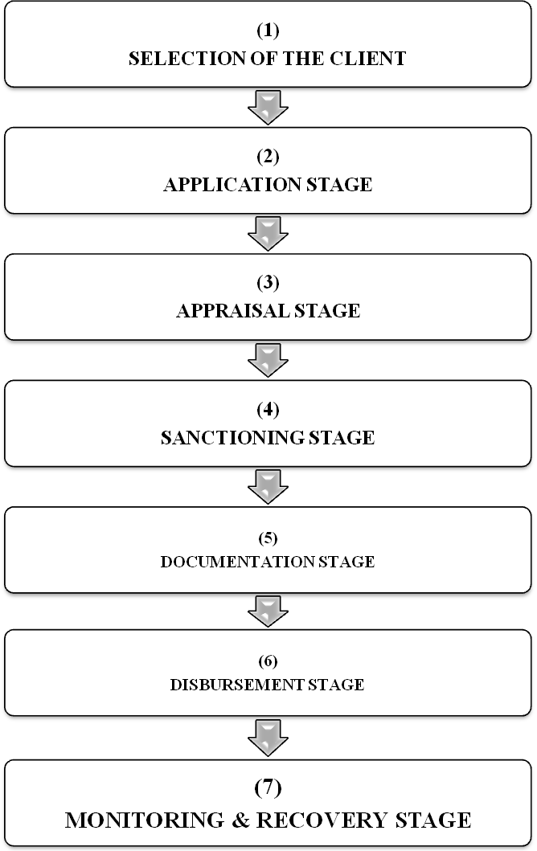

5.7.1 Selection of the client
Clients of the Bank for following Investment are to be selected with prudence and good judgment. It should be kept in mind that the person is important than their properties. They must have good character, commitment, capability, integrity and means. Their past performance must be verified first. None should be entertained without verification of his background, experience in the line of business, credit worthiness, financial needs, capacity to handle the finance applied for. Favoritism, personal relationship with a client must not get any consideration for providing Bank’s Investment. A detailed credit report of the client must be prepared and all necessary information’s should be collected and verified at the time of selection of the client. Clients of distant area/beyond control should not be entertained.
The following factors/qualities /information may be considered at the time of selection of investment client.

- Brief history of financial /credit transaction of the client.
- Social and financial behavior of the client should be verified /assessed.
- Ability of the client of utilization of credit / Investment fund.
- Ability of the client regarding repayment of Investment.
- Equity of the client.
- Effect of National & International Economic problems/crisis.
- Analysis of Investment Risk.
The above-mentioned factors may be categorized under 5-C’s.
A. Character
B. Capacity
C. Capital
D. Collateral
E. Condition

A. Character
a) The Human Factor
- Personal Circumstances (nationality, age, health condition, etc.)
- Credit Track Record
- Technical Qualifications (including business experience).
- Capacity to deal with people (or to manage relationships).

b) Management Assessment
- Business Experience
- Management Succession
- Credit Discipline.
- “Lifestyle”.
B. Capacity:
a) The Performance Factor
- Deployment of Resources (How much is the Investment need and how will it be used?)
- Friability Prospects of the project and the Enterprise (How will the project impact on the enterprise?)
b) Financial Assessment
- Profitability.
- Liquidity.
- Solvency.
C. Capital
The Financial Factor
- Client’s stake in business.
- Solvency of the enterprise.
- Availability of reserve resources.
- Other sources of income.
D. Collateral:
The Security Factor
- Ensuring the Critical Success Factors of the Business.
- Quality of Collateral’s.
- Value of Collateral’s.
- Location of Collateral’s.
- Ease of Marketability of Collateral’s.
5.7.2 Application stage
At this stage, the bank will collect necessary information about the prospective client. For this reason, bank informs the prospective client to provide and/or fill duly respective information, which is crucial for the initiation of investment proposal. Generally, here, all the required documents for taking investment have to prepare by the client himself. Documents that are necessary for getting investment of IBBL is prescribed below:

- Trade License photocopy (for proprietorship);
- Abridged pro forma income statement;
- Attested copy of partnership deed (for partnership business);
- Prior three (03) years’ audited balance sheet (for joint stock company);
- Prior three (03) years’ business transactions statement for the musharaka/mudaraba investment;
- Abridged pro forma income statement for the musharaka/mudaraba investment;
- Attested copy of the Memorandum of Association (MOA) & Articles of Association (AOA) for the joint stock company;
- Attested copy of the Tax Identification Number (TIN)- including final assessment;

5.7.3 Appraisal stage
At this stage, the bank evaluates the client and his/her business. It is the most important stage. Because, on the basis of this stage, bank usually goes for sanctioning the proposed investment limit/proposal. If anything goes wrong here, the bank suddenly stops to make payment of investment.

In order to appraise the client, Islami Bank Bangladesh Limited (IBBL) provides a standard
F-167B Form (Appraisal Report) to the client for gathering all the information. The original copy of the appraisal report is enclosed in the appendix chapter. However, the following contents are presented from that appraisal report:
- Company’s/Client’s Information.
- Owner’s Information.
- List of Partners/Directors.
- Purpose of Investment/Facilities.
- Details of Proposed Facilities/Investment.
- Break up of Present Outstanding.
- Other Liabilities of the Client/Group.
- Previous Banker’s Information etc.
5.7.4 Sanctioning stage
At this stage, the bank officially approves the investment proposal of the respective client. In this case client receives bank’s sanction letter. Islami Bank Bangladesh Limited (IBBL)’s sanction letter contains the following elements:
- Investment Limit in million.
- Mode & amount of investment.
- Purpose of investment.
- Period of investment.
- Rate of return.
- Securities:
  - Primary- Stock of goods is the primary security.
    - LC/Bills: Related Documents.
    - Murabaha Post Investment (MPI)/Bai-Murabaha: Pledge of MPI/Bai-Murabaha goods.
    - MPI/Bai-Bai Murabaha-TR: Lien on goods to be released.

  - *Cash/Goods-
    - Bai-Murabaha: 25% cash security on cost price to be subsequently converted to goods security.
    - TR (Trust Receipt): Without cash security.

  - Collateral: Immovable properties.

Cash/Goods security
In allowing Murabaha investment and amount of cash security is generally realized from the client (amount depends on the nature of goods, creditworthiness of the client, collateral security obtained etc.) which is converted to goods security after purchase of goods purchased out of bank’s investment and client’s cash security is pledged to the bank, kept under bank’s custody before its delivery to the client on payment. Example: If, for a Murabaha investment cash security is fixed at 25% Bank’s investment stands at 75% on the total goods purchased. For example, if cost of total goods purchased is Tk.100000 Bank’s investment will be Tk.75000 and client’s cash security will be Tk.25000.
Bank | Client | Total cost of goods
Tk. 75000 (75%) | Tk. 25000 (25%) | Tk. 100000 (100%)

5.7.5 Documentation stage
At this stage, usually the bank analyses whether required documents are in order. In the documentation stage, Islami Bank Bangladesh Limited (IBBL) checks the following documents of the client:
- Tax Payment Certificate.
- Stock Report.
- Trade License (renewal).
- VAT certificate
- Liability statement from different parties.
- Receivable from different clients.
- Other assets statement etc.

5.7.6 Disbursement stage
At this stage, bank decides to pay out money. Here, the client gets his/her desired fund or goods. It is to be noted that before disbursement a “site plan” showing the exact location of each mortgage property needs to be physically verified.

5.7.7 Monitoring & Recovery stage
At this final stage of investment processing of the Islami Bank Bangladesh Limited (IBBL), bank will contact with the client continually, for example- bank can obtain monthly stock report from the client in case of micro investment. Here, the bank will keep his eye on over the investment taker. If needed, bank will physically verify the client’s operations. Also if bank feels that anything is going wrong then it tries to recover its investment fund from the client.
Islami Bank emphasis on legitimate (Halal) business. Traditional bank does not follow rules and regulations approved by Islam that is the most powerful contradiction between them. Islamic Bank does not invest in loans and fixed interest securities. It can invest in ordinary share only while interest based bank can invest in loans and different kinds of securities. Islami Bank establishes and participate projects with its client as a partner and bears the risk along with the client on a proportionate basis. The bank takes deposits and invests the same based on the profit-loss sharing. Bank go for the investment mainly which are long term and profitable in nature. IBBL also give high concentration on the investment that will generate more employment.

Chapter Six

Analysis and findings

6.1 Performance of IBBL at Dhanmondi Branch.
The investment operations of Islami Bank Bangladesh Limited are increasing year by year. It’s started with very slow range but after some years it’s growing very fast.

6.1.1 Breakup of Investment:
The following table represent breakup of investment of Islami bank Bangladesh at Dhanmondi branch. In case of Bai- Murabaha outstanding is increased in 2007 regard to 2006.hear Bai- Murabaha and HPSM are the highest total compare to other mode of investment.the position of Bai-Mujjal is very low comparing to other mode of investmet.

BREAKUP OF INVESTMENT

Sl. No. | Mode of investment | Outstanding as on 31.12.2006 | Outstanding as on 30.09.2007 | % of total investment | Overdue as on 30.09.2007 | % of overdue | % of overdue to total investment
1 | Bai-Murabaha/MPI | 617.29 | 883.84 | 41.70 | 13.46 | 1.52 | 0.64
2 | Bai-Muajjal | 1.41 | 1.42 | 0.07 | 0 | 0 | 0
3 | HPSM | 893.65 | 1109.29 | 52.34 | 0 | 0 | 0
4 | Bai-Salam | 33.17 | 44.35 | 2.09 | 0 | 0 | 0
5 | QTDR | 48.49 | 40.45 | 1.91 | 0 | 0 | 0
6 | Others | 5.66 | 40.17 | 1.89 | 0 | 0 | 0
 | Total | 1599.67 | 2119.52 | 100 | 13.46 | 1.52 | 0.64
6.1.2 Investment growth:
The following table represents investment growth of Islami Bank at Dhanmondi Branch in last four years. Investment growth is increasing year to year.

2005 | 2006 | 2007 | Target for the year 2007 | Prop. Target 31.03.2007 | Achievement as on 31.03.07 | Achievement of target in % | Growth over 31.03.2007
796.37 | 905.56 | 1599.67 | 2000 | 1699.75 | 1734.92 | 102% | 85%
Investment growth for last four year
6.1.3 Particulars of investment income:
The following table represents particulars of investment income of Islami Bank Bangladesh at Dhanmondi as on march, 2007. Here we find that the income from HPSM is more than other other modes of investment. Income from Murabaha and MPI is also growing day by day.
Sl.  No. | Name of the Mode | Amount  As on 31.03.2007 | % to investment | % of Total | Amount  As on 31.12.07
1 | Murabaha | 11.36 | 30.90 | 30 | 344.63
2 | MPI | 7.97 | 22.86 | 21 | 254.95
3 | Bai Muazzal | 0.04 | 0.09 | 0.11 | 1.06
4 | HPSM | 13.89 | 44.97 | 36 | 501.50
5 | Bai Salam | 1.04 | 1.08 | 3 | 12.05
 | Baim wes Bills | - | 0.08 | - | 0.91
 | Total Investment Income | 34.31 | 100% | 10 | 1115.10
 | Others income | 4.23 |  | 100% | 213.04
 | IBG Income | (-12.57) |  |  | (-106.98)
 | Total | 25.97 |  |  | 1221.13
 | Expenditure | 17.43 |  |  | 654.33
 | Net Income | 8.53 |  |  | 566.83
 | Per Taka Income | 1.48:1=1:0.67 |  |  | 1.86:1= 1:0.53

6.1.4 Brief Position of performance:
The following table represents the position of total performance of Islami Bank Bangladesh at Dhanmondi branch. Investment is increasing which is proved by the following table.
(Figure in million Tk.)
Sl. No | Particulars | Position as on 31.03.06 | Position as on 31.12.06 | Target for the year 07 | Proportionate Target up to 31.03.07 | Achievement as on 31.03.07 | Achievement of target in % | Growth over 31.03.07
 |  |  |  |  |  |  |  | Amount | %
1 | Deposit | 969.59 | 1014.41 | 1400.00 | 1110.80 | 1097.21 | 99 | 127.62 | 13
1 | Cost Free Deposit | 125.25 | 160.49 | 350.00 | 277.70 | 209.45 | 75 | 84.20 | 67
2 | Investment | 940.11 | 1599.67 | 2000.00 | 1699.75 | 1734.92 | 102 | 794.81 | 85
2 | Overdue | 4.00 | 0 | 0.00 | 0.00 | 6.41
3 | Import | 737.87 | 1773.61 | 3000.00 | 750.00 | 458.87 | 61 | -279.00 | (38)
4 | Export | 274.27 | 924.20 | 1600.00 | 400.00 | 303.70 | 76 | 29.43 | 11
5 | Remittance | 33.77 | 135.03 | 210.00 | 52.50 | 30.01 | 57 | -3.76 | (-)11
6 | NET PROFIT | 18.44 | 56.68 | 90.00 | 22.50 | 8.53 | 38 | -9.91 | (-)54
A | Total Income | 32.93 | 122.12 |  |  | 25.96
A | (a) Investment Income | 23.82 | 111.48 |  |  | 34.31
A | (b) IBG Income | 2.25 | (-)10.70 |  |  | -12.58
A | © Non-funded Income | 6.86 | 21.34 |  |  | 4.23
B | Total Expenditure | 14.49 | 65.43 |  |  | 17.42
B | (a) Cost of Fund (PPD) | 11.96 | 53.56 |  |  | 15.15
B | (b) Salary | 1.57 | 8.87 |  |  | 2.00
B | © Other Expenditure | 0.96 | 3.00 |  |  | 0.27
Unearned Income Tk.15.25 million
BRIEF POSITION OF PERFORMANCE AS ON 31.03.2007

6.1.5 Business Growth of the Branch:
The investment of Islami bank at Dhanmondi is so smooth which is shown in the following table. Investment is increasing year by year.

(Figure in million in tk)
Sl. No. | Particulars | 2004 | 2005 | 2006 | 2007  up to 31.03.2007
1 | Deposit | 908.43 | 999.27 | 1014.41 | 1097.21
2 | Investment | 796.37 | 905.56 | 1599.67 | 1734.92
3 | Overdue | 13.89 | 1.80 | 0 | 6.41
4 | Profit | 48.04 | 52.97 | 56.68 | 8.53
5 | Foreign Exchange Business | 982.59 | 1463.65 | 2832.84 | 792.58
a | Import | 664.35 | 976.66 | 1773.61 | 458.87
b | Export | 271.18 | 406.75 | 924.20 | 303.70
c | Remittance | 47.06 | 80.24 | 135.03 | 30.01
Business Growth of the Branch for the last 4(four) years

6.2 Overall performance of IBBL

6.2.1 Trend of investment:
Trend of Investment: 2003-- 2007
59007
75859
93644
1,13,575
1,44,921
0
20,000
40,000
80,000
60,000
80,000
100,000
120,000
140,000
2003
2004
2005
2006
2007
Million Taka
160000

Investment of the bank increased to Tk. 1, 44,921 million as on 31st December 2007 from Tk.1, 13,575 million as 31st December 2006 showing an increase of Tk 31,346 million. This increased investment growth of the bank in 2007 is due to the thrust given to promote investment for effective utilization of depositors’ fun

6.2.2 Sector-Wise Investments:
The following table represents sector wise investment of IBBL of 2006 and 2007.hear it is clear that IBBL is more interested to invest in industrial sector rather than other sector and it is increasing year by year.

(Amount in Million Taka)
SL. No. | Sector | 2007 |  | 2006
 |  | Amount | % of Total Investment | Amount | % of Total Investment
(1) | Industrial | 78,788 | 54.37% | 62642.10 | 55.15%
(2) | Commercial | 43,877 | 30.28% | 28983.80 | 25.52%
(3) | Real Estate | 8,588 | 5.93% | 8357.80 | 7.36%
(4) | Transport | 2,656 | 1.83% | 5890.00 | 5.19%
(5) | Agriculture | 6,485 | 4.47% | 2711.40 | 2.40%
(6) | Others | 4,527 | 3.12% | 4978.97 | 4.38%
 | Total | 93644.15 | 100% | 113575.07 | 100%

6.2.3 Sector wise investment:

The following pie chart represents composition of sector wise investment of Islami Bank Bangladesh Limited as whole organization on 31st December 2007. Here we find that total investment of 55.15% is in industry because of smooth economic growth.

6.2.4 Mode-wise Investment:
The following table represents mode-wise investment of IBBL in the year of 2006 and 2007.
(Amount in Million Taka)
Mode | 2007 |  | 2006
Mode | Amount | % to Total Investment | Amount | % to Total Investment
Bai-Murabaha | 73,833 | 50.95% | 59465.09 | 52.36%
Hire Purchase under Shirkatul Melk | 50,201 | 34.64% | 39399.19 | 34.69%
Bai-Muajjal | 6,546 | 4.52% | 6921.40 | 6.09%
Purchase & Negotiation | 11,040 | 7.62% | 4846.62 | 4.27%
Quard | 1,995 | 1.35% | 1974.20 | 1.74%
Bai-Salam | 1,153 | 0.79% | 905.62 | 0.80%
Mudaraba | 50 | 0.03% | 50.00 | 0.04%
Musharaka | 143 | 0.10% | 12.95 | 0.01%
Total | 1,44,961 | 100.00% | 113575.07 | 100.00%

6.2.5 Composition of mode wise investment:
The following pie chart represents mode wise investment of Islami Bank Bangladesh Limited. Here we find that Bai_Murahaba investment mode is very popular comparing to other investment mode.

Composition of mode wise investment
50.95%
34.64%
4.52%
7.62%
1.35%
0.79%
0.03%
0.10%
Bai Murabaha
H.P. under Shirkatul Melk
Bai Muajjal
Purchase & Negotiation
Quard
Bai Salam
Mudaraba
Musharaka
6.2.6 Trend of investment in industry:

The following table represents trend of investment in industry. Here we find that investment in industry is increasing year by year.the growth rate of investment in industry is 34% more in 2007 comparing to 2006.

Trend of investment in industry: 2004-2007

6.2.7 Maturity wise classification of investment
Maturity wise  Classification | December  31.12.2004(Taka) | December  31.12.2005(Taka) | December  31.12.2006(Taka)
Not more than 3 months | 19,170,271,247 | 26,967,375,328 | 35,435,878,082
Over 3 months but not more than 1 year | 31,120,279,466 | 34,944,475,680 | 40,705,450,096
Over 1 year but not 5 year | 15,769,667,267 | 20,003,701,723 | 24,813,782,433
More than 5 years | 9,798,344,244 | 11,728,602,243 | 12,619,960,518
Total | 75,858,562,224 | 93,644,154,974 | 113,575,071,129

This table shows maturity wise classification of investment. From this graph we can see that in the year 2004, maturity wise investment of the bank was low in comparison to the year 2006. So we can say that the bank’s maturity wise investment is increasing. Rationally people are concern about not more than 3 months investment, that’s increasing rate is higher than rest of them. Both over 3 months but not more than 1 year and over 1 year but not 5 year is increased moderately.
6.2.8 Division wise classification of investment
Name of the  Division | December  31.12.2004(Taka) | December  31.12.2005(Taka) | December  31.12.2006(Taka)
Dhaka | 44,800,177,763 | 55,794,482,596 | 72,637,666,426
Chittagong | 14,432,947,930 | 16,573,817,541 | 19,020,12,156
Khulna | 7,118,625,161 | 9,598,190,707 | 8,336,566,722
Rajshahi | 6,548,822,474 | 8,370,466,909 | 10,129,510,794
Barisal | 755,594,461 | 883,161,140 | 990,277,259
Sylhet | 2,202,394,435 | 2,424,036,081 | 2,460,929,772
Total | 75,858,562,224 | 93,644,154,978 | 113,575,071,129

This table shows division wise classification of investment. From this graph we can see that in the year 2004, division wise investment of the bank was low in comparison to the year 2006. So we can say that the bank’s division wise investment is increasing. Rationally Dhaka division’s people are get highest investment volume in the country.

6.2.9 Country wise classification of investment
Country Wise  Classification | December  31.12.2004(Taka) | December  31.12.2005(Taka) | December  31.12.2006(Taka)
- Within
Bangladesh
a) In Rural Area | 4,431,184,998 | 6,507,148,839 | 9,862,235,033
b) In Urban Area | 71,427,377,226 | 87,137,006,135 | 103,712,836,096
Sub-total | 75,858,562,224 | 93,644,154,978 | 113,575,071,129
Outside  Bangladesh | _ | _ | _
Total (A+B) | 75,858,562,224 | 93,644,154,978 | 113,575,071,129

6.2.10 Group wise classification of investment
 | Dec,31, 2004 | Dec,31.12.2005 | Dec,31.12.2006
1) Investment to Directors | 187,310,000 | 231,598,000 | 459,354,000
Investment to Chief executive and other senior executives | 30,985,108,276 | 181,568,000 | 242,029,000
2) Investment to customers groups (10% or more than of capital)
Numbers of clients | 24 | 46 | 33
Amount of Investment | 30,985,108,276 | 44,019,750,000 | 45,702,020,000

This table shows group wise classification of investment. From this graph we can see that in the year 2004, group wise investment of the bank was low in comparison to the year 2006. So we can say that the bank’s group wise investment is increasing.

6.2.11 Classification of status wise investment (according to different time circulated circular of Bangladesh Bank)

Classification of Status Wise Investment | December  31.12.2004 tk | December  31.12.2005 tk | December  31.12.2006 tk
a) Unclassified | 70,610,614,224 | 88,505.618,974 | 108,449,062,129
b) Special Mention |  | 2,091,488,000 | 1,228,310,000
c) Substandard | 677,758,000 | 625,128,000 | 898,121,000
d) Doubtful | 299,147,000 | 318,391,000 | 515,084,000
e) Bad\ loss | 4,271,043,000 | 2,103,529,000 | 2,484,494,000
Total | 75,858,592,224 | 93,644,154,974 | 113,575,071,129

This table shows classification of status wise investment (according to different time circulated circular of Bangladesh Bank).From this graph we can see that in the year 2004, status wise investment of the bank was low in comparison to the year 2006. So we can say that the bank’s status wise investment is increasing. More attentive fact is bank able to decrease bad investment rationally but worrying fact both substandard and doubtful investment increases.
5.2.12 outstanding amount of investment as at the year-end under different schemes are as under

 | Name of the scheme | 2002 | 2003 | 2004 | 2005 | 2006
1) | Rural Development Scheme | 432.04 | 570.88 | 789.97 | 1,106.47 | 2,242.22
2) | Household Durables Scheme | 886.79 | 910.91 | 878.76 | 782.09 | 699.95
3) | Investment Scheme for Doctors | 97.21 | 101.01 | 85.54 | 64.42 | 33.38
4) | Transport Investment Scheme | 1,822.38 | 2,311.60 | 2,442.16 | 2,947..38 | 2,698.88
5) | Car Investment Scheme | 28.25 | 33.58 | 30.30 | 27.75 | 23.58
6) | Small Business Investment Scheme | 325.06 | 395.75 | 501.26 | 629.81 | 678.45
7) | Micro industries Investment Scheme | 6.63 | 10.10 | 17.18 | 10.21 | 6.24
8) | Agricultural Implements Investment Scheme | 13.66 | 12.76 | 14.69 | 12.53 | 11.94
9) | Housing Investment Scheme | 597.64 | 661.56 | 672..10 | 609.78 | 506.75
10) | Real Estate Investment program | 2,264.35 | 3,418.85 | 4,713.70 | 5,859.75 | 6,582.85
 | Sub-total | 6,474.01 | 8,427.00 | 10,145.66 | 12,050.19 | 13,574.20
 | Total Investment | 46,280.11 | 59,007.49 | 75,858.56 | 93,644.15 | 113,575.07
 | % to total investment | 13.99% | 14.28% | 13.37% | 12.87% | 11.95.%

Findings

Since this study mainly focuses on the investment operations of IBBL, it has been found that the investment operations of IBBL are not so strong. From the study it is observed that IBBL has some good points as:
- IBBL is a financially sound company.
- IBBL invest huge amount in industrial sector that is essential for Bangladesh as a less develop country.
- IBBL invest more also in rural development project and real estate project.
- IBBL is now a very popular bank in our country because of its smooth operations.
- IBBL performs mass banking which other bank does not perform for that reason it is very popular bank in our country.
- Annual income of IBBL is massive comparing to other commercial banks.
- IBBL provides its customer excellent and consistent quality in every service.
- Rate of return of IBBL is low comparing to other conventional banks, which is good news for poor people.
- IBBL utilizes state-of-the art technology to ensure consistent quality and operation.
- IBBL provides its works force an excellent place to work.
- IBBL has already achieved a good will among the clients.
- IBBL has a research division.
- Emergence of E-banking will open more scope for IBBL.
- IBBL can introduce more innovative and modern customer service.
- Many branches can be open in remote location.

Also from the report, it is observed that IBBL has some problems as:

- IBBL does not interest to invest in agriculture sector.
- IBBL has a research division but not so strong.
- The annual income of IBBL rate is low comparing to other commercial banks.
- The internal audit section of IBBL is very poor.
- The employees are not so efficient.
- Employees are not satisfied with their working condition.
- Customers are not satisfied with their service.
- The worldwide trend of mergers and acquisition in financial institutions is causing problem.
- Frequent taka devaluation and foreign exchange rate fluctuation is causing problem.
- Lots of new banks are coming in the scenario with new service.
- Local competitors can capture huge market share by offering similar products.
- IBBL lacks well-trained human resource in some area.
- IBBL lacks aggressive advertising
- The procedure of credit facility is to long compare to other banks.
- Employees are not motivated in some areas.

Chapter seven
Conclusion and Recommendations

7.1 Conclusion
Islam is a relation of peace and also a complete code of life. Allahs’guidance extents into all areas of our lives. Islam has given detail guidelines for our economic life.Therefore, Islami Bank Bangladesh Limited (IBBL) is trying to set up the maximum happiness of the society by maintaining the morality of Islamic Shariah which is based on “Quran” and “Sunnah”. Since 1983, IBBL is the pioneer in welfare banking in this subcontinent and it is trying to do all its activities for the betterment of its depositors. For the greater interest of the depositors the investment policy of IBBL is to invest on the basis of profit and loss sharing in accordance with the tents and principles of Islamic Shariah. Profit earning is not the only motive and objective of the bank’s investment policy rather emphasis is given in attaining social good and in creation employment opportunities.

IBBL is not material in its orientation. IBBL does not invest any scheme, which conflicts with the moral value system of Islam. IBBL does not strictly consider the credit worthiness of the industrialist. IBBL receives a return only if the project succeeds and produces a profit. IBBL considers the soundness of the project and business acumen and managerial competency of the entrepreneur. Therefore, the rate of return of investment of IBBL is greater comparing to that of conventional banks.

Finally, Islami Bank Bangladesh Limited (IBBL) has been established with a view to conduct interest free banking to establish participatory banking instead of debtor-creditor relationship and finally to establish welfare oriented banking through its investment operations that would lead to a just society.

7.2 Recommendations
- IBBL should initiates different investment modes according to changing /diverse needs of clients by conducting huge Research and study.
- IBBL should appoint a sufficient number of women employees to deal women entrepreneurs and professionals and understand their needs and thus create demand for investment.
- IBBL can form sales team for investment operations.
- IBBL can start evening banking for capturing potential customers.
- Arrangement of monthly /quarterly training workshops for the clients selected by the Branches in order to promote Investment clients of the desired level.
- IBBL should provide new deposit and investment products.
- IBBL should recruit business graduates.
- IBBL should arrange various seminars every year to increase the skill of its manpower.
- To fulfill the vision of "mass banking" this Bank should grants investment portfolio to new entrepreneurs /new businessmen new companies etc.
- For the convenient of Islami Banking, necessary amendment of rules may be recommended.
- Islami money market may be introduced.
- IBBL should increase skilled manpower to do its financial activities more efficiently. So that many of the employees do not have to do extra work.
- IBBL can recruit experienced, efficient and knowledgeable work force as it offers good working environment.
- The Bank should go aggressive advertising and promotional activities to get a broad geographic coverage.
- The authority of IBBL should introduce more innovative and modern customer service.

Appendix

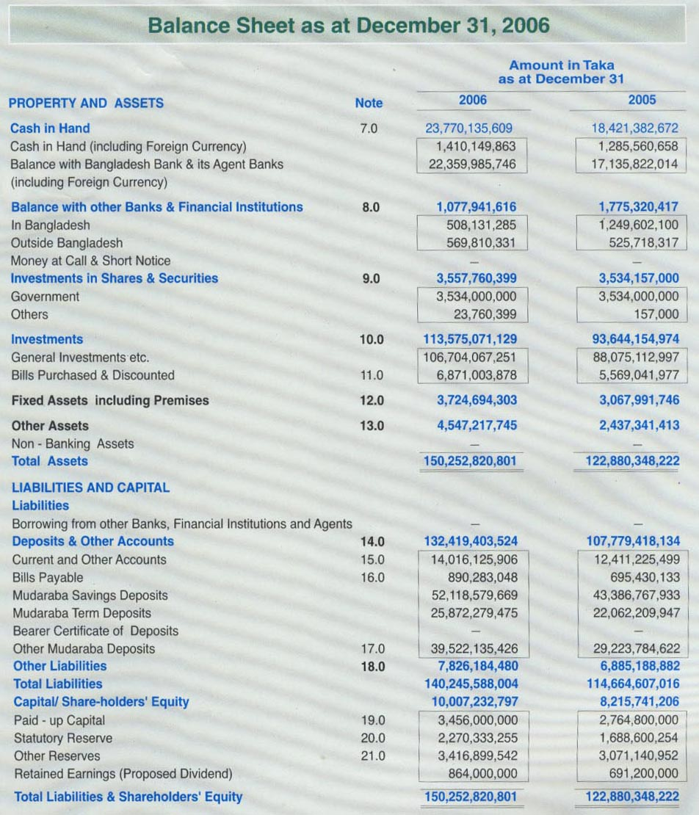
AI
AII
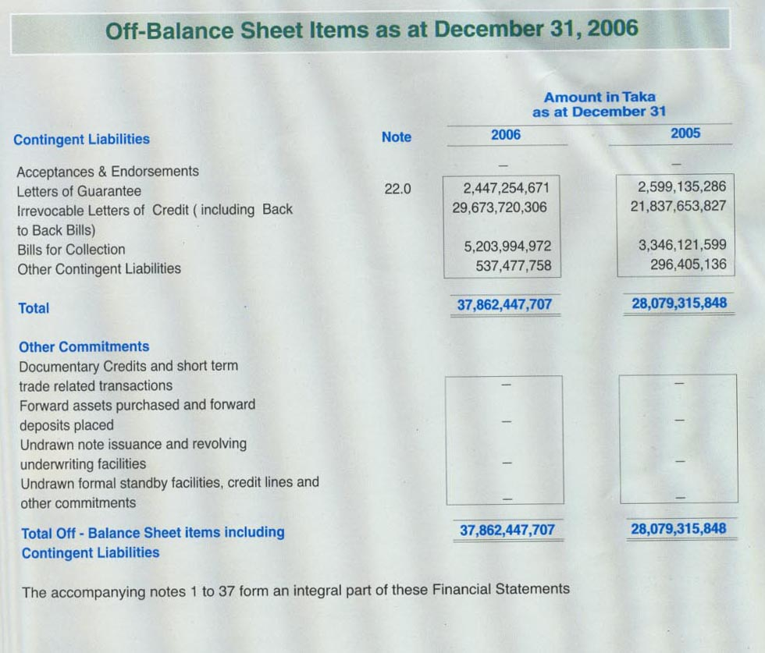
AIII
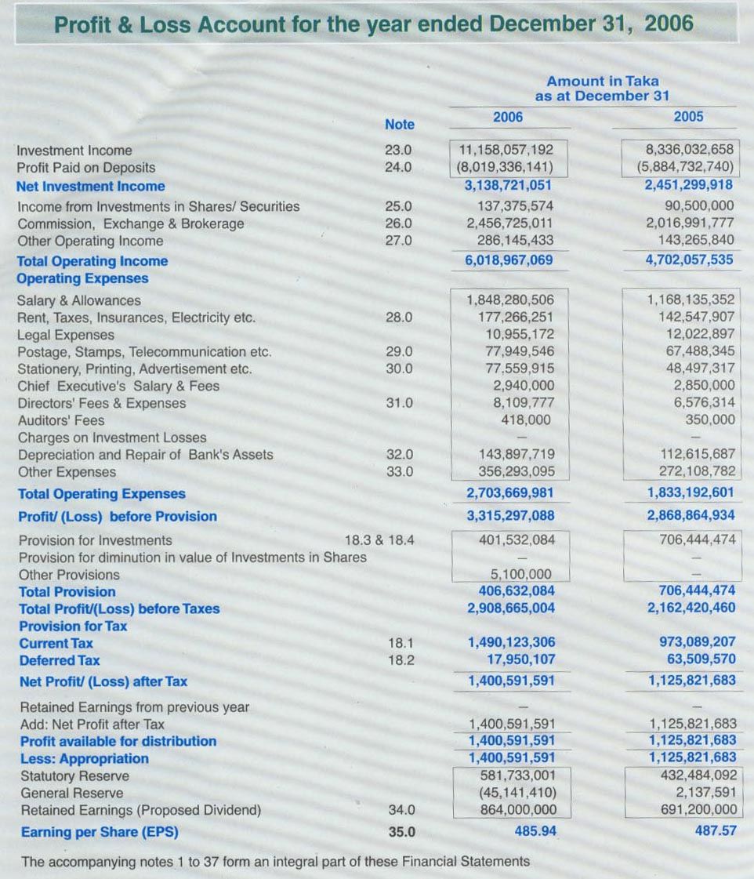
AIV
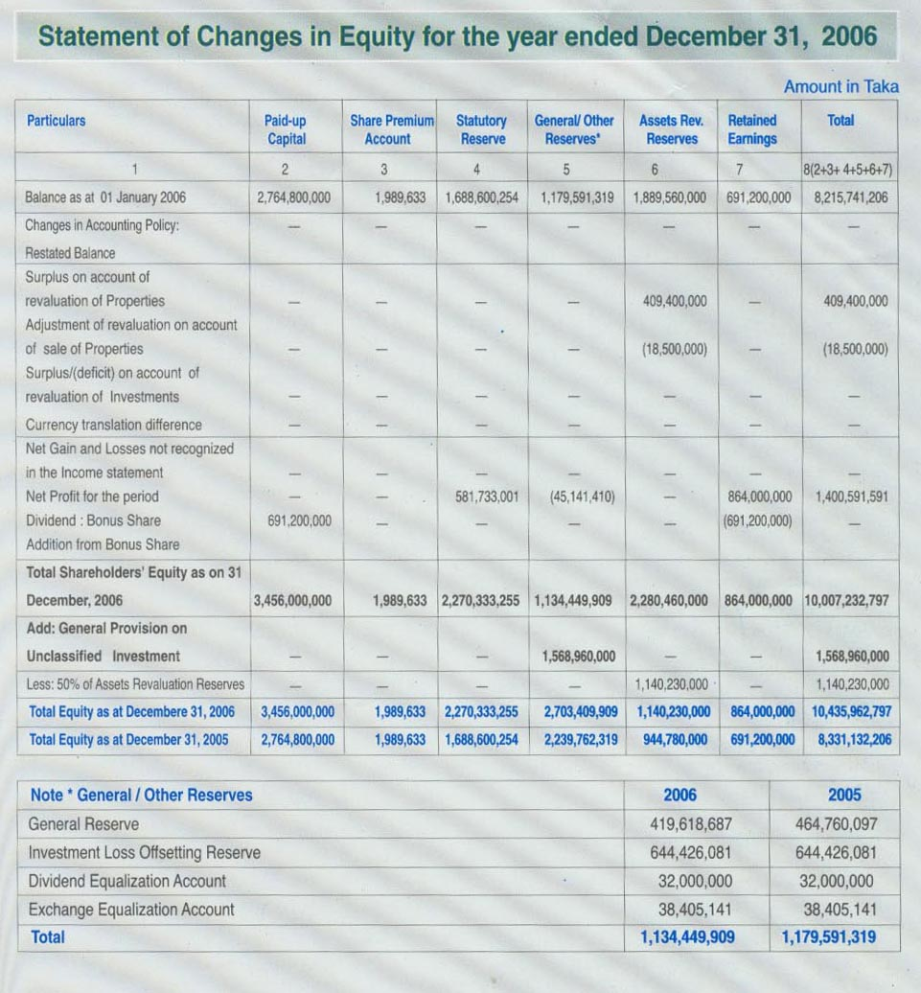
AV
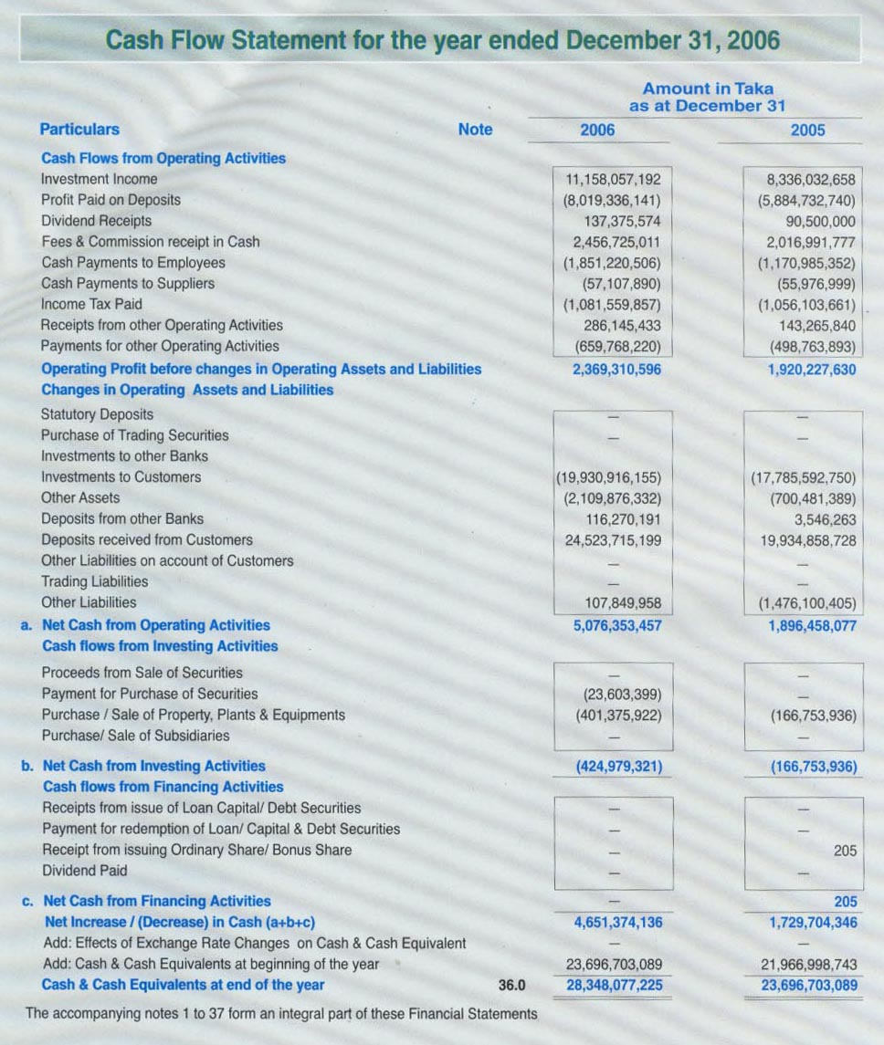
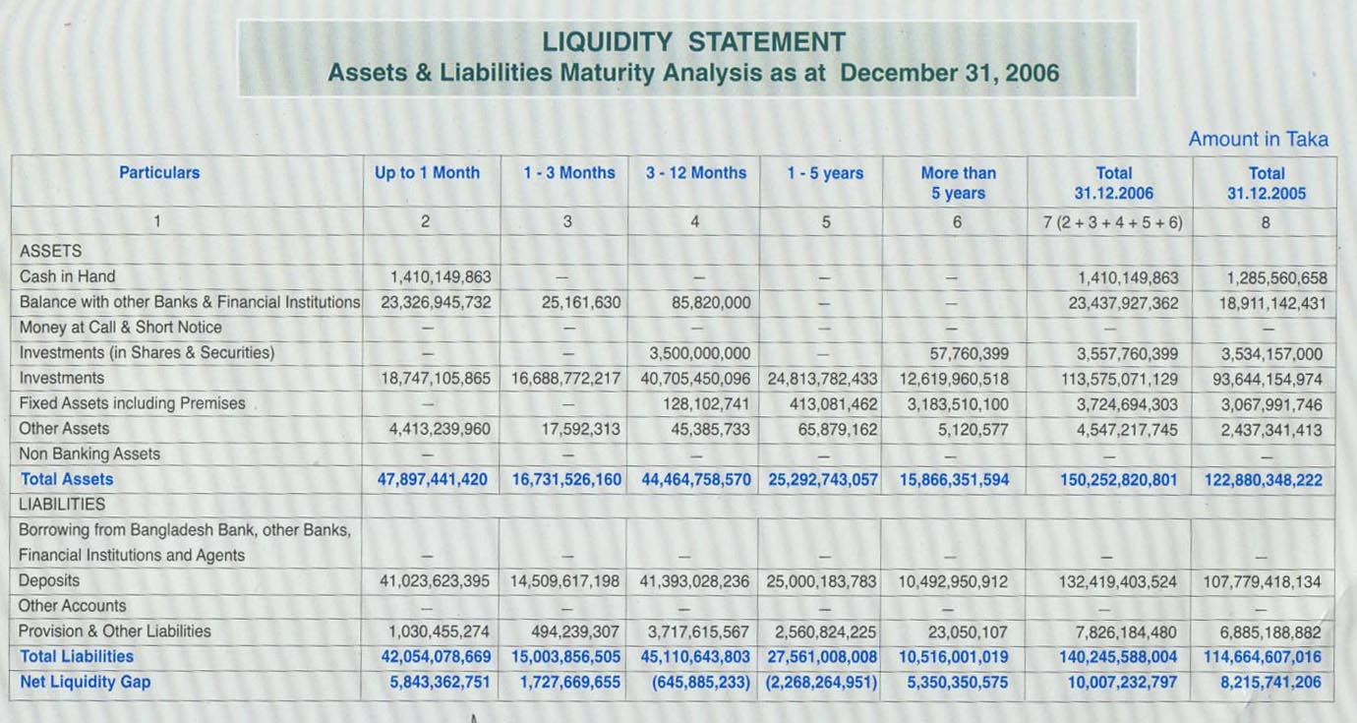
AVI
QUESTIONNAIRE ON INVESTMENT OPERATIONS OF ISLAMI BANK BANGLADESH LTD. (IBBL)
Serial No.

Hello,This is Md. Humayun Kabir,BBA student of University of Development Alternative (UODA), As a part of evaluating the course, I need to work on a Internship report, “A Study on the Investment Operations of Islami Bank Bangladesh Limited. I will ask you few questions in this regard. It takes 10 to 15 minutes. Your kind cooperation by answering question will assist me to prepare a quality project work.

Name: ……………………………………………………………
Designation:

Q1. Do you have any account at IBBL?

A. Yes B. No
[If ‘no’, thank you very much for cooperation, no further question to you]

2. What type of account that you have maintained in IBBL?
- Al Wadiah Current A/C B. Mudaraba Savings A/C
- Mudaraba Schemes A/C D. Others A/C

3. What is the motivation to maintain account at IBBL?
-----------------------------------------------------------------------------------------------
4. Is the present investment mode of IBBL effective?

A) Yes B) No

5. Bank should develop more investment-oriented campaign.

- Agree B) Disagree
C) No comment

6. Bank should cover clients without considering race (Hindus, Christian)

A) Agree B) Disagree
C) No comment

7. Do you think that sales team is essential for investment operation of IBBL?
A) Yes B) No

8. Does the client receive the goods from the seller directly?

A) Yes B) No

9. Is Bai-Murabaha permissible under Islamic Shariah?

A) Yes B) No

10. Whether the equity is being obtained in HPSM from the client and credited to the investment account

A) Yes B) No

11. Whether acknowledgement of asset is being obtained from the client

A) Yes B) No

12. Conversion of investment under Bai-Murabaha & Bai Muajjal into Hire purchase) SM) is not made.

A) Yes B) No

13. Is the profit receivable voucher not being passed before making delivery of goods?

A) Yes B) No

14. Type of service that you are securing from IBBL?
A. Excellent B. Good
C. Fair D. Satisfactory
E. Not Satisfactory

15. What is your confidence level on the IBBL due to its Shariah based banking?
A. Very high B. High
C. Average D. Less
E. Very less

16. What is your view about the different service charges taken by IBBL?
A. Very excessive B. Excessive
C. Justified D. Less
E. Very less

Glossary
IBBL Islami Bank Bangladesh Ltd.
AAOIFI Accounting and Auditing Organization for Islamic Financial Institutions
ATM Automated Teller Machine
CSBIB Central Shari’ah Board for Islamic Banks of Bangladesh
CRISL Credit Rating Information and Services Limited
EIBS Electronic Integrated Banking System
GCIBFI General Council for Islamic Banks and Financial Institutions
HPSM Hire Purchase under Shirkatul Melk
IBB The Institute of Bankers, Bangladesh
IBCF Islami Banks Consultative Forum
IBTRA Islami Bank Training and Research Academy
IDB Islamic Development Bank
L/C Letter of Credit
MTD Mudaraba Term Deposits
RDS Rural Development Scheme
SLR Statutory Liquidity Ratio
SWIFT Society for Worldwide Inter-Bank Financial Tele-communication

Bibliography

- Annual Report of IBBL –2004,2005, 2006,2007
- Training materials- Islami Bank Training & Research Academy (IBTRA).
- Hossain Musharaf “Different Investment Scheme of IBBL”
- Hossain Abul “Different Investment modes followed by IBBL”
- Engr. Basar Abul “An overview of Investment portfolio of IBBL”.
- Special Investment Scheme manual of IBBL.
- Booklet namely “Introduction of Islami Bank Bangladesh Ltd.”
- Books, Journals related to Islami Banking.
- WWW.islamibankbd.com

