Thesis Paper
On
DEVELOPMENT OF A NETWORK SIMULATOR MODIFYING NS2 FOR EVALUATING QoS PARAMETERS OF HYBRID NETWORKS

Submitted by
WWW.ASSIGNMENTPOINT.COM

Network simulation is without a doubt one of the most predominant evaluation methodologies in the area of computer networks. It is widely used for the development of new communication architectures and network protocols. This chapter is to introduce various concept of simulation of different types of data networks. Among all the concurrent simulators at present, the supremacy of NS2 as the network simulator is also stated here. A brief description of QoS parameters along with their importance is narrated afterwards. The main motivation behind this thesis is highlighted in the foregoing section. Finally the organization of this dissertation is discussed in brief.

1.1 Network simulation

There are three ways to study the effect of any change on the existing networks as well as to analyze the performance of it for further development [1]. Those are
- Experimental setup
- Mathematical modeling
- Simulation.
The first one is more realistic but expensive and sometimes even non realizable. The second one gives a complete insight but some assumptions to be made. The last one is cheaper, faster but does not include the complete insight and also some assumptions are to be made.

The simulation process may be subdivided into two distinct categories as follows [1].
- Time-Driven Simulation.
- Event-Driven Simulation.

The details of these two simulation techniques are enumerated in the foregoing sections.

    - Time-Driven simulation

In time-driven simulation, the simulation proceeds chronologically. It observes the system after a fixed interval throughout a predefined simulation time. Event occurring within an interval is assumed to occur at the end of the interval.

Time-driven Simulation proceeds as follows:
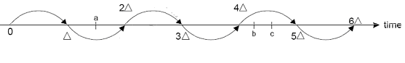
Figure 1.1: Time driven simulation sequence.

In Figure 1.1.1, the event a is assumed to happen at t=2Δ and event b and c are assumed to happen at t=5Δ.

1.1.2 Event driven simulation

Every event is observed at the instant it is happening. It provides greater granularity.
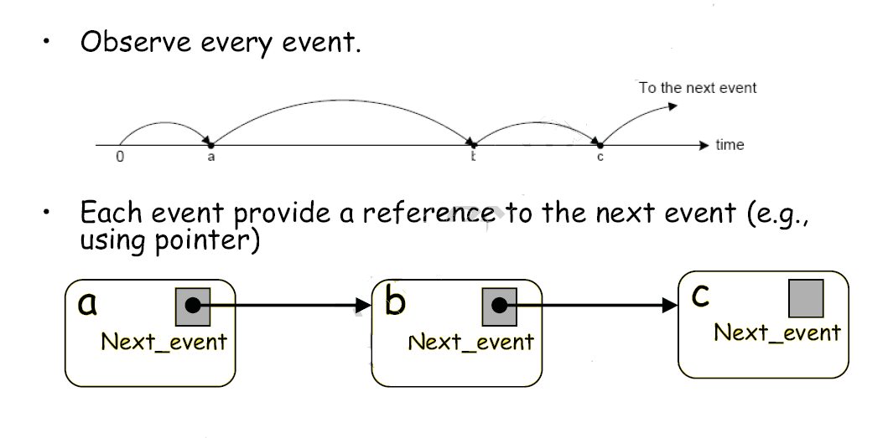
Figure 1.2: Event driven simulation sequence.

Among all the present network simulators now-a-days, one of the most powerful and versatile network simulators is the NS2 (Network Simulator version 2). NS2 is an event driven network simulator developed at UC (University of California), Berkeley that simulates variety of IP (Internet Protocol) networks. It implements network protocols such as TCP (Transmission Control Protocol) and UDP (User Datagram Protocol), traffic source behavior such as FTP (File Transfer Protocol), Telnet, Web, CBR(Constant Bit Rate) and VBR(Variable Bit Rate), router queue management mechanism such as Drop Tail, RED (Random Early Detection) and CBQ (Class Based Queuing), routing algorithms such as Dijkstra, and more. NS also implements multicasting and some of the MAC (Media Access) layer protocols for LAN (Local Area Networks) simulations. The NS project is now a part of the VINT (Virtual Inter Network Testbed)) project that develops tools for simulation results display, analysis and converters that convert network topologies generated by well-known generators to NS formats. Currently, NS (version 2) written in C++ and OTcl (Tcl script language with Object-oriented extensions developed at MIT) is available [2].

1.2 Quality of Service of a network

Quality of service (QoS) is a network's ability to support varying levels of network performance that can then be mapped to the needs of the applications supported by that network. The performance parameters we seek to control include such things as delay across the network, variations in delay, and total bandwidth available for a connection or information flow, to name a few [3].

1.2.1 The Importance of QoS

The term QoS is most commonly used in reference to packet networks. Circuit networks have very little problem with bandwidth, delay, and delay variation. In fact, assuming a circuit has been selected with the appropriate bandwidth to begin with, it is the very nature of a circuit network to maintain a consistent bandwidth, have little variation in delay, and the least possible total delay. They are essentially “wire speed.” One might say that the circuit network, in terms of QoS, is the gold standard against which packet networks can be measured.

It is reasonable to ask why we want to work to put QoS capabilities in our packet networks if already have a gold standard in circuit networks. The reason is fairly straightforward: sometimes we do not want, or are unwilling to pay for, the gold standard. Circuit networks will always provide the best QoS, but packet networks have the potential to provide varying levels of QoS to match the needs of different applications [4, 5, 6, 7, 8 ].

1.2.2 Four QoS Parameters

Quality of service generally works on four well-defined network factors that affect the end-to-end quality of transmitted data. If the path a packet takes from point A to point B over the network can be thought of as a series of roads between two cities, then QoS tries to manage four elements of that trip [9].

- Bandwidth/Throughput: In communication networks, such as Ethernet or packet radio, throughput or network throughput is the average rate of successful message delivery over a communication channel. These data may be delivered over a physical or logical link, or pass through a certain network node. The throughput is usually measured in bits per second (bit/s or bps), and sometimes in data packets per second or data packets per time slot.

- Delay: End-to-end delay is the elapsed time for a packet to be passed from a sender through network domains to its intended destination.

- Jitter: In the context of computer networks, the term jitter is often used as a measure of the variability over time of the packet latency across a network. However, for this use, the term is imprecise. The standards-based term is packet delay variation (PDV). PDV is an important quality of service factor in assessment of network performance. A network with constant latency has no variation (or jitter). Packet jitter is expressed as an average of the deviation from the network mean latency.

- Packet loss: Most networks have some packet loss, but how much loss is acceptable can differ from application to application.

Applications and users also expect the network to have appropriate levels of reliability (e.g., survivability, mean time to repair) and security (e.g., confidentiality, integrity, and availability of information). These latter two issues are dealt with under the larger umbrella of information security.

1.3 Thesis Motivation

The Network Simulator NS-2 works under UNIX and Windows system platforms and is mainly used for network research. It is widely used all over the world, especially at the universities. Network simulation scripts in Tcl are used to create the network scenarios and upon completion of the simulation, trace files that capture events occurring in the network are produced. The trace files would capture information that could be used in performance study, e.g. the amount of packets transferred from source to destination, the delay in packets, packet loss etc. However, the trace file is just a block of ASCII data in a file and quite cumbersome to access using some form of post processing technique [10]. Along with this trace file analysis problem, the main problem is that NS doesn’t provide any visualization options for simulation results (trace files) analysis.

In order to ease the process of extracting data for performance study, various NS2 trace analyzers is proposed [10, 11, 12, 13, 14]. The fundamental feature of those works is based on the post-processing of a huge output trace file which incurs additional delay.

At present, with the advent of 4G wireless network concept, one of the key features is to enhance the QoS of the network in order to get a service quality like a circuit-switched network. So it is very much desirable that a strong powerful simulator like NS2 should have a better and faster technique to evaluate the QoS for every application on IP based networks, especially the real-time applications, rather than the complex raw output file processing.

1.4 Organization of this Dissertation

In order to develop a new simulator enhancing the capabilities of NS2 to evaluate QoS parameters, I have embedded the capability of data collection and data presentation in some suitable network components in my works. Thus without the help of a huge output trace file we can easily get desired formatted data. As a result the time associated with huge data processing will be saved. This will benefit the user since he or she can concentrate on developing new algorithms or new architectures, rather spending too much time on post-processing of data.

After the modifications made on of the simulator, some typical IP based wired, wireless and hybrid networks were simulated using the modified NS2 simulator for evaluating their QoS. After analyzing the behavior of TCP and UDP based applications like FTP, VOIP, HTTP etc; a new upgraded protocol is proposed as “Acknowledge Augmented UDP” which is aggressive in nature like UDP, but it is also enhanced with the error correcting capabilities like TCP.

In this dissertation, I have first explained the present architecture and capabilities of the NS2 along with its limitations in Chapter 2. Then in Chapter 3, I have introduced the modified structure of the new simulator with its enhanced feature, especially, for the evaluation of QoS. In Chapter 4 the new protocol is proposed along with its analytical model. The simulation results are analyzed in Chapter 5. The concluding remarks, present limitations and future scope are stated in Chapter 6. The Installation process and some sample scripts are presented in the Appendices.
Chapter Two
Network Simulator NS2

NS or network simulator is a very popular and versatile discrete event network simulator. It is widely called NS2, network simulator 2, in reference to its current generation. NS began as a variant of the REAL network simulator in 1989 and has evolved substantially over the past few years. In 1995 NS development was supported by DARPA through the VINT project at LBL, Xerox PARC, UCB, and USC/ISI. Currently NS development is supported through DARPA with SAMAN and through NSF with CONSER, both in collaboration with other researchers including ACIRI. NS has always included substantial contributions from other researchers, including wireless code from the UCB, Daedalus and CMU Monarch projects and Sun Microsystems. . Due to its open source model and its substantial support for simulation of TCP, routing, and multicast protocols over wired and wireless (local and satellite) networks it is very popular among the network researchers and NS2 has established itself as virtually the standard network simulation tool. This chapter provides a brief overview of this simulator putting emphasis on its architecture and organization. The output format and its present limitations are also discussed here.

2.1 Overview of the NS2

NS2 is an object oriented simulator, written in C++, with an OTcl interpreter as a front end. The simulator supports a compiled class hierarchy in C++, and a similar interpreted class hierarchy within the OTcl interpreter. The two hierarchies are closely related to each other; from the user’s perspective, there is a one-to-one correspondence between a class in the interpreted hierarchy and one in the compiled hierarchy. The root of this hierarchy is the class TclObject. Users create new simulator objects through the interpreter; these objects are instantiated within the interpreter, and are closely mirrored by a corresponding object in the compiled hierarchy. The interpreted class hierarchy is automatically established through methods defined in the class TclClass. User instantiated objects are mirrored through methods defined in the class TclObject. There are other hierarchies in the C++ code and OTcl scripts; these other hierarchies are not mirrored in the manner of TclObject. NS2 uses two languages because simulator has two different kinds of tasks it needs to perform. On one hand, detailed simulations of protocols require a system programming language which can efficiently manipulate bytes, packet headers, and implement algorithms that run over large data sets. For these tasks run-time speed is important and turn-around time (run simulation, find bug, fix bug, recompile, re-run) is less important. On the other hand, a large part of network research involves slightly varying parameters or configurations, or quickly exploring a number of scenarios. In these cases, iteration time (change the model and re-run) is more important. Since configuration runs once (at the beginning of the simulation), run-time of this part of the task is less important.

NS meets both of these needs with two languages, C++ and OTcl. C++ is fast to run but slower to change, making it suitable for detailed protocol implementation. OTcl runs much slower but can be changed very quickly (and interactively), making it ideal for simulation configuration. NS2 (via tclcl) provides glue to make objects and variables appear on both languages.

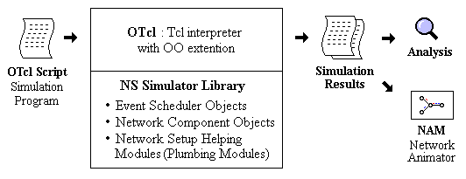

Figure 2.1: Simplified User's View of the NS2.

As shown in Figure 2.1, in a simplified user's view, NS is Object-oriented Tcl (OTcl) script interpreter that has a simulation event scheduler and network component object libraries, and network setup (plumbing) module libraries (actually, plumbing modules are implemented as member functions of the base simulator object). In other words, to use NS, we have to program in OTcl script language. To setup and run a simulation network, a user should write an OTcl script that initiates an event scheduler, sets up the network topology using the network objects and the plumbing functions in the library, and tells traffic sources when to start and stop transmitting packets through the event scheduler. The term "plumbing" is used for a network setup, because setting up a network is plumbing possible data paths among network objects by setting the "neighbor" pointer of an object to the address of an appropriate object. When a user wants to make a new network object, he or she can easily make an object either by writing a new object or by making a compound object from the object library, and plumb the data path through the object. This may sound like complicated job, but the plumbing OTcl modules actually make the job very easy. The power of NS comes from this plumbing.

Figure 2.2 shows an object hierarchy example in C++ and OTcl. One thing to note in the Figure 2.2 is that for C++ objects that have an OTcl linkage forming a hierarchy, there is a matching OTcl object hierarchy very similar to that of C++.
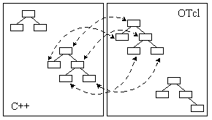
Figure 2.2: C++ and OTcl: The Duality.

Figure 2.3 shows the general architecture of the NS. In this figure a general user (not an NS developer) can be thought of standing at the left bottom corner, designing and running simulations in Tcl using the simulator objects in the OTcl library. The event schedulers and most of the network components are implemented in C++ and available to OTcl through an OTcl linkage that is implemented using tclcl. The whole thing together makes NS, which is an Object Oriented extended Tcl interpreter with network simulator libraries [9].
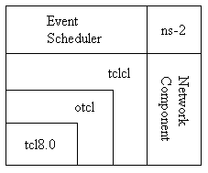
user
modifier
Figure 2.3: Architectural View of the NS2.

2.2 Organization of the NS2

This section discusses about the NS2 components, mostly compound network components.

2.2.1 Network components

This section discusses about the NS2 components, mostly compound network components.

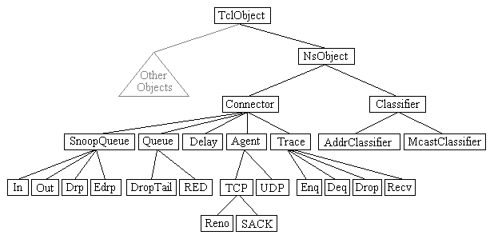
Figure 2.4: Class Hierarchy in NS2 (Partial).

Figure 2.4 shows a partial OTcl class hierarchy of NS, which will help understanding the basic network components. The root of the hierarchy is the TclObject class that is the super class of all OTcl library objects (scheduler, network components, timers and the other objects including NAM related ones). As an ancestor class of TclObject, NsObject class is the super class of all basic network component objects that handle packets, which may be composed of compound network objects such as nodes and links. The basic network components are further divided into two subclasses, Connector and Classifier, based on the number of the possible output data paths. The basic network objects that have only one output data path are under the Connector class, and switching objects that have possible multiple output data paths are under the Classifier class [15, 16, 17, 18, 19].

• Node and Routing

A node is a compound object composed of a node entry object and classifiers as shown in Figure 2.5, There are two types of nodes in the NS. A unicast node has an address classifier that does unicast routing and a port classifier. A multicast node, in addition, has a classifier that classify multicast packets from unicast packets and a multicast classifier that performs multicast routing.
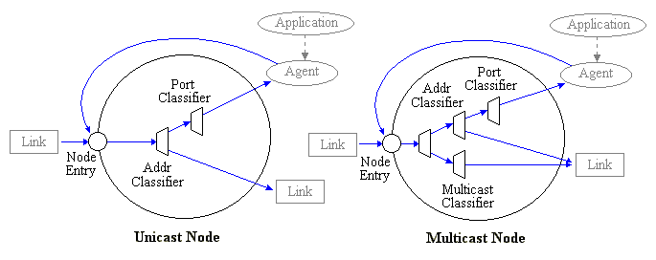
Figure 2.5: NS2 Node (Unicast and Multicast).

In the NS, Unicast nodes are the default nodes. To create Multicast nodes the user must explicitly notify in the input OTcl script, right after creating a scheduler object, that all the nodes that will be created are multicast nodes. After specifying the node type, the user can also select a specific routing protocol other than using a default one [19].

• Link
A link is another major compound object in the NS2. When a user creates a link using a duplex-link member function of a simulator object, two simplex links in both directions are created as shown in Figure 2.6.
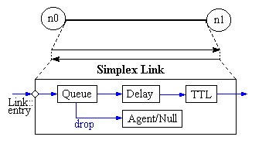
Figure 2.6: The NS2 Link.

One thing to note is that an output queue of a node is actually implemented as a part of simplex link object. Packets dequeued from a queue are passed to the Delay object that simulates the link delay, and packets dropped at a queue are sent to a Null Agent and are freed there. Finally, the TTL object calculates Time To Live parameters for each packet received and updates the TTL field of the packet.

• Tracing

In NS, network activities are traced around simplex links. If the simulator is directed to trace network activities (specified using $NS trace-all file or $NS namtrace-all file), the links created after the command will have the following trace objects inserted as shown in Figure 2.7. Users can also specifically create a trace object of type type between the given src and dst nodes using the create-trace {type file src dst} command.
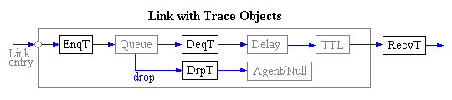
Figure 2.7: Inserting Trace Objects in NS2.

When each inserted trace object (i.e. EnqT, DeqT, DrpT and RecvT) receives a packet, it writes to the specified trace file without consuming any simulation time, and passes the packet to the next network object [19].

2.2.2 Event scheduler

One of the most vital components of NS2 is the discrete event schedulers. As described in the Overview section, the main users of an event scheduler are network components that simulate packet-handling delay or that need timers. Figure 2.8 shows each network object using an event scheduler. Note that a network object that issues an event is the one who handles the event later at scheduled time
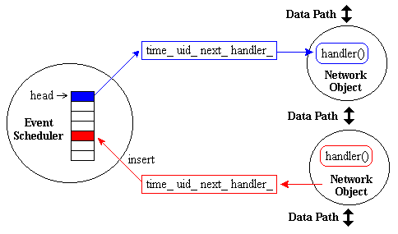
Figure 2.8: NS2 Discrete Event Scheduler.

Also note that the data path between network objects is different from the event path. Actually, packets are handed from one network object to another using send(Packet* p) {target_->recv(p)}; method of the sender and recv(Packet*, Handler* h = 0) method of the receiver [19].

2.2.3 Packet Format

An NS packet is composed of a stack of headers, and an optional data space (see Figure 2.9).A packet header format is initialized when a Simulator object is created, where a stack of all registered (or possibly useable) headers, such as the common header that is commonly used by any objects as needed, IP header, TCP header, RTP header (UDP uses RTP header) and trace header, is defined, and the offset of each header in the stack is recorded. What this means is that whether or not a specific header is used, a stack composed of all registered headers is created when a packet is allocated by an agent, and a network object can access any header in the stack of a packet it processes using the corresponding offset value [19].
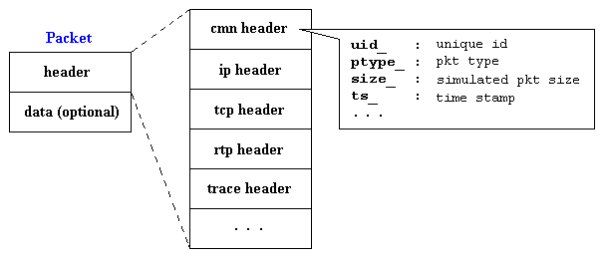
Figure 2.9: NS2 Packet Format.

2.3 NS2 Trace Format

The NS2 simulator produces different types of output ASCII files for wired, wireless and hybrid networks.
The format may also vary due to the difference in routing protocols used. For wireless outputs there may be a new form of output [20, 21, 22].

2.3.1 Wired Trace Format

The trace format of the wired network is simple and has the fields as shown in Figure 2.10.
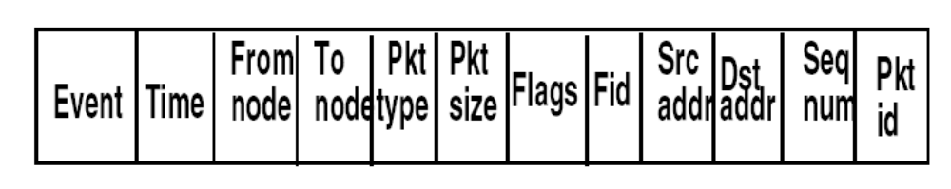
Figure 2.10: NS2 Wired Trace Format.

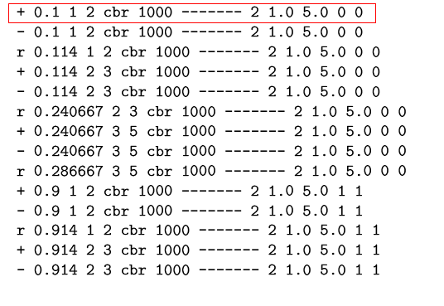
We can use an example for proper understanding of the trace format,

Table 2.1: Example of a wired trace file.

The first field in the trace output represents the events. The events may be
- r: Receive
- d: Drop
- e: Error
- +: Enqueue
- -: Dequeue
According to the highlighted portion of the current example, in Table 2.1, a 1000byte CBR packet from node 1 to 2 is enqued (+) at time 0.1.The source address is 1.0 and the destination address is 5.0. The packet ID and sequence number both are zero here while the flow ID is 2.

2.3.2 Wireless and Hybrid trace format
This NS2 has various wireless trace formats:

- Old Wireless Trace Formats
- New Wireless Trace Formats
- AODV Trace Formats
- DSDV Trace Formats
- DSR Trace Formats
- TORA Trace Formats
- Mobile node movement and energy trace formats

Format of wireless trace stated above is quite different from the wired trace files as we can see in the following tables, which represents an old format.

s 10.000000000 _0_ AGT --- 2 TCP 40 [0 0 0 0] ------- [0:0 1:0 32 0] [0 0] 0 0
r 10.000000000 _0_ RTR --- 2 TCP 40 [0 0 0 0] ------- [0:0 1:0 32 0] [0 0] 0 0
s 13.520299645 _0_ RTR --- 3 message 32 [0 0 0 0] ------- [0:255 -1:255 32 0]
s 15.315262986 _1_ RTR --- 4 message 32 [0 0 0 0] ------- [1:255 -1:255 32 0]
s 16.000000000 _0_ AGT --- 5 TCP 40 [0 0 0 0] ------- [0:0 1:0 32 0] [0 0] 0 0
r 16.000000000 _0_ RTR --- 5 TCP 40 [0 0 0 0] ------- [0:0 1:0 32 0] [0 0] 0 0
s 26.204382509 _0_ RTR --- 6 message 32 [0 0 0 0] ------- [0:255 -1:255 32 0]

Table 2.2 Example of the old wireless trace files

s -t 10.000000000 -Hs 0 -Hd -2 -Ni 0 -Nx 5.00 -Ny 2.00 -Nz 0.00 -Ne -1.000000 -Nl AGT -Nw --- -Ma 0 -Md 0 -Ms 0 -Mt 0 -Is 0.0 -ID 1.0 -It TCP -Il 40 -If 2 -Ii 2 -Iv 32 -Pn TCP -Ps 0 -Pa 0 -Pf 0 -Po 0
r -t 10.000000000 -Hs 0 -Hd -2 -Ni 0 -Nx 5.00 -Ny 2.00 -Nz 0.00 -Ne -1.000000 -Nl RTR -Nw --- -Ma 0 -Md 0 -Ms 0 -Mt 0 -Is 0.0 -ID 1.0 -It TCP -Il 40 -If 2 -Ii 2 -Iv 32 -Pn TCP -Ps 0 -Pa 0 -Pf 0 -Po 0

Table 2.3: Example of the new wireless trace files.

In case of simulation of a hybrid network, the trace file is a complex combination of wired and wireless formats, an example of which is shown in Table 2.4.

s 160.007171930 _3_ AGT --- 63 cbr 210 [0 0 0 0] ------- [4194305:0 0:0 32 0] [4] 0 0
s 160.008940351 _3_ AGT --- 64 cbr 210 [0 0 0 0] ------- [4194305:0 0:0 32 0] [5] 0 0
+ 160.00924 2 1 cbr 230 ------- 1 1.0.1.0 0.0.0.0 1 60
- 160.00924 2 1 cbr 230 ------- 1 1.0.1.0 0.0.0.0 1 60
s 160.010708772 _3_ AGT --- 65 cbr 210 [0 0 0 0] ------- [4194305:0 0:0 32 0] [6] 0 0
r 160.011608 2 1 cbr 230 ------- 1 1.0.1.0 0.0.0.0 1 60
+ 160.011608 1 0 cbr 230 ------- 1 1.0.1.0 0.0.0.0 1 60

Table 2.4: An example of hybrid output trace files.

2.4 Limitations of NS2

NS2 is one of the most powerful network simulators now-a-days; however it has the following imitations [23, 24, 25].

- Large multi format output files, which require post processing.
- Huge memory space consumption due to a very large output file.
- Relatively slower.
- Lack of built-in QoS monitoring modules.
- Lacks the capability of visual output representation.

The main output file is just a block of ASCII data in a file and quite cumbersome to access using some form of post-processing technique. The format of data representation is different for wired, wireless and hybrid network and also varies widely from protocol to protocol. In addition all the information are stored in this single file for every packets on the net. Therefore the output file becomes too bulky consuming huge memory spaces and also incurring additional time to record every pros and cons.

In the upcoming chapter the modified NS2 structure is proposed to minimize the limitations as stated above. Two new modules are added with their inherent capability of collecting, manipulating and representing data. The present packet structure is modified to ease the data collecting capabilities of the newly deployed agents. Finally there is a comparison showing the fairness of the modified structure along with the improvement of performance.
Chapter Three
Modification of the NS2

In this chapter the modified structure is proposed to make the simulation more user-friendly and faster with less memory consumption to alleviate all the problems stated in the section 2.4 of chapter 2.

3.1 The Modified structure

In developing the modified structure of the simulator the basic objectives were
- to embed the data collecting, calculating and storing in C++ domain for faster simulation,
- to eliminate the post processing of the huge trace file while evaluating QoS,
- to introduce QoS monitoring object independent of traffic type,
- to ease the visualization of result without any post processing,
To enhance the capabilities of present NS2 following structure shown in Figure 3.1 has been proposed
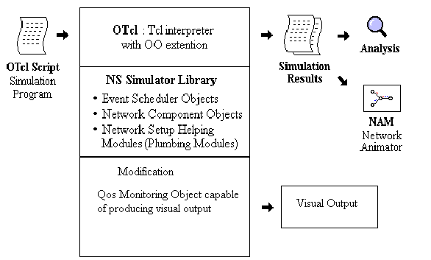
Figure 3.1 The structure of the proposed simulator (Modified NS2).

3.2 QoS Monitoring Agents

To fulfill the objective stated in the section 3.1 some QoS monitoring agents is need to be created using C++ programming language. The basic requirements for those agents are as follows:
- It must be capable of calculating the four QoS parameters throughput, jitter, number of packet loss and end to end packet delay and store the result in the corresponding files.
- In order to calculate those parameters it must be capable of gathering information on
    - the source address and the destination address of a packet,
    - the unique ID of that packet,
    - the send time of the packet,
    - the receive time, and
    - the number of lost packet.
3. To find out the individual QoS parameters of each network host in a complex network environment, consisting of many different hosts handling different type of traffics. It must also be
a) independent of type of traffic it is handling,
b) independent of network topology and equally deployable in all IP based wired, wireless and hybrid networks.

Considering all the above mentioned criteria, two new agents are proposed as follows.

- QosMonitor for UDP based applications and
- TCPQosMonitor for TCP based applications.

These two agents are defined in C++ as a subclass of the NS2 ‘AGENT’ class. In order to make its dual in OTcL class hierarchy, a link has to be established in between C++ and OTcL. A constructor is defined in each QoS monitoring agent in order to invoke the variables from both C++ and TCL by binding them together [26, 27, 28].

The steps can be viewed as follows:
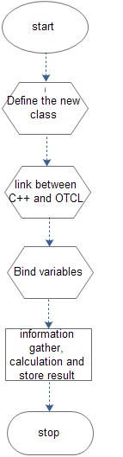

Figure 3.2: Development of QoS monitoring Agents at a glance.

Both the agents work similarly being attached to a traffic sink. The basic difference between them is the way they collect necessary information from the received packets.

3.2.1 The QosMonitor

The QosMonitor is a QoS measuring agent for UDP based applications, which is inherited from the class AGENT of NS2. It works as a UDP packet sink. On receiving a packet it stroes the packet receiving time and updates the packet count.
It extracts the following information from the received packet header:
- the flow ID. From the IP header
- the send time and unique packet ID from a common header (modified), and
- the sequence number from the RTP header.

The following figure shows the information extraction of QosMonitor.

header
Pay load
RTP
UDP
header
IP
header
1.Packet ID
2.Send Time
Sequence Number
UDP packets: Embedded Information used
Common
Header
1.Flow ID
2.Size

Figure 3.3: Extracting information for UDP based packets.

Instead of using the flow ID, we can also use the source address and destination address to identify a specific data flow.

After collecting these information, it also calculates the Instant throughput, jitter, number of loss packets and end to end packet delay for different packet flows.

Instant throughput is calculated as the ratio of the additional bytes received to the time interval elapsed. The jitter is the variation of end to end packet delay, and it is the ratio of delay variation to the packet ID variation. The loss of packet is identified by missing sequence number and thus updating a counter. The end to end delay is just the difference between the receive time and send time [29].

In addition, the other statistics kept by the agent are the following:

- bytes_ : are the total number of bytes sent to the application layer.

- nlost_ : is the number of packets lost. This is calculated from the
sequence number in the header of TCP packets. If the received
packet has a sequence number higher than the expected value
it means that some packets have been lost.

- npkts_ : is the total number of received packets

After the calculation is performed, the result representing the QoS parameters are stored in different files further differentiated by the flow ID , those can be readily plotted with any graph plotter.

3.2.2 The TCPQosMonitor

The TCPQosMonitor is a QoS measuring agent for the TCP based applications, which is inherited from the class AGENT of NS2. It works as a TCP packet sink. On receiving a packet it stores the packet receiving time and updates the packet count.

It extracts following information from the received packet header:

- the flow ID. From the IP header,
- from TCP and the Common header, it also extracts
- the send time,
- unique packet sequence number, and
- the size of the packet data.

Pay load
1.Sequence Number
2.Acknowledgement
TCP
header
IP
header
1.Flow ID
2. Size
TCP packets: Embedded Information used
Common
header
Send time

Figure 3.4: Extracting information from a TCP packet.

After gathering information, it calculates and stores all the four QoS parameters in specific files.

Besides all the information related to QoS, like the UDP qosMonitor it also stores following parameters
- recvbytes_ : are the total number of bytes sent to the application layer.

- nlost_ : is the number of packets lost. This is calculated from the sequence number in the header of TCP packets. If the received packet has a sequence number higher than the expected, it means that some packet have been lost.

- ndup_ : is the number of duplicated packets. Duplicated packets may arrive if some acknowledgements get lost. This is calculated from the sequence number in the TCP header of the packet. If the received packet has a sequence number lower than expected it means that source has re-sent some packets due to ack loss or timeout.

- expected_ : is the sequence number of the next expected packet.

- npkts_ : is the total number of received packets (including duplicate).

3.3 Modified Packet Structure

The original packet structure of NS2 is slightly modified to ease the data collecting capabilities of these two powerful QoS monitoring Agents. The common header of every packet in the simulator has a “common” header which is defined in ~NS/packet.h. Two different fields are introduced for identifying each packet individually and to record the send time of the packet.

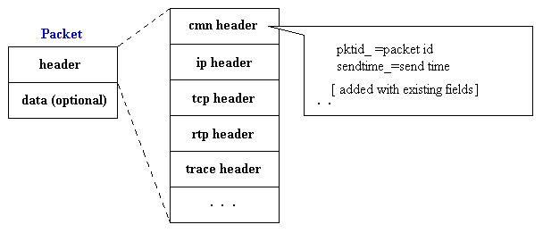
Figure 3.5: Modified packet structure used.

3.4 How to Use the Agents

To enhance the capabilities of the NS2 incorporating the modified structure proposed above, we have to install the modified structure on any the existing installation of NS2, for the version 2.27 and above, in the way as stated in Appendix A.

After successful installation of the modified structure, the qosMonitor and the TCPQosMonitor agents can be created in OTcl scripts to work as the UDP sink and a TCP sink with the capabilities of measuring QoS for UDP and TCP based application respectively.

Two parameters should be carefully initialized. One is the IP level flow ID and the other is the maximum number of flow that a QoS Monitor is going to handle. Use of flow ID help to distinguish each flow having separate common source and destination address pair, and to store their values in separate and specific files in an easy to plot format.

These two QoS monitors are versatile enough to handle any application based on TCP and UDP, like the simple CBR, FTP, VOIP, VIDEO and even the HTTP traffic with a minor modification in the existing HTTP structure, in any network topology.

These two agents by default produce 4 types of output file those can be easily potable by Xgraph (usually available with all NS2 installation packages) and also with any other plotting software, without any further processing on the data. The output files are

  - throughput vs. time
  - jitter vs. time
  - delay vs. time
  - packet loss vs. time

There is also another well formatted output file containing all the layer 3 relevant information for a complete insight of error checking. Further more, with slight post-processing, we can have any type of graphical representation of the following variables to show their effect of variation on those 4 QoS parameters any TCP/IP compatible network.

- the effect of varying sending rate of the traffic,
- the effect of varying the packet size,
- the effect of varying congestion window of the TCP,
- the effect of increasing payload and
- the effect of handoff. etc

We can also observe the inter-relation of any of the 4 QoS parameters. Some sample scripts are provided in the Appendix B.

These agents can also be used with differentiated and integrated service enabled network and learn their behavior.

3.5 The Scope of the QoS Monitors

We can easily measure the QoS response of them with the modified NS2 simulator without any post processing. For any existing TCP and UDP based applications, and also for any future applications type, as long as the sending Agent is TCP or UDP and the recipient is the appropriate QoS monitor, it will save a huge amount of time for the researchers to engage them selves to study the network from different perspectives and thus suggest some future enhancements.

Since it is applicable to both differentiated and integrated services to enhance the QoS of a network, we can compare the behavior of the two technologies, modify them and even obtain a new solution for the QoS enhancement for the next generation networks.

As long as the network is compatible with TCP/IP protocol we can use this technique for evaluation of the QoS of a network.

  - Verification of Fairness

In this section, a simple network is analyzed first using the existing NS2 and then with modification proposed to show the fairness of the result obtained.

    - Output Obtained by Original NS2

After simulation of the network using existing NS2, we will get a huge output file. A very small portion from its first few lines is presented below to show how to collect data from there. As explained earlier ‘+’ represent enqueued ‘-’ represents dequeued , ‘r’ represents received and ‘d’ represents dropped packets. We are going to investigate 1st two CBR packets destined from node 0 to node 3 via node 2.

+ 0.1 1 2 cbr 1000 ------- 2 1.0 3.1 0 0
- 0.1 1 2 cbr 1000 ------- 2 1.0 3.1 0 0
+ 0.1 0 2 TCP 40 ------- 1 0.0 3.0 0 1
- 0.1 0 2 TCP 40 ------- 1 0.0 3.0 0 1
+ 0.108 1 2 cbr 1000 ------- 2 1.0 3.1 1 2
- 0.108 1 2 cbr 1000 ------- 2 1.0 3.1 1 2
r 0.11016 0 2 TCP 40 ------- 1 0.0 3.0 0 1
………………………………………………………………………………………………………………
- 0.138 2 3 cbr 1000 ------- 2 1.0 3.1 3 4
r 0.138706 2 3 cbr 1000 ------- 2 1.0 3.1 0 0
+ 0.14 1 2 cbr 1000 ------- 2 1.0 3.1 5 7
…………………………………………………………………………………………………………
- 0.146 2 3 cbr 1000 ------- 2 1.0 3.1 4 6
r 0.146706 2 3 cbr 1000 ------- 2 1.0 3.1 1 2
………………………………………………….

Table 3.1: Analyzing an NS2 output file.

To highlight first packet enqueue and its successful reception we have used here black bold faced underlined data and to focus on the 2nd packets sending and reception I have used bold faced red italic underlined data. Knowing the sending time and the receive time
along with the receive bytes we can calculate the throughput using following formula.

Instant throughput = 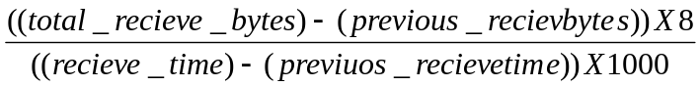 kbps

We can also calculate the jitter, propagation delay since the sending time and receiving time is known. Since there is no‘d’ as we see in the Figure 3.6.1 for portion of output shown the packet loss is zero.

So we get following results

- Instant throughput at time 0.146706 sec is 1000.000000 kbps.
- Jitter at time 0.146706 sec is 000000 sec.
- End to end packet delay at time 0.146706 sec is 0.038706 sec.
- And packet loss at time 0.146706 sec is 0.

To automate the whole process we can use AWK, PERL etc. scripting files. But due to wide variation of output format we need separate scripts for wired, wireless and hybrid networks and their old and new formats. More over processing times taken is also very high and the graphical representation is also quite cumbersome.

As an example, an AWK script, Instantthroughput.awk, [30] can be used to find out the instant throughput from a raw out put file and produce a file as follows after following command is properly written in the command prompt at the working directory where both the AWK script and out.tr files should reside.

$ awk –f instantthroughput.awk tic=0.1 src=0 dst=3 flow=2 pkt=1000 out.tr >>t_put.txt

the t_put.txt will contain following data as in Table 3.2

# flow flowType src dst time throughput
………………………………………………………………………………………………………………………………………………………..
2 cbr 1 3 5.242706 1000
2 cbr 1 3 5.250706 1000
2 cbr 1 3 5.258706 1000
2 cbr 1 3 5.266706 1000

………………………………………………………………………………………………………………………………………………………..
Table 3.2: Output file processing using AWK script

This sort of scripting used at present is time consuming and not so user friendly. For large networks it will consume quite large amount of time and the user must be well aware of all the input parameters and their significance. The script file requires major amended while handling conventional wireless output files.

3.6.2 Output Obtained by Modified NS2

In modified NS2, the post processing is completely eliminated for QoS base evaluation of TCP/IP networks. Instead of the raw output data file as shown in Table 3.1 it produces following easy to plot, formatted data files with the help of two QoS monitoring agent completely relieving the user from mastering the output trace format.

3.6.2.1 Instant throughput vs. Time curve

Depending on the flow ID separate file for TCP and UDP agents are created which looks as follows in Table 3.3. The file obtains information about the UDP agent having flow ID which is reflected in the name of the file as ‘UDP_tp_fid2.xg’. The ‘*.xg’ extension is to facilitate the plot with ‘xgraph’ plotting tool. Nevertheless, this file can be plotted by any plotting software. We can easily verify that it is producing exactly the same result as the original one.

Time Throughput
0.146706 1000.000000
0.154706 1000.000000
………………………….
5.242706 1000.000000
5.250706 1000.000000
5.258706 1000.000000
5.266706 1000.000000
5.274706 1000.000000
5.282706 1000.000000
5.290706 1000.000000
5.298706 1000.000000
5.306706 1000.000000
5.314706 1000.000000
5.322706 1000.000000
5.330706 1000.000000
……………………………
Table 3.3: ‘UDP_tp_fid2’ file obtained without post-processing.

3.6.2.2 Instant Jitter vs. Time curve

We also get a file named ‘UDP_jitter_fid2.xg’; It is clearly evident from its name that this file will contain the information about the jitter of an UDP flow having the flow ID 2. The partial content of this file is as in Table 3.4.

0.138706 0.000000
0.146706 0.000000
0.154706 0.000000
0.162706 0.000000
………………………
Table 3.4: ‘UDP_jitter_fid2.xg’ file (partial) obtained without post-processing.

3.6.2.3 End to End Packet delay vs. Time

The ‘UDP_delay_fid2.xg’ file contains the end to end packet delay of the UDP flow having the flow ID 2. The partial content of this file is given in Table 3.5 for example and verification.
0.138706 0.038706
0.146706 0.038706
0.154706 0.038706
0.162706 0.038706
0.170706 0.038706
………………………
Table 3.5: ‘UDP_delay_fid2.xg’ file (partial) obtained without post-processing.

3.6.2.4 Number of Lost Packets vs. Time

To record the information about the lost packet a file is generated having a name corresponding to its content as earlier. The content of ‘UDP_nlost_fid2.xg’ is shown in Table 3.6.

0.138706 0.000000
0.146706 0.000000
0.154706 0.000000
0.162706 0.000000
0.170706 0.000000
0.178706 0.000000
0.186706 0.000000
………………………
Table 3.6: ‘UDP_nlost_fid2.xg’ file (partial) obtained without post-processing.
The bold faced results shown in the Table 3.3 to 3.6, exactly same as the result of that same instant obtained from original NS2, presented in section 3.6.1.

3.6.2.5 The Layer Three Information File

In order to get a better insight of the whole simulation process, two information file is generated; one associated with TCP agent other with UDP agent. It holds information of the all the TCP and UDP flows together. For the above simulation the layer three information file for the UDP agents looks as in Table 3.7.

1000 2 0 0.100000 0.138706 0.038706
2000 2 1 0.108000 0.146706 0.038706
3000 2 2 0.116000 0.154706 0.038706
4000 2 3 0.124000 0.162706 0.038706
5000 2 4 0.132000 0.170706 0.038706
6000 2 5 0.140000 0.178706 0.038706
7000 2 6 0.148000 0.186706 0.038706
8000 2 7 0.156000 0.194706 0.038706
9000 2 8 0.164000 0.204456 0.040456
…………………………………………………
Table 3.7: Layer three file for UDP based flows (partially)

In the Table 3.7, the 1st column represents the received byte, the next column is the flow ID, the 3rd column shows the sequence number, the rest are the send time, receive time and the delay respectively.

In the next chapter a new protocol and its analytic model is presented. The objective of the newly proposed protocol to improve the performance of the TCP, mainly in a competitive environment when the total bandwidth is shared by many aggressive applications based on the UDP while preserving its error correcting features ingeniously.

Chapter Four
The Proposed New Protocol

In this chapter, the problems existing with traditional TCP and UDP protocols are briefly highlighted and a need for modified and improved protocol is stated. Finally, a newly devised protocol AAUDP (Acknowledgement Augmented UDP) is proposed which incorporates the aggressive data sending approach of UDP with the error correcting features of TCP ingeniously.

4.1: TCP and UDP A Comparative Overview

The two transport layer protocols in the TCP/IP family, TCP and UDP, provide network services for applications and application layer protocols (including HTTP, SMTP, SNMP, FTP, and Telnet). These two protocols perform those services by employing the IP to route packets to their destination networks. TCP provides connection-oriented, reliable, byte-stream packet delivery, while UDP provides connectionless, unreliable, byte-stream packet delivery.

TCP (Transmission Control Protocol) is the most commonly used protocol on the Internet. The reason for this is because TCP offers error correction. When the TCP protocol is used there is a “guaranteed delivery.” This is due largely in part to a method called “flow control.” Flow control determines when data needs to be re-sent, and stops the flow of data until previous packets are successfully transferred. This works because if a packet of data is sent, a collision may occur. When this happens, the client re-requests the packet from the server until the whole packet delivery is complete and is identical to its original.

UDP (User Datagram Protocol) is anther commonly used protocol on the Internet. However, UDP is never used to send important data such as WebPages, database information, etc; UDP is commonly used for streaming audio and video. Streaming media such as Windows Media audio files (.WMA), Real Player (.RM), and others use UDP because it offers speed! The reason UDP is faster than TCP is because there is no form of flow control or error correction. The data sent over the Internet is affected by collisions, and there is every possibility of errors being introduced. It should be noted here UDP is only concerned with speed. This is the main reason why streaming media is not of high quality [31, 32, 33, 34, 35 ].

4.1.1 Advantages of TCP

TCP offers various advantages as follows
- TCP guarantees three things:
  - that the data gets to the destination,
  - that it gets there in order, and
  - that it gets there without duplication.
- Routers may notice TCP packets and treat them specially.
- TCP has good relative throughput on a modem or a LAN

4.1.2 Disadvantages of TCP

The TCP has some disadvantages as well which are:

- TCP may have a lot of features one does not need. it may waste bandwidth, time, or effort on ensuring things that are irrelevant to the task at hand.
- TCP has no block boundaries; one must create his own.
- Routers on the Internet today are out of memory. they cannot pay much attention to TCP flying by, and try to help it.
- TCP has relatively poor throughput on a lossy, high bandwidth, high latency link, such as a satellite connection or an overfull T1.
- TCP cannot be used for broadcast or multicast transmission.
- TCP cannot conclude a transmission without all data in motion being explicitly acknowledged.

4.1.3 Disadvantages of UDP

The UDP protocol has some disadvantages as follows:

- There are no guarantees with UDP. a packet may not be delivered, or delivered twice, or delivered out of order; one will get no indication of this unless the listening program at the other end decides to say something. TCP is really working in the same environment; one gets roughly the same services from IP and UDP. However, TCP makes up for it fairly well, and in a standardized manner.
- UDP has no flow control. Implementation is the duty of user programs.
- Routers are quite careless with UDP. They never retransmit it if it collides, and it seems to be the first thing dropped when a router is short on memory. UDP suffers from worse packet loss than TCP.

4.1.4 Advantages of UDP

Following advantages we get from the UDP protocols
- It does not restrict one to a connection based communication model, so startup latency in distributed applications is much lower, as is operating system overhead.
- All flow control, acknowledging, transaction logging, etc is up to user programs;
- The recipient of UDP packets gets them un mangled, including block boundaries.
- Broadcast and multicast transmission are available with UDP.

4.2 The Need for a New Protocol

The UDP protocol has some outstanding characteristics as given below in comparison with TCP [35].

- Latency can be as low as rtt if the protocol is suitably designed.
- The Flow control is up to user space; windows can be infinite, latency well tolerated, and maximum speed is enforced only by real network bandwidth, yet actual speed is chosen by the agreement between the sender and receiver.
- Under UDP, receiving of an image simultaneously from multiple hosts is much easier with UDP, as is sending one to multiple hosts, especially if they happen to be part of the same broadcast or multicast group.
- Also under UDP, single sending host with multiple transfers proceeding can balance them with excellent precision.

The biggest problem is the error correcting features specially needed for reliability through acknowledgement and retransmission which we just can’t maintain very easily with the UDP. In recent past, M. Nazmul Ahsan and M. S. Rahman [36] have proposed modified UDP incorporating flow control and time out with retransmission. However, in my work I have proposed a simple protocol modifying the existing UDP protocol so that it can ingeniously make use of the TCP’s acknowledgement feature and retransmission feature, so that we can have a robust new protocol having all the benefit of existing UDP and also some goodness of TCP.

It should be noted here that the major difference between two work is, in our research work both TCP and UDP is working together as a single protocol. Moreover an analytical model is present here along with its performance analysis by simulating it with the modified NS2.

4.3 Acknowledge Augmented UDP (AAUDP)

The proposed new protocol can be named as AAUDP (Acknowledge Augmented UDP).It can be seen as the integration of UDP and TCP protocol with a slight modification to get the goodness of both. Altogether, the combination performs in the following ways

- The modified UDP is responsible for sending data with its aggressive nature and should be capable of resending data if some valuable data is lost.
- The simple TCP with a modified structure of acknowledgement packet is employed to inform the modified UDP about the need for re-transmission at the end of data transfer.

4.3.1 How AAUDP works

The Acknowledge augmented UDP (AAUDP) has two goals. The first is to keep the network pipe as full as possible during bulk data transfer. The second goal is to avoid TCP’s per-packet interaction so that acknowledgments are not sent per window of transmitted data, but aggregated and delivered at the end of a transmission phase.
Figure 4.1 and 4.2 below illustrates the AAUDP data delivery scheme. In the first data transmission phase (Host1 to Host2 in the figure),

Send /Receive thread
UDP
TCP
Controlling thread

Send /Receive thread

UDP
TCP

Controlling thread

END
END
ACK
ACK
Application Layer
Transport
Layer
Other Layers
Host 1
Host 2
Figure 4.1: The data transmission between 2 hosts using AAUDP.
.
Data sent using AAUDP
Ack bit array
T_start
T_send
T_ pdelay
T_recv
T_ pdelay
T_ resend_i
T_ pdelay
T_ pdelay
T_end
T_ack

Figure 4.2: Data, Acknowledgement and timing for AAUDP: Time sequence diagram.

AAUDP sends the entire payload at a user-specified sending rate using UDP datagram’s. Since UDP is an unreliable protocol, some datagram’s may become lost due to congestion or an inability of the receiving host from reading the packets rapidly enough. The client program at the receiver therefore must keep a tally of the packets that are received in order to determine which packets must be retransmitted. At the end of the bulk data transmission phase, the sender program sends a DONE signal via TCP so that the client program at the receiver knows that no more UDP packets will arrive. The receiver responds by sending an Acknowledgment consisting of a bitmap tally of the received packets. The sender responds by resending the missing packets, and the process repeats itself until no more packets need to be retransmitted.

Unlike the normal UDP this AAUDP can resend the data depending on the special acknowledgement packet received by the TCP entity at the sending side. The special acknowledgement has the following characteristics:

- One bit for every packet sequentially. i.e the position of the bit in the acknowledgement packets is related to the order which the packets reached the receiver.
- The acknowledgement packets should not be larger than the MTU specified in the network.
- To accommodate larger acknowledgement packets it can be subdivide into several smaller packets each less than the specified MTU.

4.3.2 Analyzing the behavior of AAUDP

From the Figure 4.2 it is evident that the total time needed to complete data transfer in AAUDP is
T_{total}= (T_{send} + T_{pdelay} )+(T_{ack} +T_{pdelay})+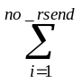[( T_{resend_i}+T_{pdelay} +T_{ack_i}+ T_{pdelay})]
(1)
for best possible result, i.e for a case where there is no loss the time will be minimized to
T_{min} = (T_{send} + T_{pdelay}) + (T_{ack} +T_{pdelay}) (2)

if the data size to be sent is S_{data} and the max available banbwidth available is
B_{max} =S_{data}/T_{min} (3)

Now if the data size to be sent is S_{data} and the chosen banbwidth is B_{send}
T_{send} =S_{data}/ B_{send} (4)

and since there is 1bit for every sent packet in the acknowledgement and the acknowledgement packet should be less than and equal to the MTU so we can easily calculate the number of acknowledgement packets(S_{ack}) , time to send ack packets (T_{ack}) depending on the chosen bandwidth B_{send} and the MTU(S_{packet}).

T_{ack} =S_{ack}/ B_{send} (5)
S_{data}
8 * S_{packet}
S_{ack}= (6)

Now from equation (2) putting the values of T_{send} , T_{ack,} we get,

T_{min} = T_{pdelay} + + + T_{pdelay} (7)
S_{data}
B_{send}
S_{data}
8 * S_{packet} * B_{send}

So from equation (4), we get
S_{data}
B_{max} = (8)
S_{data}
B_{send}
S_{data}
8 * S_{packet} * B_{send}
+ + 2T_{pdelay}

S_{data}
8 * S_{packet} * B_{send}

In equation (8), in the denominator is much smaller, about 10⁻⁴th of the other two terms, and can be neglected.

Thus we get,
B_{max}
B_{send}
1
1 +
RTT* B_{send}
S_{data}
=
(9)

From equation (9), we can easily see that the achievable bandwidth B_{send} can approach the maximum achievable banwidth B_{max} , when the payload S_{data} is large enough.

Now if we assume, a flat loss rate R , it can be shown that the number of resend N_{resend} may be as follows ,

N _{resend} = ⌊ Log _{R} (Spacket/Sdata ⌋

The data size of all retransmits is therefore,
R(1-R^{Nresend})

(1-R)

S_{resend} = S_{data} *

To compare its behavior along with the existing UDP and TCP, the protocol has been simulated using the modified NS2 simulator, and the results so obtained are seen to perform better than individual TCP and UDP, as expected. The results are discussed in the next chapter.

Chapter Five
Simulation Results and Evaluation

To evaluate the capabilities and the goodness of the modified NS2 simulator in measuring the QoS parameters, especially, some typical scenarios have been simulated with it. The simulation results along with the analysis of those simulated scenarios are presented in this chapter.

5.1 Simulated Scenarios

Starting from very simple wired topology, various wireless and hybrid networks are simulated to demonstrate that the modified NS2 is working well for all types of TCP/IP networks for different types of network traffic. The effect of variation of some network parameters on the QoS is also studied. After that the proposed new protocol is simulated to show the improved performance compared to the existing TCP and UDP protocols.

In the first category to show the capabilities of the tool the following typical scenarios have been simulated.

- A simple wired network, where the resource is over-provisioned for two similar competing sources.
- A simple best effort wired network, where TCP agent suffers in presence of an aggressive UDP sender.
- A simple QoS enabled network.
- A wireless network with fixed wireless nodes.
- A hybrid network carrying different types of data traffic.

Then secondly, the effect of varying different parameters is shown as follows:

- Effect of varying the packet size on QoS parameters.
- Effect of varying the sending rate on QoS parameters.
- Effect of handoff on QoS parameters.

Finally, the proposed protocol AAUDP is simulated comparing its improvement over simple TCP and UDP protocols a simple wired environment.

5.2 Basic Simulation results

As the basic simulation result, four different files are generated each holding the relevant information regarding one of the four QoS parameters(i.e. Throughput, Jitter, Packet loss and delay) at the time of reception of each packet.

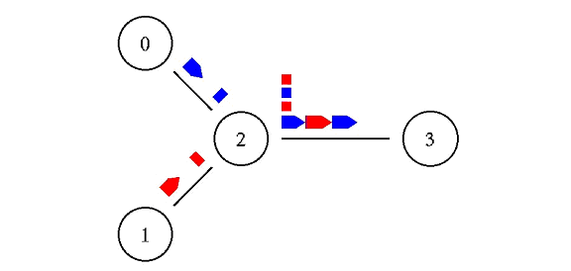
The first simple network simulated has only two sources and a sink as in the Figure 5.1. Both the Nodes 0 and 1, independently send CBR (Constant Bit Rate, Like packetized voice data) traffic at a rate 100kbps over a over-provisioned network having 1.7Mbps band width using the UDP and TCP protocols respectively.
Figure 5.1: Case 1- Over-Provisioned Network.

Since the link capacity 1.7mbps is larger then the summation of the two sending rates, about 0.2 mbps, the delay and instant throughput is not hampered in presence of the second data source.

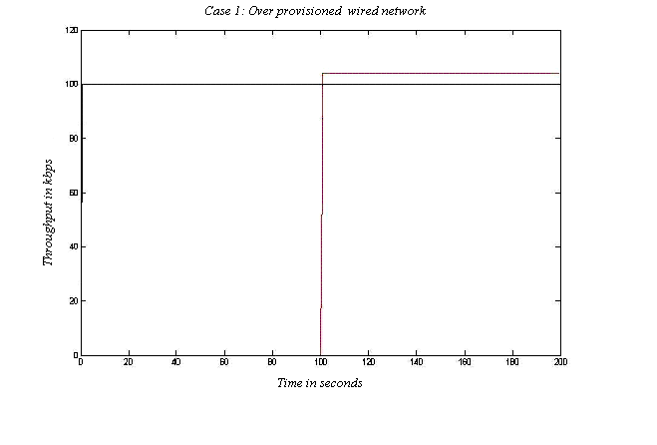

--- UDP data
--- TCP data

Figure 5.2: Throughput in kbps vs. Time in sec for Case 1.

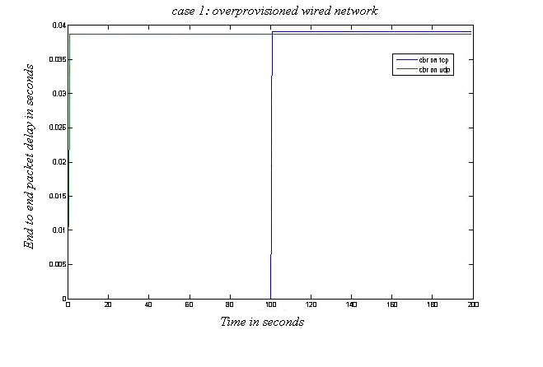
Figure 5.3: Delay in sec vs. Time in sec for Case 1.
--- UDP data
--- TCP data
From Figure 5.2 and 5.3, it is clearly visible that when the network resources are available in plenty, , the delay and instant throughput is not hampered in presence of the second data source.
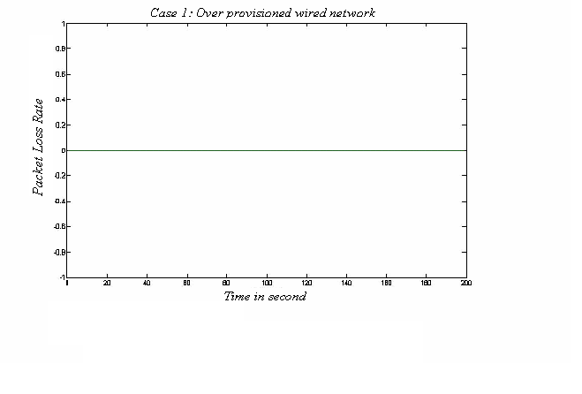
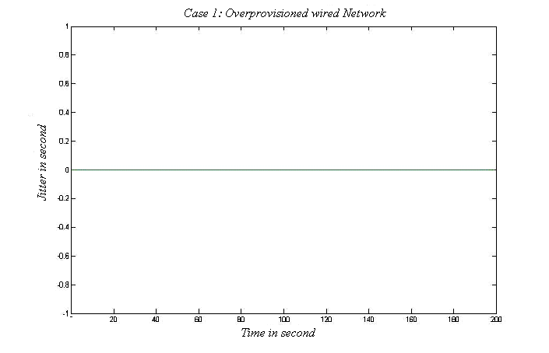
Figure 5.4: Jitter vs. Time for Case 1.
--- UDP data
--- TCP data

--- UDP data
--- TCP data

Figure 5.5: Packet Loss rate vs. Time

Figure 5.5: Packet loss Rate vs. Time for Case 1.
From the results shown in Figure 5.4 and 5.5, it is evident that the problem of jitter and packet loss is nil in a over-provisioned network as expected.
Now, the two sources in the above network is changed to share a bottle neck link and the effect of TCP in case of aggressive an UDP application is observed. Both the sender sends at a fixed rate of 2Mbps over the 1.7Mbps link. TCP application is assumed to have turned ON for the entire simulation time and the UDP application is ON after the 1st 100 sec.
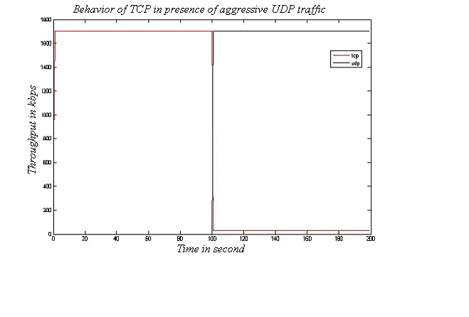
Figure 5.6: Throughput in kbps vs. Time curve in a Best effort network
--- UDP data
--- TCP data
From Figure 5.6, it is easily seen that when only TCP agent sends packet, the throughput is as high as the link capacity of 1.7mbps, However as soon as UDP agent starts sending data capturing almost all the channel capacity, the TCP throughput decreases abruptly. It is due to the congestion control algorithm followed by the TCP agents.

In the Figures from 5.7 to 5.9 in the next pages the effect on the 3 other important QoS parameter is shown for this best effort network where TCP is competing for the scarce network resource in presence of the aggressive UDP sender.

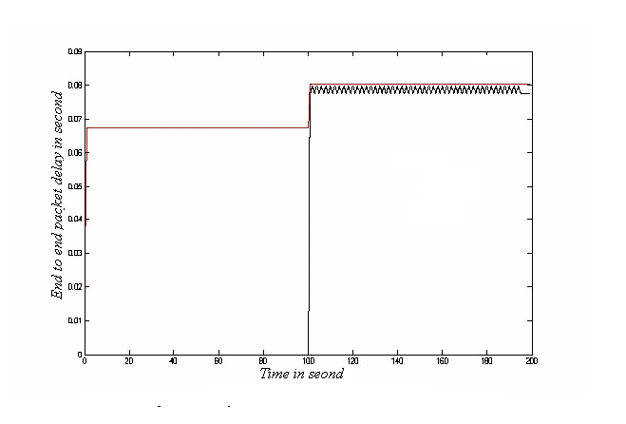

--- UDP data
--- TCP data

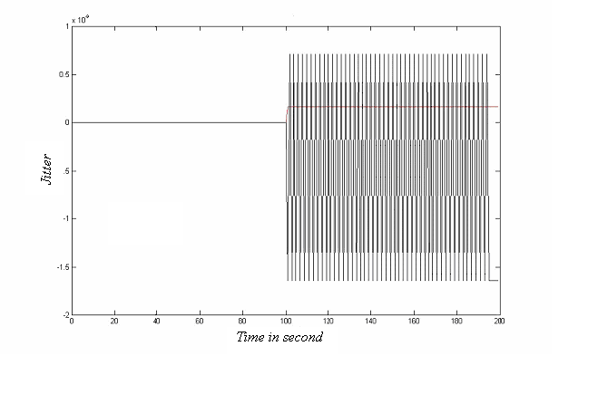
Figure 5.7: Delay vs. Time in the Best effort Network

--- UDP data
--- TCP data

Figure 5.8: Jitter vs. Time in Best effort network

We can easily see in Figure 5.7 that end to end packet delay is not too much affected in presence of aggressive UDP traffic. There is a slight increase in delay only. However when we look at the Jitter and packet loss in Figure 5.8 and Figure 5.9, it is clearly visible that the UDP based application suffers adversely and the TCP based application is almost unaffected.
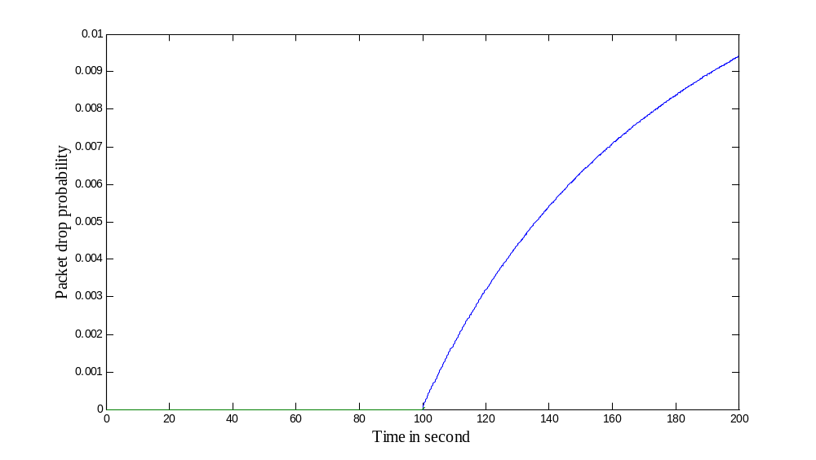

--- UDP data
--- TCP data

Figure 5.9: Packet drop probability vs. Time in the BE network when the sending rate is 2mbps and the packet size is 1000bytes

In the next scenario, a diffserv enabled network will be examined, where the QoS is guaranteed for a single sender and two other best effort service competing with each other. The network topology is as followos where source S1 gets ensured service and other to gets best effort service.
10M,5ms 10M,5ms
S1-----\ /-------destination1
\ /
S2------ edge1--------core-------edge2---------destination2
/ 5M,10ms M,10ms \
S3-----/ \-------_destination3
10M,5ms 10M,5ms

Figure 5.10: A Diffserv Enabled network.
The sender S1 and S2 starts from the very beginning and the S1 sender is intentionally stopped for some times to show its effect on network. The sender S3 starts sending after 5 seconds; however, being a best effort service it remains quiet until enough network resource is free as the S1 refrains from transmission from 10 seconds to 15 seconds.
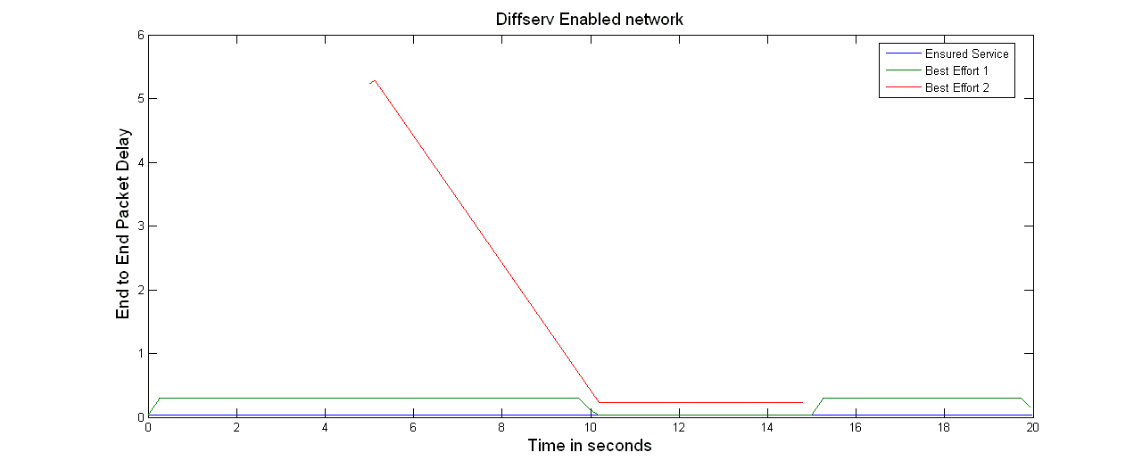
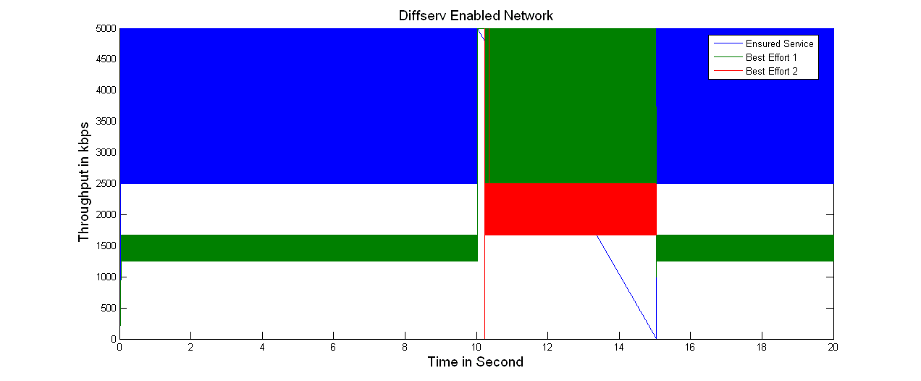
Figure: 5.11: Throughput in kbps vs. Time in second in Diffserv network
Figure: 5.12: Packet delay in sec vs. Time in second in Diffserv network
By observing Figure 5.11 and 5.12, it is evident to us that in a diffserv network, the ensured service gets a very fairly good throughput with a very negligible delay compared to the to other best effort services.

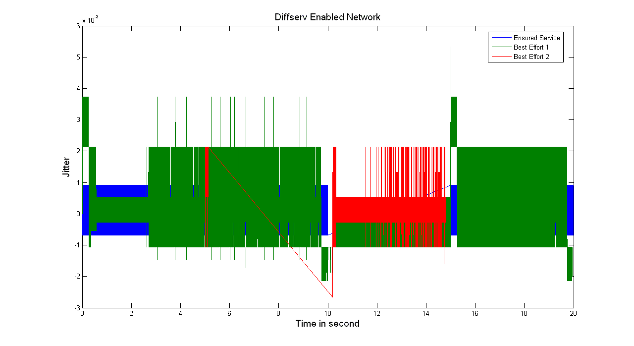
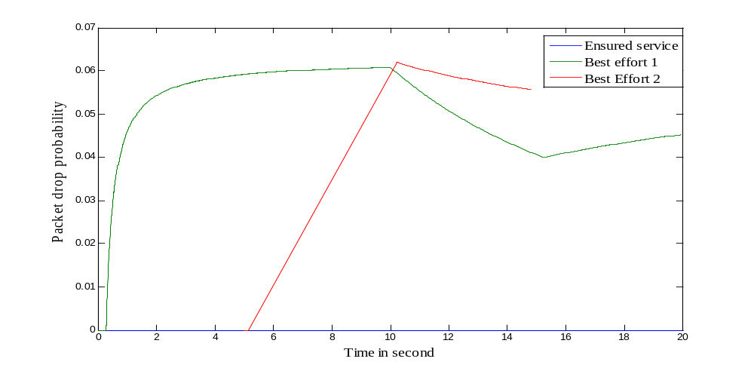
Figure 5.13: Jitter vs. time in second in Diffserv network

.

Figure 5.14: Packet drop probability vs. time in second in Diffserv network.
Two other remarkable improvement for the ensured service, that is for S1, are the controlled jitter and zero packet loss is observed in Figure 5.13 and 5.14.

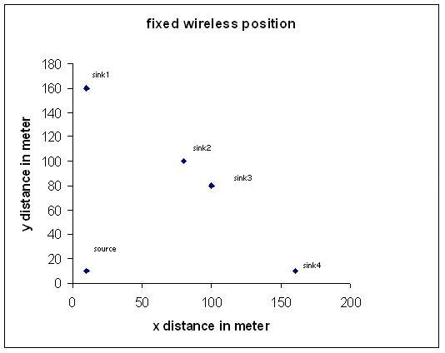
Next a fixed wireless network is simulated to show that the simulator is working in wireless environment as well.

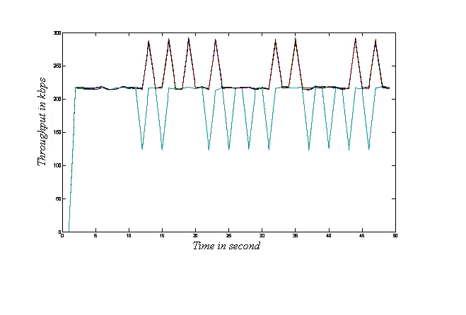
Figure: 5.15: A simple fixed wireless network.

Figure: 5.16: Throughput vs. time in fixed wireless network.
In Figure 5.16 the throughputs of all the 4 sinks are not the same due to some noisy
behavior on channel 4.
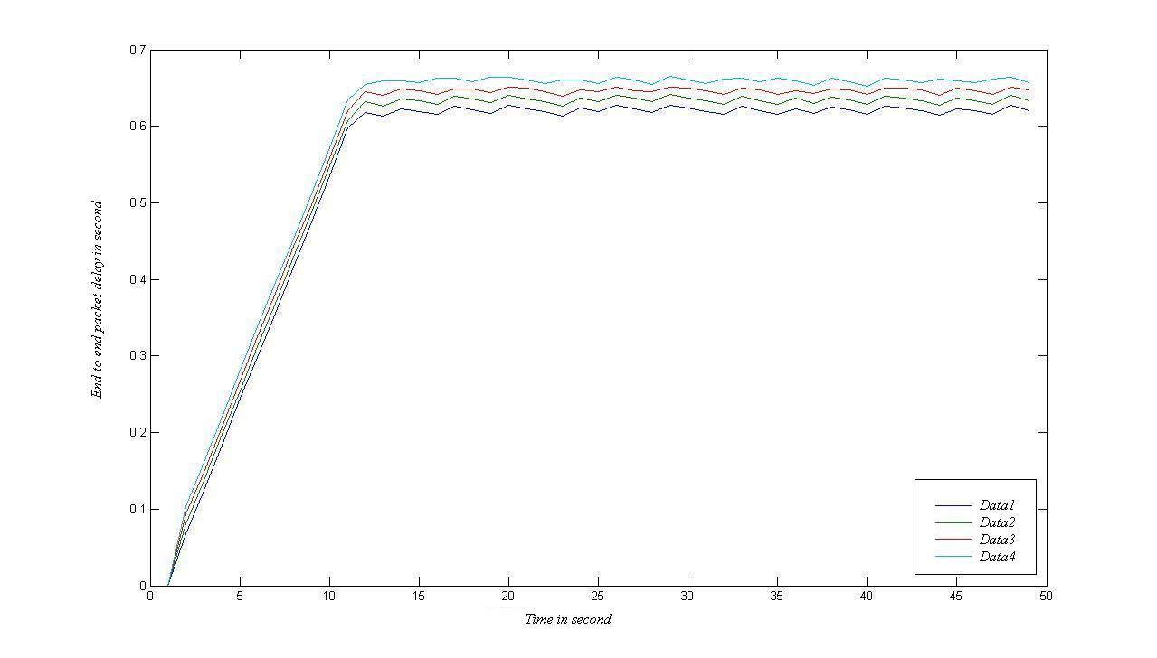
Figure: 5.17: Delay vs. time in fixed wireless network.
Due to almost the same distance from the source, the end-to end packet delay is found to be very similar to each other in Figure 5.17.
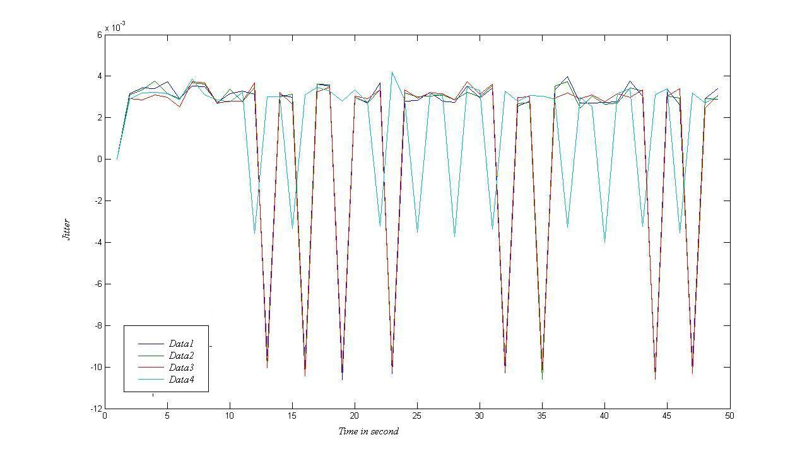

Figure: 5.18: Jitter vs. time in fixed wireless network.
In Figure 5.18, it is clearly visible the jitter may be a big problem in wireless environment

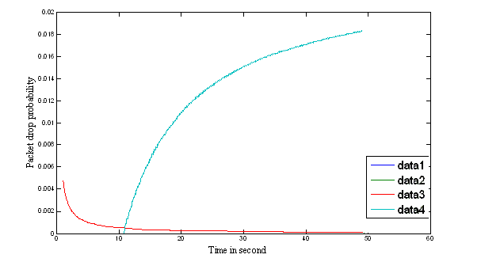
Figure: 5.19: Packet drop probability vs. time in fixed wireless network.

Due to noisy nature of the link 4, a huge packet loss is seen in Figure 5.19

Now, we can examine a hybrid network as shown in the following topology consisting of 3 mobile host and 3 wired nodes.
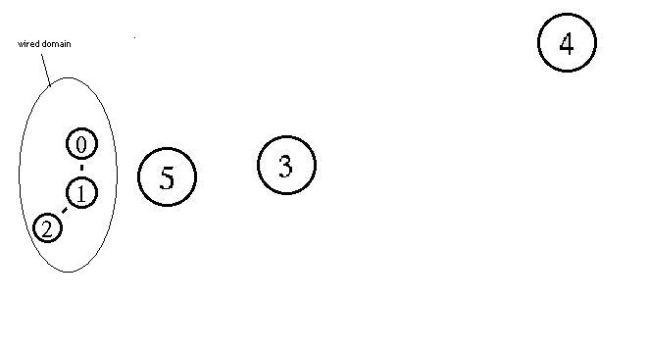

Figure: 5.20: A simple hybrid Network consisting of 3 mobile nodes.
We will examine data to and from a mobile node, here mobile node 3, to the wired domain while it is roaming inside the network.
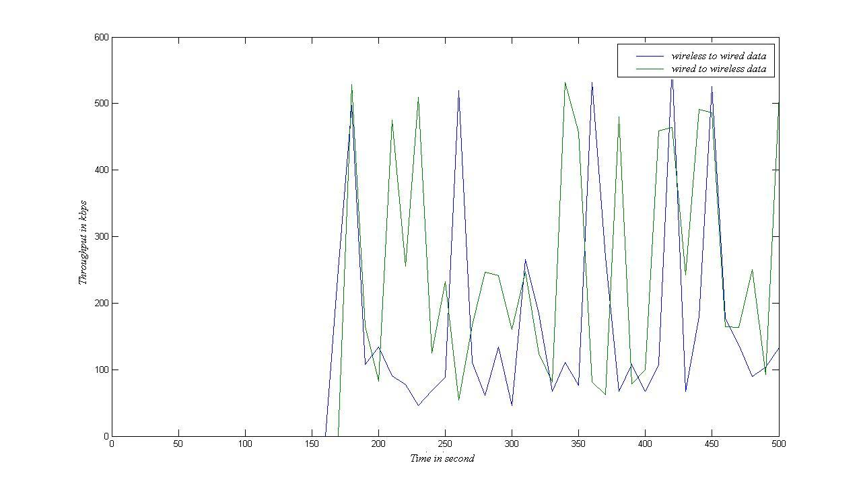
Figure 5.21: throughput vs. time in hybrid network.

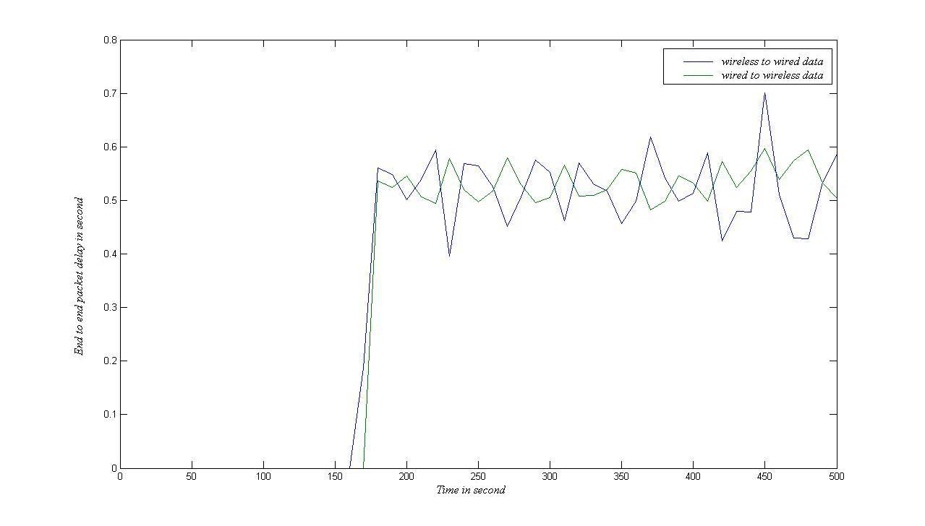
Figure 5.22: delay vs. time in hybrid network.

There are two different flows of data from wireless domain to wired domain and vice versa through the base station 2. Wireless node 3 sends data to wired node 1 and the wireless node 4 receives data packets from wired node 1.
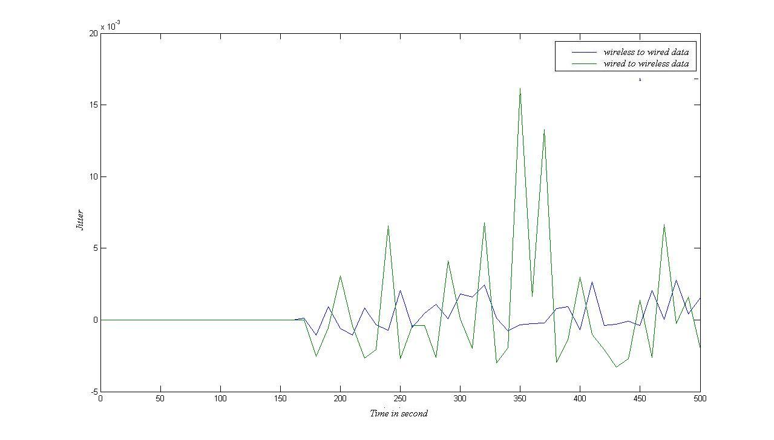
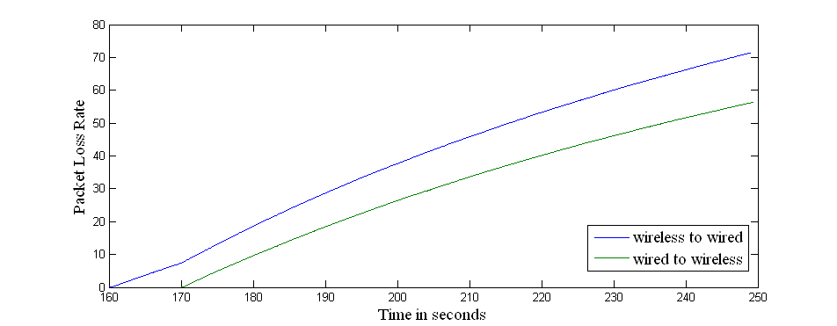
Figure 5.23: Jitter vs.. Time in hybrid network.

Figure 5.24: Packet Loss Rate vs. Time in hybrid network. When the sending
packet rate is 2000 packets/seconds.

From the simulation results, from Figure 5.21 to 5.24, the observation shows that the throughput and the delay of the both flow is more or less the same. However considering jitter and packet loss, it is found that the flow from wireless to wire is some what superior.

5.3 Derived Simulation results

In addition to get all the information about the four QoS parameters with respect to time, the effect of various parameters such as effect of different packet size, effect of different sending rate of sources, effect of varying different TCP parameters such as size of congestion window etc. can be easily found with a little effort without any post processing. Furthermore, the effect of different phenomena like handoff can be demonstrated.

Here, for demonstration purposes, effect of different packet size and varying sending rate on QoS parameters are presented in this section.
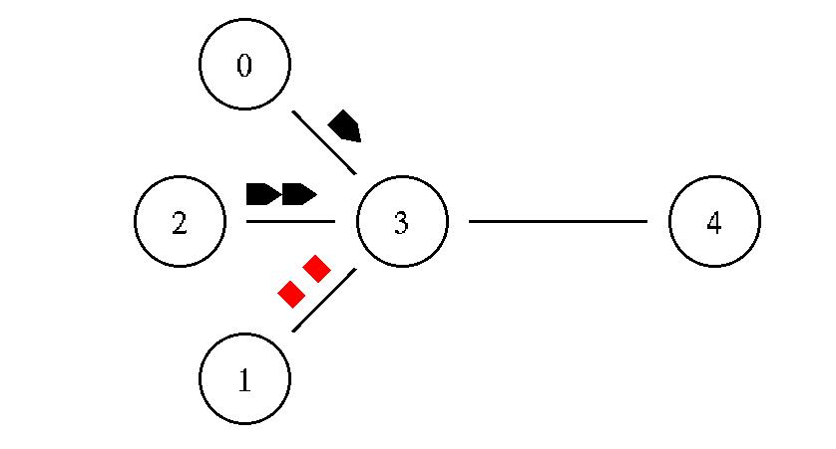

Figure 5.25: Different packet size of three similar data sources.

To demonstrate the effect of different packet size on the QoS parameters, the node 0 is sending data packets of size 1024 bytes, While the node 1 and 2 are sending data with a packet size of 512 and 2048 bytes respectively in this scenario.

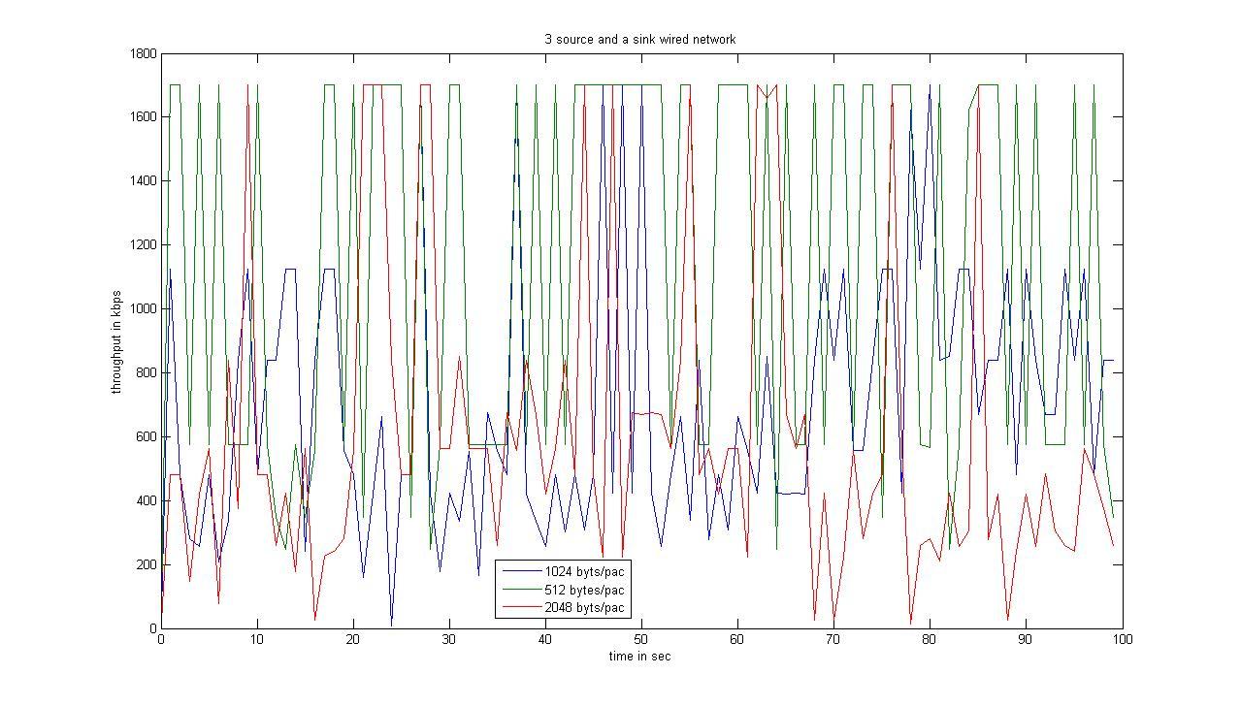

Figure 5.26: Throughput vs. time for different packet size.
3 sources having different packet sizes, as shown in Figure 5.26, compete for the higher throughput and the lowest packet size (green) is found to be more successful in this competition.
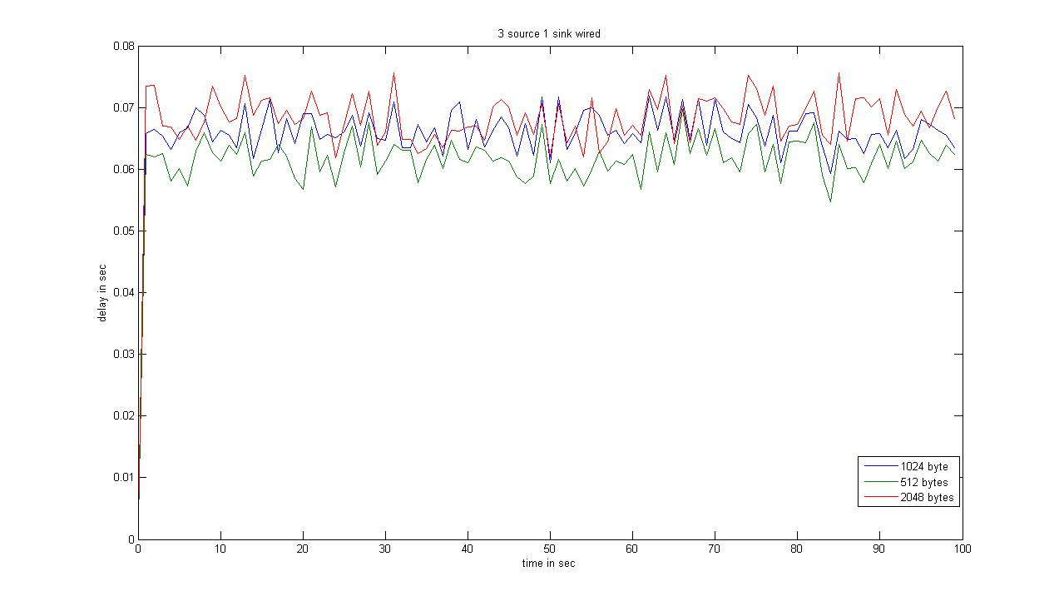

Figure 5.27: Delay vs. time for different packet size.

From figure 5.27, it is revealed that, in terms of packet delay all the sources with different packet size behaves almost the same.
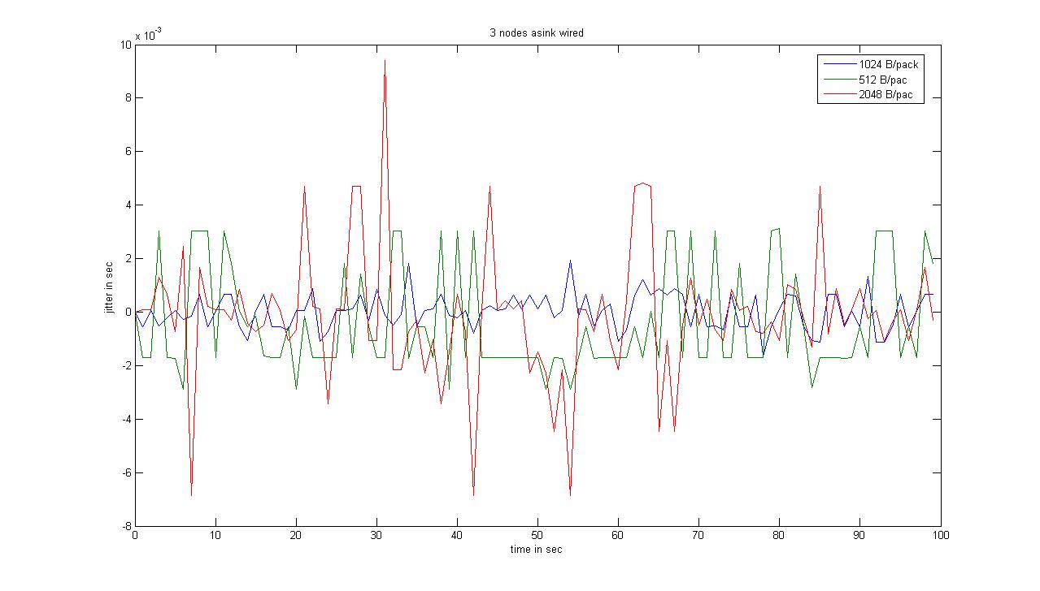
From observation of Figure 5.28 and 5.29, it is found that the highest packet size data suffers from jitter most. However, the smallest packets size also not the best among three. So to reduce jitter we just can’t use a very high or low packet size because both can lead to higher jitter. The lowest packet loss is found for the smallest packet size.

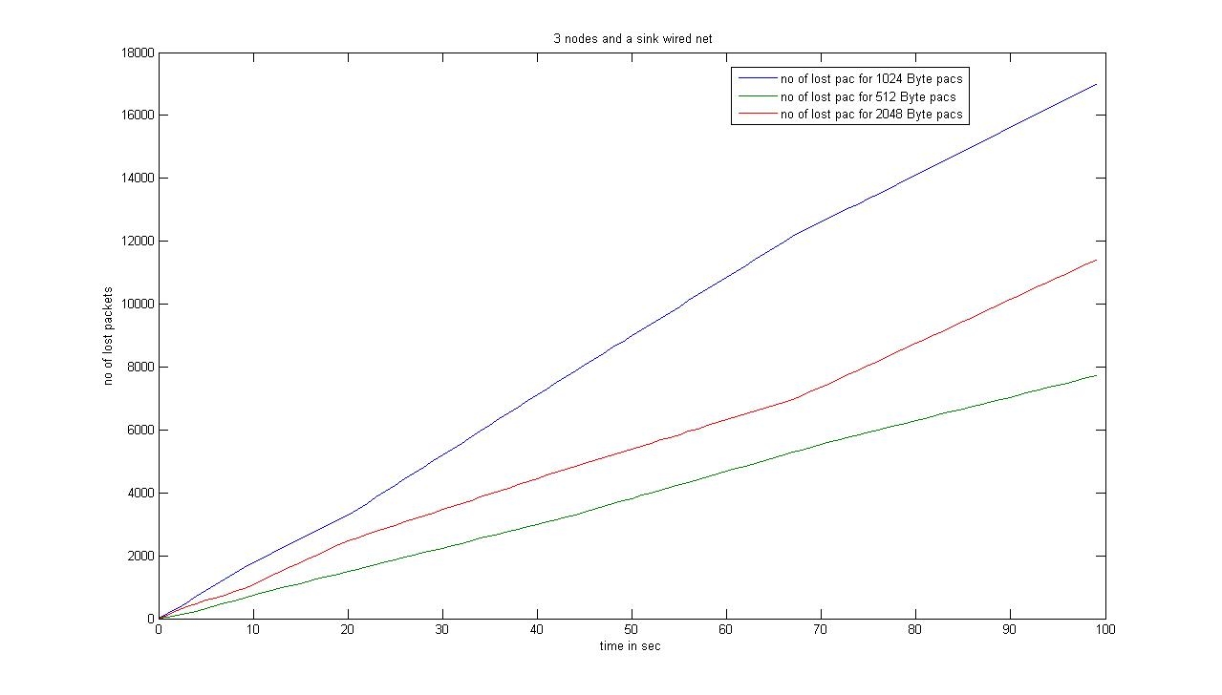
Figure 5.28: Jitter vs. time for different packet size.

Figure 5.29: Packet loss vs. time for different packet size.

Now, the effect of varying sending rate is demonstrated in the next simulation, where we used a wired wye net work, consisting of two senders and a receiver.The bottle neck link is still only 1.7mbps but both the senders are made to send data at an increasing sending rate from 0 to 2 Mbps.
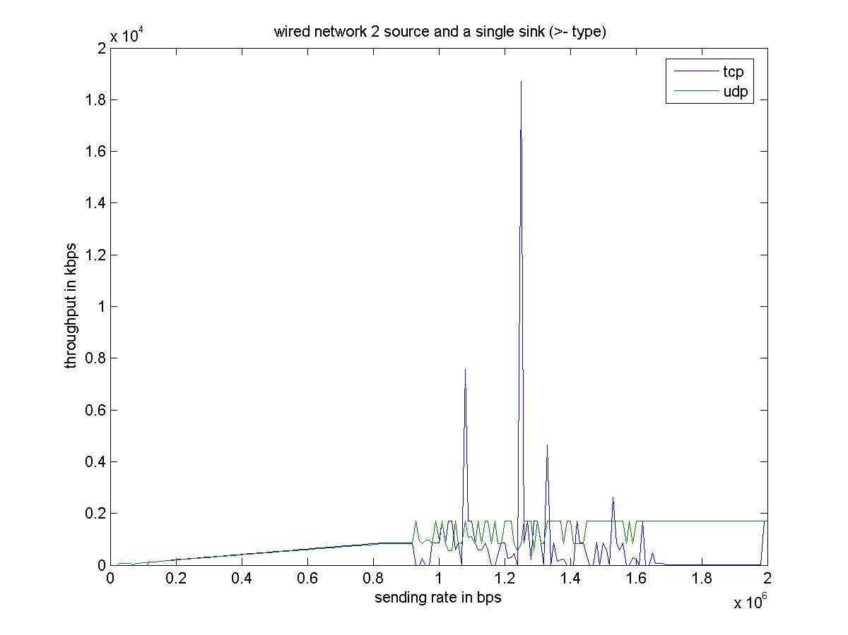

Figure 5.30: Throughput in kbps vs. sending rate bps

In Figure 5.30, some very interesting things are visible; Firstly, the UDP sender gets a fairly good through put as high as the raw bandwidth of the bottle-neck link with the increase in sending rate. The TCP sender exhibits a fair competition when the sending rate was well below the bottle neck capacity; however it shows a very poor throughput at higher sending rate due to aggressive nature of its counter part and it congestion control algorithm.

Secondly, sometimes the throughput is zero and again some times it crosses the capacity of the bottle neck link, it is because of the windowing phenomena of TCP receiver. The receiver window will deliver data to the application layer only after proper acknowledgement and also after proper ordering of packets.
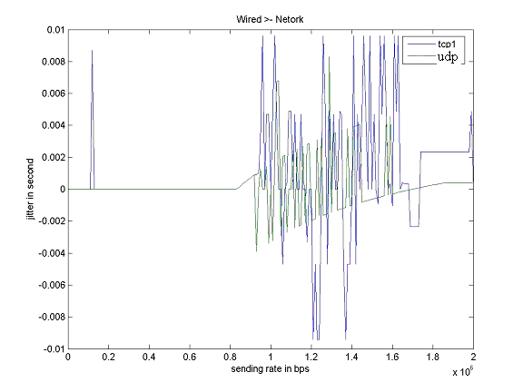

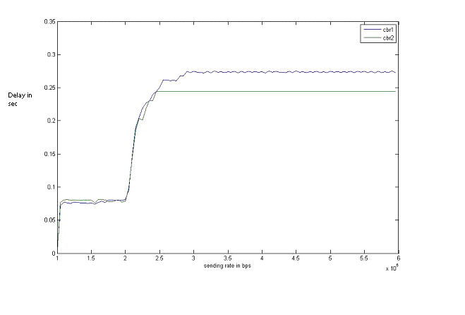
Figure 5.31: Jitter vs. sending rate bps.

Figure 5.32: Delay in sec vs. sending rate bps.

From Figure 5.31 and 5.32, it is seen that the TCP sender also suffers in terms of jitter and delay as the sending rates are increased.
Now, to show the effect of hand off and mobility a simple hybrid network is chosen with a single mobile host which receives data from a wired node through a base station while it roams in side the network at a speed 20m/sec.firstly it moves towards the region of Foreign agent and then again come backs to its home agent so it experiences two handoff in this simulation.
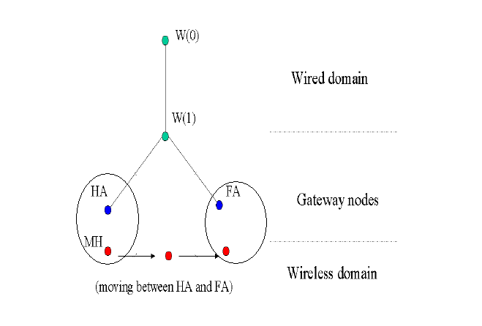
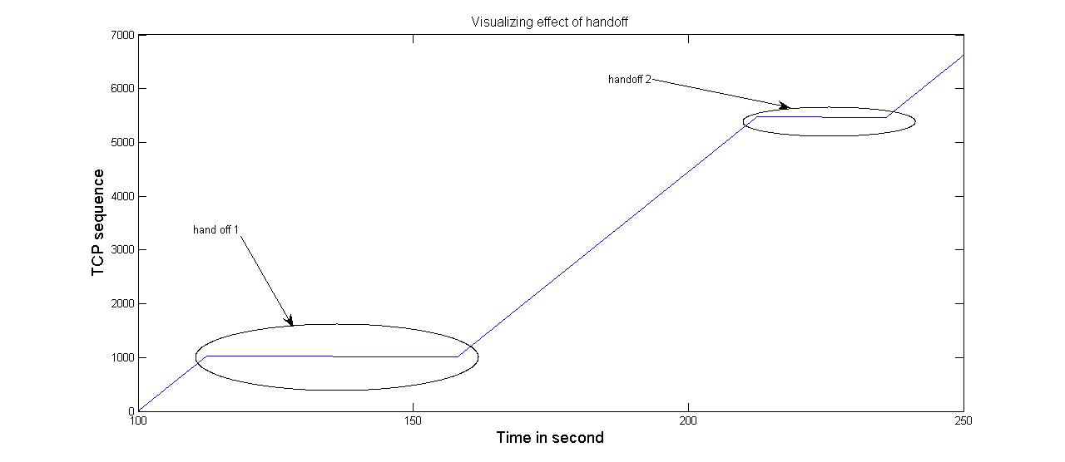
Figure: 5.33: Topology to demonstrate affects of hand off on QoS params.

Figure: 5.34: Detecting handoff during data transfer.
In the Figure 5.34, an approach to detect hand-off during a continuous data transmission at fixed rate is shown. Due to temporary unavailability of the receiver during hand-off no new packet arrives at the receiver. After success full hand-off the receiver begins to get data packet with proper sequence number (for TCP based applications). First hand of is due to its movement from it’s HA to a completely new Foreign agent so it take larger time to register but the second one is from the FA to the HA back again so the handoff time is less now.
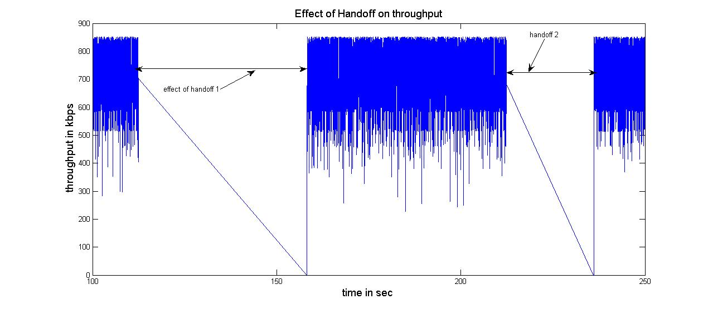
Figure: 5.35: Effect of handoff on throughput.
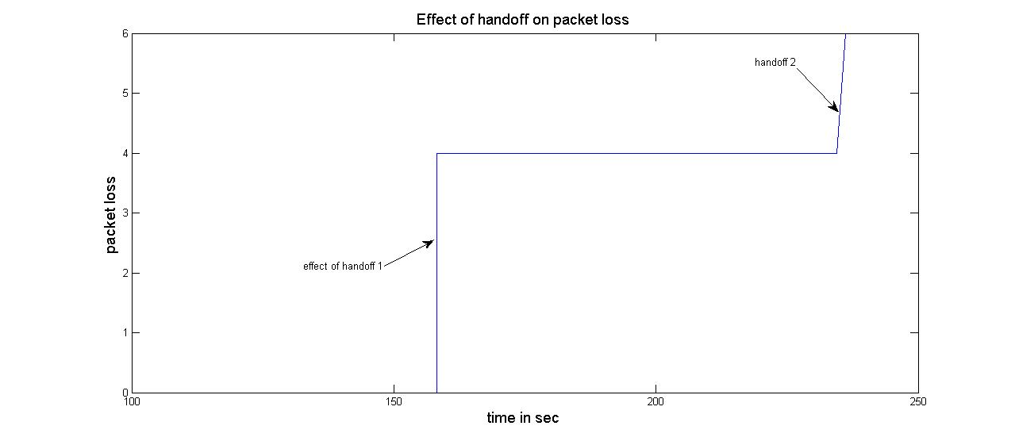

Figure: 5.36: Effect of handoff on packet loss.

From the Figures 5.35 to 5.36, it is clearly found that how due to handoff latency i.e the time it takes to register from old mobility agent to new mobility agent some packets are lost when it leaves its previous home agent and still not yet the registration process is completed. Since it’s not receiving any data during hand off, the instant throughput drastically falls down. This sort of phenomena can be exhibited by sudden power failure of either sender or the receiver, which is strictly avoided during simulation to get the actual effect of hand-off.

5.4 Simulating the proposed AAUDP:
In the second simulation we have seen how TCP suffers in presence of aggressive UDP data transfer and also found that that the draw back of UDP of loosing packets and not retrieving it back. So I presented a new protocol empowered by the aggressive nature of UDP and capability of retrieving the lost packet like TCP named as Acknowledgement augmented UDP (AAUDP). The next simulation is to compare among these three protocols to show the goodness of the newly proposed protocol.

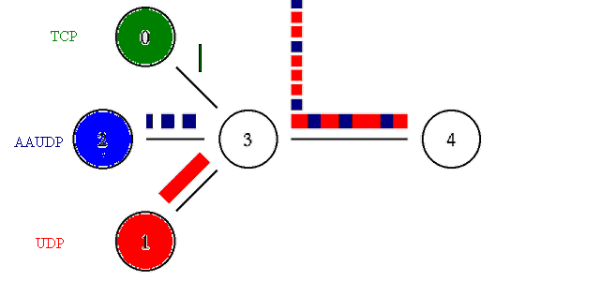
Figure 5.37: The topology for comparing TCP, AAUDP and UDP.

In Figure 5.37, the three sources using TCP, AAUDP and UDP are sending similar data at a different rate over a single bottle-neck link of 1.7mbps capacity. The Green Source and the Blue Source are sending data at the same rate of 3Mbps using TCP and AAUDP respectively. The Red source sends data with a higher rate of 5 Mbps. All the sources started sending simultaneously to compete for the scarce bandwidth.
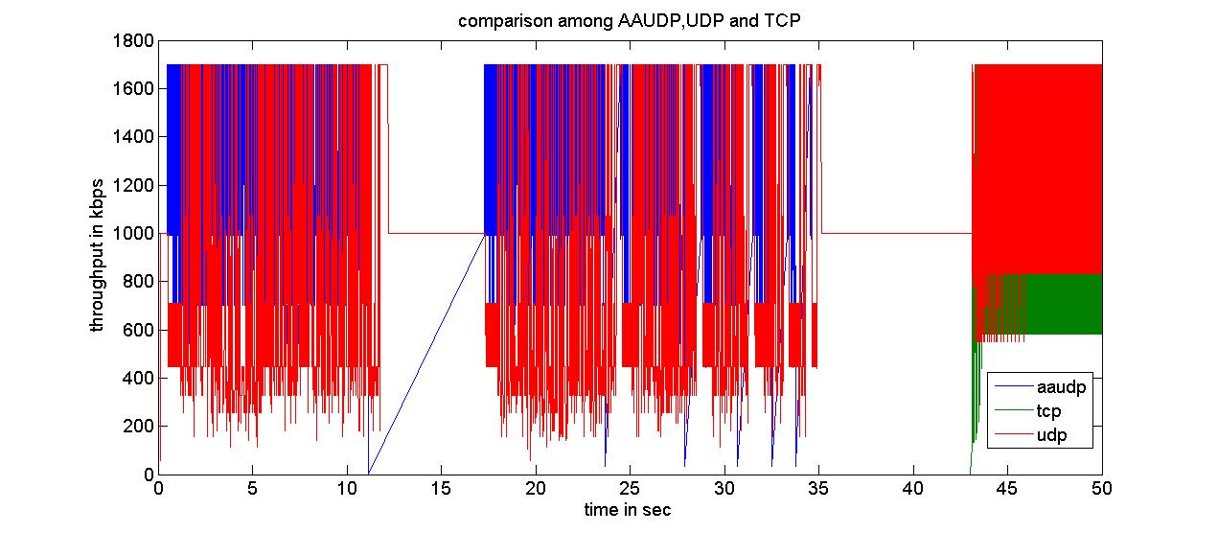
Figure: 5.38: Through put of AAUDP in presence of Aggressive UDP.

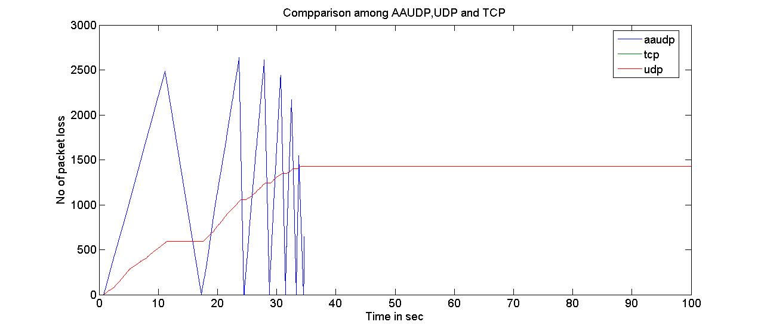
Figure: 5.39: Minimizing Packet loss of AAUDP in presence of Aggressive UDP.

It is evident from Figure 5.38 and 5.39, Although, all the three sources started sending simultaneously, in presence of an aggressive UDP sender, the TCP gets hardly any chance to send data, however the AAUDP, with similar data and sending rate as the TCP, gets a very good throughput as compared to the UDP. After AAUDP ceases data sending then TCP now start sending but with a very low throughput.Then a remarkable improvement in its lost packet recovery is shown. After complete data transfer it starts to resend only the lost data until there is no more lost data to send.

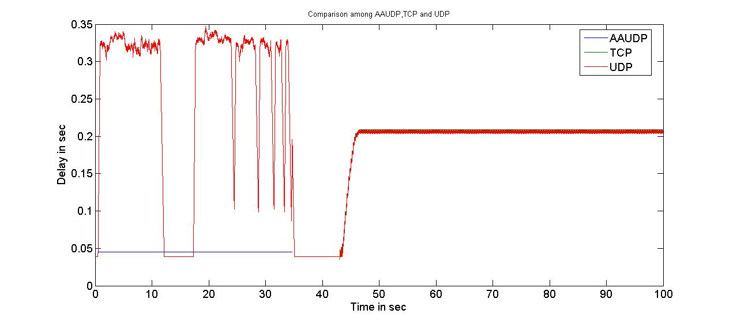
Figure: 5.40: Flat delay of AAUDP in presence of Aggressive UDP.

From figure 5.40, we can easily see that AAUDP maintains a very low and flat delay profile throughout the data transfer showing its elegance.

Chapter Six
Conclusions and Suggestions for Future work

In this chapter, the major contributions of this thesis work are highlighted first. Secondly, the limitations are briefly discussed and finally, the scopes for future developments are suggested also.

6.1 Major Contributions

The major outcome of my thesis work can be broadly subdivided into two groups, which are enumerated below.

1. A network simulator has been developed modifying the NS2 simulator, especially for the evaluation of the QoS parameters.

2. A new protocol has been proposed and implemented to get improved performance over the traditional UDP and TCP protocols.

In developing the modified NS2 simulator, the main consideration was to get a well formatted out and visual representation without any post-processing. In doing so two new agents are added with the existing NS2 structure and also the packet format is also modified to facilitate the work of the agents, which is discussed in details in chapter 3.

The newly devised agents added to NS2, not only facilitate the representation of output data in user-friendly format, but also reduce the total simulation time and memory consumptions.

Furthermore, the two agents are powerful enough to measure the QoS based performance of any TCP/IP network irrespective of the type of data it would handle. With a very little knowledge in the output format of NS2 any network researcher can get the desired output, which is also very easy to understand.

Finally, a new protocol Acknowledgement augmented UDP (AAUDP) is proposed to get a better throughput like UDP based applications enhanced with the error correcting features like TCP. The goodness of both UDP and TCP is integrated together in this protocol. It is discussed elaborately with its analytical model in chapter 4.

The improvement in performance in comparison with the existing traditional TCP and UDP is verified using the modified NS2 simulator. The results found prove that the AAUDP is outperforming elegantly both its predecessors’ (TCP and UDP) performance. The simulation results are presented in section 5.4 of chapter 5.

6.2 Improvement in performance

All the simulated scenarios could be also generated and evaluated with the existing NS2 simulator, after a lot of post-processing, however with a different representation. Non the less, the improvement in the modified simulator is that it works comparatively faster consuming much less memory space and provides formatted output without any post-processing.
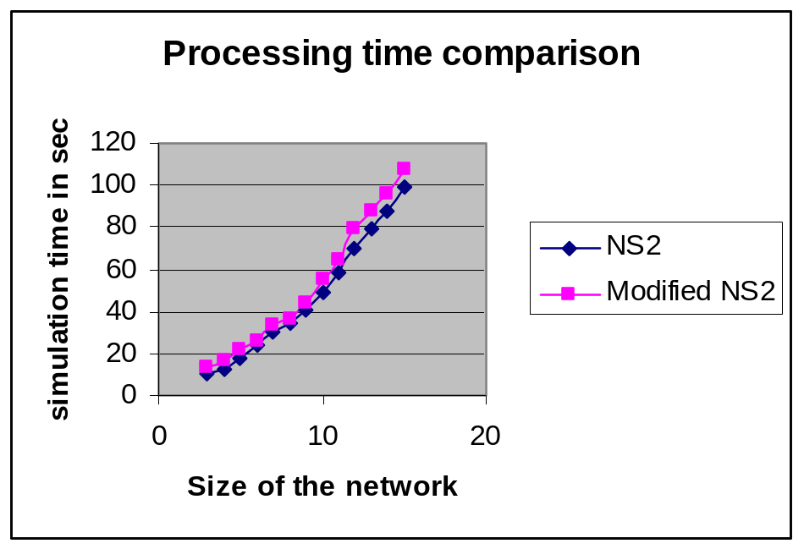

Figure 6.1: Comparison of simulation times of the NS2 and modified NS2.
Form the curve of Figure 6.1; it is evident that the modified NS2 takes slightly longer simulation time. The post-processing time required for both will be investigated next.
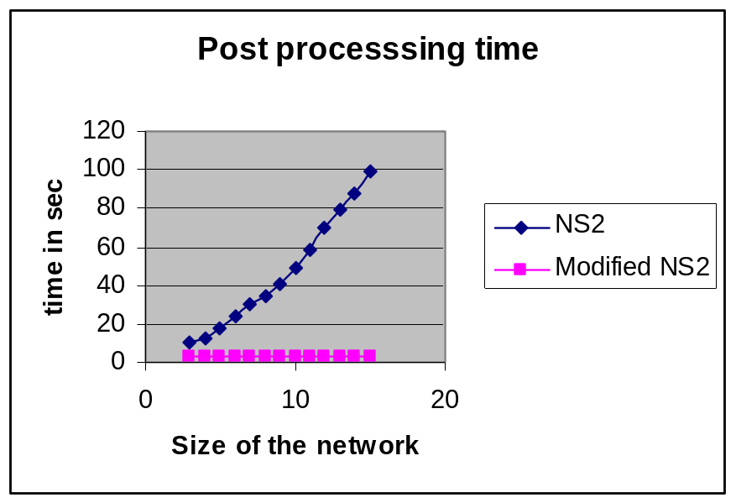

Figure 6.2: Comparison of post-processing times of the NS2 and modified NS2.

It is now clear that modified version of NS2 is very elegant considering its saving in post processing time from Figure 6.2.If we now consider the total time altogether, the comparison would seen as follows as shown in Figure 6.3
Total time requirement
0
50
100
150
200
250
0
10
20
Size of the nodes
Time
in
sec
NS2
Modified NS2

Figure 6.3: Comparison of Total processing times of the NS2 and modified NS2.

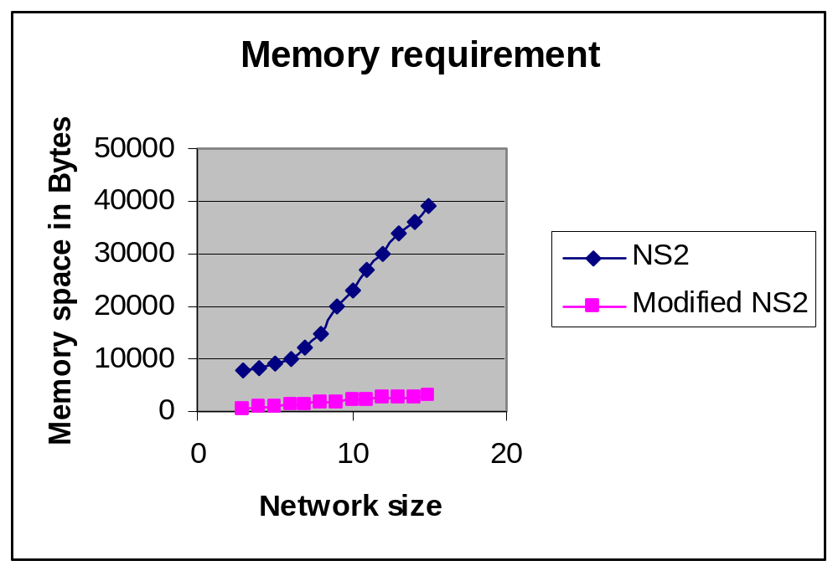

Figure 6.4: Comparison of memory req. by the NS2 and Modified NS2 simulators.

Looking at the memory requirements of both the simulator, as found in Figure 3.7.4, it is
clear that the memory requirement of the modified NS2 is also very low. Therefore it is evident that the modified version of NS2 is outperforming the performance of the existing version of NS2.

The modified structure of NS2 provides advantages especially for computing of the QoS related calculations in the network, and it is especially designed for TCP/IP based networks. Moreover, it is concerned with the layer three packets only. So it is at its first stage of evolution and it is highly centralized on QoS related issues of TCP/IP networks. The total Installation process is still a bit cumbersome and lengthy.

6.3 Limitations

The modified structure of NS2 provides advantages especially for computing of the QoS related calculations in the network, and it is especially designed for TCP/IP based networks. Moreover, it is concerned with the layer three packets only. So it is at its first stage of evolution and it is highly centralized on QoS related issues of TCP/IP networks. The total Installation process is still a bit cumbersome and lengthy.

6.4 Future Scopes

The future work plan is to extend the capabilities of the proposed modified simulator so that it can be used for all types network and can handle packets of different layers also. Also, the ultimate aim would be to handle any number of flows and any size of network.

To facilitate the installation process and to use with any existing version of NS2.27 or above, an easy to use patch file may be developed.

In addition, a more user friendly input scheme, using a GUI, may be developed for ease of the simulation.

References

[1] T. Issariyakul and E. Hossain, “Introduction to Network Simulator NS2”, 1st edition. Springer, 2008.

[2] "The Network Simulator - ns-2", http://www.isi.edu/nsnam/ns/, accessed at October, 2007.
.
[3] Ray Hunt, ”IP Quality of Service Architectures”, IEEE 2001, pp. 338-343, June 2001.

[4] A. S. Tanenbaum, “Computer Networks ”, 4th edition, Prentice_Hall,1998.

[5] C. Metz, ”IP QoS: Traveling in First Class on the Internet.,” IEEE Internet Computing, vol. 3, no. 2, pp 84-88 ,March-April, 1999.

[6] S. Shenker and J. Wroclawski, ”General characterization Parameters for Integrated
Service Network Elements,” RFC 2215 (proposed standard) IETF Sep. 1997.

[7] M. Moshin, W. Wong and Y. Bhatt, “Support for real-time traffic in the Internet and QoS issues,” IEEE Internet computing, March 30, 2002.

[8] S. Giordano, S. Salsano, G. Ventre and D. Giannakopoulso, “Advanced QoS provisioning in IP Networks: The Europian Premium Projects,” IEEE Communication Magazine, pp. 30-36, Jan. 2003.

[9] E. B. Fgee, J. D. Kenney . J. Phoillips, W. Robertson and S. Sivakumar, “ Comparison of QoS performance between IPv6 QoS management model and IntServ and DiffServ QoS models”. IEEE Proceedings of the 3rd Annual Communication Networks and Services Research Conference, Jan 2005.

[10] A. Umair Salleh, Z. Ishak , N. Md. Din, Md Z. Jamaludin ,”A trace Analyzer for NS2”, IEEE 4th Student Conference on Research and Development (SCOReD 2006), 27-28 June, 2006.
[11] J. Malek, K. Nowak, “ Trace Graph – Data Presentation System for NS-2 ” ISAT 2003.
[12] G. Wang and Y. Xia, An NS2 TCP Evaluation Tool, NEC lab China, April, 2007.

[13] "Nam: Network Animator", http://www.isi.edu/nsnam/nam/, accessed at October, 2007.
[14] jTrana- A java based NS2 trace file analyzer. https://sourceforge.net/projects/jtrana/,
accessed at April, 2007.

[15] Kevin fall, Kannan Varadhan. “The NS Manual”, The VINT project, March, 2008.

[16] www.cabmphandbooks.com/Documents/Construction/NS-2.pdf, accessed at Feb, 2007.

[17] http://www.scribd.com/doc/6505211/Introduction-NS2-Simulator, accessed at Oct, 2007.

[18] www.cs.virginia.edu/~cs757/slidespdf/cs757-ns2-tutorial&21.pdf, accessed at Feb, 2007.

[19] Jae Chung and Mark Claypool, “NS by Example”, Worcester Polytechnic Institute.
http://nile.wpi.edu/NS , accessed at Feb 2007.

[20] www.cs.uc.edu/~dpa/courses/Spring2008/tutorial%20(ns).pdf, accessed at April, 2007.
[21] www.ece.utk.edu/~xwang/ece692/nstutorial.pdf, accessed at Feb, 2007.

[22] NS-2 Trace Formats, http://nsnam.isi.edu/nsnam/index.php/NS-2_Trace_Formats. accessed at Feb, 2008.

[23] Yi Lu,” Report for CS641 Project”, Department of Computer Sciences, Purdue University, December 9, 2002 .

[24] http://ds.informatik.rwth-aachen.de/publications/2009/pdfs/icc-submission.pdf.
accessed at Feb, 2007.

[25] http://portal.acm.org/citation.cfm?id=1454630.1454639. accessed at July, 2007.

[26] Marc Greis's tutorial, http://www.isi.edu/nsnam/NS/tutorial/index.html. accessed at Feb, 2007.

[27] P. Novák. “Simulation of network structures”. Master's thesis, Department of software Engineering, Charles University in Prague, August 2006.

[28] B. Schilling. “Qualitative comparison of network simulation tools”. Technical report, Institute of Parallel and Distributed Systems (IPVS), University of Stuttgart, January 2005.

[29] F. A. Sekib, S. McClellan, M. Singh and S. Hakravarthy, “ End to End Testing of IP QoS Mechanisms”, IEEE Communication Magazine, pp.-30-36. Jan 2002.

[30] NS2 trace2stats, http://www.reti.polito.it/fiore, accessed at Feb, 2007.

[31] Braden, R., "Transaction TCP -- Concepts", RFC-1379, USC/Information Sciences Institute, September 1992.

[32] Dalal, Y. and C. Sunshine, "Connection Management in Transport Protocols", Computer Networks, Vol. 2, No. 6, pp. 454-473, December 1978.
[33] J. Walrand and P. Variya, “High-Performance Communication Networks”, Morgan Kaufmann Publishers, San Francisco, California 2000.

[34] J.R. karim, M. L. bari., “Behavior of TCP in an over congested link”, ACM communications mag, vol. 14, no. 2, pp. 556-582, 1976.

[35] J-C. Bolot, End-to-end Packet Delay and Loss Behavior in the Internet, In Proc. ACM SIGCOMM93, pp. 289-298, September 1993.

[36] M. S. Rahman, M. N. Ahsan and M. A. Abedin, “Modified UDP for Reliable Data Transmission Through a Lossy Communication Link”, Proceedings of the 2nd International conference, The Institution of Engineers, Bangladesh, 0ct 2002.

Appendix A: Installation and Usage
The Installation process can be subdivided in the following manner
  - Modification of packet header.
  - Initialization of
    - QoS Monitors.
    - AAUDP.
  - Making.
a.) Modification of Packet Header:
To modify the packet header of the existing NS2 and to add two new fields packet ID (pkt_ID_) and the send time (sendtime_) we have to update the packet.h files in ~ns-2.xx/common as followos:
:
struct hdr_cmn {
enum dir_t { DOWN= -1, NONE= 0, UP= 1 };
packet_t ptype_; // packet type
:
dir_t direction_; // direction: 0=none, 1=up, -1=down
double sendtime_;
unsigned long int pkt_ID_;
:
inline double& sendtime() { return (sendtime_); }
b) Initialization :
we have to first copy all the source files to appropriate directory as followos
a) TCP-qos-monitor.cc and ~.h along with qos-monitor.cc and its headerfiles are copied in tools folder.
b) the existing UDP.cc and UDP.h in apps folder should be replaced by the UDP.cc and its associated header provided with the package.
c) all the six C++ files:app-rd.h, app-rd.cc, app-rc.h, app-rc.cc, aaudp.h and aaudp.cc; should be copied in aaudp folder.

Different destinations can be used also but there must be appropriate update in makefile
1)To initialize different parameters of the two QoS monitoring Agents we have to update only the following values in the ns-default.tcl file in ~ns-2.xx/tcl/lib as followos:
For TCPQosMonitor
Agent/TCPQosMonitor set sport_ 0
Agent/TCPQosMonitor set dport_ 0
#XXX other kinds of sinks -> should reparent
Agent/TCPQosMonitor set packetSize_ 40
Agent/TCPQosMonitor set maxSackBlocks_ 3
Agent/TCPQosMonitor set ts_echo_bugfix_ false
Agent/TCPQosMonitor set generateDSacks_ false
Agent/TCPQosMonitor set qs_enabled_ false
Agent/TCPQosMonitor set RFC2581_immediate_ack_ true
Agent/TCPQosMonitor set bytes_ 0
Agent/TCPQosMonitor set recvbytes_ 0
Agent/TCPQosMonitor set nlost_ 0
Agent/TCPQosMonitor set ndup_ 0
Agent/TCPQosMonitor set expected_ -1
Agent/TCPQosMonitor set npkts_ 0
Agent/TCPQosMonitor set seqno_ 0
Agent/TCPQosMonitor set lastPktTime_ 0.0
Agent/TCPQosMonitor set pkt_ID 0
Agent/TCPQosMonitor set send_time 0
Agent/TCPQosMonitor set max_flow_ 0
Agent/TCPQosMonitor set lastseqno 0
Agent/TCPQosMonitor set delay1 0.0
Agent/TCPQosMonitor set delay 0.0
Agent/TCPQosMonitor set delay_diff 0.0
Agent/TCPQosMonitor set jitter 0.0
Agent/TCPQosMonitor set pktseqno_ 0
Agent/TCPQosMonitor set tp 0.0
Agent/TCPQosMonitor set precv_time 0.0
Agent/TCPQosMonitor set obytes 0
and For qosMonitor
Agent/qosMonitor set nlost_ 0
Agent/qosMonitor set npkts_ 0
Agent/qosMonitor set bytes_ 0
Agent/qosMonitor set lastPktTime_ 0
Agent/qosMonitor set expected_ 0
Agent/qosMonitor set firstPktTime_ 0
Agent/qosMonitor set first_ 0
Agent/qosMonitor set sendtime_ 0
Agent/qosMonitor set pkt_ID_ 0
Agent/qosMonitor set seqno_ 0
Agent/qosMonitor set tp 0.0
Agent/qosMonitor set precv_time 0.0
Agent/qosMonitor set obytes 0
Agent/qosMonitor set max_flow_ 0
Agent/qosMonitor set lastseqno 0
Agent/qosMonitor set delay1 0.0
Agent/qosMonitor set delay 0.0
Agent/qosMonitor set delay_diff 0.0
Agent/qosMonitor set jitter 0.0
Agent/qosMonitor set seqno_ 0

Then save necessary changes.
2) To initialize AAUDP we have to do following things:

The necessary changes to the existing files are listed as follows:

1).Edit ./common/packet.h file
a.Insert PT_RD into the function enum packets in this way:
enum packets
{ ¡
PT_RD
¡}
b.Add the following line to class p_info{}:
Class p_info
{¡
name_[PT_RD] = aaudp //aaudp is the name appearing in the trace file
¡}

2).Edit ./tcl/lib/ns-packet.tcl
Insert the following line in the function for each prot {}
For each prot
{
aaudpData //Header name defined in the static class aaudpDataHeaderClass
¡}
3).Edit ./tcl/lib/ns-default.tcl file
Set default values in this file: Application/AppRd set snd_rate_, pktsize_ and payload_.

4).Edit ns-process.h file
Add packet type such as RD_PKT, RC_NOE and RC_END

C. Making:

First we have to update the OBJ_CC of Makefile as followos:

tools/qos-monitor.o tools/TCP-qos-monitor.o \
aaudp/app-rd.o aaudp/app-rc.o aaudp/aaudp.o \

Where tools and aaudp are the directory where the C++ source files exist.

Then we have execute following commands

1) make clean 2) make

Now after Success Full Installation the user can use the newly installed agents in following manner:

How to use the QoS monitoring Agents:
--------------------------------------------------------------------------------------------------------

1. flow ID (fid_ ) should be 1,2,3..etc
2. It should be defined for each flow initiated by TCP or UDP agent

as example:

set TCP_($i) [new Agent/TCP]
$TCP_($i) set fid_ $i

or

set udp1 [new Agent/UDP]
$udp1 set fid_ 1

3. for each qosMonitor or TCPQosMonitor

must define max_flow_ = highest fid_

4.These two agents will generate following files

a)*_qos_tr
b)*_loss_fidi.xg
c)*_jit_fidi.xg
d)*_delay_fidi.xg
e)*_tp_fidi.xg

* means TCP/UDP

5 *.xg files can b plotted using xgraph so to get the graphical output directly we can use following commands as example

exec xgraph UDP_delay_fid1.xg UDP_delay_fid2.xg -geometry 800x400 &

exec xgraph UDP_loss_fid1.xg UDP_loss_fid2.xg -geometry 800x400 &

exec xgraph UDP_jitter_fid1.xg UDP_jitter_fid2.xg -geometry 800x400 &

exec xgraph UDP_tp_fid1.xg UDP_tp_fid2.xg -geometry 800x400 &

6.it is better to add following line also.
exec rm -f *_qos_tr

Appendix B: Sample Scripts

Two example scripts is provided for better understanding and implementations

- In a hybrid network with mobile IP enabled
- Comparison of AAUDP,TCP and UDP

# simulation of a wired-cum-wireless topology running with mobileIP
#======================================================================
# Define options
#======================================================================

set opt(chan) Channel/WirelessChannel ;# channel type
set opt(prop) Propagation/TwoRayGround ;# radio-propagation model
set opt(netif) Phy/WirelessPhy ;# network interface type
set opt(mac) Mac/802_11 ;# MAC type
set opt(ifq) Queue/DropTail/PriQueue ;# interface queue type
set opt(ll) LL ;# link layer type
set opt(ant) Antenna/OmniAntenna ;# antenna model
set opt(ifqlen) 50 ;# max packet in ifq
set opt(nn) 1 ;# number of mobilenodes
set opt(adhocRouting) DSDV ;# routing protocol

set opt(cp) "" ;# cp file not used
set opt(sc) "" ;# node movement file.

set opt(x) 670 ;# x coordinate of topology
set opt(y) 670 ;# y coordinate of topology
set opt(seed) 0.0 ;# random seed
set opt(stop) 250 ;# time to stop simulation

set opt(ftp1-start) 100.0

set num_wired_nodes 2

# =====================================================================

# check for boundary parameters and random seed
if { $opt(x) == 0 || $opt(y) == 0 } {
puts "No X-Y boundary values given for wireless topology\n"
}
if {$opt(seed) > 0} {
puts "Seeding Random number generator with $opt(seed)\n"
ns-random $opt(seed)
}

# create simulator instance
set ns_ [new Simulator]
# set up for hierarchical routing
$ns_ node-config -addressType hierarchical

AddrParams set domain_num_ 3 ;# number of domains
lappend cluster_num 2 1 1 ;# number of clusters in each domain
AddrParams set cluster_num_ $cluster_num
lappend eilastlevel 1 1 2 1 ;# number of nodes in each cluster
AddrParams set nodes_num_ $eilastlevel ;# of each domain

set tracefd [open wlq-out.tr w]
set namtrace [open wlq-out.nam w]
$ns_ trace-all $tracefd
$ns_ namtrace-all-wireless $namtrace $opt(x) $opt(y)

# Create topography object
set topo [new Topography]

# define topology
$topo load_flatgrid $opt(x) $opt(y)

# create God
# 2 for HA and FA
create-god [expr $opt(nn) + 2]

#create wired nodes
set temp {0.0.0 0.1.0} ;# hierarchical addresses
for {set i 0} {$i < $num_wired_nodes} {incr i} {
set W($i) [$ns_ node [lindex $temp $i]]
}

# Configure for ForeignAgent and HomeAgent nodes
$ns_ node-config -mobileIP ON \
-adhocRouting $opt(adhocRouting) \
-llType $opt(ll) \
-macType $opt(mac) \
-ifqType $opt(ifq) \
-ifqLen $opt(ifqlen) \
-antType $opt(ant) \
-propType $opt(prop) \
-phyType $opt(netif) \
-channelType $opt(chan) \
-topoInstance $topo \
-wiredRouting ON \
-agentTrace ON \
-routerTrace OFF \
-macTrace OFF

# Create HA and FA
set HA [$ns_ node 1.0.0]
set FA [$ns_ node 2.0.0]
$HA random-motion 0
$FA random-motion 0

# Position (fixed) for base-station nodes (HA & FA).
$HA set X_ 1.000000000000
$HA set Y_ 2.000000000000
$HA set Z_ 0.000000000000

$FA set X_ 650.000000000000
$FA set Y_ 600.000000000000
$FA set Z_ 0.000000000000

# create a mobilenode that would be moving between HA and FA.
# note address of MH indicates its in the same domain as HA.
$ns_ node-config -wiredRouting OFF

set MH [$ns_ node 1.0.1]
set node_(0) $MH
set HAaddress [AddrParams addr2id [$HA node-addr]]
[$MH set regagent_] set home_agent_ $HAaddress

# movement of the MH
$MH set Z_ 0.000000000000
$MH set Y_ 2.000000000000
$MH set X_ 2.000000000000

# MH starts to move towards FA
$ns_ at 100.000000000000 "$MH setdest 640.000000000000 610.000000000000 20.000000000000"
# goes back to HA
$ns_ at 200.000000000000 "$MH setdest 2.000000000000 2.000000000000 20.000000000000"

# create links between wired and BaseStation nodes
$ns_ duplex-link $W(0) $W(1) 5Mb 2ms DropTail
$ns_ duplex-link $W(1) $HA 5Mb 2ms DropTail
$ns_ duplex-link $W(1) $FA 5Mb 2ms DropTail

$ns_ duplex-link-op $W(0) $W(1) orient down
$ns_ duplex-link-op $W(1) $HA orient left-down
$ns_ duplex-link-op $W(1) $FA orient right-down

# setup TCP connections between a wired node and the MobileHost
set sink1 [new Agent/TCPQosMonitor]
$sink1 set max_flow_ 2

set tcp1 [new Agent/TCP]
$tcp1 set fid_ 1
puts "test1"
puts "test2"
$ns_ attach-agent $W(0) $tcp1
$ns_ attach-agent $MH $sink1
$ns_ connect $tcp1 $sink1
set ftp1 [new Application/FTP]
$ftp1 attach-agent $tcp1
$ns_ at $opt(ftp1-start) "$ftp1 start"

# source connection-pattern and node-movement scripts
if { $opt(cp) == "" } {
puts "*** NOTE: no connection pattern specified."
set opt(cp) "none"
} else {
puts "Loading connection pattern..."
source $opt(cp)
}
if { $opt(sc) == "" } {
puts "*** NOTE: no scenario file specified."
set opt(sc) "none"
} else {
puts "Loading scenario file..."
source $opt(sc)
puts "Load complete..."
}

# Define initial node position in nam

for {set i 0} {$i < $opt(nn)} {incr i} {

# 20 defines the node size in nam, must adjust it according to your
# scenario
# The function must be called after mobility model is defined

$ns_ initial_node_pos $node_($i) 20
}

# Tell all nodes when the siulation ends
for {set i 0} {$i < $opt(nn) } {incr i} {
$ns_ at $opt(stop).0 "$node_($i) reset";
}
$ns_ at $opt(stop).0 "$HA reset";
$ns_ at $opt(stop).0 "$FA reset";

$ns_ at $opt(stop).0002 "puts \"ns EXITING...\" ; $ns_ halt"
$ns_ at $opt(stop).0001 "stop"
proc stop {} {
global ns_ tracefd namtrace
close $tracefd
close $namtrace
}

# some useful headers for tracefile
puts $tracefd "M 0.0 nn $opt(nn) x $opt(x) y $opt(y) rp \
$opt(adhocRouting)"
puts $tracefd "M 0.0 sc $opt(sc) cp $opt(cp) seed $opt(seed)"
puts $tracefd "M 0.0 prop $opt(prop) ant $opt(ant)"

puts "Starting Simulation..."
$ns_ run

# Comparison of AAUDP,TCP and UDP protocol in a wired environment

#Create a simulator object
set ns [new Simulator]

#define parameters
set PAYLOAD 4000000

set SND_RATE 3000000
set PKT_SIZE 1400

#Application/AppRd set payload_ $PAYLOAD
#Application/AppRd set snd_rate_ $SND_RATE
#Application/AppRd set pktsize_ $PKT_SIZE

#Define different colors for data flows
$ns color 1 Blue
$ns color 2 Red

#Open the NAM trace fine
set nf [open out2.nam w]
$ns namtrace-all $nf

set f0 [open tcp1.tr w]
set f1 [open udp1.tr w]
set f2 [open udpr.tr w]

set f [open out2.tr w]
$ns trace-all $f

#Define finish procedure
proc finish {} {
global ns nf f
global app_rd_s
$ns flush-trace

close $nf

#execute NAM on trace file
#exec nam out2.nam &
exit 0

}

#Create 2 nodes
set n0 [$ns node]
set n1 [$ns node]

set n1a [$ns node]
set n2 [$ns node]
set n3 [$ns node]

#Create links between the nodes
$ns duplex-link $n0 $n2 2Mb 10ms DropTail
$ns duplex-link $n1 $n2 2Mb 10ms DropTail
$ns duplex-link $n1a $n2 2Mb 10ms DropTail

$ns duplex-link $n2 $n3 1.7Mb 20ms DropTail

#Set Queue Size of link (n2-n3) to 10
#$ns queue-limit $n2 $n3 10

#Give node position (for NAM)
$ns duplex-link-op $n0 $n2 orient right-down
$ns duplex-link-op $n1 $n2 orient right-up
$ns duplex-link-op $n1a $n2 orient right

$ns duplex-link-op $n2 $n3 orient right

#Monitor the queue for link (n2-n3). (for NAM)
$ns duplex-link-op $n2 $n3 queuePos 0.5

#Setup a TCP connection
set TCP [new Agent/TCP]
#$TCP set class_ 2
$ns attach-agent $n0 $TCP
set sink [new Agent/TCPQosMonitor]
$sink set max_flow_ 2

$ns attach-agent $n3 $sink
$ns connect $TCP $sink
$TCP set fid_ 1

#Setup a FTP over TCP connection
set ftp [new Application/FTP]
$ftp attach-agent $TCP
$ftp set type_ FTP

#Setup a UDP connection
set UDP [new Agent/UDP]
$ns attach-agent $n1 $UDP
set null [new Agent/qosMonitor]
$null set max_flow_ 2
$ns attach-agent $n3 $null
$ns connect $UDP $null
$UDP set fid_ 2

#Setup a CBR over UDP connection
set cbr [new Application/Traffic/CBR]
$cbr attach-agent $UDP
$cbr set type_ CBR
$cbr set packet_size_ 1000
$cbr set rate_ 5000000
$cbr set random_ false

#Schedule events for the CBR and FTP agents
$ns at 0.1 "$cbr start"
$ns at 1.0 "$ftp start"
$ns at 100.0 "$ftp stop"
$ns at 100.15 "$cbr stop"

#Detach TCP and sink agents (not really necessary)
#$ns at 4.5 "$ns detach-agent $n0 $TCP; $ns detach-agent $n3 $sink"

#setup a UDPRD connections
set UDP_s [new Agent/aaudp]
set UDP_r [new Agent/aaudp]
set UDP_r [new Agent/qosMonitor]

$UDP_r set max_flow_ 4

$ns attach-agent $n1a $UDP_s
$ns attach-agent $n3 $UDP_r
$ns connect $UDP_s $UDP_r

$UDP_s set packetSize_ $PKT_SIZE
$UDP_s set fid_ 3
$UDP_r set packetSize_ $PKT_SIZE
$UDP_r set fid_ 3

#setup a RBUDP Data Application
set app_rd_s [new Application/AppRd]
set app_rd_r [new Application/AppRd]
$app_rd_s attach-agent $UDP_s
$app_rd_r attach-agent $UDP_r

#Setup a TCP application
set tcp0 [new Agent/TCP/FullTcp] ;#Create agent
set tcp1 [new Agent/TCP/FullTcp]

$ns attach-agent $n1a $tcp0 ;#bind tcp0 to node n0
$ns attach-agent $n3 $tcp1 ;#bind tcp1 to node n1
$ns connect $tcp0 $tcp1 ;#active connection tcp0 to tcp1

$tcp0 set fid_ 4
$tcp1 set fid_ 5
$tcp1 listen

#setup a RBUDP control application
set app0 [new Application/AppRc $tcp0]
set app1 [new Application/AppRc $tcp1]

$app1 connect $app0

#complete Rd/Rc connection
$UDP_s set-status server
$app_rd_s set-status server
$app0 set-status server
$app_rd_s set-target $app0
$app0 set-target $app_rd_s
$app_rd_r set-target $app1
$app1 set-target $app_rd_r

$app_rd_s set payload_ $PAYLOAD
$app_rd_s set snd_rate_ $SND_RATE
$app_rd_s set pktsize_ $PKT_SIZE
$app_rd_r set payload_ $PAYLOAD
$app_rd_r set snd_rate_ $SND_RATE
$app_rd_r set pktsize_ $PKT_SIZE

#setup transmission parameters
$UDP_s set udprd_hdr_size_ 4

#Initialization
$ns at 0 "$app_rd_s initialize"
$ns at 0 "$app_rd_r initialize"

#schedule events for the RD and RC applications
$ns at 0.5 "$app_rd_r start"
$ns at 0.5 "$app_rd_s start"

#source recsr.tcl
#$ns at 0.0 record

# call the finish procedure
$ns at 100.15 "finish"

#Run the simulation
$ns run

