Internship Report
On

Overall Branch Banking of EXIM Bank Limited

Submitted by

WWW.ASSIGNMENTPOINT.COM

In the world of consumerism, the business organization of the world strive for the consumers satisfaction as a number one business strategy whatever may be the product of the organization, either service or non service. Service is the product of Bank. It is a said that customer service starts right from the stairs of the bank building. The guard at the door is the first person represents the bank, receives a customer with wishes in smiling face.

Rational of the study:

With the rapid growing competition (due to free market economy) among nationalized, foreign and private commercial banks as to how the banks operates its banking operation and how customer service can be made more attractive, the expectation of the customers has immensely increased. Reciprocating the sentiment, commercial/private banks are trying to elevate their traditional banking service to a better standard, to meet the challenging needs, demands. Side by side these banks have now concentrated their attention towards diversification of their products for better performances and existence. For the above circumstances, it has become necessary for Export Import Bank of Bangladesh Limited, one of the leading commercial banks, to focus its attention towards the improvement of the customer service. That's why it is quite justified to make an indepth study about its operation and evaluate the service provided by this bank and scope
for its improvement. The study may help formulating policy regarding the ideas relating
to the feelings of the customers and bankers.

Further more, Export Import Bank of Bangladesh Limited executives who are actually executing the policies undertaken by the top management will have a chance to communicate their feelings and will have the feedback about their dealing from the customers.
Objectives of the Report:
The primary objectives of the report are:
. To submit a report, for the fulfillment of my BBA practical.
. The main objective of this report is to find out the "Overall Branch Banking".
. To gather comprehensive knowledge on overall banking functions and the
expectations of the customers regarding the service level of the bank.
. Identify the factors contributing to the attractive and operative performance of the
local branch of the bank.

. To make a study of the facts in order to arrive at certain conclusion about overall
banking operation.
. Critically analysis the functions and operations of each level of the organization
of Export Import Bank of Bangladesh Limited.
. To prevent current observation and unique aspects of the bank
Scope of the Study:
The scope of this report is to analyze the operation of Export Department and to evaluate the performance of the different departments of Export Import Bank of Bangladesh Limited.

Methodology:

The methodology of the report is stated below, which was appropriately exercised in _ achieving the above stated objective.

Time period of the study:
For the fulfillment of the desired purpose following working days are spend to various department:
EXIM Bank Uttara Branch, House # 61/A, Road # 7, Sector # 4, Uttara Model Town, Uttara, Dhaka - 1230

Sources of Data collection:

The inputs are collected nom two sources:

a) Primary Sources:
Discussion with Bank Officers.
Personal observation.
Desk work in different sections/departments.
b) Secondary Sources:
Annual report of the Bank.
Consultation of related book and publications.
Different Statements.
File, Balance sheet and various documents.
c) Data Processing:
Collected information is processed by the use of computer system. Detailed analysis,
working variables and working definitions are embodied in the report.

Orientation of export import bank of Bangladesh Ltd

The Structure of Modern Banking Systems:

The Banking systems of the world have many similarities, but they also differ, sometimes in quite material respects. The principal differences are in the details of organization and technique efficiency of international communication and the tendency in each country to emulate practices that have been successful elsewhere.

Organizational Overview of EXIM Bank Ltd.:

EXIM Bank Ltd. as the name implies a newly formed commercial bank but is the 1st of its kind in Bangladesh. It has been incorporated in Dhaka, Bangladesh as a public limited

company and its Head Office of the Bank is located at Printers Buildings, 5 Rajuk Avenue, Motijiheel Commercial Area, Dhaka- 1000.

In the world of consumerism the business organization of the world strive for the consumers satisfaction as a number one business strategy whatever may be the product of
the organization, either service or non. service. Service is the product of bank. There is a saying that customer service starts rights right from the stairs of the bank building. The guard at the door is first person pep resents of the bank, receives a customer with wishes in smiling face.

Historical Background of The EXIM Bank Ltd.

EXIM Bank Ltd. was incorporated under the companies Act 1994, on the 2nd June 1999. EXIM Bank Ltd. believes in togetherness with its customers, in its march on the road to growth and progress with service. As a commercial bank we will do all traditional banking business including introduction of a wide rang of savings and credit products, retail banking and ancillary services with the support of modem technology and professional skills.

The Export Import Bank of Bangladesh Ltd. commenced formal commercial banking operation from 3rd August 1999 with the permission of Bangladesh Bank. The sponsors of the Bank are leading business personalities and reputed industrialists.

The Bank has a sound capital base, its Authorized Capital is Tk. 1000.00 Million while its Initial Paid Up Capital is Tk. 225.00 Million subscribed by the sponsors. To solidify its capital base further the paid up capital will raise to Tk. 450.00 Million within a reasonable period by public offering of shares of the Company.

The Bank will be immensely benefited furthermore from the able leadership of the Chairman and the valuable advice and guidance of the Advisor.

Originally the name of the bank was BEXIM Bank of Bangladesh Ltd. Later the management of BEXIM Bank of Bangladesh Ltd. changes the name of the bank to EXIM Bank Ltd. because of the case lodged by Beximco Group of Industries.

The Board of Directors wants to carry out in the management all of this service industry's administration and credit portfolio independent without any undue influence from out side. The board will formulate policy and give policy directives to the Management. The bank will operate with integrity, competence and farsightedness abiding by all principles and provisions laid down in the Bank. Company Act, 1991.

EXIM Bank Ltd. will endeavor it's best in consolidating this sector in helping growth and development of the backward linkage industries. With continuous dependence on the imported raw materials, the country's RMG sector might find base when the global apparel trade will be wide open in 2005 with the end of multi Fiber arrangements. Development of composite textile sector may be helpful to get out of this problem. Therefore the EXIM Bank will lead its mite of the development of this vital sector.

Objectives of EXIM Bank Ltd.

Bangladesh is now an integral part of global market. As such there is an urgent requirement for Bangladesh to place the Overall Branch Banking of a free market economy by following international banking customs, practices and standards. Today clients of a bank in Bangladesh are exposed as well as to international markets. They have to stay update with their practice and standards to meet the demands of achieving harmony in the high standards of a free economy.
EXIM Bank Ltd. fully appreciates the importance and implication of the rapidly emerging competition in the banking and finance sector of Bangladesh. It intends financing its customer suited to his or her place in the market. In this regards EXIM Bank Ltd. emphasizes in its employment the software aspects of human resource capability.

Mission of EXIM Bank Ltd.

The EXIM Bank Ltd. has completed its successful existence on its career. And now it has taken a revolution of it's business operation in year 2001 searching for incremental improvement in productivity, operational efficiency and structure consequently, a new organization structure has been developing according to business focus and priorities and competitive pressures.

Performance of EXIM Bank Limited.

The business of banking consists of borrowing and lending. As in other businesses, operational must be based on capital but banks employ comparatively small of their own capital in relation to the total volume of their transaction. The purpose of capital an reserve accounts is primary to provide an ultimate cover against losses on loans and investments.

In Bangladesh, there are many types of Banks, which are formed as commercial banks. But above all, EX 1M Bank of Bangladesh Limited is a new generation of private
commercial bank. The full abbreviation of EXIM Bank Ltd. is Export Import Bank of Bangladesh Limited.

The bank has got leading personalities businessmen and reputed industrialist as its sponsors. The bank will be immensely benefited from the valuable advice of the experienced sponsors of the bank. The late chairman of the bank contributed much for the sofid foundation of the bank at the initial stage. Unfortunately his untimely death caused a vacuum in the leadership of the bank. But within the shortest possible time, the sponsors who in a position to select the next chairman of the bank.

In year 2000 EXIM Bank Ltd. made commendable in all business arenas like Deposit, Credit, Fund Management, Investment and Foreign Exchange related business. The Bank achieved satisfactory progress in all areas of its operation and earned an operating profit fork. 99.67 Million.

Performance of EXIM Bank At A Glance:

SL# | Particular |  | 1003 | 1001
J. | Total Capital |  | 748,274,077.00 | 551,331,921.00
2. | Paid- Up- Capital |  | 313,875,000.00 | 253,125,000.00
3. | Surplus/ (short Julie) of capital |  | (210,651,066.00) | 56,000.00
4. | Total Deposits . |  | 15,242,968,405.00 | 9,945,226,532.00
5. | Total Assets |  | 17,888,657,386.00 | 11,374,702,415.00
6. | Total Loans & advances |  | 12,289,120,176.00 | 7,954,562,036.00
7. | Total contingent liabilities &  commitments | & | 7,897,561,970.00 | 4,610,218,243.00
8. | Ratio on loans and deposits |  | 80.62% | 79.98%
9. | Profit after tax and provisions |  | 254,792,156.00 | 201,422,785.00
10. | Cost of fund |  | 9.26% | 9.29%
IJ. | Interest earning assets |  | 15,789,60 I ,428.00 | 10,095,448,919.00
12. | Non-interest bearing assets |  | 2,009,055,958.00 | 1,279,253,496.00
13. | Return on investment |  | 5.52% | 5.40%
14. | Return on asset |  | 3.1 5% | 3.40%
15. | Income on investment |  | 131,205,650.00 | 76.590,599.00
16. | Earning per share |  | 69.20 | 79.14
17. | Profit per share |  | 69.20 | 79.14
Figure 1: Performance of Export Import Bank of Bangladesh Limited.
{Source of Data: Annual Report 2003]

Capital:

The Authorized Capital of EXIM Bank Ltd. is Tk. 1000:00 Million and the initial paidUp- Capital of the Bank is Tk. 225.00 Million. It may be mentioned here that the reserve funds of total Tk. 40.24 Million include satisfactory reserve of Tk. 16.04 Million, Retained Earning Tk. 0.59 Million, Exchange Equalization fund of Tk. 2.11 Million and 1 % General provision of Tk. 21.50 Million made for the unclassified loans, which are also available for determination of capital adequacy requirements of the Bank

Deposits:

The total deposit of the Bank, which includes Bills Payable of Tk. 30.24 million rose to Tk. 3934.47 million as on December 31,2001 showing a substantial increase of more than 192.60 % compared to that of last year which enabled the Bank to expand its Business and improve upon the profit position.

Name | Amount | Amount
Deposit | 3863.09 | 3863091367
BIP | 30.24 | 30240359
Interest Payable | 41.14 | 41141361
Total Deposit | 3934.47 | 3934473087

Deposit Mix In EXIM Bank Ltd.

In Million
Name | Amount | Amount
CD | 117.29 | 117288177
SB | 122.29 | 122291245
STD | 373.00 | 372998080
FDR | 2250.39 | 2250393985
BCD | 174.16 | 174155006
CALL | 580.00 | 580000000
SUNDRY | 147.82 | 147822425
SCHEMES | 90.10 | 90103246
F.C | 8.03 | 8028903
OTHER | 71.39 | 71392020
TOTAL | 3934.47 | 3934473087

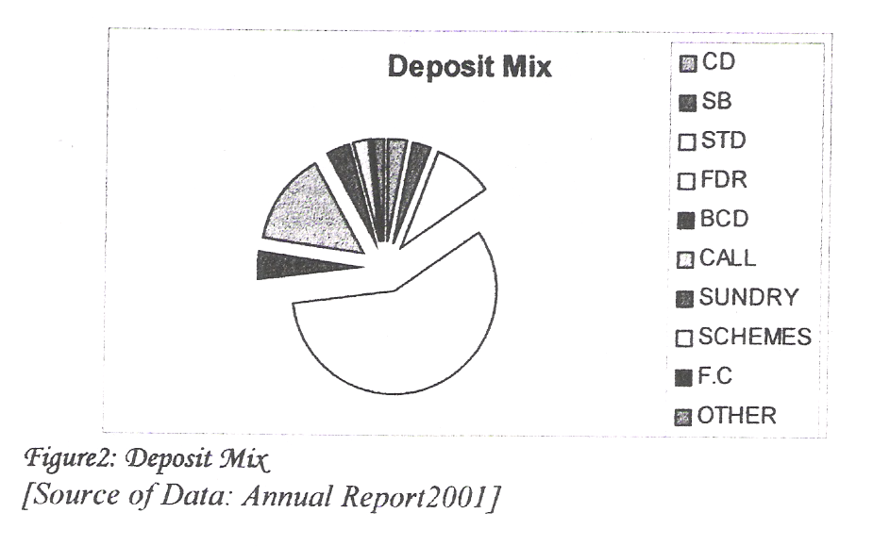

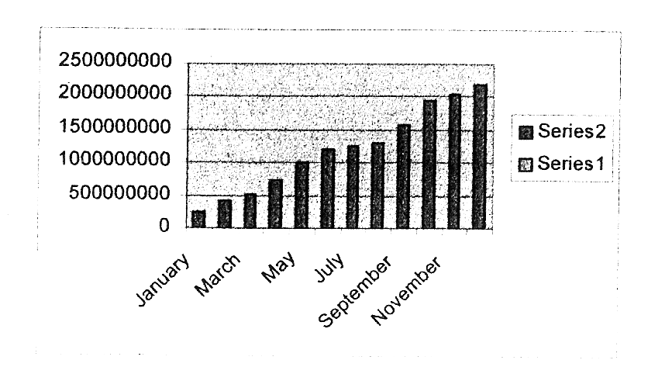

Loans and Advance In EXIM Bank Ltd.:
The total Loans and Advances of the EXIM Bank Ltd. stood at Tk. 2170.53 million as on December ~ I, 2003 against Tk. 233.78 million of last year. During the year WIder review, the bank extended loans and advances Tk. 1936.76 million for domestic and international trade as well as to project finance and working capital. Due to liberal credit to export sector, the Bank was able to handle larger volume of Foreign Exchange Business. The EXIM Bank Ltd. also extended a number of project finance and Industrial Loans singularly or in syndication with other Banks.
In Million
Month | Amount | Amount
January | 246.45 | 246447696
February | 412.68 | 412683861
March | 526.40 | 526401541
April | 728.30 | 728303656
May | 1014.37 | 101437023]
JWIe | 1194.43 | 1194431152
July | 1248.40 | 1248402266
August | 1302.04 | 1302027538
September | 1578.07 | 1578065107
October | 1941.54 | 1941541521
November | 2022.82 | 2022815598
December | 2170.53 | 2170534855

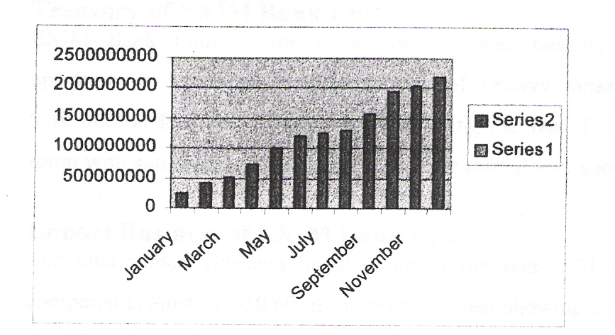

Figure3: Loans and dvance.

[Source olData: Annual Report 2001]

Investments of EXIM Bank Ltd.

The size of Investment portfolio of the Bank as on December 13,200 I stood at TK. 312.59 million against TK. 71.27 million in the previous year recording growth of TK.250.32 million Le.351%. The portfolio comprises of Treasury Bills and Shares.

In Million
Month | Amount | Amount
January | 115 | 115045300
February | 115 | 115047500
March | 115 | 115045800
April | 135 | 135048500
May | 175 | 175069000
June | 195 | 195071700
July | 225 | 225104900
August | 245 | 245226100
September | 295 | 295266800
October | 325 | 325083900
November | 325 | 325301400
December | 345 | 3450551700

[Source of Data: Annual Report 2001]

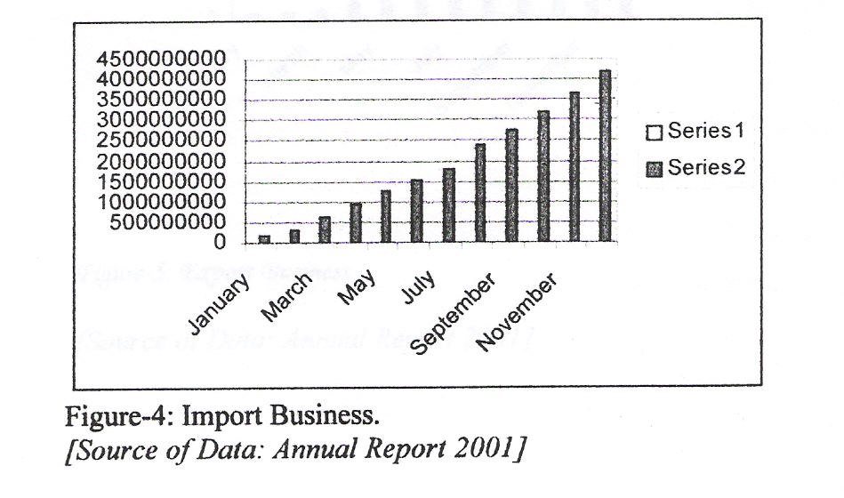

Treasury of EXIM Bank Ltd.
EXIM Bank limited, sine inspection, operates treasury detailing of local money
operations by handling a significant value of treasury transaction. The Bank earned Tk. 5.89 million form local money market during the year. Foreign money market dealing room with automated returns terminal will be started very soon.

Import Business of EXIM Bank Ltd.
The total import Business handled during the year 2001 was Tk.4199.70 million as
compared against Tk.330.60 in the previous year showing an increase of 1170.33%. The .
significant item of import were Industrial Raw Materials, Consumer Goods, Machinery,

Fabrics and Accessories etc.

In Million
Month | Amount | Amount
January | 162.20 | 162200000
February | 337.30 | 337300000
March | 633.00 | 633000000
April. | 95.80 | 955800000
May | 1240.70 | 1240700000
June | 1532.70 | 1532700000
July | 1801.00 | 1801000000
August | 2384.50 | 2364500000
September | 2727.70 | 2727700000
October | 3203.20 | 3203200000
November | 3647.30 | 3647300000
December | 4199.70 | 4199700000

Export Business of EXIM Bank Ltd.
The total volume of Export handled by the bank was Tk. ~797.30 million compared to Tk. 57.80 million in the previous year, registering an increase of 4739.62 %. The Export trade continues to be a major growth area for the bank intends to concentrate in this area of the business in coming years.
Month | Amount | Amount
January | 74.60 | 74600000
February | 106.50 | 106500000
March | 164.50 | 164500000
April | 293.20 | 293200000
May | 528.00 | 528000000
June | 812.50 | 812500000
July | 1051. 70 | 1051700000
August | 1418.00 | 1418000000
September | 1643.20 | 1643200000
October | 1968.70 | 1968700000
November | 2355.00 | 2355000000
December | 2797.30 | 2797300000

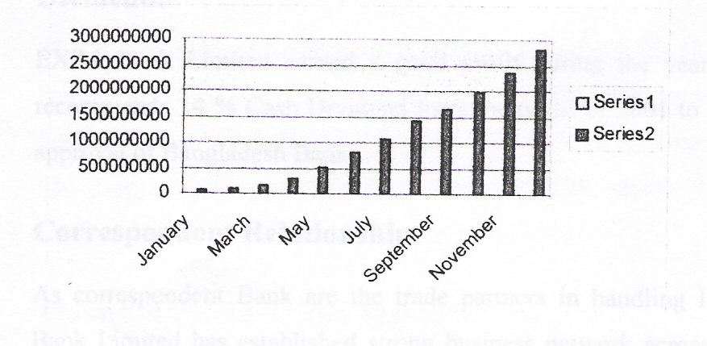

Profit and Operating Results of EXIM Bank Ltd.

In year 2000 a growth in operating profit of the bank to Tk. 99.67 million recording an application increases which was due to prudent lending and optimum management of ftmds.

Branch Expansion of EXIM Bank Ltd.

The number of Branches as it stands now is 8 (eight) and steps are being taken to open few more Branches at commercially important places by the year 2001.

Quality of Risk Assets.

In order to maintain high quality of risk assets, utmost efforts are made by the Board of
Directors and by the management on an ongoing basis. A management committee at Banks Head Office every Saturday to monitor the quality of loans apart from solving other problems of the Bank. As on 31-12-2001 Bank has no Classified Loans. The Bank has made 1 % provision ofTk. 19.44 million against Unclassified Loans.

Dividend:

EX 1M Bank Limited earned a good profit during the year. The Board of Directors recommends 14 % Cash Dividend form the profit of 2001 to the shareholders subject to approval of Bangladesh Bank.

Correspondent Relationship.

As correspondent Bank are the trade partners in handling International Trade, EXIM Bank Limited has established strong business network across the globe. The Bank has established correspondent relationship with the major Banks. At present the Bank has more than 160 Correspondents. The Bank is well equipped to handle International Trade at each comer of the world.

Office Automation.
Basic Accounti~g Systems of the Bank Branches has been automated to optimize benefits and increase overall efficiency for superior customer services by way of increased speed, accuracy and ensures security. The Bank has continuously looked for more and more sophistic~tion and efficiency. With this end in view, the Bank has established Infonnation Technology (IT) Department on a top priority area.

Human Resources Department.

There is no alternative to skilled and trained manpower in service Industry. Bearing this in mind the well educated, promising and honest workers are being appointed and trained. Bank has given top priority for developing skilled manpower and introducing them with modem technologies with the purpose to develop quality customer services. We have recruited experienced Bankers as well as fresh university graduates. The fresh recruits are being trained through BIBM and other Training Institute. As on 31 sl
December 2001, the human resources strength was 237 including 63 sub ordinate staff members.

The Sources and Uses of Fund.

The composition of sources of Banks fund are Paid Up Capital, Reserves, Customers Deposit and Call Loan from different Banks. The Bank used major portion of this fund for Investment in Loans and Advances. The Bank also invested in Securities and Shares. The surplus fund was prudently applied in Call Money Market to earn satisfactory returns.

Financial Products and Services.

The Bank has already introduced number of financial products such as Monthly Savings Scheme (Money Grower) and Monthly Income Scheme (Steady Money), Lease Finance. In addition schemes like Consumers Credit, Credit Card, A TM, On Line Banking and other lucrative schemes will be introduced soon.

Board Meetings.

The Board of Directors held 12 meetings during the year and 22 Executive Committee meetings of the Board during the same period.

Directors.

The following Directors of the Company retired from the Board of Directors by rotations as per Articles of the Company and being eligible, have offered themselves for reelection:
1. Mr. Md. Nazrul Islam Swapan.
2. Mr. Mohammad Abdullah.
3. Mr. Md. AltafHossain.
4. Mr. Md. Mazakat Harun.
5. Mr. Md. Fahim Zaman Pathan.
Respected Chairman: Mr. Md. Nurul Islam Mazumder & Respected Director: Mr. Mohammed Lakiotullah

Auditors.

In terms of Article 149 of the Articles of Association of the Bank MIS Pinaki and Co. Chartered Accountants were re-appointed as external auditors for conducting the audit of accounts as 31 sl December, 2000. The Auditor MIS Pinaki & Co. Chartered Accountants being eligible offered themselves for re-appointment for the year 2001. But now Mis Rahman Rahman Hoq becomes the auditor in the year 2005..

Future Prospect.

Bank's drive towards market leadership as well as quality in choosing business will continue during the year 2001 although competition is intensified with the opening of more financial institutions. The Bank is optimistic that the volume of business will increase in the coming years through pragmatic and market friendly policies. The Bank shall continue to explore new fields of investment and take steps to open new Branches for banking and capital market related activities. We shall endeavor to adopt customeroriented policies and introduce new techniques that will help to earn profit and increase greater confidence of the existing! prospective customers.

SOWT ANALYSIS

EXPORT IMPORT BANK OF BANGLADESH LTD.

Strength:
. Wide Image
. Enthusiastic employee.
· High deposit
· Higher profit rate to client.
· Excellent Management.
· High commitment of customers.
· Qualified & Experienced human resource. · Satisfactory Environment.
Weakness:

· Lack of proper software for Islamic banking.
. It has high cost of fund.
· It has highly exposed to volatile garment business.
· It has highly exposed dependency on term of eposit.
. Inadequate it infrastructure.

Opportunities:
. Increasing demand of client finance.
· Investment potential of Bangladesh.
· Good prospect of more export import business at Uttara turning to
commercial area.
· Relationship management.
· Complacency among rival firms.

Threats:

. Lack of customer awareness regarding Islamic asking.
. Some other bank also follow the Islamic banking policy
. Similar type of retail banking products.
· Certain Bangladesh bank's rules and regulations.

General Banking

Bangladesh is one of the less developed countries. So the economic development of the country depends largely on the activities of commercial banks. So we need to emphasis whether these commercial banks are effectively and honestly performing their functions, assigned duties and responsibilities. In thus respect we need to know about the general banking function of those banks as well as The EXIM Bank Ltd. is to provide the general banking service.

Deposit

A bank is essentially an intermediary of short-term funds. It can carry out extensive lending operations only when it can effectively channels the saving of community. A good banker is one who effectively mobilizes the saving of the cornmw1ity as well as makes such use of saving by making it available to productive and priority sectors of the economy thereby fostering the growth and the development of the nation' s economy.

Therefore deposit is the blood of a bank. From the history and origin of the banking system, we can know that deposits collections the main function of a bank.

Accepting Deposit:

The deposits that are accepted by EXIM Bank like other banks may be classified in to, A) Demand Deposits.
B) Time Deposits.

Demand Deposits:

These deposits are withdrawn without notice, e.g. current deposits. EXIM Bank accepts demand deposit through the opening of.
A) Current Account ..
B) Saving Account
C) Call deposits from the fellow bankers

Time Deposits:
A deposit which is payable at a fixed date or after a period of notice is a time deposit. EXIM Bank accepts time deposits through Fixed Deposit Receipt (FDR). Short Time Deposit (STD) and Bearer Certificate Deposit (BCD) etc.

While accepting these deposits. a contract is executed between the bank and the customer. This contract will be a valid one only when both the parties are competent to enter into contracts. As account opening initiates the fundamental relationship & since the banker has to deal with different kinds of persons with different legal status. EXIM Bank Officials remain very much careful about the competency of the customers.

Procedure for Opening of Accounts:

Before opening of a currents or savings account. the following formalities must be completed by the customer:

- Submit application on the prescribed form.
- Furnishing photographs- 2 (Two) copies.
- Introduction by an account holder.
- Putting specimen signatures in the specimen card.
- Mandate. if necessary.

After fulfilling above formalities, opens an account for the client and provide the customer with a pay-in-slip book and a checkbook in case of savings account and currents account.

. Types of Deposit Accounts and Their Formalities:

. Current Account:
In this kind of account a customer can deposit his money and can write one or more check to withdraw their money. For doing this notice is not required. He can deposit it whenever hell she wants to and also can withdraw it whenever hell she wants to.

. In The Name of Individual:

The client has to fill up a light green account opening form. Terms and conditions are printed on the back of the form. The form contains the declaration clause, special instructions etc. two copies of passport size photograph duly attested by the introducer are affixed with the form.

In Joint Name:

In this type, the formality is same as individual account, but in the special instruction clause, either or 'survivor' or 'former or survivor' clause is marked.

Proprietorship:
In addition the customer has to submit the valid Trade License and Tax Paying Identification Number (TIN) along with the application.

Partnership:

In case of partnership account, the bank asks for,

- A copy of the partnership agreement (Partnership Deed)
- A letter signed by all the partners containing the following particulars.
- The name and addresses of all partners
- The nature of the firm's business
- The name of the partner authorized to operate the account in the name of the firm,
including the authority to draw, endorse and accepting the bills and mortgage and sell the properties belonging to the firm.

. Limited Company:

On having the desire to open an account from a limited company, an EXIM Bank Officer asks for the following documents:

- Registration Certificate from the Registrar of Joint Stock of
- Companies Certificate of Incorporation
- Certificate of Commencement of Business
- Memorandum of Association
- Articles of Association
- Copies of Annual Accounts
- Copies of the Board's resolution, which contains

a). The name of the persons who have been authorized to operate the bank account on behalf of the company.

b). The name of the persons who are authorized to execute documents with the bank on company's behalf.

Societies, Clubs and Associations:

In case of these sorts of accounts EXIM Bank requires the following documents:

- Registration Certificate Under the Societies Registration Act,
- 1962 Copies of Memorandum, Articles of Association
- Resolution of the Managing Committee.
- Power of Attorney to Borrow.

Non-government Organization (NGO):

The account opening procedure is same but in exception is that the Registration Certificate from the Social Welfare Department of Government must be enclosed with the application.

Joint Account in The Name of Minor:

A minor cannot open an account in his own name due to the incapacity to enter into a contract. He can open an account in EXIM Bank in Joint name of another person who will be guardian of him.

Savings Bank Account:

This deposit is basically meant for small-scale savers. There is restriction on withdrawals in a month. Heavy withdrawals are permitted only against prior notice. Interest is paid on these types of accounts.

. Short-term Deposit (STD):

In Short-term Deposit, the deposit should be kept for at least seven days to get interest. The interest offered for SID is less than that of savings deposit. In EXIM Bank various . big companies, Organizations, Government Departments keep money in STD accounts. Frequent withdrawal is discouraged and requires prior notice.

Fixed Deposit:

They are also known as time liabilities or term deposits. These are deposits, which are made with the bank for a fixed period specified in advance. The bank need not maintain cash reserv.es against these deposits and therefore, the bank offers high are of interest on such deposits.

In EXIM Bank, fixed deposit account is opened in two forms- Midterm (MTD), which is less then one year & the other is Term Deposit, which is more than one year.
Opening of Fixed Deposit Account:

The depositor has to fill an application form where in he mentions the amount of deposit, the period for which deposit is to be made & the namely names is which the fixed deposit receipt is to be issued. In case of a deposit in Joint name EXIM Bank also takes the instructions regarding payment of money maturity of the deposit. The banker also takes the instructions regarding payment of money on maturity of the deposit. The banker also takers the instructions regarding payment of money on maturity of the deposit. The banker also taker specimen signatures of the depositors.

A fixed deposit account is then issued to the depositor acknowledging receipt of the sum of money mentioned therein. It also contains the rate of interest & the date on which the deposit will fall due for payment.

Payment of Interest:

It is usually paid on maturity of the fixed deposit. EXIM Bank calculates interest at each maturity date and provision is made on that "Miscellaneous creditor expenditure payable accounts" is debited for the accrued interest.

Encashment of FD.R:

In case of premature FDR, EXIM Bank is not bound to accept surrender of the deposit. before its maturity date. In order to deter such a tendency the interest on such a fixed deposit is made cut a certain percentage less a the agreed rate. Normally savings bank deposit interest rate is allowed.

. Loss of FDR:
In case of a lost FDR, the customer is asked to record a GD (General Diary) in the nearest Police Station. After that the customer has to furnish an Indemnity Bond to EX 1M Bank a duplicate FPR is then issued to the customer by the bank.
Renewal of F R. D.:

In EXIM Bank, the instrument is automatically renewed within seven days after the date of its maturity if the customer does not come to en-cash the FDR. The period for renewal is determined as the previous one.

Bearer Certificate Deposit (BCD):

The bearer certificate deposit is a document of title similar to time deposit receipt issued by the bank. The document is a bearer document, hence readily negotiable. Whoever presents it to the bank has the right to get the money. There is no prescribed interest rate on such funds but EXIM Bank offers ] % less than the rate of the term deposit of different maturity. The face value of the instrument is the future value. The face value is the sum of the principal amount and the interest. It is beneficial to both EXIM Bank and the investor because of the following reasons,

1. The banker is not required to encase the deposit before the date of
maturity. Hence it is assured of funs for a minimum period.'

2. The investor is assured of ready liqUidity. In case of need he can
sell the certificate in the secondary market.

As the identification of the owner is not given in the instrument, it is very much popular. During the encashment of the instrument, the excise duty and income tax (10%) is deducted. In case of premature encashment, the principal amount is only paid to the customer.

Dishonor of Cheque:

If the Cheque is dishonored, EXIM Bank sends a memorandum (Cheque return memo) to the customer stating the reason in the following way,

(1) Refer to drawer
(2) Not arranged for
(3) Effects not cleared. May be presented again.
(4) Exceeds arrangements
(5) Full cover not received.
(6) Payment stopped by drawer.
(7) Payee's endorsement irregular/ required.
(8) Payee's endorsement irregular, require Bank's confirmation.
(9) Drawer's signature differs/ required.
(10) Alterations in date/ figures/ words require drawer's full signature. ( II ) Cheque is post dated! out of date/ mutilated.
(12) Amount in words and figures differs.
(13) Crossed Cheque must be presented through a bank.
(14) Clearing stamp required! requires cancellation.
(15) Addition to Bank's discharge should be authenticated.
(16) Cheque crossed" Account Payee Only"
(17) Collecting Bank's discharge irregular/ required.

If the Cheque is dishonored due to Insufficiency of funds than EXIM Bank charges Tk. 50/= as penalty.

Rules for Passing a Cheque:

In order to enable the branches to facilitate their day-to-day transactions smoothie/ efficiently! accurately, the following schedule of Power for passing of Cheque Instrument signature of vouchers shall come into force with immediate effect:

An authorized officer shall pass Cheque for less than TK. 10,000.00 singly after
proper supervision in computer print out.

Cheque for TK. 10,000.00 & above but below TK. 50,000.00 shall be passed jointly by any two authorized officers after proper supervision by anyone officer in the computer printer out. He will however also ensure that no fictitious! wrong credit in . the account has been posted on the day by referring to credit vouchers of the day.

Cheque for TK. 50,000.00 & above shall be passed under joint signatures of two officers, one of whom must be Manager of the branch. The procedures regarding supervision of Cheque as at (2) above must however be followed.

All suspense's A/C (Debit) vouchers, Sundry Deposit (Debit) vouchers, Credit A/C Debit Vouchers, Expenditure A/C vouchers must be signed by the incumbent in
charge of the branch with any other authorized officer. As at the close of Business of the day all transactions (both debit & credit) shall be checked by referring to computer print out and relative Cheque! vouchers.

Apart from the above it will also be ensured that the total. amount of debit & credit totaling to Current A/C, Saving, SID & Term Deposit corresponds with the total of cash receipt! payment, transfer clearing (both outward and inward).

Term Deposits:
These rates are not negotiable. In this table we can find out the percentage that are given by the bank for specific period of time to the customer.

NATURE OF DEPOSITS | BAND OF RATE OF ENTEREST
Fixed Deposit 1 month | 8.00% - 8.50%
Fixed Deposit Bearer | 9.00% - 9.25%
Certificates for 3 months
Fixed Deposit Bearer | 9.25% - 9.50%
Certificates for 6 months
Fixed Deposit Bearer | 9.75% - 10.50%
Certificates for I year

Fixed Deposit Bearer | 10.25% - 11.25%
Certificates for 2 years
Fixed Deposit Bearer | 10.75% - 11.50%
Certificates for 3 years
This above intonation is based on year 200 1
eft Different types of products offer EXIM Bank. Super savings
Double your deposit in 6 years
Super savings scheme

Savings helps to build up capital and capital is the prime source of business investment in a country. Investment takes the country towards industrialization, which eventually creates wealth. That is why savings is treated as the very foundation of development. To create more awareness and motivate people to save, EXIM Bank offers Super Savings Scheme.
Deposit | Term | Payable at maturity | Payable Amount
10,000/- | 6 Years | Double | 20,000/-
20,000/- | 6 Years | Double | 40,000/-
50,000/- | 6 Years | Double | 1,00,000/-
1,00,000/- | 6 Years | Double | 2,00,000/-
2,00,000/- | 6 Years | Double | 4,00,000/-
5,00,000/- | 6 Years | Double | 10,00,000/-
Multiplus Savings
I 0 Years Deposit - More than " Triple
Savings helps to build up capital and capital is the prime source of business investment in a country. Investment takes the country towards industrialization, which eventually creates wealth. That is why savings is treated as the very foundation of development. To create more awareness and motivate people to save, EXIM Bank offers Multiples Savings Scheme.
Terms and Conditions of the Scheme:
I. Any individual, company, educational institutional, government organization,
NGO, trust, society etc may invest their savings under this scheme.
2. The deposit can be made in multiples of TK. 10,000.00/=

3 will be issued at the time of opening the account. 5. A depositor can avail loan up to 80% of the deposited amount under this scheme. 6. In case of issuing duplicate receipt the rules of issuing a duplicate receipt of Term
Deposit. The period of deposit is for ten years. But the deposit earn be withdrawn at any year with interest. As an example, if deposit is withdrawn after completion of 1 year but before 2 years then deposit with interest will be paid for 1 year only. The same rule will apply for other years. If deposit is withdrawn before 1st year then no interest will be paid.
4. Any customer can open more than one account in a branch in his name or in joint
names. A deposit receipt will be applicable.
7. (A) In case of death of the depositor, before the term, the deposit (with interest at
savings rate) will be given to the nominee. In the absence of nominee, the legal
heirs / successors will be paid on production of succession certificate.
7. (B) The nominee may, at his option continue the scheme for the full term.

Some examples are given are given in the table below. Any amount can be deposited in multiples of TK 10,000/=

Amount | 10,000 | 20,000 | 50,000 | 1,00,000
Year | Year wise | Payable | To | Customer
1 | 10,910 | 21,820 | 54,550 | 109,100
2 | 12,012 | 24,024 | 60,061 | 120,122
3 | 13,346 | 26,693 | 66,732 | 133,463
4 | 14,952 | 29,904 | 74,761 | 149,522
5 | 16,714 | 33,429 | 83,572 | 167,144
6 | 18,765 | 37,530 | 93,824 | 187,649
7 | 21,499 | 42,998 | 107,496 | 214,992
8 | 25,116 | 50,231 | 125,578 | 251,156
9 | 28,270 | 56,540 | 141,351 | 282,702
10 | 31,872 | 63,744 | 159,361 | 318,721

SMART SAVER

What is Smart Saver?

Smart Saver is a high return investment plan, which helps a customer build up sizeable amount in a period of 5 years. This scheme offers a customer to buy Smart Saver Term Deposit 5 times the invested amount. Smart Saver is a 5 years term deposit scheme.

How does it work?

Smart Saver is available unit wise. One unit of Smart Saver is TK. 25,000. For purchasing 1 (One) unit Smart Saver a customer has to invest TK. 5,000 as down payment and the Bank will provide lone for TK. 20,000. The loan is repayable monthly in equal installment of TK. 490 for a period of 5 years. At the end of the 5 years period, the Smart Saver Term Deposit will be encased. and the customer will be paid TK. 45,000.

Flexible Repayment Schedule

Customer also has the option to repay in 12, 24, 36, 48, .and 60 monthly installments. Maximum Investment 400 unit i.e. TK. 1,00,000 (One Crore) in single/ joint names.

Terms & Conditions

1. One Unit Smart Saver Term Deposit is TK. 25,000.
2. During the tenure of the loan the Term Deposit will be kept in the Bank as
security .
3. The customer will have to open an account and monthly installment of loan will
be debited from the account commencing from 30 days after opening loan account.
4. Within the 151 year if the customer fails to repay 3 consecutive installments then only the principal amount of Smart Saver Term Deposit will be encased and the loan will be liquidated inclusive of accrued interest and balance paid to the customer. After completion of 1 year, saving rate will be added to the principal amount of Smart Saver Term Deposit. In both cases closing charge will be TK. 500.
5. For missed installments on due date customer will be charge TK. 25 per unit per month.
6. In the event of death of the customer, the bank shall be entitled to encase the
Term Deposit and to the nominees/ successors.

7. The bank reserves the right to amend the rules and rates as and when deemed
necessary .

Objectives of the Scheme

An account is to be opened by filling up a form.

The Bank will provide to the customer a deposit receipt after opening the account. This receipt is non-transferable.

If the deposit is withdrawn before a 5-year term, then saving interest rate will be applicable and paid to the depositor. However, no interest will be paid if the deposit is withdrawn within 1 year of opening the account and Monthly Income paid to the customer will be adjusted from the principal amount.

A deposit can avail loan up to 80 % of the deposit amount under this scheme. In this case, interest will be charged against the loan as per Bank's prevailing rate. During the tenure

Deposit Amount | Income
Tk.25,000/= | Tk. 250/=
Tk. 50,000/= | Tk. 500/=
Tk. 1,00.,000/= | Tk. 1000/=
Tk. 2,00,000/= | Tk. 2000/=
Tk. 5,00,000/= | Tk. 5000/=
Tk. 10,00,000/= | Tk. 10,000/=

Objectives of the Scheme

An account is to be opened by filling up a form.

The Bank will provide to the customer a deposit receipt after opening the account. This receipt is non-transferable.

If the deposit is withdrawn before a 5-year term, then saving interest rate will be applicable and paid to the depositor. However, no interest will be paid if the deposit is withdrawn within 1 year of opening the account and Monthly Income paid to the customer will be adjusted from the principal amount.

A deposit can avail loan up to 80 % of the deposit amount under this scheme. In this case, interest will be charged against the loan as per Bank's prevailing rate. During the tenure

of the loan, the Monthly Income will be credited to the loan account until liquidation of the loan .amount inclusive of interest.

MONEY GROWER
A Monthly Saving Scheme

Secure your future with ease. A small savings today will provide you comfort tomorrow. Saving Period and Monthly Installment Rate

The savings period is for 5, 8, 10 or 12 years. Monthly installment rate is Tk. 500/=, . 1,000/=,2,000/= or 5,000/=.

IF Monthly Installment Deposit

The savings amount is to be deposited within the 10th of every month. In case
of holidays the deposit amount is to be made on the following day.

The deposit may also be made in advance.

The depositor can have a separate account in the bank from which a standing instruction can be given to transfer the monthly deposit in the scheme's account.

In case the depositor fails to make the monthly installment in time, then 5 % on overdue installment amount will be charged. The charge will be added with the following month installment and the lowest charge will be Tk. 10/=.

IF Withdrawal

Generally, withdrawal is not advised before a 5-year term, but if it is withdrawn before the above term, then interest will be paid at savings rate. However, no interest will be paid if the deposit is withdrawal within 1 year of opening the account.

In case the depositor wishes to withdraw between the 5, 8, 10 or 12-year period then full interest will be paid for a completed term and savings rate will applicable for the fractional period.

Loan Advantage

After three years of savings in this scheme the depositor (if an adult) is eligible for a loan up to 80 % of this deposited amount. In that case, interest rates on the loan will be applicable as per prevailing rate at that time.

Reasons For Disqualification Form This Scheme.

If the depositor fails to pay 3 installments in a row, then he will be disqualified from this scheme and interest will be applicable as mentioned in withdrawal clause. If the . depositor fails to pay 5 installments in a row after completion of 5-years term, then the Bank reserves the right to close the account and interest will be paid as mentioned in withdrawal cause.

In case of death of the depositor the scheme will cease to function. The amount will be handed over to the nominee of the deceased depositor. In case of absence of the nominee the bank will handover the accumulated amount to the successor of the deceased.

 | Monthly | Monthly | Monthly | Monthly
 | Installment | Installment | Installment | Installment
 | 500/= | 1,000/= | 2,000/= | 5,000/=
5 Years | 41,400/= | 82,800/= | 1,65,000/= | 4,14,000/=
8 Years | 81,800/= | 1.36,600/= | 3,27,200/= | 8,18,000/=
10 Years | 1,18,450/= | 2.36,400/= | 4,72,800/= | 11,84,500/=
12 Years | .65,993/= | 3.31.986/= | 6,63,973/= | 16.59,932/=

Rules and Regulation.

A form has to be filled at the time of opening the account. No introduction is needed
but attested photographs are advised.

The depositor can select any of the installment amounts, which cannot be
subsequently changed.

In case of minors the guardians may open and supervise the account in his favor.

A single person can open more than one account for saving under several installment
rates.

The accumulated deposit with interest will be returned within one month of
completion of a term.

The depositor should notify the bank immediately on any change of address.

The government tax will be deducted from the interest accumulated in this scheme.

If necessary, at the request of the depositor, the scheme can be transferred to a
different branch of the same Bank.

The Bank reserves the right to change the rules and regulations of the scheme as and
when deemed necessary.

Education Savings Scheme

Education Savings Scheme:

The most gratifying experience for parents are proper education of their children. Educational expense is rapidly increasing and therefore appropriate planning needs to be done by all parents. EXIM Bank otters you "Education Savings Scheme" to assists you in financial planning well ahead in time for your children's higher education.

Terms and Conditions of The Scheme:

I. Deposit of Tk. 25,000/= and multiples there of at a time will be accepted under the Scheme.

2. The instrument shall be issued for 7 years, 10 years, 15 years or 20 years term.

3. The deposit is payable at maturity with benefit either in lump sum or on monthly basis as education allowance for 6 (six) years staring after the completion of respective term.

4. To avail the education allowance the depositor is required to deposit the receipt or Instrument with the Bank duty discharged by him with the written instruction to pay the amount to his/ her nominated person on monthly installment basis as stipulated in the Scheme.

5. NormallYt no withdrawal will be allowed before maturity. Butt if any depositor intends to withdraw his deposit before maturity t the following rules will be applicable:

a. If withdrawal is made before seven years, interest will be calculated and paid
as per prevailing savings rate.

b. If withdrawal is made at any time after seven years the total amount payable at maturity of the immediate preceding term will be paid along with interest for the fractional period at prevailing saving rate.

6. The depositor can avail loan up to 80 % under this scheme.

7. a. II) case of death of the depositor the proceeds will be paid to the nominee of the depositor or in absence of the nomination to the legal successor of the depositor on production of Succession Certificate.

b. If, after death of depositor the nominee intends to continue the deposit to get monthly educational allowance for 6 years as admissible under the rules of the scheme, the receipt of the deposit should be surrendered to the Bank duly authenticated by the legal guardian on maturity.

8. In case of issuing duplicate receipt the rules of issuing duplicate receipt of term deposit
will be applicable.

Example Table – 1

Terms | Initial Deposit (Tk.) | Amount payable at | Education | allowance
 |  | maturity (Tk.) | per month (Tk.)
7 Years | 25,000/= | 55,000/= | 1,000/=
10 Years | 25,000/= | 77,000/= | 1,500/=
15 Years | 25,000/= | 1,36,000/= | 2,500/=
20 Years | 25,000/= | 2,40,000/= | 4,500/=

Example Table - 2

Terms | Initial Deposit (Tk.) | Amount payable at | Education | allowance
 |  | maturity (Tk.) | per month (Tk.)
7 Years | 1,00,000/'- | 2,20,000/- | 4,000/-
10 Years | 1,00,000/= | 3,08,000/= | 6,000/=
15 Years | 1,00,000/= | 5,44,000/= | 10,000/=
20 Years | 1,00,000/= | 9,60,000/= | 18,000/=

Closing of An Account:

The closing of an account may happen,

If the customer is desirous to close the account.
If EXIM Bank finds that the account is inoperative for a long duration. If the court on EXIM Bank issues Garnishee Order.

To close the account the Cheque book is to be returned to the bank. EXIM Bank takes all the charges by debiting the account and the remaining balance is then paid to the customer. Necessary entries are given to the account closing register and computer.

Cash:
The cash section of EXIM Bank deals with all types of negotiable instruments, cash and other instruments and treated as a sensitive section of the bank. It includes the vault that is used as the beyond this limit, the excess cash is then transferred to Bangladesh Bank. This section performs the following functions:

1. Cash Packing:
After the banking hour cash is packed according to the denomination. Notes are counted and packed in bundles and stamped with initial.

2. Allocation of Currency:
Before starting the Banking hour all tellers give requisition of money through" Teller cash proof sheet". The head Teller writes the number of the packet denomination wise in "Reserve sheet" at the end of the day, all the notes remained are recorded in the sheet.

Outward Bills for Collection (OBC):

Collection of bills, which. is beyond the clearing range and collected through OBC mechanism.

Inward Bills for Collection (IBC):

Collection of bills, which EXIM Bank does as an agent is called collection through IBC mechanism.

Clearing:

According to the Article 37(2} of Bangladesh Bank Order 1972, the banks, which are the member of the clearinghouse, are called as Scheduled Banks. The scheduled banks clear the Cheque drawn upon one another through the clearinghouse. This is an arrangement by the central bank where everyday the representative of the member banks gathers to clear the Cheque. Banks for credit of the proceeds to the customer's accounts accept Cheque Ana other similar instruments. The bank receives many such instruments during the day from account holders. Many of these instruments are drawn payable at other banks. If they were to be presented at he drawer banks to collect the proceeds it would be necessary to employ many messengers for the purpose. Similarly there would be many Cheque drawn on this the messengers of other banks would present bank and then at the counter. The whole process of collection and payment would involve considerable labor, delay, risk and expenditure. All the labor, risk, delay and expenditure are substantially reduced by the representative of all the banks meeting at a specified time, for exchanging the instruments and arriving at the net position regarding receipt or payment.

The place where the banks meet and ~ettle their dues is called the Clearinghouse. The clearinghouse sits for two times a working day. The members submit the climbable cheques in the respective desks of the banks and vice-versa. Consequently the debit and credit entries are given. At the debit summation and the credit summation are calculated. Then the banks clear the balances through the Cheque of Bangladesh Bank. The dishonored Cheque are sorted and returned with return memo.

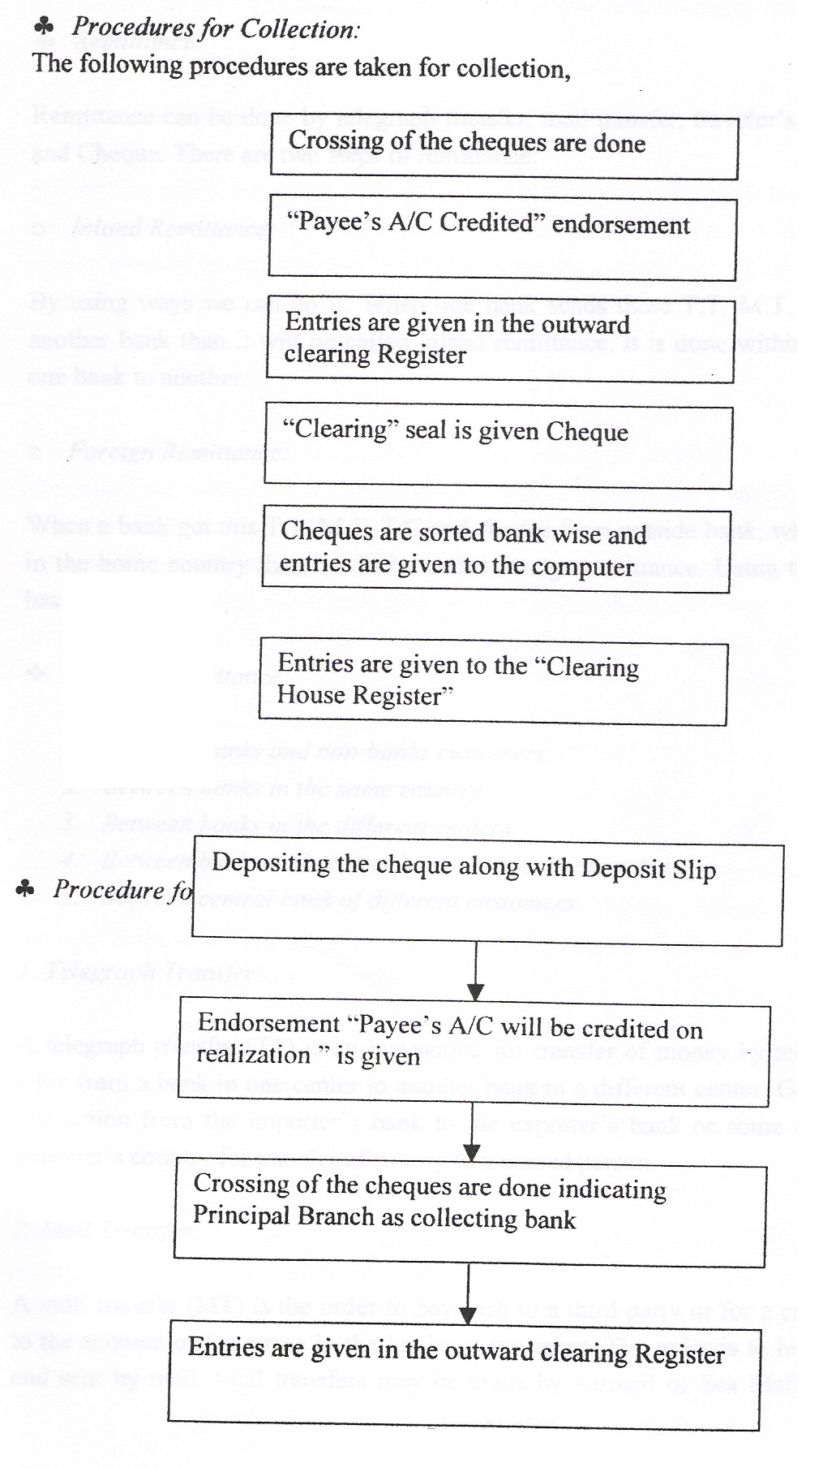

Remittance:

Remittance can be done by telegraph transfer, mail transfer, traveler's Cheque and drafts and Cherub. There are two steps of remittance:

Inland Remittance:

By using ways we can do it. When one bank sends these T.T, M.T, T.C or Cheque to another bank than :1 will be called inland remittance. It is done within the country from' one bank to another.

Foreign Remittance:

When a bank got this T.T, M.T, T.C and cherub from outside bank, which is not situated in the home country than it will be called foreign remittance. Using these methods also has done it.

Types of Remittance:

1. Between banks and non-banks customers.
2. Between banks in the same country.
3. Between banks in the different centers.
4. Between banks and central bank in the same country.
5. Between central bank of different customers.

1. Telegraph Transfer:

A telegraph transfer (IT) is an instruction for transfer of money by telegraph cable and telex from a bank in one center to another bank in a different center. Generally this is an instruction from the importer's bank to the exporter's bank or some other bank in the exporter's country for transfer of money to a named person.

2. Mail Trendier:

. A mail transfer (MT) is the order to pay cash to a third party or for a credit to be passed to the account of the payee in the books of the agent. The order is to be made in writing and sent by mail. Mail transfers may be made by Anneal or Sea Mail, but in ordinary

circumstances mail transfer are made by air unless a customer to the contrary makes a request.

3. Drafts and Chouse:

A draft is a pay order issued by one bank on another or on its branch. The purchaser of a draft makes to the seller in local currency at the domestic center while the paying after presentation of the draft by the beneficiary pays the beneficiary. There is also risk of loss of the draft in transit.

4. Traveler's Cherub:

It is the safest way to carry money from one country to another. It can be change in any country of the world. Even if the Traveler Cherub (TC) is lost then the holder of the T.C can infonn it to the bank and the bank will infonn it to the agencies so that no one can encash the T.C while issuing a Traveler Cheque (T.C) a signature is needed, so that no one can en-cash it except the holder and also another signature is needed in encashment in front of the. banker. So Traveler Cheque (T.C) is the safest way to carry out side the home country .

Advance Banking

Advance Banking is one of the significant schemes of the EXIM Bank limited. It contributes a huge portion of income in the EXIM Banks total revenue. It provides different types of loan to its borrowers as a lender. The bank operates advance facilities through different branches but the entire loan sanction procedure is controlled and monitored by Head Office.

Certain tens - and condition are followed when the can is sanctioned to the borrowers. Now advance banking is discussed in detail as follows:

Credit Policy:

EXIM Bank is a new generation Bank. It is committed to provide high quality financial services/products to contribute to growth of G.D.P. of the country through stimulating trade & commerce, accelerating the pace of industrialization, boosting up export, creating
employment opportunity for the educated youth, poverty alleviation, raising standard of

living of limited: income group and over all sustainable socioeconomic development of the country.

To achieve the aforesaid objectives of the bank credit operation of the bank is of
paramount importance as the greatest share of total revenue of the Bank is generated from it, maximum risk is centered in it and even the very existence of Bank depends on prudent management of its credit port-folio. The failure of a commercial bank is usually associated with the problem in credit portfolio and is less often the result of shrinkage in the value of other assets. As such, credit portfolio is npt only features dominants in the assets structure of the Bank also.

To provide a broad guide line for the credit operation towards achieving the objectives of
the bank, for efficient and profitable deployment of its mobilized resources and to administer the credit Portfolio in the most efficient way, a clearly defined, well planned, comprehensive and appropriate Credit Policy and control guidelines of the bank is a prerequisite.

In view of the above, this credit policy and guidelines of the bank has been prepared subject to amendment, revision, re-adjustment and refinement as and when required by the Bank.
The purpose of this policy statement, which replaces al previous ones, is to set out the credit policies of the Board of Directors.

The policies are described as under:

Credit Principles.

Global Credit Portfolio Limits.

Types of Credit Activities.

Credit Administration.

Credit Principle

The following are the principles to be adopted for lending authority, approval, monitoring and control on a basis consistent with the global operational objectives and business strategies of the bank.

1( General:

The bank will provide suitable credit services and pr ducts for the markets in which it operates.

Loans and advances shall normally be financed from customer's deposits and not out of' temporary funds or borrowing from other Bank. Credit will be allowed in a manner, which will in no way compromise the Bank's standards of excellence and to customers . who will complement such standards.
All credit extension must comply with the requirements of the of Bank's Memorandum & Articles of Association, Banking Companies Act 1991 as amended from time to time, Bangladesh Bank's instruction and other applicable rules and regulations.

x Structural

The authority structure for extension of credit should enable effective adaptation to changes in the economic, technological, regulatory and competitive environment within which the Bank operates.

x Performance

The conduct and administration of the loan portfolio should contribute, within defined risk limitation, to the Bank's achievement of portfolio growth and superior return on the bank's capital. Credit advancement shall focus on the development an~ enhancement of customer relationship and shall be measured on the basis of the total yield for each relationship with a customer (on a global basis), through individual transactions should also be profitable.
Credit facilities will be extended to those companies/persons, which can make best use of them, thus helping to maximize our profits as well as economic growth of the country. To ensue achievement of this objective it will base its leading decision mainly on the borrower's ability to repay. If credit facilities are grantee on a transaction lone-off basis the yield tom the facility should be commensurate with the risk.

x Loan pricing

Interest on various lending categories will depend on the level of risk and type of security offered. It should be keep in mind that rate of interest is the reflection of risk in the transaction. The higher is the is the higher is the interest rate. Interest may be reviewed at least once in 6 (six) months and more often when appropriate. Fixed interest rate should be discouraged; preferably all rates should vary with cost of funds fluctuation based on a spread for profit

Effective yield can be enhanced to the extent borrowers are required to maintain deposits'
to support borrowing activities. Commitment fee and service charges should further improve yield where possible. All pricing of loams should however have relevance with the market condition and be approved by the executive Committee Managing Director from time to time.

x Administration! Monitoring

The administration of the loan process shall ensure, compliance with all laws and regulations at both local and global levels including bank policy as set out in this docwnent and the Bank's credit manual/circulars.

Proper analysis of credit proposal is complex and requires a high level of nwnerical as well as analytical ability and common sense. To ensure effective understanding of the concepts and thus common sense. To ensure effective understanding of the concepts and thus to make the overall credit portfolio of the Bank healthy, proper staffing of the credit departments shall be done through placement of qualified officials who have got the right aptitude, formal training in finance, credit risk analysis, Bank credit procedures as well as required experience. Where repayment and interest servicing performance of a credit deteriorates it shall be identifies at an early state and closely monitored to avoid low losses.

Loans/facilities where appropriate and related security shall be monitored and reviewed by a separate unit unconnected with the credit, approval process on a regular basis in order to assess the collect ability of the loan and effectiveness of the security. This unit will report to the Managing Director or his designated officer.

x Exception of Loan policy

It is recognized- that there will be exceptions to the state policy, which can be justified. However, the Board should approve these by the Executive Committee or and the circumstances must be fully documented in the credit file.

Global credit Portfolio Limits:

The nature of credit portfolio shall be governed within guidelines set down by Head Office and regulatory requirements. These guidelines will however be consistent with the . global limits identified below for the banks credit portfolio in aggregate. Criteria for exposure to customers are set as under:

Total Facilities:

The aggregate of all cash facilities shall not exceed 80% of customer deposit. It is further governed by the statutory and liquidity reserve requirement of Bangladesh bank.

Term facilities:

Aggregate long-term facilities shall not exceed 20% of the total credit portfolio. Facilities shall not be allowed for a period exceeding 5(Five) years. Any exceptions will require the approval of the Board of directors.

Country/Cross Border Exposure:

Limits to be established by the Board for individual Country as well as for aggregate Bank Credit exposures to different countries. These limits are to be reviewed from time to time with due regard to the political and economic environment in each country. The country exposure limits may be utilized up to maximum amounts for different maturates as follows:

For maturity up to one year: 100%
For maturity up to two year: Maximum 50 % of the limit.
For maturity up to three year: Maximum 25% of the limit.
For maturity beyond three years: Maximum 10% of the limit.
For exceptions, approval is required from the Board of Directors.

Exposure to Customer Groups:

Credit facilities in aggregate extended to anyone-customer group shall not normally exceed 15% of the capital famed or Tk. 10 (ten) core whichever is lower. However, Board of Directors may relax these limits in deserving cases. All proposals submitted to Head Office will also be required to indicate the extent of Bank's global exposure to that
customer group. .

Sector-wise allocation:

Sector-wise allocation of credit shall be made annually with the approval of Executive Committee/ Board of Directors. This will be reviewed from time to time.

Security:

Security accepted against credit facilities shall be properly valued and shall be affected in accordance with the laws of the country in which the security is held. An appropriate margin of security will be taken to reflect such factors as the disposal costs or potential price movements of the underlying assets.

Syndication of Term Loans:
Only one factual study has been made of the extent to which term loans me dividend among more than one Banks. That study was part of the Federal Reserve business loan survey of 1955. At that time about 30 percent of outstanding term loans conceited of individual loan contracts under which the credit had been extended by more than one Bank. The use of multiple participation may arise in either of three kinds of circumstances.

First. a small Bank may be faced with a credit demand that is - in excess of its legal lending limit, in which case it may seek in dispose of the "over line" credit to its city correspondent. This form of "over line" lending is way of accommodating large local customers while at the same time avoiding the commutative risk of losing them to some other city lender. It is generally understood implicitly that a city correspondent will not solicit the business customers of its country correspondents without their permission.

Second, Large Banks, hard pressed for reserve fumes, often sell portions of their term and other loans to country correspondents. The extent to which this practice is followed varies with the tightness of money markets. In recent years New York has often been hard

pressed for funds while country financial institutions have still bad unused lending capacity .

Third, some [mandai institutions prefer participation in lending in order to improved their credit diversification. This circumstance has arisen particularly during those periods in which the demand for special kinds of loans in some areas of the country has been so large that the local institutions have become overburdened with this one type of credit. For example: Banks in the southwestern state sometimes have encountered heavy demands for petroleum industry loans. Large-scale syndicates or pools were often formed for the granting of such loans.

Types of Credit Activities:

Depending on the various nature of financing all the lending activities have been brought under the following major heads:

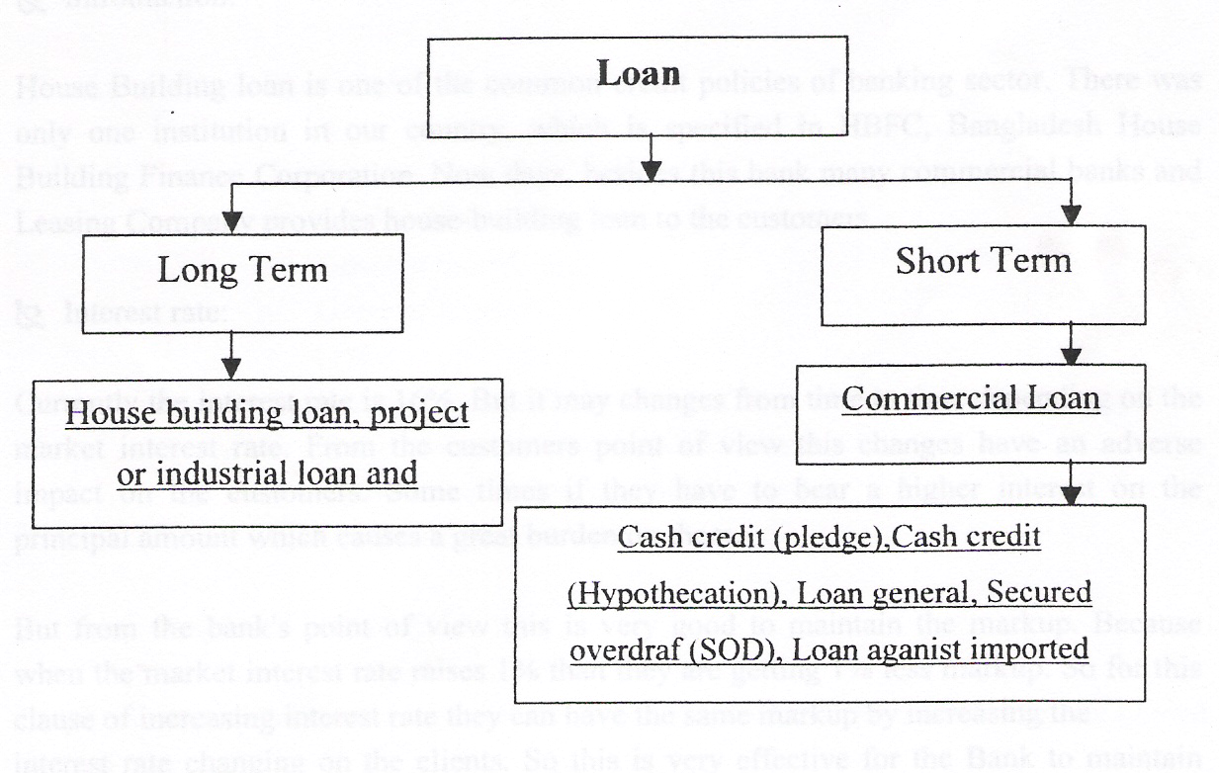

1). Loan (General):

Short term and long term loans allowed to individual/ firms/ industries for a specific purpose but a definite period and generally repayable by installments fall under this head

these types of lending are mainly allowed to accommodate financing under the categories.

a). Large and Medium Scale Industries.

b). Small and Cottage Industries. Very often tern financing for agriculture and others are also included here.

2). House Building Loan (General):

Loans allowed to individual/enterprises construction of house (residential or commercial) fall under this type of advance. The amount is repayable by monthly installment within a specified period, advances are known as Loan (HBL-GEN).

tst Introduction:

House Building loan is one of the common credit policies of banking sector. There was only one institution in our country, which is specified in HBFC, Bangladesh House Building Finance Corporation. Now days, besides this bank many commercial banks and Leasing Company provides house-building loan to the customers.

tst Interest rate:

Currently the interest rate is 16%. But it may changes from time to time depending on the market interest rate. From the customers point of view this changes have an adverse impact on the customers. Some times if they have to bear a higher interest on the principal amount which causes a great burden on them.

But from the bank's point of view this is very good to maintain the markup. Because when the market interest rate raises 1 % than they are getting 1 % less markup. So for this clause of increasing interest rate they can have the same markup by increasing the
interest rate changing on the clients. So this is very effective for the Bank to maintain markup.

Disbursement Procedure:

The disbursement procedure. or timing of disbursement depends on the client or the progress of work of the construction. The disbursement can be made two or three stages or more depending on the above conditions.

Mode of repayment:.

The loan shall be adjusted by monthly installment basis. The repayment will start from 6(six) months of the date of first disbursement (it may change according to the terms and .
conditions of the agreement) .

Collateral:

The land and the construction on the land are normally given as collateral. It may changes-

The documents to be obtained:

1. DP note.
11. Letter of disbursement.
111. Letter of installment.
IV. Letter of guarantee.
v. Letter of undertaking.
VI. Letter of agreement,
Vll. Irrevocable general power of attorney.
VlIl. Memorandum of deposit of title deed.
IX. Any other documents if considered.

House Building Loan( Staff)

Loans allowed to the Bank employees for purchase/construction of house shall be known as Staff Loan (HBFC-ST AFF).

Other Loans to Staff

Loans allowed to employees other than for House Building shall be grouped under head staff Loan (general).

Cash Credit (Hypo)

Advances allowed to individual/ firm for trading as well as wholesale purpose or to industries to meet up the working capital requirements against hypothecation of goods as primary security fall under this type of lending. It is a continuous credit. It is allowed under the categories:

"Commercial lending" when the customer is other than an industry and "Working Capital" when the customer is an industry.

Cash credit (Pledge)

Financial accommodations to individual Firms for trading as well as for wholesaler to industries as working capital against Pledge of goods as primary security fall under this head of advance. It is also a continuous credit and like the above allowed under the categories.

- "Commercial Lending"
- b. "Working capital"

Hire-purchase

Hire purchase is a type of installment credit under which the Hire-Purchaser agrees to take the goods on hire at a stated rental, which is inclusive of the repayment of principal as well as interest for adjustment of the loan within a specified period.

Lease Financing

Lease financing is one of the most convenient sources of acquiring capital machinery and equipment whereby a client is given the opportunity to have an exclusive right to use an asset usually for an agreed period of the time against payment of rent. It is a term financing repayable by installment.

Lease Finance of R Y JM Bank Ltd

The lease Financing is a major financial instrument in banking sector. As the Bank is a leading financial institution in the financial sector in our country it also involves in lease

Consumers Credit Scheme of Exim Bank Ltd

Introduction

Consenter Credit Scheme is a major program of Exim bank Ltd. In CCS the bank engage an agent who works on behalf of the Bank. This agent performs all the works prior to the sanction of the CCS. They do the inspection and make all the downbeats necessary for CCS. For this purpose they get commission.

Clients

The clients are Service Holders and Businessman. Service holders can be Government and Private. In case of Government officer, the client must be an officer in rank.

Products

Electronic goods, cars, jeeps, microbuses, Mobile telephone, T &T telephone etc. Profit Rate

Down payment

Down payment is 20% of the CCS amount. It is considered as equity. The payment is 50% for vehicles.

Maturity and Loan Limit

1-2 Years for electronic goods. Here limit is 1,00,000/=. 3 Years for vehicles. Here limit is 3700,000/=.

The documents, which is demanded by the hank:

Two letters of guarantee.

Bank statements the assets and liabilities of the clients

Assurance letter from the organization where he is currently working.

Trade license for the businessman or Article of Association.

Non-Judicial stamp amounting Tk.300/=.

Penalties

2% penal interest is charged in the residual amount.

Recovery rate

Recovery rate is 93%

It is a special credit scheme of the finance purchase of consumers' durable to the fIxed income group to raise their standard of living. The customers allow the loans on soft. terms against personal guarantee and deposit of specified percentage of equity. The loan is repayable by monthly installment within a fixed period.

SOD (Secured overdraft I (General)

Advances allowed to individual firms against financial obligation (i.e. lien on FDRlPSPIBSP
insurance Policy Share etc.). This mayor may not be a continuous Credit.

SOD (Secured overdraft) (Others)

Advances allowed against assignment of work order or execution of contractual works falls under this head. This advance is generally allowed for a defInite period and specifIc purpose. i.e. it is not a continuous credit. It falls under the category "others".

SOD (Secured overdraft) (Export)

Advance allowed for purchasing foreign currency for payment against LlCs (Back to Back) where the exports do not materialize before the date of import payment. This is also an advance for temporary period, which is known as export finance and under the category "Commercial Lending"

PAD (Payment against document)

Payment made by the Bank against lodgment of shipping documents of goods imported through L/C falls under this head. It is an interim advance connected with import and is generally liquidated against payments usually made by the party for retirement of the documents for release of imported goods from the customers' authority. It falls under the category "Commercial Bank".

LIM (Loan against imported merchandise)

Advances allowed for retirement of shipping documents and release of goods imported through LIC taking effective control over the goods by pledge in go downs under Bank's lock & key fall under this type of advance. This is also a temporary advance connected with import, which is known as post-import financing wd falls under the category "Commercial Lending".

LTR (Loan against trust receipt)

Advance allowed for retirement of shipping documents w d release of goods imported through LIC falls under trust with the arrangement that sale proceeds should be deposited to liquidate the advances within a given period. This is also a temporary advance connected with import and known as post-Import finance and falls under the category "Commercial Banking.

IBP (in/and hilly purchased)

Payment made through purchase of inland bills/Cheque to meet urgent requirement of the customer falls under this type of credit facility. This temporary advance is adjustable. from the proceeds of bill/ Cheque purchased for Collection. It falls under the category "Commercial Lending".

Credit Administration

The principle elements of bank credit administration are as follows:

A. Credit approval.
B. Credit file maintenance.
C. Facility evidence maintenance. D. Credit monitoring and review.

Credit Approval.

The primary factor determining the quality of the Bank's credit portfolio is the ability of each borrower to honor, on a timely basis, all credit commitments made to the Bank. The authorizing credit personnel period to credit approval must accurately determine this.

The credit approval process shall be governed by the Bank Credit Policy framework, which can be summarized under the following:
J) Credit Evaluation Principles

To have the optimum returns from the deployed funds in different kinds of lending, more emphasis shall be given on refund of loans and advances out of funds generated by the borrowers from their business activities (Cash Flow) in read of realization of money by disposing of the securities held against the advance which is very much uncertain and time consuming.

Accordingly the credit evaluation principles must be adhered to at every level of approval.

The lending risk analysis tool containing analysis of both the business risk and security risk provides overall ratings of risk in a particular to in under the following lending process:

Assess risk of failure to repay.
Decide whether to accept or reject a loan proposal. Set price and terms.
Obtain sanctioning documents and disburse loan. Monitor performance and ensure repayment/Recovery.

The most pertinent and part of the process is assessment of risk of failure to repay which deals with the overall lending risk combining the business risk and the security risk in a . matrix derived out or six segments of the Business risk viz.

The overall matrix provides four kinds of lending risk for decision-makers viz. Good
Accepted
Marginal And
Poor which are detailed in the Lending Risk Analysis Circular Credit Manual.

Bank shall not approve any lending having an overall risk as "managerial" and "poor' without proper justifications except for renewal of existing facilities under compelling circumstance or for other reason such as salvage, which shall also contain convenience future improvement of the position. All credit applications rated "Poor" shall require approval of the Board regardless of purpose, tenor or amount.

Credit Risk Evaluation /Assessment

The importance of a detailed and complete credit risk assessment for each facility and customer relationship cannot be over emphasized. The steps that should be followed in carrying out such an assessment are set out in the Bank credit manual and in Head Office circulars issued from time to time. All proposals of credit facilities must be supported by
a complete analysis of the proposed credit. A comprehensive and accurate appraisal of
risk in every credit exposure of the bank is mandatory. No proposal can put up for approval unless there has been a complete written analysis. It - is the absolute responsibility of the proposal officer to ensure that all necessary proposal documentation is collected before the facility request is sent to the sanctioning officer.

Lending Authority

Assure proper and orderly conduct of the business of the Bank, the Board of Directors will empower the Managing Director and other Executives of the Bank to lend up certain amount under certain terms and conditions at their discretion. The lending officer is broadly categorized as follows:

Managing Director
Deputy Managing Director
Executive Vice President
Senior Vice President
Vice President
Senior Asstt. Vice President
Asstt. Vice President

The amount and scope of each Officer's lending authority is a function of the amount and extent of authority required by the officer to carry out his /her responsibilities to the Bank and its clients ma prudent, effective and efficient manner.

It must be emphasized that an Officer will not be delegated lending authority only on the basis of his position. In other words, an officer does not automatically get lending authority by virtue of his corporate and/or functional title. Specified lending authority will be delegated by the Managing Director to various Executives after taking into
consideration his proven credit judgment, knowledge and experience. The amount of ending authority approved by the Board for various Executives forms the upper limit of
he authority that may be delegated to an officer holding corporate title. Each individual's lending authority will be delegated to him in writing. Authorities given 0 an incumbent will not automatically be transferred to a replacement. The letter will lave lending authorities' delegated to him in writing and amount delegated will depend upon the individual.
The Managing Director with the Executive Committee/ Board will review all lending authorities periodically.

Approval under Dual Signature

All approval of credit facilities must be conveyed under dual signature, and ideally both he signatures must have the required lending authority. If however, two lending officers of the required lending authority are not available, one of the signatories must have the lending authority.

The Responsibilities for the Credit Policy, procedure. approval & review shall vest
amongst the following groups.

A) Board of directors
Establishing overall policies and procedure for approving & reviewing Credits.

Delegating authority to approve and review Credits. I

Approving Credit for which authority is not delegated.
Approving all extensions of credit, which are contrary to Bank's written credit policies.

Formalities for Opening Foreign Currency (FC) Account:

The AD may without prior approval of the Bangladesh Bank open Foreign Currency (FC) account in the name of:

1. Bangladesh national residing abroad.

2. Foreign nationals residing abroad! in Bangladesh and also foreign firms registered
abroad and operating in Bangladesh and abstract.

3. Foreign Missions and their expatriate employees.

4. Resident of Bangladesh nationals working with the foreign! international organizations operating in Bangladesh provided their salary in paid in foreign currency.

Papers Required:

o Application duly billed in and signed.
o Photograph (two copies).
o Passport- Photocopy.
o Work Permit from Board of Investment. (Incase of Foreign Nationals)
Foreign exchange earned through business done or service rendered in Bangladesh cannot be put into these accounts.

No payment in Foreign Currency (FC) may be made to any resident in Bangladesh out of the Foreign Currency (FC) account.

All citizens of Bangladesh and other persons residing to Bangladesh who became the owner of any Foreign Currency (FC).

Formalities for Cash Assistance:

Eligible Party:

The party, which is engaged making fabrics locally from, thread and used In
Readymade Garments, which are finally exported abroad.

The party, which are engaged making fabrics locally from thread and to supply the
fabrics to the manufacturer of readymade garments.

Papers Required:

1. Application (as per format provided by Bangladesh Bank).

2. Cash memo/ delivery chilling letter of credit through which the party procure thread. Up to 3.00 (Three) lack party can purchase thread by cash. Other cases thread will be procured by Cheque/ draft! Pod or L/C.

3. Delivery Chelan.

4. Copy of L/C for providing fabrics to Garments.

5. Copy of commercial invoice/ truck receipt! delivery challis.

6. Copy of exporters L/C e.

7. PRC.

8. Certified invoice.

9. Certified bill of lading or Air waybill.

10. Certified of Back- To- Back L/Cs opened against master L/C.

RATE OF EXCHANGE:
It means the price of one currency expressed in terms of another currency. Rate of exchange is the rate by which the relation among different foreign currencies is established in terms of local currency of that country. Value at which one country's currency can be converted into another's currency.

Authorized Dealer:
In exercise of the power conferred by section 3 of Foreign Exchange Regulation ACT, 1947, Bangladesh Bank has issued license to certain Bank to deal in Foreign Exchange is called Authorized Dealer.

1. Spot Rate: It is quoted for transaction where the foreign currency bought or sold is to be received or delivered immediately. The current rate of exchange quoted in the foreign exchange markets.

2. Forward Rate: When a rate is applied to a future date it is called forward rate at
which foreign exchange can be sold or bought for delivery at a future time.

3. Cross Rate: The rate of exchange quoted by expressing the quotation for any two
currencies in terms of a third.

4. SWAO: Sport rate against forward purchased or a spot purchase against forward
rate.

5. Pence Rate/ Direct Quotation: Rates are quoted in terms of foreign currency per
one unit of foreign currency.

6. Currency Rate/ Indirect Quotation: Rates are quoted in terms of foreign currency
per one unit of home currency.

7. Buying Rate: Authorized Dealer applies this at the time purchasing! negotiation of export documents and payment against T.T, M.T, Cheque, and Drafts required form abroad.

8. Selling Rate: Authorized Dealer applies this ,at the time of lodgment of. import .
documents, real" Ion of L/C margin from importer and other foreign exchange transaction on overseas Bank

9. Tel One Rate: This is the rate when rate of foreign currency is quoted according
to the since of the bill.

10. Forward Rate at a Discount: When forward rate is higher than that of spot rate.

11. Forward Rate at a Premium: When forward rate is lower than that of spot rate.

Import Procedure:

To import a person should be competent to be an "Importer". According to Import and Export control Act 1950, the office of Chief Controller of Import and Export provides the
registration (lRC) to the importer. After obtaining this person has to secure a letter of credit authorization from Bangladesh Bank. And then a person becomes a qualified importer. He is the person who requests or instructs to open an LlC. he is also called opener or applicant of the credit.

Importer's Application for LIC Limit Margin:

To have an import L/C limit, an importer submits an application to the Department of EXIM Bank furnishing the following information:

- Full particulars of bank account.
- Nature of business.
- Required amount of limit.
- Payment terms and conditions.
- Goods to be imported.
- Offered security.
- Repayment schedule.

Now if the officer thinks the application to open an L/C in not fit, the following entries are given to realize the L/C, Charges, Postage and L/C margin.

Presentation of the Documents:

The seller being satisfied with the terms and the conditions of the credit proceeds to dispatch the required goods to the buyer and after that has to present the documents evidencing dispatching of goods to the negotiating ban1c After receiving all the documents the negotiation bank then checks the documents against the credit. If the documents are found in order the bank will pay and accept are negotiated to EXIM Bank checks the documents and the documents are stated below:
Invoice.
Bill of Lading
Certificate of Deposit
Packing List.
Weight List.
Shipping Advice.
Non-negotiable copy of bill of lading
Bill of Exchange
Pre-Shipment inspection report
Shipment Certificate.

Following Paper Required for New Imported While Opening on UC:

The following papers are required when opening a new L/C:
Valid Import Registration Certificate (IRC).
Trade License.
TIN Certificate.
V A T Certificate.
Three (3) copies declaration by the importer that they have paid! submitted return of
income tax of proceeding last year.
Membership Certificate of Chamber of Commerce Industry.
According to be maintained with the bank.
Membership Certificate BGMEA (Incase of Garment Ind.)
Banded warehouse license (Incase of Export Oriented Industry).
LCA From.
Insurance cover note.
Performa Invoice/ Indent.
Application for opening of L/C duly billed in and signed.
IMP form duly signed.
Memorandum and Article of Association of the company.
Certificate of incorporation with RJSC.
Certificate of Board of Directors.
Resolution of Commencement.

Resolution of Board of Directors.
Confidential report to be obtained from their previous bank.
Report! Inquiry to be obtained from CIB of Bank.
Credit Report to be obtained from correspondent bank, internationally reputed agency
introspects to the supplier.
LRA to be made in case of big liability.

Payment Procedure of The Import Documents:

This is the most sensitive task of the import department. The officials have to be very much careful while making payment. This task constitutes the following:

I. Date of payment: Usually payment is made within seven days after the document
have been received. If the payment is become deferred the negotiating bank may claim interest for making delay.

II. Preparing Sale Memo: A sale memo is made at Bangladesh currency rate to the customer. As T.T and 0.0 rate is paid to the International Department (1.0) the difference between these two rates in exchange trading. Finally an Inter Branch Exchange Trading Credit Advice is send to International Department (1.0).

III. Requisition for The Foreign Currency: For arranging necessary fund for payment
a requisition is sent to International Department.

IV. Transmission of Telex: A telex is transmitted to the correspondent bank ensuring
that payment is being made.

Advising a L/C:

It is customary to advise a credit to the seller through an advising bank. Advising through a bank is a proof of apparent authenticity of the credit to the beneficiary to whom it is addressed. Before forwarding/ advising the credit to the seller under appropriate forwarding coverage, the advising bank have to verify the signature of the officer of the opening bank and ensure that the terms and conditions of the credit are not violation of the existing exchange control regulations and other regulations relating to export. Very often advising bank receives requests from issuing ban to add their confirmation while advising credit to the beneficiary. The advising bank can do it if there is prior arrangement between advising and issuing bank or if it feels that the issuing is a reputed a reliable institution and good enough to discharge its obligation. It is also seen that sometimes banks receive credits addressed to them containing the name of the beneficiary in the body of the credit. In such case the advising bank prepares fresh letter of credit to the beneficiary containing all the terms and conditions of the original credit and signature by them selves.

Amendment of L/C

The buyer and seller satisfy the terms and conditions of a credit mutually before opening the same and the involved parties are expected to comply with the settled terms and conditions in course of performing their respective roles in the operations of a credit. But in real situation parties involved to a L/C, particularly the seller and the buyer cannot always satisfy the terms and conditions in full as excepted the time of settling the terms and conditions due to some obvious and genuine .reasons. The goal of establishing a credit might get frustrated. So in order to avoid such situation the credit should be amended. In case of revocable credit it can be amended or canceled be the issuing bank at any moment and without prior notice to the beneficiary. But the case of the issuing bank the confirming bank (if any) and the beneficiary. Partial acceptance of amendments. is not also effective without the agreement of an the above named parties. If a bank issues the services of another bank(s) to gave the credit advised to the beneficiary it mist also use the services of the same bank for any amendments must be completed and precise. If unclear or incomplete instructions are given to amend a credit, the bank requested to act on such instructions will give preliminary notification to the beneficiary.

Import Financing:

Import of Credit L/C Facility.
Loan Against Import Merchandise (LIM). y Loan Against Trust Receipt (LTR).

A) Import of Credit (L/C) Facility.

Bank in favor of exporter on behalf of the importer issue L/C. L/C is issued to import goods for trading and manufacturing process.

B) Loan Against Import Merchandise (LIM).

Loan Against Import Merchandise (UM) is post import finance, which is granted in favor
of the importer to retire shipping documents against import of goods. This is generally
repaid within 30 days.

C) Loan Against Trust Receipt (LTR).

Loan Against Trust Receipt (L TR) is post import finance extended to the importer of goods. Importer issues a trust receipt favor of Bank and takes possession of the goods markets and sells the products and repay within the stipulated period.

Export Procedure:

The exports form Bangladesh is subject to export trade control exercise by the Ministry of Commerce through Chief Controller of Export and Imports (CCI & E). no exporter is

allowed to export any commodity permissible for export from Bangladesh unless he is registered with CCI & E and holds valid Export Registration Certificate (ERC). The Export Registration Certificate (ERC) is required to be renewed every year. The Export Registration Certificate (ERC) is to be incorporated on EXP forms and other documents connected with exports.

The Formalities and Procedure Are Enumerated as Follows:

Obtaining Exports L/C: To get export L/C form exporter issued by the importer.

Submission of Export Documents: Exporter has to submit all necessary documents to .
the collecting bank after shipping of goods.

Checking of Export Documents: After getting the documents banker used to check
the documents as per L/C terms.

Negotiation of Export Documents: If the bank accept the document and pay the value draft to the exporter and forward the documents to issuing bank that is called a negotiating bank. If the bank does not buy the L/C then the bank normally act as a collecting bank.

Realization of Proceeds: This is the period when the issuing bank has realized the
payment.

Reporting to The Bangladesh Bank: As per instruction by Bangladesh Bank the bank has to report to respective department of Bangladesh Bank by mentioning latest payment.

Issue to Proceed Realization Certificate (PRC): Bank has to issue Proceed Realization
Certificate (PRC) of export L/C to the supplier exporter for getting cash assistant.

Following Papers To Be Obtained From The New Export While They Desire To Make
Export Through Us:

1) Export Realization Certificate (ERC).
2) Trade License.
3) Membership Certificate Form Chamber EPB.
4) Account To Be Maintained With Bank.
5) Export L/C Contract.
6) EXP Form To Be Certified.
7) TIN Certificate.
8) VAT Certificate.
9) Memorandum and Article of Association of The Company. 10) Confident Credit Report To Be Obtain of The Importer.

11) Registered Partnership Deed In Case of Partnership Concern.

The Following Are The Documents Normally Involved At The Stage of Shipments:

. EXP Form.
. Photocopy of The Registration Certificate.
. Photocopy of The Contract.
. Photocopy of The L/C.
. Customs Copy of ERF Form For Shipment of Jute Goods And EPC From For Raw
Jute.
. Freight Certificate From The Bank In Case Payment of The Freight At The Port of.
Lading 1s Involved.
. Railway Receipts, Barge Receipt or Truck Receipt.
. Shipping Instruction.
. Insurance Policy.
Preparation of Exports Documents:

Bill of Exchange or Draft.
Bill of Lading.
Invoice.
Insurance Policy/ Certificate. :> Certificate of Origin.
Inspection Certificate.
Consular Invoice.
Packing List.
Quality Control Certificate. GSP Certificate.
Photocopy-sanitary Certificate.

Export Finance:
Export Cash Credit (ECC).
Packing Credit (PC).
Back-to-Back Credit Facility (BTB).
Foreign Documentary Bills Purchased (FDBP).
A) Export Cash Credit (ECC):

Export Cash Credit (ECC) is extended to the companies who are involved in exporting goods and services. Export Cash Credit (ECC) is provided to procure raw materials, Packing List, Wages, Salaries, Utility etc. the quantum of Export Cash Credit (ECC) is usually 75% of the export L/C.

B) Packing Credit (PC):

Packing Credit (PC) is granted to export oriented industry usually garments industry to finance their expenses for Utility, Salaries, Wages etc. the quantum of packing credit is usually 10 % to 155% of the Valle of the export L/C.

C) Back-to-Back Credit Facility (BTB):

Back-to-Back Credit Facility (BTB) is issued to import raw materials for export -oriented industry usually of garments. The primary security of Back-to-Back Credit (BTB) is export L/C usually the quantum of Back-to-Back Credit (BTB) L/C is 75% of the value of Master L/C.

D) Foreign Documentary Bills Purchased (FDBP):

Banks purchase exports bills to the working capital needs to the customer.

The Documentary Latter of Credit (L/C):

The Letter of Credit is a credit compact where by the buyer's bank on behalf of the buyer is committed to place an agreed amount if money at seller's disposal under some agreed terms and conditions.

Since the agreed conditions include amongst other things the presentation of some specified documents the letter of credit is called documentary letter of credit. The UCPDC published by International Chamber of Commerce (1993) Revision, publication no: 500 defines documentary credit:

"Any arrangement however named of described where by a bank (the issuing bank) acting at the request and on the instructions of the customer (the applicant) or on its own behalf."

Parties To A Latter of Credit (LIC):
i. Import/ Buyer/ Applicant.
ii. Export/ Seller/ Supplier.
iii. Issuing Bank/ Operating Bank.
iv. Advising Bank/ Notifying Bank.
v. Confirming Bank.
vi. Negotiating Bank.
vii. Paying Bank/ Reimbursing Bank.

To import goods and services the buyer approaches his/ her bank to open a Letter of Credit (L/C) through its branches and correspondents abroad.

Importer: The person who requests the issuing bank to open an L/C. Exporter: The party in whose favor L/C is established.
Issuing Bank: The Bank which opens issue L/C.
Advising Bank: The Bank advised For L/C.
Confirming Bank: The Bank, which adds confirmation to the credit. Negotiating Bank: The Bank, which negotiates the bills.
Paying Bank: The Bank, which effects reimbursements.
At the instruction of the opening bank, advising bank may confirm the LlC and negotiate the documents and also be the reimbursing bank under the credit. The reimbursing bank may be different and even may be located in the third country. Intermediary bank is usually the foreign correspondent of the importer's bank through which the LlC is advised to the supplier. If the intermediary of the importer's bank simply advisesl notifies the L/C to the exporter without any obligation on its part, it is called as advising bank. If it adds undertaking to honor the credit while advising the same to the beneficiary, it becomes the confirming bank.

It is a guarantee in the form of Letter of Credit.

An instrument payable against presentation of documents.

Documents Required In Latter o/Credit Operation:

Bill of Exchange (Drawer, Drawer and Payee).

Invoice (Performa Invoice, Commercial Invoice, Consular Invoice, Legalized

Invoice, Customer Invoice).

Packing List.
Certificate of Origin.
Inspection Certificate.
Insurance.

Marine Insurance Policy.
To import goods and services the buyer approaches his/ her bank to open a Letter of Credit (L/C) through its branches and correspondents abroad.

Importer: The person who requests the issuing bank to open an LlC. Exporter: The party in whose favor L/C is established.
Issuing Bank: The Bank which opens issue L/C.
Advising Bank: The Bank advised For L/C.
Confirming Bank: The Bank, which adds confirmation to the credit. Negotiating Bank: The Bank, which negotiates the bills.
Paying Bank: The Bank, which effects reimbursements.
At the instruction of the opening bank, advising bank may confirm the LlC and negotiate the documents and also be the reimbursing bank under the credit. The reimbursing bank may be different and even may be located in the third country. Intermediary bank is usually the foreign correspondent of the importer's bank through which the L/C is advised to the supplier. If the intermediary of the importer's bank simply advises notifies the L/C to the exporter without any obligation on its part, it is called as advising bank. If it adds undertaking to honor the credit while advising the same to the beneficiary, it becomes the confirming bank.

It is a guarantee in the form of Letter of Credit.

An instrument payable against presentation of documents.

Documents Required In Latter o/Credit Operation:

Bill of Exchange (Drawer, Drawer and Payee).

Invoice (Performa Invoice, Commercial Invoice, Consular Invoice, Legalized

Invoice, Customer Invoice).

Packing List.
Certificate of Origin.
Inspection Certificate.
Insurance.

Marine Insurance Policy.

Three types of Marin insurance Policy

1. ICC (A):- Covers Maximum Risk. 2. ICC (B):- Covers Moderate Risk. 3. ICC (C):- Covers Minimum Risk.

Covers Minimum Risk ICC (C):
1. Loss or damage to the subject matter insured reasonably attributes to.
2. Fire or Explosion.
3. Vessel or credit being stranded grounded sunk or capsized. 4. Overturning or derailment of land conveyance.
5. Collision or contact of vessel craft.
6. Discharged of cargo at a port of distress.
7. Jettison.

Covers Moderate Risk ICC (B):

Same as ICC (C) and is addition:
1. Earthquake volcanic corruptions or heightening.
2. Jettison or washing over board.
3. Enter of sea lake or river water into vessel craft hold conveyance container lift-van or place of storage.
4. Total loss of any package, overboard or dropped whilst loading on to or unloading from vessel or craft.

. CO\7ers Maximum Risk ICC (A):
It covers all risk of loss or damage, but it does not state any specific risk as B & c.

Inciters

Inciters simply mean International Commercial Terms. These are also known as contract terms or Trade Terms or Delivery Terms of Sales Terms or Purchase Terms. These Terms are used in the field of Imitational Trams or Foreign Trade, Paris, France.

The purchase office inns is to provide a set of international rules for the interpretation of the most commonly used trade terms in foreign trade. Thus the uncertainties of different interpretations of such terms in different countries can be avoided or at best reduced to a considerable degree.

1. EXW: "EX Work" means that the seller fulfill his obligation to deliver when he made
the goods available at his premises (Le. works, factory, warehouse etc.) to the buyer.

2. F AS: "Free Alongside Ship" means that the seller fulfill his obligation to deliver when the goods have been placed alongside the vessel on the quay or in the lighters at the named port of shipment.

3. FCA: "Free Carriage" means that the seller fulfill his obligation to deliver when he has handed over the goods, cleared for export, into the charge of the Carrie named by the buyer at the named place or point.

4. FOB: "Free on Board" means that the seller fulfills his obligation to deliver when the
goods have passed over the ship's at the named port of shipment.

5. CFR: "Cost and Freight" means that the seller must pay the costs and freight necessary to bring the goods to the named port of destination but the risk of loss of or damage to the goods, as well as any additional costs due to events occurring after the time the goods have been delivered on board the vessel.

6. CF: "Cost and Freight" means that the seller has the same obligation, as under CRF
but with the addition that it will caver the buyer risk.

7. CPT: "Carriage Paid To" means that the seller pays the freight for the carriage of the goods to the named destination. The risk of loss of a damage to the goods as well as any additional casts due to events occurring after the time the goods have been delivered to the carrier, is transferred from the seller to the buyer when the goods have been delivered into the custody of the carrier.

8. C/P: "Carriage and Insurance Paid To" means that the seller has the same obligation as under CPT but with the addition that the seller has to procure cargo insurance against the buyer' s risk of loss of or damage to the goods during the carriage.

9. DAF: "Delivered Ex Ship" means the seller fulfill his obligation to deliver when the goods have been made available, cleared for export at the named point and place of the frontier.

10. DES: "Delivered Ex Ship" means the seller fulfill his obligation to deliver when the goods have been made available to the buyer on board the ship unclear for import at the named port of destination.

11. DEG: "Delivered Ex Quay" means that the seller makes the goods available to the buyer on the quay. The seller bears the risk in the goods up to that point and pays transport cost. The seller pays import dues taxes and other charges of deliver the goods there to.

12. DDU: "Delivered duty unpaid" It means that the seller delivers the goods at an agreed point in the buyer country. The seller has to bears the cost and risks involved in
bringing the goods there to excluding duties, taxes and other offici~ charges payable . upon importation.

13. DDP: "Delivered duty paid" It means that the seller at the named place in the country has made the goods available. Importation the seller has to bear the costs and risks including duties, taxes and other official charges of delivering the goods there to, charge for importation.

Back to. Back Letter of Credit:

A back-to-back letter of credit is a new credit. It is different from the original credit based on which the bank undertakes the risk under the back-to-back credit. In this case the bank's main surety/ security is the original credit. The original credit (selling credit) and the back-to-back credit (buying credit) are separate instruments independent of each other and in no way legally connected, although they both form part of the same business operation. The supplier (beneficiary of the back-to-back credit) ships goods to the importer or supplies goods to the exporter and presents documents to the bank as is specified in the credit. It is intended that the exporter would substitute hiss own documents and ships the goods to the importer, if necessary and present documents for negotiation under the original credit, his liability under the back-to-back credit would be adjusted out of these proceeds. The export L/ is marked lien and no margin is taken.

Foreign Exchange:

Foreign exchange can simply be defined as a process of conversion of one currency into another. A well know author of some popular books on foreign exchange, Dr. Paul Ensign tells that foreign exchange means "a system or process of conversion of one national currency into another and of transferring money from one country into another". In
ordinary sense "Foreign Exchange" means Foreign Currency, which refers to the rate of exchange the price of one unit of foreign exchange in terms of another currency. But in its complete sense, foreign exchange means the mechanism or the media used and the rate at which these media are exchange with another.

Foreign Exchange department is divided into two parts, the first one is the Export Department and the second part is the Import Department.
Export Department:

When any organization wants to export any product to other country than that particular organization usually opens an Export Letter of Credit (L/C) from this department.

Foreign Exchange Operation (Export Financing):

Exporter means any person lawfully exporting goods from Bangladesh to any other country in the world. After shipment the exporter has to tender the documents to the Bank . within the stipulated period for the negotiation of the documents are drawn under a Letter of Credit. If require, finance the duty drawback and cash compensatory support claims of the exporter.

Export credit means any credit provided by an institution to an exporter in the form of packing credit or post shipment credit. Packing credit means any loan or advance granted or any other credit provided by an institution to an exporter for financing the purchase, processing or packing of goods on the basis of Letter of Credit.

Post-shipment means any loan or advance granted or any other credit provided by an institution to an exporter of goods from Bangladesh from the date of realization of the credit after shipment of the goods to the date of extending the credit after shipment of the goods to the date of realization of the export proceeds and includes any loan or advance granted to an exporter in consideration of or on the security of any duty drawback or any cash payment by way of incentive.

Incentives are as follow
Export Finance
Interest Rate.

Incremental Incentive on Interest for Interest Based Bank.
Extent of Export Credit.
Credit to First Time Applications. Back-to-Back Letter of Credit.
Substitute Benefit:

Exporter will get this benefit only for export oriented local waving! Knitting
manufacturer.

An exporter of manufactured products is entitled to draw back the value of the customer's duties; sales tax etc. already paid on the importation of raw materials used in the production or manufacture of the export products.

Export Credit Guarantee Scheme.
Confessional Rate of Import Duty.
Income Tax Rebate.
Traveling Facilities.
Export Formalities:
Procedure for Registration of Exporter.
Books and Register/ Ledger Required for Export. ~ Export LlC Checking and Advising.
Formalities of Back-to-Back L/C Opening.
Accounting of Back-to-Back L/C.
B.B Bill Checking! Lodgment.
Mechanism of Acceptance.
Pre-shipment Financing.
Export Document Checking and Negotiation! Collection Basis. Calculation of Offering Sheer for Fund Disbursement System.
Proceeds Realization Correspondence.
Formalities of Back-to-Back Payment System.
Substitute Benefit Rea dilation! Collection System. EXP From Reporting of Bangladesh Bank. Disposal of EXP Forms.
Disputes and Settlement of Export Claim.
Procedure for Obtaining Export Registration Certificate (ERC):

For obtaining export registration certificate nom CCI & E, the following docwnents are required:

Application Form. National Certificate.
Partnership Deed (Registered).
Memorandum and Article of Association and Incorporation Certificate.
Bank Certificate.
Valid Trade License.

Copy of Rent Receipt of the Business Finn.

Checking and Advising of Export Letter of Credit:
On receipt of Export letter of Credit it is to be recorded in the Banks inward register and then the signature of a Bank and family it is to be forwarded to the beneficiary under forwarding. schedule.

Processing and Opening of Back-to-Back Letter of Credit:
An exporter desired to have an Import L/C limit under Back-to-Back arrangement. In that case the following papers & downbeats are required:

Full Particulars of Bank Account.
Balance Sheet
Statement of Assets & Liability
Trade License.
Valid Bonded Warehouse License.
Membership Certificate
Income Tax Declaration
Memorandum of Articles
Partnership Deed
Resolution.
Photographs of AI Direction .

On receipt of above documents and papers the Back-to-Back Letter of Credit opening section will prepare a credit report. Branch must obtain sanction from Head Office for
Opening Back to Back L/C.

Back-to-Back Letter of Credit opened without Head Office concern because of valued clients of the Bank. In that case an officer of Foreign Exchange Department will send a Post to the Head Office for the opened Back-to-Back Letter of Credit

Exporters prepare the documents and submit the same to the Bank for negotiation.

Preparation of Export Documents:

. Export Documents Checking:

General Verification:

L/C Registers or Not.
Exporters Submitted Documents Before Expiry Date of the Credit. Shortage of Documents etc.
Particular Examination:

Each and every Documents Should be Verified with the L/C.

Cross Examination:

Verified One Document to Another.

On receipt of documents it must be checked properly and then a proposal sheet would be prepared as per Bank's format indicating the full particulars of shipment and discrepancies under the signature of authorized person and should be placed to Manager for disposal instruction or sanction.

Sanction of Pre-shipment:

The party is to apply the Bank. On receipt of the application pre-shipment, section will start scrutiny of the application.

Types of pre-shipment, whether clean! pledge/ hypothecation of goods. Whether the investment is within Bangladesh Bank credit restriction. Whether the security offered is acceptable.
What is the purpose of the investment?

Whether the goods specified for finance is eligible for export under export control rule.
How the PSI A/C will be adjusted.
Whether the item is traditional or non-traditional.

Disbursement:

Execution of Documents:

Execution of the charge documents.
Lien mark on Master Letter of Credit (L/C).

Import Department:

When any organization want to import any product from other country than the particular organization usually opens an import Letter of Credit (LIC) from this department.

Import of Goods by Letter of Credit:

A Letter of Credit is a conditional Bank undertaking of Payment. In other words Letter of Credit is a letter form the importer Banker to the exporter that the bills if drawn as per terms and conditions are complied with will be honored on presentation.

Following papers are to be submitted by the importer before opening the Letter of Credit:

* Trade License.
* Import Registration Certificate.
* Income Tax Declaration with TIN.
* Membership Certificate.
* Memorandum of Articles (in case of Ltd. Co).
* Registered Deed (in case of Partnership firm).
* Resolution.
* Photographs.
* VAT Registration.

Invoice:

The amount of invoice to be filled with that of draft.

The invoice is shown by the beneficiary and is signed by him.
Description of goods in. the invoice and bill of landing are to be identical.
Description of goods in the invoice and bill of lading are to be identical. .:. Maintain the Register:

Give serial number of the Documents according to the entry in the relevant bill register. Full particulars of the entire document are recorded including the details of shipment, merchandise and amount etc. The import bills register must be marked of with the notion "PAID" showing the date of payment when the documents are retired by the importer against payment.

Application of Rate: B.C Selling Rate. Exchange control from: IMP and TM Form. Endorsement of LCAF:

Document must be kept under lock and key of the bank with under the custody of a responsible officer.

Reporting:

After completion of the above procedure the relevant exchange control form (for bill value IMP and for F.C.C, TM form) prescribed by the Bangladesh Bank Exchange Control Department vide Schedule.

Import on Deferred Payment Basis:

Import of heavy machinery, plant, ships, capital goods etc. may be necessary in to deferred payment terms because the importer of the consignee may fail to make full payment of the bill on receipt due to heavy involvement in the outlay of funds. Moreover here is the possibility of payment of installments spread over the period of since/ deferred time.

Letter of Credit for import on deferred payment basis can be opened in respect of capital machinery's under SEM/ WES for up to 360 days deferred payment terms and in respect of raw and packing materials imports under the Back to Back Letter of Credit (L/C) arrangement for up to 180 days credit terms by export oriented ready made Garments/ Specialized Textile/ Hosiery units operating under the bonded warehouse system.

It has been decided that for import of industrial raw materials under SEM, WES by industrial consumers as per their pas book entitlements, Letter of Credit may be opened on deferred payment terms for period up to 90 days subject to the conditions that,

I). If the price includes interest on sight FOB price, the interest rate should not be above LIBOR for the relative period and

II). The payment date must be within original validity of the relative LCA for remittance in case the LCA has been registered with the Bangladesh Bank. However if the entire fund is arranged by the Authorized Dealers under the Wage Earner's Scheme without recourse to Bangladesh Bank the due date of payment should not be beyond six months trom the date of opening of import Letter of Credit UC or 90 days trom the date of Bill of Lading whichever is earlier.

The requirement of advance deposit of foreign exchange covers before opening s Letter of Credit for import of admissible items under SEMI WES on deferred payment basis may be decided by the Authorized Dealers on the basis of Banker-customer, relationship keeping in view their responsibility for making payment on due date subject to compliance with the minimum margin requirements for import of such commodities prescribed the Banking Control Department of Bangladesh Bank trom time to time. Head office of Authorized Dealers will submit to Exchange Control Department of Bangladesh Bank Head Office, a consolidated monthly statement showing position of outstanding and fresh Letter of Credit (UC) opened on deferred payment terms under SEMI WES, in respect of all their Authorized Dealer Branches. The statement pertaining to a month should be furnished to Bangladesh Bank by the 15th day of the following month.

lodgment of The Documents:

Documents must be lodged within 7 (Seven) days and examine the same whether documents are in order or not. The exporter of Bangladesh follows the whole procedure. Necessary papers that the exporter sends with the shipment are:

Commercial Invoice.
Packing List.
Bill of Lading.
Certificate of Original Goods.
Weight and Measurement List.
Other Paper That The Importer Asked.

Kinds of Documents Bills.
At Sight.
Collection.
Cash! Loan.
Usance/ Deferred.

Application of Rate:

The foreign currency would be converted at the rate ruling on the date of Lodgment (B.C Selling Rate) or at the rate if forward exchange booked or at the rate prescribed by

Bangladesh Bank. The rate and the equivalent Bangladesh Taka should be recorded on the bill Register. Two people must check the converse on.

. Exchange Control Forms:

IMP! TM (Import Form & Traveling Miscellaneous Form) must be filled in and duly signed by the importer in all respect at the time of Lodgment.

Noting on The Letter of Credit File:

As soon as documents are ledges the utilized amount is to be noted on the Back-to-Back L/C copy or on the printed format of the Letter of Credit (LlC).

Security of The Documents:

Document must be kept under lock and key of the bank under the custody of a responsible officer.

Limitation to The Importers:

Importer is to be advised on the date of Lodgment of documents with full particulars of shipment to retire the documents against payment or to dispose the import documents as per-arrangement, if any. Documents must not be making any arrangement for disposal.

Dishonor of Document:

If the documents are found discrepant by the Bank on checking a Telex! Cable message is to be sent to the negotiating Bank! Collecting Bank on the date of receipt of documents. In the meantime, the discrepancies are also to be referred to the drawee for their acceptance. The reply of importer is to reach to the bank within 72 hours in case of nonacceptance. The dishonor is to be communicated to the negotiating bank within reasonable time. Unusual delay in communication of dishonor is not acceptable - to the negotiating bank and the issuing bank forfeit its right to claim refund.

Disposal of LCA:

Exchange Control copy of LCA if fully utilized or when the balance is too much small is submitted to the Bangladesh Bank, Exchange Control Department along with IMP! TM and schedule.

Retirement (At Sight Bills) of WES cash:

The importer must retire all the importer bills immediately after receipt of documents.

Retirement Procedure for Deferred Payment of Usance Bills:

When the draft is returned by the drawer (Importer) after duly accepted by him, the following procedure to be maintained:

The maturity date is to be worked out and noted in Bill Register and also in due date diary. The due date diary may be maintained by the dealing officer and the Manager or In-Charge of Foreign Exchange Department.

The Foreign Corresponded should be advise the due date of maturity and be authorized to debit the wrong account or to claim reimbursement on due date as per Letter of Credit (L/C).

All the downbeats delivered to the importer except accepted Bill of Exchange/ draft.

ACU Letter of Credit (LIC):

This types of L/C as same as Case L/C. reimbursement must be made on ACU NOCTRO AlC countries. Reimbursement authority should be sending on the same day of the Letter of Credit (L/C) is sent.

eta Letter 0/ Credit (UC):

Letter of Credit (L/C) is the most important thing for doing any sort of foreign business. There is no guaranteed relation between Importer and Exporter. As a result they use a media to secure their goods and currency. So exporter and importers use their respective banks as a media and Letter of Credit (L/C) is a legal obligation between the exporter and
importer. The importer can open a Letter of Credit (L/C) of 100% or take the merger of 25%, 15%. The merger actually depends on the relationship between the customer and bank. To open Letter of Credit (L/C) the importers submit the invoice/ indenture. It is
necessary to fill up following forms:

LCF form.
Application and agreement for confirmed irrevocable without resources to drawer's
Letter of Credit (L/C).
Letter of Credit (L/C) Authorization Form.
Form of IMP (Importer) and EXP (Exporter).
Parties to a Letter of Credit:

As per term and conditions of the Letter of Credit (L/C) the seller is required to be routed through some intermediary banks in order to get his claim. So we see that there are a
number of parties involved in a Letter of Credit (L/C). The involved parties to a Letter of Credit (L/C) are as under:

Importer Buyer.
Exporter Seller Beneficiary.
Opening! Issuing Bank.
Advising! Notifying Bank.
Confirming Bank (for add confirming L/C
Exporter Bank
Negotiating Bank).
Reimbursing Bank or Paying Bank.

Classification of Letter of Credit (VC):

Revocable Letter of Credit (L/C).
Irrevocable Letter of Credit (L/C).
Confirmed Letter of Credit (L/C).
Transferred Letter of Credit (L/C).
Divisible Letter of Credit (L/C).
Revolving Letter of Credit (L/C).
Restricted Letter of Credit (L/C).
Red Clause Letter of Credit (L/C).
Green Clause Letter of edit (L/C).
Back-to-Back Letter of Credit (L/C).
With Recourse Letter of Credit (L/C).
Without Recourse Letter of Credit (L/C).

Revocable Credit:

As pr Article No.8 (a) a revocable credit is a credit, which can be amended or cancelled by the issuing bank at any time without prior notification to the seller since it offers little security to the seller.

. Irrevocable Credit:

As pr Article No.9 an irrevocable credit constitutes a definite undertaking of the issuing bank. A credit cannot be amended or cancelled without the agreement of all parties. It gives the seller greater assurance of payment. An irrevocable credit can be either confirmed or unconfirmed depending on the desire of the seller.

. Confirmed Irrevocable Letter of Credit (UC).

As per Article No. 10 of UCPDC when an issuing bank authorized or requests another bank to confirm its irrevocable credit and the later has added its confirmation such confirmation constitutes a definite undertaking of the confirming bank in addition to that of issuing bank. These types of Letter of Credit (L/C) are called confirmed irrevocable Letter of Credit (L/C).

. The Recourse to Drawer or without Recourse to Drawer:

These terms are very much related with the Bill of Exchange, which are to be drawn under the strength of L/C. The recourse means in case the drawer of the bill fails to honor it, the banker as the hold of the bill can claim the amount back form the drawer.
In order to avoid such liability the exporter may ask the importer to arrange credit without recourse to the drawer. Under this case the issuing bank will have recourse to the drawer only, if the fails to honor the bill and the liability of the drawer ends as soon as the bill is negotiated.

. Transferable Credit:

A transferable credit is one that can be transferred by the original beneficiary to one or
more subsequent beneficiaries. The original beneficiary acts as the middleman and does
not supply the goods himself. The 2" beneficiary who acts as actual supplier and to whom the credit is transferred in full on in part.

As per Article No. 48 of UCPDC 500 a transferable credit is a credit under which the beneficiary has the right to request the bank called upon to effect payment or acceptance or any bank entitled to effect negotiation to make the credit available in whole or in part to one or more parties.

A transferable credit can be transferred once only. Fractions of a transferable credit can be transferred separately, provided partial shipments are not prohibited.

The credit to be transferred only under the terms and conditions specified in the original credit with exception of the amount of the credit, if any unit prices stated therein, and of the period of validity or period for shipment, any or all of which may be reduced or curtailed.

. Procedure for Transferable Letter of Credit (L/C):

The original beneficiary when request the banker in writing to effect transfer the Letter of Credit (L/C) to the second beneficiary, the signature of the original beneficiary on the letter of request must be verified by his banker. The Letter of Credit (UC) can be transferred only on the terms and conditions specified in the original credit.

A transferable credit can be transferred once only. Fractions of transferable credit can be transferred separately. The aggregate of such transfers will be treated as only one transfer. The aggregate of such transfers must not exceed the original value of UC.

When transfers are made in part it should be verified that the original Letter of Credit (UC) permits part shipment.

While transferring a credit, bank may hold the original at their custody. Each and every transfer must be noted on the back of the original one. All the transfers are to be noted in the Letter of Credit (UC) register. Bank charge commission is to be realized on the 1st beneficiary unless other wise specified.

Each transferable Letter of Credit (UC) is subject to UCPDC, ICC publication No. 500, and 1993 revision.

Revolving Credit:

The revolving credit is one, which provides for restoring the credit to the original amount after it has been utilized. A credit revolving as to time because automatically reinstated or
available on utilization at specified intervals of time within a given overall period of validity. It revolves in relation to time. In this case the issuing bank will have to consider for factors in addition to the other factors. Generated rate and maintain the growth of the special business such as Import and Export trades.

Anticipatory Letter of Credit (Red Clause and Green Clause UC):

The anticipatory credits make provisions for pre-shipment payment (at least th~ part amount) to the beneficiary in anticipation of his effecting the shipment as per UC conditions. As the clause of the credit, authorizes the negotiating bank to provide reshipment advance to the beneficiary for procurement of the goods is printed typed and red ink to draw attention to the unique nature of the credit, this type is Letter of Credit (UC) is known as Red Clause UC. The 'Green Clause' (printed or typed in green ink) is an extension of the 'Red Clause' in that if authorizes the negotiation bank to grant advance to the beneficiary for storage facilities at the port in addition to the earlier stated pre-shipment advances.

. Back-to-Back Letter of Credit (UC):

Back-to-Back Letter of Credit (L/C) is a type of Import L/C either in inland or in abroad, which open against lien on valid export L/C.

In our country in export of garments, this method of finance of widely used and is very well known to the manufactures of garments. Bangladeshi exporters received an irrevocable Letter of Credit (LIC) for supply of readymade shirts, :& ohm an American Bank. For manufacture of the ordered shirts the exporter does not have the required raw materials. To execute the order he is to import raw materials from Korea. Then the Bangladeshi exporter will have to open an import Letter of Credit (L/C) favoring Korean supplier for of fabrics and accessories. The Letter of Credit (L/C) is opened by the Bangladesh Bank lien against the American Banks Letter of Credit (L/C) under bonded warehouse system.

Restricted Letter of Credit (L/C)

When the negotiation is restricted to the Letter of Credit (L/C) advising bank only against adding confirmation to the credit. This type of Letter of Credit (L/C) is called restricted L/C.

... Procedure for Opening Letter of Credit (UC):
An importer desirous to have an import Letter of Credit (L/C) limit must have applied to the designated bank in prescribed form for sanction of margin, Letter of Credit (L/C) limit it etc. .

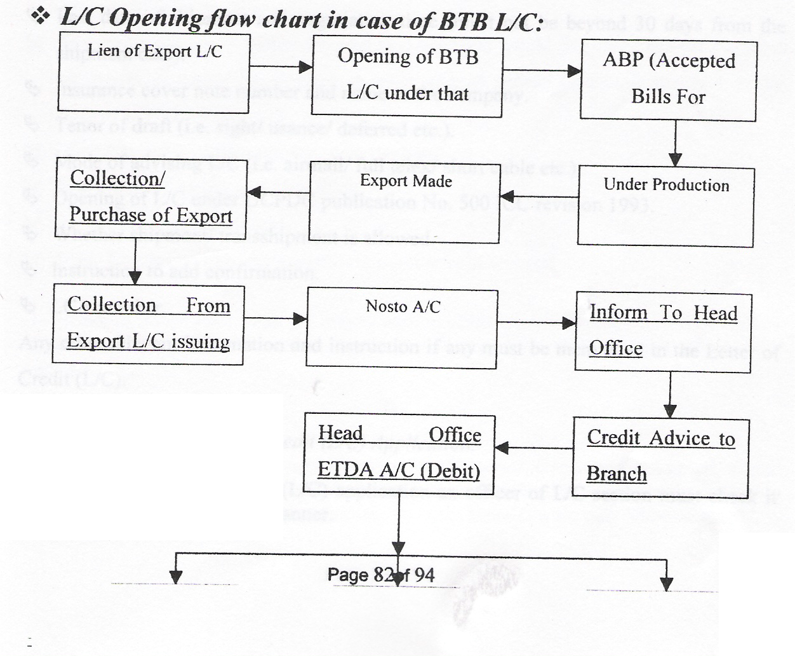

Figure: Letter of Credit (L/C) Opening Process

Letter of Credit (UC) Application:

For opening Letter of Credit (L/C) the client is to submit to the bank an application in the printed fondant of the designated bank. This is called Letter of Credit (L/C) application fun, which is also an agreement between the importer and the bank. The fun is to be stamped under stamp Act. The importer must submit the LCA and IMP and Indent or contract / purchase order/ profane invoice (duly accepted by the importer) along with Letter of Credit (L/C) application.
The Letter of Credit (L/C) application must be completed! filled in and signed by the authorized person of the importer giving the following particulars.
Full name and address of the supplier or beneficiary and importer.
Brief description of the goods.
Last date of shipment and negotiation time (must not be beyond 30 days from the
shipment date).
Insurance cover note number and name or the company.

Tenor of draft (i.e. sight! since/ deferred etc.).
Mode of advising L/C (i.e. agnail/ full telex! short cable etc.). Opening of LlC under UCPDC publication No. 500 ICC revision 1993.
Whether shipment! transshipment is allowed.
Instruction to add combination.
LCA number.
Any other relevant intonation and instruction if any must be mentioned in the Letter of
Credit (L/C).

Examination of Letter of Credit (LIC) Application:
On receipt of Letter of Credit (L/C) application an officer of L/C section must check it very careful by the following manner.

That the terms and conditions as stipulated in the L/C application are consistent with
the exchange control and import trade regulation and UCPDC 500.
That all the information mentioned in above column have been furnished.
That the teens to be imported are eligible according to importers entitlement.
That the goods are not being imported or originated form South Africa or Israel.
If the goods are imported form any member countries of ACU.
That the validity of the L/C must not exceed the validity of LCA.
L/C is opened within the validity period permitted in the License.
For Letter of Credit (L/C) limit following information are to be furnished by the applicant.
The full particulars of bank account.
Types of business (Proprietorship, Partnership, Limited Co.) in case of Ltd.
Balance sheet of last 3 (three) years and the names of directors.
Historical background.
Amount of limit required.

Terms of payment- Whether the import documents would be retired against payment on receipt or against acceptance or whether post import finance is required in the
form of MPI/ L TR etc.

Other liabilities of the customer with the bank.
Statements of Assets and Liabilities.
Account position (Balance).
Trade License and import registration number with renewal date.
On receipt of above particulars the import section of the bank will prepare credit report of the concerned importer. The report should be collected form the previous banker of the party also.

Preparation of Credit Report:
Bank prepares credit report in prescribed forms. Character, Capacity and Capital, which are known as the three C's of credit. Instead of the three C's some mentions the three R's i.e. reliability, responsibility and resources. To these three C's we may add two more C's i.e. collateral and conditions.

How a banker should obtain the necessary information regarding these fundamentals of credit? No doubt, banker have to make inquires from those of their customers and other people and inquired the report by the banker. Sometime information is gathered by deputing marking officer or credit officer.

Position of Letter of Credit (UC):

Import section will see whether there is sufficient fund available in the account to cover the margin to be sanctioned, commission, postage, cable or telex charge etc. If it is found O.K, Letter of Credit (L/C) will be sanctioned.

In all cases the sanction must be informed to the importer for acceptance. On receiving confirmation from the client then the terms and conditions of the sanctioned are acceptable, the subsequent documentation! charge document are taken up.

Following papers/ documents submitted by the importer before opening of the L/C:

Memorandum of (In case of partnership firm). Resolution.

Photo One Copy.
V A T Registration Certificate.

Bank will supply the following papers/ documents before opening of the L/C:

Letter of Credit (L/C) Application Form.
LCA Form.
IMP Form.
Charge Documents Paper.
Guarantee Form.
The above papers must be completed duly filled in and signed by the party and verified the signature.

Maintenance of Register:

The sanction must be recorded in the following registers:

Document Execution Registers.
All the charge documents must be recorded in this register.
Limit Register.
Liability Ledger.

Confidential Report of Beneficiary of Letter of Credit (UC):

According to exchange control regulations bankers are required to obtain confidential report of the beneficiary of Letter of Credit (L/C) before opening the same, if the amount of Letter of Credit (L/C) exceeds Tk. 5 lac. Bank can open Letter of Credit (L/C) below Tk. 5 lac without obtaining C.R.

Banker can write to their foreign correspondents to supply the C.R. But from practical experience foreign correspondents of different country are not supplied timely.

To overcome the above situation bankers can conduit reference book i.e. MUWN/ . DUNN/ BRADSTREET/ Trade directory of various chambers of commerce of different countries in the world.

On receipt of C.R. form any source the banker can accumulate the same in one master file.

LCA Registration:

Letter of Credit (L/C) authorization forms consisting of six c0.fies. 1st copy for exchange
control purposes, 2nd copy for the licensing authority, 3rd and 4 copies for the CCI and E, 5th copy for the registration unit and 61h is the office copy of the bank.

The procedure for registration of LCA form with the Bangladesh Bank is as under.

All LCA forms should be registered with Bangladesh Bank, Registration Unit,
Exchange Control Department, Bangladesh Bank and Dhaka.

After filling up the relevant portions of the LCAFs and duly signed by the importer there are forwarded to the registration unit of the Bangladesh Bank by the authorized dealers duly authenticated. The Bangladesh Bank registration unit subject to observation of usual drill registers the LCAFs. The officer in charge of the Bangladesh Bank unit will give the registration number on all the copies of LCA forms under his signature. Therefore, the same will be opened unless and LCA form which has been registered with the Bangladesh Bank.

After registration the original and duplicate copies of the Letter of Credit (L/C) authorization forms will be delivered to the authorized representative of the Banks from whom the same received by the registration unit. 3rd and 4th copies of the form will be passed on to the concerned licensing office, 51h copy of the form will be retained in the record of the registration unit of the Bangladesh Bank.

The authorization dealers will not issue blank Letter of Credit (L/C) authorization
form to their clients. The importer should sign the L/C authorization form in presence

of Bank's officer. The A.D should sign the LCA form and verify the importer signature. Authorized dealer shall keep it carefully.

All authorized dealers will arrange to have with them specimen signatures and photo
of the authenticate officers of the Bangladesh Bank registration unit.

The registration will remain valid for 11 months or 17 months. As the case may be
depending on the commercial and industrial machinery.

When Letter of Credit (L/C) have been opened against he exchange control copy of LCA form, full particulars must be endorsed on the back of the copy under the stamp and signature of the authorized dealer.

Letter of Credit (UC) Numbering in The Register:

If the Letter of Credit (UC) application and other all formalities are found in order then put the serial number in the Letter of Credit (L/C) opening register. This Letter of Credit (L/C) number form on the appropriate blank space.

Enter in the Letter of Credit (UC) opening register the following particular:
Date, Letter of Credit (LIC) value (F. Currency) and Bangladesh Tk., Rate of Conversion, LCA No.,. CCI and E Registration No., Shipment Date, Expiry Date of the LlC, Commission, postage and Telex etc. to be recovered.

Letter of Credit (UC) Advising:

Letter of Credit (L/C) must be typed in the printed format of a bank, after typing, Letter of Credit (UC) should again be checked up by two authorized signatories and would be dispatched under their full signature bearing their signature number.

Telex Letter of Credit L/C:

If any importer desires Letter of Credit (UC) to be transmitted by Telex. In that case the whole of the Letter of Credit L/C) is to be transmitted by Telex to the advising bank by the opening bank.

In the last pare of the above Telex Letter of Credit (L/C) must be mentioned that the telex message is an operative and no airmail confirmation will follow. In that case reimbursement authority is to be sent to the reimbursing bank separately.
If the importer desires that the Letter of Credit (L/C) is to be advised by a short cable, short cable be sent incorporation the principal terms of the Letter of Credit (L/C) as under.

Advice our irrevocable Letter of Credit (L/C) No. ... Date. Favoring ...
(Beneficiary's name and address).

Amount (Foreign currency).
Merchandise to be imported..
Last date of shipment.
Negotiation days.
Name of the Importer with address.
Test Number.
Air Mailing Details.
The airmail Letter of Credit (L/C) must state as under ''this is in confirmation of our cable date" this is necessary to eliminate the possibility of issuing two advises of dispatching the same Letter of Credit L/C) to the beneficiary by the foreign correspondent.

Add Confirmation:

Sometimes the beneficiary of the Letter of Credit (L/C) may ask for add confirmation to a Letter of Credit (L/C) by an internationally, reputed bank in the beneficiary's country. The importer is to request his bank i. e. opening bank to do so in writing.

The opening bank advised the Letter of Credit (L/C) through their correspondent with whose they have prior arrangement of credit line. Instructions are issued in the following language. "Please add your confirmation of the credit at beneficiary's cost". Adding confirmation Letter of Credit (L/C) is the negotiation restricted to the bank that has added their confirmation to the credit.

Such undertaking can neither be amended nor cancelled without the agreement of the issuing bank, the confirming bank and the beneficiary.

Accounting Procedure for Opening Letter of Credit (LIC):

The following accounting system is followed I documentary credit. The register shall be posted immediately on receipt of approval tromp the manager to open a Lie. Foreign currency should not be purchased against L/C at the time of opening of L/C. If necessary the importers may avail forward booking facilities from Head Office subject to formal approach by the branch.

Amendment:

Amendment of irrevocable Letter of Credit (L/C) is not permissible without the joint consent of all the parties involved in documentary credit operation.

Time Extension:

A written application forms the opener of Letter of Credit (L/C) and signature of the opener to be verified.

A relevant license/ LCAI Permit of the loan! barter must remain valid unto that period the extension is sought. Increase of Letter of Credit L/C amount any be done provided the LCA covers the increase in amount.

Letter of Credit L/C amount can be decreased provided the relevant indent is amends accordingly and with the consent of the beneficiary.
Each and every clause of the L/C can be amended provided the parties involved. in the LlC consents to it.

Procedure or Preparation and Dispatch:

Amendment is to be typed in the Banks printed format. The copies of the amendment must be dispatched to all concerned as done in dispatching the L/C Amendment can be done either by cable/ telex or airmail.

Each and every amendment of L/C must be noted in the L/C file and copies of each amendment are kept in the L/C file chronologically (date wise).

Bank Charge:

Amendment commission is to be realized from the party as per instruction of Bangladesh Bank F.C. circulars.

Accounting Procedure:

Dr. Party's Account.
Cr. Commission Account.
Cr. P & T Account.

Liability :

If the amount of L/C increased the liability voucher is to be passed as under.
Dr. Liability as per Contra (WES L/C).
Cr. Assets as per Contra (WES L/C). Dr. Assets as per Contra (WES L/C).

Liability as per Contra (WES L/C).

A fresh liability is to be passed including the amount of increase on the date of amendment. Other Banks accounting are same as above in case of amendment.

Conclusion

Finn the learning and experience point of view I can say that I really enjoy my internship at EXIM Bank of Bangladesh Ltd. fun the very first day. I am confident that this 3 three months internship program at EXIM Bank of Bangladesh Ltd. will definitely help me to realize my further carrier in the job market.

Predominance analysis of a department of a bank is not so sufficient to measure and express perfectly within this short time of my internship period. But it is a great opportunity for me to get use to with the operational environment of commercial banking of EXIM Bank. I have tried by soul to incorporate the research report with necessary relevant information in my report.

Few loyal committed customer base, lack of modem and effective technology or facilities, not enough skilled employee in some sector, considering all of these very important factors, EXIM Bank should always try to improve their service level in every terms.

The marketing department should think freshly about their marketing objectives and practices. Rapid changes can quickly make yesterday's winning strategies out of date. As a developing private bank in Bangladesh, EXIM Bank shouldn't allow their client to get dissatisfied with their service. They have their competitors who actively striving to take the advantages in every side.

During the course of my practical orientation I have tried to learn the practical banking to relate it with my theoretical knowledge, what I have gathered and going to acquire from Various courses.

Recommendation:

In order to get competitive advantage and to deliver quality service, top management should try to modify the services.

Rectify The Existing Problems

The synergy of dedicated manpower, technology, market opportunity can lead the organization to achieve the goal, a bank must establish and adhere to adequate policies, practices and procedures for evaluating the quality of asset and the adequacy of loan provision and reserve.

EXIM Bank should train up their branch personnel about all sort of
Information regarding SWIFT and its service.

Due to lack of proper knowledge about the operation procedures and services provided to the customers by SWIFT, certain customers are facing problem, as they have to wait for certain time to get service. And sometimes personnel are not being able to operate SWIFT without any confusion. They are not fully independent of handling SWIFT. Official training is the solution to this problem.

EXIM Bank should always monitor the performance of its competitors in the .
field of Foreign Trade.

It seems to me that day-by-day customers operation is increasing; individual employee has to handle different types of job. But that is pock a back for an employee. As a result it might be happen any big mistake by the employee and service is also timed consuming and customer has to suffer for this situation. May be it would be the reason for employee's de-motivation as well as the customer's dissatisfaction.

EXIM Bank Ltd. should focus on their promotional activities.

They should also focus on the marketing aspects to let customers know about their products and offerings and more promotion should be given to attract new customer.

EXIM Bank Ltd. must develop electronic banking system to moderate the service. Technological advantage of a bank ensuring its competitive edge in the market place can only be achieved by efficient manpower. It is market share to reduce its operating cost and to generate new revenue. Electronic banking system also allows increased access to the financial system by its customers.

Some other important factor that should be focused on the development process:

Time consumed at service level should be minimized at optimum level.
Evaluate customer's needs from their perspective and explain logically the
shortcomings.
customer's expectation and employee's perception.

Findings:

Only the cash section of the branch is computerized. Hopefully the management decided to provide to provide computer for departments, which will bolster services of the bank.

When a joint stock company comes to open an account if the company happens to be an existing one, the banker should demand copies of the balance sheet and profit & loss account, which will reflect the financial growth of the company and its soundness. But in practice companies and the bankers as well don't even bother.

Encoding and decoding process of test number eat up the lion share of the time of the officer who works in that desk. But a simple computer program could do the same if the desk were computerized.

Officers of the bank are competent. Even though many of them simply know the working procedure of what they are doing but don't know the philosophy behind doing those.

Project loan requires testing of feasibility of project and judging the marketability of the product. It requires infusion of knowledge of both the fields - marketing and banking. But the bank has hardly any person with this kind of ability.

Like most of the private banks, EXIM Bank Ltd. also imposes a target deposit for collection upon its employees. Every employee has to go out for the purpose of deposit collection, which they call "development purpose". It is an effective method no question about it, since many banks of our country rely on this method. But sometime affect negatively and cause job dissatisfaction. Officer s of the desk, where workload is very high, hardly get the chance to go out for development purpose and always feel that their duties for the organization would not be evaluated unless they can show a good amount of
deposit collection against their name.

CONCLUSION

In this age of global economy, the banks play the most vital role in almost in any economy. Local private banks are continuously enhancing their clientele services in order to be in a competitive position as well as intend to diversify country wide and globally as well. Having an appropriate infrastructure in terms of latest information technology and
competent human resources, it is required for survival in this highly competitive financial world. During the last couple of years, the number of banks (both local and foreign) is expanding extensively in Bangladesh. Therefore, in this competitive banking sector, some banks have also deteriorated. One thing that can be said in these circumstances is that all of the banks (public, private or foreign) must have to have a good mix of exquisite operational network, appropriate strategies and proper marketing mix in order to survive and to be a one of leading bank in Bangladesh.

Comments:
the bank can offer to its customer better service if all of its departments are
computerized and incorporated under local area network (LAN).

At the entry position the bank should enroll more expertise people to augment
quality services..

Bank should provide advances towards the true entrepreneur with reconsidering
conventional system of security and collateral, moreover, the whole process
should be completed within an acceptable time.

