Thesis Paper
0n
Overall Marketing Activities of GrameenPhone Limited

Submitted by
WWW.ASSIGNMENTPOINT.COM

GrameenPhone launched its mobile phone service on March 26, 1997 and since then has become the largest mobile phone operator in the country. Its number of subscribers has grown rapidly, as has its coverage throughout the country. The company is continuously improving and offering new services to add value. Along with GSM features GrameenPhone is offering Value Added Services (VAS), Special services, Push Pull services, after sales services and information services.

On top of providing top quality service, GrameenPhone has also proved to be very innovative in its Value Added Service (VAS). In this paper GrameenPhone is proposes to give its subscribers an upgraded telecommunication system, which may increase productivity with integration with existing phone system that adds to the benefit of mobility.

Accordingly, GrameenPhone is contemplating a research that would give feedback form the subscribers and generate new ideas about future products and services. This will give GrameenPhone an idea about the expectations of the subscribers and hence provide assistance to design its product in future.
1.3 Problem Statement
To continue the leading position in the telecommunication market GP has to provide different sort of services in accordance with the customers need. At the same time GP has build awareness and adoption (habituated) of services among this telecommunication market based subscribers’ life. GP has to serve services in a completive time, to endeavor excellence in business and to sustain existing customers.
GP in its initial business stage mainly focused on the voice based services, now GP is mainly focusing to provide and encourage subscribers to increase usages of non-voice services like SMS, cell e-mail, Chat, ring tone & logo down load, push pull services.
GP is already providing various types services for its subscribers but to some extend it is unsuccessful to build service awareness among its subscribers, and if subscribers are aware about a service then they are hardly adopting and using it. Under the above circumstances, the problem statement would be--- “GrameenPhone wants to know its subscribers’ awareness level, adoption enthusiasm of different sort of services, effective medias and via to make subscribers aware and promote its services and based on their feedbacks about currents services, intends to provide new and customized services, thus become subscribers’ service awareness status, awareness building possible ways”.
1.4 Objective
The objectives of this report are:
- To determine the GrameenPhone subscribers services awareness status and services usages.
- To recognize the popularity of the VAS and determine the frequency of its usage.
- To identify the efficient and effective Medias to build services awareness among GrameenPhone’s subscribers.
1.5 Scope of the Study
This report renders a close analytical look at the subscribers’ service awareness and usages with a closer to view subscribers’ expected Medias to learn GP services. At the same time this report will help to gather knowledge about the services provided by GrameenPhone.
1.6 Methodology
The type of business research used in this report is of descriptive nature. Through this descriptive research, the report sought to determine the answers to why, what, where and how questions of the existing GP subscribers and their expectations. Primary data was collected through telephone survey for analysis and secondary data was be used as a support tool.

1.7 Data Collection and Sources of Data
Primary data for this report has been collected through telephone questionnaire. Here the total number of GrameenPhone subscribers is considered the population of the research and out of these total subscribers randomly picked 55 subscribers will be the sample. For this purpose a questionnaire was developed encompassing the objectives of the reports and the sample. Printed reports available at CMD, annual reports, leaflets, brochures and the official web site were the sources of secondary data.
Sample Size Determination:
To determine the sample size I planned to use the rule for – Sample Size Determination by Proportion. Here, I am interested in estimating the proportion of GrameenPhone subscribers who has service awareness for its products and services.
Formula for sample size determination

П (1- П) z²
n =
D²
Here,
n = Sample Size =?
П = proportion of GrameenPhone subscribers who has service awareness for its products and services = 64% = .64
D = Allowable specified level of interval = ±0.10
Z = Specified Level of confidence is 90%. So, allowable interval is ±0.10. From the z table we find z = 2.33

Thus after the whole calculation based on the stated assumption, I found the value of n is 54.63 ≈ 55 (The closest integer).

1.8 Data Processing and Analysis
Collected information was compiled and processed with the aid of some statistical package tool like- MS Excel, Minitab & SPSS. Detailed explanation, analysis and future projections and were also incorporated in the report.

1.9 Limitations
The major limitation factor for this report is complexity of the topic. Since the survey will be conducted in telephone questionnaire, it is a grate challenge to ensure the actual validity of the response. In some cases, the topics were not understood by general GP subscribers who have minimal idea about the VAS. Yet the nature of the topic required the questionnaire to be designed in such a way that it extracts information as much as possible indented. On the other hand, most of the relevant literature and study materials on the web site were not up to date. Some information will be withheld to retain confidentiality of the company. Last but not the least; it is never possible to obtain 100% accurate data since the survey will be done on a set of sample, not the entire population.
2. The Company
GrameenPhone Limited, the number one and leading mobile phone company in the area of telecommunications in Bangladesh. Of four mobile operators, GP managed to grab 62% of the market share only by providing cost-effective & best service available in the market of mobile telecommunication. GP has made its expansion not only in the urban areas, but also it stretched its network in the rural areas for the economic empowerment of the rural people. GrameenPhone has made a special arrangement with Grameen Telecom, an affiliate of Grameen Bank in providing the cellular services in the rural country

GP believes Excellency in its service towards its subscribers. It is growing and at the same time being competitive. To keep up this upward trend and leading position absolute dedication to understanding and fulfilling their customer needs with the appropriate mix of standard service, reliability, improved technology and skilled as well as dedicated manpower is necessary.

2.1 Historical Background
GrameenPhone was offered a cellular license in Bangladesh by the Ministry of Posts and Telecommunications in November 28, 1996.It launched its service on the Independence Day of Bangladesh March 26, 1997.GrameenPhone has a dual purpose: to receive an economic return on its investments and to contribute to the economic development of Bangladesh where telecommunications can play a critical role. GrameenPhone has attained the Three million-subscriber milestones.

2.2 The Vision, the Mission and the Objective

2.2.1. Company Vision
“We are here to help”

2.2.2. Company Mission
The vision will be achieved by
- Connecting Bangladesh with ease and care
- Being user-friendly
- Providing value for money
- Providing simple and timely connections
- Having a right and understandable process

2.2.3. Objectives of the GrameenPhone

GrameenPhone's basic strategy is the coverage of both urban and rural areas. The Company has devised its strategies so that it earns healthy returns for its shareholders and at the same time, contributes to genuine development of the country. In short, it pursues a dual strategy of good business and good development.
Serving the mass market is one of GP's primary goals. By serving the general public as opposed to niche markets, the Company plans to achieve economies of scale and healthy profits. At the same time, service to the general public means connectivity to a wider population and general economic development of the country. In contrast to the "island" strategy followed by some companies, which involves connecting isolated islands of urban coverage through transmission links, GrameenPhone builds continuous coverage, cell after cell. While the intensity of coverage may vary from area to area depending on market conditions, the basic strategy of cell-to-cell coverage is applied throughout GrameenPhone's network. In addition, GP has positioned itself to capitalize on the declining prices of handsets, making its goal to serve the general public realistic.
2.3 The Purpose
GrameenPhone has a dual purpose to receive an economic return on its investments and to contribute to the economic development of Bangladesh where telecommunications can play a critical role. This is why GrameenPhone, in collaboration with Grameen Bank and Grameen Telecom, is aiming to place one phone in each village to contribute significantly to the economic benefit of the poor.
2.4 The Strategies
GrameenPhone’s strategy is coverage of both urban and rural areas. In contract to the “island” strategy followed by some companies, which involves connecting isolated islands of urban coverage through transmission links, GrameenPhone builds continuous coverage, cell after cell. While the intensity of coverage may vary from area to area depending on market conditions, the basic strategy of cell-to-cell coverage is applied throughout GrameenPhone’s network.

2.5 The People
The people who are making it happen- the employees are young, dedicated and energetic. All of them are well educated at home or abroad, with both sexes (gender) and minority groups in Bangladesh being well represented. They know win their in hearts that GrameenPhone is more than phones. This sense of purpose gives them the dedication and the drive, production-in about five years- the biggest coverage and subscriber-base in the country. GrameenPhone knows that the talents and energy of its employees are critical to its operation and treats them accordingly.
2.6 The Technology
GrameenPhone’s Global System for Mobile or GSM technology is the most widely accepted digital system in the world, currently used by over 750 million people in 150 countries. GSM brings the most advanced development in cellular technology at a reasonable cost by spurring severe competition among manufactures and driving down the cost of equipment. Thus consumers get the best for the least.
2.7 Company Service
GrameenPhone believes in service, a service that leads to good business and good development. Telephony helps people work together, raising their productivity. This gain in productivity is development, which in turn enables them to afford a telephone service, generating a good business. Thus development and business go together.
2.8 Shareholders of GrameenPhone
Telenor AS: is the state-owned Telecommunications Company in Norway, a country with one of the highest mobile phone densities in the world. It holds 62% share in GrameenPhone. Telenor has played a pioneering role in development of cellular communications, particularly, but not exclusively, GSM technology. In addition to Norway and Bangladesh, Telenor owns GSM companies in Portugal, Denmark, Greece, Austria, Hungary, Russia, Ukraine, and Montenegro, Thailand and in Malaysia and recently in Pakistan.
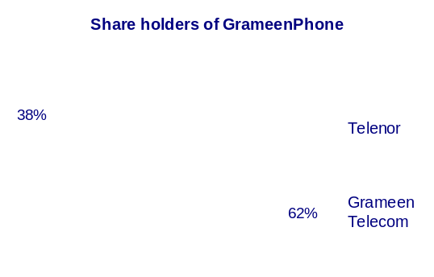
Telenor is using the expertise it has gained in its home and international markets and putting it to use in an emerging market such as Bangladesh. Telenor has many alliances in other countries, bringing experience and competence, both technological and business, to ventures such as GrameenPhone. Telenor has opened a regional Asia office in Singapore, an expansion that emphasizes its ‘No Barriers motto.
Grameen Telecom: Grameen Telecom is a not-for-profit organization and a sister concern of Grameen Bank, the internationally recognized bank for the poor with an expansive rural network and extensive understanding of the economic needs of the rural population. Grameen Telecom has 38% share in GrameenPhone. Grameen Telecom, with the help of Grameen Bank, administers the Village Phone services to the villagers and trains the operators as well as handles all service-related issues. Grameen Bank covers 40,486 villages, or 60 percent of rural Bangladesh through its 1175 bank branches. Grameen Telecom’s objectives are to provide easy access to telephones in rural Bangladesh, introduce a new income-generating source for villagers, bring the Information Revolution to villages and prove that telecommunications can serve as a weapon against poverty. More than 95,000 village phone is delivered to poor women to meet their financial need.

3. Organizational Structure
GP has in total 1131 employees. Major divisions of GP are: Customer Relations, Sales & Marketing, Technical, Finance, and Personnel & Organization. The Managing Director (MD) also heads a separate department. We would like to focus on each of these divisions to understand their work pattern and basic functions.

3.1 Organization Structure of GrameenPhone Ltd
GrameenPhone is divided into several departments namely technical, sales & marketing, customer relations, administration, human resource, finance and IT.
The top level management structure of GrameenPhone is shown below:

Organogram of GrameenPhone Ltd. (Topmost level)
Board of Directors
Ahmed Raihan Shamsi
Deputy Director, Co. Sec. & Head of Int. Audit
Syed Yamin Bakht
GM Information
Operational Committee

Represents Member of MT
Operational Committee
Treasury Committee
Stein Nævdal-Larsen
Director Information Technology
Frank Fodstad
Deputy Managing Director
Erik Aas
Managing Director
MD’s Secretariat
Head of CMD
(Bidyut Kumar Basu)

N K A Mobin
Director, Projects
Head of Supply Chain Management
(Bjorn Harald Broderson)
Director
Fiber Optic
(A M M Yahia)
Head of Admin
(M Mahtab Ali)
Head of Legal & Compliance
(Sharmini Abbasi)
Head of Village Phone
Head of CRM
(Mohammad Riaz Zaman)
Project Director CHQ
(Petter Russ)
Kafil H. S. Muyeed
Director, New Business
Md. Shafiqul Islam
Acting Chief Technical Officer
Md. Arif Al Islam
Director Finance
Khalid Hasan
Director Regulatory & Corporate Affairs
Rubaba Dowla Matin
Head of Marketing
Ingvald Lyche
Director Sales and Distribution
Emad Ul Ameen
Director Human Resources
Head of RA & FM
(Espen Wiig Warendorph)

3.1.1 Departments and Divisions
Recently management has brought a change in the organizational structure in view of need of time. As of the recent change, line function of the company comprises of the 3 different tasks. These are:
- Build & Operate
- Sell
- Care
Accordingly 3 main divisions were identified as the line organization part of the company. These are:
- Technical Division
- Sales
- Marketing Division and
- Customer Relation Division.
Besides there are:
- Finance Division.
- Administrative Division
- Corporate Affairs
- Human Resource Division
- Information Technology

The divisions of GrameenPhone are discussed in detail in the next.

3.2 Marketing Division
The marketing department has a wide span of management. It requires a high delegation of authority and allows for more discretion for subordinate managers in their own relevant fields. In the chart below the line responsibilities starting from Divisional head to departments are shown:

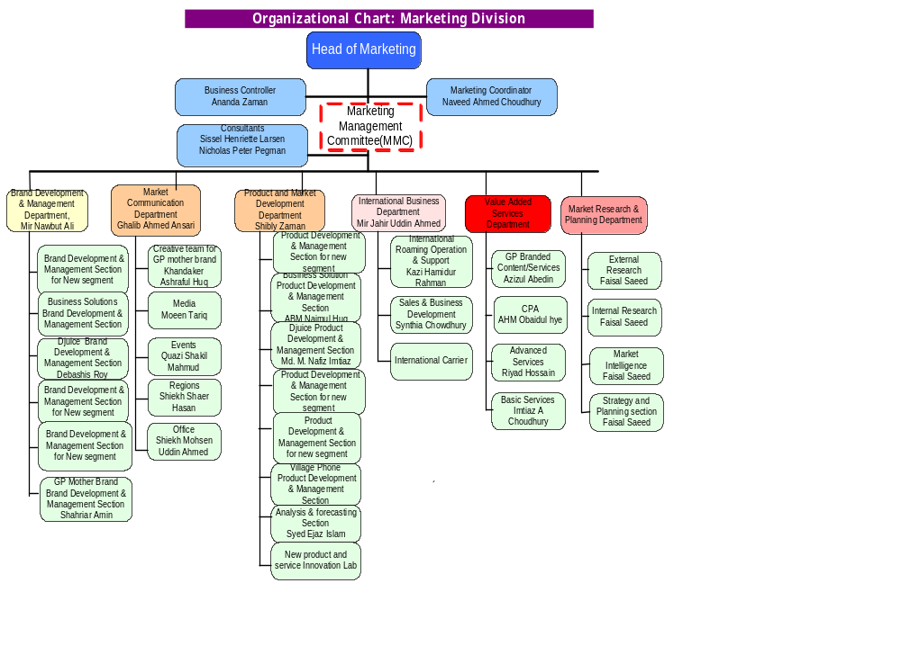

3.2.1 Marketing Department

Marketing department’s activities are of two types: Market Research and Development and Market communication.

3.2.2 Market Research and Development

MRD is responsible for communication with different departments about existing products. MRD gets feedback from Customer Care, Sales, and Market Communication departments regarding customer needs and market requirements. Feedback helps in redefining an existing product. Information flow is horizontal as well as vertical for the marketing department.

New ideas are developed after evaluation of market demands. MRD gives shape and form to vague ideas in the process of developing a new product. It then co-ordinates with Operation & Maintenance, Information System and Billing departments to get solutions and to check the functionality of Product features and prices.

3.2.3 Market Communication

The main function here is to develop product and promote concept building for promotional activities. It includes advertisement in the leasing dailies in the most effective manner within a given budget, to arrange out-door advertisement, hoarding, promotions of gift items like dairy, calendar etc. It also analyses competitor’s activity. This department is also responsible for all kinds of publications of GP. It is the responsibility of the marketing department to design and publish the monthly newsletter of GP.
3.3 Sales & Distribution
This department is involved in the selling procedure of GP. All sales to companies as well as individuals are part of this department. Distribution and Logistics department are main to department that carries out this task.
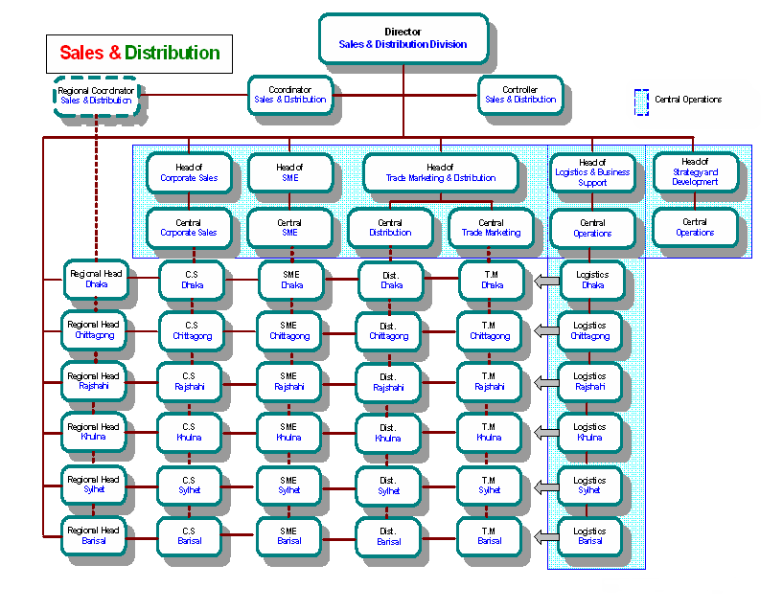

3.4 Technical Division
The technical division is vital to a technical service oriented company like GrameenPhone Ltd. It is split into two parts:

- Roll -Out Division: responsible for building the network.
- Operations Divisions: responsible for operation and maintenance of the network.

The department has a rather narrow span of management for close supervision and fast communication between top and lower level management. This is important as decision making and implementation due to technical difficulties must be addressed as fast as possible. The organogram is shown in the next page.

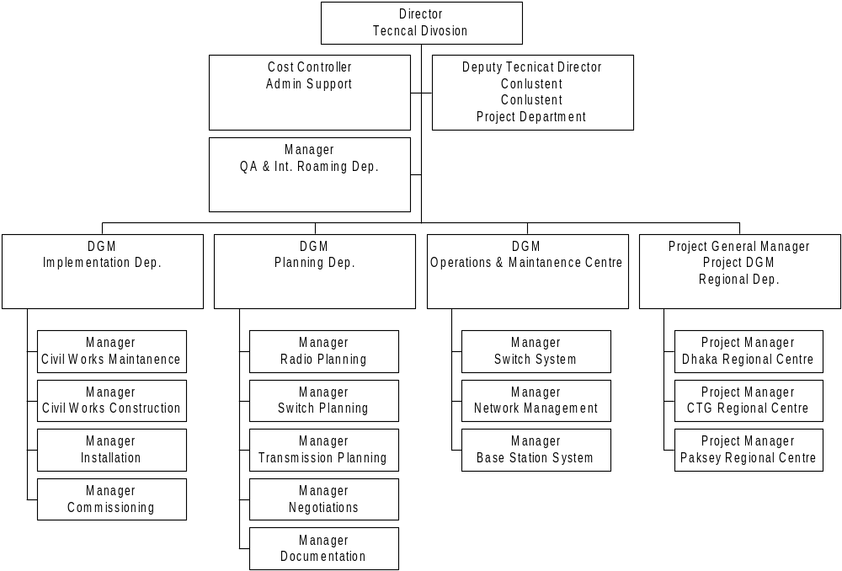Figure 1.3: Organogram of the Technical Division

3.4.1 The Roll-Out Division
The Roll-Out division has two sections, they are:

Planning Section and
- Implementation section

3.4.2 Planning
The planning section is mainly responsible for Base Station related planning. It also plans the data transmission equipment from Base Station to switch. In addition, it is in charge of timely supply of equipment, negotiating with homeowners for building Base Station on the roof and roaming agreement with other countries.

3.4.3 Implementation

The implementation section is responsible for construction and maintenance and Base station room, installation of Base Station hardware and start-up and operation of Base Station.

3.4.4 Operations Divisions
The major responsibilities of the operations division are:

- Operation and maintenance of Switch (MSC), Base station, transmission equipment
- Overall management of the network.
- Fault detection of network

4.5 Customer Management Division
Maintaining high quality service is one of the major requirements of large market service oriented companies like GrameenPhone. The organgram of Customer Management Division:

Customer Management Division
Bidyut Kumar Basu
Communication
Human Capital
Training & Competence Development
Service Quality
Technology for Customer Experiance
Process Improvement
Program Officer
Budget and Follow up
Call Center Post
paid
Call Center Pre Paid
Customer Management Center
Calling Center
Credit Management
Collection and
Banking
Corporate customer
IR Customer Service
Customer Demographic and Activation

Figure 1.4: Organogram of Customer Management Division

3.5.1 Customer Care
Customer care bridges customers and the company. It works with the objective to meet all kinds of queries from customer and provide optimum solutions. There are 135 personnel working under the supervision of one Additional General Manager and one Deputy General Manager.

4.5.2 Image Center
Image center answers all Queries by providing 24-hour service for subscribers of GrameenPhone. Information about bill and barred lines are available here through verbal communication.

4.5.3 Information Center
It provides on the spot solutions as subscribers can physically go there and get services. It deals with the following areas.
1. Bill Clarification
2. Preparation of manual bill
3. Bill correction

3.5.4 Customer Demographic and activation:
The first contact point of dealers/agents as they sell a subscription. The major task of Subscription service is to activate the newly sold subscription along with the collection, reconciliation, sorting, scanning and archiving the subscription and after sales documents. In addition, this unit provides “Instant services” by verifying the signature as well as other documents prompts after sales services to the subscribers. This unit also executes reconnection, product migration, SIM replacement and transfer of ownership.

Vision
To sustain a dynamic position providing premium support for customer satisfaction in a challenging environment.
Mission
Strategic
To deliver high quality accelerated services for both the internal and external customers meeting specific targets.
Operational
- To ensure finest quality of service in every phase.
- To carry out all the projects around the corner in time.
- To develop innovative and efficient techniques in the reporting, analyzing and checking activities.
- To evaluate and improve current performance result.
- To foster increased responsiveness.
- To create a learning environment by means of acquiring and transferring knowledge inside the constituent.

3.6 Human Resource Division
Human Resource Division is one of the most important divisions in GrameenPhone. It mainly works for the employees, with the employees. This department is mainly responsible for building and shaping employees, their career and performance also. Organogram of GP HR is given below-

3.6.1 HR Operation
HR operation is mainly dealing with the operational activities of Human Resource dept. It deals with employees’ salary, overtime, bank account, employees’ survey, and other employee relations activities. It also works for various operational activities like- employees’ dealing with various dept and cross functional events through out the GrameenPhone.

3.6.2 HR Recruitment & Selection
This dept. is mainly working for selecting and recruiting employees for GP. It has structured recruitment policy and rules. Within this rules the dept. work for workforce collection. R&S also deals with employees promotion and transfer during the job period. They also search for talents in various universities and organization when it is needed.

3.6.3 Human Resources Development (HRD)
While employee performance must be evaluated in economic terms of efficiency and effectiveness, it can be best achieved through recognizing and enhancing the human dignity of each employee. The quality of the human resources can be effectively increased through education, training, and personal development.
Human Resources Development functions aim to increase the quality of the human resources especially through training. GP training involves the following steps-
- Assessing training needs
- Selection of the participants
- Conducting training programs.
GP provides both local and overseas training on the basis of the need analysis of the employee.

3.6.4 Health, Safety & Environment (HSE)
This dept. is mainly deals with employees’ health and safety. More specifically they work for environmental issues development with in the GP, canteen facility, health clinic, various vaccination and internal medical service etc. HSE also ensures insurance facility for the employees.

3.6.5 Expatriate Affairs & Travel
This dept is dealing with employees’ travels and tours. GP has been arranging many travels and tours for its employees’ in many countries around the world. This dept is mainly to assist employees in this occasion.

3.6.4 Corporate Social Responsibility (CSR)
Activities of this dept. are self explanatory. This dept looks for various social responsibilities. This aligns with GP strategies and also social welfare. Thus this dept. is mainly the interface of GP in the society.

3.7 Finance Division
The major task of the Finance department is budgeting which is an important part of controlling. Finance division consists of various departments like- Investment Control, Financial Control, Payroll and Tax, Financial policy and Strategy (FPS), Capital Market etc. Organogram for the division is given below

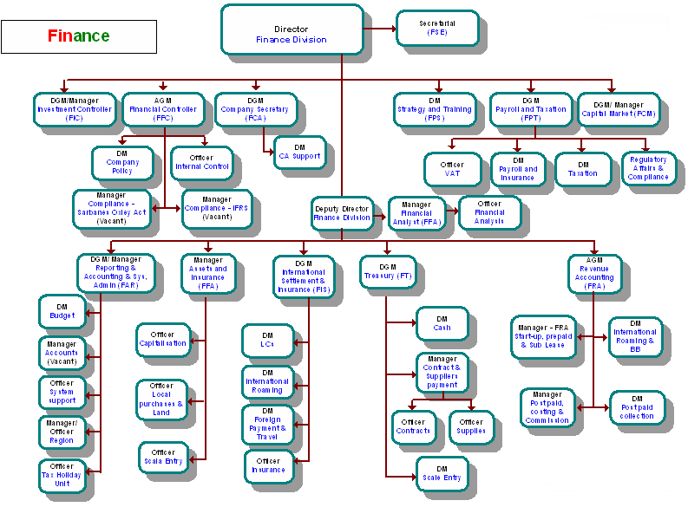

3.7.1 Finance Department
The main role of this department is financial planning and control and budgeting and control. In addition it performs tasks such as methodology and development of the system, providing management information, analysis of financial statement for future action and co-ordination of information flow for inter-departmental and intradepartmental purposes.
3.7.2 Payroll, Tax and other departments
This is a very sensitive and important segment in the finance department. This department is responsible for complying with the Companies Act and rules regulations of the Government. It also works as legal advisory of tax, VAT and other external affairs.

There is also an External Co-Ordination & Legal section which is responsible for the regulatory obligation and legal findings of the Company. They handle both internal and external legal affairs.

In addition there are the Accounts Department and the Cost and Budget Department. At present, the above departments are under supervision of the divisional director and manager of finance along with accounts officers for assistance.

3.8 Information Technology (IT) Department
Daily activities of GrameenPhone like computer applications, PABX phone system, e-mails and other internet related issues are all managed by the Information System Department. Whenever users face any problems in the above-mentioned activities, this department provides instant help.

IS mainly works with Switch and Customer Care department. It maintains and manages the server oriented application software which is known as CABS 2000. Billing and Customer Care use CABS 2000 and in this way they are closely related with IS Department.

Information System Department includes the Information Department which is responsible for information flow both within and outside the organization.

In addition to the formal management structure GrameenPhone provides a close, well-knit informal structure. Employees enjoy a recreational center with modern facilities and occasions such as GP nights celebrating achievements or rewarding competent employees. They have a well organized Cafeteria, TV room and several other facilities for relaxation. Building a encouraging environment to work together as a family is extremely important to GrameenPhone.

4. Network & Network Coverage of GrameenPhone
GrameenPhone aims to build a full range of service all over the country. The company has targeted to build extensive network all over the country. For better coverage, GP has taken 1600 Km fiber optic cable network leased from Bangladesh Railway. In April 2004, GP had 750 base stations. Now till May’05, it has 1750 base stations. Furthermore, considering the subscribers’ need of quality network and extensive coverage, the company is planning to set up another thousand base stations in the following year. Recently GP has doubled its speech quality 900GSM MHz to 1800GSm MHz. Already the company has expanded its network to 61 districts out of 64 districts and 400 upazillas out of 460 upazillas. It’s the only company which covers the most of the land areas with its net work. Approximately 52% land area is covered by GrameenPhone’s network. In over all, GrameenPhone offers the most competitive network facility to its subscribers, and continue improving it. Existing coverage areas are divided into six zones according to the divisional boundary. These are-
- Dhaka | - Sylhet
- Chittagong | - Rajshahi
- Khulna | - Barisal
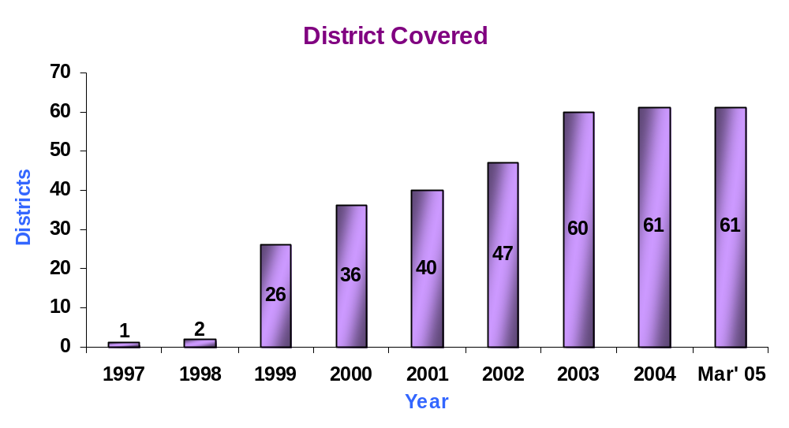
Figure5.1: GrameenPhone’s district coverage.
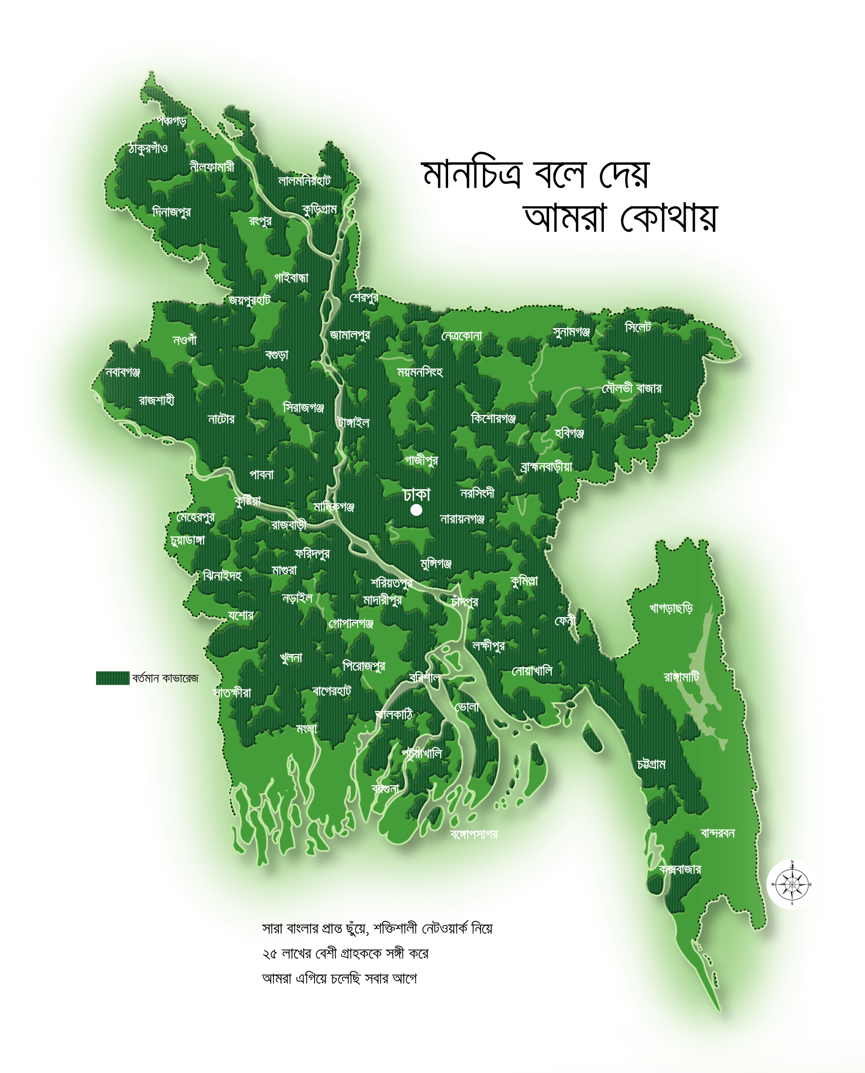
Area under GP net work covered
Figure 5.2: Net Work coverage of GrameenPhone.

The zone in which a subscriber is registered with GrameenPhone is that subscriber's Home Zone, and all other zones are Remote Zones.

5. Distribution Channel
Distribution channel is the bridge between the company and the consumers. Distribution channel is very important for any company. If there is a gap in the distribution channel, the marketer is unable to reach its products/services to the customers in time.

GP decided to distribute its products through its own distribution channel. And the agents would sell the mobiles to the customers. As GP’s growth rate is very high, there are many interested people who want to become distributor of GrameenPhone. But GP has some strict policies that are maintained while giving permission to the new sales agents.

Moreover, GP has agreements with established distribution channels like Butterfly, Flora, and Rangs; who are also acting as GP’s distributors. Currently the number of distributors in the country is over 430.
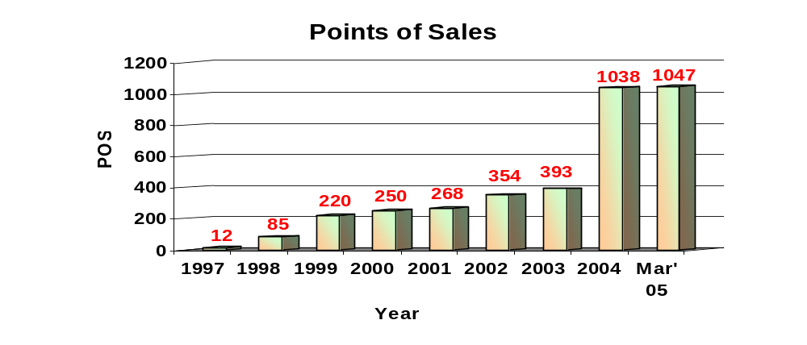
Figure 6.1: GrameenPhone’s yearly increase of Point of Sale

At the beginning, GP started its sale through only 12 POS (Point of Sales) around the country. Then simultaneously its POS have been increasing with growing demand of mobile service. The total number of Points of Sales in the GP distribution network increased to 391 in December 2003 from 353 in December 2002. Recently, total Number Point of Sales is 1047 as of March’05. Meanwhile, till March’05, GP has 75 Scratch Card distributors with 14,500 retail outlets throughout the Country.

6. Industry Analysis
6.1 Background of the Industry
In a highly populated country like Bangladesh, telecommunication can play a vital role to boost the economy and social level of people. The introduction of cellular phones has dramatically changed the lives of businesses and individuals.
As there is a growing trend of workers turning from farming to other occupations, the need for mobiles is increasing among the thousands of impoverished villages. The overall efficiency of other business has increased as an aftermath of the government's decision of deregulating the telecommunications sector, which until the late 1980s had been a state monopoly.
Privatization of the telecommunications sector began in 1989, when Sheba and BRTA were awarded 25-year licenses to install and operate fixed-wire lines and wireless services in rural areas. The same year, Pacific Telecom Bangladesh got the government's permission to launch the country's first cellular phone and paging service sold under brand name CityCell in collaboration with a Hong Kong-based company. The company targeted only the higher class of the society. During that time price of mobile was above Tk 50,000/=. Naturally, the growth of the industry was too slow. CityCell had a virtual monopoly until 1996, when the government gave licenses to three more companies to operate cell phones in Bangladesh. So, the government decided to bring more companies in the market and break the monopoly.

After careful evaluation the government decided to provide three licenses to GrameenPhone, TM International (AkTel), and Sheba Telecom (Banglalink). Only CityCell is using Code Division Multiple Access (CDMA) technology, AkTel, GrameenPhone, Banglalink these three companies are using GSM (Global System for Mobile) technology. GSM is the most popular mobile telecommunication technology in the world. About 60% of the cell phone users of the world use GSM technology.
These three new companies entered the market, not only helped trim down over-dependence on BTTB's fixed-line system, but also made mobile phones cheaper and easier to get. The price of a cell phone came down from $2,000 to as low as $100, depending on the features of the handset and SIM price is only Tk.200-300. BTTB’s mobile phone Teletalk has been launched.
A definite development has been observed in the Business Market with comparatively high expectations. Customer maturity and anticipation regarding technology has increased over time. Rumors regarding new entrants have groomed expectations in the market. Consequently, people are expecting cheaper handsets with lowered airtime.

6.2 Telecom Market Growth
At the initial stage of the mobile telecom industry because of high startup cost and high tariff there was only a few numbers of subscribers. In 1997 there were approximately 23,000 mobile subscribers around the country with a low market penetration rate (.02%). At present, the number of mobile users in the country is approximately 5.87 million and among them GP’s subscribers are over 3.5 million. Right now, in mobile industry, Bangladesh has four private companies and newly Teletalk a sister concern of BTTB has entered in the market with a target to get 0.25 million subscribers by first 6 months of launch and 1 million by 2006. Teletalk has offered lower rate with PSTN connection all over the country. The total number of districts covered in mobile industry has been increased to 61 in 2004 from 1in 1997. The total telecom growth has increased to 55% in 2004 from 19% in 1998. Initially, mobile growth rate was too high which was 178% in 1998 and now it is come into 67% in 2004. That means this industry is now going to its maturity stage. From the comparison of different operators’ subscriber base, it can be concluded that GP is still leading the way with a sharp distance. Though Citycell is the first mobile operator in Bangladesh, it is not doing its business so good. It is increasing its subscriber from 2000 in 1997 to 370000 in 2004. On the other hand, AkTel is growing its subscribers faster than Citycell which is from 3000 in 1997 to 1000000 in 2004.

 | 1997 | 1998 | 1999 | 2000 | 2001 | 2002 | 2003 | 2004
Market Penetration | 0.02% | 0.05% | 0.10% | 0.21% | 0.53% | 0.87% | 1.88% | 3.13%
Districts Covered | 1 | 2 | 26 | 36 | 40 | 49 | 59 | 61
Mobile Growth rate |  | 178% | 96% | 121% | 149% | 65% | 116% | 67%
Telecom Growth Rate |  | 19% | 17% | 34% | 66% | 42% | 40% | 55%
 | Subscriber Base
Grameen  Phone | 18,000 | 30,000 | 60,000 | 191,690 | 471,371 | 775,310 | 1878,000 | 2424,177
Citycell | 2,000 | 19,000 | 26,200 | 33,500 | 100,000 | 160,000 | 2250000 | 370,000
AkTel | 3,000 | 12,000 | 28,500 | 34,200 | 96,000 | 150,000 | 300,000 | 1000,000
BanglaLink | - | 3,000 | 11,000 | 19,000 | 27,000 | 60,000 | 70,000 | 100,000
Table 5: Development of the Telecom Market 1997-2004
The penetration rate of mobile phone industry in Bangladesh is increasing rapidly. The rate was increasing slowly from 1997 to 1999. After that, the rate was increasing faster and now till March” 05 the penetration rate is 3.48% and only GrameenPhone’s penetration rate is 2.12%. Fixed network penetration is .72%.
6.3 Subscriber Base of Mobile Operators
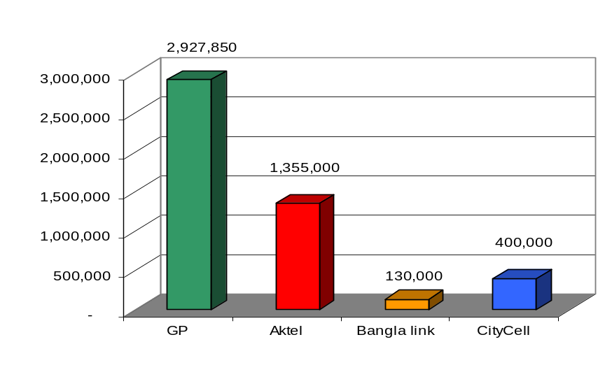
The mobile market consists of four mobile operators. Among them, GP holds 2,927,850, AkTel 1,355,000, CityCell 400,000, and BanglaLink 130,000. The total number of subscriber of all mobile operators is 4,317,506.

MOBILE OPERATORS SUBSCRIBER BASE (EOY March 05)
6.4 Market Share of Mobile Operators
The mobile phone market consists of four operators. Out of which, 62% share of the market belongs to GP, 8% to CityCell, 22% to AkTel, and 5% to Banglalink and the rest 3% to Teletalk as of June, 06. GP holding the major share maintains a ‘market leader’ strategy to all other players in the market. The telecom market intends to grow at penetration rate of more than 3.48%; where GP has already penetrated at 2.12%.
MARKET SHARE OF MOBILE OPERATORS (EOY June 06)







Telecom Market Share
62%
22%
8%
5%
3%

6.5 Competitive Position of the mobile operator

Table 6: Relative position of mobile phone operators
 | Target Customer | Price & Tariff | Quality | Technology | Strategy
 | Corporate/  Individual | Low | Deteriorating services | CDMA | Network expansion & attractive products
 | Corporate/SME/ Individual | Competitive | High quality service but limited coverage | GSM | Increase coverage and market share
 | Corporate/SME/ Individual | Very affordable | Low quality and limited coverage | GSM | Increase coverage and Market share
  GrameenPhone | Corporate/  SME/  Individual | Competitive | Good network with wider coverage | GSM | To maintain the no. 1 position as a cell phone operator
 | SME/ Individual | Competitive | Limited Coverage | GSM | To grab the market share

Target customers are almost same for the four mobile operators. Regarding to price and tariff, AkTel and GrameenPhone are very much competitive. Banglalink’s price and tariff is very affordable and Citycell is able to give low price to its subscribers. In case of service quality and network coverage, GrameenPhone is leading the number one position among them. Only Citycell use CDMA technology and others three use GSM technology. By this, Citycell differentiates its products from the others. Except GP, Other operators’ recent strategy is increase coverage and market share through attractive products. On the other hand, GP’s strategy is to maintain its number one position. Teletalk’s main strategy is to grab the market share as much as they can
6.5.1 Highlights of Competitive Positioning of Mobile Operators
- The operators have been engaged in intense competition in terms of start-up cost and tariff. Most of the competitors of GP has adopted and will adopt network expansion strategy.
- Good relationship with regularity authority is strength of some of the other mobile operators while GP has achieved it to some extent by abiding by laws and showing positive results.

6.6 Current Market Scenario
The telecom market is experiencing a transition period, at present. Singtel has already come up with CityCell to invest in the mobile telecom market of Bangladesh. Another Egyptian company named as Orascom has bought all the share of BanglaLink and planed to invest a huge amount to capture a market share of 300,000 by the mid of 2005. Flat duty has been introduced for network equipment hardware. GSM product of Bangladesh is now considered to be most economical in the region even though the startup cost has increased to BDT 5000 for mobile phones.
The parties involved in mobile and fixed telephony business have taken appropriate measures to improve their products and services accordingly. BTTB has lowered its start up cost in small towns. They have also reduced their NWD and ISD call rates. New areas of North Bengal have come under coverage through other mobile operators. CityCell and AkTel have launched pre-paid service with PSTN access. AkTel and BanglaLink have reduced their monthly access fee. Moreover, Citycell has introduced Super Off-peak rates for efficient use of technical facilities. For reducing the complexity of talk time charge, Banglalink has introduced new charge for all time which is less than 2.50 Tk/minute. Offering free talk time and free SMS is now becoming the hottest promotional tool for being competitive in the market.

Besides improved products, services, and better deals, the competitors are also competing with distinct communication strategies. They are also trying to expand their distribution network. CityCell has signed two big distributors, namely Singer and Sony.

6.7 Key Success Factors
In an industry like telecommunication in Bangladesh, competitors’ analysis is an important factor. To analyze the industry competitors there should be specific determination of Key Success Factors (KSF’s). These KSF’s will help to determine which competitor is more attacking and having the competitive power. Some of the key success factors are-
- Call rate
- Network coverage
- Customer Service
- Value Added service
- Marketing & Promotion
- Brand Value

6.8 Competitors Profile Matrix (CPM)
Based on the key success factors we have calculated CPM for the companies. The companies competing in the industry are taken into consideration and they are weighted with some values. CPM for telecom companies of Bangladesh is given below-

KSF's | Weight | GP |  | AKTEL |  | Banglalink |  | CITYCELL
 |  | Rating | Score | Rating | Score | Rating | Score | Rating | Score
1. Call rate | 0.15 | 2.00 | 0.30 | 3.00 | 0.45 | 2.00 | 0.30 | 4.00 | 0.60
2.Network Coverage | 0.30 | 4.00 | 1.20 | 3.00 | 0.90 | 2.00 | 0.60 | 2.00 | 0.60
3. Customer Service | 0.25 | 4.00 | 1.00 | 3.00 | 0.75 | 3.00 | 0.75 | 2.00 | 0.50
4. Value added service | 0.10 | 4.00 | 0.40 | 3.00 | 0.30 | 2.00 | 0.20 | 1.00 | 0.10
5. Marketing & Promotion | 0.15 | 4.00 | 0.60 | 3.00 | 0.45 | 4.00 | 0.60 | 2.00 | 0.30
6. Brand Value | 0.05 | 3.00 | 0.15 | 2.00 | 0.10 | 3.00 | 0.15 | 2.00 | 0.10
Total | 1.00 |  | 3.65 |  | 2.95 |  | 2.60 |  | 2.20

From the calculation above it has been a clear idea that GrameenPhone is the most facvorable position in the market in terms of competitive advantage. Competitive Profile matrix- CPM for GP is 3.65 which is quite high than any other mobile operator. The closest competitor is AKTEL having the score 2.95. All other competitors are far behind from GP. The strongest position in Network Coverage provides the most favorable and strong position in the market. GP needs to concentrate on increasing brand value and customer service because call rate won’t be GP’s turning point to survive. GP’s policy is “Not to be cheapest rate provider in mobile market”

Position in the market for GrameenPhone
Perceptual mapping helps to understand the position of a company in the market. It portrays the perfect picture of a company based on the characteristics and competencies it has. Thus, Strategic position for GrameenPhone has been designed here based on network coverage area and technology implementation and process innovation. Here is the strategic position map-

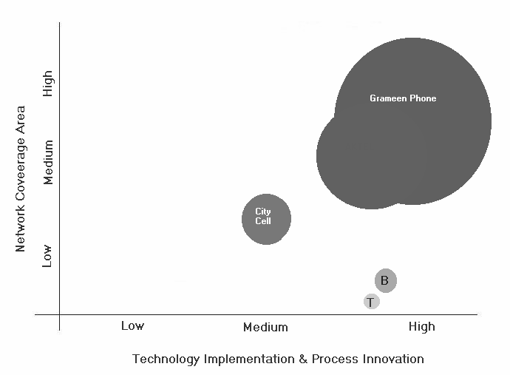
Figure: Strategic Group Map

6.9 Bangladesh Telecom Outlook (till 2005)
Citycell
AkTel
Teletalk
Factors

2 million by 2005
Total of 4 million by 2006
2.7 million by 2005
3 million by 2005
0.25 Million by first 6 months of launch and 1 million by 2006
Subscriber forecast for 2005

$ 150 million to be invested by 2005. And a total of $250 million by 2006
Additional $250 Million (by 2005)
Accumulated investment over $300 million by 2006.
1st phase $78.5 m (Tk 498.54 cr)

Investment plans

Dubai based mobile service provider “Warid”, is expected to enter the Bangladeshi market in 2005.
Bay Phone, a private PSTN operator, has announced that it will begin operation from February. The rate of phone connection will be Tk 9000 and prospective subscribers will get phone connections within 48 hours.
Other private PSTN operators, who have received license, are also expected to launch operations, although no definite dates have yet been announced. Many of these will use WLL technology as well.
New Operators

6.10 Industry analysis with Porters five forces:
Porter’s five forces Model is a key Analytical Tool for Diagnosing the Competitive Environment. It has used five forces to reveal the state of competition. It has become an important tool for analyzing an organizations industry structure in strategic processes. It allows the strategic thinkers to formulate appropriate strategy for a particular entity through systematic and structured analysis of market structure and competitive situation, and helps improve the position of the organization. The model is presented through five competing forces which are given below.

Through Porter’s model, I have tried to define the five key factors for analyzing competitiveness and attractiveness of the over all mobile Telecommunication industry.

6.8.1. The degree of rivalry within the industry
Currently, there are 5 competitive companies (GrameenPhone, AkTel, Citycell, Banglalink, Teletalk) in the market Out of which, 62% share of the market belongs to GP, 12% to CityCell, 25% to AkTel, and the rest 2% to Banglalink. GP holding the major share maintains a ‘market leader’ strategy to all other players in the market. The telecom market intends to grow at penetration rate of more than 1.33%; where GP has already penetrated at 1.56%. Number of competitors is low but the competitors are powerful and highly competitive. That’s why the degree of rivalry within the industry is very high.

6.8.2. Threat of new and potential entrants
As GrameenPhone is having the highest number of subscriber and there is a high demand for their service, customer pulling is also high. So, they are on the way to achieve economics of scale. Using economics of scale and experiencing this advantage, they are trying to keep the price lower. This strategy can discourage potential entrants from entering the market. In the long run, they have strategy to attract the highest number of local people by marketing and also lot of national or multinational by establishing high technology and achieve further economics of scale more efficiently, which is also a threat for the potential entrants. In the near future after reaching the break-even they may decrease the average cost per unit and can get the absolute cost advantage.
GrameenPhone became popular within short period of time through their effective promotions. Company made lot of press releases, TV, radio Ad, which made the name “GrameenPhone” familiar to the customers.
High switching cost for post paid subscription is a barrier for the potential entrants in this industry. As the technology, expertise, capital needed for this sector is not easily obtainable that’s why switching cost is higher.

6.8.3. Threat of substitute products:
BTTB has already reduced the NWD and ISD call charge. Furthermore, around 50 private companies get the license to provide wireless phone and lane phone service. Rankstel, North Bengal Phone Company One Tel has already started their operation. Rankstel provides wireless phone service and it covers Dhaka, Gajipur. The growing number of substitute products indicates that the existing players have to face threat from these products. But again, in other sense I can say that mobile phone service gives the freedom of mobility which its substitute cannot give. Hence, the threat of substitute is moderately is low.

6.8.4. Supplier’s bargaining power
GrameenPhone has been maintaining good relation with its suppliers. The company has strategic coordination with its suppliers; hence its suppliers bargaining power is moderately low. GSM technology give the advantage to the company and its subscribers to change mobile set any time they want. Again, the industry has lots of suppliers, as a result GrameenPhone has possible alternative to change suitable supplier.

6.8.5. Buyer’s bargaining power
There are many players in the market, which gives the customers alternative and power to choose different brand according to their preference. That’s why buyer concentration is high. The competition in the market makes the customer more powerful and the companies more competitive among each other’s.

6.8.6. Integrated evaluation of Porter’s Five Forces

The degree of rivalry within the industry | HIGH | Industry attractiveness is low
Threat of new and potential entrants | Moderately low | Industry attractiveness is moderately high
Threat of substitute products | Moderately low | Industry attractiveness is Moderately high
Supplier’s bargaining power | Moderately low | Industry attractiveness is moderately high
Buyer’s bargaining power | Moderately High

6.8.7. Evaluation of the industry’s attractiveness
From the above consequences of Porter five forces, I have identified that the mobile telecommunication industry has high degree of rivalry within the industry, low threat of new entrants and substitute products, low bargaining power of suppliers, high bargaining power of buyers. So this situation leads to consider Mobile Telecommunication industry’s attractiveness is moderately high for the existing players. Again, Government’s overall support made the telecommunication industry look more attractive for the existing players. Government has licensed only five companies for operating in market, which created an entry barrier for potential entrants. Government allowed establishing plants in the rural area, which definitely helped GP to create a vast network all over the country.
7. Other factors for Environment
7.1 SWOT Analysis
SWOT stands for Strength, Weakness, Opportunity, and Threat. This is a very important tool for a company to analyze its internal and external environment. Let us carry out a SWOT Analysis of GrameenPhone.

7.1.1 Strengths

- Market Leader:
GrameenPhone (GP) became the country’s leading cell phone operator since 2001. From year 2001 to till now GrameePhone’s subscribers has increased 471,300 to 3.3 million represent 62% of the market share. GrameenPhone in recent years has maintained its consistent growth strategy country wide, offering cellular voice and non voice services to the market at an affordable price, on a scale hitherto unprecedented. The expansion of the mobile network has gradually included a large number of remote villages.
- Good Owner Structure
GrameenPhone is 62% owned by Telenor, a sate-owned telecommunication company from Norway and 38% owned by Grameen Telecom. From these companies GrameenPhone get financial and technical supports.
- Financial Soundness:
GrameenPhone has a huge amount of capital mainly invested by the shareholders. Capital size is $280 million. Moreover, global institutions like IMF, World Bank etc. have sanctioned loan for GP. This is a huge success for GP. GrameenPhone’s total capitalization was US$120,000,000, including around US$50 million from IFC/CDC, and the Asian Development Bank (ADB). It also received US$60 million in equity from the four GrameenPhone private partners. Grameen Telecom borrowed US$10.6 million from the Open Society Institute to set up Village Phone. The company continued to invest heavily in expanding the capacity of its network and coverage.
- Largest Geographical Coverage:
GrameenPhone has the largest geographical network coverage compare to its competitors. GP will continue to make fresh investments to further expand its coverage throughout the country and increase the capacity of the network, so that more people can avail the service. GP has already put into operation 459 new base stations this year alone, bringing the total number of base stations to 1128 operating around the country. Presently, GrameenPhone has coverage in some 61 districts and 400 Upazilas. There are 1750 base stations in operation around the country. Further more the company is panning to set another thousand base station by this year. The competitors are also lagging far behind in this regard.

- Competitive price:
Price is a big competitive advantage for GP. GP is selling the hand-sets and connection package at a very low rate. E.g. lowest package rate of GP was TK 5,900/=. The competitors are no where near GP, in this regard.
- Availability of Backbone Network (Optical fiber):
GrameenPhone Ltd. sub-leases the Transmission Capacity of its 1600 Fiber Optic Network, leased from Bangladesh Railway, commercially to the prospective business units/clients. There is a contract between GrameenPhone and Bangladesh Railway that GP will use this network for the next 25 years. This advantage enables GP to set a Nation Wide Network in a very contemptible expense. GP optic facilitates nationwide coverage, technical expertise, robust network and minimum downtime for non-protective circuits.
- International Roaming:
As mentioned previously, GrameenPhone is providing international roaming facility to GP Regular subscribers. These subscribers can avail this facility after fulfilling some requirements. GP has international roaming agreement with 202 mobile phone operators of 71 countries.
- Dynamic management team:
GrameenPhone has a dynamic management team that consist experts from both home and abroad. This helps GP to always remain on track and move forward at a consistent pace.
- 24 hours customer service:
GP has a 24 hour customer service tool. This is popularly known as ‘helpline’. This service keeps a continuous relationship with the subscribers.
- GPGP Network:
GrameenPhone has an absolute advantage in mobile to mobile phone (GPGP) market in comparison to the competitors. This is really a new concept in the mobile telecommunication network. GP has developed this alternative network that is fully dominated by themselves.
- WAP:
As we have already mentioned that WAP stands for Wireless Application Protocol. Very recently they have launched this service.
- Established Brand / Brand Name / Grameen Image:
The branding activities have led GrameenPhone to build a strong brand. The mother brand is placed on the same platform as other renowned brands like British American Tobacco, Citicorp etc in Bangladesh. GrameenPhone has already built its brand image by its profound service, widest network coverage and social responsibilities. Moreover GP is the second largest taxpayer created a better brand image in customers mind.
- Individualism:
Although GrameenPhone has close affiliation with its multinational parent company, GrameenPhone has an independent brand identity in the market.
- Extensive Market presence (availability):
To make telecommunication accessible to the mass market, GP has set up its POS in the most convenient areas of the districts under the GP network. Till year 2004 the company has 1038 POS.
- Skilled Human Resource:
The employees-- are young, dedicated and energetic. All of them are well educated at home or abroad, with both sexes (genders) and minority groups in Bangladesh being well represented.
- Access to the widest rural distribution network through Grameen Bank:
To day 35.000 villages are connected and women, linked to the renowned Micro Credit Program through Grameen Bank, have become borrowers and owners of the Village Phone. The Program offers mobile service to over 40 million people in remote areas. On average a Village Phone Operator earns nearly 1.000 USD a year, nearly three times more than the average per capita income.
- Value added service:
GP recently launched two new value-added services. The SMSPAY service enables you to send subscribers bill payment information to avoid barring subscription, while the “Cell E-mail” service allows sending and receiving e-mail using GP mobile phone. Email through mobile phone service has already proved to be beneficial to the subscribers, who don’t have access to the Internet.

7.1.2 Weaknesses
- Weak Coverage:
GP has weak coverage in some districts like Netrokona, Laxmipur, Naogaon, Pirojpur, Maulvibazar, Habiganj, Cox’s Bazar and so on. As the subscribers’ complaints, they can not communicate effectively in these weak networks. Again GP still now has not three districts namely Rangamati, Bandarban and Hilltracks.
- Billing System:
The abrupt barring of connection due to a complicated billing system confuses the customers. Such hassles lead to an unfavorable impression for the company.
- Network Limitation:
Call drop, congestion, and poor connectivity with BTTB result in bad image of the company.
- Some value-added services are not successful:
-Voice Mail service due to language barrier, lack of promotions, lack of know how about interactive services and also because people are reluctant to speak to a machine.
-Usage of Short Message Service is still low due to lack of promotion, lack of knowledge of English, unawareness of handset configuration and un-ergonomic nature of keypad.
-Difficulty in Configuration, handset barrier and slow connectivity are hampering WAP’s popularity.
-Lack of co-ordination is used as an excuse not to solve problems
- Complicated price structure:
Post-paid call charge is very complicated to the customers. Even though per unit call charge is mentioned, sometimes customers get confused about their bill.
- No long-term Distribution/Channel strategy:
GrameenPhone has not yet taken initiatives of its long-term distribution channel strategy. GP’s current market expansion with its short-term distribution channel goal meet it present requirement. But for its future market expansion and to reach its new segment of customers more effectively in efficient manner GP needs to take bold steps from now on.
- Commercial ads are not too creative:
GP’s commercial ads are not that much appealing its prospective customers compare to its competitors. Valuable features are not focused in its ad. GP does not show its competitive advantages through its ads whereas its competitor such as Citicell has done it effectively.
- Becoming Market Follower:
GrameenPhone Is now becoming market follower as competition is going so fast in mobile telecommunication industry. As a market leader, it is not good for GrameenPhone to become reactive to its competitors.

7.1.3 Opportunities
- Land Phone:
Bangladesh Government has already started to provide license to private sector to setup land phone. GrameenPhone has a very good reputation in the country. They can capitalize this goodwill and take initiatives to enter the market of land phone.
- Attractive market:
Bangladesh is a highly attractive market for mobile services due to its large and highly concentrated population, low penetration of telecommunications services, and high growth in mobile subscribers. With approximately 140 million inhabitants, it ranks as the eighth most populous country in the world and is among the most densely populated. Bangladesh is served by only 1million fixed lines and has only approximately 4.5 million mobile subscribers. While mobile services have been available in Bangladesh since 1991, growth in this sector has only accelerated in recent years. This market has still low penetration rate but still there is opportunity to increase high penetration rate.
- Huge need for telecom services:
Current market growth rate of the telecommunication is significant which arises a great opportunity for the cellular phone companies to grow rapidly. The demand of the cell phone is still increasing. Variety services with most lucrative features made this sector more and more attractive day by day. Recent year’s growth reflects the enormous potential for the development to telecommunications and information technology in the country.
- Declining prices for handsets
The prices of the mobile sets are declining in Bangladesh that makes a easy gate way for the customers to use cell phones. It will create an opportunity for the telecommunication industry by getting large number of customers. There are some others opportunities, which can be important factors for GrammenPhone, are: Economic growth of Bangladesh, new and better interconnection agreement and future privatization of the fixed network

7.1.4 Threats
- Global Companies:
As global companies like AT&T, BPL are operating in India, they might think to enter the Bangladeshi market with higher capital. If so, it will be a huge threat for GP.
- T&T Mobile:
T&T is now entering the mobile telecommunication industry. It is now becoming the great threat business for all other mobile phone operators by providing unfair advantages and cause sever problems.
- City Cell and AkTel’s Recent Expansion Plan:
Among the existing competitors, City Cell and AkTel are planning to develop country wide network. This can also divide the advantage that is currently enjoyed by GrameenPhone alone.
- More rigid government regulations:
Government rigid regulations and policy narrows the direction of the cellular phone companies. GrameenPhone has to go through lengthy government procedures to take permission to launch a new service package. The imposed increased taxes for SIM price will slower the growth of this industry.
- Threats of potential new entrants:
There are rumors in the market that some companies are trying to enter the market with cheaper technology. Potential new entrants can get into the telecommunication market with cost effective approach and take off market shares. New domestic and foreign cellular phone companies can start telecommunication network business. As Bangladeshi people are very much price sensitive, it might cause serious problem for GP.
- BTTB has reduced NWD and ISD call charge:
Recently BTTB has reduced its NWD and ISD call charges to promote LAN phone usages. This has affected the mobile phone industry and significantly reflected in the revenue earning of BTTB.
- Inadequate interconnection with BTTB:
From the beginning GrameenPhone is facing inadequate interconnection with BTTB. As a result its interconnectivity network does not perform up to the mark.
- National catastrophes:
National catastrophe may severely hamper the networking system. GP’s towers at different location are affected by natural calamities.
- Price war:
All the four companies are fighting to get the market share by cutting price of the mobile phone connection. All competitors are lowering the unit price and also providing pulse facility like AkTel provides pulse at the thirty seconds of the first minute. So the market is fighting with each other with their pricing strategy.

7.2 Market Boundary
Market boundary is an important phenomenon for a company as in needs to integrate the customer group, customer functions and technological uses. A market boundary diagram helps us to build a schematic image for the company’s products and service demand and potential market. For GP I have drawn a market boundary diagram It is shown in the next page-
Customer
Group

Technologies
Customer Functions

Market boundary for GrameenPhone

GP’s services include all the customer functions. But it mostly serves the purpose of being mobile at a cheaper expense. GP uses GSM technology out three available options and its major customer group is individuals.
Segmentation:
GP’s mobile phone service targeted towards the consumer market. So, it can be treated as a consumer product or service or package.
The major factors that play important roles in the process of consumer segmentation are:
    - Demographic factors (age, income, sex etc.)
    - Socioeconomic factors
    - Geographic factors
    - Psychological factors
    - Consumption patterns
    - Perceptual factors
    - Brand loyalty patterns
Proper consideration of the above factors will result in effective consumer segmentation for GP.

7.3 Value Chain Analysis for GP
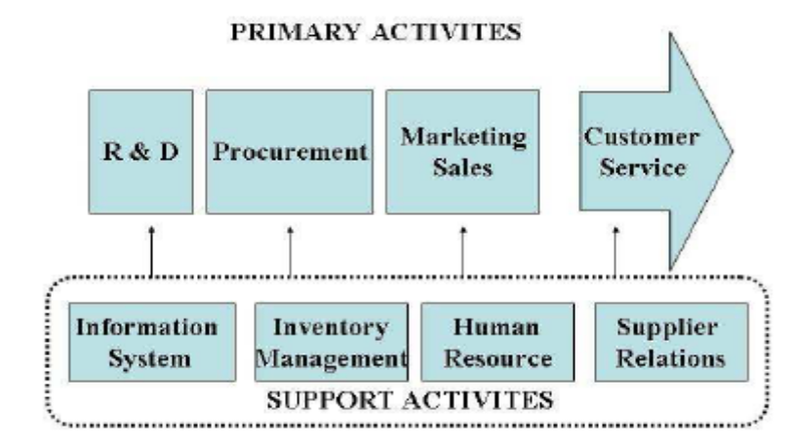
Value Chain is an important analysis method for determining how the firm is creating value for the end users. It involves various primary and secondary activities both inside and outside the firm. Both primary and secondary/ support activities help to create value for the firm. Here, I am going to analyze the value chain activities performed by GrameenPhone.

Primary Activities
- R&D- In terms of R&D GP is not in a satisfactory position. GP generally conducts its R&D activities relating the research firms and their own employees. The company has its own R&D team.
- Procurement- Procurement is an important and crucial activity that GP has been performing over the years. The company has created the environment favorable by designing different procurement team.
- Marketing & Sales- Marketing and sales is the most important primary activities for the company. Success of the company mostly depends on the marketing strategies and sales efficiency. In terms of marketing GP is doing satisfactorily compared to other competitors like AKTEL and Banglalink.
- Customer Service- Customer service is another important phenomena for a company to create value to the stakeholders. After sales service and instant service is operated by GP can create the ultimate value for the customers. Customer service is a heavily weighed key success factor in telecommunication industry. That’s why this should be emphasized more.
Secondary/Support Activity:
- Information System- For a company like GP it is very important to be attached to the information technology. Each and every day more and more technology is coming in to the scenario. Thus GP needs to integrate the information system for better service delivery.
- Inventory Management- As GP is one of the service providers in the telecom sector, it does not need to deal with Inventory issue.
- Human Resource- Another important value creation activity is managing human resources inside the firm. Without experienced and skilled human resource it is not possible to ensure efficiency for service delivery activities. Highly educated and experienced employees can take a great role in value creation activities.
Thus I think there are lacking in value chain activities for GrameenPhone which should be solved as early as possible.
8. Social Commitment of GrameenPhone
8.1. Orphanage Project: The orphanage is situated at Vatara Bazar, Baridhara, Dhaka. At present 75 children are residing there. Twenty five staffs are employed for overall look after of the children. The children are aged between 4 and 15 years The orphanage is a project of CDP (Children development program) and is funded by Telenor, the major(51%) share holder of GP.

8.2. Dhaka Shishu Hospital Project: GrameenPhone has sponsored one of the wards of Dhaka Shishu Hospital (ward #4) with various utility facilities like Pure Drinking Water, providing Bed linen, utensils, mosquito net etc.

8.3. Against Dengue:

a) Awareness buildup:
i) To create awareness against deadly diseases like dengue GP has published articles dealing with the preventive and protective measure of this disease in their monthly newsletter and in form of booklets.
ii) GP has also provided in field and in house training to create awareness among people of different classes of society.
iii) GP uses its sources in its regional offices in Chittagong, Rajshahi, Khulna And Sylhet to create awareness against this disease in those cities.

b)Spraying against Mosquito: With collaboration to Dhaka City Corporation GP has sprayed aerosol for destroying mosquito in areas like Fourth class employees colony of D.C.C in Gulshan1,Gp office premises and in locality of Gulshan circle 1 & 2.

c) Cleanliness Program: GP has sponsored Cleanliness programs in its own locality and in slam areas of Gulshan to prevent the breeding of mosquitoes and for healthy environment.

8.4. Awareness about EPI diseases:
GrameenPhone has extended its hand of cooperation in generating awareness about EPI diseases by helping UNICEF in arranging various programs in this regard. GP sponsored several programs involving children and parents with UNICEF like seminars, art competitions etc.

8.5. Awareness about Asthma:
Collaborated with Asthma Association of Bangladesh GrameenPhone has arranged rallies and seminars to create awareness about prevention & treatment of Asthma.

8.6. Awareness about Health & Hygiene:
GrameenPhone HSE team has worked extensively to create awareness about personal & community health & hygiene. GP has conducted seminars, rallies, in field and in house training in this regard in its Head office, regional offices and other organizations like EC & Nordic Club. First aid, safety in working place, clean environment etc topics is generally discussed in these awareness programs.

8.7. Blood Donation Program:
One of prominent social contribution of GP is in the field of Voluntary blood donation. GrameenPhone has sponsored and directly participated in various voluntary Blood Donation Programs around the country with voluntary blood donation organizations like Shandhani and Red Cresent Society.

Each year GP arranges a yearly HSE (Health, Safety & Environment) week. One of the regular programs of HSE week is blood donation camp in GP Head office & regional offices. Moreover round the year GP helps in arranging voluntary Blood Donation camps and works through seminars and camps to produce awareness between mass people about blood donation.

GrameenPhone maintains a database containing the information about blood groups of all the employees. When any employee or his family or friend needs blood, he can contact HSE personnel and get contacted with the persons having the required blood group.

Furthermore in February 2003 GrameenPhone has launched the new "Push-Pull" value-added service. "Push-Pull" service provides access to various information. If a subscriber sends a Text Message (SMS) to a specific number writing a key word in the message, then he/she will get the requested information instantly. For example, if a subscriber writes Blood in his text message and send it to 2000, instantly he/she will get the names and telephone numbers of major Blood Bank services. if a subscriber writes TAXI in his text message and send it to 2000, instantly he/she will get the names and telephone numbers of major Taxicab services.

8.8. Plantation Program:
GrameenPhone has under taken plantation program in its office premises in Dhaka, Chittagong, Rajshahi & Khulna City as a part of their social awareness & responsibility. GP has also planted plants in the road side in areas like Gulshan, Baridhara etc.

9. GrameenPhone Products

The products of GrameenPhone can be characterized as:
9.1 Post Paid
9.2 Pre-Paid

GrameenPhone’s post paid products are :
- GP-Regular
- GP-GP National
- Any Time 300
- Any Time 500

9.1. Post Paid

9.1.1. GP-Regular
GP Regular connects to BTTB local, BTTB-NWD (Nationwide Dialing), ISD (International Standard Dialing), all GrameenPhone mobiles, other mobiles and receives calls from the same. Recently all GP Regular phones have been given the mobility facility that enables a GP Regular mobile holder to receive and send calls from anywhere in the country (under GP coverage). This product has ‘Friends & Family’ offer for 3 GP numbers.

Tariffs and Charges
- All tariffs are subject to change without assigning any reason
- 15% VAT applicable to all Airtime charges, monthly fees & BTTB charges.


Monthly Fee | Outgoing |  |  |  | Incoming |  | Friends & Family (24 Hrs.)
Monthly Fee | Mobile to Mobile |  | Mobile to BTTB |  | From Mobile | From BTTB | Friends & Family (24 Hrs.)
Monthly Fee | Peak 8am-8pm | Off-Peak 8pm-8am | Peak 8am-8pm | Off-Peak 8pm-8am | From Mobile | From BTTB | Friends & Family (24 Hrs.)
Tk. 350 | Tk. 4/min. | Tk. 3/min. | Tk. 4/min. + BTTB Local/ NWD/ ISD charge | Tk. 3/min. + BTTB Local/ NWD/ ISD charge | Free | 1st min. free & Tk. 2/min. from 2nd min. onwards | Tk. 1.5/min. for 3 GP nos.
- 30 sec pulse in the 1st min
- 15 sec pulse after 1st min
- During Friday, 24 hours Off-Peak rate applicable
- For ISD & NWD calls: BTTB's Peak (8am - 10pm) & Off-peak (10pm - 8am) rate will be applicable for BTTB charge.
9.1.2. GP-GP National
GP-GP National is another addition of post-paid products of GrameenPhone. This phone can connect all mobiles within the home zone and all GP mobiles throughout GP's coverage area. It has National Roaming facility and a flat rate airtime charge of Tk. 4 (+Tax) per minute for all calls to anywhere within GP's coverage. This product has ‘Friends & Family’ offer for 3 GP numbers.

Monthly Fee | Outgoing |  |  |  | Incoming | Friends  &  Family  (24 Hrs.)
Monthly Fee | GP-GP |  | GP-Others |  | Incoming | Friends  &  Family  (24 Hrs.)
Monthly Fee | Peak  8am-11pm | Off-Peak  11pm-8am | Peak  8am-11pm | Off-Peak  11pm-8am | Incoming | Friends  &  Family  (24 Hrs.)
Tk. 150 | Tk. 4/min. | Tk. 3/min. | Tk. 6/min. | Tk. 5/min. | Free | Tk. 1.5/min to 3 GP nos.
- 30 sec pulse in the 1st min
- 15 sec pulse after 1st min
- During Friday, 24 hours Off-Peak rate applicable

9.1.3. Any Time 300
Any Time 300 is same as GP National connections which can connect all mobiles within the home zone and all GP mobiles throughout GP's coverage area. The main difference is that Any Time 300 has a bundle fee of TK. 1000/= for which the subscriber will get 300 min talk time free for GP-GP outgoing calls and there is no monthly access fee like TK. 250/= for GP National. It has National Roaming facility and a flat rate airtime charge of Tk. 4 (+Tax) per minute for all calls to anywhere within GP's coverage after the first 300 min. This product has no ‘Friends & Family’ offer.

Monthly  Bundle  Fee | Outgoing |  |  |  | Incoming
Monthly  Bundle  Fee | Within 1st 300 mins. |  | After 1st 300 mins. |  | Incoming
Monthly  Bundle  Fee | Peak  8am - 11pm | Off-Peak  11pm - 8am | Peak  8am - 11pm | Off-Peak  11pm - 8am | Incoming
Tk. 1000 | Tk. 0/min. | Tk. 0/min. | Tk. 4/min. | Tk. 3/min. | Free

- 30 sec pulse in the 1st min
- 15 sec pulse after 1st min
- During Friday, 24 hours Off-Peak rate applicable (after 1st free 300 mins.)

9.1.4. Any Time 500

Any Time 500 is same as GP Regular connections which connects to BTTB local, BTTB-NWD (Nationwide Dialing), ISD (International Standard Dialing), all GrameenPhone mobiles, other mobiles and receives calls from the same. The main difference is that Any Time 450 has a bundle fee of TK. 1300/= for which the subscriber will get 450 min talk time free for GP-GP outgoing call. This product don’t have ‘Friends & Family’ offer. It’s the only package which offer 1 sec pulse from the first minute.

Tariff of Any time 500
Monthly Fee | Monthly Bundle Fee | Outgoing |  |  |  |  |  |  |  | Incoming
Monthly Fee | Monthly Bundle Fee | Mobile to Mobile |  |  |  | Mobile to BTTB |  |  |  | From Mobile | From BTTB
Monthly Fee | Monthly Bundle Fee | Within 1st 500 mins |  | After 1st 500 mins |  | Within 1st 500 mins |  | After 1st 500 mins |  | From Mobile | From BTTB
Monthly Fee | Monthly Bundle Fee | Peak 8am-11pm | Off-Peak 11 pm-8am | Peak 8am-11pm | Off-Peak 11pm-8am | Peak 8am-11pm | Off-Peak 11 pm-8am | Peak 8am-11pm | Off-Peak 11pm-8am | From Mobile | From BTTB
Tk. 350 | Tk. 1,500 | Tk. 0/min. | Tk. 0/min. | Tk. 4/min. | Tk. 3/min | Tk. 0/min + BTTB Local/ NWD/ ISD charge | Tk. 0/min + BTTB Local/ NWD/ ISD charge | Tk. 4/min + BTTB Local/ NWD/ ISD charge | Tk. 3/min + BTTB Local/ NWD/ ISD charge | Free | 1st min. free & Tk. 2/min. from 2nd min. onwards
- 1 sec pulse in the 1st min
- During Friday, 24 hours Off-Peak rate applicable (after 1st free 500 mins.)

9.2 GrameenPhone’s Pre Paid Packages:
- Easy Pre-paid
- Easy Gold
- Djuice

9.2.1. EASY Pre-Paid

Introduction of GrameenPhone's EASY pre-Paid Service is another development of mobile telephony in Bangladesh. EASY has National Roaming facility and a flat airtime charge of Tk. 6 per minute. There is no incoming charge. This service helps the subscriber to control costs. It frees the subscriber from the hassles of paying bills, security deposits and line rents. But it contains nearly all services available in other GP products. Subscribers can subscribe the service from all GP authorized points of sale. To start with, one has to buy the EASY Starter Kit and a handset. The Starter kit contains a pre-activated SIM card and a Green EASY card. The Starter kit costs Tk. 1,675, the Green EASY card worth of Tk. 300 is provided free.


Outgoing |  |  | Incoming | My EASY  (24 Hrs.) | My Time  6am-9am  or  1pm-4pm
Peak  6am-12am |  | Easy Hour  12am - 6am | Incoming | My EASY  (24 Hrs.) | My Time  6am-9am  or  1pm-4pm
1st & 2nd min. | 3rd min. onwards | Tk. 3/min. | Free | Tk. 3/min.  to 1 GP no. | Tk. 3/min.  to any GP no.
Tk. 6/min. | Tk. 4/min.

- 30 sec pulse in the 1st min.
- 20 sec pulse after 1st min.

9.2.2. EASY GOLD
Easy Gold is same as Easy Pre-Paid while it connects to BTTB local, BTTB-NWD (Nationwide Dialing), ISD (International Standard Dialing), all GrameenPhone mobiles, other mobiles and receives calls from the same. Easy Gold has a flat airtime charge of Tk. 6 per minute and 2 incoming from T&T. There are no incoming charges from mobile.


Outgoing |  |  |  |  |  |  |  |  | Incoming |  | My EASY  (24 Hrs.) | My Time  6am-9am  or  1pm-4pm
Mobile to Mobile |  |  | Mobile to |  |  |  |  |  | From Mobile | From BTTB | My EASY  (24 Hrs.) | My Time  6am-9am  or  1pm-4pm
 |  |  | BTTB Local/ISD |  |  | BTTB NWD
Peak 6am-12am |  | Easy Hour 12am-6am | Peak 8am-12am |  | Easy Hour 12am-6am | Peak 8am-12am |  | Easy Hour 12am-6am
1st & 2nd min. | 3rd min. onwards | Tk. 3/min. | 1st & 2nd min. | 3rd min. onwards | Tk. 3/min. + BTTB charge | 1st & 2nd min. | 3rd min. onwards | Tk. 3/min. + Tk. 3/min. (Flat) | Free | Tk. 2/min. from 1st min. onwards | Tk. 3/min. to 1 GP no. | Tk. 3/min. to any GP no.
Tk. 6 /min. | Tk. 4 /min. | Tk. 3/min. | Tk. 6/min. + BTTB charge | Tk. 4/min. + BTTB charge | Tk. 3/min. + BTTB charge | Tk. 6/min. + BTTB charge | Tk. 4/min. + BTTB charge

- 30 sec pulse in the 1st min
- 20 sec pulse after 1st min. (for mobile to mobile)
- For BTTB outgoing (ISD) the pulse is 30 sec after the 1st minute. For NWD calls pulse is 60 sec.
after 1st min.
- For ISD calls: BTTB's Peak (8am - 10pm) /Off-peak (10pm - 8am) rate will be applicable for BTTB charge.

9.2.3. Djuice
After GrameenPhone’s eight years successful operation with tremendous business growth and development, the company has come with its sub brand djuice with remarkable advertisement camping. The company launched djuice in last Pohela Boishak (14th April, 2005). Djuice targeted young generation who craving to communicate and to interact people. Djuice is committed to meet young generation need of communication with lucrative demanding features. While focusing it target group djuice has included comparatively low charged SMS, SMS chat, music and movie top list etc. Djuice claim that it is more than a mobile phone service. Djuice by its entire means tried to grab the target groups’ attention with its creative advertisements, products features and brand image. At present it’s the only mobile operators’ sub brand, which is trying to create its own image inside subscribers mind. With 20 sec pulse throughout djuice offers improved affordability
- Peak hour tariff (calls to any mobile)
Calls to any mobile during Peak hours only Tk 1.66 /pulse
- Off peak hour tariff (calls to any mobile)
Calls to any mobile during Off-Peak hours only Tk 0.66 /pulse.

10. Service Provided by GrameenPhone
GrameenPhone along with its various products also provides variety of services. Only GrameenPhone subscribers can avail it. These services can be categorized by Value Added Services and After Sale services. Furthermore, GrameenPhone also offer GSM features.
10.1. Value Added Services:
Value Added Services (VAS) offer subscribers a service which can create value in subscribers mind and add value to the company’s service. These services generate revenue for the company. VAS are sometime created to meet subscribers demand and sometime to create demand of new services. Value added service also include non-voice services where the company concentrating to make subscribers adapt and increase usages, because the company knows one day voice service will reach to its saturation and then non-voice services will keep continuous growth of the company’s annual revenue. Hence, the bundle of VAS is a great resource for the company to generate revenue.
At present the available VAS can be categorized into the following four ways:
Value Added Services
Push Pull services

Data Services

Special Services

Information Service

10.1.1. Push Pull Service
From the word push and pull this service can be defined as a service in which a subscriber push buttons of his/her mobile set to ask for a query and pull it. Push Pull is a SMS based service which is launched in January 2003. Instead of asking query to the call centers subscribers can directly pull information by sending SMS to some selective numbers provided by GrameenPhone.
It is Text SMS based service. Subscribers can pull necessary information only by sending SMS writing specific words. For example, for cricket updates a subscriber has to write “crik” and send it to 2002. Both post-paid and pre-paid customers can enjoy this service with common air Tariff 2Tk for each query. Push pull service offers Bill general emergency query, News, Emergency, Entertainment, Standard & Chartered Bank Account info, Destiny 2000 Agent info, Vanik Account info, Bank Asia Account info, Quiz (Prothom-Alo & Daily Star), ring tone and logo down load. Except Ring tone and logo down load all the push pull services charges 2Tk/min. Logo down load and Ring tone down load charges Tk10 for each down load.
10.1.2 Data Service

10.1.2.1. Fax and Data Service
This service Allow subscribers’ mobile phone to attach to a computer to send faxes or transfer data. One can use this service even when subscribers are on the move within GP's coverage area. Currently it is available only to corporate clients. No need to have connection with a fixed line.
Both post-paid and pre-paid subscribers can avail this service. Post-paid subscribers have to pay 150Tk. Monthly access fee and 2Tk/min for Fax and Data transfer.
10.1.2.2. WAP
WAP stands for “Wireless Application Protocol”. This is an open global specification that empowers mobile users with wireless devices to easily access to various Internet information and services instantly. It provides the market with data (non-voice) services available to many more participants-anywhere anytime than a personal computer. WAP bridges the gap between the mobile world and the Internet aswell as corporate intranets and offers the ability to deliver an unlimited range of mobile value-added services to subscribers-independent of their network, bearer and terminal. Mobile subscribers can access the same wealth of information from a pocket-sized device as they can from the desktop. WAP is a global standard and is not controlled by any single company. Ericsson, Nokia, Motorola and Unwired Planet founded the WAP forum in the summer of 1997.
- Key benefits for a subscriber’s of WAP
- Easy to use.
- The possibility of having personalized services.
- Portability. You do not have to entail separate investment for WAP.
- Access to a wide variety of services on a competitive market.
- Fast, convenient and efficient access to services.
Through this service, subscribers:
 Browse the Internet,
 Send E-mail,
 Chat on the Net,
 Do On-line Shopping.
10.1.3 Some Special Service
Instead of decreasing tariff, GrameenPhone has offered some special service to meet the subscribers’ pressure of reducing tariff.
10.1.3.1. My Easy Number

Among the special services GrameenPhone first introduce my easy number. It gives the GrameenPhone Easy-Prepaid and Easy Gold subscribers an option to select a number to which the subscribers can call Tk.3/min for 24 hours a day. To avail this option the subscriber has send SMS writing the number to 2888. After six month the subscriber can change the number or keep the previous number. Almost 92% GrameenPhone subscribers activated my easy number indicate that my easy number is very popular offer.*15% VAT is applicable.

10.1.3.2. My Time
Time slots | Charge
6.00am-10am | 3Tk/min*
1.00pm-4.00pm | 3Tk/min*
My time is option which gives subscribers a choice to select a time slot, at which the subscribers can talk at cheaper rate.

*VAT is applicable
From the statistical data of my easy number users’ data I find that among the 2.87 million subscribers’ 2.49million subscribers are already taking this service. And among the my time users 80% is using 1.00pm-4.00pm time slot and the left 20% is using 6.00am-10.00am as their my time.

10.1.3.3. My Choice

After My easy number special service, in February’ 2005 GrameenPhone offered My choice to its Pre-Paid subscribers. This gives subscribers an option to enjoy lower charge in peak and off peak hour. To activate this option a subscribers has to send a SMS to 2828 writing My Choice. This will charge need Tk.25. At the time of its launch the subscribers has to select my choice each month now a subscriber has to do it only once.
Type of call | Tariff/min in BDT for EASY and EASY GOLD
Type of call | Peak Hour  (8am to 12 am ) | EASY Hour  (12 am to 8am)
GP to GP calls | 4.5 | 3
GP to other mobile operator calls | 5.5 | 3
Incoming from mobile | Free | Free
GP to BTTB local and ISD | 5.5 + BTTB charges | 3+ BTTB charges
GP to BTTB NWD | 5.5 + flat 3/min | 3+ flat 3/min
Incoming from BTTB | 2 | 2
A subscriber can not avail my time, my easy number at the same time but with these two the subscriber can not take my choice. From the factual findings of GrameenPhone subscription I find that only 148,000 subscribers (till 7th June, 2005) taking this service which implies only 5% subscribers activated my choice special service.
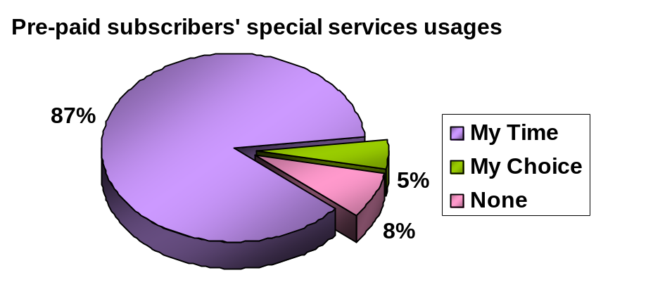
The above graph shows that My Time is the most popular special offer among the pre-paid subscribers. My time offers low tariff per min than My Choice option. This could be a reason of its popularity. From here I can draw conclusion that Bangladeshi Telecom market’s subscribers are very price sensitive.
10.1.3.4. Djuice U & I
Like My Easy number for Easy pre-paid and Easy Gold this feature gives to the djuice subscribers chance to choose someone special and talk to that person at a more affordable rate. The only difference is it offers 20 second pulse from the very beginning minute. U & I tariff is given below:
- Tk.1/pulse during peak hours
- Tk. 0.66/pulse during off peak hours
To enjoy this service the subscribers has to send SMS to 177 writing the selected number of his/her preference. This will charge regular SMS tariff. After sending the SMS it will take maximum next 72 hours to activate the number.
10.1.3.5.Short Message Service (SMS)
SMS is the most popular Value added service of GrameenPhone. It is popular because it is cheap. But SMS still many subscribers do not know how to send SMS. SMS in mobile acts like an advanced pager. Subscribers can send and receive text messages of up to 160 characters for 1 SMS, directly from one GP mobile to another GP mobile or any other operator’s mobile.
10.1.3.6.Voice Mail Service (VMS)
VMS is a unique answering machine. It provides subscribers with a personal electronic mail box in voice mail center. It records subscriber’s personalized greetings as well as stores incoming voice messages.
It records incoming voice messages if subscribers are:
- Outside GP's coverage area or
- Busy or
- Simply switched off your mobile

It provides 24-hour automatic secretarial service. Makes one available to his calling person anytime

10.1.3.7. Friends and Family
Friends and family is a special feature is given to only regular and standard post-paid subscribers. It gives the subscribers to select 3 numbers for the following next three month. In this selected three numbers the subscribers can call Tk1.5/min for 24 Hours. After three months the subscribers can change the number or can keep the previous numbers. To avail this option the subscribers has to SMS this numbers to 2800 writing three friends and family numbers. Again this will charge regular SMS tariff. After sending the SMS it will take maximum next 72 hours to activate the number.

10.1.3.8. International Roaming
GrameenPhone became the first mobile phone operator in the country to offer its subscribers the International Roaming facility from March 1999. The number of GP International Roaming partner networks increased rapidly from 12 in1996 to 56 in December 2000. And now GrameenPhone has 248 International Roaming partner networks spread across 91 countries in four continents, as of June 2005.

The International Roaming facility is a useful service for the GP subscribers who travel abroad and subscribers of the partner networks who visit Bangladesh. It has also become an additional source of revenue for the company. On average International Roamers generate Tk8293 per month. GrameenPhone regular (ISD) subscribers can use their mobile phones in the countries where GP has partner networks. The subscribers of the partner networks can also use their mobile phones in Bangladesh. GP regular (with ISD) subscribers can avail the international roaming service if they are holders of International Credit Cards (Foreign currency MasterCard issued by NBL in Bangladesh, American Express Card or any other master card from anywhere in the world). Security deposits and other terms and condition apply to avail the international roaming service.

Average Revenue per Subs | Tk.8293
Monthly Average Revenue generated | Tk.7,420,000

- Short brief on International Roaming
International Roaming is the ability to use your own GSM phone number in another GSM network (another country).
With International Roaming facility GP subscribers have the ability to make and receive calls whilst traveling to other countries having GSM network provided GP has a commercial operation with that network operator.
The unique roaming features of GSM allow cellular subscribers to use their services in any GSM service area in the world in which their provider has a roaming agreement.

10.1.3.9. FlexiLOAD
GrameenPhone Limited is introducing Electronic Recharge System named FlexiLOAD – an easy and flexible way to recharge and balance transfer from GP pre-paid to GP pre-paid accounts from April 28, 2005. With the introduction of this facility, GrameenPhone’s valued pre-paid subscribers will get the freedom to recharge their pre-paid account with any amount starting from Tk.50 to Tk.10, 000.

On 28th April 2005 FlexiLOAD have launched in Dhaka, Chittagong, and Khulna. It was available in 42 POS on that day and was available to ALL GP Sales Centers from the 1st day (28-Apr-2005). After first week of launching, another 300 POS was added in all regions.

To recharge pre-paid account through FlexiLOAD, a subscriber has to visit any of the nearest FlexiLOAD retailers of GrameenPhone, or GrameenPhone Sales Centers. Upon choosing any amount between Tk.50 to Tk.10,000, the subscriber will make the payment to the retailer, and the retailer will instantly recharge the subscriber’s account from his mobile handset. After a successful recharge, the subscriber will receive instant confirmation on the recharge on his/her mobile handset through SMS.
This new system will give the GrameenPhone subscribers the flexibility to choose from a wide range of recharge amounts and validity for recharging their pre-paid account. Moreover, at the time of launch , GrameenPhone has run a special promotion whereby recharge of any amount from Tk.300 to Tk. 599 will receive 6 months (180days) +7 days incoming validity; and for recharges starting from Tk 600 to Tk 10,000 the validity will be 1 year (365 days) +7 days incoming .
All pre-paid subscribers of GrameenPhone i.e. EASY; EASY GOLD and djuice subscribers will enjoy this Flexi LOAD service. Along with Flexi LOAD, the current pre-paid scratch cards will also be available at the market.
10.1.4 Information Service

10.1.4.1. Voice/Speech based service
For the first time GP introduces Hot-code dialing, which allows subscribers to access directly to the desired information without going through the step-by-step menu system. A subscriber can call the number to image center from his/her to get information like billing, service features, tariff, and usages detail information. Subscribers can avail this service 24 hours a day. There are both Human agent and interactive voice response (IVR). Call center human agent service charges 4Tk/min for both post-paid and pre-paid subscribers. IVR charge is free for first minute and charges 2Tk. from the second minute. Call center has the following hot lines for the prospective subscribers. Recently one hotline number for all packages of GP has been introduced 121.

10.1.4.1. Info Center: Each GrameenPhone Customer Relation Center (CRC) has info center, which provides various information about recent offered package price, tariff and after sales services related information. The only difference of info center and hot line is, hot line provides information over phone and info center provides information face to face.

10.2. After Sales Service
After sales services is after sales subscription services. All GP subscribers can take after sale service from regional CRC. After sales services includes reconnection, SIM replacement, product migration, Address change, sign change.

10.2.1. Reconnection: Pre-paid and post paid subscribers can get reconnection of their deactivate line. For reconnection subscribers has to apply in Customer Relation Center with signature. And subscribers have to pay fees for reconnection. This fee depends on products. For example, a disconnected Easy Pre-paid subscriber has to pay Tk.150 for reconnection.
Reconnection Fees:
Easy Pre-Paid | Tk. 150
Easy Gold | Tk. 400
Djuice | Tk. 150
Regular | Tk.1450
National | Tk.450
Any time 300 | 150+ Bundle fee
Any time 500 | 500+Bundle fee

10.2.2. Migration: A post paid subscriber can migrate post paid to pre-paid, and a pre-paid subscriber can migrate pre-paid to post paid. For this subscribers have to pay migration fees. In case of migration the subscribers’ previous number will change.
10.2.3. SIM replacement: If subscribers SIM is lost or damaged then the subscribers can take SIM from regional CRC. Again, for SIM replacement subscribers has to pay certain fees.
10.2.4. Address change: If post-paid subscribers’ billing address is changed then the subscriber can officially change address by applying to regional CRC. As soon as the subscribers address is changed, GrameenPhone give feedback to the subscribers by sending SMS.
11.2.5. Sign Change: After sale services is provided by verifying signature. If a subscriber wants to change signature then s/he can apply to replace old signature with new one.

10.3 GSM Features of GrameenPhone
GrameenPhone subscribers enjoy the following GSM features without bearing any additional costs:
10.3.1. Caller ID: Display of the phone number of an incoming call in your handset before the call is answered.
10.3.2. Call Waiting: While talking to the first caller, you will hear a special tone informing you about the second call on the line. At that moment you can put the first caller on hold and talk to the second caller.
10.3.3. Call Conference: Receiving calls from multiple callers can be supplemented by joining these multiple callers so as to enable them to talk to each other. You will be able to communicate with a group consisting of maximum five callers.
10.3.4. Call Divert: Call Divert lets you redirect or re-route your call to another GrameenPhone mobile or any other fixed (if you have BTTB connectivity) or mobile phone.
10.3.5. Call Barring: Enables you to restrict certain types of calls to be made from your mobile. This feature is especially important for security purposes.

10.4. Products and services that have been successful
- GP-Regular, the oldest product of GrameenPhone retains its popularity through its full connectivity to all networks including fixed line telephony services.
- EASY Pre-Paid, because of Low flat tariff and nationwide mobility, it’s a Pre-paid service, no monthly rent required and instant use due to pre-activation, no hassles of bill payment.
- GP-GP National because of low flat tariff, nationwide mobility, connectivity to other operator’s mobiles in different zones.
- Information Service through mobile because of easy access, interesting theme, and reasonable rate and for being new and innovative.
- Village phone because of use of Grameen Bank’s borrower network and for having access to BTTB & ISD.

10.5 Products and services that have not been successful
- Voice Mail service due to language barrier, lack of promotions, lack of know how about interactive services and also because people are reluctant to speak to a machine.
- Usage of Short Message Service is still low due to lack of promotion, lack of knowledge of English, unawareness of handset configuration and un-ergonomic nature of keypad.
- Difficulty in Configuration, handset barrier and slow connectivity are hampering WAP’s popularity.

11. Secondary Data Retrieval & Analysis
11.1. The Actual services receiving Scenario:
From the company subscriber’s service receiving archive I found, how many subscribers are actually receiving services provided by GrameenPhone. In the following section I have represented how many subscribers are receiving what services.

11.1.1. International Roaming
In the year inception in March, 1999 there was a few number of International roamer partner of GrameenPhone. In 2003 the total number of roaming partner was 194, in 65 countries. Then gradually GP has increased it roaming partner. Till June 2005, GP has 248 roaming partner across 91 countries. In 2002 there were only 678 international roaming subscribers then, it gradually increased to 1308 in 2003, total 2093 in 2004 and as of June, 2005 the total number of roamer subscribers stands to 3499.
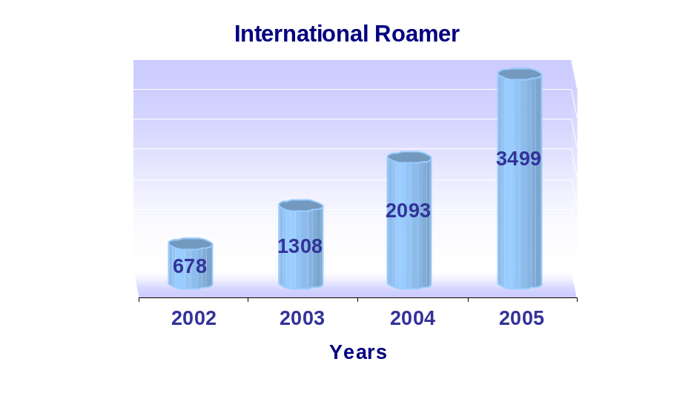
Only Post-paid regular and Any Time 500 subscribers can take International roaming service. Out of 0.15 Million post paid regular and Any Time 500 subscribers only 3499 is a very small segment. Hence GrameenPhone has the opportunity to grab large number of post paid subscribers who regularly visit, travel abroad. And to grab the attention to the prospective customer GrameenPhone has take crucial awareness building campaign, promotion, effective advertisement and other publicity.
11.1.2. Wireless Application Protocol (WAP)
Though all GrameenPhone subscribers can use WAP, only a few percent of GrameenPhone subscribers are using it. From the company achieve it is found that 3415 subscribers are using WAP service (till June, 2005). Again, it is a very small segment of total GP subscribers.

Total GP subscribers
3.5 million
Total WAP
Only 3415
Still there is potentiality to increase the number of total WAP users. For this GP has to take effective awareness building activities.

11.1.3. Friends and Family number:
Regular and National post paid subscribers get the option to talk three friends and family number 24 hours at 2Tk./min which is comparatively low than regular tariff. Still, there are many regular and standard subscribers who are not using F&F service. Our of approximately .2 million regular and standard subscribers only .134 million subscribers are taking F&F services which is 67% of total regular and standard subscribers.
11.2 Some Secondary survey of subscribers Service awareness status:
Customer Relation Division’s telemarketing team has undertaken some service aware building campaign through calling directly to GP subscribers. This team has already done campaign on International Roaming, Friends and Family (F&F), Value Added Services (VAS).
    - Friends & Family campaign (From 13 Feb to 26 Feb, 2005)
In Friends & Family campaign Telemarketing team call to subscribers who do not have the F&F option activated and ask them whether the prospective customer aware about the F&F services, and at the same time telling them how to activate it & the benefits of it.

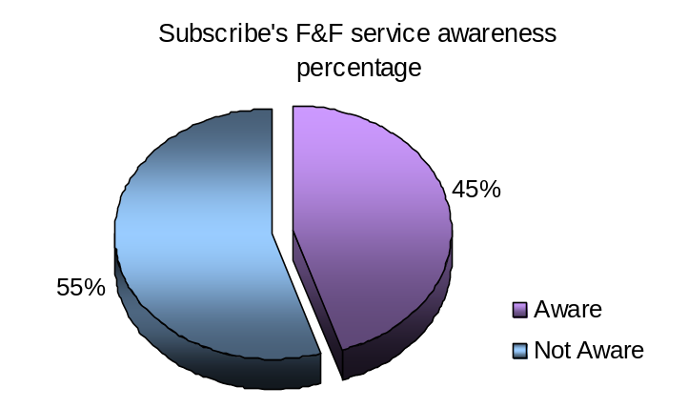

Out of 2217 reachable customer only 1000 subscriber know about the F&F service the shows 45% in the graph above and 1217 subscribers do not know about this special service that shows 55%. It implies that most of the post paid subscribers (using Regular and National) are not aware about F& F.

Statistics of Solution |  | Subscriber's Feedback
Call Dispersion |  | Subscriber's Attitude |  |  | Receptive Scale
Successful | 2217 | Delighted | 1223 | 55% | Very Interested | 1403 | 63%
 |  | Satisfied | 960 | 43% | Sounds Interesting | 561 | 25%
 |  | Dissatisfied | 34 | 2% | Not Interested | 253 | 11%
Total | 2217 |  | 2217 |  |  | 2217

Again from the Subscribers Feedback after knowing about F & F we find that most of the subscribers i.e. out of 2217 subscriber 55% are delighted, 43% are satisfied and the remaining only 2% subscribers are dissatisfied with F&F service.

And in the receptive scale we see that majority of subscribers are interested with F & F service and only 11% are not interested about it.

    - Friends & Family campaign (From 19 Feb to 23 Feb, 2005)
Informing the new subscribers who do not have the F&F option activated, telling them how to activate it & the benefits of it.
Statistics of Solution |  | Subscriber's Feedback
Call Dispersion |  | Subscriber's Attitude |  |  | Receptive Scale
Successful | 95 | Delighted | 72 | 76% | Very Interested | 75 | 79%
 |  | Satisfied | 17 | 18% | Sounds Interesting | 12 | 13%
 |  | Dissatisfied | 6 | 6% | Not Interested | 8 | 8%
Total | 95 |  | 95 |  |  | 95
Among the 95 reachable new subscribers 76% subscribers and 18% subscribers are delighted and the rest 6 subscribes are dissatisfied with F & F service. Again in the receptive scale majority of the4 subscribers i.e. 75 and 12 subscribers are very interested and sounds interested respectively.

Interpretation: Now it can be said from the above finding that if GrameenPhone can increase the awareness of the subscribers, then it will help to deliver more subscribers to provide the already offered F&F service. This will definitely increase the satisfaction level of the subscribers.

11.2.3. International Roaming campaign:
In international Roaming campaign the telemarketing team call to 1544 high revenue generating subscribers to inform about international roaming service. In the this campaign out of 1544 reachable subscribers 1011 subscribers are aware about this service and 533 subscribers are not aware about international roaming service. After the campaign, 23 subscribers have taken this service. They all are informed through the campaign.

11.2.4. Value Added Services campaign:
In the value added service campaign the telemarketing team asked 743 subscribers (in March), 3222 subscribers (in April), whether they know about the value added service. Form the camping it is found that in both month and in combine 60% is aware and 40% is not aware about value added services (VAS).

 | April |  | March |  | Total
Aware | 1918 | 60% | 743 | 60% | 2661 | 60%
Not Aware | 1304 | 40% | 504 | 40% | 1808 | 40%
Total | 3222 |  | 1247 |  | 4469

*Subscriber’s Attitude: Subscriber attitude towards GP considering overall services.
*Receptive Scale: Measuring Subscriber’s interests of campaign subject.
12. Primary Data Analysis
A comprehensive questionnaire has been developed in order to determine some of the demographic characteristics of the GrameenPhone subscribers and the existing subscribers’ service awareness status. The whole questionnaire has been divided in three parts. The first part was asked to know about the basic information about the subscribers’ product type, using duration and usages amount. The second part contained classification information consist of different types of services asking subscribers whether they aware about it or not, use it or not and how they knew about it. This part also includes Subscribers’ service learning Medias, their preference and recommendation of learning services. Moreover, one open ended question was asked to get subscribers response regarding their preference of learning GP services. In this part of questionnaire the GP services are divided into Value Added Service, After sales service, Special features, Free supplementary GSM service, Push Pull services. The last part of the questionnaire consist of identification information includes demographic question like age, sex, income, education and occupation. From this I can find whether there is any relation between demographic profile and service awareness status. The main focus of this questionnaire is to find
- Subscribers are aware about which GP services.
- Subscribers’ are using which services.
- The most effective Medias to build service awareness.
- Subscribers’ feedback of preferred Medias and possible ways to aware them and increase service usages.

12.1. Sample:
I have conducted my research through telephone questionnaire. For this survey, I have randomly picked 55 samples from GrameenPhone’s subscription archive. As my research is to find GrameenPhone’s service awareness status, the whole GP subscribers are my research population. For more accurate outcome, it is appropriate to pick sample randomly from the whole GP subscribers. Therefore to meet this purpose, telephone survey is the most convenient way.

12.2. The perspective scale of the research:
The main focus of this research is to find GP subscribers services awareness status. To measure awareness status I have prepare a perspective scale. And bases on this I have formulated my research hypothesis. The perspective scale is divided into five equal parts. In the perspective scale if more than 80% subscribers aware about GrameenPhone service then I will interpret it as GP subscribers’ service awareness status is very high. If subscribers’ awareness status ranges from more than 60% to less than equal to 80% then the interpretation will be, subscribers’ awareness is only high and so on.
≥80%
Perspective Scale of Awareness status
Very High
Moderate
Very Low
>40% to ≤ 60%
>60% to ≤ 80%
High
Low
Respondents’ awareness
20%≤
>20% to ≤ 40%

12.3. Test Hypothesis:
From the above perspective scale the formulated test hypothesis is GrameenPhone subscribers have very high services awareness status, which means more than to 80% subscribers know about GrameenPhone services. Hence,

Null Hypothesis: Less than or equal to 80% GP subscribers are aware about GP services.
Alternative Hypothesis: More than 80% GP subscribers are aware about GP services.

12.4. Data representation and Analysis:

The whole data analysis is done based on the normal distribution which is the basic criteria of data analysis and interpretation. It is tested through SPSS K-S test statistics.

12.4.1. General information:

12.4.1.1 Product name awareness:
In the first question I have asked respondents whether they know which product they are using. 60% of the respondent correctly said which product they are using and the left 40% did not know what their product name was. Out of total 55 respondents 50.91% have post-paid and 49.09% have pre-paid. (Reference Appendix Table1.1)
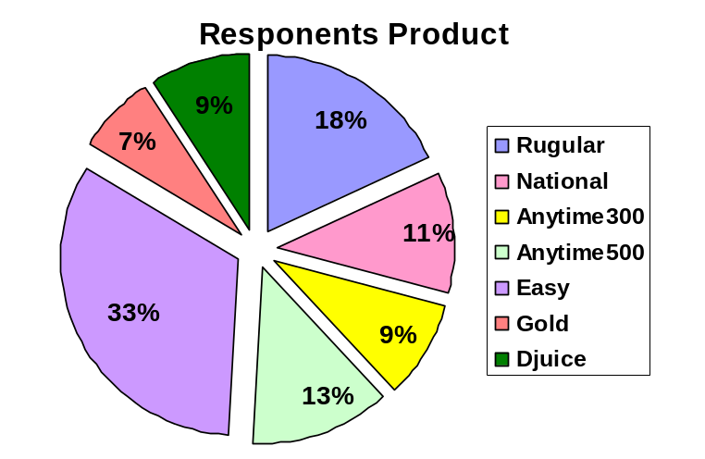
Figure13.1: Respondents different product usages

Interpretation: From the perspective scale, it can be said that Subscribers product name awareness is high. This finding is statistically valid as the chi-square test p value .005 less than the significance level .05. (Reference: Appendix Table1.2)

12.4.1.2. Subscribers recharging amount:
Subscribers’ average monthly mobile recharging amount is asked to find the financial potentially of respondents. The pie chart shows, there is no concentration of the subscribers charging amounts. Most respondents charges on average Tk. 1100 above. The mean average of the subscribers recharging amount is Tk. 601-900 (Appendix table: 1.3). From the Product type and recharge amount cross table (App table) it is observed there is a relation between subscribers product type and recharging amount and it is statistically valid as the phi Cramer’s V p-value .000 is less than the significance level .05. And the association is post paid users spend more than prepaid users. (Reference Appendix Table1.4)

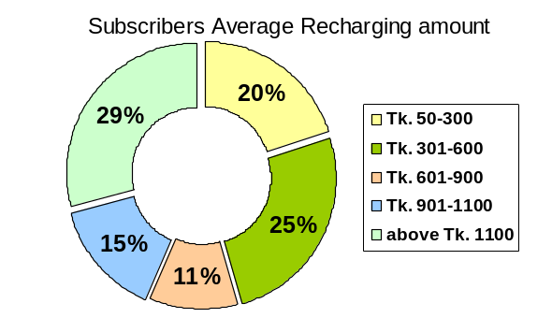
Figure13.2: Subscribers average monthly recharging amount

12.4.1.3. Subscribers Product using Duration
Most of the respondents are using their product for last one to three years; they are the recent users of GP product. Last couples of year’s prolonged growth may be the reason of it. GrameenPhone’s most of the services came during these years. Furthermore, package price decreased rapidly during this time.

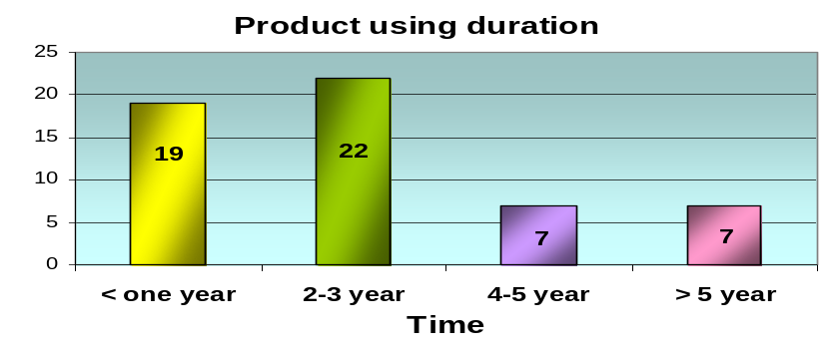
Figure13.3: Subscribers product using duration

12.4.1.4. Reason behind using GrameenPhone mobile service:
In the general information part of the questionnaire the reason(s) for buying GP mobile is asked to identify the key factors for which subscribers choose GP. From this check list question’s cumulative frequency it is found that majority of the respondents preferred GP because of widest network coverage and for its network quality. Another important factor is GP’s customer service for which 19% respondents choose GP.
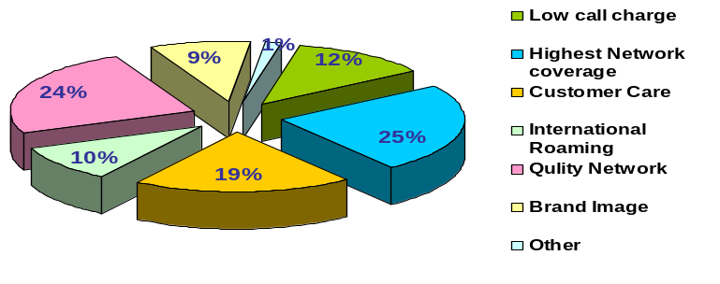
Figure 13.4: Subscribers reasons behind using GrameenPhone mobile service

12.4.2. Classification information:
In this part of the questionnaire I have asked each service in the following format:

Please tell me which of the following service you know about and you use it. If subscriber doesn’t aware please tick only column 1 and avoid ticking column 2, 3, & 4. (Please put tick √ only where applicable)
Name of the service | Doesn’t aware (1) | Aware (2) | Aware and Use (3) | Learning media(s) (4)
 |  |  |  | Newspaper | Magazine | TV | Bill  board | Radio
SMS

From column 1, 2 and 3 subscribers’ awareness status is found and from the fourth column gives the effective Medias from where subscribers noticed services.

12.4.2.1. Value Added Services awareness
GrameenPhone provides many value added services; among these I have selected some of the important services which can make subscribers life easy, time convenient and cost effective. The included Value Added Services are SMS, VAS, Ring tone down load, Logo Down load. In the questionnaire I have asked whether respondents aware or unaware about VAS services and use those services or not.

SMS awareness: From the descriptive statistics frequency distribution table 1.6 in appendix, it is found that 73% aware and use SMS service and 9% only aware about SMS and 18% does not aware about the SMS service.
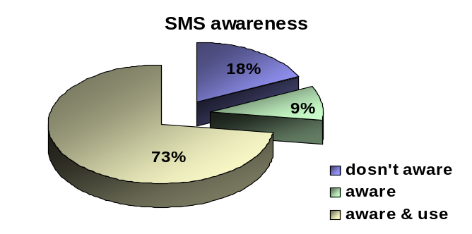
Figure 13.5: Subscribers’ awareness about SMS.
Interpretation: It means SMS is a very popular value added service and most GP subscribers use this service. In Combine 73%+9%= 82% subscribers are aware about GP services. Hence, from this pie chart and perspective scale it can be interpret that GP subscribers SMS awareness is very high. Now below the Z-test will give the statistical prove of the following hypothesis.

Null Hypothesis: Less than or equal to 80% GP subscribers aware about SMS service. H_{0:} μ₀ ≤ .80
Alternative Hypothesis: More than 80% GP subscribers aware about SMS service. H_{1:} μ₁ >.80
Now this hypothesis is tested by Z-test.

Statistical interpretation: From the Z test it is found the P-value is greater than significance level .05. So null hypothesis accepted, and alternative hypothesis is rejected. So it is proved that SMS service awareness status is not very high which is less than 80% falls in the only high range of the perspective scale. Hence SMS awareness is only high.
Reporting: The null hypothesis is rejected, p = .3710 > .05 the significance level or TS_{CAL} .3710 < TS_{CR} 1.645.

SMS Learning Media: In the questionnaire learning Medias was asked as a check list question. The respondent put tick mark as many as applicable. From the respondents cumulative count of check listed response it is found that most of the customer learn about SMS from newspaper. The second popular way to learn about SMS is billboard third is TV and fourth is magazine. Many respondents said they learn SMS from friends, relative and neighbors goes to other option accounts 23% of the total response.
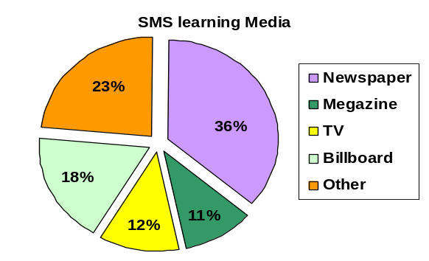
Figure 13.6: SMS learning media

Whether this finding is statistically valid or not will be proved by Chi Square test.
Null Hypothesis: Newspaper is not the most popular way to aware subscribers GP services.
Alternative Hypothesis: Newspaper is the most popular way to aware subscribers GP services.

Statistical Interpretation: The P-value is higher than significance level .05. So this is not a statistically significant finding. So null hypothesis is not rejected, and alternative hypothesis is rejected. So it is proved that newspaper is not the most popular media to aware subscribers GP services.
Reporting: The null hypothesis is not rejected, p = .001 >.05 the significance level.

Magazine, TV and Billboard’s test statistics prove that respondents’ preference is statistically valid. Only the other option is not statistically valid.

Table13.1: Test Statistics for Media
 | Newspaper | Magazine | TV | Billboard | Other
Chi-Square(a) | 11.756 | 13.889 | 11.756 | 2.689 | .022
Df | 1 | 1 | 1 | 1 | 1
Asymp. Sig. | .001 | .000 | .001 | .101 | .881

Voice Mail Service Awareness: Most of the respondents i.e. 55% doesn’t aware about the voice mail service. 40% subscribers only know about the service and left 5% subscribers are aware and use this service. (Reference Appendix Table1.7)
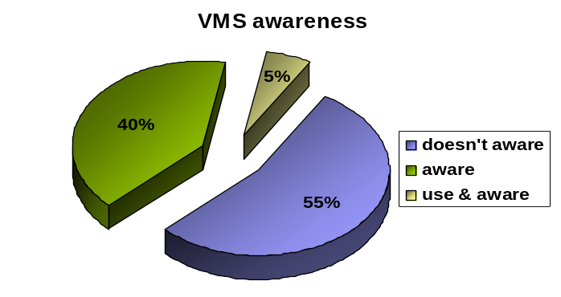
Figure 13.7: Awareness about VMS
Interpretation: More than 55% does not aware about VAS, and those i.e. 40% who aware of the about VAS, but not using VAS and only 5% of the respondents are using VAS. So from the perspective scale I can say that VAS awareness is moderate. Now below the Z-test will give the statistical prove of the following hypothesis.

Null Hypothesis: Less than equal to 40% to GP subscribers aware about VMS service. H₀: μ₀ ≤ .40
Alternative Hypothesis: More than 40% GP subscribers are not aware about VMS service. H₁: μ₁ >. 40

Now this hypothesis is tested by Z-test.
Statistical interpretation: From the Z test it is found the P-value is greater than significance level .05. So alternative hypothesis is rejected and null hypothesis accepted that is less than equal to 40% know about VMS. So it is proved that VMS awareness status is low.
Reporting: The null hypothesis is accepted, p = .2266 > .05 the significance level or TS_{CAL} .7564 < TS_{CR} 1.645.
VMS Learning Media: 38% respondents knew VAS from the newspaper advertisements, 18% knew VAS from billboard, 16% from TV, 12% from magazine. Again here I found newspaper is the most effective learning media. Now below the Chi square test will give the statistical prove of the following hypothesis.
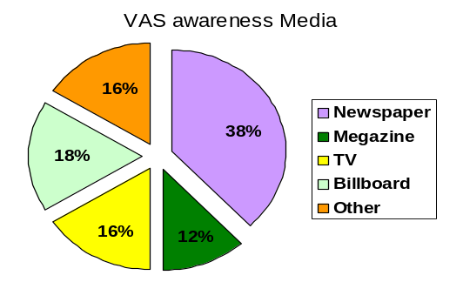
Figure13.8: VMS learning media

Null Hypothesis: Newspaper is not the most popular way to aware subscribers GP services.
Alternative Hypothesis: Newspaper is the most popular way to aware subscribers GP services.
Statistical Interpretation: The P-value is less than significance level .05. So null hypothesis is rejected, and alternative hypothesis is accepted. So it is proved that newspaper is the most popular media to aware subscribers GP services.
Reporting: The null hypothesis is accepted, p = .009 < .05 the significance level.

In the same way, respondents learning Medias effectiveness is statistically valid for Magazine as it is found that the p-value is less than the significance level. But the media effectiveness for TV, Billboard and other option is not statistically valid as these variables’ respective p value is greater than the significance level .05.
Table 13.2: Test Statistics for VMS learning media
 | Newspaper | Magazine | TV | Billboard | Other
Chi-Square(a) | 6.760 | 6.760 | 3.240 | 1.960 | 3.240
Df | 1 | 1 | 1 | 1 | 1
Asymp. Sig. | .009 | .009 | .072 | .162 | .072

Ring tone download awareness: The pie chart below represents that most of the respondents’ (64%+18%=82%) are aware about the ring tone download service. Among them 18% down load ring tone and the left 18% do not aware about ring tone down load service. (Reference Appendix Table1.7)
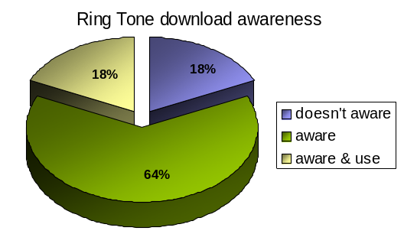
Figure: 13.9: Awareness about ring tone download awareness
It interprets that ring town awareness is very high (from the perspective scale.) now the z-test below will give the statistical prove of it.

Null Hypothesis: Less than or equal to 80% GP subscribers aware about Ring tone download. H₀: μ₀ ≤ .80
Alternative Hypothesis: More than to 80% GP subscribers aware about Ring tone download. H₁: μ₁ >.80

Now this hypothesis is tested by Z-test.
Statistical interpretation: From the Z test it is found the P-value is greater than significance level .05. So this is not a statistically significant finding. So alternative hypothesis is rejected and null hypothesis accepted i.e. less than equal to 80% subscribers are aware of Ring Tone download which goes to high awareness of the perspective scale. So it is proved that Ring tone down load awareness status is high.
Reporting: The null hypothesis is rejected, p = .3710 > .05 the significance level or TS_{CAL} .3710 < TS_{CR} 1.645.

Ring tone download Learning Media: From the pie chat below it is found, newspaper is the media from where most of the respondents have learnt about Ring tone download. So, it can be said that newspaper is the most popular and effective media. The chi-square test below will give the statistical prove of it.
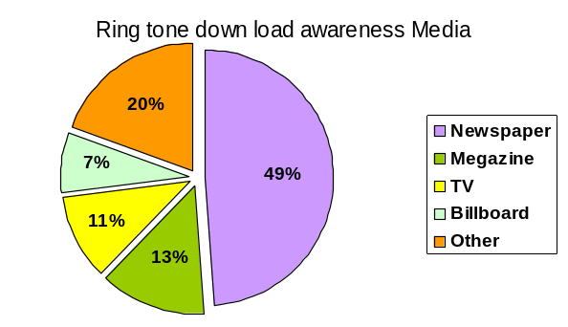
Firuge13.10: Ring tone down load learning media
Null Hypothesis: Newspaper is not the most popular way to aware subscribers GP services. Alternative Hypothesis: Newspaper is the most popular way to aware subscribers GP services.
Statistical Interpretation: The P-value is lower than significance level .05. So null hypothesis is rejected, and alternative hypothesis is accepted. So it is proved that newspaper is the most popular media to aware subscribers Ring tone down load services.
Reporting: The null hypothesis is not rejected, p = .000< .05 the significance level.

In the same way the descriptive findings for Magazine, TV and billboard is statistically valid as these variables respective p-value is less than the significance level shown in the following table.

Table 13.3: Test Statistics for Ring tone down load media
 | Newspaper | Magazine | TV | Billboard | Other
Chi-Square(a) | 23.170 | 13.298 | 17.894 | 26.064 | 4.787
Df | 1 | 1 | 1 | 1 | 1
Asymp. Sig. | .000 | .000 | .000 | .000 | .029

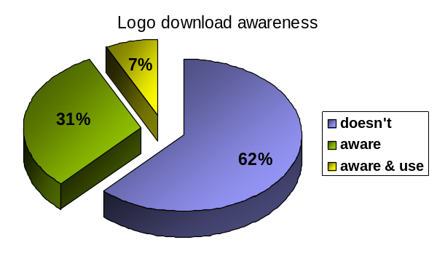
Logo download awareness: A lion portion of the respondent i.e. 62% does not familiar with logo down load service. Still 31% of the subscribers who know about logo down load are not using it. And very small portion i.e. 7% respondents are using this service. It interprets logo down is has low awareness. (Appendix Table1.9)

Figure13.11: Awareness about Logo down load
Now the following hypothesis will be tested by z-test to find its statistical validity.

Null Hypothesis: Less than equal to .20% GP subscribers aware about Logo download. H₀: μ₀ ≤ .20
Alternative Hypothesis: More than 20% GP subscribers aware about Logo download. H₁: μ₁ >.20

Now this hypothesis is tested by Z-test.

Statistical interpretation: From the Z test it is found the P-value is less than significance level .05. So this is a statistically significant finding. So null hypothesis rejected, and alternative hypothesis is accepted. So it is proved that Logo down load awareness status is low.
Reporting: The null hypothesis is rejected, p = .000 < .05 the significance level.

The Over all VAS awareness Status:
Name of VAS | Awareness Status
SMS | High
Voice mail service | Low
Ring tone download | High
Logo download | Low
Table 13.4: Overall VAS awareness status

The table above draws conclusion that, Value Added service awareness among the GP subscribers is neither very high nor very low. SMS and Ring lone download awareness is high and VMS and logo down load is low.

12.4.2.2. After Sales services awareness:

In the After sale service part of the questionnaire I have mentioned some important services which both pre-paid and post-paid subscribers should know. These after sale services are migration, Reconnection, and Transfer of Ownership.
Awareness of Product Migration:
A major portion of the subscribers do not know about the migration service. In combine only 22% subscribers are aware of Migration service. Hence, from the perspective scale, it interprets subscribers product migration service awareness is low.
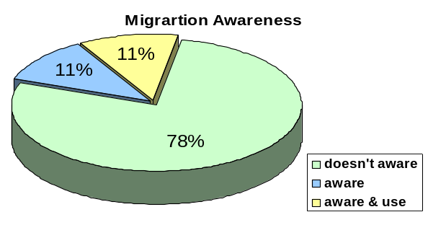
Figure 13.12: Awareness about Product migration.

The Z- test below shows the statistical validity of the following hypothesis.

Null Hypothesis: Less than or equal to .20% GP subscribers aware about product migration. H₀: μ₀ ≤ .20
Alternative Hypothesis: Less than .20% GP subscribers aware about product migration. H₁: μ >. 20

Statistical interpretation: From the Z test it is found the P-value is greater than significance level .05. So alternative hypothesis is rejected and null hypothesis accepted, i.e. less than equal to 20% GP subscribers aware of product migration. So it is proved that product migration service awareness status is very low.
Reporting: The null hypothesis is rejected, p = .3557 > .05 the significance level or TS_{CAL} .3710 < TS_{CR} 1.645.
Awareness of Reconnection:
More than 60% of the subscribers know about reconnection of the disconnected line. It interprets reconnection service awareness is high. The Z-test will show the statistical validity of the statement.
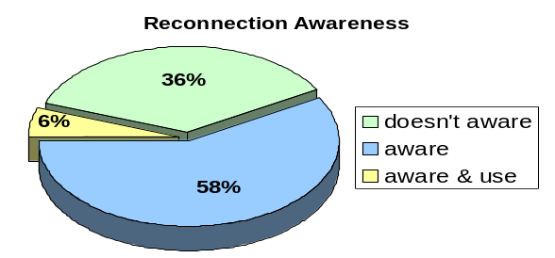
Figure13.13: Awareness about Reconnection.

Test of the following hypothesis.

Null Hypothesis: Less than or equal to 60% GP subscribers aware about reconnection. H0: μ ≤ .60
Alternative Hypothesis: More than 60% GP subscribers aware about reconnection. H1: μ >.60
Now this hypothesis is tested by Z-test.
Statistical interpretation: From the Z test it is found the P-value is greater than significance level .05. So alternative hypothesis rejected, and null hypothesis is accepted i.e. less than equal to 60% subscribers are aware of reconnection which goes to low awareness range of the perspective scale. So it is proved that reconnection service awareness status is low.
Reporting: The null hypothesis is accepted, p = .2578 > .05 the significance level or TS_{CAL} .6055 < TS_{CR} 1.645.
Awareness of Transfer of ownership:
83% of the subscribers do not know, mobile subscription can be transferred and only 17% are aware about transfer of ownership. From the perspective scale it implies this service awareness is very low.
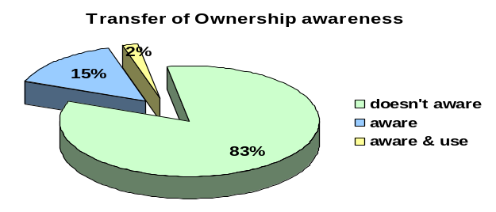
Figure13.14: Awareness about ownership transfer.
Now the statistics below will give the validity of the following hypothesis.
Null Hypothesis: Less than equal to 20% GP subscribers aware about transfer of ownership.H₀: μ₀ ≤.20
Alternative Hypothesis: More than 20% GP subscribers aware about transfer of ownership. H₁: μ₁ >.20

Statistical interpretation: From the Z test it is found the TS_{CAL} -.5566 <TS_{CR} 1.645 hence, alternative hypothesis rejected, and null hypothesis is accepted. So it is proved that transfer of ownership awareness status is very low.
Reporting: The null hypothesis is accepted as TS_{CAL} -.5566 < TS_{CR} 1.645.

The Over all after sale service awareness Status:
Name of After sale service | Awareness Status
Product Migration | Very Low
Reconnection | Low
Transfer of ownership | Very low
Table13.5: Overall after sales service awareness.
The table draws conclusion that subscribers after sale service awareness is very low.

12.4.2.3. Special Service awareness:

International roaming service (IROM) is not known by 70% of the respondents (39), 27% are aware of international roaming service and approximately 2% are international roamers. In means International roamer service awareness level is low and users are very small.
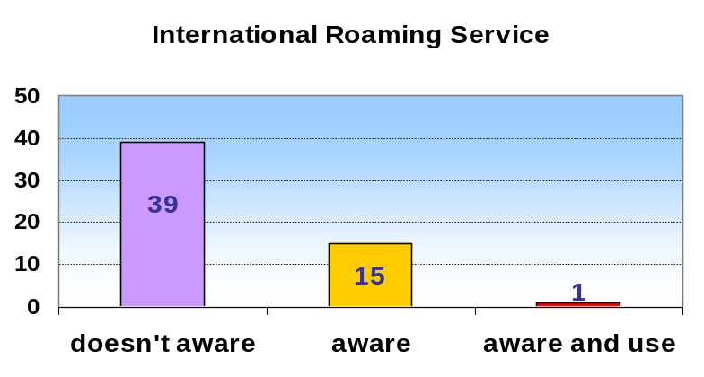
Figure13.15: Awareness about International Roaming service

Now the following hypothesis will be tasted by z-test.

Null Hypothesis: Greater than or equal to 20% GP subscribers aware about IROM. H₀: μ ≤.20
Alternative Hypothesis: Less than 20% GP subscribers aware about IROM. H₁: μ >.20
Statistical interpretation: From the Z test it is found the P-value is less than significance level .05. So this is a statistically significant finding. So null hypothesis rejected, and alternative hypothesis is accepted. So it is proved that international roaming awareness status is low.
Reporting: The null hypothesis is rejected, p = .0318 < .05 the significance level or TS_{CAL} 1.866> TS_{CR} 1.645.

Friends and Family number awareness:
Friends and family is a low charged service. It has a high awareness status. More than 80% respondent GP subscribers are aware about GrameenPhone’s this service. Hence, from the perspective scale it can be mentioned that, F&F service awareness status is very high.
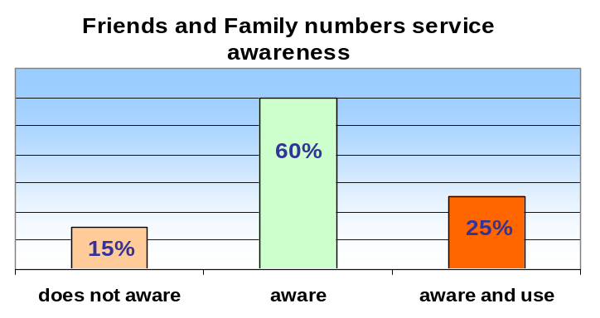
Figure13.15: Awareness about Friends and Family

Null Hypothesis: Less than or equal to 80% GP subscribers aware about F&F service. H₀: μ ≤ .80
Alternative Hypothesis: More than 80% GP subscribers aware about F&F service. H₁: μ >.80

Statistical interpretation: From the Z test it is found the P-value is greater than significance level .05. So null hypothesis accepted, and alternative hypothesis is rejected. So it is proved that F&F service awareness status is not very high which is less than 80% falls in the only high range of the perspective scale. Hence SMS awareness is only high.
Reporting: The null hypothesis is rejected, p = .1788 > .05 the significance level or TS_{CAL} .9276< TS_{CR} 1.645.

Again from the cross table 13.6, it is observable that, Regular and Notational subscribers know batter about friends and family service. Infect all the Regular and National subscribers know about it.

Table13.6: Cross Tabulation of Product type and awareness status of Friends and Family
 |  | Friends and Family |  |  | Total
 |  | does not aware | Aware | aware and use
Product | Regular | 0 | 2 | 8 | 10
Product | National | 0 | 0 | 6 | 6
Product | Anytime300 | 0 | 4 | 1 | 5
Product | Anytime500 | 0 | 7 | 0 | 7
Product | Easy | 3 | 15 | 0 | 18
Product | Gold | 1 | 3 | 0 | 4
Product | Djuice | 2 | 3 | 0 | 5
Total |  | 6 | 34 | 15 | 55

As it is low charged service, it has got its popularity. Other two post paid Any time 300 and Any time 500 mobile packages’ subscribers also know about this special service. So from here the conclusion comes, post paid subscribers are more aware about Friends and Family service. It is statistically true as the in the chi-square test p-value .000 is less than the significance level .05. Moreover, it is statistically proved that Friends and Family service has high awareness status.
WAP awareness:
WAP is an advance application of internet usages through a mobile phone. It requires high education level. From the WAP awareness data analysis it is found majority of the responds did not know about WAP. Only 20% of the respondents know about WAP from which only one respondent is using WAP. Hence, it interprets, WAP awareness is low. Now the test statistics below will interpret the statistical validity of this finding.
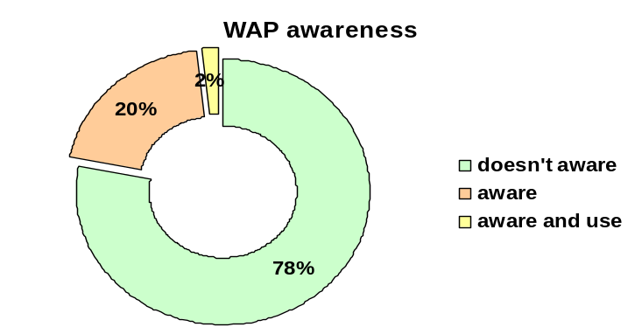
Figure13.16: Awareness about WAP

Null Hypothesis: Less than or equal to .20% GP subscribers aware about WAP. H₀: μ₀ ≤ .20
Alternative Hypothesis: Less than .20% GP subscribers aware about WAP. H₁: μ >. 20

Now this hypothesis is tested by Z-test.

Statistical interpretation: From the Z test it is found the P-value is greater than significance level .05. So alternative hypothesis is rejected and null hypothesis accepted, i.e. less than equal to 20% GP subscribers aware of WAP. So it is proved that WAP awareness status is very low.
Reporting: The null hypothesis is rejected, p = .3557 > .05 the significance level or TS_{CAL} .3710 < TS_{CR} 1.645.

WAP provides subscribers to surf internet, send e-mail etc. Hence the application of WAP depends on education level of the subscribers. Hence, from the Cross table of Education level and WAP awareness status it is found that no respondent of below higher secondary level education know about WAP and the respondents who are aware about WAP, all are Under Graduate or Graduate or Post graduate. The only respondent who is using WAP is a post graduate service holder. It interprets; there is a relationship between the WAP awareness and Education.

Table 12.7: WAP * Education Cross tabulation
 |  | Education |  |  |  | Total
 |  | Below Higher secondary | Under Graduate | Graduate | Post Graduate
WAP | doesn't aware | 30 | 9 | 5 | 0 | 44
WAP | aware | 0 | 2 | 7 | 1 | 10
WAP | aware and use | 0 | 0 | 0 | 1 | 1
Total |  | 30 | 11 | 12 | 2 | 55

In the special services part of the questionnaire there were some features which facilities subscribers to call GP numbers at a lower charge. Now the next part of the analysis will show the awareness status of these low tariff services.

My time awareness: Out of 55 respondents cumulatively (28+22) 50 respondents were aware about My Time, in which 22 respondents ware using it. 5 respondents did no know about it. It interprets respondents’ My Time awareness is very high as cumulatively 91% of the respondents were aware about it.
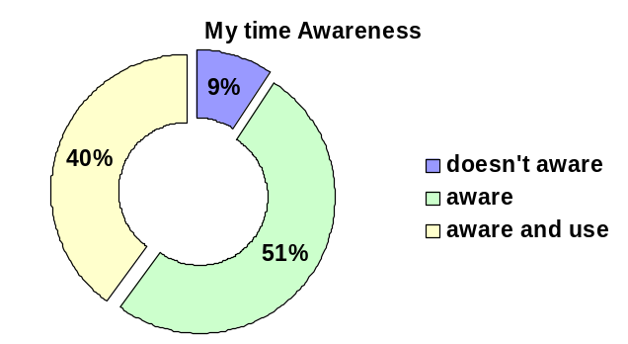
Figure 13.17: Awareness about My time.

Null Hypothesis: The proportion of subscribers My time awareness is less than equal to .80. H₀: μ₀ ≤ .80
Alternative Hypothesis: The proportion of subscribers My time awareness is greater than .80. H₁: μ₁ >.80
Now this hypothesis is tested by Z-test.
Statistical interpretation: From the Z test it is found, the P-value is less than significance level .05. So this is a statistically significant finding. So null hypothesis rejected, and alternative hypothesis is accepted. So it is proved that My time awareness is very high.
Reporting: The null hypothesis is rejected, p = .0217< .05 the significance level (for one tailed test) or the TS_{CAL} 2.02 > TS_{CR} 1.645.
My Easy Number awareness: In combine (22+30) 52 respondents were aware of My Easy number special service which represents 40% aware and 55% used My Easy number respectively. It means more than 80% subscribers are aware of My Easy number service. Therefore, My Easy number awareness is very high. Now come the point to test this finding statistic validity.
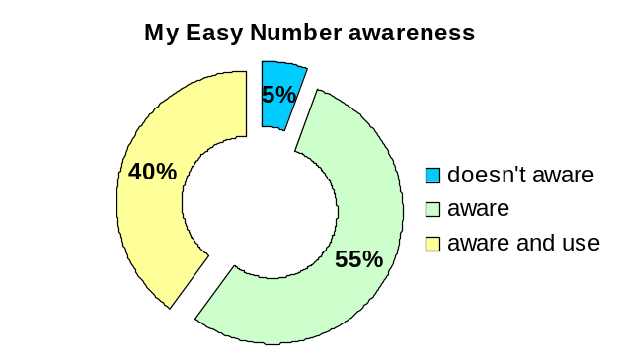
Figure 13.17: Awareness about My Easy number

Test of the following hypothesis with Z-test.
Null Hypothesis: The proportion of subscribers My Easy number awareness is less than equal to .80. H₀: μ ≤ .80
Alternative Hypothesis: The proportion of subscribers My Easy number awareness is greater than .80. H₁: μ >.80
Statistical interpretation: From the Z test it is found, the P-value is less than significance level .05. So this is a statistically significant finding. So null hypothesis rejected, and alternative hypothesis is accepted. So it is proved that My Easy Number awareness is very high.
Reporting: The null hypothesis is rejected, p = .0036< .05 the significance level (for one tailed test) or the TS_{CAL} 2.6966 > TS_{CR} 1.645.

Product type and My Easy number awareness cross tabulation analysis: From table 1.19 it is observed that all the Easy and Gold users are aware of My Easy number and at the same time using this special service. It indicates there is a relationship between product type and usages.
Now it can be tasted that whether there is any relationship between product type and My Easy number awareness by Pearson Chi-square test.
Null Hypothesis: There is no relationship between product type and My time awareness.
Alternative Hypothesis: There is a relationship between product type and My time awareness.

Statistical interpretation: From the From the Pearson chi-square test it is found, the P-value is less than significance level .025 (two tail test). So this is a statistically significant finding. Hence, null hypothesis rejected, and alternative hypothesis is accepted. It is proves that there is a relationship between Product type and My Easy Number awareness.

Reporting: From the Pearson chi-square test, X² (chi-square) = 15.11, P=.019>.025(two tail test).
My Choice awareness: My Choice is another low charged service by which subscribers can call any time at cheaper rate (mentioned previously). From the frequency distribution table 1.14 in appendix it was found that out of 55 respondents 49 respondents were aware of My Choice service and surprisingly there were no respondents using My Choice. It interprets subscribers My Choice awareness is high (from the perspective scale more than 80% means very high awareness.).
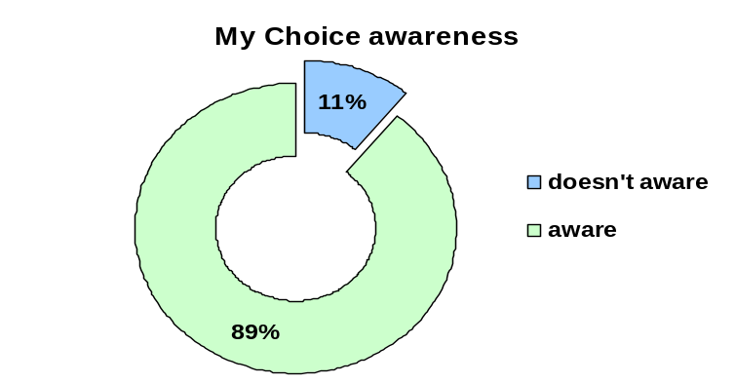
Figure 13.19: Awareness about My Choice

The following hypothesis is tested by Z-test.

Null Hypothesis: The proportion of subscribers My Choice awareness is less than equal to .80. H₀: μ ≤ .80
Alternative Hypothesis: The proportion of subscribers My Choice awareness is greater than .80. H₁: μ >.80

Statistical interpretation: From the Z test it is found, the P-value is less than significance level .05. So this is a statistically significant finding. So null hypothesis rejected, and alternative hypothesis is accepted. So it is proved that My time awareness is very high.
Reporting: The null hypothesis is rejected, p = .0465 < .05the significance level (for one tailed test) or the TS_{CAL} 1.685 > TS_{CR} 1.645.

U & I awareness: From the frequency distribution table 1.15 in the appendix, it is found 38 respondents were aware of U & I and 5 respondents were using U & I special service which shows in combine 78% respondents were aware of U & I special service. This finding interprets U & I awareness is high (from the perspective scale.)
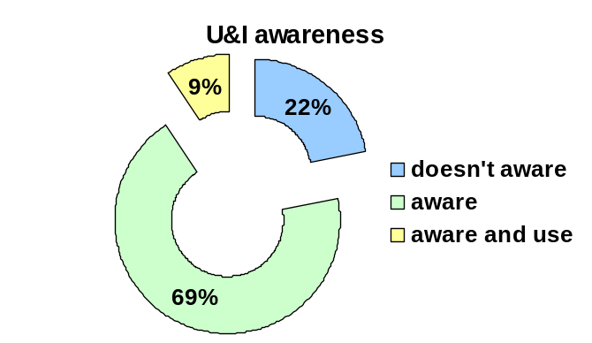
Figure 13.19: Awareness about U & I.

Null Hypothesis: The proportion of subscribers U & I awareness is less than equal to .80. H₀: μ ≤ .60

Alternative Hypothesis: The proportion of subscribers U & I awareness is greater than .80. H₁: μ >.60

Statistical interpretation: From the Z test it is found, the P-value is less than significance level .05. So this is a statistically significant finding. So null hypothesis rejected, and alternative hypothesis is accepted. So it is proved that U & I awareness is high.
Reporting: The null hypothesis is rejected, p = .003 < .05 the significance level (for one tailed test) or the TS_{CAL} 2.723 > TS_{CR} 1.645.

The Over Special service awareness Status:

Name of Special Service | Awareness Status  Low Charged Service  Knowledge base service  Expensive service
International roaming | Low
WAP | Very Low
F&F | Very High
My time | Very High
My easy number | Very High
My choice | Very High
U & I | High
Table13. 8: Overall Special service awareness

The table draws conclusion that subscribers expensive international roaming service and knowledge base service WAP awareness is low, but low tariff F&F, My time, My Easy hours, My Choice, U & I special service awareness is high.

12.4.2.4. Push Pull service awareness:
Push pull is a one kind of Value added service. In the research questionnaire I have put push pull service in a separate part so that respondents can understand it quickly. GP has offered many push pull services, among them I have selected some important push pull services those have frequent advertisement in newspaper, magazine, billboard and TV. The data analysis, representation and findings of the push pull service awareness status of GP subscribers is explained in the following part.

Daily News Updates awareness: From the frequency distribution (table 1.16 in the appendix) and pie chart below, it is found that 68% respondents do not know about daily news paper updates service. 4 respondents has been using this service which representing 7% in the graph and the 25% respondents are aware of daily news updated service but not using it. In combine (7%+25%) 32% respondents are aware of this service draws the conclusion that Daily News updates awareness is low. It falls in 20% to 40% range of the perspective scale.
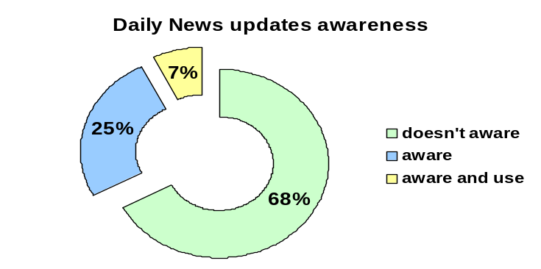
13.20: Awareness about Daily News Updates

Now Z-test will show the statistical validity the following hypothesis.

Null Hypothesis: The proportion of subscribers daily news updates awareness is less than equal to .20. H₀: μ₁ ≤ .20
Alternative Hypothesis: The proportion of subscribers daily news updates awareness is greater than .20. H₁: μ₂ >.20
Statistical interpretation: From the Z test it is found, the P-value is less than significance level .05. So this is a statistically significant finding. So null hypothesis rejected, and alternative hypothesis is accepted. So it is proved that daily news updates awareness is low.
Reporting: The null hypothesis is rejected, p = .0212< .05 the significance level (for one tailed test) or the TS_{CAL} 2.23 > TS_{CR} 1.645.
Sports Updates awareness: From the frequency distribution and pie chart below, it is found that 87% respondents do not know about daily news paper updates service. 6 respondents know about sports updates service but do not use it. Only 1 respondent is aware of this service. In combine (10%+2%) 12% respondents are aware of sports updates push pull service. Less than 20% means sports updates awareness is very low. Now by the help Z-test I can find the statistical validity of the following hypothesis.

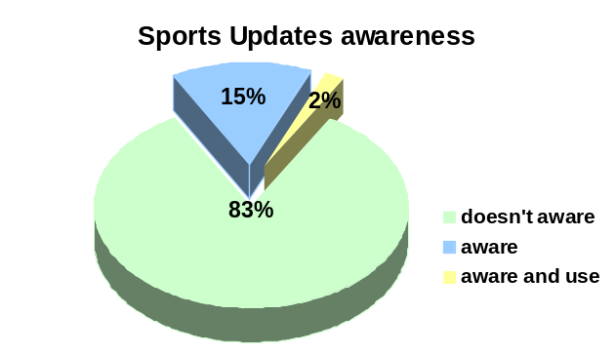
13.21: Awareness about Sports Updates

Null Hypothesis: The proportion of subscribers’ sports updates awareness is less than equal to .20. H₀: μ₁ >.20
Alternative Hypothesis: The proportion of subscribers’ sports updates awareness is greater than .20. H₁: μ₂ ≤.20

Statistical interpretation: From the Z test it is found the TS_{CAL} -.5566 >TS_{CR} -1.645 hence, alternative hypothesis rejected, and null hypothesis is accepted. So it is proved that sports updates awareness status is very low.
Reporting: The null hypothesis is accepted as TS_{CAL} -.5566 > TS_{CR} -1.645.

The Over all push-pull service awareness Status:
Table13.9: Over all Push pull service awareness
Name of push pull service | Awareness Status
Daily news updates | Low
Sports updates | Very Low

The table draws the conclusion that Push pull service awareness is low.

12.4.2.5. Analysis of media ranking preference:
In question number 9 it is asked to rank the selective Medias from where they want know about GP services. From the mean ranking of Medias it is found that 73.8% respondents prefer newspaper as their most preferred media to learn about GP service. Second preference goes to TV, third is billboard and fourth preference is magazine.

Media | Rank 1 (%)
TV | 26.2
Newspaper | 73.8
Magazine | 2.4
Billboard | 9.5
Table 13.10: Media ranking
Form the mean ranking of 4 related samples it is found, newspaper has the highest ranking. It means GP subscribers prefer promotions in newspaper most. Now from Freidman Test we can test the different Medias rating.

Fig13.22: Mean ranks of different Medias
MEDIA RANKING | Mean Rank
TV | 2.45
Newspaper | 1.45
Magazine | 3.24
Billboard | 2.86

12.4.2.6. Analysis of the open-ended question:
There was only one open ended question in which respondents was asked to recommend how they prefer to know about GP services. Here, most of the respondents said newspaper is the most preferred media. Some of the respondents from Sylhet division suggested to publish service in local Sylheti newspaper. Hence, local newspaper is a good marketing tool to aware subscribers about GP service. Some of them recommended publishing brochures and service using manual in English and Bangla and sending it to subscribers by currier service. It is an expensive service. It may be less costly for post paid subscribers if using manual is sent with monthly bill envelop. Some recommended to send service learning SMS.

12.4.2.7. Subscribers’ preference to increase service awareness:
In question number 10 respondents were asked to rank some possible recommendation to increase subscribers’ service awareness level. Out of 55 respondents 29 has ranked Decreasing service charge as number one which account for 53% of the total respondents. Respondents second preference goes to sending service aware SMS and Service usages and benefits detail Advertisements where equally 8 respondents ranked 1. Some of the respondents ranked service campaign as number 1.
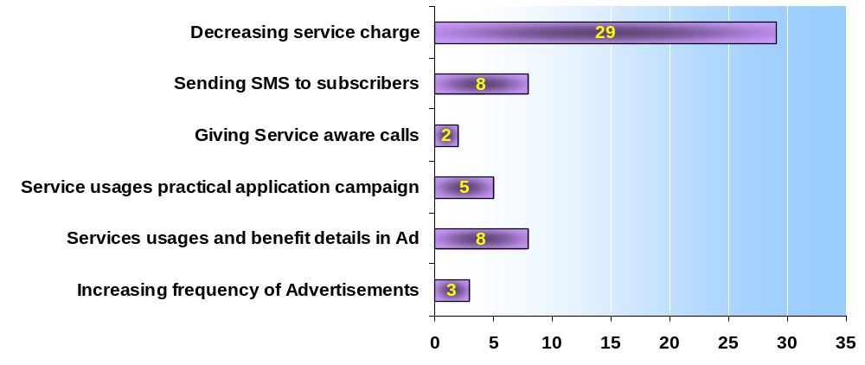
Figure13.23: Subscribers’ preference to increase service awareness

The table draws the conclusion that it GP reduces service charge then subscribers will be interested to know about GP service. Sending service aware SMS and service detail Advertisement is also a good way increase subscribers’ awareness.

12.4.3. Over all findings: From the data analysis it is found that GrameenPhone subscribers’ awareness is for some services is high and for some service low. WAP, sports updates push pull service including some after sale service awareness is very low. Low charged service such F&F, My Time etc. awareness is very high. Newspaper is the most effective and popular media and respondent prefer to learn about GP services though newspaper (including local newspaper). Most of the respondents recommended reduce service charge.

13. Recommendations
13.1 Recommendations to build service awareness
Service learning hot line: GrameenPhone’s Customer Management Division already has 24 hours hot lines call service for customer service. These hot lines are categorized as for post paid and pre-paid product and with some special services. There is no separate hot line form where subscriber can learn about GP service. Hence, GP should arrange a separate hot line which will consciously help subscribers to learn about GP service. The following lists can the unique proposition of service learning hot line.

- Only help subscribers to learn about GP service
- 24-hours human agent
- Continuous improvement of customer service
- Sending mail, letters, e-mail, fax, SMS to help subscribers to learn GP services
- Delivering service aware campaign over phone

Telemarketing: Telemarketing is another way to aware subscribers about GP services. Telemarketing is direct and fast communication, so through telemarketing GP can increase service awareness fast. The only difference of service learning hot line and telemarketing will be Telemarketing is company to subscribers and service learning hot line will be subscriber to company. The proposition of telemarketing will be:
- Arranging service aware campaign
- Developing effective ways to aware subscribers about service
- Gathering Ideas to improve subscribers’ service awareness

Service awareness building field campaign: Field campaign could be another effective way to increase subscribers’ service awareness. The advantage to field campaign will be, it will help subscribers to learn practical application of GP services. Though its exposure will be in a limited area, it is comparatively less costly than Electronics Media and other National newspaper, magazine and billboard which are can not more effective to aware and teach subscribers. The field campaign location can be Educational promise, Point of sales and Customer Relation Center (CRC). Key benefits of field campaign are:
- Effective
- Less expensive
Publishing Service application manual: Service application manual can help subscribers to learn GP services. These manual will be available in GP’s eight Customer Relation Centre (CRC), more than 1000 point of sale. Each subscriber will get a free service application manual with his/her initial subscription form. This proactive step’s success depends on the subscribers’ voluntary involvement. The benefits subscribers will get from the manual are:
- Subscriber will learn about all the services provided by GP
- Guide subscribers how to get a service
- Subscribers will learn the benefits of service
- Other option to get service from hot line, CRC etc.
Promotion days: Each month GrameenPhone should offer free service for 2/3 days. It will definitely encourage users to find the process to take free services. This will not only encourage subscribers to use GP services but also get them adopted to use those services. Once subscribers get adopted with services then this will help them to get use to and apply services regularly.
- Promotion days for push pull, VAS and Information service
- Promotion days will demonstrate the process of accruing services through newspaper, TV other effective media.
- Initiate and promote field service learning workshop for subscribers.
- Data collection after each promotion week to find the effectiveness.
- If it helping subscribers to learn services then continue, otherwise stop it.

Self Learning Service boots: This self learning service boots will contain the service manual, brochures and GP newsletters. These boots location will be in the super markets, departmental store, restaurant and fast food corner. The boots shelves will be divided in different parts and each part will be tagged with the name of the service and contain all the material that will help subscribers to learn about the service. This boots can also show the demonstration to get a specific service through recorded CD, VCD and DVD. These boots can also maintain a suggestion box to bring some new ideas from subscribers.
The unique attributes will be:
- Boot will contain services learning brochures, leaflet, and manual of each individual service individually and separately.
- Will show the direct demonstration to take a specific service in recorded TV screen.
- Will contain Recorded CD, VCD and DVD which will show the practical demonstration.

13.2 STRAEGIC RECOMMENDATION TO GRAMEENPHONE
The main focus of the recommendations is to overcome the problems that GP faced in business-both internally and externally.

Diagram 2: A bird’s eye view on GP’s problems:

Difficulty in accessing to other companies mobile services
High call charge

Major problem areas of GrameenPhone

I recommend the following action plans for GP to develop further by reducing the problems:
1. Reduce charge:
- Increase subscribers’ number- GP should increase the subscriber number until market saturation of addressable market. GP should reduce their charge as it has been identified as a major problem. For that we recommend them to further increase their subscriber number especially in the rural areas. As they had already established towers in all over the Bangladesh so no further capital investment is required to provide service in rural areas. If they can increase their subscriber number then it will reduce their fixed cost per customer (by achieving economies of scale) and will help them to charge low to the customers.
- Link activities in company – GP, by combining some of the activities in their company value chain, can cut operational cost. They can cross the activities of various sub-departments, such as the R&D, Production, Marketing departments, especially in the process of coming up with new product. This will also help them to reduce their cost and will help them to charge less.

2. Increase accessibility from GP service to other mobile companies:
Another problem of GP is inaccessibility from GP service to other mobile companies. To solve that I am recommending the follow actions-
- Develop network- Must pay attention to develop their network further that will ensure smoother accessibility to other company mobile.
- Strategic collaboration with the other companies- GP should try to create a strategic collaboration and good relationship with other mobile companies so that GP can ensure smooth access of its mobile connection with other company mobiles.

General suggestions-
Suggesting the following recommendations for further development:
1. Reshape Business model
The company should be committed to earn revenue by providing the best quality service and spend by establishing developed technology to ensure that best quality services, and by hiring best personnel.
Best cost provider strategy - In the competitive industry, it is not enough to ensure low cost only; ensuring the best quality services is a must. So we are recommending Best- cost strategy, which suggest providing best service at possible least cost. They should give best service in terms of variety of features, customer care, good network etc. On the other hand, they can achieve cost advantage by controlling cost drivers, taking advantages of their huge infrastructure, and knowledge gained from their long-term commitment. These will help them to keep their cost down in spite of retaining high quality.

2. Re-craft strategy with different objectives:
GP can maintain their image in near future by adopting some steps:

A. Reset Objectives -The financial objectives should be set to enhance profit margin through cost reduction, and higher volume of sales. The strategic objective should be set to satisfy the customers with best service and best price in the market. Objectives in particular are-
Provide better options for rush hours in terms of network, cost etc
Use alternative cellular technology to enhance efficiency for fixed phone centers
Enhance motivation to fulfill their customer-demand timely.
B. Applying collaborative approach- GP may adopt this approach to formulate their strategy, where managers from each level will participate. The benefits in particular are-
- Entrepreneurship will create new opportunities for the organization by pursuing a growth oriented behavior with the merit of their own employees.
- Provide better ideas regarding customers’ needs by contacting customers on a regular basis.
D. Patents, protection of intellectual property – When GP creates any new idea or innovative product, they need to protect their ideas and formulas from competitors.
E. Survey customers- GP needs to focus on marketing research through customer surveys and opinions to determine what customers want. GP by offering those can reduce the risk of threat from possible substitute products.
F. Increase switching costs- GP may design price-structure and product-offerings in such a way that switching cost to any substitute product becomes higher and buyers will stick to them.
I. Increase incentives and value added- GP could increase incentives for the buyers to motivate them to buy more of their products.
2. Deliberate actions:
Through holding seminars and competitions among the subscribers of GP, they can reign further by:
- Popularizing VMS
- Introducing MMS
- Providing more GPCs
- Providing ISD services
- Providing T&T incoming in Easy Pre-paid and Djuice.
3. Tackle Rivalry:
GP can avoid the price-competition currently and in near future by adopting some strategies:
- Differentiate a firm’s product - As a high-tech company, GP can adopt differentiation strategy to make their position more advanced in the market competition. They may invent new process through R&D for manufacturing activities to increase performance of their service, and focus buyer-benefits.
- Maintain Brand image- What GP requires most is maintaining the already established brand image for them, so that they can get customers who will stick to their brands only. Their loyalty will work as a barrier for current and potential competitors.
- Communicate more with competitors- GP must remain up to date with collecting information about the competitors’ strategies for product, market, promotion, distribution from various seminars, inauguration ceremonies, meetings, press conferences, and also from informal “get- to-gathers”.
Special suggestions
Careful expansion:
GP have all the potentials to grow up by utilizing their full capacity. However, if GP expand their business to such an extent that exerting control and operating with equal success become impossible, the result will be bottleneck. Therefore, GP should start thinking about expanding their business.
A Bird eye view of Strategic recommendations
In order to succeed and grow, GP must be able to adapt to the constantly changing surrounding environment. The following factors are to be taken care of greatly in this area:

Distribution-related
Marketing-related
Skills-related
Organizational capability
Other types
Technology-related
Service-related
Scientific research expertise; Product innovation capability; Expertise in a given technology; Capability to use Internet to conduct various business activities
Low-cost production efficiency; Quality of manufacture; High use of fixed assets; Low-cost plant locations; High labor productivity; Low-cost service design; Flexibility to make a range of services
Strong network of wholesale distributors/dealers; gaining ample space on retailer shelves; having company-owned retail outlets; Low distribution costs; Fast delivery
Fast, accurate technical assistance; Courteous customer service; Accurate filling of orders; Breadth of product line; Merchandising skills; Attractive styling; Customer guarantees; Clever advertising
Superior workforce talent; Quality control know-how; Design expertise; Expertise in a particular technology; Ability to develop innovative products; Ability to get new products to market quickly
Superior information systems; Ability to respond quickly to shifting market conditions; Superior ability to employ Internet to conduct business; More experience & managerial know-how
Favorable image/reputation with buyers; Overall low-cost; Convenient locations; Pleasant, courteous employees; Access to financial capital; Patent protection

Among all the given strategies, application of a combined effort will help the most I believe. As GrameenPhone concentrated a lot on their customer-base, the company should try to make its customers a vigor weapon to fight against any difficulty it faces. Along with changing the structural system, by adapting to newer and taxing revolutionize, GP can achieve success ahead of its competitors.
14. Conclusion:
As the research finding show the poor service awareness status of GrameenPhone subscribers, hence obviously GP has to increase awareness of subscribers. Increased service awareness status will raise the service value of GP, increase subscribers usages rate result increase revenue for GP. If continuous development of new product and service can not simultaneously aware subscribers then it will neither worth much to subscribers nor add value to the company. Hence, it is clearly observed there is GAP between services provided and services awareness. Now GP has to consider this GAP minimization and maintain alignment with service offering and service awareness. Otherwise, in the long run new services innovation will not give its ultimate success.

www.asiantradehub.com

