Internship Report
On

The Perception of Customer about southeast Bank Loan Offering

Submitted by
WWW.ASSIGNMENTPOINT.COM

Bank is well known as a monetary institute but Bank did not established in a day. When currency introduced as an exchange term, human life has been trouble-free that they can exchange anything between them using money. Also business and trading have been introduced.
In 1972 when Bangladesh became liberated, the Banking sector was in shatters. Lot of Banks branches during the liberation time were burnt & destroyed. In view of the above, government of the newly independent Bangladesh had to take some quick decisions. A central Bank namely Bangladesh Bank had to be created taking over the assets & liabilities of State Bank of Pakistan located in Bangladesh area Banking sector of Bangladesh has undergone dramatic changes since the independence in 1971.Immediately after liberation the government nationalized all banks.
There are 4 nationalized, 29 local and 10 foreign commercial banks in Bangladesh and SEBL is one of them. Under the above backdrop SBL is a private sector bank having a small market share of the industry. If the weaknesses are addressed appropriately and opportunities are explored keeping in view the threats behind with a stable and professional management having regard to appropriate corporate governance and modern automation technology then SBL could expect to achieve its desired target of a visionary bank.

Southeast Bank Limited is a fast growing modern banking institution having a unique corporate culture & friendly working environment which unites our people towards achieving tremendous results in every aspect of Bank’s operations. Southeast Bank Limited is a second generation leading private commercial Bank in the country with a vision to be the leading financial institution in the country having a diverse array of carefully tailored customer friendly products and financial services in the Bank which unites our people and results in continuous growth in every aspect of Bank’s operations.

1.1 Origin of the report
This report is prepared for fulfilling the requirement of Internship of B.B.A program, Eastern University. As the classroom discussion alone cannot give proper picture of real business situation, therefore, it is an opportunity for the students to know about real life situation through this program. Without practical exposure, theory can never be fruitful. For this reason, B.B.A program has been designed in such a way that a student can get practical knowledge. South East Bank Limited has given me the opportunity to complete my Internship on “The Perception of Customer about southeast Bank Loan Offering is unknown”.

1.2 Problem Statement
“The Perception of Customer about southeast Bank Loan Offering is unknown”

1.3 Justification of the problem statement
Southeast Bank Limited is a fast growing modern banking institution having a unique corporate culture & friendly working environment. They also provide high quality financial services with the help of latest technology. Southeast Bank mission is providing fast & accurate customer service, high standard business ethics, Innovative banking at a competitive price. They offer different type of services like- Account opening, Clearing, Loan offering, Export & Import, Locker etc.
Southeast Bank offer time loan, term loan, consumer loan, demand loan etc. Most of the customers try to take time loan or Consumer credit scheme (CCS) loan. They take loan for different purpose. Some customer take loan for their personal consumption, some customer takes loan for buying car or business purpose or any other reason. Most of the time customer want good environment, better service and good behave from the stuff. Customer wants low interest rate to take the loan. Some times customers need loan very frequently then they want to take loan very quickly. Most of the time customers take loan against their FDR. Southeast bank don’t give loan any risky sectors. Which customers unable to bring the loan they don’t give loan this type of customers. Some times few customers don’t make their loan against cash back in the proper time. Therefore there are some problems Southeast Bank is facing in promoting and in motivating customers to take the loan. So, we need to know customers perception about SBL loan offering.
So, the problem is “The Perception of Customer about southeast Bank Loan Offering is unknown”

1.4 Literature Review
Perception is the process of attaining awareness or understanding of sensory information. It is a task far more complex than was imagined in the 1950s and 1960s, when it was predicted that building perceiving machines would take about a decade, a goal which is still very far from fruition. The word comes from the Latin words perceptio, percipio, and means "receiving, collecting, and action of taking possession, apprehension with the mind or senses. Perception is one of the oldest fields in psychology. The oldest quantitative law in psychology is the Weber-Fechner law, which quantifies the relationship between the intensity of physical stimuli and their perceptual effects. The study of perception gave rise to the Gestalt school of psychology, with its emphasis on holistic approach.
Two types of consciousness are considerable regarding perception: phenomenal (any occurrence that is observable and physical) and psychological. The difference everybody can demonstrate to him- or herself is by the simple opening and closing of his or her eyes: phenomenal consciousness is thought, on average, to be predominately absent without sight. Through the full or rich sensations present in sight, nothing by comparison is present while the eyes are closed. Using this precept, it is understood that, in the vast majority of cases, logical solutions are reached through simple human sensation. The analogy of Plato's Cave was coined to express these ideas. Passive perception (conceived by René Descartes) can be surmised as the following sequence of events: surrounding → input (senses) → processing (brain) → output (re-action). Although still supported by mainstream philosophers, psychologists and neurologists, this theory is nowadays losing momentum. The theory of active perception has emerged from extensive research of sensory illusions, most notably the works of Richard L. Gregory. This theory, which is increasingly gaining experimental support, can be surmised as dynamic relationship between "description" (in the brain) ↔ senses ↔ surrounding, all of which holds true to the linear concept of experience.
The ecological understanding of perception derives from Gibson's early work is perception-in-action, the notion that perception is a requisite property of animate action; without perception action would not be guided and without action perception would be pointless. Animate actions require perceiving and moving together. In a sense, "perception and movement are two sides of the same coin, the coin is action." One aspect of Gibson's approach has been questioned however: it is his implicit belief that singular entities, which he calls 'invariants', already exist in the real and that all that the perception process does is to home in upon 'them'. A view known as social constructionism regards the continual adjustment of percept and action to the external input as precisely what constitutes the 'entity,' which is therefore far from being 'invariant
The processes of perception routinely alter what humans see. When people view something with a preconceived concept about it, they tend to take those concept and see them whether or not they are there. This problem stems from the fact that humans are unable to understand new information, without the inherent bias of their previous knowledge. A person’s knowledge creates his or her reality as much as the truth, because the human mind can only contemplate that to which it has been exposed. When objects are viewed without understanding, the mind will try to reach for something that it already recognizes, in order to process what it is viewing. That which most closely relates to the unfamiliar from our past experiences, makes up what we see when we look at things that we don’t comprehend. ^{[5]}
This confusing ambiguity of perception is exploited in human technologies such as camouflage, and also in biological mimicry, for example by Peacock butterflies, whose wings bear eye markings that birds respond to as though they were the eyes of a dangerous predator. Perceptual ambiguity is not restricted to vision. For example, recent touch perception research Robles-De-La-Torre & Hayward 2001 found that kinesthesia based haptic perception strongly relies on the forces experienced during touch
1.5 Objectives of the study:
1.5.1 Broad Objective
The broad objective of the research is to find out “the Perception of Customer about Southeast Bank Loan Offering”.
1.5.2 Specific Objectives
The specific objectives of the research is to:
- Find out the customers perception about SEBL.
- Find out what types of loan they have taken
- Find out the purpose of taking loan
- Find out their satisfaction level about SEBL loan offering.
- Find out the reason of taking SEBL loan
1.6 Scope of the Study
The research is mainly focused on the “Perception of Customer about southeast Bank Loan Offering”. The study has many dimensions and covers a broad spectrum. The research limits its scope to Southeast Bank Dhanmondi branch only. The data requires for sufficient analysis for report writing could not be collected due to excessive workload. The people who will be the source of information for the research are those who take loan from SEBL. Since I need to quantify some certain phenomena so, I need the opinion from all type of people who take loan from SEBL Dhanmondi branch. However, it is not possible to take opinion of all the client of the Southeast Bank because of the time accessibility and for other constraints. So, during my three month internship which customers come to take the loan I collect information from those sources.
1.7 Limitations of the Study
When I was conducting my research at that time some responses bias and administrative errors are also occurs. And I had tried my best to avoid this error. There have been some limitations from which these report suffers. The limitations are briefly pointed out below:

- Time is the first limitation as the duration of the program was of three months only.
- Confidentiality of data was another important barrier that was faced during the conduct of this study.
- The Banks were not ready to disclose information regarding their service delivery and policy information.
- By working in a branch it’s not possible to collect all information about the organizational activities.
- Supply of more practical and contemporary data is another shortcoming.
- The study was not done very successfully due to inexperience.

2.0 Methodology
2.1 Sampling Frame
Sample frame is a representation of the elements of the target population. It consists of a list or set of direction for identifying the target population also called working population. My sampling frame was all of the customers of Southeast Bank in Dhanmondi Branch who take loan. So my sampling frame was conveniently available customers of Dhanmondi Branch.

2.2 Sampling Technique
I have done Non-probability convenience sampling for conducting the research. The reason behind not choosing probability sampling is mainly time. I would use probability sampling but it would take time for collecting data. Non-probability convenience sampling facilitates me to collect data when I feel comfortable to collect data.

2.3 Sample Size
Sample size is a number of elements to be included in a study. My sample size was 40. Though sample size should be chosen by different methodology and should be representative to the population size but because time and other constraints I had to choose small size of sample size. So I conducted my survey with the sample size of 40 respondents.

2.5 Methods of Collecting Data
The source of collecting data will be based on both primary and secondary source.

Primary Source
The primary data was collect by discussion with officials of Southeast Bank and face to face conversation with the clients by using the questionnaire for SEBL customers. It also collected the data from the practical deskwork.

- Secondary Source
For conducting the research I have taken help from different Employees of SEBL, Annual report and Internet. I have also taken help from different people who have knowledge about SEBL. Different publications of SEBL, unpublished data received from the branch and different text book.

3.0 Organization Part
3.1 Company Overview:
Southeast Bank Limited is a fast growing modern banking institution having a unique corporate culture & friendly working environment which unites our people towards achieving tremendous results in every aspect of Bank’s operations. Southeast Bank Limited is a second generation leading private commercial Bank in the country with a vision to be the leading financial institution in the country having a diverse array of carefully tailored customer friendly products and financial services in the Bank which unites our people and results in continuous growth in every aspect of Bank’s operations. Southeast Bank Limited is a scheduled commercial bank in the private sector established under the ambit of Bank Company Act, 1991 and incorporated as a Public Limited Company under Companies Act, 1994 on March 12, 1995. The Bank started commercial banking operations on May 25, 1995. During this short span of time the Bank is successful in positioning itself as a progressive and dynamic financial institution in the country. The bank had been widely acclaimed by the business community, from small entrepreneurs to large traders and industrial conglomerates, including the top-rated corporate borrowers for its forward - looking business outlook and innovative financial solutions. Thus within this very short period of time it has been able to create an image and earn significant reputation in the country's banking sector as a Bank with Vision. Presently, it has 46 branches. . Southeast Bank Limited has been licensed by the Government of Bangladesh as a Scheduled commercial bank in the private sector in pursuance of the policy of liberalization of banking and financial services and facilities in Bangladesh. In view of the above, the Bank within a period of 10 years of its operation achieved a remarkable success and met up capital adequacy requirement of Bangladesh Bank.

3.2.1 Board of Director of SBL

Name | Designation
Mr. Alamgir Kabir (FCA) | Chairman
Mr. Ragib Ali | Vice Chairman
Mr. M. A. Kashem | Director
Mr. Azim Uddin Ahmed | Director
Mrs. Jusna Ara Kashem | Director
Mrs. Duluma Ahmed | Director
Bangla Capital Limited, Represented by Mr. Tahnoun A. Harun | Director
Mr. Syed Shahid Ali | Director
Mrs. Sirat Monira | Director
Karnafuli Tea Co. Ltd, represented by Mr. Abdul Hye | Director
Dr. Zaidi Sattar | Director
Mr. A.H.M. Moazzem Hossain | Director

3.2.2 Organizational Structure in Southeast Bank Limited

Managing Director (M.D)

Executive Vice President (E.V P.)

Senior Vice President (V.P)

Principal Officer (PO)

Senior Officer (SO)

Officer (O)

Probationary Officer (P.O)

Junior Officer (J.O)
Teller

3.3 Vision of Southeast Bank Ltd:
Vision of SEBL is “To stand out as a pioneer banking institution in Bangladesh and contribute significantly to the national economy”.
3.4 Mission of Southeast Bank Ltd:
- High quality financial services with the help of latest technology.
- Fast & accurate customer service.
- Balanced growth strategy.
- High standard business ethics.
- Steady return on shareholders' equity.
- Innovative banking at a competitive price.
- Deep commitment to the society and the growth of national economy.
- Attract and retain quality human resource.
3.5 Core Values of Southeast Bank Ltd:
- Integrity
- Fairness
- Harmony
- Courtesy
- Commitment
- Insight and Spirit
- Enthusiasm for Work
- Business Ethics

3.6 SWOT Analysis of Southeast Bank Ltd:
Strengths
- Transparent and quick decision making
- Efficient team of performers
- Satisfied customers
- Internal control
- Skilled risk management
Weakness:
- SEBL have not enough brand images.
- People can not recall their brand name very frequently.
- SEBL have no own ATM booths.
- SEBL is no more concern about the market research.
- The promotion strategy of SEBL is not at all effective.

Opportunity:
- SEBL should try to provide more services by increasing the number of own ATM Booths.
- SEBL should launching money changer facility. Because some time people want to have this facilities to satisfy the customers as well as to increase the foreign remittances.
- Diversification reduces the risk of default of the organization. So SBL could diversify its leading sectors by launching new schemes and increasing the number of branch.
Threat:
- Their competitors increasing day by day.
- Some stuff doing dishonest task that create bad image.
- Every private bank tries to provide better services and environment.
3.7 Duties and Responsibilities:
Southeast bank have some major responsibility. They have some division in their every individual branch. Different types of task are done by different sectors. The division is given bellow-

Bank Division

General Banking
Credit
Department

Foreign Exchange

Cash Continuous Loan
Import
Demand Loan
Accounts Opening Export
Term Loan

IT Department. Staff Loan

Bank Guarantee
Clearing

Customer Services

3.8 Accounts Opening:
Southeast Bank provides different types of deposit. The different types of accounts are very commonly in practice:
  - Current Deposits (CD)
  - Savings Bank Deposits (SB)
  - Short term deposits (STD)
  - Fixed Deposit receipts (FDR)
  - Monthly saving scheme (MSS)
  - Cash credit (CC)
  - Consumer credit scheme (CCS)
  - Security overdraft (SOD)

3.8.1 Account opening formalities:

The client needs to open a current or savings account with the bank to get any kind of credit facility. The client can request for loan individually or jointly. The required documents for opening of accounts of different types are given below:
Common Documents for all types of accounts:
- A/C opening form(single copy)- duly filled in, signed by the client and introduced by an existing account holder
- Signature card- dully filled in, signed and introduced
- Photographs (2copies for each individual) of the account holder(s) duly attested by the introducer
- Copy of first five pages of passport(s) of the account holder(s)
- Photocopies of national ID card.
Individual: Current / Savings Account
- A/C opening form(single copy)- duly filled in, signed by the client and introduced by an existing account holder
- Signature card- dully filled in, signed and introduced
- Photographs (2copies for each individual) duly attested by the introducer
Proprietorship: Current/ Savings Account
- A/C opening form(single copy)- duly filled in, signed by the client and introduced by an existing account holder
- Signature card – duly filled in, signed and introduced
- Trade license
- Mandate agreement form (Nominee form), if applicable
Partnership: Current/Savings Account
- Trade license
- Partnership deed
- Resolution outlining instructions for operation of the account
Private Ltd.: Current/Savings Account
- Memorandum and articles of association duly attested by the managing director/company secretary
- Certificate of incorporation
- Resolution as to operation of the account
- List of directors
Public Ltd.: Current/Savings Account
- Same as Private Ltd. company including certificate of commencement of business.
3.8.2 Function of foreign Exchange department:
Foreign Exchange department of Southeast Bank is divided in to two parts.
Export:
 Pre-shipment advantages.
 Negotiating of foreign bills.
 Exports guaranties
 Purchase of foreign bills.
 Advance against bills for collection.
 Advising / conforming setters (latter of credit).
 Advance for differed payments exports.
Imports:
 Bills for collection
 Advance bills.
 Opening of letter of credit (L/C)
 Import loan & guarantees.

The most commonly used document in foreign exchange:

- Documentary latter of credit.
- Bill of exchange
- Bill of lading
- Commercial invoice
- Certificate of origin of goods
- Inspection certificate
- Packing list
- Insurance policy
- Pro-forma invoice / indent
Form of Transport document:
- Marine or ocean transport document
- Air transport document
- Road transport document
- Rail transport document
- Courier and Postal Transport Document

Advising of Letter of Credit:
Advising means forwarding of a Documentary Letter o credit received from the issuing bank to the beneficiary (Exporter).
Before advising a L/C the advising bank must see the following:
- If the export L/C is intended to be an operative cable L/C Test Code on the L/C invariably be agreed.
- Signature of issuing bank officials on the L/C verified with the specimen signatures book of the said bank when L/C received.
- L/C scrutinized thoroughly complying with the requisites of concerned UCPDC provisions.
- L/C advised to the beneficiary (Exporter) promptly and advising changes recovered.
- Entry made in the L/C Advising Register.

Commercial invoice:
A commercial invoice is the accounting document by which the seller changes the goods to the buyer. A commercial invoice normally includes the following information:
- it must be issued by the beneficiary named in the credit
- it must be made out in the name of the applicant
- description of goods exactly as started in L/C
- price of goods
- shipping marks exactly as appears in the Bill of Leading
- Contract number
- Issuing date
3.8.3 Credit Facilities Offered by Southeast Bank:

Credit facilities offered by Southeast Bank Limited can be classified based on – whether actual outflow of cash takes place or not and the type of borrower availing the credit facility or more precisely, the borrower’s motive for obtaining the credit facility.

Loan and advances of Southeast Bank is divided into the following categories based on whether actual outflow of cash takes place or not:

Loans and Advances

Funded Credit
Nonfunded Credit

Continuous
Loan
Demand
Loan
Term Loan
Letter of Credit
Letter of Guarantee

Overdraft
1. Trust Receipt
2. Inland Bills Purchased (IBP)
3. Bills under Letter of Credit (BLC)
4. Time Loan
5. Packing Credit
1. Project Loan (5 years and above)
2. Consumer Credit Scheme (Maximum 2 years)

Funded Credit:
The borrowers must open a current account with the bank to get the facilities of funded loan. They have to pay interest against the funded credit facilities and service the loan upto a fixed expiry date. In funded credit, the actual outflow of cash takes place. Different types of funded credits are discussed below:

- Continuous Loan:
The clients are allowed to withdraw from and deposit to the current account cash at any time against a sanctioned limit. Best example of this type of continuous loan is overdraft.

2. Demand Loan:
In this type of credit scheme, the clients are also allowed to withdraw from and deposit to at any time but the disbursement of cash should be in one shot while the repayment is made in one shot or at intervals. Examples of demand loan are, IBP, Trust Receipt, Packing Credit, Time Loan, etc.

3. Term Loan:
There are three types of term loans:

Types of term loan | Time period/ Tenure
Short Term loan | 1 to 3 three years
Medium Term loan | Above 3 years to 5 years
Long Term loan | Above 5 years

Nonfunded Credit:
In this type of credit facility, the actual outflow of cash does not take place unless some exceptional events occur. Under this type of credit facility, the Bank promises a beneficiary on behalf of the borrower to pay a certain sum of money against the beneficiary’s claim provided certain events like, non-performance of a work occurs. Examples of non-funded credit are – Bank Guarantee and Letter of Credit. While allowing non-funded credit, the Bank charges certain percentage of the face value of the credit facility allowed as commission and creates a liability in the client’s name which is contingent in nature. When the client fails to perform the stipulated work against the non-funded credit, the claim of the beneficiary has to be met by the Bank and the non-funded credit becomes funded with the actual outflow of cash. However, in the case of letter of credit, the importer or the Bank’s client has to pay for the goods imported even if the goods are not according to his specifications.

Apart from the classifications of loans and advances based on actual outflow of cash, the credit facilities allowed by the Bank can also be divided into the following three types according to the type of borrower availing of the loan facility:
- Personal Credit
- Commercial Credit
- Industrial Credit

Personal Credit:
The characteristics of personal credit facilities are:
    - Taken by individuals
    - Low interest rate
    - Short time required for disbursement of the loan
    - Backed by cash security or personal guarantee
    - Guarantors having good net worth or social reputation
    - Expiry of 1-2 years
    - Requires strong monitoring for recovery of loan
    - No CIB inquiry made against the borrower
    - Loan amount generally ranges from Tk. 50,000 to Tk.10,00,000. (Exceptions are cash backed loans in which even Tk.50.00 lac is disbursed against cash security having face value of Tk.50.00lac or more)
Personal Credit facilities can further be classified in the following two segments:
  - Cash Backed
  - Secured by personal guarantors

Cash Backed:

These are generally overdraft facilities allowed by the Bank against FDR or DPS in the name of the borrower or a third party as a security. In this case, the customer is allowed to overdraw his/her current account by drawing against a sanctioned limit within a certain period of time but not exceeding more than one year, against acceptable securities. The overdraft limit is then renewed upon request from the client after the fixed expiry for a further period of 1 year.

The Bank also allows time loan or term loan against cash securities. The branch credit committee is the authority approving credit facility against cash security and the permissible margin against cash credit is 10% of the face value of the security.

Secured by personal guarantee:
Personal Credit is also allowed against personal guarantee of reputed and financially solvent persons. In that case if the borrower fails to repay the installment or total loan amount the guarantor is liable to repay the loan. Consumer Credit Scheme is the most common example of this loan. Since the personal guarantee of a person is quite fragile in nature, sometimes this type of credit is mentioned as Unsecured Loan as well and entails high interest rate. Consumer Credit Scheme (CCS) is offered to the borrowers who want to buy commodities like computer, refrigerator, television, vcd player or household furniture or appliances. The interest rate is 12% per annum and time duration is maximum 36 months. The bank finances up to Tk.3, 00,000 but not more than 75% of cost of the product to be purchased.

Besides, SBL provides a special type of personal credit, which is a term loan for financing the construction of a residential building or for purchasing an apartment. In that case, the borrower should be the owner of a piece of land or the apartment to be bought and submit the following documents to the Bank :

- Estimated cost of building the house by professional engineers
- A copy of permission from DIT or any other authority
- Deed signed between the developer and the purchaser of the apartment if the loan is for purchasing an apartment.
- Original sale deeds of the land and bia deeds (former deeds in the chain of ownership).
- Porchas and mutation certificates in the name of the owner of the property
- Non-encumbrance certificate
- Duplicate carbon receipt and ground rent receipt marking clearance of all types of land tax and holding tax.
- Layout plan

Commercial Credit Facility:
The commercial credit facilities offered by SBL have the following characteristics:
- Taken by business firms.
- High interest rate.
- Loan disbursement processing is lengthy.
- Generally backed by cash flow generated by the business, stock in trade, and mortgage of property.
- It has expiry of 1-5 years.
- Strong monitoring for recovery the loan (specially in the case of work order finance) is required.
- In this case CIB inquiry is mandatory.
- Loan amount ranges from 10 lac to 2 crore.

Most common types of Commercial Credit are :
  - Overdraft
  - Time Loan
  - Letter of Credit
  - Bank Guarantee
  - Trust Receipt
  - Inland Bill Purchase
  - Packing Credit

- Overdraft :
The business firms take overdraft for meeting working capital requirements in the business. The nature of the loan is continuous and allowed for 1 year. The security held against the facility are : sales proceeds, stock in trade, landed properties, cash securities, etc.

- Time Loan:
The time loan facility is taken by the business firms for needs for fund to be met in one shot. Example can be, deposit of security money to participate in a bid. The repayment can be at intervals but the disbursement is in one shot. The maximum tenure of a time loan is 1 year.

- Letter of Credit:
As discussed above, letter of credit, a very common type of non-funded credit is used for either import of goods or export of goods. When used for import of goods, the letter of credit facility is opened by the borrower with the Bank and it is sent to the exporter’s Bank for checking and agreement. If the terms and conditions stipulated in the L/C are agreeable to both the parties, the goods are exported and the borrower sends payment to the exporter’s Bank. In the case of export L/Cs the goods are shipped and then payment is received from the importer’s Bank by the borrower through SBL and SBL charges commission for the service.

- Bank Guarantee:

It has also been discussed under non-funded credit above. SBL issues the following types of Bank Guarantees -
  - Bid Bond
  - Performance Guarantee
  - Advance Payment
  - Payment Guarantee
  - Counter Guarantee

(i) Bid Bond:
Bid bond is issued by SBL when the client wishes to participate in the particular bid. The bid bond binds the client for performance of the work order in the event of winning the bid and the client, once having submitted the bids is ready for performance of the contract if he is awarded with it.
Bank will issue bid bond
The Client
Work order awarding authority

Fig: Issuance of a bid bond

(ii) Performance Guarantee:
If the client is selected as the winner of a bid and awarded a work order by the work order issuing authority of a particular bid, the bid bond is returned and he has to submit a performance guarantee in its place. By submission of the performance guarantee the borrower is bound to the work order issuing authority to perform the bid or complete the work stipulated in the contract according to the specifications and terms and conditions outlined by the authority. The bank is legally responsible to pay back a certain amount of money as a guarantor to the authority in case of failure to carry out the work order of the client and the margin held against the guarantee as a security is fixed through negotiation between the bank and the client.
(iii) Payment Guarantee:
The bank gives the payment guarantee to the beneficiary on behalf of the client as a promise to pay a certain sum of money at a certain time in future against a contract.

Lending rates of SBL:
Lending Categories | Lending Rates
1. Agriculture
a. Loan to primary producers | 8.50%
b. Loan to agricultural input traders and fertilizer dealers/distributors | 8.50%
2. Large and medium scale industries | 12.00%
3. Small and cottage industries | 11.50%
4. Work Capital
a. Jute | 11.50%
b. Other than jute | 12.00%
5. Export
a. Jute goods export | 7.00% fixed
b. Other export | 7.00% fixed
6. Commercial lending
a. Jute trading | 11.50%
b. Commercial lending (others) | 12.00%
7. House building finance
a. Real estate developers | 12.00%
b. Individual/Housing finance Comp. | 11.50%
c. Staff house building loan | 8.00%
8. Consumer credit scheme | 12.00%
9. Other loans
a. Finance to NBFIs | 11.50%
b. Others | 11.50%

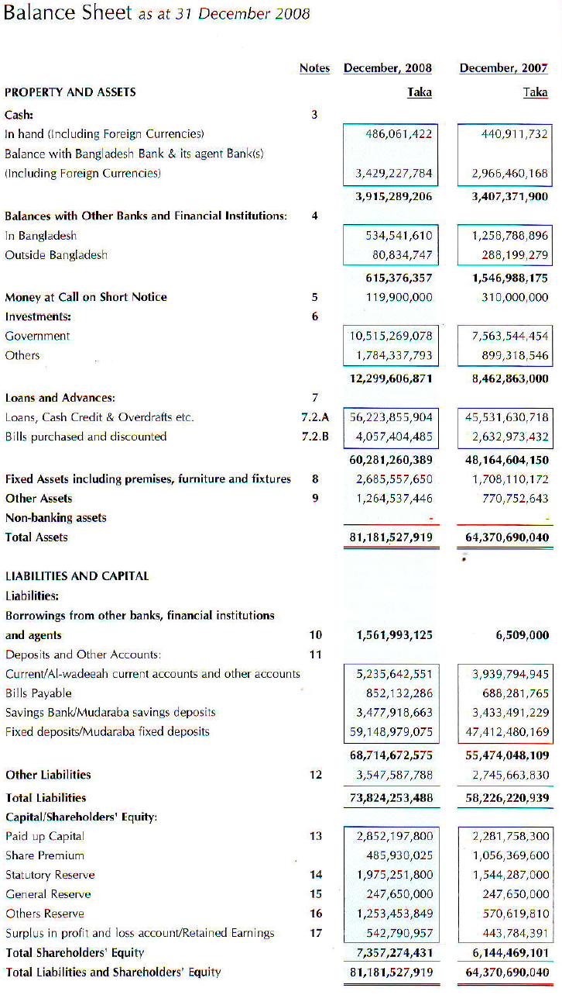
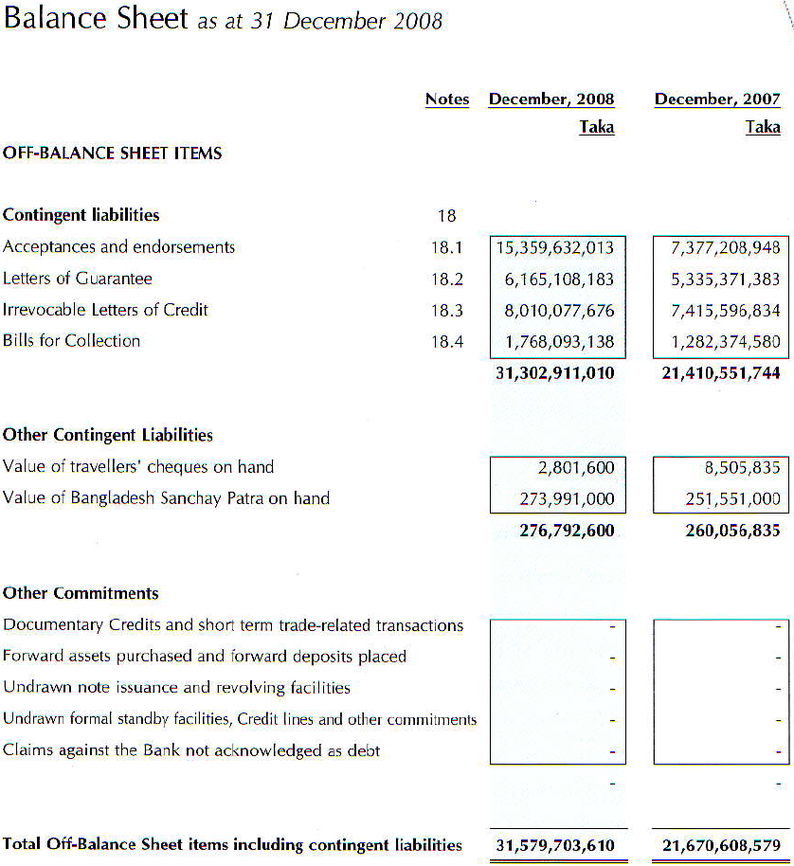
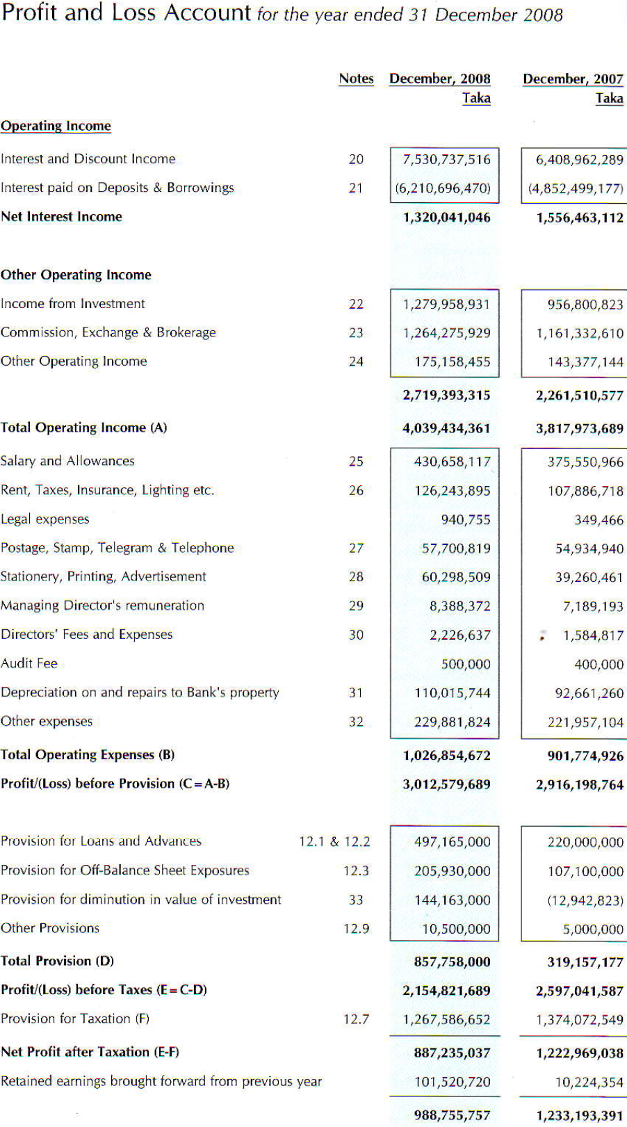
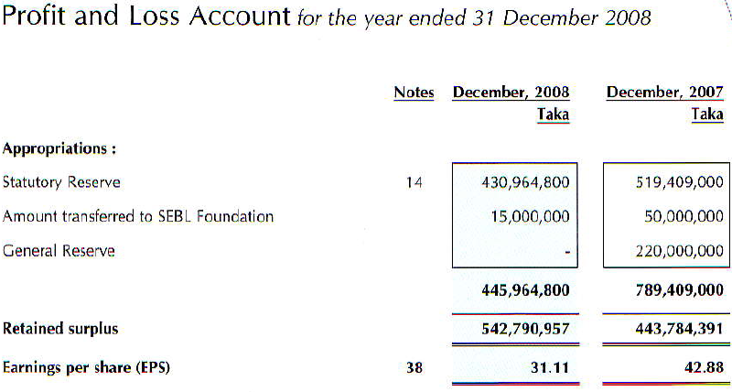

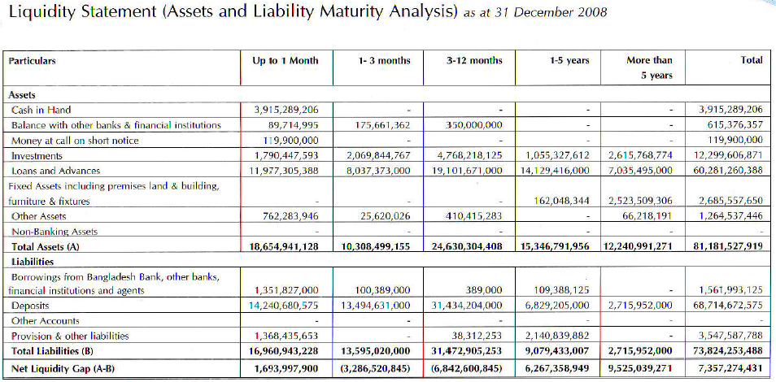
Southeast Bank Limited
Rating Report

CRAB Ratings:

Ratings 2007
Long Term: A₁
Short Term: ST-2

Date of Rating: 30 March 2008
Validity: One Year

Previous Rating
Long Term: A₁
Short Term: ST-2

Particulars | - 2006
ROAA | 4.36 3.34
ROAE | 46.36 46.18
Cost to Income | 23.62 24.21
RWCAR | 12.99 11.50
NPL Ratio | 3.77 3.97
Loans to Deposit Ratio | 84.48 86.63

Credit Rating Agency of Bangladesh (CRAB) has assigned “A₁” (Pronounced Single A One) rating in the long term and ST-2 rating in the Short term to the Southeast Bank Limited (SEBL).

Commercial Banks rate as “A₁” in this long term belong to “High Satisfy” cohort. In this grade, Companies are adjudged to be strong Banks, Characterized by good financials, healthy and sustainable franchises, and a first rate operating environment. This level of rating indicates strong capacity for timely payment of financial commitment, with low lifelikeness to be adversely affected by foreseeable events. At the same times, banks rated as ST-2 in short term grade belongs to High Grade are Characterised with commendable position in terms of internal fund generation , access to alternative sources of funds and moderate level of liquidity.

SEBL operate its banking operation by setting up 41 branches including 5 in shariah based operation. As of 31 December 2008, the paid up capital of SEBL was BDT 2.28 billion. Banks paid –up capital and statutory reserve together was BDT 2.72 billion at end of year 2007, while the regulatory requirement requires capital base of BDT 2.00 billion to be attained by June 2009. In 2007, Risk weighted capital adequacy ratio was 12.99% which was 10.24% in the year preceding. SEBL’s major shareholder are public (58.51%) followed by sponsors (28088%). However, no single sponsor shareholder individually held more than 3% of the total shares as of end of year 2007. At the end of year 2007, SEBL deposit and loan & advances became BDT 55.47 billion and BDT 48.47 billion, with growth rates of 20.45% and 15.485% respectively.

In 2007, net interest income stood at BDT 1.56 billion while it was BDT 1.06 billion in the preceding year (growth 46.40%). On the other hand, non- interest income of the Bank become BDT 2.26 billion in 2007, which had grown by 36.37 %. Spread of SEBL was 4.82% in 2007 in compared to 4.31% in 2006.
SEBL’s total assets at the year end 2007 were BDT 64.37 billion, with an increase of 17.41% over the previous year. Gross NPL ratio of SEBL declined to 3.54% in 2007 in compared to 3.79% in 2006. However, during the same year, rescheduled and written off loan were BDT 996.58 million and BDT 207.94 million respectively, which were found to be much higher compared to those of previous year. SEBL investment in government securities and quoted shares has substantially increased in 2007.

Net interest margin of SEBL was increased to (3.48% in 2006). Investment yield was grown up to 12.99%, which was only 7.72 % in the year preceding. Return on Average Asset (ROAA) of SEBL has an increasing trend over first few years. SEBL ROAA figure short up to 4.36% from 3.34% in 2006. During 2007, Bank’s Return on Average Equity was almost uncharged and became 46.36%. Internal capital generation was declined to 30.70% in 2007 from 37.48% in the year proceeding mainly because of increase in equity.

Deposit composition of SEBL was dominated by term deposit with 85.47% of total deposit following by current deposit 7.10% and saving deposit (6.19%). In 2007 SEBL earned interest income of BDT 230.30 million from call lending whereas incurred interest expense of BDT 50.90million for call borrowing. All this depict much better liquidity position in 2007 than that of 2006. SEBL also gained from investments in the bullish stock market in 2007. In 2007, interest income from Treasury bill was BDT 248.75 million in 2-007 from capital market investment vis-a vis BDT 16.80 million in 2006.

During 2007 SEBL showed its strength in profitability, liquidity position and business growth. SEBL also maintained comparatively lower interest spread than that of it’s peer median. However the Bank remained exposed to large loan exposures during the year 2007, and has had significant amount of loan rescheduling and write-off. Bank also requires up gradation of it’s the present automation status for the banking operation.

Performance Analysis

Southeast Bank is a commercial bank involved in providing banking services. The bank provides deposit products, lending products and foreign currency products. It also offers Islamic banking, credit card services, locker services and saving schemes. The bank primarily operates in Bangladesh, where it is headquartered in Dhaka and employs about 1,231 people. The bank recorded revenues of BDT 4,039.4 million (approximately $60 million) in the fiscal year ended December 2008, an increase of 5.8% over 2007. The bank's operating profit was BDT3, 012.6 million (approximately $44.7 million) in fiscal 2008, an increase of 3.3% over 2007. Its net profit was BDT 887.2 million (approximately $13.2 million) in fiscal 2008, a decrease of 27.5% compared to 2007.The company recorded revenues of BDT3, 818 million in the fiscal year ended December 2007, an increase of 40.3% over 2006. Its net profit was BDT 1,223 million (approximately $18.2 million) in fiscal 2007, an increase of 34.4% over 2006.
So we can say that, During 2007 SEBL showed its strength in profitability, liquidity position and business growth. In 2008 their net profit was decrease compared to 2007.So SEBL should follow better business strategy to improve their profits and position.

4.0 Results and discussions

Sex

Figure: 1
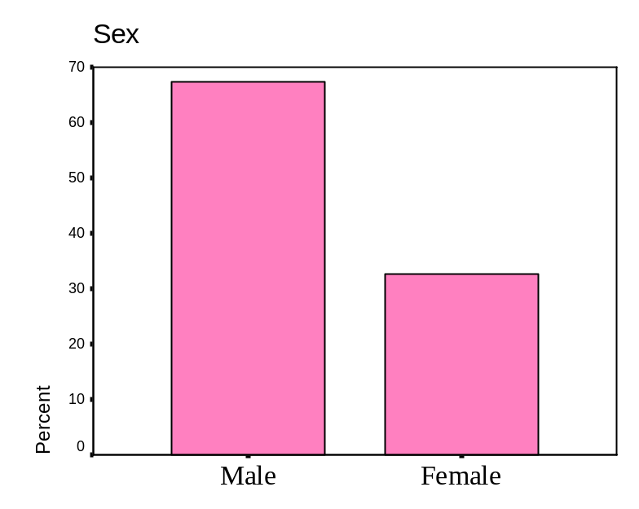

In my research I wanted to know that which types of customer takes loan more Like- is it Males or Females. Around 67.5% of the respondents are male which is 27 from 40 respondent’s and. 32.5% of the respondent are female and they are 13. As we perceive that females are still not as much active as males in getting loans to do any kind of business or other activities. But the interesting thing is loan officers also try to avoid female customers for giving loan because they think these customers are more risky or volatile. Those customers who take loan from SEBL, maximum of them take loan against their FDR. That means bankers are not willing to take risk. Often male customers came here to take the loan. So, from my data and observation I can definitely say that the maximum numbers of respondents who take loan from banks especially from SEBL are male.

Age

Figure: 2
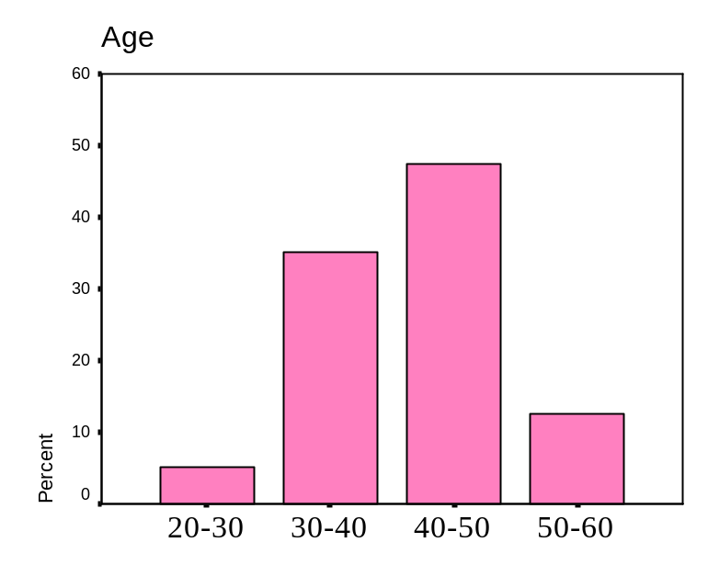

Around 47.5% of my respondents who take loan from SEBL, their age are from 40-50 and around 35% of the respondents who take loan from SEBL their age are from 30-40. It means that around 82.5% of my respondent’s age is between 30-50 and who takes loan. It indicates that majority of loan takers age is between 30-50 years. Other numbers are negligible like, 50-60=12.5% and 20-30 is 5%.Interesting thing is no one above 60yrs was taking loan. It means after that age no one is willing to take loan or bankers are not willing to give loan.

Occupation

Figure: 3
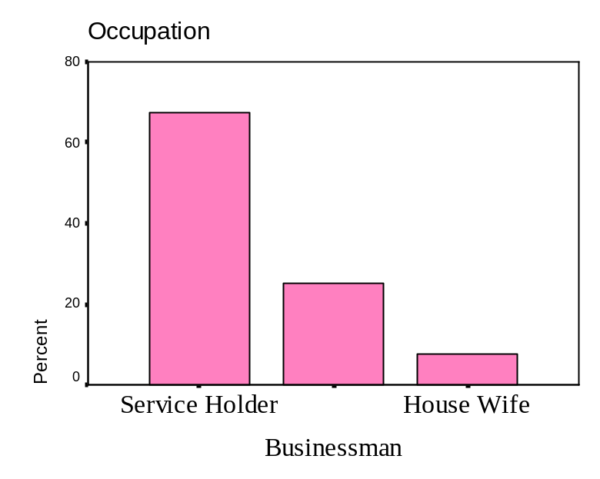

During my Internship I observed that most of the time service holders are the major clients to take loan. Loan officers are more willing to give them loan instead of businessman. They think this is less risky because service holders have a fixed income it means banks are more emphasizing on retail banking. Around 67.5% of the respondents are doing service. There were different categories in service holder’s like- Bankers, Doctors, Employees of different organization, Engineers etc. Around 25% of the respondents were businessmen, who are doing different types of business. Some of the big companies have taken loan from SEBL Like- Bishwas Group, SKY Lark Fashion Ever Lasting, Westmont polycot etc. Very few House Wives taken loan from SEBL, because condition of giving loans to house wives was not suitable, loan officers try to avoid house wives. 7.5 % of the respondents are house wife. I didn’t get any students who have taken loan from SEBL because SEBL don’t give any loan to the students or I would say they yet to have any loan scheme for students. During my survey I didn’t see any retired person taken loan.

Educational Background

Figure: 4
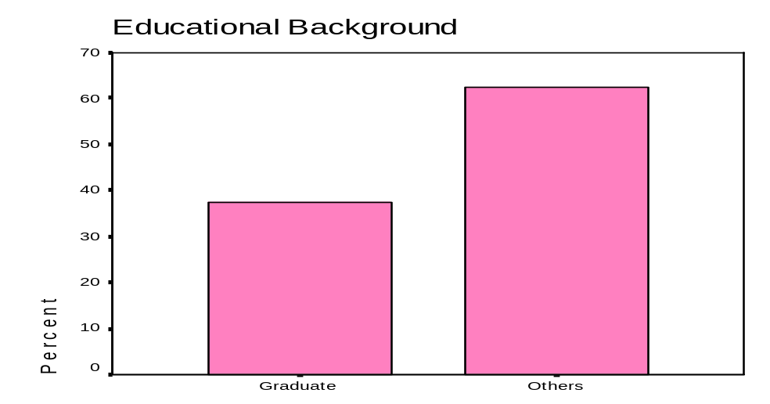

During my survey I didn’t have any respondents whose Educational Background is Primary, SSC or HSC. Most of the respondents were completed graduation or others. Around 37.5% of the respondents completed their graduation and doing jobs, business and some were house wife. When I was doing my survey I asked the respondents what is their educational background and their occupation and I give some option like- SSC, HSC, Graduate or Others. I just wanted to know educational background and occupation is how much correlated. Around 62.5% of the respondents tick in the others, which means their educational background is post graduate, MBA, Masters, Doctorate, Engineer etc. Here large numbers of respondents are male & very few were female and all of them doing good jobs in different organization, banks, companies or hospital. So I can say that most of the time educated people take loan. It means uneducated people or those who have low literacy rate do not actually want take loan from the bank, or they think it is a big hassle for them.

Monthly Income

Figure: 5
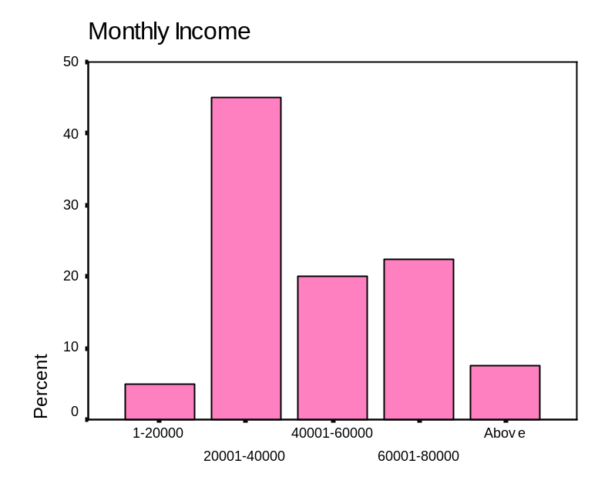

Around 45% of the respondent who take the loan their monthly income is 20,001-40,000. The number indicates that those who have the income range of twenty to forty thousand, they are the major customers of banks for taking loan or I would say they have more need to take loan. Very few of the respondents who take the loan their monthly income are 1-20000. Their number is very low because people of lower income do not actually go to banks to take loan in the other hand banks are also not willing to give loan to lower income people and their percentage is 5%. Around 20% of the respondents who take the loan their monthly income are 40001-60000. Some of the respondents who take the loan their monthly income are 60,001-80,000. Their percentage is 22.5% and frequency is 9.Some of the respondents who are doctors or doing higher quality of jobs their monthly income is more then 80,000. So for my survey I can say that, those people who have monthly income of 20001-40000 or more they are more likely to take loan.

Customers Perception about SEBL

Figure: 6
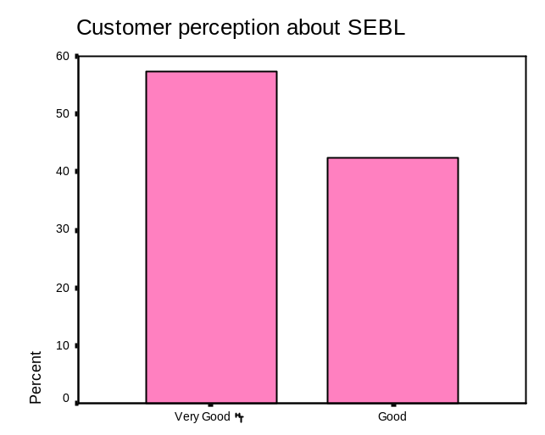

By my survey I found out that most of the customers have good perception about SEBL. Around 57.5 % of the respondents have very good perception about southeast bank Limited. They are the loyal customer and they have good relation with the Stuff. Most of the customers like SEBL officers because of their good behavior. Around 42.5% of the respondents their perception is good about southeast bank. During my survey I didn’t find one respondent whose perception is bad or very bad about southeast bank. Those who take loan from SEBL, their perception is very good or good about SEBL. And that’s why they come here and take loan. They also told me that they are satisfied about southeast bank environment, services, behavior. So it is a good sign for SEBL that not single customer is dissatisfied with SEBL.

How much knowledge do you have about SEBL loan offering?

Figure: 7
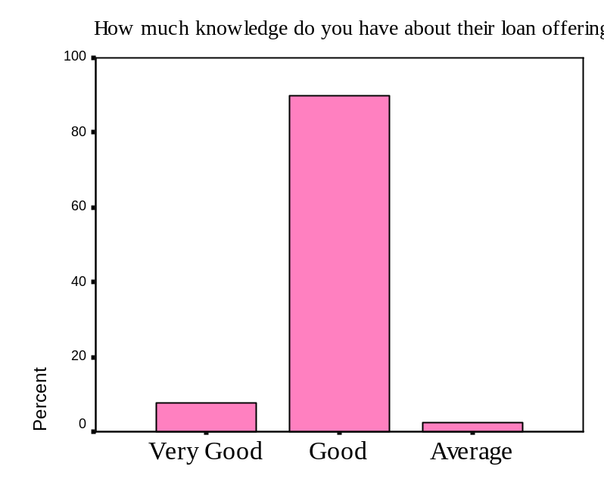

For my survey I asked the respondents, how much knowledge they have about SEBL loan offering. I found that, 90% of the respondents have good knowledge about SEBL loan offering. Some of the respondents have taken loan before that’s why they know. And some of the respondents know about SEBL loan offering from their family members or others sources. 7.5 % of the respondents have very good knowledge about their loan offering and they also know what types of loan they offer and how to get this loan. What are the terms and conditions they follow to give loan? 2.5% of the respondent has average knowledge about SEBL loan offering. They tick average because they do not have much knowledge about their loan offering. They told me that they have FDR that’s why they came here to take the loan.

Have you taken loan from any where before?

Figure: 8
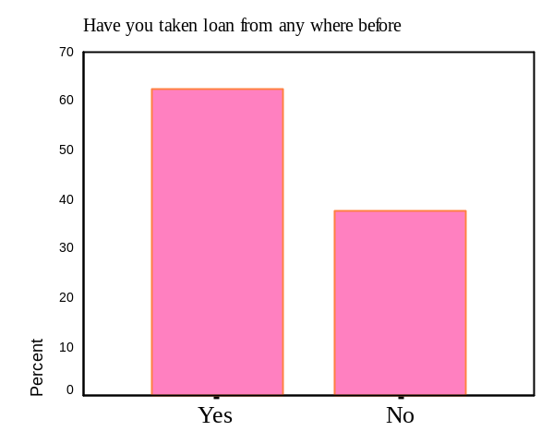

Some of the respondents have taken loan many times and some of the respondents taking loan first time. Around 62.5 % of the respondents have taken loan before from this bank or from other sources or I would say from other banks. Around 25 from 40 respondents have taken loan before. Some of the respondents taken loan from this bank or some of them take loan from other banks. 37.5% of the respondents didn’t take loan before from any where.

If yes, what’s type of loan?

Figure: 9
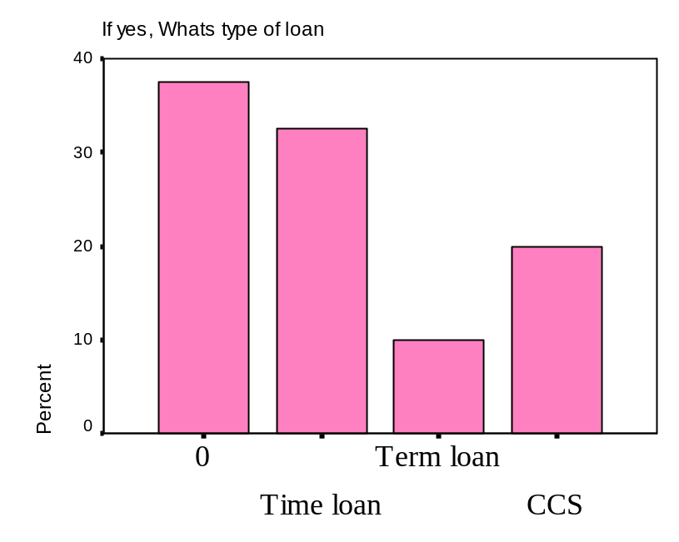

Here 37.5% of the respondents didn’t take loan before. Around 32.5% of the respondents have taken time loan before. 10% of the respondents have taken term loan before. And 20% of the respondents have taken CCS loan before. Most of the customers preferred time loan and CCS loan. Loan officers also try to give time loan because these loans have low risk. Loan officers always try to give loan to the less risky schemes. It is because they don’t want to take any risk or it is their traditional tendency.

Do you feel any problem for that loan?

Figure: 10
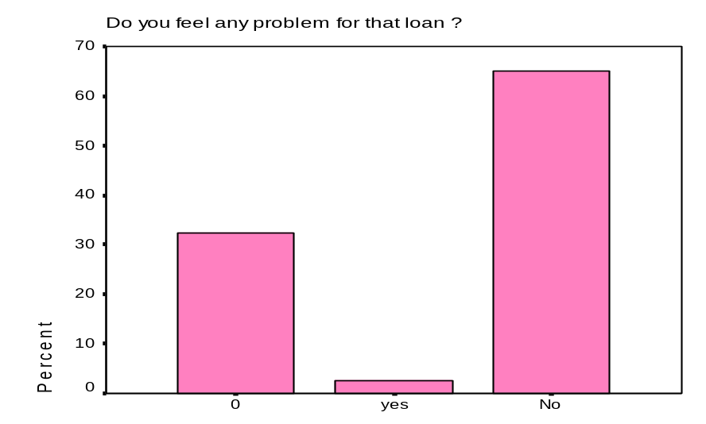

Every private bank tries to give their best services because of intense competition in banking sector. Southeast Bank also tries to provide better service. The more the process is easy the more the customer will feel comfortable to bank with. Whenever a customer comes to take the loan to SEBL, loan officers tries to do good behave to make them more comfortable and tries to how quickly they can give their service to that person. When I asked them, what ever loans you take before did you feel any problem for that loan? To that particular question I found that, 65% of the respondents didn’t feel any problem for the loan. Only one respondent said that he face problem to take loan. So the overall perception is good about the processing of loan.

It is your first loan?

Figure: 11
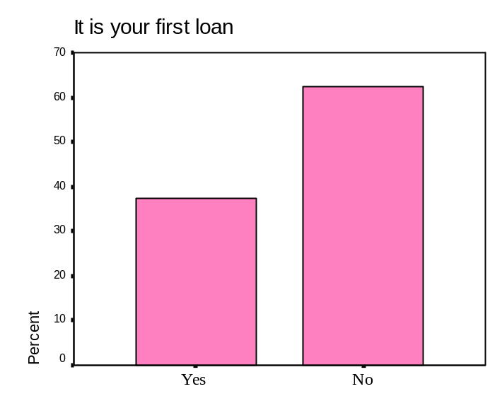

My number of respondents was 40 and around 37.5% of the respondents were taking loan for the first time. About 15 respondents didn’t take any type of loan before. About 25 of respondents have taken loan more then once, their percentage is about 62.5%. Some big companies take loan for their business more often. So the result says that Maximum number of people have taken loan for more then one tine. It means whoever takes loan once they again take loan.

Which type of loan you have taken recently?

Figure:12
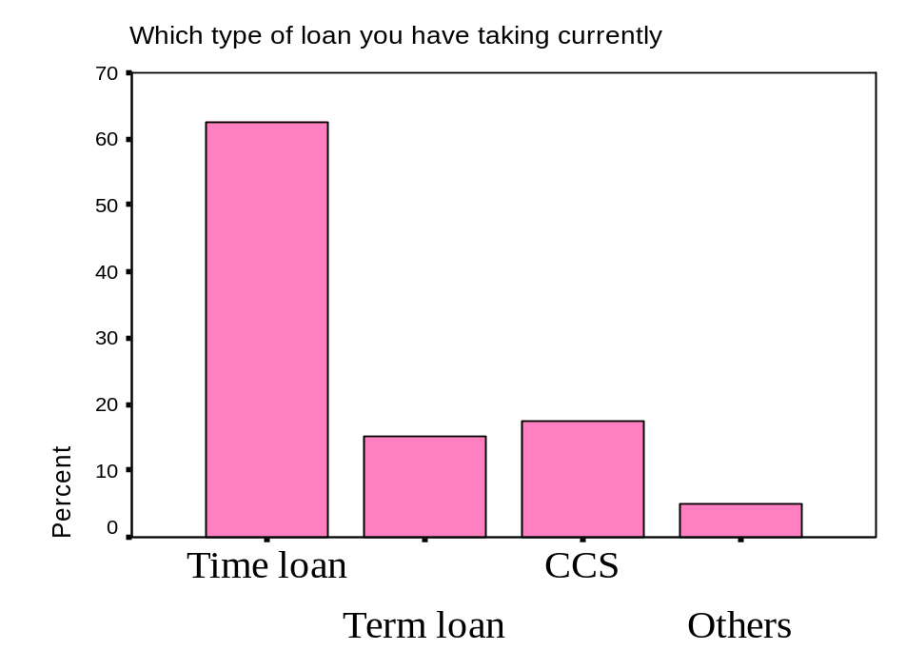

Southeast Bank offer’s different types of loan like-Time loan, Term loan, Consumer Credit Scheme (CCS), Demand loan etc. During my survey I saw that, around 62.5% of the respondents take time loan. Most of the time, the time loan facility is taken by the business firms for short term liquidity or for the instant makeover of any shortage of fund. The maximum tenure of a time loan is 1 year. Customer can get time loan very easily and loan officers also try to give them this loan because it is less risky. We all know that less time means less risky for the bank. About 15% of the respondents take Term loan. Term loan is the type of loan which customers can take for more then one year. There are three types of term loans:

Types of term loan | Time period/ Tenure
Short Term loan | 1 to 3 three years
Medium Term loan | Above 3 years to 5 years
Long Term loan | Above 5 years
For different purposes they take term loan like- Land, Building, Industry, Project etc. Around 17.5% of the respondents take CCS (Consumer Credit Scheme). Consumer Credit Scheme (CCS) is offered to the borrowers who want to buy commodities like computer, refrigerator, television, VCD player or household furniture or appliances. The interest rate is 12% per annum and time duration is maximum 36 months. Southeast bank offer another type of loan which is demand loan. Demand loan means, the clients are also allowed to withdraw from and deposit to at any time but the payment of cash should be in one shot while the repayment is made in one shot or at intervals. Examples of demand loan are, IBP, Trust Receipt, Packing Credit, Time Loan, etc. SEBL offer demand loan only for their internal stuff.

What is your purpose of taking this loan?

Figure:13
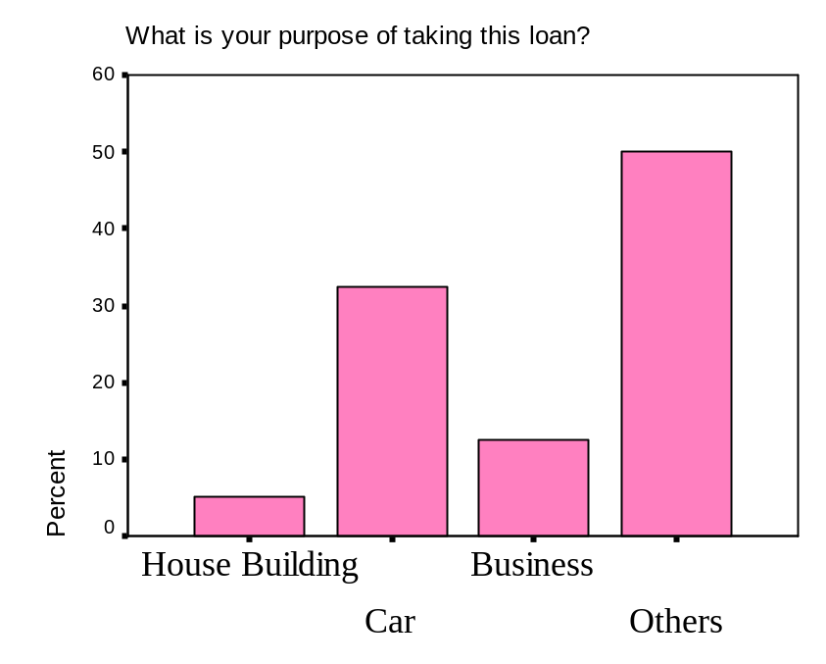

On my survey I have found that customers take loan for different purpose. 5% of the respondents were taking loan for house building purpose. Loan officer generally do not prefer to give loan for house building purpose. Those customers who have strong relationship with the managers or big officer in the SEBL they can get this loan. Stuffs of the southeast bank can get this loan for house building purpose. Because of the tight procedure, I found that very few people are taking loan for house building purpose. Around 32.5% of the respondents are taking or have loan for buying a car. Most of the time respondents take car loan against their FDR. For this loan, loan officers do some special inquiry. Around 12.5% of the respondents have taken or were taking loan for business purpose. Some big companies take loan regularly for their business purpose but during my survey I have got some small businessman. But the interesting thing is I got a businessman who is doing crocodiles business and taking loan for that business. Around 50% of respondents take loan for their personal purpose. So majority of loans are taken by customers for their personal use which is not a good sign because the fund is not used in any productive sector.

When do you make your loan against cash back?

Figure: 14
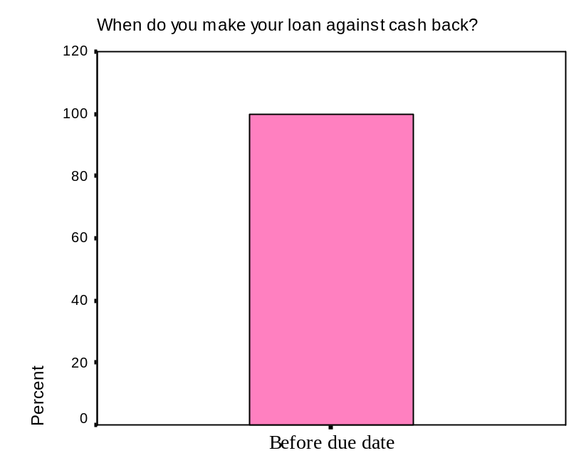

My total numbers of respondent was 40. When I asked 40 Respondents, when do you make your loan against cash back and there was two options like before due date or after due date. All of them told me that they make their loan against cash back before due date. We all know that some of the customers make their loan against cash back after due date, But during my survey I didn’t find any respondents. So by my survey I found that 100% of the respondents try to make their loan against cash back before due date. When loan holders don’t pay their loan against cash back before due date then loan officers send a request letter to the loan holders to pay their cash back.

What is your satisfaction level of SEBL Environment?

Figure: 15
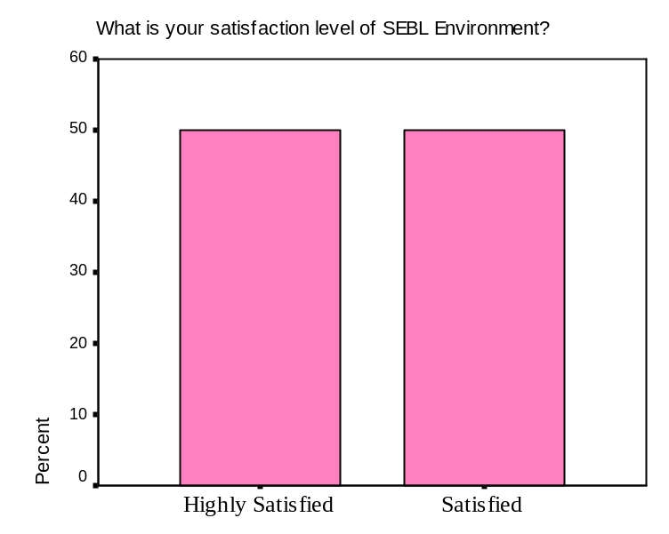

Customer’s satisfaction is very important for any bank. Most of the private banks try to provide good environment for their customers. That’s why southeast bank also provide good environment. In my survey I have found that 50% of the respondents are highly satisfied about southeast bank environment. Respondents told me, SEBL environment is very good that’s why they come here for banking and take loan. Around 50% of the respondents are satisfied about SEBL environment. During my survey I didn’t find a single respondent who is highly dissatisfied or dissatisfied about their environment. So I can say that 100% of the respondents are highly satisfied or satisfied with SEBL environment of banking.

Are you satisfied with SEBL loan offering?

Figure: 16
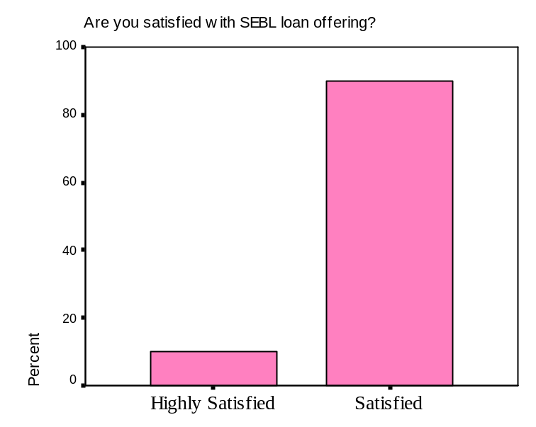

Total number of respondents is 40 and 36 respondents (which is around 90%) are satisfied with the SEBL loan offering. 4 respondents are highly satisfied with the SEBL loan offering. Southeast bank offered different type of loan. SEBL try to fulfill customer needs and wants. If loan officers think the customers are able to pay loan against cash back and they can full fill all the condition to take the loan then customer can get the loan of their choice. So by my survey I found that 90% of the respondents are satisfied with SEBL loan offering. It indicates that not a single person is dissatisfied with southeast loan offering.

Are you satisfied with SEBL interest rate?

Figure: 17
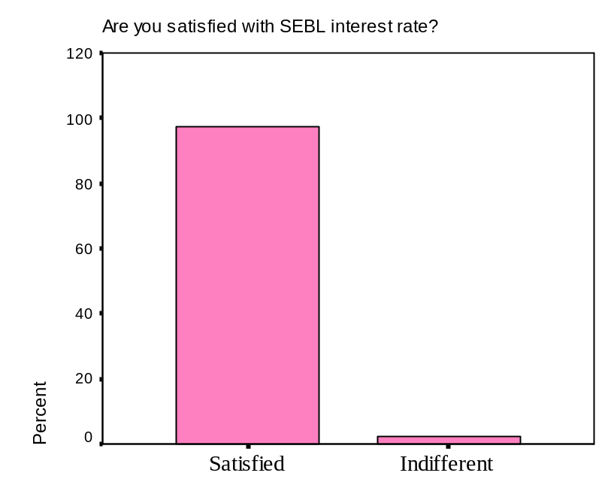

During my survey I found that 97.5% of the respondents are satisfied with SEBL interest rate. Southeast bank don’t take high interest rate. When I asked to the customers that are you satisfied with SEBL interest rate, some of the respondents told me that every bank are taking interest for the loan. Some banks are taking high interest and some are taking low interest. Southeast bank is taking low interest that’s why they come here to take loan. Compare to other most popular private banks SEBL charges lower interest rate for the customers and that is the basic reason for coming into this bank. Only 2.5% of the respondent are indifferent that means neither satisfied or neither dissatisfied. I didn’t get any respondent who are totaly dissatisfied. So it a good sign for SEBL those customers are not dissatisfied with their interest rate.

From which sources you have got information about SEBL loan offering?

Figure: 18
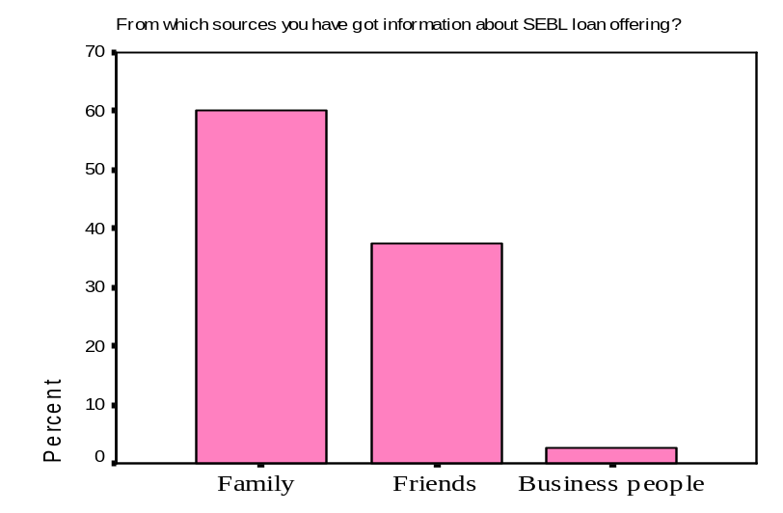

Around 60% of the respondents got SEBL loan offering information from family. Some of the respondents got information from their brother, sister, father, cousin etc, who have good knowledge about the SEBL or work-in the southeast bank. 37.5% of the respondents have got information about SEBL from friends who also have good knowledge about SEBL loan offering. 2.5% of the respondents got SEBL loan offering information from business people. So majority of the respondent got information about SEBL loan offering from their family members or relatives.

What are the reasons of taking SEBL loan?

Figure: 19
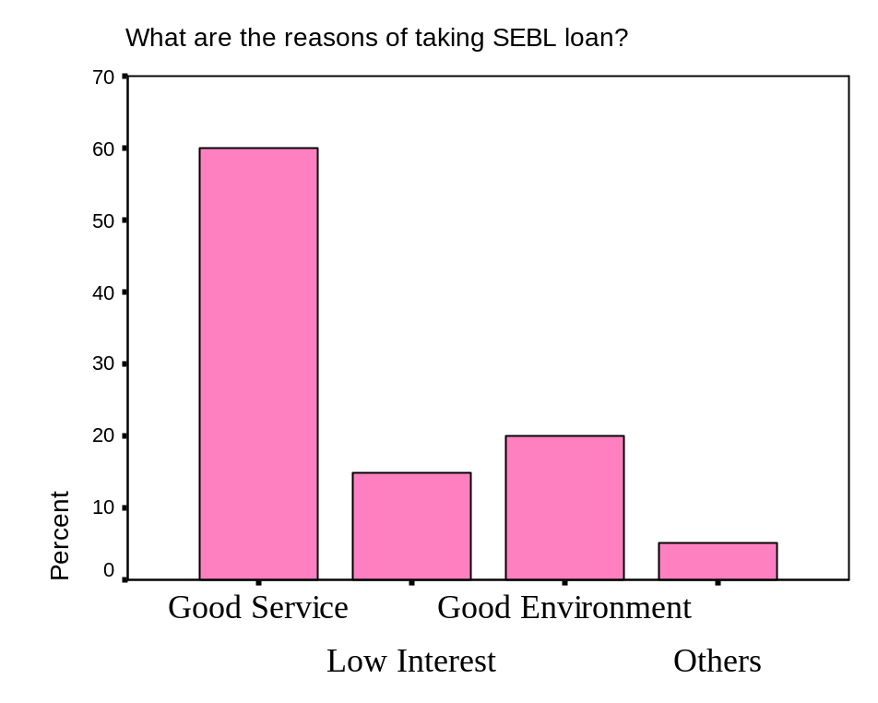

This is a big issue why they are taking loan from SEBL rather than other banks. Around 60% of the respondents taking SEBL loan because of their good service. Most of the respondents are satisfied with their service. All employees of SEBL try to give their best service by their good behave and manners. When customer come to take the loan they try to give loan very quickly or I would say try quicken the procedure. 15% of the respondents are taking loan for the lower interest rate. As SEBL offer lower interest then the other banks that’s why they come here. 20% of the respondents are taking loan because of good environment. SO I can say that the main reason for the customers to take SEBL loan is good service or I would say better service.

Have you compared loan offering with another bank?

Figure: 20
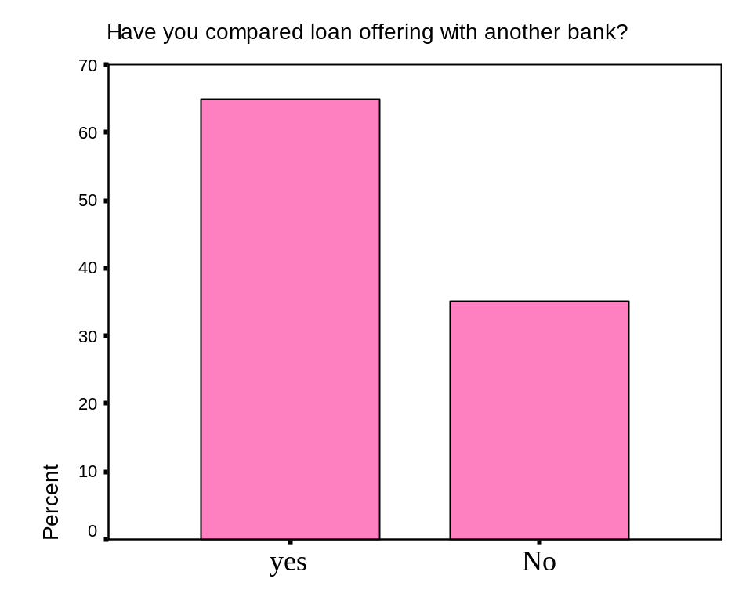

During my survey I asked customer that, have you compared SEBL loan offering with other banks. Around 65% of the respondents answer was yes. 35% of the respondents answer is no. Customers compared SEBL loan offering to other not only for the interest rate but also there are other issues also. The need of the customer is also very important, the loan they are offering is it needed for them is also very important. They compared for the varieties also. So after the comparison then they came here for the loan. Some respondents do not compared SEBL loan offering with another bank, because they think that all the private banks are offering same types of loan. So from the data we can say that majority of the respondents compare different banks and after that they finally decide which bank is suitable for them.

Why not you using other bank loan?

Figure:21
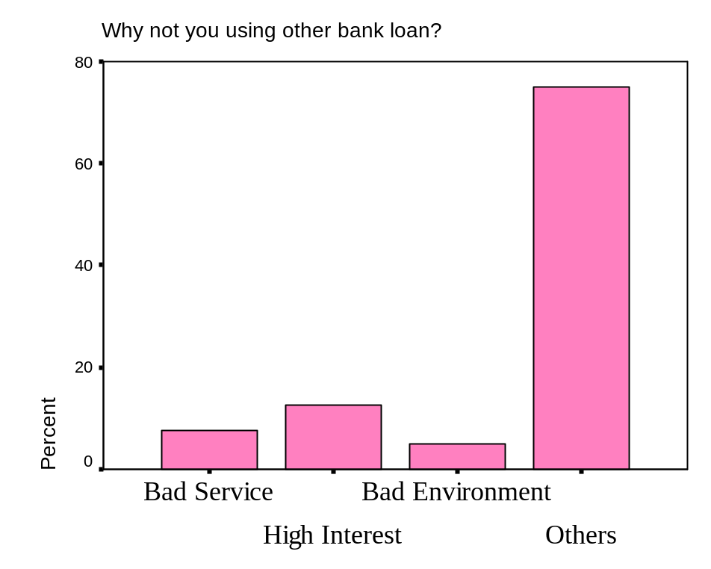

During my survey I asked respondents that, why don’t taking other bank loan and I gave some options like- Bad services, High Interest, Bad Environment or Others. About 75% of the respondents tick the other option. Some respondent told the reason but maximum respondents didn’t tell the reason. Some respondents told that they have FDR in the SEBL that’s why they are taking loan from SEBL; they are taking loan against their FDR. Another reason is that they have good relation with the SEBL manager or stuffs that are why they came here to take the loan. Around 7.5% of the respondents tick to the bad services. They didn’t mention the names of those bank but they said that the banks where they have gone before their service is not up to the mark. About 12.5% of the respondents tick in the higher interest. And 5% of the respondents answer bad environment. So I can say that most of the respondents do not using other bank loan because of their personal reason or they don’t want to disclose.
4.1 Cross tabulation:

Monthly Income on the basis of Occupation

Figure 1:
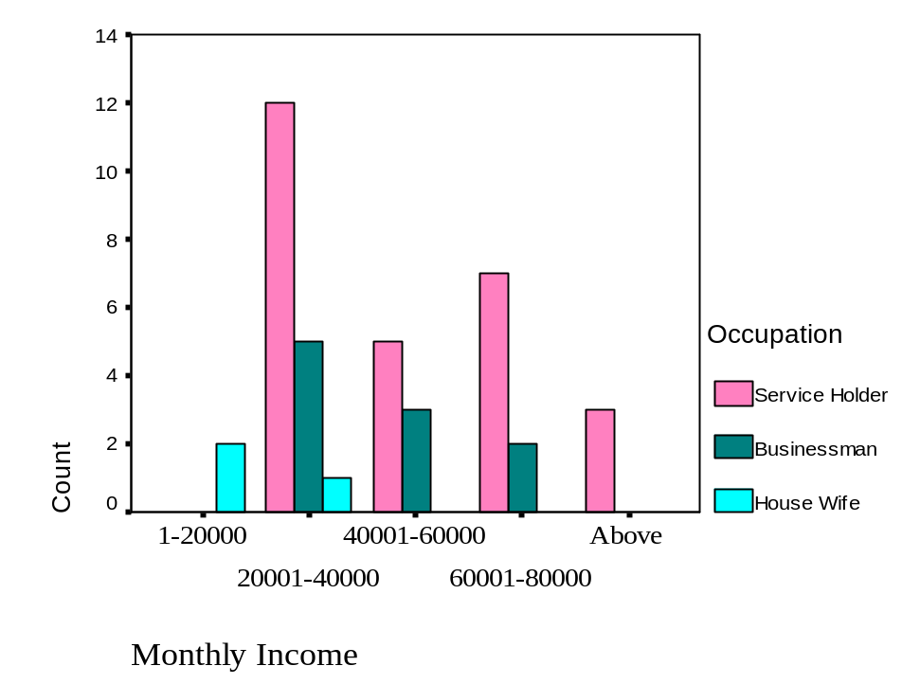

From my survey I have found that around 27 respondents are service holder and from them 44.4% respondent’s income is within 20000 barriers. About 25.9% respondents have an income between 60000- 80000 and about 18.5% respondents have an income of 40-60000tk monthly. From this data we can say that majority of respondent’s from service holder have an income of 1-20000tk. It means from service people who has a lower income they are mostly come to bank to take loan. May be they have a need which they can’t fulfill from their current income that’s why they have come to SEBL to take loan. Around 10 respondents are businessman out of 40 respondents. Around 50% of them have an income of 20000-40000tk and 30% of them have an income of 40000-60000tk and 20% have 60000-80000tk. So majority of them have an income of 20000-40000tk it means that businessman who have an income of this level they mostly go there for taking loan. Only 3 respondents from 40 are housewife and among them 2 have income of 0-20000tk it doesn’t mean that they have income there was no other option that’s why they gave that answer. They basically have no income they came to SEBL to take loan by mortgaging their asset.

Which type of loan customers are using currently on the basis of Occupation

Figure: 2
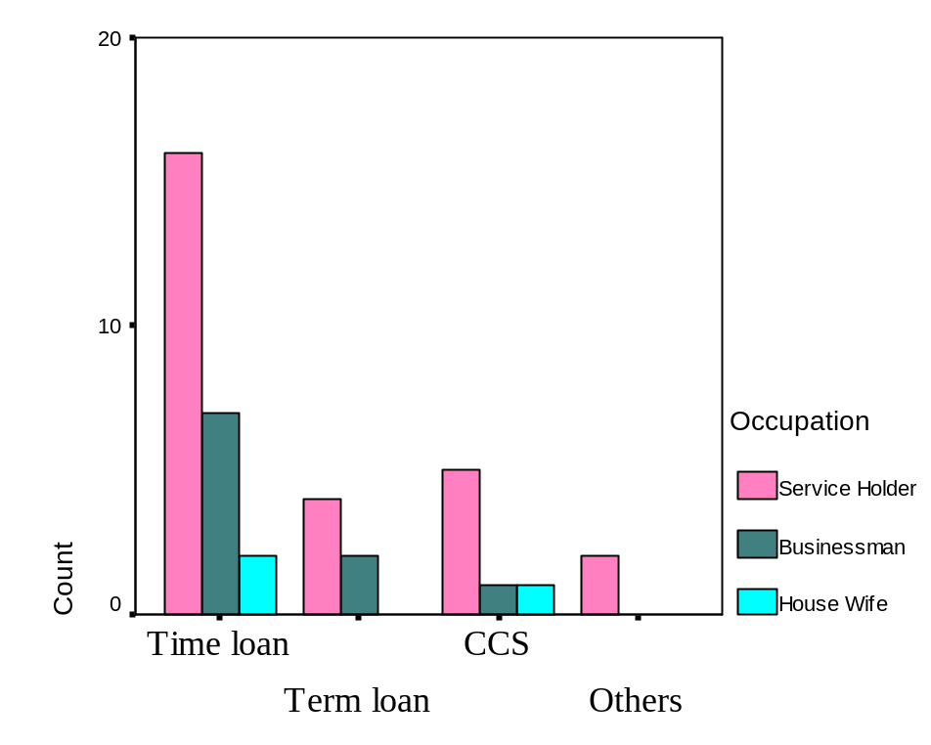

From service holders around 59.3% of respondents came here to take time loan, around 14.8% of the respondents came here to take term loan, and around 18.5% came to SEBL to take CCS. So majority of service holder came to SEBL to take time loan. This is because getting this loan is much easier than the others and bank is also trying to give this loan because it is les risky. From businessman 70% of the respondents came to take time loan, 20% of them came to take term loan and 10% of them came to take CCS. So majority of businessman also came to SEBL to take time loan. This is for the same reason taking this loan is much easier than the others. Another reason is that there was no big businessman that is why other options are not taken by the respondents. Small businessman generally takes time loan and bank also doesn’t want to give other loan to small businessman. From housewife 2 respondents were taking time loan as usual.

Purpose of taking this loan on the basis of different occupation

Figure: 3
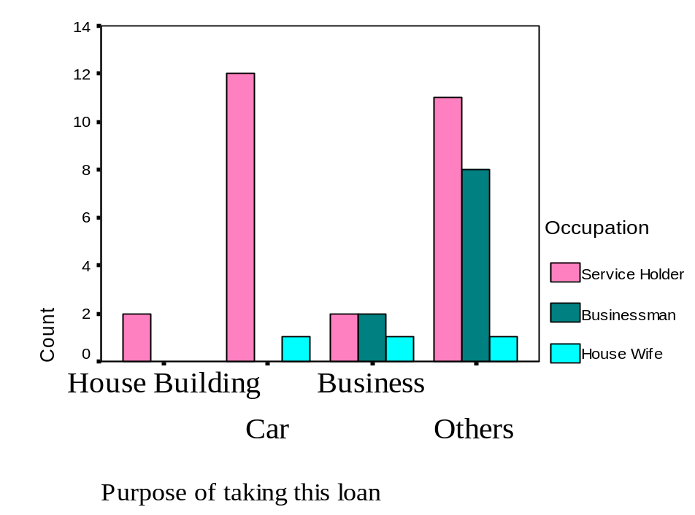

Around 44.7% of service holders are taking loan for buying car, 40.7% are taking loan for other purpose, 7.4% are taking for house building, and 7.4% are taking for business. Majority of service holder are trying to get loan for buying car. It is because they can’t afford to by a car without loan. So they are trying to take loan for buying a car. Around 80% of businessmen are taking loan for other purpose. This is astonishing that 80% of businessmen are taking loan not for their business purpose they are taking loan for other purpose. Out of 3 housewives each of them re taking loan for different purposes. One of them is taking loan for buying car one is taking loan for starting a business and one is taking loan for other purpose.

The reasons of taking SEBL loan on the basis of Occupation

Figure: 4
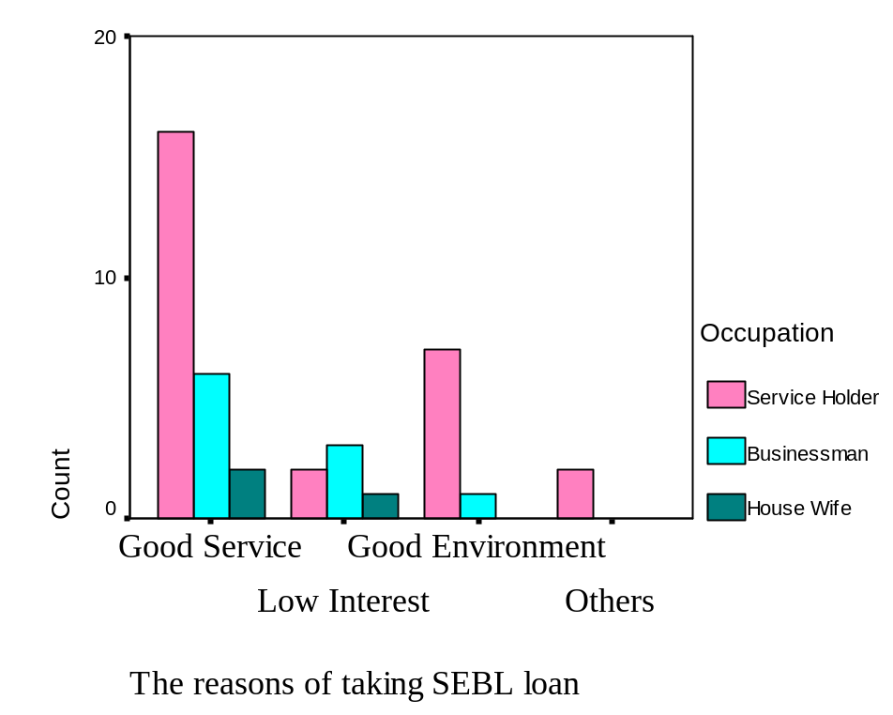

About 59.3% of the services holders are taking loan from SEBL because of their good service, 25.9% of them taking for good environment, 7.4% of each are taking loan for lower interest and other reasons. So majority of the customers are taking loan not for lower interest or other related issues they are taking loan for good service and good environment. For services holders good service is most important rather interest rate. Around 60% of the businessmen are taking loan for good service and 30% of them are taking loan for lower interest rate. The most amazing is thing is that they are not taking loan for lower interest rate rather for good service. This may be because of majority of them are not taking loan for their business rather for other purpose. 66.7% of the housewives are taking loan for the good service and 33.3% of them taking loan from SEBL for lower interest rate. So from the overall data we can say that good service is the main reason for taking SEBL loan than other bank.
5.0 Summary of Findings

- Most of the customers have good perception about SEBL.
- Majority of customers are taking loan for their personal needs.
- Bank is not interested to give loan to risky sectors like business etc rather interested to give loan to buying cars or other purpose.
- Females are not encouraged to take loan or bank is not interested give loan to house wife that’s why numbers of house wife are very less.
- Maximum clients come to SEBL for good service not for lower interest rate.
- Almost everyone is satisfied with SEBL customer service.
- Most of the clients come to SEBL for taking time loan.
- Majority of the clients are service holder not businessman because bank encouraging consumer loan rather business loan.
- Maximum customers take loan against FDR and bank is also give this loan very easily because it has least amount of risky.

6.0 Recommendation

- Bank should encourage business loan rather consumer loan that will be helpful for the economy.
- The SEBL may encourage Female entrepreneurs to take loan that will directly affect the socio economy of our country and it will help to strengthen our economy. Only men’s can’t forward our country in today’s world.
- Term loan should be encouraged so that businessman’s can take this loan easily.
- Should emphasis on promotion to create a strong brand value, in today’s world there is no alternative to promote your brand.
- SEBL should diversify its lending sector to reduce the risk of defaulting.

7.0 Conclusion

Banking sector of Bangladesh has undergone dramatic changes since the independence in 1971. For Society revolution, money and Banking system started their journey. The changing of need made an effect on Banking system and Banking system started to develop the system. Private Banks play an important part in promoting economic development of Bangladesh. Banks provide necessary funds for executing various programs underway in the process of economic development. Southeast Bank Limited is a scheduled commercial bank in the private sector established under the ambit of Bank Company Act.. In conclusion we can say that bank loans are now days diversified in to consumer loans from business loans. Banks are now more likely to give consumer loans than business loans. It is causing to have fewer entrepreneurs to come forward to take the challenge. Females are still not getting enough support to take loan or they are simply discouraged to take loan because banks are still thinks that they vulnerable and more risky to give loan specially SEBL thinks like that. So there should be a change in their thinking to stop discrimination between men and woman. Long term loans should ease up to give businessman’s more flexibility to have that kind of loan which will have a big impact on the economy. Because the more long term loan will be taken the business farms will emerge and more employment opportunity will be created. One thing is very positive about SEBL that not a single a customer is dissatisfied with their any kind of service and is very impressive for any service organization. There are certain areas of improvement those can be done to have greater impact on the consumers mind about SEBL though they have good service but it can be better starting own ATM’s rather depending on others. So overall condition is not bad but it can be improved to go forward to the next level of service.

