Internship Report
On

Corporate Governance of Eastern Bank Limited

Submitted by

WWW.ASSIGNMENTPOINT.COM
2.1 Introduction

The emergence of Eastern Bank Limited in the private sector is an important event in the banking industry of Bangladesh. Eastern Bank Limited started its business as a public limited company on August 08, 1992 with the primary objectives to carry on all kinds of banking business in and outside of Bangladesh and also with a view to safeguard the interest of the depositors of erstwhile BCCI [Bank of Credit and Commerce International (Overseas)] under the Reconstruction Scheme, 1992, framed by Bangladesh Bank.

In 19991, when BCCI had collapsed internationally, the operation of this bank had been closed in Bangladesh. After a long discussion with the BCCI employees and taking into consideration the depositors’ interest, Bangladesh Bank then gave the permission to form a bank named Eastern Bank Limited which would take over all the assets, cash and liabilities of erstwhile BCCI in Bangladesh, with effect from August 16, 1992. So, it can be said the EBL is a successor of BCCI.

EBL started its business as a scheduled bank with only four branches, which included Principal Branch, Dhaka; Motijheel Branch, Dhaka; Agrabad Branch, Chittagong and Khulna Branch. EBL started its business with motto to grow as a leader in the banking arena of Bangladesh through better counseling and efficient service to clients. EBL resumed its operational activities initially with an authorized capital of Tk. 1000 million, divided into 10 million shares of Tk. 100 each and paid up capital of Tk. 310 million. The initial shareholders were the NCBs, various govt. agencies, and some of the depositors who had agreed to accept shares in the new bank in lieu of their deposits. The first Board of Directors of EBL constituted under govt. supervision, consisted of 7 directors from various business and professions. Eastern Bank Limited was under government control until the end of 2000 and therefore, there were lots of deficiencies in the Bank’s management. In 2001, the board of directors brought in new professional management from various foreign banks who have been trying to modernize the bank ever since.

2.2 Mission

EBL will deliver service excellence to customers, both internal and external.

EBL will constantly challenge their systems, procedures and training to maintain a
cohesive and professional team in order to achieve service excellence.

EBL will create an enabling environment and embrace a team based culture where
people will excel.

EBL will ensure to maximize shareholder’s value.

2.3 Vision

The vision of Eastern Bank Limited is to become the bank of choice by transforming the way they do business and developing a truly unique financial institution that delivers superior growth and financial performance and be the most recognizable brand in the financial services in Bangladesh.

2.4 Values

- Service excellence
- Openness
- Trust
- Commitment
- Integrity
- Responsible corporate citizen

EBL see their customers’ trust as the lifeline of their business, control and compliance as their license to operate, dynamic and motivated people as their strength to multiply and technology as their weapon to service excellence.

2.5 Objectives of Eastern Bank Limited

Maximization of profit along with the benefits of employees is the main objective of the bank. In addition, the other objectives are:

To be one of the leading banks of Bangladesh in terms of ROE and ROE

To be the market leader in high quality banking products and services

Achieve excellence in customer service through providing the most modern and
advanced state-art technological in the different spheres of banking

Cater to a broader and differentiated segment of retail and wholesale customers.

To grow its credit extension service to the commercials as well industrial sector;

To increase its diversification of loan portfolio and geographical coverage

To curd present operating expenses further so as to increase earnings before tax

To reduce the burden of nonperforming assets

2.6 Historical Review and Different Milestones of EBL

In the year of 1992 EBL started their banking operation in the country. Within these 15 years EBL became one of the successful banks in Bangladesh. They are able to gain this huge success because of their employee’s honesty, integration and hard work.

EBL dreams to be the bank of choice of the general public which includes both the consumer and the corporate clients. It has adopted the tag line “simple math”, the philosophy of Easy Banking while celebrating the 10th anniversary in 2002, EBL’s logo was changed to reflect the restricting and the transformations it is going through; the colors of the new logo signify the vibrant green of mother earth, a blue sky full of possibilities and a yellow rising sun of hope.
In order to achieve superior growth and financial performance for its shareholders, EBL is radically transforming the way it dies business .The bank has already restructured from the traditional geographic matrix (branch based banking) to business unit matrix. The bank is also centralizing most of the business functions in the head office to ensure greater control and efficiency.

EBL wanted to stand up in the crowd. For moving out of the ramshackle, EBL management under the dynamic leadership of the honorable Directors of the Board switched over to a centralized platform using a world renowned banking software (Flexcube) which was the no one most popular software in the world for the year 2003. The bank also centralizing most of the business functions in the head office to ensure greater control and efficiency. The result has been incredible. List of few benefits from centralization are mentioned below:

At a glance – Benefits from Changes

• Standalone systems | = > Centralized system
• Branch Banking | = > Anywhere Banking
• EOD at Branch | = > EOD at Data Centre
• Telegraphic Transfers | = > Online Inter-branch transfer
• Hold accounts | = > Online Inter-branch transfer
• Produce MIS at Branch | = > Centralized MIS
• Poor ‘Control’ reports | = > Improved ‘Control’ reports
• Audit needs branch visit | = > MIS available at Head Office
• Information on paper | = > Information in CIF
• On Card Signature/Pix | = > Digital Signature/Pix
• No Funds Management | = > Automatic Sweep-in/Out

EBL is a leading private sector bank in Bangladesh offering full range of Personal, Corporate, International Trade, Foreign Exchange, Lease Finance and Capital Market Services. At present, this can be said; Eastern Bank Limited is the preferred choice in banking for friendly and personalized services, cutting edge technology, tailored solutions for business needs, global reach in trade and commerce and high yield on investments, assuring Excellence in Banking Services.

Within very short span of time EBL is going to open five more branches in the country. EBL is start strengthen their consumer products along with their corporate products; as they lunched “Simple Credit Card” in the market recently.

2.7 Current Profile of EBL

At present, the bank has 32 branches throughout the country with about 850 employees. The existing Board of Members is 12. Mr. A. Q. I. Chowdhury, OBE is the Chairman of Board and Mr. Ali Reza Md. Iftekhar is the Managing Director & CEO. EBL is currently going through a restructuring stage where the traditional ‘Branch Banking System` is gradually discarded and being replaced by a Centralized System till 2000. The bank has been restructured into five main businesses which is responsible for earning the revenues of the bank. These are:

Corporate Banking

Consumer Banking

SME Banking

Treasury

Cards
All other departments of the bank act as support for these five units and help them in every possible way. Under this arrangement, the responsibilities and functions of those branches have been reduced dramatically. Many of the activities like credit evaluation and approval, monitoring of loans, trade services activities etc. are now centralized in the Head Office. The branches of the bank are now termed as the “Sales & Service Centers” which are solely concentrated on delivering services to the corporate and consumer clients and maintain relationship with them.

2006, last year was another year of continued success of EBL across all the business units. The Bank has made an Operating Profit growth of 28.6% to BDT 1,358 million during the year but suffered a decline of Profit after Tax by 6.1% to BDT 513 million mainly due to increased general provisioning requirement by BB and disallowance of specific provision in tax computation. Therefore EPS dropped to BDT 61.98 in 2006 against BDT 66.00.

Corporate Banking remains the major bread earner with largest volume of loan portfolio and fees income. Adding 3 more branches at strategic locations, Consumer Banking supplied the major part of funding assets of corporate and SME, one of the potential business segments. EBL Treasury has passed a superb year 2006 by achieving an extraordinary growth of FX income by 130% to the tune of BDT 434 million by exploiting market volatility. Investment income also grew by 47.48% due to govts increased borrowing at higher rates.
2.8 BOARD OF DIRECTORS OF EBL

NAME | POSITION
Mr. Mir Nasir Hossain | Chairman
Ms. Aneela Haque | Director
Mr. G. M. Shakhawat Hossain | Director
Mr. M. Showkat A. Chowdhury | Director
Mr. A. M. Shaukat Ali | Director
Mr. Asif Mahmood | Director
Mr. Ahmed Qamrul Islam Chowdhury | Director
Mr. M. M. Abdur Rahim | Director
Mr. Mohd. Noor Ali | Director
Mr. Ali Reza Iftekhar | Managing Director & CEO
Mr. Safiar Rahman | Company Secretary

2.9 Management Aspects

The EBL Management Team comprises of a group of people and each of them comes with an international working background and is committed in leveraging their experiences to take EBL to greater heights by ensuring top line revenues with dynamic capabilities. This Management Team is unique in being able to envision the need of the business by bringing in admixture of advanced technology solutions know-how and revamping the organizational make-up for maximum profitability. Other than the CEO, the remaining Management Team Members each lead a functional department.

This mix of people is persistent to provide unparallel services to its customers, come up with timely and innovative products and services and to enhance the capabilities of its people of its people while emphasizing on the latest technology. This they believe will take the Bank to a foremost position in the country by the turn of the year 2007. This team is to drive the business to maximize the operational excellence and efficiency through acquisition of talent, developing systems, processes and people and through blending of these to let customers revel in with fulfillment and permanency.

Like any other business organization, all the major decisions in EBL are made by the top management Committee. The board mainly establishes the objectives and policies of the bank. There are three (3) committees of the board for different purposes:

    - Executive committee

In compliance with the BRPD circular no. 16 dated July 24, 2003 the board of Directors of EBL has reconstituted its Executive Committee in its 352the Board Meeting and was duly confirmed by the Board. This committee is comprised of four non-executive Directors and Managing Director of the bank and the functions and responsibilities of this committee is to Establish and periodically review the bank’s overall credit and lending policies and procedures, develop and implement uniform and minimum acceptable credit standards for the bank, new credit proposal assessment and approval etc.

    - The Audit Committee

The main objective of this committee is to assist eh Board of Directors with regard to the audit of financial reports, management reports by external auditors, internal controls and internal audits.

    - Management Committee

The main objectives of this committee is to ensure business operations are in line with the Bank’s policies, strategies and objectives, the bank has set up. This committee consists of the CEO, COO and different business unit heads. The honorable members are:

MANCOM MEMBERS OF EBL  Members of Eastern Bank Management Committee | Ali Reza Iftekhar  Managing Director & CEO
Mamoon Mahmood Shah
SEVP & Head of Consumer Banking
Md. Sirajul Islam
SVP & Head of Human Resources
Mahbubul Alam Tayiab
EVP & Head of Operations
Malick Musfique Reza
SAVP & Head of Finance & Accounts
Md. Fakhrul Alam
EVP & Area Head, Corporate Banking, CTG
Syed Rafiqul Haq
Head of Unit 5, Corporate Banking, Dhaka
Ehsan Khasru
Head of Credit Risk Management
Muklesur Rahman
Head of SME Banking
Noor E Alam Chowdhury
Head of IT
Safiar Rahman
Company Secretary

Mid and lower level employees get the direction and instruction from the top executives about the duties and tasks they have to perform. Management of Eastern Bank Ltd. assumes that; active employees are the inputs to achieve the organization goal. The manager provides the guidelines and broad directions to the subordinates but delegate responsibility for determining how tasks and goals are to be accomplished.

2.9.4 Management Hierarchy at EBL

Chairman
Board of Directors
Managing Director
Higher level
Deputy Managing Director
Senior Executive Vice President
Executive Vice President
Senior Vice President
Vice President
Senior Assistant Vice President
Higher
Midlevel
First Assistant Vice President
Assistant Vice President
Senior Principal Officer
Lower
Midlevel
Principal Officer
Management Trainee (Entry Level)
Senior Officer
Lower & Entry level
Officer (Entry Level)
Contractual Officer (Entry Level)

Figure: Management Hierarchy of EBL

2.10 Branches of Eastern Bank Limited

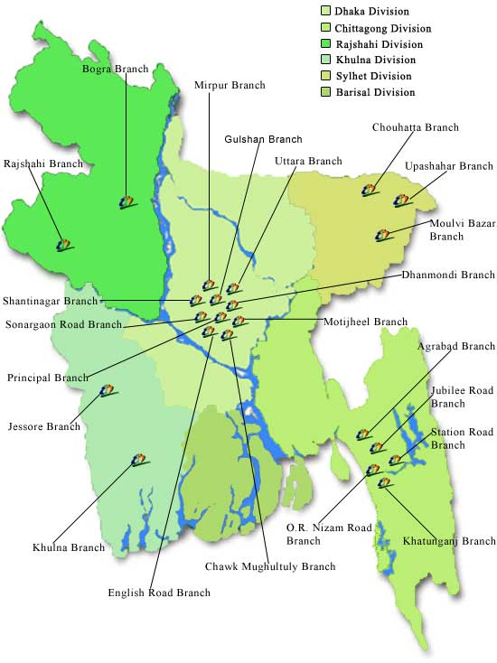
Figure: Map of the branches of EBL in Bangladesh

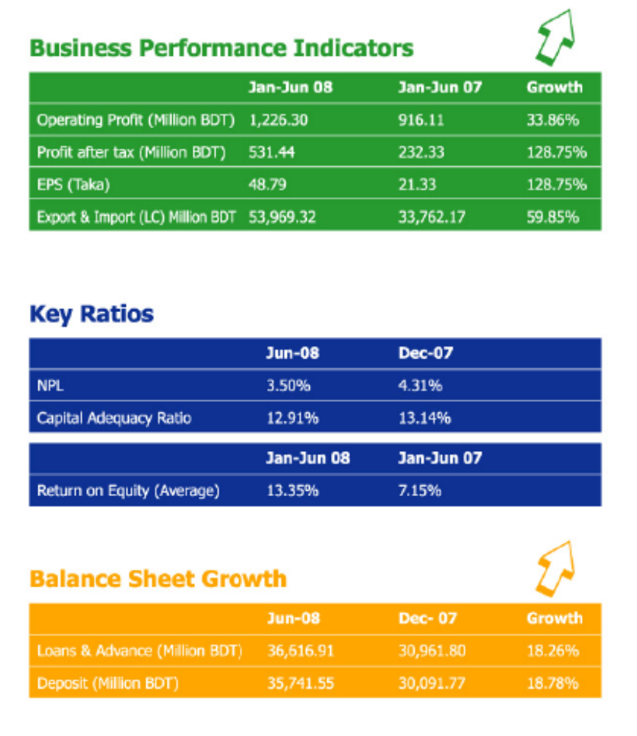
2.11 Business PERFORMANCE INDICATORS

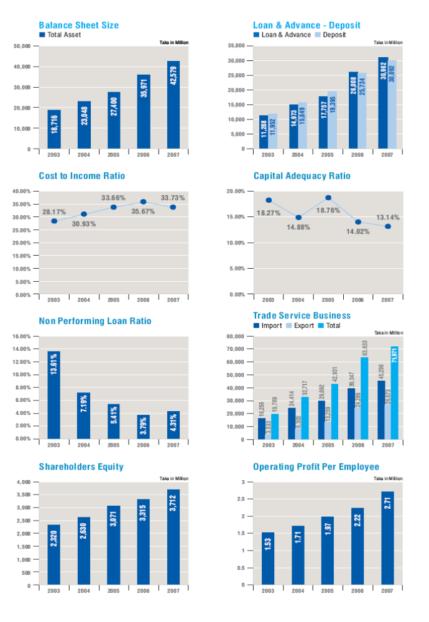
2.12 Ratio Analysis of Balance Sheet elements in 2007:

2.13 Current Banking Scenario of BD and EBL’s Position in the Market
From the beginning of the year 2004, the entire banking industry in Bangladesh started facing stiff competition to procure business, under the changed circumstances of the policy of BB to lower the rates of interest in lending and to go for syndication against large loan portfolios with the objective to ensure better operation and control of all functions of the bank.
Despite such situation the year was a remarkable on for EBL when the bank finally completed the introduction of a state-of-the art IT technology platform of Flex Cube, a world class banking software. All of bank's 25 branches were connected to this IT platform giving an enviable opportunity to all the EBL customers to obtain the most coveted services that no other bank could offer them yet.
Customers of new century are self-motivated, vigilant and informed about the market conditions, further more development of information technology and telecommunication systems created an environment whereby customers demand convenience, reasonable priced better quality financial products and personalized services. Customer demand together with technological advancement created new challenges and opportunities in the banking sector in Bangladesh. Adapting realistic and timely business policies, investments in IT are now prejudicing to stay at the edge of this assertive and competitive banking business of the country. Invention of new financial products and services and introduction of new delivery methods are the key concern of staying close to customers.
To cope with the status quo, Eastern Bank Limited welcomed these developments and restructured the bank to meet the challenges in future. The branches of the bank are now termed as the "Sales & Services Center" which are solely concentrated providing service to the corporate and consumer clients and maintain relationship with them.
2006, last year was another year of continued success of EBL across all the business units. The Bank has made an Operating Profit growth of 28.6% to BDT 1,358 million during the year but suffered a decline of Profit after Tax by 6.1% to BDT 513 million mainly due to increased general provisioning requirement by BB and disallowance of specific provision in tax computation. Therefore EPS dropped to BDT 61.98 in 2006 against BDT 66.00.
Corporate Banking remains the major bread earner with largest volume of loan portfolio and fees income. Adding 3 more branches at strategic locations, Consumer Banking supplied the major part of funding assets of corporate and SME, one of the potential business segments. EBL Treasury has passed a superb year 2006 by achieving an extraordinary growth of FX income by 130% to the tune of BDT 434 million by exploiting market volatility. Investment income also grew by 47.48% due to govts increased borrowing at higher rates.
2.14 Credit Risk Management [Portfolio Diversification]

Comprehensive risk management is a core competence of EBL. EBL take a prudent and conservative approach to risk that is fully aligned with their long-term strategy. The risk framework combines centralized policy setting with board oversight supported by risk execution and monitoring. It provides management with the ability to oversee the bank’s large and highly diversified portfolio effectively and efficiently.

EBL’s risk management systems are designed to identify and analyze risks management processes by establishing a credit risk management policy, credit underwriting standards, and credit risk rating methodology. It also established a Credit Risk Management Division, which is independent from relationship management units to ensure proper controls on its lending.
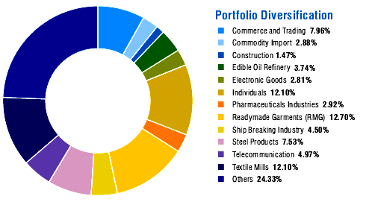

2.15 Departments and Divisions of EBL

These are the main divisions; the structures and functions of each of these divisions are given below:

Serial No | Name of Departments
1 | Audit & Compliance Division
2 | Finance & Accounts Division
3 | Human Resources Department
4 | Corporate Banking Division
5 | Treasury Department
6 | Consumer Banking Division
7 | Brand Management Division
8 | SME Banking Division
9 | Credit Risk Management Division
10 | Credit Administration Department
11 | Operations
12 | International Division
13 | Information Technology Division

2.16 Products and Services of Eastern Bank Ltd.

2.16.1 Consumer Products

Loan Products
- EBL Jibandhara Loan
- EBL Utshab Loan

- EBL Home Loan
- EBL FastCash
- EBL FastLoan
- EBL Executive Loan
- EBL Auto Loan
- EBL TraveLoan
- EBL Parseloan
- Education Finance Pack

Deposit Products

- Interesting Account
- Campus Account
- High Performance
- EBL Repeat
- EBL Confidence
- EBL Just Double

Cards Products
- Simple Credit Card
- LifeStyle Card
- Cool Car


2.16.2 SME Banking Products

Loan Products
- EBL Agrim
- EBL Uddog
- EBL Asha
- EBL Puji
- EBL Banijjo
- EBL Mukti
Deposit Products
- EBL Subidha

2.16.3 Corporate Products

RENAME | DESCRIPTION | PURPOSE | RISK / REPAYMENT | TENOR / VALIDITY
PAD | - Payment Against Document | - Advance against Sight L/C  - Forced Loan | - Recourse on title to Import document | - 21 days per BB
LTR | - Loan Against Trust Receipt | - To finance import L/Cs | - Recourse on Sales  - Clean finance | - 180 days
CC (HYPO) | - Cash Credit Against Hypothecation of inventory Debts | - To finance Inventory  - Other business operations  - General purpose | - Recourse on pledged Inventory  - Ever green | - 12 months
CC (PLEDGE) | - Cash Credit Against Pledge of Inventory and Hypothecation of Book Debts | - To finance pledged Inventory | - Recourse on pledged Inventory  - High monitoring risk  - Ever green | - 12 months
ACCEPTANCE | - Acceptance against ULC | -To finance assets thru Banker's Acceptance | - Resourse on sales | - 12 months
OAP | - Own Acceptance Purchase | - To refinance Bank's Acceptance  - Forced Loan | - No recourse  - Clean finance  - Ever green | - 12 months
LBPD | - Local Bill Purchased Documentary | -To purchase/discount against Local usance L/C  -Upfront interest to be realized | - Recourse on Banks thru acceptance  - Residual on client | - 180 days
FBPD | - Foreign Bill Purchased Documentary | -To purchase/discount/negotiate export doc. against Sight/Usance Export L/C  -Upfront interest to be realized (diff. in FX rate) | - Recourse on Banks  - Residual on client | - 45/180 days
LAFB (CLEAN) | - Loan Against Foreign Bill Clean | - To finance Export Contract | - Clean finance  -Performance risk | - 120 days
LAFBD | - Loan Against Foreign Bill Documentary | - To finance export doc. against Export Contract Sight/Usance | - Recourse on export doc  - Payment risk | - 45/180 days
SLC | - Sight Letter of Credit | - For importation | - Resourse on title to import document | - 12 months
ULC | - Usance Letter of Credit | - For importation | - Recourse on sales | - 12 months
LG | - Letter of Guarantee  -BB/PG/APG/RB/Pay. Gtee | - For Contractual Obligations | - Performance risk  -Ever green | - Specific Period  - Open ended
SOD | - Secured Overdraft | - General Purpose | - 100% cash covered  - No Credit Risk  - Ever Green | - 12 months
OD | - Overdraft Against Other Collateral | - General Purpose | - High Credit Risk  -Recourse on Sales  - Ever Green | - 12 months
Import Loan (Hypo) | - Import Loan Against Hypothecation of Inventory and Book-Debts | - To finance Import L/C or against contract | - Recourse on Sales | - 180 days
Import Loan (Pledge) | - Import Loan Against Imported Merchandise pledged and Hypothecation of Book Debts | - To finance imported merchandise under pledge | - Recourse on pledged inventory  - High monitoring risk | - 180 days
Demand Loan (Hypo) | - Demand Loan Against Hypothecation of Inventory and Book Debts | - To finance Inventory procedured locally  - To finance duty/tax | - Recourse on Sales | - 180 days
Demand Loan (Pledge) | - Demand Loan Against Pledged Inventory procured locally and Hypothecation of Book Debts | - To finance Inventory procured locally under pledge | - Recourse on pledge Inventory  - High monitoring risk | - 180 days
Time Loan | - Time Loan against Other Security/Collateral/Support | - To finance fixed/other asset | - Recourse on Sales  -Collateralise by fixed/other assets | - 12 months
Term Loan | - Term Loan against fixed assets | - To finance fixed asset | - Recourse on fixed asset  -High risk | - Over 12 months  - Max 7 years
PC | - Packing Credit against Export L/C & Export Order | - To finance Export L/C  - Pre-shipment Finance | - Performance risk  - Lien on Export L/C | - 180 days
BCP (Foreign) | - Bankers Cheque Purchase (Foreign) | - To purchase/discount foreign currency Drafts/Payment Order  - Upfront interest to be realized (diff. in FX rate) | - Recourse on Banks  - Residual on client | - 30 days
BCP (Local) | - Bankers Cheque Purchase (Local) | - To purchase/discount Bank Draft and Pay Order  - Upfront interest to be realized | - Recourse on Banks  - Residual on client | - 30 days

2.16.4 Services offered by Consumer Banking Division

- Locker Services
- EBL 5 to 9 (Evening Banking)
- Online Banking
- EBL Visa Electron Card
- Utility Services Bill Collection
- Tuition Fees Collection
- Student File
- Simple Credit Card
  - Local Classic
  - Local Gold
  - Dual Classic
  - Dual Gold

2.16.5 Services offered by SME Banking Division

▪ Debit Card (Visa Electron) Facility
▪ Online Banking
▪ Internet Banking
▪ Bill Payment Facility

2.17 Corporate Social Responsibilities of the Eastern Bank Limited

In this 21st century, the social responsibility of an organization is unavoidable. The societal marketing concept holds that the organization should determine the needs wants, and interests of target markets. It should then deliver superior value to customers in a way that maintains or improves the consumer’s and the society’s well-being. In this concept the marketers will maximize the consumers’ value in the long run rater than short run to maximize their profit.

The bank realizes the importance of contributing to the public, community, and society as a whole as well as participating in environmental protection and conservation for a sustainable future. EBL ensures that the customer already having production facility that is susceptible to damage environment has due environmental clearance certificate from the concerned ministry while granting or renewing credit facility.

Every year EBL contribute their in various types of social activities, are; awarding the talent student through “talent hunt”, monetary contribution in the disable fund, contribute increasing public awareness about the social ills and the most recently EBL contributed BDT 320 million in the Chief Advisors fund for the flood affected people. No one in society can avoid the due responsibilities, EBL’s position is positive in this regard and they wish to find a suitable segment to work with in future to meet the corporate social responsibility.
2.18 Conclusion

Since banks deal with customer’s hard earned cash and finances business, it is natural financial organization largely depends on the service quality, promotional activity, personnel effort and distribution. EBL is the first local private bank in Bangladesh which has implanted the strategy of Centralization. The ultimate goal of following this strategy is to maximizing the profit and also reduces the amount of bad debts and in most reduces the internal conflicts. EBL has diversified its assets and remittance, loan portfolio and now EBL is focusing on establishing a leading small and medium enterprise as well as adding value added consumer banking products to satisfy its customers better as it lunched Simple Credit Card with the fullest possibilities of modern credit card. It has restructured its business process to meet the challenges of rapidly evolving technology based banking services, in the awake of growing competition in the financial service industry and changes in the customer needs. For EBL, hope is shining on the horizon; it is no far that EBL will be the number one private commercial bank in Bangladesh.

CHAPTER 2

REPORTING PART

Corporate Governance of Eastern Bank Limited









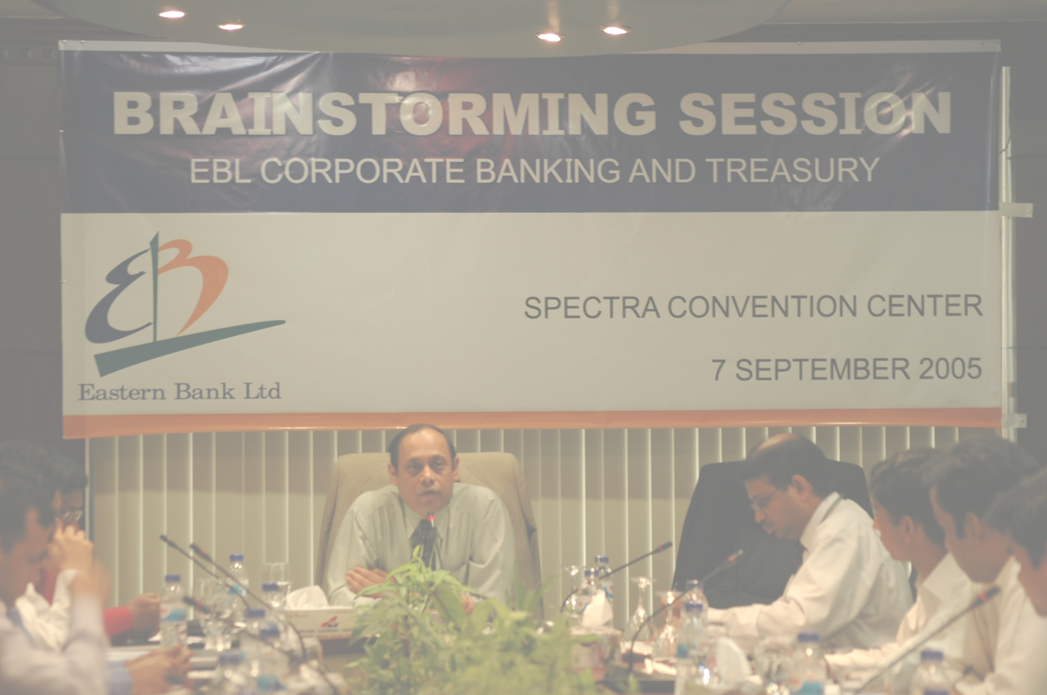


3.1 Introduction

Corporate Governance is based on several critical principles. They include an independent, active and engaged Board of Directors which has the skill to properly evaluate and oversee the business process, business and financial performance, internal control and compliance structure and direct management on strategic and policy issues. On the other hand, the Board has to ensure that the management headed by Chief Executive Officer (CEO) fully discharge their day to day administrative responsibilities prescribed by BB and the Board itself and necessarily refrain themselves from micro management of the management affairs. Eastern Bank Ltd. recognizes the importance of good corporate governance as a major factor in enhancing the efficiency of the organization. The Bank therefore seeks to encourage the conduct of its business to be in line with the principles of good corporate governance, which form a basis for sustainable growth.

3.2 Eastern Bank Limited Corporate Governance

In absence of any specific, integrated and mandatory Corporate Governance instructions, various rules and guidelines by different regulatory bodies constitute an informal structure of Corporate Governance. EBL understands that all these rules and guidelines aim at establishing and maintaining a delicate balance of authority and responsibility conferred on the Board, the collective representatives of shareholders, and the management to safeguard the interest of key stakeholders i.e. depositors and shareholders. Two very important pillars of a good corporate governance structure are “Transparency” and “Accountability” backed by strong Internal Control and Compliance Structure and MIS capabilities.

3.3 Objectives Corporate Governance

For excellence in Corporate Governance, the most important processes one has to concentrate on are:
- Strategy Process, which provides: - A link between Strategy & Operations, - Sets up a mechanism for Strategy Review
- People Process, which provides: - A link between People & Operations
- Operations Process, which provides: - A link between Strategy & People The link between Core Objectives of Corporate Governance and the important processes is the structure of the corporate & the systems through which the activities are organized and executed.

3.4 Analysis Corporate Governance of Eastern Bank Limited

The only guideline regarding Corporate Governance so far issued by Securities & Exchange Commission (SEC) vide letter no SEC/CFD/246/2006-2378 dated January 26, 2006 is currently being followed by Banks, although not mandatory yet.

Corporate Governance Checklist:

Status of Compliance with the conditions imposed by the Securities and Exchange Commission Order no. SEC/CMRRCD/2006-158/Admin/02-08 dated 20 February, 2006 issued under section 2CC of the Securities and Exchange Ordinance, 1969.

Provided, however, that these conditions are imposed on ‘comply or explain’ basis. The companies listed with any stock exchange in Bangladesh should comply with these conditions or shall explain the reasons for non-compliance in accordance with the condition No.5.

(Report under Condition No.5.00)
Condition | Title | Compliance Status. (Put in the appropriate column) |  | Explanation for non compliance
Condition | Title | Complied | Not Complied | Explanation for non compliance
1.00 | Board of Directors (BOD):
1.1 | Board's Size (Should not be less than 5 but not more than 20)
1.2(i) | Independent Directors (At least 1/10th i.e. minimum one)
1.2(ii) | Appointment of Independent Director by elected Directors
1.3 | Separate Chairman & CEO and their clearly defined roles and responsibilities.
1.4 | Directors' Report to Shareholders:
1.4(a ) | Fair presentation of Bank financials
1.4( b) | Maintenance of proper books of account
1.4( c) | Adoption of appropriate accounting policies and estimates consistently
1.4( d) | Compliance with International Accounting Standard
1.4( e) | Soundness of Internal Control System
1.4( f) | Ability to continue as a going concern
1.4( g) | Significant deviations in operating results from last year
1.4( h) | Presentation of key operating and financial data of at least 3 preceding years
1.4( i) | Declaration of Dividend
1.4( j) | Number of Board Meetings held and attendance by each Director
1.4( k) | Shareholding pattern.
2.00 | CFO, Head of Internal Audit (HoIA) and Company Secretary (CS):
2.1 | Appointment of CFO, HoIA and CS and their clearly defined roles and responsibilities.
2.2 | Attendance of CFO & CS in the Board of Directors' Meeting. |  |  | CFO attends the Meeting as end when required.
3.00 | Audit Committee:
3.1 | Constitution of Audit Committee:
3.1(i) | Size of the Audit Committee (Should be at least 3 members.)
3.1(ii) | Audit Committee comprised of Board members including independent director(s).
3.1(iii) | Filling of casual vacancy in the Audit Committee. |  |  | No such case
3.2(i) | Selection of Chairman of the Audit Committee.
3.2(ii) | Professional qualification and experience of the Chairman of the Committee.
3.3.1(i) | Reporting to BOD on the activities of the Audit Committee.
3.3.1 (ii) | Reporting of conflict of interest to the BOD.
3.3.1 (ii) | Reporting of any fraud or irregularity to the BOD.
3.3.1 (ii) | Reporting of suspected infringement of laws to the BOD.
3.3.1 (ii) | Reporting of any other matter to the BOD.
3.3.2 | Reporting of anything having material financial impact to the Commission.
3.4 | Reporting of activities to the shareholders and general investors.
4.00 | External/Statutory Auditors: The external auditors should not be engaged in:
4.00 (i) | Appraisal or valuation services or fairness opinions.
4.00 (ii) | Design and implementation of Financial Information System.
4.00 (iii) | Book keeping or any other related services.
4.00 (iv) | Broker or dealer services.
4.00 (v) | Actuarial services.
4.00 (vi) | Internal audit services.
4.00 (vii) | Any other services determined by the Audit Committee.

Reason Behind Complied

1.00 Board of Directors (BOD):

  - Board’s Size

The number of the board members of the company should not be less than 5 (five) and more than 20 (twenty).

Provided, however, that in the case of banks and non-bank financial institutions, insurance companies and statutory bodies for which separate primary regulators like Bangladesh Bank, Department of Insurance etc. exist, the Board of those companies should be constituted as may be prescribed by such primary regulators in so far as those prescriptions are not inconsistent with the aforesaid condition. Eastern Bank Limited (EBL) board consists with the 10 members and their name given below:

List of directors
- Mr. Md. Showkat Ali Chowdhury
- Mr. A. M. Shaukat Ali
- Mr. Ahmed Jamal
- Mr. Miah Muhammad Shaheedullah
- Mrs. Mahbuba Hossain
- Ms. Aneela Haque
- Mr. Gazi Md. Shakhawat Hossain
- Mr. Asif Mahmood
- Mr. Meah Mohammad Abdur Rahim
- Mr. Ali Reza Iftekhar (Ex-officio)

  - Independent Directors

All companies should encourage effective representation of independent directors on their Board of Directors so that the Board, as a group, includes core competencies considered relevant in the context of each company. For this purpose, the companies should comply with the following:-
- At least one tenth (1/10) of the total number of the company’s board of directors, subject to a Minimum of one, should be independent directors.

For the purpose of this clause

- Independent director” means a director who does not hold any share in the company or who holds less than one percent (1%) shares of the total paid-up shares of the company.
- Not connected with the company’s promoters or directors and shareholder who holds one percent (1%) or more than one percent (1%) shares of the total paid-up shares of the company on the basis of family relationship.
- Who does not have any other relationship whether pecuniary or otherwise, with the company or its subsidiary/associated companies
- Who is not a member, director or officer of any stock exchange, and who is not a shareholder, director or officer of any member of stock exchange or an intermediary of the capital market.

Eastern Bank Limited (EBL) independent directors free from any interest or any business or other relationship which could, or could reasonably be perceived to, materially interferes with the director’s ability to act with a view to the best interests of the company.

- He is not a member of management.
- Not a substantial shareholder of the company or an officer of or otherwise associated directly or indirectly with a substantial shareholder of the company.
- Not within the least three years been employed in an executive capacity by the company or any other group member or been a director after ceasing to hold any such employment.
- Not a principal or a professional adviser to a company or another group member.
- Not a significant supplier or customer of the company.

- No significant contractual relationship with the company. The independent director(s) Mr. Meah Mohammad Abdur Rahim appointed by the elected directors.
In the 15 Annual General Meeting (AGM) held on Tuesday 12 June 2007, four Directors retired and three of them being eligible for re-election were re-elected and one Director was newly elected by the shareholders, they are:

- Aquamarine Distributions Ltd., Represented by Mr. Asif Mahmood
- Unique Eastern (Pvt.) Ltd., Represented by Mr. Gazi Md. Shakhawat Hossain
- Mr. Meah Mohammad Abdur Rahim
- Borak Real Estate (Pvt.) Ltd., Represented by Mr. Miah Muhammad Shaheedullah (newly elected)

This year four Directors shall retire from the office at the 16 Annual General Meeting and four of themwill be eligible for re-election as per BRPD Circular Letter No.8 dated April 26,2003, BRPD ('R) 717/2004/234 dated April 1, 2004 and Section 15(Ka Ka) of the Banking Companies Act,1991.

  - Separate Chairman & CEO and their clearly defined roles and responsibilities

The positions of the Chairman of the Board and the Chief Executive Officer of the companies should preferably be filled by different individuals. Chairman Mr. A. Q. I. Chowdhury, OBE and Managing Director & CEO Mr. Ali Reza Iftekhar .The Chairman of the company should be elected from among the directors of the company. The Board of Directors should clearly define respective roles and responsibilities of the Chairman and the Chief Executive Officer.

- Responsibilities of the Chairman of Board of Director:
- As the chairman of the board of directors (or chairman of any committee formed by the board or any director) does not personally possess the jurisdiction to apply policymaking or executive authority, he not participates in or interferes into the administrative or operational and routine affairs of the bank.

- The chairman may conduct on-site inspection of any bank branch or financing activities under the purview of the oversight responsibilities of the board. He may call for any information relating to bank's operation or ask for investigation into any such affairs; he may submit such information or investigation report to the meeting of the board or the executive committee and if deemed necessary, with the approval of the board, he effect necessary action thereon in accordance with the set rules through the CEO. However any complaints against the CEO have to be apprised to Bangladesh Bank through the board along with the statement of the CEO.

- The chairman offered an office-room, a personal secretary/assistant, a telephone at the office and a vehicle in the business-interest of the bank subject to the approval of the board.
- Leading the board of directors.
- Obtaining contributions from other board members in the board’s deliberations is crucial to ensure that the board works effectively.

- Responsibilities and authorities of CEO:

The CEO of the Eastern Bank Limited (EBL), Mr. Ali Reza Iftekhar, shall discharge the responsibilities and affect the authorities as follows

- In terms of the financial, business and administrative authorities vested upon him by the board, the CEO discharges his own responsibilities. He remains accountable for achievement of financial and other business targets by means of business plan, efficient implementation thereof and prudent administrative and financial management.
- The CEO ensures compliance of the Bank Companies Act, 1991 and/or other relevant laws and regulations in discharge of routine functions of the bank.

- The CEO reports to Bangladesh Bank of issues in violation of the Bank Companies Act, 1991 or of other laws/regulations and, if required, may apprise the board post facto. Complied.
- The recruitment and promotion of all staff of the bank except those in the two tiers below him rest on the CEO. He acts in such cases in accordance with the approved service rules on the basis of the human resources policy and approved delegation of employees as approved by the board. The board or the chairman of any committee of the board or any director not get involved of interfere into such affairs. The authority relating to transfer of and disciplinary measures against the staff, except those at one tier below the CEO, rest on him, which he applies in accordance with the approved service rules. Besides, under the purview of the human resources policy as approved by the board, he nominates officers for training etc.

  - Directors' Report to Shareholders:

The directors of the companies should include following additional statements in the Directors’ Report prepared under section 184 of the Companies Act, 1994:-

1.4 (a) Fair presentations of Bank financials:

The financial statements prepared by the management of the issuer company present fairly its state of affairs, the result of its operations, cash flows and changes in equity.

Eastern Bank Limited (EBL) audited by an external Auditor. Hoda Vasi Chowdhury & Co Chartered Accountants have audited the accompanying Balance Sheet of Eastern Bank Limited as of 31 December 2007 and the related Profit and Loss Account, Statement of Cash Flows, Statement of changes in Equity together with the Notes 1 to 44 for the year then ended. The preparation of these Financial Statements is the responsibility of the Bank's management. Hoda Vasi Chowdhury & Co Chartered Accountants responsibility is to express an independent opinion on these Financial Statements based on Hoda Vasi Chowdhury & Co Chartered Accountants audit.

The Financial Statements prepared in accordance with Bangladesh Accounting Standards (BAS) give a true and fair view of the state of the Bank's affairs as on 31 December 2007 and of the results of its operations and its, cash flows for the year then ended and comply with the Bank Companies Act 1991, the rules and regulations issued by the Bangladesh Bank, the Companies Act 1994, the Securities and Exchange Rules, 1987 and other applicable laws and regulations.

Found their Fair presentations of Bank financials from the auditor’s report.

Auditors report:

- We have obtained all the information and explanations which to the best of our knowledge and belief were necessary for the purposes of our audit and made due verification thereof.

- In our opinion, proper books of account as required by law have been kept by the Bank so far as it appeared from our examination of those books and proper returns adequate for the purposes of our audit have been received from branches not visited by us.

- The Bank's Balance Sheet and Profit and Loss Account together with the annexed notes 1 to 44 dealt with by the report are in agreement with the books of account and returns.

- The expenditure incurred was for the purpose of the Bank's business.

- The financial position of the Bank at 31 December 2007 and the profit for the years then ended have been properly reflected in the Financial Statements, the Financial Statements have been prepared in accordance with the generally accepted accounting principles.
- The Financial Statements have been drawn up in conformity with the Bank Companies Act 1991 and in accordance with the accounting rules and regulations issued by the Bangladesh Bank.

- Subject to above paragraphs, adequate provisions have been made for advances and other assets which are, in our opinion, doubtful of recovery.

- The Financial Statements conform to the prescribed standards set in the accounting regulations issued by the Bangladesh Bank after consultation with the professional accounting bodies of Bangladesh.
- The records and statements submitted by the branches have been properly maintained and consolidated in the Financial Statements on the basis of the statements certified by the branch manager and considered by us as correct.

- The information and explanations required by us have been received and found satisfactory.

- We have reviewed over 80% of the risk weighted assets of the bank and we have spent around 3,000 person hours for the audit of books and accounts of the bank.

- The capital adequacy ratio (CAR), as required by law, has been maintained adequately during the year.

For the stakeholder and investors EBL maintain Fair presentations of Bank financials. In annual report of 2007 EBL presents highlight on the overall activities which provide the clear view to the stakeholder and investors that EBL maintain Fair presentations of Bank financials.
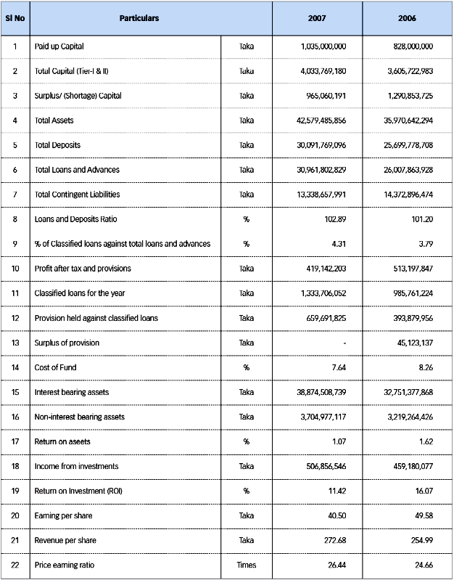

1.4(b) Maintenance of proper books of account

Eastern bank limited maintain proper book of account. Their account system totally operated by systematically and software base. Only data input to the system then automatically it’s entered into GL account, trial balance and then to balance sheet. So we can say that Proper books of account of the issuer Eastern Bank Limited (EBL) have been maintained.

1.4(c) Adoption of appropriate accounting policies and estimates consistently
Significant Accounting Policies

- Basis of preparation of the Financial Statements
These Financial Statements of the Bank as at 31 December, 2007 have been prepared in accordance with "First Schedule" of the Bank Companies Act 1991 as amended by BRPD Circular no. 14 of 2004, Bangladesh Bank Circulars, Bangladesh Accounting Standards (BASs), the Companies Act 1994, the Securities and Exchange Act 1993, Securities and Exchange Rules 1987 and other rules and regulations applicable in Bangladesh on a going concern basis.

- Consolidation
Statement of affairs and Income and expenditure statements of all branches and Head office are consolidated together to prepare Financial Statements of the Bank for the year 2007.
- Investments
Investments are stated as per following bases:
Items Basis
Government treasury bills Face Value (Marking to Market)
ICB's debenture Face value
Prize bond Cost price
Shares Lower of cost or market value

- Loans and Advances
Loans and Advances are stated at gross amount. General provisions on unclassified Loans and Advances, & contingent assets, Specific provisions for classified loans and interest suspense account thereon are shown under other liabilities.

- Fixed Assets and Depreciation
- Fixed assets are stated at cost less accumulated depreciation.
- Depreciation is charged at the following rates on all fixed assets and the amount is calculated from the date of capitalization. Depreciation is charged on disposed assets up to date of disposal and accumulated depreciation on any disposal/write off are reversed.
- Depreciation rates used for each type of fixed assets are as follows
 | Rate of
Particulars of Fixed Assets | Depreciation p.a. | Method of depreciation
Land | 0% | Reducing balance
Building | 2.5% | Reducing balance
Furniture and fixtures | 10% | Reducing balance
Office Equipment | 20% | Reducing balance
Motor Vehicles | 20% | Reducing balance
- Repair and maintenance are charged to income as and when incurred.
- Lease hold fixed assets
The Bank entered into a lease agreement in 2004 for its networking equipment for Taka 91,591,148 for a term of 5 years with IDLC Finance Limited. These assets are accounted for under finance lease in compliance with Bangladesh Accounting Standards 17 (Leases).
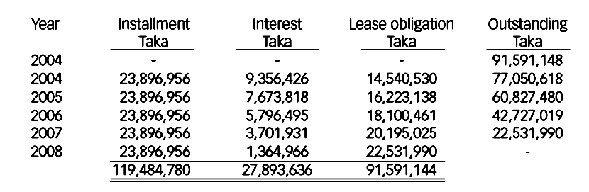

- Revenue Recognition
The revenue during the year is recognized following all conditions of revenue recognition as prescribed by BAS - 18 "Revenue Recognition".
- Interest income
Interest on unclassified (excluding SMA) loans and advances have been accounted for as income on accrual basis, interest on classified loans and advances (including SMA) is credited to interest suspense account and actual receipt of interest there from is credited to income as and when received as per instruction of Bangladesh Bank.
- Fees and Commission Income
Fess and Commission income arises on services provided by the Bank and recognized on a cash receipt basis. Commission charged to customers on letter of credit and letter of guarantee are credited to income at the time of effecting the transactions.

- Dividend Income
Dividend income from shares is recognized at the time when it is realized.

- Interest paid on borrowings and Deposits
Interest paid on Borrowings and Deposits are calculated on a day basis and recognized on accrual basis.

- Interest Income from Investments
Interest income on investments in Government and other trust securities, debentures and bonds is accounted for on accrual basis.

- Management & Other expenses
Expenses incurred by the Bank are recognized on actual or accrual basis whenever necessary.
- Provision for Loans and Advances
Provision against classified loans and advances is made on the basis of quarter end review by the management and instruction Contained in BCD Circular no.12 dated 4 September 1995, BRPD circular no. 16 dated 6 December 1998, BRPD circular no. 9 dated 14 May 2001, BRPD circular no.02 dated 15 February 2005 and BRPD circular no. 05 dated 27 April 2005. The classification rates as per Bangladesh Bank circulars used for provision are as follows:

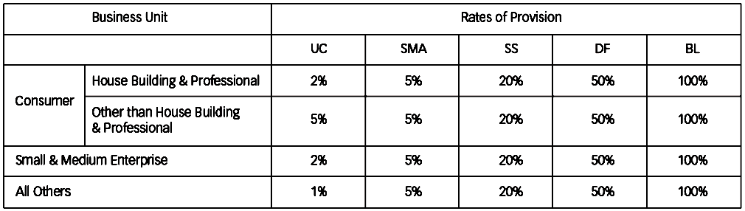

- Provision for taxation
- Current Tax

Provision for current income tax has been made @ 45% as prescribed in Finance Ordinance, 2007 of the profit made by the Bank considering major taxable allowances and disallowances and the same is understated /overstated to that extent. Any shortfall / excess provision will be duly adjusted after final assessment.

- Deferred Tax
Deferred Tax is calculated on the taxable / deductible temporary differences between tax base amount and carrying amount of assets and liabilities as required by Bangladesh Accounting Standard (BAS)-12 Accounting for Taxes".

- Retirement benefits
- Gratuity
- The Bank operates a funded gratuity scheme. The policy has been approved by the National Board of Revenue with effect from 01 January 1997. Gratuity is paid to those employees who have completed minimum 10 (ten) years of continuous service at the time of their separation from the Bank.

- Provision for gratuity is made in the books annually on the basis of actuarial valuation made once in three years (@ 7% of basic payroll each year).The next actuarial valuation will be done by June 2008.

- Provident fund

The Bank operates a contributory provident fund for its permanent employees. Provident fund is administered by a board of trustees and is funded by contributions partly from the employees and partly from the company at a pre-determined rate. This fund got approval from the National Board of Revenue on July 31, 1997. Any investment decision out of this fund is made separately from that of the company's funds.

- Superannuation fund

The Bank's superannuation fund was approved by the National Board of Revenue with effect from November 20, 1999. This is payable to the employees of the Bank as per their ranks, grades and length of service with the Bank. The Bank conducted an actuarial valuation of the fund in 2006 and the next valuation is due in 2009. The broader objective of this valuation was to calculate the ongoing as well as future liability that will arise from the pool of employees of the Bank. The actuary recommended the minimum contribution of 0.63% of total admissible benefits into the fund each year.

- Exchange rate:
Foreign currencies are translated into Taka currency at the following rates:

- Assets and Liabilities existing at the takeover date, at the rate prevailing on 6 July 1991.

- Assets relating to customers' foreign currency deposit account at standard mid rates of USD 1=Tk.68.5728 and GBP 1=Tk.136.7342 and EURO 1= Tk.100.2954 as on 31 December 2007.

- Other foreign currency related transactions have been converted by using the rate of exchange prevailing on the dates of such transactions.

- Earnings per share

Earnings per share (EPS) has been computed by dividing the profit after tax (PAT) by the number of ordinary shares outstanding as on 31 December 2007 as per BAS- 33 "Earning Per Share Diluted earnings per share was not required to calculate as there were no dilution possibilities during the year. Reconciliation of Books and Account Books of account in regard to inter-bank (in Bangladesh & outside Bangladesh) as well as inter-branches are reconciled at a regular Interval.

- Reconciliation of Books and Account
Books of account in regard to inter-bank (in Bangladesh & outside Bangladesh) as well as inter-branches are reconciled at a regular interval.

- Cash Flow Statement
Cash Flow Statement is prepared in accordance with Bangladesh Accounting Standard (BAS) 7 " Cash Flow Statement" and under the guideline of Bangladesh Bank BRPD Circular No.14 dated 25 June 2003 The Statement shows the Structure of Changes in cash and cash equivalents during the financial year. It is broken down into Operating activities, investing activities and Financing activities .
- Statement of Changes in Equity
Statement of changes in Equity is prepared in accordance with Bangladesh Accounting Standard (BAS) 1 "Presentation of Financial Statements” and relevant guidelines of Bangladesh Bank.

- Liquidity Statement
The Liquidity Statement has been prepared in accordance with remaining maturity grouping of Assets and Liabilities as of the close of the year.
1.4( d) Compliance with International Accounting Standard

Compliance of Bangladesh Accounting Standards (BAS)
Name of BAS | BAS No. | Status
Presentation of Financial Statements | 1 | Applied
Inventories | 2 | N/A
Cash Flow Statements | 7 | Applied
Accounting Policies, Changes in Accounting Estimates --and Errors | 8 | Applied
Events after the Balance Sheet Date | 10 | Applied
Construction Contracts | 11 | N/A
Income Taxes | 12 | Applied
Segment Reporting | 14 | Applied
Property, Plant and Equipments | 16 | Applied
Leases | 17 | Applied
Revenue Recognition | 18 | Applied
Employee Benefits | 19 | Applied
Accounting for Govt. Grants and disclosures of Govt. Assistances | 20 | N/A
The Effects of Changes in Foreign Exchange Rates | 21 | Applied
Borrowing Costs | 23 | Applied
Related Party Disclosures | 24 | Applied
Consolidated and Separate Financial Statements | 27 | N/A
Investments in Associates | 28 | N/A
Disclosures in Financial Statements of Banks and Similar Financial Institutions | 30 | Applied
Interest in Joint Ventures | 31 | N/A
Earning Per Share | 33 | Applied
Interim Financial Reporting | 34 | Applied
Impairment of Assets | 36 | Applied
Provisions, Contingent Liabilities and Contingent Assets | 37 | Applied
Intangible Assets | 38 | Applied
Investment Property | 40 | N/A
Agriculture | 41 | N/A
*BAS same as IAS.
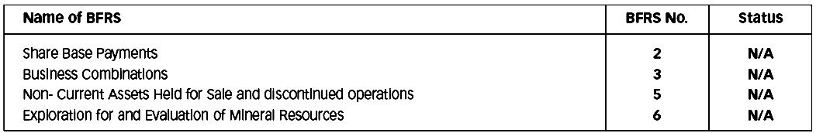

*BFRS same as IFRS

1.4(e) Soundness of Internal Control System

Internal control system one of Roles and Responsibilities of Audit Committee

- Evaluate whether management is setting the appropriate compliance culture by communicating the importance of internal control and management of risk and ensuring that all employees have understanding of their role and responsibilities.
- Review the arrangements made by the management for building a suitable Management Information System [MIS] including computerization system and its applications.
- Consider whether internal control strategies recommended by internal and external auditors have been implemented by the management.
- Review the existing risk management procedures for ensuring an effective internal check and control system.
- Review the corrective measures taken by the management as regards the reports relating to fraud forgery, deficiency in internal control or other similar issues detected by internal and external auditors and inspectors of the regulatory and inform the board on a regular basis.

1.4(f) Ability to continue as a going concern

There are no significant doubts upon the issuer Eastern Bank Limited (EBL) ability to continue as a going concern. If the issuer Eastern Bank Limited (EBL) is not considered to be a going concern, the fact along with reasons thereof should be disclosed.

1.4 (g) Significant deviations in operating results from last year
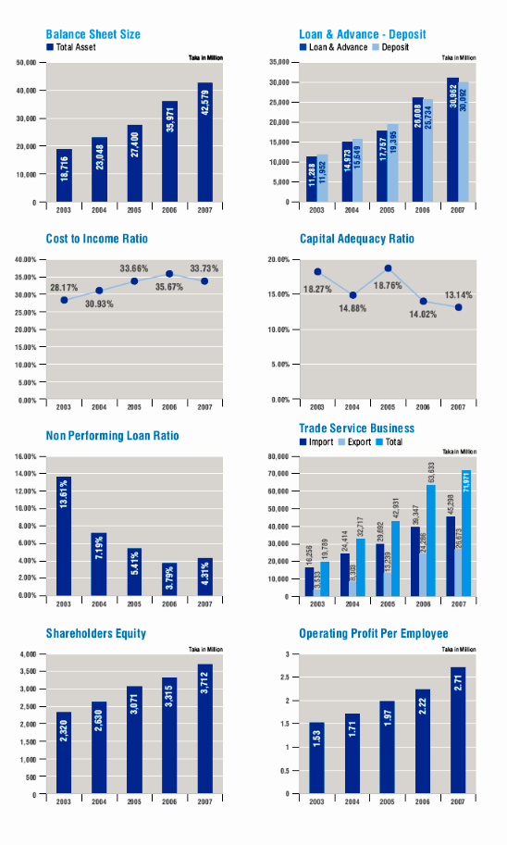
Graphical picture provide the real scenario

1.4(h) Presentation of key operating and financial data of at least 3 preceding years

Financial Highlight of Eastern Bank Limited (EBL)

Particulars | 2003 | 2004 | 2005 |  | 2006 | 2007
Authorized Capital | 1,000 | 1,000 | 3,300 |  | 3,300 | 3,300
Paid Up Capital | 828 | 828 | 828 |  | 828 | 1,035
Reserves | 2,560 | 2,733 | 3,132 |  | 3,146 | 3,539
Deposits & Other Accounts | 11,952 | 15,649 | 19,396 |  | 25,734 | 30,092
Loans & Advances | 11,288 | 14,973 | 17,758 |  | 26,008 | 30,962
Export | 3,533 | 8,303 | 13,239 |  | 24,286 | 26,673
Import (LC) | 16,256 | 24,414 | 29,692 |  | 39,347 | 45,298
Guarantee Business | 354 | 947 | 555 |  | 651 | 1,201
Operating Income | 1,985 | 2,241 | 2,957 |  | 4,272 | 5,325
Operating Expenses | 1,226 | 1,349 | 1,901 |  | 2,913 | 3,454
Operating Profit | 759 | 892 | 1,056 |  | 1,358 | 1,870
Net Profit before Tax | 638 | 851 | 967 |  | 1,134 | 1,286
Core Capital (Tier - I) | 2,321 | 2,641 | 2,837 |  | 3,068 | 3,279
Supplementary Capital (Tier - II) | 120 | 161 | 333 |  | 537 | 755
Total Capital | 2,441 | 2,802 | 3,170 |  | 3,606 | 4,034
Total Risk Weighted Assets | 13,355 | 18,829 | 16,901 |  | 25,721 | 30,687
Total Assets (Excluding contingent ) | 18,716 | 23,048 | 27,400 |  | 35,971 | 42,579
Book Value per share ( Taka ) | 282 | 318 | 371 | 400 |  | 359
Market Value per share ( Taka ) | 382 | 780 | 1,223 | 793 |  | 1,071
Earnings per share ( Taka) | 43 | 58 | 66 | 50 |  | 40.50
Dividend per share ( Taka) | 20 | 43 | 40 | 45 |  | 34
Operating Profit Per Employee ('000 Taka) | 1,533 | 1,709 | 1,970 | 2,219 |  | 2,711
Operating Income Per Branch ('000 Taka) | 1,000 | 1,000 | 3,300 | 3,300 |  | 3,300
Return on Equity ( Average ) | 15.33% | 18.44% | 19.17% | 16.07% |  | 11.93%
Return on Assets ( Average) | 1.94% | 2.32% | 2.17% | 1.62% |  | 1.07%
Cost to Income Ratio | 28.17% | 30.93% | 33.66% | 35.67% |  | 33.73%
Net Interest Margin Ratio | 2.47% | 3.26% | 2.81% | 2.11% |  | 3.34%
Classified Loan as a % of total loans | 13.61% | 7.19% | 5.41% | 3.79% |  | 4.31%
Tier - I Capital Ratio | 17.38% | 14.03% | 16.79% | 11.93% |  | 10.68%
Tier - II Capital Ratio | 0.90% | 0.85% | 1.97% | 2.09% |  | 2.46%
Total Capital Adequacy Ratio | 18.27% | 14.88% | 18.76% | 14.02% |  | 13.14%
RWA to Total Assets | 71.36% | 81.70% | 71.50% | 71.50% |  | 72.07%
Number of Branches | 22.00 | 22.00 | 22.00 | 25.00 |  | 25.00
Number of Employees | 195.00 | 522.00 | 536.00 | 612.00 |  | 690.00

1.4(i) Declaration of Dividend

Particulars | 2003 | 2004 | 2005 | 2006 | 2007
Dividend per share ( Taka) | 20 | 43 | 40 | 45 | 34

1.4(j) Number of Board Meetings held and attendance by each Director

Name of the Directors | Meetings
Mr. A. Q. I. Chowdhury , OBE | 21
Mr. Md. Showkat Ali Chowdhury | 18
Mr. A. M. Shaukat Ali [Representing Arusha & Co. (Pvt.) Ltd.] | 25
Mr. Ahmed Jamal | 20
Mrs. Mahbuba Hossain | 17
Ms. Aneela Haque | 23
Mr. Gazi Md. Shakhawat Hossain [Representing Unique Eastern (Pvt.)Ltd.] | 24
Mr. Asif Mahmood [Representing Aquamarine Distributions Ltd.] | 18
Mr. Meah Mohammad Abdur Rahim | 14
Mrs. Salina Ali (Up to 12th June 2007) | 10
Mr. Miah Muhammad Shaheedullah [Representing Borak Real Estate (Pvt.) Ltd.] (From 12th June 2007) | 14
Mr. Kazi Mahmood Sattar (Up to 30th June 2007) | 13
Mr. Ali Reza Iftekhar (From 1st July 2007) | 14
1.4( k) Shareholding pattern

Slab wise List as on 31 December 2007

In terms of the clause (cha) of the Memorandum of Association and Article # 4 of the Articles of Association of the Bank and clause 4 of the scheme of Reconstruction, the Authorized Capital of the Bank was BDT 3,300,000,000.00 divided into 33,000,000 ordinary shares of Tk 100 each. The issued, subscribed and fully paid up capital of the bank is Tk 1,035,000,000.00 divided into 10,350,000 ordinary shares of Tk 100 each. Subject to above conditions the breakup of issued, subscribed and paid up capital of Tk 1,035,000,000.00 as on 31 December 2007 is as follows:
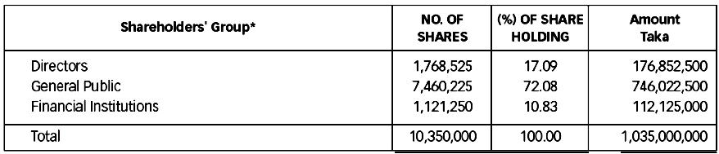

* None of the CFO, Head of Internal Audit, Company Secretary and top five salaried executives of the Bank has any shareholdings of EBL as on reporting date.

A range wise distribution schedule of the above shares is given below as required by the regulation 37 of the Listing Regulations of Dhaka Stock Exchange Limited.

De - materialization: 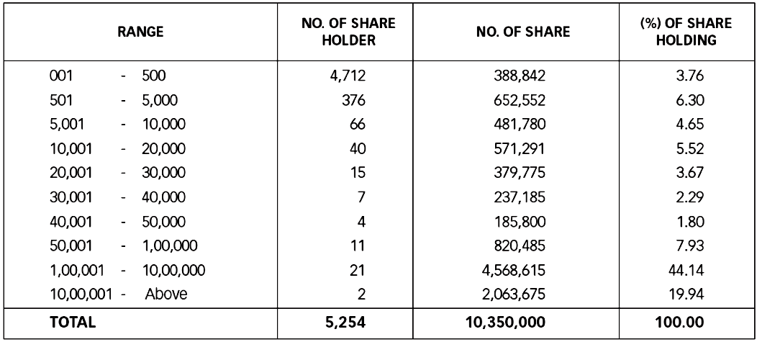

2.00 CFO, Head of Internal Audit (HoIA) and Company Secretary (CS):

2.1 Appointment of CFO, HoIA and CS and their clearly defined roles and responsibilities.

The Eastern Bank Limited (EBL) appoint a Head of Finance Malick Musfique Reza, a Head of Internal Audit Sheikh Mahfuzul Hoque and a Company Secretary Mr.Safiar Rahman. The Board of Directors clearly defines respective roles, responsibilities and duties of the CFO, the Head of Internal Audit and the Company Secretary.

2.2 Attendance of CFO & CS in the Board of Directors' Meeting.

The CFO and the Company Secretary of the companies should attend meetings of the Board of Directors, provided that the CFO and/or the Company Secretary should not attend such part of a meeting of the Board of Directors which involves consideration of an agenda item relating to the CFO and/or the Company Secretary.

3.00 Audit Committee

The Eastern Bank Limited (EBL) have an Audit Committee as a sub-committee of the Board of Directors.

The Audit Committee assist the Board of Directors in ensuring that the financial statements reflect true and fair view of the state of affairs of the company and in ensuring a good monitoring system within the business.

The Audit Committee responsible to the Board of Directors. The duties of the Audit Committee clearly set forth in writing.

3.1(i) Size of the Audit Committee (Should be at least 3 members.)

The members of the Audit Committee are:

SL. no | Name | Status with the bank | Status with the committee | Educational Qualification
1. | Mr. A. M. Shaukat Ali | Director | member | B. Sc. Engineer
2. | Mr. Ahmed Jamal | Director | member | B.Sc.(Hons),M.Sc.
3. | Mr. Gazi Md. Shakhawat Hossain | Director | member | M.Com (Accounting

3.1(ii) Audit Committee comprised of Board members including independent director(s)

The Board of Directors should appoint members of the Audit Committee who should be directors of the company and should include at least one independent director.

3.1(iii) Filling of casual vacancy in the Audit Committee

When the term of service of the Committee members expires or there is any circumstance causing any Committee member to be unable to hold office until expiration of the term of service, thus making the number of the Committee members to be lower than the prescribed number of 3 (three) persons, the Board of Directors should appoint the new Committee member(s) to fill up the vacancy(ies) immediately or not later than 1 (one) month from the date of vacancy(ies) in the Committee to ensure continuity of the performance of work of the Audit Committee.
No such Case occurred in 2007 Eastern Bank Limited (EBL).

3.2(i) Selection of Chairman of the Audit Committee

The Board of Directors select 1 (one) member of the Audit Committee to be Chairman of the Audit Committee.

3.2(ii) Professional qualification and experience of the Chairman of the Committee

The Chairman of the audit committee has a professional qualification or knowledge, understanding and experience in accounting or finance.

  - Reporting of the Audit Committee

3.3.1 Reporting to the Board of Directors

(i) The Audit Committee report on its activities to the Board of Directors.
(ii) The Audit Committee immediately report to the Board of Directors on the following findings, if any:-

- Report on conflicts of interests;
- Suspected or presumed fraud or irregularity or material defect in the internal control System.
- Suspected infringement of laws, including securities related laws, rules and\ regulations. And
- Any other matter which should be disclosed to the Board of Directors immediately.

3.3.2 Reporting of anything having material financial impact to the Commission

If the Audit Committee has reported to the Board of Directors about anything which has material impact on the financial condition and results of operation and has discussed with the Board of Directors and the management that any rectification is necessary and if the Audit Committee finds that such rectification has been unreasonably ignored, the Audit Committee should report such finding to the Commission, upon reporting of such matters to the Board of Directors for three times or completion of a period of 9 (nine) months from the date of first reporting to the Board of Directors, whichever is earlier.

The Audit Committee holds meetings at least once every three months to scrutinize matters as assigned by the Board of Directors. The Audit Committee held 5 (Five) Meetings in 2007 as per following dates:

- 16th meeting held on 4th April, 2007
- 17th meeting held on 26th July, 2007
- 18th meeting held on 2nd August, 2007
- 19th meeting held on 29th August, 2007
- 20th meeting held on 1st November, 2007
  - Reporting of activities to the shareholders and general investors

Report on activities carried out by the Audit Committee, including any report made to the Board of Directors under condition 3.3.1 (ii) above during the year, signed by the Chairman of the Audit Committee and disclosed in the annual report of the issuer company.

4.00 External/Statutory Auditors:

The Hoda Vasi Chowdhury Co. not to perform the following services of the Eastern Bank Limited (EBL); namely:-

- Appraisal or valuation services or fairness opinions
Such as they are not related with the assets revaluation.

- Financial information systems design and implementation.
They are not related any kind of system design operation.

- Book-keeping or other services related to the accounting records or financial statements
They not engage themselves with the any kind of Book Keeping and Finance related activities with the EBL.
- Broker-dealer services
Such as share or right share activities.

- Actuarial services;
Such as gratuity activities

- Internal audit services; and
External auditor not related with the internal auditor activities.
- Any other service that the Audit Committee determines
EBL not engage them any special activities. Other person or company engaged for such activities.

CHAPTER 4 & 5

FINDINGS AND RECOMMENDATIONS

4.00 Findings

Some systematic problems of corporate governance all over the world Eastern Bank Limited is not different then other company.

4.01 Systemic problems of corporate governance

- Demand for information:
A barrier to shareholders using good information is the cost of processing it, especially to a small shareholder. The traditional answer to this problem is the efficient market hypothesis (in finance, the efficient market hypothesis (EMH) asserts that financial markets are efficient), which suggests that the small shareholder will free ride on the judgments of larger professional investors.

- Monitoring costs:
In order to influence the directors, the shareholders must combine with others to form a significant voting group which can pose a real threat of carrying resolutions or appointing directors at a general meeting.

- Supply of accounting information:
Financial accounts form a crucial link in enabling providers of finance to monitor directors. Imperfections in the financial reporting process will cause imperfections in the effectiveness of corporate governance. This should, ideally, be corrected by the working of the external auditing process.

4.02 To maintain some principles for corporate governance

- Rights and equitable treatment of shareholders:
Organizations should respect the rights of shareholders and help shareholders to exercise those rights. They can help shareholders exercise their rights by effectively communicating information that is understandable and accessible and encouraging shareholders to participate in general meetings.

- Interests of other stakeholders:
Organizations should recognize that they have legal and other obligations to all legitimate stakeholders.
- Role and responsibilities of the board:
The board needs a range of skills and understanding to be able to deal with various business issues and have the ability to review and challenge management performance. It needs to be of sufficient size and have an appropriate level of commitment to fulfill its responsibilities and duties. There are issues about the appropriate mix of executive and non-executive directors.

- Integrity and ethical behavior:
Ethical and responsible decision making is not only important for public relations, but it is also a necessary element in risk management and avoiding lawsuits. Organizations should develop a code of conduct for their directors and executives that promotes ethical and responsible decision making. It is important to understand, though, that reliance by a company on the integrity and ethics of individuals is bound to eventual failure. Because of this, many organizations establish Compliance and Ethics Programs to minimize the risk that the firm steps outside of ethical and legal boundaries.

- Disclosure and transparency:
Organizations should clarify and make publicly known the roles and responsibilities of board and management to provide shareholders with a level of accountability. They should also implement procedures to independently verify and safeguard the integrity of the company's financial reporting. Disclosure of material matters concerning the organization should be timely and balanced to ensure that all investors have access to clear, factual information.

Issues involving corporate governance principles include:

- Internal controls and the independence of the entity's auditors.
- Oversight and management of risk
- Oversight of the preparation of the entity's financial statements
- Review of the compensation arrangements for the chief executive officer and other senior executives
- The resources made available to directors in carrying out their duties
- The way in which individuals are nominated for positions on the board

5.00 Recommendations

5.01 Internal corporate governance controls

- Monitoring by the board of directors:

The board of directors, with its legal authority to hire, fire and compensate top management, safeguards invested capital. Regular board meetings allow potential problems to be identified, discussed and avoided. Whilst non-executive directors are thought to be more independent, they may not always result in more effective corporate governance and may not increase performance. Different board structures are optimal for different firms. Moreover, the ability of the board to monitor the firm's executives is a function of its access to information. Executive directors possess superior knowledge of the decision-making process and therefore evaluate top management on the basis of the quality of its decisions that lead to financial performance outcomes, ex ante. It could be argued, therefore, that executive directors look beyond the financial criteria.

- Balance of power:

The simplest balance of power is very common; require that the President be a different person from the Treasurer. This application of separation of power is further developed in companies where separate divisions check and balance each other's actions. One group may propose company-wide administrative changes, another group review and can veto the changes, and a third group check that the interests of people (customers, shareholders, employees) outside the three groups are being met.

- Remuneration:

Performance-based remuneration is designed to relate some proportion of salary to individual performance. It may be in the form of cash or non-cash payments such as shares and share options, superannuation or other benefits. Such incentive schemes, however, are reactive in the sense that they provide no mechanism for preventing mistakes or opportunistic behavior, and can elicit myopic behavior

5.02 External corporate governance controls

External corporate governance controls encompass the controls external stakeholders exercise over the organization. Some Examples include

- Competition
- debt covenants
- demand for and assessment of performance information (especially financial statements)
- government regulations
- managerial labor market
- media pressure
- Takeovers.
6.00 Conclusions
Since the banking service especially the private Banks are doing good business, so it is clear that the modern people are more concerned about the securing their valuable assets and get high quality and timely services. For this reason lot of new commercial banks has been established in last few years and these banks have made this banking sector very competitive, so now banks have to organize their operation and do thir operations according to the need of the market. Banking sectors no more depends on the traditional method of banking. In this competitive world this sector has trenched its wings wide enough to cover any kind of financial services anywhere in this world. The major task for banks, to survive in this competitive environment is by managing its assets and liabilities in an efficient way.
The study was conducted on the proceeding of the activities carried out by Eastern Bank Limited (EBL) corporate governance. As the study was concentrated towards the management efficiency and the stakeholder and investors services. Therefore few limitations occurred while conducting the study. In spite of having many challenges, adverse economic conditions and market pattern during the years, the bank tried to maintain its growth trend through the indicators like strong management efficiency, proper corporate governance and their timely services to their clients.
On the basis convincing reasons, Eastern Bank Limited (EBL) management believes that in the coming years the bank will try it s level best to sustain good corporate governance and maintain rest of the years. With the current performance of the bank and they will certainly make Eastern Bank Limited (EBL) one of the best private bank inBangladesh.

CHAPTER-7
APPENDICES

Index

A
Ability to continue as a going concern 42
Adoption of appropriate accounting policies and estimates consistently 35
Appointment of CFO, HoIA and CS and their clearly defined roles and responsibilities. 47
Attendance of CFO & CS in the Board of Directors' Meeting. 47
Audit Committee 08
Audit Committee comprised of Board members including independent director(s) 48
Audit Committee 47
Auditors report 32

B
Basis of preparation of the Financial Statements 35
Board of Directors of Eastern Bank Limited 07
Board’s Size 27
Branches of Eastern Bank Limited 11
Business Performance Indicators 12

C
Cash Flow Statement 40
CFO, Head of Internal Audit (HoIA) and Company Secretary (CS) 47
Compliance with International Accounting Standard 41
Compliance with International Accounting Standard 41
Conclusions 57
Consolidation 35
Consumer Products 17
Corporate Products 18
Corporate Social Responsibilities of the Eastern Bank Limited 20
Credit Risk Management [Portfolio Diversification] 15
Current Banking Scenario of BD and EBL’s Position in the Market 14
Current Profile of Eastern Bank Limited 06
Current Tax 39

D
Declaration of Dividend 45
Deferred Tax 39
Departments and Divisions of EBL 16
Directors' Report to Shareholders: 31
Dividend Income 37

E
Earnings per share 40
Exchange rate: 40
Executive committee 08
External corporate governance controls 56
External/Statutory Auditors 40

F
Fair presentations of Bank financials: 31
Fees and Commission Income 37
Filling of casual vacancy in the Audit Committee 48
Findings 52
Findings and Recommendations 51
Fixed Assets and Depreciation 36

G,H
Historical Review and Different Milestones of Eastern Bank Limited 04

I
Independent Directors 27
Interest income 37
Interest Income from Investments 37
Interest paid on borrowings and Deposits 37
Internal corporate governance controls 55
Investments 35

J, K, L
Lease hold fixed assets 36
Liquidity Statement 40
Loans and Advances 36

M
Maintenance of proper books of account 35
Management & Other expenses 37
Management Aspects 08
Management Committee 09
Management Hierarchy at Eastern Bank Limited 10
Mission 03

N
Number of Board Meetings held and attendance by each Director 45

O
Objectives of Eastern Bank Limited 04

P
Presentation of key operating and financial data of at least 3 preceding years 44
principles for corporate governance 52
Products and Services of Eastern Bank Ltd. 17
Professional qualification and experience of the Chairman of the Committee 48
Provision for Loans and Advances 39
Provision for taxation 39

Q,R
Ratio Analysis of Balance Sheet elements in 2007 13
Recommendations 55
Reconciliation of Books and Account 40
Reporting of activities to the shareholders and general investors 50
Reporting of anything having material financial impact to the Commission 49
Reporting of the Audit Committee 49
Reporting to the Board of Directors 49
Revenue Recognition 37
Roles and Responsibilities of Audit Committee 42

S
Selection of Chairman of the Audit Committee 48
Separate Chairman & CEO and their clearly defined roles and responsibilities 29
Services offered by Consumer Banking Division 20
Services offered by SME Banking Division 20
Shareholding pattern 46
Significant deviations in operating results from last year 43
Size of the Audit Committee 48
SME Banking Products 17
Soundness of Internal Control System 42
Statement of Changes in Equity 40
Systemic problems of corporate governance 52

U, V
Values 03
Vision 03

W, X, Y,Z

Glossary
Accountability
The liability of a board of directors to shareholders and stakeholders for corporate performance and actions of the corporation.
Audit
Anexamination and verification of a company’s financial and accounting records and supporting documents by a professional and independent External Auditor
Audit report
Statement of the accounting firm's assessment of the validity and accuracy of a company's financial information and conformity with accepted accounting practices.
Auditor
a person certified at the government level conduct an audit
Auditor’s Report
An auditor’s opinion on the accuracy of the company’s financial statements commonly included in the annual report.
Business judgment rule
Rule granting directors of publicly listed companies' immunity from liability if their actions were executed in good faith, using sound business judgment and exercised with reasonable care.
Benchmarking
A company's use of information about other firms in the same industry used for comparisons and to set standards and goals.
Board of directors
The collective group of individuals elected by the shareholders of a corporation to oversee the management of the corporation.
Chief executive officer CEO
The chief executive officer or CEO is the highest ranking officer of he company, and is often Chairman of the Board as well.
Chief financial officer CFO
The corporate executive responsible for the financial planning and record-keeping of a company.
Class of shares
Multiple shares issued by the same company of the same rights or powers.
Corporate governance
The system of relations between the shareholders, Board of Directors and management of a company, as defined by the corporate charter, bylaws, formal policy and rule of law.
Disclosure
The public release of information. Often used in connection with information that may influence the market for a company's stock.
Independence
Generally defined as not receiving, other than for service on the board, any consulting, advisory or other fee from the company, and not being with the company, or any subsidiary of the company. Most governance experts believe that a majority of the board should have no other relationship to the company.
Independent Auditor
An outside accounting firm that audits the financial records a company.
Stockholder
A person or entity that owns shares of stock in a company.

Bibliography

- Corporate Ownership and Control practices by Brian R. Cheffins 2008 by Oxford University Press.
- The Professions and Corporate Governance practices by John Coffee 2006 by Oxford University Press.
- Corporate Governance practices By Jay A. Conger and Edward E. Lawler III
- Corporate Governance prepared by Kenneth A Kim and John R. Nofsinger (2nd Edition)
- Corporate Governance prepared by Robert A. G. Monks and Nell Minow
- The New Corporate Governance in Theory and Practice by Stephen Bainbridge
- Theories of Corporate Governance: The Theoretical Foundations prepared by Thomas Clarke
- Annual report of Eastern Bank Limited 2006 & 2007.
- SEC guideline for corporate governance 2006.SEC commission order no SEC/CMRRCD/2006-158/admin/02-08
- Bangladesh bank guideline for corporate governance.(BRPD circular no. 16 dated (24-07-2003)
- Dewan Mahaboob Hossain’s lectures and materials.

Internet Sources

- www.ebl-bd.com
- www.bangladesh-bank.org
- www.wikipedia.com
- www.google.com
- www.amazon.com
- www.corp-gov.org

Status of compliance of Bangladesh Bank's guideline for Corporate Governance

Sl No. | Particulars | Compliance  Status
1 | Responsibilities and authorities of the board of Directors:  (a)Work planning and strategic management:  (¡) The board shall determine the objectives and goals and to this end shall chalk out strategies and work plans on annual basis. It shall specially engage itself in the affairs of making strategies consistent with the determined objectives and goals and in the issues relating to structural change and reorganization for enhancement of institutional efficiency and other relevant policy matters. It shall analyze/monitor at quarterly rests the development of implementation of work plans. | Complied
1 | (¡¡) The board shall have its analytical review incorporated in the Annual Report as regard the success/failure in achieving the business and other targets as set out in its annual work plan and shall apprise the shareholders of its opinions/recommendations on future plans and strategies. It shall set the Key Performance Indicators (KPIs) for the CEO and the other senior executives and have it evaluated at times. | Complied
1 | (b) Loan and Risk Management:  (¡) The policies, procedures, strategies, etc. in respect of appraisal of loan/investment proposal, sanction, disbursement, recovery, re-schedulement and write-off thereof shall be made with the board's approval under the purview of the existing laws, rules and regulations. The board shall specifically distribute the power of sanction of loan/investment and such distribution should desirably be made among the CEO and his subordinate executives as much as possible. No director, however, shall interfere, directly or indirectly, into the process of loan approval. | Complied
1 | (¡¡) The board shall frame policies for risk management and get them complied with and shall monitor at quarterly rests the compliance thereof. | Complied
 | (c) Internal Control Management:  The board shall be vigilant on the internal control system of the bank in order to attain and maintain satisfactory qualitative standard of its loan/investment portfolio. It shall review at quarterly rests the reports submitted by its audit committee regarding the compliance of recommendations made in internal and external audit reports and the Bangladesh Bank inspection reports | Complied
 | d) Human Resources Management and Development:  (¡) Policies relating to recruitment, promotion, transfer, disciplinary and punitive measures, human resources development etc. and service rules shall be framed and approved by the board. The chairman or the directors shall in no way involve themselves and interfere into or influence over any administrative affairs including recruitment, promotion, transfer and disciplinary measures as executed under the set service rules. No member of the board of directors shall be included in the selection committees for recruitment and promotion to different levels. Recruitment and promotion to the immediate two tiers below the CEO shall, however, rest upon the board. Such recruitment and promotion shall have to be carried out complying with the service rules i.e., policies for recruitment and promotion. | Complied
 | (¡¡) The board shall focus its special attention to the development of skills of bank's staff in different fields of its business activities including prudent appraisal of loan/investment proposals, and to the adoption of modern electronic and information technologies, and the introduction of effective Management Information System (MIS). The board shall get these programs incorporated in its annual work plan. | Complied
 | (e) Financial Management:  (¡) The annual budget and the statutory financial statements shall finally be prepared with the approval of the board. It shall at quarterly rests review/monitor the positions in respect of bank's income, expenditure, liquidity, non-performing assets, capital base and adequacy, maintenance of loan loss provision and steps taken for recovery of defaulted loans including legal measures. | Complied
 | (¡¡) The board shall frame the policies and procedures for bank's purchase and procurement activities and shall accordingly approve the distribution of power for making such expenditures. The maximum possible delegation of such power shall rest on the CEO and his subordinates. The decision on matters relating to infrastructure development and purchase of land, building, vehicles etc. for the purpose of bank's business shall, however, be adopted with the approval of the board. | Complied
 | (f ) Formation of Supporting Committees:  For decision on urgent matters an executive committee, whatever name called, may be formed with the directors. There shall be no committee or sub-committee of the board other than the executive committee and the audit committee. No alternate director shall be included in these committees. | Complied
 | (g) Appointment of CEO:  The board shall appoint a competent CEO for the bank with the approval of the Bangladesh Bank | Complied
2 | Responsibilities of the Chairman of Board of Director:  (a) As the chairman of the board of directors (or chairman of any committee formed by the board or any director) does not personally possess the jurisdiction to apply policymaking or executive authority, he/she shall not participate in or interfere into the administrative or operational and routine affairs of the bank. | Complied
2 | (b) The chairman may conduct on-site inspection of any bank branch or financing activities under the purview of the oversight responsibilities of the board. He may call for any information relating to bank's operation or ask for investigation into any such affairs; he may submit such information or investigation report to the meeting of the board or the executive committee and if deemed necessary, with the approval of the board, he shall effect necessary action thereon in accordance with the set rules through the CEO. However any complaint against the CEO shall have to be apprised to Bangladesh Bank through the board along with the statement of the CEO. | Complied
2 | (c) The chairman may be offered an office-room, a personal secretary/assistant, a telephone at the office and a vehicle in the business-interest of the bank subject to the approval of the board. | Complied
3 | Responsibilities of Adviser: The adviser, whatever name called, shall advise the board of directors or the CEO on such issues only for which he is engaged in terms of the conditions of his appointment. He shall neither have access to the process of decision-making nor shall have the scope of effecting executive authority in any matters of the bank including financial, administrative or operational affairs. No such Adviser | Complied
4 | Responsibilities and authorities of CEO: The CEO of the bank, whatever name called, shall discharge the responsibilities and effect the authorities as follows | Complied
4 | (a) In terms of the financial, business and administrative authorities vested upon him by the board, the CEO shall discharge his own responsibilities. He/she shall remain accountable for achievement of financial and other business targets by means of business plan, efficient implementation thereof and prudent administrative and financial management. | Complied
4 | (b) The CEO shall ensure compliance of the Bank Companies Act, 1991 and/or other relevant laws and regulations in discharge of routine functions of the bank. | Complied
4 | (c) The CEO shall report to Bangladesh Bank of issues in violation of the Bank Companies Act, 1991 or of other laws/regulations and, if required, may apprise the board post facto.Complied | Complied
4 | (d) The recruitment and promotion of all staff of the bank except those in the two tiers below him/her shall rest on the CEO. He/she shall act in such cases in accordance with the approved service rules on the basis of the human resources policy and approved delegation of employees as approved by the board. The board or the chairman of any committee of the board or any director shall not get involved of interfere into such affairs. The authority relating to transfer of and disciplinary measures against the staff, except those at one tier below the CEO, shall rest on him/her, which he/she shall apply in accordance with the approved service rules. Besides, under the purview of the human resources policy as approved by the board, he/she shall nominate officers for training etc. | Complied

Eastern Bank Limited (EBL) also complied with Bangladesh Bank guideline.

