Internship Report
On

Credit Risk Management of Agrani Bank Limited

Submitted by

WWW.ASSIGNMENTPOINT.COM

Risk is inherent in all aspects of a commercial operation; however for Banks and financial institutions, credit risk is an essential factor that needs to be managed. Credit risk is the possibility that a borrower or counter party will fail to meet its obligations in accordance with agreed terms. Credit risk, therefore, arises from the bank’s dealings with or lending to corporate, individuals, and other banks or financial institutions.

Credit risk management needs to be a robust process that enables banks to proactively manage loan portfolios in order to minimize losses and earn an acceptable level of return for shareholders. Given the fast changing, dynamic global economy and the increasing pressure of globalization, liberalization, consolidation and dis-intermediation, it is essential that banks have robust credit risk management policies and procedures that are sensitive and responsive to these changes.

Agrani bank limited

1.1 background
Agrani Bank is a nationalized commercial bank operating since 1972. It was formed under the presidential order no.26 issued on March 26, 1972 by taking over legacy of assets and liabilities and all branches (i.e. 249 working branches together with 37 closed ones) situated in Bangladesh territory of former Habib Bank Limited and Commerce Bank Limited operating in the East Pakistan. Agrani Bank starts its headway in 1972 with authorized capital of Tk. 5 crore and paid up capital of Tk. 1 crore. Agrani Bank, as a nationalized commercial bank, has emphasis a lot more on providing services than on extraction profits conventionally. Keeping this in view the bank's expansion of network and its activity have not been kept confined to urban areas only but also have been spread to pastoral vicinities. Its authorized capital now increased from Tk. 5.00 crore in 1972 to Tk. 800.00 crore in 2000, paid up capital increased from Tk. 1,00 crore to Tk 248.40 crore, total number of branches increased from 249 to 867, officer's increased from 796 to 6597 and staff increased from 1471 to 5534 during the period from 1972 to 2009.
1.2 Objectives of Agrani Bank:
Agrani Bank, as a nationalized commercial bank, has the objective of serving the nation. A few of the main objectives are:
- To assist the government in development activities by providing finance.
- To provide banking service by collecting deposit from people at all strata of life and investing it in productive sector.
- To provide advance in agriculture and industrial sector on preferential basis along with finance in general business and trade as well as provide active assistance in development of the economy of the country through foreign trade transaction, expansion, proper administration.
- To expand banking service in rural areas and creation of banking habit among the people.
- Human resource development through training programmed,
- Increase loan portfolio diversification and widen the coverage of area of operation.

1.3 Activities of Agrani bank
1.General banking activities,
2.Credit activities.

1. General banking activities:
General banking activities involve collection of different deposits through current account, savings account, fixed deposit account etc., and to issue and pay demand draft, pay order, telegraphic transfer, mail transfer and transfer of other fund it also includes cash operation, clearing house activities, collection and discounting of bills and checks, maintaining accounts with Bangladesh Bank and other concerned banks as well as other various activities.

Current Account:
A current account is a running and active account. One can involve in transactions as many rimes as needed during banking hour. There is no restriction on deposits and withdrawals of the amount from a current account. This is a non-interest bearing account i.e. no interest is given on the deposit amount but bank imposes a nominal amount as bank charge on current account. .
Saving Account:
People with fixed income usually prefer savings account. This account provides them an opportunity to save a portion of their current income and entitle to get interest that can be used to meet future contingencies. Any person can open a savings accent in Agrani Bank by depositing Tk. 100. This is an interest bearing account and Agrani Bank provides 8% interest, based on the' balance interest may be paid monthly or annual v or other time intervals, which is higher than short-term deposits but lower than fixed deposits posits account. Bank imposes certain restrictions on the numbers and amount of with withdrawals from a savings account. .An advance notice of seven days is needed (i) to withdraw money more than twice in a week or (ii) to withdraw money more than 25% of balance amount, otherwise the account holder will not be entitled to any interest of that particular month. Value Added Tax (VAT) is imposed @ 15% on interest earned amount. Guardian of minor can open a savings account on behalf of the minor.
Time Deposit:
The deposits that are held by bank and financial institution for fixed period plus other deposits that can be withdrawn by notice only. From the above definition we get two types of time deposit:
i) Deposit kept with bank or other financial institution for a fixed period (e.g. fixed deposits)
ii) Other deposits that can be withdrawn by notice only (e.g. special time deposits).

Fixed Deposits: Deposit kept for a fixed period with a bank is called fixed deposit. It is kept in bank once in account. Generally big amount of money is kept in this account. Period of deposit varies from 3 months to 60 months. Advance can be taken against fixed deposit, One can withdraw the amount of fixed deposit before the maturity of period but the person will be entitled the previous ceiling interest. However, one has to deposit the amount for a period of minimum 3 months to become eligible for interest. The interest rates of fixed deposits are as follows:
Deposit ceiling | Deposit ceiling
3 months & above but less than 6 months | 7.50
6 months & above but less than 1 year | 8.00
1 year & above but less than 2 year | 8.25
2 year & above but less than 3 year | 8.5
3 year & above but not more than 5 year | 9.00

Special Notice Time Deposit: Generally different types of organizations, institutions like government, autonomous, semi-autonomous organizations maintain this type of account. A notice is to be served before 7 days of withdrawal. Notice amount will be excluded from interest consideration. Present interest rate is 4.00%.
Agrani Bank strives to provide customer services in better way. Agrani Bank has the following arrangement of remittance within and outside the country.
i. Demand draft
ii. Pay order
iii Telegraphic transfer

Demand Draft (DP):
A demand draft is an unconditional order of the bankers on branch to another to pay to some person or order the amount maintained therein on demand.

Pay Order (PO):
A pay order is a written order, issued by a branch of bank, to pay a certain sum of money to a specific person or a bank .It may be said as to be a banker's check as it is issued by a bank and. payable by itself

Telegraphic Transfer ( TT):
A telegraphic Transfer is a method of remittance, which is effected by the banker through a coded telegram attested by secret check signal, on receipt if which, the paying office pay the amount to the payee by crediting his account.

2. Credit activities:
Agrani Bank provides a wide variety of loans and advances to different sectors. Agrani Bank extends credit in agriculture, trade and commerce, industry, honing and other sectors, Bank has identified the following industrial sectors as priority sector and has decided to provide loans and advances at a concession interest rate that is going on:
i) Agro-based industry like processing and preservation of local fruits
ii) Computer software and information technology-.
iii) Electronics.
iv) Artificial flower production.
v) Frozen food.
vi) Non traditional exportable agriculture products.
vii) Presentation items.
viii) Exportable leather products.
ix) Exportable jute goods.
x) Jewellery and diamond cutting and polishing.
xi) Cultivation of silkworm and silk industry.
xii) Stuffed toys,
xiii) Textile industry (except RMG).
xiv) Oil and gas.

1.4 Organizational structure
Agrani Bank has a board of directors consist of seven members as authority of bank's internal policy making. The government appoints chairman and director of the board. Managing Director is a member the board of directors and chief exceptive of the bank. Board of directors implement administrative, business and financial power and internal policy of bank under the power or authority vested upon board by the government. Organizational structure of the bank is divided into five layers such as:
- Head office
- Circle
- Zone
- Corporate branch
- Branch
- Head office:

1.5 Capital Structure of Agrani Bank:
Agrani Bank is a hundred percent government owned nationalized commercial bank. Agrani Bank had, authorized capital of Tk. 5 crore and paid up capital of tk. 1 crore in 1972, shouldered an uphill task fairly responsibility to materialize government policy stance in matters of recasting country's economic infrastructure, speeding up economic growth and uplifting the financial condition of the nation's people from , all walks of life. Its authorized capital now increased to Tk. 800.00 crore and paid up capital increased to Tk. 248.40crorein2002.
 | Year 1 972 | Year 2002
Authorized capital | 5.00 | 800.00
Paid up capita! | 1.00 | 248,.40
Figures in crore- taka

1.6 Management and Human Resource:
Agrani Bank is a nationalized commercial bank. The Board of Directors of the bank plays
the pivotal in setting policies and guidelines. The Board of Directors of the bank consists of 7 directors. The following diagram shows the structure of the Board of Directors of the bank:
Chairman

Managing Director

Directors

The total number of officer is 7,096 and staff is 6,224 in 2000. Agrani Bank has a pool of diversified and skilled workforce.

1.7 Credit services of Agrani bank:
Agrani Bank, as a nationalized commercial bank, has emphasis a lot more on providing services than on earning profits. Most important activities of a bank are deposit collection and disbursement of collected deposit as advance and credit. It has to con to meet its operational expenses, to pay for the deposits and as well as to earn profit. Nationalized commercial bank are not able run their business profitably though the private commercial banks are doing well If the nationalized bank faces loss for subsequent years it is not possible for the government to carry on the bank. Further there is a pressure on the government to hand over the nationalized banks to private sector by the donor agencies. World Bank etc. In the view of this to sustain their existence nationalized banks need to perform in better ways. So bank must allow its credit more cautious o that there is minimum number of loan defaulter at the same time bank earns a decent Vizier of interest to meet up its expenses. Interest earned on credit is the major source of b ink's earnings. But banker should not invest its entire money; it has to keep the required money to meet its operational expenses and withdrawal of the depositors. With regard to deposit and credit of the scheduled bank, it has to abide by some rules and regulation as prescribed by the Bangladesh Bank.

1.8 Types of Credit:
The different types of advances and loans and of Agrani Bank:

Term Loan:
This category of advances put up the medium and Song term financing for capital machinery and equipment of industries and to small and cottage manufacturing industries. This type of credit is generally allowed, for more than one year.

Overdraft.
Overdraft is a common credit facility by which the banker allows its customer to overdraft his current account up to his credit limits sanctioned by the bank. The interest is charged on the amount, which he withdraws, not on the sanctioned amount.

Cash credit:
Cash Credit is preferred for meeting working capital requirements by traders, and businessmen. Cash credit accounts are opened under prior arrangement with the bank for allowing credit facilities. Incase of such advances the borrowers give pledge or hypothecation of the securities and take delivery wholly or partly according to his business requirement.

Cash credit (hypothecation): This type of cash credit is made to the individual firm, retailer, wholesaler and the industry. Generally this type of credit is given t to the firm to meet the working capita! Requirement of the firm against the hypothecation of the goods they traded as the primary security.

Cash credit (pledge). In this type of credit cash credit are allowed to individual firm, retailer, wholesaler, and also to the industry to meet their working capital requirement against the pledged of the goods as the primary security.

Working Capital:
Loans allowed to the manufacturing units to meet their working capital requirements. irrespective of their size, Big, medium or small, fall under the category. These usually take the character of continuing credit.

Import Credit:
Loan Against Imported Merchandise (LIM): Bank provides loan against imported merchandise to the importer in case failure on the importer to pay the air Mint due to the exporter against import L/C. The importer will bear all the expenses inherent to the goods imported. Bank keeps hold of the ownership of the goods.

Loan Against Trust Receipts JLTR): Advances against a trust receipt are allowed when the documents covering an import shipment are given without prior payment. This type of facility is generally given to the reliable clients. Goods are handed over to the importer under mist with the arrangement that sale proceeds should be deposited to liquidate their advances within a given period.

Local Documents Bills Purchased (LDBP): Payment made against documents representing sell of goods to local export oriented industries, which are deemed as exports, and which are denominated in local currency or foreign currency falls under this head. The bill of exchange is held as the primary security. The client subnets the bill and the bank discount it. This temporary liability is adjustable from the proceeds of the bills.

Export Credit:
Export credit is a type financing to a variety of parries of the bank that is required to facilitate export. Export financing is mainly of two types:
i) Pre shipment financing
ii) Post shipment financing
Pre shipment credit facilities are essentially a short form credit, which is to be liquidated by purchasing of export bill covering the particular shipment. Generally the pre shipment credit takes the following forms:
a) Packing credit
b) Back to back credit
Packing credit: Packing credit is generally a short-term advance granted by the bank to an exporter for supporting him to buy, process, pack and ship the goods. This credit facility is allowed by way of cash credit with or without any security.
Back to back credit: It is a secondary credit opened by the advising bank in favor of a domestic supplier on behalf of the beneficiary of the original foreign L/C. Generally the post shipment credit takes the following forms:
1. Negotiation of documents.
2. Purchase of foreign bill.
Credit risk management of Agrani bank

2 PRINCIPAL GUIDELINES
2.1 Eligibility Criteria
The Bank's criteria for loan and investment eligibility, which are to be strictly adhered to, are the following:
2.1.1 If the borrower is an individual, a proprietary entity or otherwise a natural person, he/she/it must be:
- a citizen of Bangladesh
- of legal age
- of sound mind
2.1.2 If the borrower is a corporation, a limited company, or similar entity, it must be:
- organized, formed or incorporated under the laws of Bangladesh
- in the case of foreign companies, authorized to borrow from local banks under the guidelines of Bangladesh Bank; and
- authorized to do so by a resolution from its Board of Directors

2.1.3 The individual or corporate entity must be engaged (or prospectively propose to engage) in a productive enterprise in the manufacturing, agro-based, extractive, export or service sectors

2.1.4 The Bank may NOT grant loans for re-financing purposes, nor shall facilities be approved for the following types of entities or purposes:
- bankrupt companies
- companies listed as defaulters per CIB or known chronic defaulters
- military equipment/weapons finance (except for government)
- highly-leveraged transactions
- speculative investments
- logging, mineral extraction/mining or other activity that is ethically or environmentally sensitive
- share lending
- equity stake in borrowers (except in the case of problem loan workouts, and only by converting the non-principal portion of outstanding exposures), and
- bridging loans relying on equity/debt issuance as a source of repayment

2,2 Guidelines for Lending and Investments
The Bank may not be exposed to any single borrower or a group of related borrowers beyond the following prudential limitations, as follows:

2.2.1 Lending and investment limits (Memorandum of Undertaking) The Bank is currently restricted in its lending activities under a Memorandum of Undertaking with the Bangladesh Bank. This limits annual growth of its Loans and Advances portfolio to five per cent, and also establishes a maximum funded and non-funded exposure limit to a single client or group to five percent of the Bank’s paid-up capital (BDT248 crore). Exceptions to the maximum exposure limit are:

- loans to licensed non-bank financial institutions (NBFIs):
- loans to government organizations against which government guarantees exist;
- loans extended under agricultural credit targets fixed by government;
- loans for government's food procurement program;
- loans against encashment of Sanchay Patra: and
- loans against payment of army pension

2.2.2 Lending and investment limits (BRPD Circular No.5 dated April 9 and amended on April 26and November 16, 2005)

In accordance with above circular,
a) The Bank shall not by any method provide term- or working capital-financing to any single person, enterprise or group exceeding more than thirty-five percent (35%) of its capital as defined under capital adequacy standards, where the funded portion shall not exceed fifteen percent (15%) of said capital.
However, credit exposures to export-oriented entities will be allowed up to fifty percent (50%) of capital, where the funded portion shall not also exceed fifteen percent (15%) of said capital.
b) Notwithstanding the foregoing, the maximum amount of financial assistance to a single entity shall also be further governed by the quality of the Bank's loan portfolio, where:

Level of Classified Loans Maximum Exposure
(expressed as a %age of Total (expressed as a %age of Total
Loans and Advances) Loans and Advances) V
Up to 5% 56%
More than 5% up to 10% 52%
More than 10% up to 15% 48%
More than 1 5% up to 20% 44%
More than 20% 40%

c) Exceptions
- Public limited companies, where 50% or more of the shareholdings are public, shall not be considered as a single enterprise/group
- Credit facilities provided against government guarantees, to the extent of the amount guaranteed
- For credit facilities against cash and encashable securities (e.g., FDR), where the actual level of exposure shall be determined by deducting the amount of such securities from the outstanding balance

2.2.2 Basis for Approval of Loans and Investments
a) Viability
Financial assistance shall be granted only to those entities whose operations have been evaluated as technically, commercially and financially viable. For this purpose, the Bank requires the use of screening processes with strict pass-fail criteria, as well as a scoring system to determine relative risks for the purpose of pricing and subsequent guidance in the management of loan accounts.

b) Creditworthiness
In addition, applications for financial assistance may be granted only when the entities and their principal proponents/management teams are deemed credit-worthy (demonstrated by past repayment performance with the Bank or other financial institutions, capability to absorb debt repayments from sources external to the main business being applied for, and general credit consciousness and responsibility).

Credit proposals should not be unduly influenced by an over-reliance on the sponsor's reputation, reported independent means, or their perceived willingness to inject funds into various business enterprises in case of need. Credit proposals should be based on sound fundamentals, supported by a thorough financial and risk analysis. CIB reports are required for all loans, and should reflect and incorporate credit limit, outstanding balances and name/s of lender/s.
c) Sufficiency
No funded or non-funded credit exposure may be granted unless it is sufficient, together with the owners' equity, to fully finance the proposed project or business requirements. Where the Bank's proposed assistance is insufficient, it may be possible to fulfill the financing requirements through either of the following mean's:
- additional loans from other banks/financial institutions, preferably in a syndicated arrangement, or
- an additional loan from the Bank, which is fully-secured by an unconditional guarantee from an acceptable local or foreign bank or financial institution,
provided, however, that the over-all leverage of the complete financial package does not exceed prudential limits or result in a diminution of debt-service capacity (i.e. a debt service cover of less than 1 .Ox at any time during the tenor of the debt).

2.2.3 Leverage
The debt-to-equity ratio for organized business entities assisted by the Bank should not exceed 60-40 (or 1.5:1) computed after the assistance. Exceptions to this guideline are exposures to the retail segment (e.g. rural customers, employed individuals).

2.2.4 Security and Protective Requirements
a) In general, all forms of funded financial assistance shall be extended on a fully-secured basis, where coverage of the Bank's exposure by acceptable tangible assets shall not at any time be less than 1.5 times the principal exposure. Exceptions to this policy may be granted only: i) in cases where loan products are designed to be unsecured or ii) by the Board of Directors upon the recommendation of the Crecom.
b) As a matter of principle, the Bank should not participate in credit transactions where it shall have an inferior security position compared to any other pre-existing or proposed new lenders.
c) In the case of private limited companies, all the directors must execute a joint and several Deed of Guarantee towards the performance of the terms and conditions of loan and other credit facilities.

d) The Bank shall require that its security is fully protected against risk whenever applicable (e.g., fire, riot, strike) by a duly-accredited insurance firm, Furthermore, such risk coverage shall always be in force until all the obligations shall have been fully discharged. Expenses for such coverage shall be for the account of the borrower, except when these have been foreclosed and judicially awarded to the Bank.
e) Regular inspections (i.e., monthly, quarterly, half-yearly, and yearly) are to be conducted as to the genera! state of the securities.
f) Types of Acceptable Security:
- Well-identified land and landed property located in city corporations, municipalities, pourasava, district and upazila centers, commercial developments, industrial areas and other developed are as, subject to the consent requirements applicable to the type of property.

Verification
All landed property offered as security shall have an official search conducted by and a clean report obtained from the Assistant Commissioner of Lands (ACL), Sub-Registry Office. The purpose of this verification process is to ascertain the Existence or otherwise of encumbrances and/or breaks in the chain of title.

Consent Requirements
Ail liens on offered security shall be premised on the written consent of the owners or primary lessors of private property as well as the concerned government ministries in the case of public property.
- Buildings(Industrial, Commercial, and developed Residential)
- Machinery and Equipment, provided that the economic life thereof shall be equal to or more than the life of the Bank's facility.
- Vehicles (Industrial, Commercial, and Private), provided that the economic life thereof shall be equal to or more than the life of the facility.

g) Valuation of Security
- All types of real or tangible assets offered for security shall be valued by the Bank at their forced sale value (FSV) for loan purposes. Internal valuations shall be conducted for all loans.
In connection with loan amounts between BDT1 million and less than BDT5 million, appraisals must be verified and counter-signed by the Head of Credit Processing at the Zone level.

For loans above BDT5 million, the services of a Bank-approved chartered surveyor or consultant (e.g., Asian Survey, GK Adjusters, etc.) shall be obtained by the Bank at the expense of the borrower. The Bank shall use the lower of the internal or external valuations.
- Shares of exchange-listed stock shall be valued at fifty percent (50%) of their current market value for loan purposes.

2.2.5 Pricing of Financial Assistance
Funding for project loans may be sourced from either internally-generated funds or from external institutions (both local and foreign). As a general rule, the Bank's lending charges should be adequate to cover the cost of funds from these sources, as well as to provide a marginal spread which shall take care of the Bank's administrative / overhead expenses and its profit (net of credit risk premium).

When the Bank uses its own funds, the base cost of capital shall be determined through either one of two methods:
- the cost of capital as determined by the Treasury Unit of the Bank, or
the opportunity rate foregone in alternative risk-free investment outlets (such as but not limited to Treasury Bills)
(Refer to Section 4.3.1c governing risk grading and loan pricing, for details of pricing methodology.)

2.2.6 Maturity
The usual tenor for working capital loans shall not be more than one (1) year, except in the case of permanent working capital where a maximum of three (3) years shall be allowed. Repayments for medium- and long-term loans shall (depending on the cash flow capability of the project) be made over a period of between three (3) to ten (10) years inclusive of the grace period, provided that the final maturity date shall not exceed the maximum period provided for under the terms of external lines of credit when these are used.

2.3 Authorization
No officer or staff, or operating or non-operating unit of the Bank, shall approve or otherwise commit the Bank to any credit, guarantee, or investment without prior written authorization as specified in Section 4,4 of the Credit Guidelines. Furthermore, no officer or staff may make or enter into any unauthorized arrangement/s that would result in the rescheduling, restructuring of existing loan schedules or the postponement of the recovery of the Bank's loans or investments without similar authorization. Any breach of this policy shall be treated as a fraudulent and criminal act, and shall be dealt with accordingly.

2.4 Documentation
All forms of credit, investments or variations thereof, and the security to cover these, require proper documentation in accordance with approved legal forms and formats. Communications with customers concerning their approved facilities should incorporate all standard as well as special conditions that may be imposed from time to time and, in line with best practice, the customers should signify their written conformity thereto. No modifications or deletions of approved terms and conditions will be allowed without specific authorization from the Board of Directors or the appropriate committees (i.e., Crecom in the case of corporate and retail loans or Alcom in the case of inter-bank accommodations and investments).

For monitoring and verification purposes, loan files for each borrower should incorporate a duly-accomplished checklist of credit documents (Refer to Appendix 2 for the specimen form.) This checklist should always be available for inspection by management and auditors. The Bank shall maintain a system by which it will be alerted to the need to renew charges and mortgages which expire during the life of the loans. Custodial responsibilities for all original copies of documents evidencing transactions are specified in Section 4,5 below.

2.5 Disbursements
It is the. strict policy of the Bank to ensure that all documentation and formalities, and in particular those related to large loans and loans to Directors/Officers/Shareholders/Related Interests referred to in Section 2.1.5 above, should be executed in compliance with Bangladesh Bank guidelines and the Bank Company Act PRIOR to disbursements and any other acts of exposing the Bank to financial and other related obligations.
Moreover, all financial transactions should without exception be properly recorded for accounting and monitoring purposes.

2.6 Account Monitoring & Recovery
Front offices bear the primary responsibility for monitoring and recovering the Bank's credit exposures, in accordance with the Operating Rules and Procedures in Section 4.7. Monitoring and follow-up activities should be intensified when the perceived credit risk of borrowers deteriorate, based on the latest quarterly risk grade/classification.

The Credit Operations and Administration Unit at Head Office, on the other hand, will monitor the performance of the various credit portfolios by analyzing the data base which it shall establish and maintain on a current basis. Individual exposures in the Bank's portfolio will likewise be classified in accordance with Bangladesh Bank guidelines.

The Credit Risk Management unit will develop risk grading guidelines and procedures in line with good practice. Together with the Internal Control unit of the Bank, this unit will also validate whether or not these guidelines and procedures are working effectively and reflect the actual positions indicated by the ratings.

3. ORGANIZATION STRUCTURE
3.1 Principles

3.1.1 The Board is primarily responsible for guiding the Bank's credit strategy, approving policy, and for setting limits for risk exposures related to operations and the attainment of business objectives.
3.1.2 The Credit Committee (Crecom), chaired by the MD-CEO, is responsible for the day-to-day review and oversight of the Bank's policies and procedures, and may have the additional responsibility to approve loans and investments in accordance with delegated authority from the Board.

3.1.3 The Bank's functions and responsibilities are organized on the basis of appropriate segregation in order to assure objectivity in managing credit. Accordingly, responsibilities will be divided as follows:
- front office: marketing and account management;
- middle office: loan processing and risk management;
- back office: loan documentation; accounting and classification; credit data base and information management (specifically centered around portfolio and recovery performance)

3.1.4 The Bank will emphasize the recovery of non-performing accounts by establishing a Non-Performing Loan unit that will report directly to the Managing Director-CEO through the Credit Committee (Crecom).

3.2 Functional Chart
The credit structure of the Bank is shown below, in accordance with the modified organization presented to and accepted by the Board in principle in March 2006.

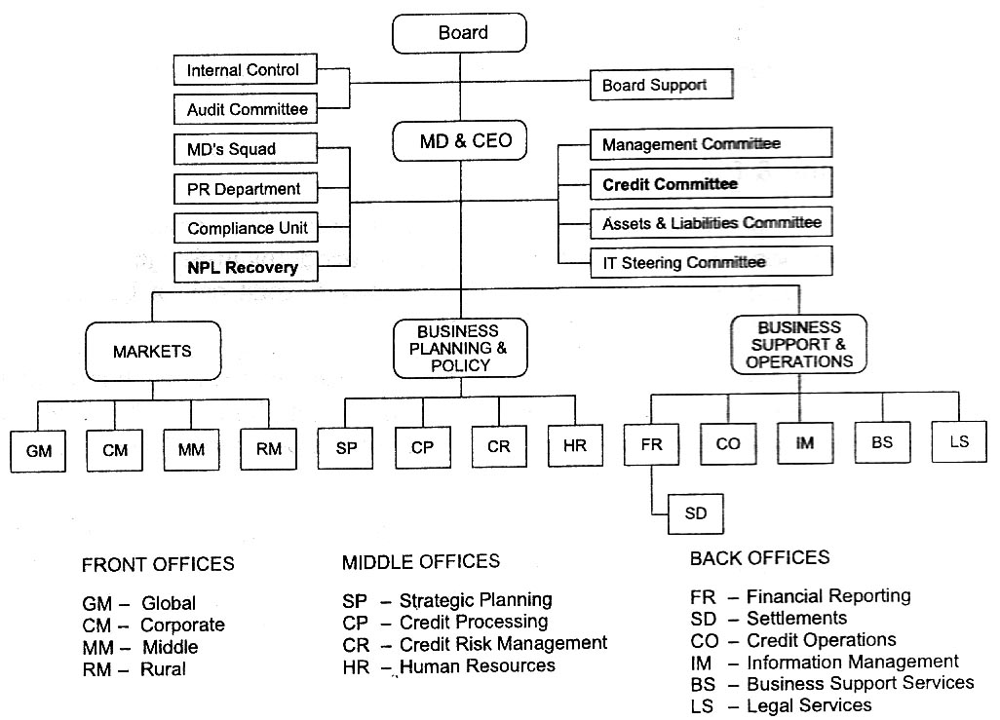

The sub-structures with regard to the credit functions are further elaborated below:

3.2.1 Credit Processing
The principal tasks of this middle office are to determine the creditworthiness based on credit scoring criteria, exposure limits, optimal financial package, risk-based pricing and terms & conditions of all forms of financial assistance. This extends to the grant of counterparty limits for treasury customers as well.
its structure and reporting lines are shown below:
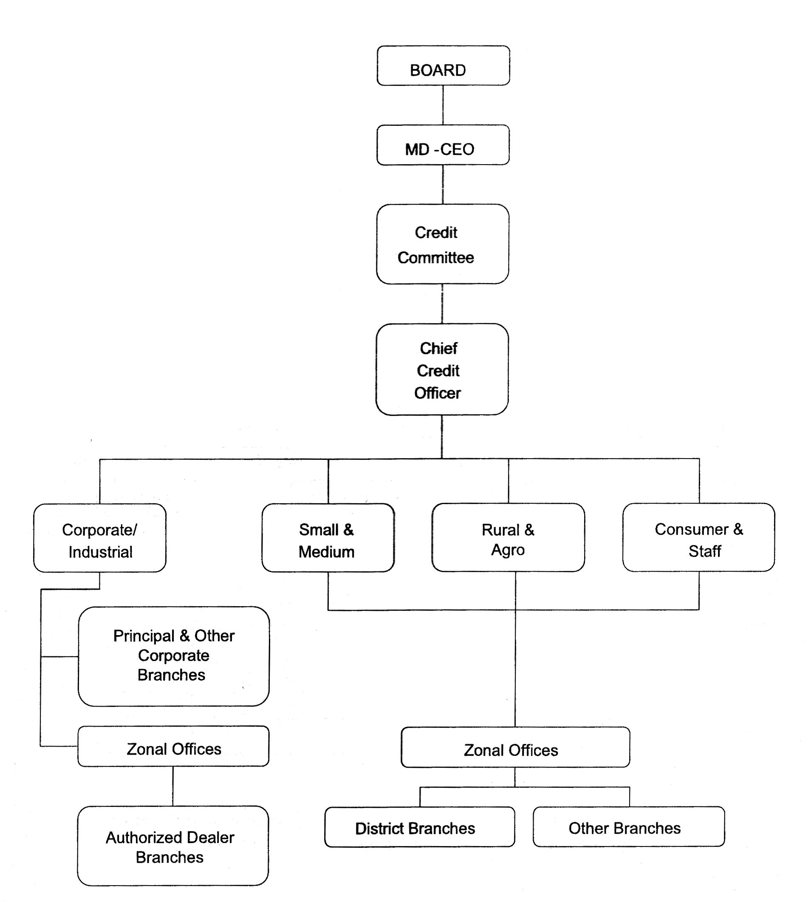

3.2.2 Credit Operations & Administration
The principal tasks of this back office are to provide efficient, common credit-based services, namely: security appraisal, credit checking, documentation & safekeeping, disbursements, loan accounting, and data base management. Its structure and servicing lines are shown below:

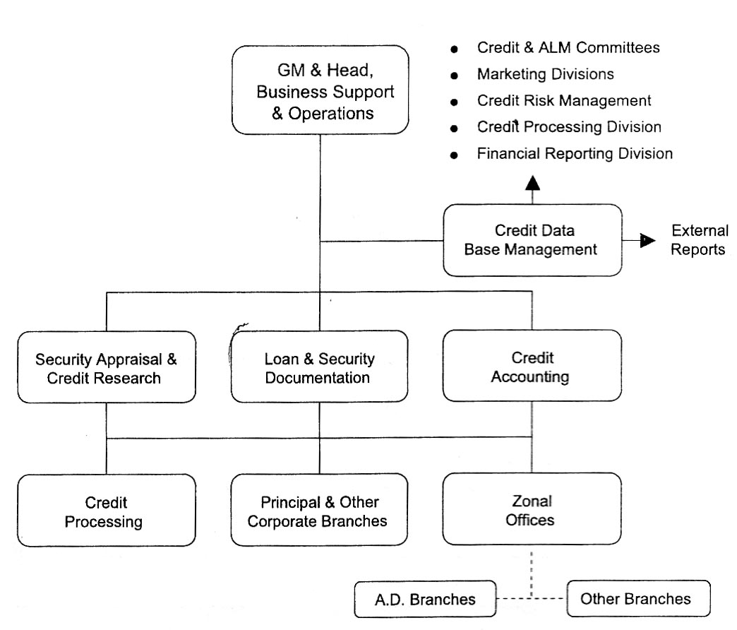

3.3.3 NPL Recovery
This is a specialized unit whose principal task is to maximize recovery and/or minimize losses on non-performing assets through extra-judicial workouts, or through litigation and the subsequent sale/lease/ operations of physical assets. The structure and reporting lines are diagrammed below:

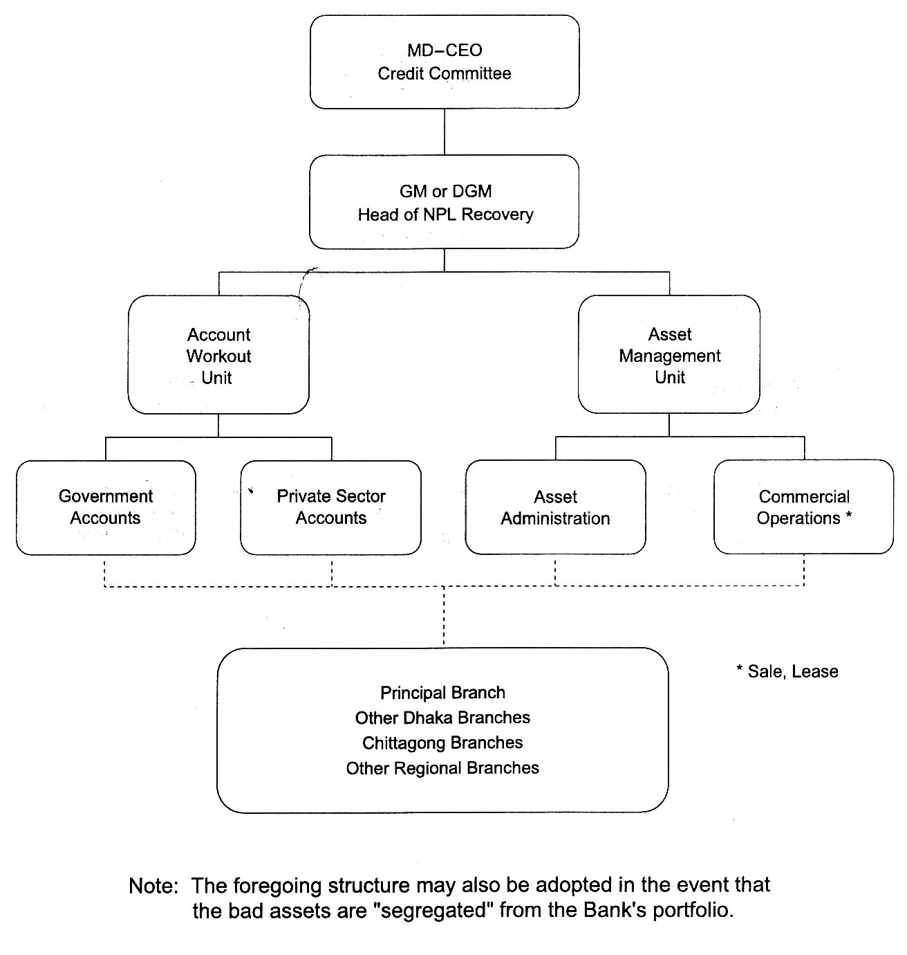

3.3.4 Credit Risk Management
This is a specialized middle office unit whose principal tasks are to evaluate the magnitude, direction and distribution of risks in credit operations and portfolios, and to recommend to the MD-CEO (through the Credit Committee) the appropriate structures, processes and procedures to control these. The functions of this unit and its reporting lines are shown in the diagram below:

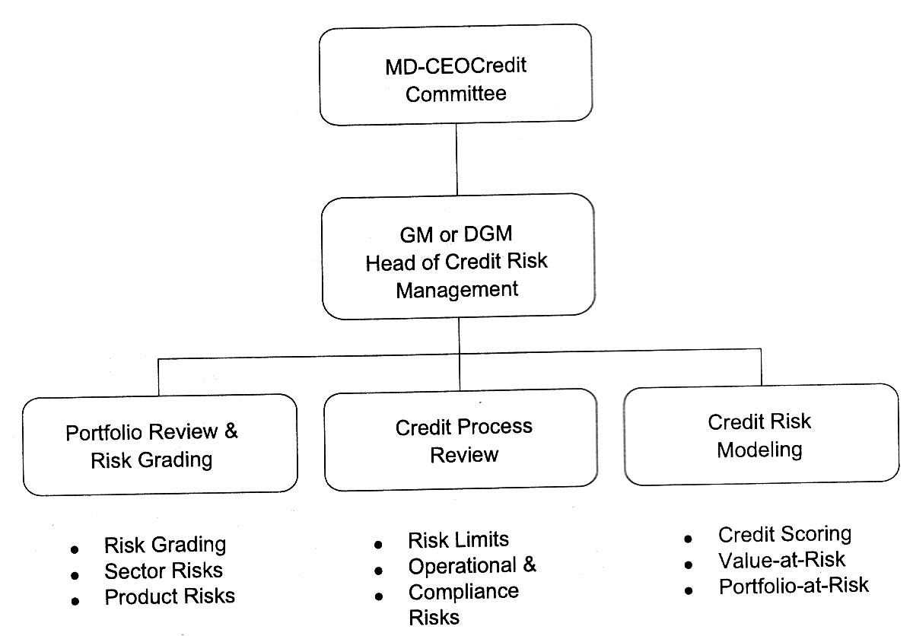

Credit Process Flow
The diagram below shows the entire credit investment cycle in relation to the credit structure.
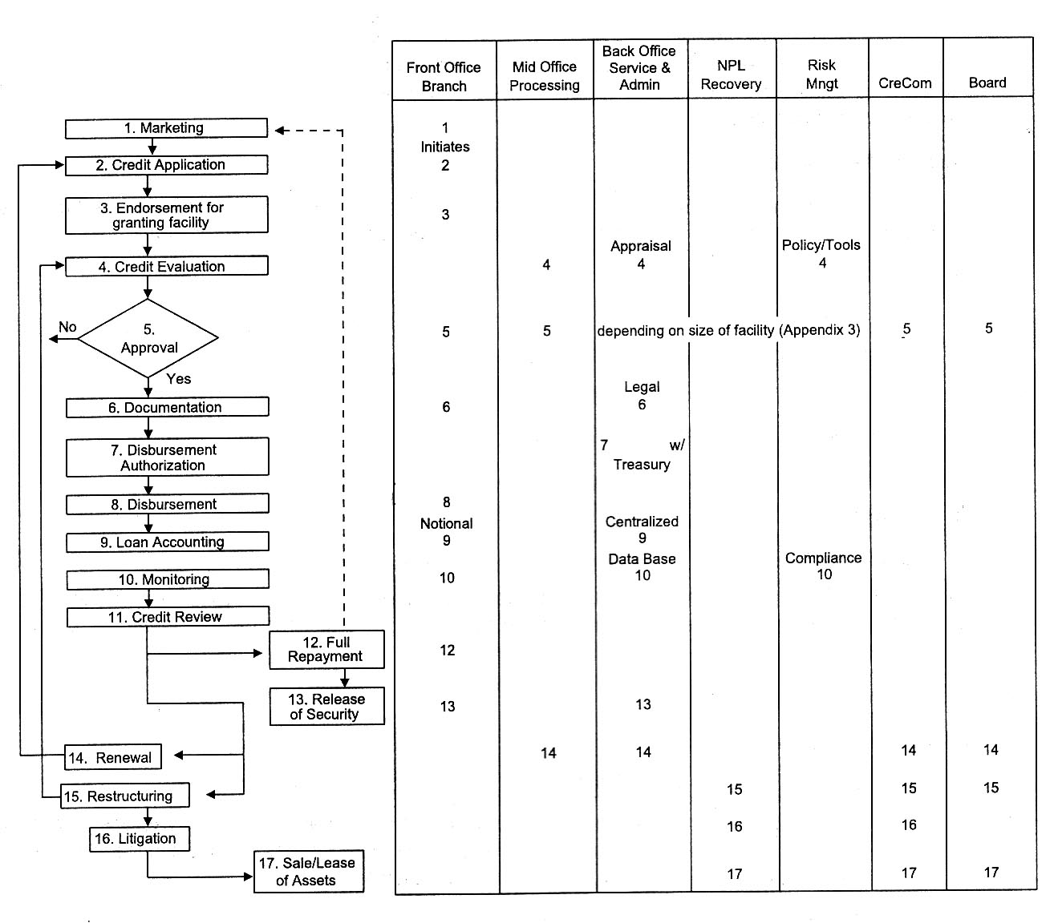

The diagram clearly illustrates the segregation of functions and responsibilities within the credit process, with appropriate middle- and back-office controls.

4. OPERATING GUIDELINES FOR RISK CONTROL

4.1 Portfolio Directives

The thrust of the Bank is to diversify its portfolio of loans and investments to avoid undue concentration. Annual plans should be geared to select those healthy borrowing segments of the economy that are projected to contribute to the Bank's business growth and profit objectives. The Bank will maintain an array of appropriate lending and investment products to meet the needs of these borrowing segments.

4.2 Product Manuals

The Bank shall maintain up-to-date manuals on all credit products and services. At the time this Manual was established, the following credit products were being offered by the Bank:

- Commercial Loans
- Industrial Loans
- Residential and Commercial Building Loans
- Rural and Agro-based Loans
- SME Loans and Micro-credit
- Consumer Loans
- Vehicle Loans
- Staff Loans

The Operating Manuals of these products are to be appended to and made an integral part of this Credit Policy, except for those portions relating to product pricing which are, henceforth, going to be risk-based.

4.3 Credit Process

4.3.1 Due Diligence Procedures

a) Large Loan/Investment Analysis
Applications for facilities in the amount of BDT1 crore and above (or representing 10% of the Bank's capital, whichever is lower), will be processed in a limited number of branches in addition to the Head Office, as follows:

Head Office - 1
Corporate Branches (including Principal Branch) - 10
AD Branches - 30
52 Zonal & 7 Circle Offices - 59
Total - 100

b) Large Exposure Assessment Framework

These applications will require assessments in line with the revised Credit Risk Grading System (CRGS) framework. This is a comprehensive analytical process that examines the following areas for potential risks:
- Borrower -ownership, ownership structure, past financial performance, management capability and depth, credit history & deposit account performance.

- Industry-vitality and prospects (sales volume trends in relation to demand levels), level of competition, buyer-supplier leverages and threats, cost and pricing structure, entry barriers and threats of new entries/substitution
- Financial Package-type and purpose of assistance required, tenor, terms and conditions
- Security-quality and quantity
Furthermore, potential risk exposures and any migrating factors must be disclosed in the analysis. These risks will invariably fall into the following categories:

- Borrower:
Any issues regarding lack of management depth, complicated ownership structure or inter-group transactions should be addressed and risk should be mitigated.

- Industry:
The key risk factors/of the borrower's industry should be assessed. Any issues regarding the borrower's position in the industry, overall industry concerns or competitive forces should be addressed and strengths and weaknesses of the borrower relative to its competition should be identified.

- Supplier/Buyer Leverages:
Any customer or supplier concentration should be addressed, as these could have a significant impact on the future viability of the borrower.

- Historical Financial Analysis:
An analysis of a minimum of 3 years historical financial statement of the borrower should be presented. Cash flow, profitability and leverage trends should be analyzed.

- Projected Financial Performances:
A projection of the borrower's future financial performance should be provided, indicating the sufficiency or lack thereof of cash flow to service debt repayment, Loans should not be granted if projected cash flow is insufficient to repay debts.

- Account Conduct:
For existing borrowers, the historic performance in meeting repayment obligations (trade payments, cheques, interest and principal payments, etc.) should be assessed.

- Loan structure
The amount and tenors of financing proposed should be justified based on the projected repayment ability and loan purpose. Excessive tenor or amount relative to business needs increases the risk of fund diversion and may adversely impact the borrower's repayment ability.

• Security:
A current valuation of collateral should be obtained and the quality and priority of security being proposed should be assessed. Loans should not be granted based solely on security,

• Mitigating Factors:
Risk factors (margin, sustainability, leverage /gearing, over-stocking, rapid growth/acquisition/expansion, management changes or succession issues, customer or supplier concentration, lack of transparency or industry issues) should be identified in the credit assessment.

Credit Scoring
Credit scoring of large loan applications (i.e., over BDT50 lac) will be based primarily on the credit risk grading guidelines of Bangladesh Bank (see Section 4.8 below). This is a system with weighted scores assigned to five risk dimensions, namely:
Financial - 50%
Business and industry -18%
Management -12%
Security -10%
Relationship -10%

The resulting aggregate score will determine whether or not a particular application should be approved. For this purpose, the cut-off score of 75 has been set as the minimum acceptable score, i.e., no applications may be considered if the aggregate score for a particular application is below 75.

d) Risk-based Pricing
In addition, the resulting aggregate score will also determine the risk premium for a borrower, as an input into the pricing of the credit facility being applied for. The schedule of risk premiums is shown below:
Score | Risk Grade | Risk Premium *(%)
Secured by cash or government guarantee | Superior | Oto1
85 & above | Good | 1 to 2.5
75-84 | Acceptable | 2.5 to 4.0
Below 75 | Unacceptable | (n.a.)

4.3.2 Analysis of Small, Medium & Other Retail Loans
Exposures that do not fall into the "large" category may have simpler evaluation routines but should nonetheless provide sufficient information for sound decision-making. These loans will usually fall into two broad categories:
- Formally organized businesses (e.g., corporations, limited liability companies, cooperative and partnerships) - this group should undergo the normal business background checks, and evaluation should focus primarily on: management capability, market prospects, and cash flow.
- Informal businesses (proprietorships) and individuals - this group will undergo the simplest evaluation routine, with the use of specially designed scorecards. Scorecard variations shall be developed over time, to conform to product-market segmentation.

4.4 Approval Procedures
All facilities strictly require the approval of designated authorities at least one level higher than the originating branch stations, zones, and corporate branches. Exceptions to this requirement involve loans to micro-enterprises or for rural and crop programs. .

4.5 Documentation Procedures
The Bank shall maintain a standard set of approved documentation forms and formats for all its facilities. While the branches will continue to initiate documentation, these should be checked one level higher than the originating branch stations, zones, and corporate branches, as in the approval procedures above.

Custody & Safekeeping of Documents
Custodial responsibility for original transaction documents shall be the responsibility of the back office administration office. These shall be retained in a secure manner preferably stored within fire- and burglar-proof premises(e.g.vaults).

Document Checklist
The approved document checklist must be maintained for every credit facility, which contains:
a) Details of all general and specific requirements
b) The dates on which these were submitted and complied with
c) The location of these documents.
Checklist must be incorporated as an integral part of the credit folders, and should be available for inspection at all times. Since the original documents are to be held in safekeeping, copies thereof should be appended to the checklist.

4.6 Commitment and Disbursement Procedures
Releases of funds, and the issuance of instruments (e.g. LCs, Letters of Guarantee) that bind the Bank to potential financial and legal obligations, are the final and most critical control stage of the credit and investment process. Accordingly, these may not be undertaken unless and until the following are accomplished;
- Documentation clearances have been issued;
- Treasury has been advised of impending disbursements ahead of time (24-hour notice in the case of BDT 1 up to less than BDT10 crore, and 5 working days in the case of amounts of BDT 10 crore and above);
- Transaction sheets are accomplished, showing sufficient detail (date, amount, promissory note number when used, applicable interest rate or fee, and payment period/dates for interest and principal/fee) - refer to facsimile below:

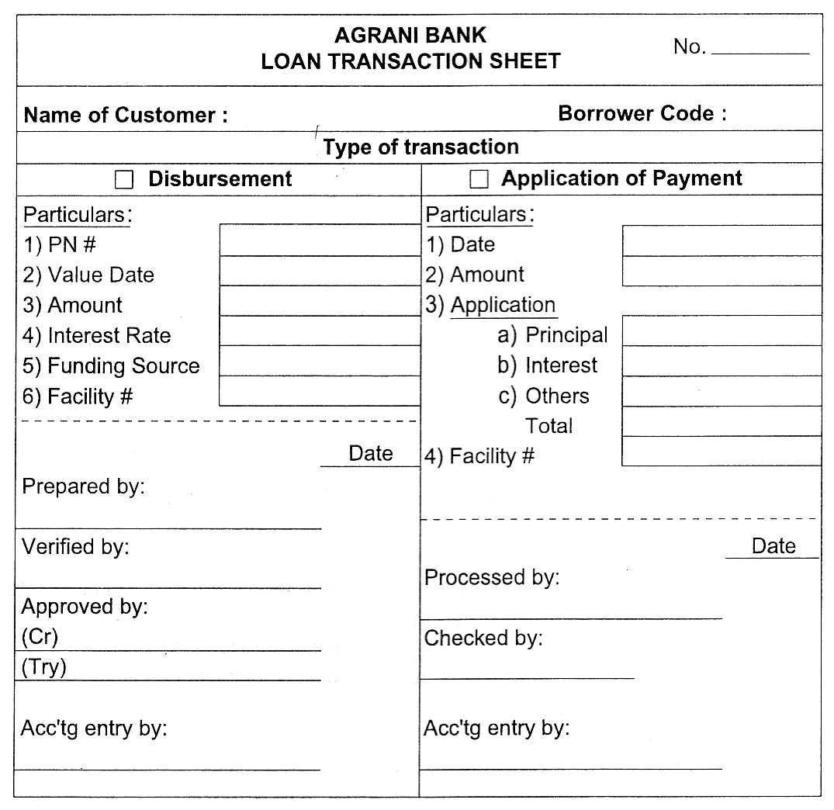

Booking of the transactions contemplated in this section should be made at the originating front offices, and advised to the Credit Operations and Administration Division at Head Office within 24 hours using a triplicate copy of the transaction sheet. The Credit Operations and Administration Division will maintain a centralized accounting record of all funded and non-funded exposures of the Bank for administration and monitoring purposes.

4.7 Account Management Procedures
This stage in the credit process has the longest duration, and key components of the Bank's credit risk infrastructure have responsibilities to ensure that risk assets are properly monitored and handled.

4.7.1 Reiationship Management
Front offices (i.e., the branch stations and corporate branches) shall have over-all responsibility for account relationships and customer interface. They have the obligation to monitor the accounts' business and performance of credit obligations through client calls (evidenced by call reports) and obtaining periodic financial reports. They have the primary task to recover the Bank's exposures, and to have a proper accounting of all credit-related transactions aside from the normal banking routines related to their deposit business.

- Pro-active monitoring of accounts is underscored with the introduction of an early alert process under which identification and prompt reporting of deteriorating credit must be reported to the immediately higher level of supervising authorities.

b) Loan Recovery
Loan recovery efforts should be undertaken using a tickler system (until a computerized information system is in place) that will alert the front office stations in advance of amounts falling due for collection. Follow-up of missed payments should be in writing. With increasing frequency and seriousness of tone with the passing of time until payment is received.

c) Reports
Periodic submission of internal and external reports should be made on time and with accuracy of information. For this purpose, all reports must be signed off by the Heads of branches, zones, and credit divisions as needed.

4.8 Monitoring of Credit Portfolio
The Credit Administration Division will oversee the credit and investment activities of the Bank with a broader portfolio-based outlook (regional dispersal, industry and customer-type segmentation, product performance, portfolio classification, etc.).

4.8.1 The Loan Administration unit of the division will establish and maintain a comprehensive data base on all credit exposures, and monitor consolidated movements as these are reported through copies of transaction sheets and summaries. It will conduct portfolio analyses for the purpose of evaluating portfolio performance and detecting any deterioration in the risk exposures. Summary reports and recommendations will be submitted to the Credit Committee for appropriate action or policy decisions.

    - The credit review unit of the division is responsible for reviewing the credit process to ensure that approved policies and procedures are being effectively being implemented throughout the Bank.

4.9 Risk Grading
The Bank will rate its individual risk exposures continuously until these have been discharged through full payment or otherwise written off. However, actual account performance will be an additional consideration in classifying the exposures into one of the following eight categories:

O Superior - Low Risk (AAA):
Industry/Business & Financials: Strong industry and business performance is indicated on the basis of volume trends and operating margins; the account may be a dominant player in the industry.
Account Performance: Account is cooperative, pays on time, and provides non-loan business.
Security: Facilities are fully secured by cash deposits, government bonds or an unconditional guarantee from a top-tier international bank or financial institution.

O Good-Satisfactory Risk (AA):
Industry/Business & Financials: The account's performance is strong, having consistently strong earnings within a vibrant industry, good liquidity and low leverage.

Account Performance: Account is cooperative, pays on time and provides non-loan business. Security: Security is sub-prime but solid real estate. Aggregate score would be 95 or above.

O Acceptable - Fair risk (A):
Industry/Business & Financials: Financial condition is currently strong but may be unable to sustain any major or continued setbacks. This classification indicates strengths below that of the previous category, but shows consistent earnings and positive cash flow.
Account Performance: Account is paying, but may be delayed by less than one month from time to time.
Security: Security position is satisfactory. Aggregate score would be 75-94.
O Marginal -Watch list (BBB):
Industry/Business & Financials: These borrowers have an above-average risk due to strained liquidity, higher than normal leverage, thin cash flow and/or inconsistent earnings.
Account Performance: Account is paying, but may be delayed by less than one month from time to time.
Security: Security position could be less than satisfactory if default occurs longer than 3 months.
An aggregate score would be 65-74.

O Special mention (BB):
Industry/Business & Financials: These borrowers deserve management's close attention because of consecutive losses over two years with the potential to have negative net worth, excessive leverage.
Account Performance: Account is paying, but may be delayed by less than three months from time to time.
Security: Security position could be less than satisfactory if default occurs longer than 3 months.
An aggregate score would be 55-64

O Substandard (B):
Financial condition is weak, and capacity or inclination to repay is in doubt. These weaknesses jeopardize the full settlement of loans.
An aggregate score would be 45-54.
O Doubtful and Bad (Non-performing):
Full repayment of principal and interest is unlikely, and the possibility of loss is extremely high. The adequacy of provisions must be reviewed at least quarterly and the Bank should pursue a loan workout arrangement (e.g. restructuring), failing which legal options should be explored to enforce security to obtain repayment.
An aggregate score would be 36-44.
O Loss ( Won - Performing ):
The prospect of recovery is poor after exploring all options. Legal procedures have been initiated. In accordance with Bangladesh Bank guidelines, these accounts should be written off.
An aggregate score would be 35 or less.

The deterioration of any loan account is regarded as a serious development that requires the attention of the Credit Committee. For this purpose, any account which is downgraded to "Substandard" should be the subject of a Classified Loan Report, the format for which is attached as Appendix 4.

4.10 Recovery of Non-Performing Loans & Investments
The NPL Recovery Unit will be responsible for all accounts assigned to it by the Credit Committee. The unit will be staffed by seasoned senior officers who will undertake the following activities:

4.10.1 Review the accounts thoroughly and diagnose business prospects; and b) determine the best way to recover the Bank's exposure with the least possible losses.

4.10.2 Restructure those accounts which are deemed to be cooperative and in temporary distress, and monitor their performance closely until they have substantially complied with the revised terms including payment of at least six months' installments; rehabilitated accounts may be returned to the originating front offices for regular monitoring and supervision after this prescriptive period.

4.10.3 Prepare accounts with security, whose operations are active but the owners are uncooperative, for legal action; coordinate with the Bank's legal counsel and/or external lawyers in the filing and prosecution stage; execute final judgment as may be determined by the courts. For these types of accounts, the NPL Unit may recommend further accounting treatments(such as additional loan loss provisions) depending on the perceptions concerning the Bank's security position. Blacklist the borrowers to ensure they are not entertained for future accommodations in the future (the blacklist should be updated).

4.10.4 Prepare accounts without any security, whose operations are either active or inactive and the owners are uncooperative, for attachment of personal assets through legal means; as above, coordinate with the legal agents of the Bank until the cases are resolved. Recommend write-off for accounts with no hope of recovery, and blacklist the borrowers to ensure they are never entertained in the future. The Board shall have the sole authority to approve write-offs.

4.11 Internal Audit & Compliance
All front office lending outlets must be audited regularly (at least bi-annually)as an independent check on their activities. However, more frequent inspections and audits may be conducted as situations may demand. Particular attention should be paid to the corporate and Authorized Dealer (AD) branches which are expected to originate and maintain the bulk of the credit and investment portfolios.

IAC should review the efficacy of credit risk controls and validate the effectiveness of screening tools in predicting borrower performance through back-testing techniques.

Compliance Requirements
4.11.1 Bangladesh Bank Circulars and other regulations must be maintained and updated regularly.
4.11.2 Guidelines with regard to CIB reporting, provisioning and write -off of bad and doubtful debts, and suspension of interest accrual should be strictly enforced. These shall require the approval of the. Board, as recommended by the MD-CEO.

4.11.3The performance of all external service providers (e.g. property appraisers, lawyers, insurers, CPAs, etc.) should be reviewed on a periodic basis.

