Internship Report
On
Different Types of Yarn Marketing in Bangladesh

Submitted by
WWW.ASSIGNMENTPOINT.COM

As a part of the Internship Program of Masters of Business Administration course, I was assigned for doing my internship on “Different Types of Yarn Marketing In Bangladesh, A Case Study of Tamijuddin Textile Mills Ltd” for a period of …... weeks, starting from ………… to …………. as an intern by Internship program committee, Department of Marketing, Faculty of Business Studies, University of Dhaka. My project was to explore “Different Types of Yarn Marketing in Bangladesh”. My faculty supervisor Dr. Anwarul Islam, Professor, Department of Marketing, Faculty of Business Studies, University of Dhaka, assigned this project and authorized me to prepare this report.

1.2 Objectives of the Report:

- To depict the standard features of a yarn manufacturing company.
- To explore the Departments, Divisions and its functions of a spinning company.
- To analyze the performance of the Company.
- To find out the way of developing relationship among management, officers, workers, external suppliers and the buyers of the organization.(Human Resource)
- To improve the quality of yarn and compare it with Uster statistics for getting marketing advantage (product development).
- To find out the way of optimum uses of machines and superior technologies for the better yarn (technology).
- To implement the superior marketing techniques ( marketing technique)
- To reduce the transportation cost, office expenses, wages and other casts (cost reduction)

1.3 Sources of Information
Information is collected to furnish this report from both primary and secondary sources.

The primary sources are:
- Practical Deskwork.
- Face to face conversation with the employees.
- Face to face conversation with the Suppliers
- Face to face conversation with the Buyers.
- Analyzing marketing follow up of yarn orders.

The secondary sources are:

- Different Manuals published by “The Textile Today”
- Business Reports of “Tamijuddin Textile Mills Ltd.”
- Journals, published by different economics related organizations of our country and abroad.
- Publications, obtained from different libraries and from Internet.
- Library research

1.4 Methodology
The information for the Yarn Manufacturing Organization of the report was collected from primary and secondary sources like practical experience, books, publications, WebPages, and annual reports of my organization-“Tamijuddin Textile Mills Ltd”. For detail concept development about the organization, short interviews and discussion session were taken as primary source.

The information for the Project “Different Types of Yarn Marketing in Bangladesh” has been collected from primary and secondary sources. For gathering concept of yarn marketing, different quality related local as well as international journals, periodicals, manuals, and industry related aspects were thoroughly analyzed. Beside this observation, discussions with the Buyers and consumers of the organization were also conducted.

For evaluation of the cost benefit of marketing and process, I tried to bring in the related theory from different books, journals and then tried to relate it to the practical way of working in the textile industry. I have considered my yarn manufacturing organization –Tamijuddin Textile Mills Ltd as a case study and that can be represented widely and clearly and as the average size of the population.

1.5 Limitation:

The major limitations faced during the preparation of this report are as follows –
- A period of ……. weeks is not sufficient to collect and understand the insights of organization.
- Textile yarn manufacturing factory policy does not permit to disclose various data and information related to their inventory and management policy.
- Most spinning factory owners are ignorant about the importance of relationship between buyers and producers.

Chapter 02:

2.1 Over View of Yarn manufacturing organization-“Tamijuddin Textile Mills Ltd.”

A Chronicle of Growth
The company was registered in 1970. LC for import of machinery opened in 1971. Liberation war broke out in the then East Pakistan and dislocated works.
1970-71

1973
In Bangladesh, the company was nationalized in 1973

1985
Company denationalized

Commercial production with finance from Bangladesh Shilpa Bank started in 1988 with 14,136 spindles with one blow-room line
Product: Assorted yarn ( 100% cotton yarn for local woven market)
Count range: 30/1 -100/1
1987-88

1st phase BMRE: spindles increased by 25,632 to 39,768 with two blow-room lines.
Product: 100% cotton and cotton –polyester blended yarn for local woven market.
Count range: 30/1 – 100/1

1990-92

2st phase BMRE: spindles increased by 9,600 to 49,368 with three blow-room lines.
Product: 100% cotton yarn for export.
Count range: 18/1-40/1 for knit market.
16/1-100/1 for woven
20/2-32/2 for sweater

2003-04

Production capacity: 3 lines of production facility with four blow room lines.
Product: 1. 100% cotton yarn for export (knit)
2. 100% cotton yarn for export (woven & sweater)
3. PC, CVC & mélange yarn for export (woven & knit)
2005- Onward
The company is producing and selling cotton, polyester, Mélange and Modal yarn for export market as well as local market. The company is exporting yarn under back-to-back LC to the local knitwear and woven industries.
From the begging of the factory it was the number one in yarn manufacturing up to 1990 in terms of quantity and quality. At that time its yarn demand was very high. After 1990 many spinning industries were established with latest technology. So the company faced huge challenge to exist in yarn market. To cope with the growing demand and increasing quality consciousness of yarn by the customer the company then started to change old machineries with latest technologies and still now it is going on. Most of the machineries are made in Germany and Japan. At present the company is producing high quality yarns of different types.
The company is purchasing raw materials such as cotton, polyester, viscose and rayon fibers from various countries around the world. Cotton is being perched mainly from Uzbekistan, Kazakhstan, Tajikistan, Pakistan and India. Polyester, viscose and rayon are mainly purchased from India, Indonesia, China, Taiwan and Thailand. Raw material is purchased through LC.
In case of local selling company is selling yarns to brokers in Madhobdi-Narshingdhi and Narayangonj local yarn market. Local brokers are buying the yarns from the company by cash money.

2.2 Business Objectives:

- Tamijuddin Textile Mills(TTML) Ltd strives to exceed the needs and demands that customers have. TTML is committed to achieve results and customer satisfaction by deploying skills and techniques designed to put our customers in front.
- TTML, develop, and maintain skilled and pro-active professionals to bridge the cultural, commercial and technical barriers. TTML is committed to constant improvement of processes to achieve shorter reaction time and constant high quality.

2.3 Corporate Commitment

- To be a leading manufacture of quality yarn in Bangladesh for fulfilling customer needs with professionalism and integrity.
- To maintain an environment that attracts, develops, retains, rewards and motivates talent and productivity.
- To establish environmental excellence in it’s all steps of production and actively promote environmentally responsible behavior at all levels of the organizations, in customers and suppliers.
- To strive for an outstanding corporate and individual behavior to maintain lasting trust and confidence of our customers, employees and suppliers.
- To maintain a level of profitability that sustains growth, ensures quality and provides generous rewards to staff and adequate return to shareholders.
2.4 Vision, Mission and objectives of the company:
Vision of the corporate company is “To become an environmentally excellent group, promoting environmentally superior products in an environmentally superior manner.”

As a company led by business ethics it stresses more on environment friendly product. In order to meet the always growing demands of a global market, the company has, apart from providing and distributing goods, to guarantee a reliable service for customers and suppliers.

The mission of the Tamijuddin Textile Mills Ltd is to maximize profit with superior quality and to be competent in all aspects of yarn manufacturing featuring cutting edge technology.

The primary aim of TTMl is to become the best specialist yarn manufacturer, meeting and exceeding our buyer’s demand. TTML hires, develops, and maintains skilled and pro-active professionals to overcome the technical barriers. It is committed to a constant improvement of processes to achieve shorter reaction time and consistent high quality.

TTML strives to add further value to the high level of services that it already offers to customers. Towards this end, TTML continuously monitors the changing market and maintain sharp lookout for new opportunities.

Nowadays yarn market is more unpredictable. Dramatic changes are occurring in market place. These radical changes are creating new sets of challenges for all of the players in the industry.
2.5 Management
A management with a clear strategy and concrete aims for the 21st century as well as a clearly defined company policy, together with a highly motivated staff, is the basis for the efficiency and the success of TTML.
Managing Team of TTML at a Glance( A sample of a yarn manufacturing organization):
 |  | Chairman/Director
 |  | General Manager –Head office
 |  | General Manager –Technical
Administration |  | Deputy General Manager
 |  | Officer
Production & Quality |  | Deputy General Manager
 |  | Manager
 |  | Sr. Officer
 |  | Officer
Maintenance & Electrical |  | Deputy General Manager
 |  | Manager
 |  | Officer
Marketing |  | Assistant General Manager
 |  | Manager
 |  | Officer
Commercial &Accounting |  | Assistant General Manager
 |  | Officer
Purchase |  | Officer
Security |  | Officer

2.6 Departments of a Yarn Manufacturing Organization (TTML):
For the ease of work procedure, TTML departmentalized itself by functions. The main departments are Production, Quality, Maintenance, Electrical, Administration & Human resource, Marketing and Financial

a) Production Department:
Min functions of the department relate to
- Allocate the machines based on products type.
- Keep good relation with the workers to maximize their efficiency.
- Maximize the production.
- Maintain the online yarn quality.

b) Quality Department:

Raw material selection.
    - Choosing the quality parameters.
    - Monitoring and controlling the oiff line quality of the yarn.
    - Providing the all the machine settings.

c) Maintenance Department:

- Keep the machines in good operating condition by doing schedule maintenance.
- Attend any unwanted breakdown in the machine.
- Keeping working environment unchanged based on Relative Humidity (RH%) and Temperature continuously.

d) Electrical Department:

- Keep the machines electrically in good operating condition over a long period of time.
- Maintaining the power generator properly and distribute the load to the machine as per requirement.

e) Administration and Human Resources(HRD)Department:

HRD performs all kind of administrative and personnel related matters. The broad functions of the division are as follows:
- Selecting & Recruitment of new Personnel.
- Prepare all formalities regarding appointment and joining of the successful candidates.
- Placement of Manpower.
- Deal with the promotion, and leave of the employees.
- Training & Development.
- Termination and retrenchment of the employees.
- Keeping records and personal file of every employee of the organization.
- Arranges workshops & training for employee & executives.

f)Financial Division
Financials Department mainly deals with the account side of the TTML. It’s functions are as follows
- Salary & Wages of the Employee.
- Rentals, maintenance and leases.
- Travel, conveyance, entertainment, medical etc.

g) Marketing Department:
Details have been discussed in project part.

2.7 Technology:
World sophisticated technologies have been used to produce high quality yarn.

2.8 Machineries of the Yarn Manufacturing Organization (Here Tamijuddin Textile Mills td):
SL.NO | Name of the Machinery brand & Origin | Type / Model | Mfg. Year | Com. Date | Qty.
1 | Blow Room Line 1 - (Ohtory Trutzschler / Trutzschler) |  | 1987-96-97 | 1998 - 2004 | 1
 | {1 Scutcher SME, Axiflo, MPM - 6 (Made of Japan)}
 | Bale opener(BO), CVT- 3 , Dustex ( Made of Germany)
 | Blow Room Line 2 - (Ohtory Trutzschler / Trutzschler) |  | 1987-96-97 | 1998 - 2004 | 1
 | {1 Scutcher SME (Made of Japan)}
 | Bale opener, MPM-4, CLC- 1, Dustex (Made of Germany)
2 | Blow Room Line 3 - ( Trutzschler Germany) |  | 2003 | 2003 | 1
 | Bale opener - BX, Maxiflo MFC, Securomat SCB, Fan TV,
 | Multimixer MPM - 8, Cleanomat CVT - 1, Material separator
 | MAS, Foreign fiber separator SCFO. VT 2, Dosing feeder MSL
 | Fan TVD 425, Electrical installation EAS, T - Distributor T - 2
3 | Blow Room Line 4 - ( Trutzschler - Germany) |  | 1996 - 97 | 2004 | 1
 | Bale opener - BO, Maxiflo AFC, Cleaner RST. Cleaner LVSAB
 | Fan TV, PWSE – 1
SL.NO | Name of the Machinery brand & Origin | Type / Model | Mfg. Year | Com. Date | Qty.
 | Blow Room Line 5 - ( Trutzschler - Germany) |  | 1996 - 97 | 2004 | 1
 | Bale opener - BO, Procupine opener (Japan) RK, Fan TV
 | PWSE - 2, Multimixer MPM - 8, Fine opener - FO, Transport
 | Fan TVD.
4 | Carding
 | [a] Howa card with autoleveler (Japan)Lap feed | CMK - 3 | 1987 | 1988 | 17
 | [b] Howa card with autoleveler (Japan) Lap feed | CMK - 3 | 1992 | 1992 | 6
 | [c] Trutzschler card with autoleveler (Germany) Chute feed | DK - 903 | 2003 | 2003 | 8
 | [d] Trutzschler card with autoleveler (Germany) Chute feed | DK - 903 | 2000 | 2004 | 6
5 | Drawing
 | [a] Howa 2 - Delivery [ Japan ] | DFK - 2 Ps | 1987 | 1988 | 7
 | [b] Cherry 2 - Delivery [ Japan ] With autoleveler | DX - 500 | 1989 | 1992 | 2
 | [c] Trutzschler 1 - Delivery [Germany] With autoleveler | HSR - 1000 | 2001 | 2001 | 2
 | [d] Trutzschler 1 - Delivery [Germany] With autoleveler | HSR - 1000 | 2003 | 2003 | 1
 | [e] Trutzschler 1 - Delivery [Germany] With autoleveler | HSR - 1000 | 2000 | 2004 | 4
 | [f] Trutzschler 1 - Delivery [Germany] | HS - 1000 | 2000 | 2006 | 4
6 | Comber
 | [a] Howa [ Japan ] | Cartory - K | 1987 | 1988 | 3
 | [b] Howa [ Japan ] | 178 | 1972 | 1990 | 1
 | [c] Tokiyu [ Japan ] | THC - 100 | 1989 | 2006 | 7

SL.NO | Name of the Machinery brand & Origin | Type / Model | Mfg. Year | Com. Date | Qty.
7 | Simplex
 | [a] Howa 120 Spindles [ Japan ] | RMK - 2 | 1987 | 1988 | 4
 | [b] Toyoda 120 Spindles [ Japan ] | FL - 16 | 1989 | 1990 | 2
 | [c] Toyoda 96 Spindles [ Japan ] | FL - 16A | 1983 | 2006 | 6
 | [e] Howa 120 Spindles [ Japan ] | RME | 1987 | 2003 | 3
 | [e] Howa 96 Spindles [ Japan ] | RME | 1987 | 2003 | 1
8 | Ring
 | [a] Howa 456 Spindles [ Japan ] | UA - 27E | 1987 | 1988 | 31
 | [b] Ishikawa zinsei 488 Spindles [ Japan ] | Type - 317 | 1972 | 1992 | 10
 | [c] Toyoda 456 Spindles [ Japan ] | RY | 1974 | 1990 | 26
 | [d] Howa 960 Spindles [ Japan ] | UA - 33E | 1989 | 2004 | 10
 | [e] Toyoda 456 Spindles [ Japan ] | RY | 1972 | 2006 | 23
9 | Cone Winnder
 | [a] Murata Manual cone winder 120 Drum [ Japan ] | Type 14 - 11 | 1987 | 1988 | 2
 | [b] RT Manual cone winder 120 Drum [ Japan ] | Type - 14 | 1976 | 1990 | 1
 | [c] Kamitsu Manual cone winder 120 Drum [ Japan ] | Type - 14 |  | 1990 | 1
 | [d] Murata auto coner 60 Drum [ Japan ] | 7- ii | 1990 | 1990 | 2
 | [e] Murata auto coner 50 Drum [ Japan ] | 7- ii | 1988 | 2003 | 2
 | [f] Murata auto coner 50 Drum [ Japan ] | oo7 | 1985 | 2003 | 2
 | [g] Murata auto coner 60 Drum with auto dofer [ Japan ] | 21 - C | 2002 | 2002 | 1
 | [h] Murata auto coner 60 Drum with auto dofer [ Japan ] | 21-C | 2003 | 2003 | 3
 | [i] Murata auto coner 60 Drum with auto dofer [ Japan ] | 21 - C | 2007 |  | 4
 | [j] Murata Link coner 24 Drum with auto dofer [ Japan ] | 7- ii | 1989 | 2004 | 10

SL.NO | Name of the Machinery brand & Origin | Type / Model | Mfg. Year | Com. Date | Qty.
 | Doubler & TFO
 | [a] Murata Doubling Machine 120 Drum [ Japan ] | NO - 23 | 1987 | 1988 | 1
 | [b] Murata two for one twisting 120 Drum [ Japan ] | NO - 363 | 1987 | 1988 | 2
 | [c] Leewha Doubling Machine 120 Drum [ Korea ] | LW - 102D | 1996 | 2004 | 1
 | [d] Leewha two for one twister 156 Drum [ Korea ] | LW - 560SA | 1996 | 2004 | 10
10 | Reeling Machine
 | [a] Janata power Reeling Machine 2 - Side [ Bangladesh ] |  | 1987 | 1988 | 20
 | [b] Yamedatekko auto Reeling Machine 2 - Side [ Japan ] | 4MR-W | 1989 | 1990 | 3
11 | Bundling
 | [a] Kyontsu Bundling Press [ Japan ] |  | 1987 | 1988 | 2
 | [b] Kasturi Bundling Press [ India ] |  | 1991 | 1991 | 2
12 | Bailing Press
 | [a] Koninami Bailing Press [ Japan ] |  | 1987 | 1988 | 1
13 | Air Conditioning Plant
 | [a] Luwa AC Plant [ Japan ] |  | 1987 | 1988 | 2
 | [b] Batliboi AC Plant [ Inida ] |  | 1990 | 1992 | 2
 | [c] Luwa AC Plant [ Switzerland ] |  | 2004 | 2004 | 2
14 | Fiber Deposited Plant
 | [a] Luwa FDP for Blowroon [ Switzerland ] |  | 2003 | 2003 | 1
 | [b] Luwa FDP for Blowroon [ Switzerland ] |  | 2004 | 2004 | 2
 | [c] Luwa Overhead Blower cleaner for Ring [ Switzerland ] |  | 2000 | 2000 | 16
 | [d] Electrojet Overhead Blower cleaner for Ring [ Spain ] |  | 2004 | 2004 | 30
 | [e] Magitex Overhead Blower cleaner [ Italy ] |  |  | 2006 | 5

SL.NO | Name of the Machinery brand & Origin | Type / Model | Mfg. Year | Com. Date | Qty.
15 | Compressor
 | [a] Kaesar Compressor BS - 61 [ Germany ] | BS61 | 2001 | 2001 | 2
 | [b] Kaesar Compressor BSD - 72 [ Germany ] | BSD72 | 2003 | 2003 | 2
 | [c] Kaesar Compressor BSD - 72 [ Germany ] | BSD72 | 2004 | 2004 | 2
 | [d] Dryer [ Germany ] | TF 201 | 2001 | 2001 | 1
 | [e] Dryer [ Germany ] | TF 201 | 2003 | 2003 | 1
 | [e] Dryer [ Germany ] | TF 203 | 2004 | 2004 | 1
16 | Yarn Conditioning Plant
 | [a] Siger (1000 kg / Batch) [ India ] | DUAL HTG | 2003 | 2003 | 1
 | [b] Siger (1000 kg / Batch) [ India ] | LPG HTG | 2005 |  | 1
17 | Auxiliary Machine ( For Trutzschler Card DK - 903)
 | [a] Flat control TC - FCT [ Germany ] | TC - FCT | 2004 |  | 1
 | [b] Cylinder wire grinding Machine [ Switzerland ] | TSG | 2003 |  | 1
 | [c] Flat grinding Machine [ Switzerland ] | TC - GD | 2003 |  | 1
 | [d] Mounting Machine [ Switzerland ] | GAV | 2003 |  | 1
 | [f] Licker in mounting Machine [ Switzerland ] | Rod - 35 | 2002 |  | 1
 | [e] Neps control Machine [ Germany ] | NCT | 2003 |  | 1
 | Auxiliary Machine For Howa Card CMK - 3
 | [a] Cylinder Wire grinding Machine [ Japan ] |  | 1987 | 1988 | 1
 | [b] Flat grinding Machine [ Japan ] |  | 1987 | 1988 | 1
 | [c] Licker - In mounting Machine [ Japan ] |  | 1987 | 1988 | 1
 | [d] Mounting Machine for Dofer & Cylinder [ Japan ] |  | 1987 | 1988 | 1
 | [e] Cylinder Grinding Machine [ Japan ] |  | 1987 | 1988 | 1
 | [f] Flat clipping Machine [ Japan ] |  | 1987 | 1988 | 1
 | [g] Tig Welding Machine [ Japan ] |  | 1987 | 1988 | 1

SL.NO | Name of the Machinery brand & Origin | Type / Model | Mfg. Year | Com. Date | Qty.
18 | Roller Cover
 | [a] Cot Grinding Machine [ Switzerland ] | BG/U | 2003 | 2003 | 1
 | [b] Berkolizing Machine [ Switzerland ] |  | 2003 | 2003 | 1
 | [c] Burkolub Machine [ Switzerland ] |  | 2003 | 2003 | 1
 | [d] Spindle Oil Refilling Machine [ Switzerland ] | 1254106 | 2001 | 2001 | 1
 | [e] Cot Surface Chemical Treatmet Machine [ Japan ] | 208B | 1987 | 1988 | 1
 | [f] Cutter Grinding Machine [ China ] |  | 2004 | 2004 | 1
 | [g] Cot Grinding Machine [ Japan ] |  | 1987 | 1988 | 1
 | [h] Flyer Washing Machine [ Germany ] |  | 2006 | 2006 | 1
 | [i] Cot Mounting Machine [ Japan ] |  | 1987 | 1988 | 1
SL.NO | Name of the Machinery brand & Origin | Type / Model | Mfg. Year | Com. Date | Qty.
19 | Power Station
 | [a] Genset Waukesha [ USA ] | VHP 7100 GSI | 1989 |  | 1
 | [b] Genset Waukesha [ USA ] | VHP 7100 GSI | 1995 |  | 1
 | [c] Genset Waukesha [ USA ] | VHP 5904 GSID | 2003 | 2003 | 1
 | [d] Genset Waukesha [ USA ] | VHP 5904 GSID | 2004 | 2005 | 1
 | [e] Transformer 1250 KVA ( 11000 V - 415 V) |  | 1987 | 1988 | 1
 | [f] Transformer 750 KVA ( 415 V - 575 V) [ Bangladesh ] |  | 2003 |  | 1
 | [g] LT Panel Board Siemens [ Germany ] |  | 1987 | 2003 | 5
 | [h] HT Panel Board Siemens [ Germany ] |  | 1987 |  | 1
 | [i] PFI Panel Board |  | 1987 | 2003 | 5
 | [j] Syncronizing Panel |  | 2003 |  | 1
 | [k] LT Panel Board (REB) |  | 2003 |  | 1
20 | Invertor
 | [a] Invertor 18.5 KW [ Taiwan ] |  |  |  | 40
 | [b] Invertor 55 KW [ Taiwan ] |  |  |  | 5
 | [c] Invertor 55 KW [ Japan ] |  |  |  | 5

SL.NO | Name of the Machinery brand & Origin | Type / Model | Mfg. Year | Com. Date | Qty.
21 | AC ( Invertor )
 | [a] Split Type AC 5 Ton |  |  |  | 4
 | [b] Split Type AC 1 Ton |  |  |  | 3
 | [c] Split Type AC 1.5 Ton |  |  |  | 1
 | [d] Window Type Ac |  |  |  | 3
22 | Work Shop Machinery
 | [a] Lathe Machine 6' |  |  |  | 1
 | [b] Lathe Machine 10' |  |  | 1999 | 1
 | [c] Shaper Machine 18'' |  |  |  | 1
 | [d] Drill Machine 1'' |  |  | 1987 | 1
 | [e] Welding Machine - 220 V |  |  | 1987 | 1
 | [f] Welding Machine - 440 V |  |  | 2003 | 1
 | [g] Hammer Drill Machine 13mm |  |  | 2003 | 1
 | [h] Hand Drill Machine 12m |  |  | 2003 | 1
 | [i] Gas Welding Machine (set) |  |  |  | 1
 | [j] Welding Glass Set |  |  |  | 1
23 | Transport
 | Fork Lift (Big) |  |  |  | 1
 | Fork Lift (Medium) |  |  |  | 1
 | Cover van Big ( 10 Ton ) |  |  |  | 1
 | Cover van Small (5 Ton ) |  |  |  | 1

SL. | Name of the Machinery brand & Origin | Type / Model |  | Mfg. Year | C/D | Qty.
24 | Quality Machin Equiptment
 | [1] Zweigle Fast Count System ( With Printer ) |  |  | 2002 |  | 1
 | [2] Zweigle Hairness Tester |  | G - 566 | 2002 |  | 1
 | [3] Zweigle OASYS ( Yarn Semulation System) |  | G - 588 | 2002 |  | 1
 | [4] Zweigle Twist Tester |  | D 314/1 | 2002 |  | 1
 | [5] Zweigle Electronic Moisture meter |  | Tem - 1
 | [6] Uster Tester |  | 4 SE | 2002 |  | 1
 | [7] HVI Spectrum |  |  | 2003 |  | 1
 | [8] AFIS Pro |  |  | 2003 |  | 1
 | [9] Single Yarn Strength Tester |  |  |  |  | 1
 | [10] Lee Strength Tester |  |  |  |  | 1
 | [11] Wrap Seal |  |  |  |  | 1
 | [12] Wrapping Drum |  |  |  |  | 1
 | [13] ASINO Twist Tester |  |  |  |  | 1
 | [14] Electronic Scale (Bolamce) Without Machine |  |  |  |  | 1
 | [15] Parth Meter |  |  |  |  | 1
 | [16] Simplex Pressure Arm Check Equipment [ India ] |  |  |  |  | 1
 | [17] Comb Sorter |  |  |  |  | 1
 | [18] Hand Techo Meter ( Manual ) |  |  |  |  | 2
 | [19] Electronic Techo Meter |  |  |  |  | 1
 | [20] Splicing Strength Test Meter ( Murata ) |  |  |  |  | 2
 | [21] Hardness Tester Meter [ India ] |  |  |  |  | 1
 | [22] Computer |  |  |  |  | 1
 | [23] Movistrop (Troroscot ) Big / Small |  |  |  |  | 3
 | [24] Stop Watch |  |  |  |  | 1
 | [25] Magnifing Glass |  |  |  |  | 1
 | [26] Uster HVI Calibration Cotton - Short Week, Long |  |  |  |  | 4
 | Strong, Mic (High Fine)
 | [27] HVI Afis Excessories |  |  |  |  | 2
 | [28] Uster - 4 , Progorm Graphics CD |  |  |  |  | 8
 | [29] Zweigle Fast Count Hairness, OASYS Program CD |  |  |  |  | 3
 | [30] UPS |  |  |  |  | 2
 | [31] Uster Micronire Tester |  |  |  |  | 1
 | [32] Cot's Hardness Tester |  |  |  |  | 1
 | [33] Electronic Vernear Scale |  |  |  |  | 1
 | [34] Kaisoki Measusing Printer |  |  |  |  | 1

2.9 Production Flow Chart of a Yarn Manufacturing Factory:

Blow Room Line
Bale Opener

Major Opening/Cleaning Machine

Fire/Metal/Foreign heavy parts Separator

Multi Mixer/Unimix

Mejor Cleaning Machine

Colored particles Separator

2.9 Production Flow Chart

Blow Room

Carding
Breaker Drawing

Lap Former

(For Combed Yarn) (For Karded Yarn)

Comber

Finisher Drawing

Simplex

Ring Frame

Winding Machine

Conditioning

Chapter 03:

Yarn Marketing in Bangladesh:
3.1 Introduction :
Since the global yarn market has become competitive, domestic consolidation and regional adjustments are anticipated. In a quota-free world, it is anticipated that relatively low priced textile products will reduce the demand for domestic yarn in some countries and reverse action will be shown in third world countries. As apparel production is moving to certain countries, with the closing of their operation, spinning manufacturers are moving in the same direction to become yarn suppliers and to gain a competitive advantage in speed to market strategy for global market place.
The key drivers determining the competitive advantage in producing textile items are many factors such as labor, energy, capital/infrastructure, technology, raw materials, interest rate etc. Labor competitiveness is defined in terms of labor cost per unit of output or called unit labor cost. Capital/infrastructure is the money available to build upon an existing base. Technology is the process of incorporating the best available expertise equipment in to the production. Raw materials are considered to be a key driver when there is a cost difference between competitors.

To understand global dynamics of yarn market we have to obtain a meaning full measurement for the consumption by consumers in each country, the import and export trade of yarn must be evaluated. Knowing where and what are being consumed by whom, always yarn production and future growth to be more understandable and predictable. Therefore this report will emphasize yarn production and consumption, and the factors likely to affect the competition in the global yarn market.

3.2 Regionalizing production networks in the textile and apparel industry:
Several broad regional shifts have occurred in the global yarn and apparel industry since 1950’s. The relocation of production is smoothly dominant in the yarn industry. Some researchers think that the internationalization of yarn manufacturing began earlier and has extended further than that of any other industry. Textile firms have relocated their labor-intensive manufacturing operations from high wage region to low-cost production region in industrializing nations. It has been shown below graphically

1950 1960 1970 1980 1990 2000

In the 1950’s and 1960’ In the 1970’s and 1980’ In the late 1980’s and Now ?
North America and Western from Japan to Hong Kong, 1990’s Hong Kong, modify the
Europe to Japan Taiwan and South Korea Taiwan and South Korea position of to China East Asia

Figure: Movement of manufacturing,
Source: Author(Tangboonritruthai,s.,2005)

3.3 SWOT Analysis of Bangladesh Spinning & RMG Industry

a) Strength:
# Advantage over China, Pakistan & India
# Adequate supply of labour force of both sexes, attributed with less attitudes problem (less absenteeism and, aptitude for learning, and loyal) and high morale
# Cheaper labour cost
# Low cost of captive power generation using gas as fuel
# GSP facility up to 2015

b) Weakness
# Bangladesh produce mostly basic products- which are low cost items; the share of fashion products i.e., high value added product is very low.
# Bangladesh does not produce the basic raw materials (only a negligible quantity of cotton but no manufactured fiber) and as such has to depend totally on sensitive global market.
# Because of inadequate backward linkage, lead-time happens to be long, nearly 3 months.
# Public power supply is erratic.
# Bank interest rate is still high enough, particularly of private sector bank, for investment of export oriented high value project.
# HRD facility, productivity and quality support, testing and accreditation support, design support and compliances are yet to be enhanced.
# Cost of doing business is high because of under table money

c) Opportunity:
# Bangladesh has now a scope to go for more fashion oriented products deserving high price in the global market.
# With the help of further increase of productivity & quality and design support, Bangladesh can minimize cost and maximize profit and export value.
# Bangladesh, as a proven experienced RMG & Textile manufacturer, can expand share in the existing market (USA, EU, Australia, Canada, etc.) and can also explore opportunity in Japan & CIS countries.
# In the long run, Bangladesh has a scope to target huge populated country like China and India- where demand as well as cost of manufacturing will be wider.
d)Threat:

# Unless new strong market is explored in home or abroad, any non-cooperation from USA & EU may jeopardize the whole Bangladesh RMG export business and consequently the textile manufacturing.
#Sudden price hike of cotton in the global market may push Bangladesh to a very awkward situation to devastate the business.
# The type of labour and political anarchies of the recent days if prevails in the future, Bangladesh may lose the business in the way Srilanka has lost.
# Growing terrorism, or its false/amplified propaganda, is also a big threat

The Demand-Supply Gap:

The growth of domestic consumption depends upon a set of complex factors that include among others, the growth of population, per capita income, growth of foreign exchange remittance, change of tastes etc. Some of these are not well graspable factors for future demand estimation through dependable prediction models. Similar is the case with the export-oriented RMG growth, which is more complicated as access to international market depends not only upon the scale of demand or competitiveness but also on global trade policies, regional treaties, bilateral relations, non-tariff barriers, image of exporters, etc.

The major factors, which influence the growth of Yarn Market are :
Domestic Consumption of apparels, home
textiles and technical textiles.
Growth of RMG export from Bangladesh and
direct export of various textile products
(finished fabrics, saris, lungis,
etc.)
Importing countries' market
characterizations, which is highly influenced
by demand trend, visible and invisible
regional factors and bilateral or multilateral
trade pacts.
Domestic factors of production (cost of
production, local export enabling factors,
etc.) and socio-political issues

Table:

Actual and Projected Demand of Yarn for the Domestic and Export Through RMG Industry: (2004-05 to 2009- 10): In Million
Growth Rate  Year | Projected Demand of Yarn in Kgs |  |  |  | Total Yarn in Kgs
Growth Rate  Year | Domestic Market (Growth Rate 4.75%) | Export through RMG |  |  | Total Yarn in Kgs
Growth Rate  Year | Domestic Market (Growth Rate 4.75%) | Knit | Woven | Total | Total Yarn in Kgs
2004/05 | 326 | 357 | 290 | 646 | 973
2005/06 | 342 | 445 | 298 | 744 | 1086
2006/07 | 358 | 535 | 308 | 843 | 1201
2007/08 | 375 | 620 | 317 | 937 | 1312
2008/09 | 393 | 700 | 327 | 1027 | 1420
2009/10 | 412 | 770 | 337 | 1107 | 1519
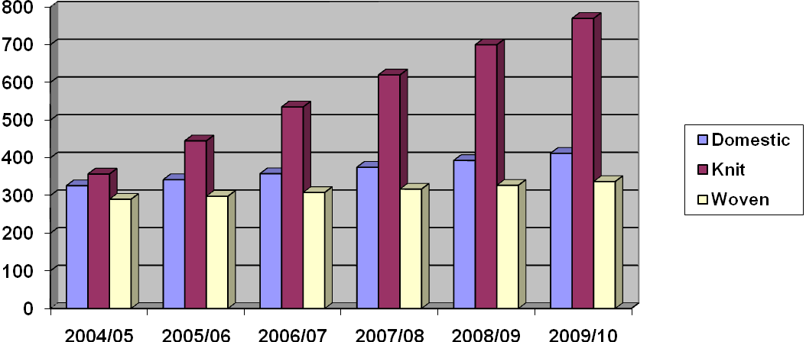
Chart: Growth of Demand of Yarn in Domestic , Knit and Woven Market.

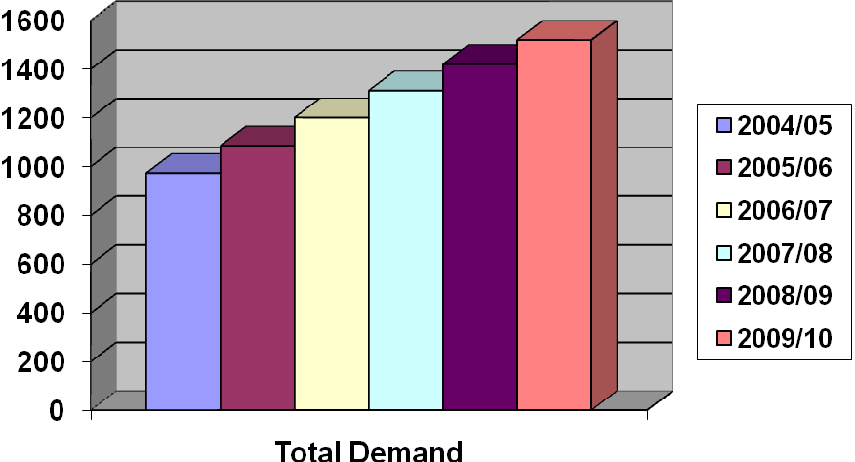

Chart: Growth of Total Demand of Yarn

Estimated New Capacity to be Created in the Private Textile sector by 2009-10
Type of Textile Processing Industry | Present production capacity | Demand by 2009-10 | Demand Supply Gap by 2009-10 | Number of units to be Built Up
Spinning Unit(25,000spindles /Unit with 4.6 million kgs capacity each | 600 Million Kgs | 1,519 Million Kgs | 919 Million Kgs | 200
Weaving (120 shuttle less looms /unit with 13 million meter capacity each | 1,740 Million meters | 4,558 Million meters | 2,818 Million meters | 217
Knitting and Knit processing (1725 tons per year) | 2,300 Million meters | 4,558 Million meters | 2,258 Million meters | 216
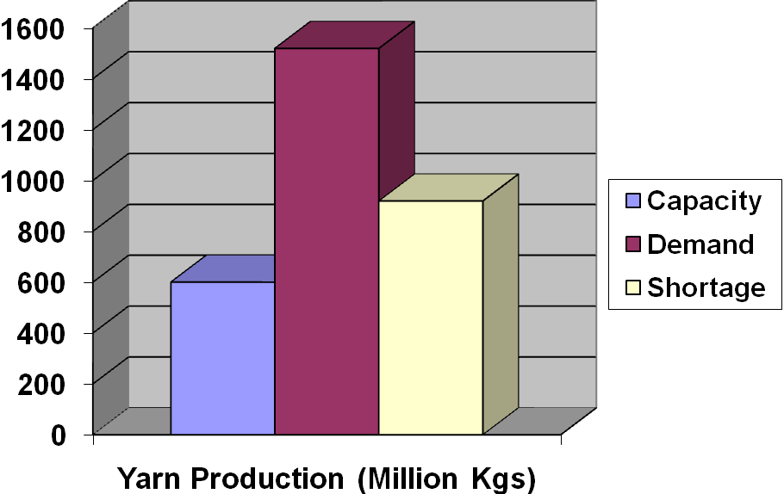
Chart: Present Yarn production, Demand and Demand-Supply Gap.
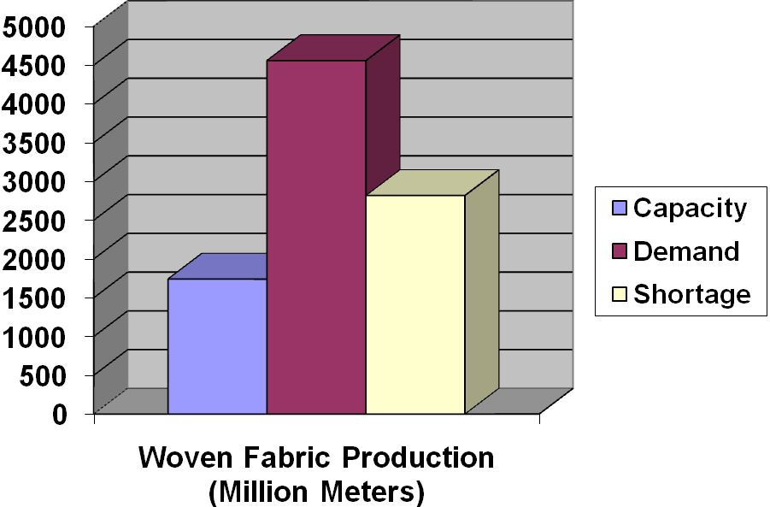

Chart: Present Woven Fabric production, Demand and Demand-Supply Gap.

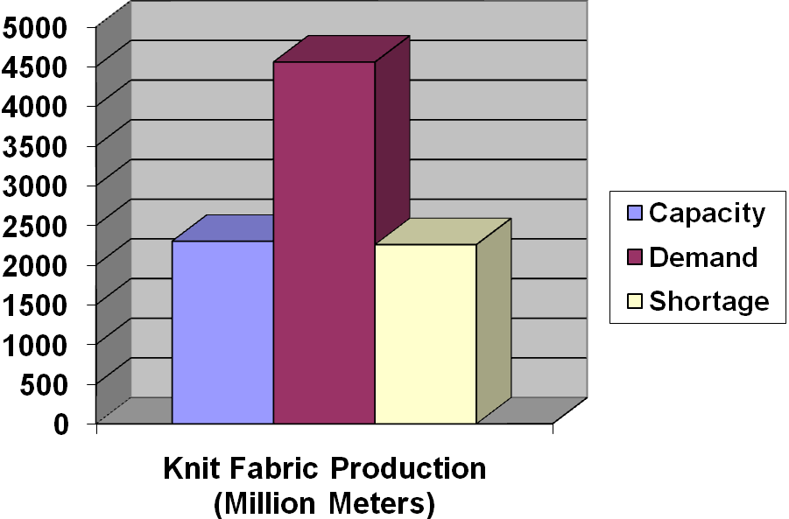
Chart: Present Knit Fabric production, Demand and Demand-Supply Gap.

Anticipation of the demand, therefore, could be done based on Naive (Time Series) model of forecasting reinforced by forecasting methods based on behavioral dimensions, which depends on historical data and intuitive assumptions made by experts having long presence in the sector. The projection estimates the demand of fabrics and yarns based on two-tire demand models: in the short-term and in the long-term perspectives. The later model indicates that total demands will comprise 9,115 million meters of fabrics & 1,519 million kg of yarn in 2009-10, of which 2,475 million meters of fabrics for domestic consumption and 6,640 million meters for consumption of export-oriented RMG industry.

4. Classification of Yarn:
Yarn may be classified from different points of view. Such as based on raw material type, based on spinning system, based on staple length etc. Details are given below:
4.1 Based on Raw Material:
Yarn may be classified in to two groups-1.Natural Yarn 2.Man Made Yarn. Natural yarns are two types-cellulosic yarn and regenerated cellulosic yarn. Cellulosic yarn can be divided in to four class-cotton yarn, silk yarn, Jute yarn and Wool yarn. Regenerated cellulosic yarns are Viscose rayon, viscose modal etc. cotton yarns are commonly two types-Karded yarn and combed yarn.
Man made yarn can be classified in to two types- Spun Yarn and Continuous Filament Yarn.
Graphical presentation of this classification:
Yarn

Natural Yarn Man Made yarn

Cellulosic Yarn Regenerated Cellulosic Yarn .

Cotton Yarn, Silk Yarn, Jute Yarn, Wool Yarn Viscose Yarn .

Karded Yarn Combed Yarn

Spun Yarn Continuous Filament Yarn
4.2 Based on Spinning System:
Based on spinning system yarns are commonly two types, Ring Spun Yarn and Rotor Spun Yarn.
Yarn

Ring Spun yarn Rotor Spun Yarn

4.3 Classification Based on Staple Length:
Based on staple length yarn may be classified in to two groups. – Staple Yarn and Continuous Filament Yarn.
Yarn

Staple Yarn Continuous Filament Yarn

Chapter 05
5.1 Yarn Composition (Ratio of Fibres):
Yarns are composed by different types of raw materials. Yarns which are manufactured by same type of raw materials are called “Virgin Yarn” and Yarns which are made by different types of raw materials together are called “Blended Yarn”.
a).Virgin Yarns:
Cotton Yarns: -Made by 100% cotton fibres.
Jute Yarn : - Made by 100% jute fibres.
Silk Yarn: Made by 100% Silk.
b).Blended Yarn:
PC Yarn:
Polyester and Cotton blended yarn.
Commonly used PC yarns are:
50:50 PC yarn: Made by 50% Polyester fibres and 50% cotton fibres.
65:35 PC yarn: Made by 65% Polyester fibres and 35% cotton fibres.
CVC Yarn:
CVC means “Cheap Value Cotton”. It is also cotton –polyester blended yarn, but cotton fibres percentage must be more than polyester fibres.
Commonly used CVC yarns are:
60: 40 CVC yarn: Made by 60% cotton fibres and 40% polyester fibres.
70:30 CVC yarn: Made by 70% cotton fibres and 30% polyester fibres.
80: 20 CVC yarn: Made by 80% cotton fibres and 20% polyester fibres.
c).Mélange Yarn:
Regenerated cellulosic fibres –“Viscose” and cotton blended yarn is called mélange yarn.
Commonly used melange yarns are:
99:01 Melange yarn “ Ecru Melange”: Made by 99% cotton fibres and 01% viscose fibres.
98:02 Melange yarn “ Ecru Melange”: Made by 98% cotton fibres and 02% viscose fibres.
97:03 Melange yarn “ Ecru Melange”: Made by 97% cotton fibres and 03% viscose fibres.
95:05 Melange yarn “ Grey Melange”: Made by 95% cotton fibres and 05% viscose fibres.
90:10 Melange yarn “ Grey Melange”: Made by 90% cotton fibres and 10% viscose fibres.
85:15 Melange yarn “ Grey Melange”: Made by 85% cotton fibres and 15% viscose fibres.

5.2 Use:
Yarn has versatile usages. It is used mainly for making cloths. It is used for making household items and it has industrial usage also.
Human being can not be a part of a civilized world without wearing cloths. Cloth is our basic need. Yarn is mainly used in garments industries for making both knitting and woven garments. More than 50% yarn, produced in our country, is used in knitting industries. Details are given below:

  - Yarn is used for making mainly human cloths.
  - Yarn is used for making households items, such as- bed sheet, curtain, carpet etc.
  - Yarn is used for making many types of decorative items.
  - Rope yarn is used in many industrial purposes for enhancing industrial process
  - Yarn is used for making some special items, such as-Parachute, astronauts’ dress, diver court, Bullet proof jacket etc.
  - Special types of yarns are used in medical surgery.

5.3 No. of spinning Factories:
In Bangladesh about 150 spinning factories are there. Total number of spindles are about 3300000. Total production is about 600,000,000 Kgs.
5.4 Source of raw material:
Without jute all others textile raw materials are imported. Cotton is mostly imported from following countries:
CIS-countries - Uzbekistan, Kazakhstan, Tajikistan etc.
Asian Countries- India, Pakistan, China.
African Countries - Zimbabwe, Mali, Benin, Nigeria, Togo, Uganda, Sudan, Egypt etc.
Cotton is also imported from USA, Australia and Brazil.
Polyester and viscose are mostly imported from China, India, Thailand, Taiwan and Indonesia.

Chapter 06
6.1 Price:
a). Price of Raw Material (present):
Sl. No. | Raw Material | USD/Kg(L/C –Value)
1 | CIS Cotton | 1.60
2 | Indian –Sankar-cotton | 1.55
3 | Indian- J-34-cotton | 1.50
4 | Indian-MCU5-cotton | 1.6
5 | Pakistani cotton | 1.40
6 | Sudanian cotton | 1.60
7 | Other African Countries’ cotton | 1.55
8 | USA-PIMA- cotton | 1.80
9 | USA –medium staple- cotton | 1.55
10 | Egypt –Giza-cotton | 1.80
11 | Polyester | 1.40
12 | Viscose-Black | 1.60
13 | Viscose-White | 1.60
14 | Viscose Modal | 1.70
Price of Yarn (present):
100% Cotton Combed Yarn:
SL. No. | Yarn Count (NE) | USD/Kg
1 | 50 | 7.20
2 | 40 | 6.80
3 | 34 | 6.50
4 | 32 | 6.30
5 | 30 | 6.30
6 | 28 | 6.30
7 | 26 | 6.25
8 | 24 | 6.25
9 | 20 | 6.20
10 | 16 | 6.10
100% Cotton Karded Yarn:
SL. No. | Yarn Count (NE) | USD/Kg
1 | 50 | 7.00
2 | 40 | 6.60
3 | 34 | 6.30
4 | 32 | 6.10
5 | 30 | 6.10
6 | 28 | 6.10
7 | 26 | 6.05
8 | 24 | 6.05
9 | 20 | 6.00
10 | 16 | 5.90

CVC Yarn:
SL. No. | Yarn Count (NE) | USD/Kg
SL. No. | Yarn Count (NE) | C:P=80:20 | C:P=70:30 | C:P=60:40
1 | 50 | 6.60 | 6.55 | 6.50
2 | 40 | 6.20 | 6.15 | 6.10
3 | 34 | 5.90 | 5.85 | 5.80
4 | 32 | 5.70 | 5.65 | 5.60
5 | 30 | 5.70 | 5.65 | 5.60
6 | 28 | 5.70 | 5.65 | 5.60
7 | 26 | 5.65 | 5.60 | 5.55
8 | 24 | 5.65 | 5.60 | 5.55
9 | 20 | 5.60 | 5.55 | 5.50
10 | 16 | 5.55 | 5.50 | 5.45

PC Yarn:
SL. No. | Yarn Count (NE) | USD/Kg
SL. No. | Yarn Count (NE) | P:C=65:35 | P:C=60:40 | P:C=50:50
1 | 50 | 6.10 | 6.05 | 5.95
2 | 40 | 5.70 | 5.65 | 5.55
3 | 34 | 5.50 | 5.45 | 5.35
4 | 32 | 5.30 | 5.25 | 5.15
5 | 30 | 5.30 | 5.25 | 5.15
6 | 28 | 5.30 | 5.25 | 5.15
7 | 26 | 5.25 | 5.20 | 5.10
8 | 24 | 5.2.5 | 5.20 | 5.10
9 | 20 | 5.20 | 5.15 | 5.05
10 | 16 | 5.10 | 5.05 | 4.95
Mélange Yarn:
SL. No. | Yarn Count (NE) | USD/Kg
SL. No. | Yarn Count (NE) | C:V=85:15 | C:V=90:10 | C:V=95:05 | C:V=97:03 | C:V=98:02 | C:V=99:01
1 | 50 | 7.00 | 7.00 | 7.00 | 7.00 | 7.00 | 7.00
2 | 40 | 6.75 | 6.75 | 6.75 | 6.75 | 6.75 | 6.75
3 | 34 | 6.55 | 6.55 | 6.55 | 6.55 | 6.55 | 6.55
4 | 32 | 6.35 | 6.35 | 6.35 | 6.35 | 6.35 | 6.35
5 | 30 | 6.35 | 6.35 | 6.35 | 6.35 | 6.35 | 6.35
6 | 28 | 6.35 | 6.35 | 6.35 | 6.35 | 6.35 | 6.35
7 | 26 | 6.30 | 6.30 | 6.30 | 6.30 | 6.30 | 6.30
8 | 24 | 6.30 | 6.30 | 6.30 | 6.30 | 6.30 | 6.30
9 | 20 | 6.25 | 6.25 | 6.25 | 6.25 | 6.25 | 6.25

Chapter 07
Costing:
7.1 Comparative Statistics of TTML:
Particulars | 2009-2010 Taka | 2008-2009 Taka | 2007-2008 Taka | 2006-2007 Taka | 2005-2006 Taka
Paid-up-Capital | 143,473 | 143,473 | 143,473 | 143,473 | 143,473
Reserves, Surplus & Others | 47,032 | 49,448 | 51,768 | 52,609 | 55,776
Shareholders’ Equity | 96,440 | 94,025 | 91,705 | 90,864 | 87,696
Net Asset | 547,550 | 523,910 | 439,221 | 438,728 | 438,622
Turnover | 766,141 | 554,377 | 456,105 | 672,398 | 735,960
Gross Profit/Loss | 160,695 | 100,027 | 79,032 | 116,333 | 114,794
Net Profit/Loss | 5,733 | 5,624 | 989 | 2,234 | 6,207
Prior year adjustment | 1,300 | - | - | 1,267 | -
Total Surplus for the year ( Before provision for tax) | 5,733 | 5,624 | 989 | 2,234 | 6,207
Provision for tax | 860 | 844 | 148 | 335 | 931
Number of Shares | 1,434 | 1,434 | 1,434 | 1,434 | 1,434
Number of shareholders | 926 | 955 | 994 | 972 | 1005
Earning per Share-EPS | 3.40 | 3.33 | 1 | 1 | 4
Dividend per Share-DPS | 1.71 | 1.71 | - | - | 2

7.2 Consolidated Manufacturing, Trading, Profit & Loss Account and Profit & Loss Appropriation Account:
Particulars | 2009-2010 Taka | 2008-2009 Taka | 2007-2008 Taka | 2006-2007 Taka | 2005-2006 Taka
Turnover | 766,141 | 554,377 | 456,105 | 672,398 | 635,960
Less, Cost of Goods sold | 605,446 | 454,351 | 377,072 | 556,065 | 521,166
Gross Profit | 160,695 | 100,027 | 79,032 | 116,333 | 114,794
Administrative | 48,752 | 45,667 | 39,794 | 84,954 | 64,084
Financial | 109,347 | 49,523 | 47,217 | 41,713 | 44,191
Other Income | 3,424 | 1,068 | 7,979 | 12,681 | -
Operating Profit/(Loss) | 6,020 | 5,905 | 1,038 | 2,346 | 6,518
Workers’ Profit Participation Fund | 281 | 49 | 111 | 310
Net Profit/(Loss) after tex | 286 | 4,780 | 840 | 1,900 | 5,277
Surplus/(Deficit) for the year | 4,780 | 840 | 1,900 | 5,277
Prior year adjustment | 1 | 4,878 | - | - | 1267
Surplus earning attributable to shareholders | 4,873 | 4,780 | 840 | 3,167 | 5,277
Less, Dividend | 2,459 | 2,460 | - | - | 2,460
Balance as per last Account | 61,061 | 63,381 | 64,222 | 67,389 | 69,959

Chapter 08:
Findings of Study:

Chapter 09:
Conclusion and Recommendation:

10.1 Conclusions

Islami Bank Bangladesh Limited through its steady progress and continued success has earned reputation and has become the leading private bank in the country. The Volume of investment of this bank has been increasing day by day. The network of the branches has widened and investment portfolio of the bank has been diversified. IBBL is trying to develop banking sector through welfare and servicing to the people. Islami economy and banking are bound together. IBBL has emerged facing the many obstacles yet. This bank is trying to operate its activities according to Islami Shari’ah. Islam is a religion for human welfare as well the social welfare. All the steps of Islam are only for the welfare for human being.

Interest free banking system is no more a concept. It is now a Reality, a dynamic system, embodying a set of superior banking Mode. More than 300 Islamic bank and Financial institutions are operating in different Countries throughout the world with a marked success from this inception in our country in 1983. IBBL has been operating with real and confidence in corporation with other conventional banks. Bringing a new concept in such business sector, which is growing too rapidly in the world, is rally bold step. As a large Islamic commercial bank, Islamic bank took various steps to create employment and socio-economic development for the poor through Islamic Shari’ah as well as to create an overall climate for the introduction of large scale Islamic banking environment in Bangladesh. To conclude we must say that, Islami bank Bangladesh Limited (IBBL) has immense potential in Bangladesh. It can play vital role in bringing revolutionary changes in our life with both material and moral world and in individual and collective level.
Bangladesh is not a full Islamized country, all activities are not operating according to the Shari’ah of Islam. But the IBBL is trying to operate its activities as much as possible. Despite this tremendous progress and success, IBBL is suffering from many problems. The most common problems are as follows:
- The marketing strategy and customer care department is not up to the mark.
- No Islami money market is available. Easily money transaction is no possible for the interest free banking system. Call rate money is not responded according to Islami Shari’ah.
- Islamic Banking is a new phenomenon in our country during last two decades. So majority of our people have no proper knowledge about the activities of Islamic Banking as well as its investment Mode hamper large scope of investment of IBBL.
- Most of the people in our country have a bad impression of IBBL’s operations regarding indirect generation of interest which meaning no difference between investment of IBBL loan / Credit / advance of conventional banks. For this reason, they are not too much interested to make investment with IBBL.Because of improper insufficient application of Islamic Banking rule in our country. The investment operations of IBBL can't run smoothly.

85

- IBBL, which is committed to avoid interest, can’t invest the permissible part of its statutory liquidity; Reserve and short Term liquidity surplus. Consequently the bank has to deposit reserve in cash with Bangladesh Bank and can not invest its surplus funds to earn income rather keeping those in idle. But the conventional banks of the country do not suffer from this problem.
- This Bank can't invest in all economic sectors, which are prohibited by the law of Islam.
- Profitable investment portfolio of IBBL requires clear investment knowledge according to Islamic Shari’ah. But sometimes IBBL can't invest its assets in proper portfolio due to insufficient and unskilled manpower in these regards .As a result, there is a large amount of money being idle and thus potential profit is not increasing.
- This Bank revalues its investment operations within limited number of investment modes and does not initiate investment modes according to changing diverse needs of people
- Sometimes investment operations of IBBL are hampered due to increase, dishonest, indiscreet, hypocritical nature of people.
- IBBL has no strong promotional activities to increase motivate its present and potential investment client.
- There are limited scopes to deal women entrepreneurs and professionals for making investment by women entrepreneurs.
- In rural areas for low income community, this Bank grants investment group wise, not individual.
- In some sectors like housing, real estate, project (industry) etc, this Bank disburses total invested money in times according to Banks pre-determined proportion. As a result, clients are failed to gain full benefits of investment disbursement at once.
- Another problem of IBBL in Bangladesh is that, no separate legal framework for Islamic Banking has yet been enacted. So, the bank is facing problems to handle contracts due to lack of Islamic law.
- Some officials of IBBL are not well conversant with Shari’ah views of the Islamic Investment norms and conditions. They have been failing to provide the service to the investment clients as the situational demands.
- Though the IBBL is expanding its investment through 196 branches (Dairy-2008), a vast majority of the rural disadvantaged people is being deprived of its investment facilities especially in the field of Agriculture, Fishery and small scale rural enterprise.
- All papers/documents/information are not always furnished by the client as per instruction given by the bank during sanction of investment.
- Lack of morality, honesty, and competency of the clients is another obstacle for the bank to make the investment operations a success.
- Clients are accustomed to interest oriented banking. They are not able to understand the investment Mode of IBBL.
- Another problem facing by the IBBL is to handle the cases of delay in payment. As per suggestions of Shari’ah Council, IBBL imposes financial penalty on overdue amount namely compensation. But the compensation is a doubtful income and it is similar to interest as per Shari’ah
- Tendency to make overdue intentionally by the clients.
86

 | IBBL has no investment in public sector as against set plan of 5% of its total investment.
 | IBBL has set its plan of 8% for Rural area & 92% for urban area of total investment. But only Rural area exceeds the set target of 8% by increasing 0.68% in 2006.
 | IBBL did not achieve its plan in the agriculture sector (i.e. 3%). Highest achievement is done in the year 2006 (2.83%).
 | Investment in trading sector has reached the set target of 40% in 2006.
 | Investment in share mode had not reached the set target of 15%. Highest investment is made in the year 2003 by 14.82%.
 | 87.13% of total deposit has been invested by the IBBL in 2007 which is highest in the last five years.
 | IBBL claims 9.05% in trade sector, 4.13% in agriculture sector, 10.35% in industry sector, 13.86% in working capital sector & 9.50% in transport sector among the all commercial banks.
 | There are observations are given below:
 | -- | Low cost of funds.
 | -- | Strong liquidity position
 | -- | IBBL take decisions carefully regarding investment.
 | -- | IBBL use Arabic word for mention investment mode, which confused customers/clients.
 | -- | Lack of appropriate interest free financial instruments where the IBBL invest its surplus fund.
 | -- | Shortage of trained manpower especially in handling Islamic investment modes.

10.2 Recommendations

From the forgoing discussion on the analysis of investment Modes it can be said that IBBL in its all transactions restricts interests and conducts its investment portfolio mainly under 3 (three) Modes. viz; i) Bai-Mode, ii) Leasing or Ijara Mode and iii) Share Mode. It is revealed from the study that IBBL provided its maximum investment facility to the investment clients or entrepreneurs under the Bai or Trading Mode is based on honesty and integrity on the part of the sellers more than anything else. The Bai-Salam and Bai-Istisna Modes have not yet been fully adopted by IBBL but started and practicing.

87

The trading Modes (Bai mechanism) are comparatively in advantageous position in the perspective of accounting of transactions, because they are based on fixed rate of return. Among the Modes, IBBL seldom applies Mudaraba and Musharaka Modes of Investment. In Mudaraba Mode, there are two parties: one with capital and with knows how, get together to carry out a project. If the project ends in profit in a pre agreed proportion. If the result in loss the entire loss is borne by the financier, and the entrepreneur gains no benefit. On the other hand, Musharaka is a joint enterprise in which all the partners shared on the base of profit or loss. Therefore, Mudaraba and Musharaka do not envisage a pre determined fixed rate of return. The return is based on the actual profit earned by the joint venture. The study reveals that the least investment facility was provided by the bank through the Mudaraba and Musharaka Modes. The reason for the lowest amount of investment may be attributed to untrustworthy clients, inefficient bank personnel, nonviable or non profitable project, lack of able, qualified and experienced entrepreneurs to carry out the project successfully, existing loss etc. Today business enterprise, industries and all others kinds of enterprises are established and run on a long term basis. Therefore, the Mudaraba and Musharaka to be applied to all kinds of enterprises shall be on along term basis. From the study it can be concluded that banks as a financial intermediary can not do banking without pre-fixed rate of return which is the only response to the moral hazards in banking.

Meaningful and effective investment planning, implementation and controlling are difficult tasks. A number of important aspects are to be considered if really any sincere attempt is expected to be made for the purpose of these tasks. In this regard some of the important recommendations are given below:
* | Islami bank Bangladesh Limited should take several necessary steps to eradicate misconceptions from people mind about interest based banking system, investment Mode, foreign exchange as well overall activities under Islamic banking Framework.
* | Promotional activities of the investment modes should be strengthened.
* | New investment product should be introduced.
* | Build up show room of Islamic Investment Mode like “Murabaha Shop”.
* | Developing unique service.
* | The Bank should go aggressive advertising and promotional activities to get a broad geographic coverage and authority of IBBL should introduce more innovative and modern customer service through outstanding marketing policy.
* | Arrangement of monthly /quarterly training courses /workshops for the clients selected by the Branches in order to promote Investment clients of the desired level.
* | Effective human resources should be placed at every department of IBBL for more speedy and smooth banking operation. Women employee should be increase more in order to deal women entrepreneurs for create demand for investment.
* | To fulfill the vision of "mass banking" this Bank should grants investment portfolio to new entrepreneurs /new businessmen new companies etc.
* | The Bank should disburse total invested money at once to the clients to achieve full benefits of invested money.
* | The amount of investment of RDS & operating range should increase. So more people will get the facility under the scheme & they will able to increase their standard of livings

88

* | To gain success in the programs like "Poverty Alleviation and "Self Reliant" especially in rural areas, this bank should provides investment facilities on the basis of individual.
* | Decision making process should be free of ambiguity and be time conscious.
* | Allocating resources for opening new branches, and expand marketing program.
* | Govt. Taxation and duty system must be in accordance with Islamic Shari’ah.
* | The officials of the bank especially who are engaged in investment department must be trained up effectively so that they can make the general people, interested to take the investment facilities, understand the salient features and other formalities of investment in a simple and understandable way. In this regard more training and research academies or centers are to be established out sides Dhaka.
* | Central banking policy in line with Islamic norms must be implemented and initiative should be taken to create Islamic Money market and capital market introducing the interest free securities.
* | To reduce overdue & classified investment, IBBL may engage recovery agency.
* | IBBL may invest in the sector of electricity, gas, water & sanitary service sector.
* | To improve investment performance the bank may reduce rate of return of investment in all sectors.
* | Investment of the Islamic bank portfolio be diversified and extended for long term financing under Musharaka and Mudaraba mode.
* | To give emphasis for housing scheme of medium and lower income group.
* | To take care of the need of the low income group.
.

89

Bibliography

Books:
1. | Ahmed, A. (1992), “Contemporary Experiences of Islamic Banks”. Journal of Objective Studies, Institute of Objective Studies, Delhi.
2. | Ahmed, A. (1993) “Contemporary Practice of Islamic Financing Techniques”. Jeddah: Islamic Research & Training Institute, IDB.
3. | Ahmed, N (2002), “Objectives of Islami Banking Bangladesh Ltd”, Islami Bank Publication, Dhaka.
4. | Ahmed, S (1990). Investment Opportunities in Bangladesh. Proceeding on Islamic Banking and Insurance. Islami Bank Bangladesh Limited, Dhaka.
5. | Annual reports, of Islami Bank Bangladesh Limited (IBBL) for 2003, 2004, 2005, 2006 & 2007.
6. | Chapra, M.U. (1995), Towards a Just Monetary System. Leicester: The Islamic Foundation, Dhaka.
7. | Hasan, M. K. (2003), Text Book on Islamic Banking, Islami Economics Research Bureau, Dhaka. The IBBL Operation Manual (2006) Islami Bank Publication
8. | IBBL (2006), Operation Manual, Islami Bank Publication, Dhaka.
9. | IBBL (2007), Introduction of Islami Bank Bangladesh Ltd. IBBL, Dhaka.
10. | Islam, M.N. (1999), Modes of Investment of IBBL, Bank Parikrama, BIBM, Dhaka.
11. | Jebal, A.A (2006), “Islamic Banking Definition, History, Growth and Present Status in Bangladesh”, IBTRA, Dhaka.
12. | Mohon, I.K. (1999), Adhunik Banking, Sourav Prakashani, Dhaka.
13. | Naresh K.M (2007-5th edition), Marketing Research”, Prentice Hall of India Pvt. Ltd. New Delhi.
14. | Raquib, A. (2007), Principal & Practice of Islamic Banking, Panam Press Ltd., Dhaka.
15. | Sadek, A.H.M. (1993), Resource Mobilization and Investment in Islamic Structure, Bank Parikrama, BIBM, Dhaka.
16. | World Bank (2007), Global Economic Prospects Report: World Bank, Washington.

Web Site:
i. | www.bangladesh-bank.org
ii. | www.islamibankbd.com
iii. | www.islamibanking.com

Chapter | Title | Page
 | Title Page
 | Letter of Transmittal
 | Researcher’s certificate
 | Supervisor’s certificate
 | Acknowledgements
 | Executive summary
Chapter: 1 | Introduction
 | 1.1: Introduction | 01
 | 1.2: Rationale of the Study | 02
 | 1.3 Origin of the report | 02
 | 1.4 Scope of the study | 03
 | 1.5 Objectives | 03
 | 1.6 Methodology | 03
 | 1.7 Data analysis techniques | 04
 | 1.8 Limitation | 04
 | 1.9 The organization of the study | 05
Chapter: 2 | An Overview of IBBL
 | 2.1 Concept of Islamic Banking | 06
 | 2.2 Business Philosophy of IBBL | 06
 | 2.3 Special features | 06
 | 2.4 Aims and Objectives of IBBL | 07
 | 2.5 Goals of IBBL | 07
 | 2.6 Mission of IBBL | 07
 | 2.7 Vision of IBBL | 07
 | 2.8 Function | 08
 | 2.9 Achievement | 08
 | 2.10 Award and prizes | 08
 | 2.11 Membership of different organization | 08
 | 2.12 Historical background | 09
 | 2.13 Mile store | 09
 | 2.14 Equity | 10
 | 2.15 Shariah council | 10
 | 2.16 Management | 10
 | 2.17 Human resources management | 10
 | 2.18 Performance of IBBL | 11
Chapter: 3 | Investment policy of IBBL
 | 3.1 Introduction | 12
 | 3.2 Objectives | 12,13
 | 3.3 Salient Features | 14
 | 3.4 Principles of investment | 14
 | 3.5 Five years perspective investment plan 2003-07 | 15

Chapter: 4 | Conceptual Frame work
 | 4.1 Meaning of investment | 16
 | 4.2 Investment Modes of IBBL | 16
 | 4.3 Modes of Investment | 16
 | 4.4 Bai-mechanism | 16
 | 4.5 Conditions of buying & selling | 16
 | 4.6 Types of buying & selling | 17
 | 4.7 General concept of Bai-Murabaha | 18
 | 4.8 Basis of Bai-Murabaha | 18
 | 4.9 Important features | 18
 | 4.10 - 4.14 Types of Murabaha | 19,20
 | 4.15 Bai-Muajjal | 20
 | 4.16 Important features | 20
 | 4.17 Bai-Salam | 21
 | 4.18 Bai-Istisna | 21
 | 4.19 Bai-ashraf | 21
 | 4.20 Quard-e-Hasana | 21
 | 4.21 – 4.31 Investment under Shirkat Mechanism | 22-24
 | 4.32 – 4.36 Musharaka | 24
 | 4.37 Mudaraba | 25
 | 4.38 Ijarah mechanism | 26
Chapter: 5 | Performance of IBBL from 2003 to 2007
 | 5.1 Performance of investment by size | 27
 | 5.2 Performance of investment by sector | 28
 | 5.3 Performance of investment by area | 29
 | 5.4 Performance of investment by economic purpose | 30
 | 5.4.1 Agriculture, 5.4.2- Project, 5.4.3- Working capital 5.4.4- Housing, 5.4.5- Special schemes | 31-37
 | 5.5 Performance of investment by mode wise | 38
 | 5.6 Classified Investment | 39
Chapter: 6 | Performance of IBBL comparing with all Banks. | 40-43
Chapter: 7 | Performance of IBBL comparing with other 04 Islamic Banks. | 44-48
Chapter: 8 | Profitability analysis of IBBL:
 | Income, Investment deposit ratio, Classified investment, Return on equity, Return of assets, EPS, Net investment income margin, other ratios. | 49-54

Chapter: 9 | Analysis of performance of Modes of Investment:
 | Introduction | 55
 | Bai-Murabaha | 56
 | Bai-Muajjal | 59
 | Bai-Salam | 63
 | Hire Purchase under Shirkatyk Meilk | 66
 | Musharaka | 70
 | Mudaraba | 74
 | Quard-e-Hasana | 77
 | Other mechanism | 81
 | Formalities of investment | 81
Chapter: 10 | Conclusions and Recommendations
 | Conclusion | 84
 | Recommendations | 86
 | Bibliography | 89

Acronyms:

IBBL | Islami Bank Bangladesh Bank
AMD | Assets Management Division
IAMD | Investment Administration and Management Division.
MIS | Management Information System
IPPD | Investment Policy and Planning Department.
HPSM | Hire Purchase under Shirkatul Meilk
EPS | Earning Per Share
NCB | National Corporatized Bank
PCB | Private Commercial Bank
REO | Return on Equity
BIBM | Bangladesh Institute of Bank Management
IBB | The Institute of Bankers of Bangladesh

Executive Summary

Today Islamic Banking has achieved significant advancement to evolve into a comprehensive Islamic banking system that is able to contribute effectively to the economic growth process. Islamic banking is becoming an integral part of the international banking landscape. This achievement is evidenced by the existence of a well developed Islamic banking network. All these positive developments have aimed to contribute towards developing Islamic banking into a efficient and sustainable functioning system of investment. The overall impact of Islamic banking in Bangladesh is that it has become acceptable not only to the ordinary masses, but also to the elite of the country including top level of industrialist and business magnet. Everybody now strongly accepts the fact that Islamic banking is a viable alternative to conventional western model of banking.
Islam requires its followers to shape their entire life, economic and financial dimensions included, in conformity with Shari’ah. Islamic Shari’ah prohibits riba (interest and usury), whether nominal or excessive, simple or compound, fixed or floating. Naturally, Islamic banking avoids riba.
The establishment of Mit Ghamar Local Savings Bank (Egypt) in 1963 marked a new milestone in the revolution of the modern Islamic banking system, then in quick succession interest free institutions appeared all over the world. From the speed of expansion, it is hoped that very soon Islamic banking will overtake conventional banking and become the mainstream of banking in the OIC countries. Islami Bank Bangladesh Limited (IBBL) is the first of this kind in our country and South East Asia also. IBBL is an Islami Bank bases on Islami Shari’ah. IBBL operates its investment activities under 03(three) Modes (mechanism) namely (i) Bai-Mechanism (ii) Share Mechanism & (iii) Ijara mechanism). The bank has already occupied an enviable position among its competitors after achieving success in all area of business operation. Both the deposit and investment of the bank are growing fast.
When money is deposited with an Islamic Bank, the bank, in turn, makes investments in different forms approved by the Islamic Shari’ah with the intent to earn a profit. Some popular modes (mechanism) of Islamic investment are discussed in this study.

A comparison is also attempted to analyze the performance of IBBL from 2003 to 2007 comparing with the performance of PCBs, NCBs & other Islami Banks as well as other 04 Islami Banks.
With the purpose of exploring the performance of IBBL, the present study first focuses on the investment activities and its plan regarding investment as well as theoretical aspect of investment mode. The first chapter consists of background of the study, origin of the report, objectives, methodology of the report and also some limitations in doing the report. Business philosophy of IBBL, special features of investment, aims & objectives, mission, vision, function, highlights and last three years of performance of IBBL is shown in chapter two. Chapter three covers the investment policy. Investment policy indicate the sector of investment, purpose of investment, objectives, features of investment and principles of investment. The bank extends investment under the principles of Bai-Murabaha, Bai-Muajjal, Hire- Purchase under Shirkatul Meilk and Musharaka. The bank is making sincere efforts to go for investment under Mudaraba principal in near future. Chapter four describes the conceptual framework of the study (performance of investment modes in banking system). There are three Modes of investment under Islamic banking system. They are Bai-mechanism (mode), Shirkat mechanism (sharing or partnership) & Ijara mechanism (partnership in ownership or shirkatul meilk). Arabic word Bai means buying and selling. The condition of buying and selling are (i) the commodity must be existing; a commodity which does not exist at the time of sale can not be sold. (ii) the seller should have acquired the ownership of that commodity and therefore, if the commodity is existing but the seller does not own it, he can not sell it to any body (iii) mere ownership is not enough, it should have come into the possession of the seller, either physically or constructively. If the seller owns a commodity but he has not taken its delivery himself or through an agent, he can not sell it. The shirkat which means ‘a partnership effected by a mutual contact’ where two or more persons agree to contribute in the capital, participate in the management and share its profit and bear the loss, if any. Mudaraba is a partnership in profit whereby one party provides capital and other party skills and labour. The provider is called ‘Sahib al-mal’ while the provider of skill and labour is called ‘Mudarib’. In Ijara mechanism, two modes of investment HPSM & Ijara or Leasing or Hire purchase.

The performance of investment of Islamic Banks is shown in chapter five & six. Chapter five covers the performance of investment of IBBL (2003-2007) by size, sector, area and economic purpose. Performance of project investment of IBBL also highlights in chapter five. Performance of IBBL comparing with all Banks in Bangladesh is shown in chapter six where the IBBL occupied 10% investment. Chapter seven covers the performance of IBBL comparing with other 04 Islamic Banks. Total investment of Islamic Banks in Bangladesh is 16% among the all Banks where the IBBL claim 10% investment. EPS of IBBL as of 31st Dec’07 is highest among the Islamic Banks i.e. Tk.53.90 and the lowest position of EPS of SIBL i.e. Tk.17.60. Return on general investment of IBBL is 10.88% as of 31.12.07. Profitability analysis of IBBL is shown in chapter eight. Growth of income of 2007 is 26.08% over the base figure of 2006. Chapter nine covers the analysis of performance of different types of investment modes in IBBL. From the last five years data of IBBL, it shows that the amount of sanction, disbursing & recovery position is good. Above 90% recovery is made from the disbursement amount. There is limitation which is identified and some recommendation has given to overcome that limitation and finally conclusion has drawn in last chapter ten. Effort is given here to make the report authentic and easily understandable. In spite of this if there is any mistake in the report; it is welcomed for the betterment of the report.

Chapter 01:

INTRODUCTION

Origin of the Report:
As a part of the Internship Program of Masters of Business Administration course, I was assigned for doing my internship on “Different Types of Yarn Marketing In Bangladesh, A Case Study of Tamijuddin Textile Mills Ltd” for a period of 13 weeks, starting from 1st October’2010 to 31st December’2010 as an intern by Internship program committee, Department of Marketing, Faculty of Business Studies, University of Dhaka. My project was to explore “Different Types of Yarn Marketing in Bangladesh”. My faculty supervisor Dr. Anwarul Islam, Professor, Department of Marketing, Faculty of Business Studies, University of Dhaka, assigned this project and authorized me to prepare this report.

1.2 Objectives of the Report:
- To depict the standard features of a yarn manufacturing company.
- To explore the Departments, Divisions and its functions of a spinning company.
- To analyze the performance of the Company.
- To find out the way of developing relationship among management, officers, workers, external suppliers and the buyers of the organization.(Human Resource)
- To improve the quality of yarn and compare it with Uster statistics for getting marketing advantage (product development).
- To find out the way of optimum uses of machines and superior technologies for the better yarn (technology).
- To implement the superior marketing techniques ( marketing technique)
- To reduce the transportation cost, office expenses, wages and other casts (cost reduction)

1.3 Sources of Information
Information is collected to furnish this report from both primary and secondary sources.

The primary sources are:
- Practical Deskwork.
- Face to face conversation with the employees.
- Face to face conversation with the Suppliers
- Face to face conversation with the Buyers.
- Analyzing marketing follow up of yarn orders.

The secondary sources are:

- Different Manuals published by “The Textile Today”
- Business Reports of “Tamijuddin Textile Mills Ltd.”
- Journals, published by different economics related organizations of our country and abroad.
- Publications, obtained from different libraries and from Internet.
- Library research

1.4 Methodology
The information for the Yarn Manufacturing Organization of the report was collected from primary and secondary sources like practical experience, books, publications, WebPages, and annual reports of my organization-“Tamijuddin Textile Mills Ltd”. For detail concept development about the organization, short interviews and discussion session were taken as primary source.

The information for the Project “Different Types of Yarn Marketing in Bangladesh, A Case Study of Tamijuddin Textile Mills Ltd” has been collected from primary and secondary sources. For gathering concept of yarn marketing, different quality related local as well as international journals, periodicals, manuals, and industry related aspects were thoroughly analyzed. Beside this observation, discussions with the Buyers and consumers of the organization were also conducted.

For evaluation of the cost benefit of marketing and process, I tried to bring in the related theory from different books, journals and then tried to relate it to the practical way of working in the textile industry. I have considered my yarn manufacturing organization –Tamijuddin Textile Mills Ltd as a case study and that can be represented widely and clearly and as the average size of the population.

1.5 Limitation:

The major limitations faced during the preparation of this report are as follows –
- A period of 13 weeks is not sufficient to collect and understand the insights of organization.
- Textile yarn manufacturing factory policy does not permit to disclose various data and information related to their inventory and management policy.
- Most spinning factory owners are ignorant about the importance of relationship between buyers and producers.

Chapter 02:

2.1 Over View of Yarn manufacturing organization-“Tamijuddin Textile Mills Ltd.”

A Chronicle of Growth
The company was registered in 1970. LC for import of machinery opened in 1971. Liberation war broke out in the then East Pakistan and dislocated works.
1970-71

1973
In Bangladesh, the company was nationalized in 1973

1985
Company denationalized

Commercial production with finance from Bangladesh Shilpa Bank started in 1988 with 14,136 spindles with one blow-room line
Product: Assorted yarn ( 100% cotton yarn for local woven market)
Count range: 30/1 -100/1
1987-88

1st phase BMRE: spindles increased by 25,632 to 39,768 with two blow-room lines.
Product: 100% cotton and cotton –polyester blended yarn for local woven market.
Count range: 30/1 – 100/1

1990-92

2st phase BMRE: spindles increased by 9,600 to 49,368 with three blow-room lines.
Product: 100% cotton yarn for export.
Count range: 18/1-40/1 for knit market.
16/1-100/1 for woven
20/2-32/2 for sweater

2003-04

Production capacity: 3 lines of production facility with four blow room lines.
Product: 1. 100% cotton yarn for export (knit)
2. 100% cotton yarn for export (woven & sweater)
3. PC, CVC & mélange yarn for export (woven & knit)
2005- Onward
Description:

The company is producing and selling cotton, polyester, Mélange and Modal yarn for export market as well as local market. The company is exporting yarn under back-to-back LC to the local knitwear and woven industries.
From the begging of the factory it was the number one in yarn manufacturing up to 1990 in terms of quantity and quality. At that time its yarn demand was very high. After 1990 many spinning industries were established with latest technology. So the company faced huge challenge to exist in yarn market. To cope with the growing demand and increasing quality consciousness of yarn by the customer the company then started to change old machineries with latest technologies and still now it is going on. Most of the machineries are made in Germany and Japan. At present the company is producing high quality yarns of different types.
The company is purchasing raw materials such as cotton, polyester, viscose and rayon fibers from various countries around the world. Cotton is being perched mainly from Uzbekistan, Kazakhstan, Tajikistan, Pakistan and India. Polyester, viscose and rayon are mainly purchased from India, Indonesia, China, Taiwan and Thailand. Raw material is purchased through LC.
In case of local selling company is selling yarns to brokers in Madhobdi-Narshingdhi and Narayangonj local yarn market. Local brokers are buying the yarns from the company by cash money.

2.2 Business Objectives:

- Tamijuddin Textile Mills(TTML) Ltd strives to exceed the needs and demands that customers have. TTML is committed to achieve results and customer satisfaction by deploying skills and techniques designed to put our customers in front.
- TTML, develop, and maintain skilled and pro-active professionals to bridge the cultural, commercial and technical barriers. TTML is committed to constant improvement of processes to achieve shorter reaction time and constant high quality.

2.3 Corporate Commitment

- To be a leading manufacture of quality yarn in Bangladesh for fulfilling customer needs with professionalism and integrity.
- To maintain an environment that attracts, develops, retains, rewards and motivates talent and productivity.
- To establish environmental excellence in it’s all steps of production and actively promote environmentally responsible behavior at all levels of the organizations, in customers and suppliers.
- To strive for an outstanding corporate and individual behavior to maintain lasting trust and confidence of our customers, employees and suppliers.
- To maintain a level of profitability that sustains growth, ensures quality and provides generous rewards to staff and adequate return to shareholders.

2.4 Vision, Mission and objectives of the company:
Vision of the corporate company is “To become an environmentally excellent group, promoting environmentally superior products in an environmentally superior manner.”

As a company led by business ethics it stresses more on environment friendly product. In order to meet the always growing demands of a global market, the company has, apart from providing and distributing goods, to guarantee a reliable service for customers and suppliers.

The mission of the Tamijuddin Textile Mills Ltd is to maximize profit with superior quality and to be competent in all aspects of yarn manufacturing featuring cutting edge technology.

The primary aim of TTMl is to become the best specialist yarn manufacturer, meeting and exceeding our buyer’s demand. TTML hires, develops, and maintains skilled and pro-active professionals to overcome the technical barriers. It is committed to a constant improvement of processes to achieve shorter reaction time and consistent high quality.

TTML strives to add further value to the high level of services that it already offers to customers. Towards this end, TTML continuously monitors the changing market and maintain sharp lookout for new opportunities.

Nowadays yarn market is more unpredictable. Dramatic changes are occurring in market place. These radical changes are creating new sets of challenges for all of the players in the industry.
2.5 Management
A management with a clear strategy and concrete aims for the 21st century as well as a clearly defined company policy, together with a highly motivated staff, is the basis for the efficiency and the success of TTML.

Managing Team of TTML at a Glance ( A sample of a yarn manufacturing organization):
 |  | Chairman/Director
 |  | General Manager –Head office
 |  | General Manager –Technical
Administration |  | Deputy General Manager
 |  | Officer
Production & Quality |  | Deputy General Manager
 |  | Manager
 |  | Sr. Officer
 |  | Officer
Maintenance & Electrical |  | Deputy General Manager
 |  | Manager
 |  | Officer
Marketing |  | Assistant General Manager
 |  | Manager
 |  | Officer
Commercial &Accounting |  | Assistant General Manager
 |  | Officer
Purchase |  | Officer
Security |  | Officer

2.6 Departments of a Yarn Manufacturing Organization (TTML):
For the ease of work procedure, TTML departmentalized itself by functions. The main departments are Production, Quality, Maintenance, Electrical, Administration & Human resource, Marketing and Financial

a) Production Department:
Min functions of the department relate to
- Allocate the machines based on products type.
- Keep good relation with the workers to maximize their efficiency.
- Maximize the production.
- Maintain the online yarn quality.

b) Quality Department:

Raw material selection.
    - Choosing the quality parameters.
    - Monitoring and controlling the oiff line quality of the yarn.
    - Providing the all the machine settings.

c) Maintenance Department:

- Keep the machines in good operating condition by doing schedule maintenance.
- Attend any unwanted breakdown in the machine.
- Keeping working environment unchanged based on Relative Humidity (RH%) and Temperature continuously.

d) Electrical Department:

- Keep the machines electrically in good operating condition over a long period of time.
- Maintaining the power generator properly and distribute the load to the machine as per requirement.

e) Administration and Human Resources(HRD)Department:

HRD performs all kind of administrative and personnel related matters. The broad functions of the division are as follows:
- Selecting & Recruitment of new Personnel.
- Prepare all formalities regarding appointment and joining of the successful candidates.
- Placement of Manpower.
- Deal with the promotion, and leave of the employees.
- Training & Development.
- Termination and retrenchment of the employees.
- Keeping records and personal file of every employee of the organization.
- Arranges workshops & training for employee & executives.

f)Financial Division
Financials Department mainly deals with the account side of the TTML. It’s functions are as follows
- Salary & Wages of the Employee.
- Rentals, maintenance and leases.
- Travel, conveyance, entertainment, medical etc.

g) Marketing Department:
Details have been discussed leter.

3.6 Technology:
World sophisticated technologies have been used to produce high quality yarn.
3.7 Common Machineries of the Yarn Manufacturing Organization.
1. Blow Room Machineries:
  - Bale Opener –BO/ BX
  - Axiflow Cleaner AFC / Maxiflow Cleaner MFC
  - CVT -3, CLC -1.
  - Securomat SCB, Fan TV
  - RST. Cleaner LVSA , RK, Fan TV
  - Dust Tex
  - MAS, Foreign fiber separator SCFO. VT 2, Dosing feeder MSL
  - PWSE
  - Fine Opener
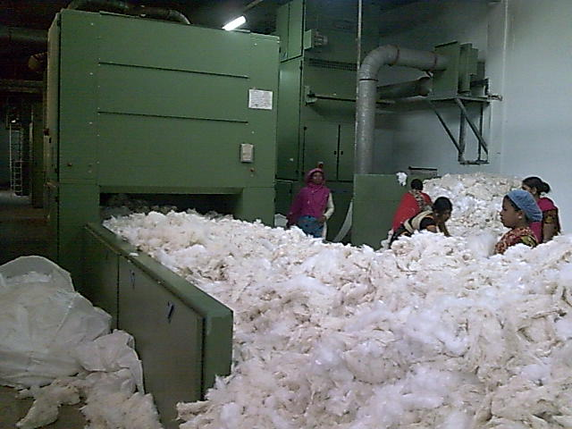
Fig: Blow Room (Workers are putting Raw Material on BO lattice)
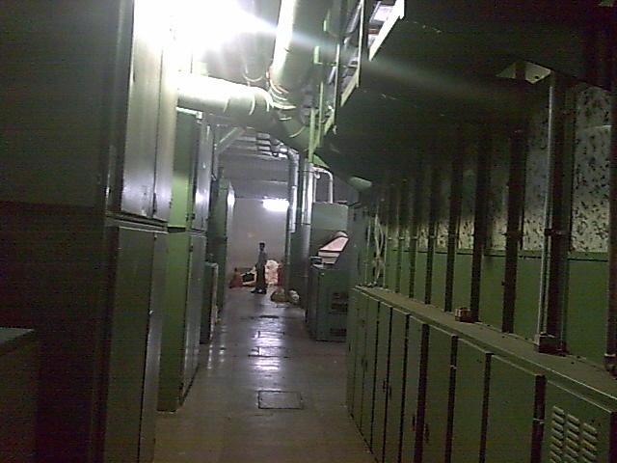
Fig: Blow Room

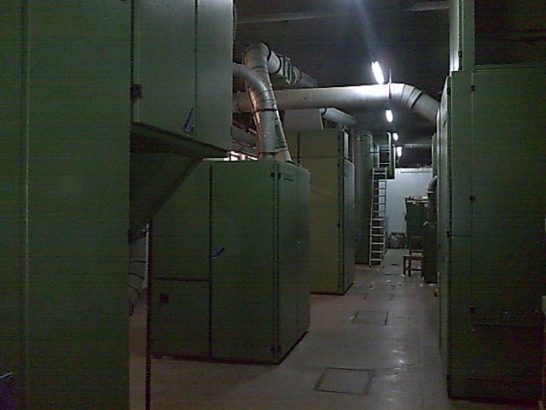
Fig: Blow Room
2. Carding Machines:
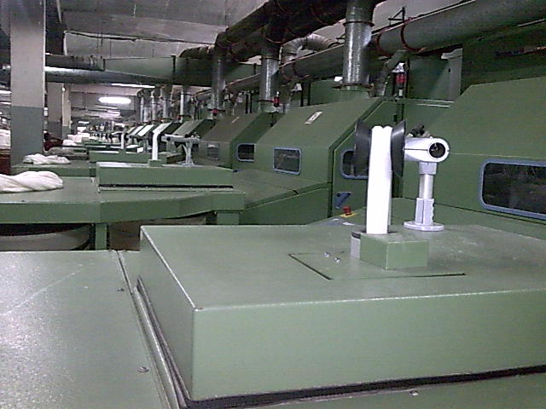
Fig: Carding Machine
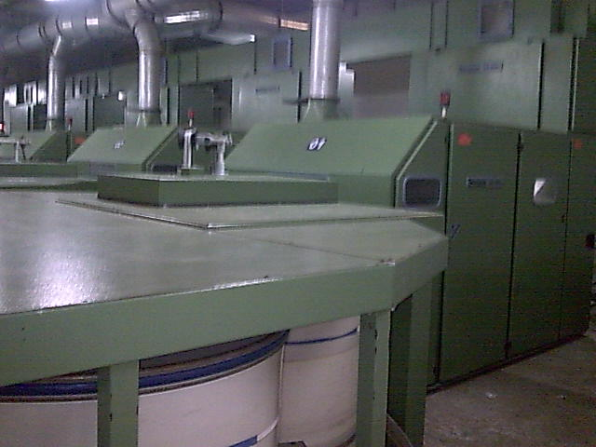
Fig: Carding Machine
3. Draw Frame:
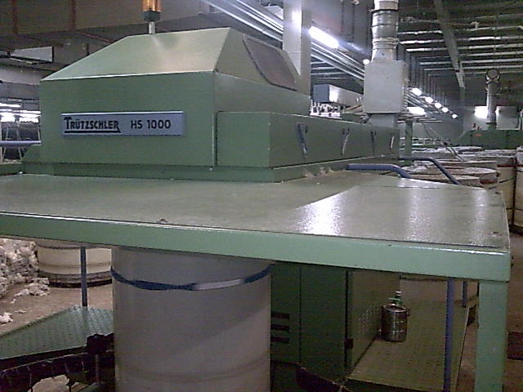
Fig: Drawing Machine
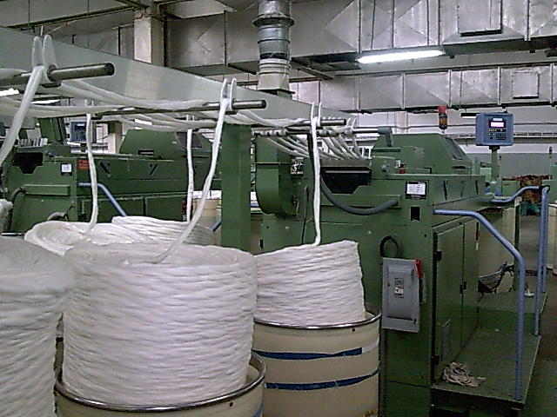
Fig: Drawing Machine
4. Simplex Machine:
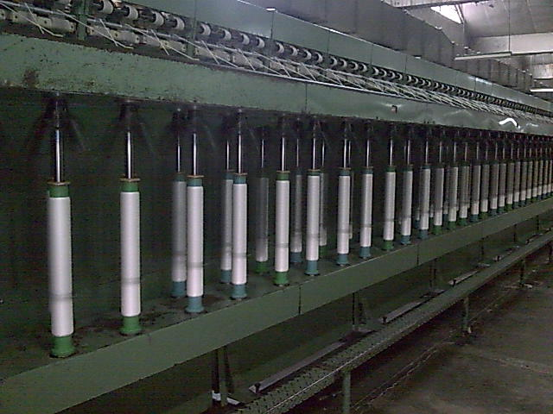
Fig: Simplex Machine
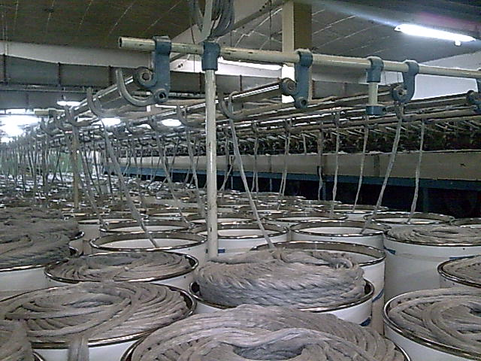
Fig: Simplex Machine
5. Ring frame:
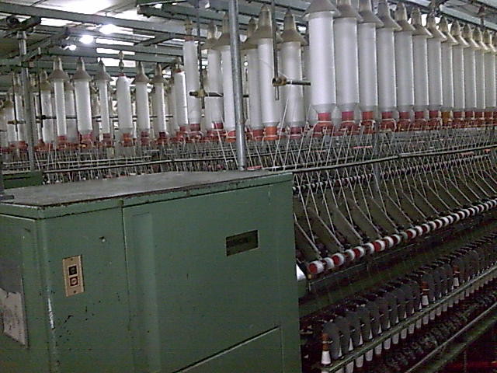
Fig: Ring Machine
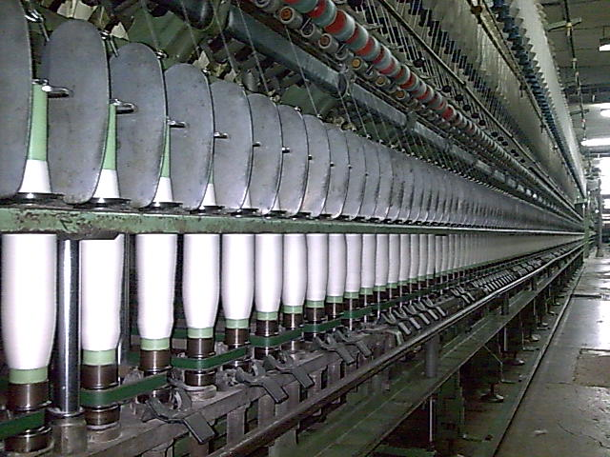
Fig: Ring Machine

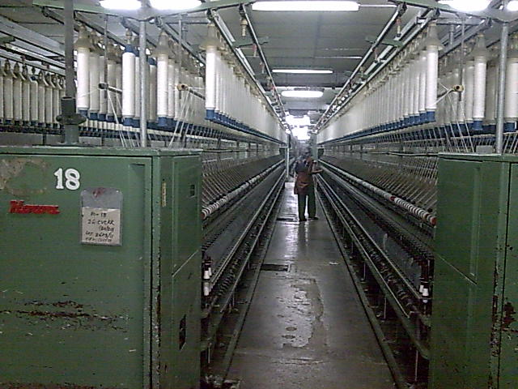
Fig: Ring Machine
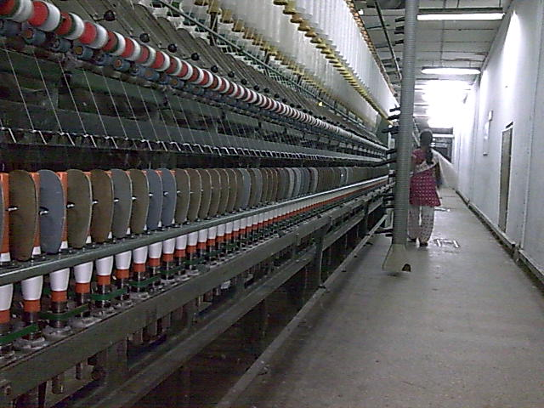
Fig: Ring Machine
6. Winding Machines:
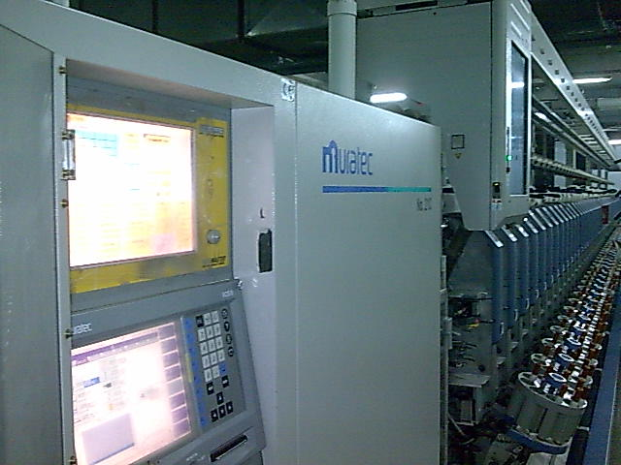
Fig: Cone Winding Machine ( 21 C).
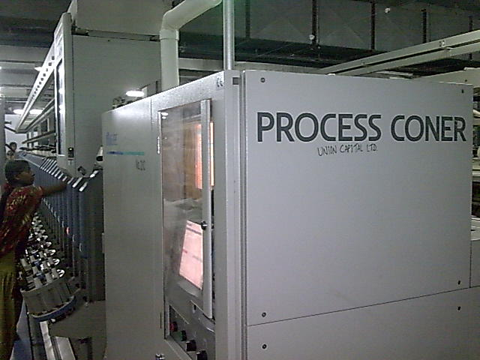
Fig: Cone Winding Machine ( 21 C).

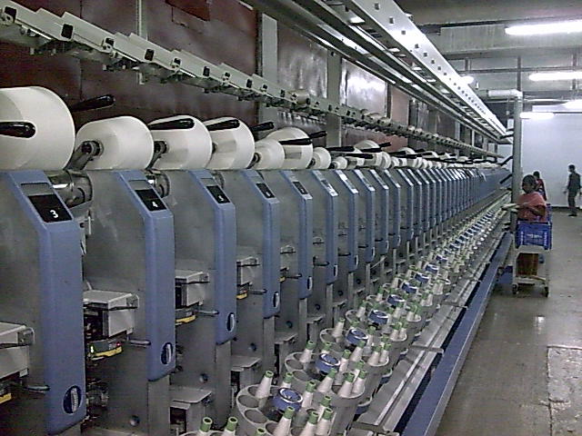
Fig: Cone Winding Machine ( 21 C).

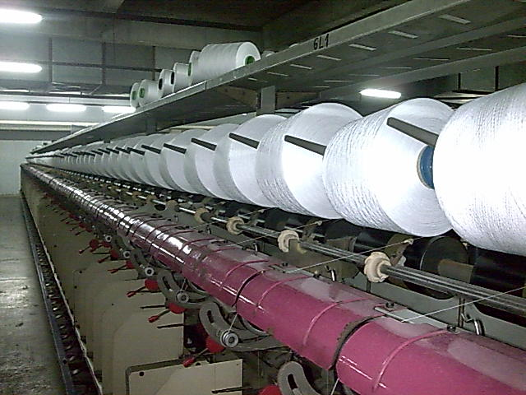
Fig: Twisting Machine(TFO)
7. Yarn Testing machines:
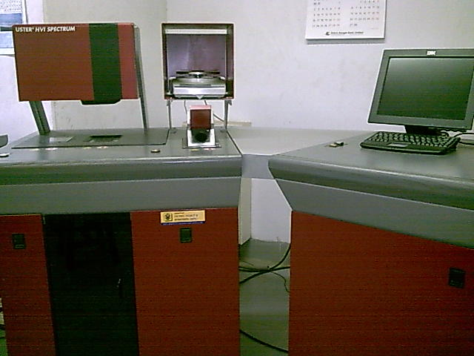
Fig: Fibre Testing Machine( HVI-High Volume Instrument)
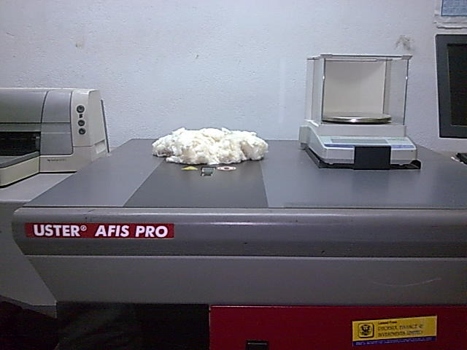
Fig: Fibre Testing Machine( AFIS-Advance Fibre Information System)
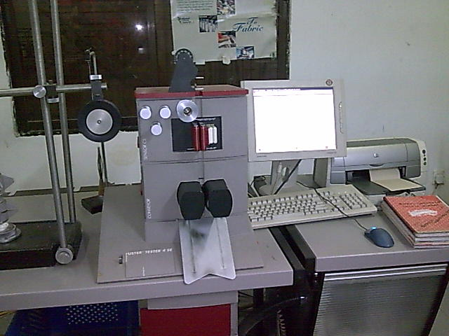
Fig: Yarn Testing Machine( Uster Tester 4 SE)
Details Machineries of Tamijuddin Textile Mills Limited:
SL.NO | Name of the Machinery brand & Origin | Type / Model | Mfg. Year | Com. Date | Qty.
1 | Blow Room Line 1 - (Ohtory Trutzschler / Trutzschler) |  | 1987-96-97 | 1998 - 2004 | 1
 | {1 Scutcher SME, Axiflo, MPM - 6 (Made of Japan)}
 | Bale opener(BO), CVT- 3 , Dustex ( Made of Germany)
 | Blow Room Line 2 - (Ohtory Trutzschler / Trutzschler) |  | 1987-96-97 | 1998 - 2004 | 1
 | {1 Scutcher SME (Made of Japan)}
 | Bale opener, MPM-4, CLC- 1, Dustex (Made of Germany)
2 | Blow Room Line 3 - ( Trutzschler Germany) |  | 2003 | 2003 | 1
 | Bale opener - BX, Maxiflo MFC, Securomat SCB, Fan TV,
 | Multimixer MPM - 8, Cleanomat CVT - 1, Material separator
 | MAS, Foreign fiber separator SCFO. VT 2, Dosing feeder MSL
 | Fan TVD 425, Electrical installation EAS, T - Distributor T - 2
3 | Blow Room Line 4 - ( Trutzschler - Germany) |  | 1996 - 97 | 2004 | 1
 | Bale opener - BO, Maxiflo AFC, Cleaner RST. Cleaner LVSAB
 | Fan TV, PWSE – 1
SL.NO | Name of the Machinery brand & Origin | Type / Model | Mfg. Year | Com. Date | Qty.
 | Blow Room Line 5 - ( Trutzschler - Germany) |  | 1996 - 97 | 2004 | 1
 | Bale opener - BO, Procupine opener (Japan) RK, Fan TV
 | PWSE - 2, Multimixer MPM - 8, Fine opener - FO, Transport
 | Fan TVD.
4 | Carding
 | [a] Howa card with autoleveler (Japan)Lap feed | CMK - 3 | 1987 | 1988 | 17
 | [b] Howa card with autoleveler (Japan) Lap feed | CMK - 3 | 1992 | 1992 | 6
 | [c] Trutzschler card with autoleveler (Germany) Chute feed | DK - 903 | 2003 | 2003 | 8
 | [d] Trutzschler card with autoleveler (Germany) Chute feed | DK - 903 | 2000 | 2004 | 6
5 | Drawing
 | [a] Howa 2 - Delivery [ Japan ] | DFK - 2 Ps | 1987 | 1988 | 7
 | [b] Cherry 2 - Delivery [ Japan ] With autoleveler | DX - 500 | 1989 | 1992 | 2
 | [c] Trutzschler 1 - Delivery [Germany] With autoleveler | HSR - 1000 | 2001 | 2001 | 2
 | [d] Trutzschler 1 - Delivery [Germany] With autoleveler | HSR - 1000 | 2003 | 2003 | 1
 | [e] Trutzschler 1 - Delivery [Germany] With autoleveler | HSR - 1000 | 2000 | 2004 | 4
 | [f] Trutzschler 1 - Delivery [Germany] | HS - 1000 | 2000 | 2006 | 4
6 | Comber
 | [a] Howa [ Japan ] | Cartory - K | 1987 | 1988 | 3
 | [b] Howa [ Japan ] | 178 | 1972 | 1990 | 1
 | [c] Tokiyu [ Japan ] | THC - 100 | 1989 | 2006 | 7

SL.NO | Name of the Machinery brand & Origin | Type / Model | Mfg. Year | Com. Date | Qty.
7 | Simplex
 | [a] Howa 120 Spindles [ Japan ] | RMK - 2 | 1987 | 1988 | 4
 | [b] Toyoda 120 Spindles [ Japan ] | FL - 16 | 1989 | 1990 | 2
 | [c] Toyoda 96 Spindles [ Japan ] | FL - 16A | 1983 | 2006 | 6
 | [e] Howa 120 Spindles [ Japan ] | RME | 1987 | 2003 | 3
 | [e] Howa 96 Spindles [ Japan ] | RME | 1987 | 2003 | 1
8 | Ring
 | [a] Howa 456 Spindles [ Japan ] | UA - 27E | 1987 | 1988 | 31
 | [b] Ishikawa zinsei 488 Spindles [ Japan ] | Type - 317 | 1972 | 1992 | 10
 | [c] Toyoda 456 Spindles [ Japan ] | RY | 1974 | 1990 | 26
 | [d] Howa 960 Spindles [ Japan ] | UA - 33E | 1989 | 2004 | 10
 | [e] Toyoda 456 Spindles [ Japan ] | RY | 1972 | 2006 | 23
9 | Cone Winnder
 | [a] Murata Manual cone winder 120 Drum [ Japan ] | Type 14 - 11 | 1987 | 1988 | 2
 | [b] RT Manual cone winder 120 Drum [ Japan ] | Type - 14 | 1976 | 1990 | 1
 | [c] Kamitsu Manual cone winder 120 Drum [ Japan ] | Type - 14 |  | 1990 | 1
 | [d] Murata auto coner 60 Drum [ Japan ] | 7- ii | 1990 | 1990 | 2
 | [e] Murata auto coner 50 Drum [ Japan ] | 7- ii | 1988 | 2003 | 2
 | [f] Murata auto coner 50 Drum [ Japan ] | oo7 | 1985 | 2003 | 2
 | [g] Murata auto coner 60 Drum with auto dofer [ Japan ] | 21 - C | 2002 | 2002 | 1
 | [h] Murata auto coner 60 Drum with auto dofer [ Japan ] | 21-C | 2003 | 2003 | 3
 | [i] Murata auto coner 60 Drum with auto dofer [ Japan ] | 21 - C | 2007 |  | 4
 | [j] Murata Link coner 24 Drum with auto dofer [ Japan ] | 7- ii | 1989 | 2004 | 10

SL.NO | Name of the Machinery brand & Origin | Type / Model | Mfg. Year | Com. Date | Qty.
 | Doubler & TFO
 | [a] Murata Doubling Machine 120 Drum [ Japan ] | NO - 23 | 1987 | 1988 | 1
 | [b] Murata two for one twisting 120 Drum [ Japan ] | NO - 363 | 1987 | 1988 | 2
 | [c] Leewha Doubling Machine 120 Drum [ Korea ] | LW - 102D | 1996 | 2004 | 1
 | [d] Leewha two for one twister 156 Drum [ Korea ] | LW - 560SA | 1996 | 2004 | 10
10 | Reeling Machine
 | [a] Janata power Reeling Machine 2 - Side [ Bangladesh ] |  | 1987 | 1988 | 20
 | [b] Yamedatekko auto Reeling Machine 2 - Side [ Japan ] | 4MR-W | 1989 | 1990 | 3
11 | Bundling
 | [a] Kyontsu Bundling Press [ Japan ] |  | 1987 | 1988 | 2
 | [b] Kasturi Bundling Press [ India ] |  | 1991 | 1991 | 2
12 | Bailing Press
 | [a] Koninami Bailing Press [ Japan ] |  | 1987 | 1988 | 1
13 | Air Conditioning Plant
 | [a] Luwa AC Plant [ Japan ] |  | 1987 | 1988 | 2
 | [b] Batliboi AC Plant [ Inida ] |  | 1990 | 1992 | 2
 | [c] Luwa AC Plant [ Switzerland ] |  | 2004 | 2004 | 2
14 | Fiber Deposited Plant
 | [a] Luwa FDP for Blowroon [ Switzerland ] |  | 2003 | 2003 | 1
 | [b] Luwa FDP for Blowroon [ Switzerland ] |  | 2004 | 2004 | 2
 | [c] Luwa Overhead Blower cleaner for Ring [ Switzerland ] |  | 2000 | 2000 | 16
 | [d] Electrojet Overhead Blower cleaner for Ring [ Spain ] |  | 2004 | 2004 | 30
 | [e] Magitex Overhead Blower cleaner [ Italy ] |  |  | 2006 | 5

SL.NO | Name of the Machinery brand & Origin | Type / Model | Mfg. Year | Com. Date | Qty.
15 | Compressor
 | [a] Kaesar Compressor BS - 61 [ Germany ] | BS61 | 2001 | 2001 | 2
 | [b] Kaesar Compressor BSD - 72 [ Germany ] | BSD72 | 2003 | 2003 | 2
 | [c] Kaesar Compressor BSD - 72 [ Germany ] | BSD72 | 2004 | 2004 | 2
 | [d] Dryer [ Germany ] | TF 201 | 2001 | 2001 | 1
 | [e] Dryer [ Germany ] | TF 201 | 2003 | 2003 | 1
 | [e] Dryer [ Germany ] | TF 203 | 2004 | 2004 | 1
16 | Yarn Conditioning Plant
 | [a] Siger (1000 kg / Batch) [ India ] | DUAL HTG | 2003 | 2003 | 1
 | [b] Siger (1000 kg / Batch) [ India ] | LPG HTG | 2005 |  | 1
17 | Auxiliary Machine ( For Trutzschler Card DK - 903)
 | [a] Flat control TC - FCT [ Germany ] | TC - FCT | 2004 |  | 1
 | [b] Cylinder wire grinding Machine [ Switzerland ] | TSG | 2003 |  | 1
 | [c] Flat grinding Machine [ Switzerland ] | TC - GD | 2003 |  | 1
 | [d] Mounting Machine [ Switzerland ] | GAV | 2003 |  | 1
 | [f] Licker in mounting Machine [ Switzerland ] | Rod - 35 | 2002 |  | 1
 | [e] Neps control Machine [ Germany ] | NCT | 2003 |  | 1
 | Auxiliary Machine For Howa Card CMK - 3
 | [a] Cylinder Wire grinding Machine [ Japan ] |  | 1987 | 1988 | 1
 | [b] Flat grinding Machine [ Japan ] |  | 1987 | 1988 | 1
 | [c] Licker - In mounting Machine [ Japan ] |  | 1987 | 1988 | 1
 | [d] Mounting Machine for Dofer & Cylinder [ Japan ] |  | 1987 | 1988 | 1
 | [e] Cylinder Grinding Machine [ Japan ] |  | 1987 | 1988 | 1
 | [f] Flat clipping Machine [ Japan ] |  | 1987 | 1988 | 1
 | [g] Tig Welding Machine [ Japan ] |  | 1987 | 1988 | 1

SL.NO | Name of the Machinery brand & Origin | Type / Model | Mfg. Year | Com. Date | Qty.
18 | Roller Cover
 | [a] Cot Grinding Machine [ Switzerland ] | BG/U | 2003 | 2003 | 1
 | [b] Berkolizing Machine [ Switzerland ] |  | 2003 | 2003 | 1
 | [c] Burkolub Machine [ Switzerland ] |  | 2003 | 2003 | 1
 | [d] Spindle Oil Refilling Machine [ Switzerland ] | 1254106 | 2001 | 2001 | 1
 | [e] Cot Surface Chemical Treatmet Machine [ Japan ] | 208B | 1987 | 1988 | 1
 | [f] Cutter Grinding Machine [ China ] |  | 2004 | 2004 | 1
 | [g] Cot Grinding Machine [ Japan ] |  | 1987 | 1988 | 1
 | [h] Flyer Washing Machine [ Germany ] |  | 2006 | 2006 | 1
 | [i] Cot Mounting Machine [ Japan ] |  | 1987 | 1988 | 1
SL.NO | Name of the Machinery brand & Origin | Type / Model | Mfg. Year | Com. Date | Qty.
19 | Power Station
 | [a] Genset Waukesha [ USA ] | VHP 7100 GSI | 1989 |  | 1
 | [b] Genset Waukesha [ USA ] | VHP 7100 GSI | 1995 |  | 1
 | [c] Genset Waukesha [ USA ] | VHP 5904 GSID | 2003 | 2003 | 1
 | [d] Genset Waukesha [ USA ] | VHP 5904 GSID | 2004 | 2005 | 1
 | [e] Transformer 1250 KVA ( 11000 V - 415 V) |  | 1987 | 1988 | 1
 | [f] Transformer 750 KVA ( 415 V - 575 V) [ Bangladesh ] |  | 2003 |  | 1
 | [g] LT Panel Board Siemens [ Germany ] |  | 1987 | 2003 | 5
 | [h] HT Panel Board Siemens [ Germany ] |  | 1987 |  | 1
 | [i] PFI Panel Board |  | 1987 | 2003 | 5
 | [j] Syncronizing Panel |  | 2003 |  | 1
 | [k] LT Panel Board (REB) |  | 2003 |  | 1
20 | Invertor
 | [a] Invertor 18.5 KW [ Taiwan ] |  |  |  | 40
 | [b] Invertor 55 KW [ Taiwan ] |  |  |  | 5
 | [c] Invertor 55 KW [ Japan ] |  |  |  | 5

SL.NO | Name of the Machinery brand & Origin | Type / Model | Mfg. Year | Com. Date | Qty.
21 | AC ( Invertor )
 | [a] Split Type AC 5 Ton |  |  |  | 4
 | [b] Split Type AC 1 Ton |  |  |  | 3
 | [c] Split Type AC 1.5 Ton |  |  |  | 1
 | [d] Window Type Ac |  |  |  | 3
22 | Work Shop Machinery
 | [a] Lathe Machine 6' |  |  |  | 1
 | [b] Lathe Machine 10' |  |  | 1999 | 1
 | [c] Shaper Machine 18'' |  |  |  | 1
 | [d] Drill Machine 1'' |  |  | 1987 | 1
 | [e] Welding Machine - 220 V |  |  | 1987 | 1
 | [f] Welding Machine - 440 V |  |  | 2003 | 1
 | [g] Hammer Drill Machine 13mm |  |  | 2003 | 1
 | [h] Hand Drill Machine 12m |  |  | 2003 | 1
 | [i] Gas Welding Machine (set) |  |  |  | 1
 | [j] Welding Glass Set |  |  |  | 1
23 | Transport
 | Fork Lift (Big) |  |  |  | 1
 | Fork Lift (Medium) |  |  |  | 1
 | Cover van Big ( 10 Ton ) |  |  |  | 1
 | Cover van Small (5 Ton ) |  |  |  | 1

SL. | Name of the Machinery brand & Origin | Type / Model |  | Mfg. Year | C/D | Qty.
24 | Quality Machin Equiptment
 | [1] Zweigle Fast Count System ( With Printer ) |  |  | 2002 |  | 1
 | [2] Zweigle Hairness Tester |  | G - 566 | 2002 |  | 1
 | [3] Zweigle OASYS ( Yarn Semulation System) |  | G - 588 | 2002 |  | 1
 | [4] Zweigle Twist Tester |  | D 314/1 | 2002 |  | 1
 | [5] Zweigle Electronic Moisture meter |  | Tem - 1
 | [6] Uster Tester |  | 4 SE | 2002 |  | 1
 | [7] HVI Spectrum |  |  | 2003 |  | 1
 | [8] AFIS Pro |  |  | 2003 |  | 1
 | [9] Single Yarn Strength Tester |  |  |  |  | 1
 | [10] Lee Strength Tester |  |  |  |  | 1
 | [11] Wrap Seal |  |  |  |  | 1
 | [12] Wrapping Drum |  |  |  |  | 1
 | [13] ASINO Twist Tester |  |  |  |  | 1
 | [14] Electronic Scale (Bolamce) Without Machine |  |  |  |  | 1
 | [15] Parth Meter |  |  |  |  | 1
 | [16] Simplex Pressure Arm Check Equipment [ India ] |  |  |  |  | 1
 | [17] Comb Sorter |  |  |  |  | 1
 | [18] Hand Techo Meter ( Manual ) |  |  |  |  | 2
 | [19] Electronic Techo Meter |  |  |  |  | 1
 | [20] Splicing Strength Test Meter ( Murata ) |  |  |  |  | 2
 | [21] Hardness Tester Meter [ India ] |  |  |  |  | 1
 | [22] Computer |  |  |  |  | 1
 | [23] Movistrop (Troroscot ) Big / Small |  |  |  |  | 3
 | [24] Stop Watch |  |  |  |  | 1
 | [25] Magnifing Glass |  |  |  |  | 1
 | [26] Uster HVI Calibration Cotton - Short Week, Long |  |  |  |  | 4
 | Strong, Mic (High Fine)
 | [27] HVI Afis Excessories |  |  |  |  | 2
 | [28] Uster - 4 , Progorm Graphics CD |  |  |  |  | 8
 | [29] Zweigle Fast Count Hairness, OASYS Program CD |  |  |  |  | 3
 | [30] UPS |  |  |  |  | 2
 | [31] Uster Micronire Tester |  |  |  |  | 1
 | [32] Cot's Hardness Tester |  |  |  |  | 1
 | [33] Electronic Vernear Scale |  |  |  |  | 1
 | [34] Kaisoki Measusing Printer |  |  |  |  | 1

2.9 Production Flow Chart of a Yarn Manufacturing Factory:

Blow Room Line
Bale Opener

Major Opening/Cleaning Machine

Fire/Metal/Foreign heavy parts Separator

Multi Mixer/Unimix

Mejor Cleaning Machine

Colored particles Separator

2.9 Production Flow Chart

Blow Room

Carding
Breaker Drawing

Lap Former

(For Combed Yarn) (For Karded Yarn)

Comber

Finisher Drawing

Simplex

Ring Frame

Winding Machine

Conditioning

Chapter 03:

Yarn Marketing in Bangladesh:
3.1 Introduction :
Since the global yarn market has become competitive, domestic consolidation and regional adjustments are anticipated. In a quota-free world, it is anticipated that relatively low priced textile products will reduce the demand for domestic yarn in some countries and reverse action will be shown in third world countries. As apparel production is moving to certain countries, with the closing of their operation, spinning manufacturers are moving in the same direction to become yarn suppliers and to gain a competitive advantage in speed to market strategy for global market place.
The key drivers determining the competitive advantage in producing textile items are many factors such as labor, energy, capital/infrastructure, technology, raw materials, interest rate etc. Labor competitiveness is defined in terms of labor cost per unit of output or called unit labor cost. Capital/infrastructure is the money available to build upon an existing base. Technology is the process of incorporating the best available expertise equipment in to the production. Raw materials are considered to be a key driver when there is a cost difference between competitors.

To understand global dynamics of yarn market we have to obtain a meaning full measurement for the consumption by consumers in each country, the import and export trade of yarn must be evaluated. Knowing where and what are being consumed by whom, always yarn production and future growth to be more understandable and predictable. Therefore this report will emphasize yarn production and consumption, and the factors likely to affect the competition in the global yarn market.

3.2 Regionalizing production networks in the textile and apparel industry:
Several broad regional shifts have occurred in the global yarn and apparel industry since 1950’s. The relocation of production is smoothly dominant in the yarn industry. Some researchers think that the internationalization of yarn manufacturing began earlier and has extended further than that of any other industry. Textile firms have relocated their labor-intensive manufacturing operations from high wage region to low-cost production region in industrializing nations. It has been shown below graphically

1950 1960 1970 1980 1990 2000

In the 1950’s and 1960’ In the 1970’s and 1980’ In the late 1980’s and Now ?
North America and Western from Japan to Hong Kong, 1990’s Hong Kong, modify the
Europe to Japan Taiwan and South Korea Taiwan and South Korea position of to China East Asia

Figure: Movement of manufacturing,
Source: Author(Tangboonritruthai,s.,2005)

3.3 SWOT Analysis of Bangladesh Spinning & RMG Industry

a) Strength:
# Advantage over China, Pakistan & India
# Adequate supply of labour force of both sexes, attributed with less attitudes problem (less absenteeism and, aptitude for learning, and loyal) and high morale
# Cheaper labour cost
# Low cost of captive power generation using gas as fuel
# GSP facility up to 2015

b) Weakness
# Bangladesh produce mostly basic products- which are low cost items; the share of fashion products i.e., high value added product is very low.
# Bangladesh does not produce the basic raw materials (only a negligible quantity of cotton but no manufactured fiber) and as such has to depend totally on sensitive global market.
# Because of inadequate backward linkage, lead-time happens to be long, nearly 3 months.
# Public power supply is erratic.
# Bank interest rate is still high enough, particularly of private sector bank, for investment of export oriented high value project.
# HRD facility, productivity and quality support, testing and accreditation support, design support and compliances are yet to be enhanced.
# Cost of doing business is high because of under table money

c) Opportunity:
# Bangladesh has now a scope to go for more fashion oriented products deserving high price in the global market.
# With the help of further increase of productivity & quality and design support, Bangladesh can minimize cost and maximize profit and export value.
# Bangladesh, as a proven experienced RMG & Textile manufacturer, can expand share in the existing market (USA, EU, Australia, Canada, etc.) and can also explore opportunity in Japan & CIS countries.
# In the long run, Bangladesh has a scope to target huge populated country like China and India- where demand as well as cost of manufacturing will be wider.
d)Threat:

# Unless new strong market is explored in home or abroad, any non-cooperation from USA & EU may jeopardize the whole Bangladesh RMG export business and consequently the textile manufacturing.
#Sudden price hike of cotton in the global market may push Bangladesh to a very awkward situation to devastate the business.
# The type of labour and political anarchies of the recent days if prevails in the future, Bangladesh may lose the business in the way Srilanka has lost.
# Growing terrorism, or its false/amplified propaganda, is also a big threat

The Demand-Supply Gap:

The growth of domestic consumption depends upon a set of complex factors that include among others, the growth of population, per capita income, growth of foreign exchange remittance, change of tastes etc. Some of these are not well graspable factors for future demand estimation through dependable prediction models. Similar is the case with the export-oriented RMG growth, which is more complicated as access to international market depends not only upon the scale of demand or competitiveness but also on global trade policies, regional treaties, bilateral relations, non-tariff barriers, image of exporters, etc.

The major factors, which influence the growth of Yarn Market are :
Domestic Consumption of apparels, home
textiles and technical textiles.
Growth of RMG export from Bangladesh and
direct export of various textile products
(finished fabrics, saris, lungis,
etc.)
Importing countries' market
characterizations, which is highly influenced
by demand trend, visible and invisible
regional factors and bilateral or multilateral
trade pacts.
Domestic factors of production (cost of
production, local export enabling factors,
etc.) and socio-political issues

Table:

Actual and Projected Demand of Yarn for the Domestic and Export Through RMG Industry: (2004-05 to 2009- 10): In Million
Growth Rate  Year | Projected Demand of Yarn in Kgs |  |  |  | Total Yarn in Kgs
Growth Rate  Year | Domestic Market (Growth Rate 4.75%) | Export through RMG |  |  | Total Yarn in Kgs
Growth Rate  Year | Domestic Market (Growth Rate 4.75%) | Knit | Woven | Total | Total Yarn in Kgs
2004/05 | 326 | 357 | 290 | 646 | 973
2005/06 | 342 | 445 | 298 | 744 | 1086
2006/07 | 358 | 535 | 308 | 843 | 1201
2007/08 | 375 | 620 | 317 | 937 | 1312
2008/09 | 393 | 700 | 327 | 1027 | 1420
2009/10 | 412 | 770 | 337 | 1107 | 1519
Chart: Growth of Demand of Yarn in Domestic , Knit and Woven Market.

Chart: Growth of Total Demand of Yarn

Estimated New Capacity to be Created in the Private Textile sector by 2009-10
Type of Textile Processing Industry | Present production capacity | Demand by 2009-10 | Demand Supply Gap by 2009-10 | Number of units to be Built Up
Spinning Unit(25,000spindles /Unit with 4.6 million kgs capacity each | 600 Million Kgs | 1,519 Million Kgs | 919 Million Kgs | 200
Weaving (120 shuttle less looms /unit with 13 million meter capacity each | 1,740 Million meters | 4,558 Million meters | 2,818 Million meters | 217
Knitting and Knit processing (1725 tons per year) | 2,300 Million meters | 4,558 Million meters | 2,258 Million meters | 216
Chart: Present Yarn production, Demand and Demand-Supply Gap.

Chart: Present Woven Fabric production, Demand and Demand-Supply Gap.

Chart: Present Knit Fabric production, Demand and Demand-Supply Gap.

Anticipation of the demand, therefore, could be done based on Naive (Time Series) model of forecasting reinforced by forecasting methods based on behavioral dimensions, which depends on historical data and intuitive assumptions made by experts having long presence in the sector. The projection estimates the demand of fabrics and yarns based on two-tire demand models: in the short-term and in the long-term perspectives. The later model indicates that total demands will comprise 9,115 million meters of fabrics & 1,519 million kg of yarn in 2009-10, of which 2,475 million meters of fabrics for domestic consumption and 6,640 million meters for consumption of export-oriented RMG industry.

4. Classification of Yarn:
Yarn may be classified from different points of view. Such as based on raw material type, based on spinning system, based on staple length etc. Details are given below:
4.1 Based on Raw Material:
Yarn may be classified in to two groups-1.Natural Yarn 2.Man Made Yarn. Natural yarns are two types-cellulosic yarn and regenerated cellulosic yarn. Cellulosic yarn can be divided in to four class-cotton yarn, silk yarn, Jute yarn and Wool yarn. Regenerated cellulosic yarns are Viscose rayon, viscose modal etc. cotton yarns are commonly two types-Karded yarn and combed yarn.
Man made yarn can be classified in to two types- Spun Yarn and Continuous Filament Yarn.
Graphical presentation of this classification:
Yarn

Natural Yarn Man Made yarn

Cellulosic Yarn Regenerated Cellulosic Yarn .

Cotton Yarn, Silk Yarn, Jute Yarn, Wool Yarn Viscose Yarn .

Karded Yarn Combed Yarn

Spun Yarn Continuous Filament Yarn
4.2 Based on Spinning System:
Based on spinning system yarns are commonly two types, Ring Spun Yarn and Rotor Spun Yarn.
Yarn

Ring Spun yarn Rotor Spun Yarn

4.3 Classification Based on Staple Length:
Based on staple length yarn may be classified in to two groups. – Staple Yarn and Continuous Filament Yarn.
Yarn

Staple Yarn Continuous Filament Yarn

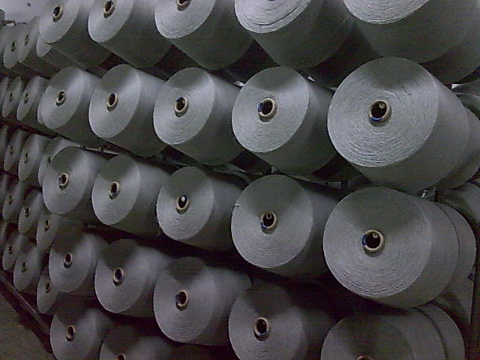
Fig: Mélange Yarn.
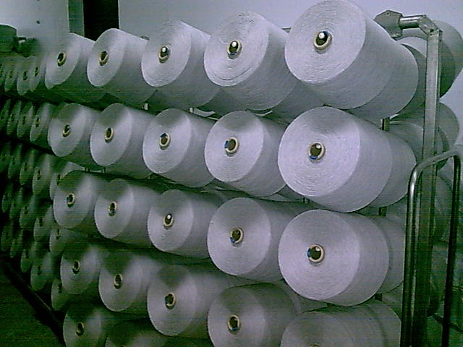
Fig: PC Yarn

Fig: CVC Yarn
Chapter 05
5.1 Yarn Composition (Ratio of Fibres):
Yarns are composed by different types of raw materials. Yarns which are manufactured by same type of raw materials are called “Virgin Yarn” and Yarns which are made by different types of raw materials together are called “Blended Yarn”.
a).Virgin Yarns:
Cotton Yarns: -Made by 100% cotton fibres.
Jute Yarn : - Made by 100% jute fibres.
Silk Yarn: Made by 100% Silk.
b).Blended Yarn:
PC Yarn:
Polyester and Cotton blended yarn.
Commonly used PC yarns are:
50:50 PC yarn: Made by 50% Polyester fibres and 50% cotton fibres.
65:35 PC yarn: Made by 65% Polyester fibres and 35% cotton fibres.
CVC Yarn:
CVC means “Cheap Value Cotton”. It is also cotton –polyester blended yarn, but cotton fibres percentage must be more than polyester fibres.
Commonly used CVC yarns are:
60: 40 CVC yarn: Made by 60% cotton fibres and 40% polyester fibres.
70:30 CVC yarn: Made by 70% cotton fibres and 30% polyester fibres.
80: 20 CVC yarn: Made by 80% cotton fibres and 20% polyester fibres.
c).Mélange Yarn:
Regenerated cellulosic fibres –“Viscose” and cotton blended yarn is called mélange yarn.
Commonly used melange yarns are:
99:01 Melange yarn “ Ecru Melange”: Made by 99% cotton fibres and 01% viscose fibres.
98:02 Melange yarn “ Ecru Melange”: Made by 98% cotton fibres and 02% viscose fibres.
97:03 Melange yarn “ Ecru Melange”: Made by 97% cotton fibres and 03% viscose fibres.
95:05 Melange yarn “ Grey Melange”: Made by 95% cotton fibres and 05% viscose fibres.
90:10 Melange yarn “ Grey Melange”: Made by 90% cotton fibres and 10% viscose fibres.
85:15 Melange yarn “ Grey Melange”: Made by 85% cotton fibres and 15% viscose fibres.

5.2 Use:
Yarn has versatile usages. It is used mainly for making cloths. It is used for making household items and it has industrial usage also.
Human being can not be a part of a civilized world without wearing cloths. Cloth is our basic need. Yarn is mainly used in garments industries for making both knitting and woven garments. More than 50% yarn, produced in our country, is used in knitting industries. Details are given below:

  - Yarn is used for making mainly human cloths.
  - Yarn is used for making households items, such as- bed sheet, curtain, carpet etc.
  - Yarn is used for making many types of decorative items.
  - Rope yarn is used in many industrial purposes for enhancing industrial process
  - Yarn is used for making some special items, such as-Parachute, astronauts’ dress, diver court, Bullet proof jacket etc.
  - Special types of yarns are used in medical surgery.

5.3 No. of spinning Factories:
In Bangladesh about 150 spinning factories are there. Total number of spindles are about 3300000. Total production is about 600,000,000 Kgs.
5.4 Source of raw material:
Without jute all others textile raw materials are imported. Cotton is mostly imported from following countries:
CIS-countries - Uzbekistan, Kazakhstan, Tajikistan etc.
Asian Countries- India, Pakistan, China.
African Countries - Zimbabwe, Mali, Benin, Nigeria, Togo, Uganda, Sudan, Egypt etc.
Cotton is also imported from USA, Australia and Brazil.
Polyester and viscose are mostly imported from China, India, Thailand, Taiwan and Indonesia.

Chapter 06
6.1 Price:
a). Price of Raw Material (present):
Sl. No. | Raw Material | USD/Kg(L/C –Value)
1 | CIS Cotton | 1.60
2 | Indian –Sankar-cotton | 1.55
3 | Indian- J-34-cotton | 1.50
4 | Indian-MCU5-cotton | 1.6
5 | Pakistani cotton | 1.40
6 | Sudanian cotton | 1.60
7 | Other African Countries’ cotton | 1.55
8 | USA-PIMA- cotton | 1.80
9 | USA –medium staple- cotton | 1.55
10 | Egypt –Giza-cotton | 1.80
11 | Polyester | 1.40
12 | Viscose-Black | 1.60
13 | Viscose-White | 1.60
14 | Viscose Modal | 1.70
Price of Yarn (present):
100% Cotton Combed Yarn:
SL. No. | Yarn Count (NE) | USD/Kg
1 | 50 | 7.00
2 | 40 | 6.60
3 | 34 | 6.30
4 | 32 | 6.10
5 | 30 | 6.10
6 | 28 | 6.10
7 | 26 | 6.05
8 | 24 | 6.05
9 | 20 | 6.00
100% Cotton Karded Yarn:
SL. No. | Yarn Count (NE) | USD/Kg
1 | 50 | 6.80
2 | 40 | 6.40
3 | 34 | 6.10
4 | 32 | 5.90
5 | 30 | 5.90
6 | 28 | 5.90
7 | 26 | 5.85
8 | 24 | 5.85
9 | 20 | 5.80
10 | 16 | 5.70

CVC Yarn:
SL. No. | Yarn Count (NE) | USD/Kg
SL. No. | Yarn Count (NE) | C:P=80:20 | C:P=70:30 | C:P=60:40
1 | 50 | 6.60 | 6.55 | 6.40
2 | 40 | 6.20 | 6.15 | 6.00
3 | 34 | 5.90 | 5.85 | 5.70
4 | 32 | 5.70 | 5.65 | 5.60
5 | 30 | 5.70 | 5.65 | 5.50
6 | 28 | 5.70 | 5.65 | 5.50
7 | 26 | 5.65 | 5.60 | 5.45
8 | 24 | 5.65 | 5.60 | 5.45
9 | 20 | 5.60 | 5.55 | 5.40
10 | 16 | 5.55 | 5.50 | 5.35

PC Yarn:
SL. No. | Yarn Count (NE) | USD/Kg
SL. No. | Yarn Count (NE) | P:C=65:35 | P:C=60:40 | P:C=50:50
1 | 50 | 6.10 | 6.05 | 5.85
2 | 40 | 5.70 | 5.65 | 5.45
3 | 34 | 5.50 | 5.45 | 5.25
4 | 32 | 5.30 | 5.25 | 5.05
5 | 30 | 5.30 | 5.25 | 5.05
6 | 28 | 5.30 | 5.25 | 5.05
7 | 26 | 5.25 | 5.20 | 5.00
8 | 24 | 5.2.5 | 5.20 | 5.00
9 | 20 | 5.20 | 5.15 | 4.95
10 | 16 | 5.10 | 5.05 | 4.85
Mélange Yarn:
SL. No. | Yarn Count (NE) | USD/Kg
SL. No. | Yarn Count (NE) | C:V=85:15 | C:V=90:10 | C:V=95:05 | C:V=97:03 | C:V=98:02 | C:V=99:01
1 | 50 | 7.00 | 7.00 | 7.00 | 7.00 | 7.00 | 7.00
2 | 40 | 6.75 | 6.75 | 6.75 | 6.75 | 6.75 | 6.75
3 | 34 | 6.40 | 6.40 | 6.40 | 6.40 | 6.40 | 6.40
4 | 32 | 6.20 | 6.20 | 6.20 | 6.20 | 6.20 | 6.20
5 | 30 | 6.20 | 6.20 | 6.20 | 6.20 | 6.20 | 6.20
6 | 28 | 6.20 | 6.20 | 6.20 | 6.20 | 6.20 | 6.20
7 | 26 | 6.10 | 6.10 | 6.10 | 6.10 | 6.10 | 6.10
8 | 24 | 6.10 | 6.10 | 6.10 | 6.10 | 6.10 | 6.10
9 | 20 | 6.05 | 6.05 | 6.05 | 6.05 | 6.05 | 6.05

Chapter 07
Costing:
7.1 Comparative Statistics of TTML:
Particulars | 2009-2010 Taka | 2008-2009 Taka | 2007-2008 Taka | 2006-2007 Taka | 2005-2006 Taka
Paid-up-Capital | 143,473 | 143,473 | 143,473 | 143,473 | 143,473
Reserves, Surplus & Others | 47,032 | 49,448 | 51,768 | 52,609 | 55,776
Shareholders’ Equity | 96,440 | 94,025 | 91,705 | 90,864 | 87,696
Net Asset | 547,550 | 523,910 | 439,221 | 438,728 | 438,622
Turnover | 766,141 | 554,377 | 456,105 | 672,398 | 735,960
Gross Profit/Loss | 160,695 | 100,027 | 79,032 | 116,333 | 114,794
Net Profit/Loss | 5,733 | 5,624 | 989 | 2,234 | 6,207
Prior year adjustment | 1,300 | - | - | 1,267 | -
Total Surplus for the year ( Before provision for tax) | 5,733 | 5,624 | 989 | 2,234 | 6,207
Provision for tax | 860 | 844 | 148 | 335 | 931
Number of Shares | 1,434 | 1,434 | 1,434 | 1,434 | 1,434
Number of shareholders | 926 | 955 | 994 | 972 | 1005
Earning per Share-EPS | 3.40 | 3.33 | 1 | 1 | 4
Dividend per Share-DPS | 1.71 | 1.71 | - | - | 2
Source: Annual report of TTML

7.2 Consolidated Manufacturing, Trading, Profit & Loss Account and Profit & Loss Appropriation Account:
Particulars | 2009-2010 Taka | 2008-2009 Taka | 2007-2008 Taka | 2006-2007 Taka | 2005-2006 Taka
Turnover | 766,141 | 554,377 | 456,105 | 672,398 | 635,960
Less, Cost of Goods sold | 605,446 | 454,351 | 377,072 | 556,065 | 521,166
Gross Profit | 160,695 | 100,027 | 79,032 | 116,333 | 114,794
Administrative | 48,752 | 45,667 | 39,794 | 84,954 | 64,084
Financial | 109,347 | 49,523 | 47,217 | 41,713 | 44,191
Other Income | 3,424 | 1,068 | 7,979 | 12,681 | -
Operating Profit/(Loss) | 6,020 | 5,905 | 1,038 | 2,346 | 6,518
Workers’ Profit Participation Fund | 281 | 49 | 111 | 310
Net Profit/(Loss) after tex | 286 | 4,780 | 840 | 1,900 | 5,277
Surplus/(Deficit) for the year | 4,780 | 840 | 1,900 | 5,277
Prior year adjustment | 1 | 4,878 | - | - | 1267
Surplus earning attributable to shareholders | 4,873 | 4,780 | 840 | 3,167 | 5,277
Less, Dividend | 2,459 | 2,460 | - | - | 2,460
Balance as per last Account | 61,061 | 63,381 | 64,222 | 67,389 | 69,959
Source: Annual report of TTML

Chapter 08:
Findings of Study:

To gain competitive advantage in producing textile yarn as well as to get strategic advantage in domestic and global market place; I have found few vital factors:
    - Labor cost. Due to high labor cost many countries are shifting their manufacturing industries in to third world countries where labor cost is low.
    - Energy. Low energy cost is always indicates low manufacturing cost and that must bring advantage in market place. In our country power generation cost is low compare to our competitors such as India, Pakistan, China and so on. But recently we are facing gas supply shortage heavily. Because of gas shortage spinning factories can not move with full volume production.
    - Raw Materials: All most all textile raw materials are being imported for producing yarn. On cotton, spinning factories are giving 22% value added tax. So our raw material cost is high than our competitors. So this factor is having maximum contribution on yarn price.

    - Capital and Infrastructure: Capital is the money available to build upon an existing base. Our infrastructure is not up to the mark. Our spinning industry is always facing capital shortage and interest rate is always high. This is also increasing yarn price directly and it is brining negative influence in yarn market.
    - Technology: We are purchasing all textile machineries from Europe, Japan, China even from India. We are not manufacturing any sophisticated textile machines. Those machines price is always higher than it should be. India is our main competitor in yarn market and they are manufacturing all type of machineries. So from this point of view our competitors are in better position in yarn market.
    - Lack of understanding about global yarn market: To understand global dynamics of yarn market we have to obtain a meaning full measurement for the consumption by consumers in each country, the import and export trade of yarn must be evaluated. Knowing where and what are being consumed by whom, always yarn production and future growth to be more understandable and predictable. So it necessary to buildup our marketing executives to handle the challenges of dynamic yarn market.

Chapter 09:
Conclusion and Recommendation:
Conclusion:
Textile industry in Bangladesh is an emerging sector. Last year total volume of RMG in Bangladesh was the highest allover the world. Government should take special care in this sector. If government policies go to the right direction; our textile industries will flourish like any thing in near future. To maintain the continuous growth of this sector government should help our entrepreneurs to establish more industries. We hope brighter future is waiting in global textile market.
Recommendation:
      - For generation of power gas supply should be ensured by the government.
      - Tax on importing of cotton and other raw materials should be reduced.
      - Government should reduce tax on machineries import and should allow foreign technicians to come in our country for building up our local engineers.
      - Workers’ unrest must be resolved by the government and textile field should be free from political involvement.
      - Government should help for searching new buyers in global yarn marketing by improving relationship and negotiating with developed countries.

Chapter 10:
Bibliography:

Sl. No | Sources
1 | Annual Report of Tamijuddin Textile Mills Ltd.
2
3
4
5
6
7
8
9
10
11
12
13
14
15
16
17
18
19
20

10.1 Conclusions

Islami Bank Bangladesh Limited through its steady progress and continued success has earned reputation and has become the leading private bank in the country. The Volume of investment of this bank has been increasing day by day. The network of the branches has widened and investment portfolio of the bank has been diversified. IBBL is trying to develop banking sector through welfare and servicing to the people. Islami economy and banking are bound together. IBBL has emerged facing the many obstacles yet. This bank is trying to operate its activities according to Islami Shari’ah. Islam is a religion for human welfare as well the social welfare. All the steps of Islam are only for the welfare for human being.

Interest free banking system is no more a concept. It is now a Reality, a dynamic system, embodying a set of superior banking Mode. More than 300 Islamic bank and Financial institutions are operating in different Countries throughout the world with a marked success from this inception in our country in 1983. IBBL has been operating with real and confidence in corporation with other conventional banks. Bringing a new concept in such business sector, which is growing too rapidly in the world, is rally bold step. As a large Islamic commercial bank, Islamic bank took various steps to create employment and socio-economic development for the poor through Islamic Shari’ah as well as to create an overall climate for the introduction of large scale Islamic banking environment in Bangladesh. To conclude we must say that, Islami bank Bangladesh Limited (IBBL) has immense potential in Bangladesh. It can play vital role in bringing revolutionary changes in our life with both material and moral world and in individual and collective level.
Bangladesh is not a full Islamized country, all activities are not operating according to the Shari’ah of Islam. But the IBBL is trying to operate its activities as much as possible. Despite this tremendous progress and success, IBBL is suffering from many problems. The most common problems are as follows:
- The marketing strategy and customer care department is not up to the mark.
- No Islami money market is available. Easily money transaction is no possible for the interest free banking system. Call rate money is not responded according to Islami Shari’ah.
- Islamic Banking is a new phenomenon in our country during last two decades. So majority of our people have no proper knowledge about the activities of Islamic Banking as well as its investment Mode hamper large scope of investment of IBBL.
- Most of the people in our country have a bad impression of IBBL’s operations regarding indirect generation of interest which meaning no difference between investment of IBBL loan / Credit / advance of conventional banks. For this reason, they are not too much interested to make investment with IBBL.Because of improper insufficient application of Islamic Banking rule in our country. The investment operations of IBBL can't run smoothly.

85

- IBBL, which is committed to avoid interest, can’t invest the permissible part of its statutory liquidity; Reserve and short Term liquidity surplus. Consequently the bank has to deposit reserve in cash with Bangladesh Bank and can not invest its surplus funds to earn income rather keeping those in idle. But the conventional banks of the country do not suffer from this problem.
- This Bank can't invest in all economic sectors, which are prohibited by the law of Islam.
- Profitable investment portfolio of IBBL requires clear investment knowledge according to Islamic Shari’ah. But sometimes IBBL can't invest its assets in proper portfolio due to insufficient and unskilled manpower in these regards .As a result, there is a large amount of money being idle and thus potential profit is not increasing.
- This Bank revalues its investment operations within limited number of investment modes and does not initiate investment modes according to changing diverse needs of people
- Sometimes investment operations of IBBL are hampered due to increase, dishonest, indiscreet, hypocritical nature of people.
- IBBL has no strong promotional activities to increase motivate its present and potential investment client.
- There are limited scopes to deal women entrepreneurs and professionals for making investment by women entrepreneurs.
- In rural areas for low income community, this Bank grants investment group wise, not individual.
- In some sectors like housing, real estate, project (industry) etc, this Bank disburses total invested money in times according to Banks pre-determined proportion. As a result, clients are failed to gain full benefits of investment disbursement at once.
- Another problem of IBBL in Bangladesh is that, no separate legal framework for Islamic Banking has yet been enacted. So, the bank is facing problems to handle contracts due to lack of Islamic law.
- Some officials of IBBL are not well conversant with Shari’ah views of the Islamic Investment norms and conditions. They have been failing to provide the service to the investment clients as the situational demands.
- Though the IBBL is expanding its investment through 196 branches (Dairy-2008), a vast majority of the rural disadvantaged people is being deprived of its investment facilities especially in the field of Agriculture, Fishery and small scale rural enterprise.
- All papers/documents/information are not always furnished by the client as per instruction given by the bank during sanction of investment.
- Lack of morality, honesty, and competency of the clients is another obstacle for the bank to make the investment operations a success.
- Clients are accustomed to interest oriented banking. They are not able to understand the investment Mode of IBBL.
- Another problem facing by the IBBL is to handle the cases of delay in payment. As per suggestions of Shari’ah Council, IBBL imposes financial penalty on overdue amount namely compensation. But the compensation is a doubtful income and it is similar to interest as per Shari’ah
- Tendency to make overdue intentionally by the clients.
86

 | IBBL has no investment in public sector as against set plan of 5% of its total investment.
 | IBBL has set its plan of 8% for Rural area & 92% for urban area of total investment. But only Rural area exceeds the set target of 8% by increasing 0.68% in 2006.
 | IBBL did not achieve its plan in the agriculture sector (i.e. 3%). Highest achievement is done in the year 2006 (2.83%).
 | Investment in trading sector has reached the set target of 40% in 2006.
 | Investment in share mode had not reached the set target of 15%. Highest investment is made in the year 2003 by 14.82%.
 | 87.13% of total deposit has been invested by the IBBL in 2007 which is highest in the last five years.
 | IBBL claims 9.05% in trade sector, 4.13% in agriculture sector, 10.35% in industry sector, 13.86% in working capital sector & 9.50% in transport sector among the all commercial banks.
 | There are observations are given below:
 | -- | Low cost of funds.
 | -- | Strong liquidity position
 | -- | IBBL take decisions carefully regarding investment.
 | -- | IBBL use Arabic word for mention investment mode, which confused customers/clients.
 | -- | Lack of appropriate interest free financial instruments where the IBBL invest its surplus fund.
 | -- | Shortage of trained manpower especially in handling Islamic investment modes.

10.2 Recommendations

From the forgoing discussion on the analysis of investment Modes it can be said that IBBL in its all transactions restricts interests and conducts its investment portfolio mainly under 3 (three) Modes. viz; i) Bai-Mode, ii) Leasing or Ijara Mode and iii) Share Mode. It is revealed from the study that IBBL provided its maximum investment facility to the investment clients or entrepreneurs under the Bai or Trading Mode is based on honesty and integrity on the part of the sellers more than anything else. The Bai-Salam and Bai-Istisna Modes have not yet been fully adopted by IBBL but started and practicing.

87

The trading Modes (Bai mechanism) are comparatively in advantageous position in the perspective of accounting of transactions, because they are based on fixed rate of return. Among the Modes, IBBL seldom applies Mudaraba and Musharaka Modes of Investment. In Mudaraba Mode, there are two parties: one with capital and with knows how, get together to carry out a project. If the project ends in profit in a pre agreed proportion. If the result in loss the entire loss is borne by the financier, and the entrepreneur gains no benefit. On the other hand, Musharaka is a joint enterprise in which all the partners shared on the base of profit or loss. Therefore, Mudaraba and Musharaka do not envisage a pre determined fixed rate of return. The return is based on the actual profit earned by the joint venture. The study reveals that the least investment facility was provided by the bank through the Mudaraba and Musharaka Modes. The reason for the lowest amount of investment may be attributed to untrustworthy clients, inefficient bank personnel, nonviable or non profitable project, lack of able, qualified and experienced entrepreneurs to carry out the project successfully, existing loss etc. Today business enterprise, industries and all others kinds of enterprises are established and run on a long term basis. Therefore, the Mudaraba and Musharaka to be applied to all kinds of enterprises shall be on along term basis. From the study it can be concluded that banks as a financial intermediary can not do banking without pre-fixed rate of return which is the only response to the moral hazards in banking.

Meaningful and effective investment planning, implementation and controlling are difficult tasks. A number of important aspects are to be considered if really any sincere attempt is expected to be made for the purpose of these tasks. In this regard some of the important recommendations are given below:
* | Islami bank Bangladesh Limited should take several necessary steps to eradicate misconceptions from people mind about interest based banking system, investment Mode, foreign exchange as well overall activities under Islamic banking Framework.
* | Promotional activities of the investment modes should be strengthened.
* | New investment product should be introduced.
* | Build up show room of Islamic Investment Mode like “Murabaha Shop”.
* | Developing unique service.
* | The Bank should go aggressive advertising and promotional activities to get a broad geographic coverage and authority of IBBL should introduce more innovative and modern customer service through outstanding marketing policy.
* | Arrangement of monthly /quarterly training courses /workshops for the clients selected by the Branches in order to promote Investment clients of the desired level.
* | Effective human resources should be placed at every department of IBBL for more speedy and smooth banking operation. Women employee should be increase more in order to deal women entrepreneurs for create demand for investment.
* | To fulfill the vision of "mass banking" this Bank should grants investment portfolio to new entrepreneurs /new businessmen new companies etc.
* | The Bank should disburse total invested money at once to the clients to achieve full benefits of invested money.
* | The amount of investment of RDS & operating range should increase. So more people will get the facility under the scheme & they will able to increase their standard of livings

88

* | To gain success in the programs like "Poverty Alleviation and "Self Reliant" especially in rural areas, this bank should provides investment facilities on the basis of individual.
* | Decision making process should be free of ambiguity and be time conscious.
* | Allocating resources for opening new branches, and expand marketing program.
* | Govt. Taxation and duty system must be in accordance with Islamic Shari’ah.
* | The officials of the bank especially who are engaged in investment department must be trained up effectively so that they can make the general people, interested to take the investment facilities, understand the salient features and other formalities of investment in a simple and understandable way. In this regard more training and research academies or centers are to be established out sides Dhaka.
* | Central banking policy in line with Islamic norms must be implemented and initiative should be taken to create Islamic Money market and capital market introducing the interest free securities.
* | To reduce overdue & classified investment, IBBL may engage recovery agency.
* | IBBL may invest in the sector of electricity, gas, water & sanitary service sector.
* | To improve investment performance the bank may reduce rate of return of investment in all sectors.
* | Investment of the Islamic bank portfolio be diversified and extended for long term financing under Musharaka and Mudaraba mode.
* | To give emphasis for housing scheme of medium and lower income group.
* | To take care of the need of the low income group.
.

89

Bibliography

Books:
1. | Ahmed, A. (1992), “Contemporary Experiences of Islamic Banks”. Journal of Objective Studies, Institute of Objective Studies, Delhi.
2. | Ahmed, A. (1993) “Contemporary Practice of Islamic Financing Techniques”. Jeddah: Islamic Research & Training Institute, IDB.
3. | Ahmed, N (2002), “Objectives of Islami Banking Bangladesh Ltd”, Islami Bank Publication, Dhaka.
4. | Ahmed, S (1990). Investment Opportunities in Bangladesh. Proceeding on Islamic Banking and Insurance. Islami Bank Bangladesh Limited, Dhaka.
5. | Annual reports, of Islami Bank Bangladesh Limited (IBBL) for 2003, 2004, 2005, 2006 & 2007.
6. | Chapra, M.U. (1995), Towards a Just Monetary System. Leicester: The Islamic Foundation, Dhaka.
7. | Hasan, M. K. (2003), Text Book on Islamic Banking, Islami Economics Research Bureau, Dhaka. The IBBL Operation Manual (2006) Islami Bank Publication
8. | IBBL (2006), Operation Manual, Islami Bank Publication, Dhaka.
9. | IBBL (2007), Introduction of Islami Bank Bangladesh Ltd. IBBL, Dhaka.
10. | Islam, M.N. (1999), Modes of Investment of IBBL, Bank Parikrama, BIBM, Dhaka.
11. | Jebal, A.A (2006), “Islamic Banking Definition, History, Growth and Present Status in Bangladesh”, IBTRA, Dhaka.
12. | Mohon, I.K. (1999), Adhunik Banking, Sourav Prakashani, Dhaka.
13. | Naresh K.M (2007-5th edition), Marketing Research”, Prentice Hall of India Pvt. Ltd. New Delhi.
14. | Raquib, A. (2007), Principal & Practice of Islamic Banking, Panam Press Ltd., Dhaka.
15. | Sadek, A.H.M. (1993), Resource Mobilization and Investment in Islamic Structure, Bank Parikrama, BIBM, Dhaka.
16. | World Bank (2007), Global Economic Prospects Report: World Bank, Washington.

Web Site:
i. | www.bangladesh-bank.org
ii. | www.islamibankbd.com
iii. | www.islamibanking.com

Chapter | Title | Page
 | Title Page
 | Letter of Transmittal
 | Researcher’s certificate
 | Supervisor’s certificate
 | Acknowledgements
 | Executive summary
Chapter: 1 | Introduction
 | 1.1: Introduction | 01
 | 1.2: Rationale of the Study | 02
 | 1.3 Origin of the report | 02
 | 1.4 Scope of the study | 03
 | 1.5 Objectives | 03
 | 1.6 Methodology | 03
 | 1.7 Data analysis techniques | 04
 | 1.8 Limitation | 04
 | 1.9 The organization of the study | 05
Chapter: 2 | An Overview of IBBL
 | 2.1 Concept of Islamic Banking | 06
 | 2.2 Business Philosophy of IBBL | 06
 | 2.3 Special features | 06
 | 2.4 Aims and Objectives of IBBL | 07
 | 2.5 Goals of IBBL | 07
 | 2.6 Mission of IBBL | 07
 | 2.7 Vision of IBBL | 07
 | 2.8 Function | 08
 | 2.9 Achievement | 08
 | 2.10 Award and prizes | 08
 | 2.11 Membership of different organization | 08
 | 2.12 Historical background | 09
 | 2.13 Mile store | 09
 | 2.14 Equity | 10
 | 2.15 Shariah council | 10
 | 2.16 Management | 10
 | 2.17 Human resources management | 10
 | 2.18 Performance of IBBL | 11
Chapter: 3 | Investment policy of IBBL
 | 3.1 Introduction | 12
 | 3.2 Objectives | 12,13
 | 3.3 Salient Features | 14
 | 3.4 Principles of investment | 14
 | 3.5 Five years perspective investment plan 2003-07 | 15

Chapter: 4 | Conceptual Frame work
 | 4.1 Meaning of investment | 16
 | 4.2 Investment Modes of IBBL | 16
 | 4.3 Modes of Investment | 16
 | 4.4 Bai-mechanism | 16
 | 4.5 Conditions of buying & selling | 16
 | 4.6 Types of buying & selling | 17
 | 4.7 General concept of Bai-Murabaha | 18
 | 4.8 Basis of Bai-Murabaha | 18
 | 4.9 Important features | 18
 | 4.10 - 4.14 Types of Murabaha | 19,20
 | 4.15 Bai-Muajjal | 20
 | 4.16 Important features | 20
 | 4.17 Bai-Salam | 21
 | 4.18 Bai-Istisna | 21
 | 4.19 Bai-ashraf | 21
 | 4.20 Quard-e-Hasana | 21
 | 4.21 – 4.31 Investment under Shirkat Mechanism | 22-24
 | 4.32 – 4.36 Musharaka | 24
 | 4.37 Mudaraba | 25
 | 4.38 Ijarah mechanism | 26
Chapter: 5 | Performance of IBBL from 2003 to 2007
 | 5.1 Performance of investment by size | 27
 | 5.2 Performance of investment by sector | 28
 | 5.3 Performance of investment by area | 29
 | 5.4 Performance of investment by economic purpose | 30
 | 5.4.1 Agriculture, 5.4.2- Project, 5.4.3- Working capital 5.4.4- Housing, 5.4.5- Special schemes | 31-37
 | 5.5 Performance of investment by mode wise | 38
 | 5.6 Classified Investment | 39
Chapter: 6 | Performance of IBBL comparing with all Banks. | 40-43
Chapter: 7 | Performance of IBBL comparing with other 04 Islamic Banks. | 44-48
Chapter: 8 | Profitability analysis of IBBL:
 | Income, Investment deposit ratio, Classified investment, Return on equity, Return of assets, EPS, Net investment income margin, other ratios. | 49-54

Chapter: 9 | Analysis of performance of Modes of Investment:
 | Introduction | 55
 | Bai-Murabaha | 56
 | Bai-Muajjal | 59
 | Bai-Salam | 63
 | Hire Purchase under Shirkatyk Meilk | 66
 | Musharaka | 70
 | Mudaraba | 74
 | Quard-e-Hasana | 77
 | Other mechanism | 81
 | Formalities of investment | 81
Chapter: 10 | Conclusions and Recommendations
 | Conclusion | 84
 | Recommendations | 86
 | Bibliography | 89

Acronyms:

IBBL | Islami Bank Bangladesh Bank
AMD | Assets Management Division
IAMD | Investment Administration and Management Division.
MIS | Management Information System
IPPD | Investment Policy and Planning Department.
HPSM | Hire Purchase under Shirkatul Meilk
EPS | Earning Per Share
NCB | National Corporatized Bank
PCB | Private Commercial Bank
REO | Return on Equity
BIBM | Bangladesh Institute of Bank Management
IBB | The Institute of Bankers of Bangladesh

Executive Summary

Today Islamic Banking has achieved significant advancement to evolve into a comprehensive Islamic banking system that is able to contribute effectively to the economic growth process. Islamic banking is becoming an integral part of the international banking landscape. This achievement is evidenced by the existence of a well developed Islamic banking network. All these positive developments have aimed to contribute towards developing Islamic banking into a efficient and sustainable functioning system of investment. The overall impact of Islamic banking in Bangladesh is that it has become acceptable not only to the ordinary masses, but also to the elite of the country including top level of industrialist and business magnet. Everybody now strongly accepts the fact that Islamic banking is a viable alternative to conventional western model of banking.
Islam requires its followers to shape their entire life, economic and financial dimensions included, in conformity with Shari’ah. Islamic Shari’ah prohibits riba (interest and usury), whether nominal or excessive, simple or compound, fixed or floating. Naturally, Islamic banking avoids riba.
The establishment of Mit Ghamar Local Savings Bank (Egypt) in 1963 marked a new milestone in the revolution of the modern Islamic banking system, then in quick succession interest free institutions appeared all over the world. From the speed of expansion, it is hoped that very soon Islamic banking will overtake conventional banking and become the mainstream of banking in the OIC countries. Islami Bank Bangladesh Limited (IBBL) is the first of this kind in our country and South East Asia also. IBBL is an Islami Bank bases on Islami Shari’ah. IBBL operates its investment activities under 03(three) Modes (mechanism) namely (i) Bai-Mechanism (ii) Share Mechanism & (iii) Ijara mechanism). The bank has already occupied an enviable position among its competitors after achieving success in all area of business operation. Both the deposit and investment of the bank are growing fast.
When money is deposited with an Islamic Bank, the bank, in turn, makes investments in different forms approved by the Islamic Shari’ah with the intent to earn a profit. Some popular modes (mechanism) of Islamic investment are discussed in this study.

A comparison is also attempted to analyze the performance of IBBL from 2003 to 2007 comparing with the performance of PCBs, NCBs & other Islami Banks as well as other 04 Islami Banks.
With the purpose of exploring the performance of IBBL, the present study first focuses on the investment activities and its plan regarding investment as well as theoretical aspect of investment mode. The first chapter consists of background of the study, origin of the report, objectives, methodology of the report and also some limitations in doing the report. Business philosophy of IBBL, special features of investment, aims & objectives, mission, vision, function, highlights and last three years of performance of IBBL is shown in chapter two. Chapter three covers the investment policy. Investment policy indicate the sector of investment, purpose of investment, objectives, features of investment and principles of investment. The bank extends investment under the principles of Bai-Murabaha, Bai-Muajjal, Hire- Purchase under Shirkatul Meilk and Musharaka. The bank is making sincere efforts to go for investment under Mudaraba principal in near future. Chapter four describes the conceptual framework of the study (performance of investment modes in banking system). There are three Modes of investment under Islamic banking system. They are Bai-mechanism (mode), Shirkat mechanism (sharing or partnership) & Ijara mechanism (partnership in ownership or shirkatul meilk). Arabic word Bai means buying and selling. The condition of buying and selling are (i) the commodity must be existing; a commodity which does not exist at the time of sale can not be sold. (ii) the seller should have acquired the ownership of that commodity and therefore, if the commodity is existing but the seller does not own it, he can not sell it to any body (iii) mere ownership is not enough, it should have come into the possession of the seller, either physically or constructively. If the seller owns a commodity but he has not taken its delivery himself or through an agent, he can not sell it. The shirkat which means ‘a partnership effected by a mutual contact’ where two or more persons agree to contribute in the capital, participate in the management and share its profit and bear the loss, if any. Mudaraba is a partnership in profit whereby one party provides capital and other party skills and labour. The provider is called ‘Sahib al-mal’ while the provider of skill and labour is called ‘Mudarib’. In Ijara mechanism, two modes of investment HPSM & Ijara or Leasing or Hire purchase.

The performance of investment of Islamic Banks is shown in chapter five & six. Chapter five covers the performance of investment of IBBL (2003-2007) by size, sector, area and economic purpose. Performance of project investment of IBBL also highlights in chapter five. Performance of IBBL comparing with all Banks in Bangladesh is shown in chapter six where the IBBL occupied 10% investment. Chapter seven covers the performance of IBBL comparing with other 04 Islamic Banks. Total investment of Islamic Banks in Bangladesh is 16% among the all Banks where the IBBL claim 10% investment. EPS of IBBL as of 31st Dec’07 is highest among the Islamic Banks i.e. Tk.53.90 and the lowest position of EPS of SIBL i.e. Tk.17.60. Return on general investment of IBBL is 10.88% as of 31.12.07. Profitability analysis of IBBL is shown in chapter eight. Growth of income of 2007 is 26.08% over the base figure of 2006. Chapter nine covers the analysis of performance of different types of investment modes in IBBL. From the last five years data of IBBL, it shows that the amount of sanction, disbursing & recovery position is good. Above 90% recovery is made from the disbursement amount. There is limitation which is identified and some recommendation has given to overcome that limitation and finally conclusion has drawn in last chapter ten. Effort is given here to make the report authentic and easily understandable. In spite of this if there is any mistake in the report; it is welcomed for the betterment of the report.

