Report on
Industrial Training of
Cotton Club BD Limited

Submitted by
WWW.ASSIGNMENTPOINT.COM

COTTON CLUB (BD) Ltd. is one of the country’s leading knit composite factories. It is a 100% export oriented composite knit textile unit with the commitment to cater the global needs of 21st century for knit & casual clothing. The project has employed the state-of-art technology in its every piece of investments. Aiming at the context of the changing global demand pattern, international environment on trade specially the withdrawal of quota system and GSP and the availability of craftsmanship in the country, the project has encompassed the knitting, dyeing and processing of fabrics and ready-made garments production to be available from one stop service.

The project ensures sampling to supply of finished ready-made garments all from one source, ensuring in time delivery & complying quality. The machines & equipments setup for this project are procured from world class brand, names that are renowned for their high quality, product integrity & dependable production. The manpower engaged in this project to carry out the day to day business are all highly skilled, purely professional, vastly experienced. The unique combination of organized managerial and technical term in one hand and latest, advanced and balanced technology on the other hand made the project one of the top to be referred in this field in the country. COTTON CLUB (BD) Ltd. is committed not only to deliver world class product but also to quality assurance, price affordability & social accountability. Considering all the above features to learn about the technology of textile manufacture as well as management & maintenance, COTTON CLUB (BD) Ltd. was surely a good choice. I feel very lucky to complete our industrial attachment here.

2.1: Name of the Factory with Address, Location
Name of Company : COTTON CLUB (BD) LTD.

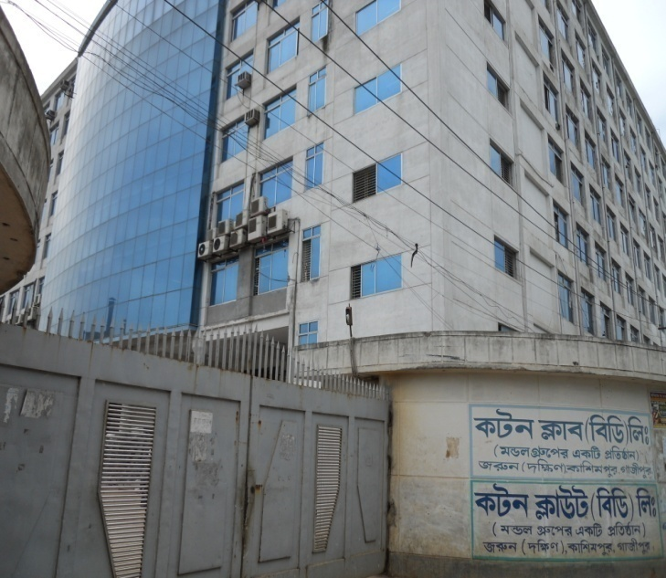 | 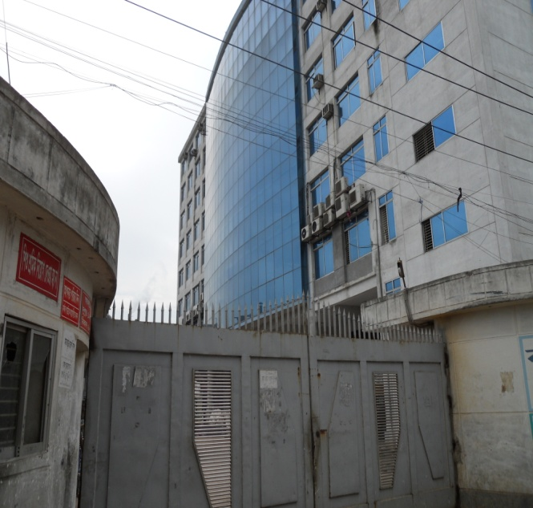
Address : COTTON CLUB (BD) LTD.
Jarun (south), Kashimpur, Gazipur.

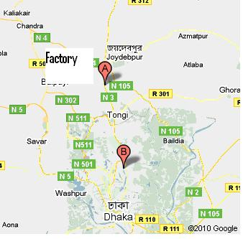
Location: From Dhaka (Mohakhali Bus stand), Buses (Provati Banasri, Ajmeri) will take about 35 taka to Konabari. From Konabari bus stand rickshaw fair is about 20 taka, 10 taka by Van, 5 Taka by Maxi and 2 taka by Local bus to the factory.

2.2: Type of Factory & Concern Department
The factory is a Knit composite industry. The factory has the following departments-
- Knitting:
  - Knitting
  - Inspection
  - Quality control
- Dyeing:
  - Batch section
  - Dye house
  - Dyeing laboratory
  - Quality control
  - Finishing
- Garments:
  - Merchandising
  - Sampling section
  - Cutting Section
  - Sewing Section
  - Finishing Section
- Maintenance:
  - Electrical
  - Mechanical
- Administration
- Security
- Marketing
- Production Planning & Control
- Human Resource & Development

3.1: Manpower management
The Cotton Club (BD) ltd. has manpower as follows-
Department | Manpower
Knitting | 275
Batch | 30
Dyeing & Finishing, Lab & QC | 200
Garments | 4000
Embroidery | 30
Printing | 100
Power, Boiler, Utility & Maintenance | 90
Inventory | 40
Administration | 130
ETP | 20
Security | 75
Others | 80
Total | 5070

3.2: Organogram
The organogram of the administration is as follows:
Organogram of Administration | Organogram of Operation
Chairman  ↓  Managing director  ↓  Director  ↓  Executive director  ↓  General Manager  ↓  Deputy General Manager  ↓  Assistant general manager  ↓  Production manager | Senior manager  ↓  Assistant manager  ↓  Production officer  ↓  Shift in charge  ↓  Supervisor  ↓  Senior operator  ↓  Operator  ↓  Assistant operator  ↓  Helper
Organogram of Laboratory
Lab in charge
↓
Assistant Lab in charge
↓
Technician
↓
Assistant Technician

3.3: Human Resource Department
The human resource department of Cotton club (BD) Ltd. is-
Support Service
Compliance
C&B and ES
T&D
ER & TM
BU HR, Garments,
BU HR, Fabrics,
GDL & FPPL,
Bu HR, ISML
BU HR, VSL
Human Resource department

3.4: Responsibility of production officer
- Overall supervision of dyeing & finishing.
- Dyes & chemicals requisition issue & check.
- Program making, sample checking color measurement.
- Control the supervisor’s operators & helpers of machines.
- Giving dye-line or the program slip according to daily production plan, batch preparation & pH check.
- Rectifying the finished fabric which rejected from quality control department
- Checking daily production report.
- Collecting the necessary information and instruction from the previous shift for the smooth running of the section.
- Making the junior officer understand how to operate the whole production process.
- Matching production sample with target shade.
- Collecting the production sample lot sample matching next production.
- Identifying disputed fabrics and report to PM/GM for necessary action.
- Signing the store requisition and delivery challan in the absence of PM
- Executing the overall floor work.
- Maintaining loading/ unloading paper.

3.5: Job Description
Title: Production officer.
Dept: Dyeing
Report to: Senior production officer.
Job summary: To plan execute & follow up the production activities & control the quality production with related activities.

3.6: Remarks
The management system of Cotton Club (BD) Ltd. has a very well established management system. Though it is very difficult to manage a large manpower, but the company is managing this manpower with a very efficient hand.

4.1: Overall View of the Industry
The overall view of the factory is as follows-

Security

Maintenance building

Main Building
ETP
Water treatment plant

Inventory

Boiler
Generator
Compressor
Entrance

Fig: Overall view of Factory

4.2: Knitting Section:
- Circular Knitting Machine = 45 in number
- Flatbed Knitting Machine = 17 in number
4.3: Laboratory Section:
- Hot Air Oven = 1 in number
- Digital Wrap Reel Machine = 1 in number
- Data Color =1 in number
- Color Cabinet = 1 in number
- Crock Meter = 1 in number
- Twist Tester = 1 in number
- Digital Balance = 1 in number
- Sample Dyeing Machine = 3 in number
4.4: Dyeing Section:
- Sample Dyeing Machine = 3 in number
- Dyeing Machine =11 in number
4.5: Batch Section:
- Air Turning Machine =1 in number
4.6: Finishing Section:
- Slitting Machine =1 in number
- Dewatering Machine =1 in number
- Dryer machine = 1 in number
- Open Compactor =1 in number
- Tube Compactor = 2 in number
- Calendaring Machine =1 in number
4.7: Power Section:
- Gas Generator = 2 in number
- Boiler = 2 in number
- Compressor =2 in number
Garments and Printing Machineries are also available in the factory.

5.1: Yarn
The raw material for knitting is the yarn. Different types of yarn of wide range of different count are used. The sources of yarn are also found. Both carded and combed yarn is used for knitting.

Generally used yarn and their count:
Yarn Type Count
Cotton | 24^{S}, 26^{S}, 28^{S}, 30^{S}, 32^{S}, 34^{S}, 40^{S}
Polyester | 75D, 100D
Spandex yarn | 20D,40D, 70D
Grey Mélange | 24^{S}, 26^{S}
PC (65%Polyester & 35% cotton) | 24^{S}, 26^{S}, 28^{S}, 30^{S}
CVC | 24^{S}, 26^{S}, 28^{S}, 30^{S}

Sources:
The required yarns are supplied from
- Badshah Spinning Mill
- Kamal spinning Mill
- Square Spinning Mill
- Hanif Spinning Mill
- Matam Spinning Mill

5.2: Fabric

Cotton Club (BD) Ltd. is a knit composite textile industry. In the industry gray fabric is used as raw material in dyeing-

Grey Fabrics:

Following types of gray fabrics are dyed:
- Single jersey
- Single jersey with lycra
- Polo pique
- Single lacoste
- Fleece
- Interlock
- Interlock with lycra
- Rib
- Rib with lycra
- 1Χ1 rib
- 2Χ2 rib
- 6X2 rib
- Sugar rib
- Regular drop needle
- Irregular drop needle
- Different types of collar & cuff

5.3: Chemicals
List of Chemicals used in Cotton Club (BD) Ltd. is as follows-
Basic Chemicals:
1. Acetic Acid
2. Hydrochloric Acid
3. Sulphuric Acid
4. Caustic soda
5. Formic acid
6. Bleaching powder

Detergent & Scouring agent:
- Felosan RGN
- Jintex-GD
- Jintex-GS

Washing Agent /Soaping agent
- Kappatex R98
- Crosen LPD
- Serafast-CRD
- ResotexWOP
- Seraperse CSN
- Jintex WRN

Levelling Agent
- Jinleve leve-RSPL
- Levelex-P
- Dyapol XLF
- Lubovin-RG-BD
- Serabid- MIP

Sequestering Agent
- Resotext 600S
- Heptol-DBL
- Heptol-EMG

Salt
- Glauber Salt
- Common Salt

Whitening Agent
- Uvitex BAM
- Uvitex BHV
- Hostalux ETBN (For polyester fabric)
- Bluton BBV
- Tuboblanc col

Softener
- Acelon
- Resomine Supper
- Sillicon (For Finishing)
- Resosoft -XCL

Fixing Agent
- Optifix-EC
- Protefix-DPE-568
- Jinfix -SR
- Tinofix-ECO

Reducing Agent
- Hydrose

Bleaching Agent
- 35 % H₂O₂

Enzyme
- Rzyme 1000
- Tinozyme 44L
- Enzyme-B50

Stabilizer
- Tinoclarite CBB
- kappazon H53
3. Stabilizer PSLT
Anticreasing Agent
- Cibafuid - C
- Biovin 109
- Kappavon CL
- AC-200

P^{H} Controller
1. Acid
2. Neutracid RBT (Non volatile)
3. Soda Ash
4. Caustic
Per-oxide Killer
- Resotex PKK
- Peroxide killers
- Enzytone-PKF

Antifoaming agent
1. AV-NO
2. Zetafoam
3. Cibaflow-JET

All these chemicals are imported from the following countries-
- India
- China
- Srilanka
- Korea
- Germany
- Singapore

4.4: Dyes
Cotton Club (BD) Ltd. uses the following dyes-
SL NO | DYE NAME | Origin
1 | REMA YELLOW RR | India
2 | REMA RED RR | India
3 | REMA BLUE RR | India
4 | REMA YELLOW 3GL | India
5 | REMA ORANGE RR | India
6 | UI-CARMINE RGB | India
7 | REMA T.BLUE-G | India
8 | REMA BLUE RSPL | India
9 | REMA G. YELLOW RGB | India
9 | REMA UI.RED RGB | India
10 | REMA NAVY RGB | India
11 | REMA BLACK GWF | India
12 | DYESHUFIX YELLOW 3RXF | China
13 | DYESHUFIX RED 3BXF | China
14 | DYESHUFIX ORANGE 22RXF | China
15 | DYESHUFIX BLACK B | China
16 | DYESHUFIX BLACK GR | China
17 | DYESHUFIX NAVY BLUE MXDRG | China
18 | DYESHUFIX BLACK N | China
19 | DRIMEREN YELLOW 3GL | China
20 | DRIMEREN YELOW CL2R | China
21 | DRIMEREN RED CL5B | China
22 | DRIMEREN T BLUE CLB | China
23 | SYNO WHITE KHR | India
24 | SW 15 LEMON YELLOW | China
25 | SW 13 RED | China
26 | SW 12N GREEN | China
27 | SYNOZOL YELLOW HB | Korea
28 | SYNOZOL RED HB | Korea
29 | SYNOZOL DEEP RED HB | Korea
30 | SYNOZOL N. BLUE HB | Korea
31 | SYNOZOL BLUE RSPL | Korea
32 | SOLA RED KHW | Korea
33 | SYNOZOL NAVY WB | Korea
34 | SULPHER BLACK BR | China
35 | Leveo Phor EHBS | China
36 | BEZA YELLOW S3R | Switzerland
37 | BEZA RED S2B | Switzerland
38 | BEZA BLUE SFR | Switzerland
39 | BEZA YELLOW SMARTIX | Switzerland
40 | BEZA RED SMARTIX | Switzerland
41 | BEZA BLUE SMARTIX | Switzerland
42 | BEZA T. BLUE VG CON | Switzerland
43 | BEZA BLUE-V-2B | Switzerland
44 | DESPERSE T. BLUE SGLD | China
45 | DESPERSE NAVY BLUE KXNF | China
46 | DESPERSE RED KFB | China
47 | DESPERSE YELLOW K4G | China
48 | REACTIVE BLACK B | India
49 | REACTIVE RED ME6BL | India
50 | REACTIVE BLACK HFGR | India
51 | REACTIVE YELLOW MERL | India
52 | REACTIVE RED ME4BL | India
53 | R/B NAVY BLUE GG | India
54 | LEVAFIX YELLOW C/A | India
55 | LEVAFIX RED C/A | India
56 | LEVAFIX BLUE C/A | India
57 | LEVAFIX AMBER C/A | India
58 | TERA G.YELLOW W3R | Korea
59 | TERA YELLOW 6GS | Korea
60 | Tircorn Yellow HWT | Korea
61 | Tircorn Yellow Brown XFT | Korea
62 | Tircorn Crimson XFT | Korea
63 | Tircorn Blue HWT | Korea
64 | Tircorn Red KXFT | Korea
65 | Tircorn Blue XFT | Korea
66 | Tircorn Yellow EACT | Korea
67 | Tircorn Red EACT | Korea
68 | Tircorn Blue EACT | Korea
69 | BLUETON – BVB | Korea
70 | SYNOZOL RED SHF GD | China
71 | SYNOZOL G.YELLOW HF-4GR | China
72 | SYNOZOL T/BLUE-G | China
73 | SYNOZOL B/ORANGE 3R | China
74 | SYNOZOL BLACK CP- TS | China
75 | SYNOZOL B RED BB | China
76 | SYNOZOL BLUE K- EF | China
77 | SYNOZOL YELLOW K- EF | China
78 | SYNOZOL B/RED –EF | China
79 | REACTOBOND RED RR | Korea
80 | REACTOBOND BLUE RR | Korea
81 | REACTOBOND YELLOW RR | Korea
82 | KIRAZOL YELLOW HB | China
83 | KIRAZOL DEEEP RED HB | China
84 | KIRAZOL RED HB | China
85 | KIRAZOL NAVY HB | China
86 | KIRAZOL ORANGE 2RX | China
87 | KIRAZOL Black HFGR | China
88 | REACTIVE BLACK- R | China
89 | D/M Blue HFRL | China
90 | SYNOWHITE KHR | Korea
91 | REAC YELLOW- 4GL | Korea
92 | REMA RED RGB | Korea
93 | Drim Navy CLR | Korea
94 | Keractive Orange-HB | India
95 | Keractive Blue – HB | India
96 | Keractive Light Blue-RHB | India

5.5: Remarks

As quality is the prime concern of the factory, qualitative raw materials are always bought by the management of the factory. Besides, there is enough space to keep those raw materials in the factory.

6.1: Production flow Chart
The production flow chart of Cotton Club (BD) Ltd. is as follows-
Yarn Received
↓
Knitting (Circular Knitting + Collar)
↓
Batching
↓
Laboratory
↓
Dyeing
↓
Finishing → Printing
↓
Garments
(Cutting + Sewing + Finishing)
6.2: Production Parameters
The production parameters of knitting-
- Machine Diameter
- Machine rpm (revolution per minute)
- No. of feeds or feeders in use
- Machine Gauge
- Count of yarn
- Required time (M/C running time)
- Machine running efficiency

The production parameters for dyeing-
- Time
- pH
- Temperature
- Pressure
- Liquor ratio
- Fabric composition (i.e. fiber used to make the fabric)
- Chemical concentration
- Dye percentage
- Dye category or Dye type
The production parameters for finishing-
- GSM
- Diameter of fabric
- Shade
- Temperature

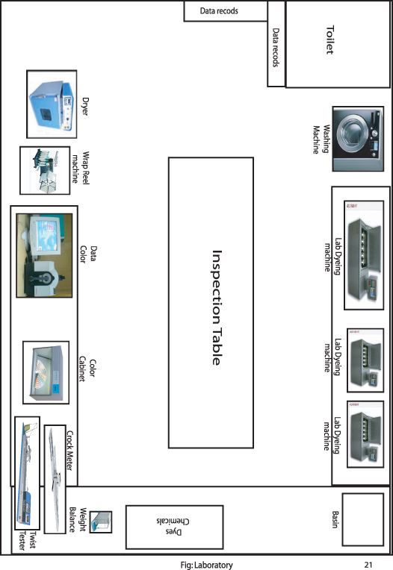
6. S.1.1: Laboratory work sequence
Sample received (Fabrics)
↓
Check & note the Lot no, Style no, Item no& Collar
↓
Sample Preparation
↓
Run the test
↓

Physical test Wet lab

Color Fastness to wash
Pilling Color Fastness to washing
Crocking

Evaluate the sample Pre-production Sample Final sample

Report Making Test Test

Prepared the report prepared the report
Pass Fail

Deliver Refinish Pass Fail Pass Fail

Need to test again Refinish

The responsibilities of the laboratory are:
- Sample preparation according to buyer requirement
- Different properties test (Wash fastness, Color fastness, rubbing fastness, Perspiration Test, Pilling Test etc.)
- Strength test of Dyestuff
- Chlorine test, Peroxide test
- Product Development etc.
6. S.1.2: Machine Specifications
Machines available in the laboratory of the Cotton Club (BD) Ltd. are as follow:
- Hot Air Oven (Quantity: 1, Name: Digital Hot Air Oven, Origin: India, Company: Paramount.)
- Digital Wrap Reel machine (Quantity: 1, Name: Digi Wrap Reel, Origin: India, Comapany: Digi Warp ReelTM)
- Data Color (Quantity: 1, Name: Gretagmacbeth, Model: Color –Eye- 7000A, Origin: Italy.)
- Color Cabinet (Quantity: 1, Company: Verivida.)
- Crock Meter (Quantity: 1)
- Twist Tester (Quantity: 1)
- Digital Balance (Quantity: 1, Name: OHAUS, Company: Pioneer, Origin: USA.)
- Sample Dyeing machine (Quantity: 3, Name: Rapid, Origin: Taiwan.)
- Washing machine (Quantity: 1, Name: Aristan.)

6. S.1.3: Lab Dyeing processes follow up
The laboratory dyeing process of Cotton Club (BD) Ltd. is as follow:
Sample Received
↓
Standard is checked with the Reference from the inventory
↓
If matched then sample prepared from that recipe
↓
If not matched than the color percentage is calculated by using Data Color
↓
Recipe Prepared
↓
Sample prepared according to recipe
↓
Standard (From Buyer) and Sample prepared is Compared
↓
If Okay then the sample is sent to Buyer
↓
Buyer approves the sample and order for the bulk production.

Sample Received: Buyer sends a sample which is considered as standard in whole process. Buyer also gives some requirements about the properties of the standard fabric. For example, Buyer wants good wash fastness, light fastness, rubbing fastness, pilling formation etc. The lab receives this standard to make this fabric according to buyer requirements.
Standard is checked with the Reference from the inventory: The factory dyed a lot of fabric in its running years. It also stores a lot of sample in its inventory. The standard is first checked with the samples kept in the inventory.
If matched then sample prepared from that recipe: If the standard is matched with the sample of inventory then the next process becomes easier. Because after matching the sample with standard previously maintained recipe is followed. If the sample does not match with the standard then the process goes to data color.
If not matched than the color percentage is calculated by using Data Color: If the standard does not match with the samples of inventory, then the standard percentage of color is found out from the data color machine.
Recipe Prepared: According to the results of data color machine the recipe is prepared to get the desired sample of that standard.
Sample prepared according to recipe: Following the procedure the sample is prepared.
Standard (From Buyer) and Sample prepared is Compared: After getting the sample is compared with the standard. And several tests are done to meet the buyer requirement.
If Okay then the sample is sent to Buyer: Sample is then sent to the buyer for the final approval.
Buyer approves the sample and order for the bulk production: When buyer gives the final approval the fabric is sent to production floor for the bulk production.

6. S.1.4: Properties test
Color fastness to rubbing (wet & dry):
Procedure:
Firstly a sample of size (14 × 5) cm is taken at Wales & Course wise. The crocking cloth is put on to the finger & is staged by finger clip & run 10 times in 10 seconds manually & assesses the crocking cloth with gray scale.

The crocking cloth is placed on the water, it will suck some water and crocking cloth is then squeezed. Then place the wet rubbing cloth on to the finger and stag with finger clip and run 10 times in 10 seconds manually. The crocking is then assessed cloth by gray scale for wet rubbing. Wet and dry rubbing are checked according to buyer’s requirement.

Color fastness to washing. (ISO/05-CO6):
Procedure:
- Size of specimen: Sample & multifibre at (10 × 2) cm then stitch.
- Detergent: 4g/l ECE detergent (WOB) + 1g/l sodium per borate put in distilled water & cooled at 20°C & measured P^{H} (where necessary).
- the program is run in the following way: -
Test no. Temp°C Liq.volume ml Time min. Steel balls Adjust pH
C2S 60°C 50 30 25 10.5±1
- The sample is rinsed twice with cold water.
- At 60°C by hanging or by flat iron pressing the dried but temperature should not less more than 150°C.
Pilling test:
Procedure:
The fabric 12.5 x 12.5cm is cut & balanced mark should be 10cm by using template. Then the fabric is sewn so that it can be firmly fit in the tube a moulded polyurethane tubes. Then four tubes are placed in a box & started 60±2 rev/min for 5 hrs or according to buyer requirement. Then the fabric is assessed by putting tested specimen on the cabinet & compared with standard photographs.
Shrinkage & Spirality test:
Buyer’s requirements:
Template size: 50cm & 35cm, 25.5cm &18cm (use after quick wash).
Shrinkage: length wise--- 5%
Width wise----5%
Spirality: Left -------- 5%
Right -------- 5%
Procedure:
Firstly two ply of fabric is taken & put the template (50cm) on to the fabric. The template has 8 holes. Both length & width wise the template holes can measure 35cm at 3 places. Then 8 holes are marked by permanent marker & also at the edges of the template.
The fabric is sewn & it is given to the washing m/c for run at 60°C for 60minutes with water. After that the sample is dried & then fabric is measured.
Calculation:
  - Shrinkage Test:
Lengthwise: After wash – Before wash
= ----------------------------------×100
Before wash
Width wise: After wash – Before wash
= ----------------------------------×100
Before wash
  - Spirality test:

= 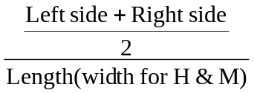× 100 %

6. S.1.5: Dyestuff Strength test:
Dyestuff strength test is very important for any textile dyeing industry.
A dye comes to industry then a sample fabric is dyed first to make it a reference. When that dye is used and finished from inventory, new dye is ordered. But it is not sure the dye that reached newly, will make a fabric as much dyed as before. That is why after arriving of dye to the factory it is used to make a sample. Then this newly made sample is checked in respect of previously dyed sample. If the two samples match with each other, it is resulted that the strength is okay. But if not match then the amount to be given (less or more) is determined.
Thus the strength of dyestuff is measured in this way.
6. S.1.6: Remarks
The laboratory of the factory is well enough to make quality products. But more attention to laboratory is required to make it more efficient. The information’s that lacks about laboratory in this report is just the result of the unavailability of time of the department.

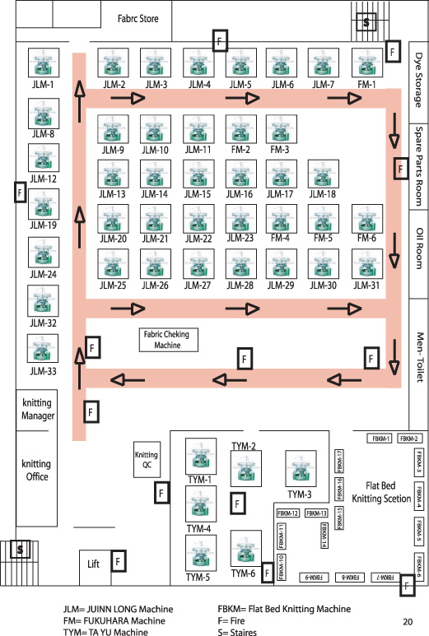

6. S.2.1: Process Flow chart of Knitting:

Yarn in cone form

Feeding the yarn cone in the creel

Feeding the yarn in the feeder via trip-tape positive feeding arrangement and Tension device.

Knitting

Withdraw the rolled fabric and weighting

Inspection

Numbering

Parts of knitting Machines:
Creel: Creel is used to place the cone of yarn.
Feeder: Feeder is used to feed the yarn to make a fabric.
Tensioning device: Tensioning device is used to give proper tension to the yarn.
VDQ pulley: VDQ pulley is used to control the GSM by controlling the stitch length.
Guide: Guide is used to guide the yarn.
Sensor: Sensor is used to seen & the machine stops when any problem occurs.
Spreader: Spreader is used to spread the knitted fabric before take up roller.
Take up roller: Take up roller is used to take up the fabric
Fixation feeder: These types of feeder are used in Electrical Auto Striper Knitting Machine to feed the yarn at specific finger.
Rethom: These devise are used in Electrical Auto Striper Knitting machine

6. S.2.2: Design Development by using CAM:
The type of fabric to produce depends on the setting of the Cam of Knitting machine. The different types of fabric can be produced by only changing the cam setting. The cam settings to produce different fabric are given below:
Single jersey:
Only knit cams are used to produce single jersey fabric. So the setting would be-
K K K
K K K
K K K
Inter lock:
Inter lock fabric is produced by using knit and miss cam. So the setting would be-
K M K
M K M
Lacost:
Lacost uses knit and tuck cam like-
K K T K K
T K K K T

French terry:
The cam setting is as follows-
K M K M K M
K T K M K T
K M K T K M

Used Raw materials for knitting:
Type of yarn | Count
Cotton Yarn | 16^{s} ,20^{s}, 22^{s}, 24^{s}, 26^{S}, 28^{S}, 30^{S}, 34^{S}, 40^{S}
Polyester Yarn | 75D, 100D,150D
Spandex yarn | 20D,40D,70D
Grey Mellange (C-90% V-10%) | 20^{S} ,22^{S} ,24^{S}, 26^{S} ,30^{S} ,34^{S}
PC (65%Polyester & 35% cotton) | 24^{S}, 26^{S}, 28^{S}, 30^{S}
CVC | 24^{S}, 26^{S}, 28^{S}, 30^{S}

6. S.2.3: Circular Knitting Machines Specification
Total Machines: 45
There are three types of machines available in the knitting floor of Cotton Club (BD) Limited. They are:
- JIUNN LONG
- FUKUHARA
- TA YU
The total Number of JUINN LONG (Made in Taiwan) machines are 33; the FUKUHARA (Made in Japan) and TA YU (Made in Taiwan) are both 6 in number the total of which is 45.
The Specifications of JUINN LONG Machines are Given Below:
Machine 1:
Model | JLS | Diameter | 18”
Machine no. | 060401 | Feeder | 54 F
Needles | 1356 T | Gauge | 24 G

Machine 2:
Model | JLS | Diameter | 20”
Machine no. | 060403 | Feeder | 60 F
Needles | 1512 T | Gauge | 24 G

Machine 3:
Model | JLS | Diameter | 21”
Machine no. | 060405 | Feeder | 54 F
Needles | 1584 T | Gauge | 24 G

Machine 4:
Model | JLS | Diameter | 22”
Machine no. | 060406 | Feeder | 66 F
Needles | 1658 T | Gauge | 24 G

Machine 5:
Model | JLS | Diameter | 23”
Machine no. | 060408 | Feeder | 69 F
Needles | 1740 T | Gauge | 24 G

Machine 6:
Model | JLS | Diameter | 24”
Machine no. | 060410 | Feeder | 72 F
Needles | 1812 T | Gauge | 24 G

Machine 7:
Model | JLS | Diameter | 25”
Machine no. | 060412 | Feeder | 75 F
Needles | 1872 T | Gauge | 24 G

Machine 8:
Model | JLS | Diameter | 28”
Machine no. | 060415 | Feeder | 84 F
Needles | 2112 T | Gauge | 24 G

Machine 9:
Model | JLS | Diameter | 30”
Machine no. | 060416 | Feeder | 90 F
Needles | 2256 T | Gauge | 24 G

Machine 10:
Model | JLS | Diameter | 32”
Machine no. | 060417 | Feeder | 96 F
Needles | 2400 T | Gauge | 24 G

Machine 11:
Model | JLS | Diameter | 34”
Machine no. | 060418 | Feeder | 102 F
Needles | 2544 T | Gauge | 24 G

Machine 12:
Model | JLS | Diameter | 36”
Machine no. | 060419 | Feeder | 108 F
Needles | 2712 T | Gauge | 24 G

Machine 13:
Model | JLD | Diameter | 30”
Machine no. | 060420 | Feeder | 60 F
Needles | 1704 T | Gauge | 18 G

Machine 14:
Model | JLD | Diameter | 32”
Machine no. | 060421 | Feeder | 64 F
Needles | 1800 T | Gauge | 18 G

Machine 15:
Model | JLD | Diameter | 36”
Machine no. | 060423 | Feeder | 72 F
Needles | 2040 T | Gauge | 18 G

Machine 16:
Model | JLD | Diameter | 38”
Machine no. | 060424 | Feeder | 76 F
Needles | 2136 T | Gauge | 18 G

Machine 17:
Model | JLD 2X4 | Diameter | 40”
Machine no. | 070806 | Feeder | 80 F
Needles | 2256 T | Gauge | 18 G

Machine 18:
Model | JLD 2X4 | Diameter | 28”
Machine no. | 070805 | Feeder | 56 F
Needles | 1584 T | Gauge | 18 G

Machine 19:
Model | JLD 2X4 | Diameter | 26”
Machine no. | 070804 | Feeder | 52 F
Needles | 1476 T | Gauge | 48 G

Machine 20:
Model | JLD 2X4 | Diameter | 24”
Machine no. | 070803 | Feeder | 48 F
Needles | 1344 T | Gauge | 18 G

Machine 21:
Model | JLS- 2 | Diameter | 38”
Machine no. | 070809 | Feeder | 114 F
Needles | 2880 T | Gauge | 24 G

Machine 22:
Model | JLS- 2 | Diameter | 40”
Machine no. | 070810 | Feeder | 120 F
Needles | 3000 T | Gauge | 24 G

Machine 23:
Model | JLS-2 | Diameter | 42”
Machine no. | 070811 | Feeder | 126 F
Needles | 3168 T | Gauge | 24 G

Machine 32:
Model | JLD 2X4 | Diameter | 42”
Machine no. | 070807 | Feeder | 84 F
Needles | 2376 T | Gauge | 18 G

Machine 33:
Model | JLD 2X4 | Diameter | 44”
Machine no. | 070808 | Feeder | 88 F
Needles | 2484 T | Gauge | 18 G

The Specifications of FUKUHARA Machines are Given Below:
Machine 1:
Model | VXC-3S | Feeder | 75 F
Serial no. | 0244856 | Gauge | 24 G
Needles | 1965 T | Diameter | 26”

Machine 2:
Model | DXC-3S | Feeder | 57 F
Serial no. | 0344851 | Gauge | 24 G
Needles | 1440 T | Diameter | 19”

Machine 3:
Model | DXC-3S | Feeder | 60 F
Serial no. | 0344852 | Gauge | 24 G
Needles | 1510 T | Diameter | 20”

Machine 4:
Model | VXC-3S | Feeder | 75 F
Serial no. | 0244855 | Gauge | 24 G
Needles | 1890 T | Diameter | 25”

Machine 5:
Model | VXC-3S | Feeder | 72 F
Serial no. | 0244854 | Gauge | 24 G
Needles | 1815 T | Diameter | 24”

Machine 6:
Model | VXC-3S | Feeder | 69 F
Serial no. | 0244853 | Gauge | 24 G
Needles | 1740 T | Diameter | 23”

The Specifications of TA YU Machines are Given Below:
Machine 1:
Serial no. | 8A12-5 | Diameter | 38”
Model | TY-S-OW | Gauge | 24 G
Needles | 2870 T | Feeder | 114 F

Machine 2:
Serial no. | 8A112-3 | Diameter | 36”
Model | TY-S-OW | Gauge | 24 F
Needles | 2720 T | Feeder | 108 F

Machine 3:
Serial no. | 7A8-2 | Diameter | 34”
Model | TY-S-OW | Gauge | 24 G
Needles | 2570 T | Feeder | 102 F

Machine 4:
Serial no. | 701-11 | Diameter | 34”
Model | TY-D21 | Gauge | 18 G
Needles | 1930 T | Feeder | 72 F

Machine 5:
Serial no. | 8A12-1 | Diameter | 32”
Model | TY-S-OW | Gauge | 24 G
Needles | 2420 T | Feeder | 90 F

Machine 6:
Serial no. | 8A1-3 | Diameter | 30”
Model | TY-S-OW | Gauge | 24 G
Needles | 2265 T | Feeder | 90 F

Flat Bed Knitting Machines:
Flat bed Knitting Machines has different main parts. They are described below-
- Earthing Line: This part is very useful to remove dirt, Dust on the yarn.
- Carriage: Carriage carries the feeder. Cam is also placed in it.
- Stopper: Stopper is used to define the point to stop the carriage which is changeable according to the length of the fabric.
- Cam: Cam is used to produce different design of fabrics. The number of Cam changes according to the machine model and required design of fabric. Mostly 4 and 7 Cams are used.
- Feeder: Feeder feeds the yarn on the needle.
- Tensioner: Tensioner maintains tension on the yarn.
- Needle bed: Needle bed contains needle. Flat bed knitting machines has two needle beds.
There are 17 Flat Bed Knitting Machines in the Knitting Section of Cotton Club (BD) Limited. All the machines are Around Star Company. The Specifications of these machines are:

Machine 1:
Model No. | 218 | Length | 56”
Serial No. | 27627 | Gauge | 14 G
 |  | Needles | 1568 T

Machine 2:
Model No. | 328 | Length | 68”
Serial No. | 37202 | Gauge | 14 G
 |  | Needles | 1904 T

Machine 3:
Model No. | 218 | Length | 40”
Serial No. | 27626 | Gauge | 14 G
 |  | Needles | 1120 T

Considered point of Knitting:
When a buyer orders for fabric then they mention some points related to production and quality. Before production of knitted fabric, these factors are needed to consider. Those are as follows-
- Finished G.S.M.
- Type of Fabric or design of Fabric.
- Yarn count
- Types of yarn (combed or carded)
- Diameter of the fabric.
- Stitch length
- Color depth.
End products of circular knitting machine:
Single Jersey M/C:
- S/J Plain
- Single lacoste
- Double lacoste
- Single pique
- Double pique
- Terry
Rib M/C:
a) 1*1 Rib fabric
b) 2*2 Rib fabric
c) Honeycomb
End product of Flat bed knitting machine:
a) Collar
b) Cuff
Production Calculation:
A. Production/shift in kg at 100% efficiency
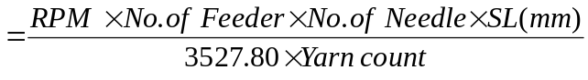
B. Production/shift in meter
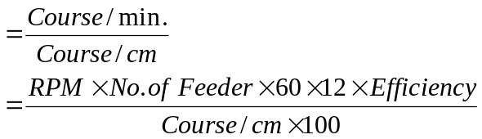

C. Fabric width in meter:
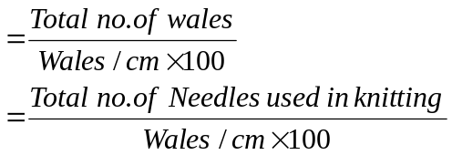
D. Needle calculation
For Circular knitting machine:
- Diameter of the Machine X Gauge of the Machine X 3.14
For example: Diameter of the machine is 18” and Gauge of the machine is 24. Then the number of Needles on the machine would be-
- 18 X 24 X 3.14 = 1356
For Flat Bed knitting machine:
- Length of the Machine needle bed X Gauge of the Machine
For example: Length of the machine needle bed is 56” and Gauge of the machine is 14. Then the number of Needles on the machine would be-
56 X 14 = 1568

Faults of Knitting:
- Hole Mark
Causes:
- Holes are the results of yarn breakage or yarn cracks.
- During loop formation the yarn breaks in the rejoin of the needle hook.
- If the yarn count is not correct on regarding structure, gauge, course and density.
- Badly knot or splicing.
- Yarn feeder badly set.

Remedies:
- Yarn strength must be sufficient to withstand the stretch as well as uniform.
- Use proper count of yarn.
- Correctly set of yarn feeder.
- Knot should be given properly.

- Needle Mark
Causes:
- When a needle breaks down then needle mark comes along the fabrics.
- If a needle or needle hook is slightly bends then needle mark comes on the fabrics.

Remedies:
- Needle should be straight as well as from broken latch.

- Sinker Mark
Causes:
- When sinker corrode due to abrasion then some times can not hold a new loop as a result sinker mark comes.
- If sinker head bend then sinker mark comes.

Remedies:
- Sinker should be changed.

- Star
Causes:
- Yarn tension variation during production.
- Buckling of the needle latch.
- Low G.S.M fabric production.

Remedies:
- Maintain same Yarn tension during production.
- Use good conditioned needles.

- Drop Stitches
Causes:
- Defective needle.
- If yarn is not properly fed during loop formation i.e. not properly laid on to the needle hook.
- Take-down mechanism too loose.
- Insufficient yarn tension.
- Badly set yarn feeder.

Remedies:
- Needle should be straight & well.
- Proper feeding of yarn during loop formation.
- Correct take up of the fabric & correct fabric tension.
- Yarn tension should be properly.

- Oil stain
Causes:
- When oil lick through the needle trick then it pass on the fabrics and make a line.

Remedies:
- Ensure that oil does not pass on the fabrics.
- Well maintenance as well as proper oiling.

7. Rust stain
Causes:
- If any rust on the machine parts.
Remedies:
- If any rust on the machine parts then clean it.
- Proper maintenance as well as proper oiling.

- Pin hole
Causes:
- Due to break down or bend of the latch, pin hole may come in the fabric.

Remedies:
- Change the needle

- Grease stain
Causes:
- Improper greasing
- Excess greasing

Remedies:
- Proper greasing as well as proper maintenance

- Cloth fall- out
Causes:
- Cloth fall- out can occur after a drop stitch especially when an empty needle with an empty needle with closed latch runs into the yarn feeder and remove the yarn out of the hook of the following needles.

Remedies:
- Make sure all the latches of needle are closed with feeding yarn after a drop stitch.

11. Barre:
A fault in weft knitted fabric appearing as light or dark course wise (width wise) Stripe.
Causes:
- This fault comes from yarn fault.
- Different micro near value of fiber content in yarn.
- Different lusture, dye affinity of fiber content in yarn.
- During spinning different similar classes of fiber is mixed specially in carded yarn & these fibers have similar characteristics.
- In draw fame different similar classes sliver is mixed and make one sliver.

Remedies:
- We can use this fabric in white color.

- Fly dust:
Causes:
- In knitting section too much lint is flying to and fro that are created from yarn due to low twist as well as yarn friction. This lint may adhere or attach to the fabric surface tightly during knit fabric production.

Remedies:
- Blowing air for cleaning and different parts after a certain period of time.
- By cleaning the floor continuously.
- By using ducting system for cleaning too much lint in the floor.
- Over all ensure that lint does not attach to the fabric.

13. Yarn contamination
Causes:
- If yarn contains foreign fiber then it remains in the fabric even after finishing,
- If lot, count mixing occurs.

Remedies:
- By avoiding lot, count mixing.
- Faultless spinning.

- Yarn Faults:
- Neps.
- Slubs.
- Yarn count variations.
- Thick/Thin place in yarn.
- Hairiness

Flat Knitting Machines Fault:
- Holes:
Causes:
- Needle Break,
- High Tension on Tensioner,
- Excess cotton with yarn on needle.
- Missing Needle:
Causes:
- Faulty Needle,
- Faulty Cam setting.
- Oil mark:
Causes:
- Improper Oiling on Machine.
- Inexperienced Operator

- Loop Miss:
Causes:
- Tension on take up roller,
- Needles miss.

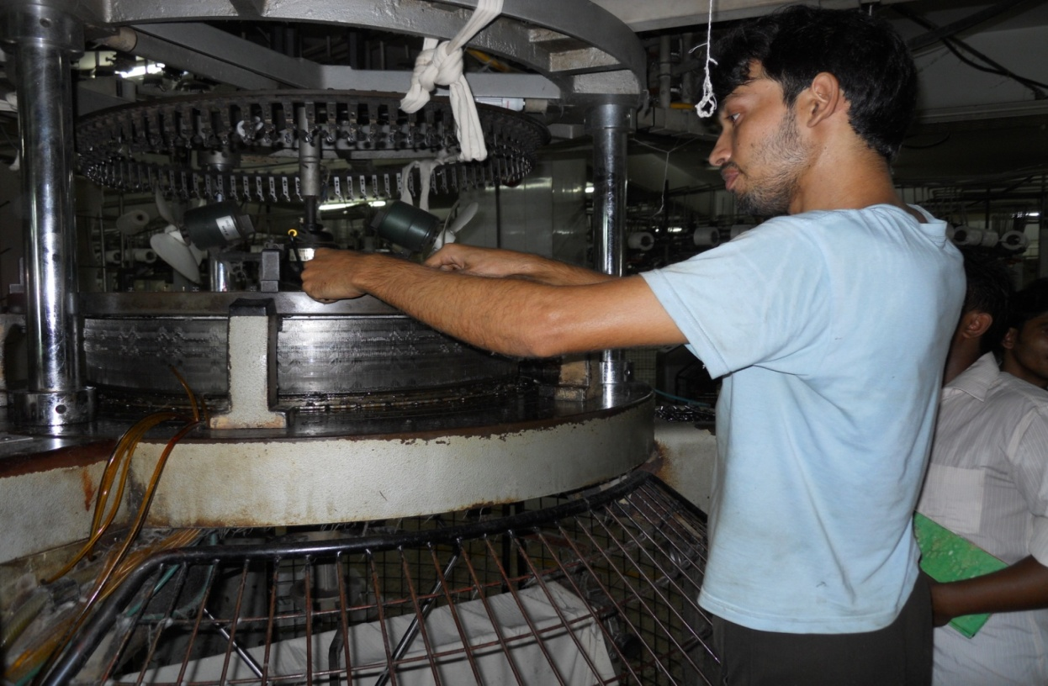
Fig: Cam set up of knitting machine
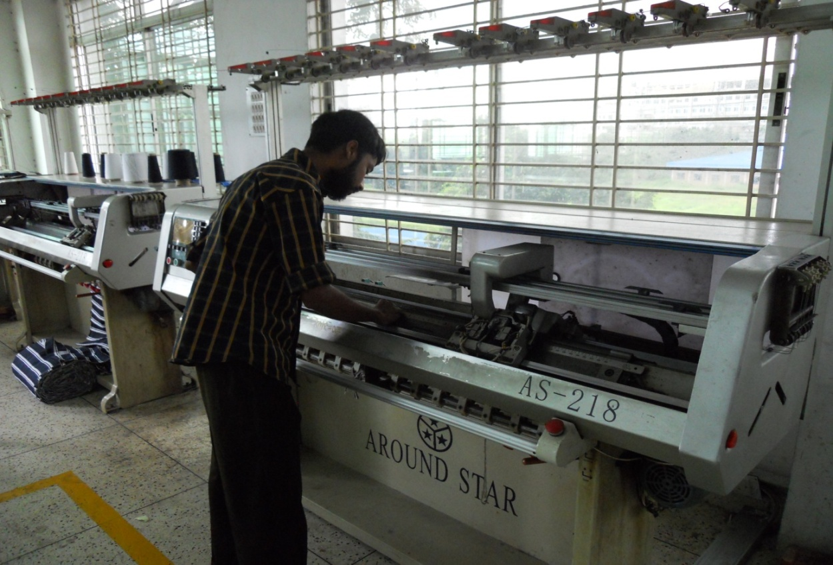

Fig: Flat Bed knitting machine
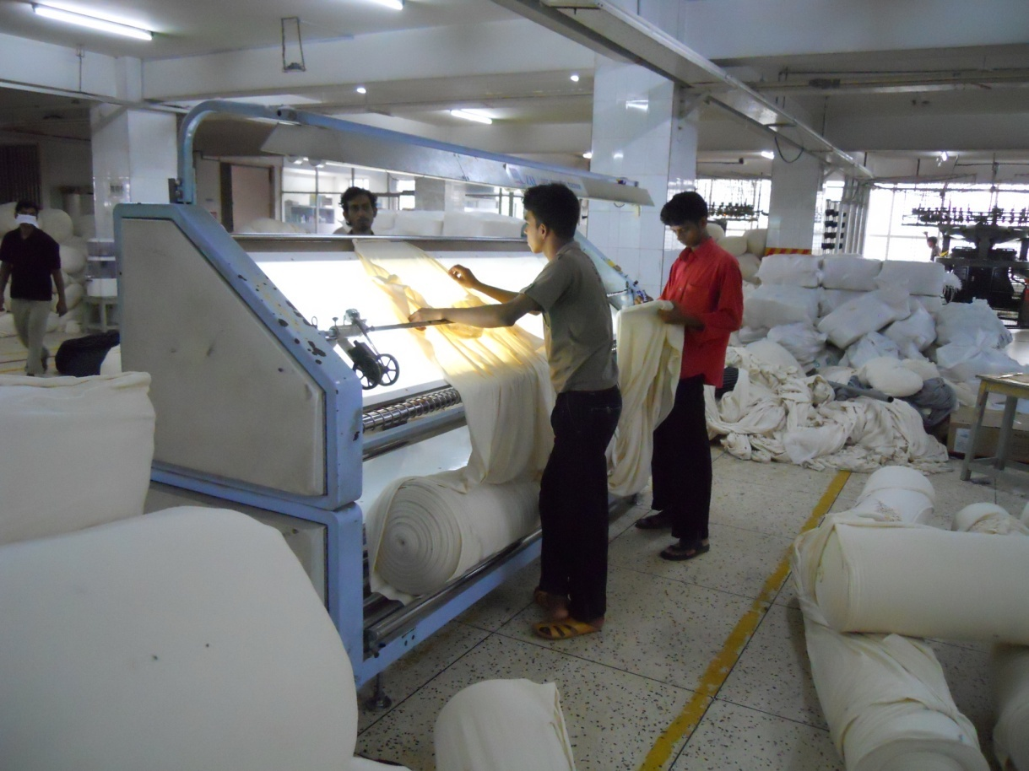

Fig: Knitting Fault checking machine

6. S.3.1: Batch process flow chart
Flow process chart of Batching Section of Cotton Club (BD) Ltd.
Fabric Received
↓
Inspection
↓
Fabric Divided according to Diameter
↓
Supervisor batches the fabric according to quantity by Calculation
↓
Sent for Dyeing

6. S.3.2: Grey fabric inspection
The batch section of the Cotton Club (BD) Ltd. inspects the following parameters of the received fabric-
- Knitting Hole
- Oil Spot
- Tara
- Shade UP
- Star Mark
- Patta
- Lack out

6. S.3.3: Batch Calculation:
= Batch Quantity (M/C Quantity) / Total Quantity X Diameter quantity
Equation for Rope Length
=Diameter Quantity (Weight of Fabric in a roll) X 39.37 X1000 / Finished GSM / Finished open Diameter

Batch management:
Primarily batching is done by dyeing manager taking the above criteria under consideration. Batch section in charge receives this primary batch plan from dyeing manager. Some time planning is adjusted according to m/c condition or emergency.

Machines in batch section
M/c quantity: 01
M/c Specification:
Machine Name : Air turning m/c
M/c No : 01
Brand Name : Taida
Origin : China
M/c Speed : 300-500m/min
Model : DF 200
Max up clothing : 150 kg
Company :Shandong Taida Dyeing & Finishing
Machinery Co.Ltd

6. S.3.4: Remarks
The batch section of the factory is well equipped but it lacks in a quality controller.

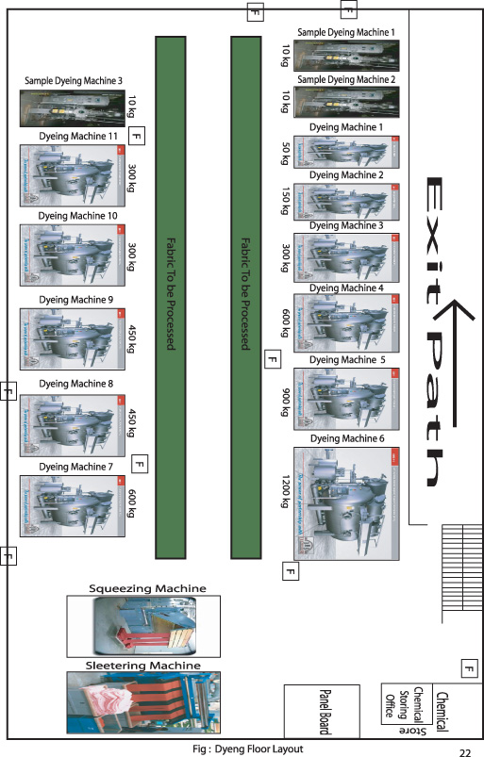

6. S.4.1: Dyeing work flow chart
Tank filling with water
↓
Fabric loading
↓
Addition of Anti-creasing + Sequestering agent (60⁰ c, inject)
↓
Detergent (inject)
↓
Soda + caustic (dosing 10/)
↓
H₂O₂ (70⁰c, inject)
↓
Temperature rise (110⁰c for 60 minutes)
↓
Temperature is decreased for sample check
↓
Hot wash
↓
P.K.K (98⁰c for 10 minutes)
↓
Rinse & Drain
↓
Acid (55⁰c for 10 minutes, P^{H} check-4.5)
↓
Enzyme (60⁰c for 60 minutes and then sample checked)
↓
Rinse & Drain
↓
Tank again filled with water
↓
Temperature raised to 60⁰c and P^{H} checked 5.5)
↓
Leveling agent (inject, run time 5min)
↓
Salt 1/3 (run time 10 minutes)
↓
Dye (dosing, 60⁰c for 30 minutes)
↓
Salt 2/3 (run time 15 minutes)
↓
Steam down (60⁰c, sample check)
↓
Soda (dosing, 60⁰c for 60 minutes)
↓
Hot wash (90⁰c for 10 minutes)
↓
Rinse (3 times)
↓
Acid (40⁰c for 10 minutes, sample check)
↓
Soaping
↓
Acid
↓
Rinse (1 time)
↓
Softener (45⁰c for 10 minutes, sample check)
↓
Cold wash
↓
Unload fabric

6. S.4.2: Dyeing Machine Specification
Sampling Machine 1:
Capacity- 10 Kgs
Maximum Temperature: 130° C
Origin: China
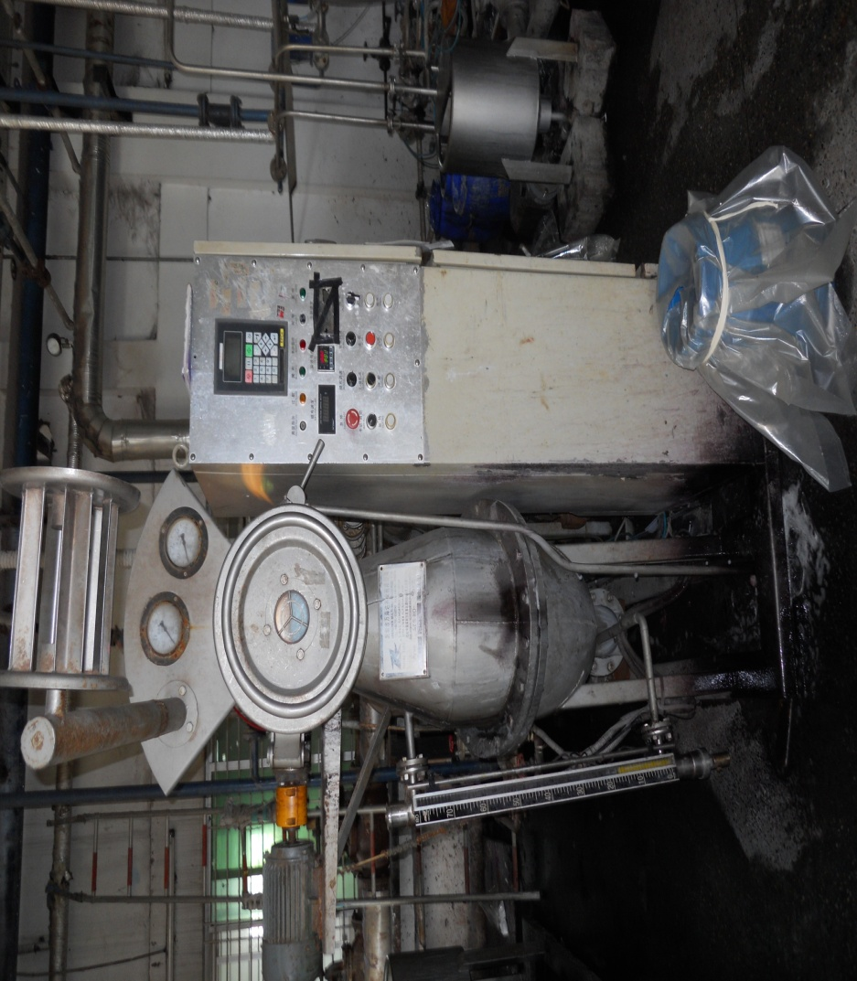
Picture of sampling machine

Dyeing Machine 1:
Name: DILMENLER
Capacity- 50 Kgs
Maximum Temperature: 135° C
M: L = 1:6
Maximum Working Pressure: 2.5 Bar
Origin: Turkey

Dyeing Machine 2:
Name: DILMENLER
Capacity- 150 Kgs
Maximum Temperature: 150° C
M: L = 1:6
Maximum Working Pressure: 2.5 Bar
Origin: Turkey
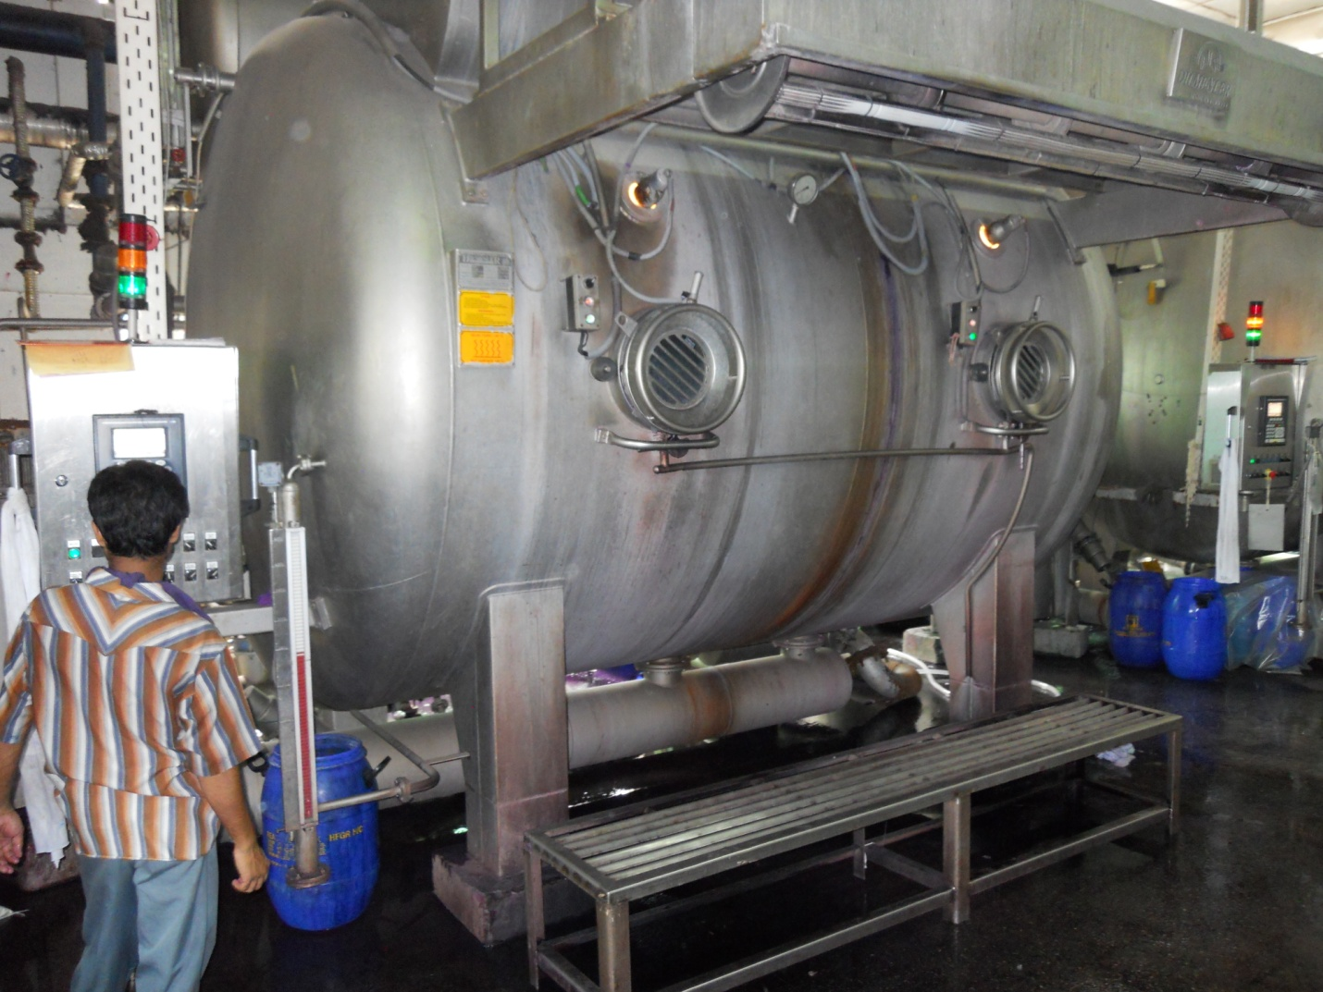

Picture of Dyeing machine
Dyeing Machine 3:
Name: DILMENLER
Capacity- 300 Kgs
Maximum Temperature: 135° C
M: L = 1:6
Maximum Working Pressure: 2.5 Bar
Origin: Turkey

Dyeing Machine 4:
Name: DILMENLER
Capacity- 600 Kgs
Maximum Temperature: 135° C
M: L = 1:6
Maximum Working Pressure: 2.5 Bar
Origin: Turkey

Dyeing Machine 5:
Name: DILMENLER
Capacity- 900 Kgs
Maximum Temperature: 135° C
M: L = 1:6
Maximum Working Pressure: 2.5 Bar
Origin: Turkey

Dyeing Machine 6:
Name: DILMENLER
Capacity- 1200 Kgs
Maximum Temperature: 135° C
M: L = 1:6
Maximum Working Pressure: 2.5 Bar
Origin: Turkey

Dyeing Machine 8:
Name: DILMENLER
Capacity- 450 Kgs
Maximum Temperature: 135° C
M: L = 1:6
Maximum Working Pressure: 2.5 Bar
Origin: Turkey

6. S.4.3: Pretreatment:
Pretreatment is the preparation period of fabric fro dyeing. For getting proper fastness of fabric and proper dyeing pretreatment is a mandatory process.
Demineralization:
It is a process of removing mineral materials from the water. It is done in water treatment plant. Water from natural sources contains many mineral materials which may hamper the dyeing process. If the mineral materials are present in water then it may lead to uneven shade in dyeing. Besides it may also damage the fabric and the machine.
Scouring:
Scouring is process of removing the natural materials from the textile fabric. This process is also a pretreatment for textile. Mostly caustic soda is used a scouring agent. Chemical used for scouring:

Name | Amount | Function
Jintex - JC | 1.0 gm/l | As a detergent
Resotex-600S | 1.0 gm/l | Sequestering agent
Caustic Soda | 3.0 gm/l | To make alkali medium
Peroxide | 3.0 gm/l | As a bleaching agent

Scouring procedure:
Dyeing machine is filled with water with liquor ratio 1:6. Then fabric is inserted through the nozzle of dyeing machine. Required amount of scouring chemicals is given through chemical tank to the machine bath. Machine is run for 10 min. Then required amount of caustic soda is added to the bath. Machine is run for 5 min. the temperature raise to 60ْc. At this temperature peroxide is dosed. Then machine is run at 110ْc temperature for 40 minutes. Finally bath is drained and rinsed by cold water.
The scouring curve is as follows-
NaOH
110 º C X 40 min
Drain
Bleaching:
Bleach is a chemical that removes colors or whitens, often via oxidation. Common chemical bleaches include household chlorine bleach, a solution of approximately 3–6% sodium hypochlorite (NaClO), and oxygen bleach, which contains hydrogen peroxide or a peroxide-releasing compound such as sodium perborate, sodium percarbonate, sodium persulfate, tetrasodium pyrophosphate, or urea peroxide together with catalysts and activators, e.g., tetraacetylethylenediamine and/or sodium nonanoyloxybenzenesulfonate. Bleaching powder is calcium hypochlorite.
The total process of whitening fabric with the bleach is called bleaching.

The bleaching curve is as follows-
H₂O₂
110 º C X 40 min
Drain
Neutralization:
Peroxide is used for neutralization if bleaching is present in fabric. So it should be removed, otherwise it will create a harmful effect on dyeing. On the other hand enzyme should enter in acidic medium. So fabric is neutralized in alkaline medium.
Chemical used:
Name | Amount | Used
1. Invatex-PC | 0.5 gm/l | To kill peroxides
2. Acetic acid | 1.0 gm/l | To neutralization

Procedure:
Chemicals in required amount are taken in the machine at 50ºc temperature. Then, the machine is run for 10 min at 80ºc temperature. Finally the bath is drained and rinsed by cold water.

6. S.4.4: Fabric Dyeing
Recipe for Light Color:

SL | Chemical | g/l or % | Add quantity | Time & Temp
1. | RGN | 0.6 g/l | 1.600 Kg | 110° C X 40 min
2. | Rentex 600S | 1.0 g/l | 2.700 Kg | 110° C X 40 min
3. | Caustic | 0.8 g/l | 2.200 Kg | 110° C X 40 min
4. | Soda | 4.0 g/l | 10.800 Kg | 110° C X 40 min
5. | H₂O₂ | 2.0 g/l | 5.400 Kg | 110° C X 40 min
6. | PKK | 0.6 g/l | 1.600 Kg | 98° C X 10 min
7. | Acid | 1.0 g/l | 2.500 Kg | 55° C X 10 min
8. | Renzyma 1000 | 1.2 g/l | 4.000 Kg | 60° C X60 min + 80° C X 10 min
9. | Levelex P | 1.0 g/l | 2.700 Kg | Varied Temp 60-80° C  Total Time 120 min
10. | Rentex 600S | 0.2 g/l | 0.600 Kg | Varied Temp 60-80° C  Total Time 120 min
11. | G. Salt | 50 g/l | 136.800 Kg | Varied Temp 60-80° C  Total Time 120 min
12. | Soda | 12-3% | 31.900 Kg | Varied Temp 60-80° C  Total Time 120 min
13. | Syn. Yellow HB  Syn. Red HB  Syn. N/Blue | 0.47%  0.575-3%  0.36% | 1.720 Kg  2.041 Kg  1.317 Kg | Varied Temp 60-80° C  Total Time 120 min
14. | Acid | 0.7 g/l | 1.600 Kg
15. | WOP-100 | 0.5 g/l | 1.200 Kg
16. | Acid | 0.12 g/l | 0.250 Kg | 50° C X 20 min
17. | XCC | 0.57 g/l | 1.700 Kg | 50° C X 20 min

Dyeing Curve for light color:
2/3 Salt
1/3 Salt
Dye
Soda
80° C X 10 Min

60° C X 60 Min
Leveler
5 min
10 min
25 min
10 min
Soda Dosing:
2% = 640 gm
3% = 1 Kg
10% = 3 Kg
20% = 6.500 Kg
30% = 9.500 Kg
35% = 11.000 Kg

Recipe for Dark color:
SL | Chemical | g/l or % | Add quantity | Time & Temp
1. | RGN | 0.6 g/l | 1.000 Kg | 110° C X 40 min
2. | Resotex 600S | 1.0 g/l | 1.600 Kg | 110° C X 40 min
3. | Caustic | 1.0 g/l | 1.600 Kg | 110° C X 40 min
4. | Soda | 4.0 g/l | 6.400 Kg | 110° C X 40 min
5. | H₂O₂ | 2.25 g/l | 3.600 Kg | 110° C X 40 min
6. | PKK | 0.6 g/l | 1.000 Kg | 98° C X 10 min
7. | Acid | 1.0 g/l | 1.200 Kg | 55° C X 10 min
8. | Renzyma 1000 | 0.7% | 1.500 Kg | 60° C X60 min + 80° C X 10 min
9. | Acid | 0.2 g/l | 0.300 kg
9. | Levelex P | 0.8 g/l | 1.300 Kg | Varied Temp 60-80° C  Total Time 120 min
10. | SQ-S117 | 0.2 g/l | 3.000 Kg | Varied Temp 60-80° C  Total Time 120 min
11. | G. Salt | 50 g/l | 81.600 Kg | Varied Temp 60-80° C  Total Time 120 min
12. | Soda | 12-3% | 19.000 Kg | Varied Temp 60-80° C  Total Time 120 min
13. | Syn. Yellow HB  Syn. Red HB  Syn. N/Blue HB | 0.49%+8%  0.655+8%  0.97-2% | 1.720 Kg  2.041 Kg  1.317 Kg | Varied Temp 60-80° C  Total Time 120 min
14. | Acid | 0.7 g/l | 1.000 Kg
15. | WOP-100 | 0.5 g/l | 0.700 Kg
16. | Acid | 0.12 g/l | 0.200 Kg | 50° C X 20 min
17. | XCC | 0.5%l | 1.000 Kg | 50° C X 20 min

Dyeing Curve:
Leveling Agent
1/3
Salt
Dye
30min
2/3
Salt
Soda (60º C X 60 min)
80º C X 10 min
20 min
10 min
5 min
60º C
Polyester dyeing:
For polyester fabrics dyeing all the steps of pretreatment is same as cotton dyeing accept leveling steps. Leveling is carried out at pH 4-5 by using Dyapol XLF and Acelon where XLF is leveling chemical and Acelon is pH controller.
Another major change is dye stuff. For polyester dyeing disperse dye is used instead of reactive dye and dye bath temperature is more than 120ْc. Chemical hot is applied at 90ْc by using caustic & hydrose.

6. S.4.5: White fabric dyeing
In case of white shade percent of hydrogen peroxide is increased for more bleaching effect. After scouring brightener is added to the bath and machine is run for 30 minutes at 110ْc. In this case no peroxide killer is used and hot wash is carried out 80ْc for 10 minutes. Enzyme and acid is added at the same time at 60ْc for 50 minutes. Special type of softener is used for white shade only.

6. S.4.6: Topping, Addition, Stripping
After treatment:
When the fabrics are dyed there may have some unbounded color. To remove remaining color hot wash with detergent is done for deep shade. On the other hand dyed fabrics become hard due to dye absorption and different chemical application. That’s why softening agent is used to make the fabric soft. Fixing is also an important step that is done as after treatment.

Chemical used:
Name | Amount | Used
1.RGN | 1.0 gm/l | To remove remaining dyes
2. Acetic acid | 1.0 gm/l | For neutralization
3. Resogen CC | 1.0 or 0.5 gm/l | For color fixing
4. Resosoft XCL | 1.0 gm/l | As a softening agent

After treatment process for deep color:
For deep shade (Red. Black, Navy, Roya blue etc.) a hot wash at about 70-80ْc with cibapon-R is applied. A sample is cut in this stage which is called hot sample. If it is okay then the bath is drained and rinsed by cold water. Then acetic acid is added. After 3 min a sample is cut which is called acid sample. If the shade is okay then fixing is dosed I 5 min. a sample is cut and match the shade, if is not okay then temperature is raised about 50-60ْc. Finally softener is used to soft the fabric and bath drain followed by cold wash and unloading.
Machine wash:
Machine wash is carried out when light shade will be dyed after dyeing a deep shade in same machine. Otherwise color of deep shade that exists in the machine will effect on light shade.
Chemical used:
Name | Amount | Function
1.RGN | 0.1 gm/l water | Soaping agent
2. Caustic soda | 1 gm/l water | pH maintain
3. Hydrose | 1 gm/l water | Color remove

Procedure:
Detergent and soda is given into the machine at a time and machine is run for 10 minutes. After that, required amount to hydrose is added to the bath and the machine is run in washing program for 30 minutes at 110ºc.
Redyeing:
After the finishing the quality control sections check the quality. If the quality of finished product is failed (if there any running shade) then it is sent to dyeing section for redyeing which is carried out in two processes.
- Stripping
- Topping

Stripping:
It is not possible to match all the shades always. The process of removing color from the dyed fabric is called stripping.
Chemical used:
Name | Amount | Used
1. Felosen- RGN | About 1.0 gm/l | Soaping agent
2. Caustic soda | About 1.0 gm/l | To maintain pH
3. Hydrose | About 1.0 gm/l | To remove color

Process description:
Required amount of chemicals are taken in at 50ºc and then the temperature is increased to 80ºc. Hydrose (NaHSO₄) is given for 10 minutes at 80ºc.The machine is run for 30 minutes at 110ºc. If the color is not removed then soda is added along with bleaching powder and NOF and the machine is run for 60 minutes.
Topping: After dyeing the textile good if required shade is not achieved than the color is removed by stripping process and make fabric light. Then the fabric is dyed again. This process is called topping. For required shade we can use dye according to the assumption in topping process.

6. S.4.7: Printing:
Textile Printing is one kind of localized dyeing that is dyes or pigments are applied locally or discontinuously to produce various design on the fabric with a motif or motives in on more colors.

Printing Sequence:

Grey Textiles
↓
Preparation of Textile materials (singing, desizing, scouring, bleaching)
↓
Preparation of printing paste
↓
Printing (with a certain style and method)
↓
Drying of the printed fabric
↓
Steaming of the printed fabric
↓
After treatment

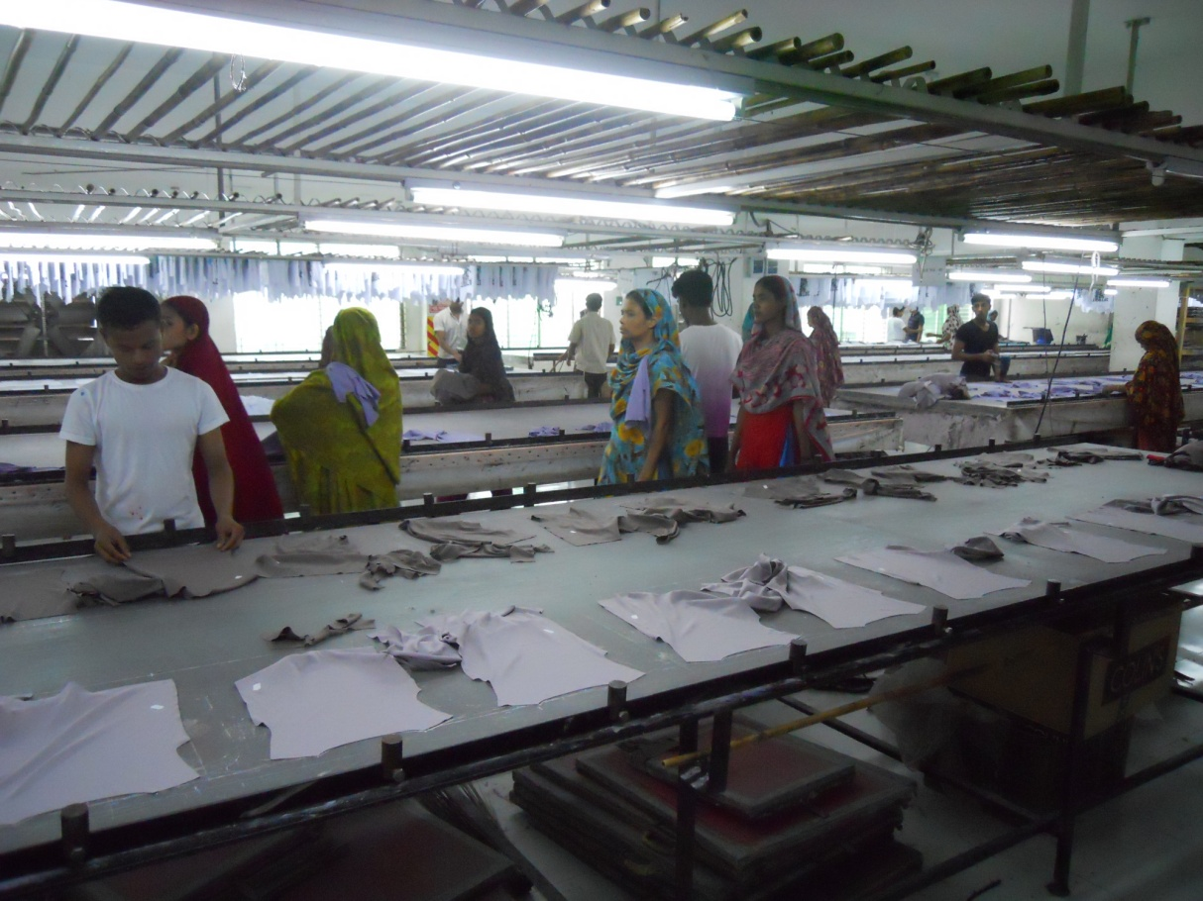

Fig: Printing Section

5. S.4.8: Remarks
The dyeing process of Cotton Club (BD) ltd. is very much satisfactory. Cotton Club only cares for quality. It is heard from the management of the company, after establishing the factory till now, a single order is not cancelled. That’s why it is sure that the company is well enough to produce quality fabric.

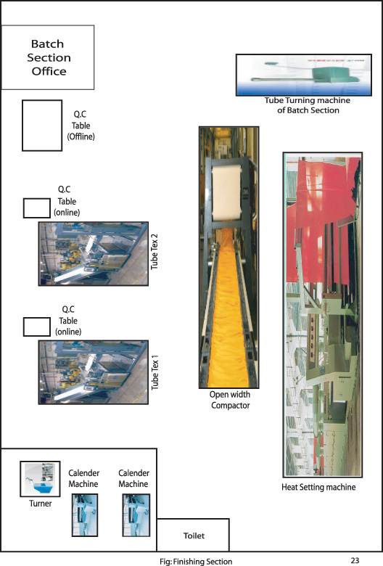

6. S.5.1: Process sequence of Finishing Section:

Finishing

Open Finish  ↓ | Tube Finish  ↓
Slitting and Dewatering  ↓ | Dewatering  ↓
Drying  ↓ | Drying  ↓
Compacting  ↓ | Compacting  ↓
Inspection  ↓ | Inspection  ↓
Delivery | Delivery

6. S.5.2: Machine specification

Machine List of Finishing Section:

Machine Name | Machine Quantity
Slitting m/c | 01
Dewatering m/c | 01
Dryer | 01
Open Compactor | 01
Tube Compactor | 02
Calendaring Machine | 01

Slitting Machine:
Machine specification:

No of Slitting m/c : 01

Slitting m/c-:

Brand name- MERSAN
Country- Turkey
Year of manufacturing- 2007

Slitting:

Slitting is a process that is applied for cutting the tubular fabric through the intended break Wales line on lengthwise direction before going to dryer.

Machine parts:

- Rotary blade
- Ring
- Guide Roller
- Plaiting
- Sensor

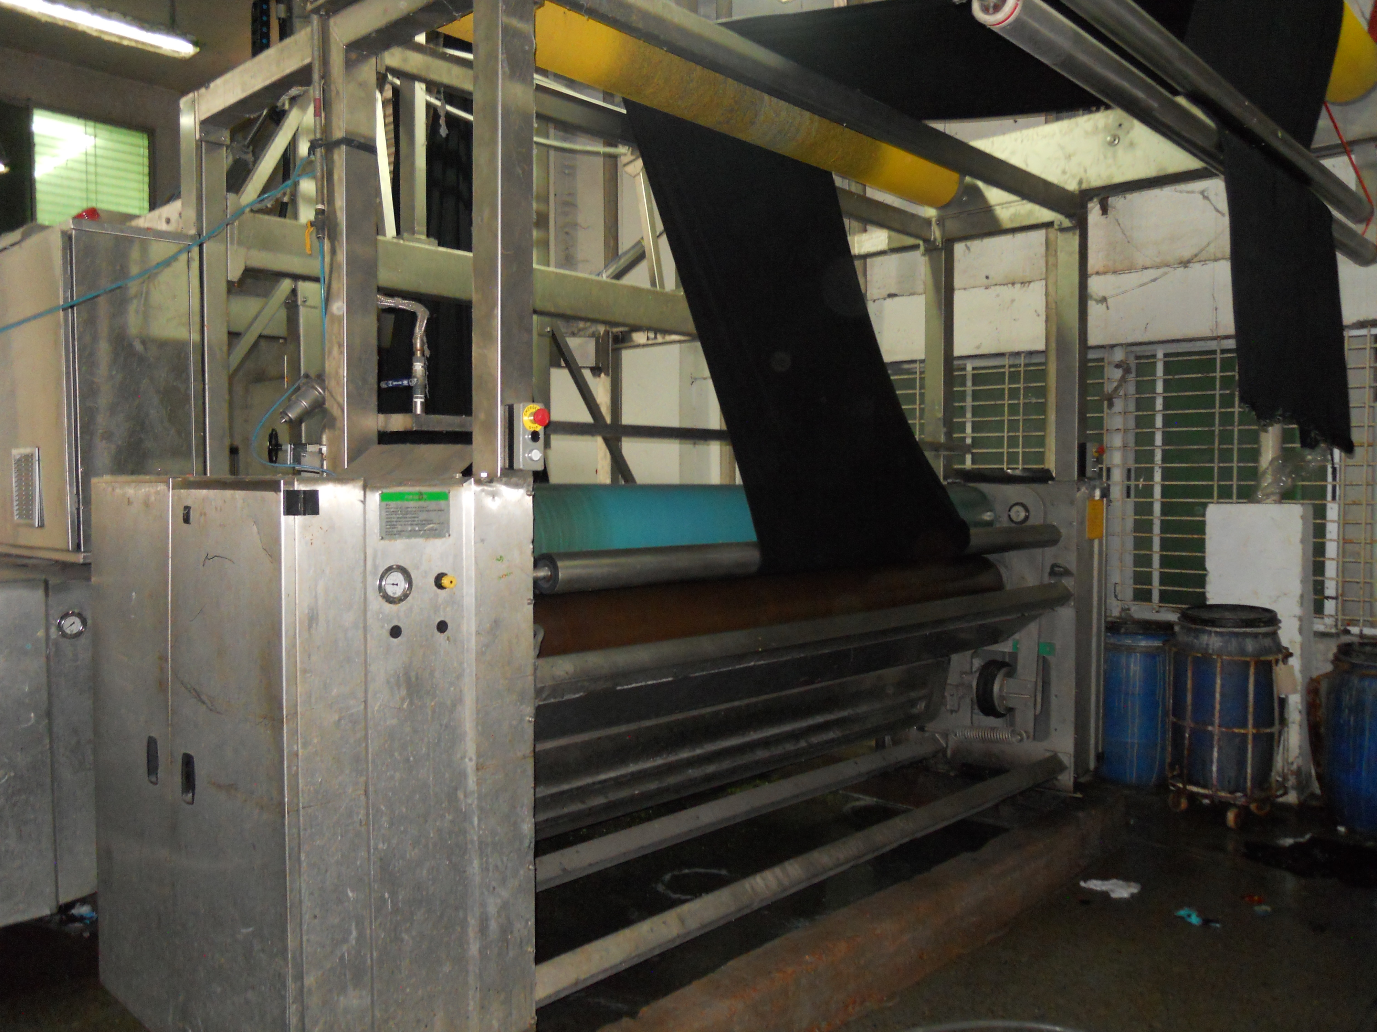

Fig: Slitting Machine

Working principle:
The slitting m/c has 4 units - initial squeezer, de-twisting, slitter and padder. After dyeing completed and falling of water from fabric the fabric is fed in slitting m/c. So it is necessary to remove some water initially for the case of further processing in this m/c. The initial squeezer does this work. The de-twisting unit removes twists that may present in tubular rope form fabric. This unit has 3 de-twisting rollers, one rotation drum and 2 feeler rollers with sensors. By these rollers it detects twist in fabric and removes by rotating rope fabric in opposite direction. Before slitting there is a blower which blows air to open the tubular fabric & makes it easy to pass over cigger. The cigger can be extended in circumference and opens the tubular fabric in full circumference. Slitting is done by using open mark detecting golden eye by around knife. Then the fabric passes through the padder where washing or chemical treatment is done. Squeezer is used to remove 60-70% of water. After removing water width is controlled by stretcher and fabric is delivered by folding device.

Operational parameter:

-Set the padder pressure as required (3-7bar)

-Set the speed as much as possible (30-80m/min).

Function of the Machine:

- Used to remove excess water after pretreatment and dyeing.
- To slit the tube fabric by the knife for opening of the fabric and ready for drying.
- Delivering fabric in crease free state.
- It can control the diameter of fabric and GSM and shrinkage by over feeding mechanism.

DEWATERING

Machine specification:

No of Dewatering m/c : 02

Machine no : 01
Machine name : Dewatering
Brand name : Heliot
Country : France
Padder pressure : 1-1.5 bar
Pressure capacity : 4 bar

Function:

- Reduce water content.
- Apply chemicals.
- Width wise stretch the fabric.

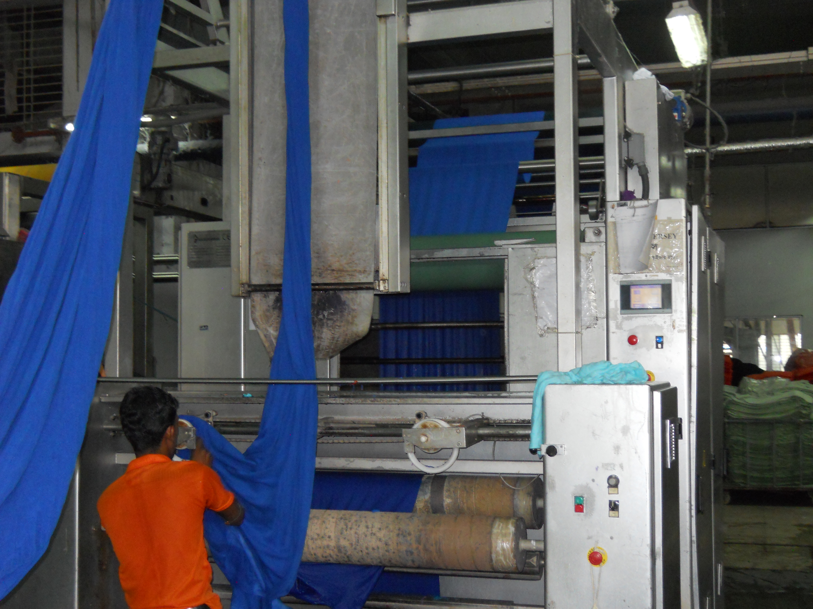
Fig: Dewatering Machine

Working principle of Dewatering:

After dyeing fabrics are sent for de-watering. Mainly tubular fabrics are dewatered in de-watering m/c. The magnetic sensor of the machine senses the twist of the fabric along with its direction. It also turns the fabric in opposite direction to remove twist automatically. Here dewatering is performed. De-watering is the process to remove the water from the fabric completely by squeezing and it is done by the padder. A suitable expander is used before the fabric is passed through the nip of the padders, which expands the fabric flat wise and adjust the width. The expander width is adjusted as S/J- 20%, PK-25%, Int.-35%, Lacoste-40% wider than the required width. There is a pair of rubber coated padder, where water is removed from fabric when passed through the nip of it. Normally squeezer contains single or double padder: one removes water and other applies finishing chemicals such as softener. The compressor of the machine gives compressed air to form balloon of the fabric before passing through the padder. This balloon removes crease mark present on the fabric after dyeing.
DRYER

Dryer- (multifunctional)
Machine name-Santex AG
Origin – Switzerland
Type-SANTASHINK
Year of construction- (2001/2008)
Chamber -5

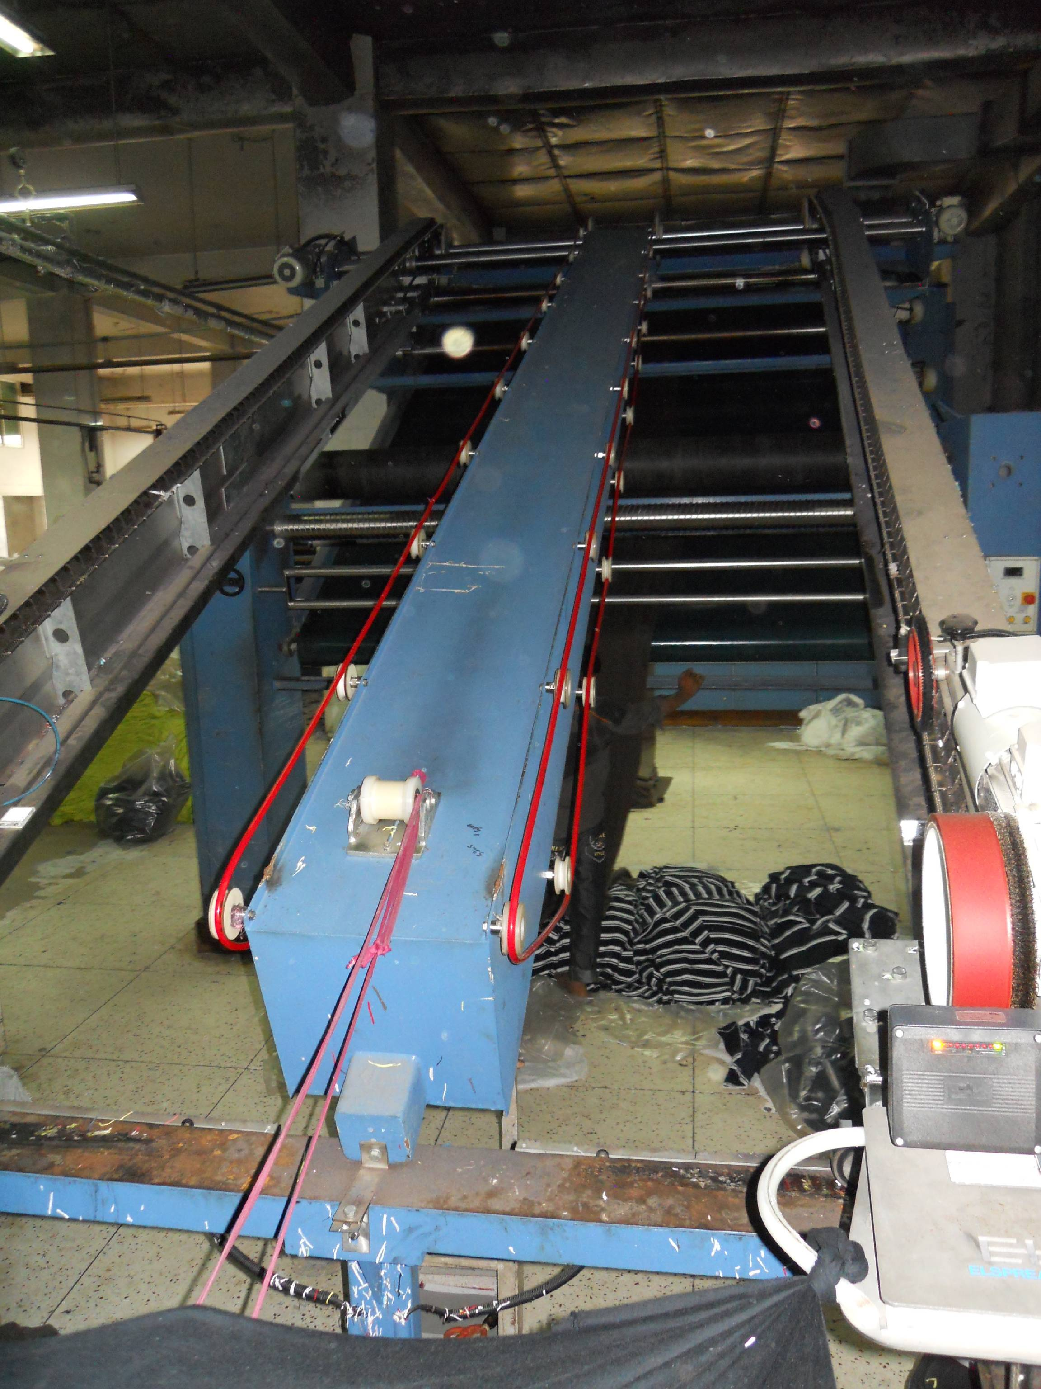
Fig: Dryer

Fabric feed for drying in santex (tube)

Fabric type-NELSON pk (tube form)
Color-white
Temp-100⁰c
Over feed-10%
Finished dia-43 inch tube
Finished GSM-160-165
M/c speed-15m/min
Capacity-10 tons/day

Fuel combustion chamber:
Fuel- Natural gas
Fuel pressure-7.2m bar
Capacity-300kw
Voltage-240/400v
Frequency-50Hz
Year-12/2007

Ratiomatic Burner:
Brand name: ECLIPSE
Year-03/2002
Capacity-300 kw
Voltage-230/400 v
Frequency-50Hz
Fuel- Natural gas
Pressure- (150-500) m bar

Ratiomatic Burner for Fuel Combustion:

Origin - Germany
Year-11/2003
Capacity-200 kw
Voltage-230/400 v
Frequency-50/60Hz
Fuel- Natural gas
Pressure- 50 m bar

Compactor

Machine specification:
No. of Compacting m/c: 01

Open Compactor:
Machine name – Open compactor
Brand name – FERRARO
Country – Italy
Manufacturing Year – 2004

Function:
- To control shrinkage.
- To control width.
- To control GSM.
- To smooth fabric.
- Heat seating of fabric for Lycra.

Important parts

- Over feed roller.
- Expander.
- Blanket(2)
Operational parameter

  - Temperature setting at 120 °C (or as required)
  - Speed setting as required (15-25 m/min).
  - Setting the overfeed % as required; to increase GSM, overfeed need to increase to a certain limit.

Function
- Shrinkage control.
- GSM control.
- Width control.

6. S.5.3: Online quality Control
Online quality control deals with the following things:

M/C Dia/Gauge
- Buyer
- Design
- Grey fabric GSN & Stitch Length
- Yarn count & Lot no
- Yarn whether approved or not by Q.C. Department
- Finished dia & grey dia.
- Fabric quality checking under 4-point system.

6. S.5.4: Fabric Inspection

It is the responsibility of fabric supplier to inspect 100% fabrics prior to deliver the garment manufacturing factory. The factory should inspect at least 10% rolls from each delivering at random. This should include all color and dye lots within a delivery. If the results show a high fault rate an addition 15% of rolls should be inspected. If these again fail the delivery must be rejected.
Any high fault rate is defined as average fault rate in excess of 28 points per 100 square yards.

Procedure:
- At the beginning of each roll a full with cutting should be taken as a color reference and checked for side to center and side shading. This full width cutting must be labeled with the fabric reference number or name, piece number, color name, color number and date.
- The width of the fabric must be measured and compared with the given width.
- The garment factory should check the fabric weight, GSM, length, width stated on the roll sticker against the actual weight. GSM, length, width or roll for variance. Both values should be recorded in the inspection sheet.

- During inspection the fabrics needed to be checked for defects which are rated on the 4 points system as follows.
Size of defect | Penalty
3 inches or less | 1 points
Over 3 but not over 6 | 2 points
Over 6 but nor over 9 | 3 points
Over 9 inches | 4 points

Acceptance calculation:

Total point per 100 square yards

Actual points counted 36 inch
= × × 100
Actual Roll length Actual width
= Points/100 square yards.

Classification of Inspection Fabric:

< 40 points = A
41-60 points = B
61-80 points = C
80 above = Reject.

6. S.5.5: Dyeing faults analysis

Common dyeing faults with their remedies
- Uneven dyeing:
Causes:
- Uneven pretreatment (uneven scouring & bleaching).
- Improper color dosing.
- Using dyes of high fixation property.
- Uneven heat-setting in case of synthetic fibers.
- Lack of control on dyeing m/c

Remedies:
- By ensuring even pretreatment.
- By ensuring even heat-setting in case of synthetic fibers.
- Proper dosing of dyes and chemicals.
- Proper controlling of dyeing m/c

2. Batch to Batch Shade variation:

Causes:
- Fluctuation of Temperature.
- Improper dosing time of dyes & chemicals.
- Batch to batch weight variation of dyes and chemicals.
- Dyes lot variation.
- Improper reel speed, pump speed, liquor ratio.
- Improper pretreatment.

Remedies:
  - Use standard dyes and chemicals.
  - Maintain the same liquor ratio.
  - Follow the standard pretreatment procedure.
  - Maintain the same dyeing cycle.
  - Identical dyeing procedure should be followed for the same depth of the Shade.
  - Make sure that the operators add the right bulk chemicals at the same time and temperature in the process.
  - The pH, hardness and sodium carbonate content of supply water should check daily.

3. Patchy dyeing effect:

Causes:
- Entanglement of fabric.
- Faulty injection of alkali.
- Improper addition of color.
- Due to hardness of water.
- Due to improper salt addition.
- Dye migration during intermediate dyeing.
- Uneven heat in the machine, etc
Remedies:
  - By ensuring proper pretreatment.
  - Proper dosing of dyes and chemicals.
  - Heat should be same throughout the dye liquor.
  - Proper salt addition.

4. Roll to roll variation or Meter to Meter variation:
Causes:
- Poor migration property of dyes.
- Improper dyes solubility.
- Hardness of water.
- Faulty m/c speed, etc

Remedies:
  - Use standard dyes and chemicals.
  - Proper m/c speed.
  - Use of soft water

5. Crease mark:

Causes:
  - Poor opening of the fabric rope
  - Shock cooling of synthetic material
  - If pump pressure & reel speed is not equal
  - Due to high speed m/c running

Remedies:
- Maintaining proper reel sped & pump speed.
- Lower rate rising and cooling the temperature
- Reducing the m/c load
- Higher liquor ratio

6. Dye spot:

Causes:
- Improper Dissolving of dye particle in bath.
- Improper Dissolving of caustic soda particle in bath.

Remedies:
- By proper dissolving of dyes & chemicals
- By passing the dissolved dyestuff through a fine stainless steel mesh strainer, so that the large un-dissolved particles are removed

7. Wrinkle mark:

Causes:
  - Poor opening of the fabric rope
  - Shock cooling of synthetic material
  - High temperature entanglement of the fabric
Remedies:
- Maintaining proper reel sped & pump speed.
- Lower rate rising and cooling the temperature
- Higher liquor ratio

8. Softener Mark:

Causes:
  - Improper mixing of the Softener.
  - Improper running time of the fabric during application of softener.
  - Entanglement of the fabric during application of softener

Remedies:
- Maintaining proper reel sped & pump speed.
- Proper Mixing of the softener before addition.
- Prevent the entanglement of the fabric during application of softener

6. S.5.6: Remarks
Finishing is the most important of all the processes of textile. Because the order accepted will be delivered or rejected by buyer depends on the finishing process. The finishing section of cotton club (BD) Ltd has a very good finishing section to ensure quality.

Garments:
The garments production processing steps and techniques involved in the manufacturing garments for the large scale of production in industrial basis for business purposes is called garments manufacturing technology.
Garments Manufacturing Process:
Stepwise garments manufacturing sequence of Cotton Club (BD) Ltd is given below:

Design / Sketch

Pattern Design

Sample Making

Production Pattern

Grading

Marker Making

Spreading

Cutting

Sorting/Bundling

Sewing/Assembling

Inspection

Pressing/ Finishing

Final Inspection

Packing

This is the Basic Production Flowchart of a Garment. In advance some of the process can be added or removed.

Sewing sequence of T-shirt:

Number matching front 2 back part (back on part on upper side)
Solder stitching (By over lock m/c)
Neck rib truck (By plain m/c)
Neck rib sewing (By plain m/c)
Neck rib joins with body part
Neck top sin
Solder to solder back tip
Size label sewing
Solder to solder back sin
Sleeve marking and number matching with body parts
Sleeve tuck with body part (sleeve mark point& solder mark point)
Sleeve joint with the body part
Side sewing and care label joint
Bottom hem tuck (At the end side)
Bottom hem sewing
Arm bottom hem joint
Inspection

Sewing sequence of polo shirt:

Lining joint with collar part by heat pressing
Collar marking for open stitch
Collar inside open stitch
Collar marking
Collar ¼ top sin
Collar cutting
Band rolling
Band joint with collar
Band top sin 1/6
Placket lining
Placket marking
Placket rolling
Placket joint
Placket top sin 1/6
Placket pattern top sin
Placket pattern top sin 1/6
Box sewing
Pocket rolling
Pocket iron
Pocket marking
Pocket joint with body
Yoke joint with back part
Yoke ¼ top sin
Back and front part matching number
Solder joint
Solder top sin
Collar and body number matching
Collar joint with body part
Collar top sin in joining point
Sleeve marking
Sleeve over locked
Sleeve rolling
Sleeve pair matching
Sleeve and body matching
Sleeve body tuck
Sleeve joint with body part
Sleeve marking for batch
Sleeve batch joint (Left and right side)
Body marking for batch
Batch joint with body part
Label making
Label ironing
Main label joint with back side
Sleeve opening tuck
Body hem sewing
Care label sewing
Side joint
Band tuck
Band tape joint
Band top sin
Sleeve chap tuck
Inspection.

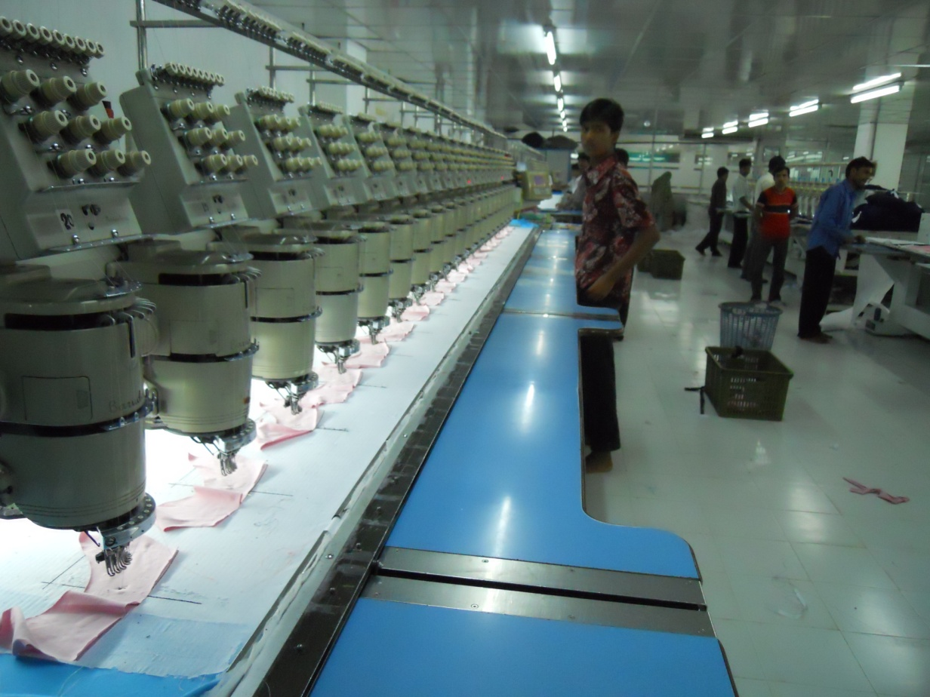

Fig: Embroidery Machine
Remarks: The Garments manufacturing process of Cotton Club (BD) Ltd. is very much satisfactory. Cotton Club always cares for quality. It is heard from the management of the company, after establishing the factory till now, a single order is not cancelled. That’s why it is sure that the company is well enough to produce quality Garments.

7.1: Object Scope of quality assurance
The scope of quality control, quality assurance and testing are good enough to control the quality. It has:
- Testing Laboratory.
- Machine auditing system.
- A good training system.
- Excellent analytical backup.
- Technical expertise.

7.2: Quality Control and testing
Quality control section checks and maintains the quality of the finished fabrics. Quality control section of Cotton Club (BD) Ltd. deals with
- Quality inspection in roll by roll
- Quality test in laboratory

The tests performed in the laboratory of Cotton Club (BD) Ltd. is as follows-
- Rubbing fastness test
- Wash fastness test
- Light fastness test
- Pilling test
- GSM test
- Shrinkage and Spirality test
- Color fastness to perspiration
- pH Test

Quality inspection:
In Cotton Club (BD) Ltd. Quality inspections are carried out by quality controller (Q.C.) in a table of high intensity light table. The quality is checked in two ways these are
- Faulty appearance
- Faults to be counted in points

Faults appearances are:
- Uneven Shade-US 7. Patche-P
- Hairyness-H 8. Edge Line-EL
- Dead Cotton-DC 9. Creample -CM
- Barrie-BR 10. Neps-NP
- Needle Line-NL 11. white Specks
- Thick & Thin-T & T 12. Band Line-BL

Faults to be counted in point:
- Dye Stain-DS 8. Dirt line-DL
- Fly-Fly 9. Foam Spot-FS
- Grease Spot-GS 10. Hole- H
- Dirt Spot-D 11. Yarn Contamination-YC
- Insect Spot-IS 12. Softener Spot-SS
- Oil Spot-OS 13. Rust Stain-RS
- Water Spot-W

Fault counted in points are record using 4 point system. According to the size as follows-
Fault size | Point
0-3 inch | 1 point
3-6 inch | 2 point
6-9 inch | 3 point
more than 9 inch | 4 point

Total points recorded for every 100m of fabrics are added and written the class of quality as follows:
1. 40 points/ 100m fabric= Class A
2. 40-60 points/ 100m = Class B
3. 60-80 points/ 100m = Class C
4. More than 80 points /100m = Reject.

7.3: Process Flow Chart of Final Quality Inspection:
After completing finishing process here firstly check the shade as per buyer standard with dimensional stability from lab.
↓
Secondly check dia / width fabric weight or G.S.M
↓
Thirdly check fabric surface or appearance as per buyer standard.
↓
The every roll with every meter check as per four point system.
↓
Make a report.
↓
If OK then ready for delivery.
↓
If not OK then the fault is identified.
↓
If it is knitting fault then inform the knitting department by job card and mail, & requested the fabric for replacement.
↓
If it is dyeing fault & If make sure that it is reprocess able then give job card to dyeing department correction. And if is not reprocess able then reject the fabric & inform the dyeing department to replace the rejected quantity.

7.4: Off line & online quality control
Offline quality checks:
- Inspection of fabric in the inspection M/C under 4-point system.
- Yarn count and lot no.
- Buyer.
- Design.
- Stitch length of grey fabric.
- Shade of grey fabric with in one order.

Online quality checks:

M/C Dia/Gauge
- Buyer
- Design
- Grey fabric GSM & Stitch Length
- Yarn count & Lot no
- Yarn whether approved or not by Q.C. Department
- Finished dia & grey dia.
- Fabric quality checking under 4-point system.

7.5: Remarks
The quality control department of Cotton Club (BD) Ltd. is very effective to control the quality of the final products. But the quality control department lacks an engineer.

8.1: Research and Development
Cotton Club (BD) Ltd. and Cotton Clout (BD) Ltd. established in the year 2006. After the establishment, the factory is increasing its capacity of producing quality fabric. It has installed many modern machines to increase the production capacity. It ensures quality, standards and is engaged in manufacturing of all kinds of knitted garments. Under the profound guidance of Mr. Haji Abdul Majid Mondol, the company has gained an immense success and has earned goodwill during last two years. He is guiding our team with their wide experience and skill.
The products are produced using top quality yarn that is imported from reliable sources across world. The factory uses world class in-house infrastructure and modern machines as well as simple hand tools that help in producing high quality fabrics in large volume and varieties. The team of talented designers and strong work force is considered as the asset who ensures quality finished fabric. The factory is dedicated to offer timely delivery of goods and services at affordable prices.
Now it has a capacity as follows-
Garments | : 16000 pcs/day
Embroidery | : 4000 pcs/day
Printing | : 8000 pcs/day
Knit Fabric | : 10 tons/day
Dye Fabric | : 10 tons/.day
Washing | : 12000 pcs dyeing & 40000 pcs wash/day

8.2: Achievements of the factory
Certification : WRAP (World Wide Responsible Accredited Product), OEKOTEX
Award : Silver Medal
For Outstanding Performance On knit Export
8.5: Remarks
The factory has outstanding quality of producing and exporting goods. The infrastructure is the fabric is well enough to be a very good composite factory in Bangladesh. The information’s are given according to source of Management department.

9.1: Maintenance systems
- Breakdown maintenance
- Schedule maintenance
- Planned maintenance
- Routine maintenance
- Preventive maintenance

Breakdown maintenance:
Breakdown maintenance is done when any electrical or mechanical problem is informed by respective division where the problem is occurred. In the mean time maintenance people reach to the spot and try their best to solve the problem. Maintenance divisions have spare parts of most common instruments and immediately they change the part. Since still now all equipments & instruments of AKH knitting 7 Dyeing Ltd. have the one year warrenty. So, the supplier engineers are called to solve the very complicated problems.

Schedule maintenance:
Schedule maintenance is done by maintenance division are as follows:
- Daily
- Monthly
- Weekly
- Yearly

9.2: Daily maintenance
Daily maintenance report contains following terms:
- Status of m/c
- Problems
Maintenance people check all the machine and equipment status is it running or not. If there is any problem of any equipment or instrument they solve it and write down the problems & its solution details in log resister.

9.3: Monthly maintenance:
Monthly maintenance jobs are done maintenance departments as follows:
- Check pump housing oil
- Check all bearing, valve, sensor etc.
- Check all electrical & electronics appliances
- Cleaning all dyeing machines
- Replace air filter element
- Change the lubricating
- Check power transmission
Monthly maintenance report is given in appendix. I think this is a good & profitable maintenance programmed which is giving the additional facilities of the factory production & smooth running of the factories machinery.

Preventive Maintenance:
Preventive maintenance is a predetermined routine actively to ensure on time inspection / checking of facilities to uncover conditions that may lead to production break downs or harmful description.

Routine Maintenance:
Maintenance of different machines are prepared by expert engineer of maintenance department. Normally in case of dyeing machine maintenance after 30 days complete checking of different important parts are done.

9.4: Maintenance Procedure:
Normally preventive maintenance should be done. During maintenance procedure following points should be checked:

Maintenance of knitting machine/flat knitting machine:
SL. | Parameters to be checked
 | Checking and tightening all motor terminals.
 | Checking and cleaning pressure sensor and tightening terminals
 | Cleaning the ventilation fans of panel board and circular fan on top of machine.
 | Checking and cleaning the interfacing and data cables.
 | Checking and tightening the proximity switch terminals.
 | Inspection, cleaning and tightening all the terminals in the panel.
 | Checking and tightening limit switch, safety door guard and the emergency switch.
 | Functional testing of the yarn detector.

Maintenance of Dyeing machine (mechanical)
SL. | Parameters to be checked
1 | Greasing the m/c bearing.
2 | Complete cleaning of machine.
3 | Cleaning of drain valves, replace seals if required.
4 | Checking air supply filters, regulators auto drain seals
5 | Cleaning filters element and blow out.
6 | Greasing of unloading roller bearing.
7 | Checking of oil level and bolts of unloading roller gearbox.
8 | Checking of unloading roller coupling and packing.
9 | Checking & cleaning (if required) of main vessel level indicator.
10 | Checking the oil level of pump bearing and refill if required.
11 | Checking the function of heat and cool modulating valves
12 | Checking all door seals.

Maintenance of Dyeing machine (electrical)
SL. | Parameters to be checked
 | Checking & cleaning fluff and dirt at dirt at all motor fan covers.
 | Checking all motor’s terminals
 | Checking main panels (by using compressed air)
 | Checking panel cooling fan & clean its filter
 | Cleaning main pump inverter and its cooling fan.
 | Checking all circuit breaker, magnetic conductors and relays.
 | Checking current setting of all circuit breaker & motor over load.
 | Visual checking of all power & control cables.
 | Checking all pressure switches
 | Checking calibration of main vessel & all addition tank
 | Checking all pneumatic solenoids
 | Checking setting of tangle sensor.
 | Checking setting & operation of lid safely switches.
 | Checking all emergency switches
 | Checking all indicating lamps
 | Checking all on/off switches
 | Checking all signal isolators.
Maintenance of Dewatering Machine
Sl. | Parameters to be checked
1. | Cleaning of softener application unit
2. | Checking of rotating device of rotating trolley unit
3. | Checking of pneumatic pressure valves
4. | Checking and replacement (if necessary) of rubber pads of stretching unit
5. | Checking of plaiting device
6. | Checking of speed regulating unit

Boiler maintenance
Sl. | Parameters to be checked
1. | Checking of gas pressure and gas supply line
2. | Dosing of softening chemicals to supply water
3. | Checking of all steam lines
4. | Cleaning of burner tank (after six month interval)
5. | Checking and replacement of valves
6. | Cleaning of feed water tank
7. | Checking and replacement of filters
8. | Cleaning of sight glass

Maintenance Tools & Equipments:

- Combination tools / spanner
- Socket ratchet set
- Slide range
- Pipe threat cutting tools
- Bearing puller
- Pipe range
- Pipe cutting tools
- Hole punch
- Divider
- Easy opener
- Heavy scissor
- Oil can
- Drill machine and drill bit
- Grease gun
- Grinding m/c
- Welding m/c
- Hammer
- Hacksaw blade
- Handsaw (wood)

9.5: Remarks:
It is necessary to check that all routine maintenance is being done regularly and properly to increase efficiency of each department.

10.1: Water Treatment Plant
Capacity: 65,000 liters
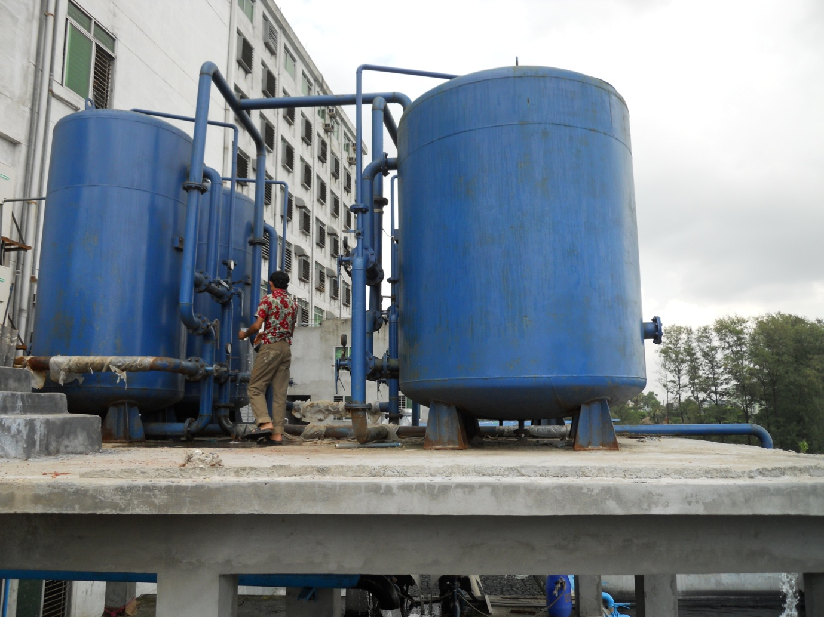
Fig: Water Treatment Plant

10.2: Generator

Gas Generator 1
Capacity: 900 kW
Origin: USA
Brand name: Wakeha

Gas Generator 2
Capacity: 500 KW
Origin: China

Diesel Generator
Capacity: 500 KW
Origin: UK
Brand: Perkins

10.3: Boiler:

1.
Capacity: 9.4 ton
Origin: USA
Brand: Clover Blooks
2.
Capacity: 6 ton
Origin: Korea
Brand Name: Dlim

10.4: Compressor:
1. Capacity- 100 KW
Origin: Spain
Brand: Air roll
2. Capacity: 600 KW
Origin: Spain
Brand: Air roll.

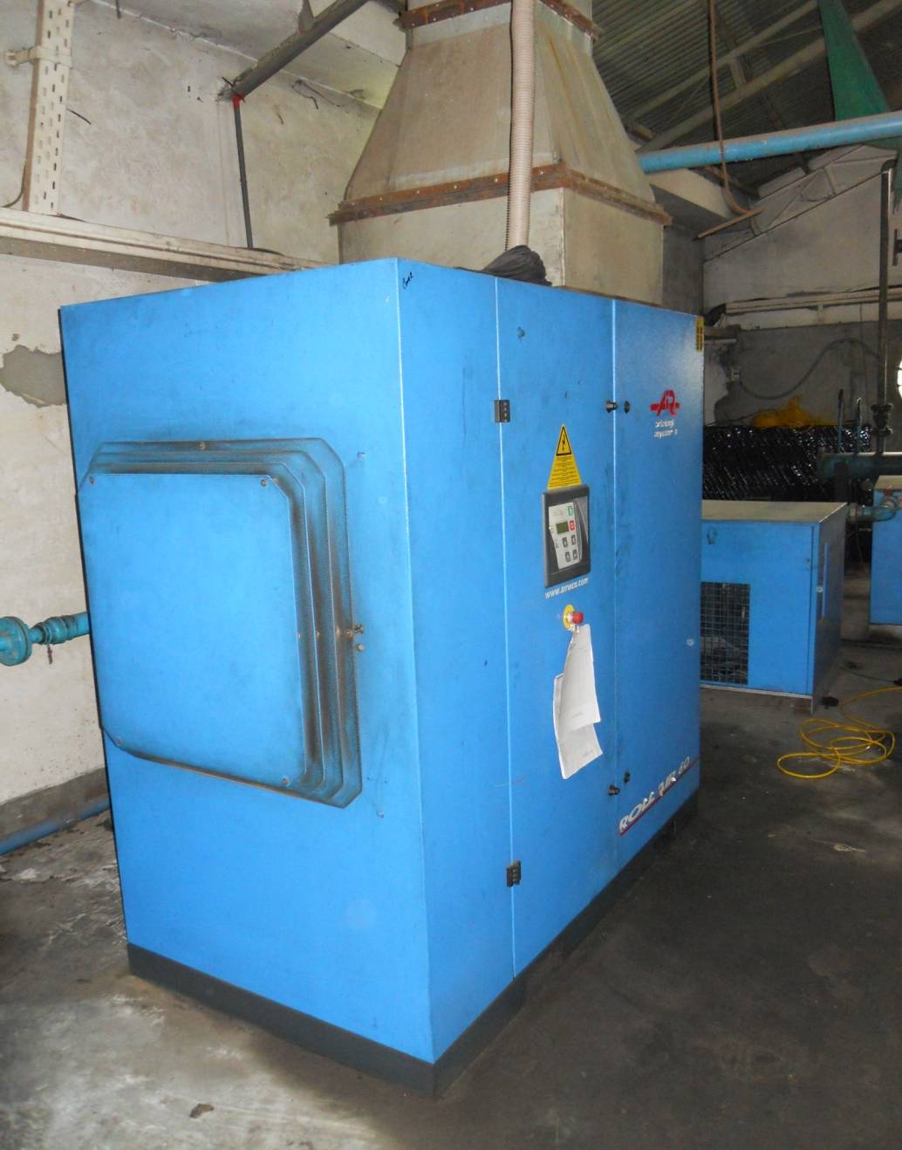

Fig: Compressor

Inventory Control
In Cotton Club (BD) Ltd. there are different inventory systems for different raw materials.
Inventory Procedure
- Bin Card
- Store Requisition
- Store Ledger Account
- Daily Inspection & Package Report
- Monthly Stock & Consumption Report
- Monthly L/C wise Delivery Report
- Received Delivery & Balance Stock

11.1: Grey Fabric Store:-
The grey fabrics are stored in the fabric store near the batch section and on the 5th floor of the factory beside the printing section. Different types of fabrics are listed in the sheet according to fabric types, quantity and consumer’s requirement. Fabrics GSM, shrinkage, diameter & other properties are also taken into consideration. The batches are prepared by taking the required fabrics from the grey store.
Stages of Grey Fabric Inventory Control:
- After knitting production.
- Grey inspection.
- Warehouse.
- Batch preparation.
- Dye house.

11.2: Finished Goods
Cotton Club (BD) Ltd. supplies its finished dyed fabrics to its garments section. So, dyed finished fabrics are stored for short time in the finishing section. All the delivered fabrics are noted on the tally book according to the lot no, quantity, fabrics diameter, buyer's name, Color & considering other technical parameters.

Stages of Finished Fabric Inventory Control:
- Finishing section.
- After final inspection.
- Warehouse

11.3: Dyes and Chemicals
There is a different store for dyes and chemicals, one is beside the panel board, and one is in the midst of dyeing and water treatment plant. Various types of dyes and chemicals are stored here according to dyes and chemicals companies. In a sheet different types of dyes and chemicals are listed. The sheet also contains the stored quantity of dyes and chemicals. Every day the sheet is updated and a copy of this sheet is supplied to the dyeing manager, dye house and lab section.
Spares:-
Required amount of spears of different machines are stored in the mechanical store room. All the spears are listed in a sheet which is controlled by the mechanical & maintenance personnel. Spares are arranged in the store room according to there size, quantity & requirements. There are shelves in the store room to keep the small spare parts.

11.4: Remarks:
Cotton Club (BD) Ltd. has individual stores for raw materials, finished goods. It requires increasing the store area. In Cotton Club (BD) Ltd. the store for inventory control is satisfactory.

COSTING: It is vital important work to determine the costing of garments or product. In the costing sheet every information is found for making garments. It is determined easily that the production of garments will be benefited or not by discussing the costing sheet of the garments, how amount of materials are needed to produce garments is known by costing.

11.1 Cost sheet:
- 1. Cost of fabric /Doz. garments or cost of yarn per dozen garments
- 2. Cost of accessories/Doz. garments.
- 3. C.M /Doz. garments.
- 4. Cost of transport from factory to sea port / airport.
- 5. Clearing and Forwarding Cost
- 6. Overhead cost.
- 7. Commission / profit.

The above processes are applicable in case of sending goods abroad on FOB basis.

11.2 Sped sheet:
- 1. Fabrication single tuck back pique.
- 2. Collar & cuff flat knit rib.
- 3. Accessory required button(3 pc per body)
- 4. Interlining (0.5 yd per body)
- 5. Level (main, size)
- 6. Sewing thread: 40/2,20/2 or 20/3
11.3 Packing:
- Poly bag (6 pcs in 1 poly)
- Carton sticker.
- Carton (36 pcs per carton)

11.4 Finishing packing:
- Gum tape for dust
- Gum tape for carton
- Scotch tape
11.5 Fabric consumption:

- 1. Fabric width and GSM: 84" & 180
- 2. Front length: (62+2.5+2) cm +5% = 27.5"
- 3. Back length: (62+2.5+2) cm +5% = 27.5"
- 4. Front width: (51+2) cm +5% = 22"
- 5. Back width: (51+2) cm +5% = 22"
- 6. Sleeve length: (22+2.5+2) cm +5% =11"
- 7. Sleeve opening: (16+2) cm+5% = 7.5"
- 8. Length required for 1 doz. Body: (27.5" + 27.5") x 12 = 660"
- 9. Length required for 1 doz. Sleeve: {(11"+11") x 2} x 12 = 528"
- 10. Total fabric required for 12 pcs garments: 660"+ 528"= 1188"= 30.18 meter 11. Fabric width: 84" = 2.13 meter
- 12. Fabric per dozen: 2.13 x 30.18 = 64.29 sq.m
= 64.29 x180 = 11.58 kg/ doz.
= 11.58 kg + 10%
= 12.74 kg/doz
- 13. Collar: 1 doz/doz of garments
- 14. Collar length: 41cm
- 15. Collar height: 8cm+1.5cm=9.5cm

Remarks
Due to the privacy policy of the Cotton Club (BD) Ltd. the management of the factory was unable to provide the data of cost analysis. We tried our best to get the appropriate costing of products but due to some company confidential we get approximate prices.

13.1: Responsibility of Merchandiser
- Order Receiving
- Fabric booking, Trim sourcing
- Sample Preparation
- Knitting, Dyeing follow up
- Production planning
- Feed back
- Shipment with buyer satisfaction
- Buyer dealings
- Worksheet preparation
13.2: Buyer
The followings are the list of buyer that buys or orders to produces quality fabrics from Cotton Club (BD) Ltd.
Company | Country
Henbury | Europe
Pull & Bear | Europe
The Fielding Group | Europe
BHS | Europe
Lu & Ca | Spain
Joma's | Spain
Burger King | Spain
Frank Q | Denmark Norway
Fransa | Denmark Norway
B-Young | Denmark Norway
4-You | Denmark Norway
Carry | Europe
Smith & Brooks | Europe
Kiabi | France
Bershaka | Europe
Inditex Group | Europe
Montecarlo | Italy Spain
PTB | Italy Spain
Instyle | Italy Spain
Job SPA | Italy Spain
Benglar | Italy Spain
Terronova | Italy Spain
Odibi | Italy Spain
W W Group(Espionage) | Europe
T.K International | Europe
Matalan Re-tailer | U.K
Takko | Germany
Springfield | UK

13.3: End Product
For Knitting:
- Single jersey (plain)
- Single jersey (with lycra)
- Rib (plain)
- Rib (designed)
- Interlock (plain)
- Interlock (designed)
- French terry
- PK (single)
- Ok (double)
For Dyeing:
- Black & white fabric with required color tone
- Dyed fabric (with light, medium & dark color)
For Garments:
- T-shirt with different design
For Printing:
- Different printed fabric

14.4: Remarks
The merchandising department of the Cotton Club (BD) limited is very efficient with a number 45 merchandiser. All of the merchandisers are very helpful, experienced and well educated.

14.1: Effluent treatment plant (ETP)
Effluent treatment plant used to remove the color, chemicals that present in the water comes from the dyeing house. Dye house water contains several chemicals in the different stages of the processing as follows-

The major sources of liquid discharge are:
- Scouring.
- Bleaching.
- Dyeing.
- Washing

After bleaching the water contains
- Dilute hypochlorite solution.
- H₂O₂
Besides dye used (Reactive, Disperse) are also present in the water
Other processes that are present in the water include:
- Detergent
- Soda ash
- Caustic soda.
- Stabilizer
- Acetic acid.
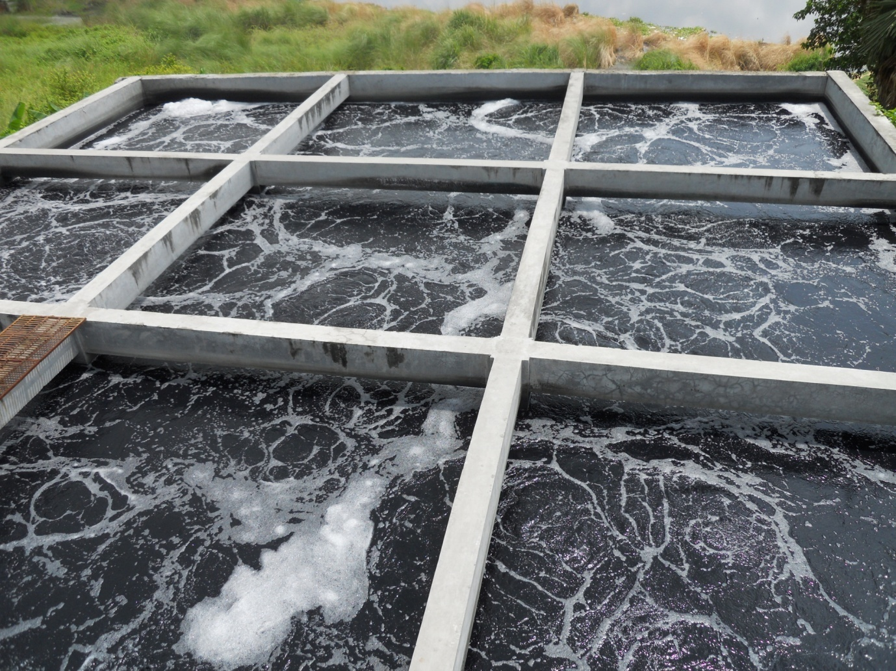
Fig: ETP

14.2: Type

There are mainly three types of ETP. They are:
- Biological ETP
- Physico-Chemical ETP
- Physico-Chemical & Biological ETP

The ETP used in Cotton Club (BD) Ltd is Biological in type.

14.3: Maintenance
Specification of the plant:
- Manufacturer : Ion exchange, India
- Capacity: 80 m³/hr

Chemical used and their functions:
- Iron (ΙΙ) sulphate (Fe₂SO₄) 10% conc. → To remove the coloring materials.
- Lime (CaO) → To remove coloring materials in alkali medium.
- Alum [Al₂ (SO₄)₃.24 H₂O] → To increase the precipitation rate.
- Sulphuric acid (H₂SO₄) 98% conc. → To reduce the pH of the waste water.

Step wise function of different unit of E.T.P

Equalizer Tank:
Used chemical: Acid solution.

Function: To neutralize raw waste water by dozing smaller particle.

P^{H} Control Tank:
Used chemical: Fe₂SO₄, Fitcary.

Function: To control pH.

Reaction Tank:
Used chemical: Lime.

Function: To agglomerate smaller particle.

Flocculation Tank
Used chemical: Polyelectrolyte & alum.

Function: To produce flock.

Primary Clarifier:

Function: To monitor performance of flocculation clarifier & separate solid waste.

Sludge Bed:

Function: Solid waste dried & send to outside for burial

Aeration Tank:
Used chemical: Bacteria, Urea, and Cow dung.

Function: Bio logical oxygen demand & Chemical oxygen demand reduced here & diffused aeration system ensures high oxidation efficiency.

Secondary Clarifier:

Function: Remaining solid waste separate here. Reduced total solid.

Chlorination Tank:
Used chemical: Sodium hypo chloride

Function: Disinfection is done here.

Multi filter:

Function: Extra suspended impurities separation by passing into the sand.
Here removed suspended solution and correction the water color.

14.4: Controlling Parameters
The characteristics of waste water assumed a Cotton Club BD Ltd. as follows:

- pH = 11
- BOD = 300 mg/L
- COD=200 mg/L
- Suspended solid (SS) = 200 mg/L
- Color = dark

Final treated Quality of Cotton Club BD Ltd. Discharge is:

- pH = 6-9 (disposable limit 6-9)
- BOD = 35 mg/ L (disposable limit 50 mg/L)
- COD = 170 mg / L (disposable limit 200 mg/L)
- Suspended solid = 50 mg/L (disposable limit 150 mg/L)
- Color = color less.

14.5: Sludge management system:
Sludge holding tank
↓
Sludge thickening tank
↓
Sludge + water ↓
Equalization tank
↓
Sludge bed with hard sludge
↓
Sludge sent for burial
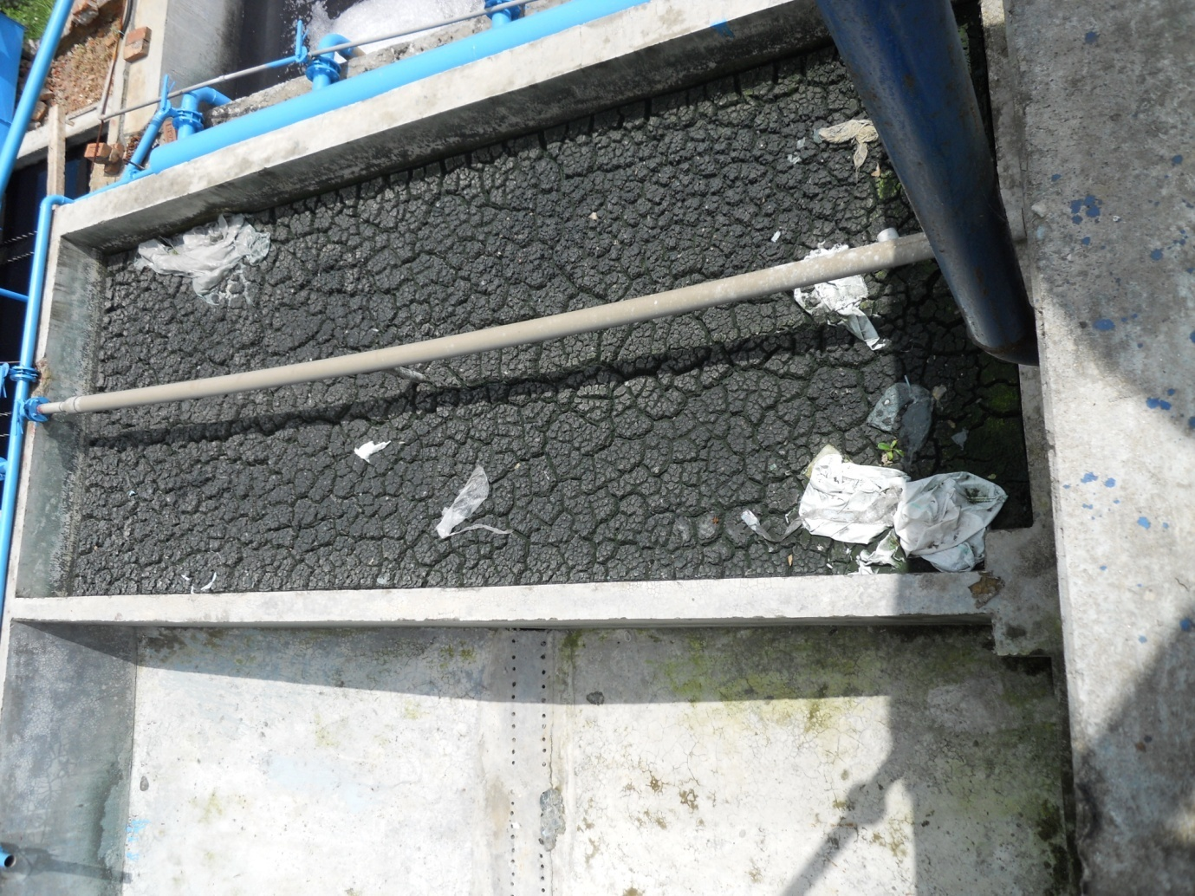
Fig: Sludge Bed

14.6: Remarks
The waste water produce in the different process of Cotton Club (BD) Ltd is effectively removed by using the ETP. The water those are disposed after treatment is perfect for disposal according to the DOE (Department of Environment).

CONCLUSION
Two month of industrial attachment at the COTTON CLUB (BD) Ltd. was a part of the B.Sc. in textile technology course. The eight weeks of the training period were segmented & scheduled to a systematic routine. I have got the impression that it is one of the most modern export oriented knit composite factories in Bangladesh. Though it was established only a few year's ago, it has earned very good reputation for its quality products, over many other export oriented textile mills. This training gives us actual picture about man, machine, material, methods and market. I have earned the direct knowledge about the raw materials, actual running condition of the machines, working technologies, production follow-ups and the administration. This mill is a well planed with enough expansion facilities. The working condition & the relation between employer & worker is wonderful. I am enough fortunate to get an opportunity of having a training in this factory. During the training period I received cordial association and co-operation from the authority & found all man, machines & materials in appreciable working condition. All stuffs & officers were very sincere & devoted to their duties for achieving the factories goal.

