Submitted by

WWW.ASSIGNMENTPOINT.COM

At present business is very much complex because of even changing customer choice, preference, taste etc. and for the technological and high competition. As globalization is on the competition is spread an over the world. So every organization should be international standard. Every company or firm wants to make their loyal customer group. Each firm would like to gain maximum profit through consumer's satisfaction. To day each company has to face so much competition. To perform all marketing tasks marketer are to faces. Two types of environment, one is macro or external and another is micro or internal environment.
We know that juice pack is a consume goods. It is classified as shopping goods. People usually drink juice for the refreshment and to reduce tiredness. In all seasons juice is widely consumed by the customers. But the demand becomes high in the summer. Juice is tasty and nutrition's. There is a wide demand and high prospects for the juice products. PRAN juice pack is one of the items to meet this demand.
This study tries to focus on marketing problems and prospects of PRAN juice pack. PRAN juice pack is one of the popular brands in Bangladesh and also in international market recently. It is manufactured and marketed by Agriculture Marketing Company Ltd. (AMCL) of PRAN group. PRAN juice pack is selling mainly local market (all over Bangladesh) already it is exporting in Europe, America and Middle East also in India. There is much higher demand for locally produced juice pack in the country than present domestic supply. We see that there is a shortage of PRAN product in our local market. So Bangladesh imports some juice from Pakistan, India and other countries. In this situation AMCL has to face few problems as well as meeting other competing juice company. AMCL has few problem areas such as distribution system, Government policy, and import system and wholesale/retailers sector. In the true sense, marketing management concept is not being implemented in the existing juice marketing system. There is no combination among product, price place and promotion.
In spite of few problems, there is increasing demand for PRAN juice pack all over the country. So we can say that PRAN juice pack has a bright prospect in the country. Undeniably juice pack of AMCL would be considered as the most potential juice to give our infrastructure greater longevity. So company should take to proper action for the fulfillment of the target of juice pack products of AMCL.
1.2 Importance of the study:
We know PRAN juice pack is a well known brand in juice industry within Bangladesh. The demand as well as the sales volume of PRAN juice pack is increasing rapidly day by day. There were 27500000 PRAN juice pack sold in 1997-1998, 30000000 PRAN juice pack in 1998-1999, 32000000 PRAN juice pack in 1999-2000, and 35500000 PRAN juice pack in 2000-2001 and 38500000 PRAN juice pack in 2001- 2002.
Marketing is the key point of the business activities that direct the flow of goods and services from producer to customer or user in order to satisfy customer and accomplish the company’s objectives. In order to achieve the customer satisfaction, product must be available in the right form, at the right time, in the right place.
The importance of this study is to analyze the marketing problems of PRAN juice pack as well as identify the real problems and what method should be used in order to overcome those problems. There is much higher demand for locally produced juice in the country than present domestic supply. Bangladesh is not self sufficient in PRAN juice product production. Bangladesh has to import a large quality of various juice product or finished juice products such as bottle, can and pack. We see that there is frequent shortage of juice product is our local market. As a result the customers of PRAN juice pack are facing a lot of trouble. There are many problems in the distribution of PRAN juice pack. The demand of juice pack is not stable in Bangladesh. There are two ways of juice pack supply in Bangladesh. 1) Domestic production and 2) Imported juice products.
The prime objective behind the creation of PRAN juice industry was to ensure the steady supply PRAN juice and to make it easily available to the customers when they need at the lower possible price.
Although Bangladesh has a favorable condition for the growth of juice product industry, yet it is not rich in production due to absence of raw material and modem machineries. The distribution system is not developed with respect to the market demand. The price of juice pack is not determined by the market forces. In this situation, marketing management concept is not being implemented in the existing juice pack marketing system. There is no combination among product, price place and promotion. In case of distribution a lot of irregularities come out due to lack of marketing management concept. Weak marketing system is responsible for this kind of error.
However, very few research works have been accomplished in the area of juice particularly on juice marketing. Although this work is not providing a specific guideline to overcome the current problems of PRAN juice pack, but I think this report will be helpful for the marketers, the customers and the policy makers who are directly involved in the formulation of the marketing strategy of PRAN juice pack. Finally a contemporary marketing strategy is proposed to overcome the current and prospective marketing problems of PRAN juice pack and also to the develop a marketing plan.

1.3 Background of Agricultural Marketing Company Ltd.

Agriculture Marketing Company Ltd. (AMCL) was set up in 1985 for farming and marketing of agricultural products for local and foreign market. Subsequently a modern fruit processing plant with bottling and canning facilities was added in 1993 to produce fruit juice squash, sherbet, jam, jelly etc. At present AMCL has forty (40) products in different types and sizes in existing market in Bangladesh and other countries in the world. It has a dehydration unit to dehydrate mushroom, banana, mango, papaya, beans and other fruits and vegetables. The products of AMCL have good acceptability to the consumer all over the country. And the turnover of AMCL has been increasing day by day.
POVERTY AND HUNGER ARE CURSES
OUR AIM:
TO GENERATE EMPLOYMENT
AND EARN DIGNITY
AND SELF-RESPECT FOR OUR
COMPATRIOTS THROUGH
PROFITABLE ENTERPRISES
CORPORATE MISSION

The company's processing unit started commercial production on July 1993 and launched its products in the market under the brand name PRAN.
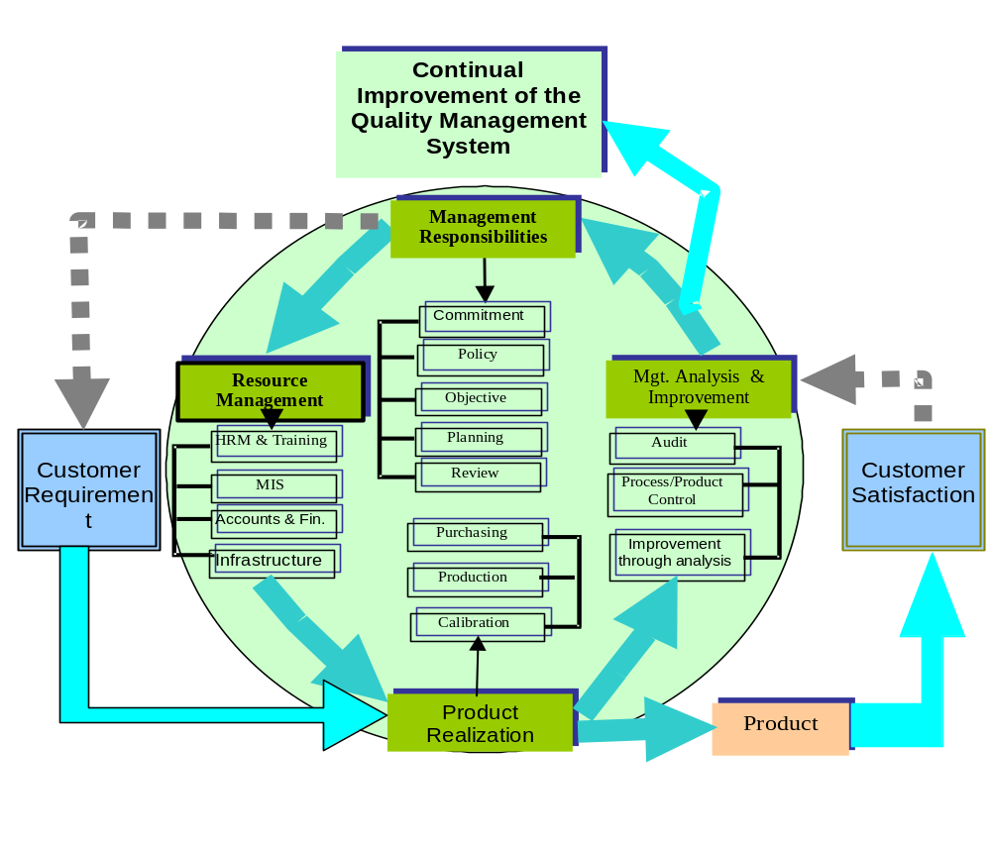
The company was initially engaged in only agro-business. The company itself cultivated many types of fruits and vegetables. More over extensive cultivation of gherkin, mushroom, and body corn were taken up through contract grousers. Processed gherkin and fresh vegetables were exported and mushroom and baby corn were canned and marketed locally.

The company processes most of the fruits produced in Bangladesh like mango, pineapple, banana, guava, lemon, satkora, and many other types of fruits and vegetables including tomato. The plant facilities includes canning, pulping, juice making and bottling jam, jelly, pickles etc. It has also facilities for dehydration of fruits and vegetables and mineral water. The AMCL has incorporated in Bangladesh on May 1985 as privet limited company under the company act, 1913 and subsequently in 22nd June, 1993 the company was converted into public limited company.
PRAN IS SPECIALIZED IN AGRO PROCESSING AND THE COUNTRY’S FIRST & LARGEST AGRO PROCESSOR HAVING ISO 9001, HACCP AND HALAL CERTIFICATION



The company is publicly traded on listed with both Dhaka and Chittagong stock exchanges since January 1996. Now it has become a renowned agro- processing industry in food sectors.

Agricultural marketing company limited at a glance:
- Name of the institution: Agricultural marketing company limited (An enterprise of PRAN-RFL Group)
- Year of establishment: 1985
- Head office: Property Heights, 12, R.K. Mission road, Motijheel C/A Dhaka.

- First commercial production: July, 1993

DHAKA
GHORASHAL
CHITTAGONGG
NATORE
RANGPUR
The Head Offices are located in Dhaka with production facilities around Bangladesh

1.4 Human Resources of PRAN-RFL Group (Till December 2009):

Property Development Ltd (PDL) 40
Agricultural Marketing Company Limited (AMCL) 1679
Common Services Personnel (CS) 305
Bangladesh Lift Industries Limited (BLIL) 79
Rangpur Foundry Limited- RFL (Head office & Sales) 229
Rangpur Foundry Limited- RFL (Factory) 123
PRAN Foods Ltd. (PFL) 1712
PRAN Agro Ltd- PAL (H/O & Natore) 875
RPL (PVC & Plastic Factory) 1202
PRAN Dairy Limited (PDL) 324
Banga Agro Processing Limited (BAPL) 20
PBL 852
Export 33
Distribution H/O 90
Distribution Ghorashal (PIP & AMCL) 257
Total number of sales Distributors 400
8220
FACTORIES:
1) Ghorashal (AMCL & PIP)
2) Rangpur (RFL)
3) Natore (PAL)
4) Brahmonbaria
5) Chittagong
ORGANIZATIONAL ADMINISTRATIVE FLOW MODEL

Chief Executive
Deputy Chief Executive
Executive
Director
Executive
Director
Executive
Director
Executive
Director
Chief of
Department
Chief of
Department
Chief of
Department
Chief of
Department
General
Manager
General
Manager
General
Manager
General
Manager
Senior
Manager
Senior
Manager
Senior
Manager
Senior
Manager
Manager
Manager
Manager
Manager
Assistant
Manager
Sub-Assistant
Manager
Assistant
Manager
Assistant
Manager
Assistant
Manager

Officer

Junior Officer

Worker

1.5 Limitations of the study
Internship program is one kind of procedural program. There are various factors involved such as time, cost, information etc. As a result I have to face some problems while doing this internship.

The company’s official did not provide sufficient current information like information on existing market share, industries demands, sales volume of competitors, accurate financial statement, cash in flow statement, rough behaviors of some employees etc. When I did survey myself directly to wholesalers, retailers and customers have not co-operated me as much as I needed.

I have some personal limitations such as financial problem, time limitation, lack of sufficient knowledge on the research field and also couldn’t find sufficient research materials on this area. I have tried my best to overcome these limitations in this study.

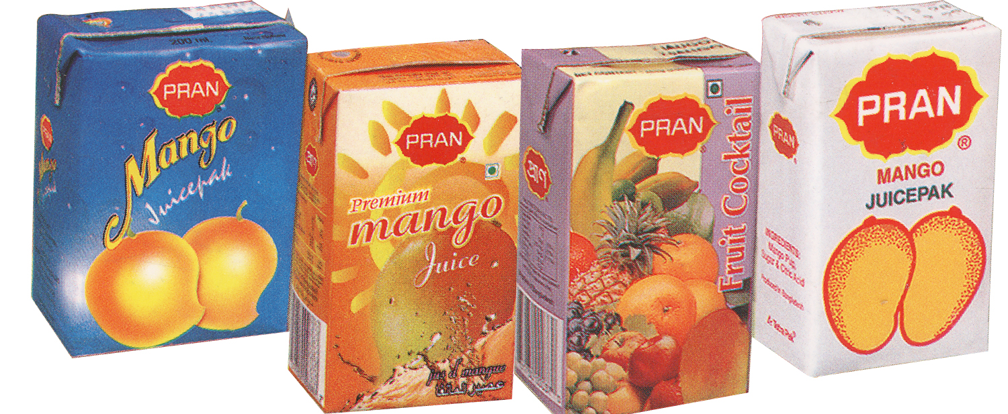

CHAPTER TWO

2.0 Research Methodology
2.1 Objectives of the study:
The objective of this study is to find out major marketing problems and prospects of PRAN juice pack as well as find out the problem solution for effective marketing plan.

The specific objectives of this study are shown below:
- To identify the present marketing strategies of PRAN juice pack in Bangladesh.
- To analyze the present problems in operating marketing function of PRAN juice pack.
- To analyze the opinion of the participants involving operating marketing function of PRAN juice pack.
- SWOT analysis and future prospects of PRAN juice pack.
- To prescribe appropriate recommendation and suggestion to overcome existing problems of PRAN juice pack.

2.2 Methodology of the study:

A research methodology is a must to follow for doing a research project or to solve a research problem. Without following a scientific method it is impossible to solve a research problem. This study is conducted by following some predicated steps in the use of sources of data collection method and selection of sample. Those are discussed below:

Sources of a nature of data:
I have collected necessary data from the following sources, which are given below:
1) Primary data
2) Secondary data

1) Primary Data: The information, which is collected directly from the field for a study is called primary data. Generally the following methods are used in collection of primary data.

- Survey questionnaire: I prepared two types of questionnaire, which are-
- Open-ended questionnaire.
- Close-ended questionnaire.
b) Observation: I observed many stores (wholesales, retailer) with sales representative. I directly observed consumer attitudes and behavior.
c) Personal communication: I had communicated personally with the executive of the firm and other officials who were the most important for this study.

2) Secondary data: Different types of secondary data are used for this study. I have collected secondary data from the following sources-
a) Annual report of PRAN, AMCL: 2004-05
b) Marketing Department of PRAN-RFL Group.
c) Human Resources Management Department of Common Services.
c) Website of PRAN-RFL group: www.pranrflgroup.com
Analytical tools
To present the data I have used the following analytical tools:
- Table
- Chart
- Graph etc.

2.3 Data Collection Method:
For primary data collection, survey questionnaire, observation and personal communication method is followed:

a) Sample: Sample is the most important representative part of the population. If sample is not correct, study will be wrong. When I have selected sample then I consider few factors, such as age, sex, occupation, rate, income etc.

b) Sample area: I have selected sample area in Dhaka City and Jessore Town. Most of the data has collected from Dhaka at New market, Nilkhet, Kalabagan, Palton, Fakirapul & Motijheel and Jessore at Barabazar, Jess Tower, Chaurasta, Daratana & M. M. College.

c) Sample size: I have selected my sample size, the sample size that I have taken is enough and representative, the following table illustrates my sample size:
Number of wholesalers | Number of retailers | Number of consumers
10 | 50 | 50

d) Sample selection method: I have used cluster sampling method and random sampling method for collecting primary data.

CHAPTER THREE

3.0 Organization Setup
3.1 The Present Marketing Strategy of PRAN Juice Pack:
Product policy and strategy:
Agriculture Marketing Company Ltd. is producing six types of juice pack. Juice pack of PRAN is dominating the juice pack market of Bangladesh. There are six types of juice pack (Including price rate) which are given below:

No. | Products name | Contents | Price (Tk.)
1. | PRAN Lemon Juice Pack | 250 ml | 12
2. | PRAN Orange Juice Pack | 250 ml | 12
3. | PRAN Guava Juice Pack | 250 ml | 12
4. | PRAN Mango Pine Juice Pack | 250 ml | - 12
5. | PRAN Mango Juice Pack | 250 ml | 12
6. | PRAN Pineapple Juice Pack | 250 ml | 12
7. | PRAN Fruit Cocktail | 250 ml | 8

Source: Official index book
Product Matrix of PRAN Juice Pack:

Juice pack of AMCL has already used the product matrix policy of market penetration for juice pack. Product matrix of juice pack of AMCL is shown in a table:


Existing Product New product

Existing Market Penetration Product development
Market

At present

New Market development Diversification
Market

Market penetration:
A strategy for company is growth by increasing sales of current products to current market segment without changing the product quality.

Market development:
A strategy for company growth by identifying and developing new market segments for current company product.

Product Development:
A strategy is for company growth by offering modified or new products to current market segment.

Diversification:
The strategy is for company growth by starting tip or acquiring business outside the company's current products and markets.
The company is trying to develop market development growth strategy for juice pack.

Positioning of PRAN Juice Pack
Positioning is the act designing the company's offering and image so to occupy a meaningful and distinctive place in the target market's mind.

PRAN Company (especially for juice pack) is following positioning which is given below:

1) Identify possible competitive advantages:

a) Products differentiation
b) Services differentiation
c) Personnel differentiation
d) Channel differentiation
e) Image differentiation
We find out market of juice pack is promising. Its demand increasing day by day so in this movement PRAN Company is following differentiation strategy for positioning of their juice pack. So company considers few differentiation variables which are given below:

Product | Services | Personnel | Channel | Image
Form (Size, shape or physical structure of product) | Ordering ease | Competence | Coverage | Symbols
Features | Delivery timely | Country | Expertise | Media
Performance | Installation | Credibility | Performance | Atmosphere
Conformance | Customer Training | Reliability |  | Events
Durability | Customer Consulting | Responsiveness
Reliability | Maintenance & Repair | Communication
Repair ability | Miscellaneous
Style
Design

2) Selecting the right competitive advantages
(Method for competitive advantage selection):

(1) | (2) | (3) | . (4) | (5) | (6) | (7)
Competitive Advantage | Company  Standing | Competitor standing | Importance Improving standing | Affordability and speed  Low  Medium  Law  High | Competitive ability to improve standing | Recommended action.
Technology  Cost  Quality  Services | 8  6  8  4 | 8  8  6  3 | Low  High  Low  High |  | Medium  Medium  111gb  Low | Hold  Monitor  Monitor  Invest.

3) Positioning according to RIES AND TROUT:

The world positioning was popularized by two advertising executives, AL RIES AND JACK TROUT. So PRAN Company has considered their strategy to be successful. So PRAN (AMCL) Company has creative exercise with an existing product, which is given below by a chart.

Company  Product | Target consumers | Benefits | Price | Value proposition
PRAN  (Juice pack) | Quality Conscious consumer of young. (Age within 3-30) | Tasty and healthy | 10% premium | The tasty, most healthy juice in which your family can rid to disease.

4) Communicating the company's positioning:

Company communicates positioning effectively. Suppose a company choose the "best-in-quality" is communicated by choosing these physical signs and cues that people normally use to judge quality.
Further, company should be followed consumers perceptual mapping properly.

Product life cycle
The market of PRAN juice pack is not new at present PRAN juice pack of AMCL takes position in the Rapid Growth stage in the product life cycle. This can be shown in a figure:

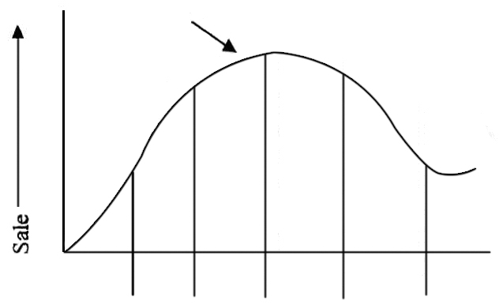
Product life cycle of PRAN juice pack:

PRAN Juice Pack

Sales

Introduction Early Rapid Mature Saturation Decline
Growth Growth Stage
Time

The market size
An industry sale of juice pack is Tk. 36.5 crores at present. The of AMCL is Tk. 35.7 crores at present. The company's sales of the last five year are given below:

Year | Sales Volume (Tk.)
2000-01 | 10,00,00,000
2002-03 | 12,00,00,000
2003-04 | 13,00,00,000
2004-05 | 16,00,00,000
2005-06 | 18,50,00,000
2006-07 | 21,50,00,000
2007-08 | 28,50,00,000
2008-09 | 35,70,00,000
Source: Official record, Annual report of AMCL 2008-2009

The information is presented in a diagram chart below:

Sales Volume of Juice Pack
0
100000000
200000000
300000000
400000000
500000000
600000000
2000-01
2001-02
2002-03
2003-04
2004-05
2005-06
2006-07
2008-09
Value in Taka (000)

Market size characteristics:
Market of juice pack is promising. It's increasing day by day. All sorts of people usually drink juice pack. But the children and the young people drinks most of them. They are very fond of drinking juice pack. The people of 3-35 years old age usually drink, upper of middle class people like juice pack. Most of people prefer tasty juice; they are price sensitive, want to get easily from any retail shop.

Total units (sales):

Total units (sales) for the last eight years are given below:

Year | Total Units (Sales)
1999-00 | 27500000
2000-01 | 30000000
2001-02 | 32000000
2003-04 | 35500000
2004-05 | 39500000
2005-06 | 43500000
2006-07 | 46000000
2007-08 | 51500000
2008-09 | 55200000

Sources: Official Record, Annual Report of AMCL 2008-09

Growth share matrix:
Product portfolio of juice pack of AMCL is developed here using the approach of Boston consulting group (BCG) based on relative market share and market growth rate:

Company Sales
Relative Market Share = -------------------------------------
Leading Competitors’ Sales

3,570,00,000
= --------------------
2,760,00,000

= 1.29

Total Market (Current year – Previous year)
Market Growth Rate = ---------------------------------------------------------- X 100
Total Market Sales of Previous year

5, 15,00,000 – 4,60,00,000
= ------------------------------------ X 10051500000
4,60,00,000

= 11.96

The figure of growth share matrix is shown:

Star | Question Mark
Cash Cow | Dog
24%

20%
Market Growth Rate

16%

12%

8%

4%

2%

0 10x 4x 2x 1.5x 1x 0.5x 0.4x 0.2x 0.4x 0.2x 0.1x

Relative Market Share

Juice pack of AMCL occupies the place of Star. So, juice pack is usually profitable. It has high market share and high market growth rate. This product is absorbing a high level of cash to support increasing advertising, sales coverage, sales support and additional machinery.

Market share:
Market share of the last eight years are given below:
Year | Market Share (%)
2000-01 | 36.5
2002-03 | 40
2003-04 | 42
2004-05 | 45
2005-06 | 49.5
2006-07 | 50.3
2007-08 | 52
2008-09 | 54.4

Source: Official record, Annual report of AMCL 2008-2009
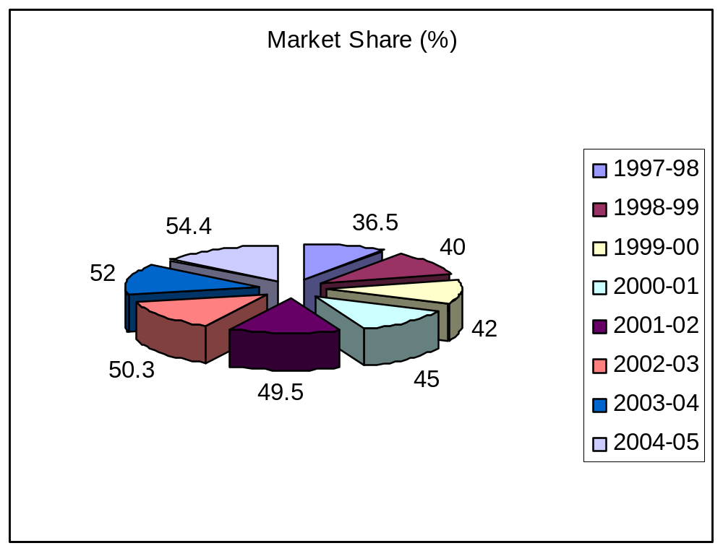

2000-01
2002-03
2003-04
2004-05
2005-06
2006-07
2007-08
2008-09

Compare Market Share of Others Competitors:

PRAN Juice Company mainly competes with Star Ship, Shezan and Danish. Two of them are foreign companies. So the style of competition that is faced by PRAN, which are price, quality and foreign image.
Now three leading companies market share of previews year given below:
Year | Company Name | Market Share (%)
2004-05 | PRAN JUICE | 54.4%
2004-05 | STARSHIP | 35.5%
2004-05 | OTHERS | 10.1%

Source: Official Report, Annual report of AMCL 2004-2005.

This market share presented by diagram, which is given below:
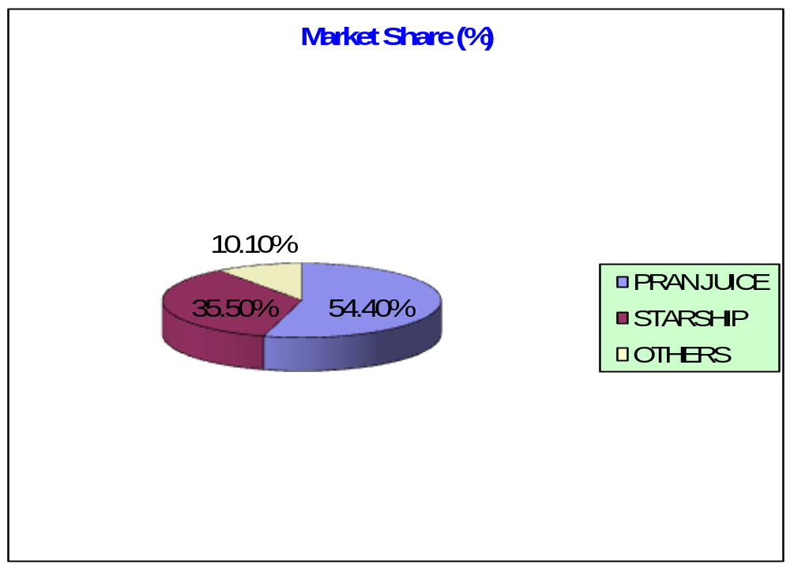

3.2 Pricing policy and strategy of PRAN juice pack

Price is the sum of all the value that consumers exchange for the benefits of having or using the product on serves. Historically, price has operated as the major determination of buyer's choice.
a) Pricing policy:
As the company has an objective to stay in the market as long as possible with this business, it has adopted the penetration price policy some both domestic and international market.

Another viewpoint is that the company has adopted a fixed pricing strategy. The cause behind this strategy is that the target consumers generally do not like bargaining. As because the PRAN products users perceive high status.

b) Pricing Strategy:
Considering consumer satisfaction, markets demand etc. the company follows the prices of juice pack is "Cost-pricing" strategy. The pricing strategy is very specific and straight according to present market situation. Pricing decision is made through the discussion among the Managing Directors.

There are three stages at which the prices are fixed to the market in Bangladesh.

Firstly, the price, which is fixed by the factory, is called factory prices.
Secondly, the wholesalers collect PRAN juice product from the factory then they fix a price for juice pack and then sell to the retailers on sub dealers. This type of pricing is called wholesale pricing. The wholesalers pricing system are given below:

Wholesaler Price = Issue price + transportation cost + storage cost + packing cost
+ Physical losses + other costs + profit margin.

Thirdly, the retailers then collect PRAN juice pack from the wholesalers. After keeping a certain profit margin, they fix a price. This type of pricing is called retail pricing.
3.3 Distribution policy and strategy of PRAN juice pack:

Distribution Channel:
A set of interdependent organizations involved in the process of making a product or services available for use on consumption by the consumer or business user.

Channel characteristics of PRAN juice pack: The juice industry of Bangladesh generally maintain a four-tier distribution channel. The PRAN Company does not more retail sale directly from the production center, PRAN juice pack move form factory to dealer's agents, agents to wholesalers, wholesalers to retailers and finally retailers to consumers. The industrial buyers mainly sell juice pack to the wholesalers. They also sell juice pack to retailers besides the wholesalers. 'The wholesalers mainly sell juice product to the customers besides the retailers. They also sell juice pack to the customers beside the retailers. The customer mainly collects juice pack from retailers.

Wholesalers of the company are trained and contractual. The company divides sales territories among the wholesales. It provides commission and other financial facilities to the wholesalers to motivate them. The company does exclusive distribution. It has power of controlling wholesalers.

PRAN juice packs distribution system:

The company has two types of distribution system for juice pack. One is domestic regarding distribution system and other is international regarding distribution system.

Domestic:
Domestic distribution structure of PRAN juice pack in Bangladesh is given below:
Domestic Distribution Structure
Manufacturer
Agent / Dealer / Distributor
Wholesalers
Retailer
Consumer
Consumer

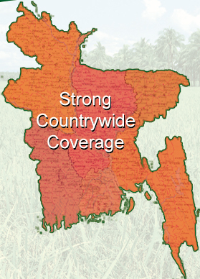
DISTRIBUTORS
400
ZONAL MANAGERS
80
REGIONAL MANAGERS
17
SALES REPRESENTATIVES
700
DISTRIBUTION NETWORK

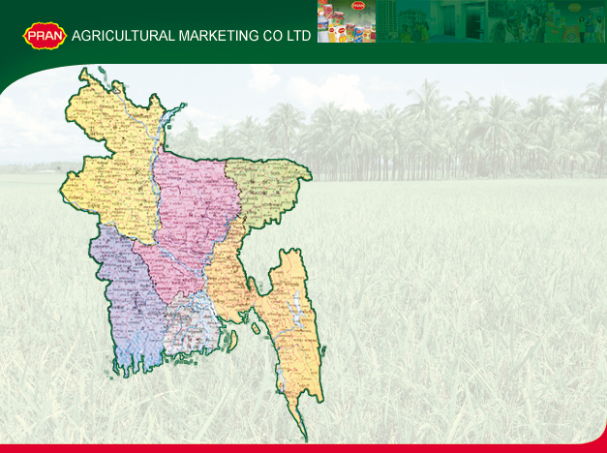

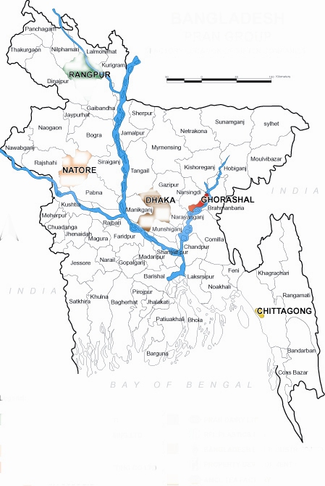
Existing Regions

Dhaka-1
Dhaka-2
Narayangonj
Mymensing
Comilla
Noakhali
Chittagong
Out Chittagong
Sylhet
Maulovi Bazar
Jessore
Barisal
Bogra
Rangpur
Faridpur

PRAN SALES
NETWORK
RANGPUR

BOGRA

SYLHET

MAULAVIBAZAR

DHAKA-1

DHAKA-2

N. GONJ

COMILLA

FARIDPUR

JESSORE

BARISHAL

NOAKHALI

CHITTAGONG

OUT CHITTAGONG

Existing Depots

Ghorasal
Tongi
Natore
Moulovibazar
Chittagong
Barisal
Noapara, Jessore

To be Opened
Comilla
Rangpur

NOAPARA
GHORASHAL
TONGI
NATORE
MOULOVIBAZAR
CHITTAGONG
BARISHAL
COMILLA
COMILLA

International:
PRAN Company uses foreign agent distributors to distribute juice pack.
Manufacturer
Agent / Distributor
Foreign Consumer

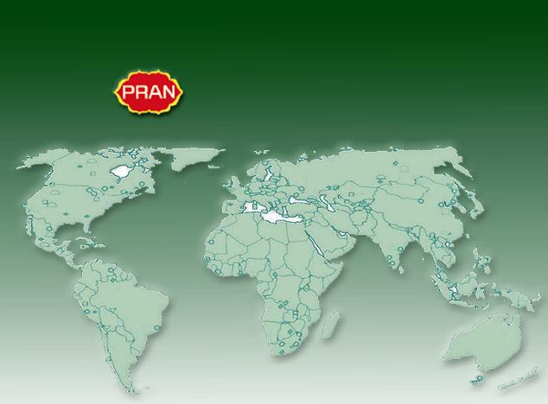
MAJOR EXPORTS
All over the world
India
USA
London
Singapore
Malaysia
Nepal
Bhutan
Switzerland
Germany
Pakistan
Sri Lanka
Australia
Japan
Canada
Austria
France
Italy
Congo
Sierra Leone
Madagascar
Belgium
Saudi Arabia
Qatar
Kuwait
UAE
Lebanon

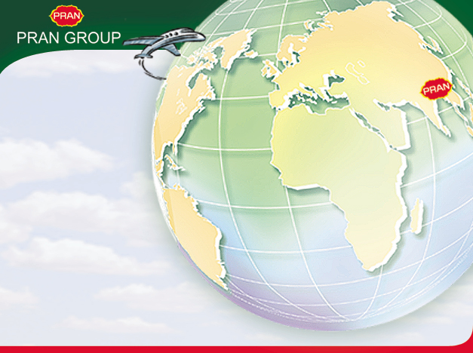
INDIA UAE
CANADA USA
FRANCE BELGIUM
AUSTRIA ITALY
GERMANY AUSTRALIA
JAPAN PAKISTAN
KUWAIT QATAR
CONGO SAUDI ARABIA
BHUTAN UK MALAYSIA
SRI LANKA SINGAPORE
MALAGASY REP.
SIERRA LEONE NEPAL
LEBANON SWITZERLAND DJIBOUTI

3.4 Promotional policy & strategy of PRAN juice pack:

Promotional Mix consists of four major modem of communication these are: Advertising, personal selling, sales promotion and publicity.

PRAN Juice Company uses all above promotional strategy to enhance its sales:

Advertising:
Advertising is one of the most common tools that the company uses to direct persuasive communications to longer target buyers, consumer and public. It is aware of the consumer about its quality, price and consumption pattern.

Advertising can be done in various ways such as:

a) Television: TV is the biggest media in Bangladesh to reach the consumer. The firm realized it and started to spend for TV advertising of PRAN juice pack.

b) Radio: Most of the people of Bangladesh live in village. Radio is now available everywhere. Radio can build up good appeals. So, the company emphasizes advertisement on radio.

c) Newspaper: Newspaper is an important media .A company can easily reach to the target customer through newspaper. Almost all the daily newspapers have been used for the advertising of PRAN juice pack marketing in Bangladesh. Such as, The Daily Prothom-Alo, The Daily Ittefaq, The Daily Amar Desh, The Daily Shamokal, The Daily Nayadiganta, The Daily Observer, The Daily Star, The Daily Jugantor, The Daily Janakantha, The Daily Manobjomin etc.

d) Cinema: Some people especially middle lower class enjoy cinema. So to increase sales volume the company has to arrange advertisement through cinema.

e) Magazine: Various kinds of Magazine are published in Bangladesh and a specific target group of (PRAN juice pack) is reading these magazines. So to create attention of PRAN juice pack the company has spent a large number of amounts for advertising in the magazine.

2) Personal selling:
Personal selling is one of the most important to the firm. Personal selling creates a good relationship to the dealers, distributors, wholesales, retailers, with customer or others of PRAN. So, the company's sales people also play a vital role there.

3) Sales promotion:
Sales promotion is another essential ingredient in marketing campaigns. Such promotion consists of diverse collection of incentive tools, mostly short term, designed to stimulate quicker and for greater purchase of particular products or services by customer, where advertising offers a reason to buy PRAN Juice Pack others trade promotion and Consumer promotion such as discount, incentives, coupon gift etc.

Publicity:
PRAN juice pack in Bangladesh uses some publicity, the company frequently provides the material for publicity in the form of news releases, press conference and photograph.

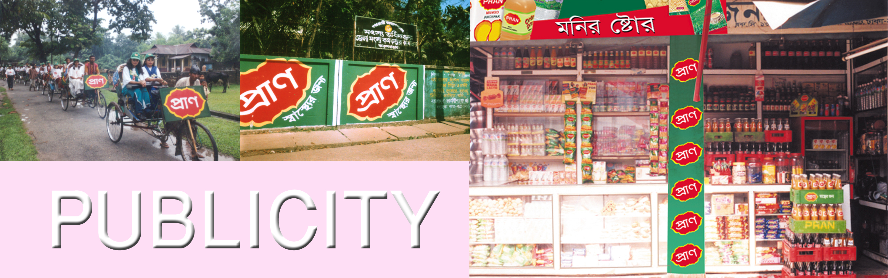

5) Out Door Advertising:
Neon signs, bell signs, billboards, walling art etc are used to aware the people.
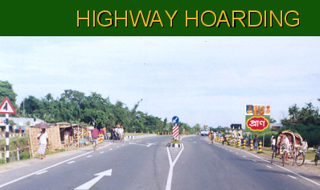

CHAPTER FOUR

4.0 Marketing Strategy
4.1 The present problems in operating marketing function of PRAN Juice Pack

The second objective in this study was to analyze the problem faced by the distribution participants in operating marketing functions. The problems faced by the wholesalers, the retailers and customers have been discussed. Different questionnaires were made to know the problems faced by the wholesalers, the retailers and the customers. We have divided this section into three parts. The wholesalers, the retailers and the customer's problems have been presented in the three different parts separately. Marketing related problems have been mainly discussed here. The main functions of the marketing are buying, selling, storages, transportation, pricing distribution, promotional and services. The participants have to face a lot of troubles in operating these functions.

4.2 The problems faced by the wholesalers:

(1) Buying problem: Buying is one of the important activities of the wholesalers. The main buying problems of the wholesalers are financial problem. The wholesalers of PRAN juice pack may not have available current cash for doing current buying activities. So, the wholesalers may fall into a lot of troubles in operating these buying functions.

(2) Selling problems: The main selling problems of the wholesalers are sales on credit, sales forecasting:

Sales on credit: The distribution mainly depends upon the retailers for selling PRAN juice pack. So, the wholesaler has to face some of the demand of the retailers. Most of the retailers want to buy PRAN juice pack on credit. There are many risks involved in sales on credit of PRAN juice pack. Retailer does not want to take risk. So, most of the retailers buy the PRAN juice pack on credit.

Sales forecasting: We know that now the business arena is much competitiveness. Most of the firm would like to gain challenge this competition. So, here sales forecasting is the main problems in the case of selling. The wholesaler does not use any method for determining sales forecasting most of the wholesaler sales forecast on the basis of last year sales.

Retailer's pressure: The retailer's pressure is a great problem of the wholesalers in the case of selling. The wholesalers cannot supply the PRAN juice pack to the retailers regularly. At this time, the retailers give a lot of pressure to the wholesalers.

Territory: Determining sales territory in an important matter for the wholesalers. No sales territory has been fixed for the wholesalers. The wholesalers buy and sell PRAN juice pack in their own responsibility.
Sales motivation: There is no sales motivational program in the PRAN juice pack marketing in Bangladesh. On the other hand, the wholesalers see that in the other business motivational program has become popular. So most of the wholesalers are frustrated and they do not know what will be happened.

(3) Transportation: It is one of the most important problems faced by wholesalers. They have not available vehicle. So the can not supply PRAN juice pack to retailers in due time.

(4) Storage: The wholesaler of PRAN juice pack has no warehouse. So they do not stock a large amount of PRAN juice pack at a time.
High distribution cost: It is one of the most important problem faced by wholesaler. There are involved many policy and procedure. So wholesalers have to pay big amount that makes great trouble of wholesalers high distribution cost involves handling cost, physical losses, tax and financial cost.

(5) Government Policy: Sometime government imposes various policies in business. And businessmen are to abide by those policies carefully . For this reasons, the wholesalers are directly being affected with there policies. It creates a great trouble for wholesalers.
(6) Communication system: The communication system of PRAN wholesalers is very traditional. Now they don't follow modernize system.
Order placed and orders maintained are operated without any modern communication system.
4.3 The problem faced by the retailers:
(1) Buying problem: Retailers have faced various buying problem. It involves various problems such as sources, prices, finance, buying cost, quality and others.

(2) Sourcing problem: The retailers have not available source, so they could not get available marketing and product related information. Sometimes they do not know what have to be done?

(3) Financial problem: Most of retailer is not strong financially. But the retailers need a lot of many for PRAN juice pack business. The retailers cannot collect required capital from any reliable sources.

(4) Timely supply problem: The retailers have to face various problems. Supply of PRAN juice pack is a long term and time consuming process. Sometimes the retailers do not supply the PRAN juice pack according to the demand of the customers.

(5) Selling problem: The retailers have to face various selling problems. The main selling problems of the retailers are to sale forecasting. They are not actual measurement of target sale. Most of the retailers of PRAN juice pack depend on wholesalers.

(6) Pricing problem: Price determination is a different task for the retailers. The retailers collect PRAN juice pack from the wholesaler and they are depending on the price that is determined by wholesalers. There are no scopes to determine the price of juice pack by retailers.

(7) Storage problem: The 35% retailers face many storage problems with their PRAN juice pack. Most of the wholesalers do not allow the retailers to use their shops. So due to the lack of modern facilities their PRAN juice pack can not maintain properly.
4.4 The problems faced by the customers:
We have defined few problems of the customer of PRAN juice pack after survey of sample customer groups. The main problems of the customers are sources, quality, and time, pricing system, weight, packing and leveling, poor services and irregular supply.

    - Sources: The customer cannot get available information related PRAN juice pack. They have no permanent sources. Few information collections from local retail stores.

    - Quality: At present the customers are more careful about product quality. They want to buy quality product. So the customers are in a big problem with the quality of PRAN juice pack. These imitated PRAN juice pack are coming to the customers in many ways. Identification of PRAN original juice pack and PRAN imitated juice pack are great problems for the customer. In this causes PRAN juice pack cannot provide quality ensure of their juice pack.

    - Packaging labeling and weight of PRAN juice pack: At least 30% customer complained packaging and labeling of PRAN juice pack as well as the 25% customer complained weight PRAN juice pack would like to change their existing packaging system. When company packed juice pack then they cannot properly maintenance weight that is written with the labeling of juice pack.

    - Poor services and irregular supply: The Company does not provide actual services that are expected by target customer and retailers. Company supply juice pack wholesaler but wholesalers does not maintenance regularity to supply sometimes it is seen that there are available PRAN juice pack stock in the market and sometimes crisis seen in the market. The customer and the retailers in Bangladesh fully depend on the wholesalers.

CHAPTER FIVE

5.0 Market - Product Focus
5.1 Opinion of The Participant Involving Operating Marketing Function Of PRAN Juice Pack

The 3rd objective in this study was to analysis the opinion of the participants involving operating marketing function of PRAN juice pack. To fulfill this objective some selected issues that are influencing the existing marketing system have been discussed. These issues are product, price, place, government policy and the performance of the participants. In this purpose I have made three types of survey questionnaire regarding to wholesalers, retailers and customers to know the participant attitudes.

- Opinions of the sample participant about the existing juice pack (PRAN):

Their opinions have been presented in table.
Table-1
Questions | Sample Wholesalers |  | Sample Retailers |  | Sample Customers
Questions | Yes | No | Yes | No | Yes | No
Do you need loan? | 6  (60%) | 4  (40%) | 30  (60%) | 20  (40%)
Do you have buying problem? | 5  (50%) | 5  (50%) | 30  (60%) | 20  (40%) | 40  (80%) | 10  (20%)
Do you have selling  problem? | 4  (40%) | 6  (60%) | 25  (50%) | 25  (50%)
Do you think the  product is being  imitated in Bangladesh? | 10  (100%) | 0  (0%) | 38  (75%) | 12  (25%) | 40  (80%) | 10  (20%)
Source: Survey data.
Different participants have commended differently. Maximum participants opinion is that they have financial capability is not strong. 60% wholesalers, 60% retailers opinion is that they have need loan from another financial source. 40% wholesalers and 40% retailers expressed their opinion they have not need loan. At least 50% wholesalers, 60% retailers and 80% customers complained that they have buying problem.
About selling problem 40% wholesalers and 50% retailers opinion is they have selling problem and 60% wholesalers and 50% retailers expressed their opinion they have no selling problem.

'Though Bangladesh has to import large quantity of various types of juice pack from foreign countries like SHEZAN (PAKISTAN), DANISH (DENMARK). So, 100% wholesalers, 75% retailers and 80% customers’ opinion in that the juice pack is being imitated. They cannot recognize that actual PRAN juice pack imitated one.

(2) Opinion of the sample participants about distribution appropriateness:

Their opinions have been presented in table.
Table-2
Opinions | Wholesalers | Retailers | Customers
Appropriate | 6 (60%) | 30 (60%) | 35 (70%)
Not appropriate | 4 (40%) | 20 (40%) | 15 (30%)
Total | 10 (100%) | 50 (100%) | 50 (100%)
Source: Survey data.
40% Wholesalers, 40% Retailer, and 30% customer think that the existing distribution system of PRAN juice packs to be not appropriate for the present situation. In their opinions the present distribution system in not customer oriented. 60% Wholesaler, 60% retailer, and 70% customers think that the existing distribution system is reasonable.

(3) Opinion of the sample participants about different distribution related questions:

From the evaluation of the participants we see that 80% wholesalers and 90% retailers does not carry PRAN juice pack to their store. According to 90% of wholesalers and 75% of retailers’ opinion, that has no major problem in the case of product transportation. 90% wholesalers and 60% retailers have no storing problem. There is no conflict seen between the others distribution participants. 50% wholesalers, 50% retailers and 20% customers expressed their opinion that they are not depended one others participants.

Table-3
Questions | Wholesalers |  | Retailers |  | Customers
Questions | Yes | No | Yes | No | Yes | No
Do you carry product to your store? | 2  (1O%j | 8  (80%) | 5  (1O%) | 45  (90%) | - | -
Do you face any problem in the case of transportation? | 4  (4O%j | 6  (60%) | 12  (25%) | 38  (75%) | - | -
Do you face any problem in the case of storage? | 3  (3O%j | 7  (70%) | 20  (40%) | 30  (60%) | - | -
Do you have any conflicts with the other participants? | 0  (0%j | 10  (100%) | 0  (0%) | 50  (100%) | - | -
How much are you depended on the participants? | 5  (5O%j | 5  (50%) | 25  (50%) | 25  (50%) | 40  (10%) | 10  (20%)
Source: Survey data

(4) Opinions of the sample participants about the price appropriateness:

Table-4
Opinions | Wholesalers | Retailers | Customers
Appropriate | 10 (100%) | 38 (75%) | 30 (60%)
Not appropriate | 0 (0%) | 12 (25%) | 20 (40%)
Total | 10 (100%) | 50 (100%) | 50 (100%)
Source: Survey data

25% retailers, and 40% customer do not think the existing pricing to be appropriate for the present situation. So there are few pricing problem has exist in present situation and it has made the marketing system complex.

(5) Opinion of the sample participants about the various price related issues:

Their opinions are given below:
Table-5
Questions | Sample Wholesalers |  | Sample Retailers |  | Sample Customers
Questions | Yes | No | Yes | No | Yes | No
Are you increasing the price any time? | 0  (0%) | 10  (100%) | 0  (0%) | 50  (100%) | - | -
Do you prefer fixed price? | 9  (90%) | 1  (10%) | 50  (100%) | 0  (0%) | 45  (90%) | 5  (10%)
Source: Survey data.
Here, mention, 90% wholesaler, 100% Retailers and 90% customer like fixed price the participant are facing various kind of trouble with market price. So we think that the price of PRAN juice pack should be fixed 100% wholesalers and 100% retailer are not increasing their juice pack price any time.

(6) Opinions of the sample participant about the wholesaler:
Table-6
Question | Special | General | Local | Regional
What kind of Wholesaler are you? | - | 4  (40%) | 5  (50%) | 1  (10%)
Source: Survey data

Here mention, we have collected from 10% wholesaler's participants. According their opinion is that 40% wholesalers are general, 50% wholesalers be are local are 10% wholesalers are regional.

(7) Opinion of the sample participants about relations:

Table-7
Question | Large | Medium | Small
What kind of Retailer are you? | 5  (10%) | 20  (40%) | 25  (50%)
Source: Survey data

Here, we have collected from 20 relaters’ opinion. 10% retailers are large, 40% retailers are medium and 50% retailers are small.

(8) Opinion of the sample participants about the marketing problem:

Their opinions are given below:
Table-8
Question | Wholesalers |  | Retailers
Question | Yes | No | Yes | No
Do you have any other marketing problem? | 4  (40%) | 6  (60%) | 20  (40%) | 30  (60%)
Source: Survey data

The participants are questioned whether they have faced any other marketing problems, 60% wholesaler, 60% retailers opinion is that they have no marketing problem.

(9) Opinion of the sample participants about existing packaging and labeling system of PRAN juice pack:

Table-9
Questions | Sample Wholesalers |  | Sample Retailers |  | Sample Customers
Questions | Yes | No | Yes | No | Yes | No
Do you think has a major defect of the existing packaging and labeling? | 1  (10%) | 9  (90%) | 5  (10%) | 45  (90%) | 15  (30%) | 35  (70%)
Do you think need to increase quality of PRAN Juice Pack? | 5  (50%) | 5  (50%) | 25  (50%) | 250  (50%) | 25  (50%) | 25  (50%)
Source: Survey data.

Here mention 90% wholesalers, 90% retailers and 70% customers have expressed their opinion that the existing packaging and labeling of PRAN Juice Pack is not major defects. 10% wholesalers, 10% retailers and 30% customers complained that existing packaging and labeling system. They have claimed, the existing packaging and labeling is more improved.

50% wholesalers, 50% retailers and 50% customers opinion is that need to increase quality of PRAN juice pack as well as same percent participants opinion is that need not to increase quality of PRAN juice pack.

(10) Opinion of the sample participants about government policy:
Table-10
Questions | Sample Wholesalers |  | Sample Retailers |  | Sample Customers
Questions | Yes | No | Yes | No | Yes | No
Is the role of the Govt. policy in favor of your business? | 7  (70%) | 3  (30%) | 38  (75%) | 12  (25%) | - | -
Have you complain about your problem to the authority any time? | 3  (30%) | 7  (70%) | 10  (20%) | 40  (80%) | 10  (20%) | 40  (80%)
Source: Survey data.

Here, 70% wholesalers and 75% retailers think that the role of government policy is favor of their business. The participant's opinion is that the government has no control over this policy. While taking interview of the participants they are asked whether they have complained to any authority about their problems 30% wholesaler 20% retailer, not 20% customer have complained to they have asked help from the authority, but they have not got any positive result how ever, 80% wholesaler has said that our business should free from political instability 50%. Retailers have said our government should increase business loan to solve business problem.

CHAPTER SIX

6.0 Analysis
6.1 SWOT ANALYSIS OF PRAN JUICE PACK

The SWOT analysis is having identified the company's external opportunities and threats as well as internal strength and weakness. In other word the over all evaluation of a company's strength, weakness, opportunities, and threats is called SWOT analysis. It can be develop new function business or corporate strategies to accomplish this change. A SWOT analysis for juice pack of PRAN is as follows:

First, I have defined strengths of PRAN juice pack which are given in below:
Strengths
- Management competence.
- Good marketing skills.
- Good materials management systems.
- Competence of information system.
- Competence of human research.
- Brand name reputation.
- Differentiation advantages.
- Innovation effectiveness.
- Appropriate organizational style.
- Appropriate management style.
- A large market share.

Secondly, I defined weaknesses of PRAN juice pack which are given in below:

Weaknesses:

- Partial poor marketing plan and maximum time emphases on only TV advertisement not on other promotional mix.
- Conflict in between pure marketing knowledge and application.
- Decline in research and development for innovation.
- Don't feel necessity of market survey and not eager to understand consumer behaviors.
- Not eager to redesign or reformat the product.
- Lack of technical manufacturing skill.
- It has no attractive advertisement.
Thirdly, I have defined opportunities of PRAN juice pack which are given in below:
Opportunities:
- Company can expand its product line by introducing differentiation or introducing new items for various using purposes.
- Can apply research and redevelopment in new areas.
- Diversity into new growth business.
- Extend cost or differentiation advantages.
- Widen product range.
- Exploit new market segments.
- Overcome barriers to entry.

Finally, I have defined threats of PRAN juice pack which are given below:

Threats:
- Increasing foreign companies’ domination.
- Changes in consumer tastes.
- Rapidly rising and invention of new or substitute products.
- New forms of vigorous industry competition.
- Political instability and government regulation.
- Economic depression.

6.2 PROSPECTS OF PRAN JUICE PACK

After analysis SWOT of PRAN juice pack, I find out few prospect of PRAN juice pack, which are discussing sequentially.

1) Geographical diversification:
I think that the PRAN juice pack has also high demand in all over the market of Bangladesh. The customer for whom the products are producing, they have scattered everywhere in the country and they have the same liking for this product. Beside it has goodwill in the whole country. So I think that there is a great opportunity of geographical diversification in domestics and foreign markets.

2) Opportunity to increase sales through advertising:
The firm as well as their competitor's do not effective advertises their products in various media. I think most of the consumer of PRAN juice pack watch TV as well as TV is a popular media in Bangladesh. So, if the advertisement is given in television most effectively its demand will be increased day by day.

3) Increasing purchasing power:
The economic condition of the country and purchasing power of the customers are increasing. Consumer purchasing power is increasing day by day. As a result the financial condition will be improved in future as well as the demand and consumption of PRAN juice pack will be increased.

4) Opportunity of product differentiation:
Most of the competition positions of the markets are alike. And they produce some quality juice pack, some differentiation and approximately some price of products. So there is a much opportunity to increase market share through the differentiation of products. Its may be related, or conglomerate differentiation.

5) Competitive advantages:
Fully competition is not started in the market of PRAN juice pack. STARSHIP, SHEZAN & DANISH is the existing competitor of PRAN juice pack. Especially, company has to face two styles of competitions: i) Price and, ii) foreign image. So, there is an opportunity to take competitive advantages and increase market share.

6) Market extension:
Most of the people of Bangladesh are lower middle classes and some are upper class. The lower middle classes are highly price sensitive to high price. They usually want various qualities and design of juice pack at a lower price. There is a great chance of increasing the market share, if a great produce attractive qualities and designs but in lover price.

So, this will indicate the firm has a bright future and prospect. Above these viewpoints the company can expand its markets.

CHAPTER SEVEN

7.0 Recommendation & Conclution
7.1 SUGGESTIONS AND RECOMMENDATIONS
I think the following suggestion and recommendation are seen feasible for the improvement of the existing PRAN juice pack marketing in Bangladesh. These are given in below:

Suggestion and recommendation related to product:

a) Quality ensures:
The firm should ensure quality of PRAN product according to the consumer’s need and expectations. Quality of a product is of attributes that the consumer expects in a particular product. In case of PRAN juice pack these attribute may be design color combination, taste, etc. So quality should be selected from consumer viewpoint.

b) Target market:
New segments will be added with the existing market. New segment will be for middle lower and old people.

c) Product positioning:
The Company will make position of juice pack as ‘economic and quality product’ for large market share.

d) Product differentiation:
Taste, color combination and flavor of juice pack will be improved.

e) Packaging and labeling:
The Company may charge the packing design a little bit and the instruction of safety ness, contents of vitamin on the level will be introduced very soon open grade labeling will be introduced.

Suggestion and recommendation related to pricing:
Pricing policy: The Company will follow the penetration pricing policy as they do. To keep the firm running it must set a low price. Because the consumer in domestic market is high price sensitive to high price.
Production cost will be reducing: Consumer usually wants to better quality and varied designed products at a lower price production cost one of the major components of price. To minimize the production cost, it is recommended that the expert and skilled workers should be appointed which will reduce the rate wastage and volume of defective production.
Establishing the fixed price: The same price should be fixed all through the county. As a result, the participants should not have to fall into trouble about price control. Besides, 100% participants expect establishing the fixed price.
To add high commission system: Dealers, agents, wholesalers and retailers should be given high commission. According to the participants they want high commission from the authority. The commission system will reduce the business task of the participants.
Competitive price: Finally, the company will offer competitive price. The company will fixed a reduced price that will be lower than other competitors.

Suggestion and recommendation related to distribution:

The company will look for intensive distribution the company wants all the retail shop store juice pack. The firm should develop a clear cut combination between channel members to distribution of properly PRAN juice pack. For the cordial co-operation of channel and sellers and wholesalers in distributing and selling PRAN juice pack successfully. It is recommended that the firm would like to get more benefit to profit share and profit margin might be increased.

The distribution pattern needs to be changed the company have to added few pickup vans for proper timely distribution. A juice pack is a very necessary product for the customer; demand oriented distribution should be introduced. Firstly it is necessary to estimate the number of customer in a certain area. And then to estimate their annual demand. Then it is necessary to appoint a dealer distributor for a certain area.

Suggestion and recommendation related to promotion:

The PRAN Company has to create creative advertisements that will create more attention to target customer. The company can participate in trade fair in different places where consumers are concentrated. These activities will help to create image and consumer awareness in flavor of its PRAN juice. Besides, the firm can advertise through the print media and electronic media.

The company will be taken sales promotion program. Cash discount quality discount and gift will be given to the sales forces. Sales promotional budget will be increased as for as possible.

Current adverting theme will be change a little bit the company is eager to make brand advertising on the front page of daily national newspaper.

Suggestion and recommendation related to research and development:

Research and development (R&D) is very essential for every business world. Information is very necessary for designing effective marketing program. The firm may collect information regarding consumer's needs, choices, attitude and exceptions through the R&D.

Other suggestions and recommendations:
We see that the participants in the business have very little knowledge about marketing field. The participants should be properly trained. The intra-communication system will be developed if the distributors /wholesalers are trained well. Sometimes workshop and seminars should be arranged for the participants.

Customer and services are being completely ignored in the existing system. There are no extra facilities given to the customers. The complains of the customers are considered. Customer oriented marketing should be established.

Though the existing product life cycle, PRAN juice pack position is rapid group stage. So there are some additional suggestion has been given to keep this position. During this stage the firm uses several strategies to sustain rapid market growth as long as possible.

- It improves product quality and adds new product features and improved styling.
- It adds new models and flanker products (i.e. products of different sizes, flavors, and so forth that protect the main product).
- It enters new market segments.
- It increases its distribution coverage and enters new distribution channels.
- It shifts from product awareness advertising to product preference advertising.
- It lowers prices to attract the next layer of price sensitive buyers.

CONCLUSION

PRAN juice is one of the most popular brands in Bangladesh as well as in international market recently. In all reasons juice is widely consumed by the customers the demand becomes high to the customers. There is a wide demand and high prospects for the juice packs. PRAN juice pack is one of the items to meet this demand.

Now the firm is facing various types of marketing problems. In this paper some suggestions and recommendations have been given so that the firm can overcome those problems. I believe that the management of PRAN is more experience as well as they are also thinking about those problems. I think management should be took care this problem. If the firm produces PRAN juice as for the customer's choice and demand oriented, the consumers will be highly motivated to purchase the juice of the firms.

So, through the observation of the activities and information collected from the interview of participant such as wholesalers, retailers, customers it can be said that this firm is being profitable conduct becomes the firm is not to strong on counter remarkable competition, workers dissatisfaction, and for sufficient demand in comparison with the manufactured goods. But the firm is not being able to perform its marketing activities with efficiency. In this condition continues the firm will be endangered and undergo less in the long run. But it is possible to expand this firm to a greater extent, if it can make use of its present opportunities and facilities properly and it will be possible for it to earn more profit than it is earning now. Therefore, the firm will have to give importance to perform the marketing activities efficiently.

PRAN Juice Company is no doubt one of the basic companies in Bangladesh. So we glad to know the locally produced juice in now in a position to fulfill the total of PRAN juice pack in the country. The PRAN juice has that success of business depends on the strength of its existing marketing policy is appropriate for the present situation. The major problems arising in the PRAN juice in Bangladesh are as follows. The distribution system is being changed complex government policy. Through the company wants most of the retail shop to store juice pack. So the company will have to make intensive distribution. The effective marketing system can be solving present problems.
REFERENCES

- Kotler Philip, Principles of Marketing, 10th Edition, Prentice Hall International, Inc, 2001.
- Kotler, Philip, Marketing Management, Millennium Edition, Prentice Hall of India Private Limited, 1999.
- Stantion. J. Willam, Fundamental of Marketing, 9th edition, 1998.
- Yoram. J. Wind, Product Policy, Concept, Method and strategy,
- Boyd Harper. W. Westfall Ralph, Marketing Research text and case, 3rd Edition 1972.
- Potter. Michael, Edeco, Competitive advantage and strategy, The Free Press.
- Annual Report of AMCL: 1998-99, 1999-2000, 2000-2001, 2001-2003, 2003-04, 2004-05.
- PRAN website: www.pranrflgroup.com

APPENDIX
Questionnaire for company officials

General Questions:
  - When have you start your business?
  - Which raw materials needed for juice pack?
  - From where do you collect these raw materials?
  - How many different raw materials are purchased every year?
  - What factor do you consider for selecting the source of raw materials?
  - What problems are faced collecting /purchasing raw materials?
  - How do you think to solve these problems?
  - Is there any problem for storage of product?
  - What method is used for demand Forecasting?
  - Do you have any segment in market? Please mention?
  - Would you please tell me the reasons?
  - Do you organization participation in social development activities?
  - What is the amount of annual expenditure for there purpose?

Market, Product and Production Related Question:
- What is reason to produce the existing product?
- Are you thinking of diversification your product?
- Have you made simplification of your products line at present?
- What types of juice pack do you produce?
- What is the industrial demand of juice pack?
- What are your target markets? What is the reason?
- What is the amount annual expenditure for the quality control of your products?
- Do you have now any step to development the quality of existing product?
- What is your annual production target (juice pack)?
- What was the amount of production in the last 5 years?
- If the target was not fulfilling, what was the reason for that?
- What is the nature of market?

Questions Relating To Distribution:
- Which areas are you now selling juice pack to?
- What sort of middleman do you engage?
- How do you appoint middleman?
- Do you provide middleman's with others facilities?
- What factor do you consider in case the appointment middleman?
- How many representatives have engaged now?
- Do the representatives work area-wise?
- How many sales Representatives work in each area?
- What sort of facilities do you provide with them?
- Do you face problem from middleman?
- Hodo you solve the problem?
- What kind of helps do you offer to the middleman?
- What kind of transportation do you use? Is it of your Own or fare?
- What is the annual expenditure for transportation in fare?
- What is the reason if you used transpiration of your own or transportation in fare?

Promotion Related Questions:
- What kind of media do you use advertising?
- What is reason to use this media?
- How much does each media cost annually?
- Do you Asses the effectiveness of your advertising?
- What kind of problems do you face in case of assessing advertising activities?
- What kind of sales promotion activities do you use?
- What do you think how to solve these problem?

Questions Relating To Price:
- What method do you follow usually to set price?
- What are you expenditure sectors? What is the amount of current annual expense sector wisely?
- Do you have any program to control the expenses?
- What types of problems do you face in case setting prices?
- What is the way do you think to solve this problem?
- What policy do you follow for pricing?

Sales Related Questions:
- How is the annual sales amount the different juice pack?
- What factor do you consider for sales juice pack?
(a) In cash (b) in credit (c) In cash credit (d) others.
- What problems do you faced in transportation of products?
- What is the way do you think to solve this problem?
- How do you collect order from customer or Buyer?
- What were the sales volumes last 5 years?
- What is the districts amount?

Management related questions:
- How many employees are there in the company?
- Would you pleas tell me the number & name of different department?
- What is your organizational structure?
- Do you take Training program for employee and workers? If you, so them, what is about that?
- How is the training expense?

Competition related Question:
- Which company do you complete with to?
- What is the style of competition?
  - Price b) quality c) others

Financial Related Questions:
- What is the quantity of this company total capital?
- How is your capital structure?
- What kind of problem do you face to collect capital?
- What is the way do you think to solve this problem?
- Do you have to increase your capital in future?
Survey Questionnaire Regarding To Wholesaler

Name: ……………………………………………………………………………..
Wholesaler’s Shop Name: ………………………………………………………
Location: ………………………………………..…. Date: ……………………..

      - What kind of wholesaler are you?
□ Special □ General □ Local □ Regional
      - Do you need loan?
□ Yes □ No
      - Do you have selling problem?
□ Yes □ No
      - Do you think the product is being imitated in Bangladesh?
□ Yes □ No
      - Do you think that existing distribution system of PRAN products is appropriate for the present situation?
□ Yes □ No
      - Do you carry product to your store?
□ Yes □ No
      - Do you face any problem in the care of product Transportation?
□ Yes □ No
      - Do you face any problem in the case of storage?
□ Yes □ No
      - Do you have any conflicts with the other Wholesaler?
□ Yes □ No
      - How much are you depended on the participants?
□ Yes □ No
      - What is your co-operation with the participants?
□ Yes □ No
      - Do you think the existing pricing system of PRAN products is appropriate for the present situation?
□ Yes □ No
      - Do you think the existing pricing control system of PRAN products is reasonable for the present situation?
□ Yes □ No
      - Are you increasing the price anytime?
□ Yes □ No
      - Do you think has a major defect of the existing pricing system of PRAN products?
□ Yes □ No
      - Do you think the existing pricing system of PRAN products is high buying price System?
□ Yes □ No
      - Do you prefer fixed pricing?
□ Yes □ No
      - In the role of government policy in Bangladesh favor of your business?
□ Yes □ No
      - Are you satisfied with the role of the government policy in Bangladesh, especially VAT System?
□ Yes □ No
      - Have you complain about your problems to the authority any time?
□ Yes □ No
      - Do you have face any other marketing problem?
□ Yes □ No
      - Do you think that there is a major defect of the existing packaging and labeling system of PRAN products?
□ Yes □ No
Survey Questionnaire regarding to Retailer
Name: ……………………………………………………………………………..
Wholesaler’s Shop Name: ………………………………………………………
Location: ………………………………………..…. Date: ……………………..

  - What kind of wholesaler are you?
□ Large □ Medium □ Smaller
  - Do you need loan?
□ Yes □ No
  - Do you have selling problem?
□ Yes □ No
  - Do you think the product is being imitated in Bangladesh?
□ Yes □ No
  - Do you think that existing distribution system of PRAN products is appropriate for the present situation?
□ Yes □ No
  - Do you carry product to your store?
□ Yes □ No
  - Do you face any problem in the care of product Transportation?
□ Yes □ No
  - Do you face any problem in the case of storage?
□ Yes □ No
  - Do you have any conflicts with the other Wholesaler?
□ Yes □ No
  - How much are you depended on the participants?
□ Yes □ No
  - What is your co-operation with the participants?
□ Yes □ No
  - Do you think the existing pricing system of PRAN products is appropriate for the present situation?
□ Yes □ No
  - Do you think the existing pricing control system of PRAN products is reasonable for the present situation?
□ Yes □ No

  - Are you increasing the price anytime?
□ Yes □ No
  - Do you think has a major defect of the existing pricing system of PRAN products?
□ Yes □ No
  - Do you think the existing pricing system of PRAN products is high buying price System?
□ Yes □ No
  - Do you prefer fixed pricing?
□ Yes □ No
  - In the role of government policy in Bangladesh favor of your business?
□ Yes □ No
  - Are you satisfied with the role of the government policy in Bangladesh, especially VAT System?
□ Yes □ No
  - Have you complain about your problems to the authority any time?
□ Yes □ No
  - Do you have face any other marketing problem?
□ Yes □ No
  - Do you think that there is a major defect of the existing packaging and labeling system of PRAN products?
□ Yes □ No
Survey Questionnaire regarding to Customer
Name: ……………………………………………………………………………..
Occupation: ………………………Age: …………Male/Female: ……………..
Address/Location: ….…………………………..…. Date: ……………………..

  - Do you have purchasing problem?
□ Yes □ No
  - Do you think the product is being imitated in Bangladesh?
□ Yes □ No
  - Do you think the existing distribution s stem of PRAN products is appropriate the present situation?
□ Yes □ No
  - How much are you dependent on the participants?
□ Yes □ No
  - What is your cooperation with the participants?
□ Yes □ No
  - Do you think the existing pricing system of PRAN products is appropriate or the present situation?
□ Yes □ No
  - Do you think the existing pricing control system of PRAN products is reasonable for the present situation?
□ Yes □ No
  - Do you think has a major defect of the existing pricing system of PRAN products?
□ Yes □ No
  - Do you think the existing pricing system of PRAN products is high purchasing price?
□ Yes □ No
  - Do you prefer fixed pricing?
□ Yes □ No
  - In the role of government policy in Bangladesh favor of your business?
□ Yes □ No
  - Are you satisfied with the role of the government policy in Bangladesh especially VAT System?
□ Yes □ No

  - Have you complain about your problem to the authority any time?
□ Yes □ No
  - Do you have face any other marketing problem?
□ Yes □ No
  - Do you think has a major defect of the existing packaging and labeling system of PRAN products?
□ Yes □ No

