Newspaper Marketing in Bangladesh:
A Case Study on
The Daily Prothom Alo

Submitted by
WWW.ASSIGNMENTPOINT.COM

Prothom Alo published from Dhaka in November 04, 1998 by Matiur Rahamn as its Editor. Its makes a believable position in every people’s heart by their true news and hard work. It made a careful journey and maintained its successive growth for few years with its qualified professional management under most unpredictable, unregulated, uncertainties and Limitations. The study is published from the Media World, a sister concern of leading business house of Bangladesh Transcom Group. Its main direct client is GP.

The Prothom Alo is ready to improve the highest quality customer service through new products and service such as Online giving advertisement Facility. It is a successful media which can give a positive change for our country and peoples. They enjoys a reputation of being intensely independent in its opinion and thoroughly accurate in its facts. First 10 year Prothom Alo’s Slogan was “Ja Kisu Bhalo Tar Sate Prothom Alo”. After 10 year Prothom alo change their slogan. Now the slogan is “Bodla Jaw bodla Dew”.

Table of Content

Topic No. | Topic | Page No
 | Title Fly | 1
 | Title Page | 2
 | Letter of Submission | 3
 | Letter of Declaration | 4
 | Letter of Approval | 5
 | Acknowledgement | 6
 | Executive summary | 7
 | Table of Content | 8-9
1.1 | Introduction and background of the report | 10
1.2 | Objectives of the study | 11
1.3 | Origin of the report | 11
1.4 | Scope of the study | 11
1.5 | Limitation of the study | 11
2.0 | Methodology of the Report | 12
2.1 | Appointing as an internship | 12
2.2 | Selection of the topic | 12
2.3 | Data Sources | 12
2.4 | Target Populations | 13
2.5 | Sample Size | 13
2.5.1 | Sampling Technique | 13
2.6 | Data Collection Method | 13
2.7 | Data Analysis Process | 13
3.0 | Discussion of the study | 14

Topic No. | Topic | Page No
3.1 | Management Apparatus | 15
3.2 | Reporting Department | 16
3.3 | Objectives of the Prothom Alo | 17
3.4 | Mission of the Prothom Alo | 17
3.5 | vision of the pothom alo | 17
3.6 | Goal of the prothom alo | 18
3.7 | Work Force | 18
3.8 | Market Overview | 18
3.9 | Current Market Share | 19-23
3.10 | Competitive Advantages | 24-25
3.11 | Competitive Position | 26
4.0 | Marketing Strategies | 27-34
5.0 | Market Segmentation | 35
5.1 | Market Targeting | 35
5.2 | Distribution Channels of the Prothom Alo | 35-43
 | SWOT analysis of Prothom Alo | 44-45
 | Findings of The Prothom alo | 46
 | Recommendation | 47
 | Conclusion | 48
 | Reference | 49

Newspaper Marketing in Bangladesh: A Case Study on
The Prothom Alo

  - Introduction and Background of the Report:
The theoretical knowledge and practical training is not a same theme. The theoretical knowledge is fulfilled when it can be used in the particular field. The goal of internship is to apply one’s theoretical knowledge in practical fields. Thus internship is a pragmatic application of knowledge and achieving practical experience by engaging one self in different and distinct sectors of work. That is why the internship program is included in the curriculum of BBA in Daffodil International University, which is undertaken in different organization of the country. I have also completed my internship program at The Prothom Alo, Kawran Bazar, Dhaka. The Prothom Alo is a Bengali daily. At First it published from Dhaka in November 04, 1998 by Matiur Rahamn as its Editor. Prothom Alo makes a believable position in every people’s heart by their true news and hard work. It made a careful journey and maintained its successive growth for few years with its qualified professional management under most unpredictable, unregulated, uncertainties and Limitations. The study is published from the Media World, a sister concern of leading business house of Bangladesh Transcom Group. Its main direct client is GP.

The Prothom Alo is ready to improve the highest quality customer service through new products and service such as Online giving advertisement Facility. Prothom alo is a successful media which can give a positive change for our country and peoples. The Prothom Alo enjoys a reputation of being intensely independent in its opinion and thoroughly accurate in its facts. First 10 year Prothom Alo’s Slogan was “Ja Kisu Bhalo Tar Sate Prothom Alo”. After 10 year Prothom alo change their slogan. Now the slogan is “Bodla Jaw bodla Dew”.

1.2 Objective of the Study:
The main objectives of the study are:
- To describe the marketing strategy of a newspaper (The Prothom Alo) in Bangladesh.
- To know about the 4 P’s(Product, Price, Place and Promotion) of The Prothom Alo
- To identify the problems related with the marketing of a daily newspaper.
- To recommend some ideas to improve the situation.
  - Origin of the Report:
Bachelor of Business Administration (BBA) Courses requires a three months attachment with an organization followed by a report assigned by the supervisor in the organization and endorsed by the faculty advisor. I took the opportunity to do my internship in the Prothom Alo .The organizational supervisor Advertisement manager asked me to conduct a study on Newspaper Marketing in Bangladesh in Prothom Alo its best practices guidelines. My faculty supervisor Sabrina Akhter, Lecturer, Department of Real Estate, Daffodil International University, also approved the topic “Newspaper Marketing in Bangladesh: A Case Study on The Prothom Alo”.

  - Scope of the Study:
Scope means area of operations or field of the study. The scope of the report was extended to the marketing of newspaper in Bangladesh and a special emphasis is given on marketing strategies followed by The Daily Prothom Alo.

1.5 Limitations of the Study:
The marketing information is very much confidential for any organization in this competitive market. It is also true for the newspaper. Under this situation, the study was conducted with scarcity of available data from the daily Prothom Alo as they keep all their marketing record.
The literature survey revealed that there is a scanty research work on this aspect of non-business organization particularly in case of newspaper industry in our country.

- Time constraints,
- updated information,
- Accessibility problem while the previous studies education,
- Lack of relevancy with the previously studied education, restrictions while collecting information
2.0 Methodology of the Report
2.1 Appointing as an internship
I have joined to The Daily Newspaper of Prothom Alo in head office at January 1, 2011. I worked as an Intern for three month Internship period. The Advertisement manager supervised me to work under other officers & supervise to him.
2.2 Selection of the topic
Internship topic selected very important for a student. I am a student of Daffodil International University and internship program completed in The Prothom Alo. The area chosen designed for the learning was selected by me and permitted by Sabrina Akther, Lecturer, Department of Real State, Faculty of Business & Economics, Daffodil International University.
2.3 Data Sources
Two types of data are used to prepare the report, which are primary and secondary data.
2.3.1. Primary Data
Mostly from my day to day observation and activities performs on those desks. The biggest sources of collecting raw data were face to face interview with the related employees and supervisors. In brief, primary data collected from:
- Practical desk work.
- Personal observation.
- Personal conversation with personnel.
- Collect advertisement information from Advertisement and Accounts division.
- Getting Information from face to face detailing with the clients.

2.3.2 Secondary Data
- Annual survey report of The Prothom Alo
- Internet browsing.
- Official documents
- Different textbooks
- Published or unpublished data from officers.
- Some articles on advertisement sectors.
This report is descriptive in nature, so data used in this report have been collected from both primary and secondary sources

2.4 Target Populations
All employees, management level and customer of The Prothom Alo.

2.5 Sample Size:
    - 8 employees from Marketing Department
    - 25 Customers

2.5.1 Sampling Technique:
Convenience sampling technique has been used.

2.6 Data Collection Method:
Most of the data /information required for the study was collected form primary sources through oral interviewing the employees.

2.7 Data Analysis Process:
This is a descriptive report about marketing strategies for a Daily Newspaper. The data/information gathered from both primary and secondary sources. For discussing the marketing strategy I have focused on the different marketing strategies of The Prothom Alo (Like, 4 P’s, Market Segmentation, Market Penetration, Advertisement etc.)

3.0 Discussion of the study:
A new Bengali daily the Prothom Alo is publishing from Dhaka City. The Daily Prothom Alo has been continuously publishing since November 04, 1998 with Matiur Rahamn as its Editor. Paper started as a partnership venture and in 2000 it turned to a public limited company. As result Prothom Alo’s growth in circulation and readership has broken all previous records in the newspaper industry history in Bangladesh. In reference to June 2011 circulation statistics average circulation per day of Prothom Alo was more than 405000 which is increasing day by day. Everyday approximately 4,40,0000 people read the print edition of Prothom Alo. On the other hand average online readership of Prothom Alo is almost 4, 00,000. Besides the impartial and authentic news presentation, Prothom Alo’s effort for serving the nation trough fulfilling corporate social responsibility is being acknowledged and applauded at home and abroad. Now it’s per month advertisement 15core taka. Its main direct client is GP. Prothom Alo made a careful journey and maintained its successive growth for few years with its qualified professional management under most unpredictable, unregulated, uncertainties and Limitations. The study is published from the Media World, a sister concern of leading business house of Bangladesh Transcom Group. Although it is a common feature for the Bangladeshi media to become biased, the Prothom Alo maintains neutrality in treating news, features editorial.
The Prothom Alo enjoys a reputation of being intensely independent in its opinion and thoroughly accurate in its facts. It produces the best possible news and views for a very demanding audience. To serve the reader the Prothom Alo maintains a brilliant reporter everywhere. More than any other newspaper, the Prothom Alo exercise tremendous impact on Bangladeshi political life. Everyday these newspapers have more comprehensive coverage. It publishes exclusive news stories and distinguished opinion pieces. So the circulation of the study is increasing day by day. It is now highest circulated daily newspaper in Bangladesh. The Prothom Alo enjoys a reputation of being intensely independent in its opinion and thoroughly accurate in its facts The Prothom Alo offering reader’s articl.es and features that cover wide range of interest. Most evident is the extensive news coverage records international, national and local events.

3.1 Management Apparatus
EDITOR

Joint Editor

News Editor

Feature Editor

Sports Editor

Business Editor

General Manager (Advertisement)

General Manager (Circulation)

Accounts Manager

HR And Admin Manager

Officer

Junior officer (J.O)

Assistant officer (A.O)

3.2 Reporting Department
Reporting

Lajjat Enab Mohaci
Chif News Editor

Tipu Sultan
Special Correspondent

Kamrul Hassan
Special Correspondent

Sawkat Hossain Masum
News Editor
Sahed Md Ali
News Editor

Sharifuzzaman Pintu
Chief Reporter

Shisir Morol
Special Correspondent

Tanvir Rahman
Sr. Reporter

Arup Dutta
Sr. Reporter

Anis Rahman
Staff Reporter

Jahangir Alam
Staff Reporter

Zahid Hossain
Staff Reporter

Nazrul Islam
Staff Reporter

Mansura Hossain
Staff Reporter

Abdullah Al Mamun
Staff Reporter

Sk. Sadi Md. Amanullah
Staff Reporter

Md. Asaduzzaman
Staff Reporter

3.3 Objectives of the Prothom Alo
The Prothom Alo is non-profitable organization. They have some objective, as follow:
- Strongly work for true news.
- Build a good working environment in newspaper industry.
- Provide highest quality services for their customer.
- Carry on prothom Alo’s reputation as a Top newspaper in Bangladesh.
- Create job opportunity for educated person.
- They start a blog site which encourages people to write various subjects.
- To create a better educational environment Prothom Alo organized various types of competition and fair. Like as-Math Olympiad, Prothom Alo-HSBC Language Competition etc.
- Make good profit for organization.
- Prothom Alo makes a trusty which work for our society by the way of helping natural disaster, flood affected, and acid victim’s people.
- Produce new product based on customers’ choice.

3.4 Mission of the Prothom Alo
The Prothom Alo’s mission is given below:
- Building an exciting team-based working environment that will attract, develop and retain employees of exceptional ability who help celebrate the success of our business, of our customers and of national development.
- Maintaining the highest ethical standards and a community responsibility worthy of a leading corporate citizen.
- Continuously improving productivity and profitability.
3.5 Vision of the Prothom Alo
The Prothom Alo’s vision is given below:
- To maintained at a certain rate or level
- To be a leading Newspaper Area
- With a social focus, assisting in the economic development of the country.

3.6 Goal of the Prothom Alo
The Prothom Alo is ready to improve the highest quality customer service through new products and service such as Online giving advertisement Facility. The Prothom Alo is always encouraging the client to give advertisement for special discount to Publish the advertisement.

3.7 Work Force
Prothom Alo has five hundred and twenty seven (527) full time employees including seventy [70] female employees. For compensating employees, Prothom Alo offers the salary structure of the fifth Wage Board of Bangladesh government. It also provides various benefits such as provident fund, gratuity, individual employee insurance coverage, group insurance coverage to its employees. Prothom Alo is offering its employees a very cordial working environment with a high opportunity to build up their career.

3.8 Market Overview:
No. of Competitors: There are so many competitors in newspaper industry. But all are not most strong condition. That’s why I take Kalar Kantho, Jugantor, Ittefaq, Amar Desh, Naya Diganta, and Janakantha.
- Kalar Kantho: it start journey 2009. Bashundhara Group is the owner of this daily. Their work force is near about 250. Kalar kantho’s market position is second in the view of newspaper industry in Bangladesh. Its online condition not so good.
- Jugantor: Jamuna Group published a newspaper in 2001. That is The Jugantor. Their work force is 200. Its market condition is Third. Its online condition bad.
- Ittefaq: Toffazal Hossain Manik Miyan established a newspaper in 1953.Once it was leading newspaper in Bangladesh. In 2002-03 they lost their position for Prothom Alo’s popularity. Ittefaq is The pioneer in Bangladesh newspaper industry.

3.9 Current Market Share:

3.9.1 MARKET SHARE OF DHAKA CITY
Newspaper Name  (June Survey report) | Print Copy  (June 2011) | Selling Copy (June Survey report) | Market share  (June Survey report)
Prothom Alo | 180537 copy | 103089 | 36.61%
Kaler Kantho | 120211 copy | 52009 | 18.47%
Juganthor | 74356 copy | 47559 | 16.89%
Ittefaq | 56323 copy | 38099 | 13.53%
Amar Desh | 28842 copy | 14530 | 5.16%
Naya Diganta | 33819 copy | 14079 | 5.00%
Janakantha | 26141 copy | 12221 | 4.34%

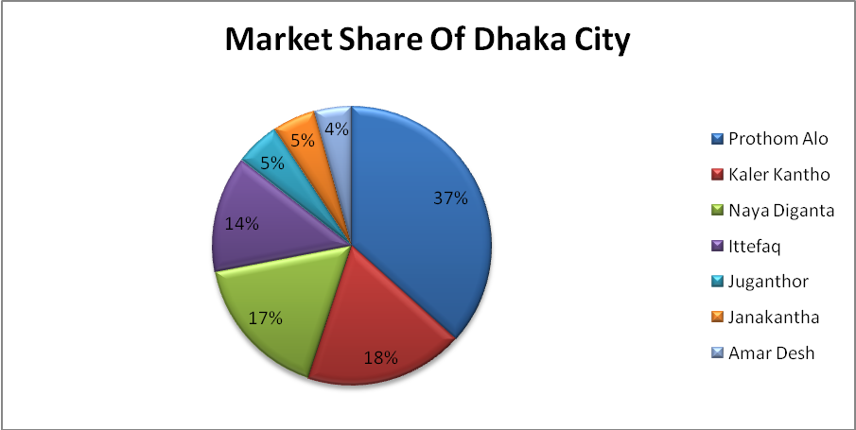
Figure: 3.9.1

3.9.2 MARKET SHARE OF Khulna City
Newspaper Name  (June Survey report) | Selling Copy (June Survey report) | Market share  (June Survey report)
Prothom Alo | 5044 | 27.09%
Kaler Kantho | 4217 | 22.65%
Juganthor | 3394 | 18.23%
Ittefaq | 2663 | 14.30%
Naya Diganta | 1422 | 7.64%
Amar Desh | 1138 | 6.11%
Janakantha | 741 | 3.98%

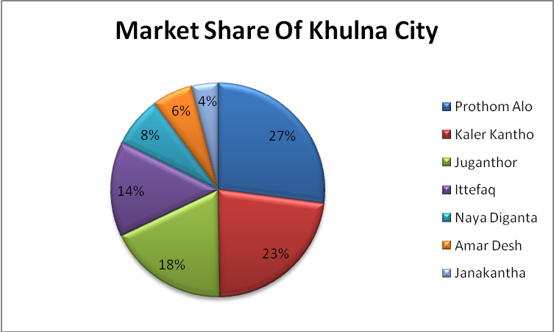Figure: 3.9.2

3.9.3 MARKET SHARE OF RAJSHAHI CITY
Newspaper Name  (June Survey report) | selling Copy (June Survey report) | Market share  (June Survey report)
Prothom Alo | 4955 | 30.86%
Kaler Kantho | 4036 | 25.14%
Naya Diganta | 2721 | 16.95%
Ittefaq | 1317 | 8.20%
Juganthor | 1188 | 7.40%
Janakantha | 1297 | 8.08%
Amar Desh | 541 | 3.37%

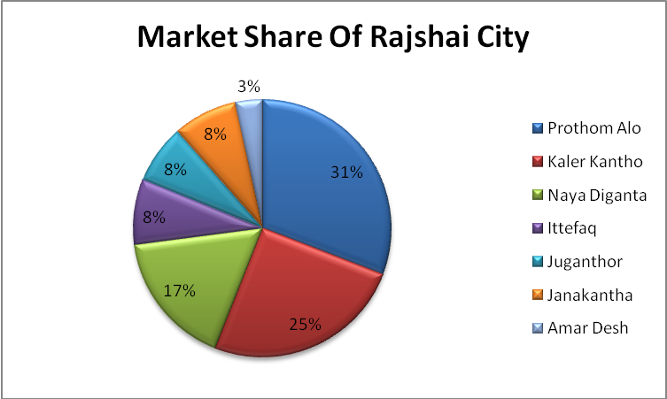
Figure: 3.9.3

3.9.4 MARKET SHARE OF SYLHET CITY
Newspaper Name  (June Survey report) | selling Copy (June Survey report) | Market share  ( June Survey report)
Prothom Alo | 9382 | 32.69%
Kaler Kantho | 4213 | 14.23%
Juganthor | 6796 | 23.68%
Amar Desh | 1814 | 6.32%
Naya Diganta | 1587 | 5.53%
Ittefaq | 4242 | 14.78%
Janakantha | 795 | 2.77%

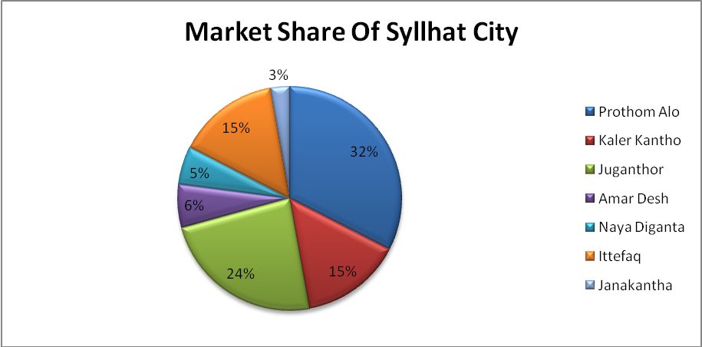
Figure: 3.9.4

3.9.5 MARKET SHARE OF BARISAL CITY
Newspaper Name  (June Survey report) | selling Copy (June Survey report) | Market share  (June Survey report)
Juganthor | 4524 | 29.10%
Kaler Kantho | 2492 | 16.03%
Prothom Alo | 3577 | 23.01%
Naya Diganta | 1710 | 11.00%
Amar Desh | 1440 | 9.26%
Ittefaq | 2808 | 18.06%
Janakantha | 535 | 3.44%

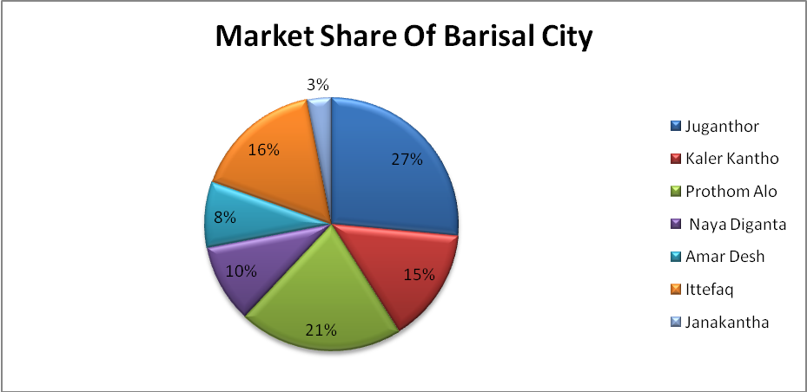
Figure: 3.9.5

3.10 Competitive Advantages of Prothom-Alo in Newspaper Industry:
- Authentic/Real News provide by Prothom Alo.
- Prothom Alo’s most important part is Social Activities.
- Prothom Alo’s Client gets good feedback to publish the Advertisement.
- Prothom Alo’s Page make up is nice.
- Special Supplement such as NOKSHA, Rosh+Alo, Ananda that is so much attractive to the reader.
- Prothom Alo is a internet base paper and it’s so much attractive to the executive level.

Price & Pages of Prothom Alo compare with others:
Newspapers (Price & Pages)
Name of Papers | Pages | Average Pages Contains in a week (24-30,June2011) | Price (tk.)
Prothom Alo | 24-28 | 24 pages (6 days) 28 pages (1 day) | 8
Kaler Kantho | 16-20 | 16 pages (4 days) 20 pages (3 days) | 8
Ittefaq | 20-24 | 20 pages (5 days) 24 pages (2 days) | 8
Janakantha | 12-16 | 12 pages (6 days) 16 Pages (1 day) | 8
Jugantor | 16-20 | 16 pages (4 days) 20 Pages (3 days) | 8
Amar Desh | 16 | 16 pages (7 days) | 6

With extra supplement of 4 pages for Dhaka city once in a week.
With extra supplement of 4 pages for greater Chittagong thrice in a week.
With extra supplement of 4 pages for greater North once in a week.
With extra supplement of 4 pages for greater South once in a week

3.11 Competitive Position of Prothom Alo with another newspaper:
3.11.1 Calculation of government Survey
Newspaper Name  (April Survey report) | Average selling Copy (April Survey report) | Market share  (April Survey report)
Prothom Alo | 327094 | 29.68%
Kaler Kantho | 180685 | 16.37%
Juganthor | 153091 | 13.87%
Ittefaq | 145475 | 13.18%
Amar Desh | 118764 | 10.76%
Naya Diganta | 111254 | 10.08%
Janakantha | 67550 | 6.12%

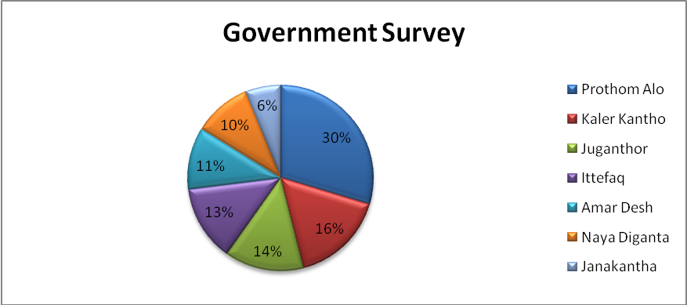
Figure: 3.11.1

4.0 Marketing Strategies:

Marketing Mix of Prothom Alo
Marketing mix is the set of controllable variables of marketing. In general it is expressed in 4 Ps: product, price, place and promotion of a particular company (Kotler, 2003). The marketing mix of Prothom Alo is described below:

A. Product
A product is a set of attributes assembled in an identifiable form. In marketing, we need a broader definition of product to indicate that consumers are not really buying a set of attributes, but rather benefits that satisfy their needs. Product is an umbrella term that covers goods, services, places, persons, and ideas (Stanton 1994). Marketing offer is some combination of products, services, information, or experiences offered to market to satisfy a need or want.
Product Mix
Now firms do not depends on a single product they sell many products. The set of all products offered for sale by a company is called a product mix. The set of all product lines and items that a particular seller offers for sale. The different elements of Prothom Alo’s product mix are:
i. daily news & views
ii. Space for advertisements
iii. Web edition of Prothom Alo

Products of Prothom Alo:
- The Prothom Alo Jobs.com: In Prothom Alo jobs.com they offered various types jobs where we can easily drop our CV. And we also see which organization are need to employee
- Mobile Phone News Service: Now The Prothom Alo has newly opened new service that is mobile phone service where any kind of people can easily know the updated news by using the mobile phone.
- E-paper:
This is one kind of internet base newspaper where we can easily see the newspaper by using the internet.
- Weekly magazine:
The Prothom Alo has also published he weekly magazine that is so much interesting to the overall people.
- Sound Knowledge
Now The Prothom Alo is one of the leading newspapers in Bangladesh. I worked the advertisement Department of The Prothom Alo and there are four section one is Front desk which all kinds of advertisement collect and also set the page make up Second one is e-mail checking and browsing, third one is banner advertisement collection, and last one is Collection team which are collect money in specific date. Most of the moment I spend my time in front desk where advertisement collect and give a money order to the client. In front desk the advertisement collects at 10A.M to 5P.m (Officially hour).But advertisement is collect at 6 p.m.
- Implement of online system:
The Prothom Alo Daily Online was formally launched on January 1, 1997. Since the first day of it’s launching. Prothom Alo Daily Online has taken disseminating information from Bangladesh as its primary task, making it sure that the esteemed news medium authority of Prothom Alo Daily be guaranteed and its role as a major website showing great appeal, good readability and increased affinity be brought into full play. Thanks to five years' effort made, Prothom Alo Daily Online has made itself one of the most authoritative, comprehensive and influential websites and a disseminator of information claiming the largest daily amount of new releases in Bangladesh. Prothom Alo Daily Online Bangladesh Edition releases news around the clock with a daily updating of thousand news pieces including Politics, International, Opinion, Economics, Education, Society, IT, Environment, Military Affairs, Entertainment, Life, Photo and so on .
Prothom Alo Daily Online Edition has been available since November, 1998. It translates major news releases from the Prothom Alo Daily, and new policies, resolutions and statements of the Bangladesh Government. Internet users can also find in special columns of Prothom Alo Daily Online useful information about the activities of Bangladesh leaders, basic facts on Bangladesh, and places of interest in Bangladesh. Prothom Alo Daily Online Edition has been made by its commendable editing work a first-rate distributing center of information about Bangladesh. Customarily Prothom Alo Daily Online makes it sure new world hot topics, thematic subjects and feature websites are presented in the interest of its readers worldwide. Prothom Alo Daily Online Strong Nation Forum has by its focusing on themes for reinforcing Bangladesh with greater national economic strength and national unity has produced wide repercussions among its netizens. To convenience Internet surfers' access, online study and information feedback, Prothom Alo Daily Online has also provided many functional services as subscription to personal electronic news reading, mails free of charge, online data retrieval and online investigation in addition to news information, policy information, laws online, short-message products etc. Prothom Alo Daily Online has by now had a daily increased influence being felt in Bangladesh and abroad and its authoritative news releasing, comprehensiveness and timelines have won wide acclaim, hence many netizens say: "za kisu valo tar shate Prothom Alo".

B. Pricing Decisions
Price is the exchange value of product. Price as the amount of money charged for a product or services, or the sum of the values that consumers exchange for the benefits of having or using the product or service. Pricing is a critical factor in the successful operation of profit and non-profit organizations. Pricing is the manual process of applying prices to purchase and sales orders, based on factors such as: a fixed amount, quantity break, promotion or sales campaign, specific vendor quote, price prevailing on entry, shipment or invoice date, combination of multiple orders or lines, and many others.. Setting prices for new and existing products appears simple enough. To find out the selling price of a product, a marketer apparently has to estimate the costs, add a margin for overhead and profit. Price is the primary element of the marketing mix that generates revenue. The pricing strategy for newspaper industry is different from other consumer products.

The details of per unit production cost of Prothom Alo are as follows:

Step 1: Determination of Per Unit Production Cost
Newsprint Tk 6.90
Printing 1.43
Factory Overhead .55
Total 8.88
Indirect Overhead 1.46

Total cost 10.34

Step 2: Determination of Per Unit Sales Revenue

Per unit sales price Tk 8.00
Agent’s Commission (42.5%) 3.40

Per unit sales revenue Tk 4.60

Step 3: Determination of Per Unit Marketing Cost

i. annual promotion expenditure bill board Tk .75 crore
Incentive to the hawker & agency .40 crore
trade promotion .91 crore
(85000 copy x 12 x 8.88)
special promotion package 1.00 crore
Tk 3.06 crore

ii. Annual distribution cost Tk 1.45 crore

iii. Annual production cost Tk 89.83 crore

Total Annual Marketing Cost Tk 95.34 crore

Per Unit Marketing Cost Tk 10.98

Step 4: Determination of Per Unit Target for Advertisement Revenue

Cost of marketing Tk 10.98
Sales revenue 4.60

Advertisement target Tk 6.38

(If we multiply this per unit advertisement target by the total sales volume we will get the total daily target of the advertisement revenue.)

Step 5: Determination of Deficit in Pricing

Per unit marketing cost Tk 10.98
Per unit price 8.00

Per unit deficit in pricing– Tk 2.98

Unlike other consumer products, Prothom Alo is not setting its product’s price by adding a markup with its total marketing cost. Rather they have to make up the deficit in pricing and to make the targeted profit with the revenue of advertisement. So it’s really tough to define the pricing strategy of Prothom Alo in the light of pricing approaches of marketing management.

Table 01: Per Unit Price Changes of Prothom Alo
Year | Taka
1998 | 6.00
1998-1999 | 6.00—7.00
2001 | 7.00
2003 | 8.00
2003-2011 | 8.00
Source: Prothom Alo

Table 02: Except:
Friday Taka 10
Foundation Day 10
Special Issue 10
Eid –ul-fiter 120

C. Place Decisions:
There is no fixed standard distribution system for all firms what can satisfy the needs of every firm. Many organizations use several distribution channels to reach different market segments. A distribution channel consists of the set of people and firms involved in the transfer of title to a product as the products move from producer to ultimate consumer or business user. In other words, channel of distribution is a set of interdependent organizations involved in the process of making a product or service available for use or consumption by the consumer and business user. Place Decisions is about getting the products to the customer. Some examples of Place Decisions include:

- Distribution channels
- Market coverage (inclusive, selective, or exclusive distribution)
- Specific channel members
- Inventory management
- Warehousing
- Distribution centers
- Order processing
- Transportation
- Reverse logistics

D. Promotion Decisions
Promotions another name is Reward. It is the element of an organization’s marketing mix that serves to inform, persuade, and remind the market of a product. Using the concept of promotion a company can get own goal. Prothom Alo is using massive promotional activities than its competitors do. They are using print media (basically magazines), electronic media (satellite television channels) and out-door media (primarily banners & bill boards) for their advertisements. They are organizing seminars, talk shows, different competitions, contests, public rallies, award giving ceremonies, awareness build up programs in different social issues etc. as a part of their public relations activities. Fundamentally, however there are three basic objectives of promotion. These are:
- To present information to consumers as well as others
- To increase demand
- To differentiate a product.
Major Promotional programs of The Daily Prothom-Alo:

Consumers have different types of needs and to satisfy these various types of promotional activities have to be planned and implemented properly. Promotional tools include advertising, and public relation activities. Some of the promotional activities are discussed below:

1. Maril Prothom Alo Taroka Proshuskar:
Since 2001, "The Daily Prothom Alo" has been sponsoring this program for awarding the best Stars and Models is the showbiz of Bangladesh for their outstanding performance. Maril organizes this program on behalf of "The Daily Prothom Alo". This program is held between March and April.

2. Debate Competition:
"The Daily Prothom Alo "has been sponsoring Inter College and University English Debate Competition since 2001. The Debating Committee of Viqarunnisa Noon College organizes this competition on behalf of "The Daily Prothom Alo".

3. Award Presentation program GPA 5 obtained SSC and HSC students:
Since 2003, "The Daily Prothom Alo" has been awarding the outstanding students of SSC and HSC level examinations. "The Daily Prothom Alo" Award Presentation Program were held 64 districts in Bangladesh jointly with Grameen Phone, AKTEL and also Banglalink.

4. Prothom Alo-HSBC Language Competition:
"The Daily Prothom Alo" in every year arranges a Language competition for the school and college going students with the Honkong Sanghai Banking Corporation (HSBC).

5. Round table discussion:
"The Daily Prothom Alo" organizes different types of round-table discussions. For example, in 2003, it organized round table discussion with Center for Policy Dialogue (CPD).

6. News in Grameen Phone:
"The Daily Prothom Alo "provides Grameen Phone with daily news. They can also accommodate other mobile phone companies. Other programs arc also organized on different occasions.

I
7. Social Activities Performance:
Many kinds of social activities performed by The Daily Prothom Alo such as help natural disaster, flood affected, acid victims and poor people.
- Acid Victim People: Prothom alo help acid victim people to give them some money or goat or give money to make a house. By the way they can lead their life easily.
- Flood affected people: Prothom alo give their team where flood is affected. Prothom alo’s team provides cloths, foods and save place for flood affected people.
- Poor People: They look after poor area’s people where they can’t get education facility and their basic needs. Prothom alo give them education facility to make school. And give them money or goat or house to take a good life.

8. Extra Work:
Prothom alo arrange some educational and entertaining program every year. Those are Math-Olympiad, Vasha Protijog, Borno mala etc.

The detail of the annual promotional expenses is shown below:

Table 03: Annual Promotional Cost of Prothom Alo
Sector of Expenditure Amount [in Tk]
Bill Board & Banner 75, 00,000
Trade Promotion [85000 x 12 x 8.88] 90, 57,600
Incentive to Hawker and Agency 40, 00,000
Television Commercials & Others 1, 00,00,000
Total 3, 05, 00,000
Source: Prothom Alo

5.0 Market Segmentation:
Market segmentation is a concept in economic and marketing. A market segment is a sub-set of a market made up of people or organizations with one or more characteristics that cause them to demand similar product and services based on qualities of those products such as price. A true market segment meets all of the following criteria:
- It is distinct from other segments (different segments have different needs)
- It is homogeneous within the segment (exhibits common needs)
- It responds similarly to a market stimulus and
- It can be reached by a market intervention.
The term is also used when consumers with identical product and service needs are divided up into groups so they can be charged different amounts for the services. The people in a given segment are supposed to be similar in terms of criteria by which they are segmented and different from other segments in terms of these criteria. These can be viewed as 'positive' and 'negative' applications of the same idea smaller groups.
5.1 Market Targeting:
One of the major differences of newspaper marketing is that the marketer has to satisfy two major groups of customers:
- Readers:(who buy the product for their personal consumption i. e, final consumers)
b. Advertisers (who buy the advertising space for their business use i. e. business buyers)

5.2 Distribution Channels of the Prothom Alo:

Distribution Channel is a element of marketing mix. An organization involved in the process of making a product or service available for use or consumption by a consumer or business user. it in supply chain management refers to the distribution of a good from one place to another. It can be factory to supplier, supplier to retailer, or retailer to end customer. Ever year distribution and increasing sales of Prothom alo is given below:
5.2.1 Circulation growth of Prothom-Alo Over the last 13 years:

Duration | Average circulation | Increasing better than last year (%)
Nov. 1998 | 53283
Nov. 1999 | 126722 | 37.78
Nov.2000 | 162212 | 28.08
Nov.2001 | 213023 | 31.32
Nov.2002 | 216337 | 1.56
Nov.2003 | 221385 | 2.33
Nov.2004 | 232407 | 4.98
Nov.2005 | 244916 | 5.38
Nov.2006 | 324333 | 32.43
Nov.2007 | 338316 | 4.31
Nov.2008 | 345152 | 2.02
Nov.2009 | 350832 | 1.65
Nov2010 | 360633 | 2.79
May.2011 | 380385 | 1.54
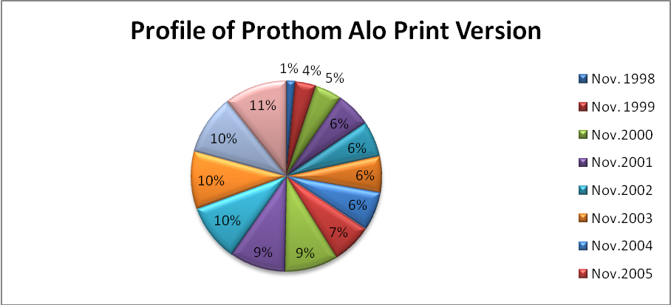
Average read per copy 6 to 8 people. In this calculation average reader of the Daily Prothom Alo 24 lack often. In same time number of internet reader is 400000 to 450000.They are updated their newspaper after two hour

5.2.2 Monthly sales of Prothom Alo Based on Territory (July 2011)
Territory | Sales
Dhaka | 103089 copies
Khulna | 5044 copies
Rajshahi | 4955 copies
Sylhet | 9382 copies
Barisal | 3577 copies

5.2.3 Advertisements in The Daily Prothom Alo:
The details about Prothom Alo’s advertisement chart which they are follow:
Space sold for advertisement:
Rate chart of The Daily Prothom-Alo
(Print Advertisement)
In 1st June 2011 The Prothom-Alo has set a New Rate Chart that is given below:
(In inner page BDT 3300 per column inch B&W, BDT 5000 per column inch color.)
Page | Price
1st page per column inch | BDT 16000 (at least color 12inch & 40inch column)
Last page per column inch | BDT 13500 (at least 6inch column)
3rd Page per column inch | BDT 12000 (color)
2nd Page per column inch | BDT 10500 (color)
Last Page in inner page | BDT 9000 (color)
5th Page in per column inch | BDT 9500 (color)
7th Page in per column inch | BDT 6000(Black and white)
9th Page in per column inch | BDT 5000 (Black and white)
9th Page in per column inch | BDT 7500 (color)
Sports page in inner page | BDT 6500 (color)

Others Advertisement (Spot Advertisement)
Page | Price
1st Page per column inch | BDT 40000 (At least 2inch)
Last Page per column inch | BDT 28000 (At least 4inch)
If any one wants a specific area, he or she must pay extra 25% charge.
Classified Advertisement Section: In Classified advertisement section, First fifteen words pay for BDT One thousand (1000/=). After each word pay for BDT 50 only and its limit up to forty words (40words). If any body want to Birthday wish (black & white), pay for BDT one thousand four hundred (1400/=).
Advertisement Booking System: Advertisement will be booked before two days if you want a specific place.
Advertisement payment System: Advancement payment must be paid otherwise your advertisement will not publish
Discount System: There are two types of discount system one is Direct client and other one is Agency discount .Twenty Percent (20%)discount only for Direct client and another one is thirty (30%) percent only for Agency client.
N:B-If You use Prothom Alo box ,you will pay extra BDT one thousand five hundred (1500/=).

THE DAILY PROTHOM ALO
INTERNATIONAL ADVERTISING TARIFF, PRINT EDITION 2011
(Effective from June 01, 2011)

Page | Ad type | Amount In USD
Front page | Color | 195
Page 02 | B&W | 70
Page 02 | Color | 105
Page 03 | Color | 125
Page 05 | Color | 100
Page 06 | B&W | 50
Page 07 | B&W | 60
Page 07 | Color | 90
Page 08 | B&W | 50
page 09 | B&W | 55
page 09 | Color | 75
page 11 | B&W | 50
page 12 | B&W | 50
page 13 | B&W | 50
page 14 | Color | 65
page 15 | B&W | 50
page 16 | Color | 60
page 17 | B&W | 50
page 18 | Color | 80
page 19 | Color | 90
Back page | Color | 150

NOTE:
25% Additional costs will be applicable for any particular space or position
Front page Spot Ad Rate US$350/ Column inch (Maximum size:2 Column-Inch)
Back Page Spot Ad Rate US$225/Column inch (Maximum size 4 Column- Inch)
Box Charge US$25/Month (on demand)
Remittance Details:
Bank Name: Dhaka Bank Limited
A\C Name: PROTHOM ALO
A/C No: 207-175-66
Branch: Karwan Bazzar, Dhaka.
Swift code for Dhaka Bank, Bangladesh: DHBLBDDH

TECHINICAL INFORMATION:
Total Column /page: 8columns
Per Column width: 1.75 Inch
Per Column Height: 20.5 Inch

WWW.PROTHOM-ALO.COM
ONLINE INTERNATIONAL ADVERTISING TARIFF 2011
(Effective from June 01, 2011)
TOP BANNER AD
Dimension | Width 220 Pixels X Height 50 Pixels
Unit Size | 220*50 Pixels
Maximum Size | 440*50 Pixels
File Size | Not more than 20 kilobyte for 440*50
Supported Format | GIF/JPG
Location | Will be viewed on all pages of the website
Comments | No Flash Ads
Ad Rate | BDT 75000/Month

LEFT PANEL AD ON HOME PAGE (AVAILABLE)
Dimension | Width 180 Pixels X Height 50 Pixels
Unit Size | 50 Pixels in height
Maximum Size | Proportionately Unlimited
File Size | Not more than15 kilobyte /Unit
Supported Format | GIF/JPG
Location | Will be viewed on home page only
Comments | No Flash Ads
Ad Rate | BDT 15000/Month

RIGHT PANEL AD ON HOME PAGE (AVAILABLE)
Dimension | Width 150 Pixels X Height 50 Pixels
Unit Size | 50 Pixels in height
Maximum Size | Proportionately Unlimited
File Size | Not more than15 kilobyte /Unit
Supported Format | GIF/JPG
Location | Will be viewed on home page only
Ad Rate | BDT 15000/Month

LEFT PANEL AD IN INNER PAGES (AVAILABLE)
Dimension | Width 180 Pixels X Height 50 Pixels
Unit Size | 50 Pixels in height
Maximum Size | Proportionately Unlimited
File Size | Not more than15 kilobyte /Unit
Supported Format | GIF/JPG
Location | Will be viewed on all the inner pages
Comment | No Flash Ads
Ad Rate | BDT 12000/Month

Web Edition/Online of Prothom-Alo:
Prothom Alo is enjoying the market leadership in its web edition/online also. On an average worldwide more than One Hundred Fifty people read Prothom Alo daily. The web address of Prothom-Alo is www.prothom-alo.com.

Online polling sponsor (booked)
Dimension | Width 138 Pixel X Height 70 pixel. With the combination Of Prothom Alo logo and Sponsor Logo polling result will be published regularly on the Front Page of Print Edition with Sponsor Logo.
Unit Size | N/A
Maximum Size | Fixed
File Size | Fixed(Prothom Alo will provide the design)
Supported Format | GIF/JPG
Location | Will be viewed on home pages
Comment | No Flash Ads
Ad Rate | BDT 35000/Month

Ad in polling “Thank You” page (available)
Dimension | Width 500 Pixels X Height 150 Pixels
Unit Size | 150 Pixels in height
Maximum Size | Unlimited
File Size | Not more than25 kilobyte /Unit
Supported Format | GIF/JPG
Location | www.prothom-alo.com/poll.confirm.php
Comment | No Flash Ads
Ad Rate | BDT 75000/Month

Classified ads (available)
Rate: First fifteen words BDT 200(BDT 20 for each word
After first 15 words)

Duration Seven Days

Special Offer 50% discount on BDT 200 if the same ad publishes
In Prothom Alo Print Edition.

Banner ad rates (BDT) in classified page (available)
Top Banner: BDT 10000

Left and Right Panel: BDT 5000
(Data collection technique: collected from Prothom-Alo head office)

SWOT analysis of Prothom Alo:
It is very difficult to find and analyses the newspaper’s market-position within a limited time. SWOT means Strengths, Weaknesses, Opportunities, & Threat. The SWOT analysis is useful when within a short time I tried to find Internal & External performance analysis of the Prothom alo.

Strengths:
1. Strong Unity:
They have a strong relationship for their company.
2. Financial Strength:
The Prothom Alo is a financially sound company backed by the enormous resource base of Transcom Group. As result customers feel comfortable in dealing with the company.
3. Efficient Management:
All the levels of the management of The Prothom alo are solely directed to maintain a culture of the betterment of the quality of the service and development of a corporate brand image in the market through organization wide term approach and open communication system.
4. Experts:
The key-contributing factor behind the success of the NCCBL is its employee, who is highly trained and most competent in their own field.

Weakness:
1. Limited Workforce:
The human-resource department of Prothom Alo is extremely understaffed compared to its financial activities. There are not many people to perform most of the tasks. As a result many of the employees are burdened with extra workloads and work late hours with out any overtime facilities. This might cause high employee turnover that will prove to be too costly to avoid.

2. Poor Telecommunication Infrastructure:
As previously mentioned, the world is advancing e-technology very rapidly. Though Prothom Alo has taken effort to join the stream of information technology, it is not possible to complete the mission due to poor technology and infrastructure of our country.
3. Salary Range low:
The employee of front desk salary is so low so they are so much dissatisfied.
4. Staff’s dissatisfaction:
The employees of front desk staff, call management operator are very much pressure in their working place.

Opportunities:
- Follow highly modern strategy to improve the position.
- Create good positioning strategy for potential customers.
- A develop market such as Internet facilities can make them different from the other Newspaper.
Threat:
- Customer satisfaction level is not good.
- In past The Prothom Alo was face in Islamic Culture. So The Prothom Alo should be careful about it.
- Competitors have adopted attractive services.
- Political unrest

Findings:
After analyzing different aspects of marketing strategies of The Prothom Alo I have discovered some findings:
- Prothom Alo used to come up with new products taking into account the choices of its exiting customers.
- They follow different marketing strategies such as, 4 P’s of Marketing (Product, Price, Place and Promotion).
- To dominate a highly competitive market, such a company should have detail information on the overall market situation which Prothom Alo does not have.
- To promote internet use among the audience, Prothom Alo provides online newspaper facility and has created a blog site. But the organization may explore audio-visual reporting like BBC News to accelerate its circulation.

- Prothom Alo works as a social worker because they make a trusty which help natural disaster, flood affected, acid victims people.

- To create a better educational environment Prothom Alo organizes various types of competition and fair. Like as-Math Olympiad, Award Presentation program GPA 5 obtained SSC and HSC students, Prothom Alo-HSBC Language Competition etc. Prothom alo make good profit and reputation by their marketing strategy.
- Prothom Alo is a financially sound company because it base of Transcom Group as result customers feel comfortable in dealing with the company.

Recommendation:
The Prothom Alo is a private Organization I have found some lacking & giving recommendations to solve these problems. The Prothom Alo must be establish monitoring system otherwise the performance level will decrease day by day .Some training facility must be establish because they will know how to deal the customer and how to give better service to the client.
As The Prothom Alo follow online news service. Long-term training very much required for the employees. They have to give some reward system. Prothom Alo’s should increase work force. The success of the media depends on how effectively they can deliver their services to the customers and earn maximum amount of profit. Extensive training can be conducted for developing the force.
Some essential things may be improved that are given below:
- It has been observed that the Prothom Alo tries to introduce new services but it barely has any intense strategy to reach the country’s large number of audience that still remains unreached.
- More innovative marketing strategies should be taken to increase the circulation.
- The organization may explore audio-visual reporting like BBC News to accelerate its circulation.
- The Management should motivate the employees more to increases the operational activities.
- Also the Human Resource Department must implement the monitoring system otherwise the management can not evaluate the performance of the employees.

Conclusion:

The Prothom Alo has performed relatively well in Bangladesh. The Prothom Alo customer’s survey result is not satisfactory. It should focus more customer orientation. On the other hand, the employees is very much dedicated the work hard for this organization they are valuable asset for this organization but employees do not get proper facilities like sufficient equipment, manpower, standard salary.
The Prothom Alo can focus on their market strengths in the Newspaper and also they can work on their weaknesses to develop the product effectively and get more opportunity which hidden in the newspaper industry. With their strengths they can also reduce the threats existing in the market. They have strength with their solid brand image and experience and skills as well, with which they are being able to satisfy the customers with their wide range of products and services. Bangladesh is growing market where new businesses are coming up and in this emerging market and The Prothom Alo can introduce its products and services effectively to the upcoming corporate. The marketing has always been important of institutions. The profitability and stability of any enterprise depends upon the manner of the financial and marketing functions are performed and other related business functions. Improved marketing strategies, marketing mix, 4p’s, marketing segmentation is important.

Prothom Alo’s uphold the slogan is "Ja Kisu Bhalo Tar Sate Prothom Alo (Prothom Alo with all good things). After 10 year Prothom alo change their slogan. Now the slogan is “Bodla Jaw bodla Dew”.

