“Overall Banking System of SIBL”

Conducted on behalf of Social Investment Bank Ltd.
Foreign Exchange Branch

Submitted by
WWW.ASSIGNMENTPOINT.COM

49 Banks operate in the financial system of Bangladesh; of which 6 are full-fledged Islamic Banks and 43 are Conventional Banks. A part from the 6 full- fledged Islamic Banks, having a network of 250 branches, 7 conventional Banks have so far established 15 Islamic branches.

The first Islamic Bank was established in Bangladesh in the year 1983. There after, between 1995 to 2001, 5 other Islamic Banks were established. With 4.255 branches, network the Islamic banks’ present market shares of deposits and advances (Investments) are 12% and 10% respectively. The growth rate of both deposits & investment of all the Islamic banks is over 30% as against 16% growth of deposit & 13% growth rate of management position, earnings and profitability and liquidity position of all the Islamic banks excepting one are satisfactory. The overall performances of all the Islamic Conventional Banks are also satisfactory. Being inspired by the success of Islamic banks and the satisfactory growth trend of its own Islamic branches, a Conventional Bank has decided to conventional its whole operations to Islamic system.

The Islamic Banks have introduced a wide range of deposits in the market through which they have been able to mobilize substantial amount of deposits. The Investment operations of Islamic banks are however, limited to a few buying & selling modes and one rent-sharing mode, Islamic Banks finance in the real sector of the economy, particularly in Industry Sector and Service sector are above the level of finance provided by Conventional banks. Due to insufficient branch network, the Islamic Banks could not yet reach up to its expectation to Agriculture Sector in rural areas. Islamic bank Bangladesh Ltd, the pioneer Islamic bank of the country has introduced a Taka 20 thousand (USD 85 to 340) per clients in the rural areas, the recovery rate of which is 99%. This Bank has also introduced various welfare oriented Schemes through a foundation.

Like their counterparts around the world, the Islamic Banks in Bangladesh are also facing some legal and practical constraints. Absences of Islamic money market, shortage of link institutions are some of such constraints.

The Islamic Banks in Bangladesh have good prospects too, As the Islamic banks meet both banking & ethical expectation, and the people of the country have reposed a great deal of trust & confidence on them. The initiative, drive, farsightedness and relentless efforts of the people who are associated with the Islamic banking system may give it a great boost & momentum.

Banking in Bangladesh

The march 1971 Bangladesh was a part of Pakistan knows as East Pakistan. A nine- month liberation war results in the creation of Bangladesh on 16 December 1971. At the end of the liberation war, the banking sector of Bangladesh was in total disarray. With the exception of two local banks incorporated in then East Pakistan, all the bigger local banks became in operational. Liberation war left these banks divided and without any corporate offices to guide them as their Head Offices was located outside Bangladesh territory. The overseas banking relationships of these banks were also shattered under such situation. Two local banks and a few branches of the then Pakistani banks were functioning in the country. Starting with such a humble and chaotic condition, the Banking Sector of Bangladesh has grown to a great extent.

At present, there are 49 banks in Bangladesh. The structure of banking in Bangladesh is as under:

- Nationalized Commercial Banks -------- 4
- Specialized Banks -------- 5
- Private Sector Commercial Banks:
    - Conventional Banks ------ 25
    - Islamic Banks ------ 5
- Foreign Commercial Banks:
    - Conventional Banks ------ 9
    - Islamic Banks ----- 1

------------------
Total 49

List of above 49 Banks & 28 non-bank financial institutions is given in Annexure-A.

Major Indicators of the Banking Sector of Bangladesh as on 31.12.2004

Amount in Million Taka (USD$1=58.80)
Indicators | All Banks | Islamic Banks | Share of Islamic  Banks (%)
Number of Banking Branches | 6,228 | 265 | 4.25
Deposits( Excluding inert-bank)
a) Total Deposits: | 1,000,026 | 88,194 | 8.82
Urban | 820,300 | 83,004 | 10.12
Rural | 179,726 | 5,190 | 2.89
b) Number of Accounts: | 31,002,627 | 2,059,213 | 6.64
Advances (Excluding inter-bank)
a)Total Advances | 835,963 | 80,065 | 9.58
Urban | 736,566 | 77,178 | 10.47
Rural | 99,396 | 2,887 | 2.90
b) Number of Accounts | 7,599,515 | 221,012 | 2.90
Deposits of Islamic Banks stood at TK. 132,170 Million and Credit (Investment) rose to TK. 104,294 million as on 31.12.
Genesis of Islamic Banking in Bangladesh

In August 1974, Bangladesh signed the Charter of Islamic Development Bank and committed itself to reorganize its economic and financial system as per Islamic Shariah.

In January 1981,the then President of People’s Republic off Bangladesh while addressing the 3rd Islamic Summit Conference held at Makkah and Taif suggested, ‘’The Islamic countries should develop a separate banking system of their own in order to facilitate their trade and commerce.’’

This statement of the President indicated favorable attitude of the Government of the People’s Republic of Bangladesh towards establishing Islamic bank and financial institution in the country.

Earlier in November 1982, a delegation of IDB visited Bangladesh and showed keen interest to participate in establishing a joint venture Islamic Bank in the private sector. They found a lot of work had already been done and Islamic banking was in a ready from for immediate introduction. Two professional bodies Islamic Economics Research Bureau (IERB) and Bangladesh Islamic Bankers Association (BINBA) made significant contributions towards introduction of Islamic banking in the country.

They came forward to provide training on Islamic banking to top bankers and economists to fill-up the vacuum of leadership for the future Islamic banks in Bangladesh. They also held seminars, symposia and workshops on Islamic economics and banking throughout the country to mobilize public opinion in favor of Islamic banking.
Their professional activities were reinforced by a number of Muslim entrepreneurs working under the aegis of then Muslim Businessmen Society (now reorganized as Industrialist & Businessmen Association). The body concentrated mainly in mobilizing equity capital for the emerging Islamic bank.

At last, the drawn struggle to establish an Islamic bank in Bangladesh become a reality and Islami bank Bangladesh Ltd. Was established on 30th March, 1983 in which 19 Bangladeshi national, 4 Bangladeshi institutions and 11 banks, financial institutions and government bodies of the Middle East and Europe including IDB and two eminent personalities of the Kingdom of Saudi Arabia joined hands to make the dream a reality.
Later, other 5 Islamic Banks were establishing in the country. 7 conventional banks have so far established Islamic banking branches in some major cities.

Orientation of the Report

INTRODUCTION

Generally, by the word “Bank” we can easily understand that the financial institution deals with money. But there are different types of banks like; Central Banks, Commercial Banks, Savings Banks, Investment Banks, Industrial Banks, Co-operative Banks etc. However, when we use the term “Bank” without any prefix, or qualification, it refers to the ‘Commercial banks’. Commercial banks are the primary contributors to the economy of a country. So we can say Commercial banks are profit-making institutions that hold the deposits of individuals & business in checking & savings accounts and then use these funds to make loans. For these people and the government is very much dependent on these banks as the financial intermediary. As,
Banks are profit-earning concern; they collect deposit at the lowest possible cost and provide loans and advances at higher cost. The differences between two are the profit for the bank.

Banking sector is expanding its hand in different financial events every day. At the same time the banking, process is becoming faster, easier and the banking arena is becoming wider. As the demand for better service increases day by day, they are coming with different innovative ideas & products. In order to survive in the competitive field of the banking sector, all banking organizations are looking for better service opportunities to provide their fellow clients. As a result, it has become essential for every person to have some idea on the bank and banking procedure.

Internship program is essential for every student, especially for the students of Business Administration, which helps them to know the real life situation. For this reason, a student takes the internship program at the last stage of the bachelor’s degree, to launch a career with some practical experience

Origin of the Report:

The report entitled “Performance Evaluation of Social Investment Bank Limited” has been prepared as a partial fulfillment of MBA program authorized by the Register, Stamford University Bangladesh.

BACKGROUND OF THE REPORT:

After completing my post graduation as a student of MBA from Stamford University Bangladesh, I wanted to do Internship in a reputed Bank, which would be helpful for my future professional career. I got the opportunity to perform my internship in the SOCIAL INVESTMENT Bank Ltd. I was sent to Foreign Exchange Branch. It was a three months long practical orientation program.

This report is originated as the requirement of SOCIAL INVESTMENT Bank Ltd.

OBJECTIVE OF THE REPORT:
The primary objective of this report is to comply with the requirement of the SOCIAL INVESTMENT Bank Ltd. However, the objective behind this study is something broader. Objectives of the study are summarized in the following manner:

- To apply theoretical knowledge in the practical field.
- To make a bridge between the theories and practical procedures of banking day-to-day operations.
- To gain practical knowledge by working in different desks of Foreign Exchange branch of social Investment Bank
- To observe the working environment in commercial banks.
- To study existing banker-customer relationship.
- To know the overall functioning of social Investment Bank Limited.
- To have some practical exposures that will be helpful for my future career.

METHODOLOGY:

This report has been prepared on the basis of experience gathered during the period of internship from January01, 2006 to March 31, 2006. For preparing this report, I have undergone group discussion, collected data, sent some questionnaires to the selected Officers, and interviewed with some of them. I also studied different circulars and files of the bank.
I hope these criteria will be enough to find out different picture of financial performance of the selected bank (SOCIAL INVESTMENT Bank)

The Process of Preparing the Report

SSELECTION OF TROPIC

RESEARCH DESIGN

Working experience in deferent department
PRACTICAL INVOLVEMENT IN THE INTERNSHIP PROGRAM

COLLECTION OF DATA, INFORMATION & KNOWLEDGE
Interviewing officers Official documents and instrument, internet etc

Personal Concept, findings etc

ANALYSIS OF DATA

REPORT

SCOPE OF THE REPORT:

As I was sent to SOCIAL INVESTMENT Bank, Foreign Exchange Branch, the scope of the study is only limited to this branch. The report covers its overall department wise function, structure and performance. The report also covers details about SOCIAL INVESTMENT Bank.

JOB ROTATION:

Departments | Duration
General Banking | From Jan 1to 31.
Foreign Exchange | From Feb 1to 28.
Advances | From March 1to 31.

SOURCES OF DATA:

In order to make the report more meaningful and presentable, two sources of data and information have been used widely.

The “Primary Sources” are as follows:

- Face-to-face conversation with the respective officer and staff of the Branch.
- Informal conversation with the clients.
- Practical work exposures from the different desks of the departments of the Branch covered.
- Relevant file study as provided by the officers concerned.

The “Secondary Sources” of data and information are:

- Annual Report of SOCIAL INVESTMENT Bank Ltd.
- Various books, articles, compilations etc. regarding general banking functions, foreign exchange operations and credit policies.
- Different ‘Procedure Manual’, published by SOCIAL INVESTMENT bank.
- Different circular sent by Head Office of SOCIAL INVESTMENT Bank and Bangladesh Bank.

LIMITATIONS:

- The time, 68 working days, is insufficient to know all activities of the branch and prepare the report.
- It was very difficult to collect the information from various personnel for their job constraint.
- As some of the fields of banking are still not covered by our courses, there was difficulty in understanding some activities.
- Another limitation of this report is Bank’s policy of not disclosing some data and information for obvious reason, which could be very much useful.
- Because of the limitation of information, some assumption was made. So there may be some personal mistake in the report

- I carried out such a study for the first time, so inexperience is one of the main constraints of the study.

ORGANIZATION OF THE REPORT:

This is a short report covering all that I experienced while working at bank. The report has seven parts. The first part is the introductory chapter. The second part contains information about SOCIAL INVESTMENT Bank. The third part gives information about Foreign Exchange branch where I have worked. General Banking is described in forth part. In fifth and sixth part, I discussed about Foreign Exchange and Advance Section respectively. The last part named ‘conclusions’ ends the report.

Organizational Overview:

Historical Background of SOCIAL INVESTMENT Bank Limited:

SOCIAL INVESTMENT Bank Limited was established under the rules & regulations of Bangladesh bank & the Bank companies’ Act 1991, on the 22nd November 1995 with the leadership of Mr. Dr. M. A. Mannan founder chairman who had a long dream of floating a commercial bank which would contribute to the social-economic development of our country. He had a long experience as a good banker. A group of highly qualified and successful entrepreneurs joined their hands with the founder chairman to materialize his dream. In deed, all of them proved themselves in their respective business as most successful star with their endeavor, intelligence, hard working and talent entrepreneurship.

Vision:
Social Investment Bank Limited started its journey with the concept of 21st century Islamic participatory three sector banking model:

- Formal Sector- Commercial banking with latest technology;
- Non-formal Sector- Family empowerment Micro-credit & Micro enterprise program and
- Voluntary Sector-Social Capital mobilization through CASH WAQF and others.

Finally, ‘’Reduction of Poverty Level’’ is our vision, which is a prime object as stated in Memorandum of Association of the Bank with the commitment ’Working Together for a Caring Society’’

Mission:
- High quality financial services with the latest technology.
- Fast, accurate and satisfactory customer service.
- Balanced& sustainable growth strategy.
- Optimum return on shareholders’ equity.
- Introducing innovative Islamic banking products.
- Attract and retain high quality human resource.
- Empowering real poor families and create local income opportunities.
- Providing support for social benefit organizations- by way of mobilizing funds and social services.

• Capital:
The bank started with an authorized capital of Tk.1000 million in 1995 and as on 31 December 1998 paid up capital stood at Tk. 126.00 million. The paid up capital stood at Tk.585.00 million as on 31 December 2004.

Analysis of capital structure:
Capital structure of Social Investment Bank has changed from year to year. The components of the capital structure are paid-up capital; proposed issue of dividend, share premium, statutory reserve, proposed cash dividend, retained earnings and other reserve.

Authorized and Paid up capital of Social Investment Bank:

Authorized Capital (TK) In Million | Year | Paid Up Capital (TK) In Million
1000.00 | 2004 | 585.00
1000.00 | 2003 | 260.00
1000.00 | 2002 | 260.00
1000.00 | 2001 | 260.00
1000.00 | 2000 | 260.00
1000.00 | 1999 | 200.00
1000.00 | 1998 | 126.00

Capital Position of Social Investment Bank:

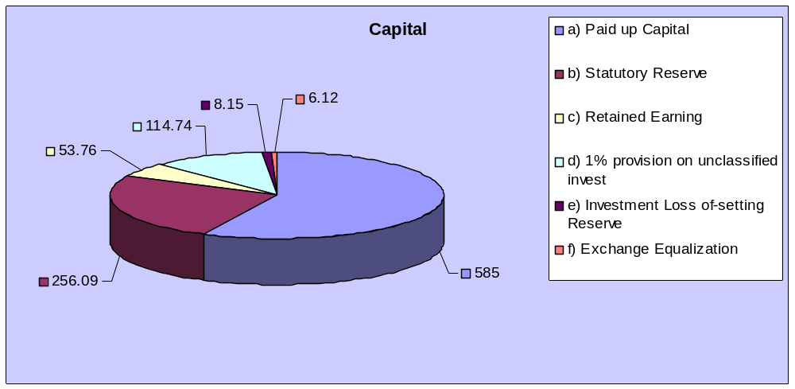
Components of capital structure and correspondent contributions:

The bank achieved the Tk.1.00 Billion Capital requirement ahead of the deadline set by Bangladesh Bank. Capital base of the bank as on 31 December 2004 stood at Tk1023.86 million as against Tk. 971.06 million as on 31 December 2003. But we could not maintain minimum Capital Adequacy ratio of 9% at the end of 2004 due to faster growth of assets, particularly investment. Meanwhile, in order to maintain the ratio, the Board of Directors of your Bank recommended to issue 1:1 Right Share at par. Subject to approval in Extra Ordinary General meeting scheduled to be held on 28 August 2005. However, comparative position of Capital Base of the year 2004 and2003 is given below:

(Figures in million taka)
Components of capital structure | 2004 | 2003
Paid-up capital | 585.00 | 260.00
Statutory Reserve | 256.09 | 225.60
Retained Earnings | 53.76 | 52.40
Proposed bonus share for the year 2001 | --- | 52.00
Proposed bonus share for the year 2002 | --- | 78.00
Proposed bonus share for the year 2003 | --- | 195.00
1%provision on unclassified investment | 114.74 | 93.79
Investment Loss Off –setting Reserve | 8.15 | 8.15
Exchange Equalization | 6.12 | 6.12
Total | 1023.86 | 971.06

Deposit:
Although the deposit trend of the Bank was almost same as on 31 December 2004 (TK. 19,704.17 million) compared to the year-end 2003(TK. 19, 09.31); the deposit mix has significantly been improved. During 2004, Bank deposit received from other commercial Bank reduced to Tk. 6243.44 million against 7,445.44 million on 31 December 2003.On the other hand, Customer deposit increased to TK. 13460.73 million as on 31 december2004 against TK. 7445.44 million as on 31 December 2004 against TK. 12263.87 million of 2003, registering growth rate of 9.76%.

Deposit:

- Al-Wadiah Current Deposit Account
- Mudaraba Term Deposit Account
- Mudaraba Notice Deposit Account
- Foreign Currency Account
- Social Fund Deposit Account
- Shelter Finance Deposit Account
- Cash-Waqf Deposit Account
- Voluntary Sector Development Deposit account

Deposit Position of Social Investment Bank:

Year | Amount Of Deposit (Tk In Million)
2004 | 13,460.73
2003 | 12,263.87
2002 | 7,986.31
2001 | 4,236.20
2000 | 2,149.57
1999 | 1,943.17
1998 | 1,337.74

Deposit in Social Investment Bank:

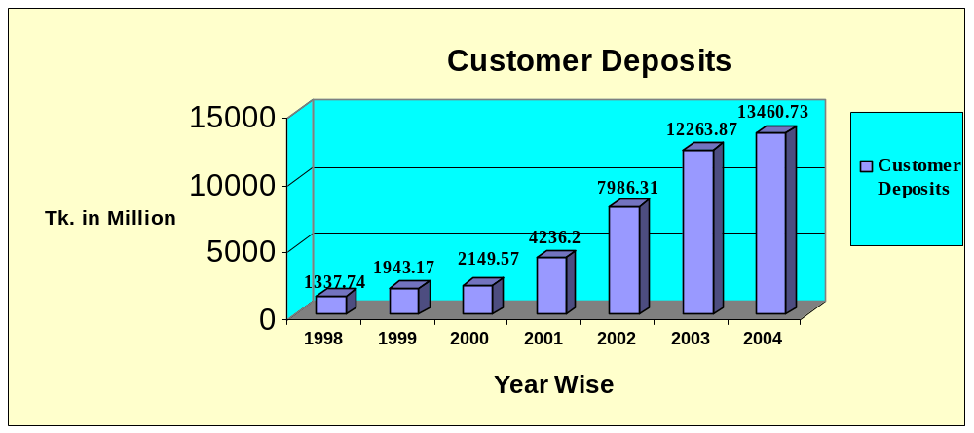

• Investment:
The investment stood at TK. 12887.27 million in various sectors as at 31 December 2004 against TK. 10059.11, million of 2003 registering a growth by 28.12%, which signifies the confidence of the clients having on their bank. At the same time, we are concentrating our efforts to increase fee based and Exchange based investments to facilitate the earnings of the Bank.

Year | Amount (Tk In Million)
2004 | 12887.27
2003 | 10059.11
2002 | 7504.03
2001 | 5499.25
2000 | 3522.25
1999 | 2192.03
1998 | 1171.40

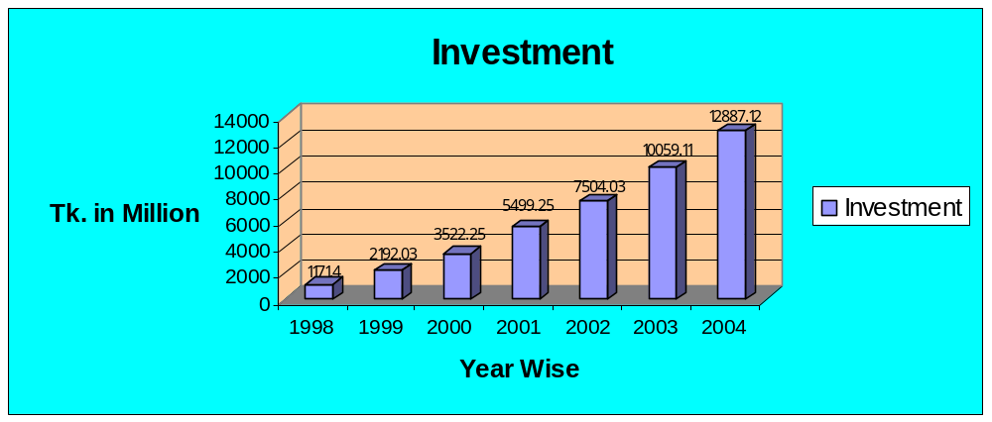
Investment Activities of Social Investment Bank:

Family Empowerment Micro-Credit Program:



A special investment program generating employment and income opportunities for small & low-income families (SLF).

Objectives:
- Targeting poverty families to be identified through socio-economic survey within 15 kilometers area of the branches.
- To organize the target families and formation of family cluster.
- To provide informal training for increasing their capabilities.
- To provide finance through custom tailored Micro-Credit package to the urban and rural poor both in farming and off farming sectors.
- To mobilize savings increasing their saving habit and thereby assist in the formation of their own capital.
- To integrate men and women in income generating activities and to create employment opportunities, thereby firming up family tie, which will steadily increase self-reliance.
- To provide participatory economic activity and sustainable social security for a caring society.
- To expand banking activities through investment in small businesses, agriculture, livestock, heath and so on at the grass-root level.

Family Empowerment Micro-Enterprise Program:



A special investment program generating employment and income opportunities for small& medium entrepreneurs (SME).

Objectives:
- To promote and development Micro and small enterprises to generate employment on a self-sustainable basis.
- To create savings habit and to provide investment resources to the potential entrepreneur to increase their business who have no access to the formal banking.
- To provide necessary investment to new entrepreneurs who want to be self-employment.
- To enroll the successful Micro- Credit graduates into Micro-Enterprise Program.

Modes of Investment:

The following modes may be selected depending upon the sector and purpose of investment:

- Mudaraba: Trust Finance Partnership

- Musharaka: Participation Financing / Equity Financing

- Murabaha: Cost plus Sale

- Bai-Muajjal: Sale Under Deferred payment

- Bai- Salam: Forward Purchase

- Leasing: The Bank leases out Machineries, Transports, Houses, Ship etc. for an agreed period of time, the company being the legal owner and the lessee having the right to use the property for the duration of the contract.

- Direct Investment: This bank directly invests capital on medium and long-term basis in Industry, Agriculture, Trade, Transport, Immovable property and construction of houses etc.

- Hire Purchase: In this system of business the bank invests for purchasing durable assets like machineries, equipment, transport, land and building etc. along with the client with the stipulation that the client shall pay off the principal amount with rent ( at the agreed rate ) in installment.

• Foreign Exchange Business:
.
Handling the amount of Foreign Exchange Business:

Particulars | 2000 | 2001 | 2002 | 2003 | 2004 | Growth rate
Import | 2,983.20 | 4,723.40 | 11,124.85 | 14,908.90 | 13,363.07 | (10.37)%
Export | 530.80 | 1,440.20 | 2,287.64 | 4,035.90 | 4,500.23 | 11.50%
Remittance | 33.40 | 31.70 | 107.57 | 120.30 | 224.82 | 86.88%
Total | 3,547.40 | 6,195.30 | 13,520.07 | 19,065.10 | 18,088.12 | (05.12)%

Handling Of Foreign Exchange Business in Social Investment Bank:

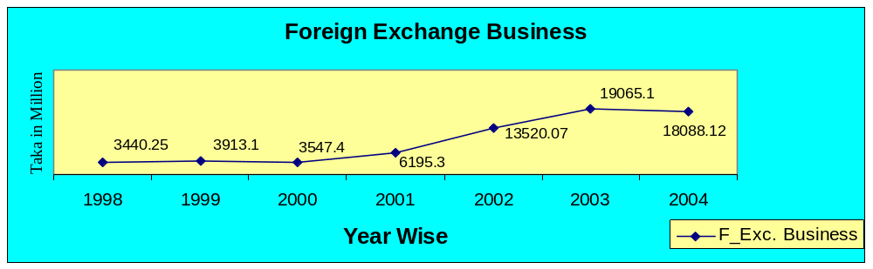

Special Banking Services:

In additional to sale and purchase of foreign currencies the Bank issue Guarantees, accept certificate and shares, accept articles & valuable documents, for safe custody locker service, discharge responsibility as investment trustee, act as client’s agents for recovery of client’s demand and carry on transactions on their behalf within the stipulated period, work as correspondent of local and Foreign Banks and other Financial institutions, act as; Banker to issue on behalf of the companies, provide consultancy service to the customers and all other Banking Services.

Special Service for Bangladesh Living Abroad:
Provide financial assistance to the Bangladeshis for the travel to the place of employment outside the country, prepare projects for investment of wage earn, accept housing projects and provide other necessary services to them.

Social Fund:
The Social Investment Bank considers man not with money but with a human face approach. So, this Bank is firmly committed to provide a human face approach in all its activities. This Bank builds a Social Fund with the part of the profit earned by the bank and collects all kinds of gifts, Zakat and Sadakah from clients. This fund is invests in projects for betterment of the less fortunate and poor people of the society.

Non- Formal Sector:
The Bank’s special program is directed mainly to up –lift the socio- economic conditions of rural and urban poor. In order to achieve this of local resources and the surplus labor mainly from within and provide employment opportunities to the unemployed and the landless besides investing in N.G.O. activities etc. Social Fellowship Program for students has already been introduced; Family health service cheque is being introduced.

Islamic Voluntary sector:
This Bank has a special program of development of various religious and social service oriented institutions. Within this program, Mosque, Maktab, Waqf, charitable organizations etc. will be modernized and activated. All properties under this program will be utilized in productive activities on participation basis. Besides, hajj (pilgrimage) and Kurbani (sacrifice of animals according to dictates of Islam) schemes are included in the program of Social Investment Bank Ltd. Cash waqf certificate has already been introduced for the first time in history. Various methods of compulsory and voluntary Islamic distribution of finance, such as Zakat, Sadakah, Waqf etc. will be institutionalized.
SWIFT Service:

The SWIFT services helped the bank in sending, receiving the messages and instructions related to our NOSTRO account operations, and L/C related matters. We have brought 6 of our Branches under SWIFT network. Other Branches will come under the network hopefully by the year 2004. Besides, we have BKE arrangements with 430 Bank Branches in 100 countries.

Values of SOCIAL INVESTMENT Bank limited:

- To be one SOCIAL INVESTMENT by holding and guiding the following values:
- To have a strong customer focus and to build relationship based on integrity, superior service and mutual benefit.
- To strive for private and sound growth.
- To work as a team to serve the best interests of the organization.
- To work for continues business innovation and improvements.
- To value and respect people and make decisions based on merit.
- To provide recognition and reward on performance.
- To value open and honest communication.

Liquidity:

Liquidity maintained in the form of Balance with Bangladesh Bank, Sonali Bank ( as the agent of Bangladesh Bank) and cash in hand including foreign currency notes stood at TK. 1308.54 million as at 31st December 2004 against TK. 1168.14 million of last year to maintain cash & statutory liquidity requirement of Bangladesh Bank. The Bank has always tried to maintain the required balance in managing asset & liability portfolios in order to maximize the profit.

Corporate Governance:

Corporate Governance ensures to bring transparency, accountability and professionalism in the Management system of a corporate body that enhances the credibility and acceptability to the shareholders, employees, potential investors, customers, lenders, governments, society at large and all other stakeholders. Under a good Corporate Governance system, goals are sets by the Board, review the result by the Board on regular interval, business decision taken by the Board and the Member of the Board discharge their duties for the best interest of the Company.

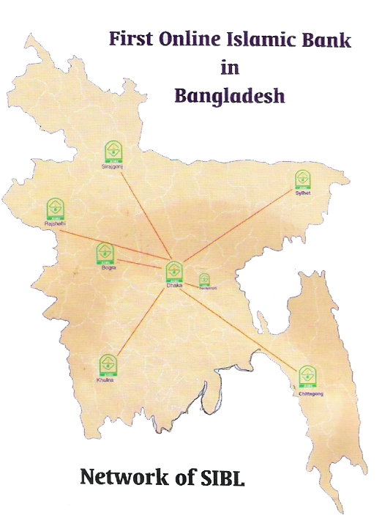
Branch Network:

SL | Branch Name | Opening Date | Branch Code
01 | Principal Branch | 22-11-1995 | 02
02 | Agrabad Branch | 10-041996 | 03
03 | Khulna Branch | 20-06-1996 | 04
04 | Sylhet Branch | 27-06-1996 | 05
05 | Rajshahi Branch | 10-08-1996 | 06
06 | Gulshan Branch | 22-04-1998 | 07
07 | Babu Baazar Branch | 26-04-1998 | 08
08 | Moulvi Bazar Branch | 30-09-1998 | 09
09 | Bogura Branch | 25-10-1998 | 10
10 | Sirajgonj Branch | 26-10-1998 | 11
11 | IDB Bhaban Branch | 23-09-1999 | 12
12 | Khatungonj Branch | 12-12-1999 | 13
13 | Phanthapath Branch | 17-12-2000 | 14
14 | Chandaikona Branch | 19-12-2000 | 15
15 | Sonargaon Branch | 09-06-2001 | 16
16 | Foreign Exchange Branch | 04-02-2002 | 17
17 | Hallishahar Branch | 09-02-2002 | 18
18 | Hasnabad Branch | 17-04-2002 | 19
19 | Dhanmondi Branch | 14-05-2002 | 20
20 | Nababpur Road Branch | 26-07-2003 | 21
21 | Jubilee Road Branch | 30-07-2003 | 22
22 | Uttara Branch | 07-12-2003 | 23
23 | Fatullah Branch | 23-12-2003 | 24
24 | Mirpur Branch | 29-12-2003 | 25
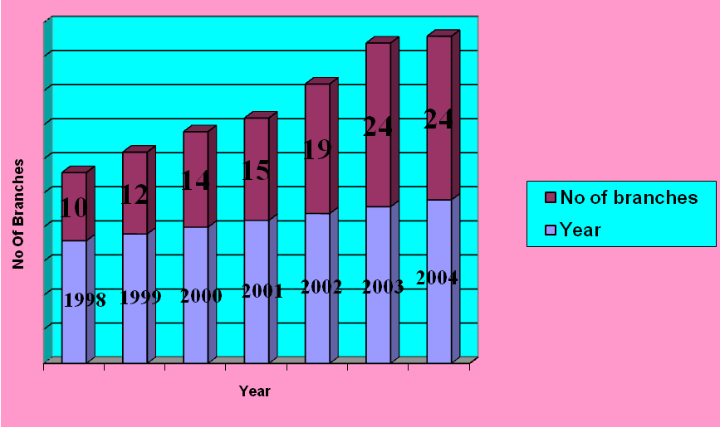

Organizational Structure of SIBL:
Board of Directors:
Board of Directors consists of twenty-one Directors, Chairman, Vice Chairman and Managing Director.

Chairman:
- Mr. Kamal Uddin Ahmed
Vice Chairman:
- Mr. Abdul Awal Patwary
- Mr. Munshi Akhtaruzzaman

Directors:
- Mr. Ahmed Akbar Sobhan
- Mr. Mohammad Shamsuzzaman
- Al-Haj Sultan Mahmood Chowdhury
- Major (Retd) Dr. Md. Rezaul Haque
- Mr. Md. Shah alam
- Al-Haj Nasiruddin
- Al-Haj Sk. Mohammad Rabban Ali
- Mr. Mohammad Azam
- Mrs. Nargis Mannan
- Mr. Anisul Haque
- Mrs. Zohara Alam
- Mr. Sadat Sobhan
- Mr. Md. Humayun Kabir Khan
- Mr. Md. Sayedur Rahman
- Al-Haj Mohammed Afzal Hossain
- Mr. Noor-A-Alam Chowdhury
- Mr. A.K.M. Imran Khan
- Mrs. Fatema Begum
- Mrs. Taslima Akhtar
- Mr. A.R.Rashidi
- Mrs. Umme Kulsum
Managing Director
Kazi Anwarul Mahbub

Hierarchy of the management of SIBL:

Chairman

↓

Managing Director

↓

Senior Executive Vice President

↓

Executive Vice President

↓

Senior Vice President

↓

Vice President

↓

Senior Asst. Vice President

↓

Asst. Vice President

↓

Senior Principal Officer

↓

Principal Officer

↓

Executive Officer

↓

Officer

↓

Junior Officer

↓

Asst. Officer

↓

Computer Operator

↓

Sub- Staff
Performance of SOCIAL INVESTMENT Bank:

In year, 2003 SOCIAL INVESTMENT Bank ltd. made commendable in all business arenas like Deposit, Credit, Fund Management, Investment and Foreign Exchange related business.
Year-wise performance analysis of SOCIAL INVESTMENT Bank in different business arenas is shown below:
Particulars | 2004  Amount (TK.) | 2003  Amount (TK.)
Paid up Capital | 585,000,000 | 260,000,000
Total Capital | 1,023,868,270 | 971,063,000
Capital surplus/(deficit) | (199,768,400) | 39,980,430
Total Asset | 21,546,955,615 | 21,193,684,475
Total Deposits | 19,704,165,978 | 19,709,314,739
Total investment | 12,887,271,564 | 10,059,109,601
Total Contingent’s Liab& Commitments | 6,013,397,076 | 4,626,201,243
Investment Client Deposit Ratio (%) | 95.74% | 82.00%
Percentage of classified loan against total loan and advances | 11.36% | 7.46%
Profit after tax and provision | 83,857,707 | 193,675,051
Amount of classified loans during current year | 1,464,301,000 | 750,270,601
Provision kept against classified loan | 391,764,434 | 161,018,787
Provision surplus /(deficit) | (302,879,566) | 23,237,787
Cost of Fund (Excluding Overhead Cost) | 7.71% | 7.86%
Profit earning Assets | 19,142,666,230 | 20,169,343,283
Non -Profit earning Assets | 2,404,289,385 | 1,024,341,192
Return on Investment(ROI) | 14.00% | 13.50%
Return on Assets (ROA) | 0.71% | 1.83%
Incomes from Investment(ICB Share) | 8,624 | 8316
Earning per Shares | 143 | 331
Net income per Share | 143 | 331
Price Earning Ratio-Times | 26 | 7

Information and Communication Technology:
ICT has an important and great bearing over the policies and procedures of an organization towards management of bulk amount of data, facts and figures, MIS and information processing as well. It has just been introducing some new means of developed operating system in day-to-day operation of an organization especially of a Bank. To keep track on recent development of ICT and adjustment thereon could enable a Bank to use the ICT in an efficient way. SIBL is also not behind of using ICT like other contemporary Banks. Introduction of Islamic Banking Version Integrated Pc BANK 2000 software at SIBL enables to provide better service to our valued clients. We facilitate our customers Online Banking Facilities through intranet using V-SAT and Radio Link Connectivity. Out of 24 Branches, we have already brought 20 Branches under the network and within 2005we would be able to bring rest of the 4 branches under online. Moreover, using of SWIFT at 9 nos. of our AD branches has added something new and improved means of overseas communication system. To expand the area of services towards the customers, SIBL has joined the ATM network under the management contract of M/S Electronic Transaction Limited (ETN).There are 20 ATM booths situated at metropolitan city of Dhaka, Chittagong & Sylhet and the customers are able to enjoy 24 hours remote banking facilities through using of SIBL ATM Debit Card. Above all, Management of SIBL is very keen to facilitate its customers IT based banking services like Remote banking facilities , EFT(Electronic Fund Transfer) Service i,e, SMS Banking, Phone banking etc., and considering the present and upcoming setup of IT, we have established a separate ICT Department staffed with some experienced computer professionals, who are directly responsible for the overall management of ICT within the bank and to explore the ideas of future innovation.

Following are the important historical events of this unique model Bank:

February 02, 1989: The concept and three-sector model of Social Investment Bank Limited was formally presented and discussed with his Excellency Late. Prof. Dr. Ahmed Al-Nagger as well as Prof. Dr. A. Wadoed Shalaby of Al-Azhar University, Cairo.

April 21, 1989: The concept of this Bank was presented and then a series of discussions took place with His Excellency Dr. Abdullah Omar Nassseef of Saudi Arabia, Vice Chairman, Majlish e- Shura, the Kingdom of Saudi Arabia, former President of the King Abdul Aziz University and Secretary General of the World Muslim League.

July 04, 1989: This model of Banking was presented and then a serious of discussions took place with His Excellency Dr. Hamid Al- Gabid, Secretary General of the Organization of Islamic Conference(OIC) of 53 Muslim Countries.

July 27, 1989: Memorandum (85) on this Bank was formal submitted to the Prime Minister of the Government of the People’s Republic of Bangladesh.

August01,1989: Formal memorandum on this Bank was formal submitted to the Hon’ble President of the People’s Republic of Bangladesh.

September 24, 1989: Formal presentation of this model was before the full council of ministers at President House from about two the President in the Chair.

September 30, 1989: The proposal of this Bank was submitted to Governor, Bangladesh Bank.

December 06, 1994: The Letter of intent for establishing this Bank was issued by Bangladesh Bank.

July 05, 1995: The Memorandum and Articles of Association were duly incorporated under the Companies Act of 1994 to implement this Model of this Bank as conceived and developed by Prof. Dr. M.A. Mannan.

August21, 1995: Permission to open First Branch of the Social Investment Bank Ltd at Dhaka was given by Bangladesh Bank.

November22, 1995: After a long journey, SIBL was formally opened at 15, Dilkusha C/A, by the Hon’ble President of the People’s Republic of Bangladesh in a grand ceremony.

Authorized capital of the company is taken 1,000 million.

June 2003: The board change SIBL concept. Old was “A Three sector Unique Model Joint Venture Bank” & present concept is “A Joint Venture Islamic Bank”

Management of SOCIAL INVESTMENT Bank:

For any financial and non-financial organization, Management is the most valuable and important resources of any kind of organization. And, a well-organize management provides the organization to reach its ultimate goal. Management means planning, organizing, staffing, directing and controlling of all financial and non-financial resources of an organization. Different aspects of management practice in SOCIAL INVESTMENT Bank are discussed below.

- Planning:

SOCIAL INVESTMENT Bank has done its planning within the purview of the corporate plan. The overall planning approach in SOCIAL INVESTMENT Bank is top-down. Each branch can plan according to the goal imposed by the corporate level. It doesn’t plan independently. And, SOCIAL INVESTMENT Bank has a planning division. This department is mainly responsible for the overall planning.

- Organizing:

Social Investment Bank is organizing as per the existing business locations. It has nineteen branches, each of which is a separate entity. Each unit is responsible for its own performance and a Senior Vice President (SVP) followed by Manager heads each. He is directly responsible for the performance of their unit. Within each branch, it is organized functionally.

- Staffing:

The recruitment in Social Investment Bank is doing in two ways. One as a “Probationary Officer” for the management program and it has a probation period of one year. Another one is non- management level as “Trainee Officers”. Probationary Officer is recruited in officer category and their career path is headed towards different managerial jobs.

- Directing and controlling:

The management approach in Social Investment Bank is top-down or authoritative. Information just seeks through lower management layer. Works are designed in such a way that one cannot leave without clearing the tasks as he is assigned for a day. Sitting arrangement in all office is done in a way that the superior can monitor the subordinate all time. Budgeting, rewarding, punishing, etc. are also practiced as control mechanism.

- Risk Management :
SIBL is much concerned about the business risk and its proper management so that the risk and return could be optimized. Now –a-days, in the very complex and unstable finance market; regular tracking on undiversifiable risk and in-depth analysis on diversifiable risk a is must especially in the banking sector. Bangladesh Bank has undertaken a project to install Core Risk Management System in every Bank to defeat the risk factors that seriously affect return and accordingly SIBL has already taken some initiative as a part of its integrated Core Risk Management system around the Bank at its both operational and Managerial Level and many other steps are underway to be considered for adoption. Our ‘’ Management Committee’’, ‘’assets Liability Committee’’ and ‘’Anti-Money Laundering Committee’’ ensure that the senior management shall pay special attention to many qualified issues of the bank, which shall ultimately reduce our risk to an acceptable level. Besides that, prudent control over bank’s assets and asset monitoring system on regular interval,, Maturity grouping analysis of assets and liabilities, limiting of Investment exposure and clients, Internal audit Department, Board Audit Cell and above all, regular holding of Board Meeting etc. shall enable us to plan for an effective Risk Management inside the Bank.

Human Resources Practices in SOCIAL INVESTMENT Bank:

Employees are the core resources of any organization. Without them, one cannot run their organization. And, human resources approach is concerned with the growth and development of people toward higher level of competency, creativity and fulfillment. It helps employees become better, more responsible persons, and then it tries to create a climate in which they may contribute to the limits of their improved abilities. It assumes that expanded capabilities and opportunities for people will lead directly to improvements in operating effectiveness. Essentially, the human resources approach means that better people achieve better results.

Recruitment:

The set-vice rule of SOCIAL INVESTMENT Bank states the recruitment policy of the bank. In, general the board of directors determines the recruitment policy of the bank from time to time. The minimum entry-level qualification for any official position other than supportive management is a Bachelors degree. However, informally the management prefers a minimum master’s degree for the appointed of probationary officers in the Executive Officer position. The recruitment for entry-level positions begins with a formal written test, which is conducted and supervised by the Institute of Business Administration, University of Dhaka. After successful completion of the written test, a personal interview is conducted for the successful candidates by a panel of experts comprising of renowned bureaucrats and prominent bankers of the country.

HUMAN RESOURCE DEVELOPMENT:

The total number of employees of the Bank stood at 651 as on 31 December 2004 as against 597 as on 31 December 2003. The manpower positions of last 7 years are given below:

Category | 1998 | 1999 | 2000 | 2001 | 2002 | 2003 | 2004
Officer | 164 | 215 | 230 | 309 | 427 | 535 | 581
Staff | 43 | 43 | 43 | 47 | 45 | 62 | 70
Total | 207 | 258 | 273 | 356 | 472 | 597 | 651

Our Training Institute had undertaken various training programs, workshops/seminars during 2004 for developing the skill, Skill, efficiency, knowledge and competence. Besides a considerable number of employees of the Bank were sent to attend various training, workshop and seminars both at home and abroad.

SOCIAL INVESTMENT Bank at a Glance:

Name: Social Investment Bank Limited
Essence: Working Together for a Caring Society

Nature of Business: Banking service and Profit oriented

Registered office: 15, Dilkusha Commercial Area,

Dhaka-1000, Bangladesh.
Phone # 9559014,9565647,9568275,9557499,

Telex: 671557-8 SIBL BJ,

Fax: 880-2-9568098, 9564944
E-mail: sibl@bdonline.com

Web Site: www.siblbd.com

Date of Incorporate: 22 November 1995
Inauguration of first branch: 22 November 1995

Chairman: Dr. M.A. Mannan
Secretary: Md. Azizul Haque
Managing Director: Md. Monowar Hossain
Number of Branch: 24
Total Manpower: 651

Authorized Capital: Taka 1000 million (Up to December 2004)

Paid up Capital: Taka 585.00 million (Up to December 2004)

Social Investment Bank at a Glance:

SL  No. | Particulars | 1998 | 1999 | 2000 | 2001 | 2002 | 2003 | 2004
01. | Authorized Capital | 1000.00 | 1000.00 | 1000.00 | 1000.00 | 1000.00 | 1000.00 | 1000.00
02. | Paid-up Capital | 126.00 | 200.00 | 260.00 | 260.00 | 260.00 | 260.00 | 585.00
03. | Total Shareholders Equity | 155.75 | 216.75 | 291.91 | 487.05 | 696.42 | 891.01 | 915.50
04. | Capital Base (Tier 1& 2) | 162.26 | 241.81 | 331.01 | 531.78 | 756.03 | 971.06 | 1023.86
05. | Total Deposits | 2068.85 | 3899.72 | 4863.21 | 10569.67 | 15141.34 | 19709.31 | 19704.20
06. | Clint Deposits | 731.10 | 1959.20 | 2173.60 | 4079.98 | 7986.31 | 12263.87 | 1346.07
07. | Investments (Customers) | 1171.40 | 2192.03 | 3522.25 | 5499.25 | 7504.03 | 10059.11 | 12887.27
08. | Investments (Shares&Security) | 0.06 | 0.06 | 0.06 | 0.06 | 0.06 | 0.06 | 0.06
09. | Foreign Exchange Business | 1442.25 | 1914.10 | 3547.40 | 6195.30 | 13520.07 | 19065.10 | 18088.12
10. | Income | 185.22 | 452.99 | 511.11 | 915.29 | 2294.58 | 3232.89 | 3273.14
11. | Expenditure | 134.72 | 378.98 | 405.40 | 613.29 | 1874.56 | 2732.35 | 2858.14
12. | Operating Profit | 50.50 | 74.01 | 105.71 | 302.00 | 420.02 | 500.54 | 414.99
.13. | Profit before Tax | 39.25 | 61.65 | 58.71 | 256.96 | 368.52 | 388.04 | 152.47
14. | Fixed Assets | 27.44 | 39.18 | 65.35 | 72.97 | 92.34 | 119.68 | 138.80
15. | Total Assets | 2239.12 | 4217.16 | 5672.00 | 11300.22 | 16223.56 | 21193.68 | 21546.96
16. | Dividend Cash  Dividend Stock | --- | 10% | --- | 20%  5:B1 | 0  4:B1 | 0  2:B1 | 0  10:B1
17. | Investments as a% of Total deposits | 56.62% | 56.21% | 72.43% | 52.00% | 49.56% | 51.04% | 65.40%
18. | Investments as a% of Clint deposits | 160.22% | 118.88% | 162.05% | 134.79% | 93.96% | 82.00% | 95.74%
19. | Risk Weighted capital adequacy Ratio | 11.69% | 9.41% | 8% | 9.79% | 9.86% | 9.39% | 7.53%
20. | Ratio of Classified investments to Total Investment | 0.68% | 1.99% | 4.92% | 5.11% | 4.39% | 7.46% | 11.36%
21. | Number of  Foreign Correspondents | 48 | 55 | 60 | 90 | 2325 | 3575 | 3575
22.. | Number of  Employees | 207 | 258 | 273 | 356 | 472 | 597 | 651
23. | Number of Branch | 10 | 12 | 14 | 15 | 19 | 24 | 24
24. | Face Value per Share (Taka) | 1000 | 1000 | 1000 | 1000 | 1000 | 1000 | 1000
25. | Earning per share (Taka) | 235 | 185 | 147 | 555 | 783 | 331 | 143
Share Range of Social Investment Bank:

Share holding | Range | Folio | Share | Percentage
1 | 10 | 94 | 620 | 0.11%
11 | 50 | 280 | 5805 | 0.99%
51 | 100 | 63 | 15340 | 0.47%
101 | 500 | 63 | 15340 | 2.62%
501 | 1000 | 16 | 13480 | 2.30%
1001 | 5000 | 33 | 68621 | 11.73%
5001 | 1000 | 21 | 152806 | 26.12%
10001 | 20000 | 12 | 158990 | 27.18%
20001 | 50000 | 4 | 116131 | 19.85%
50001 | 9999999 | 1 | 50445 | 8.62%
 | Total | 563 | 585000 | 100.00%

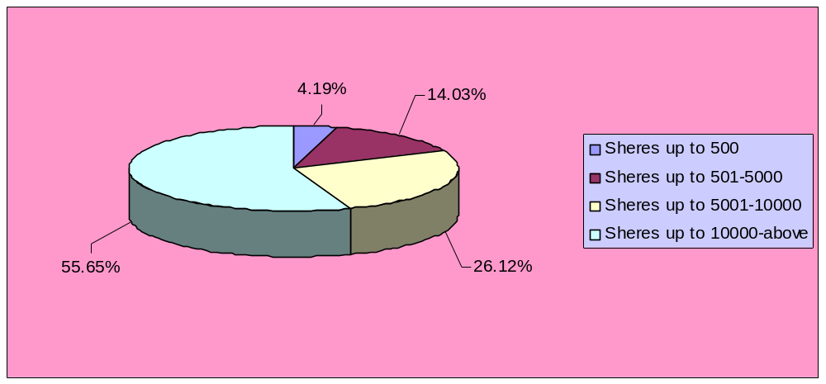

Foreign Exchange Branch:

Foreign Exchange Branch of SOCIAL INVESTMENT Bank is b opened in Feb04, 2002. It is situated at BIWTA Bhaban 141-143 Motijheel C/A, Dhaka. The name of the present branch Manager is Mr. Jalal Uddin Ahmed (SVP).
►Organ gram of Foreign Exchange Branch:

Foreign Exchange Branch

General
Banking
Advance
Foreign
Exchange
Import
Export
Foreign Remittance
Deposit:
Every body knows that the deposit is the lifeblood of a Bank. From the very beginning, Social investment Bank Foreign Exchange Branch is aware about deposit build-up. Though Foreign Exchange is not basically a deposit-oriented area, the branch is trying to do better day by day. At now, the deposit of the branch is around 13,460.73 million on 2004.

Deposit under different Schemes:
Nature of Deposits Under Different Schemes
As on December 31, 2005
Schemes | Amount (BDT)
Mudaraba Education Savings Scheme | 269,413.99
Mudaraba Pension Savings Scheme | 14,002,32.74
Mudaraba Monthly Savings Deposit Scheme | 1,140,604.41
Mudaraba Monthly Profit Deposit Scheme | 112,750,090.00
Mudaraba Hajj/Umra Savings Scheme | 89,577.84
Mudaraba Bashastan Savings Scheme | 1,833,740.07
Mudaraba Millionaire Scheme | 473,432.36

Number of Accounts:

Number of accounts in Foreign Exchange Branch as on December 31, 2005 is as follows:

Application | Total Account
Al- Wadiah current Deposit | 515
Mudaraba Savings Deposit | 2,638
Mudaraba Staff | 46
Mudaraba Short Notice Deposit | 43
First Home Owners Scheme | 01
Bai-Muazzal Trust Receipt | 04
Bai-Muazzal Commercial | 63
Hire Purchase-House Hold | 01
Hire Purchase(pre-shipment) | 08
Hire Purchase-Transport | 03
Hire Purchase-Commercial | 05
Murabaha-Commercial | 04
Quard Against Mtdr | 07
Quard Others | 04
Murabaha (Post Import) | 22
Inland Bill Purchase | 15
Bai-Muajjal (Com) Micro-Enter | 02
NF Baim (Com) SMES | 01
Mudaraba Term Deposit up to 1 month | 24
Mudaraba Term Deposit up to 3 months | 116
Mudaraba Term Deposit 6 months | 54
Mudaraba Term Deposit 1 year | 175
Mudaraba Term Deposit 2 years | 20
Mudaraba Term Deposit 3years &above | 11
Millionaire Scheme-15 Years | 05
Millionaire Scheme-20 Years | 04
Millionaire Scheme-25 Years | 09
Education Savings Scheme-7 Years | 03
Education Savings Scheme-10 Years | 01
Education Savings Scheme-15 Years | 01
Education Savings Scheme-20 Years | 03
Mudaraba Pension Scheme-5 years | 262
Mudaraba Pension Scheme-10 years | 470
Term Saving Scheme-5 Years | 14
Term Saving Scheme-8 Years | 05
Term Saving Scheme-10 Years | 13
Term Saving Scheme-12 Years | 23
MMPD | 184
Hajj Deposit | 04
Cash Waqit | 23
Mudaraba Bashastan Saving Scheme | 57
Total | 4,883
Loans And Advances:

The officials of the Branch are trying their best to follow the Head Office instruction. But the Branch believes in good investment not volume of investment. The branch continues to explore and diversify the area of financing in addition to traditional financing of domestic and international trade. It financed a number of industrial projects and participated in industrial loans.

Nature of Loan/Advances of Foreign Exchange Branch
As on 31 December 2005.
Nature of Advances | Amount (BDT)
Loan (General) | 10,000,000.00
MPI | 110,000,000.00
TR | 660,000,000.00
PC | 13,482,657.00
House Building Loan | 1,600,000.00
Lease Finance | 1,310,388.00
HPS | 9,800,000.00
HPS(Car) | 2,500000.00
CC Hypo | 8,000,000.00
Staff Loan | 1,600,000.00
LDBP | 7,285,392.18
FDBP | 41,038,019.00

Foreign Exchange Business as on 2004:

- Import Department:
No. of L/C | Total Amount
127 | Tk.88,93,45,00

- Export Department:

a) Import position (Back to Back) L/C:
Type | No. of L/C | Amount(BDT)
BTB(foreign) | 06 | 4,289,299.00
BTB(local) | 196 | 171,646,970.00
Total | 202 | 175,936,269.00

b) Export position:

Category | No of Export  Documents | Amount(BDT)
FDBC | 143 | 184,077,261.00
FDBP | 20 | 41,038,019.00
LDBC | 04 | 293,517.00
Total | 167 | 225,408,797.00

- Foreign remittance:

Position of Foreign Exchange Branch as on 30.06.2005:

In ward | $76,363.04

General Banking

General banking department is the heart of all banking activities. This is the busiest and important department of a branch, because funds are mobilized, cash transactions are made; clearing, remittance and accounting activities are done here.
Since bank is confined to provide the services everyday, general banking is also known as ‘retail banking’. In SOCIAL INVESTMENT Bank LTD Principal Branch, the following departments are under general banking section:

- Account opening section
- Deposit section
- Cash section
- Remittance section
- Clearing section
- Accounts section

ACCOUNT OPENING SECTION:

Account opening is the gateway for clients to enter into business with bank. It is the foundation of banker customer relationship. This is one of the most important sections of a branch, because by opening accounts bank mobilizes funds for investment. Various rules and regulations are maintained and various documents are taken while opening an account. A customer can open different types of accounts through this department. Such as:

1. Al –Wadia (Current) account.
2. Mudaraba Savings (SB) account.
3. Mudaraba Short Term Deposit (MSTD)

Types of Accounts with Terms and Conditions

Al- Wadia (Current) Account:

Current account is purely a demand deposit account. There is no restriction on withdrawing money from the account. It is basically justified when funds are to be collected and money is to be paid at frequent interval.
Some Important Points are as follows-

- Minimum opening deposit of TK.1000/- is required;
- There is no withdrawal limit.
- No interest is given upon the deposited money;
- Minimum Tk.1000/= balance must always maintain all the time;

Mudaraba Savings (SB) Account:

This deposit is primarily for small-scale savers. Hence, there is a restriction on withdrawals in a month. Heavy withdrawals are permitted only against prior notice. Some Important Points are as follows-

- Minimum opening deposit of Tk.500/= is required;
- Minimum Tk. 1000/= balance must always maintain all the time;
- Withdrawal amount should not be more than 1/4th of the total balance at a time and limit twice in a month.
- If withdrawal amount exceed 1/4th of the total balance at a time no interest is given upon the deposited money for that month.

Mudaraba Short Term Deposit (MSTD) Account:

Normally various big companies, organizations, Government Departments keep money in MSTD account. Frequent withdrawal is discouraged and requires prior notice. The deposit should be kept for at least seven days to get interest. The interest offered for MSTD is less than that of savings deposit. Interest is calculated based on daily minimum product and paid two times in a year. Interest rate is 6.85%

Account Opening procedure:

Step 1 | The account should be properly introduced by Any one of the following:  - An existing Current Account holder of the Bank.  - Officials of the Bank not below the rank of an Assistant officer.  - A respectable person of the locality well known to the Manager/Sub-Manager of the Branch concerned.
Step 2 | Receiving filled up application in bank’s prescribed form mentioning what type of account is desired to be opened
Step 3 | - The form is filled up by the applicant himself / herself  - Two copies of passport size photographs from individual are taken, in case of firms photographs of all partners are taken  - Applicants must submit required documents  - Application must sign specimen signature sheet and give mandate  - Introducer’s signature and accounts number – verified by legal officer
Step 4 | Authorized Officer accepts the application
Step 5 | Minimum balance is deposited – only cash is accepted
Step 6 | Account is opened and a Cheque book and pay-in-slip book is given
Documents required for opening account

□ Individual / Joint Account:

- Introduction of the account.
- Two photographs of the signatories duly attested by the introducer.
- Identity (copy of passport).
- Joint Declaration Form (For joint a/c only).
- Employee’s Certificate (in case of service holder).

□ Partnership account:

- Introduction of the account.
- Two photographs of the signatories duly attested by the introducer.
- Partnership letter duly signed by all partners (Sign should be similar as stated in Partnership Deed).
- Partnership Deed duly certified by Notary public.
- Registration (If any).
- Updated Trade license.

□ Proprietorship account:

- Introduction of the account.
- Two photographs of the signatories duly attested by the introducer.
- Valid copy of Trade License.
- Rubber stamp.
- TIN number certificate.
- Identity (Copy of passport).
- Permission letter from DC/ Magistrate (in case of newspaper)

□ Limited company:

- Introduction of the account.
- Two photographs of the signatories duly attested by the Introducer.
- Valid copy of Trade License.
- Board resolution of opening A/C duly certified by the Chairman/Managing Director.
- Certificate of Incorporation.
- Certificate of Commencement (In case of Public limited company).
- Certified (joint stock) true copy of the Memorandum and Article of Association of the Company duly attested by Chairman or Managing Director.
- List of directors along with designation & specimen signature.
- Latest certified copy of Form – xii (to be certified by register of joint stock companies) (In case of Directorship change).
- Rubber Stamp (Seal with designation of each person)
- Certificate of registration (In case of Insurance Company – Obtained from department of Insurance from the Peoples Republic of BD).
□ Club / societies account:

- Introduction of the account.
- Two photographs of the Signatories duly attested by the introducer.
- Board Resolution for Opening A/C duly certified by President/ Secretary.
- List of Existing Managing Committee.
- Registration (if any).
- Rubber Stamp.
- Permission letter from Bureau of N.G.O.(In case of N.G.O. A/C).

Savings Scheme:
- Mudaraba Education Savings Scheme
- Mudaraba Monthly Savings Scheme
- Mudaraba Monthly Profit Scheme
- Mudaraba Special Saving (Pension) Scheme
- Mudaraba Bashastan Saving Scheme
- Mudaraba Millionare Scheme
Foreign Exchange:
- Import
- Export
- Foreign Remittance
Finance/Loans:
- Corporate Finance
- Industrial Finance
- Lease Finance
- Hire Purchase Finance
- Commercial Loans
- Project Finance
- Syndicate Loans
- Retail Loans
- Mortgage Loans
- Loan against Share and Securities

Briefly Discussion about Different Savings Scheme of Social Investment Bank:

4.1 Mudaraba Education Savings Scheme
Social Investment Bank offers “Education Savings Scheme” to support customer in financial planning in time for customer children’s higher education.
Terms and conditions of the scheme
- Deposit of Tk. 25,000.
- The instrument shall be issued for 7 years, 10years, 15 years or 20 years term.
- The deposit is payable at maturity with benefit either in lump sum or on monthly basis as education allowance for 6 (six) years starting after the completion of respective term. (See example table).
- Normally, no withdrawal will be allowed before maturity. But, if any depositor intends to withdraw his deposit before maturity, the following rules will be applicable:
  - If withdrawal is made before seven years, interest will be calculated and paid as per prevailing savings rate.
  - If withdrawal is made at any time after seven years, the total amount payable at maturity of the immediate preceding term will be paid along with interest for the fraction period at prevailing saving rate.
- The depositor can avail loan up to 80 % under this scheme.

  - In case of death of the depositor, the proceeds will be paid to the nominee of the depositor or in absence of nomination to the legal successor/s of the depositor on production of Succession Certificate.
  - If, after death of depositor the nominee intends to continue the deposit to get monthly educational allowance for years as admissible under the rules of the scheme.
- In case of issuing a duplicate deposit receipt the rules of issuing duplicate receipt of Term Deposit will be applicable.
Example Table:
Terms | Initial Deposit (Tk.) | Amount Payable at maturity (Tk.) | Education allowance per month (Tk.)
7 yrs. | 25,000/- | 55,000/- | 1,000/-
10 yrs. | 25,000/- | 77,000/- | 1,500/-
15 yrs. | 25,000/- | 1,36,000/- | 2,500/-
20 yrs. | 25,000/- | 2,40,000/- | 4,500/-

For Islamic Banking, payable amounts will be treat as estimated and at the year-end may be more or less.

4.2 Mudaraba Monthly Saving Scheme
Savings period and monthly installment rate
The savings period is for 5, 8, 10 or 12 years. Monthly installment rate is Tk. 200/-, 300/-, 500/- or 2,000/-
Monthly installment deposit
- The savings amount is to be deposited within the 10th of every month. In case of holidays the deposit amount is to be made on the following day.
- The deposits may also be made in advance.
- The depositor can have a separate account in the bank from which a standing instruction can be given to transfer the monthly deposit in the scheme’s account.
- In case the depositor fails to make the monthly installment in time, then 5% on overdue installment amount will be charged. The charge will be added with the following month(s) installment and the lowest charge will be Tk. 10/-
Withdrawal
- Generally, withdrawal is not advised before a 5-year term, but if it is withdrawn before the above term, then interest will be paid at savings rate. However, no interest will be paid if the deposit is withdrawn within 1 year of opening the account.
- In case the depositor wishes to withdraw between the 5, 8, 10 or 12-year period then full interest will be paid for a completed term and savings rate will applicable for the fractional period.
Loan Advantage
After three years of savings in this scheme, the depositor (if an adult) is eligible for a loan up to 80% of his deposited amount. In that case, interest rates on the loan will be applicable as per prevailing rate at that time.
Reasons for disqualification from this scheme
- If the depositor fails to pay 3 installments in a row, then he will be disqualified from this scheme and interest will be applicable as mentioned in withdrawal clause.
- If a depositor fails to pay 5 installments in a row after completion of 5-year term, then the Bank reserves the right to close the account and interest will be paid as, mentioned in withdrawal clause.
- In case of death of the depositor, the scheme will cease to function. The amount will be handed over to the nominee of the deceased depositor. In case of absence of the nominee the bank will handover the accumulated amount to the successor of the deceased.
Terms | Monthly Installment
Terms | 200/- | 300/- | 500/- | 2,000/-
Terms | Amount Payable at the Maturity | Amount Payable at the Maturity | Amount Payable at the Maturity | Amount Payable at the Maturity
5 Years | 16,000.00 | 24,0000.00 | 40,000.00 | 1,60,000.00
8 Years | 30,000.00 | 45,000.00 | 75,000.00 | 3,00,000.00
10 Years | 42,000.00 | 63,000.00 | 1,05,000.00 | 4,20,000.00
12 Years | 54,000.00 | 81,000.00 | 1,35,000.00 | 5,40,000.00

Rules
  - A form has to be filled at the time of opening the account. No introduction is need but attested photographs are advised.
  - The depositor can select any of the installment amounts, which cannot be subsequently changed.
  - In case of minors, the guardians may open and supervise the account in his favor.
  - A single person can open more than one account for saving under several installment rates.
  - The accumulated deposit with interest will be returned within one month of completion of a term.
  - The depositor should notify the bank immediately on any change of address.
  - The government tax will be deducted from the interest accumulated in this scheme.
  - If necessary, at the request of the depositor, the scheme can be transferred to a different branch of the same Bank.
The Bank reserves the right to change the rules and regulations of the scheme as and when deemed necessary.

4.3 Mudaraba Monthly Profit Scheme
.
Highlights of the Scheme
- Minimum deposit Tk. 50,000/-
- Higher monthly income for higher deposit.
- The scheme is for a 3-year period.

Monthly income will be credited to the depositor’s account on the 5th of each month.

Deposit Amount | Income
50,000.00 | 500.00
1,00,000.00 | 1,000.00
1,50,000.00 | 1,500.00
2,00,000.00 | 2,000.00
2,50,000.00 | 2,500.00
3,00,000.00 | 3,000.00
Objectives of the Scheme
- An account is to be opened by filling up a form.
- The Bank will provide to the customer a deposit receipt after opening the account. This receipt is non-transferable.
- If the deposit is withdrawn before a 5-year term, then saving interest rate will be applicable and paid to the depositor. However, no interest will be paid if the deposit is withdrawn within 1 year of opening the account and Monthly Income paid to the customer will be adjusted from the principal amount.
A depositor can avail loan upto 80% of the deposit amount under this scheme. In this case, interest will be charged against the loan as per Bank’s prevailing rate.

4.4 Mudaraba Special Saving (Pension) Scheme

Considering increasing demands from the clients of the bank as form the people of the all walks of the country for special and attractive savings scheme on the basic of the Islamic Shariah so as to enable and encourage them to save as per their capacity in Islamic way for their old age when they will normally retire from their active economic life, Social investment Bank Limited has introduced “Mudaraba Special savings (pension) Scheme” in which a person gets the opportunity to build-up savings contribution small monthly installments for getting an attractive amount at the end of a specified term or a monthly amount for a specific period after the expiry of the term.

Monthly Deposit | Amount Payable after the Maturity(TK)
Monthly Deposit | 5 Years | 10 Years
100.00  200.00  300.00  400.00  500.00  1,000.00 | 8,000.00  16,000.00  24,000.00  32,000.00  40,000.00  80,000.00 | 22,500.00  45,000.00  67,000.00  90,000.00  1,12,500.00  2,25,000.00

4.5 Mudubara Bashastan Saving Scheme

Considering increasing demands from the clients of the bank as from the people of the all walks of the country for special and attractive savings scheme on the basic of the Islamic Shariah so as to enable and encourage them to save as per their capacity in Islamic way for their old age when they will normally retire from their active economic life, Social Investment Bank Ltd has introduced “Mudaraba Bashastan Saving Scheme” in which this scheme gets the opportunity to build-up shelter by contribution small monthly installments for getting an attractive amount at the end of a specified term or a monthly amount for a specific period after the expiry of the term.

Under this scheme account may be open for monthly deposit of, TK. 500/-,TK.1000/-, TK. 1500/-, TK. 2000/-.After 15 year he will get total amount of TK. 2,60,000/-, TK. 5,20,000/-, TK. 7,80,000/-, &10,40,000/-.

4.6 Mudaraba Millinery Deposit Scheme
Social Investment Bank Limited 1 mind has launched a new, deposit product under the name and style “Mudaraba Millinery Deposit Scheme” in accordance with the principle of Islamic Sharia.

Terms | Monthly Deposit | Amount Payable after the Maturity (TK.)
15 Years | 2,050.00 | 10,00,000.00
20 Years | 1,050.00 | 10,00,000.00
25 Years | 550.00 | 10,00,000.00

DEPOSIT SECTION:

Deposit is the lifeblood of a bank. From the history and origin of the banking system
We know that deposit collection is the main function of a bank.

Accepting deposits:

The deposits that are accepted by SOCIAL INVESTMENT Bank like other banks may be classified in to,—

a) Demand Deposits
b) Time Deposits

Demand deposits:

These deposits are withdraw able without notice, e.g. current deposits. SOCIAL INVESTMENT Bank accepts demand deposits through the opening of,-

a) current account
b) Savings account
c) Call deposits from the fellow bankers

Time deposits:

A deposit which is payable at a fixed date or after a period of notice is a time deposit. SOCIAL INVESTMENT Bank accepts time deposits through Fixed Deposit Receipt (FDR), Short Term Deposit (STD) and Bearer Certificate Deposit (BCD) etc.
While accepting these deposits, a contract is done between the bank and the customer. When the banker opens an account in the name of a customer, there arises a contract between the two. This contract will be valid one only when both the parties are competent to enter into contracts. As account opening initiates the fundamental relationship & since the banker has to deal with different kinds of persons with different legal status, SOCIAL INVESTMENT Bank officials remain very much careful about the competency of the customers.

Profit Paid To Depositor:

The Bank has distributed TK.1372.08 million among the Mudaraba Depositors as profit in 2004 as against TK.1288.08 million in 2003. Profit to the depositors for the year 2004 has been paid at the following rates:

SL No | Mode of Deposits | Profit rate  For 2004 | Profit rate  For 2003
1. | Mudaraba Term Deposits:  - 36 Months  - 24 Months  - 12 Months  - 06 Months  - 03 Months | 9.50  9.30  9.20  8.85  8.50 | 10.55  10.35  10.25  9.80  9.40
2. | Mudaraba Savings A/C :( MSD) | 6.85 | 7.55
3. | Mudaraba Notice Deposit A/C: | 5.60 | 6.25
4. | Mudaraba Scheme Deposit:  - Mudaraba Monthly Profit Deposit Scheme  - Mudaraba Millionaire savings Scheme  - Mudaraba Education Deposit Scheme  - Mudaraba Special Deposit Pension scheme (10years)  - Mudaraba Special Deposit Pension scheme (5years)  - Mudaraba Monthly Saving Scheme  - Mudaraba Bashsthan Saving Scheme  - Mudaraba Hajj Savings Deposit  - Cash Waqf | 10.80  10.55  10.55  10.25  10.00  10.00  10.80  9.50  9.50 | 12.00  11.75  11.75  11.35  11.05  11.05  12.00  10.55  10.55

CASH SECTION:

Banks, as a financial institution, accept surplus money from the people as deposit and give them opportunity to withdraw the same by cheque, etc. But among the banking activities, cash department play an important role. It does the main function of a commercial bank i.e. receiving the deposit and paying the cash on demand. As this department deals directly with the customers, the reputation of the bank depends much on it. The functions of a cash department are described bellow:

Functions of Cash Department:

Cash Payment | - Cash payment is made only against cheque  - This is the unique function of the banking system which is known as “payment on demand”  - It makes payment only against its printed valid Cheque
Cash Receipt | - It receives deposits from the depositors in form of cash  - So it is the “mobilization unit” of the banking system  - It collects money only its receipts forms

□ Cash packing:

After the banking, hour cash is packed according to the denomination. Notes are counted and packed in bundles and stamped with initial.

□ Allocation of currency:
Before starting the banking hour all tellers, give requisition of money through “Teller cash proof sheet”. The head teller writes the number of the packet denomination wise in “Reserve sheet” at the end of the day, all the notes remained are recorded in the sheet.

LOCAL REMITTANCE:

Carrying cash money is troublesome and risky. That’s why money can be transferred from one place to another through banking channel. This is called remittance. Remittances of funds are one of the most important aspects of the Commercial Banks in rendering services to its customers.

Types of remittance:

- Between banks and non banks customer
- Between banks in the same country
- Between banks in the different centers.
- Between banks and central bank in the same country
- Between central bank of different customers.

The main instruments used by the SOCIAL INVESTMENT Bank of remittance of funds are

- Payment order ( PO)
- Demand Draft ( DD)
- Telegraphic Transfer (TT)

So the basic three types of local remittances are discussed below

Points | Pay Order | Demand Draft | TT
Explanation | Pay Order gives the payee the right to claim payment from the issuing bank | Demand Draft is an order of issuing bank on another branch of the same bank to pay specified sum of money to payee on demand. | Issuing branch requests another branch to pay specified money to the specific payee on demand by Telegraph /Telephone
Payment from | Payment from issuing branch only | Payment from ordered branch | Payment from ordered branch
Generally used to Remit fund | Within the clearinghouse area of issuing branch. | Outside the clearinghouse area of issuing branch. Payee can also be the purchaser. | Anywhere in the country
Payment Process of the paying bank | Payment is made through clearing | 1.Confirm that the DD is not forged one.  2.Confirm with sent advice  3.Check the ‘Test Code’  4.Make payment | 1.Confirm issuing branch  2.Confirm Payee A/C  3.Confirm amount  4.Make payment  5.Receive advice
Charge | Only commission | Commission + telex charge | Commission +  telephone

Test – key Arrangement:

Test key arrangement is a secret code maintained by the banks for the authentication for their telex messages. It is a systematic procedure by which a test number is and the person to whom this number is given can easily authenticate the same test number by maintaining that same procedure. SOCIAL INVESTMENT Bank has test key arrangement with so many banks for the authentication of LC message and for making payment.

Commission for PO:

SOCIAL INVESTMENT Bank charges different amount of commission on the basis of Payment order amount. The bank charges for pay order are given in the following chart:

Total amount of PO | Commission | VAT
TK. 01.00 -TK.10,000.00 | TK. 10.00 | TK.2
TK. 10,001 - TK .1,00,000.00 | TK. 20.00 | TK.3
TK. 1,00,001.00 - TK. 5,00,000.00 | TK. 30.00 | TK.5
TK. 5,00,001.00-TK.10,00,000.00 | TK. 40.00 | TK.6
TK.10,00,001.00 and above | TK. 50.00 | TK.8

FIXED DEPOSIT:

The Local Remittance section of SOCIAL INVESTMENT Bank Foreign Exchange Branch also issues FDR.
They are also known as time deposit or time liabilities. These are deposits, which are made with the bank for a fixed period, specified in advance. The bank need not maintain cash reserves against these deposits and therefore, the bank offers higher of interest on such deposits.

- Opening of fixed Deposit Account: The depositor has to fill an account form where in the mentions the amount of deposit, the period for which deposit is to be made and name/names is which the fixed deposit receipt is to be issued. In case of a Joint name SOCIAL INVESTMENT Bank also takes the instructions regarding payment of money on maturity of the deposit. The banker also takes specimen signatures of the depositors. A fixed deposit account is then issued to the depositor acknowledging receipt of the sum of money mentioned there. It also contains the rate of interest and the date on which the deposit will fall due for payment.

- Term Deposits: These rates are not negotiable. In this table we can find out the percentage that is given by the bank for specific period of time to the customer.

Fixed deposit 3 (three) month

SL no. | Range of amount | Rate of Interest
01 | TK 10000.00-Above | 9.25%

Fixed deposit: 6 (six) month

SL no. | Range of amount | Rate of Interest
01 | TK 10000.00-Above | 10.00%

Fixed deposit: 12 (twelve) month

SL no. | Range of amount | Rate of Interest
01 | TK 10000.00-Above | 12.00%

- Payment of interest: It is usually paid on maturity of the fixed deposit. SOCIAL INVESTMENT Bank calculates interest at each maturity date and provision is made on that “miscellaneous creditor expenditure payable accounts” is debited for the accrued interest.

- Encashment of FDR: In case of premature FDR SOCIAL INVESTMENT Bank is not bound to accept surrender of the deposit before its maturity date. In order to deter such a tendency the interest on such a fixed deposit is made cut a certain percentage less the agreed rate. Normally savings bank deposit is allowed.

- Loss of FDR: In case of lost of FDR the customer is asked to record a GD (general diary) in the nearest police station. After that the customer has to furnish an Indemnity Bond to SOCIAL INVESTMENT Bank a duplicate FDR is then issued to the customer by the bank.

- Renewal of FDR: In SOCIAL INVESTMENT Bank, the instrument is automatically renewed within seven days after the date of its maturity if the customer does not come to encash the FDR. The period for renewal is determined as the previous one.

CLEARING SECTION:

Cheque, Pay Order (P.O), Demand Draft (D.D.) Collection of amount of other banks on behalf of its customer are a basic function of a Clearing Department.

- Clearing:
Clearing is a system by which a bank can collect customers fund from one bank to another through clearing house.

- Clearing House:

Clearing House is a place where the representatives of different banks get together to receive and deliver cheque with another banks.

Normally, Bangladesh Bank performs the Clearing House in Dhaka, Chittagong, Rajshahi, and Khulna & Bogra. Where there is no branch of Bangladesh Bank, Sonali bank arrange this function.

- Member Of Clearing House:

SOCIAL INVESTMENT Bank LTD. is a scheduled Bank. According to the Article 37(2) of Bangladesh Bank Order, 1972, the banks, which are the member of the clearinghouse, are called as Scheduled Banks. The scheduled banks clear the cheque drawn upon one another through the clearinghouse.

Types of Clearing:

- Outward Clearing: When the Branches of a Bank receive cheque from its customers drawn on the other Banks within the local clearing zone for collection through Clearing House, it is Outward Clearing.
- Inward Clearing: When the Banks receive cheque drawn on them from other Banks in the Clearing House, it is Inward Clearing.

- Types of clearing house: There are two type of clearing house: Those are

1) Normal clearing house
2) Same day clearing house

Normal clearinghouse:

- 1st house: 1st house normally stands at 10 a.m. to 11a.m
- 2nd house: 2nd house normally stands after 3 p.m. and it is known as return house.

Same day clearing house:

- 1st house: 1st house normally stands at 11 a.m. to 12 p.m
2) 2nd house: 2nd house normally stands after 2 p.m. and it is known as return house.

- Who will deposit cheque for Clearing: Only the regular customers i.e. who have Savings, Current, STD & Loan Account in the bank can deposit cheque for collection of fund through Clearing house.

- Precaution at the time of cheque receiving for Clearing, Collection of LBC, OBC & Transfer:

1) Name of the account holder same in the cheque & deposit slip.
2) Amount in The cheque & deposit slip must be same in words & in figure
3) Date in the cheque may be on or before (but not more than six months back) clearing house date.
4) Bank & Branch name of the cheque, it’s number & date in the Deposit slip.
5) Cheque must be signed.
6) Signature for confirmation of date, amount in words / in figure Cutting &
Mutilation of cheque.
7) Cheque should be crossed (not for bearer cheque).
8) Account number in the deposit slip must be clear.
9) Depositor’s signature in the deposit slip.

Return house:

Return House means 2nd house where the representatives of the Bank meet after 3 p.m. to receive and deliver dishonored cheque, which placed in the 1st Clearing House.

Cheque may be dishonored for any one of the following reasons:

- Insufficient fund.
- Amount in figure and word differs.
- Cheque out of date/ post- dated.
- Payment stopped by the drawer.
- ……….Payee’s endorsement irregular / illegible / required.
- Drawer’s signature differed / required.
- Crossed cheque to be presented through a bank.
- Other specific reasons not mentioned above.

The dishonor cheque entry in the Return Register & the party is informed about it. Party‘s signature required in the return register to deliver the dishonor cheque. After duration, the return cheque is sent to the party’s mailing address with Return Memo.

If the cheque is dishonored due to insufficiency of funds than SOCIAL INVESTMENT Bank, charges. 25/=as penalty.

Responsibility of the concerned officer for the Clearing Cheque:

- Crossing of the cheque.
- (Computer) posting of the cheque.
- Clearing seal & proper endorsement of the cheque.
- Separation of cheque from deposit slip.
- Sorting of cheque 1st bank wise and then on branch wise.
- Computer print 1st branch wise & then bank wise.
- Preparation of 1st Clearing House computer validation sheet.
- Examine computer validation sheet with the deposit slip to justify the computer posting
9) Copy of computer posting in the floppy disk.

Bills Collection:

In modern banking the mechanism has become complex as far as smooth transaction and safety is concerned. Customer does pay and receive bill from their counterpart as a result of transaction. Commercial bank’s duty is to collect bills on behalf of their customer.

Types of Bills for Collection

- Outward Bills for Collection (OBC).
- Inward Bills for Collection (IBC).

What is OBC?

OBC means Outward Bills for Collection .OBC exists with different branches of different banks outside the local clearinghouse. Normally two types of OBC:

- OBC with different branches of other banks

- OBC with different branches of the same bank

Procedure of OBC:

- Entry in the OBC register.
- Put OBC number in the cheque.
- “Crossing seal” on the left corner of the cheque & “payees account will be credited on realization “seal on the back of the cheque with signature of the concerned officer.
- Dispatch the OBC cheque with forwarding.
- Reserve the photocopy of the cheque, carbon copy of the forwarding and deposit slip of the cheque in the OBC file.

Commission for collection:

Up to 1 lac ---------------------------------------------- 0.15%
Above 1 lac---------------------------------------------- 0.10%
Above 5lac ---------------------------------------------- 0.05%

Inward bills for collection (IBC)

When the banks collect bills as an agent of the collecting branch, the system is known as IBC. In this case, the bank will work as an agent of the collection bank. The branch receives a forwarding letter and the bill.

Procedure of IBC:

- IBC against OBC: To receive the OBC cheque first we have to give entry in the IBC Register .The IBC number should put on the forwarding of the OBC with date.
- Deposit of OBC amount: OBC cheque amount is put into the “sundry deposit-sundry Creditors account”, prepare debit & credit voucher of it. If the OBC cheque is honored, send credit advice (IBCA) with signature & advice number of the concern branch for the OBC amount.
- If the OBC cheque is dishonored, the concerned branch is informed about it.
- Again, place in the clearinghouse or send the OBC cheque with Return Memo to the issuing branch according to their information.

ACCOUNTS SECTION:
Accounts Department is called as the nerve Centre of the bank. In banking business, transactions are done every day and these transactions are to be recorded properly and systematically as the banks deal with the depositors’ money. . Improper recording of transactions will lead to the mismatch in the debit side and in the credit side. To avoid these mishaps, the bank provides a separate department; whose function is to check the mistakes in passing vouchers or wrong entries or fraud or forgery. This department is called as Accounts Department. If any discrepancy arises regarding any transaction this department report to the concerned department.

Besides these, the branch has to prepare some internal statements as well as some statutory statements, which are to be submitted to the Central Bank and the Head Office. This department prepares all these statements.

Workings of this department:

- Recording the transactions in the cashbook.
- Recording the transactions in general and subsidiary ledger.
- Preparing the daily position of the branch comprising of deposit and cash.
- Preparing the daily Statement of Affairs showing all the assets and liability of the branch as per General Ledger and Subsidiary Ledger separately.
- Making payment of all the expenses of the branch.
- Recording inters branch fund transfer and providing accounting treatment in this regard.
- Preparing the monthly salary statements for the employees.
- Preparing the weekly position for the branch which is sent to the Head Office to maintain Cash Reserve Requirement (C.R.R)

- Preparing the monthly position for the branch which is sent to the Head Office to maintain Statutory Liquidity Requirement (S.L.R)
- Make charges for different types of duties
- Preparing the budget for the branch by fixing the target regarding profit and deposit so as to take necessary steps to generate and mobilize deposit.
- Checking of Transaction List
- Recording of the vouchers in the Voucher Register.
- Packing of the correct vouchers according to the debit voucher and the credit voucher

FOREIGN EXCHANGE

Foreign exchange is the means and methods by which rights to wealth in a country’s currency are converted into rights to wealth in another country’s currency. In banks when we talk of foreign exchange, we refer to the general mechanism by which a bank converts currency of one country into that of another. Foreign Exchange Department (FED) is the international department Bangladesh Bank issues license to scheduled banks to deal with foreign exchange. These banks are known as Authorized Dealers. If the branch is authorized dealer in foreign exchange market, it can remit foreign exchange from local country to foreign countries. Therefore, SOCIAL INVESTMENT Bank, Principal branch is an authorized dealer.

There are three kinds of foreign exchange transaction:

- Import
- Export
- Remittance.

IMPORT:

To import, a person should be competent to be an importer’. According to Import and Export Control Act, 1950, the Office of Chief Controller of Import and Export provides the registration (IRC) to the importer. In an international business environment, buyers and sellers are generally unknown to each other. So seller of goods always seeks security for the payment of his exported goods. Bank gives export guarantee that it will pay for the goods on behalf of the buyer if the buyer does not pay. This guarantee is called Letter of Credit. Thus, the contract between importer and exporter is given a legal shape by the banker by ‘Letter of Credit’.

Letter of Credit:

Definition:

A letter of credit is a letter issued by a bank (know as the opening or the issuing bank) at the instance of its customer (known as the opener) addressed to a person (beneficiary) undertaking that the bills drawn by the beneficiary will be duly honored by it (opening bank) provided certain conditions mentioned in the letter gave been complied with.

Parties to the L/C:

Importer | Who applies for L/C
Issuing Bank | It is the bank, which opens/issues a L/C on behalf of the importer.
Confirming Bank | It is the bank, which adds its confirmation to the credit and it, is done at the request of issuing bank. Confirming bank may or may not be advising bank.
Advising or Notifying Bank | It is the bank through which the L/C is advised to the exporters. This bank is actually situated in exporter’s country. It may also assume the role of confirming and / or negotiating bank depending upon the condition of the credit.
Negotiating Bank | It is the bank, which negotiates the bill and pays the amount of the beneficiary. The advising bank and the negotiating bank may or may not be the same. Sometimes it can also be confirming bank.
Accepting Bank | It is the bank on which the bill will be drawn (as per condition of the credit). Usually it is the issuing bank.
Reimbursing Bank | It is the bank, which would reimburse the negotiating bank after getting payment – instructions from issuing bank.

Steps for import L/C Operation – 8 steps operation:

Step 1 - Registration with CCI&E:
- For engaging in international trade, every trader must be first registered with the Chief Controller of Import and Export.
- By paying specified registration fees to the CCI&E. the trader will get IRC/ERC (Import/Export Registration Certificate), to open L/C with bank, this IRC is must.

Step 2 - Determination terms of credit:
- The terms of the letter of credit are depending upon the contract between the importer and exporter. The terms of the credit specify the amount of credit, name and address of the beneficiary and opener, tenor of the bill of exchange, period and mode of shipment and of destination, nature of credit, expiry date, name and number of sets of shipping documents etc.
Step 3 -Proposal for Opening of L/C:

To have an import LC limit an importer submits an application to department to SOCIAL INVESTMENT Bank. The proposal contains the following particulars:

- Full particulars of the bank account
- Nature of business
- Required amount of limit
- Payment terms and conditions
- Goods to be imported
- Offered security
- Repayment schedule

Step 4 - Application by importer to the banker to open letter of credit:

- For opening L/C, the importer is required to fill up a prescribed application form provided by the banker along with the following documents:

1. L/C Application form | 7. Authority to debit account
2. Filled up LCA form | 8. Filled up amendment request Form
3. Demand Promissory Note | 9. IMP form
4. pro-forma invoice | 10. Insurance cover note and money receipt.
5. Tax Identification number | 11. Membership certificate
6.Import registration certificate | 12. Rate fluctuation undertaking

Step 5 - Opening of L/C by the bank for the opener:

- Taking filled up application form from the importer.
- Collects credit report of exporter from exporter’s country through his foreign correspondence there.
- Opening bank then issues credit by air mail/TELEX/SWIFT followed by L/C advice as asked by the opener through his foreign correspondent or branch as the case may be, at the place of beneficiary. The advising bank advises the L/C to the beneficiary on his own form where it is addressed to him or merely hand over the original L/C to the beneficiary if it is so addressed.

Step 6 – Shipment of goods and lodgment of documents by exporter:

- Then exporter ships the goods to the destination of the importer country
- Sends the documents to the L/C opening bank through his negotiating bank. Generally the following documents are sent to the Opening Banker with L/C:

1. Bill of Exchange | 6. Packing List
2. Bill of Lading | 7. Advice Details of Shipment
3. Commercial Invoice | 8. Pre-shipment Inspection Certificate
4. Certification of Origin | 9. Vessel Particular
5. A certificate stating that each packet contains the description of goods over the packet. | 10.Shipment Certificate

Step 7 - Lodgment of Documents by the opening Bank from the negotiating bank:

After receiving the documents, the opening banker scrutinizes the documents. If any discrepancy found, it informs the importer. If importer accepts the fault, then opening bankers call importer retiring the document. At this time many thing can happen. These are indicated in the following:

- Discrepancy found but the importer accepts - no problem occurs in lodgment.

- Discrepancy found and importer not agreed to accept - In this case, importer protest and send back all the documents to the exporter and request his to make in the specified manner. Here banker is not bound to pay because the documents send by exporter is not in accordance with the terms of L/C.

- Documents are OK but importer is willing to retire the documents - in this case, bank is obligated to pay the price of exported goods. Since importer did not pay for bill of exchange, this payment by bank is one kind of credit to the importer and this credit in banking is known as PAD.

- Everything is O.K. but importer fails to clear goods from the port and request bank to clear - In this case banks clear the goods and takes delivery of the same by paying customs duty and sales tax etc. So, this expenditure is debited to the importer’s account and in banking it is called LIM.

Step 8 - Retirement:

The importer receives the intimation and gives necessary instruction to the bank for retirement of the import bills or for the disposal of the shipping document to clear the imported goods from the customs authority. The importer may instruct the bank to retire the documents by debiting his account with the bank or may ask for LTR (Loan against Trust Receipt).

Accounting Procedure in case of L/C Opening:
When the officer thinks fit the application to open a L/C, giving the following entries- creates the following charges-

Particulars | Debit/ Credit | Charges in Taka
Customer’s A/C | Debit
L/C Margin A/C | Credit
Commission A/C on L/C | Credit | 50%
VAT | Credit | 15% on commission
SWIFT Charge | Credit | 3000/=
Datamax | Credit | 1000/=
Stamp | Credit | 150/=
Postage | Credit | 300/=
DHL/Courier | Credit | 1500

Amendment of L/C:

After opening of L/C some time’s alteration to the original terms and conditions become necessary. These amendments involve changes in

- Unit price
- Extension of validity o the L/C
- Documentary requirements etc.

Such amendments can be affected only if all the concerned parties agree i.e. the beneficiary, the importer, the issuing bank and the advising bank.

For any amendment the importer must request the issuing bank in writing duly supported by revised indent/ Proforma invoice. The issuing bank then advises the required amendment to the advising bank. L/C amendment commission including postage is charged to the clients A/C.
Loan against Trust Receipts (LTR):

♣ Advance against a Trust Receipt obtained from the Customers are allowed to only first class tested parties when the documents covering an import shipment or other goods pledged to the Bank as security are given without payment. However, for such advances prior permission/sanction from Head Office must be obtained.
♣ The customer holds the goods or their sale-proceeds in trust for the Bank, till such time, the loan allowed against the Trust Receipts is fully paid off.
♣ The Trust Receipt is a document that creates the Banker’s lien on the goods and practically amounts to hypothecation of the proceeds of sale in discharge of the lien.

Loan Against Imported Merchandise (LIM):

Advance (Loan) against the security of merchandise imported through the Bank may be allowed either on pledge or hypothecation of goods, retaining margin prescribed on their Landed Cost, depending on their categories and Credit Restriction imposed by the Bangladesh Bank. Bank shall also obtain a letter of undertaking and indemnity from the parties, before getting the goods cleared through LIM Account.

Payment Procedure of Import Documents:

This is the most sensitive task of the Import Department. The officials have to be very much careful while making payment. This task constitutes the following:

Date of Payment:

Usually payment is made within seven days after the documents have been received. If the payment is become deferred, the negotiating bank may claim interest for making delay.

Preparing Sale Memo:

A sale memo is made at B.C rate to the customer. As the T.T & O.D rate is paid to the ID, the difference between these two rates is exchange trading. Finally, an Inter Branch Exchange Trading Credit Advice is sent to ID.

Requisition for the Foreign Currency:

For arranging necessary fund for payment, a requisition is sent to the International Department.

Transmission of Message:

Message is transmitted to the correspondent bank ensuring that payment is being made.

EXPORT:

Understanding:

The goods and services sold by Bangladesh to foreign households, businessmen and Government are called export. The export trade of the country is regulated by the Imports and Exports (control) Act, 1950. There are a number of formalities, which an exporter has to fulfill before and after shipment of goods. The exports from Bangladesh are subject to export trade control exercised by the Ministry Of Commerce through Chief Controller of Imports and Exports (CCI & E). No exporter is allowed to export any commodity permissible for export from Bangladesh unless he is registered with CCI & E and holds valid Export Registration Certificate (ERC). The ERC is required to be renewed every year. The ERC number is to be incorporated on EXP forms and other documents connected with exports.

The formalities and procedure are enumerated as follows:

- Obtaining exports LC: To get export LC form exporter issued by the importer.
- Submission of export documents: Exporter has to submit all necessary documents to the collecting bank after shipping of goods

- Checking of export documents: After getting the documents banker used to check the documents as per LC terms.

- Negotiation of export documents: If the bank accepts the document and pays the value draft to the exporter and forward the document to issuing bank that is called a negotiating bank. If the bank does buy the LC then the bank normally act as collecting bank.

- Realization of proceeds: This is the period when the issuing bank has realized the payment.

- Reporting to the Bangladesh bank: As per instruction by Bangladesh bank the bank has to report to respective department of Bangladesh bank by mentioning latest payment.

- Issue to proceeds realization certificate (PRC): bank has to issue proceed realization certificate of export LC to the supplier / exporter for getting cash assistance

Export operation:
Bangladesh exports a large quantity of goods and services to foreign households. Readymade textile garments (both knitted and woven), Jute, Jute-made products, frozen shrimps, tea are the main goods that Bangladeshi exporters exports to foreign countries. Garments sector is the largest sector that exports the lion share of the country's export. Bangladesh exports most of its readymade garments products to U.S.A and European Community (EC) countries. Bangladesh exports about 40% of its readymade garments products to U.S.A. Most of the exporters who export through SOCIAL INVESTMENT BANK are readymade garment exporters. They open export L/Cs here to export their goods, which they open against the import L/Cs opened by their foreign importers.

Export L/C operation is just reverse of the import L/C operation. For exporting goods by the local exporter, bank may act as advising banks and collecting bank (negotiable bank) for the exporter.

As an advising bank:
It receives documents from the foreign importer and hands it over to the exporter. Sometimes it adds confirmation on the L/C on request from the Opening Bank. By adding confirmation, it assumes the responsibility to make payment to the exporter.

As Negotiating Bank:
It negotiates the bills and other shipping documents in favor of the exporter. That is, it collects the proceeds of the export-bill from the drawee and credits the exporter’s account for the same. Collection proceed from the export bill is deposited in the bank’s NOSTRO account in the importer’s country. Sometimes the bank purchases the bills at discount and waits till maturity of the bill. When the bill matures, bank presents it to the drawee to encash it.
In our country, Export and Import operation of bank is very much related with one another because of use of Back-to-Back and maturity of payment for Back-to-Back L/C is set in such that it can be paid out of export proceeds. .

Back-To-Back L/C:

It is simply issued to the clients against an import L/C. Back-to-Back mechanism involves two separate L/Cs. One is master Export L/C and another is Back-to-Back L/C. On the strength of Master Export L/C bank issues bank to Back L/C. Back-to-Back L/C is commonly known as Buying L/C. On the contrary, Master Export L/C is known as Selling L/C.

Features of Back-to-Back L/C:

  - An Import L/C to procure goods /raw materials for further processing.
  - It is opened based on Export L/C.
  - It is a kind of Export Finance.
  - Export L/C is at Sight but back to Back L/C is at Usance.
  - No margin is required to open Back to back L/C
  - Application is registered with CCI&E
  - Applicant has bonded warehouse license.
  - L/C value shall not exceed the admissible percentage of net FOB value of relative Master L/C.
  - Usance period will be up to 180 days.
  - The import L/C is opened for 75% of the value of Export L/C.
  - Here L/C issued against the lien of export L/C.
  - Arrangements are such that export L/C matures first then out of this export profit, import L/C is paid out.

Documents Required for Opening a Back-to-back L/C:

In Social Investment Bank Principal Branch, following papers/ documents are required for opening a back-to-back L/C-

- Master L/C
- Valid Import Registration Certificate (IRC) and Export Registration Certificate (ERC)
- L/C Application and LCAF duly filled in and signed
- Proforma Invoice or Indent
- Insurance Cover Note with money receipt
- IMP Form duly signed
In addition to the above documents, the followings are also required to export oriented garment industries while requesting for opening a back-to-back L/C –

- Textile Permission
- Valid Bonded Warehouse License
- Quota Allocation Letter issued by the Export Promotion Bureau (EPB) in favor of the applicant for quota items.

Checklist of exports L/C:

Following defective points are usually found in the Master L/C. Therefore, the bank officials so much carefully check these points. These are:

- Name of the Advising Bank.
- Name of Transferring Bank
- Form of Doc. credit:
  - Name of Issuing Bank
  - Documentary Credit No. and issuing date
  - Date of shipment
  - Expiry date and place
- Applicant/ for order of/ On Account.
- Beneficiary/ Favouring
- Amount
- Availability of Credit
- Partial shipment/ Transshipment
- Payment condition /Draft Sight
- Category.
- Description of goods:
- Item
- Total Qty
- Unit price
- B/L Clause
- Reimbursement clause.
- UCPDC Clause
- Net FOB value.

Payment of back-to-back L/C:

In case back to back as 60-90-120-180 days of maturity period, deferred payment is made. Payment is given after realizing export proceeds from the L/C issuing bank.

L/C under EDF:

- Exporter development Fund is created by Bangladesh Bank to give encourages to the exporter in Bangladesh.
- Generally, Back-to-Back L/C is Issuance L/C that is here bill of exchange is payable after some maturity date say 90 or 120 days after the date of acceptance/negotiation. But some foreign seller may require sight payment. Here import L/C matures first. In that case Bangladesh Bank gives the fund to the bank to pay the price of imported goods in favor of the local purchaser of raw materials. When export proceeds come, first Bangladesh Bank loan to the importer is adjusted and remaining part goes to the importer of raw materials.

Negotiation of exports documents:

The most common method of financing exporters is negotiation of documents under L/C. It is a post-shipment credit. Here the bank acts as a negotiating bank. After the shipment of the goods, the exporter submits the relative documents to the branch for negotiation. The documents are to submit within the period mentioned in the L/C. after approval of negotiation of the bill the full particulars of the documents are entered into the Foreign bill Purchased (F.B.P) register. The documents are sent to the L/C opening branch with a forwarding letter. The branch claim reimbursement from the issuing bank or from the reimbursing bank, giving clear instructions to credit the proceeds of the bill to the SOCIAL INVESTMENT Bank head office NOSTRO A/C maintained with the named correspondent bank abroad under telex intimation to the Principal branch and Head Office (International Division).
Negotiation stands for payment of value to the exporter against the documents stipulated in the L\C. If documents are in order, SOCIAL INVESTMENT Bank purchases (negotiates) the same on the basis of banker- customer relationship. This is known as Foreign Documentary Bill Purchase (FDBP).
If the bank is not satisfied with the documents submitted to SOCIAL INVESTMENT Bank gives the exporter reasonable time to remove the discrepancies or sends the documents to L/C opening bank for collection. This is known as Foreign Documentary Bill for Collection (FDBC)

Presentation of export documents for negotiation/Purchase:

After shipment, exporter submits the following documents to SOCIAL INVESTMENT Bank for negotiation.

- Bill of exchange
- Bill of Lading
- Invoice
- Insurance Policy/Certificate
- Certificate of Origin
- Inspection Certificate
- Consular Invoice
- Packing List
- Quality Control Certificate
- G.S.P. certificate.

Payment Procedure for FDBP:

- After purchasing the documents, SOCIAL INVESTMENT Bank gives the following entries:

FDBP A/C ---------------------------------------------------- Dr. (at OD sight rate)
Customer A/C ------------------------------------------------ Cr.
(Before realization of proceeds)

Bank would realize only postage charges from the exporter.

- Subsequently, Bank will send the documents to the L/C opening Bank for payment with a forwarding letter detailing the enclosures. Upon realization of proceeds the Negotiating Bank would pass the following vouchers:

Head Office A/C -------------------------------------------- Dr. (at T.T Clean rate)
FDBP A/C --------------------------------------------------- Cr.
Income A/C Profit on Exchange Trading --------------- Cr.
(Adjustment after realization of proceeds)

A FDBP Register is maintains for recording all the particulars.

Foreign documentary bills for collection (FDBC):
SOCIAL INVESTMENT Bank forwards the documents for collection due to the following reasons,-

- If the document have discrepancies.
- If the exporter is a new client.

FDBC signifies that the exporter will receive payment only when the issuing bank gives payment. SOCIAL INVESTMENT Bank make regular follow-up with the L/C opening Bank in case of any delay in getting payment.

Settlement of Local Bills:

- The settlement of local bills is done in the following ways, -
- The customer submits the L/C to SOCIAL INVESTMENT Bank along with the documents to negotiate
- SOCIAL INVESTMENT Bank official scrutinizes the documents to ensure the conformity with the terms and conditions.
- The documents are then forwarded to the L/C opening bank.
- The L/C issuing bank gives the acceptance and forwards an acceptance letter.
- Payment is given to the customer on either by collection basis or by purchasing the document.

Mode of payment of export bill under L/C:

As per UCPDC 500, 1993 revision there are four types of credit. These are as follows:

Sight Payment Credit:

In a Sight Payment Credit, the bank pays the stipulated sum immediately against the exporter’s presentation of the documents.

Deferred payment Credit:

In deferred payment, the bank agrees to pay on a specified future date or event, after presentation of the export documents. No bill of exchange is involved. Payment is given to the party at the rate of D.A 60-90-120-180 as the case may be. But the Head office is paid at T.T clean rate. The difference between the two rates us the exchange trading for the branch.

Acceptance credit:

In acceptance credit, the exporter presents a bill of exchange payable to himself and drawn at the agreed tenor (that is, on a specified future date or event) on the bank that is to accept it. The bank signs its acceptance on the bill and returns it to the exporter. The exporter can then represent it for payment on maturity. Alternatively, he can discount it in order to obtain immediate payment.

Negotiation Credit:

In Negotiation credit, the exporter has to present a bill of exchange payable to him in addition to other documents that the bank negotiates.

SOCIAL INVESTMENT BANK LC nature of code:

- Cash LC (sight) Foreign - 01
- Cash LC (usance) Foreign – 02
- Inland back to back LC (sight) – 03
- Inland back to back LC (usance) – 04
- Foreign back to back LC (sight) – 05
- Foreign back to back LC (usance) – 06
- LC under AID/Loan ED – 07
- LC under STA – 08
- Import from EPZ (cash LC) (sight) – 09
- Import from EPZ (cash LC) (usance) – 10
- Import form EPZ (B/B LC) (sight) – 11
- Import from EPZ (B/B LC) (usance) – 12
- Others (LC) cash LC Local sight or usance - 99

SOCIAL INVESTMENT BANK BACK-TO-BACK LC COMMISSION

- Back to Back (Foreign):
1st quarter- 0.50%
(LC issue date to asperity date with in 90 days than 90 days (0.50%+0.30% = 80%)

Back to Back (foreign) other charge:

Data max charge – 1000
Swift – 3000
Stamp - 150

- Back to Back (Local):

1st quarter- 0.50%
(LC issue date to expiry date with in 90 days than 90 days (0.50%+0.30% = 80%).

- Back to Back (Sight Local) :

1st quarter- 0.50%
(LC issue date to expiry date with in 90 days than 90 days (0.50%+0.30% = 80%).

- Export Development fund:

1st quarter- 0.50%
(LC issue date to expiry date with in 90 days than 90 days (0.50%+0.30% = 80%).

- Export processing Zone:

1st quarter- 0.50%
(LC issue date to expiry date with in 90 days than 90 days (0.50%+0.30% = 80%).

- Export processing Zone other charge:

Data max charge – 1000
Courier charge - 200

FOREIGN REMITTANCE:

This bank is authorized dealer to deal in foreign exchange business. As an authorized dealer, a bank must provide some services to the clients regarding foreign exchange and this department provides these services.
The basic function of this department are outward and inward remittance of foreign exchange from one country to another country. In the process of providing this remittance service, it sells and buys foreign currency. The conversion of one currency into another takes place at an agreed rate of exchange, which the banker quotes, one for buying and another for selling. In such transactions the foreign currencies are like any other commodities offered for sales and purchase, the cost (convention value) being paid by the buyer in home currency, the legal tender.

Remittance procedures of foreign currency:

There are two type of remittance:

- Inward remittance
- Outward remittance.

1. Inward Foreign Remittance:

Inward remittance covers purchase of foreign currency in the form of foreign T.T., D.D, and bills, T.C. etc. sent from abroad favoring a beneficiary in Bangladesh. Purchase of foreign exchange is to be reported to Exchange control Department of Bangladesh bank on Form-C.

2. Outward Foreign Remittance:

Outward remittance covers sales of foreign currency through issuing foreign T.T. Drafts, Travelers Check etc. as well as sell of foreign exchange under L/C and against import bills retired.
Working of this department:

- Issuance of TC, Cash Dollar /Pound
- Issuance of FDD, FTT & purchasing, Payment of the same.
- Passport endorsement.
- Encashment certificate.
- F/C Account opening &filing.
- Opening of Export FC retention Quota A/C& maintain.
- Maintenance of ledger of Cash Dollar, FC Deposit A/C & TC.
- Maintain FBC register &follow up FBC.
- Opening of Student file &Maintain.
- Preparation of all related statement, Voucher & posting.
- Preparation of Weekly, Monthly, Yearly Statement for Bangladesh Bank returns timely.
- Attending all related correspondence to other Bank or Institutions.

Modes:
The remittance process involves the following four modes
Cash Remittance  Dollar/ Pound | Sell | Bank sell Dollar / Pound for using in abroad by the purchaser. The maximum amount of such sell is mentioned in the Bangladesh Bank publication of ‘Convertibility of Taka for Currency Transactions in Bangladesh’.
Cash Remittance  Dollar/ Pound | Purchase | Bank can purchase dollar from resident and non – resident Bangladeshi and Foreigner. Most dollars purchased comes from realization of Export Bill of Exchange.
Traveler’s Cheque  (TC) | Issue of TC | TC is useful to traveler abroad. Customers can encash the TC in abroad from the drawee bank. TC is alternative to holding cash and it provides better security than holding cash in hand.
Traveler’s Cheque  (TC) | Buying  Of TC | If any unused leaf of TC is surrendered bank buys it from the customer. All payments are made in local currency. Banks generally buy only those TC.
Telex Transfer | Outward TT | It remits fund by tested TT via its foreign correspondence bank in which it is maintaining its NOSTRO Account.
Telex Transfer | Incoming TT | It also makes payment according to telegraphic message of its foreign correspondence bank from the corresponding VOSTRO Account.
Foreign Demand Draft | Bank issue Demand Draft in favor of purchaser or any other according to instruction of purchaser. The payee can collect it for the drawee bank in which the Issuing bank of Demand Draft holds its NOSTRO Account. Bank also makes payment on DD drawn on this bank by its foreign correspondence bank through the VOSTRO Account.

In these processes of remittance, bank must have to make profit as a business institution. Profit is made in two ways:

- Commission charged
- Difference in the buying and selling rate.

Miscellaneous Services By This Department:

- Student File: Students who are desirous to study abroad can open file in the Bank. By opening this file, bank assures the remittance of funds in abroad for study.

- F.C Accounts: Foreign Currency Accounts opened in the names of Bangladeshi nationals or persons of Bangladeshi origin working or self – employed abroad can now are maintained as long as the account holders desires.

- RFCD: Stands for Resident Foreign Currency Accounts. Persons ordinary resident in Bangladesh may maintain foreign currency accounts with foreign exchange brought in at abroad. Balance of such accounts is freely remittable abroad.

Formalities for opening foreign currency (FC) Account:

The AD may without prior approval of the Bangladesh Bank open Foreign Currency
(FC) account in the name of:

- Bangladesh national residing abroad.
- Foreign nationals residing abroad/ in Bangladesh and also foreign firms
- Registered abroad and operating in Bangladesh and abstract foreign missions and their expatriate employees.
- Resident of Bangladesh nationals working with the foreign / international organization operating in Bangladesh provided their salary in paid in foreign currency.

Foreign exchange earned through business done or service rendered in Bangladesh cannot be put into these accounts.

No payment in foreign currency (FC) may be made to any resident in Bangladesh out of the foreign currency (FC) account.

All citizens of Bangladesh and other persons are residing to Bangladesh who became the owner of any foreign currency (FC).

Papers required:
- Application duly billed in and signed.
- Photograph (two copies).
- Passport photocopy.
- Work permit from board investment. ( in case of foreign nationals).

Rate of exchange:

It means the price of one currency expressed in terms of another currency. Rate of exchange is the rate by which the relation among different foreign currencies is established in terms of local currency of that country. Value of one country currency can be converted into another’s country.

In exercise of the power conferred by section three of exchange regulation ACT 1947, Bangladesh has issued license to certain bank to deal in foreign exchange is called authorized dealer.

Spot rate:

It is quoted for transaction where the foreign currency bought or sold is to be received or delivered immediately. The current rate of exchange quoted in the foreign exchange market.

Forward rate:

When a rate is applied to a future date it is called forward rate at which foreign exchange can be sold or bought for delivery at a future time.

Cross rate:

The rate of exchange quoted expressing the quotation for any two currencies in term of a third.

SWAO:

Sport rate against forward purchased or a spot purchase against forward rate.

Pence rate / direct quotation:

Rates are quoted in term’s foreign currency per one unit of foreign currency.

Currency rate / indirect quotation:

Rates are quoted in terms of foreign currency per one unit of home currency.

Buying rate:

Authorized dealer applies this at the time of purchasing / negotiation of export document and payment against TT. MT, check and drafts required from abroad.

Selling rate:
Authorized dealer applies this at the time of lodgment of import documents, realization of LC margin from importer and other foreign exchanges transaction on overseas bank.
Telquel rate:

This is the rate when rate of foreign currency is quoted according to the since of the bill.

Forward Rate at a discount:

When forward rate is higher than that of spot rate.

Forward rate at a premium:

When for ward rate is lower than that of spot rate.

LOAN & ADVANCES

This is the survival unit of the bank because until and unless the success of this department is attained, the survival is a question to every bank. If this section does not properly work the bank itself may become bankrupt. This is important because this is the earning unit of the bank. Banks are accepting deposits from the depositors in condition of providing profit to them as well as safe keeping their profit. Now the question may gradually arise how the bank will provide profit to the clients and the simple answer is – Investments & Advance.

Why the bank provides Investment to the Borrowers?

- To earn profit from the borrowers and give the depositors profit.
- To accelerate economic development by providing different industrial as well as agricultural Investment.
- To create employment by providing industrial Investments.
- To pay the employees as well as meeting the profit groups.

Credit is continuous process. Recovery of one credit gives rise to another credit. In this process of revolving of funds, bank earns income in the form of profit. A bank can invest its fund in many ways. Bank makes Investment to traders, businessmen, and industrialists. Moreover nature of investment may differ in terms of security requirement, disbursement provision, terms and conditions etc.

Lending principles:

The Principle of lending is a collection of certain accepted time tested standards, which ensure the proper use of Investment fund in a profitable way and its timely recovery. Different authors describe different principles for sound lending.

- Safety
- Security
- Liquidity
- Adequate yield
- Diversity

1. Safety:

Safety should get the prior importance in the time of sanctioning the Investment. At the time of maturity the borrower may not will or may unable to pay the Investment
amount. Therefore, in the time of sanctioning the Investment adequate securities should be taken from the borrowers to recover the Investment. Banker should not sacrifice safety for profitability.

SOCIAL INVESTMENT Bank Ltd. exercises the lending function only when it is safe and that the risk factor is adequately mitigated and covered. Safety depends upon:

♣ The security offered by the borrower; and
♣ The repaying capacity and willingness of the debtor to repay the Investment with profit.

2. Liquidity:

Banker should consider the liquidity of the Investment in time of sanctioning it. Liquidity is necessary to meet the consumer need.

3. Security:

Banker should be careful in the selection of security to maintain the safety of the Investment. Banker should properly evaluate the proper value of the security. If the estimated value is less than or equal to Investment amount, the Investment should be given against such securities. The more the cash near item the good the security. In the time of valuing the security, the Banker should be more conservative.

4. Adequate Yield:

As a commercial origination, Banker should consider the profitability. So banker should consider the profit rate when go for lending. Always Banker should fix such a profit rate for its lending which should be higher than its savings deposits profit rate. To ensure this profitability Banker should consider the prospect of the project.

5. Diversity:

Banker should minimize the portfolio risk by putting its fund in the different fields. If Bank put its entire Investment able fund in one sector, it will increase the risk. Banker should distribute its Investment able fund in different sectors. So if it faces any problem in any sector it can be covered by the profit of another sector.

Reason for Investment default:

There are many reasons for Investment default. The principle reasons are:
- Sick management
Integrity
Cooperation
Financial/Marketing knowledge
Technical knowledge/Experience.
Endurance and Judgment
- Sick market
Freedom
Openness
Growth
Stability
- Sick product
Quality
Competitiveness
Demand
Durability

- Sick operation
Efficient machinery’s
Skilled labor/supervision
Good labor relation
Utilities of raw materials
- Sick finance
Working capital
Repayment period
Flexible rate of profit
Assets matching to liabilities
Collateral’s
Capital market
- Other reasons
Reputation
Analysis of balance sheet
Lending risk analysis

Process of Investment:

Heads | Characteristics
Application | Applicant applies for the Investment in the prescribed form of the bank describing the types and purpose of Investment.
Sanction | - Collecting credit information about the applicant to determine the credit worthiness of the borrower. Sources of information  - Personal Investigation, Confidential Report from other bank, Head Office/Branch/Chamber of Commerce.  - CIB (Central Information Bureau) report from Central Bank.  - Evaluation of compliance with its lending policy.  - Evaluating the proposed security.  - LRA is must for the Investment exceeding one crore – as ordered by Bangladesh Bank..  - If everything is in accordance the Investment is sanctioned
Documentation | - Then bank prepare a Investment proposal which contains terms and conditions of Investment for approval of H.O. or Manager.  - Takes the necessary papers and signatures from borrower
Disbursement | A Investment Account is opened. Where customer A/C------------------Dr.  Respective Investment A/C --------------------------------------Cr.
Types of Investments:

The different types of Investments and Investment that EXI M Bank offers are as follows:
- Secured Overdraft (SOD)
- Investment against Imported Merchandise (LIM)
- Investment against Trust Receipt (LTR)
- Payment Against Document (PAD)
- House Building Investment
- House Building Investment (staff)
- Term Investment.
- Investment (general)
- Bank Guarantee
- Export Cash Credit
- Cash Credit (Pledge)
- Cash Credit (Hypo)
- Foreign Documentary Bill Purchase (FDBP)
- Local Documentary Bill Purchase (LDBP)

Secured Overdraft (SOD):

It is a continues advance facility. By this agreement, the banker allows his customer to overdraft his current account up to his credit limits sanctioned by the bank. The profit is charged on the amount, which he withdraws, not on the sanctioned amount. SOCIAL INVESTMENT Bank sanctions SOD against different security.

SOD (general):

Advance allowed to individual/ firms against financial obligation (i.e. lien on FDR/PSP/BSP/ insurance policy share etc.) This may or may not be a continuous Credit.

SOD (other):

Investment allowed against assignment of work order or execution of contractual works falls under this head. This advance is generally allowed for a definite period and specific purpose i.e. it is not a continuous credit. It falls under the category "others"

SOD (Export)

Advance allowed for purchasing foreign currency for payment against L/Cs (Back to Back) where the exports do not materialize before the import payment. This is also an advance for temporary period, which is known as export finance and under the category “commercial lending".

1. LIM (Investment against Imported Merchandise):

Investment allowed for retirement of shipping documents and release of goods imported through L/C taking effective control over the goods by pledge in go downs under Banks lock & key fall under this type of advance. This is also a temporary advance connected with import, which is known as post-import financing, falls under the category “commercial lending".

2. LTR (Investment against trust receipt):

Advance allowed for retirement of shipping documents, release of goods imported through L/C falls under trust with the arrangement that sale proceed should be deposited to liquidate within a given period. This is also a temporary advance connected with import, which is known as post-import financing, falls under the category “commercial lending".

3. PAD (payment against document):

Payment made by the Bank against lodgment of shipping documents of goods imported through L/C falls under this head. It is an interim advance connected with import and is generally liquidated against payments usually made by the party for retirement of the documents for release of imported goods from the customer’s authority. It falls under the category “commercial Bank".

4. House building Investment (General):

Investments allowed to individual/ enterprise construction of house (residential or commercial) fall under this of advance. The amount is repayable by monthly installment within a specified period, Investment is known as Investment (HBL-GEN).

- Introduction:
House building Investment is one of the common credit policies of banking sector. There was only one institution in our country, which is specified in HBFC, Bangladesh House Building Finance Corporation. Now days, besides this bank many commercial banks and Leasing Company provides house-building Investment to the customers.

- Profit rate:
Profit rate may changes from time to time depending on the market profit rate. From the customer point of view this changes have an adverse impact on the customers. Some times if they have to bear a higher profit on the principal amount which causes a great burden on them.

- Disbursement Procedure:
The Disbursement Procedure or timing of disbursement depends on the client or the progress of work of the construction. The disbursement can be made two or three stages or more depending on the above conditions.

- Made of repayment:
The Investment shall be adjusted by monthly installment basis. The repayment will start from 6 (six) months, of the date of first disbursement (it may change according to the terms and conditions of the agreement).

- Collateral:
The land and the construction on the land are normally given as collateral. It may changes: -

- The documents to be obtained:
  - DP note.
  - Letter of disbursement
  - Letter of installment.
  - Letter of guarantee.
  - Letter of under taking.
  - Letter of agreement.
  - Irrevocable general power of attorney.
  - Memorandum of deposit of title deed.
  - Any other documents if considered

5. House building Investments (staff):

Investments allowed to the Bank employees for purchase/construction of house shall be known as Staff Investment (HBFC-STAFF).

6. Term Investment:

SOCIAL INVESTMENT Bank considers the Investments, which are sanctioned for more than one year as term Investment. Under this facility, an enterprise is financed from the starting to its finishing, i.e. from installation to its production.

7. Investment (general):

Short term and long term Investments allowed to individual/ firms / industries for a specific purpose but a definite period and generally repayable by the installments fall under this head. These types of lending are mainly allowed to accommodate financing under the categories.

- Large and Medium Scale Industries.

- Small and Cottage Industries, Very often term financing for agriculture and others are also included here.

8. Bank guarantee:

The bank is very often requested by his customer to issue guarantees on their behalf to a third party – committing to make an unconditional payment of certain amount of money to the third party, if the customer (on whose behalf it gives guarantee) becomes liable, or creates any loss or damage to the third party.

9. Export cash credit (ECC):

Financial accommodation allowed to customer for exports of goods falls under this head is categorized as “Export Credit ". The Investment must be liquidated out of export proceeds within 180 days.

10. Cash Credit (Hypothecation)

The mortgage of movable property for securing Investment is called hypothecation. Hypothecation is a legal transaction whereby goods are made available to the lending banker as security for a debt without transferring either the property in the goods or either possession. The banker has only equitable charge on stocks, which practically means nothing. Since the goods always remain in the physical possession of the borrower, there is much risk to the bank. So, it is granted to parties of undoubted means with the highest integrity.

11. Cash Credit (Pledge):

Bailer in this case is called the “Pawnor” and the bailee is called the “Pawnee”. In a contract of pledge, Pawnor must deliver the goods pledged to the Pawnee either actually or constructively. Transfer of possession in the judicial sense is essential in the valid pledge. In case of pledge, the bank acquire the possession of the goods or a right to hold goods until the repayment for credit with a special right to sell after due notice to the borrower in the event of non-repayment.

- The formalities for Opening cash credit:

The intending cash credit holder should submit the following documents and being fulfill properly:

- Stock report, Rent receipt.
- Trade license.
- Up to date income tax clearing certificate.
- Charge documents
- Letter of continuity
- Letter of arrangement
- DP (Demand promissory) note.
- Letter of guarantee.
- Letter lien.
- Limit sanctions advice.
- Non-encumbrance certificate.

Observing the documents the bank authority prepares a CC proposal from that contains the following information.

- Nature of business.
- Banking with SOCIAL INVESTMENT.
- Transaction with CD account by the client.
- Allied deposit with SB/STD account.
- Number of adjustment(S)(applicable only for renewal of CC)
- Recycling: It is the ratio of total credit summation to the limit. If the ratio is higher it is better from bankers point of view.
- Turn over in the account.

Based on the above-mentioned information the dealing officer of the Investments and Investment department prepares recommendation about the prospect of granting the CC Investment to the client.

12. Foreign Documentary Bill Purchased (FDBP):

Payment made to a customer through purchase/ negotiation of a foreign documentary bills falls under this head. This temporary advance is adjustable from the proceeds of the shipping/export documents. Its falls under the category “Export Credit"

13. Local Documentary Bill Purchased (LDBP):

Payment made against documents representing sell of goods to local export oriented industries, which are deemed as exports, and which are denominated in Local currency/ foreign currency falls under this head. The bill of exchange is held as the primary security. The client submits the usance bill and the bank discounts it. This temporary liability is adjustable from the proceeds of the bills.

LENDING AUTHORITY:

As sure proper and orderly conduct of the business of the Bank, the Board of Directors' will empower the Managing Director and other Executives of the Bank to lend up certain amount under certain terms and conditions at their discretion. The lending officer is broadly categorized as follows:

- Managing Director
- Deputy Managing Director
- Executive vice President asstt.
- Senior vice President
- Vice President
- Senior asstt. Vice President
- Asst. vice President.

The amount and scope of each Officer lending authority is a function of the amount and extent of authority required by the officer to carry out his/her responsibilities to the Bank and its clients may prudent, effective manner. It must be emphasized that an Officer will not be delegated lending authority only on the basis of his position. In other words, an officer does not automatically get lending authority by virtue of his corporate and/ or functional title. Specified lending authority will be delegated by the Managing Director to various Executives after taking into consideration his proven credit judgment, knowledge and experience. The amount of lending authority approved by the Board for various Executives form the upper limits of the authority that may be delegated to an officer holding corporate title. Each individual lending authority will be delegated to him in writing. The managing Director with the Executive Committee/ Board will review all lending authorities periodically.

CIB: Bangladesh Bank has established within itself a Credit Information Bureau (CIB), which collects credit information from the banks. Banks are required to furnish such information in respect of credit limit of Tk. 50000 and over. They mention the Name of facility, security and charge along with outstanding balance. After consolidating such information in respect of each customer, the central bank supplies to the total limits sanctioned to and the number of banks dealing with a party. Thus the banks can find out if any of their customers is having excessive borrowings from the banking system at any particular time.

IINVESTMENT CLASSIFICATION:
Investment classification is a process by which the risk or loss potential associated with the Investment accounts of a bank on a particular date is identified and quantified to measure accurately the level of reserves to be maintained by the bank to provide for the probable loss on account those risky Investment.

Like other banks, all types of Investments of SOCIAL INVESTMENT Bank fall into following four scales:

- Unclassified: Repayment is regular.

- Substandard: Repayment is stopped or irregular but has reasonable prospect of improvement.

- Doubtful debt: Unlikely to be repaid but special collection efforts may result in partial recovery.

- Bad/ Loss: Very little chance of recovery.

Creation of Charges for securing Investment:
For the safety of Investment, bank requires security from the Investment so that it can recover the Investment by selling security if borrower fails to repay. Creation of a charge means making it available as a cover for an advance. The method of charging should be legal, perfect, and complete. Importance of charging security:
- Protection of profit
- Ensuring the recovery of the money lent
- Provision against unexpected change
- Commitment of the borrower

SECURITIES:

To make the Investment secured, charging sufficient security on the credit facilities is very important. The banker cannot afford to take the risk of non-recovery of the money lent. SOCIAL INVESTMENT Bank charges the following two types of security, -

- Primary security: These are the security taken by the ownership of the items for which bank provides the facility.

- Collateral security: Collateral securities refer to the securities deposited by the third party to secure the advance for the borrower in narrow sense. In wider sense, it denotes any type of security on which the bank has a personal right of action on the debtor in respect of the advance.
MODES OF CHARGING SECURITY:

There are different modes of charging the bank exercises security:

- PLEDGE:
Pledge is the bailment of the goods as security for payment of a debt or performance of a promise. A pledge may be in respect of goods including stocks and share as well as documents of title to goods such as railway receipt, bills of lading, dock warrants etc. duly endorsed in bank’s favor.

- HYPOTHECATION:
In case of hypothecation, the possession and the ownership of the goods both rest the borrower. The borrower to the banker creates an equitable charge on the security. The borrower does this by executing a document known as Agreement of Hypothecation in favor of the lending bank.

- LIEN:
Lien is the right of the banker to retain the goods of the borrower until the Investment is repaid. The bankers’ lien is general lien. A banker can retain all securities in his possession until all claims against the concern person are satisfied.

- MORTGAGE:
According to section (58) of the Transfer of Property Act,1882 mortgage is the transfer of an profit in specific immovable property for the purpose of securing the payment of money advanced or to be advanced by way of Investment, existing or future debt or the performance of an engagement which may give rise to a pecuniary liability”. In this case the mortgagor dose not transfer the ownership of the specific immovable property to the mortgagee only transfers some of his rights as an owner. The banker exercises the equitable mortgage.

DOCUMENTATION:
Documentation can be described as the process or technique of obtaining the relevant documents. In spite of the fact that banker lends credit to a borrower after inquiring about the character, capacity and capital of the borrower, he must obtain proper documents executed from the borrower to protect him against willful defaults. Moreover, when money is lent against some security of some assets, the document must be executed in order to give the banker a legal and binding charge against those assets. Documents contain the precise terms of granting Investments and they serve as important evidence in the law courts if the circumstances so desire. That’s why all approval procedure and proper documentation shall be completed prior to the disbursement of the facilities.
CREDIT DISBURSEMENT:
Having completely and accurately prepared the necessary Investment documents, the Investment officer is ready to disburse the Investment to the borrower’s Investment account. After disbursement, the Investment needs to be monitored to ensure whether the terms and conditions of the Investment fulfilled by both bank and client or not.

Administration/ monitoring:

The administration of the Investment process shall ensure. Compliance with all laws and regulations at both local and global levels including bank policy as set out in this document and the Banks credit manual/ circulars.

Proper analysis of credit proposal is complex and requires a high level of numerical as well as analytical ability and common sense to ensure effective understanding of the concepts and thus common sense. To ensure effective understanding of the concepts and thus to make the overall credit portfolio of the Bank healthy proper staffing of the credit departments shall be done through placement of qualified officials who have got the right aptitude, formal training in finance, credit risk analysis, Bank credit procedures as well its required experience. Where repayment and profit servicing performance of a credit deteriorates shall be identifies at an early state and closely monitored to avoid low losses.
Where Investment facilities appropriate and related security shall be monitored and reviewed by a separate unit unconnected with the credit approval process on a regular basis in order to assess the collect ability of the Investment and effectiveness of the security. This Unit will report to the Managing Director or his designated officer.
Performance of SIBL in relation with other Bank:

Financial Analysis

In this project part to evaluate the performance, I compare Social Investment Bank vs. Prime Bank Ltd

Financial Summary of Social Investment Bank Limited (Year 2003 &2004)
(Taka in Million)
Particulars | 2003 | 2004
Authorized Capital | 1000.00 | 1000.00
Paid-up Capital | 260.00 | 585.00
Reserve Fund | 225.60 | 256.09
Total Deposits | 19709.31 | 19704.20
Clint Deposits | 12263.87 | 1346.07
Equity Fund | 891.01 | 915.50
Total Assets | 21193.68 | 21546.96
Total Liabilities | 2030.26 | 2063.14
Investments (Customers) | 10059.11 | 12887.27
Investments( Shares & Security) | 0.06 | 0.06
Capital Base (Tier 1&2) | 971.06 | 1023.86
Foreign Exchange Business | 19065.10 | 18088.12
Income | 3232.89 | 3273.14
Expenditure | 2732.35 | 2858.14
Operating Profit | 500.54 | 414.99
Profit before Tax | 388.04 | 152.47
Fixed Assets | 119.68 | 138.80
Dividend Cash  Dividend Stock | 0  2:B1 | 0  10:B1
Investment as a % of total deposits | 51.04% | 65.40%
Investment as a %of Client deposits | 82.00% | 95.74%
Risk Weight Capital Adequacy Ratio | 9.39% | 7.53%
Ratio of Classified Investment to Total Investments | 7.46% | 11.36%
Return on Assets (ROA) | 1.83% | 0.71%
Number Of Foreign Correspondents | 3575 | 3575
Number of Employees | 597 | 651
Number Of Branches | 24 | 24
Face value per share(Taka) | 1000 | 1000
Earning per share ( Taka) | 331 | 143

Financial Summary of Prime Bank Limited (Year 2003 &2004)
(Taka in Million)
Particulars | 2003 | 2004
Authorized Capital | 1000.00 | 1000.00
Paid-up Capital | 700.00 | 1000.00
Reserve Fund | 602.89 | 815.89
Equity Fund | 1781.86 | 2239.80
Loan & Advance | 16492.22 | 23219.67
Investments | 2749.71 | 3083.81
Foreign Exchange Business | 41930.80 | 56248.80
Guarantee Business | 4247.73 | 4085.15
Operating Income | 1593.69 | 1970.37
Operating Expenditure | 592.28 | 824.23
Operating profit | 1001.41 | 1146.14
Net Profit before Tax after provision | 769.91 | 1064.24
Fixed Assets | 265.17 | 321.68
Total Assets | 24249.13 | 32361.62
Dividend Cash  Dividend Bonus | 20%  3:7 | 0  2:5
Book Value Per share | 233.12 | 223.98
Earning per share | 37.55 | 43.71
Market Value per share | 374.25 | 879.50
Number of Employees | 777 | 894
Number Of Branches | 30 | 36
Number of Share holders | 1993 | 2620
Number Of Foreign Correspondents | 441 | 501
Return on Assets(ROA) | 1.72% | 2.16%
Loan as% of total Deposits | 78% | 81%
Ratio of Classified Loan to total Loans | 1.98% | 1.52%

Capital Structure

Social Investment Bank Limited

Particulars | (Taka in Million)
Authorized Capital  Paid up Capital  Reserve Fund & others | 1000.00  585.00  256.09

During the year 2004the Authorized capital & paid-up capital of the Bank were Tk.1000.00 million (1000, 000 ordinary shares of Tk.1000each) and Tk. 585.00 million (585000fully paid ordinary shares of Tk. 1000each subscribed and paid up by the sponsors respectively. In Reserve Fund, 256.09million has been reserved.

Prime Bank Limited
Particulars | (Taka in Million)
Authorized Capital  Paid up Capital  Reserve Fund & others | 1000.00  1000.00  815.89

During the year2004the Authorized Capital & Paid-up Capital of the Bank were Tk. 1000.00 million (10,000,000 ordinary shares of Tk. 100 each) and Tk. 1000.00 million (10,000,000 ordinary shares of Tk. 100 each. In Reserve Fund, 815.89million has been reserved.
Deposit

Total deposit of Social Investment Bank Ltd stood at TK. 19704.17 million as on 31December2004.The mix of the bank is given bellow:

Deposit Mix of SIBL

Types of Deposit | % Of Total Deposit
Al –Wadiah Current Account | 2.44%
Mudaraba Saving | 57.28%
Mudaraba Short Notice Deposit | 4.59%
Mudaraba Term Deposit | 13.45%
Deposit in schemes | 11.75%
Others | 10.49%
Total | 100%

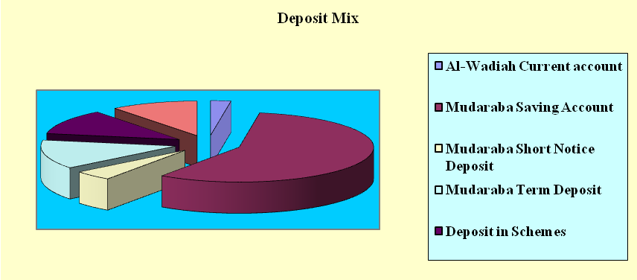

Total deposit of Prime Bank Limited stood at TK. 28069.24 million as on 31December 2004.The mix of the bank is given bellow:

Deposit Mix of PBL

Types of Deposit | % Of Total Deposit
Current and Other Deposits | 17.20%
Saving Account | 9.62%
Fixed deposit | 51.71%
Short Term Deposit | 4.89%
Deposit Schemes | 14.74%
Others | 1.84%
Total | 100%

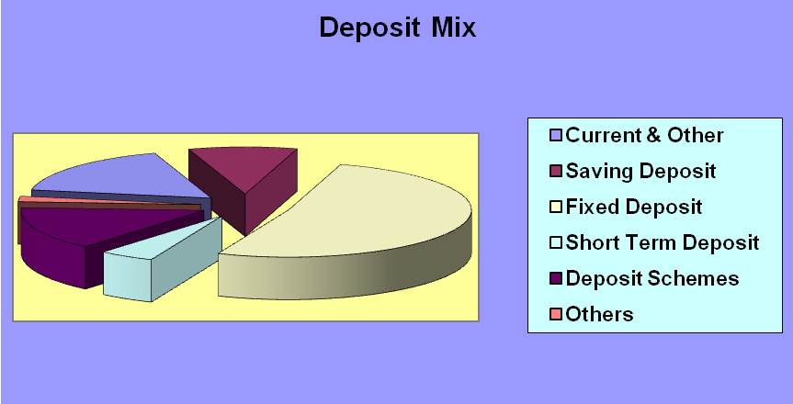

From the above two chart we understand that current account, short-term deposit, fixed deposit, and different schemes of Prime Bank Ltd are higher than the Social Investment Bank Ltd. But the saving account of Prime Bank Ltd is lower than the Social Investment Bank Ltd. Here the main reason is that the people who need these type of account usually prefer Prime Bank Ltd for availability of branch.

Ratio Analysis

Introduction:

The ‘Bank Performance Evaluation’ entails interactions between the environment, internal operation, and external activities. The prime objective of management is to maximize the value of the bank’s equity shares by making an optimal risk-return tradeoff. Realizing this bank management usually develops a comprehensive plan in order to define objectives, goals, budgets, and strategies that will be consistent with the maximization of share value. Financial ratios comprising accounting items present a historical configuration of bank returns and risk.

Analyzing Bank performance with financial ratio:

Financial ratio are constructed by forming ratios of accounting data contained in the bank’s Reports of Income (i.e. profit and loss) and condition (i.e. balance sheet). Ratio analysis is a powerful tool of financial analysis. A ratio is defined as “the indicated quotient of two mathematical expressions” and as “the relationship between two or more things.” In financial analysis, a ratio is use as a benchmark for evaluation the financial position and performance of a bank. A wide variety of financial ratios can be calculated to assess different characteristics of financial performance. To evaluate a particular financial ratio for a bank, comparison with peer group banks are often used. Also, it is beneficial to track the ratio over time relative to other banks. Even without comparison with other banks. Ratio trends over time may provide valuable information about the banks performance. The key ratios commonly used by bank analysts to evaluate different dimensions of financial performances of a bank are given below:
Profitability Analysis
To measure the performance of the bank it is important to measure some of the ratios to get a clear picture about the bank and its activities. Some of the important ratios are Return on Asset (ROA), Return on Equity (ROE), profit margin, and Asset utilization ratio.

- Profit Margin Ratio:

The profit margin ratio gives some ingredients to judge the ability of management to control expenses, including taxes, given a particular level of operating income. The profit margin ratios are as follows:

Profit Margin | 2002 | 2003 | 2004
SIBL | 21.59 | 20.63 | 14.82
SBL | 11.00 | 15.49 | 14.14
IBBL | 7.05 | 9.26 | 14.40
SIBL has the highest profit margin, IBBL’s profit margin is increasing but in very slow rate. FSBL profit margin is decreasing.
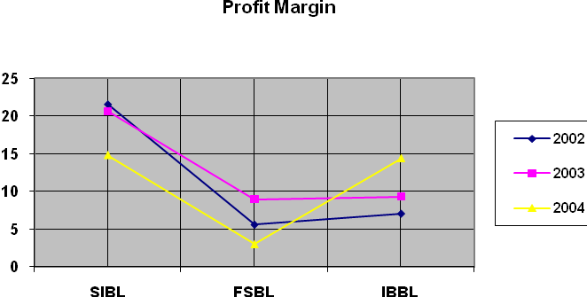

(b) Rate of Return on Assets (ROA)

The rate of return on asset is frequently used to evaluate bank management. The ROA measures the ability of management to utilize the real and financial resources of the bank to generate returns. It indicates net income per Taka of total assets owned during the period. The ROA of the banks are as follows:

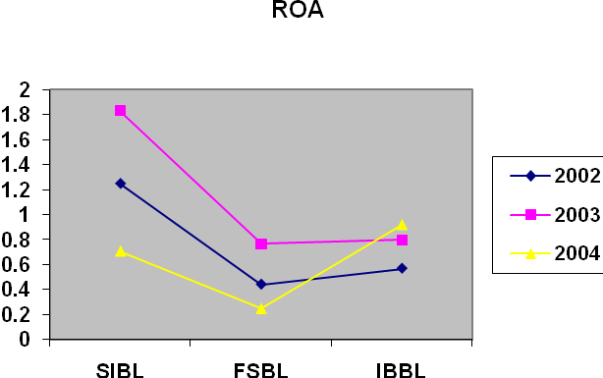

ROA | 2002 | 2003 | 2004
SIBL | 1.25 | 1.83 | 0.71
FSBL | 0.442 | 0.77 | 0.25
IBBL | 0.57 | 0.80 | 0.92

From the figure, we can see that all the banks ROA have an increasing trend. Again, SIBL fall down 2004.
- Rate of Return on Equity (ROE)

The rate of return on equity is considered as a well judgment in analyzing a bank’s financial health. ROE shows what contribution the equity capital has on net income. It measures the percentage return on each dollar of stockholders equity is the aggregate return to stockholders before disbursing dividends.

The higher the return the better, as banks can add more to retained earnings and pay more in cash dividends when profits are higher. The ROA of the banks are:
ROE | 2002 | 2003 | 2004
SIBL | 29.22 | 43.55 | 16.65
FSBL | 4.19 | 16.33 | 7.26
IBBL | 10.90 | 12.74 | 17.08

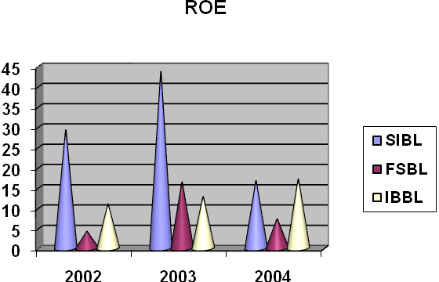

Higher Net profit margin of SIBL results in highest ROE. FSBL, ROE is too much poor.

Asset Utilization Ratio:

The asset utilization ratio represents the ability of management to employ assets effectively to generate revenues. Bank assets fall into one of four general categories; loans, investment securities, non-interest cash and due from banks, and other assets. The asset utilization ratios are:

Asset Utilization | 2000 | 2001 | 2002
SIBL | 4.51 | 5.12 | 8.46
FSBL | 7.90 | 8.64 | 5.56
IBBL | 8.15 | 8.60 | 8.04s

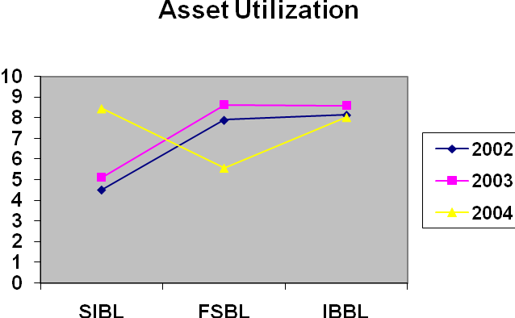

From the viewpoint of asset utilization ratio IBBL is in the best place. SIBL’s performance is increasing.

Risk Ratio Analysis:

It is very important for a bank to measure its risk associated with its operation. Without identifying risk, no bank can get success in future rather it will face liquidity, operational and market risk. Therefore, it is very important measure risks and takes necessary steps against it.

(a) Equity Multiplier (EM)

Equity multiplier measures financial leverage and represents both profit and risk measure. EM affects bank’s profits because it has a multiplier impact on ROA to determine a bank’s ROE. It should be obvious that a high equity multiplier can increase both ROE and the growth rate of the bank as long as ROA is positive. On the downside, if ROA is negative, ROA will be magnified in a negative direction.

Equity Multiplier | 2002 | 2003 | 2004
SIBL | 27.61 | 34.16 | 23.30
FSBL | 10.00 | 21.00 | 28.00
IBBL | 18.97 | 16.00 | 18.64

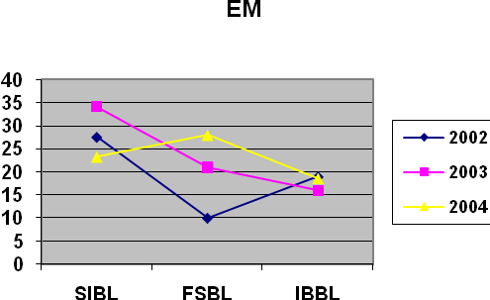

A high EM raises ROE when net income is positive but also indicates high capital or solvency risk. SIBL & IBBL’s EM has a decreasing trend in last year.

(a) The Investment ratio:

The investment ratio indicates the extent, to which assets are devoted to loans as opposed to other assets, including cash, securities and plant and equipment. The greater the loans, the greater the bank’s ability to generate income as interest that the bank owns.

Investment Ratio | 2002 | 2003 | 2004
SIBL | 54.95 | 52.00 | 46.25
FSBL | 45.53 | 56.95 | 56.74
IBBL | 40.37 | 60.31 | 71.11

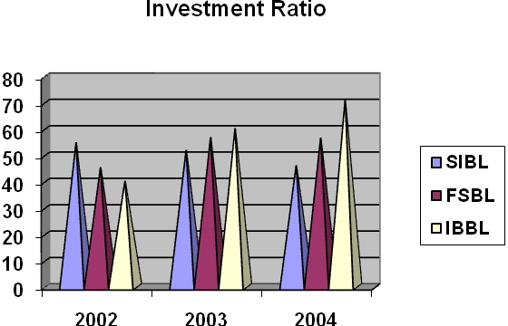

The two conventional banks (FSBL & IBBL) are relatively higher investment ratio than the Social Investment Bank. Which result lower profitability?
It revels is the ability of management in controlling expenses. Lower ratio indicates higher ability to control expense. Thus here’s low risk. By dividing Total asset, we get.

Expenses Ratio

Expenses ratio | 2002 | 2003 | 2004
SIBL | 3.01 | 3.49 | 5.87
FSBL | 7.03 | 7.06 | 6.80
IBBL | 6.43 | 6.13 | 5.70

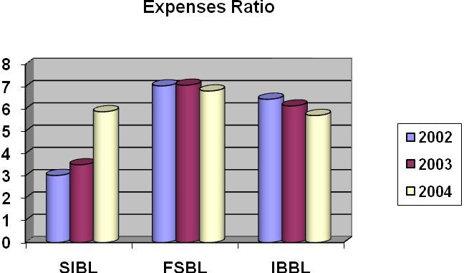

We can see that SIBL is most efficient in controlling its expenses. FSBL is least efficient in controlling expense.

Tax Ratio:

It indicates the extent of tax burden of the bank.

Tax Ratio | 2002 | 2003 | 2004
SIBL | 35.00% | 35.00 | 44.77
FSBL | 31.07 | 31.32 | 51.99
IBBL | 31.50 | 31.50 | 40

Liquidity Ratio:

Liquidity can be defined as the extant to whom the bank has funds available to meet cash demands for loans and deposit withdrawals. The failure of bank meet its obligations due to lack of sufficient liquidity, will result in a poor creditworthiness, loss of creditor’s confidence or even in legal tangles resulting in the closure of the bank. A very high degree of liquidity is also unexpected; idle cash earn nothing. Therefore, it is necessary to strike a proper balance between high liquidity and lack of liquidity. The most common ratios are as follows:

Cash Ratio:

Cash includes vault cash, deposit at other banks and cash items in the process of collection. All these earn no interest. As such, bank management should attempt to minimize its investment in these assets. On the other hand, it is the most liquid asset. Banks must maintain liquid assets to meet up any sudden need. Lower cash ratio indicates higher risk or it will lose its reputation. Therefore, banks have to maintain an optimal cash ratio. The cash ratios of the bank are 2002 to 2004.

Cash Ratio | 2002 | 2003 | 2004
SIBL | 4.50 | 4.96 | 4.17
FSBL | 34.15 | 18.37 | 15.92
IBBL | 19.00 | 20.40 | 20.11

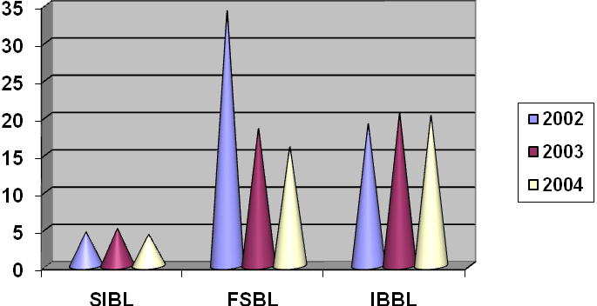

IBBL got the best cash ratio trend. Islamic banks got better cash ratio compared to other banks. This is another reason why the Islamic banks have lower profitability.

Deposit to investment ratio:

It indicates the extent of deposit in relation to investment. Higher the ratio higher the liquidity and lower the profitability.

Deposit to investment ratio | 2002 | 2003 | 2004
SIBL | 1.65 | 1.86 | 2.01
FSBL | 1.77 | 1.21 | 1.27
IBBL | 1.34 | 1.32 | 1.22

Deposits to investment ratios of SIBL are higher then others.

Conclusion: From the overall point of view of liquidity, it can be easily summarize that SIBL have higher liquidity than other banks. This means lower profitability and lower risk.

Risk Analysis:

Risk analysis examines the uncertainty of income flows for the total organization and for the individual sources of capital i.e. debt preferred stock and common stock. More volatile income flows mean greater risk facing the investors. It has two components: business risk and financial risk.

Business risk:

Business risk is the uncertainty of income caused by the bank’s industry. It can be calculated as Business risk=Standard deviation of operating income /Mean operating income. Business risks for the banks are:

Bank | Business Risk
SIBL | 22.18%
FSBL | 49.41%
IBBL | 28.99%

(Calculations are in the appendix.)

CAMEL RATING ANALYSIS

Due to change in the banking sector in the recent days the central banks of the world have improved their supervision quality and techniques. In evaluating the functions of the banks, many of the improved countries are now following the Uniform Financial Rating System (CAMEL) along with other existing procedures and techniques of supervision. Bangladesh bank is also following the CAMEL rating as off-site supervision besides on-site supervision.

CAMEL is the abbreviation of-

C-Capital rating
A- Asset Quality rating
M-Management rating
E- Earning rating
L- Liquidity rating

Capital Rating: This rating signals the institution’s ability to capital need. Capital Adequacy ratio is used as the benchmark of this ratio. The rating as follow:

Rating | Condition | Composite Range
1 | Strong | 9.00% and above
2 | Satisfactory | 8.00%-8.99%
3 | Fair | 7.00%-7.99%
4 | Marginal | 5.00%-6.99%
5 | Unsatisfactory | 4.99% and above

Asset Quality Rating: It reflects the amount of existing credit risk associated with the loan & investment portfolio as off-balance-sheet activities.

Rating | Condition | Composite Range
1 | Strong | Up to -5.00%
2 | Satisfactory | 5.01%-10.00%
3 | Fair | 10.01%-15.00%
4 | Marginal | 15.01%-20.00%
5 | Unsatisfactory | Above20.00%

Management Rating: It reflects the ability of top management to control risk and profitability. It is the average of other four ratings.

Rating | Percentage | Description
1 | 1.00-1.49 | Strong
2 | 1.50-2.49 | Satisfactory
3 | 2.50-3.49 | Fair
4 | 3.50-4.49 | Marginal
5 | 4.50-5.00 | Unsatisfactory

Earning Rating: Earning shows the sustainability of the firm, through profitable operation.

Rating | Percentage | Description
1 | Above 0.85 | Strong
2 | 0.65-0.84 | Satisfactory
3 | 0.45-0.64 | Fair
4 | Below 0.45 | Marginal
5 | Net Loss | Unsatisfactory

Liquidity Rating: It shows the firm’s sources of meeting current liability thus keeping creditability. It also indicates lower risk associated.

Rating | Condition | Composite Range
1 | Strong | Above 30%
2 | Satisfactory | 20%-29.99%
3 | Fair | 19%-19.99%
4 | Marginal | 15%-18.99%
5 | Unsatisfactory | Below 15%

CAMEL ratings of the four banks are as follows:

Social Investment Bank Ltd.

 | 2002 | 2003 | 2004
Capital Adequacy Ratio | 5.27% | 9.39% | 7.53%
 | 4 | 1 | 2
Classified Loan Ratio | 4.39% | 7.46% | 11.36%
 | 1 | 3 | 3
ROA | 1.25% | 1.83% | 0.71%
 | 1 | 1 | 1
Liquidity Ratio | 45.18% | 49.30% | 67.47%
Management Ratio | 1.75 | 1.5 | 1.75
Composite Rating | 1.8 | 1.6 | 1.8
Almost the Islamic Banks SIBL got the best rating. Its capital and liquidity rating are good as well as its profitability rating is also strong in the last three years.

First Security Bank Ltd.

 | 2002 | 2003 | 2004
Capital Adequacy Ratio | 9.91 | 4.50 | 3.21
 | 1 | 5 | 5
Classified Loan Ratio | 0 | 2.32 | 7.49
 | 1 | 1 | 2
ROA | 0.442 | 0.773 | 0.254
 | 4 | 3 | 4
Liquidity Ratio | 31.95 | 39.27 | 35.94
 | 1 | 1 | 1
Management Ratio | 2 | 3 | 3
Composite Rating | 1.8 | 2.6 | 3

FSBL capital adequacy ratio is poor, but its liquidity ratio & assets quality is better position.

Islami Bank Bangladesh Ltd.

 | 2002 | 2003 | 2004
Capital Adequacy Ratio | 11.59% | 9.24% | 5.58%
 | 1 | 1 | 4
Classified Loan Ratio | 10.36% | 8.87% | 8.06%
 | 3 | 2 | 2
ROA | 0.57% | 0.80% | 0.92%
 | 3 | 2 | 1
Liquidity Ratio | 27.10% | 22.78% | 36.29%
 | 2 | 2 | 1
Management Ratio | 2.25 | 1.75 | 2
 | 2 | 2 | 2
Composite Rating | 2.2 | 1.8 | 2

IBBl got good ratings in capital adequacy and liquidity, but very poor ratings in earning and asset quality ratings. That’s why it had a “Fair “rating till 2003. But IBBL’s rating improved in the last two years.
Comparison of CAMEL rating among the banks:

The composite CAMEL ratings form 2002 to 2004 is given bellow. This rating will judged according to guideline. Banks will be rate strong, satisfactory according to this guideline.

CAMEL rating | 2002 | 2003 | 2004
SIBL | 1.8 | 1.6 | 1.8
FSBL | 1.8 | 2.6 | 3
IBBL | 202 | 1.8 | 2

Guideline:

Rating | % Rating | Description
1 | 1.00-1.49 | Strong
2 | 1.50-2.49 | Satisfactory
3 | 2.50-3.49 | Fair
4 | 3.50-4.49 | Marginal
5 | 4.50-5.00 | Unsatisfactory

Among the three banks, SIBL got the highest rating. It is in the Strong rating, FSBL, IBBL are in satisfactory rating in the last year.

SWOT Analysis:

SWOT analysis is the detailed study of an organization’s exposure and potential in perspective of its strength, weakness, opportunity and threat. This facilitates the organization to make their existing line of performance and also foresee the future to improve their performance in comparison to their competitors. As though this tool, an organization can also study its current position, it can also be considered as an important tool for making changes in the strategic management of the organization.

Strengths:

- Social Investment Bank Limited has already established a favorable reputation in the banking industry of the country. It is one of the leading private sector commercial banks in Bangladesh. The bank has already shown a tremendous growth in the profits and deposits sector.

- Social Investment Bank has provided its banking service with a top leadership and management position. The Board of Directors headed by its Chairman Mr. Md. Nazrul Islam is a skilled person in business world. Alamgir Kabir, the Advisor of the bank is a reputed senior chartered accountant having 30 years vast experience in accounts, audit, and finance and banking at home and abroad. Mr. Mohammed Lakiotullah as the Managing Director of the bank management team. The top management officials have all worked in reputed banks and their years of banking experience, skill, and expertise will continue to contribute towards further expansion of the bank.

— Social Investment Bank Limited has already achieved a high growth rate accompanied by an impressive profit growth rate in 2001. The number of deposits and the loans and advances are also increasing rapidly.

— Social Investment Bank has an interactive corporate culture. The working environment is very friendly, interactive and informal. And there are no hidden barriers or boundaries while communicate between the superior and the employees. This corporate culture provides as a great motivation factor among the employees.

— Social Investment Bank has the reputation of being the provider of good quality services too its, potential customers.
Weakness:

— The main important thing is that the bank has no clear mission statement and strategic plan. The banks not have any long-term strategies of whether it wants to focus on retail banking or become a corporate bank. The path of the future should be determined now with a strong feasible strategic plan.

— The bank failed to provide a strong quality-recruitment policy in the lower and some mid level position. As a result, the services of the bank seem to be Deus in the present days.
__ The poor service quality has become a major problem for the bank. The quality of the service at Social Investment Bank is higher than the Dhaka Bank, Prime Bank or Dutch Bangla Bank etc. However, the bank has to compete with the Multinational Bank located here.

— Some of the job in Social Investment Bank has no growth or advancement path. Therefore, lack of motivation exists in persons filling those positions. This is a weakness of SOCIAL INVESTMENT Bank that it is having a group of unsatisfied employees.

- In terms of promotional sector, Social Investment Bank has to more emphasize on that. They have to follow aggressive marketing campaign.

Opportunity:

— In order to reduce the business risk, Social Investment Bank has to expand their business portfolio. The management can consider options of starting merchant banking or diversify into leasing and insurance sector.

— The activity in the secondary financial market has direct impact on the primary financial market. Banks operate in the primary financial market. Investment in the secondary market governs the national economic activity. Activity in the national economy controls the business of the bank.

— Opportunity in retail banking lies in the fact that the country has increased population is gradually learning to adopt consumer finance. The bulk of our population is middle class. Different types of retail lending products have great appeal to this class. So a wide variety of retail lending products has a very large and easily pregnable market.

— A large number of private banks coming into the market in the recent time. In this competitive environment, Social Investment Bank must expand its product line to enhance its sustainable competitive advantage. In that product line, they can introduce the ATM to compete with the local and the foreign bank. They can introduce credit card and debit card system for their potential customer.

— In addition of those things, Social Investment Bank can introduce special corporate scheme for the corporate customer or officer who have an income level higher from the service holder. At the same time, they can introduce scheme or loan for various service holders. And the scheme should be separate according to the professions, such as engineers, lawyers, doctors etc.

Threats:

- All sustain multinational banks and upcoming foreign, private banks posse’s enormous threats to SOCIAL INVESTMENT Bank Limited. If that happens the intensity of competition will rise further and banks will have to develop strategies to compete against an on slough of foreign the banks.

— The default risks of all terms of loan have to be minimizing in order to sustain in the financial market. Because, default risk leads the organization towards bankrupt. SOCIAL INVESTMENT Bank has to remain vigilant about this problem so that proactive strategies are taken to minimize this problem if not elimination.

- The low compensation package of the employees from mid level to lower level position threats the employee motivation. As a result, good quality employees leave the organization and it effects the organization as a whole.

Problems of Social Investment Bank:

General Banking department
- In general banking department they follow the traditional banking system. The entire general banking procedure is not fully computerized.
- They are not using Data Base Networking in Information Technology (IT) Department. So they have to transfer data from branch to branch and branch to head office by using floppy disk and sure, it is not a good system.
- According to some clients, opinion introducer is one of the problems to open an account. If a person who is new of the city wants to open account, it is a problem for him/her to arrange an introducer of SB or CD accounts holder.
Loans and Advances Department:
- Political influence is one of the major problems in Bangladesh. Due to political intervention, the bank becomes obliged to provide loans in most of the cases, which are rarely recovered. Bank has to face this in convenience situation almost every year.
- Sometimes the employee to unlawfully help the client deliberately overvalues the securities taken against the loan. As a result if the client fails to repay the loan the bank authority cannot collect even the principal money invested by the selling those assets. It is also a very important factor that leads to loan default.
- CIB report is not readily available from Bangladesh Bank.
Foreign Exchange Department:
- In foreign exchange department, it is required to communicate with foreign banks and International Division of Social Investment Bank frequently and quickly. To make the process easily modern communication media for example e-mil, Fax, Internet etc. Should be used. But the bank has not so much practice of using these media.
- Modern technical equipment such as computer is not sufficient in foreign exchange department. As a result, the exchange process makes delay and it is complicated.
- They have no own certificate of Authorization of Dealer.

Other Problem:
- Social Investment Bank doesn’t give their attention on advertisement. As a competition market, it is too much important for any organization to increasing their advertisements procedure.
Recommendation:
General Banking Department:
- If the enter general Banking system is fully computerized then they satisfy the customer by provide fast service.
- If they establish networking system with their branches then it can easily transfer data within short time.
- If they cancel the introducer system then they can collect more deposit through new account and it also satisfied the customer.

Loan and Advance Department:
- Try to avoid giving loan the political person who had bad reputation of loan repaying.
- Evaluate the securities value properly to avoid the risk of loan recovery. The punishment system should be established to discourage the unlawful activities of employee.
- Bangladesh Bank should more active to provide CIB report.

Foreign Exchange Department:
- In Foreign Exchange Department it is require communicating with foreign bank frequently and quickly. To make the process easy and quick the whole system should be computerized and modern communication media for example e-mail, fax, Internet should be used.

Other Problem:
- Social Investment Bank should give more attention to advertisement to create more attraction among their customer, which is collect, more deposit and increase investment scope.

Conclusion:
As an internee of Social Investment Bank Ltd, I have truly enjoying my internship from the learning and experience viewpoint. I am confident that this three months internship program at Social Investment Bank will definitely help me to realize my further carrier in the job market.
SOCIAL INVESTMENT bank has converted all of their system and policy of traditional banking to Islami Banking. I think that is a very practical and bold decision. As there are lots of local and foreign banks in Bangladesh the Social Investment Bank Ltd. is promising commercial Bank among them. In this competitive market Social Investment Bank has to compete not only the others commercial banks but also with the public Bank. Social Investment Bank Ltd. is more capable of contributing towards economic development as compared with other bank. Social Investment Bank Ltd. invested more funds in export and import business. It is obvious that the right thinking of this bank including establishing a successful network over the country and increasing resources will be able to play a considerable role in the portfolio of development. Success in the banking business largely depends on effective lending. Less the amount of loan losses, the more the income will be from Credit operations the more will be the profit of the SOCIAL INVESTMENT Bank Limited and here lays the success of Credit Financing.
During the course of my practical orientation I have tried to learn the practical banking activities to realize it with my theoretical knowledge, which I have greathearted and going to acquire from various courses of my MBA program.

ACRONYMS

A/C Account
AD Authorized Dealer
B/L Bill of Lading
BB Bangladesh Bank
BOE Bill of Exchange
CCI & E Chief Controller of Import & Export
CFR Cost & Freight
CIB Credit Information Bureau
CIF Cost Insurance & Freight
DD Demand Draft
DP Note Demand Promissory Note
EPB Export Promotion Bureau
EXP Export Form
FC Foreign Currency
FDD Foreign Demand Draft
FOB Free On Board
HS Code Harmonized system of coding
IBC Inward Bills for Collection
IBCA Inter Branch Credit Advice
IBDA Inter Branch Debit Advice
IMP Import Form
IRC Import Registration Certificate
L/C Letter of Credit
LCAF Letter of Credit Authorization Form
OBC Outward Bills for Collection
PO Payment Order
PSI Pre Shipment Inspection
SWIFT Society for Worldwide Inter bank Financial
TC Travelers Cheque
TIN Tax Identification Number
TR Truck Receipt
TT Telegraphic Transfer
STD Short Term Deposit FDR Fixed deposit receipt
CC Cash Credit
C & F Clearing & Forwarding
CRF Clean Report Findings
ERC Export Registration Certificate
IBCT Inter branch Credit Transaction
LIM Loan against Imported Merchandise
LTR Loan against Trust Receipt
PAD Payment against Document
SOD Secured Overdraft
UCPDC Uniform Custom & Practice for Documentary Credit

