INTERNSHIP REPORT
ON

AN OVERALL BANKING SYSTEM OF UTTARA BANK LIMITED

Submitted by
WWW.ASSIGNMENTPOINT.COM

The word “Banking” has been defined to mean the accepting, for the purpose of lending or investment of deposits of money from the public, repayable on demand or otherwise, withdraw able by cheque, draft, and order or otherwise. The term “Banker” includes any person acting as a one who has an account with a banker or for whom a banker habitually undertakes to act as such. So account is a contract between a Bank and customer. On the basis of accounts the banker customer relationships build up.

The term banking has also been defined as:
USA: Act of Congress defines Banking “As the Business of dealing in Credit “Japan: Act of 1927 in Japan defines bank as “Institutions, which carry on operations of given as well as receiving credit”
From the above definitions we find three major functions of a Bank-
- Taking Deposit
- Extending Loans & Advances
- Foreign Exchange Business

Deposits are often called the lifeblood of commercial banks. No commercial banks can be thought of without deposits. In fact modern commercial banking starts with deposits from the public followed by lending or financing trade, commerce and trade. Deposits are treated as:
- Deposits as the major source of fund
- Deposit as basis of lending
- Deposit as source of income
- Deposit and credit creation
Under the umbrella of Foreign exchange business there are three main functions as follows:
- Export Business
- Import Business
- Foreign remittance
So in simple words, Banking means taking deposit, extending loan and advances and doing foreign exchange business in order to attain profit & contribute to GDP.
Form the above discussion we can say that Bank as a financial intermediaries collects deposit form surplus areas and provides loans and advances to deficit areas (where needed) and also engaged itself in foreign exchange business, the sum-up of all these activities is known as Banking.
Credit is an arrangement whereby bank acting at the request and on the instructions of a customer or on its own behalf to make a payment to or to the order of a third party or is to accept and pay bills of exchange drawn by the beneficiary. In an economy banks play the role of an intermediary that channels resources from the surplus group to the deficit group. So obviously one of the core functions of Commercial banks is to sanction Credit facility to its customers as per requirement UTTARA BANK LTD. Bank’s Mission is to actively participate in the growth and expansion of our national economy by providing Credit to variable customers in most efficient way of delivery and at a competitive price.
Risk is inherent in all aspects of a commercial operation; however for Banks and financial institutions, credit risk is an essential factor that needs to be managed. Credit risk is the possibility that a borrower or counter party may fail to meet its obligations in accordance with agreed terms. Credit risk, therefore, arises from the bank’s dealings with or lending to corporate, individuals and other banks or financial institutions.
In general, a banking system aggregates a high number of low value deposits to fund enterprises with a smaller number of high value loans. This intermediation through a well functioning bank helps to achieve some economic benefits for the depositors, the borrowers and above all -- the economy. The Bank must allocate loans effectively for achieving these broad objectives of the Economy. While identifying profitable enterprises, the Bank in fact identifies risks of the borrower and business in order to allow loan in the context of its risk–return profile. In other words, Banks are in the business of risk taking; as such risk management is viewed as a core function of banking.
1.1 Background of the Study:
Business world is becoming very much complex day by day. Without sufficient practical experience business becomes difficult and in some cases impossible. The whole world is moving because of business relation. Business plays a very important role in developing economy of a country. So, in the business world, practical experience is regarded as a media through whom we have an acquaintance with the real world. Through this report an individual can expect to have a good knowledge and understanding on the various methods of operation performed by Uttara Bank Limited particularly in the area of Financial Institutional Services. From the last three months of the bank’s disbursement, everything is tried to include in precise form. I have tried my level best to put more emphasis on the welcome pack and its recovery process. Although, it was not the topic of my internship programs. This report is to be used only for the academic purpose. I have collected all the necessary and relevant data from various primary, secondary and tertiary sources. After eight week long hard labor, it has become possible for me to make the report comprehensive and factual. The data is truly and strictly confidential and no one can use its components in full or partial. I would like to give thanks to everyone who has helped and encouraged me in the process of preparing this report.
I was authorized to prepare a report on Overall Banking Operation of Uttara Bank Limited and performance evaluation of Uttara bank ltd. for partial fulfillment of my course requirement. I went to UBL in “Fakirapul Branch”, where I worked as an intern from 15 June 2011 to 14 September 2011. This report has been prepared based on my practical experience on the day-to-day banking activities and collected information from Bank and under close supervision of my internal guide teacher as well as course teacher Md. Nur Alam Siddik.
1.2 Objective of the study:
The general objective of this report is to complete the internship program and submit a report. As per requirement of MBA program of Stamford University, one student needs to work in a business organization for three months to acquire practical knowledge about actual Business operation. The primary purpose of this study report is to get an idea about the “Overall Banking Operation of Uttara Bank Ltd”, a first generation bank of the country and make an industry analysis on the banking sector of Bangladesh
The objectives of the study are as follows:
Broad Objective:
- To identify the pattern of the different types of schemes, its features and reasons for discontinuation of some lucrative schemes with launching of some new scheme with special features,
- To evaluate the contribution of Scheme deposits in total collection of remittance.
- To evaluate of the total performance in UBL then other bank

General Objective:

The general objective of the report is....
- To know about the management system of Uttara Bank Limited as a largest corporate bank in the country, its formation, and its functional and financial aspects.
- To identify how to deals third bank payment
- To know detail of overall banking system of Uttara Bank Limited
- To know the important criteria required for the attainment of UBL.
- To make a comparison on GB department in Uttara Bank and other private sector Banks.
- To assess the overall performance of the bank’s UBL to other private banks.
- To justify the extent of the use of Finance in UBL system.
To apply theoretical knowledge in the practical field

1.3 Rationale of the study:
Banking system occupies an important place in a nation’s economy. A banking institution is indispensable in a modern society. It plays a pivotal role in the economic development of a country and forms the core of the money market in an advanced country. In recent times the banking sector over the world has been undergoing a lot of changes due to deregulation, technological innovation, globalization etc. Bangladesh banking sector is lagging for behind in adopting these changes. To thrive well in this changing environment, not only development of appropriate infrastructure is necessary but also infusion of professionalism in to banking service is essential. The Banking sector is one of the highly regulated sectors in our country. It is governed by the rules and regulation of Central Bank of the country i.e. Bangladesh Bank and Security and Exchange Commission. The bank companies are forced to the best accounting practices. It strictly follows International Accounting Standard (IAS) norms. It publishes the financial statement every year getting it duly audited by recognized audit firms. Every bank of our country has a division named Financial Administration Division (FAD) which takes care of the accounting issues of the Bank. Most of the personnel who lead these divisions are of accounting background. Among the accounting based FAD personnel who know the banking operation better can contribute more in the banks.

Career in Banking has become very lucrative over the last few years considering the work environment and remuneration package. As a student of Accounting, I cherish to be a banker and that is why I had chosen a banking organization for my internship. I chose Uttara Bank Limited because it has a good reputation in the banking community.
It help me a lot to know many banking operations practically which could not be learnt by reading books only. I believe, it will help me to become a banker.
1.4 Methodology:
1.4.1 Research Design:
Exploratory research has been conducted for gathering better information that will give a better understanding on various information in GB sector, how to communicate other bank ,how to communicate customer and other bank employee, all are gathering knowledge about this sector of GB . Both primary and secondary sources of data collection procedure have been used in the report. Primary data has been collected mainly through the writer’s observation of the approval process and monitoring techniques, informal interviews of executives, officers and employees of Uttara Bank Limited.
1.4.2 Sources of Data Collection:
To make the Report more meaningful and presentable, two sources of data and information have been used widely such as...

Source of Data

PRIMARY DATA
SECONDARY DATA

Figure: Sources of data

Both primary and secondary data sources were used to generate this report.

The Primary sources are follows:
Primary data are measurements observed and recorded as part of an original study. When the data required for a particular study can be found neither in the internal records of the enterprise, nor in published sources, may it become necessary to collect original data. For the completion of this report, the primary sources of data are-
* Face-to-face conversation with the respective officers and staffs of Uttara Bank and other banks.
* Informal conversation with the clients.
* Practical work exposures from the different desks of the departments of the Branch.
* Study of the relevant files as instructed as instructed by the officers concerned
* Experts’ opinion and comments,
The Secondary sources and data are follows:
The data which has already been collected by others, such data are called Secondary data. For this internship report, the secondary data are collected from the below sources-

* Annual reports of Uttara Bank and other Banks.
* Training materials available at the BIBM library,
* Various books articles, compilations etc. regarding marketing of financial products are informed below:
* Published of different products,
* Office circular and other published papers,
* Website of the UBL; www.Uttarabank.com

1.4.3 Financial statement Analysis:
Ratio Analysis:
It expresses the relationship among selected items of financial statement data. I have computed the profitability and solvency ratio of the year 2006 to 2010.As a result changes in the financial relationship and significant trends can be innovated.

Time series Analysis:
The first step in making estimates for the future consists of gathering information from the past data. In this connection, one usually deals with statistical data, which are collected, observed or recorded, at successive is of time. Such data are generally referred as Time Series data.
Data Analysis:
The paper will be aimed at depicting the various thinking about banking business in Uttara Bank Limited then other bank. The data gathered from both primary and secondary sources has been arranged orderly to get a clear picture of the bank’s various system of banking and the other banks. The study will include both qualitative and quantitative analysis of consumer credit procedures and monitoring tools. Based on the observational information I shall also try to evaluate and analyze the problems involved way of banking system of business.

Series Data for Straight Line Trend:
The straight line trend is represented by the equation-
Y_{c =} a +bX;
Where-
Y_{c =} The trend (computed) values to distinguish them from the actual Y values,
a= The Y intercept on the value of the Y variable when X=0,
b= Slope of the line or the amount of change in Y variable.
By using the straight line trend, I have calculated the profit after tax of Uttara Bank Ltd. for year 2010. The time series data for this analysis are given below-

Year | Profit after tax (Million Tk.)
2006 | 13.46
2007 | 380.26
2008 | 540
2009 | 240.02
2010 | 343.46

Regression Analysis:
The statistical tool with the help of which we are in a position to estimate (on predict) the unknown value of one variable from known value of another variable is called regression. With help of regression analysis, we are in a position to find out the average probable change in one variable given in a certain amount of change in another.

Data for Regression Analysis:
The second regression analysis is drawn on total amount of scheme deposits, total
number of employees and number of branches. Here-
Amount of scheme deposits = Y; dependent variable,
Number of employees = X₁; Independent variable,
Number of branches = X₂, Independent variable.
So, the regression equation of Y on X₁ and X₂ for the regression line will be-
Y = a + b₁X₁ + b₂X₂
Where,
Y = Total amount of scheme deposits,
a = The intercept (constant),
b₁ = Slope of line, change in scheme deposits for change in no. of employee,
b₂ = Slope of line, change in scheme deposits for change in no, of branches,
X₁ = No. of employees,
X₂ = No of branches
Publications:
- Brochures of Uttara Bank Limited.
- Uttara Bank Annual Report 2010, 09, 08,07,06.
- Terms & Condition Published by Uttara Bank Limited.
- Credit Guidelines of Uttara Bank Limited.
- Statement of Affairs, Prepared by accounts section.
- Guideline for banking system of published by Bangladesh Bank.
- Previous Orientation paper.
- Reading Materials
- On Credit Managements in Banks: Published by BIBM
- On International Trade & Finance: Published by BIBM
- On Banking Theory and Practice: Published by BIB
1.5 Limitations of the study:
Since the paper is concerned with the comparison of GB department of Uttara Bank Limited with other private banks, different private commercial bands, such as, Eastern Bank Limited, Unitated Commercial Bank Limited, Dhaka Bank Limited, HSBC, and Bank Asia Ltd are mainly deal to this sector of GB. A lot of information could not obtain because the banks were not interested to disclose their information, policy, and data to maintain their secrecy. I had to depend on the websites of the respective banks for much information.
On the way of my study in Uttara Bank Limited, I have faced the following problems, which may be termed as the limitations of the study. The major limitations of this study are given as follows:

- Deficiencies in data required for the study.
- Field practice varies with the standard practice that also created problem.
- Time provided for conducting the study is another important constraint.
- The employees in Uttara Bank Limited are so much busy in their responsible fields; they could hardly provide little time to discuss with them.
- The total report like “Over all banking and Performance Evaluation of Uttara Bank Limited” is vast and not possible to make it over a night. So it is the hard task to prove all the information on that necessary segment which might make report more resourceful and out standing. I couldn’t prepare the report as the best of my capability because much information could not gathered for the recourses of confidentially. During the Banking hour there were many customers who has to be served time offered per customer was not adequate to ask about their satisfactory and dissatisfactory level in connection with scheme related transactions which might have helped to focus in more detail.
- Management Information Systems is a very wide spectrum. However the branch does not even have a separate MIS division. I could not therefore focus on MIS practices on local banks, as there is not much to deal with.
- In case of performance analysis secondary data are used.
- There were some restrictions to have access to the information confidential by concern authority.
- Sufficient records, publications regarding customer service were not available as per requirement.
- Three-month is not sufficient time to gain practical knowledge and prepare a report.
- The employees of the bank are so much busy so they cannot provide me to give information about the General Banking Department such as different types of loans and advances.
- I have no proper experience to do this kind of report. So, inexperience creates obstacle to follow the systematic and logical research methodology.

Chapter: Two

Organizational Profile



Uttara Bank Limited UBL is a private commercial Bank in Bangladesh. Uttara Bank-one of the largest and oldest private-sector commercial bank in Bangladesh, with years of experience. Adaptation of modern technology both in terms of equipment and banking practice ensures efficient service to clients. 201 branches at home and other more affiliates worldwide create efficient networking. Uttara Bank is a bank that serves both clients and country.
UBL, started the project of seven days assured payment scheme to serve quickly the foreign remittance sender On the other hand, it has achieved the membership of Society for Worldwide international Financial ‘Telecommunication (SWIFT) to accurate the international business and banking activities.
2.1 Background:
During 28th January 1965, The Eastern Banking Corporation inaugurated its operation in East Pakistan as commercial bank. After 6 months of its inauguration it has got the status of Schedule Bank. It was the first Bengali Owned Commercial Bank. After liberation the Eastern Banking Corporation was changed by name as Uttara Bank Ltd. During 1972 it was taken under national ownership. At that time it’s paid up capital was 69.13 crore and profit figure was 42lac. During September 1983 it was privatized under privatization act. At that time this deposit was 231.03 crore and profit figure was 5.06 up to 2003 its number of branches stands to 198 and it’s paid up capital was 100 million. 95% of its share holder is public and rest of share holds by Government. There are some different year’s deposits, loan, & advances and net profit has been given below.
Year | Deposit | Loan & Advances (Tk. In cr.) | Net profit (Tk. In Cr.)
December 31, 1972 | 69.13 | 60.57 | .42
December 31, 1983 | 231.03 | 226.56 | 5.06
December 31, 2001 | 2594.25 | 2333.18 | 120.00

The all branches are computerized which has been possible by local (within the organization) computerized analyst. The place, where electricity is not available they are maintaining their activities by generator. And that’s why has got access to enter in the instant Global Economy. For reaching immigrant/non-imrnigranls, sending money to the recipients as welt as to invest this money in lucrative sector UBL has established.
1. Non-residence Foreign Currency Deposit (NFCD)
2. Foreign Current Account Deposit (FCAD)
3. Wage Earners Development Bond (WFBD)
4. Home (HRC)
5. Wage Earners Investment (WEIC)

2.2 Historical Background of Uttara Bank Ltd:
Uttara Bank Ltd. has been a nationalized bank in the name of Uttara Bank under the Bangladesh Bank (Nationalization) order 1972, formally known as Eastern Banking Corporation Limited.
∗Uttara Bank ltd. started functioning from 28.01.1965
∗Consequent upon the amendment of Bangladesh Bank (Nationalization) order 1972
∗Uttara Bank ltd. converted into Uttara Bank ltd. as a public limited company in the year 1983 and obtained business commencement certificate on 21.08.1983.
∗Uttara Bank ltd. floated its shares in the year 1984.
∗Uttara Bank ltd. has 207 branches all over Bangladesh
∗The bank is listed in the Dhaka Stock Exchange Ltd. and also in Chittagong Dhaka Stock Exchange Ltd.
∗It publicly quoted company for trading of its shears.
∗The registered office of the Bank is located in 47, Bir Uttom Shahid Ashfaq-us-samad Road (90, Motijheel Commercial Area), P.O. Box No. 217 & 818 Dhaka-1000, Bangladesh.

Uttara Bank is one of the largest and oldest private-sector commercial bank in Bangladesh, with years of experience. Adaptation of modern technology both in terms of equipment and banking practice ensures efficient service to clients. 207 branches at home and 600 affiliates worldwide create efficient networking and reach capability. Uttara is a bank that serves both clients and country.
UBL is one of the largest private banks in Bangladesh.
- It operates through 207 fully computerized branches ensuring best possible and fastest services to its valued clients.
- The bank has more than 600 foreign correspondents worldwide.
- Total number of employees nearly 3600.
- The Board of Directors consists of 15 members.
- The bank is headed by the Managing Director who is the Chief Executive Officer.
The Head Office is located at Bank’s own 18-storied building at Motijheel, the commercial center of the capital, Dhaka.
2.3 Uttara Bank Ltd Networks:
The Head Office is located at Bank’s own 18-storied building at Motijheel, the commercial center of the capital, Dhaka.

Corporate Offices ( Corporate Branch & Local Office ) | 2
Regional Office | 13
Worldwide Affiliates | 600
Total Branches ( Including Corporate Branch & Local Office ) | 207
Authorized Dealer Branches | 38
Treasury & Dealing Room | 1
Training Institute | 1
Man Power | 3562

2.4 Vision:
To become a leading banking institution which play a pivotal role in the development of the country.

2.5 Mission:
- Continuous improvement in our business policies.
- Cost reduction integration of the technology at all level.

Uttara Bank ltd. has 207 branches all over Bangladesh. Fakirapul Branch is one of them. Like other branch it’s operate several department. They are like
- General Banking
- Loan and Advance, And
- Foreign exchange
In this branch operation is mostly covered by the computer system. By the use of computer here operate is like Clearing, E-mail, Money Laundering, Clean Cash and all types of letter/ application and other related works with computer.
Through there are a little bit work of foreign exchange, but FDD, LC,SC,LSC,DD,MT,TT are doing here.
2.6 Corporate Governance:

Corporate Governance is the system by which business companies are directed and controlled. Since its inception, Uttara Bank has actively and fully adhered to the principle of sound corporate governance. Fairness, Transparency Accountability and Responsibility are the minimum standard of acceptable corporate behavior today. Uttara Bank Limited continues to ensure the compliance of corporate Governance as per Securities and Exchange Commission rules and regulations. Corporate governance establishes specific responsibility and ensures accountability.
2.7 Corporate Social Responsibility:
The basic driver of CSR consists of values that have taken place within businesses where they not only feel responsible for creation of wealth but also for social and environmental well being. Uttara Bank Ltd. considers socially responsible activities as an important part of its culture, identity and business practice. We have a deep commitment, loyalty and a high sense of responsibility to our nation and its people. Uttara Bank Ltd. conforms to all of the astringent regulations issued by the Government and the Bangladesh Bank. As per of our corporate social responsibility, Bank contributes greatly to the nourishment of the country’s all types of calamities, arts, culture and sports.
2.8 Vision/Mission, Strategies Statement:

The bank has some mission to achieve the organizational goals. Some of them are as follows-
- The bank looks forward with excitement and a commitment to bring greater benefits to customers.
- Uttara Bank Limited provides high quality financial services to strengthen the well-being and success of individual, industries and business communities.
- Its aim to ensure their competitive advantages by upgrading banking technology and information system.
- UBL intends to play more important role in the economic development of Bangladesh and its financial relations with the west of the world by interlinking both modernistic and international operations.
- The bank intends to meet the needs of their clients and enhance their profitability by creating corporate market.
- The Bank has remained dynamic in its continued efforts to improve & increase core competence & service efficiency by constantly upgrading product quality, service standards, protocol and their effective participation making use of state of the art technology.
- The bank creates wealth for the shareholders
- The bank believes in strong capitalization.
- Its maintain high standard of corporate and business ethics.
- UBL extend highest quality of services, which attracts the customers to choose them first.

2.9 Ownership Structure:

To manage and operate the Bank in the most efficient manner to enhance financial performance and to control cost of fund

To strive for customer satisfaction through quality control and delivery of timely services

To identify customers' credit and other banking needs and monitor their perception towards our performance in meeting those requirements

To review and update policies, procedures and practices to enhance the ability to extend better service to customers
To train and develop all employees and provide them adequate resources so that customers' needs can be reasonably addressed.

To promote organizational effectiveness by openly communicating company plans, policies, practices and procedures to employees in a timely fashion

To cultivate a working environment that fosters positive motivation for improved performance

To diversify portfolio both in the retail and wholesale market

To increase direct contact with customers in order to cultivate a closer relationship between the bank and its customers

2.10 Capital and Reserve:

2.10.1 Share Capital:
The Authorized Capital of the Bank increased from Tk 1,000.0 million to Tk. 1,600.00 million during the year 2008. But the bank has already got approval from Bangladesh Bank to raise its Authorized Capital from Tk. 1,600.00 million to Tk. 3,200.00 million. The paid up capital of the Bank has been increased to Tk.798.7 million from Tk.399.3 million due to declaration of 100% bonus share in 2008. The total number of shares was 79, 86,592. The Government of the People’s Republic of Bangladesh, five Banks and fifty two financial institutions held total 6, 31,400 shares worth Tk. 631, 40,000.00 and remaining 27,170 private Shareholders held total 73, 55,192 shares worth Tk. 73, 55, 19,200.00. The total equity of shareholders of the Bank at the end of the year 2008 stood Tk. 3,688.8 million and in 2007 stood Tk. 2,453.5 million.

2.10.2 Reserve Fund:
The Reserve Fund increase to Tk 2,890.2 million during the year by registering 40.70 percent increase over last years tk. 2,054.2.

2.11 Milestones in the development of the organization:

- To be a dynamic leader in the financial market in innovating new products as to the needs of the society.
- To earn positive economic value addition (EVA) each year to come.
- To top the list in respect of cost efficiency of all the commercial Banks.
- To become one of the best financial institutions in Bangladesh economy participating in the most significant segments of business market that we serve

This year simultaneously for development and achievements of continuous growth rate in all the areas of banking operations. The bank has successfully been marching ahead with its prime business objective by earning Achievements were possible because of his service excellence of management with support from a very resourceful and- skilled workforce who are rendering efficient and specialized services.

2.12Organogram of UBL:

Managing
Director
Additional
MD
Deputy
MD
GM recovery
Division
GM marketing
Division
GM credit
Division
Assistant
MD
DGM MIS &
Computer
GM HRD
DGM central
Accounts
Local Office
Branch
Regional Manager
Foreign exchange Branch
Corporate
Branch
GM audit
And inspection
GM International Division
DGM central accounts

2.13 Management structure:
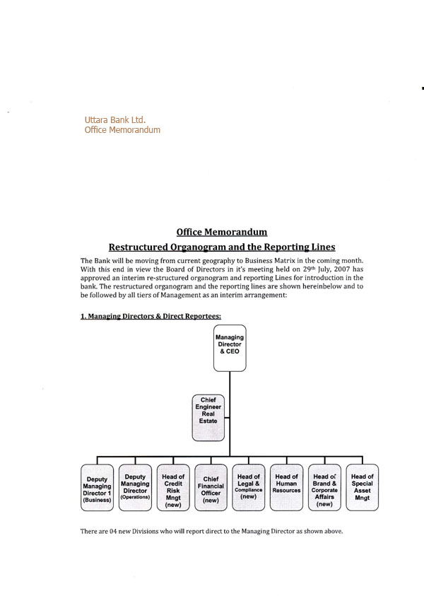
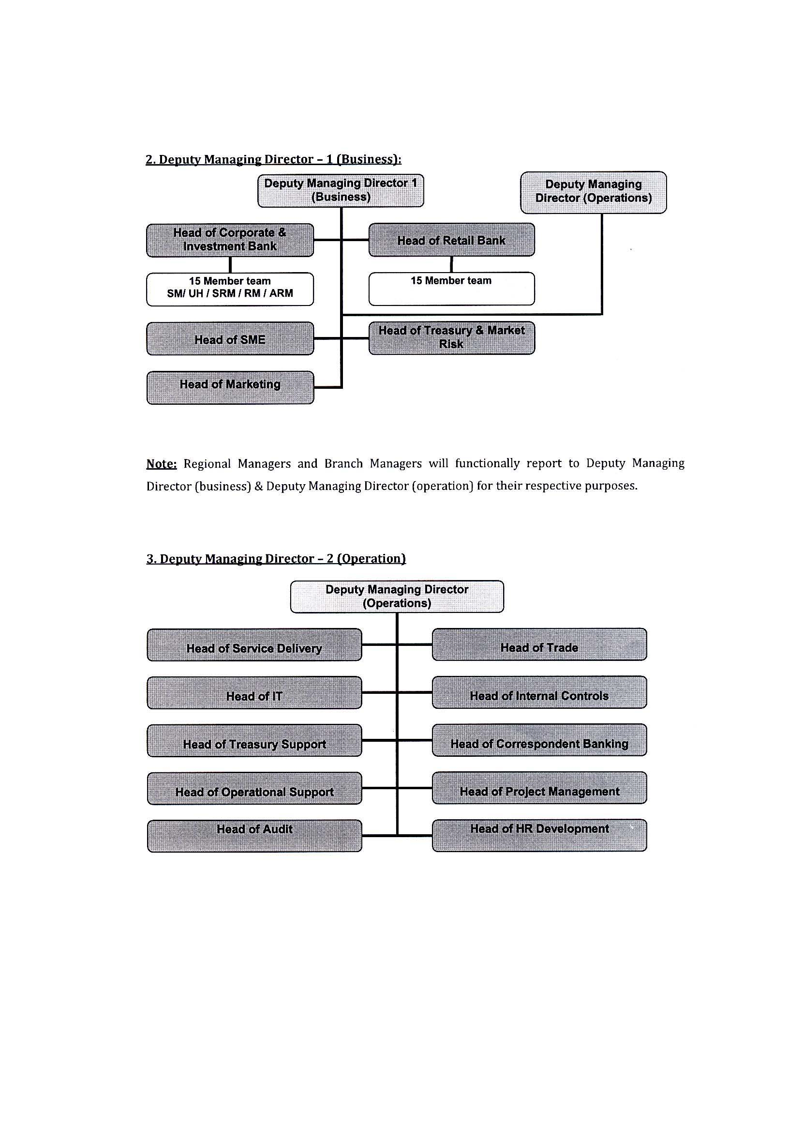
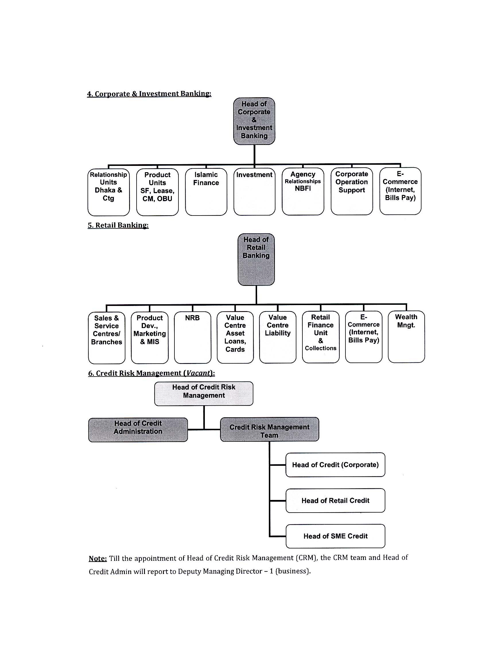
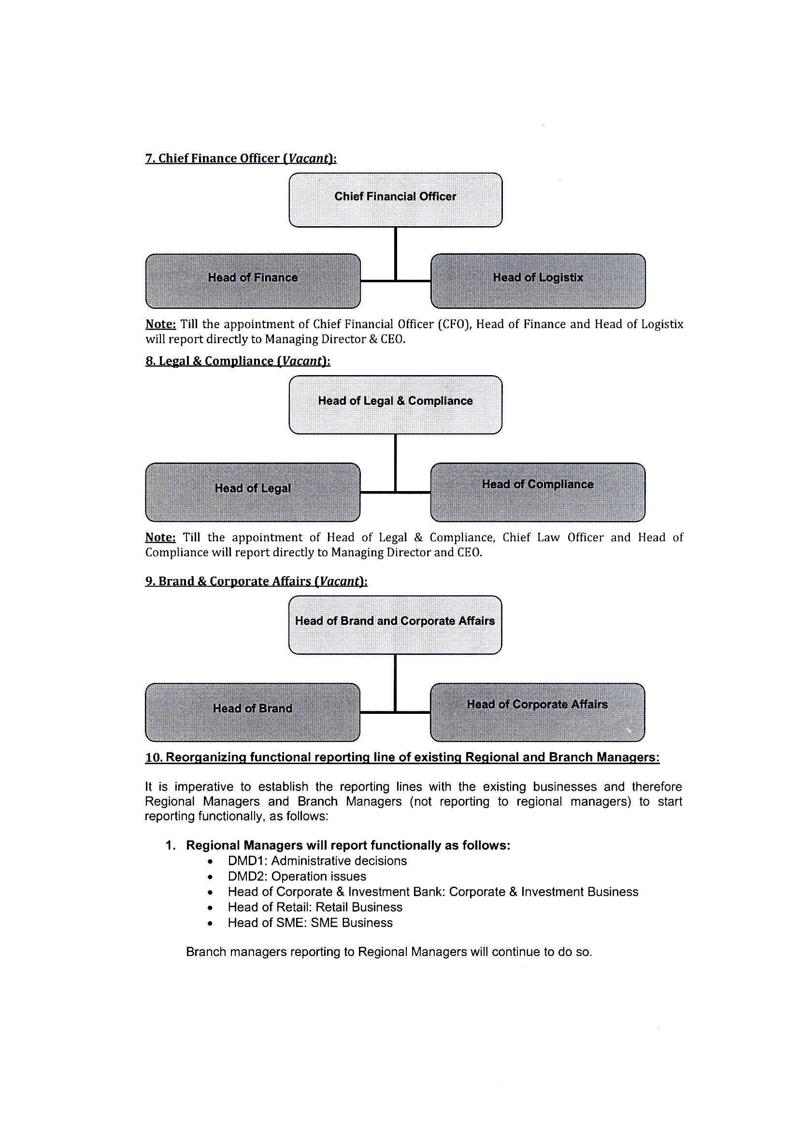
2.13.1 Human Resource Development (HRD):
Take good care of your employees; employees will take good care of the organization” UBL believes in this maxim to its core. The employees are considered as the most valued resources and are the local point of all its activities. As a service industry, UBL is constantly trying to improve its human resources where performance excellence is always encouraged by reward and recognition. In addition, a number of well thought policies were formulated for the welfare of its employees, in the form of UBL Superannuating Fund, UBL employee’s house building loan scheme, car leasing scheme, for employees
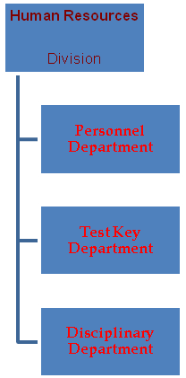
2.13.2 Human Resources and Training:
Skilled and motivated staff plays a vital role in achieving top performance. Knowledge and skill development is a continuous process and to keep our employees abreast of the latest developments in the banking sector, the Bank continuous to organize various training programmers and workshops.
The Bank’s own Training Institute is nicely decorated and equipped with the sophisticated instrument has been striving to bring about a qualitative change and improvement in human resources of the bank by imparting continuous different training throughout the whole year. Guest speaker specialized in banking participate in each training program of the bank excluding highly educated faculty members of the institute. Besides, a number of executives and officers were sent to various training institution including Bangladesh Institute of Bank Management (BIBM), and abroad for higher training.

The total manpower of the bank in different grades as on 31.12.2009 was under:

1.Executives (Assistant General Manager & Above)  2. Officers  3.Assistant Officers  4. Others | 132  1,991  420  748 | 4.01%  60.50%  12.76%  22.73%
Total: | 3,291 | 100.00%

2.13.3 Marketing Division:
There are two types of marketing division. These are:
Asset Marketing:
It refers to various kinds of loan and advances. This division maintains communication with corporate clients gives incentive to take loan from UBL and approaches them to borrow from UBL in profitable projects.

Liability Marketing:
This refers to marketing for collecting funds through buying of depository products from large depositors. The division communicates to the persons or organization having excess fund of deposit, informs them about the attractive features of the depository products and convince them to invest in UBL in various deposit scheme.
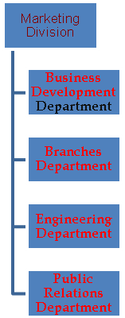

2.13.4 Credit Risk Management Division:
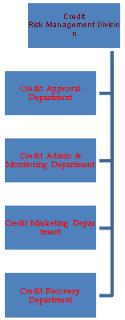
2.13.5 Central Accounts Division:
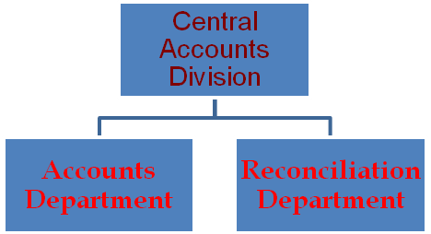
2.13.6 Internal Control and Compliance Division:

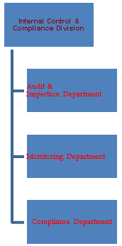

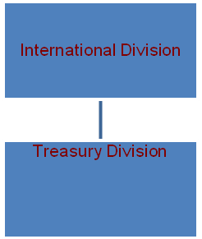

2.13.7 Computer Division:
This division operates and keeps the record of all transactions, assets, liabilities of UBL by using integrated software. Though the technology of UBL is so advanced, the computer division tries to provide the following functions:
- Supply and installation of computer as per requirement
- Design software to support accounts operation
- Train the officers and employees about the operation of different software
- Updating the software if there is any lagging in its operation.
- Using more update software
- Different sector have used different software like,

2.13.8 Research and development Division:
This division is maintained to do the research and development work to innovate new products and services as well as to improve existing products and services. Uttara Bank always thinking customer satisfaction that way provides better services then other bank.

2.13.9 Committees and Group Division:
Uttara Bank is on of the largest corporate bank in the country with current business models that heavily encourages and supports the growth of the bank. The subordinates are given chance to participate in the goal and objective setting of the bank. In this regard, there are some committees functioning in the bank. These are:

Policy Committee:
In this case, the committee members are drawn from the Board of Directors. The committee reviews the principles, policies, rules and gives a decision which later requires the approval of the Board.
Executive Committee:
This committee consists of the members of the Board. To approve the matters beyond the delegation of the board, this committee exercises the power delegated by the Board from time to time.

Management Committee:
This committee consists of the Managing Directors and Head Office Executives. They discuss about the progress and improvement on the guidelines regarding deposit, loans, gives different ideas, decision regarding various issues.

2.13.10 International Division:
This division is responsible for monitoring and supervising the foreign exchange dealings of the bank. It performs the following functions:

- Making guidelines and frameworks for foreign dealings complying the rules of Bangladesh Bank
- Circulating instructions of Bangladesh Bank
- Maintaining correspondence with foreign banks and exchange houses with which it has exchange arrangement
- Maintaining NOSTRO accounts with banks in abroad
- Fixing and sending foreign exchange rates to Authorized Dealer (AD) branches and Bangladesh Bank.

2.14 HIERARCHY OF UTTARA BANK LTD
Managing Director
↓
Deputy Managing Director
↓
Asst. Managing Director
↓
General Manager
↓
Deputy General Manager
↓
Asst. General Manager
↓
Senior Principal Officer
↓
Principal Officer
↓
Senior Officer Grade -1
↓
Officer Grade -2

2.15 Sources of UBL funds:
Uttara Bank ltd. perform the functions of mobilization funds (deposit) from one group of people for the purpose of lending or investment of the same to other group of people, (of course, after maintaining the required liquidity provisions) and thus achieve a reasonable amount of profit after meeting the cost of fund administration.

SOURCE OF UBL BANK FUNDS
Owned funds
Borrowed fund
Paid-up capital
Reserve
Statutory reserve.
General reserve.
Retained earning.

Deposit
Call money
From central bank

2.15.1 Owned Funds:

- Paid-up capital: Paid-up capital of a commercial bank is the long term funds contribution to bank primarily by its owners, subsequently contributed by public against their share of the bank. It is the bank’s last line of defense against failure.
- Reserves: Reserves are created out of the profit every year. Every commercial bank is under compulsion, required to set a part o its profit as reserve known as statutory reserve. Banks also create reserve for bad and doubtful debts etc. these reserves provide protection to depositors in getting refund of certain portion of their deposits when bank faces the danger of liquidation.
- Retained earnings: Undistributed portion of profit, which may also be employed as fund.

2.15.2 Borrowed Funds:
- Deposit: It is the main source of banks fund. It is the life blood of a bank that enables the bank to lend or interest with a view to earn profit. It helps maintain liquidity of a commercial bank.
- Call money: A bank can borrower from other banks in order to meet its liquidity short fall for a short period of time, as the same is refundable at call.
- Borrowing from central bank: Central bank is the lender of the last resort so the banking system. A bank can approach central bank for temporary assistance, but a bank can not seek assistance on a continual basis.

2.16 Risk Management:
Commercial banks are exposed to various risks. The management of Uttara Bank Limited is fully cognizance to the importance of various risk involved in the banking business. Risk management are the critical factors in banking. Bangladesh Bank has identified 05 (five) core risks of management of the bank and has provided necessary guidelines for prevention there from. The five core risks are:

- Credit Risk Management.
- Asset Liability Management.
- Foreign Exchange Risk Management.
- Prevention of Money laundering.
- Internal Control and Compliance.

Effective risk management is indispensable for smooth commercial operation in all spheres of business. So Uttara Bank Limited has implemented the following risk management system prepared in line with guidelines of Bangladesh Bank to prevent relevant risks.

- Credit Risk Management: Credit risk is defined as a risk that a borrower may be a loan default due to his failure to meet obligation to the Bank when loan or repayment installment thereof becomes due.
- Asset Liability Management: As per Bangladesh bank guidelines the Bank formed Assets Liability Committee with combination of following members:
  - Managing Directors & CEO
  - Additional Managing Director
  - Deputy Managing Director
  - Head of Treasure
  - Head of MIS & Computer Department
  - Head of Marketing Department
  - Head of Central Accounts

- Foreign Exchange Risk Management: Foreign Exchange Risk arises from adverse movement of exchange rate of the foreign currencies in possession of the Bank which may affect the profit of the Bank.

- Prevention of Money laundering: In order to prevent and control illegal hundi, unauthorized transfer of money aboard and money laundering, the Bank has taken various steps. The Bank continued its anti money laundering campaign through training programmed.

- Internal Control and Compliance: The Bank has taken various steps for ensuring internal control and compliance as per directives and guidelines of Bangladesh Bank for managing core risks in banking with a view to conducting banking business more effectively and efficiently.

2.17 Branches of Uttara Bank Ltd:
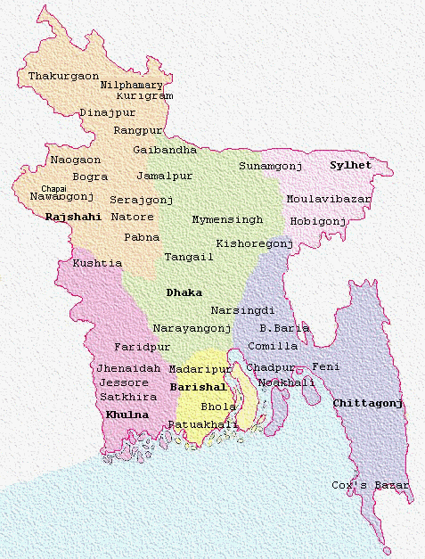

2.18 Regional Offices:
- Dhaka Central Zone | - Dhaka North Zone | - Dhaka South Zone
- Narayanganj Zone | - Mymensing Zone | - Chittagong Zone
- Sylhet Zone | - Bogra Zone | - Rajshahi Zone
- Khulna Zone | - Barishal Zone | - Comilla Zone
UBL Networks
Local Office | 2
Regional Office | 15
Worldwide Affiliates | 600
Total Branches | 211
Authorized Dealer Branches | 38
Computer Lab | 1
Treasury & Dealing Room | 1
Training Institute | 1
Man Powe Man Power | 3562

2.19 Branch Position:

2.19.1 Financial Position of the Branch (June-10)
From when I started here as an internship I expired that this branch is always over crowed with a lot of customers. This has promoted me to find out the financial position of the branch. Here I was able to extract the following data regarding the branch.

Particulars | Taka
Total Deposit | 116,663,162
Total Advance | 54,344,613
Profit/ Loss | 5,708,143
Current account G/L Balance (30.06.09) | 90
Cash Credit account G/L Balance (29.06.09) | 19,042,085

2.19.2 Profit of the Branch:
The Profits of the branch starting from January’10 to June’10 are given below:
The profit of this branch is Tk.852359, 432825, 496232, 470211,466010 and 2990506 in the month of January, February, March, April, May and June respectively.

Month | January | February | March | April | May | June
Total Profit | 8,52,359 | 4,32,825 | 4,96,232 | 4,70,211 | 4,66,010 | 29,90,506

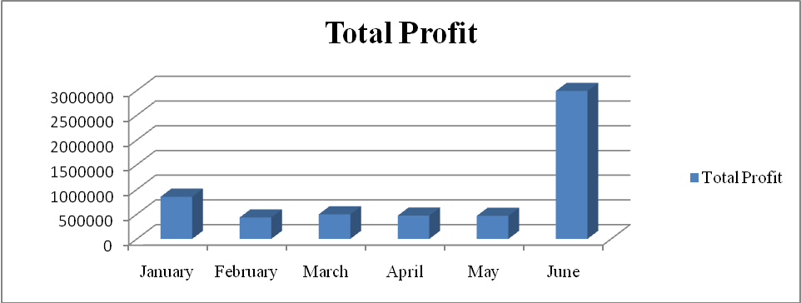

FIGURE: Total Profit of the Branch

Interpretation: From the graph it is easily understand that the profit of the branch is going high which is very good for the total organization. Because they are always provide profit for the total organization means Uttara bank limited.

Total Inflow:
Month | January | February | March | April | May | June
Total Income | 12,03,504 | 7,81,413 | 9,35,575 | 10,58,725 | 10,43,861 | 36,31,896

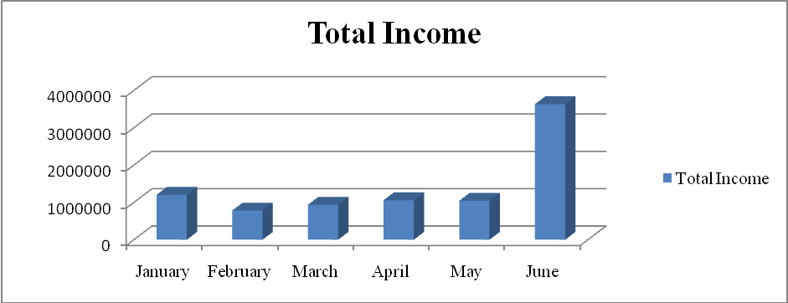
FIGURE: Total Income of Total Inflow

Interpretation: It is found that the Total income is like Tk. 1203504,781413, Tk. 935575, Tk. 1058725, Tk. 1043861, and Tk.3631896 in the month of January, February, March, April, May and June respectively. From the chart it is said that the total income of UBL Fakirapul branch is growing up since from January to June. The branch shows good performance by them.

Total Expense:

Month | January | February | March | April | May | June
Total Expanse | 3,51,145 | 3,48,588 | 4,39,343 | 5,88,514 | 5,77,851 | 6,41,389

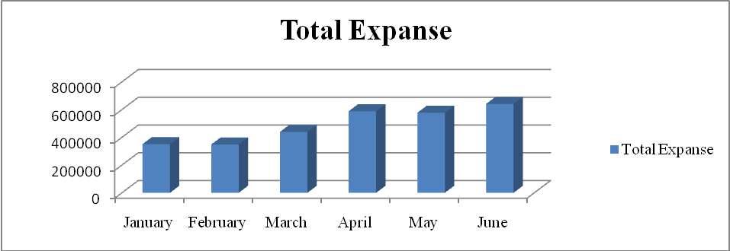
FIGURE: Total Expense

Interpretation: Total expense of Fakirapul Branch is Tk. 351145, Tk. 348588, Tk. 439343, Tk. 588514, 577851 and Tk. 641389 in the month of January, February, March, April and May respectively. The expense is decrease in May from the previous month which is shown a good responsibility by the branch.

2.19.3 Performance of Uttara Bank Ltd:
Uttara Bank’s operation has achieved the confidence of its customer with sound fundamentals in respect of deposit accumulation; loans & Advance, Import & Export business, remittance business and profitability. As a result the bank has been able to earn remarkable profit in business. Overall performance of Uttara Bank Limited has been improved for maintaining effective and constructive principle of Bangladesh Bank.

Cash:
Cash in stood at TK 1,341.4 million in 2009 which is lower than that of the previous year and the same amounted to TK 1,585.5 million in 2008.

Share Capital:
The Authorized Capital of the Bank remained at tk 1600.00 to Tk.3200.00 million during the year 2009. The paid up capital of the Bank has been increased to TK 1597.4 million from TK 798.7 million due to declaration of 100% bonus share for 2009. The total number of shareholders was 15973184. The Government of the Peoples Republic of Bangladesh, eighteen Banks and fifty two financial institutions held total 676397 sahares worth Tk. 67639700.00 and remaining 42499 private shareholders held total 15,296,787 shares worth Tk. 1,529,678,700.00. The total equity of shareholders of the Bank at end of the year 2009 stood at Tk.6,206.9 million and in 2008 stood at Tk. 3688.8 million.

Reserve Fund:
The reserve fund of the bank increased to TK 4,609.6 million during the year by registering 59.49 percent increase over last years Tk. 2,890.2 million.
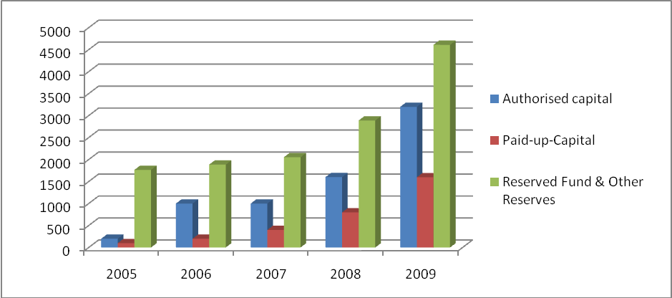
FIGURE: Authorized capital, Paid-up-Capital, Reserved fund & other Reserves

Capital Adequacy:
As per guidelines of Bangladesh Bank, the Bank adopted BIS (Bank for International Settlement) risk adjusted capital standerd to measure capital adequacy. Capital adequacy indicates the equity base with respect to risk weighted assets derived from both on and off balance sheet activities of the bank.. At the end of the year 2009, the actual capital of the bank stood at Tk 5,829.0 million against required capital of Tk 3,688.2 million on the basis of tier-1 and tier -2 showing surplus capital of Tk 2,140.8 million. Risk weighted assets increased by Tk 2,677.8 million and stood at Tk 36,882.4 million in 2009 mainly due to increase in loans and advances.. The capital adequacy rate of the Bank stood at 15.91 percent against required 10.0 percent as fixed by Bangladesh bank, which is indicative of the sound capital base of the bank.
Deposit:
The Bank’s principle source of fund was deposit. The Bank deposit stood at Tk 59,387.3 million as on December, 2009 compared to Tk 50,817.0 million in 2008, thus recording 16.87 % growth. Competitive interest rates, attractive deposit products, deposit mobilization efforts of the Bank and confidence reposed by the customer in the Bank contributed to the notable growth in deposit. The Bank evolved a number of attractive deposit scheme to cater to the requirement of small and medium savers.

Investment:
The total investment during the year 2009 were mostly in government Securities which stood at TK 22,344.1 million as against TK 11,091.8 million making a growth of 101.44 percent over the last year. The Uttara Bank Limited is primary dealer of Government securities. The Bank as a primary dealer is purchase the unsold Bond/ Bill which are put to auction in order to keep underwriting commitment. As a result the investment in Bond and Treasury bill increased. Besides one of the investment activities of the Bank was maintenance of statutory Liquidity Reserve which mainly comprise Government Treasury Bond and Treasury bill of different terms, National prize Bond, Government Approved Debenture and ICB shares. The Bank invested total Tk. 22,502.5 million in 2009 as compared to TK 11,188.8 million of the previous year.

Investment in treasury bonds and others securities:
Utilization of surplus fund was a major function of Treasury Department. Due to decline of surplus fund against previous year the entire Investment of the Bank stood at Tk. 22,502.5 million at the close of the year 2009. Mentionable that Bank has been able to increase Loans and Advance in Small Business as well as different sector by reducing investment.
Bank was maintenance of “Statutory Liquidity reserve” which generally compromise of Govt. Treasury Bills and Bonds (HTM) of various tenures, National Prize Bonds and
Govt. approved Debenture. The shares of Govt. Securities were amounted to Tk. 22,344.1 million in total Investment, which was 11,091.8 million in the previous year.

Head wise position of Bank's invested Fund at the end of the Year 2009 is given below

Head of Investment | (Taka in million)
Treasury Bills and Bonds  Approved Debenture (in purchase price)  Share & Debenture of ICB sponsored companies  Prize Bond | 22,182.9  151.0  7.3  10.2
Ordinary Shares:  1. Eastern Bank Ltd. 104.0  2. Karmo sangsthan Bank 10.0  3. ICB (Approved) 31.8  4. CDBL 1.0  5. Other Companies 4.3 | 151.1
Total: | 22,502.5

2.20 Uttara Bank at a Glance:
Sponsored by some dynamic and reputed entrepreneurs and eminent industrialist of the country and also participated by the government, Uttara Bank Ltd. started its operation in mid 1983 and has since been able to establish one of the largest networks of 207 branches as on 31 December 2008 among the first generation banks in the private sector.
The bank has in its management a combination of highly skilled and eminent bankers of the country of varied experience and expertise. The management team of the bank is successfully led by Mr. Samsudin Ahmed managing director. He is a renowned and a dynamic banker with more than three decades of banking experience to his credit. The management is ably supported and assisted by qualified executives and officers.

(Figure: Five year Glance in million)
SL. No. | Particulars | 2010 | 2009 | 2008 | 2007 | 2006
 | Income Statement
01 | Gross Income | 7396.5 | 6,313.5 | 5020.2 | 4435.1 | 4265.0
02 | Gross Expenditure | 4882.6 | 4,007.9 | 3554.0 | 3153.2 | 2650.4
03 | Gross Profit | 2513.9 | 2,305.6 | 1466.2 | 1281.9 | 1614.6
04 | Pre-tax profit | 21889 | 2,098.1 | 1143.7 | 866.8 | 782.6
05 | Post-tax profit | 1105.2 | 1,138.5 | 409.5 | 248.8 | 142.6
 | Balance Sheet
06 | Authorized capital | 3000.0 | 1,600.0 | 1000.0 | 1000.0 | 200.0
07 | Paid-up-capital | 1597.3 | 798.6 | 399.3 | 199.7 | 99.8
08 | Reserve fund and other reserves | 4609.6 | 2,890.2 | 2054.2 | 1885.8 | 1765.2
09 | Shareholders equity | 6206.9 | 3,688.8 | 2453.5 | 2085.4 | 1865.0
10 | Deposits | 59387.3 | 50,817.0 | 43586.4 | 39360.2 | 36891.9
11 | Advances(gross) | 39451.4 | 37,141.13 | 28477.4 | 25163.9 | 21851.5
12 | Investments | 22502.5 | 11,188.3 | 14455.8 | 9564.5 | 10062.1
13 | Guarantee business | 1633.5 | 1,826.9 | 1474.4 | 1564.1 | 1781.4
14 | Export business | 15096.9 | 15,039.6 | 14784.5 | 18133.9 | 18191.8
15 | Import business | 29129.3 | 31,146.9 | 25407.9 | 22630.7 | 23092.4
16 | Foreign remittance | 44635.3 | 36073.2 | 29575.3 | 28728.1 | 27276.0
17 | Fixed assets | 1088.4 | 165.7 | 1014.0 | 942.1 | 776.2
18 | Total assets | 71946.0 | 58444.3 | 52860.3 | 45217.0 | 42062.2
19 | Classified loans and advances | 2842.0 | 2633.8 | 3530.9 | 3783.9 | 3528.1
20 | Total off balance sheet exposures | 8560.5 | 8806.9 | 8830.5 | 7428.5 | 8538.8
 | BIS Capital Measures
21 | Required Capital | 3688.2 | 3420.5 | 2617.8 | 2083.0 | 1811.1
22 | Actual Capital | 5829.0 | 4048.4 | 2746.7 | 2273.0 | 2004.0
 | Credit Quality
23 | Required Provision | 889.7 | 684.8 | 727.1 | 790.6 | 727.0
23.a | Provision Maintain | 910.1 | 792.8 | 826.4 | 907.4 | 853.8
24 | Required Provision off balance sheet exposure | 85.6 | 88.1 | 44.2 | N/A | N/A
24.a | Provision Maintain | 101.7 | 101.7 | 44.2 | N/A | N/A
 | Share Information
25 | Income per share | 69.19 | 142.56 | 102.56 | 124.59 | 142.83
26 | Market value per share | 1450.25 | 3393.75 | 4854.75 | 2312.25 | 2811.00
27 | Price earning ratio | 20.96 | 23.81 | 47.34 | 18.56 | 19.68
28 | Book value per share | 388.58 | 437.88 | 573.73 | 957.66 | 1694.54
 | Operating performance Ratio
29 | Advance-Deposit ratio | 0.66:1 | 0.73:1 | 0.65:1 | 0.64:1 | 0.59:1
30 | Total Advance/ Class. Advance | 7.20% | 7.09% | 12.40% | 15.04% | 16.14%
31 | Total Adv. Class. Advance | 5.21% | 4.46% | 8.83% | 13.40% | 12.37%
32 | Income from equity | 17.80% | 30.86% | 16.69% | 11.93% | 7.655
33 | Income from Assets | 1.54% | 1.95% | 0.77% | 0.55% | 0.34%
 | Other Information
34 | Number of shareholders | 42570 | 27228 | 12467 | 5390 | 5351
35 | Number of Branches | 211 | 207 | 207 | 201 | 198
36 | Number of Employees | 3291 | 3476 | 3476 | 3505 | 3265
37 | Human Resources Development | 1239 | 1062 | 1086 | 698 | 761
2.21 BALANC SHEET:
UTTARA BANK LIMITED
BALANCE SHEET AS AT 31 DECEMBER 2009
 |  |  |  | 2009 |  | 2008
PROPERTY AND ASSETS |  | Notes |  | Taka |  | Taka
Cash |  | 03 |  | 5,860,103,625 |  | 5,002,561,855
In Hand (including foreign currencies) |  |  |  | 1,585,554,764 |  | 1,713,064,194
Balance with Bangladesh Bank and its
agent Bank (including foreign currencies) |  |  |  | 4,274,548,861 |  | 3,289,497,661
Balance with other Banks and
financial institutions |  | 04 |  | 350,941,308 |  | 1,121,909,129
In Bangladesh |  |  |  | 6,930,615 |  | 800,727,487
Outside Bangladesh |  |  |  | 344,010,693 |  | 321,181,642
Money at call and short notice |  | 05 |  | 29,900,000 |  | 30,000,000
Investments |  | 06 |  | 11,188,289,669 |  | 14,455,780,134
Government |  |  |  | 11,091,865,330 |  | 14,381,918,295
Others |  |  |  | 96,424,339 |  | 73,861,839
 |  |  |  |  | ..
Loans and Advances |  | 07 |  | 37,141,342,619 |  | 28,477,407,266
Loans, cash credits, over drafts etc. |  |  |  | 33,308,029,435 |  | 25,298,004,729
Bills discounted and purchased |  |  |  | 3,833,313,184 |  | 3,179,402,537
Fixed assets including Land, Building,
Furniture and Fixtures |  | 08 |  | 1,065,679,827 |  | 1,013,985,359
Other Assets |  | 09 |  | 2,698,386,497 |  | 2,758,688,987
Non Banking Assets |  | 9.1 |  | 109,688,573 |  | -
TOTAL ASSETS |  |  |  | 58,444,332,118 |  | 52,860,332,730
LIABILITIES AND CAPITAL / SHARE HOLDERS' EQUITY
Liabilities
Borrowings from other Banks,
Financial Institutions and Agents |  | 10 |  | 225,086,084 |  | 2,899,505,333
Deposits and other accounts |  | 11 |  | 50,816,975,020 |  | 43,586,356,057
Current and other accounts etc. |  |  |  | 15,570,321,322 |  | 12,372,373,980
Bills payable |  |  |  | 1,605,516,899 |  | 1,643,287,611
Saving bank deposits |  |  |  | 19,547,765,743 |  | 17,876,529,810
Fixed deposits |  |  |  | 12,164,269,906 |  | 10,417,183,199
Bearer certificate of deposit |  |  |  | - |  | 50,000
Other deposits |  |  |  | 1,929,101,150 |  | 1,276,931,457
Other liabilities |  | 12 |  | 3,713,428,714 |  | 3,920,914,181
TOTAL LIABILITIES |  |  |  | 54,755,489,818 |  | 50,406,775,571
CAPITAL/SHARE HOLDERS' EQUITY
Issued, subscribed and paid up capital |  | 13.2 |  | 798,659,200 |  | 399,329,600
Issuance of bonus shares |  |  |  | - |  | 399,329,600
Statutory reserve |  | 14 |  | 1,550,837,039 |  | 550,837,039
Other reserves |  | 15 |  | 1,337,631,167 |  | 1,100,864,198
Retained earnings |  | 16 |  | 1,714,894 |  | 3,196,722
TOTAL CAPITAL/ SHARE HOLDERS' EQUITY |  |  |  | 3,688,842,300 |  | 2,453,557,159
TOTAL LIABILITIES AND CAPITAL/SHARE HOLDERS' EQUITY |  |  |  | 58,444,332,118 |  | 52,860,332,730
CONTINGENT LIABILITIES |  | 17.0 |  | 8,806,887,103 |  | 8,830,513,784
Acceptances & endorsements |  |  |  | - |  | -
Letter of guarantees |  | 17.1 |  | 1,826,856,510 |  | 1,474,352,134
Irrevocable letter of credit |  | 17.2 |  | 4,517,171,591 |  | 5,382,511,516
Bills for collection |  | 17.3 |  | 3,156,536 |  | 3,140,634
Other contingent liabilities |  | 17.4 |  | 2,459,702,466 |  | 1,970,509,500
OTHER COMMITMENTS |  |  |  | - |  | -
Documentary credits and short term |  |  |  | - |  | -
trade related transactions |  |  |  | - |  | -
Forward assets purchased and forward |  |  |  | - |  | -
Deposits placed |  |  |  | - |  | -
Undrawn note issuance and revolving |  |  |  | - |  | -
underwriting facilities |  |  |  | - |  | -
Undrawn formal standby facilities, |  |  |  | - |  | -
credit lines and other commitments |  |  |  | - |  | -
Liabilities against forward purchase & sale |  |  |  | - |  | -
Litigation filed by the Bank |  |  |  | - |  | -
TOTAL OTHER COMMITMENTS |  |  |  | - |  | -
TOTAL OFF- BALANCE SHEET ITEMS
INCLUDING CONTINGENT LIABILITIES |  |  |  | 8,806,887,103 |  | 8,830,513,784

2.22 Profit and Loss Account:

UTTARA BANK LIMITED
PROFIT AND LOSS ACCOUNT FOR THE YEAR ENDED 31 DECEMBER 2009
 |  |  |  | 2009 |  | 2008
 |  | Notes |  | Taka |  | Taka
OPERATING INCOME
Interest Income |  | 18.1 |  | 4,084,288,089 |  | 2,997,432,877
Interest paid on deposits, borrowings etc. |  | 19 |  | 2,200,521,205 |  | 1,876,351,450
Net Interest Income |  |  |  | 1,883,766,884 |  | 1,121,081,427
Income from Investment. |  | 20 |  | 784,896,516 |  | 921,189,131
Commission,Exchange and Brokerage |  | 21 |  | 907,895,386 |  | 744,994,717
Other Operating Income |  | 22 |  | 431,106,660 |  | 356,650,099
Total operating income |  |  |  | 4,007,665,446 |  | 3,143,915,374
OPERATING EXPENSES
Salary and allowances. |  | 23 |  | 1,272,357,540 |  | 1,158,073,662
Rent, taxes,insurance,electricity etc. |  | 24 |  | 151,877,811 |  | 188,502,215
Legal expenses |  | 25 |  | 9,429,329 |  | 11,544,740
Postage,stamp,telecommunication etc. |  | 26 |  | 39,680,054 |  | 48,215,055
Stationery,printing,advertisements etc. |  | 27 |  | 51,324,787 |  | 40,275,975
Managing Director's salary & allowances and fees |  | 28 |  | 6,424,333 |  | 5,060,000
Directors' fees and expenses |  | 29 |  | 2,264,000 |  | 1,916,000
Auditors' fees |  |  |  | 250,000 |  | 130,000
Repair, maintenance and depreciation
of Bank's property |  | 30 |  | 107,256,133 |  | 85,308,986
Other expenses |  | 31 |  | 166,472,931 |  | 138,653,184
Total operating expenses |  |  |  | 1,807,336,918 |  | 1,677,679,817
Operating profit |  |  |  | 2,200,328,528 |  | 1,466,235,557
Add: Profit on sale of fixed asset |  | 32 |  | 105,289,644 |  | -
Profit before provision |  |  |  | 2,305,618,172 |  | 1,466,235,557
Provision |  |  |  | 207,500,000 |  | 322,500,000
Provision for loans & advances |  | 33 |  | 92,550,000 |  | 255,800,000
Provision for off balance sheet exposures |  | 34 |  | 57,450,000 |  | 44,200,000
Provision for outstanding unreconciled entries |  | 35 |  | 55,000,000 |  | -
Transfer to gratuity fund |  |  |  | - |  | 20,000,000
Transfer to benevolent fund |  |  |  | 2,500,000 |  | 2,500,000
Profit before tax |  |  |  | 2,098,118,172 |  | 1,143,735,557
Provision for Tax |  |  |  | 959,600,000 |  | 734,200,000
Current tax |  |  |  | 940,000,000 |  | 727,000,000
Deferred tax |  |  |  | 19,600,000 |  | 7,200,000
Profit after tax |  |  |  | 1,138,518,172 |  | 409,535,557
Retained surplus brought forward |  | 16 |  | 3,196,722 |  | 22,990,765
Profit available for appropriation |  |  |  | 1,141,714,894 |  | 432,526,322
Appropriations |  |  |  | 1,140,000,000 |  | 429,329,600
Statutory reserve |  |  |  | 1,000,000,000 |  | 30,000,000
General reserve |  |  |  | 140,000,000 |  | -
Issue of bonus share |  |  |  | - |  | 399,329,600
Retained earnings |  |  |  | 1,714,894 |  | 3,196,722
Earning per share (EPS) |  | 40 |  | 142.55 |  | 51.28

2.23 Cash Flow Statement:
UTTARA BANK LIMITED
 | CASH FLOW STATEMENT FOR THE YEAR ENDED 31 DECEMBER 2009
 | Particulars | Notes | 2009 |  | 2008
 |  |  | Taka |  | Taka
A. | Cash flows from operating activities
 | Interest received |  | 4,799,748,773 |  | 3,936,910,026
 | Interest paid |  | (2,200,521,205) |  | (1,876,351,450)
 | Dividend received |  | 23,588,570 |  | 16,648,690
 | Fees, commission & exchange received |  | 907,895,386 |  | 744,994,717
 | Recoveries of loans previously written off |  | - |  | 3,301,343
 | Cash paid to employees |  | (1,278,781,873) |  | (1,162,793,662)
 | Cash paid to suppliers |  | (58,060,381) |  | (46,182,229)
 | Income tax paid/adjustment |  | (786,931,386) |  | (717,853,962)
 | Received from other operating activities |  | 431,106,660 |  | 356,650,099
 | Payments for other operating activities | 36 | (449,246,922) |  | (356,040,511)
 | Cash generated from operating activities before changes |  | 1,388,797,622 |  | 899,283,061
 | in operating assets and liabilities
 | Increase/(decrease) in operating assets and liabilities |  | (3,268,836,413) |  | 141,888,315
 | Statutory deposits |  | - |  | -
 | Purchase/sale of trading securities |  | 1,278,445,559 |  | (3,266,583,619)
 | Loans and advances to other banks/Money at call & short notice |  | 100,000 |  | -
 | Loans and advances to customers ( other than Banks) |  | (8,663,935,353) |  | (3,313,550,245)
 | Other assets | 37 | 783,392,565 |  | 555,995,056
 | Deposits from other Banks/borrowings |  | 76,282,903 |  | 73,963,121
 | Deposits from customers (other than Banks) |  | 7,154,336,060 |  | 4,152,185,748
 | Other liabilities on account of customers |  | (25,231,983) |  | 26,227,577
 | Other liabilities | 38 | (3,872,226,164) |  | 1,913,650,677
 | Net Cash received / (used) from operating activities |  | (1,880,038,791) |  | 1,041,171,376
B. | Cash flows from investing activities
 | Proceeds from sale / payments for purchase of securities |  | 1,994,620,606 |  | (1,625,596,994)
 | Purchase of property, plants and equipments |  | (188,474,399) |  | (134,565,821)
 | Sale of property, plants and equipments |  | 163,428,107 |  | 365,327
 | Purchase/sale/Adjustment of subsidiary |  | 2,614,126 |  | (2,681,155)
 | Net Cash received / (used) in investing Activities |  | 1,972,188,440 |  | (1,762,478,643)
C. | Cash flows from financing activities
 | Received from issue of loan capital and debt securities |  | - |  | -
 | Repayment of loan capital and debt securities |  | - |  | -
 | Received from issue of ordinary shares |  | - |  | -
 | Dividend paid |  | - |  | (39,932,960)
 | Dividend distribution tax |  | - |  | -
 | Net cash received / (used) from financing activities |  | - |  | (39,932,960)
D. | Net (Increase) /decrease in cash & cash equivalents (A+B+C) |  | 92,149,649 |  | (761,240,227)
E. | Effects of exchange rate changes on cash and cash-equivalents |  | - |  | -
F. | Opening cash and cash equivalents |  | 6,132,593,284 |  | 6,893,833,511
G. | Closing cash and cash-equivalents (D+E+F) | 39 | 6,224,742,933 |  | 6,132,593,284
 | Cash and cash equivalents at end of the year
 | Cash in hand (including foreign currencies ) |  | 1,585,554,764 |  | 1,713,064,194
 | Bal. with Bangladesh Bank & its agent Banks (including foreign currencies) |  | 4,274,548,861 |  | 3,289,497,661
 | Balance with other banks and financial institutions (note-4 ) |  | 350,941,308 |  | 1,121,909,129
 | Prize bonds |  | 13,698,000 |  | 8,122,300
 |  |  | 6,224,742,933 |  | 6,132,593,284

Chapter: Three

Body of the Report



3.1 Introduction of UBL at Fakirapul Branch:
This branch was established 3rd June, 1984 it is situated at the 1st floor of Bhaban, 3 Inner Circular Road Fakirapul, Dhaka-1000. The bank is designed under one floor. It has been providing banking services for the customers of Fakirapul area.
3.2 Objectives:
- To provide banking service to the people within the commanding area.
- To expand business.
- To keep position in the competitive market.
- To contribute in profitability of UBL
3.3 Department of the Branch:
- Account opening department
- Cash department
- Accounts department
- Investment department
- Foreign exchange department
- Clearing department
- Remittance department
3.4 A list of Employees of the UBL Fakirapul Branch:

SL. |  | Designation | Number of Employer
01 |  | Assistant General Manager (AGM) & Manager | 1
02 |  | SPO | 2
03 |  | PO | 4
04 |  | Senior Officer (SO) | 8
05 |  | OG | 8
06 |  | Account Officer (AO) | 3
10 | Staff |  | 5
Total |  |  | 31

3.5 General Activities of the organization:
3.5.1 General banking:
General Banking is the starting point of all banking operation. It is a combination of activities of different sections.
General banking has some section in the bank. These sections are as follows:
- Accounts Opening Section.
- Cash Section.
- Clearing Section.
- Remittance Section.
- Accounts Section.
- Others.
3.5.2 Accounts Opening Section:
Opening account with a bank is the way of creating a banker customer relationship. In other words, it is a contract between banker and customer. With this contract, bankers enter into certain obligations and responsibilities.
Proper introduction serves as a precaution against fraud and forgeries and safeguard against inadvertent overdraft to bank. Obtaining proper introduction may absolve the banker from the charges of negligence for conversion. So, while opening a new account, emphasis would be given without exception to introductory reference and inquiry. The following instruction to be followed while opening account: -

- Introduction of Account to be obtained from a respectable client acceptable to bank.
- The introduction shall be obtained in writing in the respective column of Account opening form.
- For opening savings bank account of individual either singly or jointly, passports and identity cards may be accepted for introduction, but subsequently proper introduction may be obtained.
- Introduction of Current Account by members of the staff may be allowed but shall be discouraged as far as possible.
- Current Account shall preferably be introduced by another Current Account holder acceptable to bank.
3.5.3 Documents for opening some special account:
The following documents duly completed shall be obtained from the customer at the time of opening different types of accounts as applicable:
- Individual/ joint:
- Account opening form as applicable duly filled in.
- Specimen Signature Card.
- Two photographs duly attested by introducer.
- Nominee Form (if nomination given by the account holder).
- Mandate or Authority Form (if a third person is authorized to operate the account).
- Proprietorship Firm:
- Account Opening Form.
- Specimen Signature Card.
- Copy of Trade License
- Two photographs duly attested by introducer.
- Proprietorship Rubber Stamp against all signatures of the proprietor.
- Partnership Concern:
- Account Opening Form.
- Specimen Signature Card.
- Copy of Trade License
- Partnerships Deed
- Two photographs of each partner duly attested by introducer.
- Partnership Rubber Stamp against all signatures of partners operating the accounts.
- Partnership letter.

3.5.4 Limited Company:
I. Private Limited Company:
- Account Opening Form.
- Specimen Signature Card.
- Copy of Trade License.
- Copy of Memorandum and Articles of Association duly attested by the Managing Director/ Chairman of the Co.
- Certificate of Incorporation.
- List of Director as per return of Joint Stock Company with signature.
II. Public Limited Company:
- Account Opening Form.
- Specimen Signature Card.
- Copy of Trade License.
- Photograph of Directors and account operators other than Director.
- Certified copy of Memorandum and Articles of Association.
- Certificate of commencement of business.
- List of Directors as per returns of Joint Stock Company with their signature.
- Resolution of the Board for opening account with the Bank.
- Certification of incorporation.

3.5.5 Clubs/ Association/ Society etc. (Non-Trading Concerns):
- Account opening Form for current account or SB accounts.
- Specimen Signature Card.
- Certified copy of Bye laws/ constitution of the organization.
- List of the Executives of Managing Committee with their signature and present and permanent address.
- Resolution of the Committee for opening account with the bank.
- 2 Photographs of each operator of the account.
3.5.6 Savings account Individual or joint:
- Account opening form as applicable duly filled in.
- Specimen Signature Card.
- Two photographs duly attested by introducer.
- Nominee Form (if nomination given by the account holder).
- Mandate or Authority Form (if a third person is authorized to operate the account).
  - Corporation/ Autonomous Bodies/ Govt. Organization
- Account Opening Form as applicable.
- Specimen Signature Card.
- Copy of the Act or Ordinance Showing authority to open account.
- Letter from the authorized persons in absence of the Board.
  - Account Of Constituted Attorney
- Account Opening Form (As applicable)
- Specimen Signature Card
- Power of Attorney
3.6 Other products and services:
Along side traditional banking product and services, the bank has some tailor made products in liability and asset sides. Of those mentionable are Monthly Savings Scheme and Double Benefit scheme etc. for deposit mobilization in one hand and consumer credit scheme, lease finance, personal loan, Uttara house repairing and renovation Scheme and SME financing in other hand. Besides, the Bank has also some electro-products based on information technology of which Q-cash UBL ATM Debit cards are to be mentioned for providing 24 hours services to customers.

3.7 Different Banking Sectors Limited:
3.7.1 Corporate Finance:
Uttara Bank is a major player in Bangladesh wholesale banking industry to offer the full scope of innovative, customized solutions and services. We offer service at the highest level. Our focus is not on short-term profit, but on building long-term relationships and standing by our clients whenever they need us.
e have a unique business focus on enabling project financing, trade, investment and supply chain financing for clients. We aim to be a one-stop gateway for corporate and financial institutions looking to extend their business. And we are committed to using our country wide network to facilitate our clients’ growing trade and investment flows and supply chain financing needs across our business footprint.
We focus exclusively on corporate and institutional clients domiciled or conducting business in our footprint, offering clients access to our extensive branch network and award-winning suite of state of the art services.
Uttara Bank fully understands the importance of time, convenience and efficiency to the success of your business. We make easy the complex financial world for you and help you maximize every opportunity.
3.7.2 Working Capital Finance:
Overdraft:
A convenient and flexible form of short-term financing for routine operating expenses and overheads of your company
Guarantees and Bonds:
Uttara Bank issues a full range of Performance Guarantees, Advance Payment Guarantees, and Financial Guarantees and Bid bonds for supporting the underlying business of our customers.
3.7.3 Trade Finance:
Uttara Bank’s trade finance is tailored to meet the individual needs of your business. We can help even if your company has limited unstructured credit lines, due to reasons such as limited financial resources or sudden spike requirements. That’s because our risk evaluation focuses more on your performance track record, existing performance and collateral valuation
3.7.3.1 Imports:
- Letter of Credit
- Back-To-Back Letter of Credit
- Deferred Letter of Credit
- Import bills for collection
- Shipping Guarantee
- Performance bonds and other guarantees
- Import Financing
3.7.3.2 Exports:
If you are in the export business, we can help you with Export L/C advising, L/C Safekeeping, L/C Confirmation, L/C Checking and Negotiation. For financing solutions, tap on to Pre-shipment Export Finance, Export Bills for Collections, Invoice Financing. Outsource your administrative functions to Uttara Bank’s document preparation service.
**Export letter of credit advising
*Export letter of credit safekeeping
*Export letter of credit confirmation
*Pre-shipment export financing
*Letter of credit checking and negotiation
*Export bills for collection
*Export invoice financing
*Document preparation

3.7.4 Short & Mid-term Finance:
3.7.4.1 Short Term Financing:
As the responsive player in market, you may anytime need fund to utilize for a very short time due to either emergency or short term projects. In such case, Uttara Bank is there to facilitate you. This can be a Short Term Loan or a Short Term Revolving Loan. You can get it either for your inland business or cross-border payment in foreign trade.
3.7.4.2 Mid Term Financing:
Uttara Bank can also equip you the required fund for a longer period. If you worry about fund requirement for a bit longer, ‘Uttara Bank Term Loan’ will make you feel confident that, you got a friend for this.

3.7.5 Project Finance:
Uttara bank has been very active in the finance in a Project:
Our project financing solutions:
  - Mitigate sponsor exposure to project risk.
  - Enhance use of leverage to increase project returns by lowering the weighted average cost of capital.
  - Provide access to significantly longer tenor debt financings.
  - Create optimum financing structures (source of debt, currency, derivatives) that take into account your company’s particular capital needs as well as industry specific issues.
Lease and Long Term Loans:
We can customize a Term Loan or Lease to finance the fixed assets that your business needs (such as land, new premises, equipment and machinery). It may be a Greenfield project or an expansion of an existing plant, which may be financed at competitive floating rate of interest.
3.7.6 Islamic Finance:
With over 1.5 billion Muslims in the world, the global Islamic funds market is currently valued at USD 750 billion and is expected to grow exponentially every year.
3.7.6.1 Innovative Shariah compliant banking solutions
At Uttara Bank our dedicated Islamic Banking team combines Shariah expertise with strong business acumen to offer customers the best of both worlds - comprehensive international banking services and a wide range of Shariah compliant financial products based on Islamic values.
At Uttara bank, we've blended Shariah principles with our rich banking heritage of more than 150 years to provide banking services that support your business while respecting your beliefs.
Our diverse range of Islamic Banking products are designed to give you greater flexibility while conducting business through Shariah-compliant process

3.7.6.2 Our Products
Bai Muajjal:
For financing procurement of raw material where goods are kept under customer’s custody.
Bai Murabaha:
For financing procurement of raw material where goods are kept under bank’s custody.
Hire Purchase under Shirkatul Melk:
For financing procurement of capital machinery.
Bai Salam:
For financing pre-shipment expenses by purchasing exportable goods in advance.
S
3.7.7 Structured of Finance:

A leading provider of cost-efficient, lease-based and asset-based financing solutions to businesses in Bangladesh, we can create and tailor the right structured solutions for your business needs in order to enhance shareholders’ wealth and your market competitiveness.
These solutions include:
3.7.7.1 Structured financing solutions:
Principal to principal structured capital market transactions optimizes investment returns and reduces effective funding costs.
3.7.7.2 Syndications:
This normally involves getting a group of banks together (forming a syndicate) to provide the loan amount required by the customer under a set of common terms and conditions laid down in a loan agreement.
Choose Uttara Bank and you gain access to full loan origination, distribution and trading capabilities, together with an unrivalled ability to match lenders and borrowers. Our leadership position and world class distribution capability result from the team’s ability to read the market, and to provide superb sell down coverage.

3.7.8 Cash Management:
In today's competitive financial environment, effective cash management has become a critical success factor. This is the right time to have integrated cash management solution.
Our cash management services include local and cross border payments, collections, information management, account services, liquidity management and investment services for both corporate and institutional clients.
3.7.8.1 Payment Services:
We can help you save time and money by reducing processing costs while providing a value-added service to your suppliers.
Uttara Bank’s payment solutions can help to reduce your overall processing costs – for domestic and global payments – saving you time and money while providing a value-added service to your suppliers. Our comprehensive payment services will be tailored to enhance your accounts payable process. This will eliminate many manual tasks involved in making payments, allowing you and your staff to spend more time focusing on your core business needs.
We understand that most of your effort in the payment cycle is directed towards initiation; difficulties in the subsequent reconciliation process can jeopardize the whole process. With Uttara Bank Channels you can now track the exact status of each payment through timely reports that can be uploaded seamlessly into your company’s system.
3.7.8.2 Collection Services:
We have a comprehensive branch network and the local knowledge to help you with lower costs and greater efficiency.
The Uttara Bank Collections Solution leverages the Bank's extensive regional knowledge and widespread branch network across our key markets to specially tailor solutions for your regional and local collection needs.
This Collections Solution, delivered through a standardized international platform, has the flexibility to cater to your local needs, thus enabling you to meet your objectives of reducing costs and increasing efficiency and profitability through better receivables and risk management. The key components of our solution include the following:

3.7.8.3 Liquidity Management:
Let us help you to get the most out of your company’s cash resources with physical sweeping, notional pooling, interest reallocation and investment.

3.7.9 Investment Banking:
We are a market leader across our footprint in innovative, landmark deals, multi-jurisdiction solutions and sophisticated product structuring for corporate and institutional clients. We hold leading positions in fixed income local currencies and loan syndications. Our in-depth understanding of the local regulatory framework in the domestic debt and loan markets, product expertise and wide geographic reach, help you achieve your financing and investment objectives.
3.7.9.1 Debt Capital Market:
Our proven knowledge, product capabilities and global reach make us well-suited to matching investors’ needs with the funding requirements of international and domestic issuers.
3.7.9.2 Asset Backed Securities:
We structure, arrange and distribute asset-backed and future flow transactions for clients and our track record of innovative deals puts us at the forefront of developing securitization markets in our footprint.
3.7.9.3 Credit Derivatives:
We offer investment tools and a range of local currencies to provide structured asset solutions to meet specific investment needs, achieve target yields on your portfolio and manage risk exposure.
3.7.9.4 Convertible Bonds / Equity Derivatives:
Our convertible bonds and equity derivatives teams open avenues of financing and investing linked to the equity asset class - all underpinned by local market knowledge, deep client relationships and innovation.

3.8 Account Section:
3.8.1 Individual Account:
Most of the accounts of a branch are individual. As such they deserve regular attention of the members of the staff of a branch. An individual account holder may nominate his near and dear ones to inherit his deposit in case of his death. He/ she can also give mandate or authority to operate his account in his short absence.

3.8.2 Joint Accounts:
- At the time of opening accounts in the name of two or more persons, clear and specific instructions shall be obtained regarding operation of the account and payment of balance to the survivor(s) or surviving members in the event of death of one or more joint account holders.
- The instructions as far as possible shall be obtained in the hand writing of the parties concerned, under the signatures of all the joint account holders.
- If the account is opened in the name of two persons instruction may be: Either or Survivor or singly or jointly.
- If the account is in the names of more then two persons instructions may be: By either or Survivor singly or by any two or more of them or by all of them.
- Incase of death of any joint account holders, if the specific instructions are either a or b, the balance will be payable to the survivor(s).
- In the absence of specific instructions in the “Either or Survivorship” form, balance of the joint account will be payable to the survivors and the legal representatives of the deceased joint account holders.
- Account payee cheque in the name of one of the account holders may be deposited in their joint name account for collection.
- In the event of any of the Joint Account holders becoming bankrupts, all operation in the joint account shall be stopped until fresh instructions are given by the remaining solvent account holders jointly under their signature and the official assignee.
- In the event of death of any joint account holders, the survivor or survivors shall be requested to close the old account and open a new account in the name of surviving account holders.

3.8.3 Account of Proprietorship Concern:
- While opening accounts in the names of proprietorship concern care should be exercised that the person opening account is the proprietor of the firm. Obtaining trade license issued by Municipal Authority/ Union Parishad can be a proof. On specific instruction the account may be operated by persons authorized by the proprietor.
- In case of death of proprietor, all operations in the account shall be stopped. Procedure laid down in Para (r) may be followed. On the death of the proprietor authority given by him ceases and the authority holder can not be allowed to operate the account.
3.8.4 Accounts of Partnership Firm:
A partnership account shall be allowed to be opened and operated by any one partner of the firm under his signature provided a partnership letter has been signed by all the partners of the firm in their individual capacity.
- Partnership Deed or Partnership Letter should be thoroughly studied to know the names and address of all the partners.
- In case of death of partner, if the deceased partner was operating the account singly, the balance shall be paid to the heirs of the deceased and the surviving partners as per orders of the Court agreement or arrived at between the surviving partners and heirs of the deceased. In the later case, the recipient shall execute indemnity bond as explained in Para ® regarding deceased account.
- If a partnership Deed is submitted the same should be accepted and recorded with the bank.
- In case of death of a partner who was not operating the account the surviving partners shall be advised to close the partnership account and open a new account.
- An operating partner may give mandate to a third person to operate the account in place of him.

3.8.5 Accounts of Joint Stock Companies:
- A Joint Stock Company is a separate legal entity. The shareholders may die or become insolvent. The company shall continue to exist unless the number of share holders falls below the minimum number of members.
- The minimum number of members is two and maximum is 50 excluding employees and ex employees. Private Limited Company cannot invite public to subscribe to its shares and therefore, not required to issue a prospect us. Right to transfer share is restricted. It can commence business as soon as it receives certificate of incorporation. It need not obtain “Certificate of Commencement of Business”.
- No cheque book shall be issued or withdrawals allowed from the account of the newly floated companies unless a certified copy of commencement of business is produced by the company.
- If the company fails to produce such certificate as mentioned at Para (v), the deposits accepted by the bank on their behalf representing share money, received in anticipation of the commencement of business, shall be refunded in lump sum to the Directors of the company obtaining a joint receipt from all of them subject to prior approval of Head Office. 55
- Account of Limited Companies operated by the Managing Agents of the company shall not be opened or allowed to be operated unless a certified copy of the Managing Agent’s, Agreement is obtained and the authority of the persons signing on behalf of the firm or company or the Managing Agent is verified.

3.8.6 Death of Constituent/ Deceased Account:
While releasing the balance in the deceased account the following procedure and precaution shall be observed. The Branch Manager should at first be satisfied about the benefited of the beneficiary/ Legal heirs of the deceased and obtain the following papers/ documents. Notice on knowledge of death, insolvency or insanity of a constituent precludes the bank from paying further cheques on his account even though these are dated prior to his death. If the information is authentic, the same should be noted in the record of banks and payment on the account be stopped. In case of any doubt, immediate inquiries are made to ascertain the correct position.
- Application of the legal heirs of the deceased.
- Succession Certificate
- Death Certificate
- Union Council / Pourashava Chairman/ Ward Commissioner Certificate.
- Certificate as to the balance of the deceased account (given by the branch).
- Liability position of the deceased if any duly certified jointly by two attorneys.
- Letter of authority or Power of Attorney is to be obtained in case the amount of one heir is to be with drawn by another heir.
- Legal Guardian or an Executor appointed by them may withdraw the money of a minor legal heir without guardianship Certificate.
- Where the balance in the deceased account is up to Tk.25, 000/- the same may be released without succession certificate, but other formalities to be observed.

3.8.7 Handling of Dormant Accounts:
Dormant Accounts: Current or Savings Bank Account, if remains inoperative for a certain period, will be treated as Dormant Account. In case of Current Account the period is 12 months while in case of Savings Bank Account the period is 24 months.
The dormant accounts should be identified annually during the month of January by applying computer programmed which marks each dormant account with remark “Dormant” against the account in the daily/ monthly periodical print out. In case computer facility is not available, dormant ledger is to be maintained.
The following procedures and precautions shall be taken to avoid fraudulent withdrawals/ transfer of funds from such accounts.
- All individual Current Account and Savings Bank Accounts shall be classified as Dormant if it falls within the criterion as mentioned in the foregoing paragraph.
- The account of Proprietorship and Partnership concerns, Joint Stock Companies, Local Authorities, Semi Government and Government Institutions shall not be treated as Dormant Account even if no withdrawal/ deposits take place for such period. Rather efforts should be made to revive those accounts so that they remain regular accounts.

- The Branch Manager shall scrutinize and ensure genuineness of the instruction/ advice before authenticating action in the Dormant Account on the following:
- Transfer of fund to any account of the branch.
- Transfer of Dormant Account to another branch
- Transfer of fund from Dormant Account to another branch/ bank.
- Closure of account.
- Change of Address.
- Issuance of fresh Cheque Book.

Unclaimed Accounts:
- Current and Savings Bank Accounts dormant/ inoperative for 5 years may be treated as unclaimed accounts.
- Overdue Fixed Deposits, Demand Draft Payable, T.T. Payable, Sundry Deposits, Pay Order outstanding for 3 (three) years and above may be treated as unclaimed accounts.
- All these accounts be listed out and retained in file for reference.
- No interest shall be applied to Savings/ Fixed Deposit Account if treated unclaimed.
- However, Branch shall follow Bangladesh Bank and Head Office circulars on the above from time to time.
Inter Branch Transfer of Account:
In case of transfer of Savings or Current account to another branch, a letter of request should be obtained and action be taken after verification of the signature and taking proper approval of the Manager. The request of the account holder desiring the transfer of the account shall be taken an application.
- When the application is received Manager of the branch will check up the same and if found in order will approve transfer of the account. The relative specimen signature cards and account opening form shall then be taken out from file for transfer by the concerned department.
- The following entries shall be passed by the branch transferring the account.
- Debit : Party’s account.
- Credit : UBL General Account (Transferee branch).
- The transferring branch should not recover any charges from the account holder for transfer of the account.
- The forwarding letter as per the following specimen shall be singed by the Manager.
- At the time of transferring the account the branch may retain photocopy of AOF and SS Card together the application and preserve in Account transfer file.
- Entries shall be made in the Account opened and Closed Register and a note to this effect “Account Transferred to ………….. Branch on…………. shall be made therein.
- Measures to be taken by the Transferred Branch.

3.9 Issuance of Cheque Books:
General Service Division of Head Office will supply required Cheque Books to branches against their requisition from time to time. On receipt of these cheque books/ other security stationery, the branch shall record the stock in the Security Stationery Stock Register. While recording the stock, the Prefix number shall invariably be mentioned.
- Separate folios will be opened in the Cheque Book issue Register for CD/ SB/ STD account cheque books.
- The requisition slip shall be sent to the respective Computer Terminal for posting in the respective account.
- All subsequent Cheque Books shall be issued against Cheque Requisition Slips extracted from the previous cheque books issued to the customer; however, the requisition slip pasted with subsequent cheque book on its first page shall be destroyed.
- The cheque requisition slip duly filled in by the customer shall be forwarded to cheque posting Terminal to ascertain:
- The average balance maintained by the customer.
- Whether previous cheque leaves are properly consumed.
- Cheques are not frequently returned for insufficient funds in the account.
- Payment of Cheque is not frequently stopped.
- The manner in which the account is operated.
- The account is not dormant.

3.10 Balance Inquiries & Statements:
3.10.1 Balance Inquiries.
- The account holder may enquire about his/her balance in the account. The client may be advised to fill and sign the Balance Requisition Slip (BRS) or to produce the Letter of Authority (LOA) duly signed by the account holder.
- The signature of the account holder shall be verified on the BRS or LOA before disclosing the balance.
- If a slip is required to be sent by mail or hand, it shall be sent in a closed envelope addressed to the account holder.

3.10.2 Balance Certificate.
In the event of a balance certificate required by an account holder, he/she may be provided with such certificate as per computer print report recorded by the branch against his/her written request. Certificate may be delivered as per instruction of the account holder.

3.10.3 Balance Confirmation.
- In a computerized system of accounts, the computer program will provide print report of balance confirmation of Accounts along with a sub-joined part. It will contain the full address of the account holder. The balance confirmation shall be dispatched to account holder in a window envelope. Follow-up should be made to get back the sub-joined part duly signed by the account holder.
- On receipt of the confirmation from the party regarding his/her balance duly signed, it shall be preserved in a file after verification of signature.
- Balance confirmation for debit balances in case of over-draft, cash Credit and/or loan accounts shall be dealt with separately. The sub-joined part to be received from clients duly signed by them and preserved in their document file after verification of signature.
3.11 Closing of Accounts:
For different reasons, the account holder(s) may request for closure of his/ their account with the bank. On receipt of such letter of request for closure of account, the Manager should ascertain the reasons to satisfy himself that the constituent is not severing his relations for grievance from the bank which may possibly be redressed. If for genuine reason the account holder(s) approach for closure of his/their account, the following steps shall be taken:
- The application shall be received together with unused cheque leaves.
- The signature of the account holder shall be verified
- The number of unutilized cheque leaves shall be noted on the letter.
- The Manager shall approve closure of the account and ascertain liability position (if any) and closing charges at prescribed rate to be recovered.
- The account holder may be requested to withdraw the balance on deduction of the charges. Other wise the balance payable may be paid by way of pay Slip / Pay Order in favour of the account holder
- After closure of the account, "Account Closed" Stamp shall be affixed on the account opening form, S.S. Card and in the Account Opened and Closed Register with date under signature of an authorized officer.
- The Account opening form together with S.S.Card and the request letter shall be retained in Account closed file to be maintained in branches for Current and Savings Accounts separately.
- If the balance is paid by way of Pay Slip/Pay order, the debit advice may be delivered to the account holder either by hand or by mail.
- The unused cheque leaves shall be destroyed by authorized officer and shall be recorded on the application for reference under joint signature.
- The unused cheque leaves shall be entered in the A/C Opening Register and the running number of the account shall be drawn reducing the closed account on each day.

3.12 Deposit Section
The bank’s deposit stood Tk 50,817.0 million as on December, 2008 compared to Tk 43,586.4 million in 2007, thus recording 16.59 percent growth. Competitive interest rates, attractive deposit products, deposit mobilization efforts of the Bank and confidence reposed by the customers in the Bank contributed to the notable growth in deposit. The Bank evolved a number of attractive Deposit Schemes to cater to the requirement of small and medium savers. These helped to improved not only the quantum of deposits but also to bring about qualitative changes in deposit structure.
Types of Deposit Accounts:
The branches may accept deposits from the public in the following accounts:
- Current Deposits
- Savings Bank Deposits
- Fixed Deposits (Term Deposit)
- Short Term Deposits
- Monthly Term Deposits
- Any other deposits as may be approved/ advised by Head Office.

3.12.1 Current Deposit Account:
- Minimum balance to be maintained in the account is Tk.2,000/-
- Customer willing to open Current Deposit Account shall fill up the Account Opening Form (AOF) applicable to him/ her and Specimen Signature Card (SS Card). The customer will sign in the space provided under “Yours faithfully” and on the specimen signature cards.
- In case of proprietorship and partnership firms the relevant account opening form is to be filled in and signed by the proprietor/ partner in their individual capacity in the space provided under “Yours faithfully” and on the specimen signature card in their official capacity.
- In all other cases including companies etc. the persons opening the account shall fill in the relevant Account Opening Form and sign the Form in the space provided under “Yours faithfully” and in the specimen Signature Card in their official capacity.
- Introduction of acceptable clients to be obtained as per guidelines.
- The Manager’s approval for opening account shall be obtained by the concerned staff member.
- A Current Deposit Account may be opened by individual, firm, company, and club, association, body corporate etc.

3.12.2 Savings Bank Deposit Account:
Savings Bank Account may be opened in the name of adult individual who are mentally sound and also jointly in the names of two or more persons payable to either or both or all of them or to the survivor or survivors.
- Savings Bank Account may be opened in the name of a minor also.
- Saving Bank Account may be opened in the names of clubs, societies, association and similar institutions and even by government and semi-government offices.
- Account shall be opened with at-least a minimum initial deposit of Tk.1, 000/-.
- Interest at the rates fixed by Head Office from time to time is applied half-yearly on the balances held on daily product basis.
- Not more that one account be allowed to be opened in the same name. But this will not be applicable to parents willing to open more than one account in his/ her name in respect of each minor child.
- Savings Bank Account shall not be allowed to be overdrawn under any circumstances.
- Account opening formalities like Current Account should be followed.
- Savings Bank Account should not be allowed to be operated like Current Account
- Not more than 25% of the balance can be withdrawn without 7 days notice. Withdrawals in the account shall be allowed twice in a week.
3.12.3 Short Term Deposit Account (STD):
Deposits held in this account are payable on short notice. Normally corporate bodies, bank and financial organizations invest their funds temporarily. Now-a-days, private individuals having sound financial means also open this type of deposit accounts. The following rules shall apply:
- Deposits held in STD Account are payable in 7 (Seven) days notice.
- Cheque books may be issued to account holders for withdrawal of funds.
- Repeated withdrawal without notice shall be discouraged.
- Interest is payable on balance held on daily product basis as per computer program used by bank.
- For opening STD Account, AOF used for Current Deposit Account shall be used.
- Other formalities are similar to Current Deposit Accounts.

3.12.4 Fixed Deposit Account:
Fixed Deposit is neither transferable nor negotiable.
- Fixed Deposit Account may be opened by individuals, firms, companies, corporate body etc.
- Fixed Deposit Account shall be opened for a fixed period ranging from 3 months to 36 months or above as determined by Head Office from time to time.
- Rate of interest payable to Fixed Deposit Accounts shall be approved/ advised by Head Office from time to time.
- Interest on deposits shall normally be payable on maturity along with principal.
- Customers may however, have the option of withdrawing interest accrued after every six months provided that the account is for more than 24 months period.
- FDR may be encased before maturity on written request of the depositor. For payment of interest, branch shall follow Head Office instruction in this regard from time to time.
- In case of FDR in joint names, written consent of all holders shall be obtained before premature encashment, irrespective of instruction provided for operation of the account.
3.12.5 Monthly Term Deposit Account:
In order to extend better opportunity for investment of funds for short period to the existing and potential clients, Uttara Bank Limited has introduced this deposit scheme. The salient features of the scheme are as follows:
- A minimum deposit of Tk.50, 000/- and its multiple shall be accepted by branch for one month.
- All other formalities similar to Fixed Deposit Account shall be followed.
- In case of premature encashment within 15 days of issue, no interest shall be paid.
- In case of premature encashment i.e. after 15 days of issue but before maturity, interest at the STD rate shall be paid.
- MTD will be renewed automatically if no instruction otherwise is received by the branch.
- Credit facility may be allowed against MTDR.
- Interest on MTD shall be fixed by Head Office from time to time.

3.13 Clearing section:

3.13.1 out ward clearing:
All cheques, demand drafts and other credit instruments tendered for the credit of customers account will be delivered by the depositor at the clearing counter. Any deposits received by post will also be sent over to the clearing counter. The counter officer shall at the time of receipt examine such deposits carefully to ensure that:
- The name of the account is very clearly written on the Deposit slips.
- The particulars of deposits such as cheque numbers, names of bank etc. are properly entered on the deposit slip.
- The depositor has signed the Deposit Slip.
3.13.2 Inward Clearing:
- Local Office/Main Branch shall receive cheques etc drawn on Uttara Bank Limited branches from the Clearing House. On receipt of the cheque etc. they shall segregate the same branch-wise and issue IBDA on branches against total amount of cheque etc. and shall arrange delivery of the UBL together with the cheques etc. within Clearing House time schedule.
- Branches shall send the cheques dishonored by them supported by UBL issued on Local Office/Main Branch, within Clearing House time schedule for enabling Local Office/ Main Branch to return these instruments in the 2nd Clearing House.
3.13.3 Transfer Delivery:
- All such instruments drawn on easily accessible local Branches of UBL (say within Dhaka city) and deposited for credit of customer's account shall be treated as "Transfer Delivery".
- Uttara Bank Limited is yet to introduce transfer delivery system of collection amongst its branches in Dhaka. Till such time the branches shall continue to collect proceeds through outward bills for collection procedure as laid down in bills chapter.

3.13.4 Internal Transfer:
- Transfer Book shall be maintained for entering transfer cheques/ vouchers.
- Serial number shall be allotted both on the debit and credit side of the book, which shall be required for recording the daily transactions. The same serial number shall be noted on the voucher entered in the book including their contra credit and debit voucher and or a set of credit or debit vouchers of a transaction.
- Entries in the debit and credit column of the book shall be directly made from the respective debit and credit vouchers. At the end of the banking hours the total of the debit and credit shall be arrived at and tallied with the computer figure in Transfer Head.
- Transfer Stamp is affixed on the face of voucher; Vouchers are released from Transfer book. It is balanced and signed by the writer and Book is checked and signed by the authorized officer.
- In a computerized system scroll is done by the computer system. But branch shall maintain the Transfer Book manually as a safe guard against easy detection of mistakes and issuing vouchers if any.
3.14 Cash section
314.1 Receipt of Cash:
Cash may be deposited either by deposit Slips for SB/ CD/ CC accounts or by other credit voucher like single credit voucher, pay order/ Draft/ T.T. application forms. Branches shall ensure the following:
- Cash receiving officer shall check the deposit slip/ credit voucher/ application form as to its title of account, number and amount in words and figures.
- The cash currency notes shall be counted physically /by cash counting machine as per denominations of the currency notes on the back of the voucher /deposit slip. The officer will enter the particulars in the cash Receiving Register and sign on the related deposit slip/voucher and affix "Cash Received" Stamp with date.
- At the close of business the cash receiving officer shall add all the entries in the register and if agreed with the actual cash received by him, shall hand over the register for checking by officer-in-charge.
- Receiving Cash officer will hand over the cash to the entire cash in-charge duly checked by him.

3.14.2 Payment of Cash:
Cheques, Cash Debit Vouchers, Fixed Deposit Receipts, Monthly Term Deposit Receipts, Bearer Certificates of Deposit, Demand Drafts, may be placed for payment at the counter by clients, beneficiaries and various departments for encashment. Branches shall ensure the following:
- The instrument is checked for any apparent discrepancy and evidence of posting and cancellation.
- Specimen Signature of cancellation officer shall be available with cash paying officer for convenience of payment.
- On being satisfied, the cash paying officer shall count cash for payment and the denominations of notes are written on the reverse of the instrument invariably.
- Signature of the bearer is obtained on the reverse of the instrument and compared with the signature already obtained from the bearer while presenting the instrument.
- "Cash Paid" Stamp is affixed on the face of the instrument and signed by the cash paying officer.
- Particulars of the instrument are entered in the cash payment register.
3.15 Dishonor of Cheques/ Instruments:
Bankers are under legal obligation to honor customer’s cheque if funds permit. If they honor a cheque through oversight when there are no funds to the credit of the drawer’s account Bank may lose the money. On other hand, if they dishonor it through inadvertence they may pay damage for wrongful dishonors.
Therefore, it is incumbent upon the bankers to proceed with caution in the matter of dishonoring cheque drawn on them. A banker is not under statutory obligation to give a written answer on a dishonored cheque. But as per practice, as well as agreement of Banker’s Clearing House a banker should return it with Return Memo giving the appropriate reason for the dishonor.
While giving such reasons, due care should be taken to see that the credit of the customer is not damaged by an unwarranted/ exaggerated answer. It should also be ensured that such reason does not mislead the payee.
In the event of dishonoring a cheque it must be entered in the Cheque Returned Register and the authorized officer must sign in the register and the Cheque Return Memo.

The following reasons are generally used for returning cheques/ instruments:
- Effects not cleared, please present again.
- Not arranged for
- Payee’s endorsement required.
- Payee’s endorsement irregular.
- Payee’s endorsement illegible.
- Drawer’s signature differs from specimen recorded in the office.
- Endorsement requires bank’s confirmation.
- Alteration requires drawers signature in full.
- Cheque is post dated.
- Cheque is out of date.
- Exceeds arrangement.
- Amount in words and figures differ.
- Crossed cheque must be presented through bank.
- Payment stopped by the drawer.
- Full cover not received.
- Vernacular endorsement requires confirmation
- Instrument Mutilated/ requires confirmation.

3.16 FOREIGN EXCHANGE OPERATION OF UTTARA BANK LTD
3.16.1 Meaning of Foreign Exchange

Foreign Exchange means Foreign Currency. It is a process, which is converted one national currency into another and transferred money form one country to another. If we consider ‘Foreign Exchange’ as a subject, then it means all kind of transaction related to Foreign Currency, as well as currency instruments, such as Draft, MT, TT, TC, and Payment Order & Foreign Trade.

3.16.2 Necessity of Foreign Exchange:

No country is self-sufficient in this world. Every one is more or less dependent on another, for goods or services. Say, Bangladesh has cheap manpower whereas Saudi Arabia has cheap petroleum. So Bangladesh is dependent on Saudi Arabia for petroleum and Saudi Arabia is dependent on Bangladesh for cheap manpower. People of one country are going to another country for Education, Medical Service etc. One-country export Agricultural commodities, another country exports Industrial products, all these transactions needs Foreign Currency & are related to Foreign Exchange.

3.16.3 Function of Foreign Exchange:

The Bank actions as a media for the system of foreign exchange policy. For this reason, the employee who is related of the bank to foreign exchange, especially foreign business should have knowledge of these following functions:
- Rate of exchange works.
- How the rate of exchange works.
- Forward and spot rate.
- Methods of quoting exchange rate.
- Premium and discount.
- Risk of exchange rate.
- Causes of exchange rate.
- Exchange control.
- Convertibility.
- Exchange position.
- Intervention money.
- Foreign exchange transaction.
- Foreign exchange trading.
- Export and import letter of credit.
- Non-commercial letter of credit.
- Financing of foreign trade.
- Exchange Arithmetic
3.16.4Foreign Exchange Products in Bangladesh
c.act
Ship Goods
Importer,
Buyer,
Applicant
Exporter,
Seller,
Beneficiary
Take Delivery
Of Goods
Apply For L/C
Release Documents Against Cash of T/R
Negotiation of
Export Bills
Prepare and
Pass
Documents
Advise
L/C
Make
Payment
Issuing
Bank
Advising /
Confirming
/negotiating bank

Send
Document
LC

3.16.5 Activities of Foreign Exchange:

There are three kinds of Foreign Exchange transaction:
- Import
- Export
- Remittance
3.16.6 Mechanism of foreign Exchange:

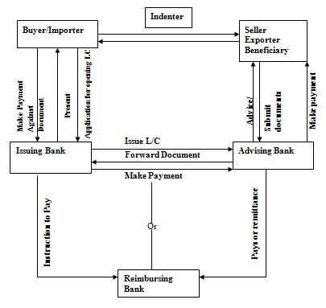
FIGURE: Mechanism of Foreign Exchange
3.17 Definition of L/C:

A Letter of Credit is a definite undertaking of the Issuing Banks, to make the payment for the import, on behalf on the importer; in other words, it is a letter of the issuing Bank to the beneficiary, undertaking to effect payment under some agreed conditions. It is an undertaking of the Issuing Bank to the Beneficiary to make payment or to accept bill of exchange. It is also an authorization of the Issuing Bank to effect payment or to negotiate bill of exchange, against stipulated documents, complying credit terms. L/C is called documentary Letter of Credit. Because the undertaking of the Issuing Bank is subject to presentation of some specified documents. The Uniform Customs and Practice of Documentary Credit (UCPDC), 600, govern International Letter of Credit.
3.18 Classification of L/C:

In different considerations there are many kinds of L/Cs. Few of them are:

- Irrevocable L/C
- Revocable L/C
- Add-Confirmed L/C
- Back to Back L/C
- Revolving L/C
- Transferable L/C
- Restricted L/C
- Red Clause L/C
- Green Clause L/C
- Clean Letter of Credit
- Documentary Letter of Credit
- Straight Documentary Credit
- Irrevocable Negotiation Documentary Credit
- With recourse & Without recourse to drawers

UTTARA Bank Ltd, FAKIRAPUL Branch deals with the following L/C:
- Sight L/C
- Sight Local L/C
- Deferred Foreign L/C
- Back to Back L/C
3.19 Party Involved With L/C Operation:
A letter of credit is issued by a bank at the request of an importer in favor of an exporter from whom he has contracted to purchases some commodity or commodities. The importer, the exporter and issuing bank are parties to the letter of credit. There are however, one or more than one banks that are involved in various capacities and various stages to play an importer role in the total operation of the credit.

The following parties are involved with L/C operation procedures:

- The Opening Bank.
- The Advising Bank.
- The Buyer and the Beneficiary.
- The Paying Bank.
- He Negotiating Bank.
- The Confirming Bank.

- The Opening Bank: The opening Bank is one that issues the letter of credit at the request of the buyer. By issuing a letter of credit it takes upon itself the liability to pay the bills drawn under the credit. If the drafts are negotiated by another bank, the opening bank reimburses that bank. As soon as the opening bank, issuing a letter of credit (L/C), it express its undertaking to pay the bill or bills as and when they are drawn by the beneficiary under the credit.
- The Advising Bank: The letter of credit is often transmitted to the beneficiary through a bank in the letters country. The bank may be a branch or a correspondent of the opening bank. The credit is some times advised to this bank by cable and is then transmitted by it to the beneficiary on its own special form. On the other occasions, the letter is sent to the bank by mail or SWIFT and forwarded by it to the exporter. The bank providing this service is known as the advising bank. The advising bank undertakes the responsibility of prompt advice of credit to the beneficiary and has to be careful in communicating all its details.
- The Buyer and the Beneficiary: The importer at whose request a letter of credit is issued is known as the buyer. On the strength of the contract he makes with the exporter for the purchase of some goods that the opening bank opens the letter of credit. The exporter in whose favor the credit is opened and to whom the letter of credit is addressed is known as the beneficiary. As the seller of goods he is entitled to receive payment, which he does by drawing bills under the letter of credit.
- The Paying Bank: The paying bank only pays the draft drawn under the credit but under takes no opening bank, by debating the letters accounts with it there is such an account or by any other measured up, between the two bankers. As soon as the beneficiary has received payment for the draft, he is out of the picture and the rest of the operation concerns only the paying bank and the opening bank.
- The Negotiation Bank: The negotiating ban has to be careful in scrutinize that the drafts and the documents attached there to be in conformity with the condition laid down in the L/C. Any discrepancy may result in reused on the part of the opening bank to honor the instruments is such an eventuality the negotiating bank has to look back to the beneficiary for refund of the amounts paid to him.
- The Confirming Bank: Sometimes an exporter stipulates that a L/C issued in his favor be confirm by a bank in his own country. The opening this country to add its confirming to the credit the bank confirming the credit is known as the confirming bank and the credit is known as confirmed credit.
3.20 Document Required For Open A L/C:

The importer after receiving the preformed invoice from the exporter, by applying for the issue of a documentary credit, the importer request his bank to make a promise of payment to the supplier. Obviously, the bank will only agree to this request if it can rely on reimbursement by the applicant. The applicant must therefore have adequate funds in the bank account or a credit line sufficient to cover the required amount. Banks deal in documents and not in goods. Once the bank has issued the credits its obligation to pay is conditional on the presentation of the stipulated documents with in the prescribed time limit. The importer should submit the following documents for opening L/C:
- Valid Import Registration Certificate (commercial/industrial).
- Tax Identification Number Certificate (TIN)
- VAT Registration Certificate.
- Membership Certificate of a recognized Trade Association as per IPO.
- A declaration, in triplicate, that the importer has paid income-tax or submitted income tax returns for the year preceding year.
- Pro-forma Invoice or Indent duly accepted by the importer.
- Insurance Cover Notice with money paid receipt covering value goods to the imported.
- L/C Application form duly signed by the importer.
- Letter of Credit authorization Form (LCAF) commercial or industrial as the case may be duly signed by the importer and incorporation new ITC number of at least 6 digits under the Harmonized system as given in the import Trade Control schedule 1998.
- IMP UTTARA BANK LTD – 170) Form duly signed by the importer.
3.21 Proposal of L/C:
Preparing a L/C proposal is fundamental function of a letter of credit operation. Preparing a L/C proposal a lot of information is needed. For this purpose the client should co-operate the bank. Otherwise the bank will not able to complete the proposal successfully. However, the following papers/documents are required to process L/C proposal.

Completion of A/C opening as per Bank’s form under terms and condition stipulated thereon.

- Completion of L/C agreement form as per bank’s format.
- Valid trade license.
- VAT Registration Certificate.
- TIN Certificate.
- Valid/Renewed IRC – IRC to be properly Transferred/N.O.C from previous bank.
- Membership Certificate form Chamber of Commerce.
- Undertaking bearing Exchange Fluctuation.
- Undertaking having no overdue liability with bank’s / financial institute.
- Indent/P.I having address, Tel, Fax, E-mail address of Exporter/Indenter & Importer duly to be signed by both with acceptance and mentioning actual date of delivery, shipment date, ports with terms and condition.
3.22 L/C Operation of Uttara Bank Ltd:

Today UTTARA BANK LTD is one of the leading and most successful Banking enterprises in the country. It plays great role in the economy of the country. By export-import business the bank play a great role to the economy of Bangladesh. UTTARA BANK LTD is one of the greatest banks in export – import business.

Foreign trade plays a vital role in the economic advancement process of a nation. So the trend of country’s foreign trade, i.e. import & export is of a great concern to the government of a country. Fluctuation in the parameters of foreign trade immediately brings about some impact on the total economy. As such the nature, trend and the volume of foreign trade are required to keep peace with the national economic needs and objective. There may be some areas where emphasis is to be given while there may be others which deserve restrictions or discouragement. Moreover the items of import & export value and volume of the same, the corresponding time period, sources of fund far payment and receipt, all these factors are to be considered very carefully for making necessary adjustment to match with the national economic policies as well as achieve balanced economic growth through the inter policy and inter policy co-ordination.

International trade policy relates to commercial policy, which has two main components of Import policy relates to commercial policy, which has two main components of Import policy and Export policy. With a view to achieving favorable balance of payment position as well as to encouraging or well to encouraging or well regulated and need based foreign trade of the country, the government formulated the national commercial policy i.e. import and export policy for a certain period considering all the favorable & unfavorable aspects of the nation’s previous trade performance as well as the future requirement and prospects.

The main purpose of the policy is to conserve scare foreign exchange & to ensure its utilization for the import of goods and services, which have national priority. The selected persons on institutions those who have got valid Import Registration Certificate (IRC) form the Chief Controller of Import and Export (CCI & E) can import and they are known as importers.

These importers can import goods as entitled in each year as per import policy by opening letter of credit (L/C) through bank i.e. Authorized Dealer (AD). Authorized Dealer means the Branches of commercial banks, those that are authorized by the Bangladesh Bank to deal in foreign exchange. Letter of Credit may be defined as the letter of undertaking or letter of guarantee issued by the L/C opening bank on behalf of the importer submits all the documents as mentioned in the L/C submits all the documents as mentioned in the L/C within the time schedule to his bank i.e. exporters bank.

Before opening L/C in favor of the exporter the entitlement of the importer to be registered with Bangladesh Bank. For this purpose the importer is to apply through L/C Authorization form. After filled up and signed up the appropriate column of the LCA form, the importer will submit it to Authorized Dealer who in turn forwards the same to Bangladesh Bank for registration where fund is purchased from Bangladesh Bank. After registration Bangladesh Bank forward the 1st and 2nd copy of LCA form to the Authorized Dealer, 3rd and 4th copy to CCI & E and keep the 5th copy as their office copy.

Now the importer will come to his bank with a request to open a L/C along with the following documents:

- L/C application and agreement form with adhesive stamp of Tk. 150.
- Indent / Pro-forma Invoice/ Contract- 3 copies.
- Insurance cover note with premium paid receipt.
- IMP form one set duly signed by the importer.
- Any other documents if necessary.

Authorized Dealer will scrutinize the documents and open the L/C in favor of the exporter by converting the Bangladesh Taka into foreign currency at the existing B.C selling rate of exchange. Care must be taken so that the limit of Bangladesh Taka is not exceeded in any way. The foreign currency value of the L/C must correspond the equivalent amount of Bangladesh Taka if LCA registered with Bangladesh Bank.

The Authorized Official of the Authorized Dealer will check the L/C very carefully and signed the same jointly and forward the 1st and 2nd copy to their foreign correspondent situated at the nearest place of the exporter. Thus Bank is known as Advising Bank. On receipt of the L/C the Advising Bank after verification of the duplicate copy at their end.

On getting the L/C the exporter prepares the goods and ship the same as per instruction of the L/C and obtain a Bill or Lading from the shipping Authority. The exporter will prepare bill of exchange, invoice and other documents as specified in the L/C and submits the same along with the original copy L/C to his bank within the time mentioned in the L/C. The Bank with whom the exporter submits the documents is known a Negotiating Bank as this negotiates the documents i.e. makes payment to the exporters.

The negotiating bank will scrutinize the documents with terms and conditions of the L/C very carefully. If every thing is in order the bank will make payment of the amount of L/C to exporter in their local currency by debiting to their own account. Subsequently the negotiating bank will claim the L/C with whom the Head Office of L/C opening bank maintained foreign currency.

This is known as Reimbursing Bank. Reimbursing Bank will make payment to the negotiating bank by debit to L/C opening bank’s head office A/C. Simultaneously the negotiating bank will forward all the documents submitted by the exporter to the L/C opening bank as per instruction of the L/C. The date of forwarding letter of negotiating bank should be date of negotiating of documents.

After taking delivery of documents from the L/C opening bank, the importer will clear the goods which has already been arrived or due to arrive from the customs authority on submission of these documents along with the custom purpose copy of LCA from.
3.23 Import:

Import Trade of Bangladesh is controlled under the Import & Export control Act 1950. Authorized Dealer Banks will import the goods into Bangladesh following import policy, public notice, F.E circular & other instructions from competent authorities from time to time. Goods are being imported for personal use, commercial purpose or industrial use.
3.23.1 Import Procedures:

3.23.1.1 Registration of importer: In terms of the importers, Exporters and Indenters order, 1981 no person can import goods into Bangladesh unless he is registered with the Chief Controller of Import & Export from the provisions of the said order. Only commercial & industrial importer must have registration from CCI & E.

To obtain import Registration certificate (IRC), the applicant will submit the following paper/documents to the CCI & E through this nominated Bank.

- Questionnaire duly filled in & signed by applicant.
- Trade license.
- Membership certificate from chamber of commerce or any other trade Association.
- Nationality certificate.
- Income tax registration certificate.
- Partnership deed/Certificate of registration with the register of joint stock companies where applicable.

On being satisfied the CCI & E issues IRC obtaining original copy of treasury Challan for payment of registration fee
3.23.1.2 Import Policy: At the beginning of each financial year, the Chief Controller of Imports and Exports announces the Import policy covering various aspects of imports in the coming year. The main points covered by the Import Policy are the following:
- Items eligible for imports during the shipping period.
- Items importable against – Cash foreign Exchange, Foreign aid and barter, Wages Earners Scheme.
- The Procedure for induction of new comers into the import trade.
- The procedure for imports by industrial consumers and commercial importers and for import under Wages Earners scheme.
- Procedure for formation of groups.
- The procedure for submission of application for Repeat License.
- The dates for opening Letter of Credit, and shipment and the rules for revalidation of the License/LCA and the L/C.
3.23.1.3 Licensing for Imports: Most imports into Bangladesh require a license from the licensing authority. In recent years, however, the task of licensing has increasingly been delegated to the commercial banks. Beginning from the shipping period 1983-84, the commercial banks have been entrusted with the responsibility of licensing imports in both industrial and commercial sectors. Licensing is done by the commercial banks by means of a specially designed form known as Letter of Credit Authorization or simply LCA. The following documents are required to be submitted by the importer to his banker:
- LCA form properly filled in and signed.
- LC application.
- Purchase contract in the shape of an indent or pro-forma invoice.
- Insurance cover note.
- Membership certificate from a Chamber of Commerce and Industry or registered Trade Association.
- Proof of renewal of Import Registration Certificate for the current year.

3.23.1.4 Making the purchase contract: After being licensed, the next task for the importer is to make a contract with an overseas supplier or the letter’s local agent. The contract usually consists of a
pro-forma invoice issued by the supplier or his local agent and signed by the importer in token of having accepted the contractual terms.

3.23.1.5 Amendment of Letter of Credit: Not infrequently, the letter of credit opened by a bank needs amendment either because the terms and conditions incorporated in the L/C conflict with those of the underlying contract between the buyer and the seller or the buyer and seller agree, at a later date, to vary terms keeping in view the emerging circumstances.

3.23.1.6 Scrutiny and Lodgment of Documents: On shipping the contracted goods the beneficiary sets about the task of collecting and preparing the documents stipulated in the L/C. He collects Bill of Lading etc. from the carrier company, prepares the invoice, certificate of origin, packing list, bill of exchange and so on and present these to his banker. Unless the L/C restricts negotiation through any particular bank, the bank receiving the documents from his customer would negotiate these keeping in view the terms of the L/C. After that, the negotiating bank forwards the shipping Documents to the opening bank, simultaneously realizing payment by debiting the opening bank’s account.

3.23.1.7 Verification and Lodgment of Document by the opening Bank: On receipt of the shipping documents from the negotiating bank, the L/C opening bank should carefully examine these to ensure that they confirm to the terms of the credit; in particular, the following are the main points that should be looked into:
- The documents have been negotiated within the stipulated dates.
- The amount drawn dose not exceeds the amount authorized in the credit.
- The bill of exchange is drawn in the manner stipulated in the credit; the amount is written in figures and words and corresponds to that of the invoice, and properly endorsed.
- The merchandise in properly invoiced in the name of the opener of the credit i.e. the buyer or the importer with full description of the merchandise indicating, where applicable, the unit price. The invoice is signed and bears Bangladesh Bank’s Registration number.
- The Bill of Lading is clean, shipped ‘on board’ showing freight prepaid and endorsed to the order of the issuing bank.
- The certificate of origin given by the supplier is in conformity with that mentioned in the credit.
- Other documents like weight list, packing list, pre-shipment inspection certificate etc. have been received and are in accordance with the terms of the credit.
3.24 Preparatory Steps for Opening L/C:
Before opening the L/C Uttara BANK LTD will takes the following steps:
- Applicant to be Bank’s A/C Holder: Bank will open the L/C on behalf of a person who has an account with the Bank. Unknown person will not be allowed to open L/C.
- Registered Importer: Before opening the L/C Bank must confirm that the L/C applicant is a registered importer or personal user and the IRC of the importer has been renewed for the current year.
- Permissible Item: The item to be imported must be permissible and not banned item. If the item is from conditional list the condition must fulfill to import the same.
- Market Report: Bank will verify the marketability of the item & market price of the goods. Some times the importer may misappropriate the Bank’s money through over invoicing.
- Sufficient Security or Margin: Price is some items fluctuate frequently. In case of those items Bank will be more careful to take sufficient cash margin or other security.
- Business Establishment: Bank should not open an L/C on behalf of a floating businessman. The importer must have business establishment, particularly he must have business network for marketing the item to be imported.
- Restricted Country: Goods not to be imported from Israel. Credit report of the beneficiary. In the amount of L/C in one item exceeds Tk. 500 Lac. Supplier’s credit report is mandatory. Bank will collect credit report of the beneficiary through its correspondent in abroad.

3.24.1 Applicant of the client to open the L/C: The client will approach to open the L/C in Bank’s prescribed form duly stamped & signed along with the following paper & documents.
- Indent/Pro=forma invoice.
- Insurance cover note with money receipt.
- LCAF duly felled in & signed.
- Membership certificate from chamber of commerce/Trade Association.
- Tax payment certificate/declaration.
- IMP & TM form signed by the importer.
- Charge documents.
- IRC pass book, Trade license, Membership certificate & VAT registration certificate in case of new client.
- Export L/C in case of Back-to-Back L/C.

3.24.2 Permission from ministry of Commerce: If the goods to be imported under CIF (cost insurance & finance), then permission from ministry of commerce to be obtained.

3.24.3 Creditability of the Client: In consideration of all the above points, if Bank becomes satisfied regarding the client then L/C may be opened on behalf of the client. Before opening the L/C Bank will issue & authenticate a set of LCAF in the name of the importer.

3.24.4 Importer points to prepare an L/C:

To prepare an L/C the Ads should take care on the following points:

L/C Number, Place & Date of issue, Date & Place of expiry, Shipment date, Presentation period, Applicant, Beneficiary, Advising Bank Account, Part-shipment & Transshipment, Availability, Port of Shipment, & Port of destination, Tenure of the Draft, Documents required, Payment, UCP, Bill of lading, Bill of Exchange, Pre-shipment Inspection, Data content, Special Conditions, Authenticity of the credit.

- Scrutiny of Import Documents:

After shipment of the goods, the exporter will submit the export documents to the negotiating Bank. Negotiating Bank will check & will send the documents to the Issuing Bank after negotiation. Upon receipt of the import documents Issuing Bank will examine the documents. Bank will decide within 7 banking days, following the day of receipt of the documents. Whether it will accept the documents or will reuse. If the Issuing Bank fail to communicate the refusal to the negotiating Bank writhing 7 days, the documents deems to be accepted.

At the time of scrutiny the following points to be checked specially:

- Scrutiny of Draft
- Whether the Draft is drawn on the Issuing Bank or not?
- Whether the amount of draft with the invoice & credit value and not over drawn.

- Scrutiny of Invoice
- Whether the description of the goods as per credit terms.
- Whether the data contain such as, HS code number, unit price, quality & quantity of the goods, LCA number, Importer & Inventor’s Registration Number, country of origin and any other information are as per credit terms.
- Custom Invoice and /or consular invoice to be presented as per credit terms.

- Scrutiny of Transport Documents

Transport documents must ensure that:

- It is presented in full set as called for the L/C. In how many number of documents are issued for mentioned.
- The date of shipment on the transport documents must not later than the date stipulated in the L/C.
- Shipped on Board’ ‘Freight Prepaid’ notations must be appeared on the B/L as called for in the L/C.
- B/L must be ‘clean’ not ‘caused’.
- Transshipped B/L not to be acceptable unless allowed by the L/C.
- Stale B/L is not acceptable, if not permitted in the L/C.
- The port of shipment & destination must be as per credit terms.
- B/L must bear the name of carrying vessel and the flag.
- Carrier must sign L/C.
- Scrutiny of pre-shipment inspection report

Bank will examine and scrutinize the following:
- Whether the entire document required by the credit is submitted.
- Documents to be consistent with one another.
- Documents to be presented with in the stipulated time.
- Documents to be issued by the authorized person as stipulated in the credit.
- Documents to be examined as per credit terms & international standard Banking practice.

After examination, if the documents become discrepant. Issuing Bank will serve refusal notice to the negotiation/presenting Bank with seven banking days. The notice must stale all discrepancies and must also state whether it is holding the documents at the disposal of or is returning them to the presenter.

- Lodgment of Import Documents:

If import documents found in order, it to be made entry in the bill register and necessary voucher to be passed, putting Bill number on the documents, this process is called Lodgment of the bill. The word ‘Lodgment’ means temporary stay. Since the documents, stay at this stage for a temporary period i.e. up to retirement of the documents, the process is called Lodgment, Bank must lodge the documents immediate after receipt of the same, not exceeding 7 banking days, following the day of receipt of the documents.

- Procedures of Lodgment:
- Bill register: Bank wills entry the documents in the bill register. Bill register must include date of Lodgment, Bill No., Bill of Exchange No, Amount, and Name of the Negotiation Bank, B/L no & date, merchandise, retirement date & other particulars.
- Application of rate: Foreign Currency would be converted at B.C selling rate ruling on the date of Lodgment.
- Exchange Control Form: IMP & Tm form must be filed in and signed by the importer at the time of Lodgment.
- Endorsement of LCAF: LCA form must be endorsed showing utilization of shipment.
- Noting on the File: Utilized amount showing bill no to be noted on the printed format of L/C file.

3.24.5 Retirement of Documents:

Importer is to be advising on the date of lodgment of documents with full particulars of shipment to entire the documents against payment or to dispose the import documents as per pre-arrangement, if any. Subsequent reminders are also to be issued very week till retirement of the bill. Such bills will be considered and be reported as overdue if the importer fails to retire the documents with 21 days of arrival of the relative import-consignments at the port of destination.

When the importer intends to retire the documents, the branch will prepare following retirement vouchers for adjustment of PAD liabilities there against:

Dr. Party’s A/C

Cr. PAD A/C

Cr. SWIFT charges

Cr. Income A/C: Interest on PAD

Thereafter the documents may be handed over to the importer against proper acknowledgement after certification endorsement.
3.25 Issuance and Disposal of LCAF:

All imports transacted through the bank shall require LCA form. The LCAs are issued in sets of six (6) copies each. Of these, the one marked, “For Exchange Control Purchase” should be used for opening L/C and for effecting remittance.
- The branch should not issue blank LCAFs to their clients. The importer should himself sign the LCAF in the presence of an officer of the branch. An authorized official of the branch should put his signature with date and seal on the LCAF, evidencing verification of the importer’s signature and import entitlement as per current IPO.
- If foreign exchange is intended be bought from the Bangladesh Bank against an LCAF it has to be registered with Bangladesh Bank’s Registration Unit.
- Where no F.C fund is required from Bangladesh, LCAFs are needed not to be the registered with Bangladesh Bank; the branch will send the third & fourth copies LCAF along with the copy of the L/C and amendments thereto to the area office of the CCI & E within 15 days retaining other copies with the branch.
- LCAFs issued for import of capital machinery and spares will remain valid for remittance for 18 months subsequent to the month of issuance.
- When L/Cs is opened, full particulars thereof must be endorsed on the bank of the Exchange Control copy of the LCAF under the stamp and signature of the branch.
- LCAFs can normally be utilized on CRF basis. Full LCAF value is therefore not remittable as F.O.B value goods. The branch should also give a certificate to the importers to the effect that the amounts of freight, handling charges. etc. has been endorsed on the relative LCFA.

3.26 Back-To-Back L/CS:

The branch may open back to back import L/Cs against export L/Cs received by export oriented industrial units opening advise the beneficiary under the bonded warehouse systems, subject to observance of domestic value addition requirement prescribed by the NBR/Ministry of Commerce from time to time. The following instructions should be complied with while opening Back-to-Back Import L/Cs:

- The unit requesting for this facility should process valid IRC, ERC and valid bonded warehouse license.
- The branch shall hold the Master Export L/C affixing bank lien stamp thereon and be kept in safe for security purpose.
- The master export L/C should have validity period adequate to the time needed for importation of inputs, manufacture of merchandise, and shipment to consign.
- The Back-to-Back L/C value shall not exceed the admissible percentage of net FOB value of the relative mater export L/C.
- The Back to Back import L/C shall be opened on up to 180 days usance (DA) basis except in case of those opened against Export Development Fund administered by Bangladesh Bank in which case the back to back L/C will be opened on sight (DP) basis.
- Interest for the usance period shall not exceed LIBOR or the equivalent interest rate in the currency of settlement.
- All amendments of the master export L/C should be noted down carefully to rule out chances of excess obligation under the back-to-back import L/C.
- Back-to-Back L/C can either be local or foreign. Inland BTB L/Cs denominated in foreign warehouse system up to value limits applicable as per prescribed value additional requirement.
3.27 Accounting Procedure:

Creation of L/C liability:

Dr. Customer’s liability on BTB L/C
Cr. Banker’s liability on BTB L/C

2. Commission and other charges:
Dr. Customers A/C: Commission for 180 days + FCC+ Postal/SWIFT + Misc.
Cr. Income A/C: Commission on L/C foreign
Cr. Income A/C: Postal/SWIFT Recoveries
Cr. Income A/C: Miscellaneous earning (handling charges, stationary etc.)
Cr. Sundry deposits A/C: F.C.C.
Cr. Stamp in hand.

3. Amendment Charges:

a) If the L/C value is increased:

Dr. Customer’s liability on BTB (for increased amount)

Cr. Banker’s liability on BTB L/C; then,

Dr. Customer’s A/C: commission for increased amount + other charges

Cr. Income A/C: Postal/SWIFT Recoveries

Cr. Income A/C: Miscellaneous earning (handling charges if any)

Cr. Sundry deposits A/C: F.C.C.

b) If L/C expiry time is extended beyond 180 days:

Dr. Customer’s A/C: Commission for further one quarter

Cr. Income A/C: Commission on L/C (Foreign)

Exchange may be opened in favor of local suppliers or manufacturer under bonded
3.28 Export:

Export means law fully carrying out any thing from one country to another country for sale. No person can export anything from Bangladesh, unless he is registered with the CCI & E, under the registration order 1952.
3.29 Legal Requirements:

Although payment aspects of export are Bangladesh Bank’s concern, the Export policy Order announced by the Ministry of Commerce controls physical aspects. Bangladesh has set out elaborate procedure and laid down detailed rules and regulations concerning Export and Export payments. All exports, to which the requirement of declaration applies, must be declared on the EXP form. The branch should before certifying any export form, consider and take notice of the following:

- The intended exporter shall have valid Export registration Certificate.
- Payment for goods exporter from Bangladesh should be received through the branch in freely convertible foreign currency or in Taka form a non-resident Taka account of a bank branch or correspondent abroad.
- Commission, brokerage and other trade charge are admissible only up to a maximum of 5% the value of goods. The charges beyond 5% may be admissible subject to prior approval of the Bangladesh Bank.
- In respect of export of goods by land route or by sea, the Bill of Lading, Railway Receipts, and other documents of title to cargo should be drawn only to the order of DHAKA Bank Ltd.
In respect of export goods by air, the Airway Bill and any other documents of title to cargo should be drawn the order of a bank in the country of import nominated by the bank
3.30 Procedure for Obtaining Export Registration Certificate (ERC):

For obtaining Export Registration Certificate from CCI & E the following documents are requited:

- Application for ERC.
- Nationality Certificate.
- Trade License.
- Income Tax Certificate.
- Memorandum & Articles of Association and Incorporation Certificate, in case of company.
- Bank Certificate.
- Copy of rent receipt of the Business Firm.
- Treasury Challan for payment of fees.
3.31 Export L/C Advising:

Advising Bank shall take reasonable care to check the apparent authenticity of the credit, which it advises. If the Bank elects not to advice or can not establish apparent authenticity, it must inform to the issuing Bank without delay. The Bank also may advise unauthenticated credit, informing the beneficiary that it has not been able to establish the authenticity of the credit, (UCP Article-7). Bank will make entry of the L/C, in the L/C advising register, with its full particulars, putting separate serial number under different Issuing Bank. Subsequent amendment also to be recorded under correspondent L/C. Bank will advise the photocopy of the L/C, keeping the original in the records, in case of L/C in SWIFT L/C advising commission to be realized accordingly.
3.32 Verification of L/C:
Upon receipt of an export L/C, Exporter will verify the L/C carefully, particularly the following points:
- Bill of Lading must not allow blank endorsement. B/L to be endorsed favoring a Bank, other than the Issuing Bank, is also risky & should avoid accepting such kinds of B/L clause. B/L must not be to the importer in abroad.
- Name & Description of the goods to be cleared 7 the item to be available and not banned by the export policy.
- Unite price to be consistent to total value of the L/C considering the quantity of the goods.
- Payment clause must be unconditional & specific.
- Required documents to be easily prepared able.
- L/C must be subject to UCPDC publication No: 500, 1993 revision or amendment there of from time to time.
- L/C to be freely negotiable.
- Place of Expiry of the credit must be in Bangladesh.
3.33 General Rules for Export:
There are some rules, which are mandatory for export of any goods from Bangladesh. The rules are as under:

- No person can export any goods from Bangladesh, unless he is duly registered as an exporter with the CCI & E.
- All export must be declared on the EXP form, which is consisting of 4 copies.
- Export must be against any of the following:
- Export L/C
- Firm Contract
- Advance Payment
- Transport documents related to land route or sea and any other documents of title to cargo, should be drawn only to the order of an Authorized Dealer. The Airway bill and any other documents of title to cargo may be drawn to the order of a bank in the country of import.
- The exporter must submit ‘EXP’ to the Bank & Bank will submit the Duplicate Copy to the Bangladesh Bank with in 14 days from the date of shipment.
- Payment for goods exported should be received through an authorized dealer in freely convertible currency.
- The exporters must receive export proceeds within 4 Months.
- Overdue export bill statement to Bangladesh Bank should be submitted by the 15th of the month, following the quarter to which it relates.
- In case of short shipment, exporter should give a notice of short shipment on the prescribed form in duplicate to the customer, who will forward a Certified Copy of the notice, to the Bangladesh Bank.
3.34 Issuance of EXP Forms:
Banks will certify EXP form only after confirming the following:
- Arrangements have been made for realization of Export proceeds.
- Bonfires of the importer/consignees abroad.
- Authorized dealer of documents of title to goods has made arrangements for receipt.
- The exporter has signed the EXP.
3.35 Stages and Mechanisms of Export:

There are some stages and mechanisms are mention below:
- Exporter will make the goods ready for shipment.
- Arrangement has to be taken for inspection of the goods by the competent authority as per credit terms.
- Exporter will declare export on EXP form against export L/C firm contract/advance payment.
- Exporter have to arrange approval for export from custom authority on EXP form by submitting Export L/C, Export permission from CCI & E, Quota clearance from EPB, U.D in case of garments, invoice, packing list along with shipping bill prepared by C & F agent.
- After completion of custom formalities, shipping company will receive the goods and will issue B/L.
- Exporter will collect visa/license and certificate of origin for final documentation.
- Negotiating Bank will dispatch the documents to the issuing Bank for clearance of the goods from port of destination against payment as per credit terms.

3.36 Export Financing:

To meet up the cost of the goods to be exported, the exporter may require Bank finance. Besides, he may require finance for go down rent, freight etc. Even after shipment of the goods, exporter may require Bank finance to meet-up his current expenditure up to repatriation of the export proceeds. There are two types of export finance:
- Pre-shipment finance.
- Post shipment finance.

- Pre-shipment Finance:

Pre-shipment investment (PSI) is finance, allowed by a Bank to an exporter, to meet the cost up to the shipment of the goods to overseas buyer. The purpose of the investment is to purchase raw materials or finished goods or manufacturing, processing, packing and transporting the goods.

Limit of Pre-shipment Finance-
- As per existing rule Banks can extend pre-shipment facility up to 90% of export L/C value (FOB value)
- Bank will finance within the Head office sanction limit for the concerned Client.
- Other liabilities of the client with the Bank also to be considered for extending Pre-shipment facility.

b) Post shipment Finance:

There is a time gap between export of the goods and realization of the proceeds. So exporter may require finance in that period to continue his business. So Bank may finance against export documents ensuring the following.
- Export documents comply the credit terms.
- Buyer is bonafide.
- Party’s past performance is satisfactory.
- Any other security in case of export under contract.

3.37 Securitization, Negotiation and Collection of Export Bill:

Upon receipt of the documents, the branch shall examine the documents with the L/Cs. If the documents appear in their face not to be in compliance with the terms and conditions of the credit the beneficiary may be advised to rectify the discrepancies are not possible to be rectified the following ways are open for disposal of the documents:

- The best way is to refer the matter to the issuing bank by SWIFT detailing the discrepancies for acceptance. On having tested message of acceptance, the documents may be negotiated.
- The branch may negotiate the discrepant documents under reserve or against submission of indemnity by the exporter when the beneficiary of a L/C is not a customer of the branch, in that case the indemnity of the beneficiary’s bank may be obtained.
- The branch may send the documents on collection basis with the permission of the exporter.

a) Export Bill Security Checklist:

General:
- Late shipment
- Late presentation
- Early shipment
- L/C Expired
- L/C over-drawn
- Partial shipment or transshipment beyond L/C terms.

Bill of exchange:
- Amount of B/E differ with Invoice
- Not drawn on L/C issuing Bank
- Not signed
- Tenor of B/E not identical with L/C
- Full set not submitted

Invoice:
- Not issued by the beneficiary
- Not signed by the beneficiary
- Not made out in the name of the applicant
- Description, Price, Quantity, sales terms of the goods not correspond to the credit
- Not marked one fold as original
- Shipping marks differ with B/L & Packing List.

Packing List:
- Gross Wt. Net Wt. & Measurement, Number of cartons/packages differ with B/L
- No marked on as original
- No signed by the beneficiary
- Shipping marks differ with B/L

Bill of Lading/Airway Bill etc.:
- Full set of B/L not submitted
- B/L is not drawn or endorsed to the order of Dhaka Bank Limited
- “Shipped on Board”, “Freight Prepaid” or “Freight Collect” etc. Nations are not marked on the B/L.
- Name & Address of the Notify Parties are not mentioned or differ with L/C.
- B/L not indicate the name and the capacity of the party i, e carrier or master, on whose behalf the agent is signing B/L
- Shipped on Board nation not showing name of pre-carrier vessel/intended vessel.
- Shipped on Board nation not showing port of loading and vessel name.
- Short From B/L
- Charter party B/L.
- Description of goods in B/L both agrees with that invoice, B/L & P/L
- Alteration in B/L not authenticate
- Loaded on Deck.

b) Negotiation:

If the documents are found in order or if the discrepancies are covered by the indemnity of the exporter or by negotiation authorization of the issuing bank, a proposal sheet for negotiation would be prepared as per bank’s format indicating the full particulars of shipment/export and discrepancies, if any. Under the signature of authorize person and should be placed to the manager for disposal instruction/sanction.

Particulars of export bills and negotiation are to be recorded in the foreign bill purchase register assigning a number to each export bill. The branch then, may make payment to the party by passing the vouchers as per calculation as shown in the negotiation proposal at O.D sight buying rate or at usance buying rate as per respective of the usance bills. The branch will realize overdue interest @ 16% per annum from all export bills after 21 days from the date of negotiation of proceeds.

c) Mailing of Export Bill:

The branch shall mail export bills under a Forwarding schedule enclosing all documents as per export L/C by DHL or any other internationally reputed courier service to the issuing bank. The branch also incorporates appropriate payment instruction in the forwarding schedule mentioning number of bank’s Nostro account with bank name and address. Acknowledgement receipt of the courier service and the office copy of the export bill to be field and are dept in safe for reporting and inspection purpose.
3.38 Transfer of L/CS:

The branch at the request of the original beneficiary (first beneficiary) may execute transfer of L/Cs to the subsequent beneficiary (second beneficiary), for doing so, the first beneficiary must maintain an accounting relationship with the branch and the branch will verify his signature on the request letter.

A letter of credit can be transferred once only if it is expressly stated, as “transferred” only on the terms and conditions specified in the original L/C with the exception of L/C amount, unit price, expiry date, presentation time of documents and shipment validity, any or all of which may be reduced or curtailed. In addition, the same of first beneficiary can be submitted for that of the applicant, but if the name of the applicant is specially required by the original L/C to appear in any documents other that the invoice, such requirement must be fulfilled.

A transferable credit can be transferred once only i.e., second beneficiary cannot transfer the L/C to any subsequent third beneficiary. However, a credit can be transferred to more that one-second beneficiary and when transfers are made in part it should be verified that the original L/C permits part shipment and the aggregate of such transfer must not exceed the original L/C.

The branch shall verify the signature of the transferor and authenticate the transfer under seal and signature of an authorized officer expressly stating that the bank does not assume any responsibility/obligation in this behalf. The branch shall check the apparent authenticity of the L/Cs with the L/C at their custody. Each and every transfer must be enclosed on the bank of this original L/C so as to avoid transfers of amount beyond the credit value.
3.39 Foreign Remittance:

UTTARA BANK LTD Foreign Exchange Branch has no authority to open FCA. This Branch is depended on Dhaka Main Branch. Convertibility of Taka in current account transactions symbolized a turning point in the country’s exchange management and exchange rate system. Now the operations of foreign currency accounts have been more liberalized. Funds from this A/Cs are freely remittable to any county according to the needs of A/C holder. Foreign Remittance is classified into two way-Outward Remittance and Inward Remittance.
3.40 Outward Remittance:

On March 24, 1994 Bangladesh Taka was declared convertible for current account international transaction. As a result remittance becomes more liberalized. Outward remittance include sale of Foreign Currency by T.T, M.T, Draft, T.C or in cash for private, official and commercial purpose.

Outward
SL. | TYPES OF SEssRVI CES | NATURE | RATE OF COM. / CHARGES | Remarks
27 a) | Issuance of  i) T.C.  ii) Cash  iii)Endorsement in passport | Com. & charges | i) 1.00 %  ii) - - -  iii) Tk.250/=
b) | Issuance of FDD on our foreign correspondent | Com. /  SWIFT charge | i) Up to USD 2,000= $5/= or eqv. Tk.  ii)USD(2001 – 5000)=$15/= or eqv. Tk.  iii) USD (5001– 10,000) =$25/= or eqv. Tk.  iv) Above USD10,000 = $40/= or eqv. Tk.  Min Tk. 350/= plus  SWIFT charges if any at actual
c) | Issuance of T.T./EFT (F.C.) through foreign correspondents | Com./ | Tk.1,000/= per T.T. plus  SWIFT charges if any at actual
d) | Cancellation of FDD | Com.  SWIFT charge | Tk.500/= per DD  At actual

3.41 Present Limit for outward Remittance:

A) Private Remittance

1. Family Maintenance:
- Foreign nationals working in Bangladesh may remit 50% of salary and 100% of leave salary as also actual saving and admissible pension benefits for their family maintenance.
- Moderate amount of Foreign Currency for maintenance abroad of family members (spouse, children, parents) of Bangladesh nationals are allowed.

2. Member ship/Registration fees etc.: ADS are allowed to remit membership fees of foreign professional and scientific institutions and fees for application, registration, admission, examinations in connection with admission into foreign education institute, supported by demand notice letter of the concerned institution.

3. Education: ADS may release foreign exchange favoring Bangladeshi students studying abroad or willing to proceed abroad for study according to the following drill:
- Application by the student as per prescribed formant.
- Admission letter issued by the concerned institution.
- Estimate relating to Tuition Fee, Lodging and Incidental Expenses issued by the concerned institution.
- Attested copies of Education Certificates.
- Valid passport.

4. Travel: Private travel quota entitlement of Bangladesh national is set at USD 3000 per year for visit to countries other than SARC member countries and Myanmar. Quota for SARC member countries and Myanmar is USD 1000 for travel by Air and USD 500 for travel by Overland route.

5. Health & Medical: The ADS may release up-to USD 10,000 for Medical Treatment abroad on the basis of the recommendation of the Medical Board.

6. Foreign Nationals: The ADS may issue T.C to foreign nationals without any limit & currency notes up-to USD 300 against surrender of equivalent Foreign Currency.

7. Remittance for Hajj: ADS may release F.C to the intending pilgrims as per instructions circular to be issued by the Bangladesh bank each year.
3.42 Official and Business Travel:

Official Visit: For official or semi-official visits abroad by the officials of Govt. autonomous/semi-autonomous institutions etc. ADS may release foreign exchange as per entitlements fixed by the ministry of Finance from time to time. In such cases, the applicant for foreign exchange shall be required to submit the sanction letter and the component authority’s order/notification/circular authorizing the travel.

Travel Quota for New Exporter: ADS may release up-to USD 6000 to a new exporter for Business Travel abroad against recommendation EPB.

Travel Quota for Importer: Subject to annual upper limit of US$ 5000 importers are entitled to a Business Travel quota @ 1% of their imports settled during the previous financial year. Local producers are also entitled to Business travel quota as above.

Exporters Retention Quota: Merchandise exporters may retain up-to 40% realized FOB value of their export. It is 7.5% for export of goods having high import content.
3.43 Travelers Cheque (TC):

Travelers Cheque (TC) is an instrument for a specific amount of widely accepted foreign currencies, issued in favor of Travelers/Visitors to carry foreign exchange for meeting their expenses in abroad. Travelers cheque may be in different currencies, such as US$, Pound Starling, Japanese Yen, Saudi Real, Canadian Dollar, French Frances, German Marks, Swiss Frances, etc.
3.44 Procedure of T.C Issue:
- Insure that the intending traveler is a client of the Authorized Dealer (AD) Bank or is sufficiently well known to the AD Bank.
- The intending travelers must come to the Bank with the following documents to have the T.C.
- Valid Passport.
- Confirmed Valid Air Ticket.
- Verification of the Passport & Air Ticket regarding validity, Illegibility, status etc. of the same.
- Filling up the T/M form by the purchaser and signing on that T/M.
- Realization of required fund.
- Fill up the purchase Agreement Form (PAF) regarding the name, address etc.of the purchaser, T.C series no. Date of issue, amount etc, and give endorsement on the passport.
- Be sure that purchaser signed all cheques in the upper left side of the cheque, only one person may sign any cheque.
- Use original P.A.F. for settlement and retain duplicate for records.
- Two sets of Photographs of Passport and Air Ticket to be obtained.
3.45 Procedure of Encashment:

Travelers Cheques (T.C) to be Encashment Observing the following Formalities,

- Compare the counter signature with the original signature. Cheque will not be honored if signatures differ.
- Additional signature may be obtained if the signature differs.
- Blank cheque-should not be Encashed.
- Previously counter signed cheques not be Encashed.
- Be aware of large Encashment & take caution against hurry.
- Check the passport endorsement, purchase contract of the purchaser if available.

If the dealing Officer is satisfied regarding the genuineness of the purchaser and the T.C. then he can pay equivalent Local Currency to the customer. And record the T.C. in inward Remittance Register.
3.46 Inward Remittance:

The term inward remittance includes not only purchase of Foreign Currency by TT.MT. Draft etc. but also purchase of Bills, purchase of Traveler’s Cheque. Utmost care should be taken while purchasing currency, Notes, T.C, DD, & similar instrument for protecting the Bank from probable loss as well as safety of the Bank officials concerned.
3.46.1 Dealing rates to customer:

SELLING |  |  | BUYING
TT & OD | B.C. | CURRENCY | T.T. CLEAN | TT (DOC) | OD SIGHT (EXP.) | OD TRANSFER
69.4000 | 69.4500 | USD | 68.4500 | 68.420 | 68.3503 | 68.1550
88.5470 | 88.6102 | EUR | 86.5532 | 86.4502 | 86.3050 | 86.2351
0.7557 | 0.7562 | JPY | 0.7279 | 0.7275 | 0.7252 | 0.7249
104.0970 | 104.1716 | GBP | 101.7380 | 101.6754 | 101.3403 | 101.3496
56.0280 | 56.0682 | CAD | 54.8225 | 54.7885 | 54.6146 | 54.5955
44.4686 | 44.5005 | AUD | 43.4608 | 43.4183 | 43.3020 | 43.2849
18.5625 | 18.5759 | SAR | 18.1971 | 18.1891 | 18.1283 | 18.1183
57.7386 | 57.7802 | CHF | 56.7634 | 56.7386 | 56.5592 | 56.5184
45.7124 | 45.7452 | SGD | 44.6124 | 44.6015 | 44.4531 | 44.4296
9.0029 | 9.0094 | HKD | 8.7950 | 8.7926 | 8.7056 | 8.6669
236.8555 | 237.0252 | KWD | 231.4950 | 231.4037 | 230.6871 | 230.4844
19.0007 | 19.0143 | AED | 18.5715 | 18.5634 | 18.5110 | 18.5012
19.1914 | 19.2052 | MYR | 18.7452 | 18.7394 | 18.6793 | 18.6741
1.9524 | 1.9538 | THB | 1.8986 | 1.8975 | 1.8914 | 1.8871
3.46.2 INWARD REMITTANCE:
25. a) | Purchase of FDD, Cheques, T.C. drawn abroad. (FBP)  (O.D.Transfer buying rate to be applied) | Com./ charges | Tk.0.20% per USD  Tk.0.30% per GBP + exchange earnings .(In all other currency at per with USD)
 |  | Courier/ SWIFT | At actual
b) | Payment of any foreign taka draft which are drawn on our bank | Com. | Free
c) | Encashment of any foreign T.T. in Taka. at our counter | Com. | Free
d) | Encashment of F.C.Draft / M.T. | Handling charge | Foreign Bank /SWIFT charges at actual plus service charge Tk.300/=
e) | Issuance of FC Draft under remtt. arrangement drawn on Bangladesh Bank | Com/  Charges | Free
f) | Issuance of FC Draft drawn on Bangladesh Bank | Com./  Charges | USD 10/= flat plus VAT if any
h) | Purchase of FC Cash | Com./  Charges | As per daily Exch. Rate Circular

3.47 Purchase of Foreign Currency Notes T.C and DD:

Following General observations are required to purchase the above:
- Currency notes to be checked very carefully so as to avoid risk of purchasing counterfeit notes.
- While purchasing T.C signature of the holder to be obtained on the Travelers and should be verified with the signature of the holder given at the time of issuance of T.C passport of the seller as well as purchase contract of the T.C to be asked for to ensure genuineness.
- Draft should not be purchased unless the holder is a regular customer of the Bank. Indemnity bond to be obtained for recovering the amount paid to the holder in case of dishonor.
- Private cheque should not be purchased without prior approval of head office.
3.48 Opening of FC Account:

The Authorized Dealership may without prior approval of Bangladesh Bank open Foreign Currency Account in the name of:
- Bangladeshi nationals residing abroad.
- Foreign nationals or firms residing/operating in Bangladesh or abroad.
- Foreign missions and their expatriate employees.
- Exporters.
- Diplomatic Bonded Ware House (Duty free shops) licensed by custom Authorities.
- Local and joint venture contraction firms employed to execute projects by foreign donors/international donor agencies.
- Bangladeshi nationals working with the Foreign/International organization operation in Bangladesh if salary is paid in Foreign Currency.
- Bangladeshi nationals who are ordinarily resident in Bangladesh may open FC account will Foreign Exchange brought in at the time of their return to in Bangladesh from visit abroad.

3.49 Documents Required For Opening A/C:

a) For Bangladeshi Nationals:
- Opening Form i.e.: Application, Signature Card, Nomination Form If Any, to be duly filled in and signed by the applicant and the nominee.
- Original passport to be submitted for the verification and photocopy of first seven pages to be submitted for preservation.
- Two copies Passport size photographs of both the account holder and the nominee are to be submitted, photograph of nominee to be attested by the A/C holder and account holder photo to be attested by the authorized officer of the Bank.
- Service contract in English or Bengali version to be submitted with the account opening form.
- If the intending person desire to open A/C forms abroad the necessary papers are to be sent duly attested by authorized officials of Bangladesh EBB Assay working there. All signatures are to be same that of passport

b) For Foreign Nationals/Company/Firms:

- Two copies of photographs of account holder.
- Copies of relevant pages of Passport.
- Copy of service contract/appointment letter/work permit etc.
- Copies of Registration in Bangladesh with Board of Investment for Foreign/Joint venture firm.
- Copies of memorandum and Articles of Association/Laws/Bye Laws etc. or joint venture Agreement.
3.50 Loans and Advances:
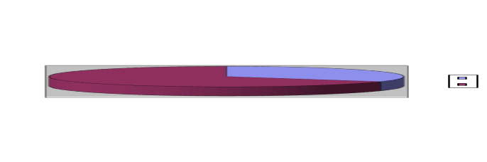Loan and advance is the largest items of Bank assets. This is almost 68.67% of the total value of bank’s asset. A bank’s loan account typically is broken down into several groups of similar types of loans. In 2008 prime bank ltd. has a total amount of Tk. 21,036.86 million loan.
Loan and Advance

68.67%

The graph shows 68.67% Total loans and Advances

UBL was in constant efforts to explore different areas of credit operation and could raise the credit portfolios to Tk. 2106.86 million in 2009 with an increase of Tk. 4419.41 million (26.59%) over that of the preceding year. The total credit was on 31.12.07 was Tk. 16617.45 million. From the year previous the amount of loans and advances is increasing respectively. Here it is shown by a graph.

Taka in million

 | Year 2006 | Year 2007 | Year 2008 | Year 2009 | Year 2010
Loan and Advance | 6,723 | 11,012 | 12,797 | 16,617 | 21,037

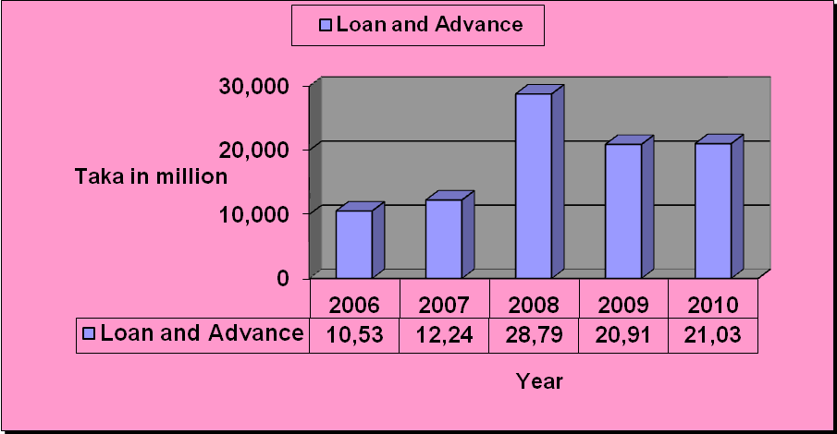

3.50.1 Loan Administration and Monitoring:

1. For this purpose, UBL have in place, a full fledged Division at Head Office, where all the credit functions are constantly supervised and closely monitored, not only to keep the existing portfolio in sound footing but also for recovery/ regularization of overdue/ classified loans and advance.
2.The executive committee of the board, in order to ensure perfection of credit documentation has instructed the management to get all the mortgage documentation counter vetted and checked by a second legal adviser enlisted with the bank other than the lawyer who vetted it originally. Finally, to help smooth functioning of the audit committee of the board, the boards of directors have decided to appoint a reputed chartered accountancy firm in addition to the existing external auditors to conduct special audit and report on quarterly basis in order to monitor and supervise the internal operations of the bank more frequently. This is expected to bring absolute transparency and accountability, as well as strengthening bank’s internal control procedure.

End Result.
We believe our risk management system is functioning quite effectively, which is amply illustrated from the fact that the position of classified loans has reduced to 0.36% in the year 2003 from 0.60% in 2002.however, your board of directors would like to assure the future also to upgrade and strengthen the risk management and control methodology of the bank.

3.51 Credit and Risk Management (CRM):
Credit risk is the possibility of failure f a bank borrower or counterparty to meet its obligations in accordance agreed terms. The major causes of serious banking problems continue to be directly related to lack of credit standards for borrowers and counterparties, poor portfolio risk management, or a lack of attention to change in economic or other attention to change in economic or other circumstances that can lead to deterioration in the credit standing of a bank’s counterparties. The goal of credit risk management is to maximize a bank’s risk- --adjusted rate of return by maintaining credit risk exposure within acceptable levels. The effective management of credit risk is a critical component of a comprehensive approach to risk management and essential to the long term success of any banking organization. The Basel Committee is encouraging bank to promote sound practices focus on the flowing aspects:

- Establishing an appropriate credit risk monitoring environment.
- Operating under a sound credit- granting process.
- Maintaining an appropriate credit administration, measurement and monitoring process, and
- Ensuring adequate controls over credit risk.

Uttara Bank Limited is keenly aware of the need to identify measure, monitor and control credit risk as well as to hold adequate capital against these risks for adequate compensation of risks incurred since exposure to credit risk continues to be the leading sources of problems in banks world - wide. In this respect, following the system as per Guidelines of Bangladesh Bank. The Bank has also adopted a policy to the whole system from time to time to copy with the multifarious of credit risk.

Credit recovery and legal division is engaged in vigilant monitoring of the total credit classification of the bank, managing all classified and special Mention Accounts to regularize for maximization of recovery and ensuring appropriate loan loss provision timely. By dint of special attention, Bank could reduce the percentage of classified portfolio from 5.06% to 2.84% in 2008 through substantial amount of loan recovery and regularization.

3.52: Inter bank transaction in foreign exchange:
- Applicant name and address to be mentioned and to be signed by the authorized signatory.
- Date & place shipment. Expiry and present action period to be mentioned.
- Beneficiary
- Mode of advice
- Transferable or not
- Confirmation
- Amount
- by deferred payment-does, without draft
- by acceptance-does, with draft.
- Availability
- by sight payment –dose, with/or without draft.
- by negotiation-does, with draft.
- Port of Loading/Place of’ taking in charee and port place of delivery.
- Partial shipment.
- Transshipment
- Transport details
- Mode of Transport
- Country o origin
- Goods description along with H. S. Code number.
- Trade term C & F etc.
- Documents to be stipulated
- Additional Instructions
- Signature of the Applicant (Authorized signature)

3.53 Movement of monthly averages of USD/BDT exchange rate:
3.53.1 Performance of Principle
  - Remittance
The growth of the export business has significantly been increase by 20.67%. It stood at TK 55790.42 million as of December 31, 2010against TK. 46233.87 million of the previous year.

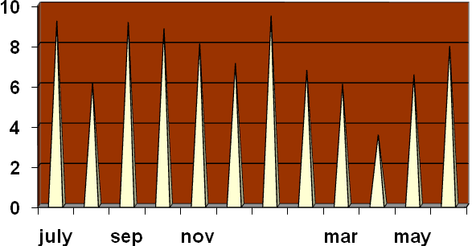
Earning from outward Remittance of Principle Branch :
As on July 2009 to June2010
Month | Amount (Taka) (Fig in Lac)
July09 | 10.17
August09 | 9.90
September 09 | 11.10
October 09 | 9.05
November 09 | 8.22
December 09 | 7.07
January 10 | 10.43
February 10 | 9.73
March 10 | 8.07
April 10 | 9.52
May 10 | 9.50
June 10 | 10.95

3.53.2 Local Money Market:
After introduction of Report auction in the year 2009the local money market witnessed appearance of another indirect monetary policy tools in the form of reverse Report auctions to facilitate day-to-day liquidity management to meet ant temporary and unexpected adversities in the supply for and demand of money.

The call money rates during the year 2010ose in the month’s of February and may, caused by increase in demand during eid and during the period of the transitional adjustment of taka on a market based exchange rate regime. The call money interest rates varied between 1.50% to 43.00% for lending and 1.25% to 30.05% for borrowing.

3.54 Category wise position of inter bank FX transaction:
Total Foreign Exchange Business handled during the year 2010 was Tk.48, 929.14 million as against Tk. 36,182.17 million of 2009 registering an increase of Tk.12, 746.97 million, i.e. 35.23% growth. The particulars of Foreign Exchange Business are given below:

Particulars | Amount in Million Taka | Percentage of Total
Import | 30,311.71 | 61.95%
Export | 18,617.43 | 38.05%
Total | 48,929.14 | 100.00%

Composition of Foreign Exchange Business of 2010
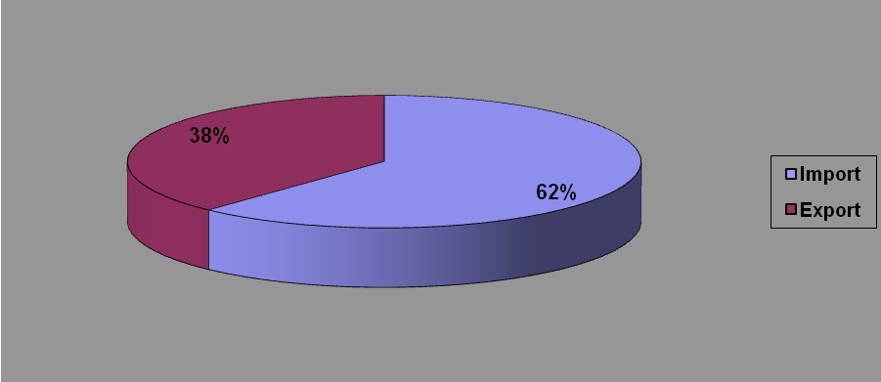
The graph shows Total Foreign Exchange of UBL of last five years
3.55 Foreign exchange Department:
Foreign Exchange is a process which is converted one national currency into another and transferred money from one country to another country. According to Mr.H.E.Evitt “Foreign Exchange is that section of economic science which deals with the means and method by which right to wealth in one country currency is converted into rights to wealth in terms of another country currency”. It involved the investigation of the method by which the currency of the country is exchanged for that of another, the causes which rented such exchange is necessary the forms which exchange may take and ratio or equivalent values at which such exchange are effected.

Foreign exchange means the exchange of currency in terms of goods from one country to another. This is the most well know and well-organized business uniform in world business. Foreign exchange mainly has two parties:
- Exporter
- Importer
Foreign Exchange means foreign currency and includes:
- Traveler’s cheques, letter of credit and bills of exchange, expressed or drown in Indian currency but payable in any foreign currency.
- All deposits, credits and balance payable in any foreign currency and any drafts.
- Any instrument payable, at the option of the drawer or holder thereof or any other party thereto. Either in Indian currency or in foreign currency or partly in one and partly in the other. Thus the foreign exchange includes foreign currency.

3.56 Import Business:
The total import handled by the bank in 2010 was Tk. 30311.71 million compared to Tk. 22191.84 million in the preceding year registering a rise f Tk. 8119.87 million being 36.59 percent. A sizeable L/C’s were also opened by the bank in the year under review. The import items included industrial raw materials, machinery, consumer goods, fabrics, accessories etc
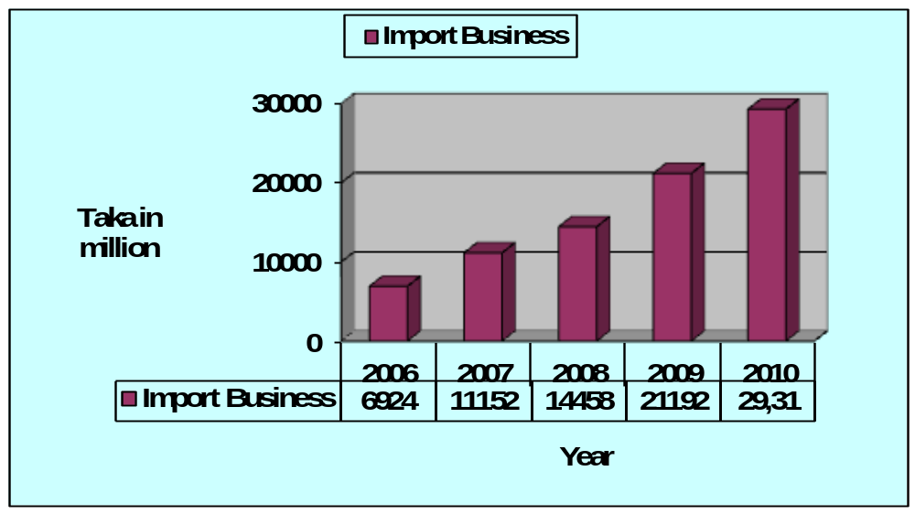
The graph shows the import business of UBL of last five years

3.57 Export Business
The bank handled export business worth Tk. 18617.43 million in the year under report. In 2009 total export business handled by the bank was Tk. 13990.33 million. Thus there was an increase of Tk. 4627.10 million in export business handled by the bank, being 33.07 percent over the preceding year. The major export item was Readymade Garments. Here the last 5 years export business of JBL is presented by a graph:
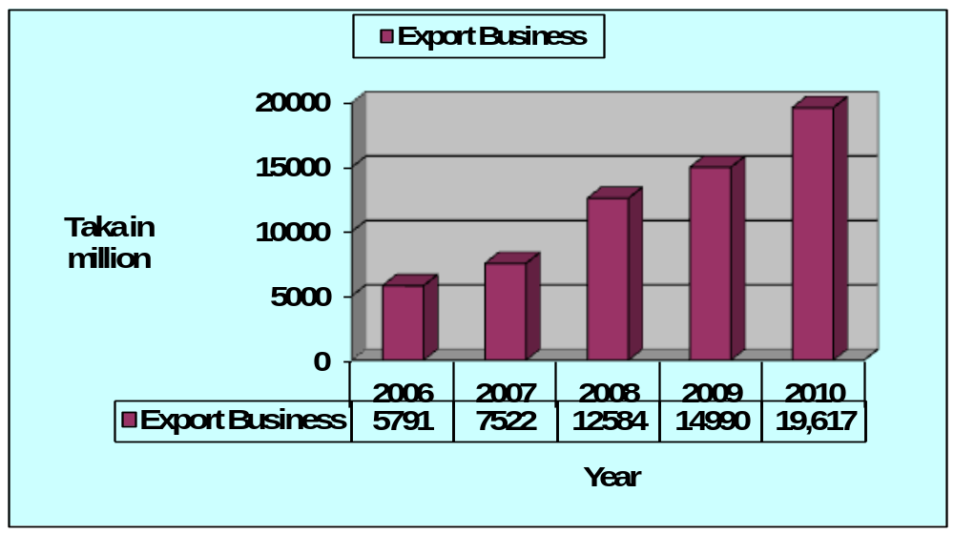The graph shows the export business of UBL of last five years.

Chapter Four:
Finding of the study

4.1 Definitions of 26 financial ratios:
Bank profitability ratios:

1. ROA=return on assets=NI /ATA=net income/ average total assets
2. ROE=return on equity=NI /SE=net income/ average stockholders' equity
3. PM=profit margin=NI /OI=net income/ operating income
4. ROD=return on deposits=NI /ATD=net income/ average total customer deposits
5. ROSC=return on shareholder capital=NI /SC=net income/ shareholder contributed capital
6. NOM=net operating margin=OI /IN=operating profit or income/ interest income

Bank efficiency ratios:

7. IEE=interest income to expenses= (IN−IE) /ATLA= (interest income−interest expenses) / average total
Loans and advances
8. OEA=operating expense to assets=OE/ATA=operating expenses/ average total assets
9. OIA=operating income to assets=OI /ATA=operating income/ average total assets
10. OER=operating expenses to revenue=OE/OI=operating expenses/ operating income (revenue)
11. ATO=asset turnover=IN/ATA=interest income/ average total assets
12. NIM=net interest margin= (IN−IE) /ATA=(net interest income−net interest expenses) / average total assets
13. NNIM=net non-interest margin= (NIN−NIE)/ATA=(net non-interest income−net non-interest expenses) /average total assets

Asset-quality indicators:

14. PEA=provision to earning assets=PLL/ATLA=provision for loan losses / average total loans and advances
15. APL=adequacy of provision for loans=ALL/ATLA=allowance for loan losses at the end of the year / average total loans and advances
16. WRL=write-off ratio=WR/ATLA=write-off of loans during the year / average total loans and advances
17. LR=loan ratio=ATLA/ATA=average total loans and advances / average total assets
18. LTD=loans to deposits=ATLA/ATD=average total loans and advances / average total customer deposits

Liquidity ratios:

19. CTA=cash to assets=C/ATA=cash / average total assets
20. CTD=cash to deposits=C/ATD=cash / average total customer deposits
Risk ratios
21. DTA=deposits to assets=ATD/ATA=average total customer deposits / average total assets
22. EM=equity multiplier=ATA/SE=average total assets / average stockholders' equity
23. ETD=equity to deposits=SE/ATD=average shareholders' equity / average customer total deposits
24. TLE=total liabilities to equity=TL/SE=average total liabilities / average stockholders' equity
25. TLSC=total liabilities to shareholder capital=TL/SC=average total liabilities / shareholder contributed capital
26. RETA=retained earnings to total assets=RE/ATA=retained earnings / average total assets

4.2 Ratio Analysis:
4.2. Profitability ratio:
It measures the income or operating success of an enterprise for a given period of time. Profitability is a frequently used as the ultimate test of management’s operating effectiveness.
4.2.1 Return on Assets:
An overall measure of profitability is return on assets. This is computed by Net income divided by Average assets.
Year | 2006 | 2007 | 2008 | 2009 | 2010
Return on Assets | 2.85% | 1.52% | 1.75% | 0.58% | 0.71%

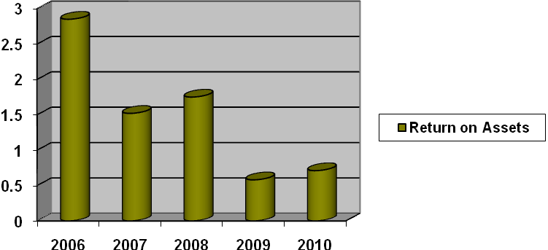
Comments:
Uttara Banks Return on assets decreased from 2006 but in 2008 it is slightly increased. So its return on assets situation is not satisfactory.

4.2.2 Return on Equity:
This ratio shows how many taka of net income were earned for each taka invested by the owners

Year | 2006 | 2007 | 2008 | 2009 | 2010
Return on Equity | 1.70% | 34.34% | 32.05% | 10.69% | 12.71%

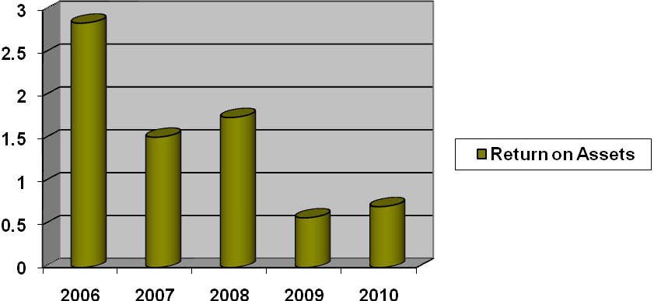
Comments:
Uttara Banks return on equity of 2010 is substantially higher than 2009.Again in 2010, its return on equity (12.71%) is higher then its return on assets (0.71%) The reason is that City Bank has made effective use of leverage or trading on the equity at a gain. It earns more on its borrowed funds than it has to pay in the form of interest. Thus the return to stockholders exceeds the return on the assets, benefiting from the positive leverage.
4.2.3 Earning Per share:
It is a measure of the net income earned on each share of common stock.
Year | 2006 | 2007 | 2008 | 2009 | 2010
Earning Per Share (Taka) | 5.61 | 79.22 | 75.13 | 20.20 | 28.91

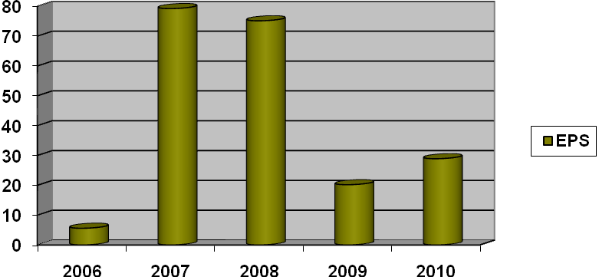
Comments:
From the chart we can see that in 2007 & 2008 EPS increased in compare to other years. The reason is that net profit after tax had been increased in those times
4.2.4 Price-Earning Ratio:
This ratio reflects investor’ assessments of a companies future earnings. It is computed by dividing the market price per share of the stock by earnings per share.
Year | 2006 | 2007 | 2008 | 2009 | 2010
Price Earning ratio (Times) | 40.55 | 11.08 | 10.24 | 19.31 | 25.09
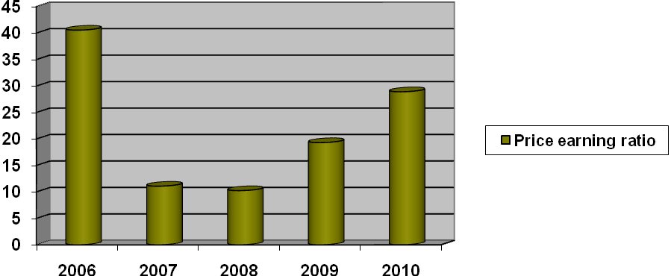
Comments:
In 2010 each share of Uttara Banks stock sold for 25.09 times the amount that was earned on each share. Company’s price earning ratio is higher then previous year
4.2.5 Solvency Ratio:
It measures the ability of the company to survive over a long period of time. It includes the following ratio:
4.2.6 Debt to Total Assets Ratio:
It measures the percentage of the total assets provided by creditors. It is computed by dividing total debt by total assets.
Year | 2006 | 2007 | 2008 | 2009 | 2010
Debt to Total Assets | 96.64% | 94.63% | 94.45% | 94.67% | 94.10%

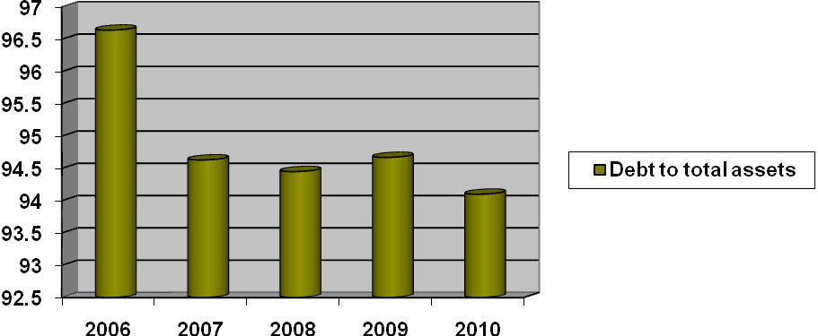
Comments:
The higher the percentage of debt to total assets, the greater the risk that the company may be unable to meet its maturing obligation. In 2010 a ratio of 94.10% means that creditors have provided 94.10% of Uttara Banks total assets.
4.2.7 Times Interest Earned:
It provides an indication of the company’s ability to meet interest payments as they come due. It is computed by dividing income before interest expense and income taxes by interest expense
Year | 2006 | 2007 | 2008 | 2009 | 2010
Times Interest Earned(times) | 1.17 | 1.74 | 1.83 | 1.25 | 1.25

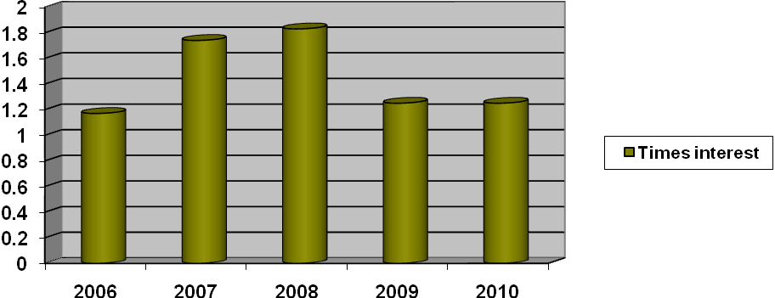Comments:
This represents the amount available to cover interest. Uttara Banks interest expense is well covered at 1.25 times in 2010.
4.3 Introduction:
To conduct the Analysis part two techniques of analysis are used. These are Least Squares method for Time Series Analysis and Regression Analysis. By using time series data a straight-line trend is drawn for the actual and trend value

4.4 LEAST SQUARES METHOD FOR STRAIGHT LINE TREND
The table, the calculated steps and the results for the year 2010’s estimated profit are given below-
Fitting the straight line trend by using Least Squares method
Year | Profit after Tax  (Million Tk.)  (Y) | Deviations From Middle Year(X) | XY | X² | Trend Values(Y_{c})
2006 | 13.46 | -2 | -26.92 | 4 | 199.48
2007 | 380.26 | -1 | -380.26 | 1 | 251.46
2008 | 540.00 | 0 | 0 | 0 | 303.44
2009 | 240.02 | 1 | 240.02 | 1 | 355.42
2010 | 343.46 | 2 | 686.92 | 4 | 407.4
N=5 | ∑Y=1517.2 | ∑X=0 | ∑XY=519.76 | ∑X²=10 | ∑Y_{C}=1517.2

Here,
The equation of straight line is-
Y_{c =} a +bX;
Where, Y_{c =} The trend (computed) values to distinguish them from the actual Y values,
a= The Y intercept on the value of the Y variable when X=0,
b= Slope of the line or the amount of change in Y variable.

Since,
∑X=0,
a = ∑Y/N

= 1517.2/5
= 303.44
b = ∑XY/∑X²
= 519.76/10
= 51.98

Here,
The Equation of straight line trend is -
Y_{c =} 303.44 +51.98X
Now,

For X=-2, Y_{c} = 303.44 +51.98(-2)
= 199.48
X= -1, Y_{c} = 303.44 +51.98(-1)
=251.46
X= 0 , Y_{c} = 303.44 +51.98(0)
=303.44
X= 1 , Y_{c} = 303.44 +51.98(1)
=355.42
X= 2 , Y_{c} = 303.44 +51.98(2)
=407.4
For Year 2010, X would be +3. Putting X=+3 in the equation-
X= 3 , Y_{c} = 303.44 +51.98(3)
= 459.38
Hence, a likely Profit after Tax for 2010 is 459.38 million Tk
4.5 GRAPHICAL PRESENTATION OF THE STRAIGHT LINE TREND:
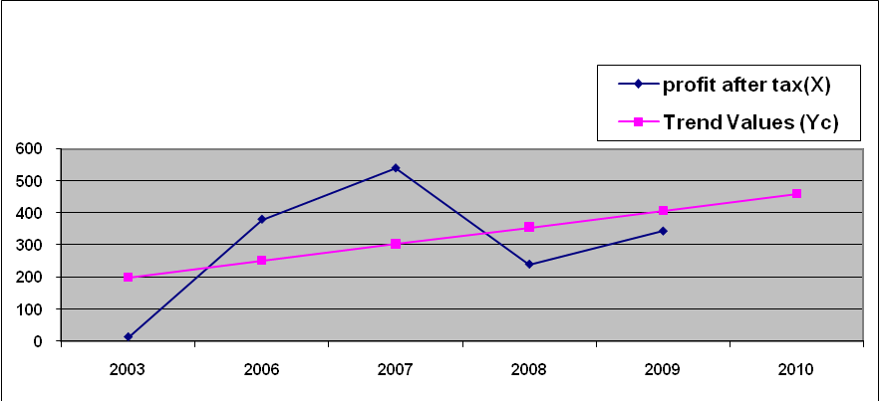
From the above straight line trend we can see that profit after tax has an increasing trend and the value of year 2010 for profit is 459.38 million Tk.

4.6 REGRESSION ANALYSIS:
The regression analysis is drawn on total amount of scheme deposits, total
number of employees and number of branches. Here
The regression equation of Y on X₁ and X₂ for the regression line will be-
Y = a + b₁X₁ + b₂X₂

Where,
Y = Total amount of scheme deposits,
a = The intercept (constant),
b₁ = Slope of line, change in scheme deposits for change in no. of employee,
b₂ = Slope of line, change in scheme deposits for change in no, of branches,
X₁ = No. of employees,
X₂ = No of branches.

Data table for this regression analysis is given below-

Scheme Deposits | Employees | Branches
3714.45 | 1692 | 76
3954.43 | 1803 | 77
4870.48 | 1829 | 77
5435.24 | 1989 | 77
5580.14 | 1997 | 84

4.6.1 OUT PUT OF THE REGRESSION ANALYSIS:
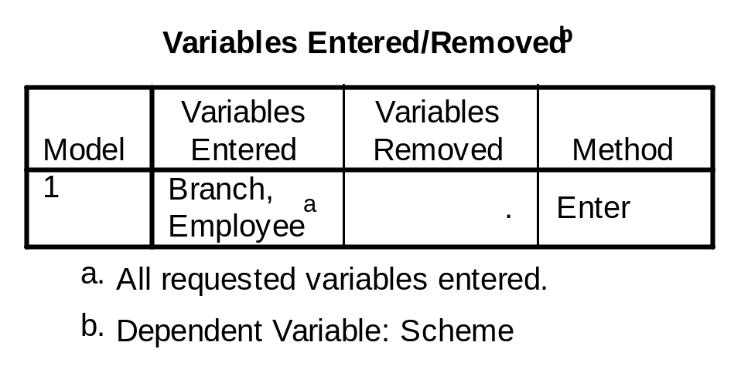

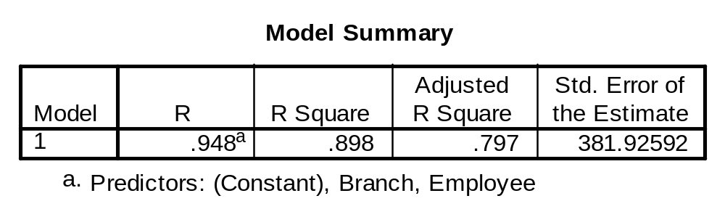
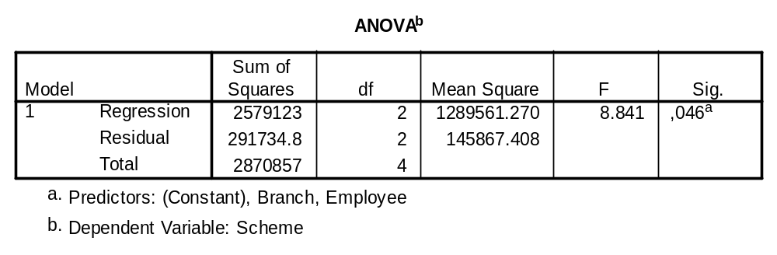
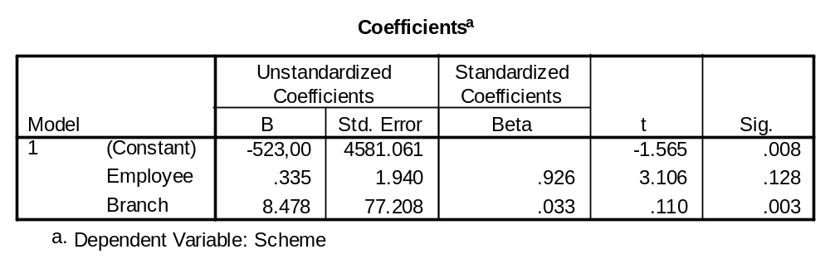

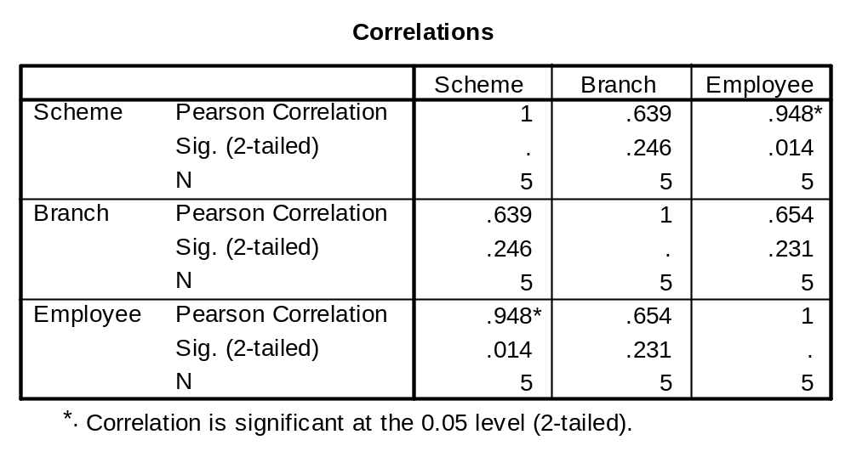
4.6.2 RESULTS OF THE REGRESSION ANALYSIS:
- The regression equation of Y on X for the regression line will be-
Y = a + b₁X₁ + b₂X₂
From the table of Co-efficient, we can find that
Y = -523+ .335X₁ + 8.478X₂
In this equation, b₁ = .335 indicates that if the no of employees increases by 1 percent, the amount of scheme deposits increases by .335 million Tk. provided no of branches remains unchanged.
In this equation, b₂ = 8.478 indicates that if the no of branches increases by 1, the amount of scheme deposits increases by 8.478 million Tk. provided no of employees remains unchanged.

- The Explanatory power of the independent variable can be assed with the help of Coefficient of determination, R².
From the table of Model Summary we can find that-
R² = .898
R² = .898 indicates that 89.8% of the scheme deposits can be explained by the no. of employees and no of branches.

- The relative importance of the independent variables can be indicated with the help of Beta coefficient.
From the table of Coefficient (Standardized) we find that
ß_{no of employee} .926> ß_{no of branch} .033
From this we may conclude that no of employees exerts more influence on collection of scheme deposits.
Problem of Multicolinearity:
Multicolinearity arises if
  - Correlation coefficient between the independent variables is higher than that of dependent variable and any other independent variable.
From the table of Correlation Matrix-
r _{employee, branch} = .654> r _{branch, scheme} = .639
or, r _{employee, branch} = .654< r _{employee, scheme} = .948
From first correlation coefficient there is multicolinearity problem but from the second relation there is no multicolinearity.

  - Correlation coefficient between independent variables is greater than .8
r _{employee, branch} = .654 < .8

So, the problem of multicolinearity is not existed from this point of view.

- Test the significance of the result
From the table of ANOVA, we can find that the regression model is statistically significant because-
The significance level .046 < .05 level.
From the table of coefficient we can see that b₁ is statistically significant. Because-
The significance level of b₁, .128< .05 level
From the table of coefficient we can see that b₂ is statistically significant. Because-
The significance level of b₂, .003< .05 level
4.7 SWOT Analysis of the Uttara Bank Ltd:

SWOT Analysis is an important tool for evaluating the companies Strengths, Weaknesses, Opportunities and Threats. It helps the organization to identify how to evaluate its performance and can scan the macro environment, which is turn would help the organization to navigate in the Turbulence Ocean of competition. Following is given the SWOT analysis of the Uttara Bank Ltd:

From my practical observation I get the following Strength opportunity, weakness and threat (SOWT).

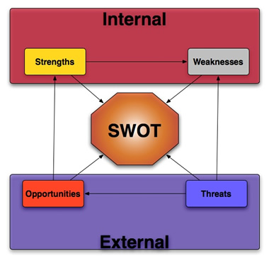

4.7.1 Strengths:
4.7.1.1 Sponsors:
UBL has been founded by a group of outstanding entrepreneurs. The sponsors, directors, chairman belongs to large industrial conglomerates and philanthropist of Bangladesh

4.7.1.2 Company Reputation:
UBL has created standing in the banking organization which has goodwill in the upcoming and new built banking organization. Uttara Bank has created a good reputation in the banking industry of the country. It tries to give the best services. The popularity of this bank is increase day by day in the general public area.

4.7.1.3 Top Management:
The strength of the Uttara Bank lies on the top management of the company and the financial soundness of the sponsors, as they are all well reputed personalities in the Bangladesh. This impressive lay of Bank Ltd. helps to have a good image
.
4.7.1.4 Modern Facilities and Computer:
From the very beginning The Uttara Bank tries to furnish their work surroundings with modern equipment and facilities. For speedy service to the customer, The Bank had installed money-counting machine in the teller counter. The bank has computerized banking operation under software called FINACLE. More over computer printed statements are available to internal use and occasionally for the customers. The Bank is equipped with telex and fax facilities.
4.7.1.5 Stirring Branches:
From the formative stage of The Uttara Bank tried to furnish their branches by the impressive style. Their well-decorated branches gets attention of the potential customer, this is one kind of positioning strategy.

4.7.1.6 Interactive Corporate Culture:
The corporate culture of The Uttara Bank is very much interactive compare to other local organization. This interactive environment encourages the employee to work attentively. Science the banking jobs is very much routine work oriented and lovely environment boots up the work capability of the employees.

4.7.1.7 High quality of Services:
Services is so much important that way UBL provide online banking facility and after ten minute provide remittance in customer With a team of bankers that comprises of experience as well as vigor of youth, the Bank strives for a customer-oriented banking culture, with prudent lending and attractive deposit schemes and new restructure of banking system with Business Matrix. While keeping on expanding its reach, Uttara Bank aims at maintaining the high quality of services it has already achieved.

We have identified some important aspect about Uttara Bank Ltd such this strength like as...

It has well reputation in the market
Not engaged in unfair business practice.
Concentrated market.
Officers are highly educated.
Executives are highly qualified and experienced.
Bank has many attractive deposit schemes.
Well-furnished and Air-conditioned Bank.
Efficient management practice in the Bank.
Provide online banking.
After ten minute provide customer remittance.

4.7.2 Weaknesses:
4.7.2.1 Limitation of information System:
They have always face problem in software system that way customer face hazard. The software used by the UBL-“Financial” is not updated. It is easy to handle but contains some flaws.

4.7.2.2 Time Consuming:
The top-level management consumes much time in taking fervent decision, i.e. decision-making experiences a debacle of unnecessary time passing. This phenomenon becomes vivid in case of changing interest rate on Fixed Deposit.

The decision undertaken by the management is sometimes self centered i.e. the market competitiveness is often ignored to give priority on their own capability and resources
4.7.2.3 Advertising and Promotion:
The bank does not effectively carry out advertising and promotion. This lacking makes a steady situation for the external banking services and effects largely in the all system.

There is another weakness for The Uttara Bank is advertisement. Their media coverage is so much low that people do not know the bank thoroughly. The marketing strategy adopted by the bank is effective but not efficient. The appearance of the bank in the printing media and electronic media has become a matter of fortune. General people take time to index Uttara Bank; Most of the time they disregard it with other Bank.

4.7.2.4 Lack of full scale automation:
Even through UBL is providing online banking services and ATM cards but it should use more advanced technology to compete with the multinational banks lack of ATN booth or etc.
There are also some other weaknesses of the Uttara Bank such as...

Deposit is lower than advance.
Officer has limited experience and not enough trained.
Long-term credit is not sufficient.
Small market shares in Banking-business.

4.7.3 Opportunities:
4.7.3.1 Diversification:
The management cans diversity the business into issuance or leasing business. They also easily divers each place to other place because it’s online system.
Uttara Bank can pursue diversification strategy in expanding its current line of business. They can serve not only the Specific person but also the general people.

4.7.3.2 Training Center:
Bank can introduce a training center for its employees to make the employees more helpful and efficient.

Some point related in this opportunity...
Can increase the advertising of the Bank.
Private Banks becomes more reliable to local public.

4.7.4 Threats:
4.7.4.1 Upcoming Banks:
Upcoming bank like Eastern Bank, The City Bank, Prime Bank, Dutch-Bangle Banks are the major competitors of UBL. The contemporary banks of The Uttara Bank like: Dhaka Bank, Dutch Bangla Bank, National Bank, Brac Bank, Prime Bank are its major rivals. They are carrying out aggressive campaign to attract lucrative clients as well as big time depositors. Uttara Bank should remain vigilant about the steps taken by these banks, as these will in turn affect The Uttara Bank strategies.

4.7.4.2 Multinational Bank:
The Rapid expansion of multinational bank poses a potential threat to existing commercial Bank. Due to the booming energy sector, more foreign banks are expected to operate in Bangladesh. Moreover, the existing foreign banks such as HSBC, AMEX, CITI N.A, and Standard Chattered are now pursing an aggressive branch expansion strategy. Since the foreign banks have tremendous financial strength, it will pose a threat to local bank to a certain extant in terms of grabbing the lucrative clients.

4.7.4.3Default Culture:
Default culture is very much familiar in our country. However as the bank grows older it might become big problems. In these senses Uttara Bank has to be careful.

4.8 Competitor Analysis:
The competitors also focus on market segments where they can meet customer needs in a superior way and command a price premium. Foreign currency business is one of the most competitive sector or almost every commercial bank. . The consumer credit scheme is very much conductive to the limited income citizen. Because these type of schemes are mainly based on flexible terms and conditions and subject to installment based payment. In recent times the overall demand and prospect of these type of credit service has increased a lot. Now various commercial banks are providing this service but nine banks are the best service included Mercantile Bank.
4.8.1 Mercantile Bank:
Mercantile Bank in a good position from its image perspective. It has a good profit since 1999. Compared the other new bank which is start their work since 1999 in that sense MBL is in a market good position.
The bank considers savings and deposits as lifeblood of the bank. Mort the deposit greater is the strength of the bank. So they intend to launch various new savings schemes with prospect of higher return duly supported by a well-orchestrated system of customer services. Technologies such as computer, ATM, ‘fete-communication etc. all would be harmonized and adapted to the system in order to provide found the clock and any branch services to the clients.
The Authorized capital of the Bank is TK. 800 million and the Paid-up capital of the Bank is Tk.276.85 million as of December 31, 2001. The Authorized Capital of the Bank is Tk.800.00 million of 8,000,000 ordinary shares of Tk.100 each.
The issued, subscribed and paid-up capital of the Bank is Tk.276.85 million of 2,768,500 ordinary shares of Tk. 100 each fully paid-up in cash in 2001
4.8.2 Islamic Bank:
Islami bank is the pioneer in this sector. This bank is mainly activated and regulated by Islami sharia. They first introduced this type of scheme under title of household durable investment scheme in January 1993. Presently 73 out of 103 branches of Islami bank are under this project. The amount of loan disbursement is 91 crore 11 lac Taka so far. The highest loan amount of household durables investment schemes is one lac. The equity is 25% and the profit rate is 13%. Beside these, one percent is for risk fund and two percent is for supervisory organization. The responsibility of overall supervision of this scheme has given to three companies by Islami bank. Their duties include client selection, investment, disbursement, collection and overall supervision. The companies are Ibne Sina Investment Company Limited, Faisal Investment Foundation and Anudip Services Private Limited.
4.8.3 Prime Bank:
The prime bank limited has introduced this consumer credit scheme in July 1995. In beginning, it was only introduced in motijheel branch. But for having very positive feed bank from the clients within one year, now the service is being provided by other more branches also. The supply rate is 11.90 percent of total disbursement and the recovery rate is 98.41%. But the scheme is slightly exceptional from other banks scheme. There are two categories under this scheme. The first one is car investment project. The credit amount is up to three lac. The equity is 50% for recondition car and 30% for now car. The second one is household durables scheme and the loan amount is one lac. The equity is 20% against the loan. The time limit for repayment is three years for recondition car and four years for new car. For others the time limit is two years.
4.8.4 Pubali Bank:
In private sector Pubali bank has also adapted this scheme in mid July 1996. Primarily nineteen branches of Dhaka City are providing the services. But soon four branches in Chittagong and two branches in sylhet will provide the services. The credit limit is one lac and 20% equity. The rare of interest is 12%. The service charge rate is 2.75%. There are two supervisory organization, S.F. service private limited and Advance Technology. So far the no. of client is seven hundred ninety seven and the amount of disbursement is 2 crore 75 lac 15 thousand and 75 taka. The supply rate is 1.80% and the recovery rate is hundred percent.

4.8.5 Southeast Bank:
Presently sixteen branches of southeast Bank are under its consumer credit scheme. So far the no. of clients under this scheme is two hundred thirty one. The total amount of disbursement is 4 crore 49 lac 59 thousand taka. The overall recovery rate of southeast Bank is hundred percent. The supply rate is 2.99 percent of the total disbursement.
4.8.6 Al Arafah Islami Bank:
Presently fourteen branches of Al Arafah Islami bank are under its consumer credit scheme. SO far the no. of clients under this scheme is four hundred four. The total amount of disbursement is 1 crore 10 lac 99 thousand Taka. The overall recovery rate of Al Arafah Islami Bank is 97.5%. The supply rate is .74 Percent of the total disbursement.
4.8.7 Eastern bank:
The practice of consumer credit scheme is not very much wide spread in Eastern Bank. So far the no. of client is four hundred thirteen. The recovery rate is hundred percent and the supply rate is .018 percent.
4.9 Others Analysis:
4.9.1 Age Limit of the Client:
According to the survey, most of the clients are carrying out cards whose ages are between 20 to 40. It has been found that few clients are on above 50.

0%
10%
20%
30%
40%
50%
Age of Clients
Series1
33%
47%
20%
Below 30
Between 20 to
40
Above 50
Figure: Age Limit of the Client

4.9.2 Educational Qualification of the Clients:
It can be state that the educational qualifications of the most clients are educated at this business level in our country. Most clients have passed HSC and some completed Graduation or Masters. In terms of their higher educational background might help long run decision-making business.
0%
20%
40%
60%
Educational Status
Series1
42%
29%
20%
9%
HSC
Graduation
Masters
PhD
Figure: Educational Qualifications of the Clients

4.9.3 Business Commencement:
As an intern of this division, it should be mentioned that client has to maintain the card at least one. So by carrying out day-to-day activities clients should carry at least one card for his/her interest.

CHAPTER FIVE:



RECOMMENDATION AND CONCLUSION

6.1 Recommendations:
Uttara Bank Limited tries to give the best customer support, the have some lake and linkage compare to other bank of the same generation such as the way........
- Employee may need advance training
- Policy may be revised from time to time
- Customized software may be implemented
The bank has to increase their advertisement and also increase their social activity
- The interest rate in Uttara Bank Limited is now 18%, which is very high for the customers. Interest rate should be reduced to attract more customers and raise the satisfaction level significantly.
- The employees of RFC especially the MIS division should be more cooperative with the customers over phone when applicants are looking for the necessary information.
- A new internal division can be opened for information deliver in RFC.
- HR should be more concerned about to train the sales team.
- The disburse time in the Uttara Bank Limited is very lengthy. It should be reduced and the customers should get their service at a shortest possible time.
- The application process time is very lengthy. The time required for the applications should be reduced as well.
- Debt burden ratio should be relaxed especially in case of highly potential and successful business personnel.
The specific and board recommendations of the study are as follows:
- The authority should recruit more employees to serve the customers. The can recruit experienced employee as well as fresh graduate.
- The bank should introduce more products based on the market demand.
- The bank should reduce their minimum balance to attract more customers.
- The salary of the worker need to be rise, as a result experienced people from other bank will be attract to join Uttara Bank Limited Limited.
- The bank can open more branches to reach to more customers.
- The bank can open branches or foreign booth because many people send money from abroad every year to Bangladesh.
- The bank should finance to the consumer goods, because many people in the country wants to buy consumer goods from bank loan.
- The marketing department of the bank should more efficient to reach at the hart of the customer.
- For the success of any organization, employee satisfaction is one of he most important factor and DBBL authority have to look about it.
- The bank should be more profit concern as well as took part to the economics development of the country.
- The departments of the bank should more efficient to make profit by satisfying customers.
- The bank should use printed instruments like cheque, pay orders etc.
- Being a clear transparent the bank can provide the best support to the customer as earn profit.
The loan processing fee should be reduced.

6.2 Conclusion:
It is revealed from the above presentation that in 2010, the bank has achieved remarkable success in various financial activities as well as in bank’s business. During the year under report the bank has earned commendable operating profit and also attained capital adequacy. Substantial amount has been recovered from classified loan because of appropriate action in this regard.
UBL Bank contains an important part in overall operation of the Bank. Our industrial sector that are operating their business in different countries getting a good benefit from this department. Although there have some limitation in total operation process including online disturbance, management process, code fore, d authorization, technical problem etc. Bank now trying their best to improve such problem and to enhance their operation and customer services. For more facilities UBL bank have a good step to serve in rural areas. They made a deal with an ego, which facilitates them for more service in this sector. Moreover they have taken steps to open more branches in different area for wide operation. Due to clear and transparent operation bank have introduces Corporate Governance where board reviews and approves various policies for compliance by the management. The Board/ Executive committee reviews the polices / guidelines issued by the Central Bank regarding operation of the Industry. The Board / executive committee of the board approves the credit proposal as per approved policy and Bangladesh Bank guidelines/regulations. Due to maintaining different level of transparency bank are now receiving more profit in every year.

Needless to mention that continuous support and extended by our valued clients, shareholders, sponsors, business associates and well wishes played a vital role behind these operating results and the Board of Directors express felicitation to them in this regard. New CEO has joined to existing team and in 25th silver jubilee celebration a new logo with utterly new concept is introduced. Consequently, the directors acknowledge with gratitude the valuable guidance and co-operation received from the Ministry of Finance, Bangladesh Bank and Securities and Exchanges Commissions. The directors place on record their depreciation for the dedicated services rendered by the executives, officers and staff members of the bank.
As borrower selection is the key to successful retail lending, Uttara Bank Limited should focus on the selection of true borrower. At the same time it must be taken into account that right borrower selection does not mean that Uttara Bank Limited has to adopt conservative lending policy but rather it means that compliance with the KYC or Know Your Customer to ascertain the true purpose of the loan.

Uttara Bank Limited is bank of new generation. Though I tried to include at my report about deposit, customer service and general banking, I followed their rules and regulation and tried to use them in my report to prepare this report with my best effort.
Though all departments and sections are covered in the internship program, it is not possible to go to depth of each activities of branch because of time limitation. Bank is an institution, which acts as a financial intermediary. Since bank collect deposit from various source by paying interest to them and grant loan to some other parties at high rate to interest then the interest paid to the depositor, the differences between the two interests is termed as the profit.

Since Uttara Bank Ltd. Credit limit increased by taka 9907 core or 18.10% to tk. 64553.10 core during 2008-2009 as compared to increase of 10.30% in the preceding year, Uttara bank Ltd. Should pay more attention to loan and advance which not only increase it’s profit position but also alleviate poverty level of Bangladesh by providing loan to the capital seeker, increase standards of living.

Bibliography:
Annual Reports of Year 2007 to Year 2008, 2009 .Uttara Bank Limited,
Website of the UBL; www.Uttarabank.com
Uttara Barta, the In House news letter of the Uttara Bank Ltd.
Leaflets of different Schemes,
Peter S. (2005), Bank Management & Financial Services, 6th Edition, McGraw-Hill International, New York, NY.
Timothy W. (2003), Bank Management, 5th Edition, Southwestern, Moscow.
Hazel T. (1993), Financial Institutions and Markets, A Global Perspective, McGraw-Hill International, New York, NY.
Peter S. (2002), Commercial Bank Management, 5th Edition, McGraw-Hill International, New York, NY.
Bank Magazines, Brochures.
Statistical Technique in Business & Economics, By- Douglas A Lind, William G Marchal, Edition-Twelfth,
Accounting Principle, By-Weygandt, Kieso, Kimmel

Abbreviation:
SL. NO. | ABBREVIATION | ELABORATION
1 | UBL | Uttara Bank Limited
2 | BB | Bangladesh Bank
3 | SME | Small & Medium Enterprise
4 | ATM | Automatic Teller Machine
5 | TT | Telex Transfer
6 | DD | Demand Draft
7 | C&I | Corporate & Investment
8 | SMS | Short Message Service
9 | SWIFT | Society for Worldwide Inter Bank Financial Telecommunication
10 | L/C | Letter of Credit
11 | DSE | Dhaka Stock Exchange
12 | NRB | Non Resident Bangladeshi
13 | MBS | Monthly Benefit Scheme
14 | JSS | Junior Savers Scheme
15 | TSS | Three Stage Savings Scheme
16 | LSS | Lakpati Savings Scheme
17 | ESS | Education Savings Scheme
18 | MSS | Marriage Savings Scheme
19 | SPSS | Statistical Package for Social Science

Appendix:
Uttara Bank Ltd. since its incorporation, continued to maintain its stable position in the industry. The bank has been able to show a strong performance in business and financial accounts. With better customer services, fulfillment of commitments to corporate social responsibilities, ensuring sound corporate governance Bank consolidated a solid presence with the customers and general public and within the industry. During the last few years, significant improvement was evident in deposit mobilization, advance portfolio augmentation and recovery of non-performing loan. Foreign trade, in terms of import, export and inward foreign remittance have also shown noteworthy growth in the year 2010 Last few years performances have been below:
Sl.  No | Particulars | Year Under  Review  (2010) | Previous Year  (2009)
1 | Paid-up capital | 1,188.00 | 1,080.00
2 | Total capital | 3,156.25 | 2,601.00
3 | Capital surplus/(deficit) | 652.55 | 59.50
4 | Total assets | 48,755.40 | 47,445.75
5 | Total deposits | 40,539.63 | 40,881.41
6 | Total loans and advances/investments | 26,788.47 | 30,789.02
7 | Total contingent liabilities and commitments | 8,277.64 | 12,901.57
8 | Credit deposit ratio | 66.08% | 75.31%
9 | Percentage of classified loans/investment against total loan and advances/investment | 6.24% | 7.18%
10 | Profit after tax provision | 343.46 | 240.02
11 | Amount of classified loans/investments during current year | 1,671.83 | 2,209.73
12 | Provisions kept against classified loans/investments | 462.78 | 943.26
13 | Provision surplus/(deficit)against classified loans/investments | 40.00 | -
14 | Cost of fund | 7.55% | 6.94%
15 | Interest earning assets | 42,757.28 | 40,820.24
16 | Non-interest earning assets | 5,998.12 | 6,625.51
17 | Return on investment(RIO) | 12.33% | 8.58%
18 | Return on assets(ROA) | 0.71% | 0.58%
19 | Income from investment | 860.27 | 431.45
20 | Earning per share(Taka) | 28.91 | 20.20
21 | Net income per share(Taka) | 28.91 | 20.20
22 | Price earning ratio(times) | 25.09 | 19.31

