Submitted by
WWW.ASSIGNMENTPOINT.COM

The 3-I Group is one of the promising business organization in Bangladesh. Basically, 3-I group is providing real estate facilities in Bangladesh and also serving their role in export-import segment. Starting from year 2005, the company is doing well in both real estate and export-import business. 3-I group is not a very old company but company earned a good name.
3-i group Introduces:-
      - 3-I Builders Ltd.
      - 3-I International
I am focusing on 3-I Builders, which is a promising real estate firm with complete facilities of modern living. 3-I group operate their business only in Bangladesh and it’s a local company.3-I group has the potential of working with all Multi-national, multi-cultural and multi-discipline companies.

1.1.3 3-I Builders Ltd. (3-IBL)
3-I Builders Ltd. (3-IBL) established in the year 2005 with REHAH membership, and is now the promising and pioneering company in the real estate of Bangladesh. With the rapidly increasing demand for land and development for housing, 3-I Builders Ltd started the development of land in various locations of Dhaka and sold over several apartments. 3-I Builders Ltd has also played a pioneering role in the construction and selling apartments to substantial number of city dwellers. During the past years, it has successfully completed a good number of apartments and also focusing on delivery land toward customers.
Since that time, (2005) the company has progressively consolidated its expertise in developing projects and has gained a high reputation in successfully completing its assignments. And serious in commitment to hand-over its ready flats. Essentially, company manages and develops community and affordable housing for people on low to moderate incomes. They provide clients with a range of housing options, from income-based community housing rental to shared-equity house purchases. Company characteristic is always to perform their task with the specialized workers i.e. with the right man for the right job All construction materials and equipment are procured with great care so as to ensure highest possible standard. Eastern Housing Limited is committed to maintain a very high standard in quality control and workmanship.
3-I Builders Ltd has got over 5% market shares in this business covering both apartment and land for housing. This dominating leadership is unlikely to be challenged in near future. 3-I Builders Limited under the prominent leadership of Mrs .Anina Islam as Chairman along with Managing director Md. Mahiul islam emerged into a separate physical entity in real estate segment.3-I builders Limited comprising of a number of business, has diversified its activities in various areas like product and project marketing, construction and real estate business and land.
3-I Builders Ltd corporate office located at House-29, Road-10, Sector-14, Uttara, Dhaka-1230, Bangladesh. It has an own building for operating its business and serving customers.

1.1.4 3-I International
Being specialized in the corporate world of export & import trading, 3-i international is another name for quality and assurance where we offer the standard warranty on all the products we provide. So, this is our concrete confidence that enabled us to put forward our ideas & concepts with outstanding performance. Likewise, we intended to reach the heart core of our clients just with our firm belief in commitment & quality. Our clients delight is all that we need to keep this pace uphold in the upcoming future.

1.1.5 Relation with the Group
The following figure shows the flow from group to 3-I Builders Ltd and its sister concern:
3-I Group

3-I Builders Ltd
3-I International

Figure 1: Relationship

1.2 Company Vision

“We always kept in mind the unequaled excellence in the field of real estate construction in Bangladesh, with cost effective views, while designing your dream-homes”
3-I Builders Ltd is already proved its potential in real estate market. In the future, the company wishes to extend its wings. The company believes that the management already proved their ability toward its customers. Right now they need to concentrate on improving their process capability. Now the whole process is going to accelerate more and altogether it will reach the level of world class performance and gradually it will extend its leadership in all aspects in a very competitive environment.

1.3 Company Mission
The 3-I Builders Limited will use innovative practices and a diverse range of options to provide affordable, appropriate and secure housing for people in need in a fair, equitable and financially robust manner. The company is planning to double its net revenue by the year 2020. That means in the span of 10 years time the revenue must rise at a tremendous rate. This requires a continuous and consistent growth in revenue in the coming years. One thing must be noted here that the target is to increase the revenue rather than the profit. It has several missions which stated below:
- Increasing profit
- Growing our share of real estate market.
- Capture the top position of this market
- Introducing new dimension.
- We will involve at Govt. Projects.

1.4 Objectives & Goal
To promote the relief of poverty by providing affordable housing to people on the Gold Coast who are in need, including members of low and moderate-income households.

- To ensure equitable and fair access to affordable housing for people in very low, low and moderate income households.
- To provide cost effective and efficient housing management services.
- To provide high quality infrastructure and management services that meet client needs.
- To provide security of tenure to tenants meeting their tenancy obligations.
- To be managed prudently in order to become and remain financially self sufficient in accordance with good commercial practice.
- To promote and seek to provide quality diverse living environments and housing forms that reflect cultural and community values, energy efficiency and ecological sustainability.
- Seek to provide affordable housing that is well positioned in terms of access to transportation and services.

1.5 Guiding Principles and values
3-I Builders Ltd Guiding Principles – Commitment & Quality. The company has also values and objectives. 3-I Builders Ltd always belief that by providing better quality can be a tool of differentiation. Commitment is a small word to say but in case of doing it’s very difficult for save the commitment. We also think about values and that’s we valued our customer by opening consumers division. We always think about this line “Your Dream…Our Inspiration.”

1.6 3-IBL’s Corporate Slogan
As we know that our company believes on commitment and quality, so we use it as a corporate slogan. “Commitment & Quality”

1.7 3-IBL’s Way of Working
- Ensure consumer focus is at the heart of every business process.
- Become the benchmark performer compared to market leader.
- Drive innovation and individual empowerment to the heart of our organization.
- Be admired, respected and trusted by our customer.
- Sustainability
- Nurture a progressive, dynamic and transparent working environment and culture.
- Using world class technologies.
- Always contribute in society.
- By providing customer satisfaction 3-IBL will spread their business.
- Corporate social responsibility.

PART-2

3-IBL: Organization Structure

- Historical Background of 3-IBL
- Organizational structure of 3-IBL
- Board of Directors & Management Team
- Functional Area
- CSR Program
- Corporate Partners

2.1 Historical Background of BATB
3-i Builders Ltd. is one of the renowned, promising & leading real estate companies in Bangladesh. It specializes in developing luxury apartment complexes in prime locations of the city. The company embarked upon its journey since 2005 at the corporate head office building of 3-i Builders Ltd. in Dhaka. 3-iBL is also an active member of Real Estate of Housing Association of Bangladesh (REHAB) and has become a trusted name in the real estate sector in Bangladesh with unsurpassed value. From its very inception the company has won the confidence and good will of its clients within a short span of time as people have found them an eligible & invaluable partner for the work they plan for their homes. Thus 3-iBL has grown into a dependable organization by building elegant & aesthetically pleasing structures that grace Dhaka’s finest neighborhoods. It uses the highest quality building materials and finishing products to ensure durability and customer satisfaction. Its main concentration has been in the prime, attractive locations of Dhaka city, the emphasis being on sound construction and aesthetic design. In addition, 3-iBL has tried to provide accommodation suitable for small families while aviating scope for developments of residential lands in the vicinity of the capital city. Thus it gained its ground in the arena of real estate companies.
The whole team of 3-i Builders Ltd. is uniquely trained & qualified to deliver outstanding quality, on-time performance & on-budget completion. Efforts are underway to cater to the needs of clients in every market segment. The success of such a large construction company requires specialized laborers and highly qualified professional back up and 3-iBL has developed a strong team of such highly skilled experienced professionals to work under its competent management. The company currently has sufficient employees working, experienced in their respective fields.
For the last few years, 3-i Builders Ltd. has accomplished pretty good track records, enthusiastic customers only through a client-centered approach and unwavering commitments to the satisfaction of construction performance & architectural design. Reputation as a reliable real estate company that gives high priority to customer’s desire and needs has been created through the hard work and dedication of its work force.

2005 | Formation of 3-I Group.
2005, First quarter | 3-I International establishment.
2005, Second Quarter | 3-I Builders Ltd establishment.
2005 | Owned REHAB membership
2006 | Hand Over of first project and land acquisition.
2007 | Introducing own Engineering & Design segment
2008 | Signed different MoU with land owner
2009 | The Company was expecting to capture 08% market share.
Table 1: Historical Background of 3-IBL

2.2 Structure of 3-IBL
3-IBL was incorporated as a private limited company under the Corporations (Bangladesh) Act 1994. The 3-IBL enrolled as a profit organization. At the beginning of this company, it had several investor and directors, but now a day it run by single owner. 3-IBL has a effective management structure.

CHAIRMAN
MANAGING DIRCTOR
MANAGER MARKETING & ADMINISTRATION
A

DIRECTOR
MANAGER ACCOUNTS
MANAGER PROQUREMENT
CONSULTANT
ACCOUNTS OFFICER
MARKETING OFFICER
SITE ENGINEER
SITE SUPERVISOR
OFFICE ASSISTANT
OFFICE SECRETARY
DRIVER
Figure 2: 3-IBL Organization Structure

2.3 Board of Directors & Management Team of 3-IBL

Chairmen | Mrs. Anina Isam
Managing Director | Mr. Md. Mahihul Islam
Directors | Eng. Tanjilur Rahman
Directors | TBA
Directors | TBA
Marketing Manager | TBA
Accounts Manager | TBA
Audit Committee | Mrs. Anina Islam, chairman
Audit Committee | Mr. Md. Mahihul Islam
Audit Committee | Eng. Tanjilur Rahman
Company Secretary | TBA
Legal Adviser | Advocate Munna (L.L.B)
Auditors | Rahman Mostafa Alam&Co.  Chartered Accountants.
Principal Bankers | Trust Bank Limited
Principal Bankers | Standard Chartered Bank Limited
Principal Bankers | HSBC
Table 2: Management Team

3-IBL is a private limited company. Managing Director is the operational head and appointed by the Chairman. Head of every department carries out their functions with the help of line managers. Different departments have different structure according to their function and responsibility. The management team and Board of directors took all decision along with managing director. This committee is the head of all department.

2.4 Functional Areas
3-IBL has been operating its business under the following major functional areas:
    - Land Purchase Department
    - Finance & Accounting
    - Engineering & Design
    - Architect Department
    - Human Resource
    - Marketing Department
    - Internal Audit Department
    - Quality Control
    - Information Technology
    - Corporate and Regulatory Affairs
    - Business Development
    - Customer Service
    - NRB’s Corner.

2.5 Corporate Social Responsibility
Recently we saw that lots of problem regarding housing were took apart. This creates negative impact on real estate as well as housing companies. 3-IBL corporate social responsibilities were to ensure a safe home for all at a least price. We always said about quality and commitment. Beside this we had plantation program, job offering, and creating job for rural people etc.

2.6 Corporate Partners

2.6.1 Financial Partners

  - Trust Bank Limited
  - Standard Chartered Bank Limited
  - HSBC

2.6.2 Media Partners
  - Daily Jay Jay Din
  - Real Estate Yellow Page Book
  - Daily Prothom- Alo
  - Daily Aajker Kagoz

2.6.3 Lift & Substation
  - LG
  - Mann Bangladesh
  - Aziz & Co.

2.6.4 Cement & Electrical Cable
  - Seven ring cement
  - Mir cement
  - PARADISE Cable Limited
  - SINGER Cable Limited

2.6.4 Mobile Partner
- Warid Telecom.

PART-3
Products & Services

- PRODUCT & SERVICES
- OVERVIEW OF PROJECTS
- PROCESS OF BUSINESS
- TERMS & CONDITIONS

3.1Product & Service
The apartment or commercial space that you choose is an expression of your specific needs and wants… in fact; it is a statement of the self, reflecting your mindset. We promise our customers total service backed by years of collective experience and an extensive portfolio to successful assignment… service that hinges on our complete understanding and anticipation of your expectations, aspirations and needs. This stands us in good stead in delivering top quality apartments & commercial spaces. We ensure full fledged after sales service support to our customers, backing them even in their smallest of needs. Quality runs in the veins of the organization and has imbibed into each and every one of us at real value. The in-depth experience gained from executing large residential and commercial developments has created the urge in us to set ourselves high standards to comply witty. This effort has really made us a cut above the rest, as our prestigious developments will testify to our fresh path-breaking designs that highlight several exciting new features. It is only logical that the customer feels very much at home with real value investment.

Services for Luxury Apartment, Commercial Space & Hotel Suites:

- Payment Service
- Loans & Benefits
- Customer Service
- Site visit & Outdoor counseling services
- Maintenance Department
- Resale Opportunity
- Legal Advice

3.2 Overview of Projects
Project Name | 3-i ALEV
Address | Plto No # 23, Road No # 03, Sector # 11, Uttara, Dhaka.
Number of Building | 1 (One)
Building Height | Ground + Six Floor, Ground floor is open for car parking.
No. of Apartments | 12 (Twelve)
Size of Apartments | Type A : 1350 Sft,  Type B : 1350 S
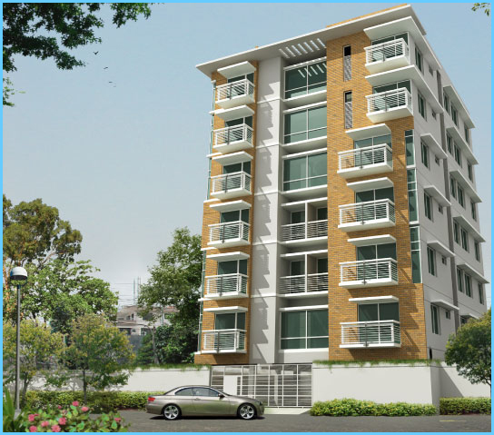

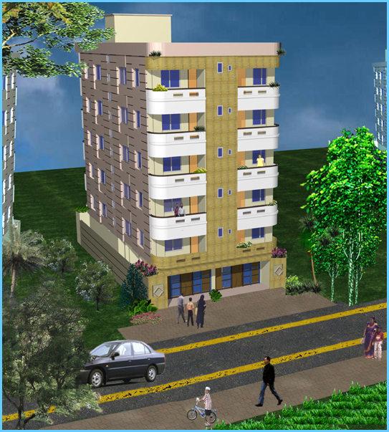
Project Name | 3-i RUYA
Address | Plto No # 29, Road No # 10, Sector # 14, Uttara, Dhaka.
Number of Building | 1 (One)
Building Height | Ground + Five Floor, Ground floor is open for car parking.
No. of Apartments | 10 (Ten)
Size of Apartments | Type A : 1200 Sft,  Type B : 1200 Sft

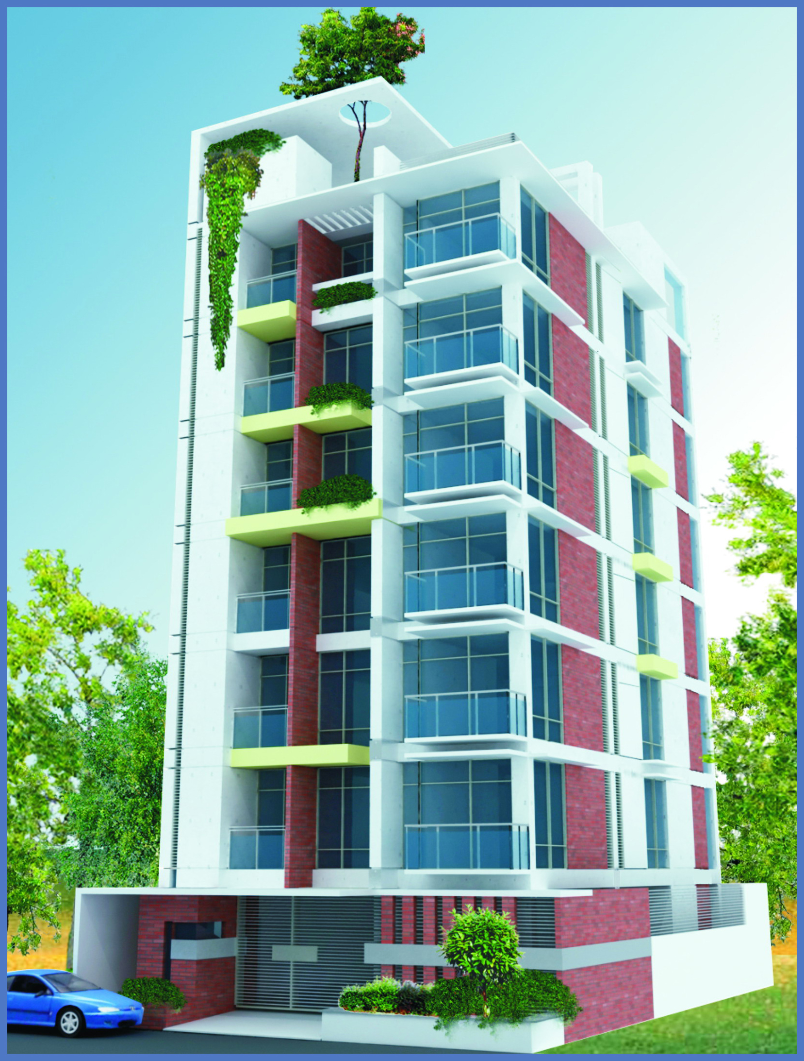
Project Name | 3-i Alena
Address | Plto No # 04, Road No # 16, Sector # 10, Uttara, Dhaka.
Number of Building | 1 (One)
Building Height | Ground + Six Floor, Ground floor is open for car parking.
No. of Apartments | 6 (Six)
Size of Apartments | Type A : 1500 Sft (Approx) Type B : 1500 Sft (Approx)

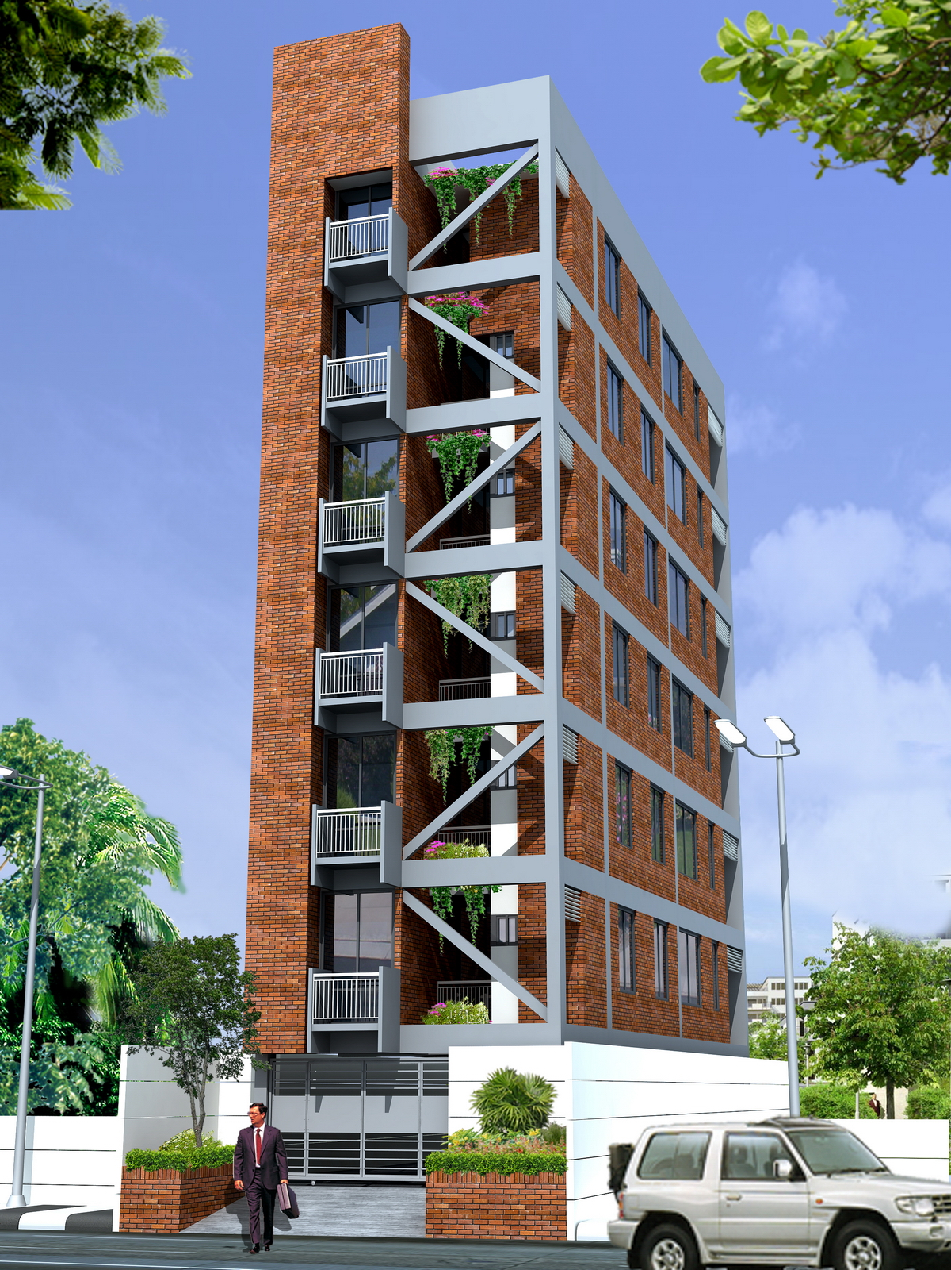
Project Name | 3-i Rania
Address | GP-Kha 38/3, Shahajadpur, Gulshan, Dhaka-1212
Number of Building | 1 (One)
Building Height | Ground + Six Floor, Ground floor is open for Parking.
No. of Apartments | 6 (Six)
Size of Apartments | Type A : 1350 Sft (Approx).

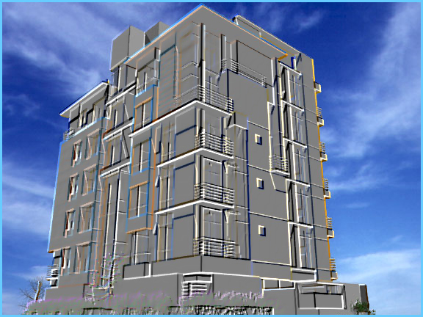
Project Name | 3-i Fatima
Address | Plot No. 146, Ibrahimpur, Dhaka Cantonment, Dhaka.
Number of Building | 1 (One)
Building Height | Ground + Six Floor, Ground floor is open for Parking.
No. of Apartments | 12 (Twelve)
Size of Apartments | Type A 1000 Sft. (Approx), Type B 900 Sft. (Approx)

Picture: 1- Overview of Projects

3.3 Buying Process of Land
Before purchasing the land for developing any apartment on the land EHL always, look for some criteria’s of the land. Suppose-
- The location of the land.
- Utility facility like gas, water, power facilities etc.
- Communication facilities like road, transportation.
- Community facility like school, college, mosque, university.
- Shape of the place.
- Probability threat of natural calamities like flood.
Normally for building any apartment or commercial complex, they buy lands by following two basic processes.
- Joint venture
- Direct purchase.
Joint venture: Under this process, EHL and landowner make a contract or sign a contract and EHL purchase the land from the landowner by following some condition. This are-
- EHL will be the owner of the land.
- EHL will give the landowner (current) two or three or more number of apartment (or proportion of flats that agrees) and a good amount of money, but all are depends on the land location, facility etc.
[N.B.This policy is not a standard. only 3-IBL internally follows this policy.]
Direct Purchases: In this process EHL purchase the land from the landowner by giving them case only. Here in this condition EHL will not give the landowner any other facilitys, such-Flat or apartment.
For the both cases sometimes EHL goes to the land owner and then purchase the land;or owner may come to contract with EHL and sell their land or this buying or selling process could be done by a “broker”. In this case, broker may get some commission, this is set internally, and no standard is follow.
During direct purchase, the land purchase department of EHL goes through all the relevant documents regarding the land and if all the papers are, “well enough” then they make contract with the top management and set an “approximate” price of the land. Then purchase department make contract with the landowner and purchase the land.

3.4 Terms & Conditions
APPLICATION: Interest buyer shall submit application on the prescribed form duly signed by him/her along with booking/down payment money. EHL reserves the right to accept or reject any application without assigning any reason.

ALLOTMENT: Allotment shall be made on first come first serve basis and as far as possible according to the choice of applicant and mutual understanding arrived in between the company and the applicant. On acceptance of application and booking money, EHL will issue an allotment deed of agreement to the application on receipt of which he / she shall start making payments as per the schedule of payments in the agreements. Applicant from abroad may give option for more than one flat. The company shall try to allot the flat for which the applicant has give option. In any case, the company shall not be bound to allot a flat according to applicant’s choice. The applicant will be asked to confirm his acceptance of the flat by making payment of the initial deposit with in a specified period.

PENALTY: Allottee must strictly follow the payment schedule. In case ,an applicant after payment of initial deposit or it’s part of a flat fails to sign the agreement within the time specified or within such extended period as the company may allow, then the allotment shall stand cancelled and the allottee will be entitled to get refund of initial deposit after deduction of TK.50,000/- only. If the Deed of Agreement is executed and either the allottee want to surrender or the Company want wanted to cancel the allotment of the flat due to none fulfillment of terms and conditions of the Deed of agreement, then the allottee will be entitled to get refund of deposited money after deduction of T1,00,000/- only. If the above cases arise after execution of sale Deed of share of land then the deduction will be TK 2,00,000/- and the refundable money will be borne by the defaulted allottee.The model of refund of money in all the above three case made by installments as manner as the company decides.
If an applicant wants to get allotment of a flat situated within the same project instead of the flat for which he/she/they deposited money he/she/they require to pay TK 25,000/- as transfer fee, similarly if an application wants to get allotment of a flat in another project other than for which he/she/they shall require to pay TK 50,000/- as transfer fee. Again a transfer fee of an amount of TK1,00,000 be payble,if any allottee wants to transfer the the allotment in favour of any person or persons whose relations is other than children and parents, husband and wife. It may be mentioned here that this kind of free transfer opportunity can be availed only for one time.

PAYMENT: All payment shall be made in cash or A/C payee check or Bank Draft or Pay-order in favor of “Eastern Housing Ltd.". Bangladeshis residing abroad may remit payments by T.T, DD, or Wire Transfer to bank accounts of “Eastern Housing Ltd." As per breakdown shown in the allotment letter & in the cost schedule.

COMPANY RIGHT: The Company may make minor changes in the design both Architectural and Structural of the project should these become necessary for benefit of the allottees. Limited changes in the specification and facilities may be made by EHL for overall interest of the project. The price rate of the variation portion would retain the same i.e. if the area is increased the price will also be increased according to the increased area and if the area is decreased the price will be increased according to the decreased area.
REFUND: For any reason beyond the control of EHL as force majored, natural calamities, political disturbances, strikes, riots, war, economic conditions, Act of God, etc., the company may be bound to abandon the project. In such an event, allottee will be entitled to get full refund already paid by her/him.

UTILITY CONNECTION: The Company will initially pay Connection fees, Security deposit for water, Sewerage, Electricity, and incidental expenses relating to these to the concerned authorities on Allottee behalf. Allottee shall reimburse the same to the company proportionate to his/ her share.

TRANSFER OF OWNERSHIP: The apartment will be owned through individual mutation along with a partition deed for the demarcation of the apartment. Proportionate share of undivided and undemocratic land will be registered in favor of each allotee.

TRANSFER COST: Registration charges i.e. cost of stamp, gain tax, registration fees, registration processing cost and any other government fees for registration of sale deed in favour of allottees shall have to be borne by the allottes.Cost of registration and power of attorney if any, Vat and other incidental charges shall have to be paid by the allotters.

BUYER OPTION: Buyer may change and choose any material or design of individual flat in that case, Difference in cost of additional work/ modification desired by the allottee will have to be paid in advance before the work on those items start.

MANAGEMENT: The allottee must undertake to become a member of the owner's Co-operative Society that will be formed by the owners of the spaces for the management of common services such as lift, pumps, security, compound, etc. Each allottee must initially deposit a specific amount in the reserve fund of the association or company for future maintaining management expenses of the complex. For the purpose of effective management of the apartment project all owner of the apartments shall form and constitute “Flat Owner Cooperative Society” (FOCS).all owners of apartments shall compulsorily become member of the co-operative society through deposit of TK.500/- only as membership free.

PART-4
Functional Areas

- RELATIONSHIP BETWEEN DIFFERENT DIVISION
- DIFFERENT FUNCTIONAL AREAS DESCRIPTIONS

4.1 Relationship between Different Division

The 3-IBL is one of the largest multi-disciplinary conglomerates of the country. It is involved in construction, engineering, manufacturing and trading activities. Their main business is buying the land, build apartment, commercial complex, hoping complex and sale it.EHL is divided into several functional departments namely

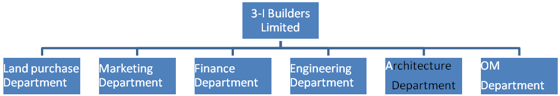
Figure 4: Relationship between Different Divisions

4.2 Major Functional Areas
3-IBL Bangladesh has several functional departments that are integrated to give the best output for the organization. There are also some independent division which was running under managing director.
The departments are independent from any divisions. The names of 5 departments are:
- Administration Department
- Revenue Assurance and Fraud Management Department
- Information Department
- Internal Audit Department
- Legal and Compliance Department
4.2.1 Land Purchase Department
The land purchase department‘s of EHL, goal is find out the suitable place for build the Apartment or commercial complex. This department contract with the land owner, if landowner want to sale the land therefore, purchase department goes through all the relevant documents regarding the land .If all the papers are “well enough” then they make contract with the top management and set an “approximate” price of the land. Then purchase department make contract with the land owner and purchase the land.

4.2.2 Operation Department
Operations are the system of process that creates well and provide service.The operations management department’s of EHL, goal is to minimize the cost and maximize the profit. All raw materials (cement, stone, brick, rod, etc) purchase this department and provide it to the project manager of the project.

4.2.3 Finance & Accounting Department
Finance is responsible for securing financial resources at favorable price and allocating those resources throughout the organization, as well as budgeting, analyzing investment proposal, and providing fund for operations. The financial departments of 3-IB, goal is provide “Budget” for the project as soon as possible. They find out the NPV, IRR of the project. They also consider the “pay back period” associated with the project. As the same time their main responsibility is done the cost-profit analysis before, start the project work. If company sells any apartment or commercial complex or space then the “amount” come to hand.
Finance managers within 3-IBL are part of the decision-making team, a business partner who is consulted and involved day to day, not merely reporting results and setting budgets. Having moved beyond the 'comfort zone' of purely technical accountants, into added value decision support, The Company require people who are commercially astute, intellectually curious and passionate about business life, not just figures. Whether you are working in tax or treasury, or in the business partnership roles supporting marketing, operations and the other functions, you will need excellent communication and influencing skills to represent finance in the commercial arena.
Finance department's activities within 3-IBL includes:
- Setting and delivering against financial objectives.
- Planning and budgeting for optimal use of resources to grow business.
- Management reporting to the Board on business performance, current and future.
- Statutory reporting and support of investor relations.
- Audit and business risk management.
- Acting as a value adding business partner to all functions.

4.2.4 Engineering & Design
The Engineering department’s of 3-IBL is an important department. They work for-
    - Planning the work or objectives.
    - Analysis & Design of objectives.
    - Assessing and mitigating risk.
    - Estimating resources.
    - Allocation of resources.
    - Organizing the work.
    - Acquiring human and material resources.
    - Assigning tasks.
    - Directing activities
    - Controlling project execution
    - Tracking and reporting progress.
    - Analyzing the results based on the facts achieved.

Within one month of purchasing the land, they start construction on that land. In this one-month period, they do some important works such as “RAJUK Permission”, Design & plan of the project, arrange the fund and purchase certain amount of raw materials of initial construction. They can do these kind of stuff within one month time because to the good relationship among their department.

4.2.5 Architect Department
It is very important department of 3-IBLl. Their main accountability is making the good and acceptable design. Another thing is they visit the project (every week) and help the project manager of project to sustain the quality. After purchase the land, this department start their work by design the new project, and their another important work is obtain the RAJUK permission.

4.2.6 Human Resource Division
Human resource department plays a very important role in the functioning of the organization. The main tasks of this department are employee recruitment, selection, transfer, promotion, training, performance appraisal, manpower planning etc. Different divisions send their personnel requirement to HR department. Then HRD sets target, prepare recruitment planning and go for the recruitment process. When an employee is recruited a separate employee file is opened comprising of all information of the particular employee which is regularly upgraded by HRD. This department is also responsible for performance appraisal, manpower planning etc. Different divisions send their personnel requirement to HR department. Then HRD sets target, prepare recruitment planning and go for the recruitment process. When an employee is recruited a separate employee file is opened comprising of all information of the particular employee which is regularly upgraded by HRD. This department is also responsible for performance appraisal of employees that is very important for the confirmation, increment, promotion, transfer of employees. This is done through job analysis, setting up of performance standard and appraisal interview.

4.2.7 Regulatory & Corporate Affair Division

This division looks after the regulatory and interconnection issues. It is responsible for maintaining close relationship with BTRC, MOPT, PSTN operators and mobile operators for matters related to interconnection with fixed and mobile operators, and interconnection & Revenue Sharing Agreement. This division is also responsible for maintaining relationships with Ministries, the National Parliamentary Telecom Committee, Government agencies like the Board of Investment (BOI), the National Board of Revenue (NBR), and law-enforcing agencies.

4.2.8 Legal
Legal and Secretarial functions is considered as the first line of defence and an essential business process of the company. The major activities of Legal and Secretarial includes litigation management, combat-illicit trade, trade marks & agreement management, in-house legal counsel, share management which is listed with two stock exchanges and operating under central depository system, company secretarial function, records management, shaping regulatory environment, trust fund management, policy compliance etc. Legal and Secretarial function also drives to ensure Corporate Governance in the company.

4.2.9 Marketing Department
Marketing improves the selling environment and plays a very important role in sales. The marketing department's of 3-IBL, goal is to increase the number of interactions between potential customers and company, which includes the sales team using promotional techniques such as advertising, sales promotion, publicity, and public relations, creating new sales channels, among other things and to improve the interaction between the customer and the sales facility or mechanism and/or salesperson.. It also includes bringing the potential customer to the company's website (www.3igroupbd.com)) for more information, or to contact the company for more information, or interact with the company via social media such as Twitter, Face book etc.

4.2.10 Information Technology
With the emergence of super information highway and the ever evolving technological environment, a competitive advantage is created for business. 3-IBL, have a robust Information Technology team which provides critically important support service to all the other departments.
At 3-IBL Information Technology contributes to a whole range of ways, from the general application of IT to specific advice on hardware and software; from the application of telecommunications for voice, data and video to solving complex, strategic business challenges to support the business of 3-IBL. While a robust Information Technology infrastructure is a vital component of a dynamic and world class organization, the people also have the imagination to create whole new ways of adding value to the business. Information Technology includes business area management, architecture & service delivery and IT Management.

4.2.11 Quality Control Department
Quality Services Department is responsible for ensuring the quality and integrity of all products from the raw materials to the finished goods. The quality of the products has been given the prime importance by the management in recent times with “Quality First” being one of the slogans of the company. 3-IBL worked hard to serve a better quality in homes. 3-IBL appointed several architect for this reason.

4.2.12 Internal Audit Department
This department, with a direct reporting to the Managing Director, is responsible for monitoring the activities in the light of policies or procedures set by the Board of Directors and/or the Management Team. In addition, this unit has to follow the Group Internal Auditing Guideline as a part of subsidiary of 3-I Group. On the basis of reports of the Internal Auditor, actions are taken to bring about developments and rectifications of systems or policies and procedures.

4.2.13 Customer Service Department
One of 3-iBL’s strongest points in its efficient customer service department that gives personal attention to each client and is known to give prompt effective action. A warm, friendly atmosphere is created for the client who can make purchase decisions at his/her pace without feeling pressurized. The mode of operation has always been focused on the core commitments to our clients and the finest trade know-how. Every project receiving equal professional supervision, attention to detail and design rarely found in our field, took over the reins of the company and since then there has been no looking back. In such extremely competitive market of home construction, 3-i Builders Ltd. is promised to provide the greatest values and the highest caliber workmanship.
In terms of clients-builders relationship, 3-iBL believes that open, on-going and unhindered communication is a pivotal to a successful project and a happy client. For elimination of any uncertainty and variability in such relationship, the construction plans and project will be closely supervised and managed from conception to design and to completion.

4.2.14 NRB’s Corner
3-IBL has some offer for NRB’s. The company gives some benefit for them. There are some special Land development, apartment purchase, remittance facilities, land purchase and special discount on flat purchase although, company give them monthly payment facilities.

4.2.15 Business Development
By offering superior service and innovative ideas, company started its business development department after establishment. To seek new business opportunity in the real estate industry is the main objective of this department. Now a day’s real estate Company’s number are booming. So, Board of Director suggests toward company that it’s highly necessary item of real estate to create a model of business development segment.

PART-5
SWOT Analysis, Competitive Conditions & Industry Analysis

- SWOT ANALYSIS
- COMPETITIVE CONDITIONS
- INDUSTRY ANALYSIS

5.1 SWOT Analysis
The overall evaluation of a company’s Strengths, Weaknesses, Opportunities and Threats is called SWOT analysis. It involves monitoring the external and internal marketing environment. By reviewing the business strengths, weaknesses, opportunities and threats, a company can respond to changing market conditions.
- Strengths: Any activates the organization does well or any unique resources that is has.
- Weaknesses: Any activities the organization does not do well or resources it need but does not possess.
- Opportunities: Are positive trends in external environmental factors.
- Threats: Are negative trends in external environmental factors

SWOT Analysis of 3-IBL given bellow: 3-IBL was founded on 2005 with maximum investment. The company was founded as a part of 3-I group. By comparing with other companies, we found that company maximized its profit with a good growth rate.
Strengths:
- Market Share: 3-IBL has got over 5-8% market shares in this business covering both apartment and land for housing.
- Reputation: Another thing is company reputation; it helps the business sustain its competitive strengths. With a valuable private label business, innovative formats, customer service focus and quality control, the company can compete against the likes of Nondon Kanon, RANGS Properties etc.
- Expertise: 3-IBL have many experts in different department. They are working on the industry to get the company’s profit. These experts, with many years of experience in the Real Estate industry, now help in the day-to-day operation of the business.
- Price, Value & Quality: With a minimum price company sale their products (land, apartment, commercial complex), which have a great quality.
- Customer service: 3-IBL Provide high quality infrastructure and management services that meet client needs.

Weaknesses:
Although they have not any mark able weakness, there we point out some weakness of them.
- Lack of Information.
- Improper management in of availability of labor and helper.
- Lack of proper management system
- Employee shortage.
Opportunities:
As mentioned earlier, the company created a strong base when it entered the market. People now buying 3-IBL Apartment, commercial complex, land for their own purpose and they are getting quality full products and service. Others opportunities are-
- In Dhaka, there is no availability of land at the good places so people have to buy flat and 3-IBL can be a good option for the flat buyers.
- There is prospect for developing flat in most of our big cities.
- Increase the supply of housing options for low-income households through research, innovation and strategic collaborating.
Threats:
- More rigid government regulations.
- National catastrophes.
- Price war.
- Loss of experience stuff.
- Non-availability of funds.
- Huge number of competitors & Lack of suitable land.

5.2 Competitive Position of 3-I Builders Limited
5.2.1 Real Estate Industry in Bangladesh
The Real estate developers are playing the vital role regardless of high, middle, and low-income people since the past two decades in providing the housing provision. During 1970s there were fewer than 5 companies in Bangladesh engaged in this business. In 1998 there were 42 such developers working in Dhaka, which increases to 250 during 2003 (REHAB, 2003). ROLE OF PRIVATE SECTOR HOUSING IN BANGLADESH ECONOMY providing shelter to all the people is one of the fundamental responsibilities of the state. The UN Declaration on Fundamental Rights also reveals that every person has a right to an adequate standard of living, which includes housing. Statistics show that Bangladesh will need to construct approximately 4 million new houses annually to meet the future demand of housing in the next twenty years. Dhaka, with a total population of 15 million, is now one of the largest cities in the world. While comparing the growth of the real estate and housing and the construction sector with that of GDP, it was found that trend growth in the two sectors for the period 1992-2002 was 4.8 and 7.5 per cent respectively, which is much higher than the trend growth in GDP of 4.6 per cent for that period. The shares of the real estate and housing sector and the construction sector in the GDP were quite high in the year 2002 and accounted for 8.3 and 8.0 per cent respectively. However, the incremental contributions of these two sectors in the same year were also considerably high at 6.0 and 12.8 per cent respectively (CPD, 2003). The real estate sector is at present creating employment for about one million people who are directly or indirectly involved in the sector. According to the Labor Force Survey (LFS), in 1999-2000, 2.1 per cent of the labor force was engaged in construction, whereas for 1995-1996 the figure was 1.8 per cent respectively (CPD, 2003). Recent information concerning investment in the housing sector shows steady growth both in absolute terms and as a percentage of total private investment and GDP. Private investment in housing and construction has more than doubled during the Fourth Five Year Plan period, from US$ 11.66 million in 1989-1990 to US$ 264.83 million in 1994-1995. During the first three years of the Fifth Five Year Plan period, the average investment in housing and construction was US$ 1273.65 million. As a share of total private investment, private investment in housing and construction in the 1997-1998 to 1998-1999 period accounted for 47.3 per cent, which far exceeded the target of 16.35 per cent for this period. The proportion of investment in housing and construction in the national GDP increased from 3.4 percent in FY 1997 to 4.1 percent in 1999 (CPD, 2003). Various revenues like VAT (Value Added Tax), registration fees, utility connection fees etc. generated in the real estate sector amount to about US$ 6 million per year. During the peak years of the early 1990s, developers built over 3,000 apartment units every year. Today around 2000 units are built, which indicates a 30 per cent drop in output (CPD, 2003). At present, more than 250 companies are active in the real estate business in the country (CPD, 2003 Housing demand is depending on several factors. Following are the factors, which differentiate the demand of housing from person to person. Factors are as follows: Family income After late 1960s, the economic condition of the city deteriorated. The economy of a city can best be revealed through the income pattern of the city dwellers. The average household income per month is Taka 5,543. It is equivalent to per capita yearly income of US$ 283. In Dhaka City, more than 60 per cent use to earn US$ 58 to 167 per month. Table 01 shows the income label of the people of Dhaka City. Table 01: Income label of the people of Dhaka city Monthly income label Percentage distribution <2500 14.0 2501-3500 14.0 3501-5500 34.0 5501-10000 30.0 10001< 8.0 Total 100.0 Net household formation Housing demand also depends based on the number of members in a family. The family, which has more than 5 members, required bigger home. Housing demolition and vulnerability Dhaka where housing condition is explained largely by its critical shortages, in Dhaka the poor quality of housing is apparently more serious than the number of units required. PRIVATE HOUSING SCHEMES It has been found that maximum private housing schemes do not provide any facilities other than road and mosque. Housing delivery system of Dhaka city is dominated by private informal sector, like other cities of Bangladesh. While cooperative housing system was found to be absent. Public housing sub-systems are providing housing units for the government employees

5.2.1 3-I Builders Ltd
3-I Builders Ltd. One of the promising real estate companies in development sector in Bangladesh. 3-IBL operates its business in Dhaka city with own land development and also developed as a joint venture. Starting operating from year 2005, 3-IBl, has recently completed its 6th year of dominant present in the market. It is now able to say that it has the good position with the good number of projects. 3-IBL as a new organization has an average competitive position in the real estate industry in the country.

5.2.1 Assets Development & Holdings
Asset development is the market leader of real estate industry. They captured almost half market share in real estate business industry. It’s has both own developments activities as well as joints venture activities,

5.2.2 ABC Real Estates Limited
ABC Real Estates Limited was established in the year of 1988. It is an associate company of Associated Builders Corporation Limited (ABC Ltd.), a reputed construction company of Bangladesh since 1972. ABC achieved paramount fame in this country’s construction scenario through successful construction of many Industrial Structures, Fertilizer Factories, Power Stations, Multistoried Buildings, Bridges etc. in the last three decades. With proficient workforce, steadfast sincerity, contemporary technical quality control and supportive client service, ABC has been able to establish itself as the synonym of quality and reliance.

5.2.3 Building for Future Ltd
Building For Future Ltd. being one of the prominent real estate developer companies of this country really appreciates the participation of our valued clients and well-wishers, who helped us in various ways from the nascent condition of the company. To come to this condition today, the salient cause definitely may be attributed to the elegance of our apartments, unbeaten quality control and strict adherence to our word-to-word commitment. Our objectives are to build modern architectural structure with the infusion of latest technologies. We also ensure sophisticated facilities and comfort keeping in mind the needs of our valued clients in order to make their living comfortable with environment friendly atmosphere.

5.2.4 Advance Development Technologies
Advanced Development Technologies Ltd, is one of the leading real estate companies in Bangladesh. It specializes in developing luxury apartment complexes in prime locations of the city. The overseas Corporate & Liaison Office in Bangladesh of Bangladesh-British Chamber of Commerce (BBCC)-UK was established in 2001 at the Corporate Head Office building of Advanced Development Technologies at Dhaka. With formal inauguration recently, Advanced is now known as Chamber's Regional Head quarter in Bangladesh while its Chairman has been appointed the First ever Regional President Bangladesh. Advanced is also an active member of Real Estate & Housing Association of Bangladesh (REHAB). Advanced Development Technologies Ltd. has become a trusted name in the real estate sector in Bangladesh. From its very inception, the company has won the confidence and goodwill of its client's achieving a yearly turnover of taka 600 million with a compound growth of sixty percent. Within a short span of time, Advanced has grown into a renowned and dependable organization, building elegant, aesthetically pleasing structures that grace Dhaka's finest neighborhoods.

5.2.5 Amin Mohammad Group
Amin Mohammad Group is a market leader in the real estate building and development sector. Amin Mohammad Land Development Ltd. Is our environmentally responsible response to the rapid spate of urbanization in Bangladesh? Pressures of urbanization in this country are compounded by the unfavorable land man ration. Amin Mohammad Land Development Ltd. Has embarked upon a mission to make the maximum use of minimum land being sensitive to both environmental concerns and social continuity. Planned development by Amin Mohammad Land Development Ltd. of the sites around the city has added value to those areas, released pressure on inner cities and persecuted the city dwellers with breathing space.

5.2.6 Biswas Builders Limited
Biswas Builders Limited is one of the leading and well established real estate Company in Bangladesh since 1995. To solve the residential problem of Dhaka City BBL constructing luxury flats & duplexes and commercial buildings through developing lands in Dhaka city mostly located in Dhanmondi, Gulshan, Baridhara, Banani, Mohammadpur, Green Road, Goran, Uttara, Ashulia & other attractive place of Dhaka City. The company builds the sculptures with modern outlook and with all facilities that make one to live in tune of life. Its aim is to offer the best real-estate product to our buyers to maximize our client’s valuable investment

5.2.7 Concord Real Estate Limited
Concord is one of the oldest business houses in Bangladesh (founded in 1972) and one of the biggest players in the construction and real estate industry. We have successfully handed over more projects to satisfied clients than any other company, over 600 in number and ranging widely in size and cost. We are the market leader in luxury apartments and the first to produce and use environmentally safe and earthquake proof building materials in Bangladesh, materials previously only seen in “wealthy nations.” Many make claims to having the best safety and structural integrity; ours is proven by independent tests carried out by local as well as foreign experts. From our vast experience in construction - building bridges, airports, theme parks etc. we employ the best engineers and most up-to-date construction techniques in Bangladesh today. We have a unique insight into structural engineering and can handle any project of any size or difficulty. Apart from our real estate ventures, we have been entrusted to build many landmark projects in the country.

5.2.8 DOM-INNO Limited
DOM-INNO Builders Ltd. is one of the leading real estate companies in Bangladesh. It specializes in developing exclusive apartment complexes in prime locations of the Dhaka city. DOM-INNO is also an active member of Real Estate & Housing Association of Bangladesh (REHAB) and ISO 9001:2008 Certified. DOM-INNO Builders Ltd. has become a trusted name in the real estate sector in Bangladesh. From its very inception, the company has won the confidence and goodwill of its clients achieving a yearly turnover of taka 500 million. At present, Dom-Inno has Two Hundred and Fourty Six (246) apartment building projects at hand in the most prestigious areas of the city such as Gulshan, Banani, Baridhara, Dhanmondi Uttara .

5.3 Industry Analysis
Although 3-IBL is not a market leader but the nature of the industry is oligopolistic in nature. It is characterized by price transparency, very little product differentiation and intense competition in the market. For a competitive environment analysis, Porter’s 5 forces model is most useful.
5.3.1 Porter’s 5 Force Model
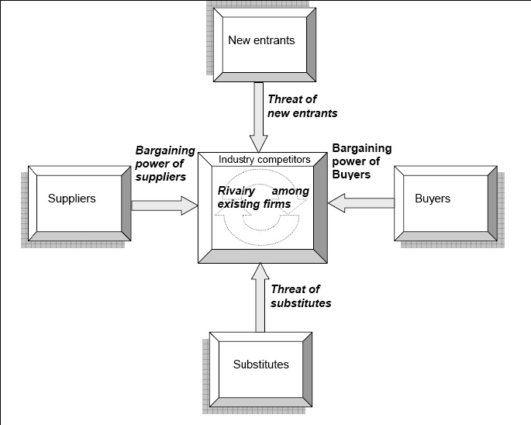Figure 4: Porter’s Five Model
5.3.1.1 Bargaining Power of Suppliers

Huge number of real estate firms in Bangladesh real estate market shows that the market is pretty much attractive to the investors. But the real scenario is a bit different which is elaborated below.

Number of producers: As mentioned earlier that there are lots of real estate firms in the market to produce the real estate products in Bangladesh. But major gains go to some of the big companies in the market. These companies could survive at the time of crisis in the market. At the same time these firms have advantages from economies of scale and scope. Lots of real estate business can be treated as the portfolio diversifier of investors. In case of market concentration market is pretty much concentrated as only 10-15 large companies hold the 95% of the total market share.

Differentiation of Input mix: One of the major inputs in the real estate business in land. Therefore values & prices of lands affect the Bangladesh real estate business very much. They play a strong role in determining the selling price of the real estate products. For example, prices of houses vary considering the locations they are in. A house with lake view in Dhanmondi is far more expensive than the houses in other regions of Dhanmnodi. In case of commercial spaces, Motijheel is that much expensive compared to new market region. In addition to that, the time when the real estate firms buy lands is very important. Firms that have bought lands in the suburbs of Dhaka city ten years back are now in advantageous position than the rivals in the market. The price of the lands in the suburbs of Dhaka city has risen more than 5-6 times in the last ten years. Therefore early buyers have an advantage over costs and gain more. At the same time they if want can influence the rival’s business by setting the price at relatively low level.
So this is about the charisma of top management. The top management that could figure out today’s scenario of Dhaka city at ten years back and took actions in accordance of that is now gainer to a large extent.

Importance of volumes to producers: Not all the real estate firms are capable to operate largely to cover all the segments of real estate business. But depending on the business condition in Bangladesh, experts argued that a firm should target at least two income level’ of the society. If one targets only one level says for example high income level, one might be pretty much limited to the Gulshan area. In bad business time one will face problem because of the limited customer base one has. But if one targets high and medium income people together one might make a tradeoff in bad business time.

Switching costs for customers: Normal law is that if the switching costs are high then customers have low incentive tonswitch. In Bangladesh real estate market we can think about two switching scenarios. One is pre purchase scenario and the other is post purchase scenario. Though there are some companies in market having brand loyalty, this loyalty not necessarily came from their real estate business operations. It came from other business operation of them in Bangladesh. For example, Sheltech, a well known real estate company is a sister concern of Square Groups of Bangladesh, a group having huge brand loyalty and recognition in different segments including information technology, consumer products, and medicine. Therefore real estate buyers normally have no predetermined suppliers. Their choice depends on a combination of factors like available budget, location where one wants to buy the house, who are the companies operating there etc.
So one might argue that before making a purchase decision one searches information and real estate companies meet the demand of that information in different ways. One of the ways is extensive marketing campaign through different marketing tools. Physical inspection of the house premise is a frequent incident in case of real estate buying in Bangladesh. Now one might switch the companies in this period and this is pre purchase switching. It has the costs of time, energy, transportation, and information collection mainly.
Considering the Bangladesh situation this costs are not that high. But it could be pretty high when one switches a lot and find it difficult to get the proper offer one was looking for. At the same time in case of high income group and the blue collar job holders the costs is high mainly because of the high level value of time of them.

5.3.1.2 Bargaining Power of Buyers

Bargaining power of buyers that arises from different factors is the ability to force prices down, bargaining for higher quality or more service, and playing competitors against each other. The parameters of this force are described below:

Buyers-producers ratio (concentration): In Bangladesh there is lots of real estate developers in the market with the varied offers to buyers. This variation is something that constraint the bargaining power as the products are not perfectly substitutes of each other. Each offer has something new and producers try to manipulate that. Customers have a narrow chance to compare in reality. But in case of general real estate products customers go for bargaining though the depth of bargaining depends on the location and the fact which party is in crisis. For example if a buyer is in a position that he has to buy a certain product, seller has the advantage and buyer cannot bargain a lot. The opposite is also true.

Ability of buyers to produce: It happens when one at least has the land to build a house. Still one has to have the access to the financing institutions to finance construction activities. This kind of ability is pretty present among rich people. But they still hire some third parties to construct their dream house according to their preference. Most importantly these rich people also have the access to the financing services in Bangladesh.

Availability of information to buyers: Well though real estate companies offer some kind of online services to the customers, those are mostly insufficient because its widely claimed that there is a gap in between their description of properties in the website and the reality. Companies claim that they just put a general description of their ventures in their website as it’s not possible for them to update all the specifications of their ventures. At the same time they think that in Bangladesh still people don’t rely much on online information

Volume of purchase: Well it says that when one buys a bulky amount of products one can go for significant bargaining with the producers. In case of real estate this does not work that much as there are few or no bulky purchases. Above all almost all companies have some offers that reduce the total price if one buys more than one unit.

Price of total purchase: Buyers consider the total price that includes the price of relevant services like gas and electricity connection, lift service, parking lot price etc. Now if these services make the total amount bulky buyers get an incentive to switch the producers; at least they go for bargaining with the producers.

5.3.1.3 Threat of New Entrants
It’s widely believed that the real estate sector in Bangladesh has been rewarding abnormal profits to investors and therefore lots of investors came to the market. Abnormal profits here refers to the situation where price for the real estate products is more than the average costs to produce that products. In course of time profit margin has been declined and more and more competition came up in the sector.

Legal barriers to entry: In Bangladesh there is no legal barrier to entry to the real estate market. All are free to do business here.

Economies of scale: There are some big companies in the market enjoying these benefits. But it does not mean that they did lower the price to put the competitor in problem or put the buyers in high satisfaction level. They rather enjoy the high profit margin by reducing the costs. The author did not find at least in the urban area of Bangladesh that any firm having economies of scale trying to be more competitive by reducing the price. Therefore advantages from the economies of scale are being used to increase profit margin rather than building competitiveness, which could be a threat for new entrants.

Initial investments and fixed costs: Well it requires large amount of investment. But in most cases real estate companies has very good access to the financial market of Bangladesh. At the same time they get the down payments from the buyers and this money can be used to start the project.

Learning curve advantages: It’s very difficult to prove that the companies in real estate market in Bangladesh are experiencing the learning curve advantage because of the unavailability of data. But this is true that companies do not spend much money in R&D activities. They spend much money in land acquisitions rather than R&D.

Brand Loyal Customers: This can’t be an entry barrier in Bangladesh market as brand loyalty is low here. Here buyers justifies the alternatives first based on the available data and then decide which one to select. At the same difference in locations and needs discourages the brand loyalty to some extent. The reason is that it might happen that the company to whom one is loyal is not present where one wants to buy a house.

5.3.1.4 Threat of Substitutes
This refers to the extent by which buyers can replace their current products by another one. In the context of this report substitutes does not mean the pure substitutes of the core products. In fact here substitutes mean the substitutes of different dimensions of core products. The core product is house and different dimensions include among others location, luxury, producers etc.

Switching costs: Switching costs are very high in case of post purchase switching. So there are few post purchase switching. But there are many more pre purchase switching as this is not expensive most often. This leaves an opportunity for the innovators in the market. Their innovation gets attention easily and if they can make it affordable for the target market, they can create a high substitution ratio in the market in favor of their products.

Loyalty of customers: As mentioned earlier that in Bangladesh real estate buyers are not brand loyal to any brand. In other words no company could yet build up brand image in such a way that can influence the buying decision. Therefore, though well known brands can motivate buyers sometimes, purchasing decision depends on lots of factors like price, desired location, other related attributes etc. Buyers inspect the activities directly beforehand to make a good decision. Therefore brand loyalty is less here and people has more switching tendency if they have the options available to switch.

5.3.1.5 Rivalry Among Existing Firms
This is all about competition in the market. By nature Bangladesh market is free for all and anyone can invest here. Therefore there are lots of companies in the market who compete among themselves. However competition is much fiercer in the urban areas like Dhaka city compared to the sub urban areas like Savar, an area about 20 kilometers away from the Dhaka city.

Market concentration: Market concentration determines how many firms are in control of how much of the total market. If there is high level of concentration, competition is not fierce normally. Only few firms enjoy almost all the benefits.

Product differentiation: When a firm can differentiate products from the products of rivals, at least at the initial stage the differentiator gets some advantages. This can be described as the introduction of new features by real estate firms in Bangladesh market.

Barriers to exit the market: Like all other business sectors, in real estate sector also the hard worker is the winner. Now if someone can’t work hard one has to get out from a market like Bangladesh market where there is no legal barrier to compete and there is no regulation to control the market competitive behaviors. Therefore one is free to enter and exit at least theoretically.

Threat of new entrants: Day by day the real estate sector is getting new orientation in the Bangladesh market. New places are being penetrated and the market expands with good pace. That’s why the business has high profit potential to lots of investors which put the threat of new entry to the existing firms. This increases the rivalry among the existing firms to a large extent.

Conclusion:
After gone through the entire activities of 3-IBL, it can be recommended that 3-I Builders Limited is a well structured company running a successful business with a group of strong, dedicated work force. The company provides pure employee satisfaction. All activities are done in a decent way. The company has got superior relationship with the government as well as the consumers.

PROJECT PART

PART-6
PROJECT ANALYSIS

- PROJECT INTRODUCTION
- PROJECT ANALYSIS
- LIMITATION
- RECOMMENDATION

6.1 Introduction

In the report I will try to provide an in-depth analysis of real estate business facilities for low income people on behalf of a particular real estate company. In present there is lots of advertisement, promotion and other stuff provided by different Developers. But none of them are working for middleclass or low income people. So I will provide the answer that the low income people don’t get any benefit from real estate as to fulfill their drams. The paper will also present the suggestions and future prospects of real estate in the country.

6.1.1 Objectives
The paper aims to examine the present scenario of real estate in Bangladesh for low income people, who want to achieve their dream by buying a house or flat. In this broader framework, an attempt will be achieving the following specific objectives:-
- To study the fundamental factors affecting the real estate value.
- Bangladeshi people income range for buying home
- Financial terms for housing loan.
- To examine the present factors of real estate boom.
- To present the constraints of real estate facilities for low income people.
- To prove that actually low income people doesn’t benefited from real estate companies facilities.
- Future assumption basis of present situation in this issue.

6.1.2 Scope and Significance of the study
The scope of the study will cover the in the low income group people of Dhaka City. The market related information is based on Dhaka region. The significance of this study is dual. From an internee’s perspective this study gave me the opportunity to apply my knowledge earned in last four years education. From the company’s point of view this study will help them to look at some problems from a very different perspective which is from the view-point of a person not from the company. This study may help them to evaluate their marketing strategy according to customer satisfaction and renovate their strategy which will increase the sales of the company.

6.1.3 Research Hypothesis
The low income group population is always deprived of from real estate facilities because of current allotment of housings, price, location and finance system regarding personal income, Which always push upward this ratio in case of other group of people. My research hypothesis is “The real estate facilities don’t benefit for low income people because of high flat price, low per capita income, high interest & inflation rate, corruption and high land price.”

6.1.4Research Methodology
The research methodology will be like analytical and exploratory nature. I will mostly use secondary as well as primary data. The secondary data will be collected mainly through various newspapers, magazines, Internet and RBI review. To supplement the secondary data, most primary data will be collected through interviews and personal visits to the various companies to know the present situation of the market.

6.1.5 Methodology
The project part will be done mostly on the basis of a qualitative study. Some quantitative analysis will be there. In this research paper I will use questionnaire, population survey and hypothesis test to evaluate the factor effect on low income people. I have designed questionnaire and will interview people to complete the survey. Different data and information are required to meet the goal of this report. I will use both primary and secondary data. I will enter the survey result in statistical software SPSS. Next I will test the hypothesis using SPSS.

The outline of the methodology is shown below:

- Analysis
In the research I will use the following analysis:
- Graph & frequency table
- Descriptive Statistics
- Cross Tabulation
- Reliability Test
- Correlation
- Regression
- ANOVA
- Test of Hypothesis

- Questionnaire Construction and measurement

I will provide the questionnaire after approval of my proposal.

- Sampling Technique: Random.

6.1.6 Research Design

A master plan that specifies the methods and procedures for collecting and analyzing needed information is called research design. Typically research design is the second stage of the marketing research process. Research design stage is the stage in which we the researchers determined the overall framework for the research plan of action by basically selecting the research method.
I actually have done my project with quantitative research design and most of the measurement of the questions was like method. To test the hypothesis I have to develop all of the research method and those are: exploratory, descriptive and causal. The research data was obtained from both primary and secondary sources. I have collected some secondary data to what extent it is available.

6.1.7 Data Collection Method

I went to different real estate companies, builder’s office for data collection. Besides visiting their offices, I also took interview of their executives, client and other officials. We therefore collected response from 100 respondents who belongs to this business sector. I also collected low income people response. Since I collected 100 responses, I achieved our target ratio. I have given the questionnaires to them and explained them what to do. Thus I have done data collection.

6.1.8Data Processing and Analysis
The collected data is processed by applying standard editing and coding procedures. For analyzing the data I will utilize simple tabulation and cross tabulation formats. Statistical methods and procedures such as simple and multiple regression analysis, correlation, hypothesis testing and ANOVA have been applied for conducting data processing and analysis.
For this purpose, I used more than one software packages including SPSS (Statistical Packages for Social Sciences), Microsoft Word, or Microsoft Excel. In-depth analysis of the relevant part of the research has been given in the latter part of the report.

6.1.9 The Sampling Frame
I had selected different offices, clients contact number as locations wise from where I chose the sampling frame.

6.1.10 Data Analysis
In this section of the report I will analyze the data of the questionnaire survey. The questionnaire consisted of twenty five (25) questions which are related to the research topic.
I have entered the data in SPSS and run various statistical processes. Here I discuss them. I begin with simple frequency distribution of some of the most important questions in the questionnaire, including the relevance for the question in the report as well as relating the marketing logic that would help us to prove or disprove the hypothesis.
After analyzing the simple frequency distributions, I will analyze various cross-tabulations that I have prepared to analyze the findings. Finally the statistical processes, the various statistical (ANOVA, T-test, F-test, correlation, reliability analysis, etc) tests that I have performed have been explained in simple language for the convenience of the reader.

6.2 Frequency Tables & Graphical Analysis

I have used frequency tables and graphs to interpret the findings of the questionnaire answered by the respondents. Individual graph for all the variables are considered in this section and justification for their inclusions are shortly discussed below.
- Type of consumer Real Estate companies want:
Table 1: Consumer type of Real Estate Company
Valid | Frequency | Percent | Valid Percent | Cumulative Percent
Business people | 25 | 25 | 25 | 25
Govt. Employee | 30 | 30 | 30 | 55
Private job | 15 | 15 | 15 | 70
Other | 30 | 30 | 30 | 100
Total | 100 | 100 | 100

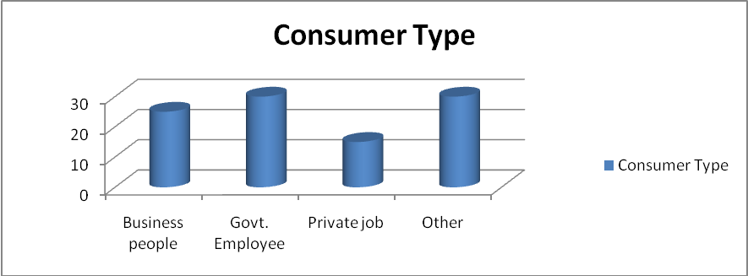
Figure 1: Consumer type of Real Estate Company
Findings from the frequency table & graph:
From the frequency table and the graph we can see that real estate companies have several choices on their consumer. According to my survey out of 100 respondents, 25% company like business profession customer, 30% want Govt. employee as their customer and 15% argued that they like private job profession customer. Finally, 30% real estate Company hasn’t any specific choice. They want all of type of consumers. So, we can say that companies in real estate business more less like stable income population.

- Targeted group people in society:
Table 2: Targeted group people in society
Valid | Frequency | Percent | Valid Percent | Cumulative Percent
High level | 35 | 35 | 35 | 35
Mid level | 30 | 30 | 30 | 65
Low level | 10 | 10 | 10 | 75
ALL | 25 | 25 | 25 | 100
Total | 100 | 100 | 100

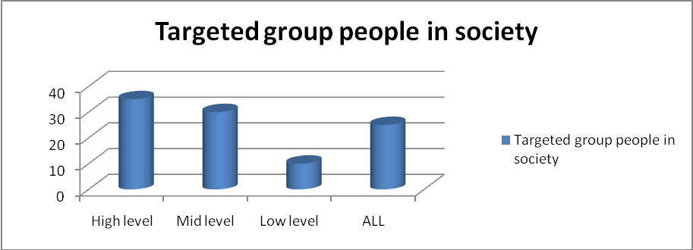
Figure 2: Targeted group people in society
Findings from the frequency table & graph:
From the frequency table and the graph we can see that real estate companies basically prefer high level consumer group in society. According to my survey out of 100 respondents, 35% prefer high level, 30% prefer mid level and 10% respondent choose low income people. On the other hand 25% populations choose any level or all. Actually they didn’t care about level.

- Monthly income of Consumers:
Table 3: Monthly income of consumer in BDT
Valid | Frequency | Percent | Valid Percent | Cumulative Percent
10,000- 20,000 | 5 | 5 | 5 | 5
20,000- 40,000 | 10 | 10 | 10 | 15
50,000- 80,000 | 30 | 30 | 30 | 45
80,000- 100,000> | 55 | 55 | 55 | 100
Total | 100 | 100 | 100

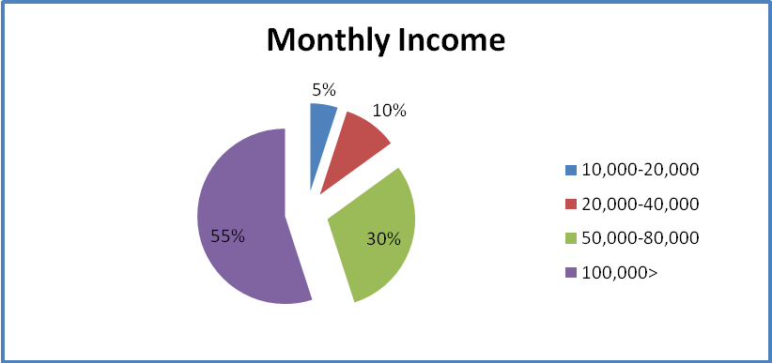
Figure 3: Monthly income of consumer in BDT
Findings from the frequency table & graph:
Monthly income of consumer creates a great effect on real estate business. From the frequency table and the graph we can see that most consumer of Real Estate Company belongs to high income level. According to my survey out of 100 respondents, 5% belongs to 10,000-20,000 taka range, 10% belongs to 20,000-40,000 taka range, 30% belongs to 50,000-80,000 taka range and 55% belongs to 100,000> taka monthly income range. So, we can say that high income peoples are the main consumer of real estate companies.

- Average Flat Price of Companies
Table 4: Average Flat Price of Companies (BDT)
Valid | Frequency | Percent | Valid Percent | Cumulative Percent
20- 30 Lac | 10 | 10 | 10 | 10
30- 50 Lac | 15 | 15 | 15 | 25
50-80 Lac | 50 | 50 | 50 | 75
100> Lac | 25 | 25 | 25 | 100
Total | 100 | 100 | 100

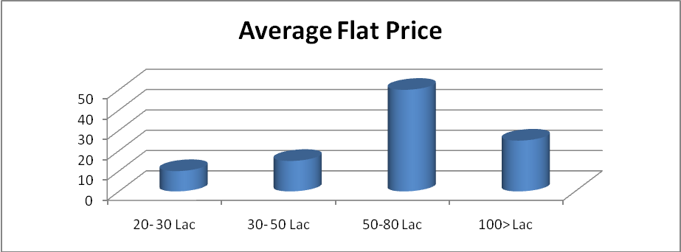
Figure 4: Monthly income of consumer in BDT
Findings from the frequency table & graph:
From the frequency table and the graph we can see the true picture of average flat price charged by individual builders. According to my survey out of 100 respondents, only 10% agree that they have some flat which price belongs to 20-30 lac, 50% said about 30-50 lac, 25% said about 50-80 lac and almost 25% agreed that they set a price of above100 lac.

- Special Package for Low Income people
Table 5: Special Package for Low Income People
Valid | Frequency | Percent | Valid Percent | Cumulative Percent
Yes | 25 | 25 | 25 | 25
No | 60 | 60 | 60 | 85
Neutral | 15 | 15 | 15 | 100
Total | 100 | 100 | 100
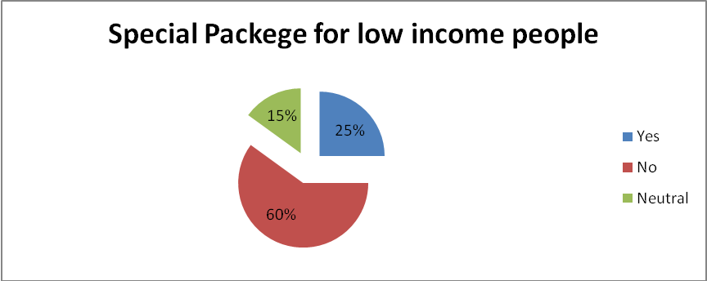
Figure 5: Special Package for Low Income People
Findings from the frequency table & graph:
From the frequency table and the graph we can observed that 25% real estate Company have some sort of package benefit for low income people. 15% react as neutral and 60% real estate Company hasn’t any package for low income people.

- Project Build for Low Income people
Table 6: Project Build for Low Income people.
Valid | Frequency | Percent | Valid Percent | Cumulative Percent
20 or less | 25 | 25 | 25 | 25
25- 50 | 5 | 5 | 5 | 30
50- 75 | 0 | 0 | 0 | 30
75-100> | 0 | 0 | 0 | 30
None | 70 | 70 | 70 | 100
Total | 100 | 100 | 100

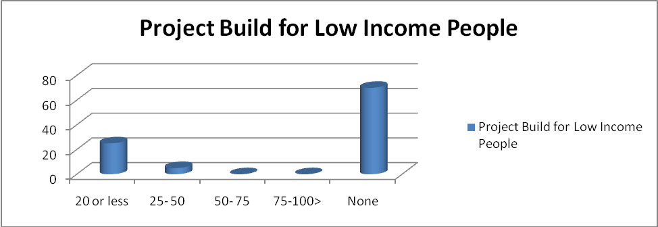 Figure 6: Project Build for Low Income people.

Findings from the frequency table & graph:
From the frequency table and the graph we can observed that real estate companies didn’t build enough project for low income people. According to my survey, we found 25% agreed that they had built 20 or less project for low income people. Other respondent said 5% belong to 25-50 project wad build for them and 70% agreed that they didn’t build anything for them.

- Facilities toward Low Income People by Individual Companies

Table 7: Facilities toward low income people by individual companies
Valid | Frequency | Percent | Valid Percent | Cumulative Percent
10- 25 % | 30 | 30 | 30 | 30
20- 40 % | 10 | 10 | 10 | 40
40- 60 % | 5 | 5 | 5 | 45
60- 80 % | 0 | 0 | 0 | 45
80 – 100 % | 0 | 70 | 0 | 45
None | 55 | 55 | 55 | 100
Total | 100 | 100 | 100

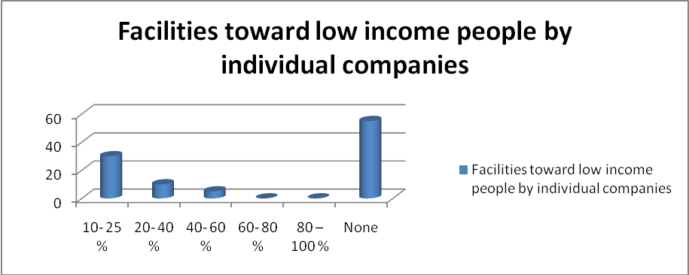
Figure 7: Facilities toward low income people by individual companies
Findings from the frequency table & graph:
From the frequency table and the graph we can observed that real estate companies have not enough facilities for low income people. According to my survey out of 100 respondents, only 30% company give 10-25% facilities toward low income people, 10% said they give 20-40% facility, 5% said they give 40-60% facility and 60 % of these companies didn’t give any facilities.
- Govt. Facilities for Low Income People

Table 8: Facilities exist from govt. for low income people to buy a flat
Valid | Frequency | Percent | Valid Percent | Cumulative Percent
Yes | 55 | 55 | 55 | 55
No | 35 | 35 | 35 | 90
Neutral | 10 | 10 | 10 | 100
Total | 100 | 100 | 100

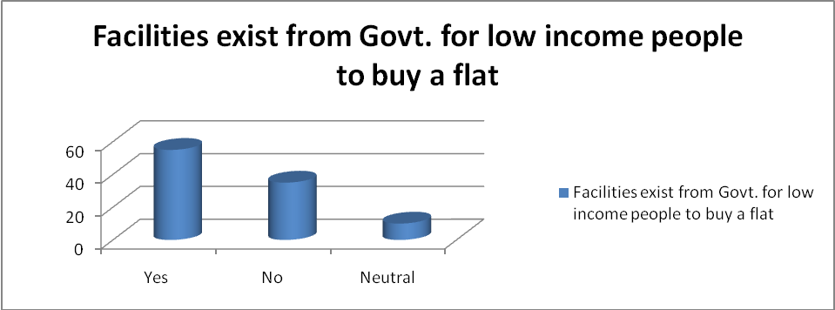
Figure 8: Facilities exist from govt. for low income people to buy a flat
Findings from the frequency table & graph:
From the frequency table and the graph we can say that govt. give different facilities toward low income people. According to my survey out of 100 respondents, 55% said govt. gives facilities and 35% disagreed.10% of they act as neutral.

- Low income People deprived by Real Estate Company(Overall Opinion)
Table 9: Low income people do not benefit by Real Estate Company
Valid | Frequency | Percent | Valid Percent | Cumulative Percent
Strongly agree | 10 | 10 | 10 | 10
agree | 40 | 40 | 40 | 50
Neutral | 10 | 10 | 10 | 60
Disagree | 25 | 25 | 25 | 85
Strongly disagree | 15 | 15 | 15 | 100
Total | 100 | 100 | 100

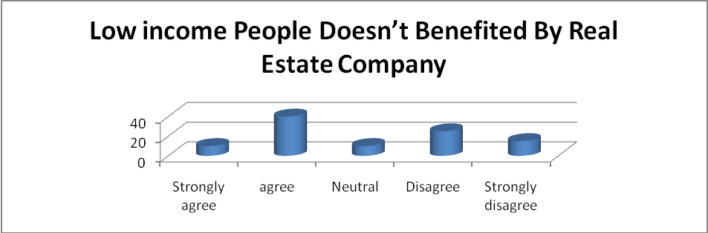
Figure 9: Low income people doesn’t benefited by Real Estate Company
Findings from the frequency table & graph:
From the frequency table and the graph we can say that low income peoples are not benefited by real estate companies. According to my survey out of 100 respondents, 10% strongly agreed, 40% agreed, 10% act neutral, 25% disagreed and 15% strongly disagreed. This statement is my dependent variable. It’s also the Overall opinion of low income people.

- Inflation Rate increased Housing Price
Table 10: Inflation rate Increase Product Price
Valid | Frequency | Percent | Valid Percent | Cumulative Percent
Strongly Agree | 14 | 14 | 14 | 14
Agree | 58 | 58 | 58 | 72
Neutral | 19 | 19 | 19 | 91
Disagree | 6 | 13 | 6 | 97
Strongly Disagree | 3 | 0 | 3 | 100
Total | 100 | 100 | 100

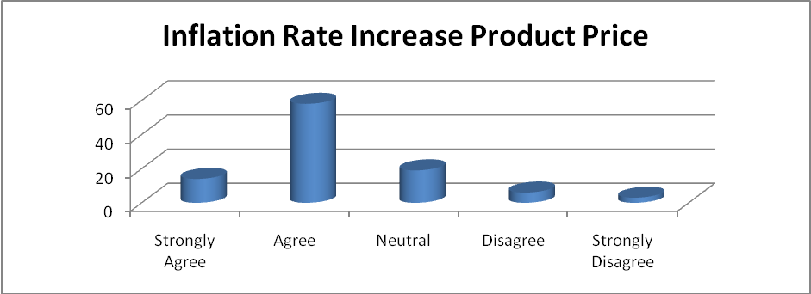
Figure 10: Inflation rate Increase Product Price

Findings from the frequency table & graph:
From the frequency table and the graph we can say that inflation rate increases housing price. According to our survey, 14% strongly agreed and 58% agreed this. In this case, 19% act as neutral. On the other hand, 6% disagreed and 3% strongly disagreed this assumption.

- Per Capita Income of Low Income People
Table 11: Per capita income of people effects on purchasing power
Valid | Frequency | Percent | Valid Percent | Cumulative Percent
Strongly Agree | 16 | 16 | 16 | 16
Agree | 65 | 65 | 65 | 81
Neutral | 16 | 16 | 16 | 97
Disagree | 2 | 13 | 2 | 99
Strongly Disagree | 1 | 0 | 1 | 100
Total | 100 | 100 | 100

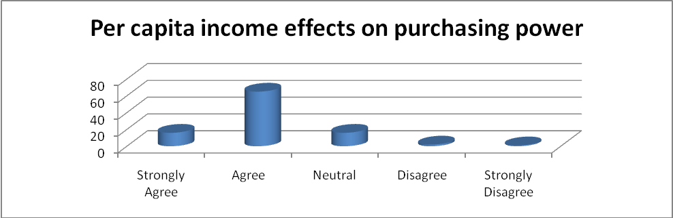
Figure 11: Per capita income of people effects on purchasing power

Findings from the frequency table & graph:
From the frequency table and the graph we observed that low per capita income create barriers on low income people purchasing power. Our respondents also support this argument. Out of 100respondents, 16 strongly agreed, 65% agreed. 16% argue as neutral and rest of respondent did not agree with us.

- Interest Rate on Housing Loan
Table 12: Interest rate of the housing loan charged by the financial institutions is reasonable-
Valid | Frequency | Percent | Valid Percent | Cumulative Percent
Strongly Agree | 6 | 6 | 6 | 6
Agree | 20 | 20 | 20 | 26
Neutral | 15 | 15 | 15 | 41
Disagree | 30 | 30 | 30 | 71
Strongly Disagree | 29 | 29 | 29 | 100
Total | 100 | 100 | 100

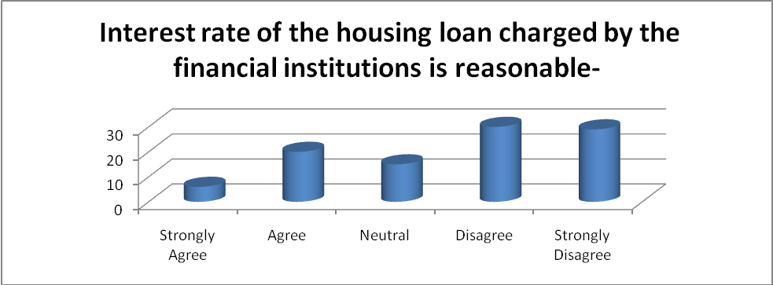
Figure 12: Interest rate of the housing loan charged by the financial institutions is reasonable

Findings from the frequency table & graph:
Out of 100 respondents, 6% strongly agreed and 20% agreed with this statement. On the other hand 30% respondent disagrees and 29 % strongly disagree with this statement, rest of respondents act as neutral. Interest rate charged by the several financial institutions is not favorable for low income people.

- Low Priority by Government
Table 13: Low priority given to housing sector by Govt. is a cause for not getting benefit by low income people
Valid | Frequency | Percent | Valid Percent | Cumulative Percent
Strongly Agree | 19 | 19 | 19 | 19
Agree | 32 | 32 | 32 | 51
Neutral | 21 | 21 | 21 | 72
Disagree | 15 | 13 | 15 | 87
Strongly Disagree | 13 | 13 | 13 | 100
Total | 100 | 100 | 100

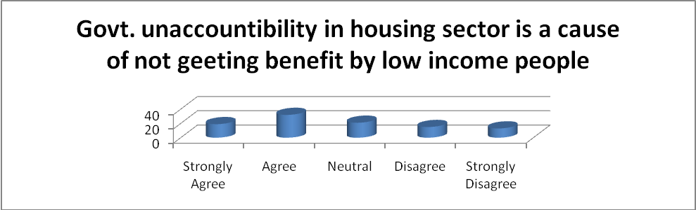
Figure 12: Low priority given to housing sector by Govt.

Findings from the frequency table & graph:
Out of 100 respondents, 19% strongly agreed and 32% agreed with this statement. On the other hand 15% respondent disagrees and 13% strongly disagree with this statement, rest of 21% respondents act as neutral. Our respondent accepts this statement.

- The Formal Financial System in Housing Sector

Table 13: The formal financial system creates barrier for low income people.
Valid | Frequency | Percent | Valid Percent | Cumulative Percent
Strongly Agree | 10 | 10 | 10 | 10
Agree | 49 | 49 | 49 | 59
Neutral | 25 | 25 | 25 | 84
Disagree | 12 | 13 | 12 | 96
Strongly Disagree | 4 | 0 | 4 | 100
Total | 100 | 100 | 100

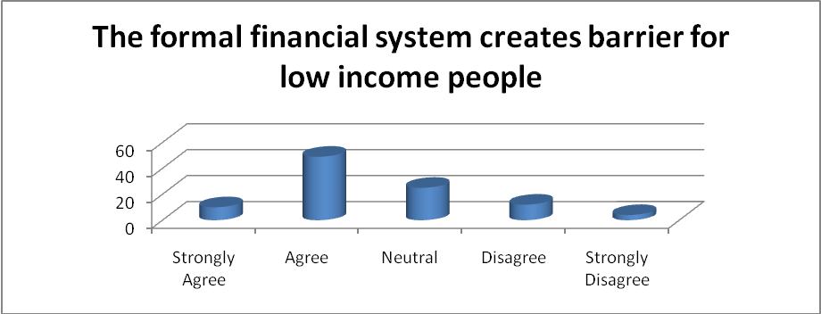
Figure 13: The formal financial system creates barrier for low income people.

Findings from the frequency table & graph:
Out of 100 respondents, 10% strongly agreed and 49% agreed with this statement. On the other hand 12% respondent disagrees and 4% strongly disagree with this statement, rest of 25% respondents act as neutral.

- Cost of Housing Going High Because of Land Shortage and Raw Material Price

Table 14: Cost of Housing going high because of land shortage and raw material price
Valid | Frequency | Percent | Valid Percent | Cumulative Percent
Strongly Agree | 24 | 24 | 24 | 24
Agree | 51 | 51 | 51 | 75
Neutral | 15 | 15 | 15 | 90
Disagree | 3 | 13 | 3 | 93
Strongly Disagree | 7 | 0 | 7 | 100
Total | 100 | 100 | 100

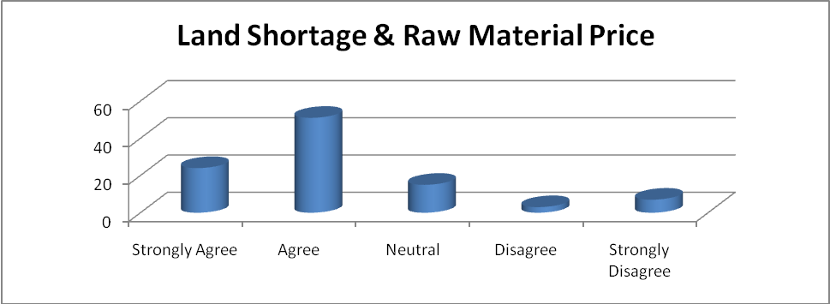
Figure 14: Cost of Housing going high because of land shortage and raw material price
Findings from the frequency table & graph:
From the frequency table and the graph we observed that land shortage and raw material price create barriers on low income people purchasing power. Our respondents also support this argument. Out of 100respondents, 24% strongly agreed, 51% agreed. 15% argue as neutral and rest of respondent did not agree with us.
- Bureaucracy and Illegal Activities
Table 15: Bureaucracy and illegal harassment is other barriers for low income people for not getting any facilities-
Valid | Frequency | Percent | Valid Percent | Cumulative Percent
Strongly Agree | 20 | 20 | 20 | 20
Agree | 50 | 50 | 50 | 70
Neutral | 15 | 15 | 15 | 85
Disagree | 10 | 10 | 10 | 95
Strongly Disagree | 5 | 5 | 5 | 100
Total | 100 | 100 | 100

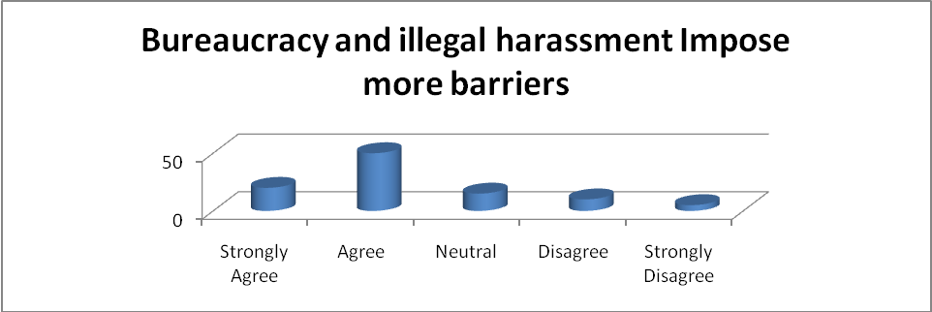
Figure 15: Bureaucracy and illegal harassment

Findings from the frequency table & graph:
From the frequency table and the graph we observed that create barriers Bureaucracy and illegal harassment on low income people purchasing power. Our respondents also support this argument. Out of 100 respondents, 20% strongly agreed, 50% agreed. 15% argue as neutral and rest of 10% disagree and 5%respondents strongly with us.

- High Registration and Other related Fess

Table 16: Do you think High registration fees and other related charge affect on flat pricing?
Valid | Frequency | Percent | Valid Percent | Cumulative Percent
Strongly Agree | 20 | 20 | 20 | 20
Agree | 40 | 40 | 40 | 60
Neutral | 5 | 5 | 5 | 65
Disagree | 20 | 20 | 20 | 85
Strongly Disagree | 15 | 15 | 15 | 100
Total | 100 | 100 | 100

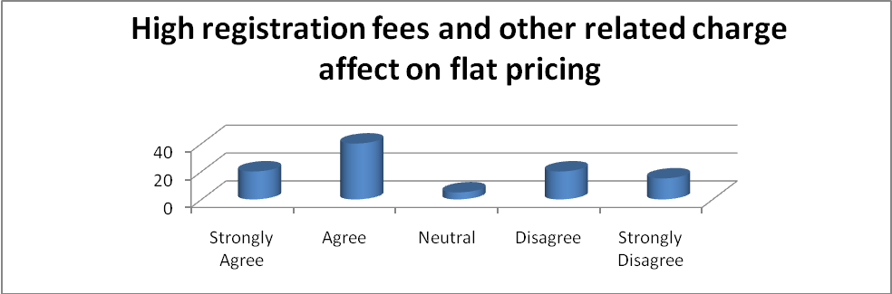
Figure 16: High Registration and other related fees

Findings from the frequency table & graph:
From the frequency table and the graph we observed that high registration fees create barriers on low income people purchasing power. Our respondents also support this argument. Out of 100 respondents, 20% strongly agreed, 40% agreed. 5% argue as neutral and rest of 20% disagree and 15%respondents strongly with us.

- Imported Material Increase Flat Costing
Table 17: Expensive imported material increase flat price which affect low income people buying power.
Valid | Frequency | Percent | Valid Percent | Cumulative Percent
Strongly Agree | 12 | 12 | 12 | 12
Agree | 64 | 64 | 64 | 76
Neutral | 17 | 17 | 17 | 93
Disagree | 5 | 13 | 5 | 98
Strongly Disagree | 2 | 0 | 2 | 100
Total | 100 | 100 | 100

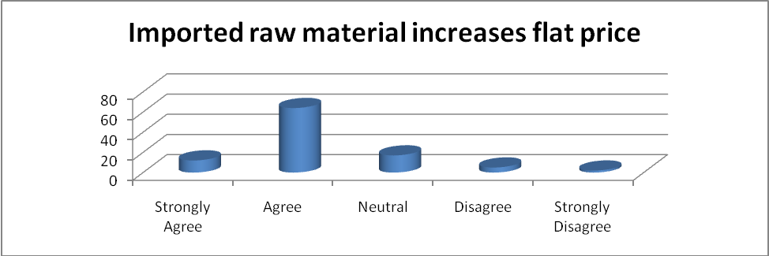
Figure 17: Imported Material Increase Flat Costing

Findings from the frequency table & graph:
From the frequency table and the graph we observed that raw material as well as expensive material import increase flat costing. Our respondents also support this argument. Out of 100 respondents, 12% strongly agreed, 64% agreed. 17% argue as neutral and rest of 5% disagree and 2%respondents strongly with us.

- Lack of Proper Guideline

Table 18: Lack of proper guideline in housing system is creating barrier for low income people.
Valid | Frequency | Percent | Valid Percent | Cumulative Percent
Strongly Agree | 10 | 10 | 10 | 10
Agree | 58 | 58 | 58 | 68
Neutral | 21 | 21 | 21 | 89
Disagree | 7 | 13 | 7 | 96
Strongly Disagree | 4 | 0 | 4 | 100
Total | 100 | 100 | 100

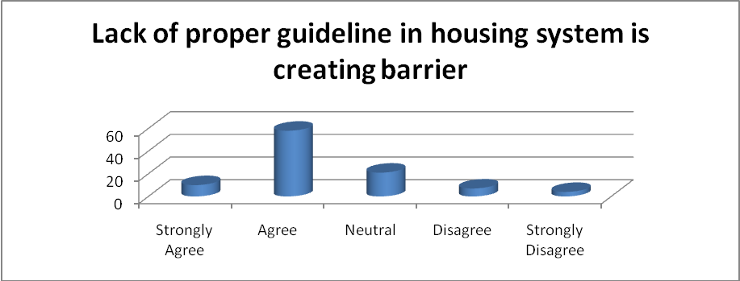
Figure 18: Lack of proper guideline
Findings from the frequency table & graph:
From the frequency table and the graph we can see that real estate companies have several choices on their consumer. According to my survey out of 100 respondents, 10% strongly agreed, 58% agreed, 21% neutral, 7% disagree and 4% strongly disagreed with us.

6.3 Descriptive Statistics
Table 19: Descriptive Statistics
 | N | Minimum | Maximum | Mean | Std. Deviation | Variance
Low income people don’t benefited by Real Estate Company | 100 | 1 | 5 | 2.95 | 1.290 | 1.664
Average flat price | 100 | 1 | 4 | 2.90 | .893 | .798
Inflation Rate | 100 | 1 | 5 | 2.26 | .883 | .780
Per capita income | 100 | 1 | 5 | 2.07 | .700 | .490
Interest rate | 100 | 1 | 5 | 3.56 | 1.266 | 1.602
The formal financial system | 100 | 1 | 5 | 2.51 | .969 | .939
land shortage & raw material price | 100 | 1 | 5 | 2.18 | 1.058 | 1.119
Bureaucracy and illegal harassment | 100 | 1 | 5 | 2.30 | 1.059 | 1.121

Mean - This is the arithmetic mean across the observations. It is the most widely used measure of central tendency. It is commonly called the average. The mean is sensitive to extremely large or small values.
Variance: The variance is a measure of variability. It is the sum of the squared distances of data value from the mean divided by the variance divisor. The Corrected SS is the sum of squared distances of data value from the mean. Therefore, the variance is the corrected SS divided by N-1. We don't generally use variance as an index of spread because it is in squared units. Instead, we use standard deviation.

Table 20: Descriptive Statistics
 |  | Low income people Don’t Benefit by Real Estate Facilities | Average flat price | Inflation Rate | Per capita income | Interest rate | The formal financial system | Land shortage and raw material price | Bureaucracy and illegal harassment
N | Valid | 100 | 100 | 100 | 100 | 100 | 100 | 100 | 100
Mean |  | 2.95 | 2.90 | 2.26 | 2.07 | 3.56 | 2.51 | 2.18 | 2.30
Median |  | 2.50 | 3.00 | 2.00 | 2.00 | 4.00 | 2.00 | 2.00 | 2.00
Mode |  | 2 | 3 | 2 | 2 | 4 | 2 | 2 | 2
Std. Deviation |  | 1.290 | .893 | .883 | .700 | 1.266 | .969 | 1.058 | 1.059
Variance |  | 1.664 | .798 | .780 | .490 | 1.602 | .939 | 1.119 | 1.121
Minimum |  | 1.00 | 1.00 | 1.00 | 1.00 | 1.00 | 1.00 | 1.00 | 1.0
Maximum |  | 5.00 | 4.00 | 5.00 | 5.00 | 5.00 | 5.00 | 5.00 | 5.00
Percentiles | 25 | 2.00 | 2.25 | 2.00 | 2.00 | 2.00 | 2.00 | 2.00 | 2.00
Percentiles | 50 | 2.50 | 3.00 | 2.00 | 2.00 | 4.00 | 2.00 | 2.00 | 2.00
Percentiles | 75 | 4.00 | 3.75 | 3.00 | 2.00 | 5.00 | 3.00 | 2.75 | 3.00

Std. Deviation- Standard deviation is the square root of the variance. It measures the spread of a set of observations. The larger the standard deviation is, the more spread out the observations are.
Findings:
All the variables have the same number of observations with no values missing. The statistics above are based on the variables of the major hypothesis of the project.

Independent Variables:
- Average Flat Price: From the 100 responses survey Mean calculated is 2.90 with a Max of 4.00 and Min of 1.00, which means most the respondents are satisfied with the average price from the mean calculated. As the variable was calculated using likert-scale we can say by seeing the mean that customers are dissatisfied by price. But the standard deviation (89.30%) is very high which means among the respondents there is varying degree opinion.
- Inflation rate: Mean of inflation rate is not very high at 2.26 compare to the other variables but still we can say that respondents are likely to be very happy if the inflation rate is lowered and that can be seen from the Min and Max of the respondents and the standard deviation (80.83%).
- Per capita income: Mean calculated for the variable is 2.07 which are closer to agree in the likert-scale and although the respondents gave a considerable amount of varying between strongly agree and agree and respondent agreed that it is a major cause variable.
- Interest rate: interest rate on housing loan Mean calculated for this variable is 3.56 the highest and probably this variable has the unbalance in terms of mean and standard deviation (approx. 120%).
- The formal financing system: Mean calculation for this variable is 2.51 and standard deviation is 96%.
- Land shortage & raw material price: This variable content two factor and mean of this variable is 2.18 and standard deviation is approx. 105.8%, which indicate unbalance with mean.
- Bureaucracy and illegal harassment: this variable mean is 2.30 and slandered deviation of 105.9%, which is closely related with land shortage and raw material variable.

Dependent Variable:
- Overall Opinion about Low income people don’t benefit by Real Estate Company: Mean calculated is 2.95 and standard deviation is 129.0%, thus we can say that other independent variables support on their logic.

6.4 Correlation

Here I focused the correlation between the dependent variable “The low income peoples don’t benefit by real estate companies facility.” and the other independent variables. We know that correlation values ranged between -1 to +1. Negative one (-1) indicates perfectly negative correlation which means the variables move in opposite direction and positive one (+1) indicates perfectly positive correlation which means the factors move in same direction. A correlation of zero indicates no linear relationship between the two variables but there might or might not be non-linear relationship.
The hypothesis tested here for all different pairs:
Ho: There is no correlation between X and Y.
H1: There is correlation between X and Y.
Table 21: Correlations
 |  | Overall opinion by low income people | Average flat price | Inflation Rate | Per capita income | Interest rate | The formal financial system | land shortage and raw material | Bureaucracy and illegal harassment
Low income people doesn’t benefited by Real Estate Company | Pearson Correlation | 1 | .434** | -.121 | .261** | .463** | -.294** | -.326** | .861**
Low income people doesn’t benefited by Real Estate Company | Sig. (2-tailed) |  | .000 | .229 | .009 | .000 | .003 | .001 | .000
Average flat price | Pearson Correlation | .434** | 1 | -.031 | .561** | .595** | .235* | -.141 | .406**
Average flat price | Sig. (2-tailed) | .000 |  | .762 | .000 | .000 | .019 | .161 | .000
Inflation Rate | Pearson Correlation | -.121 | -.031 | 1 | -.062 | .013 | -.546** | .641** | -.171
Inflation Rate | Sig. (2-tailed) | .229 | .762 |  | .537 | .898 | .000 | .000 | .090
Per capita income | Pearson Correlation | .261** | .561** | -.062 | 1 | .400** | .274** | -.208* | .189
Per capita income | Sig. (2-tailed) | .009 | .000 | .537 |  | .000 | .006 | .038 | .059
Interest rate institutions is reasonable | Pearson Correlation | .463** | .595** | .013 | .400** | 1 | .061 | -.099 | .265**
Interest rate institutions is reasonable | Sig. (2-tailed) | .000 | .000 | .898 | .000 |  | .545 | .329 | .008
The formal financial system | Pearson Correlation | -.294** | .235* | -.546** | .274** | .061 | 1 | -.268** | -.151
The formal financial system | Sig. (2-tailed) | .003 | .019 | .000 | .006 | .545 |  | .007 | .135
of land shortage and raw material | Pearson Correlation | -.326** | -.141 | .641** | -.208* | -.099 | -.268** | 1 | -.202*
of land shortage and raw material | Sig. (2-tailed) | .001 | .161 | .000 | .038 | .329 | .007 |  | .044
Bureaucracy and illegal harassment | Pearson Correlation | .861** | .406** | -.171 | .189 | .265** | -.151 | -.202* | 1
Bureaucracy and illegal harassment | Sig. (2-tailed) | .000 | .000 | .090 | .059 | .008 | .135 | .044
**. Correlation is significant at the 0.01 level (2-tailed).
Here, we find the Pearson’s correlation coefficient for all the different pairs of variables checked for correlation. Significant correlation between any two pairs is marked with ** at .01 level. So I can say all the variables are correlated with each other from the table and reject the null hypothesis. Where my null hypothesis was low income people benefited by real estate facilities.

6.5 Coefficient

Table 22: Coefficients

Model |  | Unstandardized Coefficients |  | Standardized Coefficients | t | Sig. | 95.0% Confidence Interval for B
 |  | B | Std. Error | Beta | t | Sig. | Lower Bound | Upper Bound
1 | (Constant) | 1.520 | .320 |  | 4.742 | .000 | .883 | 2.156
1 | Average flat price | .043 | .088 | .034 | .492 | .624 | -.131 | .217
1 | Inflation rate | -.050 | .083 | -.034 | -.603 | .548 | -.216 | .115
1 | Per capita income | .112 | .080 | .061 | 1.400 | .165 | -.047 | .270
1 | Interest rate | .243 | .048 | .238 | 5.057 | .000 | .148 | .338
1 | The formal financial system | -.402 | .065 | -.302 | -6.186 | .000 | -.531 | -.273
1 | land shortage and raw material | -.254 | .058 | -.208 | -4.358 | .000 | -.370 | -.138
1 | Bureaucracy and illegal harassment | .815 | .071 | .669 | 11.490 | .000 | .674 | .956
a. Dependent Variable: Low income people don’t benefit by Real Estate Company.

Table 22: Coefficient Correlations
Model |  |  | Bureaucracy and illegal harassment | The formal financial system | Interest rate | land shortage and raw material | Per capita income | Inflation rate | Average flat price
1 | Correlation | Bureaucracy and illegal harassment | 1.000 | .394 | .279 | .021 | .073 | .258 | -.730
1 | Correlation | The formal financial system | .394 | 1.000 | .069 | -.179 | -.278 | .592 | -.207
1 | Correlation | Interest rate | .279 | .069 | 1.000 | .057 | -.104 | -.032 | 554
1 | Correlation | land shortage and raw material | .021 | -.179 | .057 | 1.000 | .226 | -.609 | -.029
1 | Correlation | Per capita income | .073 | -.278 | -.104 | .226 | 1.000 | -.223 | -.269
1 | Correlation | Inflation rate | .258 | .592 | -.032 | -.609 | -.223 | 1.000 | -.094
1 | Correlation | Average flat price | -.730 | -.207 | -.554 | -.029 | -.269 | -.094 | 1.000
1 | Covariance | Bureaucracy and illegal harassment | .005 | .002 | .001 | 8.828E-5 | .000 | .002 | -.005
1 | Covariance | The formal financial system | .002 | .004 | .000 | .000 | -.001 | .003 | -.001
1 | Covariance | Interest rate | .001 | .000 | .002 | .000 | .000 | .000 | -.002
1 | Covariance | land shortage and raw material | 8.828E-5 | .000 | .000 | .003 | .001 | -.003 | .000
1 | Covariance | Per capita income | .000 | -.001 | .000 | .001 | .006 | -.001 | -.002
1 | Covariance | Inflation rate | .002 | .003 | .000 | -.003 | -.001 | .007 | .000
1 | Covariance | Average flat price | -.005 | -.001 | -.002 | .000 | -.002 | .000 | .008
a. Dependent Variable: Low income people don’t benefit by Real Estate Company.

Findings from Coefficient Correlations:

From above table we can analyze the correlation coefficient among all the independent variables. The correlation between Bureaucracy and illegal harassment and finance system are average strong because the correlation coefficient is (.394), but they are positively related Bureaucracy and illegal and interest rate has a less strong relationship as the correlation coefficient is (.279). Inflation rate, low per capita income and raw material price validates my research with a positive relation with other variables. On the other hand, average flat price has an inverse relationship with illegal harassment. The financial system variable has both positive and negative relation with other variables. The land shortage and raw material price also have positive and negative relation with other variables. As we know all these independent variable makes individual effect on dependent variable but at the same time they also put a same result on dependent variables and that’s why those variables have some inverse relationship. In terms of other explanation we can say each of independent variable causes barriers for low income people. Covariance tells how the variables are behaving differently from one another. From the Variance Analysis we can also that variables are closely related as their movements are not that different and showing close coordination of movements.

6.6 Cross Tabulation Analysis
We have done cross tabulation analysis among our sets of data that we got from survey. Then, we also tried to develop a comparison between Variables and also the Test of Hypothesis’s. The analyses are given below.

- Average flat price verses income factors Cross tabulation:

Ho: Average flat price and income factors are independent
H1: Average flat price and income factors are dependent

Table 23: Cross tabulation of Average flat price verses Monthly income of consumer
 |  |  | Monthly income of consumer |  |  |  | Total
 |  |  | 10,000- 20,000 | 20,000- 40,000 | 50,000- 80,000 | 80,000- 100,000> | Total
Average flat price | 20- 30 Lac | Count | 3 | 5 | 2 | 0 | 10
Average flat price | 20- 30 Lac | % within Average flat price | 30.0% | 50.0% | 20.0% | .0% | 100.0%
Average flat price | 20- 30 Lac | % within income | 60.0% | 50.0% | 6.7% | .0% | 10.0%
Average flat price | 20- 30 Lac | % of Total | 3.0% | 5.0% | 2.0% | .0% | 10.0%
Average flat price | 30- 50 Lac | Count | 2 | 5 | 8 | 0 | 15
Average flat price | 30- 50 Lac | % within Average flat price | 13.3% | 33.3% | 53.3% | .0% | 100.0%
Average flat price | 30- 50 Lac | % within income | 40.0% | 50.0% | 26.7% | .0% | 15.0%
Average flat price | 30- 50 Lac | % of Total | 2.0% | 5.0% | 8.0% | .0% | 15.0%
Average flat price | 50-80 Lac | Count | 0 | 0 | 13 | 37 | 50
Average flat price | 50-80 Lac | % within Average flat price | .0% | .0% | 26.0% | 74.0% | 100.0%
Average flat price | 50-80 Lac | % within income | .0% | .0% | 43.3% | 67.3% | 50.0%
Average flat price | 50-80 Lac | % of Total | .0% | .0% | 13.0% | 37.0% | 50.0%
Average flat price | 100> Lac | Count | 0 | 0 | 7 | 18 | 25
Average flat price | 100> Lac | % within Average flat price | .0% | .0% | 28.0% | 72.0% | 100.0%
Average flat price | 100> Lac | % within income | .0% | .0% | 23.3% | 32.7% | 25.0%
Average flat price | 100> Lac | % of Total | .0% | .0% | 7.0% | 18.0% | 25.0%
Total |  | Count | 5 | 10 | 30 | 55 | 100
 |  | % within Average flat price | 5.0% | 10.0% | 30.0% | 55.0% | 100.0%
 |  | % within income | 100.0% | 100.0% | 100.0% | 100.0% | 100.0%
 |  | % of Total | 5.0% | 10.0% | 30.0% | 55.0% | 100.0%

Chi-Square Tests
 | Value | df | Asymp. Sig. (2-sided)
Pearson Chi-Square | 71.701ª | 9 | .000
Likelihood Ratio | 77.360 | 9 | .000
Linear-by-Linear Association | 47.478 | 1 | .000
N of Valid Cases | 100
a. 9 cells (56.3%) have expected count less than 5. The minimum expected count is .50.

From the cross tabulation above the findings state that majority of the respondent in the income range 80,000- 100,000> have the potential of buying. Beside this range, 50,000-80,000 income range people also have the ability.But when we go to even a lower level of income in the low level income group which is 10,000- 20,000 range, wasn’t in impressive situation.
Overall Findings: In the lower income group among the 100 responded answers approximately 55% preferred that high income group level have more purchasing power while approximately 5% and 10% that low income people group have also some buying power. Moreover from the Pearson Correlation test we can also say that independent variables flat price and income Preference Factors are dependent as p-value is less than .05 thus rejecting the null hypothesis.

- Monthly Income verses Low income people opinion factors Cross tabulation:

Ho: monthly income and low income people opinion are independent
H1: Monthly income and low income people opinion are dependent.

Table 24: Monthly income vs. Low income people don’t benefit by Real Estate Company Cross tabulation
 |  |  | Low income people don’t benefit by Real Estate Company |  |  |  |  | Total
 |  |  | Strongly agree | agree | Neutral | Disagree | Strongly disagree | Total
Monthly income of consumer | 10,000- 20,000 | Count | 5 | 0 | 0 | 0 | 0 | 5
Monthly income of consumer | 10,000- 20,000 | % within income | 100.0% | .0% | .0% | .0% | .0% | 100.0%
Monthly income of consumer | 10,000- 20,000 | % within Low income people opinion | 50.0% | .0% | .0% | .0% | .0% | 5.0%
Monthly income of consumer | 10,000- 20,000 | % of Total | 5.0% | .0% | .0% | .0% | .0% | 5.0%
Monthly income of consumer | 20,000- 40,000 | Count | 5 | 5 | 0 | 0 | 0 | 10
Monthly income of consumer | 20,000- 40,000 | % within income | 50.0% | 50.0% | .0% | .0% | .0% | 100.0%
Monthly income of consumer | 20,000- 40,000 | % within Low income people opinion | 50.0% | 12.5% | .0% | .0% | .0% | 10.0%
Monthly income of consumer | 20,000- 40,000 | % of Total | 5.0% | 5.0% | .0% | .0% | .0% | 10.0%
Monthly income of consumer | 50,000- 80,000 | Count | 0 | 30 | 0 | 0 | 0 | 30
Monthly income of consumer | 50,000- 80,000 | % within income | .0% | 100.0% | .0% | .0% | .0% | 100.0%
Monthly income of consumer | 50,000- 80,000 | % within Low income people opinion | .0% | 75.0% | .0% | .0% | .0% | 30.0%
Monthly income of consumer | 50,000- 80,000 | % of Total | .0% | 30.0% | .0% | .0% | .0% | 30.0%
Monthly income of consumer | 80,000- 100,000> | Count | 0 | 5 | 10 | 25 | 15 | 55
Monthly income of consumer | 80,000- 100,000> | % within income | .0% | 9.1% | 18.2% | 45.5% | 27.3% | 100.0%
Monthly income of consumer | 80,000- 100,000> | % within Low income people opinion | .0% | 12.5% | 100.0% | 100.0% | 100.0% | 55.0%
Monthly income of consumer | 80,000- 100,000> | % of Total | .0% | 5.0% | 10.0% | 25.0% | 15.0% | 55.0%
Total |  | Count | 10 | 40 | 10 | 25 | 15 | 100
 |  | % within income | 10.0% | 40.0% | 10.0% | 25.0% | 15.0% | 100.0%
 |  | % within Low income people opinion | 100.0% | 100.0% | 100.0% | 100.0% | 100.0% | 100.0%
 |  | % of Total | 10.0% | 40.0% | 10.0% | 25.0% | 15.0% | 100.0%

Chi-Square Tests
 | Value | df | Asymp. Sig. (2-sided)
Pearson Chi-Square | 148.295ª | 12 | .000
Likelihood Ratio | 141.297 | 12 | .000
Linear-by-Linear Association | 62.161 | 1 | .000
N of Valid Cases | 100
- 13 cells (65.0%) have expected count less than 5. The minimum expected count is .50.

From the cross tabulation above the findings state that majority of the respondent agree with statement. Out of 100 respondents, 40% agreed and the high income level people also agreed this statement by 55%.
Overall Findings: In the lower income group among the 100 responded answers approximately 55% preferred that high income group level have more purchasing power while approximately 50% agreed that real estate facilities is not for poor people.. Moreover from the Pearson Correlation test we can also say that independent variables flat price and income Preference Factors are dependent as p-value is less than .05 thus rejecting the null hypothesis.

- The formal financial system verses interest rate factors Cross tabulation:

Ho: The formal financial systems and interest rate are independent
H1: The formal financial systems and interest rate are dependent

Table 25: Cross tabulation of The formal financial system verses Interest rate
 |  |  | Interest rate of the housing loan charged by the financial institutions is reasonable |  |  |  |  | Total
 |  |  | Strongly agree | Agree | Neutral | Disagree | Strongly disagree | Total
The formal financial system | Strongly agree | Count | 0 | 10 | 0 | 0 | 0 | 10
The formal financial system | Strongly agree | % within The formal financial system | .0% | 100.0% | .0% | .0% | .0% | 100.0%
The formal financial system | Strongly agree | % within Interest rate | .0% | 50.0% | .0% | .0% | .0% | 10.0%
The formal financial system | Strongly agree | % of Total | .0% | 10.0% | .0% | .0% | .0% | 10.0%
The formal financial system | Agree | Count | 6 | 0 | 0 | 14 | 29 | 49
The formal financial system | Agree | % within The formal financial system | 12.2% | .0% | .0% | 28.6% | 59.2% | 100.0%
The formal financial system | Agree | % within Interest rate | 100.0% | .0% | .0% | 46.7% | 100.0% | 49.0%
The formal financial system | Agree | % of Total | 6.0% | .0% | .0% | 14.0% | 29.0% | 49.0%
The formal financial system | Neutral | Count | 0 | 10 | 15 | 0 | 0 | 25
The formal financial system | Neutral | % within The formal financial system | .0% | 40.0% | 60.0% | .0% | .0% | 100.0%
The formal financial system | Neutral | % within Interest rate | .0% | 50.0% | 100.0% | .0% | .0% | 25.0%
The formal financial system | Neutral | % of Total | .0% | 10.0% | 15.0% | .0% | .0% | 25.0%
The formal financial system | Disagree | Count | 0 | 0 | 0 | 12 | 0 | 12
The formal financial system | Disagree | % within The formal financial system | .0% | .0% | .0% | 100.0% | .0% | 100.0%
The formal financial system | Disagree | % within Interest rate | .0% | .0% | .0% | 40.0% | .0% | 12.0%
The formal financial system | Disagree | % of Total | .0% | .0% | .0% | 12.0% | .0% | 12.0%
The formal financial system | Stronly disagree | Count | 0 | 0 | 0 | 4 | 0 | 4
The formal financial system | Stronly disagree | % within The formal financial system | .0% | .0% | .0% | 100.0% | .0% | 100.0%
The formal financial system | Stronly disagree | % within Interest rate | .0% | .0% | .0% | 13.3% | .0% | 4.0%
The formal financial system | Stronly disagree | % of Total | .0% | .0% | .0% | 4.0% | .0% | 4.0%
Total |  | Count | 6 | 20 | 15 | 30 | 29 | 100
 |  | % within The formal system | 6.0% | 20.0% | 15.0% | 30.0% | 29.0% | 100.0%
 |  | % within Interest rate | 100.0% | 100.0% | 100.0% | 100.0% | 100.0% | 100.0%
 |  | % of Total | 6.0% | 20.0% | 15.0% | 30.0% | 29.0% | 100.0%

Chi-Square Tests
 | Value | df | Asymp. Sig. (2-sided)
Pearson Chi-Square | 168.095ª | 16 | .000
Likelihood Ratio | 174.736 | 16 | .000
Linear-by-Linear Association | .371 | 1 | .542
N of Valid Cases | 100
a. 18 cells (72.0%) have expected count less than 5. The minimum expected count is .24.

Overall Findings:
From the cross tabulation above the findings state that majority of the respondent disagree with statement. Out of 100 respondents, 30% strongly disagreed and the 29% strongly disagreed with variable. The formal finance system and interest rate have a positive. Moreover from the Pearson Correlation test we can also say that independent variables flat price and income Preference Factors are dependent as p-value is less than .05 thus rejecting the null hypothesis.

- The Inflation rate verses per capita factors Cross tabulation:

Ho: Inflation rate and per capita income are independent
H1: Inflation rate and per capita income are dependent
Table 26: Cross tabulation of Inflation Rate verses Per capita income
 |  |  | Per capita income of people is a big factor for not getting any facilities |  |  |  |  | Total
 |  |  | Strongly agree | Agree | Neutral | Disagree | Strongly disagree | Total
Inflation Rate | Strongly agree | Count | 7 | 7 | 0 | 0 | 0 | 14
Inflation Rate | Strongly agree | % within Inflation Rate | 50.0% | 50.0% | .0% | .0% | .0% | 100.0%
Inflation Rate | Strongly agree | % within Per capita income | 43.8% | 10.8% | .0% | .0% | .0% | 14.0%
Inflation Rate | Strongly agree | % of Total | 7.0% | 7.0% | .0% | .0% | .0% | 14.0%
Inflation Rate | Agree | Count | 0 | 51 | 4 | 2 | 1 | 58
Inflation Rate | Agree | % within Inflation Rate | .0% | 87.9% | 6.9% | 3.4% | 1.7% | 100.0%
Inflation Rate | Agree | % within Per capita income | .0% | 78.5% | 25.0% | 100.0% | 100.0% | 58.0%
Inflation Rate | Agree | % of Total | .0% | 51.0% | 4.0% | 2.0% | 1.0% | 58.0%
Inflation Rate | Neutral | Count | 0 | 7 | 12 | 0 | 0 | 19
Inflation Rate | Neutral | % within Inflation Rate | .0% | 36.8% | 63.2% | .0% | .0% | 100.0%
Inflation Rate | Neutral | % within Per capita income | .0% | 10.8% | 75.0% | .0% | .0% | 19.0%
Inflation Rate | Neutral | % of Total | .0% | 7.0% | 12.0% | .0% | .0% | 19.0%
Inflation Rate | Disagree | Count | 6 | 0 | 0 | 0 | 0 | 6
Inflation Rate | Disagree | % within Inflation Rate | 100.0% | .0% | .0% | .0% | .0% | 100.0%
Inflation Rate | Disagree | % within Per capita income | 37.5% | .0% | .0% | .0% | .0% | 6.0%
Inflation Rate | Disagree | % of Total | 6.0% | .0% | .0% | .0% | .0% | 6.0%
Inflation Rate | Stronly disagree | Count | 3 | 0 | 0 | 0 | 0 | 3
Inflation Rate | Stronly disagree | % within Inflation Rate | 100.0% | .0% | .0% | .0% | .0% | 100.0%
Inflation Rate | Stronly disagree | % within Per capita income | 18.8% | .0% | .0% | .0% | .0% | 3.0%
Inflation Rate | Stronly disagree | % of Total | 3.0% | .0% | .0% | .0% | .0% | 3.0%
Total |  | Count | 16 | 65 | 16 | 2 | 1 | 100
 |  | % within Inflation Rate | 16.0% | 65.0% | 16.0% | 2.0% | 1.0% | 100.0%
 |  | % within Per capita income | 100.0% | 100.0% | 100.0% | 100.0% | 100.0% | 100.0%
 |  | % of Total | 16.0% | 65.0% | 16.0% | 2.0% | 1.0% | 100.0%

Chi-Square Tests
 | Value | df | Asymp. Sig. (2-sided)
Pearson Chi-Square | 110.734ª | 16 | .000
Likelihood Ratio | 97.627 | 16 | .000
Linear-by-Linear Association | .386 | 1 | .535
N of Valid Cases | 100
a. 20 cells (80.0%) have expected count less than 5. The minimum expected count is .03.

Overall Findings:
From the cross tabulation above the findings state that majority of the respondent agree with statement. Out of 100 respondents, 60% agreed that on high inflation rate per capita income goes down and low per capita income is another reason for low buying power. Moreover from the Pearson Correlation test we can also say that independent variables flat price and income Preference Factors are dependent as p-value is lower than .05 thus we rejecting the null hypothesis.

- The Low income people opinion verses Land shortage & raw material factors Cross tabulation:

Ho: Low income people opinion and land shortage & raw material are independent
H1: Low income people opinion and Land shortage & raw material are dependent.

Table 27: Cross tabulation of Low income people opinion verses land shortage and raw material
 |  |  | Cost of Housing going high because of land shortage and raw material price hike |  |  |  |  | Total
 |  |  | Strongly agree | Agree | Neutral | Disagree | Strongly disagree | Total
Low income people opinion | Strongly agree | Count | 0 | 0 | 0 | 3 | 7 | 10
Low income people opinion | Strongly agree | % within Low income people opinion | .0% | .0% | .0% | 30.0% | 70.0% | 100.0%
Low income people opinion | Strongly agree | % within land shortage and raw material | .0% | .0% | .0% | 100.0% | 100.0% | 10.0%
Low income people opinion | Strongly agree | % of Total | .0% | .0% | .0% | 3.0% | 7.0% | 10.0%
Low income people opinion | agree | Count | 24 | 1 | 15 | 0 | 0 | 40
Low income people opinion | agree | % within Low income people opinion | 60.0% | 2.5% | 37.5% | .0% | .0% | 100.0%
Low income people opinion | agree | % within land shortage and raw material | 100.0% | 2.0% | 100.0% | .0% | .0% | 40.0%
Low income people opinion | agree | % of Total | 24.0% | 1.0% | 15.0% | .0% | .0% | 40.0%
Low income people opinion | Neutral | Count | 0 | 10 | 0 | 0 | 0 | 10
Low income people opinion | Neutral | % within Low income people opinion | .0% | 100.0% | .0% | .0% | .0% | 100.0%
Low income people opinion | Neutral | % within land shortage and raw material | .0% | 19.6% | .0% | .0% | .0% | 10.0%
Low income people opinion | Neutral | % of Total | .0% | 10.0% | .0% | .0% | .0% | 10.0%
Low income people opinion | Disagree | Count | 0 | 25 | 0 | 0 | 0 | 25
Low income people opinion | Disagree | % within Low income people opinion | .0% | 100.0% | .0% | .0% | .0% | 100.0%
Low income people opinion | Disagree | % within C land shortage and raw material | .0% | 49.0% | .0% | .0% | .0% | 25.0%
Low income people opinion | Disagree | % of Total | .0% | 25.0% | .0% | .0% | .0% | 25.0%
Low income people opinion | Strongly disagree | Count | 0 | 15 | 0 | 0 | 0 | 15
Low income people opinion | Strongly disagree | % within Low income people opinion | .0% | 100.0% | .0% | .0% | .0% | 100.0%
Low income people opinion | Strongly disagree | % within land shortage and raw material | .0% | 29.4% | .0% | .0% | .0% | 15.0%
Low income people opinion | Strongly disagree | % of Total | .0% | 15.0% | .0% | .0% | .0% | 15.0%
Total |  | Count | 24 | 51 | 15 | 3 | 7 | 100
 |  | % within Low income people opinion | 24.0% | 51.0% | 15.0% | 3.0% | 7.0% | 100.0%
 |  | % within f land shortage and raw material | 100.0% | 100.0% | 100.0% | 100.0% | 100.0% | 100.0%
 |  | % of Total | 24.0% | 51.0% | 15.0% | 3.0% | 7.0% | 100.0%

Chi-Square Tests
 | Value | df | Asymp. Sig. (2-sided)
Pearson Chi-Square | 195.588ª | 16 | .000
Likelihood Ratio | 178.826 | 16 | .000
Linear-by-Linear Association | 10.551 | 1 | .001
N of Valid Cases | 100
a. 17 cells (68.0%) have expected count less than 5. The minimum expected count is .30.

Overall Findings:
In this cross tabulation awe see the findings state that majority of the respondents agree with statement. Out of 100 respondents, 51% agreed that low income people opinion about real estate facilities is true. On the other hand, costing will be higher at increased land and material price. Moreover from the Pearson Correlation test we can also say that independent variables flat price and income Preference Factors are dependent as p-value is lower than .05 thus not rejecting the null hypothesis.
- The low income people opinion vs. formal financing system factors Cross tabulation:

Ho: low income people opinion and formal financing system are independent
H1: low income people opinion and formal financing system are dependent

Table 28: low income people opinion vs. formal financing system cross tabulation
 |  |  | The formal financial mortgage system creates barrier for low income people |  |  |  |  | Total
 |  |  | Strongly agree | Agree | Neutral | Disagree | Strongly disagree | Total
Low income people opinion | Strongly agree | Count | 10 | 0 | 0 | 0 | 0 | 10
Low income people opinion | Strongly agree | % within Low income people opinion | 100.0% | .0% | .0% | .0% | .0% | 100.0%
Low income people opinion | Strongly agree | % within The formal financing system | 100.0% | .0% | .0% | .0% | .0% | 10.0%
Low income people opinion | Strongly agree | % of Total | 10.0% | .0% | .0% | .0% | .0% | 10.0%
Low income people opinion | agree | Count | 0 | 0 | 25 | 11 | 4 | 40
Low income people opinion | agree | % within Low income people opinion | .0% | .0% | 62.5% | 27.5% | 10.0% | 100.0%
Low income people opinion | agree | % within The formal financing system | .0% | .0% | 100.0% | 91.7% | 100.0% | 40.0%
Low income people opinion | agree | % of Total | .0% | .0% | 25.0% | 11.0% | 4.0% | 40.0%
Low income people opinion | Neutral | Count | 0 | 9 | 0 | 1 | 0 | 10
Low income people opinion | Neutral | % within Low income people opinion | .0% | 90.0% | .0% | 10.0% | .0% | 100.0%
Low income people opinion | Neutral | % within The formal financing system | .0% | 18.4% | .0% | 8.3% | .0% | 10.0%
Low income people opinion | Neutral | % of Total | .0% | 9.0% | .0% | 1.0% | .0% | 10.0%
Low income people opinion | Disagree | Count | 0 | 25 | 0 | 0 | 0 | 25
Low income people opinion | Disagree | % within Low income people opinion | .0% | 100.0% | .0% | .0% | .0% | 100.0%
Low income people opinion | Disagree | % within The formal financing system | .0% | 51.0% | .0% | .0% | .0% | 25.0%
Low income people opinion | Disagree | % of Total | .0% | 25.0% | .0% | .0% | .0% | 25.0%
Low income people opinion | Strongly disagree | Count | 0 | 15 | 0 | 0 | 0 | 15
Low income people opinion | Strongly disagree | % within Low income people opinion | .0% | 100.0% | .0% | .0% | .0% | 100.0%
Low income people opinion | Strongly disagree | % within The formal financing system | .0% | 30.6% | .0% | .0% | .0% | 15.0%
Low income people opinion | Strongly disagree | % of Total | .0% | 15.0% | .0% | .0% | .0% | 15.0%
Total |  | Count | 10 | 49 | 25 | 12 | 4 | 100
 |  | % within Low income people opinion | 10.0% | 49.0% | 25.0% | 12.0% | 4.0% | 100.0%
 |  | % within The formal financing system | 100.0% | 100.0% | 100.0% | 100.0% | 100.0% | 100.0%
 |  | % of Total | 10.0% | 49.0% | 25.0% | 12.0% | 4.0% | 100.0%

Chi-Square Tests
 | Value | df | Asymp. Sig. (2-sided)
Pearson Chi-Square | 196.705ª | 16 | .000
Likelihood Ratio | 185.088 | 16 | .000
Linear-by-Linear Association | 8.586 | 1 | .003
N of Valid Cases | 100
a. 20 cells (80.0%) have expected count less than 5. The minimum expected count is .40.

Overall findings:
By analyzing this cross tabulation we can say that 49% agree that formal financing system increased barriers and support depended variable. On the other hand, costing will be higher at increased land and material price. Moreover from the Pearson Correlation test we can also say that independent variables flat price and income Preference Factors are dependent as p-value is lower than .05 thus not rejecting the null hypothesis.

6.7 Reliability Test
Using SPSS we have also performed reliability tests of the models in our questionnaire. Reliability test is particularly important for our research since we have 19 variables clustered in different section. Internal reliability helps to give an idea of the coherence between the variables, the degree to which the different independent variables in a question set measure the dependent variable, and are reliable measures of performance.

Table 28 : Reliability Statistics
Cronbach's Alpha | Cronbach's Alpha Based on Standardized Items | N of Items
.498 | .493 | 8

Table 29: Inter-Item Correlation Matrix
 | Low income people opinion | Average flat price | Inflation Rate | Per capita income | Interest rate | The formal financial system | land shortage and raw material | Bureaucracy and illegal harassment
Low income people opinion | 1.000 | .434 | -.121 | .261 | .463 | -.294 | -.326 | .861
Average flat price | .434 | 1.000 | -.031 | .561 | .595 | .235 | -.141 | .406
Inflation Rate | -.121 | -.031 | 1.000 | -.062 | .013 | -.546 | .641 | -.171
Per capita income | .261 | .561 | -.062 | 1.000 | .400 | .274 | -.208 | .189
Interest rate | .463 | .595 | .013 | .400 | 1.000 | .061 | -.099 | .265
The formal financial system | -.294 | .235 | -.546 | .274 | .061 | 1.000 | -.268 | -.151
f land shortage and raw material | -.326 | -.141 | .641 | -.208 | -.099 | -.268 | 1.000 | -.202
Bureaucracy and illegal harassment | .861 | .406 | -.171 | .189 | .265 | -.151 | -.202 | 1.000

Table 30 : Inter-Item Covariance Matrix
 | Low income people opinion | Average flat price | Inflation Rate | Per capita income | Interest rate | The formal financial system | land shortage and raw material | Bureaucracy and illegal harassment
Low income people opinion | 1.664 | .500 | -.138 | .236 | .756 | -.368 | -.445 | 1.177
Average flat price | .500 | .798 | -.024 | .351 | .673 | .203 | -.133 | .384
Inflation Rate | -.138 | -.024 | .780 | -.039 | .015 | -.467 | .599 | -.160
Per capita income | .236 | .351 | -.039 | .490 | .354 | .186 | -.154 | .140
Interest | .756 | .673 | .015 | .354 | 1.602 | .075 | -.132 | .356
The formal financial system | -.368 | .203 | -.467 | .186 | .075 | .939 | -.275 | -.155
land shortage and raw material | -.445 | -.133 | .599 | -.154 | -.132 | -.275 | 1.119 | -.226
Bureaucracy and illegal harassment | 1.177 | .384 | -.160 | .140 | .356 | -.155 | -.226 | 1.121

Table 31: ANOVA
 |  | Sum of Squares | df | Mean Square | F | Sig
Between People |  | 186.714 | 99 | 1.886
Within People | Between Items | 180.449 | 7 | 25.778 | 27.225 | .000
Within People | Residual | 656.176 | 693 | .947
Within People | Total | 836.625 | 700 | 1.195
Total |  | 1023.339 | 799 | 1.281
Grand Mean = 2.59

Findings from Table:
In reliability analysis, internal consistency is used to measure the reliability of a summated scale where several items are summed to form a total score. This measure of reliability in reliability analysis focuses on the internal consistency of the set of items forming the scale. Here, Cronbach’s Alpha equals .498 means the correlation between the variables is 49.8%, which mean 50%. We also find ANOVA in reliability test where f value is 27.225.

6.8 Regression Analysis

Multiple Regressions
For the research I run multiple regressions to test the validity of our independent variables. The main goal of the analysis was to determining that low income consumers are deprived by real estate companies. I use Overall Opinion as the main dependent variable to measure the satisfaction level of the low income group population.
The major hypothesis of my research is:
“The real estate facilities don’t benefit for low income people because of high flat price, low per capita income, high interest & inflation rate, corruption and high land price”
The variables of the major hypothesis are:
Dependent Variable
- Low income people overall opinion

Independent Variables
  - Average flat price
  - Inflation rate
  - Interest rate
  - Per capita income
  - The formal financing system
  - Land shortage and raw material price
  - Bureaucracy and illegal harassment
The estimated regression model is,
Y = β + β 1 X1+ β 2 X2 + β 3 X3+ β 4 X4+ β5 X5 + β6 X6 + β7 X7
Where,
Y= Overall Opinion
β = Constant
X= Independent variables,
X1= Average flat price
X2 = inflation rate
X3 = interest rate
X4 = Per capita income
X5 = Formal financing system
X6 = Land shortage and raw material price
X7 = Bureaucracy and illegal harassment

So the estimated regression model is-
Overall Opinion= β + β 1 (Average Flat Price) + β 2 (Inflation rate) + β 3 (Interest rate) + β 4 (Per capita income) + β5 (Formal financing system) + β6 (Land shortage and raw material price) + β7 (Bureaucracy and illegal harassment).
In order to compare the strength of the coefficient of a specific variable to the coefficient for another variable the column of Beta coefficients was used. The beta coefficients are used by some researchers to compare the relative strength of the various predictors within the model. Because the beta coefficients are all measured in standard deviations, instead of the units of the variables, they can be compared to one another. In other words, the beta coefficients are the coefficients that you would obtain if the outcome and predictor variables were all transformed to standard scores, also called z-scores, before running the regression.
Table 32: Model Summary
Model | R | R Square | Adjusted R Square | Std. Error of the Estimate | Change Statistics
 |  |  |  |  | R Square Change | F Change | df1 | df2 | Sig. F Change
1 | .942ª | .888 | .879 | .449 | .888 | 103.752 | 7 | 92 | .000
a. Predictors: (Constant), Bureaucracy and illegal harassment, The formal financing system creates, Interest rate, land shortage and raw material, Per capita income s, Inflation rate, Average flat price
From the model summary we can see that the correlation coefficient R is 0.942, which means that there is strong correlation between the two independent variables (taken together) and the resulting changes in the dependent variable.
R Square measures the fraction of variation in the dependent variable that is explained by the regression model. R Square is 0.888, which means that 88.8% of the changes in the dependent variable (Overall Opinion) is measured or explained by the regression model. If it had been a simple regression model than the value of R Square would have been extremely satisfactory. However, we cannot say this for this case unless we evaluate R Square since our model is of multiple regressions.
As I added more and more variables on the right hand side of the regression equation, generally R Square would inflate automatically even if the independent variables are unnecessary and have no real significance in determining the dependent variable. The more independent variables are in the regression model, the more would be the R Square, but this does not mean that the model is very accurate and the variables are very reliable. So I measured Adjusted R Square. Adjusted R Square measures the fraction of variation in the dependent variable that is explained by the regression model after imposing penalty for including unnecessary variables in the right hand side. My Adjusted R Square is 0.879 which means that 87.9% of the variation in the dependent variable is explained by the regression model, even after imposing penalty for adding unnecessary variables. In the context of my model I found this result overwhelming.
Normally an Adjusted R Square of over 70% is considered to be a measure of good model, but as I know the more independent variables I have on the right hand side, the lower is usually the Adjusted R Square, since the more becomes the probability of including unnecessary or false variables. In effect, I had a total of 24 independent variables which had impact on the dependent variable, and despite having so many variables my Adjusted R Square is 87.9%, which means that the model is an extremely good predictor.
Also one must notice the difference between our R Square and Adjusted R Square. Normally a difference of 2% is considered acceptable in most projects. Our R Square is 88.8% where as Adjusted R Square is 87.9%, and the difference is only 0.9%, so the measure is considered acceptable.

ANOVA
Ho: B=0 (Model is not adequate)
H1: B≠0 (Model is adequate)
Table 33 : ANOVA^{b}
Model |  | Sum of Squares | df | Mean Square | F | Sig.
1 | Regression | 146.227 | 7 | 20.890 | 103.752 | .000ª
1 | Residual | 18.523 | 92 | .201
1 | Total | 164.750 | 99
a. Predictors: (Constant), Bureaucracy and illegal harassment,, The formal financing system, Interest rate , land shortage and raw material , Per capita income , Inflation rate , Average flat price
b. Dependent Variable: Low income people don’t benefit by Real Estate Company

The table shows the F test for overall model significance which includes both the model where all the variables are included and when all the insignificant variables are dropped from the model.
Findings:
The ANOVA table gives the result of F-test. F-test measures the joint significance of the independent variables—whether the independent variables taken together would influence the dependent variable or not. In other words, the F-test is a procedure used to determine whether there is more variability in the scores of one sample variance compared to another sample variance.
Our SSR (Regression Sum of Squares) is 146.227 while SSE (Error Sum of Squares) is 18.523, giving a SST (Total Sum of Squares of 164.750. The F-ratio calculated by SPSS is 103.752. If the calculated F-statistic is greater than the critical F-statistic, then the test is significant. Degrees of freedom are the number of observations minus the number of constraints or assumptions needed to calculate a statistical item.). Since the calculated test statistic is greater than the critical value, the test is significant and the model is adequate, hence reject the null hypothesis.

Coefficients

Ho: Independent Variables are insignificant
H1: Independent Variables are not insignificant

Table 34 : Coefficients
Model |  | Unstandardized Coefficients |  | Standardized Coefficients | t | Sig.
 |  | B | Std. Error | Beta | t | Sig.
1 | (Constant) | 1.520 | .320 |  | 4.742 | .000
1 | Average flat price | .043 | .088 | .034 | .492 | .624
1 | Inflation rate | -.050 | .083 | -.034 | -.603 | .548
1 | Per capita income | .112 | .080 | .061 | 1.400 | .165
1 | Interest rate | .243 | .048 | .238 | 5.057 | .000
1 | The formal financing system | -.402 | .065 | -.302 | -6.186 | .000
1 | land shortage and raw material | -.254 | .058 | -.208 | -4.358 | .000
1 | Bureaucracy and illegal harassment | .815 | .071 | .669 | 11.490 | .000
a. Dependent Variable: Low income people doesn’t benefited by Real Estate Company
Interpretations & Findings:

Likewise two-tailed T-tests have also been calculated form SPSS. The t-distribution is a symmetrical bell-shaped distribution that is contingent on sample size. The student’s t-distribution is like standard normal distribution—it has a mean of zero and standard deviation of 1. T-test is used to test individual significance of the independent variables. Normally, if the calculated t-statistic is greater than the critical t-value, than the test would be considered significant.
For the different independent variables, the average flat price t- value is .492, which is lower than the critical value. Beta calculated for average price is .034, which means one unit change in average flat price will bring a positive .034 change in Overall Opinion assuming that other independent variables remain same OR distribution has positive .034 effects on Overall Opinion.
For, inflation rate p-value is high than .05 from the above table so; we cannot reject the null hypothesis and say that inflation rate is not significant for the model. Beta calculated for inflation rate is --.034, which means price has negative impact on Overall Opinion by factor of -.034 assuming all other variables remaining same.
For Per capita income p-vale found is lower than .05, thus can able to reject the Null Hypothesis and making the variable insignificant Beta calculated for Per capita income is .061 , which means price has positive impact on Overall Opinion by factor of.061 assuming all other variables remaining same.
For Interest rate, The formal financing system, land shortage and raw material and Bureaucracy and illegal harassment p-vale found is lower than .05, thus can able to reject the Null Hypothesis. Beta calculations for this independent variable are 5.057, -6.186, -4.358, and 11.490.

As a related topic, it must also be pointed out that the critical t-value for 99% confidence level is 2.576, which is lower than the calculated test statistics of product, so we can also test the significance of the two independent variables at level 5. In other words, the variables are significant in determining the overall opinion and factor affecting customers.
6.9 Revised Regression Model
The Revised hypothesis of my research is:
“The real estate facilities don’t benefit for low income people because of high interest rate, corruption, high land price & raw material price”
The variables of the major hypothesis are:
Dependent Variable
- Low income people overall opinion
Independent Variables
  - Interest rate
  - The formal financing system
  - Land shortage and raw material price
  - Bureaucracy and illegal harassment
The estimated regression model is,
Y = β + β 1 X1+ β 2 X2 + β 3 X3+ β 4 X4+ β5 X5 + β6 X6 + β7 X7
Where,
Y= Overall Opinion
β = Constant
X= Independent variables,
X1= interest rate
X2 = Formal financing system
X3 = Land shortage and raw material price
X4 = Bureaucracy and illegal harassment
In my multiple regression models, I used seven independent variables but three of them discovered as insignificant to model. So, in this revised model I use only four independent variables.

So the estimated regression model is-
Overall Opinion= β + β 1 (Interest rate) + β 2 (Formal financing system) + β 3 (Land shortage and raw material price) + β 4 (Bureaucracy and illegal harassment).

Table 35: Model Summary
Model | R | R Square | Adjusted R Square | Std. Error of the Estimate
1 | .940ª | .884 | .879 | .448
a. Predictors: (Constant), Bureaucracy and illegal harassment , The formal financing, Interest rate, land shortage and raw material
Findings:
After dropping the variables the model still shows a strong Co-efficient correlation of 88.4% and adjusted R-square of 71% which is good and a good indicator for the model to be true. Thus, we can say that overall Opinion of low income people depends on following variables.

ANOVA

Ho: B=0 (Model is not adequate)
H1: B≠0 (Model is adequate)
Table 36: ANOVA
Model |  | Sum of Squares | df | Mean Square | F | Sig.
1 | Regression | 145.663 | 4 | 36.416 | 181.252 | .000ª
1 | Residual | 19.087 | 95 | .201
1 | Total | 164.750 | 99
a. Predictors: (Constant), Bureaucracy and illegal harassment, The formal financing system, Interest rate, land shortage and raw material
b. Dependent Variable: Low income people don’t benefit by Real Estate Company

Findings:
Once again we can say the variables Distribution and Price are significant for Model as the p-value is less than .05, thus rejecting the Null Hypothesis that variables ( average flat price, per capita income, inflation rate) are not Adequate for the model.

Coefficients

Ho: Independent Variables are statistically insignificant
H1: Independent Variables are statistically significant

Table 37 : Coefficients
Model |  | Unstandardized Coefficients |  | Standardized Coefficients | t | Sig.
 |  | B | Std. Error | Beta | t | Sig.
1 | (Constant) | 1.499 | .255 |  | 5.886 | .000
1 | Interest rate | .275 | .037 | .270 | 7.405 | .000
1 | The formal financing system | -.355 | .050 | -.266 | -7.142 | .000
1 | land shortage and raw material | -.279 | .046 | -.229 | -6.111 | .000
1 | Bureaucracy and illegal harassment | .857 | .046 | .704 | 18.567 | .000
a. Dependent Variable: Low income people don’t benefit by Real Estate Company

Findings:
From the above table we can see that p-value for both Distribution and Price is less than .05 thus rejecting the null Hypothesis that the variables are insignificant and accepting the alternative hypothesis.

6.10 Limitations
The possible limitations that I might face in undertaking my research are:

- The major limitation of the study is that it has much primary data. And most of the data are very difficult to collect as it targets only the low income segment population.
- Time constraint is one of the major obstacles of finishing the project in a limited time.
- Some of the information’s are highly confidential for any company. For this reason, it takes long time.

6.11 Recommendation

After the analysis of the current trend of real estate business, I found several important issue for discuss which may give benefit toward them.
The following recommendations are made by this paper-

- Due to high prices the lower income group is not able to purchase the land, so govt. should take measures to protect the lower income group.

- The agriculture land covered into the commercial and residential purpose. But the population is also increasing day by day. So govt. should steps for the same.

- The investors should analyze the type of land in which they are going to invest and the potential returns from it.

- There is a lack of proper data and management of the real estate sector so govt. should take the Corrective steps in this regard so that the proper estimation and management of the real estate can be made possible.

- Real estate is a capital-intensive business; it is quite impossible for individual developers to operate this sector depending only on equity fund. Institutional support is essential for financing real estate business in rural areas. If the housing developers get loan facility at reasonable cost, they can develop land and make apartment at a reasonable price. On the other hand, if the buyers have easy access to low cost and long-term institutional loan, then they can afford land and apartment units.

- Loan & land facilities from government should be available. If govt. takes initiative to acquire the land and if BHBFC provides loan to the company for the development, the problem can be solved. If government offers the company to do business in rural areas by joint venture agreement, it will be very productive. More loans from government sectors [BHBFC and National Commercial Bank (NCB)] should be provided at flexible rate to encourage investment in real estate business in rural areas. Interest rate of institutional loan should be reduced.

- Existing registration procedure is lengthy and related cost is also very high. Many incidental costs are incurred for registration. It should be checked. Existing process of VAT, tax and registration should be made easier

- Necessary steps are to be taken to protect the developers from local hoodlum who sometimes creates pressure on land developer for subscription.

- Private sector should be encouraged with necessary incentives (such as tax holiday for investment in rural areas) for its greater participation in the rural housing sub-sector

- Sites and services for residential accommodation of low and middle income group of people should be developed.

Conclusion

After studying all the factors of the real estate it can be concluded that the Real Estate is a very wide concept and it is highly affected by the macro-economic factors like GDP, FDI, per capital income, Interest rates and employment in the nation. The most important factor in the case of Real Estate is location which affects the value and returns from the Real Estate.
Bangladesh needs a stronger capital market base for property financing. Low income people do not have enough facilities from real estate companies. In most cases, they even couldn’t find single benefits. If the policymakers pay attention to the above recommendations, real estate business will undoubtedly by expanded in rural Bangladesh.

