Submitted by
WWW.ASSIGNMENTPOINT.COM

Sanofi Aventis Bangladesh Limited is the local affiliate of sanofi aventis, which is the parent company. Sanofi aventis is one of the world’s leading pharmaceutical companies which are dedicated to the discovery, development, production and distribution of medicines and vaccines, for all people throughout the world. Everyone at sanofi aventis Bangladesh is committed to improving health and quality of life to people every day through our strong partnership with healthcare professionals, medical institutions and patients.
A worldwide presence, market leadership in vaccines, major biological products and a strong and long- established presence in emerging markets: these are the core strengths of sanofi aventis. Company business activities also include consumer healthcare products, generics and animal health products.
Sanofi aventis is present in 110 countries on five different countries, with almost 100,000 employees (end 2006). Sanofi aventis Bangladesh Limited is the entity that has been formed due to the amalgamation of three legal entities-Aventis Limited, Fisons (Bangladesh) Limited and Hoechst Marion Roussel Limited. The legal integration process has taken few years after the global merger between sanofi-synthalebo and Aventis in 15 September 2004 and finally the existing three legal entities have amalgamated as sanofi aventis Bangladesh Limited on June 11, 2006.

2. COMPANY OVERVIEW:

Sanofi aventis is the largest global pharmaceutical company in Bangladesh with a dedicated team of more than 1200 employees. Sanofi-aventis Bangladesh Limited is the entity that has been formed due to the amalgamation of three legal entities- Aventis Limited, Fisons (Bangladesh) Limited and Hoechst Marion Roussel Limited. The head office of sanofi aventis Bangladesh Limited is in Segun Bagicha, Dhaka. The local distribution of sanofi aventis products are ensured by 12 sales and distribution offices nationwide.
May & Baker
PPI, 1958
BPI, 1972
Rhone-Poulenc Bangladesh, 1989
Rhone-Poulenc Rorer Bangladesh Ltd
FISONS (Bangladesh) Ltd, 1973
RPR Bangladesh Ltd, 1995
FISONS (Bangladesh) Limited
Hoechst Marion Roussel (HMR), 1996
Dacca Pharmaceutical (Fison Marker) Ltd, 1964
Dacca Pharmaceuticals (Fisons) Ltd, 1972
Hoechst Pharmaceuticals Company Ltd, 1958
Hoechst Bangladesh Ltd, 1992
Aventis, 1999
Sanofi aventis (effective September 15, 2004)
Sanofi aventis Bangladesh Limited
(effective December 11, 2007)

2.1 Business Strategy:
Sanofi-aventis is a diversified global healthcare leader with a number of core strengths: a strong and long-established presence in Emerging Markets, a portfolio of diabetes drugs including the biggest selling insulin in the world (Lantus®), a market-leading position in Vaccines and Animal Health, a broad range of Consumer Health Care products and research that is increasingly focused on biological products, allied with a track record of adapting cost structures and a solid financial position.

Like most pharmaceutical companies, they are facing competition from generics for several of our major products, in an environment subject to cost containment pressures from both third party payers and healthcare authorities and to tougher regulatory hurdles. We have decided to respond to these major challenges by developing our growth platforms. Throughout 2010, it implemented a wide-ranging transformation program launched in 2009, designed to secure sources of sustainable growth. Company strategy focuses on three key themes:

• Increasing innovation in Research & Development (R&D)

Sanofi aventis conducted a complete and objective review of company research portfolio in 2009, in order to reassess the allocation of resources. This review led to a rationalization of it portfolio, targeting the most promising projects. In February 2011, 53% of our development portfolio consisted of biological products and vaccines. It also redefined their decision-making processes so that new commercial potential and the scope for value creation are better integrated into our development choices. R&D is now based on an organizational structure that focuses on patient needs and encourages entrepreneurship and autonomy. This network-based organization, open to external opportunities, will enable our R&D to be more creative and make the most of innovation, wherever it comes from.

• Adapting structures to meet the challenges of the future

During 2009, sanofi aventis adapted their operating model, previously too focused on the best-selling prescription drugs in our traditional markets, to reflect the diversity of our activities and our geographical reach. In particular, company tailored their strategy, structure and offering to each region’s needs, so as to deliver the most appropriate solution to each patient. 30% of their 2010 sales were in emerging markets, where approximately 39% of our employees are located, and where we have strengthened our Consumer Health Care operations. They also realigned their industrial capacity to reflect their expectation of changes in volumes and their analysis of the opportunities for growth. Streamlining their structures and their operating model has also enabled them to further improve their operating ratios. In 2010, company cost control program allowed them to reduce the weight of their research and development expenses and their selling and general expenses compared to company net sales.

• Exploring external growth opportunities

Business development is wholly integrated into their overall strategy, and translates into disciplined acquisitions and alliances that create or strengthen platforms for long-term growth and create value for our shareholders. During 2010, they pursued this active and targeted policy, announcing 37 new transactions, including nine acquisitions or creations of joint ventures and 28 R&D alliances. Sanofi aventis successfully completed their acquisition of Chattem, one of the leading manufacturers and distributors of branded consumer health products, toiletries and dietary supplements in the United States. They also strengthened their Consumer Health Care platform through the acquisition of Nepentes S.A. in Poland, as well as the creation of a joint venture with Minsheng Pharmaceutical Co., Ltd. and the acquisition of BMP Sunstone Corporation in China. In the generics sector, they created a joint venture with the Japanese company Nichi-Iko Pharmaceutical Co., Ltd. they also acquired two R&D companies: the U.S. biopharmaceutical company TargeGen Inc., which develops small molecule kinase inhibitors for the treatment of certain forms of leukemia, lymphoma and other hematological malignancies and blood disorders; and the U.S. biotechnology company VaxDesign, which develops in vitro models of the human immune system used for the development of vaccines. In Animal Health, on March 8, 2010, it exercised their contractual right to combine the Intervet/Schering-Plough Animal Health business with Merial to form a new animal health joint venture equally owned by the new Merck and Sanofi-aventis, which when completed will create a global leader in Animal Health. On February 16, 2011, Sanofi-aventis announced an agreement to acquire Genzyme Corp., a leading U.S.-based biotechnology company specializing in the treatment of rare diseases. The agreement is described at “Item 10. Additional Information — C. Material Contracts” and any acquisition remains subject to fulfillment of a number of conditions including acceptance of the transaction by holders of a majority of shares of Genzyme common stock on a diluted basis.
Sanofi aventis expect their sound financial position should give them significant potential to create value via external growth opportunities, with the aim of securing a return on investment in excess of their cost of capital.

2.2 Mission & values of sanofi-aventis:
Sanofi aventis believe in giving life to their values on a daily basis. These are at the very foundations of the identity and the culture of the new Group: courage, creativity, respect, solidarity, audacity and performance. They also believe in developing the image of the new Group both internally and externally. As it is the 3rd largest pharmaceutical company in the world which has to have a strong, dynamic image, that of an international Group whose primary mission is improving the quality of health care. Explaining what is at stake, their commitments and their contribution to the media, to health professionals, to local communities and to opinion leaders in all countries where we are present. Sanofi aventis, worldwide follows their six core values in compliance with the organizational generic value. These are:

Audacity
Sanofi-Aventis must set ambitious objectives that form the foundation of its future success. They must ensure the progress in the face of uncertainty and approach its work with the mindset of an entrepreneur.

Courage
It needs courage to make decisions and manage change. They have the courage to debate, even when the person on the other side of the issue is your boss. It also needs the courage to take action. If you make a mistake, have the courage to recognize it, and count on the continued support and respect of your colleagues.
Creativity
Sanofi-Aventis must be open-minded in its solutions and thrive on the uniqueness of its people and teams. Creativity leads to innovation, and innovation leads to the creation of a unique foundation for leadership.
Performance
Given the size of our opportunities and challenges, sanofi aventis must be accountable not only for its individual performance, but also for team performance.
Respect
It must respect people and their contributions. This includes establishing ethical business practices and complying with clear and high standards. It further defines respect as over-communication, listening to others, and analyzing their input before acting.

Solidarity
The English and French interpretations of "solidarity" are embraced. In English, solidarity suggests commonality of interest and purpose. In French, this word conveys two separate, but linked concepts - interdependence and mutual responsibility.

Furthermore, values of sanofi aventis are at a glance are given below:
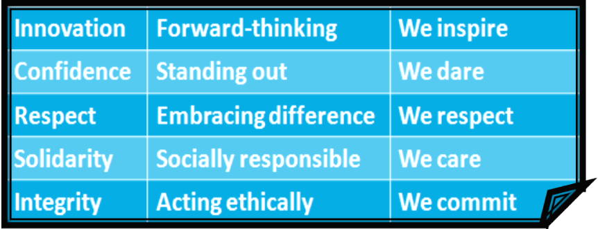
2.3 Compliance and Ethics:
By compliance of a company, we mean respect for values and rules which mentioned in the Code of Ethics of any specific group. Like other companies, sanofi aventis also have their own compliance program to follow. Such as:
  - Increasing awareness by all employees of rules and regulations applicable to the activities Global structures for implementation, follow-up and internal communications
  - Monitoring/Investigations where necessary
  - Implementation of all appropriate actions in case of violation and of requisite
  - of our company

  - Quickly detecting any deviation from these rules and principles
  - Permitting the implementation of appropriate remedial steps
  - Written rules and procedures: Code of Ethics & Early warning procedure
remedial steps like specific education programs, etc.

2.4 Sanofi Aventis in Bangladesh Therapeutic Areas:
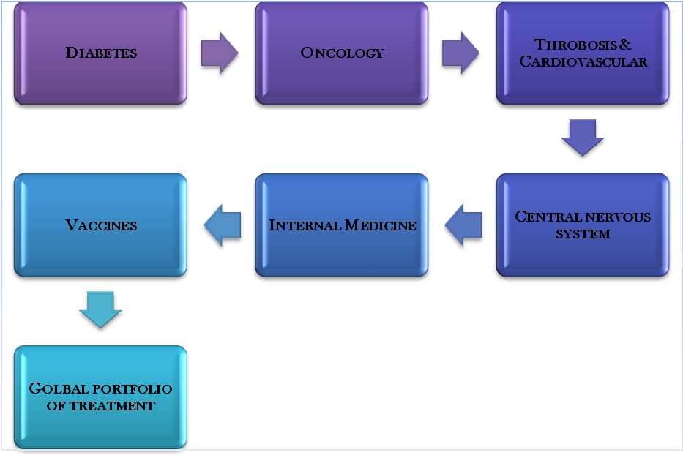
2.6 Sanofi-Aventis Pharmaceutical Operation:
Currently in Bangladesh Sanofi-Aventis is operating with more than 900 employees. These employees are working in various areas of our organization. Whether one’s expertise is in Sales, Marketing, Research & Development, Finance, Manufacturing, Legal, IS, Human Resources or any of their other departments, that individual can impact the lives of others.
Finance and Accounts:
The Finance and Operations department contributes greatly to the direction of our company, as well as to the development and implementation of its strategic planning, in addition to challenging the organization to maximize results. Our team counsels internal client groups on financial matters, assesses the financial impact of business decisions and provides various support services, such as Information Services, Legal and Purchasing. Finance & Accounts departments mainly focused on:
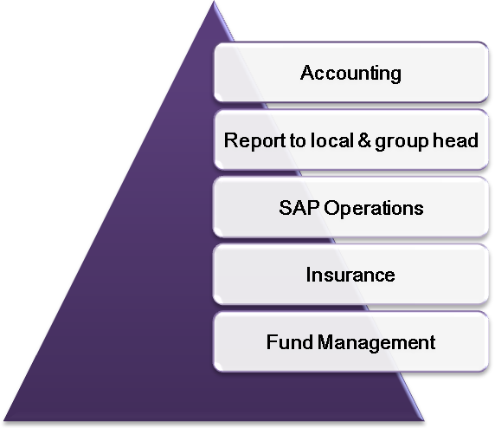
Business Support
United by a common purpose of enhancing the effectiveness of our sales and marketing functions, Business Support provides a service to the company through business planning and intelligence, learning and development training for our staff, market research, forecasting, events planning and measuring and rewarding sales staff performance support.
Sales and Marketing
Sales team is mainly focused around Sanofi-Aventis’s key customers in the areas of Hospital, General Practice (Retail) and Pharmacy, their sales and marketing teams work together to ensure that patients, physicians and healthcare providers are well-informed about the company’s products. They are dedicated to sustaining their corporate image and maintaining the trust of the medical profession and their patients. Its success is mainly on team effort and already sales & marketing team has achieved great success.
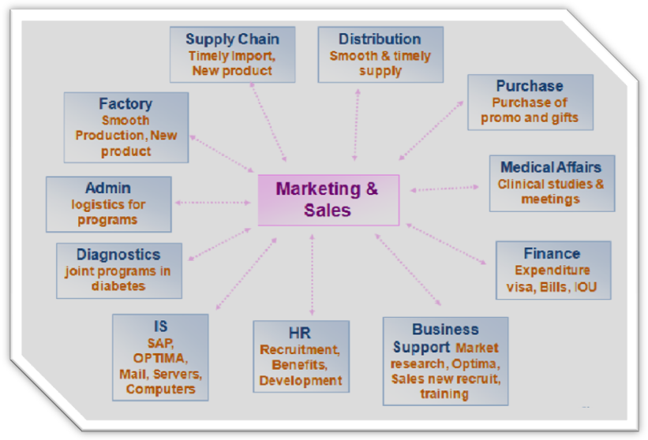
Marketing & Sales
Medical and Regulatory Affairs
Medical and Regulatory Affairs encompasses a variety of disciplines and job responsibilities that begin during product development and continue throughout the drug’s life cycle. We offer opportunities in fields of Regulatory Affairs, Medical Information and Product Safety, Medical Affairs. We ensure compliance with the local (country) and group regulations of drug administration such as registration and approval of new products and renewal of old ones. They also provide support to marketing and sales team by preparing literatures, clinical studies and looking after safety issues of drugs. In short, regulatory affairs of Sanofi-Aventis are:
- Product both local & import, new and line extension submission and
approval from Drug Administration.
- Price (regular/revise) of product submission and approval.
- Product and manufacturing License renewal.
- Promotional and packaging materials submission and approval.
- Variation/amendment submission and approval.
- Notification submission to Drugs.
- Liaising with regulatory authorities
Supply Chain
Our supply chain department ensures the distribution of the medicines all over the country.
With distribution centers in 12 locations of the country this department ensures storage and timely distribution of the medicines all over Bangladesh.
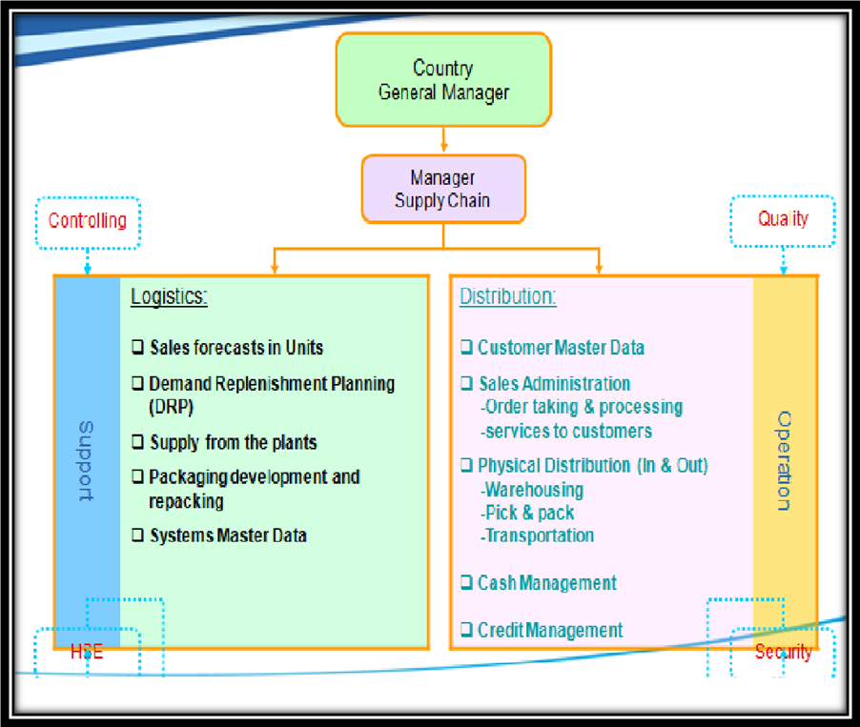
Supply Chain Function
Communications
Our Communications team is responsible for positively positioning, projecting and protecting sanofi-aventis’ reputation and ensuring that we work in accordance with our corporate Values. Also deals with increasing company visibility through internal communication, corporate communication, Multimedia (intranet and internet) and Humanitarian Sponsorship. This helps to strengthen image and reputation and build clear corporate identity.
Human Resources
The sanofi-aventis Bangladesh Human Resources department develops and implements strategic initiatives consistent with our Values and business imperatives to both attract potential candidates and retain current employees. In doing so, the team enhances employee performance, promotes personal development and organizational effectiveness.
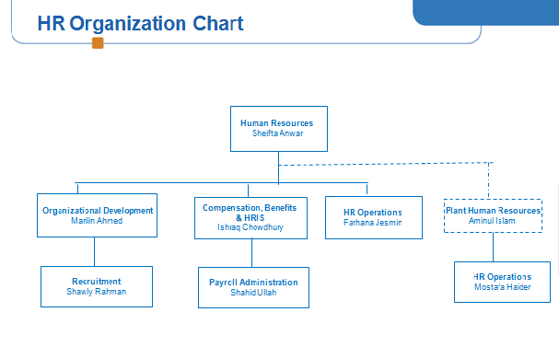
HR Projects:
- Implementation of IHRIS (International Human Resources Information System
- SAP HR
- E-Performance
- E-compensation
- Regional / Zonal reporting
- Talent Development Program
- Asia Pacific Strategic Development Group
- Bangladesh Strategic Development Group
- Bangladesh Operations Development Group

Industrial Affairs
Our industrial team greatly contributes to our company’s success in producing the highest quality pharmaceuticals for patients around the world. It is responsible for transitioning the medicine from a laboratory compound to a product ready for distribution. All employees are expected to conduct their activities in full compliance with the rules that apply to our industry and act in accordance with our compliance policies and guidelines.
Several disciplines contribute to this process, including:
- Manufacturing
- Maintenance
- Engineering & Process Development
- Supply Chain & Purchasing
- Quality Operations, Quality Management
- Health Safety and Environmental

At sanofi-aventis, Quality and Compliance (R&D Q&C) makes vital contributions to the drug development process in terms of quality, efficacy, safety and pharmaceutical ethics, in an internationally regulated and competitive environment. We also provide support and compliance for regulated activities associated with new drug development and R&D-related activities, including: Good Laboratory Practices (GLP), Good Manufacturing Practices (GMP), Good Clinical Practices (GCP), and Quality & Compliance in Regulatory Affairs practices and Validation. With this philosophy in mind, R&D Q&C seeks to hire those who not only have the necessary technical skills for the job, but also the attitude and ethical principles that complement the department’s overall values. Our industrial affairs site is located in Tongi, station road.

3. Organizational structure
In terms of top management, Sanofi-aventis applies geocentric approach to employ the local managerial board. However egocentric approach is also at practice in inter-continental employment.
The below mentioned figure shows the global organizational framework:

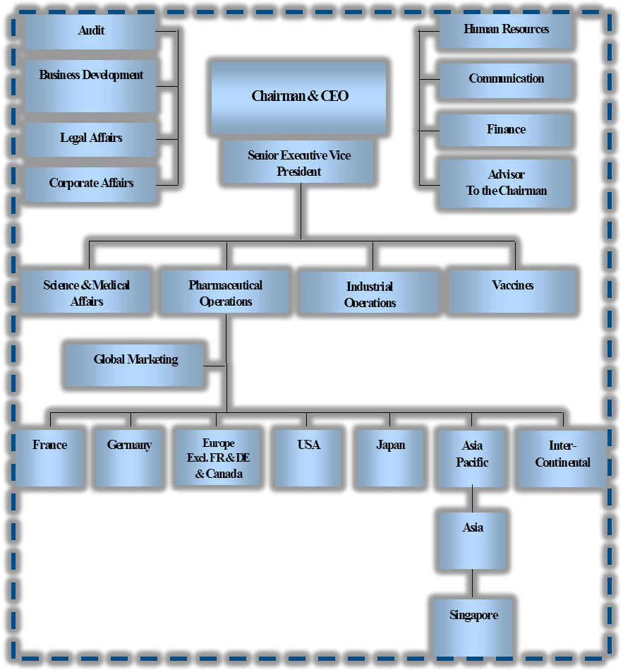
wide-ranging Organizational Table

3.1 Research and Development
Sanofi Aventis believes, sanofi aventis' R&D portfolio to be among the pharmaceutical industry’s most promising, especially in its fields of excellence and expertise: thrombosis, cardiovascular, diabetes, vaccines, oncology, the central nervous system and internal medicine. The Group invested 4.6 billion Euros in R&D in 2009. The R&D structure at Sanofi-aventis promotes a culture of sharing expertise and experience among multicultural teams.

R&D Portfolio in early stage – Pharmacy and Vaccines
Each year, Clinical Development begins and carries out several hundred clinical trials of the Group's drugs and vaccines. The R&D portfolio comprises projects in different phases of clinical development, of which some in late stages (phase III) or submitted to health authorities for approval. Among the applications for approval, the application of Ciltyri® (eplivanserin), in the treatment of sleep disorders, was submitted to the FDA and the EMEA during the fourth quarter of 2008 and accepted for filing. Subsequent to the submission of the application of Multaq® mid 2008 in the EU and U.S. which granted a priority review, a FDA advisory committee is scheduled for March 18, 2009.

New approaches and partnerships
Sanofi’s new R&D strategy is focusing on key technologies and diseases to better serve the needs of patients. Our internal R&D division is organized to maximize flexibility and innovation. Biotechnology, genomics and proteomics are the pathways of future research, areas that Sanofi-aventis has already begun to explore. The Group has entered into a number of collaboration agreements with both public and private research organizations and biotechnology companies. To strengthen Discovery Research, the Group has set up two types of alliances: technological partnerships (for access to new technologies) and product-based partnerships, which make it possible to explore new opportunities in the Group's spheres of excellence. A Scientific Advisor contributes to the R&D decision making process related to the portfolio and strategy, particularly in the creation of partnerships.
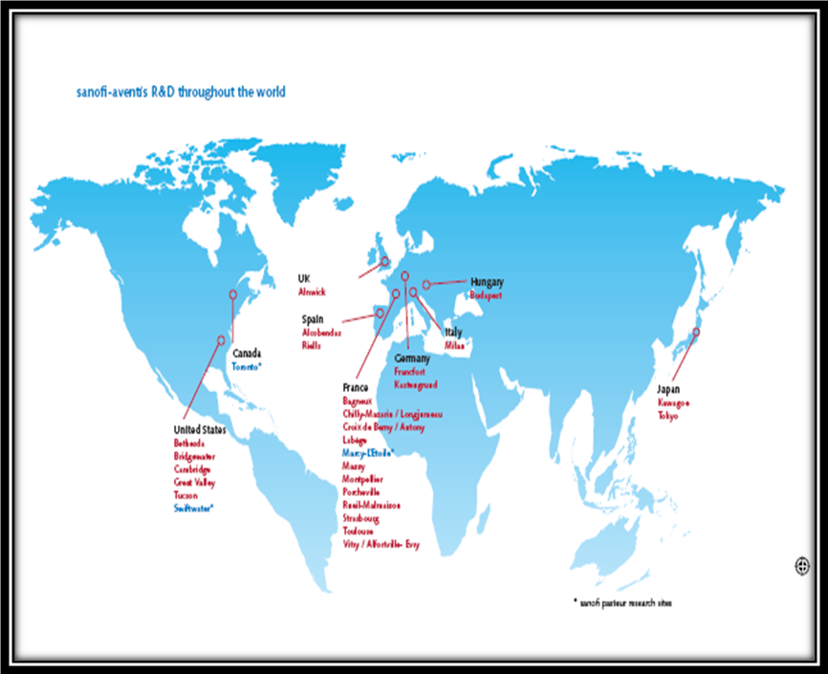

3.2 Product & Presence:
Metabolic disorders
- Amaryl®
(glimepiride tablets)


- Lantus®
(insulin glargine [rDNA origin] for injection)


Thrombosis:
- Clexane®
(enoxaparin sodium)


Central Nervous System
- Epilim®
(sodium valproate et valproic acid)

Oncology
- Taxotere® for Injection Concentrate
(docetaxel)


Cardiovascular
- Tritrace®
(ramipril)

Primary Health Care:
- Asec
(Omeprazole)
- Asinar
(Ranitidine)
- Enocef
(Ceftriaxone)
- Fimoxyclav
(Potentiated amoxycillin+clavulanic acid)
- Fimoxyl
(Amoxycillin)
- Fiprox
(Ciprofloxacin)
- Profenid
(Ketoprofen)
- Sandom
(Domperidone)
- Sefrad
(Cephradine)
- Sefurox
(Cefuroxime)

3.3 Ethics & Responsibilities
Sanofi aventis strives to provide a stimulating and creative working atmosphere and to establish relations based on trust with its workforce, its customers, its suppliers, the authorities, and everyone with whom sanofi aventis comes into contact in the course of its activities. All forms of discrimination for whatever cause or reason are therefore banned, as is all behavior that may compromise another person's dignity. Sanofi aventis ensures equal opportunities for all with respect to recruitment, training, remuneration, appointment, and professional development on the basis of personal skills and aptitudes.
Main key codes of ethics of sanofi aventis are:
- Respect for Individuals
- Confidentiality and Protection of Sensitive Information
- Respect for Private Life and Data Protection
- Good Commercial Practices
- Illegal Payments and Corruption
- Respect for the Principle of Free Competition
- Health, Safety and the Environment
- Provision for information to the financial market
- Insider trading
- Conflict of Interest
- Participation in Political and Public Life
- Response to Official Inquires
- Rules Specific to the Pharmaceuticals Industry
- Commitment of the Group and its Employees
By virtue of its commitments, sanofi aventis constantly adapts its development model to the world’s emerging human and economic problems. Because they believe that the patients themselves, in their own specific environment and conditions, best know what is relevant for them, they are investing in a move forward to more individual healthcare. The epidemiological and sociological data that they handle enable them to tailor their scientific advances to each economic and cultural context, to help position good health as a fundamental human right, for everyone throughout the world.

- HSE
H.S.E culture training for managers
The mission of the Health Safety Environment Directorate is to provide guidance and support in the prevention of occupational health and safety hazards, major risks and environmental incidents.
It implements the HSE Policy through goals established in the HSE Strategic Plan. Additionally it implements and maintains the HSE Management System using as a basis the minimum HSE requirements. These requirements are the basis for the development and implementation of HSE Standards and Guides which are utilized to develop site programs. This ensures that a robust HSE management system is in place.
According to the HSE Policy, the Central HSE organization defines and distributes to all Group business activities Requirements, Standards and Guides which serve to implement the Standard Operating Procedures (SOP) in each site.
The document hierarchy is a critical component of the HSE Management System. By organizing documents into a hierarchy, we clearly communicate the flow and interconnections between the HSE Policy, Requirements, Standards and Guidelines, and site-level Standard Operating Procedures. As the pyramid illustrates, the ownership and maintenance of the various documents reside with the Central HSE organization, the sites or a partnership of the two, based on the level of detail and breadth of coverage of the document.
- Sustainability
The Sustainability Department’s missions are concentrated in four major areas, and their impact is felt both in-house and by our stakeholders. The goal of the Sustainability Department is to integrate sustainability into the heart of the company and employee practices, bringing them together on this issue of key importance. They are now integrating the sustainability approach into the Group’s day-to-day business. To reach this objective, priority challenges must be identified and the Sustainability policy as well as topics on which the Group would like to act must be submitted to the General Management for approval. The Sustainability Department is in charge of coordinating and monitoring implementation of the sustainability approach within the various activities. To accomplish this, cross-functional internal working groups have been created for each sustainability topic. They make proposals for action plans and submit them to the Group Sustainability Committee (GSC). The plans are then transmitted to the relevant Group entities.
To translate the sanofi aventis sustainability strategy into action, the Group’s approach is based on four key areas:
Patient 21: The patient at the center of the Group’s business activities
Ethics 21: Being committed to ethical principles in both business conduct and research.
People 21: Employees and local communities
Planet 21: Focus on the Group’s environmental performance
Through these four key areas and the Group’s approach to them, sanofi aventis recognizes its full responsibility toward patients, employees and the local communities and physical environment in which they live and where the Group operates.
- Humanitarian Sponsorship
As an extension of its work as a pharmaceutical company and as part of its social responsibility, sanofi aventis has pursued a humanitarian partnership agenda for the past 20 years. Together with its partners and humanitarian associations, the Group helps reduce inequalities and works towards more equitable access to health care worldwide.
Sanofi-aventis' humanitarian partnership offers a concrete illustration of the Group's sense of social responsibility and its core values of courage, audacity, creativity, respect, performance and solidarity. At Group level, global humanitarian partnership results from programs run at corporate level and pilot programs driven by affiliates and sites around the world: At Corporate level sanofi-aventis’s actions operate at the interface of health, solidarity and childhood, and target the most destitute and vulnerable populations; At affiliate and site level the company’s the Humanitarian Partnership Charter enables everyone to contribute effectively to Group level involvement, while remaining flexible enough to address local priorities. Through its humanitarian partnership, sanofi aventis has the capacity to react to humanitarian emergencies where health needs are most vital; commit to development programs, especially for the least empowered populations in developed and developing countries.

Sanofi-aventis selects humanitarian sponsorship actions on the basis of 6 main criteria:

- Consistency: Prioritize thematic actions: health - solidarity - childhood in the field of prevention, education, training, hygiene, access to care, combating exclusion, disability, children's traumas.

- Usefulness: Respond to the most basic needs that society handles inadequately today, especially for the most destitute populations.

- Involvement: Go beyond a purely financial reflex and share human, professional and technical skills with civil society partners, and encourage employee commitment.

- Sustainability: Build lasting partnerships with recognized associations/NGOs in the health and solidarity community.

- Transparency: Ensure that actions and the usage of funds are fully transparent.

- Innovation: Develop original pilot actions, that can later be localized to other countries

4. Human Resource applications

This department works on the human assets of the organization. Its major function is job analysis, job designing, recruitment and selection, induction program, preparing performance appraisal, training and development, evaluating compensation. Rewards management, maintain a learning environment and proper OH & S.

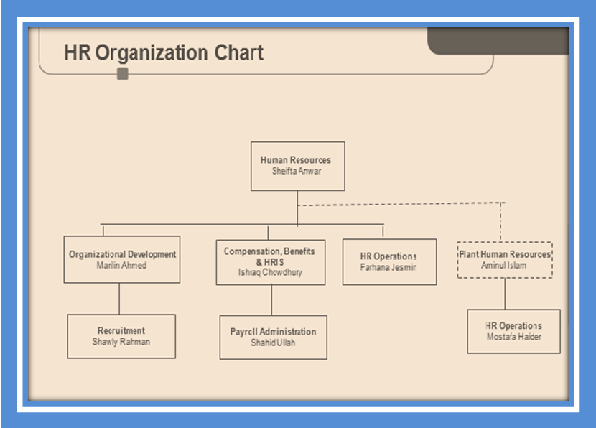
Sanofi-Aventis: Human Resource Activities

- Recruitment & Selection
  - Recruitment, selection and placement of employee
  - Employee Branding
  - Interview for promotion
  - Campus campaign
  - Participation in job fair
- Training & Development
  - Orientation of new employees
  - Performance review / appraisal
  - Training Need Assessment (TNA)
  - Arranging training & workshop
  - Evaluate the effectiveness of training programs
  - Support organization development processes though Talent Management

- Employee Relation
  - Employee coaching / counseling
  - Grievance handling
  - Observing special events - Family Day, Valentines’ Day, Pahela Baisakh
  - Hosting Town Hall meeting
- Compensation & Benefit
  - Salary disbursement
  - Preparation of yearly payroll budget
  - Coordination of group & health insurance
  - Maintenance of HRIS
  - Conducting Salary Survey
  - Development of different HR policies
  - Income Tax assistance
- HR Operation
  - Maintenance, safe keeping & updating of employees’ Personal File
  - Record keeping of documents relating to transfer & promotion
  - Support R&S and CompBen team through various statistical data
  - Coordinate employee clearance at the time of separation
  - all HR related support to the employees - from employee joining to employee separation
- HR Projects
  - Implementation of IHRIS (International Human Resources Information System)
    - SAP HR
    - E-Performance
    - E-compensation
  - Regional / Zonal reporting
  - Talent Development Program
  - Asia Pacific Strategic Development Group
  - Bangladesh Strategic Development Group
  - Bangladesh Operations Development Group

4.1 Human Resource Policy:

In today’s rapidly changing business environment, a well defined recruitment policy is necessary for organizations to respond to its human resource requirements in time. Therefore, it is important to have a clear and concise recruitment policy in place, which can be executed effectively to recruit the best talent pool for the selection of the right candidate at the right place quickly. Creating a suitable recruitment policy is the first step in the efficient hiring process. A clear and concise recruitment policy helps ensure a sound recruitment process. It specifies the objectives of recruitment and provides a framework for implementation of recruitment program.

Policy Statement:
Policy statements serve to clarify intent, describe how a policy is administered and define the particulars of a policy. They serve to protect an organization from misunderstandings that might lead to unauthorized behavior or lawsuits. Sanofi aventis Bangladesh’s policy statement establishes parameters that assist managers and employees in the accomplishment of their jobs. It helps to set the tone for what is done in the organization, as well as the manner in which it is done. With a team of dedicated and high performing employees, Sanofi aventis believes in professional development and incessant opportunities for growth. Self development, highly competitive compensation and benefits, long term career development programs are also part of the company policies. The positive organizational climate in Sanofi aventis enhances motivation, improves quality of work, decreases turnover and reduces absenteeism. Sanofi aventis invites interested individuals to be a part of the diverse and talented group of individuals to strive to remain the multinational pharmaceutical leader in the country.
A recruitment policy of a Pharmaceuticals Organization should be like:
- It should focus on recruiting the best potential people.
- To ensure that every applicant and employee is treated equally with dignity and respect.
- Unbiased policy.
- To aid and encourage employees in realizing their full potential.
- Transparent, task oriented and merit based selection.
- Weight age during selection given to factors that suit organization needs.
- Optimization of manpower at the time of selection process.
- Defining the competent authority to approve each selection.
- Abides by relevant public policy and legislation on hiring and employment relationship.
- Integrates employee needs with the organizational needs.
Factors affecting Recruitment Policy of Pharmaceutical company
- Organizational objectives
- Personnel policies of the organization and its competitors.
- Government policies on reservations.
- Preferred sources of recruitment.
- Need of the organization.
- Recruitment costs and financial implications.
Component of Recruitment Policies
- The general recruitment policies and terms of the organization
- Recruitment services of consultants
- Recruitment of temporary employees
- Unique recruitment situations
- The selection process
- The job descriptions
- The terms and conditions of the employment
HR Policies of Sanofi-aventis:
- Employment Type
  - Regular
  - Contractual (Fixed Term Contract, Trainee)
- Performance review & appraisal
  - Priority & Competency Setting
    - By February
  - Review
    - Twice in a calendar year (June & December)
  - Appraisal
    - Yearly generally in December
- Separation Type
  - Resignation
  - Termination
  - Dismissal
    - Misconduct
    - Convicted by court
  - Discharge
    - Continuous ill health
    - Infirmity of body and mind
    - Physical or mental incapacity
  - Retirement
- Leave policies (for Permanent NU staff)
- Holidays
  - Weekly holiday
    - Friday : All employees
    - Saturday : Support function (excluding Sales Centers/ Depots)
  - Festival holiday
    - public/festival holiday declared by Govt. not exceeding 17 days in a calendar year
- CompBen Policies
  - Provident fund
    - Employee 10% & Employer 10%
  - Gratuity
Length of Service | Basic salary X number of Years
5 Years | 1 Month
6 to 10 Years | 1.5 Month
11 Years and above | 2 Month
  - LFA
    - After completion of one year service
    - 5 days annual leave
  - Bonus
    - 5 times of Basic in a calendar year
  - Performance Bonus
    - Incentive on sales
    - Individual Variable Remuneration (IVR)
    - Ex-gratia
- CompBen Policies
  - Canteen facilities
    - Employee’s contribution: 15%
    - Employer’s contribution : 85%
  - Group Insurance
    - In case of death (normal & accidental)
  - Health Insurance
    - Includes: Employee, spouse and upto 2 children (age below 21 year)
    - Only in case of hospitalization for more than 24 hours
  - Long Service Award
    - Gold medal for completing 20 years of service
4.2 Scope
Sanofi aventis Bangladesh targets highly talented individuals interested in health and healthcare. To be a part of a company, where “health matters”, Sanofi-aventis aims to identify or recruit a pool of individuals true to their values, committed to their work and championed to take on innovation and change. The organization targets recruitment to a very niche market. Mainly the medical students from reputed universities, doctors/physicians and medical representatives/executives are aimed for. However, as per department need, business graduates (with a major in Finance, Marketing, Human Resource Management, Accounting, etc.) are recruited as well. But the focus remains on the aforementioned group of individuals.

4.3 Human Resource Scheduling
The wants of HR planning are to ensure that Sanofi-aventis:
- Staffs potential employees in line with organizational strategic plan and need;
- Finds and retains the number of satisfactory or excellent staff it needs with the skills, expertise and competencies required;
- Occupy a miscellaneous workforce;
- Builds the best use of its human resources;
- Build up a well-trained and flexible workforce, thus contributing to the organization's ability to adapt to an uncertain and changing environment;
- Look forward to the problems of potential surpluses or deficits of people;
- Formulates maintenance and staff development strategies in line with policy and strategic directions ensure appropriate career development for every individual, clearly identifying distinctive mobility paths for them.
4.4 Vacancy Announcement
Vacancies occur when new positions are created or when the incumbent of an existing position separates from Sanofi-aventis Bangladesh, is absent for a significant number of days or is transferred to another position. The respective department Manager has to inform HR department to initiate the recruitment process duly filling a Recruitment Request form, if replacement is required. HR will issue the letter for such assignment upon receiving Recruitment Requests (RR) [see appendix] from concerned departments. The concerned initiating manager may also make recommendation of any specific issues that may be helpful to appoint the suitable person. Vacancies may be filled either through exclusively internal recruitment or through both external and internal recruitment.

In case of internal recruitment, vacancies will be internally circulated for all Sanofi-aventis staff. Any employee with requisite qualifications and background and at least one-year service in Sanofi-aventis Bangladesh can apply directly to HR for the advertised position. But the internal candidates must discuss their application with their current Manager before sending their application.
In case of the recruitment of a budgeted new position, concerned manager will request Human Resources Department to initiate recruitment process duly filling the RR form, in case of permanent management staff.
In exceptional cases, where department or business offices may need to create a new position (which is not under the plans & budget of the year), the concerned manager has to submit a written proposal to HR Department with full justification as per format for approval of the position and budgetary provision well in advance. The HR Department will process in consultation with Country Manager.
4.5 Job description of Recruitment & Selection Process of HR Officer:
Coordinate and manage recruitment activities as per departmental requirements; corporate and local policy and guidelines. Also support the HR team in various HR and organizational development activities as per corporate and local policy and guidelines.

KEY ACCOUNTABILITIES:

- Coordinate entire Sales Force recruitment in line with budgeted and approved head count. Prepare and raise RR, publish advertisements, prepare written test questions and interview rating sheet, coordinate written test exam and schedule panel interviews. Act on/ prepare letters for the following: reference check, appointment, medical tests, joining letters etc, after obtaining necessary approvals.

- Assist in Marketing & Support Function recruitment through raising RRs (recruitment request) by coordinating with concurrent managers, prepare vacancy advertisement, schedule panel interviews, prepare written test questions and interview rating sheet after consulting respective supervisor/manager. Tap internal and external sources. Make initial shortlist for entry level and send to responsible line managers/heads for further screening. Maintain database for potential CVs for future openings. Act on/ prepare letters for the following: invitation for selection test, regret letter to interviewed candidates, reference check, offer & appointment, medical tests, joining letters etc, after obtaining necessary approvals.

- Organize orientation by setting up appointments with Directors and departmental heads and others, facilitate introduction to various departments and collecting the orientation report.

- Coordinate Internship Programs as per the internship policy of the company, and in line with the course requirement of respective universities/institutes.

- Work as Diversity and The Association delegate for Bangladesh and arrange various programs and initiatives for Diversity. Work as the contact point for Diversity & Association related issues. Work closely with communication regarding these issues. Provide information and guidance to employees regarding diversity plans, The Association and send updates to region.

A detailed job description must be prepared before any recruitment is undertaken. This should include:

- Job title
- Department/Project
- Location
- Job holder’s line manager
- Information on staff to be line managed
- Job responsibilities
- Job’s key result area
- Person specification including qualifications and experience, character and skills competencies; divided into essential and desirable criteria
- The information that sanofi-aventis operates a Code of Conduct

4.6 Interview Ethics
The key ethical issue in interviewing is that the participants should not be harmed or damaged by the interview in any way. The following list provides a few examples of ethical situations that could arise during an interview:
- The interviewee should be assured of their own confidentiality.
- If the interviewee becomes distressed, the interview should be abandoned.
- The interviewee has the right not to answer a particular question or to terminate the interview altogether.
- It is crucial that you obtain informed consent before commencing the interview.
- If the interviewee asks for practical guidance or help, you must refer them to an appropriate organization or support centre. Do not allow yourself to be drawn into this type of discussion. If your interview concerns information of a particularly sensitive nature, it might be worth getting the details of relevant organizations beforehand, should you be asked.
4.7 Goals of recruitment:
The goal of recruitment is to attract suitably qualified applicants reflecting the promotion of equality and diversity. Sanofi aventis Bangladesh will seek to recruit committed and capable individuals who will add to the effectiveness of the organization. It will depend on the nature of the vacancy whether it is necessary to recruit from within and/or from outside the organization. It is the policy of the organization to offer staff opportunities for career advancement where there are suitable candidates available within the organization.
4.8 Methods and Sources Used in Recruitment Process:
The recruitment method includes mainly advertisement in selected daily newspapers and/or on the internet, or by whichever method is deemed the most appropriate for the position. Advertisements in the daily circulars are generally used as they allow potential candidates to be reached on a broad scale. A specific date is announced for written exams or interviews (as per need and current market processes). All advertisements are on the basis of the position’s job description. The job specification should also be stated clearly. For specialized position they mainly focused on www.bd-jobs.com and for their recruitment of sales force they focused on daily newspapers because it’s regular basis recruitment. External and Internal recruitment can be used, depending on market scenario and internal employee performance, to identify the suitable pool of candidates for the required vacant positions. The message sent to the targeted pool of candidates should give a clear picture of the job and Sanofi- aventis itself. The contents must avoid direct or indirect discrimination or misinterpretation. The message includes job requirements, key accountabilities and work areas and other information as per need of the position. The message should include the following factors briefly:
- Which post is vacant?
- The area where the post is vacant
- The inherent job requirements to be built into the job specifications;
- The job title and a brief job description;
- Education and training details
- Whether any experience is required;
- Language proficiency and age limit;
- CV or completed application form (including photographs and references)
- What documentation must accompany the application?
- To whom and at which address an application for the post can be submitted;
- The closing date for receipt of applications at a particular address;
- That the sanofi-aventis is an equal opportunity employer who welcomes and fosters diversity at workplace;
- The organizational culture in brief.
- Clear job description for position, including extent of responsibilities

4.9 Leader-Pursuing function:
Employment organizations can only lend a hand with head-hunting with the aforesaid approval of the Managing Director or his or her entrusted official. Head-hunting can be used to persuade properly skilled, expert and competent people to apply only for a position advanced than the managerial level and is usually used when recruiting folks for the top management. Adequate funds should be accessible in the budget of the related dealing entity.
4.10 Selection of Applications:
The Human Resource unit will choose the CVs. Requests are screened in the lead of a careful similar based on the organizational need and reviewed carefully to identify applicants’ experience, skill and other necessary abilities which are paramount suitable for the required position. Recognizing the job related conditions and matching it to the applicant’s CV is a vital division of short listing as well.

5. Scope
In my research study, I plan to assess the every single step in the overall recruitment process which is managed and updated by sanofi aventis HR department. In this company HR department is an autonomous department and account for recruiting employees from attracting to retaining them. Hence studying on the step and finding out the areas of development should not be influenced by constraints like location or people’s involvement. However as people’s development is an exceptionally immense topic to cover and understand to its fullest, three months of internship period may not be sufficient to study more intensely and have a profound insight. The data to be used will be collected primarily from several sources including the assistant manager of people development, HRD of sanofi aventis and few other supporting personnel. Apart from that, collection and usage of some secondary data from the company internet site, journals, annual reports and company code of conducts will also take place.
5.1 Objectives
The purpose of the study is to analyze and evaluate the overall recruitment process of sanofi aventis and figure out the best practice which can be beneficial for the company like sanofi aventis.
My research specific objective of the study is to support the HRD of sanofi aventis in order to simplify the recruitment process in an effective way and bring improvement in the necessary areas so that the company can grow big and strong in a simplified and efficient manner. This will be resulting from the proper implementation of the recommended strategies which will eliminate the constraints from the process. The findings and analysis of this study will provide some new ideas and recommendations which might help the authority to make development in terms of the era of recruitment.
5.2 Research Methodology
The report is based on both primary and secondary research. In order to collect primary data, two methods will be used in this study. One is the use of questionnaire and another is the observation method. In the questionnaire, the use of close ended questions will be more prone as it will be designed to understand the factual information about the trend in company branding in the minds of the prospective pool of candidates. The findings from the questionnaire will be interpreted by counting the frequency of occurrence in favor of a particular dimension. The findings will also be interpreted and showed by using pie chart, bar chart in excel worksheet in terms of percentage.
As for the observation method of collecting primary data, an unstructured observation system will be at use. It is appropriate when the problem is yet to be formulated precisely and flexibility is needed in observation to identify key components of the problem. As the observation will be a natural and disguised process. Neither the interviewees nor the interviewers would be concerned about the observation of the observer. Hence it will be a non-participant observation as well. Due to working within the organization alongside other employees, effectively as one of them; the role of the researcher may or may not be explicit. This role will be appropriate as the research needs the researcher to become totally immersed and experience the work or situation at first hand.
While sampling the respondents for the survey, a probability sampling has been done by using the method “Simple Random sampling”. 50 career aspirers from sanofi aventis Human resource department were selected randomly and were asked to fill up the survey questionnaire. The sample was selected randomly and it was small in size as the main purpose of the survey was not to quantify the trend but to qualify the general drift about sanofi’s branding in the minds of the potential career seekers.
Finally, I will try to collect some company periodicals and online articles for making my illustration more exact and accurate.
5.3 Limitations of the Study
The limitation of the study was very low. However, resource and time constraints are always there. Absence of proper planning scarcity of proper tools, low headcount, and employee mind set, culture obstacles, low association all these dimension can create problem if the implication of the recommended strategies are at concern. However, all these can be avoided to maximum extent and thus the growth opportunity would not be affected as well. And for this, proper planning, sufficient manpower and resource are very much essential. These are the foremost limitations of the research study.

6. EVALUATION OF RECRUITMENT PROCESS OF SANOFI- AVENTIS:
The recruitment and selection is the major function of the human resource department and recruitment process is the first step towards creating the competitive strength and the strategic advantage for the organizations. Recruitment process involves a systematic procedure from sourcing the candidates to arranging and conducting the interviews and requires many resources and time. A general recruitment process is as follows: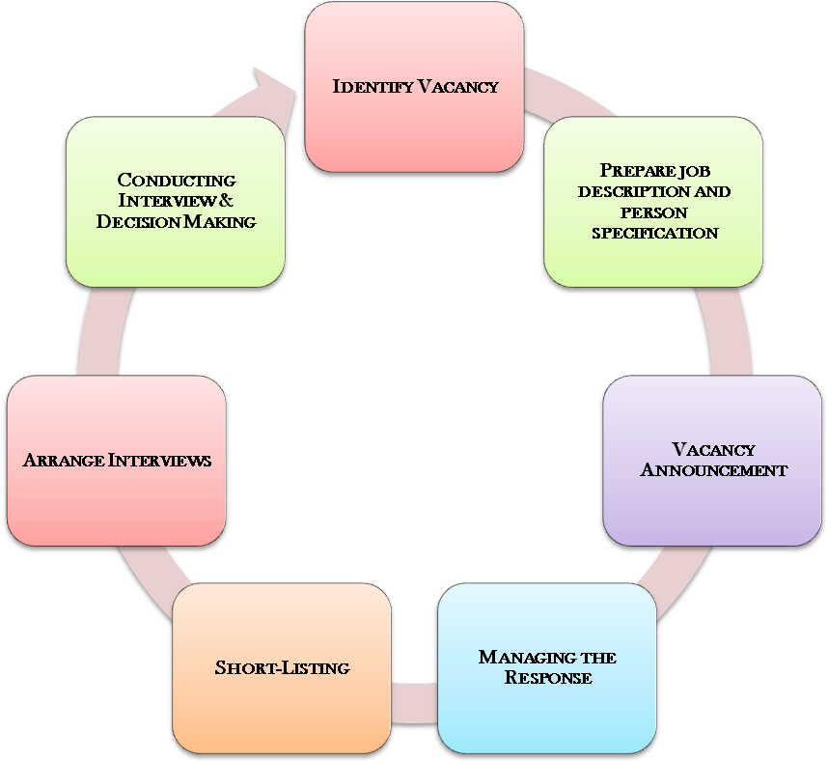
Recruitment Process

Identifying the Vacancy:
The recruitment process begins with the human resource department receiving requisitions for recruitment from any department of the company. These contain:
- Posts to be filled
- Numbers of persons
- Duties to be performed
- Qualifications required

Preparing the job description and person specification:
Job description including personal profile is a pre- condition for approval of a new position, irrespective of regular or contract. The Job description should be prepared in collaboration with Human Resource department and approved by GM. Job description will be provided to the employees when he or she is appointed, transferred, promoted or newly assigned. The Line Manager will ensure that their employees have the appropriate and updated job description.
Vacancy Announcement:
Vacancies may be filled either through exclusively internal recruitment or through both external and internal recruitment. However, management may decide direct promotion or placement based on performance instead of making any internal/external advertisement. All advertisements should be based on the position’s job description. In case of internal recruitment, all internal candidates must discuss their application with their current Manager prior to sending their application. Internal candidates must have at least one-year service to apply for other positions.

6.1 Recruitment Process of Entire Sales Force:
Sales Force Area covers the recruitment criteria, process and procedure of selecting the right candidate to feel up the vacant positions in the sales force.
Objective of Sales Force Recruitment Process:
- Adding value to overall organizational effectiveness by attracting & selecting a pool of acceptable/exceptional people
- Ensure the qualification of better & qualified candidates through a transparent selection method
- Meet up of head count requirement in Sales Force
- Identifying the gap between availability and requirement of personnel

The sales force area of sanofi-aventis Bangladesh currently covers –
- Jr. /Medical Information Associate
- Oncology Associate
- Diabetes Educators
- Area Sales Executive/Manager
- Regional Sales Manager

There should be a need of minimum 20 sales forces namely Jr. /MIA, before a fully fledged recruitment can be launched. Other than Jr. / MIA for minimum 3 vacancies a recruitment process can be initiated. A complete recruitment process includes the followings:
- Approved Recruitment Request/vacancy confirmation in line with approved headcount.
- Design of advertisement in compliance to company’s branding guide.
- Placing advertisement in preferred daily newspapers.
- Selection process
- Result announcement
- Joining/ Induction training

Source, Method & Communication Message:
Sanofi aventis mainly depends on two types of sourcing: Internal and External sourcing.
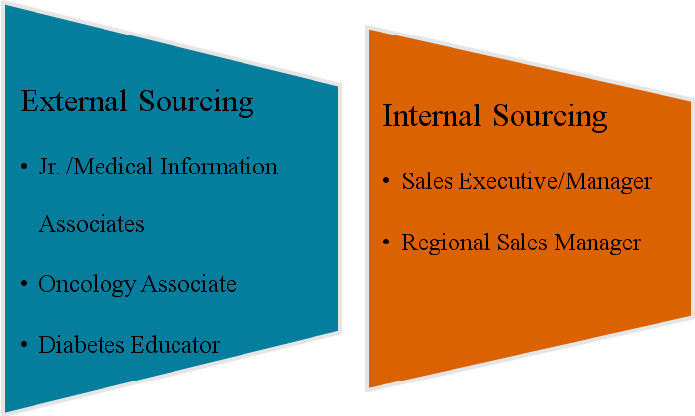

Recruitment methods mainly focused on advertisement in selected daily newspapers. Methods includes-
- Walk-in Interviews
- Written Exams
- An Interview
- Employee Referrals (Reference of potential candidate from MIA, from Sales Force through Area Sales Manager or Regional Sales Manager can be taken to account if this information is sent to the head quarters for further consideration)

Communication Message gives a clear picture of the vacant position and sanofi aventis itself. The message conveyed to the targeted pool of applicants includes job requirements, key accountabilities and work areas and other information as per need of the position.
Selection Process:
Selection process involves a systematic procedure from screening the candidates to arranging and conducting The Written Exams, Interviews and requires many resources and time. Some recruitment can start with written judgment and followed by interview and some interviews can start with interview to be followed by written assessment. Only for Jr. /Medical Information Associate “Walk-in-interview” is arranged as primary selection method.
- Application Screening:
During the initial screening, the recruiter checks for completeness of the application, along with a comparison against the job requirements. Once the application is screened, and it is determined that the application meets the initial requirements, the recruiter can move the candidate forward to the next step of the hiring process. If an application is not deemed a proper fit to continue, the company will disqualify the candidate.
- Written Assessment:
Written assessment can include essays, assignments, reports, dissertations, diaries, portfolios and workbooks. It may take place as course work or in an examination. The following reasonable adjustments may be employed, depending on the needs of the individual. The written assessment process might contain the followings:
- Analytical Ability
- English Language Understanding
- Mathematical Problems
- Questions Related to the Activities of Pharmaceuticals; etc.
- Interview:
During this interview process, the employer of Sanofis’ recruiter hopes to determine whether or not the applicant is suitable for the job. Interview is done to evaluate a candidates overall appearance, smartness, confidence, conversation skill etc. Interview might be the second phase of some recruitment and in some case might be the first phase. The short listed candidates are called for an interview. A team / committee / Panel will be formatted with specified schedule and time frame to select best potential candidate for the organization. Some of Focal points of Interview board are given below:
- Verbal ability of the candidates are tested
- Minimum one of the interview members must be a HR representative
- Candidate’s knowledge about pharmaceutical operation as well as the knowledge of sanofi-aventis Bangladesh Limited is tested
- The interviewers need to fill up the interview sheet and the decision about the candidate
- Walk-in-Interviews:
Sanofi-aventis sometimes mentioned about walk-in-interview on their job advertisement. As per advertisement, interested candidates are interviewed on specific date and place. Walk-in-interview is done only for Jr. / Medical Information Associate. Some of important factors of walk-in-interviews are:
- An interview board of at least two members, whose minimum qualification should be Area Sales Manager. Moreover, one of the members has to be from the sales department.
- Written exams are taken for this interview.
- Verbal ability of the candidates are tested with the help of word/ spelling sheets, English and Bengali newspaper clippings.
- Candidate’s product knowledge and also about the important brands of sanofi-aventis Bangladesh Limited is tested as well.
Joining (Jr. /Medical Information Associate)

After successful completion of induction training program, the list of the successful candidates is provided by the training department. In harmonization with HRD the business function selects the number and persons for their department as per approved head count. After receiving the posting from business units, HRD gives Appointment to the candidates and communicates their place of posting and other formalities.

Diabetes Educator / Oncology Associate:
Short-listed candidates for the post of Oncology Associate/ Diabetes Educator must processed with written and interview segment. After that selected candidates are offered employment in the organization. After accepting the offer the candidates are provided with the joining kit to join within a precised time period.
Compensation and benefits:
Reward and benefit package of the candidate will be given as per the approved package for the candidate depending on the job grade and assigned responsibilities that is aligned with the pay structure of the current employees of same level and also as per company policy.

Authority to amend:
The administration committee reserves the right to change or make omission of the laid down Rules & Regulations partly/fully from time to time as per the requirement. Dismissal of employment can happen by various reasons like – Misconduct, Convicted by Court etc.
6.2 Recruitment process of Marketing & Support Function:
Sanofi aventis aims to commit everyday to fight back diseases all over the world with a team of dedicated and high performing employees, it believes in professional development and incessant opportunities for growth. Sanofi aventis invites interested individuals to be a part of the diverse and talented group of individuals to take on innovation and change and strive to remain the multinational pharmaceutical leader in the country.
- Recruitment request by coordinate with concurrent managers.
- Vacancy advertisement posted by the HR Department through online or newspaper.
- schedule panel interviews
- The Human Resources Department will contact the candidates by letter/ phone for appearing in the test/interview.
- Make initial shortlist for entry level and send to responsible line managers/heads for further screening.
- Upon completion of the test and interview the selection committee will discuss about candidates among themselves and prepare the outcome of the process. In the write up the panel will put their recommendations about the selection with signature
- Maintain database for potential CVs for future openings.
- Request candidates for selection test.
- After completion of the selection process (written & interview) the selected candidates are offered employment in the organization
- After accepting the offer the candidates are provided with the joining letter to join within a specified time period.
- The candidates those who are got appointment letter go for medical test.
- obtaining necessary approvals if needed

6.3 DIVERSITY AND DISABILITY MANAGEMENT

- Diversity in sanofi aventis
As an international company that respects all cultures, sanofi-aventis draws on the diversity of its workforce and the very broad range of talents available. In this context, all our employees acknowledge that differences between employees, business partners, suppliers, and customers are considerable advantages that strengthen the Group's competitiveness and efficiency. True open-mindedness and the absence of prejudices concerning other people's views or attitudes are a vital prerequisite for performing our work effectively. Sanofi-aventis strives to provide a stimulating and creative working atmosphere and to establish relations based on trust with its workforce, its customers, its suppliers, the authorities, and everyone with whom sanofi-aventis comes into contact in the course of its activities.

More and more employees today seek a balance between their private and professional lives. On an individual level, this balance is important for personal development, while for businesses it is a strategic choice. When policy and corporate culture contribute to reconciling family and professional life, they help attract, motivate and retain employees.
Sanofi-aventis undertakes to respect its employees' private lives (Social Charter, article 7) and, as much as possible, to provide conditions that allow employees to reconcile their professional and private lives, in accordance with local practices and circumstances. Sanofi-aventis encourages local initiatives (at the country and even site level) on this issue in order to better respond to employees' needs.

- Disability Management:
Since the conditions to obtain the status of “disabled worker” vary from country to country, sanofi-aventis chose the World Health Organization definition of disability: “Loss or abnormality of body structure or of physical or psychological function, which leads to limitation of work related activities”. Disability is of different types. Impaired mobility, Physical problem and illness, Sensorial impairment (hearing, vision, etc), Psychological problem are few among them. The Group’s Commitment on disability has been established for more than 15 years in France and extended in all countries. Four major dimensions are covered under this aspect: recruitment and/or training of jobseekers with disability, retention of those employees who become disabled, sub-contracted work within sheltered workplaces where more severe disabled persons are working, continuous education and raising awareness on disability and work among employees.

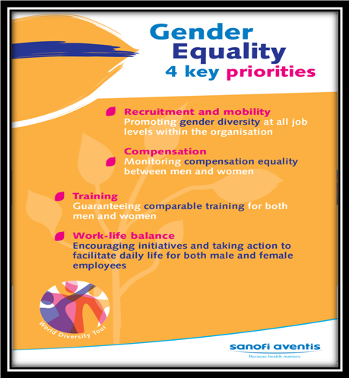
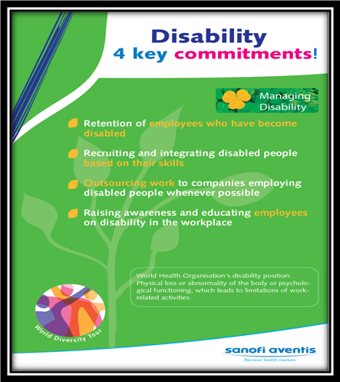

To highlight various dimensions of disability, a major part of the World Diversity Tour, an event was launched at our IA premises on December 7, 2009. The event was opened with a brief presentation by Sheifta Anwar, Director, Human Resources, followed by a session by Valeria A. Taylor, founder of Centre for the Rehabilitation of the Paralysed (CRP). Her sharing of experience and opinion on the inclusion of disabled individuals in the workforce was indeed inspiring for the employees and stirred a lot of interest among them. Later, the General Manager, Iftekharul Islam, and Mahbubul Hoque, Director IA, spoke about the necessity of management actions to establish Diversity in the sanofi-aventis working culture. The event was closed with a fun quiz competition with enthusiastic participation of everyone.
Moreover, the physical arrangements, including appropriate workstations, washrooms and ramps for disabled employees, need to be seriously considered. Overcoming these barriers in the workplace, would ideally help in the thought of including disabled individuals in the sanofi-aventis family. Thereby, it is their responsibility to embed the “duty to accommodate” DNA in The corporate culture to create a better working environment.

7. Analysis and Interpretation of the survey data:

7.1 Recruitment Process Analysis:

For Sanofi-aventis, it is very important to find out the best candidate who belongs to the group of potential pool of candidates. Recruiting a person is easy, but hiring the right person takes more effort and makes a huge difference. The best employees get the job done, are a pleasure to manage and help the company grow. Recruitment that focuses on simply hiring warm bodies can cause headaches and unanticipated problems. The quick hire can require hours of supervision and time spent in discipline, retraining and, worst case, termination. In view of the fact that it is a pharmaceutical company which deals mainly about healthcare products; the best concerned candidates are supposed to be from medical, pharmacy or science background. Apart from that all other concerned areas, for example- IT, Business, law etc are also potential sectors from which sanofi aventis needs to recruit to fulfill the employee headcount demand.
In my project I tried to find a way to support the HRD of sanofi aventis in order to simplify the recruitment process in an effective way and bring improvement in the necessary areas so that the company can grow big and strong in a simplified and efficient manner. This will be resulting from the proper implementation of the recommended strategies which will eliminate the constraints from the process. The findings from the survey i did on 50 employees of sanofi aventis provide me some new ideas and recommendations which might help the authority to make development in terms of the era of recruitment. They were provided with a questionnaire which contained several questions. Those questions were the pointers and the answer of those questions found out the actual positioning of sanofi-aventis’ recruitment process and its efficiency.

- In my feedback form, first asked question were the preference towards pharmaceutical sector in terms of career development.

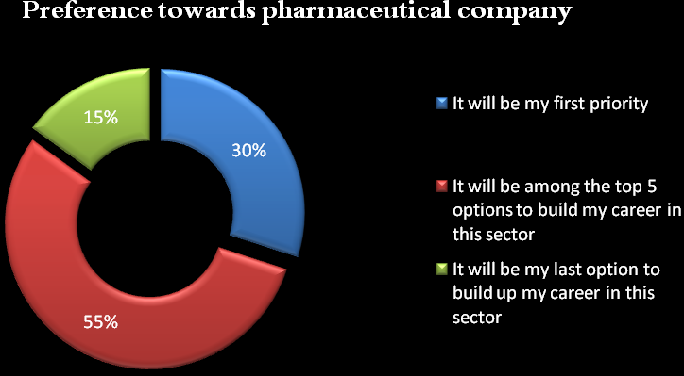
In survey, I found 30 % people agreed that for career development their first choice is pharmaceutical companies and then 55% people said pharmaceutical sector will be among the top 5 options to build their career. Other 15 % people have less interest for this sector. So, it shows majority percent of people are now trying to involve more in pharmaceuticals.

- On response of second question which was on the most effective recruitment process, people gave different types of response. Mostly supported written and interview both like near about 40 % of 50 employees voted for this process.

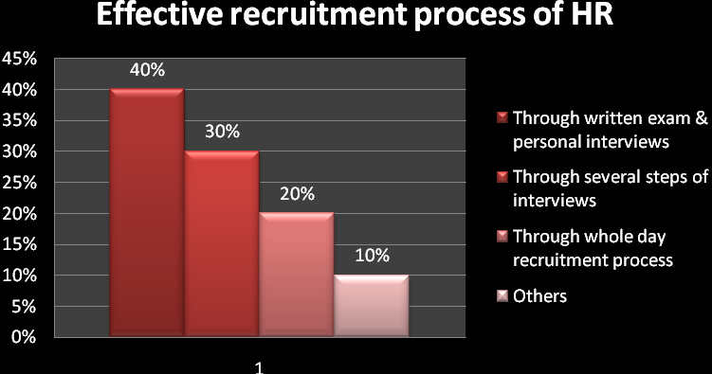

30% like just the interview steps rather than written exam, then 20% are more into whole day recruitment process and rests are interested in other steps of recruitment. So, we can say more people like written and interview both as a recruitment process.

- Next question was to find out the parameter of selecting a qualified candidate according to the current employees’ point of views. Sanofi-aventis mainly focused on educational background and results in terms of hiring people. But employees gave a bit different picture.

45 % employees think communication & personal skills are more important for a person to get involved in his/her job and helps to give the best shot in the office. Educational qualification is also a must. 30% people were agreed on that. Among rests 15 % believe in sincerity and 10 % believe on other skills.

- In my fourth question, I wanted to find out about their reaction on the time manner and scheduling about the interview session. Whether they can get the news of recruitment process on time or after the time.

- Employee’s point of view towards Sanofis’ recruitment process’s time line is a matter of importance to analysis the overall recruitment process. My next question was about how they rate the required time of whole hiring process. They gave me a range of reflections on that question. 15 % people said the process is very long, 30% said a bit long, 13% said its short and 7% said they have no idea about the

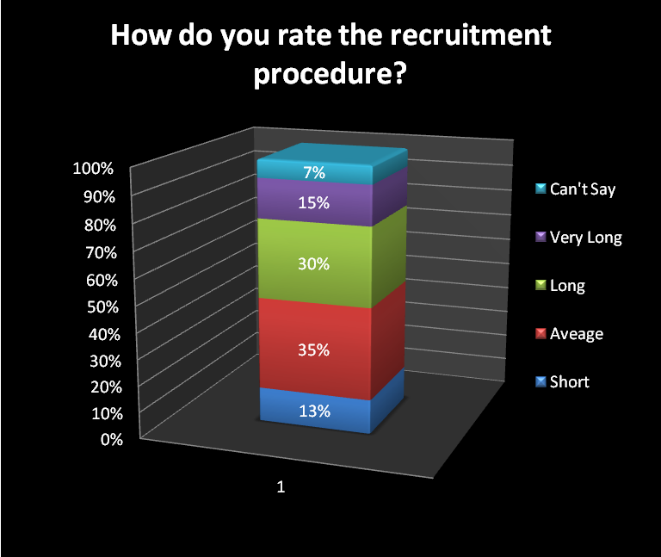

time period of whole process. Rest 35% said the time period is average neither too long nor short. Judging the time period of recruitment process is always depends on one’s personal evaluation. But mostly think sanofi’s process of hiring people is a bit long.

- After that I asked them about whether Sanofi can implement its recruitment policy on them in a proper way or not? According to them majority percent(57%) said
Sanofi Human Resource Department can easily implement the hiring policy

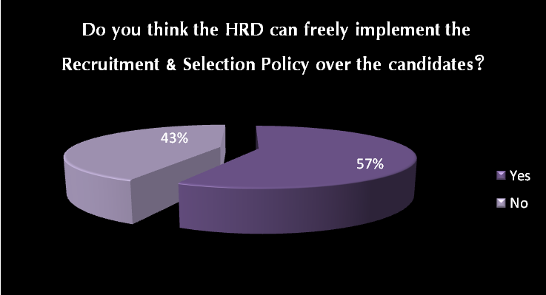

on them. But a lot people like 43% think Sanofi HRD cannot do that on them.

- Lastly I asked them about their satisfactory level towards overall recruitment process and I found various opinions.

According to the survey, 12 % were very satisfied, 8% were more than satisfied, 20% were normally satisfied, 35% were average satisfied and only 25 % were not at all satisfied. So, Sanofi HRD should more concentrate on improving recruitment process in a good manner to get 100% satisfaction from employees.

- Improving Sales force motivation Pack:
As an ideal employer, sanofi-aventis’ employer especially sales force related employees’ identify needs to be reinforced and communicated attractively and clearly. Therefore a new and Employer Boost up kit which, as an integral part of the Group’s corporate communications, responds to the recruitment challenges around the world should be made and practiced properly. The Employer Boost up Kit is supposed to help to modify the employer in a good way and also can encourage them to finish up their work in their best way. Currently, motivation factor of sanofis’ is a bit low compare to other companies. So, by increasing the motivational factors, company can make a boost among the employers.

- Implement Diversify Recruitment Process:
Sanofi aventis always prefer educational qualification rather than other skills in terms of recruitment process. It sometimes hampers the hiring process. Educational background is important always but sometimes other potentiality matters for the post. Especially for sales force- dynamism, creativity, good communication skills are must rather than educational qualification. So, management should focus on diversity of recruitment process.

- More specific and time-effective recruitment process:
Lots of employees think time period is a bit long in terms of recruitment. It should be processed in specific and perfect time. Time period shouldn’t be so long because candidates get stuck in it. So, they lost their enthusiasm to give their best shot in exams of job recruitment. So, sanofi should give extra focus on making a more generic and flexible recruitment process.

7. Recommendation:
On basis of summary of findings, I want to suggest some recommendation for sanofi aventis’s recruitment process. Those suggestions might help sanofi aventis to modify their hiring process a bit.
- Improving Sales force motivation Pack:
As an ideal employer, sanofi-aventis’ employer especially sales force related employees’ identify needs to be reinforced and communicated attractively and clearly. Therefore a new and Employer Boost up kit which, as an integral part of the Group’s corporate communications, responds to the recruitment challenges around the world should be made and practiced properly. The Employer Boost up Kit is supposed to help to modify the employer in a good way and also can encourage them to finish up their work in their best way. Currently, motivation factor of sanofis’ is a bit low compare to other companies. So, by increasing the motivational factors, company can make a boost among the employers.

- Implement Diversify Recruitment Process:
Sanofi aventis always prefer educational qualification rather than other skills in terms of recruitment process. It sometimes hampers the hiring process. Educational background is important always but sometimes other potentiality matters for the post. Especially for sales force- dynamism, creativity, good communication skills are must rather than educational qualification. So, management should focus on diversity of recruitment process.

- More specific and time-effective recruitment process:
Lots of employees think time period is a bit long in terms of recruitment. It should be processed in specific and perfect time. Time period shouldn’t be so long because candidates get stuck in it. So, they lost their enthusiasm to give their best shot in exams of job recruitment. So, sanofi should give extra focus on making a more generic and flexible recruitment process.

8. Conclusion:

Sanofi aventis is aimed to be beyond doubt leader in the field of world pharmaceutical companies. To achieve this goal, sanofi aventis has to develop its employee panel as most promising and all rounder and also for ready to take any challenge. They have to be capable for each operating country office with local competencies. Recruitment process of sanofi aventis is already well-appreciated to all but still now HRD need to improve some policies and steps to make it compatible with everything. By analyzing all findings, I recommended some necessary steps which are needed to make an efficient and effective recruitment process. That will help HRD to hire the most eligible candidate without making any fault.

Appendix

Topic: Recruitment process of Sanofi Aventis.
Please answer the following questions regarding Recruitment process. All answers will be used only for research purposes and will be kept in strict confidence.
1. Are you prefer pharmaceutical industry to build your career?
a) It will my first priority
b) It will be among the top 5 options to build my career in
c) It will be my lat option to build up my career in this sector
2. Which one is the most effective recruitment process of HR?
a) Through written exam & personal interviews
b) Through several steps of interviews
c) Through whole day recruitment process
d) Others
3. What are the criteria sanofi aventis prefer to select the qualified candidates?
a) Educational background
b) Communication skills
c) Sincerity
d) Others
4. Interviews were scheduled and confirmed in a timely manner?
a) Yes b) No
5. How do you rate the recruitment procedure?
a) Short
b) Average
c) Long
d) Very Long
e) Can’t say

6. Was there enough information included in the pack to enable you to make an informed decision about whether or not to apply for this job?
a) Yes
b) Maybe
c) No
7. Do you think the HRD can freely implement the Recruitment & Selection Policy over the candidates?
a) Yes b) No
8. How satisfied were you with the overall recruitment process?
a) Very satisfied
b) More than satisfied
c) Satisfied
d) Not satisfied

Bibliography

- http://en.sanofi.com/home.asp
- http://en.sanofi.com/at-a-glance/edito.asp
- http://en.sanofi.com/ethics_responsibilities/being_sanofi.asp
- http://reportingrse.sanofi-aventis.com/web/
- http://www.sanofi-aventis.com.bd/l/bd/en/index.jsp
- http://www.sanofi-aventis.com.bd/l/bd/en/layout.jsp?scat=2B2B8263-1505-4358-B9E4-51C279398C98#p12
- http://www.buzzle.com/articles/recruitment-process-steps.html
- http://en.wikipedia.org/wiki/Recruitment
- http://en.sanofi.com/binaries/Sanofi_RA_EN_tcm28-24842.pdf
- http://www.careers.sanofi-aventis.co.uk/job-search-and-apply/the-recruitment-process
- http://www.sanofi-aventis.us/l/us/en/layout.jsp?scat=F3CCA6EA-4A34-4556-B3A3
- 5928506111E5
- http://www.sanofipasteur.us/sanofi-pasteur2/front/index.jsp?siteCode=SP_US
- http://en.sanofi.com/research_innovation/rd_key_figures/rd_key_figures.asp

