Strategic Human Resource Planning System of

Kohinoor Chemical Co. (BD) Ltd

Submitted by

WWW.ASSIGNMENTPOINT.COM

PROFIL OF THE ORGANIZATION:

KOHINOOR CHEMICALS CO. (BD) LTD



  - ESTABLISHMENT AND HISTORY:
Kohinoor Chemical Company Limited (KCCL) started its business in 1956 and was engaged in manufacturing high quality cosmetics, toiletries, soap and glycerin for decades.
After the independence of Bangladesh, KCCL became a fully government owned company under the direct control of Bangladesh Chemical Industries Corporation (BCIC) up to May 05, 1988. It was transformed into a Public Limited Company under Companies Act 1913 and was named as Kohinoor Chemical Company (Bangladesh) Limited from May 05, 1988. The Government of the peoples’ Republic of Bangladesh has vested the company’s 51% share of Bangladesh Chemical Industries Corporation. Out of 49% balance shares 34% shares were soled to the public and rest 15% shares were reserved for sale among the officers, staff and workers. The shares of the company are the publicly traded in Dhaka and Chittagong Stock Exchange Ltd.
  - BEGINNING OF THE JOURNEY:
As the pioneering soap, cosmetics and toiletries manufacturing industry of Bangladesh, Kohinoor Chemical Company (Bangladesh) Ltd. has all along ensured to introduce standard, exciting and value-added innovations in beauty care products. As a result, Tibet products of KCCL have assumed substantial market shares and all of its products have already achieved the leading position.

Kohinoor Chemical Company (Bangladesh) Ltd. (KCCL), a former state-owned enterprise under Bangladesh Chemical Corporation (BCIC), was acquired by the present entrepreneurs on August 03, 1993 as the unit was privatized by the Government of the People's Republic of Bangladesh.

Most of its products carry the widely brand name of Tibet while some other products carry individual brand identity (e.g. Super Lemon Dew, Sandalina, Genstar, Dee-5, Honey Dew etc). Tibet products have been the market leaders for the years among the common masses of the country. Immediately after taking over the unit, the present entrepreneurs tried to turn to higher quality through acquisition of newer and state-of-the-art technology along with skilled and professional manpower. As such new quality elements were added to traditional items and a sophisticated, fresh and new-generation bath soap (Tibet Beauty Care Soap) rolled out of the newly installed plant.

Soon after taking over the once losing state-owned enterprise the present entrepreneurs group turned the industry into a profiting and futuristic one ensuring more and more value-added beauty and personal care products.

The new management of KCCL is contemplating an arduous BMRE program with the technical collaboration of a reputed industrial conglomerate of Europe, in order to make it as a repositioned cosmetics and toiletries manufacturing industry of Bangladesh with the most advanced technology.

  - STRENGTHENING MARKETING ACTIVITIES:
To strengthen the marketing activities of KCCL the management has rearranged its distribution system to reach quality Tibet products throughout the country. Recently the Export Division has been assigned to look out for regional and overseas markets and to attend various industrial fairs abroad. At the same time the management has revamped the Research & Development and the Quality Control organs to ensure Standard Quality regime of all products batch by batch-piece by piece.

  - KCCL MANAGEMENT:
KCCL provides more than 2000 skilled workers, staff and management executives to meet consumer's need to take Tibet products from the plant to the consumer doorsteps. The new management has taken up KCCL as a mission to prove the success of private entrepreneurship in Bangladesh and as part of its drive to improve the human resources, it has stepped up various welfare measures like subsidized canteen, free uniform, Medicare facilities, welfare center etc. aimed at ensuring higher productivity both at plant and at the head office. In short, KCCL has not only emerged as a profitable industrial entity, but also Tibet has become a popular household brand name getting deeper from mass production to up markets both at home and abroad with introduction of new products in addition to further improvement of its traditional items.

  - KCCL QUALITY:
Quality happens to be the guiding philosophy of Kohinoor Chemical. While quality leads to precision, precision lead to brand loyalty. It’s an authentic consumer response that they get only in Tibet the best products at the least price tags. Recently our products have started enjoying consumer trust beyond Bangladesh.

1.6 VISSION:
We also have a vision to attain our avowed mission of assuming the above duty and responsibility. We envisage for a more beautiful tomorrow for the country, for the region and for the whole world.

1.7 MISSION:
Time has rewarded us with the rank of leadership. But we will always remember what it means to us to be the leader in the market. We will always try to explore beyond the boundaries of possibilities. Customer need and the customer need alone will be our guiding philosophy in manufacturing and marketing of products that beautiful people and satisfy their souls.

1.7 VALUES:
Quality of the products, reliability, and strong distribution channel are the core values of the organization and are the basis on which they do business.

1.8 CULTURE:

KCCL build up an interesting and friendly working environment where all the employees play individual rules to achieve a particular goal for the organization. From the very beginning of KCCL, we know that the organization needs to adapt to a culture consistent with their operation. The top management of KCCL puts a lot of emphasis on this. Along with the operation of the organization they also concentrate on the practiced & shared norms, values & customs of KCCL, which eventually has given the birth of "KCCL culture", a culture incorporated with the revolutionary operation of the organization.
Time, the keynote for discipline is largely emphasized at KCCL. In today's ever-changing environment any organization needs to be balanced rather than extremist in their practiced norms. In case of KCCL, the culture of the organization has succeeded to find the balance with the odd mixture of discipline & flexibility in their culture, which only disposition them to be aware of their surroundings.

SRUCTURE

1.9 Board of Directors
Md. Obaidul Karim Chairman
Md. Rezaul Karim Managing Director
Md. Ebadul Karim Directors
Mrs. Arzuda Karim Directors
Mrs. Shirin Akhter Directors
Lt. Col. Kamal Ahmed PSC. (Rtd) Independent Director
Abu Bakar Siddique Chief Financial Officer
Md. Maksud Hossen Siddique Chief Internal Auditor
Md. Ferdous Jaman Company Secretary
Executive Committee | Management Committee
Md. Rezaul Karim  Md. Abul Khair  Zafar Ahmed  Abu Bakar Siddique  Shah Md. Abdul Wadod | Md. Abul Khair  Zafar Ahmed  Md. Abu Bakar Siddique  Shah Md. Abdul Wadod

1.10 Functional Departments
KCCL comprises of six departments. The Various Functional Departments are:
- Sales and Marketing Department
- Account and Finance Department
- Production Department
- HRM and Admin Department
- Store Department
- Audit and Survey Department.

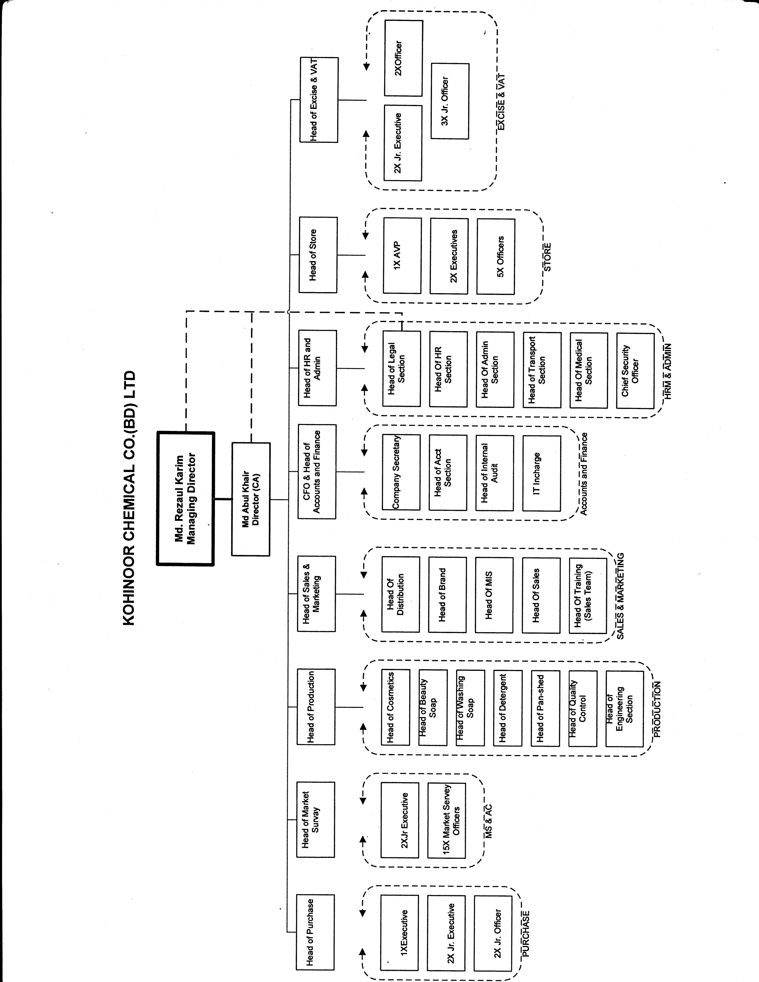

KCCL PRODUCTS

1.11 KCCL’s products can be classified into four broad categories.
- Cosmetics
- Toiletries
- Soap
- Detergent

1.11.1 Cosmetics & Toiletries
- Tibet Pomade
- Tibet Perfumed Petroleum Jelly
- Fair & Care
- Tibet glycerine

- Tibet Snow
Body Powder
- Tibet Luxury Talcum Powder
- Tibet Talcum Powder
- Tibet Prickly Heat Powder
- Tibet Baby Powder
Dental Care

- Tibet Tooth Powder
Baby Lotion
- Tibet Baby Lotion
- Shaving Cream
- Tibet Lather Shaving Cream B-22
- Ice Cool Shaving Cream

- Genstar Lather Shaving Cream
Hair Oil
- Tibet Pure Coconut Oil
- Tibet Medicated Hair Oil
- Tibet Pumpkin Hair Oil

Lip gel
- Tibet Lip gel
- Fruity Chap Stick
- Chandan Attar
- Tibet Chandan Attar


1.11.2 Soap

Bath Soap
- Tibet Beauty Care Soap (Pink)
- Tibet Beauty Care Soap (White)
- Tibet Beauty Care Soap (Green)
- Tibet Beauty Care Soap (Jasmine)
- Ice Cool Soap

- Sandalina Sandal Soap
- Bactrol Family Health Soap
1.11.3 Detergent

- Tibet 570 Laundry Soap (Red)
- Tibet Ball Soap
- Tibet Laundry Soap (Green)
- Tibet Laundry Soap (Blue)
- Tibet Detergent Powder
- Xpet Dish Wash Powder

.

1.12 TECHNOLOGY

The plants of KCCL are used highly automated and sophisticated machines. They also follow standard quality control procedure that helps to produce quality products. The company follows the technological innovation. It import hi-tech machine from foreign country.

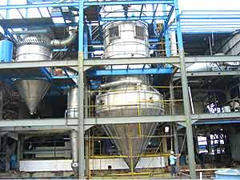
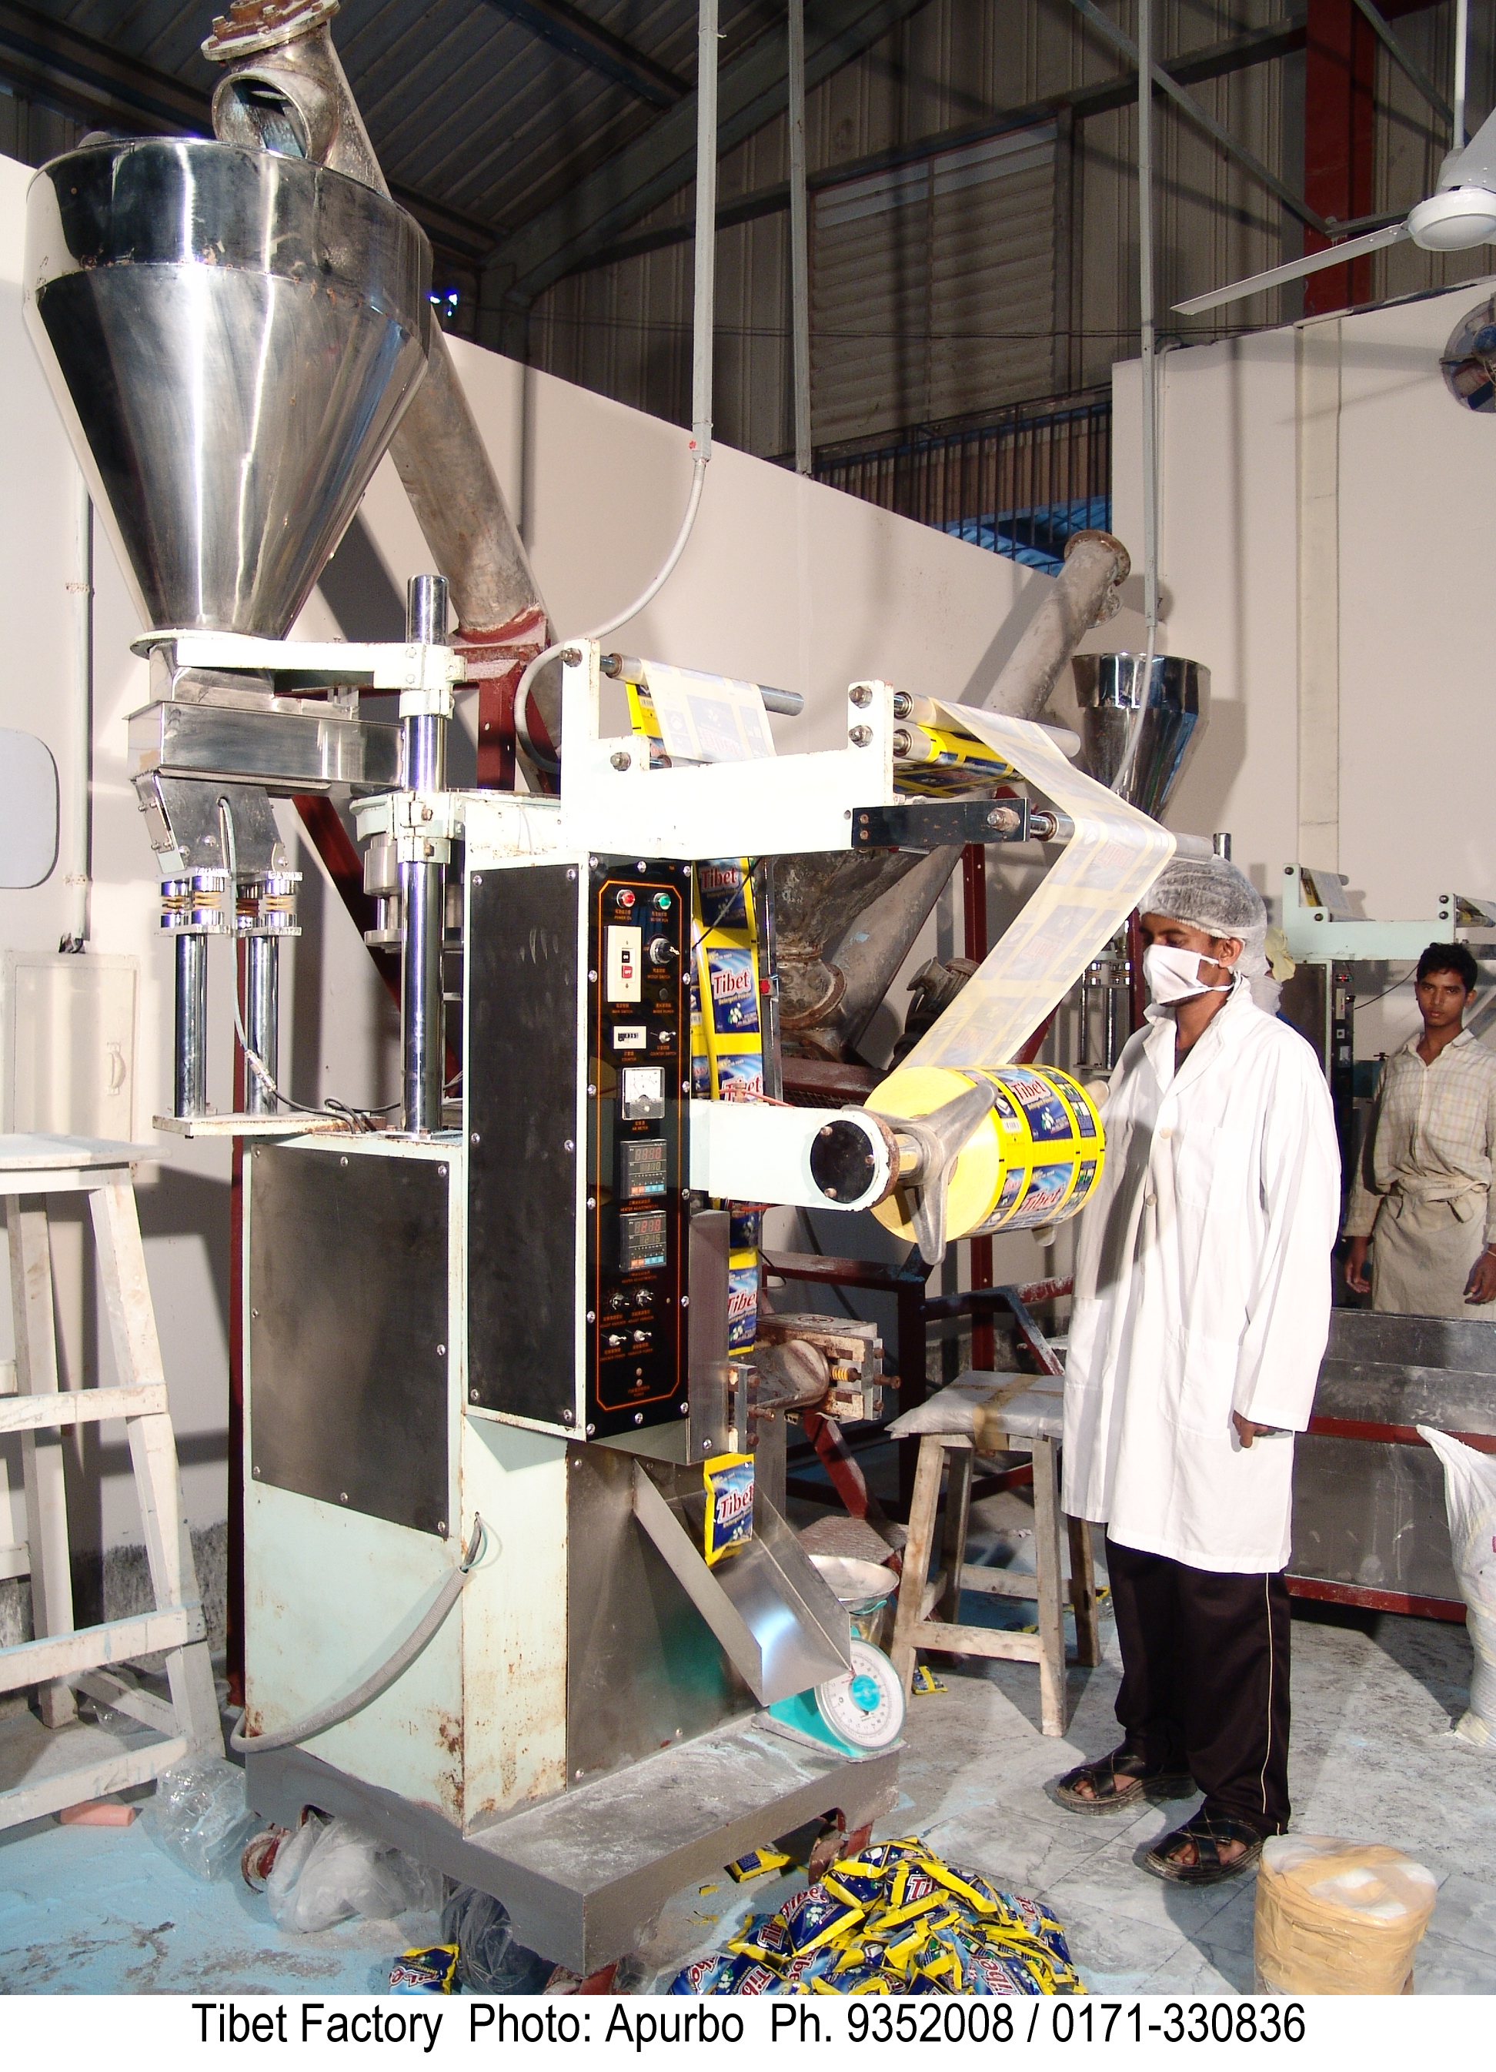

1.13 PRODUCTION CAPACITY:

- Cosmetics : As per the requirement
- Toilet Soap : 40 metric tones per day
- Washing Soap : 90 metric tones per day
- Detergent : 100 metric tons per day.

1.14 PACKAGING:
Packaging process in KCCL differs from their product to product. For some product packaging they depend totally on manual process, for some products they depend on semi-manual process and for sensitive products they are fully dependent on automated process.
For example:
Cosmetics soaps are fully done in automated process. No worker touch the product unless it is fully packaged and tagged. As the soap is for facial use.
Washing soaps are totally depend on manual process. The entire packaging process is done manually. From wrapping to tagging, the entire process is done by workers hand. Example: Tibet ball soap.
Detergents are packaged in semi manual process. While making the product the workers use their hand to transfer the detergent from one machine to another and lastly to packaging process. Sealing process is then done manually.
This is how the packaging process is done in KCCL.

PART:2

2.1 INTRODUCTION TO THE STUDY:

A) RATIONALE OF THE STUDY:
In the past times there were nothing call Human Resource Management. It was all about Administration. But as time passed, there were growing need for Human resource management to maximize the resource utilization. With that in mind, present management reorganized the administration department and renamed it as “HRM and Administration Department” .In recent past, this department is recognized as the strategic partner of the business and corporate strategy making strategic Human Resource Planning.
Being a student of Human Resource Management, I truly believe that Strategic Human Resource Planning is highly relevance with me as a student. It will help in preparing myself to be a HR professional in future.
Kohinoor Chemical Co.(BD) Ltd. Is the oldest local company of this nature with a great success story which may be good class room topic for the business students.

B) STATEMENT OF THE PROBLEMS:
The study will provide an idea about the process of Strategic human resource planning in KCCL. It is also going to evaluate the effectiveness of strategic human resource planning in KCCL.

C) SCOPE AND DELIMITATION OF THE STUDY:

- SCOPES:
This study will relate to the HR department of Kohinoor Chemical Co.(BD) Ltd. where Strategic Human Resource Planning is a very important area to work with. The study will be conducted based on “Kohinoor Chemical Co.(BD) Ltd. in evaluating different aspects and criteria’s related to companies’ Strategic Planning process. This report will give a detailed idea about how Strategic Planning is done to support the corporate and business strategy.

- DELIMITATION:
- Kohinoor Chemicals is a very old company. With the change of ownership, it had gone through re-structuring many times. As such many of the old documents are destroyed.
- The main constraint of the study would be to get schedule of the important personnel due to their work load.
- Since I would be carrying out such a study for the first time so experience might be a limitation.
- Confidentiality of the strategic information.

- OBJECTIVE OF THE STUDY:
- BROAD OBJECTIVES:
To evaluate the effectiveness of Strategic Human Resource Planning System in Kohinoor Chemical Co.(BD) Ltd. and make recommendations if any.
- SPECIFIC OBJECTIVES:
- To understand the current strategic planning process.
- To find out the benefit of Strategic Human Resource Planning Process.
- To identify key areas of Strategic Human Resource Planning.
- To identify the people involved in Strategic Human Resource Planning.
- To find out how do they implementy their planning in real work field.
- To evaluate the effectiveness of Stratehic HR Planning.

2.2 REVIEW OF RELATED LITERATURE:
A comprehensive Human Resource Strategy plays a vital role in the achievement of an organizations overall strategic objectives and visible illustrates that the human resources function fully understands and supports the direction in which the organization is moving. An HR strategy will also support other specific strategic objectives undertaken by the marketing, financial, operational and technology department.
2.2.1 OBJECTIVES OF STRATEGIC HRP:
In essence, the HR strategy aims to capture “the people element” of what an organization is hoping to achieve in the medium to long term, ensuring that,
- It has the right people in right place.
- It has the right mix of skills.
- Employees display the right attitude and behavior,
- Employees are developed in the right way.
- The ongoing process of systematic planning to achieve optimum use of an organizations most valuable assets- its human resources. The objective of Human Resource Planning is to ensure the best fit between employees and jobs, while avoiding the manpower shortages and surpluses. The three key elements of Hr planning process are forecasting labor demand, analyzing present labor supply, and balancing projected labor demand and supply.
Aging worker population in most western countries and growing demands for qualified workers in developing economies have underscored the importance of effective Human Resource Planning. Human Resources Planning is a process that indentifies current and future Human Resources needs for an organization to achieve its goals. Human Resource Planning should serve as a link between Human Resources Management and overall strategic plan of an organization.
Well done is better than well said.
-Benjamin Franklin
Strategic Planning allows an organization to put down on paper where they are, where they want to go, and how they plan to get there. But the best planning in the world does nothing for an organization if they does not act on those plans. So performing activities that supports organizations mission accomplishment and measuring how well those activities contribute to achieving organizations strategic goals is also very important.

Haines & Bandt introduce 5 major challenges that affect HR professionals from fully
developing the “people edge” notion, and may be the reasons many companies have
difficulty attaining their goals and keeping their employees satisfied. The challenges
introduced are; (1) Aligning HR practices to the company’s business strategies, (2)
Business Partnerships between line managers and staff to address the people related
business needs of the organization, (3) Facilitating Organizational Change, and learning
throughout the organization, (4) Understanding and utilizing state-of-the-art Technology to increase the efficiency and effectiveness of the organization, and (5) Strategizing and understanding the diverse environment in which they work, and positioning their organization for the future.
Stephen Haines is the President and founder of the Haines Centre for Strategic
Management with locations in the United States, Canada, Australia, and 15 offices worldwide.
Haines is an internationally recognized leader in Strategic Management and has
over 30 years of international and executive experience in the private and public sectors.
Allan Bandt is a Director of Bandt Gatter & Associates, a Human Resource Consultancy Service in West Australia and the regional managing partner of the Haines Centre for all of Australia and New Zealand. Bandt previously served as President of the Australian Human Resource Institute.
  - Nidya R.M.

2.2.2 STRATEGIC HUMAN ESOURCE PLANNING MODEL:

Strategic Human Resource Planning Model indentifies six specific steps in developing an HR Strategy. Those are:

- Setting the strategic direction.
- Designing the Human Resource Management system.
- Planning the total Workforce.
- Generating the required Human Resources.
- Investing Human Resource development and performance.
- Assessing and sustaining organizational competence and performance.

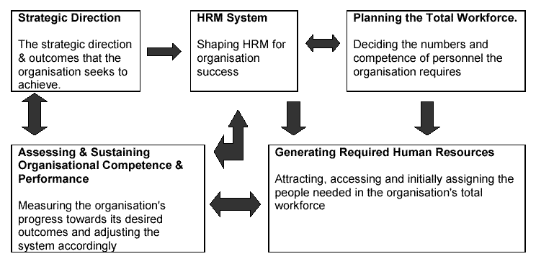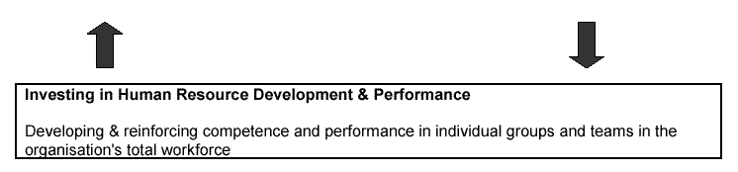
Source: A strategic Human Resource Management System for the 21st Century. Naval Personnel Task Force, September 2000.
The six broad interconnected components of this system consists of three planning steps and three execution steps.
The top three components represents the need for planning. Organization must determine their strategic direction and the outcomes they seek. This is usually accomplished with some form of strategic planning. Classic strategic planning is a formal , top down, staff driven process. When down well, it is workable at a time when external change occurs at a more measured pace.
However, as the pace and the magnitude of the change increases, the approach to strategic planning changes subsequently.
- First, the planning process is more agile. Change in plans are much more frequent and are often driven by events rather than made on a predetermined timed schedule.
- Second, the planning process is more proactive. Successful organizations no longer simply respond to changes in their environment, they proactively change their environment to maximize their own effectiveness.
- Third, the planning process is no longer exclusively top down, input into the process comes from many different organizational levels and segments. This creates more employment ownership of the plan and capitalizes on the fact that often the most valuable business intelligence can come from employees who are at the bottom of the organization hierarchy.
- Lastly, the strategic planning process less reactive and more driven by line leadership.
Once strategic planning is under way, a process must be undertaken by the organization to design and align its HRM policies and practices to provide for organizational success. The remaining step in planning is to determine the quality and quantity of human resources the organization needs for its total force. The rest of the HR strategic system exists for and is guided by these plans, policies, and practices. These execution components contain mechanisms that generate the correct skill sets, invest in staff development and performance, and productively employ them in the organization. The last component provides a means to assess and sustain the competence and performance of the organization and the people in it with regard to outcomes that the organization seeks.

2.2.3 STRATEGIC HR ADD VALUE TO THE PLANNING FOR THE ORGANIZATION:

If, as is sometimes the case, organization strategies and plans have been developed without any human resource input, the justification for the HR strategy may be more about teasing out the implicit people factors which are inherent in the plans, rather than simply summarizing their explicit "people" content.

An HR strategy will add value to the organization if it:

- Articulates more clearly some of the common themes which lie behind the achievement of other plans and strategies, which have not been fully identified before;
and
- Identifies fundamental underlying issues which must be addressed by any organization or business if its people are to be motivated, committed and operate effectively.

The first of these areas will entail a careful consideration of existing or developing plans and strategies to identify and draw attention to common themes and implications, which have not been made explicit previously.

The second area should be about identifying which of these plans and strategies are so fundamental that there must be clear plans to address them before the organization can achieve on any of its goals. These are likely to include:

workforce planning issues
- Succession planning
- Workforce skills plans
- Employment equity plans
- Black economic empowerment initiatives
- Motivation and fair treatment issues
- Pay levels designed to recruit, retain and motivate people
- The co-ordination of approaches to pay and grading across the organisation to create alignment and potential unequal pay claims
- A grading and remuneration system which is seen as fair and giving proper reward for contributions made
- Wider employment issues which impact on staff recruitment, retention, motivation etc.
- A consistent performance management framework which is designed to meet the needs of all sectors of the organization including its people.
- Career development frameworks which look at development within the organization at equipping employees with "employability" so that they can cope with increasingly frequent changes in employer and employment patterns
- Policies and frameworks to ensure that people development issues are addressed systematically : competence frameworks, self-managed learning etc.
The HR strategy will need to show that careful planning of the people issues will make it substantially easier for the organization to achieve its wider strategic and operational goals.
2.2.4 TYPES OF HUMAN RESOURCE PLANNING:
HR Planning is generally done on two different levels
- Aggregate Planning
- Succession Planning.
Aggregate planning anticipates needs for groups of employees in specific, usually lower level jobs and the general skills employees need to ensure sustained high performance.
Aggregate Planning follows two types of forecasting:
- Unit forecasting
- Top-Down Forecasting
In Unit Forecasting, each individual unit, department, or branch of the organization estimates its future needs for employees. For example: each branch of a bank might prepare its own forecast based on the goal and the objectives each branch manager has for the particular office. These estimates are then presented to subsequent layers of management, who combine and sum the totals and present them to senior management for approval.
Top-Down Forecasting involves senior managers allocating a budgeted amount for employee payroll expenditures and then dividing the pool at subsequent levels down the hierarchy. Each manager receives a budget from his/her supervisor and then divides how to allocate these funds down to the next group of manager.
Succession Planning focuses on key individual management position that the organization needs to make sure remain filled and the types of individuals who might provide the best fit in these critical position.
Succession Planning serves two purposes:
- First, it facilitates transition when an employee leaves. It is not unusual to have a departing employee work alongside her/his successor for a given period prior to departure to facilitate the transition. Succession planning aids in this process.
- Second, succession Planning identifies the development needs of high potential employees and assists with their career planning.
2.3 METHODOLOGY OF THE STUDY:
Major part of data was collected through the secondary source. It was difficult to collect the data through primary source due to the time scarcity of the important personnel. The secondary and the primary sources are –
2.3.1 THE PRIMARY SOURCES:
- Staff of the company.
- Observation during the internship.
- Discussion with the HR Vice President of Kohinoor Chemical Co.(BD) Ltd.

2.3.2 THE SECONDARY SOURCES:
- Company profile and annual report.
- Website of Kohinoor Chemical Co.(BD) Ltd.
- Text Books.
- Internet, Newspaper, Magazines.
2.4 ANALYSIS AND INTERPRETATION OF DATA:
The analysis and the interpretation of data of the study is given below:
2.4.1 SOME QUESTIONEER REGARDING STRATEGIC HUMAN RESOURCE PLANNING TO THE HEAD OF HUMAN RESOURCE OF KCCL:
- Do KCCL follows Strategic Human Resource Planning?
A) Yes B) No
- Do you think KCCL strategic Human Resource Planning is proactive in anticipating and preparing flexible responses to changing HR requirements?
A) Yes B) No
- Do you think KCCL is overstaffed?
A) Yes B) No
If yes, then how do the balance their overstaffing?
- Do you think KCCL is understaffed?
A) Yes B) No
If yes, then how do they balance their understaffing?
- Do you think the organization have the right people with the right skills in the right places at the right time?
A) Yes B) No
- Do you thing the organization plan for the total workforce?
A) Yes B) No
How do the organization do so?
- How do you attract people for recruitment?
- Do you think the organization maintain Succession planning in which one employee will fill up the other employees position who already left the organization?
A) Yes B) No
- To maintain the succession planning process do the organization outsource?
A) Yes B) No
- Do the employee best fit for the particular position or they still need any training?
- What do you think, when 2/3 employees are enlisted for a particular position, organization selects:
  - The one who has more connection with the top management but less eligible for the position.
  - The one who fills more requirements for the job but doesn’t have that connection with the top management?
- Do the organization provides proper training to their employees?
A) Yes B) No
- Do the organization want to invest to train their employees?
A) Yes B) No
- What do you think, the organization is responsive to the changes in its environment?
A) Yes B) No
- When a new technology is bought in the organization, how willingly do the old employees adopt or cope with the change made by the new technology?
A) Positively B) Negatively
- How do the top management maintains the connection with the staff management?
- How do the top management motivates the lower management to work more effectively?
- Do you think the KCCL follows Unit Forecasting?
A) Yes B) No
- Do the organization follows any HRIS system or software?
A) Yes B) No
If not then how do they maintain the employee record?
- How flexible is KCCL to the changing circumstances?
A) Flexible B) Not Flexible
- How do KCCL measures its progress?

2.4.2 ANALYSIS AND INTERPRETATION :
- Proactive Strategic Human Resource Planning:
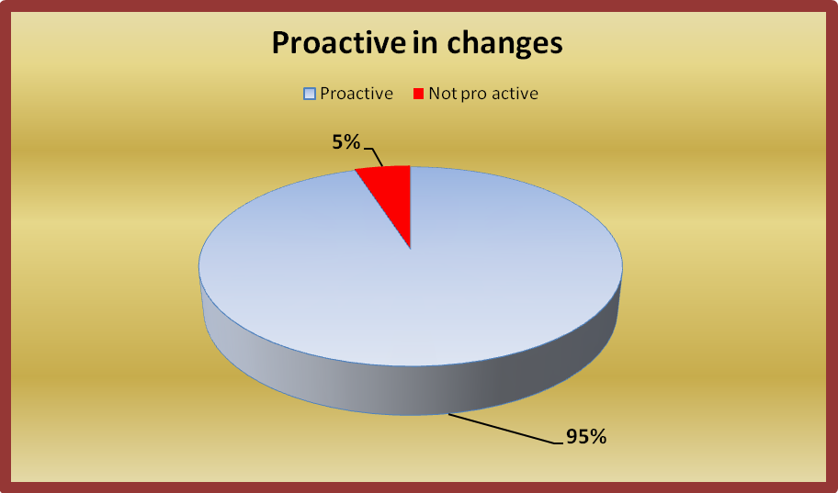
The table is given below:
 | Proactive | Not proactive
Number of employees | 10 employees | 1 employee
% of employees | 95% | 5%

There are total 11 employees in our Human Resource Department. Among them 10 employees, which covers 95% thinks that the Strategic Human Resource System of KCCL is proactive in anticipating and preparing flexible responses to changing HR requirements.
But only 1 employee, which covers only 5% said that Strategic Human Resource Management of KCCL is not proactive.
So, from the given statistics we see that KCCL Strategic Human Resource Planning is very proactive in anticipating and preparing flexible responses to changing HR requirements.
- Overstaffed:
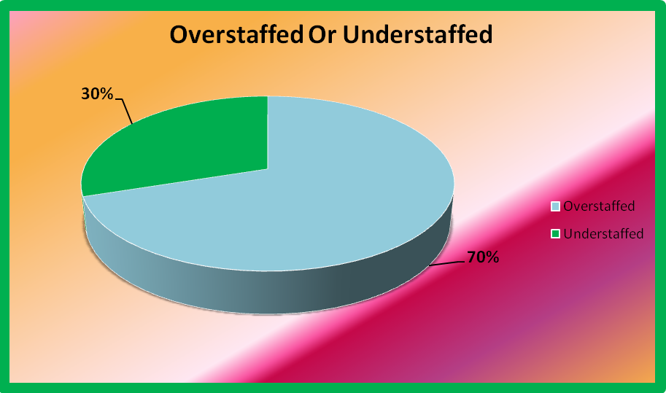
The table is given below:
 | Thinks Over Staffed | Thinks Under Staffed
No Of Employees | 8 Employees | 3 Employees
% Of Employees | 70% | 30%
From the given statistics we can understand that, 8 employees think KCCL is overstaffed which actually covers 70% of the HR department. But the rest which covers 30% thinks that KCCL is understaffed as they want more people as their helping hand and they don’t have enough idea about the proper workforce.
Since KCCL is an organization from the BCIC period it had to conceive many old staffs from that period. But gradually these staffs are retiring and KCCL is getting closer to the standard workforce structure. Furthermore, they are not giving them any Golden Handshake or early retirement. But, as they need to balance their overstaffing, once the staffs retires, KCCL does not replace them unless the position is very important.
- Understaffed:
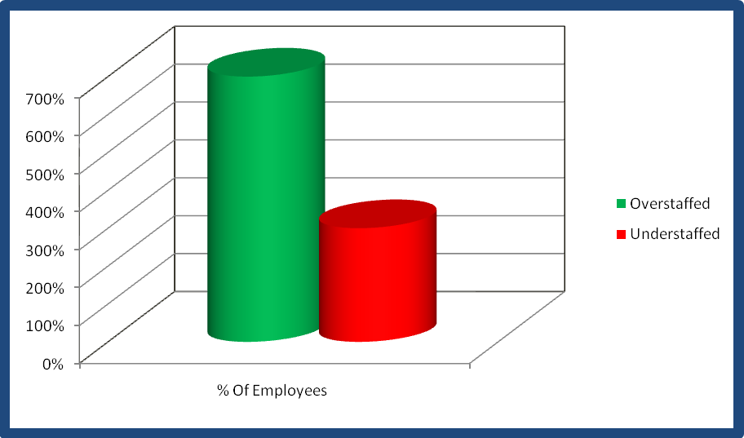
The table is given below:
 | Under Staffed
% Of Employees | Only 30% Employees Thinking
From the above we can see that only 30% employees of the Human Resource Department thinks that they are understaffed but still they couldn’t provide any logical reasons for that.
As we see that, KCCL is not replacing any people to get closer to the standard workforce structure, we can say that this organization is not understaffed.
- Workforce Planning:
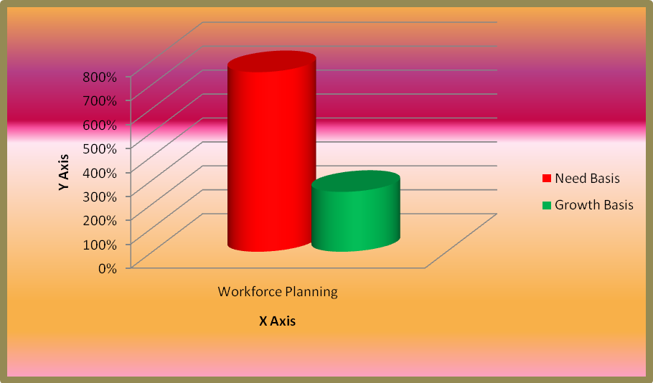
KCCL always plans for their total workforce. Workforce Planning in KCCL is done in Two ways:
- Need Basis: Depending on the needs of the organizations workforce they recruit people.
- Growth: Seeing the market growth, if KCCL management decides to increase one more region or brand of their company, they recruit people. They start recruiting them from the very date, when the top management signs the agreement for introducing a new region. They recruit them and start giving them training to make them capable of performing their tasks which, the management will provide them after the establishment of the new region.
The table is given below:
WORKFORCE PLANNING
Need Basis | 7.5%
Growth Basis | 2.5%
From the table we can say that, KCCL mainly plans for their workforce according to their need of workers in their organization. But very seldom when they feel for the demand of increasing a region in their factory only then they plan their workforce according to their growth.
- Succession Planning:
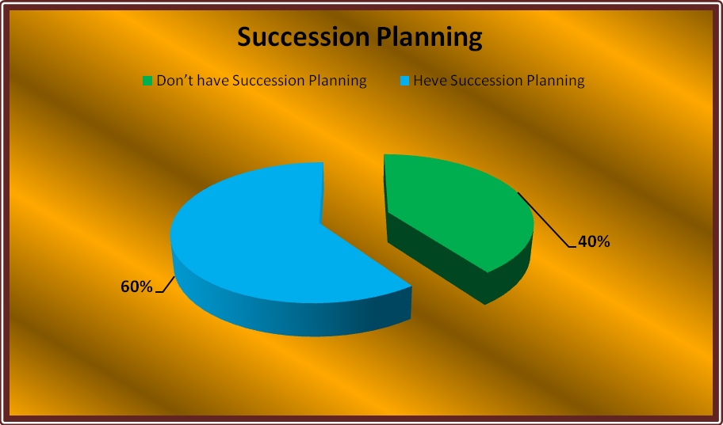
The table is given below:
SUCCESSON PLANNING
 | Do not have Succession Planning | Maintains Succession Planning
No Of Employees | 4 Employees | 7 Employees
% Of Employees | 40% | 60%
Here, we can see that, 4 employees which is actually 40% of the HR department think that KCCL doesn’t have any Succession Planning but the rest which covers 60% of the HRD knows that KCCL follows succession planning.
KCCL maintains Succession Planning, but they do not publish it. For example: Multinational companies rotates one employee to attend various works together. As a result, other employees understands that, this specific employee is going to be promoted.
But in Kohinoor Chemicals this process is done internally. The top management keeps the targeted employee under observation and according to that they suddenly promote them. For this reason some few employees doesn’t have the idea that KCCL maintains succession planning, as they maintains it internally. But other employees know that KCCL follows succession planning but internally.
- Outsourcing:
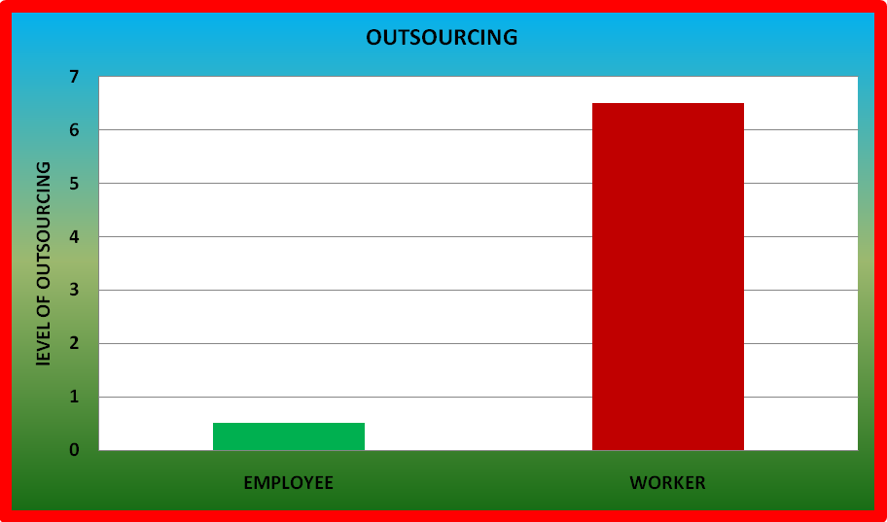
The table is given below:
 | % Of Outsourcing | Level Of Outsourcing
Employee | 0.5% | Very low
Worker | 6.5% | Moderate
In this table we can see that KCCL outsource very seldom for employees, mostly they don’t outsource them. On the other hand we see that worker outsourcing is comparatively high which is likely 6.5%.
To provide the duty of recruiting employees to an outside agent is called outsourcing. But KCCL never goes for outsourcing to recruit people. They recruit their employees by their own.
But only in the case or worker recruitment, KCCL do outsourcing.
- Employee best fit in a position:
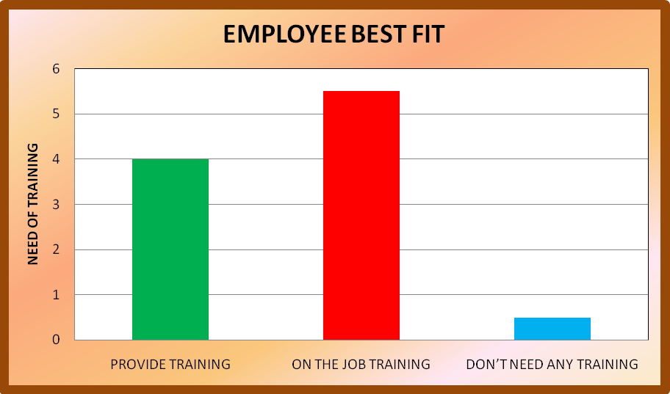
The table is given below:
EMPLOYEE BEST FIT IN A POSITION
 | % Of Training | Level Of Training
Provide Training | 4% | Moderate
On The Job Training | 5.5% | Moderately High
No Training | 0.5% | Very Low
In this table we see that, KCCL provide separate training to the 4% of the total workforce. 5.5% of the total workforce, they provide on the job training. And very low percentage of employees in KCCL need no training means they do their job without any training as they just best fit the job.
Most of the cases employees that KCCL recruits needs training to get fit for a particular position. Because works vary from company to company. So, if an employee is absolutely fresh then KCCL provides them a proper training, otherwise they provides on the job training to their employees.
- Who do the organization selects:
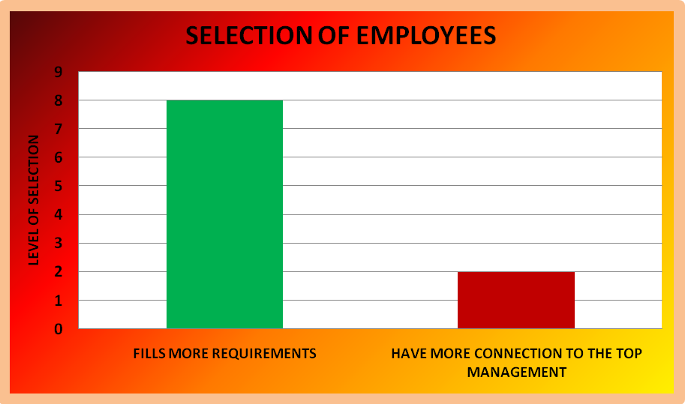
The table is given below:
 | % Of Recruitment | Level Of Recruitment
Fills More Requirements | 8.0% | Very High
More connection To The Top Management | 2.0% | Very Low
Here we can see that, KCCL gives more priority in recruiting employees who fills more requirement which is in percentage comes almost more than 80%. But in some few cases, they take people on request of the top management, which covers less than 20%
The organization always recruits those, who fills more requirements for a particular position but doesn’t have that much connections with the top management, rather than selecting the one who is less able but have more connections to the top management.
- Investment:
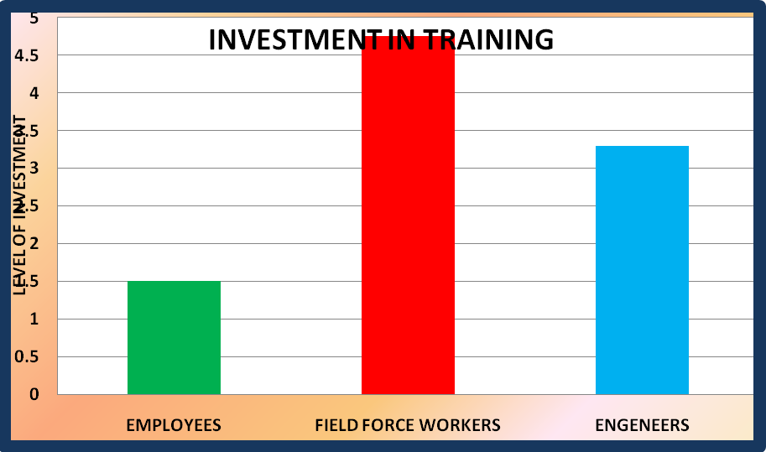
The table is given below:
INVESTMENT FOR TRAINING
 | % Of Investment | Level Of Investment
For Employees | 1.5% | Very Low
For Field Force Workers | 4.75% | Very High
For Engineers | 3.30% | Moderately High
From the table we can say that, KCCL invest very low for normal employees, which is likely 1.5%. They invest more for the field force workers, which covers almost 4.75% and also invest for engineers which is almost likely 3.30%.
KCCL do not invest much in providing on the job training. This is being done by the employee supervisors.
But, the employees who are more engaged in doing field force, KCCL invest more in organizing training for them. Furthermore, KCCL also provides a six months training for the engineers who also submits a report after completing their training, on how well did they learned in their training.
- HRIS System:
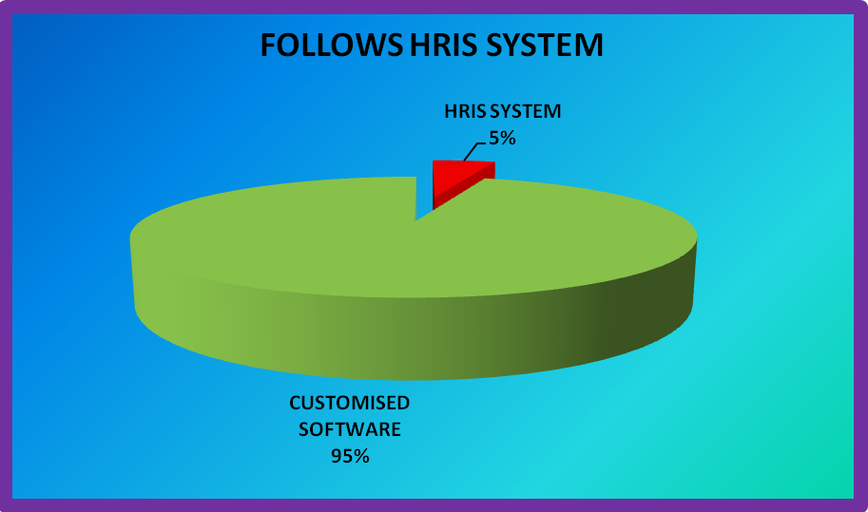
The table is given below:
FOLLOWS HRIS SYSTEM
 | Percentage Of Following HRIS
Follows HRIS System | 5%
Follows Customized System | 95%
In this table we can see that, nobody follows HRIS system, which is even lower than 5%. On the other hand, KCCL follows customized software to keep employee record, which fills more than 95%.
KCCL does not follows any Human Resource Information System. For that reason KCCL use customized software for maintaining their employee record.

2.5 FINDINGS OF THE STUDY:
There are total 11 employees in the Human Resource Department of Kohinoor Chemical Co. (BD) Ltd. I surveyed some few questioners on them. Some of the questions were open-ended and some were descriptive. Result of the survey is discussed below.
2.5.1 SHRP IS PROACTIVE IN CHANGING HR REQUIREMENTS:
Strategic Human Resource Planning is the first component of HRM Strategy. All other functional activities are derived from and flow out of the HRP Process. Thus Kohinoor Chemical Co. (BD) Ltd. follows Strategic Human Resource Management very strictly.
2.5.2 PROACTIVE STRATEGIC HUMAN RESOURCE PLANNING:
KCCL Strategic Human Resource Planning is very proactive in anticipating and preparing flexible responses to changing HR requirements.
2.5.3 OVERSTAFFED:
KCCL is overstaffed as it is an organization from BCIC period.
2.5.4 UNDERSTAFFED:
As we know that Kohinoor Chemical Co.(BD) Ltd. is overstaffed, so it cannot be understaffed anyway.
2.5.5 RIGHT PEOPLE WITH THE RIGHT SKILLS AND AT THE RIGHT TIME :
As KCCL follows Strategic HRP very strictly, they always maintains the right people with the right skills in the right place and at the right time.
2.5.6 WORKFORCE PLANNING:
KCCL always plans for their total workforce. And this workforce planning is mainly done in two ways
1. Need Basis
2. Growth Basis.
2.5.7 ATTRACTION OF PEOPLE:
Kohinoor Chemical Co.(BD) Ltd. attracts people for their recruitment process through advertisement.
2.5.8 SUCCESSION PLANNING:
Kohinoor Chemical Co(BD) Ltd. maintains Succession Planning but they do not publish it. KCCL maintains their Succession Planning internally.
2.5.9 OUT SOURCING:
Kohinoor Chemical Co.(BD) Ltd. do not do any outsourcing for recruiting their employees. But they sometimes do outsourcing only when they recruit workers for their production sector.
2.5.10 EMPLOYEES BEST FIT IN A POSITION:
In most cases employee doesn’t best fit in a position, they all need training. But very seldom there comes some employees who does not need any training who best fit the job.
2.5.11 WHO DO THE ORGANIZATION SELECT:
The organization selects mainly those people who fulfills the requirements for selection process.
2.5.12 TRAINING:
Kohinoor Chemical Co.(BD) Ltd. mainly provides on the job training to their employees.
2.5.13 INVESTMENTS:
KCCL does not invest much in providing on the training. But they invest for field force workers and engineers.
2.5.14 RESPONSIVE TO CHANGES:
KCCL is very much responsive to the changes in their working environment.
2.5.15 INTRODUCING NEW TECHNOLOGY:
As KCCL is a production based company, they often need to introduce new technologies. But old employees very positively adopt the new challenge always.
2.5.16 MAINTAINING RELATIONS OR CONNECTIONS:
KCCL maintains two way communications with their employees. Both upper level and mid level workers can communicate with each other.
2.5.17 MOTIVATING WORKERS:
KCCL motivates their employees through mentoring, counseling, compensation, infringe benefits e.t.c.
2.5.18 UNIT FORECASTING:
As KCCL is a very big company they very strictly follows unit forecasting so that they don’t need to face any difficulties.
2.5.19 HRIS SYSTEM:
KCCL doesn’t follows any HRIS system but they follows customizes software.
2.5.20 FLEXIBILITY:
Kohinoor Chemical Co.(BD) Ltd. is very much flexible and responsive to the changing circumstances.
2.5.21 MEASURING PROGRESS:
KCCL measures their progress by measuring their growth.
2.6 RECOMMENDATION:
- Kohinoor Chemical Co.(BD) Ltd. follows Strategic Human Resource Planning but still there are some lackings. They can make their SHRM more effective by introducing HRIS system, by maintaining proper manpower, by doing succession planning externally so that the other employees can understand that the company follows succession planning and as a result the employee will work more in-order to get a promotion.
- Though KCCL Strategic Human Resource Planning is proactive in anticipating to changing HR requirements, still because of some old employees who cannot understand new changes at all, so the company lack behind. So, they should provide all computerized works to the new employees and only manual works to the old employees.
- The most important problem is that, the company is overstaffed. As a result it becomes difficult for them to maintain the workforce properly and also to fire the old staffs. As a result the company is lacking behind from being fully computerized. So , they can give golden handshake with gratuity only to those employees who really work very less and unable to work in computers.
- Kohinoor Chemical Co.(BD) ltd. should introduce external Succession Planning. If they do so, then other employees will work more in order to get promotion. Because they will see, when someone is working very hard she/he is getting promotion, seeing that others will also work hard unless they get into a higher position.
- KCCL can outsource for recruiting employees also. Because if they start doing so then, the company can have more time for other works. Or else, they can segregate their recruiting process to department wise. Means, individual department will select and recruit their department employees according to their needs.
- KCCL should introduce TNA (Training Need Analysis) Form so that they can understand which employee needs what training in which sector and for how long. They can even estimate their investment even, if the introduce this form.
- Kohinoor Chemical Co.(BD) Ltd. should introduce Human Resource Information System (HRIS). As the company follows customized software or keep employee record manually, it becomes very difficult and also very much time consuming for them to search for an employee and get the necessary information about them. But, if they follow HRIS system then they can have all the information about an individual in a minute and can save huge time.

2.7 CONCLUSION:
Most of the local industries in Bangladesh don’t practice the Strategic Human Resource Planning. Organizations should establish HR department which will work on different HR related issues like ‘Development of HR policies’,’ Development of Performance System’ , ‘Development of job description & Specification’, ‘Training & development’, etc should ensure the proper implementation of the policies/systems.
Kohinoor Chemical Co.(BD) Ltd. has implemented the HR policy, they developed their SHRP and modified .They also makes new reward policy to motivate their employees. They follows almost every steps of SHRP but with little lacking. They should introduce HRIS system and should reduce their manpower as soon as possible for their betterment They should maintain the policy and after getting the feedback should take steps according to those.

QUESTIONEERS TO THE HEAD OF HR:

- Do KCCL follows Strategic Human Resource Planning?
A) Yes B) No
- Do you think KCCL strategic Human Resource Planning is proactive in anticipating and preparing flexible responses to changing HR requirements?
A) Yes B) No
- Do you think KCCL is overstaffed?
A) Yes B) No
If yes, then how do the balance their overstaffing?
- Do you think KCCL is understaffed?
A) Yes B) No
If yes, then how do they balance their understaffing?
- Do you think the organization have the right people with the right skills in the right places at the right time?
A) Yes B) No
- Do you thing the organization plan for the total workforce?
A) Yes B) No
How do the organization do so?
- How do you attract people for recruitment?
- Do you think the organization maintain Succession planning in which one employee will fill up the other employees position who already left the organization?
A) Yes B) No
- To maintain the succession planning process do the organization outsource?
A) Yes B) No
- Do the employee best fit for the particular position or they still need any training?
- What do you think, when 2/3 employees are enlisted for a particular position, organization selects:
  - The one who has more connection with the top management but less eligible for the position.
  - The one who fills more requirements for the job but doesn’t have that connection with the top management?
- Do the organization provides proper training to their employees?
A) Yes B) No
- Do the organization want to invest to train their employees?
A) Yes B) No
- What do you think, the organization is responsive to the changes in its environment?
A) Yes B) No
- When a new technology is bought in the organization, how willingly do the old employees adopt or cope with the change made by the new technology?
A) Positively B) Negatively
- How do the top management maintains the connection with the staff management?
- How do the top management motivates the lower management to work more effectively?
- Do you think the KCCL follows Unit Forecasting?
A) Yes B) No
- Do the organization follows any HRIS system or software?
A) Yes B) No
If not then how do they maintain the employee record?
- How flexible is KCCL to the changing circumstances?
A) Flexible B) Not Flexible
- How do KCCL measures its progress?

