The Role of Human Resource Department in Corporate Social Responsibility

A Study on Square Pharma Perspective

Submitted by
WWW.ASSIGNMENTPOINT.COM

This internship report on “The Role of Human Resource Management in Corporate Social Responsibility: A study on Square Pharma perspective” has to be prepared as per requirement of completing the Master of Business Administration (MBA) course from International Islamic University of Chittagong. I have done my internship in Square Pharmaceuticals Ltd, where I am attached in the Human Resource Department. CSR activities; both internal and external are maintained by the HRD. So in my report I have attempted to examine the impacts CSR may have on HRM as well as examining and identifying what a CSR compatible human resource management (HRM) may look like. It also attempts to explore the engagement of human resource management professionals in undertaking Corporate Social Responsibility In Square Pharmaceuticals Ltd. A questionnaire survey has been done on the employees of HRD of Square Pharmaceuticals. The sample size of the survey was 50 and the independent variables were Employee motivation, Employee retention, Recruitment, and Employee loyalty. The dependent variable was Integration of CSR and HRM. I have also discussed about the findings of the analysis from the survey and interviews, and tried to find out the relationship of CSR and HRM.

 2. Objectives of the Study

Broad Objectives: The broad objective of the report was to look on Human Resource Management (HRM) through the framework of Corporate Social Responsibility (CSR). How CSR trend and expectations forced specific HRM changes, developments, and HRM influences through internal corporate stakeholders, employees the corporate social responsibility, sustainability performance of a company. Discussing different important parts and views of CSR we often mention the important formula CSR‐HR=PR while indicating a key role for human resource management, and indirectly to employees themselves.
Specific Objectives: In order to fulfill this broad objective, the following specific objectives have to be pursued:
- Internal CSR activities have helped HRM activities like motivation, retention, loyalty and recruitment Gather information on the internal CSR activities of Square Pharmaceuticals Ltd.
- Considering the HRM practices from their CSR perspective How SPL intend to integrate CSR and HRM; and to which level they are successful.
- The company successfully used HRM to promote CSR
- The role/influence of HRM on the CSR policy of the company is significant
- Relationship between Employee Motivation and Internal CSR activities

3. Significance of the study

Human resource managers are well positioned to play an instrumental role in helping their organization achieve its goals of becoming a socially and environmentally responsible firm – one which reduces its negative and enhances its positive impacts on society and the environment. Further, human resource (HR) professionals in organizations that perceive successful corporate social responsibility (CSR) as a key driver of their financial performance, can be influential in realizing on that objective. While there is considerable guidance to firms who wish to be the best place to work and for firms who seek to manage their employee relationships in a socially responsible way, there is a dearth of information for the HR manager who sees the importance of embedding their firm’s CSR values throughout the organization, who wish to assist the executive team in integrating CSR into the company’s DNA. And as high profile corporate failures such as Enron make all too clear, organizations that pay lip-service to CSR while neglecting to foster a CSR culture run the risk of damaging their corporate reputation if not their demise. Indeed, HR’s mandate to communicate and implement ideas, policies, and cultural and behavioral change in organizations makes it central to fulfilling an organization’s objectives to “integrate CSR in all that we do.” That said, it is important to understand that employee engagement is not simply the mandate of HR. Indeed people leadership rests with all departmental managers. HR can facilitate the development of processes and systems; however, employee engagement is ultimately a shared responsibility. The more the HR practitioner can understand their leverage with respect to CSR, the greater their ability to pass these insights along to their business partners towards the organization’s objectives in integrating CSR throughout their operations and business model.

As human resources influences many of the key systems and business processes underpinning effective delivery, it is well positioned to foster a CSR ethic and achieve a high performance CSR culture. Human resource management can play a significant role so that CSR can become “the way we do things around here”. HR can be the key organizational partner to ensure that what the organization is saying publicly aligns with how people are treated within the organization. HR is in the enviable position of being able to provide the tools and framework for the executive team and CEO to embed CSR ethic and culture into the brand and the strategic framework of the organization. It is the only function that influences across the entire enterprise for the entire ‘lifecycle’ of the employees who work there – thus it has considerable influence if handled correctly. HR is poised for this lead role as it is adept at working horizontally and vertically across and within the organization, so important for successful CSR delivery.

4. Methodology

To accomplish the research both qualitative and quantitative methods has been followed. Initially, I will rely on the secondary sources to collect data. For this, I will go through the available literature
- Secondary Research: Secondary Research has been performed by undertaking various literature reviews and internet- based research to gather information about the background and history of Square Pharmaceuticals operations. Furthermore, secondary research in terms of various journal and literature review and related web research has also been undertaken to gather relevant information regarding the issue of CSR and HRM about Square Pharmaceuticals Ltd.
- Primary Research: While collecting the primary data, I have followed the following methods:
- Questionnaire method: This report is extensively based on extensive primary research in terms of conducting surveys on different activities of HR and the effects on internal CSR activities. The survey has helped me to understand about various HR activities like motivation, retention, recruitment and loyalty in contrast with internal CSR activities of Square Pharmaceuticals. And also helped to understand the employees position about the integration of CSR and HRM.
- Interview method: While collecting information, I have taken the interview of some officials of SPL and individual employees of Square Pharma.
5. Limitations of the study

The internship report is not free from limitations. The study has been conducted on the subject of “The Role of Human Resource Management in Corporate Social Responsibility: A Square Pharma perspective” Key limitations of the study are as follows:
- Sufficient books, publications, facts and figures are not available; these constraints narrowed the scope of accurate analysis.
- It was very difficult to collect data from such a big organization. My internship was at Square Pharmaceuticals Ltd. But because of some divisional and confidential problem, I could not get enough information.
- Another limitation of the report is the organizations’ policy not to disclose some data and information to keep secrecy the administration policy.

6. Findings and Analysis
Thereof the the present section relates to findings or results and analysis or discussion thereof presented in the following sub-sections: Integration of CSR and HRM.

Variables
List of the Variables
I have identified 4 independent variables which affect the integration of CSR and HRM towards Square Pharmaceuticals Ltd. The variables are:

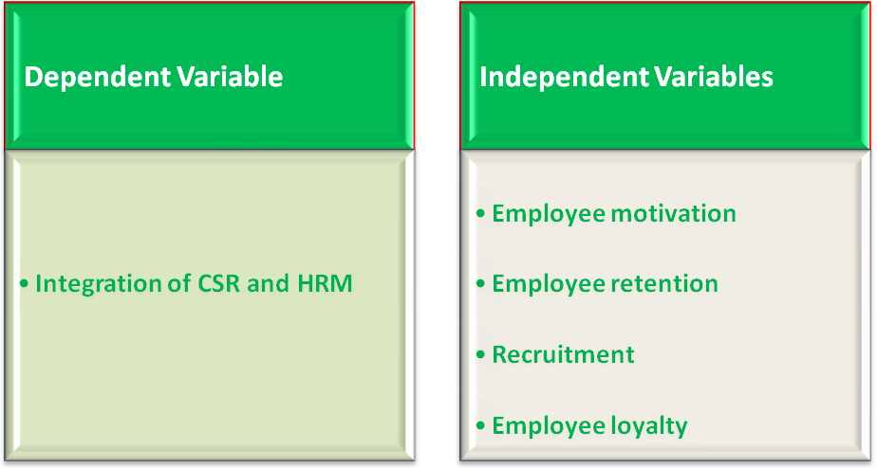
Table 1: dependent and independent variables

- Influence of Internal CSR activities and HRM activities

Frequency Analysis:

Table 2: Internal CSR activities and HRM activities

 |  | Frequency | Percent | Valid Percent | Cumulative Percent
Valid | disagree | 2 | 4.0 | 4.0 | 4.0
Valid | neutral | 4 | 8.0 | 8.0 | 12.0
Valid | agree | 21 | 42.0 | 42.0 | 54.0
Valid | highly agree | 23 | 46.0 | 46.0 | 100.0
Valid | Total | 50 | 100.0 | 100.0

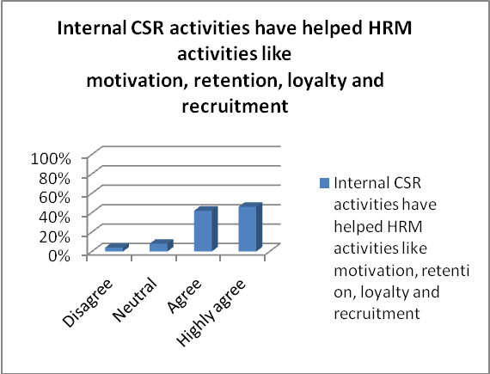

Figure 2: Internal CSR activities have helped HRM activities like motivation, retention, loyalty and recruitment

From the frequency table we see that 46% percent respondents highly agreed that their company’s internal CSR activities have helped HRM activities like motivation, retention, loyalty and recruitment, another 42% respondents agreed with this statement. 8% respondents are neutral about this statement and 4% disagree the statement.
- Considering HRM practices from CSR perspective

 |  | Frequency | Percent | Valid Percent | Cumulative Percent
Valid | disagree | 8 | 16.0 | 16.0 | 16.0
Valid | neutral | 10 | 20.0 | 20.0 | 36.0
Valid | agree | 21 | 42.0 | 42.0 | 78.0
Valid | highly agree | 11 | 22.0 | 22.0 | 100.0
Valid | Total | 50 | 100.0 | 100.0

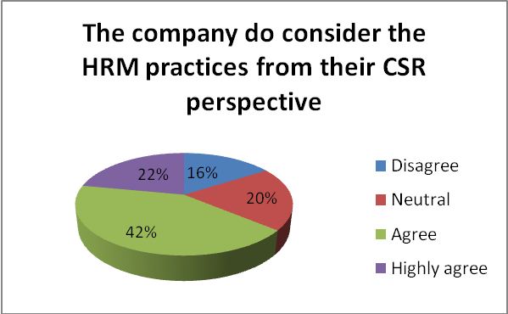

Figure 3: The Company does consider the HRM practices from their CSR perspective

From the frequency table we see that 42% respondents agreed that their company do consider the HRM practices from their CSR perspective, another 22% respondents highly agreed with this statement. 20% respondents are neutral about this statement and 16% disagree the statement.
- The company successfully used HRM to promote CSR
 |  | Frequency | Percent | Valid Percent | Cumulative Percent
Valid | disagree | 6 | 12.0 | 12.0 | 12.0
Valid | neutral | 7 | 14.0 | 14.0 | 26.0
Valid | agree | 25 | 50.0 | 50.0 | 76.0
Valid | disagree | 12 | 24.0 | 24.0 | 100.0
Valid | Total | 50 | 100.0 | 100.0

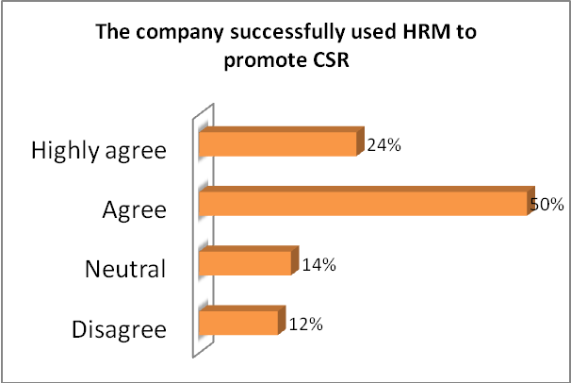

Figure 4: The company successfully used HRM to promote CSR

From the frequency table we see that 50% respondents agreed that their company has successfully used HRM to promote CSR, another 24% respondents highly agreed with this statement. 14% respondents are neutral about this statement and 12% disagree the statement.
- The influence of HRM on the CSR policy

 |  | Frequency | Percent | Valid Percent | Cumulative Percent
Valid | disagree | 4 | 8.0 | 8.0 | 8.0
Valid | neutral | 12 | 24.0 | 24.0 | 32.0
Valid | agree | 14 | 28.0 | 28.0 | 60.0
Valid | highly agree | 20 | 40.0 | 40.0 | 100.0
Valid | Total | 50 | 100.0 | 100.0

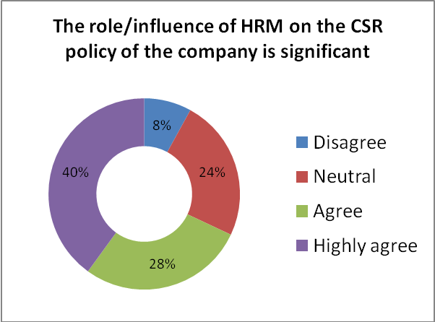

Figure 5: The role/influence of HRM on the CSR policy of the company is significant

From the frequency table we see that 40% respondents highly agreed that the role/influence of HRM on the CSR policy of the company is significant, another 28% respondents agreed with this statement. 24% respondents are neutral about this statement and 8% disagree the statement.

- Employee Motivation and Internal CSR activities

Regression:

Employee Motivation and Internal CSR activities

The null and alternative hypotheses for testing are assumed below:
Ho: There is no relationship between “Employee Motivation” & “Internal CSR activities have helped HRM activities like motivation”
H1: There is relationship between “Employee Motivation” & “Internal CSR activities have helped HRM activities like motivation”
ANOVA^{b}
Model |  |  | Sum of Squares |  | df |  | Mean Square |  | F |  | Sig.
1 |  | Regression | 6.963 |  | 4 |  | 1.741 |  | 3.328 |  | .018ª
 |  | Residual | 23.537 |  | 45 |  | .523
 |  | Total | 30.500 |  | 49
a. Predictors: (Constant), Increasing Corporate Image & Branding allows a company to enhance employee morale., Our staffs are motivated and proud to work at our company., “Shohoj Kisti Reen Prokalpa” helps to motivate the employees., CSR activities directed towards women employees help to has increased their moral significantly.
b. Dependent Variable: Internal CSR activities have helped HRM activities like motivation, retention, loyalty and recruitment
Coefficientsª
Model |  |  |  | Unstandardized Coefficients |  |  |  | Standardized Coefficients |  | t |  | Sig.
 |  |  |  | B |  | Std. Error |  | Beta
1 | (Constant) |  |  | 1.913 |  | .981 |  |  |  | 1.950 |  | .057
1 | Our staffs are motivated and proud to work at our company. |  |  | .031 |  | .226 |  | .020 |  | .139 |  | .040
1 | “Shohoj Kisti Reen Prokalpa” helps to motivate the employees. |  |  | .208 |  | .138 |  | .244 |  | 1.503 |  | .042
1 | CSR activities directed towards women employees help to has increased their moral significantly. |  |  | .333 |  | .170 |  | .318 |  | 1.960 |  | .056
1 | Increasing Corporate Image & Branding allows a company to enhance employee morale. |  |  | -.013 |  | .174 |  | -.013 |  | -.075 |  | .037
a. Dependent Variable: Internal CSR activities have helped HRM activities like motivation, retention, loyalty and recruitment

Interpretation:
From the analysis we see that F is 3.328 and the sig or probability of F is 0.018 which is less than .05. Which means it is significant. So we reject the null hypothesis. H1 is proven true which implies that there is relationship between “Employee Motivation” & “Internal CSR activities have helped HRM activities like motivation”
In this case we can say that internal CSR activities have helped to influence the employee motivation.
Employee Retention and Internal CSR activities

The null and alternative hypotheses for testing are assumed below:
Ho: There is no linear relationship between “Employee Retention” & “Internal CSR activities have helped HRM activities like retention”
H1: There is linear relationship between “Employee Retention” & “Internal CSR activities have helped HRM activities like retention”

ANOVA^{b}
Model |  | Sum of Squares | df | Mean Square | F | Sig.
1 | Regression | 6.655 | 4 | 1.664 | 3.140 | .023ª
1 | Residual | 23.845 | 45 | .530
1 | Total | 30.500 | 49
a. Predictors: (Constant), On-Job Training to all level employees reduce employee turnover, Strict maintenance of the labor standards enabled the initiative to be a big success improving the employee retention levels., Workers’ Trade Union “Square Kormochari Samity” can negotiate with the management about labor issues which promotes retention, Incorporating CSR into the corporate image & brand can enhance employee retention
b. Dependent Variable: Internal CSR activities have helped HRM activities like motivation, retention, loyalty and recruitment

Employee motivation and HRM practices from CSR perspective

The null and alternative hypotheses for testing are assumed below:
Ho: There is no linear relationship between “Employee motivation” & “The company do consider the HRM practices from their CSR perspective”
H1: There is linear relationship between “Employee motivation” & “The company do consider the HRM practices from their CSR perspective”

ANOVA^{b}
Model |  | Sum of Squares | df | Mean Square | F | Sig.
1 | Regression | 16.758 | 4 | 4.190 | 5.939 | .001ª
1 | Residual | 31.742 | 45 | .705
1 | Total | 48.500 | 49
a. Predictors: (Constant), Increasing Corporate Image & Branding allows a company to enhance employee morale., Our staffs are motivated and proud to work at our company., “Shohoj Kisti Reen Prokalpa” helps to motivate the employees., CSR activities directed towards women employees help to has increased their moral significantly.
b. Dependent Variable: The company do consider the HRM practices from their CSR perspective

Coefficientsª
Model |  | Unstandardized Coefficients |  | Standardized Coefficients | t | Sig.
 |  | B | Std. Error | Beta | t | Sig.
1 | (Constant) | .043 | 1.139 |  | .038 | .070
1 | Our staffs are motivated and proud to work at our company. | .037 | .263 | .019 | .140 | .089
1 | “Shohoj Kisti Reen Prokalpa” helps to motivate the employees. | .408 | .160 | .380 | 2.546 | .014
1 | CSR activities directed towards women employees help to has increased their moral significantly. | .106 | .197 | .080 | .537 | .094
1 | Increasing Corporate Image & Branding allows a company to enhance employee morale. | .308 | .203 | .234 | 1.519 | .036
a. Dependent Variable: The company do consider the HRM practices from their CSR perspective

Interpretation:
From the analysis we see that F is 5.939 and the sig or probability of F is 0.001 which is less than .05. Which means it is significant. So we reject the null hypothesis. H1 is proven true which implies that there is significant relationship between “Employee motivation” & “The company do consider the HRM practices from their CSR perspective”
In this case we can say that the company do consider employee motivation from their CSR perspective.
Employee retention and HRM practices from CSR perspective

The null and alternative hypotheses for testing are assumed below:
Ho: There is no linear relationship between “Employee retention” & “The company do consider the HRM practices from their CSR perspective”
H1: There is linear relationship between “Employee retention” & “The company do consider the HRM practices from their CSR perspective

ANOVA^{b}
Model |  | Sum of Squares | df | Mean Square | F | Sig.
1 | Regression | 15.991 | 4 | 3.998 | 5.534 | .001ª
1 | Residual | 32.509 | 45 | .722
1 | Total | 48.500 | 49
a. Predictors: (Constant), On-Job Training to all level employees reduce employee turnover, Strict maintenance of the labor standards enabled the initiative to be a big success improving the employee retention levels., Workers’ Trade Union “Square Kormochari Samity” can negotiate with the management about labor issues which promotes retention, Incorporating CSR into the corporate image & brand can enhance employee retention
b. Dependent Variable: The company do consider the HRM practices from their CSR perspective

Coefficientsª
Model |  | Unstandardized Coefficients |  | Standardized Coefficients | t | Sig.
 |  | B | Std. Error | Beta | t | Sig.
1 | (Constant) | -.375 | 1.145 |  | -.327 | .045
1 | Strict maintenance of the labor standards enabled the initiative to be a big success improving the employee retention levels. | .070 | .173 | .058 | .407 | .086
1 | Incorporating CSR into the corporate image & brand can enhance employee retention | -.041 | .182 | -.034 | -.223 | .024
1 | Workers’ Trade Union “Square Kormochari Samity” can negotiate with the management about labor issues which promotes retention | .459 | .161 | .401 | 2.849 | .007
1 | On-Job Training to all level employees reduce employee turnover | .475 | .190 | .322 | 2.492 | .016
a. Dependent Variable: The company do consider the HRM practices from their CSR perspective

Interpretation:
From the analysis we see that F is 5.534 and the sig or probability of F is 0.001 which is less than .05. Which means it is significant. So we reject the null hypothesis. H1 is proven true which implies that there is significant relationship between “Employee retention” & “The company do consider the HRM practices from their CSR perspective”
In this case we can say that the company do consider employee retention from their CSR perspective.

Recruitment and HRM practices from CSR perspective

The null and alternative hypotheses for testing are assumed below:
Ho: There is no linear relationship between “Recruitment” & “The company do consider the HRM practices from their CSR perspective”
H1: There is linear relationship between “Recruitment” & “The company do consider the HRM practices from their CSR perspective”

ANOVA^{b}
Model |  | Sum of Squares | df | Mean Square | F | Sig.
1 | Regression | 26.541 | 4 | 6.635 | 13.598 | .000ª
1 | Residual | 21.959 | 45 | .488
1 | Total | 48.500 | 49
a. Predictors: (Constant), CSR activities of our company has lessen the recruitment cost , Incorporating CSR into the employer brand can enhance recruitment, We recruited based on their skill and competency, Our CSR activities for the employees helps to attract talent pool while recruiting
b. Dependent Variable: The company do consider the HRM practices from their CSR perspective

Coefficientsª
Model |  | Unstandardized Coefficients |  | Standardized Coefficients | t | Sig.
 |  | B | Std. Error | Beta | t | Sig.
1 | (Constant) | -.207 | .985 |  | -.210 | .035
1 | Incorporating CSR into the employer brand can enhance recruitment | .173 | .170 | .119 | 1.020 | .013
1 | We recruited based on their skill and competency | .015 | .160 | .012 | .091 | .028
1 | Our CSR activities for the employees helps to attract talent pool while recruiting | .155 | .155 | .140 | 1.002 | .022
1 | CSR activities of our company has lessen the recruitment cost | .620 | .128 | .683 | 4.834 | .000
a. Dependent Variable: The company do consider the HRM practices from their CSR perspective

Interpretation:
From the analysis we see that F is 13.598 and the sig or probability of F is 0.000 which is less than .05. Which means it is significant. So we reject the null hypothesis. H1 is proven true which implies that there is significant relationship between “Recruitment” & “The company do consider the HRM practices from their CSR perspective”
In this case we can say that the company do consider recruitment from their CSR perspective.

Employee motivation and using HRM to promote CSR

The null and alternative hypotheses for testing are assumed below:
Ho: There is no linear relationship between “Employee motivation” & “The company successfully used HRM to promote CSR”
H1: There is linear relationship between “Employee motivation” & “The company successfully used HRM to promote CSR”

ANOVA^{b}
Model |  | Sum of Squares | df | Mean Square | F | Sig.
1 | Regression | 13.632 | 4 | 3.408 | 5.402 | .001ª
1 | Residual | 28.388 | 45 | .631
1 | Total | 42.020 | 49
a. Predictors: (Constant), Increasing Corporate Image & Branding allows a company to enhance employee morale., Our staffs are motivated and proud to work at our company., “Shohoj Kisti Reen Prokalpa” helps to motivate the employees., CSR activities directed towards women employees help to has increased their moral significantly.
b. Dependent Variable: The company successfully used HRM to promote CSR

Coefficientsª
Model |  | Unstandardized Coefficients |  | Standardized Coefficients | t | Sig.
 |  | B | Std. Error | Beta | t | Sig.
1 | (Constant) | .622 | 1.078 |  | .578 | .566
1 | Our staffs are motivated and proud to work at our company. | .359 | .249 | .200 | 1.446 | .055
1 | “Shohoj Kisti Reen Prokalpa” helps to motivate the employees. | .452 | .152 | .452 | 2.978 | .005
1 | CSR activities directed towards women employees help to has increased their moral significantly. | -.119 | .187 | -.097 | -.637 | .027
1 | Increasing Corporate Image & Branding allows a company to enhance employee morale. | .101 | .192 | .082 | .526 | .032
a. Dependent Variable: The company successfully used HRM to promote CSR

Interpretation:
From the analysis we see that F is 5.402 and the sig or probability of F is 0.001 which is less than .05. Which means it is significant. So we reject the null hypothesis. H1 is proven true which implies that there is significant relationship between “Employee motivation” & “The company successfully used HRM to promote CSR”
In this case we can say that the company successfully used employee motivation to promote CSR.

Recruitment and using HRM to promote CSR

The null and alternative hypotheses for testing are assumed below:
Ho: There is no linear relationship between “Recruitment” & “The company successfully used HRM to promote CSR”
H1: There is linear relationship between “Recruitment” & “The company successfully used HRM to promote CSR”

ANOVA^{b}
Model |  | Sum of Squares | df | Mean Square | F | Sig.
1 | Regression | 23.885 | 4 | 5.971 | 14.817 | .000ª
1 | Residual | 18.135 | 45 | .403
1 | Total | 42.020 | 49
a. Predictors: (Constant), CSR activities of our company has lessen the recruitment cost , Incorporating CSR into the employer brand can enhance recruitment, We recruited based on their skill and competency, Our CSR activities for the employees helps to attract talent pool while recruiting
b. Dependent Variable: The company successfully used HRM to promote CSR

Coefficientsª
Model |  | Unstandardized Coefficients |  | Standardized Coefficients | t | Sig.
 |  | B | Std. Error | Beta | t | Sig.
1 | (Constant) | 1.070 | .895 |  | 1.195 | .038
1 | Incorporating CSR into the employer brand can enhance recruitment | -.182 | .154 | -.134 | -1.179 | .045
1 | We recruited based on their skill and competency | .119 | .145 | .103 | .820 | .016
1 | Our CSR activities for the employees helps to attract talent pool while recruiting | .241 | .140 | .234 | 1.714 | .093
1 | CSR activities of our company has lessen the recruitment cost | .516 | .117 | .610 | 4.426 | .000
a. Dependent Variable: The company successfully used HRM to promote CSR

Interpretation:
From the analysis we see that F is 14.817 and the sig or probability of F is 0.000 which is less than .05. Which means it is significant. So we reject the null hypothesis. H1 is proven true which implies that there is significant relationship between “Recruitment” & “The company successfully used HRM to promote CSR”
In this case we can say that the company successfully used recruitment to promote CSR.

Chi-square analysis:

- Chi-square analysis of Employee motivation

The null and alternative hypotheses for testing are assumed below:
Ho: There is no association between Employee motivation and Internal CSR activities
H1: There association between Employee motivation and Internal CSR activities

Test Statistics
 | Our staffs are motivated and proud to work at our company. | “Shohoj Kisti Reen Prokalpa” helps to motivate the employees. | CSR activities directed towards women employees help to has increased their moral significantly. | Increasing Corporate Image & Branding allows a company to enhance employee morale.
Chi-Square | 37.240ª | 38.200^{b} | 32.080^{c} | 12.640ª
df | 2 | 4 | 3 | 2
Asymp. Sig. | .000 | .000 | .000 | .002
a. 0 cells (.0%) have expected frequencies less than 5. The minimum expected cell frequency is 16.7.
b. 0 cells (.0%) have expected frequencies less than 5. The minimum expected cell frequency is 10.0.
c. 0 cells (.0%) have expected frequencies less than 5. The minimum expected cell frequency is 12.5.

Interpretation:
From the analysis we see that all the sig or probability of F is less than .05. Which means it is significant. So we reject the null hypothesis. H1 is proven true which implies that there is association between Employee motivation and Internal CSR activities.
- Chi-square analysis of Employee retention

The null and alternative hypotheses for testing are assumed below:
Ho: There is no association between Employee retention and Internal CSR activities
H1: There is association between Employee retention and Internal CSR activities

Test Statistics
 | Strict maintenance of the labor standards enabled the initiative to be a big success improving the employee retention levels. | Incorporating CSR into the corporate image & brand can enhance employee retention | Workers’ Trade Union “Square Kormochari Samity” can negotiate with the management about labor issues which promotes retention | On-Job Training to all level employees reduce employee turnover
Chi-Square | 19.280ª | 29.040ª | 16.400ª | 14.680^{b}
df | 3 | 3 | 3 | 2
Asymp. Sig. | .000 | .000 | .001 | .001
a. 0 cells (.0%) have expected frequencies less than 5. The minimum expected cell frequency is 12.5.
b. 0 cells (.0%) have expected frequencies less than 5. The minimum expected cell frequency is 16.7.

Interpretation:
From the analysis we see that all the sig or probability of F is less than .05. Which means it is significant. So we reject the null hypothesis. H1 is proven true which implies that there is association between Employee retention and Internal CSR activities

- Chi-square analysis of Recruitment

The null and alternative hypotheses for testing are assumed below:
Ho: There is no association between Recruitment and Internal CSR activities
H1: There is association between Recruitment and Internal CSR activities

Test Statistics
 | Incorporating CSR into the employer brand can enhance recruitment | We recruited based on their skill and competency | Our CSR activities for the employees helps to attract talent pool while recruiting | CSR activities of our company has lessen the recruitment cost
Chi-Square | 9.760ª | 23.440^{b} | 14.480^{b} | 32.600^{c}
df | 2 | 3 | 3 | 4
Asymp. Sig. | .008 | .000 | .002 | .000
a. 0 cells (.0%) have expected frequencies less than 5. The minimum expected cell frequency is 16.7.
b. 0 cells (.0%) have expected frequencies less than 5. The minimum expected cell frequency is 12.5.
c. 0 cells (.0%) have expected frequencies less than 5. The minimum expected cell frequency is 10.0.

Interpretation:
From the analysis we see that all the sig or probability of F is less than .05. Which means it is significant. So we reject the null hypothesis. H1 is proven true which implies that there is association between Recruitment and Internal CSR activities.
- Chi-square analysis of Employee loyalty

The null and alternative hypotheses for testing are assumed below:
Ho: There is no association between Employee loyalty and Internal CSR activities
H1: There is association between Recruitment and Internal CSR activities
Test Statistics
 | The more socially responsible the company becomes the more loyalty is shown by the staffs towards their jobs. | The company helps to ensure the health and safety of employees, which influences loyalty. | Management and Labor Mutual Understanding in workplace influences loyalty. | Have a policy to ensure honesty and quality in all company’s contracts, dealings and advertizing promotes loyalty
Chi-Square | 12.280ª | 22.800^{b} | 17.360^{b} | 18.960^{b}
df | 2 | 3 | 3 | 3
Asymp. Sig. | .002 | .000 | .001 | .000
a. 0 cells (.0%) have expected frequencies less than 5. The minimum expected cell frequency is 16.7.
b. 0 cells (.0%) have expected frequencies less than 5. The minimum expected cell frequency is 12.5.

Interpretation:
From the analysis we see that all the sig or probability of F is less than .05. Which means it is significant. So we reject the null hypothesis. H1 is proven true which implies that there is association between Recruitment and Internal CSR activities
- Chi-square analysis of Integration of CSR and HRM

The null and alternative hypotheses for testing are assumed below:
Ho: There is no association between Internal CSR activities and HRM
H1: There is association between Internal CSR activities and HRM
Test Statistics
 | Internal CSR activities have helped HRM activities like motivation, retention, loyalty and recruitment | The company do consider the HRM practices from their CSR perspective | The company successfully used HRM to promote CSR | The role/influence of HRM on the CSR policy of the company is significant
Chi-Square | 29.200ª | 8.080ª | 18.320ª | 10.480ª
df | 3 | 3 | 3 | 3
Asymp. Sig. | .000 | .044 | .000 | .015
a. 0 cells (.0%) have expected frequencies less than 5. The minimum expected cell frequency is 12.5.

Interpretation: From the analysis we see that all the sig or probability of F is less than .05. Which means it is significant. So we reject the null hypothesis. H1 is proven true which implies that There is association between Internal CSR activities and HRM
ANOVA:
- One way ANOVA between CSR activities directed towards woman employees and Integration of CSR and HRM

The null and alternative hypotheses for testing are assumed below:
Ho: The population means of Internal CSR activities have helped HRM activities like motivation, retention, loyalty and recruitment and CSR activities directed towards women employees help to has increased their moral significantly are not equal
H1: The population means of Internal CSR activities have helped HRM activities like motivation, retention, loyalty and recruitment and CSR activities directed towards women employees help to has increased their moral significantly are equal

ANOVA
 |  | Sum of Squares | df | Mean Square | F | Sig.
Internal CSR activities have helped HRM activities like motivation, retention, loyalty and recruitment | Between Groups | 7.538 | 3 | 2.513 | 5.034 | .004
 | Within Groups | 22.962 | 46 | .499 | 5.034 | .004
 | Total | 30.500 | 49 | .499 | 5.034 | .004

If the value of the mean MSG ÷ MSW = F then we accept null hypothesis
If the value of the mean MSG ÷ MSW ≠ F then we reject null hypothesis
From the analysis we see that MSG ÷ MSW is 5.036 and the F ratio is 5.034 which is not equal. So we reject the null hypothesis. H1 is proven true which implies that the population means of Internal CSR activities have helped HRM activities like motivation, retention, loyalty and recruitment and CSR activities directed towards women employees help to has increased their moral significantly are equal.
In this case we can say that internal CSR activities have helped to influence the moral of woman employees.

- One way ANOVA between CSR activities directed towards woman employees and HRM practices from CSR perspective

The null and alternative hypotheses for testing are assumed below:
Ho: The population means of The company do consider the HRM practices from their CSR perspective and CSR activities directed towards women employees help to has increased their moral significantly are not equal
H1: The population means of The company do consider the HRM practices from their CSR perspective and CSR activities directed towards women employees help to has increased their moral significantly are equal

ANOVA
 |  | Sum of Squares | df | Mean Square | F | Sig.
The company do consider the HRM practices from their CSR perspective | Between Groups | 9.843 | 3 | 3.281 | 3.904 | .014
 | Within Groups | 38.657 | 46 | .840 | 3.904 | .014
 | Total | 48.500 | 49 | .840 | 3.904 | .014

If the value of the mean MSG ÷ MSW = F then we accept null hypothesis
If the value of the mean MSG ÷ MSW ≠ F then we reject null hypothesis
From the analysis we see that MSG ÷ MSW is 3.906 and the F ratio is 5.904 which is not equal. So we reject the null hypothesis. H1 is proven true which implies that the population means of The company do consider the HRM practices from their CSR perspective and CSR activities directed towards women employees help to has increased their moral significantly are equal.
In this case we can say that internal CSR activities have helped to influence the moral of woman employees.

- One way ANOVA between CSR activities directed towards woman employees and successfully using HRM to promote CSR

The null and alternative hypotheses for testing are assumed below:
Ho: The population means of The company successfully used HRM to promote CSR and CSR activities directed towards women employees help to has increased their moral significantly are not equal
H1: The population means of The company successfully used HRM to promote CSR and CSR activities directed towards women employees help to has increased their moral significantly are equal

ANOVA
 |  | Sum of Squares | df | Mean Square | F | Sig.
The company successfully used HRM to promote CSR | Between Groups | 7.414 | 3 | 2.471 | 3.285 | .029
 | Within Groups | 34.606 | 46 | .752 | 3.285 | .029
 | Total | 42.020 | 49 | .752 | 3.285 | .029
If the value of the mean MSG ÷ MSW = F then we accept null hypothesis
If the value of the mean MSG ÷ MSW ≠ F then we reject null hypothesis
From the analysis we see that MSG ÷ MSW is 3.286 and the F ratio is 3.285 which is not equal. So we reject the null hypothesis. H1 is proven true which implies that the population means of The company successfully used HRM to promote CSR and CSR activities directed towards women employees help to has increased their moral significantly are equal.
In this case we can say that internal CSR activities have helped to influence the moral of woman employees.

Crosstabs:
Crosstabs between “Employee Motivation” and “Integration of CSR and HRM”

Chi-Square Tests
 | Value | df | Asymp. Sig. (2-sided)
Pearson Chi-Square | 13.527ª | 6 | .035
Likelihood Ratio | 14.012 | 6 | .030
Linear-by-Linear Association | .902 | 1 | .342
N of Valid Cases | 50
a. 10 cells (83.3%) have expected count less than 5. The minimum expected count is .24.

Symmetric Measures
 |  | Value | Approx. Sig.
Nominal by Nominal | Phi | .520 | .035
Nominal by Nominal | Cramer's V | .368 | .035
N of Valid Cases |  | 50

We can see from the Crosstabs that 40 % respondents highly agree that Internal CSR activities have helped HRM activities like motivation, retention, loyalty and recruitment. 28% respondents think that Our staffs are motivated and proud to work at our company.
Chi-Square (degree of freedom) = value, p=?
Chi-square (6) = 13.527, P= .035
Since, the significance level is less than 0.05; we can say that this test is statistically significant. Hence, there is significant association between “Employee Motivation” and “Integration of CSR and HRM”
Moreover, in this test, Cramer’s value is 0.368 and the corresponding significance level is 0.035. From the Cramer’s value we can say that the relationship between the two variables is strong. And, significance level less than 0.05 indicate that this finding is significant.
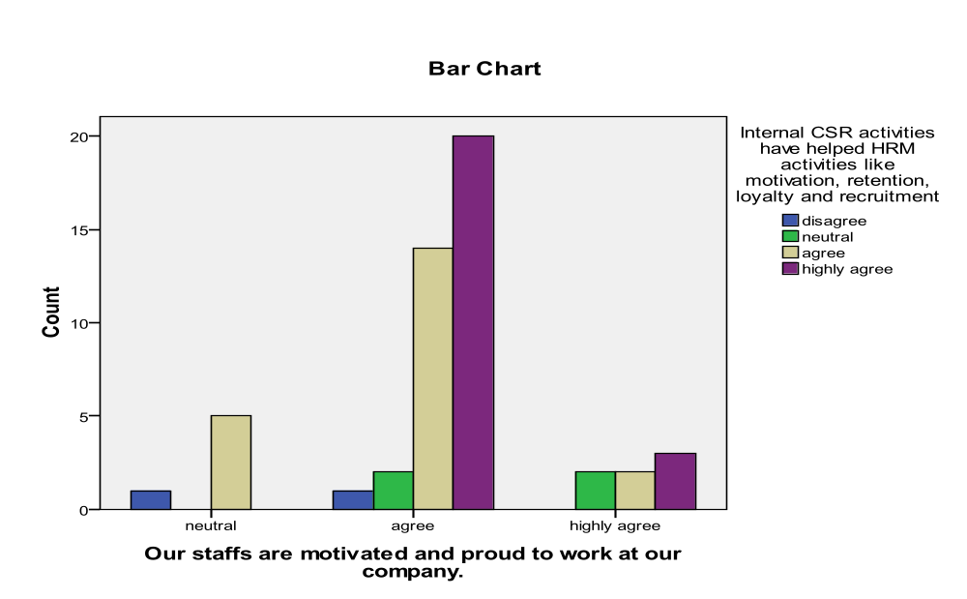
From the Bar Chart that we have got from the crosstabs analysis; we can see that the tallest bar is highly agree and agree respectively. So, it seems that that most of the respondents agree that internal CSR activities has helped the HRM activies and also has motivated the staffs to work in this company.

Correlation:

- Correlation between Integration of CSR and HRM and Employee motivation

Correlations
 |  |  | Increasing Corporate Image & Branding allows a company to enhance employee morale. | Internal CSR activities have helped HRM activities like motivation, retention, loyalty and recruitment
Spearman's rho | Increasing Corporate Image & Branding allows a company to enhance employee morale. | Correlation Coefficient | 1.000 | .007
Spearman's rho |  | Sig. (2-tailed) | . | .050
Spearman's rho |  | N | 50 | 50
Spearman's rho | Internal CSR activities have helped HRM activities like motivation, retention, loyalty and recruitment | Correlation Coefficient | .207 | 1.000
Spearman's rho |  | Sig. (2-tailed) | .150 | .
Spearman's rho |  | N | 50 | 50

Here we can see that the correlation coefficient (r) between “Increasing Corporate Image & Branding allows a company to enhance employee morale” and “Internal CSR activities have helped HRM activities like motivation, retention, loyalty and recruitment” is r = 0.007 (0 < r < 1), which means the two variables tend to increase or decrease together.

- Correlation between Integration of CSR and HRM and Employee retention

Correlations
 |  |  | Internal CSR activities have helped HRM activities like motivation, retention, loyalty and recruitment | Incorporating CSR into the corporate image & brand can enhance employee retention
Spearman's rho | Internal CSR activities have helped HRM activities like motivation, retention, loyalty and recruitment | Correlation Coefficient | 1.000 | .015
Spearman's rho |  | Sig. (2-tailed) | . | .016
Spearman's rho |  | N | 50 | 50
Spearman's rho | Incorporating CSR into the corporate image & brand can enhance employee retention | Correlation Coefficient | .015 | 1.000
Spearman's rho |  | Sig. (2-tailed) | .916 | .
Spearman's rho |  | N | 50 | 50

Here we can see that the correlation coefficient (r) between “Incorporating CSR into the corporate image & brand can enhance employee retention” and “Internal CSR activities have helped HRM activities like motivation, retention, loyalty and recruitment” is r = 0.015 (0 < r < 1), which means the two variables tend to increase or decrease together.

- Correlation between Integration of CSR and HRM and Recruitment

Correlations
 |  |  | Internal CSR activities have helped HRM activities like motivation, retention, loyalty and recruitment | Our CSR activities for the employees helps to attract talent pool while recruiting
Spearman's rho | Internal CSR activities have helped HRM activities like motivation, retention, loyalty and recruitment | Correlation Coefficient | 1.000 | .002
Spearman's rho |  | Sig. (2-tailed) | . | .091
Spearman's rho |  | N | 50 | 50
Spearman's rho | Our CSR activities for the employees helps to attract talent pool while recruiting | Correlation Coefficient | .002 | 1.000
Spearman's rho |  | Sig. (2-tailed) | .991 | .
Spearman's rho |  | N | 50 | 50

Here we can see that the correlation coefficient (r) between “Our CSR activities for the employees helps to attract talent pool while recruiting” and “Internal CSR activities have helped HRM activities like motivation, retention, loyalty and recruitment” is r = 0.002 (0 < r < 1), which means the two variables tend to increase or decrease together. The value of r is also very close to 0, so we can also say that the two variables do not vary together.

- Correlation between Integration of CSR and HRM and Recruitment

Correlations
 |  |  | Internal CSR activities have helped HRM activities like motivation, retention, loyalty and recruitment | The more socially responsible the company becomes the more loyalty is shown by the staffs towards their jobs.
Spearman's rho | Internal CSR activities have helped HRM activities like motivation, retention, loyalty and recruitment | Correlation Coefficient | 1.000 | .091
Spearman's rho |  | Sig. (2-tailed) | . | .085
Spearman's rho |  | N | 50 | 50
Spearman's rho | The more socially responsible the company becomes the more loyalty is shown by the staffs towards their jobs. | Correlation Coefficient | .191 | 1.000
Spearman's rho |  | Sig. (2-tailed) | .185 | .
Spearman's rho |  | N | 50 | 50

Here we can see that the correlation coefficient (r) between “The more socially responsible the company becomes the more loyalty is shown by the staffs towards their jobs” and “Internal CSR activities have helped HRM activities like motivation, retention, loyalty and recruitment” is r = 0.091 (0 < r < 1), which means the two variables tend to increase or decrease together.

Discussion of Results
From the frequency table we have found that most of the respondents highly agree or agree that internal CSR activities have helped HRM activities like motivation, retention, loyalty and recruitment. They also thinks strongly that the company do consider the HRM practices from their CSR perspective and successfully used HRM to promote CSR. The respondents also agrees about the role/influence of HRM on the CSR policy of the company is significant.
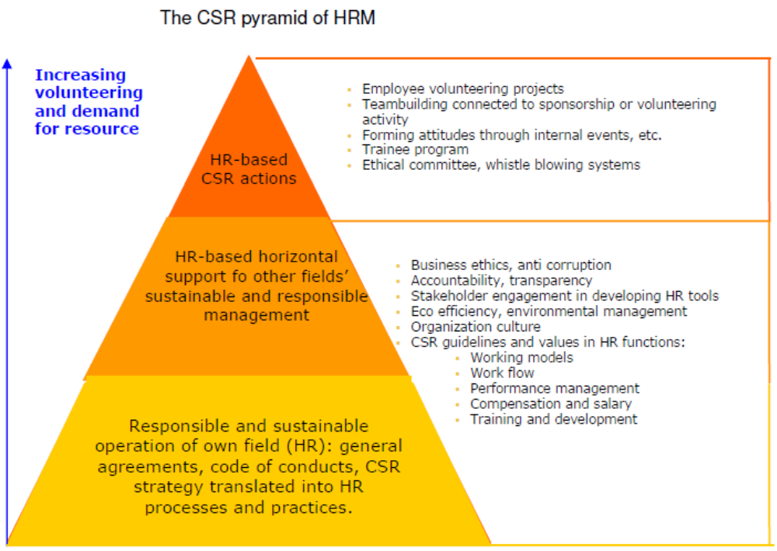
Figure 6: The CSR pyramid of HRM
From the regression analysis we have found that that internal CSR activities have helped to influence the employee motivation and employee retention. We have also found that the company do consider employee motivation, retention and recruitment from their CSR perspective. The company successfully used employee motivation and recruitment to promote CSR. We can say from the results that the company successfully used recruitment to promote CSR, and most of the respondents agree that internal CSR activities has helped the HRM activities and also has motivated the staffs to work in this company.
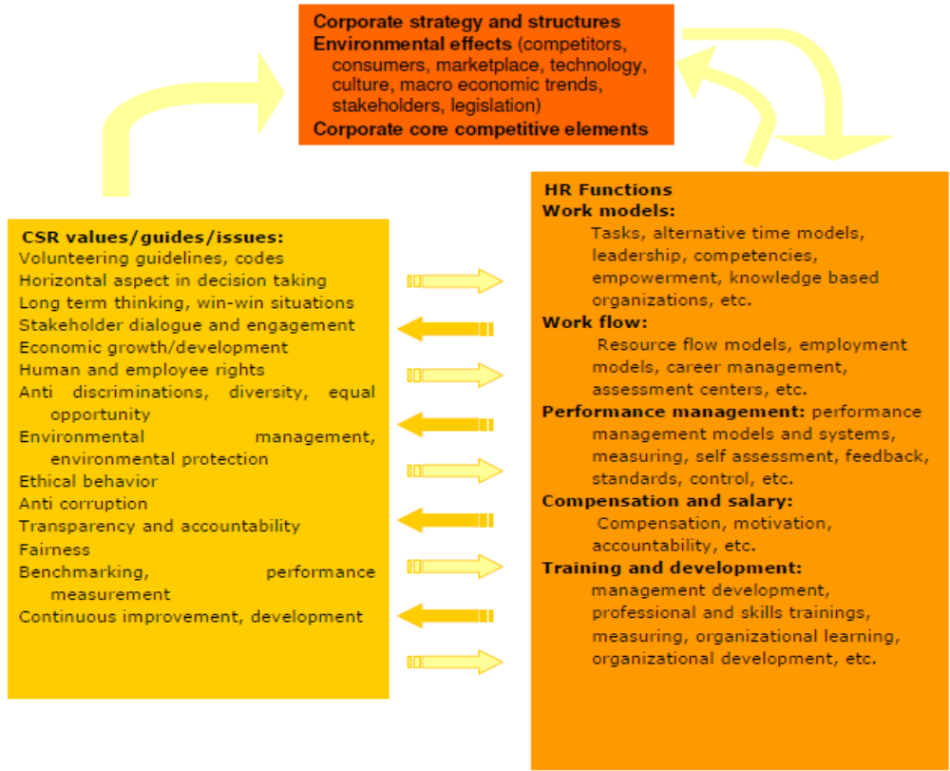
Figure 7: Two way flow between CSR and HRM
Recommendations
Recommendations of these report has been made on the basis of the research findings of the Role of Human Resource Department in Corporate Social Responsibility. It is very difficult to recommend about this topic because of research restrictions and unavailability of data. I have tried to give recommendation based on my personal experience in the company and the findings.

- Developing a formal policy on sustainable practices: The HR department should take the responsibility to develop a formal policy on sustainable practices involving employees. For example, Square can use employee volunteering as a vehicle to achieve business-driven culture. The success of the initiative will lead to the development of a formal policy on employee volunteering. The initiative can be a big success improving the employee retention levels and employee satisfaction.

- The orientation program of newly recruited candidates: The orientation program of newly recruited candidates should be designed in a manner that corporate philosophy about CSR gets highlighted. The commitment of top management towards CSR is very important which should be expressed in tangible terms to reinforce the right kind of behavior in the organization. Corporate presentations, keeping employees updated through mails, regular newsletters are the instruments used to keep employees energized about the organization’s socially responsible initiatives.
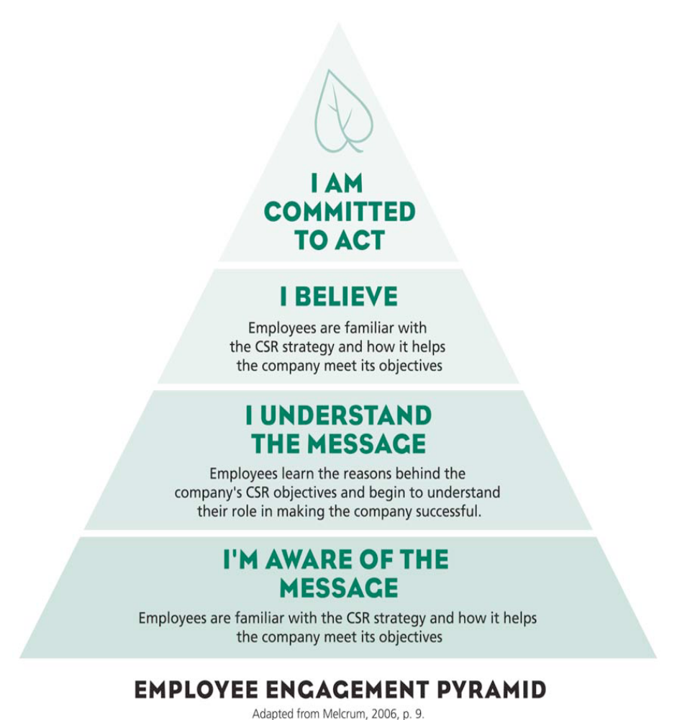
Figure 8: Employee engagement pyramid

- Designing of Performance Management System to measures the socially responsible initiatives: The designing of Performance Management System should be done in such a manner that it measures the socially responsible initiatives taken by employees. This becomes important as the internalization of CSR in an organizational culture requires that appropriate behaviors get appraised, appreciated as well as rewarded. Otherwise, the organization might fail to inculcate it amongst all employees due to lack of positive reinforcement.

- Training facilities to instill the CSR culture: The Training facilities may also be made available to instill the CSR culture among employees. This becomes necessary to make employees learn and practice CSR activities.

- Empowerment of managers by giving them decision-making authority: Empowerment of managers by giving them decision-making authority shall help in executing social responsibility at local level. It becomes important when an organization like Square with plants or units at multiple locations around the country operate. Armed with decision making authority, the managers will be able to appreciate and assess the needs. Therefore, the employees may be appropriately authorized to encourage initiative in the area of social responsibility. Clear reporting and review mechanisms may be put in place in the organization which shall improve the focus and effectiveness of CSR.

- Code of ethics: Code of ethics of an organization can stimulate social responsibility to a great extent reinforcing amongst its employees the underlying values. Training on code of ethics should be undertaken by the organization. The HR department of Square Pharmaceuticals can also develop an e-learning course for its employees built CSR Competency framework.

- Give credibility to the CSR initiatives of the organization: Responsible Human Resource Management practices on equal opportunities, diversity management, whistle blowing, redundancy, human rights, harassment shall give credibility to the CSR initiatives of the organization. It is beyond doubt that protecting human rights such as denial or prevention of legal or social rights of workers is a very important issue under CSR. Square should have framed whistle blowing policy, providing protection to the employees who come to know about any unethical practice going on within the organization, covering a whole gamut of subjects and showing their positive approach towards unethical practices.

- The separation of employees should be strategically aligned with the business strategy as well as CSR: The separation of employees during mergers, acquisitions, downsizing etc. should be strategically aligned with the business strategy as well as Corporate Social responsibility. Retraining, retention, redeployment of people can be worked out with aggressive communication, information campaigns and outplacement services in place to assist the transition of people from the organization.

- Commitment to social or sustainable practices: Social Reports or Sustainability Reports should be prepared to underline the organization’s commitment to social or sustainable practices.

- Effectively measure and evaluate CSR activities: The Human Resource department should effectively measure and evaluate CSR activities. The value added by CSR in the form of direct results, such as, economic savings and indirect results like increase in employee satisfaction, less employee turnover, measured by staff attitude surveys, shall indicate contribution to improved business performance. There is also a need to conduct periodic review of the CSR activities.

Conclusions
Successful programs on social responsibility rely heavily on enlightened people management practices. In this context HR department is assumed to be the coordinator of CSR activities in getting the employment relationship right which is a precondition for establishing effective relationships with external stakeholders and thus can orient the employees and the organization towards a socially responsible character. There is also an increasing trend in the corporate sector which has started leveraging upon employees and their management for exhibiting their commitment towards CSR. Armed with a strong and committed organizational culture reinforced by responsible Human Resource Management practices, the organizations can achieve heights of success by improved profitability, employee morale, customer satisfaction, legal compliance and societal approval for its existence. It is high time for all other organizations which have been paying only lip service to CSR that they must capitalize upon the existing Human Resource Department in framing such practices, procedures and policies that ensure the internalization of quality, ethics and excellence in the whole system. By doing this they can sensitize the employees and the whole organization towards CSR without adding any additional cost.

