Thesis Paper
On

User of Zones for Gis-Based Transport and Socioeconomic Analysis

Submitted by

WWW.ASSIGNMENTPOINT.COM

GIS is designed to accept geographic data from a variety of sources, including maps, satellite photographs, and printed text and statistics. The applications of a GIS are vast and continue to grow. By using a GIS, scientists can research changes in the environment; engineers can design road systems; electrical companies can manage their complex networks of power lines; governments can track the uses of land; and fire and police departments can plan emergency routes. GIS-based transport information of different zones in Bangladesh can make fulfillment of the entire data requirement in the form of maps and tables.

The study area needs to be defined to ensure that all data pertaining
to present and future transportation needs are collected in an efficient and economic manner. These data may be in the form of maps, aerial photograph, charts or maps, and so on and may require the application of a large variety of engineering, environmental, social, and economic knowledge. By analyzing the collected data, study is subdivided by small units which ideally contain a homogeneous activity and closely related to types and intensity of land use. These small units are called zones.

Transportation is very important in every phase of our daily activities that it almost impossible to imagine what would be like without transportation. It is the movement of people and goods and the facilities used for that purpose. The movement of people assumes first importance in the minds of many, especially in urban areas, but the movement of goods, that is, freight transportation, is probably of greater significance to the functioning of our economic society. Both must be considered essential.

Transportation has been an essential part of most societies of the past. One can hardly conceive of a future society in which it would not continue to be essential. The adequacy of its transportation system is a fair index of a country’s economic development. An adequate and efficient transportation system is prerequisite for an overall development of a country. Transport acts as catalyst for socio-economic development which in turn generates demand for transport. Transportation systems, however the term is applied, are also subsystems in the socio-economic system.
Transportation, for example, is only one of several subsystems, albeit an important one, along with sewage, lighting water supply and other components of the socio-economic land use organization known as the urban system or community.

Bangladesh is a low lying country. Large number of rivers and canals crisscrossed the country all over causing construction of large number of bridges and culverts. The soil of Bangladesh is silty alluvium which has low CBR value. So, flood is a major problem here. Also cyclone creates same major problem. That is why infrastructures are highly affected with these occasional natural calamities. Due to natural calamities we get only 5-6 months alright for construction. Rest of the period is non-working. Also scarcity of good construction materials and inadequate fund is major problem in high way.

Due to siltation and corrosion, canal depth is being reduced, so frequent dredging is necessary. Riverbank is shifted due to corrosion and hence the relocation of part becomes very difficult. Also poor condition of river courses, bad storage facilities major ports, no specific training for drivers, manual time consuming loading unloading of goods in waterways transports are the common problem in Bangladesh.

Existence of non-uniform rail gauges, hinders smooth journey, absence of fixed crossing over rivers, inefficient management, lack of skilled manpower are the major problem in the rail ways of Bangladesh.

As small country, we can’t afford much air transit. Poor fare evaluation and travel agents control overall reservation causing major losses in revenue are the problem in air ways.

By studying all the problems of various modes of transport with respect to Bangladesh it can be said that analysis of collected socio-economic data and transport information system is must. Also the data analysis is required to get efficient, economic, dependable, serviceable, convenient and safe transportation facilities.

1.2 OBJECTIVES OF THE STUDY:

For the purpose of getting successful outcome from any research work, there should be certain goals and objectives. In research or studies, objectives must be set before. Objectives of the study help in determining the success of that particular study. The objectives formulated for this study are as follows:

- To investigate zone concepts used for different purposes in Bangladesh.
- To collect relevant transport and socio-economic information.
- To develop GIS maps to represent zone wise transport & socio-economic information.

1.3 SCOPE OF THE STUDY:

In case of traffic management, traffic along major highways in the cities can be monitored by remote cameras or sensors in the roadway to prepare GIS database. A central computer system can be possible to analyze the GIS database information. If roads are congested, traffic flow can be improved by automatically adjusting traffic-signal timing, controlling traffic flow on freeway ramps, or providing information to drivers by means of electronic signs along the roads.

To improve the efficiency of inter-modal transportation, for using various combination of modes of transportation, such as automobiles, mass transit, and airplanes, commuters will be able to receive the GIS database information on the location of bus, train, or subway stations, parking availability, and current arrival and departure times. The availability of advanced GIS information is expected to increase the use of mass transit and thereby decrease traffic congestion.

In the context of Bangladesh, agriculture is of such greater national and economic importance that it is usually inventoried and monitored than other natural resources. The national statistical surveys are performed to monitor growing conditions of crops, annual production and thus can be predicted national agricultural market demand and supply. Many food product companies are dependent on large volumes of agricultural products. They can use a wide range of GIS based data sources including field reports, information on past production.

Land use management and policy decisions are almost always based on the analysis of the interplay of factors pertaining to an issue. The preservation of prime agricultural land involves political, institutional and economic factors. GIS based information system can support this type of complex decision making. GIS applications provide systematic collection, updating, processing and distribution of land-related data as well as all socio-economic data. These are also can be used for legal, administrative and economic decision making as well as various planning, designing activities of road networking. The terms Land Information System (LIS) and Land Records Information System (LRIS) are frequently used to refer to GISes that have been specialized for this application.

For transportation planning, the important starting point is to know what transportation network consists of and the condition and performance of these facilities. Much of the investment that occurs in a state or urban area is aimed at upgrading the physical condition of a facility or improving its performance and that can be too easy to do if GIS database is available. Planning department can be developed by supporting such activities as statistical analysis, mapping of land use, mapping of neighborhood demographics, protection of school and recreational needs and planning for transportation, commercial and industrial development utilizing the GIS data. GIS based socio-economic and transport information techniques can provide cost-effective techniques to generate basic resource planning information.

In my study, analysis of socio-economic data is performed using GIS software. Graphical representation of different types of data analysis is obtained. These can be easily used by planners, designers, and road makers.

1.4 ORGANIZATION OF THE THESIS:

This thesis consists of six chapters. Chapter one contains introduction, chapter two contains literature review. Chapter three contains zone wise other data collection. Chapter four contains integrated multi-modal transport system of Bangladesh. Chapter five contains findings of the study, and chapter six includes conclusions and recommendations.

CHAPTER TWO
ZONE IDENTIFICATION

2.1 WHAT IS ZONE:

The area for data collection needs to be defined. The area is subdivided into small geographic units called traffic analysis zones. The zone should ideally contain a homogeneous activity which is closely related to types and intensity of land uses. The zones should be small enough so that there are a large number of inter-zonal trips being made in the study area. Generally the study area is circumscribed by a boundary line known as cordon line.

The boundaries of these zones should, whenever feasible, coincide with census and with jurisdictional boundaries. The zones should also be small enough so that there are a large number of inter-zonal trips being made in the study area.

2.2 ZONES USED FOR DIFFERENT PURPOSES:

Zoning is performed in different perspectives. Those are as follows:

        - Administrative zone
        - Traffic zone
        - Statistical zone
        - Electoral zone

2.2.1. Administrative zone:

According to this type of zone, the study area is divided into Thana, Upazila, District, Division etc whereas the study area is a country like Bangladesh. In Dhaka city “ward” is also considered as a zone.

2.2.1.1. General administration:

There are two streams of the administrative structure of Bangladesh: I) Policy making centre or Secretariat and II) Field administrative.

I) The Secretariat:

The Secretariat is the source of administrative activities of Bangladesh Government and the centre of Government activities. The different ministries and the offices of their divisions are collectively called the Secretariat. In the Secretariat all the fundamental rules of administration are formulated and finally approved.
The Secretariat is divided into some Ministries. Every ministry is placed under a minister. But the administrative head of the ministry is the secretary. All the responsibilities of the ministry lie with the secretary. The chief function of the minister is formulation of projects and determination of policies. The secretary helps the minister in all affairs.
At the lowest level of the administrative structure of the secretariat in Bangladesh is the Assistant secretary and at the top is the Minister. It is shown in the following chart:

Minister
↓
Secretary
↓
Additional Secretary
↓
Joint Secretary
↓
Deputy Secretary
↓
Senior Assistant Secretary
↓
Assistant Secretary

There may be more than one secretary, Additional Secretary, Joint Secretary, Deputy Secretary, Senior Assistant Secretary and Assistant Secretary in a Ministry. But the number of search officers depends on the importance and volume of activities in addition to ministry there are some Divisions, Departments and Directorate for proper functioning of Government activities and responsibilities. Among the Directorates there are Directorate of Education, Directorate of Health, Directorate of Fisheries etc. One Director General is in charge of one Directorate. The Directorates have been established for the implementation of various development programs. They work according to the principles formulated by the respective ministries.

II) Field Administration:

In Bangladesh, there is Unity form of Government. Areas of the country have been divided into different parts for the purpose of smooth and efficient administration. Here administration is run according to area or field administration is prevalent. In the administrative structure, the next stage of the centre is the Division. Every Division is divided into some districts and districts are divided into some Upazilas. The Upazilas are again divided into some unions and a union consists of some villages. In the administrative structure of Bangladesh local Government is prevalent under the central Government and local self-government. is prevalent at the union level. Field administration structure is shown in the following chart:

Division
↓
District
↓
Upazila
↓
Union

(a) Divisional Administration:

There are Six Divisions in Bangladesh. The responsibility of the Divisional Administrative lies with the Divisional Commissioner. He is a senior member of the Bangladesh civil service (ADMINISTRATION). The Divisional commissioner supervises and coordinates the activities of the Deputy Commissioners. He gets all the facilities like a Joint Secretary. His activities are as follows:
              - to manage the activities of the division relating to the revenue.
              - to plan and implement public welfare activities.
              - to do welfare works and take measure during natural calamities.

(b) District Administration:

Every division is divided into some districts. The Deputy Commissioner is the highest level officer of the district administration. He is a member of the Bangladesh civil service (Administration). A district is the heart of the administration of Bangladesh. There are at present, sixty-four districts in Bangladesh. A Deputy Commissioner has to perform following activities:

              - to implement of all administrative decisions and principles taken in the secretariat.
              - to supervise of the activities of different Govt. departments and providing help and co-operation to the government in the determination of principles.
              - to fix and collect land revenue and other taxes as the chief collector by taking helps of the Additional Deputy Commissioner (Revenue).

              - to maintain peace and tranquility in the district with the assistance of the Police Super as an administrator and a Judge.

              - to performs various functions relating to development of agriculture, industry, education communication and population control f the district.
              - to supervise and control the activities of various autonomous organizations and coordinates activities of all departments and organizations of the district.

(c) Upazila Administration:

Every district is divided into some Upazilas. There are 465 administrative Upazilas in Bangladesh which is proposed to be 476. The chief of the Upazila administration is the Upazila Nirbahi Officer (U.N.O.). He is also a member of Bangladesh civil service (administration). He works as the representative of the Deputy Commissioner in the Upazila.

He has to perform following activities:
              - to supervise of all development and administrative activities, trying cases in the absence of magistrate, acting as the custodian of Treasury and Drawing and Disbursing Officer (D.D.O) of the Upazilas.
              - to perform various activities delegated by the Government.

2.2.1.2 Administrative Structure of police:

The topmost officer of police administration in Bangladesh is the Inspector General of Police (IGP), who controls all departments of police under general supervision of the Home Minister. Senior police officials help him in his work at the Police Headquarters. A Deputy Inspector General of Police is appointed for each range or division (civil administrative unit) of the country. There are six police ranges and one railway police range. Police Commissioner of Dhaka Metropolitan Police, administrative heads of Criminal Investigation Department (CID) and Special Branch (SB) and the Director General of Rapid Action Battalion (RAB) are of the rank of Additional Inspector General.

The Superintendents of Police (SP) are the heads of police administration at the district level. An Additional SP, few Assistant Superintendents of Police and other officials help him in the discharge of his duties. An Assistant SP controls the police administration of a circle. An Officer-in-charge (OC) of the rank of an Inspector heads a Police station ( thana ) under a circle. There are now 573 Police station ( thana ) in the country including those in metropolitan police jurisdictions. After 1982, each thana was upgraded into a upazila (sub-district) and the existing unit of administration, i.e., 'subdivision' was abolished based on the recommendations of Committee for Administrative Reform/Reorganization (CARR) formed in early 1982 by the Ershad government. The principal functionary of an upazila was known as Upazila Nirbahi Officer (UNO). In 1992, the upazila system was abolished and the post of UNO was transformed into Thana Nirbahi Officer (TNO). Under the upazila system, the rank of the OC was upgraded into that of an inspector. The upazila system has since 1999 been revived.

Organizationally, Bangladesh Police has 10 branches and each branch has its own method of action. These branches are under the control of IGP, but they work almost independently. These branches are: District police administration, CID, Special Branch, Railway Police, Traffic Police, River Police, Metropolitan Police, Mounted Police, Armed Police Battalion, Range Reserve Force and Rapid Action Battalion.

Armed police from the Armed Police Battalion are kept reserved in districts and cities to face emergency law and order situations. Activities of CID and SB are extended up to the field level parallel to the mainstream police administration.

The Rapid Action Battalion is the latest addition to the police force, which has been constituted recently in accordance with an Act of Parliament. Forty four percent of this elite force comes from the police and the rest on deputation from various branches of the armed forces. It is at present headed by a Director General of the rank of Additional IG, while a Colonel from the Army is serving as the Deputy Director General. It has a number of battalions in the metropolitan cities of the country, but is mostly concentrated in capital Dhaka. It has gone into full-scale operation with effect from June 2004.
Structure of Police administration can be seen in the following rank formation:

INSPECTOR GENERAL OF POLICE
↓
ASSISTANT INSPECTOR GENERAL (Police Commissioner of DMP, Head of SB & CID, Director General of RAB )
↓
DEPUTY INSPECTOR GENERAL (Division level)
↓
SUPERINTENDENT OF POLICE (District level)
↓
ASSISTANT SUPERINTENDENT OF POLICE (District Circle level)
↓
OFFICER-IN-CHARGE (Police Station / Thana level)

2.2.2. Traffic zone:

The so-called O-D database provides some indication of where the majority of trips are coming from and where they are going to and in which transportation corridors these trips are likely to travel. To determine the origins and corresponding destinations of the trips made in a study area is a critical step in the transportation planning process which is performed with zones and is designated as traffic zone.

2.2.3. Statistical zone:

The study area is divided into analysis zones in order to perform the statistical survey such as population census, people income source and other socio-economic data.

2.2.4. Electoral zone:

In order to perform the electoral system of the country, the study area is divided into some zones which are called electoral zone. Each zone may contain one or more than one upazila. Each zone belongs to a member of parliament (MP) of the Govt.

Table2.1: Electoral seat & electoral zone:
National seat | Electoral seat | Electoral Zone
1 | PANCHAGARH-1 | TETULIA THANA, ATWARI THANA & PANCHAGARH SADAR THANA
2 | PANCHAGARH-2 | BO0DA THANA & DEBIGANJ THANA
3 | THAKURGAON-1 | THAKURGAON SADAR THANA
4 | THAKURGAON-2 | BALIADANGI THANA, HARIPUR THANA, & RANISONKAIL THANA PART
5 | THAKURGAON-3 | PIRGANJ THANA &RANISONKAIL THANA PART
6 | DINAJPUR-1 | KAHARUL THANA & BIRGANJ THANA
7 | DINAJPUR-2 | BOCHAGANJ THANA & BIRAL THANA
8 | DINAJPUR-3 | DINAJPUR SADAR THANA
9 | DINAJPUR-4 | CHIRIRBANDAR THA & KHANSHAMA THANA
11 | DINAJPUR-6 | BIRAMPUR, HAKIMPUR, NAWABGANJ & GHORAGHAT THANA
12 | NILPHAMARI-1 | DOMAR THANA & DIMLA THANA
National seat | Electoral seat | Electoral Zone
13 | NILPHAMARI-2 | NILPHAMARI SADAR THANA
14 | NILPHAMARI-3 | JALDHAKA THANA & KISHORGANJ THANA PART
15 | NILPHAMARI-4 | SAIDPUR THANA & KISHORGANJ THANA PART
16 | LALMONIRHAT-1 | PATGRAM THANA & HATIBANDA
17 | LALMONIRHAT-2 | KALIGANJ THANA & ADITMARI THANA
18 | LALMONIRHAT-3 | LALMONIRHAT SADAR
19 | RANGPUR-1 | RANGPUR SADAR THANA PART
20 | RANGPUR-2 | BADARGANJ THANA & TARAGANJ THANA
21 | RANGPUR-3 | RANGPUR SADAR THANA PART
22 | RANGPUR-4 | KAUNIA THANA & PIRGACHHA THANA
23 | RANGPUR-5 | MITHAPUKUR THANA
24 | RANGPUR-6 | PIRGANJ THANA
25 | KURIGRAM-1 | BHURUNGAMARI THANA & NAGESWARI THANA
26 | KURIGRAM-2 | KURIGRAM SADAR THANA, RAZARHAT THANA & FULBARI THANA
27 | KURIGRAM-3 | ULIPUR THANA
28 | KURIGRAM-4 | CHILMARI THANA, RAUMARI THANA & RAJIBPUR THANA
29 | GAILBANDHA-1 | SONADANGA THANA
30 | GAILBANDHA-2 | GAILBANDHA SADAR THANA
31 | GAILBANDHA-3 | PALASHBARI THANA & SADULLAPUR THANA
32 | GAILBANDHA-4 | GABINDAGANJ THANA
33 | GAILBANDHA-5 | SHAGHATA THANA & FULCHHARI THANA
34 | JOYPURHAT-1 | PANCHBIBI THANA & JOYPURHAT SADAR THANA
35 | JOYPURHAT-2 | AKKELPUR THANA, KHETLALA THANA & KALAI THANA
36 | BOGRA-1 | SHARIAKANDI THAN & SHONATOLA THANA
37 | BOGRA-2 | SHIBGANJ THANA
38 | BOGRA-3 | DHUPCHANCHIA THANA & ADAMDIGHI THANA
39 | BOGRA-4 | KAHALU THANA & NANDIGRAM THANA
40 | BOGRA-5 | SHERPUR THANA & DHUNOT THANA
41 | BOGRA-6 | BOGRA SADAR THANA PART
42 | BOGRA-7 | GABTALI THANA & BOGRA SADAR THANA PART
43 | NAWABGANJ-1 | SHIBGANJ THANA
44 | NAWABGANJ-2 | BHOLAHAT THANA, GOMASTAPUR THANA & NACHOL THANA
45 | NAWABGANJ-3 | NAWABGANJ SADAR THANA
46 | NAOGAON-1 | PORSHA THANA, SHAPAHAR THANA & NIAMATPUR THANA
47 | NAOGAON-2 | PATNITALA THANA & DHAMOIRHAT THANA
48 | NAOGAON-3 | BADALGACHHI THANA & MOHADEBPUR THANA
49 | NAOGAON-4 | MANDA THANA
50 | NAOGAON-5 | NAOGAON SADAR
51 | NAOGAON-6 | RANINAGAR THANA & ATRAI THANA
52 | RAJSHAHI-1 | GODAGARI THANA & TANOR THANA
53 | RAJSHAHI-2 | PABA, BOALIA, RAJPARA, MOTIHAR & SHAH MOKHDUM THANA
54 | RAJSHAHI-3 | MOHANPUR THANA & BAGMARA THANA
55 | RAJSHAHI-4 | DURGAPUR THANA & PUTHIA THANA
56 | RAJSHAHI-5 | CHARGHAT THANA & BAGHA THANA
57 | NATORE-1 | LALPUR THANA & BAGATIPARA THANA
National seat | Electoral seat | Electoral Zone
58 | NATORE-2 | NATORE SADAR THANA
59 | NATORE-3 | SINGRA THANA
60 | NATORE-4 | GURUDASHPUR THANA & BARAIGRAM THANA
61 | SIRAJGANJ-1 | KAJIPUR THANA
62 | SIRAJGANJ-2 | SIRAJGANJ SADAR THANA
63 | SIRAJGANJ-3 | RAIGANJ THANA & TARASH THANA
64 | SIRAJGANJ-4 | ULLAPARA THANA
65 | SIRAJGANJ-5 | BELKUCHI THANA & KAMARKHANDA THANA
66 | SIRAJGANJ-6 | CHAUHALI THANA & SHAHJADPUR THANA PART
67 | SIRAJGANJ-7 | SHAHJADPUR THANA PART
68 | PABNA-1 | SHATHIA THANA & BERA THANA PART
69 | PABNA-2 | SHUJANAGAR THANA & BERA THANA PART
70 | PABNA-3 | CHATMOHAR THANA, BHANGURA THANA & FARIDPUR THANA
71 | PABNA-4 | ATGHARIA THANA & ISHWARDI THANA
72 | PABNA-5 | PABNA SADAR THANA
73 | MEHERPUR-1 | MEHERPUR SADARM THANA & UJIBNAGAR THANA
74 | MEHERPUR-2 | GANGNI THANA
75 | KUSTHIA-1 | DAULATPUR THANA
76 | KUSTHIA-2 | BHERAMARA THANA &MIRPUR THANA
77 | KUSTHIA-3 | KUSTHIA SADAR THANA
78 | KUSTHIA-4 | KHOKSHA THANA & KUMARKHALI THANA
79 | CHUADANGA-1 | ALAMDANGA THANA & CHUADANGA SADAR THANA PART
80 | CHUADANGA-2 | JIBANNAGAR THANA, DAMURHUDA THANA & CHUADANGA SADAR THANA PART
81 | JHENAIDAH-1 | SHAILKUPA THANA
82 | JHENAIDAH-2 | HARINAKUNDA THANA & JHENAIDAH SADAR THANA PART
83 | JHENAIDAH-3 | KOTCHANDPUR THANA & MOHESHPUR THANA
84 | JHENAIDAH-4 | KALIGANJ THANA & JHENAIDAH SADAR THANA PART
85 | JESSORE-1 | SHARSA THANA
86 | JESSORE-2 | CHAUGACHHA THANA & JHIKORGACHHA THANA
87 | JESSORE-3 | JESSORE SADAR THANA PART
88 | JESSORE-4 | ABHOYNAGAR THANA, BAGHERPARA THANA & JESSORE SADAR THANA PART
89 | JESSORE-5 | MANIRAMPUR THANA
90 | JESSORE-6 | KESHABPUR THANA
91 | MAGURA-1 | SREEPUR THANA, MAGURA SADAR THANA PART
92 | MAGURA-2 | SHALIKHA THANA, MOHAMMADPUR THANA & MAGURA SADAR THANA PART
93 | NARAIL-1 | KALIA THANA & NARAIL SADAR THANA PART
94 | NARAIL-2 | LOHAGARA & NARAIL SADAR THANA PART
95 | BAGERHAT-1 | FAKIRHAT THANA, MOLLAHAT THANA & CHITALMARI THANA
96 | BAGERHAT-2 | BAGERHAT SADAR THANA & KACHUA THANA
97 | BAGERHAT-3 | RAMPAL THANA & RAMNA THANA
98 | BAGERHAT-4 | MORELGANJ THANA & SHORANKHULA THANA
99 | KHULNA-1 | BATTIAGHATA THANA & DACOPE THANA
100 | KHULNA-2 | KHULNA MATROPOLITON THANA & SHONADANGA MATROPOLITON THANA
National seat | Electoral seat | Electoral Zone
101 | KHULNA-3 | KHALISHPUR & DAULATPUR MATROPOLITON THANA, KHANJAHAN ALI MATROPOLITON THANA PART
102 | KHULNA-4 | RUPSHA THANA, DIGHALIA THANA & TEROKHADA THANA
103 | KHULNA-5 | DUMURIA THANA & FULT ALA THANA PART
104 | KHULNA-6 | PAIKGACHHA THANA & BOYRA THANA
105 | SATKHIRA-1 | TALA THAN & KALAROA THANA
106 | SATKHIRA-2 | SATKHIRA SADAR THANA
107 | SATKHIRA-3 | ASSASUNI THANA
108 | SATKHIRA-4 | DEBHATA THANA & KALIGANJ THANA
109 | SATKHIRA-5 | SHAMNAGAR THANA
110 | BARGUNA-1 | BETAGI THANA & BARGUNA SADAR THANA
111 | BARGUNA-2 | BAMNA THANA & PATHARGHATA THANA
112 | BARGUNA-3 | AMTALI THANA
113 | PATUAKHALI-1 | PATUAKHALI SADAR THANA, DUMKI THANA & MIRZAGANJ THANA
114 | PATUAKHALI-2 | BAUPHAL THANA
115 | PATUAKHALI-3 | DASHMINA THANA & GALACHIPA THANA PART
116 | PATUAKHALI-4 | KALAPARA THANA & GALACHIPA THANA PART
117 | BHOLA-1 | BHOLA SADAR THANA
118 | BHOLA-2 | DAULATKHAN THANA & BURHANUDDIN THANA
119 | BHOLA-3 | TAZUMUDDIN THANA & LALMOHAN THANA
120 | BHOLA-4 | CHARFASSON THANA & MANPURA THANA
121 | BARISAL-1 | GAURNADI THANA & AGAILJHARA THANA
122 | BARISAL-2 | BABUGANJ THANA & ULIPUR THANA
123 | BARISAL-3 | HIZLA THANA & MULADI THANA
124 | BARISAL-4 | MEHENDIGANJ THANA
125 | BARISAL-5 | BARISAL SADAR THANA
126 | BARISAL-6 | BAKERGANJ THANA
127 | JHALOKATI-1 | RAJAPUR THANA & KANTHALIA THANA
128 | JHALOKATI-2 | JHALOKATI SADAR THANA & NALCHITY THANA
129 | PIROJPUR-1 | PIROJPUR SADAR THANA & NAJIRPUR THANA
130 | PIROJPUR-2 | BHANDARIA THANA & KAWKHALI THANA
131 | PIROJPUR-3 | MATHBARIA THANA
132 | BARISAL+PIROJPUR | BANARIPARA THANA & NESARABAD THANA
133 | TANGAIL-1 | MADHUPUR THANA
134 | TANGAIL-2 | BHUAPUR THANA & GUPALPUR THANA
135 | TANGAIL-3 | GHATAIL THANA
136 | TANGAIL-4 | KALIHATI THANA
137 | TANGAIL-5 | TANGAIL SADAR THANA & DELDUAR THANA
138 | TANGAIL-6 | NAGARPUR THANA
139 | TANGAIL-7 | MIRJAPUR
140 | TANGAIL-8 | BASAIL THANA & SHAKHIPUR THANA
141 | JAMALPUR-1 | BAKSHIGANJ THANA & DEWANGANJ THANA
142 | JAMALPUR-2 | ISLAMPUR THANA & MELANDAHA THANA PART
143 | JAMALPUR-3 | MADARGANJ THANA & MELANDAHA THANA PART
144 | JAMALPUR-4 | SHARISHABARI THANA
145 | JAMALPUR-5 | JAMALPUR SADAR THANA
146 | SHERPUR-1 | SHERPUR SADAR THANA
147 | SHERPUR-2 | NAKLA THANA & NALITABARI THANA
National seat | Electoral seat | Electoral Zone
148 | SHERPUR-3 | SREEBARDI THANA &
149 | MYMENSINGH-1 | HALUAGHAT THANA
150 | MYMENSINGH-2 | PHULPUR THANA
151 | MYMENSINGH-3 | GOURIPUR THANA
152 | MYMENSINGH-4 | MUNSHIGANJ SADAR THANA
153 | MYMENSINGH-5 | MUKTAGACHHA THANA
154 | MYMENSINGH-6 | PHULBARIA THANA
155 | MYMENSINGH-7 | TRISHAL THANA
156 | MYMENSINGH-8 | ISHWARGANJ THANA
157 | MYMENSINGH-9 | NANDAIL THANA
158 | MYMENSINGH-10 | GAFARGAON THANA
159 | MYMENSINGH-11 | BHALUKA THANA
160 | MYMENSINGH+NETROKONA | DHOBAURA THANA + PURBADHALA THANA
161 | NETROKONA-1 | DURGAPUR THANA & KALMAKANDA THANA
162 | NETROKONA-2 | NETROKONA SADAR THANA & BARHATTA THANA
163 | NETROKONA-3 | ATPARA THANA & KENDUA THANA
164 | NETROKONA-4 | MOHANGANJ THANA, MADANTHANA,& KHALIAJHURI THANA
165 | KISHOREGANJ-1 | HOSSAINPUR THANA & PAKUNDIA THANA
166 | KISHOREGANJ-2 | KATIADI THANA
167 | KISHOREGANJ-3 | KISHOREGANJ SADAR THANA
168 | KISHOREGANJ-4 | KARIMGANJ THANA & TARAIL THANA
169 | KISHOREGANJ-5 | ITNA THANA, MITHAMAIN THANA, & AUSTRAGRAM THANA
170 | KISHOREGANJ-6 | NIKLI THANA & BAJITPUR THANA
171 | KISHOREGANJ-7 | BAJITPUR THANA & BHAIRAB THANA
172 | MANIKGANJ-1 | DAULATPUR THANA & GHIOR THANA
173 | MANIKGANJ-2 | HARIRAMPUR THANA SHIBALAY THANA
174 | MANIKGANJ-3 | SATURIA THANA MANIKGANJ SADAR THANA PART
175 | MANIKGANJ-4 | SINGAIR THANA & MANIKGANJ SADAR THANA PART
176 | MUNSHIGANJ-1 | SREENAGAR THANA
National seat | Electoral seat | Electoral Zone
177 | MUNSHIGANJ-2 | LOHAJANG THANA & SERAJDIKHAN THANA PART
178 | MUNSHIGANJ-3 | TONGIBARI THANA & MUNSHIGANJ SADAR THANA PART
179 | MUNSHIGANJ-4 | GAZARIA THANA MUNSHIGANJ SADAR THANA PART
180 | DHAKA-1 | DOHAR THANA
181 | DHAKA-2 | NABABGANJ THANA
182 | DHAKA-3 | KERANIGANJ THANA
183 | DHAKA-4 | DEMRA THANA, SABUJBAGH THANA PART, SHYAMPUR THANA PART,KHILGAON THANA PART
184 | DHAKA-5 | BIMANBANDER, BADDA, GULSHAN &CANTONMENT THANA AND UTTARA, KAFRUL,KHILGAON THANA PART
185 | DHAKA-6 | MOTIJHEEL THANA, SHABUJBAGH THANA PARTR & KHILGAON THANA PART
186 | DHAKA-7 | SUTRAPUR THANA, KOTWALI THANA & SHYAMPUR THANA PART
National seat | Electoral seat | Electoral Zone
187 | DHAKA-8 | LALBAGH THANA, KAMRANGIRCHAR TAHNA & HAZARIBAGH THANA PART
188 | DHAKA-9 | MOHAMMADPUR THANA, DHANMONDI THANA & HAZARIBAGH THANA PART
189 | DHAKA-10 | RAMNA THANA & TEJGAON THANA
190 | DHAKA-11 | .MIRPUR THANA, PALLABI THANA PART & KAPHRUL THANA PART
191 | DHAKA-12 | SAVAR THANA
192 | DHAKA-13 | DHAMRAI THANA
193 | GAZIPUR-1 | KALIAKAIR THANA & SREEPUR THANA
194 | GAZIPUR-2 | TUNGI THANA & GAZIPUR SADAR THANA
195 | GAZIPUR-3 | KALIGANJ THANA
196 | GAZIPUR-4 | KAPASIA THANA
197 | NARSHINGDI-1 | NARSINGDI SADAR THANA PART
198 | NARSHINGDI-2 | PALASH THANA & NARSINGDI SADAR THANA PART
199 | NARSHINGDI-3 | SHIBPUR THANA
200 | NARSHINGDI-4 | MANOHARDI THANA & BELABO THANA
201 | NARSHINGDI-5 | RAIPURA THANA
202 | NARAYANGANJ-1 | RUPGANJ THANA
203 | NARAYANGANJ-2 | ARAIHAZAR THANA
204 | NARAYANGANJ-3 | SONARGAON THANA
205 | NARAYANGANJ-4 | NARAYANGANJ SADAR THANA PART
206 | NARAYANGANJ-5 | BANDAR THANA & NARAYANGANJ SADAR THANA PART
207 | RAJBARI-1 | GOALANDA GHAT THANA & RAJBARI SADAR THANA PART
208 | RAJBARI-2 | PANGSHA THANA & BALIAKANDI THANA PART
209 | FARIDPUR-1 | ALFADANGA THANA, BOALMARI THANA & MADHUKHALI THANA
210 | FARIDPUR-2 | NAGARKANDA THANA PART
211 | FARIDPUR-3 | FARIDPUR SADAR THANA
212 | FARIDPUR-4 | CHAR BHADRASAN THANA & SADARPUR THANA
213 | FARIDPUR-5 | BHANGA THANA
214 | GOPALGANJ-1 | MUKSUDPUR THANA & KASHIANI THANA PART
215 | GOPALGANJ-2 | GOPALGANJ SADAR THANA & KASHIANI THANA PART
216 | GOPALGANJ-3 | TUNGIPARA THANA & KOTALIPARA THANA
217 | MADARIPUR-1 | SHIBCHAR THANA
218 | MADARIPUR-2 | RAJOIR THANA & MADARIPUR SADAR THANA PART
219 | MADARIPUR-3 | KALKINI THANA & MADARIPUR SADAR THANA PART
220 | SHARIATPUR-1 | JAJIRA THANA & SHARIATPUR SADAR TRHANA PART
221 | SHARIATPUR-2 | NARIA THANA
222 | SHARIATPUR-3 | BHEDARGANJ THANA, DAMUDYA THANA & GOSHAIRHAT THANA
223 | SUNAMGANJ-1 | TAHIRPUR THANA, DHARMAPASHA THANA & JAMALGANJ THANA
224 | SUNAMGANJ-2 | DIRAI THANA & SULLA THANA
225 | SUNAMGANJ-3 | JAGANNATHPUR THANA & SUNAMGANJ SADAR THANA PART
National seat | Electoral seat | Electoral Zone
226 | SUNAMGANJ-4 | BISHAMBARPUR THANA & SUNAMGANJ SADAR THANA PART
227 | SUNAMGANJ-5 | DWARABAZAR THANA & SATAK THANA
228 | SYLHET-1 | COMPANIGANJ THANA & SYLHET SADAR THANA PART
229 | SYLHET-2 | BISHWANATH THANA & BALAGANJ THANA
230 | SYLHET-3 | FENCHUGANJ THANA & SYLHET SADAR THANA PART
231 | SYLHET-4 | GOWAINGHAT THANA & JAINTAPUR THANA
232 | SYLHET-5 | KANAIGHAT THANA & JAKIGANJ THANA
233 | SYLHET-6 | BEANI BAZAR THANA & GOLAPGANJ THANA
234 | MOULVIBAZAR-1 | BARLEKHA THANA
235 | MOULVIBAZAR-2 | KULAURA THANA
236 | MOULVIBAZAR-3 | RAJNAGAR THANA & MOULVIBAZAR SADAR THANA
237 | MOULVIBAZAR-4 | KAMALGANJ THANA & SREEMANGAL THANA
238 | HABIGANJ-1 | NABIGANJ THANA & BAHUBAL THANA
239 | HABIGANJ-2 | AJMIRIGANJ THANA & BANIYACHANG THANA
240 | HABIGANJ-3 | HABIGANJ SADAR THANA & LAKHAI THANA
241 | HABIGANJ-4 | CHUNARUGHAT THANA & MADHABPUR THANA
242 | BRAHMANBARIA-1 | NASIRNAGAR THANA
243 | BRAHMANBARIA-2 | SARAIL THANA, ASHUGANJ THANA & BRAHMANBARIA THANA PART
244 | BRAHMANBARIA-3 | ASHUGANJ THANA PART & BRAHMANBARIA THANA PART
245 | BRAHMANBARIA-4 | AKHAURA THANA & KASBA THANA
246 | BRAHMANBARIA-5 | NABINAGAR THANA
247 | BRAHMANBARIA-6 | BANCHHARAMPUR THANA
248 | COMILLA-1 | HOMNA THANA & MEGHNA THANA PART
249 | COMILLA-2 | DAUDKANDI THANA & MEGHNA THANA PART
250 | COMILLA-3 | MURADNAGAR THANA
251 | COMILLA-4 | DEBIDWAR THANA
252 | COMILLA-5 | BRAHMANPARA THANA & BURICHONG THANA
253 | COMILLA-6 | CHANDINA THANA
254 | COMILLA-7 | BARURA THANA
255 | COMILLA-8 | COMILLA SADAR THANA PART
256 | COMILLA-9 | COMILLA SADAR THANA PART & LAKSHAM THANA PART
257 | COMILLA-10 | LAKSHAM THANA PART
258 | COMILLA-11 | NANGALKOT THANA
259 | COMILLA-12 | CHAUDDAGRAM THANA
260 | CHANDPUR-1 | KACHUA THANA
261 | CHANDPUR-2 | MATLAB THANA PART
262 | CHANDPUR-3 | MATLAB THANA PART & CHANDPUR THANA PART
263 | CHANDPUR-4 | HAIMCHAR THANA & CHANDPUR THANA PART
264 | CHANDPUR-5 | HABIGANJ THANA & SHAHRASTI THANA
265 | CHANDPUR-6 | FARIDGANJ THANA
266 | FENI-1 | PARSHURAM THANA & SAGOLNAYA THANA
267 | FENI-2 | DAGANBHUIYAN THANA & FENI SADAR THANA PART
268 | FENI-3 | SONAGAZI THANA &FENI SADAR THANA PART
269 | NOAKHALI-1 | SENBAGH THANA
National seat | Electoral seat | Electoral Zone
270 | NOAKHALI-2 | BEGUMGANJ THANA & SUNAYMURI THANA
271 | NOAKHALI-3 | CHATKHIL
272 | NOAKHALI-4 | CHAR JABBAR THANA & NOAKHALI SADAR THANA PART
273 | NOAKHALI-5 | COMPANIGANJ THANA & NOAKHALI SADAR THANA PART
274 | NOAKHALI-6 | HATIYA THANA
275 | LAKSHMIPUR-1 | RAMGANJ THANA
276 | LAKSHMIPUR-2 | RAIPURA THANA & LAKSHMIPUR SADAR THANA PART
277 | LAKSHMIPUR-3 | LAKSHMIPUR SADAR THANA PART
278 | LAKSHMIPUR-4 | RAMGATI THANA
279 | CHITTAGONG-1 | MIRSHARAI THANA
280 | CHITTAGONG-2 | SITAKUNDA THANA
281 | CHITTAGONG-3 | SANDWIP THANA
282 | CHITTAGONG-4 | FATIKCHHARI THANA
283 | CHITTAGONG-5 | HATHAZARI THANA & CITY CORPORATION 1 NONG WARD
284 | CHITTAGONG-6 | RAOZAN THANA
285 | CHITTAGONG-7 | RANGUNIA THANA
286 | CHITTAGONG-8 | DOUBLE MOORING THANA PART, PAHARTALI THANA, KHULSHI THANA PART, HALISHAHAR THANA, BANDAR THANA, PATENGA THANA
287 | CHITTAGONG-9 | DOUBLE MOORING THANA PART, KOTWALI THANA, PANCHLAISH THANA PART, KHULSHI THANA PART, CHANDGAON THANA PART & BALKIA THANA
288 | CHITTAGONG-10 | BAYJID BOSTAMI THANA, PANCHLAISH THANA PART, CHANDGAON THANA PART & BOALKHALI THANA
289 | CHITTAGONG-11 | PATIYA THANA PART
290 | CHITTAGONG-12 | ANOWARA THANA & PATIYA THANA PART
291 | CHITTAGONG-13 | CHANDANAISH THANA & SATKANIA THANA PART
292 | CHITTAGONG-14 | LOHAGARA THANA & SATKANIA THANA PART
293 | CHITTAGONG-15 | BANSHKHALI THANA
294 | COX'S BAZAR-1 | CHAKARIA THANA
295 | COX'S BAZAR-2 | KUTUBDIA THANA & MAHESHKHALI THANA
296 | COX'S BAZAR-3 | COX'S BAZAR SADAR THANA & RAMU THANA
297 | COX'S BAZAR-4 | UKHIA THANA & TEKNAF THANA
298 | KHAGRACHHARI | PURBATTA KHAGRACHHARI
299 | RANGAMATI | PURBATTA RANGAMATI
300 | BANDARBAN | PURBATTA BANDARBAN

Source: The Election of Bangladesh, 1st edition, Bangladesh Research and Publications

CHAPTER THREE
SOME KEY TRANSPORT RELATED INFORMATION

3.1. FUNCTION WISE CLASSIFICATION AND DEFINITION OF
ROADS IN BANGLADESH:

Roads are classified functionally respect to Bangladesh as follows:

i) Rural Roads:
(a) National Highways
(b) Regional Highways
(c) Zila Roads
(d) Upazila Roads-A
(e) Upazila Roads-B
(f) Union Roads
(g) Village Roads

ii) Urban Roads:
- Primary / Main / Arterial Road
- Secondary Road / Collector Road
- Local Road / Access Road

Definition:

- National Highways: Highways connecting the national capital with divisional headquarters, old district headquarters, port cities and international highways.

- Regional Highways: Highways interconnecting district headquarters (HQ) of the region and with national highways.

- Zila Roads: Roads connecting upazila HQ with R&H road network.

- Upazila Roads-A: Roads connecting major rural market/ development centers (growth centers) with Upazila HQ and R&H network and also one upazila with other upazila.

- Upazila Roads-B: Roads connecting union headquarters and local markets with the upazila headquarter or the road system.

- Union Roads: Roads connecting village and farms to local markets and union headquarter.

- Village Roads: Roads within a village or between villages.

- Urban Roads: Roads within the territorial boundaries of cities/towns and under Municipal Corporation or pourashavas.

3.2. BANGLADESH GOVERNMENT MINISTRIES INVOLVED IN THE TRANSPORT SECTOR:

The Government Ministries which have responsibilities in the transport sector, and provides information on their roles and responsibilities are listed below in the table 3.1.

Table 3.1: Bangladesh Govt. ministries involved in the transport sector

Ministry | Agency | Transport Sub-Sector | Mode | Role & Responsibility
Ministry of Finance |  | All | All | Financial allocations (ADP, Revenue, PSOs, etc)
Ministry of Planning | Planning Commission | All | All | Policies, planning, appraisals, co-ordination, modal integration & monitoring.
Ministry of Communication | Roads & Highways Department (RHD) | Road Infrastructure | Road | Management of national roads & bridges (<1 km) (including construction, rehabilitation, maintenance, heavy vehicle management) & Ferry services
Ministry of Communication | Bangladesh Bridge Authority (BBA) | Road Infrastructure | Road (Bridges) | Management of major bridges (>1 km) (including maintenance)
Ministry of Communication | Bangladesh  Road Transport Association (BRTA) | Road Transport | Road | Regulation of road transport services (including veh. registrations, route permits. Fitness certificates, licenses, traffic signs, heavy vehicle mgt. (with RHD / LGED), road safety )
Ministry of Communication | Bangladesh  Road Transport Corporation (BRTC) | Road Transport | Road & Urban transport | Management & operation of public transport passenger services
Ministry of Communication | Bangladesh Railway (BR) | Rail | Rail | Management & operation of rail infrastructure, freight & passenger services
Ministry | Agency | Transport Sub-Sector | Mode | Role & Responsibility
Ministry of Local Govt., Rural Development and Cooperatives (MLGRDC) | Local Govt. Engg. Dept. (LGED) | Road infrastructure | Road | Management of rural roads & bridges ( including construction, rehab., maintenance, heavy vehicle mgt. )
 | City Corporations and Municipalities | Urban transport infrastructure | Urban transport | Management of urban roads ( incl. planning, construction, rehab., maintenance) and urban traffic mgt. ( incl. traffic signals)
Ministry of Works (MOW) | City Development Authorities | Urban roads | Urban transport | Construction of urban roads > 60 ft wide (maintenance under City Corporations)
Ministry of Shipping (MOS) | Bangladesh Land Ports Authority (BSBK) | Road infrastructure | Road & Rail | Management & operation of land ports ( border trade)
Ministry of Shipping (MOS) | Dept. of Shipping | Maritime Ports | Ports | Administration & regulation of maritime ports
Ministry of Shipping (MOS) | Chittagong Port Authority | Maritime Ports | Ports | Management & operation of Chittagong port, operation  ( with BR) of Dhaka Inland Container Depot (ICD)
Ministry of Shipping (MOS) | Bangladesh Inland Waterway Transport Association (BIWTA) | IWT infrastructure | IWT | Management & operation of IWT infrastructure (incl. river ports, landing stations, cargo handling equipment(ports), navigation aids, dredging / route maintenance ) & tariff-setting
Ministry of Shipping (MOS) | Bangladesh Inland Waterway Transport Corporation (BIWTC) | IWT infrastructure | IWT | Management & operation of public sector vessels, dockyards & IWT and coastal / off-shore services (incl. passengers, dry cargo & tankers ), and ferry services
Ministry | Agency | Transport Sub-Sector | Mode | Role & Responsibility
Ministry of Civil Aviation And Tourism (MOCA) | Civil Aviation Authority of Bangladesh (CAAB) | Civil Aviation | Civil Aviation | Management of civil aviation (incl. airports, runways, taxiways, terminal buildings, ATC, ANS, buildings, etc)
Ministry of Civil Aviation And Tourism (MOCA) | Biman, Bangladesh Airlines | Air transport services | Civil Aviation | Air transport passenger services (international & domestic), international air cargo services
Ministry of Home Affairs (MOH) | Dept. of Police (Taffic) | Road & Urban transport | Road & Urban transport | Enforcement of road transport laws and regulations, traffic accident data collection

In addition to the organizations listed in above table, there are other agencies under Local Government (MLGRDC) and other different ministries that influence functioning of the transport sector, as follows:
→Ministry of Local Government, Rural Development and Cooperatives (MLGRDC)
- Water and Sewerage Authority
→Ministry of Water Resources (MWR)
- Bangladesh Water Development Board (BWDB);
→Ministry of Telephone and Telegraph (MTT)
- Bangladesh Telephone and Telegraph Board (BTTB); and
→Ministry of Energy and Mineral Resources (MEMR)
- Gas distribution companies
- Bangladesh Power Development Board
-Rural Electrification Board (REB)
BWDB,s responsibilities include dredging rivers and constructing flood embankments on which roads are often constructed. The other agencies, particularly WASA, BTTB and gas distribution companies negatively impact efficiency and maintenance of roads, particularly in urban areas.

SOURCE: ROAD MASTER PLAN: STATUS REPORT (August, 2005), PLANNIN COMMISSION.

3.3. INTEGRATED MULTI-MODAL TRANSPORT SYSTEM OF BANGLADESH:

A major development in long-distance freight transportation since the 1950s has been the use of multimodal transportation carriers. Multimodal transportation is the combination of two or more transportation modes used to move freight from origin to destination. Multimodal transportation improves the transfer of freight from intercity movement to local distribution. An example of this is the combined use of trucks and trains to move cargo over longer distances. Truck trailers are loaded with goods, driven to a rail yard, and transferred to a rail flatcar. They are then moved a long distance by train, unloaded at the destination rail yard, and driven to a market or a supply warehouse. Such a freight trip is called trailer-on-flatcar or container-on-flatcar. Multimodal transportation requires cooperation and agreements relating to prices and delivery arrangements among the different carriers.
Multimodal freight transport represents an integrated system for moving goods quickly and inexpensively from shipper to consignee by at least two different modes under a single contract. Multimodal transport has typically targeted mainly developed economies comprising highly integrated supply chain systems in which modelling and optimisation of some system component is required ahead of further development. The role of an efficient transport system in providing a catalyst for national economic growth is well-rehearsed as transport and logistics service quality influence both the demand for products and services and delivery cost and time. Pressures to raise the productivity and efficiency of freight transport also increase as manufacturing and service sectors adopt logistical concepts including just-in-time and supply chain integration accompanied by globalisation and electronic data interchange. To develop a normative model for efficient goods movement promoting supply chain integration in developing countries, the influence of containerisation and some benefits and limitations of multimodalism should be considered. After reviewing the trend towards supply chain integration, the roles of intermediaries and shippers or manufacturers are considered. Barriers to supply chain integration in developing economies of Bangladesh, and its particular transport problems which affect the scope for multimodal transport should be considered. Multimodal freight transport is then considered as a catalyst for removing trade barriers, providing a model for achieving supply chain integration.
Bangladesh faces barriers to international trade which also impede supply chain integration. Impediments to the smooth flow of cargo include transport, customs, business practices, knowledge and skill on logistics management, information technology, banking and insurance.Despite a liberal economic policy in recent decades, many port, terminal and rail services are offered by government bodies incurring financial losses.Growing exports and imports shifted trade towards manufactured and finished goods rapidly increasing movements of containers through Chittagong Port to and from Dhaka, the main load centre. Although containerised cargo volumes between these two points are theoretically sufficient to support multimodal services, investment in port and inland terminals handling equipment and facilities has not kept pace. The international competitiveness of Mongla port is reduced by high ship turnaround times in port which increase transport costs, transit times and unreliability. Limited inland transport infrastructure by road, rail and waterway serving both ports has developed to accommodate door-to-door movement of containers. Ship delays in Chittagong are directly related to insufficient and inadequate port facilities and a fragmented inland transport system.Corruption in the form of toll collection on the inland leg of international transport may exacerbate delays. Seaports inaccessible to door-to-door containerised cargo movement present the greatest barrier to an efficient and integrated transport system.

Too few logistics centres or ICDs have been developed close to load centres, restricting freight forwarders' ability to offer door-to-door pick-up and delivery services. With little regulation to govern freight forwarder operations, few are equipped with information systems reporting freight rates and transit times. Shippers or consignees are unable to find information about consignments because of inadequate modern communication technology, particularly EDI. Many shippers lack knowledge of EDI or its potential benefits. With only 6 or 7 h transit time separating major cargo centres, road transport has the potential to contribute to an integrated and efficient door-to-door service by performing the inland leg of international multimodal transport. Bangladesh has regularly spent about 15% of its development budget on surface transport, yet users cannot access door-to-door services. The Dhaka–Chittagong road corridor is adequate for container movements, but feeder roads are not, denying locations set away from the main corridor any multimodal transport by road. Owing to scarcity of wagons, locomotives, handling equipment, insecurity of cargo, infrequent services, non-availability of containers and suspicion of a commercial attitude, main line operators do not encourage door-to-door movement of containers by rail. Inland shipping is considered a low-cost mode, which like road, suffers insufficient inland container-handling facilities and container terminals. The inland transport infrastructure hampers both trade and investment.

There are few origin-to-destination transport and logistics services, denying integrated, efficient, reliable door-to-door transport, raising logistics costs and adversely affecting the competitiveness of products in the global market. Change towards efficient containerisation and multimodal transport is hampered by delays and confusion arising from multiple ministries involved in administering transport services and multimodal development.

Bangladesh's trade with neighbouring countries is increasing, particularly with India, but is asymmetric, dominated by movements from India along formal and informal channels, widening the trade deficit. Exports from Bangladesh to neighbouring countries involve a narrow product range, hampered by limited liberalisation and higher tariff and non-tariff barriers in India.Until Bangladesh diversifies and expands its export base, trade imbalances will exacerbate empty running causing higher costs and unreliable services. Such inefficiencies translate into higher commodity costs and reduce the trading credibility and status of the countries in the regional and international market. A regional strategy would ensure effective and efficient transport corridors .

The success of transport corridors is constrained by documentation and procedural inefficiencies. Protocols restrict cross-border movement of trucks and route choice. Gaps in physical infrastructure include incompatible physical transport links or facilities at border crossings including warehouses, parking and storage and terminal facilities. Natural barriers comprise hundreds of rivers, with about 80 river gaps, lacking bridges on the road network requiring ferries.These rivers restrict road and rail transport in the rainy season through flooding, even where there are bridges. Unlike road, rail does not require transhipment at border crossings, but has not attracted substantial traffic. Five rail routes operate between India and Bangladesh, with both governments owning rail-operating organisations. It is not known whether scale economies could be achieved by closing routes which generate inadequate social or commercial returns. Rail could capture some medium-value cargo but requires an integrated network. Inland waterway incurs longer transit times and little cargo is available. As road hauliers do not have the right to carry cargo on the roads of neighbouring countries, they require transhipment at border crossing. With a dozen border crossings, road will dominate in the transport of higher-value goods between Bangladesh and India. Potentially, road could offer combined transport, with short haul collection and delivery services for rail or waterways on longer hauls. This needs 'prioritised cooperation to develop an integrated transport system and infrastructure through collective action with equipped logistics centres or inland terminals. Increased cooperation with neighbouring countries may also improve relations between private parties engaged in trade.

An idealised multimodal transport system should be developed for an integrated supply chain in which all shippers and consignees have access to door-to-door services from factory premises to port or through inland clearance depots. Full integration into the international supply chain is only possible when all shippers and consignees have been empowered to access multimodal door-to-door services. To promote multimodal freight transport demands cooperation between parties is required. Governments must encourage investment and training in relevant modern information technology. They must retain responsibility for identifying and promoting potential load centres given that multimodal transport poses significant risks in investments favouring large load centres with long containerised goods hauls offering scope for low unit costs per load, with high terminal handling and other fixed costs. The potential for developing multimodal systems is limited in countries like Bangladesh by short hauls and domestic markets with limited total purchasing power, but increases where transport services are efficient with no intermediate handling.

CHAPTER FOUR
GIS REPRESENTATION OF TRANSPORT AND
SOCIO-ECONOMIC DATA

4.1 ROAD NETWORK CHARACTERISTICS OF DIFFERENT AGENCIES:

4.1.1. Roads & Highways Dept. (RHD):

Roads & Highways Dept. (RHD) is responsible for management of road network system in Bangladesh. So far RHD’s road network system consists of more than 21,560 km of roads in three categories namely National Highways, Regional Highways and Zila Roads. RHD has divided the whole Bangladesh into seven zones which are Dhaka, Chittagong, Khulna, Rajshahi, Barisal, Comilla & Rangpur.

RHD road network covers over 21,560 km of roads and there exist approximately 14,679 bridges and culverts of span of more than 3.0 meter on these roads. That means there is one structure per 1.40 km of road and 12.47 m of bridging per km of road. RHD road network can be seen in table 4.1.

Table 4.1: RHD road network

Type of road | No. of roads | Total Length (km)
National Highway | 66 | 3520.50
Regional Highway | 113 | 4286.81
Zila Road | 617 | 13752.73
Total | 796 | 21560.44

Road length of each RHD zones can be seen in table4.2.

Table 4.2: Details of zone wise road length

Zone | Road type | Road Lengths (km) | Paved Road Lengths (km) | Unpaved Road Lengths (km)
Barisal | National | 395.867 | 274.469 | 0.000
Barisal | Regional | 421.140 | 373.975 | 0.000
Barisal | Zila | 1777.311 | 415.408 | 33.650
Total |  | 2594.318 | 1063.852 | 33.650
Chittagong | National | 391.133 | 386.532 | 6.998
Chittagong | Regional | 437.552 | 276.721 | 22.976
Chittagong | Zila | 1717.325 | 260.880 | 118.673
Total |  | 2546.010 | 924.133 | 148.647
Dhaka | National | 718.099 | 609.880 | 5.157
Dhaka | Regional | 1195.904 | 925.478 | 12.925
Dhaka | Zilla | 2350.206 | 1142.311 | 75.223
Zone | Road type | Road Lengths (km) | Paved Road Lengths (km) | Unpaved Road Lengths (km)
Total |  | 4264.209 | 2677.669 | 93.305
Khulna | National | 371.280 | 351.757 | 0.000
Khulna | Regional | 608.100 | 549.549 | 0.000
Khulna | Zila | 1684.766 | 725.545 | 92.420
Total |  | 2664.146 | 1626.851 | 92.420
Rajshahi | National | 370.628 | 327.516 | 0.000
Rajshahi | Regional | 461.757 | 439.816 | 0.039
Rajshahi | Zilla | 1358.947 | 472.998 | 88.657
Total |  | 2191.332 | 1240.330 | 88.696
Comilla | National | 656.754 | 552.144 | 0.000
Comilla | Regional | 737.687 | 525.490 | 9.446
Comilla | Zila | 2310.526 | 985.283 | 50.773
Total |  | 3704.967 | 2062.917 | 60.219
Rangpur | National | 604.706 | 577.346 | 0.000
Rangpur | Regional | 311.400 | 278.380 | 5.474
Rangpur | Zila | 1864.336 | 510.472 | 32.138
Total |  | 2780.442 | 1366.198 | 37.612

Source: Road network database of Bangladesh (Annual Report 2004), Roads & Highways Dept. (RHD), Bangladesh.
GIS representation of RHD zone wise road network & river of Bangladesh: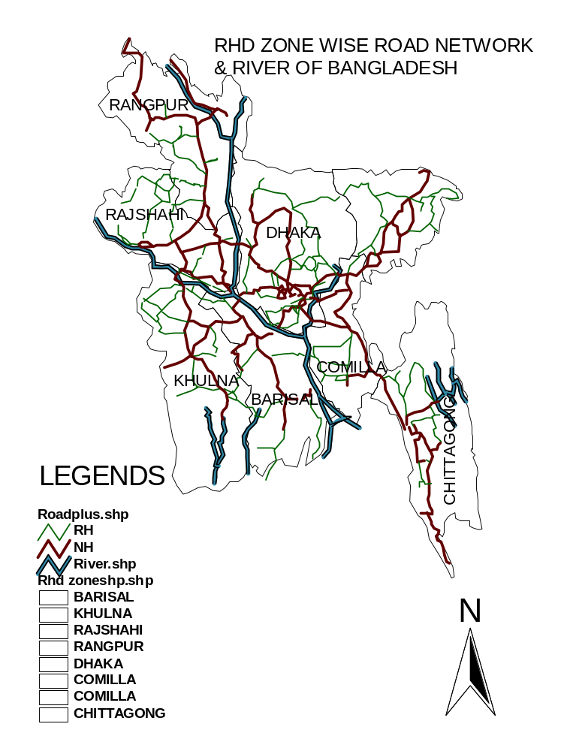

Figure 4.1: RHD ZONE WISE ROAD NETWORK & RIVER OF BANGLADESH

4.1.2. Local Govt. Engineering Dept. (LGED):

LGED road network system consists of more than 2,51,820 km of roads in three categories namely Upazila Road, Union Road, Village Road-A & Village Road-B. Basic information of district wise road can be seen in table4.3

Table 4.3: Basic Information of district wise length coverage of LGED

DISTRICT | TOTAL LENGTH (km) | DISTRICT | TOTAL LENGTH (km)
DINAJPUR | 6544 | DHAKA | 4307
THAKURGAON | 3453 | GAZIPUR | 3838
PANCHAGARH | 3226 | NARSHINGDI | 2363
RANGPUR | 5059 | NARAYANGANJ | 2017
LALMONIRHA | 2704 | MUNSHIGANJ | 1833
NILPHAMARI | 3060 | MANIKGANJ | 2710
KURIGRAM | 3295 | FARIDPUR | 3705
GAIBANDHA | 4079 | RAJBARI | 3087
BOGRA | 5257 | COMILLA | 7402
JOYPURHAT | 1666 | B.BARIA | 2769
RAJSHAHI | 4866 | CHANDPUR | 4284
NAOGAON | 5054 | NOAKHALI | 6181
NATORE | 3279 | LAXMIPUR | 3622
KUSHTIA | 2887 | FENI | 2931
CHUADANGA | 2031 | CHITTAGONG | 10279
MEHERPUR | 1515 | COX'S BAZAR | 2918
JESSORE | 6597 | RANGAMATI | 4073
JHENIDAH | 3984 | KHAGRACHARI | 2557
MAGURA | 2159 | BANDARBAN | 1881
NARAIL | 1884 | BARISAL | 7416
KHULNA | 4391 | JHALOKATHI | 2551
SATKHIRA | 4796 | PEROJPUR | 3301
BAGERHAT | 4774 | BHOLA | 3621
JAMALPUR | 3478 | PATUAKHALI | 7225
SHERPUR | 2080 | BARGUNA | 4390
MYMENSINGH | 8993 | SYLHET | 5124
NETROKONA | 3872 | MOULVIBAZAR | 3849
KISHOREGANJ | 5836 | HABIGANJ | 3398
TANGAIL | 6277 | SUNAMGANJ | 3456

Source: Basic Information of District wise Road, Local Govt. Engg. Dept.(LGED), Bangladesh.

4.1.3. Bangladesh Railway:

Bangladesh Railway has a total of 2,855 route kilometers at the end of the year 2004-2005. Bangladesh Railway has divided the whole country into two zones namely East and West. East zone has 1,277 route kilometers of MG track only and West zone has 553 route kilometers of MG 660 route kilometers of BG and 365 route kilometers of DG track. The total length of running track including track on double line, in the yards and siding is 4,443 kilometers.

At the end of 2004-2005, there were a total of 3,650 bridges of which 3,104 are minor and 546 are major ones. Foot over-bridges are provided in important cities and district towns. At the end of 2004-2005, Bangladesh Railway has a total of 454 stations of which 239 MG stations in the East zone and 134 BG & 81 MG stations in the West zone. At the end of 2004-2005, Bangladesh Railway has a total of 1,610 level crossings of which 207 level crossings having heavy road and rail traffic are manned round the clock and 1,188 with light traffic are casually manned. At the end of 2004-2005, only 44 districts of the country could be connected by Railway. The district wise Railway stations and Route kilometers are shown in table 4.4

Table 4.4: District Wise Railway Stations and Route Kilometers

Sl No. | District | No. of Stations | Kilometers
1 | BAGERHAT | 0 | 42.95
2 | KHULNA | 7 | 28.24
3 | JESSORE | 11 | 57.42
4 | JHENAIDAH | 5 | 43.40
5 | CHUADANGA | 9 | 44.25
6 | FARIDPUR | 0 | 43.80
7 | GOPALGANJ | 0 | 34.13
8 | RAJBARI | 9 | 94.22
9 | KUSHTIA | 10 | 59.35
10 | SERAJGANJ | 9 | 48.0
11 | PABNA | 10 | 61.0
12 | CHAPAINAWABGANJ | 6 | 69.81
13 | RAJSHAHI | 13 | 63.0
14 | NATORE | 8 | 37.0
15 | NAOGAON | 5 | 29.0
16 | JOYPURHAT | 4 | 54
17 | THAKURGAON | 7 | 50
18 | PANCHAGARH | 3 | 22.0
19 | NILPHAMARI | 9 | 66.68
20 | KURIGRAM | 9 | 51.0
21 | DINAJPUR | 18 | 152
22 | LALMONIRHAT | 15 | 110
23 | RANGPUR | 9 | 69
24 | GAIBANDHA | 16 | 80
25 | BOGRA | 18 | 84
Sl No. | District | No. of Stations | Kilometers
26 | TANGAIL | 5 | 68
27 | JAMALPUR | 18 | 102.90
28 | NETROKONA | 13 | 65
29 | KISHOREGANJ | 11 | 73.75
30 | MYMENSINGH | 23 | 128.33
31 | GAZIPUR | 11 | 91.80
32 | DHAKA | 7 | 30
33 | NARAYANGANJ | 2 | 9.5
34 | NARSINGHDI | 12 | 38.97
35 | SUNAMGANJ | 3 | 13.9
36 | BRAHMANBARIA | 11 | 72.19
37 | HABIGANJ | 25 | 85.87
38 | MOULVI BAZAR | 14 | 125.33
39 | SYLHET | 8 | 50.64
40 | NOAKHALI | 8 | 29.4
41 | CHANDPUR | 11 | 40.66
42 | COMILLA | 16 | 106.4
43 | FENI | 5 | 51.73
44 | CHITTAGONG | 45 | 178.45

Source: Railway Information Book 2005, Bangladesh Railway.

4.1.4. City Corporation:

There are six city corporations in Bangladesh which perform the management activities of the road network in the six divisions namely Dhaka, Chittagong, Khulna, Rajshahi, Barisal and Sylhet. City Corporation performs all sorts of activities including planning, road construction, maintenance, traffic control & management etc.

4.2 DISTRICT WISE COVERAGE OF SOCIO-ECONOMIC DATA OF BANGLADESH:

Table 4.5: District wise coverage of area, population & population density:

ZONE | NAME | AREA (sq. km) | POP_2001 | POPULATION DENSITY
1 | THAKURGAON | 1809 | 1213000 | 671
2 | PANCHAGARH | 1405 | 838000 | 597
3 | NILPHAMARI | 1641 | 1563000 | 953
4 | DINAJPUR | 3438 | 2642000 | 769
5 | LALMONIRHAT | 1241 | 1104000 | 890
6 | KURIGRAM | 2296 | 1754000 | 764
7 | RANGPUR | 2308 | 2527000 | 1095
8 | GAIBANDHA | 2179 | 2129000 | 978
9 | JAMALPUR | 2031.98 | 2106040 | 1036
10 | SHERPUR | 1363.76 | 1267940 | 929
11 | MYMENSINGH | 4363.48 | 4460120 | 1022
ZONE | NAME | AREA (sq. km) | POP_2001 | POPULATION DENSITY
12 | NETROKONA | 2810.4 | 1971240 | 701
13 | SUNAMGANJ | 3670 | 1991000 | 543
14 | SYLHET | 3490 | 2547000 | 730
15 | MOULVIBAZAR | 2794 | 1609000 | 576
16 | HABIGANJ | 2637 | 1750000 | 664
17 | KISHOREGANJ | 2688.62 | 2557240 | 951
18 | NARSHINGDI | 1140.76 | 1901840 | 1666
19 | BRAHMANBARIA | 1927 | 2378000 | 1234
20 | TANGAIL | 3414.38 | 3261600 | 955
21 | GAZIPUR | 1741.53 | 2023260 | 1162
22 | MANIKGANJ | 1378.99 | 1301900 | 945
23 | DHAKA | 1463.6 | 8618700 | 5889
24 | MUNSHIGANJ | 954.96 | 1289100 | 1350
25 | NARAYANGANJ | 759.57 | 2170740 | 2857
26 | COMILLA | 3085 | 4591000 | 1489
27 | CHANDPUR | 1704 | 2241000 | 1316
28 | FENI | 928 | 1206000 | 1300
29 | NOAKHALI | 3601 | 2571000 | 714
30 | LAKSHMIPUR | 1456 | 1486000 | 1021
31 | CHITTAGONG | 5283 | 3103000 | 588
32 | KHAGRACHHARI | 2700 | 517000 | 192
33 | RANGAMATI | 6116 | 525000 | 86
34 | BANDARBAN | 4480 | 301000 | 67
35 | COX'S BAZAR | 2492 | 1759000 | 706
36 | JOYPURHAT | 965 | 856000 | 896
37 | BOGRA | 2920 | 3015000 | 1033
38 | SIRAJGANJ | 2498 | 2673000 | 1071
39 | NAOGAON | 3436 | 2386000 | 695
40 | NAWABGANJ | 1703 | 1422000 | 835
41 | RAJSHAHI | 2407 | 2273000 | 945
42 | NATORE | 1896 | 1517000 | 800
43 | PABNA | 2371 | 2165000 | 914
44 | KUSHTIA | 1621.15 | 1737360 | 1072
45 | MEHERPUR | 716.08 | 587620 | 821
46 | CHUADANGA | 1157.42 | 1005180 | 868
47 | JHENAIDAH | 1961.14 | 1568440 | 799
48 | JESSORE | 2566.68 | 2469680 | 962
49 | RAJBARI | 1118.8 | 952280 | 850
50 | MAGURA | 1048.61 | 821840 | 783
51 | FARIDPUR | 2072.72 | 1742720 | 1527
52 | NARAIL | 990.23 | 694900 | 702
53 | SHARIATPUR | 1181.53 | 1080680 | 914
54 | MADARIPUR | 1144.96 | 1129940 | 986
55 | GOPALGANJ | 1489.92 | 1151800 | 773
56 | SATKHIRA | 3858.33 | 1845120 | 478
57 | KHULNA | 4394.46 | 2357940 | 536
58 | BAGERHAT | 3959.11 | 1516820 | 384
59 | PIROJPUR | 1307.61 | 1099780 | 841
60 | BARGUNA | 1831.31 | 845060 | 461
61 | JHALOKATI | 758.06 | 692680 | 914
ZONE | NAME | AREA (sq. km) | POP_2001 | POPULATION DENSITY
62 | BARISAL | 2774.94 | 2348440 | 847
63 | PATUAKHALI | 3220.15 | 1464800 | 455
64 | BHOLA | 3403.48 | 1703200 | 501

Source: Statistical Year Book (2004), Bangladesh Bureau of Statistics.

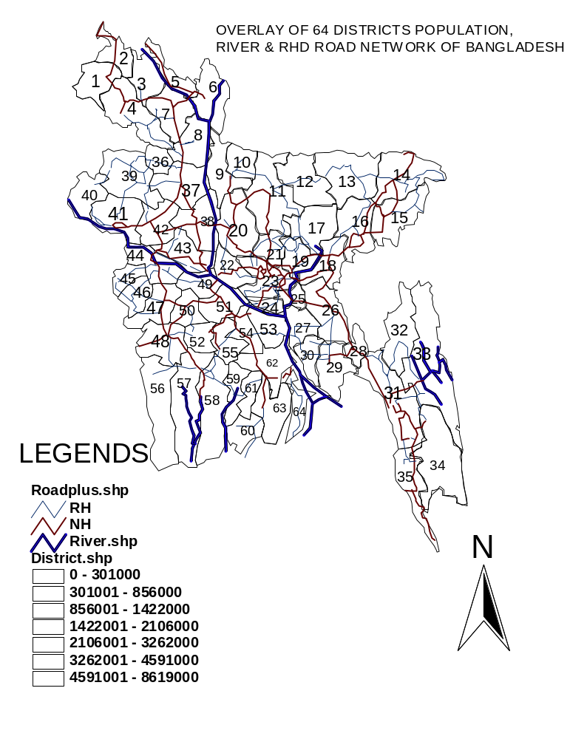
Figure 4. 2: OVERLAY OF 64 DISTRICTS POPULATION, RIVER & RHD ROAD NETWORK OF BANGLADESH

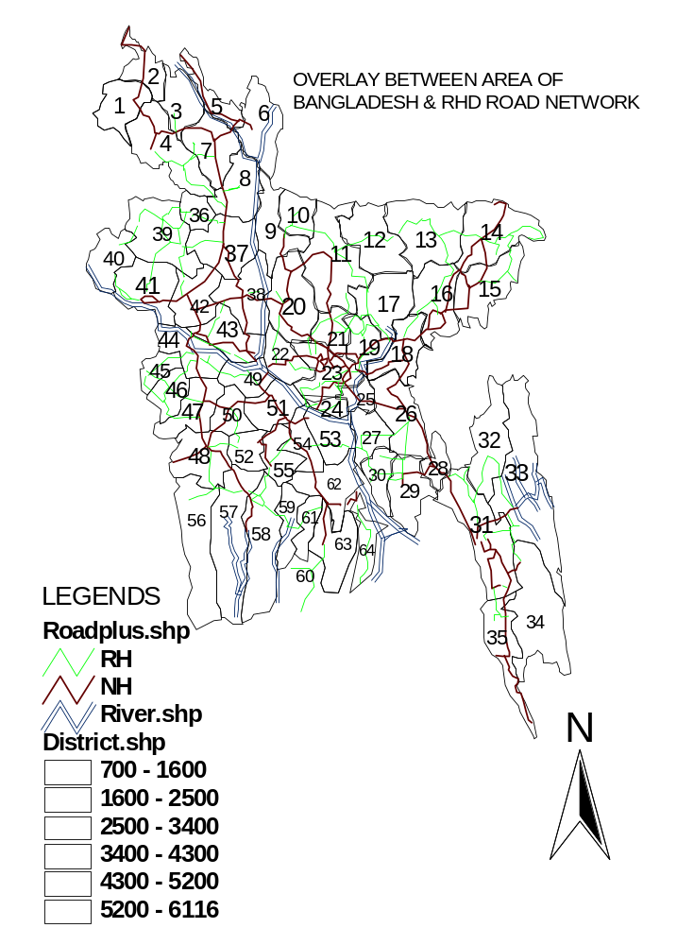
OVERLAY OF 64 DISTRICTS LAND AREA (sq. km), RIVER & RHD ROAD NETWORK OF BANGLADESH

Figure 4.3: OVERLAY OF 64 DISTRICTS LAND AREA (SQ. KM), RIVER & RHD ROAD NETWORK OF BANGLADESH

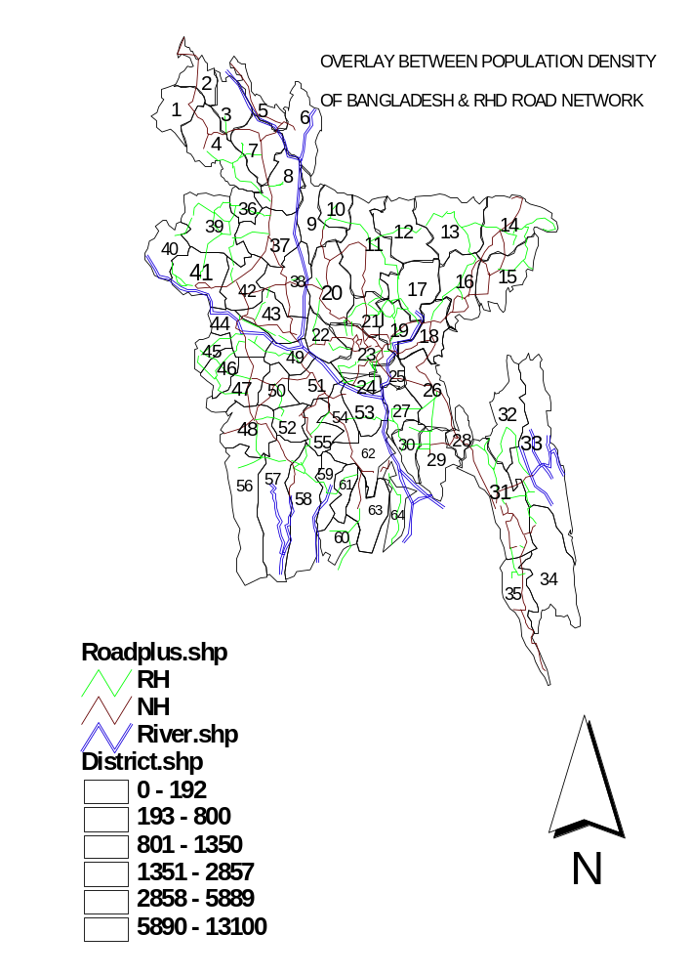
OVERLAY OF 64 DISTRICTS POPULATION DENSITY (persons per sq. km), RIVER & RHD ROAD NETWORK OF BANGLADESH

Figure 4.4: OVERLAY OF 64 DISTRICTS POPULATION DENSITY (PERSONS PER SQ. KM), RIVER & RHD ROAD NETWORK OF BANGLADESH

Table 4.6: District Wise Distribution of Agricultural Land Types

Zone | District | Cultivable Land ( ha ) | Uncultivable Land ( ha ) | Unsurveyed Area ( ha ) | Grand total ( ha )
1 | THAKURGAON | 162017 | 18843 | 165 | 181025
2 | PANCHAGARH | 118487 | 11086 | 695 | 130268
3 | NILPHAMARI | 140891 | 15499 | 7707 | 167097
4 | DINAJPUR | 302367 | 38826 | 2630 | 343826
5 | LALMONIRHAT | 102053 | 11110 | 10930 | 124093
6 | KURIGRAM | 167459 | 39757 | 15974 | 223190
7 | RANGPUR | 200184 | 23102 | 6394 | 229680
8 | GAIBANDHA | 174912 | 32106 | 7311 | 214329
9 | JAMALPUR | 181070 | 27836 |  | 208906
10 | SHERPUR | 120843 | 11061 |  | 131904
11 | MYMENSINGH | 372707 | 59428 |  | 432135
12 | NETROKONA | 823665 | 139027 |  | 962692
13 | SUNAMGANJ | 324764 | 42880 |  | 357644
14 | SYLHET | 285947 | 58808 |  | 344755
15 | MOULVIBAZAR | 225241 | 32120 |  | 257361
16 | HABIGANJ | 226142 | 25979 |  | 2252121
17 | KISHOREGANJ | 213590 | 43668 |  | 257258
18 | NARSHINGDI | 89265 | 24835 |  | 114100
19 | BRAHMANBARIA | 159615 | 25519 |  | 185134
20 | TANGAIL | 285984 | 49305 |  | 335289
21 | GAZIPUR | 158837 | 15263 |  | 174100
22 | MANIKGANJ | 103355 | 34545 |  | 137900
23 | DHAKA | 93041 | 23034 | 30325 | 146400
24 | MUNSHIGANJ | 66304 | 29196 |  | 95500
25 | NARAYANGANJ | 42082 | 14382 | 19436 | 75900
26 | COMILLA | 245806 | 59211 |  | 305017
27 | CHANDPUR | 106989 | 56837 |  | 163826
28 | FENI | 73917 | 20864 |  | 94781
29 | NOAKHALI | 186394 | 106403 |  | 292797
30 | LAKSHMIPUR | 94860 | 34744 |  | 129604
31 | CHITTAGONG | 360176 | 113504 |  | 473680
32 | KHAGRACHHARI | 261633 | 7446 |  | 269079
33 | RANGAMATI | 558652 | 59615 |  | 618267
34 | BANDARBAN | 432925 | 5206 |  | 438131
35 | COX'S BAZAR | 188518 | 37104 |  | 225622
36 | JOYPURHAT | 87 | 9676 | 11 | 96667
37 | BOGRA | 233 | 51994 | 5835 | 291497
38 | SIRAJGANJ | 185268 | 48318 | 10980 | 244566
39 | NAOGAON | 299144 | 45147 | 351 | 344642
40 | NAWABGANJ | 43027 | 21120 | 69 | 164215
41 | RAJSHAHI | 187418 | 41417 | 4208 | 233043
42 | NATORE | 158560 | 30146 |  | 188706
43 | PABNA | 187001 | 41594 | 10200 | 238795
44 | KUSHTIA | 121002 | 37340 |  | 158342
45 | MEHERPUR | 60338 | 11006 |  | 71344
46 | CHUADANGA | 94597 | 21632 | 0 | 116229
Zone | District | Cultivable Land ( ha ) | Uncultivable Land ( ha ) | Unsurveyed Area ( ha ) | Grand total ( ha )
47 | JHENAIDAH | 158583 | 36715 |  | 195298
48 | JESSORE | 199864 | 57641 |  | 257505
49 | RAJBARI | 85958 | 27284 |  | 113242
50 | MAGURA | 84988 | 18349 |  | 103337
51 | FARIDPUR | 165131 | 43406 |  | 208537
52 | NARAIL | 77031 | 20026 |  | 97057
53 | SHARIATPUR | 85290 | 31924 |  | 117214
54 | MADARIPUR | 88499 | 26011 |  | 114510
55 | GOPALGANJ | 124807 | 21545 |  | 146352
56 | SATKHIRA | 187261 | 42346 | 143375 | 372982
57 | KHULNA | 165756 | 45572 | 173558 | 384886
58 | BAGERHAT | 152984 | 50839 | 150920 | 354743
59 | PIROJPUR | 89726 | 38082 |  | 127808
60 | BARGUNA | 107845 | 59842 |  | 167687
61 | JHALOKATI | 56523 | 18404 |  | 74927
62 | BARISAL | 182649 | 76430 |  | 259079
63 | PATUAKHALI | 196676 | 111199 |  | 307875
64 | BHOLA | 146026 | 162273 |  | 308299

Source: Statistical Year Book (2004), Bangladesh Bureau of Statistics.

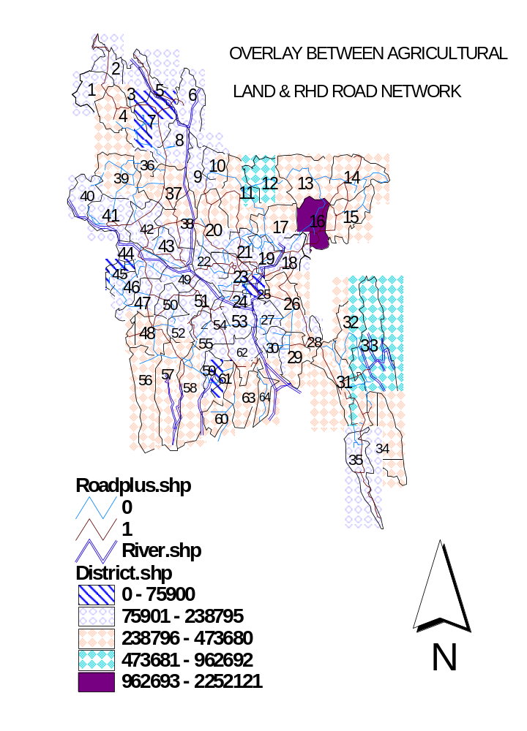

OVERLAY OF 64 DISTRICTS OF AGRICULTURAL LAND AREA (ha.), RIVER & RHD ROAD NETWORK
(RH & NH) OF BANGLADESH
Figure 4.5: Overlay of 64 districts agricultural land area (ha), river & RHD road network of Bangladesh

Table 4.7: District Wise Forest Coverage

Zone | Name | Total Forest Land ( Acres) | Zone | Name | Total Forest Land ( Acres)
1 | THAKURGAON | 2239.6 | 33 | RANGAMATI | 630392.86
2 | PANCHAGARH | 4611.31 | 34 | BANDARBAN | 266228.8
3 | NILPHAMARI | 2628.73 | 35 | COX'S BAZAR | 198900.5
4 | DINAJPUR | 18750.1 | 36 | JOYPURHAT | 0
5 | LALMONIRHAT | 82.62 | 37 | BOGRA | 518.7
6 | KURIGRAM | 128.61 | 38 | SIRAJGANJ | 0
7 | RANGPUR | 3941.12 | 39 | NAOGAON | 7147.64
8 | GAIBANDHA | 0 | 40 | NAWABGANJ | 0
9 | JAMALPUR | 10364.39 | 41 | RAJSHAHI | 79.04
10 | SHERPUR | 19468.69 | 42 | NATORE | 602.68
11 | MYMENSINGH | 38701.26 | 43 | PABNA | 0
12 | NETROKONA | 1824.68 | 44 | KUSHTIA | 0
13 | SUNAMGANJ | 17614.45 | 45 | MEHERPUR | 0
14 | SYLHET | 58395.74 | 46 | CHUADANGA | 0
15 | MOULVIBAZAR | 64691.69 | 47 | JHENAIDAH | 0
16 | HABIGANJ | 33388.24 | 48 | JESSORE | 0
17 | KISHOREGANJ | 0 | 49 | RAJBARI | 0
18 | NARSHINGDI | 4.05 | 50 | MAGURA | 0
19 | BRAHMANBARIA | 0 | 51 | FARIDPUR | 0
20 | TANGAIL | 122876.9 | 52 | NARAIL | 0
21 | GAZIPUR | 64620.42 | 53 | SHARIATPUR | 0
22 | MANIKGANJ | 2 | 54 | MADARIPUR | 0
23 | DHAKA | 144.74 | 55 | GOPALGANJ | 0
24 | MUNSHIGANJ | 1.86 | 56 | SATKHIRA | 400965
25 | NARAYANGANJ | 3.35 | 57 | KHULNA | 357400
26 | COMILLA | 1678.64 | 58 | BAGERHAT | 667531
27 | CHANDPUR | 0 | 59 | PIROJPUR | 6000
28 | FENI | 20000 | 60 | BARGUNA | 75000
29 | NOAKHALI | 380000 | 61 | JHALOKATI | 0
30 | LAKSHMIPUR | 50000 | 62 | BARISAL | 0
31 | CHITTAGONG | 357233.52 | 63 | PATUAKHALI | 150000
32 | KHAGRACHHARI | 95835.5 | 64 | BHOLA | 360000

Source: Population Census 2001 & Statistical Year Book 2003 Prepared by BBS

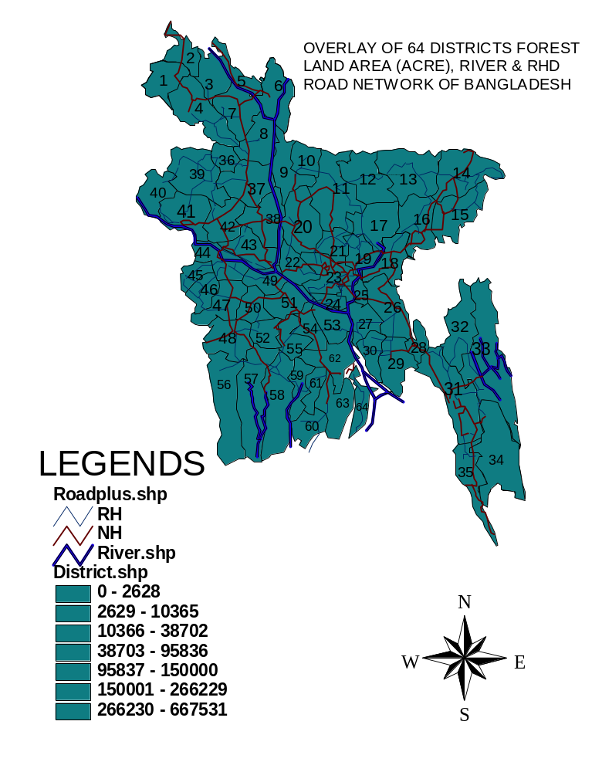
Figure 4.6: OVERLAY OF 64 DISTRICTS FOREST LAND AREA (ACRE), RIVER & RHD ROAD NETWORK OF BANGLADESH

Table4.8: District Wise Income
ZONE | NAME | Per Capita GDP ( US $ ) | ZONE | NAME | Per Capita GDP  ( US $ )
1 | THAKURGAON | 346 | 33 | RANGAMATI | 415
2 | PANCHAGARH | 301 | 34 | BANDARBAN | 372
3 | NILPHAMARI | 264 | 35 | COX'S BAZAR | 391
4 | DINAJPUR | 317 | 36 | JOYPURHAT | 318
5 | LALMONIRHAT | 283 | 37 | BOGRA | 289
6 | KURIGRAM | 273 | 38 | SIRAJGANJ | 292
7 | RANGPUR | 297 | 39 | NAOGAON | 297
8 | GAIBANDHA | 247 | 40 | NAWABGANJ | 267
9 | JAMALPUR | 275 | 41 | RAJSHAHI | 343
10 | SHERPUR | 273 | 42 | NATORE | 340
11 | MYMENSINGH | 307 | 43 | PABNA | 360
12 | NETROKONA | 306 | 44 | KUSHTIA | 329
13 | SUNAMGANJ | 266 | 45 | MEHERPUR | 335
14 | SYLHET | 322 | 46 | CHUADANGA | 332
15 | MOULVIBAZAR | 288 | 47 | JHENAIDAH | 322
16 | HABIGANJ | 299 | 48 | JESSORE | 369
17 | KISHOREGANJ | 276 | 49 | RAJBARI | 282
18 | NARSHINGDI | 364 | 50 | MAGURA | 315
19 | BRAHMANBARIA | 294 | 51 | FARIDPUR | 277
20 | TANGAIL | 264 | 52 | NARAIL | 323
21 | GAZIPUR | 693 | 53 | SHARIATPUR | 257
22 | MANIKGANJ | 299 | 54 | MADARIPUR | 249
23 | DHAKA | 872 | 55 | GOPALGANJ | 267
24 | MUNSHIGANJ | 274 | 56 | SATKHIRA | 320
25 | NARAYANGANJ | 657 | 57 | KHULNA | 460
26 | COMILLA | 264 | 58 | BAGERHAT | 335
27 | CHANDPUR | 254 | 59 | PIROJPUR | 271
28 | FENI | 252 | 60 | BARGUNA | 336
29 | NOAKHALI | 277 | 61 | JHALOKATI | 256
30 | LAKSHMIPUR | 308 | 62 | BARISAL | 286
31 | CHITTAGONG | 559 | 63 | PATUAKHALI | 361
32 | KHAGRACHHARI | 297 | 64 | BHOLA | 320

Source: Statistical Year Book (2004), Bangladesh Bureau of Statistics.

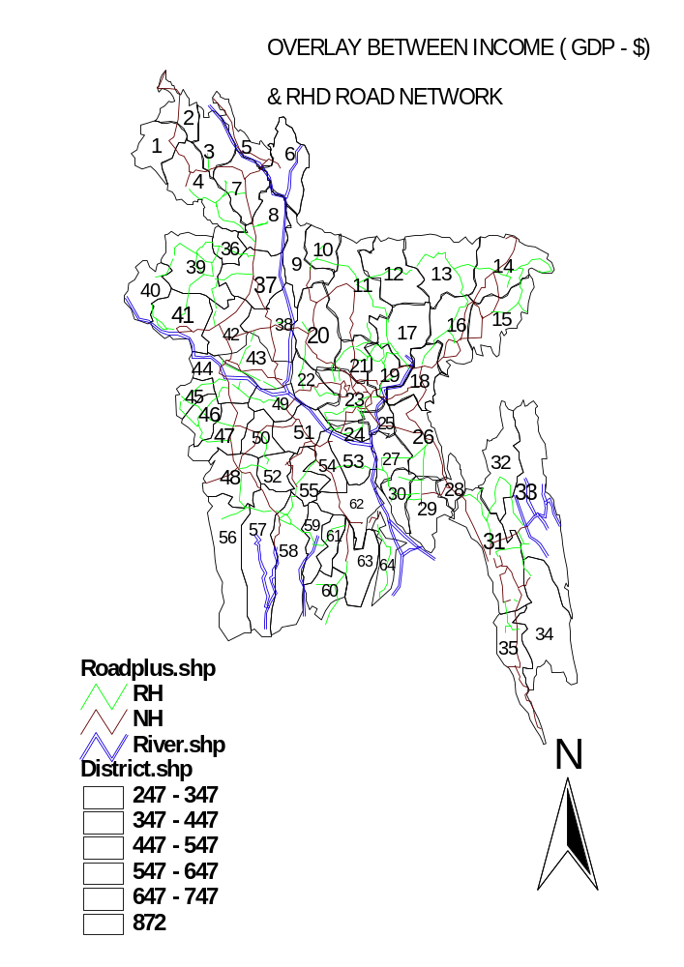
OVERLAY OF 64 DISTRICTS GDP (US $), RIVER & RHD ROAD NETWORK OF BANGLADESH

Figure4.7: OVERLAY OF 64 DISTRICTS GDP (US $), RIVER & RHD ROAD NETWORK OF BANGLADESH

Table4.9: District wise coverage of rail station, bus terminal, air port, river port & sea port
ZONE | NAME | RAIL STATION | BUS TERMINAL | AIR PORT | RIVER PORT | SEA PORT
1 | THAKURGAON | YES | YES | YES | NO | NO
2 | PANCHAGARH | YES | YES | NO | NO | NO
3 | NILPHAMARI | YES | YES | YES | NO | NO
4 | DINAJPUR | YES | YES | NO | NO | NO
5 | LALMONIRHAT | YES | YES | NO | NO | NO
6 | KURIGRAM | YES | YES | NO | NO | NO
7 | RANGPUR | YES | YES | NO | NO | NO
8 | GAIBANDHA | YES | YES | NO | NO | NO
9 | JAMALPUR | YES | YES | NO | YES | NO
10 | SHERPUR | NO | YES | NO | NO | NO
11 | MYMENSINGH | YES | YES | NO | NO | NO
12 | NETROKONA | YES | YES | NO | NO | NO
13 | SUNAMGANJ | NO | YES | NO | NO | NO
14 | SYLHET | YES | YES | YES | NO | NO
15 | MOULVIBAZAR | YES | YES | NO | NO | NO
16 | HABIGANJ | YES | YES | NO | NO | NO
17 | KISHOREGANJ | YES | YES | NO | YES | NO
18 | NARSHINGDI | YES | YES | NO | NO | NO
19 | BRAHMANBARIA | YES | YES | NO | YES | NO
20 | TANGAIL | NO | YES | NO | NO | NO
21 | GAZIPUR | YES | YES | NO | NO | NO
22 | MANIKGANJ | NO | YES | NO | NO | NO
23 | DHAKA | YES | YES | YES | YES | NO
24 | MUNSHIGANJ | NO | YES | NO | NO | NO
25 | NARAYANGANJ | YES | YES | NO | YES | NO
26 | COMILLA | YES | YES | YES | NO | NO
27 | CHANDPUR | YES | YES | NO | YES | NO
28 | FENI | YES | YES | NO | NO | NO
29 | NOAKHALI | YES | YES | NO | NO | NO
30 | LAKSHMIPUR | NO | YES | NO | NO | NO
31 | CHITTAGONG | YES | YES | YES | NO | YES
32 | KHAGRACHHARI | NO | YES | NO | NO | NO
33 | RANGAMATI | NO | YES | NO | NO | NO
34 | BANDARBAN | NO | YES | NO | NO | NO
35 | COX'S BAZAR | NO | YES | YES | NO | NO
36 | JOYPURHAT | YES | YES | NO | NO | NO
37 | BOGRA | YES | YES | NO | NO | NO
38 | SIRAJGANJ | YES | YES | NO | YES | NO
39 | NAOGAON | YES | YES | NO | NO | NO
40 | NAWABGANJ | YES | YES | NO | NO | NO
41 | RAJSHAHI | YES | YES | YES | NO | NO
42 | NATORE | YES | YES | NO | NO | NO
43 | PABNA | YES | YES | YES | NO | NO
44 | KUSHTIA | YES | YES | NO | NO | NO
45 | MEHERPUR | NO | YES | NO | NO | NO
46 | CHUADANGA | YES | YES | NO | NO | NO
47 | JHENAIDAH | NO | YES | NO | NO | NO
48 | JESSORE | YES | YES | YES | NO | NO
49 | RAJBARI | YES | YES | NO | NO | NO
ZONE | NAME | RAIL STATION | BUS TERMINAL | AIR PORT | RIVER PORT | SEA PORT
50 | MAGURA | NO | YES | NO | NO | NO
51 | FARIDPUR | YES | YES | NO | NO | NO
52 | NARAIL | NO | YES | NO | NO | NO
53 | SHARIATPUR | NO | YES | NO | NO | NO
54 | MADARIPUR | NO | YES | NO | NO | NO
55 | GOPALGANJ | NO | YES | NO | NO | NO
56 | SATKHIRA | NO | YES | NO | NO | NO
57 | KHULNA | YES | YES | NO | YES | NO
58 | BAGERHAT | NO | YES | NO | NO | YES
59 | PIROJPUR | NO | YES | NO | NO | NO
60 | BARGUNA | NO | YES | NO | NO | NO
61 | JHALOKATI | NO | YES | NO | NO | NO
62 | BARISAL | NO | YES | YES | YES | NO
63 | PATUAKHALI | NO | YES | NO | NO | NO
64 | BHOLA | NO | NO | NO | NO | NO

Source: Statistical Year Book (2004), Bangladesh Bureau of Statistics.

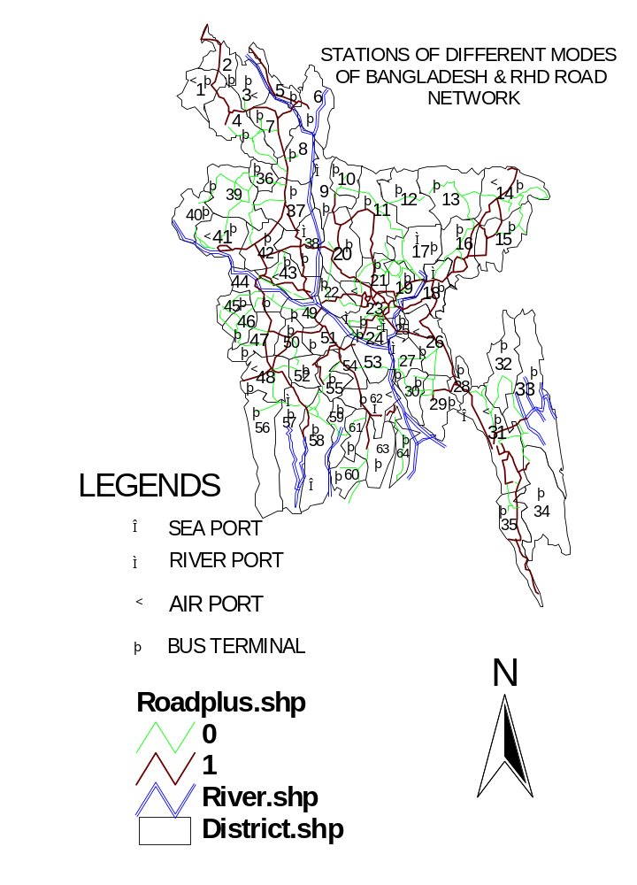
OVERLAY OF 64 DISTRICTS SEA PORT, RIVER PORT, AIR PORT, BUS TERMINAL, RIVER & RHD ROAD NETWORK OF BANGLADESH

Figure 4.8: OVERLAY OF 64 DISTRICTS SEA PORT, RIVER PORT, AIR PORT, BUS TERMINAL, RIVER & RHD ROAD NETWORK

CHAPTER FIVE
CONCLUSIONS AND RECOMMENDATIONS

5.1. CONCLUSIONS:

    - Zone wise (District) transport and socio-economic data is collected and represented in GIS maps.

5.2. RECOMMENDATIONS FOR FUTURE IMPROVEMENT:

- To make more precise GIS based analysis of study area, zoning area should be taken small as possible depending on the availability of data.
- Since the lacking of geo-referencing (providing latitude and longitude) in GIS map of CEGIS and RHD or LGED, there are the difficulties to make an overlay between them. That is why, the map of RHD has been digitized for the zones of administration to make overlays of river, road network and socio-economic data based map. Hence, geo-referencing should be performed.

- There is a limitation in getting comprehensive data of transport information and socio-economic in the level of small zoning area. But, if the data of small zoning area is available, then it is easer to integrate the data to get large zoning area which makes GIS based representation more fruitful.

