Changes in Biodiversity: An Assessment on Dhamshona and Yearpur Union of Savar Upazila

Submitted by

WWW.ASSIGNMENTPOINT.COM

Biodiversity is the variety of the world’s living species, including their genetic diversity and the communities and ecosystems that they form. Ecosystem diversity varies greatly from one region to another. The distribution of life forms is not similar due to the climatic and ecological differences in different geographical regions of the earth. Each particular ecosystem sustains a particular life form and has to adjust and adopt all the time to the changing conditions of the environment. Tropical forests, coral reefs, and deep benthic communities are rich in species, deserts and high latitude areas are species poor. Species abundance changes naturally along latitudinal and humidity gradients.

The geographical position and climate of Bangladesh are very favorable for growth and development of many plants and animals. Bangladesh is rich in biodiversity. It has diverse fisheries and aquatic life. The country has one of the world largest tidal flood mangrove forests in its southwest seaboard. There are more than 10,000 paddy verities, 5,000 species of flowering plants, 1,500 species of vertebrates, of which approximately 750 are birds and over 500 are coastal estuarine and freshwater fish exist in wetland areas. Some 400 vertebrate species and 300 plant species are dependent on wetlands for all or part their life spans (Banglapedia, 2006).

The IUCN Bangladesh Red Data Book (2000) has mentioned 266 species of inland fishes, 442 marine fishes, 22 amphibians, 109 inland reptiles, 17 marine reptiles, 388 resident birds, 240 migratory birds, 110 inland mammals, as well as 3 species of marine mammals in Bangladesh.

Biodiversity makes up the structure of the ecosystems and habitats that support essential living resources, including wildlife, fisheries and forests. It helps to provide basic human needs such as food, shelter, and medicine. It composes ecosystems that maintain oxygen in the air, enrich the soil, purify the water, protect against flood and storm damage and regulate climate.
Society’s growing consumption of resources and increasing populations have led to a rapid loss of biodiversity, eroding the capacity of natural systems to provide essential goods and services on which human communities depend. Bangladesh is a developing country. To keep pace with development we are going for rapid industrialization without considering their consequences on environment and also with uncontrollable use of natural resources ignoring the environmental impact.

Savar, a suburban area under Dhaka district, is only 25 kilometers north west of Dhaka metropolitan city. In 1985 Savar was included with the greater Dhaka city and declared as an industrial area by the Rajdhani Unnayan Kartipakkha (RAJUK). After independence, Dhaka became the capital city of Bangladesh and also a centre of business and industry. Since Savar is very near to Dhaka and Asian highway passes through it, it became an important place. As such the urban infrastructural development activities took place in the area. In one hand a number of industries were established and on the other, initiatives of various housing societies made Savar an area suitable for residential purposes. Apart from changes in the landuse pattern, increased human activities in this area have put pressure on its ecosystem.

In Savar upazila there are 12 unions. Dhamshona and Yearpur are the union of this upazila. This area has diverse fisheries and aquatic life, diverse of bird and animal species. There are paddy varieties, plant varieties. Many species of flowering plants are found in this area and many of them have economic importance. The main crops are rice, wheat, jute, sugarcane, potato, oil seeds and numerous species of vegetables. Among fruits- jackfruit, mango, banana, coconut, papaya etc, are common. Many plants, herbs and bamboos are found here. Many species of insects and other invertebrate animals are also found. Urbanization and development works are increasing here day by day. Thus, various ecosystem are loosing there biodiversity continually due to human activities and interference. This is endangering the probable future survival adaptation of many species. Changes in the landuse and cropping system, increased human activities, population pressure, and various development activities are some of the factors, which are causing this stress. But there is no significant work has been done on the biodiversity changes of Dhamshona and Yearpur union. In this context, the present study has been taken an attempt to investigate the present status of biodiversity in Dhamshona and Yearpur union. Though Dhamshona and Yearpur are two different unions but in these studies these two unions measured a unit.

  - Literature Review

Biological resource and biological diversity form the basis of both the ecology and economy of Bangladesh. The country’s agriculture, fisheries, and livestock, along with a number of other sectors are heavily dependent, directly or indirectly, on biological resources. According to UNESCO (1994), biological diversity provides resources for food, construction, and raw materials for industry. It provides the basis for improvement of the domesticated species; maintains functions of ecosystems, including evolutionary processes; stores and cycles nutrients essential for life; absorbs and breaks down pollutants, including organic waste, pesticides, and heavy metals; recharges ground water, protects catchments basins, and buffers extreme water conditions; and produces soil and protects it from excessive erosion. For this reason, the biodiversity have immense importance for the country. Now off time the biodiversity are in a threatening condition. But, few works is done on this topic and literature on this topic is inadequate. In Bangladesh, the studies on biodiversity change not got much importance till now. Some works, which mainly comprises the various aspects of biodiversity, are viewed in below.

Biodiversity as an interdisciplinary concepts, has been making rapid stride during the twentieth century. Zoologists, botanists, pedologists, geographers and other social scientists have come forward in the field of biodiversity study for solving the problems faced by the modern world, particularly in the field of regional development.

Biodiversity concepts, however, lay its basic foundation by the ancient Greek and Roman thinkers like Hipprocrates (460 - 377 B.C), Aristotle (384 - 322 B.C), Theophastus (372 - 287 B.C), Plinty the Elder (23 – 79 A.D), etc. They worked in the fields of environment, health and disease, animal and plant behaviour and their habitats. Hippocrates, who is regarded as the ‘father of medicine’ published a paper on environmental aspect entitled, ‘On airs, waters and places’. Aristotle in his writings on natural history focuses to the habitats of animals and environmental conditions prevailing in certain areas. Theophrastus is regarding as the firsts ecologists, because of his writings on plant communities and spatial variations (Knight, 1965).

After a long gap of several centuries, a number of naturalists during 12th to 20th centuries revived the biodiversity study and laid strong foundation for development of it as a distinct scientific discipline in different fields such as natural history and faunal exploration, environmental study, evolution and theories of natural selection, population studies and demography, ecological geography and conservation.

In the 19th century people have been increasingly aware of the interaction between man and environment. The science of ecology, which deals with plants, animals and environment is recognized throughout the world. In the nineteenth century the life zone concepts founded by Merrium C. Hart, Vernon B., Nelson E.W. and Preble E.A., needs special mention (Marriam, et.al., 1910). During the twentieth century, L.R. Dice (1943) identified the biotic provinces. It was Transley in 1935, who for the first time introduced the term ‘ecosystem’ to embrace not only the living organism but also the whole complex of environmental factors, both biological and physical operative in an ecological unit. According to him ‘ecosystem’ is ‘the whole complex of organisms-both animals and plants- naturally living together as a sociological unit’ (Transley, 1935).

Hodder (1971) expressed his doubts that there is intimate relation between the occurrence of natural resources - water, forests, soils, minerals or power and the level of economic development in any particular country. But on the contrary he had his opinion that there is also no justification to ignore the role of natural resources in any developmental aspect. He warned that there will be danger if there is any tendency to underestimate the role of natural resources in the development process of tropical countries.

Stoddart (1972) considered ‘ecosystem’ as a complex relationship of man and environment. He outlined four main properties of an ecosystem for geographers, as a) monistic - which brings man, plant and animal and environment in a single framework, b) structural - studying the relationship in more orderly, rational and detailed ways, c) functional - need of quantification of the interaction and interchanges between component parts and d) open system - ecosystem is an open system tending towards a steady state and obeying the open system thermo dynamics. Concern for the application of biodiversity concepts to the relationships between man and environment has become a subject matter of ecological studies now.

Robinson (1982) stated that the study of vegetation constitutes a science, and one that geographers often wish to know about, since plant cover is an important element of landscapes and a delimiter of regions. For a geographer there are three ways of ‘knowing’ about vegetation familiarizing himself with plants as they occur in nature, learning methods for studying plants and communities in order to arrive at useful inferences; and acquiring a consistent theoretical understanding vegetation development and dynamics. He also showed some factors as soil depth the pH value, water logging, slope and drainage condition, exposure to wind, air and soil temperature etc. Which help to study more particularly of vegetation information in biogeographically point of view.

Weischet (1985) discusses the ecological hardship in the wet tropical regions with their optimum climatic conditions for growth.

Meurer (1987) discusses the various ecological problems like over – exploitation of resources, destruction of soils and degradation of environment in recent years has stressed on the need for an intensive conservation programme for ecological and economic reasons.
E. O. Wilson (1988) to describe the number and variety of living organisms, at all scales; from individual parts of communities to ecosystems, regions, and the entire biosphere. This term includes the genetic diversity of an individual species, the subpopulations of an individual species, the total number of species in a region, the number of endemic species in an area, and the distribution of different ecosystems.

Randall (1988, p. 218) has argued that preference is the basis for value and that it is possible to treat all species values as preferences of humans. Preferences-based approaches to valuation can provide economic (dollar) estimates of value. This valuation process may include methods for assessing and quantifying option values. A claimed advantage of such approaches is that the only good way to protect species is to place an economic value on them. Randall argues that such quantification is advantageous because the species preservation option will fare well when the full range of values is included in conservation priority setting.

Canziani and others (1989) see that developing countries face problem in taking advantage of their resource base without inflicting damage to the environment. They carried out Argentinean hydro meteorological case studies to demonstrate the undesirable environmental degradation arising out of faculty use of natural resources.

Norton (1994) has argued that there will never be a single "objective scientific definition" of biodiversity, in the sense of a prescription for how to measure it. In fact, Norton claims that any increase in our understanding of biodiversity will make it less likely that there will be a single objective measure. This biodiversity pluralism is based on an argument that inevitably there are many different "theory bound" versions of biodiversity and many different ways to value it. This perspective is in accord with recognition of functional-compositional perspectives on biodiversity. For example, Norton (1994; 2001) points to recent emphasis on structure and process regarding ecological "health" or "integrity" that is seen as going beyond a conventional elements-oriented perspective for biodiversity.

Callicott et al. (1999) examined "biodiversity" as one of the current normative concepts in conservation. They concluded that it remains ill-defined, and that distinctions can be made between "functional" and "compositional" perspectives in approaching biodiversity. "Functional" refers to a primarily concern with ecosystem and evolutionary processes, while "compositional" sees organisms as aggregated into populations, species, higher taxa, communities, and other categories. Callicott et al. call for a better integration of these different perspectives, an issue discussed in the section on Integrating Process and Elements Perspectives.

Roebuck and Phifer (1999) lament what they perceive as current "positivism" in biodiversity conservation, described by them as based variously on processes of verificationism and falsificationism in seeking facts. They argue that biodiversity conservation is rooted primarily in ethics and we must not continue to back away from values and advocacy.

Kennedy et.al. (2005) worked on dietary diversity they found a fundamental tenet of nutrition in order to ensure adequate nutrient intakes, yet few studies in developing countries have attempted to quantify patterns of plants genetic diversity.

Dorrough et.al. (2007) survey the status and impact on biodiversity through agricultural activities and middle stage livestock grazing and uses of fertilizer. According to them improving grazing management across broad scales in likely to result in enhanced profitability and could also benefit native vegetation. Extensive management may necessary to maintain biodiversity and prevent further long term degradation of the resource base.

Colasanti et.al. (2007) worked on two-dimensional (ground-plan) cellular automata model of vegetation dynamics specifically to investigate high level community process. Plant types, when grown in real experiments with virtual communities, reproduce classical community-level behavior and in complex communities simulated over a wide range of environmental conditions, produce clearly ‘hump-backed’ curved linking plant diversity to community productivity.

Renata et.al. (2007) worked on the dynamics of re-colonization of disturbed patches that may aid in understanding of spatial variation of species richness. The study experimentally tested the hypothesis that the variation of litter ant local species richness and composition is caused by the dynamics of re-colonization after disturbances.

Durgio and Sammaggio (2007) worked on to study the syrpfid fauna in rural landscapes and to evaluate the quality of environment by means of the faunistic data collected. Sampling was carried out by Malaise traps and yellow sticky traps, baited with different kinds of glue. Malaise traps proved to be the most efficient monitoring system.

Groot et.al. (2007) studied the impact of the invasive plant species. Solidago Canadensis on the species richness of vascular plants and abundance, species richness and diversity of butterflies, hoverflies and carotid beetles in herbaceous semi-natural habitats near Ljubljana, Slovenia. The species groups were natural vegetation plant species richness and species richness, abundance and diversity of butterfly species were lower in plants dominated by S. Canadensis.

In Bangladesh, there are many researchers who have been worked on biodiversity and its related environment. The deciduous ‘Sal’ forest and its habital were studied by Ismail and Kabir (1973). They selected some ‘Sal’ forests as Rajendropur, Chandra, Salbon-bihar, Rajaspur, Modhupur, Runctia, Gajni sal forest. They recorded a consolidated account of survey. As for their investigation it may be observed that salban include various species, which have sprung out from elevation of the patches, biotic interference, soil status as organic carbon, nitrogen potassium, pH, texture and nutrient status. The work of the deciduous ‘Sal’ forest reported here that the habitat and properly of the soil (of old alluvium) are not very ideal for a good forest development and additional care such as modulating legumes, protection from fire, grazing control of illicit felling are some useful measures for the forest.

The aquatic angiosperms and its relative habitat was studied by Khan and Halim (1987) who devoted themselves to exploit our native plant wealth, to identify and to know their distribution and abundance in the country. In fact the study provided a working guide to the botanical studies of our aquatic angiosperms. The analytical keys to identify families and lower taxa had been purposely simplified to aid botanists having even a fundamental knowledge of taxonomic vocabulary. The account included 123 species under 67 general distributed in 35 angiosperm families. The work was based on direct field investigation and substantiated by the preserved material at the Bangladesh National Herbarium. The taxonomic accounts were brief and diagnostic. The additional information under each species was also gathered from adjoining ecological habitat and distribution.

Sarker and Sarker (1988) published a list of amphibian in which 10 species were mentioned by Hussain and Rahmat (1982) and 3 species were mentioned by Khan (1982). Khan (1982) published an amphibian’s checklist and mentioned that 19 species were present in our country.

Khan (1982) gave a checklist of 124 species of reptiles with the status and distribution in Bangladesh. Rashid (1965) made systematic list of birds of East Pakistan (now Bangladesh). Husain and Sarker (1968-1970) studied the birds of Pabna. Islam (1968-70) worked on the birds of Rangpur. Khan (1973) made a checklist of birds of Rajshahi with their ecological grouping. Husain and Hauque (1977) made a list of the avifauna of Modhupur forest. Hussain and Sarker (1982) made a list the summer birds of ‘Sandarbans Sanctury’ of Bangladesh. Khan (1982) gave a checklist of 119 species of mammals with their status and distribution.

Khan (1991) studied the geology of the different areas of Bangladesh. He classified Bangladesh into four distinct physical regions, which have distinguishing characteristics.

Rashid (1991) in his book deals about the water regime, river system, fisheries and main environmental issues of Bangladesh.

Khan et.al. (1994) in there book viewed the wetlands as an invaluable component of the environment and biodiversity in Bangladesh. They described the definition, history; heritage and importance of wetland for Bangladesh, the types, ecology and resources, socio-economic values and development activities and threats are also described here. This publication was undertaken to bring together available information about wetlands of Bangladesh under one cover to be used as a referenced documents.

Ali (1997) discussed the different components of openwater fisheries in Bangladesh and quantified from available data and information. The role of different components of the open water system in completion of the life cycles of different species of fish and prawn also presented in some detail. The importance of open water fish production, particularly floodplain fish production, for nutrition and the economy of rural people is highlighted.The importance of other natural occurring aquatic animals, snails, tortoises and the turtles, and their needs for undisturbed aquatic habits are stated. Water pollution caused by discharged of untreated industrial effluents, domestic wastes and agro-chemicals into surface water and their impacts on aquatic organisms including fishes and prawns are presented and discussed. Principles and procedures of open water fisheries management and practiced are also presented.

The idea that the choice of a measure of biodiversity depends on values finds support in Sarkar (2005). He argues that biodiversity operationally amounts to whatever is the valued target of conservation priority setting for different localities.

The above research literature review clearly indicates that the aim of the research was to analyze the biodiversity, environmental and ecological conditions in the study area. Biodiversity are very important for Bangladesh, they are in very threatening conditions. Environment is changes now very rapidly. These changes have very impact on the biodiversity.

Therefore, the present study is under taken to explore the nature and processes involved in the changes of biodiversity, their extinction and consequential effects on environment.

1.3 Justification of the Study
In the recent years human intervention has speeded up the loss of biodiversity in Bangladesh. It is important to have sufficient knowledge about the biodiversity changes occurred in Bangladesh from the point of view of proper management, conservation and sustainable development and their natural resources.
This study will provide the present status of biodiversity including the changes scenario. The present study will provide some recommendations and suggestions to overcome the problems of rapid changes. The finding of the study will also help to determine the planning needs and polices by the planner and the concern authority including government and non-government agencies for proper management of conservation biodiversity. In addition, some of the outputs of the research will especially lead to build up of an effective database for biodiversity management.
1.4 Organization of the Study
To organize the study, different themes are presented in various chapters. The work is arranged in six chapters that follow the chronological development of the study.
In the first chapter a general account is given about the statement of the problem, literature review, and justification of the study.This is followed by chapter-two presenting aim and objectives of the study, discusses the methodology, which includes data sources, methods of data collection, analytical procedure.
A brief statement is incorporated about the study area in chapter-3. The environmental settings of Dhamshona and Yearpur union both physical and cultural environment is briefly described in this chapter.
Chapter-4 presented a detail overview of biodiversity includes the definition, nature, types, values and description of biodiversity in Bangladesh. This is followed by chapter-5, which analyzed the nature, causes of extinction, the changing pattern of biodiversity of Dhamshona and Yearpur union. This chapter also incorporates the list of flora and fauna of the study area with their past and present status.
The summary and conclusion of the study is presented in chapter-6. It also gives some recommendations and guidelines for sustainable biodiversity management.
2.0 METHODOLOGY

2.1 Introduction
This chapter provides an outline of the design of present research and describes the adopted methodology. The methodology has been considered in relation to the aim and objectives of the research. A research methodology defines what the activity of research is, how to proceed, how to measure progress, and what constitute success. The study analyzed the changing scenario of the biodiversity of Dhamshona and Yearpur union.
2.2 Aim and Objectives of Study
The present study has mainly focused upon changes in biodiversity. Socio-economic activities of the people of Dhamshona and Yearpur union are linked with biodiversity in various ways. Lately, local environment is changed drastically due to physical and anthropogenic activities. Large scale biodiversity changes imbalances the ecology and threatened the whole environment. The aim of the present study is therefore to explore the nature, process and causes of biodiversity changes in Dhamshona and Yearpur union and its consequences.

To achieve this aim, the objectives of the study are:

1) To list the floral and faunal biodiversity of the Dhamshona and Yearpur areas including their past and present status.

2) To analyze the changes in floral and faunal biodiversity of the Dhamshona and Yearpur areas.

3) To analyze the changes in physical and cultural environment of the study area.

4) To identify the causes of changing environment.

5) To find out the causes of depletion of biodiversity.

6) To put forward some recommendations for sustainable biodiversity management.

2.3 Sources of Data and Research Methodology

In order to fulfill the aims and objectives of the research, the following sources of data and research methodology have been adopted:

2.3.1 Sources of Data

For a reliable thesis, a huge number of published materials and maps are necessary. In this research work, the necessary data and information were collected from the primary and secondary sources.

2.3.1.1 Sources of Primary Data

The methodology of the research study includes empirical field observation and field level data collection through the inventory, questionnaire survey and field level information by interview. The data used to address the central issues of biodiversity change with relation to the population change and industrialization. Each questionnaire includes the question which has been designed to obtain information related to the topic in a logical sequence. As a part of primary data collection, this study have also been conducted a FGD (Focused Group Discussion) with different professionals as like as farmers group, businessman group, governmental officials, schoolteachers, women, agricultural labor etc.

2.3.1.2 Sources of Secondary Data

The secondary information were collected through the survey of literature on the study of Bangladesh biodiversity, environment and also through surveying, relevant published and unpublished materials. In this research, data has also been collected from the Statistical Yearbook, Population Census Report, Dhaka District Statistics, District Gazetteers, BIDS, CUS, BBS, URP, BGS, BNGA, IUCN and from different journals and publications.

Research Methodology

The following methodological procedures have been considered to analyze the collect data and information.

Selection of Sample Mauza: The study area Dhamshona contsists of 15 mauzas and Yearpur contsists of 12 mauzas. Eleven mauzas out of 27 in Dhamshona and Yearpur union representing the Savar upazila were selected by random sample survey.

Data Assemble and Analysis: All collected data and information from the primary and secondary sources were statistically analyzed and represented through various tables, diagrams, graphs and flow chart. The collected information of the main part of the study is explained by tables and graphs then the outcome of the research are explained from those tables and graphs.

Table 2.1: Sources of data collection

PRIMARY DATA |  | SECONDARY DATA
DATA | SOURCES | DATA | SOURCES
1) Inventory Survey  2)Questionnaire Survey | Dhamshona & Yearpur Area  Inventory | 1)Published, Unpublished Papers & Report.  2) Map  3) Photographs | 1) Jahangirnagar University, Geography and Environment Department.  2)IUCN Bangladesh

Research problem

Aims & objectives of the study
Research methodology
Primary data sources
Secondary Data
Reconnaissance Survey
Questionnaire Survey
Focus Group Discussion
Published & unpublished materials
Data Analysis and presentation
Maps
Tables
Figures
Description
Results, findings and Recommendation

Figure 2.1: Flow chart of research methodology

2.4 Limitation of the Research

The required data are collected with as much sincerely and patience as possible. Even after that it has some limitations. The subject of this research is a vast and analytic one. Within the scope of general objective, the study required a great deal of systematic analysis and an understanding of a wide variety of information and knowledge. No researches on this type of subject have been thoroughly done on Dhamshona and Yearpur area. Moreover, there was lack of reliable information. Due to the above mentioned reasons the research work has mainly relied on the questionnaire survey and secondary information.

  - Summary

This chapter is mainly focused on the aim and objectives of the present study; consequently an attempt has been made to demonstrate the importance of the area under study and importance of the study to formulate a proper planning which will be able to reduce the species extinction and protection of biodiversity.

3.0 ENVIRONMENTAL SETTING OF THE STUDY AREA

3.1 General description

Savar, a western Upazila of Dhaka District and also a peri-urban area of the capital city of Bangladesh, has been selected as the study area of the research. Savar Upazila headquarters is a distance of about 30 kilometers (road distance) away from the heart of the Capital and is connected with the Dhaka Aricha National Highway, one of the busiest roads of Bangladesh. The Upazila occupies an area of 280.13 km2, including 32 km2 of river and 15 km2 of forested area. According to 1991 census report, the population of Savar Upazila was 3, 66,050. It has a rapidly growing population, and has experienced a change in its traditional agrarian land use during the last few decades due to the influences of urbanization from of Dhaka Metropolitan Mega city. For instance, during the pre-urbanisation census period (1951-1961), the decodal population growth rate of Savar was 24.6 percent, which was slightly below than the national average. At that time national population growth rate was 25.04 percent. But after starting its urbanization process, particularly during 1981-91 census periods, the population growth rate was almost double the then national average. The decennial growth of Savar was 44.30 percent while the national rate was only 23.96 percent. Savar came into the limelight during the late 1970s when it becomes that it would be engulfed by the expansion of Dhaka. Since 1995, the study area has come within the jurisdiction of the RAJUK (Capital Development Authority) and therefore its overall development planning and implementation are now being guided by this agency.

3.2 Location

The study area Dhamshona and Yearpur union is located in Dhaka district under Savar upzila with an area of about 60.14 square kilometers. It lies between 23◦44' and 24◦02' N latitudes and between 90◦11' and 90◦22' E longitudes. Dhamshona union is bounded by Shimulia union and Gazipur Sadar thana on the north; Dhamrai thana on the west; Pathalia union on the south and Yearpur union on the east. Yearpur union is bounded by Gazipur sadar thana on the north, Dhamshona on the west, Ashulia union on the south and Tongi thana on the west.

3.3 Physical Environment

3.3.1 Geology

Dhaka occupies the southern part of Modhupur Garh and this Garh is formed of three terrace viz., Modhupur terrace, Bhawal terrace and Dhaka terrace. Among these Bhawal terrace consists of Sreepur, Kaliakair, Joydebpur, Savar, Tongi and Kapashia areas. Its elevation ranges from 30 feet to 50 feet A.M.S.L.

Madhupur Garh is on inlier and this inlier is covered with Dupitla formation and Modhupur clay. According to the geological records at Bangladesh Geological Survey of the area , the geological condition are as follows :

3.3.1.1 Dupitla Formation

Dupitla Formation is the oldest Lithological Unit exposed along the Cut Bank of the Bansi river, and in the faulted zone near the villages of Modhupur. The significant characteristics of this area are as follows –

1) This formation is mainly composed of sandstone.

2) The rock is yellow to light brown, massive, cross badded with red and white clay.

3) The sandstone is coarser at depth.

4) The upper part of the Aormation is fairly consolidated and becomes more consolidated at depth.

5) The unconformity indicates that the area was under vigorous river action and was insensely dissected.
- The age of this formation is late Pliocene to early Pleistocene. (Alam & Aurangzeb, 1975).

89⁰

90⁰

91⁰

92⁰

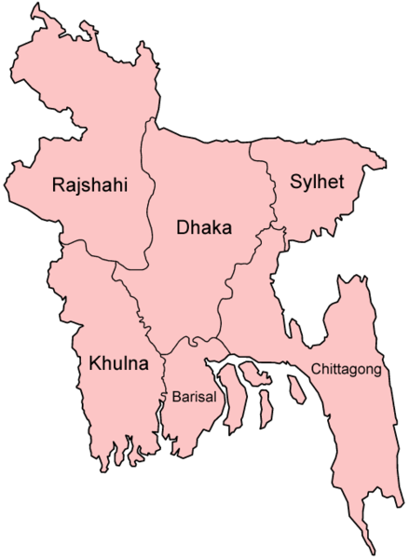
70

21

Savar Upazila

26⁰

26

23⁰

22⁰

26⁰

25⁰

21

22

23

24

25

INDIA
INDIA
INDIA
SAVAR UPZILA
B A Y OF B E N G A L
0
70
140 KM
N
INDIA
89⁰
90⁰
91⁰
92⁰

Source: Banglapedia, 2006
Fig. 3.1: Savar Upzila in Bangladesh

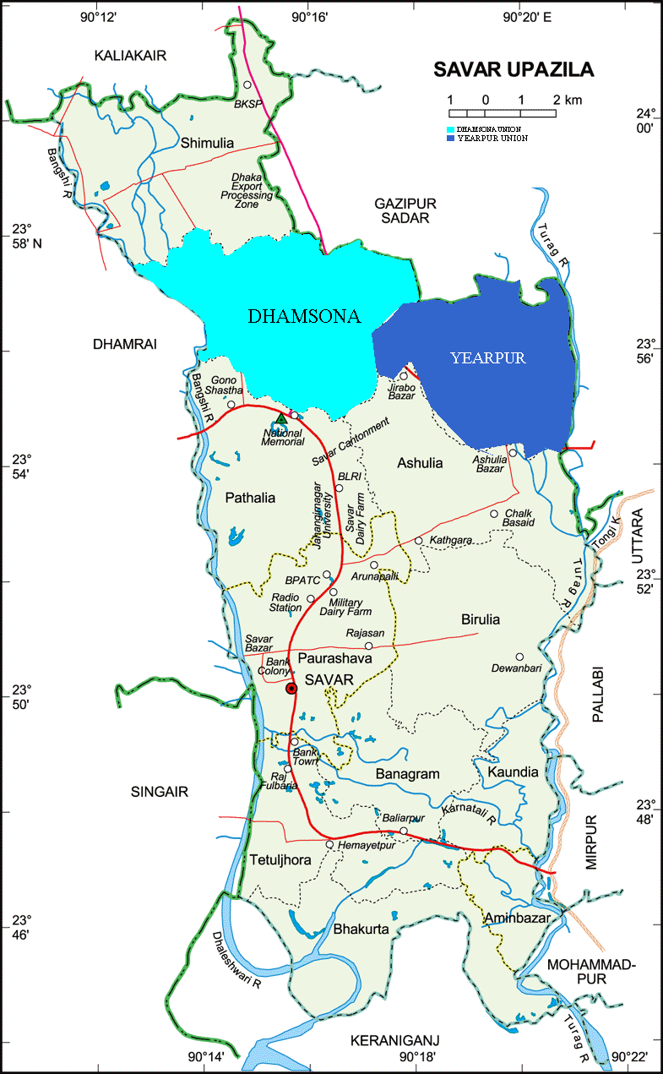

Source: Banglapedia, 2006

Fig. 3.2: The Study Area

Table 3.1: Geological Succession

Formation |  | Lithology | Thickness
Sub-Recent  to Recent | Alluvium | b. Low Land alluvium : Sand, clay, silty, gray, yellowish gray and peaty | 1' – 20'
Sub-Recent  to Recent | Alluvium | a. High land alluvium: clay and clayey soil, grey, massive sticky. It lies above the present flood level. | 1' – 10'
Pleistocene | Modhupur  Clay | Unconformity  b. Red clay: Brownish red to brick red, massive oolitic, contains ferruginous and calcareous nodules laterite, and surfacial deposits of slag.
Pleistocene | Modhupur  Clay | a. Mottled clay: Earth grey with mottling of red, brown and orange colours, massive, oolitic,sticky,contains calcareous nodules. | 100'
Pliocene | Dupi Tila | Unconformity  Sandstone: Yellow, massive, cross-beded, fine to medium grained, fairely consolidated contains gravels at depth. | 300' +

Source: Alam&Aurangzeb, 1975

3.3.1.2 Modhupur Formation

In the Modhupur formation there are two parts. The lower part of the formation is mottled and upper part is red. According to the description of Alam & Aurangzeb (1975), the characteristics of mottled clay and red clay are as follows :

Mottlted clay

Mottled clay development in between the Dupi Tila sandstone and Modhupur red clay. It is earthy grey, spotted with patches of red, brown, and orange colors. Clays is sticky, massive, compact resiculor. Oolitic, pisolitic, pisolitic – mottled clay also contains white sand, calcareous and ferruginous modules.

Stream bed, hillock slopes and lowtable lands expose this lithological unit. This rock unit unconformably overlies the Dupitilla sandstone formation, and underlines the red clay. The contact between the red and mottled clay is gradual and irregular. The rock thickness unit varies from 8 feet to 40 feet.

Red clay

The hillocks and high lands of the Modhupur inlier are capped and blanketed with red clay. The rocks colour varies from red, orange to brownish red and brick red. It is massive, vericular and oolitic. The clay is interring calated with sand and silt. The rock unit is associated with ferruinous nodules, oolites and mud balls. In many places of red clay zone surfacial deposit of slage occur as heaps and scattered. Red clay ranges thickness from less than 1 foot to more than 46 feet. The age of the Modhpor formation is late Pleistocene.

3.3.1.3 Alluvium

The study area belongs to older alluvium of the ancient rivers and has been uplifted (Morgan and McIntire1959). In this area high land low land developed with alluvium deposits. High land rock units consists of clay and silt and it is earthy grey to dark grey. High land alluvium cover vanges from less than 1 foot to more than 10 feet in thickness.

On the other hand, the most recent deposit and which is under the processes of fluviatile deposition is low land alluvium. Low land consists of clay, silt, sand and peaty clay. There are three sets of fault developed in this area. They are-

1) The north south trending faults-Bansi fault, Baunia fault and Demra fault.

2) The north west-south east trending fault Burigonga fault, Dhamrai fault, Kalakair fault and Kalian fault and Triusal-Balian fault.

3) The east west trending fault of Tongi area.

3.3.2 Topography and Hydrology

The Modhupur tract is a distinct geomorphic unit, geographically the tract is more elevated than the flood plains surrounding it as all four sides. The surface comprises of highly dissected, faulted and weathered soil cover. The elevation of the area is 50-100 ft high from the adjacent flood plain. The whole area is bounded by Brahmaputra on the north, Jamuna flood plain on the west, Buriganga on the south and Meghna flood plain in the east but all along the western edge it formic a steep escarpment with the floodplain. One good example of their can be found on the right hand side of the Tangail Mymensingh road just before entering the National Park, where it will be found, (Miah & Bazlee ,1968). The escarpment is rather in conspicuous on the southern side. The terrace sloping gradually from the north, merges gently with the floodplain of the Buriganga like the west, the eastern side, the terrace surface is very well marked from the floodplain by a distinct level although the escarpment is not as high or as steep as its western counterpart. Miah & Bazlee (1968) described that the surface is flat and extensive. The presence of baids the flatness may be broken here and there. At places gullies and sheet erosion might give some relief to the otherwise monotonous plain. The author in his study showed that Modhupur National Park and Joydevpur areas are the specific examples of flat surface.

However, most of the study area lies above over flood level but a small down – warped area immediately north of Hemayetpur and Turag river basin are deeply flooded. Most of the part of the study area is above 15' MSL and some where it is above 35' MSL.

For Dhaka city ground water is an important phenomenon. The static water table has already adversely affected for the with draw of ground water in and around the Dhaka city. Every year the static water table is going down. Networks of deep tub wells being developed now in and around the city will further affect the aquifer and the rate of digenesis in the underlying sandy formation will be higher. Differential compaction of the aquifer will create instability (Alam &Aurangzeb, 1975). Brammer (1967) suggested that ground water is believed to be readily available at shallow depths throughout all flood plain areas.

3.3.3 Soil

All the soils of Dhaka district area developed over unconsolidated alluvial sediments. Unconsolidated alluvial sediments are of two kinds: Compact Modhupur clay which occupies dissected terrace topography in the Modhupur tract, and recent or sub recent mixed floodplain sediments deposited by the Ganges, Brahmaputra and Meghna rivers. There are four principal types of soil in the Modhupur tract to according the structure, texture, porosity, drainage and reaction . Based on Brammer’s (1967) findings they are:

1) Shallow red-brown terrace soils

2) Deep red-brown terrace soils

3) Brown-mottled terrace soils and

4) Gray terrace soils.

However, in the study area all of above mentioned soils are present. Shallow and deep-red brown terrace soils are also present in the broadly dissected level terrace and brown-mottled and grey rest part of the study area. In the study area there are 14 soil associations. They are:

(1) Tejgaon (2) Tejgaon-Noadda (3) Tejgaon Chandra (6) Chandra-Noadda (7) Tejgaon-Khilgoan ( broadly dissected ) (8) Tejgaon-Khilgaon ( closely dissected ) [ ІІ (b) ] Tejgaon-Kalma (13) Khilgaon-Pryati-Sajek (20) Demra-Chitta-Kalma (23) Khilgaon-Gerna (21) Gerna-Chitta-Kalma (27) Bhatpara-Kalma-Gerna (32) Tejkunipara-Chhiata-Kalma (37) Kajla-Jatrabari-Turag & (38) Kajla-Turag association.

The soil colour ranges from yellowish brown to radish brown in the study area. In the well drained areas they are yellowish and poorly drained areas they are brown and grayish brown.

The soil’s sub soil material is a deeply and strongly weathered and leached. However, it can be said that most of the soil of the study area is silt to clay expect Turag river basin which is dominant with sandy soil.

3.3.4 Vegetation

Once upon a time the study area was covered by dense forest but the advancement of time due to severe human interference and partly due to natural change, this vegetation covers has diminished. In fact, at present in the study area there is no considerable amount of vegetation cover but in some small patches there remains rampant of this vegetation covers.

In the Modhupur tract the study area lies which has already been mentioned. According to Brammer (1971) the entire Modhupur tract was covered by dense semi-evergreen mangrove forest. But through a latest phase of plant succession, the Modhupur jungle has now changed into deciduous type (Alam, 1979). But presently the baids of the study area which is in the Modhupur tract are now more or less used for rice cultivation. However it can be said that the natural vegetation have no other organized and spontaneous growth (Mirza, 1979). In the broad terrace zones which have more or less a cultivated land use, the jackfruit predominates. Whereas the closely dissected undulating surfaces have thorny bushes and shrubs.

3.3.5 Climate and Weather

The overall Climate of Dhamshona and Yearpur union is moderate and humid. The main features of the climate of this area are incessant rain in the rainy season and high temperature in the summer. More rain occurs between June and September. October to January is the minimum rain period. Winter starts from November to February-March. Summer prevails in the rest of the month

Table 3.2: Average temperature of each month in the study area (2006-2007)

Month | Highest Temperature  (*C) | Lowest Temparature (*C) | Average  Temparature (*C)
July | 31.99 | 28.4 | 30.19
August | 31.58 | 27.66 | 29.62
September | 31.55 | 26.98 | 29.26
October | 31.11 | 25.93 | 28.52
November | 28.44 | 21.51 | 24.97
December | 24.45 | 16.51 | 20.48
January | 23.17 | 13.86 | 18.51
February | 29.71 | 21.83 | 25.77
March | 30.86 | 22.18 | 26.52
April | 33.01 | 25.95 | 29.48

Source: Department of Geography and environment. J.U. (2006-2007)

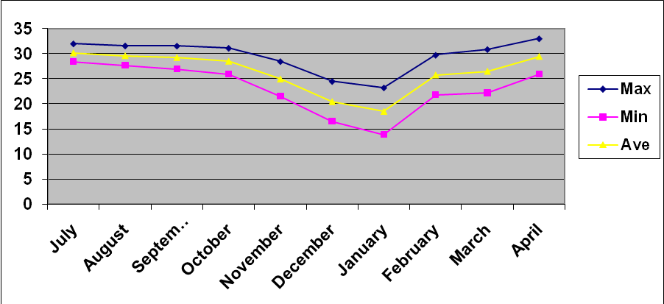

Source: Table 3.2
Figure 3.3: Monthly fluctuation of highest and lowest temperature.

Table 3.3: Average rainfall per month in 2006

Month | Rainfall (mm)
July | 6.94
August | 4.72
September | 23.23
October | 2.15
November | 0
December | 0
January | 0
February | 0
March | 0
April | 0.27

Total annual rainfall =56.71 mm

Source: Department of Geography and Environment. J.U. (2006-2007)

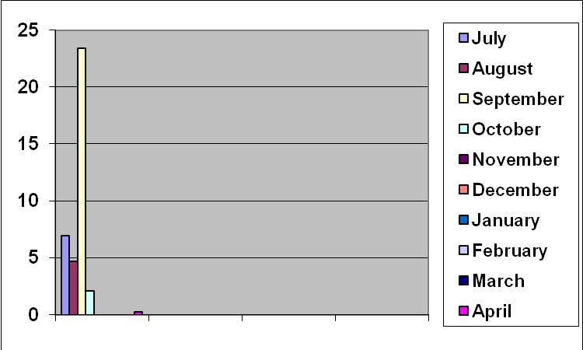

Source: Table 3.3

Figure 3.4: Monthly rain fall

Table 3.4: Monthly humidity of the study area

Month | Relative humidity (%)
July | 88.72
August | 84.3
September | 85.6
October | 84.64
November | 81.24
December | 74.28
January | 84.64
February | 90.83
March | 85.90
April | 85.59

Source: Department of Geography and Environment. J.U. (2006-2007)

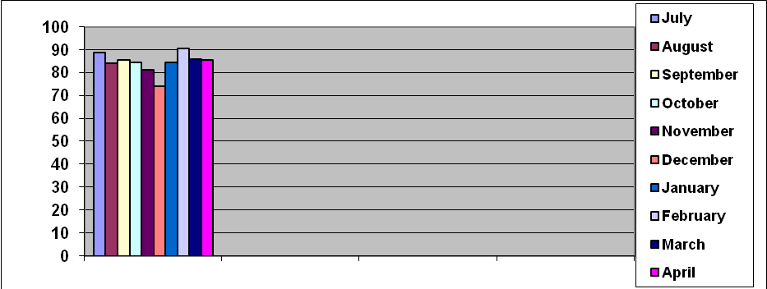 Source: Table 3.4 Fig 3.5: Monthly fluctuation of monthly humidity

3.4 Socio-economic Condition

The socio-economic condition of a place refers to the current state of economic and social characteristics. It may be said to correspond to the average situation prevailing in the given area as a whole with respect to commercial, industrial and other economic activities and social facilities (GOB, 1986). The existing pattern of settlement in the study area is a mixture of urban and rural forms. The landuse is predominantly agricultural with village type of homestead groups with low level of urban services but a significant proportion of the inhabitants are engaged in non-agricultural pursuits for their livelihood. Due to the various urban linkages and proximity to Dhaka city, the study area is characterized by some changes in socio-economic condition in terms of literacy, occupation etc.

Socio-economic conditions and their changing pattern have been highlighted in the following paragraphs.

3.4.1 Population

According to the census of 1991, total population of Savar is 3,66,050 and the total population of Dhamshona union is 33,626 which is the 9.19% of the total population of this upazila. Dhamshona union has 15 mouza. Total area of Dhamshona union is 33.14 square kilometer. There are 684 people live in per square kilometer of Dhamshona union.

Yearpur union has 12 mouza. Total area of Yearpur union is 27 square kilometer. According to the census of 1991, total population of Yearpur union is 16,422 which is the 4.49% of the total population of Savar upazila. In Yearpur 598 people are living per square kilometer.

3.4.2 Level of Literacy

Table 3.5 shows the literacy structure of various age groups of Savar in 1981 which indicates the pattern of population characteristics identifying the urban structure. In the study area, 27,234 children between 5 and 14 years of age were literates, being 32.8 % and of them 32.9% were males and 32.7% were females; between 15 and 24 years age group 44,600 persons representing 64.9% out of 68,685 were literates and of them 68.6% were males and 59.8% were females ; between the age group of 25-44 years 52,161 persons which amounted to 61.3% out of 85,146 were literates and of them 69.3% and 46.9% were males and females respectively ; between 45 and 64 years of age group 14,326 persons out of 28,415 accounted for 50.4% were literates and of them 63.3% were males and 29.6% were females and in the age group of above 65 years 2,692 persons out of 6,633 being 40.6% were literates and of them 55.4% and 20.0%were males and females, respectively (Table 3.5).

Table 3.5: Literacy Structure in Various Age Groups in Savar, 1981

Age group | Both sexes |  |  | Male |  |  | Female
Age group | Total | Literacy |  | Total | Literacy |  | Total | Literacy
Age group | Total | Number | Percentage | Total | Number | Percentage | Total | Number | Percentage
5-14 | 82977 | 27234 | 32.8 | 42683 | 14053 | 32.9 | 40294 | 13181 | 32.7
15-24 | 68685 | 44600 | 64.9 | 40242 | 27586 | 68.6 | 28443 | 17014 | 59.8
25-44 | 85146 | 52161 | 61.3 | 54627 | 37853 | 69.3 | 30519 | 14308 | 46.9
45-64 | 28415 | 14326 | 50.4 | 17549 | 11111 | 63.3 | 10866 | 3215 | 29.6
65+ | 6633 | 2692 | 40.6 | 3818 | 2128 | 55.7 | 2815 | 564 | 20.0

Source: GOB, 1984.

Thus, in the study area higher percentage of literates were in the age groups of 15-24 years and 24-44 years and the lower percentage of literates were in 5-14 years, and 65 years and above age groups. Higher percentage of male literates in the age groups of 15-24, 25-44 and 45-64 years, while female literates were in the 15-24 and 25-44 years age groups ( Table 3.5).

During 1974-1990, there appeared a significant change in literacy rate in Savar (Table 3.6). Here the literacy rate for population refers to the ratio between literate population of aged 5 years and above to the total population expressed in percentage (GOB,1984). In 1974, there was 31,408 literates accounted for 15..32% of the total population, but it increased to 19.48% in 1981 and 25.59% in 1990 (Table 3.6). Thus, in the changing pattern of literacy rate during the intercensal period of 1974-1981, there has been an increase of 4.16% for both sexes, but for males and females it was 5.75% and 1.56% respectively; while it was slightly increased to 6.11% for both sexes whereas for males and females it was 7.99% and 3.57% respectively during the period of 1981-1990. The total change of literacy rate during 1974-1990 was 10.27% for both sexes, 13.74% for males and 5.13% for females (Table 3.6).

 | Both sexes |  |  | Male |  |  | Female
 | Total  population | Literacy |  | Total population | Literacy |  | Total population | Literacy
 | Total  population | Number | Percent  Age | Total population | Number | Percent  age | Total population | Number | Percentage
1974 | 204988 | 31408 | 15.35 | 106534 | 22830 | 21.43 | 98454 | 9067 | 9.21
1981 | 261904 | 51009 | 19.48 | 139002 | 37775 | 27018 | 122902 | 13234 | 10.77
1990 | 404623 | 103536 | 25.59 | 218496 | 76845 | 35.17 | 186127 | 26691 | 14.34

Table 3.6: Literacy Rates in Savar Upazila, 1974-1990

Source: GOB, 1977, 1984 and RAJUK, 1990

In all categories of education, males dominate over the females and the literacy rate for males increases at a higher rate over the female literacy rate in the study area. The variation of literacy rate for 1974-1981 is lower than the variation of 1981-1990.

According to the census of 1991 the literacy rate of Dhamshona union is 37.1%. There are 10 government primary school, 1 satellite school, 1 registered primary school, 3 high school, 3 senior madrasa and 1 non-government primary school in Dhamshona union.

According to the census of 1991 the literacy rate of Yearpur union is 32.3%. Male literacy rate is 39.4% and female literacy rate is 24.8%. There are 7 government primary school, 1 satellite school, 1 non government primary school, 4 high school, 1 senior madrasa and 2 college in Yearpur union.

3.4.3 Occupational Characteristics

Occupation is an important term plays vital roles in the identification of social characteristics. Economically active population of a country comprises persons who are actually engaged or desirous of engaging themselves in the production of economic goods and services. Economically, active population, therefore, comprises both employed and unemployed population (seeking for job). On the other hand, housewives, students and other inactive persons are treated as not in a economically active population (Shryoch, Henry and Associates, 1976). There are many types of occupations among the active and inactive populations in the study area which indicate the general socio-economic conditions in response to the urbanization processes. In the study area, 86,038 persons representing 31.27% (Hassan, 1988) were engaged in the household works, 53,598 persons being 19.48% were in the cultivation, 5,861 persons being 2.13% were engaged in the agricultural non-cropped works, 9,409 persons responding 3.12% in the manufacturing works, 23,745 persons being 8.63% were engaged in the business for their livelihood; while 72,473 persons out of 2,75,144 persons being (26.34%) were unemployed.

In the study area, the majority of the people (31.27%) were engaged in the household works; while the lower percentage ( 2.13%) of the people were engaged in the agricultural non-cropped works, but a large percentage of people (26.34%) were unemployed (Hassan,1988).

3.5 Industries and Commerce

Industrialization is an important factor for urban growth. A good number of large, medium and small sized industries are established in the study area. However, the industries are of various categories ranging from consumer goods, such as, textile yearns, cloth etc., light engineering products, paper board, food products, etc. The progressive development in other sectors like poultry and dairy farming, fishery, horticulture, mushroom cultivation are worth mentioning. During the period of 1974-2009, there has been a significant change in the number of industrial establishment and industrial land utilization in the study area. Dhaka export processing zone is adjacent to Dhamshona union. There are 75 local and foreign industries in the old and new EPZ zones where most of them are textile and dying industries. The diverse natures of the industries create a complex task for analysis and treatment of the composite effluent. The industries altogether consume a huge quantity of chemicals everyday and a large portion of effluent is discharged in the Dhalai Beel (West side of old DEPZ), which in turn spreads over the adjacent farmland and to immediate locality. The effluents contain a wide variety of toxic chemicals that are harmful and increase the pollution burden of the environment.

3.5.1 General Aspects of Industrial Pollution

      - Steel industry

The effluents from steel industry is toxic to aquatic life as it contain high values of BOD, COD, phenol, cyanides and other constituents and a very low value of DO.

3.5.1.2 Textile Industries

Raw cotton is corded, spun, spooled and warped, sixes, drawn and woven into cloth before being sent into the finishing unit in the textile mills. No water borne pollution originates into this section of operation. The major wet processes in the mills are: sizing, bleaching, mercerizing, fancy dyeing, screen printing, khaki dyeing, yarn dyeing, and finishing. The quantities and the characteristics of the waste water discharge by mill vary from one mill to another and depend upon water usage and average daily production and the process involved. The combined waste water discharged by the factory is late in volume and show sharp variation in physicochemical properties.

3.5.1.3 Dairy and dairy products

Industrial wastes arising out of dairy plants include wash water for milk cans, equipment, bottles tanks drums and floors. The milk contains carbohydrates protein and fats in addition to minor organic and inorganic materials.

      - Distillery

The distillery waste is highly organic in nature and because of its high biochemical oxygen demand (BOD) quality removes the oxygen for the water and unless waste is diluted can produce pollution hazards in the aquatic ecosystem.

3.5.1.5 Tanning industry

Cr (VI) in the effluents of tanning industry is very hazard for plant and animal life, which is produced from the “chrome alum”, used in the cleaning of the leather.

3.5.1.6 Oils industry

The substances of oils are affects the living organisms in water.

3.5.1.7 Electroplating and heat treatment industries

The effluents contain harmful metal ions such as Cr, Ni, Cd, Ag, Au, and highly poisonous cyanide which caused excessive acidity and alkalinity in water and become harmful for aquatic life.

3.5.1.8 Can sugar industry

During manufacture of sugar the effluents are discharged and they contain high polluted contents. The effluents contain high degree of organic pollutants is produced in the setting tank which disputes the aquatic life very harmfully.

3.5.1.9 Detergent industry

The detergents cause serious pollution of water resources because they contain phosphate.

3.5.1.10 Pulp and paper factory

Most of the paper and straw board mills use lime and caustic for pulping and do not recover the chemicals and hence the BOD and suspended solids are invariably high. Another important toxic pollutant in pulp and paper industry is mercury. This is so because some of the mills make their own caustic and chlorine in mercury cells. Further some organic mercury compounds such as phenyl mercuric acetate, methoxy ethyl mercury and pyridyl mercury salts are being used as silicates on paper machines which finally find their way into the effluents.

3.5.1.11 Fertilizer industry

The potassic fertilizer contains 37% k2o rest being silica, calcium, iron and some sodium is the end product of the process.

3.5.1.12 Alcohol industry

In the fermentation of molasses besides alcohol we get glycerine, succinic acid acetaldehyde, allyl alcohol, acetic acid, and fuse oil as by products. This byproducts cause serious pollution of water and environment.

3.5.1.13 Thermal pollution

Thermal pollution means the addition of hot water to a streams or lake. Steam and nuclear power plants need water for cooling, especially the latter, which produce 60% more heat per unit of electricity than cool plants. The water is usually taken from a steam or lake, passed through the cooling system and turned at a temperature higher by 5 or 10º C. With the projected increased in nuclear power, the requirements for cooling water are growing greatly, and in heavily industrial region, all the available water could be used for cooling. The cost of cooling increases with the degree of cooling. The difference in construction cost between permitting a 10ºF increase in the temperature of cooling water or a 20ºF increase in 514 steam plants operation in 1965 would be $132 million. There is much controversy about the extent of damage cause by thermal pollution. Some animal are killed outright by the hottest water. The major damage is probably caused not by heat but by mechanical injury to the small fish and invertebrates swept though the cooling tubes at high speed, most of which are killed. Several plants along a river could impose a very significant mortality on the population and eliminate some species of fish.

3.5.1.14 Radioactive wastes

Radioactive substances are used for power industry, heating the home, preserving food, fueling and as medicines in curing the diseases. They can also be used to prepared bombs etc. The wastes from atomic reactor, hospitals etc. are most dangerous because their radioactivity wastes destroy the plants and animals to a great extent.

3.5.2 Commercial landuse

Commercial function is an important factor of an urbanization process. In the study area there is a significant evidence of commercial landuse expansion over time. This type of landuse consist mainly hat and bazaars which include small shop, retail, and wholesale etc. Major concentrations are located mainly in Baipal, Bashbari, Dehara, Anayetpur, Gonokbari, Nolam, Nolam bagbari, Polashbari, Jirabo, Tajpur, and Chitrashial. The process of suburban development in this area is, in recent decades, complementes by an unpreceedented population increase, expansion and development of housing and settlements, industrial, commercial and other non-agricultural areas; urban infrastructural services and the decrease of agricultural land area. The demand for more space arising out of rapid growth of population for housing, food production, market expansion, communication, commerce, industries etc, is going to exert even more competing pressure on land; and this will play significant roles in the changes of biodiversity in this area.

3.6 Summary

The unifying theme of this chapter is the relationship among the location, geology, soils, topography and hydrology, vegetation, weather and climate, population, level of literacy, occupation, industries and commerce for suitability of biodiversity. Urban services and infrastructures are gradually increasing in the study area. An attempt has been made to establish either this place is suitable or not for rich biodiversity considering the above criteria.

4.0 BIODIVERSITY OF BANGLADESH: AN OVERVIEW

4.1 Introduction

Biodiversity is the extraordinary variety of living creatures and ecological communities growing and interacting with each other all over the world. It is the richness and complexity of species and ecosystems throughout the planet-continually adaptations necessary for survival under constantly changing conditions.

Earth is home to an estimated 10 to 20 million species, but only a fraction is known and scientifically classified (Sahney et.al. 2010). The interdependence among organisms and their environments creates and sustains the conditions needed for survival by all living creatures.

Biodiversity is disappearing at an alarming rate, at levels from genes and species to ecological communities. Some ecologists predict that 50 per cent of all mammals and birds will be extinct within the next century. In 2007, German Federal Environment Minister Sigmar Gabriel cited estimates that up to 30% of all species will be extinct by 2050. Biologists believe the loss of these resources threaten the functioning of natural systems and the overall well-being of human society

4.2 Nature and value of biodiversity

Having a wide diversity of life on Earth is valuable for a variety of reasons. These can be grouped into the three basic categories listed below.

Ecological Values: All living creatures are supported by the interactions among ecosystems and organisms. Biodiversity supports ecosystem services including air quality, climate (e.g., CO2 sequestration), water purification, pollination, and prevention of erosion (Robert et.al. 1997). Loss of biodiversity makes ecosystems less stable, more vulnerable to extreme events, and weakens its natural cycles. The following natural cycles make Earth hospitable by moderating temperatures and climate, and by providing us with food, clean water and breathable air.

Energy cycle: Photosynthesis is the process by which green plants convert sunlight, water, nutrients, and carbon dioxide into carbohydrates (which also releases oxygen into the atmosphere). Plants and photosynthetic bacteria transform energy from the sun into stored chemical energy, which is the foundation for virtually all food webs.

Water cycle: Biodiversity is directly involved in water purification, recycling nutrients and providing fertile soils. It refers to the circulation, transformation, and replenishment of fresh water from all of Earth’s ecosystems. Forests, for example, moderate water flows by catching, holding and recycling rainwater. Plants release absorbed rainwater into the air through the loss of water through their leaves, called transportation. In addition, wet lands and estuaries purify water and control flooding. Cattails, for example, catch and filter rainfalls and stream flows, remove toxins and gradually release water into creeks and rivers.
Carbon and oxygen cycles: Carbon dioxide in the atmosphere is generated by animal respiration, plant decay and the burning of fossil fuels. Through photosynthesis Carbon dioxide (CO2) is absorbed into the oceans by tiny sea-dwelling organisms called phytoplankton. CO2 is stored by trees and plants as carbohydrates or complex sugars, and release oxygen back into the atmosphere, which provides us with a breathable atmosphere.

Nitrogen cycle: For all organisms Nitrogen are needed in order to live and it makes up a large component of Earth’s atmosphere. In its natural atmospheric form, nitrogen isn’t directly accessible to most organisms, so it needs to be converted, primarily by bacteria which live on the roots of certain plants such as clover, beans alfalfa, and peas. These bacteria absorb nitrogen from the air and “fix” it into compounds like nitrate and ammonia--which helps plants grow. Creatures feeding on these plants release nitrogen in their waste products, which decompose and are then recycled into the atmosphere in their original form.

Ecosystems provide numerous additional services to humans, animals and plants that we take for granted. For example, bacteria and soil organisms decomposed waste products and create fertile soils in which crops can be grown. Pollinators such as bees ensure our food crops reproduce, while other animals such as bats, ladybugs and dragonflies control crop pests.

The daily activities of a diverse range of creatures helps keep ecosystems functioning in turn, these ecosystems support life. Healthy ecosystems are more stable and more adaptable to any change, such as extreme events like drought or floods which can alter entire ecosystems.

Economic Values: The basis for the economy a biologically diverse natural environment provides humans with the necessities of life and forms. Everything we buy and sell originates from the natural world. Nature provides the raw materials we need for survival, and forms the basis for the global economy. The world food supply today is derived from 30 crops which supply about 90 per cent of calories to the human diet. And just 14 animal species make up 90 per cent of the livestock we raise. Earth's surviving biodiversity provides resources for increasing the range of food and other products suitable for human use, although the present extinction rate shrinks that potential (Wilson, 2002). Since we depend so few plant and animal species to supply us with food. We are vulnerable to environmental changes and crop diseases.
Scientists have identified and named about 270,000 species of plants. Some experts estimate the total number of plants could be as high as 320,000 worldwide. New species are regularly discovered (on average between 5–10,000 new species each year, most of them insects) and many, though discovered, are not yet classified (estimates are that nearly 90% of all arthropods are not yet classified (www.unep.org). Most of the terrestrial diversity is found in tropical forests. Tropical rain forests support some of Earth’s highest levels of biodiversity. At least 1,650 known tropical forest plants have the potential to be grown as vegetable crops, which could reduce our reliance on the few crops grown today.
Biodiversity provides critical support for drug discovery and the availability of medicinal resources (www. gmo-compass.org).A significant proportion of drugs are derived, directly or indirectly, from biological sources: at least 50% of the pharmaceutical compounds on the US market are derived from plants, animals, and micro-organisms, while about 80% of the world population depends on medicines from nature (used in either modern or traditional medical practice) for primary healthcare (www.cohabnet.org).

Nature is the source for many medicines such as aspirin, heart stimulants, antibiotics, anti-malarial and cancer fighting compounds. For example, a drug called Taxol, derived from the Pacific yew tree, has shown promise in the treatment of ovarian and breast cancers in trials conducted by the U.S.-based National Cancer Institute. But only a tiny fraction of wild species has been investigated for medical potential. Biodiversity has been critical to advances throughout the field of bionics. Evidence from market analysis and biodiversity science indicates that the decline in output from the pharmaceutical sector since the mid-1980s can be attributed to a move away from natural product exploration ("bioprospecting") in favor of genomics and synthetic chemistry; meanwhile, natural products have a long history of supporting significant economic and health innovation (Harvey, 2008).
About a quarter of all prescription drugs are taken directly from plants or are chemically modified versions of plant substances. More than half are modeled on natural compounds. About 121 prescription drugs are derived from higher plants. Yet less than 1 per cent of rainforest plants have been tested for their medicinal properties. It has been estimated that of the world’s 250,000 known plants species, only 5,000 have been tested for their medicinal potential. In the US, more than $6 billion (US) is spent annually on medicines derived from tropical plants (Hawkins et.al. 1992).

Everything we use in our daily lives was originally derived from the natural world. In 1997, a team of ecologists and economists estimated the monetary value of nature’s services to society to be at least $33 trillion (US) each year, nearly twice the $18 trillion combined gross national product (GNP) of all the world’s 194 countries that year (Costanza et. al. 1997). Climate regulation, water purification, soil regeneration, nutrient cycling, waste recirculation, crop pollination and production of timber, fodder and biomass are provided by our living environment for free. This dollar estimate is purely a thought experiment since nature’s services can’t be replaced, but it demonstrates why maintaining biodiversity is essential for sustaining the global economy (Robert et.al. 1997).

Leisure, Cultural and Aesthetic Values: Most people feel connected to nature, often for reasons that can be hard to explain. Biodiversity inspires musicians, painters, sculptors, writers and other artists. They feel a strong spiritual bond and inspired by its beauty. Popular activities such as gardening, fish keeping and specimen collecting strongly depend on biodiversity. Human cultures around the world profoundly reflect our visceral attachment to the natural world. Thus cultural diversity is inextricably linked to Earth’s biodiversity. Philosophically it could be argued that biodiversity has intrinsic aesthetic and spiritual value to mankind in and of itself.

4.3 Types of biodiversity

Biodiversity is the totality of genes, species, and ecosystems in a region (Gaston, 1996). The wealth of life on Earth today is the product of hundreds of millions of years of evolutionary history. The fossil record suggests that the last few million years featured the greatest biodiversity in history (Sahney et. al. 2010). Some scientists believe that corrected for sampling artifacts, modern biodiversity may not be much different from biodiversity 300 million years ago (Alroy et. al. 2001). Over the course of time, human cultures have emerged and adapted to the local environment, discovering, using, and altering local biotic resources. Many areas that now seem “natural” bear the marks of millennia of human habitation, crop cultivation, and resource harvesting. The domestication and breeding of local varieties of crops and livestock have further shaped biodiversity.

Biodiversity can be divided into three hierarchical categories-genes, species, and ecosystems that describe quite different aspects of living systems and that scientists measure in different ways. In 2003 Professor Anthony Campbell at Cardiff University, UK and the Darwin Centre, Pembrokeshire, defined a fourth level diversity: Molecular diversity (Campbell, 2003).

Genetic diversity: For geneticists, biodiversity is the diversity of genes and organisms. It refers to the variation of genes within species. They study processes such as mutations, gene exchanges, and genome dynamics that occur at the DNA level and generate evolution.This covers distinct populations of the same species (such as the thousands of traditional rice varieties in Bangladesh) or genetic variation within a population (which is very high among Bangladesh rhinos, for example and very low among cheetahs). Until recently, measurements of genetic diversity were applied mainly to domesticated species and populations held in zoos or botanic gardens, but increasingly the techniques are being applied to wild species.

Species diversity: For biologists, biodiversity is the diversity of populations of organisms and species. It refers to the variety of species within a region. The number of species in a region-its species “richness”-is one often-used measure, but a more precise measurement, “taxonomic diversity,” also considers the relationship of species to each other. For example, an island with two species of birds and one species of lizard has greater taxonomic diversity than an island with three species of birds but no lizard. Thus, even though there may be more species of beetles on earth than all other species combined, they do not account for the greater part of species diversity because they are so closely related. Similarly, many more species live on land than in the sea, but terrestrial species are more closely related to each other ocean species are, so diversity is higher in marine ecosystems than a strict count of species would suggest.

Ecosystem diversity: For ecologists, biodiversity is the diversity of durable interactions among species. It is harder to measure than species or genetic diversity because the “boundaries” of communities-associations of species-and ecosystems are elusive.It not only applies to species, but also to their immediate environment (biotope) and the eco regions the organisms live in. In each ecosystem, living organisms are part of a whole; they interact with one another, but also with the air, water, and soil that surround them.Nevertheless, as long as a consistent set of criteria is used to define communities and ecosystems, their number and distribution can be measured. Until now, such schemes have been applied mainly at national and sub-national levels, though some coarse global classifications have been made.
Besides ecosystem diversity, many other expressions of biodiversity can be important. These include the relative abundance of species, the pattern of communities in a region, the age structure of populations, changes in community composition and structure over time, and even such ecological processes as prediction, mutualism and parasitism. More generally, it is often important to examine to meet specific management or policy goals, not only compositional diversity-genes, species, and ecosystems-but also diversity in ecosystem structure and function.

Human cultural diversity could also be considered part of biodiversity. Like genetic or species diversity, some attributes of human cultures (say, nomadism or shifting cultivation) represent “solutions” to the problems of survival in particular environments. And, like other aspects of biodiversity, cultural diversity helps people adapt to changing conditions. Cultural diversity is manifested by diversity in language, land-management practices, crop selection, art, music, religious beliefs, social structure, diet, and any number of other attributes of human society.

  - Biodiversity in Bangladesh

Bangladesh is a transitional zone of flora and fauna, because of its geographical settings and climatic characteristics. In Bangladesh about 8-10 percent of the land area is under good canopy cover. It supports approximately 5000 species of angiosperms, out of which about 300 species are being cultivated (Banglapedia, 2006). Mia and Hauque (1986) showed there are 224 species of timber yielding plants found in Bangladesh. Khan and Mia (1954) described 130 species of indigenous fiber plants. According to the Red List of IUCN on vascular plants, there are 96 seed-bearing plant species in Bangladesh.

Bangladesh is rich in fish and aquatic resources, and other biodiversity. Bangladesh’s inland water bodies are known to be the habitat of 266 species of indigenous fish, 13 exotic fish, 56 prawns, about 26 freshwater mollusks, and 150 birds (Ahmed and Ali, 1996).

The IUCN Bangladesh Red Data Book (2000) has described 266 species of inland fishes, 442 marine fishes, 22 amphibians, 109 inland reptiles, 17 marine reptiles, 388 resident birds, 240 migratory birds, 110 inland mammals, as well as 3 species of marine mammals in Bangladesh and according to the Red List of IUCN, there are 54 species of inland fishes, 8 amphibians, 58 reptiles, 41 resident birds, and 40 mammals, which are threatened throughout the country. Among the marine and migratory species of animals, 4 fishes, 5 reptiles, 6 birds, 3 mammals are threatened

In Bangladesh several species of crabs, and 31 species of turtles and tortoises, of which 24 live in freshwater are found (Sarker and Sarker, 1988; Ali, 1997). Ahmed and Ali (1996) published species list of 168 seaweeds, 3 sponges, 15 crabs, 3 lobsters, 10 frogs, 3 crocodiles, 24 snakes, 3 otters, 1 porcupine, 9 dolphins, and 3 species of whale found in Bangladesh. There are numerous invertebrates in the country that are yet to be identified. Various authors have recorded about 70 species of bees, and many species of wasps (Alam, 1967). The marine water bodies (200 nautical miles along the coasts) are also remarkable for being habitat of 442 species of fish. There are at least 36 species of marine shrimps. About 336 species of mollusks, covering have been identified from the Bay of Bengal. Table 4.2.1 showed the list of flora and fauna in Bangladesh.

Table 4.2.1: Flora and Fauna in Bangladesh

Categories | Total Number of Species
Flora
Angiosperms | 5000
Gymnosperms | 5
Algae/seaweed | 168
Fauna
Sponges | 3
Corals | 66
(Marine + freshwater) Molluscs | (336+26) 362
Insets | 2493
Mites | 19
Shrimps/prawns | 56
(Marine + freshwater) Crabs | (11+4) 15
Lobsters | 3
Echinoderms | 4
(Marine + freshwater) Fish | (442+266) 708
Amphibians | 22
(Marine + inland) Reptiles | (17+109) 126
Birds | 628
(Marine + inland) Mammals | 3+110) 113
Sources: Khan, 1991; Ahmed and Ali, 1996; Alam 1967; IUCN, 2000

4.4.1 Fauna of Bangladesh
Bangladesh is situated within the subtropical belt and has a wide variety of ecological conditions. In addition to a long sea coast, numerous rivers and their tributaries, lakes, haors, baors, ponds and other forms of wetlands, there are lowland evergreen forests of tropical nature, semi-evergreen forest, hill forests, moist deciduous forests, swamps, and flat lands with tall grasses. According to the IUCN the country has about 113 species of mammals, over 630 species of birds, 125 species of reptiles and 22 species of amphibians. It has 260 freshwater species and 475 marine species and other faunal species include 327 mollusks and 66 corals. Status of insect species is not available but it is reported to be highly diverse.

Fish
The fish and fisheries sector in Bangladesh is keeping very important role in national economy. The principal sources are inland fisheries and artisan marine fisheries. This sector contributes 4.7 per cent of GDP, 6.9 percent of agricultural GDP, and 11 percent of export earning (Ahmed and Ali, 1996). Over 2 million people are involved in this sector as fishermen, trades, transporters, packers, etc.

Fisheries in Bangladesh are diverse; there are about 795 native species of fish and shrimp in the fresh and marine waters of Bangladesh and 12 exotic species that have been introduced. In addition, there are 12 species of edible tortoise and turtle, 15 species of crab, 10 species of pearl bearing bivalves, and 3 species of lobster.
The total inland capture is still contributing the major part of the total fish production in the country, which is about 52.2 percent. The total annual production of the inland culture fishes is about 23.3 percent, where as the production of marine fishes is about 24.5 percent (Ahmed & Ali, 1996).

Bangladesh is one of the world's leading inland fisheries producer with a production of 1646 819 tonnes during 2003–4, with marine catch total of 455 601 tonnes and a total production from aquaculture of 914 752 tonnes during 2003–4. Bangladesh's total fish production for the year totaled above 2.1 million tonnes (DoF, 2005). FAO (2005) ranked Bangladesh as sixth largest aquaculture producing country with its estimated production of 856 956 tonnes in 2003 (FAO, 2005). Aquaculture accounted for about 43.5 percent of the total fish production during 2003–4, with inland open water fisheries contributed 34.8 percent (DoF, 2005).

According to the studies conducted by the Department of Fisheries of Bangladesh, a remarkable declining trend is already discernible in the capture fisheries of Bangladesh. A host of man induced stresses due to large scale water abstraction for irrigation, construction of embankments for flood control, siltation, and soil erosion due to deforestation in the catchment water, pollution from industrial, agriculture and municipal waste, etc. have left a trial of devastating effects on fish stocks of the country. The world harvest of fish crustaceans and mollusk reached a record of 99.6 million metric tons in 1989 then decline to 95.2 million metric tons in 1990 (Ahmed, 1999).

IUCN Red List (2000) revealed 54 threatened species of fishes in Bangladesh, some of them are –Freshwater eel (Anguilla bengalensis), Darkina (Rasbora rasbora), Snakeheads (Channa marulius, C. barca and C. orientalis), Grey feather back (Notopterus notopterus), Bhagna (Labeo boga), Mahashol (Tor tor), Baghir (Bagarius bagarius), Bacha (Eutropichthys vacha), Olive barb (Puntius sarana), Tara baim (Macrognathus aculeatus), Neptani (Ctenopis nobils), Napitkoi (Badis badis), and Bhangan (Liza tade). No such endangered or threatened list of marine fish is not available in Bangladesh (Ahmed, 1995).

Shrimp
Bangladesh, with a large deltaic flood plain, has a long tradition of fishing and fish culture. In recent decades, due to an increased international demand, shrimp has become one of the most important export products. According to the studies conducted by the Department of Fisheries of Bangladesh, Seafood ranks third in export earnings, and 85 per cent of this is earned through export of shrimp. Bangladesh exported 6,903 metric tons of shrimp, worth Tk. 904 million in 1981-82. In 1987-88 this rose to 18,665 metric tons amounting 4,373 million. Another report estimates exports of 4,386 metric tons in 1983-84, which reached 23,530 metric tons in 1992-93. Recently the amount is estimated to be about 38,000 metric tons, and it is increasing every year. Most of this comes from shrimp culture in gher or through excavation of ponds that are seeded with fry, which are later harvested.

Bangladesh has about 2.5 million hectares of brackish water, of which 0.13 million hectares is under shrimp culture (Ahmed, 1995a). Two cultured species are Penaeus monodon (brackish-water prawn) and Macrobrachium rosenbergii (freshwater prawns), which are mainly cultured in ponds, beels, and paddy fields. As a consequence of the shrimp trade, a vast area in the coastal zones of Khulna, Satkhira, Bagherhat and Cox’s Bazar has been concerted into shrimp farm. The large landowners, and city based non locals mainly dominate shrimp culture in the southern districts.
Shrimp cultivation is undertaken in areas with access to saline water. Flooding of fields with saline water increases salinity and leads to a decline in soil fertility. Long-term inundation destroys traditional fish populations in lakes and canals, affecting the livelihoods of the poor who depend on these common-property water resources. Fine-meshed nets used to catch shrimp fry deplete fish stocks. This also creates ecological imbalances, affecting species composition, since catchers retain only the shrimp larvae. All other species are discarded; dead.Other natural resources and biodiversity are seriously affected or neglected by the change in environmental conditions in the area.

Crab

Crab fishery is now an important economic activity in Bangladesh. This is big business in the coastal areas, and thousands of fisheries are involved in it. There are about 7 species of crab found in the Sundarbans, and about 15 throughout the whole country (Banglapedia, 2006). The major species for export is the mud crab (Scylla serrata) and is widely distributed in the Indo-Pacific region, including the Bay of Bengal.

Bangladesh earns about US $ 6 million per year by exporting 1,500 m tons of live mud crab to Singapore, Hong Kong, China, Taiwan and Japan (Banglapedia, 2006). The major sources of this exportable item are from crab fishing in around Sundarbans, Chakaria Sundarbans, coastal shrimp culture farms, and some fattening ponds in Satkhira, Bagherhat, Pikegacha, and Mongla area. Now about 500,000 people are engaged in the fishing, fattening and trading of crabs, as well as in export. But in recent decades crab culture particularly the culture of mangrove mud crab, Scylla serrata, has received the most attention because of its market demand and decreasing natural production.

The major problem in crab farming in Bangladesh is the scarcity of seed. The natural populations of mud crab are declining throughout Southeast Asia due to (i) over-exploitation, (ii) loss of natural mangrove habitat, and (iii) coastal environmental degradation.
Frogs
Frogs are cold-blooded vertebrates of the order Anura, class Amphibia. They have a two-phase life-style: a free-living aquatic developmental stage and a terrestrial juvenile or adult stage. Frogs are environmentally important because they eat a lot of insects (about 42 species) that are agricultural pests. Frogs are in high demand for the international market; therefore, indiscriminate collection of frogs from agriculture fields has resulted in enormous use insecticides to control the subsequent colossal attack of insect pests. The excessive harvesting of frogs from the wild has also affected the food chain of their predators, such as monitor lizards, snakes, and many species of birds. However, frog leg export is now banned.

Turtles and Tortoises
Turtle and Tortoise reptiles of order Testudines with characteristic bony shell; carapace above and the plastron below, joined along the flanks between the fore and hindlimbs. Bangladesh supports 25 species under order Chelonia, of which 18 are freshwater turtles, 5 are marine turtles (Table 4.2.2), and two are land tortoises (IUCN, 2000).The Bostami turtle (Aspiderates nigricans), found only in the pond of Saint Bayezid Bostomi in Chittagong (hence its name), is the only endemic wildlife of Bangladesh.

Table 4.2.2: List of Marine Turtles
Sl. No. | English name | Scientific name
1. | Olive Ridley | Lepidochelys olivacea
2. | Green turtle | Chelonia mydas
3. | Hawksbill | Eretmochelys imbricate
4. | Loggerhead | Caretta caretta
5. | Leatherback | Dermochelys coriacea
Source: CNRS, 1999
According to the Red list of IUCN, among the turtle and tortoise, 12 species of reptiles are critically endangered, including the estuarine crocodile, Gangetic gharial, river terrapin, tortoise, turtle, flying lizard, and reticulated python.

The majority of freshwater turtles is herbivorous, and thus controls growth of aquatic weeds and other submerged vegetation to maintain a healthy aquatic environment for other wildlife and fish. Land tortoises are mostly found in the northeastern and southeastern parts of Bangladesh. Turtles and tortoises are exported commercially; flesh and eggs are consumed locally by many non-Muslims. The collection of turtles’ eggs from the seashores of Cox’s Bazar, St. Martins, and Teknaf is a major threat to the sea turtles. Habitat destruction, pollution and overexploitation are also the main threats.

Monitor Lizards
Monitor Lizard (gui sap) large dry-bodied tetrapod reptiles of family Varanidae. Body covered with tubercles; well developed sharp clawed pentadactylus limbs; neck long, more flexible than in most other lizards; tail not fragile; backwardly curved pleurodont teeth; tongue smooth, long, slender and bifid at the tip and protractile. The monitor lizards play a very vital role in agricultural pest control. Their skins are in high demand to make a variety of fancy leather items. There are three species of monitor lizards found in Bangladesh viz. Varanus bengalensis, V. salvator, and V. flavescens. Monitor lizards are commercially exploited during the last half-century, with no consideration of maintaining their populations, or the ecological consequences. Because of the habitat destruction and indiscriminate capture for skin, the population of monitor lizards has now fallen to a vulnerable status.

Birds
Bird (pakhi) warm-blooded, egg-laying, vertebrate animal of class Aves having its body covered with feathers and forelimbs modified into wings. They have a relatively large brain, keen sight, and acute hearing, but little sense of smell. The population of birds in Bangladesh is still very rich, and there is a wide variety in the country. IUCN’s Red List (2000) revealed Bangladesh has 628 species (16 orders and 67 families; 276 passerine and 352 non-passerine), of which 388 are resident (16 orders and 60 families; 171 passerine and 217 non-passerine), and 240 are migratory birds (10 orders and 33 families; 105 passerine and 135 non-passerine) and among the 388 species of resident birds, 41 species are threatened in Bangladesh. There are 19 species of birds that have been recorded as critically endangered. Some of these are: Black francolin, peacock, White-winged duck, Comb duck, Hornbill, Pin-tailed green pigeon, and Red-headed vulture. About 2 species of birds have become extinct in Bangladesh (Table 4.2.3).

Table 4.2.3: List of Extinct Wildlife in Bangladesh

^{Animals} | ^{Common name} | ^{Scientific name}
^{Reptiles} | ^{Marsh Crocodile} | ^{Crocodylus palustris}
^{Birds} | ^{Pink-headed Duck} | ^{Rhodonessa caryophyllacea}
^{Birds} | ^{Common Peafowl} | ^{Pavo cristatus}
^{Mammals} | ^{One-horned Rhinoceros} | ^{Rhinocerus unicornis}
^{Mammals} | ^{Asiatic Two-horned Rhinoceros} | ^{Didermoceros sumatrensis}
^{Mammals} | ^{Java Rhinoceros} | ^{Rhinocerus sondaicus}
^{Mammals} | ^{Wolf} | ^{Canis lupus}
^{Mammals} | ^{Swamp Deer} | ^{Cervus duvauceli}
^{Mammals} | ^{Hog Deer} | ^{Axis porcinus}
^{Mammals} | ^{Gaur} | ^{Bos gaurus}
^{Mammals} | ^{Banteng} | ^{Bos banteng}
^{Mammals} | ^{Wild Buffalo} | ^{Bubalus bubalis}
^{Mammals} | ^{Blue Bull (Nilgai)} | ^{Bosephalus tragocamelus}
^{Source: IUCN. 2000}

Mammal
Mammal any of the members of the class Mammalia including humans; generally regarded as the most advanced of the vertebrates. The word is derived from the milk-producing mammary glands unique to the class. In Bangladesh 10 species of mammals have become extinct and 40 species are threatened (IUCN, 2000).
There are 21 critically endangered species of mammals enlisted by IUCN. Some of these are:, Crab-eating macaque, Hanuman langur monkey, Slow loris Hoolock gibbon, Asiatic Wild dog, leopard, tiger, otter, bear, dolphin, Golden Cat, Asiatic elephant, sambar, and anteater. Among the wild animals, mammals have been highly depleted over the last few decades in Bangladesh. The most affected ones are leopard, Golden Cat, Royal Bengal Tiger, elephant, monkey, jackal, Gaur, porcupine, fox, hedgehog, and anteater. The population of mammals are so depleted that in recent times they are rarely found. In the forests still now various types of mammals are found. Wild elephants are found in the Chittagong Hill Tracts (CHT). Once upon a time wild buffaloes, sambars, barking deer, leopards, and many other animals were spread all over the CHT, but now most of them are rarely seen.
Most of the wildlife in the Sal forest has rapidly vanished due to degradation of the natural forest. Leopards, bears, deer, and many other animals, which were abundant in the Sal forest areas, have now totally disappeared. Bands of monkeys are rarely seen now. Although common in the past, pheasants, peacocks, pythons, and a variety of birds have no place now in the afforested rubber and fuel-wood plantations.

4.4.2 Flora of Bangladesh

Bangladesh supports approximately 5000 floral species, of which about 300 species are being actively cultivated (Banglapedia, 2006). Bangladesh is primarily a land of agriculture, and rich in germplasm resources of some of the world’s most important crops, namely banana, eggplant, (aubergine), cotton, bean, jute, lime, litchi, mango, rice, sugarcane, tea, taro, etc. The predominant crop is rice, which covers up to 80 per cent of the land area. The number of indigenous rice cultivars is estimated to be 8,000. There are two wild relatives of rice found, namely, Oryza rufipogon and Porteresia coarctata. Various research institutes in the country have collected germplasm of about 5000 cultivars of rice, 3685 jute, 256 tea, 1098 timber, 11 bamboo, 18 wild grasses, and 2929 varieties of miscellaneous crops.

Medicinal Plant Resources

Yusuf et. al., (1994) gave a list of 546 medicinal plants that occur in Bangladesh. The Rangamati Hill District in CHT still harbors a portion of virgin forest. But the procurement of medicinal plants from the wild habitat for professional collectors to make local medicines is unscientific, indiscriminate, and in most cases leads to overexploitation. There is severe depletion of the natural stands, without any provision for the regeneration of species. Some rare species like Ulat chandol (Gloriosa superba), Sarpo ganha (Rawolfia serpentine), and Aswa gandha (Withania somnifera) have become regionally endangered.

Orchids
Recently orchids have become immensely popular among urban people. There are more than 100 species of orchids found in Bangladesh. Some are located in the Sal forest, Sylhet hill forest and also in the mangrove forests. Cirrhopetalum roxburghii is endemic to the litoral forests of Sundarbans. As orchids have caught the attention of businessmen, they are now collected from nature secretly and indiscriminately. Therefore, if steps are not taken to prevent indifferent collection of them, some of the species will be eliminated from the country.

4.5 Habitats
Water bodies provide sanctuary to the inland water fish species, and also the thousands of other plants and animals. The delta has a total of 4,395,966 hectares of inland waters, of which 2,832,792 hectares are flood plain, 146,890 hectares are ponds and tanks, and 610,000 hectares are estuaries and mangroves (Ahmed & Ali, 1996, Table 4.2.4).
In Bangladesh forestry contributes to a great extent of the economic and ecological stability. According to a recent estimate, total forestlands including plantations, gardens, and homesteads cover about 2,600,000 hectares in Bangladesh, which is 17.87 percent of the land surface of the country (Table 4.2.4).

Table 4.2.4: Estimated Water Bodies and Forest Areas in Bangladesh
Water bodies*
● | 4,395,966 hectares of inland water
● | 479,735 hectares rivers and canals
● | 16,607,000 hectares marine water bodies
Forest land**
● | 2,600,000 hectares (ca. 18% of total land surface)  forestland, including village forests and tea gardens
● | 670,000 hectares evergreen forest
● | 123,000 hectares deciduous forest
● | 601,700 hectares natural, and 130,000 hectares coastal and forested mangrove forest
● | 270,000 hectares village forests
● | 40,000 hectares social forest
● | 70,000 hectares tea garden

Source: Ahmed &Ali, 1996

Forests

Most of the forests of Bangladesh are located in the Greater Districts of Chittagong, Chittagong Hill Tracts (CHT), Sylhet, Khulna, Dhaka, Mymensingh, and Tangail. The moist deciduous forests are found in Dhaka, Mymensingh, Rangpur, Dinajpur, and Rajshahi districts. In the coastal areas, plantations have been established on the newly accreted char land.

Throughout the country the forestlands are largely devoid of adequate natural cover, except negligible forest pockets. To conserve plants and other biodiversity, the GOB has declared a number of protected areas throughout the country (Table 4.2.5). However, a vast majority of land designated as forests is without tree cover. Most of the protected areas are not properly managed due to lack of proper implementation or enforcement of existing rules, as well as inadequate facilities.

Under the management of the Forest Department, the three main types of forest are hill forest, plain-land forest, and mangrove forest (Table 4.2.5).

Table 4.2.5: Types of Forest in Bangladesh
1. | Hill Forest  Reserved Forest  Unclassified State Forest
2. | Plain-land Forest  Deciduous Forest  Village Forest
3. | Mangrove Forest  Sundarban Natural Forest  Coastal Afforestation
4. | Social Forest
5. | Tea Gardens
Source: Department of Forest, Bangladesh

Hill forest
The hill forests have been broadly classified as tropical wet-evergreen forest, and tropical semi- evergreen forests. The flora of the hill tracts is distinctive in character and resembles the flora of Arakan.Ecologically; these hill forests constitute a transition between the Indian subcontinent floristic region and the Indo-China floristic region. Under hill forests two types of forests are found:

● Reserved Forest (RF)
● Unclassified State Forests (USF)
The largest categories of the forests of Bangladesh are "reserved forests" which include the Sundarbans (mangroves) in the southwest, the Chittagong region in the southeast and the Modhupur tracts in the north-central region. The Reserved Forests are managed by the Forest Department and collect revenue from them. Rest of the hills forest comes under Unclassified State Forests. The basic difference between the reserved and the protected forests is that the inhabitants in the reserved forest areas have no rights over the forest products but in the protected forests they have far more rights. The unclassed state forest (USF), are in the Chittagong Hill Tracts (CHT). 'Village common forests' managed by the indigenous people in the CHT include substantially forested portions of the USF lands. Most of the hill forests in Bangladesh are characteristics as mixed evergreen forests (Table 4.2.5). In such forests, the tropical evergreen plant communities are mixed with tropical deciduous trees, in association with diverse herbs, shrubs, and bamboo jungles. Forests in Greater Chittagong Hill Tracts, Chittagong, and in Sylhet and Mymensingh districts fall under this category. Usually canopies of different evergreen trees are formed, having three distinct heights and gallery sequences. Among the dominant trees are Garjan (Dipterocarpus turbinatus), Uriam (Bouea oppositifolia), Civit (Swintonia floribunda), Telsur (Hopea odorata), Chandul (Tetrameles nudiflora), Boilam (Anisoptera scaphula), Jarul (speciosa Lagerstroemia), Dhaki jaam (Syzigum grande), and Chaplaish (Artocarpus chaplasha).

Hill forests in the eastern districts of Chittagong, Cox’s Bazar, Sylhet, and the CHT region are tropical evergreen or semi-evergreen forest. The most important commercial timber species of the CHT are Jarul, Koroi (Albiziaprocera),, Gamari (Gmelina arborea), Toon (Cedrella microcarpa), Garjan, Chaplaish, Civit, Champa (Michelia champaca), Shimul (Salmalia insignis), and Chandul.
Bamboo and savannah type of forests are of immense economic and environmental value. Bamboo is a very important non-wood forest resource in Bangladesh. Bamboo grows among various types of forests in CHT and Sylhet. The bamboo is used as a raw material to make pulp for paper mills. It is also used for house construction, and supports many cottage industries. Savannah types of forests are those where there are practically no trees and the areas are invaded by Sungrass. A very large portion of the Unclassified State Forests consists of this type of forest. It is not only the trees and mountains that dominate the Chittagong Hill Tracts - the fauna also makes the area different.

Due to human intervention the natural look and character of the CHT forest has been changed through plantation activities. Rubber plantations undertaken by the Bangladesh Forest Industries Development Corporation (BFIDC) have not proven to be environmentally or economically successful. They have played a big role in hastening deforestation, and changing the natural features of the CHT forests.

Sal forest
The traditional sal forest has some unique features. The soil all over a sal forest looks yellowish or reddish in color. The Sal forests used to extend over Modhupur Tract, as well as the district of the Dhaka, Mymenshing, Rangpur, Dinajpur, and Rajshahi. The Modhupur Sal forest is the largest Sal forest patch in the country. In the Sal forest, 70-75 per cent of the trees are Sal (Shorea robustared). The other commercially valuable trees in the Sal forest are Koroi (Albizzia procera), Haritaki (Tarminalia chebula), Bahera (Terminalia belerica), Bajna (Zanthoxylum rhetsa), and Chambal (Artocarpus chaplasha).
Now the Sal forest has been denuded, degraded, and encroached upon by people, or used for plantation of rubber monoculture and mostly exotic commercial fuel-wood species. Demand of Sal and other forest products seems unlimited. Even though the supply has decreased drastically, Sal trees, including the stumps, are still used as fuel in brick kilns and for industry. For these reasons Modhupur sal forest represents the critical conditions face today.

Reed-land Forest
The reed-land forest is very rich in faunal diversity which is situated in Sylhet comprises a total area of 23,590 hectares. The forest ranges from swamp forest to mostly reed or Kash (Saccharum spontaneum), Nal (Phragmites karka), Ikra (Saccharum ravinae), and Hijal (Barringtonia acutangula). A variety of grassland and wetland ecosystems also are found in wetland areas of Sylhet District. The grassland and wetlands are very important for many species of birds and fish. According to the IUCN, 27 mammals, 49 birds, 22 reptiles and 9 amphibians from the reed-land forest and all of them are used as food, medicine, bait, for commercial trade, and recreation. Some small patches of freshwater swamp forest also are seen in Sunamganj district and at Pasua Haor in Gurmar Beel. The reed populations are declining now due to indiscriminate harvesting. To protect the reed-land forest proper management is necessary now.

  - Mangrove forest biodiversity

The Sundarban is the most biologically resourceful and unique forest in Bangladesh. It is the largest mangrove forest in the world - the second largest (in Malaysia) is only one tenth of its size. The Sundarban forests have a unique combination of terrestrial and aquatic ecosystems. The mangrove forests serve as a natural fence against cyclonic storms and tidal surges, stabilize coastlines, enhance land accretion, and enrich soil near the aquatic environment. According to the Department of Forest, the Sundarbans occupies an area of 601,700 hectares of which 406,900 ha forests, 187,400 ha water (rivers, rivulets, ponds, and canals), 30,100 ha from wildlife sanctuaries, and 4200 hectares are sand bars. Sundarban is also the home to several uniquely adapted flora and fauna, and provides feeding and nursery grounds for many animals. Many animals spend their entire life in the mangroves.

The mangrove forest is very rich in biodiversity. According to the IUCN mangrove forest supports 334 species of plants, as many as 77 insects of different orders, 7 cabs, 1 lobster, 23 shrimp/prawns, 400 fish, 8 amphibians, 35 reptiles, 270 birds, and 42 species of mammals. There are about 13 and 23 species of orchids and medicinal plants, respectively, found in the Sundarbans. In Bangladesh Sundarbans is also the largest honey-producing habitat with giant honey bees (Apis dorsata). Khulshi (Aegiceras comiculatum) is the best tree for producing honey in Sundarbans.

World renowned Royal Bengal Tiger is the magnificent animal of the Sundarbans. It is also a unique habitat for a number of wildlife. The forest harbors large numbers of threatened wildlife species including Python, Masked Fin-foot, Adjutant Stork, White-bellied Sea Eagle, Clawless Otter, King Cobra, Ring-lizard, and River Terrapin. The Sundarbans is also home to thousands of spotted deer (Axis axis).

Sundri (Heritiera fomes) is the most important tree species in the Sundarban. The more prominent tree species are Gewa (Excoecaria agallocha), Baen (Avecinnia offcecinalis), Passur (Xylocarpur mekongensis), Keora (Sonneratia apetala) etc are high value. Among the trees, Gewa and Goran (Ceriops roxburghiana) are being used for paper production in newsprint mills, as well as for fuel-food. The Sundari and Keora (Sonneratia apetala) are used as timber woods. Leaves of gol pata (Nypa fruticans) are used for thatching. Now there is no commercial timber felling due to a moratorium imposed by the Government of Bangladesh, with the exception of Gewa and Goran.

Chokoria Mangroves in Cox’s Bazar is another mangrove forest in Bangladesh totally about 21,020.45 acres of land has been destroyed mainly due to uncontrolled logging, shrimp culture and agricultural expansion. There it is pretty difficult to see remnants of mangrove vegetation other than few dead stumps here and there. Along with the forest all other flora and fauna are destroyed from the areas where fish is not also excluded.

Table 4.2.6: List of Wildlife Sanctuaries (WS), National Parks (NP), and Game
Reserves (GR) in Bangladesh
Sl. No. | Status | Area | Forest type
1 | Sundarban East (WS) | 31226.938 ha | Mangrove forest
2 | Sundarban South (WS) | 36970.454 ha | Mangrove forest
3 | Sundarban West (WS) | 71502.13 ha | Mangrove forest
4 | Rema Kalenga (WS) | 1795.54 ha | Mixed evergreen forest
5 | Char-Kukrimukri (WS) | 40 ha | Mangrove forest
6 | Pabkhali (WS) | 42,087 ha | Mixed evergreen forest
7 | Teknaf (GR) | 11,625 ha | Mixed evergreen forest
8 | Himchari(NP) | 1,729 ha | Mixed evergreen forest
9 | Bhawal (NP) | 5,022 ha | Deciduous forest
10 | Modhupur (NP) | 8436 ha | Deciduous forest
11 | Chunati (WS) | 7761 ha | Mixed evergreen forest
12 | Lawachara (NP) | 1250 ha | Mixed evergreen forest
13 | Kaptai(NP) | 5464.77 ha | Mixed evergreen forest
14 | Hazaribill (WS)* | 2903 ha | Mixed evergreen forest
Total 227802.06 ha
* Not declared Source: Department of Forest, Bangladesh

  - Wetland Biodiversity in the Hoar Basin

The majority of the natural ecosystems of Bangladesh are wetlands. The floodplains of Bangladesh represents one of the world’s most important wetlands – home to hundreds of species of fish, plants, and wildlife and critical habitat for thousands of migrating birds.The medieval travelers used to describe Bangladesh as a “hell full of bounties” (Ali, 1985, Khan, 1993). In Bangladesh it is estimated that about 50 per cent or more of the land surface is wetland, consisting of about 700 rivers, creeks, streams, and other water bodies knows locally as hoar, boar, beel and khal.

The haors in the north-eastern parts of Bangladesh are probably the most complex of seasonally inundated wetlands. They switch between a vast basin of water during the monsoon and a well-networked system of smaller wetlands including beels and khals in the summer. Surface water is the most severely impacted natural resource in the country. The haors are depressions located between two or more rivers, and function as small internal drainage basins. Within the lowest points of the haor, there are one or more beels, which are lake-like deep depressions retaining water permanently or for a greater part of the year. The biological features in the haors are unique and fascinating to observe. Once upon a time, the Haor Basin was known for its rich biodiversity, but recently it is diminishing since the environment has degraded so much.

Several distinct vegetation zones that are found in the haors as follows:

● Submerged: The submerged plant community consists of Aponogeton appendiculatus, Hydrilla verticillata, Naja spp., Potamogeton crispus, and Ottelia alismoides. These plants remain permanently under water around the year.

● Free Floating: This type of vegetation floats freely in the water. Among the available species found in the water bodies of the country are Utricularia spp., Salvinia natans, Eichhornia crassipes and Salvinia cullata.

● Rooted Floating: The plants of rooted floating include Euryale ferox Trapa maximowiczii, Nelumbo nucifera, Hygroryza aristata, Nymphoides indica, Limnophila indica,and Pseudoraphis minuta.

● Sedges and Meadows: These plants grow at the transition zone, and are basically ecotonal plants. Some of them are aquatic, some are terrestrial, and others are amphibious in nature. These include Clinogyne dichotoma, Eclipta alba, Fimbristylis dichotoma, Alternanthera philoxeroides, Ipomoea aquatica, Enhydra fluctuans, Ludwigia spp., Persicaria spp., Scripus erectus, Vetiveria zizanioides, and Xanhium indicum.

On the floating plants waterfowl make their nests. A total of 284 species of waterfowl were recorded in the Haor Basin (FAP 6, 1993). Various wildlife, e.g. otters, cormorants, jacanas, coots, egrets, herons, etc., also find this vegetation a safe place for feeding and nesting, as well as for breeding. Despite massive habitat losses, the northeast region of the country is still an important place for migratory waterfowl, principally shore birds and ducks The Haor Basin alone produces a remarkable quantity of freshwater fish, and each haor acts as a fish sanctuary for several indigenous fish species. Bangladesh has very rich freshwater algal resources, and psychologists have already identified about 150 species.

The swamp forests of the Haor Basin have communities of Karaja or Koroch (Pongamia pinnata), Hijal (Barringtonia acutanhula), Gota gamar (Trewia nudiflora), and Barun (Crataeva nurvala). The tree cover is greatly reduced but the grassland and wetlands remain very important for many species of birds and fish. In present, the wetland ecosystems are degraded due to overexploitation.

4.8 Coastal biodiversity

Bangladesh has the world’s longest (710 km) beach filled with a rich and unique coastal biological resources. It has a great natural ecosystem value in terms of scientific interest, and because of its outstanding aesthetic value. It also provides multiple renewable resources of direct economic benefits to the nation. The marine resources in the Bay of Bengal waters are yet to be explored fully in terms of biodiversity. According to the IUCN (2000) about 442 species of finish, 336 mollusks including 7 edible oysters, and 3 species of lobster have been recorded in the Bay of Bengal, and there are 17 reptiles, and 3 species of mammals.

St. Martin’s Island and Nijhum Dweep

St. Martin’s is a small and beautiful coral island located in the Bay of Bengal and therefore it is of significance in the context of coastal and marine ecosystems. Estuarine floodplains, sand dunes and beaches characterize the coastal ecosystems of Bangladesh. The west coast of the island is an important nesting beach for marine turtles. During the winter months of November to January two globally threatened species of marine turtle, Olive Ridley and Green turtle, visit the pristine sandy beach to lay their eggs. St. Martin’s coastal area is fringed with inter-tidal rocks that support a diverse coral community, associated with fish and invertebrate fauna characteristics of coral reefs. Corals of diverse species are in abundance, ranging from honeycomb, branched, brain coral, and a dozen more. At St. Martin’s Island about 66 species of corals from 22 genera have been identified. A rich growth of benthic algae consisting of 168 species belonging to 77 genera was reported from the coral reef of St. Martin’s Island. A wide variety of multicolored coral reef-associated fishes, e.g., moon wrasses, parrot, angel, spotted bat, groupers, rabbit, tiger, snappers, sea horses and soldier fish are very common in the inter-tidal waterlogged areas between coral boulders, or rocks and sand dunes. There are 86 species of coral reef-associated fish belonging to 34 families existing in the waters surrounding St. Martins Island (Tomascik, 1997).

The important marine fishes are skates, rays, sharks, pomphrets, etc. There are mangrove formations at the southern intertidal mudflats. During the winter season nearly 150 species of shorebirds used to visit the mudflats, including some of the globally threatened waders such as Spoon-billed Sandpiper, Nordman’s Greenhank, Asian Dowitcher, etc., but now the population of shorebirds have decreased.

Nijhum Dweep, is located at the confluence of Meghna estuary on the Bay of Bengal with an area of 4,232 hectares within the Hatiya thana, under the territorial jurisdiction of Noakhali Forest Division. It is the habitat for migratory shore birds, waterfowl and a large number of reptiles and mammals.

  - Biodivrsity in Dhamshona and Yearpur Area

The study area Dhamshona and Yearpur were rich in biodiversity. This area has diverse fisheries and aquatic life, diverse of bird and animal species. There are paddy varieties, plant varieties. Many species of flowering plants are found in this area and many of them have economic importance. The main crops are rice, wheat, jute, sugarcane, potato, oil seeds and numerous species of vegetables. Among fruits- jackfruit, mango, banana, coconut, papaya etc, are common. Many plants, herbs and bamboos are found here. Many species of insects and other invertebrate animals are also found.

4.10 Summary

This chapter has showed that there is a great potential in Bangladesh for biodiversity-based sustainable development. In spite of threatened wild fauna and flora, there are nearly 10,000 species of plants, animals, and microbial organisms-a good percentage of which are found still in abundance. All out efforts are needed to be taken, so that these biological resources are not overexploited and sustainable management plans need to be formulated and implemented.

5.0 DATA ANALYSIS AND PRESENTATION

5.1 Introduction

Biological resource and biological diversity form the basis of both the ecology and economy of Bangladesh. The country’s agriculture, fisheries, and livestock, along with a number of other sectors are heavily dependent, directly or indirectly, on biological resources. Biological diversity helps prevent extinction of species and helps preserve the balance of nature. At the 1992 United Nations Conference on Environment and Development, over 150 nations, including Bangladesh, signed a treaty to preserve the planet's biological diversity. Biodiversity is not evenly distributed. Flora and fauna diversity depends on climate, altitude, soils and the presence of other species. In 2006 many species were formally classified as rare or endangered or threatened; moreover, scientists have estimated that millions more species are at risks which have not been formally recognized. About 40 percent of the 40,177 species assessed using the IUCN Red List criteria are now listed as threatened with extinction—a total of 16,119 (www. nationalgeographic.com).

5.2 Changes in biodiversity

Biodiversity is the variety of different species of flora and fauna, is a Latin word bios means life and diversitas means variety; the variety that exists among organisms and their environments. Mainly scientists, conservationists, and others interested in the study, protection, and sustainable use of living things use the tern, short for biological diversity. Protecting biodiversity is one of the greatest challenges facing humankind. The scientists who specialize in ways to preserve it are called conservation biologists.

Rapid environmental changes typically cause extinctions. One estimate is that less than 1% of the species that have existed on Earth are extant (Raup, 1994). In the present study an attempt has been made to understand the changing biodiversity of Dhamshona and Yearpur union. Systematic survey of the biological resources (animals and plants) was initiated in study area. Particulars of the species of animals and plants as well as their management and utilization methods has been collected through visits to different areas of the study area and also contacting the villagers (respondents) using questionnaires. During field visits, local people, farmers, landless laborers, local NGO leaders, local elected representatives of people, school teachers, etc were interviewed for these purpose.

5.2.1 Flora

The biodiversity have a wide range of ecological, socio-cultural, economic and commercial importance and values in Bangladesh in terms important habitats for a large variety of floral of local, national and regional significance. The floras of study area were used in many ways. Most of the areas are neat and clean now. But the people of that area claim that 20-25 years ago these areas were full of different kinds of plants.

In the study area the floral composition includes tress (e.g. Amm (Magnifera indica),Jam (Syzigium cumini), Telul (Tamarindus indica), Radhachura (Caesalpinia pulcherrima), Madar (Erythrina variegate), Gab (Diospyros peregrine), Barun (Crataeya murvala), Babla (Acacia nilotica).etc); herbs (e.g. grass, creepers, thankuni (Centella asiatica), kalmi (Ipomoea aquatica), helencha (Enhydra flactuans), etc); shrubs (e.g. Ghagra (Xanthium indicum), Dhutura (Dutura metal), Hasnaena (Cestrum nocturnum), and medicinal plant (e.g. Ulatcombol (Abroma Augusta), Basak (Adhatoda vasica), Bel (Aegle marmelos) etc. List of flora and its past and present status is given in below.

5.2.1.1 Trees:

Bangladesh is endowed with rich plant resources on which we depend directly or indirectly not only for food and essential requirements but also for our very existence. This plant resource is impoverished by continuous loss and degradation of the plant diversity. Table 5.1 shows the list of tress in Dhamshona and Yearpur union. In the study area a total of 68 species of trees was recorded.

Table 5.1: List of trees found in Dhamshona and Yearpur union
SI. | Local name | Scientific name | Past | Present
1. | Tal | Borassus flabellifer | VC | R
2. | Narikel | Cocos nucifera | VC | C
3. | Royal palm | Royitonia vegina | C | R
4. | Khejur | Phoenix sylvestris | VC | C
5. | Supari | Areca catechu | VC | C
6. | Jamir | Citrus jamberi | C | ED
7. | Rain tree | Samanea saman | VC | C
8. | Silkoroi | Albizia indica | VC | E
9. | Badar Lathi | Cassia fistula | VC | E
10. | Polash | Butea monosperma | VC | ED
11. | Koroi | Sarchochlamys pulcherima | VC | E
12. | Babla | Acacia nilatica | VC | E
13. | Tejpata | Cinnammomum tamala | F | R
14. | Bottle brush | Callistramon linearis | C | R
15. | Eucalyptus | Eucalyptus citriodora | C | R
16. | Amra | Spondias pinnata | C | F
17. | Peara | Psidium quajava | VC | VC
18. | Aam | Mangifera indica | VC | C
19. | Jam | Syzigium cumini | VC | C
20. | Jamrul | Syzigium samarangens | C | R
21. | Akashmoni | Acacia moniliformes | C | F
22. | Shirish | Akbizia lebbek | C | E
23. | Kathbadam | Terminalia catappa | C | ED
24. | Radhachura | Caesalpinia pulcherrima | VC | F
25. | Hijal | Barringtonia acvutangula | VC | E
26. | Madar | Erythrina indica | VC | ED
27. | Beal | Aegle marmelos | VC | R
28. | Nim | Azadiracta indica | VC | ED
29. | Kotbel | Fironia limonia | C | F
30. | Bot | Ficus benghalensis | VC | R
31. | Dumur | Ficus scandens | VC | E
32. | Ashotho | Fiscus religiosa | VC | F
33. | Garjan | Dipterocarpus turbinatus | C | F
34. | Jolpai | Elacocarpus robustus | C | F
35. | Nageswarchapa | Masua nagassarium | C | F
36. | Sobeda | Mamilkasa achras | VC | ED
37. | Shimul | Salmalia insignis | VC | ED
38. | Gamari | Gmelina arborea | C | F
39. | Arjun | Terminalia arjuna | C | E
40. | Boroi | Zyziphus mauritiana | VC | C
41. | Debdaru | Polyalthia logifalia | VC | F
42. | Rubber | Havea brasiliensis | F | E
43. | Jhau | Casuarina littorea | C | ED
44. | Chalta | Dillenia indica | VC | R
45. | Kathal | Artocarpus heterophylus | VC | VC
46. | Pakur | Fisus comosa | VC | R
47. | Deuwa | Artocarpas lakoocha | C | E
48. | Kamranga | Aerrhoa carambola | VC | F
49. | Mehegoni | Swietenia mahagoni | VC | C
50. | Sal | Sorea robusta | VC | C
51. | Mohua | Madhuca indica | C | F
52. | Bokul | Memosops elemgi | C | E
53. | Shajna | Maringa oleifera | VC | ED
54. | Shegim | Tectona grandis | VC | E
55. | Tetul | Tamarindus indica | VC | ED
56. | Pine | Pinus longifolia | C | F
57. | Kadam | Anthocephalus kadamba | VC | C
58. | Nona Ata | Anona reticulate | VC | F
59. | Ulotkombol | Abroma augustus | VC | E
60. | Gab | Diospyros peregrine | VC | R
61. | Koroi | Sarchochlamys pulcherima | VC | E
62. | Pine | Pinus longifolia | C | F
63. | Jiga | Lagerstroemia perviflora | VC | R
64. | Pipul | Piper longum | C | E
65. | Or boroi |  | C | R
66. | Bohera | Terminalia belirica | C | E
67. | Bilati Gab | Diospyros phillipensis | VC | R
68. | Barun | Crataeva nurvala | VC | E

[Code: Status: Very common=VC, Common=C, Rare=R, Endangered=ED, Few=F, Locally extinct=E]
Source: Questionnaire survey-2009/ November & modified after, Env-020808 (2005)

Of the total 68 species 32 species were timber yielding (46.26%); 24 species were fruit yielding (35.82%); 5 species were medicinal yielding (7.46%) and 7 species were ornamental yielding (10.44%).

The villagers claim that once upon a time these areas were abundant with different kinds of plants. Plants are locally extinct due to industrialization and over exploitation. Table 5.2 shows the past and present status of trees in Dhamshona and Yearpur union. It reveals that 40 species (59.70%) of trees were very common in past but in present only 2 species are very common. There are 23 species of trees found common in past but of late among them 10 species (14.92%) are common, 13 species (19.40%) are rare, 12 species (16.41%) are endangered, 16 species (22.38 %) are few and 16 species (23.88%) are locally extinct as shown in table 5.2.
Table 5.2: Past and Present status of trees

Type | Past |  | Present
Type | Amount | % | Amount | %
VC | 40 | 59.70 | 2 | 2.98
C | 24 | 34.32 | 10 | 14.92
R | 4 | 5.97 | 13 | 19.40
ED |  |  | 12 | 16.41
E |  |  | 15 | 22.38
F |  |  | 16 | 23.44

Source: Questionnaire survey-2009/ November

Among the tress Koroi (Albizia procera), Tetul (Tamarindus indica), Polash (Butea monosperma), Radhachura (Caesalpinia pulcherrima) Madar (Erythrina indica), Jamir (Citrus jamberi), Nim (Azadiracta indica), Sobeda (Mamilkasa achras), Shajna (Maringa oleifera), Shimul (Salmalia insignis), Kathbadam (Terminalia catappa) and Jhau (Casuarina littorea) are endangered now. Once abundance in the study area, the tress (Chalta, Bilati, Gab, Giga) are now rare species.

Figure 5.1: Past Statuses of Trees are shown in Pie charts
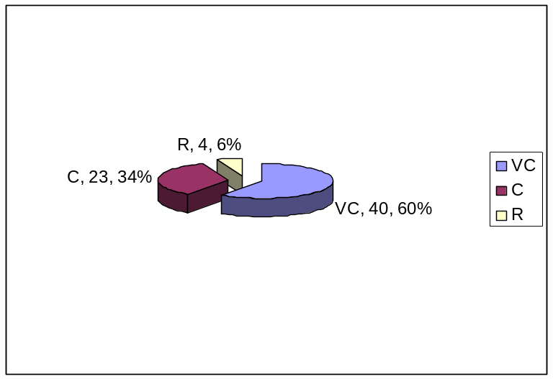

Source: Questionnaire survey-2009/ November

Figure 5.2: Present Status of Trees are shown in Pie charts

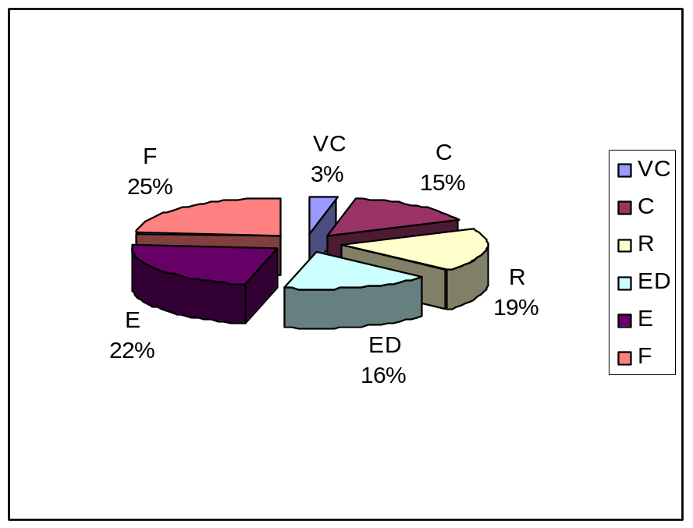
Source: Questionnaire survey-2009/ November

5.2.1.2 Shrubs

Shrubs are medium sized plants. Their stems are hard but not very thick. Many branches and branchlets grow from the stem, giving the plant a bush-like appearance. Shrubs do not have a main stem. The roots of shrubs do not penetrate deep into the ground. According to the people of the study area, 20-25 years ago, these areas were full in different kinds of shrubs. Extensive agriculture practice plays an important role to take away some shrubs, which are attached with substratum soil. Shrubs are locally extinct due to industrialization. A total of 45 species shrubs were found in the study area as shown in table 5.3.

Table 5.3: List of shrubs found in Dhamshona and Yearpur union
SI. | Local name | Scientific name | Past | Present
1. | Kagoji lebu | Citrus aurentifolia | VC | C
2. | Gandharaj | Gardenia jesminoides | VC | C
3. | Reri | Ricinns communis | VC | E
4. | Beli | Jasminum jambac | VC | C
5. | Jui | Jasminum auriculatum | VC | F
6. | Kamini | Murray a paniculata | VC | F
7. | Ghanta phool | Allamanda cathartica | VC | E
8. | Joba | Hibiscus rosa-sinensis | VC | C
9. | Hatishur | Heliotropium indicum | VC | R
10. | Padma | Nelombo nucifera | VC | F
11. | Baganbilash | Bonganvilla glabra | VC | C
12. | Bora Hatishur | Acalyphy hispida | VC | F
13. | Dolonchapa | Hedychium coronarium | VC | R
14. | Bichikola | Musa sapientum | VC | C
15. | Ghagra | Xanthium indicum | VC | R
16. | Mehendi | Lawsonia alba | VC | F
17. | Hasnahena | Cestrum nocturnum | VC | C
18. | Jarul | Lagerstroemia parviflora | VC | R
19. | Roktodron | Leonusus sibiricus | VC | C
20. | Pathorkuchi | Kalanchol pinnata | VC | R
21. | Bashok | Adhatoda vasica | VC | C
22. | Lantena | Lantana camera | VC | R
23. | Akondo | Calotropis procera | VC | C
24. | Akondo | Calotropis gigeatia | VC | C
25. | Katamehendi | Duranta repens | VC | F
26. | Shon pat | Crotalaria juncea | VC | C
27. | Pepe | Caryca papaya | VC | C
28. | Epil epil | Leucaena leucocephala | VC | R
29. | Shondhamaloti | Mirabilis jalapa | VC | C
30. | Arhor dal | Cajamis cajan | VC | E
31. | Anarosh | Ananus sativas | VC | E
32. | Dhutura | Datura metel | VC | C
33. | Dhoincha | Sesbania canabina | VC | C
34. | Rongon | Ixora rosesa | VC | F
35. | Mankochu | Alocasia indica | VC | C
36. | Patabahar | Acalypha welkesiana | VC
37. | Ada | Zingiber officinalis | VC | F
38. | Patabahar | Codeaeum variegatum | VC | C
39. | Jonli Ada | Apinia nigra | VC | F
40. | Shadajoba | Hibiscus syriacus | VC | C
41. | Dherosh | Abelmoscus esculentus | VC | C
42. | Stholpodma | Hibiscus mutabilis | VC | F
43. | Mokta |  | VC | E
44. | Mera |  | VC | E
45. | Shapla |  | VC | E

[Code: Status: Very common=VC, Common=C, Rare=R, Endangered=ED, Few=F, Locally extinct=E]
Source: Questionnaire survey-2009/ November & modified after, Env-020808 (2005)

There were 7 species of weed shrubs (15.90 % of the total shrubs); 17 species of ornamental shrubs (38.09% of the total shrubs); 11 species of vegetable shrubs (25% of the total shrubs); 8 species of medicinal shrubs (18.18% of the total shrubs) and 2 species of fruit shrubs (4.54% of the total shrubs) were found in the study area. Among the 45 species of shrubs all are found very common in past but of late there is no species found very common, 20 species are common (47.72% of the total shrubs), 7 species are rare (15.90% of the total shrubs), 11 species are few (25% of the total shrubs); and 7 species are locally extinct as shown in table 5.4.

Table 5.4: Past and Present status of shrubs
Type | Past |  | Present
Type | Amount | % | Amount | %
VC | 45 | 100 | 0 | 0
C |  |  | 20 | 47.72
R |  |  | 7 | 15.90
ED |  |  | 0 | 0
E |  |  | 7 | 13.63
F |  |  | 11 | 25

Source: Questionnaire survey-2009/ November

Among the shrubs Arhor dal (Cajamis cajan); Reri (Ricinns communis), Helencha (Alternanthera philoxeroides) are locally extinct. Once abundance the shrubs Hatishur (Heliotropium indicum), Ghagra (Xanthium indicum), Patlhorkuchi (Kalanchol pinnata), Jarul (Lagerstroemia parviflora) Dolonchapa (Hedychium coronarium) are rare now. Rongon (Ixora rosesa), Shetodron (Ixora arborea), Jui (Jasminum auriculatum), Kamini (Murray a paniculata), Bora Hatishur, (Acalyphy hispida), Jonli Ada (Apinia nigra), Ada (Zingiber officinalis) Katamehendi (Duranta repens), Mehendi (Lawsonia alba) and Padma (Nelombo nucifera) are few in the study area.

The villagers claim that once upon a time this area was abundant with different kind of shrubs. Shrubs are locally extinct due to over exploitation, urban expansion and industrialization. Large, medium, and small sized industries are available in the study area. These industries all together consume a huge quantity of chemicals everyday and a large of effluent in the low land, which in turn spreads over the adjacent farmland and to immediate locality. The effluents contain a wide variety of toxic chemicals that are harmful and increase the pollution burden of the environment. This is replaced by the present depression.

Figure 5.3: Past statuses of shrubs are shown in Pie charts
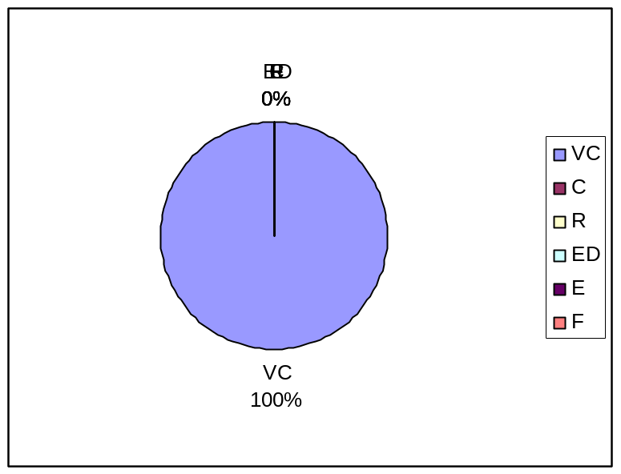

Source: Questionnaire survey-2009/ November

Figure 5.4: Present statuses of shrubs are shown in Pie charts
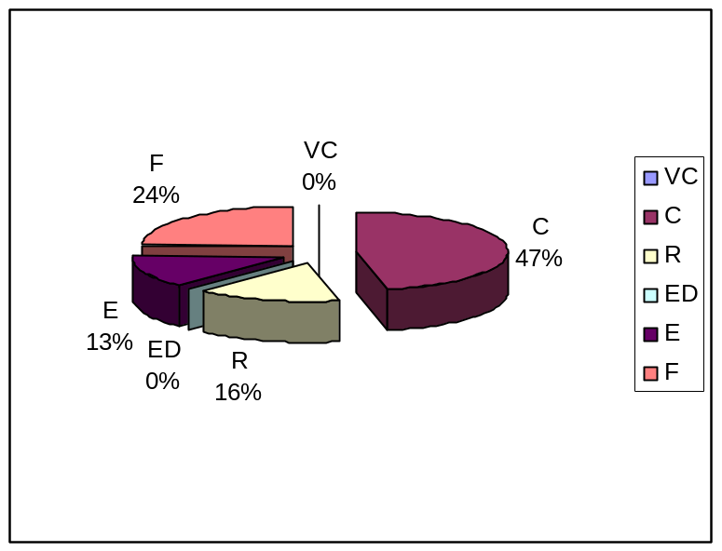

Source: Questionnaire survey-2009/ November
5.2.1.3 Herbs

Herbs are small in size. They have soft stems, branches and branchlets. The roots of these plants penetrate only the upper layer of the ground. A total of 101 species of herbs were found in the study area as shown in table 5.5. There were 25 species of weed herbs (24.5% of total herbs); 46 species of vegetable yielding herbs (45% of total herbs); 17 species of ornamental herbs (16.6% of total herbs); 11 species of medicinal herbs (10.8% of total herbs); and 2 species of fruit yielding herbs (1.9% of total herb).

Table 5.5: List of herbs found in Dhamshona and Yearpur union

SI. |  | Local name | Scientific name | Past | Present
1. |  | Shama ghash | Echinochola crussgalli | VC | E
2. |  | Jonli dhan | Echinochola column | VC | E
3. |  | Durba ghash | Cynodon dactylon | VC | E
4. |  | Shial leza | Sctaria viridis | VC | E
5. |  | Kash | Saechasum spontaseum | VC | E
6. |  | Ulu ghush | Imperata aylindriea | VC | E
7. |  | Prem kata | Chrysopogon aciculatus | VC | F
8. |  | Nolkhagra | Phragmites varka | VC | F
9. |  | Bash | Bamhma tulda | VC | F
10. |  | Tolla bash | Bambura ligispiculata | VC | F
11. |  | Dhan | Oryza saliva | VC | C
12. |  | Ulha | Cyperm pilosm | VC | R
13. |  | Helencha | Enhydra fuictuam | VC | E
14. |  | Shialmutta | Blamea lavra | VC | F
15. |  | Tridakkha | Tridex procumbent | VC | E
16. |  | Asamlata | Mikania cordata | VC | E
17. |  | Chandramollica | Chrysenlhemum coronorium | VC | F
18. |  | Kochmoch | Cosmos bippinatus | VC | C
19. |  | Dalia | Dohia hybrida | VC | F
20. |  | Gadaphool | Tagetes patula | VC | R
21. |  | Zinia | Zinic elegens | VC | R
22. |  | Lazzaboti | Mimosa pudica | VC | C
23. |  | Chinabadam | Arachi hypogaea | VC | F
24. |  | Chholabut | Cicer arietinum | VC | F
25. |  | Seem | Lablab purpuea | VC | C
26. |  | Kheshati | Lathyrus sativus | VC | R
27. |  | Shakalu | Pachvrrhizus | VC | R
28. |  | Aporajita | Clitoria tioinetea | VC | R
29. |  | Ban sharisha | Brassica kaber | VC | C
30. |  | Shalgom | Brassica rapa | VC | F
31. |  | Kaloshorisha | Brassica nigra | VC | F
32. |  | Fulcopy | Brassica oleracea | VC | C
33. |  | Dholkalmi | Var. botrytrs | VC | R
34. | Kachu |  | Ipomoea fistulosa | VC | C
35. | Sola/Hogla |  | Colocasia esculenta | VC | F
36. | Keshordham |  | Aeschynomene sp. | VC | F
37. | Bil kachu |  | Ludwigia adsendens | VC | C
38. | Birio pata |  | Polygonum plebejum | VC | E
39. | Kalmisak |  | Ipomoea aquatica | VC | F
40. | Malencha |  | Enhydra sp. | VC | F
41. | Singara |  | Trapa bispinosa | VC | ED
42. | Chala grass |  |  | VC | ED
43. | Pola grass |  |  | VC | E
44. |  | Badhacopy | Brassica oleracea Var. capittata | VC | C
45. |  | Mula | Raphanus sativas | VC | C
46. |  | Kata begun | Solarium corolinense | VC | C
47. |  | Kacha morich | Capsicum frutescence | VC | C
48. |  | Tomato | Lycopericon lycopercicum | VC | C
49. |  | Ban palong | Rumex meritimus | VC | F
50. |  | Biskatali | Polygonum hydropiper | VC | F
51. |  | Bon Dhonia | Scroparia dulcis | VC | F
52. |  | Khetpapra | Lindernis percumbens | VC | E
53. |  | Kalmilata | Ipomea aquatica | VC | E
54. |  | Sharnalata | Cuscutta reflesea | VC | E
55. |  | Kachuripana | Eicchornia crassipes | VC | C
56. |  | Panikachu | Monochoria hastana | VC | C
57. |  | Keshordam | Jussiaca repens | VC | F
58. |  | Kesordam | Ladwigia abscenden | VC | R
59. |  | Shetordron | Leucus aspera | VC | R
60. |  | Tulsi | Ocimum sanctum | VC | F
61. |  | Shapla | Nymphaea nouchali | VC | C
62. |  | Topa pana | Pistia stratioites | VC | C
63. |  | Money plant | Scindapsus aurieus | VC | F
64. |  | Bishkochu | Steuduera virosa | VC | C
65. |  | Dhekishak | Dryopteris flixmas | VC | F
66. |  | Panifal | Trala bispinosa | VC | F
67. |  | Thankuni | Hydrocotyle aciatica | VC | F
68. |  | Dhonia | Coriandrum sativum | VC | C
69. |  | Shialkata | Argemone mexicana | VC | F
70. |  | Shushni shak | Massilia quadrifolia | VC | C
71. |  | Ghechu | Aponogeton appendiculatus | VC | F
72. |  | Telakucha | Cephandra indica | VC | F
73. |  | Shosha | Cucumis sativus | VC | F
74. |  | Kutnra | Cucurlita mexima | VC | F
75. |  | Lau | Lageneria siceraria | VC | VC
76. |  | Jhinga | Luffa acutangala | VC | VC
77. |  | Dhundul | Suffa cylindrical | VC | VC
78. |  | Korolla | Momordica charantea | VC | VC
79. |  | Potol | Trichosanthes dioida | VC | C
80. |  | Kola | Musa indica | VC | C
81. |  | Kachakola | Musa paradisiacal | VC | C
82. |  | Shotomuli | Asparagus recemosus | VC | F
83. |  | Piaz | Allium cepa | VC | C
84. |  | Rashun | Attium satrvum | VC | C
85. |  | Ghretokumari | Aloe indica | VC | F
86. |  | Shenchi Shak | Alternanthera sesilis | VC | C
87. |  | Note Shak | Amaranthus viridis | VC | C
88. |  | Morogful | Celosia cristata | VC | R
89. |  | Kalomegh | Andrographis paniculata | VC | R
90. |  | Pui shak | Basella alba | VC | C
91. |  | Kolaboti | Canna indica | VC | F
92. |  | Gaja | Cannabis sativa | VC | F
93. |  | Beter Shak | Chanopodium album | VC | F
94. |  | Palong shak | Spinacea oleracea | VC | C
95. |  | Madhobilata | Hiptage benghalensis | VC | R
96. |  | Pargachha | Hoya parasitica | VC | F
97. |  | Gondho veduli | Paederia foetida | VC | E
98. |  | Pata jhaji | Ceratophylum sp. | VC | ED
99. |  | Keorali | Crytocoryne spiralis | VC | E
100. |  | Khudipana | Lemna sp. | VC | C
101. |  | Kuripana | Pistyia stratiotes | VC | C
[Code: Status: Very common=VC, Common=C, Rare=R, Endangered=ED, Few=F, Locally extinct=E]
Source: Questionnaire survey-2009/ November & modified after, Env-020808 (2005), Geo-020232 (2005)

Table 5.6 reveals the past and present status of herbs in the study area. Among the 101 species of herbs 98 species found very common in past but in present only 3 species are very common, 31 species are common, 12 species are rare, 35 species are few, 3 species are endangered and 16 species are locally extinct as shown in table 5.6.

Table 5.6: Past and Present status of herbs
Type | Past |  | Present
Type | Amount | % | Amount | %
VC | 98 | 100 | 3 | 2.97
C | 3 |  | 31 | 30.69
R |  |  | 12 | 11.88
ED |  |  | 3 | 2.97
E |  |  | 16 | 15.84
F |  |  | 35 | 34.65

Source: Questionnaire survey-2009/ November

Figure 5.5: Past statuses of herbs are shown in Pie charts
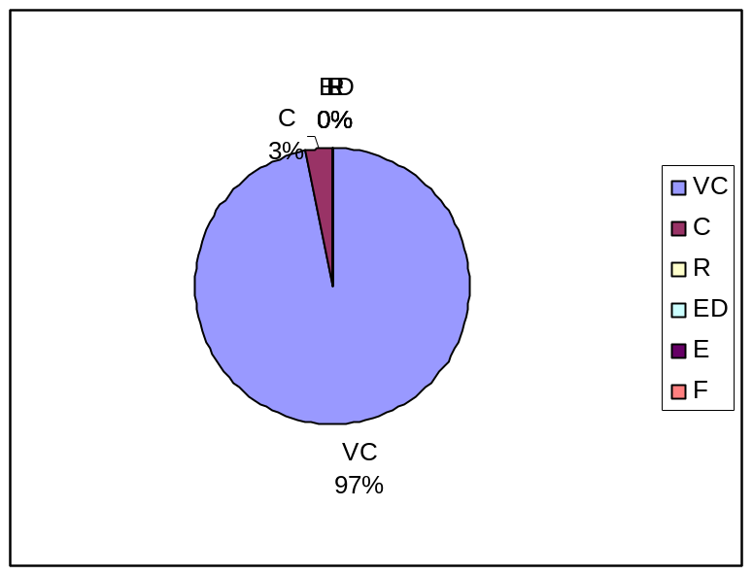

Source: Questionnaire survey-2009/ November

Figure.5.6: Present status of herbs are shown in Pie charts
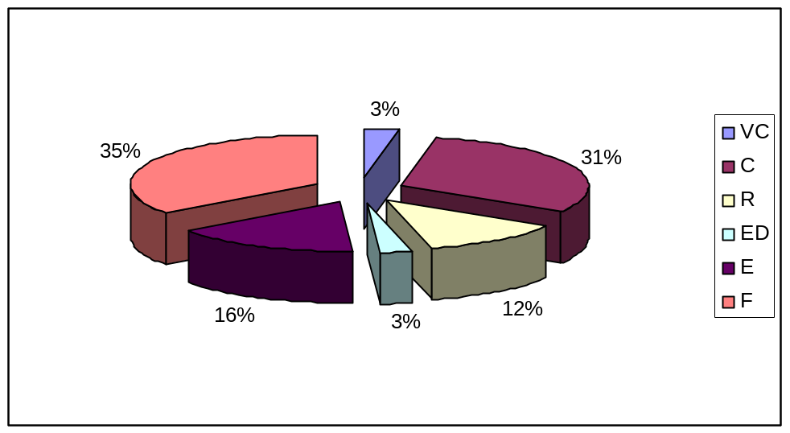

Source: Questionnaire survey-2009/ November

Once abundance Shama ghash (Echinochola crussgalli), Durba ghash (Cynodon dactylon), Shial leza (Sctaria viridis), Kash (Saechasum spontaseum), Ulu ghush (Imperata aylindriea), Birio pata (Polygonum plebejum), Pola grass, Khetpapra (Lindernis percumbens), Kalmilata (Ipomea aquatica), Sharnalata (Cuscutta reflesea) are locally extinct. Prem kata (Chrysopogon aciculatus), Nolkhagra (Phragmites varka), Bash (Bamhma tulda), Tolla bash (Bambura ligispiculata), Shialmutta (Blamea lavra), Dalia(Dohia hybrida), Chholabut (Cicer arietinum), Shalgom (Brassica rapa), Sola/Hogla (Colocasia esculenta), Kalmisak (Ipomoea aquatica), Malencha (Enhydra sp.), Tulsi (Ocimum sanctum), Dhekishak (Dryopteris flixmas),Panifal (Trala bispinosa), Thankuni (Hydrocotyle aciatica), Shialkata (Argemone mexicana), Ghechu (Aponogeton appendiculatus), Telakucha (Cephandra indica), Shosha (Cucumis sativus), Kutnra (Cucurlita mexima), Shotomuli (Asparagus recemosus), Ghretokumari (Aloe indica), Kolaboti (Canna indica), and Beter Shak (Chanopodium album), are few now. Once abundance Ulha (Cyperm pilosm), Zinia (Zinic elegens), Kheshati (Lathyrus sativus), Shakalu (Pachvrrhizus), Aporajita (Clitoria tioinetea), Dholkalmi (Var. botrytrs), Kesordam (Ladwigia abscenden), Shetordron (Leucus aspera), Morogful (Celosia cristata) are rare species. Singara (Trapa bispinosa), Chala grass and Pata jhaji (Ceratophylum sp.) are endangered species in the study area.

5.2.1.4 Medicinal plants

Yusuf et. al., (1994) gave a list of 546 medicinal plants that occur in Bangladesh. The Rangamati Hill District in CHT still harbors a portion of virgin forest. But the procurement of medicinal plants from the wild habitat for professional collectors to make local medicines is unscientific, indiscriminate, and in most cases leads to overexploitation. There is severe depletion of the natural stands, without any provision for the regeneration of species. Some rare species like Ulat chandol (Gloriosa superba), Sarpo ganha (Rawolfia serpentine), and Aswa gandha (Withania somnifera) have become regionally endangered. A total of 276 species of medicinal plant were observed in the study area as shown in table 5.7 with their past and present status.
Table 5.7: Medicinal plant found in Dhamshona and Yearpur union

SI. | Local name |  | Scientific name | Past | Present
1. | Ulatkambal |  | Abrona augusta | VC | C
2. | Kunch, Ratti |  | Abrus precatories | VC | C
3. | Patori |  | Abutilon indicum | C | E
4. | Khair, Katha |  | Acacin catechu wild | C | E
5. | Babla, Kikor |  | Acaia nilotica | VC | C
6. | Muktajhuri |  | Acalypha indica | VC | E
7. | Apang, Upathlengra |  | Achyranthes aspera | VC | R
8. | Rakta Kambal, Ranjon |  | Adenanthera Pavonina | VC | E
9. | Basak |  | Adhatoda vasica | VC | E
10. | Mayurshikha |  | Adiantum caudatum | VC | R
11. | Bel |  | Aegle marmelos | VC | C
12. | Oochunti, Dochunti, Fulkurui |  | Ageratum conyziodes | VC | R
13. | Ankor, Akar kanta |  | Alangium salvifolium | VC | R
14. | Sirish, Kala Koroi |  | Albizzia lebbeck | C | E
15. | Kori, Koroi, Sil koroi, Jat koroi |  | Albizzia procera | VC | C
16. | Malatila, Ghanta Phul, Harkara |  | Allanmanda cathartica | VC | C
17. | Piaj |  | Allium cepa | VC | VC
18. | Rasun |  | Allium sativum | VC | VC
19. | Mankachu |  | Alocasia indica | VC | C
20. | Ghritakumari, Ghritakanchan, |  | Aloe barbadensis | VC | R
21. | Tara, Jangli, Ada |  | Alpinia nigra | VC | R
22. | Chhantim, Chaitar, Saptapani |  | Alstonia scholaris | VC | R
23. | Chanchi, Haicha, Sachishak |  | Alternanthera sessilis | VC | C
24. | Kantanotey, Kantadenga, Katamaris |  | Amaranthus spinous | VC | ED
25. | Notey, Notey shak, Marissag |  | Amaranthus viridis | VC | ED
26. | Dadmari, Janlimendi, Banmarach |  | Ammamnnia baccifera | VC | ED
27. | Ol, Olkachu | Amorphophallus anulatus |  | VC | ED
28. | Kakamari |  | Anamirta cocculus | VC | E
29. | Anaras |  | Ananas sativas | C | R
30. | Gobura |  | Anisomeles indica | C | E
31. | Nona, Ramphal, Nona Ata |  | Annona reticulata | VC | R
32. | Ata, Sharifa, Luna |  | Annona squamosa | VC | R
33. | Kadam, Bulkadam |  | Anthocephalus chinensis | VC | C
34. | Pitraj, Tikataraj, Royena |  | Aphananamixis polystachya | VC | R
35. | Cheenabadam |  | Arachis hypogea | VC | R
36. | Ban Jam |  | Ardisia solanacea | VC | C
37. | Supari, Gua |  | Areca catechu | VC | E
38. | Shialkanta, Baroshial kanta |  | Argemone maxicana | VC | E
39. | Guguli, Bijtarak |  | Argyreia nervosa | VC | E
40. | Iswarmul |  | Aristolochia indica | VC | C
41. | Kanthal, Kathal |  | Artocarpus heterophylius | VC | E
42. | Dewa, Deophal, Deoacham, Barta, Dalo |  | Artocarpus lacucha | VC | R
43. | Satamoli, Hilum |  | Asparagus racemosus | VC | E
44. | Banurkalia, Thitkalai |  | Atylosia scarabaioides | VC | R
45. | Billimbi |  | Averrhoa billimbi | VC | R
46. | Kamranga, Kamarka |  | Averrhoa carambola | VC | C
47. | Nim |  | Aazadirachta indica | VC | R
48. | Brahmi Shak, Adhabirani, Dhupkamini |  | Bacopa monniera | VC | E
49. | Bans, Kantabans, Ketsi |  | Bambusa arundinacea | VC | E
50. | Kanta jati, Swarnajhinti |  | Barleria prionitis | VC | R
51. | Hijal kunita |  | Barringatonia acutangula | C | R
52. | Poi, Rakto-pui |  | Basella alba | VC | VC
53. | Kanchan, Devakanchan, Koiral, |  | Bauhinia purpurea | C | R
54. | Dasba, Basbichandi |  | Belamchada chinensis | C | R
55. | Chalkumra |  | Benincasa hispida | C | C
56. | Bannaringa, Jhalai |  | Biophytum senitivum | VC | C
57. | Latkan, Belatihaldi, Utkana |  | Bixa arellana | VC | R
58. | Barakukshima, Kukursunga, Shealmota, Shialmoti |  | Blumea lacera | VC | R
59. | Punarnava, Gandhapurna, Sheapurna |  | Boerhaavia diffusa | VC | E
60. | Simul, LalsEhimul, Tula |  | Bombax ceiba | VC | R
61. | Tal |  | Borarrus flablellifer | VC | E
62. | MadRnabatakadu |  | Borrerin articularis | VC | C
63. | Salai, Gandhabiroja |  | Boswellia serrata | C | R
64. | Kalosorisha, Raisarisha, |  | Brassica nigra | VC | C
65. | Palash, Kinguk, Kinaka |  | Butea monosperma | VC | R
66. | Nata, Natakaranja |  | Caesalpinia bonduc | C | E
67. | Krishnachura, Radhachura, Bakam |  | Caesalpinia pulcherima | VC | C
68. | Arhar, Tur, Aral |  | Cajanus cajan | VC | E
69. | Akanda, Bara, Akand |  | Calotropis gigantea | VC | E
70. | Sarbajaya phena |  | Canna indica | VC | ED
71. | Lanka-marich, Marich, Dhanimarich |  | Capcicum frutescence | VC | C
72. | Lataphatkari, Sibihul, Lataphatki |  | Cardiospermum halicacabum | C | R
73. | Kumbi, Kumba, Gade, Gadik |  | Caeya arborea | C | R
74. | Pape, Papya |  | Carica papaya | VC | C
75. | Karamcha, Karancha |  | Carissa congesta | C | E
76. | Dadmardan, Dadmari |  | Cassia alata | VC | E
77. | Sonalu, Badar Lathi, Sondal |  | Cassia fistula | VC | E
78. | Chakunda, Goleski |  | Cassia obtusifolia | VC | R
79. | Kalkasunde, Eski, Essi, Tolikoroi |  | Cassia occadentalis | VC | R
80. | Kalkasunde, Chotto kalkesunde, Jhigni |  | Cassia sophera | VC | E
81. | Nayantara |  | Catharenthus roseus | VC | C
82. | Lalmurga, Huldimurga |  | Celosia cristata | C | E
83. | Thankuni, Thujkuri, Takamanik |  | Centella asiatica | VC | E
84. | Tejpata, Tamal |  | Cinnanmomum tomala | C | R
85. | Tarmuj |  | Citrullus lanatus | C | E
86. | Lebu, Kaghzinimbu, Patinebu |  | Citrus aurantifalia | VC | C
87. | Jambura, Batabi Mahanimbu, Chakotra |  | Citrus grandis | VC | C
88. | Hurhuria, Halde hurthurey |  | Cleome viscosa | C | R
89. | Bamunhatti, Banchat |  | Clerodendrum indicum | VC | R
90. | Ghetu, Bhant |  | Clerodendrum viscosum | C | E
91. | Aparajita, Nila |  | Clitoria tarnetea | VC | C
92. | Telakuch, Kuchila |  | Coccinea cordifolia | VC | C
93. | Daikhai, Jalajmani, Heyer, Huyer |  | Cocculus hirsutus | C | E
94. | Narikal, Dab |  | Cocos nucifera | VC | C
95. | Tasbi, Gurgur, Kalo kanch, Kawoakathi |  | Coix Lachrymajobi | C | E
96. | Kachu, Mukhikachu, Bahumukhi, Mokaddamkachu |  | Colocasia esculenta | VC | C
97. | Kanchira, Dholpata, Jatakanshira |  | Commelina benghalensis | C | E
98. | Pat, Titapat, Nalita, Sadapat, Narcha, Deshipat |  | Corchorus capsularis | VC | C
99. | Toshapat, Mithapat, Pat, Lalitapat, Bogipat |  | Corchorus olitorius | VC | C
100. | Dhane, Dhaniya |  | Coriandrum sativum | VC | C
101. | Kou, Tara, Kemak |  | Costus speciosus | VC | E
102. | Barun, Bannay, Tikoshak, Pithgola |  | Crataeva nurvala | VC | R
103. | Nagdaun, Barakanur, Nagdal, Sukdarshan |  | Crinum asiaticum | C | E
104. | Khira, Sasa |  | Cucumis sativus | VC | C
105. | Kumra, Mistikumra, Mithakumra, Mithakadu |  | Cucurbita maxima | VC | C
106. | Halud, Haldi |  | Curcuma longa | VC | R
107. | Sothi, Ekangi |  | Curcuma zedoaria | C | R
108. | Swarnalata, Tarulata, Algusi |  | Cuscuta reflexa | VC | R
109. | Ghandhabena, Lebugandhi ghas |  | Cymbopogon citratus | VC | C
110. | Durba, Dubla, Durbaghas |  | Cynodon dactylon | VC | R
111. | Mutha, Nagarmutha, Badaylla |  | Cyperus rotundus | VC | E
112. | Makra |  | Dactyloctenium aegyptium | C | R
113. | Sisu, Sishookat |  | Dalbergia sisso | C | C
114. | Dhutra, Dhutura |  | Datura metel | VC | C
115. | Gajor |  | Daucas carata | VC | R
116. | Karail (Bans) |  | Dendrocalamus strictus | C | R
117. | Baramanda, Bandha, Pharulla |  | Dendrophthoe falcate | VC | E
118. | Salpani, Chalani |  | Desmodium gangeticum | C | R
119. | Chalta, Chalita |  | Dillenia indica | VC | C
120. | Chupri alu, Metealu, Kamalu |  | Dioscorea alata | VC | R
121. | Banalu, Ratalu, Pagla alu |  | Dioscorea bulbifera | VC | R
122. | Gab, Deshi Gab |  | Diospyros peregrima | VC | C
123. | Shim, Urushi |  | Dolichos lablab | VC | R
124. | Kesuti, Kesaraj, Kalokeshi, Bhinraj |  | Eclipta alba | VC | R
125. | Jalpai |  | Elaeocarpus seratus | VC | R
126. | Malangakuri, Malankuri |  | Eleusine indica | VC | E
127. | Sadhimodi, Mechitra, Sadusi |  | Emilia sadusi | VC | E
128. | Helencha, Hinchashak, Harhach |  | Enhydra fluctuans | C | C
129. | Palitamadar, Paniamadar, Mandar, Madar |  | Erythrina variegata | C | C
130. | Assamlata, Barashialmuti |  | Eupatorium odoratum | VC | C
131. | Barakeru, Ghoopata, Bara Dhudi, Dudhiya, Barakarni |  | Euphobia hitra | VC | E
132. | Shwetkerui, Dudhiya, Swetkan |  | Euphorbia thymifolia | VC | E
133. | Bot, Krishna-bot |  | Ficus benghalensis | VC | R
134. | Kakdumur, Dumur, Dhungri, |  | Ficus hispida | VC | R
135. | Jagadumur, Gulang dumur, Yajnadumbar |  | Ficus racemosa | VC | R
136. | Aswatha, Pipal, Panbot |  | Ficus religiosa | VC | R
137. | Gandha Raj |  | Gardenia jasminoides | VC | C
138. | Gima, Jima |  | Glinus oppositifolius | VC | R
139. | Ulatchandal, Bishlanguli,  Bilambuli, Agnishikha |  | Gloriosa superba | VC | R
140. | Ashshoura, Matkila, Aidali |  | Glycosmis Pentaphyla | C | E
141. | Bara kamra |  | Gnaphalium liteo | C | E
142. | Namuti |  | Grangea maderespatana | F | E
143. | Khetpapra |  | Hedyotis corymbosa | F | E
144. | Tokma, Ganja Tulsi, Bilati Tulsi |  | Hyptis suaveolens | C | E
145. | Dudhi, Syamalota |  | Ichnocarpus frutescens | C | F
146. | Dupati, Dopatta |  | Impatiens balsamina | C | F
147. | Kalmi,Kalmi shak |  | Ipomoea aquatica | C | C
148. | Misti Alu |  | Ipomoea batatus | C | C
149. | Nilkalmi, Kaladhana |  | Ipomoea hederacea | C | F
150. | Ban kalmi |  | Ipomoea maxima | C | F
151. | Rangan, Ranjan |  | Ixora coccinea | C | F
152. | Jui, Juthi, Gunica |  | Jasminum auriculatum | C | F
153. | Beli, Ban Mallika |  | Jasminum sambac | C | C
154. | Bagh verenda, Ban verenda, Chanda, Jamalgota, Sadajeol, Baron |  | Jatropha curcas | C | F
155. | Lalbheranda, Laljeol, Erenda |  | Jatropha gossypifolla | C | F
156. | Patharkuchi, Koppata |  | Kalanchoe pinnata | C | F
157. | Lau, Kadu, Panilau |  | Lageneria siceraria | C | C
158. | Chhotojarul, Purus, Farash |  | Lagerstroemia indica | C | F
159. | Jiga, Jeol, Bhadi, Kamila |  | Lannea coromandelica | C | F
160. | Chotra |  | Lantana camara | C | F
161. | Kantakachu |  | Lasia spinosa | C | C
162. | Mehedi, Mendi |  | Lawsonia inermis | C | F
163. | Masur, Masuri |  | Lens culinaris | F | F
164. | Guma, Raktodrone, Juma, Jajura |  | Leonurius sibiricas | F | E
165. | Dulfi, Dandakalos, Shetadrone |  | Leucas aspera | F | E
166. | Karpur |  | Limnophila indica | F | E
167. | Basanti, Haldi Basanti |  | Lindenbergia indica | F | E
168. | Tisi, Chikna, Masina |  | Linum usitatissimum | F | E
169. | Lichu |  | Lichi chinensis | F | F
170. | Jhinga, Jinga, Sataputi |  | Luffa acutanqula | C | C
171. | Dhundul |  | Luffa cylindrical | C | C
172. | Am |  | Mangifera indica | C | C
173. | Khirkhejur |  | Manilkara hexandra | C | F
174. | Safeda |  | Manilkara zapota | C | F
175. | Tikiokra |  | Melochia corchorifolia | F | E
176. | Pudina |  | Mentha spicata | C | F
177. | Lajjaboti, Lajuk |  | Mimosa pudica | C | F
178. | Bakul |  | Mimusops elengi | F | F
179. | Krishnakali, Sandhyamalati |  | Mirabilis jalapa | C | F
180. | Julpapra, Khetpapra |  | Mollugo pentaphylla | C | F
181. | Karolla, Uchhe, Usta |  | Momordica charantea | VC | C
182. | Kakrol, Gulkakra |  | Momordica cochinchinensis | C | C
183. | Baranukha |  | Monochoria hastata | F | E
184. | Nanka, Sarkachu, Nukha, Bhainsakachu |  | Monochoria vaginalis | F | E
185. | Sajna, Sajina |  | Moringa oleifera | C | F
186. | Tut, Melberry |  | Morus indica | F | R
187. | Alkhshi, Bichchoti, Khamach, Banda, Bilaiachra |  | Mucuna prurients | F | R
188. | Kariaphuli, Chhoto kamini, Babsanga, Barasunga, Girinion, Gandhal |  | Murraya koenigii | F | R
189. | Kamini |  | Murraya paniculata | F | F
190. | Kala, Aittakola, Bichikala |  | Musa paradisiaca | VC | C
191. | Padma |  | Nelumbo nucifera | VC | F
192. | Chanmala, Chandmona, Panchulti |  | Nymphoides cristatum | F | E
193. | Ban Tulsi |  | Ocimum americanum | C | E
194. | Babui Tulsi |  | Ocimum basilicum | F | R
195. | Dudh kalmi, Tahri |  | Operculina turpethum | VC | R
196. | Phanimansa, Naghana |  | Opuntia dillenii | F | E
197. | Sona, Nasona, Patti, Dinga, Kanak |  | Oroxylum indicum | F | R
198. | Amrul, Amboli, Chukatripati |  | Oxalis corniculata | F | R
199. | Keya, Ketaky, Keora, Keurikanta |  | Pandanus odoratissimus | F | E
200. | Jhumkolata, Gorak phal |  | Passiflora foetida | F | E
201. | Rangchita, Belatisiz, Berachita |  | Pedilanthus tithymaloides | F | R
202. | Luchi pata, Peperomia |  | Peperomia pellucida |  | E
203. | Chaguibati, Dudhilata |  | Pergularia daemia | F | E
204. | Khajur, Khejur |  | Phoenix sylvestris | C | F
205. | Bhuiokra, Karghas, Bakkan |  | Phyla nodiflora | F | E
206. | Arbori, Horbori, Noari |  | Phyllanthus acidus | C | E
207. | Amlaki, Amla |  | Phyllanthus emblica | F | E
208. | Bhuiamla |  | Phyllanthus freternus | F | E
209. | Panjuli, Panseuli, Chithi, Pankushi |  | Phyllanthus reticulates | F | R
210. | Ban Tipariya, Phuika, Tepari |  | Physalis minima | F | R
211. | Pan, Tambuli |  | Piper betel | F | E
212. | Topapana, Phena,Tokapana |  | Pistia stratiotes | VC | C
213. | Dekhani, Babul, Dharsundar, Khoi, Bilatitetul |  | Pithecellobium dulce | C | E
214. | Rajanigandha |  | Polianthes tuberose | C | F
215. | Meradu, Meraru |  | Polygola chinensis | C | F
216. | Biskatali, Pakhurmul, Pani marich |  | Polygonum hydropiper | VC | F
217. | Barapanimarich, Bishkatali |  | Polygonum orientale | VC | F
218. | Chemti Sag, Dubia Sag, Anjaban |  | Polygonum plebejum | VC | F
219. | Karanja, Karamcha, Dehur kanji, Pitagola, Kosa, Dahur karanja |  | Pongamia pinnata | F | E
220. | Nune, Lanya, Baraloniya |  | Portulaca oleracha | F | E
221. | Piyara, Sabri, Gam, Guachi |  | Psidium guajava | VC | C
222. | Basantilata, Begunlata |  | Quisqualis indica | C | F
223. | Beri, Bherenda, Arenda |  | Ricinus communis | VC | F
224. | Akh, Kushiar, Kuishyal, Gendari, Ikhkhu |  | Saccharum officinarun | VC | C
225. | Chhoto kut, Muyamuya |  | Sagittaria Sagittifolia | F | R
226. | Murba, Sutahara, Sutimukhi |  | Sansevieria hyacinthoides | F | R
227. | Murba, Gorachakra |  | Sansevieria roxburghiana | F | E
228. | Ritha, Chhoto Ritha |  | Sapindus mukorossi | F | E
229. | Asok, Asoka, Anganapriya |  | Saraca indica | F | E
230. | Bandhane, Mistridana, Chinigura, Madhumisti |  | Scoparia dulcis | F | E
231. | Til, Kalatil |  | Sesamum indicum | C | F
232. | Kathsola, Joyanti, Daincha |  | Sesbania sesban | VC | F
233. | Sal, Gajari |  | Shorea robusta | C | C
234. | Lal berela |  | Sida orientalis | F | E
235. | Tit Begun, Gotha Begun, Hat Begun |  | Solanum filicifolium | VC | C
236. | Phutki Begun, Tit Begun, Baikur, Brihati Begun |  | Solanum indicum | VC | C
237. | Bhuti Begun, Gurkamai, Kakmachi, Tit Begun |  | Solanum nigrum | VC | C
238. | Urusa |  | Solanum verbasci | C | F
239. | Ban Palang |  | Sonchus wightianus | VC | C
240. | Palang Shak, Palong |  | Spinacea oleracea | VC | C
241. | Amra, Amna, Piayala |  | Spondias pinnata | F | R
242. | Akandi, Nimuka, Maknadi |  | Stephania japonica | F | R
243. | Shoara, Asshoara, Khirnasta, Harbon, Hekra |  | Streblus asper | F | E
244. | Jam, Kalojam |  | Syzyium cumini | VC | C
245. | Golapjam |  | Syzygium jambos | C | F
246. | Bottejam, Dhepajam, Patijam, Thengajam |  | Syzygium operculatum | VC | F
247. | Tetul, Ambil |  | Tamaringus indica | VC | F
248. | Segun |  | Tectona grandis | C | C
249. | Ban Nil, Lohamori, Sarpunkha |  | Tephrosia purpurea | R | E
250. | Arjun |  | Terminalia arjuna | F | R
251. | Bangla Badam, Kath Badam |  | Terminalia catappa | F | R
252. | Haritaki |  | Terminalia chebula | F | R
253. | Kalkephul, Halde Korobi, Kanai, |  | Thevetia peruviana | F | E
254. | Gulancha, Gurach, Gadancha |  | Tinospora cordifolia | F | E
255. | Paniphal, Singara |  | Tropa bispinsa | VC | F
256. | Chikan, Jibon |  | Trema orientalis | F | E
257. | Latim, Medda, Bhatam, Petali, Panigambhar, Meragota |  | Trewia polycarpa | VC | F
258. | Chichunga, Koida, Hopa |  | Trichosanthes cucumerina | VC | F
259. | Potol |  | Trichosanthes dioica | VC | C
260. | Tridhara, Tridaksa |  | Tridax procumbens | F | E
261. | Methi, Methishak |  | Trigonella foenum | C | F
262. | Banokrn |  | Triumfella rhomboidea | F | E
263. | Antamul |  | Tylophora indica | F | E
264. | Banokra, Atlera, Nageji, Jangli Ghagra |  | Urena tobata | F | E
265. | Baicha, Bicha, Patajhangi, Patseola |  | Vallisneria spiralis | F | R
266. | Rasna, Nai, Rasna Nai |  | Vanda tessellata | F | R
267. | Kukshima |  | Vernonia patula | F | E
268. | Khaskhas, Bena, Gandhabena |  | Vetiveria zizanioides | C | R
269. | Barboti, Laisha, Ramhikolai |  | Vigna sinensis | VC | C
270. | Nijhinda, Baranishinda, Nigunda, Samalu |  | Vitex negundo | VC | F
271. | Titakunga, Nakachikni, Madhumalati |  | Wattakaka volubilis | C | F
272. | Kesaraj, Bangra, Bhimraj, Bhimra |  | Wedelia chinensis | C | F
273. | Banokra, Chotadhatura, Ghagra |  | Xanthium indicum | F | E
274. | Manphal, Mankanta, Belong |  | Xeromphis spinosa | F | E
275. | Ada shuth |  | Zingiber officinale | F | E
276. | Kul, Boroi |  | Zizyphus mauritiana | VC | C

[Code: Status: Very common=VC, Common=C, Rare=R, Endangered=ED, Few=F, Locally extinct=E]
Source: Questionnaire survey-2009/ November & modified after, Yusuf et.al. (1994)

Table 5.7 reveals the past and present status of medicinal plants in the study area. Among the 276 species of medicinal plants 134 species found very common in past 81 species were common, 60 species were few but in present only 3 species are very common, 64 species are common, 68 species are rare, 49 species are few, 5 species are endangered and 87 species are locally extinct as shown in table 5.8.

Table 5.8: Past and Present status of medicinal plants
Type | Past |  | Present
Type | Amount | % | Amount | %
VC | 134 | 48.55 | 3 | 1.08
C | 81 | 29.34 | 64 | 23.18
R | 1 | 0.36 | 68 | 24.63
ED | 0 | 0 | 5 | 1.81
E | 0 | 0 | 87 | 31.52
F | 60 | 21.74 | 49 | 17.75

Source: Questionnaire survey-2009/ November

Once abundance the medicinal plant Rakta Kambal (Adenanthera Pavonina), Basak (Adhatoda vasica), Muktajhuri (Acalypha indica), Kakamari (Anamirta cocculus), Shialkanta, Baroshial kanta (Argemone maxicana), Satamoli, Hilum (Asparagus racemosus), Brahmi Shak, Adhabirani, Dhupkamini (Bacopa monniera), Dadmardan, Dadmari (Cassia alata), Sonalu, Badar Lathi, Sondal (Cassia fistula), Kalkasunde, Chotto kalkesunde, Jhigni (Cassia sophera), Thankuni, Thujkuri, Takamanik, Brahmankuti (Centella asiatica), Baramanda, Bandha, Pharulla (Dendrophthoe falcate) are locally extict now. Ankor, Akar kanta (Alangium salvifolium), Chhantim, Chaitar, Saptapani (Alstonia scholaris), Nona, Ramphal, Nona Ata (Annona reticulate), Ata, Sharifa, Luna (Annona squamosa), Dewa, Deophal, Deoacham, Barta, Dalo (Artocarpus lacucha) Banurkalia, Thitkalai (Atylosia scarabaioides) Barakukshima, Kukursunga, Shealmota, Shialmoti (Blumea lacera), Barun, Bannay, Tikoshak, Pithgola (Crataeva nurvala), Nim (Aazadirachta indica), Durba, Dubla, Durbaghas (Cynodon dactylon), Chupri alu, Metealu, Kamalu (Dioscorea alata), Banalu, Ratalu, Pagla alu (Dioscorea bulbifera), Kakdumur, Dumur, Dhungri, Thoska (Ficus hispida), Bot, Krishna-bot (Ficus benghalensis), Jagadumur, Gulang dumur, Yajnadumbar (Ficus racemosa), Aswatha, Pipal, Panbot (Ficus religiosa) Gima, Jima (Glinus oppositifolius), Ulatchandal, Bishlanguli, Bilambuli, Agnishikha (Gloriosa superba) etc. are rare species now. From the survey it is found that landuse and land cover was remarkable changed in the recent decades.Agricultural land has decreased due to human interferences with the increased of settlements. Significant changes have occurred in agriculture practices. The intensive cultivation has been extended to accelerate soil erosion, excessive land degradation and reduces the soil fertility and increased the plant species extinction.
Figure 5.7: Past statuses of medicinal plants are shown in Pie charts
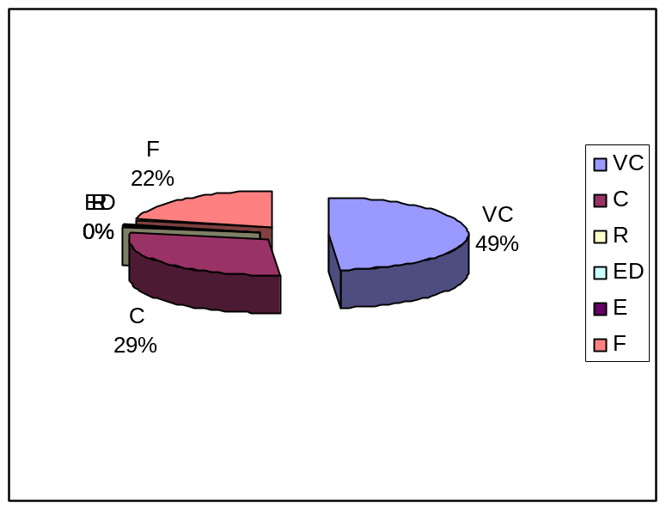

Source: Questionnaire survey-2009/ November

Figure 5.8: Present statuses of medicinal plants are shown in Pie charts
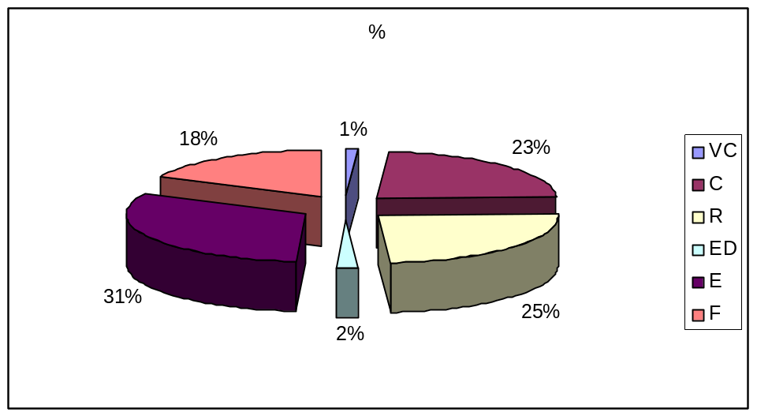

Source: Questionnaire survey-2009/ November

5.2.2 Fauna

In the study area the faunal composition includes fishes (e.g. Boal (Wallago attu), Rui (Labeo rohita), Kachki (Corica soborna), Teri punti (Puntius terio), Baim (Anguilla bengalensis),Shing (Heteropneustes fossilis), Mola (Amblypharyngodon) etc.); mammals (e.g. Pati Shial (Canis aureus), Khek Shial (Vulpes bengalensis), Bagdagh (Viverra zibetha), Chika/Chucho (Suncus murinus), Badur (Negaderma lyra) etc); reptiles (e.g. Kasim (Melanochelys tricarinata), Tiktiki (Hemidoctylus flaviviridis), Anjoni/Anjon (Mabuya carinata), Gui Shap (Varanus bengalensis), Dora Shap (Amphiesma stolata), Rokto-chosha (Calotes versicolor) etc) and birds (e.g. Pati Hans (Anas), Bali Hans/ Bele Hans (Nettapus), Khaththikra (Dinopium), Maachranga (Halcyon snyrnensis), Kokil kuli (Eudynaeus scolopeaus), Fingey (Dicrurus macrocercus), Cheena Bok (Ardeola bacchus), Pata Bulbuli (Chloropsis aurifrons) etc. List of fauna and its past and present status is given in below.

5.2.2.1 Fish resources

The fishery resources of Bangladesh are one of the richest in the world. Fisheries now play a major role in nutrition, employment and foreign exchange earning. Fish alone supply about 60% of animal protein and about 1.4 million people are directly employed by the fisheries sector. About another 11 million people indirectly earn their livelihood out of activities related to fisheries. Among the types of fishery, open water fisheries play an important role. The open water fisheries included rivers, canal, beels, hoars, ponds and etc. The open water fishery production system is a natural uncultivated production system composed of self reproducing and self sustaining (Rahman et.al. 2000). In the study area 112 species of fish were found. List of fishes and its past and present status is given in table 5.9.

Table 5.9: List of Fishes in Dhamshona and Yearpur union

SI. | Local name |  | Scientific name | Past |  | Present
1. | Boal |  | Wallago attu | VC |  | C
2. | Rui |  | Labeo rohita | VC |  | VC
3. | Katal |  | Catla catla | VC |  | E
4. | Shing |  | Heteropneustes fossilis | VC |  | R
5. | Baim |  | Anguilla bengalensis | VC |  | R
6. | Nol Baim |  | Pisodonophis boro | VC |  | R
7. | Koi Puti/Chakunda |  | Anodontosoma chacunda | VC |  | R
8. | Kachki |  | Corica soborna | VC |  | C
9. | Chapila/Goni |  | Gonialosa manmina | VC |  | R
10. | Chapila/Khoira |  | Gudusia chapra | VC |  | R
11. | Chapila/ Chapla/Afla |  | Gudusia varigata | VC |  | R
12. | Chandana/Chandina fish |  | Tanualosa toli | VC |  | R
13. | Choukka |  | Pellona ditchela | VC |  | ED
14. | Teli Phasa/ Fewa |  | Setipinna taty | VC |  | R
15. | Phasa/Fewa |  | Setipinna phasa | VC |  | R
16. | Mola |  | Amblypharyngodon | VC |  | C
17. | Mola/Molongi/Moya |  | Amblypharyngodon mola | VC |  | C
18. | Joya/Piali/Piashi |  | Aspidoparia jaya | VC |  | R
19. | Catla/ Katal |  | Catla catla | VC |  | C
20. | Jarua/ Utti |  | Chagunius chagunio | C |  | ED
21. | Chep chela/Benki chela |  | Chela cachius | C |  | ED
22. | Laubuca/ Kash khaira |  | Chela laubuca | C |  | ED
23. | Mrigel/Mirka |  | Cirrhinus mrigala | C |  | R
24. | Raik/ Tatkini/Bata/Laacho |  | Cirrhinus reba | C |  | ED
25. | Kalabata |  | Crossocheilus latius | C |  | ED
26. | Chebli |  | Danio aequipinnatus | C |  | R
27. | Nipati |  | Danio dangila | C |  | R
28. | Bashpata/Chebli |  | Danio devario | C |  | R
29. | Darkina/Danrika/Darka/Dadhika |  | Esomus danricus | VC |  | E
30. | Goni/Kurchi/Ghannya/Ghonia |  | Labio gonius | VC |  | E
31. | Morari/Morar/Piali |  | Aspidoparia molar | VC |  | E
32. | Koksa/Bani |  | Barilius borna | VC |  | E
33. | Chedra |  | Barilius bendelisis | VC |  | ED
34. | Pawn Rui/Rehala |  | Labeo sp. | VC |  | ED
35. | Kosuati |  | Oreichthys cosuatis | VC |  | E
36. | Dhela/Dhipali/Keti/Mauwa |  | Osteobrama catio | VC |  | ED
37. | Darkina |  | Parluciosama daniconius | VC |  | E
38. | Chala punti |  | Puntius | VC |  | C
39. | Kanchan punti/Taka punti |  | Puntius conchonius | VC |  | C
40. | Gilipunti |  | Puntius gelius | VC |  | E
41. | Mola punti |  | Puntius guganio | VC |  | C
42. | Puntani Punti |  | Puntius phutunio | VC |  | C
43. | Sarpunti/Sarna punti/Saralpunti/Kurti |  | Puntius sarna | VC |  | ED
44. | Punti/ Jat punti/Vadi punti |  | Puntius sophore | VC |  | C
45. | Teri punti |  | Puntius terio | VC |  | C
46. | Tit punti |  | Puntius ticto | VC |  | ED
47. | Bhol/ Bol |  | Raiamas bola | VC |  | ED
48. | Leuzza Darkina |  | Rasbora rasbora | VC |  | ED
49. | Chela |  | Salmostoma acinaces | VC |  | E
50. | Katari/Narkeli/Chela |  | Salmostoma bacala | VC |  | C
51. | Fulchela |  | Salmostoma phulo | VC |  | C
52. | Mahashol/Mashol Maach |  | Tor tor | VC |  | E
53. | Rani/Beti/Batya |  | Batia dario | VC |  | ED
54. | Rani |  | Botia dayi hora | C |  | ED
55. | Rani/Putul/Beti |  | Botia lohachata | C |  | ED
56. | Gutum/Puiya | Lepidocephalus annandobi |  | VC |  | C
57. | Puiya |  | Lepidocephalus berdnorei | VC |  | ED
58. | Gutum/Puiya |  | Lepidocephalus guntea | VC |  | C
59. | Puiya |  | Lepidocephalus irrorata | VC |  | E
60. | Gutia/ Khude Gunte/ Gunte |  | Lepidocephalus thermalis | VC |  | E
61. | Ayre/ Aor |  | Aorichthys oar | VC |  | ED
62. | Guizza/ Guizza Ayer |  | Aorichthys seenghala | VC |  | ED
63. | Tenra |  | Batasio batasio | VC |  | C
64. | Tengra |  | Batasio tengana | VC |  | ED
65. | Tengra/ Golsha-tengra |  |  | VC |  | C
66. | Golsha/Kabashi-tengra/Golsha tengra |  |  | VC |  | ED
67. | Nuna-tengra/Guillya/Penchgula |  |  | VC |  | ED
68. | Ghagla/Gang-Magur/Arwari/Golsha-tengra/Koune/Koune Magur |  |  | VC |  | C
69. | Bajari-tengra/Ghuit tengra |  |  | VC |  | C
70. | Futki Guzi/Gura Tengra |  | Rama chandramara | VC |  | ED
71. | Rita |  | Rita rita | C |  | E
72. | Kani Pabda/Boali Pabda/Pabda/Pupta/Pafta |  | Ompok bimoculatus | VC |  | ED
73. | Modhu Pabda/Pabda |  | Ompok pabda | VC |  | ED
74. | Pabda |  | Ompok pabo | VC |  | ED
75. | Kajuli/Baspata |  | Ailia coila | VC |  | ED
76. | Ghaura |  | Clupisoma garua | VC |  | E
77. | Muri Bacha |  | Clupisoma naziri | VC |  | C
78. | Bacha |  | Eutropiichthys vacha | VC |  | R
79. | Batashi |  | Pseudeutropius atherinoides | VC |  | R
80. | Shillong |  | Silonia silonia | VC |  | ED
81. | Pungus |  | Pangasius pangasius | VC |  | C
82. | Baghair |  | Bagarius garrellii | C |  | ED
83. | Cenia/ Jungla/Kouwa/ Tengra |  | Gagata cenia | VC |  | C
84. | Hudda/Gang Tengra |  | Gagata gagata | VC |  | C
85. | Singi |  | Heteropneustes fossilis | VC |  | C
86. | Cheka/Chaga |  | Chaca chaca | VC |  | ED
87. | Gang Magur/ Kan Magur |  | Plotosus conius | VC |  | ED
88. | Nehari |  | Harpodon nehereus | VC |  | C
89. | Kaikha/Kakila/Kakhle/Thuria/Gang Turi/Bachari Bach |  | Xenentodon cancila | VC |  | E
90. | Bechi/ Kanpona |  | Oryzias melastigma | VC |  | E
91. | Techoukka/ Kanpona/Choukkani |  | Aplocheilus panchax | VC |  | R
92. | Kuicha/ Kuchia/Kunche |  | Monopterus cuchia | VC |  | E
93. | Chanda/Nama Chanda |  | Chanda nama | VC |  | E
94. | Chanda |  | Pseudambassis boculis | VC |  | ED
95. | Runga-chanda/Lal Chanda/Chanda |  | Pseudambassis ranga | VC |  | ED
96. | Meni/Bheda/Bhedary |  | Nandus nandus | VC |  | ED
97. | Napit Koi/Koi Bandi |  | Bodis bodis | VC |  | ED
98. | Bata/ Kachki |  | Sicamugil cascasia | VC |  | C
99. | Koi |  | Anabas testudineus | VC |  | C
100. | Neftani |  | Ctenops nobilis | VC |  | ED
101. | Khailsha/Khalish |  | Colisa fasciatus | VC |  | C
102. | Lal khailsha/Boicha/Ranga khalisha |  | Colisa lalia | VC |  | C
103. | Chuna khalish/Boicha |  | Colisa sota | VC |  | C
104. | Pipla shol/Tila Shol/Tila |  | Channa barca | VC |  | E
105. | Gajor/Gajal |  | Channa marulius | VC |  | ED
106. | Telo Taki/ Gachua Raga/Cheng |  | Channa orientalis | VC |  | R
107. | Taki/Lata/Chaitan/Lati/Okol |  | Channa punctatus | VC |  | C
108. | Shol |  | Channa striatus | VC |  | C
109. | Tara Baim |  | Macrognathus arol | VC |  | E
110. | Chirka/Guchi/Baim/Panka/Turi |  | Macrognathus pancalus |  | VC | C
111. | Baim/Sal Baim/Baim |  | Mastacembalus armatus |  | VC | ED
112. | Tepa/ Potka/ Kutkuitta |  | Tetrondon cutcutia |  | VC | R

[Code: Status: Very common=VC, Common=C, Rare=R, Endangered=ED, Few=F, Locally extinct=E]
Source: Questionnaire survey-2009/ November & IUCN Bangladesh

Among the fishes, the family Cyprinidae (order cypriniformes) accounts the larges number of species: these include carps (Rui, Catla, Mrigal, Kalibous, etc); barbs (Punti, Mohashol etc); minnos (Darkina, Chela, Molas etc). But most of the species are now rare in Dhamshona and Yearpur union. Fish species that attain large sizes are locally termed as Boromach, such as major carps belonging to the family Cyprinidae, and large catfishes belonging to the families Siluridae, Schilbeidae, Bagridae and Sisordae under the suborder Silurodei. The important species of catfishes are boal (Wallago attu), Pangas (Pangasius pangasius), aire (Mystus aor), and baghaire (Bagarius bagarius).

Fish species that do not attain large sizes are termed as chotomaach. The majority of finfishes in the inland water belong to this category. From the viewpoint of providing nutrition and subsistent and supplemental income chotomaach are important to the vast majority of the rural people including the pooreset of the poor, the landless and the destitute. The small sized fishes include minor carps (Punti, Sarpunti, Chela, Darkina, Jaiya, Morar, Koksa, Patharchata, Chapchela, Chebali, Nepati, Mola, Jarua, Ghonia etc.) belonging to the family Cyprinidae; Kanpona belonging to the family Cyprinidontidae; Kakila (gars) belonging to the family Belonidae; half-beaks belonging to the family Hemirhampidae, Taki, Cheng, Tila shol, etc belonging to the family Channidae; Panga, Rani, Lohachata, Gutum, Puiya, ect. (loaches) belonging to the family Cabitidae; Magur belonging to the family Claridae; Pabda, Modhupabda and Pabo pabda belonging to the family Siluridae; Shingi belonging to the family Hetoropneustidae, Chaga (family Chacidae); Kajli; Bashpata, Batashi, Bacha, Ghoura etc. of the family Silurdae; several species of Tengra, Guzi, Aire, etc. belonging to the family Schilbeidae; several species of the famly Sisoridae, such as Gang tenra; several species belonging to the family Totopteridae; Pholi (family Notopteridae); anchovies, such as Phasa (family Engraulidae); Chapila (Gudusia chopra); Kechki (Corica soborna), Gopi chapila (Gonialosa manminna); etc. of the family Clupeidae; Tara baim (Macroganthus aculeatus), Baim or Sal baim (Mastacembelus armatus), Pankal (Mastacembelus panaculas) belonging to the family Mastacenibelidae; Kholisha Neftani and Koi ( family Anabantidae); Bele (Glossonggabius giurs) and several other members of the family Galiedae, etc.

Among the 112 species of catfishes Tengra, Shingi, Magur, etc. are found in the study area. Loaches (Punti, Gutum, Puiya, Panga, etc.) are the least explored fish species. Once abundance in this area, the snakehead fishes (Shol, Taki, Gojar etc) are now endangered. Of the five species of family Channidae three are threatened: Barca snakehead (Pipla shol), Channa barcha is critically endangered, giant snakehead (Gojar), Channa marulius is endangered and Asiatic snakehead (Telo taki), Channa orientalis is common but vulnerable. Of the species (usally with two lateral gill openiys), the Gangetic amuddel (Kuichya), Monopterus cuchia, is unique in possessing a single gill opening on the ventral side. Once abubdant, it is now a vulnerable and rare species. Another beautiful eel, the one-stripe spiny eel (Tara baim), Macrognathus aral, is also now vulnerable. Of the gars or crocodile fishes (Kaikka), Deocota pipefish, Microphis decota, is now endangered.

Table 5.10 reveals the past and present status of fishes in the study area. Among the 112 species of fishes 99 species (88.39%) found very common in past but in present only 1 species (0.89%) is very common, 35 species (31.25%) are common, 21 species (18.75%) are rare, 35 species (31.25%) are endangered, and 21 species (18.85%) are locally extinct as shown as table 5.10.

Table 5.10: Past and Present status of fishes
Type | Past |  | Present
Type | Amount | % | Amount | %
VC | 99 | 88.39 | 1 | 0.89
C | 13 | 11.60 | 35 | 31.25
R |  |  | 21 | 18.75
ED |  |  | 35 | 31.25
E |  |  | 21 | 18.85
Source: Questionnaire survey-2009/ November

According to the table a remarkable declining trends are already discernible in the capture fisheries of the study area. A host of man induced stresses due to large scale water abstruction for irrigation, siltation, and soil erosion due to deforestation in the catchment water, pollution from industrial, agriculture and municipal waste, etc. left of a trial of devasting effects on fish stocks. The extensive irrigation schemes for agricultural fields and indiscriminate use of agrochemicals are changing the feeding and breeding grounds of many indigenous fish species. Discharge of pollutants into water bodies (rivers, canals, ponds, etc.) from industries, and over-fishing are highly responsible for the destruction of fish species.
Figure 5.9: Past statuses of fishes are shown in Pie charts.
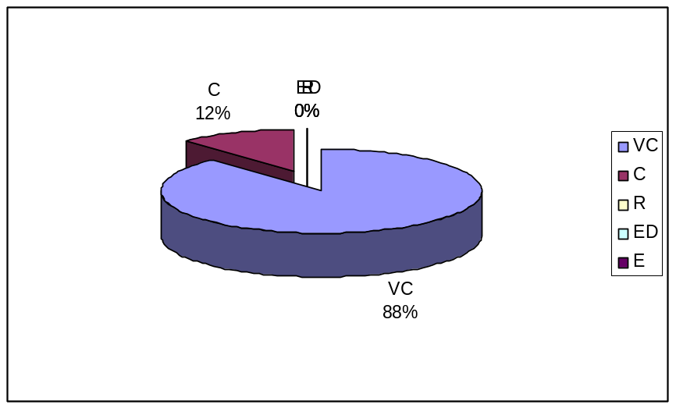

Source: Questionnaire survey-2009/ November

Figure 5.10: Present statuses of fishes are shown in Pie charts.
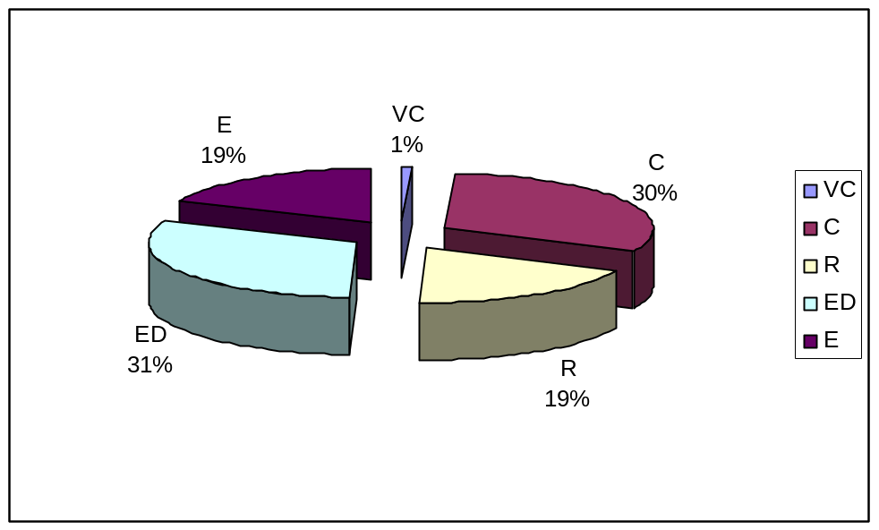

Source: Questionnaire survey-2009/ November

5.2.2.2 Introduction of exotic species of fish

Although about 150 exotic species of freshwater fishes were introduced into the country in the earlier part of this century, and were mostly ornamental or aquarium fish, 13 are cultured in freshwater and brachish water ponds. Gambusia, a larvivorous fish was introduced in the 1930s/1940s to control mosquito. The fishes that are contributing substaintially to commercial fisheries are: Chinese Silver Carp, Grass Crap, Big Head Carp, Common Carp, Tilapia, Catfish, Thai Pangas, Sor Punti, etc (Banglapedia, 2003).

Table 5.11 New fishes in Dhamshona and Yearpur union

SI. | Local name | Scientific name | Past | Present
1. | Common carp |  | VF | VC
2. | Pangas |  | R | VC
[Code: Status: Very common=VC, Common=C, Rare=R, Endangered=ED, Locally extinct=E]
Source: Questionnaire survey-2009/ November

Table 5.11 reveals the past and present status of new fishes in the study area. Like other areas of Bangladesh, exotic carps like silver carp, common carp, grass carp, catfishes, tilapias, prawns, etc are cultured in the study area as to obtain high production per unit area of water body (Table 5.11).

5.2.2.3 Mammals

The mammalian fauna of Bangladesh is the most highly affected from their habitat destruction and over exploitation.The following table 5.12 includes a list of mammals of Dhamshona and Yearpur union and their past and present status. This is mainly the based on the field experience. A total of 40 species of mammals was observed in the study area. Out of 40 species of mammals 24 species (60%) were very common; 8 species (20%) were common;

Table 5.12: List of Mammals in Dhamshona and Yearpur union
SI. | Local name | Scientific name | Past | Present
1. | Lojjawati Banor/ Lajuk Banor | Nycticebus coucany | R | E
2. | Banor | Macaca mulatto | C | ED
3. | Ultoleji Banor/ Kuku Bandor | Macaca nemestrina | F | E
4. | Hanuman | Semnopithecus entellus | R | E
5. | Ulluk | Hylobates hoolock | R | E
6. | Pati Shial | Canis aureus | VC | ED
7. | Khek Shial | Vulpes bengalensis | VC | ED
8. | Ban Biral/Wab | Felis chaus | C | ED
9. | Sonali Biral | Catopuma temmincki | F | E
10. | Mecho Biral/ Mecho Bagh | Prionailurus viverrinus | F | ED
11. | Bara Benji | Herpestes ed wardsi | VC | ED
12. | Kakrabhuk Benji | Herpestes urva | VC | ED
13. | Vd/Vd Biral/Bhodor | Lutra perspicillata | VC | ED
14. | Gandho Gokul/Nongar | Paradoxurus hermaphroditus | VC | ED
15. | Bagdagh | Viverra zibetha | VC | ED
16. | Khatash/ Gandho Gokul | Vivericula indica | C | ED
17. | Shishu Shushuk/Huchchum Houm | Platanistidae | F | E
18. | Shojaru | Hystrix indica | F | E
19. | Khargosh/Shashak | Lepus nigricallis | C | ED
20. | Chika/Chucho | Suncus murinus | VC | C
21 | Badur | Pteropus giganteus | VC | C
22. | Kola Badur | Rousettus leschenaultia | VC | ED
23. | Sheath tailed Bat/Long-winged Tomb Bat | Taphozous longimanus | VC | ED
24. | Bearded Sheath-tailed Bat/Black-bearded Tomb Bat | Taphazous melanopogon | VC | E
25. | Badur/Daini Badur | Negaderma lyra | VC | C
26. | Leaf-rosed Bat/Cantor’s Leaf-nised Bat | Hipposideros galeritus | C | ED
27. | Tickell’s Bat | Hesperoptenus tickelli | C | ED
28. | Benji/Nakul | Herpestes auropunctatus | C | R
29. | Buno Shukar/Shuor/ Bonnya | Sus scrofa | C | R
30. | Indur | Bandicota bengaleasis | VC | C
31. | Kathbirali | Ratufa bicolor | VC | E
32. | Bara Indur/Dhari Indur | Bandicota indica | VC | C
33. | Metho Indur | Mus booduga | VC | C
34. | Nengti Indur | Mus musculus | VC | C
35. | Indur | Rattus rattus | VC | C
36. | Kangaru Indur | Tatera indica | VC | ED
37. | Banrui | Manis javanica | VC | E
38. | Badami Kathbirali | Callosciurus | VC | F
39. | Dora Kathbirali | Funambulus pennanti | VC | F
40. | Uranta Kathbirali | Petaurista pentaurisa | VC | ED
[Code: Status: Very common=VC, Common=C, Rare=R, Endangered=ED, Locally extinct=E]
Source: Questionnaire survey-2009/ November & IUCN Bangladesh

5 species (12.54%) were few and 3 species (7.5%) were rare in past but in present there is no very common species, 8 species (20%) are common, 11 species (27.5%) are locally extinct, 17 species (42.5%) are endangered 2 species (5%) are few, 2 species (5%) are rare in the study area as shown in table 5.13.

Table 5.13: Past and Present status of mammals
Type | Past |  | Present
Type | Amount | % | Amount | %
VC | 24 | 60 | 0 | 0
C | 8 | 8 | 8 | 20
R | 3 | 7.5 | 2 | 5
ED | 0 | 0 | 17 | 42.5
E | 0 | 0 | 11 | 27.5
F | 5 | 12.5 | 2 | 5

Source: Questionnaire survey-2009/ November

According to the people of Dhamshona and Yearpur union, 20-25 years ago, this area was abundant with different types of mammals. Once abundance Pati Shial (Canis aureus), Khek Shial (Vulpes bengalensis), Bara Benji (Herpestes ed wardsi), Kakrabhuk Benji (Herpestes urva), Vd/Vd Biral/Bhodor (Lutra perspicillata), GandhoGokul/Nongar (Paradoxurus hermaphroditus) Bagdagh (Viverra zibetha), Kola Badur (Rousettus leschenaultia), Kangaru Indur (Tatera indica), Uranta Kathbirali (Petaurista pentaurisa) are endangered now. Benji/Nakul (Herpestes auropunctatus), Buno Shukar/Shuor/ Bonnya (Sus scrofa) are rare species now.
Figure 5.11: Past statuses of mammals are shown in Pie charts.
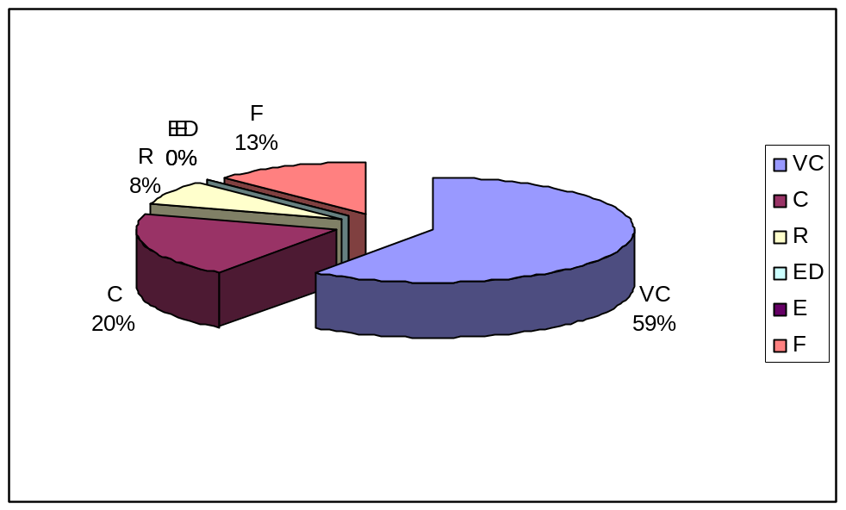

Source: Questionnaire survey-2009/ November

Figure 5.12: Present statuses of mammals are shown in Pie charts.
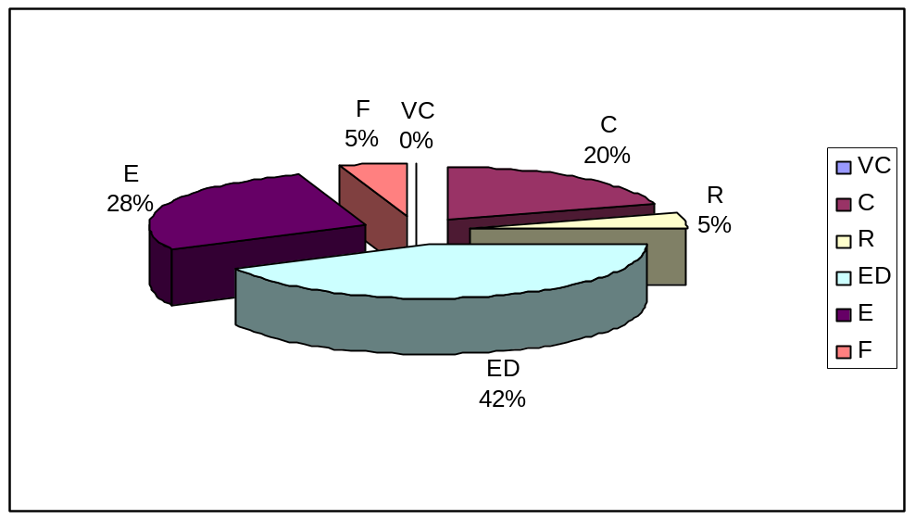

Source: Questionnaire survey-2009/ November

5.2.2.4 Reptiles

Reptiles are environment friendly as they eat many agricultural pests, and help control their numbers.The depletion of reptilian fauna in Bangladesh is noteworthy. A total of 36 species of reptiles was observed in the study area belonging to 3 order and 9 families. Table 5.14 shows the past and present status of reptiles in Dhamshona and Yearpur union.

Table 5.14: List of repliles in Dhamshona and Yearpur union
SI. | Local name | Scientific name | Past | Present
1. | Kalo Kasim | Geoclemys hamiltonii | C | ED
2. | Kali Kaitta | Hardella thurji | C | ED
3. | Majhari Kaitta | Kachuga tentoria | C | ED
4. | Kasim | Melanochelys tricarinata | C | ED
5. | Kasim | Melanochelys trijuga | C | ED
6. | Halday Kaitta | Morenia petersi | C | E
7. | Khalua Kasim | Aspideretes gangeticus | C | ED
8. | Dhum Kasim | Aspideretes hurum | C | ED
9. | Shundhi Kasim | Lissenys punctata | C | E
10. | Tokkhak/ Shanda | Gekko gecko | C | E
11. | Tiktiki | Hemidoctylus brookii | VC | VC
12. | Tiktiki | Hemidoctylus flaviviridis | VC | VC
13. | Rokto-chosha | Calotes versicolor | VC | C
14. | Uranto Tiktiki | Draco blanfordie | VC | ED
15. | Anjoni/Anjon | Mabuya carinata | VC | C
16. | Anjon | Malbuya macularis | VC | ED
17. | Gui Shap | Varanus bengalensis | VC | E
18. | Shona Gui/ Holdey Giu/Hungui Shap | Varanus flavescens | VC | E
19. | Dumukha Shap | Ramphotyphlops braminus | F | E
20. | Dumukha Shap | Typhlops diardii | F | E
21 | Dumukha Shap | Typhlops porrectus | F | E
22. | Laodoga Shap/Sutanali Shap | Ahaetulla nasutus | F | E
23. | Dora Shap | Amphiesma stolata | VC | C
24. | Kalnagin/Wranto Shap | Chrysopelea oranta | F | E
25. | Daraj/Dhaman | Coluber mucosus | F | E
26. | Gecho Shap | Dendrelaphis pictus | R | E
27. | Bet Anchora/Gecho Shap | Dendrelaphis tristis | F | E
28. | Dudhraj | Elaphe radiate | F | E
29. | Gharginni Shap/Kaurilla | Lycodon aulicus | F | E
30. | Gharginni Shap | Lycodon fasciatus | F | E
31. | Gharginni Shap | Lycodon jora | F | E
32. | Kal Keotey | Bungarus caeruleus | F | E
33. | Shakini Shap/Shankhini Shap/Shankhamoti Shap |  | F | E
34. | Gokhra Shap/Jati Shap/Keauthia | Naja kaouthia | C | E
35. | Khoia Gokhra/Naga Gokhra | Naja naja | F | E
36. | Chandrobora/Bora/Uloo Bora | Vipera russellii | F | E

[Code: Status: Very common=VC, Common=C, Rare=R, Endangered=ED, Locally extinct=E]
Source: Questionnaire survey-2009/ November & IUCN Bangladesh

Out of the 36 species, 9 species (25%) were very common in past but in present only 2 species (5.55%) are very common. Among this species 11 species (30.55%) were common in past, 16 species (44.44%) were few but in present 3 species are common, 22 species (61.11%) are locally extinct and 8 species (22.22%) are endangered as shown as table 5.15.

Table 5.15: Past and Present status of reptiles
Type | Past |  | Present
Type | Amount | % | Amount | %
VC | 9 | 25 | 2 | 5.55
C | 11 | 30.55 | 3 | 8.33
R | 0 | 0 | 0 | 0
ED | 0 | 0 | 8 | 22.22
E | 0 | 0 | 22 | 61.11
F | 16 | 44.44 | 0 | 0

Source: Questionnaire survey-2009/ November

From Table-5.15 it is evident that 61 percent of the sample mammals are locally extinct and 22 percent of the mammals are endangered. Kalo Kasim (Geoclemys hamiltonii), Kali Kaitta (Hardella thurji), Kasim (Melanochelys tricarinata), which were abundant in the study areas, have now totally disappeared. Although common in past Tokkhak/ Shanda (Gekko gecko), Shundhi Kasim (Lissenys punctata), Halday Kaitta (Morenia petersi) are locally extinct.
Figure 5.13: Past statuses of reptiles are shown in Pie charts.
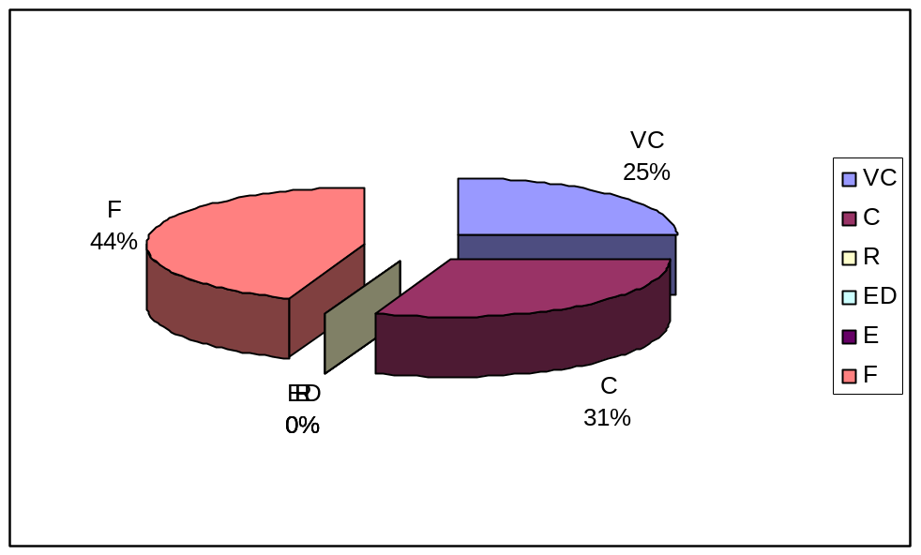

Source: Questionnaire survey-2009/ November

Figure 5.14: Present statuses of reptiles are shown in Pie charts
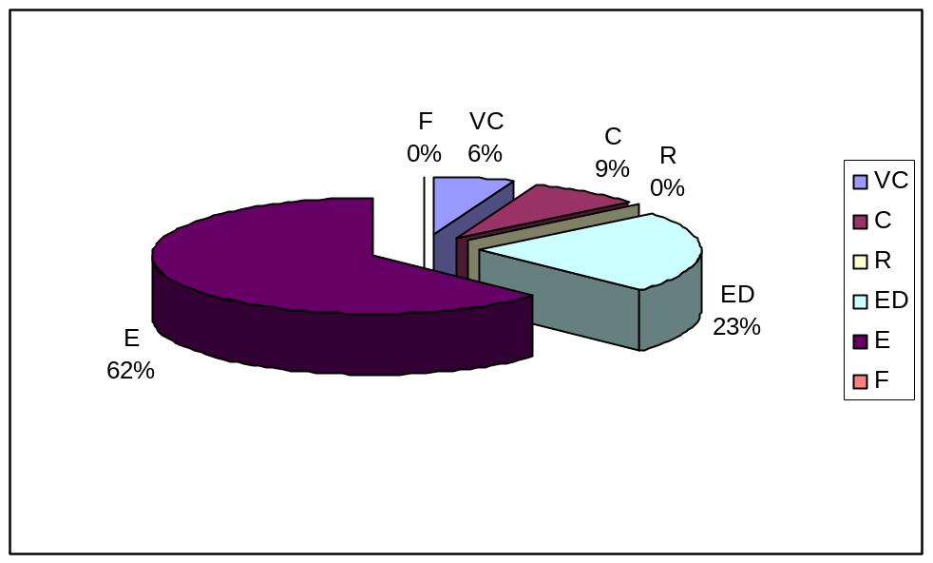

Source: Questionnaire survey-2009/ November

5.2.2.5 Birds

The population of birds in Bangladesh is very rich, and there is a wide variety in the country. However, bird populations around the globe are declining at an alarming rate, and that does not exclude Bangladesh. In the study area 169 species of birds were found and its past and present status is given in table 5.16

Table 5.16: List of Birds in Dhamshona and Yearpur union
SI. | Local name |  | Scientific name |  | Past |  |  | Present
1. | Cheena Bater |  | Coturnix coromondelica |  | VC |  |  | E
2. | Kalo Titir/ Sheikh Farid |  | Francolinus francolinus |  | F |  |  | E
3. | Kea/ Jolar Titir |  | Francolinus |  | F |  |  | E
4. | Titir |  | Francolinus |  | F |  |  | E
5. | Ban Morog/Murgi |  | Gallus gallus |  | F |  |  | E
6. | Mothura kalo Mayur |  | Lophura leucomelanos |  | F |  |  | E
7. | Bormi Mayur |  | Pavo muticus |  | F |  |  | E
8. | Kalo Gundri |  | Perdicula |  | VF |  |  | E
9. | Kat-Mayur/Katmor |  | Polyplectron |  | VF |  |  | E
10. | Bhadi Hans |  | Dendrocy gnidne |  | VC |  |  | E
11. | Boro Shorali |  | Dendrocygna bicolor |  | VC |  |  | C
12. | Sharali/Gecho Hans |  | Dendrocygna Javanica |  | VC |  |  | C
13. | Pati Hans |  | Anas |  | VC |  |  | C
14. | Bali Hans/ Bele Hans |  | Nettapus |  | C |  |  | C
15. | Buncha Hans |  | Sarkidiornis |  | C |  |  | E
16. | Lalchey Kaththakra |  | Celeus brachyurus |  | VC |  |  | C
17. | Dhushar Matha Baman Kaththokra |  | Dendrocopos canicapillus |  | VC |  |  | C
18. | Pakra Kaththokra |  | Dendrocopos macei |  | VC |  |  | C
19. | Pakra Kaththokra |  | Dendrocopos mahrattensis |  | VC |  |  | ED
20. | Bana Kaththokra |  | Dendrocopos nanus |  | VC |  |  | E
21 | Lawa |  | Turnix sylvatica |  | C |  |  | ED
22. | Khaththikra |  | Dinopium |  | VC |  |  | C
23. | Common Flameback |  | Dinopium |  | VC |  |  | C
24. | Khudey Kaththokra |  | Picumnus innominatus |  | VC |  |  | C
25. | Sabujey Kahthokra |  | Picus xanthopygaeus |  | VC |  |  | C
26. | Lal khudey Kaththokra |  | Sasia achracea |  | VC |  |  | C
27. | Basabta Bauri |  | Megalaimidae |  | VC |  |  | C
28. | Choto Basanta Bauri |  | Megalaima |  | VC |  |  | F
29. | Guskhod/Beghbou |  | Megalaima lineate |  | VC |  |  | F
30. | Kao Dhanesh |  | Anthracoceros albirostris |  | VC |  |  | ED
31. | Raj Dhanesh |  | Buceros bicornis |  | VC |  |  | E
32. | Putial Dhanesh |  | Ocyceros birostris |  | VC |  |  | ED
33. | Hudhud/Solaiman Pakhi |  | Upupa epops |  | VC |  |  | F
34. | Lal Trogon/Kuchkuchia |  | Harpactes erythrocephalus |  | C |  |  | ED
35. | Nilkantha |  | Coracias |  | VC |  |  | F
36. | Pahari Nilkantha |  | Eurystomus |  | VC |  |  | ED
37. | Maachranga |  | Alcedo Hercules |  | VC |  |  | ED
38. | Choto Maachranga |  | Alcedo athis |  | VC |  |  | C
39. | Blue-eared King fisher |  | Alcedo meninting |  | VC |  |  | ED
40. | Brown-winged King fisher |  | Halcyon amauroptera |  | VC |  |  | C
41. | Megh-hao |  | Halcyon capensis |  | VC |  |  | C
42. | Lal Maachranga |  | Halcyon cormandra |  | VC |  |  | ED
43. | Maachranga |  | Halcyon snyrnensis |  | VC |  |  | C
44. | Pakra Maachranga |  | Ceryle rudis |  | VC |  |  | C
45. | Suichora Banspati |  | Merops orientalis |  | VC |  |  | C
46. | Chatak/Sorgom |  | Cacomantis merulinus |  | VC |  |  | C
47. | Kanakua/Coucal |  | Centropus sinensis |  | VC |  |  | F
48. | Papiya |  | Clamator jacobinus |  | VC |  |  | F
49. | Bou-katha kao Pakhi |  | Cuculus microotuns |  | VC |  |  | F
50. | Kokil kuli |  | Eudynaeus scolopeaus |  | VC |  |  | F
51. | Sabuj Kokil |  | Phaenieohaeus tristis |  | VC |  |  | ED
52. | Lotkan/Lejkata Tia |  | Loricuas vernalis |  | VC |  |  | ED
53. | Tota |  | Psittacha alexania |  | C |  |  | ED
54. | Chondona/Boro Tia |  | Psittanula alexonia |  | VC |  |  | E
55. | Kalomatha Tia |  | Psittanula finschii |  | VC |  |  | ED
56. | Tia |  | Psittacula krameri |  | VC |  |  | C
57. | Lalmatha Tia/Hiramon |  | Psittacula roseate |  | VC |  |  | C
58. | Ababil |  | Apus affinis |  | VC |  |  | C
59. | Nakkati |  | Cypsiurus balasiensis |  | VC |  |  | F
60. | Laxmi Pencha |  | Tyto alba |  | VC |  |  | F
61. | Pencha |  | Bubo nipalensis |  | VC |  |  | ED
62. | Bhutum Pencha |  | Ketupa zeylonensis |  | VC |  |  | E
63. | Kupokh |  | Ninox scutulata |  | VC |  |  | E
64. | Nimpokh |  | Otus lempiji |  | VC |  |  | F
65. | Nimpokh |  | Otus scops |  | VC |  |  | F
66. | Dinkana/ Ratchora |  | Caprimulgus indicus |  | VC |  |  | E
67. | Ratchara |  | Caprimulgus macrurus |  | VC |  |  | C
68. | Jalali kobutar/Kapot/Paira |  | Columba livia |  | VC |  |  | C
70. | Tila Ghughu |  | Streptopelia chinensis |  | VC |  |  | F
71. | Raj Ghughu/Dhobal Ghughu |  | Streptopelia decaocto |  |  | VC |  |  | F
72. | Khudey Ghuhgu |  | Streptopelia senegalensis |  |  | VC |  |  | ED
73. | Lal Ghughu/Jongla Ghughu |  | Streptopelia transquebarica |  |  | VC |  |  | C
74. | Horial/ Horikol |  | Treron apicauda |  |  | VC |  |  | ED
75. | Horial/ Horikol |  | Treron bicincta |  |  | VC |  |  | F
76. | Horial/Batkol |  | Treron phoenicoptera |  |  | VC |  |  | F
77. | Choto Horial |  | Treron pompadora |  |  | VC |  |  | F
78. | Dahor |  | Houbaropsis bengalensis |  |  | VC |  |  | E
79. | Sarash Pakhi |  | Grus antigon |  |  | VC |  |  | E
80. | Dahuk |  | Amaurornis phoenicuns |  |  | VC |  |  | C
81. | Kura |  | Gallicrex eixer |  |  | VC |  |  | F
82. | Kalim/Kaim |  | Porphyx porphyxia |  |  | VC |  |  | C
83. | Rongila Chaga |  | Rostnix bengeus |  |  | VC |  |  | C
84. | Jol Moyur Neo |  | Hydrophasianus chirurgus |  |  | VC |  |  | R
85. | Jolpipi/ Pipi |  | Metopidius indicus |  |  | VC |  |  | F
86. | Lal-pa Dhenga |  | Himantopus himantopus |  |  | VC |  |  | F
87. | Lal lotika/Hot-ti-ti |  | Vanellus malabaricus |  |  | VC |  |  | E
88. | Khudey Gangchil |  | Sterna albifrons |  |  | VC |  |  | C
89. | Gangchil |  | Sterna acuicauda |  |  | VC |  |  | ED
90. | Maach khaikka |  | Sterna aurantia |  |  | VC |  |  | C
91. | Turki Baj |  | Accipiter bodius |  |  | VC |  |  | ED
92. | Kura/Bowol/Koral |  | Haliaeetus leucoryphus |  |  | VC |  |  | E
93. | Shankho Chil/Lal Chil |  | Haliastur Indus |  |  | VC |  |  | R
94. | Maachmorol/Ukosh |  | Ichthyophaga |  |  | VC |  |  | R
95. | Bhubon Cheel |  | Milvus migrans |  |  | VC |  |  | F
96. | Raj Shakun |  | Sarcogyps calvus |  |  | C |  |  | ED
97. | Tila Baj/Shap kheko Baj |  | Spilornis cheela |  |  | VC |  |  | F
98. | Turmuti |  | Falco chicquera |  |  | VC |  |  | ED
99. | Duburi/Dubalu |  | Podicipedidae |  |  | VC |  |  | ED
100. | Goyer/ Shap-pakhi |  | Anhingidae |  |  | VC |  |  | ED
101. | Paan-kowri/Jolkak |  | Phalacrocoracidae |  |  | VC |  |  | C
102. | Dhushor Bok |  | Ardea cinerea |  |  | VC |  |  | C
103. | Beguni Bok |  | Ardea purpurea |  |  | VC |  |  | C
104. | Cheena Bok |  | Ardeola bacchus |  |  | VC |  |  | E
105. | Kani Bok/Kana Bok/Korchey Bok |  | Ardeola grayii |  |  | VC |  |  | C
107. | Sabuj Bok |  | Butorides striatus |  |  | VC |  |  | C
108. | Jathu/ Sada Bok | Casmerodius albus |  | VC |  |  | C
109. | Kalo Bok | Dupetor flavicollis |  | VC |  |  | E
110. | Choto Bok | Egretta garzetta |  | VC |  |  | C
111. | Lal Bok | Ixobrychus cinnamomeus |  | VC |  |  | ED
112. | Holdey Bok/ Kath Bok | Ixobrychus sinensis |  | VC |  |  | C
113. | Maijhla Bok/ Korche Bok | Mesophoyx intermedia |  | VC |  |  | C
114. | Waak/ Nishi Bok | Nycticorax nycticorax |  | VC |  |  | C
115. | Kastey chora | Threskiornis melanocephalus |  | VC |  |  | ED
116. | Shumuk-bhanga/Shamuk-khol | Anastomus oscitans |  | VC |  |  | R
117. | Manikjor | Ciconia episcopus |  | VC |  |  | E
118. | Hargila | Leptoptilos dubius |  | VC |  |  | E
119. | Modontak | Leptoptilos javanicus |  | VC |  |  | ED
120. | Nilpakhi/Shumcha | Pitta brachyura |  | VC |  |  | ED
121. | Pata Bulbuli | Chloropsis aurifrons |  | VC |  |  | C
122. | Sabuj Bulbuli | Chloropsis cochinchinensis |  | VC |  |  | R
123. | Bagha Tiki | Lanius schoch |  | VC |  |  | ED
124. | Sabuj Harichacha | Cissa chinensis |  | VC |  |  | ED
125. | Daar Kak | Corvus macrorhynchos |  | VC |  |  | VC
126. | Pati Kak/Kaua | Corvus splendens |  | VC |  |  | VC
127. | Hanrichacha/Kutum | Dendrocitta vagobunda |  | VC |  |  | C
128. | Towfik/Fatikjal | Aegithina tiphia |  | VC |  |  | F
129. | Holdey Pakhi | Oriolus xanthornus |  | VC |  |  | F
130. | Choto Fingey | Dicrurus aeneus |  | VC |  |  | C
131. | Fingey | Dicrurus macrocercus |  | VC |  |  | C
132. | Latora | Artamus fuscus |  | VC |  |  | C
133. | Gudhuka | Coracina macei |  | VC |  |  | C
134. | Sat Saili | Pericrocotus cinnamomeus |  | VC |  |  | C
135. | Lejnachani | Rhipidura albicollis |  | VC |  |  | C
136. | Lajnachani | Rhipidura aureola |  | VC |  |  | C
137. | Sada Shipahi/Lal Shipahi | Terpsiphone paradise |  | VC |  |  | C
138. | Shama | Copsychus malabaricus |  | VC |  |  | C
139. | Doel/Doinachani | Copsychus saularis |  | VC |  |  | C
140. | Futfuti | Culicicapa ceylonensis |  | VC |  |  | C
141. | KaloDoel | Saxicoloides fulicata |  | VC |  |  | F
142. | Jhuti Shalik | Acridothere fuscus |  | VC |  |  | C
143. | Gang Shalik | Acridotheres ginginianus |  | VC |  |  | C
144. | Bhat Shalik | Acridotheres tristis |  | VC |  |  | C
145. | Kalo Shalik | Aplonis panayensis |  | VC |  |  | F
146. | Moyna | Gracula religiosa |  | VC |  |  | C
147. | Gobrey Shalik/Gu Shalik | Sturnus contra |  | VC |  |  | C
148. | Kath Shalik | Sturnus malabaricus |  | VC |  |  | C
149. | Baman Shalik | Strunus pagodarum |  | VC |  |  | F
150. | Kalo Bulbuli | Hypsipetes leucocephalus |  | VC |  |  | F
151. | Bulbuli | Pycnonotus cafer |  | VC |  |  | C
152. | Sipahi Bulbuli | Pycnonotus jocosus |  | VC |  |  | C
153. | Shet-ankhi | Zosterops palpebrosus |  | VC |  |  | C
154. | Panga | Garrulax galbanus |  | VC |  |  | R
155. | Tunyuni/Tuni | Orthotomus sutorius |  | VC |  |  | F
156. | Shathbaila | Pellorneum albiventre |  | VC |  |  | ED
157. | Shatbhai/Satbhaira | Turdoides striatus |  | VC |  |  | F
158. | Bharat Pakhi | Alauda gulgula |  | VC |  |  | E
159. | Balu Chata/Dhulchata | Eremopterix grisea |  | VC |  |  | E
160. | Bharat Pakhi | Mirafra assamica |  | VC |  |  | E
161. | Moutushi | Nectarinia zeylonica |  | VC |  |  | F
162. | Fuljhuri | Dicaeum erythrorynchos |  | VC |  |  | F
163. | Lal munia | Amandava amandava |  | VC |  |  | F
164. | Kalomatha munia | Lonchura Malacca |  | VC |  |  | F
165. | Tila munia | Lonchura punctulata |  | VC |  |  | F
166. | Munia | Lonchura striata |  | VC |  |  | F
167. | Charui | Passer domesticus |  | VC |  |  | F
168. | Babui/ Baoi | Ploceus philippinus |  | VC |  |  | R
169. | Pakra khonjon | Motacilla maderaspatensis |  | VC |  |  | R
[Code: Status: Very common=VC, Common=C, Rare=R, Endangered=ED, Locally extinct=E, VF=Very few]
Source: Questionnaire survey-2009/ November & IUCN Bangladesh
Among the 169 species of birds in past 156 species were very common in the study area, 6 species were few, 2 species were very few and 5 species were common but of late, among them there are only 2 species are very common, 64 species are common, 38 species are few, 8 species are rare, 28 species are endangered and 29 species are locally extinct.Once abundance in the study area, the resident birds Bhadi hans belonging to the family Dendrocygnidae, Bancha hans belonging to the family Anatidae, Bana kaththokra belonging to the family Picidae, Lal Maachrange belonging to the family Alcedinidae, Kalomatha Tia belonging to the family Psittacidae, Pencha belonging to the family Strigidae, Khudey Ghughu belonging to the family Columbidae, Horial/Horikal belonging to the family Columbidae, Raj Shakun belonging to the family Accipitridae, Turmuti belonging to the family Falconidae, Duburi/Dubalu belonging to the family Podicipedidae, Goyer/Shap Pakhi belonging to the family Anhingidae, Lal Bok belonging to the family Ardeidae, Nilpakhi/Shumcha belonging to the family Pittdae, Bagha Tiki belonging to the family Baniidae, Shabuj Harichacha belonging to the family Corvidae, Shatbhaila belonging to the family Sylviidae, are now in endangered. Once abundance the birds Cheena Boter belonging to the family Phasianidae, Raj Dhanesh belonging to the family Bucerotidae, Chondona/Boro Tia belonging to the family Psittacidae, Bhutum Pencha belonging to the family Strigidae, Kupokh belonging to the family Strigidae, Dinkana Ratchara belonging to the family Caprimelgidae, Shabuj Ghughu belonging to the family Columbidae, Dahor belonging to the family Orididae, Sarash Pakhi belonging to the family Gruidae, Lal lotika/ Hot-ti-ti belonging to the family Charadriidae, Kura/Koral/Bowol belonging to the family Accipitridae, Cheena Bok belonging to the family Ardeidae, Manikjor belonging to the family Ciconiidae, Hargila belonging to the family Ciconiidae, Bharat Pakhi belonging to the family Alaudidae, Balu Chata/Dhul Chata belonging to the family Alaudidae are now in locally extinct. Table 5.17 represents the past and present status of birds in the study area.
Table 5.17: Past and Present status of birds
Type | Past |  | Present
Type | Amount | % | Amount | %
VC | 156 | 92.30 | 2 | 1.18
C | 5 | 2.95 | 64 | 37.86
R | 0 | 0 | 8 | 4.73
ED | 0 | 0 | 28 | 16.56
E | 0 | 0 | 29 | 17.16
F | 6 | 44.44 | 38 | 22.48
VF | 2 | 1.18 | 0 | 0

Source: Questionnaire survey-2009/ November
Figure 5.15: Past statuses of birds are shown in Pie chart
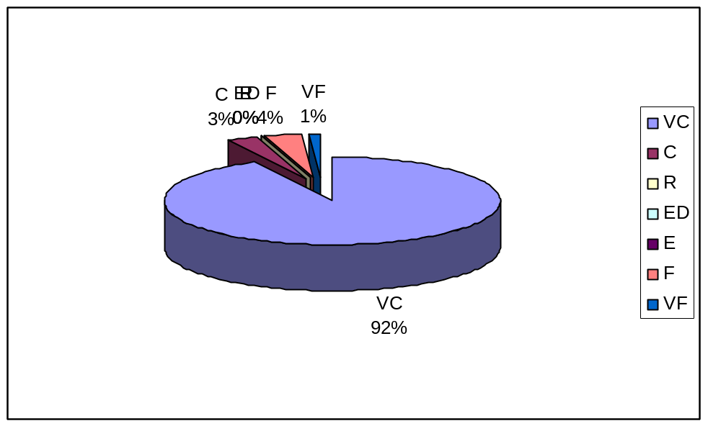

Source: Questionnaire survey-2009/ November

Figure 5.16: Present statuses of birds are shown in Pie charts
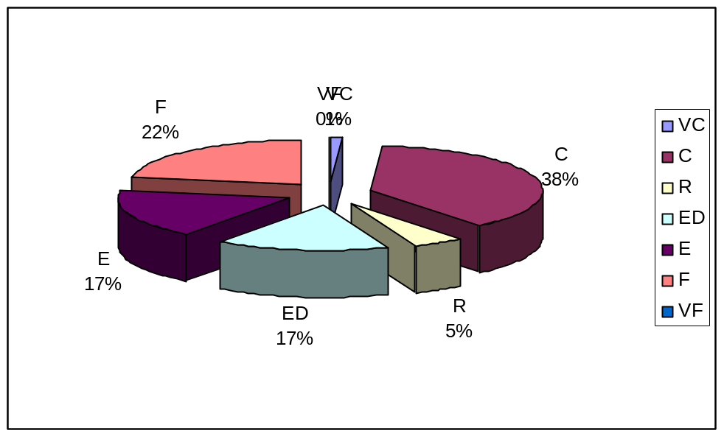

Source: Questionnaire survey-2009/ November

5.3 CAUSES & FACTORS OF BIODIVERSITY CHANGES

The biodiversity of the study area is changing rapidly due to presence of various factors. Both flora and fauna are threatened by the loss of habitat resulting from increasing human populations, industrialization and unwise bio-resource utilization. The unplanned rapid urbanization and industrialization are leading to waste and pollution problems that affect natural ecosystems. As the land and water-based ecosystems are environmentally compromised, the flora and fauna populations are being seriously affected.

Table 5.18: Major Threats to Biodiversity
Cause | No.of respondents | %of respondent
● Destruction of habitat | 25 | 33.35
● Overexploitation of flora and fauna | 28 | 42.25
● Indiscriminate use of agro-chemicals | 11 | 13.49
● Industrial waste disposal | 23 | 21.05
● Encroachment into the natural forests | 19 | 18.43
● Change in land use pattern and land use conflict | 29 | 45.89

Source: Questionnaire survey-2009/ November

Table 5.18 claim that changes in landuse pattern and landuse conflict is increased as a result of biodiversity changes. About 45.89% people support this cause.Changes the landuse pattern has caused several problems including extinction and reduction of animal life, extinction of many indegenious plant varieties, loss of many indegenous aquatic plants, herbs, shrubs and weed, loss of natural soil nutrients, loss of natural reservoirs and of their resultant benefits and degeneration of ecosystems, occupations, socio-economic institutions and cultures. Another important impact of biodiversity changes is destruction of habitat which alters and potentially eliminates the conditions needed for plants and animals to survive. About 33.35% people support this cause. The trend of industrialization in the study area is an evident of the rapid growth of urbanization. Natural ecosystems are most seriously affected by urban development.When developers build shopping centres, housing developments and office spaces critical habitat is not just degraded habitat, it’s obliterated. In addition, over exploitation of flora and fauna though unsustainable hunting, fishing, or extracting raw material has serious implications for biodiversity. Overexploitation has resulted in the extinction of many species and the loss of genetic diversity within others.Overexploitation is caused due to pressure of population. Population is increasing but the plants, animals and fishes are not growing such a rate. So fulfill their demand, the inhabitants of the study area are being caused overexploitation.Other important causes are indiscriminate use of agro-chemicals, industrial waste disposal and encroachment into the natural forests.

The overall factors, which are involved with the changes biological diversity in the study area, are given in below-

5.3.1 Habitat Destruction

Habitat or ecosystem destruction is the major source of species depletion and extinction today. All species have specific food and habitat needs. The more specific these needs and localized the habitat, the greater the vulnerability of species to loss of habitat to agricultural land, livestock, roads and cities. Habitat destruction can take many forms. The world Coservation Strategy (WCS) lists them as:
1) Replacement of the entire habitat by settlements, harbours and other human constructions.

2) Replacement of the entire habitat by cropland, grazing land or tree plantation.

3) The effects of dams: blocking, spawning migrations, drowning
terrestrial habitat, altering chemical or thermal conditions.

4) Drainage, channelisation and flood control.

5) Chemical, nutrient and solid waste pollution, of domestic agricultural, industrial and mining origin, which is widespread.

6) Overexploitation of water, for domestic, agricultural and industrial purposes, which lowers water levels.

7) Removal of materials, such as vegetation, sand, gravel and stones.

8) Erosion and siltation.

5.3.2 Overexploitation

Overexploitation occurs when a resource is consumed at an unsustainable rate. In order to maximize short-term profit, human has historically exploited plant and animal species at the expense of sustainability of the species or population. This exploitation follows a predictable pattern: initially, from the wild a harvested species can turn a substantial profit, encouraging more people to get involved in its extraction. This increased competition encourages the development of more large-scale and efficient methods of extraction, which inevitably deplete the resource. Joe Walston, director of the Wildlife Conservation Society’s Asian programs, called the latter the "single largest threat" to biodiversity in Asia. It occurs on land in the form of over hunting, excessive logging, poor soil conservation in agriculture and the illegal wildlife trade.
Overexploitation is another vital factor for depletion of faunal resources. Increasing of population decreased the biodiversity of study area. Many types’ birds, fishes have been pushed to the brink of extinction. Alter habitat loss, over harvesting has had the greatest effect on biodiversity. In fact, over harvesting and habitat loss often occur simultaneously, as removal of an organism from its environment can have irreversible impacts on the environment itself.

The problem with biological resources extraction is when the rate of increase in demand for the resources far outstrips the reproductive rate of the population – demand outstrips supply – and drives the value of that resource higher, increasing the incentive to extract the and causing the population to eventually collapse. Such a fate has been fallen whales, elephants, spotted cats, cod, old-growth forests, ginseng, parrots, tuna and passenger pigeons, just to name a few.

5.3.3 Introduction of exotic species

Introduction of exotic species is causing threat to the indigenous fish. For example carp fish includes silver carp, mirror carp, crossbreeding pangus etc. Introduction of HYV paddy bounds the indigenous fish for locally extinction. Before the introduction of HYV paddy indigenous fish was naturally cultured in paddy field. That time there is no use of chemical fertilizer.

The threat of exotic species to natural habitats falls into different categories:

Habitat alteration: The effect of this impact on biodiversity is discussed above;

Competition: Exotic species can often out compete native species for food and habitat acquisition, mainly because they have no local controls (disease and predators) to keep their population in check.

Predation: The introduction of a predator that organisms have not previously been exposed to can profoundly affect food chains. Introducing new species often leaves endemic and other local species unable to compete with the exotic species and unable to survive. The exotic organisms may be predators, parasites, or may simply out compete indigenous species for nutrients, water and light. At present, several countries have already imported so many exotic species, particularly agricultural and ornamental plants, that the own indigenous fauna/flora may be outnumbered.

Hybridization: Hybridization and introgression are side-effects of introduction and invasion. Introduction of non-native species, whether intentional or not, has resulted in the interbreeding of native and non-native species, with the consequent decline of native species. It has been estimated that hybridization was a major factor in 38% of North American fish species extinctions. However, hybridization with or without introgression may, nevertheless, threaten a rare species' existence (Rhymer et. al 1996).

Disease and parasites: Pest species accidentally introduced to an area provide the most dramatic example of the damage that exotics can pose to native species. For instance, an exotic beetle was the vector for Dutch elm disease, which has devasted elm trees in North America.

Homogenization of ecosystems: Species introduction can occur accidentally, when organisms “hitchhike” into new systems on other animals or objects. The above impacts combine to decrease the number of native species in a habitat and replace them with “weedy”, widespread species- and thus cause regional homogenization of ecosystems. Unintentional species introductions can also result from lack of education of the general public. For instance, releasing aquarium fishes or using exotic ornamental garden plants whose seeds escape into natural systems can increase the probability of an exotic species becoming established in our native ecosystems.

5.3.4 Dynamics of population and settelement change

Growth of the human population is a major factor affecting the environment. Simply put, overpopulation means that there are more people than there are resources to meet their needs. Almost all the environmental problems we face today can be traced back to the increase in population in the world. The human population is at 6 billion; with an annual global growth of 1.8%, three more people are added to the earth every second. This represents an increase of almost 60% since 1970 and over 150% since the Second Worlds War (Miller, 1992).

In Dhamshona and Yearpur union, the high lands are associated for human settlements and housing societies and the inventory lowlands for agricultural purposes. Most of the housing societies and real estates are concentrated along highways of Savar-Tongi Highway, Savar-Jirabo Road. About 30 percent of lands were in type of housing and settlement in 2001 what rises only 6 percent within five years. The present settlements are randomly distributed, but they are concentrated in some areas. On the basis of the surface configurations, electricity, and gas supply situation and transport system have led to highly scattered population distribution with a distinctively dispersed pattern of settlement, due to scarcity of raised lands with the increase of population created the compact pattern of settlement through out the area.

Population and settlement dynamics of
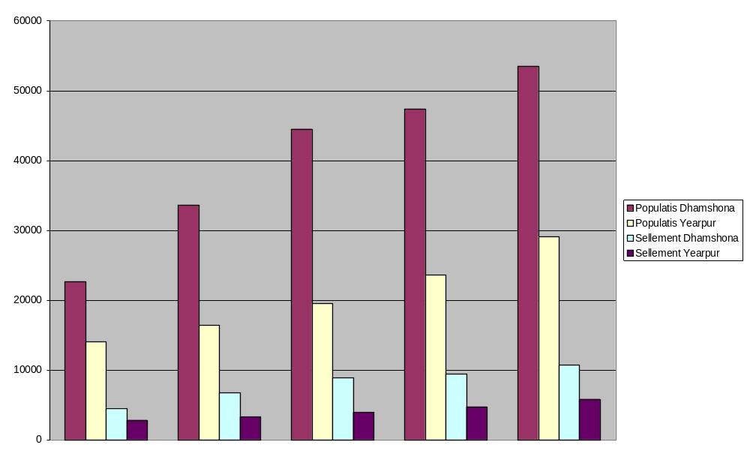
Dhamshona and Yearpur

1981

1991

2001

2004

2006

Figure-5.17 Population and settlement of Dhamshona and Yearpur union of different periods

Overpopulation and over consumptions effects are not only felt locally or nationally. Population generated in one region can affect the air, water, vegetation or animals in another. The effect of global warming, CO2 changes, loss of biodiversity and marine pollution do not respect political boundaries and ultimately affect everyone in the world.

Over consumption and population growth Increased demand for goods
Increase in
economic
growth rate and
Unscientific agriculture practice more fertilizer and pesticide use
Over harvesting Habitat degradation Agricultural Practice Threats to Biodiversity

Source: Geo-020232 (2005)
Fig. 5.18: The relationship between human activity and biodiversity impacts.

Factors of biodiversity change

Overall Facto1rs of changes

Factors of biological change

Habitat destruction

Overexploitation

Introduction of exotic species

Population & Settlement changes

Industrialization and Urbanization
Climate&
Non-scientific agriculture

Figure 5.19: Causes and factors of changing biodiversity

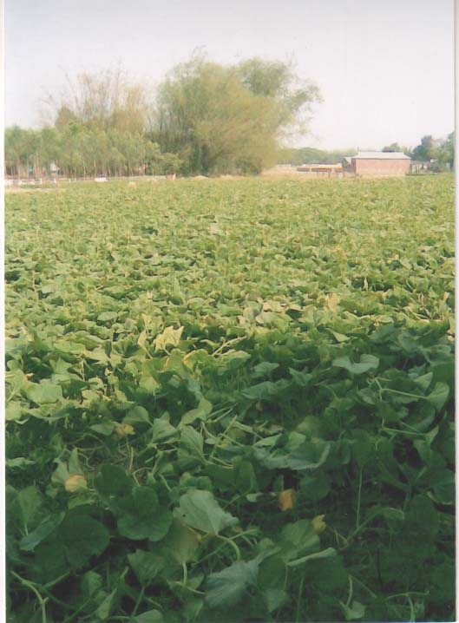
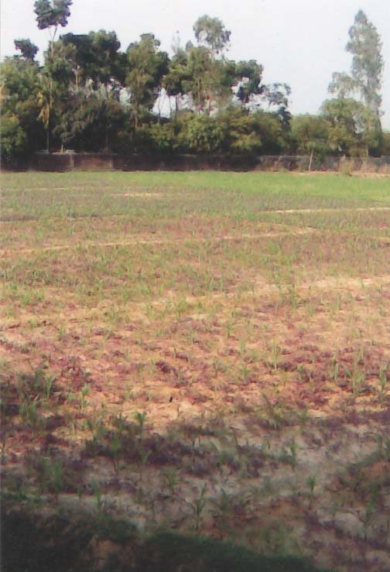

Picture 5.1: Agriculture practice in Dhamshona and Yearpur union

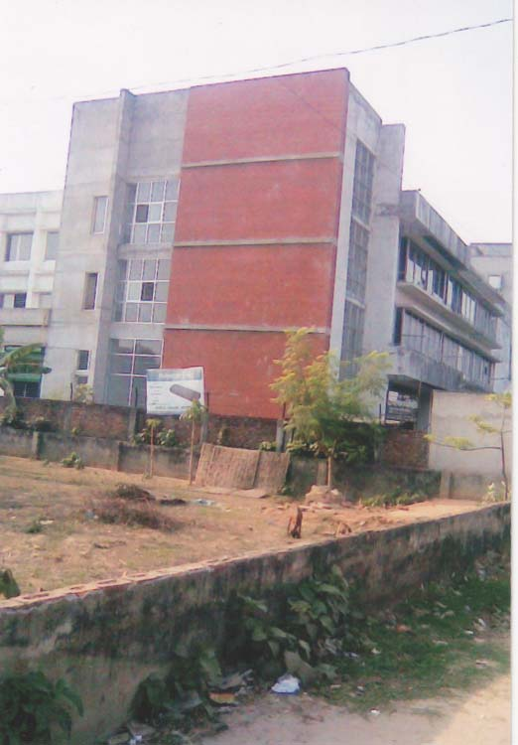
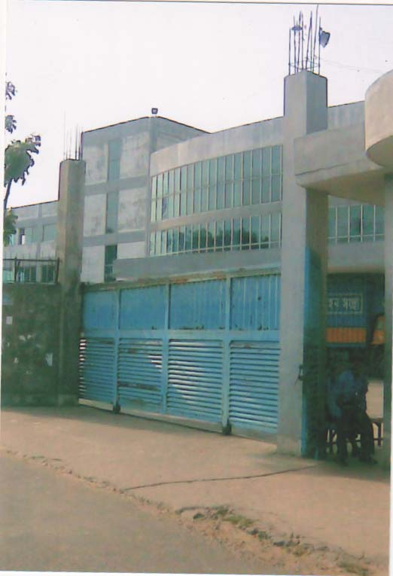

Picture 5.2: Industrial development in Dhamshona and Yearpur union

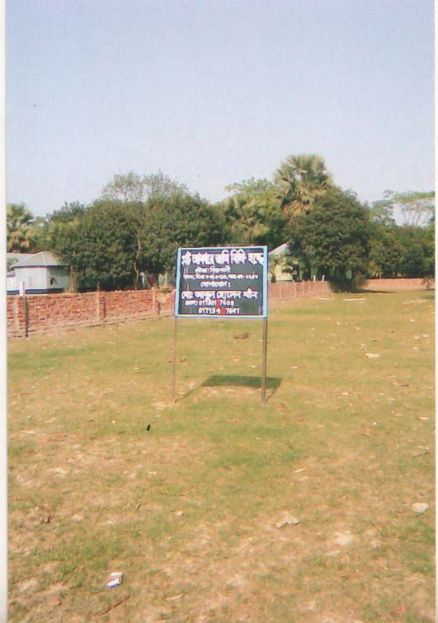
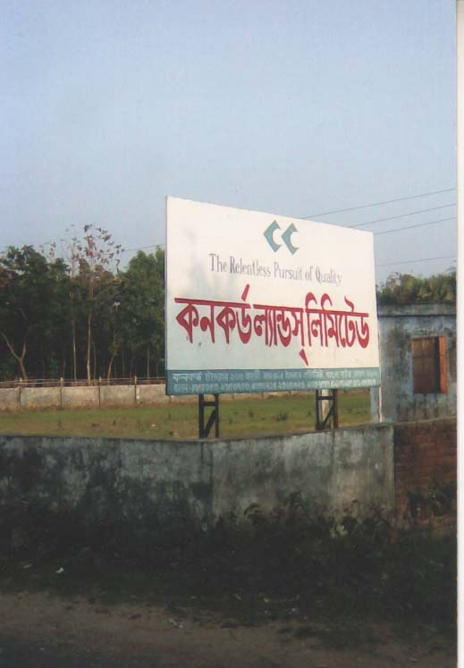

Figure 5.3: Land speculations in Dhamshona and Yearpur union-
Advertisement of Commercial Housing Comoplexes.

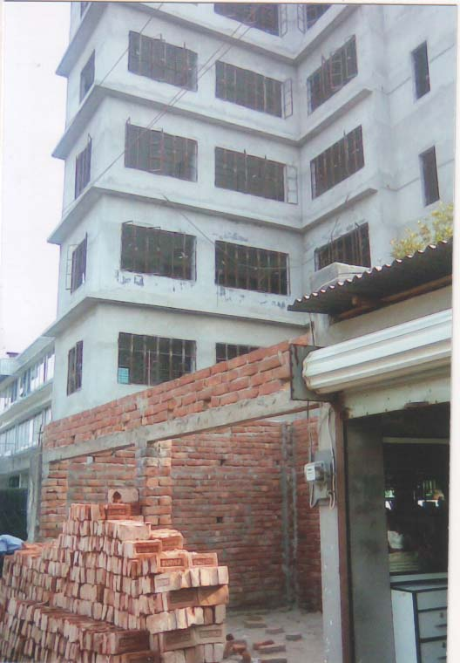
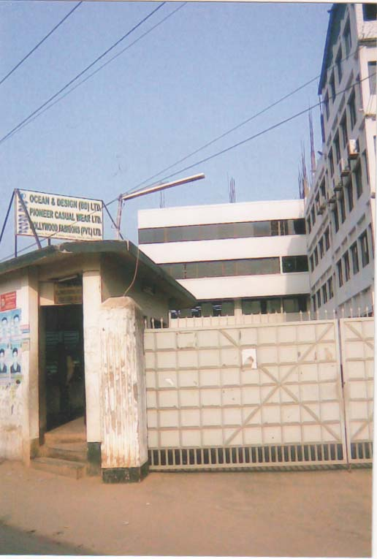

Figure 5.4: Expansion Industries

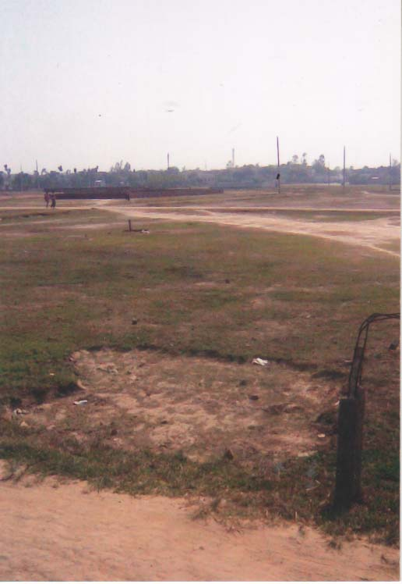
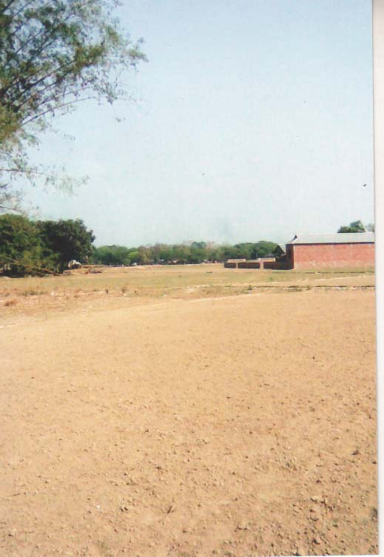

Figure 5.5: Previous agricultural land ready for Housing Society.

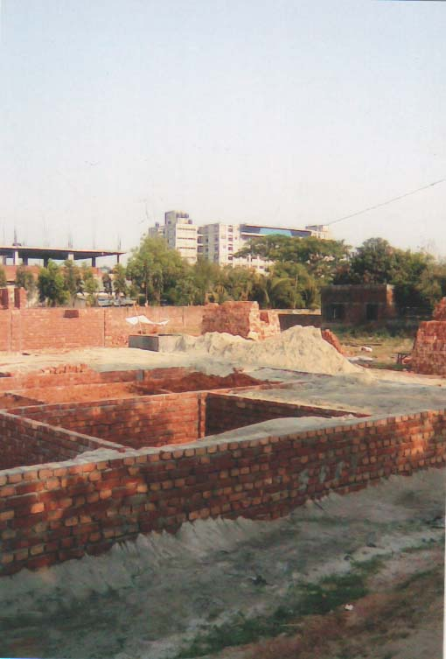
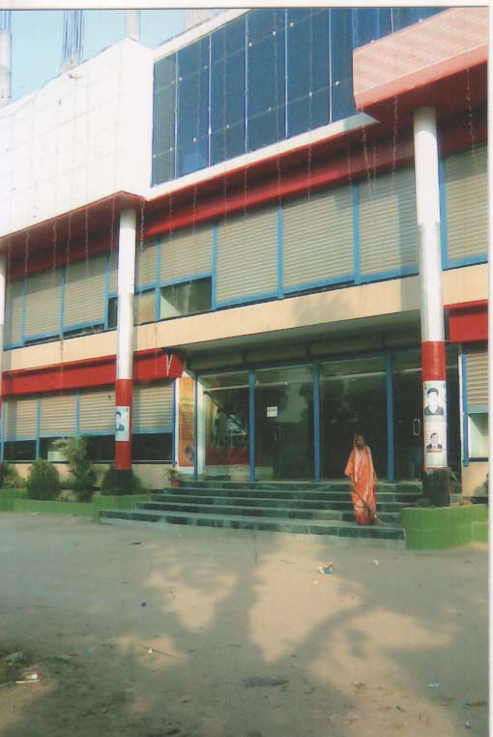

Figure 5.6: A growing shopping complex in Dhamshona union.

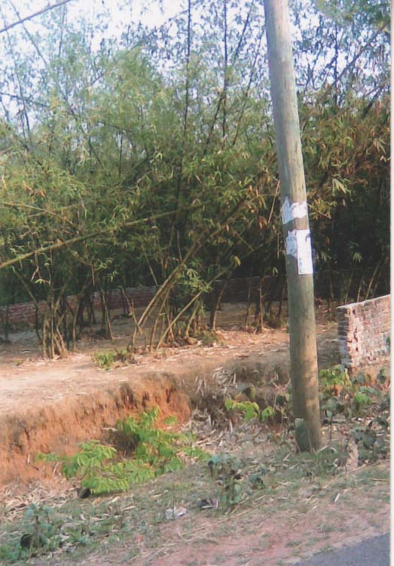
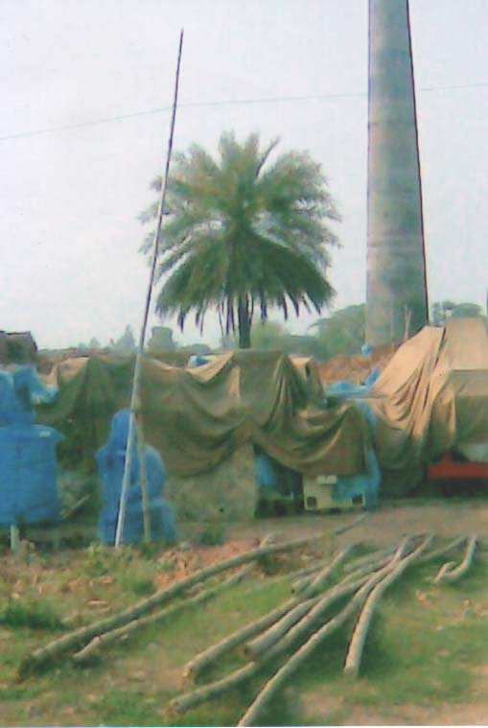

Figure 5.7: Vulnarable trees

5.3.5 Climate change

Global warming is also considered to be a major threat to global biodiversity. Animals and plants are sensitive to fluctuations in temperature and rainfall. An international collaborative study on four continents in 2004, estimated that 10 percent of species would become extinct by 2050 because of global warming. "We need to limit climate change or we wind up with a lot of species in trouble, possibly extinct," said Dr. Lee Hannah, a co-author of the paper and chief climate change biologist at the Center for Applied Biodiversity Science at Conservation International (Brown, 2004). The following graph 5.20 and graph 5.21 shows the average temperature and total rainfall of four stations around the study area respectively. The graph shows the changes of temperature and rainfall of different four stations. Variations of climate also alter the habitual condition of plants and animals.

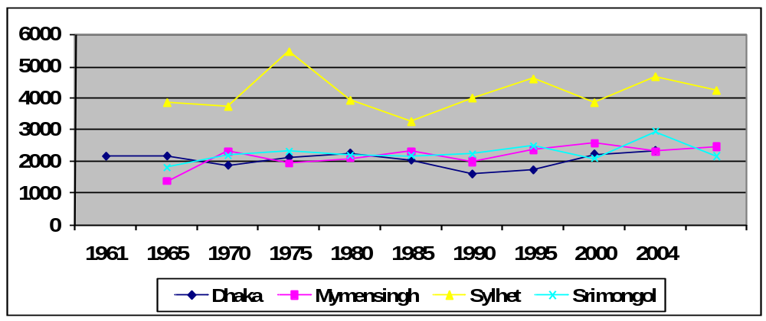

Source: Geo-020232 (2005)
Figure 5.20: Average temperature of Dhaka, Mymensingh and Srimongol during 1961 to 2004

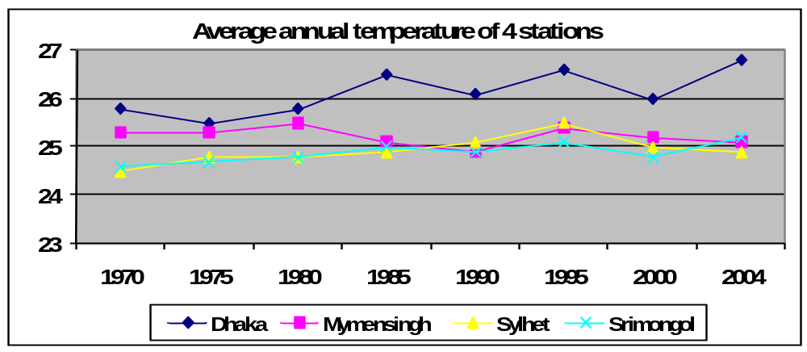

Source: Geo-020232 (2005)
Figure 5.21: Average temperature of Dhaka, Mymensingh and Srimongol during 1970 to 2004

5.3.6 Agriculture

Agriculture has had a significant effect on biodiversity because of its prevalence over landscape. Effects include habitat alternation, exotic pest introduction and pollution from pesticides and fertilizers.
There is the potential for agriculture to play a beneficial role in the conservation of certain plant species, mainly by protecting habitats from urbanization. Cultivation processes that integrate wild species into agricultural landscapes could achieve this.
Agriculture has the greatest impact on the environment of any human activity both because of the degree of habitat alteration that occurs and because of the widespread geographical scale of this alteration. Some of the impacts include: changes in natural genetic plant stocks, changes in established ecosystems, the introduction of exotic species and large-scale drainage modifications which disrupt natural flood regimes and increase topsoil erosion.

Loss of habitat/species: Loss of native habitat in our country due to farming has been significant: we have lost more than 65% of paddy, 35% of vegetables and 55% of fish (SEHD, 2003). Loss of habitat, combined with reliance on a few genetically-engineered crop strains instead of indigenous crops, has resulted in the endangerment of a disproportionately large number of plant and animal species in Bangladesh.

Erosion: Soil erosion is an agricultural problem because natural vegetation has been removed from an area. As a result, surface water, or winds can carry away topsoil, the surface layer of soil that is rich in nutrients and beneficial microorganisms. In Bangladesh, it is estimated that 2.4 million tones of soil per year are eroded by water. Soil erosion has a direct effect on habitat quality, making an area barren and unsuitable for plants that were native to that habitat. As well, soil that is washed away gets deposited in waterways, destroying fragile aquatic habitat (SEHD, 2003).

5.3.7 Indiscriminate use of agro-chemicals

5.3.7.1 Chemical Fertilizer
Fertilizers and manures are sources of basic plant nutrients. In recent years fertilizer use has dramatically increased. The factors which affect crop production; fertilizer is the single most important component that plays a crucial role in yield increase. Chemical fertilizers today hold the key to the success of the crop production system of Bangladesh agriculture, and contribute about 50% of the total production. This important input first came into use in the Bangladesh agriculture is in 1951 with the introduction of 2,698 m tons of ammonium sulphate. But its use started increasing steadily only from the mid-sixties and paralleled the introduction and expansion of modern crop varieties accompanied by the development of irrigation facilities. The increasing trend in fertilizer use, particularly urea-N, still continuing. Until 1980, three primary major plant nutrients (N, P, K) were supplied from fertilizers like Urea, TSP and MP to the soils (Banglapedia, 2003). Particularly spreading of HYV paddy, the farmers of the study area use fertilizer. They claimed that they are bound to use chemical fertilizer because they have not sufficient cow for cow dung to use manure in the agriculture. In 20-25 years ago they do not use any fertilizer for local varieties of paddy.
In a recent study assume that about 30% of the applied fertilizer remains in the environment. The concentration of fertilizer dissolved in the water column would be 04 mg/l for the region as a whole 1733 km3 annual water supply. An average inundation level of one meter of water the maximum dissolved residual fertilizer concentration would be about 36mg/l. It also problems of low water quality and increasing fish diseases (khan, 2003).

5.3.7.2 Pesticides
Pesticides are substances or mixture of substances intended for preventing, destroying, repelling or mitigating any pest. It includes insecticides, herbicides, acaricides, fungicides, rodenticides or any chemical that has biological action. Pesticide chemicals have been used in Bangladesh since 1956. On an average, about 3.5 million kg of pesticides are used in Bangladesh annually, including, insecticides, fungicides, and herbicides (Banglapedia, 2003). In Bangladesh every year 4000-5000mt of pesticides used mainly in paddy field (Khan et.al 2001). Among the using pesticides group diaginon, carboforun and dichlorophos are dominantly used in the study area. Pesticides introduced in the study area when they started to cultivate HYV paddy.
Pesticides can present danger to consumers, bystanders, or workers during manufacture, transport, or during and after use. The use of pesticides decreases the general biodiversity in the soil. Not using those results in higher soil quality with the additional effect that more life in the soil allows for higher water retention (Johnston, 1986). Organophosphate pesticides are associated with acute health problems such as abdominal pain, dizziness, headaches, nausea, vomiting, as well as skin and eye problems ( Ecobichon, 1996).
The ESCAP (1988) stated that the degree of high concentration of pesticides in soil arise because fertile soil contain living bacteria that fixea the N2 for continued fertility of the soil and bring out the essential process of decay. Agricultural runoff after spray application increased the concentration of pesticides in river and beels to a level lethal fishes. Most species of fish cannot survive insecticides in concentration greater than about 1-10 ppb. A sub lethal dose for fish and birds do not bring immediate danger. A low concentration includes reproductive failure and behavioral change in fish and birds (Huq et. al 2000).
Residuals of pesticides, which are issued in the agriculture, enter the land. The increasing use of pesticides in the region parallels the introduction of HYV rice. Fertility of land is degrading little by little. Thus there is decline of aquatic vegetation and increase mortality of fishes. Most of the farmers argued that when the above-mentioned pesticides are used in agriculture, the fishes of these areas are reduced drastically.

5.4 Summary
It is revealed from the above discussion that Dhamshona and Yearpur union were very rich in depository of plants and animals. In recent years human intervention has speeded up the loss of biodiversity of the study area. The main factors of the biodiversity loss of the study area are: a) Overexploitation b) habitat destruction c) introduction of new exotic species d) industrialization and urbanization. Besides, population pressure and climatic variation act as an overall factor for biodiversity changing.

6.0 CONCLUDING REMARKS, FINDINGS AND RECOMMENDATIONS

6.1 Concluuding Remarks

Biological resources and biological diversity from the basis of both the ecology and economy of Bangladesh. The country’s agriculture, fisheries, and livestock, along with a number of other sectors are heavily dependent, directly or indirectly, on biological resources. But biological resources have suffered considerably from the impacts of a burgeoning human population, including direct extraction and habitat loss. Since independence there has been an accelerated expansion of physical infrastructure in the study areas. In this area, agricultural and fallow lands are reducing with the rate of urbanization process. In the other side the commercial area, industrial land use rises, what is assign of rapid urbanization as well the infrastructure for urbanization is developing faster in these few years. The impact of human interference has been particularly damaging to the fragile ecosystem and sustainability of the study area. This area has dynamic ecosystems, which change over a long time. As a whole, degradation of environment has caused several problems including extinction and reduction of wildlife, extinction of many indigenous wild and domesticated rice verities, loss of many indigenous plants, herbs, shrubs and weeds, loss of natural soil nutrients, loss of natural water reservoirs and of their resultant benefits and degeneration of ecosystems, occupations, socio-economic institutions and cultures.

Dhamshona and Yearpur union was rich in biodiversity. But there has been a changing trend in the biodiversity over years in the study area in the human ecological factors. This is happening mostly in the recent decades. The biodiversity of Dhamshona and Yearpur union are disturbing. To restore the biodiversity back to an ecologically productive status, it has become imperative to know correctly and precisely changes that have occurred over the years and also to know the changes which continue to occur even now. This is important to plan for a development strategy that may harness the full development potential of biodiversity on a sustainable basis. Therefore, a geographical study on the changing biodiversity of Dhamshona and Yearpur union has been carried out in the present research. Both primary and secondary information has been used in the present study. Primary data has been collected by field observation and interviewing with the key information. Secondary information has been also used to fulfill the aim and objectives.

6.2 Findings of the study

The process of urban development and industrialization in Dhamshona and Yearpur union are, in recent decades, complements by an unprecedented population increase, expansion and development of housing and settlements, industrial, commercial and other non-agricultural areas; urban infrastructural services and the decrease of agricultural land area. The demand for more space arising out of rapid growth of population for housing, food production, market expansion, communication, commerce, industries etc. is going to exert even more competing pressure on land; and this will play significant roles in the biodiversity change in study area. Major findings of the study is given in below-

- The biodiversity of the study area have changed due to both physical and socio-economic causes. Poverty, population pressure, illiteracy, absence of adequate institutional or administrative frame works, lack of awareness, industrialization and pollution are the major factors of changes biodiversity.

- Dhamshona and Yearpur union were very rich in depository of plants. In recent years human intervention has speeded up the extinct of plant species of the study area. Agriculture land has decreased due to human interferences. Increasing residential, industrial and commercial uses are observed in previously agricultural land. This happening in relation to the changing nature and biodiversity.

(c) The fishery sector have suffered significantly as water bodies have been drained to bring in more land under cultivation as well as encouragement of over fishing. Among the 112 species of fishes 21 species (18.75%) are rare, 35 species (31.25%) are endangered, and 21 species (18.85%) are locally extinct. The reduction of water bodies, excessive use of chemical fertilizer, pesticides and over extraction of water for irrigation have greatly affected the fisheries of Dhamshona and Yearpur union.

(d) Dhamshona and Yearpur union have a great diversity of fauna. According to the people of the study area, 15-20 years ago, many birds found in these area. They were frequent and feed here and there. Most of the birds are locally extinct, few and rare. Birds were killed, trapped and disturbed by local people and hunter. In addition, habitat destruction, lack of availability of food, uses of pesticides is responsible for reducing birds.

(e) Biodiversity is threatened by the sum of all human activities. It is useful to group threats into the categories of over-hunting, habitat destruction, invasion of non-native species, pollution and climate change.

6.3 Recommendation

Systematic information on biodiversity at all levels and particularly at ecological and genetic level is limited for Bangladesh. Base line information is not available to estimate trends. Most of the original natural habitat areas have been lost. The people of Bangladesh depend on biodiversity for their day to day sustenance as well as overall livelihood security. For biodiversity preserve, Bangladesh has signed the Convention on Biological Diversity in 1992, and the Convention on International Trade in Endangered Species of Wild Fauna in 1973. She is signatory to the Ramsar Convention and the World Heritage Convention. The Bangladesh Wildlife (Preservation) Act, 1974, the Forest Act, 1927 (amended in 1989), the Fish Act, 1950, and the Environment Protection Act, 1995 provide legal support for biodiversity conservation in the country. But thoughtless industrialization, intensified land use and introduction of high yielding varieties of seeds, rapid urbanization, rural infrastructural growth and over harvesting of natural resources coupled with population boom have put severe stress on the environment, resulting in the destruction of ecosystems and habitats and depletion of the biological resource bases both in the wild and cultivated states. In the study the people have given their input through a series of questionnaire filling, discussions, Participatory Rural Appraisal (PRA) and Focused Group Discussion (FGD) processes. They not only identified the environmental problems but also gave their perspective on the solutions and in many cases have identified actors for actions related to each solution. In view of the above as well as the outcome of the present study, the following specific recommendations for biodiversity conservation may be made:

(a) Recognize the value and importance of biodiversity for the Bangladesh people and document properly its components, distribution, and value. Inventory to assess the present status of wildlife and evaluate their types and quantities available.

(b) Restore ecosystems and rehabilitate endangered species. Giving priority to the protection of wildlife birds, frogs, snakes etc.

(c) The government of Bangladesh should establish such types of rules & legislation which obligates the owners of industries to establish effluent treatment plant and the government shouldn’t give license or shouldn’t permit anybody to establish industries without fulfilling the criteria of ISO-14000.

(d) Establish institutions for intersectoral implementing mechanism for the Bangladesh National Biodiversity Strategy and Action Plan. Enhance Protected Area management, recognizing the benefits of collaboration with local communities in their management (co-management).

(e) Establish participatory mechanisms to receive and utilize the inputs from private sector, civil society, academia and local communities about the different processes leading to biodiversity conservation, use and sharing of benefits.

(f) Develop a financial strategy that is innovative and sustainable. Establishment

of gene bank and local general inventory on wild relatives.

(g) Integrate biodiversity conservation in to the national development making planning and processes.Preservation of Genetic Resources, Change in cropping pattern and agricultural land use pattern.

(h) Studies and development of environmentally sound biotechnology, and evaluation of the positive and negative effects on biotechnology on biodiversity.

(i) Prohibition on hunting, trapping of wildlife and theft hides; hunting, trapping and disturbances of migratory birds and aquatic birds through appropriate legislation.

(j) Fisheries production depletion caused by reducing water depth and randomly using of fertilizer and pesticides should be quantitatively assessed and value there of determined by the Ministry of Fisheries and Livestock through development and Implementation of comprehensive projects for this purpose.

(k) Appropriate regulation for the use of pesticide and agro-chemicals and its enforcement. Motivation to reduce the use of agro-chemicals, pesticides.

(l) Media campaign, extension, TV and Radio program, Short film. Exhibitions, Seminars and Symposia, Newspapers Articles and Essay Competitions at school.

REFERENCES

Ahmed, A.T.A. (1995a). Impact of Shrimp Culture on the Coastal Environment of Bangladesh. Proc. Workshop Coastal Aquaculture Environment Management, pp 77-82. Cox’s Bazar, Bangladesh.

Ahmed, A.T.A. (1995b). Impact of other Sectoral Development on the Inland Capture Fisheries of Bangladesh. Proceeding of the Fourth Asian Fisheries Forum. The Fourth Asian Fisheries Forum. China Ocean press. Beijing, China.

Ahmed, A.T.A. and Ali, M.L. (1996). Fisheries Resources Potential in Bangladesh and Manpower Development for Fisheries Activities. In “Population Dimension Of Fisheries Development And Management Policies Of Bangladesh.” Dhaka, Bangladesh.

Ahmed, M. (1995). Biodiversity Conservation of Bangladesh. Compilation of Theme Papers on Environmental Studies. Bangladesh Technical Education Board pp 136-150. Dhaka, Bangladesh.

Ahmed, M (1999) Aquatic Pollution and Its Impact on Fisheries. Training Course on Industrial Accidents and Safety Management, IEB, Bangladesh University of Engineering and Technology (BUET), Dhaka, Bangladesh.

Alam, M.Z. (1967). A report on the survey of insect and mite fauna of Bangladesh (East Pakistan). Agricultural Research Institute. Dhaka, Bangladesh.

Alam, M.K. and Aurangzeb, M.M., Geological Environment for greated Dhaka city. Third Annual Conference, Conference Issue 175 Bangladesh Geological Society,1975.

Alam, M.S., et, al, Remote sensing for Coastal landuse mapping. A case stydy on Shirmp Culture in Pickgacha, Khulna. Jahangirnagar University, Savar, Dhaka-1342.

Alam, M.S., Erodibility in the Madhupur Tract: A Case Study in Kalma Mouza. Unpublished M.Sc. Thesis, Dept. of Geography and Environment, Jahangirnagar University, Savar, Dhaka 1978-79.

Ali, S. 1972. The book of Indian Birds. ( Ninth edition) Bombay Nat. Hist. Soc.

Ali, S. 1972 and 1996. The book of Indian birds, Bombay watt History Society, Bonmay.

Ali. M.Y. (1997). Fish, Water and People, University Press LTD. Dhaka, Bangladesh.

Ali, M.O. and Ahmed, M. (2000). Biodiversity Conservation Vision For Bangladesh, Presented in the Reporting Workshop on Biodiversity in Bangladesh. Organized by Environmental Forum of Journalists Bangladesh. National Press Club. Dhaka, Bangladesh.

Ameen,M., Islam, M. A., and Nishat, A. (eds). 2000. Red Book of Threatened Amphibians and Reptiles of Bangladesh. Dhaka: IUCN- The World Conservation Union.

Ameen,M., Islam, M. A., and Nishat, A. (eds). 2000. Red Book of Threatened Birds of Bangladesh. Dhaka: IUCN- The World Conservation Union.

Ameen,M., Islam, M. A., and Nishat, A. (eds). 2000. Red Book of Threatened Fishes of Bangladesh. Dhaka: IUCN- The World Conservation Union.

Ameen,M., Islam, M. A., and Nishat, A. (eds). 2000. Red Book of Threatened Animals of Bangladesh. Dhaka: IUCN- The World Conservation Union.

Ameen,M., Islam, M. A., and Nishat, A. (eds). 2000. Red Book of Threatened Mammals of Bangladesh. Dhaka: IUCN- The World Conservation Union.

Alroy, J; Marshall, CR; Bambach, RK; Bezusko, K; Foote, M; Fursich, FT; Hansen, TA; Holland, SM et al. (2001). "Effects of sampling standardization on estimates of Phanerozoic marine diversification". Proceedings of the National Academy of Sciences of the United States of America 98 (11): 6261–6.

Brown, Paul (2004-01-08). "An unnatural disaster". The Guardian (London). [Online]Availablefrom:http://www.guardian.co.uk/science/2004/jan/08/biodiversity.sciencenews. [Accessed 20 July 2009].

Banglapedia.2003. Asiatic Society of Bangladesh, Dhaka.

Banglapedia.2006. Asiatic Society of Bangladesh, Dhaka.

Bangladesh: State of the Environmnt 2001 [online] Available from: www.moef.gov.bd/html/state_of_env/pdf/bangladesh_biodiversity [Accessed 20 Apil 2009].

BBS. 1991. Statistical Year Book of Bangladesh. Dhaka: Bureau of Statistics. Ministry of Planning, GoB.

BBS. 2000. Statistical Year Book of Bangladesh. Dhaka: Bureau of Statistics. Ministry of Planning, GoB.

BBS. 2004. Statistical Year Book of Bangladesh. Dhaka: Bureau of Statistics. Ministry of Planning, GoB.

BBS. 2006. Statistical Year Book of Bangladesh. Dhaka: Bureau of Statistics. Ministry of Planning, GoB.

Brammer, H.E, Report of the Reconnissance Soil Survey Dhaka District, 1965, Directorate of soil survey of Bangladesh, Dhaka, Dhaka, 1967.

Brahmmer, H. 1996. The Geography of the Soils of Bangladesh, Dhaka: University Press Limited.

Callicott, J. B., 1986, "On the intrinsic value of nonhuman species", in The preservation of species: the value of biological diversity, B. G Norton (ed), Princeton, NJ: Princeton University Press.

Callicott, J. B., 1989, In defense of the land ethic: essays in environmental philosophy, Albany: State University of New York Press.

Callicott, J. B., Crowder, L. B. and Mumford, K., 1999, "Current normative concepts in conservation", Conservation Biology, 13: 22-35.
Campbell, AK (2003). "Save those molecules: molecular biodiversity and life". Journal of Applied Ecology 40 (2): 193–203. doi:10.1046/j.1365-2664.2003.00803.x
CBD (1992). Convention on Biological Diversity. Text and Annexes, the Interim Secretariat for the CBD Geneva Executive Centre.

Chowdury, Q.I.1988. “Bangladesh Biodiversity” in Quamrul Islam Chudury’s (ed). Bangladesh State of Environment reports 1998. Dhaka: FEJB.

Clark, J.R.(1969). Thermal pollution and aquatic life. Sci, amer, 3,22.

CNRS (1999). Pamphlet on Sea Turtles. Dhaka, Bangladesh.
Costanza, Robert; D'arge, Ralph; De Groot, Rudolf; Farber, Stephen; Grasso, Monica; Hannon, Bruce; Limburg, Karin; Naeem, Shahid et al. (1997). "The value of the world's ecosystem services and natural capital". Nature 387 (6630): 253–260.
Dani, H.A. 1962. Dacca : A Record of Its Changing Fortunes. Dhaka : Asiatic Press.

D.E.P.C. (1980), Report on industrial pollution and polluting industries in Bangladesh, Dhaka, government of the people’s republic of Bangladesh.

DoF. 2005. Fishery Statistical Yearbook of Bangladesh 2003–2004. Fisheries Resources Survey System, Department of Fisheries, Ministry of Fisheries and Livestock, Matshya Bhaban, Dhaka, 46 pp.
"Endangered Species List Expands to 16,000". [On line] Available from http://news.nationalgeographic.com/news/2006/05/0502_060502_endangered.htm [Accessed 20 November 2009].
Env. 0202808 (2005). “Biodiversity (Plant, Birds and Mmmals) of Patalia union, Savar upazila, Dhaka district.” Undergraduate thesis, Jahangirnagar University.

FAP6 (1993). Fisheries Specialist Study. North East Regional Water Management Project. Canadian International Development Agency and the Government of Bangladesh, Dhaka.

FAO.1988.Agro-ecological Regions of Bangladesh.Rome: FAO.

FAP 6 (1993). Fisheries Specialist Study. North East Regional Water Mnagement Project. Canadian International Development Agency and the Government of Bangladesh, Dhaka.

Freexe, (1979). Chemical Analysis of industrial water, New York, Chemical Publication company.

Gabriel, Sigmar (2007-03-09). "30% of all species lost by 2050". BBC News. http://news.bbc.co.uk/2/hi/science/nature/6432217.stm

Gain, P. (ed.).1998. Bangladesh Facing the 21ST Century. Dhaka: Society for Environment and Human Development (SEHD).

Gani, M. O. 2003. Ex-situ and in-situ conservation of flora and fauna in Bangladesh. Concept Note on Bangladesh National Conservation Strategy and Action Plan. IUCN Bangladesh Country Office.
Gaston, K. J. (ed). 1996, Biodiversity: a biology of numbers and difference, Oxford: Blackwell.
Geology of Modhupur Tract and its adjoining areas in Bangladesh. Records of Geological Survey of Bangladesh Vol.5 part 3 Geological Survey of Bangladesh 1988.

Geo-020232 (2005). “A Study of changing wetland in Mithamain Union, 1961-2004.” Thesis (M.Sc). Jahangirnagar University. Dhaka

GOB, 1977. Bangladesh Population Census Report, 1974. Dhaka District. Dhaka : Bangladesh Bureau of Statistics.

GOB, 1984. Bangladesh Population Census Report, 1981. Dhaka District. Dhaka : Bangladesh Bureau of Statistics.

GOB, 1986. Socio-Economic Indicators of Bangladesh. Dhaka : Bangladesh Bureau of Statistics.

Green (1978). Primates of Bangladesh: A Preliminary Survey of Population and Habitat. Biological Conservation. 13.141-160.
Hawkins E.S., Reich; Reich, MR (1992). "Japanese-originated pharmaceutical products in the United States from 1960 to 1989: an assessment of innovation". Clin Pharmacol Ther 51 (1): 1–11.
Halim, M. and Khan, M.S. 1991. Eulophia mackinnonii Duthie ( Orchidaceae)- A new Angiospermic record for Bangladesh. Bangladesh J. Bot. 20 (2): 231-233.

Hassan, M.M. 1990. Population Change and Suburban Expansion: A case Study of Savar. M.Sc. Thesis, Department of Geography and Environment, Jahangirnagar University.

Harvey, W.g. 1990 and 1992. Birds in Bangladesh, University Press Ltd., Dhaka.

Harvey L., 2008. Natural products in drug discovery. Drug Discovery Today.

Haq, A.M. (1986). Plant Names of Bangladesh, BARC, Dhaka.

Heywood, V. H. (1995). Global Biodiversity Assessment. Cambridge, UK: Cambridge University Press

Huq. M.F. 1993. Institutional Aspect of Wetland Management in Bangladesh; In:Nishat, A. et.al. (eds.). Fresh Water in Bangladesh- Issues and approaches for Management. Dhaka: IUCN- The World Conservation Union.

Husain, K.Z. (1974). An Introduction to the Wildlife of Bangladesh. Dhaka, Banglasedh.

Husain, K.Z. (1986). Eleventh Annual Bangladesh Science Conference Rajshahi University. March 2-6 Rajshahi. Bangladesh.

Islam, M.A., Mahmud-ul Ameen, Ainun Nishat (eds) (2000). Red List of Threatened Animals of Bangladesh. The World Conservation Union. Dhaka, Bangladesh.

IUCN (1994). Species Survival Commission. IUCN Red List Category, pp 101. The World Conservation Union. Dhaka, Bangladesh.

J.E. Fox, J. Gulledge, E. Engelhaupt, M.E. Burrow & J.A. McLachlan (2007). Pesticides reduce symbiotic efficency of nitrogen-fixing rhizobia and host plants. PNAS. 104:10282-7.

Johnston, A. E. (1986). Soil organic-matter, effects on soils and crops. Soil Use Management 2:97-105.
Kapoor, Promila. 1988. Biological Diversity and Genetic Resources: Status Report. CSC Technical Series No. 258. Commonwealth Science Council, London, U.K.

Keller, (1985). Pollution and control in Textile Industry, London, Noyes Data corporation.

Khan, M.S. and Mia, M.M.K. (1984). Fiber Plants of Bangladesh (wild and cultivated). P 35. Bangladesh National Herbarium, Bangladesh Agricultural Research Council. Dhaka. Bangladesh.

Khan, S. 1972. Flora of Bangladesh, No.1:1-13, Dhaka, Bangladesh.

Khan, M.A.R., 1982. Wild life of Bangladesh: A checklist, University of Dhaka, Dhaka.

Khan, M.S. and Mia, M.M.K. (1984). Fiber Plants of Bangladesh (wild and cultivated). P 35. Bangladesh National Herbarium, Bangladesh Agricultural Research Council. Dhaka. Bangladesh.

Khan M.A.R.1987. Bangladesher banyaprani (Wildlife of Bangladesh), Vol.2, Bangla Academy, Dhaka.

Khan, M.S. and Halim, M. 1987. Aquatic Angiosperm of Bangladesh. Bangladesh National Herbarium, Bangladesh Agricultural Research Council, Dhaka, p.50.

Khan, M.S. (1991). Towards Sustainable Development: Conservation of Genetic Resources of Bangladesh, p 35. Ministry of Environment and Forest and National Conservation Strategy of Bangladesh Agricultural Research Council. Dhaka, Bangladesh.

Khan, F.H. 1991. Geology of Bangladesh. Dhaka: University Press Limited.

Khan, A.A. 1993, Fresh Water Wetland in Bangladesh: Oppurtunities and Options; In: Nishat, A.et.al. (eds.). Fresh Water Wetlands in Bangladesh- Issues and approaches for Management. Dhaka: IUCN-The World Conservation Union.

Khan, S. M. M. H. 2001. Biodiversity. In Nishat, A., Ullah, M. and Haque, A. K.E. (eds.) Bangladesh Environment Outlook 2001. Centre for Sustainable Development (CFSD), Dhaka, Banngladesh.

Khan, M. S., Rahman, M. M. and Ali, M. A. 2001 (eds). Red Data Book of Vascular Plants. Bangladesh National Herbarium, Dhaka. 179pp.

Krenkel, P.F. and Parker, F.L. (1969). Biological aspect of thermal pollution. Vanderbit University Press, Nashville, Teen.

Kudesha, V.P. (1989-1990). Industrial pollution. Progoti prakashoni, p-13.

Mapping the web of life [on line] Available from: www.unep.org [Accessed 20 July 2009].

Kirtikar, K.R. AND Basu, D.D.1988. Indian medicinal plants. Second edition 1985. Alahabad, India.

Miah, M.M.B., & Lutfnnahar, B., Some aspects of the Geomorphology of the Madhupur Tract. The Oriental Geographer, 1967.

Mia, M.M.K. and Huq, A.M. (1986). Timber Plants of Bangladesh (Wild And Cultivated), p 71. Bangladesh National Herbarium. Bangladesh Agricultural Research Council. Dhaka, Bangladesh

Mia, M.M.K. 1996. Combretaceae. In: Khan, M.S. and Rahman, M.M. (eds.), Flora of Bangladesh, fasc. 50: 22-23, PI. 19. Bangladesh National Herbarium, Dhaka.

Miller, J.S., and S.J. Brewer. 1991. The discovery of medicines and forest conservation. Unpublished manuscript, Missouri Botanical Garden and Monsanto Company, St. Louis, Missouri, USA.

Ministry of Environment and Forest, 1995. National Environment Mnagement Action Plan (NEMAP).Volume-la: Summery. Dhaka: Government of the People’s Republic of Bangladesh.

Mofizuddin, M., (1984). The nature of relationship between landform and landuse pattern in the Modhupur Tract Project Report, Jahangirnagar University. Dhaka.

"Molecular Pharming (2006)" [on line] Available from: www.gmo-compass.org
[Accessed 7 November 2009].

Morgan, P. and Mc Intire, N.G. 1960. Quarternary Geology of the Bengal basin, Bulletin of the Geological society of America. Vol. 70. P 319-342.

Mountfort, G. (1969). The Vanishing Jungle. Collins. London, UK.

Pocock, R.I. (1939). The Fauna Of British India, Including Ceylon And Burma, (2nd edn.) Mammals. 1&2 Taylor of Francis, London, UK.

Prater, S.H.(1971). The Book of Indian Mammals. Bombay Nat. Hist. Soc. India.

Quarnmen, D. (1997). The Song of the Dodo: Island Biogeography in an Age of Extinctions. Simon & Schuster, New York.

Rahman, M.A. and Wilcock, C.C. 1995. Asclepiadaceae. In: Khan, M.S. and Rahman, M.M. (eds.), Flora of Bangladesh, fasc. 48: 12, under Ceropegia angustifolia Wight Bangladesh National Herbarium, Dhaka.

Rahaman M.S and Mortula M.M (2000). Studies on waste disposal at Dhaka Export Processing Zone, Savar, Undergraduate thesis, Bangladesh University of Engineering and Technology.

Rahman, A. (eds.). 2003. People’s Report on Bangladesh Environment-2001.Vol. II & I. Unnayan Shamannay & The University Press Limited.

Rashid, H.E. 1991. Geography of Bangladesh. Dhaka: University Press Limited.

Raup, D. M. (1994). "The role of extinction in evolution". Proceedings of the National Academy of Sciences 91: 6758–6763. doi:10.1073/pnas.91.15.6758. PMC 44280. PMID 8041694.

Raven, P.H. 1981. Research in botanical gardens. Bot. Jabrb. Syst. 102: 53-74.

Raven, P.H. 1988. Biological resources and global stability. Pp. 3-27 In: S. Kawano, J.H.Connell, and T.Hidaka (eds.), Evolution and Coadaption in Biotic Communities. University of Tokyo Press, Tokyo, Japan.

“Reports of the 1st and 2nd International Conferences on Health and Biodiversity.” [On line] Available from: www.cohabnet.org [Accessed 10 November 2009].

Rhymer, Judith M.; Simberloff, Daniel (1996). "Extinction by Hybridization and Introgression". Annual Review of Ecology and Systematics 27: 83–109.

Sahney, S.; Benton, M.J.; Ferry, Paul (2010). "Links between global taxonomic diversity, ecological diversity and the expansion of vertebrates on land". Biology Letters (The Royal Society) 6 (4): 544–7.

Sarker, S.U and Sarker, N.J. 1988. Wild life of Bangladesh (a systematic list status, distribution and habitat), The Rico Printers, Dhaka.

Sarkar, S., 2005, Biodiversity and Environmental Philosophy: An Introduction, (Cambridge Studies in Philosophy and Biology), New York: Cambridge University.

Shryock, S.H.; Siegel, S.J. and Associates, 1976. The Methods and Materials of Demography. Condensed Edition, London: Academin Press.

The New York Times, 2010. "Restaurants Selling Exotic Meats” 3 September.

Thomas, C.D. 1990. Fewer species. Nature 347:237.

Tomascik, T. (1997). Management Plant for Coral Resources of Narikel Jinjira (St. Martins Island).

UNESCO (1994). Science Conservation and Sustainable Use. Biodiversity No.7. Paris.

WEMC (1992). Global Biodiversity: Status of the Earth’s Living Resources. Chapman and Hall. London, UK.

Wilson, E. O. (1992). The Diversity of Life. W.W. Norton & Co., New York

Wilson, E. O. (2002). The Future of Life, Alfred A. Knopf., New York

Worls Book (2000). The world book encyclopedia, Chicago: World book, © 2000

WWF and IUCN 1994-1995. Centres of Plant Diversity. A guide and strategy for their conservation. 3 Volumes. IUCN Publications Unit, Cambridge.

Yusuf, M., Chowdhury, J.U., Wahab, M.A. and Begum, J.(1994). Medicinal Plants of Bangladesh, p 340. Bangladesh Council of Scientific and Industrial Research. Dhaka, Bangladesh.

APPENDIX A
Questionnaire Survey
Department of Geography & Environment
Jahangirnagar University
Savar, Dhaka-1342

[Research topic: Changes biodiversity: An assessment on Dhamshona and Yearpur union in Savar upazala: A geographical study]

[N.B: Respondents are considered those in age group 50yrs+]

01. Identification of the respondent:
a) Name: | b) Father’s name:
c) Village: | d) Union:
e) Thana: | f) District:

02. Population characteristics:
Age | Sex | Education | Occupation

03. Status of Flora and Fauna in Dhamshona and Yearpur union

3. a Collection of trees (please specify no. of species)

Sl.No | Name of trees | Status
Sl.No | Name of trees | Past | Present
01.
02.
03.
04.
05.
06.
07.
08.
[Code: Status: Very common= VC; Common=C; Rare= R; Endangered=ED; Extinct=E]

3.b collection of shrubs (Please specify no. of species)

Sl. No. | Name of shrubs | Status
 |  | Past | Present
01
02
03
04
05
06.
07.
08.
Code: Status: Very common= VC; Common=C; Rare= R; Endangered=ED; Extinct=E]

3.c No. of different species of herbs.

Sl.No | Name of herbs | Status
Sl.No | Name of herbs | Past | Present
01.
02.
03.
04.
05.
06.
07.
08.
[Code: Status: Very common= VC; Common=C; Rare= R; Endangered=ED; Extinct=E]

3.d No. of different species of medicinal plants:

Sl. no. | Name of medicinal plants | Status
 |  | Past | Present
01.
02.
03.
04.
05.
06.
07.
08.
[Code: Status: Very common= VC; Common=C; Rare= R; Endangered=ED; Extinct=E]

3.e No. of different species of fishes:

Sl. No. | Name of fishes | Status
01. |  | Past | Present
02.
03.
04.
05.
06.
07.
08.
[Code: Status: Very common= VC; Common=C; Rare= R; Endangered=ED; Extinct=E]

3. f. No. of different species of mammals.

Sl. No. | Name of mammals | Status
01. |  | Past | Present
02.
03.
04.
05.
06.
07.
08.
[Code: Status: Very common= VC; Common=C; Rare= R; Endangered=ED; Extinct=E]

3. g. No. of different species of reptiles.

Sl. No. | Name of reptiles | Status
01. |  | Past | Present
02.
03.
04.
05.
[Code: Status: Very common= VC; Common=C; Rare= R; Endangered=ED; Extinct=E]

3. h No. of different species of birds:

Sl. No. | Name of birds | Status
 |  | Past | Present
01.
02.
03.
04.
05.
06.
07.
08.

[Code: Status: Very common= VC; Common=C; Rare= R; Endangered=ED; Extinct=E]

04. Compared to past what new fishes do you find now? (Please specify)

Sl. No. | Name of fish | Sl. No. | Name of fish
01 |  | 11
02 |  | 12
03 |  | 13
04 |  | 14
05 |  | 15
06 |  | 16
07 |  | 17
08 |  | 18
09 |  | 19
10 |  | 20

05. What crop do you grow now?

a) Rice b) Jute c) Others

06. Do you use irrigation water?

a) Pump b) canal c) Others

07. Have you seen any changes on cropping pattern due to industrialization?

08. What the causes behind the extinction of trees?

- Unplanned constructure
b) Over exploitation of trees
- Development activities
- Others (please specify)

13. What are the causes behind the extinction of shrubs?

a) Unplanned constructure
b) Fertilizer and pesticides
c) Over exploitation of shrubs
d) Development activities
- Others (please specify)

14. What are the causes behind the extinction of herbs?

- Over exploitation.
- Development activities.
- Extinction of natural biodiversity.
- Habitat destruction.
- Others (please specify)

15. What are the causes behind the extinction of medicinal plants?

a) Unplanned constructure
b) Fertilizer and pesticides
c) Over exploitation of medicinal plants
d) Development activities
- Others (please specify)

16. What are the causes behind the extinction of fishes?
a) Siltation
b) Fertilizer and pesticides
c) Over exploitation of fishes
d) Habitat destruction
- Others (please specify)

17. What are the causes behind the extinction of mammals?
a) Habitat destruction
b) Industrialization
c) Development activities
d) Others (please specify)

18. What are the causes behind the extinction of reptiles?
a) Habitat destruction
b) Industrialization
c) Development activities
d) Others (please specify)

19. What are the causes behind the extinction of birds?
a) Habitat destruction
b) Over exploitation of birds
c) Development activities
d) Others (please specify)

20. What type of measures should be taken for proper biodiversity?

A)

B)

C)

D)

E)

APPENDIX B

Table 1: Total rain fall of Dhaka, Mymensingh, Sylhet and Srimongol during 1961 to 2004

Year | Dhaka | Mymensingh | Sylhet | Srimongol
1961 | 2170 | 1386 | 3877 | 1818
1965 | 2177 | 2335 | 3747 | 2191
1970 | 1895 | 1946 | 5474 | 2315
1975 | 2140 | 2102 | 3947 | 2191
1980 | 2268 | 2325 | 3280 | 2182
1985 | 2053 | 2008 | 4017 | 2234
1990 | 1627 | 2364 | 4619 | 2487
1995 | 1752 | 2587 | 3873 | 2098
2000 | 2241 | 2322 | 4690 | 2939
2004 | 2347 | 2479 | 4254 | 2175

Table2: Average temperature of Dhaka, Mymensingh and Srimongol during 1970 to 2004

Year | Dhaka | Mymensingh | Sylhet | Srimongol
1970 | 25.8 | 25.3 | 24.5 | 24.6
1975 | 25.5 | 25.3 | 24.8 | 24.7
1980 | 25.8 | 25.5 | 24.8 | 24.8
1985 | 26.5 | 25.1 | 24.9 | 25.0
1990 | 26.1 | 24.9 | 25.1 | 24.9
1995 | 26.6 | 25.4 | 25.5 | 25.1
2000 | 26.0 | 25.2 | 25.0 | 24.8
2004 | 26.8 | 25.1 | 24.9 | 25.2

Table 3: Population and settlement dynamics of Dhamshona and Yearpur

Year | Populatis |  | Sellement
 | Dhamshona | Yearpur | Dhamshona | Yearpur
1981 | 22672 | 14055 | 4534 | 2811
1991 | 33626 | 16422 | 6725 | 3284
2001 | 44504 | 19509 | 8900 | 3901
2004 | 47397 | 23612 | 9403 | 4722
2006 | 53525 | 29102 | 10705 | 5820
Source BBS- 2004-2006

N

26⁰

