Analysis New Business Ideas for Concept of Bangladesh

Submitted by
WWW.ASSIGNMENTPOINT.COM

Buttercup Food Products is a various kinds of food products business. It will focus with different fast foods like Apple pie, Apple Halua, Apple Biscuit, Mango Pie, Coconut Pie, Plum Pie, and Mango Lime Cream Pie. Buttercup Food Products (BFP) not only a. Brand names. It is an identity for the food lover's. Buttercup Food Products is a new company of existing products of food industry. In product description part, Buttercup Food Products has studied about product feature, product benefits, proprietary rights and stage of new product development. BFP will produce Apple pie, Apple Halua, Apple Biscuit, Mango Pie, Coconut Pie, Plum Pie, and Mango Lime Cream Pie. The products of BFP have legal and cultural value. BFP targets the people who like to take the taste of different foods. So BFP thinks that the target customer's are ready to consider our products. The target customer of BFP is middle, upper classes and vegetarian people. BFP has made a marketing plan before launch the product in the market. The parts of the marketing plan of BFP are customer research, target market strategy, channel strategy, market positioning, product strategy, pricing strategy and advertising & promotion strategy. The target market of BFP is Upper middle, upper classes people. BFP will open a Web Site for adverting and selling products to the customer. BFP will also offer customer to buy products by phone call Apple pie, Palm Pie, Apple pie, Apple Halua, Apple Biscuit, Mango Pie, Coconut Pie, Plum Pie, Mango Lime Cream Pie are totally new product in the market. The unique selling proportion (USP) of BFP is Different and Hygienic food for the food lovers. BFP thinks the customers are available but products are not available in the market. BFP will start its business in Centre Park at Gulshan. BFP is a sole trader business. In marketing area BFP need one experienced marketing officer and two sells person need. BFP always wishes to increase sales volume by providing hygiene and quality food. Sales and marketing manager is important employee of BFP. Manpower is the heart production business for making quality food. BFP is a sole trader business. BFP thinks every business is risky. BFP has a plan against risk. Finally we can assure to the customer that all the products of BFP are demandable.

At the present semester, I am studying “Entrepreneurship Development (MGT-360)” as a partial requirement of BBA program. Theoretical knowledge is not enough to get an inside of this subject. Theoretical discussions have sometimes difference with the practical world. In the classroom, I get the opportunity to know the theoretical part of the subject. However, without practical orientation it is somewhat difficult to learn the core concept of an Entrepreneurship Development. This business plan as a course requires many decisions, which are entirely based on practical situations. So my course instructor Ms. Jafrin Farid has assigned me to prepare a business plan on a practical situation about various fruit products, which has given me the opportunity to relate theory in practice as a successful entrepreneur. I were independently formed of the Instructor selected the focus. The submission date of this Business Plan is May 15, 2008.

1.2 Purpose

Immediate purpose of this Business Plan is to practically accomplish the requirements of the Entrepreneurship Development (MGT-360) course prerequisite and as a consequence to learn the formal Business Plan for a new business.

Today’s life growing fast, it is full of demand and expectation. For that there are so much opportunities satisfy the peoples’ demand. This is an overwhelming opportunity for me to work at a part of a professional business field. In this regard I feel honored to prepare a formal Business Plan. In addition to serve this purpose it tries to find out-

- To determine how to make a proper Business Plan,
- To determine consumers need and
- To learn how to be successful in business career

1.3 Scope of the Study

There are lots of opportunities to make new businesses. The raw materials are very simple and available around us. As well as there are demand also. So, I used the scope is to take the opportunities and do a food products business by introducing new food product with different flavor for the people. I have tried my level best to gathering the information regarding this type of business.

1.4 Limitation

It is difficult to include all the information to prepare a proper Business Plan in food products industry by providing different flavor in this short time. There for, I have arbitrarily picked some infamous information and I did not get enough information about that. I have tried to include all the information about the food products business by introducing different flavor in Dhaka city in order to succeed in food business.

1.5 Sources and Methods of Collecting Data

Most of the relevant data and information taken from market survey of customer demand. So to find out enough information for fast food by providing new product and flavor, I have analyzed the customer demand and opportunity of making profit. Then I have collect data from different ways in different fast food centers. I also talked with some people to know about their need and demand. I also collected some information from web area.

2.0: Company overview

2.1 General Description of Business

Buttercup Food Products is a various kinds of food products business. It will offer various types of hygiene and quality foods mainly for middle, upper classes and vegetarian people in Dhaka, Bangladesh. It will be organized as a sole proprietorship business. The target area of it is Banani, Uttara and Dhanmondi and Golshan residential area.

The main objective of BFP is to promote quality products with the objective of setting benchmarks for industry practices. BFP also wants to minimize the unemployment problem in Dhaka city. Though it is a profit seeking company but our main target is to fulfill the customer’s satisfaction and needs. It will focus with different fast foods like Apple pie, Apple Halua, Apple Biscuit, Mango Pie, Coconut Pie, Plum Pie, and Mango Lime Cream Pie.
Brand Name: Buttercup Food Products (BFP).Brand names are more than just a name and symbols. Buttercup Food Products grab the position in consumer's mind and let the consumer's feel about the products and its performance. That’s why I select this kind of company name to create a positive and reinforcing image for customers.

Products: Apple pie, Apple Halua, Apple Biscuit, Mango Pie, Coconut Pie, Plum Pie, Mango Lime Cream Pie

Location:
Head Office and Sales Center
Central park
Road no#2
Gulshan
Dhaka, Bangladesh.
Formation of business: Buttercup Food Products is a new company of existing products of food industry. This will provide the existing food in a different flavor. BFP will be established in 2009 as a sole proprietorship business. The owner of the business is Mr. Asif Mahmud. BFP will offer various types of hygienic and quality fast food mainly for upper middle, upper classes and vegetarian people in Dhaka, Bangladesh.

2.2 Mission

BFP will be an exclusive and entertaining fast food centre; this will provide a nice atmosphere with excellent and hygienic foods. The mission is to have a different food offering and efficient and superior service - customer satisfaction is our paramount objective. BFP will be the fast food centre of choice for a mature and adult crowd, couples and singles, young and old, male or female.

2.3 Vision
To be regarded as an exclusive First Food centre though products and services.

2.4 Business Objectives

BFP wants to promote quality and different products with the objective of setting benchmarks for industry practices. Though it is a profit seeking company but our main target is to fulfill the customers’ needs and satisfaction. To fulfill the customers’ needs-

- Launching new and specialized and hygienic products and ensuring customers’ satisfaction.
- Ensuring sustained and significant growth in sales and profit.

2.5 Our Values

In order to achieve our aspired vision we shall subscribe to the following values-

- Quality in everything we do
- Transparent and fair in all our dealings
- Trust and respect for each other
- Share social responsibility
- Work as a team
- Live up to our commitments
3.0: Product and service

3.1 Product Features

In product description part, Buttercup Food Products has studied about product feature, product benefits, proprietary rights and stage of new product development.

Apple Pie

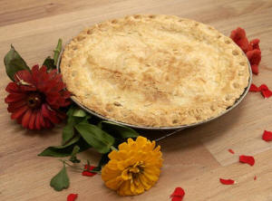

Apple pie is the one dessert that is a tradition at family reunions and social events. It has always been a treat that is appetizing any time of the year. There is no dessert more looked forward to after a good meal than a home made apple pie. Our recipe book will take you through step by step instructions on how to make this out standing, mouth watering dessert. We also include pictures for every step, so that you will find it very easy to comprehend our instructions. This recipe makes a crust from scratch, and is much better than a bought crust.

Why This Apple Pie Is Everyone's Favorite
Apple pie has always been a dessert that no one can pass up and one that is always welcome. I have tried many apple pie recipes and none of them can stand up to this ones delicious flaky crust or its mouth watering cinnamon flavored filling.

Apple pie American Apple pie
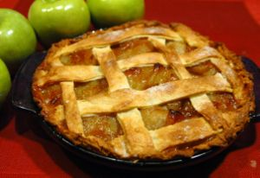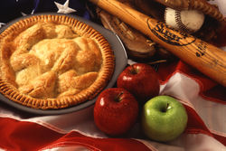
In cooking, an apple pie is a fruit pie (or tart) in which the principal filling ingredient is apples. Pastry is generally used top-and-bottom, making a double-crust pie, the upper crust of which may be a pastry lattice woven of strips; exceptions are deep-dish apple pie with a top crust only, and open-face Tarte Tatin.

BISCUIT APPLE PIE RECCEIPY

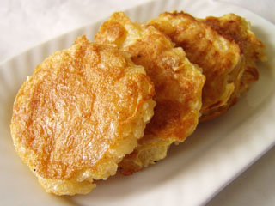

Apple pie and cheese
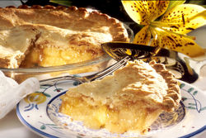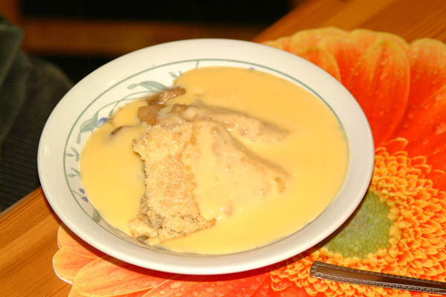
One combination of flavors common in the nineteenth century and earlier, which were referred to in English novels of the time was apple pie and cheese, by which was meant sharp cheddar cheese. This was because the apple was not always sweet (the leading sweet variety, Red Delicious, was developed in 1868). The sharpness of the cheese combines with the tartness of the apple and so produces an appealing taste. While its popularity has waned as modern pies have become sweeter, some people still enjoy this combination. This combination of tastes is still practiced in Maryland.

Apple Filling
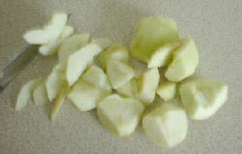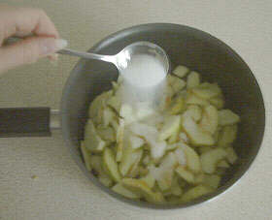
Step-1 Step-2
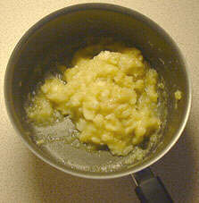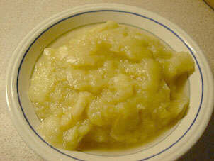
Step-3 Step-4

Step-1: Wash and peel the apples, then core and chop them using a small knife.

Step-2: Place the apple slices into a pan and sprinkle over 2 oz (50g) of sugar, two tablespoons of water and 3/4 teaspoon of cinnamon.
Step-3: Cook slowly until the apples are soft and ……

Step-4: place into a suitable container and refrigerate for later us

Coconut Cream Pie
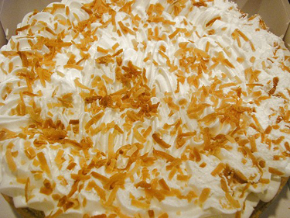

Comments: This is a healthy and delicious coconut cream pie recipe, made with a non-gluten crust using organic coconut flour.

Plum Pie

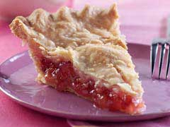

Apple Halua

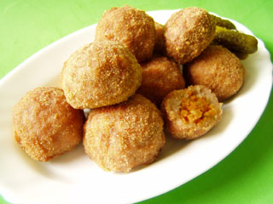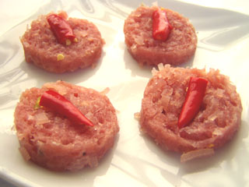

Mango Lime Cream Pie

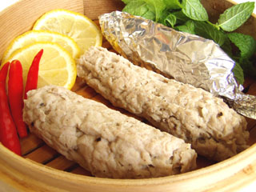

3.2 Product ingredients and Description

Product Line | Raw Materials | Weight | Price (Taka)
Apple Pie | Apple Slice, Flour, Sugar, , Butter,. | 200 g.m. | 120.00
American Apple pie | Apple Slice,Flour, Sugar, Butter, | 200 g.m. | 115.00
BASIC APPLE PIE | Apple Slice ,Flour, Sugar, Egg, Butter, | 200 g.m. | 50.00
Apple pie and cheese | Apple Slice, Flour, Butter, Egg, Sugar. | 100 g.m. | 85.00
Coconut Cream Pie | Coconut slice, Flour, Sugar, teaspoon honey Egg, Butter. | 150gm. | 50.00
Palm Pie | Fresh Plam,Suger,Flower,Butter | 150gm. | 100.00
Mango Lime Cream Pie | Flour, Sugar, mango puree, fresh lime juice, cream cheese, | 1 k.g. | 450.00

Fig: BFP’s product description

3.3 Product Benefits

Buttercup Food Products is a small house but suitable decorated and simplicity comfort to the guests. It want to provide hygiene & quality food with reliability. Customer will get greater out put because it will never use synthetic harmful color. All the products color of it will be natural. It is committed not to use harmful raw materials to produce the products. All the customer will get Fresh and healthy food from it. It will provide various kinds of apple halua, apple pie and Weeding halua to fulfill the demand of potential customer.

3.4 Proprietary Rights

Buttercup Food Products will produce a trade mark for its fast food house that can be able to contain the property’s sign and this sign provides the brand rights of Buttercup Food Products. As I know that no one can use my logo, brand name and copy the center’s name. Though there is no law for the sole proprietorship and partnership but there are some preferences for us.

3.5 Stage of Development

Buttercup Food Products can include with another new flavor, the shape and style. It will try to find out the demand of new product with original products, products improvements, products modifications and new brands. It will follow in their new products development which represented as follow—

MFP’s New Product Development

Business Analysis
Idea Generation
Concept Dev. & Testing
Marketing Strategy
Product Development
Test Marketing
Commercialization
Idea Screening

Fig: BFP’s new product development

4.0 Industry and Market Analysis

4.1 Industry Analysis

In Bangladesh, food industry is continuous to grow. Within the industrial sector, the growth of the food processing industry is particularly important for Bangladesh as this is one of the major industries in terms of contribution to total manufacturing production and employment. Changes in mean capacity realization rates in the food processing industry over the three periods suggest that enterprises in different sectors within the industry recorded only moderate increases in efficiency during the post-reform period. The average rate of capacity realization for this industry increased by only 7 per cent, from 51 per cent in 1981 to 58 per cent in 1991. There is still a substantial unrealized productive capacity in most of the enterprises in the food processing industry. On the average, capacity realization increased most sharply in the fish and seafood sector by 31 per cent from a low mean of 47 per cent in 1981 to 78 per cent in 1991. The reason for this sharp rise may be attributed to the outward orientation of this sector and the need for competition. All the firms in this sector adopted a 100 per cent export orientation approach. The remaining industries showed little or no improvement.

Y (Product Quality)……………
Boomers

Bamboo Castle
Others

X (Product Differentiation)
0

The consumers of Dhaka City now spend a whopping 3000 million Taka per year on fast food centre. During the period of 2002 to 2006 the fast food centre market of Dhaka city grew at 40%. This has generated a boom in fast food centre food opening the last five years. People are always wish different types of food with new and desirable flavor. We can change the section of product and market by producing a range of hygiene and quality food with different flavor. Our business is oligopoly organization.

4.2 Opportunity and Trends

Fast foods are major Tiffin food in our daily life for students, travelers and young generation. But some specific time these are used as immediate food especially in many occasions. BFP will produce Apple pie, Apple Halua, Apple Biscuit, Mango Pie, Coconut Pie, Plum Pie, and Mango Lime Cream Pie. The growing number of health conscious people can be a good market for future various kinds of fruit and vegetable juice. As the raw material of the products are available in Bangladesh. Huge amount and various types of fruits are growing in Bangladesh. And the Government is also fear about agro based business and others types of business boom to contribute in national GDP. So, Raw materials and skilled employees are available and BFP thinks intense, reoccurring and detailed training is the cornerstone to success. Technology are also easy to operate and available with reasonable price. BFP will organize Superior building, good quality show room, excellent sitting arrangement, and hygienic environment for infrastructure support.
BFP will start with a suitable footprint ranges from a 300-square-foot kiosk to the 1,500-square foot in-line location. This unit square footage range allows BFP to address a wide range of location formats on a modular basis. The basic module represented by the 300-square-foot kiosk represents the core concepts of business. BFP will start its operation firstly in Golshan area. BFP will produce a wide range of fast food with various fruits flavor which are not available in the market. So, the numbers of competitor are not so high. The direct competitors are Boomers and Bamboo Castle. The products of BFP have legal and cultural value. On the other hand BFP think there is a great chance of distribution and promotion. BFP will add some extra service like home service delivery by phone call and internet that will be demandable in future. BFP thinks it will get political and legal support for a clear concept that is better for the people and their health. So, BFP will get political and legal environment support. From opportunity analysis BFP think Apple pie, Apple Halua, Apple Biscuit, Mango Pie, Coconut Pie, Plum Pie, Mango Lime Cream Pie flavor and test will get good support from Bangladeshi market especially in Dhaka area. Finally the main trends of BFP are to provide a wide range of fast food with different flavor and reasonable price.

4.3 Competitive Environment and Competition

Fresh and quality fast foods are always demandable. There are many fast foods centre in Dhaka city. All the fast food centers are willing to making more profit. Before starting the operation BFP tried to gather information about some competitor in fast food sector in Golshan Banani, Uttara and Dhanmondi area. The nearest six competitors that BFP found are as follow-
- Boomers
- Bamboo Castle

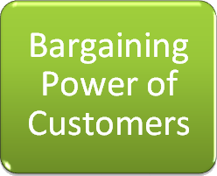


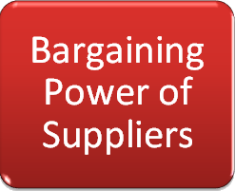
High
High
High
High
High

A larger number of firms: Here in Dhaka city there are so many fast food shops operating business. So it increases rivalry because more firms must compete for the same customers and resources. The rivalry intensifies if the firms have similar market share, leading to a struggle for market leadership.
Threat of Substitutes: In Dhaka city there are so many fast food shops operating business. Though they are not proving the same service but they can easily copy the products. So this market is very competitive for BFP.

Suppliers: In the Dhaka city the bargaining power of the suppliers is really high. Because they have other options to run their business.

Buyers: In Dhaka city there are so many fast food shops. So the customer's have options to choose. That's why they have the high bargaining power.

Competitive Matrix Chart
Competitor | Product  Service | Unique Feature | Distribution  System | Adverti  sing | Geogra-  Phic Location | Product  Layout | Packaging
Boomers | 5 | 4 | 4 | 3 | 4 | 4 | 4
Bamboo Castle | 5 | 3 | 4 | 3 | 4 | 3 | 4
Agree completely=5, Mostly agree=4, partially agree=3, Mostly disagree=2, Disagree completely=0.

From the competitor analysis BFP find out some information of competitor’s strength and weakness. The strength and weakness are as follows:

Boomers:
Product services, unique feature, distribution system, packaging and product layout are the strength of Boomers. Advertising is the main weakness of Boomers. On the other hand there is some problem in selecting location.
Bamboo Castle:
Product services, unique feature, distribution system and packaging are the strength of Bamboo Castle. Advertising is the main weakness of Bamboo Castle. There is some problem in selecting location and product layout.

4.4 Target Market and Customer

Foods are actually delicious for anybody. And when it is fast food that time it is more attractive for young people. These young peoples are basically Schools Colleges and Universities going student. So, for my target group, I have selected theses young generation as my target customer. Apple pie, Apple Halua, Apple Biscuit, Mango Pie, Coconut Pie, Plum Pie, Mango Lime Cream Pie flavor are demandable for all classes’ people in the society. In this moment there are not single bakeries that are producing fruit pie, fruit halua for vegetarian people. On the other hand no bakeries are providing outstanding quality, service, cleanliness, and home service delivery by using internet or phone call. We hope we will make every customer in every house or area smile. The target customers of BFP are:

Class of Customers | Importance
Upper class | High
Upper Middle class | Medium
Tourists | High
Vegetarians People | High

Class of Customers | Importance
Universities students | High
Colleges students | High
School students | Medium
Others | Medium

4.4.1 Market Segment

The maximum upper middle and upper classes people seek different food with different taste and flavor. In general, people are likely to accept various types of fast food with different flavor. Firstly, our target is upper middle and upper class consumer in Dhaka city. BFP thinks it will get approximately 100,000 customers per year. And the buying condition will be acceptable for all consumers.

4.4.2 Market Size and Growth
BFP targets the people who like to take the taste of different foods. The primary customers are upper middle and upper class people. Market survey of BFP conducted that it will get 20-25% customer in beginning time. And BFP wishes it will capture minimum 10% growth rate. Total sales volume can be approximately 400000 units per year.

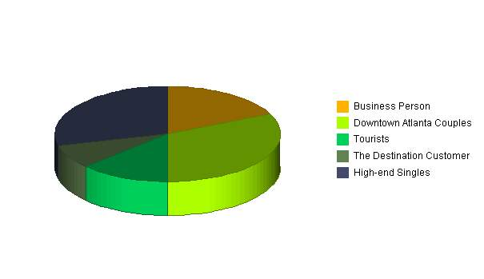
Market Analysis (Pie)

Market Analysis
Potential Customers | Growth | 2008 | 2009 | 2010 | 2011 | 2012 | CAGR
Business Person | 18% | 9,925 | 10,223 | 11,348 | 11,688 | 12,039 | 4.95%
Couples | 32% | 17,645 | 18,527 | 20,565 | 21,593 | 22,673 | 6.47%
Tourists | 13% | 7,168 | 7,311 | 7,896 | 8,054 | 8,215 | 3.47%
The Destination Customer | 8% | 4,411 | 4,499 | 4,724 | 4,818 | 4,914 | 2.74%
High-end Singles | 29% | 15,991 | 16,950 | 18,815 | 19,944 | 21,141 | 7.23%
Total | 5.76% | 55,140 | 57,510 | 63,348 | 66,097 | 68,982 | 5.76%

4.5 Market trend

The current market trend of this industry was once monopolistic but not anymore. Over the past decade or so this industry has evolved much more than anybody has anticipated.
Over the past few years the rate of potential consumers has increased profoundly specially in the commercial areas. The contemporary habit or lifestyle has forced people to adapt the life style of western society. So the bottom line is more people are prone to go for gift shops whenever necessary.

4.6 Customer Analysis

Target Customer analysis
Customer Quality | Area/Location | Demand
Upper & middle classes people | Gulshan | High
Vegetarians People | Everywhere in Dhaka city | High
Students | Gulshan | High
Tourists | Gulshan | High
All the products of Premier Cake House will be highly specialized and profitable, that would be capable to fulfill the demand of potential customer.

Upper class and upper Middle class people
Maximum of upper class and upper middle class people wish to taste the different food. They always desire different kinds of entertaining foods. Though the Apple pie's is not a familiar food in our country. But the people in Gulshan are ready to take the taste of different flavor. So BFP thinks that the target customer's are ready to consider our products.

Students
Young people are always like to taste the new and different products. They have the tendency to adopt the new culture. So BFP thinks that the new offering is going to be hit to the young people.

Tourists who are visiting the city
Gulshan is very important place for business sector. There are more than twenty manpower and travel agency in Gulshan. On the other hand there are many Embassies and private bank in Gulshan area. Many people come to Gulshan for process their VISA and others paper. Many business person come to the bank for transaction. So every day there are many people comes to Gulshan in bank, offices and manpower & travel agency. Sometimes it takes huge time to process their work or many people come from different district. In the lunch time or evening time they wish to eat something. If they find fresh and quality different food then they would be potential customer of BFP.

4.7 Sales Analysis

The target customer of BFP is middle, upper classes and vegetarian people. For sales analysis BFP analyzed the Gulshan area. A common way to estimate total market demand is as follow:
Year | 2008 | 2009 | 2010 | 2011 | 2012
Sales | 371,416 | 398,407 | 406,976 | 415,276 | 423,597

Sales by Yearly

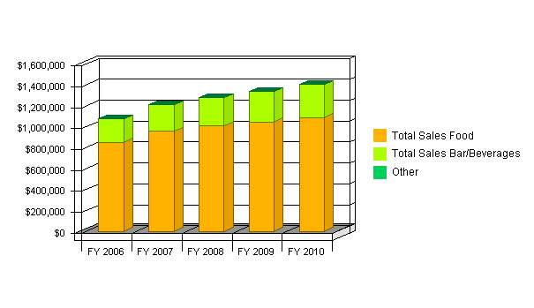

5.0 Marketing Plan

BFP has performed a market diagnostic study and gathered some important information from the market. BFP will provide the necessary product that the consumer wants to get. Various kinds of pie are not providing by any fast food house. So there is a huge demand of this item. BFP has made a marketing plan before launch the product in the market. The parts of the marketing plan of BFP are customer research, target market strategy, channel strategy, market positioning, product strategy, pricing strategy and advertising & promotion strategy.

5.1 Customer Research

BFP thinks about customer sincerely and a survey was conducted properly from the customer market. The 80% of upper classes people are ready to buy new products; the young people have the tendency to taste the new food. There are more than 5% upper middle class people who are fond of new food trends. Huge numbers of people wish different kinds of tasty food with different flavor. On the other hand many potential customers are willing to buy products by internet or phone call. And MFP will offer these kinds of facilities. So, MFP think people will be more interested when MFP will start its operation.

5.2 Target Market Strategy

The target market of BFP is Upper middle, upper classes people. These types of customer are very interested to enjoy the taste of new foods. All the products of BFP will be free from harmful chemical. Customer will get different kinds of food with different flavor easily. BFP will open a Web Site for adverting and selling products to the customer. BFP will also offer customer to buy products by phone call. By offering various types of product and marketing variations to segments, BFP hope for higher sales and a stronger position within each market segment.

5.3 Market Positioning

BFP will provide different types of new food with different flavor in the targeted segment. Apple pie, Palm Pie, Apple pie, Apple Halua, Apple Biscuit, Mango Pie, Coconut Pie, Plum Pie, Mango Lime Cream Pie are totally new product in the market. The unique selling proportion (USP) of BFP is Different and Hygienic food for the food lovers. BFP thinks the customers are available but products are not available in the market. BFP will take care about the quality and variety of new food with different flavor.

5.4 Product Strategy

Before telling anything about our product strategy I would like to mention few factors that we always keep in mind to make our brand a successful one. We know there is one controllable and two uncontrollable variables exist in marketing. Controllable variable are the elements of the marketing mix. 4ps of marketing mix are Product, price, promotion and place. The proper mixing of these 4ps is very important to survive in the market. The one most important task of marketing people is proper mixing of 4ps.

Controllable variable

- Product, price, promotion and place.

Uncontrollable variable

- Market/ consumer/ customer.
- Economy, geography, socio/ religion/ culture, technology, ethics, competitive structure.

So, marketing people cannot control those uncontrollable variables which are strongly associating with the business. On the other hand marketing people can strongly control the controllable variable which is 4ps of marketing. Now a day it is not only 4ps but also 4Cs and 4As. These have been shown below:

4Ps 4Cs 4As

Product Customer value Acceptability
Price Customer cost Affordability
Place Customer convenience Access ability
Promotion Customer communication Awareness

5.5 Channel Strategy

Though BFP is going to start with one sales centre but BPF has a plan for expanding the distribution channel. BPF will provide products and services through selective distribution channel.

Direct Marketing

BPF

Potential Customer

Indirect Marketing
BPF
BPF’s representatives or sales branch
Potential Customer

Fig: Channel Strategy of BPF

5.6 Pricing Strategy

We know that there are few ways of pricing a product. These are

- Price skimming
- Value pricing,
- Cost pricing
- Market Penetration Pricing

In pricing strategy, BPF will follow “Market-penetration pricing”. Market penetration pricing represents setting a reasonable price for a new product in order to attract a large number of buyers and a large market share. BPF think production and distribution costs must fall as sales volume increases.

5.7. Promotion Strategy

Buttercup Food Products is a new company of existing products of food industry. Food industries of our country have made advertise in print media like Magazine, Poster, News Paper and Billboard as well as electronic media also. My company is launching for the first time with a totally new and different product in food market. So my advertisement is to create awareness to my customer in my introducing level. So, I think my advertisement will be better to publish in print media and I will also use News paper poster and billboard near any shopping complex, tourism place, school, college and university to introduce my new innovation and exclusive collection to my target customer.

Promotional tools: Promotion has been defined as the coordination of all seller initiated efforts to set up channels of information and persuasion in order to sell goods and services or promote an idea. There are four types of promotional tools are more emphasis in the marketing process. The different types of promotional tools are mention bellows:

Sales Promotion: Sales promotions are used for increase the sales volume by customer attraction. Here BFP throwing a special offer to the customer. It could be discount offer or it could be the offer of buy one get one free. Consumer –oriented sales promotion is targeted to the ultimate user of a product and includes coupon, samplining, and various point-of-purchase materials. These promotional tools encourage consumers to make an immediate purchase and thus can stimulate short term sales. So I try to use most of the tools regarding sales promotions to attracting my target customer.

Advertising: Advertising is use to inform, persuade, remind in order to gain a response from the target market. As we are new in the market we will go for informative advertising. Advertising is the effective way to pass the product benefits and information to the ultimate customer. Advertising involves mass media that can transmit a message to large group of individuals, often the same time. One advertisement may seek to generate immediate response or action from the customer; another may want to develop awareness or a positive image for a product over a longer period. Advertising can be use to create brand image and symbolic appeals for company or brand, a very important capability for companies selling products and services that are difficult to differentiate on functional attributes. Observing these kinds of facilities I would like to inform my target customer to create awareness my products through advertisement. The way of advertising can be different type. This are-

1. TV advertisement
2. FM Radio
3. Newspaper
4. Magazine
5. Bill board

Publicity: publicity refers to non personal communications regarding an organization, product, service or idea not directly paid for or run under identified sponsorship. It usually comes in the form of a news story, editorial, or announcement about an organization and its products and service. The company or organization attempts to get the media to cover or run a favorable story on a product, service, and cause or even to affect awareness, knowledge, opinion, and behavior. These techniques used to gain publicity include news releases, press conference, feature articles, photographs, films, and videotapes. So I have use publicity as promotional tools to increase my sales and create my product image.

Personal Selling: The final elements of an organization’s promotional mix is personal selling, a form of person to person communications in which a seller attempt to assists and/or persuade prospective buyers to purchase the company’s product or service or to act on an idea. Unlike advertising, personal selling involves direct contract between buyer and seller, either face-to-face or through some form of telecommunications such as telephone sales. This interaction gives the marketer communication flexibility, the seller can see or hear the potential buyer’s reaction and modify the message accordingly. Personal selling efforts can also be targeted to specific markets and customer types that are the best prospects for the company’s product and service. So personal selling is needed for my products selling and also get the customer immediate feedback. Therefore action taking and decision making are very much easier to me.

Slogan of the promotional program:



Slogan or tag line is very important for a particular product. Without a slogan product positioning cannot happen. Through a promotional slogan a product position set into the customer mind. According to product category slogan can be different. There are few examples as follows:

- COCA COLA: “Think Globally, Act Locally”.
- FEDEX: “Relax. It’s FedEx”.
- AIRTEL: “Express Yourself”.

So the customer can make a perception about my product. I am sure that the perception will be favorable. They can understand what kind of food items I provide them.

Copy:

Buttercup Food Products

Rational:
My product is mainly food items. So my slogan has made with making a similarity of my products and services. That’s why my slogan is –

The reason behind the slogan is, people work hard in whole day and they want refreshment and food to recover the energy. If he takes my various food items of my company he will get refreshment as well his body will fit for working.

That is why my promotional slogan is “Eat, Fit & Become Hit”, which really mean that or relevant to my product category as well it set the product position into the customer mind.

Gantt chart:
 | July | August | September | October | November | December
TV | 10 | 10 | 10 | 8 | 8 | 6
Radio | 25 | 25 | 20 | 20 | 20 | 25
Newspaper | 30 | 30 | 28 | 25 | 25 | 30

Time period:
My company produces food products, so there is no time limitation. My business is not depending of time period. Various foods are available in different seasons and I use the seasonal food to produce delicious item. Time period does not affect me a lot.

Promotional Planning Matrix
 | Reputation | Life Span | Target market | Cost | Flexibility | Availability | Reach | Total
Newspaper | 5 | 3 | 5 | 2 | 5 | 5 | 5 | 30
SMS | 4 | 4 | 2 | 5 | 4 | 2 | 2 | 23
Magazine | 5 | 5 | 3 | 4 | 3 | 4 | 4 | 28
Television | 5 | 1 | 5 | 0 | 0 | 3 | 3 | 17
Radio | 3 | 1 | 2 | 3 | 3 | 3 | 3 | 18
Billboard | 4 | 5 | 4 | 3 | 3 | 3 | 4 | 26

Let's Go for BFP


Mom, I want to have some Apple Pie

Buttercup Food Products
A House of Different, Quality full and Hygienic Foods.

We Offer:

Ж Apple pie
Ж Apple Halua
Ж Apple Biscuit
Ж Mango Pie
Ж Coconut Pie
Ж Plum Pie
Ж Mango Lime Cream Pie

Central park, Road no#2, Gulshan
Dhaka, Bangladesh.

6.0 Operation Plan

BPF has made a plan to operate the production sector. BPF wish it will get much benefit from the operation plan. The operation plan of BPF is started from the purchase raw materials. The operation plan of BPF divided in eleven stages. The stages are as follow:

Purchase Raw Materials

Transportation
Storage & Inspection
Deliver to Production Plant

Processing and Washing

Mixing the ingredients

Microwave Woven

Quality Control

Packaging & Distribution
Wait for Sometime and Quality Testing

Dividing the ingredients

Fig: Operation Plan of BFP

6.1 Location

BPF has selected its Factory, Head office and Sales centre in Centerl Park, Gulshan. Gulshan is very important place. There are many English medium schools, Bank, post office, and many private offices in this road. But Boomers and Bamboo Castle are not operating their business in this road. Transportation and parking facilities are also a part of great advantages. On the other hand office rent and other expenses are very high. So, expensive office and availability of parking area are the part of disadvantages.

6.2 Supply chain analysis

BFP will use road transportation to buying raw materials and selling products. BFP will involve with entire supply chain management. It represents the managing upstream and downstream value-added flows of materials, final goods and related information among suppliers, the company, resellers and final consumers. It is a vertical job. In quality control, BFP always tries to control the quality and time management. Firstly the head of the cook order to start production. Then the receivers others cook receive the order and start the production. Then the head of the cook and production manager test the quality and evaluate the unit. Finally folding and packaging represents the last step of production or supply chain.
Quality Control
Time Management
Order
Receiver
Quality
Evaluation
Folding
Packaging

Fig: Supply chain Management

6.3 Inventory Management System

The entire inventory will be use in first in first out method. BFP will be organized a store room for store up the raw materials. Inventory management of BFP can be—

Inventory Req.
Order Quantities
Received Quantities
Store Quantities
Inventory supply for used in FIFO method
Inventory Valuation, monitoring and Control
Fig: Inventory Management System

6.4. Stakeholders-Suppliers, Vendors

The main raw material of BFP is flour, sugar, and fruit. Senakallyan sangstha will be supplier of flour and sugar. And BRAC will be fruit supplier. BFP will buy essential raw materials according to their demand from karwan bazaar. BFP can contact with Pepsi or IGLOO for strategic partner.

6.5 Physical Facilities and Factors

BFP will start its business in Centre Park at Gulshan. The size of the showroom will be 800-1000sft. The construction of Centre Park is going on. It will be 15 storied commercial building. This building will also provide parking facilities. The environment and the site of this building is suitable place for making good relationship with the customer and making profit.

6.6 Building Interiors

The office and sales centre is not harmful for the customer and employee. BFP will organize proper lighting and sitting arrangement for the valuable customer. Factory and Sales office will be organized as totally air-conditioned. BFP will provide Z type of comfortable chair and Sofa for the customer in sales centre.

6.7 Layout Patterns

Layout patterns of BFP will be formal, control and divides store into a series. And it will be friendly environment and acceptable for everyone.

6.8 Manufacturing Layouts

In manufacturing layout BFP will deals with product layout, process layout, fixed position layout and functional layout. In product layout sector production will perform by sequence. Process layout will perform according product process function. Layout patterns of BFP will be open spaces in production and sells centre.

6.9 Equipment

BFP needs different types of equipment to produce various types of Pie. BFP will buy all the equipment from the Naogaon Engineering Workshop. BFP has made a contact with Naogaon Engineering Workshop. They are eager to supply all the necessary equipment with reasonable price. The necessary machinery of BFP is Diesel/ Gas and Electric Rotary Rack Oven, Ingredients Mixing Machine, Packaging machine and Cutting machine.

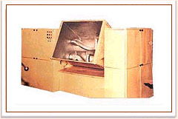 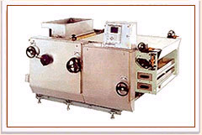Ingredients Mixing Machine Rotary Microwave Woven

Microwave Woven
The microwave woven to be mounded is fed into the hopper and a forcing roller forces the dough into the cavities of the molding roller made out of gun metal, uniformly engraved and coated with food grade Teflon. Excess dough is cleared with a knife, which is held by a holder made from tool steel, to ensure uniform filling.
An adjustable rubber roller conveying the discharge cotton web presses it uniformly against the molding roller for perfect transfer of molded pieces from the molding roller on to the web. The adjustable rubber ruler is very important in operation sector.
The purpose of three drives is, speed of the forcing roller influences the density of dough forced in to the molding cavity. The speed of the die roller influences the production speed. The discharge web speed influences the shape of the biscuits produced along the web or across the web.

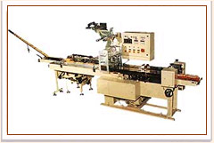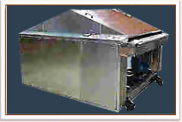

 | Model BOI/H/60
1) Power = 440 Volts Phase | 1.5 H.P Motive
2) Power = 440 Volts 3 Phase | 15. K.W Heating
 | Net | Gross
 | Kg | Kg
1) Machine Weight (Approx.) | 1075 | 1500
2) Machine Dimension (Approx.)
  Ht | Wt | Lt.
  2000 | 1100 | 3000
  Mm | mm | Mm
  80 | 40 | 180

Fig: Power, Weight and Dimension of ingredients machine

6.10 Manpower Requirements

BFP is a sole trader business. The managing director is the owner of the business. Managing director can operate in production sector. Manpower is required for Marketing, cook and sales person. So, total sales person needed five people in cooking sector who will also operate packaging and leveling. In marketing area BFP need one experienced marketing officer and two sells person need.

7.0 Management Plan

7.1 Develop an Organization Chart

Managing Director:

Managing Director is the owner and head of the business. The Managing Director of BFP will also take responsibility of production management. BFP always wishes to increase sales volume by providing hygiene and quality food. The managing director will serve his qualified working experience to BFP. For this reason Managing director should be motivated, proficient and truly concern in working area.

Sales and Marketing manager:

Sales and marketing manager is important employee of BFP. Sales and Marketing manager should be experienced in fast food sector at least 5 years. The job responsibility of sales and marketing manager is to increase the sales volume by providing different ways.

Managing Director
Production Manager
Sells and Marketing Manager
Head of the Cook
Pie Maker
Sells Person
Figure: Organ gram

7.2 Personnel Plan

Man, Machine and money are the three basic elements of business. Manpower is the heart production business for making quality food. For making quality and hygiene food BFP need a small number of employees. One Production Manager, one Sells and Marketing Manager with two sells person will be administration sector. BFP will start with two skilled and three inexperienced cook. Small number but qualified people are more desirable and worthwhile for more production rather than unskilled large number of people. So, quality should be more preferable than the quantity.

7.3 Principals

BFP is a sole trader business. The owner of the business will be the director and the director is responsible for operating and production sector. The director will take the responsible of production sector to control the quality. The director is experienced person in fast food production. The director of BFP is also responsible to handling the marketing manager and the head of the cook. The marketing manager has five years experience in fast food marketing sector. The cook is experienced in fast food especially Pie. Others cook are also able to handle the Pie and other production. So, BFP has qualified strength in management, marketing and production area.

8.0 Human Resource Management

Mauritius Food Product Company is looking for a young, energetic, smart marketing executive.

Job Title: Marketing Executive
Company Name: Buttercup Food Product
Job Description:
- Responsible for guiding the company in a profitable direction
- Oversee all aspects of the business, from sales and marketing to human resources and accounting.
All employees report directly to the president

Qualifications:
- Business degree from any reported University.
- 2 years experience in sales and marketing at food business in Bangladesh
- Excellent financial and management skills
- Strong understanding of English language
- Salary: By Negotiable
Those who can fill the above criteria, please send your CV with a passport size photograph within 30th June 2007. Contract: Mauritius Food Product, 15/A Central park, Road # 2, Gulshan – 2.
9.0: Financial Plan

9.1: Capitalization

Financial plan is very important factor in Business Plan. It is impossible for BFP to start fruitful operation without capital. Capitalization plan is the part of financial plan which bears three functions. Capital required, Capital sources and Loans required are the main part of Capitalization plan.

Start Up

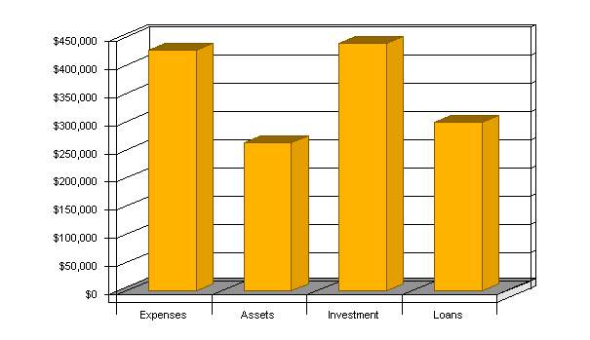

Start-up
Requirements
Start-up Expenses
Project Management | Tk 0
Restaurant Consultant (4 months) | Tk 15,911
Design | Tk 0
Architectural Design | Tk 2,195
Structural & Plumbing Design | Tk 1,368
Mechanical & Electrical Design | Tk 2,155
Graphic Design | Tk 1,185
Electrical & Structural Engineering Fees | Tk 2,592
Design Consultants (Kitchen, Interior & Dining) | Tk 9,119
Engineer & Architect Fees | Tk 7,040
Construction | Tk 0
Plumbing | Tk 33,244
HVAC (Air Return, Air Ducts, etc.) | Tk 19,250
Electrical | Tk 7,964
Disposal & Demolition | Tk 4,122
Structural Construction (4 Months General Labor) | Tk 52,099
Façade (Exterior Construction) | Tk 3,092
Plaster (Dry Wall) | Tk 2,061
Mill & Metal Work | Tk 8,244
Interior Finishes (2500 - 3000 sq. ft.) | Tk 14,538
Flooring | Tk 14,622
Fire Alarm System | Tk 3,092
Security & Phone System | Tk 4,615
Equipment | Tk 0
Liquor Control System – Lease | Tk 0
Stools, Chairs, Tables, Uniforms | Tk 38,025
POS (Point of Sale System) - Lease | Tk 0
Glassware, Flatware, Small ware (Bar & Lounge) | Tk 3,298
Glassware, Flatware, Small ware & Supplies (FOH) | Tk 8,298
Dishwasher, Ice & Glass washer - Lease | Tk 0
Kitchen Equipment Freight Fees | Tk 2,389
FF&E Taxes (Taxes on Purchase) | Tk 7,988
Operational | Tk 0
Capitalized Legal Fees (LLC, Investor Agreements) | Tk 7,080
Software: Restaurant/Inventory | Tk 5,500
Software: Cost Control | Tk 6,000
Impact, Tap & Permit Fees | Tk 3,115
Business License & Temp Certificate of Occ. | Tk 1,615
Liquor Licenses | Tk 4,615
Utilities, Disposal, Tax & Insurance | Tk 9,275
Security Deposits (Phone/Elec/Gas/Water) | Tk 6,250
Initial Lease Deposits | Tk 6,250
Bank & Loan Closing Costs | Tk 6,250
Web Site Construction | Tk 5,800
Initial Marketing, Training & PR | Tk 19,550
Research & Development | Tk 3,050
Start-Up Salary (Mngt & Chefs) | Tk 58,050
Recruiting (Staff) | Tk 14,550
Inspections | Tk 750
Initial Cleaning Services | Tk 1,000
Total Start-up Expenses | Tk 427,209
Start-up Assets
Cash Required | Tk 97,099
Start-up Inventory | Tk 27,500
Other Current Assets | Tk 73,311
Long-term Assets | Tk 65,000
Total Assets | Tk 262,910
Total Requirements | Tk 690,119

9.2: Income Statement (Monthly):

Month | January | February | March | April | May | June | July | August | September | October | November | December
Sales | 180000 | 300000 | 190000 | 220000 | 200000 | 250000 | 240000 | 400000 | 200000 | 300000 | 220000 | 300000
Expense | 60000 | 80000 | 70000 | 70000 | 65000 | 60000 | 60000 | 80000 | 70000 | 60000 | 65000 | 60000
Net Income | 60000 | 120000 | 120000 | 150000 | 145000 | 190000 | 180000 | 320000 | 130000 | 240000 | 155000 | 240000

9.3: Pro Forma Statement:

9.3.1: Twelve Month Income Projection Statement:

BFP has made a twelve month income projection statement. The income projection statement shown below:

Sales Tk371, 416
Cost of Goods Sold (80000)
Contribution Margin 291416

Fixed Factory Overhead (85000)

Selling and Administration Expenses (110000)
Advertising and Promotional expenses (30000)
Other Expenses (15000)
Net Income 51416

10.0 Risk Assessment

10.1 Risk Potential Problem

Risk is the part of business. BFP thinks every business is risky. BFP has a plan against risk. BFP will save risk purpose 15% from sales revenue. BFP thinks it will get much benefit from the risk fund.

10.2 Obstacles and Risks

BFP thinks it can face some problem. All the products of BFP are demandable. Apple pie, Apple Halua, Apple Biscuit, Mango Pie, Coconut Pie, Plum Pie, Mango Lime Cream Pie will get popularity quickly to the upper middle, upper and vegetarian people. Food business is profitable business. So, there is a chance to copy the products in the market. On the other hand, every business has some risk. To start the business of BFP, it needs huge amount of money. To collect the money and interest rate is risky for BFP. Every business has a probability to get loss. BFP is a sole trader business, so if any accident or any other financial problem can occurs harmful effect to BFP.

10.3 Plans against the Risk and Obstacles

10.3.1 Contingency Plan

BFP will take the license from the food industry. BFP will prepare trademark and logo for its products. The entire products will be different shape from the other fast food products of the market. BFP will take every types of authority from the relevant sector. Tax identification number and it will be organized with trade license by the power of Business sector of Dhaka City Corporation. So, BFP will get the legal authority from the city corporation and other business area.

10.3.2 Insurance Plan

BFP will be organized by Insurance Plan to reduce the risk. BFP will open an insurance file for Business Purpose in Peoples Insurance Company. Firstly, insurance file will be open for ten years.

11.0 Funding

11.1 Source of funding

- Personal Savings
- Friends and family
- Bank loan

12.0 Appendix

- www.google.com
- Bplans.com
- International Marketing
Philip kotler & Gary Armstrong
- Pro forma of Balance Sheet
- Resume
- Some Photograph of my Product



