Term Paper
On

Challenges Faced by Entrepreneurs in Plastic Industry

Submitted by
WWW.ASSIGNMENTPOINT.COM

This report is prepared as a fulfillment of partial requirement of Microeconomics. The topic was authorized by the course teacher Dr. A.K.M. Saiful Majid, Professor of IBA, as a term paper to be submitted on February 12, 2007.

1.2 Background

By definition, plastics are a large and varied group of materials, consisting wholly or partially of combinations of carbon, with oxygen, hydrogen and other elements and are capable of being readily formed into many shapes.

The growth of plastics industry in Bengal goes back to not much more than four decades. It started with the opening up of a belt and plastics factory in Calcutta. During the period of 1973-88, the growth of plastic industry in Bangladesh has been quite satisfactory.

The plastic industry is clustered in the IslamBagh area of old Dhaka. There is no official registration of these firms; there total number is not certain. According to estimates by a number of entrepreneurs the total number of firms could exceed 3000. But the industry has now expanded to outside the capital. It has been learnt that, some new plastic industries has been recently established in Chittagong, Bogra, Comilla and many other parts of the country, mainly to cater the needs of the local markets.

1.3 Objective

In this report I will try to fulfill the following objectives.
- The purpose of this report is to get an exposure to the real world situation of the economic environment of the country.
- This study will give us an opportunity to experience how the small and medium sized enterprises are actually operated in the country. In order to achieve this objective I have chosen the Plastic Industry sector of Bangladesh to conduct the study.
- The main goal will be to point out the problems and challenges of entrepreneurs in this industry and find some solutions.
- The secondary purpose of the report is to get acquainted with survey procedures
- Learn to make use of statistical tools and analysis
- Getting familiar with micro-economic analysis

1.4 Methodology

I have selected several plastic industries to conduct the report. Data will be collected both from primary and secondary sources. The research will be done based on the followings –
- Primary data will be collected through questionnaires and interviews.
- Interviews will be taken and the questions asked guided by the questionnaire.
- Secondary data from various sources will also be collected. Internet, books and reports obtained from various libraries and agencies shall be used.
- The information thus collected from various sources were first organized and then analyzed to draw conclusions.

1.4.1 Stages of work
The report will be prepared by four stages of work. Each stage requires specific time and consideration. The stages are –
- Planning of work
- Data collection
- Interpretation of data
- Drawing conclusion and recommendation

1.5 Scope

The report will provide background information on Small and Medium Industries in Bangladesh; the focus will be on Plastic industry. The scope of the study is the manufacturers of different plastic products in the areas of Green-road, Alu-bazar, Nazimuddin-road, Lalbagh, the Mitford area, Tejgaon industrial area and Islambagh; all in Dhaka city. In my report I will focus on the plastic furniture and toys.

1.6 Limitation

The report will not cover the whole Plastic industry of the country. It will only cover a few selected areas of Dhaka city and a few industry types of the Plastic industry. There is no well structured information, like current sales figure or current investment figure, or else they are apprehensive to disclose the figures. So it was hard to get necessary information on this context.
Chapter 2
Business and Ownership

2.1 Business

The term business has different meanings to different people this broad all-inclusive term can be applied to many kinds of organization. Business provides the bulk of our employment. Business consists of all profit-seeking activities and enterprises that provide goods and services necessary to an economic system. Some businesses produce tangible products, such as automobiles, breakfast, computer chips etc. Others provide services, such as insurance, hotel room rental etc.

Business is the economic pulse of a nation, the means through which society’s standard of living improves. Profits are a primary mechanism for accomplishing these goals. But, besides earning profits, successful businesses also seek to meet their ethical and social responsibilities. This means businesses must be responsible in the dealings with employees, consumers, competitors, suppliers, government. But its implication vary from country to country on the basis of the stage of economic development and the nature of the economy itself, type of industry, section importance in the economy and many other considerations.

A profitable business should be able to perform the following things:
- Buy goods and services
- Hire and train employees
- Raise money
- Keep records
- Study market
- Give credit
- Produce or provide one or more products and services
- Market the product or service
2.2 Small Industries in Bangladesh

In Bangladesh, the definition of small-scale industry has undergone changes from time to time. The evolution of the definitions is discussed below.

During the period 1957-65, small industry in Bangladesh, then East Pakistan, stood for an industrial establishment or unit run mainly with hired labor, not exceeding 50 workers when power was used; and whose investment in land, building and machinery did not exceed Tk.0.25 million in value.

In 1970, the definition was changed by raising the fixed investment ceiling in fixed assets to Tk. 1.00 million. There was no limitation on the number of workers that could be employed by small industry.

In the post-liberation policy of 1972-73, the Government limited the size of investment in the private sector to Tk.2.50 million. It was stated that an industrial unit having less than Tk.2.5 million fixed investments, including land would be considered small industry. These definitions indicate in Bangladesh there is no uniformity either in respect to fixed investment or employment criterion. In most cases, the employment criterion is absent. There appears to be no clear-cut demarcation between small, medium and cottage industries.

Such a diversity is not surprising, since small is a relative concept. As stated before what is considered large in one country may be considered small in another. Moreover, the definitions will vary depending on the purpose for which they were designed in a particular country at a particular time. Thus, we can see changing definitions of small-enterprises in Bangladesh over the years.

2.2.1 The Growth Rate of Small Industries

There was almost no data on small industries from 1971-1978. The data on this important sector was available from the year 1979. Since then the number of small industries has steadily increased over the years. The number and growth rate of the small industries are presented in the following table.

Table 2.1: The growth Rate of Small Industries in Bangladesh
Years | Number of Industries Added | Growth Rate
1979-82  1882-85  1985-88  1988-91  1991-94  1994-97  1997-2000  2000-03  2003-04 | 369  573  1020  1456  802  1443  3043  2306  3814 | 1.46%  2.22%  3.80%  5.17%  5.75%  4.72%  9.05%  6.62%  9.60%
Source: Survey Report on Small Industries; BISIC; 2004

2.2.2 Small Industries and the Government

A careful study of the documents on the policy of incentives and facilities revealed that there is a wide gap between policy announcements and implementations steps. Though it has been repeatedly emphasized that small industries constitutes an important part of the economy, yet no separate clear cut policy for this sector has been ever designed and whatever was designed has not been fully and consistently implemented. As for example, the investment outlay for the small sector during the Second and Third Five Year Plans were Tk.125.00 million and Tk.160.00 million respectively. But the performance during the Second and Third plan was 25 percent and 52 percent respectively.

Problems of the large and small industries of the country are not identical. But it seems that, these two sectors were viewed in Government Policy from almost same angle. Excepting minor concessions in some specific areas, no real discrimination was made in the provisions of incentives and fiscal concessions between the large and small industries. The natural outcome was the deprivation of the facilities and concessions to small entrepreneurs in the face of competition from the affluent big industrial counterparts.

There exists a good deal of gap regarding the scope, concept and definitions of the small industries. One agency took it to be an enterprise which has fixed assets up to Tk.2.5 million including land, while another agency took it to be an enterprise with fixed assets up to Tk.1.00 million excluding the value of land. Despite the disadvantages felt an appropriate definition has not yet been evolved or designed. This situation has led to many difficulties in developing and executing proper promotional assistance programs by the concerned institutions keeping in view the special needs of the small industries sector. So there is a strongly felt need of a uniform and appropriate definition of the small industries.

2.3 Forms of Ownership

Selecting a legal form of business ownership is a complex and critical decision for the owners of any organization. Every business, be it Beximco Pharma. Or the local plastic utensil shop, must choose the legal form of ownership that best fits the needs. Various factors must be considered when choosing a form of business ownership. Some of these variables include ease of formation, financial liabilities, ability of financial resources and management skills, taxes, the ability to raise capital and the personal interests of those involved.

The most widely used form of private ownership is the Sole proprietorship, Partnership and corporation.

2.3.1 Sole-proprietorship

The original form of business ownership is the Sole-proprietorship, an organization owned and usually operated by single individual. It is also the simplest type of ownership because there is no legal distinction between the sole-proprietor as an individual and as a business owner.

Advantages | Disadvantages
Retention of profit  Ease of formation and dissolution  Ownership flexibility | Unlimited financial liability  Limitations of financing  Management deficiencies

2.3.2 Partnership

In this case two or more persons operate a business as co-owners by voluntary legal agreement.
Advantages | Disadvantages
Ease of formation  Complementary management skills  Expanded financial capability | Unlimited liabilities  Conflicts  Lack of continuity

2.3.3 Corporation

A corporation is a legal entity with authority to act and have liability seperate and apart from its owners. A corporation can be formed only with the authorization of appropriate government agencies. Corporate ownership is represented by shares of stock in the firm.
Advantages | Disadvantages
Limited liabilities  Specialized management skills  Expanded financial capanility | Heavy taxation  Legal restrictions
2.3.4 Other special forms of business

- Limited partnership
- Joint ventures
- Cooperatives
- Mutual companies

Chapter 3
History of Plastic Industry

3.1 Plastic defined

By definition, plastics are a large and varied group of materials, consisting wholly or partially of combinations of carbon, with oxygen, hydrogen and other elements and are capable of being readily formed into many shapes.

Most plastics are synthetic, and only a few occur naturally e.g. rubber, gutta percha and some types of vegetables waxes. The molecules of plastics are composed principally of carbon, hydrogen, oxygen and nitrogen. These are derived from petroleum, coal, salt, air and water. Initially, the plastics are monomeric, resinous compounds composed of small, single molecules; but under the influence of heat or heat and pressure or of chemical catalysts, these small molecules combine to form polymeric compounds and become solid or semisolid structure.

Many synthetic resins which are used as plastic materials are useful in their forms; further mixing with other ingredients is required to make them more flexible or more rigid as the case may call for.

The purpose of mixing the basic resin with other materials is to improve and enhance the properties of resin.

3.2 Classification of plastic

Plastics are categorized in two different ways. According to this these are –
- Scientific classification
- Industrial classification

3.2.1 Scientific classification

Scientifically all kinds of plastics can be classified into broad two groups. They are:

- Thermoplastic (remeltable)
- Thermosetting (non-remeltable)

Thermoplastics become soft when heated and harden on cooling; no matter how often this process is repeated. A notable feature of this type of plastic material is the ability of their scraps or rejects to be reworked afresh with new members of this group of plastics. The notable members of this group are: polyethylene, polystyrene, cellulose, acetate, polyvinyl, polyacrylates and so on.

The other form of plastic is Thermosetting Plastic. They take a permanent shape on setting, when heat and pressure are applied to them during forming. Re-heating generally does not soften these plastics. Phenolic and Urea Plastics are notable members of this group.

3.2.2 Industrial Classification

There are about 50 types of plastics available in the market. Some of them are widely used while some of them have become out of date. Plastics have a wide range of properties from very hard to sufficiently soft. In the market Plastic is classified into 17 groups. The names of these groups are given in the appendix.

3.3 Background of Plastic Industries in Bangladesh

The growth of plastics industry in Bengal goes back to not much more than four decades. It started with the opening up of a belt and plastics factory in Calcutta (in the then undivided India) by a pioneering businessman named Mr. Monirullah. After the partition of Bengal in 1947 some of his associates opened 2/3 factories at ChawkBazar in old Dhaka at a small scale with machinery bought from India. Since the level of mechanization was very low and dice moulds were underdeveloped, most of the works had to be done by hand at immense manual labor. Lack of proper electricity supply necessitated the use of kerosene blow lamps. The workers are mostly unskilled and no training facility was available for them in the then East Pakistan to develop their technical skills. At present, the Plastic Training Centre (PTC) in the Tejgaon Industrial Area is the only facility available for skill development.

During the period of 1973-88, the growth of plastic industry in Bangladesh has been quite satisfactory. The following Table shows the growth rate of mechanized, semi-mechanized and hand operated plastic industry in Bangladesh during the period of 1973-88.

Table 3.1: The Growth of Plastic Industries in Bangladesh
 |  | 73-74 | 83-84 | 87-88
A. Semi-mechanized or hand operated | - Industrial Units  - Number  - Index Number  - Average Growth Rate  - Annual Production  - Metric Tons  - Index Number  - Average Annual Growth Rate  - Employment Generation  - Persons  - Index numner  - Average annual growth rate | 127  100  3684  100  635  100 | 247  194  9.5%  157.3  57%  1009  158  55.9% | 500  393  49.8%  14362  389.8  2500  393.7  58.7%
B. Mechanised Plastic Industries | - Industrial Units  - Number  - Index Number  - Average Growth Rate  - Annual Production  - Metric Tons  - Index Number  - Average Annual Growth Rate  - Employment Generation  - Persons  - Index numner  c. Average annual growth rate |  |  | 141  371.1  67.8%  25600  149.8  12.5%  7975  766.8  167.8%

The plastic industry of Bangladesh encompasses a large variety of products for different types of customers.
Chapter 4
Plastic Industry in Bangladesh

4.1 Location

The plastic industry is clustered in the IslamBagh area of old Dhaka. There is no official registration of these firms; there total number is not certain. According to estimates by a number of entrepreneurs the total number of firms could exceed 3000. But the industry has now expanded to outside the capital. It has been learnt that, some new plastic industries has been recently established in Chittagong, Bogra, Comilla and many other parts of the country, mainly to cater the needs of the local markets.

Production Process: Plastic chips comprised the principle raw material used in the production of plastic products. Plastic chips used in Bangladesh, are of two types

- High Quality Imported Chips
- Locally produced from waste Plastic

A die is usually designed by the entrepreneurs and manufactured by a local engineering workshop. The die is then used in a molding machine to produce plastic products. After molding, products are checked and finishing is done using a pair of scissors and other simple tools. The final stage of production consists of coloring and packaging of products.

4.2 Sales and Revenues

The Table shows that output sales vary according to season. Average sales of manufacturing units during the peak period are about 2.5 times higher than the off peak period. About 43% of the total output was sold on credit compared to 58% of raw materials bought on credit. Credit sales were made to retail and wholesale shops. As seen in Table credit is repaid within 2-4 weeks depending on the type of units and was about 3 weeks on average. The period of which credit is outstanding was shorter for firms with lower sales. Average interest paid on credit sales by the retailers and wholesalers was about 9% with little variation observed by the type of unit. There is also little variation in the rate of interest between the peak and non-peak season. During the non-peak season manufacturers are willing to sell their products on credit to retailer and wholesalers. However such willingness only prevailed for some selective products for which demand declines during the non peak season.

Table 4.1: Sales Output
Product Type | Monthly peak Taka | Monthly off-peak Taka | Annual Total Taka | Cash Sales % | Credit sales % | Total
- Toys and Games  - Furniture & Fixture | 18,650  16,000 | 5,900  8,500 | 134,900  154,500 | 60%  50% | 40%  50% | 100%  100%
Source: Plastic Household products manufacturing, 1999.

4.3 Permanent Assets

Assets including own premises, advances paid for rental premises, machinery and equipment ancillary equipment and fixtures and fittings. The principal fixed assets of enterprises in this industry are machinery and equipment, since premises are in most cases rented. Apart from those the inventory of raw materials and finished goods is also important.

Most of the industries are located in a kutcha (temporary structure) while some have semi-pucca and a very few have pucca (permanent structure). The average area of the premises is 172 square feet. The actual area varies from 135 square feet to 200 square feet depending on the type of unit. A large number of manufacturing units use kutcaha premises compared to raw materials manufacturers.
Machinery and equipment are simple. The main machine used is a hand molding machine. Ancillary machinery and equipment are hand cutter, die, measuring and weighting equipment, scissors and other simple tools. Coloring brushes are used for coloring and making designs on products. Machinery and equipment are locally produced and available in local markets. A typical enterprise has a few other assets such as wooden shelves, tables for the molding machine and an electric fan.

4.4 Financing the Industry

The important financial aspects of the industry are as follows:
- Financing of Fixed Assets
- Credit Purchases of Raw materials (Inputs)
- Credit Sales of Output

Plastic product manufacturing especially by small firms has grown rapidly with increased urbanization and population growth. These enterprises are initiated by the entrepreneurs themselves without any institutional support or formal finance. Investment was financed from the owner’s savings; fund’s borrowed from friends and relatives involving no visible payment, and from funds obtained from professional money lenders at interest rates of up to 100%. Operating costs were met from internal cash generation and trade credit. The output of this industry is often sold out on credit, depending on the relationship of the entrepreneurs with retailers and wholesalers.

The role of money lenders in the financing fixed assets had been significant in this industry, even though the 100% rate of interest charged was about 6 times higher than that prevailing in the formal financial sector. The main reasons which promoted the entrepreneurs to use such high cost finance are described below:
- Easy access to the money lenders
- Adequate Repayment Schedule (over 20 weeks)
- Confidence in the ability to repay since the investment is considered as involving very little risk and hence able to absorb the high cast of borrowing.
The confidence reflects their earlier experience in similar activities. The role of money lenders was insignificant in financing operating costs because trade credit for purchase inputs was easily available at much lower interest rates which did not exceeded 33%.

About 43 percent of output is sold on credit while 58% of inputs is bought on credit. Entrepreneurs find credit sales of output very risky. Credit sales are based only on the good relationship between the entrepreneurs and the retailers or wholesalers with whom they deal further, because of the shortage of operating capital, entrepreneurs prefer not to sale on credit.

Financing of fixed Assets mainly involves raising capital for following reasons:
- To procure machinery and equipment
- To pay a rental advance of the premises at the time of set-up
- For financing of additional machinery and equipment and new premises for expansion.
As all most all the entrepreneurs in this industry had experience in similar businesses that had good knowledge about machinery. The following table shows the types of Machinery and equipment in use and they are value according to different types of production units. Enterprises producing raw materials incurred an average machinery cost of Tk.30,600. The machinery cost for the units producing finished products varied from Tk.10,530 to Tk.15,700.

4.5 Effects of Seasonality
The demand for plastic products increases during the winter season, when there are a number of fares in the city. Extra people are employed to handle the increased level of production and sales. The duration of peak period varies from 4-7 months (October to March) depending on the type of product. It can be mentioned here that the demand for toys and house hold goods continues at a reasonably uniform level during the off-peak season.
Chapter 5
Findings & Analysis

5.1 Analysis of collected data

5.1.1 Ratio of Entrepreneurs
The entrepreneurs in plastic industry are by and large male. All the owners surveyed was male. The environment and procedures prohibit any female intrusion, although there are some female workers. If we ignore the sampling error we can say that 100% owners are male. So it is evident that female are not comfortable in this business.

5.1.2 Age variation
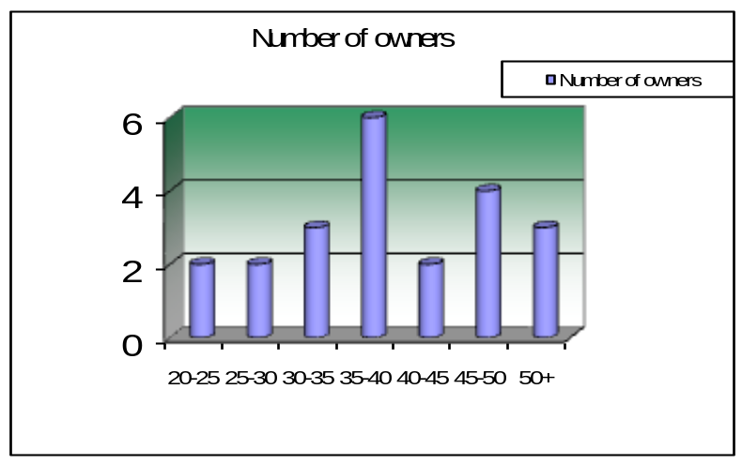This industry needs a healthy mount of initial investment. So, very young entrepreneurs are found rarely. Most owners of the plastic industries show a trend to engage in the industry in their late 30s and early 40s.
Figure 5.1: Age of entrepreneurs

5.1.3 Educational Qualification
Largely the entrepreneurs seem to lack much educational background. Generally educational qualification is not of much importance in this industry. Most of the owners are only High-school passed.
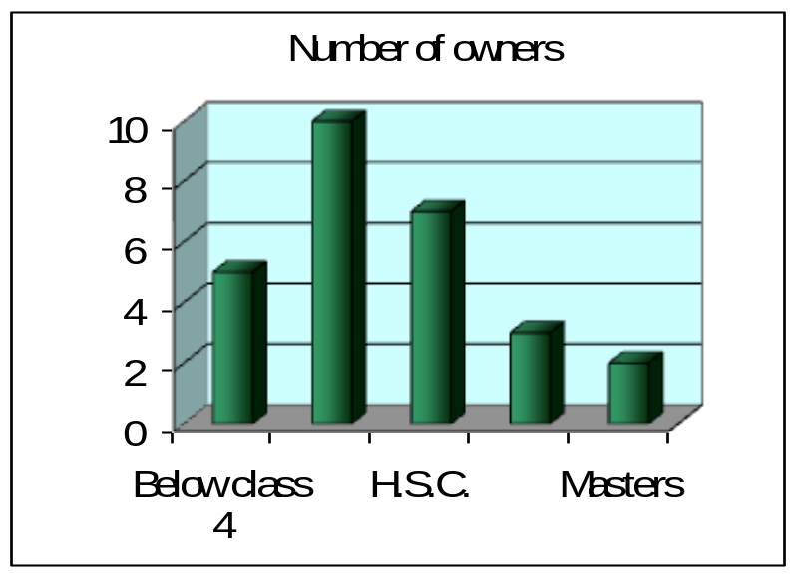Figure 5.2: Educational background of the owners

5.1.4 Forms of Ownership
All of the plastic industry units are either sole-proprietorships or partnerships. Family owned partnerships are also prevalent.

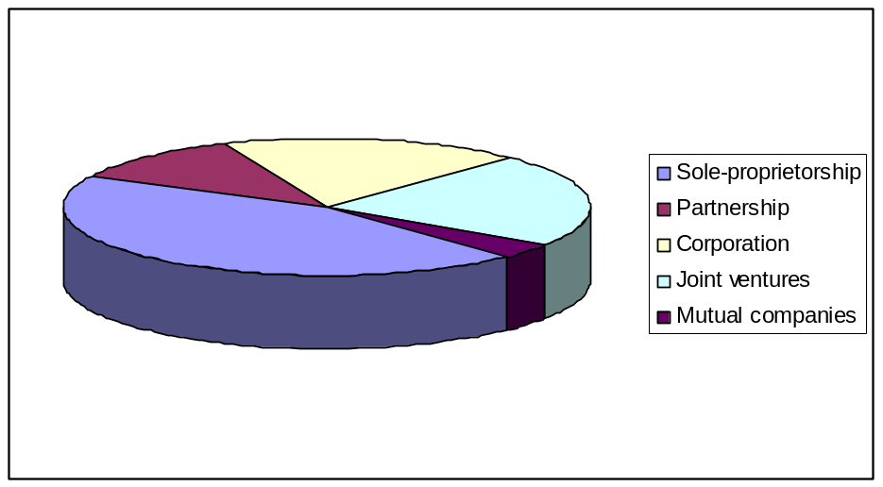
Figure 5.3: Forms of ownership

5.1.5 Starting Period of the Business
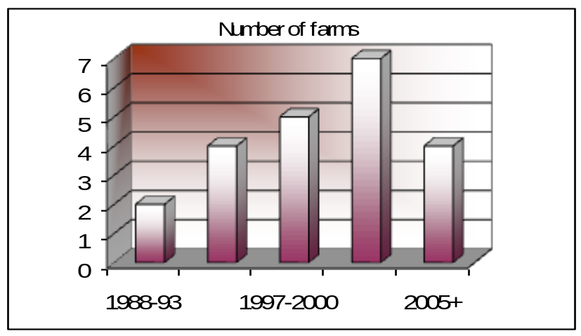Although plastic industry came to Bangladesh in the 1980s the trend for that business in a large scale is relatively much more recent. More than 90% of the industry units that we surveyed started operating in 1990s, majority of them were within 6 years.
Figure 5.4: Year of business commencement

5.1.6 Latest occupation prior to starting the business
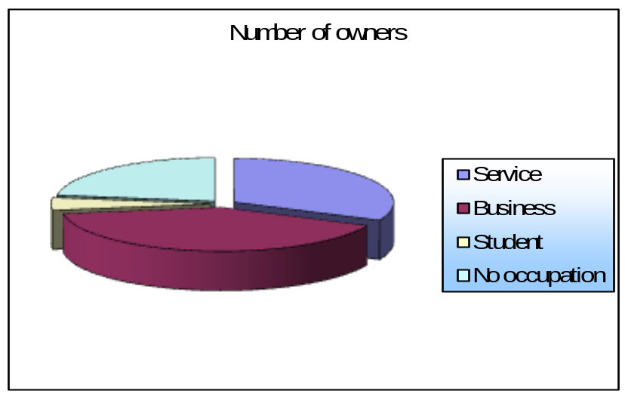About 70% of the owners, that is 16 out of 22 owners surveyed, said that they were previously engaged in another job before turning to this profession. Most of the previously employed owners had a business.
Figure 5.5: Latest occupation before starting the business

5.1.7 Business Experience
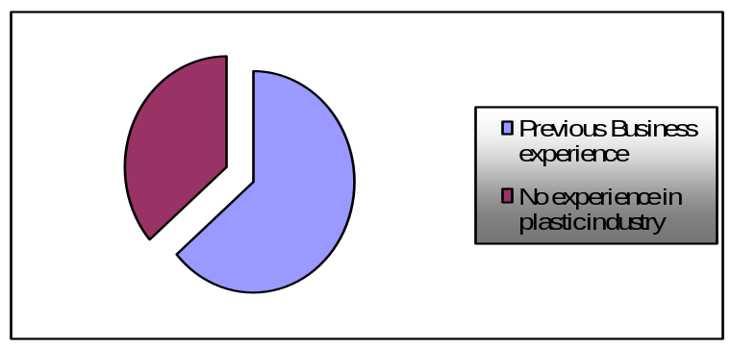Of the 40% owners who said that they were previously engaged in some business and some the others a total of 32% had previous business experience in this industry, some from family business and some from occupational background.
Figure 5.6: Previous business experience

5.1.8 Family Members

Many of the owners of the industries live with a joined family of more members. In 60% cases the owner is the only earning member of the family.
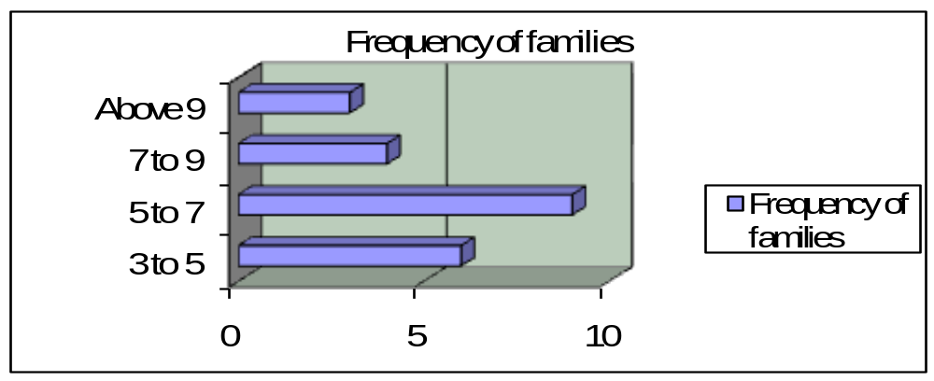Figure 5.7: Number of family members

5.1.9 Reasons for Starting the Business

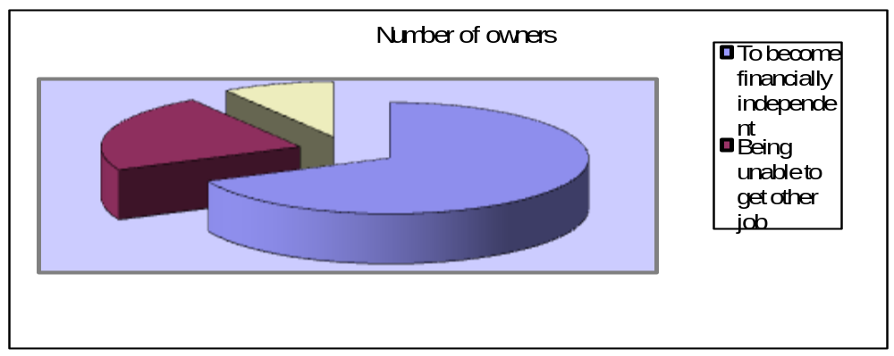Most of the owners pointed financial self-sufficiency as the key reason for starting the business. 70% of the respondents identified financial incipiency as the primary reason while 23% said failure to find employment as the reason. There were few cases where added social status and others were also a reason.
Figure 5.8: Reasons for starting the business

5.1.10 Capital invested primarily
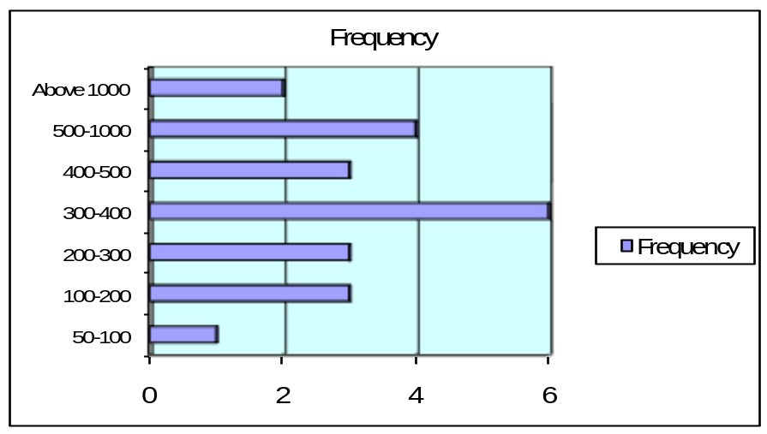The amount of capital invested in the industry varied a great deal, mainly with the product type. The manufactures of PVC pipe had invested a lot more than the utensil manufacturer and they also had more return on investment. The total investment of the whole industry varied from Tk. 50000 to more than Tk. 20 lakh.
Figure 5.9: Initial capital invested

5.1.11 Sources of Initial Capital
Almost all the owners said that the capital was acquired from own or family sources. Some said that they themselves invested the full amount of capital. On the other hand there were cases where the full amount was bear by some family member.

5.1.12 Current Capital
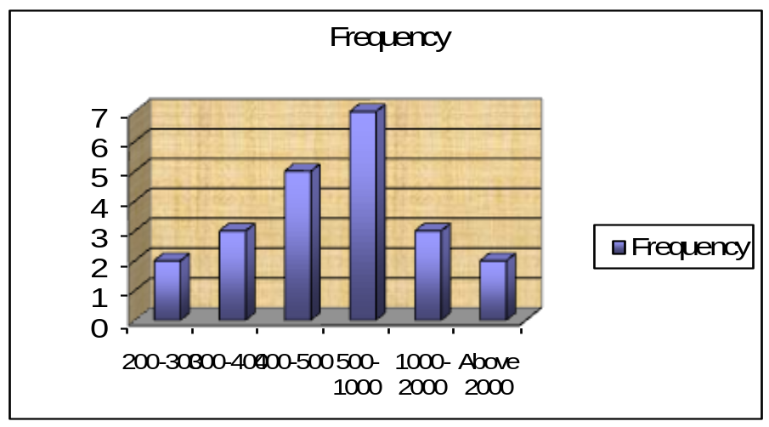While some said that capital has increased. In some cases the amount of capital has increased by quite a significant margin, whereas in other cases the increase has been insignificant. Some others have also claimed that the amount of capital has decreased due to losses.

Figure 5.10: Current capital

5.1.13 Peak and Low Business Season
Here different types of industry show different peak seasons according to their production and sales volume. The P.V.C. pipe industries show rapid sales in the winter season. In the dry season pipes are required by the farmers for the irrigation of lands. They show a depressed sale volume in the rainy season because in this season not many construction works are underway.

5.1.14 Risk Factors in the Business
In any business undertaking or entrepreneurial activities, there always exist certain risk factors. These factors may be negligible or they may be high, but they do persist. The owners of the businesses interviewed asserted that all the businesses at the starting point included a high degree of risk; with only a few exceptions saying moderate risk. More than 90% said high initial risk. As the business progressed the risk degrees were lessened.
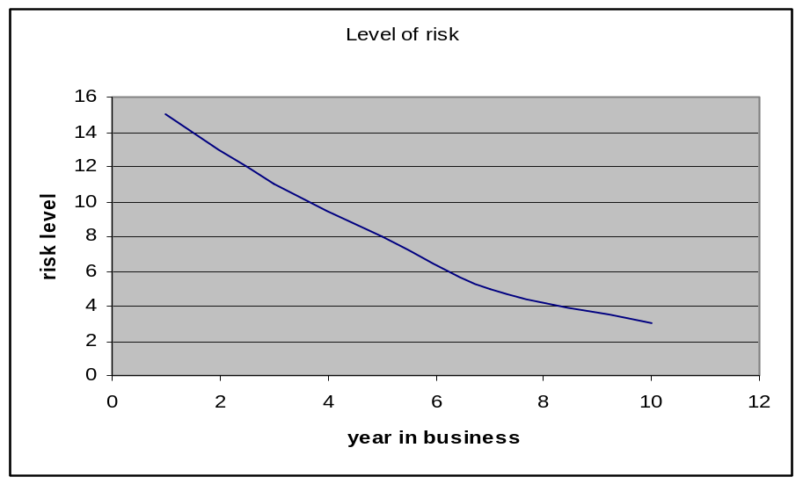

Figure 5.11: Risk level in the business

5.1.15 Pricing
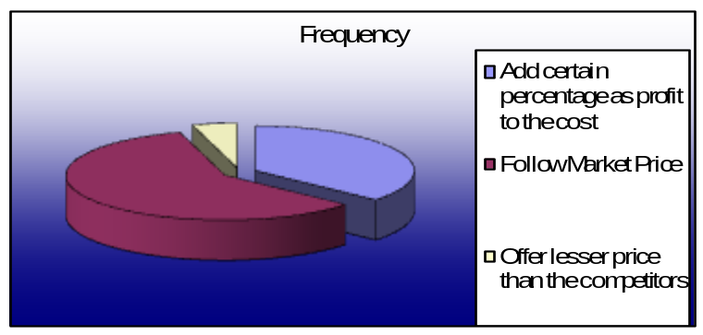Most of the firms practice cost-plus or mark up pricing to determine the price of their products. Many others just follow the current market price or the on-going pricing.

Figure 5.12: Pricing method
5.2 Major Challenges

The plastic product manufacturing was quite profitable in the past years. Recently, the industry has faced a number of problems. From the interview of several entrepreneurs the major problems can be summarized by the following –

- The first challenge for the entrepreneur is keep up with the imported products. As many companies are importing low price products from India, Singapore, Thailand and so on.
- Government help is not sufficient. Starting the business needs lots of paper work and formalities if done properly. So many of the entrepreneurs do their business without proper documents.
- Unstable political condition hampers the production a lot. It also decrease the supply of raw materials.
- As this industry was profitable, many entrepreneurs has come up and set new industries. This has caused an intense competition in the sector. For this reason the price of end products has decreased 300-400%. While the technology has not improved that much.
- Sometimes there is a crisis in the raw materials market. For this reason, the price of raw materials has increased almost 100% in the last 4 years.
- The Industry was exporting some of its products in the North-Eastern India. But recently, some plastic industries have been established in that area to cater the local market. So the export has dried up. This is also affecting the industry.
- There depression going on in our economy. As a result the people are not spending much. Especially in the villages, which is the largest market of most of the plastic goods, the farmers are not getting due price of their products. So indirectly the plastic industry is also faced with problems.
- Electricity failure is affecting the industry very much, as the whole production process is based on electricity.
- The Dhaka based producers are also facing competition from the producers of plastic hailing from other districts. For example, quite a few plastic industries have been established in the Chittagong, Bogra abd in Comilla districts.
- As it is a manufacturing industry, the profit comes little later than service companies. So the entrepreneurs have to survive in the initial stages.
Chapter 6
Recommendation

6.1 To the Government

- First of all Government should create a secluded industrial zone for plastic industries with gas and electricity and other supplies and transfer all the industries there.
- Government should provide loans according to their capital.
- Ensuring uninterrupted Electric Supply. It has been mentioned by the most of the respondents that the electricity problem of recent times is heavily affecting the industry. The government must solve this problem as soon as possible. Government should take steps to stabilize the economy and political condition
- Government has to minimize the bureaucracy and the harassment that the entrepreneurs have to go through to import raw materials.
- Government should remove taxation on the plastic sector for at least a five year period to give the growing industries a chance. In the case of PVC pipe manufacturers, the government has imposed VAT recently, which is affecting the industry very much. So the government should exempt VAT for all new PVC pipe industry for at least five years.

6.2 To the entrepreneurs

To overcome the challenges entrepreneurs need to take some steps. These are –
- As most of the workers are unskilled, there should be a training period for each worker so that they can learn and contribute more.
- Most of the small enterprises are not following the rules and regulations, which eventually hampers the business.
- Entrepreneurs should update the technologies for production. Use of computer should be increased to get more efficiency.
Conclusion

Entrepreneurs in our country seldom face many challenges because of corruption, inefficiency in government and unstable political condition. The plastic manufacturing industry assumes a very important position in manufacturing activities. It now possibly generates gainful employment of at least 1 lakh people in manufacturing activity. All this have been achieved without the help of the government or any of its institutions. The industry processes a great potential for expansion and can meet the demand for a large variety of domestic goods and children’s toys and games. It also has export potential. Therefore government intervention is necessary in terms of providing access to credit acquiring improved technology, training to produce and develop products and marketing services. As a developing country and a having market of 15 crore entrepreneurs should come forward to develop this industry.
Bibliography

- Paul A. Samuelson, William D. Nordhaus. “Economics”, Tata McGraw-Hill Company Ltd. Eighteenth Edition, 2006.

- http://www.alibaba.com/member/sattargroup/product.html, February, 2007

- http://www.alibaba.com/member/bengalrafiq/product.html, February, 2007

- www.wikipedia.org/plastic.htm, February, 2007

- Raymond V. Lesikar, “Business Communication: Theory and Application”, A.I.T.B.S. Publishers and Distributors, India. Sixth Edition, 2004

Appendix A

Microeconomics
(Questionnaire for Entrepreneur)
I, a student of MBA 40th batch, Institute of Business Administration, University of Dhaka have been assigned to make a term paper for the course ‘Microeconomics’. I have proposed ‘Plastic industry’ as an SME for this report. Therefore, I am going to ask the following questions. It is hereby mentioned that I shall not force you to disclose any information, which may be confidential from your viewpoint. The information gathered will be used only for educational purposes and will not be used elsewhere. Your cooperation will always be worthy to us.

Name of the firm:

Name of the entrepreneur:

Age of the entrepreneur:

Educational qualification:

Establishment year:

1. What is the type of ownership in your firm?
- Sole-proprietorships
- Partnership
- Family owned partnerships

2. What was Latest occupation prior to starting the business?
- Service
- Other business
- Student
- No occupation

3. Did you have any prior experience of business in plastic industry?
- Yes
- Very little
- No

4. What is the reason for starting the business?
- To become financially independent
- Being unable to get other job
- Other reasons
5. What was the amount of capital invested initially?

6. What was the source of the initial capital?
- Own
- Family
- Bank Loan
- Borrow from friend

7. What were the business starting risk factors in this industry?

8. What problems you are facing currently?

9. What is the pricing method for your products?

10. What are the most popular products of your firm?

11. How much is the degree of profitability of your firm?

12. Is government supporting you sufficiently?
a) Yes b) No

13. If no, what are steps government should take?

Thank you for your cooperation…..

