Internship Report
On
Deposit and Loan Schemes of Premier Bank Limited

Submitted by

WWW.ASSIGNMENTPOINT.COM

A bank is a financial institution that is licensed to deal with money and its substitutes by accepting time and demand deposits, making loans, and investing in securities. The bank generates profits from the difference in the interest rates charged and paid.

A bank earns money by reinvesting these funds in longer-term assets. A Commercial Bank invests funds gathered from depositors and other sources principally in loans. An investment bank manages securities for clients and for its own trading account. In making loans, a bank assumes both interest rate risk and credit risk; market rates may rise above the Net Interest Margin a bank earns on its loan portfolio and investments, and borrowers may default.
Banks dominate the financial sector and other financial institutions play a relatively minor role in the economy. At present there are 49 banks in the country, of which 30 are privately owned commercial banks (PCBs), 10 are foreign owned commercial banks (FCB), 4 are state owned nationalized commercial banks (NCBs) and 5 are development finance institutions, all operating under the license and supervisory authority of the Bangladesh Bank (the central bank of the country). In recent years, the banking industry witnessed a number of positive developments.

Starting the journey in the Banking sector with the motto “Service First” in the year 1999, the Premier Bank Limited relentlessly providing most quality and caring banking services to its customers. Over the last six and a half years the Bank is successfully operating its business in combination of traditional and Islamic banking to cater the banking needs of rapidly growing customers; over the years, the Bank distinguished its position in operating and competing with other banks among the peer group in the country. Among the third generation banks of Bangladesh, the Premier’s Bank’s performance in terms of profitability, maintaining superior asset quality have exceeded the expectations.

This paper is an attempt to show a comparative study on Deposit & Loan Schemes of premier Bank Limited. This paper will also focus about the History, Features & Commitment, Customer Services, Product & Services, and Performance etc. of the Premier Bank Limited.

1.2 Objective of the study

● To understand the customer services of Premier Bank.
- To study the deposit & loan schemes of Premier Bank.
- To highlight the performance of Premier bank Ltd.
- To highlight the comparative study of deposit & loan schemes of Premier Bank.

1.3 METHODOLOGY
The study requires a systematic procedure from selection of the topic to final report preparation. To perform the study data sources are to be identified and collected, they are to be classified, analyzed, interpreted and presented in a systematic manner and key points are to be found out. This overall process of methodology is given in the following page in the form of flowchart that has been followed in the study.

- Selection of the topic: The topic of the study was assigned by Premier Bank official. Before assigning the job it was discussed with my faculty supervisor so that a well-organized internship report can be prepared.

- Identifying data sources: The report is prepared mainly using secondary data. But some primary data were required as well, which have been collected with help of a formatted questionnaire.

i) Primary Sources: A little of the required information came from primary sources. These sources are -
  - Face to face conversation with the officers: Officers of the General Banking & Credit Division of Barisal Branch, Barisal have been interviewed. The total number of officers interviewed is 10 (7 are from General Banking Division and 3 from Credit Division have been

  - interviewed in the study).
  - Practical desk work
  - Relevant file study as provided by the concerned officer

ii) Secondary sources: Conceptual parts of the report have been collected by studying different literatures. Some of these secondary sources are:

  - Different Circulars issued by the Head Office and Bangladesh Bank
  - Different ‘Prospectus & Brochure, published by Premier Bank.
  - Annual Reports (2004, 2005 & 2006) of Premier Bank Limited.
  - Web Site of the Premier Bank.

- Collection of data: Primary data was collected using interviewing technique. The report is an exploratory research and for qualitative survey open-ended questions were asked to the bank officials.

- Classification, analysis, interpretation and presentation of data: Some arithmetic and graphical tools are used in this report for analyzing the collected data and to classifying those to interpret them clearly.

- Findings of the study: The collected data were scrutinized very well and were pointed out and shown as findings. Few recommendations are also made for improvement of the current situation.

- Final report preparation: On the basis of the suggestions of our honorable faculty advisor some corrections were made to present the paper in this form

1.4 Scope of the Study

Mode of Marketing is much talked in the gaining of economic development. This topic includes a vast area of marketing analysis. This present study covers only the modes of competitive Products of Premier Bank, specially the Deposit & Loan Schemes of Premier Bank Bangladesh Limited (PBL). This study is confined to only this bank other than conventional bank.

1.5 Limitation of the study

- It is very difficult to analyze this issue without proper knowledge about commercial banking and economy.
- As it is not conventional so it bears some complexity to understand.
- It is time consuming to differentiate & understand sector wise loan distribution & loan schemes.

1.6 Background of the Premier Bank

 |  | BACKGROUND  The Premier Bank Limited is incorporated in Bangladesh as banking company on June 10, 1999 under Companies Act.1994. Bangladesh Bank, the central bank of Bangladesh, issued banking license on June 17, 1999 under Banking Companies Act.1991. The Head Office of The Premier Bank Limited is located at Banani, one of the fast growing commercial and business areas of Dhaka city.  Corporate Information  Authorised Capital : BDT 2000.00 Million  Paid up Capital : BDT 681.45 Million

1.7 Vision & Mission of the Bank
Vision of the Bank
The Bank has clear vision towards its ultimate destiny - to be the best amongst the top financial institutions.
Missions of the Bank
- To be the most caring and customer friendly provider of financial services, creating opportunities for more people in more places.
- To ensure stability and sound growth whilst enhancing the value of shareholders investments.
- To aggressively adopt technology at all levels of operations to improve efficiency and reduce cost per transaction.
- To ensure a high level of transparency and ethical standards in all business transacted by the Bank.
- To provide congenial atmosphere which will attract competent work force who will be proud and eager to work for the Bank.
- To be socially responsible and strive to uplift the quality of life by making effective contribution to national development.

1.8 Special Features of the Bank

- Real time Online Banking facility allowing transactions at any branches of the Bank irrespective of the Branch where customer opens his account.

- The Bank pay interest on daily balance of the Personal Savings Account which also operates like a current account.
- The Bank is one of the principal members of VISA international & offer VISA credit card both local and international ever first by a local bank in Bangladesh.

- The Bank has introduced SMS banking facility allowing the customers to make query regarding account balance, cheque payment and deposit status and also delivery request for account statement.

- Customer’s Call Center under direct supervision of Managing Director has been set up to attend different queries and suggestions as well as various Objections / allegations from the customers for the purpose of improving the quality of service of the Bank.

- New product and services with attractive features have been designed to fulfill the needs of various socio-economic strata.
- CMS banking facility provides the opportunity to know credit card balance at any time.
- Premier’s evening banking gives the opportunity to bank beyond transaction hours till 8’ o-clock in the evening at selective branches.

- Premier has two Islamic banking branches which are operating on Islamic Shariah Base profit and loss sharing principles.

1.9 SERVICE HIGHLIGHTS OF PREMIER BANK
SMS Banking Service

Evening Banking Service

Islamic Banking Service

Relationship Banking Service

Online Banking Service
VISA Credit Card Service

Utility Service

CMS Banking Service

Wage Earner Remittance Payment Service

Locker Service

Treasury Solution Service
Corporate Web Site Service

Customer Call Center Service

Premier Debit Card ATM/POS Service (Proposed)

1.10 Board of Directors
Board of Directors
The Board consist of 12 (Twelve) Directors. The members of the Board of Directors of the Bank hold very respectable positions in the society. They are from highly successful group of Business and Industries in Bangladesh. Out of 12 members one is from Taiwan. Each member of the Board of Directors plays a significant role in the socio-economic domain of the country. A list of the Directors and their shareholding along with associated business is given below:

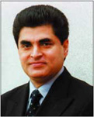 |  | Dr. H.B.M. Iqbal
Chairman
Dr. H.B.M Iqbal

 |  | 
Mr. B.H. Haroon  Vice Chairman |  | Dr. Arifur Rahman  Director

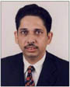 |  | 
Mr. Nurul Amin  Director |  | Ms. Nawrin Iqbal  Director

 |  | 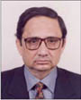
Mr. Abdus Salam Murshedy  Director |  | Mr. Shafiqur Rahman  Director

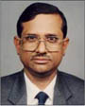 |  | 
Al-haj Abul Kashem  Director |  | Mr. Lutfor Rahman  Director

 |  | 
Mr.Yeh Cheng Min  Director |  | Mrs. Shaila Shelly Khan  Director


Mr. Khondker Fazle Rashid
Managing Director

1.11 Management Committee
Mr. Khondker Fazle Rashid
Managing Director

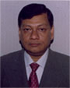
Mr. Mokhlesur Rahman
Additional Managing Director

1.12 List of Branches

At present Premier has 27 branches and 8 proposed branches (Sorted Alphabetically)
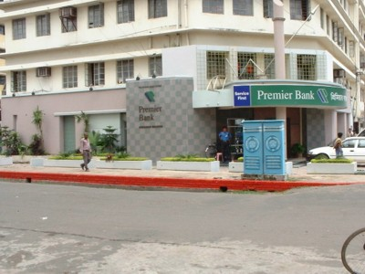 | Agrabad Branch  Al Islam Chamber  91, Agrabad Commercial Area  Chittagong  Tel : 714418, 717204,728256  Mobile : 01711825200 (Branch)  Fax : 880-031-714418  Telex : 633081 PREAG BJ  Email : prebankag@spnetctg.com
Ashugonj Branch
Station Road, Ashugonj, Brahmanbaria.
Tel: 08528-448
Mobile: 01711826048
 | Banani Branch  Ground and 2nd Floor, Iqbal Center,  42, Kemal Ataturk Avenue, Banani, Dhaka – 1213  Tel: 9887581-84, Ext. – 301, 306  Fax: 880-2-8815393  Telex: 642542 PRBHO BJ  E-mail : prebank@bangla.net  S.W.I.F.T. : PRMRBDDH
Bangshal Branch
1st Floor, 70, Shahid Syed Nazrul Islam Sarani
(North-South Road), Bangshal, Dhaka
Tel : 880-2-9565684, 880-2-9565738
Fax: 880-2-9565807
Barishal Branch
54, Sadar Road, Barisal
Tel : 0431-63102-4
Mobile : 0173450651, 0171465788
Fax : 0431-63104
Email : info@premierbankltd.com
Bhairab Bazar Branch
129 (Old), 172 (New) East Kalibari Rd, Bhairab Bazar, Kishoregonj
Tel : 09424-71122, 71133; Mobile : 01713144282 (Open: 16-11-2006)
Fax: 71133
Email : info@premierbankltd.com
 | Dhanmondi Branch  House # 84, Road # 7/A, Dhanmondi, Dhaka –1209  Tel : 9145186, 9143081, 8124746  Mobile : 01711- 595720  Fax : 9112395  Telex : 642552 PRBDB BJ  Email : prbankdl@bttb.net.bd  S.W.I.F.T. : PRMRBDDHDHN
 | Dilkusha Branch  44, Dilkusha C/A, Dhaka – 1000  Tel: 880-2-9552303, 880-2-9569180, 880-2-9552328  Fax: 880-2-9552801  Telex: 642552 PRBDB BJ  E-mail : prebankdl@bttb.net.bd  S.W.I.F.T.: PRMRBDDHDIL
Elephant Road Branch
1st floor, 248, New Elephant Road, Dhaka
Tel : 880-2-8616803, 8617992, 8618003 (Direct)
Mobile : 01713-001815 (Manager)
 | Gulshan Branch  140, Gulshan Avenue, Gulshan Circle 2, Dhaka-1212  Tel: 880-2-8815268, 880-2-9882781, 880-2-9890391  Fax: 880-2-8818338  Telex: 642541 PRBGL BJ  E-mail : prebankgl@bttb.net.bd  S.W.I.F.T.: PRMRBDDHGUL
Imamgonj Branch
75, Mitford Road, Imamgonj, Dhaka
Tel : 7313199, 7317752
Mobile : 01199805334 (Manager)
Fax : 7313199
Telex : 642556 PRBIM BJ
Email : prebankim@bttb.net.bd
Joydebpur Branch
Ground Floor, Dilan Complex, Dhaka Road
Chandana Chowrasta, Joydebopur, Gazipur-1702
Tel : 9257551, 9257552
Mobile : 01713-039774
 | Kawran Bazar Branch  Pragati Rhone Poulenc Centre, RAJUK Plot No. 20 / 21  Kawran Bazar C/A, Tejgaon, Dhaka  Tel: 880-2-9121485, 9139657  Fax: 880-2-9133645  E-mail: prbankkb@bttb.net.bd
Khatungonj Branch
Nabi Super Market (1st floor), 232, Khatungonj, Chittagong
Tel: 639521 (Direct), 639523, 618259
Fax: 639468, Mobile: 01711- 723119
Kakrail Branch
46/A (2nd floor), VIP Road, Kakrail, Dhaka-1000 (Opening: 24 Dec 06)
Tel: 9344628, 9344438, 9353963, 9359116
Mobile: 01199885888, 01711584401, 01815447980 (Manager)
Fax: 9344438
Khulna Branch
Ist floor, 141 Sir Iqbal Road, Khulna
Tel : 880-41-810253-4
Mobile : 01711-218373 (Manager)
Meghnaghat Branch
New Town Commercial Complex (1st Floor)
Meghnaghat, Sonargaon, Narayangonj.
Tel: 0607-8210111, 0189-249836
Mohakhali Branch (Islami Banking Branch)
99 Mohakhali C/A, Dhaka
Tel : 8853503, 8859223, 8858118(Direct)
Mobile : 01713-007659 (Manager)
Moulvi Bazar Branch
855/6 Sayed Mujtoba Ali Road, Moulvi Bazar, Sylhet (Opening: 28 Dec 06)
Tel : 62880, 62881
Mobile : 01715397399 (Manager)
 | Motijheel Branch  81, Motijheel C/A Dhaka – 1000  Tel: 880-2-957113-4,9557656,9555340(D)  Fax: 880-2-9557317  Telex : 642552 PRBDB BJ  email: prebankmt@bangla.net
Narayangonj Branch
2nd Floor, Rahat Complex, Old-56, New 53/3
SM Maleh Road, Tanbazar, Narayangonj
Tel: 9750102-3; Mobile : 01713031878 (Manager)
Fax: 9752493 (Opening: 15 Feb 2004)
O. R. Nizam Road Branch
Hotel Harbour View Building (1st Floor), 721 CDA Avenue,
O.R.Nizam Road, Chittagong (Open: 23-11-2006)
Tel : 031-2852437, 2852434, 2852438, 2852436
Mobile : 01713124422, 0189310526 Fax: 2852438
Email : info@premierbankltd.com
Savar Branch
Hashem Plaza, DEPZ Gate, Ganakbari, Savar
Tel : 880-2-7702108-9, Fax:7702108
Mobile : 01199808332 (Manager)
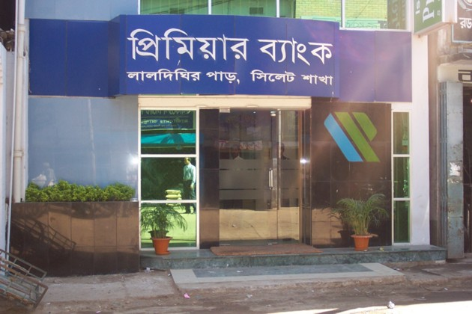 | Sylhet Branch (Islamic Banking)  Plot # 177, Laldighirpar, Sylhet  Tel : 0821-813050-2  Mobile : 01713-010346, 01713-302002
Tongi Branch
175 Kazi Market (1st Floor), Mymensingh Road, Tongi.
Tel : 9815756-7; Mobile : 01711538758 (Manager)
Fax: 9815758
 | Uttara Branch  Ground floor, House # 39, Road # 7  Sector 4, Uttara, Dhaka  Tel : 880-2-8956430, 8953945  Mobile : 01199812862 (Manager)
Zinzira Branch
Haji Nannu Bepari Mansion(1st Floor),2nd Buriganga Bridge Road,
Zinzira, Keranigonj, Dhaka
Mobile : 01730000466(Manager)

1.13 Contact Information
The Premier Bank Limited
Head Office
IQBAL CENTRE (4th Floor), 42 Kemal Ataturk Avenue, Banani, Dhaka-1213
Tel : 880-2-9887581-84, 8811417, 9890591-2, 8819916, 9890547, 9890012, 8825614
Mobile : 01711826047, 01711595718, Fax : 880-2-8815393, 9889153
Telex : 642542 PRBHO BJ
Email : info@pemierbankltd.com
Head of Division and PABX Extentions
Name | Division | Desig. | Ext. #
Mr. Md. Abdul Hai | Financial Administration | SEVP | 106
Mr. Sahdat Hossain | Credit | EVP | 209
Mr. Shafiuddin Ahmed | International Division | VP | 117
Mr. Golam Mahmud Jamil | Card Division | VP | 708
Mr. Md. Munibur Rahman | Treasury Division | FVP | 204
Mr. Sayed Nowseher Ali | General Services | FVP | 122
Mr. Nasim Ahmed | Internal Control & Compliance | SVP | 115

THE PREMIER BANK LIMITED

2.1 FORMATION OF PREMIER BANK

The Premier bank limited its operation from October, 1999 under the bank Companies Act 1991. The Bank was established by Dr. H.B.M Iqbal, Chairman in association with a few successful entrepreneurs from various fields of business activities to fulfill his dream to create a financial institution that would stand out from the crowd and meet the demand of 21st century.

Since than, the bank has emerged as a quality financial institution and making significant contribution to the national economy. The authorized capital of the Bank is BDT 2000.00 million and the total capital funds as on 31.122006 is BDT 1855.58 million including Pain-up capital of Tk. 845.00 million. The Premier Bank is a full service Commercial Bank and licensed by Bangladesh Bank as a scheduled bank.

2.2 Premier Bank, an Overview

Starting the journey in the Banking sector with the motto “Service First” in the year 1999, the Premier Bank Limited relentlessly providing most quality and caring banking services to its customers. Over the last six and a half years the Bank is successfully operating its business in combination of traditional and Islamic banking to cater the banking needs of rapidly growing customers; over the years, the Bank distinguished its position in operating and competing with other banks among the peer group in the country. Among the third generation banks of Bangladesh, the Premier’s Bank’s performance in terms of profitability, maintaining superior asset quality have exceeded the expectations.

In a challenging market conditions and also to fetch/explore post-MFA globalization effects, the bank continued to provide more innovate products and best quality services to retain the market share. The strategic objective and goal for the bank has been clearly identified and laid down in the corporate plan. Priorities identified in the corporate plan including expansion of business lines in new areas such as house building loan, investment and portfolio management, lease finance, overseas remittance business.

2.3 CORPORATE INFORMATION

Board of Directors

Chairman : Dr. H.B.M. Iqbal

Vice Chairman : Mr. B.H. Haroon

Directors : Dr. Arifur Rahman
Mr. Nurul Amin
Mr. Abdus Salam Murshedy
Mr. Shafiqur Rahman
Al-haj Abul Kashem
Mr. Yeh Cheng Min
Mrs. Shaila Shelly Khan
Ms, Nawrin Iqbal
Mr. Sanwar Dito
Mr. Md. Lutfur Rahman

Managing Director : Mr. Abu Haniff Khan

Company Secretary : Syed Ahsan Habib, ACMA

Executive Committee

Chairman : Dr. H.B.M Iqbal

Vice Chairman : Mr. B.H. Haroon

Members : Mr. Nurul Amin
Mr. Abdus Salam Murshedy
Mr. Shafiqur Rahman
Ms. Nawrin Iqbal

Managing Director : Mr. Abu Haniff Khan

Managing Director : Mr. Abu Haniff Khan

Additional Managing Director : Mr. Md. Mokhlesur Rahman

Additional Managing Director : Mr. Md. Nurul Alam Chowdhury

Consultant : Mr. Kazi Anwarul Mahbub

List of Executives

Managing Director : Mr. Abu Haniff Khan

Additional Managing Director : Mr. Md. Mokhlesur Rahman

: Mr. Md. Nurul Alam Chowdhury

Senior Executive Vice President : Mr. Dewan Anwarul Latif

Executive Vice President

Mr. Md. Shah Alam Mr. A.K.M. Shamsuddin
Mr. Md. Abdul Hai Mr. Md. Wahidur Rahman
Mr. Sahdat Hossain Mr. AHM Wali Khan
Mr. Md. Khurshed Alam Chowdhury Mr. Qazi Abdur Razzaque
Mr. A.K.M. Fazlul Hoq Mr. Kazi

2.4 Commitment of the Bank

Service First – “Service First” is not just the Bank’s motto the Bank really mean it. Premier know that, by responding to customer needs, the Bank can provide better services. The Bank train its employees to use their own initiative to satisfy customers’ needs, resolve problem quickly and make suggestions about how to serve them better.
Easier Banking – Providing customers with a comfortable environment and up to date technical facilities to do their banking is an important aspect of the customer service at Premier Bank. The Bank’s goal is to make banking easier through one to one communication.
Better Relationship – Premier view banking to be a long term relationship with customers. The business they transact with Premier help the Bank to understand their goal and expectations and the Bank respond proactively to their financial needs.
Assured Confidentiality – At Premier Bank, the bank takes great care of the customers, to make sure that all the banking transactions are done in a confidential & profession manner.
Good Corporate Governance – The Premier Bank Limited has a very dynamic Board of Directors drawn from different disciplines. They hold very respectable positions in the society and are from highly successful group of Business and Industries in Bangladesh. The Bank has a very competent Management Team who have long experience in domestic and international banking. The Bank upholds and strictly abides by good corporate governance practices and is subject to the regulatory supervision of Bangladesh Bank.

2.5 Corporate Governance

Corporate governance establishes professionalism and trust among the interested parties, builds capacity to operate business efficiently and creates a congenial working environment which is inevitable to face the challenges of the present competitive business arena. The Premier Bank practices good corporate governance at all level since its inception. The dynamic Board of Directors of the Bank is entrusted with formation of policy guidelines and objectives setting, strategic planning and supervising business activities and performance of the Management. The Management Committee (MANCOM) at head office and at branch ensures that the activities of the bank are always conducted with the highest ethical standards and in the best interest of all its stakeholders. Interdivisional co-ordination is good and the workflow and job responsibility is specific. The Management formed several divisions to handle the banking operation efficiently. Internal control and compliance division, responsible for internal control and compliance and they report directly to the Managing Director and the Board Audit Committee, which works independently. Various committees such as asset-Liability Committee, Management Committee and Purchase Committee etc. are exercising their delegated authorities to discharge their responsibilities within banking norms/practices complying with all regulatory restrictions. Each and every Branch is being audited once in a month. Surprising inspections were also conducted. Bangladesh Bank also conducted inspection on all major branches during the year. As a result House Keeping and Compliance in the Branches are reflected as excellent.

2.6 Management

For smooth operation, risk management and monitoring purpose Premier Bank’s Board has formed several Committees comprising members from Management. The main committees are MANCOM, Risk Management Committee, Asset Liability Management Committee (ALCO), Treasury Committee, audit Committee etc. In the Management team, the Managing Director is assisted by two Additional Managing Directors, SEVP, EVPs, SVPs, Vice President and other executives of different capacities. The day-to-day banking functions are handled by these professionals with modern banking knowledge and experience in their respective fields. The Head Office Management Committee (MANCOM) examines all the cases thoroughly before referring for decision of Executive committee. Also the Premier Bank has introduced “Branch Management Committee” in all branches with the objective to ensure informal control and smooth operation of the Branches. These two measures have brought in dynamism, involvement and fast decision making process both at Head Office and at Branches.

2.7 Human Resources

The Premier Bank considers its employees as the most valued resources and focal point of all its activities. The Premier Bank follows a structured recruitment policy, service rules and compensation package for its workforce at all tires. Since its inception, the Bank has recruited highly talented professional manpower coupled with fresh university Graduates and build the finest team to cope up with the growing business needs. Considering its employees at the most valued resources and the focal point of all its activities, the Bank conducted comprehensive training sessions and workshops through its own Training Institute and Bangladesh Institute if Bank Management (BIBM) with the vision of developing Human Resources to the highest professional level and boosting productivity across the Bank. The Bank also sends its executives outside Bangladesh for specialized training on banking activities. As a service industry, the Bank is constantly trying to improve quality of its human resources where performance excellence is always encouraged by reward and recognition. The total number of employees of the Bank as on December 31, 2006 stood at 677, as against 605 in the preceding year.

2.8 Premier Social Activities

The Premier Bank Limited is very much keen and conscious about its corporate social commitment and it has been operating different types of charity, social welfare and benevolent activities during the last several years. In order to strengthen the Bank’s involvement in social and philanthropic activities, a non profitable, non-political and non-governmental organization in the name of “The Premier Bank Foundation”, has been set up and the Board of Directors has decided to contribute to the foundation out of its operating profit each year. The Bank’s helping hand has already covered different areas as:
Donation of Tk. 1.5 million to the poor and distressed people to purchase warm clothes to protect them from cold waves.

Donation of Tk. 0.52 million to the poor and distressed people to celebrate Eid-ul-Fitre, 2006.

In the coming years, the Bank expects to expand its contribution in diversified areas towards fulfillment its social commitments and responsibilities.

Social Activities (2005)

- Donation of Tk. 4.00 million to the Prime Minister’s relief fund and Tk. 4.00 million to the relief fund of Leader of Opposition of Parliament for rehabilitation of flood affected poor people.

- Donation of Medical Equipments worth Tk. 5.00 lac to the Dhaka National Medical College.

- Rewarding the GPA – 5.00 holders in the SSC examination’ 2005 as the recognition of their excellent performance.

- Sponsoring the Premier Division Football League-2005.

2.9 Customer Services
Locker Service
For safekeeping of customers' valuables like important documents and goods like jewelries and gold ornaments, Premier Locker Service is available in most of the Branches in urban areas.
Nature of Service | Nature of Charges | Rate of Charges
Custody of Locker / Safe | Rent | a) Yearly TK.1,500/= for small size locker  b) Yearly TK.2,500/= for medium size locker  c) Yearly TK.3,000/= for big size locker
*Condition apply TK.2500/= for Security Money (Refundable)
Islamic Banking
The Bank is presently operating two branches one at Mohakhali, Dhaka & another in Laldighirpar, Sylhet on Islamic Shariah base profit & loss sharing principles. Premier Bank Shariah Council, under the chairmanship of Mr. Shah Abdul Hannan, supervises and guides the operational activities of these two branches.

Call Center
"Service first" is Premier’s motto and to ensure further development in customer service, the bank has setup own "Call Center" at Head Office under the direct supervision of the Managing Director. If clients have any queries, need any product or service information or have any complaints, this is the right place to call & get the solution at the earliest.

Evening Banking Services
"Evening Banking", a unique service of The Premier Bank, only for receiving Cash and Documents beyond transaction hours till 8 o'clock in the evening, is available at Premier Bank. The service is attractive for those, like shopkeepers, who accumulate cash as sales proceeds in the afternoon when counters of Bank branches usually remain closed.
CMS and SMS Banking

Check bank account or credit card balance while he/she is stuck in traffic. Stop cheque payment from the airport. Request for account statement while watching TV. Check last three transactions at the restaurant......all these and more are possible through PREMIER CMS and SMS Banking Service.

Real Time Online Branch Banking Service
It gives clients real time any branch banking facility. Under this system, clients shall be able to withdraw Cash from account at any Branch of the Bank. Client can also deposit in his/her account, transfer money from account to any other account with any Branch of the Bank. All Branches have online banking facility.ONLINE BRANCH BANKING SERVICE is designed to serve its valued clients. Under this system, clients shall be able to do the following type of transactions:
Cash withdrawal from account at any branch of the Bank.
Deposit in account at any Branch of the Bank.
Transfer of money from his/her account to any other account with any Branch of the Bank.
Transaction Limit
Unlimited transaction.
Online Transaction Membership Fee
No Membership fee is required.
Charges for Online Transaction
No charges for online transaction except inter zonal transactions.

2.10 Product and Services

The Premier successfully marketed its products designed to fulfil the needs of various socio-economic strata. Attractive features of the products have given a distinctive image among the private banks. The bank has been making continuous endeavor to offer new products and services. Apart from usual fixed deposits, the Bank offers Monthly Income Scheme, Monthly Savings Scheme, Education Savings Scheme, Special Deposit Scheme etc. In continuous endeavour to satisfy the customers, some new products like Double Benefit scheme, Dui Bochore Digun Scheme have been introduced. The Bank finance in Project Loan, Working Capital Loan, Trade Financing, House Building Financing, Contractors Financing, Cash Credit, Overdraft, Packing Credit, Trust Receipt, Gurantee, Letter of Credit, etc. Apartment Finance Scheme is under the new product line of the bank. Moreover, the Bank offers some special credit scheme, inter-alia, Lease Financing, Personal Loan Scheme, Doctor’s Loan Scheme, Small and Medium Business Loan Scheme, Student Credit Scheme etc.

2.11 Islamic Banking

The Bank has two Islamic Banking branches located at 99, Mohakhali C/A, Dhaka and Laldighir par, Sylhet that offer Islamic Banking services under the principal of Shariah. For smooth operation of Islamic Banking and proper guideline, the Bank has a shariah Council consisting of renowned Scholars, Alem, Faqih, Lawyer, Islamic Banker, Philosopher under the chairmanship of Janab Shah Abdul Hannan, a renowned Islamic Scholar.
The members of Shariah Council are

Name | Designation
Janab Shah Abdul Hannan | Former Secretary, Peoples Republic of Bangladesh  Former Chairman, Islami Bank Bangladesh Ltd.
Advocate Mujibur Rahman | The Chairman, The Ibne sina Trust
Dr. M. Shamsher Ali | The Vice Chancellor of Southeast University
Dr. Anisuzzaman | Professor, Department of Philosophy, Dhaka University
Dr. Abu Bakar Siddique | Professor, Department of Arabic, Dhaka University
Dr. A.R.M. Ali Haider | Professor, Dept. of Islamic Islamic Studies, Dhaka University
Moulana Ruhul Amin Khan | Executive Editor, The Daily Inqilab
Dr. Mohd. Haroon Rashid | Research Officer, Bangla Academy

Ex-officio members of the council are:

Name | Designation
Dr. H.B.M. Iqbal | Chairman of the board of directors
Janab B.H. Haroon | Vice Chairman
Al-haj Abul Kashem | Director
Janab Shafiqur Rahman | Director
Janab Abu Hanif Khan | Managing Director

Underr Islamic Banking system, the bank receives deposit and operates under ‘Al-Wadiah’ (Amanah) and ‘Al-Mudaraba’ principle where depositors share the profit at pre-determined ratio of weightage.

Some of exclusive Islamic products are:

- Al-Wadiah Current Deposit
- Mudaraba Savings Deposit (MSD)
- Mudaraba Term Deposit Receipt (MTDR)
- Mudaraba Short Term Deposit (MSTD)
- Mudaraba Monthly Savings Scheme (MMSS)
- Mudaraba Monthly Income Scheme (MMIS)
- Mudaraba Education Savings Scheme (MESS)
- Mudaraba Special Deposit Scheme (MSDS)
- Mudaraba Double Benefit Scheme (MDBS) etc.

Premier’s Islamic Banking Branches meticulously follow the operational modes and methodologies as permissible under Shariah principle. The Bank invests the fund received from the depositors on the principle of Mudaraba under different mode of investments, such as
- BaiAI-Murabaha
- BaiAI-Muajjal
- BaiAI-Salam
- Hire-purchase under Shirkatul Milk
- Ijara (Lease)
- Qard against MTDR etc.

The Islamic Banking wings maintain separate Balance Sheet for transparency of the practices. They are gaining popularity in respective areas.

2.12 Automation in Banking Operation

All the branches of the Bank are working under one network in order to facilitate ‘Real Time Online Banking’ services to its customers. As a result, customers are enjoying the advantage of any branch banking facility. The Bank has launched SMS banking facility allowing its customers to make query regarding account balance, cheque payment and deposit status and also delivery request for account statement. Besides, Introducing of other online banking services like ATM service, Tele banking service, internet-banking service etc. will be launched within short span of time.

2.13 Future Outlook

Despite severe competition in the Banking sector in Bangladesh, the Premier Bank is emerging as a financially strong and strategically focused financial institution. Over the last seven years, the bank achieved significant growth and earnings which is close to expectation. The bank has now refocused to make the growth stable and steady and to retain its core commercial banking activities with corporate customers, develop fresh relationship with small and medium scale business firms. Having better asset quality, acceptable capital adequacy, moderate liquidity and network of 26 branches the bank Management aims to attain its target to become a top ranking bank of the country within short span of time. In the near future the bank expects to increase its branch network and trained manpower to serve more areas of the country and position itself as one of the best few banks in the private sector.

DEPOSIT A/C & SCHEMES OF PREMIER BANK LIMITED

3.0 Deposits
Savings Account
Current Account
Corporate Account
Foreign Currency (FC) Account
Short Term Deposit Account
Fixed Deposit
Double Benefit Scheme
Dui Bochore Digun
Monthly Income Scheme
Monthly Savings Scheme
Education Savings Scheme
Special Deposit Scheme

3.1 Savings Account
Premier has added a special feature to Savings Deposit Accounts. The Bank pays interest (6.50% p.a.) on daily balances on Savings Accounts. Most of the Banks in Bangladesh pay interest on monthly minimum balance. So, if clients are maintaining say Tk. 10.00 Lac in Savings Account with present Banker for 29 days and deposit balance drops below Tk. 1000 even for a single day; clients are not getting any interest on that amount. There are also several restrictions on withdrawal from the Account to qualify for interest.
In Premier Bank, however, he/she will get interest on any amount that he/she keeps in the account. There is no restriction for withdrawal from the account and is paying interest @ 6.50 % p.a. on daily balance. Premier hopes that clients will take full advantage of this offer and place deposits with Premier Bank to earn more.

3.2 Current Account
This is a non interest bearing deposit account. Current (CD) Account: The current account is probably the most useful bank account client will ever have. It is a non-interest bearing cheque account. Premier’s current account saves the hassle of carrying around cash every month.

3.3 Corporate Account
Premier is also paying interest @6.50% p.a. on daily balance for Corporate customers. It is a savings account that operates like a virtual current account. There is no restrictions on withdrawal.
Now clients can have all the features of current account with the interest of savings account.

3.4 Foreign Currency (FC) Account

Foreign currency account is an account in foreign currency that can be opened in any of Bank’s authorized dealer Branches. Bangladesh nationals residing abroad, foreign nationals residing abroad or in Bangladesh and also foreign firms registered abroad and operating in Bangladesh or abroad may open and maintain this account. In addition, Foreign missions and their expatriate employees may open this account. This account may also be opened in the names of resident Bangladesh nationals working with the foreign/international organizations, operating in Bangladesh provided their salary be paid in foreign currency.

Premier Bank offer a number of foreign currency accounts such as RFCD and NFCD Account. Other account includes Convertible Taka Account which is an account in Taka and the account holder has the option to convert Taka into foreiqn currency and vice versa.

3.5 Short Term Deposit (STD) Account
The Bank pay interest @7.00% p.a. for minimum 1 Crore and @6.50% p.a for bellow 1 Crore on the daily closing balance of Short Term Deposit (STD) Account. Interest is payable on daily closing balance. Any individuals and corporate bodies can open STD account.

3.6 Fixed Deposit
Fixed Deposits: A fixed deposit is meant for those investors who want to deposit a lump sum of money for a fixed period; say for a minimum period of 30 days to two years and above, thereby earning a higher rate of interest in return. Fixed Deposit Accounts offer flexibility at competitive rates of interest.
Premier offers very competitive rate of interest on Fixed Deposit (FDR). Indicative rate for one year deposits at present is 12.25% - 12.50% p.a. he/she could also deposit for 1/2/3/6/12/24/36 months term - The choice is up to them.
Term | Interest (%) | Tk. 10 Crore & above Interest (%) | Tk. 40 Crore & above Interest (%)
1 Month | 8.75 | 8.75 | 8.75
3 Month | 11.50 | 11.75 | 12.00
6 Month | 11.75 | 12.00 | 12.25
1 Year & above | 12.00 | 12.25 | 12.50

3.7 Double Benefit Scheme
Under this scheme, any deposit becomes almost double after only 6 years! The accepts deposits in multiple of Tk.10,000.00.
Specially designed instrument shall be issued for the deposit under under the scheme in the same manner as issued in case of FDR. The instrument is not transferable and renewable. In case of premature encahsment after 3 months, benefits may be allowed on the deposit amount at ruling savings rate.
Loan facility may be allowed up to 80% of deposit against lien/pledge on such instrument at bank's prescribed rates and rules.
Terms | Initial Deposit | Payable at Maturity
6 - Years | Tk.1,00,000/- | Tk.2,00,000/-
6 - Years | Tk.2,00,000/- | Tk.4,00,000/-
Deposit Amount: Tk.1,00,000/- or its multiple(s).

3.8 Dui Bochore Digoon
The Prime objective of the scheme is to offer attractive investment opportunity. The individual/institutions have opportunity to invest for meeting any large expenditure in short future for various purposes. Different organizations, schools, colleges, universities may also invest their provident funds, security funds, trust funds of reserve funds for higher rate of return under the scheme. under this scheme, the initial investment will be double after two years subject to the additional 24 equal monthly deposits,. this scheme will build an attractive deposit base in a convenient way to meet his/her future business requirement. The duration of the scheme is two (2) years.

Initial Deposit | Monthly Deposit for 24 Months | Payable at Maturity
Tk. 1,00,000 | Tk.3,400 | Tk.2,00,000
Tk. 2,00,000 | Tk.6,650 | Tk.4,00,000
Tk. 5,00,000 | Tk.16,350 | Tk.10,00,000
Tk. 10,00,000 | Tk.31,450 | Tk.20,00,000

3.9 Monthly Income Scheme

Savings are precious! Let investment generate a regular monthly income for clients trough this scheme. The account holder shall get benefit of Tk. 1,000.00 every month against deposit of Tk. 1,00,000.00 for generate a regular holder shall get benefit 1,00,000.00 for 5 years, initial deposit. Also has the lj precious! Let investment irough this Scheme. The account month against deposit of Tk. account holder shall get back his/ her years Term. He/she can keep deposit in taka 50,000.00 or in multiples thereof. There is no upper limit. He/she can also avail loan up to 85% of the deposit. Bangladeshis living abroad may also open this account for providing fixed amount of income to their dependent/ families residing in Bangladesh.

Terms | Initial Deposit | Monthly benefit
3 - Years | Tk. 100,000/- | Tk. 980/-
5 - Years | Tk. 100,000/- | Tk. 1000/-
3 - Years | Tk. 50,000/- | Tk. 490/-
5 - Years | Tk.1,15,000/- | Tk. 500/-
Deposit of Tk. 50,000 or its multiple is acceptable.

3.10 Monthly Savings Scheme
A regular saving pays off when he/she really need it. Save small amount in account each month and let savings grow with time through Monthly Savings Scheme. Under this Scheme, if he/she makes regular savings for Tk. 500 or any multiple thereof per month, he/she gets a substantial amount after 3 or 5 years. A monthly saving of Tk. 1,000.00 grows to be Tk. 43,200.00 within a period of 3 years and Tk. 82,000.00 within 5 years. There is a wide range of flexibility. Monthly deposit of Tk. 500.00 or its multiple is acceptable. He/she can also avail loan up to 85% of the deposit.

Terms | Monthly deposit | On maturity
3 - Years | Tk. 500/- | Tk.21,600/-
3 - Years | Tk. 1,000/- | Tk.43,200/-
5 - Years | Tk.500/- | Tk.41,000/-
5 - Years | Tk.1,000/- | Tk.82,000/-
Monthly deposit of Tk. 500 or its multiple is acceptable.

3.11 Education Savings Scheme
The scheme has been designed to make future educational expenses of children easier. Against an initial deposit, the bank provides a monthly amount after maturity or payment at a time as the depositor desires.These days providing a good education for his/her children are costly. To ensure bearing such costly education expenses of his/her children, he/she need to start savings early. This scheme has been designed to make future educational expenses of his/her children easier. Against an initial deposit, the Bank provides a monthly amount after maturity or payment at a time as the depositor desires. A deposit of Tk. 50,000.00 will be Tk. 88,000.00 after 5 years. He/she may draw the amount at a time or may choose to draw by monthly installment of Tk. 1,900.00 for a period of next 5 years. Deposit of Tk. 25,000.00 or its multiple is acceptable. He/she can also avail loan up to 85% of the deposit. In case of extreme emergency, if he/she make premature encashment not before 1 month, interest will be paid at prevailing saving rate.

Terms | Deposit | Monthly Benefit for 5 Years | Lump sum payment
5 years | Tk.25,000/- | Tk.900/= | Tk.44,000.00
5 years | Tk.50,000/- | Tk.1800/= | Tk.88,000.00

3.12 Special Deposit Scheme

Under this scheme, the bank accepts deposit in multiple of Tk. 10,000.00 for 5 years term in which if deposit is Tk. 1, 00,000.00 it becomes Tk. 1,75,000.00 after maturity. An Order instrument mentioning the amount payable after maturity shall be issued favoring the depositor(s). Loan facility may be allowed up to 80% of deposit against lien/pledge on such instrument at Bank's prescribed rates & rules. The depositors may select nominee(s). In case of premature encashment not before 1 month, benefits be allowed on the deposit amount at ruling savings rate.
A sample chart of deposit and benefit is shown below:

Term Initial Deposit Payable at Maturity
5 years Tk. 1,00,000.00 Tk. 1,75,000.00
5 years Tk. 2,00,000.00 Tk. 3,50,000.00

LOAN & LOAN SCHEMES OF PREMIER BANK LIMITED

4.0 Loans & Advances
Loan Products:
Project Loan
Working Capital Loan
Trade Finance (Domestic & International)
House Building Finance (Commercial & Residential)
Contractors Financing
Receivable Financing
Cash Credit
Over Draft
Packing Credit
Trust Receipt
Guarantee
Letters Of Credit
Premier’s Special Credit Schemes:
Personal Loan
Consumer Credit Scheme
Lease Finance
Doctors Loan Scheme
Student Credit Scheme
Rural Credit Scheme - Poverty Alleviation
Agro Processing Loan Scheme
Apartment Finance

4.1 Loan (General)

Short term, Medium Term & Long Term loans are allowed to firm/industries for a specific purpose, for a definite period and generally repayable by installments. This type of lending is mainly allowed to accommodate financing under the categories (I) Large & Medium Scale Industry or business firms and (II) Small & Cottage Industry or business firms.

Premier offer Cash Credit (Hypo), SOD, PAD, LTR, IBP, Export Cash Credit, Packing Credit, Hire-Purchase and many more to meet client’s business financial requirements.

4.2 Personal Loan

Premier newly introduced Personal Loan is any purpose loan. It could be anything from buying household appliances to emergency medical needs. Some of these could be

- House Renovation
- Hospitalization or other emergency Medical needs
- Marriage in the family
- Travel or Holiday expenses
- Advance Rent Payments
- Educational / Professional Training
- Payment of Taxes

Salaried persons working as confirmed employee in established organizations such as Multi-national companies/ Bank-Si other financial institutions/Government/Semi-Government/Autonomous body can apply for the loan. In this case Gross salary should be Tk. 10,000/- per month. Other than the above, Gross salary should be Tk. 15,000/- per month. Loan amount could be minimum Tk. 50,000/- to maximum Tk. 10.00 Lac, Maximum repayment period for the loan up to Tk. 5.00 Lac will be 4 (four) years and for more than Tk. 5.00 Lac, this period will be 5 (five) years.

4.3 Lease Finance
Lease Finance never been so easy......
Premier Bank, a fast growing Private Commercial Bank has introduced Lease Finance to facilitate clients funding requirement for the procurement of assets in order to grow his/her business.
Premier’s Corporate Culture:
“Premier believes in promotion of trust, team work and professionalism which benefits customers, employees, shareholders and the society”.
Premier Bank offers Lease Finance facility for:
a) Capital Machinery.
b) Medical Equipment.
c) Office Equipment.
d) Heavy Construction Equipment.
e) Lifts, Elevators, Generators, Air conditioners.
f) Machinery for Agro based Industry.
g) CNG Filling Station.
h) Automobiles like Bus, Mini Bus, Truck, Car, Pick up etc.
i) Other Costly consumer's durable.
j) Other items for potential emerging sector which is considerable to Head Office Management / Leasing Division.
Benefits of availing Lease Finance:
i) Simple Security Arrangements.
ii) Prompt service, simplicity and convenient.
iii) Financial need meet up without out flowing own fund: Little cash
required. Clients can acquire the Lease Assets keeping Capital intact.Thus leasing helps to build up fund raising capacity.
iv) Tax incentives: Because lease rentals are treated as revenue expenditure and are entirely deductible for lease purpose.
v) Extension of credit sources: Leasing does not impair the ability of the Lessee to obtain credit in traditional ways since it does not make any change in the financial structure of the Lessee.
vi) Off Balance Sheet item; does not appear in the Lessee’s Balance Sheet and improves financial Ratios.
vii) Financial Flexibility: Through leasing capital will not be tied up with the acquisition of assets. He/she can invest his/her costly capital elsewhere for more profitable venture.
viii) Sales Aid Device: If he/she is a Manufacturer / Dealer, he/she may utilize Leasing as a sales promotion tool for achieving Sales Target.
Lease Term:
i) In case of Machinery / Equipment (Maximum) up to 5 Years.
ii) In case of Vehicle (Maximum) up to 4 Years.
Participation:
The Bank may finance 100% of the Acquisition cost of the Lease Item.
Competitive Rate & Charges:
Interest Rate, Service Charge and Risk Fund all are competitive and affordable .
Security:
Following collateral securities may be accepted:
a) Leased item itself.
b) Immovable properties such as Land, Building, etc.
c) Encashabel securities like FDR, BSP, Share Certificates of listed companies, ICB unit Certificate, Bank / Insurance Guarantees etc.
d) Corporate Guarantees.
e) Personal Guarantee of a person acceptable to the Bank.
f) Any other Assets acceptable to the bank as security.
Lease Rental:
The Lessee will pay monthly Lease Rentals through post-dated cheque containing the amount of Rental in each cheque. The Rentals offered by The Premier Bank Limited are modest and more competitive than other Banks or financial Institutions.
Lease Deposit:
Lessee shall have to deposit 3 months’ Rentals as Lease Deposit (non-interest bearing Lease Deposit) which shall be refunded /adjusted at expiry of the lease term.
Grace Period:
In case of Capital Machinery and Equipment, maximum grace period of 6 (six) months may be allowed.
Insurance Coverage:
The Vehicle / Equipment / Lease Asset(s) shall have to be covered by a Comprehensive Insurance policy throughout the lease term at Lessee’s own cost in the name of The Premier Bank Limited. The premium shall be on account of the Lessee.
Repair and Maintenance:
The Lessee is obliged to maintain the Lease Asset(s) in good working order and is solely responsible for any loss or damage as long as it is in his / her possession. Repair or maintenance cost for taking care of normal wear and tear and keeping the Lease Asset in good running condition during the lease period shall be the responsibility of the Lessee.
Transfer of Ownership:
On final adjustment of the Lease Finance, the Lessee may have an option to purchase the Equipment at the prescribed rate. Besides the above option, the Lessee may renew the lease on year-to-year basis or return the Equipment to the Bank.


Key features
a) Competitive Interest rate & Lower Charges.
b) Shortest possible approval time.
c) Dedicated & prompt service before and after sanction.
d) Fast & accurate assistance from professionally qualified & experience workforce.

4.4 Doctors' Loan Scheme

Doctors' Loan Scheme :
Doctors in Bangladesh : Case Study
Every year in Bangladesh, many medical students are graduating as Doctors and a significant portion of them remain unemployed for long time due to scarcity of job. Moreover, the experienced and specialist Doctors have been rendering their services to the people with the limited medical equipments and facilities. As a result, they are losing patients who are going abroad for better medical facilities.
A change is required:
Every one believes that a rapid change is required in the Medical Sector of the country to overcome the above unacceptable situation. In Premier Bank, The Bank does not end thinking in just believing in change. Rather, the Bank goes beyond to find the path of solution & try to implement it to solve the problems.
That is why Premier has introduced "Doctors Loan Scheme".

What is Doctors' Loan?
At Premier Bank, found that many Doctors are very much interested to be self-employed but for financial reasons most of them are unable to do the same. Similarly, Experienced Doctors, Specialists and Clinics are also not equipped with the up-to-date Medical tools & equipment for the same financial reason.
Premier Bank has introduced easy to afford financial assistance program "Doctors' Loan" to financially assist these qualified Doctors & Medical Practitioners as follows:
- Up to 100% Lease Finance for Medical Equipment.
- Up to 100% Lease Finance for Motor Vehicles / Ambulance
- Loan for Rental Advance, Office decoration, Furnishing etc.
Some of the great features that Doctors' Loans offer are:
- Quick & easy loan processing.
- Lower interest rate.
- Lower charges.
- Rebate for timely repayment.
- Longer term of repayment.
- Early repayment without any penalty.
Eligibility:
Registered Doctors & Medical Practitioners, Eye Specialists, Heart Specialists, Child Specialists, Surgeons, Dentists. Also Hospitals, Clinics and Diagnostic Centres owned & operated by the registered Doctors.
Security/Collateral & Terms & Conditions:
- Flexible Terms & Conditions.
- Collateral is not mandatory.
- Three (3) advance Lease/Loan installments.
- Personal Guarantees.
- Machineries/Equipments will be purchased under Hire purchase/Lease Fiance/Consumer Credit Scheme and the ownership will remain in the name of Bank (Hypothecated) duly insured until the borrower repays his debt in full.
More Good News to share!
Apartment Loan/Loan for Medical Chamber
People will be happy to know that Premier is not only focusing to improve professional career but also giving high priority to uplift living standard by providing Personal Loans.
Now he/she can also avail personal loan for the following purposes:
- Apartment Finance for purchase of residential flat/Chamber up to 50% of value. Repayment can be made in 10 years!
- Consumer Credit Scheme for purchase of Car, TV, Air Conditioner, Freeze, Computer, Washing Machine etc.
How to apply ?
Just call or visit any of the Bank’s Branches. Premier’s officers will be glad to be the financial advisor and provide him/her the application form and all information in details.
4.5 Consumer Credit Scheme
Consumer Credit Scheme: The Premier Bank Limited has devised and introduced Consumer Credit Scheme to extend credit facility to limited and fixed income group to improve their standard of living. The bank finances their purchases of consumer durable such as  - Air Conditioner  - Refrigerator, Washing Machine, Cooking Range, Micro-wave  - TV, VCD, VCR, Music System, Camera, Video Camera  - Mobile Phone  - Personal Computer, Printer, IPS, UPS  - Small non-commercial Generators  - Car, Micro Bus, Jeep etc.  OBJECTIVES  - To extend credit facility to the limited income group.  - To develop standard of living of middle and upper middle class people.  - To participate in the socio economic development of the country.  Loan Limit  • For household items - Tk. 1,00,000.00  • For Motor Vehicles - Maximum Tk. 20,00,000.00  The consumer loan is repayable in easy equal monthly installments stretching from 12 to 60 installments. 1% of the loan will be waived for the Customers who repay the Loan regularly. |   

4.6 Rural Credit Scheme

Rural Credit Scheme: The Premier Bank is determined to extend credit facilities to the people at village level. The objectives of this scheme are-  OBJECTIVES  - Alleviation of poverty so as to make people self reliant  - Mobilization of rural savings  It is a short-term loan for maximum one year targeted to the lower income group of the rural area. The maximum amount of loan will be Tk. 10,000/- per borrower. Authorized bank officers will make on the spot survey regarding relevant information about the willing borrower. The loan is to be sanctioned in lump sum amount. The loan is given for  - Poultry: Layer, Broiler  - Agro-based handicrafts  - Rice husking  - Purchase of sewing machine  - Grocery shop  - Small business  - Purchase of milking cow  - Goat fattening & more  The credit facility is given without any security and equity but personal and group guarantee for each other. Loan is repayable in 50 equal weekly installments starting after 7 days of loan disbursement. | 

4.7 Students Credit Scheme

Students Credit Scheme : For Higher Education  Students Credit Programme: The Premier Bank Limited is proud to introduce a new Credit Scheme which is being first of its kind whereby the meritorious students in the country shall enjoy credit facility in each month to defray educational expenses. The loan is to be disbursed in a lumpsum amount or as monthly installments basis where necessary. Monthly installment varies from Tk. 1,000 to Tk. 1,500 for a period of maximum 4 years.  OBJECTIVES  - Provide financial assistance to the meritorious students for higher education.  - To achieve one of the social welfare objectives of the bank.  Purpose of Loan could be:  - Ad mission fees  - Instruments  - Monthly fees  - Examination fees  - Boarding & lodging etc.  Loan is repayable in 36 equal monthly installments after one year from the date of disbursement or completion of the course or securing job, which ever is earlier. Parents/guardian may apply along with estimate of education expense in a prescribed form to any Branch of the Bank duly recommended by the Head of the Department or Head of the Education institution. | 

4.8 Apartment Finance / Housing Loan

The Premier Bank Limited understands the importance of having one's own place to live. It is the place where family ties together. It is the place where people relax and spend time with family after having busy day at work. It also assures the secured future of our children. However, day by day it is becoming difficult for the middle class and upper middle class people to buy their own address in a metro city like Dhaka where living cost is very high.

Now he/she need not to be worried. Spend his/her time finding a home, the Bank will finance it. The Premier Bank makes dream come true in reality through introducing this loan product. Competitive interest rates than any other financial institutions. Eligibility for loan will depend on the analysis of the repayment capability of the borrower and the loan amount. Premier offer:

- Competitive Interest Rates
- Interest is calculated on a monthly reducing balance as opposed to an annual
reducing balance, giving a lower monthly installment amount
- Early repayment is accepted, whenever borrower desires

Just call or visit any of Premier’s branches, the bank be glad to provide the necessary application form and information in details.

4.9 SME Finance

Bangladesh, as a developing country has been trying for its overall economic growth. The development of small and medium enterprises (SMEs) would be the key element in this regard. Recognizing the demand in financing of the companies operating small and middle sized business, Premier Bank offers a simplified scheme of providing financing.

It is more than a loan, a financing solution for business. Initially small and medium size industries which have total assets (excluding land & building) between Tk. 50,000/- to Tk. 1.00 Crore will be eligible under this scheme. Loan ceiling is Minimum Tk. 2,00,000/- to Maximum Tk. 50,00,000/-. Tenure of Loan payment is 1 year to 5 years.

Under this scheme, Premier provide –

- Project Finance
- Working Capital Finance
- Lease Finance/ Hire Purchase
- Work Order Finance
- Bai-Muazzal (Commercial)
- Bai-Muazzal (Term Loan)

Just let Premier know what need is. The bank will tailor made loan scheme to meet client’s business needs.

4.10 VISA Credit Card

Premier Bank Visa Credit Card

  No joining Fee
  Auto Debit Payment
  Cash Advance Facility
  Zero Cost Liability
  Free Credit up to 45 days
  Photo Card Options
  Worldwide Acceptance
The Premier Bank offers lowest fee and interest rate in the market for everyone.
It's Everywhere he/she want to be..
Clients can rely on The Premier Bank VISA Card and practical support 24 hours a day worldwide. Leaving free to enjoy shopping, traveling and much more... | 

About Premier Bank Visa Credit Card
The Premier Bank is a 3rd generation private Bank that has been approved as a Principal & Plus Member of VISA International. Premier has launched prestigious VISA Credit Card Services, a first of its kind by a local private Bank in Bangladesh. This is no doubt an exciting addition to product line that not only brings additional satisfaction to the customers but also helps the bank achieve goal in customer services.

 | 
  Special features
  Special features | Credit Card Policy
  Special features | Credit Card Eligibility
  Special features | Products with documents required
  Special features | Terms and conditions
  Special features | Bangladesh Bank Rules
The Premier Bank offers lowest fee and interest rate in the market for everyone.
It's Everywhere he/she want to be...

Special Features

1. | Premier Bank ensures high level of security by placing cardholder’s photograph on the card.
2. | 15-45 days credit from the date of transaction.  When customer receive their monthly statement, they can either choose to pay in full or just the minimum due amount shown in the statement. No interest is charged if they pay in full within payment due date.
3. | 24 hours a day, 365 days a year worldwide services.
4. | No joining/ administrative fees.
5. | Waiver of annual fees for International Card - If they accumulate 20,000 Premier Bank Bonus Point for their Gold Int’l Card or 10,000 Bonus point for their Classic Int’l Card in a year then they can enjoy their card without fees.  (USD 1 Purchase: I Bonus Point)
6. | Waiver of Annual fees for Local Card: If they accumulate 10,000 Premier Bank Bonus Point for their Gold Card or 8,000 Bonus Points for their Classic Card in a year then they can enjoy the card without fees.  (Tk 50/- Purchase: 1 Bonus points)
7. | The highest Premier Bank Bonus Point holder can enjoy free air ticket Dhaka-Bangkok-Dhaka (Economy Class)
8. | Cash Advance Facility- See detailed in Fees & Charges

Card Policy
Presently, Premier does not have any credit rating company in the country and at the same time information on the customer from third party is not always reliable. Therefore, the bank needs to make own scoring system. Since it will be difficult to prepare a standard scoring system to assess everybody’s credit worthiness premier has to substantially depend on judgmental analysis to make decision on individual cases. Every individual case shall be unique and separate from others. The bank has also built a credit matrix, which will tell us how much a card applicant may be entitled for the card limit. But issuance of Premier Bank Visa Credit Card to individuals and to corporate members under corporate guarantee shall be decided on a case-to-case basis.
Types of Visa Credit Card offered by Premier Bank:
1. | Visa Classic Local(Valid Only in Bangladesh)
2. | Visa Classic International(Valid worldwide except in Bangladesh)
3. | Visa Gold Local(Valid Only in Bangladesh)
4. | Visa Gold International(Valid worldwide except in Bangladesh

Credit Limit:
The Credit limit should be flexible, proportionate to cardholder’s income reflects financial soundness and employment status etc. The following card limits may be applied to different Card types:
Card Type | Credit Limit
Visa Classic-Local | Tk. 10,000-Tk. 49,000
Visa Gold-Local | Tk. 50,000- Tk. 50,00,000
Visa Classic- International | USD 1,000-USD 3,000
Visa Gold-International | USD3,000-USD 25,000
Following points should be given due consideration:
1. | Amount and stability of the prospective cardholder’s income
2. | Ownership of Home, Car, Telephone and other movable and immovable property.
3. | Current financial status
4. | Sound Previous credit history, especially whenever recommended by own branches or any other schedule commercial banks of Bangladesh
5. | Age, Marital Status, dependence and nature of job
6. | Credit worthiness
7. | TIN

Eligibility of VISA Card
The persons from the following groups have the Eligibility for a Card:
1. | Directors of all Commercial Banks
2. | For Banker’s, any officer drawing monthly salary of minimum Tk. 10,000/- and above.
3. | Any borrowers who have credit limit of Tk. 5.00 Lac with any bank with regular payments.
4. | Customers maintaining average balance of Tk. 1.00 Lac in the bank
5. | Chairman & Directors of all Government Corporations, Local Bodies, reputed NGOs, Multinational Companies, and reputed Local organizations etc.
6. | Assistant Director and above in Bangladesh Bank
7. | Deputy Secretary and above in the Govt. Secretariats
8. | All Doctors/ Physicians who have private/public practice
9. | All Vice Chancellors, Professors and Associate Professors of Universities (Govt.& Private).
10. | All Lawyers who have Bar-at-Law degree and in regular practice
11. | Corporate customers of other banks enjoying credit facility of Tk. 1 crore and above, who are not overdue/ classified.
12. | Employees of all reputed NGOs, Multinational Companies, Local organizations having monthly salary of Tk. 15,000/- and above.
Following will not be eligible for Credit Cards:
1. | Students and pupils who do not have regular job.
2. | Borrowers who have classified loans.
3. | Minors, Lunatics, Bankrupts, defaulters and insolvent.

Products & Documents required for application
1. International Retention Quota Card under corporate guarantee of exporting houses:
As per Guidelines for Foreign Exchange Transactions Vol. 1, Premier can issue the International Credit Cards against retention quota to the top Executives against export volume of an exporting firm.
I | International Credit Card to Company Directors/ Executives/ Employees to be issued against corporate guarantee of the company supported by Board Resolution.
II | Credit limit would be decided on case-to-case basis where primary consideration would be lien on foreign currency account balance equivalent to proposed limit. Premier can issue up to three cards favoring the three top Executives of an exporting organization.
Required Documents
a. | Filled Application form
b. | Passport size Photograph(Color) -two
c. | Board Resolution
d. | Corporate Guarantee
e. | Export Performance certified by bank
f. | Passport (1-7 pages) Photocopy
g. | Letter of Undertaking/ Letter of Lien
h. | TIN
2. International Credit Card against yearly Personal Travel Quota:
Bangladesh Bank has given permission to Premier Bank Limited to issue International Credit Card and instructed to follow the travel quota rules and regulations strictly. Therefore, Premier should follow their instruction to issue international credit card under travel quota entitlements. Issuance of credit card against travel quota is very difficult to monitor due to its restrictive entitlements. However issuance of international credit card against travel quota will be issued against 100% security in the form FDR. FDR should be liened favoring Card Division. TQ card may also be issued without security on a case-to-case basis depending on the merit of each case.
Travel Quota entitlement per calendar year for Bangladeshi Citizen as per Bangladesh Bank’s existing rules:
I | USD 3,000/- for visiting countries other than SAARC member countries and Myanmar.
II | USD 1,000/- for travel quota for SAARC member countries and Myanmar by air and USD 500/- by overland route.
Issuance of Credit Card against Travel Quota to be supported by a personal undertaking from the prospective Cardholder to the effect that he/she will not violate the Travel Quota entitlement.
Required Documents:
a. | Filled Application form
b. | Passport size Photograph(Color) -two
c. | Passport (1-7 pages) Photocopy
d. | TIN
e. | Personal Undertaking
f. | Lien of FDR/PSP
3. International Credit Card against RFCD account balance:
As per FE circular no – Baimuni (aba) 43/99 – 575 dated 16.05.99, Premier can issue International Credit Card against the balance of RFCD (Resident Foreign Currency Deposit) Account. RFCD card will be fully secured and RFCD account balance should be lined favoring Premier Bank Card Division.
Required Documents
a. | Filled Application form
b. | Passport size Photograph(Color) -two
c. | RFCD Declaration form
d. | Lien Request Letter
e. | Lien Confirmation Letter
f. | Passport (1-7 pages) Photocopy
g. | Banks Statement-latest six months
h. | TIN
4. Local Card to individual:
Gold Card on individual capacity may be issued to high government officials like Secretary, Additional Secretary, Joint Secretary, Deputy Secretary, Chairmen, Directors, Managing Directors of Banks, Financial Institutions, Insurance Companies, Corporations, high officials of Defense and Multinational Companies etc and other individuals on a case to case basis.
Required Documents- Service Holders
a. | Filled Application form
b. | Passport size Photograph(Color) -two
c. | Passport (1-7 pages) Photocopy
d. | TIN
e. | Banks Statement-latest six months
f. | Salary Certificate

Required Documents- Business Personnel
a. | Filled Application form
b. | Passport size Photograph(Color) -two
c. | Passport (1-7 pages) Photocopy
d. | TIN
e. | Banks Statement-latest six months
f. | Salary Certificate
g. | Valid Trade License/ Memorandum/ Deed of Partnership
h. | Proof of T&T Phone
i. | Proof of Residence/ Car (If any)
5. Local Supplementary Card:
Supplementary cards may be issued against guarantee of basic cardholder and will be billed to the basic cardholder accounts.
6. International Supplementary Card:
No Supplementary Card can be issued against International Cards.
Terms and Conditions
1. | If a Cardholder pays the minimum payment amount as shown on the statement of card account within the payment due date, cardholder does not need to pay late payment charge. If payment received late twice (two months) then the card will be suspended.
2. | Excess Over limit Charge:  For Local Cards: Tk. 500(Gold) and Tk. 300 (Classic)  For International Cards: USD 20(Gold) and USD 15 (Classic).
3. | Any excess over limit must be repaid immediately otherwise further penalty may be applied.
4. | Foreign exchange markup 1% (for International Cards only).
5. | Interest: 2.5% (monthly) both Local and International Cards. Interest will be calculated on a daily basis from the date of posting of the transaction.
6. | If the cardholder pays the full-billed amount within the payment due date as shown on the monthly statement of card account, no interest will be charged, thus the member has the option to enjoy a maximum of 45 days interest free credit facility.
7. | Cash advance interest: 2.5% (month) both Local and International Cards. Interest will be calculated on a daily basis from the date of posting.
8. | Cash advance fees: 3% or Tk. 150 whichever is higher. Fee will be debited on card account on the posting date. In case of Cash Advance, Cardholder must pay Cash Advance fee once and cash advance interest until the amount is paid in full.
9. | Interest, excess limit charge and cash advance interest (if any) will be debited to card account on the statement date. Late payment charge (if any) will be debited to card account on payment due date.
10. | Minimum payment amount is calculated according to the following method:
10. | a. | For Local Cards: When the current outstanding is less than or equal to credit limit, the minimum amount is 5% of the current balance shown in the statement or Tk.500/- whichever is higher.
10. | b. | For International Cards: if the current outstanding balance is less than or equal to the credit limit, the minimum amount is 5% of the current balance shown in the statement or USD 50/- whichever is higher.
10. | c. | If current outstanding balance is less than USD 50/-, then the cardholder must pay in full amount.
10. | d. | If the current outstanding balance is more than the credit limits for both the local and international cards: the minimum amount is 5% of credit limit, plus exceeded amount.
10. | e. | Any overdue account: for both local and international cards it is the minimum amount of the previous statement plus 5% of the billing amount.
The above charges are subject to change by the bank time to time at its own discretion.
Bangladesh Bank Rules
premier is required, strictly, to observe rules & regulations of Bangladesh Bank:
1. | Limit of Travel Quota cards shall be for one calendar year. Any payment through a particular payment mode shall not restore the limit to the previous position.
2. | As per Bangladesh Bank’s rules, under personal travel quota, a Bangladeshi national is entitled to spend up to USD 1,000/-(by air) in SAARC member countries and Myanmar. These countries are Bangladesh, India, Pakistan, Sri Lanka, Maldives, Nepal, Bhutan and Myanmar.
3. | A Bangladeshi national is entitled to spend up to USD 3,000/-in other than SAARC member countries and Myanmar.
4. | Usually Travel Quota cardholders pay their dues in local currency (BDT). Travel Quota outstanding can be adjusted / paid from RFCD Account only if cardholders exceed Travel Quota entitlement i.e. for the exceeding amount. Payment from RFCD account shall only increase the Card limit.

Fees and Charges
 | CLASSIC | GOLD
Annual Fee
Local | Tk. 1,000 | Tk. 1,800
International | USD 40 | USD 80
Supplementary Card Fee
Local | Free | Free
Replacement Card Fee
Local | Tk. 300 | Tk. 500
International | USD 15 | USD 15
Late Payment fee
Local | Tk. 200 | Tk. 300
International | USD 10 | USD 10
Cheque Return Fee
Local | Tk. 250 | Tk. 350
International | USD 10 | USD 10
Statement Retrieval Fee
Local | Tk. 50 | Tk. 50
International | USD 5 | USD 5
Charge Slip Retrieval Fee
Local | Tk. 200 | Tk. 250
International | USD 10 | USD 10
Outstation Cheque Collection Fee
Local | Tk. 100 | Tk. 100
International | USD 15 | USD 15
PIN Replacement Fee
Local | Tk. 500 | Tk. 500
International | USD 10 | USD 10
Excess Limit Fee
Local | Tk. 200 | Tk. 300
International | USD 10 | USD 15
Cash Advance Fee
Local | 2% or | TK. 150(higher)
International | 3% of | withdrawal amnt.
Interest Charge(Per Month)
Local | 2.5% | 2.5%
International | 2.5% | 2.5%
Note:
1. | Minimum Payment For local Card is 5% or Tk. 500 whichever is higher and for International Card it is 5% or USD 50 whichever is higher
2. | Interest is 2.5% monthly for both local and international cards. Interest shall be calculated daily basis on card account from from the transaction posting date.
3. | Cash advance facility: The bank offers cash advance up to 50% (local) and 20%(international) respectively of the credit limit
4. | All fees and charges mentioned in this page are subject to change without notice
5. | No refund of annual fees will be available if the card is terminated.
6. | Charges, fees etc. listed on this page are applicable for The Premier Bank Limited Credit card
7. | Additional expenses, eg. postage, cable, courier, tax, legal fee etc will be charged for, where incurred.
8. | For any enquiries on interest rates, fees, charges etc. please call us at +8802 9887581-4 ext 701-3

Apply for a card
Its easy. Contact customer support centre. They will come to him/her and take necessary documents required.
After a short period he/she will receive a card which will be activated after receiving his/her acknowledgement letter.

ATM Information
Premier Bank Visa Credit card is an ATM card too, accepted by 8,40,000 ATMs worldwide.
For withdrawal of cash he/she can use those ATMs as well as ATMs possessed by Standard Chartered bank in Bangladesh.

Contact Information
Card Division, IQBAL Centre (7th Floor)
Banani, Dhaka 1213, Bangladesh
Fax: +8802 9889153
Tel: +8802 8854675 or +8802 9887581 Extn 701-3
Email: cards@premierbankltd.com
Web: www.premierbankltd.com/visa



1. What should I do if my card is lost or damaged?
Immediately inform Premier Bank Card Division. They will immediately freeze payments on current card and a new card will be delivered to him/her within few days.
2. Can I retain my Credit Card if I immigrate?
Credit Cards (including local/ International cards) are issued to resident Bangladeshi nationals only. Therefore, under Central Bank’s guidelines, he/she has to surrender cards to the bank if he/she is proceeding abroad on employment or on emigration.
3. Can I use my Credit Card for expenses on the Internet?
Presently, Premier Bank does not allow any Internet Transaction on cards.
4. What do I do if my Credit Card is declined?
Please call the Premier Bank Card Division.
5. What if I cross my credit limit?
If he/she crosses credit limit, Excess limit penalty will be charged at the rate of Tk 300 and Tk 500 for Classic Local & Gold Local card respectively; USD 15 and USD 20 for Classic and Gold International card respectively.
6. What is the Revolving Credit Facility?
When he/she receive bill, he/she has the flexibility of selecting any of the following payment options:
Pay the total amount due.
Pay only the minimum amount due (5% of the bill amount subject to a minimum of Tk. 500 or USD 50) and the balance can be carried forward to subsequent statements.
Pay any amount ranging from the minimum amount due to the total amount due.
After settling of the bill cardholder’s limit goes up and limit can be used again. This is call Revolving Credit Facility.
7. When do I start paying interest on new purchases if I am already revolving credit?
If he/she is revolving credit, fresh purchases attract interest from their date of transaction / posting.
8. Are there any interest charges?
If he/she send a payment for the Total Amount Due before the "Payment Due Date" no interest charges are applied. Thus he/she can enjoy interest-free credit from the date of purchase to the date on which the payment is due. This can be as high as 45 days for all card members. However, for certain transactions like cash withdrawals, interest charges would be applicable from the date of transaction till date of payment received
If he/she send a payment for the "Minimum Amount Due" or pay any part amount less than the "Total Amount Due", interest charges are applied on the outstanding amount and on any fresh charges that incur subsequently.
If there are some unpaid "Minimum Amounts Due" of previous statements, then these will also be added on to the "Minimum Amount Due" of current statement.
If for some reason exceeded his/her credit limit then the amount by which he/she has exceeded the credit limit will also be added to the "Minimum Amount Due".
9. When will the interest be charged?
If all outstanding charges are paid at any point of time, the interest charges will cease to apply immediately.
10. How do I pay my Credit Card bill?
1. | Drop cheques at the 'drop box' facility at Premier Bank branches.
2. | Cash payments are accepted only at Premier Bank branches during banking hours.
3. | Premier Bank account holders can avail the convenience of the "Auto Debit" facility.
4. | If he/she is not a PREMIER Bank account holder, he/she can still pay from existing Bank account through cheques.
11. What is the "Auto Debit" facility?
"Auto Debit" allows a Premier Bank account holder to give standing instructions to pay their Credit Card bills (either minimum amount or total amount due) directly through their bank account. Simply give a written instruction to the Premier Bank to directly debit the payment from account every month or call the Premier Bank Card Division.
12. What happens if my cheques gets delayed in the mail beyond the payment due date?
If his/her payment is not received by the payment due date, a late payment fee is applicable and interest will also be charged.
13. What happens if I pay more than the total amount due?
The excess amount shows up in his/her monthly statement and is adjusted against future purchases.
14. What is the credit period?
Card Maximum Interest free period*
For all types of cards 45 days
*This is applicable provided the Total Payment due shown in the previous statement is settled in full.
15. Am I guaranteed to receive a credit card?
No, by applying for a credit card, he/she authorize us to verify the information provided on his/her application. Approval is subject to review of the information provided in the application form.
16. Can I have more than one credit card account?
Yes, he/she may have one Local Credit Card and one International Credit Card.
17. I already have a MasterCard. Can I apply for a VISA card instead?
Yes, he/she can apply for a premier Bank Visa Credit Card.
18. When will I receive my Visa Credit Card?
If he/she is approved, he/she will receive new Premier Bank Visa Credit Card within few days after having approval from the Management
19. Is there an Annual Fee?
Yes, the card will have an annual fee depending on the type card
20. What is a Cash Advance?
A cash advance is a withdrawal against the available credit on his/her credit card account and all advances made by cash advanced over the counter and through Standard Chartered Bank’s ATMs. There is no grace period when obtain a cash advance and finance charges begin to accrue on the transaction date. Cash advance amount is up to 50% of the credit limit for local cards; 15% and 20% of the credit limit for classic & Gold International Card respectively.
21. Who can I call if I have a question regarding my account?
He/she can contact Customer Service of Card Division.
22. Why Should I Apply for a Premier Bank Visa Card?
Premier Bank Visa Credit Card offers the following facilities
Cash Advance Facility
World wide acceptance
Free Credit up to 45 days
Photo card options
Real time Online Banking
Auto Debit payment
Zero Lost card liability
Bonus Rewards program
Flexible payment facility
23. How Do I Apply?
It's easy, and takes just a few minutes. Go to the web site www.premierbankltd.com\Visa or call +8802 8854675 for customer services.

Premier Discount Partners
Use Premier Bank Visa Credit Card at the following Premier Merchant Partner and enjoy fabulous discounts;
SL | Merchant Name | Discount
1 | Ecstasy | 10%
2 | Artisti Collection | 5%
3 | Sweet Dreams | 8%
4 | Texmart | 7%
5 | Trendz | 10%
6 | Barnali Shoes | 7%
7 | Miss Shoes | 7%
8 | Show Time Music & Play | 10%
9 | Rupahali Sarees | 10%
10 | Baton Rouge | 10%
11 | Dia Gold | 12 & 10%
12 | Casa Greek | 10%
13 | Voot Restaurant | 10%
14 | Bukhara Restaurant | 10%
15 | Cheers Food Pvt Ltd | 10%
16 | New Yorker Café | 7%
17 | Salimar Garden Restora | 5%
18 | Helvetia | 5%
19 | Dominous Pizza Ltd | 10%
20 | Emmanuelles | 5%

PERFORMANCE OF PREMIER BANK LIMITED

5.1 Monthly Performance at a glance (Tk. in million)

Monthly Performance at a glance (Tk. in million)
Particulars | Mar 07 | Apr 07 | May 07 | June 07 | July 07 | Aug 07
Total Assets | 31913.20 | 33196.90 | 30021.80 | 30451.90 | 31055.90 | 31830.60
Total Deposits | 26493.80 | 29052.60 | 24672.80 | 25533.00 | 25286.80 | 25765.70
Loan and Advances | 22035.60 | 21795.40 | 21351.60 | 21884.10 | 21025.30 | 20746.40
Operating Profit | 211.90 | 309.20 | 367.50 | 467.50 | 551.50 | 628.00
Return on Equity | -- | 49.47% | 33.47% | 35.17% | 35.56% | 35.13%
Total Employee | 702 | 706 | 708 | 704 | 704 | 700
5.2 Performance at a glance
(Tk. in million)
Particulars | 2002 | 2003 | 2004 | 2005 | 2006 | 2007
Authorised Capital | 1000.00 | 1000.00 | 2000.00 | 2000.00 | 2000.00 | 2000.00
Paid-up Capital | 239.76 | 408.91 | 557.55 | 681.45 | 845.00 | 1689.99
Reserve Fund | 98.24 | 130.00 | 301.08 | 403.85 | 543.76 | 649.79
Deposits | 5373.75 | 10030.52 | 18005.20 | 20290.47 | 24199.01 | 27114.47
Advances | 4280.73 | 8095.57 | 15383.93 | 18032.50 | 20677.68 | 23637.61
Investments | 680.09 | 1330.20 | 2750.00 | 2242.78 | 2394.01 | 3463.45
Foreign Trade Business | 11782.80 | 20934.30 | 33937.38 | 33571.00 | 38797.20 | 28172.20
Foreign Remittance | 54.80 | 364.50 | 1408.00 | 1427.40 | 940.10 | 1620.60
Income | 576.78 | 1251.76 | 2395.45 | 2863.86 | 3622.05 | 4186.33
Expenditure | 380.54 | 851.03 | 1464.52 | 1964.83 | 2679.98 | 3188.22
Operating Profit | 196.24 | 400.73 | 930.93 | 899.03 | 942.07 | 998.11
Fixed Assets | 73.29 | 107.90 | 149.57 | 165.48 | 163.93 | 219.79
Total Assets | 6036.92 | 11096.30 | 20100.25 | 22767.84 | 27170.45 | 32573.19
Book Value per share (Taka) | 140.97 | 168.12 | 207.69 | 203.31 | 192.44 | 145.88
Earning per share | 28.30 | 67.02 | 84.40 | 32.45 | 43.63 | 4.66
Dividend | 13.70% | 36.35% | 36.84% | 24% | 10% | 7% stock
Loan as % of total Deposits | 79.66% | 80.71% | 85.44% | 88.87% | 85.45% | 87.18%
Non-Performing Loan as percentage of total Loan | 1.16% | 0.36% | 0.43% | 3.86% | 4.91% | 5.96%
Capital Adequacy Ratio | 9.27% | 11.76% | 10.69% | 8.24% | 10.66% | 12.66%
Number of Branches | 12 | 17 | 21 | 21 | 26 | 27
No of Foreign Correspondents | 156 | 238 | 297 | 345 | 350 | 397
Number of Employees | 281 | 435 | 554 | 605 | 677 | 731
Bank started operation on 26-10-1999

5.3 Total Deposits (Tk. in million)

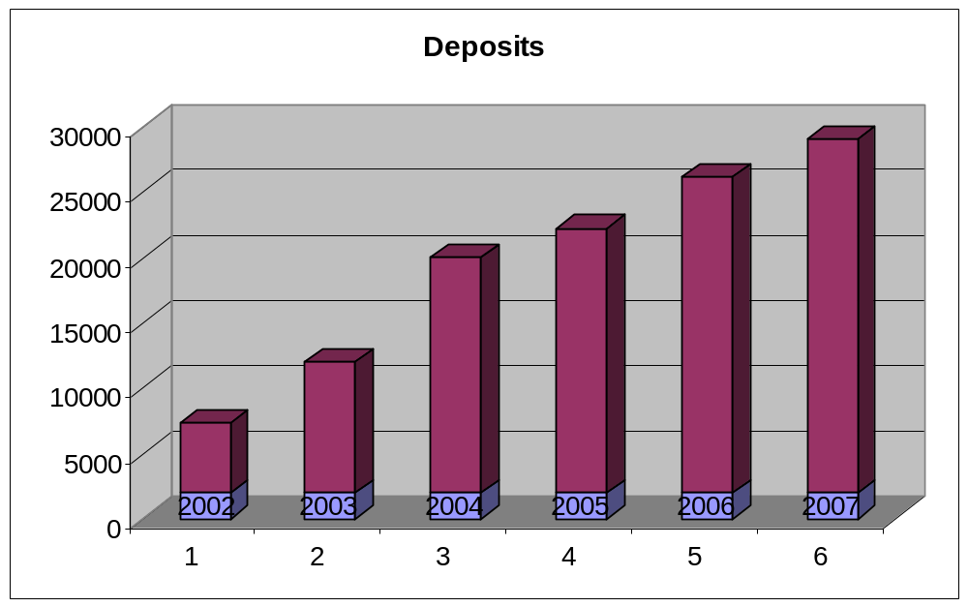

5.4 Loans & advances (Tk. in million)

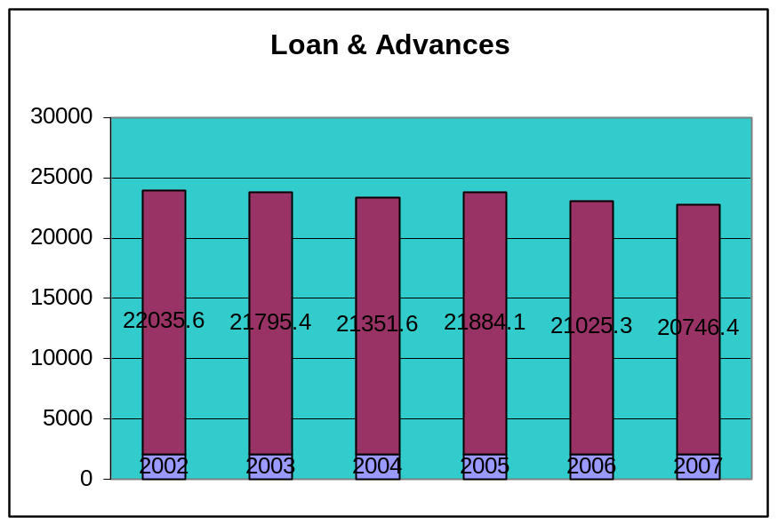

5.5 Total Assets (Tk. in million)
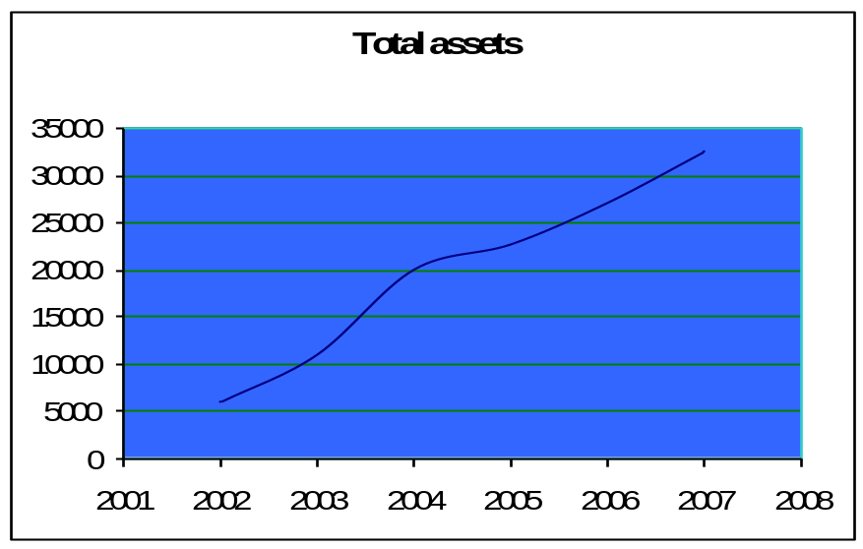

5.6 Profit (Tk. in million)

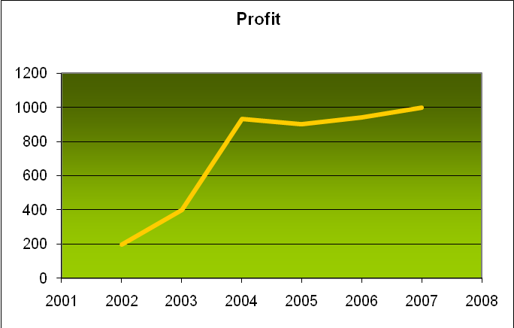

5.7 Branch (Tk. in million)
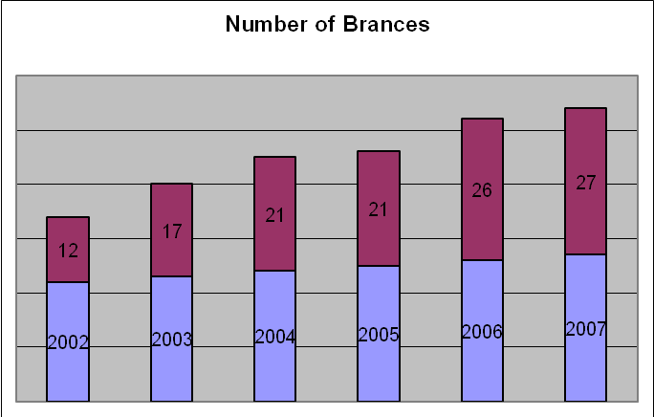

5.8 Employee (Tk. in million)
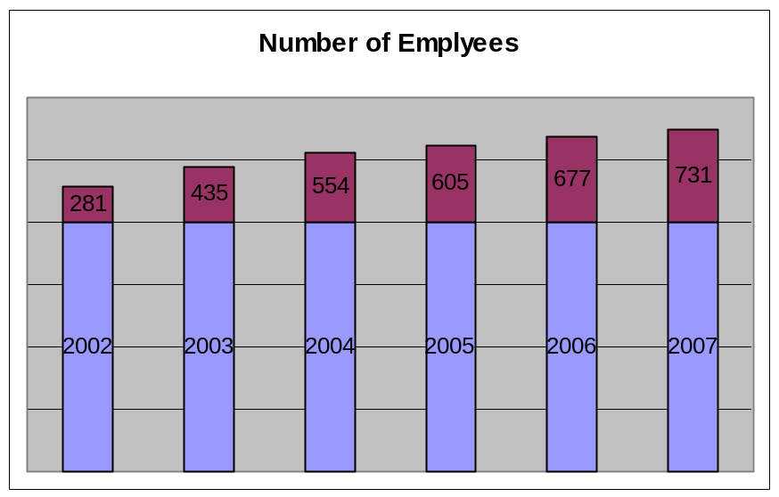

COMPARATIVE STUDY OF DEPOSIT & LOAN SCHEMES OF PREMIER BANK LIMITED

COMPARATIVE STUDY OF DEPOSIT SCHEMES OF PREMIER BANK LIMITED

6.1.1 Deposits (2006)

As of December 31, 2006 total deposits of the Bank stood at Tk. 24199.01 million which was Tk. 20290.47 million in the previous year, registering 19.26% growth. The upward trend of deposits growth reflecting continuous trust of the customers on the Bank emanated from untiring marketing and promotional efforts during the whole year.

Deposit mix at the end of Year 2006 is as follows

Sl. No. | Items | Tk. In Million | % of Total deposit
1 | Current Deposits | 706.44 | 2.92%
2 | Savings bank deposits | 1472.08 | 6.08%
3 | Fixed deposits | 16411.05 | 67.82%
4 | Short term deposits | 730.60 | 3.02%
5 | Deposits schemes | 2465.78 | 10.19%
6 | Bills payable | 235.33 | 0.97%
7 | Other deposits | 2177.73 | 9.00%
 | Total | 20290.47 | 100.00%

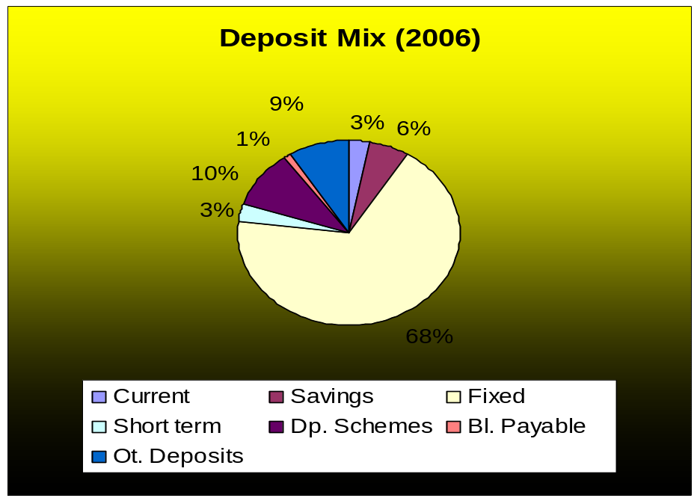

6.1.2 Deposits (2005)

The bank’s deposit registering a significant 12.69% growth and reached Tk. 20290.47 million at the end of December, 2005 which was Tk. 18005.20 million in the preceding year. The upward trend of deposits growth reflecting continuous trust of the customers on the Bank emanated from the Bank’s untiring marketing and promotional efforts during the whole year.

Deposit mix at the end of Year 2005 is as follows

Sl. No. | Items | Tk. In Million | % of Total deposit
1 | Current Deposits | 800.79 | 4.00
2 | Savings bank deposits | 1259.50 | 6.00
3 | Fixed deposits | 13544.53 | 67.00
4 | Short term deposits | 564.77 | 3.00
5 | Deposits schemes | 1940.99 | 10.00
6 | Other deposits & bills payable | 2179.89 | 10.00
 | Total | 20290.47 | 100.00%

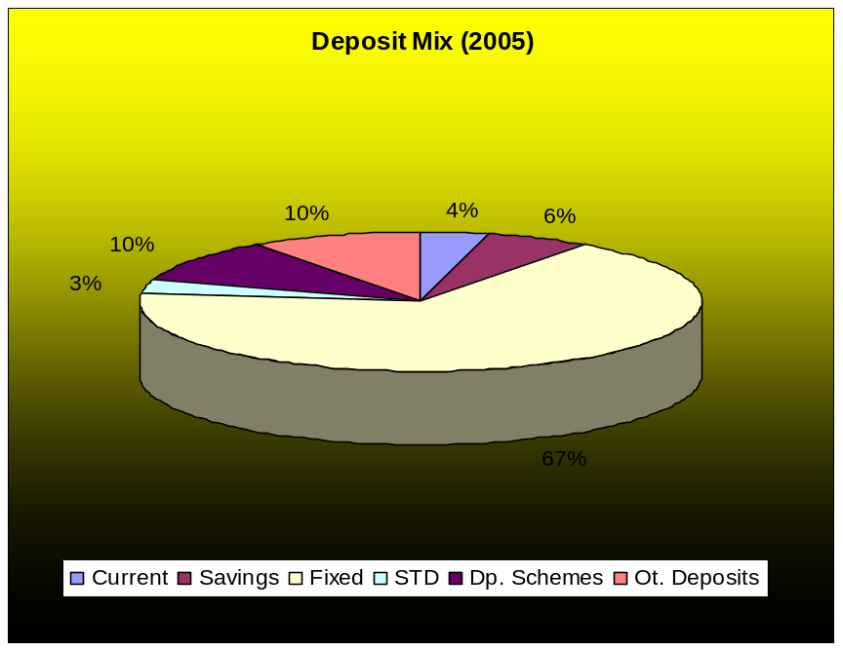

6.1.3 Deposits (2004)

The deposit base of the Bank registered at significant growth of 79.50 percent and stood at Tk. 18005.20 million at the end of 2004 as against Tk. 10030.52 million in preceding year.

Deposit mix at the end of Year 2004 is as follows

Sl. No. | Items | Tk. In Million | % of Total deposit
01 | Current deposits | 530.20 | 2.94
02 | Savings bank deposits | 1320.06 | 7.33
03 | Fixed deposits | 12356.38 | 68.63
04 | Short term deposits | 510.93 | 2.84
05 | Deposits schemes | 1574.33 | 8.74
06 | Bills payable | 294.55 | 1.64
07 | Other deposits | 1418.75 | 7.88
 | Total | 18005.20 | 100.00

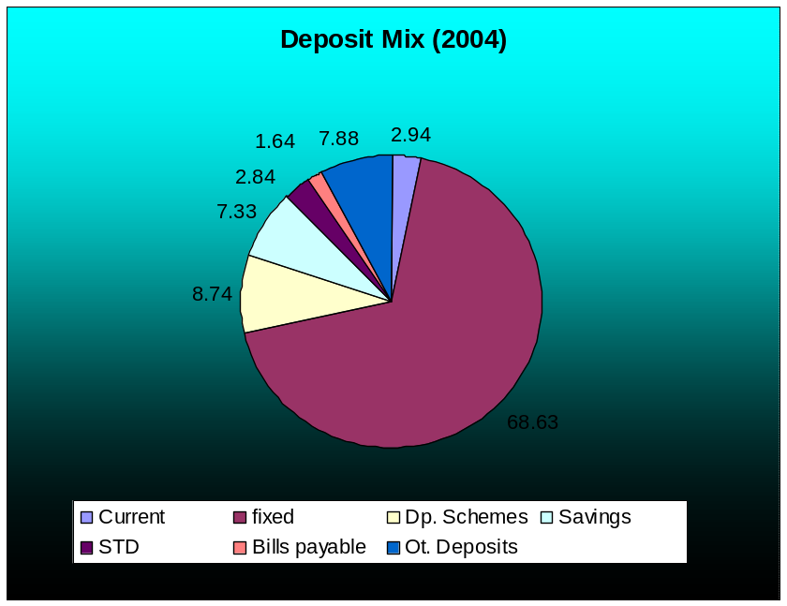

6.1.4 Comparison of Deposit Schemes

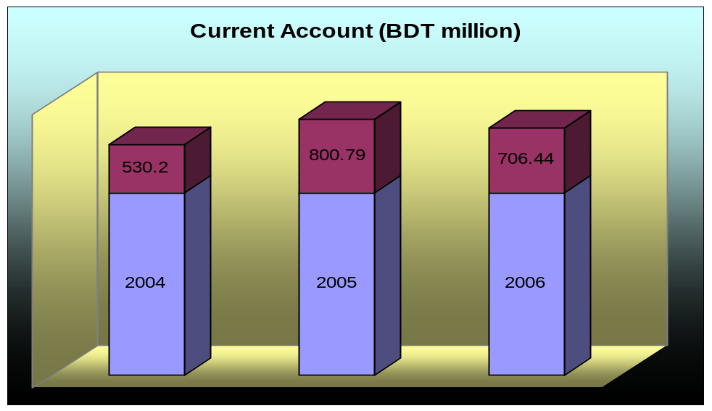

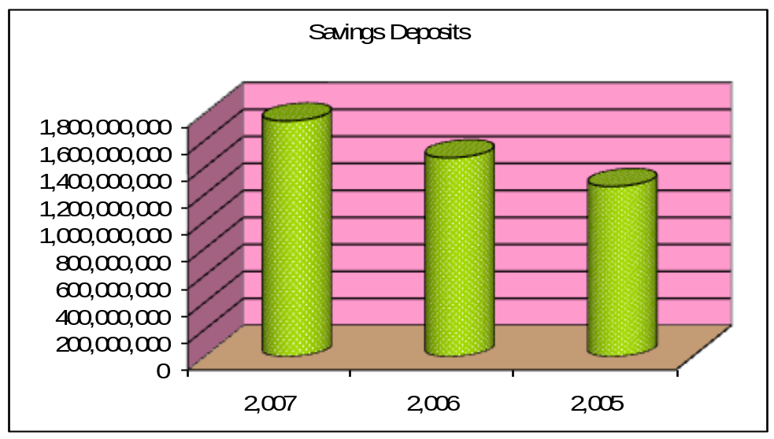

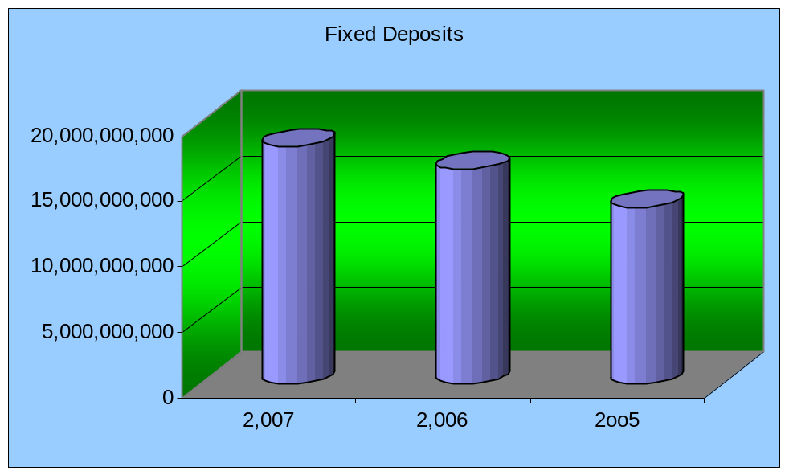

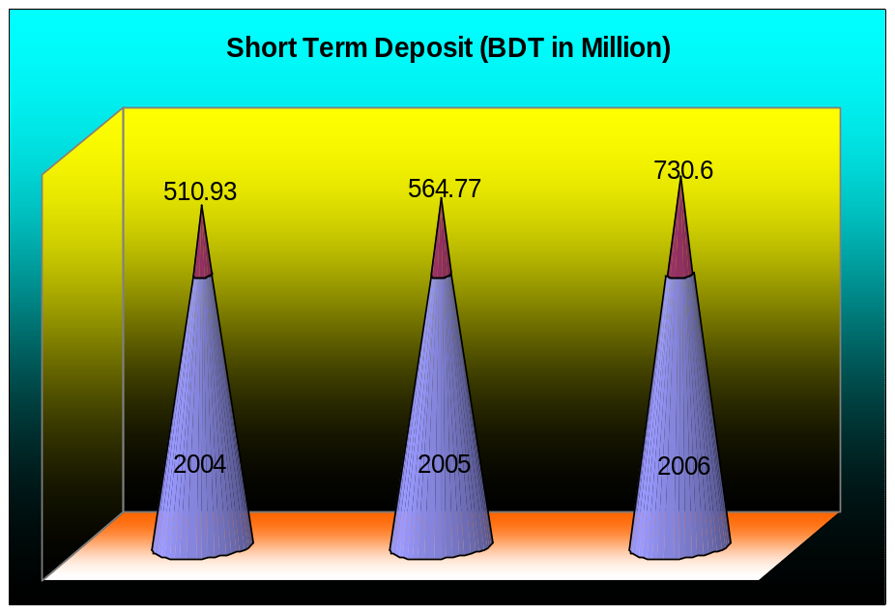

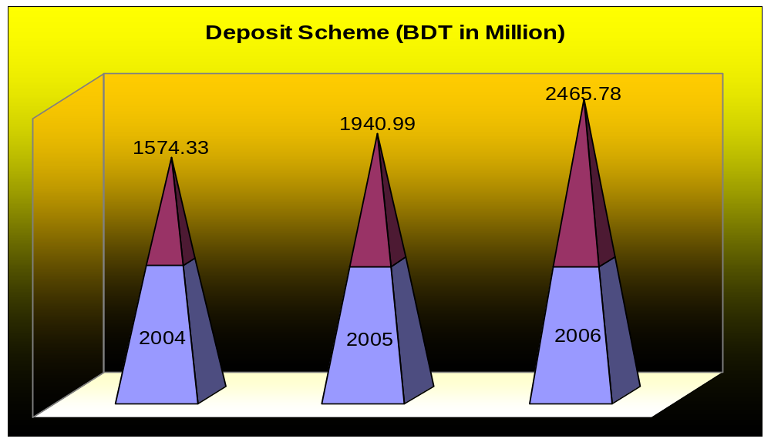

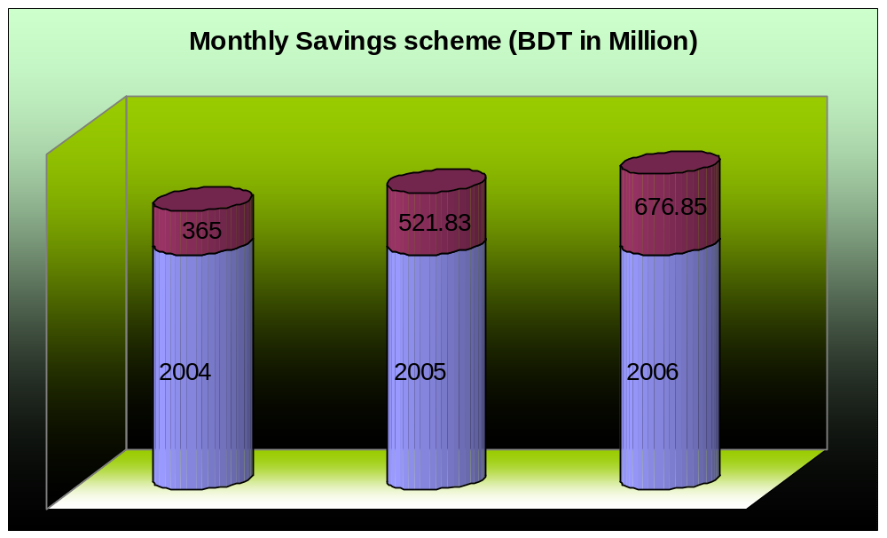

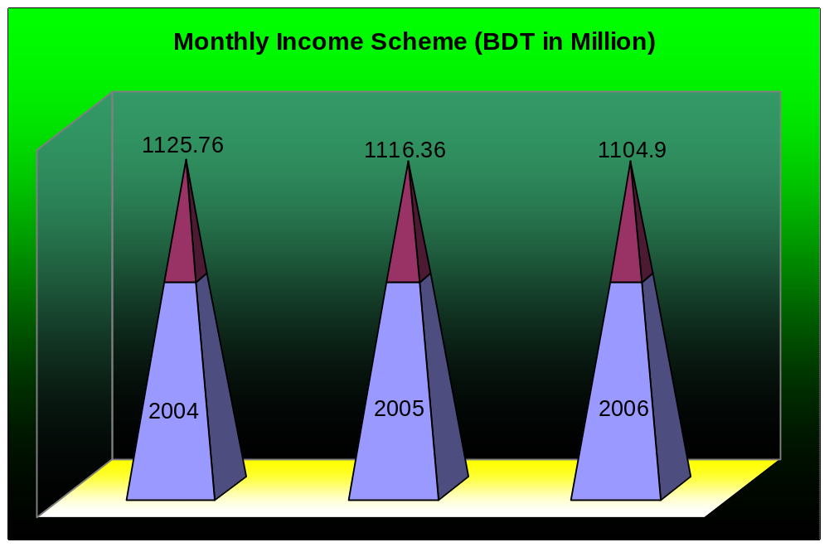

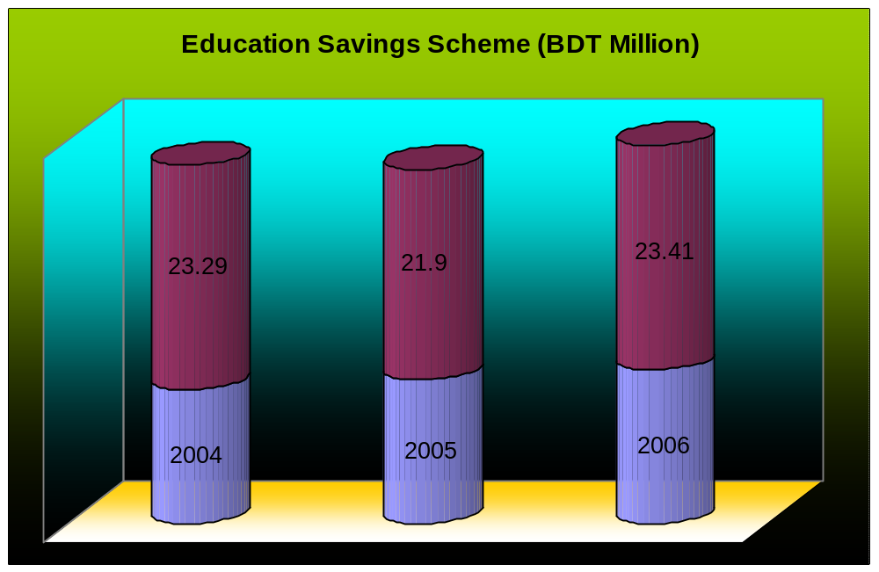

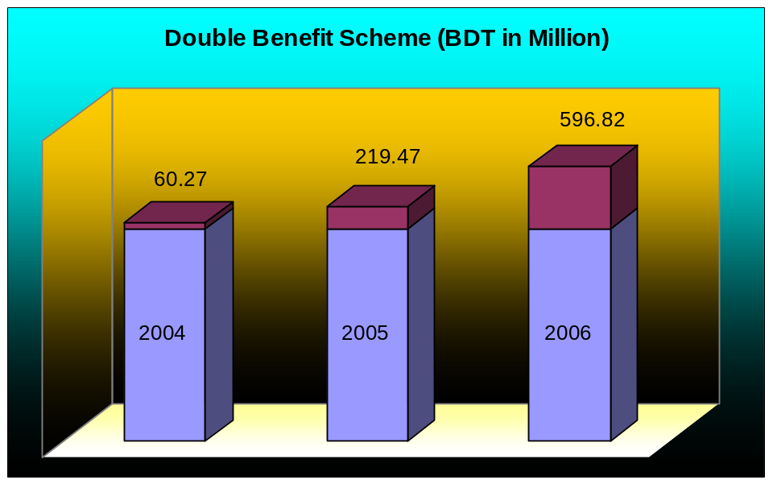

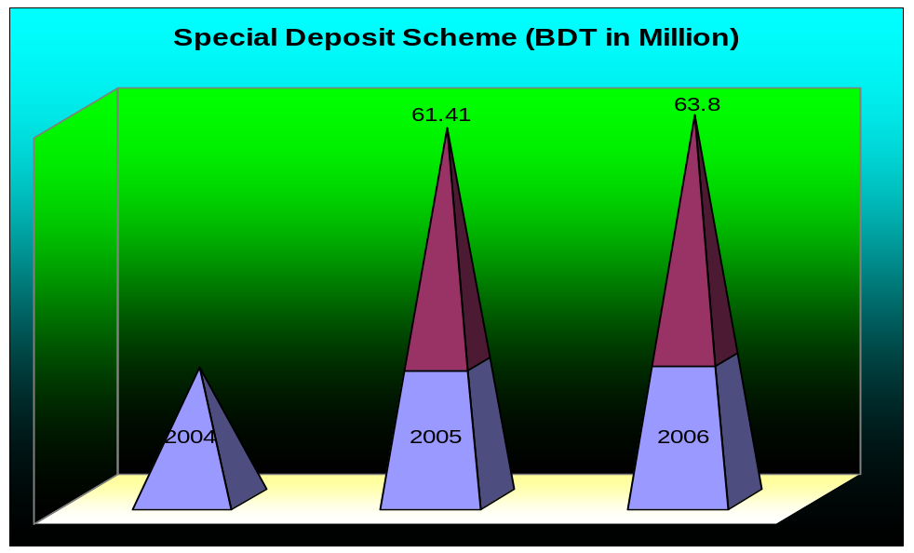

COMPARATIVE STUDY OF LOAN SCHEMES OF PREMIER BANK LIMITED

6.2.1 Loans and Advances (2006)

Credit activities of the Bank are being administered by the management Committee (MANCOM) at Head Office by strict separation of the responsibilities between assessment of risk, leading decisions and its monitoring functions.

Total loans and advances stood at Tk. 20677.68 million at the end of 2006 against Tk. 18,032.50 million of last years yielding significant 14.66% growth. The Bank is very much cautious about selection of borrowers to retain its asset quality. The classified loans and advances as a percentage of total loans and advances in only 4.91% as on 31st December, 2006. Loan to deposit ratio as on December 31, 2006 was 85.45% as against 88.87% in the preceding year. The Bank continuous to attract quality borrowers and during the short span of time, it has been highly recognized and praised by the business community, from small entrepreneurs to large traders and industrial conglomerates.
A wide range of business, industries and service sectors constitutes the Bank’s advance portfolio. The Premier Bank has been keeping its loan portfolio well diversified and extending project Finance, Export Finance, small and Medium Enterprise loans, commercial Credit, Continuous Loans, Agricultural Loan, House Building Loan, Staff Loan and Consumer Financing Loan.

Credit Card: At the beginning of 2004,Premier Bank, as the first local bank in Bangladesh, introduced VISA credit card (Local & International). The Bank issued 17,200 cards up to December 31, 2006 with accumulated revenue of Tk. 113 million and profit of Tk. 40.00 million by the end of the year under review. Card division is now conducting its operating as an independent profit center of the Bank and different steps have been taken for extending merchant network for acquiring more business as well. Introduction card facility to the valued customers is under sincere consideration.

Portfolio of Loans and Advances as on December 31, 2006 is given below:

Sl.  No. | Sector | Million  Taka | Percentage
01 | Agriculture | 20.19 | 0.10%
02 | Ready Made Garments | 2872.11 | 13.89%
03 | Textile Mills | 1265.91 | 6.12%
04 | Iron and Steel | 906.92 | 4.39%
05 | Edible Oil Mills | 262.15 | 1.27%
06 | Other Mfg. companies | 1272.56 | 6.15%
07 | Trade Finance | 4997.31 | 24.17%
08 | Construction | 1630.65 | 7.89%
09 | Professional & Self Employed | 300.30 | 1.45%
10 | Credit Card | 415.11 | 2.00%
11 | Others | 6734.47 | 32.57%
 | Total | 18032.50 | 100.00

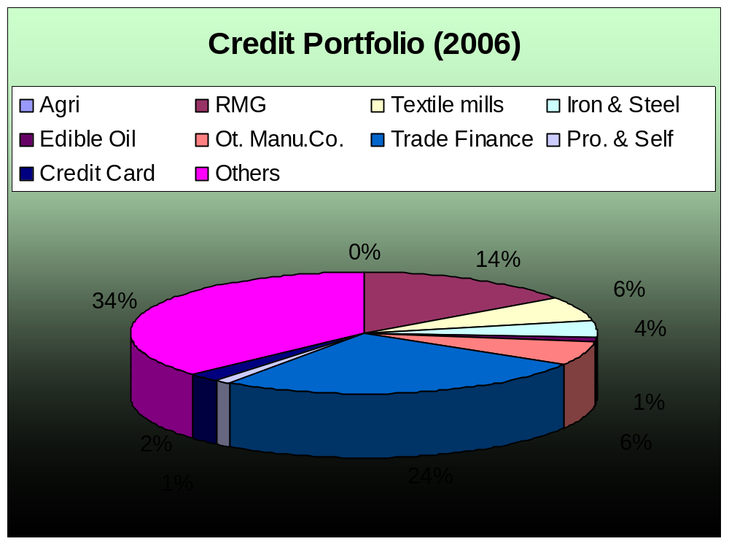

6.2.2 Loans and Advances (2005)

Loans and Advances are focal point of all the activities of every bank and in Premier Bank this is even more seriously dealt with to uphold the ‘Zero classification” policy of the Bank. Credit activities of the Bank are being administered by the management Committee (MANCOM) at head office by strict separation of the responsibilities between assessment of risk, lending decisions and its monitoring functions.

At the end of 2005 total loans and advances stood at Tk. 18032.50 million against last year’s Tk. 15383.93 million yielding 17.22% growth. While growth in loans and advances were the Bank’s major focus, under no circumstances there was any compromise on quality of advances. The Bank’s credit quality is very strong and sound. Classified loans and advances, as a percentage of total loans and advances is only 3.86% as on 31st December, 2005. Loan to deposit ratio as on December 31, 2005 was 88.87% as against 85.47 percent in the preceding year. The Bank continues to attract quality borrowers and during the short span of time, it has been highly recognized and praised by the business community, from small entrepreneurs to large traders and industrial conglomerates.

Consumer Credit and Personal Loan (2005)
The Bank is extending credit facilities through credit scheme and Personal Loan Scheme to cater the credit needs of the fixed income group for household durables, cars/automobiles and to meet up short term financial needs. Total outstanding in this segment stood at Tk. 256.71 million and recovery rate was 95.19 percent as at December 31, 2005.

Portfolio of Loans and Advances as on December 31, 2005 is given below:

Sl.  No. | Sector | Million  Taka | Percentage
01 | Agriculture | 600.00 | 3.33
02 | Ready Made Garments | 1800.00 | 9.98
03 | Textile Mills | 2550.00 | 14.14
04 | Iron and Steel | 500.00 | 2.77
05 | Edible Oil Mills | 400.00 | 2.22
06 | Other Mfg. companies | 2500.00 | 13.86
07 | Trade Finance | 3600.00 | 19.96
08 | Construction | 1750.00 | 9.70
09 | Professional & Self Employed | 300.00 | 1.66
10 | Credit Card | 450.00 | 2.50
11 | Others | 3582.50 | 19.88
 | Total | 18032.50 | 100.00

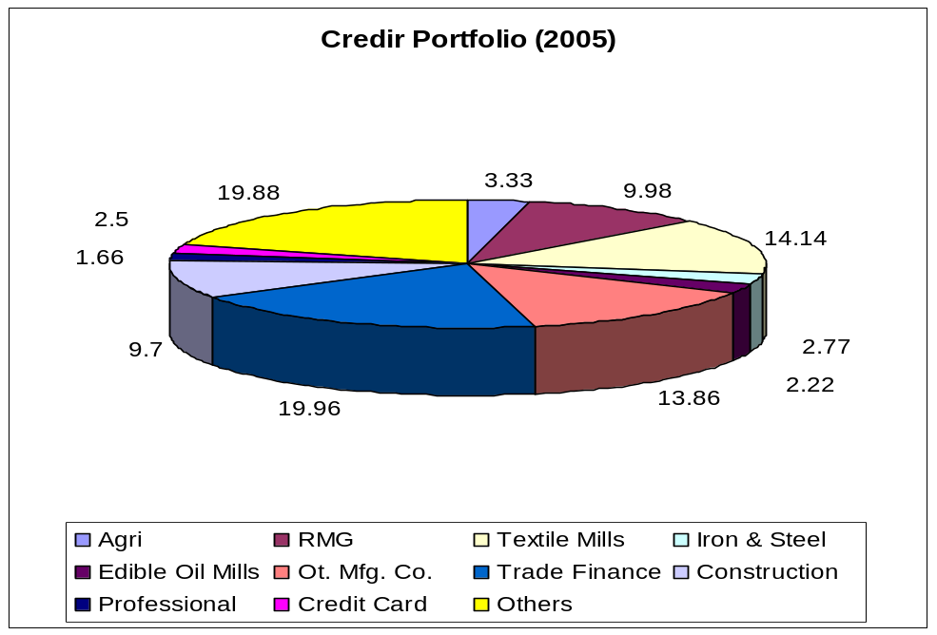

6.2.3 Loans and Advances (2004)

Loans and advances are focal point of all the activities of every bank and in Premier Bank this is even more seriously dealt with to uphold the “zero classification” policy of the Bank. Credit activities of the Bank are being administered by the Management Committee (MANCOM) at head office by strict separation of the responsibilities between assessment of risk, lending decisions and its monitoring functions.

At the end of 2004 total loans and advances stood at Tk. 15383.93 million, a 90.03 percent increase compared to Tk. 8095.57 million from the preceding year. While growth in loans and advances were major focus, under no circumstances there was any compromise on quality of advance.

Consumer Credit (2004)
The Bank is extending credit facilities through its Consumer Credit Scheme to cater the credit needs of the fixed income group for household durables and cars/automobiles. Total outstanding in this segment stood at Tk. 196.94 million and recovery rate was 94 percent as at December 31, 2004.

Credit Card (2004)
Premier Bank launched VISA Credit Card (Local & International) at the beginning of 2004 as New Year bonanza – first time in Bangladesh by a local bank. The Bank issued 14,200 cards just in 11 months with accumulated revenue of Tk. 78.10 million and profit of Tk. 35.00 million by the end of the year under review. Card division is now conducting its operation as an independent vital profit center of the Bank and steps have been taken for extending merchant network for acquiring more business as well.

Portfolio of Loans and Advances as on December 31, 2004 is given below:

Sl.  No. | Sector | Million  Taka | Percentage
01 | Agriculture | 1048.39 | 6.81
02 | Ready Made Garments | 1696.71 | 11.03
03 | Textile Mills | 1416.52 | 9.21
04 | Iron and Steel | 694.6 | 4.52
05 | Edible Oil Mills | 467.4 | 3.04
06 | Other Mfg. companies | 1500.63 | 9.76
07 | Trade Finance | 5657.44 | 36.77
08 | Construction | 800.72 | 5.20
09 | Professional & Self Employed | 333.25 | 2.17
10 | Credit Card | 358.46 | 2.33
11 | Others | 1409.93 | 9.16
 | Total | 15383.93 | 100.00

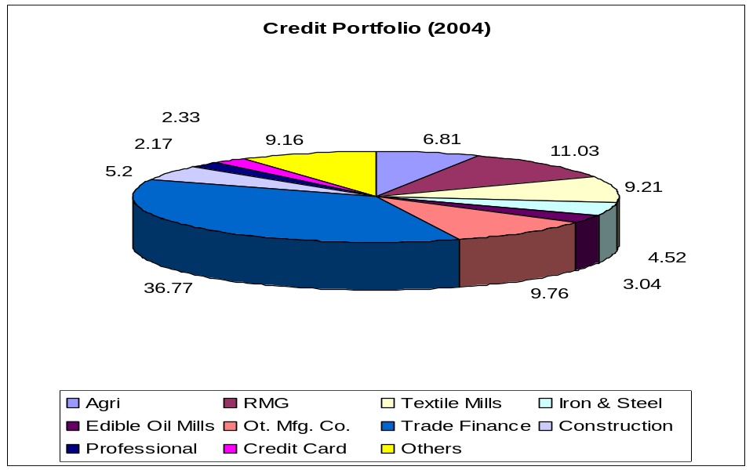

6.2.4 Comparison of Sector Wise Loan distribution

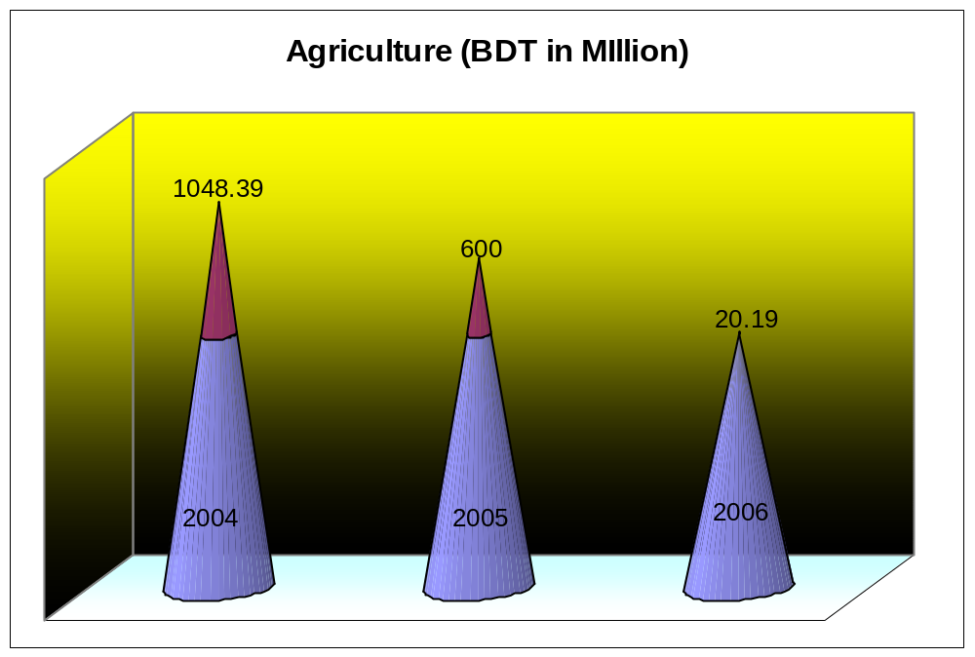

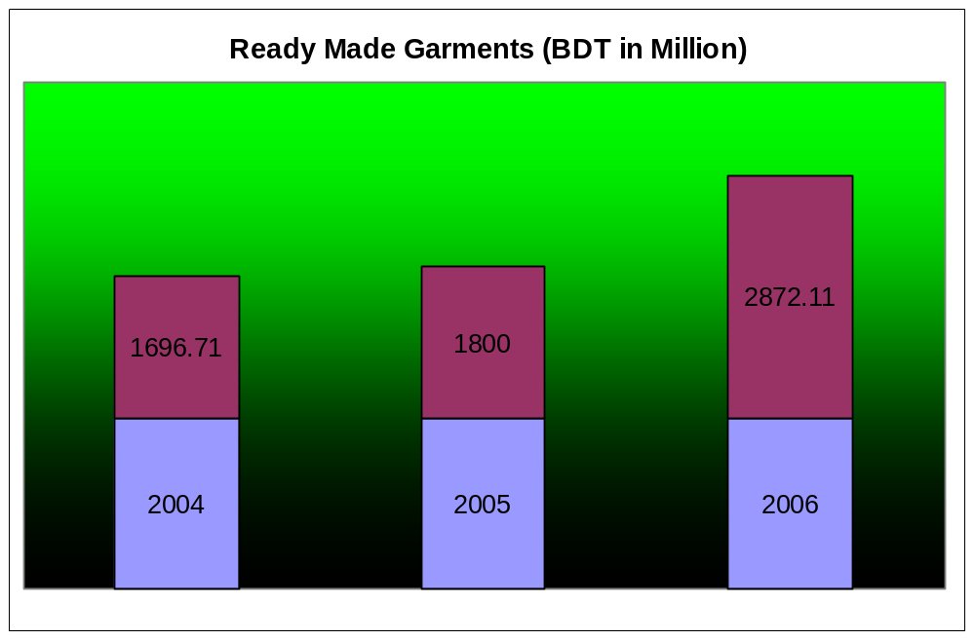

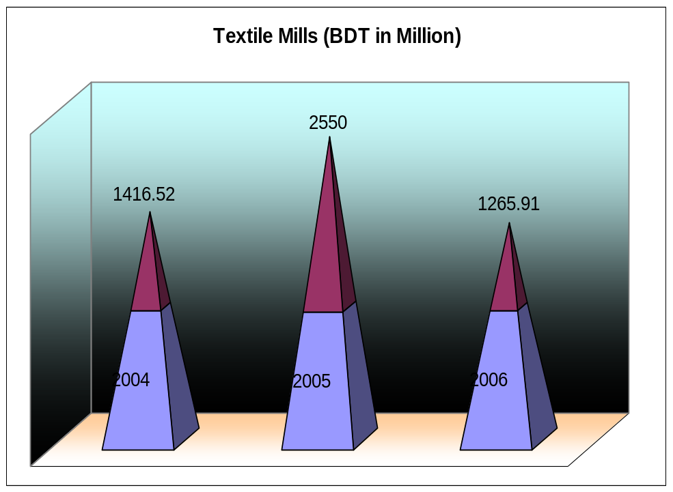

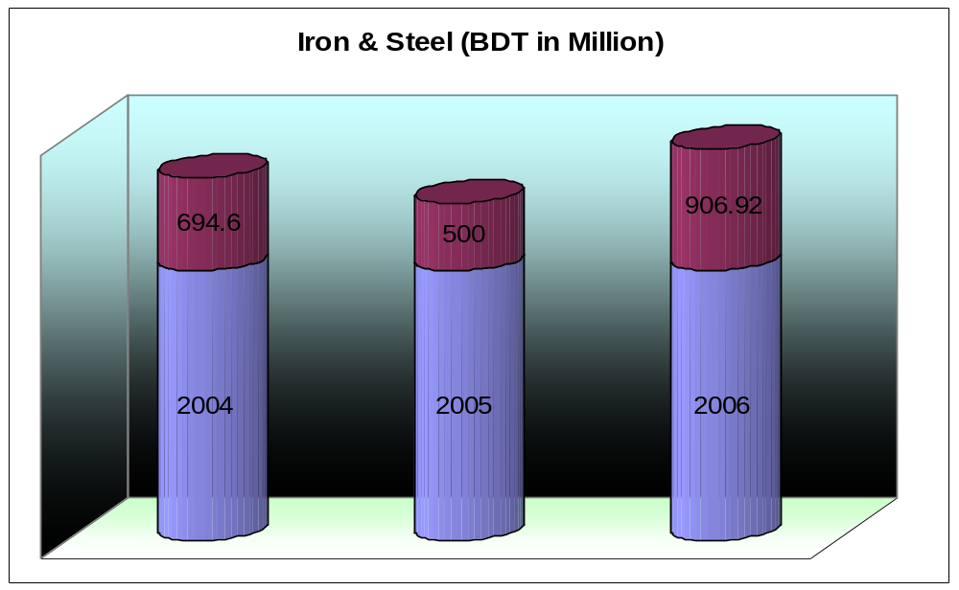

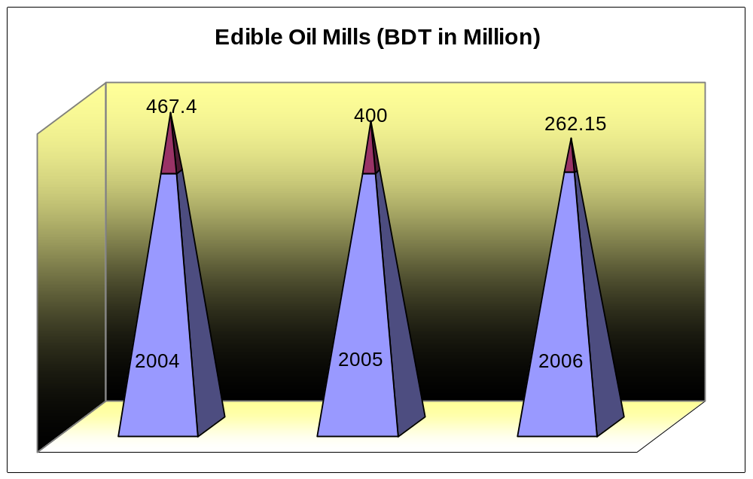

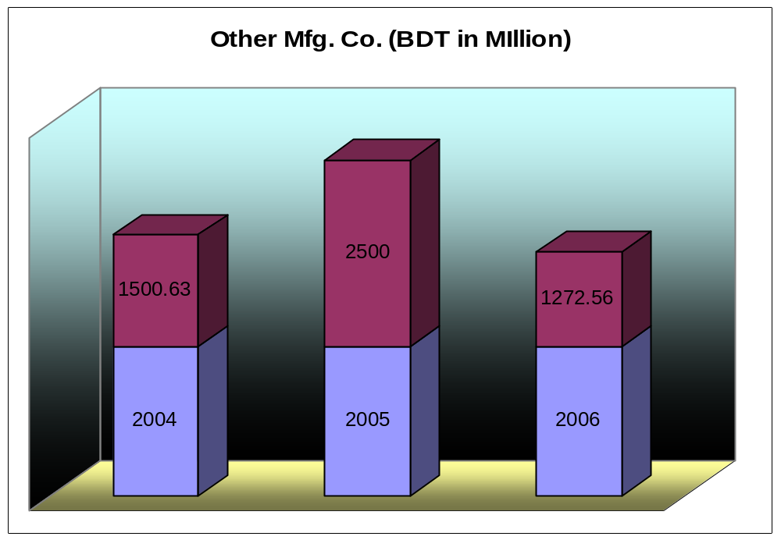

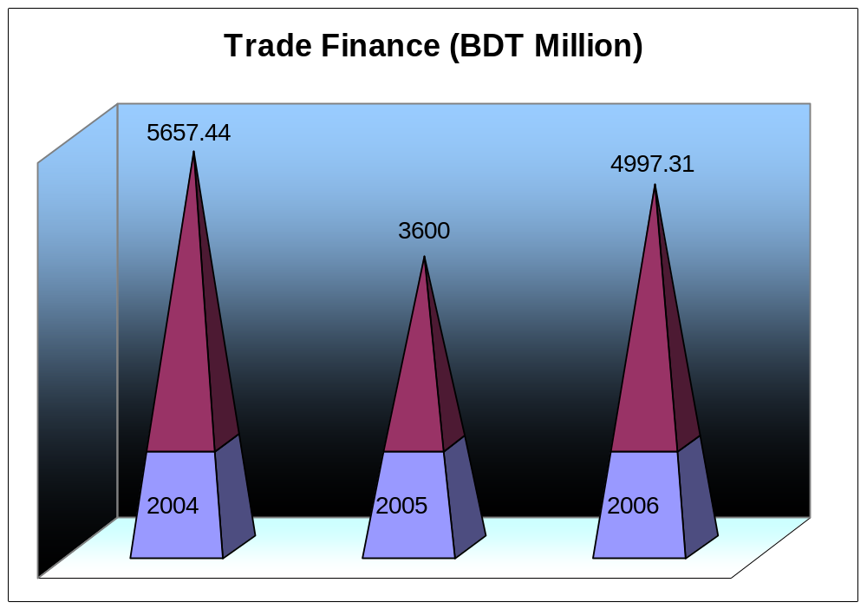

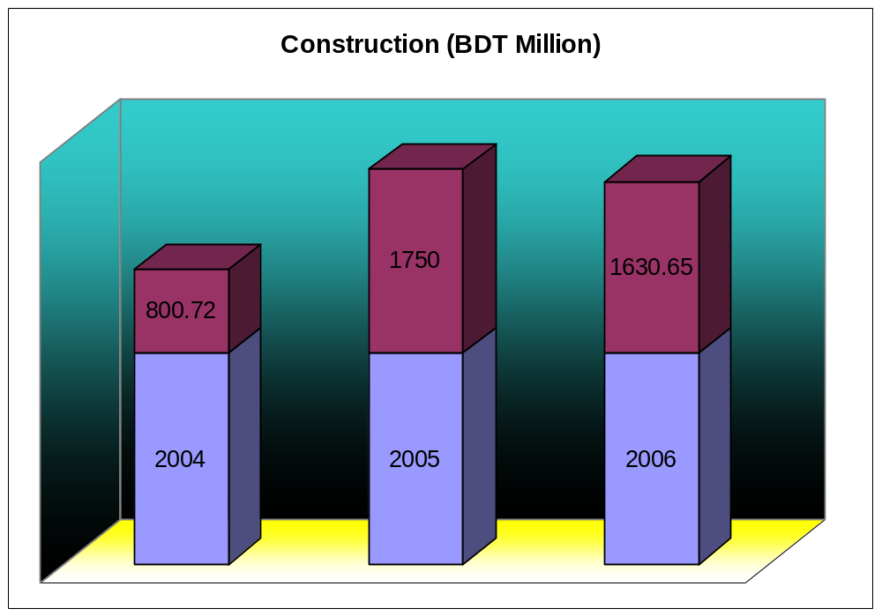

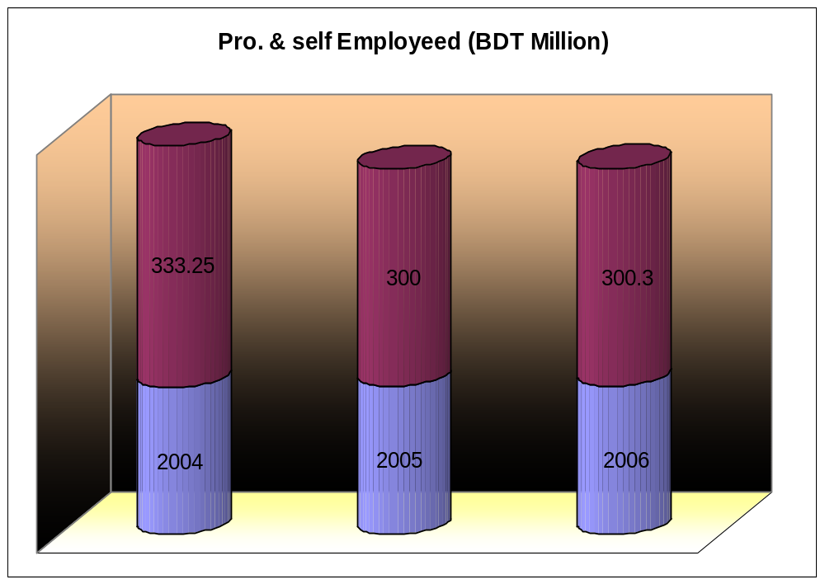

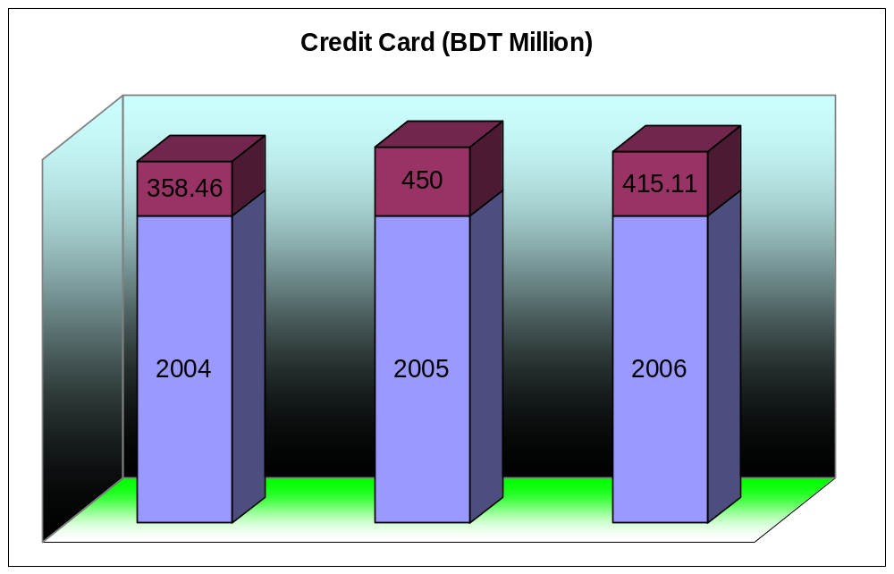

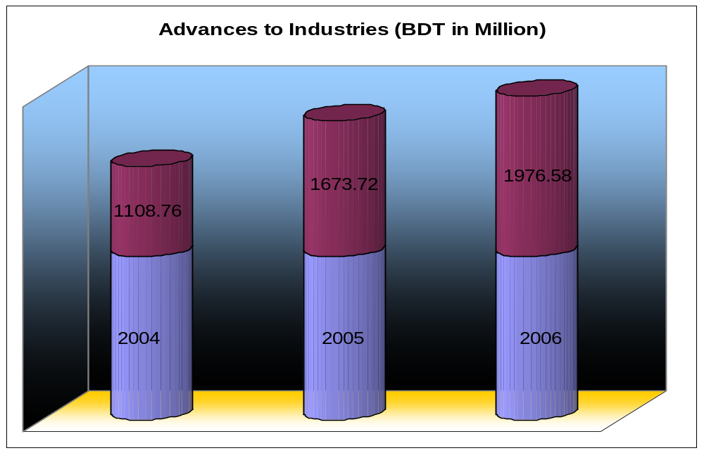

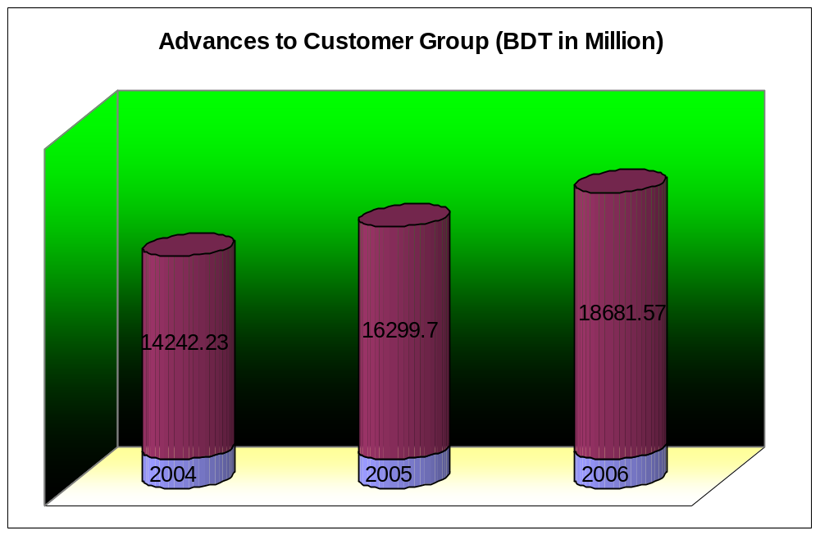

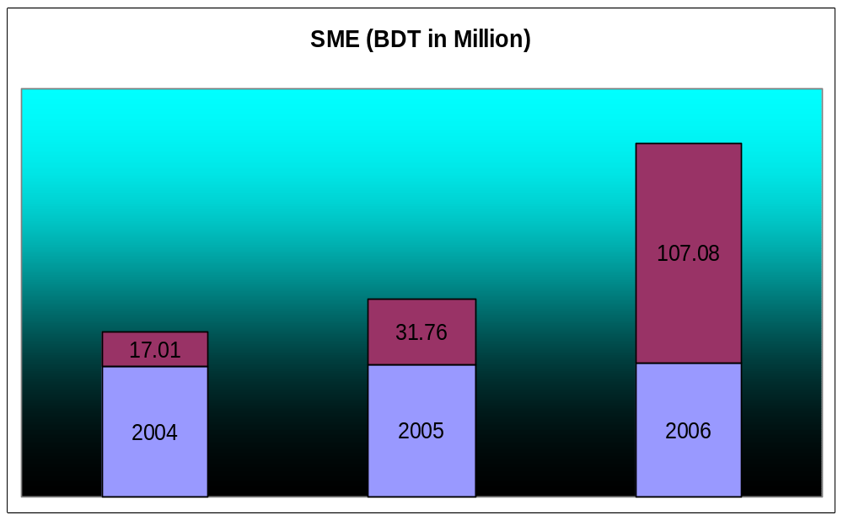

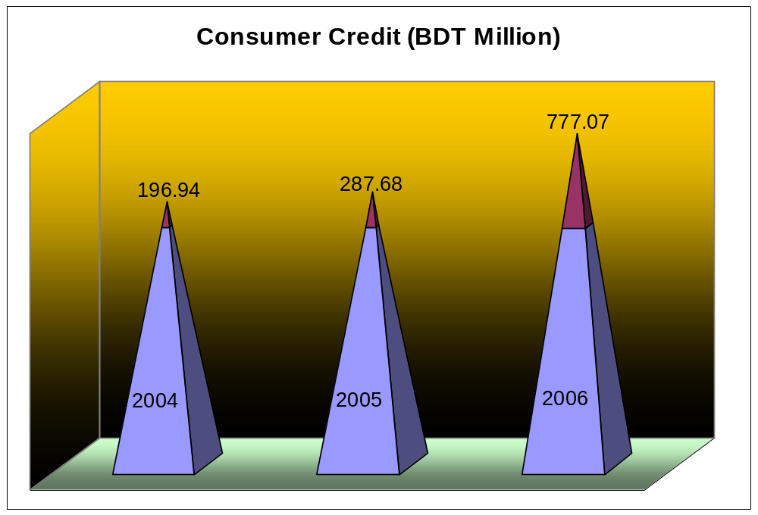

Conclusion

The Premier Bank is one of the new generation private commercial banks that began its journey in 1999 under the license of Bangladesh Bank and has become a top performing bank within short periods.

The Bank’s motto "Service first" reflects Premier’s concern for customer satisfaction, flexibility, responsiveness and productivity. The Premier Bank Limited is managed by a group of dynamic Board of Directors drawn from different disciplines. The Bank has a very competent Management Team who has long experience in Banking. The Bank upholds and strictly abides by good corporate governance practices and is subject to the regulatory supervision of Bangladesh Bank.

Premier Bank is always conscious of the changing needs of the customers and strives to develop new and improved services for its valued customers. The Bank offers a wide range of Deposit and Lending Products & quality Services to meet the customers all kinds of financial needs.

The Premier bank will be more effective in our economy by lunching new financial products& services to attract customers such as, Pension Scheme, car Loan, Plastic Money ATM etc.

Recommendation

After observing the operations of Premier Bank, I recommend the following:

- The Premier Bank should launch new financial products to attract more people, as Car Loan Scheme, Teacher’s Loan, and Salary Loan etc.

- The no. of branches is not adequate. New branches should be launched is order to get more customers.

- Deposit Scheme such as Current Account was comparatively lower in 2006 than the previous years. So special emphasis has to give to increase Current Account in the coming years.

- The Premier Bank should launch ATM services as one of the necessities of modern banking.

- Special emphasis has to give to finance the Agricultural & Construction Sector.

