INTERNSHIP REPORT
ON

“Evaluation of Foreign Exchange Operations of First Security Islami Bank Limited”

Submitted by

WWW.ASSIGNMENTPOINT.COM

Bankers or Bank was defined as a person who carried on business of receiving money, collecting of drafts, honoring cheque drawn upon it.
First Security Islami Bank Limited (FSIBL) was incorporated in Bangladesh on 29 August 1999 as a banking company under Companies Act 1994 to carry on banking business. It obtained permission from Bangladesh Bank on 22 September 1999 to commence its business. The Bank carries banking activities through its Twenty Nine (29) branches in the country. The commercial banking activities of the bank encompass a wide range of services including accepting deposits, making loans, discounting bills, conducting money transfer and foreign exchange transactions, and performing other related services such as safe keeping, collections and issuing guarantees, acceptances and letter of credit.
With its firm commitment to the economic development of the country, the Bank has already made a distinct mark in the realm of Private Sector Banking through personalized service, innovative practices, dynamic approach and efficient management. The Bank, aiming to play a leading role in the economic activities of the country, is firmly engaged in the development of trade, commerce and industry thorough a creative credit policy.

Mission of First Security Islami Bank Limited
To be able to provide banking products and services of high quality to a large part of the population of the country both at home and abroad at a reasonable and affordable price with cutting edge technology and transparency of our books.

Origin of the Report
This report has prepared as a requirement of internship program of school of business,
American International University-Bangladesh (AIUB). The organization attachment started on 3rd February, 2009 to 3rd May 2009. In internship program, I attached to First Security Islami Bank Ltd. Dhanmondi Branch and was assigned to conduct study on Evaluation of Foreign Exchange Operations - A Case Study of First Security Islami Bank Ltd. (FSIBL).

Rationale of the Study
The report titled “Evaluation of Foreign Exchange Operations of FSIBL” prepared to fulfill the requirement of the internship program of the BBA degree in Department of Business Administration, American International University-Bangladesh.
The Banks provide different types of product and services to its counter parts like, general Banking services or finance or investing that results transaction of currency. To do this, they also need capital, assets and other resources. These elements of business results, changes in their capital, assets and other factors which effects directly in the banks performance. This report will be helpful to understand the performance of the First Security Islamic Bank Limited, compare to some other local Banks and as well their strengths and weaknesses. As a result we can easily rank the Banks position which will give us the idea of Banks capabilities.

Background of the Report
The economic basement of Bangladesh, a developing country in south Asian region, is known as agriculture. From the very past history of Bangladesh, it is learnt that the ultimate prospect of the country depends on agricultural resources. But now a day the earlier concept is going beyond a lot. The contribution of agricultural sector to GDP has gone down from 80% to 16% in three decades and the balance has been backed up by the manufacturing and industrial sector. To cope with the present trend of industrialization and development, financing the industries and increasing saving propensity among people is a must. The banking sector, the fastest growing sector in Bangladesh, is playing more than talked about role in this regard. It smoothes the industrialization process and creates employment for a large mass as well. So, selecting and reporting on a member of this sector “First Security Islami Bank Limited” is obviously a major financial one.

Objective of the Study
- To assess import and export dealings of the First Security Islami Bank Limited
- To evaluate import and export trend of the selected Bank
- To examine foreign remittance of the selected Bank
- To identify problems regarding foreign exchange transaction
- To suggest probable measures in order to solve the identified problems

Scope of the Report
This report gives a narrative overview of the First Security Islami Bank Limited. Any development of First Security Islami Bank Limited, there after is thus out of the scope of the report. This report consists of the writer’s observation and on the job experience during the internship period. Topic of the report is study on foreign operation of FSIBL. Finally, this report incorporates an evaluation of export import activities, and the different aspects of cost of fund and return on investment.

Methodology of the Report
The report is a combination of primary and secondary data analysis along with financial analysis. To accomplish the report both primary and secondary data are necessary. Primary data is collected though meetings, surveys and secondary data are collected through annual report, books, articles, journals, brochures, website etc.
Area of the study
The proposed study has been focused on the management of Investment of the First Security Islami Bank Limited. In relation with the primary and secondary objectives, the Dhanmondi Branch of the First Security Islami Bank Limited has been selected to perform our internship program.

Primary Data
The primary data of this report are:
- Direct interview of principal officer of the bank
- Practical experiences gained during performing duties in different desks and department of the foreign exchange branch office of First Security Islami Bank Limited.

Secondary Data
I collected secondary data from the following sources:
- Annual report of First Security Islami Bank Limited
- Printed forms and documentation supplied by FSIBL
- Booklets of international division of First Security Islami Bank Limited
- Different Publications and Journals regarding banking activities and policies
- Auditors report of First Security Islami Bank Limited
Website of First Security Bank Limited (www.fsiblbd.com)

Data Processing & Analysis
Data has been computerized & processed by using MS Word, MS Excel. For the purpose of analyzing the data we have presented in tabular form, percentage form with necessary chart and graphs.

Determination of Time Horizon
The time horizon has been selected of five years from 2004 to 2006. Over the five year time period, the related data of the FSIBL has been evaluated.

Limitation of the Study
As I have completed my internship in First Security Islami Bank Limited, Dhanmondi Branch, I have enjoyed a very well decorated environment and comfortable place. The officers are very co-operative but they are too busy to give me time to get knowledge about practical activities. Moreover they have to deal in a very competitive environment based on money related activities. Any mistake from me may hamper their performance and goodwill in the banking sector, for these reasons I deprive of having practical knowledge. Short time duration and lack of practical knowledge are the main limitations of the study.
Every project has some limitations. I faced some usual constraints during the coursed of my internship. The experienced problems that have, to some extent, affected the presentation of the report are presented below:
- Business of The Administration - Since the representatives of the FSIBL are very busy, in some case I could not communicate with them properly.
- Fears to Disclosure - The administration also feared to disclose the confidential data related to the party and various forms and documents.
- Lack of Experience - Experience makes a man efficient. I am not experienced enough to complete the study because I am a person of new hand on such study. That is why inexperience creates obstacles to follow the systemic approach and logical research methodology.
- Shorter of Time Remaining a Loft - I had to complete this internship program designed for two months only out of three months which many days were wasted. So, the time constraint of the study hindering the course of vast area and time for preparing a report within the mentioned period is really difficult.
- Banks officials, for security reasons, declined the request for providing information in some crucial issues.
- As some of the fields of banking are still not covered by our courses, there was difficulty in understanding some activities.
- Another limitation of this report is Bank’s policy of not disclosing some data and information for confidential reason, which could be very much useful.
- Because of the limitation of information, some assumptions were made. So there may be some personal mistake in the report.
- Omissions and error may be there due to lack of my prior experience in preparing a professional report like this one; nevertheless, I have tried utmost to avoid mistakes.

PART TWO – THEORETICAL FRAMEWORK

Meaning of Foreign Exchange
Foreign Exchange Market
Euro Dollar, Petro Dollar, Asian Dollar
Exchange is being Controlled
Authorized Dealer Branch
Arbitrage of Foreign Exchange
Foreign Exchange Regulation Items
Multiple Exchange Rates
Exchange Rate Rules
Methods of Effecting Payment of FSIBL

Meaning of Foreign Exchange
Foreign Exchange means currency & trade exchange say conversion of one to another. This is a part of economic and science. This is a big deal divided into different currencies instrument such as Draft, Traveler Cheque, Bill of Exchange business including sell, purchasing of currency notes & TC etc. Currency Exchange means the conversion of one currency into another. The bank has established correspondent relationship with over 220 foreign correspondents all over the world viz. the Hong Kong and Shanghai Banking Corporation Ltd., UK, The Bank of Tokyo Mitsubishi Ltd., Japan, Commerzbank, Germany, American Express Bank Ltd., USA Mashreq Bank Psc, UAE, Union De Banquea Arabes Et Francaises, France and ICIC Bank, India to cater to the needs of the bank’s customers engaged in international trade. Our bank is maintaining adequate number of Nostro accounts in important currencies of the world to facilitate payments and transfer of funds. The Bank is providing excellent services to the clientele in foreign exchange and foreign trade operations through the above foreign correspondents. Foreign exchange is mainly combination of three parts. Those are given below:
- Import
- Export
- Remittance

I will discuss about this topics later. These three parts are most essential parts of Foreign Exchange Operations of FSIBL at Dhanmondi Branch. Not only FSIBL but also all banks of Bangladesh have maintained these rules for foreign exchange operations.

Foreign Exchange Market
Foreign Exchange market means the places where foreign currency is bought & sold. In this more that supply, currency value. Alternately following are the features of foreign exchange market:
- Bank & Client
- Different Banks in the same foreign exchange market
- Different Bank & Schedule Bank of the same country
- Different Control Bank

First Security Islamic Bank Ltd. (FSIBL) is a bank follows the following the two craters in respect & payment of foreign exchange:
- Local Currency market value
- Foreign Currency market value

Euro Dollar, Petro Dollar, Asian Dollar
Euro Dollar is virtually no paper dollar, but mark in dollars; it’s a new name in the currency market in the world, similarly Petro Dollar means the Dollar earn from sale of fuel. Particularly oil based middle-east countries. Thirdly Asian Dollar means the Dollar of Singapore, Hong Kong, Tokyo, Bahrain etc. Asian Dollar move or less control Euro & Petro Dollars. FSIBL can buy or sale foreign currency from the foreign exchange market for profit. This bank posse’s license from Bangladesh Bank to deal foreign currency business in the currency exchange market in the world. FSIBL maintains overseas inter A/C, with different banks in different countries. In the world for network system for Import, Export & Remittance purpose foreign exchange currency may be created a commodity for which FSIBL can sell or purchase the same to the party or other bank with some profit (exchange).

Exchange is being Controlled
Exchange is being controlled by the following ways:
- To stabilize the rate of exchange
- To protect implementation of plans
- For proper implementation of plans
- To increase the bargaining strength
- To check over invoicing & under invoicing
- To check the blank marketing & smuggling
- For regulating the international movements of goods

Authorized Dealer Branch
Bangladesh Bank in exercise of the power under section 3 of Foreign Exchange regulation Act. 1947 issues a license to schedule Bank where they have adequate trained officer/staff to deal in foreign exchange. The banks that are authorized to deal in foreign exchange are called authorized dealers.

Arbitrage of Foreign Exchange
Arbitrage can be defined as simultaneous buying and selling of foreign currencies for the purposes of making profit Arbitrage is carried out mostly by banks, they keep constant watch over the latest development in the financial market of the world.

Foreign Exchange Regulation Items
Foreign Exchange regulation items are given below:
- Bangladesh Bank Manual
- Foreign Exchange Circular
- Public Notice
- Import & Export Policy Gazette
- Ministry of Commerce Circular
- BCD Circular
- Guide lines for foreign exchange regulation
- Other authorization (i.e. NBC Dept)

Multiple Exchange Rates
Various rate quoted for one currency purchase and sale. Our country rate is multiple exchange rates. The rates of exchanges are the price of one currency in relation to others. Rates are three types:
- Currency Rate
- Pense Rate
- Cross Rate

Currency Rate: (Indirect Quotation)
Buy high sell low i.e. local currency fixed and foreign currency variable e.g. India & London quoted this rate. In case of currency rates:
- Buy high
- Sell low
- For buying in currency rate higher discount is added and lower premium is deducted.
- For selling lower discount is added and higher premium is deducted
Local currency fixed and foreign currency variable i.e. by & sell high. New York money market quoted this rate.

Pense Rate
Foreign currency fixed and local currency variable i.e. buy low & sell high. New York money market quoted this rate.
Cross Rate
Other currency rate to one another. There are two ways quotation in exchange rate i.e. (a) Buying Rate & (b) Selling Rate
Others Rate
There are also other rates. Those are given below:
TT (Telegraphic Transfer) & OD (On Demand) Rate
TT & OD rate should be applied for foreigners & Govt. people i.e. other than import. BC (Bills for Collection).
Selling Rate
This rate should be applied for Import Bills only.
IT Clean Rate
This rate should be applied for other than foreigners i.e. the A/C holders and for purchasing Cheque, Draft, TT, MT, PO and TT. Clean rate also will get foreign currency account holder and purchasing of foreign currency note.
Sight Expert
When we will purchase the export document in that case rate will apply OD sight export.
Transfer Rate
This rate should be applied for official people & foreign only. Cheque, Drafts, MT, TT, PO, and Coupons etc. will be purchased applying OD transfer rate.
Exchange Rate Rules
There are different types of exchange rate rules. Those are given below:

In case of Pense Rate
- Buying low
- Selling high
In case of currency Rate
- Buy high
- Sell low
For Buying
- In currency rate higher discount is added and lower premium is deducted
- In pense rate higher discount is deducted and lower premium is added
For Selling
In currency rate low discount is added and higher premium is deducted
In pense rate lower discount is deducted and higher premium is added

Basket of Currency in our Country
- US Dollar
- Pound Sterling
- DM
- Yen
- France Frank
Our rate quoted based on US Dollar in the year 1986 January instead of Pound Sterling. Now the rate in our country is unification from January 1992.

Methods of Effecting Payment of FSIBL
First Security Bank Limited follows the following methods to make payments between countries.
Telegraphic Transfer (TT)
This is an instruction for transfer of money by Telegram, Cable or Telex from a bank in one country to another Bank in different center. This is an instruction form the Importers Bank to the exporters Bank. The TT charge is realized by us from the partly as per Bank circular.
Mail Transfer (MT)
This transfer is the order to pay cash to a 3rd party. This transfer is sent by mail & the charge must be realized as per Bank circular.
Drafts & Cheque
A draft is pay order issued by one bank to another bank or its branch.

IMPORT OPERATION

Import
Definition of Letter of Credit
Classification of Letter of Credit
Parties to the Letter of Credit
To Open a Letter of Credit the Following Factors Should Consider
Import Financing
Payment Procedure of Import Documents
Kind of Import Business Related to L/C

Import
Import may be defined as bringing of visible item to the country from abroad through letter of credit or the Authorization form (LCAF) paying foreign Currency to that of exporting country.
To import, a person should be competent to be an importer. According to Import and Export Control Act, 1950, the Office of Chief Controller of Import and Export (CCI & E) provides the registration (IRC) to the importer. In an international business environment, buyers and sellers are generally unknown to each other. So, seller of goods always seeks security for the payment of his exported goods. Bank gives export guarantee that it will pay for the goods on behalf of the buyer if the buyer does not pay. This guarantee is called Letter of Credit. Thus, the contract between importer and exporter is given a legal shape by the banker by ‘Letter of Credit’.
A letter of credit is a letter issued by a bank (known as the opening or the issuing bank) at the instance of its customer (known as the applicant) addressed to a person (beneficiary) undertaking that the bills drawn by the beneficiary will be duly honored by it (opening bank) provided certain conditions mentioned in the letter have been complied with.

Definition of Letter of Credit
A letter of credit is a letter issued by a bank (known as the opening or the issuing bank) at the instance of its customer (known as the applicant) addressed to a person (beneficiary) undertaking that the bills drawn by the beneficiary will be duly honored by it (opening bank) provided certain conditions mentioned in the letter have been complied with.

Classification of Letter of Credit
- Irrevocable Credit
- Transferable Credit
- Restricted Credit
- Red Clause Credit
- Green Clause Credit
- Confirmed Credit
- Divisible Credit
- Back to Back Credit
- LC without resource Credit
- LC with resource Credit
- Revolving Credit
- Anticipatory Credit

Parties to the Letter of Credit
- Importer - Who Applies for L/C.
- Issuing Bank - It is the bank which opens/issues a L/C on behalf of the importer.
- Confirming Bank - It is the bank, which adds its confirmation to the credit and it is done at the request of issuing bank. Confirming bank may or may not be advising bank.
- Advising or Notifying Bank - It is the bank through which the L/C is advised to the exporters. This bank is actually situated in exporter’s country. It may also assume the role of confirming and negotiating bank depending upon the condition of the credit.
- Negotiating Bank - It is the bank, which negotiates the bill and pays the amount of the beneficiary. The advising bank and the negotiating bank may or may not be the same. Sometimes it can also be confirming bank.
- Accepting Bank - It is the bank on which the bill will be drawn (as per condition of the credit). Usually it is the issuing bank.
- Reimbursing Bank - It is the bank, which would reimburse the negotiating bank after getting payment – instructions from issuing bank.

To Open a Letter of Credit the Following Factors Should Consider

Amendment of Letter of Credit
After opening of L/C some time’s alteration to the original terms and conditions become necessary. These amendments involve changes in -
- Unit price
- Extension of validity of the L/C
- Documentary requirements etc.
Such amendments can be affected only if all the concerned parties agree i.e. the beneficiary, the importer, the issuing bank and the advising bank.
For any amendment the importer must request the issuing bank in writing duly supported by revised indent/ Proforma Invoice. The issuing bank then advises the required amendment to the advising bank. L/C amendment commission including postage is charged to the clients A/C.
- L/C Authorization Form
- Filled up LCA form
- Trade License
- Pro-forma Invoice
- Tax Identification Number
- Import Registration Certificate
- Value Added Tax.
- Filled up Amendment Request Form
- IMP form-Bangladesh Bank
- Insurance Cover Note and Money Receipt
- Authority to Debt Account

Shipment of Goods and Lodgment of Documents by Exporter
Then exporter ships the goods to the destination of the importer country Sends the documents to the L/C opening bank through his/her negotiating bank. Generally the following documents are sent to the Opening Banker with L/C:
- Bill of Exchange
- Bill of Lading
- Commercial Invoice
- Certification of Origin
- A certificate stating that each packet contains the description of goods over the packet.
- Packing List
- Advice Details of Shipment
- Pre-shipment Inspection Certificate
- Vessel Particular
- Shipment Certificate

Import Financing :

Payment against Documents (PAD)
Payment made by bank against lodgment of shipping documents of goods imported though Letter of credit falls under this head. It is an interim advanced with import and it is generally liquidated against payments usually made by the party for retirement of the documents for release of imported goods from the customer’s authority. It falls under the category of commercial loan.

Loan against Imported Merchandise (LIM)
Advances allowed for retirement of shipping document and release of goods imported though LIM taking effective control over the goods by pledge fall under this type of advance. When the importer failed to pay the amount payable the exporter against import LIM, then FSIBL gives loan against imported merchandise to the importer. The importer will bear all of the expenses.
Import against Trust Receipt (LTR)
Advance against a LTR obtained from the customer is allowed when the documents covering an importer shipment are given without payment. The customer holds the goods or their sale proceeds in trust for the bank until the LTR are fully paid off. LTR is a document that creates the bankers line on the goods. The period of LTR may be 30, 45, 60 or 90 days.

Payment Procedure of Import Documents
This is the most sensitive task of the Import Department. The officials have to be very much careful while making payment. This task constitutes the following:
Date of Payment
Usually payment is made within seven days after the documents have been received. If the payment is become deferred, the negotiating bank may claim interest for making delay.
Preparing Sale Memo
A sale memo is made at BC rate to the customer. As the TT & OD rate is paid to the ID, the difference between these two rates is exchange trading. Finally, an Inter Branch Exchange Trading Credit Advice is sent to ID.
Requisition for the Foreign Currency
For arranging necessary fund for payment, a requisition is sent to the International Department.

Transmission of Message
Message is transmitted to the correspondent bank ensuring that payment is being made.

Kind of Import Business Related to L/C
- Food
- Chemical(Textile)
- Medical Instruments
- Electric Device( IPS, UPS cables etc)
- Computer accessories
- Others

EXPORT OPERATION

Export
Parties Involved in Export Letter of Credit
Documents Required for Export Letter of Credit
Procedure for Export Letter of Credit
Preparation of the Export Document
Export Financing
Payment Procedure for FDBP
Kind of Export Business Related to L/C

Export
The goods and services sold by Bangladesh to foreign households, businessmen and Government are called export. The export trade of the country is regulated by the Imports and Exports (control) Act, 1950. There are a number of formalities, which an exporter has to fulfill before and after shipment of goods. The exports from Bangladesh are subject to export trade control exercised by the Ministry Of Commerce through Chief Controller of Imports and Exports (CCI & E). No exporter is allowed to export any commodity permissible for export from Bangladesh unless he is registered with CCI & E and holds valid Export Registration Certificate (ERC). The ERC is required to be renewed every year. The ERC number is to be incorporated on EXP forms and other documents connected with exports.

Parties Involved in Export Letter of Credit
- Importer
- L/C Issuing Bank
- Exporter L/C Advising Bank.
- Negotiating Bank
- The paying/ Reimbursing Bank

Documents Required for Export Letter of Credit
These documents should be submitted to the bank for negotiation:
- Export L/C EXP form
- Proforma invoice
- Bill of Exchange
- Certificate of origin
- Bill of Lading
- Packing list
- Inspection certificate Insurance document
- Any other document as per L/C

Procedure for Export Letter of Credit
There are a number of formalities that require to procedure of Export Letter of Credit:
ERC (Export Registration Certificate)
For export from Bangladesh unless he is registered with CCI & E and holds valid Export Registration Certificate (ERC). The ERC is required to be renewed every year. The ERC number is to be incorporated on EXP forms and other documents connected with exports.
Obtaining EXP
After having the registration, the exporter applies to First Security Bank Limited with the trade license, Export Registration Certificate and the Certificate from the concerned government Organization to get EXP. If the bank is satisfied, an EXP is issued to the exporter. An EXP-From contains the following particulars:
- Name and address of Authorized Dealer
- Particulars of the commodity to be exported with code
- Country of destination
- Port of destination
- Quantity
- L/C value in foreign currency
- Terms of Sale
- Name and address of Importer / Consignee
- Bill of Lading/ Railway Receipt! Airway Bill/ Truck Receipt/ Post Parcel Receipt no. and date
- Port of Shipment
- Land Custom Post
- Shipment Date
- Name of the Exporter with address CCI & EI’s Registration number and date of the Exporter
- Sector (Public or Private) under which the Exporter falls

Securing the Order
Upon registration, the exporter may proceed to secure the export order. Contracting the buyers directly through correspondence may be done. Some buyers of goods like jute and jute goods maintain liaison office. Representative of local agents who can be contacted to secure a deal.
Signing of the Contract
The following points are to be mentioned in terms of signing of the contract:
- Quantity of the commodity
- Price of the commodity
- Shipment
- Insurance and marks. Inspection
- How can solve any kind of conflicts between the contract parties.
- The terms of the L/C are in conformity wit those of the contract
Procuring the Materials
After making the deal and on having the L.C opened in his favor, the nest step for the exporters to set about the task of procuring or manufacturing the contracted merchandise.
Shipment of Goods
The following are the documents normally involved at the stage of shipment:
- EXP Form
- Photocopy of registration certificate
- Photocopy the contract
- Photocopy of the L/C
- Freight certificate from the bank in case of payment of the freight at his port of loading is involved.
- Railway Receipt, Berge Receipt or Truck Receipt.
- shipping instructions
- Insurance policy

Settlement of Local Bill to Back to Back
The settlement of local bills is done in the following ways:
- The customer submits the LIC to First Security Islamic Bank Limited along with the documents for negotiate
- First Security Islamic Bank Limited official scrutinizes the documents to endue the conformity with the term and conditions.
- The documents are then forwarded to the to the L/C opening bank.

Preparation of the Export Document:

Substantive Document
Substantive document are those which are normally required to be furnished under almost all the contracts for sale of goods to overseas buyers and they include:
- Draft or bill exchange
- Commercial invoice
- Bill of lading or airway bill
- Marine insurance policy
Auxiliary Document
In substantive document, the exporter may be required to prepare other document, called auxiliary document. The number and type of those documents depends on the terms of the contract and /or the L/C, but they mainly include:
- Packing list
- Consular invoice
- Certificate of origin
- Inspection certificate
- Quality control certificate
- Photo- sanitary certificate
- GSP certificate

Export Financing
Export financing can be two types:
Pre- Shipment
Pre- shipment, as the name suggest, is given to finance the activities of an exporter prior to the actual shipment of goods. Pre-shipment credit is essentially a short-term credit and liquidated by negotiation or purchase of export bills covering the merchandise.
Export Cash Credit (Hypothecation)
Under this arrangement, a credit is sanction against hypothecation of the raw materials or finished goods for export. Such facility is allowed only to major exports. As the bank has no got security, in this case, except change documents and line of export L/C or contract, the bank normally insists on the exporter furnishing collateral security.
Export Cash Credit (Pledge)
This credit facility is allowed against a pledge of exporter goods or raw materials. In this case, cash credit facilities are extended against pledge of goods to be stored in the go down under banks control by signing the letter of pledge and other documents.
Export Cash Credit against Trust Receipt
In this case, credit limit is sanctioned against Trust Receipt (TR). Here also, unlike the pledge, the exportable goods remain in the custody of the exporter. He is required to execute a stamped export trust receipt in favor of the bank, wherein a declaration is made that goods purchased with financial assistances of bank are held by him in trust for the bank.
Packing Credit
In this case, the credit facilities are extended against security of railway receipt or steamer receipt or barge receipt or truck receipt evidencing transportation of goods to the port for shipment of the goods in addition to the usual charge document and lien of export letter of credit.
Back-To-Back Letter of Credit
Under this arrangement, the bank finances export by opening a letter of credit on behalf of the exporter who has received a letter of credit from the overseas buyer. As the exporter (the applicant) is going to purchase raw material, this new letter of credit is opened in favor of the supplier of raw materials within or outside the country. Since the second letter of credit is opened on the strength of, and backed by, another letter of credit it is called back-to-back letter of credit.
Cash against Red-Clause Letter of Credit
Under the Cash against red-clause Letter of Credit, the opening bank authorizes the advising bank/negotiation bank to made an advance to the beneficiary prior to shipment enable him/her to procure and store the exportable goods in anticipation of his/her effecting the shipment and submitting a bill under the L/C.
Post-Shipment
Post shipment credit refers to the credit facilities extended to the exporter by the bank after shipment of the goods against export documents. Necessary of credit arises, as the exporter cannot afford to wait for a long time without paying manufacturers/ suppliers.
Negotiation of Documents under Letter of Credit
Under this arrangement, after the goods are shipped, the exporter submits the concerned document to the negotiating bank for negotiation. The documents should be negotiated strictly in accordance with the terms and conditions and within the period mentioned in the letter of credit.

Purchase of DP& DA Bills

In such a case, the bank purchased/discount the DP (document against payment) and DA (document against acceptance) bills operated under the payment method of documents separately, and clear instructions have to be obtained from the drawer of the bills in regard to all important issues related to the negotiation of the bills.
Advances against Bills for Collections

Banks generally accept export bills for collection of proceeds when they are not drawn under against an L/C contain some discrepancies. The bank generally negotiates bills drawn under L/C, without any discrepancy in the documents and the exporter gets the money from the bank immediately.
The goods and services sold by Bangladesh to foreign households, businessmen and Government are called export. The export trade of the country is regulated by the Imports and Exports (control) Act, 1950. There are a number of formalities, which an exporter has to fulfill before and after shipment of goods. The exports from Bangladesh are subject to export trade control exercised by the Ministry Of Commerce through Chief Controller of Imports and Exports (CCI & E). No exporter is allowed to export any commodity permissible for export from Bangladesh unless he is registered with CCI & E and holds valid Export Registration Certificate (ERC). The
ERC is required to be renewed every year. The ERC number is to be incorporated on EXP forms and other documents connected with exports.

Payment Procedure for FDBP
- After purchasing the documents, Bank gives the following entries:
  - FDBP A/C ---------------------------------------------------- Dr. (at OD sight rate)
  - Customer A/C ------------------------------------------------ Cr.
(Before realization of proceeds)
Bank would realize only postage charges from the exporter.
- Subsequently, Bank will send the documents to the L/C opening Bank for payment with a forwarding letter detailing the enclosures. Upon realization of proceeds the Negotiating Bank would pass the following vouchers:
  - Head Office A/C -------------------------------------------- Dr. (at T.T Clean rate)
  - FDBP A/C --------------------------------------------------- Cr.
  - Income A/C Profit on Exchange Trading --------------- Cr.
(Adjustment after realization of proceeds)
A FDBP Register is maintained for recording all the particulars

Kind of Export Business Related to Letter of Credit
- Garments
- Shrimpfish
- Jute
- Plastic
- Others

REMITTANCE

Remittance
Export Operation
Classification of Back to Bank Letter of Credit
Features of Back to Back Letter of Credit
Payment Procedure for FDBP
Foreign Remittance
Working of this Department
Inward Foreign Remittance
Outward Foreign Remittance

Remittance
The basic functions of this department are outward and inboard remittance of foreign exchange from one country to another country. In the process of providing this remittance service, it sells and buys foreign currency. The conversion of one currency into another takes places at an agreed rate of exchange, in where the banker quotes, one for buying and another for selling. In such transactions the foreign currencies are like any other commodities offered for sales and purchases, the cost being paid by the buyer in home currency, the legal tender.
Export Operation
Bangladesh exports a large quantity of goods and services to foreign households. Readymade textile garments (both knitted and woven), Jute, Jute-made products, frozen shrimps, tea are the main goods that Bangladeshi exporters exports to foreign countries. Garments sector is the largest sector that exports the lion share of the country's export. Bangladesh exports most of its readymade garments products to U.S.A and European Community (EC) countries. Bangladesh exports about 40% of its readymade garments products to U.S.A. Most of the exporters who export through UC BANK are readymade garment exporters. They open export L/Cs here to export their goods, which they open against the import L/Cs opened by their foreign importers. Export L/C operation is just reverse of the import L/C operation. For exporting goods by the local exporter, bank may act as advising banks and collecting bank (negotiable bank) for the exporter.

• As Advising bank – It receives documents from the foreign importer and hands it over to the exporter.
• As Negotiating Bank – It negotiates the bills and other shipping documents in favor of the exporter. That is, it collects the proceeds of the export-bill from the drawee and credits the exporter’s account for the same.
In our country, Export and Import operation of bank is related with one another because use of Back to Back and maturity of payment for Back to Back L/C is set in such that it can be paid out of export proceeds.
• Back-To-Back L/C – It is simply issued to the clients against an import L/C. Back-to-Back mechanism involves two separate L/Cs. One is master Export L/C and another is Back-to-Back L/C.

Classification of Back-to-Back Letter of Credit
Back to back L/C can be divided into four categories. These are:
- Local (04)
- EDF(05)
- EPZ foreign (12)
- Foreign (06)

Features of Back-to-Back Letter of Credit
- An Import L/C to procure goods /raw materials for further processing.
- It is opened based on Export L/C.
- It is a kind of Export Finance.

Payment of Back-To-Back Letter of Credit
In case back to back as 60-90-120 days of maturity period, deferred payment is made. Payment is given after realizing export proceeds from the L/C issuing bank.

Negotiation of Exports Documents
The most common method of financing exporters is negotiation of documents under L/C. It is a post-shipment credit. Here the bank acts as a negotiating bank. After the shipment of the goods, the exporter submits the relative documents to the branch for negotiation.

Presentation of Export Documents for Negotiation/Purchase

After shipment, exporter submits the following documents to First Security Islamic Bank Limited for negotiation.
- Bill of exchange
- Bill of Lading
- Invoice
- Insurance Policy/Certificate
- Certificate of Origin
- Inspection Certificate
- Consular Invoice
- Packing List
- Quality Control Certificate
- G.S.P. certificate.

Mode of Payment of Export Bill under Letter of Credit
As per UCPDC 500, 1993 revision there are four types of credit. These are as follows:
- Sight Payment Credit
- Deferred payment Credit
- Acceptance credit
- Negotiation Credit

Exp Form Register
Full particulars of the EXP Form should be entered in the Export Register B-77 maintained for the purpose, assigning a number for each set of EXP form and inserting the same along with code numbers in box of the EXP form in the manner as prescribed by Bangladesh Bank in Para 7(a) of Chapter 22 of Guidelines for Foreign Exchange Transaction Volume-1, 1996 Edition and then certify the EXP form as required. All exports require declaration on EXP form, which are supplied by the authorized dealers for use of exports.

Payment Procedure for FDBP
- After purchasing the documents, FSIBL Bank gives the following entries:
FDBP A/C ---------------------------------------------------- Dr. (at OD sight rate)
Customer A/C ------------------------------------------------ Cr.
(Before realization of proceeds)
Bank would realize only postage charges from the exporter.
- Subsequently, Bank will send the documents to the L/C opening Bank for payment with a forwarding letter detailing the enclosures. Upon realization of proceeds the Negotiating Bank would pass the following vouchers:
Head Office A/C -------------------------------------------- Dr. (at T.T Clean rate)
FDBP A/C --------------------------------------------------- Cr.
Income A/C Profit on Exchange Trading --------------- Cr.
(Adjustment after realization of proceeds)
A FDBP Register is maintained for recording all the particulars

Foreign Remittance
The basic functions of this department are outward and inboard remittance of foreign exchange from one country to another country. In the process of providing this remittance service, it sells and buys foreign currency. The conversion of one currency into another takes places at an agreed rate of exchange, in where the banker quotes, one for buying and another for selling. In such transactions the foreign currencies are like any other commodities offered for sales and purchases, the cost being paid by the buyer in home currency, the legal tender.

Working of this Department
- Overall supervision of foreign remit. Dept
- Foreign TT payment & purchase of F. Drafts, preparations of FBP (Foreign Bill Purchase)
- Issuance of outward TT & FDD
- Issuance of proceed responding certificate (PRC)
- Foreign collection, Bangladesh Bank Clearing Check Collection, that comes from all branch of FSBL
- Withdrawal from F.C. A/C
- Encashment of T.C & Cash Dollar and Sterling Pound
- Deduction of Tax and VAT. On behalf of Bangladesh Bank
- Preparation of related statements including convertible Take Accounts
- Preparation of IBCA & IBDA and balancing of collection and other special assignment as desired by department in charge
- Balancing of account statement
- Compliance of audit & inspection
- Statement of all related works submitted to Bangladesh Bank

Inward Foreign Remittance
Inward Foreign Remittance covers purchase of foreign currency in the form of foreign TT, DD, MT, Bills etc. sent from aboard favoring a beneficiary in Bangladesh. Purchase of foreign exchange is to be reported to exchange control department of Bangladesh Bank prescribing two forms:
- EXP from: Remittances received against export of goods from Bangladesh are done by this.
- From C: Inward remittances equivalent to US$ 2000/- and above are done by this.

Outward Foreign Remittance
Outward Foreign Remittance covers sales of foreign currency though issuing foreign T.T, Drafts, Travelers Check etc. as well as sell of foreign exchange under L/C and against import bills retired. Two forms are used for outward remittance of foreign currency are:
- IMP Form: All Outward Remittance on account of imports
- TM: For all other Outward Remittances

Remittance Facilities:

Private Remittances
- Family remittances facilities
- Remittances of membership fees
- Education
- Remittances of consular fees
- Remittances of evaluation fees
- Travel
- Health & medical
- Seminars & workshops
- Foreign nationals
- Remittances for Hajj
- Other private Remittances

Official and Business Travel
- Official visit
- Business travel quota for new exporter
- Business travel quota for importer
- Exporter retention quota

Commercial Remittances
- Opening of branches or subsidiary companies abroad.
- Remittances by shipping, airlines and courier services.
- Remittance for royalty and technical fees.
- Remittance on account of training & consultancy.
- Remittance of dividends.
- Subscription of foreign media services.
- Fees for return monitors.
- Adv. of Bang. Products in mass media abroad.
- Bank charges.
- Sundries.

PART THREE– FINDINGS & ANALYSIS

Findings & Analysis
Table 1 – Position of Import Transaction
Graph 1 – Import Position
Table 2 – Position of Import%
Graph 2 – Position of Import%
Table 3 – Position of Export
Graph 3 – Position of Export%
Table 4 – Position of Export%
Graph 4 – Position of Export%
Table 5 – Position of Trend Value of Import, Export & Remittance
Graph 5 – Position of Trend Value
Table 6 – Position of Remittance
Graph 6 – Remittance Position
A Comparative study on foreign exchange operation of FSIBL & EXIM bank

Findings & Analysis
Facts and figures collected by an auditor to satisfy the objectives of the audit (the findings), inferences drawn by the auditors from the findings (the conclusions), and courses of action suggested by the auditor in line with the objectives of the audit (the recommendations).

The following table shown import position of FSIBL during 2004-2006.
Table1-Position of Import Transaction
Year | 2004 | Increase | 2005 | Increase | 2006
Food | 75.60 | 39.45 | 115.05 | 31.18 | 146.23
Chemical(Textile) | 56.50 | 15.8 | 72.30 | 2.22 | 74.52
Medical Instruments | 35.90 | 4.95 | 40.85 | 11.45 | 52.30
Electric Device | 26.03 | 1.87 | 27.90 | 3.52 | 31.42
Computer Accessories | 11.32 | 5.09 | 16.41 | 6.23 | 22.64
Others | 13.48 | 4.83 | 18.31 | 6.08 | 24.39
Total | 210.24 | 68.85 | 279.09 | 62.12 | 341.21

Source: Annual report of FSIBL during (2004-2006)
The above table shows that the total amount of import transaction of First Security Islamic Bank Ltd. as on December 31, 2004 to December 31, 2006.
The number of import transaction rose from just 210.24 in 2004 to about 279.09 in 2005, but then gradually increases to about 341.21 in 2006. Import of food has been relatively stable, around 39.45 of importing in 2004-05, but felling back to 31.18 by 2005-06.
On the other hand, import of medical instruments increased steadily from just 4.95 in 2004-05, reaching almost 11.45 by 2005-06, whereas the import of chemical (textile) has declined since 2005, falling from just 15.8 in 2004-05and only 2.22 in 2005-06.
The table indicates the growing transaction of import between “2004-2006”, and the corresponding decline in the chemical (Textile) from being the most popular mode of import in 2004 to the least popular in 2006. Moreover, the amount of import transactions is expected to show increases between “2004-2006”.
Graph: 1-Import Position
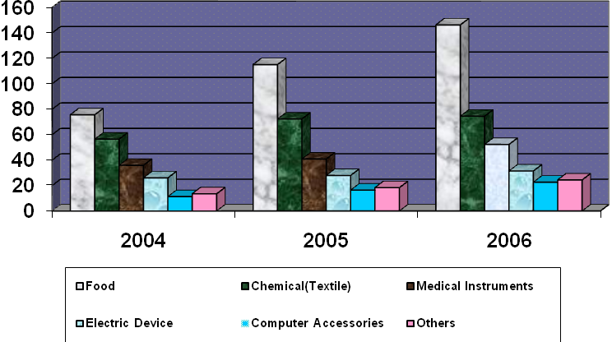
No. of import transactions

The following table represents the Import percentage of FSIBL during 2004-2006

Table-2 Position of Import %
Year | 2004 | Increase | 2005 | Increase | 2006
China | 32% | 00% | 32% | 03% | 35%
India | 25% | 01% | 26% | 02% | 28%
Thailand | 15% | 04% | 19% | (08%) | 11%
Singapore | 14% | 01% | 15% | 04% | 19%
Others | 14% | (06%) | 08% | (01%) | 07%

Source: Annual report of FSIBL-2006

The table shows that the percentage of Import position with a range of import durables steadily increased between 2004 and 2006. The greatest increase is in Singapore, rising from 01% in 2004-05 to 04% in 2005-06. Next come China, rising from 00% imports in 2004-05 to 03% in 2005-06. The percentage of import position of India rose 01% in 2004-05 to 02% in 2005-06. Import position of Thailand with Bangladeshi exporter decreased by 04% in 2004-05 to (08%) in 2005-06 respectively.
The significant imports reflected in the statistics are that over the period the proportion of Bangladesh with different country rose. Together with the big increases in Singapore and China, they are evidence of both rising well things and the trend to changes demand based on comfort and convenience.
Graph: 2- Position of Import %
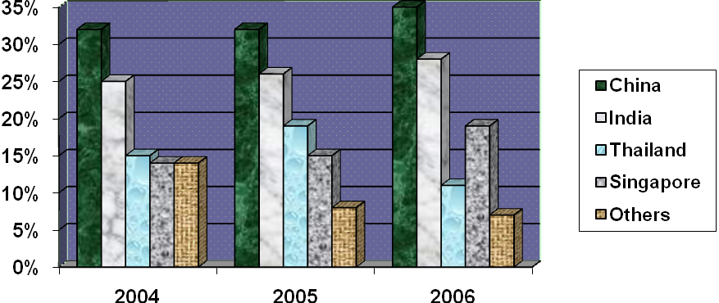
Percentage of Import
Year
The following table shown export position of FSIBL during 2004-2006.
Table 3- Position of Export
Year | 2004 | Increase | 2005 | Increase | 2006
Garments | 55.63 | 6.75 | 62.38 | 9.58 | 75.32
Shrimpfish | 31.25 | 4.21 | 35.46 | 7.15 | 41.19
Jute | 13.21 | 3.36 | 16.57 | 5.75 | 23.42
Plastic | 16.32 | 0.66 | 16.98 | 2.73 | 21.07
Others | 26.65 | 1.58 | 28.23 | 3.78 | 33.67
Total | 143.72 | 15.33 | 159.05 | 35.62 | 194.67
Source: Annual report of FSIBL during 2004-2006
The table shows that the figures for position of export in the five categories mentioned indicate overall pattern of increase or decrease. In fact there is considerable fluctuation from product to product.
In Bangladesh the numbers of Garments product have increased steadily from 6.75 in 2004-05 to 9.58 in 2005-06. On the other hand, Shrimpfish particularly the numbers rise markedly from 2004 to 2006. Since then Jute have increased gradually, apart from in 2004-05 when the numbers of Garments product rise by about 6.75 from the 2004-05 total. Plastic is the only product in which the numbers have Increased slowly over the period 2004 to 2006, although there have been fluctuations in this trend. The figure for the Total indicates the greatest number of products increased rapidly from 2004 to 2006 and this must be a well trend.
Graph 3- Export Position

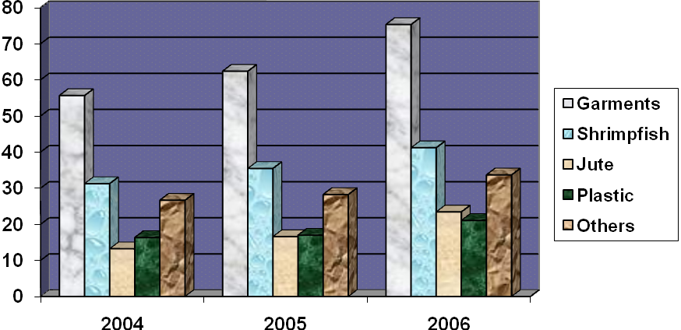
No. of Export transactions
Year

The following table represents the Export percentage of FSIBL during 2004-2006
Table 4- Position of Export %

Country | Export (%)
America | 35%
Europe | 45%
Others | 20%

Source: Yearly Report of Export Business of FSIBL during 2006

The table shows that Position of export in three continents with Bangladesh of First Security Islamic Bank Ltd. Dhanmondi Branch. There are America, Europe and Others continent percentage of export different types of products from Bangladesh. These figures show that how much they export from Bangladesh.
Export transactions are higher in wealthier countries, no doubt a reflection of ability to invest in industrial sector. America and Europe continent both reported wealthier continents; as a result export transaction of America is 35%, while Europe is 45%. Others, the least economically developed countries, have an export rate of 20%.
The data appear to confirm the often cited link between Bangladesh exporter and Wealthier Countries importer.

Graph 4- Position of Export %

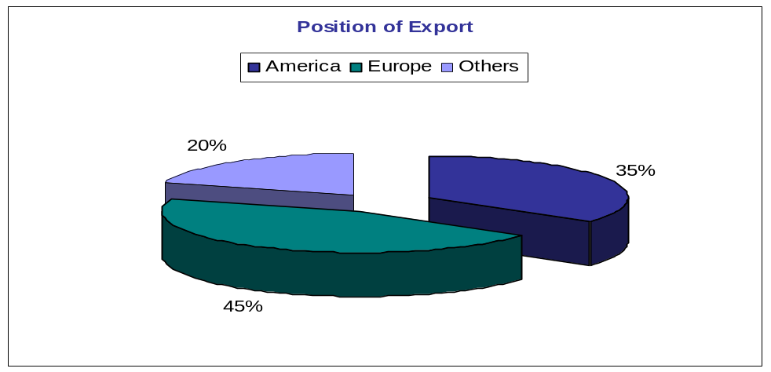

The following table shown trend value of import, export & remittance position of FSIBL during 2004-2006.
Table 5- Position of Trend Value of Import, Export & Remittance

Year | Import | Export | Remittance
2004 | 210.24 | 143.72 | 39.12
2005 | 279.09 | 159.05 | 41.26
2006 | 341.21 | 194.67 | 44.55
Source: Annual report of FSIBL during 2004-2006
The table shows the trend value of import, export and remittance during 2004, 2005 and 2006. Overall, In Dhanmondi Branch, import letter of credit is done more than export letter of credit, that’s why, the rate of remittance is less rather than import and export.
The import value in 2004 is 210.09 that is going to higher in 2005 is 279.09 and it rapidly rises from this figure to 341.21 in 2006. Export value is lower than the import value. Almost 2004’s export value is lower than 2005 and also the value of 2006 is 194.67 higher than the value of 2005 is 159.05. The highest rate of remittance in the table is 44.55 in 2006. In contrast, the lowest figures for remittance are 39.12 in 2004.
In conclusion, it seems that value of import, export and remittance is higher than respective previous year.
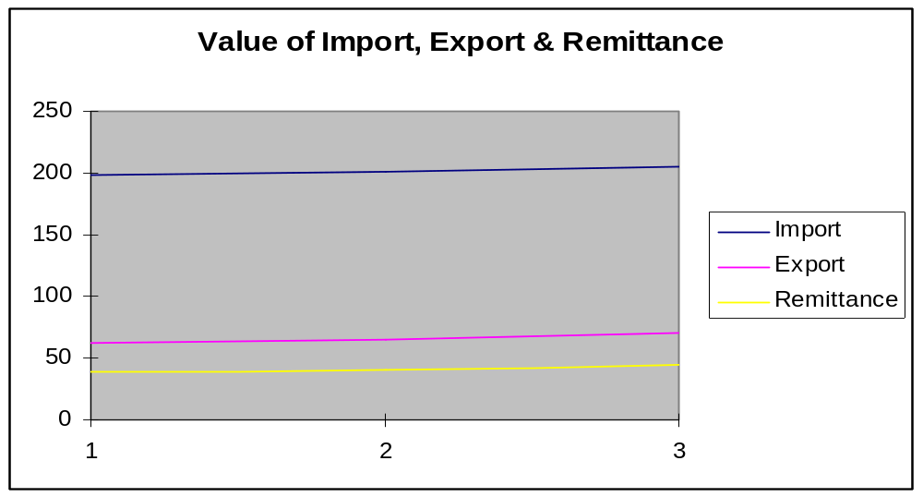
Graph 5- Position of Trend Value

The following table shown remittances position of FSIBL during 2004-2006.

Table-6 Position of Remittances
Year | Foreign Remittance (Tk. In Million) | Local Remittance (Tk. In Million)
2006 | 285.35 | 72.95
2005 | 236.52 | 52.91
2004 | 209.80 | 55.16

The above table represents the total amount of remittance transaction as on December 31, 2006 is Tk. 358.30 million while it was Tk. 289.43 million as on December 31, 2005 showing an increase of Tk 68.87 million. The figure of the above table (05) has been shown in the following graph.

Graph 6-Remittance Position

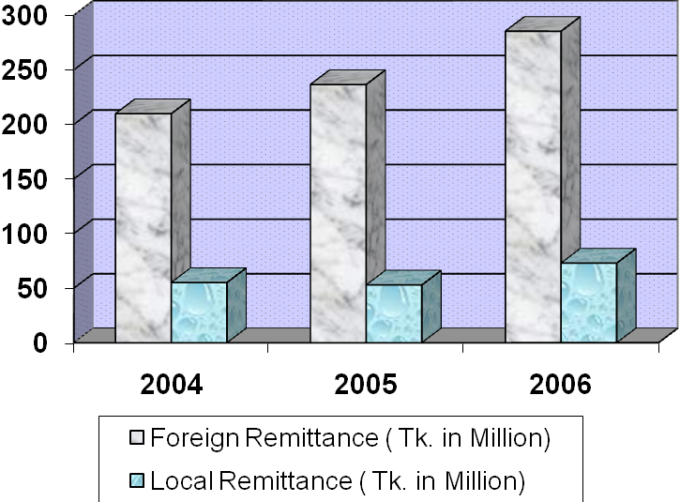
Tk. In million

- A comparative study on Foreign Exchange Business of FSIBL & EXIM Bank
Foreign Exchange Business of FSIBL
Year | FSIBL
2003 | 1674.2
2004 | 1432.7
2005 | 1568.4
2006 | 1497.8
2007 | 5098.3
Total | 11271.34
(Amount in Corer)Tk.

The following table shows the position of foreign exchange business of FSIBL:

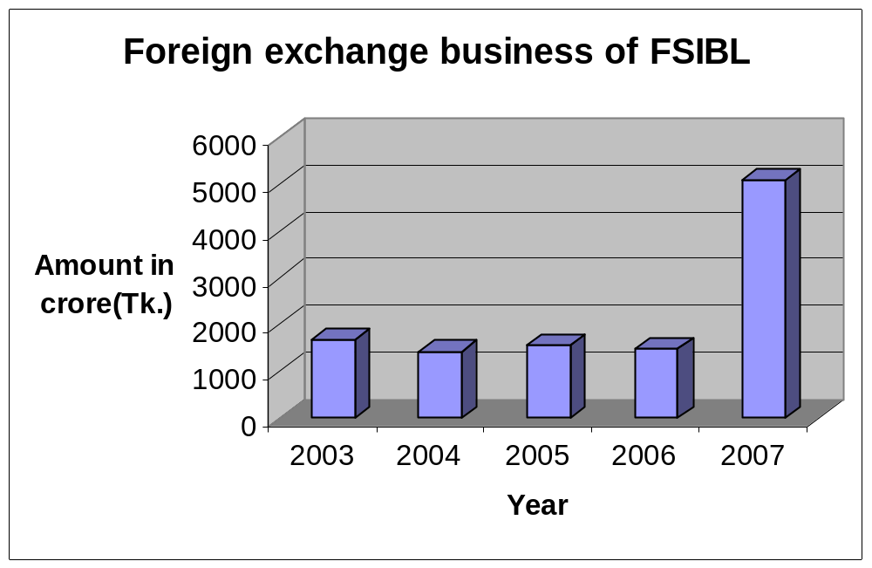
Source: Annual report of FSIBL

Foreign Exchange Business of EXIM Bank

Year | EXIM
2003 | 3462
2004 | 4931.2
2005 | 7294
2006 | 9617.5
2007 | 11568
Total | 36873.71

The following table shows the position of foreign exchange business of EXIM Bank:

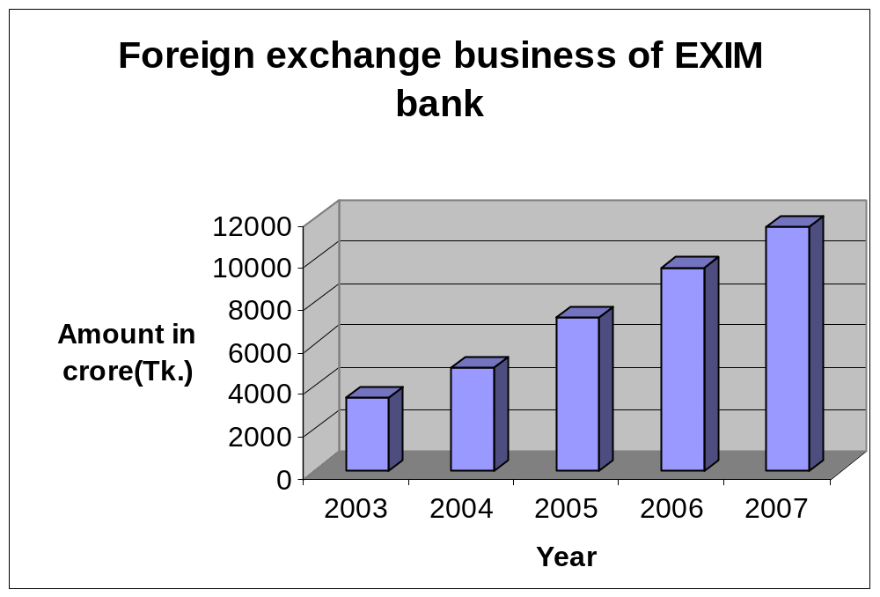
Source: Annual report of EXIM Bank
Foreign Exchange Business
(Amount in Corer)TK
Year | FSIBL | EXIM
2003 | 1674.24 | 3461.96
2004 | 1432.65 | 4931.24
2005 | 1568.36 | 7294.00
2006 | 1497.83 | 9617.51
2007 | 5098.26 | 11568.28
Total | 11271.34 | 36873.71
Average | 2254.27 | 7374.74

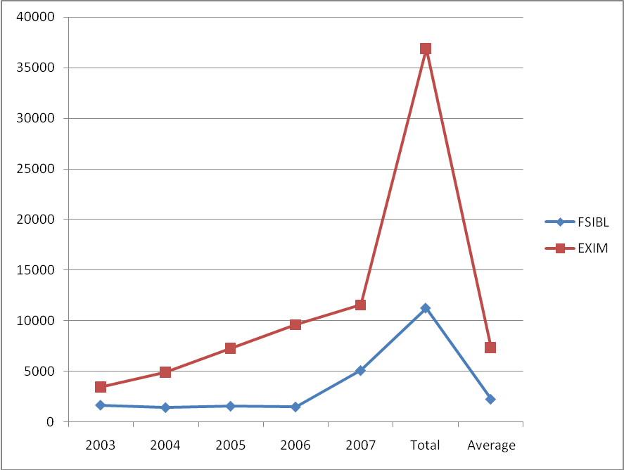
A
M
O
U
N
T
Y E A R
EXIM Bank is one of the major competitors of First Security Islami Bank Limited, so here I just tried to compare the performance of EXIM Bank and FSIBL in Foreign Exchange Business. From our above Graph and data table it is clearly visible that EXIM bank performance in Foreign Exchange business is far better than First Security Islami Bank Limited. But as I mentioned earlier that due to some Political Disturbance and Decision taken by the management not to invest in the RMG sector hampered their Foreign Exchange earning and that’s the reason that in the year 2007 foreign exchange business of FSIBL was not up to the mark and as a result FSIBL never touched the performance line of EXIM bank.

PART FOUR – PROBLEMS, RECOMMENDATIONS & CONCLUSION

Problems Regarding Foreign Exchange Transaction
Positive Findings
Negative Findings
Customers’ View
Suggestions to Overcome the Identified Problems
Conclusion
Bibliography

Problems Regarding Foreign Exchange Transaction

- Lack of manpower in Foreign Exchange Department of Dhanmondi Branch is a big problem. The manpower of that section is not sufficient for prompt service.
- As FSIBL is not a foreign bank As a result, it can not attract as much as clients for Foreign Trade. Because client prefer Global banking for foreign transaction.
- Lack of promotional initiatives to expand the Foreign Exchange business.
- From the previous years it has been observing that frequently the currency of taka is devaluating and dollar currency is going very high. And devaluation of taka is hampering import business and other sectors too.
- Government new regulations like as L/C margin reduce the Foreign Exchange transaction.
- Strict controlling of Central Bank in foreign currency endorsement is a major problem.
- Employees of that department should have fluency in their tasks, so that customer does not feel boring.
- Most of the customers of the bank ask for more quickly service especially quick, accurate service and good behavior from bankers as they think a private bank should provide such quality sufficiently. It has been found that inappropriate and slow work process often compels the customers to compare the bank with government bank, which is not a good indication for the reputation of the bank.
- Lack of enthusiastic scheme for importers and exporters.
- Lack of attractive products at foreign exchange department
- FSIBL has no strong promotional activities to increase motivate its present and potential investment client.
FSIBL does not grant investment portfolio for new entrepreneurs new businessmen new companies etc., which ultimately create "Class Banking”.

Positive Findings
- It is newly generation bank and short history of operation but it has created a brand value among the customers.
- A lot of savings and credit schemes have been introduced for different market segmentation.
- It has a lot of customers and they are loyal very to the Dhanmondi branch.
- Dhanmondi branch has some energetic and efficient human resources who maintain the daily activities more smoothly.
- This bank comparatively charge very low service charge due to providing various services even than the government banks.
- The Foreign Exchange department now performs comparatively better than previous as they have very bitter but valuable knowledge about this.
- Foreign Exchange department is also fluent in processing the necessary foreign exchange documents and in servicing to the customers.
- This branch has much space for performing banking activities and for relaxation of the customers.

Negative Findings
- The relationship among employees is not up to the mark.
- Online banking facilities are not available in every branch.
- Employees are not satisfied their salary.
- Poor customer service.
- Advertisements about various products and services and comparative advantages of doing business with this bank neither are nor properly managed.
- Job rotation is not performed timely as the officers demand it.
- Some employees are not well motivated in doing their routine jobs.
- Relationship among the co-workers is not good in all cases.
- Computer efficiency of the officers is not observed suitable enough in all cases.
- Computer hardware and software have not been updated timely. Even all computers are not well equipped.
- Banking law and banking practice are found sometimes inverse.

Customers’ View
- Most of the clients are satisfied with the management philosophy of the Bank.
- They diverse modern technology in banking service.
- Most of the client treats the bank as their friend so they were not hesitating to say about the bad side of the service while they were interviewing by me.
- Clients especially the corporate clients are required to be trained through workshop and training season for the clients.
- The bank can achieve success if they can handle the situation efficiency

Suggestions to Overcome the Identified Problems
- The bank should try to arrange more training programs for their officials. Quality training will help the officials to enrich them with more recent knowledge of International Trade Financing
- Install require technology
- Sucking license for doing foreign trade business from Bangladesh Bank
- Reduce commission and other charge for expand foreign trade business and help to gear up countries economy
- Need expert & experience and well behave employees to the Bank
- In many cases, the foreign banks want confirmations from other foreign banks with which this bank has correspondence. This proves the poor financial condition of our country. Bank should try to improve this situation.
- First Security Islamic Bank Limited should increase skilled manpower to do its financial activities more efficiently. So that many of the employees do not have to do extra work.
- The Bank should go aggressive advertising and promotional activities to get a broad geographic coverage.
- The authority of First Security Islamic Bank Limited should introduce more innovative and modern customer service.
- Practice amount of doubtful income declined substantially during the year as compared to the past few years, indicating more carefulness of the Management. As a result, idle money will be invested to increase potential profit of this Bank.
- Arrangement of monthly/quarterly training courses/workshops for the clients selected by the Branches in order to promote Investment clients of the desired level.
- First Security Islamic Bank Limited should initiates different investment modes according to changing/diverse needs of clients by conducting huge research and study.
- First Security Islamic Bank Limited should utilize "Internship Program" as one kind of promotion policy to encourage its present and potential investment clients. Because, young generation plays a vital role in our economy. To do so this Bank should provides facilities to the internees through proper placement and practical operations as well as job certainty to those who brings introduce themselves the best performers in doing their particulars.
- First Security Islamic Bank Limited should appoint a sufficient number of women employees to deal women entrepreneurs and professionals and understand their needs and thus create demand for investment.
- To fulfill the vision of "mass banking" this Bank should grants investment portfolio to new entrepreneurs/new businessmen new companies etc.
First Security Islamic Bank is a progressive commercial bank in bank in banking sector. Its foreign exchange branch is a very busy branch. Therefore it is not fully computerized as yet. So, it is very difficult to find any thing within a very short period for quick customer service. To improve their customer service and to improve the overall-banking sector, the following recommendation can be suggested.

- Computer facility in all sectors: Nowadays, to survive in the competitive market, bank has to provide various facilities to satisfy the customer, the service should be swiftly, timely, accurately and good behavior pattern. And to provide these facilities to the customer, computer is a must.
- Immediately start online banking: online banking facilities make the customers life more easy and safe. Many private commercial banks and foreign banks provide online banking facilities to the customer.

Higher Rate of Interest for Credit
Clients generally complain that rate of interest for various types of credit are quite high. In many cases productivity from loaned investment is inadequate that borrower become incapable in repaying loan.

Irregularity in Providing Loan
Usually banks are responsible to provide loan to those who are eligible for the loan. But in reality, small investors do not get the loan easily. They have to fulfill more terms & conditions than those who have greater influence in the business community. That irregularity in providing loan is not ethical, banks all rules and regulations are equal for every one or every parties.

Diversify the Loan Facility
Bank can provide long term loan, loans fir highway and high rise constructions of to provide different small business sectors or agriculture sectors, which can also help the economy as well.

Involve Modern Technology in the Service System
Without using modern technology no bank can even think of remaining in the business in near future. So the bank must decide right now how it can equip its branch with modern technology. Use of modern technology in one sense can increase cost but another sense it increase productivity highly and it attract big clients.

Advertisement
The management should impart more imphasis on the advertisement of the bank in different electronic and printing media. The Basic goal of the advertisement should be firstly to make people know and understand that the bank is universal one and permits anyone’s access.

ATM Card Facilities
First Security Islamic Bank Limited is now providing the ATM Card Service that is also a very important phenomenon of a financial institution. All the third generation banks have taken this facility to the door-step of the people. FSIBL has to give more emphasize in this regard. In the first phase, the ATM card service will be available in Dhaka City, which will gradually be made available in other major cities.

Up Gradation of Computer Hardware and Software
Computer hardware and software are not updated as necessary. Some computers lack of required accessories and the some are not well performing.

Use of Bangla in Documentation
All the necessary charged documents are written in English which are quite understandable to all kinds of parties. Most of them agree with the terms and conditions without reading the conditionality. So, I hope use of Bengali language along with English may be helpful for the parties.

More Motivational Activities
Some officers are not well motivated in doing their routine tasks. They should be motivated by applying various motivational tools. They should be motivated in such way that they would feel proud to be a part of FSIBL.

Direct Social Involvement
To enhance the image of the bank and to assume social responsibility, the bank should engage itself to various social programs like Scholarship to poor but meritorious students, Empowerment of the children in abject poverty, sponsor ship in various sports and job fair, Compaign against dowry and other social evil etc.

Cost Accounting Cell
It should maintain a separate cost accounting cell at the head office of this Bank furnished by professional cost accounts for implementation of appropriate costing system.

Research Cell
The research cell of this Bank should be strengthening with the efficient manpower by studying the feasibility of introduction of new products, analysis of manpower productivity and similar other research works.

Analyze the Competitors
FSIBL should observe competitors closely to analyze any new action taken by them and react competitively to that action. It can be accomplished by the following ways:
- FSIBL can get information about a certain competitor’s Business policies by recruiting that company’s employees.
- It can get information from people who do Business with rivals.
- It can get information about other Banks from published materials and published document.

Reengineering Its Core Business
FSIBL should reengineer its core Business process in order to eliminate duplicate work and reduce overhead cost.
Analyzing the current competitive situation in terms of opportunity and threats and its strengths and weaknesses, several strategies are recommended for FSIBL. It should start credit card services by forming strategic alliance with other banks. It should also introduce new innovative services, increase its area of coverage and train its new employees in professional institutions like Bangladesh Institute of Bank Management (BIBM). But most importantly the bank should go for Asset-driven marketing instead of buying liabilities, because deposit is liability for the bank. On the other hand, if they can invest this deposit through giving investment, and then it will become their asset. There is no point in increasing the deposit unless it can be invested profitably. So they should try to maintain a balance between deposits and investment. In addition to that, it should also improve its services through launching its own website, and promote its services through it. If FSIBL always keeps itself up to date with the current trend and development in the outside world, it can reap the benefit of new opportunities, and thus become an ideal bank for the generations to come.

Conclusion
As an internee of First Security Islamic Bank Limited, I have truly enjoyed my internship from the learning and experience viewpoint. I am confident that this three months internship program at First Security Islamic Bank Limited will definitely help me to realize my further carrier in the job market.

First Security Islamic Bank Limited is a new generation bank in Bangladesh. It is committed to provide high quality financial services/products to contribute to the growth of GDP of the country through stimulating trade and commerce, accelerating the pace of industrialization, boosting up export, creating employment opportunity for the educated youth, poverty alleviation, raising standard of living of limited income group and overall sustainable socio-economic development of the country. Though it is a new bank, First Security Islamic Bank Limited makes a strong position through its various activities. Its number of clients, amount of deposit and investment money increases day by day. This bank already has shown impressive performance in investment. The bank now should think to start new services and take different types of marketing strategy to get more customers in this competition market of banking.
As there are lots of local and foreign banks in Bangladesh the First Security Islamic Bank Limited is promising commercial Bank among them. In this competitive market Bank has to compete not only the others commercial banks but also with the public Bank. First Security Islamic Bank Limited is more capable to contributing towards economic development as compared with other bank. FSIBL invested more funds in export and import business. It is obviously that the right thinking of this bank including establishing a successful network over the country and increasing resources will be able to play a considerable role in the portfolio of development. Success in the banking business largely depends on effective lending. Less the amount of loan losses, the more the income will be from Credit operations the more will be the profit of the FSIBL and here lays the success of Credit Financing.
I do believe that all these will assist me in my career build-up.

