General Banking & Loan System
of
IFIC Bank Limited
Pallabi Branch, Dhaka

Submitted by

WWW.ASSIGNMENTPOINT.COM

Banking service in Bangladesh is characterized as a highly competitive and highly regulated sector. With a good number of banks already in operation and a few more in the pipeline, the market is becoming increasingly competitive by the day.

With the global slowdown in the face of rising competition, the commercial banks are constantly looking for ways to develop their market and product offers to remain ahead of others. A significant amount of regulation by Bangladesh Bank prevents the scope of introducing newer products into the market and thereby restricts a banks’ ability to outperform others with a diversified product range.
However, recent trends have shown banks shifting away from vanilla products (basic products) towards higher value added products that are highly structured, to meet the needs of the clients.
Involvement of the banking sector in different financial events is increasing day by day. At the same time the banking process is becoming faster, easier and the banking arena is becoming wider. As the demand for better service increases, the banking organizations are coming with innovative ideas. In order to survive in the competitive field of the banking sector, all banking organizations are looking for better service opportunities to provide to their clients.

As the student of Bachelor of Business Administration (BBA) every student has to conduct a practical orientation (Internship) on any organization for fulfilling the requirements of the B.B.A program. In order to fulfill this requirement of the Internship program I choose IFIC Bank Limited. The main purpose of the program is to know the real world situation. The topic of my report is “General Banking & Loan System of IFIC Bank Limited”. In this regard I have opportunity to make my internship in IFIC Bank Limited from January 04 to April 04, 2011.

International Finance Investment and Commerce (IFIC) Bank Limited started banking operation on June 24, 1983. Prior to that it was set up in 1976 as a joint venture finance company at the instance of the Government of Bangladesh. Government then held 49 percent shares, while the rest were held by the sponsors and the general public. IFIC Bank is the oldest bank operating in Bangladesh. It has, over the years, created one of the largest networks among all the banks in Bangladesh.

1.2 Origin of the report

Present world is changing rapidly to face the challenge of competitive free market economy. To keep pace with the trend banks need executive with modern knowledge and provide fresh graduate with modern theoretical and practical knowledge in banking and financial institution management. As the practical origination is an integral part of the BBA degree requirement, I was placed as an internee in IFIC Bank Limited (Narshingdi Branch) to take the real life exposure of the activities of banking financial institution for three months only starting from January 04, 2011. This research is a partial requirement of BBA Internship Program in the Institute of Science and Technology (IST) affiliated by National University and report is being prepared from three months extensive knowledge and research.

  - Objective of the report

The primary objective of this report is to comply with the requirement of my course. But the objective behind this study is something broader. The principal intent of this report is to analyze the trends of modern banking and their customer’s satisfaction. Objectives of the study are summarized in the following manner:

- To identify the present state of IFIC Bank Limited.
- To get an idea about the financial strength of IFIC bank.
- To find out the problems exist in general banking department.
- To describe General Banking, SMS Banking, ATM facilities & other facilities provided by it.
- To discuss the potential of the bank.
- To provide the recommendation for improvement.
- Finally, to sketch out the overview of IFIC bank Ltd.
- To describe the loan department of this bank.

1.4 Scope of the study

IFIC Bank Limited is one of the new generation banks in Bangladesh. The scope of the study is limited to the Narshingdi Branch only. The report will cover the functions of different departments of IFIC Bank (Narsingdi Branch) like General banking, Loan. It will also present a brief scenario of the IFIC bank in total.
I will include on my report first of the introduction of IFIC Bank Ltd .Then the overall banking activities, products and services. Finally, I shall provide an analytical view on a real project that IFIC Bank (Narsingdi Branch) is facing, and it is the special focus of my report.

1.5 Methodology of data collection

For achieving the specific objective of this study, I have collected the related data both from primary & secondary sources.

Primary data have been collected from:
- Interviewing and interacting with the customers of IFIC Bank.
- Observing different organizational activities.
- Conversation with the staffs of this bank.

Secondary data have been collected from:
- The annual reports of IFIC bank.
- Different papers of the bank.
- Various records of the bank, unpublished data.
- Different textbooks, journals, booklets and
- Web site of IFIC bank.

Methodology
Framework

General Banking & Loan System of IFIC Bank

Secondary Data
- Brochures
- Newsletters
- Product Catalogs
- Website
- Annual Report

Primary Data
- Interview
- Survey
- Conversation
- Observation

Problem Findings and recommendations

Fig: 1.1 Conceptual Research Framework of the report

1.6 Limitations of the study

- The internship was based upon only IFIC bank, Narshingdi Branch, so the report doesn’t show all branches’ activity of IFIC bank in depth.

- Although I have obtained wholehearted co-operation from employees and customers of IFIC bank, Narshingdi Branch but they could not manage enough time to deal with my report.

- The annual report and Web page are the main secondary sources of the information but this information was not enough to complete the report and it was not identified clear idea about this bank.

- Due to some policies of the bank I couldn’t collect the organizational hierarchy to show the organizational decisions flow.

- The main limitation for me was that relevant data and document collection was difficult because of the confidentiality of the administration.

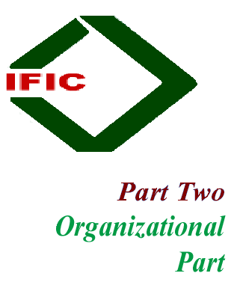



2.1 Historical background of IFIC Bank in Bangladesh

International Finance Investment and Commerce Bank Limited (IFIC Bank) is banking company incorporated in the People’s Republic of Bangladesh with limited liability. It was set up at the instance of the Government in 1976 as a joint venture between the Government of Bangladesh and sponsors in the private sector with the objective of working as a finance c company within the country and setting up joint venture banks/financial institutions aboard. In 1983 when the Government allowed banks in the private sector, IFIC was converted into a full fledged commercial bank. The Government of the People’s Republic of Bangladesh now holds 32.75% of the share capital of the Bank. The Government of the People’s Republic of Bangladesh now holds 32.75% of the share capital of the Bank. Directors and Sponsors having vast experience in the field of trade and commerce own 11.42% of the share capital and the rest is held by the general public.

The Bank had been widely welcome by the business community, from small entrepreneurs for forward-looking business outlook business outlook and innovative financing solutions. Thus, within this very short period it has been able to create an image for itself and has earned significant reputation in the country’s banking sector as a bank with vision.

General banking department is the ‘Heart’ of the banking activities. It performs the core functions of the bank, operates the day-to-day transaction. It is the storage point for all kinds of transaction of foreign exchange department, loan and advances department and itself. IFIC Bank provides different types of accounts and special types of schemes under general banking.

The sponsors of IFIC Bank Ltd are leading entrepreneurs of the country having stakes in different segments of the national economy. They are eminent industrialists and businessman having wide business reputation.
2.2 Time Line of IFIC Bank

1976 | - | Established as an Investment & Finance Company under arrangement of joint venture with the govt. of Bangladesh.
1980 | - | Commenced operation in Foreign Exchange Business in a limited scale.
1982 | - | Obtained permission from the Govt. to operate as a commercial bank.
 | - | Set up a its first overseas joint venture (Bank of Maldives Limited) in the Republic of Maldives (IFIC's share in Bank of Maldives Limited was subsequently sold to Maldives Govt. in 1992)
1983 | - | Commenced operation as a full-fledged commercial bank in Bangladesh.
1985 | - | Set up a joint venture Exchange Company in the Sultanate of Oman, titled Oman Bangladesh Exchange Company (subsequently renamed as Oman International Exchange, LLC).
1987 | - | Set up its first overseas branch in Pakistan at Karachi.
1993 | - | Set up its second overseas branch in Pakistan at Lahore.
1994 | - | Set up its first joint venture in Nepal for banking operation, titled Nepal Bangladesh Bank Ltd.
1999 | - | Set up its second joint venture in Nepal for lease financing, titled Nepal Bangladesh Finance & leasing Co. Ltd. (which was merged with NBBL in 2007)
2003 | - | Overseas Branches in Pakistan amalgamated with NDLC, to establish a joint venture bank: NDLC-IFIC Bank Ltd., subsequently renamed as NIB Bank Ltd.
2005 | - | Acquired MISYS solution for real time on-line banking application.
 | - | Core Risk Management implemented.
2006 | - | Corporate Branding introduced.
 | - | Visa Principal and Plus (Issuer and Require) Program Participant Membership obtained.
2008 | - | Observing 25th Anniversary of Customer Satisfaction.
2009 | - | 64 Branches offering Real Time On-line banking facility.
2010 | - | All 87 Branches & SME Service Centers of IFIC Bank is operating under state-of-art world class Real Time On-line Banking Solution.

2.3 Objectives of the IFIC Bank Limited

It conveys its objective via their motto: “Your Satisfaction First.”


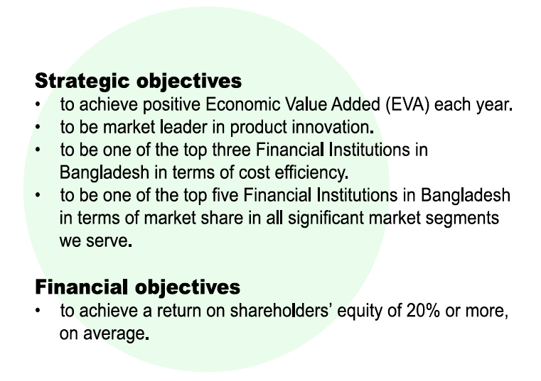
2.4 Vision, Mission and Core values




For the customers:
Providing with caring services by being innovative in the development of new banking products and services.

For the shareholders:
Maximizing wealth of the bank.

For the employees:
Respecting worth and dignity of individual employees devoting their energies of the progress of the bank.

For the community:
Strengthening the corporate values and taking environment and social risks and reward into account.

To become a leading banking institution in terms of efficiency, adequacy, quality & sound management.

To provide service to their clients with the help of a skilled & dedicated workforce; and committed to the welfare & economic prosperity of the people and community: and wants to be the leader among banks in Bangladesh.
2.5 At a Glance of IFICBL

Name | IFIC Bank Limited
Date of incorporation | 1976
Head Office
  BSB Building (8th - 10th & 16th – 19th Floor)
  8, Rajuk Avenue G.P.O. Box – 2229
  Dhaka-1000 Bangladesh
  Telephone : 9563020, 9562060, 9562062, 9562068
  Fax : 880-2-9562015 880-2-7161644
Logo | IFIC BANK LIMITED  Tomorrow’s Bank Today
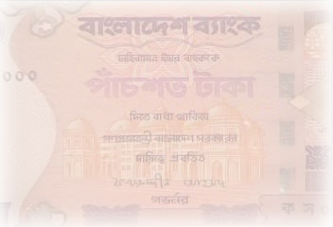  Name of the Chairman of the Board | Mr. Salman F Rahman
Name of the managing Director | Mr. Mosharraf Hossain
Number of branches | 87
Services provided | Deposit Scheme, credit facility and foreign exchange services
Diversification of Product And Services | Corporate banking, Retail Banking, SME Banking
Paid up capital | 1743.86 (Million)
Profit after tax & provision | 899.52 (Million)
Publicly Traded Company | Shared quoted daily in DSE & CSE
Credit Card | VISA Credit Cards
Banking operation system | Both conventional and foreign exchange system
Technology used | Misys International Banking System Inc. (UK), Q-Cash, Member of SWIFT, online banking, UNIX based computer system
Income per share | 372.41
Earning per share | 51.58
E-mail | info@ificbankbd.com
Website | www.ificbankbd.com
SWIFT | IFIC BD DH

Fig 2.1: At a Glance of IFICB



2.6 Network of the Branches of IFIC Bank
Mercantile Bank has 51 existing branches and some other proposed branch all over Bangladesh to provide better services to their valuable customer.

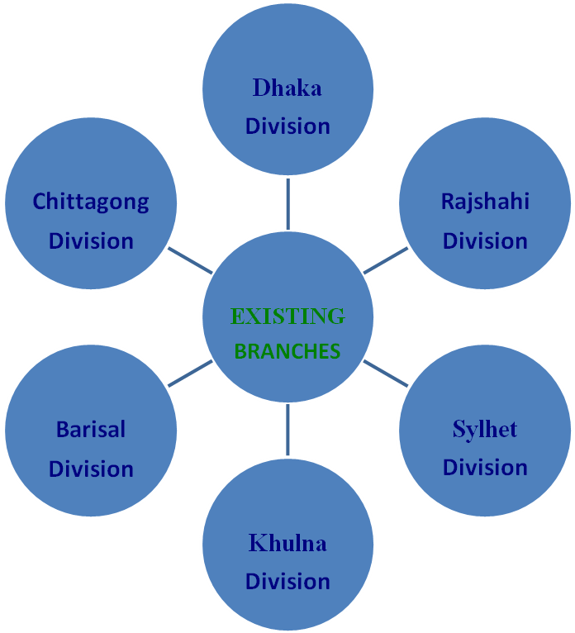

Figure 2.2: Network of the Branches

2.7 Branch Location of IFIC Bank

There are 97 branches of IFIC Bank limited all over the country. All the branches are involved in providing service to its clients in various ways.

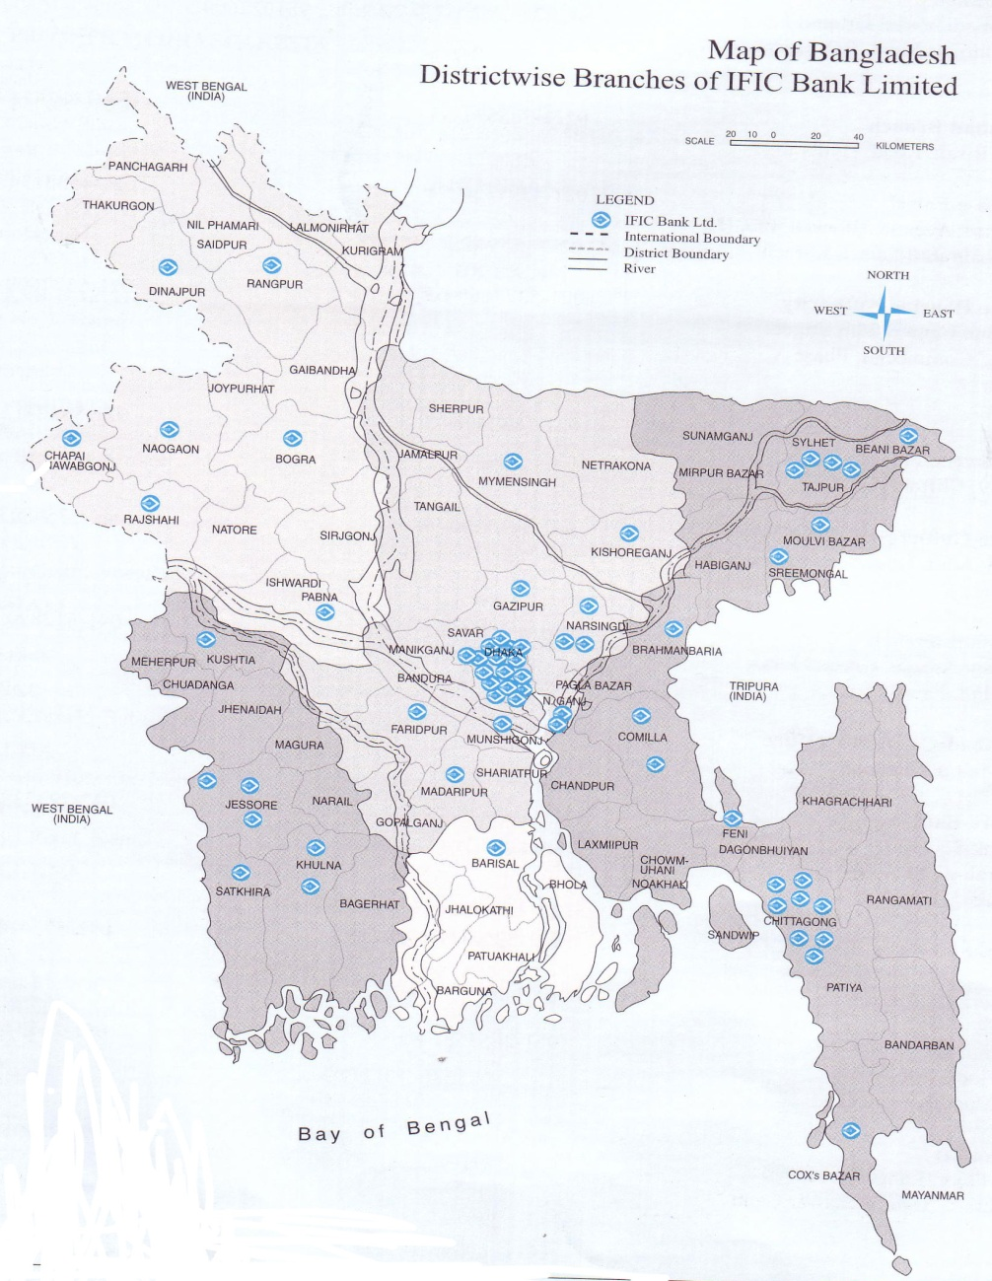

Branch Location of IFIC Bank

2.8 The organizational structure

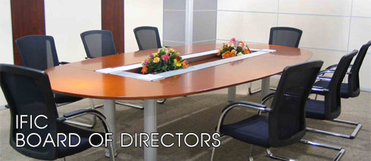
  01.
  Mr. Salman F Rahman
  Honourable Chairman
  02.
  Mr. Mohammad Lutfar Rahman
  Honourable Director

  03.
  Mr. Aminur Rahman
  Honourable Director
  04.
  Mr. Syed Anisul Huq
  Honourable Director

  05.
  Mr. Mohammed Nayem Syed
  Honourable Director
  06.
  Mr. Tanim Noman Sattar
  Honourable Independent Director

  07.
  Mr. Mahmudul Huq Bhuiyan
  Honourable Director
  08.
  Mr. Arastoo Khan
  Honourable Director

  09.
  Mr. Syed Monjurul Islam
  Honourable Director
  10.
  Mr. Mohammad Ali Khan, ndc.
  Honourable Director

  11.
  Mr. Abu Tahir Mohammad Golam Maruf
  Honourable Director
  12.
  Mr. Mosharraf Hossain
  Managing Director


  01.
  Mr. Mosharraf Hossain
  Managing Director
  02.
  Mr. Mohammad Abdullah
  Deputy Managing Director
  03.
  Mr. A.K.M. Mozharul Hoque
  Senior Executive Vice President & Company Secretary

  04.
  Mr. Syed Zahidul Islam
  Senior Executive Vice President & Head of Human Resources Division
  05.
  Mr. S.M. Abdul Hamid
  Senior Executive Vice President & Head of Finance and Accounts Division
  06.
  Ms. Zaitun Sayef
  Senior Executive Vice President & Head of Training & Research Division

  07.
  Mr. Shaikh Rashid Ahmed
  Executive Vice President & Head of Treasury & International Banking Division
  08.
  Mr. Narayan Chandra Roy
  Executive Vice President & Head of Internal Control and Compliance Division
  09.
  Mr. Fariduddin Al Mahmud
  Executive Vice President & Head of Corporate Banking & Marketing Division

  10.
  Mr. Wakar Hasan
  Executive Vice President & Head of Credit Risk Management Division
  11.
  Mr. Md. Abul Hossain
  Executive Vice President & Head of Corporate Communication and Support Service
  12.
  Mr. Md. Ruhul Amin
  Executive Vice President & Head of Remedial Asset Management

13.
Mr. Gopal Chandra Guha Roy
Senior Vice President & Head of IT

3.1 Balance Sheet
Balance Sheet
IFIC Bank Limited
Balance Sheet as at December 31, 2009

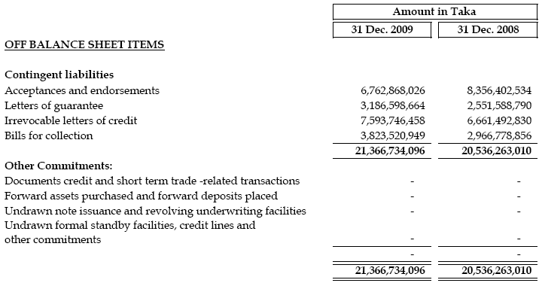

3.2 Cash Flow Statement

Cash Flow Statement
Mercantile Bank Limited
For the year ended December 31, 2009

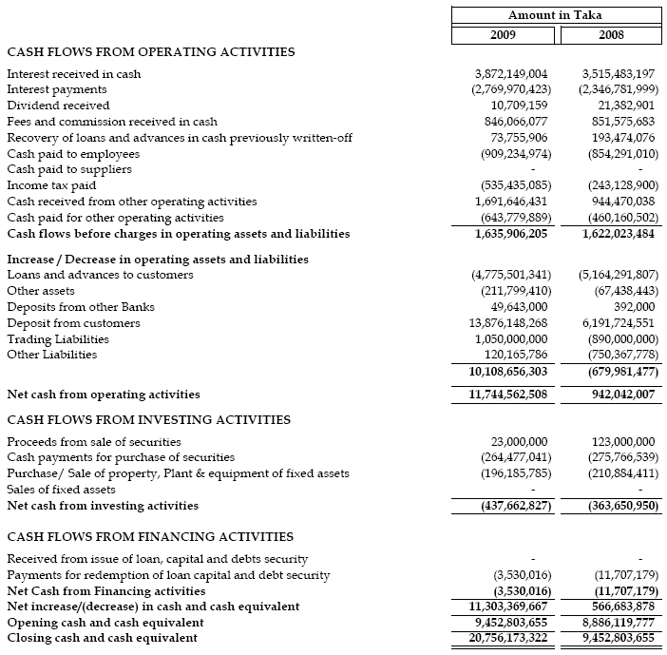

3.3 Profit and Loss Account

Profit and Loss Account
Mercantile Bank Limited
For the year ended December 31, 2009
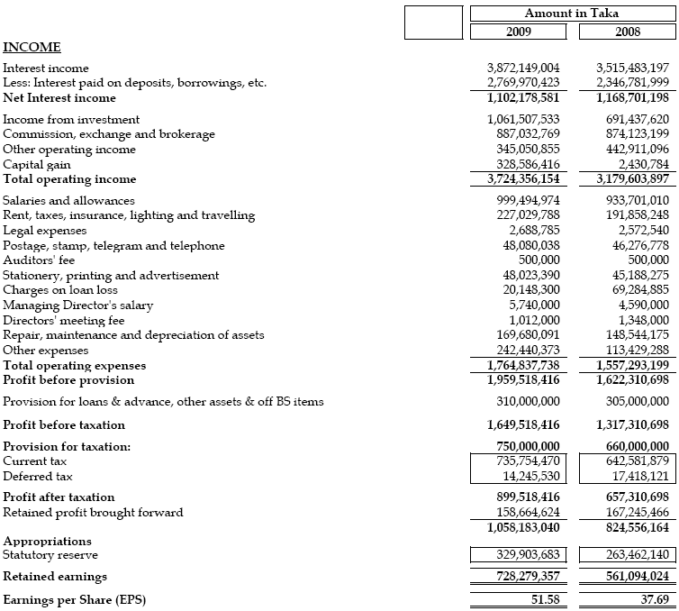

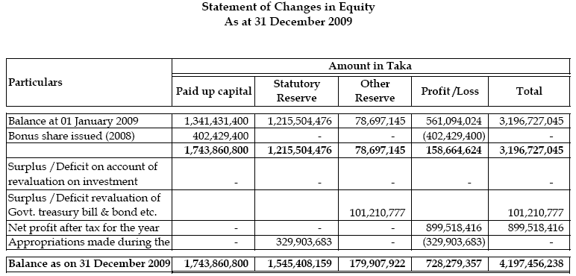

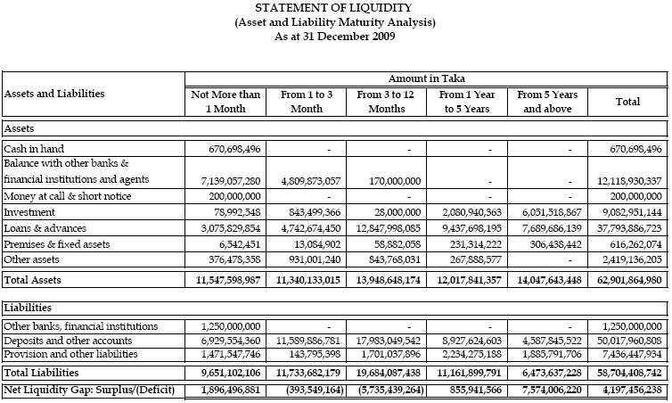
3.4 Financial Highlights

Financial Highlights
Highlights for the year 2009 and 2008

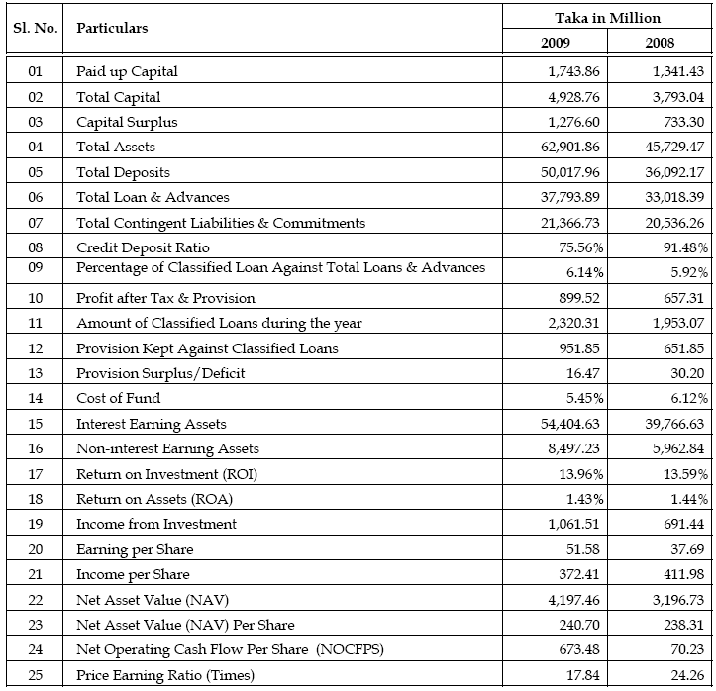

3.5 Auditor’s Report

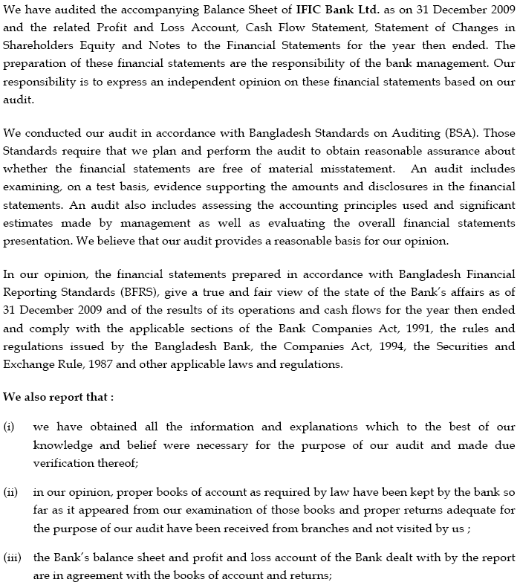

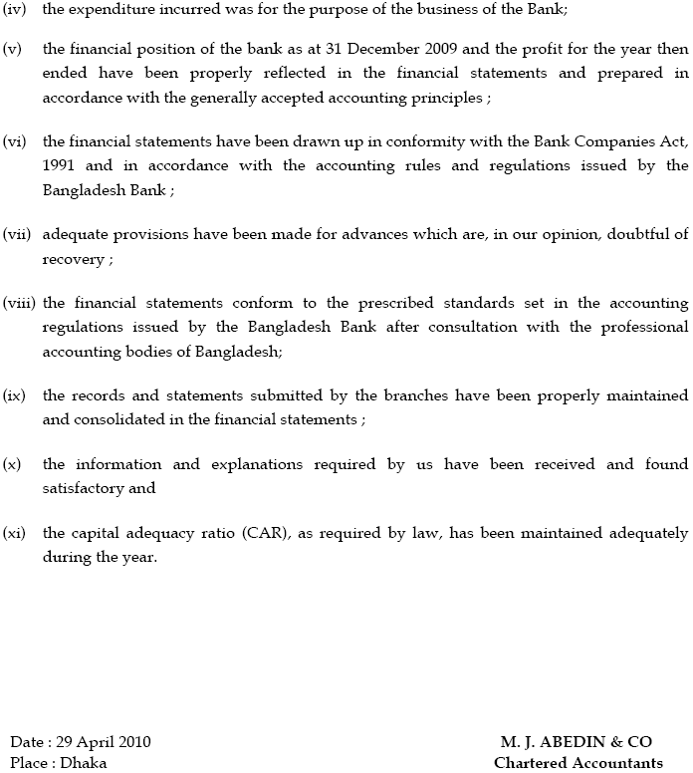


General Banking
Department
4.0 Introduction

Division of IFICBL

IFICB, being one of the financial intermediaries in the country, blended in operation in conventional banking, Corporate banking and Retail banking. The blending has been done with the objective of diversifying the operations for catering to the needs of the customers of the different sterna of the society. The bank’s operations were diversified into the following areas of activities as a dynamic financial intermediary.

- Corporate banking
- Retail Banking
- SME Banking

Services Provided by IFIC Bank

- General Banking
- Credit or Loan Department
- Foreign Exchange Business

4.1 General Banking

The general banking department does the most important and basic works of the bank. All other departments are linked with this department. It also pays a vital role in deposit mobilization of the branch. IFIC Bank provides different types of accounts, locker facilities and special types of saving scheme under general banking. For proper functioning and excellent customer service this department is divided into various sections namely as follows.

- Account Opening Section,
- Local Remittance Section,
- Deposit Schemes Section,
- Accounts Section,
- Clearing Section,
- Collection Section,
- Cash Section,

4.1.1 Account Opening Section

To establish a Banker and customer relationship account opening is the first step. Opening of an account binds the banker and customer into contractual relationship. But selection of customer for opening an account is very crucial for a Bank. Indeed, fraud and forgery of all kinds start by opening account. So, the Bank takes extremely cautious measure in its selection of customers.

Deposited Products
IFICB has the following types of deposited products:

 | A. | Savings Account
 | B. | Current Account
 | C. | Fixed Deposit Receipt (FDR)
 | D. | Special Notice Deposit (SND)
 | E. | Pension Savings Scheme (PSS)
 | F. | Monthly Income Scheme
 | G. | Double Return Deposit Scheme
 | H. | Three Years Deposit Plus

A. Savings Account

IFIC Bank is offering the most attractive interest rate of 5% on Savings Account:

- Initial Deposit: Tk. 500.00 at rural branches & Tk. 1000/- for urban branches which should be considered as minimum balance.
- Competitive Interest Rate.
- No extra hidden charge.
- Debit Card facility.
- SMS Banking Facility.
- ATM facility.
- Online banking facility.
- Utility payment service.
- Transfer of fund from one branch to another.
- Opportunity for availing locker facility.

B. Current Account

- Minimum required balance Tk. 2000/-.
- Debit Card facility.
- ATM facility.
- Online Banking facility.
- SMS Banking Facility.
- Utility payment service.
- Transfer of fund from one branch to another.
- Opportunity for availing locker facility.
- No extra hidden charge.

C. Fixed Deposit Receipt (FDR)

This branch maintains a separate section for maintaining Fixed Deposit. FDR is an important factor for the bank and volume of FDR determines the investment base of the bank.
FDR gives one higher interest than other forms of deposits. IFIC Bank is offering competitive interest rate in FDR:
FDR (3 Months & above)
 | Less than Tk. 1.00 crore | 12.00%
 | Tk. 1.00 crore and above but less than Tk. 5.00 crore. | 9.75%
 | Tk. 5.00 crore and above | 9.00%
FDR (6 Months & above)
 | Less than Tk. 1.00 crore | 10.50%
 | Tk. 1.00 crore and above but less than Tk. 5.00 crore. | 11.00%
 | Tk. 5.00 crore and above | 9.25%
FDR (1 Year)
 | Less than Tk. 1.00 crore | 10.00%
 | Tk. 1.00 crore and above but less than Tk. 5.00 crore. | 8.25%
 | Tk. 5.00 crore and above | 9.50%

D. Monthly Income Scheme ( MIS )

One Enjoy Higher Return on Monthly basis

Deposit | Term | Gross Monthly Income
Tk. 50,000 or multiple | 3 Yrs. | Tk.350.00 (i.e Tk.700.00 per lac)

Eligibility

- If individual is 18 years of age or above, he is welcome to apply for keeping deposit under this Deposit scheme. If e/she is not yet 18, become so and soon.
- Can be opened in Joint names or in the name of any Institutions.
- He/she will require opening / having a CD/SB Account with the Branch.
- He/she can open more than one account in his/her name in any branch.

Credit Facility
One can avail loan/overdraft facility against registering lien on the MIS account as per the Bank’s prescribed rates and rules.
E. Pension Savings Scheme (PSS)
IFIC Bank is pleased to offer 3(three) / 5(five) Years Monthly Savings plan with higher return and monthly pension option at maturity. Monthly Installment option and Payment after maturity, now being offered under the scheme, are as under:

Monthly Installment | 3 years Terms | 5 years Terms
Monthly Installment | Amount payable After maturity | Amount payable After maturity
Tk. 500 | Tk. 20,781 | Tk. 38,134
Tk. 1,000 | Tk. 41,562 | Tk. 76,268
Tk. 2,000 | Tk. 83,125 | Tk. 1,52,536
Tk. 3,000 | Tk. 1,24,687 | Tk. 2,28,804
Tk. 5,000 | Tk. 2,07,812 | Tk. 3,81,340
Tk.10,000 | Tk. 4,15,624 | Tk. 7,62,680
Tk.15,000 | Tk. 6,23,435 | Tk. 11,44,020
Tk.20,000 | Tk. 8,31,247 | Tk. 15,25,360
Tk.25,000 | Tk. 10,39,059 | Tk. 19,06,699
Tk.50,000 | Tk. 20,78,118 | Tk. 38,13,399

Income Tax Rebate
Monthly installments of IFICB PSS will qualify as allowable investment in Yearly Income Tax Return. The account under this scheme will also be exempted from deduction of tax on interest payable at source. However, If any tax or other Govt. Levy is payable under this Scheme in future the same shall be deducted from the account.

Credit facilities
The A/c holder can avail loan / Secured Overdraft (maximum 80% of the deposited principal amount but not less than Tk.20,000/-) against lien of the PSS account to meet the personal need, educational expenses of his/her children or for medical treatment.

F. Special Notice Deposit (SND) Account
Special Notice Deposit (SND) Account is opened for any individual/firm/company/Financial Institutions/societies/clubs/Trust/NGOs/Banks/Corporations/Autonomous bodies/ government organizations.

Initial Deposit for opening account Tk. 25,000/- (Min.)
SND Interest Rate
 | - Less than Tk. 1.00 crore | 2.00%
 | - Tk. 1.00 crore and above but less than Tk.25.00 crore | 2.50%
 | - Tk. 25.00 crore and above but less than Tk. 50.00 crore | 4.00%
 | - Tk. 50.00 crore and above but less than Tk. 100.00 crore | 2.00%
 | - Tk. 100.00 crore and above | 2.00%

Types of Customer and the accounts they are allowed to open by this bank
Types of customer | CA | SB | FDR | STD
Individual | √ | √ | √ | X
Sole Proprietorship / Partnership firms | √ | √ | √ | √
Private / Public Limited Company | √ | X | √ | √
Trustee / Liquidators / Executors | √ | √ | √ | √
Clubs / Societies / Non–Trading Concern | √ | √ | √ | X
Co-operatives / Non–Government Organizations | √ | √ | √ | √

4.1.2 Analysis of this Department

Types of Account | No. Of Accounts | Amounts (In Taka.)
Current Account | 1943 | 53124838.98
Savings Account | 3908 | 117763791.63
Short Term Deposit | 85 | 77277094.94
FDR | 444 | 392538521.29
PSS | 1498 | 20948745.63
FDR (MIS) | 2 | 250000.00
Source: General Ledger on 12 – 07 - 2010
Table 3.1: No & Amounts of deposits of IFICB at Narshingdi Branch

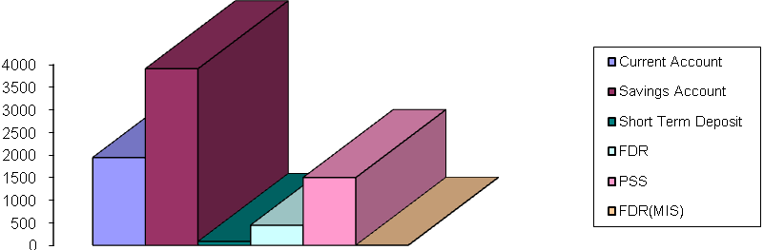
Fig 4.1 : Number of Different Accounts Maintained by this Department

Types of Account | Amounts (In Taka.) | Percentage (%)
Current Account | 53124838.98 | 9
Savings Account | 117763791.63 | 19
Short Term Deposit | 77277094.94 | 5.8
FDR | 392538521.29 | 62
PSS | 20948745.63 | 3
FDR (MIS) | 250000.00 | 1.2
Source: General Ledger on 12 – 07 - 2010

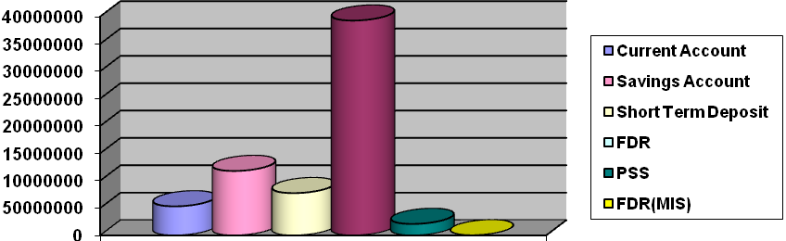
Fig 4.2: Amount Deposited in Different Accounts Maintained by this Department

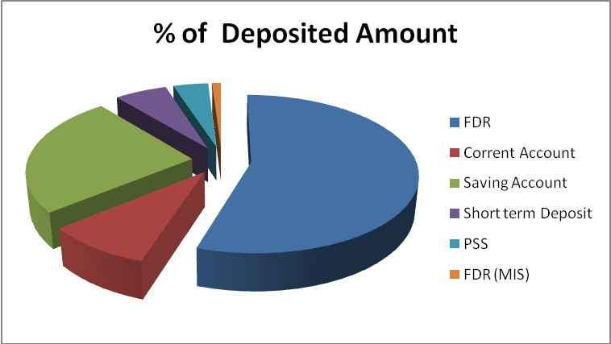

Fig 4.3: Percentage (%) of Amount Deposited in Different Accounts Maintained by this Department

4.1.3 Procedure to open an Account

- For opening an account, at first the prospective account holder will apply for opening an account by filling up account opening form. Account opening form consists of the name of the branch, type of account, name of the applicant(s), present address, permanent address, passport number (if any), date of birth, nationality, occupation, nominee(s), special instruction (if any), initial deposit, specimen signature(s) of the applicant(s), introducer’s information etc.

- The prospective customer should be properly introduced by the followings:
- An existing customer of the bank.
- Officials of the bank not below the rank of Assistant Officer.
- A respectable person of the locality who is well known to the manager or authorized officer.

- Two copies of passport size photograph duly attested by the introducer.

- Signature of the prospective account holder in the account opening form and on the specimen signature card duly attested by the introducer.

- Then the concerned authority will allocate a number for the new account.

- The customer than deposit the “initial deposit” by filling up a deposit slips. Initial deposit to open a current account in MBL is Tk. 10000.00 and saving account is Tk. 5000.00.

When the following requirements are fulfilled, the account is considered to be opened. IFIC Bank maintains all of its accounts in computer. After depositing the initial deposit, Bank records it in the computer by giving new account number. Then it issues chequebook requisition slip by the customer. Then it distributes all relevant papers to respective department.

Activities & papers necessary for opening an account
Joint Account:
If the account is a joint account, then the joint account holder should submit a declaration and operational instructions of the account along with their signature. The declaration is
“Any balance to the credit of the account is and shall be owned by us as joint depositors. Any liability whatsoever incurred in respect of this account shall be joint and several.”

Partnership firm:
The following documents have to be submitted for preparing an account of a partnership firm:
- Partnership deed.
- If the partnership firm is a registered one, then one copy of registration forms.
- If not, then a copy of certificate from the notary public.

Limited Company:

For the opening of an account of a limited company, following documents have to be submitted:
- A copy of resolution of the company that the company decided to open an account in IFIC Bank Limited.
- Certified true copy of the Memorandum & Articles of Association of the Company.
- Certificate of Incorporation of the company for inspection and return along with a duly certified Photocopy for Bank’s records.
- Certificate from the Registrar of Joint Stock Companies that the company is entitled to commence business (in case of Public Ltd. Co. for inspection and return) along with a duly certified Photocopy for Bank’s records.
- Latest copy of balance sheet.
- Extract of Resolution of the Board/General Meeting of the company for opening the account and authorization for its operation duly certified by the Chairman/Managing Director of the company.
- List of Directors with address (a latest certified copy of Form-XII).

Club/Society:

Following documents have to be obtained in case of the account of the club or society:
- Up to date list of office bearers.
- Certified copy of Resolution for opening and operation of account.
- Certified copy of Bye-Law and Regulations/Constitution.
- Copy of Government Approval (if registered).

Cooperative Society:

Following documents have to be obtained in case of the account of Cooperative Society:
- Copy of Bye-Law duly certified by the Co-operative Officer.
- Up to date list of office bearers.
- Resolution of the Executive Committee as regard of the account.
- Certified copy of Certificate of Registration issued by the registrar, Co-operative societies.

Non-Govt. College / School / Madrasha / Muktab:

Following documents have to be obtained in case of the account of non-govt. college/school /Madrasha / Muktab:
- Up to date list of Governing Body/Managing Committee.
- Copy of Resolution of the Governing Body/Managing Committee authorising opening and operation of the account duly certified by Gazetted Officer.

Trustee Board:

Following documents have to be obtained in case of the account of trustee board:
- Prior approval of the Head Office of IFIC Bank.
- Certified copy of Deed of Trust, up to date list of members of the Trustee Board and certified copy of the Resolution of Trustee Board to open and operate the account.

Minor’s Account:

Following documents have to be obtained in case of the account of minor:
- Putting the word “MINOR” after the title of the account.
- Recording of the special instruction of operation of the account.
- The AOF is to be filled in and signed by either the parents or the legal guardian appointed by the court of law and not by the minor.

4.2 Local Remittance Section

Local remittance is one of the main components of general banking. The activities of local remittance are ---
- Telegraphic Transfer,
- Demand Draft issue,
- Pay order.

Telegraphic Transfer
It is an order from the issuing branch to the drawee bank / branch for payment of a certain sum of money to the beneficiary. The payment instruction is sent by telex and funds are paid to the beneficiary through his account maintained with the drawee branch or through a pay order if no account is maintained with the drawee branch.

Procedure of issuing TT:
Following procedures are followed while issuing of TT:
- The applicant fills up the relevant parts of the prescribed application form in triplicate, duly signed the same and gives it to the GB.
- GB will fill up the commission part for bank’s use and request the applicant to deposit necessary cash or cheque at the cash booth.
- The first copy of the application form will be treated as Debit Ticket while the second copy will be treated as Credit Ticket. The third copy will be handed over to the applicant as customer’s copy.
- GB will prepare telex in appropriate form, sign it and send it to the telex operator for transmission of the message.
- GB will prepare necessary advice. Debit advice is sent to the client if clients account is debited for the amount of T.T.
- T.T. Confirmation Advice is sent to the drawee branch.
- Credit Ticket (second copy of the application form) is used to credit the PBL General Account.

Payment of T.T.

On receipt of T.T. payment instructions the following entries are passed by the drawee branch if the T.T. is found to be correct on verification of the Test number.

In case the beneficiary does not maintain any account with the drawee branch a pay order will be issued in favor of the payee and sent to his banker / local address as the case may be.

Every branch maintains a prescribed T.T. Payable Register. All the particulars off T.T. are to be properly recorded in this register duly authenticated. A separate Type of T.T. confirmation advice is sent to the drawee branch on the same day. On receipt of T.T. confirmation advice, the particulars of T.T. are verified with reference to particulars already recorded in the T.T. payable register.

Demand Draft (DD) Issue

Sometimes customers use demand draft for the transfer of money from one place to another. For getting a demand draft, customer has to fill up an application form. The form contains date, name and address of the applicant, signature of the applicant, cheque number (if cheque is given for issuing the DD), draft number, name of the payee, name of the branch on which the DD will be drawn and the amount of the DD. The form will be duly signed by the applicant and by the authorized officer. IFIC Bank charges .15% commission on the face value of DD as service charge.

Process of issuing Local Draft:

Followed procedures are followed while issuing local draft-
- Get the application form properly filled up and signed by the applicant.
- Complete the lower portion of the form for the bank’s use.
- Calculate the total amount including the bank’s commission.
- If the cheque is presented for of the local draft, the officer should get the cheque duly passed for payment by the authorized person and record the particulars of local draft on the back of the cheque.
- If the client wants to debit his account for the payment of the draft amount, the officer should get the account holder’s signature verified properly, from signature card on record of the branch and debit clients account for the total amount including commission.
- The first copy of the application form will be treated as Debit Ticket while the second copy will be treated as Credit Ticket and kept by the GB. The third copy is handed over to the applicant as customer’s copy.

The GB Department maintains a prescribed L.D. Issue Register. All the required particulars of LDs issued and should be entered in that register duly authenticated.

Cancellation of Local Draft

The followings are followed while canceling a L.D.-
- The purchaser should submit a written request for cancellation of the L.D. attaching therewith the original L.D.
- The signature of the purchaser will have to be verified from the original application form.
- Manager’s prior permission is to be obtained before refunding the amount of draft.
- Cancellation charge is to be recovered from the applicant and only the amount of the draft less cancellation charge should be refunded. Commission charge, posted charge etc. recovered for issuing the L.D. should not be refunded.
- The original entries are to be reversed giving proper narration. An IBDA for the cancelled L.D. should be issued on the drawee branch.
- Cancellation of L.D. should also be recorded in the L.D. Issue Register.

Payment of L.D.

While payment of L.D., IFICB performs the following functions-
- On receipt of Credit Advice (IBCA) from the issuing branch the receipt amount is credited in responding branch.
- When L.D. is presented for payment at the paying branch, its details are to be carefully examined with reference to the following points-

- Whether the draft is drawn on the Local office.
- Whether the draft is crossed or not. Amount of crossed draft is not paid in cash to the payee but to be paid to his account with a bank.
- Draft must have to be signed by two authorized officers of the issuing branch. Their signatures are to be verified from the specimen signature book for being sure that draft that the draft is genuine. The verifier should put his initial.
- Endorsement on the back of the draft must be regular in case the draft is presented through clearing.
- The amount of the draft should not exceed the amount written in red ink at the top of the draft.
- The payee is to be properly identified in case of cash payment.
- The particulars of the draft i.e. the draft number, date, amount and the name of the payee should be verified from the L.D. Payable Register.

- In case of payment, the draft should be cancelled with red ink. The date of payment should be recorded in the L.D. Payable Register.

Stop payment of Local Draft
The payee or purchaser of the draft can not give stop payment instruction to the drawee branch. If the paying branch receives a request from the purchaser of the draft for stopping payment of the draft, it will ask the purchaser to approach the issuing branch about the purpose. The paying branch should however exercise necessary precaution in this regard. Only the issuing branch can issue instruction for stop payment of the draft under special circumstances.

Pay Order

For issuing a pay order, the client is to submit an application to GB in the prescribed form. This form should be properly filled up and signed. The procedure of the issuing pay order is similar to that of the Local Draft. For issuing pay order IFICB charges commission on the following rate-

Total amount of PO | Commission | Vat
Up to TK. 10,000.00 | TK. 25.00 | Tk. 4
TK. 10,001.00 - TK .1,00,000.00 | TK. 50.00 | Tk. 8
TK. 1,00,001.00 - TK. 5,00,000.00 | TK. 100.00 | Tk. 16
TK. 5,00,001.00 and above | TK. 150.00 | Tk. 23

Table 3.2: Charges on issuing pay order commission and vat

Payment of Pay Order:

The pay order is presented to the bank either through clearance or for credit to the client’s account. While payment, relative entry is given in the pay order register with the date of payment.

Cancellation of Pay Order:

The following procedure should be followed for the cancellation of the pay order:
- The client should submit a written request for canceling the pay order attaching therewith the original pay order.
- The signature of the purchaser will have to be verified from the original application form.
- Manager’s prior permission is to be obtained before refunding the amount of the pay order.
- Cancellation charge is to be recovered from the applicant and only the amount of the pay order less cancellation charge should be refunded. Commission recorded for issuing of the original pay order should not be refunded.
- Then the officer should write “cancelled” on the pay order.
- The original entries should be reversed with narration.
- Cancellation of the pay order should also be recorded in the register.

4.3 Account Section

In banking business transactions are done every day and these transactions are to be recorded properly and systematically as the banks deal with the depositors’ money. The branch has to prepare some internal statements as well as some statutory statements, which are to be submitted to the Central Bank and the Head Office.

Functions of Accounting Department

We can divide the functions of accounting department into two categories. This are-
- Day to day functions: Here day-to-day function refers to the every day tasks. Accounting department of MBL performs the following day to day functions:
- Recording of transaction in the cashbook, general and subsidiary ledger.
- Preparing the daily position of deposit and cash.
- Making the payment of the expense of the branch.
- Recordings of inter branch fund transfer.
- Checking whether all the vouchers are correctly passed.
- Recording the voucher in the voucher register.
- Packing and maintains the total debit and total credit vouchers.

- Periodical functions: Periodical functions of accounts department include the preparation of different weekly, fortnightly, monthly, quarterly and annual statement. The accounts department prepares the following statements:
- Monthly statement of deposits, loans and advances, profit and loss etc.
- Quarterly statement of deposits, loans and advances, profit and loss etc.
- Yearly statement of deposits, loans and advances, profit and loss etc.
- Yearly statement of classified Loans and Advances.
- Statement of Affairs.
- Yearly Budget of the Branch, etc.

4.4 Clearing House:

According through the 37(2) of Bangladesh Bank Order 1972, which are the member of the clearinghouse, are called as Scheduled Bank. The scheduled banks clear the cheques drawn upon one another through the clearinghouse. Banks for credit of the proceeds to the customers account accept cheques and other similar instruments. The banks receive many such instruments during the from account holders.
The Clearinghouse sits for two times a working day. The members submit the climbable cheque in the respective desks of the banks and vice-versa. Consequently the debit and credit entries are given. Then the banks clear the balances through the cheque of Bangladesh Bank. The dishonored cheque are sorted and returned with return memo.
Processing for clearing cheque collection

“Received” seal is stamped on the cheque

Crossing the cheques are done

“Payees A/C Credited” and disbursement

Entries are given in the Outward Clearing Register.

“Clearing” seal is given on cheque

eque.

Cheques are sorted bank wise and entries are given to the computer

puter

Entries are given to the “Clearing House Register”

Figure 4: Processing for clearing cheque collection

Procedures for outward bills for collection (OBC

Depositing the cheque along with deposit slip
Crossing of the cheques are done indicating Principal Branch as collecting bank
Endorsement “Payees A/C will be credited on realization “is given
Entries are given in the outward clearing register

Fig 3.3: Cheque Collection Process
4.5 Cash Section

Cash section is a very sensitive organ of the branch and handle with extra care. Operation of this section begins at the start of the banking hour. Cash officer begins his/her transaction with taking money from the vault, known as the opening cash balance. Vault is kept in a much secured room. Keys to the room are kept under control of cash officer and branch in charge. The amount of opening cash balance is entered into a register. After whole days’ transaction, the surplus money remain in the cash counter is put back in the vault and known as the closing balance. Money is received and paid in this section.

Cash Receipt
- At first the depositors fill up the Deposit in Slip. For saving account and current account same Deposit in Slip is used in this Branch.
- After filling the required deposit in slip, depositor deposits the money.
- Officers at the cash counter receives the money, count it, enter the amount of money in the register kept at the counter, seal the deposit in slip and sign on it with date and keep the banks’ part of the slip. Other part is given to the depositor.
- In this branch, i.e., Elephant Road Branch, two different officers maintain two different books for entering such entries. All deposits of saving account are maintained by one officer and other accounts by another officer.
- At the end of the day entries of both of these registers are cross checked with the register kept at the cash counter to see whether the transactions are correct or not.

Cash Payment
- When a person comes to the bank to cash a cheque, s/he first gives it to the computer desk to know the position of the check and posting of the cheque. If the account has sufficient fund the computer in charge will post it into the computer, will sign it and seal it.
- This cheque is then sent to the concerned officer. There are two officers who verify the cheques - one for savings and similar types of account and another for current and similar types of account.
- After receiving the cheque respective officer first checks it very carefully for any kind of fraudulent activity. S/he also checks the date of the cheque, amount in word, amount in figure and signature of the drawer.
- If the instrument is free of all kind of error the officer will ask the bearer to sign on the back of it.
- He will then put his/her initial beside the bearers’ signature. S/he will also sign it on its face; will write down the amount by red pen.
- Then the cheque will be sent to the cash counter. At the cash counter bearer will be asked again to sign on the back of the instrument.
- The cash officer will then enter the details of the cheque in his/her register and will pay the money to the bearer.


4.6 SMS Banking

IFIC Bank Ltd. catered the demand of time in the era of modern banking technology through SMS Banking Service. It is indeed a fast, secure, convenient, economical and quickest way of banking. The service is available round the clock seven days a week. Get real-time banking information and be in touch any time with IFIC Bank from one’s mobile. One can check his balance, account information, or even get his mini account statements through IFIC SMS Banking Service.

Account Service

Push /Pull Services | Push Services
Balance Enquiry | Bank Product Information
Mini Statement Request(Last 5 Transactions) | Greetings
Foreign exchange Rate enquiry | Loan Installment Notification (overdue)
Fixed Deposit Rate enquiry | Any other Massage
Interest Rate enquiry
Branch Location enquiry
PIN Change
Help

Table 3.3: SMS Banking Account Service of IFICB

Card Services
Push /Pull Services | Push Services
Current Outstanding Balance | Payment Due Alert
Mini Statement Request ( Last 5 Transactions) | Transaction Notification
Minimum Payment Due
Payment Due Date

Table 3.4: SMS Banking Card Service of IFICB

Bank Charges
SMS Banking facility is free of charge.

Eligibility
All Account & Card Holder of IFIC Bank are eligible to apply for SMS Banking service.

How to apply
Fill up Application Form and drop it to his/her nearest IFIC Bank Branch.

How to send SMS
Go to message option and type the designated Hotkey- IFIC, Service Code - ( For Balance Enquiry- BAL, for Mini Statement- STM), PIN Number and send the SMS to 6969.

SMS Format 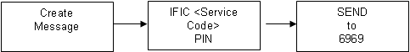



4.7 IFICB Cards

IFIC Card is powered by VISA, world's largest electronic payments network. IFIC Bank has been issuing VISA branded:
- Credit Card,
- Debit Card &
- Prepaid Card.

IFIC Credit Card
IFIC Bank VISA Credit Cards are issued in two types namely Gold and Classic for both local and international use. The Local Cards can be used at any ATM displaying VISA Logo for withdrawal of cash and at any POS displaying VISA Logo for purchase of goods & services within Bangladesh whereas the International Cards can be used at any ATM and POS displaying VISA logo anywhere in the world. International credit card is a dual currency card and as such one can use the same plastic at home & abroad. Classic cards are for lower limits and less costly.
Maximum Interest Free Period
IFIC credit cardholders can enjoy 20 to 50 days interest free period depending on the date of transaction and the date of statement generation. Therefore, cardholders can make their schedule of spending & payment at their convenience. Interest free period will not be allowed for cash advance.
Flexibility in Repayment
One can repay any amount not less than the minimum payment due within the due date and keep his account regular to enjoy revolving credit facility.
Low Interest Rate
He can enjoy credit facility at lower interest rate of 2% per month.
Maximum Cash Withdrawal
Cardholder can enjoy cash withdrawal facility up to 60% of his credit limit through ATMs. He can enjoy up to 100% of his credit limit through Bank POS from any branch of IFIC Bank Limited.
Free Supplementary Card
First two supplementary cards are free. One can select any two from his near & dear persons and give them supplementary credit cards. They can also enjoy and share his credit limit. He can also allow specific limits for them within his credit limit.
Calculation of Interest
No interest will be calculated on the amount other than cash advance if the total billing amount is paid within the payment due date. In case of part payment or no payment, interest @2% per month will be applied from the date of transaction on daily product basis until the outstanding balance is fully paid.
Minimum Documents Required
Filled-in Application Form, 2(two) copies of photograph, copy of TIN Certificate, Salary Certificate/Pay Slip (for Service Holder), Bank Account Statement ( for Businessman/Self Employed Persons) Copy of Passport (for International Card)and Photocopy of National ID. Other documents may be required for assessment of individual credit worthiness.
Submission of Application
Filled-in Application Form along with other required documents may be submitted directly to the Card Division of Head Office or to any branch of IFIC Bank Limited.

IFIC Debit Card
FIC Bank VISA Debit Card can be used at any ATM displaying VISA Logo for withdrawal of cash and at any POS displaying VISA Logo for purchase of goods & services within Bangladesh. ATM transactions are to be secured by Personal Identification Number (PIN) known by the concerned customer only. POS transactions will not require PIN. However, all the transactions are to be authorized by the system electronically

IFIC debit card is issued against any individual savings/ current account maintained with any branch of IFIC Bank Limited. The designated savings/current account can be operated by using the debit card without using cheques 24 hours in a day, 7 days in a week, and 365 days in a year.
The customers are not required to pay any charge for transactions at Merchant Point of Sale (POS) for purchasing goods and services. For cash withdrawal from ATM/Branches, a little charge may be applied.
No interest will be calculated on cash withdrawal or purchases. No minimum amount due and no hassle of payment of monthly bills.

Minimum Documents Required
Filled-in Application Form, 1(one) copy of photograph

Submission of Application
Filled-in Application Form is required to be submitted to the branch where the designated account is maintained.

IFIC Prepaid Card
IFIC Bank VISA Prepaid Card can be used at any ATM displaying VISA Logo for withdrawal of cash and at any POS displaying VISA Logo for purchase of goods & services within Bangladesh. ATM transactions are to be secured by Personal Identification Number (PIN) known by the concerned customer only. POS transactions will not require PIN. However, all the transactions are to be authorized by the system electronically. Prepaid card is safer than carrying cash and more convenient than writing cheques.
IFIC Prepaid card is issued by the branches instantly on filling-up the Application Form and making initial deposit. There is no need to have any account with the Bank. Prepaid card are suitable for the customers who does not maintain any account with IFIC. No interest will be calculated on cash withdrawal or purchases. No minimum amount due and no hassle of payment of monthly bills.

Minimum Documents Required
Filled-in Application Form, 1(one) copy of photograph and Photocopy of National ID.

Submission of Application
Filled-in Application Form is required to be submitted to any branch of IFIC Bank Limited.

Bank POS
Bank POS are available at all the branches of the Bank. Any IFIC Card Holder can withdraw cash from any branch of IFIC Bank Ltd. through Bank POS. Credit Card Holders can withdraw cash up to 100% of their credit limit.


Credit or Loan
Department

5.0 CONSUMER LOAN

Banking is essentially a business dealing with money and credit. Like over other business activity, Banks are profit oriented. It depends mainly on how much profit they can make. Profit is the yardstick for the bank to move on. They work as reserves of “savings’ of the community and also as lenders or investors for trade business and industry. A bank invests its funds in many ways to earn income. The bulk of its income is derived from loans and advances.

Banks give loans and advances to traders, businesspersons and Industrialists against the security of some assets or on the basis of the personal security of the borrower. This is the survival unit of the bank because until and unless the success of this section the survival is a question to every bank.

IFIC Bank offers a wide variety of loan product & value added services to suit ones banking requirements. This includes:

IFIC Easy Loan

Consumer Durable Loan
- Parua (Education Loan)
- Thikana (Home Loan)
- Any Purpose Loan
- IFIC marriage Loan
- CNG Conversion Loan
- IFIC Home Renovation Loan
- IFIC Medical Loan
- IFIC Holiday Loan
- IFIC Peshajeebi Loan
- IFIC Auto Loan




5.1 IFIC Easy Loan
Easy Loan of IFICB is to serve to any personal financial needs. The loan is absolutely hassling free & paid against financial securities.

Eligibility
Adult person having an account with IFICB then easily apply for the IFIC Easy Loan.

Loan Size
- Maximum 95% of the face value of FDR.
- Maximum 100% * of the MIS amount.
- Maximum 100% of the principal amount of PSS.
- Maximum 90% of ICB Unit Certificate.

Repayment Tenure
12 to 36 months.
Shortest possible processing & least formalities.



5.2 Consumer Durable Loan
IFIC creates an opportunity to satisfy customers' desire to purchase consumer durables like - computer, television, refrigerator, washing machine, air conditioner, music systems, motor cycle and a lot of other things by Consumer Durable Loan.

IFIC Bank is providing maximum 1.00 lac taka to be repayable in by 12 to 36 monthly installments.

Consumer Durable Loan Repayment Schedule

Loan Amount | Interest Rate | Monthly installment
Loan Amount | Interest Rate | 36 months | 24 months | 12 months
Maximum Tk. 100,000/- | @16.50% | Tk. 3,542/- | Tk. 4,922/- | Tk. 9,099/-



5.3 Parua (Education Loan)
IFIC Bank offers Education Loan that can make a student's dream comes true. IFIC Bank firmly believes that expense for education is an investment for future. Only education can fulfill the dreams of an individual as well as a nation.

IFIC Bank is providing maximum Tk. 8.00 lac to be repayable in 12 to 48 monthly Installments.

Parua (Education Loan) Repayment Schedule

Loan Amount
Interest Rate | Monthly installment
Interest Rate | Monthly installment | 48 months | 36 months | 24 months | 12 months
Tk. 100,000/-  or multiple | @16.50% | Tk. 2,861/- | Tk. 3,542/- | Tk. 4,922/- | Tk. 9,099/-



5.4 Thikana (Home Loan)
Home is an address, a shelter for entire life, and this is what one leaves behind for the family. A house is the single biggest investment that one will make in his lifetime. To own a home from savings takes a long time and full payment at a time is difficult too.
IFIC Bank is providing maximum Tk.75.00 lac to be repayable in 12 to 180 monthly installments.
Thikana (Home Loan) Repayment Schedule
Loan Amount | Interest Rate | Monthly installment (Tk.)
Loan Amount | Interest Rate | 15 years | 14 years | 13 years | 12 yearss
Tk.1,00,000/-  or Multiple | @ 15.00% p.a. | 1,401/- | 1,429/- | 1,462/- | 1,503/-
Tk.1,00,000/-  or Multiple | @ 15.00% p.a. | 11 years | 10 years | 09 years | 08 yearss
Tk.1,00,000/-  or Multiple | @ 15.00% p.a. | 1,553/- | 1,615/- | 1,694/- | 1,796/-
Tk.1,00,000/-  or Multiple | @ 15.00% p.a. | 07 years | 06 years | 05 years | 04 yearss
Tk.1,00,000/-  or Multiple | @ 15.00% p.a. | 1,932/- | 2,117/- | 2,381/- | 2,785/-
Tk.1,00,000/-  or Multiple | @ 15.00% p.a. | 03 years | 02 years | 01 years
Tk.1,00,000/-  or Multiple | @ 15.00% p.a. | 3,469/- | 4,851/- | 9,029/-



5.5 Any Purpose Loan
If one is looking for a personal loan to meet any financial requirement that's easy to get, one’s search ends with IFICB. IFIC Any Purpose Loan caters to various needs of salaried people. With minimum formalities one can get a loan for an amount upto Tk.3.00 lac to be repayable at 12 to 36 monthly installments. The loans are easy & absolutely hassle free.

Any Purpose Loan Repayment Schedule

Loan Amount | Interest Rate | Monthly installment
Loan Amount | Interest Rate | 36 months | 24 months | 12 months
Tk. 100,000/- | @16.50% | Tk. 3,542/- | Tk. 4,922/- | Tk. 9,099/-



5.6 IFIC Marriage Loan
The single most important day of one’s life, begin he/she new family in style. Money is only an object for such an important event and shouldn't be a barrier to its perfection. If he needs extra funds to ensure his special day is one to remember then come into on IFIC Bank branch and trust them to help.

IFIC Bank is providing maximum Tk. 3.00 lac to be repayable in 12 to 36 monthly installments.

Marriage Loan Repayment Schedule

Lo Loan Amount
Interest Rate | Monthly installment
Interest Rate | Monthly installment | 36 months | 24 months | 12 months
Maximum Tk. 100,000/- | @16.50% | Tk. 3,542/- | Tk. 4,922/- | Tk. 9,099/-

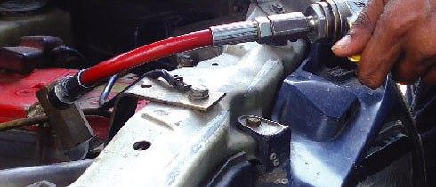

5.7 CNG Conversion Loan
Due to price hike of fuel, CNG conversion has become the necessity of time. IFIC Bank understands the needs and offers the best suitable loan for CNG conversion of vehicle.

IFIC Bank is providing maximum Tk. 1.00 lac to be repayable in 12 to 36 monthly installments.

CNG Conversion Loan Repayment Schedule

Loan Amount | Interest Rate | Monthly installment
Loan Amount | Interest Rate | 36 months | 24 months | 12 months
Maximum Tk. 100,000/- | @16.50% | Tk. 3,542/- | Tk. 4,922/- | Tk. 9,099/-



5.8 IFIC Home Renovation Loan
IFIC Bank provides home loan for the needed family with easy terms and conditions.
The installment is not so thigh to bear someone regularly.

IFIC Bank is providing maximum Tk. 3.00 lac to be repayable in 12 to 36 monthly installments.

Home Renovation Loan Repayment Schedule

Loan Amount | Interest Rate | Monthly installment
Loan Amount | Interest Rate | 36 months | 24 months | 12 months
Maximum Tk. 100,000/- | @16.50% | Tk. 3,542/- | Tk. 4,922/- | Tk. 9,099/-



5.9 IFIC Medical Loan
IFIC Medical Loan caters hospitalization or other emergency medical needs to salaried people. The loans are easy & absolutely hassle free.

IFIC Bank is providing maximum Tk. 3.00 lac to be repayable in 12 to 36 monthly installments.

Medical Loan Repayment Schedule

Loan Amount
Interest Rate | Monthly installment
Interest Rate | Monthly installment | 36 months | 24 months | 12 months
Maximum Tk. 100,000/- | @16.50% | Tk. 3,542/- | Tk. 4,922/- | Tk. 9,099/-



6.1 IFIC Holiday Loan
IFIC Bank provides holiday loans. These Loans are easy & absolutely hassle free.

IFIC Bank is providing maximum Tk. 3.00 lac to be repayable in 12 to 36 monthly Installments.

IFIC Holiday Loan Repayment Schedule

Loan Amount | Interest Rate | Monthly installment
Loan Amount | Interest Rate | 36 months | 24 months | 12 months
Maximum Tk. 100,000/- | @16.50% | Tk. 3,542/- | Tk. 4,922/- | Tk. 9,099/-




6.2 IFIC Peshajeebi Loan (Loan for Professional Loan)
Whatever one is Doctor/ Engineer/ IT professional/ Management Consultant or any other professional, sometimes they just need that little bit extra money for whatever reason. IFIC bank provides Peshajeebi loan in these cases.

IFIC Bank is providing Maximum Tk. 10.00 lac to repayable in 12 to 48 monthly installments.

The loan procedures is Quick Processed & have Least Formalities.

IFIC Peshajee Loan Repayment Schedule

Loan Amount | Interest Rate | Monthly installment
Loan Amount | Interest Rate | 48 months | 36 months | 24 months | 12 months
Tk. 100,000/-  or multiple | @16.50% | Tk. 2,861/- | Tk. 3,542/- | Tk. 4,922/- | Tk. 9,099/-




6.3 FIC Auto Loan
Owning a car means freedom of convenience for moving out, affords punctuality, shelter from rain and heat during traveling and above all guarantees the much needed safety. Owning a car is a dream of many people. To materialize the dream, IFICB has Auto Loan with more flexible, affordable and convenient package option.

IFIC Bank is providing maximum Tk. 20 lac to be repayable in 12 to 60 monthly installments.

Auto Loan Repayment Schedule

Loan  Amount | Interest  Rate | Monthly installment (TK.)
Loan  Amount | Interest  Rate | 60 months | 48 months | 36 months | 24 months | 12 months
Tk.1,00,000/-  or Multiple | 15.50%  p.a. | 2,407/- | 2,810/- | 3,493/- | 4,874/- | 9,051/-
Tk.20,00,000/-  maximum | 15.50%  p.a. | 48,140/- | 56,200/- | 69,860/- | 97,480/- | 1,81,020/-

7.0 SWOT ANALYSIS
Every organization is composed if some internal strengths and weaknesses and has some external opportunities and threats in its whole life cycle. The following will briefly introduce the customers to the IFIC bank ltd. internal strengths and weaknesses, external opportunities and threats as I have exposed in the past few weeks:

7.1 STRENGTHS
- Trust worthy: As the bank is one of the oldest banks in Bangladesh people have faith on its products and services.
- State Of The Art Technology: IFIC Bank Ltd utilizes of the art technology to ensure consistent quality and operation. The corporate office is equipped with Reuters screen and SWIFT.
- Employees’ Loyalty: The employees of the bank are very much loyal to the bank.
- Affluent Clients: Its a remarkable strength that IFICB has a number of affluent clients that the bank is having benifits from them.

- IFIC bank has an interactive corporate culture. The working environment is very friendly, interactive and communicate provides as a great motivation factor among the potential customer.
7.2 WEAKNESSES
- Limited Workforce: IFIC Bank Limited has limited human resources compared to its financial activities. There are not many people to perform most of the task. As a result many of the employees are burdened with extra workloads and work late hours without any overtime facilities.
- Problem in Delivery: Few of the products that IFIC Bank is offered to its clients are lying idle due to lack of proper marketing initiative from the management.
- Poor Performance Evaluation System: The performance evaluation system in IFIC Bank Limited is faulty. Though it is a private organization, many times performance is evaluated in light of political performance and internal conflicts.
- Employees are not skilled enough and most of the employees’ educational qualification is not related to banking service that their performance and communication way with clients is poor.

7.3 OPPORTUNITY
- Government Support: Government of Bangladesh has rendered its full support to the banking sector for a sound financial status of the country. Such government concern will facilitate and support the long –term vision of IFIC Bank Limited.
- Invest Opportunity: there is a great opportunity to take new dimension of banking such as Islamic banking, specialized banking. Otherwise, there are many sectors where this can give special privileges.
- Evolution of E-Banking: Emergence of E Banking will open more scope for IFIC Bank Limited to reach the clients not only in Bangladesh but also in the global banking arena. Although the bank has already entered the world of E banking but yet to provide full electronic banking facilities to its customer.
- High awareness among all level of people to deposit money in the banks.
- Increasing the demand of customer finance.

7.4 THREATS
- Merger And Acquisition: The worldwide trend of merging and acquisition in financial institution is causing concentration. The industry and competitors are increasing in power in their respective areas.
- Competition: Many banks are entering the market with new and lucrative products. Actually, the market for banking industry is now a buyer-dominated market. Unless IFIC Bank Limited can come up with attractive financial products in the market; it will have to face steep competition in the days to come.
- World Economic Recession: Now a days world economy is in threat. Worldwide many of the banks’ insolvency is a threat for the banks in our country too, and IFICB is not out of them.
- Similar type of retail banking products, such as insurance company, stock exchange, financial institution etc.
- Frequent changes in rules and regulations from Bangladesh Bank.
- Customer awareness of pricing and service.

  - FINDINGS
- The decoration of the branch is not competitive.
- Officers of the bank are competent. Even though many of them simply know the working procedure of what they are doing but don’t know the philosophy behind doing those.
- The bank does not have any so called IT section. So the maintenance of computer is very unsound and the bank does not have any permanent personnel for that purpose, hence it is bearing a large monthly expense in this regard.
- Project loan requires testing of feasibility of project and judging the marketability of the product. It requires infusion of knowledge of both the fields-marketing and Banking. But the bank has hardly any person with this kind of ability.
- The manager of the branch is a very dynamic person and is doing management by walking. He is well capable of handling a branch in an efficient and effective manner.
- I observed cordial relation among the employees.
- Once from the information it is found it was profitable branch but now it has lost its previous position.
- Most of the employees are experienced banker.
.
- Most of the employees are not familiar with computer or technology.

8.2 RECOMMENDATION
- Banking is a service-oriented marketing. Its business profit depends on its service quality. That’s why the authority always should be aware about their service quality.
- To deliver quality service top management of this breach should try to mitigate the gap between customer’s expectation and employee’s perception and customer’s convenience should give priority.

- Administrative cost of this branch is on the medium side, which has a major impact on profitability. Te manager should bring down the administrative cost and take all effective steps, strategy and action plan to reduce the cost at the desired level.

- IFIC Bank should always monitor the performance of its competitors in the field of Foreign Trade.
- To provide quality service to the customer it is necessary to have a trained team of an organization or an institutionp. For this reason the bank should recruit more fresh, bright and energetic persons such as MBA, BBA, and MBM etc.
- The employee should be given more training for the better communication with customers.
- The bank has a provision for internship program, but it is not well organized. Although the officials are very careful and cooperative with the interns, the authority should be more structured. If they can properly make them trained it will be very fruitful to recruit them. Because they learn overall banking in the internship period, so in the beginning of the job they can work as experienced persons. It is also very important that they should give an honorarium to the intern.
- Bank should offer more facilities to the customers such as credit card, visa card, ATM machine etc.
- As soon as possible the bank should start more branches in Dhaka city as well as the other cities of the country.
- Now a day’s world is going very fast. Now most of the banks open online customer service system. So in order to compete in the world market they should adopt true & fast online banking system.
- To capitalize more money bank should take attempt to issue more shares in the capital market and invest those to increase the number of branches around the city.
- One of the business strategies is promotion. Successful business depends how they can promote their products or services to the customer. In this connection to improve the business status bank should introduce more promotional programs.
- It should increase the interest rate of return and reduce amount of deposit for the locker services.
- It seemed to me that the bank having a large amount of deposit is not simply encouraging the large scale of producers that is this bank is not providing that much of long term industrial loans to accelerate the economy as well as to help the economy to solve unemployment problem.

9.1 CONCLUSION

A bank is an economic institution whose main aim is to earn profit through exchange of money and credit instruments. It is a service oriented as well as profit oriented organization. To perform those two functions simultaneously, the bank divides its operations mainly in three parts- General Banking, Loan and Advances, and Foreign Exchange. Bank also invests their money into different financial securities and also in different types of project to diversify the risk and getting more profit.

The Banking sector in any country plays an important role in economic activities. Bangladesh is no exception of that. As because it's financial development and economic development are closely related, that’s why the private commercial banks are playing significant role in this regard. This report focused and analyzed on General Banking performance or we can say operational performance and credit system of IFIC Bank Limited, Pallabi Branch.
During the three months internship program, almost all the desks have been observed more or less. This internship program, in first, has been arranged for gaining knowledge of practical banking and to compare this practical knowledge with theoretical knowledge. Though all departments and sections are covered in the internship program, it is not possible to go to the depth of each activities of branch because of time limitation. However, highest effort has been given to achieve the objectives the internship program.

From the learning and experience point of view I can say that I really enjoy my internship at IFIC Bank of Bangladesh Ltd. I have tried by soul to incorporate the research report with necessary relevant information in my report. Few loyal committed customer bases, lack of modern and effective technology or facilities, not enough skilled employees in some sector, considering all of these very important factors, IFIC Bank should always try to improve their service level in every term.

The marketing department should think freshly about their marketing objectives and practices. Rapid changes can quickly make yesterday’s winning strategies out of date. As a developing private bank in Bangladesh, IFIC Bank shouldn’t allow their client to get dissatisfied with their service. They have their competitors who actively striving to take the advantages in every side.

