INTERNSHIP REPORT ON

“General Banking Procedure and Performance Analysis of Jamuna Bank Limited.”

Submitted by
WWW.ASSIGNMENTPOINT.COM

The banking sector of Bangladesh played an important role towards economic growth. From the beginning of financial year 2003, Bangladesh Bank took initiatives in reforming financial sector. The Bank undertakes all types of banking transactions to support the development of trade and commerce of the country. Steps for prevention of money laundering, loan write off policy and effective measures to gain accountability and transparency made banking operations more acceptable. As a result, the image of banking sector has been elevated. Bangladesh Bank also identified five core risk management, Asset Liability Management, Prevention of Money Laundering, Credit risk Management, Internal Control and Compliance. This initiative will bring in overall discipline in the sector and enhance operational profit.
1.1 Origin of the Report
This internship report on Jamuna Bank Limited is prepared to fulfil the partial requirement of BBA degree from American Internation University-Bangladesh. To fulfil this internship, I was assigned to the Jamuna Bank Limited at Islampur Branch, Dhaka to take the real banking experience. Our total credit hours are 123. After completing 123 credits we have to complete three credit hours under internship program or Project work for three month of period. After this three month we have to complete a report on the selected topics. For this reason I prepared my internship report on Jamuna Bank Limited. As the classroom discussion alone cannot give proper picture of real business situation, therefore it is as opportunity for the students to know about real life situation through this program.

1.2 Scope of the Report
The report is prepared based on the commercial banking operations of the Jamuna Bank ltd. These activities involve the following:
- General Banking activities
- Loan And Advance Activities
- JBL’s performance in different year

1.3 Objective of the Study:
The objective of the internship report can be classified in two ways. These are discussed below:
1.3.1 General Objective:
- To figure out major functions and to do performance analysis of Jamuna bank limited.
1.3.2 Specific Objectives:
- To make the readers familiar with the operation in the banking arena.
- To evaluate the credit approval and monitoring process.
- To identify their pricing mechanism based on share market.
- To find out the SWOT analysis of JBL.

1.4 Methodology:
As the report is information basis the secondary data sources are emphasized. Moreover I am also reliable on some primary sources as well. So Data regarding the completion of this report are collected from both primary and secondary sources.
1.4.1 PRIMARY SOURCES
- Face to face conversation with employees.
- Face to face conversation with clients visited the branch.
- Face to face conversation executives.
- Practical deskwork.
1.4.2 SECONDARY SOURCES
- Various publications on bank..
- Website of JBL.
- Annual reports of JBL.
- Relevant research papers.

1.5 Limitations of the Study:
The internship report is not free from limitations. The study has been conducted on “General banking procedure and Performance analysis of Jamuna Bank Ltd.” Key limitations of the study are as follows:
- Time was the most important limitation in preparation of the internship report; that was very limited which disable many opportunities for a comprehensive study.
- Sufficient books, publications, facts and figures are not available; these constraints narrowed the scope of accurate analysis. If these limitations were not been there, the report has been more useful and attractive.
- It was very difficult to collect data from such a big organization. But for better interpretation I had to collect some information from the head office. But because of some divisional and confidential problem, I could not get enough information.





2.0 The Bank
Jamuna Bank Limited (JBL) is a Banking Company registered under the Companies Act, 1994 with its Head Office at Chini Shilpa Bhaban, 3, Dilkusha C/A, Dhaka-1000. The Bank started its operation from 3rd June 2001.
The Bank undertakes all types of banking transactions to support the development of trade and commerce of the country. JBL's services are also available for the entrepreneurs to set up new ventures and BMRE of industrial units. Jamuna Bank Ltd., the only Bengali named new generation private commercial bank was established by a group of winning local entrepreneurs conceiving an idea of creating a model banking institution with different outlook to offer the valued customers, a comprehensive range of financial services and innovative products for sustainable mutual growth and prosperity. The sponsors are reputed personalities in the field of trade, commerce and industries.
The Bank is being managed and operated by a group of highly educated and professional team with diversified experience in finance and banking. The Management of the bank constantly focuses on understanding and anticipating customers’ needs. The scenario of banking business is changing day by day, so the bank's responsibility is to device strategy and new products to cope with the changing environment. Jamuna Bank Ltd. has already achieved tremendous progress within only eight years. The bank has already ranked as one of top quality service providers & is known for its reputation.
At present the Bank has real-time centralized Online banking branches (Urban & Rural) throughout the Country having smart IT-Backbone. Besides this traditional delivery point, the bank has ATM of its own, sharing with other partner banks & Consortium throughout the Country.
The operation hour of the Bank is 9:00 A.M. To 5:00 P.M. from Sunday to Thursday with transaction hour from 10:00 A.M. to 4:00 P.M. The Bank remains closed on Friday including government holidays.
2.1 Vision
To become a leading banking institution and to play a pivotal role in the development of the country.
2.2 Mission
The Bank is committed to satisfying diverse needs of its customers through an array of products at a competitive price by using appropriate technology and providing timely service so that a sustainable growth, reasonable return and contribution to the development of the country can be ensured with a motivated and professional work-force.
2.3 Management:
JBL is managed by highly professional people. The present Managing Director of the Bank is a forward looking senior banker having decades of experience and multi discipline of knowledge to his credit both at home and abroad. He is supported by an educated and skilled professional team with diversified experience in finance and banking. The management of the bank constantly focuses on the understanding and anticipating customers’ needs and offer solution thereof. Jamuna Bank Limited has already achieved tremendous progress within a short period of its operation. The Bank is already ranked as one of the quality service providers and known for its reputation.

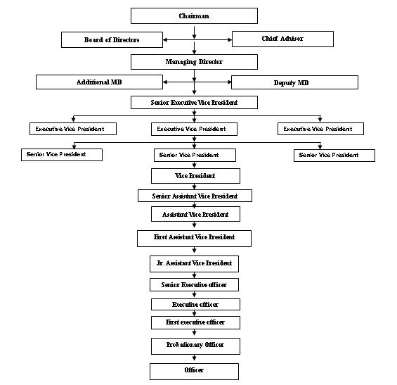
2.4 Growth of Jamuna Bank:
Jamuna Bank Ltd., the only Bengali named new generation private commercial bank was established by a group of winning local entrepreneurs conceiving an idea of creating a model banking institution with different outlook to offer the valued customers, a comprehensive range of financial services and innovative products for sustainable mutual growth and prosperity. The bank has already ranked as one of the quality service providers & is known for its reputation.
2.5 Corporate Slogan:
Your partner for growth.
2.6 Branch and SME Network:
Currently the Bank has 65 branches.
2.7 Strategies
• | To manage and operate the Bank in the most efficient manner to enhance financial performance and to control cost of fund
• | To strive for customer satisfaction through quality control and delivery of timely services
• | To identify customers' credit and other banking needs and monitor their perception towards our performance in meeting those requirements.
• | To review and update policies, procedures and practices to enhance the ability to extend better service to customers.
• | To train and develop all employees and provide them adequate resources so that customers' needs can be reasonably addressed.
• | To promote organizational effectiveness by openly communicating company plans, policies, practices and procedures to employees in a timely fashion
• | To cultivate a working environment that fosters positive motivation for improved performance
• | To diversify portfolio both in the retail and wholesale market
• | To increase direct contact with customers in order to cultivate a closer.

2.8 Objectives
• | To earn and maintain CAMEL Rating 'Strong'
• | To establish relationship banking and improve service quality through development of Strategic Marketing Plans.
• | To remain one of the best banks in Bangladesh in terms of profitability and assets quality.
• | To introduce fully automated systems through integration of information technology.
• | To ensure an adequate rate of return on investment.
• | To keep risk position at an acceptable range (including any off balance sheet risk).
• | To maintain adequate liquidity to meet maturing obligations and commitments.
• | To maintain a healthy growth of business with desired image.
• | To maintain adequate control systems and transparency in procedures.
• | To develop and retain a quality work-force through an effective human Resources Management System.
• | To ensure optimum utilization of all available resources.
• | To pursue an effective system of management by ensuring compliance to ethical norms, transparency and accountability at all levels.

2.9 Services:
Jamuna Bank offers different types of Corporate and Personal Banking Services involving all segments of the society within the purview of rules and regulations laid down by the Central Bank and other regulatory authorities.

2.9.1 Online Banking

Jamuna Bank Limited has introduced real-time any branch banking on April 05, 2005. Now, customers can withdraw and deposit money from all branches located throughout the Country. Our valued customers can also enjoy 24 hours banking service through ATM card from any of Q-cash ATMs located at different location throughout the Country. All the existing customers of Jamuna Bank Limited will enjoy this service by default.

Key features:
- Centralized Database
- Platform Independent
- Real time any branch banking
- Internet Banking Interface
- ATM Interface
- Corporate MIS facility
Delivery Channels:
- Branch Network
- ATM Network
- POS (Point of Sales) Network
- Internet Banking Network

2.9.2 Corporate Banking

The motto of JBL's Corporate Banking services is to provide personalized solutions to our customers. The Bank distinguishes and identifies corporate customers' need and designs tailored solutions accordingly. Jamuna Bank Ltd. offers a complete range of advisory, financing and operational services to its corporate client groups combining trade, treasury, investment and transactional banking activities in one package. Whether it is project finance, term loan, import or export deal, a working capital requirement or a forward cover for a foreign currency transaction, our Corporate Banking Managers will offer you the accurate solution. Our corporate Banking specialists will render high class service for speedy approvals and efficient processing to satisfy customer needs.

Corporate Banking business envelops a broad range of businesses and industries. You can leverage on our know-how in the following sectors mainly:

- Agro processing industry
- Industry (Import Substitute / Export oriented)
- Textile Spinning, Dyeing / Printing
- Export Oriented Garments, Sweater.
- Food & Allied
- Paper & Paper Products
- Engineering, Steel Mills
- Chemical and chemical products etc.
- Telecommunications.
- Information Technology
- Real Estate & Construction ·
- Wholesale trade
- Transport · Hotels, Restaurants ·
- Non Bank Financial Institutions
- Loan Syndication ·
- Project Finance · Investment Banking
- Lease Finance · Hire Purchase · International Banking ·
- Export Finance
- Import Finance

2.9.3 Personal Banking

Personal Banking Division (PBD) introduces to the customers with a variety of products. Our PBD continuously meets the challenges of developing new products and services to match the specific requirements of customers.
Personal Banking Division (PBD) issues both VISA Debit Cards and VISA Credit Cards. VISA is the renowned Card brand in the earth. Jamuna Bank Limited is a principal member of VISA Worldwide. Remittance Cell is another successful wing of the Personal Banking Division. Our product range includes:
- VISA Debit Cards - You can now avail the convenience of VISA Debit Card. It is the easiest and the most secured way of utilizing your money for 24/7 retail purchases as well as cash withdrawal.
- VISA Credit Cards - The JBL Credit Card gives you a fast, convenient and reliable way to pay, 24 hours a day, wherever you are in the world.
- VISA Classic
- VISA Gold
- International Credit Cards – JBL International Credit Cards (VISA) allows you flexibility and convenience when you travel internationally. The VISA International card entitles you to exclusive discounts worldwide.
- VISA Dual (Gold)
- JBL Remittance Cell – “Remit Fast” is the motto of JBL Remittance Cell. It provides the best & faster services to its customers and connects the world through the renowned money exchange agencies. Such as Placid Nk Corporation, Money -gram Payment System Inc., Raffles Exchange Ltd.UK, Euro Bangla Money Transfer (UK) Ltd., Money-link, UK, Home-link Remit (UK) Ltd., Rumana Money Services. Customers can avail improved pricing on remittance.
- Bank Transfer
- Instant Cash
- Spot Cash
- To offer our customers a greater banking convenience, we have introduced many modern banking facilities and some are under developments that include:
- With our large ATM network including non-branch ATM across the country you have the privilege of round the clock withdrawal and other account services at your convenience. · Customer can enjoy higher ATM withdrawal limit each day.
- No fees on retail purchase and can use our Credit Cards at thousands of retail outlets around the world. · There will be no commission charge on the endorsement of foreign currency for self and spouse.
- Our customer service agents are available on 365 days to offer assistance for you. Just connects to our agents and satisfy your banking needs anytime of a day or any query that you might have.

2.9.4 International Trade Finance

International Trade forms the major business activity undertaken by Jamuna Bank Ltd. The Bank with its worldwide correspondent network and close relationships with key financial institutions provides an extensive trade services network to handle your transactions efficiently. Our key branches in Dhaka, Chittagong, Sylhet and Naogaon are staffed by personnel experienced in International Trade Finance. These offices are the focal point for processing import and Export transactions for both small and large corporate customers. We offer a complete range of Trade Finance services. Our professionals will work with you to develop solutions tailored to meet your requirements, through mobilizing our full range of trade services locally, and drawing on our global resources. We can offer you professional advice on all aspects of International Trade requirements, namely:

- Issuing, advising and confirming of Documentary Credits.
- Pre-shipment and post-shipment finance.
- Negotiation and purchase of Export Bills.
- Discounting of Bills of Exchange.
- Collection of Bills. Assist customers to insure all risks.
- Foreign Currency Dealing etc.

2.9.5 Foreign Remittance

Jamuna Bank Ltd. has a network of 19 branches in Bangladesh and 4 more branches are going to be added to network soon. Remittance services are available at all branches and foreign remittances may be sent to any branch by the remitters favoring their beneficiaries.

Remittances are credited to the account of beneficiaries instantly through Electronic Fund Transfer (EFT) mechanism or within shortest possible time.

Jamuna Bank Ltd. has correspondent banking relationship with all major banks located in almost all the countries/cities. Expatriate Bangladeshis may send their hard earned foreign currencies through those banks or may contact any renowned banks nearby ( where they reside/work) to send their money to their dear ones in Bangladesh.

To facilitate sending money in Bangladeshi Taka directly, Jamuna Bank Ltd. has Taka Drawing Arrangement with many banks/exchange companies in different countries. The expatriate Bangladeshis may send their money in BDT through the branches/subsidiaries of Jamuna Bank Ltd.

2.9.6 Q-Cash Round The Clock Banking

Jamuna Bank Q-Cash ATM Card enables you to withdraw cash and do a variety of banking transactions 24 hours a day. Q-Cash ATMs are conveniently located covering major shopping centres, business and residential areas in major cities. The network will expand to cover the whole country within a short span of time.

With your Jamuna Bank Q-Cash ATM card you can:
- Cash withdrawal Round The Clock from any Q-Cash logo marked ATM booths.
- POS transaction (shopping malls, restaurants, jewellaries etc)
- Enjoy overdraft facilities on the card (if approved)
- Utility Bill Payment facilities
- Cash transaction facilities for selective branches nationwide
- ATM service available in Dhaka and Chittagong Withdrawal allowed from ATM's of Jamuna Bank Ltd., AB Bank, The City Bank, Janata Bank, IFIC Bank, Mercantile Bank, Pubali Bank, Eastern Bank Ltd. respectively
- And more to come Is Q-Cash
2.9.7 Swift
Jamuna Bank Limited is the member of SWIFT (Society for Worldwide Inter-bank Financial Telecommunication). SWIFT is a member owned co-operative, which provides a fast and accurate communication network for financial transactions such as Letters of Credit, Fund transfer etc. By becoming a member of SWIFT, the bank has opened up possibilities for uninterrupted connectivity with over 5,700 user institutions in 150 countries around the world.
SWIFT No.: JAMUBDDH
2.9.8 Automation in Banking Operation
IT Infrastructure Strategy:
At present, all the branches of the bank are now in an automated environment as far as customer transactions are concerned and excepting a few branches in locations not accessible by Leased Line, all other branches are under Wide Area Network. They are in a process of selecting a robust retail banking software as a total solution to their needs.

General banking

Financial institution/ intermediary that mediates or stands between ultimate borrowers and ultimate lenders is knows as banking financial institution. Banks perform this function in two ways- taking deposits from various areas in different forms and lending that accumulated amount of money to the potential investors in the other different forms.
General Banking is the starting point of all the banking operating. General Banking department aids in taking deposits and simultaneously provides some ancillaries services. It provides those customers who come frequently and those customers who come one time in banking for enjoying ancillary services. In some general banking activities, there is no relation between banker and customers who will take only one service from bank. On the other hand, there are some customers with who bank are doing its business frequently. It is the department, which provides day-to-day services to the customers. Everyday it receives deposits from the customers and meets their demand for cash by honouring cheques. It opens new accounts, issue bank drafts and pay orders etc. since bank in confined to provide the service everyday general banking is also known as retail banking.
General Banking consists of the many sections in the branch. These are:
- Customer Service.
- Account Opening/Closing.
- Remittance.
▫ Payment Order Issue
▫ Demand Draft Issue/Collection
▫ T.T. Issue/Collection
▫ Endorsements
▫ IBC/OBC Collection.
- Account’s Department.
▫ Clearing.
▫ Transfer.
▫ Cash.
3.0 Customer Services of Jamuna Bank Limited

Professional merit and Competency, Flexibility, Determination and Dedication are the core resources that JBL consider to be of paramount importance for building a client oriented modern banking. Customer satisfaction is JBL foremost professional undertaking. Therefore, a satisfied client is JBL precious product and they consider them JBL ambassador in the market.

3.1 Account Opening of JBL
Under this department, JBL officer opens different types of account on the request of clients. The procedure of opening account is given bellow:

3.1.1 Types of Accounts: General Products are:

- Current Deposit:
▫ Individual Account
▫ Joint Account
▫ Proprietor Ship Account
▫ Limited Company Account
- Savings Deposits:
▫ Individual Account
▫ Joint Account
▫ Proprietor Ship Account
▫ Limited Company Account
- Short Term Deposits:
▫ Individual Account
▫ Joint Account
▫ Proprietor Ship Account
▫ Limited Company Account
- Fixed Deposits: Fixed deposit is one, which is repayable after the expiry of a predetermined period fixed by him. The period varies from 1 month to 12 months. These deposits are not repayable on demand but they are withdrawal subject to a period of notice. Hence, it is a popularly known as ‘Time Deposit’ or ‘Time Liabilities”. Normally the money on a fixed deposit is not repayable before the expiry of a fixed period.

- Special deposit scheme:

  - Monthly Saving Scheme: Deposit Amount Maturity Value after 3 years, 5 years & 10 Years. The maturity value is an indicative figure. Tax/Excise Duty will be deducted as per govt. rules. 70% Loan Advantage on deposited amount.
  - Lakhpoti Deposit Scheme: Deposit Amount Maturity Value after 3 years, 4 years & 5 Years. The maturity value is an indicative figure. Tax/Excise Duty will be deducted as per govt. rules. 70% Loan Advantage on deposited amount.
  - Millionaire Deposit Scheme: Deposit Amount Maturity Value after 3, 4, 5,6,7,10,12 & 15 Years. The maturity value is an indicative figure. Tax/Excise Duty will be deducted as per govt. rules. 70% Loan Advantage on deposited amount.
  - Double Growth Deposit Scheme: It will take 7 years 4 months to double a certain amount.
  - Triple Growth Deposit Scheme: It will take 11 years 8 months to triple a certain amount.
  - Fixed Deposit Chamak: Rate of interest 8.25%.
  - Student Saving Account: 0.50% higher rate than existing saving account rate.
  - Marriage Deposit Scheme: Deposit Amount Maturity Value after 3.5 years, 5.5 years, 10.5 Years, 12 year, 15 year & 18 year. The maturity value is an indicative figure. Tax/Excise Duty will be deducted as per govt. rules. 90% Loan Advantage on deposited amount.

  - Monthly benefit Scheme:
Deposit [Tk] | Tenor | Monthly profit/interest
1,00,000/- | 6 months | 765/-
1,00,000/- | 1 year | 785/-

- Daily Profit Saving Account: Interest will be calculated on daily closing balanceat normal saving account rate.
- Education saving scheme.
- JBL Unique Saving plan: Unique Savings Plan is an any day, any amount savings plan. The beauty of this plan is that a customer can deposit any day, any time and any amount.
Unique Savings Plan offers you to deposit any amount of your choice but not less than Tk. 500/- for 3/4/5 years. This is a high income plan with withdrawal facilities. The withdrawal facility will help you at the time of any emergency. You can withdraw 50% of the deposited balance for once a month. At maturity you will get a handsome amount.

3.1.2 Requirements for opening accounts
Saving account (SB):
- Photograph 2 copies attested by introducer
- Introducer’s signature
- Photocopy of National ID card or birth certificates
- Nominee’s Photograph attested by A/c holder.

Current account (CD): Individual
- Photograph 2 copies attested by introducer
- Introducer’s signature
- Photocopy of National ID card or birth certificates
- Nominee’s Photograph attested by A/c holder.
Current account (CD): Proprietorship
- Photograph 2 copies attested by introducer
- Introducer’s signature
- Photocopy of National ID card or birth certificates
- Photocopy of valid/renewal trade license
- Seal of Proprietorship firm
- Tin or Vat copy if available
- 18-permission from Bangladesh Bank (for GSA & Agents only).

Current account (CD): Partnership
- Photograph 2 copies of all partner attested by introducer
- Introducer’s signature
- Photocopy of National ID card or birth certificates
- Photocopy of valid/renewal trade license
- Seal of Proprietorship firm
- Tin or Vat copy if available
- Deed of partnership registered by RJSC & letter of partnership
Societies/clubs/trust etc. (CD/SB/STD):
- Photograph 2 copies of all operating person attested by introducer
- Introducer’s signature
- By laws/rules &regulation/constitution duly certified by the chairman/trustees
- Resolution
- Seal of society/club/trust/ID cards/passport copy of operators
- Registration certificates

Current account (CD): Limited company (Private/Public):
- Photograph 2 copies of all operating person attested by introducer
- Resolution
- List of directors
- Registered copy of memorandum & articles of association of company
- Certificate of incorporation
- Certificate of commencement of business
- Photocopy of valid/renewal trade license
- Personal information of all directors in company letter pad.

3.1.3 Interest rate: Jamuna bank provides the following rates of interest in various types of account:

Name of account | Interest rate in percentage  (per annum)
Fixed deposit | 8.5%
Savings account | 5.00%
Short term deposit | 4.00%
Current deposit | 0.00%
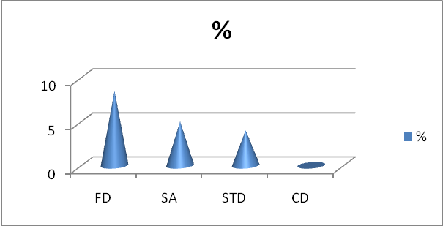
3.1.4 Procedure of Account Opening:
Account Opening (Normal Account):
- Collect an Account opening form from the Bank.
- Fill all the requirements of the form.
- Nominee is must be specified.
- Photograph is most important for any account.
- The account holder sign of his/her own self in front or the specific bank principle Officer in the account opening form.
Account Opening (Saving Account):
- Collect an Account opening form from the Bank.
- Fill all the requirements of the form.
- Nominee is must be specified.
- Photograph is most important for any account.
- The account holder sign of his/her own self in front or the specific bank principle Officer in the account opening form.
- To open this account the most important things is that Passport Photocopy or the Word Commissioner Certificate must have to add with the account opening form.
Account Opening (Current Deposit Account):
- Collect an Account opening form from the Bank.
- Fill all the requirements of the form.
- Nominee is must be specified.
- Photograph is most important for any account.
- To open this account the most important things is that Passport Photocopy or the Word
- Commissioner Certificate must have to add with the account opening form and also enclose the form 12 with the account opening form.
Fixed Deposits:
Before opening a Fixed Deposit Account a customer has to fill up an application form which contains the following:
- Amount in figures
- Beneficiary’s name and address
- Period
- Rate of interest
- Date of issue
- Date of maturity
- Instructions:
- To be renewed automatically with interest for the next period.
- Not to be renewed for next period.
- Pay interest to account no. (-------) on maturity
- Special instruction
- How the account will be operated (singly or jointly)
- Signature (s)
- FDR no.
Then a FDR account is opened and it is recorded in the FDR Register which contains the following information,-
▫ FDR A/C no.
▫ FDR (Fixed Deposit Receipt) no.
▫ Name of the FDR Holder with address
▫ Maturity period
▫ Maturity date
▫ Interest rate
The FDR becomes renewed automatically in JBL if the customer does not encash it within 7 days of maturity. In case of encashment of FDR in maturity, following accounting treatments are given:
Excise Duty on FDR--------------------Dr.
Income Tax on interest --------------Dr.
FDR A/C---------------------------------Dr.
Cash A/C----------------------------------------Cr.
Interest on FDR A/C---------------------------Cr.
If the customer wants to draw the interest only, then following entries are given:
Interest on FDR A/C-----------------Dr.
Cash A/C---------------------------------------Cr.
In case of ‘before maturity enactment’ interest is calculated for the days from the date of opening the FDR account.
3.1.5 Cheque Book Issues:
Types of Cheque Book’s:
- Savings Account – 10 Leaves
- Current Deposit Account – 10 Leaves
- Current Deposit Account – 25 Leaves (CDTF)
- Current Deposit Account – 50 Leaves (CDF)
- NB: CDTF: Current Deposit Twenty Five
- CDF: Current Deposit Fifty

Cheque Issuing is Two Types:
- Direct requisition slip
- Cheque Book’s requisition slip
Customers Service Officer receives these types of slip from the client’s and gives the cheque books under processing. Processing means Cheque Book’s collect from the VOLT and the put account number in the cheque book, write down the serial number of the cheque book in the requisition slip and cheque book register, then Verified client signature. After all this things the Principal officer sign in the cheque leaves and sent the cheque book to another Principal officer for sign, after his sign the client receive the cheque book. These things the Principal Officer for sign, after his sign the client receive the cheque book. Then Principal Officer posting that cheque books leaves number in the computer data processing system.
A cover file containing the requisition slip is effectively preserved as vouchers. If any defect is noticed by the ledger keeper, he makes a remark to that effect on the requisition slip and forward it to the cancellation officer to decide whether a new check book to be issued to the customer or not.

3.1.6 Account Closing:
For two reasons, one can be closed. One is by banker and other is by the customer.
- By banker: If any customer doesn’t maintain any transaction within six years and the A/C balance becomes lower than the minimum balance, banker has the right to close an A/C.
- By customer: If the customer wants to close his A/C, he writes an application to the manager urging him to close his A/C.
Different procedures are followed in cash of different types of A/C to close:
- Fixed deposit A/C is closed after the termination of the period.
- Brick by Brick A/C is very easily closing if one of the clients didn’t pay his/her monthly instalment at the bank three months one after one, in this way three months.
- Another account’s will be closed on the parties advice, if they want to close any one of the account clients must have to submit an A/C closing letter through des pass. Then the Sr. Principal Officer checks it out and closes the A/C.

Closing process for current & savings A/C:

- After receiving customer’s application the officer verifies the balance of the A/C.
- He then calculates interest and other charges accumulated on the A/C.
- If it bears a credit balance, the officer writes advice voucher. He gives necessary accounting entries post to accounts section.
- The balance is returned to the customer. And lastly the A/C is closed.
But in practice, normally the customers don’t close A/C willingly. At times, customers don’t maintain any transaction for long time. Is this situation at first, the A/C becomes dormant and ultimately it is closed by the bank.

3.2 Remittance
Commercial bank in Bangladesh offers the facility of transferring fund from one place to another to their customer as well as to the general public. Such transfer of fund can be affected either through demand draft or telegraphic transfer or mail transfer. The aforesaid methods of remitting money from one place to another within the country are known as remittance. While it is for outside Bangladesh called foreign remittance. The advantage of this facility is the quick transfer of money with minimum cost and also the risk of physical transportation of cost is eliminated.

3.2.1 DEMAND DRAFT:

A demand draft is a written order of one branch upon another branch of the same bank to pay a certain sum of money to or to the order of a specified person. Drafts that are issued are not payable to bearer. In practice drafts are not to be drawn between branches within the same city. The person intending to remit the money through a Demand Draft (DD) has to deposit the money to be remitted with the commission which the banker charges for its services. The amount of commission depends on the amount to be remitted. On issue of the DD, the remitter does not remain a party to the instrument: i) Drawer branch ii) Drawee branch iii) Payee. This is treated as the current liability of the bank as the banker on the presentation of the instrument should pay the money. The banker event on receiving instructions from the remitter cannot stop the payment of the instrument. Stop payment can be done in the following cases:
- Loss of draft before endorsement: In this case, “Draft reported to be lost, payee’s endorsement requires verification” is marked.
- Loss of draft after endorsement: In this case, the branch first satisfies itself about the claimant and the endorsement in his favour.

3.2.1.1 ISSUE OF DEMAND DRAFT:
The procedures of issuance of DEMAND DRAFT are as well as followed:

- The customer is asked to complete filing in a form which is treated as an application as well as voucher. The application form should be checked carefully.
- Commission charges are included in the form.
- The voucher is given to the customer to deposit cash.
- After receiving the cash the voucher will delivered to the remittance department against issuance in his book.
- After preparing the Draft it is entered into the register.
- Branch wise serial number is given on the draft besides the oriented number putting on oblique between.
- The draft number is written on the voucher and is sent to the officer in charge for checking and signature. Then it is sent to the manager or second officer for second signature.
- The draft is crossed if customer wants and delivered to him against his acknowledgement on the voucher.
- A memorandum is issued to the stoner if wants.
- The cheque is sent for passing and cancellation.
3.2.1.2 Account treatment:
In case of issuing of the instrument:

Cash/ customer’s A/C ---------------------Dr.
JBL General A/C (Drawn on branch) ----------Cr.
Income A/C commission---------------------------Cr.

After giving these entries an Inter Bank Credit Advice is prepared which contains the controlling number, depicting that the branch is credited to whom it is issued.
An IBCA implies the following entries,
JBL General A/C Issuing Branch -------Dr.
Drawn on branch------------------------------------Cr.
3.2.1.3 Cancellation:
To cancel an issued DD, the client has to submit an application. Issuing branch then sends an Inter Branch Debit Advice (IBDA) to the drawn branch against previously issued IBCA.
After that the following entries are given:
General A/C drawn on branch---------Dr.
Client’s A/C ---------------------------------------Cr.
3.2.1.5 Issuing of Duplicate DD:
If the customer wants to issue a duplicate DD, than customer is asked to do the following formalities:
- Make a general diary (GD) in the nearest Police Station.
- Furnishing an Indemnity Bond in Tk.50/= stamp.
The banker immediately marks “stop payment” in the register after receiving the application from the customer and a duplicate DD is issued.
3.2.1.6 REVALIDATION OF DEMAND DRAFT:
A draft becomes invalid after lapse of six month from the date of issue. The purchaser of the draft may approach the issuing branch to revalidate the draft to make it payable again. The draft should be ermined and there must be no alteration of draft. The purchaser must give a letter in requesting for the revalidation of the draft. An officer should duly verify his signature on the letter. All particulars of the draft should be compared from the draft issued register. Before the draft is revalidated it is ascertained that no duplicate draft has been issued, a note about revalidation of the draft be made in the register.
The drawee branch should be intimated about the revalidated of the draft. A note to this affect in the remark column against the relative entry in the draft payable register should be made at the drawee branch.

3.2.1.7 PAYMENT OF DEMAND DRAFT:
The payment will be assured after properly validate the following information:
Record of loss: On receipt of information from the drawee branch about the loss of any draft, caution is noted as red mark in the remark column of the register if the draft is not yet paid.
Record of duplicate draft: On receipt of information from the issuing branch in respect of duplicate draft of draft, note to this effect is made in the register.
Record of cancellation: On receipt of information from the issuing branch in respect of cancellation of draft, note to this effect is made in the register.
Record of revalidation: On receipt of information from the issuing branch in respect of revalidation of draft, note to this effect is made in the register.

3.3.1 Payment Order

The pay order is an instrument issued by bank, instructing itself a certain amount of money mentioned in the instrument taking amount of money and commission when it is presented in bank. Only the branch of the bank that has issued it will make the payment of pay order.
3.3.1.1 Issuing of Pay Order:

The procedures for issuing a Pay Order are as follows:
- Deposit money by the customer along with application form.
- Give necessary entry in the bills payable (Pay Order) register where payee’s name, date, PO no, etc is mentioned.
- Prepared the instrument.
- After scrutinizing and approval of the instrument by the authority, it is delivered to customer. Signature of customer is taken on the counterpart.

Jamuna Bank charges different amount of commission on the basis of payment order amount:
Total Amount of PO | Commission | VAT
Up To 10000 | TK. 15 | TK. 3
10001-100000 | TK. 25 | TK. 4
100001-500000 | TK. 40 | TK. 6
500001 and above | TK. 50 | TK. 8

3.3.1.2 Settlement of a PO:
When PO submitted by collecting bank through clearing house, the issuing bank gives payment.
Bills payable (PO) A/C ……………….Debit
JBL General A/C ……………………..Credit.
But before giving payment it is duty for issuing to observe whether endorsement was given by the collecting bank or not, then the instrument is dishonored and marking ‘Endorsement required’.
3.3.1.3 Cancellation of a Pay Order:
If a buyer wants to cancel it, he should submit a letter of instrument in this regard and also return the instrument.
Accounting treatment: Adjustment entry wills be-
Bills payable (PO) ---------------Dr.
Customer A/C--------------------Cr.
3.3.1.4 When PO is lost:
If the instrument is lost, the holder will inform to the issuing bank immediately. Bank will mark ‘stop payment’ on the Bills payable (PO) Register. Buyer will then ask for a new instrument by submitting a GD copy, and indemnity bond. A new instrument will be delivered.

3.3.2 T.T. Issue/Collection
Telex transfer (TT) is another widely used mode for remittances of funds. In case of telex transfer the message for transfer of funds is communicated through tested telex. JBL generally recovers from the telex charges in addition to the usual service charges.
3.3.2.1 Issuing of TT:

JBL follows the following procedures:
- The customer deposits money with JBL to be sent.
- The customer obtains a cash memo containing TT serial number.
- TT serial number, notifying part name is mentioned in the telex message.
- The Telex Department confirms transmission of the telex.

3.3.3 Endorsements

JBL endorses US$ in passports. To endorse US Dollar, the client has to apply in the prescribed from (TM Form).
The following entries are given in this regard:
Cash or Customers’ A/C.............................................Dr.
Foreign Currency on Hand< Dollar Special> ............Cr.

3.3.4 IBC/OBC
By OBC, we mean that those cheques drawn on other banks which are not within the same clearing house. Officer gives OBC seal on this type of cheques and later sends a letter to the manager of the branch of the some bank located in the branch on which cheque has been drawn. After collection of that bill branch advises the concerned branch in which cheques has been presented to credit the customer account through Inter Branch Credit Advice (IBCA).
In absence of the branch of the same bank, officer sends letter to manager of the bank on which the cheques is drawn. That bank will send pay order in the name of the branch. This is the procedure of OBC mechanism.

3.4 Accounts Department

Accounts Department is play most vital role in Banking. Accounts Department is a department with which each and every department is related. It records the profit & loss A/C and statement of assets and liabilities by applying “Golden Rules” of book-keeping. The functions of it are theoretical & computerized based. JBL Mohakhali Branch records its accounts daily, weekly, and monthly every record. JBL Mohakhali Branch Accounts Department in Charge: Mr. Mostafizur Rahmane, Sr. Executive Officer (having 8 years of experience in banking sector). Another officer’s are: Mr. Faruk, (Officer), Mr. Hamid (Teller-Officer).
This entire executive’s helps me a lot in my internship program at JBL. They didn’t guide me as an Internee; they guide me as a training officer of JBL to gather practical knowledge about Banking. They tried their best to inform me everything about accounts department. I hope I knew everything that gave me as a new comer in banking sector.
Basically Accounts Department is not alone. Accounts department is a mix of as follows:
1.Cash
2.Transfer
3. Clearing

3.4.1 CASH
Mr. Mostafizur Rahmane, Sr. Executive Officer (having 8 years of experience in banking sector) & Mr. Faruk, (Officer)both of the two senior executives helps me lot to get practical knowledge and prepare this report.
The cash section of any branch plays very significant role in Accounts Department. Because, it deals with most liquid assets the JBL Mohakhali Branch has an equipped cash section. This section receives cash from depositors and pay cash against cheque, draft, PO, and pay in slip over the counter. Every bank must have a cash counter where customer withdrawn and deposit their money. When the valued client’s deposit their money at the cash counter they must have to full fill the deposit slip his/her own, then they sing as the depositor option’s then they deposit their money through cash officer at the cash counter.
3.4.1.1 SEVERAL TYPES OF DEPOSIT SLIP
- There are several types of deposit slip as follows:
- Current Deposit A/C Slip,
- Saving’s Deposit A/C Slip,
- Festival Deposit A/C Slip,
- Brick By Brick Deposit A/C Slip,
- Pay order Slip,
- Demand Draft Slip,
- T.T. Slip.
After paying this kind’s of slip, the valued client waits for the deposit slip book outside of the cash counter. The cash officer deposit the money in their account through computer software, while the depositors account credited, then the cash officer put a seal in the deposit slip and return it to the client.
3.4.1.2 RECEIVING CASH:
Any people who want to deposit money will fill up the deposit slip and give the form along with the money to the cash officer over the counter. The cash officer counts the cash and compares with the figure written in the deposit slip. Then he put his signature on the slip along with the ‘cash received’ seal and records in the cash receive register book against A/C number.
At the end of the procedure, the cash officer passes the deposit slip to the counter section for posting purpose and delivers duplicate slip to the clients.
Account treatment:
Cash A/C--------------------- Dr.
Customer’s A/C------------- Cr.

3.4.1.3 DISBURSING CASH
The drawn who wants to receive money against cheque comes to the payment counter and presents his cheque to the officer. He verifies the following information:

- Date of the cheque
- Signature of the A/C holder
- Material alteration
- Whether the cheque is crossed or not
- Whether the cheque is endorsed or not
- Whether the amount in figure and in word correspondent or not

Then he checks the cheque from computer for further verification. Here the following information is checked:

- Whether there is sufficient balance or not
- Whether there is stop payment instruction or not
- Whether there is any legal obstruction (Garnishee Order) or not

After checking everything, if all are in order the cash officer gives amount to the holder and records in the paid register.

3.4.1.4 Account treatment:
Customer’s A/C................ Dr.
Cash A/C........................... Cr.

The cash section of JBL deals with all types of negotiable instruments, cash and other instruments and treated as a sensitive section of the bank. It includes the vault which is used as the store of cash instruments. The vault is insured up to Tk. 120 lacs. If the cash stock goes beyond this limit, the excess cash is then transferred to Principle Branch Office. When the excess cash is transferred to JBL Principle Branch Office the cash officer issues IBDA.

3.4.1.5 Crossed Cheque:
Those which can only be paid to a banker for crediting the proceeds to the account of its payee is called crossed cheque. Where a chaque is crossed generally to the banker on whom it is drawn shall not pay it otherwise than to a banker and/or specially the banker on whom it is drawn shall not pay it otherwise than to a banker to whom it is crossed or his agent for collection.
3.4.2 Transfer
Transfer is not a critical sector in banking but it is very important. Transfers play a vital role in banking sector. So now we have to know what transfer is: basically transfer is a type of register maintaining matter. In this register officer write down every day transactions in Debit and Credit side then the officer calculate both the side of the register if both side shown same amount, it means that the total day’s transaction is completely okay.
3.4.3 Clearing
Clearing is one of the magical parts of banking. I really enjoyed this part of the accounts department and banking sector. In Jamuna Bank Limited clearing in charges Mrs. Mebin (Officer), I did work with her. I went Bangladesh Bank lots of time with Mrs. Mebin.
3.4.3. 1 What is clearing House?
In Bangladesh Bank, there is a very large room, which contains fifty (50) or more tables for each bank that is called the clearing house.
3.4.3.2 Nature of clearing house:
- 1st Clearing House
- Return Clearing House

3.4.3.3 Clearing House Process:
Every bank has an officer of clearinghouse who is work with Bangladesh Bank clearing house. Actually most of major client deposit their account in different kinds of bank cheques. Clearing officer check all the cheques and deposit slip very carefully and then he received the cheque. After that the clearing officer posting all the cheques in computer software which is recognized through Bangladesh bank computer department. Then clearing officer seal all the cheques in advance date after that the officer endorsement all the cheques and sign all the cheques. All the cheques are posted in the computer by branch wise, then officer print the entire document and staple all the cheques by branch wise this is called schedule of clearing house. It is a very difficult job to staple all the cheques, because some time’s the cheques are huge in quantity, it may be 250 to 400, this is very vital job because every cheque must have to staple very carefully, it means cheque amount and the print sheet amount and cheque branch must have to be same. If the cheques staple in wrong direction, the cheque may be return from another bank, that’s why JBL not to be able to credited party account.
Then the clearinghouse officer copying the entire document into two floppy disk as per Bangladesh Bank requirement. When the clearing officers enter the clearinghouse, his first job is that the floppy delivered to the Bangladesh Bank computer department.
All of the procedure the clearing in charge goes to the Bangladesh Bank clearing house before 10 am in the morning. The clearing officer check all the bank’s cheque and he put all the cheques in bank wise, like as this another bank’s delivered their cheques in JBL desk. Then the officers of JBL have to calculate all the cheques by using calculator machine, Staple pin remover, and then he divided all the cheques as JBL Branch wise.
3.4.3.4 Types of Clearing Cheque:
JBL Mohakhali Branch performs the bill clearing function through Bangladesh Bank. JBL Mohakhali Branch acts as the agent of all JBL branches for the clearing house of the Bangladesh Bank. There are two types of cheque which are-
1. Inward clearing cheque.
2. Outward clearing cheque.


CREDIT DEPARTMENT

The primary function of commercial bank is the disbursement of credit to borrowers. Bank credit is a catalyst for bringing about economic development. Without adequate finance there can be no growth or maintenance of a stable output. Bank lending is important to the economy, for it makes possible the financing of agriculture, commercial and industrial activities of a nation. At the same time, a bank will, therefore, distribute its funds among various assets in a manner as to derive sufficient income. But as liquidity and profitability are conflicting consideration for Jamuna bank limited, as a bank, while employing the funds pays due regard to both profitability and liquidity.
The objective of the credit management of a bank is to maximize the performing asset and the minimization of the non-performing asset as well as ensuring the optimal point of loan and advance and their efficient management. Credit management is a dynamic field where a certain standard of long-range planning is needed to allocate the fund in diverse field and to minimize the risk and maximizing the return on the invested fund. Continuous supervision, monitoring and follow-up are highly required for ensuring the timely repayment and minimizing the default. Actually the credit portfolio is not only constituted the bank’s asset structure but also a vital factor of the bank’s success. The overall success in credit management depends on the banks credit policy, portfolio of credit, monitoring, and supervision and follow-up of the loan and advance.

4.1 Lending Principles Followed By JBL:
JBL Credit Policy is guided by the following Principles:
Principle # 1
Credit is not to be made available nor services to a customer where we lack an understanding of the customer or the customer’s business.
Principle # 2
Insider loans and self-dealing loans are prohibited.
Principle # 3
Name lending is to be avoided in respect of all customers/ counter parties.
Principle # 4
All companies in a group shall be assessed individually and collectively. Applies for approval, reporting and regulatory ceiling compliance purposes.
Principle # 5
Lending to the holding companies is prohibited.
Principle # 6
Lending to the Govt. or sector corporations should not always be considered as low risk.
Principle # 7
- Money should not be lent in property merely because of evident collateral.
- Companies or individuals who are seeking to develop their property should have a proven title or legitimate construction authority.
Principle # 8
No lending or deal is to be made with a bank or financial institution unless its credit worthiness is established through due diligence and appropriate counter party limit is approved by the appropriate authority.

Principle # 9
While dealing with the groups their tendency of drawing accommodation bills and originating in-house transactions should be clearly identified and avoided. Bank’s own acceptance is not to be purchased unless business case supports it and specific permission from head office authority.
Principle # 10
Per party credit exposure to be clearly worked out and determined.
Principle # 11
Only the products that are covered by approved product program guidelines (PPGs) or Departmental operating Instructions (DOI) may be provided to CBL customer.
Principle # 12
Facilities should be priced on risk adjustment basis. Nature of product or facilities, Customer credit grades, security, risk transfer factor (customer guarantee from another bank/insurance cover) should be considered.
Principle # 13
Products that are appropriate for the nature of business and amount of loan that is appropriate for the scale of operation of the customer should provided.
Principle # 14
Tenor &terms of financing should be structured in relation to customer’s own business cycle.
Principle # 15
Specialized areas for bank financing should be defined, measured and clearly understood. Only those areas where CBL has competence and capacity may be taken up for financing.

Principle # 16
Facilities will be provided after a full analysis of the risks associated with customers as well as facilities proposed & review of the risk adjusted return has been completed &documented.
Principle # 17
All Corporate clients should be allocated a credit grade using appropriate grading methods as adopted from the best practices & in compliance with central bank’s Prudential Guide Lines.
Principle # 18
All loan application should be obtained in bank’s standard format and signed by the authorized signatories.
Principle # 19
Loan origination and disbursement authority must generate from two different persons and/or Department/Divisions.
Principle # 20
Facilities may be drawn only after authorization from credit Administration & Monitoring Department, which must be organizationally independent of the credit marketing and credit approval process.
Principle # 21
All items that are pledged, mortgaged, collateralized to the bank must be tangible, have quantifiable value and should be under physical (actual or constructive) control of CBL or have legal title/charge thereto. These characteristics should be backed by appropriate documentation.
Principle # 22
All loans and advances originated and disbursed should be collected or realized from the borrower at maturity.

Principle # 23
All decision makers should be aware of the risk concentration at portfolio level. They must proactively manage, define and diversify the risk concentration

4.2 Target Customers of the Jamuna Bank Ltd.
The customers for loan and advances are categorized as follows:
- Individual person
- Sole proprietorship firm
- Partnership firm
- Private Limited Company
- Public Limited Company
- Government and semi Government Organization
- Bank employee
4.3 Processing Of Loan Application and Approval

Selection of the Borrower:
In lending, the most important step is the selection of the borrower. Due to the asymmetric information and moral hazard, bank shaves to suffer a lot due to the classified loans and advances, which weakens the financial soundness of the bank.

Studying Past Track Record:
After getting an application for a loan, a CBL official studies the past tract record of the applicant. Generally the study includes-
- Account balances and the past transactions.
- Credit report from other banks.
- Information of the industry by studying market feasibility.
- Financial statement.
If the amount is large Report to credit information bureau of Bangladesh Bank.

4.3 Borrower Analysis:
Five C | Five P | Five M | Five R
Character | Persons | Man | Reliability
Capital | Purpose | Management | Respectability
Capacity | Profit | Material | Resources
Condition | Place | Money | Responsibility
Collaterals | Products | Market | Returns

4.4 Preparation of Credit Report:
Credit report is a comprehensive on the borrower in which bank trusts the borrower that he/they will repay the loan in accordance with originally agreed upon by the borrower and the bank.
Before performing credit report the manager has to go through an investigation. The degree of investigation will be greater or less depending upon the amount of the loan and the type of loan. For investigation the loan official has to enquire about–

- Who the borrower is
- Nature of business
- Experience in the business
- Investment made in the business
- Purpose of borrowing
- Amount of loan asked for
- Duration of loan
- Sources of repayment
- Means of finance
- Security offered
- Profitability of the transaction
- History of accounts operation by borrower
- Market reputation regarding character, honesty, integrity etc of the borrower.

Sources of Credit Investigation:
- Loan application
- Financial statement
- Study of account
- Market reputation
- Other sources
- Press report
- Registration office revenue and municipal rent receipt.
- Register of Joint Stock Company
- Vat return
- Report from credit information bureau (CIB)
- Personal interview
- Personal visit

On the basis of above sources the manager of the bank prepares a credit report.

4.5 Analyzing the Information
Banks then starts examination that whether the loan applied for is complying with its lending policy. If comply, then it examines the documents submitted and the credit worthiness. Credit worthiness analyses, i.e. analysis financial conditions of the loan applicant are very important. If loan amount is more than 50 lakh then bank goes for Lending Risk Analysis (LRA) and Spreadsheet Analysis (SA) which are recently introduced by Bangladesh Bank According to Bank rule. LRA and SA are must for the loan exceed one crore. If these two analyses reflect favourable condition and documents submitted for the loan appear to be satisfactory, then bank goes for further action.

4.6 Information Collection
The loans and advance department gets a form filled by the party seeking a lot of information. The information is listed below:
- Name and address (present and permanent)
- Constitution or status of the business
- Particulars of properties, partners and directors
- Background and business experience
- Particulars of personal assets, names of subsidiaries, percentage of share holding and nature of business
- Details of liabilities in name of borrowers, in names of any directors
- Financial statement for the last three years
- Nature and details of business/ products
- Details of requested credit facilities
- Details of securities offered
- Other relevant information
- Proposed debt equity ratio.

4.7 Relevant matter of Document checked before sanctioning any Loan

- There must be an account of the person want to take loan. The account must transact for not less than 3 months to 6 months. Otherwise the loan will not be sanctioned.
- After checking the duration of account than the transaction made by the account holder must be checked. The debit credit position must be also checked, because it is related with future dealings of the borrower.
- The purpose for what the loan is taken by the borrower is another important matter to see and check. Whether the purpose is business or else must be checked with its marketability. Because there is risk of fraud and forgery by the borrower by seeing one purpose in cash of ding any illegal business.
- The banker should check through security whether it is enough or not.
4.8 Documentation of the loan
These are the most common documents for creation of above mentioned charges and for other formalities of sanctioning loan.
- Demand promissory note: Here, the borrower promises to pay the loan as and when demand by bank to repay the loan.
- Letter of arrangement.
- Letter of continuity.
- Letter of hypothecation of goods and capital machinery.
- Stock Report: This report is used for CD and CC. In this report, information about the quality and quantity of goods hypothecated furnished.
- Memorandum of deposit to title of property duly signed by the owners of the property with resolution of Board of Directors of the company owning the landed property.
- Personal guarantee of the owners of the property.
- Guarantee of the all directors of the company.
- Resolution of the board of director to borrow fund to execute documents and completes other formalities.
- Letter of Disclaimer: By this letter, the borrower withdraws his all claim on the claim of the property/ goods lined/ mortgaged.
- Form no. 18/19 for filling charges with the register of joint stock companies under relevant section.
- Taxpaying certificate.
- Letter of instalment.
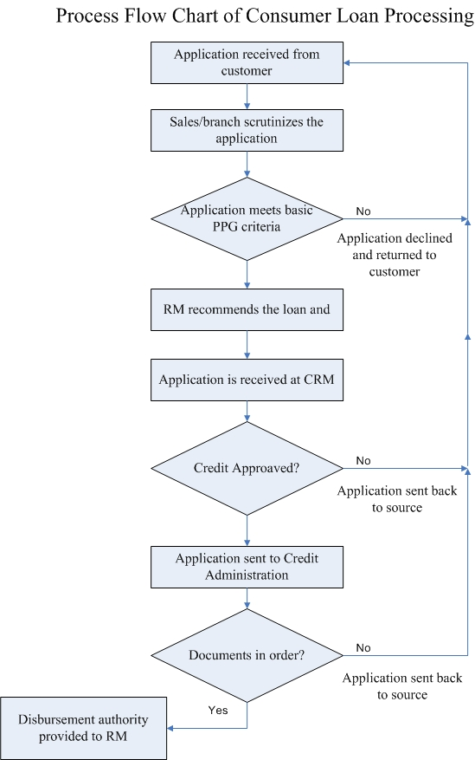

4.9 Loans Disbursement:

Loan disbursement has to be made after completion documentation and observation of the sanctioning terms against rising of equity by sponsors and lay down. Each phase of loan disbursement to be supervised by bank official that the project and the phase of implementation of the project to be effectively supervised and borrowers persuaded for completion of project in time. There are main three important factors in the loan disbursement, such as-
- Completion of Documentation.
- Verification of Stocks.
- All-important Documentation

4.10 Credit Monitoring, Follow-up and Supervision:

Credit monitoring implies that the checking of the pattern of use of the disbursed fund to ensure whether it is used for the right purpose on not. It includes a reporting system and communication arrangement between the borrower and the lending institution and within department, appraisal, disbursement, recoveries, fallow-up etc.
CBL Officer Check on the Following Points
- The borrower behavior of turnover.
- The information regarding the profitability, liquidity, cash flow situation and trend in sales in maintaining various ratios.
The review and classification of credit facilities start at credit department of the branch with the branch manager and finally with the head office.

- Monitoring:
The purpose of monitoring is to achieve efficient and effective project performance by providing feedback to project management at all levels in improving operational plan and in taking timely corrective action in case of shortfalls and constraints if any, in implementation of each project as a whole monitoring thus is a part of management information system and hence an essential activity.

- Follow-up:
Close follow-up begins after selection of the borrower and sanction of loan. A good advance may turn bad in the absence of proper and timely follow-up. Quite often bankers do not bother to follow up and monitor newly sanctioned loans and advances. However, their main function should begin after sanctioning of the loan.

4.11 Recovery System:
If any borrower fails to adjust the loan within validity period or to repay his monthly instalment then the responsible loan-monitoring officer of the concerned branch will arrange for adjustment of the overdue instalments from the loaner’s savings account if there is adequate balance. The officer shall regularly follow up for recovery and take any measure including legal action for recovery.
Recovery Strategy includes the followings:

  - Meeting with the client
  - Phone call
  - Checking & verification of collateral security
  - Explore the possibility of amicable settlement
  - Initiate legal action
  - Any other strategy depending on the situation deemed appropriate

If any loaner fails to repay his consecutive 02(two) monthly instalments, then the Branch’s loan monitoring officer will investigate into the actual causes of default and report to the Branch Manager with a copy to Head office for further action and advice for recovery/regularization of the loan.
The borrower shall maintain a non-withdrawal savings account with the concerned branch where he shall make compulsory deposit of @ 0.5% of outstanding loan amount per month for building up his own fund. The borrower must not change the nature of business and place of business without prior permission of the Bank.

5.1 Financial Performance of JBL
5.1.1 Deposit:
JBL was Able to install confidence in customers as to its commitment to the depositors & borrowing customers and thereby could mobilize a total deposit of Tk.60673.56 million in 2010 against that of Tk.42356.20 million in the preceding year showing an increase of Tk.18317.36 million being 43.25 percent.

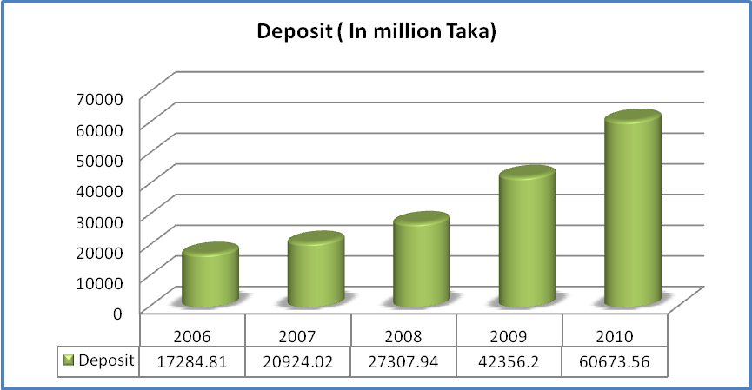

Figure5.1: Deposit in year 2006 to 2010

5.1.2 Investment:
The investment portfolio of the Bank as on 31.12.2010 stood at Tk.10891.03 million from Tk.8503.44 million as on 31.12.2009. The investment portfolio was blended with government treasury bills amounting to Tk.1589.46 million, Treasury bonds of Tk.2595.39 million, investment in primary shares and Zero Coupon Bond of Tk.1.16 million. Its investment was made in acquisition of preference share of Tk. (50.00-25.00) 25.00 million Aftab Automobiles Limited. Besides, Tk.2.00 million has been invested in acquisition of two shares of Central Depository Bangladesh Limited (CDBL).

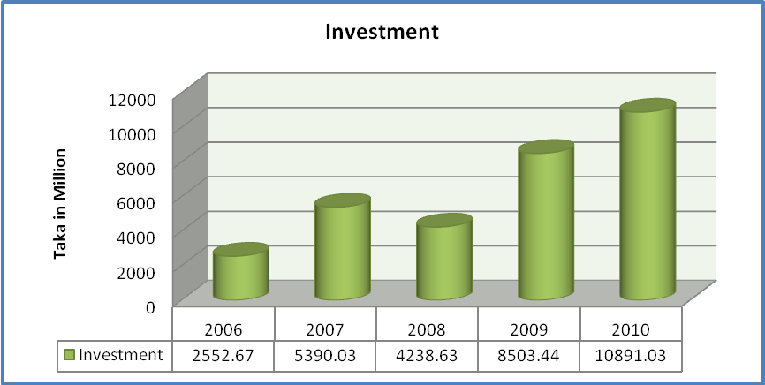

Figure5.2: Investment in year 2006 to 2010

5.1.3 Profit:
In 2010 Jamuna bank limited posted an operating profit of tk.2406.30 million as against tk.1914.25 million in 2009 with a growth of 25.70 percent over the preceding year. After having made necessary provisions for loans and advances in accordance with the instructions of Bangladesh bank net income before tax (NIBT) stood at tk.2064.90 million in the year under review against tk.1563.20 million in the preceding year. An amount of tk.988.20 million has been kept as provision for payment of tax. Thus Net income after tax and provision stood at tk.1066.38 million in 2010 which was tk.923.12 million in 2009.

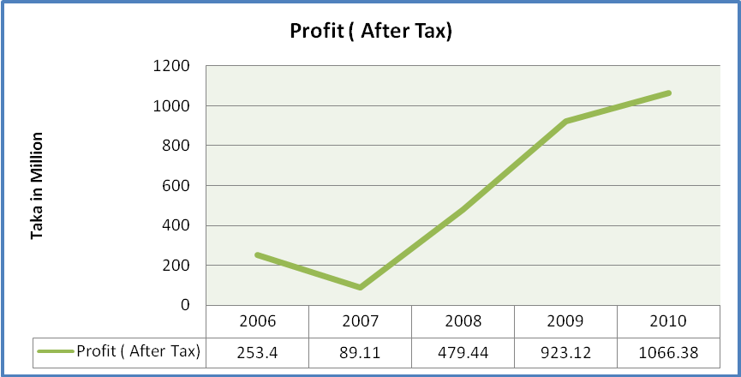

Figure5.3: Profit in year 2006 to 2010

5.2 Bank Profitability ratio

5.2.1 Return on assets: An indicator of how profitable a company is relative to its total assets. ROA gives an idea as to how efficient management is at using its assets to generate earnings. Calculated by dividing a company's annual earnings by its total assets, ROA is displayed as a percentage. Sometimes this is referred to as "return on investment".
The formula for return on assets is:

After calculating the banks ROA we found the figure for five years:

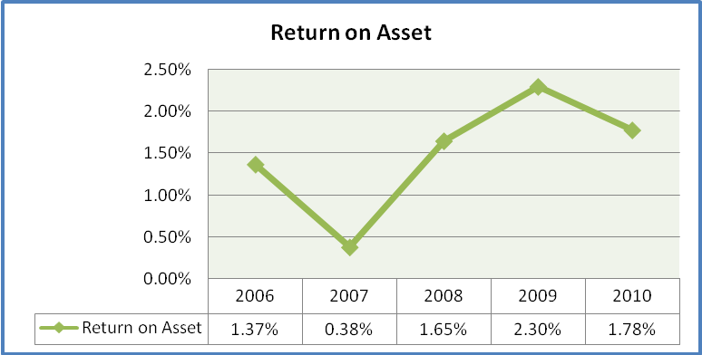

From the figure we see that, return on asset is different from one year to another year. It shows both increasing and decreasing trend. Return on asset is higher in 2009 which is 2.30% and lower in 2007 which is 0.38%. In 2007 their net Income was decreased because in that financial year banks provision for loan, advance and assets was higher (419.16 million in taka) than other financial year like 2008,2009 and 2010 which was 174.39, 351.05 and 341.40 (million in taka) so that was the main reason why in 2007 their Return on Asset was fall and in 2010 the same problem was reflacted.
5.2.2 Return on Equity: The amount of net income returned as a percentage of shareholders equity. Return on equity measures a corporation's profitability by revealing how much profit a company generates with the money shareholders have invested. ROE is expressed as a percentage and calculated as:
Return on Equity = Net Income/Shareholder's Equity

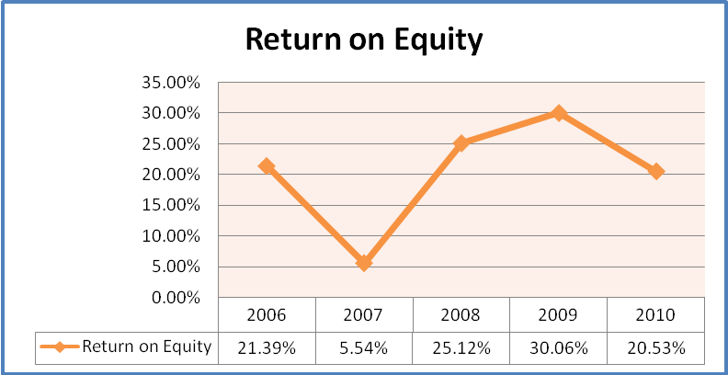

This figure shows the position of return on equity in different year. The position is higher on the year 2009 which is 30.06% and the lower position hold the year 2007 which is 5.54%. In 2007 banks Net Income was decreased, which was 89.11 (Million in taka)but in 2008 and 2009 banks Net Income was increased incompare to 2007 on the hand in 2010 banks Net income was also slightly decreased in compare to 2008 and 2009. That is why we can see in that line chart in 2007 and 2010 banks Return On Equity was decreased.

5.2.3 Profit Margin:
A ratio of profitability calculated as net income divided by revenues, or net profits divided by sales. It measures how much out of every dollar of sales a company actually keeps in earnings. The banks five years ratio are given below:

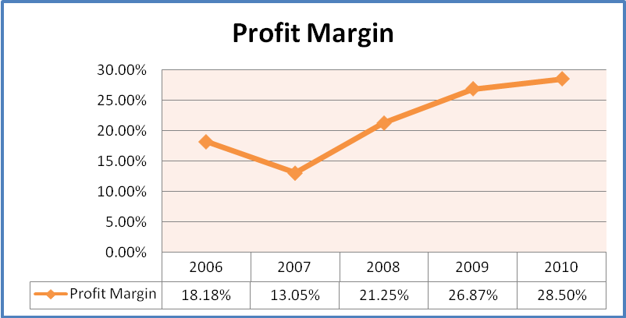

This figure shows the position of profit margin in different year. The position is higher on the year 2010 which is 28.50% and the lower position hold the year 2007 which is 13.05%. In that line chart we can see that In 2007 banks profit margin was declined due to decrease of net income which was 89.11 (Million in taka)but in 2008, 2009 and 2010 banks profit margin was gradually increased because net income was increased.

5.2.4 Return on Deposit:
When measuring performance, the actual rate of return of an investment or a pool of investments over a given evaluation period. Total return includes interest, capital gains, dividends and distributions realized over a given period of time. The scenario of JBL’s ROD is as follow:

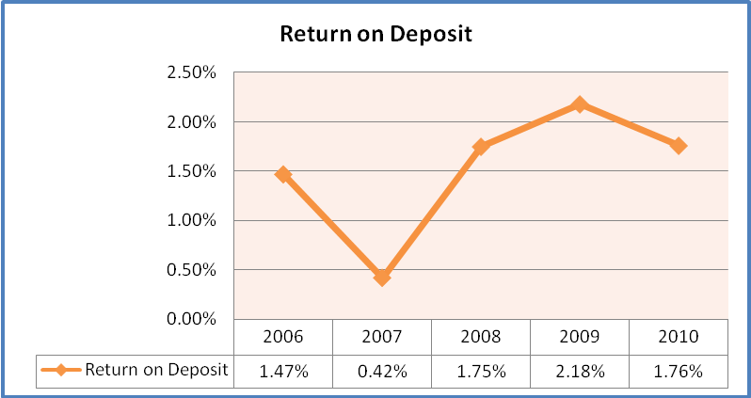
From the figure we assure the position of return against deposit in different year. The return on deposit is higher in the year 2009 which is 2.18% and the position is lower in the year 2007 which was 0.42%. In 2007 banks net income was decreased on the other hand deposits was increased. Thats way return on deposit was lower in 2007 and similar thing was happened in 2010.
5.2.5 Net operating margin:
A ratio used to measure a company's pricing strategy and operating efficiency. Net operating margin is denoted as Operating Profit Divided by interest income.
Operating margin is a measurement of what proportion of a company's revenue is left over after paying for variable costs of production such as wages, raw materials, etc. A healthy operating margin is required for a company to be able to pay for its fixed costs, such as interest on debt.
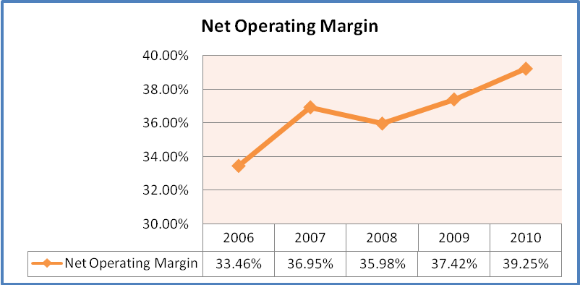
From the figure we see that, in the year 2010 net operating margin is 39.25%, in the year 2009 which was 37.42%, in the year 2008 which was 35.98. We can say net operating margin shows increasing trend except year 2008.

5.3 Efficiency ratio
- Interest income to expenses: (IN−IE) /ATLA= (interest income−interest expenses) / average total loans and advances.

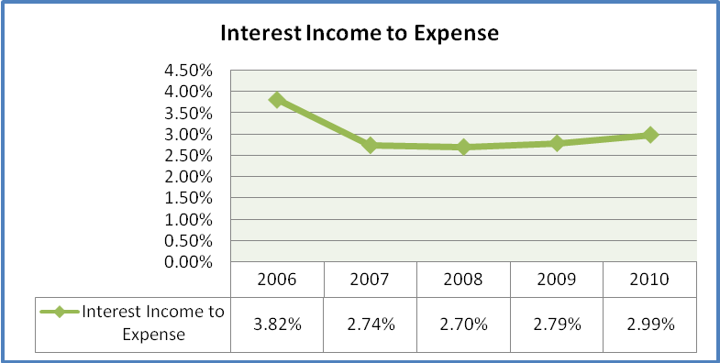

This figure shows the position of interest income to expense in different year. In that line chart we can see that in 2006 to 2008 banks interest income to expense was gradually decreased but in 2009 and 2010 interest income to expense was increased in compare to 2008 becacause the net interest income was higher.

- Operating expense to assets: OE/ATA=operating expenses/ average total assets.

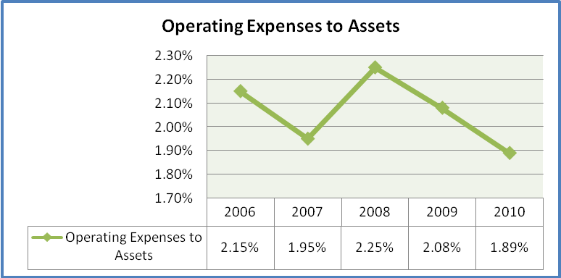

From the figure we assure the position of operating expense to assets in different year. The operating expense is higher in the year 2008 which is 2.25% and the position is lower in the year 2010 which was 1.89%. In 2006 and 2008 the graph was upward because in this two year banks opetating expense was increased compare to average total assets.

- Asset turnover: IN/ATA=interest income/ average total assets.

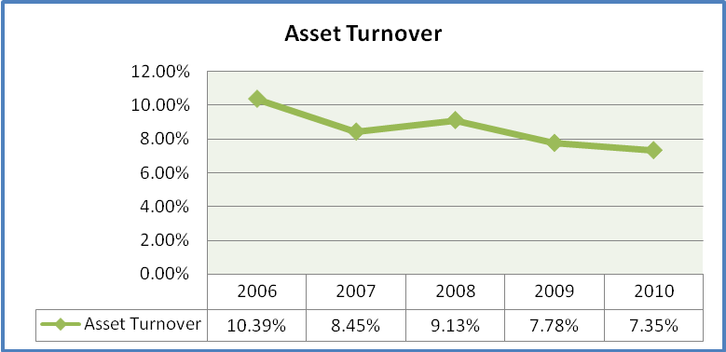

The figure asset turnover thoroughly explains the position in different year. In that line chart we can see that in 2006 to 2010 the asset turnover ratio was fluctuated due to the changes of interest income.
Net interest margin:

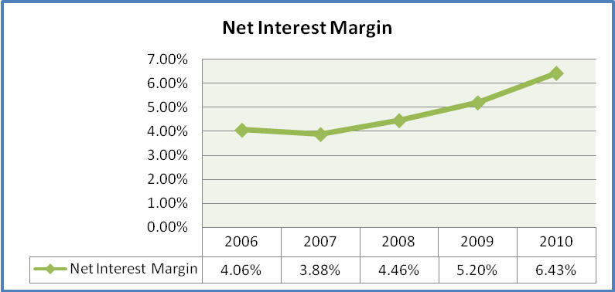

The figure assures the position of net interest margin in different year. The net interest margin is higher in the year 2010 which is 6.43% and the position is lower in the year 2007 which was 3.88%. The overall figure shows an increasing trend from 2008 to 2010 due to increase of net interest income except the year 2007.
- Return on investment: When measuring performance, the actual rate of return of an investment or a pool of investments over a given evaluation period. Total return includes interest, capital gains, dividends and distributions realized over a given period of time.

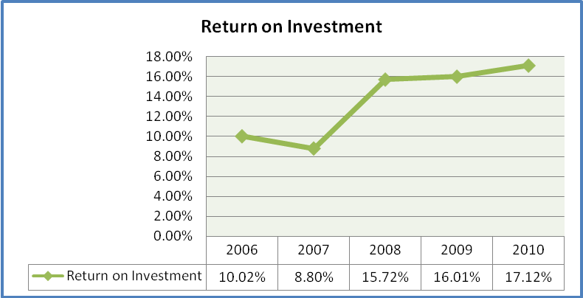

This figure shows the position of return on investment in different year. The position is higher on the year 2010 which is 17.12% and the lower position hold the year 2007 which is 8.80%. The overall figure shows an increasing trend from 2008 to 2010 due to increase of net income and investment but in 2007 the banks net income was lower in compare to investment.

5.4 Asset Quality Ratio
5.4.1 Nonperforming loans: NPL, are loans that are no longer producing income for the bank that owns them. Loans become nonperforming when borrowers stop making payments and the loans enter default. The exact classification can vary from institution to institution, but a loan is usually considered to be nonperforming after it has been in default for three consecutive months.

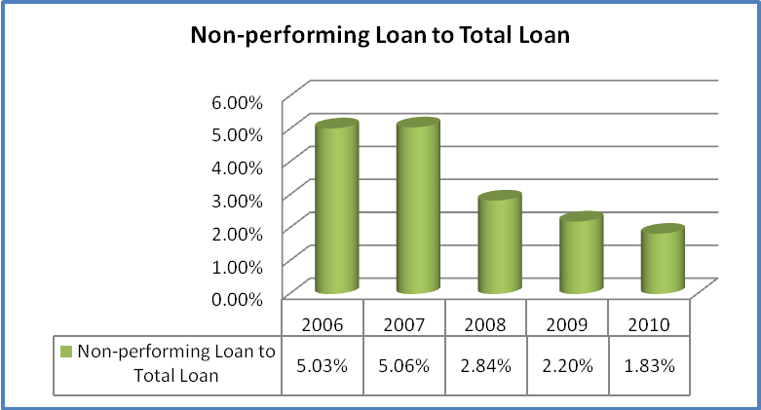

From the figure we see that, NPL is higher in 2006 which is 5.03% and lower in 2010 which is 1.83%. The figure shows non performing loan to total loan is in decreasing trend.

5.4.2 Loss Reserves: That portion of a fund's earnings or permanent capital designated by the board of directors as a reserve against possible loan losses and, as such, unavailable for lending purposes. Generally accepted accounting principles governing for-profit and regulated financial institutions require that loan loss expense be deducted as an annual expense on an accrual basis and that the loan loss reserve be shown as a contra asset reducing loan assets.

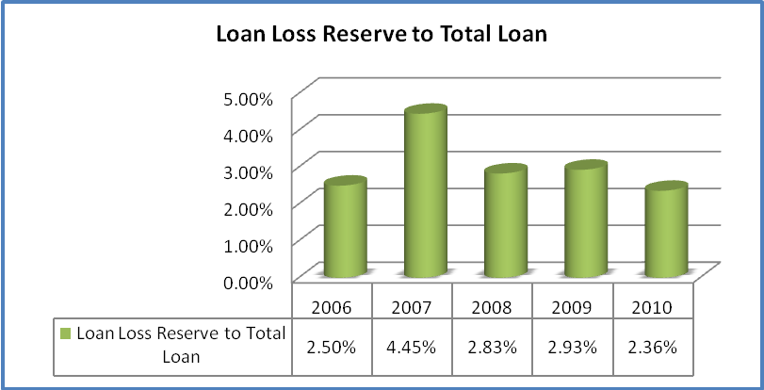

From the figure we see that, in the year 2010 loan loss reserve to total loan is lower which is 2.36%, in the year 2009 which was 2.93%, in the year 2008 which was 2.83%, in the year 2007 it was 4.45 %( higher).

5.4.3 Loan Ratio: The ratio, expressed as a percentage, of the amount of a loan to the value or selling price of real property. Usually, the higher the percentage, the greater the interest charged. Maximum percentages for banks, savings and loans, or government insured loans, is set by Loan ratio=ATLA/ATA=average total loans and advances / average total assets.
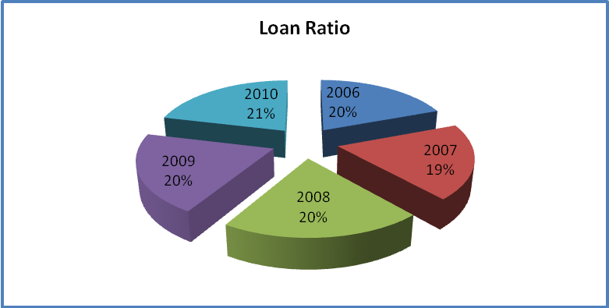
The figure assures the position of loan ratio in different year. The loan ratio is higher in the year 2010 and the position is lower in the year 2007.
5.4.4 Loan-deposit ratio: The amount of a bank loans divided by the amount of its deposits at any given time. The higher the ratio, the more the bank is relying on borrowed funds, which are generally more costly than most types of deposits.
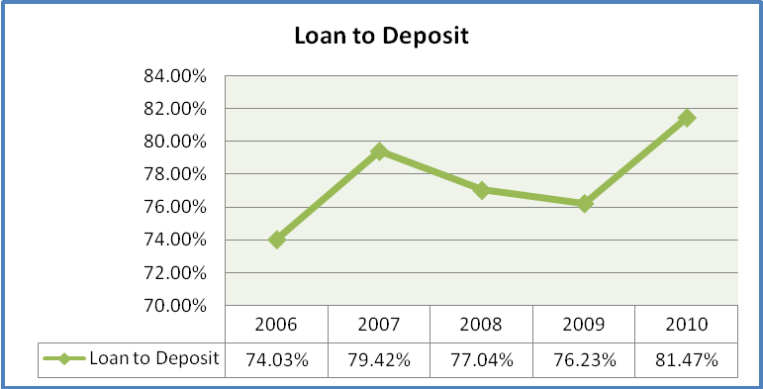
The figure loan to deposit thoroughly explains the position in different year. The loan to deposit is greater in the year 2010 then the previous year which was 76.23%. In that line chart in 2007 the loan was higher compare to deposit thats way the slope is upward but in 2008 and 2009 both loan and deposit was lower than 2007. In 2010 both loan and deposit was increased so much.

5.4.5 Cash to Asset: An asset that can be converted into cash immediately, such as bank account balances and marketable securities. Assets that provide liquidity to a portfolio. In Russell Performance Attribution (RPA), cash assets are used to ensure that all day-weighted entries are correctly balanced.

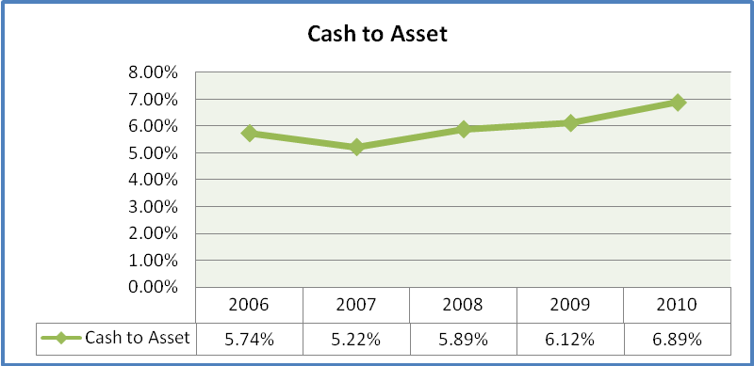

This figure shows the position of cash to assets in different year. The position is higher on the year 2010 which is 6.89% and the lower position hold the year 2007 which is 5.22%. In 2007 the amount of cash was lower on the other hand cash was increased gradually from year 2008 to 2010.

5.5 Risk Ratio
5.5.1 Deposit to asset: ATD/ATA=average total customer deposits / average total assets.

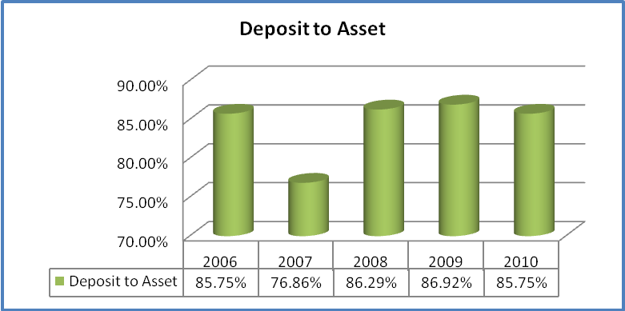

The figure deposit to asset explains the position in different year. The deposit to asset is greater in the year 2009 then the previous year which was 86.29%. The lower deposit to assets is in the year 2007 which was 76.86%.

5.5.2 Equity multiplier: ATA/SE=average total assets / average stockholders' equity.
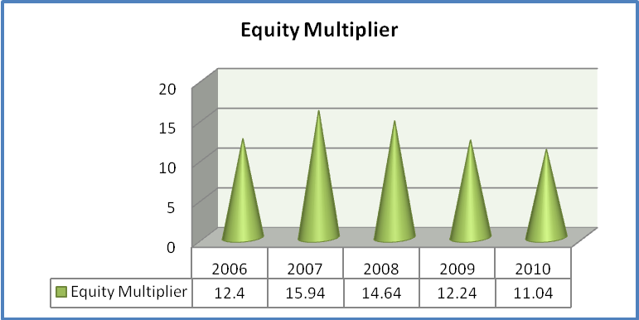
The figure explain that, in the year 2007 loan equity multiplier is higher which is 15.94%, in the year 2010 loan equity multiplier is lower which is 11.04%. The overall figure shows decreasing trend. In 2007 the slope was upward because the asset was increased more than the equity increased but from the year 2008 to 2010 the slope was downward because the equity was increased copare to asset.

5.5.3 Debt equity ratio: Debt to equity ratio is calculated by dividing total debt to total equity.
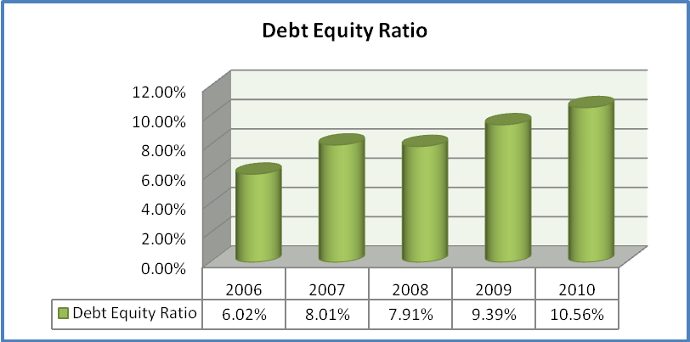

The figure assures the debt to equity ratio is higher in the year 2010 which is 10.56% and the position is lower in the year 2006 which was 6.02%. In 2007 the amount of debt was higher in compare to equity but in year 2008 debt was decreased in compare to equity on the other hand from the year 2009 to 2010 the debt was again inecreased against equity.

Ratios of JBL from year 2006-2010
Ratio | 2006 | 2007 | 2008 | 2009 | 2010
ROA | 1.37% | 0.38% | 1.65% | 2.30% | 1.78%
ROE | 21.39% | 5.54% | 25.12% | 30.06% | 20.53%
Profit Margin | 18.18% | 13.05% | 21.25% | 26.87% | 28.50%
Return on Deposit | 1.47% | 0.42% | 1.75% | 2.18% | 1.76%
Net Operating Margin | 33.46% | 36.95% | 35.98% | 37.42% | 39.25%
Interest Income to Expense | 3.82% | 2.74% | 2.70% | 2.79% | 2.99
Operating Expense to Assets | 2.15% | 1.95% | 2.25% | 2.08% | 1.89%
Asset Turnover | 10.39% | 8.45% | 9.13% | 7.78% | 7.35%
Non-Performing Loans | 5.03% | 5.06% | 2.84% | 2.20% | 1.83%
Loss Reserves | 2.50% | 4.45% | 2.83% | 2.93% | 2.36%
Loan Deposit Ratio | 74.03% | 79.42% | 77.04% | 76.23% | 81.47%
Cash to Asset | 5.74% | 5.22% | 5.84% | 6.12% | 6.89%
Deposit to Asset | 85.75% | 76.85% | 86.29% | 86.92% | 85.75#
Equity Multiplier | 12.4% | 15.94% | 14.64% | 12.24% | 11.04%
Debt Equity Ratio | 6.02% | 8.01% | 7.91% | 9.39% | 10.56%
Net Interest Margin | 4.06% | 3.88% | 4.46% | 5.20% | 6.43%
Return on Investment | 10.02% | 8.80% | 15.72% | 16.01% | 17.12%

5.6 SWOT Analysis of JBL
The SWOT analysis comprises of the organization’s internal strength and weaknesses and external opportunities and threats. Basically, this analysis is a conceptual framework for a systematic analysis that facilities matching the external threats and opportunities with the internal weakness and strengths of the organization. SWOT analysis gives an organization an insight of what they can do in future and how they can compete with their existing competitors. This tool is very important to identify the current position of the organization like bank relative to others, which are playing in the same field and also used in the strategic analysis of the organization.
The acronym for SWOT stands for –
S – Strengths
W – Weakness
O – Opportunities
T – Threats

Internal actors  External | Internal Strengths  (S) | Internal Weaknesses (W)
External Opportunities  (O) | SO Strategy:  Maxi - Maxi  Potentially the most successful strategy, utilizing the bank’s strengths to take advantage of opportunities. | WO Strategy:  Mini - Maxi  Development strategy to overcome weaknesses in order to take advantage of opportunities.
External Threats  (T) | ST Strategy:  Maxi - Mini  Use of strengths to cope with threats or to avoid threats. | WT Strategy:  Mini - Mini  Retrenchment, insolvency etc.

Figure: The TOWS Matrix for strategy formulation

5.6.1 Strengths:

Strength

66 Numbers of Branches

Online banking system

Satisfactory capital base

Experienced employees

More strengths of Jamuna bank are:

- Energetic as well as smart team work.
- Cooperation with each other.
- Membership with SWIFT.
- Strong Financial position.
- Largest Portfolio Among PCBs
- Strong Liquidity Position
- Low Cost Fund
- Satisfactory Profitability
- Satisfactory capital base.

5.6.2 Weaknesses:
In my case study, I have gathered some weakness in this organization which is very essential to overcome for this organization, such as:-

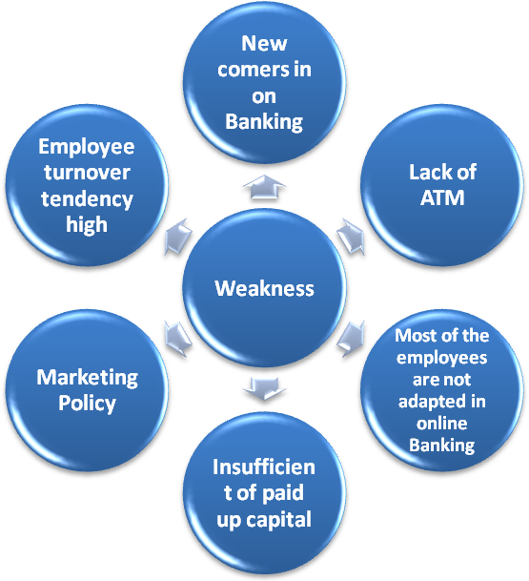

From my point of view there are many weaknesses in this organization.

- High cost of fund.
- High rate of interest.
- Traditional banking.
- Absence of strong marketing activities.
- IT & E-Banking Status Dose Not Match With Other Banks

5.6.3 Opportunities:

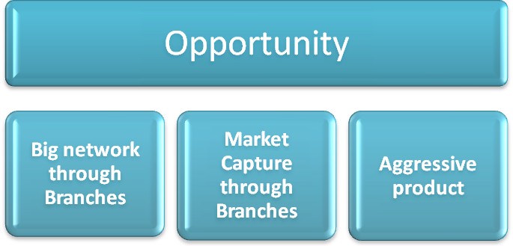

More opportunities of Jamuna bank Ltd are:
- Growing business in the South Asian region.
- Bank can engage with worldwide remittance transfer network.
- The experience, skill and compatibility of bankers.
- Scope to increase EPS
- Earn enough profit for reinvestment

5.6.4 Threats:
Bangladesh is a third world country & practicing a democratic policy. By this policy Bank are affected some hassles, which is a big threat for a Bank. On the other hand global recession & Rising of new generation Bank is also a big threat for a Bank. New generation bank are provide highest facilities for their customer which is lack of the Jamuna Bank limited.
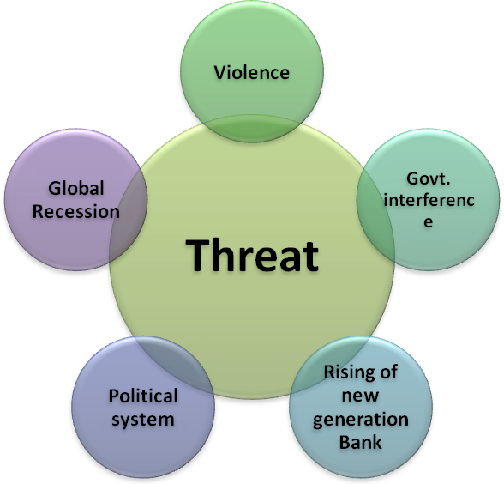

More threats for Jamuna bank limited are:
- Increased Competition In The Market For Quality Assets
- Supply Gap Of Foreign Currency
- Overall Liquidity Crisis In Money Market

Findings

Jamuna Bank Ltd. is new generation private commercial bank was established by a group of winning local entrepreneurs conceiving an idea of creating a model banking institution with different outlook to offer the valued customers, a comprehensive range of financial services and innovative products for sustainable mutual growth and prosperity. The sponsors are reputed personalities in the field of trade, commerce and industries. Findings from my point of veiw are:
- Lack of motivation toward the employee.
- JBL has not enough branches that is why they can not provide sufficient customer service.
- JBL uses flora-bank online software to record day to day transaction.
- Some cases the quality the employee is not up to the mark.
- JBL offers various types of attractive products to customers.
- Now a day most of the customers are using ATM card. Though JBL provides ATM card they do not have enough ATM booth.
- JBL follows some principle for lending.
- Interest rate of JBL is high in compare to other bank.
- JBL does not have enough features to loan lending sector.
- Default rate of JBL is decreasing.
- Net income and deposit are increasing year by year.
- JBL has strong loan monitorig system.
- Jamuna Bank Ltd. is heavily relying on debt and borrowing than equity financing.

Recommendation

Though Jamuna Bank is providing very efficient banking services, there is also room for improvement to provide their services even better and of international standards. After a thorough analysis of all the banking operations, it is evident that banking procedures and activities are completely structured in Jamuna Bank Ltd. That is why there exist little opportunity to discover any flaws in these procedures and practices. However, based on my everyday observation and perception, I would like to give my personal opinion about some facts that might help Jamuna Bank Ltd. to enhance its performance as well as success. Some recommendations that the Bank may benefit from are given below:
- JBL should upgrade the Online Banking Services
- Charges should be reduced by JBL as a result Jamuna Bank will be able to attract more customers by reducing these charges.
- JBL should expand its Network inside and outside Dhaka and Chittagong to provide better service.
- Jamuna Bank Ltd. is heavily relying on debt and borrowing than equity financing. It increases risk as well as interest cost. The bank should consider the issue of reducing the reliance on debt which will reduce both the risk and the cost.
- There is some mismanagement due to the negligence of the HR department of the bank regarding training, placement, compensation package, etc. The management and administration of the bank should take these matters into consideration and might redesign the task of the HR department if necessary.
- JBL can come up with innovative ideas and introduce attractive schemes especially designed for premium customers to create more business for the bank.
- To attract customers and to be visible among the competitors, JBL should strengthen its promotional activity.

Conclusion

Jamuna Bank Limited is a solid, forward-looking, modern local bank with a record of sound performance. It is a new generation bank. It is committed to provide high quality financial services /products to contribute to the growth of GDP of the industrialization, boosting up export, creating employment opportunity for the educated youth, rising standard of living of limited income group and overall sustainable socio-economic development of the country. Despite the fact that 2010 was a year of many challenges, the Bank was managed quite successfully. The year was concluded with a steady growth and the market share was retained in all areas of operation. To conclude writing the report, I wish that Jamuna Bank Ltd. is the bank, which will survive in the banking sector of the world on the Slogan-YOUR PARTNER FOR GROWTH.

