Internship report

On

Foreign Trade

Of

Shahjalal Islami Bank Limited

(Foreign Exchange Branch)

Submitted by

WWW.ASSIGNMENTPOINT.COM

1.1 Background ………………………… 2
1.2 Objective of the Study ………………………… 2
1.3 Scope of the study ………………………… 2
1.4 Methodology of the Study ……………………….. 3
1.5 Organization of the Report ………………………… 4
1.6 Limitation ………………………… 4

CHAPTER 1: Introduction of the Study

1.1 Background

Bachelor of Business Administration (BBA) program consists of integrated theoretical and practical method of teaching. In fact practical orientation with day-to-day activities of an organization is one of the most important requirements of BBA program. To fulfill this purpose I was sent to Shahjalal Islami Bank limited (SJIBL), Foreign Exchange Branch as an intern in this regard under the supervision of one supervisors one is internal from the educational institute World University of Bangladesh. The paper will deal with the “The Foreign Trade of Shahjalal Islami Bank Limited”. On the basis of working experience for internship period I have prepared this report and I have tried my best to relate the theoretical knowledge with the practical work situation.

1.2 Objective of the Study

In broader sense the objective of this report is to get acquainted with the banking business operation of Islamic Banking system. The specific objectives of the report are set as:
- To know about the Foreign Trade system.
- To know the performance of foreign trade activities of SJIBL.

1.3 Scope of the study
The focus of the report will be on Foreign Exchange functional areas of Shahjalal Islami Bank Limited.
I was assigned to Shahjalal Islami Bank Limited by the authority and found the following boundary of my study there:
- Account opening department
- Cash department
- Export and import department
- Investment department
1.4 Methodology of the Study:
To meet the objectives of the study I realized that a single method would not be effective. Formal & oral discussion, direct observation & printed papers of the Bank were found useful. To collect the necessary and meaningful information the following methods were applied.
Both primary and secondary sources were used in here.

1.4.1 Data Collection:
The report was fully investigative in nature. Data have been collected from two sources:
- Primary sources
- Secondary sources
1.4.1.1 Primary Sources are as follows:
- Face-to-face conversation with the respective officers and staffs of the Branch.
- Practical work experience in the different desks of the departments of the Branch covered.
- Relevant file study as provided by the officers concerned.
1.4.1.2 Secondary Sources of data and information are:
- Annual Report of Shahjalal Islami Bank Limited.
- Web site of Shahjalal Islami Bank Limited.
- Different 'Procedure Manual', published by Shahjalal Islami Bank Limited.

1.5 Organization of the Report

This report is divided into two major parts. One is organizational part and another is main assigned part.
Chapter 1&2 uncovers Organizational part, that mainly focuses on the reason why this report is done and also consist of limitation, scope and overview of the organization that goes comprehensive idea about SJIBL by covering the issues like; background of the bank, mission and vision of the SJIBL, corporate profile, organizational structure, function of SJIBL, branch network, performance and growth of SJIBL.
The main part of the report contains Chapter 3,& 4, ( Foreign Trade, Financial Statement & contains, Findings of SJIBL). And finally Chapter 5 Conclusion and Recommendation

1.6 Limitation
- Due to confidentiality of the data, adequate data were not available.
- Supply of more practical and contemporary data is another shortcoming
- The study may not be done very successfully due to inexperience.
- On our schedule time we could not find the respondent. Because they were busy with their work on that time.

2.1 Introduction ………………………… 6
2.2 Overview of (Bank) ………………………… 6
2.3 Organizational Overview ………………………… 9
2.4 Products and Services of SJBL ………………………… 17
2.5 Current Position of the Bank ………………………… 24
2.6 Corporate governance ………………………… 27
2.7 Operational Performance of SJIBL ………………………… 28
2.8 An Overview of Foreign Exchange Branch of SJIBL …….……. 30
2.9 Future out Look of SJIBL ………………………… 31
2.10 Social Welfare Activities of SJIBL ………………………… 32
2.11 Manpower Position of SJIBL Foreign Exchange Branch …… 33
2.12 Functions and Responsibilities of the Branch .......................... 34

CHAPTER 2: Organizational Profile

Introduction:
Shahjalal Islami bank limited is a commercial bank and its play a very important role in our economy; in fact it is difficult imaging how our economic system would function efficiently without the help of commercial bank. They are heart of our financial structure since they have the ability, co-operation with the Bangladesh Bank to add to the money supply of the nation and thus create additional purchasing power. These characteristics set commercial banks apart from other financial institution. In addition to issuing deposits payable on demand they accept time deposit. By lending and investing these resources and by transferring funds throughout the nation and even between countries, they make possible a more complete utilization of resources of the nation. Although banks create no new wealth, their lending. Investing and related activities facilitate the economic process of production, distribution and consumption. There are mainly three sections in SJIBL: - General Banking Division
- Investment Division
- Foreign Trade Division
These Divisions have small departments or units under them.

2.2 Overview of (Bank):

At birth, Bangladesh inherited an interest based banking system, which was introduced here earlier when the country was a part of British Colony. Since its inception Bangladesh saw a new trend in banking both at home and abroad. Islamic banking was successfully tries in Egypt. After the Mit Ghamar Model, Naser Social Bank was in the process of establishment. During the seventies, Islamic Development Bank (IDB) and a number of Islamic banks at national levels were established in the Islamic world. At home, the Islamic groups were vigorously working for adoption of Islam as the complete code of life. They found Islamic banking in ready form of immediate introduction. Two professional bodies “Islamic Economics Research Bureau” (IERB) and “Bangladesh Islamic Bankers Association” (BIBA) were taking practical steps for imparting training on Islamic Economics and banking to a group of bankers and arranging some national
and international seminars/workshops to mobilize local and foreign people and attract investors to come forward to establish Islamic bank in Bangladesh. Their professional and right-thought activities were reinforces by a number of Muslim entrepreneurs working under the aegis of Muslim Businessman Society (MBS).

The body concentrated mainly in mobilizing equity capital for the emerging Islamic bank. Due to continuous and dedicated work of the above groups and individuals and active support from the Government, Islamic banking could be established in early eighties. Islamic banks have been operating in Bangladesh for about one and half decade alongside with the traditional banks. Out of over 39 banks only five banks (including one foreign Islamic bank) and two Islamic banking branches of a traditional bank, Prime Bank Limited (PBL) have been working on Islamic principles. Like any other traditional commercial banks, they do mobilize deposits and produce loans. But their modes of operation, based on Shariah, are different from the other traditional commercial banks.

2.2.1 Role of Bangladesh Bank in Promoting Islamic Banking in Bangladesh

Though there is no complete Islamic Banking Act for controlling, guiding and supervising the Islamic banks in Bangladesh, some Islamic banking provisions have already been incorporated in the amended Banking Companies Act, 1991 (Act No. 14 of 1991). Bangladesh Bank did not set up any separate Department at its Head Office to control, guide and supervise the operation of the Islamic banks. Inspection and supervision of the Islamic banking operations are conducted by the Bangladesh Bank as per the general guidelines framed for the conventional banks. So, ensuring implementation of Shariah principles in the Islamic banks are being conducted by their own Shariah Councils. The role of Bangladesh Bank in controlling, guiding and supervising the Islamic Banks in Bangladesh in accordance with Islamic Shariah is very minimal. In observing the Shariah implementation status of the Islamic banks, Bangladesh Bank examines only the report of the respective banks’ Shariah Councils. Recently Bangladesh Bank try to establish separate team/division for control, guideline, supervise & monitor the Islamic banks in Bangladesh.

However, the inspectors and supervisors of Bangladesh Bank are not equally familiar with the technicalities of the different operational methodologies of the Islamic banking. This is because of the fact that there is no separate Department to look into this important matter. International Journal of Islamic Financial Services Vol. 2 No.1 A committee of experts set up by the Governors of Central Banks and Monetary Authorities of the OIC countries examined the whole range of relationships between the Central Banks and the Islamic Banks and submitted a report in 1981 on the “Promotion, Regulation and Supervision of Islamic Banks”. The report highlighted the need to provide for central bank assistance to the Islamic banks on a basis compatible with the Shariah. The report also discussed many monetary aspects such as liquidity requirements, reserve requirements, supervision of Islamic banking activities, and fiscal treatment of income from participation, ownership, capital requirements, and the maintenance of sound relationships between capital, reserves and total assets. The report recommended the fostering of interest-free financial instruments to enable the Islamic banks to meet the statutory liquidity requirements of the central banks.

2.2.2 Theoretical Basis and Business Practice of Islamic Banking

From the viewpoint of Islamic Shariah, in order to be justified islami thought the banking system has to avoid interest. Consequently, financial intermediation in Islamic banking between the bank and the client takes place as a partner rather than a debtor-creditor. The financial activities of modern conventional banks are based on a creditor-debtor relationship between depositors and bank on the one hand and between the borrower and the bank on the other. Interest is regarded by conventional banks as the price of credit reflecting the opportunity cost of money. As interest is prohibited in Islam, commercial banking in an Islamic framework could not be based on the creditor debtor relationship. The other aspect of the theoretical basis of Islamic banking is that the interest free bank is not risk free. This principle is applicable to two main factors of production, i.e. labor and capital. According to this principle, as no payment is allowed to labor, unless it is applied to work, no reward for capital should be allowed, unless it is exposed to business risk.

2.3 Organizational Overview:
2.3.1 Brief History
Shahjalal Islami Bank Limited (SJIBL), a Shariah based commercial bank in Bangladesh, was incorporated as a public limited company on 1st April, 2001 under Companies Act 1994.The bank commenced commercial operation on 10th May, 2001 by opening it’s first branch i.e. Dhaka Main Branch at 58, Dilkusha, Dhaka obtaining the license from Bangladesh Bank, the Central Bank of Bangladesh. Its first corporate head office was situated at 10, Dilkusha C/A, Jibon Bima Bhaban, Dhaka-1000 which is shifted to , Uday Sanz, Plot No. SE (A) 2/B, Gulshan South Avenue, Gulshan - 1, Dhaka-1212, Bangladesh. The bank opened two branches in 2001, six branches in 2002, two branches in 2003, two branches in 2004, and four branches in 2005, eleven branches in 2006, 2007 and 2008, about 31 branches opened in the year 2009, 2010 & 2011. Total number of branches stood at 63 in 2011 and some more branches are likely to open in important business locations of the country during this year subject to the approval of Bangladesh Bank.
As per Article 30 of the Article of Association of the Bank, Shariah Council for the bank has been constituted. The Shariah Council of the bank consists of prominent Ulamas, Bankers, Lawyers and Economists to advise and guide on the implementation of Islamic Shariah in business activities. The council enjoys a special status in the structure of the bank and playing a vital role to make the bank as Shariah compliant. Members of the Shariah Council meet frequently and deliberate on different issues confronting the Bank on Shariah matters. They also conduct Shariah inspection of branches regularly so as to ensure that the Shariah principles are implemented and complied with meticulously by the branches of the Bank.

  1. Chairman
  Moulana Mufti Abdur Rahman
  Founder Director
  Islamic Research Centre Bangladesh
  2. Member
  Prof. Dr. Muhammad Mustafizur Rahaman
  Former Vice Chancellor
  Islamic Uiversity, Kustia.

  3. Member
  Moulana Abul Kalam Azad
  Khateeb
  Banani Bazar Bara Masque
  4. Member
  Prof. Hamidur Rahman
  Islamic University of Technology (IIUT)
  Gazipur

  5. Member
  Shah Abdul Hannan
  Former Chairman
  Islami Bank Bangladesh Ltd.
  6. Member
  Barrister M. Ziaul Hasan
  Head of the Chamber
  Hassan & Associates

  7. Member
  M. Kamaluddin Chowdhury
  CEO
  Shahjalal Islami Bank Securities Ltd.
  8. Member
  Alhaj Anwer Hossain Khan
  Chairman, Board of Directors
  Shahjalal Islami Bank Ltd.

9. Member Secretary
Md. Abdur Rahman Sarker
Managing Director
Shahjalal Islami Bank Limited

Figure : 2.3.1- Members of Shariah Council

SJIBL offers a full range of banking services for the personal and corporate customers, covering all segment of society within the framework of Banking Company Act 1994 as well as rules and regulations laid down by central bank. Diversification of products and services include corporate banking, retail banking and consumer banking right from industry to agriculture, real estate to software and is backed by the latest technology.

The bank is being managed by a group of highly experienced professionals with diversified experience in finance and banking. The bank has already achieved tremendous progress in only five years. The bank has already ranked as one of the quality service providers and is known for its reputation.
2.3.2 Vision of SJIBL
To be the unique modern Islami Bank in Bangladesh and to make significant contribution to the national economy and enhance customer’s trust & wealth, quality investment, employees’ value and rapid growth in shareholders’ equity.

2.3.3 Mission of SJIBL

- To provide quality services to customers.
- To set high standard of integrity.
- To make quality investment.
- To ensure sustainable growth in business.
- To ensure maximization of shareholders’ equity.
- To extend our customers innovative services acquiring state-of-the-art technology blended Islamic principles.
- To ensure human resource development to meet the challenges of time.

2.3.4 Strategies of SJIBL
- To strive for customers best satisfaction & earn their confidence.
- To manage and operate the bank in the most effective manner.
- To identify customers’ needs and monitor their perception towards meeting those needs.
- To review and update policies, procedures and practices to enhance the ability to extend better services to the customer.
- To train and develop all employees and provide them adequate resource so that the customer needs are reasonably addressed.
- To promote organizational efficiency by communicating company plan, policies and procedures openly to the employees in a time fashion
- To cultivate a congenial working environment.
- To diversify portfolio both the retail and wholesale market.

2.3.5 Nature of business
Shahjalal Islami Bank Limited offers services for all banking needs of the customers, which include deposits, making loans & advances, discounting bills, conducting money transfer and foreign Trade transactions and performing other related services such as safe keeping, collections, issuing guarantees, acceptances and letters of credit.
Name of the Company | Shahjalal Islami Bank Limited
Legal Form | A public limited company incorporated in Bangladesh on 1st April 2001 under the companies Act 1994 and listed in Dhaka Stock Exchange Limited and Chittagong Stock Exchange Limited.
Commencement of Business | 10th May 2001
Head Office | Uday Sanz, Plot No. SE (A)  2/B Gulshan South Avenue,  Gulshan - 1, Dhaka-1212.
Telephone No. | 88-02-8825457,8828142,8824736,8819385,8818737
Fax No. | 88-02-8824009
Website | www.shahjalalbank.com.bd
SWIFT | SJBL BD DH
E-mail | sblho@shahjalalbank.com.bd
Chairman | Alhaj Anwer Hossain Khan
Managing Director | Md. Abdur Rahman Sarker
Auditors | M/S. Hoda Vasi Chowdhury & Co.  Chartered Accountants  Ispahani Bhaban  14-15 Motijheel C/A  Dhaka-1000  Phone: 88-02-9555915, 9560332
Tax Advisor | M/S K.M Hasan & Co.  Chartered Accountants  87, New Eskaton Road  Dhaka.  Phone: 88-02-9351457, 9351564
Legal Advisor | Hasan & Associates  Chamber of Commerce Building  (6th floor), 65-66 Motijheel C/A, Dhaka
No. of Branches | 63
No. of ATM Booth | 14
No. of SME Centers | 06
Off-Shore banking Unit | 01
No. of Employees | 1,671
Stock Summary:
Authorized Capital | Tk. 6,000 million
Paid up Capital | Tk. 4452.70 million
Face Value per Share | Tk. 10

Figure : 2.3.5 - Nature and Legal status of SJIBL

2.3.6 Objectives of SJIBL
Twenty first century opened the predictable door of globalization. The whole world is being changed with a modern, extensive & technological revolution. Life style & status are widely changing to have a artistic, delightful & flourishing environment. Demand and
attitude of the whole mankind escalating with time revolution. Everyone has a vision of such a life and status. To fulfill such a vision, it needs possessions, prosperity, fortune, prudent deposit and consistent investments. Unfortunately, the Banks did a few to be a prosperous, service oriented, technology based banking. Shahjalal Islami Bank Limited is committed to fulfill the requirements of the mass people. Shahjalal Islami Bank Limited is patterned of Islamic norms & ethics with modern technology to achieve the goal in the new era. Humanitarian perfection, Economic progress, Assistance & service to the mass people are the basic objectives of Shahjalal Islami Bank Limited.

2.3.7 Organizational Structure:

There are different wings to consist the organizational structure of SJIBL. There are –
■ Board of Directors
■ Board Committees
■ Executive Committees
■ Policy Committees
■ Management Team

2.3.8 Board of Directors
There is a board of Directors of 13 members in the bank. The board of Directors is the apex body of the bank. It appears like this-

Chairmen
Vice-Chairmen
Directors
Managing Directors
Secretary

2.3.9 Name of the Board of Directors

Chairman | Alhaj Anwer Hossain Khan
Vice Chairman | Alhaj Md. Harun Miah
Vice Chairman | Alhaj Khondoker Shakib Ahmed
Director | Alhaj Sajjatuz Jumma
Director | Alhaj Mohammad Faruque
Director | Alhaj Tofazzal Hossain
Director | Alhaj Md. Sanaullah Shahid
Director | Alhaj Md. Farooq
Director | Alhaj Mohammed Hasan
Director | Alhaj Md. Abdul Barek
Director | Alhaj Mohammed Solaiman
Director | Alhaj Syed Nurul Arefeen
Director | Alhaj Abdul Halim
Director | Alhaj Mohiuddin Ahmed
Director | Alhaj Akkas Uddin Mollah
Director | Alhaj Md. Towhidur Rahman
Director | Alhaj A.K. Azad
Director | Alhaj Mohammed Younus
Independent Director | Alhaj Nazmul Islam Nuru
Alternative Director | Alhaj Md. Masud
Alternative Director | Alhaj Rukun Uddin Khan
Sponsors | Alhaj Md. Abdul Mannan
Managing Director | Md. Abdur Rahman Sarker
Company Secretary | Md. Emran Hossain

2.3.10 Management hierarchy
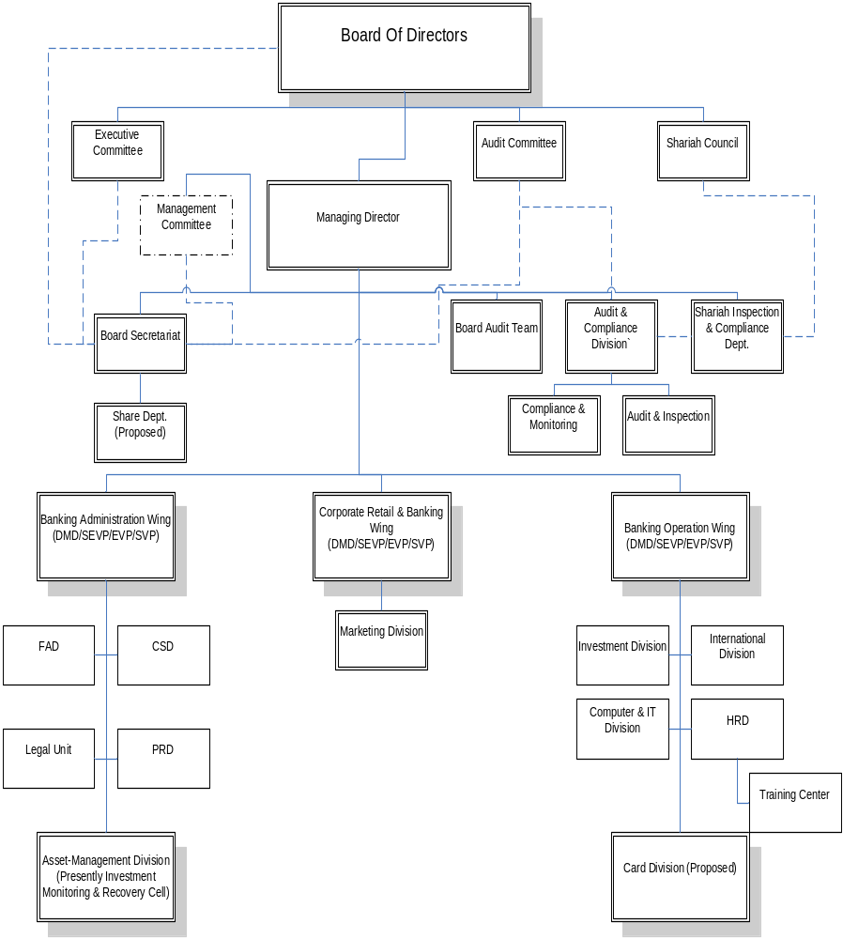

2.3.11 Policy Committee
Al matters relating to the principles, rules and regulation, ethics etc. for operation and management of the bank are recommended by the committee to the board of directors.

2.3.12 Management Team

Managing Directors
Executive vice-president
Vice-president ice-president ice-president
Sr. Asst. vice-president
Asst. vice-president

2.4 Products and Services of SJBL

The bank is managed by a team of professional executives and officials having profound banking knowledge and experience in different sectors management and operation of banking. During the short span of time SJIBL so far introduced a good number of attractive deposit products to broaden the resources base and also investment products to deploy the deposit products. SJIBL always try to introduce a wide verity of attractive deposit, investment and services for suiting taste and requirement of the client.

2.4.1 Products
Bank means mobilizing fund from surplus unit and deployment of fund for deficit unit. SJIBL mobilize its fund from surplus unit through different types of deposit schemes and deployment this fund for deficit unit through various investment schemes. So the main products of SJIBL are different kinds of deposits and investment schemes.

2.4.2 Deposit scheme
Deposit is the “life-blood” of a bank. Bank has given utmost importance in mobilization of deposits introducing a few popular and innovative schemes. The mobilized deposits were ploughed back in economic activities through profitable and safe investment.
This type of deposit schemes of SJIBL are:
- Mudaraba Monthly Income Scheme
- Mudaraba Double/Triple Benefit Scheme
- Mudaraba Monthly Deposit Scheme
- Mudaraba Millionaire Scheme
- Mudaraba Hajj Scheme
- Mudaraba Housing Deposit Scheme
- Mudaraba Cash Waqf Scheme
Other than these deposits schemes SJIBL also operate some traditional deposit schemes these are:
- Al-Wadia Current Deposit
- Mudaraba Saving Deposit
- Mudaraba Short Notice Deposit
- Mudaraba Term Deposit
- Mudaraba Scheme Deposit
The total deposit of SJBL stood at TK. 76,648.87 million as on 30th June 2011, which was about 62,964.95 million at the end of 31 December, 2010.

The deposit mix of the bank as on 30th June 2011 is as bellow:
Sl. No. | Nature of Deposit | Taka in Million | % of Total Deposit
1 | Al-Wadia Current& Other Deposit | 7,753.80 | 10.12%
2 | Mudaraba Saving Deposit | 3,944.48 | 5.15%
3 | Mudaraba Term Deposit | 49,709.12 | 64.85%
4 | Other Mudaraba Deposit | 14,288.08 | 18.64%
5 | Bills Payable | 953.37 | 1.24%
 | Total | 76,648.85 | 100.00%

Table 01: Deposit Mix as on 30th June, 2011.

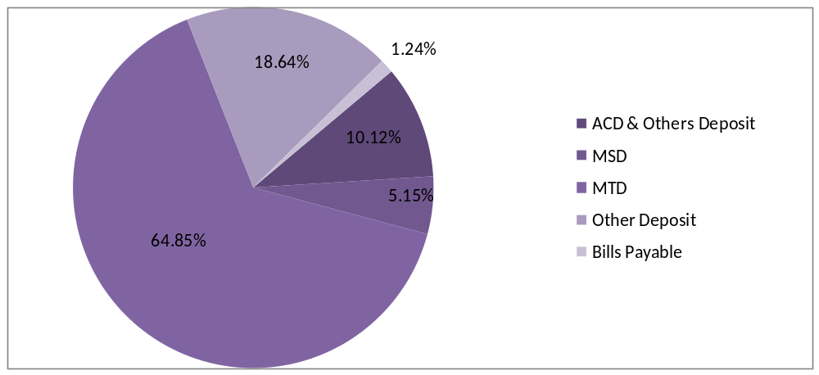

Figure : 2.4.2.1 - Deposit Mix as on 30th June, 2011

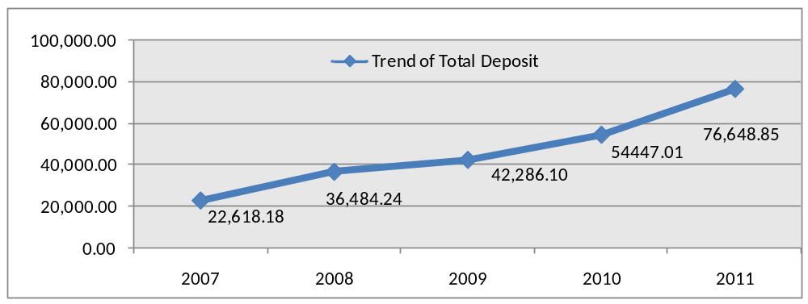Figure:2.4.2.2- Trend of Deposit from 2007 to 2011(Amount in Millions)
2.4.3 Investment Schemes

The special feature of the Investment policy of Shahjalal Islami Bank Limited is to invest on the basis of profit loss sharing system in accordance with the tenets and principles of Islamic Shariah. Earning of profit is not only the motive and objective of the bank’s investment policy rather emphasize is given in attaining social good and in creating employment opportunities.
The investment and credit department is very important department of a Bank. The money mobilized from ultimate surplus units are allocated through this department to the ultimate deficit unit (Borrower). The success of this department keeps a great influence over the profit of a bank. Failure of this department may lead the bank to huge losses or even to bankruptcy. So special care should be given to this department. Bank landing is important to the economy. Adequate finance can maintain a stable output. But as liquidity and profitability are conflicting considerations, SJIBL, as a bank, while employing the funds pays due regard to both profitability and liquidity.
The bank entertains good investment clients, having credit worthiness and good track record. The bank has different profitable investment projects these are:

- Mudarabaha
- Bi-Muajjal
- Hire Purchase and Ijara
- Investment Against L/C
- Bill Purchase/Discounted
- Investment Against Scheme Deposit
- Quard
The bank has got a few investment schemes to provide financial assistance to comparatively less advantage group of people; which are:
- Household Durable Scheme
- Small Business Investment Scheme
- Small entrepreneur Investment Program
- Medium Entrepreneur Program
- Housing Investment Scheme
- Rural Investment Program
- Car Investment Scheme
- Woman Entrepreneur Investment Scheme
Total investment of the bank stood at TK. 66,269.66 million as on 30th June, 2011. Mode wise investment portfolio of SJIBL as on 30th June, 2011 is given below:

SL.No | Modes of Investment | Taka in million | Percentage of  Total Investment
1 | Murabaha | 15,211.02 | 23%
2 | Bi-muajjal | 26,407.76 | 40%
3 | Hire-purchase & Ijara | 11,245.64 | 17%
4 | Bill purchase & discounted | 9,429.09 | 14%
5 | Investment against scheme deposits | 1,325.39 | 2%
6 | Others | 2,650.76 | 4%
 | Total | 66,269.66 | 100%

Table 02: Investment Portfolio as on 30th June, 2011

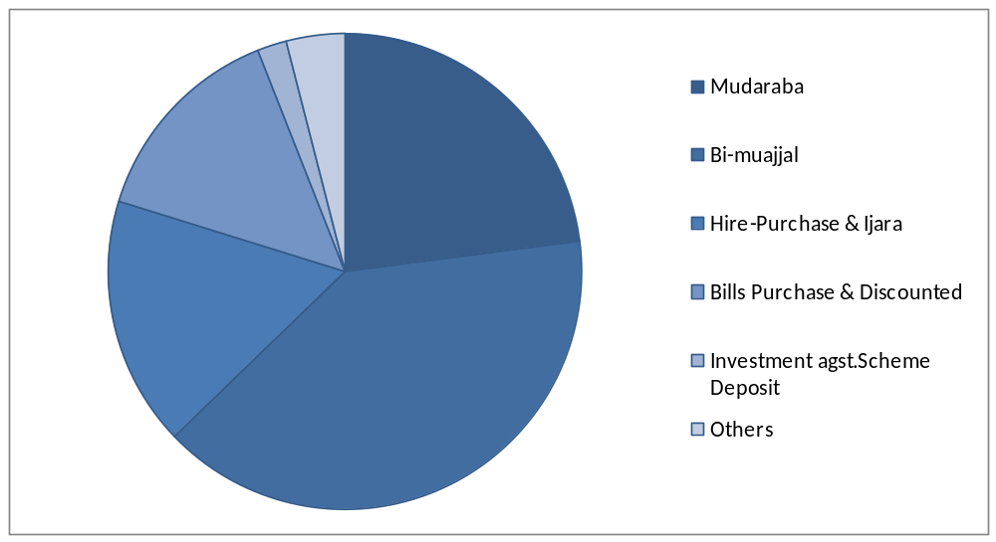
Figure: 2.4.3.1 - Investment Portfolio as on 30th June, 2011
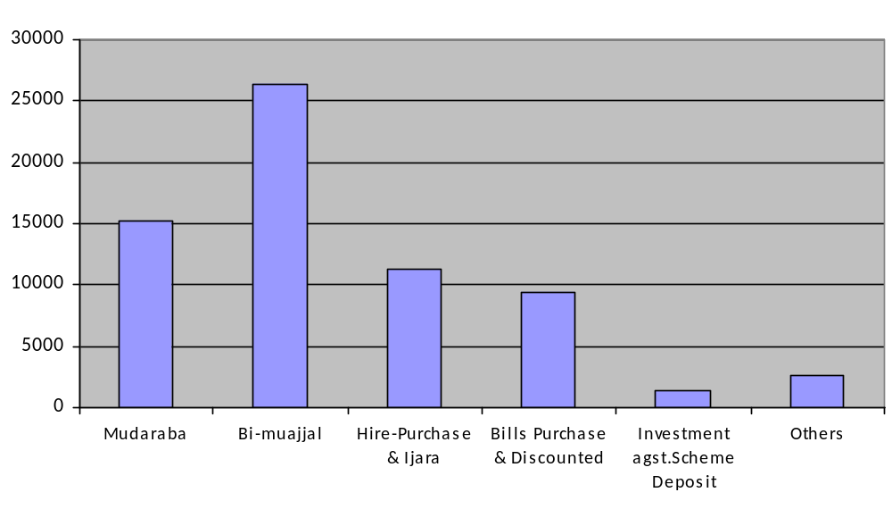Figure: 2.4.3.2 - Investment Portfolio as on 30th June, 2011

2.4.4 Services
Shahjalal Islami Bank Limited is an industry standard, Islami Shariah and latest technology based modern bank. The bank is equipped with state-of-the-art technology and committed to provide technology based modern banking to its valuable customers. Services provided by SJIBL are:

2.4.5 Online Banking
To provide better services to the valued customers using the latest technology and electronic media competing with other private banks to set the establish full automated, on-line, centralize banking systems interfacing with all delivery channels link, like ATM (Automated Teller Machine), POS (Point of Sale-Fund Transfer Machine for purchasing at any shop/service center.), any branch banking, home banking, tele banking, internet banking etc. Online banking or any branch banking is a system where transactions, queries and statements of any client of a certain branch may be carried out from another branch of the bank.
2.4.6 SJIBL VISA Card
Card is considered as a new dimension of product resulting from technological development in the banking arena. In line with our affiliation with VISA International for VISA ATMs and POS, the following two products are launched broadening service product of the bank to the clients:
- VISA Electron (SJIBL VISA Debit Card – Local)
- VISA Prepaid (SJIBL VISA Prepaid Card – Local and International)
The important features of SJIBL VISA Card are given below:
- Sense of satisfaction of having an international brand.
- Any where any time banking.
- 24 hours and 7 days a week banking.
- Directly linked with cardholders account.
- Convenient cash withdrawal at ATMs.
- Acceptability at huge number of Q-cash ATMs around Bangladesh.
- Accepted at all VISA terminals locally and globally.
- Local and international transaction with the same card (for duel card).
- Balance Inquiry.
- Mini statement.
- PIN change.
- Shopping at a large number of Q-cash POS terminals around Bangladesh.
- Payment of utility bill.
- Avoid pressure of at counter of bank.
- Minimizing risk of carrying cash.

2.4.7 SMS / Pull Push Service
This is a service provided by the bank through mobile phone. This new technology based service will helps the bank to attract new customer base. Through SMS or Pull Push service client will be facilitated with cell phone based banking service. This SMS service will help the bank to enhance and extend customer service levels on a collaborative basis and reduce teller queues.
2.4.8 SWIFT
Society for Worldwide Inter-Bank Financial Telecommunication (SWIFT) is a bank owned co-operative serving the financial community worldwide. The SWIFT Transport Network (STN) is a dedicated global network for secure communication between SWIFT Customers. SWIFT supports the financial data communication and processing needs of financial institutions, through a range of financial messaging services and value-added processing, as well as, access through the STN and interface and application software. In short SWIFT is a pioneer in the automation of the global financial industries. Shahjalal Islami Bank Limited has introduced this SWIFT alliance entry system firstly in October 2002 and introduced SWIFT alliance access in October 2003.

2.5 Current Position of the Bank
Despite changing macroeconomic condition and volatile money market and foreign exchange market SJBL was successfully in achieving much higher than national growth in deposit, investment (loan), export, and import and remittance business. The bank has maintained and achieved strong position in all key areas covering capital adequacy, asset quality, sound management, good earning and strong liquidity. Here shows current position of SJBL in different areas as on 30th June, 2011.

2.5.1 Equity
Authorized capital -------------------------------------Tk.6,000 million
Paid-up Capital --------------------------------------Tk.4,452.66 million
Total equity was ---------------------------------------Tk.7,380.40 million

Comparative position of equity for the year 2011(30th June) & 2010 is given below:
(Amount in Million Taka)
SL. No. | Particulars | 2011 | 2010
1 | Paid-up capital | 4,452.66 | 3,425.11
2 | Statutory reserve | 2,021.82 | 1,774.63
3 | Retained earnings | 905.93 | 1,548.61
4 | General Provision | 317.50 | 568.50
Source: Yearly Financial Statement of 2010 & Half Yearly Statement of 2011
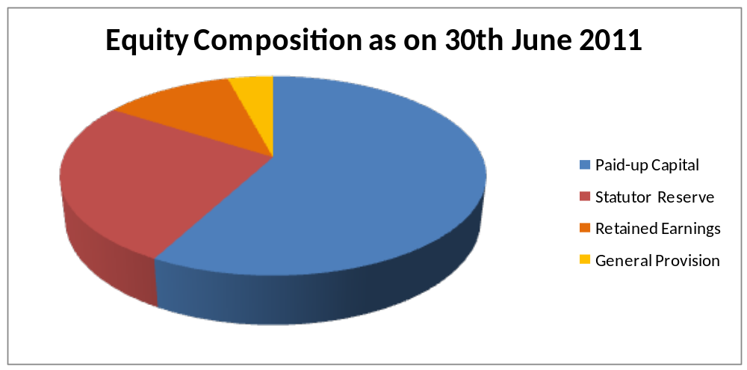
Figure : 2.5.1- Equity Composition as on 30th June, 2011

2.5.2 Capital Adequacy
Total equity of the bank as on 31.12.2007 was Tk. 3040.88 million and the total equity stood at tk.4069.09 million on 31.12.2008, which was13.81% of the risk weighted Assets as against the requirement of 10.00%.
The core capital was 12.24% of Risk weighted Assets as on 31st December 2008 as against requirement of 5%.
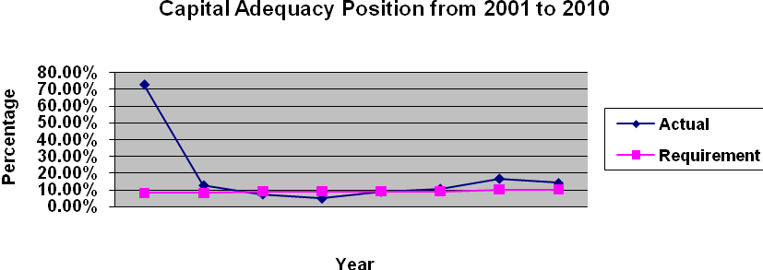
Figure: 2.5.2 - Capital Adequacy Position from 2001 to 2010

2.5.3 Branch Network
The bank has been operating with a network of 63 branches all over the country as on 30th June 2011. In the year 2008 & 2009 the bank has opened 19 new branches. Among these 7 is in Dhaka and rest of the Braches are in Rajshahi, Khulna and Chittagong. Here shows zone wise branch distribution of SJIBL:

Office / Zones | number
Dhaka | 34
Chittagong | 13
Sylhet | 5
Khulna | 3
Rajshahi | 6
Barisal | 1
Offshore Banking Unit | 1
Total | 63

Table 03 : Zone-wise number of Branches

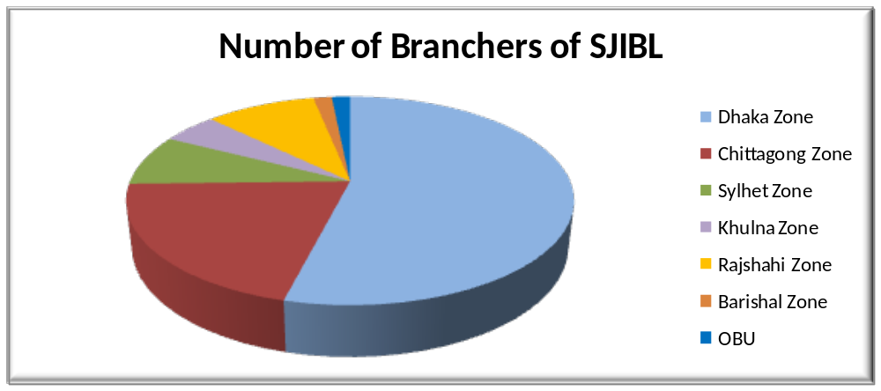 Figure :2.5.3 - Number of Branches

2.6 Corporate governance
The Board of Directors of the bank consists of successful distinguish personalities emerging from area of trade, commerce and industries. The bank conducts it’s business and operations under the policy, directions and guidelines of the Board. The bank has also a Shariah Council consisting of prominent Faquih, Economists, Lawyers, Bankers to advise and guide the Board and the Management of Shariah matters relating to the business and operations.
Under the table guidance of the Board of Directors and the Shariah council, the professional management team carries out the business operation of the bank, ensuring good governance practicing sound, best corporate and risk management process. The result that was achieved by the bank so far is due to the constant guidance, cooperation and support of the Board and Shariah Council and devoted, dedicated and hard work of the management team and all functionaries of the bank.

2.7 Operational Performance of SJIBL

HIGHLIGHTS OF PERFORMANCE
SL # | PARTICULARS | June 2011 | June 2010
 | Paid up Capital | 445.27 | 342.51
 | Total Capital ( Core + Supplementary) | 875.16 | 647.42
 | Capital Surplus | 1 ,122,702,335 | 1,189,432,802
 | Total Assets | 45,216,968,653 | 28,346,996,395
 | Total Deposit | 7,664.89 | 5,444.70
 | Total Investment (Loans & Advance) | 6,626.97 | 5,239.13
 | Total Contingent Liabilities and Commitment | 10,771,113,500 | 6,402,844,932
 | Investment Deposit Ratio ( % ) | 86.46% | 96.22%
 | Classified Investment against total Investments | 127.39 | 65.80
 | Profit after Tax and Provision | 64.73 | 89.42
 | Amount of Classified Investment | 143,243,000 | 128,246,000
 | Provisions kept against classified Investment | 28,009,403 | 23,009,403
 | Provisions surplus | 20,801,366 | 10,723,827
 | Cost of Fund | 10.99% | 10.40%
 | Profit Earning Assets | 39,889,424,692 | 25,303,841,268
 | Non-Profit Earning Assets | 5,327,543,961 | 3,043,155,127
 | Return on Investment in Securities (ROI) | 16.84% | 11.41%
 | Return on Assets (ROA) | 2.22% | 2.60%
 | Income from Investment in Securities | 192,717,942 | 97,974,405
 | Earnings Per Share (2008: Basic EPS, 2007: Adjusted EPS) | 36.41 | 28.81
 | Net Income Per Share | 36.41 | 28.81
 | Price Earnings Ratio (Times) | 8.55 | 10.58

2.7.1 Income
Total income of SJIBL mainly derives from two important sources; investment income and non-investment income.
- Investment Income: Total investment income of the bank as at 31st December 2008was Tk.4,428.89 million as against Tk. 3071.41 million of the preceding year registering 44.20% growth over last year, which was 83.80% of the total income against 85.58% of 2007
- Non-Investment Income Total Non investment income of the bank as at 31st December 2008 was Tk. 856.49 million as against Tk. 517.43 million of the preceding year registering 65.53% growth over last year, which was 16.20% of the total income compared to 14.42% of 2007.

2.7.2 Expenditure
Total expenditure of SJIBL mainly derived from two important sources; profit paid on deposit and operating expense.
- Profit Paid on Deposit: Bank distributed profit of Tk. 4,657.92million among the Mudaraba Depositors in the year 2010 against Tk. 4,200.28 million in the year 2009 which is 61.93% of the Investment income earned from deployment of Mudaraba Fund and 77.89% of total expenditure of 2010 against 82.75% of 2009.

- Operating Expenses: Total operating expenses as on 31.12.2010 was Tk. 1,322.25 million as against Tk 875.60 million of 2009, Which was 22.11% of the total expenditure of the year 2010 against 17.25% of 2009.

(Amount in Million Taka)
Particulars | 2010 | 2009
Total Income | 9,508.88 | 7,117.04
Less: Total Expenditure | 5,980.18 | 5,075.88
Net profit before provision & Taxation | 3,528.71 | 2,041.16
Less: Provision for investment, off Balance Sheets & Others | 568.50 | 246.00
Net Profit before Taxation | 2,960.21 | 1,795.16
Less: Provision for taxation | 887.87 | 724.60
Net Profit after tax | 2,072.34 | 1,070.56

Appropriation: 2010 2007

Statutory Reserve 592.04 359.03
Retained Earnings 1,480.30 711.53

2.8 An Overview of Foreign Exchange Branch of SJIBL

Foreign Exchange Branch started its operations as 5th branch of Shahjalal Islami Bank Limited in 2002. The branch is located at Modern Mansion (1st Floor), 53 Motijheel C/A, Dhaka-1000. Office floor is spacious that can accommodate good number of customers comfortably.
Branch has efficient human resources that can meet up customer's needs. Order wise work load is distributed properly. Besides, interpersonal relationship is remarkable. Most noted strength is customer service. Prompt, cordial & enthusiastic service satisfies almost all customers. Flexible banking hour attracts more clients doing banking transactions with the branch. In some cases, customers, coming outside the banking hour can honour the cheque & others without delay.

Now under the charge of Senior Vice President M. Samsul Arefin the branch has been performing very well. Under his efficient handling, the branch has already been able to introduce itself as one of the best performers among all other branches of SJIBL. Last year (2007) Foreign Exchange Branch earned a net profit of Tk. 2013 lac. From this viewpoint the branch was in the second position among all other branches of SJIBL in the country.
Even after it has an organized Foreign Exchange Department, the import and export businesses that are usually done in this branch make it a profitable one.
The table below shows the performance of the branch:
TK. In Lac
Year | Deposit |  | Investment |  | Profit
Year | Target | Achievement | Target | Achievement | Target | Achievement
2008 (up to June) | 28609 | 26683 | 36875 | 43029 | 1395 | 1284
2007 | 30000 | 25426 | 35000 | 32273 | 2000 | 2013
2006 | 22500 | 21500 | 22500 | 28900 | 1200 | 1200
2005 | 20000 | 14790 | 17500 | 16088 | 500 | 578

Table 04: Operational performance of SJIBL FEx. Br.

2.9 Future out Look of SJIBL

“Business policy and six years perspective plan” of the Bank from 2007 to 2012 has been formulated to attain the financial strength, sustainable growth and operational efficiency. To protect the interest of the stakeholders, bank has formulated the six years perspective plan for consolidation of the growth and profitability. During the period of perspective plan, Bank has the main objective to attain the height operational excellence and consolidation to turn the bank into a dynamic Islamic Bank in the country. During the period from 2007 to 2012, this period, new and potential avenues of Business in all areas of operation to be explored and expanded through the network of existing 26 branches and more new branches to be opened gradually during the plan period subject to permission of Bangladesh Bank.
Necessary change, adjustment, modification & re-allocation shall be made after periodical review keeping the real scenario in view. All out efforts shall be made for promotion and improvement of quality-investment through effective supervision, control, follow-up and monitoring in order to lessen the quantum of over dues, to arrest further over dues and to recover, regularize the over dues and declassify the classified investments. Adequate care & caution to be exercised for compliance with 05 core risks as per Bangladesh Bank’s Policy/instructions during the planned period. Asset-Liability of the Bank shall be managed effectively through ALCO to avoid Liquidity Risk, profit rate risk, operational risk and other risks.
Thus, Shahjalal Islami Bank Limited will be turned into a dynamic Islamic Bank in the country and will expand its Banking Business all over the Country to provide the Banking services to the groups including the deserving economic groups of the society who have no easy access to the banking channel. This will help for alleviation of the poverty, income generation, creation of employment opportunity, up-grading of the standard of living of the lower economic groups, which will also contribute to the emancipation of the national economy of the country. Shahjalal Islami Bank Limited is looking forward to see such a bright day in the years to come.

2.10 Social Welfare Activities of SJIBL
With a view to proving financial assistance to the poor and needy people of the society and also for the welfare of the community, Bank has established “Shahjalal Islami Bank Foundation” the foundation among others has also objective to provide health care, relief & rehabilitation, education, dawa, distribution of winter cloths during the winter etc.
At present Shahjalal Islami Bank Foundation has a planning to establish the following projects soon:
- Shahjalal Islami Bank International School & College.
- Shahjalal Islami Bank Hospital.
2.11 Manpower Position of SJIBL Foreign Exchange Branch
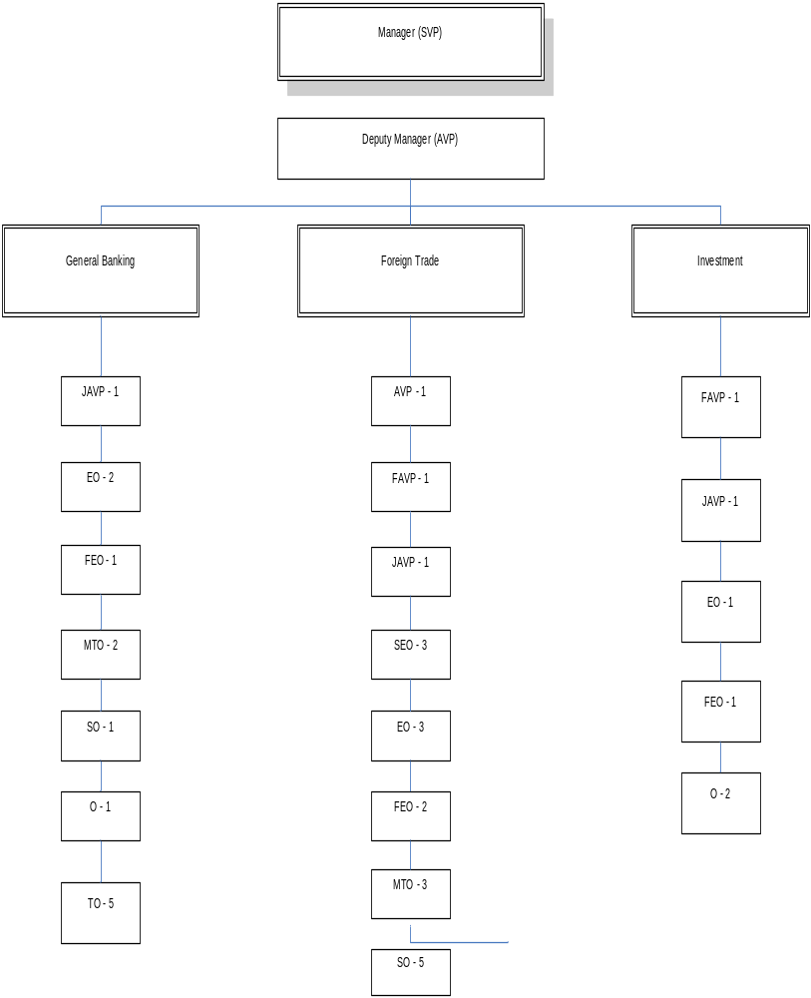
2.12 Functions and Responsibilities of the Branch
The whole activities of the Foreign Exchange Branch of SJIBL are divided in to three major areas. These are:
- General Banking
- Investment
- Foreign Trade
General banking is the starting point of all the banking operations. This department does the most important and basic works of the bank. It is also the department, which provides day-to-day services to the customers. All other departments are linked with this department. It also pays a vital role in deposit mobilization of the branch. SJIBL provides different types of accounts, locker facilities and special types of saving scheme under general banking.
The special feature of the Investment policy of Shahjalal Islami Bank Limited is to invest on the basis of profit loss sharing system in accordance with the tenets and principles of Islamic Shariah. Earning of profit is not only the motive and objective of the bank’s investment policy rather emphasize is given in attaining social good and in creating employment opportunities.

Foreign Exchange means foreign currency and it includes any instrument drawn, accepted, made or issued under clause (13), Article 16 of the Bangladesh Bank Order, 1972. All deposits, credits and balances payable in any foreign currency and draft, travelers cheque, letter of credit and bill of exchange expressed or drawn in Bangladeshi currency but payable in any foreign currencies.

3.1 Foreign Trade …………………………. 36
3.2 Import Section …………………………. 39
3.3 Delivery of Shipping Documents …………………………. 42
3.4 Parties of an LC …………………………. 46
3.5 Contents of the Letter of credit …………………………. 47
3.6 LC on Deferred Payment Basis …………………………. 47
3.7 Export Section …………………………. 48
3.8 Foreign Remittance …………………………. 55

Chapter 3: The Overall Performance of SJIBL (Foreign Trade)

Foreign Exchange means foreign currency and it includes any instrument drawn, accepted, made or issued under clause (13), Article 16 of the Bangladesh Bank Order, 1972. All deposits, credits and balances payable in any foreign currency and draft, travelers cheque, letter of credit and bill of exchange expressed or drawn in Bangladeshi currency but payable in any foreign currencies.
Taka In Million
SL | Particulars | 2010 | 2009 | 2008 | 2007 | 2006
1 | Import | 60,066.24 | 39,543.12 | 42,551.30 | 25,490.10 | 18,684.40
2 | Export | 48,856.76 | 29,434.03 | 26,347.30 | 15,084.00 | 11,281.94
3 | Foreign Remittance | 6,155.96 | 10,473.09 | 9,497.50 | 4,294.50 | 3,534.62
 | Total | 115,078.96 | 79,450.24 | 78,396.10 | 44,868.60 | 33,500.96
Table: 05- Analysis of Foreign Exchange Business
3.1 Foreign Trade
Foreign Exchange means foreign currency and it includes any instrument drawn, accepted, made or issued under clause (13), Article 16 of the Bangladesh Bank Order, 1972. All deposits, credits and balances payable in any foreign currency and draft, travelers cheque, letter of credit and bill of exchange expressed or drawn in Bangladeshi currency but payable in any foreign currencies.
Bangladesh Bank issues Authorized Dealer (AD) license by observing the bank’s performance and also the customers associated with the bank for conducting foreign dealings. So, Shahjalal Islami Bank Limitade, FEx. branch is an authorized dealer.
Banks play a vital role by minimizing the risk of two parties, namely buyer and seller. In fact without the help of banks we cannot think about a congenial international trade environment. The special feature of the Investment policy of Shahjalal Islami Bank Limited is to invest on the basis of profit loss sharing system in accordance with the tenets and principles of Islamic Shariah. Earning of profit is not only the motive and objective of the bank’s investment policy rather emphasize is given in attaining social good and in creating employment opportunities.
Now the question comes how banks help international trade. We know that in a local trade there is a chance to know about each other. But in international trade the involved parties stay two distant places. For a buyer the following risks are involved-
- Risk of non-delivery of goods.
- Risk of receiving sub standard goods.
- Risk of fraud in goods.

For the seller the following risk is involved-
- Risk of non-payment.

To reduce the aforesaid risks an independent system is introduced which will safeguard the buyer as well as seller in an international trade. Actually banks play due role by getting into two parties and bind them.

Foreign Trade

Export Section
Remittance Section
Import Section

Figure :3.1- Area of Foreign Trade
The Bank has been providing services to import and export trade and for repatriation of hard-earned foreign exchange of Bangladeshis living and working abroad and has, by now, consolidated its position in these areas.
3.2 Import Section

In case of Import, the importers are asked by their exporters to open a letter of credit, so that their payment against goods is ensured.
Letter of Credit (L/C) is a payment guarantee to the seller by the buyer’s bank. It is in fact, a Credit Contract whereby the buyer’s bank is committed (on behalf of the buyer) to place an agreed amount of money at the seller’s disposal under some agreed conditions. If the conditions of the credit do not require for presentation of specified documents, it is called Clean Credit. On the contrary, if the presentation of specified documents is obligatory, the credit is called a Documentary Credit.
Buyers and sellers enter into contracts for buying and selling goods/ services and the buyer instructs his bank to issue L/C in favor of the seller. Here bank assumes fiduciary function between the buyer and seller.
SJIBL FEx. Branch deals with two types of L/C. These are -
- Sight L/C
- Deferred L/C.
3.2.1Forms of Letter of Credit:
A Letter of Credit (L/C) may be two forms. These as Below
- Revocable letter of credit
- Irrevocable letter of credit

- Revocable L/C
If any letter of credit can be amendment or change of any clause canceled by consent of the exporter and importer is known revocable letter of credit.
A revocable letter of credit can be amended or canceled by the issuing bank at any time without prior notice beneficiary. It does not constitute a legally binding undertaking by the bank to make payment. Revocation is possible only until the issuing bank or correspondent has honored the document. Thus a revocable credit does not usually provide adequate security for the beneficiary. Undertaking by the bank to make payment. Revocation is possible only until the issuing bank or correspondent has honored the document. Thus a revocable credit does not usually provide adequate security for the beneficiary.
- Irrevocable L/C
A documentary credit takes many different forms. The first decision i.e. the choice of the basic form of the credit is usually made at the time of negotiation between the seller and the buyer. The terms of the credit will be determined in detail when the buyer instructs his bank to issue the credit. At this stage the seller, on being informed by the bank regarding the credit terms, should ensure whether the credit terms are agreeable and, if necessary, demand from the buyer a more precise wording of the credit terms or the necessary amendments. It is in the interest of both the parties to the contract that the individual terms of the credit transaction are clearly and correctly stipulated. This facilitates the examination of the documents at the time of utilization.

The following parties are involved to a letter of credit, namely -

Obligatory Parties are:
- Importer/ Buyer/ Applicant
- Opening Bank/ Issuing bank
- Advising Bank/ Notifying Bank
- Exporter/ Seller/ Beneficiary
Optional Parties (In case of need) are
- Negotiating Bank
- Confirming Bank
- Paying/ Reimbursing bank
An importer is required to have the following formalities to import the goods through SJIBL:
- An account with Islami Bank Bangladesh Ltd. FEX. Branch
- Import Registration Certificate (IRC)
- Tax Paying Identification (TIN) Number
- Proforma Invoice/ Indent
- Membership Certificate
- LCA (Letter of Credit Application) form duly attested

One set of IMP Form

Insurance Cover note with money receipt

Others

3.2.2 Retirement of documents
On receipt of the cost memo/lodgement voucher the importer pays the required amount.
This stage is known as 'Retirement of Import Bills'. Bank will prepare the vouchers to reflect the amount of cost and other charges from the importer, adjustments of margin and PAD Account. Thereafter the documents may be handed over to the importer against proper acknowledgement after certification and endorsement.

3.3 Delivery of Shipping Documents

If the bill is to be retired by debit to the importer’s account, the shipping documents are handed over to the importer or his duly authorized clearing and forwarding agent for clearance of the goods from customs at his own account.

- MPI (Pledge) Facility
In case MPI (Pledge) facility is given, the branch should itself arrange or through debiting the account of client, clearance by bank’s nominated Clearing & Forwarding Agent of the goods on payment of import duty, sales tax etc. and store the goods at the bank’s go down subject to release on production of Delivery order as per arrangement.

- TR Facility
Sometimes documents are also handed over to the importer against T.R. for clearance of the goods on the clear undertaking that the importer will hold the goods or the sale proceeds thereof in trust with him at the disposal of the bank till the entire facility is liquidated.
Coordination between Investment and LC Departments
As per our existing system, imports bills are held under the custody of branches LC Department but bank finance for opening of LCs is handled by Investment Administration Department. After completing of TR/MPI facilities, documents are delivered to the importers by LC Department. In order to make a full proof system for controlling of import documents, branches should observe the following procedures while releasing import documents retired against T.R. or MPI facilities.

- Investment Department under authorized signatures must issue a memo advising the LC Deptt. To release the documents after full adjustment of bank dues and/or TR/MPI facilities, as per prescribed formats.

- The Investment Department must ensure that the necessary vouchers have been passed relating to the release of Import Bills against full payment/TR/MPI facilities under authorized signatures. The accounting entries are to be passed and relative tickets prepared as per instructions given in annexure 1

- The LC Department must ensure that necessary approval has been obtained while releasing the import documents against TR or MPI facilities.

- LC Department will forward the documents to Bank’s approved C&F agent, as per standing instructions, with necessary instructions regarding payment of duty and other taxes and the mode of transportation from the port. A copy of he forwarding letter should be endorsed to Investment Department for their record and follow up. Cases where goods are to be cleared locally, documents should be delivered to local approved C&F agents with written permission of branch manager.

- The accounting entries are to be passed and relative tickets prepared as per instructions given in annexure 1

Payment of Import Duty Sales Tax etc
If the bank, on behalf of the importer, clears the goods, the MPI Account is further debited with the amount of import duty, sales tax etc. and other clearing charges including go down rent etc. Delivery of the goods is made in one or more installments through Delivery Orders issued by the branch against cash payment by the importer.

- IMP Procedure
All payments for imports into Bangladesh are required to be reported to Bangladesh Bank on IMP form. The importer submits the IMP form in duplicate duly filled in and signed by him or by his authorized agent.

- Remittance by the Branch
If the shipping documents concerning the import are received by the branch directly from the foreign correspondent under irrevocable LC, the branch can approve the remittances if otherwise found in order and fully documented and covered by a valid LCA form. Otherwise prior approval of Bangladesh Bank is to be obtained on IMP form on arrival of the goods into Bangladesh, before effecting remittance to the foreign supplier.
In case of import by post, the branches may make remittance against the import without prior approval of Bangladesh only if the post parcels are addressed directly to the branch. In other case prior approval on form IMP is required before effecting remittances.

The relative original copy of IMP form is required to be certified by the branch accordingly in the space provided for the purpose along with a copy of Invoice duly certifying the amount remitted and submitted to Bangladesh Bank with usual Monthly Return (Summary statement S-1, S-2 etc. as the case may be) supported by E-2 schedule. The other copies are to be retained by the branch for disposal in future according to Exchange Control Regulations.
- Disposal of IMP Forms
The branch will obtain invoices in duplicate and certify these as usual. After recording in the IMP form the particulars of the remittance the original copy of the IMP form along with a copy of the certified invoice should be forwarded to the Bangladesh Bank with usual monthly returns. The branch should retain the duplicate copy of IMP form. Subsequently, when the importer submits the exchange control copy of the Bill of Entry/Custom’s Certified Invoice, its particulars should be matched and checked with those in the IMP form and invoice to see that the merchandise for which remittance was made had been duly received in Bangladesh.

- Bill of Entry for Consumption
Subsequently, when the importer submits the exchange control copy of the Bill of Entry/Custom’s Certified Invoice, its particulars should be matched and checked with those in the IMP form and invoice to see that the merchandise for which remittance was made had been duly received in Bangladesh.

This B/E after proper checking should be matched with the duplicate copy of the relative IMP form previously retained by the branch and kept separately party wise and month wise for inspection by the Inspectors of Foreign Trade Department of Bangladesh Bank, after which the same will be destroyed. If the importer does not submit the B/E within 4 months, the matter should be taken up with the concerned importer and also promptly reported to the area Exchange Control Office of Bangladesh Bank for further necessary action against the defaulting importer.

Other copies of the IMP forms are to be filed in the relative file for the importer along with other import documents. In case of imports on Govt. Account the IMP form is marked with bold letter “G”.
- Returns & Reports
On the last working day of the month, the returns of bills lodged during the month should be sent to Bangladesh Bank along with original copy of the IMP form. The second copy should be filed with the Bill of Entry after clearance of goods. The branch will also retain the third copy. The 4th copy should be sent to Bangladesh Bank on failure of the importer to submit the Bill of Entry within time.

3.4 Parties of an LC
- Applicant for the Credit
The importer or buyer on whose request and on whose behalf the letter of credit is opened is called the applicant.

- Issuing Bank/Opening Bank
The bank that opens a letter of credit, at the request of the importer, is known as Issuing Bank. The issuing bank is the buyer's bank and is called opening bank.

- Beneficiary
The party, normally the supplier of the goods, in whose favor letter of credit is opened, is called beneficiary. The seller, after shipping the goods as per terms of the credit, presents the documents to negotiating bank/confirming bank for negotiation.

- Advising Bank
The bank in the exporter's country, usually the foreign correspondent of the importer's bank, through which letter of credit is advised to the supplier is called the 'advising bank'.

- Confirming Bank
If the advising bank also adds its own undertaking to honor the credit while advising the same to the beneficiary, he becomes the confirming bank. The confirming bank, in addition, becomes liable to pay for documents in conformity with the LC terms and conditions.

- Negotiating Bank
The bank, which negotiates the bill (draft) of the exporter drawn under the credit, is known as negotiating bank. If the advising bank is also authorized to negotiate the bill (draft) drawn by the exporter it itself becomes the negotiating bank.

3.5 Contents of the Letter of credit
Bank normally issued letter of credit (L/C) on forms, which clearly indicate the Banks name and extent of the banks obligation under the credit. The contents of the L/C of different may be different. In general, L/C contains the following information.

Name of the buyer: Who is also known as the accounted since it is for his account that the credit has been opened?
Name of the seller: who is also known as the beneficiary of the credit?
Moment of the credit: This should be the value of the merchandise plus any shipping charge intent to be paid under the credit.
Trade terms: Such as FOB and CIF
Tenor of the draft: which is normally dependent upon the requirements of the buyer.

Expiration Date : which is specified the last date documents my be presented in this manner on by including additionally a latest shipping date the buyer may be exercise control over the time of shipment .

3.6 LC on Deferred Payment Basis
Subject to compliance with other conditions laid down in this chapter and the current IPO, import LCs may be opened on deferred payment (DA) basis in the follows cases:
- Capital machinery up to 360 days usance basis;
- Industrial raw materials for own use of industrial importers (including back-to-back imports discussed later in the section) on up to 180 days usance basis.
- Import of coastal vessels including oil tankers and ocean-going vessels including those procured for scrapping on up to 360 days usance basis;
- Import of agricultural implements and chemical fertilizer on up to 180 days basis;
- Import of life saving drugs on up to 90 days usance basis;

For import on deferred payment basis, the price must be internationally competitive and usance interest, if any, should not be higher than the LIBOR for the corresponding period or the rate prevailing in the currency of the country of the supplier.
Instructions regarding opening of import LCs on longer usance terms against supplier’s credits arranged by industrial enterprise in the private sector as per general or specific BOI approval are contained in chapter 23 of the ‘Guidelines for Foreign Trade Transactions’ of Bangladesh Bank.

3.7 Export Section
Foreign Exchange Regulation Act, 1947 nobody can export by post and otherwise than by post any goods either directly or indirectly to any place outside Bangladesh, unless a declaration is furnished by the exporter to the collector of customs or to such other person as the Bangladesh Bank (BB) may specify in this behalf that foreign exchange representing the full export value of the goods has been or will be disposed of in a manner and within a period specified by BB.
Export section deals with two types of L/C that are as follows-

Export L/C

Back-to-Back L/C
Export Section
Figure: 3.7.1- Back to Back L/C
      - Back-to-back L/C is a secondary L/C (New Import L/C) opened by the seller’s bank based on the original L/C (Master L/C) to purchase the raw materials and accessories for manufacturing of the export product (s) required by the seller. Under the ‘Back to Back’ concept, the seller as the Beneficiary of the master L/C offer it as a ‘security’ to the advising Bank for the issuance of the second L/C. The beneficiary of the Back-to-Back L/C may be located inside or outside the original beneficiary’s country. In case of a Back-to-Back L/C, the bank takes no cash security (margin). Bank liens the Master L/C and the drawn bill are a Usance/ Time bill.
Buyer, USA instructs his bank to issue an Import L/C in favor of Lenny Fashions Ltd, Bangladesh. |  | USA bank issues a L/C and forwards the same to Lenny Fashions Ltd. through a B’deshi Bank (e.g. SJIBL FEx. Branch.)
SJIBL issues a Back to Back L/C and forwards the same to 'Y' Textile Ltd. through another Exporter Bank. |  | Lenny Fashions Ltd. submits his Export L/C with a request to SJIBL FEx. Br. to create lien against L/C and issue Back to Back L/C in favor of 'X' Textile Ltd.
Figure: 3.7.2- Back-to-Back L/C Procedure
SJIBL FEx.Branch, following papers/ documents is required for opening a back-to-back L/C –
- Master L/C
- Valid Import Registration Certificate (IRC) and Export Registration Certificate (ERC)
- L/C Application and LCAF duly filled in and signed
- Proforma Invoice or Indent
- Insurance Cover Note with money receipt
- IMP Form duly signed
  - The other type of L/C facility offered by this branch is Export L/C. Bangladesh exports a large quantity of goods and services to foreign households. Readymade textile garments (both knitted and wove), jute, jute-made products, frozen shrimps, tea are the main goods that Bangladeshi exporters exports to foreign countries. Garments Sector is the largest sector that exports the lion share of the country’s export. Bangladesh exports most of its readymade garments products to USA and European Community (EC) countries. Bangladesh exports about 40 % of its readymade garments products to USA. Most of the exporters who export through this branch are readymade garment exporters. They open L/Cs in this branch to export.
Their goods, which they open against the import L/Cs opened by their foreign importers.
The export trade of the country is regulated by the Imports & Exports (Control) Act, 1950. There are a number of formalities that an exporter has to fulfill before and after shipment of goods. These formalities or procedures are enumerated as follows –

- Export Registration Certificate (ERC): The exports from Bangladesh are subject to export trade control exercised by the Ministry of Commerce through Chief Controller of Imports & Exports (CCI&E). No exporter is allowed to export any commodity permissible for export from Bangladesh unless he is registered with CCI&E and holds valid ERC. The ERC is required to be renewed every year. The ERC number is to be incorporated on EXP (Export) Forms and others documents connected with exports.
- The EX Form: After having the registration, the exporter applies to SJIBL, FEx. Branch with the Trade License, ERC and the Certificate from the concerned Government Organization to get the EXP Form. If the branch is satisfied, an EXP Form is issued to the exporter. An EXP Form usually contains the following particulars –
- Name and address of the Authorized Dealer;
- Particulars of the commodity to be exported with particulars and code no;
- Country of destination;
- Port of destination;
- Quantity;
- L/C value in foreign currency;
- Terms of sale;
- Name and address of Importer/ Consignee;
- Bill of Lading/Railway Receipt/Airway Bill/Truck Receipt/Post Parcel Receipt no. and date;
- Port of Shipment/Post Office of Dispatch;
- Land Custom Post;
- Shipment Date;
- Name of the Exporter with address;
- CCI&E’s registration number and date;
- Sector (public or private) under which the exporter fails.

  - Securing The Order: Upon registration, the exporter may proceed to secure the export order. This can be done by contracting the buyers directly through correspondence.
  - Signing Of The Contract : While making a contract, the following points are to be mentioned: a) Description of the goods; b) Quantity of the commodity; c) Price of the commodity; d) Shipment; e) Insurance and marks; f) Inspection, and g) Arbitration.
  - Procuring The Materials: After making the deal and on having the L/C opened in his favor, the next step for the exporter is set about the task of procuring or manufacturing the contracted merchandise.
  - Registration of Sale: This is needed when the proposed items to be exported are raw jute and jute-made goods.
  - Shipment of Goods : The following documents are normally involved at the stage of shipment: (a) EXP From, (b) photocopy of registration certificate, (c) photocopy of contract, (d) photocopy of the L/C, (e) customs copy of ERF Form for shipment of jute-made goods and EPC Form for raw jute, (f) freight certificate from the bank in case of payment of the freight if the port of lading is involved, (g) railway receipt, berg receipt or truck receipt.

3.7.1 Payment Terms
The terms of payment i.e. when and how payments are to be received by the exporters are incorporated in the sales contract as per mutual agreement between the buyer and the seller. These are normally the following:
- Advance Payment
- CAD (Cash against Document)
- Consignment Sales
- Trust Receipt
- Documents against acceptance (D.A. Bill)
- Documentary against Payment (D/P
- Documentary Usance Bill
- Letter of Credit

3.7.2 Receiving the LC and advising it to the Beneficiary
On receipt of the LC the steps to be taken are the following: The branch should enter full particulars of the LC in the LC Advising Register allotting separate serial number for each LC. Serial number of the Register should be recorded on the left hand top corner of the printed LC advising form or on the original LC itself as the case may be In case of cable LC, on receipt of mail confirmation update the record by noting the particulars in the LC Advising Register Particulars of all amendments (if any) are also to be recorded in the same register before advising the same to the beneficiary If the credit is an Air Mail LC “Hand-on-credit”, addressed to the beneficiary, dispatch the same in original to the beneficiary under cover of the Bank’s forwarding letter either by registered mail or through messenger, as may be convenient, retaining a photo copy for the bank’s record.

The Head Office, before approving the confirmation of the LC, will ensure that the issuing bank is our correspondent and LC confirmation limit has already been sanctioned for this correspondent after proper verification of the credit standing

Branches should neither forward any case to Head Office for approval for adding confirmation to LCs issued by a bank, which is not our correspondent, or in respect of revocable LC; nor should they add any confirmation to an LC without prior approval of the competent authority in the bank. Any amendment to an LC received from Issuing Bank should be advised to the beneficiary promptly. Only request of Issuing bank for any amendment should be accepted.

3.7.3 Realization of advising/confirmation charges
Branch should recover LC advising commission from the beneficiary. If the beneficiary is the bank’s client, the charge is debited to his account and if the beneficiary is not our client, the charge will be cash.
Charges should be recovered either from the beneficiary or the opening bank depending on the terms of the LC.

3.7.3.1 Amendments of LC
Amendments of LC may be initiated either by the beneficiary or the foreign buyer through LC issuing bank. On receipt of a request for effecting amendment of LC, the branch should proceed as follows:

- Time stamp the letter/cable/telex requesting amendment of the LC.
- Take out the work card and LC folder.
- Verify the signature on amending letter/test number on tested amending telex/cable with Test Key.
- Review the LC amending letter/cable/telex for their clarity, completeness and conformity with the existing rules and regulation/sale contract, etc.
- Record all particulars of amendment in the LC Advising Register and all other documents/papers connected with the LC.
- Obtain Head Office approval in case of amendment of confirmed LC involving amount or expiry date.
- Prepare LC amendment form and promptly advise the beneficiary and issuing bank.
- Check and obtain official approval signature before dispatching amendment advice.

3.7.4 Certification by the Branch
After negotiation of the bill or acceptance of the documents for collection, the branch should complete the certificates in the space provided on the duplicate copies of the EXP Form to the effect that they have negotiated bills/received-shipping documents for collection for the value stated on the form.

When payment is received the branch shall certify on the reverse of the Triplicate copy of the form retained with them and forward it to the Bangladesh Bank with the usual return. The quadruplicate copy will be retained by the branch for record.
3.7.5 Payments to Exporter
Negotiation/ Purchase of Documents
On negotiation purchase of the export bill, the exporter may be paid the value of the bill after converting the bill amount into Bangladesh Taka at the ruling bill buying rates--OD Sight Export buying rate for sight bill and long bill buying rate for usance bill. Other approved charges of the bank may also be adjusted against the bill amount. If forward cover had been booked with the branch, the conversion should be made at the booked rate of exchange.

3.7.6 Advance against export bill
When shipment is not covered by an LC or the documents are found discrepant even though shipment is made against LC, the export bill is sent to the correspondents for collection. In that case, the bank may give advance to a trust worthy exporter against the security of the export bills ranging up to 90% of the value of the bill, depending upon the merit of each case. In such cases, bank may also insist on collateral securities, like guarantee from third party or equitable/legal mortgage of property.

As any LC does not cover the shipment, the Bank should obtain clear instructions from the drawer (exporter) of the bill particularly on the following points:

  - DA/DP/Sight Bills
  - Noting/Protesting
  - Advising fate of the bill
  - Realization of Collection charges, interest etc
  - Case in need
  - Clearance, storage, insurance etc. at destination
  - Mode of Presentation of the bill

3.8 Foreign Remittance
On March 24, 1994 Bangladesh Taka was declared convertible for current account international transaction. As a result remittance became more liberalized.
SJIBL is very happy to announce to have joined hands with western union system and kushiara and introduce swift service to serve expertise to send money back home quickly from anywhere in the world. money can also be sent quickly through western union, kushiara and swift service from bangladesh to other part of the world.

3.8.1 Kushiara
Kushiara Money Transfer’s a definition of safety and reliability and a popular Money Transfer Company in United Kingdom (U.K.). Kushiara offers “Instant Cash” next day collection from Bank counter at most cities in Bangladesh and “Quick Credit” to beneficiary’s account in all over the Bangladesh.
Payment may be made by bank deposit (Kushiaras account at Barclys Bank) or cheque or bank draft. Please do not send cash through post. We shall process the remittance request and post the customer copy of the remittance form to customers given address after the fund are cleared. The usual times for clearing of cheques require 3-5 working days. The Remittance Form can be downloaded from the website: www.kushiara.net

1. Contact with us, ask for exchange rate and know how much you need to pay. Deposit the money to Barclays Bank-Kushiara Finacial Services Ltd, A/C No: 20651079 Sort Code: 202178.

2. Post your Remittance Form along with bank receipt or cheque or draft ot Kushiara Financial Serviece Ltd. 313-317 Commercial Road, London E1 2PS. (for prompt processing initially you may send Remittance Form & Payment Slip to Fax No: 02077903063

ID Requirements:
Please note that the Government anti money laundering regulations requires us to obtain proof of name & address of remitter in case of transaction over equivalent Euro1000. Further information regarding ID please contact with us. The following type of ID we require:

1. Certificate copy of Passport or certified copy of Full UK or another EU Driving License
2. Certificate copy of Bank or Building Society Statement or Utility bill (gas, water, electricity) within three month.
3. All transaction is authorized under the money laundering regulation. Kushiara has all necessary licenses to carry out the financial service business it offers.

3.8.2 Western Union

“Western Union a fast, reliable and convenient way to send a money transfer”

Western Union Financial Services Inc. U.S.A. is the number one and reliable money transfer company in the world. This modern Electronic Technology based money transfer company has earned world wide reputation in transferring money from one country to another country within the shortest possible time.
Shahjalal Islami Bank Limited has set up a Representation Agreement with Western Union Financial Services Inc. U.S.A. Millions of people have confidence on Western Union for sending money to their friends and family. Through Western Union Money Transfer Service, Bangladeshi Wage Earners can send money quickly from over 280,000 Western Union Agent Locations in over 200 countries and territories world wide- the world’s largest network of its kind, only by visiting any branches of Shahjalal Islami Bank Limited in Bangladesh.
The money sent by your loved ones is very special to you indeed. So, at Western Union, we offer the following benefits:

Reliability:
Our customers have benefited from our electronic money transfer for over 150 years. Each transfer can be tracked electronically to make sure that you receive the money your loved one has sent.

Speed:
When your loved one sends you money, within minutes you can receive it in Bangladesh.
Convenience: Bank account is not required!
Just go to a Shahjalal Islami Bank Limited branch anywhere in Bangladesh offering Western Union Money Transfer. Then simply fill a form and collect your money. Shahjalal Islami Bank Limited has 26 such branches all over Bangladesh and Western Union has over 280,000 agent locations across 200 countries and territories.

Three easy steps to receive your money:
1. Ones deposit the money at any Western Union Agent location and get a receipt with MTCN.
2. He/she then informs to persons for the amount sent (sender name, amount, sending country, receiver name and MTCN).
3. Just go to the nearest Shahjalal Islami Bank Branch with a valid identity card. Fill a simple form and receive the money.

3.9 SWOT Analysis of SJIBL
Shahjalal Islami Bank has the strength, weakness, opportunity and threat .such as

3.9.1 Strength of SJIBL:
- Develop Management system : SJIBL has better management system which is always responsible for better service.
- More found for investment : For adequate financial ability they can provide loan to the more investment clients.
- Straightforward and reliable employee: all of the employees of SJIBL are sincere reliable. They are always devoted themselves to the works for better customer service.
- Shahjalal Islami Bank Limited has already achieved a goodwill among the clients that’s helps it to retain valuable clients.

3.9.2 Weakness of the SJIBL:
- SJIBL has lack of ATM booth.
- Credit proposal evaluation process lengthy.
- No substantive use of annual confidential report to reward or to punish employee. Hence employee becomes in efficient.
- Server problem

3.9.3 Opportunity of the SJIBL:
- Regulatory environment favoring private sector development
- Wide banking network
- Credit card business
- The bank provides the better customer service.
- They can offer micro credit business for small business.

3.9.4 Threat of SJIBL:
- The common attitude of Bangladeshi clients to default.
- Increased competition in the market for public deposit.
- Market pressure for lowering the interest rate.
- Bangladesh bank sometimes requires private commercial banks to be abide by such rules and regulation which is not suitable every commercial bank.

4.2 Findings ………………………… 59
4.3 Financial Statement ………………………… 60

.

Chapter 4: Findings
4.1 Findings
- Lack of strong monitoring unit.
- Sometimes the process of information transferring to the management is lengthy.
- “Banks deal with documents not goods” is one of the core principles of conventional banking. However Islamic banking needs to with goods are imposed by shariah.
- Bank has limited ATM booth.
- Lake of central AC for better working environment.
- Generally investment clients do not come to the Islamic Banks only for Shariah purpose rather for low transaction cost.
- Lake of training facility of junior officers.
- Fewer clients for trade business.
- PC Bank server problem.

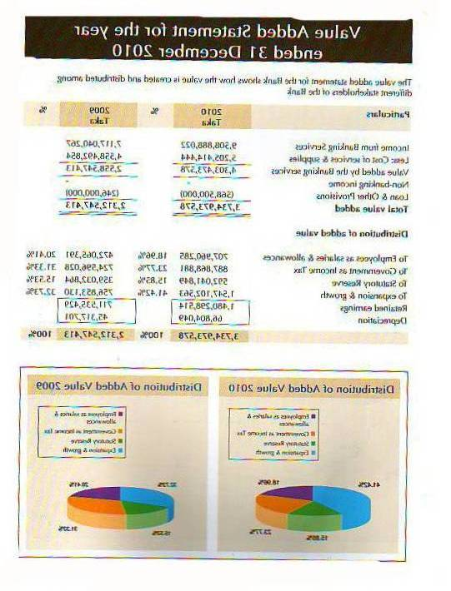
Figure 1
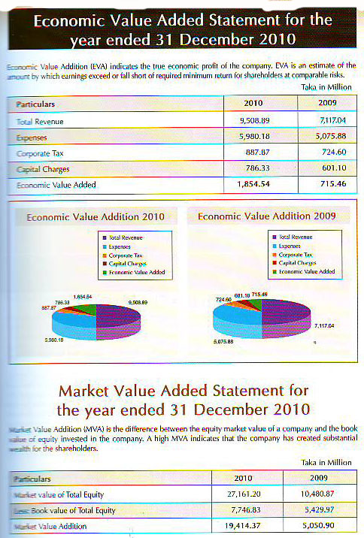
Figure 2
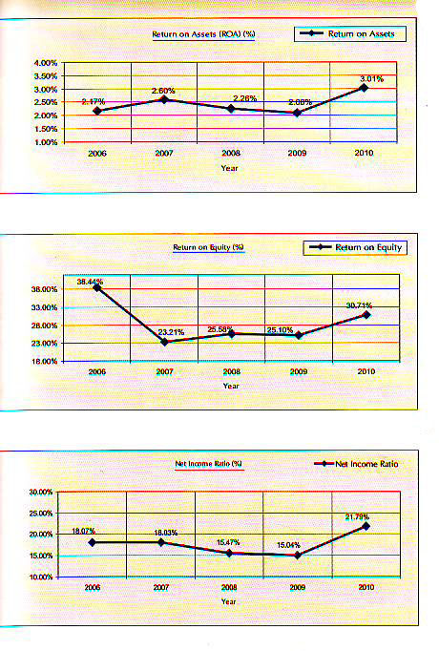
Figure 3
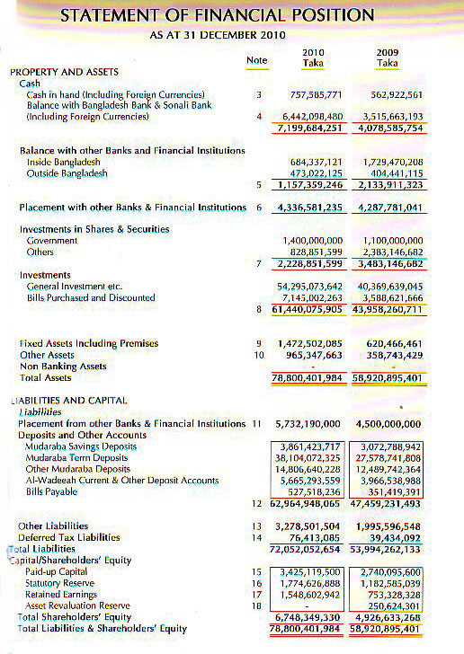

Figure 4

Figure 5

5.1 Conclusion …………………………. 66
5.2 Recommendation …………………………. 67

Chapter 5: Conclusion

5.1 Conclusion

Shahjalal Islami Bank Limited is one of the most renowned bank in the country.
SJIBL has introduced a new dimension in the field of innovative and benevolent banking in our country. The bank has successfully made a positive contribution to the economy of Bangladesh with in very short period of time. Its profit is gradually increasing. Therefore, Shahjalal Islami Bank Limited (SJIBL) is trying to establish the maximum welfare of the society by maintaining the principles of Islamic Shariah which is based on “Quran” and “Sunnah”. Profit earning is not the only motive and objective of the bank’s overall policy rather emphasis is given in attaining social good and in creation employment opportunities. Shahjalal Islami Bank Limited (SJIBL) has been established with a view to conduct interest free banking to establish participatory banking instead of debtor-creditor relationship and finally to establish welfare oriented banking through its overall banking operations that would lead to a just society.

I hope SJIBL do more work for socio-economic development besides their banking business. To keep pace with ever-changing uncertain domestic business environment and face the challenges of revised global economic scenario, the bank should be more pro-active and responsive to introduce new marketing strategy to hold the strong position in home and abroad. For the future planning and the successful operation in its prime goal in this current competitive environment I hope this report can provide a good guideline. I wish continuous success and healthy business portfolio of Shahjalal Islami Bank Limited (SJIBL).

5.2 Recommendation
- Proper and sufficient training is required for each and every staff to work with full capability in the best way.
- Proper monitoring is the pre-consideration for good collection. So monitoring unit is required to be efficient enough to collect more deposit.

- Staffs of branches require being sincere enough in their jobs. This will help in banking procedure.
- The brochures of the products and services of the branch can be mailed through the welcome letters along with the status of the customers via courier.
- Interpersonal relationship needs to be built among the employees and superiors.
- Customer must be convinced to use token system, which will help the personnel of the customer service work smoothly.
- Complain of the customers should be decreased on zero level.
- Increase the SJIBL’s own ATM booth.
- SJIBL requires resorting to massive image re-engineering in order to capture the public perception to take the lead role in this sector.
SJIBL’s investment processing should become easier than other conventional banks.

SJIBL should make its investment schemes more attractive for availing high-return projects.

SJIBL should consider utilization of rural potentials from both efficiency and equity grounds in the context of the present-day socio-economic conditions of Bangladesh. Strong commitments and stepping up through experiment and implementation of innovative ideas are the appropriate ways to do that.

SJIBL should deserve immediate attention in the promotion of the image of Shariah based banks as PLS (Profit-loss-sharing)-banks.

List of Terms used in the Report …………………… 69
Bibliography …………………… 70
List of Graphs …………………… 71
List of Table …………………… 72

List of Terms used in the Report

SJIBL- Shahjalal Islami Bank Limited
IBCA- Inter Branch Credit Advice
IBDA- Inter Branch Debit Advice
HO- Head Office
L/C- Letter of Credit
LCA- Letter of Credit Authorization
IMP- Import
EXP- Export
TIN- Tex Identification Number
SWIEFT- Society for Worldwide Inter-bank Financial Telecommunication
B/E- Bill of Exchange
B/L- Bill of Lading
FCC- Foreign Currency Clearing
TR- Trust Receipt
FDD- Foreign Demand Draft
TT- Telegraphic Transfer

