Market Potential of New Energy Drinks In Bangladesh

Submitted by
WWW.ASSIGNMENTPOINT.COM

The internship is an integral part of the BBA program. As a student of BBA program in International Islamic University Chittagong everyone has to submit a report after completion of internship program.
As a student of BBA, major in Marketing, internship is an academic requirement. For my internship under the supervision of Md. Abdullah Raihan, Assistant Professor, Department of Business Administration, International Islamic University Chittagong. My supervisor asked me to prepare a report. That's why I have chosen the topic "Market Potentials of New Energy Drinks In Bangladesh”.

1.2 Objective of the Study:
The main objectives of this report are to identify and familiarize with the organizational objectives, functions and analyzed performance of Market potential of new energy drinks in Bangladesh. Other objectives of this report are as follows:
a. To check the market share of different companies of energy drink.
b. To analyze the performance of energy drink and its role in the capital market of Bangladesh.
c. To know the consumer perception about energy drink.
d. To understand the future of energy drink in Bangladesh.
e. To review the over all performance of market potentiality of energy drinks.
f. To focus on the overall view about energy drink.
g. To know the energy drink of Bangladesh.
h.. To understand the target consumer of energy drink in Bangladesh.

1.4 Interested areas of the Study:
In this report at first I would like to analyze the existing energy drink market. That is –
a) Existing producers & their brands
b) Market share
c) Major competitors
d) Market Growth
e) Consumer response
f) Target market etc.
Based on this analysis I will evaluate the potentiality of developing a new brand in the energy drink market.

1.3. Methodology of the Study:
Methodology can be termed as underlying principles and rules of organization that work at the background of the study. It clarifies the problem involving the research in an ordered and systematic way. For this study data and other information can be collected by the following ways:

1.3.1 Sources and Methods of Collecting Primary data:
By Observation: This process is very useful for gathering primary data. This process is very costly, time consuming. Through this process limited but accurate data can be collected. Using the following primary sources I had to gain the primary data from-
Consumers – residing in the Azimpur, Lalbag, Rayer Bazar & Sukrabad.
Retailers- found in Nilkhet, Azimpur, Sukrabad,& Lalbag area.

1.3.2 Sources and Methods of Collecting Secondary data:
To collect relevant Secondary data I had to use the following secondary sources:
- Akij Food & Beverage Ltd. (Website)
- Globe Soft Drinks Ltd. (Website)
- PRAN foods Ltd (Website)
- Eurydice & Eleftheria Ltd. (Website)
- Newspaper
- Others Sources.

CHAPTER-

ANALYSIS OF EXISTING DRINKS BRAND.

2.1: Comparative Analysis
2.2: Brand names & their meanings
2.3: Market share of each producers brand
2.4: Sizes, prices& profit contribution
2.5: Promotional Activities of each brand
2.6: Advertising Activities of each brand
2.7: Export Business of energy drinks

ANALYSIS OF EXISTING DRINKS BRAND.


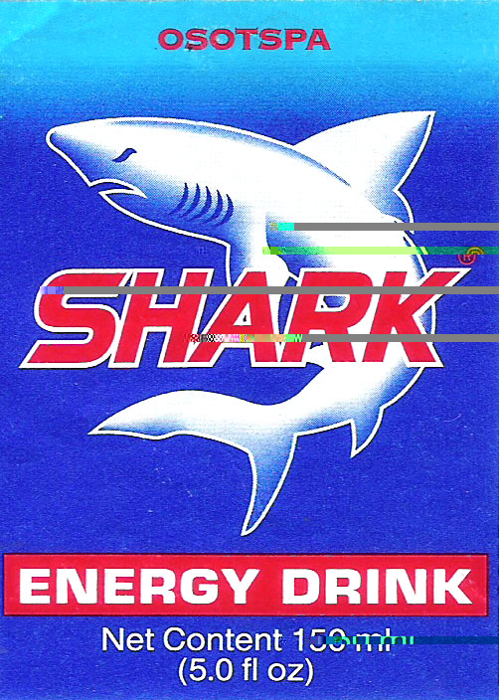
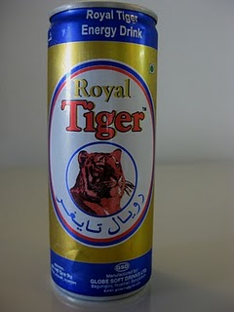
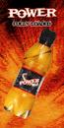
2.1) Comparative analysis:
In our country the energy drink market is a promising sector and it’s expanding day by day. That’s why a few companies working here to gain the market. They are analyzed as follows –

2.1.1) Globe soft drinks Ltd: The market leader:
This is the pioneer company is producing energy drinks in our country. They have captured a huge market share around 70% & obtain handsome profit. The sale of Tiger is also increasing. Energy drinks brand from Globe soft drinks Ltd. is “Royal Tiger”.

2.1.2) Akij Food and Beverage Ltd. (AFBL) : The market challenger
The second largest market owner of energy drink is AFBL. They have captured almost 25% market & their sales volume is also increasing. Brand from AFBL is “Speed”.

2.1.3) PRAN Foods Ltd. :
The market follower PRAN came in the energy drink market as the follower. PRAN commercially launched its product in 2008. It’s market share is approximately 1%. Brand from PRAN Foods Ltd is “Pran Power”.

2.1.4) Osotspa Co. Ltd. :This company is working in Thailand & it’s product is imported here by Eurydice & Eleftheria Ltd. It’s brand name is “Shark”. It performs niche marketing & gained 4% market share.

2.2) Brand names & their meanings: In a brief

Brand name | Meanings
Royal Tiger | The brand name is synonymous to Royal Bengal Tiger, which is the symbol of power and strength.
Speed | Speed means motion/force. It brings motion in our life. Makes our life dynamic.
Shark | Shark is a fast moving & energetic animals in the sea. This drink enables us move fast & be stronger like shark.
PRAN Power | This drink generates power for us to work more powerfully & smartly.
2.3) Market Share of each producer’s brand:

Producer & Brand Name | Market Share (%)
Globe Soft Drinks Ltd.  Royal Tiger | 70
Akij Food & Beverage Ltd.  Speed | 25
PRAN Foods Ltd.  Pran Power | 01
Osotspa Co. Ltd.  Shark | 04

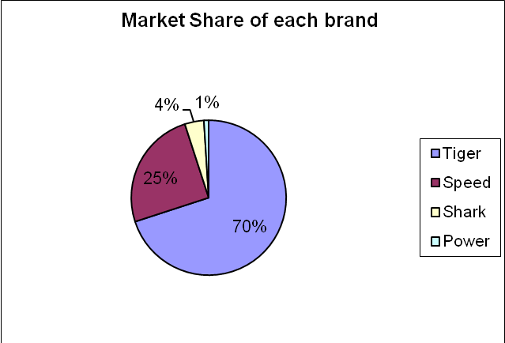
Figure: Market share of existing brands
2.4) Sizes, Prices & Profit Contribution:
Brand Name | Size (ml) | Retail Price (Tk.) | Profit/Pcs.
Royal Tiger | 270 | 20 | 2.17
Speed | 250 | 20 | 2.23
Shark | 150 | 40 | 5.32
Pran Power | 250 | 20 | 2.12

2.5) Promotional activities of each brand:
Brand Name | Quantity purchased (Pcs) | Bonus (Pcs)
Royal Tiger | 24 | 2
Speed | 24 | 2
Shark | 24 | 2
Pran Power | 24 | 2

2.6) Advertising activities of each producer:
Brand Name | Advertising Medium | Brand Ambassador
Royal Tiger | TV | Ayub Bacchu  (most popular rock star)
Speed | TV | ---
Shark | TV | ---
Pran Power | --- | ---

2.7) EXPORT BUSINESS OF ENERGY DRINKS:
“Local Energy Drinks Launch Export Push”- Our domestic producers not only serves the local market but also expand their business in the overseas market. Now the amount of export business of energy drinks is small but it is increasing day by day. The Globe Soft Drinks’ Royal Tiger, the leading brand as well as Akij Food & Beverage’s Speed are exporting to the different countries especially to Middle East.

Brand Name | Export To
Royal Tiger | Qatar, Dubai
Speed | UAE, Malaysia, Bahrain.

Mentioned that export earnings from the Royal Tiger brand so far stood at $18,500 out of total earnings of about $1 lakh. Now the export order worth of $70,000 from Dubai and $25,000 from Qatar are in their pocket. In the overseas market our brands are competing with the international brand Red bull.

CHAPTER-
DISCUSSION ON SURVEY FINDINGS

3.1: Introduction
3.2: Consumer Responses

DISCUSSION ON SURVEY FINDINGS

3.1: INTRODUCTION

Market Survey is conduced in some areas of Dhaka City – Lalbag, Azimpur, Nilkhet, Shukrabad. It is conduced on 40 consumers & retailers residing in the mentioned area. Survey finding are as follows:
Retailer’s responses
No. of Respondents: 40
Area: Lalbag, Azimpur, Nilkhet, Sukrabad

3.1.1) Brands availability, sales volume & profit contribution:

i. What are the available brands of energy drink in your store?

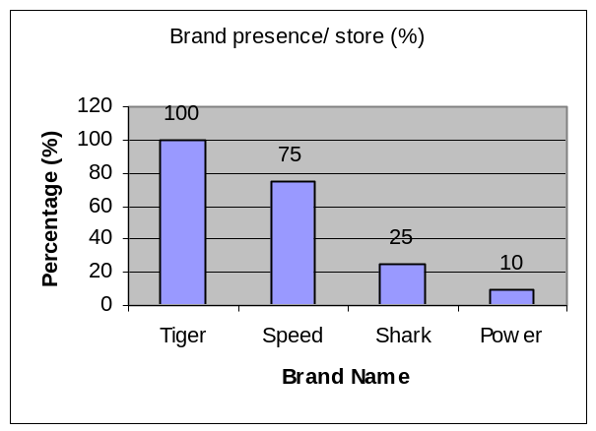

Brand name | Size | Price (Tk) | Brand presence/ store (%)
Tiger | 270ml | 20.00 | 100
Speed | 250ml | 20.00 | 75
Shark | 150ml | 40.00 | 25
Power | 250ml | 20.00 | 10

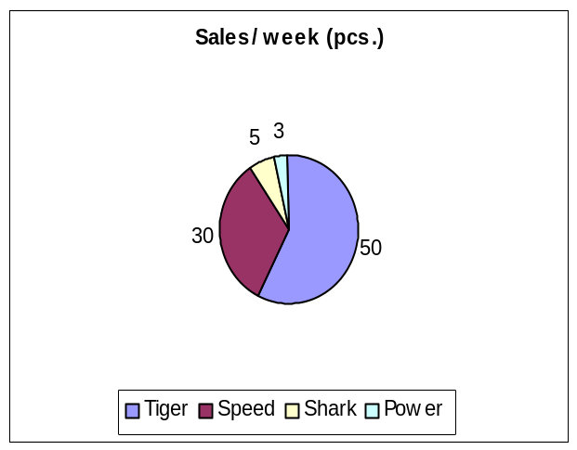
ii. How much sales occur of each brand in a week?

Brand name | Sales/  week (pcs.)
Tiger | 50
Speed | 30
Shark | 05
Power | 03

iii. Which brand offers you the maximum profit?
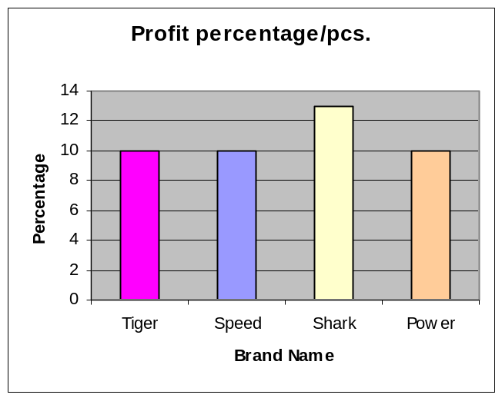
Brand name | Profit/Pcs. (Tk) | %
Tiger | 2 | 10
Speed | 2 | 10
Shark | 5.20 | 13
Power | 2 | 10

3.1.2) Ultimate consumers, consumptions reasons and pattern
iv. Who are the ultimate consumers of these drinks?
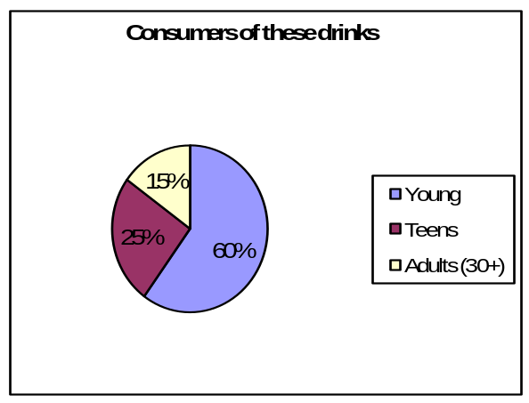
Age Limit | No. of respondents | %
Young | 25 | 60
Teens | 10 | 25
Adults (30+) | 05 | 15

v. Why do they consume those energy drinks?

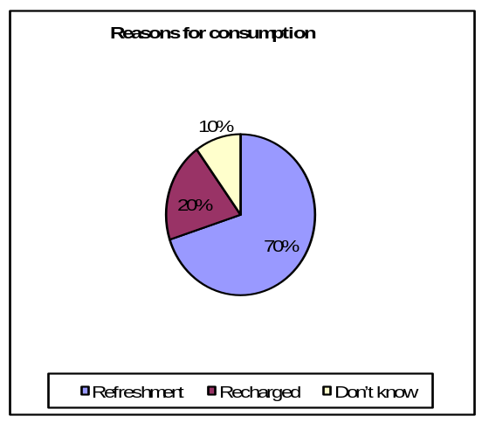Reasons | No. of respondents | %
Refreshment | 28 | 70
Recharged | 08 | 20
Don’t know | 04 | 10

vi. How frequently they consume these energy drinks?
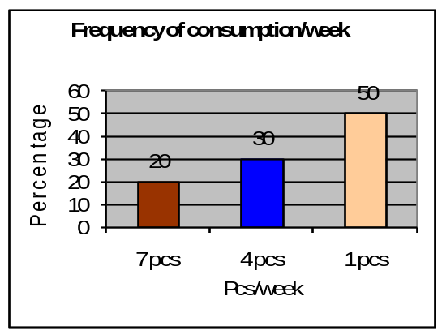
Frequency/  week | No. of Respondents | %
7 pcs | 08 | 20
4 pcs | 12 | 30
1 pcs | 20 | 50
3.1.3) Brands demand and acceptance of price:

vii. Which brand is more demandable to consumers?
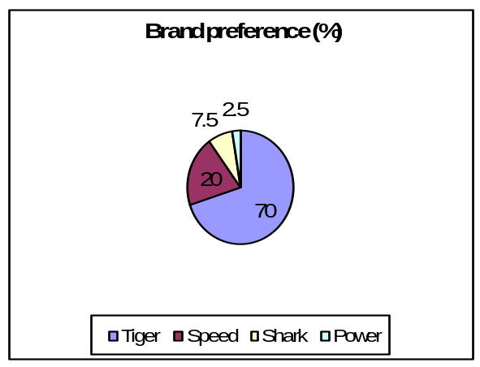
Brand Name | No. of Respondents | %
Tiger | 28 | 70
Speed | 08 | 20
Shark | 0  3 | 7.5
Power | 0 | 2.5

viii. Is this price affordable to consumers (Tk. 20 = 250ml/270ml)?
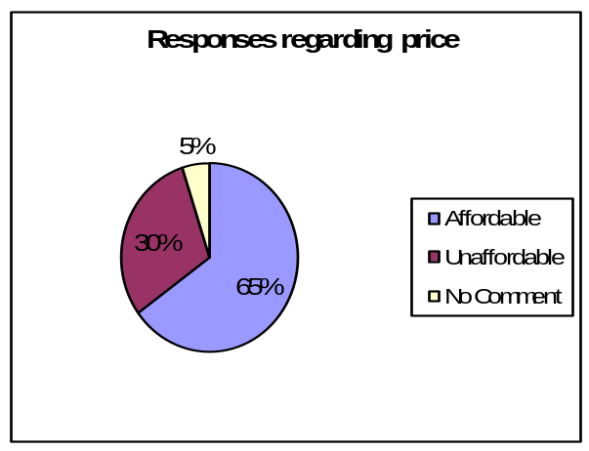
Response | No. of respondent | %
Affordable | 26 | 65
Unaffordable | 12 | 30
No Comment | 02 | 05

3.1.4) Retailers Suggestions :

ix. Is there any seasonal/occasional affect of consuming energy drink?
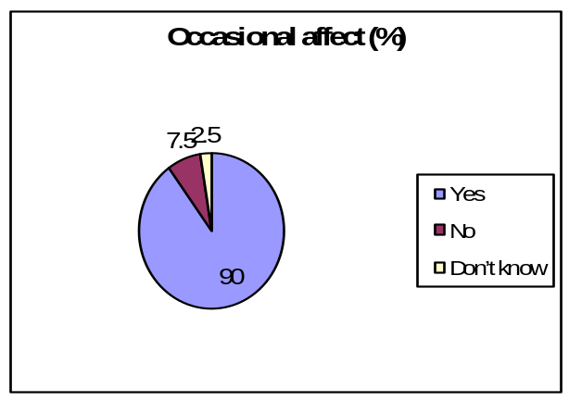
Responses | No. of respondent | %
Yes | 36 | 90
No | 3 | 7.5
Don’t know | 1 | 2.5

x. Do you have any suggestions to improve drink market?
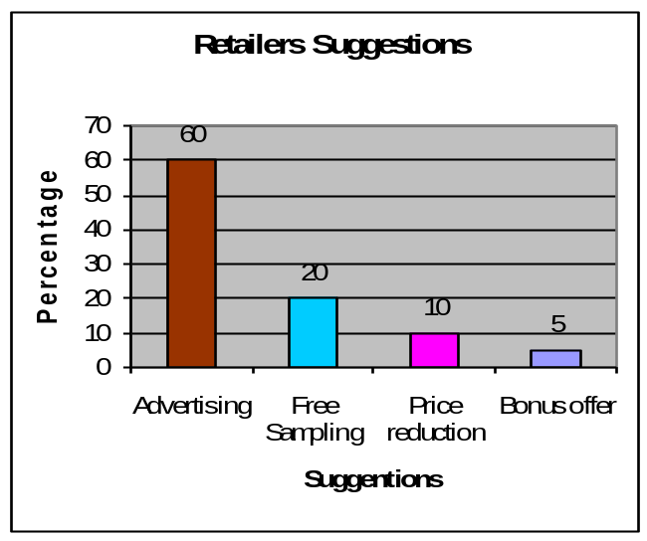
Suggestions | No. of respondent | %
Advertising | 24 | 60
Free Sampling | 10 | 20
Price reduction | 4 | 10
Bonus offer | 2 | 5

3.2. Consumer Responses:

Participants: 40 consumers
(Age limit: 15-40 years)

3.2.1) First Consumption experience & brand preference:

i. Which brands of energy drink you have taken at first?
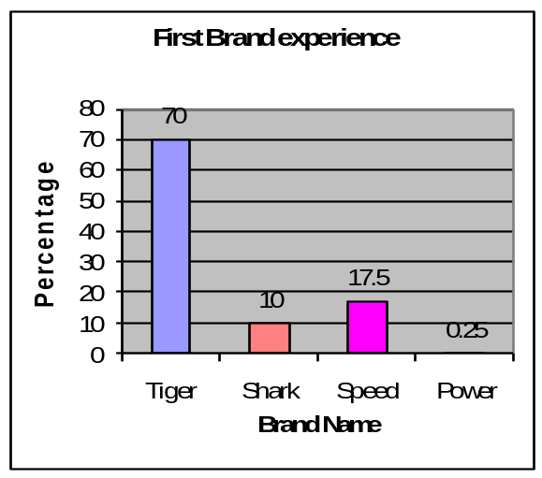
Brand Name | No. of respondents | %
Tiger | 28 | 70
Shark | 4 | 10
Speed | 7 | 17.5
Power | 1 | 0.25

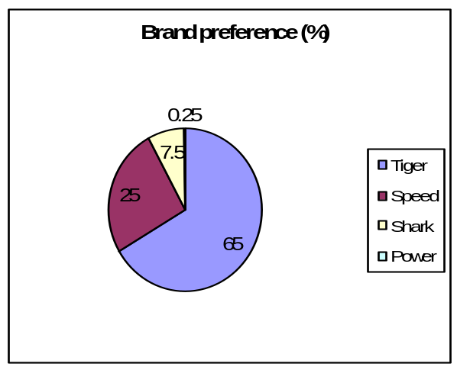ii. Which brand you like most?

Brand Name | No. of respondents | %
Tiger | 26 | 65
Speed | 10 | 25
Shark | 3 | 7.5
Power | 1 | 0.25

3.2.2: Consumer responses regarding product, price & promotion

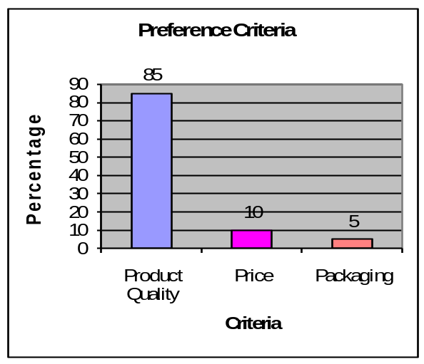iii. Which one you prefer for choosing the brand?

Characteristics | No. of respondents | %
Product Quality | 34 | 85
Price | 4 | 10
Packaging | 2 | 5

iv. Do you think the price is reasonable charged against your favourite brand?
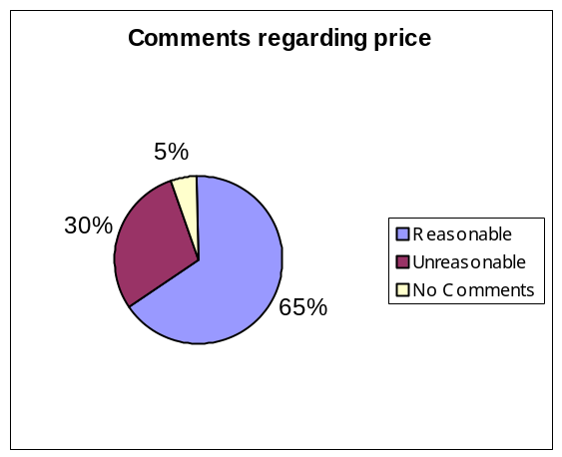
Comments | No. of respondents | %
Reasonable | 26 | 65
Unreasonable | 12 | 30
No Comments | 2 | 5

v. Are you satisfied with promotional activities of your favourite brand?
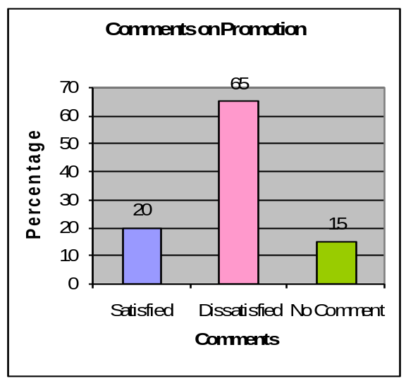
Comments | No. of respondents | %
Satisfied | 8 | 20
Dissatisfied | 26 | 65
No Comment | 6 | 15

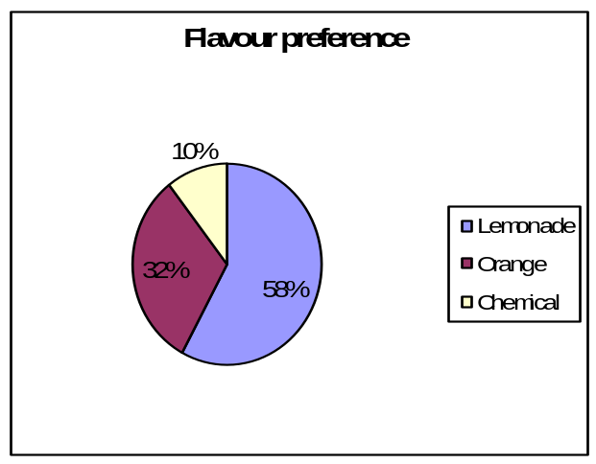vi. What types of flavor you like best?

Flavour | No. of respondents | %
Lemonade | 22 | 55
Orange | 12 | 30
Chemical | 4 | 10
Don’t know | 2 | 05

3.2.3: Media Preference for Advertisement:

vii. In which TV channel you see the Advertising of energy drink?
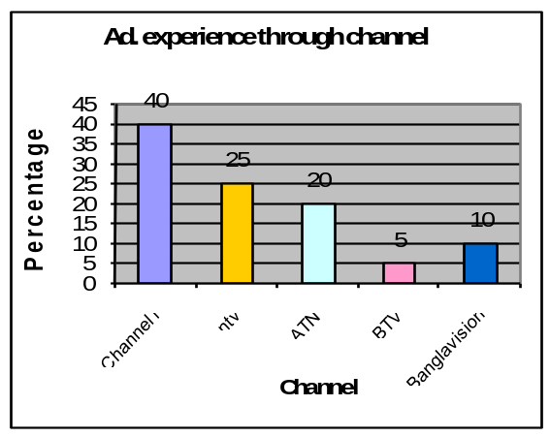
TV Channel | No. of respondents | %
Channel i | 16 | 40
NTV | 10 | 25
ATN | 08 | 20
BTV | 02 | 05
Bangla vision | 04 | 10

viii. Which media you prefer for the first time advertisement of energy drink?
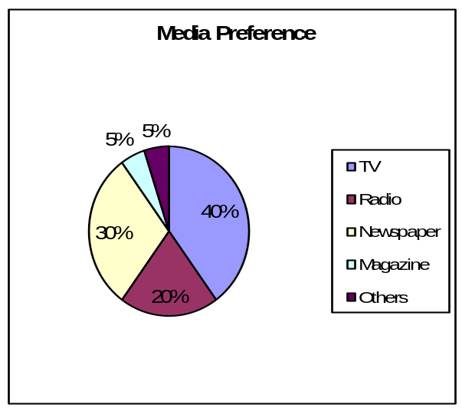
Media | No. of respondents | %
TV | 16 | 40
Radio | 08 | 20
Newspaper | 12 | 30
Magazine | 02 | 05
Others | 02 | 05

3.2.4: Consumers Suggestions:
x. Do you have any suggestion to improve your favoutite brand?
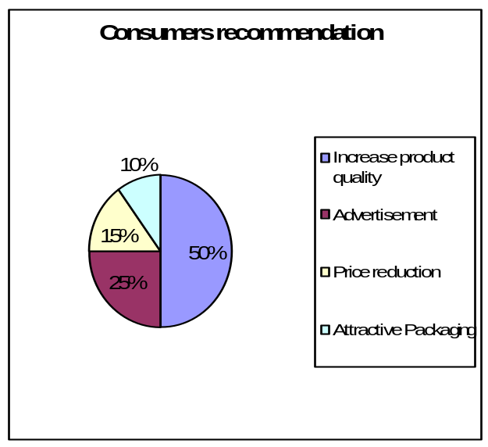
Suggestion | No. of respondents | %
Increase product quality | 20 | 50
Advertisement | 10 | 25
Price reduction | 06 | 15
Attractive Packaging | 04 | 10

CHAPTER-

FINDINGS, RECOMMENDATIONS, & CONCLUSION

4.1: Findings
4.2: Recommendations
4.3: Conclution
4.4: Appendices

FINDINGS, RECOMMENDATIONS, & CONCLUSION

4.1 : Findings :
I worked hard for analyzing the current scenario of energy drinks market. From my careful analysis I got some key points. These are –
Major Findings:
- In our country energy drinks market is very potential. This market is expanding day by day.
- Now this market is worth of Tk. 100 crore (approx) and it is increasing continuously.
- Target consumers of energy drinks are young, Teenagers and Middle aged adult.
- Products taste, flavor & packaging play a vital role. All these attract the consumers greatly & motivate them to consume the brand.
- Energy drinks brand positioning isn’t decent in the minds of the consumers. They think it’s not a normal soft drinks, it’s something like drug.
- The price of the existing brands – Royal Tiger, PRAN Power & Speed (Plastic Bottle) is Tk. 20 except shark (Tk. 40). More than Tk. 20 is not acceptable.
- The existing energy drinks brands – Royal Tiger, Pran Power, Speed contain the same quantity- 250ml. And the imported brand Shark contains 150ml. The quantity – 250ml is mostly acceptable.
- Distribution activities of each company are – at least once in a week per market.
- Promotional activities are not so aggressive and attractive of any brand. Only TV advertisement is available, Brand attachment with media super start causes great impact on sales. e.g. Ayub Bacchu + Royal Tiger, makes the brand more desirable & prestigious.
- Mentioned that, in the energy drinks market Globe Soft Drinks Ltd. (Royal Tiger) is the market leader, Akij Food & Beverage Ltd. (Speed) is the challenger, Ostospa Co. Ltd., Thailand (Shark) is the niche marketer & PRAN Foods Ltd (Pran Power) is the follower. Their market share is respectively – 70%, 25%, 4% & 01%.
So, the overall scenario of the present energy market indicates that there is a unquenchable thirst of the consumer which is not met by the current producers

4.2 Recommendations:
By conducting the research carefully the following recommendations are provided to the producer –
- New brand’s positioning should be unique in the minds of the consumers.
- Brand name, brand elements should be selected carefully to touch the consumer’s minds.
- Product quality, taste, flavor, color should be different from the existing brands.
- Packaging can be done in two ways:
  - Plastic bottle – 250ml (Normal Packaging)
  - Steel Cane – 300ml (Prestigious Packaging)
- The existing price (Tk. 20 = 250ml/270ml) provided the producers is satisfactory but we have to add more values with the new brand for Tk. 20.
- The price for the plastic bottle (250ml) can be Tk. 20 and for steel cane (300ml) Tk. 30.
- Product distribution can be conducted through existing dealers all over the country.
- Every market should be touched once in a week and the market where demand is high should be touched frequently.
- Attractive advertising campaign should be conducted especially through TV, Newspaper, FM radio & billboards.
- Another promotional activities like free sampling in university, campus or on Pahela Baishak in Dhka City including others big cities.
- Brand attachment with superstars like James, The Rock Stars or Bangladesh cricket team will bear unique brand positioning.

4.3: Conclusion:

To conclude in this report, I want to say that it’s a great experience to work here for three months and I have learned lot from here. Through out this experience I want to add some thing it has a great opportunity to gain market leadership. It is important to remember that though RC is enjoying monopoly in the middle and lower income group segment, it will face difficulty as people are gradually becoming health conscious. They have all kind of work force but they just need to implement those workforces in proper way.

My main focus on this report is evaluate the potentiality of developing a new brand in the energy drink market. From the analysis it found that the position of RC is good. There is low risk involvement. The study is the second time for me to get the opportunity for conducting such and elaborate study in a different field. Hence I do not know how far I am successful in writing this report.

4.4: APPENDICES:
Appendix-A: Questionnaire
Appendix-B: Bibliographyl

Survey
On
Energy Drink Market in Bangladesh.

Questionnaire for Retailers

Name-----------------------------------------------------

Address--------------------------------------------------

1. What are the available brands of energy drink in your store?
--------------------------------------------------------------------------------------------
2. How much sales occur of each brand in a week?
------------------------------------------------------------------------------------- -------
3. Which brand offers you the most profit?
---------------------------------------------------------------------------------------------
4. Who are the ultimate consumers of these energy drinks?
--------------------------------------------------------------------------------------------
5. Why do they consume these energy drinks?
---------------------------------------------------------------------------------------------
6. How frequently they consume these energy drinks?
---------------------------------------------------------------------------------------------
7. Which brand is more demandable to the consumers?
---------------------------------------------------------------------------------------------
8. Is this Price affordable to consumer?
---------------------------------------------------------------------------------------------
9. Is there any seasonal/ occasional affect of consuming energy drink?
---------------------------------------------------------------------------------------------
10. Do you have any suggestion to improve the energy drink market?
--------------------------------------------------------------------------------------------

Survey
On
Energy Drink Market

Questionnaire for Consumer

Name………………………………….. Age……………

Address………………………………. Occupation………..

1. Which brand you have taken at first?
a) Tiger b) Speed c) Shark d) Power
2. Which brand you like most?
a) Tiger b) Speed c) Shark d) Power
3. Which one you prefer for choosing the brand?
a) Product quality b ) Price c) Packing
4. Do you think the price is reasonable charged against your favorite brand?
a) Reasonable b) Unreasonable c) No Comment
5. Are you satisfied with the promotional activities of your favorite brand?
a) Yes b) No c) No comment
6. What types of flavor you like best?
a) Orange b). Lemonade c.) Chemical d) Can not distinguish e.) Others
7. In which TV channel you see the advertisement of energy drink?
a) BTV b) n TV c) ATN d) CH-I e ) Bangla Vision f) Others……….
8. Which media you prefer for the first time advertisement of energy drink?
a) TV b) Newspaper c) Radio d) Magazine e) Others……………….

