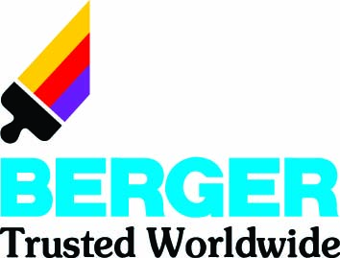

Marketing strategies
Of
Berger Paints Bangladesh Limited (BPBL)

Submitted by
WWW.ASSIGNMENTPOINT.COM

Knowledge and learning become perfect when it is associated with theory and practice. Theoretical knowledge gets perfection with practical implication. As the concerning parties; educational institution and the organization substantially benefit from such a program namely “Internship”, the sole purpose of internship is to train the students and prepare themselves for the real life in job markets. I have developed this internship report as a partial requirement to acquire the BBA degree under direct supervision of Mohammad Mahfuz Ahmed. I have tried my level best to make this report informative and enriched so that the real things can easily be displayed.

  - Scope of the study

This report has covered almost all the strategy of Berger Paints Bangladesh ltd for marketing its product. It also includes a brief profile of the company. To know the strategy of the company it also includes the product categories and the distribution channel of the company.

  - Objectives of the study

This study had been carried out to achieve some predetermined objectives. This has been broken down into two different categories of objective.

1.3.1 Broad objective
- To identify and analyze the marketing strategies that Berger adapt in different levels

1.3.2 Specific objectives:

- To identify Segment strategies
- To identify Target market selection strategies
- To identify Positioning Strategies
- To identify Pricing strategies
- To identify promotional strategies

1.4 Methods and Procedures

Every Research work should be conducted through a specific and predetermined methodology to explore an effective research outcome. The nature of the study is a qualitative research. It has been conducted with a methodology and the laments of methodology are as following:

1.4.1 Primary sources

Primary data have been collected by direct interviews and conversations with the employees within the Dhaka sales office of Berger Paints Bd. Ltd.

1.4.2 Secondary sources

- Berger’s Bluebook
- The website of Berger (www.bergerbd.com)
- Prospectus of Berger
- Different journals and publications
- Other Research Papers

1.5 Data gathering Method

The needed primary data has been collected through some questionnaire. Besides, some data has been collected by conducting in depth interview with The Area Sales Manager (ASM) Sabuj Shawpan Barua.

1.6 Limitations

In this research I faced some obstacles that hindered me from obtaining the objective of my project. In brief the problem that I faced is;

- A major limitation of the report was that only dealers were selected as the respondents.
- Most of the traders are very much afraid of disclose the information about sales.
- Time and cost constraints also other limitations regarding this research.
- Most of the traders of paints are illiterate or little educated.
- Every organization has some rules and regulation regarding its privacy policy. So does Berger paint Bangladesh Ltd. Moreover financial information is regarded more sensitive. That is why I failed to collect some market share related information in different months which would have proved very effective in preparing the report. However this limitation is not very unnatural.
- Lack of experience of the researcher.
- As the report is based totally on personal observation, personal bias might have hampered the findings. I might have unintentionally missed any important point that I should have covered in my project work.
In my survey I have droped some Berger’s dealer as I want to focus on the traders who sales more than one company’s paints.

1.7 History of Berger

Berger is one of the oldest names in paint industry detailing back more than 200 years to 1760. Lewis Berger, a German national, founded dye & pigment making business in England.
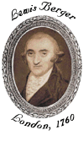
Lewis Berger & Sons Limited grew rapidly with a strong reputation for innovation and entrepreneurship culminating in perfecting the process of making Prussian Blue, a deep blue dye, a color widely used for many European armies' uniform.
Production of dyes & pigments evolved into production of paints & coatings, which till today, remains the core business of Berger.
Berger grew rapidly by establishing branches the world over and through merging with other leading paint & coating companies.

1.8 Berger in Bangladesh
Berger Paints began its painting in Bangladesh since independence. And this has been a footstep to bring more than 230 years of global paint industry experience into Bangladesh.
In 1970, Berger Paints Bangladesh Limited (BPBL) erstwhile Jenson & Nicholson had set up its paint factory in Chittagong at an estimated investment of TK.4 million. The shareholders were Jenson & Nicholson (J& N), Duncan Macneil & Co Ltd and Dada Group.
Duncan Macneil subsequently sold their shares to majority shareholder J& N group. The Dada group's share ultimately vested with the Government of Peoples' Republic of Bangladesh after the independence
The name of the company was changed from J& N (Bangladesh) Limited to Berger Paints Bangladesh Limited on 1st January 1980. In August 2000, J& N investment (Asia) Ltd purchased Government shareholding. Now, Berger Paints Bangladesh Limited is 100% owned by J& N Investment (Asia) Limited, UK. Over the decades, Berger has evolved to becoming the leading paint solution provider in this country and has diversified into every sphere of the industry – from Decorative Paints to Industrial Coatings, from Marine Coatings to Powder Coating and what not.
To give a comprehensive and sustainable painting solution to the need of the industry, Berger has invested more on technology and Research & Development (R & D) than any other manufacturer in this market. It selects the raw materials from some of the best known names in the world: MITSUI, MOBIL, DUPONT, HOECHST and BASF are a few to name. The superior quality of Berger's products has been possible because of support from its advanced plants and an international-standard of strict quality.

2.1 Company Profile

Origin : United Kingdom

Registered Office : 43/3, Chtteeswari Road
Chittagong- 4000, Bangladesh.
Email:bergerbd@spnetctg.com
Web:http//www.bergerbd.com

Corporate Headquarter : Berger House
P#-08, R#-02, Sector#03,
Uttara Model Town, Dhaka.
Email:info@bergerbd.com
Web:http//www.bergerbd.com

Factory : Dhaka factory- Nabinagor, Savar.
Chittagong factory—27D, FIDC Road,
Kalurghat, Chittagong.

Date of Incorporation : 6th July, 1973.

Commercial Production : 1973

Business Line : Manufacturing and Marketing of High Quality Paints.

Status : Public Limited Company, Enlisted in both Dhaka
And Chittagong Stock Exchange

Position of the Industry : 1st.

Percentage of Market Share : 55%

Special Achievement : ISO 9001:2000.

Berger is one of the oldest names in the paints industry and the country’s major specially paints business with products and ingredients dating back more than 200 years to 1760. Louis Berger, a German national founded dye and pigment making business in England. Louis Berger and Sons Limited grew rapidly with a strong reputation for innovation and entrepreneurship culminating in perfecting the process of making Prussian blue a deep blue dye , a color widely used for the uniforms of many European armies .Production of the dye and pigments evolved into production of paints and coatings ,which till today ,remains the core business of Berger .The company grew rapidly by establishing branches all over the world and through Berger and acquisitions with other leading paint and coating manufacturing companies.
Berger’s mission in 2008 was to increase its turnover by 100% with the next five year. To accomplish this Berger promotes its sales department to increase the gross sales through direct selling and developing substantial number of new dealers and projects. The company can increase its sales by 35% in 2009. The company recently introduced a manual production system called ‘ ‘ for the production of 27 slow moving shades of Robbialac Acrylic Plastic Emulsion, 10 shades if Robbialac Synthetic Polyvinyl Distemper and 15 shades of Weather Coat. As the averages monthly sales of these 52 shades are less than their batch sizes, these are consider as slow moving items. So production of these shades from factory increase the stock level which finally fixes the working capital and increase the product cost per unit. The objectives of this system was to reduce the pressure on factories production capacity by ensuring the production of these slow moving shades from depot and by guarantees the spot delivery against customer demand.
Berger's one of the prime objectives is to provide best customer support-connecting consumers to technology through specialized services like free technical advice on surface preparation, color consultancy, special color schemes etc. To bolster customer satisfaction, Berger has recently launched Home Decor Service from which once can get an array of services pertaining to painting.

Investment in technology and plant capacity is even more evident from the new factory of Berger Paints Bangladesh Limited at Savar. The state-of-the-art factory is an addition to Berger's capacity to make it the paint-giant in Bangladesh. Not to forget about the first Double Tight Can manufacturing unit in its Chittagong factory. All, together with a devotion into R & D to make it the reputed center of Basic & Applied Research in paint and Resin Technology, proof the commitment that Berger has for this industry.

With its strong distribution network, Berger has reached almost every corner of Bangladesh. Nationwide Dealer Network, supported by 7 Sales Depots strategically located at Dhaka, Chittagong, Rajshahi ,Khulna, Bogra, Sylhet and Comilla has an unmatched capability to answer to paint needs at almost anywhere in Bangladesh.

The sheer innovation and development drive is reflected on the various products Berger has so far launched in this market. The product range includes, specialized outdoor paints protective of the worst weather conditions, Color Bank, superior Marine Paints, Textured Coatings, Heat Resistant Paints, Roofing Compound and Epoxies. In each of the product category, Berger has always been the pioneer and will continue to do so proudly.

Berger's one of the prime objectives is to provide best customer support-connecting consumers to technology through specialized services like free technical advice on surface preparation, color consultancy, special color schemes etc. To bolster customer satisfaction, Berger has recently launched Home Decor Service from which once can get an array of services pertaining to painting.

With world class range and durability, Berger is always ready to answer to all weather conditions.

It was honored with “The top tax payer’s award 2003” in June 2004 by the income tax authorities of the government of Bangladesh.

Additionally the company received the “Channel i performance award 2004” for its effort in promoting the young painters and architects of the country through the burger young painter’s art promotion and young architects award. This award recognized the role of Berger paint Bangladesh limited (BPBL) as a responsible corporate citizen.

2.2 Vision:
The vision of the company is to remain as the benchmark in the Paint industry
being an innovative and technology driven Company consistently delivering world-class products ensuring best consumer satisfaction through continuous value added services provided by highly professional and committed team.

2.3 Mission:
- To increase the turnover by 100% in the next five years.
- It will remain socially committed ethical Company.

2.4 Objectives:
Berger paints Bangladesh Ltd is committed to add value to life to out performs the peers in terms of longevity, customer service, revenue growth, earnings and cash generation. Besides the company will be the employer of choice for all existing and future employers. But it also tries to do best in the conjunction with activating the ultimate objective of a business organization –Wealth Maximization.

2.5 Focusing points of BPBL

- Commitment to achieve total customer satisfaction.
- Commitment to project the company as an ethical and socially responsible one.
- Commitment to continue as the market leader through consistent sales growth, increasing productivity and developing new products befitting customer needs.
- Ensuring continuous improvement in operation through utilization of highly professionals and dedicated team, proper process management and participation of the stakeholders.
- Setting measurable target at appropriate stages and continuously monitoring them.

2.6 Nature of Business

The core business of Berger `is manufacturing and marketing of paints, varnishes and coatings. It produces a wide range of paints including architectural paints, industrial coatings, marine paints and powder coatings. With a view to improving consumer satisfaction, Berger has also introduced end-user oriented services such as color bank, home décor, pro link and tinting. Its wholly owned subsidiary, JENSON & NICHOLSON BANGLADESH LIMITED, is engaged in tin container production – most of which is supplied to their parent company.

2.7 Organization Structure

Like all other manufacturing organizations, BPBL has a conventional organization structure. Generally six board meeting are called in BPBL during a year where chairman of the board of Directors presided over the meeting .In BPBL several committees like the Audit committee, Risk committee, Remuneration committee, Executive committee and the Purchase committee are formed along with Managing Director (MD) and other Executive & non-Executive Directors. These committees sit at least once a month to approve various proposals brought by the management prior to implementation. All the proposals are initiated by the mid level managers and then forwarded to the Managing Director (MD) through the head of the divisions or departments. The company has also a legal problems faced by the company and external auditors to conduct audit activities of BPBL.

There are four Non-Executive Directors, two Executive Director and ten Managers work under the Managing Director (MD) of the company. Among the ten managers three directly report to the Executive directors and other report to the Managing Director. The Managers of each department monitor the work activities of subordinates, convey top management decisions and provide necessary feed back to reach organizational goals and objectives. In response the bottom level managers perform their responsibilities sincerely and report regularly to their immediate superiors.

Director
Finance
GM MFG & Projects
Manager HR
& Admin
GM Planning
Marketing Manager
General Sales Manager
Assistant Mkt Manager
Marketing Officer
Assistant Manager
HR
Officer
Assistant Manager
System
Officer
Assistant Manager
Officer
Assistant Manager
Planning Officer
Finance Manager
Managing Director
Director
Operation
Deputy Finance Manager
Assistant Manager
Finance Officer
Regional Sales Manager
Area Sales Manager
Sales Officer
Branch Manager
Sales Officer
System
Manager

Organogram of BPBL

2.8 Major products of Berger paints Bangladesh limited

Production of paints and coatings is the core business of Berger. Berger produce a wide range of paints including decorative/architectural paints, industrial coatings, marine paints and powder coatings. The main products of the company are:

Major categories | Brand name
Decorative

Synthetic enamel | Robbialac synthetic enamel
Synthetic enamel | Jhilik synthetic enamel
Interior emulsion | Robbialac acrylic plastic emulsion
Exterior emulsion | Weather coat
Distemper | Robbialac distemper SPD
Cement paint | Durocem
Industrial | Jensolin
Industrial | Epoxy
Industrial | Berger industrial enamel
Marine | Berger marine
Powder coatings | Supracoat

2.9 Major Competitors of BPBL

Berger paints Bangladesh LTD operates its business in a competitive environment with both local and multi-national organizations. At present the company holds 55% market share where as the rest of 45%market share holds by the other multi-national and local companies. It’s clearly indicated that Berger paints Bangladesh Ltd is in the leading position among all other competitors in the paints industry .The majors participant of the paints industry are ; Asian Paints, Elite Paints, Romana Paints , Roxy Paints , Aqua Paints , Pailac Paints ,Al-karim Paints, Uzalla Paints, etc. Among this company only Asian Paints is multinational and others are all local producers. Asian Paints has started its operation in Bangladesh very recently. Already it diversifies its business with huge ranges of color and product verities.
But still Berger paints Bangladesh Ltd holds its top position with strong distribution networks, effective and efficient management team and human resource.

Internship Position and Duties

3.1 Job Description:

Being an Intern I worked at Berger Paints BD Ltd. as a Sales Support Officer. I really enjoyed the job during my internship program. I had to conduct market survey, field visit and dealing with the dealers of Berger Paints. That’s why I got a clear cut picture of Marketing Strategy that Berger follows. I had to maintain a regular communication with the dealer; whether the dealers are satisfied with the existing products or service that Berger offers them. If they raised any complain, I would report to my Boss, Mr. Sabuj Shawpan Barua; ASM, Dhaka Sales Office. Moreover I would visit Buildings that are under construction and asked those land lords that which paints they are going to use for their wall. If they would select Berger, I did aware them about various services of Berger and inspired them to stay with the most renowned paint Brand “Berger”. If I got any who are interested to use other brands instead of Berger, I did try my level best to build a space in the mind of that person so that Berger could occupy a position in that space. I would inform them about the details services, products, and facilities for using Berger. I would always try to represent the Berger as a superior brand in front of them.

3.2 Purpose and function of the job:

3.2.1 Purposes:

Theoretical knowledge gets perfection with practical implication. The primary purpose of the job is to gather a practical experience on the basis of four years study. I tried to combine my theoretical knowledge with practical implementation of that.

And the secondary purpose is to achieve the partial requirement to fulfill my BBA degree.
3.2.2 Functions:

- The main function of my job was to increase sales.
- Regular communication with dealers.
- Site visiting (Builders & Private House under construction)
- Sales inspection of different stores.
- Promote Berger by spreading positive word of mouth communication.

3.3 A little bit about my workplace where I did Internship program

I have worked Berger sales office situated at Tejgaon industrial area. The names and designations of the officers are given below serially:

- Mr. Mizanur Rahman (RSM)

- Mr. Sabuj Shawpan Barua (ASM)

- Mr. Abdur Rashed (ASM)

- Mr. Rajesh Chandra Debnath (ASM)

- Mr. Hasan Mahmed (ASM)

- Mr. Mayeenuddin Rumee Faisal (SO)

- Mr. Minhaz Ahemd (SO)

- Mr. Zahuruddin (SO)

- And other Sales officers (SO) and sales support officers (SSO) and staffs.

Name: Berger Paints Bangladesh Ltd. (Sales Office)

Address: 272, Tejgaon Industrial Area, Dhaka 1208, Dhaka

P A B X: 9897717 (Hunting), 9897809, 9897847

Fax: 88-02-8825770

E-mail: info@ds.bergerbd.com

3.4 FUNCTION OF THE ORGANIZATION

BPBL performs different functions, like-
- Provide customers complete solution of paint service.
- Provide customers vast range of products.
- Provide training to painters.
- Provide paints related information to the house owners and painters

4.1 Marketing Strategies of Berger Paints BD Ltd.

Marketing strategies of Berger is built on STP – Segmentation, Targeting and Positioning. Berger discovers different needs and groups in the market place, target those needs and groups that it can satisfy in the superior way and then position its offerings, so that the target market recognize the companies distinctive offerings and image.

Marketing strategies of Berger depends on

- Segmentation of products.
- Target market selection.
- Positioning their product.

4.2 Segmentation strategies of Berger

Before segmentation their product Berger segments its business through the year. Generally the summer and winter is the peak season not only for Berger but also every paint producer. October to June is peak season and July to September is the lean season for the paint industry in Bangladesh, which is related to weather conditions.

The peak and lean months of the year, on the basis of the seasonality of the paint market, is as follows:

Month/ period | Conditions
January | Peak
February | Peak
March | Peak
April | Peak
May | Peak
June | Peak
July | Lean
August | Lean
September | Lean
October | Peak
November | Peak
December | Peak

Berger paint Bangladesh limited mainly segments their product mainly on three categories. These are

4.2.1 Decorative.

4.2.2 Industrial.

4.2.3 Marine.

Decorative paints are generally three types; Oil based, water based, and cements paint.

Paints
Decorative
Industrial
Marine
Oil Based
Water Based
Cement Based

Fig: Paints Major category

4.2.1 Decorative

Berger paints Bangladesh Ltd offers both interior and exterior paints. It leads the way for introducing high quality color bank products and top coat finishes Decorative paints in Bangladesh. Interior paints like plastic and distemper are used in wall, cement plaster etc. and enamel is used for metal, wood, bamboo, hardboard etc. Those products ensure long life of metal, wood, bamboo, hardboard, cement plaster etc. as well as its beauty. Very recent Berger offers Robbialac easy clean which is high quality interior wall finishes, highly applicable for concrete wall and cleanable. It offers exterior paints like weather coat which is high quality exterior liquid and durocem is power based. Both are water, weather and fungus resistant. It also provides primers, undercoats, thinners and other decorative products.

Premium emulsions, regular acrylic emulsions, distempers, first quality enamels, exterior finishes, textured finishes, automotive refinishes- you would expect a company like BERGER, the premier paint company in Bangladesh, to have leading brands in all these categories.

The following chart shows the categories of Decorative products of Berger paints:

Decorative paints
RSE
Jhilik
Water Based
Interior
Exterior
Weather Coat
WC Long life
Easy Clean
APE
Oil Based
Cement Based
Durocem
Luxury silk
SPD

The following table introduces Decorative top coat finishes

Product Name | Product Description

Luxury Silk | A marvel of international emulsion technology, Luxury Silk combines the best of aesthetic appeal with the best of functional properties like durability and ease of maintained.
Robbialac Acrylic Plastic Emulsion (APE) | A standard emulsion paint formulated with acrylic, copolymer emulsion, quality pigments and other raw, materials. Robbialac Acrylic Plastic Emulsion has a smooth, rich, matt finish and is available in a very wide range of pleasing shades. Painted surfaces, which have matured for at least two months, are easy to clean with a solution of water and mild soap.
Robbialac Super Gloss Synthetic Enamel (RSE) | Robbialac Super Gloss Synthetic Enamel is hardworking, premium quality synthetic enamel formulated to retain its gloss and film integrity in the face of extreme climatic variations. Its excellent weather ability makes it ideal for rolling stock like railway coaches, buses, lories, oil tankers, as well as for doors, windows, signboards and hoardings. It is equally versatile for interior application like furniture, fixtures and various other domestic articles.
Robbialac Acrylic Distemper (SPD) | A specially formulated acrylic co-polymer emulsion based washable distemper for elegant, smooth, durable, matt finish for interiors. Compared to other conventional distempers, Robbialac Acrylic Distemper can cover 30% more area because of its special formulation.
Weather Coat Smooth | Weather coat is smooth water based super exterior wall finish formulated to give exceptional durability in adverse climatic conditions. It provides the buildings with a long lasting and fresh appearance. It based on tough, flexible and high quality resin emulsion, which provides excellent flexibility and adhesion.
Jhilik Synthetic Enamel | Jhilik Synthetic Enamel is economy synthetic enamel formulated for interior and exterior application to give a glossy durable surface. It is ideally suitable for wood and steel furniture, toys and various household items.
Durocem Cement Coating | Durocem is an exceptional formulation based on selected raw materials and specially treated white cement that makes it ideal for both indoor and outdoor applications. It affords a hard, durable and waterproof surface. This product is a unique combination of aesthetics, durability and economy.
Wood Keeper | It provides brightness to polished or polish less or uneven surface of wood and spot resistance.
Robbialac Aluminium Paint | Robbialac Aluminium Paint is a superior 2- pack aluminum paint with a brilliant silver-like luster. It is ideal for application on the exteriors of storage tanks for water, petrol, oil...
Tartaruga Textured Coating | This is one of the most famous BERGER formulations in the world. The product is paste like having special aggregate to facilitate drawing desired textured patterns on the surface.
illusion

Robbialac Wall Putty | It used for new even plaster wall and only applicable for outer wall.
Robbialac Damp Stop | This specially formulated two-pack compound is based on selected binder system incorporated with inert pigments' and fillers, which seals the surface by eliminating the permeability of moisture and water that actually cause dampness...
Flexible Roofing Compound | This high-tech roofing compound is a highly flexible waterproof coating based on a special grade polymer...
Silicone Water Repellent | This unique product based on special type of Silicone compound is designed for water repellency of all masonry works and it keeps water on the run...
Robbialac Synthetic Clear Varnish
Robbialac Epoxy Clear Lacquer
Robbialac Polyrethane Wood Lacquer
Wood Keeper Polyurethane Clear Wood Finish

Robbialac Red Lead Primer
Robbialac Zinc Phosphate Primer
Robbialac Plastron Primer Sealer |  | This is an excellent primer, specially for plastered walls which seals and stops penetration of moisture from inside the wall and thus keeps the topcoat finish unharmed...
Robbialac Synthetic Undercoat
Robbialac Anticorrosive Red Oxide Primer |  | Robbialac Red Oxide Primer provides an excellent, quick-drying protective coating on various types of ferrous metal surfaces...
Robbialac Water Sealer
Robbialac T-6 for Air-Drying Primers & Enamels
Bison All Purpose Primer |  | Bison All Purpose Primer is applicable on concrete, wooden and metal surfaces. It can be applied on both new and old surfaces...
Auto Coat Primer Surfacer/Undercoat

4.2.1.1 Color Bank

Berger Color Bank introduces you to the global way to paint with a unlimited choice of shades to match your taste-instantly. The shade cards in Berger Color Bank stores are merely indicative of the amazing choice Berger Color Bank can give you. The rest is up to your imagination and your fingertips. Every Berger Color Bank store has a computerized color tinting machine to help you choose and take home your own shades from our world class range of paints. Availability of your chosen shades is always ensured as the paint is created and dispensed by the machine before your very own eyes.
What's more, as you see the shades of your choice on the screen, it also suggests three other colors to match it. Today thousands of satisfied customers swear by Berger Color Bank. Resulting in the installation of numbers of tinting machines in Berger Color Bank stores across the country. Our Access to World Class Quality. Berger Color Bank uses superior imported colorants and the world renowned tinting technology of Italianate, Italy. All these assure you a paint quality which is world class. Match and Compare endless Color Combinations Berger Color Bank has an unique Tint vision software which allows you to see infinite color combinations on the screen of the computer. If you so desire you can mix and match and create your own shades as well.

Color Bank Products at a Glance

Robbialac Plastic Emulsion Classic
Robbialac Synthetic Enamel Gold
Luxury Silk Splendour
Robbialac Pearl Lustre Finish
Weather coat Smooth Classic
Robbialac SPD Super
Wood Keeper Finesse

4.2.2 Industrial Paints

This is a different segment of Berger’s wide range of paints mostly used for the industries both as raw materials and as protective paints for the equipments and buildings. Berger industrial paint is the economy brand of industrial paints. Protecting industrial assets is increasingly becoming critical owing to rising asset costs, harsh weather conditions and mounting chemical pollution. Therefore asset owners are looking at specialized protective coatings specific to their requirements. We perceive this to be just the right environment for Berger Paints to demonstrate its growing technical strength.

Protective Coatings from Berger paints offer a choice of high-performance, heavy-duty coatings, designed to protect assets against the specific corrosive environment they are exposed to. Berger Paints Protective Coatings are tested under extreme conditions to ensure that they are durable and can withstand the vagaries of the different climatic conditions. Today the range of coatings find use across diverse industries such as nuclear, thermal or hydel power plants, chemical, petrochemical or fertilizer plants, refineries, sugar, pulp and paper industry, offshore structures, pharmaceuticals etc.

Berger offer industrial finishes, high protective coatings, industrial primers and other industrial products for the requirement of industrial paints. These paints are long lasting and prepared in a special method to protect industrial equipments, structures from heat, swatting and bulging. Berger paints offers the following products for its industrial customers;

Product Name | Product Description

Berger Suprakoat Powder Coating
Jensolin Industrial Enamel | A top quality glossy paint based on high quality selected resins and pigments. It has versatile applications...
Jensolin Aluminum Paint
Jensolin Stoving Primer | This primer is based on Alkyd / Amino resin combination as well as anti-corrosive pigment and is most suitable under staving finishes...
Jensolin Chlororubber Lacquers | A chlorinated rubber based finish with exceptional properties like water impermeability, resistance to salt spray, spillage and fumes of most acids...
Jensolin Stoving Enamel | This is high performance enamel based on a blend of high grade thermosetting Alkyd-Amino resin together with high quality pigments...
Jensolin Road/Runway Marking Paint | This is a quick drying, high opacity, heavy-duty paint prepared from a chlorinated rubber system...
Jensolin Swimming Pool Paint | This special paint is based on special grade of Chlorinated Rubber together with a suitable plasticizer...
Jensolin Tennis Court Paint | This non-slip primer is based on chlorinated Rubber resin and inert pigments...
Jensolin Cycle Paints (Primer & Finish)
Jensolin Insulating Varnish
Jensolin Bituminus Aluminum Paint | This is a quick drying anticorrosive, flexible, bituminous paint formulated to withstand exposure to the elements, acid fumes and occasional contact with dilute solutions of chemicals...
Jensolin Apexior Boiler Compositions | A specially formulated anticorrosive composition for hot-wet metal surfaces...
Jensolin Heat Resisting Chimney Black
Jensolin High Heat Resisting Paint
Jensolin Overprint Varnish
Jensolin Paint Remover
Jensolin Rust Remover
Jensolin Epoxies | A two pack anticorrosive epoxy primer for use on steel surfaces. This primer is ideally designed for offering superior performance in highly corrosive chemical and coastal environments...
Jensolin Polyurethanes
Jensolin Red Oxide Primer
Jensolin Red Lead Primer | This is a quick drying Red Lead Primer to use on structural steel. Provides a hard drying, anticorrosive coating, suitable for over coating with conventional finishes and chlorinated rubber coatings...
Jensolin Zinc Phosphate Primer | Jensolin Zinc Phosphate Primer is based on a special synthetic resin in which zinc phosphate is used as a rust-inhibiting pigment...
Jensolin Zinc Chromate Primer | Jensolin Zinc Chromate Primer is based on a special synthetic resin in which zinc chromate is used as a rust-inhibiting pigment...
Jensolin Wash Primer | A two pack etch primer for use on C.I. sheets, G. I. Sheets or pipe...

4.2.3 Marine

Berger produces completely different top coat finishes, special coatings, primers and thinners for ships, boats and other marine vessels. These paints are exclusively produced to maintaining sea and river vessels & other constructions besides sea and river Berger has a wide range of Marine paints. Some marine products of Berger are:

Product Name | Product Description
Seaborne High Gloss Enamel
Seaborne Aluminium Paint
Seaborne Aluminium Hold Paint
Seaborne Boot Topping
Seaborne Topside
Seaborne Deck Paint
Seaborne Funnel Heat Resisting Chimney Black
Seaborne Bituminus Black
Berger Marine Enamel
Seaborne Red Lead Primer
Seaborne Zinc Chromate Primer
Seaborne Zinc Phosphate Primer
Seaborne Metallic Protective Coatings
Berger Marine Red Lead Primer
Berger Marine Anticorrosive Primer
Seaborne Thinner T-1
Seaborne Thinner T-6
Seaborne Thinner T-7
Jensolin Thinner T-1 | For Stoving paints, cycle paints.
Jensolin Thinner T-2 | For Chlororubber paints, Swimming pool paints, Tennis court paints.
Jensolin Thinner T-3 | For N.C paints.
Jensolin Thinner T-4 | For Road / Runway marking paints.
Jensolin Thinner T-7 | For all epoxy paints.
Jensolin Thinner T-8 | For polyurethanes.

4.3 Target market selection Strategies

Berger has chosen target markets to co-operate in the interest of overall company in a socially responsible manner. The total size of the paint industry in Bangladesh is estimated at taka 4.29-4.44billion in 2005. The paint industry can be divided into three segments. These are

a) Decorative.
b) Industrial.
c) marine.

The decorative segments of the market accounts for a whopping 83.42% of the total industry, whereas industrial, marine segments contribute 12.17%, and 4.41%, respectively.
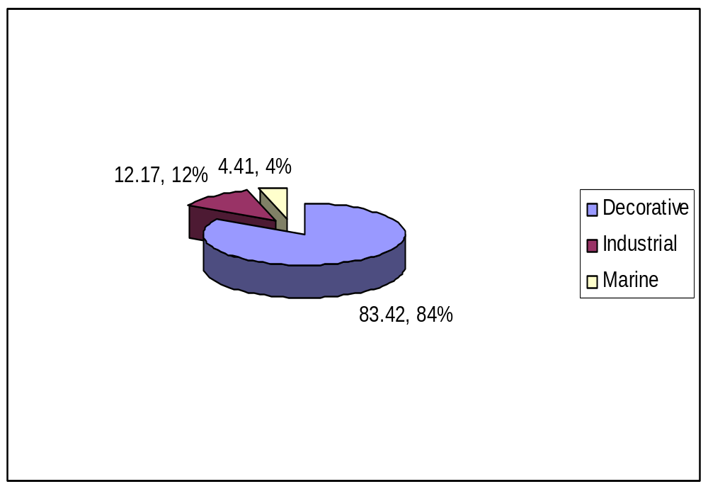

The major focus of the companies, operating in the industry, is towards decorative segment. Only a few of the companies have their product offerings in industrial and marine segment. All the competitors are concentrating their best efforts for carving out their share of the pie in the decorative segment of the industry. The enamel segment accounts for around 50% of the decorative paint market by value and approximately 40% by volume.

Berger market share in the synthetic enamel category is increasing gradually. As this product is accountable for the major share of the paint market, its continued success will result in significant growth of the overall market share of the company. This will also enable Berger to battle its competitors by weakening then in such a strategically important segment.

4.4 Positioning Strategy

Berger designs the company’s offerings and image to occupy distinctive place in the mind of the target market.
For positioning in the mind of the target market Berger has differentiated its variables.

4.4.1 Product differentiation
Product differentiation on the basis of size, shape, color shade, convenient size of their paint container, plastic container and so on. It’s also maintain its better quality product, finest color shade, durable & long lasting paint, and they are also responsible to the customer wants and satisfaction.

4.4.2 Service differentiation

Every company in the service market differentiate their service to be the best service company and capturing most of the market share. Berger differentiates its service comparing to the other competitors. These are

- Ordering ease
- Customer consulting & delivery Service

Ordering ease
Ordering ease of Berger refers to how easy it is for the customer to place an order to the company. So they introduce the online service in case of order. So the customer can order and receive its product without going to market.

Customer consulting & delivery Service

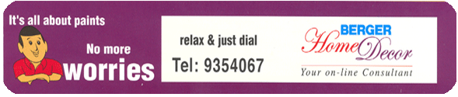

With a view to bolstering consumer satisfaction, Berger Paints Bangladesh Limited has introduced “Berger Home Décor” on June 15, 2002 through which one can get an array of services pertaining to painting.

Berger Home Decor offers two-stage services:
- Free Service
- Paid Service
Berger Home Décor is currently offering wide range of services to its prospects and existing consumers embracing:
4.4.3 Technical advice on surface preparation and application guideline:
- Paint selection.
- Dealer selection.
- Painter/ Contractor selection and
- Color scheme.
There is defined Telephone number, 02-9354067 for queries. By ringing simply in the number one can make query or seek available services from the company. According to the nature of query, the company provides solutions.
4.5 Personnel differentiation
Berger always gain a strong competitive advantage through having better trained people. To recruit personnel Berger follows some strategies that are

- Skill & knowledge.
- Courtesy, friendly.
- Reliability.
- Responsiveness.
- Communicating ability.

4.6 Channel distribution
Berger achieve competitive advantage through the way they design their distribution channels coverage, expertise and performance
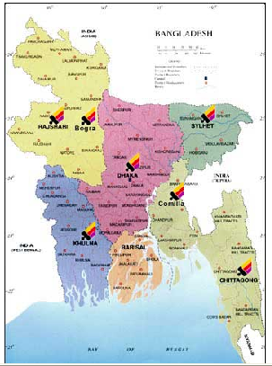
4.7 Distribution of product

With its strong distribution network, Berger has reached almost every corner of Bangladesh. Their nationwide dealer network, supported by seven sales depots strategically located in Dhaka, Chittagong, Rajshahi, khulna, Bogra, Sylhet and Comilla has an unmatched capability of cater to the needs of the consumers of paints products, almost everywhere in Bangladesh

(Special shade
Dhaka factory
Chittagong factory
Dhaka
Depot
Khulna
Depot
Bogra
Depot
Rajshahi
Depot
Chittagong
Depot
Sylhet
Depot
Comilla
Depot
Indirect dealers
Indirect dealers

Indirect dealers

Direct Dealears
Direct Dealears

End
Users
& products)

4.8 Image differentiation
Berger has taken many powerful marketing strategies to build a high image in the market. It has strong slogan and symbols to identify image powerfully.

4.9 Media & sponsorship
Media is the mainstream to built and develop image not in our country but also allover the world. Burger built up its image through advertising, sponsoring different social and cultural activities.

4.10 Social responsibility
Berger paints has been organizing Young Painters; Art Competition for the last nine (9) years and also introduced Young Architects’ Award from 2003. The company regularly contributes to a number of causes and social welfare institutions through donations and sponsorships. These efforts results in a better image for BPBL, as minds of the general public, who are, after all, consumers of their products.

4.11 Quality policy of the company
Burgers objective is to achieve business excellences through quality by understanding, accepting, meeting and exceeding customer expectations. Berger follows international standard on quality management system to ensure consistent quality of product and services to achieve customer satisfaction.

4.12 ISO Quality Policy
Berger Paints Bangladesh Limited is committed to achieving total consumer satisfaction. They commit to project themselves as an ethical and socially responsible company. Berger commits to continue as the market leader through consistent sales growth, increasing productivity and developing new products befitting consumer needs. It shall ensure continual improvement in their operations through utilization of highly professional and dedicated team, proper process management and participation of stakeholders. Berger will set measurable targets at appropriate stages and shall continuously monitor them.

4.13 Environment strategies of Berger for marketing

Berger is committed to main etingtain the harmonious balance of our eco system and therefore constantly seeks ways to manufacture and produce products in an eco friendly manner. From its inception, Berger has played a pioneering role in introducing new paint and paint technologies to the Bangladeshi market; Berger’s efforts have established it as the most esteemed paint company of the country and have contributed significantly in its growth. Berger intends to continue its ceaseless endeavors in the future years, and it is expected that such efforts will contribute immensely to the sustained and growing success of the company’s business.

4.14 Technology orientation:
Berger has always been the most technology oriented paint company of the country. It has the most modern state-of-the-art production facilities installed in its Dhaka factory. Its Research and Development (R&D) and Quality Control (QC) departments are equipped with the best technologies in this country. Such technolo0gy driven strategy will definitely assist the future business growth of the company.
4.15 Market responsiveness:
Berger has always tried to respond promptly to market feedback. AS a result, Berger enjoys competitive advantage over its competitors. It is expected that Berger will enjoy more growth in the future, if it continues to be so be market responsive.

4.16 Social Commitment
The 9th term of Berger Young Painters' Art Competition has been completed successfully in 2004 .We are encouraged to see the increasing level of enthusiasm among the young painters. This year also, a large number of participants took part in this nationwide Art Competition.
Berger has always been a responsible corporate citizen. This unique Art Competition is one of the examples of Berger's social commitment as a responsible corporate citizen.
Like previous year, in line with our convention of showcasing the best six paintings, we present before you the paintings of the award winners of 2004 competition. The top six winners of this year are Selina Haque Lina, Mohammad Imran Ali, Pintu Chandra Deb, Dip Narayan Biswas, Touhin Hasan and Shahida Begum.
The Jury Committee for the competition comprised of Prof. Qayum Chowdhury, Prof. Hashem Khan, Prof. Rafiqun Nabi, Prof. Abdus Sattar, Prof. Abdus Shakoor Shah, Associate Prof. Jamal Ahmed and Asst. Prof. Shishir Bhattacharjee.
Berger Paints Bangladesh Limited had also organized an exhibition with the top 40 paintings, at the Zainul Art Gallery of Institute of Fine Arts University of Dhaka.

4.17 Pricing strategies
The fierce competition has also made the industry highly price competitive. Most of the competitors consider pricing as one of the major marketing tools.

The price strategy of Berger is to offer a high quality product at a competitive price. They set its price in relation to the value delivered and perceive by the customer. Because it believes that if the price is higher than the value perceived, the company will miss potential profits and if the price is lower than the value received the company will fail to harvest potential profits.

5. Findings and Analysis

5.1 Analysis

SWOT Analysis

To formulate the marketing & overall strategy of Berger paints Bangladesh limited,(BPBL) the management 1st analyze their mission and objective and then use the steps of SWOT analysis to find out the strength, weakness, opportunities and threats and then find out the main strategies for the company.

Strength
- Strong brand image.
- Good reputation among customers
- Experienced top management.
- Global experienced of Berger.
- Cost advantage from proprietary know-how.
- Favorable access to distribution network
- Strong market share.
- Good profitability.
- Strong solvency.
- Satisfactory MIS.

Weakness
- Exposed of currency risk.
- High cost structure
- Lack of access to the best natural resources
- Lack of access to key distribution channels
- High cost for importing raw materials

Opportunities
- Increasing demand on paints.
- An unfulfilled customer need in some cases
- Arrival of new technology
- Loosening of regulations
- Removal of international trade barriers
- A developing market such as the internet
- A new international market

Threats

- Shifts in consumer tastes away from the firm's products.
- Emergence of substitute products.
- New regulations.

- Increased trade barriers.
- A new competitor in your home market.
- Price wars with competitors.
- A competitor has a new, innovative product or service.
- Competitors have superior access to channels of distribution.
- Taxation is introduced on your product or service.

The SWOT Matrix
A firm should not necessarily pursue the more lucrative opportunities. Rather, it may have a better chance at developing a competitive advantage by identifying a fit between the firm's strengths and upcoming opportunities. In some cases, the firm can overcome a weakness in order to prepare itself to pursue a compelling opportunity.
To develop strategies that take into account the SWOT profile, a matrix of these factors can be constructed. The SWOT matrix (also known as a TOWS Matrix) is shown below:
 | Strengths | Weaknesses
Opportunities | S-O strategies | W-O strategies
Threats | S-T strategies | W-T strategies
• S-O strategies pursue opportunities that are a good fit to the company's strengths.
• W-O strategies overcome weaknesses to pursue opportunities.
• S-T strategies identify ways that the firm can use its strengths to reduce its vulnerability to external threats.
• W-T strategies establish a defensive plan to prevent the firm's weaknesses from making it highly susceptible to external threats.

Sales Analysis

The Sales achieved during the financial year ended 31st December 2009 was 3480.20 million as against Tk 3065.50 million in the previous year showing a growth of 23.05%. The profit after tax at Tk 227.12 million marked a growth of 4.93%. However, due to abnormal inflation of raw materials prices, progressive devaluation of the taka and intensive competition in the market, desired profit could not be achieved.
The company improved its overall market share due to strong brand pull form consumers, continued support from the distribution network as well as projects. The growth in the building construction resulting in a growth in the use of Exterior Emulsion paint, as opposed to the conventional cement paint. Moreover the innovative marketing strategies during 2008 i.e., Berger Home Décor the one stop paint solution together with color consultancy, the launch of ‘Berger Illusions’ range of design coatings, as well as ‘ Robbialac Easy Clean’. Emulsion paint has provided the consumers with unique coatings resulting in improvement in life style.

Monthly sales in different product of BPBL

Division | Daily sales | Monthly sales
Colorant | 64390 | 3,075,379.20
Decorative | 14,412,758.05 | 226,623,218.50
Durocem | 1,107,778.60 | 22,637,121.55
Industrial | 472,934.05 | 19,094,378.84
Marine | 985,926.95 | 19,375,401.79
Suprakoat | 69,368.00 | 5,975,928.00
Total | 17,113,153.65 | 296,781,425.39

Source: Primary data
Performances over the last five years and value added statement of Berger paints Bangladesh Ltd have shown below with tables and graphical presentation

Particulars | 2009 | 2008 | 2007 | 2006 | 2005
Turnover | 3480.2 | 3065.65 | 2410.1 | 2121.12 | 1737.64
Value Added Tax (VAT) | 370,540 | 331,210 | 285,903 | 274,084 | 216,730
Turnover (Net off VAT) | 2,645,210 | 2,347,650 | 2,154,652 | 1,847,032 | 1,520,907
Gross Profit | 810,549 | 779,689 | 754,210 | 729,092 | 693,710
Profit Before Tax | 492,212 | 440,587 | 399,045 | 360,521 | 316,020
Profit After Tax | 271,121 | 259,450 | 240,540 | 227,120 | 216,448

Source: Secondary data

Sales Volume in Current year:

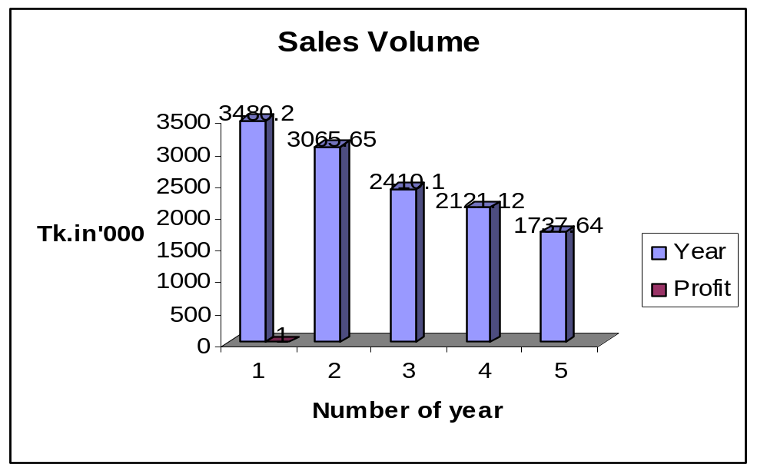

Turnover of BPBL for the last five years

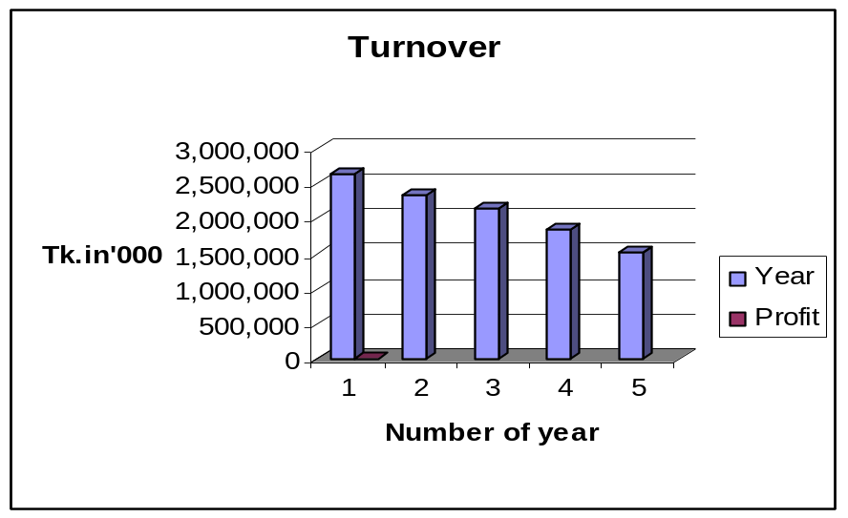

Trend of Profit after Tax of BPBL

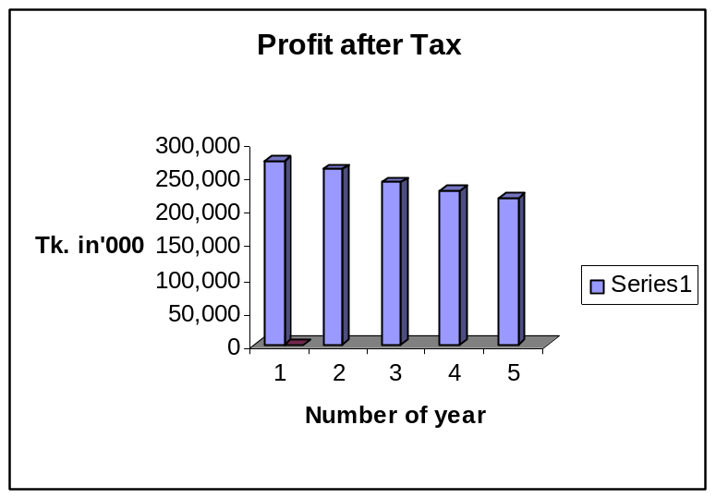

MARKET SHARE

Market share studies determine the proportion of total sales received by a company and its competitors.
A term used frequently in business as a performance measure, market share is the proportion of total sales of a product during a stated person in a specific market that is captured by a single firm. Market share can refer to entire industries, segment of industries or particular geographic areas and can also apply to past, present, or future periods.

MARKET SHARE 2009
The following table shows the market share of Decorative paints in Dhaka city for the year 2008,

Companies | Value sales (%)
Berger | 55.40
Asian | 17.20
Roxy | 5.90
Pailac | 3.40
Elite | 7.90
Aqua | 1.33
Romana | 3.54
Uzala | 0.80
Others | 4.53
Total | 100

Source: Secondary data

In 2009, Berger paints held 55.4% of market share in Dhaka city whereas the second largest market share was occupied by Asian paints with 17.20%.Elite paint possessed the third largest market share 7.90% where Roxy paint held the fourth position with 5.9% market share. Romana and Pailac possessed consecutively 3.94% and 3.40%of the market share. Other paints like as Polac, Dunkun, paramax, Bengal Agency, Nazrul Brothers paint, Imperial, Navana etc Held 4.53% of the paint market share.

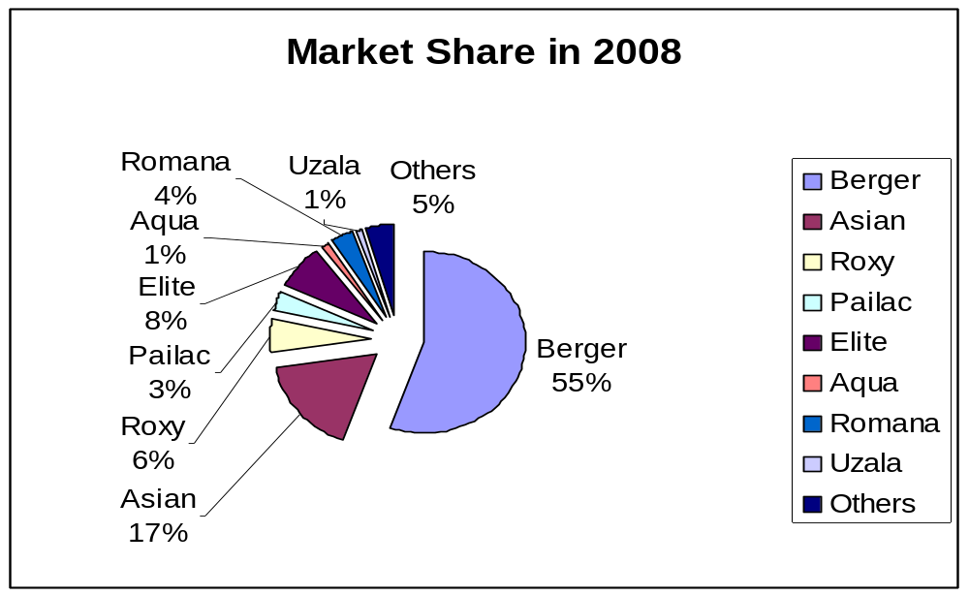 Source: Secondary data

Outcomes:
- Berger paints possessed the leading position in paints market.
- Asian paints possessed the second position.
- Elite paints held third highest market share.
- Roxy paints acquired fourth position of the paints market.

PRODUCT BASIS MARKET SHARE, 2009

Enamel

Almost every company has two category of enamel – premium and economy had already mentioned earlier. Berger paints premium enamel is Robbialac Superglues Synthetic Enamel and Economy Jhilik. Asian paints premium enamel is Apcolite Synthetic Enamel and Economy is Decora. Generally the sales of Enamel are comparatively high in comparison to the other category of product irrespective of areas.

The following table shows the market share of Enamel-

Companies | Value Sales %
Berger | 44.60
Asian | 19.20
Roxy | 15.23
Pailac | 9.80
Elite | 3.20
Romana | 3.54
Uzala | .90
Others | 3.53
Total | 100

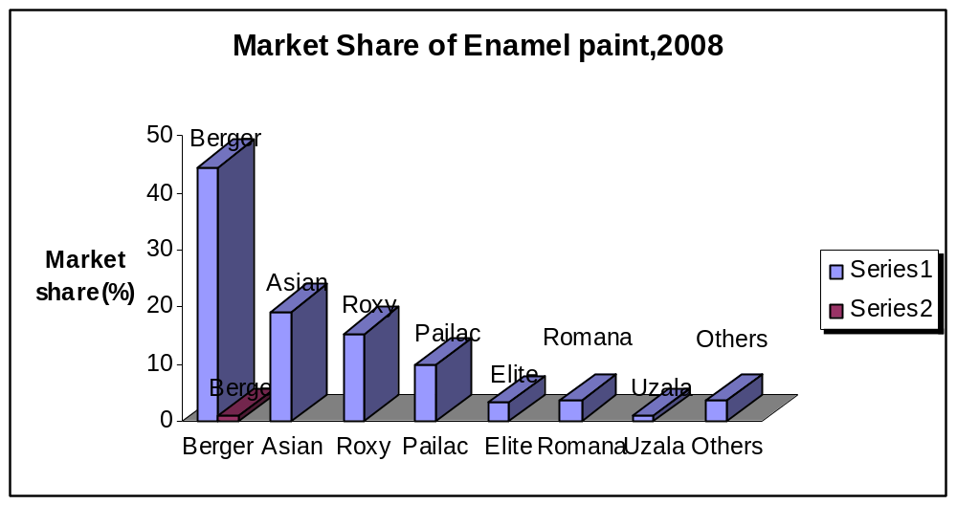

PLASTIC EMULSION

Plastic Emulsion is comparatively higher priced interior emulsion.Generally the areas where constructions are raising and, plastic Emulsion are highly demanded in these areas. It is also more demanded in higher class societies. Different companies try to different product by making it luxury, washable, and vast range of color.

The following table shows the market share of Plastic emulsion-

Companies | Value Sales %
Berger | 40.5
Asian | 20.30
Roxy | 15.21
Pailac | 9.80
Elite | 5.65
Romana | 3.54
Uzala | 1.15
Others | 3.85
Total | 100

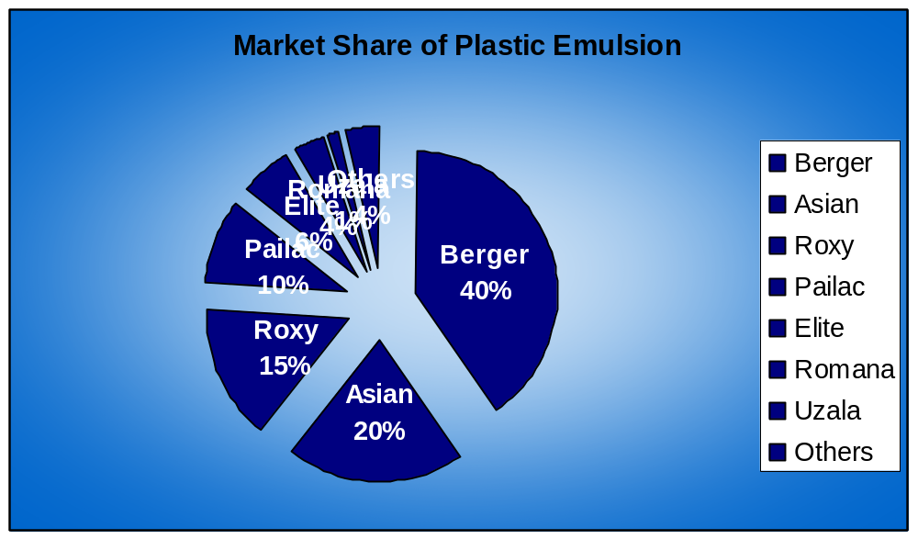

DISTEMPER

Distemper is lower price but higher volume sales product. Generally upper lower class and middle class societies highly require distemper. All most all companies have distemper. Distemper is highly demanded hole Dhaka city.

The following table shows the market share of Distemper-

Companies | Value Sales %
Berger | 59.60
Asian | 12.32
Roxy | 8.3
Pailac | 6.30
Elite | 4.56
Romana | 2.2
Uzala | 1.15
Others | 5.56
Total | 99.96

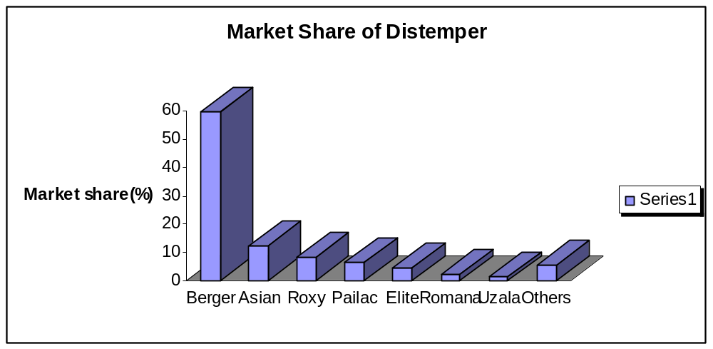

EXTERIOR LIQUID

Exterior liquid is higher quality exterior emulsion. Exterior liquid are introduced in the market in different brand names. Berger paints exterior liquid are Weather Coat Classic and weather Coat Long Life. It is highly demanded on VIP area in Dhaka city.

The following table shows the market share of Exterior liquid-

Companies | Value Sales %
Berger | 45.6
Asian | 30.2
Roxy | 8.30
Pailac | 2.32
Elite | 4
Romana | 2.2
Uzala | 1.15
Others | 6.2
Total | 99.95

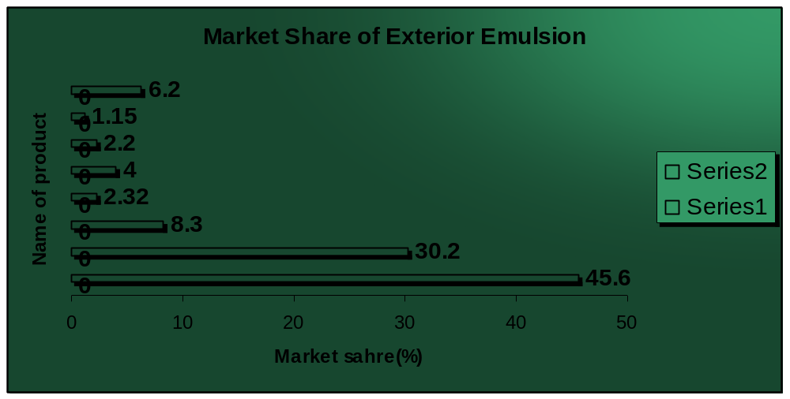

CEMENT PAINT

Cement paint affords a hard, durable and waterproof surface. Cement paints are introduced in the market in different brand names. Berger’s paints Cement paint is Durocem, Asian paint cement os Decora, Elite paint’s Cement paint is Elitecem, Bengle agency’s cement paint is Snowcem etc. It almost all areas in Dhaka city, this product are highly required.

The following table shows the market share of Cement-

Companies | Value Sales %
Berger | 55.5
Asian | 24.20
Roxy | 6.32
Pailac | 2.32
Elite | 2.2
Romana | 1.8
Uzala | 1.45
Others | 6.20
Total | 100

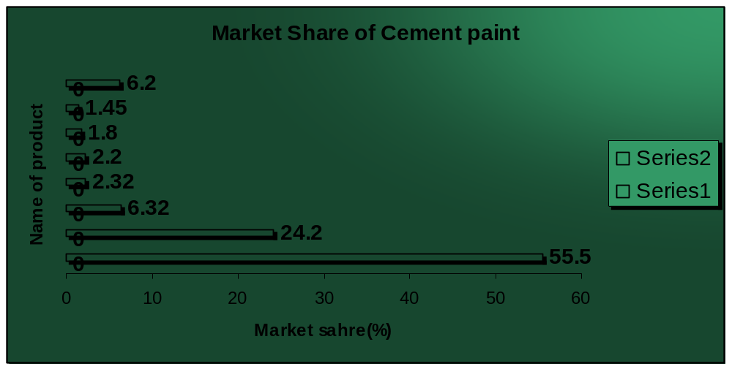

5.2 FINDINGS OF THE STUDY

The survey has been conducted on 120 traders of paints. In this survey it is tried to cover the Dhaka City to get the real picture. After processing the gather information I can draw the followings findings.

- As it is found that 45% dealers order for Robbialac Acrylic Plastic Emulsion and 55%
Of the total sales the other products.
- Average monthly sales of the Dhaka sales office are 45 core liters. But monthly
Production capacities of the Saver factory are 40 core liters. Besides majority portion
Of the dealers claim that they receive about half of their total order. So it can be said
that production capacity of the factory fails to meet the dealers demand.
- Most of the dealer agreed that customer usually switch to competitors products due to
Supply shortage and lengthen delivery system. Customers mostly switch to Asian
Paints, Elite paints and Roxy paints as these companies also offer almost similar shades
. So to Some extent Berger paints faces sales loss for other product.
- Cent percent dealer’s claims that they are dissatisfy with the product only for shortage
Of supply and lengthen delivery process.
- The main reason behind increase the market share of Berger Paints is its high quality
Products, well established customer loyalty, comparative organized structure of
Management, marketing, sales, distribution.
- In, 2009 Berger paints also possesses it leading position and its market share increase
to 62%.
- In, 2009 Asian paints possesses second largest market share and increase there position.
- Asian paints is very much promising because of its better quality, good competitive
Strategies, well market analysis well established communication, frequent dealer visit
Some time this is more than that of Berger paints.
- Berger paints can take the Asian paints as their largest competitor because Berger
Paints Started its business in Bangladesh since Independence where as Asian paints
started its Business just before four years. But with in a very short time Asian paints
capture it’s Market place with competitive strategies.
- Berger Paints with in a very short time create more dealers of their own with liberal
credit policies, providing more profit to dealers, providing more discounts facilities etc.
- In, 2009 Elite paint has possessed the third position in paints market.
- Though Elite paint has popularity in market for better quality with comparative lower
Price, but it management, sales and distribution procedure is not structured. So any time
It may lose its current market share.
- In, 2009 Roxy paints held the fourth position in the paints market.
- Recently Roxy has taken aggressive to serve the market. It has totally redesigned its
management, sales, distribution, and also human resource.
- Though in 2009, Romana paints possessed fifth position in the paint market.

Though it has great brand image, it will have to be struggled in the paints market because of its huge bad debts.

6.1 Conclusion

Berger Prints Bangladesh ltd is the market leader of paint industry having about 40% shares. The company has strong distribution network all over the country. It has more than 1000 direct dealers. In addition, numerous secondary dealers operating in the outskirts of the major markets are engaged in selling the products of the company. BPBL introduced many new products into the market like exterior emulsion, silk emulsion, readymade wall putty etc. it first introduced Color Bank back in 1998, which enabled the customers to choose his desired shades from an exclusive array of over 5,000 shades. It also introduces home décor service. It has good brand image. Berger has been trying to increase its brand image further through more media presence, arranging programmers like Berger Young Painters are competition, Berger Young architects award, scholarship program for architecture students of BUET. It is constantly working to improve its products quality through comparative study and customer feedback in order to maintain competitive edge.

6.2 Recommendation

By reviewing report it can be recommended that:

- The company should find out new sector.
- Reduce dependence on special brand as decorative.
- They should expand their sales depot countrywide.
- They should deal more with construction firm.
- It should always pay heed to the dealers growth rate, take initiative to recover gap and always monitor their activities.
- Berger paint should restructure its sales system. Its can restructured through employing more salesperson, improving it’s delivery system, enrich end-user activities, frequent market visit and better communication with distribution.
- Its general sales procedures like taking order, preparing invoice, categorization of invoice, Preparing rout plan, lining products for loading of vehicles should be automated.
- Safety stocks should be maintained in the product to ensure the instant delivery against Customers demand regarding the products.

