Internship Report
On
“Marketing Strategy of Spa Drinking Water”

Submitted by
WWW.ASSIGNMENTPOINT.COM

Modern, business is very much complex because of even changing customer choice, preference, taste etc, and for the technological and high competition. As globalization is on the competition is spread an over the world. Therefore, every organization should be international standard. Every company or firm wants to make his or her loyal customer group. Each firm would like to gain maximum profit through consumer's satisfaction. Today, each company has to face so much competition. To perform all marketing tasks marketer are to faces. Two types of environment, one is macro or external, and another is micro or internal environment.
We know that Mineral Drinking Water is an existing consumes goods. It is classified as shopping goods. People usually drink water for removing thirsty the refreshment and to reduce tiredness. In all seasons, mineral water is widely consumed by the customers. Nevertheless, the demand becomes high in the summer. There is a wide demand and high prospects for the Mineral Drinking Water. SPA Mineral Drinking Water is one of the items to meet this demand and building new demand and features in the consumers’ mind by eliminating thirsty.
This study tries to focus on marketing strategy of SPA Mineral Drinking Water. It has become one of the popular brands in Bangladesh and trying to capture major market share.
It is manufactured and marketed by “AKIJ FOOD AND BEVERAGE LIMITED” from AKIJ GROUP of INDUSTRY. SPA Mineral Drinking Water is selling mainly local market all over Bangladesh.
In spite of few problems, there is increasing demand for SPA Mineral Drinking Water all over the country. Therefore, we can say that SPA Mineral Drinking Water has a bright prospect in the country. Therefore, company should take correction action for the fulfillment of the target of drinking mineral water products of AFBL.

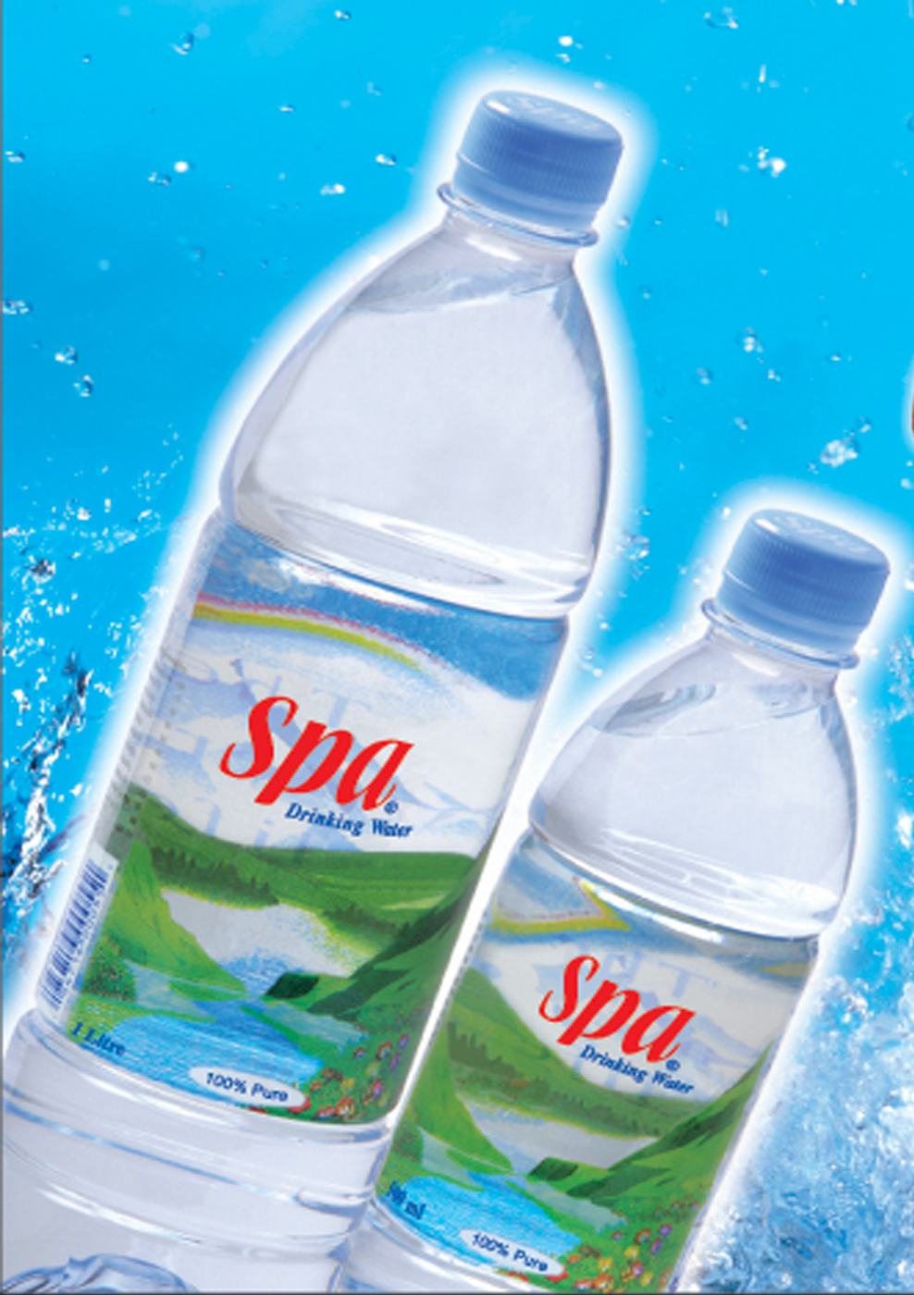

1.2 Importance

We know SPA Mineral Drinking Water is a well-known brand in Mineral Drinking Water industry within Bangladesh. The demand as well as the sales volume of SPA Mineral Drinking Water is increasing rapidly day by day.
Marketing is the key point of the business activities that direct the flow of goods and services from producer to customer or user in order to satisfy customer and accomplish the company’s objectives. In order to achieve the customer satisfaction, product must be available in the right form, at the right time, in the right place.
The importance of this study is to analyze the marketing strategy of SPA Mineral Drinking Water as well as identify the real problems and what method should be used in order to overcome those problems. There is much higher demand for locally produced SPA Mineral Drinking Water in the country than present domestic supply. Bangladesh is not self sufficient in SPA Mineral Drinking Water product production. We see that there is frequent shortage of Mineral Drinking Water product is our local market. As a result, the customers of SPA Mineral Drinking Water are facing a lot of trouble. There are some problems in the distribution of SPA Mineral Drinking Water. The demand of SPA Mineral Drinking Water is not stable in Bangladesh. There is only one way of SPA Mineral Drinking Water supply in Bangladesh, which is Domestic production. But they are trying to export it.
The prime objective behind the creation of SPA Mineral Drinking Water industry was to ensure the steady supply SPA Mineral Drinking Water and to make it easily available to the customers when they need at the lower possible price.
Although Bangladesh has a favorable condition for the growth of SPA Mineral Drinking Water, yet it is not rich in production due to absence of modem machineries. The distribution system is not developed with respect to the market demand. The price of SPA Mineral Drinking Water is determined by the market forces. In case of distribution, many irregularities come out due to lack of marketing management concept. Weak marketing system is responsible for this kind of error.
However, very few research works have been accomplished in the area of SPA Mineral Drinking Water particularly on Mineral Drinking Water marketing. Although this work is not providing a specific guideline to overcome the current problems of SPA, but I think this report will be helpful for the marketers, the customers and the policy makers who are directly involved in the formulation of the marketing strategy of SPA Mineral Drinking Water. Finally a contemporary marketing strategy is proposed to overcome the current and prospective marketing problems of SPA Mineral Drinking Water and to develop a marketing plan.

Water for Life

The importance of water in human health cannot be overemphasized. There is not a more important element needed by the body, which must constantly be replaced throughout each day. Not providing your body with adequate amounts of water can be devastating to your health. A rule of thumb for water is that the body needs a minimum of half your weight in ounces everyday. (Example: If you weigh 150 lb., you need 75 ounces of water per day.) The need for water is summed up best by the following: "Chronic cellular dehydration painfully and prematurely kills.
Ionized water (or alkaline water) is one of the greatest preventative health advances and technological marvels of the 20th century, yet it has gone almost entirely unnoticed. Ionized water is a powerful Antioxidant providing the body with tremendous amounts of oxygen and therefore lots of energy. It is very alkaline and helps neutralize and flush acid waste from the body, which can encourage disease. It is a superior hydrator and detoxifier because Ionized Water molecule clusters have been "reduced" in size (from 10 to 5) and therefore is "lighter". Ionized Water's smaller size allows it to hydrate your body more effectively, pushing out toxins as it easily passes through your body's tissue.

Natural Mineral Water VS Spring Water
Spring Water is bottled water which does not conform to the Natural Mineral Water Regulations, but which must meet the 'Tap Waters Regulations' at the time of sale. Under EEC Regulations Spring Water must conform to the same criteria as Natural Mineral Water with one important exception, Spring waters do not have to prove a consistent mineral content. However, under current UK law, spring waters may also be treated.
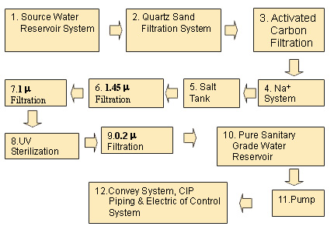
figure 1: Process of producing Mineral water.

1.3 Background of AFBL

Akij Food and Beverage Ltd.
“Brings Quality in Life.”

History of Akij Group stretches back to later part of the forties. In its infancy, the Group started in humble way with jute trading which was known as the golden fiber of the country, earning highest amount of foreign exchange.

1.3 Background of the Company:

Akij Group's ceaseless efforts with dynamic management and support from our numerous clients have led our Group in diversifying its business activities. In the second phase, the Group went into manufacturing handmade cigarettes popularly known as bides. This sector gave a real boost to the revenue earning of the Group as well as making a substantial contribution to government exchequer. With the passage of time, the Group undertook new ventures and presently there are 15 units of industries under its umbrella like cigarettes, handmade cigarettes, printing & packaging, textiles, hand board, pharmaceutical, leather processing and real-estate business are in operation, catering jobs for more that 32,000 people in various categories.

The Group has plans for setting up more projects. The projects are already in pipeline. Foreign investors have shown keen interest in joining with us for joint ventures. The matter is under our active consideration and will hopefully soon mature. This will also help the nation's economy growth and will create job opportunities to various professionals.

Akij Group is also involved in socio-cultural activities. The Group has been operating a sizeable orphanage free of charge in district town. The Group has also acquired a modern mother & children hospital previously owned by Save the Children (UK). The hospital is being operated as a non-profitable concern by Ad-Din Welfare Trust.

Akij Corporation Limited
A sister concern of Akij Group, Akij Corporation Limited is the most organized distribution company in the country. Akij Group is country’s one of the leading business conglomerates. Initially Akij Corporation Limited was known as Amin Enterprise and started its operation in 1992. In June 1997 Amin Enterprise was renamed as Aminuddin Enterprise Limited and in 2001 Aminuddin Enterprise Limited was again renamed as Akij Corporation Limited. Akij Corporation Limited is responsible for the marketing and distribution of three industries of Akij Group namely Dhaka Tobacco Industries, Akij Match Factory Limited and Akij Zarda (chewing tobacco) Factory.

Akij Jute Mills Ltd.
AKIJ JUTE MILLS LTD. a unit of Akij Group is a 100% export oriented Jute yarn Industry catering to the need to carpet manufacturers and other end users of jute yarn all over the world. Apart from being a member of a leading industrial group of Bangladesh, the mill is run by a team of qualified and highly experienced professionals whose principle objective is customer satisfaction. In respect of production, the mill is one of the largest in Bangladesh producing about 20,000 Metric Tons of Jute yarn annually. The mill is creating jobs to over 3,000 people most of them are destitute females of the locality.

Akij Match Factory Ltd.
Akij Match Factory Ltd. has been established in the year 1992 at a beautiful site near Muktarpur Ghat on the bank of river Sitalakshaya. It is a fully automatic match factory, which produces 100% Carborized high quality safety matches.
Dolphin is the brand name of the matches produced from this factory. Immediately after the introduction of the brand it became very popular among its consumer because of the high quality and intensive distribution in every nook and corner of the country.
.The river Shityalakhkha flows next to the factory and facilitates transportation greatly. Some of the wood used to make matchsticks comes from Pakistan.
A cutter with a circular saw cuts the logs into 15” portions. The bark is taken off the portions and these are then put through the peeling machine, which peel layers of wood off the log. These layers are chopped into the rough shape and size of matchsticks. As these sticks are usually quite moist, they are dried. Carborization and treatment with other chemicals such as Boric acid occurs at this point. This is to ensure that the matchsticks don’t break when ignited and that their quality is preserved even in highly humid conditions. The chemically treated sticks are polished in two stages to give them uniform proportions.

At every stage, non-standard products (wood layers or sticks) are rejected. However, these are not wasted. The sticks, wood layers and any other scrap wood goes to be recycled in AKIJ Particle and Hardboard Mills. The faults in the rejected matches are dealt with and these are packed manually.
Rotary packers pack the bulk of the matches and these go directly to the market.

Akij Food & Beverage Ltd.
Akij Food & Beverage Ltd. has been established at a beautiful site Krishnapura, Dhamrai of Dhaka. It has come with the best food & beverage in Bangladesh.
There are various types of drink. Mojo is the brand name of cola, Lemu is the brand name of Lemon, and Speed is the brand name of energy drink. Immediately after the introduction of the brand, it became very popular among its consumer because of the high quality and intensive distribution in every nook and corner of the country.
Cheeky Monkey is the brand name of banana chips produced from this factory. It also is becoming popular chips in Bangladesh.
Most of our Raw materials come from various foreign countries. The quality is very strictly controlled. At every stage, non-standard products are rejected.

Dhaka Tobacco Industries
Dhaka Tobacco Industries came to the fold of Akij Group in late seventies when Government has decided to disinvest and hand over the Factory to private sector from the nationalised sector.
The Factory is located at Morkun near Tongi and lot of investment into MEN & Machineries has turned the Factory in to a Modern cigarette-producing unit. It employs about 1,200 people who work in a congenial atmosphere to deliver right quality to satisfy the million of Smokers’ taste and needs.
Currently, Dhaka Tobacco industries produces eight brands of cigarettes. These are Navy, Legend White, Five Star, Red & White, K2, Surma and Diamond. Approximately one billion cigarettes are produced per month by the company’s factory in Tongi, Gazipur.One hundred million of the Navy brand are exported quality and are sold in Dubai.
In storage, the tobacco is kept in air-conditioned and moisture controlled rooms where its perfection can be maintained for up to two years.The bales of processed tobacco are sliced in uniform sizes and ground. This is stored in the blending silos in specific ratios. The tobacco (lamina) is moistened, cut, and dried.

Some of the excess stem produced in National Leaf is also used. It is fed into a conditioner using auto feed. Then, it is cooled and stored in silos to be processed further when necessary. A stem roller is used to flatten the stem so that it is ready to be cut first by the cutter and then by a millicutter. It is moistened using steam in low pressure and dried to attain the desired level of humidity. At this point the lamina and stem come together in the mixing cylinder where chemicals are added. There are different silos for each blend and the cut tobacco is stored in these. Four Rotary feeders are involved in transporting this to the secondary manufacturing department.
A Molin’s Plug making machine makes filters. The filter making machine is capable of making plugs of different length and dia. There are cigarette making machines of various brands and speeds. Recently, the company has invested in Molmac Mark 9 machines. They are equipped with a system to remove ferrous material and stems from the tobacco supplied to the machine. In addition, there is an automatic system of weight and density control to maintain uniformity.
Focke Hinge Lid Packers are used for packing cigarettes. Quality Test Module is used to test the circumference of cigarettes and filters using a laser mike head, the total ventilation with closed ventilation zone and the pressure drop in cigarettes is a completely encapsulated condition. The percentage of moisture, nicotine, and sugar in various blends is found using the Infralab TM Gauge. A Tobacco Oven determines the total oven volatile content of tobacco and stems. There are varieties of other installations to measure both physical and chemical properties, with the most impressive being a latest smoking machine.
The machines run around the clock except on Friday when most of the maintenance work is done. The well-disciplined environment and efficiency of this factory has caused man multinational companies to offer us deal to manufacture their product in order to supply the subcontinent.

Akij Textile Mills Ltd.
Akij Textile Mills Limited (ATML) is a sister concern of Akij Group. Since 1998, Akij Textile has been operating its business by supplying excellent quality Yarn primarily in the export market. The yarns produced by ATML are sold to the export oriented knit & woven garments industry. ATML’s production capacity is around 50 tons per day - 25 tons combed & carded from Ring Spinning, 20 tons from Schlafhorst Autocoro & 5 tons from BD Rotors. The mill can produce all yarn counts from Ne 6/1 to Ne 100/1. The counts mostly being produced are Ne 20/1 to Ne 40/1 combed & carded 100% cotton yarn from Ring Spinning, Ne 6/1 to Ne 26/1 from Schlafhorst Autocoro machine and Ne 7/1 to Ne 16/1 from BD Rotors. The blow rooms are equipped with Vision Shields – foreign fiber (contamination) detectors. From the process of bale breaking to the packaging of yarn, everything is done with automation & state -of - the -art- technology.Quality is of utmost significance and is therefore very carefully controlled.

Beside other routine equipment to measure various properties of the cotton, sliver, and yarn, the lab is equipped with a H.V.1 spectrum. It is used to check the suitability of the cotton from each bale and according to the results; the bale would either be accepted or rejected. The software in the machine is able to select the bales, which do not meet the set standards and compile a list of them automatically. The Uster T4 is used to test sliver, roving, and yarn. It measures thickness variation per kilometer. Frequent samples are taken and tested meticulously. The level of computerization of the machines on the factory floor also mean that their performance can be monitored from the lab.

Akij Particle Board Mills Ltd.
Akij Particle & Hard Board Mills Ltd. has come with the best particleboard in Bangladesh. It started business in the year 2001 & already she has created a place in the market for improved quality.
The factory is situated at Torraghat in Manikgonj District on the bank of the river Kaliganga. Akij Particle Board is a Timber substitute three-layer board made of wood chips. The objective is to produce and supply international standard Particleboard to meet the demand of Architect, Interior Designers & Furniture Manufacturers in the country. With the guidance of Honorable M.D. Sheikh Akij Uddin, Akij Particle & Hard Board Mills Ltd. will maintain quality and better service to satisfy her valued customers and users.
Due to the high levels of humidity in Bangladesh, wood is not a long lasting building material unless it is of the best quality and is excellently treated. However, good quality wood is very expensive and often acquired through the illegal eradication of forests, which has led to many species becoming scarce. The rate at which objects made of wood need to be replaced is greater than the rate at which most trees grow. Particleboards are longer lasting, less expensive, and greener alternative of wood. A lot of the scrap wood produced by various factories in the group is recycled to be particleboards.
Akij Printing & Packaging Ltd.
APPL is one of the biggest printing & packages in Bangladesh. The most modern and sophisticated technology of APPL have ensured our high quality printing and packaging including the best quality wide format digital printing system in Bangladesh. Situated in Tongi and Navaran, two factories provide almost all the packaging required by the group. Besides this, they also provide packaging for other companies.
The paper needs to be slit and trimmed before printing. Goebel Optima 2000 are multiple slitters; they are able to work with paper, board, and film.
There are various types of printing machines. The Heidelberg Speed master CD102 does four-colour offset printing. It is capable of printing 45,000 impressions per shift. There is

a Gravure 7 color-printing machine capable of printing 150 m per minute. Some of the ‘stations’ may be shut off to enable images of smaller numbers of color to be printed with this machine.
The printed media are then cut to the appropriate sizes by easily programmable machines. These then go through the folding and gluing process. There are wet and dry laminating machines for waterproof packaging. These factories are engaged in advertising and not only printing posters. A state of the art new printing machine is able to print front-lit, back-lit and other types of signs on a variety of media.
Akij Zarda (Chewing Tobacco) Factory Limited:
Akij Zarda Factory Ltd. is producing 4 different types of Zarda to full fill the needs of different consumers in diversified taste. Different types of Zarda produced by AZFL are as follows: 1) Special Patti (99): Pack Size - a) 50gm b) 25gm c) 12.5gm, 2) Golden Patti (Surovi) (55): Pack Size - a) 50gm b) 25gm c) 12.5gm, 3) Akiz Zorda (Beli) (44): Pack Size - a) 50gm b) 25gm c) 12.5gm and 4) Vhiza Patti (33): Pack Size - a) 25gm b) 10gm.

Export:
For outstanding performance in export, the company achieved “The National Export Trophy-2001 (Gold)” for Navy Special Filter Cigarette export and “The National Export Trophy (Silver)” for hand made cigarette (popularly known as bidi) export as well as a pioneer employment provider with employment strength of 60,000 staff and officer in different categories.
Marketing:
Government ban on tobacco and anti tobacco campaign has induced our marketing team to become innovative in their marketing strategies. Marketing operations at Akij Corporation Ltd. includes a range of activities like Brand Management, Trade Marketing and Distribution and Marketing Research.
Human Resource:
The Human Resource department is responsible for developing and sustaining a workforce for Akij Corporation Ltd. There is separate HRD wing for ACL for running day-to-day administrative work of Marketing Department.

Product of AFBL
The recent launching of the Akij Groups beverage line has been gaining popularity among all carbonated water lovers. It gained popularity particularly among teenage people and children. Presently the company able to introduce new types of product, which increase the depth of the category of AFBL. Akij food &Beverage limited started there journey officially on July 2006 with three products but now the company gives the products, which are offering, below:
Product  Category | Brand Name | Size
Cola | MOJO | 150ml can, 250ml pet and can,  500ml pet, 1-liter pet, 2-liter pet.
Cloudy Lemon | Lemu | 150ml can, 250ml pet and can,  500ml pet, 1-liter pet, 2-liter pet.
Clear Lemon | Clemon | 250ml pet and can 500ml pet, 1-liter pet, and 2-liter pet.
Energy Drink | Speed | 250ml pet and can
Mineral Water | Spa | 500ml pet, 1 liter pet, 2 liter pet
Juice | Frutika (Mango, Red grape, Red orange) | 250ml pet, 1 liter.
Milk | Farm Fresh UHT milk | ½ - liter tetra pack.
Malt Beverage | Wild Brew | 250ml can.
Snacks | Cheeky Monkey | 15 and 30 gm Foil pack.
Snacks | Cheese Puffs | 15 and 30 gm Foil pack.
Snacks | O’ Potato  (vegetable masala, Magic masala) | 15 and 30 gm Foil pack.

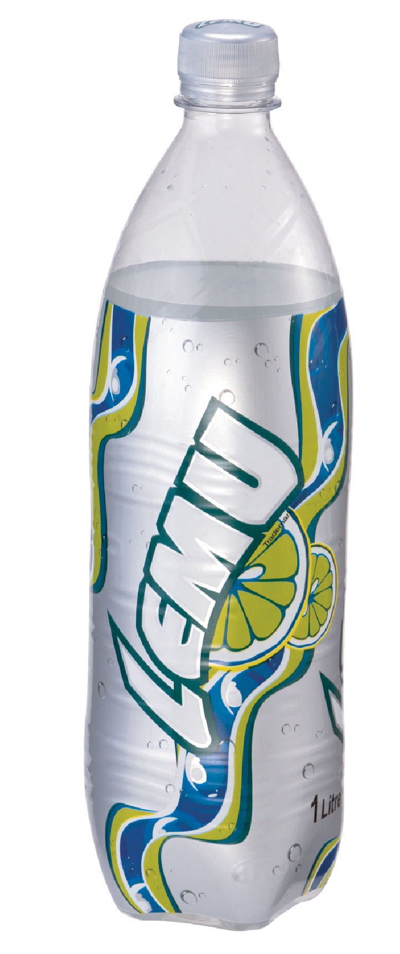
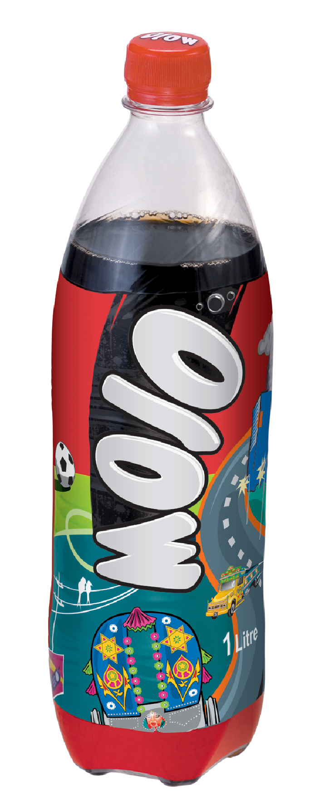
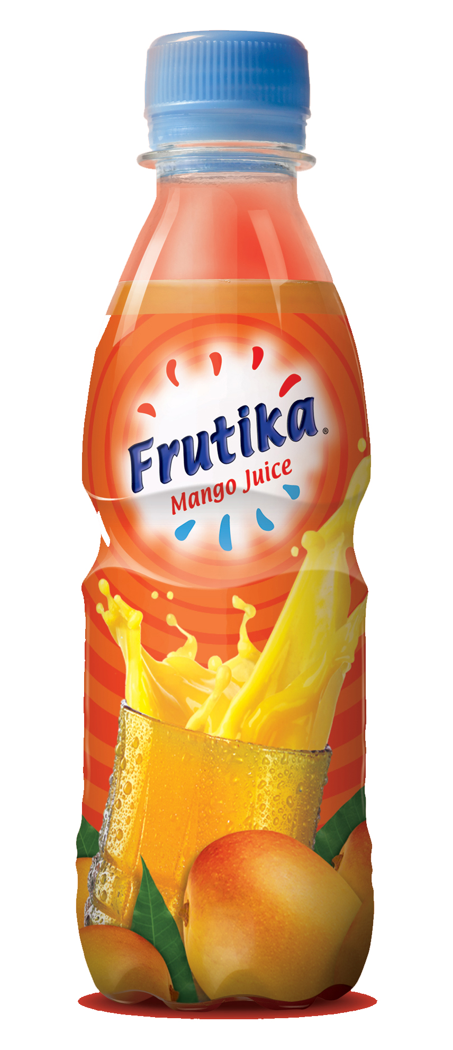
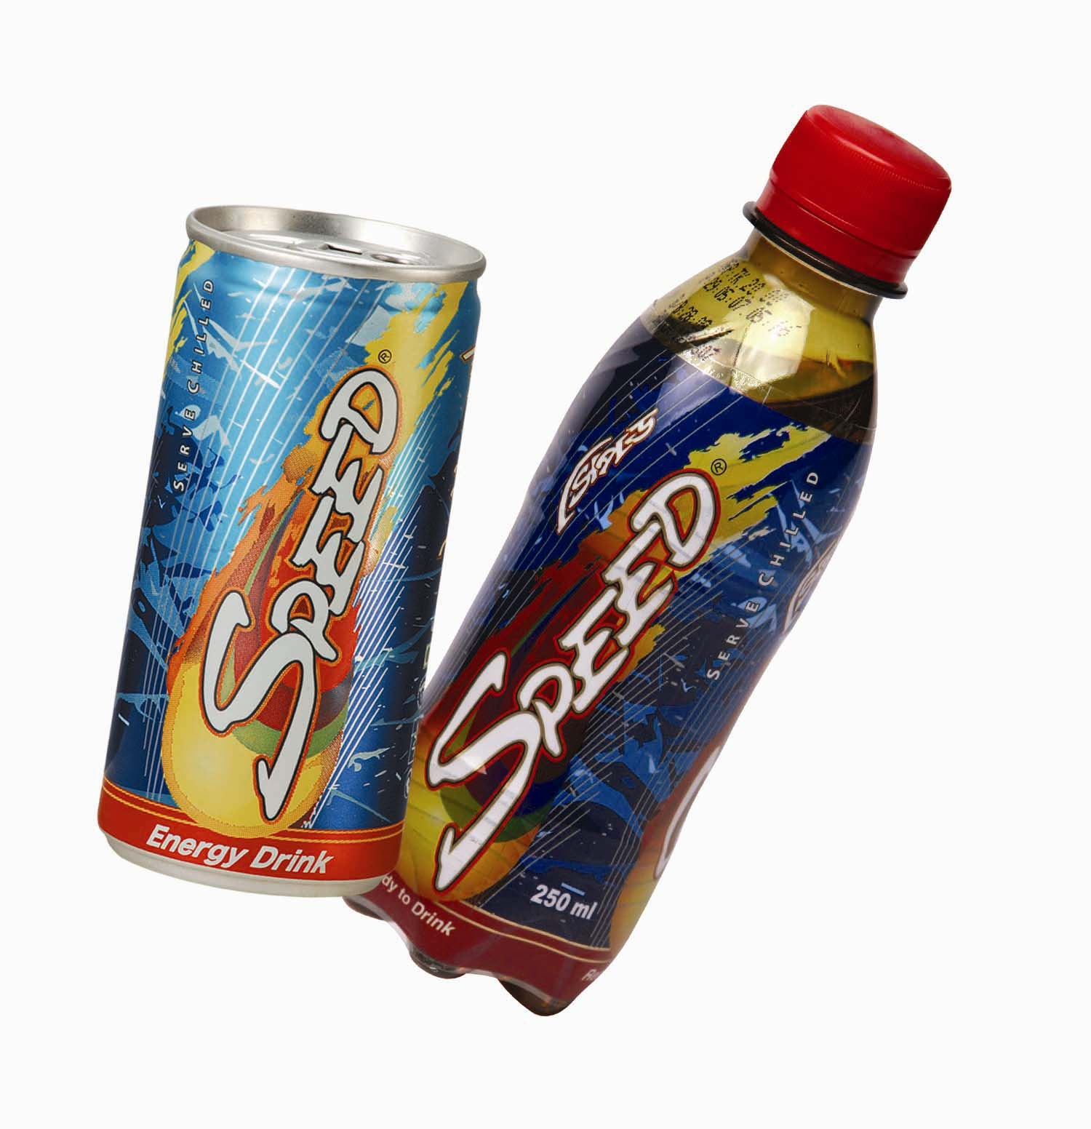

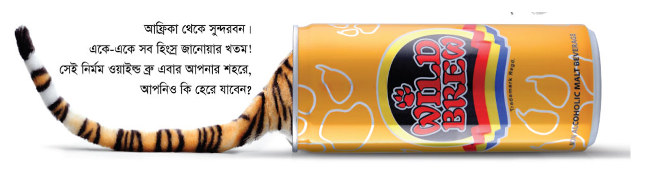

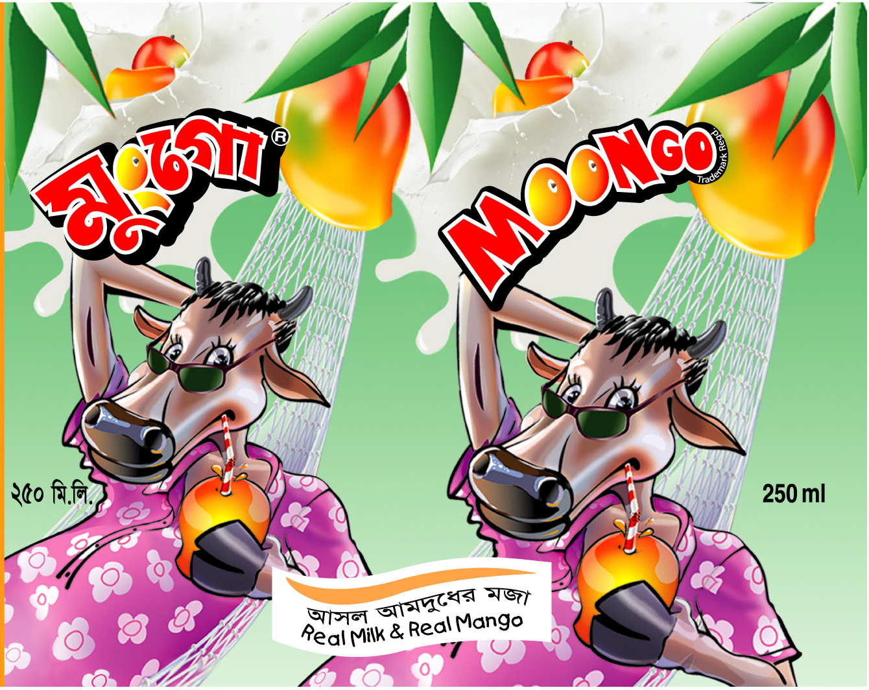
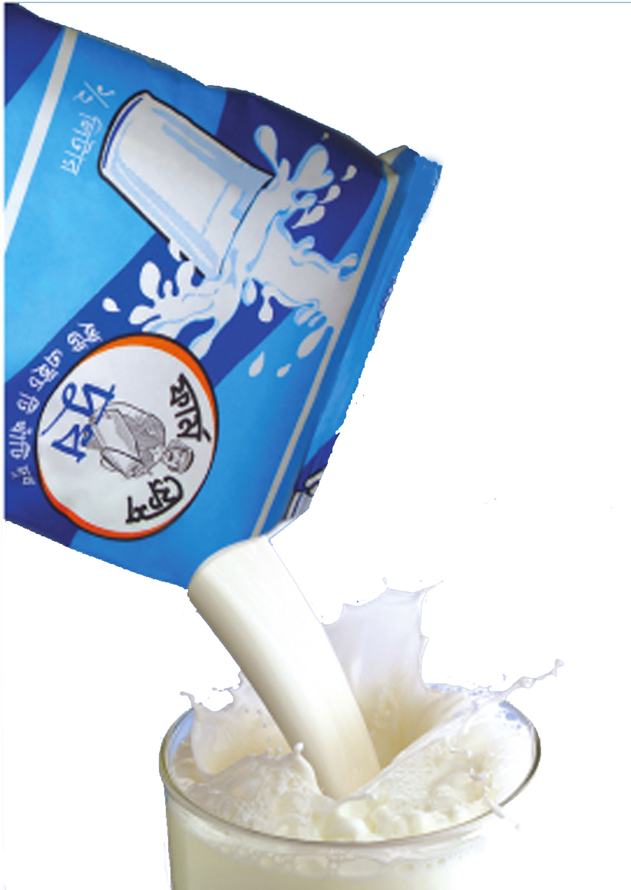

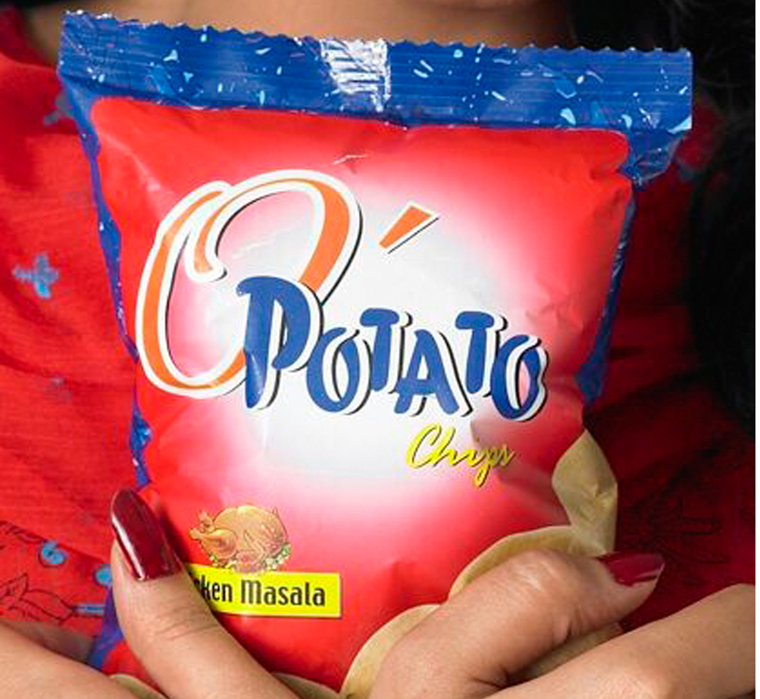




Business Philosophy

Akij Group diversified their business in Food & Beverage industry because in Bangladesh we have 14 corers people. It is large market size to serve and food is required continually for the population. Akij food & beverage want to serve quality food for their target market.
In soft drink industry, there are many local & foreign companies. Akij want to be local unique soft drinks producer with the same quality of foreign company. For this purpose AFBL produces CSD for young target group who like to live stylist life. Main slogan of AFBL is “Brings Quality in Life”.

AFBL has its own marketing & sales department in Akij chamber. The functions of this department are very wide and dynamic. Main functions performed by this department are:
- Product development

- Raw material sourcing

- Find out or create market for its product

- Price set up

- Packaging development

- Developing communication strategy

- Preparing sales forecast

- Maintain sales management in the field

- Keeping record of sales and stock

- Collection & analysis of competitors information

Beside these, it performs a number of activities to conduct their day-to-day business. Under marketing & sales department, a Brand team performs the key:

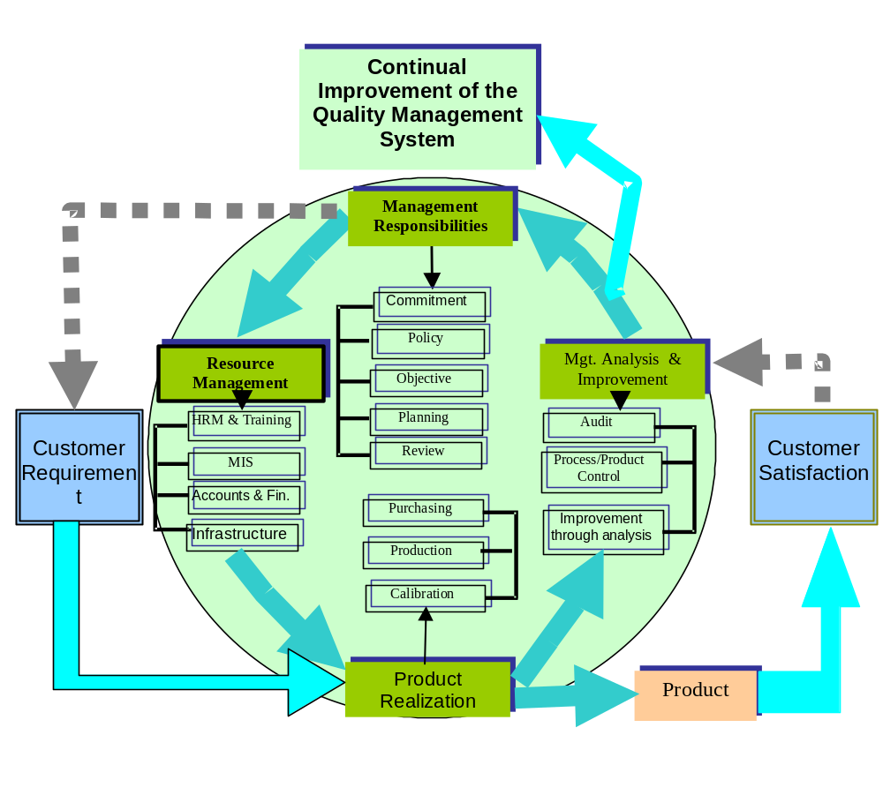

1.4 Human Resource and Organization Structure

Employees

In AFBL Marketing and sales department, a number of employees work under Sr. G.M (Marketing & sales). Numbers of employees are working in different positions in the 4th floor of Akij chamber. Here I found:

- Senior General Manager
- General Manager
- National Sales Manager
- Brand Manager
- Purchase executive
- Research executive
- Brand executives
- Brand officers
- Event management officers.

Beside these employees, AFBL has a Sales team working all over the country. Four Regional sales managers control these sales forces. An area sales manager & an area sales officer is engaged to conduct regular sales management for each sales area. They work at the retail outlet with the authorized distributors.

The actual marketing activities of AFBL are performed by the Brand office under Marketing and sales department.

ORGANIZATIONAL ADMINISTRATIVE FLOW MODEL (AFBL)

Managing Director

Director (Factory)

Director (Marketing)

GM (Sales)

GM (D & L)

Brand Manager

Sr. GM (Factory)

Factory Personnel

RSM/RSI

Brand Personnel

ASM/ASI

SO

SO

SO

SO

SO

SO

SO

PSR

PSR

PSR

PSR

PSR

PSR

PSR

Literature Review

Perception:

Perception is defined as the process by which an individual selects, organizes, and interprets stimuli into a meaningful and coherent picture of the world. It can be described as “how we see the world around us.”

Elements of Perception

Sensation

Sensation is the immediate and direct response of the sensory organs to stimuli. A stimulus is any unit of input to any of the senses. Examples of stimuli include products, packages, brand names, advertisements, and commercials.
The Absolute threshold

The lowest level at which and individual can experience a sensation is called the absolute threshold. The point at which a person can detect a difference between something and nothing is that person’s absolute threshold for that stimulus.

The Differential Threshold

The minimal difference that can be detected between two similar stimuli is called the differential threshold or the just noticeable difference. Manufacturers and marketers endeavor to determine the relevant J.N.D for their products for two different reasons:
- So that negative Changes (reduction in product size or quality, increase in product price).
- So that product improvements (such as improved or updated packaging, larger size, or lower price)

Research Process

Research process consists of series of actions or steps necessary to effectively carry out research and the desired sequencing of these steps, are given below:

- Formulate the research problem
- Extensive literature survey
- Developing the hypothesis
- Preparing the research design
- Determining the sample design
- Collecting the data
- Execution of the project
- Analysis of data
- Hypothesis testing
- Generalizations and interpretation
- Preparation of the report or presentation of the results
Managers have to analyze competitive forces in an industry’s environment in order to identify the opportunities and threats that confronting a company. Michael E. Porter of Harvard School of Business Administration has developed a framework that helps managers in this analysis. Porter’s framework, known as the five forces model. This model focuses on five forces that shape competition within industry:
- The risk of new entry by potential competitors.
The degree of rivalry among established companies within an industry.
- The bargaining power of buyers.
- The bargaining power of suppliers.
- The threat of substitute products.

Akij Food & Bevarage Limited (AFBL) at a glance:
- Name of the Company: Akij Food & Bevarage Ltd. (An enterprise of Akij Group)
- Year of establishment: 1985
- Head office: Akij Chember, 73 Dilkusha, Motijheel, Dhaka.
- First commercial production: July, 1993
Human Resources of Akij Group (Till December 2006):

No | Name of Unit | No. of Employees
01 | Corporate Office | 284
02 | Dhaka Tobacco Industries | 2670
03 | Akij Printing and Packaging | 448
04 | Akij Particel Board Mills Ltd. | 622
05 | Akij Textile Mills Limited | 1654
06 | Dhaka Tobacco Industries – LPF | 818
07 | Akij Food and Beverage Ltd. | 539
08 | Akij Cement Company Ltd. | 148
09 | Akij Poly Fiber Ind. Ltd | 19
10 | Akij Match Factory Ltd. (Unit-1) | 2912
11 | Akij Match Factory Ltd. (Unit-2) | 72
12 | Akij Zarda Factory Ltd. | 86
13 | Akij Zarda Factory Ltd. (Marketing) | 18
14 | Akij Juit Mills Ltd. | 306
15 | Dhaka Tobacco Industries – CLA | 74
16 | Dhaka Tobacco Industries – KLA | 141
17 | Dhaka Tobacco Industries – MLA | 12
18 | Dhaka Tobacco Industries – RLA | 26
19 | Akij Transport Agency | 59
20 | Akij Corporation Ltd. | 904
21 | Akij Cement Company Ltd. (Marketing) | 40
22 | Grand Total | 11,855

1.5 Limitation of the Study:

Internship program is a one kind of procedural program. There are involved various factors such as time/cost/information etc. Therefore, I have to face some problem to working this study. Mainly I have faced few problem these so much important of my study.

The companies official are not provided sufficient current information such are information on company existing market share, industries demands, sales volume of competitors, accurate financial statement, cash in flow statement, rough behaviors of some employees etc. When I have survey sample wholesalers, retailers, and customers then they have not cooperation with me.

After also I have some personal limitations such as money problem, time problem, lack of available previous research materials due to insufficient knowledge about this research fields through above limitation are exist. I have tried my best to overcome these limitations in this study.

PART TWO

2.0 RESOURCH METHODOLOGY

2.1 Objective of the Study
2.2 Methodology of the Study
2.3 Data Collection Method
2.4 Ingredients of Mineral Water

2.0 RESEARCH METHODOLOGY

2.1 Objective of the Study

The broad objectives of this study are to find out major marketing strategies and prospects of SPA Mineral Drinking Water as well as find out the suggestion for effective marketing plan.
The specific objectives of this study are show below:
- To identify the present marketing strategies of SPA Mineral Drinking Water in Bangladesh.
- To analyze the present problems in operating marketing function of SPA Mineral Drinking Water.
- To analysis the opinion of the participants involving operates marketing function of SPA Mineral Drinking Water.
- SWOT analysis and future prospects of PRAN juice pack.
- To prescribe appropriate recommendation and suggestion to overcome existing problems of SPA Mineral Drinking Water.

Specially, the above objectives of this study are to know the way by which we can take best decision regarding its product, price, distribution, and promotional activities with the marketing environment.

2.2 Methodology of the Study

Research methodology is followed to perform a research project or to solve a research problem without a scientific method it is impossible to solve a research problem. So it is very important for research. This study is conducted by following some predicated steps in the use of sources of data collection method and selection of sample.

I have collection necessary data from the following sources, which are given below:
1) Primary data
2) Secondary data

1) Primary Data:
The information, which is collected directly, from the field for a study is called primary data. Generally, the following methods are used in collection of primary data.

a)Survey questionnaire: I prepared two types of questionnaire, which are-
- Open-ended questionnaire.
- Close-ended questionnaire.
b) Observation: I was observed many stores (wholesales, retailer) with sales representative. I directly observed consumer attitudes and behavior.

c) Personal communication: I have been personal communicated with the executive of the firm and other participants whose ware most important of this study.

2) Secondary Data:
Different types of secondary data are used for this study. I have collected secondary data from the following sources-
a) Collecting Report of AFBL.
b) Brand and Marketing Department of Akij Food & Beverage Ltd.

c) Human Resources Management Department of Common Services.
c) Website of Akij Group of Industries: www.akijgroup.com

Analytical Tools:
To present the collecting data I have the following analytical tools:
- Table
- Chart
- Graph etc.

2.3 Data Collection Methods

For primary data collection, survey questionnaire, observation and personal communication method is followed:

a) Sample: Sample is the most important representative part of the population. If sample is not correct, study will be wrong. When I have selected sample then I consider few factors, such as age, sex, occupation, rate, income etc.

b) Sample area: I have selected sample area in Dhaka City. Most of the data has collected from Whole Seller, Retailer, and Customers or public. For Whole Seller: Bata Signal Distributor and whole Seller and Zigatola Point: for retailer:Dhanmondi, Mirpur, Motijheel and Mohammadpur.

a) Sample size: I have selected my sample size, the sample size that I have taken is enough, and representative, the following table illustrates my sample size:
Number of wholesalers | Number of retailers | Number of consumers
10 | 10 | 20

d) Sample selection method: I was used of cluster sampling method and random sampling method for collecting primary data.

2.4 Ingredients of Mineral Water
This page contains the name and amount of ingredients that used to prepare mineral water by various companies, which are given below:
Mineral Composition of MUM Mineral Composition of JIBON
Ingredients  Name | Amount
TDS | <250 mg/L
Arsenic | NIL
Cadmium | <0.003 mg/L
Lead | <0.01 mg/L
Chloride | <250 mg/L
Nitrate | <4.5 mg/L
Nitrite | NIL
Cyanide | NIL
pH | 6.4 to 7.4
Ingredients  Name | Amount
Calcium | 20.00 mg/L
Magnesium | 7.00 mg/L
Potassium | 2.00 mg/L
Chloride | 25.00 mg/L
Fluoride | 0.20 mg/L
Sulphate | 4.00 mg/L
Iron | 0.03 mg/L
Nitrate | 3.00 mg/L
Bi-carbonate | 130.00 mg/L
Lead | NIL
Arsenic | NIL
Mercury | NIL

Mineral Composition of SPA
Ingredients  Name | Amount
Total Dissolved Solids | <500
Calcium | <75
Arsenic | NIL
Cadmium | NIL
Lead | NIL
Nitrite | NIL
Nitrate | <0.5
Chlorides | <250
Magnesium | <35
Chlorine | NIL
pH | 6.4 – 7.4

PART THREE

3.0 Marketing Strategy

3.1 Industry Analysis on the Basis of Porter’s five Forces
3.2 Marketing Mix
3.3 Pricing Policy and Strategy
3.4 Distribution Policy and Strategy
3.5 Promotional Policy and Strategy

3.0 Marketing Strategy

3.1 Industry Analysis based on Porter’s five Forces:

A Model for Industry Analysis

The model of pure competition implies that risk-adjusted rates of return should be constant across firms and industries. However, numerous economic studies have affirmed that different industries can sustain different level of profitability; part of this difference is explained by industry structure.
Michael Porter provided a framework that models an industry as being influenced by five forces. The strategic business manager seeking to develop an edge over rival firms can use this model to better understand the industry context in which the firm operates.

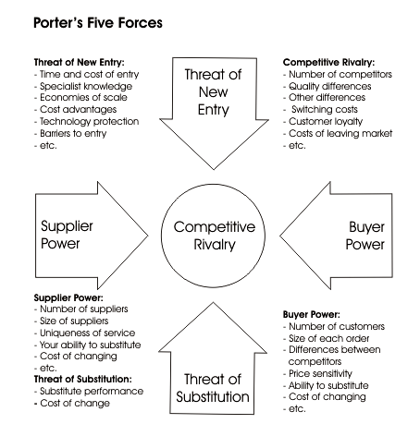

Threat of new entry or potential competitors:

Potential competitors are companies that are not currently competing in an industry but have the capability to do so if they choose. Incumbent companies try to discourage potential competitors from entering the industry, the more companies enter, the more difficult it becomes for established companies to hold their share of the market and generate profits. A high risk of entry by potential competitors represents a threat to the profitability of established companies. On the other hand the risk of new entry are low, incumbent companies can take advantage of this opportunity to raise prices and earn greater returns. Barriers to entry→ it means to those factor that make costly for companies to enter in an industry. Now some barriers to entry are given below:

- Brand Loyalty:
Brand loyalty is buyer’s preferences for the products of incumbent companies. A company can create brand loyalty through continuous advertising of brand & company names, patent protection of products, product innovation achieved through its research and development programs, an emphasis on high product quality and good after sales service. Now some other techniques of brand loyalty are given below:
- Provide quality product and services.
- Warranties & Guaranties.
- Value adds service.
- Continuous advertisement.
- Strong customer relationship.

- Absolute Cost Advantages:
Absolute cost advantages can arise from three main sources; such as:
- Superior production operations due to experience, patents or secret process.
- Control of particular inputs required for production such as labor, materials, equipment or management skills.

- Economies of scale:
Economic of scale are the cost advantages associated with large company size. It implies that it will increase productivity or decrease the average cost of production. It also includes:
  - Mass production of standardizes output.
  - Discount on bulk purchase of raw materials.
If these cost advantages are significant, a new entrant faces the dilemma of either entering on small scale and suffering a significant cost disadvantage or entering on large scale and bearing the large risk of significant capital costs.

- Government Regulation:
Historically, GOVT. regulation has constituted a major entry barrier many industries. For example: Until recently in the United States, government regulation prohibited provides of long distance telephone service, such as AT&T, MCI and sprint, from competing for local telephone service with the Regional Bell Operating Companies such as US West and Bell Atlantic.

- Barriers to Entry and Competition:
If established companies have built brand loyalty for their products, have an absolute cost advantage with respect to potential competitors, have significant economies of scale, or enjoy regulatory protection, then the risk of entry by potential competitors is greatly diminished. When the risk is low, established companies can charge higher prices and earn greater profits than would be possible otherwise.

Rivalry among Established Companies:

The second of Porter’s five competitive forces is the extent of rivalry among established companies within an industry. If this rivalry is weak, companies have an opportunity to raise prices and earn greater profits. If rivalry is strong, significant pricecompetition, including price wars, may result. The extent of rivalry among established companies within an industry is largely a function of three factors:
- The industry’s competitive structure.
- Demand condition.
- The height of exit barriers in the industry.

Competitive Structure:
Competitive structure refers to the number and size distribution of companies in an industry: Structure varies from fragmented to consolidate and have different implications for rivalry. A fragmented industry contains a large number of small or medium-sized companies, none of which is in a position to dominate the industry. A consolidated industry may be dominated by a small number of large companies (in which case it is referred to as an oligopoly) or, in extreme cases, by just one company (a monopoly). Fragmented industries range from agriculture, video rental and health clubs to real estate brokers and sun tanning parlors. Consolidated industries include aerospace, automobiles and pharmaceuticals, etc.

Demand Conditions:

Growing demand from either new customers or additional purchasers by existing customers tends to moderate competition by providing greater room for expansion. Growing demand tends to reduce rivalry because all companies can sell more without taking market share away from other companies, and high profits are often the result. Conversely declining demand results in more rivalry as companies fight to maintain revenues and market share. Demand declines when consumers leave the marketplace or when each consumer buys less. Under these conditions a company can grow only by taking market share away from other companies.

Exit Barriers:
Exit barriers are economic, strategic and emotional factors that keep companies in an industry even when return are low. If exit barriers are high, companies can become locked into an unprofitable industry in which overall demand is static or declining.

- Investments in plant and equipment that have no alternative uses and
- cannot be sold off. If the company wishes to leave the industry, it has to write off the book value of these assets.
- High fixed costs of exit, such as severance pay to workers who are being made redundant.
- Emotional attachments to an industry, as when a company is unwilling to exit from its original industry for sentimental reasons.
- Economic dependence on the industry as when a company is not diversified and so relies on the industry for its income.

Buyer’s Power:

The power of buyers is the impact that customers have on a producing industry. In general, hen buyer power is strong, the relationship to the producing industry is near to what an economist terms a monopoly- a market in which there are many suppliers and one buyer. Under such market condition, the buyer sets the price. In reality, few pure monopolies exist, but frequently there is some asymmetry between a producing industry and buyers.
The third of porter’s five competitive forces is the bargaining power of buyers. A company’s buyers may be the customers who ultimately consume its products (its end users) but they may also be the companies that distribute its products to end users, such as retailers and wholesalers. According to porter, buyers are most powerful in the following circumstances:

- When the supply industry is composed of many small companies and the buyers are few in number and large. These circumstances allow the buyers to dominate supply companies.
- When the buyers purchase in large quantities, in such circumstances, buyers can use their purchasing power as leverage to bargain for price reductions.
- When the supply industry depends on the buyers for a large percentage of its total orders.
- When the buyers can switch orders between supply companies at a low cost, thereby playing off companies against each other to force down prices.
- When it is economically feasible for the buyers to purchase the input from several companies at once.
- When the buyers can use the threat to supply their own needs through vertical integration as a device for forcing down prices.

Supplier Power:

The fourth of Porter’s competitive forces is the bargaining power of suppliers. Suppliers can be viewed as a threat when they are able to force up the price that a company must pay for its inputs or reduce the quality of the inputs they supply, thereby depressing the company’s profitability. According to Porter, suppliers are most powerful:
* When the product that they sell has few substitutes and is important to the company.
- When the company’s industry is not an important customer of theirs. In which instances, the supplier’s health does not depend on the company’s industry, and suppliers have little incentive to reduce prices or improve quality.
- When their respective products are differentiated to such an extent that it is costly for a company to switch from one supplier to another. In such cases, the company depends on its suppliers and cannot play them off against each other.
- When, to raise prices, they can use the threat of vertically integrating forward into industry and competing directly with the company.
- When buying companies cannot use the threat of vertically integrating backward and supplying their own needs as a means to reduce input prices.

Threat of Substitute Products:

In Porter’s mode, substitute products refer to products in other industries. To the economist, a thereat of substitutes exists when a product’s demand is affected by the price change of a substitute product. Substitute products affect a product’s price elasticity – as more substitutes become available, the demand becomes more elastic since customers have a more alternatives. A close substitute product constrains the ability of the firms in and industry to raise prices.

The final force in porter’s model is the threat of substitute producers. Substitute products are those of industries that serve consumers needs in a way that is similar to those being served by the industry being analyzed. The existence of close substitutes presents a strong competitive threat, limiting the price a company can charge and thus its profitability. However, if a company’s products have few close substitutes (that is, if substitutes are a weak competitive forces) then, other things being equal, the company has the opportunity to raise prices and earn additional profits.

  - Marketing Mix

Every marketer has heard of the four P’s - product, price, place, and promotion. They are the foundation of many marketing educations and the cornerstones of many marketers’ practices.
Recently, however, a new marketing mix has begun to emerge, no longer based on the four P’s. This New Marketing Mix is based on the Four C’s - create, connect, correct and cancel.
Create
This is the basis of The New Marketing Mix. Gone are the days where a marketer can just create a product and then spend all his money convincing people to care about it. In today’s marketplace, where information flows fast and free, it is vital to put all your effort into creating something that people truly believe is worthwhile. If he/she can get them to care about it, then he/she has really accomplished something.
Connect
As in make it possible for his/her to connect with his/her customers and for his/her customers to connect with each other. This kind of connection is vital to the growth and success of any person/product/company/service. Find out what people like and what they don’t like. All this connection creates a community, where the whole is always more than the sum of its parts.
Change
As in, if it is not working change it. Test and measure repeatedly. The solution is never to plow more money into it and wait for people to “catch on.” Why waste time and money on something that is not doing what it is supposed to? Use analytics to test the success of your ad campaigns or landing pages. Measure the results, tweak it, and measure again… and then tweak it again, etc. In New Marketing, not only is there constant room for improvement, there is a need for it. Just because the ad is up or the copy done, does not mean it is set in stone.
Cancel
As in get rid of it, If you’ve tried to fix something, but it’s still not working - then stop doing it. Do not be afraid to give an under performing ad/product/service/page the axe. With so many other, positive things, you could find to spend your time

The 4 P’s of Marketing

The major marketing management decisions can be classified in one to the following:

- Product
- Price
- Place (distribution
- Promotion

These variables are known as the marketing mix or 4 P’s of marketing mix. They are the variables that marketing managers can control in order to best satisfy customers in the target market. The marketing mix is portrayed in the following diagram:

Product
Place




Target Customer




Promotion
Price

Product:
The product is the physical product or service offered to the customer. In the case of physical products, it also refers to any services or conveniences that are part of the offering.
Product decisions include aspects such as function, appearance, packaging, service, warranty, etc.

Price:
Pricing decisions should take in to account profit margins and the probable pricing response of competitors. Pricing includes not only the list price, but also discounts, financing, and other options such as leasing.

Place:
Place or placement decisions are those associated with channels of distribution that serve as the means for getting the product to the target customers. The distribution system performs transactional, logistical, and facilitating functions.
Distribution decisions include market coverage, channel member selection, logistics, and levels of service.

Promotion:
Promotion decisions are those related to communicating and selling to potential consumers. Since these costs can be large in promotion to the product price, a break-even analysis should be performance when making promotion decisions. Promotion decision involves advertising, public relation, medical types, etc.

Summary Table of the Marketing Mix based on Spa drinking water:

Product | Price | Place | Promotion
Functionality  Appearance  Quality  Packaging  Brand  Warranty  Service/Support | List Price  Demounts  Allowances  Financing  Leasing | Channel Members  Channel Motivation  Market Coverage  Location  Logistics  Service Level | Advertising  Personal Selling  Public Relation  Message  Media  Budget

AFBL have done these four marketing mix very well for Spa drinking water.

- Appearance of Spa drinking water is good but is should be changed the bottle of deign, because these types of bottle is very common in Bangladesh. So to capture the customers attention, shape of the bottle needs to change, something new.

- Packaging of the Spa drinking water is very good in the context of Bangladesh market and compared with it’s competitors. AFBL ensures the quality of Spa drinking water is very good.

- Price of the Spa drinking water is reasonable comparing with it’s competitors.

- AFBL has already taken many steps for motivating channel members such as distributors, employees, customers etc. and by market coverage, they also prove their best try for service.

- To build up a strong bran “Spa”, AFBL gives sufficient advertisement in TV, Radio, Newspapers etc and build up a good public relationship by participating in many social work, fair, and events.

3.3 Pricing Policy and Strategy

Price is the sum of all the value that consumers exchange for the benefits of having or using the product on serves. Historically, price has operated as the major determination of buyer's choice.

a) Pricing policy:
As the company has an objective to stay in the market as long as possible with this business. It has adopted the penetration price policy some both domestic and international market.

Another viewpoint is that they company has adopted a fixed pricing strategy. The cause behind this strategy is that the target consumers generally do not like bargaining. As because the AFBL products users perceive high status

b) Pricing Strategy:
Considering consumer satisfaction, market demand etc. The company follows the prices of juice pack is "Cost-pricing" strategy. The pricing strategy is very specific and straight according to present market situation. Pricing decision is made through the discussion among the Managing Directors.

There are three stages at which the prices are fixed to the market in Bangladesh.

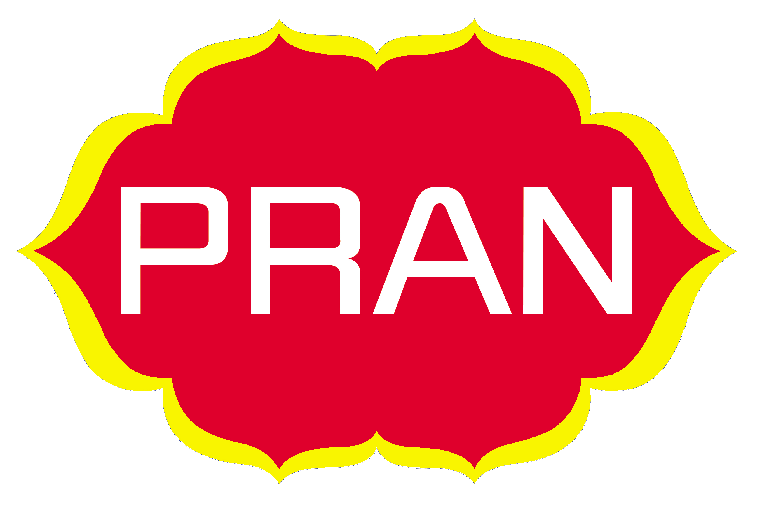
Firstly, the price, which the factory fixed, is called factory prices.
Secondly, the wholesalers collect PRAN juice product from the factory then they fix a price for juice pack and then sell to the retailers on sub dealers. This type of pricing is called wholesale pricing. The wholesalers pricing system are given below:

Wholesaler Price = Issue price + transportation cost + storage cost + packing cost + physical losses + other costs + profit margin.

Thirdly, the retailers then collect PRAN juice pack from the wholesalers, after keeping a certain profit margin they fix a price this type of pricing is called retail pricing

Akij Food and Beverage Ltd. is producing three types SQ of Spa drinking water. Spa drinking water of AFBL is dominating the drinking water market of Bangladesh. The three types of juice pack (Including price rate) which are given below:

No. | Products name | SQ | Price (Tk.)
1. | Spa Drinking Water | 500 ml | 10
2. | Spa Drinking Water | 1000 ml | 15
3. | Spa Drinking Water | 2000 ml | 20

Source: Official index book

3.4 Distribution Policies and Strategy

Distribution Channel:
A set of interdependent organizations involved in the process of making a product or services available for use on consumption by the consumer or business user.

Channel characteristics of Spa drinking water is the food industry of Bangladesh generally maintain a four-tier distribution channel. The Akij Food and Beverage Ltd. does not more retail sale directly from the production canter, Spa drinking water moves form factory to dealer's agents or distributors, agents to wholesalers, wholesalers to retailers and finally retailers to consumers. The industrial buyers mainly sell Spa drinking water to the wholesalers. They also sell Spa drinking water to retailers besides the wholesalers. 'The wholesalers mainly sell it to the customers besides the retailers. They also sell it to the customers beside the retailers. The customer mainly collects it from retailers.

Wholesalers of the company are trained and contractual. The company divides sales territories among the wholesales. It provides commission and other financial facilities to the wholesalers to motivate the. The company does exclusive distribution. It has power of controlling wholesalers.

Distribution System:
The company has two types of distribution system for Spa drinking water. One is domestic regarding distribution system and other is international regarding distribution system.

Domestic:
Domestic distribution structure of PRAN juice pack in Bangladesh is given below:
Domestic Distribution Structure
Manufacturer
Agent / Dealer / Distributor
Wholesalers
Retailer
Consumer
Consumer

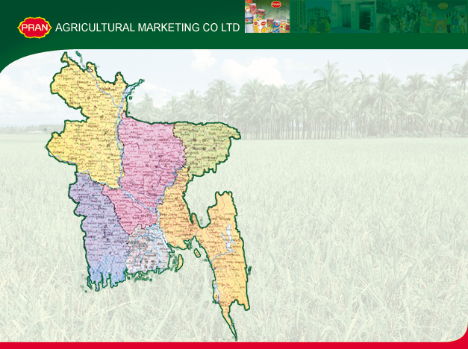
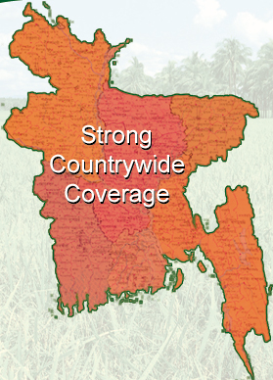

DISTRIBUTORS
250
REGIONAL MANAGERS
8
SALES REPRESENTATIVES
250
Distribution Network of AFBL
ASM
27

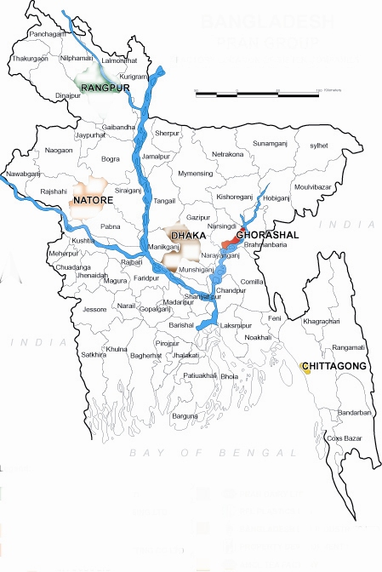
27
Existing Regions

Dhaka-1
Dhaka-2
Narayangonj
Mymensing
Comilla
Noakhali
Chittagong
Out Chittagong
Sylhet
Maulovi Bazar
Jessore
Barisal
Bogra
Rangpur
Faridpur

N. GONJ
SYLHET
MAULAVIBAZAR
Spa drinking water sales
DHAKA-2
Network
RANGPUR

DHAKA-1
COMILLA

OUT CHITTAGONG

FARIDPUR

NOAKHALI

CHITTAGONG

JESSORE
BARISHAL

BOGRA

Total: 35

Existing Depots

Dhamrai
Tongi
Jessore
Rongpur
Shaver
Narayangonj
Manikgonj

NOAPARA
GHORASHAL
TONGI
NATORE
MOULOVIBAZAR
CHITTAGONG
BARISHAL
COMILLA
COMILLA

International:

3.5 Promotional Policy and Strategy

Promotional Mix consists of four major modem of communication these are: Advertising, personal selling, sales promotion, and publicity.

Spa drinking water, a product of AFBL, Company uses all above promotional strategy to enhance its sales:

1) Advertising:
Advertising is one of the most common tools that the company uses to direct persuasive communications to longer target buyers, consumer, and public. It is aware of the consumer about its quality, price, and consumption pattern.

Advertising can be done in various ways such as:

- a) Television: TV is the biggest media in Bangladesh to reach the consumer. The firm realized it and started to spend for TV advertising of Spa Drinking Water. The advertisement of Spa mineral water has shown on the TV channels:
- BTV
- NTV
- ATN
- Channel i

b) Radio: Most of the people of Bangladesh live in village. Radio is now available everywhere and known as FM Radio. Radio can build up good appeals. So, the company emphasizes advertisement on radio.

- Newspaper: Newspaper is an important media .A company can easily reach to the target customer through newspaper. Almost all the daily newspapers have been used for the advertising of Spa Drinking Water marketing in Bangladesh. Such as,
- Prothom Alo
- Ittefaque
- Jugantor
- Daily Star

d) Cinema: Some people especially middle lower class enjoy cinema. So to increase sales volume the company has to arrange advertisement through cinema.

e) Magazine: Various kinds of Magazine are published in Bangladesh and a specific target group of (Spa Drinking Water) is reading these magazines. So to create attention of Spa Drinking Water, the company has spent a large number of amounts for advertising in the magazine.

2) Personal selling:
Personal selling is one of the most important to the firm. Personal selling creates a good relationship to the dealers, distributors, wholesales, retailers, with customer or others of AFBL. So, the company's sales people also play a vital role there.

3) Sales promotion:
Sales promotion is another essential ingredient in marketing campaigns. Such promotion consists of diverse collection of incentive tools, mostly short term, designed to stimulate quicker and for greater purchase of particular products or services by customer, where advertising offers a reason to buy Spa Drinking Water others trade promotion and Consumer promotion such as discount, incentives, coupon gift etc.

4) Publicity:
Spa Drinking Water in Bangladesh uses some publicity, the company frequently provides the material for publicity in the form of news releases, press conference and photograph.

5) Out Door Advertising:
- Neon signs, bell signs, billboards, walling art etc are used to aware the people.
- Hoarding Board Installation
- Bus, Rail & Lunch Station Branding
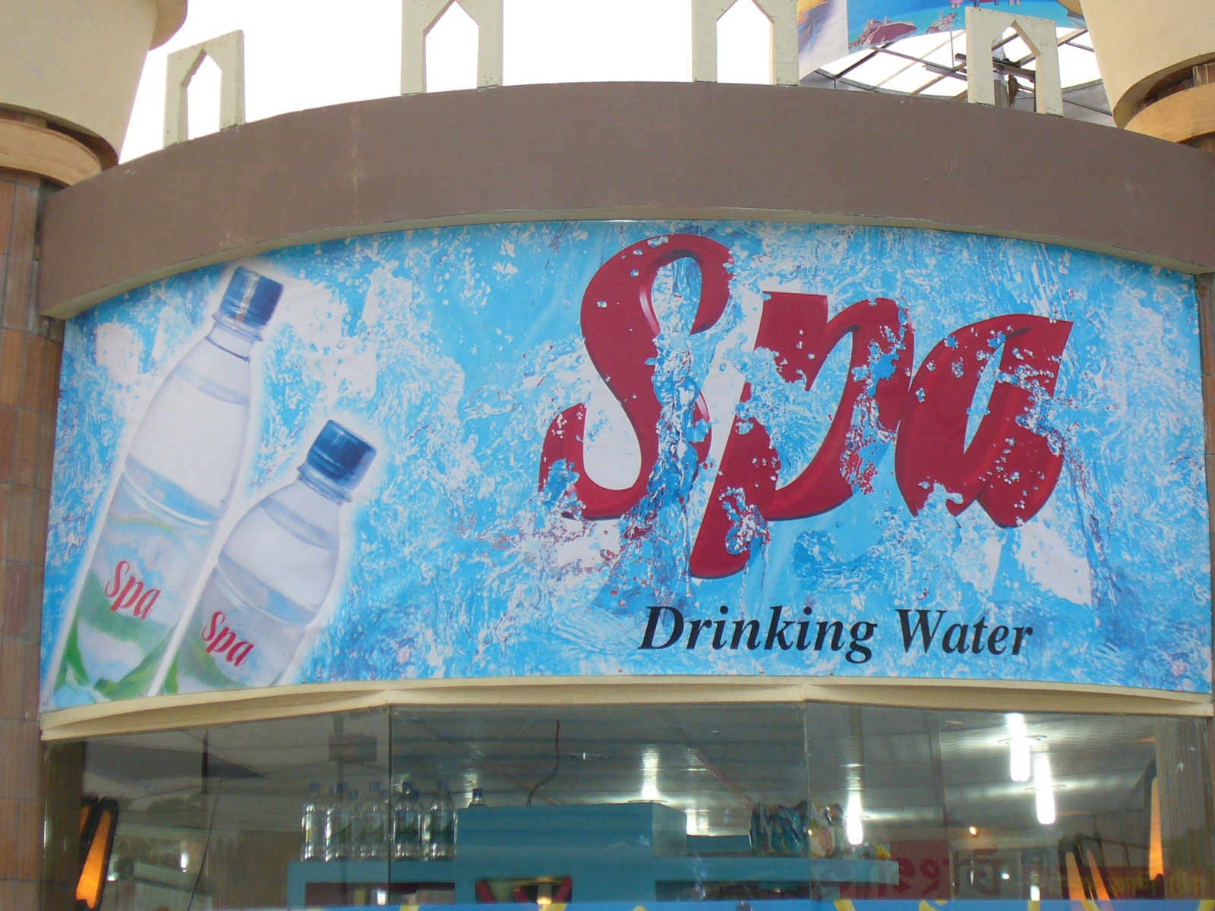

6) Special Sales Drive:
  - Pharmacy Outlet
  - Bus Station
  - Lunch Ghat
  - Rail Station

Advertisement of Spa

TV Advertisement
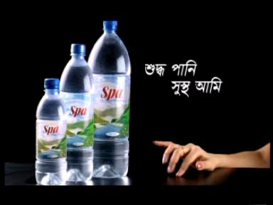

Print Media Advertisement
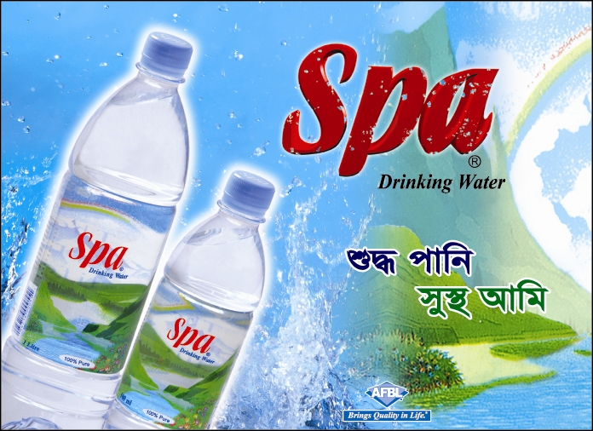

PART FOUR

4.0 Problems:

4.1 Problem Faced by wholesaler
4.2 Problem Faced by retailer
4.3 Problem Faced by Customer

4.0 Problems

4.1 Problem Faced by wholesaler

(1) Buying problem: Buying is one of the important activities of the wholesalers. The main buying problems of the wholesalers are financial problem. The wholesalers of Spa drinking Water may not have available current cash for doing current buying activities. So, the wholesalers may fall into a lot of troubles in operating these buying functions.

(2) Selling problems: The main selling problems of the wholesalers are sales on credit, sales forecasting:
Sales on credit: The distribution mainly depends upon the retailers for selling Spa drinking Water. So, the wholesaler has to face some of the demand of the retailers. Most of the retailers want to buy Spa drinking Water on credit. Retailer does not want to take risk. So, most of the retailers buy the Spa drinking Water on credit.
Sales forecasting: We know that now the business arena is much competitiveness. Most of the firm would like to gain challenge this competition. So, here sales forecasting is the main problems in the case of selling. The wholesaler does not use any method for determining sales forecasting most of the wholesaler sales forecast on the basis of last year sales.
Retailer's pressure: The retailer's pressure is a great problem of the wholesalers in the case of selling. The wholesalers cannot supply the Spa drinking Water to the retailers regularly. At this time, the retailers give a lot of pressure to the wholesalers.
Territory: Determining sales territory in an important matter for the wholesalers. No sales territory has been fixed for the wholesalers. The wholesalers buy and sell Spa drinking Water in their own responsibility.

Sales motivation: There is no sales motivational program in the Spa drinking Water marketing in Bangladesh. On the other hand, the wholesalers see that in the other business motivational program has become popular. So most of the wholesalers are frustrated and they do not know what will be happened.

(3) Transportation: It is one of the most important problems faced by wholesalers. They have not available vehicle. So the cannot supply Spa drinking Water to retailers in due time.

(4) Storage: The wholesaler of Spa drinking Water has no warehouse. So they do not stock a large amount of Spa drinking Water at a time.
High distribution cost: It is one of the most important problem faced by wholesaler. There are involved many policy and procedure. So wholesalers have to pay big amount that makes great trouble of wholesalers high distribution cost involves handling cost, physical losses, tax and financial cost.

(5) Government Policy: Sometime government imposes various policies in business. In addition, businesspersons are to abide by those policies carefully. For this reasons, the wholesalers are directly being affected with there policies. It creates a great trouble for wholesalers.

(6) Communication system: The communication system of Spa drinking Water wholesalers is very traditional. Now they do not follow modernize system.Order placed and orders maintained are operated without any modern communication system.

4.2 Problem Faced by retailer

(1) Buying problem: Retailers have faced various buying problem. It involves various problems such as sources, prices, finance, buying cost, quality and others.
(2) Sourcing problem: The retailers have not available source, so they could not get available marketing and product related information. Sometimes they do not know what have to be done.
(3) Financial problem: Most of retailer is not strong financially. But the retailers need a lot of many for Spa drinking Water business. The retailers cannot collect required capital from any reliable sources.
(4) Timely supply problem: The retailers have to face various problems. Supply of Spa drinking Water is a long term and time consuming process. Sometimes the retailers do not supply the Spa drinking Water according to the demand of the customers.
(5) Selling problem: The retailers have to face various selling problems. The main selling problems of the retailers are to sale forecasting. They are not actual measurement of target sale. Most of the retailers of Spa drinking Water depend on wholesalers.
(6) Pricing problem: Price determination is a different task for the retailers. The retailers collect PRAN juice pack from the wholesaler and they are depending on the price that is determined by wholesalers. There are no scopes to determine the price of juice pack by retailers.
(7) Storage problem: The 35% retailers face many storage problems with their Spa drinking Water. Most of the wholesalers do not allow the retailers to use their shops. So due to the lack of modern facilities their Spa drinking Water cannot maintain properly.

4.3 Problem Faced by Customer

We have defined few problems of the customer of Spa drinking Water after survey of sample customer groups. The main problems of the customers are sources, quality, and time, pricing system, weight, packing and leveling, poor services, and irregular supply.

Sources: The customer cannot get available information related Spa drinking Water. They have no permanent sources. Few information collections from local retail stores.

Quality: At present, the customers are more careful about product quality. They want to buy quality product. So the customers are in a big problem with the quality of Spa drinking Water. These imitated Spa drinking Water are coming to the customers in many ways. Identification of Spa drinking Water pack and AFBL are great problems for the customer. In this, causes Spa drinking Water cannot provide quality ensure of their Spa drinking Water.

Packaging labeling and weight of Spa drinking Water: At least 30% customer complained packaging and labeling of Spa drinking Water as well as the 25% customer complained weight Spa drinking Water would like to change their existing packaging system. When company packed drinking Water then them cannot properly maintenance weight that is written with the labeling of Spa drinking Water.

Poor services and irregular supply: The Company does not provide actual services that are expected by target customer and retailers. Company supply juice pack wholesaler but wholesalers does not maintenance regularity to supply sometimes it is seen that there are available Spa drinking Water stock in the market and sometimes crisis seen in the market. The customer and the retailers in Bangladesh fully depend on the wholesalers.

PART FIVE

5.0 Market-Product Focus

5.1 Opinion of the Percipients involving operating Marketing Function

5.0 Market Product Focus

5.1 Opinion of the Percipients involving operating Marketing Function

The objective in this study was to analysis the opinion of the participants involving operating marketing function of Spa drinking water. To fulfill this objective some selected issues that are influencing the existing marketing system have been discussed. These issues are product, price, place, government policy, and the performance of the participants. In this purpose, I have made three types of survey questionnaire regarding to Distributor & wholesalers, retailers, and customers to know the participant attitudes.
(1) Opinions of the sample participant about the existing Spa drinking water:

Their opinions have been presented in table.
Table-1
Questions | Sample Wholesalers |  | Sample Retailers
Questions | Yes | No | Yes | No
Do you need loan? | 6  (60%) | 4  (40%) | 6  (60%) | 4  (40%)
Do you have buying problem? | 5  (50%) | 5  (50%) | 6  (60%) | 4  (40%)
Do you have selling  problem? | 4  (40%) | 6  (60%) | 5  (50%) | 5  (50%)
Do you think the  product is being  imitated in Bangladesh? | 10  (100%) | 0  (0%) | 7  (70%) | 3  (30%)
Source: Survey data.
Different participants have commended differently. Maximum participants opinion is that they have financial capability is not strong. 60% wholesalers, 60% retailers opinion is that they have need loan from another financial source. 40% wholesalers and 40% retailers expressed their opinion they have not need loan. At least 50% wholesalers, 60% retailers complained that they have buying problem. They thing that for dieinking water, TK. 10 is too much to buy 250ml water comparing with other soft drinks.
About selling problem 40% wholesalers and 50% retailers opinion is they have selling problem and 60% wholesalers and 50% retailers expressed their opinion they have no se
lling problem.

(2) Opinion of the sample participants about distribution appropriateness:

Their opinions have been presented in table.
Table-2
Opinions | Wholesalers | Retailers
Appropriate | 6 (60%) | 6(60%)
Not appropriate | 4 (40%) | 4 (40%)
Total | 10 (100%) | 10 (100%)
Source: Survey data.
40% Wholesalers, 40% Retailer, think that the existing distribution system of Spa drinking water to be not appropriate for the present situation. In their opinions, the present distribution system in not customer oriented. 60% Wholesaler, 60% retailer thinks that the existing distribution system is reasonable.

(3) Opinion of the sample participants about different distribution related questions:
From the evaluation of the participants we see that 80% wholesalers and 90% retailers does not carry Spa drinking water to their store. According to 90% of wholesalers and 75% of retailers’ opinion, that has no major problem in the case of product transportation. 90% wholesalers and 60% retailers have no storing problem. There is no conflict seen between the others distribution participants. 50% wholesalers, 50% retailers expressed their opinion that they are not depended one others participants.

Table-3
Questions | Wholesalers |  | Retailers
Questions | Yes | No | Yes | No
Do you carry product to your store? | 2  (1O% | 8  (80%) | 1  (1O%) | 9  (90%)
Do you face any problem in the case of transportation? | 4  (4O%j | 6  (60%) | 2  (20%) | 8  (80%)
Do you face any problem in the case of storage? | 3  (3O%j | 7  (70%) | 4  (40%) | 6  (60%)
Do you have any conflicts with the other participants? | 0  (0%j | 10  (100%) | 0  (0%) | 10  (100%)
How much are you depended on the participants? | 5  (5O%j | 5  (50%) | 5  (50%) | 5  (50%)
Source: Survey data

(4) Opinions of the sample participants about the price appropriateness:

Table-4
Opinions | Wholesalers | Retailers
Appropriate | 10 (100%) | 7 (70%)
Not appropriate | 0 (0%) | 3 (30%)
Total | 10 (100%) | 10 (100%)
Source: Survey data

Only 30% retailers do not think the existing pricing to be appropriate for the present situation. So there are few pricing problem has exist in present situation and it has made the marketing system complex.

(5) Opinion of the sample participants about the various price related issues:

Their opinions are given below:
Table-5
Questions | Sample Wholesalers |  | Sample Retailers
Questions | Yes | No | Yes | No
Are you increasing the price any time? | 0  (0%) | 10  (100%) | 0  (0%) | 10  (100%)
Do you prefer fixed price? | 9  (90%) | 1  (10%) | 10  (100%) | 0  (0%)
Source: Survey data.
Here, mention, 90% wholesaler, 100% Retailers like fixed price the participant are facing various kind of trouble with market price. So we think that the price of Spa drinking water should be fixed 100% wholesalers and 100% retailer are not increasing their drinking water price any time.

(6) Opinions of the sample participant about the wholesaler:
Table-6
Question | Special | General | Local | Regional
What kind of Wholesaler are you? | 0 | 4  (40%) | 5  (50%) | 1  (10%)
Source: Survey data

Here mention, we have collected from 10% wholesaler's participants. According their opinion is that 40% wholesalers are general, 50% wholesalers be are local are 10% wholesalers are regional.

(7) Opinion of the sample participants about relations:

Table-7
Question | Large | Medium | Small
What kind of Retailer are you? | 1  (10%) | 4  (40%) | 5  (50%)
Source: Survey data

Here, we have collected from 20 relaters’ opinion. 10% retailers are large, 40% retailers are medium, and 50% retailers are small.

(8) Opinion of the sample participants about the marketing problem:

Their opinions are given below:
Table-8
Question | Wholesalers |  | Retailers
Question | Yes | No | Yes | No
Do you have any other marketing problem? | 4  (40%) | 6  (60%) | 4  (40%) | 6  (60%)
Source: Survey data

The participants are questioned whether they have faced any other marketing problems, 60% wholesaler, 60% retailers opinion is that they have no marketing problem.

(9) Opinion of the sample participants about existing packaging and labeling system of Spa drinking Water:

Table-9
Questions | Sample Wholesalers |  | Sample Retailers
Questions | Yes | No | Yes | No
Do you think has a major defect of the existing packaging and labeling? | 1  (10%) | 9  (90%) | 1  (10%) | 9  (90%)
Do you think need to increase quality of Spa drinking water? | 1  (10%) | 9  (90%) | 4  (40%) | 6  (60%)
Source: Survey data.
Here mention 90% wholesalers, 90% retailers have expressed their opinion that the existing packaging and labeling of Spa drinking water is not major defects. 10% wholesalers, 10% retailers complained that existing packaging and labeling system. They have claimed, the existing packaging and labeling is more improved.

10% wholesalers’, 40% retailers’ opinion is that need to increase quality of Spa drinking water as well as same percent participant’s opinion is that need not to increase quality it. But some participants agree that drinking water without any flover is very good. But in Spa, there is a flavor of green coconut.

(10) Opinion of the sample participants about government policy:
Table-10
Questions | Sample Wholesalers |  | Sample Retailers
Questions | Yes | No | Yes | No
Is the role of the Govt. policy in favor of your business? | 7  (70%) | 3  (30%) | 8  (80%) | 2  (20%)
Have you complain about your problem to the authority any time? | 3  (30%) | 7  (70%) | 2  (20%) | 8  (80%)
Source: Survey data.

Here, 70% wholesalers and 80% retailers think that the role of government policy is favor of their business. The participant's opinion is that the government has no control over this policy. While taking interview of the participants they are asked whether they have complained to any authority about their problems 30% wholesaler 20% retailer have complained to they have asked help from the authority, but they have not got any positive result how ever, 80% wholesaler has said that our business should free from political instability 20%. Retailers have said our government should increase business loan to solve business problem.

Customer Opinion:
Total Respondent: 20

01. Customers Awareness about Spa Drinking water:
Yes | No
18 | 2

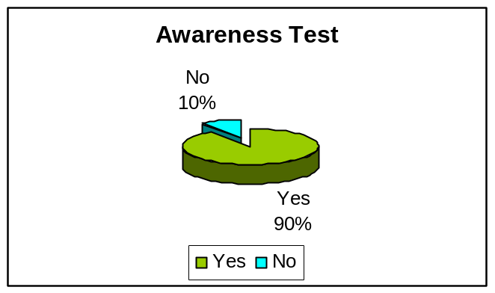

02. Quality test of Spa Drinking water:

Best | Good | Below the Average | Poor
12 | 5 | 3 | 0

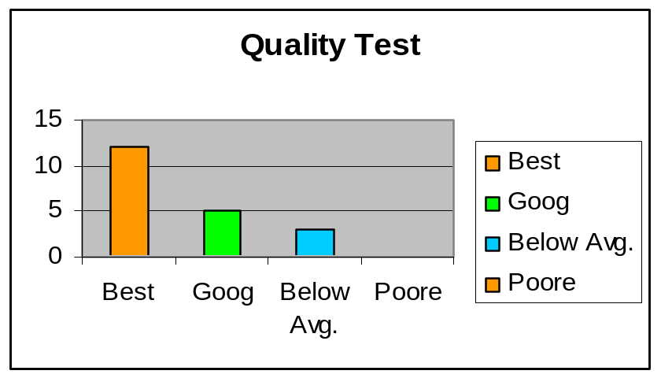

03. Opinion about the price of Spa Drinking water:
Reasonable | High
15 | 5

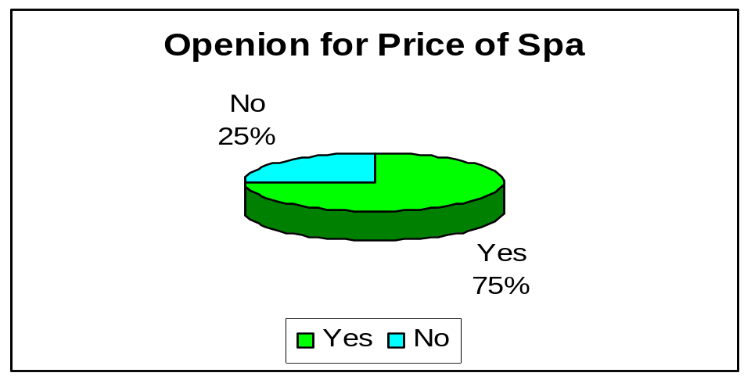

04. Do you like the packaging of Spa Drinking Water?
Yes | No
13 | 7

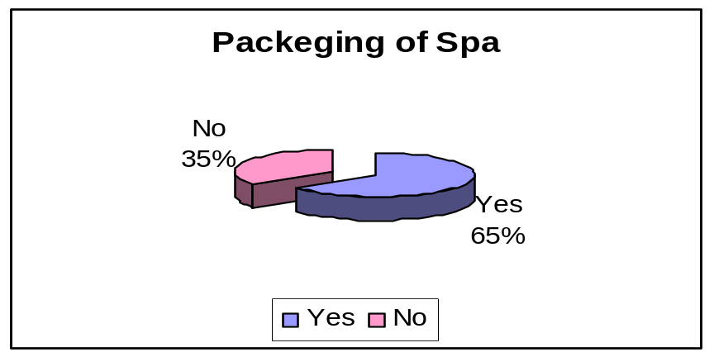

05. Availability in the market:
Yes | No
18 | 2

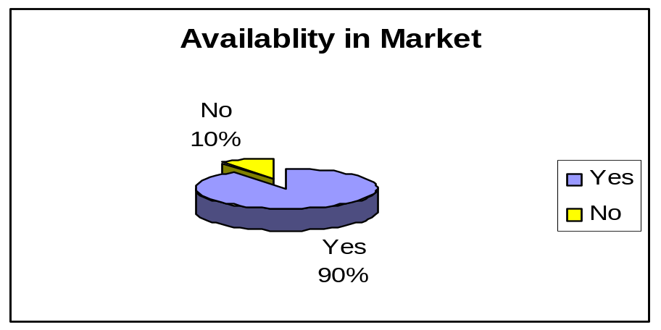

06. Sufficiency of present promotion and advertisement of Spa drinking water:
Yes | No
8 | 12

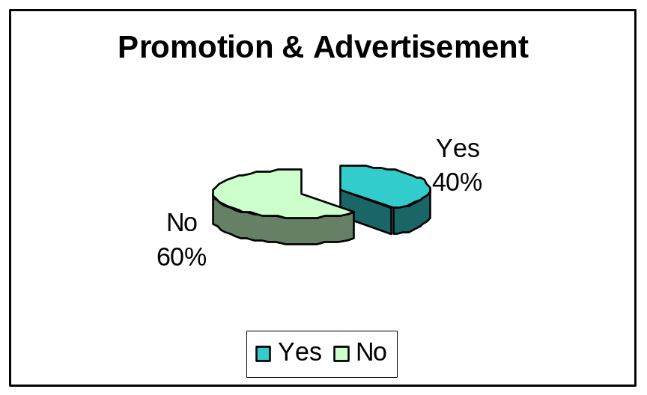

PART SIX

6.0 Analysis

6.1 SWOT Analysis
6.2 Prospects of Spa

6.0 Analysis

6.1 SWOT Analysis

The SWOT analysis is having identified the company's external opportunities and threats as well as internal strength and weakness. In other word the over all evaluation of a company's strength, weakness, opportunities, and threats is called SWOT analysis. It can be develop new function business or corporate strategies to accomplish this change. A SWOT analysis for Spa Drinking Water of AFBL is as follows:

First, I have defined strengths of Spa drinking water, which are given in below:
Strengths
- Strong and dedicated sales force.
- Good quality product.
- Good production capacity.
- Management competence.
- Good marketing skills.
- Competence of information system.
- Brand name reputation.
- Differentiation advantages.
- Appropriate management style.

Secondly, I defined weaknesses of Spa drinking water which are given in below:
Weaknesses:
- Some distribution lacking
- Decline in research and development for innovation
- Do not feel necessity of market survey and not eager to understand consumer behaviors.
- Not eager to redesign or reformat the product.
- It has no attractive advertisement

Thirdly, I have defined opportunities of Spa drinking water which are given in below:
Opportunities:
- It’s a growing market
- Market players are limited
- Can apply research and redevelopment in new areas
- Diversity into new growth business
- Extend cost or differentiation advantages.
- Exploit new market segments.
- Overcome barriers to entry.

Finally, I have defined threats of Spa drinking water, which are given below:
Threats:
- New regulations imposed by BSTI
- Increasing foreign companies’ domination
- Changes in consumer perception
- New forms of vigorous industry competition
- Political instability and government regulation
- Economic depression.

6.2 Prospects of Spa

After analysis SWOT of Spa drinking water, I find out few prospect of it, which are discussing sequentially.

1) Geographical diversification:
I think that the Spa drinking water has also high demand in all over the market of Bangladesh. The customer for whom the products are producing, they have scattered everywhere in the country and they have the same liking for this product. Beside it has goodwill in the whole country. So I think that there is a great opportunity of geographical diversification in domestics and foreign markets.

2) Opportunity to increase sales through advertising:
The firm as well as their competitor's do not effective advertises their products in various media. I think most of the consumer of Spa drinking water watch TV as well as TV is a popular media in Bangladesh. So, if the advertisement is given in television most effectively its demand will be increased day by day.

3) Increasing purchasing power:
The economic condition of the country and purchasing power of the customers are increasing. Consumer purchasing power is increasing day by day. As a result the financial condition will be improved in future as well as the demand and consumption of PRAN juice pack will be increased.

4) Opportunity of product differentiation:
Most of the competition positions of the markets are alike. In addition, they produce some quality juice pack, some differentiation, and approximately some price of products. So there is a much opportunity to increase market share through the differentiation of products. Its may be related, or conglomerate differentiation.

5) Competitive advantages:
Fully competition is not started in the market of Spa drinking water. MUM, Jibon, Fresh, Pran & ACMI is the existing competitor of Spa drinking water. Especially, company has to face two styles of competitions: i) Price and, ii) foreign image. So, there is an opportunity to take competitive advantages and increase market share.

6) Market extension:
Most of the people of Bangladesh are lower middle classes and some are upper class. The lower middle classes are highly price sensitive to high price. They usually want various qualities and design of juice pack at a lower price. There is a great chance of increasing the market share, if a great produce attractive qualities and designs but in lover price.

Therefore, this will indicate the firm has a bright future and prospect. Above these viewpoints, the company can expand its markets.

PART SEVEN

7.0 Recommendation & Conclusion

7.1 Suggestion & Recommendation
7.2 Conclusion
7.3 Reference & Bibliography

7.0 Recommendation & Conclusion

7.1 Suggestion & Recommendation

I think the following suggestion and recommendation are seen feasible for the improvement of the existing Spa drinking water marketing in Bangladesh. These are given in below:

Suggestion and recommendation related to product:

a) Quality ensures:
The firm should ensure quality of AFBL product according to the consumer’s need and expectations. Quality of a product is of attributes that the consumer expects in a particular product. So quality should be selected from consumer viewpoint.

b) Target market:
New segments will be added with the existing market. New segment will be for middle lower and old people.

c) Product positioning:
The Company will make position of drinking water as ‘economic, quality product for large market share.

d) Product differentiation:
Taste of the drinking water should be natural. Any flyover in drinking water fails to fulfill the thirsty of human.

e) Packaging and labeling:
The Company may charge the packing design a little bit and the instruction of safety ness, contents of vitamin on the level will be introduced very soon open grade labeling will be introduced. The existing packaging is very much common for Bangladesh markrt. To attract the customer attention, it should be changed. I will provide a picture of foreign brand, which will very much attractive.

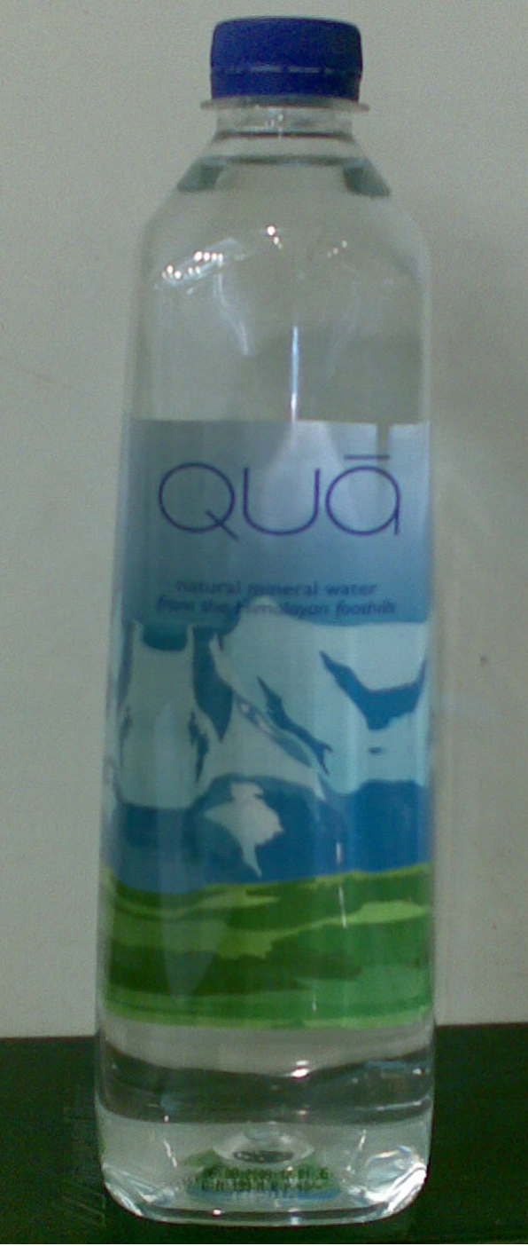

Suggestion and recommendation related to pricing:

Pricing policy:
The Company will follow the penetration pricing policy as they do. To keep the firm running it must set a low price. Because the consumer in domestic market is high, price sensitive to high price.
Production cost will be reducing:
Consumer usually wants to better quality and varied designed products at a lower price production cost one of the major components of price. To minimize the production cost, it is recommended that the expert and skilled workers should be appointed which will reduce the rate wastage and volume of defective production.
Establishing the fixed price:
The same price should be fixed all through the county. As a result, the participants should not have to fall into trouble about price control. Besides, 100% participants expect establishing the fixed price.
To add high commission system:
Dealers, agents, wholesalers and retailers should be given high commission. According to the participants, they want high commission from the authority. The commission system will reduce the business task of the participants.
Competitive price:
Finally, the company will offer competitive price. The company will fixed a reduced price that will be lower than other competitors.

Suggestion and recommendation related to distribution:

The company will look for intensive distribution the company wants all the retail shop store Spa drinking water. The firm should develop a clear-cut combination between channel members to distribution of properly Spa drinking water. For the cordial co-operation of channel and sellers and wholesalers in distributing and selling Spa drinking water successfully. It is recommended that the firm would like to get more benefit to profit share and profit margin might be increased.
The distribution pattern needs to be changed the company have to added few pickup vans for proper timely distribution. A drinking water is a very necessary product for the customer; demand oriented distribution should be introduced. Firstly, it is necessary to estimate the number of customer in a certain area, then to estimate their annual demand. Then it is necessary to appoint a dealer distributor for a certain area.

Suggestion and recommendation related to promotion:

The Akij Food & Beverage Company has to create creative advertisements that will create more attention to target customer. The company can participate in trade fair in different places where consumers are concentrated. These activities will help to create image and consumer awareness in flavor of its drinking water. Besides, the firm can advertise through the print media and electronic media.

The company will be taken sales promotion program. Cash discount quality discount and gift will be given to the sales forces. Sales promotional budget will be increased as for as possible.

Current adverting theme will be change a little bit the company is eager to make brand advertising on the front page of daily national newspaper.

Suggestion and recommendation related to research and development:

Research and development (R&D) is very essential for every business world. Information is very necessary for designing effective marketing program. The firm may collect information regarding consumer's needs, choices, attitude, and exceptions through the R&D.

Other suggestions and recommendations:
We see that the participants in the business have very little knowledge about marketing field. The participants should be properly trained. The intra-communication system will be developed if the distributors /wholesalers are trained well. Sometimes workshop and seminars should be arranged for the participants.

Customer and services are being completely ignored in the existing system. There are no extra facilities given to the customers. The complains of the customers are considered. Customer oriented marketing should be established.

However, the existing product life cycle, Spa drinking water position is rapid group stage. So there are some additional suggestion has been given to keep this position. During this stage, the firm uses several strategies to sustain rapid market growth as long as possible.

- It adds new models and flanker products (i.e. products of different sizes, flavors, and so forth that protect the main product).
- It enters new market segments.
- It increases its distribution coverage and enters new distribution channels.
- It shifts from product awareness advertising to product preference advertising.
- It lowers prices to attract the next layer of price sensitive buyers.

7.2 CONCLUSION

Spa drinking water is one of the most popular brands in Bangladesh as well as in international market recently. In all reasons drinking water is widely consumed by the customers the demand becomes high to the customers. There is a wide demand and high prospects for the drinking water. Spa drinking water is one of the items to meet this demand.

Now the firm is facing various types of marketing problems. In this paper, some suggestions and recommendations have been given so that the firm can overcome those problems. I believe that the management of AFBL is more experience as well as they are also thinking about those problems. I think management should be took care this problem. If the firm produces Spa drinking water as for the customer's choice and demand oriented, the consumers will be highly motivated to purchase the mineral drinking water of the firms.

So, through the observation of the activities and information collected from the interview of participant such as wholesalers, retailers, customers it can be said that this firm is being profitable conduct becomes the firm is not to strong on counter remarkable competition, workers dissatisfaction, and for sufficient demand in comparison with the manufactured goods. But the firm is not being able to perform its marketing activities with efficiency. In this condition continues the firm will be endangered and undergo less in the long run. But it is possible to expand this firm to a greater extent, if it can make use of its present opportunities and facilities properly and it will be possible for it to earn more profit than it is earning now. Therefore, the firm will have to give importance to perform the marketing activities efficiently.

Akij Food & Beverage Ltd. is no doubt one of the basic companies in Bangladesh. So we glad to know the locally produced mineral water in now in a position to fulfill the total of Spa drinking water in the country. The Spa drinking water has that success of business depends on the strength of its existing marketing policy is appropriate for the present situation. The major problems arising in the Spa drinking water in Bangladesh are as follows. The distribution system is being changed complex government policy. Through the company wants most of the retail shop to store juice pack. So the company will have to make intensive distribution. The effective marketing system can be solving present problems.

7.3 Bibliography

Books:
1. Kotler Philip, Principles of Marketing, 10th Edition
2. Kotler, Philip, Marketing Management, Millennium Edition, Prentice Hall of India Private Limited, 1999.
3. Stantion. J. Willam, Fundamental of Marketing, 9th edition, 1998.
4. Yoram. J. Wind, Product Policy, Concept, Method and strategy,
5. Potter. Michael, Edeco, Competitive advantage and strategy, The Free Press.
Report:
6. Annual Report of MUM: 2004-05.
Website:
7. www.akijgroup.com
8. www.afbl.com
9. www.google.com
10. www.buxton.com
11. www.himalayan.com
12. www.partexbeverage.com
13. www.akij food & beverages.com

APPENDIX

- Questionnaire for Officials
- Questionnaire for Wholesaler
- Questionnaire for Retailer
- Questionnaire for customer

Questionnaire for Officials

General Questions:
1. When have you start your business?
2. Which raw materials needed for Mineral Water?
3. From where do you collect these raw materials?
4. How many different raw materials are purchased every year?
5. What factor do you consider for selecting the source of raw materials?
6. What problems are faced collecting /purchasing raw materials?
7. How do you think to solve these problems?
8. Is there any problem for storage of product?
9. What method is used for demand Forecasting?
10. Do you have any segment in market? Please mention?
11. Would you please tell me the reasons?
12. Do you organization participation in social development activities?
13. What is the amount of annual expenditure for there purpose?

Market, Product and Production Related Question:
1. What is reason for producing the existing product?
2. Are you thinking of diversification your product?
3. Have you made simplification of your products line at present?
4. What is the industrial demand of Mineral Water?
5. What are your target markets? What is the reason?
6. What is the amount annual expenditure for the quality control of your products?
7. Do you have now any step to development the quality of existing product?
8. What is your annual production target (Mineral Water)?
9. What was the amount of production in the last 2 years?
10. If the target was not fulfilling, what was the reason for that?
11. What is the nature of market?

Questions Relating To Distribution:
1. Which areas are you now selling Mineral Water to?
2. What sort of middleman do you engage?
3. How do you appoint middleman?
4. Do you provide middleman's with others facilities?
5. What factor do you consider in case the appointment middleman?
6. How many representatives have engaged now?
7. Do the representatives work area-wise?
8. How many sales Representatives work in each area?
9. What sort of facilities do you provide with them?
10. Do you face problem from middleman?
11. How do you solve the problem?
12. What kind of helps do you offer to the middleman?
13. What kind of transportation do you use? Is it of your Own or fare?
14. What is the annual expenditure for transportation in fare?
15. What is the reason if you used transpiration of your own or transportation in fare?
Promotion Related Questions:
- What kind of media do you use advertising?
- What is reason to use this media?
- How much does each media cost annually?
- Do you Asses the effectiveness of your advertising?
- What kind of problems do you face in case of assessing advertising activities?
- What kind of sales promotion activities do you use?
- What do you think how to solve these problem?

Questions Relating To Price:
- What method do you follow usually to set price?
- What are you expenditure sectors? What is the amount of current annual expense sector wisely?
- Do you have any program to control the expenses?
- What types of problems do you face in case setting prices?
- What is the way do you think to solve this problem?
- What policy do you follow for pricing?

Sales Related Questions:
- How is the annual sales amount the different Mineral Water?
- What factor do you consider for sales Mineral Water?
(a) In cash (b) in credit (c) In cash credit (d) others.
- What problems do you faced in transportation of products?
- What is the way do you think to solve this problem?
- How do you collect order from customer or Buyer?
- What were the sales volumes last 2 years?
- What is the districts amount?

Management related questions:
- How many employees are there in the company?
- Would you pleas tell me the number & name of different department?
- What is your organizational structure?
- Do you take Training program for employee and workers? If you, so them, what is about that?
- How is the training expense?

Competition related Question:
- Which company do you complete with to?
- What is the style of competition?
  - Price b) quality c) others

Financial Related Questions:
- What is the quantity of this company total capital?
- How is your capital structure?
- What kind of problem do you face to collect capital?
- What is the way do you think to solve this problem?
- Do you have to increase your capital in future?

Questionnaire Regarding To Wholesaler

Name: ……………………………………………………………………………..
Wholesaler’s Shop Name: ………………………………………………………
Location: ………………………………………..…. Date: ……………………..

      - What kind of wholesaler are you?
□ Special □ General □ Local □ Regional
      - Do you need loan?
□ Yes □ No
      - Do you have selling problem?
□ Yes □ No
      - Do you think the product is being imitated in Bangladesh?
□ Yes □ No
      - Do you think that existing distribution system of Mineral Water is appropriate for the present situation?
□ Yes □ No
      - Do you carry product to your store?
□ Yes □ No
      - Do you face any problem in the care of product Transportation?
□ Yes □ No
      - Do you face any problem in the case of storage?
□ Yes □ No
      - Do you have any conflicts with the other Wholesaler?
□ Yes □ No
      - How much are you depended on the participants?
□ Yes □ No
      - What is your co-operation with the participants?
□ Yes □ No
      - Do you think the existing pricing system of Mineral Water is appropriate for the present situation?
□ Yes □ No
      - Do you think the existing pricing control system of AFBL products is reasonable for the present situation?
□ Yes □ No
      - Are you increasing the price anytime?
□ Yes □ No
      - Do you think has a major defect of the existing pricing system of AFBL products?
□ Yes □ No
      - Do you think the existing pricing system of AFBL products high buying price System?
□ Yes □ No
      - Do you prefer fixed pricing?
□ Yes □ No
      - In the role of government policy in Bangladesh favor of your business?
□ Yes □ No
      - Are you satisfied with the role of the government policy in Bangladesh, especially VAT System?
□ Yes □ No
      - Have you complain about your problems to the authority any time?
□ Yes □ No
      - Do you have face any other marketing problem?
□ Yes □ No
      - Do you think that there is a major defect of the existing packaging and labeling system of AFBL products?
□ Yes □ No

Questionnaire regarding to Retailer
Name: ……………………………………………………………………………..
Wholesaler’s Shop Name: ………………………………………………………
Location: ………………………………………..…. Date: ……………………..

  - What kind of wholesaler are you?
□ Large □ Medium □ Smaller
  - Do you need loan?
□ Yes □ No
  - Do you have selling problem?
□ Yes □ No
  - Do you think the product is being imitated in Bangladesh?
□ Yes □ No
  - Do you think that existing distribution system of AFBL products is appropriate for the present situation?
□ Yes □ No
  - Do you carry product to your store?
□ Yes □ No
  - Do you face any problem in the care of product Transportation?
□ Yes □ No
  - Do you face any problem in the case of storage?
□ Yes □ No
  - Do you have any conflicts with the other Wholesaler?
□ Yes □ No
  - How much are you depended on the participants?
□ Yes □ No
  - What is your co-operation with the participants?
□ Yes □ No
  - Do you think the existing pricing system of AFBL products is appropriate for the present situation?
□ Yes □ No

  - Do you think the existing pricing control system of AFBL products is reasonable for the present situation?
□ Yes □ No
  - Are you increasing the price anytime?
□ Yes □ No
  - Do you think has a major defect of the existing pricing system of AFBL products?
□ Yes □ No
  - Do you think the existing pricing system of AFBL products is high buying price System?
□ Yes □ No
  - Do you prefer fixed pricing?
□ Yes □ No
  - In the role of government policy in Bangladesh favor of your business?
□ Yes □ No
  - Are you satisfied with the role of the government policy in Bangladesh, especially VAT System?
□ Yes □ No
  - Have you complain about your problems to the authority any time?
□ Yes □ No
  - Do you have face any other marketing problem?
□ Yes □ No
  - Do you think that there is a major defect of the existing packaging and labeling system of AFBL products?
□ Yes □ No

Questionnaire for customer

Dear Respondents,
I am Mritunjay Biswas, student of The University of Asia Pacific, student of BBA (Bachelor of Science in Business Administration) Major in Marketing. For the purpose of my study, I need to take opinion you on Spa drinking water.

So I would like to request you to kindly spare a few minutes from your busy schedule to fill up the questionnaire and make research a fruit full one.
- Do you know about Spa drinking water?
a) Yes b) No
- What is about the quality of Spa drinking water?
a) Best b) Good c) Below the Average d) Poor
- What do you think about the price of it?
a) Reasonable b) High
- Do you like the packaging of Spa Drinking Water?
a) Yes b) No
- Is it available able in the market?
a) Yes b) No
- Do you think that the present promotion and advertisement of Spa drinking water is sufficient?
a) Yes b) No

